

**Disclaimer**

The information in this publication is, according to the Ministry for the Environment’s best efforts, accurate at the time of publication. The Ministry will make every reasonable effort to keep it current and accurate. However, users of this publication are advised that:

* The information does not alter the laws of New Zealand, other official guidelines, or requirements.
* It does not constitute legal advice, and users should take specific advice from qualified professionals before taking any action based on information in this publication.
* The Ministry does not accept any responsibility or liability whatsoever whether in contract, tort, equity, or otherwise for any action taken as a result of reading, or reliance placed on this publication because of having read any part, or all, of the information in this publication or for any error, or inadequacy, deficiency, flaw in, or omission from the information in this publication.
* All references to websites, organisations or people not within the Ministry are for convenience only and should not be taken as endorsement of those websites or information contained in those websites nor of organisations or people referred to.

This document may be cited as: Ministry for the Environment. 2022. *New Zealand Emissions Trading Scheme interim auction monitor report: 7 September 2022 auction*. Wellington: Ministry for the Environment.

Published in December 2022 by the  
Ministry for the Environment   
Manatū Mō Te Taiao  
PO Box 10362, Wellington 6143, New Zealand

ISBN: 978-1-991077-15-8

Publication number: ME 1724

© Crown copyright New Zealand 2022

This document is available on the Ministry for the Environment website: [environment.govt.nz](http://www.environment.govt.nz).

# Contents

Figures 4

Introduction and purpose of this report 5

Background 6

Auction monitor to provide information on auctions 6

(Interim) auction monitor’s functions 6

Auction information: 7 September 2022 7

Auction metrics 7

Commentary on the results of the auction 7

The auction clearing price 8

The confidential reserve price 8

Resolved tied bids 9

Cost Containment Reserve (CCR) 9

Commentary on the auction operation 10

General 10

Collateral and settlement 10

Feedback on the auction monitoring report 11

Appendix 12

Graphical presentation of historical auction metrics 12

References 16

# Tables

Table 1 Metrics for NZ ETS auction held on 7 September 2022 7

# Figures

Figure A.1 Volume of NZUs bid for and Cover Ratio in each auction 12

Figure A.2 Total number of bids in each auction 13

Figure A.3 Participant numbers in each auction 13

Figure A.4 Bid volume (of thousands of NZUs) per participant 14

Figure A.5 Breakdown of successful bids by participant, September 2022 14

Figure A.6 Breakdown of successful bids aggregated by participants 15

Figure A.7 Proportion of Participants with mandatory compliance obligations under the NZ ETS 15

# **Introduction and purpose of this report**

This report is produced by the Ministry for the Environment (the Ministry) acting in the role of the interim auction monitor for the seventh scheduled New Zealand Emissions Trading Scheme (NZ ETS) auction, the third auction for 2022, held on 7 September 2022.

Auctioning of New Zealand Units (NZUs or ‘units’) is currently scheduled at quarterly intervals throughout the year as prescribed by the Climate Change Response (Emissions Trading Reform) Amendment Act 2020 and the Climate Change (Auctions, Limits, and Price Controls for Units) Regulations 2020.

The purpose of this report is to record and provide details on the results of the auction, to present a comparison with previous auctions, and to provide an assurance that the auction was conducted properly and in accordance with the applicable rules and laws.

The final auction for 2022 is scheduled to be held on 7 December.

# Background

Following the 2015/16 review of the NZ ETS, the Government agreed to introduce auctioning of NZUs to align the supply of units in the Emissions Trading Scheme with New Zealand’s climate change targets.[1] Further public consultation on auctioning regulations took place between November and December 2019.[2]

Following extensive regulatory and legislative development and an open market procurement process, an auction operator was appointed to run regular scheduled auctions through the NZX Managed Auction Service.

The first auction occurred on 17 March 2021.

This report concerns the seventh scheduled auction which occurred on 7 September 2022.

## Auction monitor to provide information on auctions

The appointment of an auction monitor requires regulations to be made prescribing the appointment process and the functions of the auction monitor.

Until the required consultations and regulation development have been concluded to appoint an auction monitor, the Minister of Climate Change has agreed that the Ministry for the Environment will perform the function of the auction monitor, referred to in this document as interim auction monitor (IAM).

The IAM function is performed independently of the auction operator and of the Ministry for the Environment policy team responsible for developing the regulations for the auction monitor and auctioning.

## (Interim) auction monitor’s functions

Based on feedback from the 2019 consultation, the Government agreed that the auction monitor should:

* publish certain information about each auction as soon as is practical following the auction
* publish a report on the outcome of each auction before the next auction occurs
* review the auctioning system after the first year and every subsequent two years.

Cabinet has agreed that the auction monitor must publish a report containing prescribed information from each auction and on the outcome of each auction prior to the subsequent auction occurring [DEV-20-MIN-0047].[3]

The auction operator publishes information about each auction shortly following the close of the auction, which can be read in conjunction with this report.

# Auction information: 7 September 2022

## Auction metrics

Table 1 provides relevant metrics of the auction. Additional details are presented graphically in the appendix.

Table Metrics for NZ ETS auction held on 7 September 2022

|  |  |
| --- | --- |
| Number of participants | 26 |
| Number of successful participants | 23 |
| Volume available at auction (No CCR units available for auction) | 4,825,000 |
| Volume of NZU sold | 4,825,000 |
| Volume of NZU Bid for | 6,413,700 |
| Average Bid Size | 29,556 |
| Average volume bid per participant | 246,681 |
| Average volume won per successful participant | 209,782 |
| Average number of bids per participant | 8 |
| Total number of bids submitted (not including withdrawn bids) | 217 |
| Number of bids withdrawn | 2 |
| Number of successful bids | 96 |
| Aggregated ’top 5’ participants volume (aggregated successful bids) as a percentage of total units sold | 75 |
| Herfindahl–Hirschman Index (measure of market concentration by volume purchased ‘top 10’) | 0.13 |
| Percentage of bidders with mandatory compliance obligations | 43 |

## Commentary on the results of the auction

The seventh NZ Emissions Trading Scheme auction and the third of 2022 was successfully conducted on 7 September 2022. The preceding (June) auction resulted in the sale of the remainder of the annual cost containment reserve volume for 2022. Consequently, no additional (CCR) units were available for sale in the September auction.

All 4,825,000 units scheduled for sale were sold in the September auction.

The September auction was somewhat muted in comparison with previous instances.

A similar number of entities participated in the September auction to that of the June auction, with 23 of the 26 participants being successful in their bids.

Auction ‘bid volume’ (the total number of NZUs bid for) was markedly down from the average figure but sufficiently high to result in cover ratio of 1.33.

The range of bids (by dollar value) widened in the auction, perhaps in the absence of any Cost Containment Reserve volume.

The market concentration index of 0.13 was the equal lowest result to date. The familiar players dominated the auction volume, though as indicated, a little less than usual. The ‘top five’ participants purchased 75 per cent (the ‘top 10’ won 96 per cent) of the sold volume.

All the participants registered as having compliance obligations under the Emissions Trading Scheme were successful in securing some, if not all of their bid volumes. Historically, the number of participants registered as having ETS surrender obligations failing to secure any units is very low.

As usual, it is very likely that a number of the larger players represent multiple third parties.

The relationship between the secondary market carbon price and the auction clearing price remains relatively consistent.

## The auction clearing price

The auction operator is required to publish the clearing price following the auction.

The auction clearing price was correctly interpreted as NZ$85.40. This compares with an interim clearing price (the clearing price in the absence of available CCR volume) of NZ$78.00 in June and an interim clearing price of NZ$86.00 in the March auction.

The CCR trigger mechanism (NZ$70) was breached, however, as noted, no CCR volume was available in the September auction, the annual allocation of CCR volume having been expended across the March and June auctions.

***The auction clearing price was slightly below the secondary market closing pricing preceding the auction which is not unusual.***

## The confidential reserve price

The Climate Change Response Act enables the Minister of Climate Change to set a methodology for calculating a confidential reserve price for NZ ETS auctions. The confidential reserve price has the purpose of preventing NZUs from being sold at auction at a price significantly below the secondary market price. If the auction clearing price is less than the confidential reserve price, the auction will not sell any NZUs. Unsold NZUs will be rolled forward to be sold at the next auction in the same calendar year.

The legislation requires that the confidential reserve price cannot exceed the trigger price(s) for the cost containment reserve.

***The IAM independently confirms that the calculated confidential reserve price was not directly influential on the distribution of NZUs nor the auction result.***

## Resolved tied bids

If more than one bid sets the clearing price, those bids are referred to as tied bids. If all tied bids together bid for more units than are left, each tied bid is allocated a proportional share of the remaining units, subject to rounding rules. Bids are only accepted in multiples of 100 units from 500 units (the lot size and minimum bid respectively). Units are allocated to bids in multiples of lot size. Therefore, when tied bids occur and the operator calculates proportional shares, they apply the following rounding rules:

* the number of units allocated to a tied bid, if not a multiple of the lot size, is rounded down to the nearest 100 units (this may include being rounded down to zero)
* if unallocated units remain after tied bids are awarded their proportional share (rounded to the nearest 100 units), any remaining lots are randomly allocated to the tied bids, but only up to their original bid amount.

***The IAM has examined how units have been allocated among bids and confirms that the auction operator has correctly applied the allocation and rounding rules.***

***There were no tied bids requiring consideration in the September 2022 auction.***

## Cost Containment Reserve (CCR)

The cost containment reserve (CCR) mechanism provides for an additional volume of NZUs to be added to the auction volume if the auction clearing price is equal to or exceeds the CCR trigger price. Currently, there is only one trigger price level in an ETS auction. The cost containment reserve trigger price for the September 2022 auction was set at NZ$70 per NZU, as previously published.

The available CCR volume to be shared across all four auctions in 2022 is 7.0 million NZUs.

Both the CCR trigger price and available volumes are set by regulation, though both may be reviewed and are subject to change. The available annual auction volumes and auction dates are published in October of the preceding year by the Ministry for the Environment.

***The CCR trigger price was breached in the September 2022 auction, though no units of CCR reserve volume were available for sale with the CCR having been expended in the previous auctions of 2022.***

# Commentary on the auction operation

## General

The auction operator has confirmed that the auction ran smoothly with no outages or delays. The Ministry for the Environment has similarly confirmed a successfully conducted auction.

***The IAM has no reason to believe that the auction rules were not followed.***

## Collateral and settlement

There were no significant issues noted with the receipt of collateral or the timely payment of invoices for settlement.

**The auction operator continues to remind prospective participants of the requirement to ensure payment within the prescribed schedule; particularly the need for offshore participants to allow additional time for banking and clearance processes.**

Participants (ie, those who have lodged collateral) should note that there is no requirement for the auction operator to ‘remind’ them that an auction is underway.

All invoices for successful participants were settled within the four working days of the auction as required, though three payments were received on the final allowable date.

Uncommitted collateral was returned to participants promptly. The auction operator has instituted revised processes for international payment (return of unused collateral).

Cash was the main instrument for lodging collateral, though six participants preferred to submit Standby Letters of Credit (SBLC) for lodging non-cash collateral.

The total amount of collateral deposited was again significantly less than previously, in line with lower bid volumes in the auction and perhaps an increasing familiarity with the dynamics of NZU auctioning.

All NZUs were transferred to successful bidders’ NZ ETS Registry accounts on the same day as the invoice settlement.

***The IAM notes that all participants lodged collateral within the prescribed timeframes, and all successful participants received their allocated units within the prescribed timeframe.***

# Feedback on the auction monitoring report

Please send any information about the ETS auctions to the interim auction monitor at [etsconsultation@mfe.govt.nz](mailto:etsconsultation@mfe.govt.nz) for consideration in future reports.

# Appendix

## Graphical presentation of historical auction metrics

|  |
| --- |
| Legend for graphs in this report  Sept. 21 Auction 3, held on 1 September 2021  Dec. 21 Auction 4, held on 1 December 2021  Mar. 22 Auction 5, held on 16 March 2022  June 22 Auction 6, held on 15 June 2022  Sept. 22 Auction 7, held on 7 September 2022 (this auction)  The most recent auction and four trailing auctions will be presented in this appendix. |

Figure A. Volume of NZUs bid for and Cover Ratio in each auction

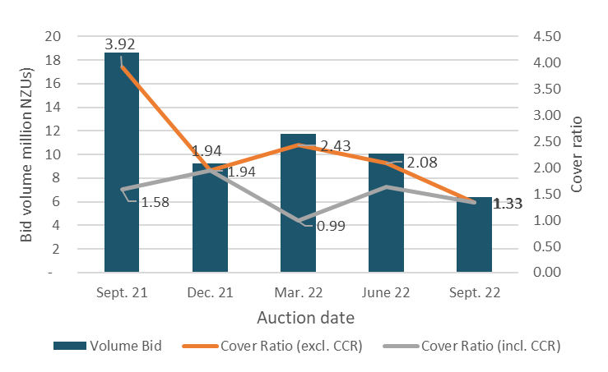

Figure A. Total number of bids in each auction

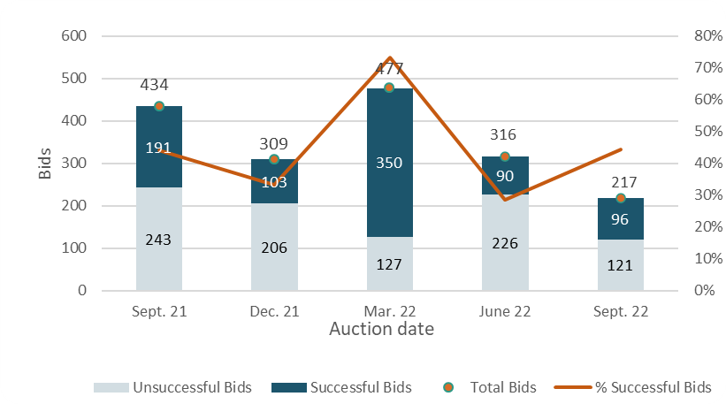

Figure A. Participant numbers in each auction

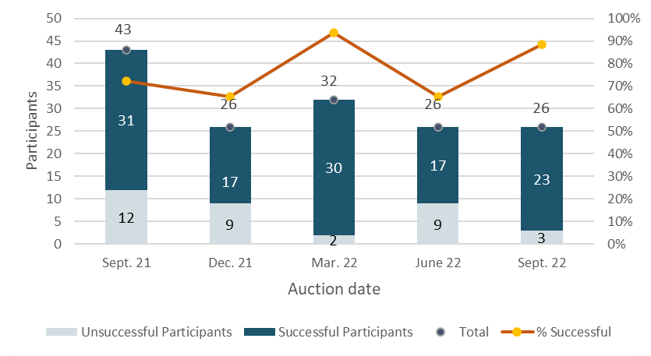

Figure A. Bid volume (of thousands of NZUs) per participant

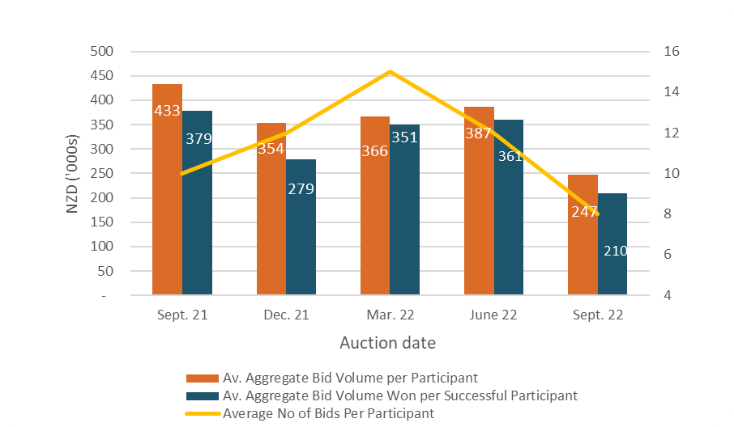

Note that many participants submitted multiple bids and there may be multiple bidders representing a single participant.

Figure A. Breakdown of successful bids by participant, September 2022

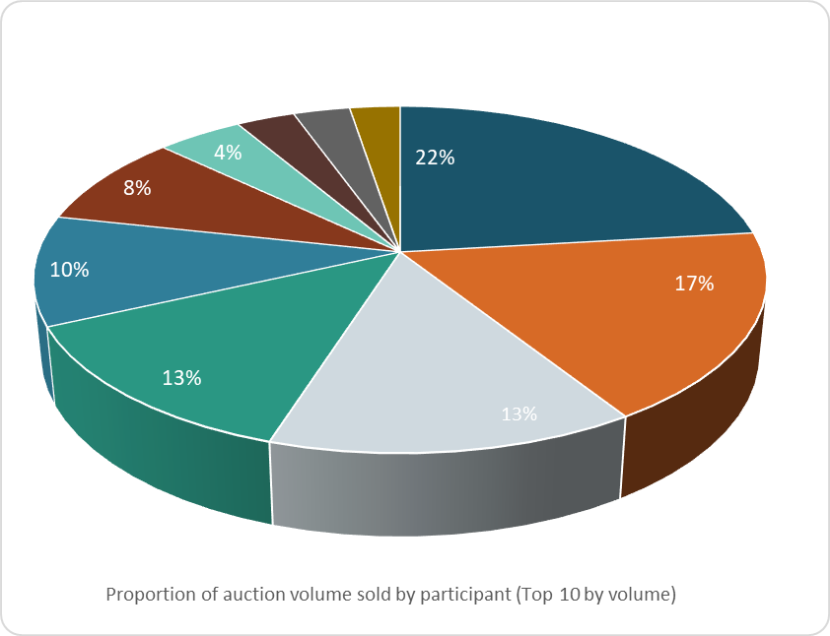

Figure A. Breakdown of successful bids aggregated by participants

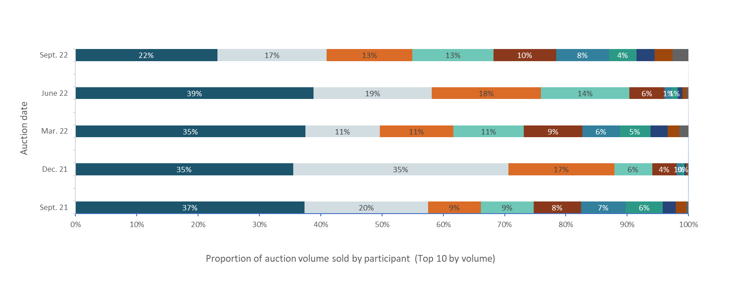

Figure A. Proportion of participants with mandatory compliance obligations under the NZ ETS

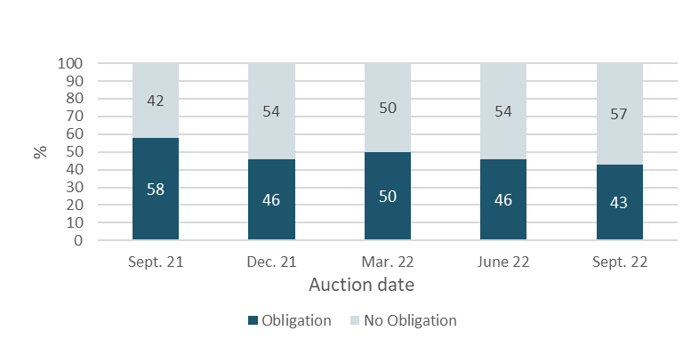

Figure A.7 represents the percentage of participants that are registered as having mandatory compliance obligations on the ETS Register. Larger volume participants, not necessarily registered as having compliance obligations, may be purchasing NZUs on behalf of smaller third parties that do have compliance obligations.

# **References**

New Zealand Cabinet. 2018. Am*endments to the Climate Change Response Act 2002: Tranche One*. Cabinet Committee Minute of Decision CAB-18-MIN-0606.01. Wellington: Cabinet Office, Department of the Prime Minister and Cabinet.

Ministry for the Environment. 2019. *Reforming the New Zealand Emissions Trading Scheme: Rules for auctioning: Technical consultation document*. Wellington: Ministry for the Environment.

New Zealand Cabinet. 2020. *New Zealand Emissions Trading Scheme: Regulatory Decisions on the Rules for Auctioning*. Cabinet Economic Development Committee Minute of Decision DEV-20-MIN-0047. Wellington: Cabinet Office, Department of the Prime Minister and Cabinet.

1. <https://environment.govt.nz/assets/Publications/amendments-to-ccra-tranche-1-cab-18-min-0606.01.pdf>
2. <https://environment.govt.nz/publications/reforming-the-new-zealand-emissions-trading-scheme-rules-for-auctioning-summary-of-submissions/>
3. <https://environment.govt.nz/assets/Publications/DEV-20-MIN-0047-Minute.pdf>