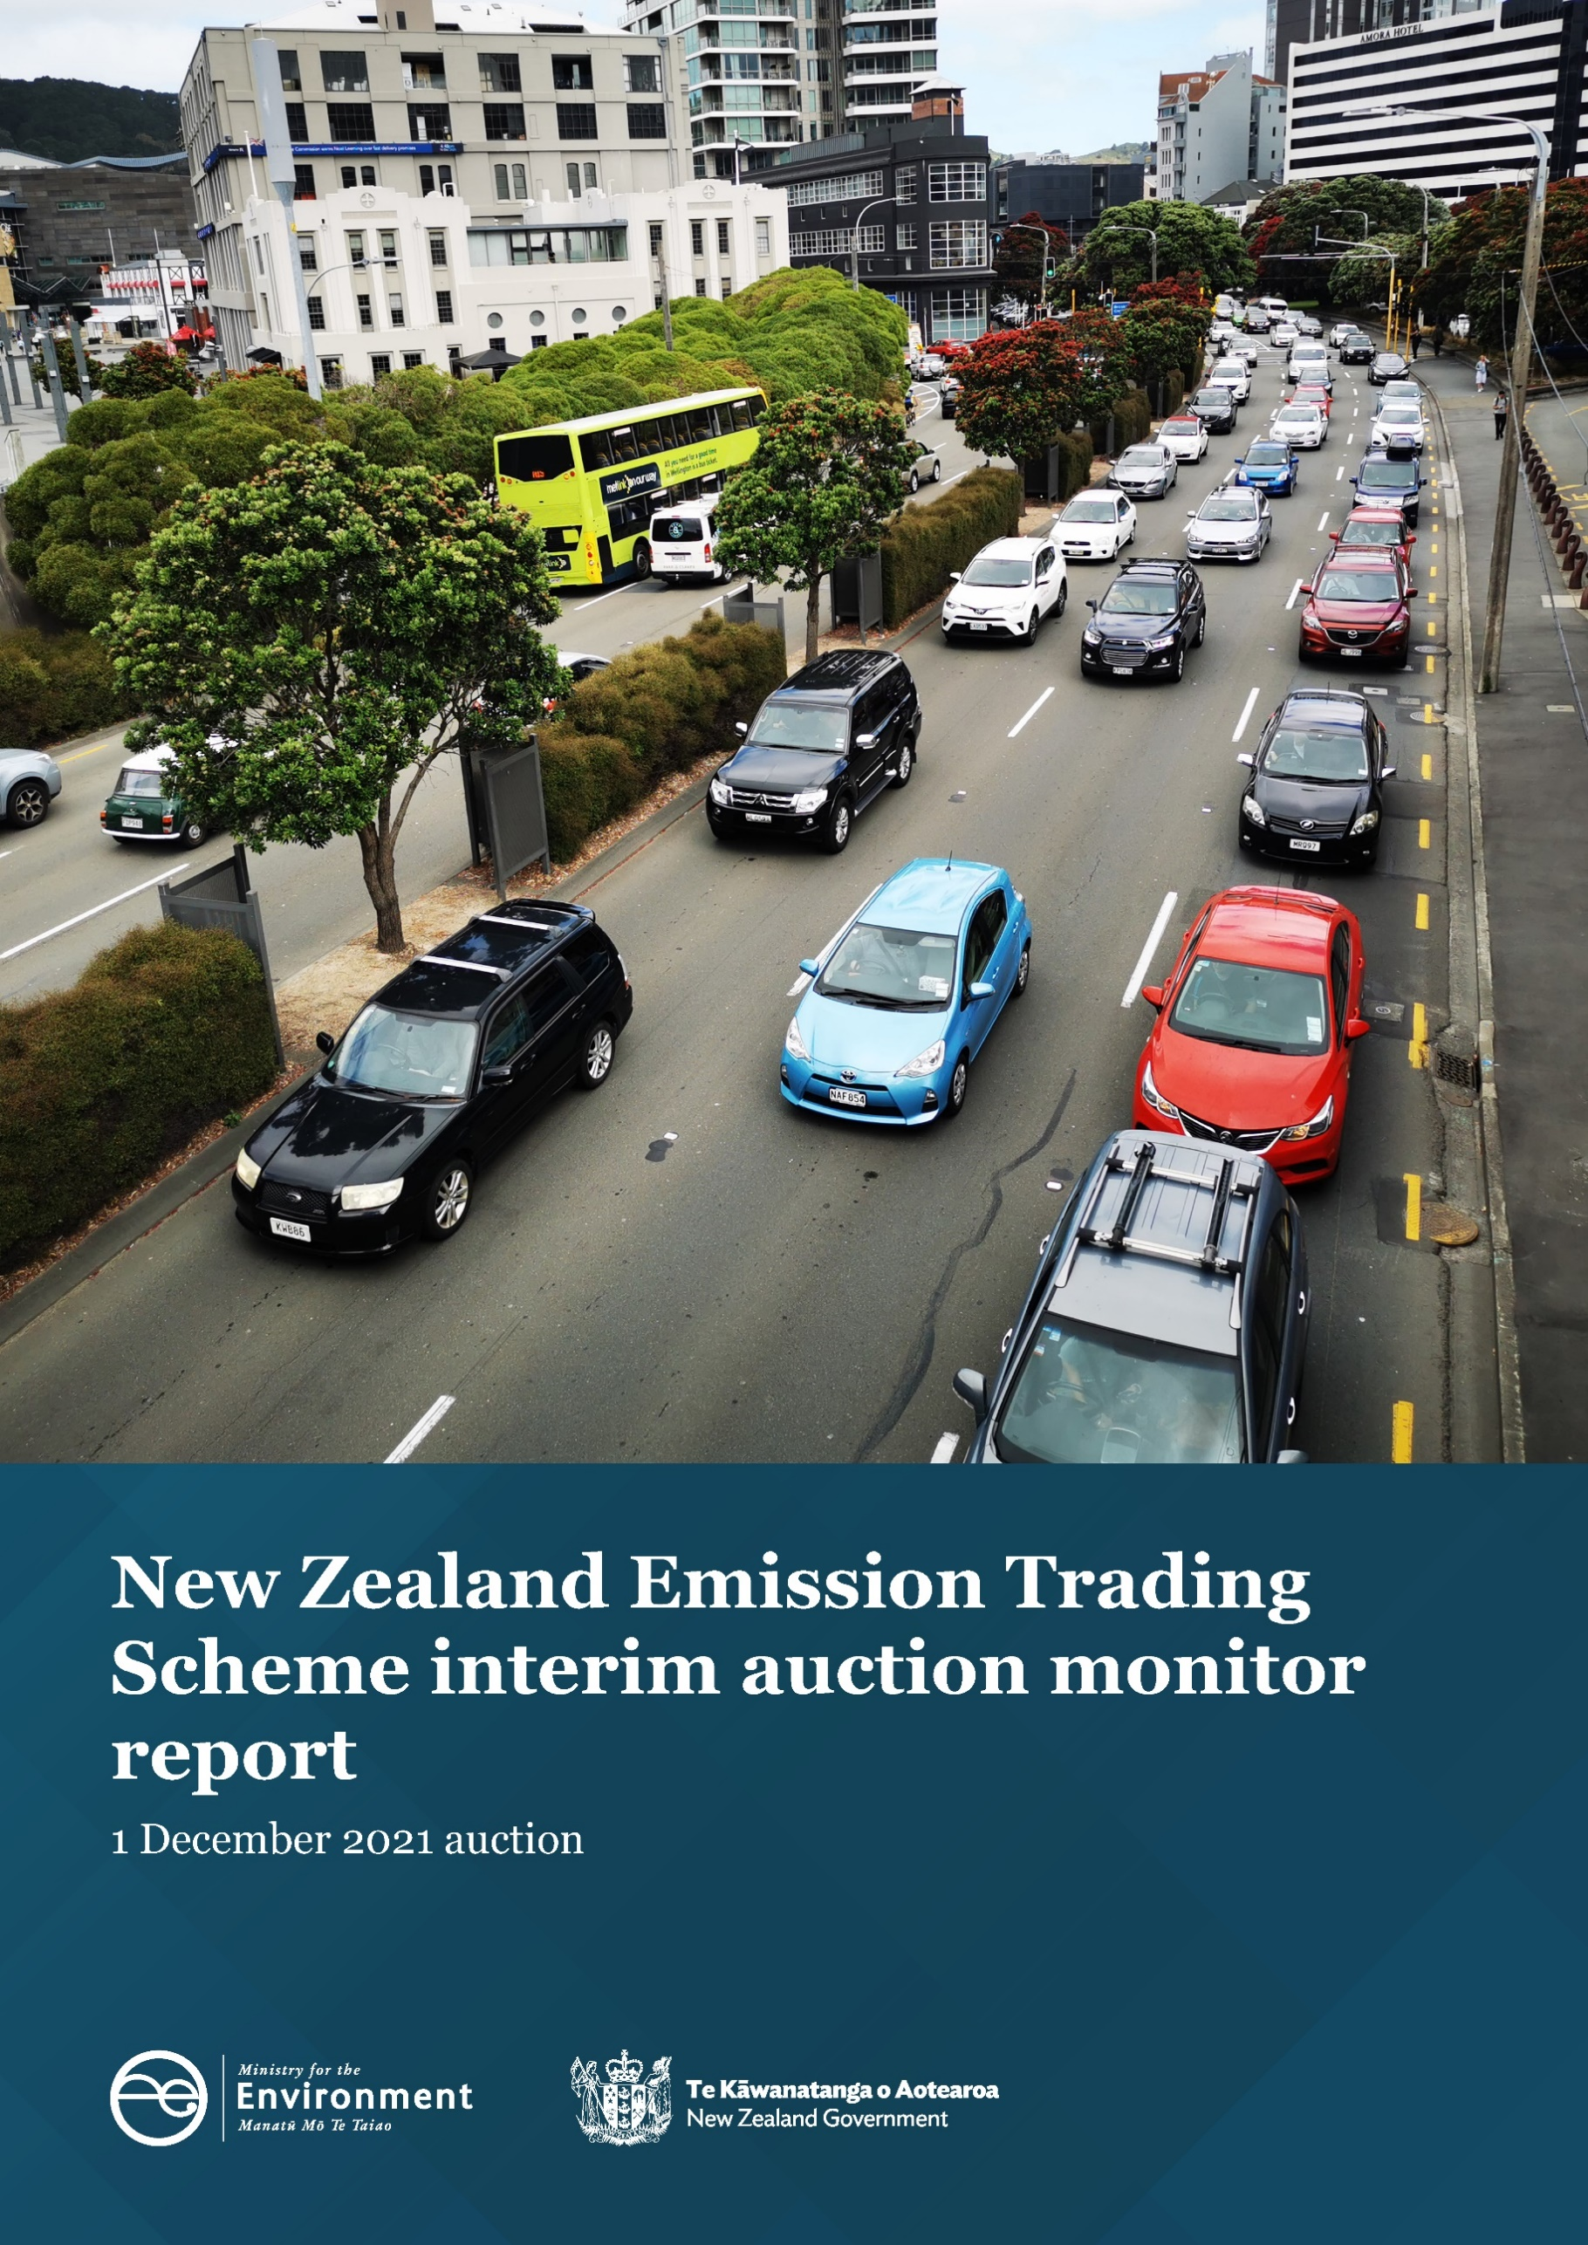
Disclaimer
The information in this publication is, according to the Ministry for the Environment’s best efforts, accurate at the time of publication. The Ministry will make every reasonable effort to keep it current and accurate. However, users of this publication are advised that:
- The information does not alter the laws of New Zealand, other official guidelines, or requirements.
- It does not constitute legal advice, and users should take specific advice from qualified professionals before taking any action based on information in this publication.
- The Ministry does not accept any responsibility or liability whatsoever whether in contract, tort, equity, or otherwise for any action taken as a result of reading, or reliance placed on this publication because of having read any part, or all, of the information in this publication or for any error, or inadequacy, deficiency, flaw in, or omission from the information in this publication.
- All references to websites, organisations or people not within the Ministry are for convenience only and should not be taken as endorsement of those websites or information contained in those websites nor of organisations or people referred to.

This document may be cited as: Ministry for the Environment. 2021. New Zealand Emissions Trading Scheme interim auction monitor report: 1 December 2021 auction. Wellington: Ministry for the Environment.

Published in December 2021 by the
Ministry for the Environment
Manatū Mō Te Taiao
PO Box 10362, Wellington 6143, New Zealand
ISBN: 978-1-99-102501-2
Publication number: ME 1615
© Crown copyright New Zealand 2021
This document is available on the Ministry for the Environment website: environment.govt.nz

Contents
Contents 3
Introduction and purpose of this report 5
Background 6
Auction monitor to provide information on auctions 6
(Interim) auction monitor’s functions 6
Auction information: 1 December 2021 7
Auction metrics 7
Commentary on the results of the auction 7
The auction clearing price 7
The confidential reserve price 8
Resolved tied bids 8
Cost Containment Reserve (CCR) 8
Commentary on the auction operation 9
General 9
Collateral and settlement 9
Feedback on the auction monitoring report 10
Appendix 11
Graphical presentation of historical auction metrics 11
References 15

Tables
Table 1: Metrics for NZ ETS auction held on 1 December 2021 7

Figures
Figure A.1: Volume of NZUs bid for and Cover Ratio in each auction 11
Figure A.2: Total number of bids in each auction 12
Figure A.3: Participant numbers in each auction 12
Figure A.4: Bid volume (of thousands of NZUs) per participant and ‘win’ ratio 13
Figure A.5: Breakdown of successful bids by participant, December 2021 13
Figure A.6: Breakdown of aggregated successful bids by ‘Top 10’ participants 2021 14
Figure A.7: Proportion of Participants with mandatory compliance obligations under the NZ ETS 14

Introduction and purpose of this report
This report is produced by the Ministry for the Environment (MfE) acting in the role of the interim auction monitor for the fourth scheduled New Zealand Emissions Trading Scheme (NZ ETS) auction of 2021 held on 1 December 2021.
Auctioning of New Zealand Units (NZUs) is currently scheduled at quarterly intervals throughout the year as prescribed by the Climate Change Response (Emissions Trading Reform) Amendment Act 2020 and the Climate Change (Auctions, Limits, and Price Controls for Units) Regulations 2020.
The purpose of this report is to record and provide details on the results of the auction, to present a comparison with previous auctions, and to provide an assurance that the auction was conducted properly and in accordance with the applicable rules and laws.

Background
Following the 2015/16 review of the NZ ETS, the Government agreed to introduce auctioning of NZUs to align the supply of units in the scheme with New Zealand’s climate change targets. Further public consultation on auctioning regulations took place between November and December 2019.
Following extensive regulatory and legislative development and an open market procurement process, an auction operator was appointed to run regular scheduled auctions through the NZX Managed Auction Service.
The first auction occurred on 17 March 2021.
This report concerns the fourth and final auction of 2021, which occurred on 1 December 2021.

Auction monitor to provide information on auctions
The appointment of an auction monitor requires regulations to be made prescribing the appointment process and the functions of the auction monitor.
Until the required consultations and regulation development have been concluded to appoint an auction monitor, the Minister of Climate Change has agreed that the Ministry for the Environment (MfE) will perform the function of the auction monitor, referred to in this document as interim auction monitor (IAM).
The IAM function is performed independently of the auction operator and of the MfE policy team responsible for developing the regulations for the auction monitor and auctioning.

(Interim) auction monitor’s functions
Based on feedback from the 2019 consultation, the Government agreed that the auction monitor should:
- publish certain information about each auction as soon as is practical following the auction
- publish a report on the outcome of each auction before the next auction occurs
- review the auctioning system after the first year and every subsequent two years.
Cabinet has agreed that the auction monitor must publish a report containing prescribed information from each auction and on the outcome of each auction prior to the subsequent auction occurring [DEV-20-MIN-0047].
The auction operator publishes information about NZ ETS auctions, which can be read in conjunction with this report.

Auction information: 1 December 2021

Auction metrics
Table 1 provides relevant metrics of the auction. Further details are presented graphically in the appendix.
Table 1: Metrics for NZ ETS auction held on 1 December 2021
Number of participants | 26
Number of successful participants | 18
Average bid size | 29,809
Average volume bid per participant | 354,265
Average volume won per successful participant | 263,888
Average number of bids per bidder | 12
Total number of bids submitted (not including withdrawn bids) | 309
Number of bids withdrawn | 7
Number of successful bids | 103
Largest participant (aggregated successful bids) as a percentage of total units sold | 35%
Herfindahl–Hirschman Index (measure of market concentration Top 10) | 0.28
Percentage of bidders with mandatory compliance obligations | 46

Commentary on the results of the auction
The fourth and final quarterly auction of 2021 was held on 1 December. The containment reserve volume having been exhausted in the previous auction was not available, limiting the available auction volume to 4.75 million NZUs.
Although the number of participants registered on the Managed Auction Service (in excess of one hundred) continues to increase, only 27 entities participated in the December auction in comparison with 43 in the previous auction.
Two thirds of the participants in the auction were successful in obtaining NZUs. This is a similar portion to that in September.
As in previous auctions, a small number of larger participants by volume purchased dominate the auction statistics, though it is likely that some of the larger players represent a number of third-party bidders. Although the market concentration metrics suggest that the market has become slightly less competitive as a result, it is still ‘early days’ for the Managed Auction Service and the market.

The auction clearing price
The auction operator is required to publish the clearing price following the auction.
The IAM has calculated the clearing price using raw data provided by the auction operator and confirms that the clearing price is $68.00.

The confidential reserve price
The Climate Change Response Act enables the Minister of Climate Change to set a methodology for calculating a confidential reserve price for NZ ETS auctions. The confidential reserve price has the purpose of preventing NZUs from being sold at auction at a price significantly below the secondary market price. If the auction clearing price is less than the confidential reserve price, the auction will not sell any NZUs. Unsold NZUs will be rolled forward to be sold at the next auction in the same calendar year.
The Legislation requires that the confidential reserve price cannot exceed the trigger price(s) for the cost containment reserve.
The auction operator has robust procedures and checks in place to ensure that the confidential reserve price is correct. The IAM is satisfied that these checks are sufficient and that the clearing price was above the confidential reserve price.

Resolved tied bids
If more than one bid sets the clearing price, those bids are referred to as tied bids. If all tied bids together bid for more units than are left, each tied bid is allocated a proportional share of the remaining units, subject to rounding rules. Bids are only accepted in multiples of 100 units from 500 units (the lot size and minimum bid respectively). Units are allocated to bids in multiples of lot size. Therefore, when tied bids occur and the operator calculates proportional shares, they apply the following rounding rules:
- the number of units allocated to a tied bid, if not a multiple of the lot size, is rounded down to the nearest 100 units (this may include being rounded down to zero)
- if unallocated units remain after tied bids are awarded their proportional share (rounded to the nearest 100 units), any remaining lots are randomly allocated to the tied bids, but only up to their original bid amount.
There were seven tied bids at the clearing price (i.e., at the price that all available NZU volume was exhausted) submitted by five participants.
The IAM has examined how units have been allocated among tied bids and confirms that the auction operator has correctly applied the allocation and rounding rules.

Cost Containment Reserve (CCR)
The cost containment reserve (CCR) mechanism provides for an additional volume of NZUs to be added to the auction volume if the auction clearing price is equal to or exceeds the CCR trigger price. Currently, there is only one trigger price level in an ETS auction. The cost containment reserve trigger price for the September auction was unchanged from the first two auctions at $50.00 per NZU.
The available CCR volume to be shared across all four auctions in 2021 is 7.0 million NZUs.
Both the CCR trigger price and available volumes are set by regulation, though both may be reviewed and are subject to change. The available annual auction volumes and auction dates are published in September of the preceding year by the Ministry for the Environment.
As the CCR trigger price was reached in the September auction and the full CCR reserve volume (7.0 million NZUs) were sold there were no additional units available in the December auction.

Commentary on the auction operation

General
The auction operator has confirmed that the auction ran smoothly with no outages or delays. New participants continue to register as interest in the auctions increases.
The IAM has no reason to believe that the auction rules were not followed.

Collateral and settlement
All the potential participants who lodged collateral ‘in cash’ did so on or before T-5 (24 November 2021).
Standby Letters of Credit (SBLC) were the preferred instrument for lodging non-cash collateral for five of the participants. Most buyers deposited cash as collateral, though the value of cash and SBLC received was about the same.
All invoices for successful participants were processed and were settled by 7 December. There were no defaults on invoicing.
All NZUs were transferred to successful bidders’ NZ ETS Registry accounts on the same day as the invoice settlement date; 7 December 2021.
The IAM notes that all participants lodged collateral within the prescribed timeframes, and all successful participants received their allocated units within the prescribed timeframe.

Feedback on the auction monitoring report
Please send any information about the ETS auctions to the interim auction monitor at etsconsultation@mfe.govt.nz for consideration in future reports.

Appendix

Graphical presentation of historical auction metrics
Legend for graphs in this report
March Auction 1, held on 17 March 2021
June Auction 2, held on 23 June 2021
Sept. Auction 3, held on 1 September 2021
Dec. Auction 4, held on 1 December 2021

Figure A.1: Volume of NZUs bid for and Cover Ratio in each auction
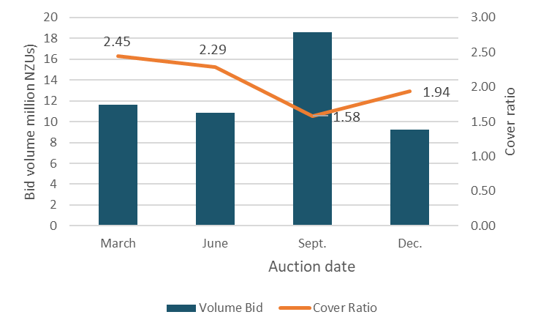

Figure A.2: Total number of bids in each auction
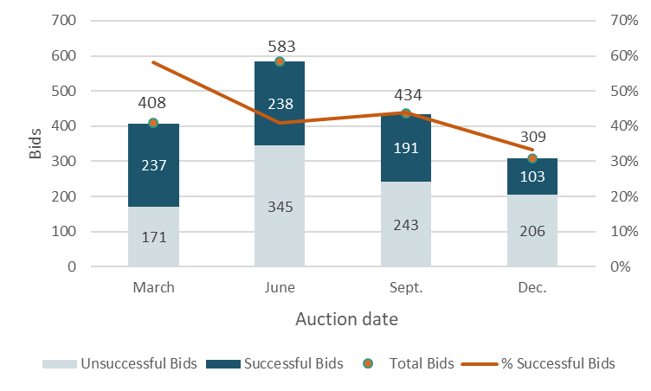

Figure A.3: Participant numbers in each auction
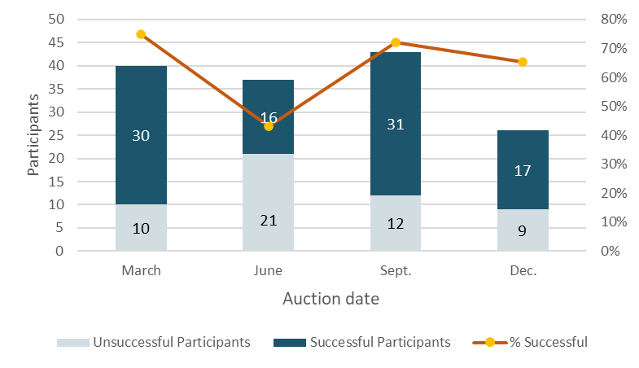

Figure A.4: Bid volume (of thousands of NZUs) per participant and ‘win’ ratio
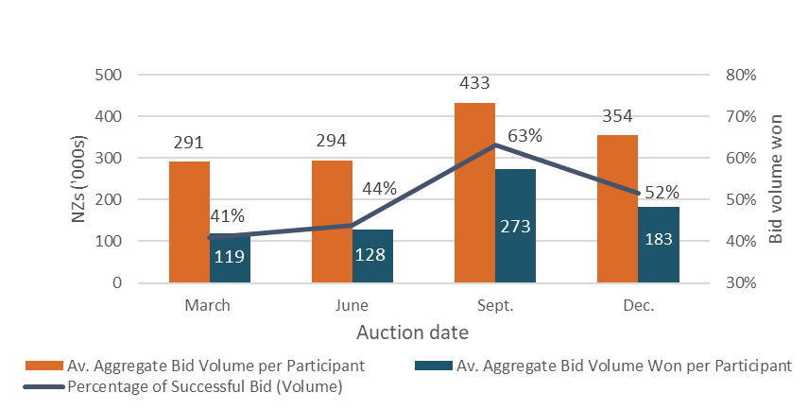
Note that many participants submitted multiple bids and there may be multiple bidders representing a single participant.

Figure A.5: Breakdown of successful bids by participant, December 2021
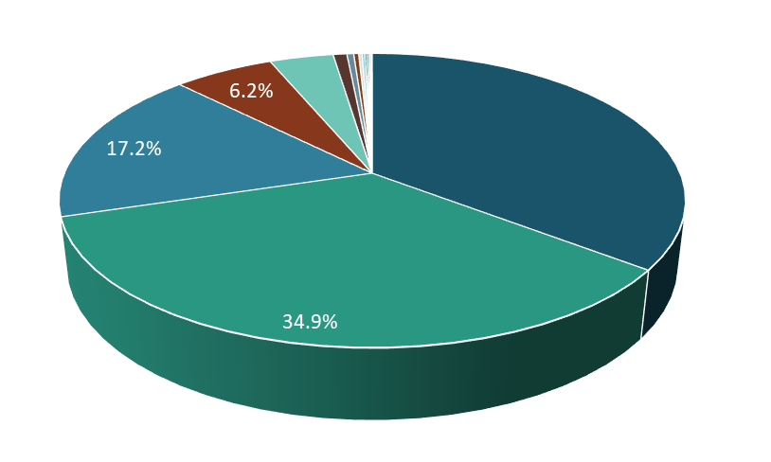

Figure A.6: Breakdown of aggregated successful bids by ‘Top 10’ participants 2021
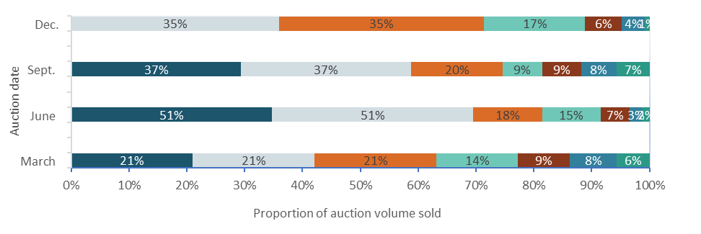

Figure A.7: Proportion of Participants with mandatory compliance obligations under the NZ ETS
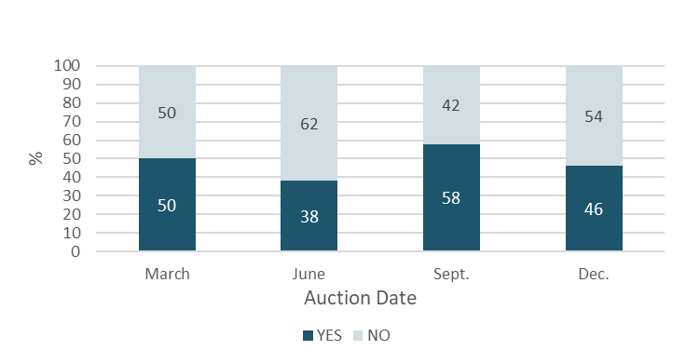
Figure A.7 represents the number of participants that are registered as having mandatory compliance obligations on the ETS Register. ‘Larger volume’ participants not necessarily registered as having compliance obligations, may be purchasing NZUs on behalf of third parties that do have compliance obligations.

References
New Zealand Cabinet. 2018. Amendments to the Climate Change Response Act 2002: Tranche One. Cabinet Committee Minute of Decision CAB-18-MIN-0606.01. Wellington: Cabinet Office, Department of the Prime Minister and Cabinet.
Ministry for the Environment. 2019. Reforming the New Zealand Emissions Trading Scheme: Rules for auctioning: Technical consultation document. Wellington: Ministry for the Environment.
New Zealand Cabinet. 2020. New Zealand Emissions Trading Scheme: Regulatory Decisions on the Rules for Auctioning. Cabinet Economic Development Committee Minute of Decision DEV-20-MIN-0047. Wellington: Cabinet Office, Department of the Prime Minister and Cabinet.

https://environment.govt.nz/assets/Publications/amendments-to-ccra-tranche-1-cab-18-min-0606.01.pdf
https://environment.govt.nz/publications/reforming-the-new-zealand-emissions-trading-scheme-rules-for-auctioning-summary-of-submissions/
https://environment.govt.nz/assets/Publications/DEV-20-MIN-0047-Minute.pdf
T-5 refers to the day five working days prior to the day the auction was held on.

