

Disclaimer
The information in this publication is, according to the Ministry for the Environment’s best efforts, accurate at the time of publication. The Ministry will make every reasonable effort to keep it current and accurate. However, users of this publication are advised that:
- The information does not alter the laws of New Zealand, other official guidelines, or requirements.
- It does not constitute legal advice, and users should take specific advice from qualified professionals before taking any action based on information in this publication.
- The Ministry does not accept any responsibility or liability whatsoever whether in contract, tort, equity, or otherwise for any action taken as a result of reading, or reliance placed on this publication because of having read any part, or all, of the information in this publication or for any error, or inadequacy, deficiency, flaw in, or omission from the information in this publication.
- All references to websites, organisations or people not within the Ministry are for convenience only and should not be taken as endorsement of those websites or information contained in those websites nor of organisations or people referred to.

This document may be cited as: Ministry for the Environment. 2023. New Zealand Emissions Trading Scheme interim auction monitor report: 6 September 2023 auction. Wellington: Ministry for the Environment.

Published in September 2023 by the
Ministry for the Environment
Manatū mō te Taiao
PO Box 10362, Wellington 6143, New Zealand
environment.govt.nz
ISBN: 978-1-991077-96-7
Publication number: ME 1808
© Crown copyright New Zealand 2023

Contents
Introduction and purpose of this report 5
Background 6
Auction monitor to provide information on auctions 6
(Interim) auction monitor’s functions 6
Auction information: 6 September 2023 8
Auction result 8
Changes to the NZ ETS auction settings 8
Auction metrics 9
Commentary on the results of the auction 9
The auction clearing price 11
The confidential reserve price 11
Resolved tied bids 11
Cost containment reserve 11
Commentary on the auction operation 13
General 13
Collateral and settlement 13
Feedback on the auction monitoring report 14
Appendix 15
Graphical presentation of historical auction metrics 15
References 20

Table
Table 1 Metrics for NZ ETS auction held on 6 September 2023 9

Figures
Figure A.1 Volume of NZUs bid for and cover ratio per auction 16
Figure A.2 Total number of bids per auction 16
Figure A.3 Participant numbers per auction 17
Figure A.4 Bid volume (of thousands of NZUs) per participant 17
Figure A.5 Proportion of bids (by volume) by participant, September 2023 18
Figure A.6 Proportion of successful* bids (by volume) by participant over the previous five auctions 18
Figure A.7 Proportion of participants with compliance obligations under the NZ ETS 19

Introduction and purpose of this report
This report is produced by the Ministry for the Environment (the Ministry) acting in the role of the interim auction monitor, for the eleventh scheduled New Zealand Emissions Trading Scheme (NZ ETS) auction, the third auction for the year, held on 6 September 2023.
Auctioning of New Zealand Units (NZUs or ‘units’) is currently scheduled at quarterly intervals throughout the year as prescribed by the Climate Change Response (Emissions Trading Reform) Amendment Act 2020 and the Climate Change (Auctions, Limits, and Price Controls for Units) Regulations 2020.
The purpose of this report is to record and provide details on the results of the most recent auction, to present a comparison with previous auctions, and to provide an assurance that the auction was conducted properly and in accordance with the applicable rules and laws.
The fourth and final auction of 2023, is scheduled to be held on 6 December 2023.

Background
Following the 2015/16 review of the NZ ETS, the Government agreed to introduce auctioning of NZUs to align the supply of units in the Emissions Trading Scheme with New Zealand’s climate change targets. Further public consultation on auctioning regulations took place between November and December 2019.
Following extensive regulatory and legislative development and an open market procurement process, an auction operator was appointed to run regular scheduled auctions through the NZX Managed Auction Service.
The first auction occurred on 17 March 2021.
This report concerns the eleventh scheduled auction which occurred on 6 September 2023.

Auction monitor to provide information on auctions
The appointment of an auction monitor requires regulations to be made prescribing the appointment process and the functions of the auction monitor.
Until the required consultations and regulation development have been concluded to appoint an auction monitor, the Minister of Climate Change has agreed that the Ministry for the Environment will perform the function of the auction monitor, referred to in this document as interim auction monitor (IAM).
The IAM function is performed independently of the auction operator and of the Ministry for the Environment policy team responsible for developing the regulations for the auction monitor and auctioning.

(Interim) auction monitor’s functions
Based on feedback from the 2019 consultation, the Government agreed that the auction monitor should:
- publish certain information about each auction as soon as is practical following the auction
- publish a report on the outcome of each auction before the next auction occurs
- review the auctioning system after the first year and every subsequent two years.

Cabinet has agreed that the auction monitor must publish a report containing prescribed information from each auction and on the outcome of each auction prior to the subsequent auction occurring [DEV-20-MIN-0047]. The auction operator publishes information about each auction shortly following the close of the auction, which can be read in conjunction with this report.

Auction information: 6 September 2023

Auction result
Following the completion of the 6 September 2023 auction window the auction operator declared that there were no successful bids in the auction.
Under the Climate Change (Auctions, Limits, and Price Controls for Units) Regulations 2020 section 33(a)(b), no bids are deemed to be successful, and no units may be sold to bidders, if—
- there is a confidential reserve price at the auction; and
- the final clearing price is less than the confidential reserve price.
As has been the case in the previous auctions of 2023, both of these conditions were met in the September auction and no NZUs were sold.
As the Cost Containment Reserve (CCR) mechanism was not triggered, the full allocation of CCR units will again be available in the next auction.

Changes to the NZ ETS auction settings
The Government has consulted on proposals to update New Zealand Emissions Trading Scheme (NZ ETS) unit settings for the period 2024 to 2028. This includes changes to the available volumes and trigger prices for the next auction to be held on 6 December 2023.
The requisite changes to the regulations are anticipated to be passed into law in late September or early October 2023.
A summary of the suggested changes may be viewed on the Ministry for the Environment’s website: Government announces updated NZ ETS auction settings | Ministry for the Environment.
Participants are strongly encouraged to review the published changes to the regulations and settings before engaging in the next auction process.

Auction metrics
Table 1 provides salient metrics of the auction. Additional details are presented graphically in the appendix.
Table 1 Metrics for NZ ETS auction held on 6 September 2023
Number of participants | 17
Number of successful participants | 0
Volume available at auction (Including 8,000,000 million CCR units) | 21,425,000
Volume of NZU sold | 0
Volume of NZU bid for | 7,674,400
Average bid size | 16,979
Average volume bid per participant | 451,435
Average volume won per successful participant | 0
Average number of bids per participant | 27
Total number of bids submitted (not including withdrawn bids) | 452
Number of bids withdrawn | 0
Number of successful bids | 0
Cover Ratio (Excluding 8,000,000 million CCR units) | 0.57
Aggregated ‘top 5’ participants volume (aggregated bids) as a percentage of total units sold | 99.7
Herfindahl–Hirschman Index (measure of market concentration by volume purchased ‘top 10’) | 0.21
Estimated percentage of bidders with compliance obligations | 53

Commentary on the results of the auction
The eleventh NZ ETS auction and the third of 2023 was conducted on 6 September 2023.
As a consequence of the earlier ‘declined’ auctions of 2023, the available cumulative NZU volume was three times greater than the first scheduled auction of the year. The resulting impact on trigger volumes was even more pronounced than for the June 2023 auction.
No units were sold as a result of the auction and consequently the auction operator declared the status of the auction to be ‘declined’.
No bids were considered to be successful as the lowest bid received did not exceed the confidential reserve price (CRP) and there were less bids received than the available cumulative volume.
Following the June auction, this is the third auction in which the CRP mechanism has prevented the sale of any units. The auctioning mechanism, systems and processes functioned as designed and in accordance with regulation and policy.
The cost containment reserve mechanism was not triggered, therefore no CCR volume was required to be released.
Auction bid volume (the total number of NZUs bid for) totalled almost 7.7 million; over double that of the previous auction demand and indicated the highest level of interest since June 2022. Cover ratios (the ratio of demand to available volume) remain low due to the high cumulative volumes.
As in June, there were 17 active participants in the auction. A total of 452 bids were submitted compared to 110 bids in the previous auction. However, 324 of these bids were from a single participant.
The participant submitted 70 per cent of the total number of bids received though accounted for only a small fraction of the number of NZUs bid for. Whereas there is evidence that the majority of regular bidders now have a mature understanding of the auction mechanism, the application of apparent bidding strategies by a small number of participants, run the risk of assumedly unintended consequences. For example, placing a single excessively low bid or submitting a range of minimum bid values extending well below the current market price virtually excludes the possibility of a ‘partially completed’ auction (where a lower total bid volume many still result in the distribution of NZUs provided that the lowest bid is above the CRP) and the consequent distribution of units to any participants.
Participants are urged to carefully consider the potential consequences of their approach to participation in the auction process and to be mindful of their obligations under the Auction Participant Terms and Conditions.
The auction operator and the IAM continue to closely monitor the behaviour of auction participants.
Neither the increased demand nor the elevated supply of NZUs manifestly impacted the market concentration index of 0.21. Although the larger players continue to dominate demand (the top 10 participants submitting 99 per cent of the bids), allocations are being relatively evenly distributed amongst themselves. The top five participants submitted 89 per cent of bids. There is some variation across auctions in the positions of the major bidders relative to one another.
Nine of the 17 participants are estimated to have compliance obligations under the NZ ETS. Participants directly registered in the NZ ETS submitted bids for 38 per cent of the total bid volume in this auction.
As usual, it is highly likely that several of the larger players in the auction (not registered as having compliance obligations) represented multiple third parties, some of which may have compliance obligations.
Approximately 40 per cent of the bid volume exceeded the CRP.
The appendices to this document provide summary auction data. Note that the summary data relating to participant averages should be considered in the light of extraordinarily high number of bids submitted by a single participant.

The auction clearing price
The auction operator is required to publish the clearing price following the auction.
The received bid volume did not exceed the available cumulative volume nor were the conditions for a partially complete auction met, as the lowest bid was below the confidential reserve price, therefore no bids were considered successful.

The confidential reserve price
The Climate Change Response Act enables the Minister of Climate Change to set a methodology for calculating a confidential reserve price for NZ ETS auctions. The confidential reserve price has the purpose of preventing NZUs from being sold at auction at a price significantly below the secondary market price. If the auction clearing price is less than the confidential reserve price, the auction will not sell any NZUs. Unsold NZUs will be rolled forward to be sold at the next auction in the same calendar year.
Note that the NZ ETS auction settings are likely to be amended before the December 2023 auction which may affect the available volumes. Participants are urged to review the updated settings when they are published.
The IAM independently confirms that the confidential reserve price was correctly calculated and applied to the bid data which resulted in no bids being considered successful.

Resolved tied bids
If more than one bid sets the clearing price, those bids are referred to as tied bids. If all tied bids together bid for more units than are left, each tied bid is allocated a proportional share of the remaining units, subject to rounding rules. Bids are only accepted in multiples of 100 units from 500 units (the lot size and minimum bid respectively). Units are allocated to bids in multiples of lot size. Therefore, when tied bids occur and the operator calculates proportional shares, they apply the following rounding rules:
- the number of units allocated to a tied bid, if not a multiple of the lot size, is rounded down to the nearest 100 units (this may include being rounded down to zero)
- if unallocated units remain after tied bids are awarded their proportional share (rounded to the nearest 100 units), any remaining lots are randomly allocated to the tied bids, but only up to their original bid amount.
There were no tied bids in the 6 September 2023 auction.

Cost containment reserve
The cost containment reserve (CCR) mechanism provides for an additional volume of NZUs to be added to the auction volume if the auction clearing price is equal to or exceeds the CCR trigger price. Currently, there is only one trigger price level in an NZ ETS auction. The cost containment reserve trigger price for all four 2023 auctions was set according to regulation at NZD80.64 (increased from NZD70.00 per NZU applied in 2022) and as previously published.
The available CCR volume to be shared across all four auctions in 2023 is 8.0 million NZUs.
Both the CCR trigger price and available volumes are set by regulation, though both may be reviewed and are subject to change. The available annual auction volumes and auction dates are published in October of the preceding year by the Ministry for the Environment.
Note that the NZ ETS auction settings are likely to be amended before the December auction which may affect the available volumes and other auction settings. Participants are urged to review the updated settings when they are published.
The CCR trigger price was not breached in the September 2023 auction. No units of CCR reserve volume were made available for sale. The full CCR volume remains available across the remainder of the year’s auctions.

Commentary on the auction operation

General
No NZUs were sold as a result of this auction. The auction operator has confirmed that the auction process ran smoothly with no outages or delays. The Ministry for the Environment has similarly confirmed that the auction ran smoothly.
The IAM has no reason to believe that the auction rules were not followed.

Collateral and settlement
Collateral deposits were less than usual and in keeping with the overall demand and price expectations.
With no NZUs being transferred as a result of the auction, collateral was returned to the participants on the day of the auction for domestic participants and on the following day for offshore depositors.
The majority of participants continue to prefer cash to other instruments when providing collateral.
It is encouraging to see collateral being deposited earlier than usual by some participants though most deposited the cash within the final 24 hours of the ‘collateral window’.
No invoices were required to be issued.

Feedback on the auction monitoring report
Please send any information about the NZ ETS auctions to the interim auction monitor at etsconsultation@mfe.govt.nz for consideration in future reports.

Appendix

Graphical presentation of historical auction metrics
Legend for graphs in this report
September 22 Auction 7, held on 7 September 2022
December 22 Auction 8, held on 7 December 2022
March 23* Auction 9, held on 15 March 2023
June 22* Auction 10, held on 14 June 2023
September 23* Auction 11, held on 6 September 2023 (this auction)
The most recent auction and four trailing auctions will be presented in this appendix.
*Auction dates noted with an asterisk were declared ‘declined’ by the auction operator.
No NZUs were sold at these auctions.

Figure A.1 Volume of NZUs bid for and cover ratio per auction
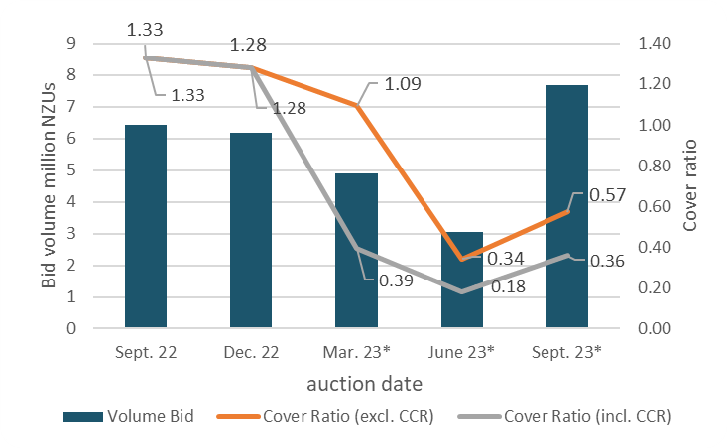
- Declined auction
Figure A.2 Total number of bids per auction
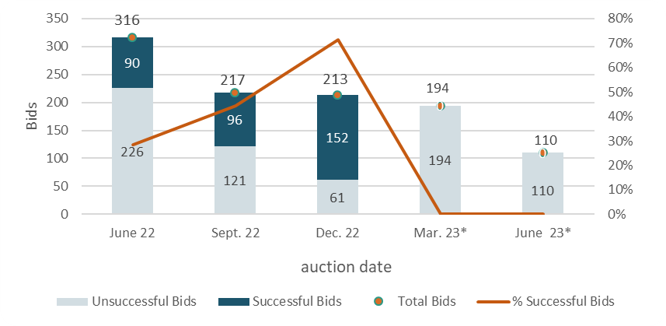
- Declined auction
Figure A.3 Participant numbers per auction
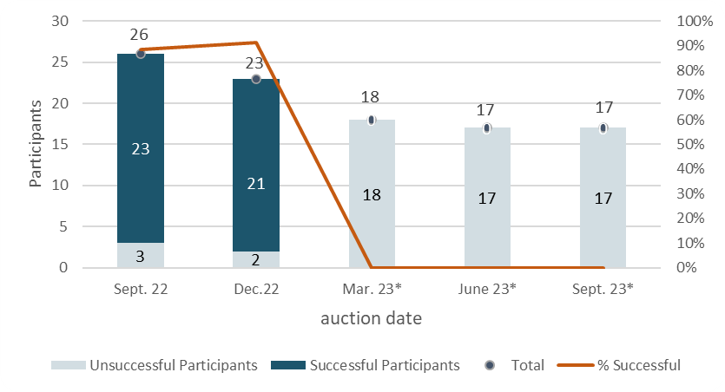
- Declined auction
Figure A.4 Bid volume (of thousands of NZUs) per participant
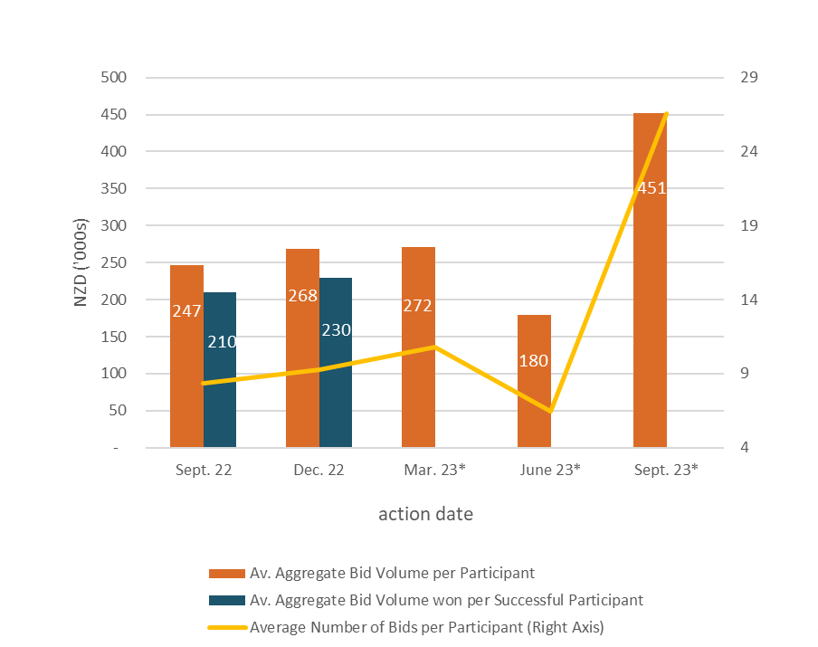
- Declined auction
Note that many participants submitted multiple bids and there may be multiple bidders representing a single participant.
Figure A.5 Proportion of bids (by volume) by participant, September 2023
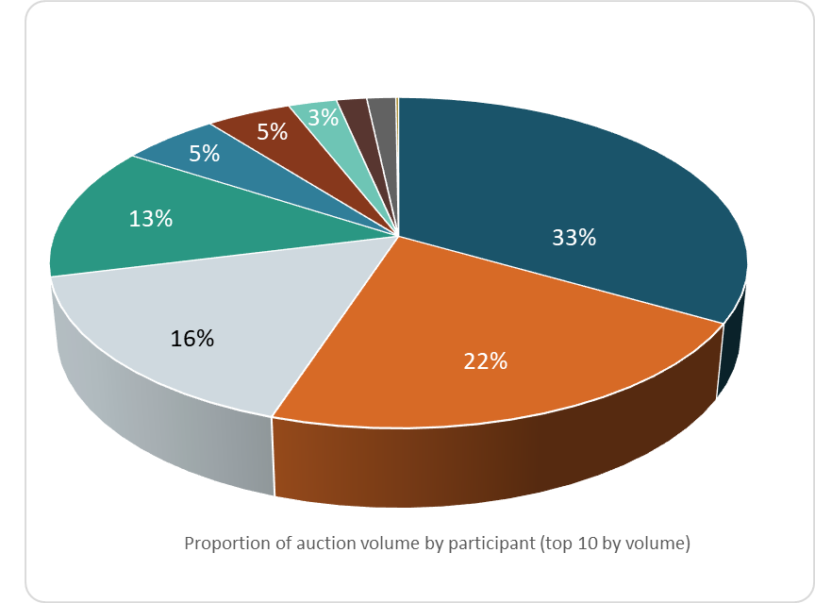
Figure A.6 Proportion of successful* bids (by volume) by participant over the previous five auctions
Auctions held on the dates marked with an asterisk were declined. The percentages presented are of bid volumes as a facsimile of ‘sold auction volume’.
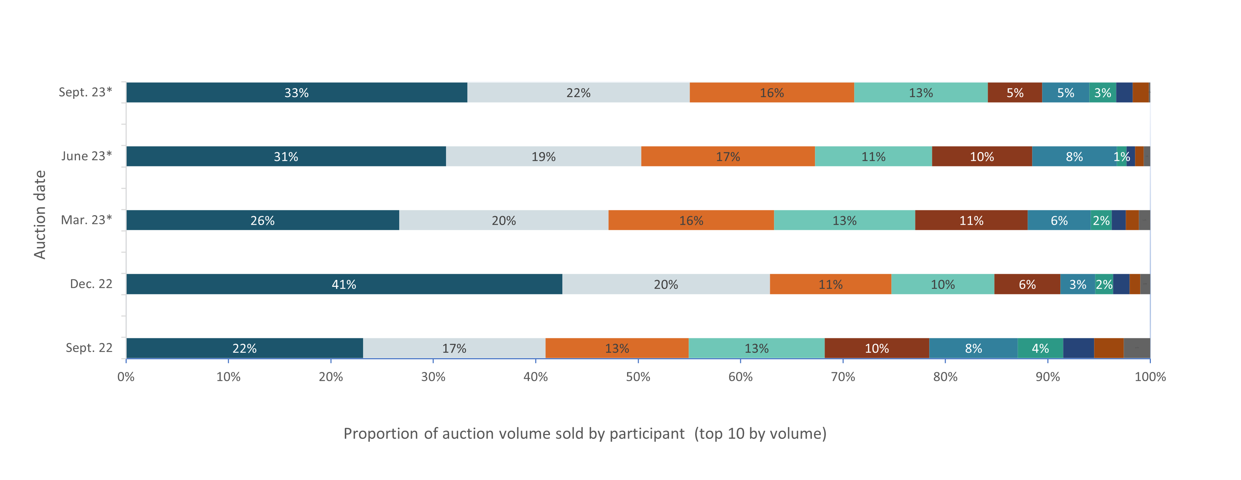

Figure A.7 Proportion of participants with compliance obligations under the NZ ETS
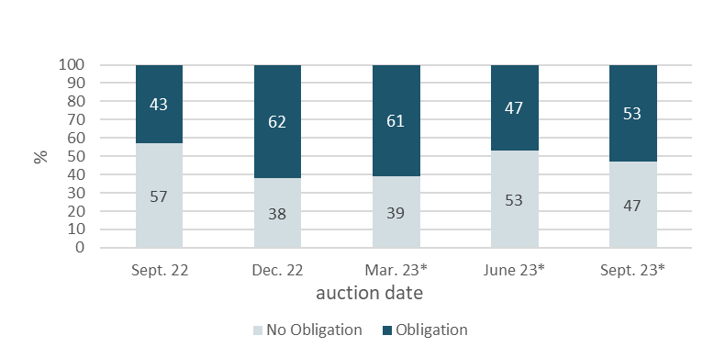
* Declined auction
Figure A.7 represents the estimated percentage of participants that are registered as having compliance obligations on the NZ ETS Register. Larger volume participants, not necessarily registered as having compliance obligations, may be purchasing NZUs on behalf of smaller third parties that do have compliance obligations.

References
New Zealand Cabinet. 2018. Amendments to the Climate Change Response Act 2002: Tranche One. Cabinet Committee Minute of Decision CAB-18-MIN-0606.01. Wellington: Cabinet Office, Department of the Prime Minister and Cabinet.
Ministry for the Environment. 2019. Reforming the New Zealand Emissions Trading Scheme: Rules for auctioning: Technical consultation document. Wellington: Ministry for the Environment.
New Zealand Cabinet. 2020. New Zealand Emissions Trading Scheme: Regulatory Decisions on the Rules for Auctioning. Cabinet Economic Development Committee Minute of Decision DEV-20-MIN-0047. Wellington: Cabinet Office, Department of the Prime Minister and Cabinet.

https://environment.govt.nz/assets/Publications/amendments-to-ccra-tranche-1-cab-18-min-0606.01.pdf.
https://environment.govt.nz/publications/reforming-the-new-zealand-emissions-trading-scheme-rules-for-auctioning-summary-of-submissions/.
https://environment.govt.nz/assets/Publications/DEV-20-MIN-0047-Minute.pdf.

