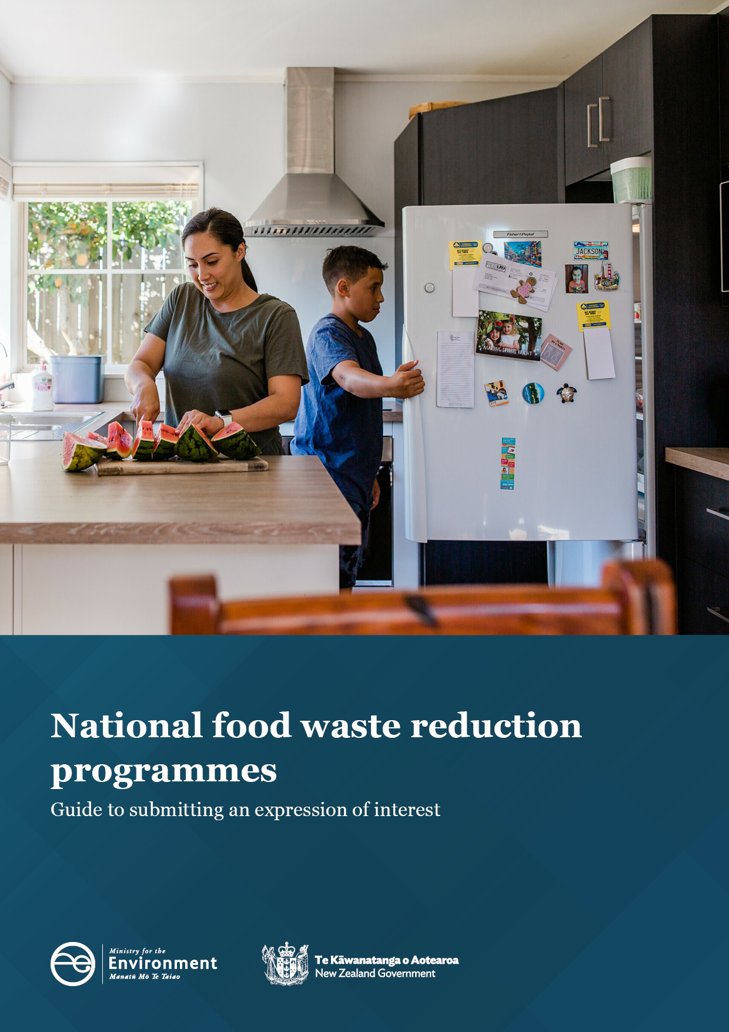

This document may be cited as: Ministry for the Environment. 2022. National food waste reduction programmes: Guide to submitting an expression of interest. Wellington: Ministry for the Environment.

Published in November 2022 by the
Ministry for the Environment
Manatū Mō Te Taiao
PO Box 10362, Wellington 6143, New Zealand
ISBN: 978-1-99-102593-7
Publication number: ME 1702
© Crown copyright New Zealand 2022
This document is available on the Ministry for the Environment website: environment.govt.nz.

Contents
Expression of interest (EOI) 4
The opportunity 4
What we need 4
What we don’t want 5
What’s important to us? 5
A bit about us 5
SECTION 1: Key information 6
1.1 Context 6
1.2 Our timeline 6
1.3 Who is eligible? 6
1.4 How to contact us 7
1.5 Developing and submitting your EOI 7
1.6 How to submit 8
SECTION 2: Our requirements 9
2.1 Background 9
2.2 What we are seeking and why 9
2.3 What we are not funding 11
SECTION 3: Our assessment approach 12
3.1 Assessment approach 12
SECTION 4: Guidance on completing the response form 13
Applicant details 13
Questions 13
Additional guidance 15

Expression of interest (EOI)
By: Ministry for the Environment
For: National food waste reduction programmes
EOI released: 14 November 2022
Webinar: 15 November 2022
Deadline for EOI responses: Midnight, 4 December 2022

The opportunity
The Ministry for the Environment – Manatū Mō Te Taiao is calling for expressions of interest to develop and deliver national programmes to reduce food waste.
This is an opportunity for organisations to express interest in working with us to reduce the amount of food that is lost or wasted between farm and fork each year.

What we need
To deliver on emissions reduction plan (ERP) actions that contribute to reducing emissions from waste, the Ministry has identified a need to work deliberately and in a targeted way with non-profit / industry sector organisations and the food sector in order to accelerate food waste prevention.
We are seeking to work with a small number of organisations to design, develop and deliver behaviour change programmes to reduce food waste and emissions and to progress ERP outcomes. These may be existing, emerging or newly proposed programmes that will have impact and scale over three to four years.
The aim of these programmes is to focus on the very top of the waste hierarchy – preventing and reducing food waste.
We want to invest in three work programmes:
1. National programmes to help households prevent and reduce food waste.
2. National programmes by-Māori-for-Māori to support the prevention and reduction of food waste in Māori-led settings (such as marae, kōhanga reo, kura kaupapa and papakāinga).
3. National programmes to drive business practices that prevent food waste, including voluntary agreements to reduce food waste.

What we don’t want
The following actions sit lower in the waste hierarchy, so while they are part of the wider solution to food waste to landfill, they are not the focus of this call for expressions of interest:
- recycling of food waste (eg, through composting or food scraps collection)
- gardening or growing and eating local food
- food rescue and redistribution.
We are seeking to work closely with a small number of organisations as we are looking for impact and scale and to ensure that there is alignment across programmes. At this time, we are not seeking to fund small-scale/locally focused projects (although such projects could eventually become a component within an overall programme of work that we fund).

What’s important to us?
Working closely with external organisations is one of the levers available to the Ministry to accelerate and scale the changes needed to achieve our vision of a flourishing environment for every generation. We are seeking organisations to work with who are deeply committed to preventing and reducing food waste. We are looking for organisations that have a long-term focus and commitment in this area to provide ongoing public value. We expect that organisations we select to work with will contribute in some way to ongoing programme development and delivery (whether financially, through programme intellectual property / collateral or in-kind contributions, such as voluntary hours and donated services).
We want to identify organisations who have strong relationships and connections to the communities they will be working with.
We want to achieve lasting behaviour change to reduce food waste. This means we are seeking organisations who can use evidence-based approaches to achieve agreed outcomes.

A bit about us
We are the Government's principal adviser on the environment in New Zealand and on international environmental matters. Our vision is ‘A flourishing environment for every generation He taiao tōnui mō ngā reanga katoa’.
In this context we expect to work with organisations who are committed to environmentally sustainable practices and processes. We therefore require respondents to this EOI to provide information to help us understand your capability and alignment to our objectives.

SECTION 1: Key information

1.1 Context
This is an invitation to submit an expression of interest (EOI) to work with the Ministry to design, develop and deliver national food waste reduction programmes.
This EOI is the first step in a multi-step process. After an initial evaluation of your EOI, shortlisted respondent/s will be invited to participate in the next step, which is to give a presentation to the Ministry. Shortlisted respondents will be supplied with additional requirements if they reach this stage.
At the completion of the EOI process a final selection of suitable organisations will be notified and invited to proceed with funding agreement negotiations, directly with the Ministry.
The Ministry reserves the right to select none, one, or multiple organisations to progress with developing funding agreements for one or more years.

1.2 Our timeline
Here is our timeline for this EOI (all are New Zealand times and dates):
What | When
Call for expressions of interest opens | 14 November 2022
Webinar session | 12 noon, 15 November 2022
Deadline for EOIs to be lodged | Midnight, 4 December 2022
Shortlisted respondents will be notified (indicative) | Mid-December 2022
Shortlisted respondents will be invited to present (indicative) | Mid-December 2022 to end January 2023
All respondents, whether successful or unsuccessful will be notified (indicative) | End January 2023

1.3 Who is eligible?
We are accepting responses from individual organisations.
We are also open to consortium responses. A consortium is where an organisation submits a joint EOI with one or more other organisations or individuals. Organisations usually form a consortium when they cannot meet the requirements individually but can collectively or can add additional value by working together. Expressions of interest will need to identify the lead organisation.

Criteria for expressions of interest
The criteria for expressions of interest are:
- The lead organisation must be a legal entity.
- The lead organisation must be a non-profit eg, not-for-profit, social enterprise, charitable trust, incorporated society, registered charity, industry body, sector organisation.
- The lead organisation must be based in New Zealand.
- The lead organisation or a member in the consortium may not be another Government department or agency or council.
- The lead organisation or a member in the consortium must have experience and expertise in waste minimisation.
Notes:
- We will accept commercial entities and international organisations as part of consortium applications.
- Government agencies and local government are encouraged to provide support as co-funders for initiatives.

1.4 How to contact us
Contact us via email: WasteBehaviourChange@mfe.govt.nz.

1.5 Developing and submitting your EOI
a. This is a multi-stage open expression of interest process.
b. Take time to read and understand the EOI. In particular:
i. understand our requirements. These are outlined in Section 2 of this document
ii. understand how your EOI will be assessed. See our assessment approach in Section 3 of this document.
c. Use the response form provided to submit your expression of interest.
d. Complete and sign the declaration at the end of the response form.
e. Check you have provided all the necessary information in the correct format and order.
f. Submit your response form by completing the online registration in Citizen Space before the deadline for EOIs which is midnight on Sunday 4 December 2022.
g. If you have any questions, email us or attend the webinar on 15 November.

1.6 How to submit
We will only accept EOI responses through uploading a word version of the response form on Citizen Space. PDF versions of the form will not be accepted.
We will not accept EOIs sent by post, email or delivered to our office.

SECTION 2: Our requirements

2.1 Background
To deliver on emissions reduction plan outcomes, we seek to reduce emissions from organic waste (specifically food waste), by reducing this waste being generated and sent to landfill.
The emissions reduction plan sets out how we intend to achieve this:
- Action 15.1.1: Encourage behaviour to prevent waste at home: Support national programmes to help households prevent and reduce food waste.
- Action 15.1.2: Enable businesses to reduce food waste: Develop programmes to drive business practices that prevent food waste, including by encouraging businesses to engage in voluntary agreements to reduce food waste.

An EOI process will provide an open approach that allows organisations with capability, capacity and interest in working with us to register interest in developing and delivering long-term food waste reduction programmes.

2.2 What we are seeking and why
We are seeking to work with a small number of organisations to design, develop and deliver behaviour-change programmes that reduce food waste. These may be existing or new programmes.
We are looking to work with these organisations over a three-to-four-year period to deliver programmes that will have impact and scale.
We wish to support behaviourally designed or informed programmes. These include programmes that use research and evidence of how people or organisations behave to effectively support them to make changes that lead to sustainable outcomes. This is not the same as information-driven mass media campaigns. Instead, it involves interventions that address drivers and barriers to change for specific behaviours.
You can read a literature review on the effectiveness of existing international initiatives to reduce household and business food waste on the Ministry for the Environment website.

We strongly encourage respondents to read this review before submitting an EOI.
In this EOI process, we refer to actions that ‘prevent’ and ‘reduce’ food waste. Food waste reduction is also used as an umbrella term to encompass both food waste prevention and food waste reduction initiatives. We use the terms as follows:
Prevention of food waste interventions are activities that stop food waste occurring in the first place. For example, if a family shops with a list and buys the right amount of food they may not have any avoidable food waste. In a business context, prevention could be a café no longer using side garnishes.
Reduction of food waste interventions are activities that decrease the amount of food waste created. For example, if you freeze leftovers to eat another day that decreases the amount of food waste. For a restaurant, this could involve proactively offering diners ‘doggy bags’.
If a child regularly only eats half of their apple, buying a smaller apple is a prevention method, taking the uneaten apple and freezing it and then using it to make a fruit smoothie is a reduction method. Sometimes an intervention can both prevent and reduce food waste.
We want to invest in three work programmes to prevent and reduce food waste:

National programmes to help households prevent and reduce food waste
We anticipate this will include designing, developing and implementing a behaviour-change programme to reduce household food waste. This programme may support or accelerate existing initiatives to reduce food waste. There may be scope for trialling and evaluating smaller scale local interventions, which could then be rolled out nationally.
The programme may be developed or delivered by more than one organisation. It may involve delivery by more than one organisation and/or developing new initiatives in collaboration with other stakeholders.
There may be one or more programmes selected to receive funding support.
Successful respondents will be able to demonstrate:
- expertise in waste minimisation
- expertise in food waste minimisation or sustainable food systems
- expertise in delivering national scale behaviour change programmes
- knowledge of and delivery experience working with householders, consumers and communities
- ability and experience of collaborating with stakeholders, including local government.
Indicative level of support available 2023–26: up to $6,000,000.

National programmes to help prevent and reduce food waste in Māori-led settings
We anticipate these programmes will be designed, developed and delivered by-Maōri-for-Maōri. They may involve small-scale interventions that can be trialled at individual marae, kōhanga reo, kura kaupapa and papakāinga. Then, if successful, these could be rolled out around the country. For example, reducing catering food waste from large events on marae.
There may be one or more programmes selected to receive funding support. Successful respondents will be able to demonstrate:
- expertise in waste minimisation
- expertise in food waste minimisation or sustainable food systems
- expertise in delivering national scale behaviour change programmes
- existing relationships with iwi and hapū
- knowledge of te ao Māori and mātauranga Māori and how this relates to the circular economy and waste hierarchy.
Indicative level of support available 2023–26: up to $1,000,000.

National programmes to drive business practices that prevent food waste, including voluntary agreements to reduce food waste
There may be one or more programmes supported to reduce business food waste. This may include sector-specific programmes to help certain types of businesses reduce their food waste. Other approaches such as voluntary agreements to reduce food waste will also be considered.
Successful respondents will be able to demonstrate:
- support from the relevant business sectors for the initiative
- knowledge or expertise of working with businesses to minimise waste
- ability to deliver national scale initiatives
- knowledge or experience of international best practise for reducing business food waste.
Indicative level of support available 2023–26: up to $1,300,000.

2.3 What we are not funding
The following actions sit lower in the waste hierarchy so are not the focus of this call for expressions of interest:
- the recycling of food waste (eg, through composting or similar processing, or food scraps collection)
- gardening or growing and eating local food
- food rescue and redistribution.

SECTION 3: Our assessment approach
This section sets out the assessment approach we will use to evaluate and shortlist expressions of interest (EOI). Respondents will be assessed on the sufficiency and quality of the evidence provided in response to the questions in Section 4.

3.1 Assessment approach
Our assessment panel will assess EOIs based on the key components listed in the following table.
We will conduct a structured and documented decision process and may seek advice from subject matter experts and internal Ministry policy experts to inform assessment decisions.
If your EOI is successful, you will be invited to a second round where you will be required to give a presentation and answer questions from the assessment panel.
Following this, the assessment panel will meet to discuss and moderate and recommend a final selection of suitable organisations to proceed to funding agreement negotiations.
Key components for assessment
Expertise in waste minimisation
Expertise in food waste minimisation or sustainable food systems
Expertise in delivering national scale behaviour change programmes
Involvement in or ownership of existing programmes to reduce food waste or similar
Ability to deliver
Experience and knowledge of engaging with target audience
Track record
Innovation / quality of proposed solution to reduce food waste and emissions (eg, new, scalable or transferable programme or initiative)
Following the outcomes of this EOI process, we reserve the right to select none, one or multiple organisations to progress with developing funding agreements for one or more years. We may choose to run future EOI processes to identify suitable organisations to work with to deliver on emissions reduction plan outcomes, for the same or other organic waste streams, such as green/garden waste reduction (subject to suitable respondents).
There is an expectation and understanding that organisations selected will contribute to the subsequent programme development and delivery, including financially, through programme intellectual property / collateral or in-kind contributions. This will form part of the assessment under ‘ability to deliver’.
In the event of no suitable organisations responding to this EOI, we will seek feedback on our process and revisit our approach, which may or may not include progressing with a future EOI process.

SECTION 4: Guidance on completing the response form
This section supports you throughout your expression of interest (EOI) submission. It covers every section of the EOI form and provides a high-level guide to answering the questions.
You can download the response form for the EOI from our website. You need to save the form as a word document and fill it out. You then need to upload the completed EOI form on Citizen Space.

Applicant details
The information you provide in this section of the response form will be used throughout all the project stages. For the project main contact, ensure you choose the person from the lead organisation most suited to responding to queries about the EOI.

Questions
For the questions below, ‘organisation’ refers to both organisations and consortium members (ie, in answering questions you can draw on relevant examples from any/all consortium members).
For many of the questions you will be asked to provide evidence. This can be done through providing links to relevant reports, websites or relevant social media pages as appropriate. Reports can also be uploaded in Citizen Space if not accessible online.
There is a word limit of 300 words for the response to each section.
Question | What we’re looking for in your answer | Notes
1. Outline your experience and expertise at delivering waste minimisation programmes | - List any relevant expertise and experience staff or members of your organisation may have.  - List the specific waste minimisation programmes your organisation has been involved with.  - Outline the role of your organisation – did you create, administer or deliver the programme(s)?  Note: waste minimisation programmes can include reduction, reuse, recycling, or composting initiatives.  Word limit: 300 words | Waste minimisation means—  (a) the reduction of waste; and  (b) the reuse, recycling, and recovery of waste and diverted material.  Source: Waste Minimisation Act 2008
2. Demonstrate your experience and expertise in food waste minimisation or sustainable food systems | - List any relevant expertise and experience your organisation may have in reducing food waste or sustainable food systems.  - Provide specific examples of any initiatives you have undertaken to achieve these outcomes.  Word limit: 300 words | A sustainable food system is a food system that delivers food security and nutrition for all in such a way that the economic, social and environmental bases to generate food security and nutrition for future generations are not compromised. This means that it:  - is profitable throughout (economic sustainability)  - has broad-based benefits for society (social sustainability)  - has a positive or neutral impact on the natural environment (environmental sustainability).  Source: Sustainable food systems: Concept and framework (fao.org)
3. Give evidence of your experience and ability to deliver behavioural change programmes at scale | - List and briefly outline the specific regional or national scale behaviour change programmes with which you have been involved.  - Outline the role of your organisation ie, did you create, administer or deliver the programme?  - List the programme impact model, theory of change, or established framework your organisation has used to bring about change.  - Be clear about the specific behaviour(s) your organisation has been involved in supporting change for and provide evidence of success (where evaluation is available).  Word limit: 300 words | You can refer to programmes discussed in questions 1 and 2 if relevant. You can include examples which do not relate to waste minimisation for this answer.
4. Describe current initiatives or programmes you have been involved with to reduce food waste, including outcomes achieved, such as reducing waste and/or emissions | - List and briefly outline the specific food waste reduction behaviour change programmes you have designed, developed or are currently delivering.  - Outline the role of your organisation ie, are you involved in creating, administering or delivering the existing programme?  - Demonstrate evidence of success, including (if available) waste and emissions reductions. Include the date the programme was initiated and list any current co-funders.  Word limit: 300 words | You can refer to programmes discussed in questions 1, 2 or 3 if relevant.
5. Demonstrate your ability to deliver food waste reduction programmes | - Include your relevant experience, resources, skills, and any previous experience managing grant/donor funds. Comment on your organisational capacity, governance structure, number of existing full time equivalent positions, membership (if relevant).  - Outline your ability to contribute (financially or in-kind) towards desired outcomes during and after any agreed funding period has ended.  Word limit: 300 words
6. Demonstrate your knowledge of and delivery experience of engaging and working with the target audience(s). | - Outline who you have worked with and how. Include any specific knowledge, research or work with audience groups or stakeholders that is specific or unique to your organisation. Where possible provide examples specific to food waste reduction.  Word limit: 300 words | The target audience will be either households, businesses or Māori depending on which audience your organisation is seeking to work with.
7. Demonstrate your track record with funding partners | - Indicate if you have received Ministry for the Environment funding before eg, through the Waste Minimisation Fund.  - Supply up to three examples of funding you have secured (either from the Ministry or other donors). Include the name of the funding organisation, the amount of funding received and a paragraph describing what the funding was provided for and the outcomes achieved.  Word limit: 300 words
8. If you are shortlisted for developing and delivering a programme or initiative with Ministry support, what would your proposed solution for reducing food waste and emissions look like? | - Describe your proposed solution, explaining the benefits of what it has the potential to deliver.  - Include whether it is an existing initiative which can be scaled up, an expansion of an existing programme, a transferable programme delivered elsewhere, or a new initiative.  - If this is an existing initiative, explain why Ministry support is needed to achieve outcomes eg, the project can be expanded/replicated.  - If this is a new initiative, list any other co-funding you have secured.  Word limit: 300 words | The information you provide is intended to be indicative but not binding. Negotiations with successful organisations may result in changes to proposed programme delivery.

Additional guidance
- Please adhere to the suggested word limits. The panel is unlikely to read content in excess of the word limit.
- You may use the same programme for more than one question – for example, if you are an organisation who has only run one waste minimisation programme which involved reducing food waste you can use the same programme for question 1 (Outline your experience and expertise at delivering waste minimisation programmes), and for question 2 (Demonstrate your experience and expertise in food waste minimisation or sustainable food systems).
- We encourage organisations to only apply to undertake one programme of work and focus on making a strong application rather than applying for all three.
- If listing the emissions impact of your project, please note whether the emissions are based on New Zealand’s Greenhouse Gas Inventory (production emissions from the waste sector) or whether they are complete supply chain emissions looking at the costs from growing, transporting and ultimately landfilling the food.
- Ministry staff are unable to provide guidance on individual EOI responses but questions about the EOI process or criteria can be emailed to WasteBehaviourChange@mfe.govt.nz.

By “legal entity” we mean a body that is legally incorporated under relevant New Zealand legislation (such asAct 1908 or 2022, a Charitable Trust Board under the Charitable Trusts Act 1957), or alternatively trustees of a trust that is a registered charity under the Charities Act 2005.

