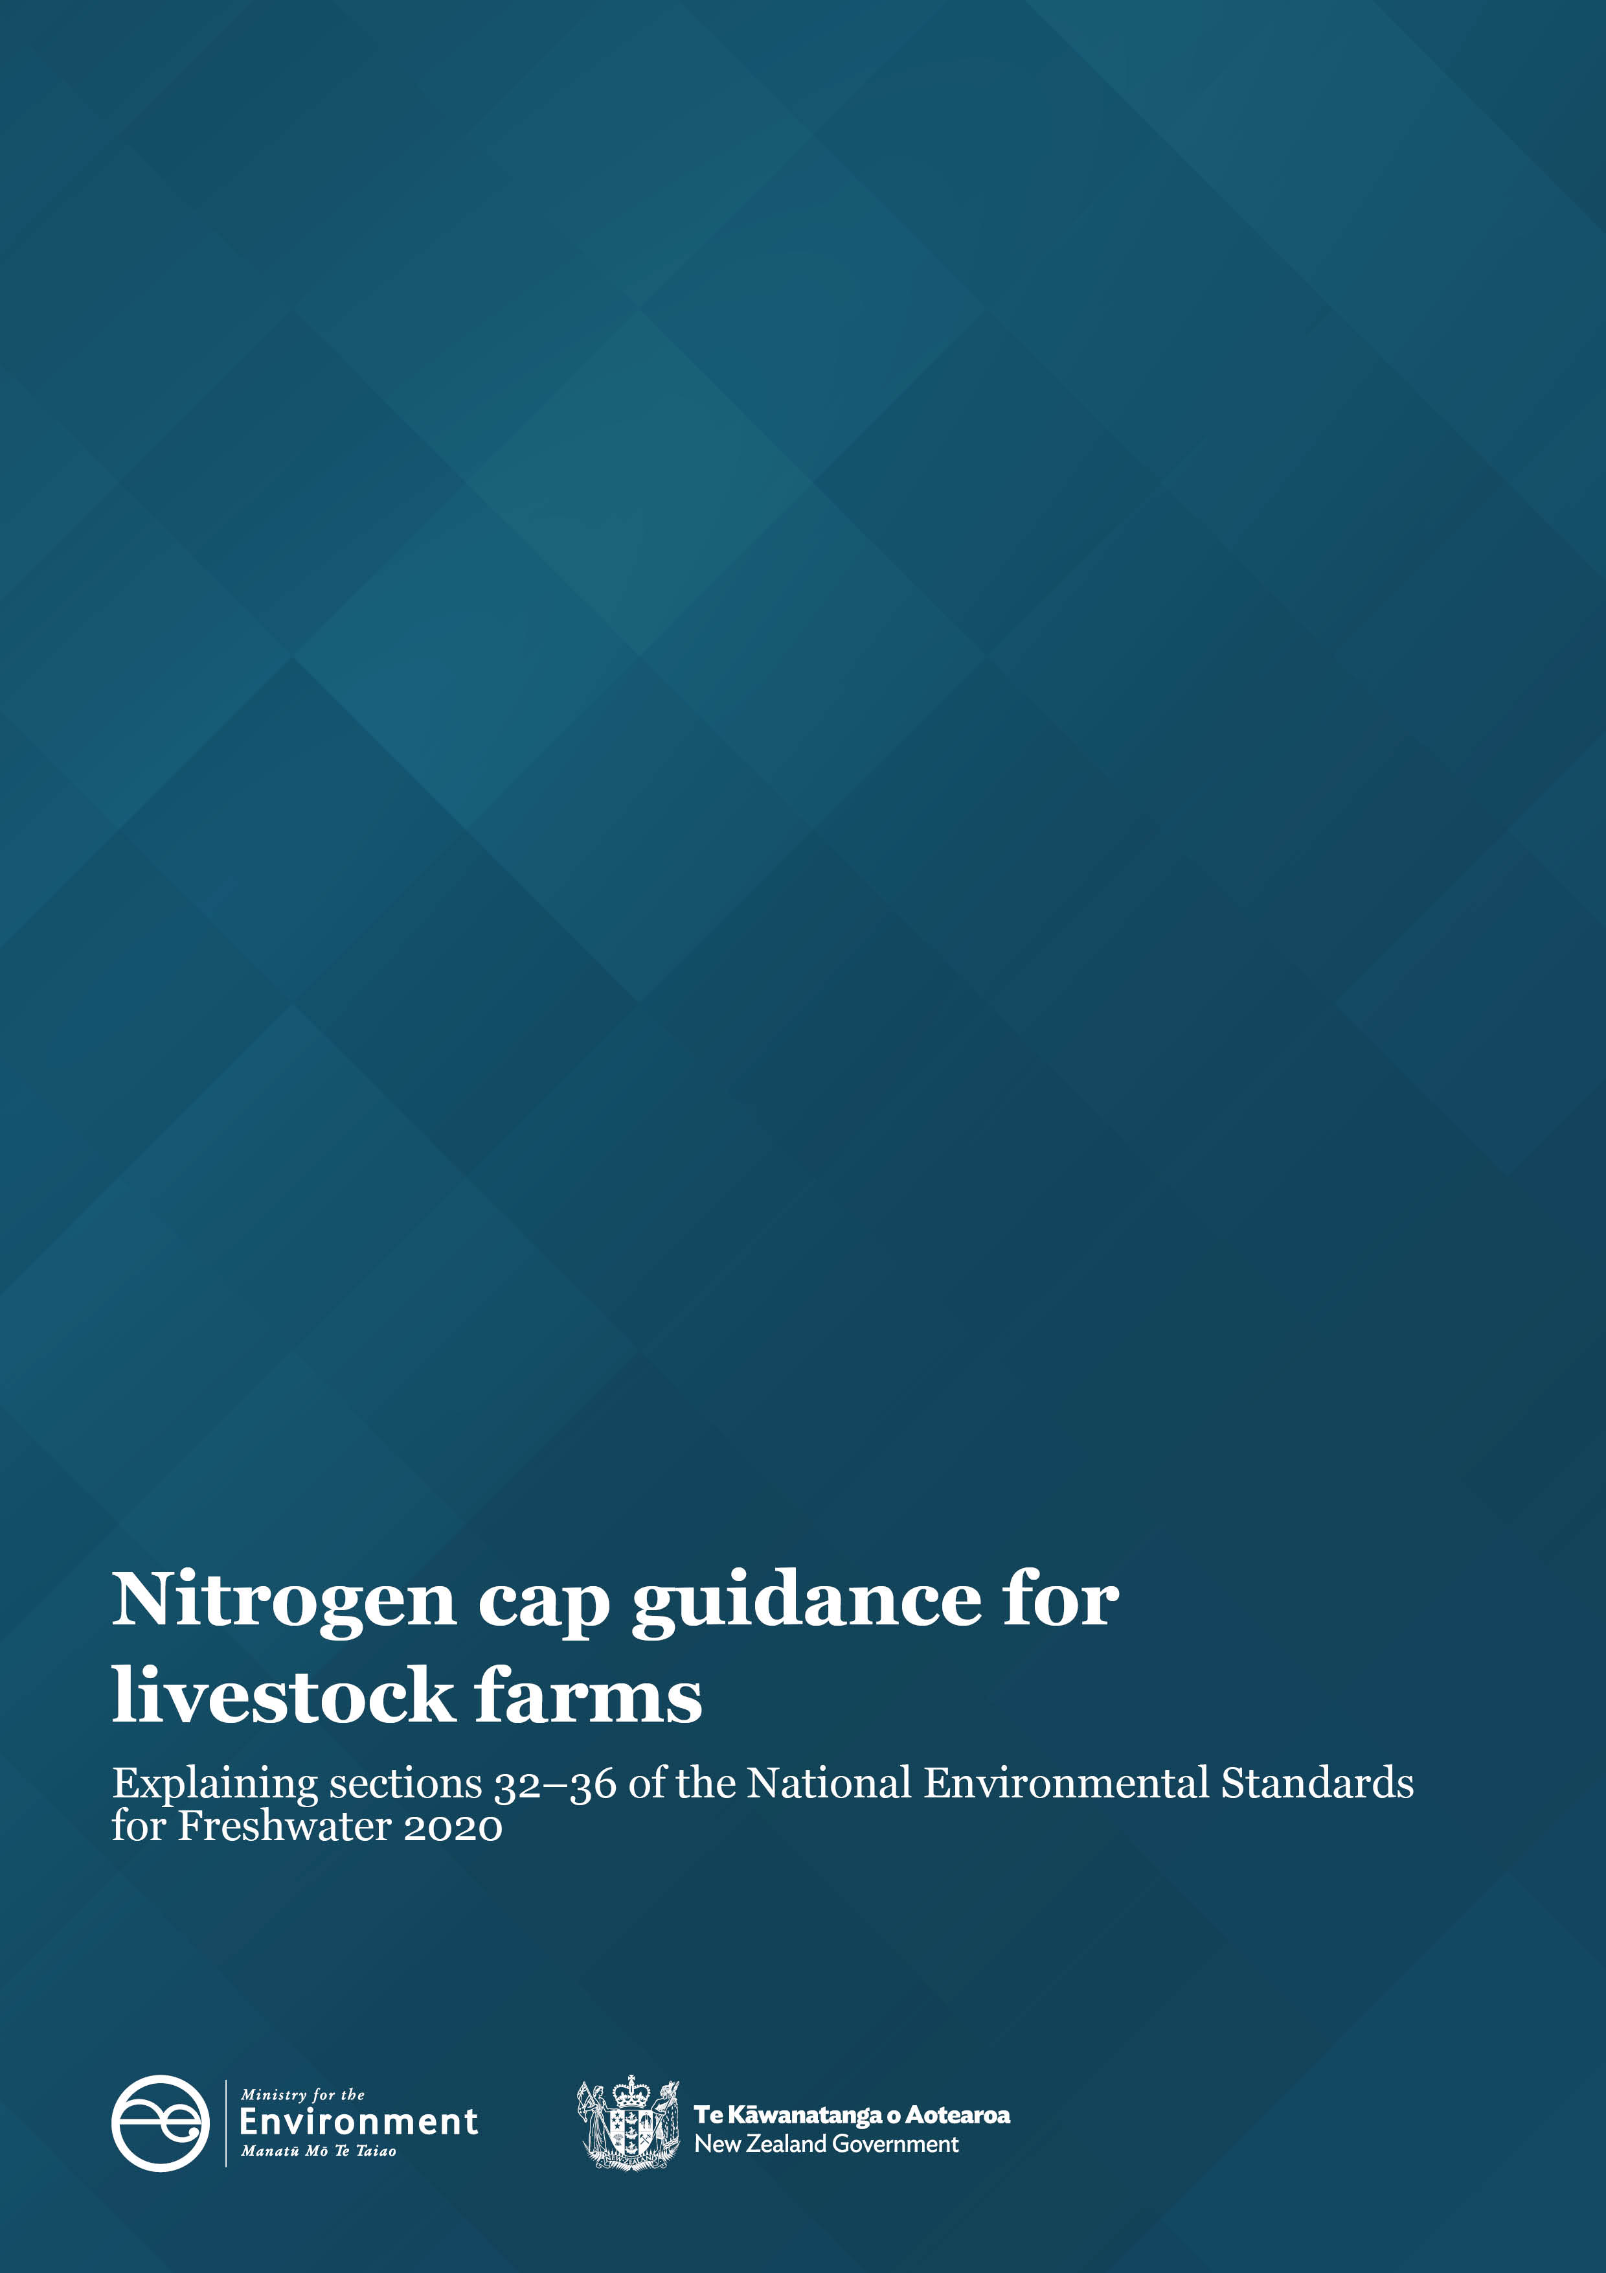

Disclaimer
The information in this publication is, according to the Ministry for the Environment’s best efforts, accurate at the time of publication. The Ministry will make every reasonable effort to keep it current and accurate. However, users of this publication are advised that:
- The information provided has no official status and so does not alter the laws of Aotearoa New Zealand, other official guidelines or requirements.
- It does not constitute legal advice, and users should take specific advice from qualified professionals before taking any action as a result of information obtained from this publication.
- The Ministry for the Environment does not accept any responsibility or liability whatsoever whether in contract, tort, equity or otherwise for any action taken as a result of reading, or reliance placed on, this publication because of having read any part, or all, of the information in this publication or for any error, or inadequacy, deficiency, flaw in or omission from the information provided in this publication.
- All references to websites, organisations or people not within the Ministry for the Environment are provided for convenience only and should not be taken as endorsement of those websites or information contained in those websites nor of organisations or people referred to.

Acknowledgements
The Ministry for the Environment thanks KapAg Ltd for their input and the following organisations for reviewing drafts of this guidance, though none is responsible for the final content: Ballance Agri-Nutrients; Bay of Plenty Regional Council; Choose Clean Water; DairyNZ; Environment Canterbury; Environmental Defence Society; Environment Southland; Federated Farmers; Fertiliser Association of New Zealand; Fonterra; Foundation for Arable Research; Greenpeace Aotearoa; Horizons Regional Council; Ravensdown; Waikato Regional Council.

This document may be cited as: Ministry for the Environment. 2021. Nitrogen cap guidance for livestock farms: Explaining sections 32–36 of the National Environmental Standards for Freshwater 2020. Wellington: Ministry for the Environment.

Published in October 2021 by the
Ministry for the Environment
Manatū Mō Te Taiao
PO Box 10362, Wellington 6143, New Zealand
ISBN: 978-1-99-003391-9
Publication number: ME 1605
© Crown copyright New Zealand 2021
This document is available on the Ministry for the Environment website: environment.govt.nz.

Contents
Introduction 5
Purpose 5
Background 5
Nitrogen cap 8
Synthetic nitrogen vs synthetic nitrogen fertiliser 8
Biological and mixed fertilisers 8
Identifying contiguous landholdings 9
Pastoral use land (any grazed land) 10
Harvested pastoral crops (silage, hay, and cut-and-carry fodder) 11
Seed crops 11
Arable crops, horticulture and forestry 11
Crop stubble grazing 11
Calculating the nitrogen cap 12
Livestock farming under the nitrogen cap 13
Existing use rights 13
Non-complying activity consents 13
Appendix A: Calculating synthetic nitrogen use 15
Appendix B: Nitrogen cap regulations 16

Tables
Table 1: Checklist of key synthetic nitrogen cap management tasks for farmers 7
Table 2: How the nitrogen cap applies to different categories of pastoral use 10
Table 3: Examples of nitrogen cap calculations on a sheep and beef farm 14

Figures
Figure 1: How the nitrogen cap applies to different farming operations 6
Figure 2: Contiguous landholdings 9

Introduction

Purpose
This guidance clarifies how the regulations capping the use of synthetic nitrogen apply to livestock farms that do not have a dairy platform.

Background
The nitrogen cap sets a yearly limit on the amount of synthetic nitrogen that farmers may apply to the grazed land on each of their contiguous landholdings (that is, on each separate block of land that has no shared boundary with other parts of the farm).
The cap is one of several government regulations aimed at limiting the impacts of nitrogen on our waterways. Underpinning these regulations is the principle of Te Mana o te Wai which requires that water quality and ecosystem health be prioritised over any human activities that might cause harm, such as, in this case, the excessive use of synthetic nitrogen fertiliser.
In nature, most nitrogen exists as inert gas in the atmosphere. A tiny fraction is converted by natural processes (mainly lightning and soil bacteria) into solid forms (ammonium and nitrates) that plants can absorb and turn into protein. All living things are dependent on this.
A century ago, chemists discovered how to synthesise solid nitrogen from thin air using fossil fuels. Since then, synthetic nitrogen fertiliser has boosted farm production but has also doubled the amount of nitrogen circulating in the environment. This is now having impacts on freshwater and the climate.
When nitrates and ammonia are lost from soil to surface and ground water they can harm aquatic life, ecosystems and human health. When waste nitrogen is converted by soil bacteria into the powerful greenhouse gas nitrous oxide, it accelerates global warming.
The nitrogen cap seeks to limit these impacts by restricting synthetic nitrogen use on grazing land. Grazing land – or pastoral use land – is targeted because it is the predominant land use in most catchments and is where more than 90 per cent of the synthetic nitrogen is spread.
The cap does not apply to non-grazing land because far less synthetic nitrogen is used there and its use on non-pastoral land is too diverse to be managed under a single cap.
Figure 1 shows at a glance how the nitrogen cap applies to different farming operations. Table 1 is a checklist of things that farmers will need to do to comply with the nitrogen cap regulations.
The full text of the regulations is reproduced in appendix B of this guidance.
Figure 1: How the nitrogen cap applies to different farming operations
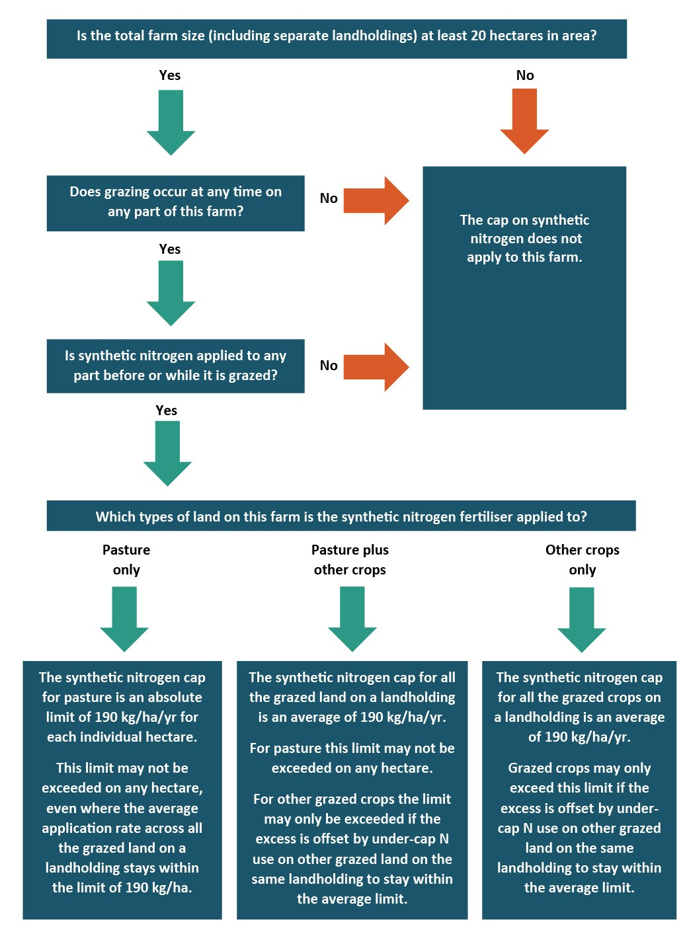

Table 1: Checklist of key synthetic nitrogen cap management tasks for farmers
Preliminary tasks | Check
Decide who, in the farming operation, is responsible for managing the synthetic nitrogen use on each contiguous landholding and for recording and reporting this to the regional council. | ☐
Determine which areas of the farm the nitrogen cap applies to. This means identifying the contiguous landholdings on the farm and, within each one, the areas that are or will be in the following land uses: pasture, annual forage crop, other pastoral uses (that is, any other grazing activity) and other land uses (that is, any land that is not grazed). | ☐
Calculate how much synthetic nitrogen can be spread during the year on each land use area within each contiguous landholding, and adjust this for any area that is over cap. | ☐
Note: This nitrogen management plan should be done even if the farmer intends to ask the council about applying for a non-complying activity consent.
Ongoing tasks | Check
During the year, farmers will need to keep track of their synthetic nitrogen fertiliser use on each contiguous landholding with grazing animals on it. This means having to:
- keep records of each synthetic nitrogen application (including on the non-grazed land) | ☐
- update their synthetic nitrogen calculations after each application | ☐
- manage the synthetic nitrogen use on each contiguous landholding to keep it within the nitrogen cap for the total pastoral use area on each landholding and also for each hectare of pasture. | ☐
End-of-year tasks | Check
Coming to the end of the year, the farmer will need to:
- plan the next year’s fertiliser-spreading schedule to keep it within the nitrogen cap for the total pastoral use area on each landholding and also for each hectare of pasture. | ☐
- begin preparing a report to the regional council for delivery by 31 July (this task is only required of dairy farmers and non-complying activity consent holders). | ☐
Note: Nitrogen spread up to 30 June counts under the current year’s cap and, after that, under the following year’s cap.

Nitrogen cap
Since 1 July 2021, on all farms 20 hectares and larger with any grazed land, no more than 190 kilograms of synthetic nitrogen per hectare may be applied per year to:
- any individual hectare of pasture
- the pastoral use land as a whole (that is, the combined area of pasture, annual forage crops, and other pastoral use land) when averaged across that area.
Any synthetic nitrogen used to grow pasture or other grazed vegetation is covered by the cap regardless of the:
- type of vegetation grazed – whether pasture or crops
- type of grazing animal – whether cattle, sheep, goats, pigs, deer, poultry, or other animals
- duration of the grazing – whether it is for a few days or the whole year.
Many farming operations will not be affected by the nitrogen cap, but heavy users of synthetic nitrogen fertiliser on grazed land will be. They will need to calculate their expected use of synthetic nitrogen and, if it is likely to exceed 190 kilograms/hectare/year, they will need to plan how to get it down to the legal limit.
In rare cases, they may be able to exceed the cap through a non-complying activity resource consent – but only if they can meet certain requirements, as outlined later in this guidance.

Synthetic nitrogen vs synthetic nitrogen fertiliser
The cap’s weight limit applies only to the nitrogen part of the fertiliser, not to the fertiliser in its entirety, so it is important to distinguish between the synthetic nitrogen and synthetic nitrogen fertiliser.
- Synthetic nitrogen fertiliser contains nitrogen but also has other ingredients. For the purposes of the regulation, synthetic nitrogen fertiliser is any solid or liquid fertiliser, not of plant or animal origin, whose dry weight is more than 5 percent nitrogen.
- Synthetic nitrogen is the nitrogen part of the synthetic nitrogen fertiliser. It can vary from 6 per cent to over 40 per cent of the fertiliser dry weight, depending on the fertiliser. (If it is 5 percent or under, it is not counted as synthetic nitrogen.)

Biological and mixed fertilisers
Biological nitrogen fertilisers are not covered by the nitrogen cap. These are any solid or liquid substance applied to plants or land in which the nitrogen comes from animals or plants.
- Biological nitrogen fertiliser may include matter that has been minimally processed by being composted, mixed, liquified, dried, or pelleted, but does not include manufactured nitrogen.
- Dairy effluent that has not had any manufactured nitrogen added to it is considered a source of biological nitrogen, so is excluded from the nitrogen cap.
- Where manufactured and biological nitrogen fertilisers are mixed together, and their combined nitrogen content comes to more than 5 per cent of their dry weight, they become synthetic nitrogen fertilisers and are covered by the nitrogen cap.

Identifying contiguous landholdings
A contiguous landholding is any block of connected land belonging to a farming operation. If a farm has several unconnected blocks, separated by land not belonging to the farm, each block is a separate contiguous landholding.
This is important because the nitrogen application rate must be calculated and managed separately for each contiguous landholding. If a farm has several contiguous landholdings, the nitrogen application rate cannot be averaged across them.
The area of a contiguous landholding may or may not be the same as the title area. It can be in several titles provided that the land is adjoining, is managed as part of a single farming operation, and can be encompassed by a single perimeter line on a map.
A contiguous landholding may contain one paddock or many paddocks and may have multiple land uses. It may be crossed by streams, roads or railway lines but, as long as the adjoining land on either side of these corridors belongs to the same farming operation, it remains a single contiguous landholding. Figure 2 illustrates this with three farms in Canterbury.
Figure 2: Contiguous landholdings
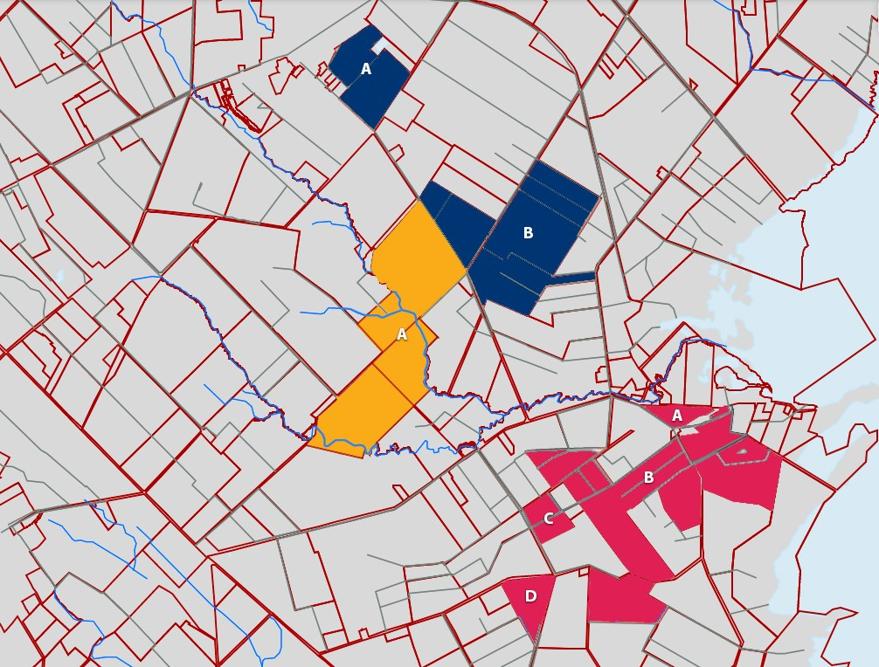
The yellow farm has one continuous block of land. Although it is crossed by roads and streams, its paddocks adjoin both sides of those roads and streams and so form one contiguous landholding (labelled A). The blue farm has two contiguous landholdings (A and B) separated by land not belonging to the farm. Each comprises a block of adjoining paddocks, some of which straddle roads. The red farm has four contiguous landholdings – three small ones (A, C and D) and one large one (B) with multiple adjoining paddocks straddling roads.

Pastoral use land (any grazed land)
The nitrogen cap applies to all areas where ground-rooted vegetation is grazed. Grazed areas are referred to as ‘pastoral use land’.
Pastoral land use is defined in section 217B of the Resource Management Act (RMA) as “the use of land for the grazing of livestock”. This includes pasture, annual forage crops and any other grazed land (see table 2).
Table 2: How the nitrogen cap applies to different categories of pastoral use
Pastoral use land (any grazed land)
Pasture  (grassland used primarily for grazing) | No hectare of pasture may receive more than 190 kilograms of synthetic nitrogen in a year.
Annual Forage Crops  (land other than pasture used primarily for grazing) | The limit of 190 kilograms/hectare/year may be exceeded on annual forage crops if the average for all the pastoral use land is kept within cap.
Other Pastoral Use Land  (land that is intermittently grazed but is primarily used for other purposes e.g. arable, horticultural, forestry, hay, silage, ‘cut and carry’, and seed crops) | The synthetic nitrogen limit for other pastoral use land is similar to that for annual forage crops.  The cap is in effect on other pastoral use land until the end of the last grazing period before harvest.
Other land (all land that is not grazed)
The nitrogen cap does not apply to other land, but dairy farm annual nitrogen reports must report any synthetic nitrogen applied to other land if it is contiguous with the dairy platform.
An annual forage crop is defined in the regulations as “a crop, other than pasture, that is grazed in the place where it is grown”. This refers to any crop, other than pasture, that is grown annually for the purpose of grazing.
Other pastoral use land is any land, including crops grown for the purpose of being harvested, where some grazing occurs during the year even though grazing may not be the primary land
The period of pastoral use begins with crop or pasture preparation (including the first fertiliser application) and ends when grazing ceases. Synthetic nitrogen use is capped throughout this period but is not capped between the end of grazing and the harvest.
If a crop or pasture area is grazed for less than 12 months, the 190 kilograms of nitrogen/ hectare/year limit applies in full during that limited period and is not subdivided nor scaled down to match the timeframe, even if the pastoral use is brief.
The synthetic nitrogen limit for pasture is an absolute limit per hectare. Farmers must ensure that no hectare of pasture receives more than 190 kilograms of nitrogen per year.
The limit for annual forage crops may exceed the cap if the average for all the pastoral use land is no more than 190 kilograms of nitrogen per hectare per year. The farmer must ensure that any over-cap use on a forage crop is offset by under-cap use on the other grazed land.

Harvested pastoral crops (silage, hay, and cut-and-carry fodder)
If land used for silage, hay, or cut-and-carry feeding of livestock is grazed at any time before being harvested, all synthetic nitrogen applied up to the end of the final grazing period is capped and must be included when calculating the application rates for the pastoral use area.
Any synthetic nitrogen applied after the end of grazing and before the crop’s harvest is not capped.

Seed crops
The same applies to any perennial crops, such as herbage seed and small-seed crops harvested more than once over a number of years and grazed between harvests.
All synthetic nitrogen applied until the end of grazing must be either within cap or offset by below-cap applications on adjacent pastoral use land.
Synthetic nitrogen is not capped if it is applied after the last grazing episode before the harvest.
Nor is it capped if crop growth is controlled mechanically, rather than by grazing, such as by harvesting for silage or cut-and-carry fodder.

Arable crops, horticulture and forestry
If grazing occurs on arable, horticultural or forestry blocks (for example, to help control weeds or excessive vegetation growth) then these areas are pastoral use land until grazing ends.
They are covered by the nitrogen cap during this period.
Once the final grazing ceases through to harvest, these areas are no longer in pastoral use and so are not covered by the nitrogen cap.
Where excessive vegetation is controlled by methods other than grazing, such as by harvesting for silage or cut-and-carry fodder, the cap does not apply.

Crop stubble grazing
If the only grazing that occurs on a crop is on the stubble after the harvest, then any fertiliser used to grow that crop before harvest is not capped.
It is only capped where there is pre-harvest grazing.
After harvest, the 190 kilograms of nitrogen/hectare/year limit only applies to crop stubble areas where synthetic nitrogen is used to promote the growth of new vegetation that will be grazed.
If the new growth will not be grazed, the cap does not apply.

Calculating the nitrogen cap
The following calculation process is described in more detail in appendix A of this guidance.
First, farmers record how many hectares are in each land-use category (that is, pasture, annual forage crops, other pastoral, and all pastoral – and additionally, for dairy farmers, the non-grazed other land). Then they record how much synthetic nitrogen fertiliser is spread in each.
The kilograms of fertiliser are then multiplied by the fertiliser’s nitrogen content (as a decimalised fraction – that is, 0.18, not 18%). Nitrogen content is usually on the bag or invoice. If not, it will need to be tested or requested. If several fertilisers are used, this calculation is done separately for each, and the results combined to get the total synthetic nitrogen applied.
The year’s total synthetic nitrogen used in each land-use category is then divided by the area. This gives the rate of application, in kilograms per hectare per year, for each land-use category.

Why these calculations count
If the calculations show that average synthetic nitrogen on the pastoral use land exceeds the cap, reductions will be needed. If the calculations show, for pasture, that the cap will be exceeded on one or more hectares, corrective actions will be needed.
Measuring the nitrogen applied to each hectare is best done with fertiliser spreaders that are fitted with GPS technologies. If spreaders are used that cannot do this, then the average application rate per hectare should be calculated for each area of pasture where fertiliser has been evenly spread – whether that is a paddock, a group of paddocks, or part of a paddock.
Where the spread is uneven, the hectare with the heaviest application should be the focal point. If the application on this hectare is under cap, the other hectares will also be under cap.

Sloping land
GPS does not take slope into account when measuring the distance between two points, and nor does the nitrogen cap. The 190 kilograms/hectare limit applies everywhere, even though a sloping hectare has a bit more surface area than a flat hectare.
As a result, farmers who are applying synthetic nitrogen at or near the 190 kilograms/hectare limit will not be able to spread it quite as heavily on the slopes as on the flat. For farmers operating well within the cap, however, there will be sufficient margin to adjust for slope.

Livestock farming under the nitrogen cap
Although annual nitrogen use reports are only required for contiguous landholdings with a dairy platform, the cap limit on synthetic nitrogen applies to all pastoral use land. Table 3 shows how the cap applies on a sheep and beef farm.
Any farm of 20 hectares or more with grazing livestock is advised to keep a log of when, where and how much synthetic nitrogen is applied to the grazed areas in each contiguous landholding. This is prudent both for management purposes and in case of a council monitoring request.

Existing use rights
If, prior to 1 July 2021, a farmer had been spreading synthetic nitrogen at rates above 190 kilograms/hectare/year, they may continue doing so as an ‘existing use right’ for a limited period of time - but only if the activity complies with the rules in the regional plan and meets the other requirements of section 20A(2) of the RMA.
A farmer exercising this existing use right has up to six months from 1 July 2021 to apply for a non-complying activity consent. They may continue with the activity until their consent application has been considered but may not change its character, intensity or scale.

Non-complying activity consents
The nitrogen cap regulations provide two options for non-complying activity resource consents that would permit a farmer to exceed the nitrogen cap in exceptional circumstances.
These options are not provided to maintain business as usual for high nitrogen use, but to make the reduction more manageable where immediate compliance is not possible.
The application will need to present a detailed and evidence-based case, recognising that, under Te Mana o te Wai, environmental outcomes take priority over economic and social ones.
To be granted a non-complying activity consent, the applicant must satisfy the council that:
- exceeding the cap will have no more than minor adverse effects, or, in all other respects, will comply with the objectives and policies in the regional plan
- the applicant will also meet one of the following requirements:
- for a ‘good practice’ consent of up to five years, they will use good practices (as described in an expert’s report furnished by the applicant) to limit nitrate loss to what it would have been if 190 kilograms/hectare/year were applied using good practices
- for a ‘phased reduction’ consent until 1 July 2023, they will follow a plan to get their synthetic nitrogen use down to the cap level by the time their consent expires.
For more information on the non-complying activity consent option, farmers should contact their regional council.
Table 3: Examples of nitrogen cap calculations on a sheep and beef farm
Sheep and beef farm with two contiguous landholdings
In this example, a 600-hectare sheep and beef farm has two contiguous landholdings, A and B.
Contiguous landholding A has 200 hectares of flat to rolling country. Of this, 100 hectares is used to grow kale, which is grazed by dry dairy cows over winter; 50 hectares is pasture grazed by lambs, with some made into balage; and 50 hectares is not grazed, being mainly in riparian strips.
Contiguous landholding B has 400 hectares of hills and rolling country, with 300 hectares in forestry, 70 hectares grazed by sheep and beef cattle, and 30 hectares not grazed.
Contiguous landholding A is over cap
The kale is sown in November and gets 450 kilograms/hectare of diammonium phosphate fertiliser (DAP), at 18 per cent (0.18) nitrogen, and three dressings of 100 kilograms/hectare of urea at 46 per cent nitrogen (or 0.46). This totals 81 kilograms/hectare of nitrogen from the DAP (0.18 x 450) and 138 kilograms/hectare from the urea (0.46 x 300), or 219 kilograms/hectare overall – which is over-cap.
The excess 29 kilograms/hectare might not be a problem if the amount of synthetic nitrogen applied to pasture is low enough to bring the average rate for all the pastoral use land down to cap level.
1. The pasture receives a total of 15.7 tonnes of urea (11.5 tonnes in spring and 4.2 tonnes in autumn).
2. In kilograms, this is 15,700 kilograms of urea (15.7 tonnes x 1000).
3. The nitrogen weight in the urea is: 0.46 x 15,700 = 7222 kilograms of synthetic nitrogen.
4. So, the application rate on the pasture is 144 kilograms of nitrogen/hectare (7222 ÷ 50 hectares).
This is below the cap, but not low enough. With 29,122 kilograms applied across the whole 150-hectare pastoral-use area (21,900 on the kale and 7222 on the pasture), the average rate is 194 kilograms of nitrogen/hectare overall, which is 4 kilogram over-cap. So, synthetic nitrogen use on the grazed land on contiguous landholding A needs to be reduced by 4 kilograms per hectare, or 450 kilograms in total.
(Note: The balage paddock receives an additional 0.5 tonnes of urea after it has been closed up from grazing, but this is not counted because the urea was applied to plants that will be harvested, not grazed.)
Contiguous landholding B is below cap
On contiguous landholding B, the pasture receives 20 tonnes (20,000 kilograms) of urea. At 0.46 nitrogen, this comes to 9200 kilograms of nitrogen spread over 70 hectares – or 131 kilograms of nitrogen/hectare.
If this were on contiguous landholding A, it would have brought the pastoral use land average down to 174 kilograms of nitrogen/hectare. But, because they are on different land blocks, under-cap nitrogen use on contiguous landholding B cannot offset over-cap use on contiguous landholding A.
Key points
- Contiguous landholdings are independent. Over-cap nitrogen use on one cannot be offset on another.
- Within a contiguous landholding, the cap may be exceeded on forage crops, but only if the average rate of application across all the pastoral use land is below the cap.
- Over-cap nitrogen use on annual forage crops may be offset by under-cap nitrogen use on pasture or other pastoral use land, but over-cap nitrogen use on pasture cannot be offset.
- On pasture the cap is an absolute limit for each hectare. Even where the average application rate on pasture is below the cap, no hectare may receive more than 190 kilograms/year.
- Synthetic nitrogen spread on ungrazed land is not capped.

Appendix A: Calculating synthetic nitrogen use
The key steps in the calculations are as follows, for each contiguous landholding:
- Record the area of the following land use types:
- pasture (grassland used primarily for grazing)
- annual forage crops (land other than pasture used primarily for grazing)
- other pastoral use land (land that is intermittently grazed, but grazing is not its primary use)
- pastoral use land (all the grazed land – that is, the combined area of a, b and c above)
- other land (all land that is not grazed).
- Record the kilograms (1 tonne = 1,000 kilograms) of each fertiliser spread within each of these land use areas during the year.
- Calculate how much synthetic nitrogen is spread in each area by multiplying the kilograms of fertiliser by its nitrogen percentage (as a decimalised fraction). If more than one fertiliser is used, do this calculation for each one, then add the results together.
For example, if 2 tonnes of urea (which has 46 per cent nitrogen) are spread on the forage crop, this is 2,000 kilograms x 0.46 = 920 kilograms of nitrogen.
If 5 tonnes of DAP (18 per cent nitrogen) are also spread on the forage crop, then this is 5,000 kilograms x 0.18 = 900 kilograms of nitrogen.
Adding the results together gives the total amount of nitrogen applied to the forage area.
In this example, that is 920 kilograms + 900 kilograms = 1,820 kilograms of nitrogen.
- Calculate the per hectare rate for each land use area. This is done by dividing the total nitrogen from all fertilisers (in step 3) by the area of the land use type to which it was applied.
For example, if the area in annual forage crops is 20 hectares and the 1,820 kilograms of nitrogen just referred to is applied to some or all of the forage crops, the per hectare application rate is 1,820 ÷ 20, which comes to 91 kilograms of nitrogen/hectare/year.
- Calculate the nitrogen per hectare rate across all the pastoral use land by:
- combining the nitrogen applied to the forage crops, the pasture and any other pastoral use land (from step 3 above), and then
- dividing this total by the total pastoral use area (from step 1 above).
For example, if:
- 1,820 kilograms of nitrogen were applied to 20 hectares of forage land, and
- 6,000 kilograms of nitrogen were applied to 50 hectares of pasture, and
- 5,000 kilograms were applied to 100 hectares of other pastoral use land,
then the combined rate would be 12,820 kilograms divided by 170 hectares.
This gives an average application rate of 75.4 kilograms of nitrogen/hectare/year for the pastoral use area.

Appendix B: Nitrogen cap regulations
Note: Because these nitrogen cap regulations are a subset of the regulations contained in the Resource Management (National Environmental Standards for Freshwater) Regulations 2020, they are subject to the definitions and requirements in those broader regulations (for example, the definition of annual forage crop and the limitation of the regulations to farms of 20 hectares or more).
Subpart 4—Application of synthetic nitrogen fertiliser to pastoral land
32 Interpretation of this subpart
In this subpart,—
contiguous landholding means each area of 1 or more contiguous parcels of land within a farm
Example
A farm is managed as a single operation on 50 ha of land, comprising 2 parts: 20 ha of contiguous parcels and a separate 30 ha of contiguous parcels. Each of those parts is a contiguous landholding.
nitrogen cap, for the land in pastoral land use in a contiguous landholding, means the application of nitrogen at a rate of no more than 190 kg/ha/year—
(a) to all of that land, as averaged over that land; and
(b) to each hectare of that land that is not used to grow annual forage crops
pastoral land use does not include the use of land for the grazing of livestock on the stubble of a crop that has been harvested after arable land use
synthetic nitrogen fertiliser—
(a) means any substance (whether solid or liquid) that—
(i) is more than 5% nitrogen by weight; and
(ii) is applied to any plant or soil as a source of nitrogen nutrition for plants; and
(b) includes any manufactured urea, diammonium phosphate, or sulphate of ammonia to which paragraph (a) applies; but
(c) does not include a compost, soil treatment, or fertiliser that—
(i) is derived from plant or animal waste or residue; and
(ii) is minimally processed (for example, by being composted, mixed, dried, and pelleted).
33 Permitted activity
(1) The following discharge of synthetic nitrogen fertiliser is a permitted activity if it complies with the condition:
(a) the discharge is for the purpose of applying nitrogen to land in pastoral land use; and
(b) the discharge is into the air, or into or onto land, including in circumstances that may result in the synthetic nitrogen fertiliser (or any other contaminant emanating as a result of natural processes from the fertiliser) entering water.
Condition
(2) The condition is that the application of nitrogen, as a component of the synthetic nitrogen fertiliser, to the land in pastoral land use in a contiguous landholding must not exceed the nitrogen cap.
34 Non-complying activity
(1) The following discharge of synthetic nitrogen fertiliser is a non-complying activity if it does not comply with the condition in regulation 33(2):
(a) the discharge is for the purpose of applying nitrogen to land in pastoral land use; and
(b) the discharge is into the air, or into or onto land, including in circumstances that may result in the synthetic nitrogen fertiliser (or any other contaminant emanating as a result of natural processes from the fertiliser) entering water.
Requirements for granting resource consent
(2) A resource consent may be granted for the non-complying activity only if (in addition to section 104D of the Act being satisfied)—
(a) the applicant provides the consent authority with a report by a suitably qualified and experienced practitioner that—
(i) sets out good practices for applying synthetic nitrogen fertiliser to the land in pastoral land use in each relevant contiguous landholding;
and
(ii) states that granting the consent would not result in the rate at which nitrogen may enter water exceeding the baseline rate for each contiguous landholding; and
(b) the consent authority is satisfied as to the matters in the practitioner’s report.
Conditions required in resource consent
(3) A resource consent granted for a non-complying activity under subclause (2) must impose conditions requiring its holder to—
(a) ensure that the rate at which nitrogen may enter water as a result of their application of synthetic nitrogen fertiliser to the land in pastoral land use in a contiguous landholding does not exceed the baseline rate for that contiguous landholding; and
(b) report their use of synthetic nitrogen fertiliser to the consent authority each year.
Term of resource consent
(4) A resource consent granted for a non-complying activity under subclause (2) must be for a term of no more than 5 years.
Meaning of baseline rate
(5) In this regulation, baseline rate means the rate at which nitrogen may enter water if—
(a) nitrogen, as a component of the synthetic nitrogen fertiliser, were applied to the land in pastoral land use in a contiguous landholding at the highest rate that does not exceed the nitrogen cap; and
(b) the synthetic nitrogen fertiliser were applied to the land in pastoral land use in the contiguous landholding using the good practices set out in the practitioner’s report.
Alternative requirement for granting resource consent
(6) As an alternative to subclause (2), a resource consent may be granted for the non-complying activity if (in addition to section 104D of the Act being satisfied) the consent authority is satisfied that the applicant has provided it with a synthetic nitrogen reduction plan.
(7) A synthetic nitrogen reduction plan must demonstrate how the applicant will reduce their use of synthetic nitrogen fertiliser (year by year) so that, on and from 1 July 2023, their application of nitrogen, as a component of the fertiliser, to the land in pastoral land use in each relevant contiguous landholding does not exceed the nitrogen cap.
Conditions required in resource consent
(8) A resource consent granted for a non-complying activity under subclause (6) must impose conditions requiring its holder to—
(a) comply with their synthetic nitrogen reduction plan; and
(b) report their use of synthetic nitrogen fertiliser to the consent authority each year.
Term of resource consent
(9) A resource consent granted for a non-complying activity under subclause (6) must be for a term that ends before 1 July 2023.
Revocation of alternative
(10) Subclauses (6) to (10), and the headings above those subclauses, are revoked on 1 July 2023.
35 Compliance with regional rules
To avoid doubt, a discharge to which regulation 33(1) or 34(1) applies must comply with any applicable regional rule that relates to the discharge of nitrogen or its compounds (including synthetic nitrogen fertiliser) for agricultural purposes.
36 Operating dairy farm: monitoring and information required
A person who is responsible for operating a contiguous landholding that includes any dairy farm land must provide to the relevant regional council, no later than 31 July of each year, the following information relating to the previous 12-month period ending on 30 June of that year:
(a) the area of land in pastoral land use in the contiguous landholding and, within that land, the areas of the following (all in hectares):
(i) the land used to grow annual forage crops:
(ii) the other land:
(b) the area of land in other uses in the contiguous landholding (in hectares):
(c) the receipts for the synthetic nitrogen fertiliser purchased for the contiguous landholding:
(d) the types of synthetic nitrogen fertiliser applied to the contiguous landholding and, for each type, the percentage of the nitrogen component by weight:
(e) the rate at which each type of synthetic nitrogen fertiliser was applied (in kg/ha/year)—
(i) to the land in pastoral land use in the contiguous landholding and, within that land, to—
(A) the land used to grow annual forage crops:
(B) the other land:
(ii) to the land in other uses in the contiguous landholding:
(f) the dates on which the synthetic nitrogen fertiliser was applied.

The National Policy Statement for Freshwater Management 2020 (NPS-FM), the National Environmental Standards for Freshwater 2020 (NESF), and regulations made under section 360 of the Resource Management Act 1991 (RMA) contain provisions to limit contaminants, including nitrogen, from getting into freshwater. Regional councils are responsible for implementing and enforcing these regulations.
For example, at a slope of 15 per cent (8 degrees), a hillside hectare is 1 per cent larger than a hectare on the plain, and at 60 per cent slope (31 degrees), it is 17 per cent larger.

