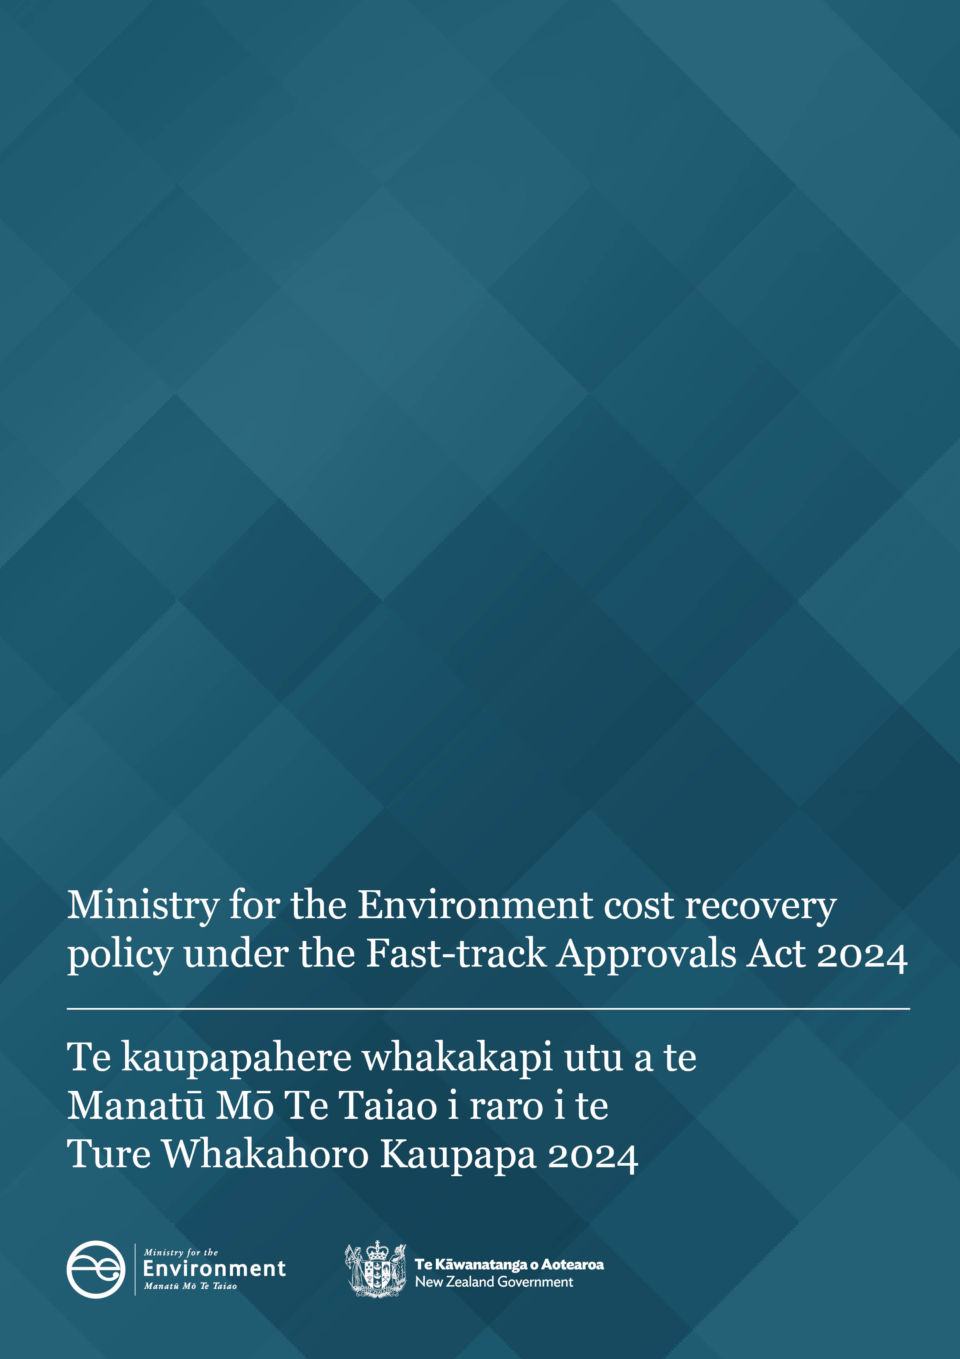

Ministry for the Environment cost recovery policy under the
Fast-track Approvals Act 202

Disclaimer: This policy has been published in advance for applicants’ information. The policy is not operational until 7 February.
This policy sets out the Ministry for the Environment’s approach to cost recovery under section 104 of the Fast-track Approvals Act 2024 (the Act). It also publishes the Ministry’s rates for cost-recovery in accordance with clause 5(3) of the Fast-track Approvals (Cost Recovery) Regulations 2025. These regulations were published in the Gazette on 30 January 2025 and come into force on 7 February 2025. This policy has been published in advance for applicants’ information, however the policy is not operational until 7 February when applications may be lodged under the Act in accordance with paragraph 4 of Schedule 1 of the Act, and the cost-recovery regulations are in force.
The information in this policy is, according to the Ministry’s best efforts, accurate at the time of publication. The Ministry will make every reasonable effort to keep it current and accurate. However, users of this publication are advised that:
- the information does not alter the laws of New Zealand, other official guidelines, or requirements
- it does not constitute legal advice, and users should take specific advice from qualified professionals before taking any action based on information in this publication
- the Ministry does not accept any responsibility or liability whatsoever whether in contract, tort, equity, or otherwise for any action taken as a result of reading, or reliance placed on this publication because of having read any part, or all, of the information in this publication or for any error, or inadequacy, deficiency, flaw in, or omission from the information in this publication
- all references to websites, organisations or people not within the Ministry are for convenience only and should not be taken as endorsement of those websites or information contained in those websites nor of organisations or people referred to.

This document may be cited as: Ministry for the Environment. 2025. Ministry for the Environment cost recovery policy under the Fast-track Approvals Act 2024. Wellington: Ministry for the Environment.

Published in January 2025 by the
Ministry for the Environment
Manatū mō te Taiao
PO Box 10362, Wellington 6143, New Zealand
environment.govt.nz
ISBN: 978-1-991140-62-3
Publication number: ME 1870
© Crown copyright New Zealand 2025

Contents
Introduction 4
Role of the Ministry under the Act 4
Authority to charge 5
Ministry for the Environment’s rates 6
Guiding principles 6
Ministry’s hourly charge-out rates 6
Time recording and contracting 7
Scheduled review of cost recovery approach 7
Cost recoverable activities 8
Pre-lodgement costs 8
Referral application costs 8
Land exchange application costs 8
Substantive application costs 9
Other recoverable costs 9
How the Ministry will recover costs 10
Pre-lodgement costs 10
Post-lodgement costs (referral, land application, substantive and other costs) 10
Cost recovery if an application does not proceed 11
Withdrawal of a referral, land exchange or substantive application 11
Suspension of a substantive application 11
General policies to support cost recovery 12
Procurement policy 12
Invoicing and payment of costs 12
Dispute resolution 12

Table
Table 1: Ministry’s fast-track approvals staff charge-out rates 6

Introduction
This document sets out the Ministry for the Environment’s (the Ministry’s) policy for recovering costs from applicants (and prospective applicants) under the Fast-track Approvals Act 2024 (the Act).
This document sets out the Ministry’s rates to recover its costs. Other agencies – including other ministries – also have functions, duties and powers under the Act, and can also recover their actual and reasonable costs from applicants. This document does not cover cost recovery by other agencies.
The Act provides a fast-track approvals process that infrastructure or development projects with significant national or regional benefits can apply to use. The regime is a ‘one-stop-shop’ and provides an alternative process for resource consents, notices of requirement, and certificates of compliance under the Resource Management Act 1991, and various other approvals under other specified Acts.
The fast-track approvals regime is intended to be a user pays system. The actual and reasonable costs incurred by government agencies, local authorities and expert panels in exercising powers, functions and duties in relation to applications (and prospective applications) are recovered from applicants and/or prospective applicants. Wider system costs are also recovered from applicants through levy payments.

Role of the Ministry under the Act
The Ministry for the Environment’s core function in relation to individual applications under the Act is to assess referral applications, and provide advice to the Minister of Infrastructure to inform their decision whether to refer an application to an expert panel.
Applicants may also engage with the Ministry before lodging an application, and the Ministry may provide advice and assistance.
The Ministry receives the referral application and assesses it for completeness. This includes checking whether the application has complied with the information requirements, whether the project may be capable of satisfying the acceptance criteria, and that the project does not appear to involve an ineligible activity. The Ministry also prepares a report on Treaty Settlements and other obligations.
The Ministry has numerous other functions, duties and powers throughout the wider fast-track approvals process. It is also responsible for advising relevant ministers in exercising their powers, functions and duties under the Act. For example, this includes supporting a response to an invitation to the Minister for the Environment or Minister of Climate Change to comment on an application.

Authority to charge
Sections 104 to 107 of the Act give the Ministry the legal authority and outline the mechanisms for agencies (including the Ministry for the Environment) to recover actual and reasonable costs incurred in relation to their functions, duties and powers under the Act.
Section 104 of the Act sets out the costs that the Ministry for the Environment and other agencies can recover. All of the cost recoverable activities set out in the section below are part of the Ministry’s powers, functions and duties under the Act.
Sections 108 and 109 of the Act enable regulations to be made that set fees, charges and contributions, including the upfront deposit and levy amounts set in the Fast-track Approvals (Cost Recovery) Regulations 2025.

Ministry for the Environment’s rates

Guiding principles
The following principles guided the Ministry’s approach to cost recovery under the Act.
- Costs to government (of carrying out its functions and duties and exercising its powers under the Act) should be fully funded by users of the fast-track approvals system; the Crown should not subsidise the cost of processing applications or running the system.
- Costs to users should be reasonable; functions should be carried out efficiently.
- Where costs can be attributed to specific applications and/or users, these should be borne by that user rather than shared between all users.
- The approach to charging users should be simple and easy to understand.
These principles are consistent with the Treasury’s Guidelines for Setting Charges in the Public Sector and the Controller and Auditor-General’s good practice guide Setting and administering fees and levies for cost recovery.

Ministry’s hourly charge-out rates
The Ministry will recover the actual and reasonable cost of staff time at hourly charge-out rates as set out in table 1 below. Rates include direct staff time (and a share of overheads and operating costs).
Table 1: Ministry’s fast-track approvals staff charge-out rates
Staff role | Rate per hour (excluding GST)
Manager | $238.00
Principal Advisor | $217.00
Senior Advisor | $190.00
Advisor | $165.00
Assistant Advisor | $153.00

Time recording and contracting
The Ministry will use electronic timesheets to track work completed. Time will be recorded and charged in 15-minute increments by project, task and expenditure type.
The Ministry may use contractors for this work. The staff charge-out rates are not applicable to contractors. The cost of contractors will be passed onto applicants (as described in the cost recoverable activities below).

Scheduled review of cost recovery approach
The overall cost recovery approach (including the deposit and levy amounts set in the Fast-track Approvals (Cost Recovery) Regulations 2025) is due to be reviewed in early 2026 to ensure full cost recovery is occurring. The Ministry may review its rates as part of this.

Cost recoverable activities

Pre-lodgement costs
The Ministry may recover actual and reasonable costs it incurs, particularly for staff time, from a prospective applicant who intends to lodge an application (even if an application is not subsequently lodged). Costs include, but are not limited to, assisting applicants to understand application requirements and processes under the Act.
When a prospective applicant engages with the Ministry, the Ministry will advise whether costs will be recovered.

Referral application costs
The Ministry will recover its actual and reasonable staff time and all other recoverable costs that it incurs at the referral stage as part of exercising its functions, powers and duties under the Act. Costs include, but are not limited to:
- assisting applicants to understand referral application requirements and processes under the Act
- receiving an application for referral and checking if it complies with the Act (is complete and within scope)
- returning an application that does not comply
- providing an application (if it is complete and within scope) to the Minister for Infrastructure
- inviting parties to provide comments on an application and/or requesting further information or advice
- commissioning advice or other services required to process an application
- undertaking consultation
- providing secretarial and support services
- providing advice, reports and information to a relevant minister (Minister for the Environment and/or Minister of Climate Change) if they have been invited to comment
- preparing and providing reports to the Minister for Infrastructure on the referral application. This includes producing a Treaty Settlements and customary rights report, and a summary of any comments and further information received through consultation with Māori
- notifying the Minister for Infrastructure’s decision.

Land exchange application costs
The Ministry will recover its actual and reasonable staff time and all other costs recoverable under the Act associated with a land exchange application. Costs include, but are not limited to, providing advice, reports and information to a relevant minister who has been invited to comment.

Substantive application costs
The Ministry will recover actual and reasonable staff time and all other costs recoverable under the Act associated with the substantive application and assessment. Costs include, but are not limited to:
- providing advice, reports and information from the referral process to the Environmental Protection Authority (EPA)
- preparing a Treaty Settlements report for projects listed in Schedule 2 of the Act, on the request of the EPA
- preparing advice to support ministers invited to comment on an application
- providing advice to an expert panel if requested
- responding to enquiries from the EPA as required (this may include providing additional advice, reports and information)
- making comments on an application
- appearing at an expert panel hearing (if any are held)
- exercising any other functions, duties and powers, as defined in section 103 of the Act, as an administering agency.

Other recoverable costs
The Ministry may also recover costs incurred in fulfilling its functions, powers and duties under the Act when completing the preliminary steps before the substantive application stage. These steps may include supporting the Minister for Infrastructure in making determinations on priority under section 38 and ineligibility under section 39.
The Ministry will recover actual and reasonable staff time, and all other costs associated with the preliminary steps including:
- preparing advice
- providing secretarial support
- carrying out any other functions, duties and powers in relation to the preliminary steps.

How the Ministry will recover costs

Pre-lodgement costs
For costs incurred as part of pre-lodgement engagement with applicants, the Ministry will recover these costs by directly billing the prospective applicant (under section 104 of the Act). The Ministry will issue invoices after costs are incurred (under section 106(1)(a) of the Act).
The Ministry will provide an applicant an estimate of the pre-lodgement costs, if requested. The estimate can be broken down by types of costs. An applicant may also ask for updates on pre-lodgement costs incurred by the Ministry, on a reasonable basis.

Post-lodgement costs (referral, land application, substantive and other costs)
The Ministry’s cost recovery policy sits within a wider framework for recovering costs under the Act. Costs incurred by agencies and others after an application is lodged are recovered via the EPA‘s centralised invoicing system.
These costs will be met in the first instance by the Ministry invoicing the EPA. The Ministry will receive payments from the EPA’s distribution of the upfront deposit paid when applications are lodged. Upfront deposits are set under the Fast-track Approvals (Cost Recovery) Regulations 2025, and are also used for application processing costs for other agencies, local government and panel members.
If costs are greater than the upfront deposit, the EPA will charge the applicant with the additional actual and reasonable costs incurred and invoiced by the Ministry (and other agencies).
The applicant may receive a partial refund from the EPA if all referral, land exchange or substantive application costs do not reach the deposit amounts paid under the regulations. The Ministry’s costs are only one part of the total costs; the EPA will include other costs when invoicing applicants and calculating any partial refunds.

Cost recovery if an application does not proceed
The Ministry will recover all costs associated with a referral, land exchange or substantive application where those costs are recoverable under the Act, even if the application does not proceed, is withdrawn or declined.

Withdrawal of a referral, land exchange or substantive application
Where an applicant withdraws a referral, land exchange or substantive application, the Ministry will recover the costs it has incurred in processing the application up until the date that it receives written notification of withdrawal from the EPA.
The Ministry will also recover any costs it may incur as a consequence of an applicant withdrawing, including costs associated with:
- advising ministers
- advising the expert panel (if applicable)
- advising any person or group who has made comments or who has been contacted (if this is done on behalf of the applicant)
- updating relevant information on the Ministry’s website.

Suspension of a substantive application
Under the Act, the processing of a substantive application may be suspended under section 60.
The Ministry will recover all costs incurred in performing its functions, duties and powers under the Act in relation to the suspension. Costs may include, but are not limited to:
- advising the Minister for Infrastructure in considering a suspension under section 62
- updating relevant information on the Ministry’s website.

General policies to support cost recovery

Procurement policy
The Ministry follows the New Zealand Government Procurement Rules and has a procurement policy and guidelines that apply to the procurement of any services required for it to carry out its functions, duties or powers under the Act.

Invoicing and payment of costs
Invoices for the Ministry’s costs will be broken down by project phase:
- The Ministry may invoice applicants directly for actual and reasonable costs it has incurred in consulting and providing assistance before the application is lodged and after the application is complete. In this case, the invoice will include a detailed identification of line items.
- The EPA is responsible for invoices relating to referral, land exchange or substantive applications on behalf of government agencies and local authorities. The Ministry will provide EPA with timesheets and regular invoices. EPA will invoice applicants on behalf of the Ministry and other agencies, with costs itemised. The EPA will then reimburse the Ministry.
Applicants must pay invoices in full by the due date on the invoice. Any costs not paid by the applicant become debts due and may be pursued through the appropriate court, by the Ministry (for pre-lodgement invoices) and by the EPA on behalf of the Crown (for post-lodgement invoices).

Dispute resolution
The Act does not provide a formal process for applicants to object to costs charged. Any applicants with concerns about an invoice relating to Ministry charges can contact the agency who sent the invoice as soon as possible, and no later than 15 working days after the invoice is received. This will either be the Ministry, if costs relate to pre-lodgement activity, or the EPA, if it is after lodgement and through the centralised invoicing system. If disputed costs relate to post-lodgement activity, the EPA’s dispute-resolution policy will apply.
For disputes relating to Ministry charges, if the matter cannot be resolved through initial communication, the issue will be escalated within the Ministry as appropriate.
The Ministry will respond to issues as soon as reasonably practicable and will provide the applicant progress updates if the issue cannot be immediately resolved.
The Ministry will provide the applicant a response detailing the concern, the matters taken into consideration, and the outcome.

Including approvals under the Wildlife Act 1953, Conservation Act 1987, Reserves Act 1977, Freshwater Fisheries Regulations 1983, Heritage New Zealand Pouhere Taonga Act 2014, Exclusive Economic Zone and Continental Shelf (Environmental Effects) Act 2012, Crown Minerals Act 1991, Public Works Act 1981 and Fisheries Act 1996.
This refers to considering individual projects and applications. The costs of overall system running costs that cannot be attributed to individual applications are shared among users.
The Treasury. Guidelines for Setting Charges in the Public Sector. Retrieved 20 December 2024.
Controller and Auditor-General. Setting and administering fees and levies for cost recovery: Good practice guide. Retrieved 20 December 2024.
This refers to projects listed in Schedule 2 of the Act, that subsequently apply to the EPA for a substantive decision. It does not apply at the substantive stage to non-listed projects, as in those cases the Treaty Settlements report occurs at the referral stage.

