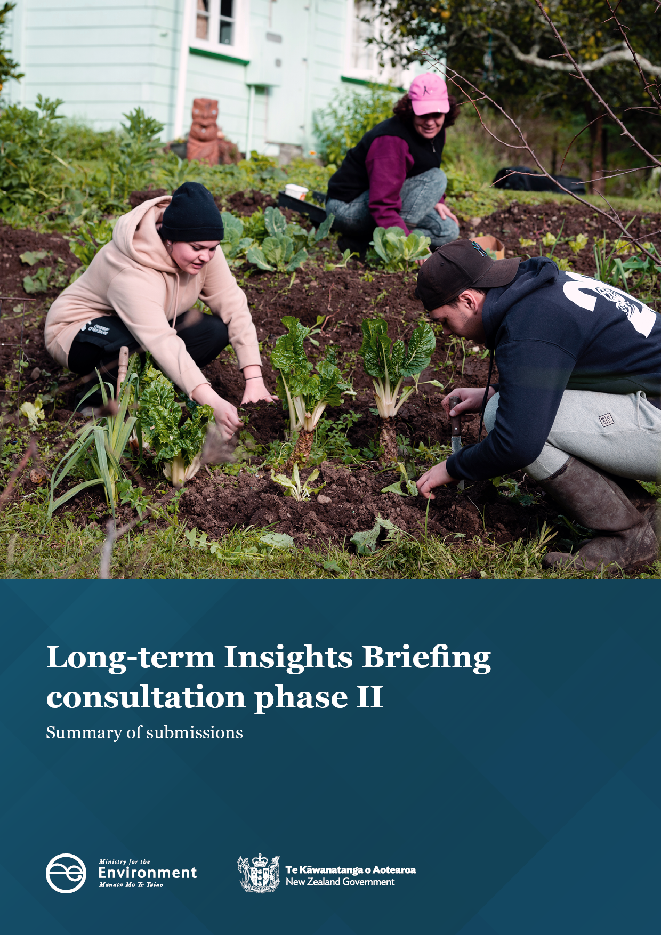

Disclaimer
The information in this publication is, according to the Ministry for the Environment’s best efforts, accurate at the time of publication. The Ministry will make every reasonable effort to keep it current and accurate. However, users of this publication are advised that:
- The information does not alter the laws of Aotearoa New Zealand, other official guidelines, or requirements.
- It does not constitute legal advice, and users should take specific advice from qualified professionals before taking any action based on information in this publication.
- The Ministry does not accept any responsibility or liability whatsoever whether in contract, tort, equity, or otherwise for any action taken as a result of reading, or reliance placed on this publication because of having read any part, or all, of the information in this publication or for any error, or inadequacy, deficiency, flaw in, or omission from the information in this publication.
- All references to websites, organisations or people not within the Ministry are for convenience only and should not be taken as endorsement of those websites or information contained in those websites nor of organisations or people referred to.

This document may be cited as: Ministry for the Environment. 2023. Long-term Insights Briefing consultation phase II: Summary of submissions. Wellington: Ministry for the Environment.

Published in February 2023 by the
Ministry for the Environment
Manatū Mō Te Taiao
PO Box 10362, Wellington 6143, New Zealand
ISBN: 978-1-991077-02-8 (online)
Publication number: ME 1711
© Crown copyright New Zealand 2023
This document is available on the Ministry for the Environment website: environment.govt.nz.

Contents
Executive summary 4
Background 5
Summary of submissions 6
Our approach 7
Consultation questions 7
What we heard from people 8
How these submissions informed the briefing 10
Next steps 11

Executive summary
As part of the Long-term Insights Briefing (LTIB), the Public Service Act 2020 requires a chief executive of a government department to consult with the public on the draft of the briefing.
In October 2022, the Ministry for the Environment (the Ministry) carried out public consultation on the draft briefing. This document summarises the responses to the public consultation. Thank you to everyone who provided the Ministry with feedback. Your input has helped to strengthen this and future briefings.

Background
The Public Service Act 2020 introduced a new requirement for departmental chief executives to publish an LTIB at least every three years. The purpose of the LTIB is to reveal medium- and long-term trends, risks and opportunities that may affect Aotearoa New Zealand’s land and people.
The LTIB is not government policy, and the requirement to publish it is a statutory duty of departmental chief executives, independent of Ministers. LTIBs differ from the advice that the public service provides Ministers, or the accountability and planning documents prepared for Parliament. For more information, see the Department of the Prime Minister and Cabinet.

Summary of submissions
The second phase of public consultation of the Ministry’s LTIB ran from 5 October to 18 October 2022. The draft was titled Where to from here? How we ensure the future wellbeing of land and people.
The consultation asked for input and feedback about how to ensure a resilient and sustainable future for the land and all New Zealanders.
The Ministry received 27 submissions. About one-third came from individual members of the public, and the remainder came from central and local government, industry bodies, NGOs and the academic community. Many submissions offered ideas about how we might analyse and understand the different drivers of change for the future of land in Aotearoa outlined in chapter two. For those who responded to the specific question, the majority of submissions supported the aspirations (chapter 3) laid out in the draft briefing. As well, most submissions supported the framework presented for achieving incremental changes, supporting transitional changes and enabling transformational change with the inclusion of some examples of how the pathways for change described in chapter four could be made more effective.
We also sought public feedback on the draft LTIB through various forms of engagement, including workshops with rangatahi – the long-term state of the land will be a core part of their lived experience.
Submissions represented a range of perspectives from diverse organisations, sectors and regions of Aotearoa New Zealand. However, the volume of feedback was relatively small, and respondents were self-selecting, so participants were likely to be those already engaged with the subject matter and not necessarily representative of all New Zealanders. Despite this, the Ministry has been able to draw value and richness from the range and diversity of perspectives represented in the submissions.

Our approach
The consultation invited people to provide their views, insights, and knowledge on a range of ideas presented in the draft briefing.
Questions were divided into sections corresponding to three chapters.

Consultation questions
In chapter 2, the draft LTIB outlined seven broad-themed drivers that could affect the state of the land over the coming years.
Question 1: Are there any other main drivers you think should be included?
In chapter 3, the draft outlined a possible future for the land and New Zealanders’ relationship with it. In this vision, all New Zealanders would share a sense of deep environmental responsibility and give back to the land as much as it provides.
To help illustrate the vision, the draft LTIB described what the future could look like if Aotearoa New Zealand addresses four main challenges:
- empowering tangata whenua to exercise kaitiakitanga
- protecting, revitalising and making the land more resilient
- enabling action and responsibility for improving land
- ensuring all New Zealanders are connected with nature.
Question 2: How well does the way we describe what the future could look like align with your aspirations for the land and New Zealanders’ relationship with it? (scale responses: 1 strongly agree; 2 agree; 3 somewhat agree; 4 disagree; 5 strongly disagree; 6 don’t know)
Question 3: Would you add to or change anything about the descriptions of what the future could look like?
In chapter 4, we outlined nine pathways (or leverage points) to a more resilient future for the land and every generation.
Question 4: For each leverage point, what could we do to make them effective?
Question 5: Are there any other leverage points you think should be included?
Question 6: Do you have any final comments you would like to share about our draft briefing?
Respondents were also invited to upload supporting documentation or submit responses by email.
The Ministry received feedback from eight individuals and 19 organisations, including central and local government, industry bodies, NGOs and the academic community.

What we heard from people

Question 1: Are there any other main drivers you think should be included?
In general, respondents agreed that the broad-themed drivers described in the draft briefing covered the main drivers of land change in the future. Submissions detailed a number of specific examples that could be included under the umbrella of the seven listed drivers to expand analysis or provide more details. Examples included the impact of mis/disinformation, biosecurity risks, systemic disadvantages affecting Māori landowners and mahinga kai systems, freshwater scarcity, and the resource demands for growing populations and infrastructure needs.
A number of respondents commented that the briefing would be enhanced by additional detail and analysis of the way drivers are interconnected and how these might interact to produce cumulative impacts on the land.

Question 2: How well does the way we describe what the future could look like align with your aspirations for the land and New Zealanders’ relationship with it? Do you:
Response | Count
Strongly agree | 5
Agree | 8
Somewhat agree | 5
Somewhat disagree | 1
Strongly disagree | 0
Don’t know | 0
No response* | 8
Grand total | 27
*Approximately half of the submissions to the consultation were written submissions, rather than through Citizen Space. Some of the written responses did not follow the question structure in the consultation – eight of the responses did not clearly identify a position in response to question 2.

Question 3: Would you add to or change anything about the descriptions of what the future could look like?
In general, feedback was supportive of the approach taken in the LTIB. Respondents mostly agreed with the aspirations for the future of the land described in chapter 3.
Some submissions suggested the aspirations could have been bolder and more explicit in describing outcomes. Ideas included ensuring the rights of non-human species, living within Aotearoa New Zealand’s environmental means, and bringing intergenerational perspectives into environmental values.
Other submissions considered the vision should be more aligned with instrumental values. One example was to more clearly consider how the land supports prosperous and vibrant rural communities and enables primary producers to be globally competitive – while acknowledging the increasing challenges the land-based productivity sectors will face through climate change.

Question 4: For each leverage point, what could we do to make them effective?
There were useful suggestions about how leverage points could be made effective. Examples included enhanced data collection and monitoring of environmental outcomes, inclusion of stronger incentives and regulatory penalties, and a more strategic approach towards research and development to support long-term investments.

Question 5: Are there any other leverage points you think should be included?
A range of suggestions were submitted for other leverage points that could be covered in the LTIB. Many of these contributions would enhance or extend leverage points already included. Submissions suggested increased funding and empowerment for community-led initiatives, including the precautionary principle and environmental risk disclosures in decision-making; stronger commitments to land rehabilitation; emphasis of sustainability of infrastructure and investments; localisation of food production; and waste minimisation. Data collection, monitoring and transparency of decision-making were also highlighted.

Question 6: Do you have any final comments you would like to share about our draft briefing?
Many final comments in the submissions were supportive of the overall direction and content of the draft LTIB and acknowledged the importance of sustaining the future wellbeing of land and people. Highlighting the importance of this topic for New Zealanders, several respondents were keen to find ways to enhance engagement and further the conversation with the wider community.
Some submissions acknowledged that people would have different values and perspectives, noting that it would be important for readers to reflect on their own values when reading the document.

How these submissions informed the briefing
The contributions, input, and ideas we received through submissions have added depth, nuance and diverse perspectives to the final briefing. Each of the chapters has been updated with additional examples and increased emphasis on the diverse perspectives raised through the consultation. While the Ministry was not able to cover all the ideas and specific examples received, the range of input has influenced the considerations and perspectives included in the final briefing.

Next steps
Thank you to everyone who provided their feedback, knowledge, and insights on the Ministry’s draft briefing. The briefing has now been finalised and will be presented to Parliament.

Public Service Act 2020, Schedule 6, clauses 8 and 9.

