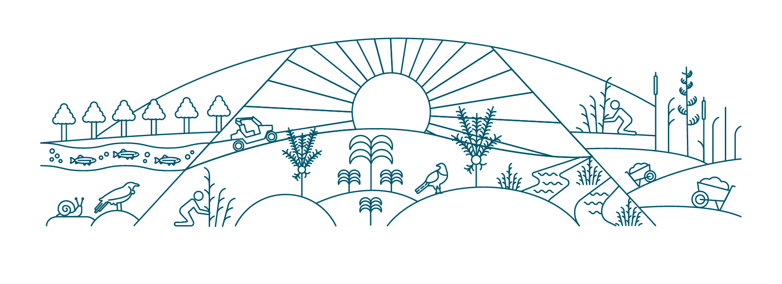




Jobs for Nature Programme

Interim Evaluation 2023
Lessons from the first two years

Jobs for Nature Interim Evaluation 2023
Lessons from the first two years

Disclaimer
The Secretariat of the Jobs for Nature has made its best efforts to make the information in this publication accurate at the time of publication. The Secretariat will make every reasonable effort to keep it current and accurate. Users of this publication are advised that:
- the information does not alter the laws of New Zealand, other official guidelines, or requirements
- it does not constitute legal advice, and users should take specific advice from qualified professionals before taking any action based on information in this publication
- the Secretariat does not accept any responsibility or liability whatsoever whether in contract, tort, equity, or otherwise for any action taken as a result of reading, or reliance placed on this publication because of having read any part, or all, of the information in this publication or for any error, or inadequacy, deficiency, flaw in, or omission from the information in this publication
- all references to websites, organisations, or people are for convenience only and should not be taken as endorsement of those websites or information contained in those websites nor of organisations or people referred to.

Acknowledgements
The Secretariat would like to thank all the staff in the agencies who provided information for the report and took the time to review it. Without them there would be no report.
We’d also like to thank our external reviewers, Valmai Copeland, Deborah O’Kane, AJ Millward and Tom Milton for their thoughtful comments.

Published in June 2023 by the Ministry for the Environment
on behalf of the Jobs for Nature Inter-Agency Secretariat
ISBN: 978-1-991077-66-0



Publication number: ME 1776



© Crown copyright New Zealand 2023

Table of contents
Table of contents 1
Table of figures 3
Introduction from James Palmer 4
Overview 5
Since the research was completed 7
Supporting transition from Jobs for Nature funding 7
Responding to adverse weather events 8
Reprioritising and managing unallocated funding 8
Introduction 9
What this evaluation covers 10
Terms used in the report 11
Background to Jobs for Nature 12
The programme and its objectives 12
How the programme works 13
Breakdown of funding 13
Adapting to the changing context 14
Evaluation criteria 16
Understanding the logic behind the programme 17
Other key frameworks 18
Previous reviews of the programme 19
The data we have and its limitations 20
Implementation state of play 21
Overview 21
The state of play after two years 24
How effective has Jobs for Nature been so far? 29
Labour market context 29
Programme response to changing context 29
Who has Jobs for Nature helped into employment? 30
More than just jobs 32
Contributing to nature outcomes 33
Working together 37
Conclusions on programme effectiveness 38
How efficient has Jobs for Nature been so far? 40
How the programme was designed 40
Cost of implementation 44
Did the programme approach add value? 45
Conclusions on the efficiency of the programme 47
How relevant has Jobs for Nature been so far? 49
Conclusions 50
Key lessons 51
For the Jobs for Nature programme 51
For future programme designs 51
Glossary of terms 53
List of commonly used acronyms across the Jobs for Nature programme 54
Appendix A – Jobs for Nature funding programmes 56
Appendix B – Programme dashboard 58
Appendix C – Jobs for Nature Advisory Group Investment Framework 60
Appendix D – Jobs for Nature programme benefits map 61
Appendix E – Benefits indicators framed by capital 62
Appendix F – Agency evaluation initiatives 63
Appendix G – Jobs for Nature programme metrics 65

Table of figures
Figure 1 Key terms we use 11
Figure 2 Structure of the programme 13
Figure 3 Key milestones in Jobs for Nature and the COVID-19 pandemic 15
Figure 4 The OECD (DAC) evaluation criteria 16
Figure 5 The DAC criteria applied to the programme logic 17
Figure 6 Programme Logic Model 18
Figure 7 Programme key outputs at end of year two (30 June 2022) 21
Figure 8 State of funding implementation at end of year two ($ Million) 25
Figure 9 Distribution of Jobs for Nature funding by region 25
Figure 10 Payments of approved project funding ($m) by agency (end of year two). 26
Figure 11 Distribution of funding by organisation type 27
Figure 12 Project intentions as reported by projects 28
Figure 13 Snapshot of Jobs for Nature employer survey results 31
Figure 14 Type of roles created at 30 June 2022 by main project objective (employment starts) 32
Figure 15 Snapshot of reported employment and training 32
Figure 16 Jobs for Nature environmental outputs 34
Figure 17 Intended and potential long-term benefits 35
Figure 18 How long it takes to see full environmental benefits (years) 35
Figure 19 Illustrative steps in the Jobs for Nature programme approval process 42
Figure 20 Average weeks between approval and project start by agency and funding level 42
Figure 21 Average weeks between approval and project start date by organisation type 43
Figure 22 Average cost per opportunity created by agency (at 30 June 2022) 45

Introduction from James Palmer
Secretary for the Environment and Senior Responsible Official for Jobs for Nature
The $1.2 billion Jobs for Nature fund was established in 2020 as a part of the Government’s COVID-19 response. In anticipation of the economic impacts of the pandemic, particularly rising unemployment rates, Jobs for Nature aimed to support New Zealanders in a time of uncertainty, while also benefitting the natural environment. The programme’s intent was to create a skilled workforce that could carry out significant environmental restoration and management reforms, that would address environmental issues affecting Aotearoa New Zealand.
I am proud of the Jobs for Nature programme. It has been my pleasure to have been part of this incredible journey since its early days. Prior to my appointment as the Secretary for the Environment this year, I was a member of the Jobs for Nature Reference Group. I have witnessed the effort put into the rapid stand-up of the programme and getting boots on the ground. It is a testament to the incredible work across the programme at all levels.
It is important to acknowledge how much has been achieved in this time by so many. By the end of 2022 over 450 projects had been funded across the whole of New Zealand. Nearly 11000 people had been employed in funded projects. We are so close to reaching one of the original intents of the programme, to provide 11,0000 employment opportunities. Our people have planted millions of plants and put up thousands of kilometres of fencing and stock exclusion around our waterways. Millions of hectares of lands are under plant and pest control.
The tenacity and passion shown by our project partners cannot be overstated. While New Zealand did not experience the levels of unemployment originally anticipated in 2020, the programme has faced numerous other challenges along the way. Severe weather events like Cyclone Gabrielle have had an enormous impact on many at a personal and professional level. For those who have been able, it is inspiring to see continued work in affected areas, and to see projects rally together to provide support. These events demonstrate how important environmental-based work is to New Zealand to address environmental pressure from human development and climate change.
I would also like to extend my gratitude towards the delivery agencies: the Department of Conservation, Ministry for the Environment, Ministry for Primary Industries, Toitū Te Whenua Land Information New Zealand and the Ministry for Business, Innovation and Employment. Your input into the interim evaluation shows strength in your reflections over the past few years. Thanks also to the former Reference and Advisory Group members who volunteered their time to provide their feedback and insights to inform this work.
Jobs for Nature is an unprecedented injection of funding into the environment. Now the programme is into its later years, it is important to use this opportunity to reflect on the work that has been done to inform our future endeavours. There are many lessons we can learn from this endeavour, and this interim evaluation is one of the key steps to understanding them.

Overview
This interim evaluation is part of a broad programme of work designed to assess the success of the cross-agency Jobs for Nature programme at both programme and agency / fund level. The annual reviews of the programme highlight the progress and successes to date and provide insights on the achievements of some of the individual projects.
This interim evaluation is the component that looks for areas where there could be improvements or where opportunities could be more fully embraced so that future programmes can learn from the experience, and where possible, adjustments can be made for the remainder of the programme.
Before doing that, it is important to note:
- It should be recognised that implementing a cross-agency programme of this scale and complexity was in itself a major achievement, particularly at the time when uncertainty and concerns for the future were at their peak due to the pandemic. This reflects significant effort from all parties from Ministers to individual project promoters, including some agencies standing up the administrative processes from inception, and the establishment of the Jobs for Nature Secretariat.
- Individual projects are already reporting positive outcomes for individuals, iwi and communities, and are on track to show encouraging progress towards achieving positive environmental outcomes in the longer term.
Overall, Jobs for Nature investments have been successful in providing employment opportunities in line with the programme objectives and have resulted in environmental improvements across a wide range of areas, from protecting biodiversity to improving water quality. Other reported benefits include developing the capacity and capability of individuals, iwi, hapū and marae, and communities, building on environment-led opportunities in both rural and urban areas.
All the funds recognise the importance of supporting and working with iwi / Māori, and this takes many different forms, from Māori-led projects and the co-governance of projects to specific funding for Māori organisations or projects being carried out on Māori-owned land. In terms of project content many projects are undertaking training in or are being guided by the principles of mātauranga Māori.
The programme was implemented as part of the Government response to COVID-19, when the focus was on making sure people were meaningfully employed at a critical time for Aotearoa New Zealand. As with much of the COVID-19 response, this activity needed to occur concurrently as the systems, processes and people needed to support and administer the Jobs for Nature programme were being set up. The need to act with haste may have resulted in some opportunities to achieve greater efficiency across the programme being missed because planning for that was just not possible at the time.
Coordination across the programme has had some difficulties, as individual agencies are responsible for managing their funds (subject to ministerial approval) and implementation processes. While this has allowed a degree of innovation, it has also resulted in some missed opportunities. There is currently a lack of coherent data on the impacts of the programme beyond the immediate environmental outputs. As a result, there is currently little information at the programme level on who worked in the projects, and whether target groups were reached, which is important to understand more fully the benefits achieved by the programme. The application, contracting and reporting processes for organisations on the ground were costly and complicated, particularly where contestable funding or funding from multiple agencies were involved. In some cases, this also led to issues with the ability to amend contracts when needed, due to external factors including COVID-19 outbreaks and restrictions, supply chain and pricing issues and adverse weather effects encountered by projects.
The Implementation Unit of the Department of the Prime Minister and Cabinet (DPMC) suggested that future cross-agency programmes could significantly reduce administrative workloads for funding recipients by aligning applications, contracts and reporting into a single source. Each agency and fund having different processes for applications, contracts, and reporting adds considerably to workloads of recipients who seek and/or receive funding from multiple agencies.
There are also tensions between the need for speedy investment in the short term and the need to develop relationships for the longer term, and between fixed-term funding and long-term environmental needs for environmental protection and improvement.

Since the research was completed
Since the research on this interim evaluation was completed, the programme has continued to progress and at the end of March 2023:
- a further 40 projects were approved, bringing the total to 469
- 38 more projects were contracted
- 62 projects were completed
- the objective of 11,000 employment opportunities has been met, with 11,495 employment starts
- the overall programme funding has reduced to $1.199 billion, due to unallocated funds being returned to the centre.
The programme has been:
- supporting transition from Jobs for Nature funding
- responding to adverse weather events
- reprioritising and managing unallocated funding.

Supporting transition from Jobs for Nature funding
A focus for 2023 has been the development of an overall transition strategy to support projects and ensure the sustainability of outcomes. This is supplemented by specific plans for each agency, where appropriate (some funds existed before and have a life beyond Jobs for Nature). This is in the context that no further Crown funding is available for Jobs for Nature, but that some projects want or intend to continue their activity and stopping work on some activities, particularly in pest control, risks losing the investment to date.
The Jobs for Nature Reference Group’s Investment Framework included enduring outcomes as a consideration for initial funding decisions. Many projects have built this into their project planning, with iwi, council, community or other groups committing to undertake maintenance work in future years, or active plans in place to secure future funding.
The strategy aims to identify and share opportunities to be taken up by participants across three interrelated themes:
- People/Tangata: opportunities are visible and accessible for people employed and upskilled to continue nature-based employment
- Environment/Taiao: plans are in place to ensure ongoing maintenance of project environmental outputs to deliver outcomes
- Resourcing/Rawa: potential wider resourcing sources and pathways beyond Jobs for Nature are visible and accessible.
Delivery agencies are engaging directly with funding recipients to understand project needs and provide tailored support to develop and implement their specific transition plans. They are also encouraging regional councils and landowners to continue partnering with Jobs for Nature project entities to provide opportunities for participants and entities who have upskilled through Jobs for Nature to deliver wider benefits.
The Secretariat, with support from across Jobs for Nature, is working on a national platform for projects to connect and collaborate with others (for example, regional councils), share best practice in partnerships, and understand opportunities that exist across the country.
Regional collaboration across agencies and with iwi is encouraged, and non-government organisations (NGOs), businesses and philanthropy are connecting in regions to maintain gains made through Jobs for Nature.

Responding to adverse weather events
Recent severe weather events, including the Nelson floods and Cyclone Gabrielle, have had a significant impact on some projects, and delivery agencies have been working with funding recipients to determine how projects have been affected. Initial assessments show impacts vary between projects, with some experiencing little to no impact, and others facing more significant challenges due to flooding, land slips, and broader community focus on response and recovery. However some remote sites were still inaccessible at the last date, so impacts will become clearer over time as access is restored.
Some workers have been redeployed to assist with community clean-up efforts in conjunction with civil defence authorities, or support delivery of other Jobs for Nature projects, where they have been unable to access their project sites for the time being.
Funding agencies are continuing to support individual projects affected to determine any change processes that may be required. This may include contract variations to outputs or project sites, timeframe extensions, or in a small number of cases withdrawal if delivery is no longer viable.

Reprioritising and managing unallocated funding
In March 2023, a Cabinet decision was taken to reprioritise $11.55 million from Jobs for Nature to support the Ministry for the Environment's Environmental Monitoring and Reporting System initiative.
The Department of the Prime Minister and Cabinet (DPMC) Implementation Unit’s stocktake report recommended the Secretariat report back to Cabinet with a clear programme-wide protocol for how unused funding could be returned to the centre or be reallocated within an initiative. This protocol was developed. However, following the severe weather events around the country and the need to respond, Cabinet made the decision in April 2023 that all unallocated programme funding be immediately returned to the centre.
To ensure accountability and transparency over remaining funds, the Secretariat is developing operational fund management guidance to help agencies to manage their respective Jobs for Nature programme funds. This guidance will help manage any financial risks and issues that may arise for projects including supporting them to meet the programme’s long-term objectives.

Introduction
This interim evaluation is part of a suite of activities reviewing the effectiveness of the Jobs for Nature programme at both programme and agency / fund level. The annual reviews of the programme, which should be read in conjunction with this evaluation, highlight the progress and successes to date and provide insights on the achievements of some of the projects.
covers areas of the programme where there could be improvements or where opportunities have not been fully realised, so future programmes can learn from the experience and, where possible, adjustments can be made for the remainder of the programme. This evaluation does not assess the performance of individual projects.
The interim evaluation aims to:
- learn from the setup, implementation and results of the programme to inform future, particularly cross-government, interventions
- assess the extent to which the potential future outcomes for the participants and the environment are likely to be achieved.
The interim evaluation is not an audit of the programme or its component elements.
Along with the interim evaluation, there is a suite of other work underway to assess the programme including:
- regular monitoring and reporting, now on a quarterly basis, of the key programme outputs together with some progress measures and indications of delivery confidence – how sure we are that projects will deliver against their contracts
- an overall independent evaluation based on case studies on the ground, which examine the extent to which the programme is on track to achieve the environmental and people outcomes intended; this evaluation will include a review of the programme through a Māori lens. This evaluation will report in 2025 but will provide interim reports each year until then
- a benefits report, which looks at the long-term impacts of the programme and the work undertaken through it. A first benefits report was published in 2022.
- studies on assessing the socio-economic benefit and social impacts of the programme, in addition to the environmental outcomes.
The quarterly dashboards check the programme is on track, the external evaluation checks that the programme is reaching the outcomes it wanted, and this interim evaluation is a look under the bonnet on how it’s all working.
Several of the implementing agencies have plans to, or are in the process of, evaluating their activities at the fund level.
In addition to the above, the overall programme was externally reviewed by RDC Group Ltd for the Jobs for Nature Reference Group and Secretariat in May 2021, and by the Implementation Unit of the Department of the Prime Minister and Cabinet in December 2021.
This interim evaluation is focused on how the Jobs for Nature programme is performing at the system level. While it does reflect comments from the various funds, the scope does not include any assurance or audit work in relation to the individual agencies’ systems or processes. This is the responsibility of the implementing agencies, their internal audit assurance programmes and their external auditors.
This report has been prepared by the Jobs for Nature Secretariat based on information supplied by the implementing agencies. The report has been reviewed by the five implementing agencies for accuracy and content. It has also been reviewed by three independent external experts, and their comments have been incorporated. The Secretariat is grateful for their input and for that of the agencies in the preparation of this report.

What this evaluation covers
The interim evaluation looks mainly at questions of efficiency and effectiveness and is largely based on an analysis of programme data. The Secretariat also sought the views of agency programme managers and recipients on the key issues.
In setting the scope of the evaluation, considerations of time, cost, scope and quality have been taken into account, based on the following assumptions:
- it is neither practical nor desirable to do a large scale, in-depth evaluation at the project level. Agencies will have their own arrangements for evaluation of their own funds or projects. (However, some project-level analysis will be involved in analysis of specific themes for the external evaluation)
- there is interest in learning from the differences between implementation processes, but the evaluation is of the programme, not of the implementing agencies
- long-term effects of the programme, especially on the natural environment, will not be fully manifest until after the end of the funding programme
- agencies would be actively involved in supporting the development and implementation of the evaluation
- essential data was available or could be collected.
The interim review was conducted by the Secretariat, with the findings subject to external peer review, with full involvement of the agencies to ensure acceptance of the findings. The key function of the evaluation programme is for agencies to learn from the experiences to date and assess the extent to which the potential future outcomes for the participants and the environment are likely to be achieved.
The evaluation brings together a range of other reporting and analysis undertaken by the Jobs for Nature agencies and the programme, as well as original research and contextual data.

Terms used in the report
Because many of the terms used in evaluation are also used widely in other contexts, there is a risk of confusion or misunderstanding if words are not used the same way by everyone. In this context we are using the following concepts, and terms to describe them.
Figure 1 Key terms we use
What we mean | The word we use | Words other people might use for something similar | What it means in Jobs for Nature
An individual activity funded or otherwise part of a programme. Not all projects are part of wider programmes – they may be standalone or pilot activities. | Project | Action  Initiative | The projects contracted and funded by the individual agencies under the umbrella of Jobs for Nature.
The set of activities managed together over a period that aims to achieve some sort of positive change for a person or group of people. | Programme | Project  Initiative  Intervention | The overall set of activities funded through Jobs for Nature, including projects and the implementation by agencies.
The changes, including in attitudes or behaviours, that are likely to be or achieved through delivering the programme in the short, medium, and long term. | Outcome | Result  Impact | The achievements of the programme for people and places, reflecting the various stakeholders’ priorities and needs.
The extent to which we have achieved the changes we set out to make for the people we work with and the places we work. | Effectiveness | Success  Efficacy | Whether the programme has achieved its overall objectives. Individual projects will have their own objectives and measures.
How far the programme is delivered with the least possible resources and how far it is getting the best possible results for the resources it has. | Efficiency | People are pretty much agreed on this one | Whether programme resources have been best used, enabling the outcomes to be in scale with the investment.
The long-term, big-picture change at a population, society, or place level. | Impact | Strategic outcomes | The contribution of the programme to long-term environmental and social change.
Other technical terms and acronyms can be found at the end of this report, in the Glossary of terms.

Background to Jobs for Nature

The programme and its objectives
The Budget 2020 process included establishment of the COVID-19 Response and Recovery Fund (CRRF), and the decision by the Government to respond to anticipated high unemployment as an element of this. A key driver behind this was a Treasury report on economic scenarios which projected peaks in the unemployment rate between 13 and 26 per cent and a highly uncertain world outlook.
In June 2020, the Government brought together the $1.219 billion Jobs for Nature programme, of which 90 per cent was funded through the COVID-19 Response and Recovery Fund and the remainder from existing appropriations across Vote Environment, Vote Forestry, and the Provincial Growth Fund. Individual Budget funding was approved for agencies, with those funds brought into shared objectives.
This order of events is important context for the evaluation, given the need to create job opportunities so people could be meaningfully employed at a critical time for Aotearoa New Zealand. As with much of the COVID-19 response, this activity needed to occur at the same time as the systems, processes and people needed to support and administer the Jobs for Nature programme were coming on stream.
The Jobs for Nature programme has three core objectives:
- create approximately 11,000 employment opportunities in regions that need work the most
- establish enduring benefits for healthy waterways, biodiversity, climate change and cultural values
- support sustainable land use and the implementation of regulatory requirements, including for freshwater, biodiversity and climate change.
The funding is administered through 25 programme funds across the Department of Conservation (DOC), Ministry for the Environment (MfE), Ministry for Primary Industries (MPI), Kānoa, and Toitū te Whenua Land Information New Zealand (LINZ). The individual funds that make up the programme can be found in Appendix A – Jobs for Nature funding programmes. The Sustainable Land Use (SLU) Ministers group oversee the programme. A small cross-agency Secretariat supports coordination across the programme, including reporting and evaluation.
The Jobs for Nature funding supports people into nature-based work, including vegetation planting for freshwater and biodiversity restoration, fencing waterways, pest control (including both predators and herbivore pests, wilding pines and other pest plants), fish passage remediation and skills training to support people into environmental careers.

How the programme works
Despite being characterised as a programme, Jobs for Nature is a portfolio of programmes implemented by a group of agencies who have direct control over their funds. The programme direction and major funding decisions (in the case of new funding) are taken by the Sustainable Land Use Ministers, with advice from the Jobs for Nature Independent Advisory Group (initially the Reference Group). Implementation design and decisions are made within individual agencies. The governance structure is therefore complex, with the standalone programme Secretariat having primarily a coordinating function.
The funding was appropriated to each delivery agency, and it remains their responsibility to ensure work is progressing to an acceptable standard. The programme Secretariat supports SLU Ministers and the Jobs for Nature Advisory Group and provides consolidated reporting and programme-level insights. The Secretariat acts as a conduit between the delivery agencies and coordinates the programme as a whole.
Figure 2 Structure of the programme
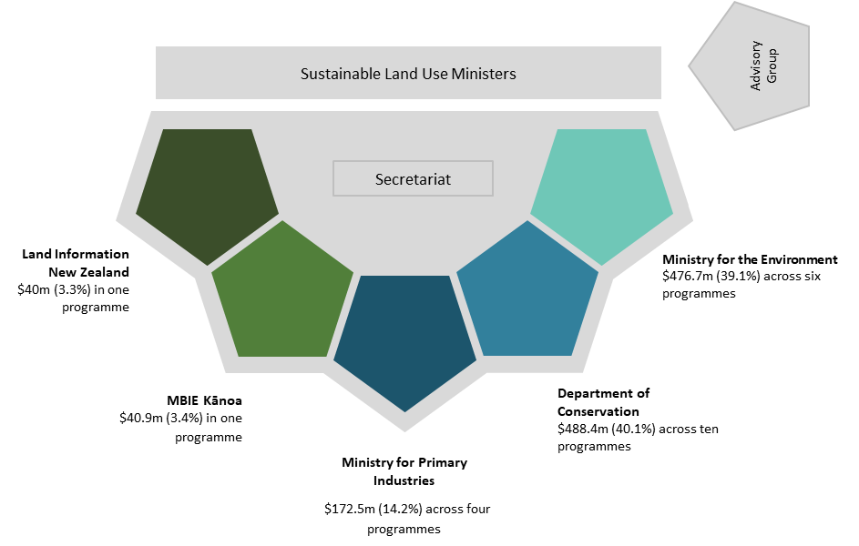

Breakdown of funding
The Ministry for the Environment (MfE) administers $476.7 million of total funding (39.1 per cent) across six programmes focused on freshwater. MfE also serves as lead agency and the MfE Chief Executive as the Senior Responsible Official.
The Department of Conservation (DOC) administers $488.4 million (40.1 per cent) across 10 programmes focused on predator control, restoring wetlands, weed control, freshwater restoration, ecosystem restoration, regenerative planting, and improving recreational assets including huts and tracks.
The Ministry for Primary Industries (MPI) administers $172.5 million (14.2 per cent) across four programmes including One Billion Trees, wilding conifer control, wallaby control, and Agricultural Investment Services.
Kānoa (the Regional Economic Development and Investment Unit) within the Ministry of Business Innovation and Employment (MBIE) administers $40.9 million (3.4 per cent) in one programme, Fencing of Waterways.
Toitū te Whenua Land Information New Zealand (LINZ) administers $40 million (3.3 per cent) in one programme, Biosecurity.
Agencies delivered the funding in a variety of ways, including:
- targeted contracts with organisations
- upscaling existing operations
- partnering with distressed businesses to allow them to retain their workforce by temporarily redeploying workers into nature-based projects
- contestable funding rounds and Expressions of Interest (EOI)
- targeting funding through partnerships.
By the end of June 2022 most of the programme funds were fully committed.

Adapting to the changing context
As it became clear that unemployment was not reaching the levels predicted, SLU Ministers made the deliberate decision to shift the emphasis of the investments within the existing programme objectives from the immediate need to create employment opportunities, to a greater concentration on achieving environmental outcomes and the associated need to build resource capacity and capability in a range of areas, including freshwater management and supporting the reforms to the resource management system. In general, there was a shift from short-term job creation to meet immediate employment needs, to investing to meet future needs and supporting both individuals and organisations to develop.
It is important, in considering the various aspects of the programme design and implementation, to recall the level of uncertainty that existed at the start of the COVID-19 pandemic and the challenging circumstances surrounding the standing up of the programme – lockdowns, working from home, absences due to illness – and other complexities meant that the optimal path was not always possible when setting up the programme at pace.
Figure 3 Key milestones in Jobs for Nature and the COVID-19 pandemic
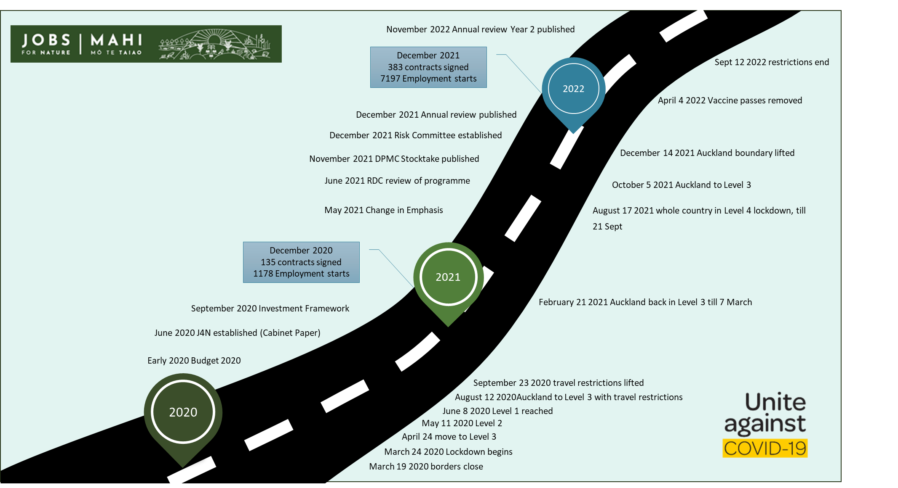

Evaluation criteria
The Organisation for Economic Cooperation and Development (OECD) Development Advisory Committee (DAC) has defined six evaluation criteria recognised as international best practice in evaluation:
- Relevance: Was the programme aligned with its intended purpose?
- Efficiency: How efficient was programme delivery?
- Effectiveness: Did the programme achieve its outcomes and benefits?
- Coherence (Alignment): Was the programme aligned with other government and local priorities?
- Impact: What difference has the programme made?
- Sustainability: Will the programme benefits endure beyond the life of the programme?

Figure 4 The OECD (DAC) evaluation criteria
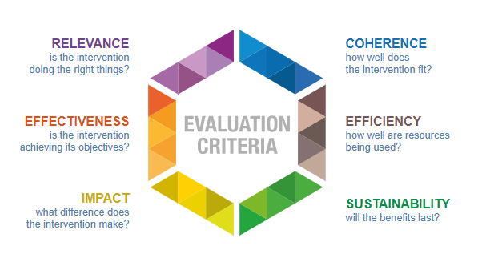
The overall programme of monitoring and evaluation work is guided by these criteria. This review can only consider limited aspects of impact and sustainability, given the nature of the interventions and the time needed to know whether lasting change has been achieved.
The above criteria relate to the programme as outlined in figure 5.
Figure 5 The DAC criteria applied to the programme logic
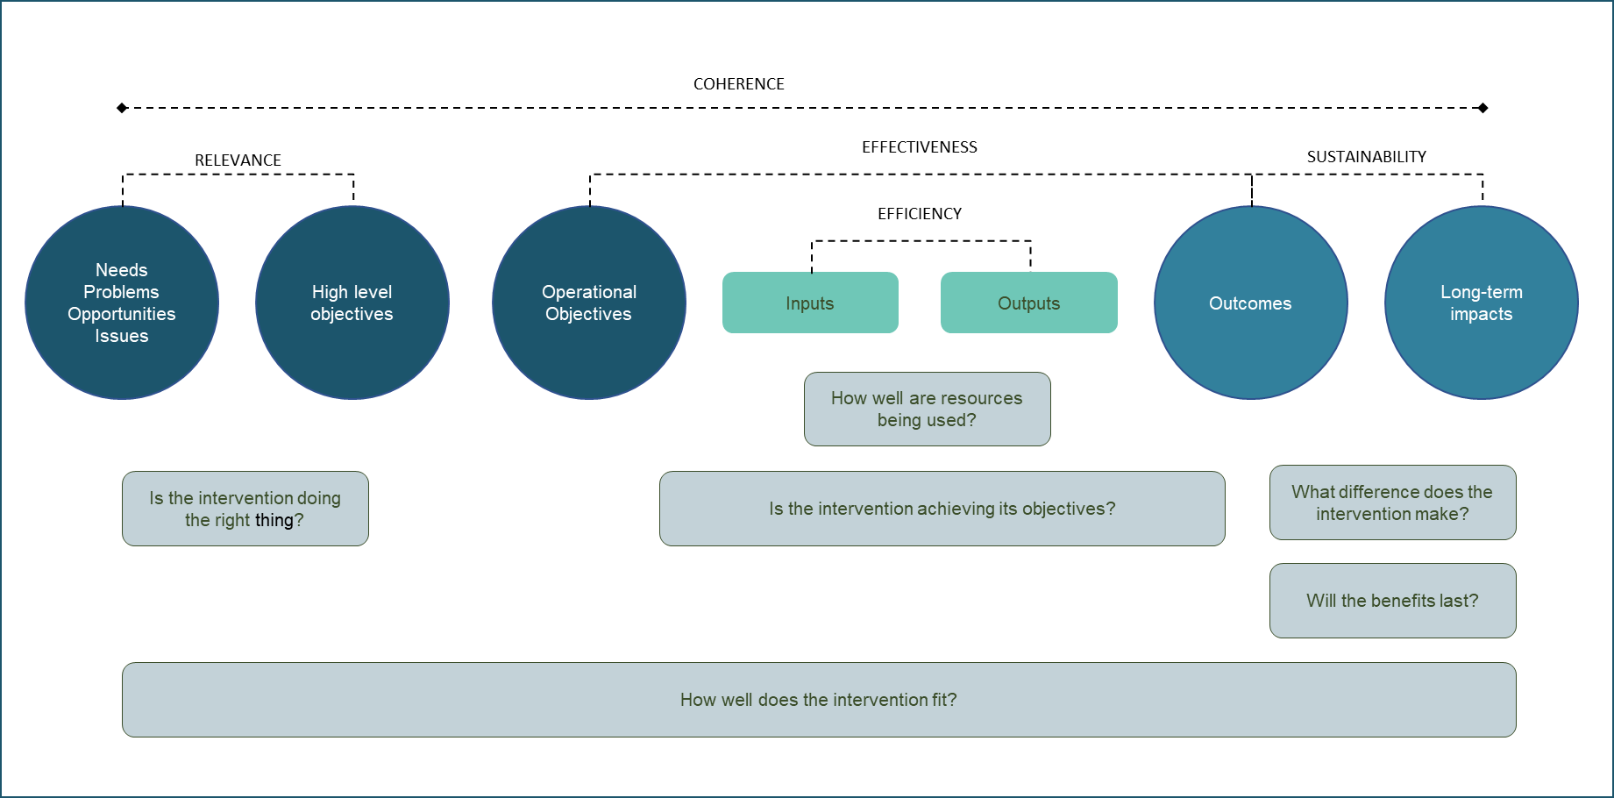
The final external evaluation of the programme will focus on the outcomes achieved and the benefits reporting looks at the long-term impacts of the programme for both people and nature. This exercise covers the issues of efficiency and elements of effectiveness. Taken as a whole, the various activities will give an overall picture of the programme and its achievements over time.

Understanding the logic behind the programme
As a first step the Secretariat together with delivery agencies drew up an intervention logic that sets out the narrative of the programme and what it is intended to achieve. This was based on the Investment Framework developed by the programme Reference Group, and other programme documentation and early discussions with the agencies. This was then summarised in a logic model that shows what the programme was aiming to achieve.
Figure 6 Programme Logic Model
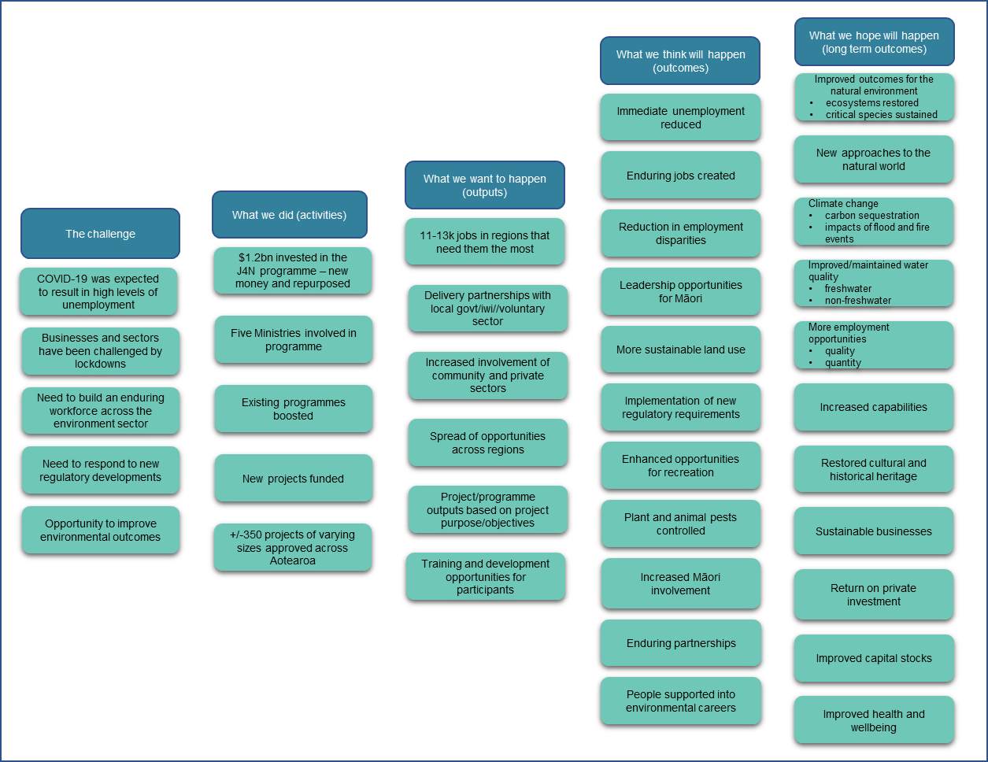

Other key frameworks
The Jobs for Nature Investment Framework (see Appendix C – Jobs for Nature Advisory Group Investment Framework) was developed by the programme Reference Group. It sought to translate the programme’s overall objectives into clear guidelines for investment decisions on how to best create jobs while directing Jobs for Nature funding towards the right interventions to deliver environmental outcomes. The framework is composed of investment principles, criteria to inform the design and assessment, and an overview of programme assurance including risk management principles.
The Investment Framework was also instrumental in helping to identify the programme benefits and measures. The Secretariat then developed the programme benefits map (see Appendix D – Jobs for Nature programme benefits map), by taking the strategic context and operating model from the Investment Framework, as a basis for preparing to assess the long-term impacts of the programme. The purpose of the benefits map is to show the Jobs for Nature programme’s unique value proposition and what New Zealanders can expect in the short-to-medium and long term because of the funding. The programme benefits map is not a static diagram, as the benefits may change over the life of the investment, and the Secretariat will update it accordingly.
The Treasury’s Living Standards Framework includes the four capitals — natural environment, human capability, social cohesion and financial and physical — which help explain the types of ways wellbeing can be positively impacted by government policy interventions. To help categorise wellbeing benefits, the programme benefits have been aligned to the four capitals.
These Frameworks draw heavily on western scientific approaches. The programme has an objective of increasing opportunities and participation for Māori. As part of the external evaluation, a Māori framework is being developed with Māori participants which forms part of the overall external evaluation, ensuring a te ao Māori perspective is captured in the course of the work and using the principles of the He Awa Whiria approach to bring the perspectives together.

Previous reviews of the programme
The programme has been externally reviewed on three occasions, with an initial external review reported in May 2021 and a stocktake review by the Implementation Unit of the Department of Prime Minster and Cabinet in late 2021. A review of funding was also undertaken in 2022 by MartinJenkins. Recommendations from the three reviews have been taken up by the Secretariat.
In addition to external reviews the Secretariat working with agencies has produced annual programme reviews following the end of each financial year of the programme. The Secretariat worked with agencies to address the recommendations in the 2020/21 Annual Review, to better support the work ahead. The key recommendations included:
- Reducing the frequency of reporting and looking for opportunities to streamline – monthly reporting in year one was amended to quarterly reporting in year two. Errors have reduced, and data quality has improved. The Secretariat has also improved the data validation process as part of a continuous improvement cycle.
- Focusing on delivery confidence through regular reporting – agencies now report on ‘delivery confidence’ for projects funded for $1 million and over, as part of their quarterly reporting. This reporting brings greater visibility of any risks, and of how agencies are managing these.
- Reviewing forecasts to ensure they are robust – agencies have had time to amend forecasts and project plans with funding recipients. Forecasting and reporting now aligns with the July to June financial year.
- Finalising and embedding reporting on programme benefits – the programme benefits report sets out the wellbeing, environmental and economic benefits that have been and will be delivered through the Jobs for Nature programme.
- Designing an approach to programme evaluation - the Secretariat has designed an evaluation approach, together with agencies and the Advisory Group.
- Developing a transition strategy – Crown funding for the Jobs for Nature programme is allocated for a limited time. Some short-term projects are already complete, but most of the 421 approved Jobs for Nature projects are being delivered and are scheduled to be completed over the next three years. Attention is now on a transition strategy, to support projects and people with planning for after the Jobs for Nature funding has ended.
- Co-designing and piloting with partners a ‘community of practice’ – a key part of the transition strategy is a network of communities of practice. Projects connect with each other and take opportunities to support their transition beyond the current Jobs for Nature funding. A national digital platform could support this network, connecting communities and projects at a national level. It would also help projects share resources, good practice, and highlight new opportunities.

The data we have and its limitations
The ability to report on the programme is limited to the current metrics that agencies provide as part of regular programme reporting, and the small sample of information collected through the benefits survey. The full list of metrics currently reported to the Secretariat is in Appendix E – Benefits indicators framed by capital. This report draws on a subset of available programme metrics relevant to wellbeing or environmental benefits. Other data may be reported but does not cover the whole programme.
This report relies solely on data and information reported by Jobs for Nature agencies and, in most cases, quality and assurance checks were in place to vet the data. It also draws on external publications and scientific research where relevant.
Data from agencies for reporting on their planned activities annually or for the lifetime of the project is incomplete. There are inconsistencies in the data between what environmental outputs are planned and what has been achieved. In some cases, no metrics for planned outcomes are reported, making it difficult to compare programme performance against the target.

Implementation state of play

Overview
At the end of year two the programme had approved 421 projects, with 402 of those being contracted. These projects had employed 9,262 people, who had worked 4,458,612 hours. This meant that 91 per cent of the money had been approved for projects. Most projects were in the delivery phase and 28 were already completed, although many projects were slower to start than originally anticipated.
These projects range significantly in size, scope and type. These e large national initiatives with existing infrastructure to govern, oversee and align the Government’s initiatives on sustainable land-based sectors spanning multiple years, to small, locally based initiatives developed specifically for the programme. There was also a mix of funding mechanisms, including direct funding and contestable funding.
Figure 7 Programme key outputs at end of year two (30 June 2022)
While most projects were on track to meet their agreed milestones, COVID-19 has caused issues for employment and supply chains. Regional lockdowns and ongoing worker availability issues due to illness affected employment outcomes, as did the overall state of the labour market. In practice, the unanticipated effect of ongoing illness has had a major impact on some projects, while the unexpectedly small increase in overall unemployment has contributed to recruitment difficulties in some sectors and regions.
In addition, two key supply issues emerged in the second year:
- The rising rate of inflation from 3.9 per cent in June 2021 to 7.3 per cent in June 2022 resulting from increases in costs of materials such as fuel above the level of inflation budgeted for (around two per cent per annum). This is even more marked when looking at producer prices where inputs (all industries excluding admin, health and education) for June 2022 show a 10 per cent rise from the same quarter of the previous year, and farm expenses (excluding livestock) show a 13.7 per cent increase over the same period.
- Supply chain disruptions (for example in fencing materials) began to cause delays in project delivery. A shortage of skilled fencing and planting contractors, a shortage of plants from regional nurseries, and high rainfall and flooding were also reported as preventing some work from being completed as originally planned.
In addition, wage costs increased with the increase in the living wage, which is generally the minimum paid by projects. This presents a challenge for agencies, requiring discussion on whether to increase funding (where this is possible) or altering output targets to recognise the situation.

The key barriers from COVID-19 management actions were lockdown of all non-essential activity (alert level 4)
- restrictions on trading activity (alert level 3)
- border restrictions
- domestic travel restrictions (including in and out of Auckland and Northland)
- limits on gatherings and public venues.

Fund allocation
The programme drew on the agencies’ significant knowledge and relationships that had existed prior to the programme. This meant agencies could move with haste to leverage this knowledge and these relationships for COVID-19 jobs. It was felt that while a more ‘efficient/integrated’ programme may have had efficiency gains, it might have achieved less without the agency-specific knowledge and support.
Initial allocation decisions sought to address the immediate impacts of COVID-19. A range of allocation approaches were adopted across the programme, which evolved over time. Initial responses included targeted “quick starts” (no-regrets quick funding decisions), with redeployment of forestry workers to wilding conifer control as the forestry supply chain was shut down due to ports being closed, and redeploying workers from distressed tourism businesses (due to border closure) to conservation work.
Later approaches included co-funding, with multiple agencies working together (for example, Te Uru Rākau/Kānoa), competitive funding rounds (for example, Freshwater Improvement Fund, DOC Community Fund, Private Land Biodiversity Fund), targeting types of groups (for example, Te Mana o te Wai fund).
Some funding was directed into existing programmes or mechanisms, but others required processes and structures to be created. For example, LINZ used Jobs for Nature funding to expand its established biosecurity and biodiversity programme, focusing on land where LINZ had responsibilities (mainly Canterbury and Otago). Similarly, Biosecurity New Zealand (BNZ) funding went to existing programmes (wallabies and wilding conifers), not individual projects.
The programme-wide approach to funding was through the Investment Framework, developed by the programme Reference Group (see Appendix C – Jobs for Nature Advisory Group Investment Framework), which provided high-level guidance across the funds.

Initial feedback on the programme
As with most publicly funded programmes, it is difficult to strike the balance between fiscal responsibility and management of public funds, and ease of process for the applicant. Feedback from both the Reference Group and the applicants was that preparing and submitting funding applications required a high degree of effort (and therefore cost), and many applications were unsuccessful due to significant oversubscription of the contestable funding rounds.
The Reference Group advised agencies to take a 'single window' approach and have one path into the programme, with consistency around information gathered and an ability to pass applications across to another funding stream if the one applied for wasn't the best fit. There was also advice from the Reference Group to use common or joint contracts across the different agencies.
Agencies initially explored how this could be done and what information was common across the different processes. After preliminary investigation, the barriers and costs of aligning application processes a year into the programme (after many of the funding rounds had already been open for application) was considered to likely be a high effort and low reward exercise, which agencies were not resourced to undertake concurrently with delivering on the programme. There was then an attempt to streamline contracting and monitoring data requirements across the programme, but this proved to have insurmountable barriers within agencies due to internal processes, contracting requirements and other administrative system and process barriers.
Contestable processes used approaches ranging from calling for fully developed proposals to multi-stage approaches starting with Expressions of Interest (EOI). Some funds incorporated feedback received on the application processes. As an example, the Freshwater Improvement Fund adapted their process so that recipients only provided a short EOI initially. The top rated EOIs were then selected to provide a full application, with a high chance of being funded. This was reported as being well received by recipients, who took less time and effort to present their EOI and were given a good chance of receiving funding if progressing to a full application. Feedback was also given to recipients who were then offered the chance to provide a full application, making the process easier for everyone with less guessing from recipients. It also resulted in a lower administrative overhead in assessing the proposals.
DOC funding used a range of approaches with just over half allocated to contestable and regional funding, the remainder being targeted funding for specific purposes. This was designed to enable a range of approaches covering smaller allocations that could be widely spread and more effective at a local level and larger funding amounts that could be more targeted. A reported trade-off of this approach was the increased overhead of managing many small projects, including lack of capacity or experience in some recipients.
As well as a mix of scale and administrative approaches across the funds, there was a mix between “quick starts” and more strategic projects. Responding to the immediate issue was a priority, but in some cases this speed of development led to some elements of the project, especially budget estimates, needing to be renegotiated as some costs had been underestimated. Initial targeting for some funds was largely towards areas suffering the greatest impacts from COVID-19, but other needs on the ground were also taken into account. Others took a broader approach – the Public Waterways and Ecosystem Restoration Fund (PWER) managed by MfE aimed to ensure that at least one project was included from each regional council.
There were some examples of joint projects, for example between Kānoa and Te Uru Rākau. This involved separate contracts with each agency. While the alignment and extra support across agencies was reported as positive in being able to draw on the different strengths and resources of each agency, there were also issues with different reporting requirements and different project officers, leading to potential confusion or inconsistent advice, especially over time if personnel changed. The Secretariat has worked with agencies to develop a protocol on joint funding to improve communication, but the mechanism itself remains cumbersome.

The state of play after two years
At the end of year two, 91 per cent of the money had been approved for projects. Most projects were in the delivery phase and 28 projects were already completed, although many projects were slower to start than originally anticipated for a variety of reasons including lengthy approval and contracting processes. The level of implementation varies between agencies and funds, with some having more focus on quick-start projects, while others had more concentration on more complex or strategic projects. It is worth noting, the majority of MfE funding not yet approved was for the Essential Freshwater Fund. At the time, the Essential Freshwater Fund was re-orienting its funding strategy to address capability and capacity gaps in the freshwater management system (for example, Freshwater Farm Plans). Essential Freshwater funding was fully approved in August 2022 and projects are in development and delivery now.
Many of the new initiatives funded had large and dispersed groups of stakeholders including, in many instances, central, regional and local government partners, private and public landowners, and iwi/hapū in regions where projects had commenced. Projects involving a single organisation have generally been easier to stand up.
Figure 8 State of funding implementation at end of year two ($ Million)
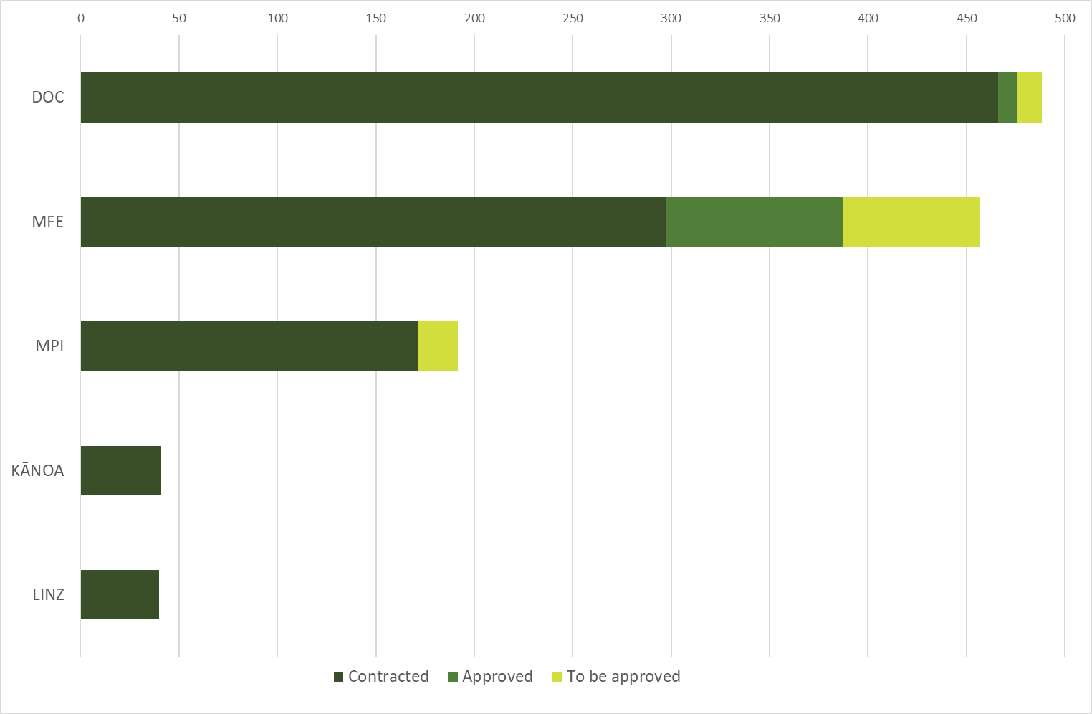
In allocating funding the agencies took account of a range of factors, including regional distribution, needs on the ground and the type of recipient (including councils, community organisations or Māori organisations). Other criteria varied between funds but included project readiness, sustainability of outcomes and cost per job. The pattern of distribution at the end of year two is shown in figure 9.
Figure 9 Distribution of Jobs for Nature funding by region
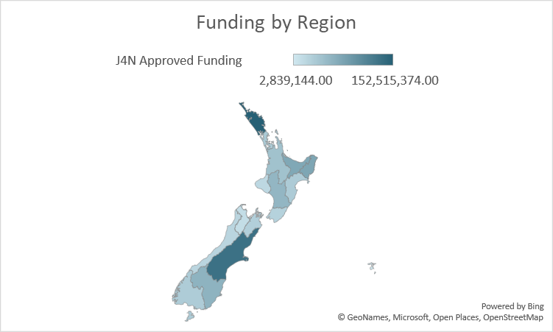
The Northland allocation is skewed by the inclusion of the $100 million for the Kaipara Remediation project, which sits across the boundary between Auckland and Northland, and is jointly funded with Auckland and Northland councils and landowners. The Jobs for Nature contribution is about half the total long-term planned funding.
The rate at which funding approved to projects has been spent is shown in figure 10. The overall rate for the programme was 33 per cent, with $367.8 million paid by June 2022 out of the total approved funding of $1,115.1 million.
Figure 10 Payments of approved project funding ($m) by agency (end of year two).
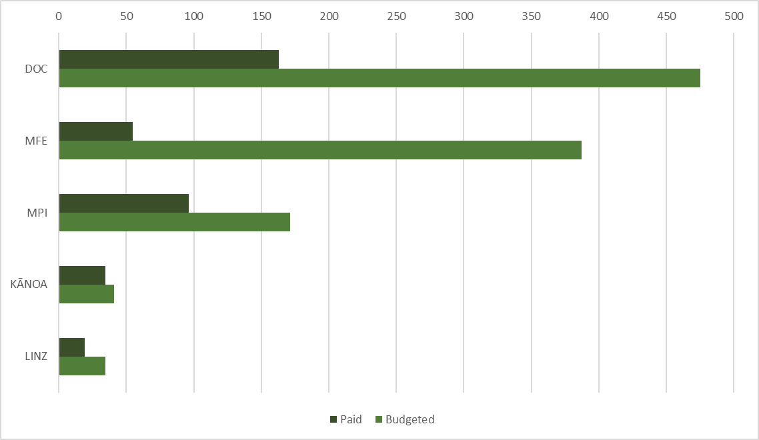
The rate varied widely across individual funds – even within agencies. For example, rates within MPI varied from 47 to 82 per cent.
Some of the observed lag may be due to the time taken between approval and the final contract being signed. Again, this can vary depending on the agency processes and the complexity of the project, but it is worth noting as a source of frustration from projects. The need for Reference Group endorsement and ministerial approval of projects over $1 million also added to the time taken.
Factors affecting approval and contracting times largely relate back to the difficulties of operating in a COVID-19 environment (as described in previous sections) leading to projects being slower to reach their full operating capacity, rather than an inability to use the funding for the intended purposes.
Established programmes were best able to create employment opportunities quickly, by drawing on existing relationships with third parties and existing programme management structures, including contract management, governance and approval processes. For example, at 30 June 2022 the Wilding Conifer Programme (an established MPI programme) had led to 1,556 employment starts, representing a major contribution to results in the early stages of Jobs for Nature.
Developing new relationships does take longer, but brings benefits of future, potentially wider, relationships. One key outcome of the programme is that projects and community groups build relationships and networks across an array of different groups, including developing close working relationships with council staff. Over time it is expected that they will develop considerable experience and strategic networks that will help implement system-wide change through integration between local, central and regional levels.
These networks are a valuable resource and should be encouraged to support other nature-based investments and build on the foundation that exists because of this programme.

Further detail on funding breakdown
A range of organisations have been supported by the programme, with almost half the money being distributed through local government and charitable trusts. At the end of year two of the programme, 14 per cent of funding was reported as distributed directly to Māori recipients. This is likely to be an under reporting due to the limitations in the data used to generate this number, which has been subsequently updated for future reporting cycles. In addition, it is a non-exclusive category, so there may be Māori organisations who have selected a different category in reporting. Overall, this figure is considered to underrepresent funding going to Māori recipients for example, DOC is now reporting close to 50 per cent of funding for iwi-led projects which is not yet reflected in the overall reporting.
It is also worth noting that these are the contracting parties, and there are likely to be other (potentially many other) organisations involved in projects. The figure is also likely skewed due to the proportion of funds channelled through local government. For example, many DOC projects have several sub-projects but information on project partners is not collated at programme level.
Figure 11 Distribution of funding by organisation type
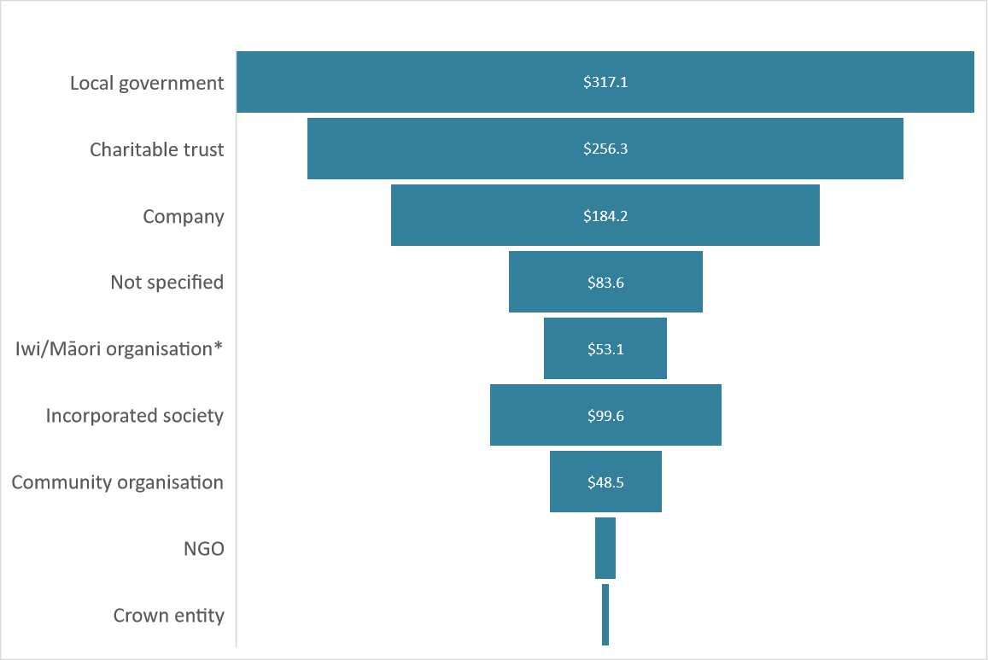
* Māori organisations are self-identified, and this area of reporting has been subject to data improvement going forward to address significant under-reporting.
Projects set out to deliver a range of (non-exclusive) objectives ranging from ecosystem restoration to regulatory implementation.
Figure 12 Project intentions as reported by projects
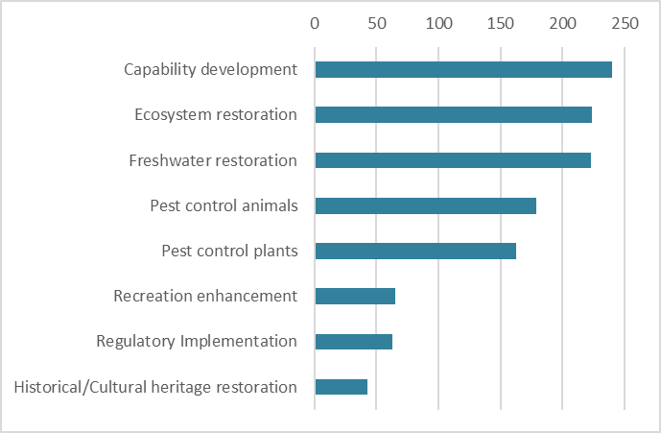
Nationally, councils, community organisations, and mana whakahaere have identified many environmental projects that sought Jobs for Nature funding as part of the ‘build back better’ aspirations post COVID-19. They estimate that there is a significant gap between what funding was available versus what was required, with the overall need close to 10 times the funding that was allocated to Jobs for Nature.
From the programme perspective, all the contestable funds were highly over-subscribed, with some MfE funds receiving applications for four times the available funding, and DOC receiving formal and informal applications for over $3 billion. Even after triage against the programme objectives, projects seeking double the available funding were assessed. In some cases, suggestions on alternative funding were provided, but the total applied for was hugely in excess of resources available for environmental investment.

How effective has Jobs for Nature been so far?
This section looks at what the programme achieved in the first two years of operation, recognising projects are still in their delivery phase, and it will take time to determine whether longer term aspirations will be met.
The Jobs for Nature programme was set up to directly support regional communities through the economic crisis resulting from the COVID-19 pandemic. The primary focus was on getting New Zealanders back into work and protecting their wellbeing, retaining or redeploying workers in impacted sectors, and immediately creating job opportunities that would help restore our natural environment, including training people to protect our ecosystems and reduce environmental degradation. This was a response to initial Treasury forecasts during the pandemic anticipating a sharp fall in economic activity and a substantial rise in unemployment.

Labour market context
In its 2020 pre-election economic and fiscal update, the Treasury forecast an increase in unemployment to a peak of 7.8 per cent by March 2022. This was a revision downwards from the original scenarios of 13 to 26 per cent. Forecasts also showed certain regions were expected to be hit hard by the effects of COVID-19, particularly those with a large tourism industry where the loss of revenue from international visitors would not be offset by increased spending on domestic travel. Forestry workers were also displaced due to supply chain disruptions. Creating new employment opportunities quickly was vital to support people to transition to other employment or sustain them until their employment returned.
In the June to September 2020 period, the official unemployment rate did rise to 5.3 per cent, which at the time was the biggest quarterly rise on record, with 151,000 workers unemployed. This was not evenly distributed. The NEET (Number of people aged 16 to 24 not in Employment, Education or Training) rate in 2020 was 15.1 per cent. The rate for Māori and Pacific peoples ranged from 11.2 per cent in Northland to 5.5 per cent in Nelson/Tasman/Marlborough/West Coast.
By June 2022 the overall unemployment rate had fallen to 3.3 per cent, declining from 6.7 per cent in June 2020 to an overall 5.3 per cent for Māori men. The NEET rate also declined but remained high at 12.1 per cent.

Programme response to changing context
Recognising the changing labour market context, in May 2021, SLU Ministers agreed that “agencies should place greater weight on environmental outcomes relative to employment outcomes”. This was not intended as a change to the programme objectives, but an adjustment in the weighting of funding criteria under the existing objectives, in response to the evolving labour market context.
At that point, $240 million of MfE administered funding and $89 million of DOC funding was awaiting approval for specific projects, representing about 27 per cent of total programme funding.
MfE then redesigned investment criteria for several programme funds to focus on long-term capability building and made decisions not to fund projects geared towards short-term employment. DOC shifted emphasis within the same investment criteria to give greater weight to projects with skills and training components in areas with high social need.
These jobs have moved towards roles better suited to developing career pathways, such as land management advisors and planners. These changes may result in fewer jobs relative to the original programme design, but the jobs that will be created have the potential to better address long-term programme objectives, providing sustainability of employment can be secured.

Who has Jobs for Nature helped into employment?
By June 2020 the programme had provided employment opportunities for 9,262 people, mainly paying at least the living wage. The programme reports against three employment metrics using the approach agreed by agencies across government, and endorsed by Employment, Education and Training (EET) Ministers, for collecting data on the employment results from ‘job creation’ initiatives funded through the Government’s COVID-19 response and recovery initiatives.
- employment starts
- hours worked
- people currently employed.
The full EET framework also includes people metrics, including age, gender and ethnicity of people employed and additional best practice data capture, for instance whether those employed by programmes were previously unemployed. Jobs for Nature agencies chose not to report on these metrics, given concerns around the extra burden on recipients of further reporting, and managing privacy of personal data. This results in a limited ability to understand whether the programme is reaching the people most affected by the impacts of COVID-19 on the labour market, or how well it is reaching its target audience, particularly Māori.
Kānoa uses the social procurement model and can report more data, including that 579 jobs have been filled across 35 projects. These jobs represent part-time and full-time roles.
- 53 per cent of these jobs were filled by Māori
- 35 per cent were previously unemployed or displaced by COVID-19
- 25 per cent of employees were aged between 15 and 24
- 76 per cent of employees were local.
There is currently no centralised data on the nature of work undertaken, although it is known that this ranges from basic outdoor occupations (restoration of tracks, for example) to highly skilled opportunities in, for example, forestry and support to wider environmental management. There is a mix of full-time, part-time and seasonal work, including some innovative approaches such as supporting businesses, particularly in forestry in the short-term and in tourism in the longer term, where people could switch between tourism and conservation activities according to demand.
To gain some understanding of the participants and the nature of work on the ground the Secretariat surveyed Jobs for Nature employers in April 2022. Reaching employers proved difficult due to the dispersed nature of the programme, so the response rate was low (21 per cent), but this is sufficient to give some limited but useful insights.
Figure 13 Snapshot of Jobs for Nature employer survey results
Employer survey results
71% of employers responding said their project had a positive impact on their communities, with the remainder indicating it was too early to assess the impact. | 16% of employers responding indicated their project had a mātauranga Māori focus.  22% of respondents identified as a Māori organisation.
68% told us they provided their employees with formal qualifications, with 55% of these in field work, and 13% offering technical, scientific and mātauranga Māori/ pūtaiao training. | 84% stated they offered additional training such as chainsaw, pest and plant management, health and safety, four-wheel driving and first aid.
57% reported having a positive experience being part of the Jobs for Nature programme, some commenting on being able to focus on the benefits to the environment and having an ability to retain or employ new staff to achieve their goals and support their businesses. | 77% were working in partnership with at least one other organisation to deliver Jobs for Nature outcomes; 21% partnered with local government and 18% partnered with iwi or Māori.
Overall: In addition to reporting a positive experience from receiving Jobs for Nature funding, sustainability of the project, retaining staff, and the contracting process were all top of mind for employers who responded to the survey.
Early programme outcomes reported through the survey and site visits showed strong support to help individuals, including Māori, to lessen the negative impacts of COVID-19 including:
- support to vulnerable communities and whānau who were at high risk of unemployment, or previously unable to enter the labour market
- helping maintain an income stream and generate food security throughout the economic recovery period
- reducing the risk of long-term unemployment through immediate job creation
- improved health and wellbeing of individuals through increasing opportunities to connect to nature through their employment.
At 30 June 2022, the initial objective to create between 11,000 and 13,000 employment opportunities was on track to be met.
Figure 14 Type of roles created at 30 June 2022 by main project objective (employment starts)
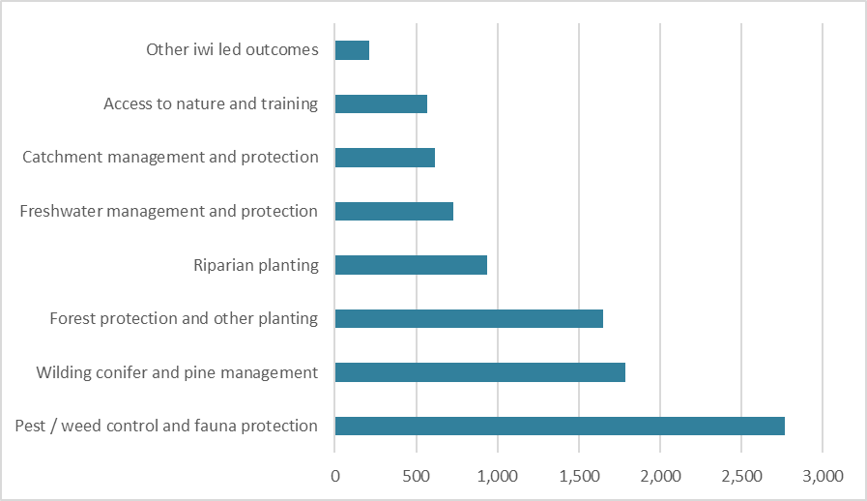

More than just jobs
Although delivering employment opportunities remains an important objective for the programme, there is also a strong focus on building capability and capacity to improve people’s long-term job prospects and fill environmental management skills gaps. It also contributes to wellbeing, which was a particular concern during the various COVID-19 outbreaks.
A large part of the programme (around 57 per cent of projects) report capability and skills development as being among their intentions, with 240 projects building individuals’ capability and capacity to work on environment-related work.
Two of the five agencies currently report on training delivered, although the level of completeness is unclear. The figure 15 provides a snapshot of reported employment and training for the programme.
Figure 15 Snapshot of reported employment and training
Agency | People currently employed | Hours worked to date | Employment starts to date |  | Number of NZQA credits earned | People in formal training | People completed formal training
DOC | 1,904 | 2,335,996 | 4,063 |  | 54 | 1,133 | 443
LINZ | 206 | 155,125 | 751
MfE | 737 | 536,222 | 1,449 |  | 105 | 362 | 202
MPI-AIS | 106 | 123,086 |  | 232
MPI-BNZ | 389 | 712,521 |  | 1,865
MPI-TUR | 144 | 241,882 |  | 344
MBIE | 144 | 353,780 |  | 556
Total | 3,185 | 4,458,612 |  | 9,261 | 159 | 1,495 | 645
Source: Jobs for Nature monitoring data (note: shaded cells indicate no data has been reported)
In the Jobs for Nature Employer survey, 67 per cent of employers responding stated they provide on-the-job training and formal qualifications as part of their project funding. The types of formal qualifications offered include:
- conservation work, trapping and planting
- project management
- administration
- mātauranga Māori.
The early outcomes from training and qualifications are that:
- training and qualifications offered through the programme lead to greater inclusivity in the labour market for environment-related employment, supporting improvements in the long-term employment prospects of those participating, and securing household incomes
- the programme contributes to creating behaviour changes in how people, communities and regions consider the environment
- qualifications in mātauranga Māori enable greater participation and support the ability of Māori to exercise autonomy and self-determination in addressing long-term environmental challenges
- the programme is helping reduce labour market disparities by creating a highly skilled environmental workforce and lifting employer capability to support Māori employees
- the pool of skilled labour to protect and preserve the environment is increasing. Jobs created in the near-term will likely be durable over the longer term as iwi / hapū, councils, communities and farmers will continue to require the services provided by an upskilled workforce.
Others, such as the Essential Freshwater Fund (MfE), focused on developing capacity and capability with job creation not being a specific focus. Later projects funded through DOC had an increased focus on training and capacity building and this was also taken into account when making any variations to contracts. As a result, 90 per cent of DOC projects are undertaking training or have capability objectives.
It is too early in the life of the programme to assess the effectiveness of training offered and the extent to which the training and qualifications will have an impact on sustainable employment outcomes.

Contributing to nature outcomes
The programme is contributing to a wide range of long-term outcomes that result in direct improvements to the environment. The environmental outcomes targeted through the programme fall into three main (but overlapping) themes:
- biodiversity conservation (for example, projects that reduce the decline of our biodiversity)
- freshwater improvement (for example, projects that reduce discharges to soil, prevent stock from accessing freshwater, riparian planting to improve water quality and freshwater ecosystems)
- pest control (for example, projects that control plant and animal pests to reduce harm to our biodiversity and vegetation, and biosecurity risks for our agricultural sector).
The programme collects detailed information on programme environmental outputs through its quarterly reporting process. These metrics were developed and standardised across the agencies. Some agencies collect other metrics specific to their funds, but these are not currently reported at the programme level.
Figure 16 Jobs for Nature environmental outputs
Area | Metric | Lifetime plan | Achieved to end of year two | Percentage complete
Biodiversity | Area of ecosystem restoration (ha) | 10,537 | 2,631 | 25%
 | Number of plants planted in terrestrial areas | 4,605,296 | 2,132,355 | 46%
 | Length of tracks maintained (km) | 2,747 | 2,363 | 86%
 | Number of assets maintained (including huts) | 356 | 259 | 73%
Freshwater | Area of freshwater restoration (ha) | 1,332 | 896 | 67%
 | Area of riparian/lake/wetland plantings (ha) | 2,582 | 1,165 | 45%
 | Number of plants planted in riparian/lake/wetland areas | 10,280,890 | 3,141,169 | 31%
 | Length of fencing constructed (km) | 11,416 | 7,032 | 62%
 | Number of fish passages remediated | 1,941 | 189 | 10%
 | Area of wilding conifers control (ha) | 2,203,142 | 1,473,029 | 67%
Pest control | Area of other plant pest control (ha) | 277,807 | 378,706 | 136%
 | Area of wallabies controlled (ha) | 1,627,306 | 801,055 | 49%
 | Area of other animal pest control (ha) | 2,178,016 | 1,499,768 | 69%
Note: Agencies can revise quarterly data when more accurate reporting is available. Some environmental outputs achieved have inflated percentages due to some projects not reporting. annual / project lifetime plans.
These outputs are expected to lead to positive environmental outcomes. At this stage it is too early to measure whether these outcomes are being achieved. However, Jobs for Nature benefits reporting is designed to understand how the long-term outcomes are tracking and forms a key part of the oversight reports portfolio.
It is anticipated the following long-term direct benefits will be achieved five to 10 years beyond the life of the programme. It is also expected there may be some spill-over benefits in the long term. These benefits are not intended as the initial reason for funding but could be expected to occur through either the direct benefits funded or through project activities.
Figure 17 Intended and potential long-term benefits
For people (human capability and social cohesion) |  | For place (natural environment) | For the economy (financial and physical)
- Contribution to a highly skilled workforce.  - Increased skills and capability of individuals to collaborate and respond to environmental management issues.  - Māori/iwi/hapū can realise their aspirations for the environment.  - Improved health and wellbeing of individuals and whānau.  - Increased connection to nature for individuals and whānau.  Potential spill over benefits 10+ years:  - Sustainable jobs in environment-based roles as careers are enabled and new pathways for environmental management are created. | - Improved terrestrial and aquatic biodiversity.  - Improved water quality of streams/rivers/lakes.  Potential spill over benefits 10+ years:  - Improved resilience of ecosystems to the impacts of climate change (adaptation).  - Reduced environmental degradation of New Zealand’s ecosystems.  - Contribution to climate change mitigation. |  |  | - Contribution to sustainable tourism growth.  Potential spill over benefit 10+ years:  - Savings to the New Zealand economy from environmental damages.

The benefits report also set out the relevant timings for the realisation of the programme outcomes.
Figure 18 How long it takes to see full environmental benefits (years)
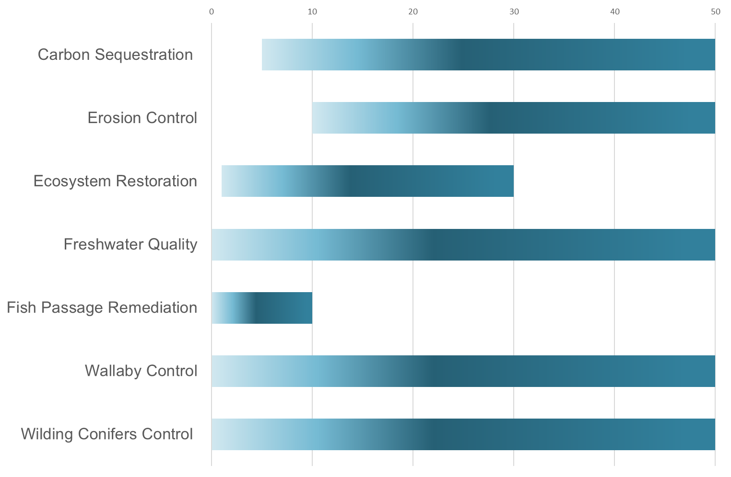
Anecdotally the programme is seeing movement towards outcomes. For example, DOC reports the programme is already making progress against many of the Te Mana o te Taiao (Aotearoa New Zealand Biodiversity Strategy 2020 (ANZBS)) objectives, including:
- treaty partners, whānau, hapū, iwi and Māori organisations are rangatira and kaitiaki – 116 of DOC projects (or sub-projects) are iwi or hapū-led. Projects are also trialling new ways of working to learn from and use going forward
- all New Zealanders have the skills, knowledge and capability to be effective – most DOC projects provide training and have helped more than 1,600 kaimahi towards earning formal qualifications
- ecosystems and species are protected, restored, resilient and connected from mountain tops to ocean depths – 26, or 11.8 per cent, of DOC’s projects support management of threatened species including hoiho, kākāriki, karaka and kauri. The $52 million Ngā Awa workstream is supporting restoration of six priority freshwater catchments.
Collectively, the programme is achieving significant benefits for the environment and for New Zealand. Less tangible outcomes result from the injection of funding to community projects that likely result in better connections and alignment of community priorities and objectives.
Empowering smaller organisations to plan, lead and kick start visions they may have held for some time, and engaging local people to help achieve those visions, are also reported as significant outcomes.
As well as the work of the projects themselves, the programme has also developed supporting or enabling tools for projects. For example, LINZ supported the use of geographic information system (GIS) applications to collect data, support evidence of environmental outcomes, and make informed decisions on the programme. Seven field apps have been developed for use by LINZ project partners. MfE has also invested in new monitoring technologies. There is no evidence yet of agencies working together on these, but there are opportunities.
Some projects have faced unexpected challenges outside the control of the project. Some of these have the potential to impact on the scale and timing of outcomes. These range from natural events (particularly flooding) to human behaviour such as the reported destruction of plantings by recreational four-wheel drivers. These are on top of the knock-on effects of COVID-19 noted earlier, such as increased cost of materials and labour, supply chain disruptions affecting access to materials and labour, and a tight labour market affecting ability to recruit staff in some cases.
One issue noted by several agencies was the development of an expectation among projects that there would be a continuation of funding, despite it being made clear from the outset that the programme was time limited. This issue was also identified by the Advisory Group, who noted the potential tension between developing long-term relationships (and associated expectations), and the time-limited nature of the Jobs for Nature programme. Projects, agencies and the Secretariat are working on transition strategies ranging from alternative funding to projects becoming self-supporting to ensure the benefits achieved can be sustained. It is important to the agencies and the participants that communities should not be left worse off at the end of the programme.
The future funding of environmental investment was the subject of a paper from the Jobs for Nature Advisory Group to the SLU Ministers, acknowledging that the issue is bigger than Jobs for Nature, and more than just direct grant funding.
In general projects were not solely funded by the Jobs for Nature programme, but attracted funding from other sources, ranging from local and regional councils to projects’ own resources and private funds (for example from landowners or businesses). The programme has reported that over $220 million of non-Jobs for Nature funding has been leveraged as a result of this programme, representing an approximately 20 per cent of additional approved funding.
While financial contributions can be quantified, a significant proportion of support is in the form of in-kind or volunteer contributions, which are difficult to measure consistently. These range from volunteer labour to supply of resources such as premises and tools. As well as direct employment, projects also support activities such as internships and cadetships. Some projects have this as their main focus; for example, Bay Conservation Cadets (MfE funded), Predator Free Apprenticeship Programme (DOC funded), Sentinel ā Nuku (DOC–Nga Whenua Rahui funded). Projects report on these, but the information is not held at programme level.

Working together
The programme is a good opportunity for inter-agency coordination. Agencies are connected through the programme and leveraged off the group’s strength and resources. In particular they discuss overlaps and collectively manage risks. While there are frustrations in some corners over the level of coordination (both too much and too little), nevertheless it was an achievement in a system where the underlying separation of organisational responsibilities and differing operating models make collaboration difficult.
The programme has brought some agencies into direct contact with people and organisations they would otherwise not have reached. It also allowed some synergies within agencies through sharing of contacts and expertise. Kānoa, for example was able to connect to several groups and pass on contacts, enabling nurseries within their projects to position themselves as credible, quality plant suppliers.
The programme has enabled agencies to support projects in partnership with iwi and rūnanga, regional councils, community trusts and other agencies. Agencies have reported that it has taken time to build levels of trust and understanding in some cases, as is the nature with new relationships. In others, where work on relationships had been underway for some time, projects were able to move faster.
In funds where projects were developed collaboratively to ensure they met local needs and conditions, there were benefits from building relationships which also helped with the subsequent management of the project. This did add time to the process, so the benefits had to be offset against the need for speed at the start of the programme. Over time the initial imperative to move at pace decreased, giving more space for relationship development.
In some cases agencies or projects have worked with other agencies outside the SLU group. For example, DOC has been formally working with the Ministry of Social Development (MSD) on employment matters, including finding employment opportunities post Jobs for Nature, and it is likely this will be a focus for others through the transition work that is getting under way to support projects moving away from Jobs for Nature funding at the end of the programme.
The programme not only brought agencies together with organisations on the ground, but it also brought together or, where relationships existed, supported cooperation between organisations across local areas. Some projects, such as Reconnecting Northland (He Ripo Kau), have been proactive in bringing people together.
In many cases projects were able to demonstrate activities and benefits that encouraged others to undertake environmental and conservation activities outside the programme.
All the funds recognise the importance of supporting and working with iwi/Māori, and this takes many different forms, from Māori-led projects and co-governance of projects to specific funding for Māori organisations or projects on Māori-owned land. In terms of project content, many projects are undertaking training in or are being guided by mātauranga Māori.
The programme monitoring process is limited in how it reflects outcomes for Māori. Factors such as the nature of employment are not well reflected in the monitoring data collected, since that is data without context or quality information. This reflects the general context of integrating mātauranga Māori into traditional assessment and monitoring frameworks, and is an issue faced by many agencies. This will be addressed through the wider external evaluation programme, including a specific piece of work on evaluating the programme with a te ao Māori perspective. Agencies are also investing in understanding outcomes for Māori. There is also an opportunity to capture this information through project closure reports which can reflect more qualitative outcomes from the projects. The Secretariat is actively working with agencies to coordinate consistency across these reports to enable the drawing of cross-agency lessons.

Conclusions on programme effectiveness
Jobs for Nature projects have generally been shown to have made significant achievements on the ground, in some cases despite difficulties associated with the uncertainties and barriers of COVID-19 itself, including additional lockdowns, absences due to illness and supply chain disruptions. Secondary issues such as increases in costs and supply shortages and the more resilient than expected labour market have also been problematic for some projects. These issues have also been challenging for the agencies to manage.
Jobs for Nature is the first significant programme in the environment sector that has also had a substantial focus on developing human capital. There has been little monitoring of progress on the development of human capital beyond the core employment statistics, meaning there is currently no objective way to assess whether the programme is reaching the groups it was intended to support, despite the very positive feedback from projects on the ground.
This may result in a significant underestimation of the human impact of the programme and reflects the importance of being able to objectively capture this information.
With the benefit of hindsight, the situation in which the programme was implemented led to some decisions that were not optimal, although many of the identified gaps have been worked on over time, and the programme-level processes have improved. This was fundamentally a “no regrets” approach, where making any decision is better than none where the cost of inaction risked being far higher than the cost of action, given the level of knowledge available at the time. The consensus is that the programme is achieving good outcomes, but it could have achieved even more had it been set up in other circumstances (outside of COVID-19 context), or as a more coordinated model. The programme will struggle to fully demonstrate its achievements, or to understand where opportunities might have been missed, because monitoring at the programme level has been focused on environmental outputs rather than overall outcomes.
There is concern across all agencies about the process of transition to sustainable funding even though in many cases it was among the investment criteria for the funds. The general shortage of funding across the sector remains a critical issue for some projects, potentially leading to competition where cooperation is instead essential. There are many examples of projects that are actively managing transition, including generating sustainable funding, and agencies are actively engaged in supporting projects in their transition planning.
At the very least the programme needs to be able to assess whether it has reached the people it was intended to. Basic demographic statistics (including age, gender and ethnicity) are fundamental additional requirements that need to be captured from the projects, even if only through project closure reports. The collection needs to comprise consistent metrics across the programme that are also compatible with those being developed for wider programmes. Without this basic information it will be impossible to assess or demonstrate the value of the programme.
Information on capacity building (which is clearly more than just training) is also lacking. Given the breadth of the programme this is of necessity likely to be qualitative and descriptive, but consistent approaches to reporting will support more rigorous analysis, and an understanding of needs and how they have been met.
Agencies will always concentrate on their core business, but for cross-agency programmes such as this there is a need for a strong coordinating role that keeps a focus on the overarching goals of the programme and ensures oversight of the bigger picture.

How efficient has Jobs for Nature been so far?
This section looks at governance, financial management, operations management, stakeholder management, strategic management, benefits management, learning and leverage, systems and support, and how these elements played a role in the success of the fund or created unnecessary complexities.

How the programme was designed
When approved in July 2020, ministers agreed a shared approach to the $1.3 billion of environmentally focused funding under the name “Jobs for Nature”. Of that funding, $1.1 billion was part of the Government’s COVID-19 Response and Recovery Fund under Budget 2020. This funding is time limited, ending after financial year 2023/24. The remainder was repurposed from agencies’ existing programmes or other funds.
There have been some subsequent adjustments to the funding including repurposing to other priorities, so the funding envelope stood at $1.219 billion at 30 June 2022. Various implementation models were discussed, including a shared centralised model with resources seconded in from the agencies, although the initial Cabinet paper only indicated a possibility of joint procurement or joint contracting.
In practice the budget was split across five Sustainable Land Use agencies, through 25 funds, with each agency responsible for administering and monitoring their own funds (see Appendix F – Agency evaluation initiatives). This, and the fact agencies had very different internal structures and procedures, focuses, priorities and drivers (some with regional presence and others not), led to complications in coordination and standardisation of reporting. There are some examples of agencies co-funding projects, but none were through joint contracting arrangements.
Although agencies (and to some extent funds) managed their financing autonomously, the governance structure included joint decision-making by SLU Ministers on funding for projects above $1 million. While this was designed to ensure good governance and a degree of coordination (including through review by the Reference Group), it introduced a heavy process burden when for example, relatively minor contract variations potentially required ministerial sign-off. The original Cabinet paper noted that SLU Ministers would revisit the threshold, and after discussion a proposal to raise the delegation to $2.5 million was made but was not agreed to. There was an exception for pre-existing programmes that had their own governance mechanisms that took precedence.
Coordination between agencies was managed through a Deputy Chief Executives’ (DCE) group as the programme moved into delivery. In practice, membership of this forum has become more mixed over time as the programme has matured, and usually attendance is typically at a Tier 3 Director or Tier 4 Manager level. This might suggest that perhaps a more operationally focused forum was necessary with a three- to six-monthly DCE meeting to focus on programme progress. The Advisory Group also reported their role becoming more diffuse, with lower access to ministers and cross-agency senior staff.
In July 2021 SLU Ministers agreed the Reference Group be reframed as an external Advisory Group, with a revised terms of reference and a reduced and amended membership.
Many models now exist for inter-agency working with differing levels of formality and governance methods. Jobs for Nature is at the lighter touch end of the spectrum, with a coordinated approach to some programme reporting through harmonised metrics. The structure has advantages and disadvantages – on the one hand, in principle it enabled a faster approach at the start, but from the perspective of the project promoters it resulted in different processes, complexities in reporting and a confusing structure without a central source of information.
Environmental output targets were not defined at the outset and were largely determined by the projects proposed by applicants and approved, where appropriate, by SLU Ministers. The employment metrics were only agreed in December 2020, driven by the Jobs for Nature Secretariat working with EET and StatsNZ. Before this there was no consistent way to report on or measure job creation across government. More broadly, there remains a general lack of agreement or understanding of what constitutes a job, an issue faced across several government departments. Given many Jobs for Nature employment opportunities are seasonal or involve innovative part-time or flexible approaches, this is more difficult to define in this case. For some purposes an estimate of full-time equivalents (FTEs) is calculated based on a definition from StatsNZ, but needs to be used with care to avoid inaccuracies.
The challenges in coordination also meant programme reporting did not capture some important metrics needed to understand whether the programme was reaching the people it was intended to reach, and what benefits were being delivered as a result, both for the individuals and the programme as whole. While some agencies recognised the relevance of the information, others still question the relevance of demographic data.
was out of establishment mode, to reduce the cost of monitoring overall. Some projects reported needing to recruit administrators to deal with project administration – project designs appear to have underestimated accountability requirements, and the level of reporting required was a concern for both projects and agencies. The reporting requirements at programme level were reduced in frequency from monthly to quarterly once the programme same time some requirements and processes collected a range of information that was not particularly useful in practice.
Internal systems in both projects and agencies for managing funds faced, and in some cases still face, challenges – especially in agencies where the funding streams were new, requiring everything to be stood up from the beginning. Some of this reflected the need for speed and urgent environment at the start. DOC, for example, set up a new unit to manage the Jobs for Nature programme. Agencies report this meant delays for some funds, which have impacted implementation rates. Funds that built on existing programmes had the fewest issues with this, because they could leverage existing systems and processes.
The programme-wide arrangements were only instituted several months into the programme, often on top of the arrangements for existing programmes. Existing programme funds did not always have to follow these arrangements; for example, only new programme funds were subject to SLU Ministers’ approval. The DPMC Implementation Unit found that many programme arrangements duplicated agency processes or imposed additional processes, particularly for approvals and reporting, which meant some contracts had to be amended to meet new reporting requirements.
The DPMC Implementation Unit report provided an outline of the average approval process and various stages involved, including time taken for the projects they examined.
Figure 19 Illustrative steps in the Jobs for Nature programme approval process
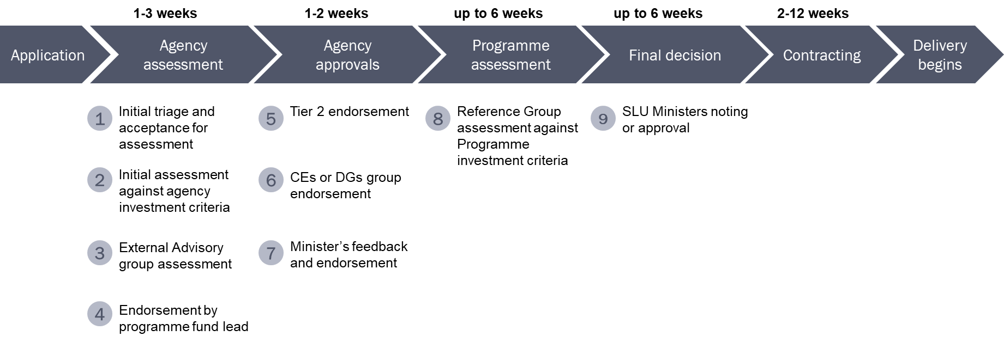
Source: DPMC Implementation Unit stocktake report
They also found the processes meant some approvals reportedly took up to nine months, and some projects went through up to 10 layers of consideration before reaching SLU Ministers for decision.
The time from approval to project start is the only stage for which we have programme-level data. This showed the average reported time from approval to contracting across the programme was 16 weeks during the first two years. This does not include the time taken from application to approval.
Figure 20 Average weeks between approval and project start by agency and funding level
 | Not specified | <$0.5m | $0.5m–$1m | $1m–$2m | $2m–$5m | $5m+ | Overall
DOC | 15 | 13 | 14 | 14 | 15 | 10 | 14
LINZ |  | 0 | 0 | 0 | 0 | 0 | 0
MfE | 32 | 19 | 17 | 29 | 28 | 35 | 25
MPI-AIS |  | 18 | 10 | 31 | 22 |  | 18
MPI-BNZ |  |  | 3 | 3 | 26 | 3 | 9
MPI-TUR |  | 9 | 19 | 13 | 11 |  | 15
Kānoa |  | 8 | 10 | 10 | 12 |  | 10
Programme average | 27 | 13 | 14 | 18 | 19 | 18 | 16
While the larger projects (by funding) might be expected to take longer, the amount of funding does not correlate to the level of complexity, so no real pattern can be established. Organisation type also does not seem to have a clear impact on the length of the process.
Figure 21 Average weeks between approval and project start date by organisation type
 |  |  |  |  | MPI
Organisation Type | DOC | LINZ | MfE | AIS | BNZ | TUR | Kānoa
Charitable trust | 13 | 0 | 26 |  |  | 0 | 11
Charity |  |  |  |  |  | 7
City council | 9 |  | 39
Community | 20 |  |  | 20
Company | 12 | 0 | 22 |  |  | 11 | 9
Crown entity | 17
District council | 23 |  | 24 | 1 | 3
Government organisation | 4 | 0 | 17 |  | 3 |  | 20
Incorporated society | 13 |  | 26 |  |  |  | 8
Individual | 15
Māori landowner | 20 |  | 10 |  |  | 26
Māori organisation | 17 | 0 | 3 |  |  | 16
Non-government organisation |  |  |  |  |  | 9
Regional council | 12 | 0 | 23 |  | 11 | 19
Other |  |  | 36
Agency average | 14 | 0 | 25 | 18 | 9 | 15 | 10
The data does not properly reflect the complexity of the projects. The recent MartinJenkins funding review found most of the projects with significant delays in implementation involve a range of partners, and the coordination required to start and agree projects is what is causing delays. Even then there are differences between projects where the partners have existing relationships and those where building the partnership is an integral part of the project itself – which by its nature slows the process at all stages, including the project design and set-up.

Working in partnership
Partnership arrangements often come with contributory funding through actual funding, or in-kind donations such as the use of facilities and volunteer hours from individuals in local communities. Around 177 projects have reported other non-Jobs for Nature funding, although it is difficult to assess the level of contributions based on current reporting, and so the full extent of leverage achieved.
Another reported advantage of the partnership approach to projects is the potential for them to be more enduring once the Jobs for Nature contribution ends than projects solely funded by the programme. The tension between partnership and time-limited funding still remains, as partners want to see Government co-invest beside them.
The Secretariat and agencies have made changes to strengthen delivery across the programme. Programme management and governance arrangements within and across agencies were judged by the DPMC Implementation Unit to be appropriate for managing delivery, although it suggested agencies could more actively validate that projects are delivering their intended outputs, particularly related to workforce development components.
The DPMC Implementation Unit suggested that future cross-agency programmes could significantly reduce administrative workloads for funding recipients by aligning applications, contracts and reporting into a single source. Currently each agency and fund has different processes for applications, contracts, and reporting and this adds considerably to workloads of recipients who seek and/or receive funding from multiple agencies.

Cost of implementation
Agencies, except for Kānoa (MBIE), received budget from the programme for implementation and management overhead. Overall, Including the cost of the Secretariat, this averages out at just over 6 per cent, which is broadly in line with international guidelines for development projects. In practice it is probably slightly higher, as some existing programmes support their projects through current infrastructure.
There is variation between the agencies, with MPI and LINZ being the highest, reflecting the lack of economies of scale for their smaller allocations. DOC appears to run the leanest operation at 3.33 per cent compared to MfE’s 6.23 per cent for a similar level of overall budget. There is no information on the trade-off between low overheads and the capacity to manage effectively without putting too much strain on staff at either end of the transaction. DOC recognises this is particularly lean, and any future programme would have a higher overhead cost forecast.
Projects also have operating costs, mainly related to the cost of materials and services, some of which have increased significantly in price or been affected by supply chain difficulties (as noted above). At this stage it is not possible to assess what proportion of costs are for staff. Analysis of the small number of completed projects where data has been provided shows it varies from around 30 per cent up to around 70 per cent with a few co-funded projects spending more than the Crown contribution. This sample is too small for considered analysis at this stage, other than to suggest that materials and other costs are a significant element of overall project costs. In addition to operating costs, agencies had policies on the amount of budget funding projects could use towards programme management costs (ranging from 0 to 10 per cent) depending on the fund and/or agency. Projects with lower allowances particularly reported struggling with the administrative requirements of the programme.
Questions have been raised about whether the jobs created through this programme reflect value for money. The initial thinking around the original objectives of the programme, to create between 11,000 and 13,000 employment opportunities over the full term of the programme, used an approximate yardstick of $100,000 per job. This takes no account of the cost of infrastructure, materials and equipment needed to carry out the work, or the value of the environment outcomes achieved. By the end of June 2022, the actual average cost per job calculated on the same basis was around $128,696. This may reflect a combination of factors:
- start-up costs that will be amortised over the project life
- cost increases generally, particularly fuel and materials
- increases in the living wage since the start of the programme
- moving away from living-wage entry-level jobs to higher skilled, and therefore more costly, jobs in line with the move to more emphasis on skills and competences.
Some projects also involve tools and technologies that are expensive but justifiable in terms of environmental outcomes – for example, the typical cost of treating dense infestations of wilding pines can be $2,000 per hectare to aerial boom spray.
Based on the achievement of the programme at the end of year two, the average cost per agency is outlined in figure 22.
Figure 22 Average cost per opportunity created by agency (at 30 June 2022)
Agency | Total employment starts | Average cost/ employment start | Total estimated FTE effort | Average cost per estimated FTE | Cost per FTE less estimated project costs
DOC | 4,063 | $40,146 | 1,497 | $108,931 | $76,252
LINZ | 751 | $25,415 | 99 | $191,947 | $134,363
MfE | 1,449 | $37,990 | 344 | $160,200 | $112,140
MPI – AIS | 232 | $34,665 | 79 | $101,927 | $71,349
MPI – BNZ | 1,865 | $38,504 | 457 | $157,222 | $110,055
MPI – TUR | 344 | $47,776 | 155 | $105,995 | $74,197
MBIE – Kānoa | 556 | $61,717 | 230 | $149,486 | $104,640
LINZ's costs reflect the need for specialist materials and equipment associated with delivering its biosecurity work. Overall costs per FTE were higher in year one as two LINZ projects received funding in year one, but delivery was delayed until year two (due to a range of factors associated with setting up a project and the impact of COVID-19 restrictions) contributing to higher costs per FTE for year one. LINZ’s costs per job vary according to the work reflecting the nature of LINZ biosecurity work. It includes not only staff costs but also the use of specialist equipment, such as helicopters for boom and spot spraying, boats, and specialist divers for aquatic weed control, herbicide, and other general equipment costs such as vehicles, drones, transport, etc. The focus is to create jobs and at the same time achieve significantly improved biosecurity outcomes.

Did the programme approach add value?
The 25 funds cover a wide range of projects and their work. Each fund has its own specific objectives and investment criteria. This reflects the breadth of activities and investment needs across the environmental/sustainable land use sector.
This means coordination of many aspects of the programme is difficult, especially for reporting, without reducing reporting measures to where they are too broad to be meaningful. The external reviews suggest the trade-off between detail and complexity has been navigated relatively successfully, and generally the programme is on track to demonstrate value across the range of environmental activities. The people measures remain undeveloped – possibly reflecting that agencies involved have limited previous experience working on people-focused activities on this scale.
Agencies reported that bringing the initiatives together as Jobs for Nature had some advantages. For example, some felt it did make it easier to coordinate projects reducing chances of duplication or doubling up of funding, once the process was stabilised. Not all fund managers agreed with some seeing it as an additional overhead on work that would have been done without the need for coordination. This possibly reflects the different management and reporting lines and how well the programme objectives match agency priorities.
Others reported positive outcomes from the coordination, including exchanges of knowledge but suggested that for future programmes there could be further exploration of the role of cross-agency coordination and the functions of the Secretariat, to examine what further efficiencies could be realised.
The relationship between the Jobs for Nature “brand” and individual agency activities was confusing for participants. This could have been reduced by having a clear online presence that enabled people to navigate the programme from a single point of entry and understand the overall geometry. This was requested early on by the Reference Group but is still only represented by a landing page within the MfE website. The website contains useful information on programme progress, including summary data and an interactive map of most but not all project data. The programme structure still leads to confusion, for example when agencies report to their Minister on their own data which is different from the programme-wide data. There is evidence even within agencies people are not always aware the work is part of a wider cross-agency initiative. Efforts are underway to improve this but were not in place by the end of year two.
Within agencies, delivery and finance teams are most focused on managing within their own appropriation line, rather than across the programme as a whole. This has made it a challenge to encourage a collective view of expenditure and delivery against outcomes among the participating agencies. The underlying mechanisms and priorities within agencies and of budget processes make it difficult to collaborate even when there are strong incentives to do so. This is not just an issue for Jobs for Nature.
This individual agency approach to fund management is particularly obvious when projects have funding from more than one agency. In these cases recipients are subject to separate contracting arrangements and have separate reporting and progress tracking for the individual agency teams, meaning local projects may be creating duplicate or different formats of progress reports. Coordination between agencies to ensure funding is not duplicated is also important.
Embedding the Secretariat in one of the major spending agencies alongside the funds management teams has presented challenges, as it was sometimes difficult for people to differentiate between the funds management and cross-agency coordination functions. The Secretariat budget was also influenced by agency imperatives, and support functions (such as communication, especially internal communication) suffered from this problem of distinction. It may also have influenced the relationships with other agencies and the ability to be seen by all delivery agencies as an independent and objective cross-agency function. A more differentiated identity could have reduced some of these issues – important, because the Secretariat relies on cooperation, since influencing is the only available tool.
Overall, the institutional arrangements teamed with the programme design make it hard to achieve synergies at scale, and the opportunities for consistent administrative approaches were not, in general, realised. This means some chances for efficiencies have been missed. It also potentially increased the burden on project recipients.

Conclusions on the efficiency of the programme
Under the circumstances in which the programme was set up, it was not possible for best practice to be achieved. Many of the gaps have been worked on over time and there has been improvement in many of the programme-level processes. The fact the programme was successfully implemented is itself an achievement.
The division into the different funds has meant in challenges around cohesion, some duplication of effort, and a lack of transparency around some of the funding when trying to consolidate to programme level because of the different mechanisms involved. Some of this is due to factors and institutional arrangements outside the programme – including the budget process itself – but the result is additional burden and confusion for recipients that ideally would have been avoided. While these inefficiencies are frustrating for the agencies, for the projects on the ground they can be a major barrier to effective participation – from finding opportunities to implementation and reporting.
Some of the agencies/funds were well established and experienced in implementing funding programmes. Others were teams with limited experience in managing funds, requiring new systems to be stood up and new skills acquired. This diversity of experience is something the programme approach could have supported, enabling funds to learn from each other and share tools. The Advisory Group pointed out that the lack of experience worked against the need for creating opportunities at pace.
Existing relationships were equally critical to creating opportunities at pace and understanding needs. Funds aimed at issues where new relationships needed to be forged were inevitably much slower to reach implementation, although the relationships developed are an important asset of the programme and have significant potential value going forward.
A stronger Secretariat could potentially have improved the level of coordination across the programme. This was also raised by the Advisory Group, who felt with more resourcing they could have been more effective. This was particularly true at the start of the programme, again reflecting the difficult circumstances in which the programme was established.
The programme needs to continue to enhance reporting and processes so the costs of participation can be minimised while providing effective information on progress. There are examples in other sectors of moves to high-trust models of funding where the focus is on the outcomes, and there may be some learning to be had from those.
The programme has changed focus from jobs to capacity and capability building without this being reflected in reporting and how the success of the programme will be assessed. At the least the programme needs to be able to assess whether it has reached those intended. Basic demographic statistics (including age, gender and ethnicity) are fundamental requirements that need to be captured from the projects. The collection needs to comprise consistent metrics across the programme that are also compatible with those being developed for wider programmes.
The best opportunity to gather this information at this stage in the programme is through good project closure reporting, but future environment programmes need to ensure social metrics are built in from the start and include approaches such as those taken by Kānoa incorporating social procurement.
Project closure reports need to ensure that consistent core information, both qualitative and quantitative, are collected through project final reports. Without this core information it is impossible to effectively assess or demonstrate the value of the programme.
The programme reporting does provide a lot of information on environmental outputs, but the link to outcomes is not yet well developed, especially when looking across the programme. While it is too early for outcomes in this domain, the right information must be collected to understand the full story and ensure assumptions on future benefits are well founded.

How relevant has Jobs for Nature been so far?
The programme has three key objectives:
- providing employment opportunities
- providing a sizeable investment into the environment, especially healthy waterways, biodiversity, climate change and cultural values
- supporting sustainable land use and the implementation of regulatory requirements, including for freshwater, biodiversity, and climate change.
These objectives are set out at a very high level and interpreted by the agencies and funds involved.
Once the immediate imperative for employment to mitigate the economic and social effects of COVID-19 passed, the environmental focus of the programme became the more significant factor, and agency strategic objectives became the main driver. There was a shift in the employment focus from quantity to quality (including more focus on capacity and skills development and jobs requiring and supporting higher skill levels), and a longer term sustainable economic recovery lens. The impact of COVID-19 has not been felt equally, with some regions impacted more than others, and the pattern of the impact on sectors has been quite different. For example, tourism was more affected by the border closures than many other sectors. Some population groups were affected more than others (for example, women and Pacific peoples), and ongoing effects vary across sectors, (for example, construction and medical services). Analyses of these impacts are beginning to emerge, but the programme currently does not have sufficient data to judge whether it reached affected people.
The need for significant investment in the natural environment has not diminished and remains an important outcome of the programme. Projects have been both affected by and responsive to natural disasters, but it is too early to judge any programme-level response.
The programme remains relevant to the need for investment in the environment, but the job creation aspect is no longer as critical, although still highly relevant to some areas or population groups.

Conclusions
The programme has achieved a great deal of what was expected of it, particularly being on target to create 11,000-13,000 employment opportunities, with most of the funding being contracted to projects on the ground.
Because of the circumstances in which the programme was set up, it has not achieved the scale of efficiencies that would have otherwise been expected of a programme this size. The circumstances the programme was stood up in, with the foundations being built after the fact and around work that was already by necessity underway, made it difficult to coordinate across five agencies at different stages of programme maturity.
Successes have been due largely to people inside and outside agencies who:
- were committed to going above and beyond to make it work
- put in extra effort to do so
- could see the value in working across the divisions of departments and domains.
A weakness of the programme is the current lack of consistent information on social benefits beyond the positive narratives coming from the projects. This means the programme is unable to provide evidence to support what all levels agree is a strong positive impact.
The variations across agencies and the division into many different funds leads to potential for duplication of activities, additional administration, fragmented reporting and monitoring, and inconsistencies of approach.
While some agencies have seen value in the overall programme, with the opportunities for exchanging knowledge and actively working together in a few cases, some funds expressed a view that the programme and high-level objectives prevented them from aligning with their organisational objectives.
Over time, as the programme has matured, levels of agency engagement with the programme have varied either because their projects are completing or because of other factors such as staff turnover and competing agency priorities. This represents a risk for coordination and accountability at the programme level, and risks setting up greater competition for any future funding (Crown and non-Crown) that may be available.
The programme has some important achievements, ranging from the work being done by projects on the ground to the development or further support of relationships with key actors. These should lead to long-term benefits. The programme design and institutional environment in which it operates has however meant many potential benefits of collaboration have not been realised. Lessons can be learnt from this, but it should not overshadow the successes the programme could demonstrate.

Key lessons

For the Jobs for Nature programme
- Agencies need to collaborate and work together given the importance of transition planning. In particular, agencies must avoid creating labour market competition between each other, and ensure a strategic approach across the natural resource system to any continuing funding opportunities.
- A clear coordinated approach is needed to manage the expectations of providers for ongoing funding and to support them in sustaining their activity where appropriate – not necessarily through direct funding.
- Cross-agency collaboration should be driven from the top (especially given the dispersal of the funds within some agencies) and the need for coherent and transparent reporting should be emphasised as the programme nears its conclusion. Effective collaboration would also enable agencies to demonstrate integration with other relevant initiatives.
- Agencies need to ensure they can report on whether the programme is reaching its social objectives. Final project closure reports should provide the necessary information without a heavy reporting burden, providing agencies take a harmonised approach that permits analysis at the programme level.
- Improving access to information about and for projects would be a significant benefit in the transition process. This includes both the information sharing platform under development and the programme website.

For future programme designs
- Cross-agency programmes need strength at the centre to ensure the necessary coordination occurs and there is the necessary mechanism for accountability. There are models elsewhere in the public sector that can be explored for this.
- Where external expertise is brought in to advise or steer the programme, it should be adequately supported and have a clear role. It needs to be set up in a way that enables the participation of the expertise needed, which may involve ensuring the requisite financial support.
- Future programmes need to ensure there is sufficient flexibility in design coupled with overall coherence and transparency of decision-making. Institutional barriers still exist ranging from ministerial accountability to budget and contracting mechanisms that reinforce a siloed approach. Cross-agency work programmes are generally set up around complex issues that need to be addressed in a coordinated framework; the advantage of a single coordinated programme is the flexibility to address this. There is also a risk that overall objectives make it difficult to deal with specific issues – one size does not fit all. This relates also to the issue of individual agency objectives not being completely aligned with programme objectives. The risk of losing sight of the big issue by establishing multiple independent specialist funds, and the lack of transparency in investment decision-making is more significant than the advantages of multiple specific funds.
- Clarity of objectives and how they will be measured is important from the start of the programme to ensure a functional monitoring system can be implemented that captures the key metrics and does not lead to an excessive project reporting burden. Moving to a high-trust model of contracting – or even complete partnerships – means the burden of counting outputs can be reduced with more focus on measuring the changes achieved.
- There is tension between the needs of COVID-19 response and recovery, which diminished over the life of the programme, and the needs for environmental investment. The recovery response was driven by the expected immediate impacts of COVID-19, while the environmental objectives are long term, requiring continuing investment to avoid many advances being lost. This is always going to be the case for any time-limited investments in the sector and is potentially a greater issue here than in some other sectors.
- Future programmes need to be clear on how and when funding for the programme can be reprioritised in response to changing needs, with built-in flexibility to claw back uncontracted funding so this can be repurposed appropriately (for example, to cope with increasing materials costs), or even potentially for funds to be reallocated to responding to emerging urgent needs such as climatic weather events.
- Programme implementation, especially spending programmes, are best implemented by organisations that have capability in fund management. They can include organisations outside central government agencies, including councils and philanthropic and voluntary organisations. Where projects need support to develop capacity, including some iwi and catchment groups, to be successful in implementation this should be supported and funded through the programme. Developing capacity on the ground is an outcome of the investment. Enabling existing communities working in, or with aspirations to work in, nature should have priority over potentially undermining them by intervening over the top of existing initiatives.
- Funding the employment of people is essential to achieve our environmental/nature aspirations, as are formalised skills and capability building. The programme would have benefited from having greater alignment with MSD and MBIE due to connection with skills and capability building and employment. This breadth of involvement including relevant policy areas, would be a key element of setting objectives and programme design for any future programmes.
- Good relationships are essential for delivery to be effective. This includes relationships between agencies and delivery partners, funding recipients and their stakeholders. It is important to allow adequate time to develop and strengthen these relationships, especially if they do not already exist.

Glossary of terms
Term | Definition
Attribution | Assigning a causal link between observed (or expected) changes and a specific intervention.
Baseline | The situation before the initiative.  The value against which all future measurements will be compared. In benefits management it is a point of reference that includes values and a schedule.
Benefit | The measurable improvement resulting from a project or programme (change) that is perceived as positive by one or more stakeholders and contributes to programme objectives.
Benefits management | The process for realising benefits. This includes the identification, quantification, analysis, planning, and tracking the realisation and optimisation of benefits.
Cost-benefit analysis | Analysis that quantifies in monetary terms as many of the costs and benefits of a project or programme as possible.
Dis-benefit | A negative impact that might occur as a direct consequence of implementing a particular solution. A measurable loss from an investment that a stakeholder perceives to be disadvantageous.
Evaluation | The systematic and objective assessment of a project, programme or policy, and its design, implementation and results. The aim is to determine the relevance and fulfilment of objectives, efficiency, effectiveness, impact, and sustainability.  In a benefits context, this is the assessment undertaken after programme implementation to assess whether the anticipated outcomes and benefits were realised and what lessons and insights can be applied to future change initiatives.  Evaluations are either formative or summative and focus on learning to improve performance. They are forward-looking (formative) or compare actual performance against what was originally planned (summative).
Impact | The change that can credibly be attributed to an intervention.
Indicator | Something you can use to measure or demonstrate a change you have probably influenced. Some people use indicator when it is not possible to directly measure an outcome; others use the term interchangeably with measure.  A benefits key performance indicator (KPI) is a measure selected to demonstrate a benefit expected from an investment that has been delivered.
Initiative | An overarching term to induce change, which may include planned change activities for policy, programmes and projects.
Measure | Something you can count that is the direct result of your activity.  Measures are used to express the benefit in quantifiable terms. These are also called performance indicators.
Outcome | The changes (for example, in attitudes or behaviours) likely achieved as the result of the intervention. An outcome in a statement is sometimes called an objective.
Programme | A temporary, flexible organisational structure that is created to coordinate, direct and oversee the implementation of a set of related projects and deliver outcomes and benefits related to an organisation’s strategic objectives.
Project | A unique, transient endeavour undertaken to achieve planned objectives.
Qualitative benefits | Benefits of a subjective or intangible nature; for example, wellbeing.
Quantitative benefits | Benefits expressed in terms of quantifiable improvement (in financial, percentage or other numerical terms).
Value for money | The optimum combination of whole of life costs and quality.
Willingness to pay | The amount someone is prepared to pay to acquire, maintain or restore a good or service without a market value. This is usually estimated via revealed or stated preferences. For example, willingness to pay measures are often used when assessing the economic value of our waterways.

List of commonly used acronyms across the Jobs for Nature programme

1BT | One Billion Trees (a work programme led out of Te Uru Rākau)
AIS | Agriculture and Investment Services (part of the Ministry for Primary Industries)
BNZ | Biosecurity New Zealand (part of the Ministry for Primary Industries)
CRRF | The Government’s overall COVID-19 Response and Recovery Fund from Budget 2020. $1.1 billion of this was allocated to the Jobs for Nature programme.
DOC | Department of Conservation
DPMC | Department of the Prime Minister and Cabinet
EET | Education, Employment and Training. Refers to a group of ministerial portfolios, serviced by a separate Secretariat led out of the Ministry of Social Development.
EOI | Expression of Interest
FIF | Freshwater Improvement Fund – administered by the Ministry for the Environment, within scope of the Jobs for Nature programme
IRAC | Inter-agency Risk Advisory Committee
J4N | Jobs for Nature programme
LINZ | Toitū Te Whenua Land Information New Zealand
MBIE | Ministry of Business, Innovation and Employment
MfE | Ministry for the Environment
MPI | Ministry for Primary Industries
MSD | Ministry of Social Development
NPS-FM | National Policy Statement for Freshwater Management 2020 – a piece of national direction under the Resource Management Act 1991.
PWERF | Public Waterways and Ecosystem Restoration Fund – administered by the Ministry for the Environment
SLU | Sustainable Land Use – government agencies responsible for administering funding across the Jobs for Nature programme
SLU CEs | A group of Chief Executives of the Sustainable Land Use government agencies responsible for administering funding across the Jobs for Nature programme
SLU DCEs | A group of Deputy Chief Executives of the Sustainable Land Use government agencies, responsible for administering funding across the Jobs for Nature programme
SLU Ministers | Sustainable Land Use Ministers. Includes the following ministerial portfolios: Environment, Climate Change, Agriculture, Biosecurity, Local Government, Regional Economic Development, Forestry, Land Information
TMOTW | Te Mana o Te Wai Fund – administered by the Ministry for the Environment
TUR | Te Uru Rākau (Forestry New Zealand, part of the Ministry for Primary Industries)

Appendix A – Jobs for Nature funding programmes
Agency | Government funding  source | Cabinet funding purpose | Fund or programme name
Department of Conservation | B20 CRRF |  | JFN Overheads DOC
Department of Conservation | B20 CRRF | Biosecurity, weed and pest control | Kiwis for Kiwi
Department of Conservation | B20 CRRF | Biosecurity, weed and pest control | Predator Free 2050 Ltd
Department of Conservation | B20 CRRF | Biosecurity, weed and pest control | Prevention of North Island Indigenous Forest Collapse
Department of Conservation | B20 CRRF | Kaimahi for Nature | Kaimahi for Nature
Department of Conservation | B20 CRRF | This fund supports community-led restoration projects on public and private land that create jobs. | JFN Community Fund
Department of Conservation | B20 CRRF |  | Māori Land Grant
Department of Conservation | B20 CRRF |  | Nga Awa
Department of Conservation | B20 CRRF |  | Private Land Biodiversity Fund
Department of Conservation | B20 CRRF |  | Programme 1 Quickstarts
Department of Conservation | B20 CRRF |  | QEII National Trust – Covenanting
Department of Conservation | B20 CRRF |  | South Island Threatened Species Recovery
Toitū Te Whenua Land Information New Zealand | B20 CRRF | Biosecurity, weed and pest control | Boffa Miskell –– Aquatic and Terrestrial Weeds and Pests Control – Canterbury
Toitū Te Whenua Land Information New Zealand | B20 CRRF | Biosecurity, weed and pest control | Overheads
Toitū Te Whenua Land Information New Zealand | B20 CRRF | Biosecurity, weed and pest control | Strategic Projects Workstream
Ministry for the Environment | B19 | Freshwater Improvement Fund and At-Risk Catchments | At Risk Catchments
Ministry for the Environment | B19 | Freshwater Improvement Fund and At-Risk Catchments | Freshwater Improvement Fund
Ministry for the Environment | B20 CRRF | New jobs in regional environmental projects targeted at freshwater improvement | Essential Freshwater Fund
Ministry for the Environment | B20 CRRF |  | J4N Admin (MfE)
Ministry for the Environment | B20 CRRF |  | Kaipara Moana Remediation
Ministry for the Environment | B20 CRRF |  | PWERF
Ministry for the Environment | B20 CRRF |  | Te Mana O te Wai
Ministry for Primary Industries (MPI) – Agricultural and Investment Services | B20 CRRF | New jobs in regional environmental projects targeted at freshwater improvement | Agricultural and Investment Services
 | B20 CRRF |  | Māori Agribusiness
MPI – Biosecurity New Zealand | B20 CRRF | Biosecurity, weed and pest control | Containing wallabies to protect agriculture, forestry and native plants, and boost regional economies
MPI – Biosecurity New Zealand | B20 CRRF | Biosecurity, weed and pest control | National Wilding Conifer Programme
MPI – Te Uru Rākau | B20 non-CRRF | One Billion Trees | One Billion Trees
Kānoa – Regional Economic Development and Investment Unit | B20 non-CRRF | Fencing waterways, water reticulation and riparian management | Provincial Growth Fund (PGF)

Appendix B – Programme dashboard
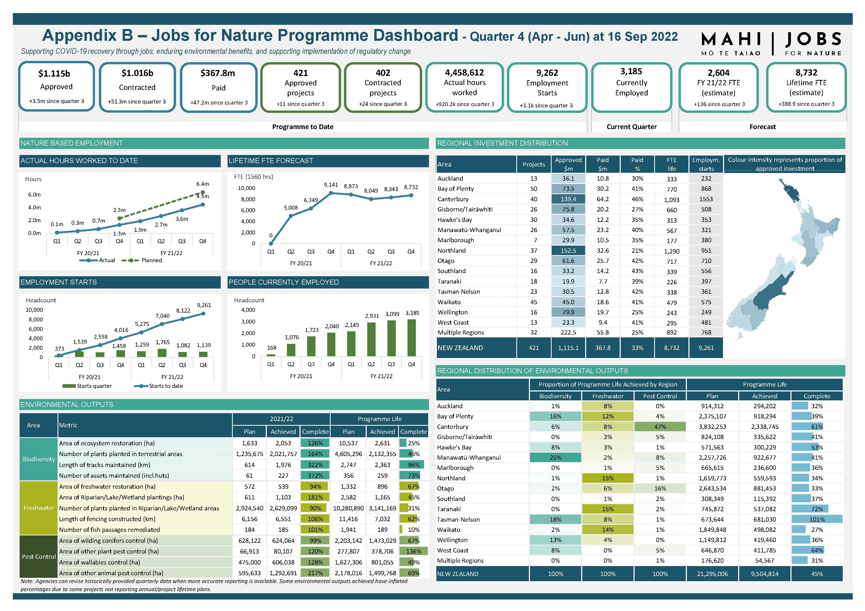
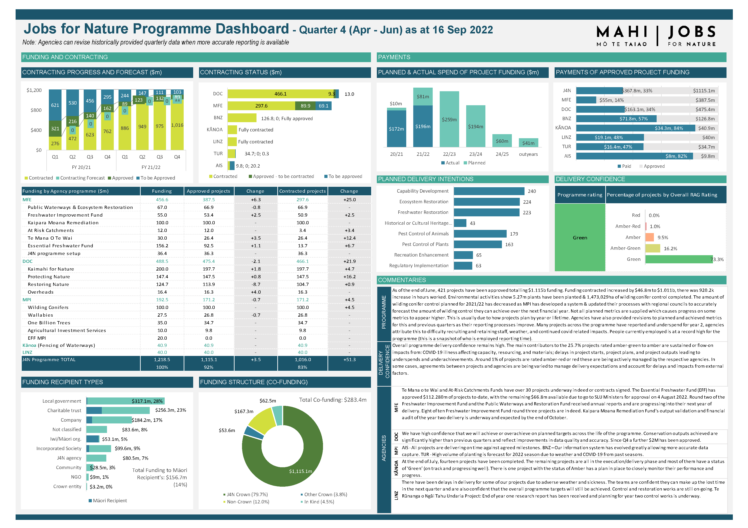

Appendix C – Jobs for Nature Advisory Group Investment Framework
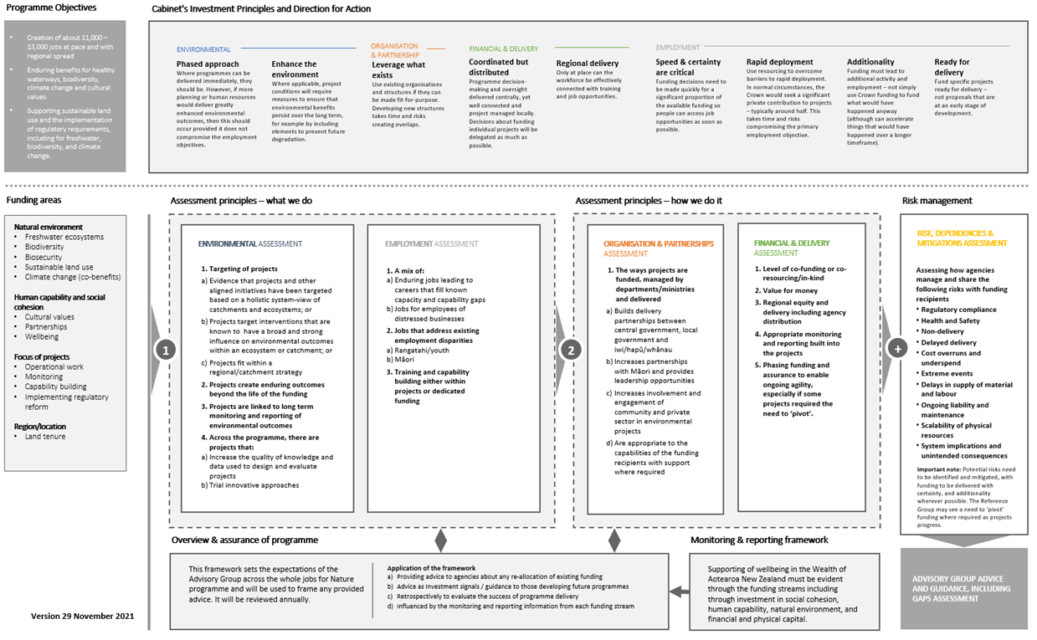

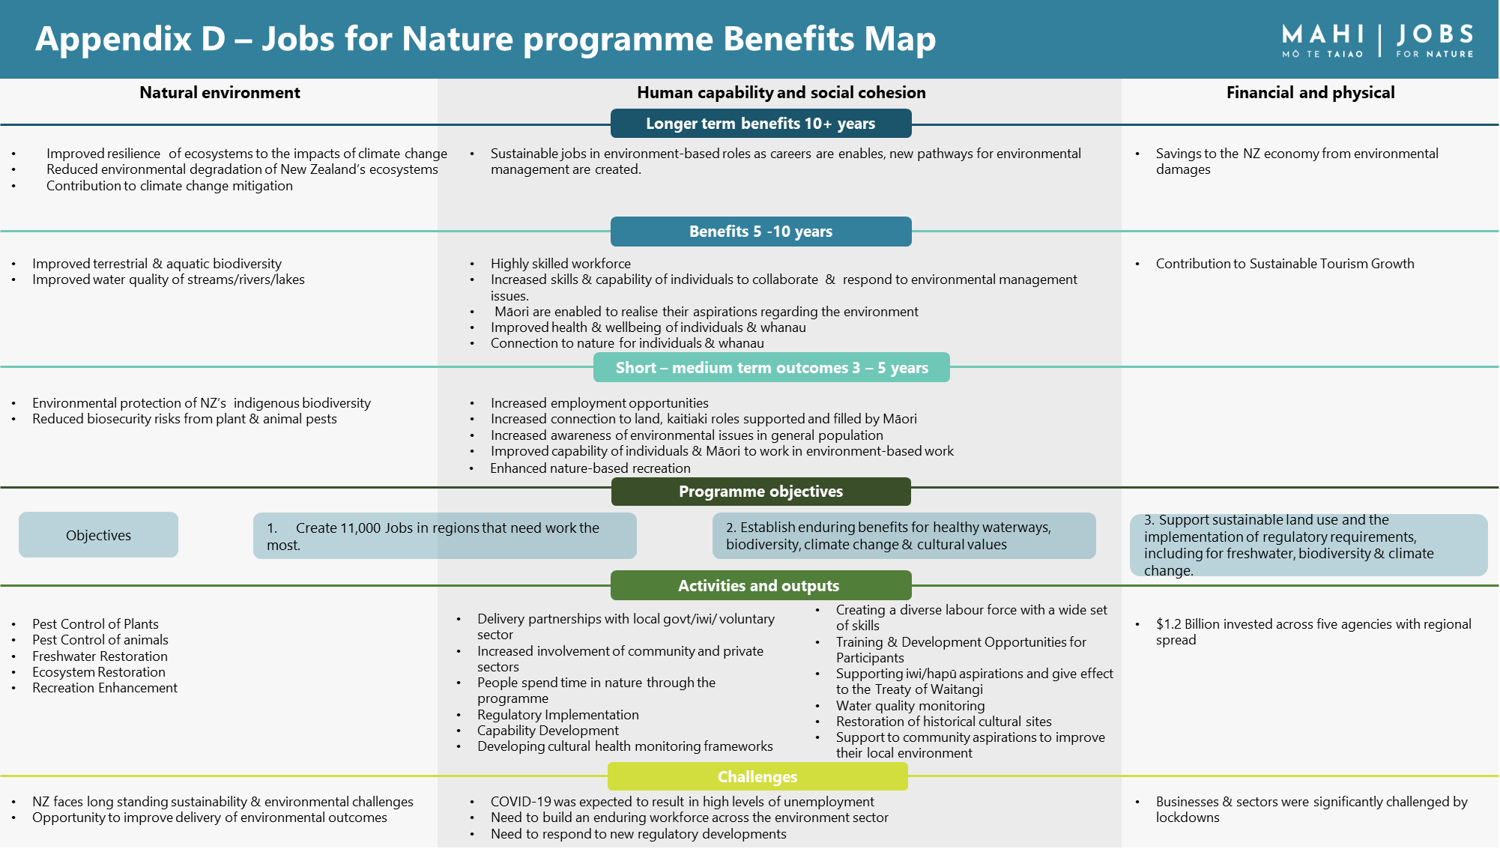

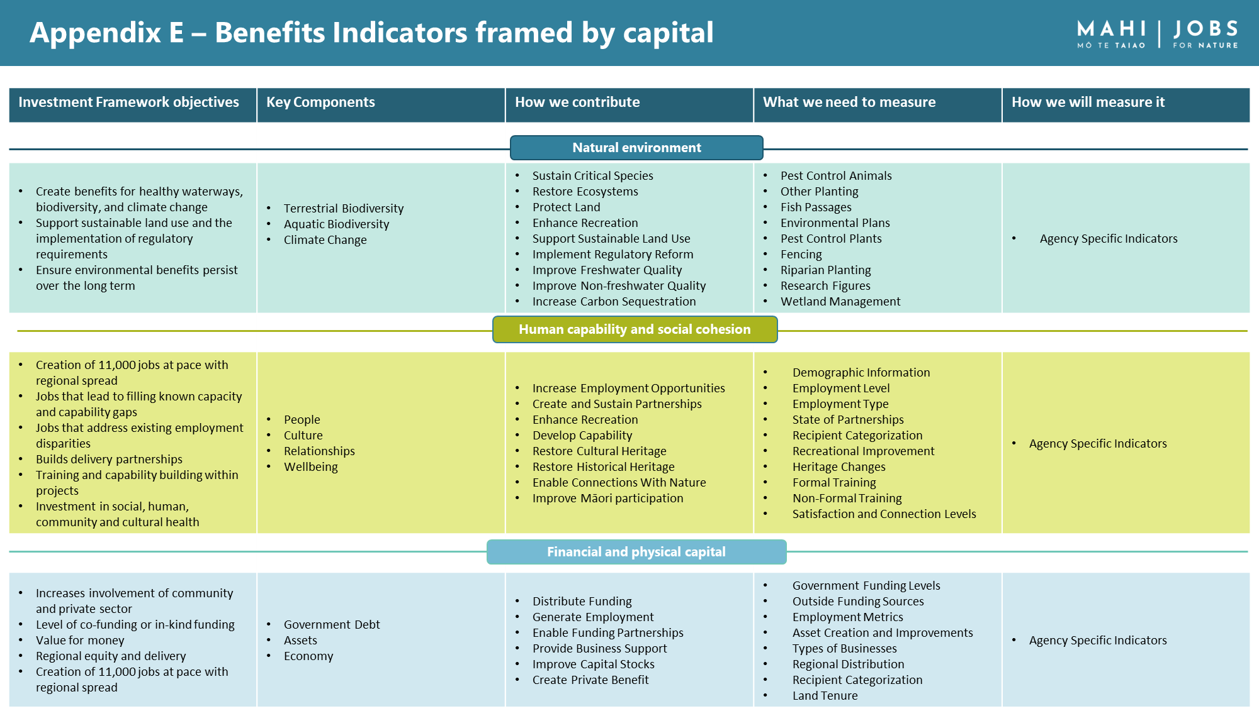

Appendix F – Agency evaluation initiatives
Ministry for the Environment
- Policy Implementation and Delivery Evaluation Report. This will include Jobs for Nature funds and provide detailed insights into three projects.
- Embedding te ao Māori in the design of the MfE Policy Implementation and Delivery Evaluation Framework – work undertaken to design a separate te ao Māori framework for MfE.
- Te Mana o te Wai evaluation with te ao Māori catchment survey. This report will summarise survey results from TMOTW fund recipients and other tangata whenua involved in catchment kaitiakitanga work. This will provide early insights for the overall evaluation on how Te Mana o te Wai fund recipients are doing and identify early impacts from MfE’s investment.
Department of Conservation
DOC have six case studies planned and the first three are:
- Jobs for Nature and te ao Māori – a focus on the te ao Māori benefits including projects led by Māori, use of mātauranga Māori, connection to rohe and kaitiakitanga.
- Jobs for Nature supporting conservation training – profile projects primarily focused on training eg Predator Free Apprenticeship, Conservation Leaders and marine cadet training.
- Threatened species – highlight the work and significance of Jobs for Nature projects supporting active management of threatened species, for example the nationally critical kākāriki, karaka, hoiho, and pest and disease issues myrtle rust and kauri dieback.
A DOC Benefits Report (with case studies as chapters) is planned. This report will address all benefits and case studies highlighted in the DOC benefits realisation plan, and provide short commentary on those topics not part of the case studies (for example, progress on six of 14 significant waterways for the Ngā Awa programme, total hectares of protected land, wellbeing of participants, cultural and heritage site improvements and more). These updates, along with the case studies, will demonstrate the wider outputs and potential outcomes from the $488.45 million investment.
Ministry for Primary Industries
Agricultural Investment Services
- Evaluation survey – this report will summarise survey results from catchment groups, whenua Māori owners, and other fund recipients. This will provide insights into how projects are progressing, results being achieved on the ground, and early impacts from MPI’s investment.
Te Uru Rākau
- KPMG was commissioned by MPI to evaluate the Te Uru Rākau One Billion Trees Fund (1BT). The scope of the evaluation covers MPI’s role in effectively optimising and enabling 1BT’s ability to deliver the programme outcomes, not the achievement of the specific outcomes themselves.
Biosecurity New Zealand
- Biosecurity New Zealand intend to commission an evaluation of the first three years of the Tipu Mātoro National Wallaby Eradication Programme against a performance framework agreed for the programme. It is intended the evaluation results will be used to improve the delivery of wallaby control and the effectiveness of the programme’s partnerships. The evaluation is expected to be completed by December 2023.
- The National Wilding Conifer Control Programme undertook an evaluation in 2021/22 of the 2019/20 and 2020/21 financial years (2020/21 being the first year of Jobs for Nature). The programme plans to undertake an evaluation every two years – the next will be in the 2023/24 financial year, which will cover the 2021/22 and 2022/23 financial years.
Kānoa
- The Evaluation of the Provincial Growth Fund (PGF) report, carried out by Allen + Clarke, looks at what the $3 billion PGF initially achieved since its establishment in 2018.

Appendix G – Jobs for Nature programme metrics
Metric name | Agency | Unit
Funding paid | all | dollars
Funding paid on wages | all | dollars
Hours worked | all | hours
Employment starts | all | headcount
People currently employed | all | headcount
People in formal training | all | headcount
People completed formal training | all | headcount
Number of NZQA credits earned | all | count
Area treated for possums | DOC | ha
Area treated for rats and/or mustelids | DOC | ha
Area treated for goats | DOC | ha
Area treated for deer | DOC | ha
Area treated for wallabies | BNZ | ha
Area treated for other animal pests | DOC | ha
Area of animal pest control completed | MFE, LINZ | ha
Area treated for weeds | DOC, MFE, LINZ | ha
Area treated for wilding conifers | DOC, MPI | ha
New fencing | DOC, MBIE, MPI | km
Existing fencing maintained | DOC, MBIE | km
Riparian fencing | MBIE, MPI | km
Fencing not riparian | MBIE, MPI | km
New fencing constructed or existing fencing maintained | MFE | km
Area restored by plantings (excluding riparian planting) | DOC | ha
Area of afforestation or other biodiversity planting not riparian or lake or wetland | MFE | ha
Area under active restoration (not riparian/wetland) | MPI | ha
Area of planting for erosion control completed | MFE | ha
*NEW* Area of land protected | DOC | ha
Area of riparian strip restored by plantings (excluding other restoration planting) | DOC | ha
Freshwater area under active restoration (riparian/wetland) | MPI | ha
Area of riparian or lake or wetlands planting completed | MFE | ha
Area where aquatic weeds were controlled | LINZ | ha
Number of fish passage barriers remediated | MFE | count
Number of plants planted in riparian or lake or wetland areas | DOC, MFE | count
Number of trees | MPI | count
Number of other plants | MPI | count
Number of huts maintained | DOC | count
Length of tracks maintained | DOC | km
*NEW* lengths of tracks created | DOC | km
Number of historic heritage assets maintained | DOC, MFE | count
Number of farm environment plans completed | MFE | count
Area covered by farm environment plans completed | MFE | ha

Ministry for the Environment. 2020. Shared approach to $1.3 billion in “Jobs for Nature” funding. Cabinet Paper. Wellington: Cabinet Office, Department of the Prime Minister and Cabinet.
Ministry for the Environment. Jobs for Nature Annual Review – Year Two. Wellington: Ministry for the Environment on behalf of Jobs for Nature Inter-Agency Secretariat.
See Appendix B – the Jobs for Nature Dashboard
Jobs for Nature Inter-Agency Secretariat. 2022. Jobs for Nature Programme Benefits Report 2022. Wellington: Ministry for the Environment on behalf of Jobs for Nature Inter-Agency Secretariat.
See Appendix F – Agency evaluation initiatives.
RDC Group Ltd. 2021. Final Report – Jobs for Nature Programme Review. Wellington: RDC Group.
New Zealand Cabinet. 2021. Jobs for Nature Stocktake Progress. DPMC-2021/22-607. Retrieved 17 June 2023.
The Treasury. 2020. Economic scenarios (report T2020/973). Wellington: Treasury.
Ministry for the Environment. 2020. Shared approach to $1.3 billion in “Jobs for Nature” funding. Cabinet Paper. Wellington: Cabinet Office, Department of the Prime Minister and Cabinet.
Set up in 2019 to govern, oversee and align the Government’s initiatives on sustainable land-based sectors [CBC-18-MIN-0062].
Such as deer, goats, rabbits, wallabies.
The Advisory Group completed their work on 31 December 2022.
A full list of funds at June 2020 can be found in Appendix A – Jobs for Nature funding programmes.
The Treasury. 2021. The Living Standards Framework 2021. Wellington: The Treasury.
See for example Social Policy Evaluation and Research Unit. 2015. Frameworks to measure family and whānau wellbeing. Wellington: Social Wellbeing Agency.
New Zealand Cabinet. 2021. Jobs for Nature Stocktake Progress. DPMC-2021/22-607. Retrieved 17 June 2023.
RDC Group Ltd. 2021. Final Report – Jobs for Nature Programme Review. Wellington: RDC Group.
Source: Stats NZ.
Experiments with single agency contracts across jointly funded initiatives have proved hugely difficult to implement due to complexities with delegations and signoffs.
The Treasury. Pre-election Economic and Fiscal Update 2020. Retrieved 17 June 2023.
Ministry of Business, Innovation and Employment. 2021. Estimating Labour Market Activity post COVID-19 – Analytical Report. Wellington: Ministry of Business, Innovation and Employment.
Ministry of Business, Innovation and Employment. 2020. Labour Market Statistics Snapshot September 2020. Wellington: Ministry of Business, Innovation and Employment.
2021-B-07910.
The EET framework does not require any personal data to be collected.
For example, riparian planting has biodiversity benefits, but is captured in the 'Freshwater' area for Jobs for Nature reporting. Likewise most of the pest control activity has biodiversity benefits.
This includes asset (huts) and track maintenance that improve public access to conservation areas, which promotes more awareness of biodiversity.
In May 2021, $26,600 million was redistributed out of the programme to support the rollout of cameras on inshore commercial fishing vessels [see CAB-21-MIN-0181].
See Cabinet Paper (CAB-20-SUB-0128) paragraph 4.
The work of the Advisory Group was completed in December 2022.
One FTE is 30 hours per week for 52 weeks, totalling 1560 hours per year.
MPI reports separately for the three functions.
For instance, the World Bank and the European Commission use 7 per cent in their guidelines.
At this stage the concept of job had not been defined.
Wyatt S. 2018. Benefits and Costs of the Wilding Pine Management Programme Phase 2. Wellington: Sapere.
Based on a small sample of projects; it will vary widely according to the nature of the work undertaken.
CRRF refers to COVID-19 Response and Recovery Funding

