Disclaimer
While all care and diligence has been used in processing, analysing, and extracting data and information for this publication, the Ministry for the Environment and the data providers give no warranty in relation to the report or data used in the report – including its accuracy, reliability, and suitability – and accept no liability whatsoever in relation to any loss, damage, or other costs relating to the use of any part of the report (including any data) or any compilations, derivative works, or modifications of the report (including any data).
Acknowledgements
This report was prepared by Sean Hudgens, Joe Val Alipin, and Chris Page from the Ministry for the Environment. The authors would like to acknowledge Doug Booker and Channa Rajanayaka (NIWA) for providing technical advice, Mike Thompson (Greater Wellington Regional Council), Amy Lennard and Raelene Mercer (Horizons Regional Council) for providing data and information, and Philippa Aitchison-Earl (Environment Canterbury) for reviewing this report.

This document may be cited as: Ministry for the Environment. 2021. Improving our understanding of the effects of water use on river flows: A case study for the Wellington and Manawatū-Whanganui Regions for the period June 2015–June 2018. Wellington: Ministry for the Environment.

Published in December 2021 by the
Ministry for the Environment
Manatū Mō Te Taiao
PO Box 10362, Wellington 6143, New Zealand
ISBN: 978-1-99-003398-8
Publication number: ME 1611
© Crown copyright New Zealand 2021
This document is available on the Ministry for the Environment website: www.mfe.govt.nz.

Contents
Executive summary 4
Background 6
Importance and potential consequences of water use 6
Water allocation and accounting 8
Understanding the effects of water use on river and stream flows 9
Purpose and approach 13
Streamflow depletion as a proportion of long-term natural median flow 14
Comparing measured abstractions by primary water use 15
Estimating streamflow depletion using measured abstraction data 18
Comparing estimated streamflow depletion to estimated long-term natural median flow 21
Comparing the estimated streamflow depletion effects from measured abstractions with the maximum potential effects of consented allocation 24
Streamflow depletion as a proportion of estimated natural daily flow 27
Comparing measured streamflows to measured upstream surface- and groundwater abstractions 32
Using estimated streamflow depletion and measured streamflow to estimate natural streamflow 37
Comparing estimated streamflow depletion to estimated natural flow 38
Conclusion 46
Appendix A: Technical summary of updated streamflow depletion calculations 49
References 59

Tables
Table 1: Comparison of first approach with previous works 14
Table 2: Assignment of primary water use categories to measured non-hydropower abstraction sites 15
Table 3: Comparison of second approach with first approach and previous works 27
Table 4: Catchment details for Wellington region river- and streamflow gauging sites included in analysis 29
Table 5: Catchment details for Manawatū-Whanganui region river- and streamflow gauging sites included in analysis 30
Table 6: Summary of progression of analysis and recommended future works 48

Figures
Figure 1: Effects of taking water 7
Figure 2: Modelled potential streamflow reduction due to upstream consented abstractions for non-hydropower consumption for July 2017–June 2018, as a ratio of estimated long-term natural median streamflow 11
Figure 3: Primary water use for (non-hydropower) abstraction sites with measured abstraction data in the Wellington and Manawatū-Whanganui regions, June 2015–June 2018 16
Figure 4: Average annual measured abstractions in million cubic metres for Wellington region sites by primary use type, June 2015–June 2018 17
Figure 5: Average annual measured (non-hydropower) abstractions in million cubic metres for Manawatū-Whanganui region sites by primary use type, June 2015–June 2018 18
Figure 6: Estimated streamflow depletion from measured non-hydropower abstractions in the Wellington and Manawatū-Whanganui regions on 14 February 2016, 2017 and 2018 20
Figure 7: Average estimated daily streamflow depletion due to measured abstractions in the Wellington region, as a ratio of estimated long-term natural median flow, June 2015–June 2018 22
Figure 8: Average estimated daily streamflow depletion due to measured (non-hydropower) abstractions in the Manawatū-Whanganui region, as a ratio of estimated natural median streamflow, June 2015–June 2018 23
Figure 9: Comparison of average estimated daily streamflow depletion to predicted maximum annual streamflow depletion for river segments with measured and consented allocation data for July 2017–June 2018 (as a ratio of estimated long-term natural median flow) 25
Figure 10: Locations of GWRC river- and streamflow gauging sites in the Wellington region 28
Figure 11: Locations of Horizons river- and streamflow gauging sites in the Manawatū-Whanganui region 31
Figure 12: Monthly median daily streamflow measured at assessed river- and streamflow gauging sites in the Wellington region by catchment, June 2015–May 2018 33
Figure 13: Monthly median daily streamflow measured at assessed river- and streamflow gauging sites in the Manawatū-Whanganui region by catchment, June 2015–May 2018 34
Figure 14: Monthly average total daily surface- and groundwater abstraction rates measured upstream of assessed river- and streamflow gauging sites in the Wellington region by catchment, June 2015–May 2018 35
Figure 15: Monthly average total daily surface- and groundwater abstraction rates for non-hydropower use, measured upstream of assessed river- and streamflow gauging sites in the Manawatū-Whanganui region by parent catchment, June 2015–May 2018 36
Figure 16: Average daily ratio of estimated streamflow depletion to estimated natural streamflow at gauging sites in the Wellington and Manawatū-Whanganui regions by season, winter 2015–autumn 2018 40
Figure 17: Percentage of spring, summer, autumn and winter days where the ratio of upstream depletion to estimated natural streamflow exceeded thresholds at gauging sites in the Wellington region, June 2015–May 2018 42
Figure 18: Percentage of spring, summer, autumn and winter days where the ratio of upstream depletion to estimated natural streamflow exceeded thresholds at gauging sites in the Manawatū-Whanganui region, June 2015–May 2018 43

Executive summary
Our freshwater ecosystems and species, our economy and our way of life rely on the freshwater that moves through our streams, rivers, lakes and aquifers. Aotearoa New Zealand’s expansive freshwater system provides us with hydropower, opportunities for recreation and enjoyment of nature, and our drinking and irrigation water. It is therefore critical we protect our freshwater resources from overuse, to ensure enough freshwater is available to sustain ecosystems and human needs.
To effectively protect our freshwater resources, we need a sound understanding of how much water:
- we have
- we (and the environment) need
- we use.
Despite this, our water use to date has not been effectively measured, analysed and reported at the national level. We have a good idea of how much water has been legally allocated for use through consents, so can estimate the maximum potential pressure our water use can exert on the freshwater system, but we cannot estimate the actual pressure. The Ministry for the Environment and Stats NZ most recently reported the potential impacts of water allocation on river and streamflows in Our freshwater 2020 (Ministry for the Environment & Stats NZ, 2020), using allocation data and National Institute of Water and Atmospheric Research (NIWA) streamflow depletion models.
Owing to the tightening of requirements under the Resource Management (Measurement and Reporting of Water Takes) Regulations 2010 (as amended in 2016 and 2020), and initiatives of some regional councils, measured water abstraction data is becoming more readily available. While it will be some time before useable datasets are available for all regional councils, this case study aims to demonstrate some of the insights that can be drawn from these data, by using abstraction datasets obtained from Greater Wellington and Horizons Regional Councils for the three years from June 2015 to June 2018.
Methods used for previous environmental reporting have used maximum consented abstraction rates to calculate the maximum potential impact of consented water use on river and stream flows. Previous assessments have compared these calculations to available estimates of long-term natural median streamflow, which has provided useful insights into the potential magnitude of streamflow depletion effects experienced by individual rivers and streams at the annual scale. This case study builds on these methods by using measured abstraction and flow data provided by Greater Wellington and Horizons regional councils to derive more meaningful insights.
First, it uses daily measured abstraction rates to estimate the actual impact of water use on river and stream flows, and second, it compares these estimates to daily measured streamflows. By connecting these two datasets, the new analyses were able to estimate the proportion of flow removed from rivers and streams on every day of the three-year study period, providing much more precise insights into depletion pressures than previously possible.
The case study achieved its primary objective, which was to demonstrate viable methodologies for estimating the streamflow depletion effects of measured water abstractions at a more meaningful temporal scale than previous methods. These analyses are repeatable and can be used for other regions as more data become available, and the methods can be refined over time. The case study also clarified existing barriers to wider implementation of the analyses and identified opportunities for improvements to the methods.
These findings will provide useful insights that can feed into national guidance on water use measurement, reporting, and data protocols, and development of reliable tools that regional councils can use for freshwater quantity accounting under the National Policy Statement for Freshwater Management 2020.

Background

Importance and potential consequences of water use
The use of freshwater supports our economy and way of life in Aotearoa New Zealand. In te ao Māori, water has vital intrinsic importance (Te Mana o te Wai) that prioritises the health of water and people above its other uses (see Water allocation and accounting). This concept is central to how we manage the surface water, and groundwater taken from aquifers, we rely on for drinking, domestic, and industrial uses, irrigation for agriculture, and for power – most of our electricity is provided by hydroelectric power schemes that capture renewable energy from freshwater as it moves from the mountains to the sea (Ministry of Business, Innovation & Employment, 2020). Alongside these uses, freshwater also provides for recreation, fishing and other social and cultural opportunities essential for the wellbeing of all of our communities.
However, removing water can reduce the flow of water in rivers and streams, and decrease the level of groundwater in aquifers. So can diverting, capturing and storing freshwater for hydroelectric power generation. Surface- and groundwater are part of the same hydrological system, so removing water from aquifers can reduce river and stream flows, and vice versa. Even in areas where removing, diverting or storing water do not reduce the overall streamflow, these activities can still alter natural seasonal streamflow patterns. Greater impacts on streamflow occur when larger volumes of water are removed, diverted or captured, particularly in dry periods (Ministry for the Environment & Stats NZ, 2020). All these activities can decrease the mauri of our waterways.
Reduced river and stream flows and groundwater levels can have several consequences. Unnaturally low streamflow reduces the habitat for freshwater fish and other species that depend on available freshwater. For instance, taking water can reduce the flows and number of channels in braided rivers, which affects some threatened birds like wrybill and kakī (black stilt). Reduced streamflow can also lead to secondary impacts on freshwater ecosystems; lower flows can increase the concentrations of nutrients, pathogens and other pollutants in rivers, and can raise the temperature of the water. Increased nutrients combined with higher temperatures make rivers more susceptible to algal blooms. All of these effects degrade freshwater ecosystems and habitats, and can make waterways unfit for recreational and cultural uses. Finally, reduced streamflow and groundwater levels may mean that less water is available for domestic supply, sanitation, or commercial uses such as irrigation that rely on these sources (Ministry for the Environment & Stats NZ, 2020; see figure 1).

Figure 1: Effects of taking water
Source: Environment Aotearoa 2019

Water allocation and accounting
Regional authorities are responsible for allocating water under the Resource Management Act 1991 (RMA), and granting consents (permits) to abstract freshwater for specific uses through the resource consent process. Consents may have specified conditions, such as how much water can be abstracted from where, at what rate, and at what times. Regional authorities can limit the total consented allocation within catchments or water management zones. They can also permit abstractions that are under specified limits (by rate and/or volume) without consent, and these limits are sometimes specific to what the water is used for.
Given the potential consequences of water use for aquatic ecosystems and secure reliable water supplies, it is vital water is used efficiently and allocated equitably. To enable this, the National Policy Statement for Freshwater Management 2020 (NPS-FM) requires that regional authorities set environmental targets for river and stream flows, and river, lake and groundwater levels, and that they set limits on water abstraction to achieve these targets. These measures must be implemented in a way that gives effect to Te Mana o te Wai Wai (as defined in part 1.3 of the NPS-FM), by ensuring the health and wellbeing of water sources is protected and human health needs are provided for, before enabling other uses of water. To provide the information required to set targets, every regional council is required to establish, operate and maintain freshwater quantity accounting systems for all freshwater bodies in its region. These record information on the amount of water abstracted, the proportion abstracted for each major type of use, and the proportion abstracted relative to abstraction limits. NPS-FM policy directs regional councils to:
- implement these measures to ensure water is allocated and used efficiently
- phase out consents that grant water in excess of abstraction limits (over-allocation)
- avoid future over-allocation.
Holders of consents to abstract water for consumptive uses are required by the Resource Management (Measurement and Reporting of Water Takes) Regulations 2010 (the 2010 regulations) to measure and report how much water they abstract if their use exceeds certain amounts. The regulations came into force in November 2010, but for existing consents the requirements were introduced in stages over the following six years, based on abstraction rates. Beginning in 2012, the regulations were applied to holders of consumptive water use consents that allowed water to be abstracted at a rate of 20 litres per second or more. In 2014, this extended to consents that allowed water to be abstracted at a rate of 10 litres per second or more, and finally in 2016, 5 litres per second or more. Under the requirements, consent holders must measure their water use every 15 minutes and submit these data to their regional council every day.
To improve the accuracy of water use monitoring, the 2010 regulations were amended in 2016 to require consent holders to install measuring devices, have them independently verified for accuracy, and submit their data electronically. Despite these requirements, in many cases the data supplied to regional councils has been of poor and irregular quality (Controller & Auditor General, 2018). The regulations were amended on 3 September 2020 (the 2020 regulations) to introduce stricter requirements (including meters that can be accessed via telemetry), to ensure greater accuracy and consistency of measuring and reporting. It is hoped improved data will enable better national reporting, but data gaps will remain.
Councils can require consent holders who abstract less than 5 litres per second to monitor and report their water use, but as it is not required by the 2020 regulations, most councils do not require this. There is also no monitoring or reporting requirement for permitted abstractions that do not require consents (for example, for stock and domestic supply or minor irrigation activities). Some councils estimate and report this kind of permitted use using models based on assumptions about property and land-use types and likely consumption rates, but others do not report on this use at all. Therefore, many legal water abstractions, as well as non-permitted (illegal) abstractions, are not accounted for.

Understanding the effects of water use on river and stream flows
The Ministry for the Environment and Stats NZ are required to regularly report on the state (condition) of the freshwater environment under the Environmental Reporting Act 2015 (the ERA 2015). The mandated reporting topics relating to water use are set out in the Environmental Reporting (Topics for Environmental Reports) Regulations 2016, and include the:
- state of freshwater quantity and flows
- pressures on the state of the freshwater environment from abstractions and diversions of water
- impacts of freshwater use on biodiversity and ecosystem processes, public health, the economy, culture and recreation.
The Ministry and Stats NZ most recently reported on the freshwater environment in Our freshwater 2020 (Ministry for the Environment & Stats NZ, 2020).
Owing to the poor and inconsistent quality of data supplied by many consent holders, and inconsistencies between regional council datasets, accurate measured abstraction data has not been available from all regional authorities to date. This has prevented measured data being used to report on the effects of consumptive water use on freshwater resources. As a result, national environmental reporting has relied on water use consent information to estimate abstraction pressures. This information is available nationally, and can be used to determine:
- where water abstraction has been consented
- the maximum amount of water that has been allocated by each consent
- what the water is used for.
However, national data are not available to determine these statistics for permitted non-consented abstractions, as these abstractions are generally not registered, and are only estimated by some regional authorities. Consent data therefore cannot be used to estimate all abstraction pressures.
Nationwide consent information was compiled by the National Institute of Water and Atmospheric Research (NIWA), and used to calculate the potential reduction of streamflow as a result of all upstream consented allocation for every river segment in Aotearoa for July 2013–June 2014 and July 2017–June 2018 (Booker et al, 2016; Booker & Henderson, 2019). The 2019 analysis estimated that abstracting water for irrigation had the greatest potential to cause widespread reductions in river and stream flows compared with other water uses, and that abstracting water for ‘consumptive’ hydroelectricity generation had the potential to significantly reduce streamflow in some large rivers. In some parts of Canterbury and Hawke’s Bay the accumulated streamflow depletion modelled based on the consented maximum abstraction rates for non-hydropower uses exceeded the estimated long-term natural median streamflow (see values >1 on figure 2). These estimates are based on the conservative assumption that groundwater abstractions only deplete flow from rivers and streams up to two kilometres away, which happens relatively quickly. In reality, many of these abstractions, particularly the deeper ones, would cause some or all of their flow depletion in rivers and streams much farther away and over considerably longer timeframes.

Figure 2: Modelled potential streamflow reduction due to upstream consented abstractions for non-hydropower consumption for July 2017–June 2018, as a ratio of estimated long-term natural median streamflow
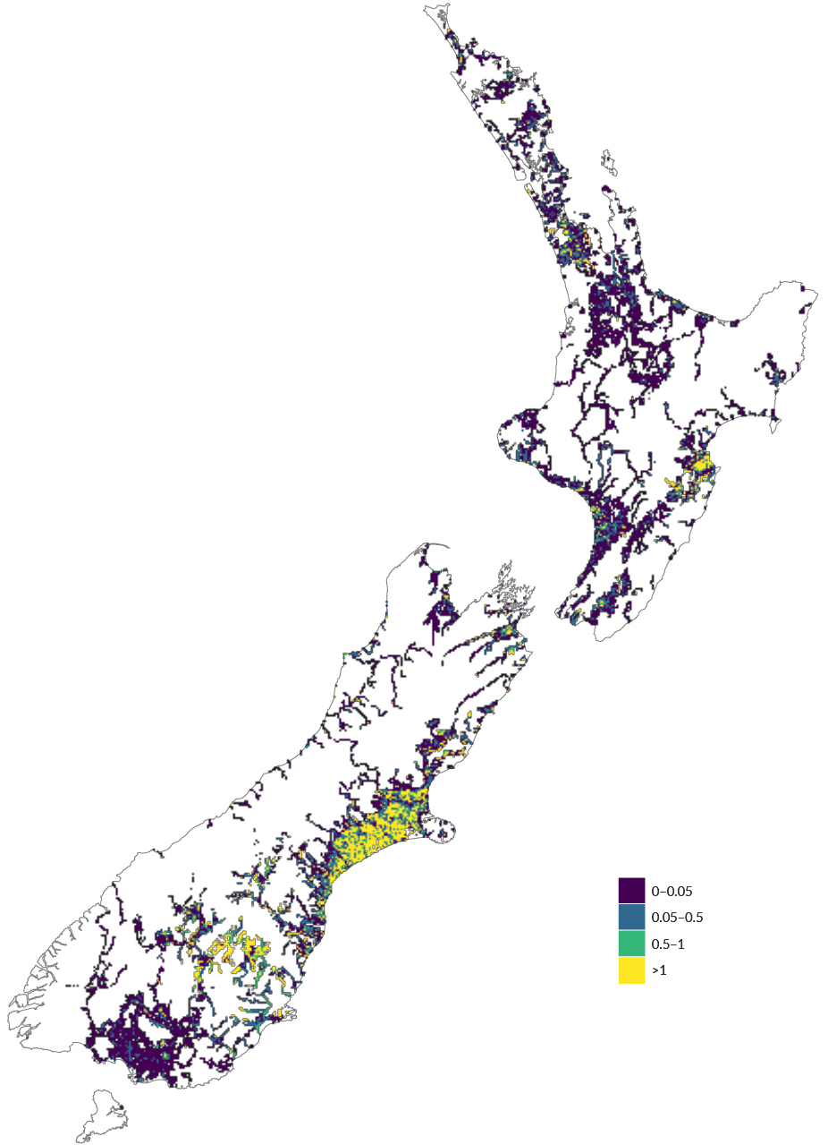
Source: Our freshwater 2020
Note: Data used is for maximum consented volumes and does not include the potential impacts of water use restrictions (Booker & Henderson, 2019). Abstractions for hydropower can have potentially significant impacts on streamflow, but hydropower consents could not be included in the analysis because they are not easily comparable to non-hydropower consents. Flow reduction is shown as a proportion of modelled long-term natural median streamflow, not measured flow. Analysis assumes that all groundwater abstractions deplete streamflow, and that no abstracted surface- or groundwater is returned to the river network.
Using consented allocation to estimate streamflow depletion has many known limitations (Booker et al, 2016). Consented allocation does not equate to actual water abstraction, meaning that it only provides an indication of the maximum potential impact on streamflow, rather than the actual streamflow alteration.
Maps of accumulated pressure represent a ‘worst case scenario’ in which each consent is fully implemented to maximum abstraction rate. These maps cannot represent actual impacts on streamflow because they do not consider temporal patterns in streamflow or water abstractions. Furthermore, water consents are often complex; some consent conditions require abstractions to cease or be restricted during times of low flow or other environmental conditions. National analysis of consented freshwater abstractions to date does not account for the potential effects of these restrictions, due to a lack of nationwide data availability (Booker et al, 2016; Booker & Henderson, 2019).

Purpose and approach
The overarching goal of this case study was to help build the analytical capability of the Ministry for the Environment and Stats NZ environmental reporting, to enable better future understanding and reporting of the effects of water use on river and stream flows nationally. To do this, it set out to demonstrate a viable and replicable methodology for estimating the depletion effects of measured water abstractions on natural streamflow, using consented abstraction and river and stream flow datasets supplied by Greater Wellington Regional Council (GWRC) and Horizons Regional Council (Horizons). It also aimed to clarify some of the technical challenges and barriers to accessing, processing and using council datasets for these purposes, and to identify opportunities for improvement.
This report details two analytical approaches trialled in the case study, and the methodological steps undertaken to develop them. Where relevant and to the extent possible, it presents and discusses the findings of the analyses to demonstrate the kinds of insights they can provide. The analyses comprise the following:
- The first approach compares the streamflow depletion effects of measured abstractions with modelled estimates of natural flow, similar to analyses undertaken previously using consented maximum allocation data (see Understanding the effects of water use on river and stream flows). Supplemental to this, it also uses metadata supplied by GWRC and Horizons to:
- assign a primary water use to each measured abstraction site, to add greater context for the measured abstraction data and enable statistical and spatial comparisons of different water uses (similar to Our freshwater 2020)
- employ a separate model for estimating streamflow depletion from groundwater wells deeper than 30 metres, based on the aquifer conditions expected at these depths
- generate a like-for-like comparison of the new approach with the analyses undertaken previously that used consented maximum allocation data.
- The second approach builds on the first, by comparing the streamflow depletion effects of measured abstractions with estimates of natural flow derived from measured river and stream flow. It also uses metadata supplied by GWRC and Horizons to:
- segregate measured abstraction timeseries data by catchment and by source type, to enable comparisons of spatial and temporal surface- and groundwater abstraction patterns
- segregate measured river and stream flow timeseries data by catchment, to enable comparisons of spatial and temporal abstraction pattens with measured river and stream flow patterns.
The report finishes with a conclusion section, which discusses the:
- extent to which the analytical approaches were able to improve our understanding of the effects of water use on river and stream flows
- barriers encountered in the case study, and opportunities for improvement
- potential implications of these developments on future measurement, analysis and reporting of water use and its effects on river and stream flows.

Streamflow depletion as a proportion of long-term natural median flow
Our first approach to exploring the relationship between measured abstractions and river and stream flow was to model the streamflow depletion effects of measured abstractions, and compare these estimates with estimates of long-term natural median streamflow. It was intended to replicate the Booker & Henderson (2019) approach adopted in Our freshwater 2020 (Ministry for the Environment & Stats NZ, 2020), which explored the maximum potential streamflow depletion effects of consented non-hydropower water allocation, but with improved utility and temporal resolution through use of daily measured abstraction data instead of the maximum annual allocation allowed by consents. This new approach used a different model for estimating the streamflow depletion effects from groundwater abstractions deeper than 30 metres, which accounts for the greater influence that some aquifer characteristics are expected to have on the timing and rates of depletion resulting from abstractions below this depth (Booker et al 2019). See table 1.
Table 1: Comparison of first approach with previous works
Analysis |  | Previous works | This approach
Consented maximum annual allocation | Water use type | 🗸
 | Modelled streamflow depletion | 🗸 ¹
 | Modelled long-term natural median streamflow | 🗸
Measured daily abstraction rates | Water use type | 🗸 | 🗸
 | Modelled streamflow depletion | 🗸 ¹ | 🗸 ²
 | Modelled long-term natural median streamflow |  | 🗸
¹ Approach uses the same model for all groundwater abstractions, regardless of depth.
² Approach uses a separate model for groundwater abstractions deeper than 30 metres.
To complete this analysis, the Ministry for the Environment and the National Institute of Water and Atmospheric Research (NIWA) obtained the following data from Greater Wellington Regional Council (GWRC) and Horizons Regional Council (Horizons) staff for abstraction sites in the Wellington and Manawatū-Whanganui regions for three full hydrological years (1 June 2015 to 1 July 2018):
- the rate of consumptive water abstraction from each site on each date
- metadata, including:
- location of water abstraction
- source of water (surface- or groundwater)
- type of water use
- volume of water abstraction
- bore depth, screen depth, storativity and transmissivity (for groundwater abstractions).
The Horizons records did not include abstractions for consumptive hydropower, so these were not included in the analysis for the Manawatū-Whanganui region (there are no consumptive hydropower schemes in the Wellington region). The analytical implications of omitting this data are discussed in the following sections.
NIWA obtained earlier versions of these non-hydropower abstraction datasets in 2018, using an automated procedure to download them remotely from council web services. Their format was suitable to run the streamflow depletion model and demonstrate the viability of the methodology (Booker et al, 2019), but there were quality issues that prevented their use in this analysis. These issues, the subsequent dataset improvements, and the data acquisition process for the current study, are detailed in Appendix A.

Comparing measured abstractions by primary water use
To provide context for the measured abstraction data, we used GWRC and Horizons metadata to assign a primary water use to each measured abstraction site and plotted them onto a map (see table 2 and figure 3). Based on this assessment, irrigation (red in figure 3) was the primary non-hydropower water use for most abstraction sites in the supplied datasets.
Table 2: Assignment of primary water use categories to measured non-hydropower abstraction sites
Regional council | Use | Primary use category
Greater Wellington | Drinking  Private water supply | Drinking
Horizons | Municipal and/or drinking water
Greater Wellington | Industrial | Industrial
Horizons | Industrial, processing and manufacturing  Industrial, research and science (includes educational)
Greater Wellington | Irrigation  Stock  Frost protection | Irrigation
Horizons | Agriculture, feed crops (includes pastures) Horticulture, vegetables  Horticulture, fruit  Horticulture, garden plants  Horticulture, floriculture  Agriculture, intensive farming, dairy  Agriculture, intensive farming, sheep  Agriculture, dairy cattle farming
Greater Wellington | Combined/mixed | Other and multiple uses
Horizons | Recreational, sports ground  Recreational, rivers, lakes and watercourses
Note: Sites without a use specified in their metadata were assigned to the “Use type not available” primary use category.
Figure 3: Primary water use for (non-hydropower) abstraction sites with measured abstraction data in the Wellington and Manawatū-Whanganui regions, June 2015–June 2018
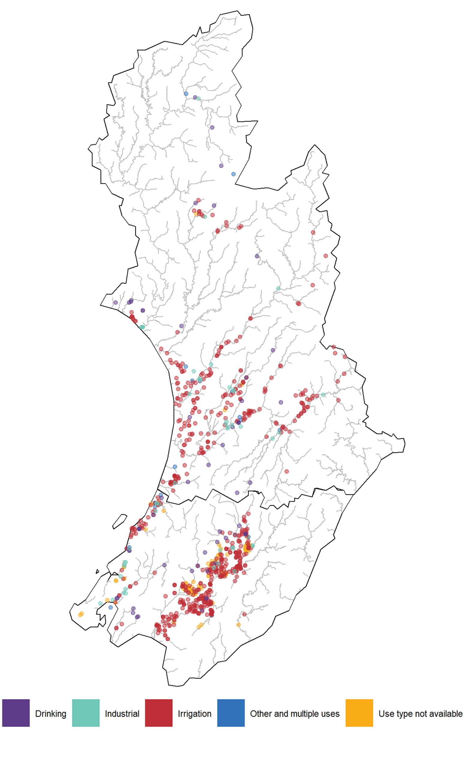
Data sources: GWRC and Horizons
Note: Only sites with verified time series datasets are shown.
To compare the relative proportions of measured abstractions by primary use type for each region, we took the average annual total measured abstraction volume for each use type over the three-year study period and generated water use profiles (see figures 4 and 5). This assessment estimates that abstractions for drinking and irrigation (purple and red in figure 4) made up most of the overall measured water use in the Wellington region, at 52 per cent and 39 per cent respectively, and industrial and ‘other and multiple’ uses (turquoise and blue) made up less than 1 per cent. The use type was not specified for 9 per cent of the measured abstractions (yellow in figure 4). The assessment for the Manawatū-Whanganui region estimates that abstractions for:
- irrigation and drinking (red and purple in figure 5) made up the greatest proportions of overall measured (non-hydropower) water use, at 63 per cent and 27 per cent respectively
- industrial use (turquoise) made up 9 per cent
- ‘other and multiple’ uses (blue) made up 1 per cent.
Note that consumptive hydropower schemes in the Manawatu-Whanganui region abstract more water than is consented for all other consumptive uses of water in the region combined (Horizons Regional Council, 2019).
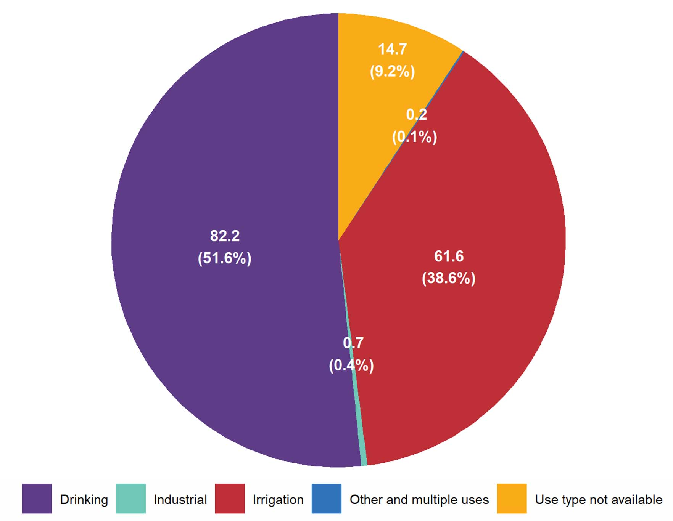
Figure 4: Average annual measured abstractions in million cubic metres for Wellington region sites by primary use type, June 2015–June 2018
Data source: GWRC

Figure 5: Average annual measured (non-hydropower) abstractions in million cubic metres for Manawatū-Whanganui region sites by primary use type, June 2015–June 2018
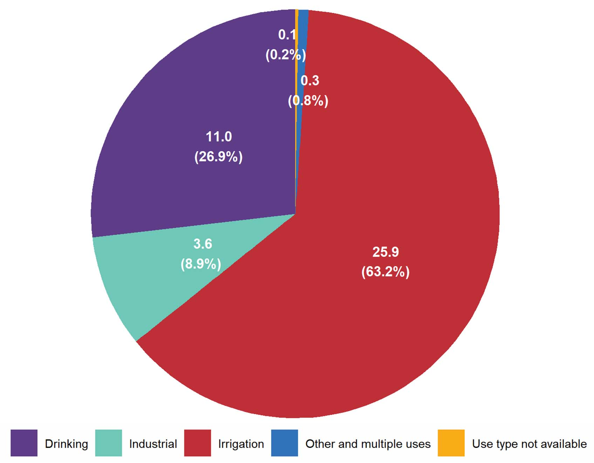
Data source: Horizons
This method provided useful context for the measured abstraction data, and allowed us to visualise where water was abstracted, what it was used for, and how much was abstracted for each use.

Estimating streamflow depletion using measured abstraction data
To provide improved estimates of streamflow depletion for the Wellington and Manawatū-Whanganui regional river networks, NIWA used the updated versions of the GWRC and Horizons measured abstraction datasets and applied the modelling methods outlined in Booker et al (2019) (with minor requisite adjustments, see Appendix A) as follows:
- Spatial coordinates were used to assign measured abstraction sites to one or more segments of the digital river network (Snelder & Biggs, 2002)
- surface water sites were assigned to the nearest river or stream segment, or if multiple segments were within 100 metres, to the segment with the largest estimated seven-day mean (average) annual low flow (MALF) (Booker & Woods, 2014)
- groundwater sites were assigned to all river and stream segments within 2 kilometres (this method assumes the groundwater abstraction will deplete streamflow within this radius).
- The daily abstraction value for each surface water site was apportioned to a single digital river network segment (this method assumes the abstraction is taken from a single segment, and only that segment).
- Because groundwater abstractions can cause depletion over a large area, the daily abstraction value for each groundwater site was apportioned across a group of digital river network segments as a function of distance and MALF. A two-layer model was used to calculate streamflow depletion across the collection of river and stream segments affected by groundwater abstraction, based on the screen depth of the groundwater well.
- For screen depths 0 to 30 metres below ground level, the calculation assumes the aquifer from which groundwater is abstracted is connected to the river(s) that deplete due to groundwater pumping (as implemented in Booker et al, 2016).
- For screen depths below 30 metres, the calculation assumes the well is screened in a semi-confined aquifer, and depletion is estimated using an analytical model developed by Ward & Lough (2011).
Using these methods NIWA estimated the accumulated streamflow depletion effects of measured non-hydropower abstractions for each segment of the digital river network, and for every day of the study period, expressed in cubic metres per day (m3/day) (see example in figure 6 of depletion maps for a selected summer day in each year of the study period).
Due to the time it can take for groundwater abstractions to affect waterways, the delayed effects from abstractions prior to the study period will not be captured by these calculations. For the same reason, they will not capture any effects that would have been estimated to have occurred after the study period ended. The calculations also are likely to underestimate actual streamflow depletion effects to some degree because they do not account for abstraction sites excluded from the analysis due to data quality issues, or abstractions under-reported or not reported.
Conversely, they may overestimate streamflow depletion for river and stream segments that are not significantly affected by these data gaps. This is because they do not account for the proportion of abstracted water that flows back into rivers and streams after use (for example, where farms are over-irrigated).

Figure 6: Estimated streamflow depletion from measured non-hydropower abstractions in the Wellington and Manawatū-Whanganui regions on 14 February 2016, 2017 and 2018
Data source: NIWA
Note: Analysis assumes that all groundwater abstractions deplete streamflow, and that no abstracted surface- or groundwater is returned to the river network.
While these methods rely heavily on assumptions and are sensitive to the aquifer parameters used and must be considered in light of the data gaps noted above, they allowed estimates to be made about the potential influence of known and quantified (that is, measured and reported) surface- and groundwater abstractions on surrounding rivers and streams. More detailed explanations of the streamflow depletion modelling and the equations used are given in Appendix A, Booker et al (2016) and Booker et al (2019).
The methods could have integrated abstractions and augmentations for the consumptive hydropower schemes in the Manawatū-Whanganui region into the streamflow depletion estimates, but these data were not available. Streamflow depletion will therefore be significantly underestimated for the Whangaehu River, the Moawhango River and the middle and lower reaches of the Rangitīkei River, and the Whanganui River and its tributaries, as they will not account for the approximately 2.5 million cubic metres of daily flow diverted from the headwaters of the Whangaehu, Whanganui and Rangitīkei rivers into Lake Taupō and the Waikato River for the Tongariro Power Scheme (Genesis Energy, nd). To a lesser extent, these methods will also underestimate streamflow depletion for the Mangahao River and most of the main stem of the Manawatū River downstream of the Mangahao River, and significantly overestimate streamflow depletion for the Mangaore Stream in the lower Manawatū River catchment, by not accounting for diversions to the Mangahao Power Station (Horizons Regional Council, 2019). The specific implications of these under- and overestimates on subsequent analyses are discussed in the following sections.

Comparing estimated streamflow depletion to estimated long-term natural median flow
To estimate the potential depletion effects of measured abstractions on natural streamflows, we compared the streamflow depletion estimates for each segment of the digital river network to the estimated flow for the same segment. NIWA was able to generate a time-series of estimated daily streamflow depletion for considerable proportions of the Wellington and Manawatū-Whanganui regional river networks, but suitable modelled estimates of daily or seasonal streamflow were not available to compare to. This meant we could only assess potential depletion effects at an annual (or longer) scale, by comparing streamflow depletion estimates to estimates of long-term natural median flow. These streamflow estimates represent the long-term rates of flow expected in the absence of major human intervention, like water extraction, dams, and diversions (Booker & Woods, 2014). Median flow is used because it best approximates ‘normal’ flow conditions over the long term, unlike mean (average) annual low flow (MALF), which approximates low flow conditions, and long-term average flow, which can be heavily influenced by extreme high- or low-flow events (Booker & Henderson, 2019).
For each river and stream segment, we divided the estimated daily streamflow depletion value by the estimated long-term naturalised median flow and calculated an average ratio for each segment for the three-year study period. To support a comparison of rivers and streams within each region, we plotted these ratios onto maps of the Wellington and Manawatū-Whanganui regional river networks (see figures 7 and 8). For simplicity, figures 7 and 8 aggregate these ratios into arbitrary categories of less than or equal to 5 per cent, 5–25 per cent, 25–50 per cent, 50–100 per cent, and greater than 100 per cent of estimated long-term natural median flow. While this analysis cannot provide insight into how streamflow depletion pressure is experienced seasonally or daily, it is useful for highlighting the areas of the river network likely to have experienced the greatest longer-term pressure.

Figure 7: Average estimated daily streamflow depletion due to measured abstractions in the Wellington region, as a ratio of estimated long-term natural median flow, June 2015–June 2018
Data source: NIWA
Note: Analysis assumes that all groundwater abstractions deplete streamflow, and that no abstracted surface- or groundwater is returned to the river network. Streamflow depletion is shown as a proportion of modelled long-term natural median streamflow, not actual natural streamflow.

Figure 8: Average estimated daily streamflow depletion due to measured (non-hydropower) abstractions in the Manawatū-Whanganui region, as a ratio of estimated natural median streamflow, June 2015–June 2018
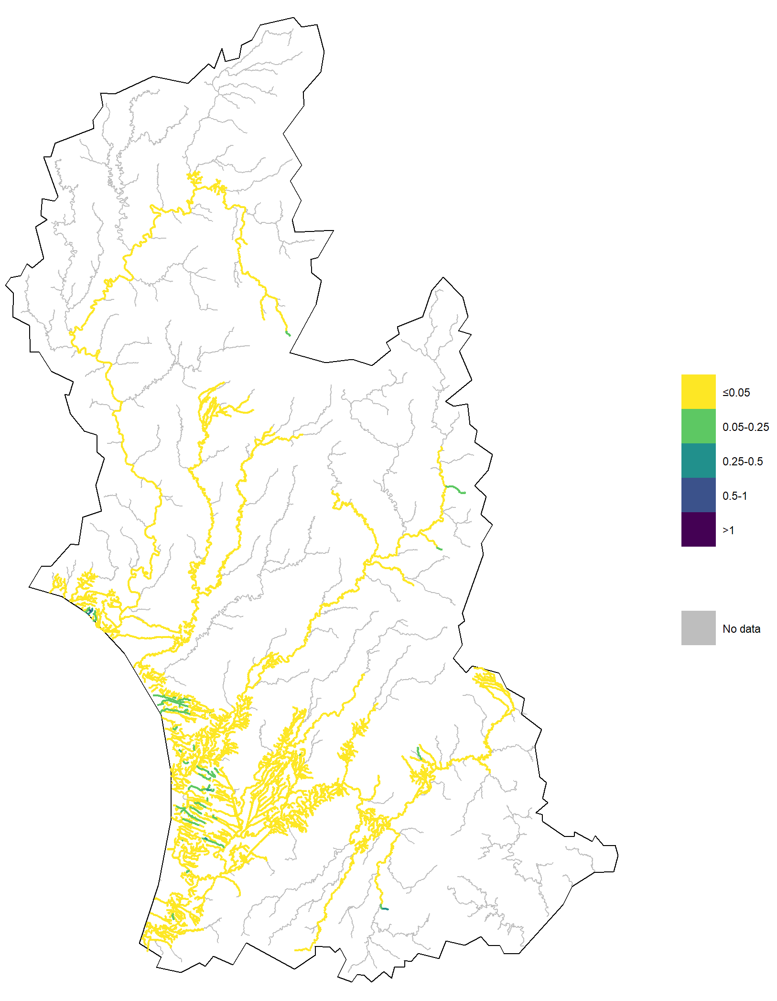
Data source: NIWA
Note: Analysis assumes that all groundwater abstractions deplete streamflow, and that no abstracted surface- or groundwater is returned to the river network. Streamflow depletion is shown as a proportion of modelled long-term natural median streamflow, not actual natural streamflow.
This method successfully gave rough estimates of the proportion of natural streamflow diverted from rivers and streams for measured non-hydropower abstractions across the three-year study period. It estimates that, of the assessed river and stream segments:
- only 7 per cent experienced average daily streamflow depletion greater than 5 per cent of their estimated long-term natural median flow due to measured abstractions (light green, dark green, blue and dark blue in figures 7 and 8)
- less than 1 per cent experienced average daily streamflow depletion greater than 25 per cent of their estimated long-term natural median flow (dark green, blue and dark blue in figures 7 and 8).
Measured abstractions in the Wellington region are estimated to have depleted streamflows for the Orongorongo River, the main stems of the Hutt and Wainuiomata rivers, and significant lengths of the Ruamahanga River and its main tributaries by 5–25 per cent of their estimated long-term natural median flow on average (light green in figure 7). Measured abstractions in the Manawatū-Whanganui region are estimated to have depleted streamflows for a number of river and stream reaches near the coast in the Manawatū and Rangitīkei districts by the same proportion on average (light green in figure 8). However, the actual flow-proportional depletion effects would be:
- significantly greater for the:
- Whangaehu River
- Mangahao River
- Moawhango River
- middle and lower reaches of the Rangitīkei River
- Whanganui River and its tributaries
- somewhat greater for most of the main stem of the Manawatū River downstream of the Mangahao River
- significantly less for the Mangaore Stream.
See Estimating streamflow depletion using measured abstraction data.

Comparing the estimated streamflow depletion effects from measured abstractions with the maximum potential effects of consented allocation
To provide additional context for the analyses based on measured non-hydropower abstractions, we compared the streamflow depletion results for the July 2017–June 2018 hydrological year to depletion results from the previous analysis, based on consented maximum allocation for the same year (Booker & Henderson, 2019).
For a direct comparison of these streamflow depletion estimates for the same river and stream reaches, we only included the digital river network segments that had depletion values in both datasets. This allowed us to generate a figure comparing a map of the average estimated daily streamflow depletion from measured abstractions for July 2017–June 2018 to a map of the predicted streamflow depletion from consented maximum allocation for the same river and stream segments, each as a ratio of estimated long-term natural median flow (see figure 9).

Figure 9: Comparison of average estimated daily streamflow depletion to predicted maximum annual streamflow depletion for river segments with measured and consented allocation data for July 2017–June 2018 (as a ratio of estimated long-term natural median flow)
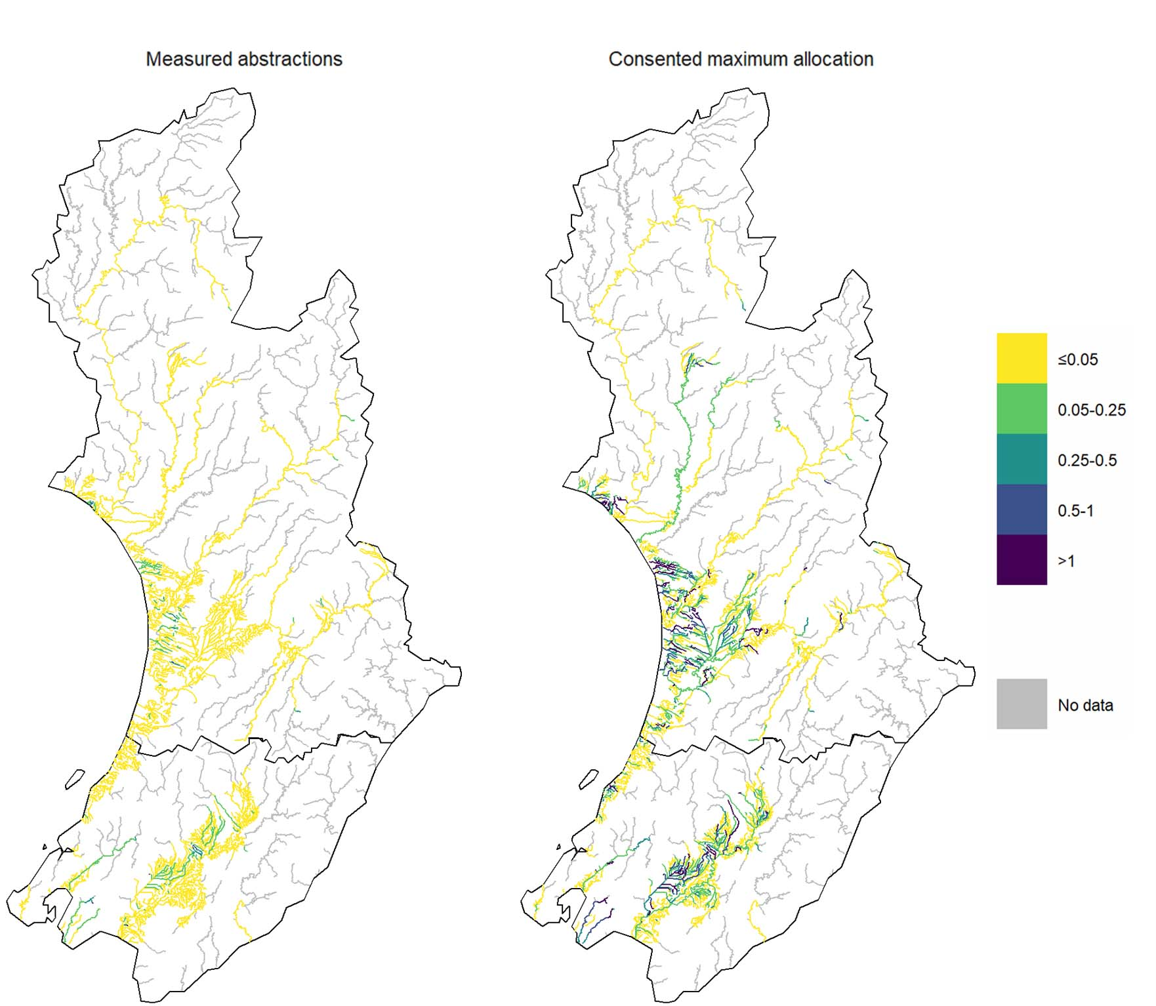

Data source: NIWA
Notes: The estimated streamflow depletion and augmentation effects of consumptive hydropower schemes are not shown. Analysis assumes that all groundwater abstractions deplete streamflow, and that no abstracted surface- or groundwater is returned to the river network. Streamflow depletion is shown as a proportion of modelled long-term natural median streamflow, not actual natural streamflow. Maps only display data for river and stream segments with verified measured abstraction datasets and streamflow depletion values for July 2017–June 2018. Consented maximum allocation analysis does not account for the potential impacts of water use restrictions, and used the same model for all groundwater abstractions regardless of depth (see Booker & Henderson, 2019). Measured abstractions analysis used a different model for groundwater abstractions deeper than 30 metres (see Booker et al, 2019).
The figure shows that for July 2017–June 2018, the portions of the river network in this comparison are estimated to have experienced far less significant daily depletion effects than if the measured abstraction sites in their upstream catchments had abstracted their full allocation. If accurate, this difference may reflect the effects of water use restrictions triggered by droughts experienced across both regions in summer 2017/18 (Stats NZ, 2020).
This is not a precise comparison, because the daily streamflow depletion values were estimated using a two-layer model for calculating depletion from groundwater abstractions, where the maximum annual depletion values were predicted using a simpler one-layer model that does not account for the greater influence that some aquifer characteristics are expected to have on the timing and rates of depletion resulting from deeper abstractions (see Booker et al, 2019). These approaches were also derived from different datasets, subject to different sets of limitations (see Comparing estimated streamflow depletion to estimated long-term natural median flow and Booker & Henderson, 2019). Considering these differences, the comparison still provides some indication of consented water use patterns and how these may have affected natural streamflows.

Streamflow depletion as a proportion of estimated natural daily flow
Our second approach to exploring the relationship between measured abstractions and river and stream flow was to compare the modelled estimates of streamflow depletion from measured abstractions to the measured streamflow at river- and streamflow gauging sites.
This follows our first approach, which compared daily streamflow depletion estimates from measured abstractions to estimates of long-term natural median streamflow (see Streamflow depletion as a proportion of long-term natural median flow), but improves its accuracy and temporal resolution by comparing these daily streamflow depletion estimates to daily measured flow (see table 3).
However, this analysis is far less spatially comprehensive, because unlike estimated long-term natural median streamflow (which is available for all rivers and streams), streamflow is only measured for a subset of river and stream reaches.
Table 3: Comparison of second approach with first approach and previous works
 | Analysis |  | Previous works | First approach | Second approach
Measured daily abstraction rates |  | Water use type | 🗸 | 🗸
 |  | Water source | 🗸 |  | 🗸
 |  | Modelled streamflow depletion | 🗸 ¹ | 🗸 ² | 🗸 ²
 |  | Modelled long-term natural median streamflow | 🗸 | 🗸
 |  | Measured daily streamflow |  |  | 🗸
 |  | Estimated natural daily streamflow |  |  | 🗸
¹ Approach uses the same model for all groundwater abstractions, regardless of depth.
² Approach uses a different, more precise model for groundwater abstractions deeper than 30 metres.
To complete this additional analysis, we obtained the following data from Greater Wellington Regional Council (GWRC) and Horizons Regional Council (Horizons) staff for river- and streamflow gauging sites in the Wellington and Manawatū-Whanganui regions, for the same three full hydrological years (1 June 2015–1 July 2018) covered by the council abstraction datasets:
- the average flow rate for each gauging site on each date
- metadata for each gauging site, including:
- site name (river or stream name, and location description)
- spatial coordinates
- digital river network segment identification number.
GWRC measures continuous streamflow at 29 long-term river- and streamflow gauging sites in the Wellington region, which are mainly used for flood warning, and are located in reaches with stable streambeds and channels suited to long-term monitoring (see figure 10).
The GWRC gauging network has not been designed specifically for monitoring the effects of water use, and many of its sites were not suitable for this analysis. We excluded 12 sites because they have no consented abstraction sites in their upstream catchments, so did not have the potential to be affected by recorded abstractions. We excluded a further site because its daily streamflow time-series datasets did not meet our inclusion criteria (data for more than 20 per cent of days in more than 20 per cent of months during the study period). Streamflow data for 16 gauging sites was ultimately included in the analysis for the Wellington region (blue in figure 10). Notably excluded from the analysis are the Ōtaki and Waikanae rivers, which drain significant proportions of the Kāpiti Coast, and several rivers that drain to the east coast of the Wairarapa.
Figure 10: Locations of GWRC river- and streamflow gauging sites in the Wellington region
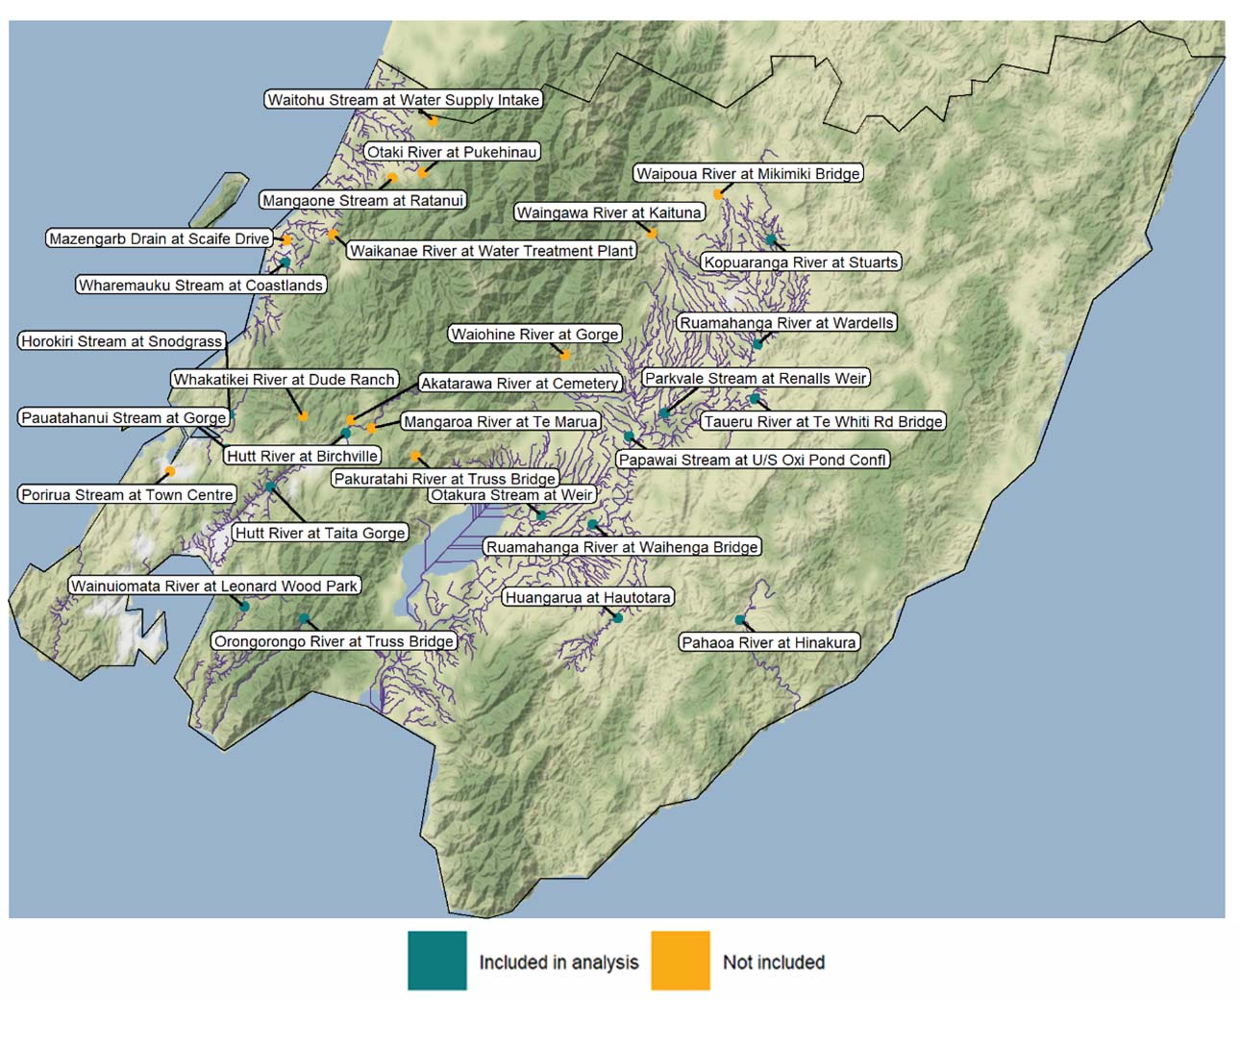
Data source: GWRC
Horizons measures continuous streamflow at 69 long-term river- and streamflow gauging sites in the Manawatū-Whanganui region, but did not provide streamflow time-series for 21 sites that were either not typically used in their water allocation framework, or for which they are not the primary data holder. Streamflow time-series data for a total of 48 gauging sites were ultimately provided (see figure 11).
While the Horizons gauging sites were generally installed for water allocation purposes, many were installed for purposes such as flood warning. We excluded 20 sites from the analysis because they have no consented abstraction sites in their upstream catchments, so did not have the potential to be affected by recorded abstractions. We excluded a further two sites because their daily streamflow time-series did not meet our inclusion criteria (data for more than 20 per cent of days in more than 20 per cent of months during the study period). Streamflow data for a total of 26 gauging sites was ultimately included in the analysis for the Manawatū-Whanganui region (blue in figure 11). Notably excluded from the analysis is the Turakina River, which drains a large catchment between the Whangaehu and Rangitīkei River catchments, and the Akitio, Owahanga and Wainui River catchments, which drain to the east coast.
To provide greater spatial context for the measured streamflow data, we used GWRC and Horizons metadata and the digital river network to segregate the assessed gauging sites by catchment. We then used digital river network metadata to determine the size of each catchment and the upstream catchment area for each gauging site, so we could assess the spatial proportion of each catchment represented. This assessment shows that the 16 gauging sites assessed for the Wellington region represent significant portions of five river catchments, including the region’s three largest by area (the Ruamahanga, Pahaoa and Hutt), and significant portions of three stream catchments (see table 4). For the 26 assessed gauging sites for the Manawatū-Whanganui region, it shows that these represent significant portions of five river catchments, including the region’s four largest by area (the Whanganui, Manawatū, Rangitīkei and Whangaehu), and significant portions of two stream catchments (see table 5).
Table 4: Catchment details for Wellington region river- and streamflow gauging sites included in analysis
Catchment (size) | Location | River/stream | Gauging site (upstream catchment size)
Hutt River (640 km²) | Hutt Valley | Hutt River | Birchville (425 km²)
 |  |  | Taita Gorge (560 km²)
Orongorongo River  (95 km²) | Remutaka Forest Park | Orongorongo River | Truss bridge (30 km²)
Pahaoa River  (650 km²) | Wairarapa | Pahaoa River | Hinakura (565 km²)
Ruamahanga River (3,435 km²) | Wairarapa | Huangarua River | Hautotara (140 km²)
 |  | Kopuaranga River | Stuarts (165 km²)
 |  | Ruamahanga River | Waihenga bridge (2,360 km²)
 |  |  | Wardells (645 km²)
 |  | Taueru River | Te Whiti Road bridge (495 km²)
 |  | Otakura Stream | Weir (45 km²)
 |  | Papawai Stream | Upstream oxidation pond confluence  (7 km²)
 |  | Parkvale Stream | Weir (50 km²)
Wainuiomata River (135 km²) | Wainuiomata Valley | Wainuiomata River | Leonard Wood Park (80 km²)
Horokiri Stream  (35 km²) | Horokiri Valley/ Pauatahanui | Horokiri Stream | Snodgrass (30 km²)
Pauatahanui Stream (40 km²) | Judgeford/ Pauatahanui | Pauatahanui Stream | Gorge (40 km²)
Wharemauku Stream (15 km²) | Paraparaumu/ Raumati Beach | Wharemauku Stream | Coastlands (7 km²)
Table 5: Catchment details for Manawatū-Whanganui region river- and streamflow gauging sites included in analysis
Catchment (size) | Location | River/stream | Gauging site (upstream catchment size)
Manawatū River  (5,875 km²) | Dannevirke/ Palmerston North/ Foxton | Makakahi River | Hamua (165 km²)
 |  | Manawatū River | Hopelands (1,265 km²)
 |  |  | Teachers College (3,915 km²)
 |  |  | Upper Manawatū Gorge (3,190 km²)
 |  |  | Weber Road (715 km²)
 |  | Mangahao River | Balance (280 km²)
 |  | Mangatainoka River | Pahiatua Town Bridge (405 km²)
 |  | Mangatoro River | Mangahei Road (220 km²)
 |  | Oroua River | Almadale Slackline (305 km²)
 |  | Pohangina River | Mais Reach (485 km²)
 |  | Makino Stream | Boness Road (0.2 km²)
 |  | Mangapapa Stream | Troup Road (125 km²)
 |  | Oruakeretaki Stream | State Highway 2, Napier (55 km²)
Ohau River¹  (185 km²) | Levin | Ohau River | Rongomatane (105 km²)
Rangitīkei River  (3,930 km²) | Bulls/Taihape | Hautapu River | Alabasters (275 km²)
 |  | Rangitīkei River | McKelvies (3,850 km²)
 |  |  | Pukeokahu (770 km²)
Whangaehu River² (1,990 km²) | Waiouru/Mangamahu/ Whangaehu | Makotuku River | Raetihi (55 km²)
 |  | Mangawhero River | Ore Ore (670 km²)
 |  |  | Pakihi Road Bridge (140 km²)
 |  | Whangaehu River | Aranui (790 km²)
 |  |  | Kauangaroa (1,895 km²)
Whanganui River (7,135 km²) | Taumarunui/ Whanganui National Park/Whanganui | Whanganui River | Pipiriki (6,030 km²)
 |  |  | Te Rewa (6,620 km²)
Kai Iwi Stream  (190 km²) | Whanganui | Kai Iwi Stream | Handley Road (190 km²)
Waikawa Stream  (80 km²) | Manakau | Waikawa Stream | North Manakau Road (30 km²)

Note: Not all provided flow data included for Ohau and Whangaehu river catchments. Datasets for Haines Ford (Ohau River catchment) and Kiwitea Stream (Whangaehu River catchment) gauging sites did not meet inclusion criteria and were excluded from analysis.

Figure 11: Locations of Horizons river- and streamflow gauging sites in the
Manawatū-Whanganui region
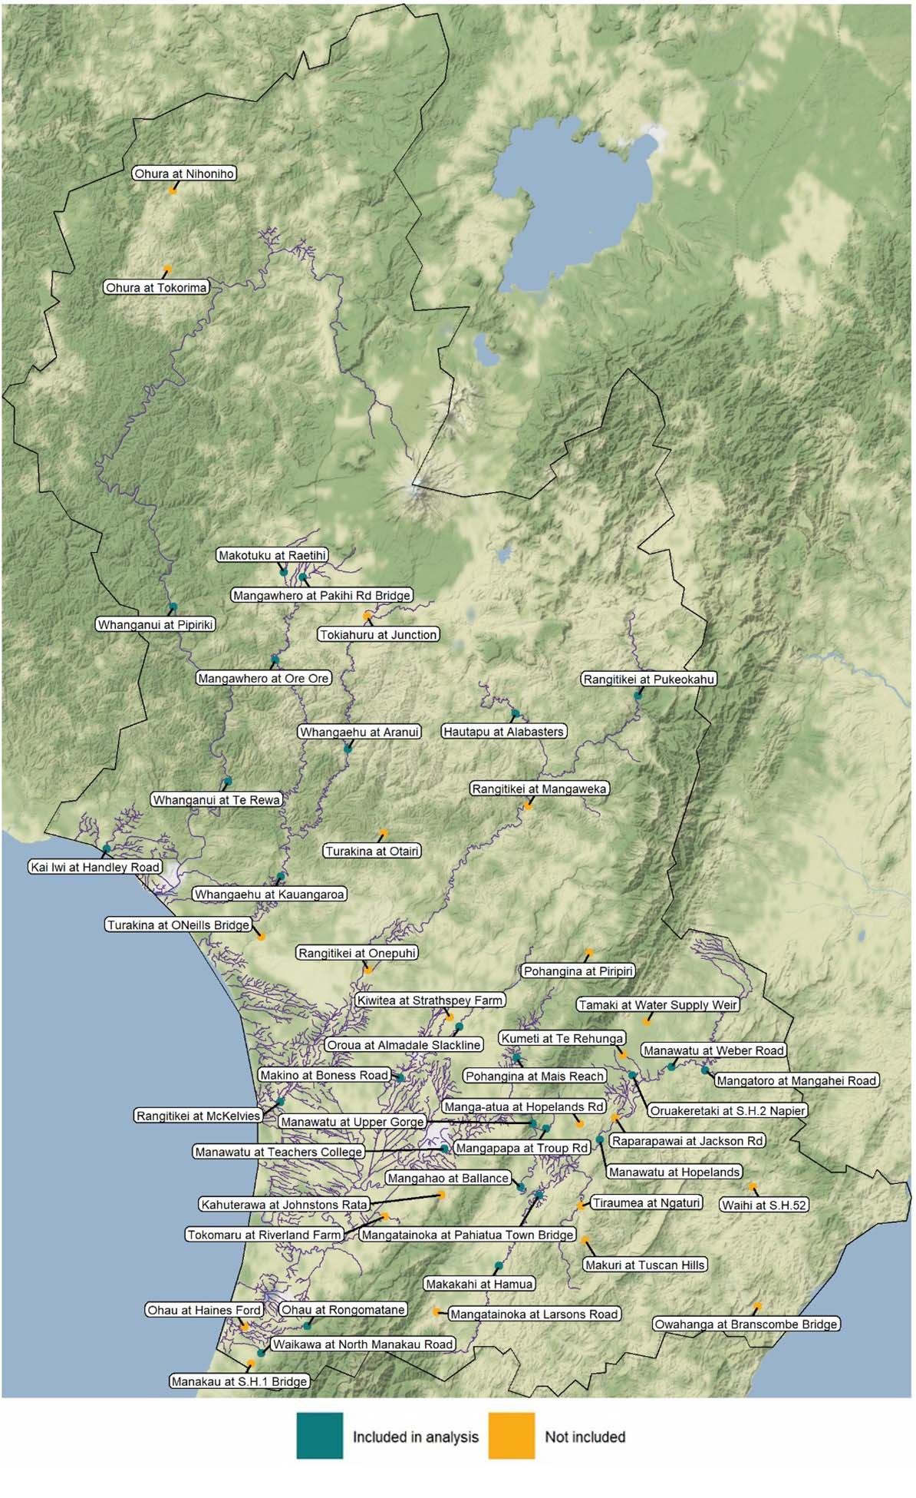
Data source: Horizons
Note: Figure only includes sites that are part of Horizons water allocation framework, and for which Horizons is the primary data holder.

Comparing measured streamflows to measured upstream surface- and groundwater abstractions
To explore how water use and demand relate to river and stream flows, we compared the temporal patterns of measured streamflow for the assessed GWRC and Horizons gauging sites to the measured non-hydropower abstractions in their upstream catchments. We also disaggregated surface- and groundwater abstractions, to determine how water use patterns differed by source type over time and between catchments. These comparisons helped identify the times of year that measured abstraction rates from surface- and groundwater sources upstream of gauging sites in the assessed catchments were at their highest, relative to measured streamflow. The analysis was able to show that average measured daily abstraction rates upstream of the assessed gauging sites were variable between catchments, but were generally higher during the summer and autumn months when the median measured daily river and stream flows were generally at their lowest. The methods to complete this analysis are detailed in the following subsections.

Monthly median daily streamflow for
assessed river- and streamflow gauging sites
To examine temporal streamflow patterns, we generated a plot for each catchment aggregating streamflow time-series for each gauging site in the catchment that had verified streamflow data for the three-year period June 2015–May 2018.
For the Wellington region, this included the Hutt, Orongorongo, Pahaoa, Ruamahanga and Wainuiomata river catchments and the Pauatahanui and Wharemauku stream catchments, but excluded the Horokiri Stream catchment (see figure 12). For the Manawatū-Whanganui region, this included the Manawatū, Ohau, Rangitīkei, Whangaehu and Whanganui river catchments and the Kai Iwi and Waikawa stream catchments (see figure 13). To minimise the influence of interannual variation, and for simplicity of communication, these plots display median daily flow rates at each gauging site in each month of the year (for example, the median of daily values for the 90 days in June 2015, 2016 and 2017).
The individual plots are displayed at different scales to best illustrate temporal patterns, and are not intended to compare flow rates between catchments.
Figure 12: Monthly median daily streamflow measured at assessed river- and streamflow gauging sites in the Wellington region by catchment, June 2015–May 2018
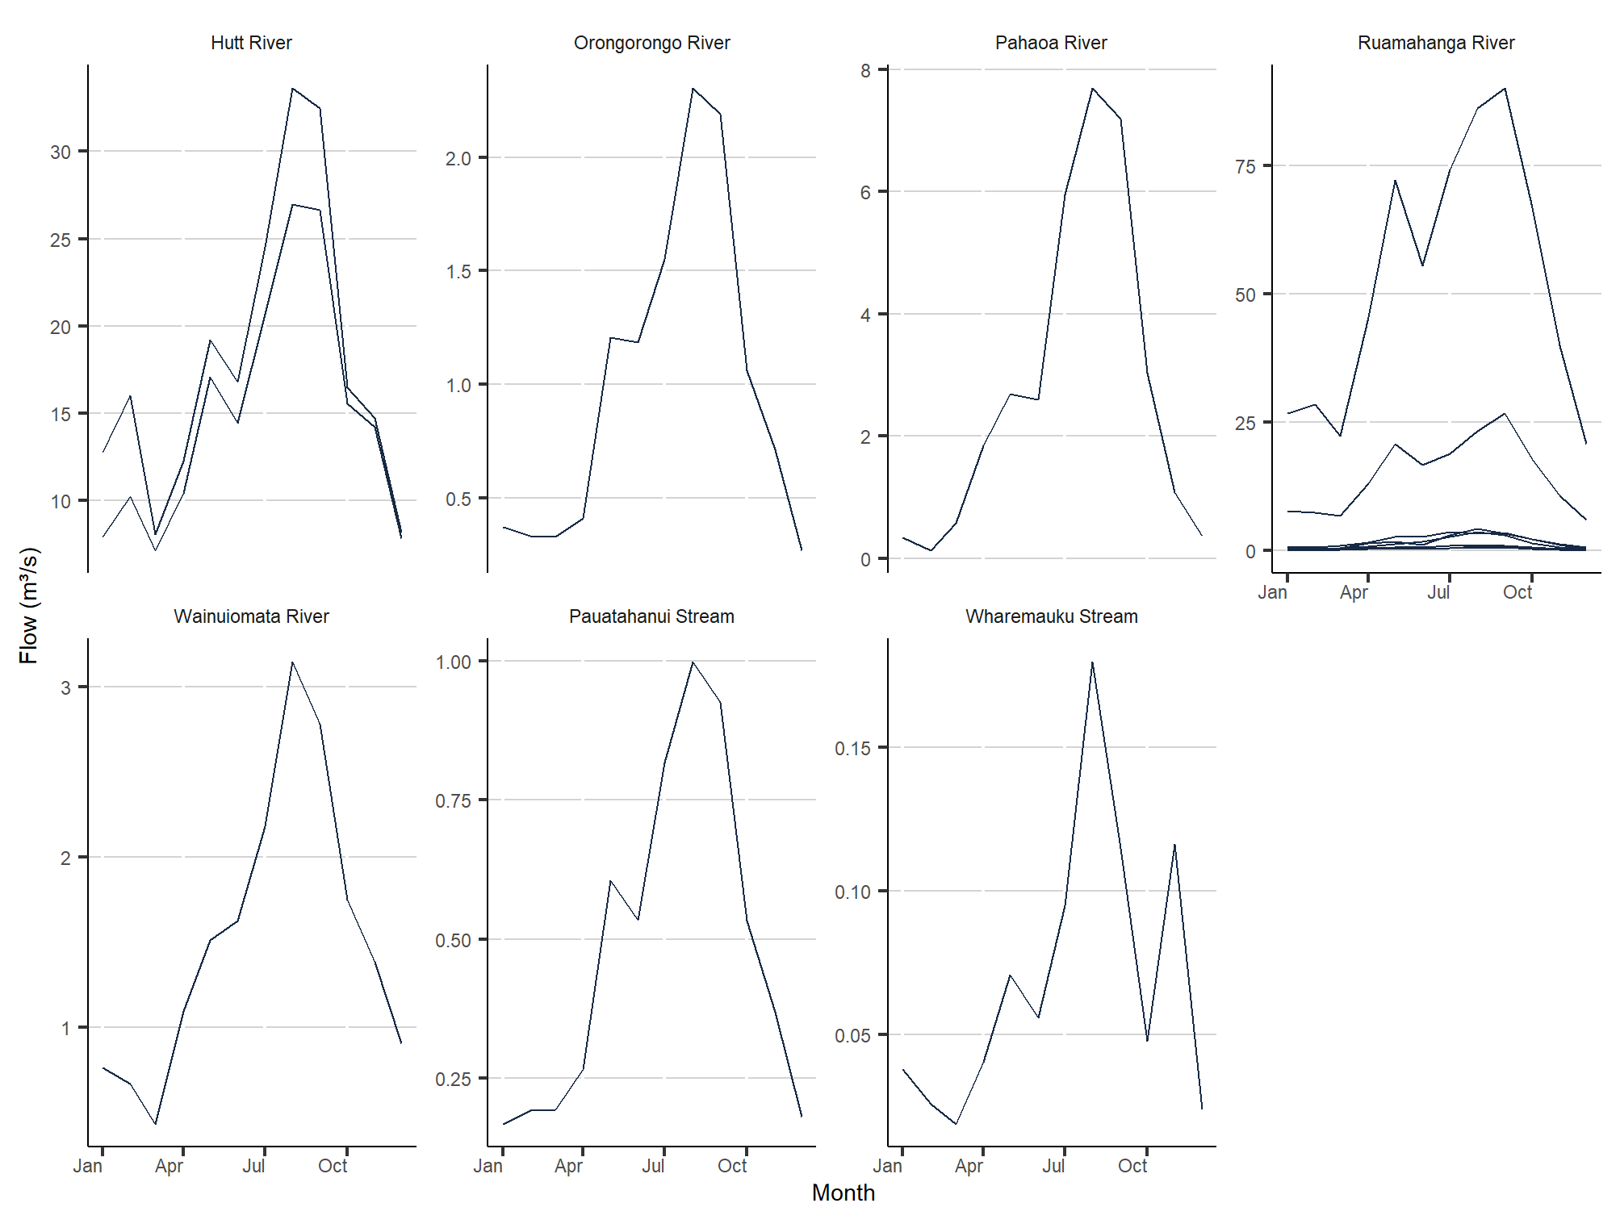
Data source: GWRC
Note: Only sites with verified streamflow time-series datasets are shown. For the catchments with multiple sites, downstream sites may re-measure some or all of the flow measured at upstream sites. Figure excludes Horokiri Stream catchment, as no measurable abstractions were recorded upstream of its gauging site.
Figure 13: Monthly median daily streamflow measured at assessed river- and streamflow gauging sites in the Manawatū-Whanganui region by catchment, June 2015–May 2018
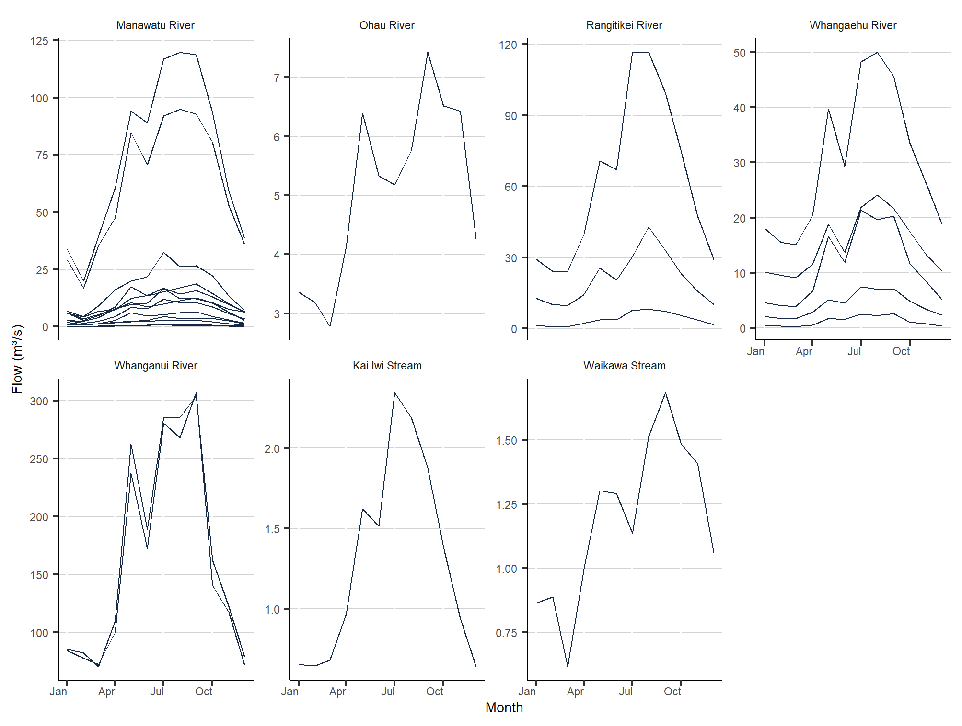
Data source: Horizons
Note: Only sites with verified streamflow time-series datasets are shown. For the catchments with multiple sites, downstream sites may re-measure some or all of the flow measured at upstream sites.
This assessment was able to show that the daily average streamflow measured at the assessed gauging sites in the Wellington and Manawatū-Whanganui regions was variable over the three-year study period, but generally followed the expected temporal pattern of lower flows in summer and autumn, and higher flows in winter and spring.
These flow patterns are likely to have been influenced by the effect of droughts in Wellington and the Wairarapa from summer 2015 to spring 2016, and in summer 2018, and across the Manawatū-Whanganui region in summer and autumn 2016 and summer 2018. They may not be representative of non-drought conditions (Stats NZ, 2020).

Monthly average totalised daily surface- and groundwater abstractions upstream of assessed river- and streamflow gauging sites
To examine abstraction patterns for the same catchments for the same period, we used council-supplied metadata to determine which abstraction sites were upstream of one or more assessed river- or streamflow gauging site in each catchment. We then used the same metadata to segregate the surface- and groundwater abstraction timeseries, to allow a comparison of surface- and groundwater abstraction patterns. Finally, we totalised the daily measured upstream abstraction rates in each catchment by source type, and plotted the combined average daily total abstraction rate by month (for example, the average of the combined abstraction rates for the 90 days in June 2015, 2016 and 2017; see figures 14 and 15).
The individual plots are displayed at different scales to best illustrate temporal patterns, and are not intended to compare abstraction rates between catchments.
Figure 14: Monthly average total daily surface- and groundwater abstraction rates measured upstream of assessed river- and streamflow gauging sites in the Wellington region by catchment, June 2015–May 2018
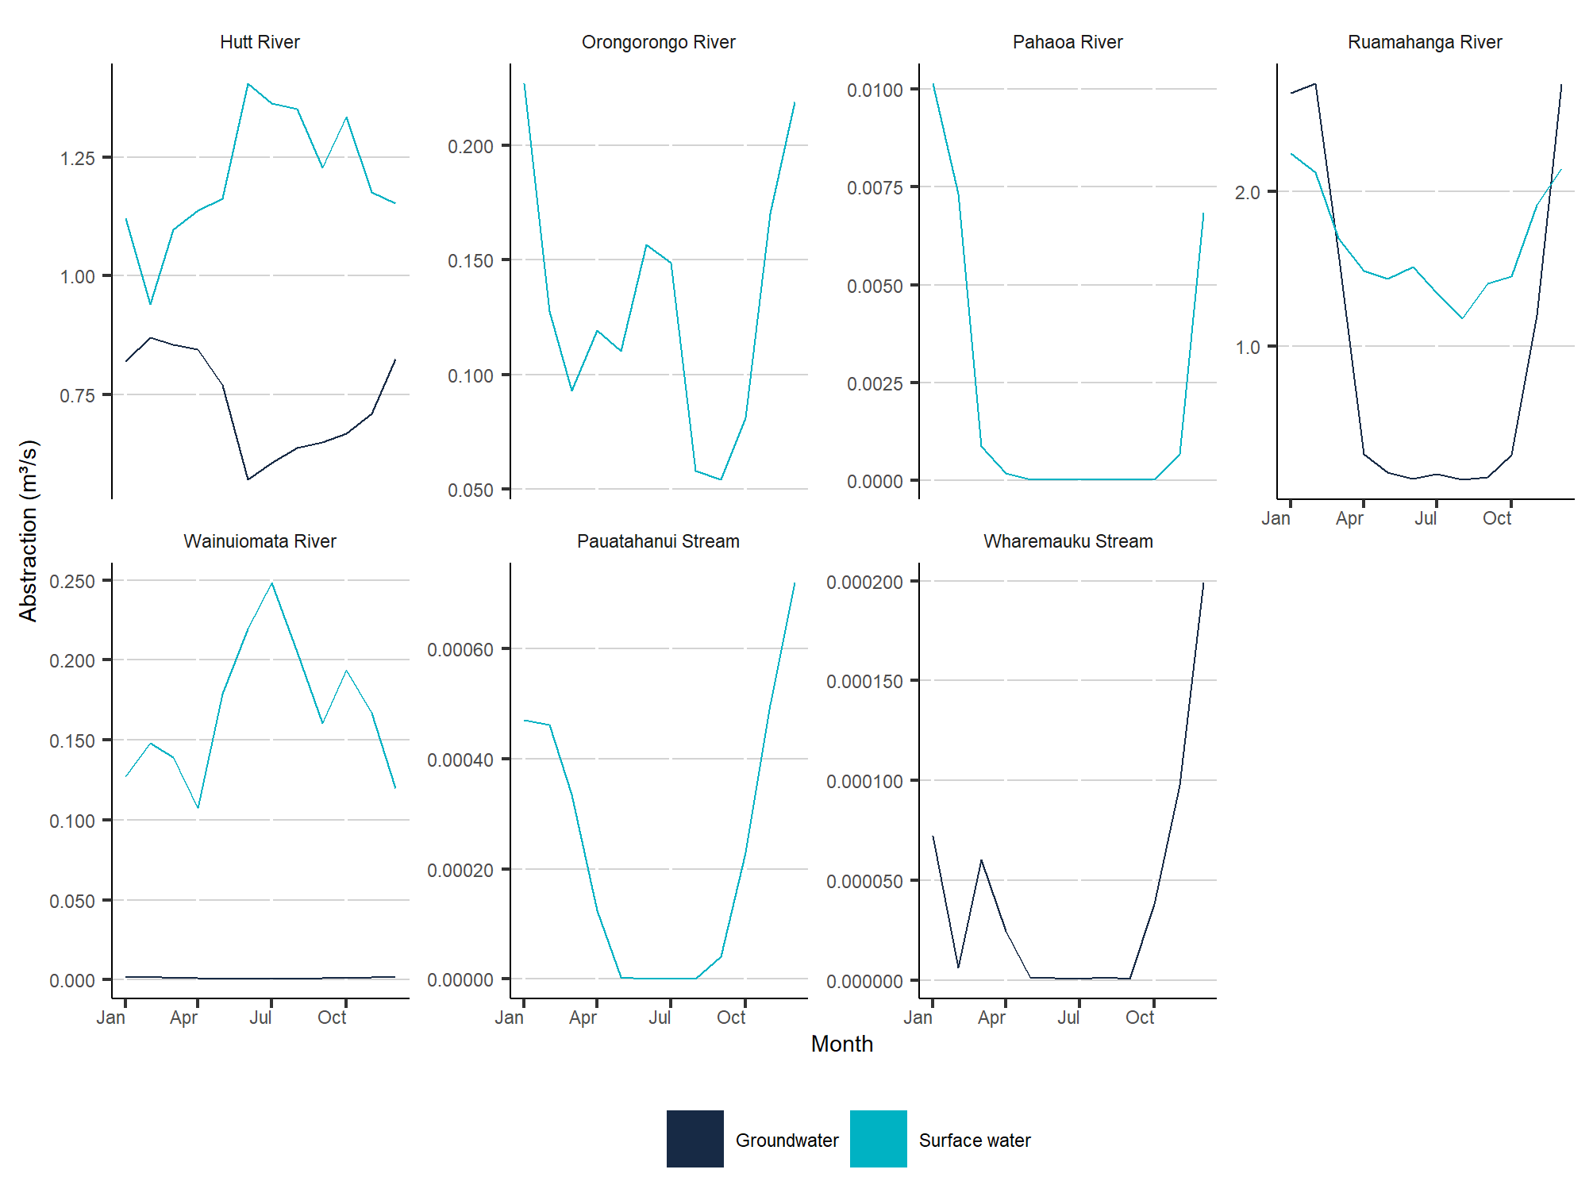
Data source: GWRC
Note: Only catchments with verified streamflow time-series datasets and at least one recorded abstraction greater than zero upstream of an assessed gauging site are shown.
Figure 15: Monthly average total daily surface- and groundwater abstraction rates for non-hydropower use, measured upstream of assessed river- and streamflow gauging sites in the Manawatū-Whanganui region by parent catchment, June 2015–May 2018
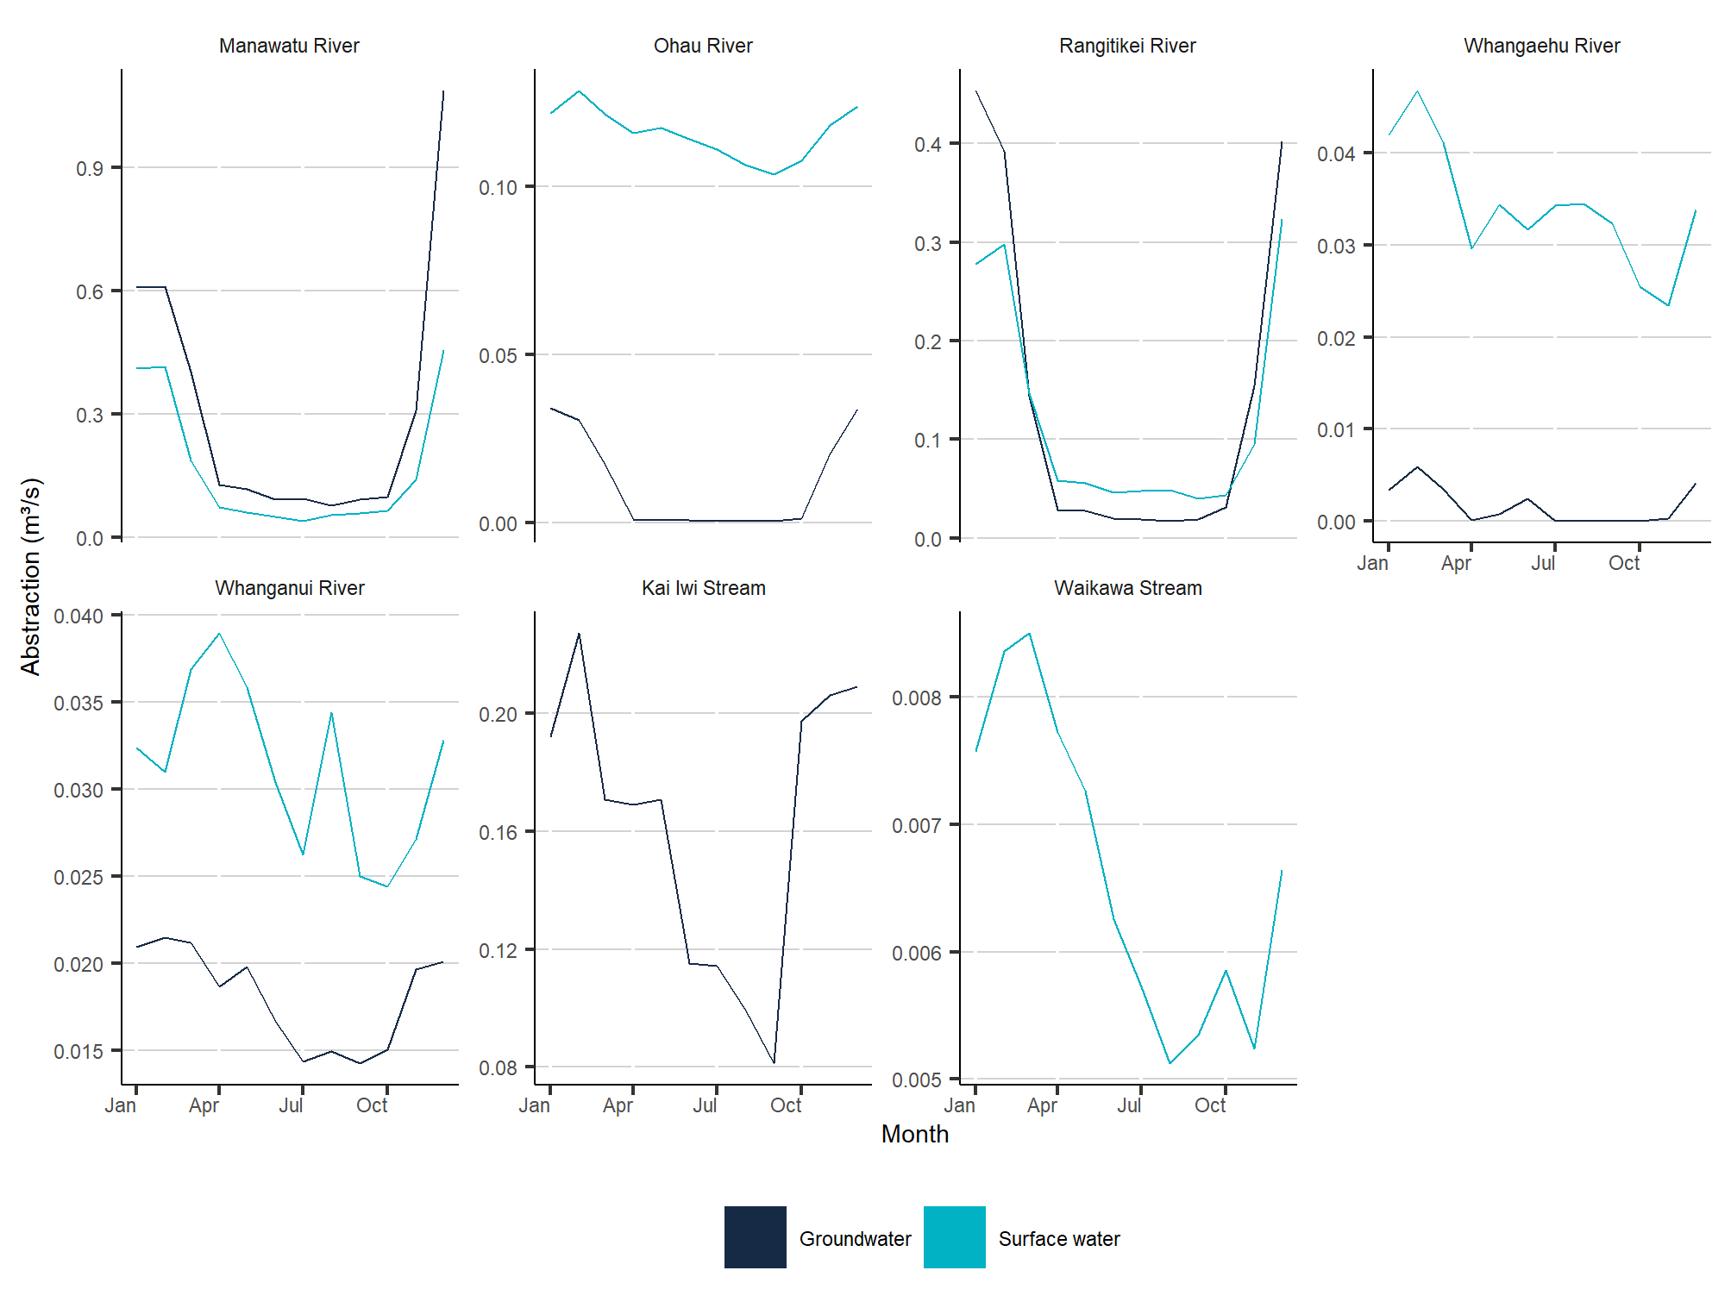
Data source: Horizons
Note: Only catchments with verified streamflow time-series datasets and at least one recorded abstraction greater than zero upstream of an assessed site are shown. Surface water plots do not include the consumptive hydropower diversions that remove flow from the Rangitīkei, Whangaehu, Whanganui rivers, and divert flow from the Whangaehu River catchment to the Whanganui River catchment and from the upper Mangahao River to the lower Manawatū River.
This helped illustrate seasonal patterns of non-hydropower surface- and groundwater use and demand in the assessed catchments. In the Hutt and Ruamahanga river catchments in the Wellington region, for most months of the year the average combined daily surface water abstraction rates upstream of assessed gauging sites (light blue in figure 14) were considerably higher than the average combined daily groundwater abstraction rates (dark blue in figure 14), but in summer months the groundwater abstraction rates were similar to, or higher than, surface water abstraction rates. In the Manawatū and Rangitīkei river catchments in the Manawatū-Whanganui region, for most months of the year the combined average daily surface- and groundwater abstraction rates upstream of assessed gauging sites (light blue and dark blue in figure 15, respectively) were similar, but in summer months the groundwater abstraction rates were considerably higher than surface water abstraction rates.
These patterns reflect known patterns of water use in these catchments. Wellington and Palmerston North rely heavily on a combination of surface- and groundwater sources in the Hutt and Manawatū river catchments respectively, and both municipal schemes increase their reliance on groundwater sources in summer when surface water is in higher demand (Wellington Water, 2021a; Palmerston North City Council, 2021). A similar explanation applies to the rural towns and large agricultural areas in the Wairarapa and surrounding Palmerston North, which get their water from surface- and groundwater sources in the Ruamahanga, Manawatū and Rangitīkei river catchments; these areas will increasingly rely on groundwater sources in summer, when there is limited surface water available to fill the higher demand for water for irrigation (Wellington Water, 2021b; Land Air Water Aotearoa, nd; Rangitīkei District Council, 2018).
These patterns are likely to have been magnified by the effects of the droughts in Wellington and the Wairarapa summer 2015 to spring 2016, and in summer 2018, and across the Manawatū-Whanganui region in summer and autumn 2016 and summer 2018 (Stats NZ, 2020). These droughts would have placed even greater pressures on surface water resources, triggering restrictions on surface water abstractions and increased demand for groundwater for municipal and irrigation use.
This analysis is likely to under-report actual totalised abstraction rates to some degree, because it does not account for abstraction sites excluded due to data quality issues, or abstractions under-reported or not reported. By excluding consumptive hydropower schemes in the Manawatū-Whanganui region, it will also significantly underestimate actual totalised surface water abstraction rates for the assessed portions of the Whangaehu, Whanganui and Rangitīkei River catchments, and to a lesser degree, the Manawatū River catchment. This is because the analysis does not account for the ongoing diversion of approximately 29 cubic metres of flow per second from the headwaters of the Whangaehu, Whanganui and Rangitīkei rivers into Lake Taupō and the Waikato River for the Tongariro Power Scheme, or the smaller scheme that diverts flow from an upper tributary of the Manawatū River to the Mangahao Power Station in the lower Manawatū River catchment (Genesis Energy, nd; Horizons Regional Council, 2019).

Using estimated streamflow depletion and measured streamflow to estimate natural streamflow
To estimate what the daily streamflow at each assessed gauging location would have been if none of the upstream measured abstractions had taken place, we added the daily average measured flow rate for each gauging site to the estimated daily streamflow depletion rate calculated for the corresponding digital river network segment (see Estimating streamflow depletion using measured abstraction data), for each day of the three-year period 1 June 2015–31 May 2018. We describe this figure as the ‘estimated natural streamflow’; however, the potential accuracy of this figure is affected by all the limitations of the streamflow depletion analyses it is derived from. This means it:
- will overestimate true natural flow for some segments affected by hydropower augmentations (that is, added flows from other catchments)
- will underestimate true natural flow for segments affected by consumptive hydropower abstractions
- may underestimate true natural flow for some segments, where the analyses have not captured delayed depletion effects from abstractions before the study period or depletion estimated to have occurred after the study period ended
- may underestimate or overestimate true natural flow due to input data gaps and various modelling uncertainties.
Counter to this, these calculations may overestimate true natural flow for segments where the total actual upstream abstractions are well represented by the measured data. This is because the streamflow depletion calculations do not account for the proportion of abstracted water that flows back into rivers and streams after use (for example, where farms are over-irrigated). In these instances, the returned flow will be double counted in the estimate of natural streamflow. The implications of these under- and overestimates on subsequent analyses, to the extent they are known to affect findings, are discussed in the following subsection.
While these methods rely heavily on assumptions and are affected by the uncertainties noted above, they allowed the estimation of the potential influences of known and quantified (that is, measured and reported) surface- and groundwater abstractions on surrounding rivers and streams. More detailed explanations of the streamflow depletion modelling and equations used are provided in Appendix A, Booker et al (2016), and Booker et al (2019).

Comparing estimated streamflow depletion to estimated natural flow
To estimate streamflow depletion proportional to natural streamflow for each river- and streamflow gauging location included in the analysis, we divided the estimated daily streamflow depletion rate for the corresponding digital river network segment by the estimated natural streamflow for the segment. This allowed us to generate a daily streamflow depletion time-series for each gauging location, expressed as a ratio of estimated natural streamflow.
This analysis only describes the estimated flow-proportional depletion at discrete locations along the river network (gauging sites), and cannot demonstrate potential impacts for any portion of the upstream network. However, as the estimated streamflow depletion calculations it uses are based on the accumulated impact of all measured abstractions upstream of each gauging site, it does provide some indication of how each of the catchments upstream of the assessed gauging sites were affected by measured abstractions. The methods used for this analysis are detailed in the following subsections.
This analysis is likely to underestimate streamflow depletion to some degree, and by extension, natural flow and flow-proportional depletion, for reasons discussed previously (see Using estimated streamflow depletion and measured flow to estimate natural streamflow). The analysis for the Manawatū-Whanganui region is also likely to significantly underestimate flow-proportional streamflow depletion for the assessed portions of the Whangaehu, Whanganui and Rangitīkei river catchments and, to a lesser extent, the Manawatū River catchment. This is because it does not account for the ongoing diversion of approximately 2.5 million cubic metres of daily flow from the headwaters of the Whangaehu, Whanganui and Rangitīkei rivers into Lake Taupō and the Waikato River for the Tongariro Power Scheme, or the smaller hydropower scheme that diverts flow from an upper tributary of the Manawatū River to the Mangahao Power Station in the lower Manawatū River catchment (Genesis Energy, nd; Horizons Regional Council, 2019).

Average daily flow-proportional streamflow depletion across seasons
To enable us to assess the estimated impacts of measured abstractions on natural daily streamflows at the assessed gauging sites across the regions and across seasons, we calculated the average daily ratio of streamflow depletion to estimated natural flow for each site for each of the 12 seasons from winter 2015 to autumn 2018, and plotted these on maps (see figure 16). To provide context for the findings, and for simplicity of communication, we aggregated these ratios into the same arbitrary categories used in our first approach (see Comparing estimated streamflow depletion to estimated long-term natural median flow).

Figure 16: Average daily ratio of estimated streamflow depletion to estimated natural streamflow at gauging sites in the Wellington and Manawatū-Whanganui regions by season,
winter 2015–autumn 2018
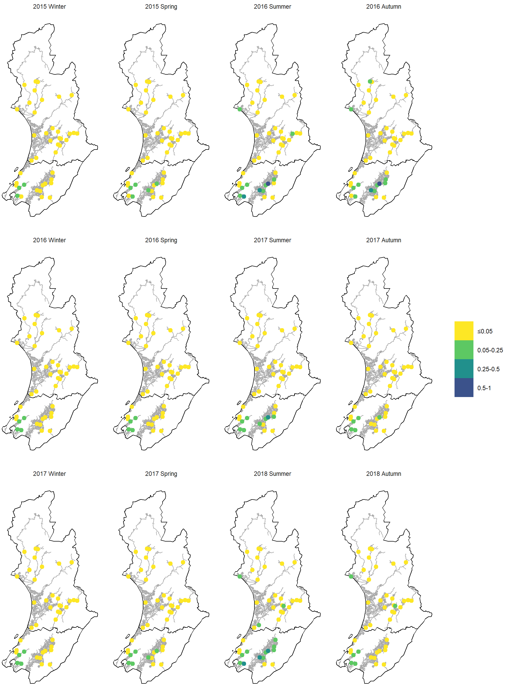
Data sources: National Institute of Water and Atmospheric Research (NIWA), GWRC and Horizons
Note: Abstractions for hydropower were not included in the analysis, so the estimated streamflow depletion effects of consumptive hydropower abstractions are not shown. Analysis assumes that all groundwater abstractions deplete streamflow, and that no abstracted surface- or groundwater is returned to the river network. Estimated natural streamflow calculated using validated abstraction and streamflow time-series datasets only; excludes datasets that did not meet data quality criteria, and does not account for the potential influence of unmeasured, unreported and underreported abstractions, or for the influence of hydropower schemes.
This method was successful in providing rough estimates of the average proportion of natural daily streamflow removed from catchments upstream of the river- and streamflow gauging sites as a result of measured non-hydropower abstractions across the three-year study period. It demonstrated that flow-proportional depletion was experienced to different degrees according to location and season, and was most pronounced in the summer seasons.
The analysis for the Wellington region estimates that none of the catchments upstream of the assessed gauging sites experienced average daily streamflow depletion greater than 25 per cent of natural streamflow in winter or spring seasons (June to November), or in autumn of 2017 or 2018, and that most experienced average daily streamflow depletion less than 5 per cent of natural streamflow during these seasons. However, it estimates that most of these catchments experienced average daily streamflow depletion greater than 5 per cent in summer and autumn 2016, and summers of 2017 and 2018, and that several experienced average daily streamflow depletion greater than 25 per cent of natural streamflow in one or more of these seasons. If these estimates are accurate, they may partly be the result of lower natural streamflows due to a drought in Wellington and the Wairarapa from summer 2015 to spring 2016, and in Summer 2018 (Stats NZ, 2020).
The analysis for the Manawatū-Whanganui region estimates that none of the catchments upstream of the assessed gauging sites in the region experienced average daily streamflow depletion greater than 5 per cent of natural streamflow in winter or spring 2015, or during any seasons from winter 2016 to spring 2017, and that only a few catchments experienced average daily streamflow depletion greater than this outside of these seasons. It also estimates that none of the assessed catchments experienced average daily streamflow depletion greater than 25 per cent of natural streamflow during any season of the three-year study period. It is noted that the higher average daily streamflow depletion estimated for some catchments during summer and autumn 2016 and summer and autumn 2018 coincided with droughts that occurred across the region during these seasons (Stats NZ, 2020).

Frequency and severity of flow-proportional streamflow depletion by season
To refine our assessment of the estimated impacts of measured abstractions on natural daily streamflows at the assessed gauging sites, we calculated the proportion of winter, spring, summer and autumn days that the estimated flow-proportional streamflow depletion ratios for each site exceeded the same arbitrary numeric categories used in the preceding analyses, and plotted these graphically (see figures 17 and 18). We also used the upstream catchment areas from the digital river network to assess the potential spatial significance of the results for individual gauging sites at the catchment level.
The numeric categories in figures 17 and 18 are divided by arbitrary thresholds of 5 per cent, 25 per cent, 50 per cent, and 100 per cent of estimated natural daily streamflow, but the 5 and 25 per cent thresholds roughly align with the streamflow alteration thresholds for ecological protection found in international research in Richter et al (2011). This paper suggested that alteration less than 10 per cent of natural daily flow is expected to have minimal impact on ecosystems, and greater than 20 per cent will likely result in moderate to major ecosystem impacts. It could therefore be expected that streamflow depletion:
- less than 5 per cent of estimated natural daily flow (yellow in figures 17 and 18) would not harm ecosystems
- 5–25 per cent (light green in figures 17 and 18) might have some ecosystem impacts
- greater than 25 per cent (dark green and blue in figures 17 and 18) would almost certainly cause ecosystem harm.
This method was successful in providing a more detailed assessment of seasonal patterns of flow-proportional streamflow depletion; specifically, it demonstrated the frequency and severity of the daily depletion effects estimated to have occurred in individual catchments, and how these effects were expressed seasonally. In doing so, it captures potentially significant flow-proportional depletion events that might be too infrequent or of too short a duration to be captured by seasonal averages. A detailed discussion of the results for the Wellington and Manawatū-Whanganui regions is provided in the following paragraphs.
Figure 17: Percentage of spring, summer, autumn and winter days where the ratio of upstream depletion to estimated natural streamflow exceeded thresholds at gauging sites in the Wellington region, June 2015–May 2018
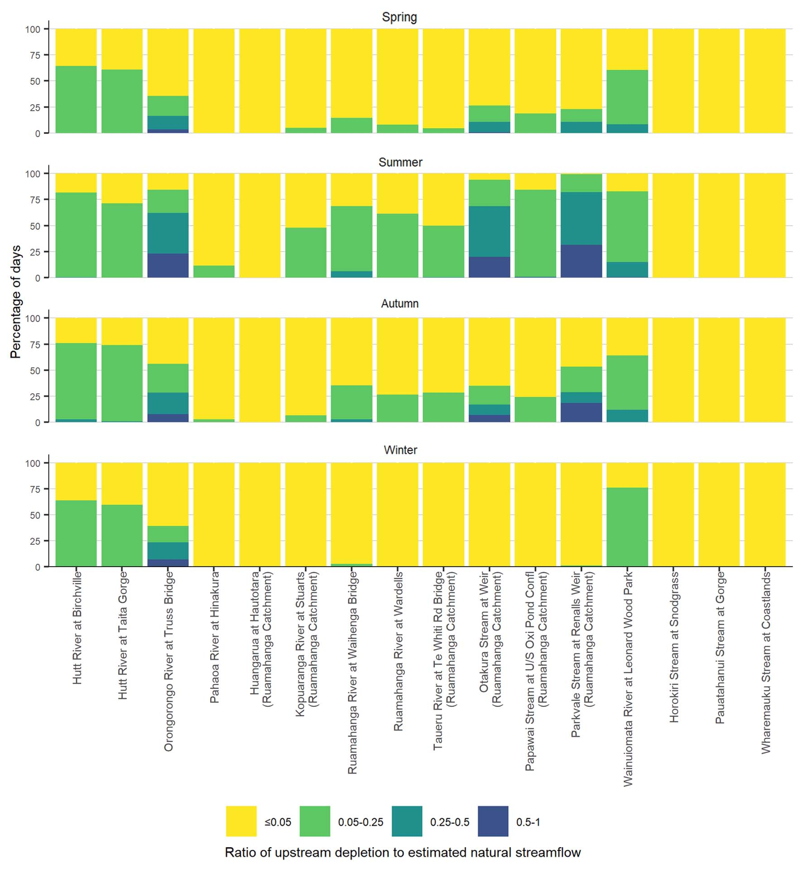
Data sources: NIWA and GWRC
Note: Analysis assumes all groundwater abstractions deplete streamflow, and no abstracted surface- or groundwater is returned to the river network. Estimated natural streamflow calculated using validated abstraction and streamflow time-series datasets only; excludes datasets that did not meet data quality criteria, and does not account for the potential influence of unmeasured, unreported and underreported abstractions.
Figure 18: Percentage of spring, summer, autumn and winter days where the ratio of upstream depletion to estimated natural streamflow exceeded thresholds at gauging sites in the Manawatū-Whanganui region, June 2015–May 2018
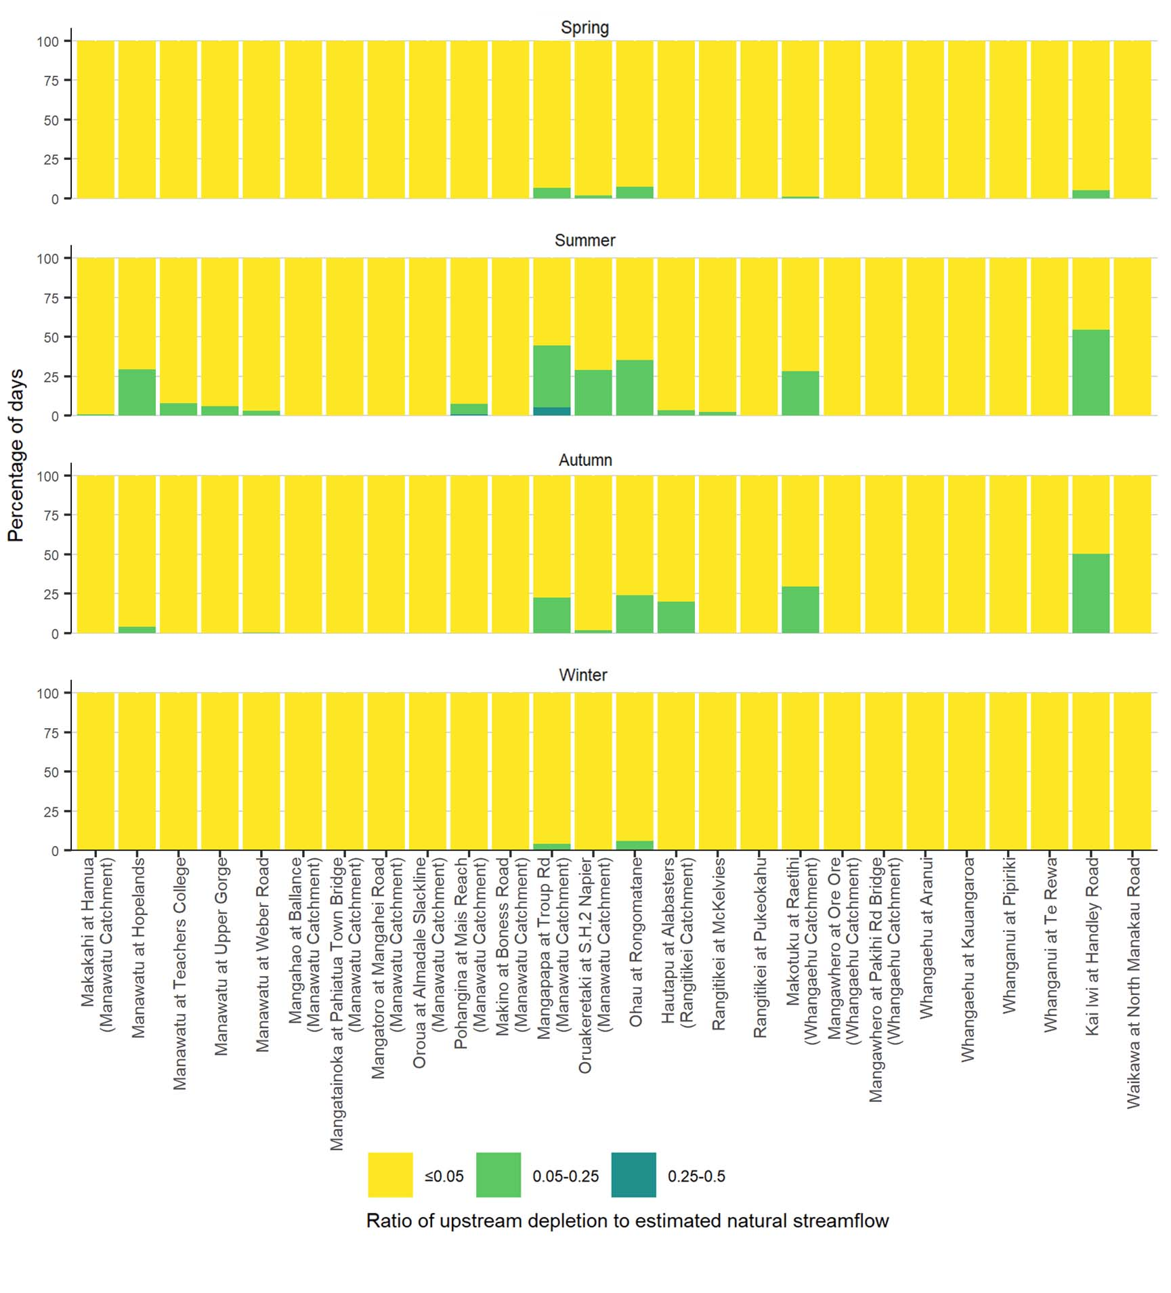
Data sources: NIWA, Horizons Regional Council
Note: Abstractions for hydropower were not included in the analysis, so the estimated streamflow depletion effects of consumptive hydropower abstractions are not shown. Analysis assumes all groundwater abstractions deplete streamflow, and no abstracted surface- or groundwater is returned to the river network. Estimated natural streamflow calculated using validated abstraction and streamflow time-series datasets only; excludes datasets that did not meet data quality criteria, and does not account for the potential influence of unmeasured, unreported and underreported abstractions, or for the influence of hydropower schemes.
The assessment for the approximately 3,435 square kilometre Ruamahanga River catchment in the Wellington region estimates that the 95 square kilometres upstream of the Otakura and Parkvale Stream gauging sites experienced streamflow depletion greater than 25 per cent of natural streamflow (dark green and blue on figure 17) on most summer days, and on approximately 20 per cent of autumn and spring days, but the 140 square kilometres upstream of the Huangarua River gauging site experienced depletion of 5 per cent of natural flow or less (yellow on figure 17) for the entirety of the three-year study period. It further estimates that the 2,125 square kilometres upstream of the five other river- and streamflow gauging sites in the Ruamahanga River catchment experienced depletion between 5 and 25 per cent of natural flow (light green on figure 17) between approximately half and three quarters of summer days, approximately a quarter of autumn days, and approximately 10 per cent of spring days.
The assessment for the other Wellington region catchments estimates that the 30 square kilometres upstream of the gauging site in the approximately 95 square kilometre Orongorongo River catchment experienced streamflow depletion greater than 25 per cent of natural streamflow (dark green and blue on figure 17) on more than half of summer days, and on approximately a quarter of autumn, winter and spring days, and that the 640 square kilometres upstream of the gauging sites in the approximately 640 square kilometre Hutt River and approximately 135 square kilometre Wainuiomata River catchments experienced depletion between 5 and 25 per cent of natural flow (light green on figure 17) on more than half the days for each of the four seasons, with very little seasonal variation. It further estimates that the approximately 40 square kilometre Pauatahanui Stream catchment, and the 572 square kilometres upstream of the gauging sites on the approximately 650 square kilometre Pahaoa River and approximately 15 square kilometre Wharemauku Stream catchments experienced depletion of 5 per cent of natural flow or less (yellow on figure 17) for all but a handful of days during the three-year study period.
There were no recorded abstractions in the 30 square kilometres upstream of the gauging site in the approximately 35 square kilometre Horokiri Stream catchment, so the analysis estimates that no depletion occurred in this portion of the catchment.
The assessment for the approximately 5,875 square kilometre Manawatū River catchment in the Manawatū-Whanganui region estimates that only the 610 square kilometres upstream of the Pohangina River and Mangapapa Stream gauging sites experienced streamflow depletion greater than 25 per cent of natural streamflow (dark green on figure 18), and only on a handful of summer days. It further estimates that the 125 square kilometres upstream of the Mangapapa Stream gauging site experienced depletion between 5 and 25 per cent of natural flow (light green on figure 18) on approximately 40 per cent of summer days and approximately 25 per cent of autumn days respectively. The assessment also estimates that the 550 square kilometres upstream of the Oruakeretaki Stream gauging site and one of the gauging sites on the upper Manawatū River experienced depletion between 5 and 25 per cent of natural flow on approximately 25 per cent of summer days, and on a handful of autumn days. For the 3,060 square kilometres upstream of the remaining assessed gauging sites in the Manawatū River catchment, the assessment estimates that most did not experience depletion of 5 per cent of natural flow or greater on any days during the three-year study period (yellow in figure 18), and those that did only experienced depletion between 5 and 25 per cent of natural flow for a handful of summer and autumn days.
The assessment for the other large river catchments in the Manawatū-Whanganui region estimates that the 6,620 square kilometres upstream of the gauging sites in the approximately 7,135 square kilometre Whanganui River catchment did not experience streamflow depletion of 5 per cent of natural streamflow or greater on any days during the three-year study period (yellow on figure 18). For the approximately 1,990 square kilometre Whangaehu and approximately 3,930 square kilometre Rangitīkei River catchments, it estimates that only the 55 square kilometres upstream of the Makotuku River gauging site and the 275 square kilometres upstream of the Hautapu River gauging site experienced depletion between 5 and 25 per cent of natural flow (light green on figure 18) for more than a handful of days, and only in summer or autumn. The assessment for the smaller catchments estimates that the 30 square kilometres upstream of the gauging site in the 80 square kilometre Waikawa Stream catchment did not experience depletion greater than 5 per cent of natural flow on any days during the three-year study period. However, it estimates that the approximately 190 square kilometre Kai Iwi Stream catchment, and the 105 square kilometres upstream of the gauging site in the approximately 185 square kilometre Ohau River catchment, experienced depletion between 5 and 25 per cent of natural flow on approximately half of summer days and approximately a quarter of autumn days.

Conclusion
This study demonstrated that, by updating and building on methods previously employed by the National Institute of Water and Atmospheric Research (NIWA), Ministry for the Environment and Stats NZ for estimating the streamflow depletion effects of non-hydropower freshwater abstractions, we were able to improve our understanding of these effects in the following ways:
- Using measured council water abstraction data and metadata allowed us to estimate actual water use for measured locations by primary use, with greater accuracy than relying on consent information (which has only enabled estimates of the maximum amount of water that could be abstracted under consents).
- Using measured abstraction data and metadata instead of consent information allowed us to use streamflow depletion models to generate streamflow depletion predictions based on measured water use.
- Comparing streamflow depletion predictions based on measured water use for the three-year study period to estimated long-term natural median flow allowed us to estimate the gross depletion pressures experienced at the river and stream reach level.
- For the river and stream reaches with consent information, we were able to use the above method for July 2017–June 2018 to compare the estimated depletion pressures from measured water use to the depletion pressures estimated to have been experienced if all upstream sites abstracted their consented maximum allocation.
- For the river and stream locations with useable measured council time-series streamflow data, we were able to determine the daily streamflow remaining after abstractions had taken place.
- Comparing measured council time-series streamflow data to measured abstraction data for the same catchments allowed us to explore temporal and spatial relationships between surface water use, groundwater use, and river and stream flows.
- We were able to derive a rough estimate of natural daily streamflow at the assessed council gauging sites, by adding the estimated streamflow depletion based on measured water use upstream of each site to the measured flow remaining.
- Comparing streamflow depletion calculations based on measured water use upstream of assessed council gauging sites with estimated natural daily flow at the same sites allowed us to examine the seasonal and spatial variation of the flow-proportional depletion effects estimated to have been experienced for the river and stream catchments upstream of these gauging sties.
While we were able to derive many insights into the potential effects of how water is used in the Wellington and Manawatū-Whanganui regions by using the improved datasets and updated methods detailed above, the potential accuracy and spatial representativeness of the analyses are subject to analytical limitations, and are highly sensitive to the quality and completeness of the required data. In our attempts to provide a comprehensive assessment for the two regions, we encountered the following barriers and opportunities for improvement:
- Daily time-series records of water abstraction were available in a useable form from council web servers, but much additional effort was required to resolve data quality issues and retrieve critical metadata. Quality issues still could not be resolved for some records, and these had to be removed from the analyses.
- The spatial representativeness of the analyses was limited to the data available, which were not sufficiently comprehensive to generate findings at the regional scale. This could be improved with greater access to data, or using available models to infill data gaps.
- We were not able to integrate consumptive hydropower abstractions and augmentations into the analyses, owing to limited data availability. Improved access to hydropower time-series abstraction and augmentation records and metadata would allow future analyses to capture the seasonal and daily effects of non-consumptive hydropower schemes at the river and stream reach level.
- We did not prioritise sourcing and integrating regional council estimates for permitted abstractions that are not legally required to be measured, so the potential streamflow depletion effects from these are not accounted for. These abstractions could collectively exert a significant pressure on flows in some areas, and future assessments should consider integrating these estimates into their depletion modelling.
- Comparing streamflow depletion to estimated long-term median natural streamflow allowed us to report at a very fine spatial scale region-wide, but only at a very broad (annual or longer) temporal scale. Developing similarly accurate estimates for seasonal natural flows would support more informative comparisons.
- The datasets used to compare streamflow depletion to estimated long-term natural median streamflow included digital river network segment IDs, but we did not use these to link segments to available metadata that would have enabled us to identify and report depletion statistics for specific river and stream catchments. This limited us to a high-level cursory visual inspection of the spatial outputs for unnamed river and stream segments.
- The comparison of river- and streamflow gauging point data to upstream depletion values provides an estimate of flow-proportional depletion at a single point along a river or stream. This gives an indication of the depletion pressure faced by the upstream river network as a whole, but gives no indication of how these pressures are distributed within the upstream network. The spatial resolution of this analysis could be improved by using existing hydrological information and measured flow data to derive flow estimates, and flow-proportional depletion ratios, for more points along the river network.
- This analysis considers generic daily streamflow alteration thresholds for ecological protection derived from international research in Richter et al (2011), but has intentionally not applied any specific environmental thresholds. The application of these thresholds is critical to the interpretation of these analyses, but the selection of which are most appropriate to use will need to be thoroughly considered.
- The results of the depletion analyses could be disaggregated by water use and source type, to investigate the specific temporal and spatial abstraction patterns for each, and how these impact river and stream flows.
- We were able to make valuable comparisons using the consent data compiled by NIWA for July 2017–June 2018 and the measured abstraction datasets, but this could only be done for the one year, and was challenged by inconsistent and missing metadata. Future analyses would be able to provide much greater insight into the relationship between water allocation and use if comprehensive and standardised datasets for all water use consents and for all measured abstractions can be secured in a format that enables abstractions to be easily linked to their respective consent record.
- Spatial data were readily available to enable a more comprehensive interpretation of the results, which would account for the highly relevant complexities of the river and stream network and properly qualify the representativeness of the results. This was not prioritised for this case study, as the focus was on exploring the general viability of the new analyses and methods, but it would significantly strengthen future assessments.
A summary of the analytical progress demonstrated by this case study, and recommended future works, is provided in table 6.
Table 6: Summary of progression of analysis and recommended future works
 | Analysis | Previous works | This case study | Future works | Added benefit of novel analysis
Consents | Maximum annual abstraction rate | 🗸 | 🗸 | 🗸
 | Abstraction restrictions | 🗸 |  | 🗸 | to determine impacts on unmeasured abstractions
 | Water use type & source | 🗸 | 🗸 | 🗸
Measured | Daily abstraction rate | 🗸 | 🗸 | 🗸
 | Water use type and source | 🗸 | 🗸 | 🗸
 | Daily streamflow |  | 🗸 | 🗸
Models | Abstraction rates for unmeasured abstractions |  |  | 🗸 | to infill missing data, improve spatial models
 | Streamflow depletion:  - one-layer approach  - two-layer approach | 🗸 | 🗸 | 🗸
 | Long-term natural median streamflow | 🗸 | 🗸
 | Seasonal or daily natural streamflow |  |  | 🗸 | to infill missing data, improve temporal resolution of flow-proportional depletion estimates
In summary, this case study has demonstrated that estimating streamflow depletion effects from recorded abstractions is technically feasible, but the spatial representativeness and accuracy of these estimates is reliant on data availability.
The development of analyses for this study was significantly encumbered by the availability, quality and consistency of council-supplied abstraction datasets, and these issues limited the insights that could be derived. These challenges highlight that establishing nationally consistent water use measurement, reporting, and analytical methods is required before we can reliably assess the impacts of our water use on river and stream flows, and on the environment.
It is expected that the implementation of the National Policy Statement for Freshwater Management 2020 (NPS-FM) and the Resource Management (Measurement and Reporting of Water Takes) Regulations 2020 (2020 regulations) will result in useable datasets becoming available from more regional councils across Aotearoa New Zealand, and that improved access to data will enable more accurate infilling of missing data using models. These developments should eventually allow Ministry for the Environment and Stats NZ to expand the analyses implemented in this case study to form a national state of the environment indicator (building on the Consented freshwater takes indicator published for Our freshwater 2020).

Appendix A: Technical summary of updated streamflow depletion calculations

Memo
From | Doug Booker, NIWA Christchurch.
To | Sean Hudgens and Joe Val Alipin  Ministry for the Environment
CC
Date | 26 November 2020
Subject | Technical summary of updated Greater Wellington Regional Council and Horizons Regional Council streamflow depletion calculations
File path  (right click to update) | O:\MFE21501\Working\Reporting\Memo_StreamflowDepletionTechnicalSummary_Nov2020_Final.docx

Background
In 2018 NIWA conducted work for the Ministry for the Environment (MfE) to quantify daily time-series of streamflow depletion. In that 2018 study, streamflow depletion was calculated using records of water takes supplied by Horizons Regional Council (Horizons) and Greater Wellington Regional Council (GWRC). Daily time-series of estimated streamflow depletion were mapped across the Greater Wellington and Manawatu-Wanganui regions. The estimates of streamflow depletion covered a three-year period from mid-2015 to mid-2018. The report of Booker et al. (2018) provided details of the purposes, methods and results associated with that 2018 study. The study successfully fulfilled its main purpose to develop and demonstrate methods for automatically obtaining records of water takes and then calculating streamflow depletion on any day at any river segment across the landscape. The study used an automated procedure to remotely download records of water take from each council’s data servers and provided MfE with streamflow depletion estimates that would allow them to report on impacts of water takes for environmental reporting purposes. However, the report of Booker et al. (2018) noted that “visual inspection showed that some records contained suspicious patterns such as large spikes and possible changes in measurement units that may compromise streamflow depletion calculations”. This finding indicated that some water take records used in the 2018 study, and therefore the streamflow depletion estimates that were derived from them, may not be fit for the purposes of environmental reporting due to data quality issues.
In September 2020, NIWA were contracted by the Ministry for the Environment (MfE) to obtain updated records of water takes from Horizons and GWRC in order to generate updated estimates of streamflow depletion by applying the methods described by Booker et al. (2018). These updated results would then be used by MfE to support the development of their “actual water takes technical paper” and also be available to MfE for other purposes. The brief for this work included “identify input data requirements, generate the required modelled outputs, provide a technical summary of the methods and findings, and review the subsequent MfE analysis that will form the draft actual water takes technical paper.”
This memo provides a brief technical summary of the work carried out by NIWA for MfE during September-November 2020 to produce updated streamflow depletion estimates for the Manawatu-Wanganui regions using the methods developed in the 2018 study. This memo also provides analysis designed to indicate whether the updated streamflow depletion estimates represent an improved set of estimates in comparison to those from the 2018 study.

Methods
As part of this work, NIWA carried out the following tasks:
- We supplied Horizons and GWRC with the data files and associated format descriptions used to calculate streamflow depletion for their regions as part of the 2018 study. We requested that each council update the information included in these files. The files included information on:
  - Recorded water takes. Each record comprises a time-series of volume of water recorded to have been taken (abstracted from groundwater or surface water) on each day. Within each record entries of “0” (zero) represent days on which the volume of water taken was measured to be zero. Zero entries appear when instrumentation was functioning, a legitimate measurement was made, and a value of zero was recorded indicating no water was taken. Within each record entries of “NA” (aka Not Available or missing) represent days on which the volume of water taken was not measured, no value was recorded, and therefore actual water take is unknown. NA entries within records of water take may appear for several reasons: at the start of a record before instrumentation has been installed or validated; within a record because of instrument failure; at the end of a record after instrument failure or instrument termination; between two periods that used different instrumentation.
  - Information associated with each record of water take such as location, water source (groundwater or surface water), as well as bore depth storativity and transmissivity for groundwater takes.
  - Parameters for calculating streamflow depletion resulting from groundwater takes (bore depth storativity and transmissivity) available from any monitored groundwater bore locations in the region. This information was used to construct statistical models from which any missing values of bore depth, storativity or transmissivity for groundwater takes could be filled.
- We subsequently received updated recorded water take and groundwater bore data from Horizons and GWRC.
  - Horizons returned data using the same file structure and data format as was used in the 2018 study. The period of recorded water take provided by Horizons matched that used in the 2018 study (02/06/15 to 01/07/18).
  - GWRC returned all necessary data but used a different file structure and data format. We subsequently post-processed the GWRC data to be consistent with the required format. For many records, the period of recorded water take provided by GWRC extended beyond that used in the 2018 study.
- We carried out an initial inspection of the updated data received from Horizons and GWRC. We made some minor alterations to these data after consulting with staff from the two councils.
  - We reset values greater than 1,000,000,000 m³/day to be “NA” (missing data) in six groundwater records supplied by Horizons. The next largest recorded groundwater take across all records was 561,197 m³/day.
  - Record “X1” for Horizons had one suspicious negative value (-2874 on 6/12/2017). The absolute value of this negative take was similar to the positive values in this record. We changed this value to (+2874).
  - Record “X292” for Horizons had three suspicious negative values (on 4/01/2017, 6/01/2017 and 25/01/2017). The absolute values of these negative takes were very small. We changed these values to be zeros.
  - We obtained co-ordinates for each of two sets of three sites where locations were recorded as “More than one meter on this consent” from GWRC.
  - We made minor corrections to site locations for a further three sites after consultation with GWRC.
  - We removed 229 (of 743) records supplied by GWRC that contained no recorded values anywhere in their record. We confirmed with GWRC that although these records are likely to correspond to consents with no associated takes, it should not necessarily be assumed that “no recorded value” equates to “no take’”.
  - We removed 15 records supplied by GWRC because all non-NA values in these records started after the reporting date (01/07/18).
- We then re-ran the methods described in the report of Booker et al. (2018) to calculate streamflow depletion across the two regions using the updated data.
  - We made minor adjustments to the computer code that runs this procedure to account for changes in data structure that had occurred since the 2018 study (e.g. formatting of dates, method used to represent missing data, conventions for naming of records).
  - We produced streamflow estimates for all river reaches influenced by upstream takes covering the same time period used in the 2018 study.
  - The method of Booker et al. (2018) was designed to represent the flow augmentation effect of discharges to rivers (as would result from a river flow diversion) by using records of water take consisting of negative values. We confirmed with GWRC and Horizons that no records representing flow diversions or augmentations to river flows were included in either the 2018 or updated data they supplied. However, some records did contain some negative values amongst mainly positive values. All negative values of recorded water take were therefore set to be zero before calculating streamflow depletion in all cases. To provide one indicator of data quality, we recorded the frequency of negative recorded water take values before they were set to zero.
  - NA entries representing missing data can appear within records of water take for days on which water take is unknown. Information about these NA entries can be useful when assessing data quality and is also useful when interpreting streamflow depletion estimates. We recorded the total number of missing entries as one indicator of changes between the 2018 data and the updated data. It should be noted that the 2018 method was designed to ignore missing entries within the recorded water take data when calculating streamflow depletion.
  - We plotted the rate (expressed as volume taken per day) of recorded water take using the 2018 data and the updated data.
  - We plotted maps of calculated streamflow depletion produced using the 2018 data and the updated data for some arbitrary dates.
  - Comparisons between the 2018 data and the updated data for individual records of water take were not possible because record names were not necessarily consistent.
- We post-processed the updated streamflow depletion calculations so they could be viewed using an interactive app developed as part of the 2018 study and described in the report of Booker et al. (2018).
  - We inspected the updated results using this interactive app to assess the credibility of the streamflow depletion estimates. We did this by visually inspecting streamflow depletion time-series and records of water take for spikes (volumes of water that could not be physically taken in a day) and flat lines (suspiciously long periods where the same amount of water was recorded as being taken each day).
  - We gave an online demonstration of the app to the staff from Horizons and GWRC who had supplied the updated water take data so that they could view the updated streamflow depletion estimates.
  - We supplied all computer code and the updated data required to run the app to staff from Horizons and GWRC.
- We supplied updated data on observed water takes from groundwater and surface water, and using the updated data, subsequently calculated and provided estimates of streamflow depletion across the two regions to MfE. The data were supplied using the same file structure and data format as that supplied after the 2018 study.

Summary of data changes
Table 1 provides a summary of changes between the 2018 data and the updated data. Changes between the two datasets are described below together with some possible explanations for the differences:
- The overall number of records decreased between the 2018 data and the updated data. Changes in the number of records may have occurred because new records were found, faulty records were removed, and/or several short records for the same location were merged to make a single longer record.
- The number of records assigned to groundwater versus surface water changed between the 2018 data and the updated data. This may have occurred due to changes to the water source (groundwater or surface water) to which records were assigned.
- A very small number of negative entries were present in the Horizons data for both the 2018 data and the updated data.
- The number of negative entries in the GWRC data was much larger in the 2018 data than the updated data.
- The number of legitimate (non-NA) entries changed between the 2018 data and the updated data. The number of legitimate entries may have increased for some records because new data were found, whereas the number of legitimate entries may have decreased for other records because erroneous entries due to faulty instrumentation were found, or because false infilling of missing data was found.
- More than half of the legitimate (non-NA) entries were zero (no take was recorded) for the 2018 data and the updated data regardless of region or water source.
- The third quartile of the legitimate (non-NA) entries showed both increases and decreases between the 2018 data and the updated data.
- The maximum recorded entry and the mean of all recorded entries both reduced greatly between the 2018 data and the updated data. This indicated that large outliers had been removed from the updated data.
Table 1. Summary statistics for supplied data (after removal of all GWRC entries for days after the reporting date of 01/07/18).
Statistic | Source | Council | 2018 data | Updated data
Number of records
 | Groundwater | GWRC | 402 | 375
 | Groundwater | Horizons | 185 | 206
 | Surface water | GWRC | 150 | 124
 | Surface water | Horizons | 133 | 110
Number of entries (including NA entries)
 | Groundwater | GWRC | 453054 | 422250
 | Groundwater | Horizons | 208495 | 231956
 | Surface water | GWRC | 169050 | 139624
 | Surface water | Horizons | 149891 | 123860
Number of negative entries before post-processing
 | Groundwater | GWRC | 4749 | 188
 | Groundwater | Horizons | 3 | 3
 | Surface water | GWRC | 2371 | 35
 | Surface water | Horizons | 0 | 1
Percent legitimate (non-NA) entries after post-processing (%)
 | Groundwater | GWRC | 71 | 87
 | Groundwater | Horizons | 93 | 85
 | Surface water | GWRC | 72 | 91
 | Surface water | Horizons | 89 | 83
Median take (m³ d⁻¹)
 | Groundwater | GWRC | 0 | 0
 | Groundwater | Horizons | 0 | 0
 | Surface water | GWRC | 0 | 0
 | Surface water | Horizons | 0 | 0
3rd quartile take (m³ d⁻¹)
 | Groundwater | GWRC | 36 | 17
 | Groundwater | Horizons | 83 | 97
 | Surface water | GWRC | 49 | 80
 | Surface water | Horizons | 94 | 189
Maximum take (m³ d⁻¹)
 | Groundwater | GWRC | 12118200 | 402910
 | Groundwater | Horizons | 2139095295 | 561197
 | Surface water | GWRC | 5291858 | 142133
 | Surface water | Horizons | 1316366178 | 14525
Mean take (m³ d⁻¹)
 | Groundwater | GWRC | 2079 | 466
 | Groundwater | Horizons | 143935 | 407
 | Surface water | GWRC | 2353 | 2517
 | Surface water | Horizons | 151565 | 448

Patterns in recorded take remained broadly similar between the updated data and data used in the 2018 study (Figure 1 and Figure 2). There were some noticeable changes between the two recorded take data sets as described below:
- The updated data contained fewer periods with constant high rates of take compared to the 2018 data.
- The updated data contained fewer records with long periods of missing values compared to the 2018 data.
- The updated data contained fewer records with suspiciously high spikes compared to the 2018 data (see also Table 1).
There were also some noticeable similarities between the two data sets:
- A small number of records exhibiting year-round takes were present in both data sets.
- Temporal patterns of take were strongly seasonal in both data sets. Takes were higher in summer regardless of region, source or data set.
- Intra-seasonal temporal patterns of take were very similar between data sets. There were distinct periods of reduced takes across many records towards the end of the 2016/2017 and 2017/2018 summers regardless of region, source or data set.
Figure 1. Recorded daily volume of water taken from surface water for two data sets by regional council. White indicates legitimate measurement of no take. Grey indicates unknown take due to missing entries. See Table 1 for number of records for each data set and region.
Figure 2. Recorded daily volume of water taken from groundwater for two data sets by regional council. White indicates legitimate measurement of no take. Grey indicates unknown take due to missing entries. See Table 1 for number of records for each data set and region.
Patterns in streamflow depletion over the three-year reporting period calculated using the 2018 data and the updated data remained broadly similar (Figure 3). However, there were some noticeable changes between the sets of calculated streamflow depletion mainly resulting from removal of large spikes from the updated data compared to the 2018 data. Since our calculations of streamflow depletion from groundwater abstractions simulated temporal lags between time of take and streamflow depletion, the effects of large spikes in water take on single dates persisted in time within the 2018 streamflow depletion estimates. For example, visual inspection of results indicated that the effect of the largest takes from groundwater in the 2018 data on estimated streamflow depletion persisted throughout the following year, whereas the effect of the largest takes from groundwater in the updated data on calculated streamflow depletion were less persistent (several months at most). Spikes in the 2018 recorded take data were the cause of the highest estimates of streamflow depletion seen in Figure 3.
Figure 3. Maps of estimated stream depletion from surface water and groundwater for the 14th of February 2016, 2017 and 2018 based on the two-layer model of Booker et al. (2018) calculated from the 2018 data and the updated data. Black symbols indicate the location of takes.
Our own visual inspection of the updated water take records for a selection of locations using the interactive app showed no obviously erroneous “spikes” or “flat lines”. This indicated an improvement in quality of the recorded water take data from both regions and the resulting streamflow depletion estimates.
We also provided staff from Horizons and GWRC with the interactive app to view estimated streamflow depletion results. We gave an online demonstration of the app to the staff from Horizons and GWRC who had supplied the updated water take data. During this demonstration we confirmed that the positions of takes, take time-series and estimated streamflow depletion results for a small number of randomly selected catchments did conform to expected patterns. However, it should be noted that this demonstration did not constitute an exhaustive inspection of all results.

Data provided to MfE
Data files were provided to MfE on 16/11/2020. The data format followed the same format as files previously provided in the 2018 study:
- AbsMatrixList_3.RData (recorded water takes at each location on each date, organised by groundwater and surface water).
- AccumulatedTakeList_3.RData (information describing the estimated streamflow depletion from each river segment on each date attributed to either groundwater takes, surface water takes or the combination of groundwater and surface water takes).
- TakeFrame_3.RData (meta data relating to each take location).
- ForGetDepletionAnySegment_3.RData (additional information used to calculate the proportion of streamflow depletion from any river segment attributed to any recorded take).
Data contained in “AccumulatedTakeList_3.RData” should match patterns shown in Figure 3 when plotted.

Conclusions
Streamflow depletion was estimated for the period 02/06/15 to 01/07/18 because Horizons supplied data spanning this period. GWRC supplied data beyond this period. The same methods could be applied to estimate streamflow depletion over the Greater Wellington region for a longer period using the data GWRC supplied, or both regions if more longer records were obtained from Horizons.
This work demonstrated that assuring the quality of recorded water take data with respect to calculation of streamflow depletion estimates is a complex task. Although relevant standards exist for measurement of water take/use, to the best of our knowledge there is a lack of adequate procedures and guidelines relating to quality assurance of recorded water take data and associated meta-data required for the purposes of estimating streamflow depletion. Treatment of negative values, missing data, and accurate co-ordinates describing the location of each take might not be crucial when take data is used for compliance purposes, but these aspects need careful consideration when calculating streamflow depletion.

Acknowledgements
Many thanks to Amy Lennard of Horizons and Mike Thompson of GWRC for their dedicated assistance in providing data and checking results in relation to this work. Thanks to Neale Hudson of NIWA for reviewing this memo.

References
Booker, D.J., Rajanayaka, C., Yang, J. (2018) Modelling streamflow depletion from recorded abstractions; application to the Greater Wellington & Manawatu-Wanganui regions. Client report to the Ministry for the Environment. MFE18502, 45pp.

References
Booker D, Henderson R. 2019. National water allocation statistics for environmental reporting; 2018. NIWA, Client Report no. 2019049CH. Wellington: Ministry for the Environment.
Booker D, Henderson R, Whitehead A. 2016. National water allocation statistics for environmental reporting. NIWA, Client Report no. 2017065CH. Wellington: Ministry for the Environment.
Booker D, Rajanayaka C, Yang J. 2019. Modelling streamflow depletion from recorded abstractions; application to the Greater Wellington and Manawatu-Wanganui regions. Prepared for the Ministry for the Environment. Wellington: Ministry for the Environment.
Booker D, Woods R. 2014. Comparing and combining physically based and empirically-based approaches for estimating the hydrology of ungauged catchments. Journal of Hydrology 508: 227–239. https://shiny.niwa.co.nz/Estuaries-Screening-Tool-3/pdfs/Booker,%20Woods%20-%202014%20-%20Journal%20of%20Hydrology.pdf
Controller & Auditor General. 2018. Monitoring how water is used for irrigation. Wellington: Office of the Controller & Auditor General. Retrieved from www.oag.parliament.nz/2018/irrigation/docs (3 May 2021).
Environmental Reporting Act 2015. Retrieved from https://www.legislation.govt.nz/
Environmental Reporting (Topics for Environmental Reports) Regulations 2016. Retrieved from https://www.legislation.govt.nz/
Genesis Energy. nd. Tongariro Power Scheme. Retrieved from https://genesisenergy.co.nz/assets (22 July 2021).
Horizons Regional Council. 2019. 2019 State of Environment. Palmerston North: Horizons Regional Council. Retrieved from https://horizons.govt.nz
Land Air Water Aotearoa. nd. Manawatū-Whanganui region; Surface Water Zone: Manawatu. Retrieved from www.lawa.org.nz/explore-data/manawat%C5%AB-whanganui-region/water-quantity/surface-water-zones/manawatu (10 February 2021).
Ministry of Business, Innovation & Employment. 2020. Electricity statistics. Retrieved from www.mbie.govt.nz/building-and-energy/energy-and-natural-resources/energy-statistics-and-modelling/energy-statistics (9 March 2021).
Ministry for the Environment. 2020. National Policy Statement for Freshwater Management 2020. Retrieved from https://environment.govt.nz/publications/national-policy-statement-for-freshwater-management-2020/
Ministry for the Environment & Stats NZ. 2019. New Zealand’s Environmental Reporting Series: Environment Aotearoa 2019. Retrieved from www.mfe.govt.nz and www.stats.govt.nz
Ministry for the Environment, Stats NZ. 2020. New Zealand’s Environmental Reporting Series: Our freshwater 2020. Wellington: Ministry for the Environment and Stats NZ. Retrieved from www.mfe.govt.nz and www.stats.govt.nz
Palmerston North City Council. 2021. Water supply. Retrieved from www.pncc.govt.nz/services/water (10 February 2021).
Rangitīkei District Council. 2018. Rangitīkei District Council Asset Management Plan; 3 Waters –
2017–2018. Retrieved from www.rangitikei.govt.nz/files/general/Asset-Management-Plans/Asset-Management-Plan-RDC-3-Waters-2017-18.pdf (15 November 2021).
Resource Management Act 1991. Retrieved from https://www.legislation.govt.nz/.
Resource Management (Measurement and Reporting of Water Takes) Amendment Regulations 2020. Retrieved from https://www.legislation.govt.nz/
Resource Management (Measurement and Reporting of Water Takes) Regulations 2010. Retrieved from https://www.legislation.govt.nz/
Richter BD, Davis MM, Apse C, Konrad C. 2011. A Presumptive Standard for Environmental Flow Protection. River Research and Applications 28(8): 1312–1321.
Stats NZ. 2020. Drought. Retrieved from https://www.stats.govt.nz/indicators/drought (31 May 2021).
Snelder TH, Biggs BJF. 2002. Multiscale river environment classification for water resources management. Journal of the American Water Resources Association 38(5): 1225–1239. https://doi.org/10.1111/j.1752-1688.2002.tb04344.x
Ward N, Lough H. 2011. Stream depletion from pumping a semiconfined aquifer in a two-layer leaky aquifer system. Journal of Hydrologic Engineering 16(11): 955–959.
Wellington Water. 2021a. Wellington Region Water Supply. Retrieved from www.wellingtonwater.co.nz/your-water/drinking-water/where-does-it-come-from (10 February 2021).
Wellington Water. 2021b. South Wairarapa Water Supply. Retrieved from www.wellingtonwater.co.nz/your-water/drinking-water/where-does-it-come-from (10 February 2021).

Consumptive hydroelectricity generation describes hydro schemes that remove water from a river system without later returning it to the same river system (for example, diversion schemes that remove flow from a river catchment and discharge it into another river catchment).
Best available estimates of median streamflow in the absence of major abstractions (Booker & Woods, 2014).
Hydro diversion occurs on the Moawhango River, which is a tributary of the upper Rangitīkei River.
Based on approximated diversion rate of 29 cubic metres per second (m³/sec) (Horizons Regional Council, 2019).
Based on approximated diversion rate of 29 cubic metres per second (m³/sec) (Horizons Regional Council, 2019).
Figure excludes the catchment areas upstream of the gauging sites on the Huangarua River and the Otakura and Parkvale Streams.
Figure excludes the catchment area upstream of the uppermost gauging site on the Manawatū River.

