
Ngā whakahau whāomoomo wai: Te neke ki te pūnaha hou
Water conservation orders: Moving to the new system

The new resource management system:
Natural and Built Environment Act 2023
and Spatial Planning Act 2023

New laws are being phased in that aim to help Aotearoa New Zealand protect and manage the environment and its resources. The Spatial Planning Act 2023 (SPA) and the Natural and Built Environment Act 2023 (NBA) were enacted on 23 August 2023.
Water conservation orders (WCOs) are designed to recognise and protect outstanding bodies of water. They can be applied to rivers, lakes, streams, ponds, wetlands, aquifers and geothermal water outside the coastal marine area.
The WCO provisions in the NBA are essentially the same as those in the Resource Management Act 1991 (RMA). For example, the things they protect and the types of restrictions that can be imposed are the same, and the process for putting WCOs in place is very similar.
Part 7, subpart 1 of the NBA contains the provisions relating to WCOs, and Schedule 1 contains the transitional provisions that apply during the move to the new resource management system.
For information about existing WCOs, visit Water conservation orders.

This fact sheet contains:
- overview of water conservation orders
- transitional provisions for water conservation orders
- the water conservation order process.

Overview of water conservation orders
Like the RMA, the NBA allows WCOs to be put in place to:
- preserve an outstanding water body
- protect the outstanding characteristics that a water body has or contributes to:
- as a habitat for terrestrial or aquatic organisms
- as a fishery
- for its wild, scenic, or other natural characteristics
- for scientific and ecological values
- for recreational, historical, spiritual, or cultural purposes
- protect characteristics of outstanding significance, in accordance with tikanga Māori, that a water body has or contributes to.
WCOs can put restrictions on activities that affect water bodies’ flow, level, temperature and other factors including maximum allocation, maximum contaminant and loading concentrations.

Transitional provisions for water conservation orders
The RMA’s WCO provisions will continue to apply in a region until its natural and built environment plan (NBE plan) comes into effect.
This will be on the region’s NBEA date, which is 10 working days after the regional planning committee notifies the decisions version of the NBE plan.
From the region’s NBEA date:
- WCOs made under the RMA will continue to be valid
- WCO applications already underway will continue to be processed under the RMA, and those that are made will be added to the region’s NBE plan
- WCO provisions granted under the RMA cannot be submitted on or considered in hearings on NBE plans.

The water conservation order process
The process under the NBA is essentially the same as under the RMA. There is a minor difference to the special tribunal’s role (noted below).
Any person may apply to the Minister for the Environment for a WCO. The application must:
- identify the water body
- state the reason for the application
- outline the matters that must be considered by the special tribunal.
The Minister may require further information and may accept (as complete) or reject the application. If the Minister accepts the application, they then:
- appoint a special tribunal to hear and report on the application
- consult the Minister for Māori Development and Minister of Conservation (if appropriate) on the membership of the tribunal.
The special tribunal notifies the application in preparation for a hearing on the WCO. When considering the application, the tribunal must consider the:
- purpose of a WCO
- preservation of the water body and protection of the characteristics
- application and all submissions
- needs of primary and secondary industry and community
- relevant provisions of the National Planning Framework and the NBE plans for the relevant regions.
Once all the information has been considered, the special tribunal must:
- either recommend a draft WCO to the Minister, or recommend that the application be declined
- if the recommendation is to approve the WCO, provide the regional planning committee with the draft provisions to include in the region’s NBE plan (under the RMA, the special tribunal provides a draft WCO, but not draft provisions about the order).
The Minister then makes the final decision. If their decision is to approve, they recommend the making of a WCO by Order in Council.
The applicant, submitters or any other person granted leave by the Environment Court can request a public inquiry into the special tribunal’s report and recommendations. If an inquiry is held, the Environment Court recommends whether the Minister should accept or reject the special tribunal’s report, with or without modifications.
Once a WCO is made under the NBA, the regional planning committee (RPC) will include its provisions in the region’s NBE plan without needing to go through a plan change process. Consent authorities must then take the WCO into account when making decisions on resource consents. However, a WCO doesn’t affect or restrict existing resource consents or lawfully established uses in place before the WCO was made.

Disclaimer
The information in this publication is, according to the Ministry for the Environment’s best efforts, accurate at the time of publication. The Ministry will make every reasonable effort to keep it current and accurate. However, users of this publication are advised that:
• The information provided has no official status and so does not alter the laws of New Zealand, other official guidelines or requirements.
• It does not constitute legal advice, and users should take specific advice from qualified professionals before taking any action as a result of information obtained from this publication.
• The Ministry for the Environment does not accept any responsibility or liability whatsoever whether in contract, tort, equity or otherwise for any action taken as a result of reading, or reliance placed on this publication because of having read any part, or all, of the information in this publication or for any error, or inadequacy, deficiency, flaw in or omission from the information provided in this publication.
• All references to websites, organisations or people not within the Ministry for the Environment are provided for convenience only and should not be taken as endorsement of those websites or information contained in those websites nor of organisations or people referred to.

Published in October 2023 by the  Ministry for the Environment – Manatū Mō Te Taiao  Publication number: INFO 1195 | 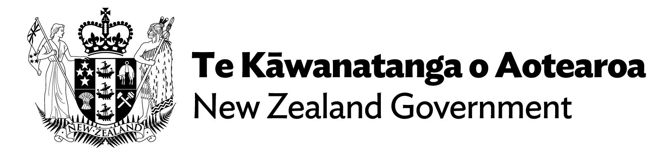

The Climate Adaptation Act is also planned, which will address managed retreat, and funding and financing of climate adaptation. A date for introduction of the Bill is not yet confirmed.
Section 364 of the NBA.
Section 365 of the NBA.
Schedule 1 clause 48 of the NBA.
Schedule 1 clause 49 of the NBA.
Section 366 of the NBA.
Section 366(2)(b) of the NBA refers to sections 364, 365 and 372 of the RMA.
Section 366(2)(b) of the NBA refers to sections 372 of the RMA.
Section 367(1)(b) of the NBA.
Section 367 of the NBA.
Section 367(3) of the NBA.
Section 372 of the NBA.
Section 373 of the NBA.
Section 373(2) of the NBA.
Section 379 of the NBA.
Section 374 of the NBA.
Section 378 of the NBA.
Section 384(2) of the NBA.
Section 383 of the NBA.
Section 382 of the NBA.

