
Ngā putanga pūnaha i te Ture Taiao Tūturu me te Hanga 2023
System outcomes in the Natural and Built Environment Act 2023

The new resource management system:
Natural and Built Environment Act 2023
and Spatial Planning Act 2023

New laws are being phased in that aim to help Aotearoa New Zealand protect and manage the environment and its resources. The Spatial Planning Act 2023 (SPA) and the Natural and Built Environment Act 2023 (NBA) were enacted on 23 August 2023.
The new resource management system makes an important shift. Rather than continuing the approach of the Resource Management Act 1991 (RMA) of managing adverse effects, it focuses on achieving system outcomes.
There’s no hierarchy of outcomes in the NBA; it sets out the system outcomes to achieve the purpose of the Act and provides a set of decision-making and procedural principles about those outcomes.
Managing the adverse effects of using and developing the environment remains an important part of the NBA. However, unlike the RMA’s focus on avoiding, remedying and mitigating effects in the first instance, the NBA specifies that adverse effects are managed in a way that achieves, and doesn’t undermine, outcomes.

This fact sheet contains:
- system outcomes
- providing for system outcomes.

System outcomes
The purpose of the system outcomes is to help uphold Te Oranga o te Taiao (which is the overall purpose of the NBA). They do this by setting out positive outcomes that must be achieved through the national planning framework (NPF) and natural and built environment plans (NBE plans). The system outcomes can be summarised as:
- protecting and restoring air, soil, the freshwater and coastal environments, indigenous biodiversity, outstanding natural features and landscapes, and cultural heritage
- addressing climate change
- reducing risks from and building resilience to natural hazards and climate change
- sustainably using coastal areas
- maintaining and enhancing public access and recreation
- protecting trout and salmon habitat
- ensuring urban and rural areas function well and are responsive to people’s needs
- providing infrastructure that promotes wellbeing
- protecting highly productive land
- recognising and providing for iwi and hapū relationships with ancestral land, water, sites, wāhi tapu, wāhi tūpuna, and other taonga
- recognising statutory acknowledgements in Treaty of Waitangi ǀ te Tiriti o Waitangi settlement Acts.

Providing for system outcomes
The outcomes must be provided for at national and regional levels. This means they’ll shape the NPF and each region’s NBE plan.
As there’s no hierarchy of outcomes in the NBA, consideration must be given to how to achieve synergies. The NBA stipulates that when providing for system outcomes, the following approach must be taken:
- the health of the natural environment and its capacity to sustain life must be protected as outlined in the purpose of the NBA
- not all outcomes are required to be achieved in all places or at all times
- conflict between or among outcomes must be identified and resolved at the highest practicable level in the NPF and NBE plans
- to avoid conflict between outcomes, achieving compatibility between or among them must be preferred (rather than achieving one outcome at the expense of another)
- the goal of achieving outcomes must be preferred over the goal of avoiding conflict.
This approach is further supported by an overarching set of decision-making principles, which anyone making recommendations or decisions on the NPF or NBE plans must follow.
For more information, see the Decision-making, procedural and information principles in the Natural and Built Environment Act 2023 factsheet

Disclaimer
The information in this publication is, according to the Ministry for the Environment’s best efforts, accurate at the time of publication. The Ministry will make every reasonable effort to keep it current and accurate. However, users of this publication are advised that:
• The information provided has no official status and so does not alter the laws of New Zealand, other official guidelines or requirements.
• It does not constitute legal advice, and users should take specific advice from qualified professionals before taking any action as a result of information obtained from this publication.
• The Ministry for the Environment does not accept any responsibility or liability whatsoever whether in contract, tort, equity or otherwise for any action taken as a result of reading, or reliance placed on this publication because of having read any part, or all, of the information in this publication or for any error, or inadequacy, deficiency, flaw in or omission from the information provided in this publication.
• All references to websites, organisations or people not within the Ministry for the Environment are provided for convenience only and should not be taken as endorsement of those websites or information contained in those websites nor of organisations or people referred to.

Published in October 2023 by the  Ministry for the Environment – Manatū Mō Te Taiao  Publication number: INFO 1193 | 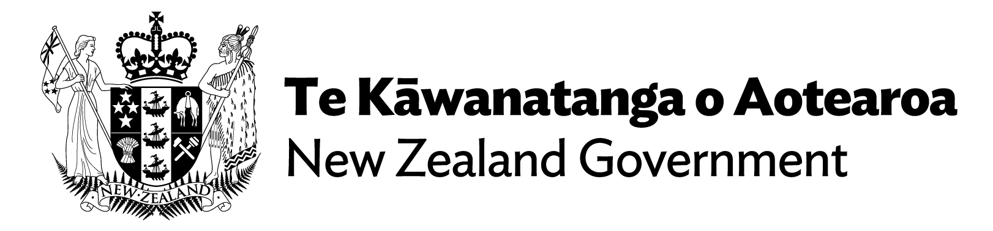

The Climate Adaptation Act is also planned, which will address managed retreat, and funding and financing of climate adaptation. A date for introduction of the Bill is not yet confirmed.
Sections 6 and 7 of the NBA.
Sections 6 to 10 of the NBA.
Section 8(1)(d) of the NBA.
Section 3 of the NBA.
See section 6 of the NBA for the complete set of system outcomes.
See section 11 of the NBA for a definition of “statutory acknowledgement”. Schedule 14 of the NBA sets out a list of Acts that include statutory acknowledgements.
Section 7(1) of the NBA.
Section 7(2) of the NBA.
Section 8 of the NBA.

