

He Kaponga o te Whakawhitiwhiti Kōrero ā-motu me te Rīpoata Taurua 2022
Hakihea 2022
Kua pā kē mai ngā pānga o te āhuarangi e panoni ana ki Aotearoa, ā, ka haere tonu aua panoni ki roto i ngā tau haere ake nei.
I ēnei rau 100 kua hori, kua 1.1°C te pikinga ake o te mahana o te āhuarangi. He nui ake ngā rā wera, he iti iho ngā rā makariri, ka mutu e ai ki ngā pūkete ko te tau 2021 te mea tino mahana rawa. Ko te tūmanako, nā te kaha haere ake o ngā panoni e matapaetia ana mō anamata pērā i te pikinga o te tai moana, te mahana haere ake o ngā moana, te pikinga haere o ngā pāmahana huri noa i te ao, ka kaha ake ngā pāpātanga me ngā tūraru o te panoni āhuarangi.
Kua whakaaturia e Aotearoa tōna ūnga ki te whakatutuki i aua wero mā ngā mahi kua oti ko te hanga i te ōhanga tukuwaro iti, māpua, manawaroa, toitū, e whai wāhi atu ai te katoa te take. Mā aua mahi e taurikura ai ō tātou hapori me ō mātou taiao mō ngā whakatupuranga kei te heke mai.
E ū ana mātou ki te pūrongorongo i runga i te pūrangiaho i ā mātou mahi whakatutuki i te panoni āhuarangi me te āhua e tutuki ai ō mātou herenga, ruruku anō hoki. I aua pūrongo ki te Anga Whakaaetanga a Te Rūnanga Whakakotahi i ngā Iwi o te Ao mō te Panoni Āhuarangi e kōrero āmikihia ana ā mātou tukunga o te wā, me ngā matapae e whakaatu ana i te pāpātanga o ā mātou kaupapahere, mahi hoki ki te whakaheke tukunga, ki ngā mahi urutau, me te tuku pūtea ki ngā take āhuarangi.
Mā aua pūrongo e āwhina ngā tāngata o Aotearoa kia mōhio ki ā mātou mahi mō te panoni āhuarangi, ki ngā āhua e tutuki ai tō mātou ūnga o te tau 2020, me ētahi atu mōhiohio tukuwaro.
He pūrongo āmiki te Whakawhitiwhiti Kōrero Tuawaru ā-Motu o Aotearoa mō ā mātou mahi ki te whakamauru i te huringa āhuarangi, ā, ka āta aro ki ngā whanakaetanga mai i te Whakawhitinga Kōrero ā-Motu Tuawhitu. Kua kapi i te Rīpoata Taurua Tuarima he huinga iti o ngā mōhiohio. Ka hiahiatia aua pūrongo e rua hei wāhanga o ā Aotearoa herenga i raro i te UNFCCC.
Ngā kōrero matua
- E ai ki te matapae, ka heke ngā tukuwaro katoa o Aotearoa mai i te ōritenga ki te 78.8 miriona tana o te hauhā (Mt CO₂-e) i te 2020 ki te 66.7 Mt CO₂-e hei te 2035. He ānga hira ngā kaupapahere me ngā ritenga kua poua kētia hei whakarite whakahekenga i roto i ngā rāngai tukuwaro matua katoa.
- E matapaetia ana kia piki ngā tukunga more mai i te 55.5 Mt CO₂-e i te 2020 ki te 63.8 Mt CO₂-e ā te 2025, i mua i te hekenga ki te 41.2 Mt CO₂-e ā te 2035. He kaha tō te rāngai ahurākau whakarite i taua ia, nā te mea ka aweawetia ngā tukunga more e ngā hurihanga whakatō me te topetope.
- Ko te whakatau tata ka whakahekea e ngā kaupapahere me ngā ritenga kua takoto kē a Aotearoa ngā tukunga more mā te 30.7 Mt CO₂-e ā te 2035, ina whakatairitea ki te kore e mahi i tētahi mahi whakaheke.
- E ai ki te whakapae ka iti iho ngā tukunga tapeke me ngā tukunga more ā te 2035 i tā te Rīpoata Taurua Tuawhā i matapae ai i te 2019.
- Ka tutuki i Aotearoa tana ūnga o te tau 2020 ki te whakaheke i te tapeke o ngā tukunga haurehu kati mahana ki te 5% ki raro i ngā taumata 1990 (e tārewa ana te arotake mātanga), mā ngā whakahekenga tukunga, ngā mahi ahurākau e whakaheke tukunga ana, me ngā waeine tukunga nō tāwāhi.
- Kua oti i a mātou i tēnei tau he kokenga hira, ā, kua whakatūria te anga e whakaheke haere tonutia ai ngā tukunga me te hanga i te anamata e noho manawaroa ana ki te panoni āhuarangi.
- E ū ana a Aotearoa ki te āwhina i ngā whenua whakawhanake ki te whakatutuki i te panoni āhuarangi, me te aha kua tāpuitia te pūtea o te NZ$1.3 piriona mō ngā take āhuarangi i waenga i te 2022 me te 2025.

Ko te matapae, ka heke ā mātou tukunga
Ka matapaetia te heke haere o te tapeke o ngā tukunga a Aotearoa mai i te 78.8 Mt CO₂-e i te 2020 ki te 66.7 Mt CO₂-e ā te 2035.
He ānga hira ngā kaupapahere me ngā ritenga kua poua kētia hei whakarite whakahekenga i roto i ngā rāngai tukuwaro matua katoa.
E matapaetia ana ka piki ngā tukunga more a Aotearoa mai i te 55.5 Mt CO₂-e i te 2020 ki te 63.8 Mt CO₂-e ā te 2025, i mua i te hekenga ki te 41.2 Mt CO₂-e ā te 2035.
Kei roto i ngā tukunga more e pūrongotia ana i raro i te UNFCCC ko ngā tukunga me nga tangohanga hauhā i te otaota me ngā one puta noa i ngā momo whakamahi whenua katoa, tae atu ki te ahurākau, ngā pākihi me ngā rohe kōreporepo, ā, i muri i te whakarerekē i te whakamahi whenua. Kei te āwhina ngā ngahere ki te tango i te hauhā ina tupu, engari ka tuku anō hoki pea i te hauhā, i te taha o ētahi atu haurehu kati mahana mā ngā mahi pēnei i te whakarake me te topetope, i ngā raruraru ao tūroa rānei.
He mea kite wheako e Aotearoa ngā kaha pikinga o te whakatō ngahere ahurākau mai i ngā tau 1980 ki waenga i ngā tau 1990, nā reira kei te topetopea, kei te whakatōkia, kua topetopea, kua whakatōkia rānei, te wāhanga āhua nunui o ā mātou ngahere ahurākau. Ko te matapae, ka haere tonu tēnei tae rā anō ki te hiku o ngā tau 2020.
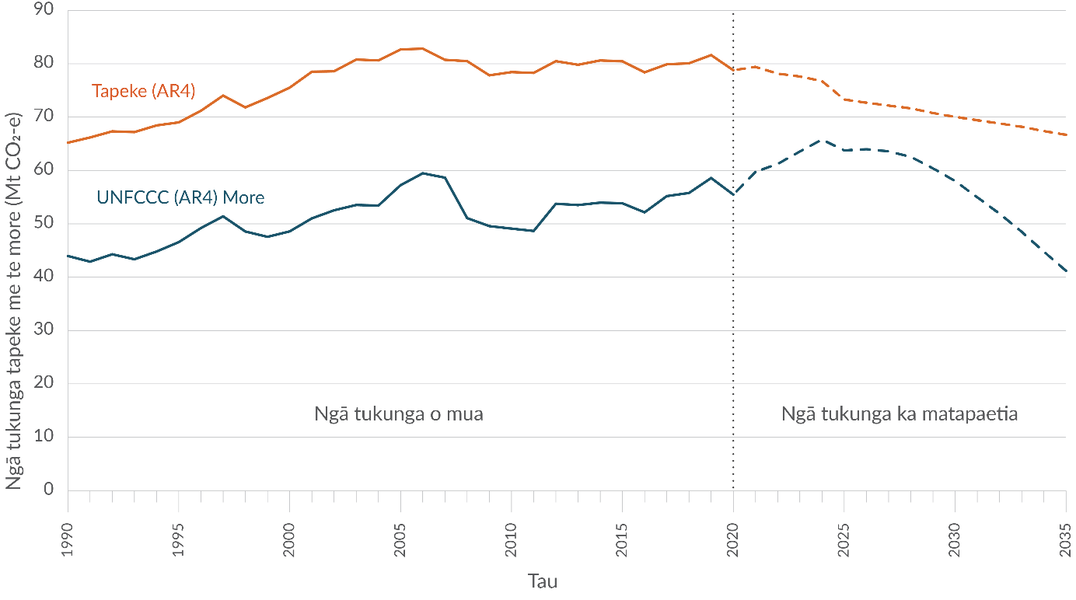
Hoahoa 1: Ngā tukunga tapeke me ngā tukunga more a Aotearoa o mua, ka matapaetia anō hoki mō muri atu
Kia mōhio: Ko te pūtake o ā mātou tukunga e matapaetia ana ko ngā raraunga o nāianei me ngā kaupapahere kua whakamanahia. Ka whakamahi ngā tātai i ngā pitomata whakamahana o te ao, he tirohanga 100 tau te roa, nō te Pūrongo Aromatawai Tuawhā (AR4) a te IPCC. E whakamahi ana ngā matapae i ngā raraunga tino pai rawa ka wātea, engari ka pā nuitia pea ēnei e ngā taurangi ōhanga me ngā panoni ā-kaupeka tau.
Kua whakatau tatahia ngā matapaenga i ēnei pūrongo i runga anō i ngā aratohu UNFCCC mō te whakariterite i ngā whakawhitiwhiti ā-motu me ngā Rīpoata Taurua. Kāore ēnei i te whakaata i ngā ture mahi kaute e whakamahi ana a Aotearoa ki te whakatutuki i ērā atu o ōna ūnga tāwāhi, rāroto anō hoki. Nā reira kē, tē taea te whakamahi i aua matapae mō te whai haere i te whakatutuki ūnga i tua atu i tā mātou ūnga UNFCCC 2020.
E ai ki te whakapae ka iti iho ā mātou tukunga ā te 2035 i tā te Rīpoata Taurua Tuawhā (BR4) a Aotearoa, he mea whakaputa i te 2019, i matapae ai.
E ai ki te matapae, ka 7.6 ōrau te itinga iho o ngā tukunga tapeke ā te 2035 i tā te BR4 i matapae ai, ko te pūtake matua ko ngā hekenga ka matapaetia mō ngā rāngai pūngao me ngā tukanga ahumahi.
E matapaetia ana ka 28.8 ōrau te iti iho o ngā tukunga tapeke ā te 2035 i ērā i matapaetia i te BR4.
I roto i ngā whenua whanake he rerekē a Aotearoa nā te mea ka puta mai te nuinga o ngā tukunga i ngā mahi ahuwhenua, tērā i whakaputa i te 50 ōrau o ā mātou tukunga haurehu kati mahanga katoa i te 2020 (hoahoa 2). Ko te rāngai he tuarua te rahi ko te pūngao (kei roto te tūnuku) tērā i whakaputa tōna 40 ōrau i te 2020.
Ka matapaetia te heke haere o te tapeke o ngā tukunga a Aotearoa mai i te 39.4 Mt CO₂-e i te 2020 ki te 35.3 Mt CO₂-e ā te 2035. Nā ngā kaupapahere pēnei i te Kaupapa Hokohoko Tukunga o Aotearoa, te mōkī Wai Māori Waiwai me te whakaurunga o ngā utu mō ngā tukunga ahuwhenua ēnei, i te taha anō hoki o ngā ritenga whakahaere pāmu ki te whakapai ake i ngā putanga taiao, he hekenga o te tapeke o ngā kararehe me ngā whakapai haere tonu i te māpua kararehe me te whāomo i runga pāmu.
E matapaetia ana ka heke ngā tukunga mai i te rāngai pūngao mai i te 18.3 Mt CO₂-e i te 2020 ki te 11 Mt CO₂-e ā te 2035, ko te take matua ko te katinga haere o ngā punahiko whakapeto kapuni, waro hoki ka whakakapia ki ngā kātū pukuhiko ā-hau, ā-ngāwhā rānei.
He 13.2 Mt CO₂-e ngā tukunga tūnuku i te 2020, ā, kei te piki haere tonu ēnei nā te popono nui ake mō te hāereere. Ko te tūmanako ka papatahi haere ēnei i te 15.1 Mt CO₂-e ā te 2023, me te heke haere ki te 13.8 Mt CO₂-e ā te 2035, ko te whakamahinga nui ake o ngā waka hiko me te whakapainga haere tonu i te whāomo kora ngā take.
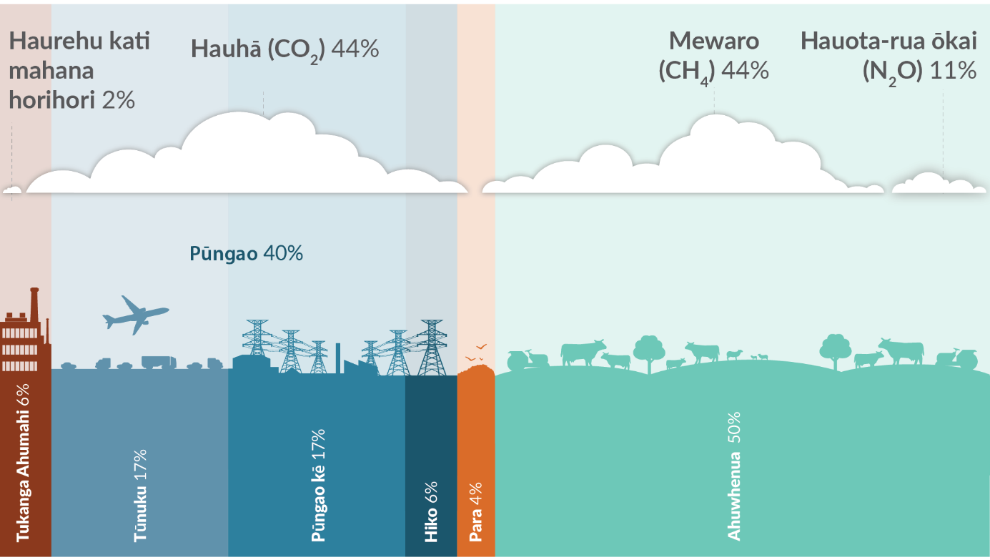
Hoahoa 2: Tō Aotearoa kāhua tukunga tapeke i te 2020
Kia mōhio: E whai wāhi ana a Tokerau ki ngā pūrongo panoni āhuarangi mai i te 2017, engari he tino iti rawa ōna tukunga (0.005 ōrau i te 2020) kia whakaaturia. Kāore pea te tāpiripiri ōrautanga e ōrite ki te 100 ōrau nā te whakaawhiwhi.

Te hua o ā mātou mahi
He mea whakatauira ētahi tauari matapae i ēnei pūrongo hei matapae i te hua o ngā kaupapahere me ngā tikanga ka taea te ine atu ki te 2035.
E whakaatu ana aua matapae e ai ki te whakatau tata ka whakaheke ngā kaupapahere me ngā tikanga o nāianei a Aotearoa i te tapeke o ngā tukunga mā te 30.7 Mt CO₂-e ā te 2035, ina whakatairitea ki te kore e mahi i tētahi mahi whakaheke.

Ngā mahi a Aotearoa e pā ana ki te panoni āhuarangi
I oti i Aotearoa te kokenga hira, kua whakamanahia he kaupapahere me ngā tikanga hei āwhina ki te whakaiti tukunga me te hanga i te anamata e noho manawaroa ana ki te panoni āhuarangi.
I te 2019, ka menamenatia e te Kāwanatanga te Climate Change Response Act hei whakarite i te anga mō te whakawhanake me te whakatinana kaupapahere panoni āhuarangi tērā ka whai wāhi ki ngā mahi huriao ki te whakatiki i te pikinga pāmanaha toharite o te ao kia 1.5 1.5 putu Celsius i runga ake i ngā taumata o mua i te ao ahumahi.
I roto i tērā ko te whakatū i He Pou a Rangi – Climate Change Commission, tērā e hoatu i ngā tohutohu mātanga motuhake me te aroturuki i ngā kokenga o ngā take panoni āhuarangi.
Kua menamenatia te Kaupapa Hokohoko Tukunga o Aotearoa, te taputapu matua e noho tūāpapa ana ki ngā mahi whakaheke i ngā tukunga rāroto o Aotearoa, ki te whakapakari i tōna pāpātanga. Tae atu ki te 2025, ka kapi ngā rāngai katoa taea noatia te rāngai ahuwhenua i tētahi pūnaha whakarite utu.
I whakarewaina te Kaupapa Kore Waro a te Kāwanatanga i te 2020 ki te whakahoro ake i te hekenga o ngā tukunga i te rāngai tūmatanui. I taua tau anō hoki ka whakapuakina e te Kāwanatanga he Ohotata Āhuarangi.
I whakahoutia e Aotearoa tana Whai Wāhitanga He Mea Whakatau ā-Motu (NDC1) i te 2021 ki te ūnga māia ake o te whakaheke i ngā tukunga haurehu kati mahana more ki te 50 ōrua ki raro iho i ngā taumata 2005 mā te 2030. Ka haere tonu ā Aotearoa mahi i konei, me tāwāhi anō hoki, ki te whakarite kia tika ā mātou mahi whakatutuki me te hāpaipai mahi e pā ana ki te panoni āhuarangi.
Kua tautuhia e mātou he ūnga rāroto kia tae ki te kore o ngā tukunga more mō ērā atu haurehu kati mahana katoa, hāunga te mewaro ahukoiora, ā te 2050, ā, kia whakaheke i ngā tukunga mewaro ahukoiora ki te 24 ki te 47 ōrau ki raro i ngā taumata o te 2017 ā te 2050, me tae atu anō hoki ki te 10 ōrau ki raro i ngā taumata o te 2017 ā te 2030. Kua tautuhi kētia ngā mahere pūtea tukunga tuatahi e toru hei wāhanga o te raupapa o ngā ūnga taupua e neke ai mātou ki tēnei ūnga mō te tau 2050.
I te tau 2022 i whakaputaina tā mātou mahere whakaheke tukunga tuatahi hei whakatakoto i ngā kaupapahere me ngā rautaki e tutuki ai tā mātou mahere pūtea tukunga tuatahi, ā, i te mutunga iho te ūnga mō te tau 2050.
I roto i taua mahere ko tētahi mahi whakatū i te pūhara mō ngā mahi a te Māori ki te whakamauru panoni āhuarangi e noho tūāpapa ai te rangapū mahitahi me te whakakanohitanga, ka tautoko i ngā rautaki me te whakahāngai mā te Māori e ārahi, ka whakahohe i ngā kaupapa Māori, me ngā rongoā nō ngāi Māori.
I whakaputaina anō hoki tā mātou mahere urutaunga ā-motu tuatahi i te 2022 hei whakatakoto i ngā rautaki, kaupapahere me ngā marohi e tukuna ai mātou ki te hanga i te anamata e noho manawaroa ana ki te panoni āhuarangi.
Ko tā mātou he haumi ki te rangahau panoni āhuarangi puta noa i te tūnuku, te ahuwhenua, te ahurākau, te pūngao, me te whakawhanaketangā ā-tāone toitū. Ka whai wāhi ki tēnei ko te whakatūnga o tētahi Pokapū Panoni Āhuarangi Whakaiti Tukanga Ahuwhenua.

Te tautoko i ngā mahi whakamauru i ngā panoni āhuarangi i ngā whenua whakawhanake
E ū tonu ana a Aotearoa ki te āwhina i ngā whenua whakawhanake ki te whakatutuki i te panoni āhuarangi. I hoatu te Kāwanatanga i te $285.78 miriona tāra Aotearoa hei āwhina i ngā take panoni āhuarangi mā ngā whenua whakawhanake i ngā tau 2019 me te 2020 (hoahoa 3), he pikinga o te 22.16 miriona tāra Aotearoa tērā ina whakatairitea ki te 2017 me te 2018.
E tuku ana a Aotearoa i ana tahua āhuarangi ki tāwāhi mā ngā mahi i tana Hōtaka Pāhekoheko Whakawhanaketanga ā-Ao. E aro ana ngā mahi ki te ahuwhenua, te ārai aituā me te noho takatū, te whakapakari i te pūnaha hauropi, te pūngao hangarua me te whakamaru puna wai.
Kua tāpuitia e mātou he $1.3 piriona tāra Aotearoa hei pūtea mō ngā take āhuarangi i waenga i te 2022 me te 2025, hei tautoko whenua whakawhanake ki te whakapakari i tō rātou manawaroa ki te panoni āhuarangi, me ā rātou mahi ki te whakatiki i te whakamahanatanga o te ao kia kaua e piki ki tua o te 1.5 putu Celsius.
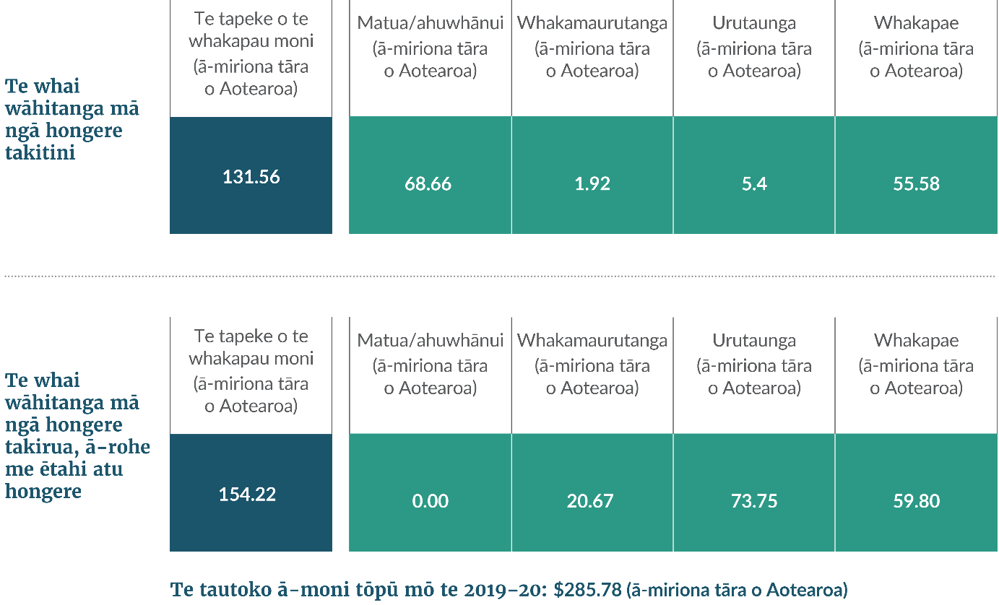
Hoahoa 3: Te tautoko a Aotearoa ki ngā take āhuarangi, 2019 me te 2020

Ka pēhea tā mātou whakatutuki i ō mātou ūnga
Ka tāpae a Aotearoa i tētahi Rārangi Haurehu Kati Mahana ia tau ki te UNFCCC. Kei roto i tā mātou tāpaetanga o te 2022 he whakarārangitanga o ngā tukunga me ngā tangohanga haurehu kati mahana mai i te 1990 ki te 2020.
Ka tutuki i Aotearoa tana ūnga o te tau 2020 ki te whakaheke i te tapeke o ngā tukunga haurehu kati mahana ki te 5% ki raro i ngā taumata 1990, mā ngā whakahekenga tukunga, ngā mahi ahurākau e whakaheke tukunga ana, me ngā waeine tukunga nō tāwāhi.
Ka whakaūngia tēnei hei te otinga o te tukunga arotake mātanga UNFCCC o tā mātou Rārangi Haurehu Kati Mahana me tā mātou Rīpoata Taurua.
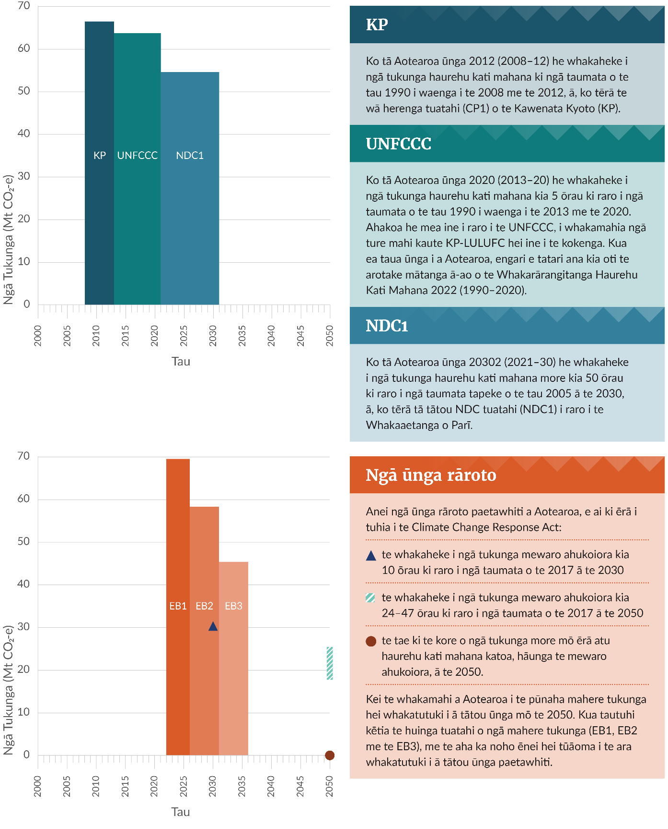
Hoahoa 4: Ngā ūnga whakaheke tukunga tāwāhi me rāroto a Aotearoa
Kia mōhio: Ka kapi i ngā wā mahere pūtea ngā tau 2022–25 mō te EB1, 2026–30 mō te EB2, me te 2031–35 mō te EB3. Ka mutu ngā wā ūnga me ngā wā mahere pūtea i te 31 o Hakihea. Ko te whakamāramatanga o te mewaro ahukoiora ko te mewaro e whakaputahia ana e ngā rāngai ahuwhenua me te tukatuka para. E whakamahi ana ngā tātaitanga e whakaaturia nei i te AR4 hei inenga whakatairite ki ngā ūnga tāwāhi.
E takune ana a Aotearoa ki te whakatutuki i tērā o ana ūnga tāwāhi – te NDC1 i raro i te Whakaaetanga o Parī (hoahoa 4) – mā tētahi kōwhiringa o ngā whakahekenga tukunga rāroto, te tango i te hauhā mā ngā puna whakataratahi pēnei i ngā ngahere, ā, te whai wāhi ki ngā mākete hoko waro ā-ao.
Ka tīmata mātou ki te pūrongo i ngā tukunga mō te wā NDC1 i tā mātou Rārangi Haurehu Kati Mahana tērā ka whakaputaina ā te Paengawhāwhā 2023. Ka whakaratohia he mōhiohio atu anō mō te kokenga ki te NDC1 i te Pūrongo Pūataata ā-Rua Tau tuatahi i raro i te Whakaaetanga o Parī. ā te 2024.
Kua tautuhia anō e Aotearoa ētahi mahere pūtea tukunga rāroto hei uruhi i te whakaumutanga ki tētahi ōhanga tukunga iti. Kua tautuhia ngā tepe heke haere ki ngā tukunga rāroto hei whakarite kei te anga whakamua mātou ki te whakaea i tō mātou ūnga 2050 i raro i te Climate Change Response Act (hoahoa 4). He mea whakatakoto e Aotearoa ana rautaki me ana kaupapahere ki te whakatutuki i te mahere pūtea tukunga tuatahi i roto i te mahere whakaiti tukunga tuatahi.

He kupu whakamihi
E tuku mihi ana te Manatū mō te Taiao i ēnei umanga a te kāwanatanga mō tā rātou whai wāhi ki te whakaputa i te Whakawhitiwhiti Kōrero Tuawaru ā-Motu me te Rīpoata Taurua Tuarima o Aotearoa.
Te Papa Atawhai, Te Tari Taiwhenua, Te Tari Tiaki Pūngao, Te Mana Rauhī Taiao, Hīkina Whakatutuki, Manatū Aorere, Manatū Ahu Matua, Te Tūāpapa Kura Kāinga, Te Manatū Whakahiato Ora, Te Manatū Waka, Taihoro Nukurangi, Te Tai Ōhanga me Waka Kotahi.
He mea whakaputa i Hakihea 2022 e Te Manatū Mō Te Taiao  Nama whakaputa: INFO 1137 | 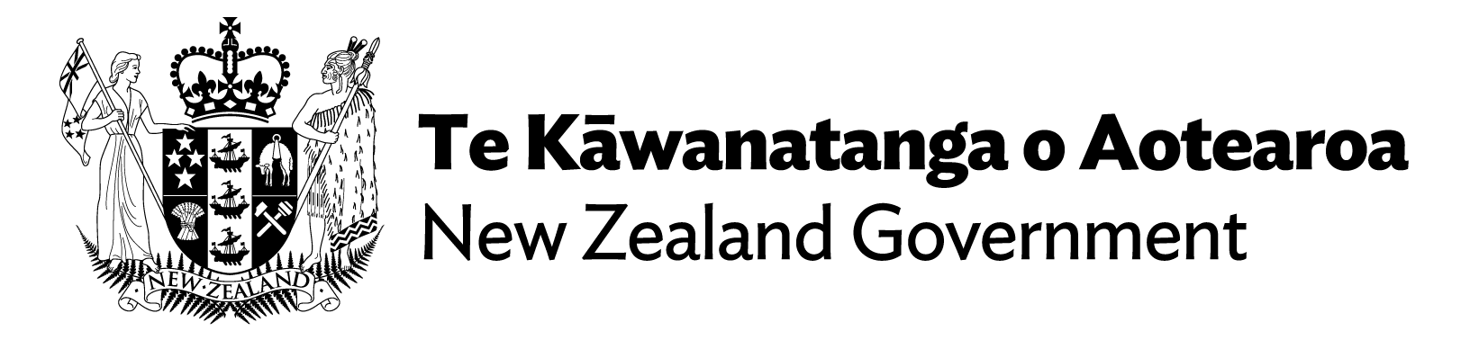

Pānuitua ngā pūrongo katoa
- Te Whakawhitiwhiti Kōrero Tuawaru ā-Motu o Aotearoa
- Te Rīpoata Taurua Tuarima o Aotearoa

