**This guidance was updated in August 2023.** The updated version,[*A guide to implementing clause 3.13 of the NPS-FM 2020*](https://environment.govt.nz/publications/a-guide-to-implementing-clause-3-13-of-the-nps-fm-2020/), can be found [on  
the Ministry’s website](https://environment.govt.nz/publications/a-guide-to-implementing-clause-3-13-of-the-nps-fm-2020/).

**Disclaimer**

The information in this publication is, according to the Ministry for the Environment’s best efforts, accurate at the time of publication. The Ministry will make every reasonable effort to keep it current and accurate. However, users of this publication are advised that:

* The information provided has no official status and so does not alter the laws of New Zealand, other official guidelines or requirements.
* It does not constitute legal advice, and users should take specific advice from qualified professionals before taking any action as a result of information obtained from this publication.
* The Ministry for the Environment does not accept any responsibility or liability whatsoever whether in contract, tort, equity or otherwise for any action taken as a result of reading, or reliance placed on this publication because of having read any part, or all, of the information in this publication or for any error, or inadequacy, deficiency, flaw in or omission from the information provided in this publication.
* All references to websites, organisations or people not within the Ministry for the Environment are provided for convenience only and should not be taken as endorsement of those websites or information contained in those websites nor of organisations or people referred to.

**Acknowledgements**

The Ministry acknowledges NIWA for producing the draft guide for the periphyton attribute note, which this document updates.

Ministry for the Environment would also like to thank council staff for attending the workshops and giving their feedback on earlier drafts, which has been invaluable in the production of this document. This includes contributors from the following councils: Northland Regional Council; Auckland Council; Waikato Regional Council; Bay of Plenty Regional Council; Hawkes Bay Regional Council; Taranaki Regional Council; Horizons Regional Council; Greater Wellington Regional Council; Marlborough District Council; Environment Canterbury; and Environment Southland.

This document may be cited as: Ministry for the Environment. 2021. *A guide to setting instream nutrient concentrations under clause 3.13 of the National Policy Statement for Freshwater Management 2020*. Wellington: Ministry for the Environment.

This guidance was updated in August 2023 to reflect amendments to clause 3.13 of the National Policy Statement for Freshwater Management (2020). The changes to policy reflect stakeholder feedback. The updated version, *A guide to implementing clause 3.13 of the NPS-FM 2020*, can be found here [on the Ministry’s website](https://environment.govt.nz/publications/a-guide-to-implementing-clause-3-13-of-the-nps-fm-2020/).

Published in June 2021 by the  
Ministry for the Environment   
Manatū Mō Te Taiao  
PO Box 10362, Wellington 6143, New Zealand  
   
ISBN online version: 978-1-99-003360-5   
Publication number: ME 1569

© Crown copyright New Zealand 2021

This document is available on the Ministry for the Environment website: [www.mfe.govt.nz](http://www.mfe.govt.nz).

# Contents

1. Introduction 7

1.1 Document structure 7

1.2 Other guidance for the National Policy Statement for Freshwater Management 8

2. About clause 3.13 special provisions for attributes affected by nutrients 9

2.1 What is clause 3.13 9

2.2 Purpose of clause 3.13 in the NPS-FM 10

2.3 Requirements of clause 3.13 11

3. Applying clause 3.13 13

3.1 Clause 3.13(3)(a): Determining if the FMU supports, or could support, conspicuous periphyton and deriving appropriate instream nutrient concentrations and exceedance criteria 13

3.2 Clause 3.13(3)(b): Are there sensitive downstream receiving environments? 32

3.3 Step (c): How are nutrient criteria reconciled across the FMU and downstream receiving environments? 47

References 64

# Tables

Table 1: Recommended approach to use of existing guidelines and models for setting nutrient criteria 18

Table 2: Macrophyte life form types with primary nutrient source and example species 31

Table 3: Nutrient concentrations that may constrain macrophyte growth and biomass 31

Table 4: Summary of trophic bands and nutrient criteria for downstream receiving environments 36

Table 5: Opportunistic macroalgal blooming tool (OMBT, WFD-UKTAG, 2014) values for macrolagal metrics used to assign individual macroalgal ecological quality rating (EQR) scores of “open” estuaries (table 4 in Robertson et al., 2016b) 43

Table 6: Indicative *potential* TN threshold concentrations (mg/m3) for macroalgal and phytoplankton trophic-states in New Zealand estuaries. Values derived from Plew et al. (2017) 45

Table 7: Connectivity of an estuary receiving environment to management units based on upper, middle and lower regions of a hypothetical catchment 46

Table 8: Summary of NPS-FM and other potentially useful nutrient criteria that correspond to the trophic state of downstream receiving environments. Refer to section 3.2.2 for details 49

Table 9: Three examples of long-term median concentrations of N and P forms, and the corresponding inorganic-to-total nutrient ratios. Dataset from 2004 to 2013 50

Table 10: Results of FMU to estuary scenario shown in Figure 12 52

Table 11: Nutrient criteria (upper limit of trophic-state band used) for meeting different trophic-state objectives for a FMU to SIDE system represented in Figure 12 53

Table 12: Predicted estuarine TN concentrations (*potential*TNest) using FMU instream criteria for two dilution factors (*D*=2 and 6), and back-calculated FMU criteria that correspond to the upper limits of the A, B and C estuarine band trophic states 54

Table 13: Results of FMU to lake scenario shown in Figure 18 (all concentrations are mg/m3) 63

# Figures

Figure 1: Flow diagram of the process outlined by clause 3.13(3) 12

Figure 2: Process for developing a new regional, river class or FMU model to identify nutrient criteria to achieve a periphyton objective in hard-bottom streams and rivers 24

Figure 3: An illustration of the process to reconcile periphyton nutrient criteria for hard-bottom streams and rivers using a simple example 30

Figure 4: Flowchart identifying the recommended process to develop wetland nutrient criteria (figure 1 in US EPA, 2008). 37

Figure 5: Illustration of the two approaches to inform nutrient criteria using a high percentile (eg, 75th percentile) from a ‘reference site’ population (blue line), or a low percentile (eg, 25th percentile) from a general population (modified from figure 8.1 in US EPA, 2008) 38

Figure 6: The four types of estuary used by the ETI for assessing the eutrophic susceptibility of NZ estuaries 40

Figure 7: Regression of measured macroalgal EQR value (NZ estuaries) and potential TN concentrations derived from CLUES Estuaries (Plew et al., 2017) 43

Figure 8: Phytoplankton trophic bands (or ‘zones’) as a function of *potential* TN concentrations and estuary flushing time (days). Taken from Plew et al. (2017) 44

Figure 9: Hypothetical catchment showing examples of catchment and sub-catchment-scale FMUs. Downstream receiving environments include lakes (L), wetlands (W) and a single estuary 46

Figure 10: Hypothetical catchment showing example of river classification-based FMUs – hill (black dashed boundary) and lowland (yellow dashed boundary). Downstream receiving environments include lakes (L), wetlands (W) and a single estuary 47

Figure 11: Key components and pathways envisaged for implementing step (c) of Clause 3.13 48

Figure 12: A simple scenario of an FMU that discharges into a shallow, intertidal dominated estuary (SIDE) that is susceptible to macroalgal blooms. 51

Figure 13: *Potential* TNestimated concentrations (ie, [Y]) in the estuary (shown in figure 12) as a function of dilution factor (*D*) using a FMU instream criterion value of 500 mg/m3 of TN (ie, [Z]) 53

Figure 14: Matrix tables showing the outcome of different FMU instream criteria (ie, upper TN limits shown in bold for each band) with respect to different trophic-state objectives for an estuary (in this case macroalgal trophic-state A-, B- and C-bands) in the estuary – both ‘low’ (*D*=2, figure 2a) and ‘high’ (*D*=6), figure 2b) dilution factors scenario shown 55

Figure 15: Look-up chart of estimated TPin-lake concentrations using Eq. 3 (Vollenweider, 1976) for TPFMU values of 0-100 mg/m3 and lake residence times (*T*) of 0-10 years. Solid black line = 1:1 line (TPFMU = TPinlake) 59

Figure 16: Look-up chart of estimated TPin-lake concentrations using Eq. 5 (OECD, 1982) for TPFMU values of 0-100 mg/m3 and lake residence times (*T*) of 0-10 years. Solid black line = 1:1 line (TPFMU = TPinlake) 59

Figure 17: Look-up chart for estimated TNin-lake concentrations using Eq. 4 (OECD, 1982) for TNFMU values of 0-2000 mg/m3 and lake residence times (*T*) of 0-10 years. Solid black line = 1:1 line (TNFMU = TNin-lake) 60

Figure 18: A simple, hypothetical scenario of FMU that discharges to a polymictic lake 61

Figure 19: Estimated concentrations of TPin-lake (a) and TNin-lake (b) using Eq. 3b and 5b for TP and Eq. 4b for TN using TPFMU and TNFMU values of 20 and 500 mg/m3, respectively 62

# **Introduction**

The National Policy Statement for Freshwater Management (NPS-FM) 2020 requires regional councils and unitary authorities (referred to in this report as ‘councils’) to manage attributes in rivers and lakes by setting target attribute states to provide for the compulsory values, including ecosystem health. As a part of achieving the target attribute states for any attribute affected by nutrients, councils must at least set appropriate instream concentration levels and exceedance criteria for dissolved inorganic nitrogen (DIN) and dissolved reactive phosphorus (DRP).

Nitrogen and phosphorus are nutrients necessary for all plant growth and are present naturally at low levels in freshwater ecosystems. However, excessive nutrients can:

* contribute to problematic growth of periphyton (slime) or macrophytes (rooted plants), affecting ecosystem health and people’s use and enjoyment of the waterbody
* change the way that microbes and invertebrates break down and recycle organic matter (such as leaf litter) in rivers, which alters the way ecosystems function.

International and New Zealand-based research shows that many complex and interacting factors influence ecosystem health in freshwater systems. Elevated nutrient concentrations change the habitat conditions for macroinvertebrates and fish primarily by promoting plant growth, when other conditions are also suitable (eg, when flows are low and stable), and when the river channel is unshaded. Excessive accumulation of plant biomass causes changes in dissolved oxygen and pH. These effects can interact with other impacts of human activities that can reduce habitat quality and the capacity of the river to support aquatic life.

This guidance will help councils to derive appropriate instream nutrient concentrations and exceedance criteria in accordance with the NPS-FM and take a ki uta ki tai (from the mountains to sea) integrated resource management approach. This approach will ensure water is managed from its original source, over land and out to the sea; and all water bodies along this watershed continuum are considered together. This approach is enshrined in Policy 3, clause 3.5 and clause 3.13(2) of the NPS-FM. This guidance may also help iwi and hapū, water users, or community members who are participating in a regional freshwater planning process.

## Document structure

This guidance document is structured as follows:

* section 1 introduces the guidance and outlines the structure of the document
* section 2 explains the policy for setting instream nutrient concentrations
* section 3 outlines the process councils should follow when applying the nutrient policies in the NPS-FM.

This document guides councils through the process for deriving nutrient criteria in Policy 3.13 and explains the details and methods behind each step with illustrative examples. This guidance does not mandate a single correct or preferred method for deriving instream nutrient criteria. Instead, it provides information to help councils select the most appropriate method for the circumstances specific to their region.

## Other guidance for the National Policy Statement for Freshwater Management

To support the implementation of the 2020 NPS-FM, the Ministry has produced and is continuing to produce guidance. In cases where guidance specific to the 2020 NPS-FM is not yet available, the existing guidance on the 2014 NPS-FM (and its subsequent 2017 amendment) will continue to be of use.

Factsheets detailing specific aspects of the Essential Freshwater programme can be found on [environment.govt.nz](https://environment.govt.nz/what-government-is-doing/areas-of-work/freshwater/e/freshwater-reform/factsheets-on-policies-and-regulations-in-the-essential-freshwater-package/).

# About clause 3.13 special provisions for attributes affected by nutrients

## What is clause 3.13

Clause 3.13 is part of the overall process for achieving environmental outcomes under the National Objectives Framework (NOF). It requires councils to set instream nutrient concentrations and exceedance criteria that are appropriate to achieve the target attribute states set for periphyton, any other nutrient attribute, and any other attribute affected by nutrients under clause 3.11, as well as the outcomes sought for downstream receiving environments.

Clause 3.13(3) sets out, in three sequential steps, the process councils must follow to derive those instream concentrations and exceedance criteria in their FMUs.

Clause 3.13 states:

1) To achieve a target attribute state for periphyton, any other nutrient attribute, and any attribute that is affected by nutrients, every regional council must, at a minimum, set appropriate instream concentrations and exceedance criteria for dissolved inorganic nitrogen (DIN) and dissolved reactive phosphorus (DRP).

2) Where there are nutrient-sensitive downstream receiving environments, instream concentrations and exceedance criteria for DIN and DRP must be set for the upstream contributing water bodies to achieve the environmental outcomes sought for the downstream receiving environments.

3) In order to determine instream concentrations and exceedance criteria for DIN and DRP, for upstream contributing water bodies, every regional council must apply the following process, in the order given:

a. either:

i. if the FMU or part of an FMU supports, or could support, conspicuous periphyton, derive instream concentrations and exceedance criteria for DIN and DRP to achieve the periphyton target attribute state; or

ii. if the FMU or part of an FMU does not support, or could not support, conspicuous periphyton, consider the instream concentrations (or instream loads) and exceedance criteria for nitrogen and phosphorus needed to achieve any other target attribute state

b. if there are nutrient-sensitive receiving environments, derive the relevant instream concentrations (instream loads) and exceedance criteria for nitrogen and phosphorus needed to achieve the environmental outcomes sought for those receiving environments

c. compare instream concentrations and exceedance criteria for nitrogen and phosphorus derived in steps (a) and (b) and adopt those necessary to achieve the relevant target attribute state and the environmental outcomes sought for the nutrient-sensitive receiving environments as instream concentrations and exceedance criteria for DIN and DRP for the upstream contributing water bodies.

4) Examples of attributes affected by nutrients include dissolved oxygen (Appendix 2A, Table 7 and Appendix 2B, Tables 17, 18, and 19), submerged plants (invasive species) (Appendix 2B, Table 12), fish (rivers) (Appendix 2B, Table 13), macroinvertebrates (Appendix 2B, Tables 14 and 15), and ecosystem metabolism (Appendix 2B, Table 21).

## Purpose of clause 3.13 in the NPS-FM

Clause 3.13 clarifies the existing policy intent that regional councils must manage and set limits on nutrients in rivers to provide for values and long-term visions. This requires more than achieving the target attribute states for nitrate and ammonia (toxicity). Setting instream nutrient concentrations for DRP under this clause will also help councils determine appropriate target attribute states for DRP.[1]

The NPS-FM includes NOF attributes for nitrate and ammonia, to avoid toxicity effects in rivers, but these should not be applied to ecosystem health issues associated with trophic state (anthropogenic eutrophication), which are covered by the NOF attributes for periphyton, macroinvertebrate community index (MCI), submerged plants, fish and so on in rivers. This is because nutrient criteria to manage trophic state are more stringent than those to manage toxicity.

Clause 3.13 originated as the periphyton attribute note in the NPS-FM 2017. It clarified that achieving the target attribute state for periphyton required the management of nutrient (nitrogen and phosphorus) concentrations. Clause 3.13(3)(a)(i) requires councils to derive instream nutrient concentrations and exceedance criteria for DIN and DRP. These criteria must be appropriate (ie, set at a sufficient level) to achieve the periphyton target attribute state that councils set for the freshwater management unit (FMU) under clause 3.12, if that FMU supports, or could support, conspicuous periphyton. Clause 3.14(3) then requires councils to set limits on resource use that ensure those concentrations and exceedance criteria are achieved.

The intent is to ensure nutrient concentrations are always managed as a part of achieving the periphyton target attribute state. Councils can use Ministry for the Environment guidance and the tools outlined in the rest of this guide to derive the appropriate instream nutrient criteria for periphyton in their areas.

#### Clause 3.13 and other nutrient-affected attributes

Clause 3.13, however, is not only about achieving the target attribute state for periphyton. Where an FMU does not or could not support conspicuous periphyton, clause 3.13(3)(a)(ii) requires councils to “consider the instream concentrations and exceedance criteria needed to achieve any other target attribute state”, which includes (but is not limited to) the attributes outlined in clause 3.13(4).

Along with achieving periphyton target attribute states, councils must, at a minimum, set appropriate instream concentrations and exceedance criteria to achieve the target attribute states for any other nutrient attribute and any other attribute that is affected by nutrients, according to clause 3.13(1). Therefore, councils must effectively undertake the same process outlined for periphyton, using the best available information (whether through case studies, modelling or other means the councils’ deems appropriate), to derive instream concentrations and exceedance criteria that will achieve the target attribute states set for the relevant attributes.

Regardless of whether a specific nutrient-affected attribute requires limits to be set (eg, appendix 2A; periphyton, dissolved oxygen) or for action plans to be published (eg, appendix 2B; submerged plants, macroinvertebrates), clause 3.14(3) requires limits on resource use, to ensure the instream concentrations and exceedance criteria for DIN and DRP determined under clause 3.13 are achieved.

This will provide an important part of councils’ consideration of how to achieve target attribute states and environmental outcomes under clause 3.12(1)(a) and 3.12(2)(b), although it cannot be assumed it will fully satisfy the requirements of those clauses. Councils should set limits on resource use that ensure identified instream nutrient concentrations are achieved.

#### Clause 3.13(3)(B) and downstream receiving environments

The NPS-FM also requires councils to manage the effects of fresh water on nutrient-sensitive receiving environments, including the coastal environment. The risk is that objectives and instream nutrient concentrations set for attributes upstream, while good enough to protect some river waters, may not sufficiently protect nutrient sensitive downstream environments, such as lakes and some estuaries. Clause 3.13 makes it clear that setting instream nutrient concentrations in rivers must be stringent enough to account for the effects of these concentrations on nutrient sensitive downstream receiving environments.

Once the instream nutrient concentrations for achieving the desired attribute states are derived, councils must adopt the final nutrient concentrations and exceedance criteria required to achieve all target attribute states. This will be the most stringent or constraining of the nutrient concentrations. Achieving the nutrient concentration is done through the requirement to set limits on resource use (clause 3.14).

The relationships between periphyton and nutrients are complex and spatially variable. To date, it has not been possible to validate nationally derived threshold concentrations for DIN and DRP to manage periphyton in accordance with the NOF attribute bands. This holds true for other nutrient-affected attributes as well. The process in this guidance will help councils manage nitrogen (N) and phosphorus (P) to achieve periphyton objectives at the regional level and ensure this issue is addressed appropriately in each FMU.

## Requirements of clause 3.13

Regional councils must follow the steps outlined in clause 3.13(3), in the order specified, to determine instream DIN and DRP concentrations for their FMUs. They must do this while applying the direction contained in subclauses (1), (2) and (4). Figure 1 summarises the process to be followed.

Figure : Flow diagram of the process outlined by clause 3.13(3)

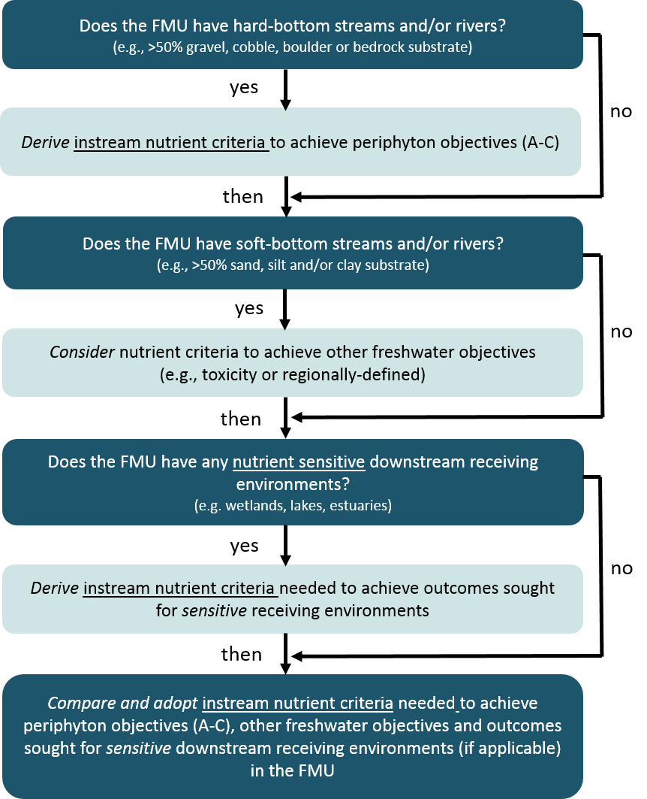

# 3. Applying clause 3.13

## 3.1 Clause 3.13(3)(a): Determining if the FMU supports, or could support, conspicuous periphyton and deriving appropriate instream nutrient concentrations and exceedance criteria

|  |
| --- |
| Key points   * Clause 3.133(a)(i) applies to hard-bottom streams and rivers while step (a)(ii) applies to soft-bottom streams and rivers. * For clause 3.133(a)(i) nutrient criteria must be derived for hard-bottom streams and rivers to manage periphyton consistent with the NPS-FM periphyton attribute. * Hard-bottom streams and rivers with didymo and benthic cyanobacteria should have nutrient criteria set for them, but these forms of periphyton may not respond to nutrient management, especially phosphorus, in the same way as other periphyton. * Key factors other than nutrients that control periphyton biomass and reflect the unique characteristics of a region or FMU need to be considered in deriving nutrient criteria * Many existing guidelines and models could be used to derive nutrient criteria, if satisfactorily validated or used as an interim measure, while a more robust regional model is developed. |

For clause 3.13(3)(a)(ii) consider the nutrient criteria required to achieve other freshwater objectives. These nutrient criteria should be set for other relevant NPS-FM attributes such as those defined 3.13(4) (macroinvertebrates, submerged plants, etc.) and any regionally-defined attributes. The latter could include attributes additional to the attributes talked stated in 3.13 (4) such as macrophytes, epiphyton and phytoplankton.

#### Why address hard-bottom and soft-bottom rivers separately?

The NPS-FM periphyton attribute was developed using scientific information derived exclusively from hard-bottom streams and rivers. These are streams and rivers that currently have mainly boulder, cobble or gravel substrates (see box below). Clause 3.13(3)(a)(i) applies to hard-bottom streams and rivers. Section 3.1.1 discusses the various methods for deriving nutrient criteria for hard-bottomed streams and rivers.

Soft-bottom rivers are those with mainly sand, silt or clay substrates. These rivers can sometimes support conspicuous growths of periphyton; for example, on sand or silt deposits following long periods of stable river flow, or adhering to macrophytes or other instream debris. Step (a)(ii) applies to soft-bottom streams and rivers. However, the ecosystem health effects of such periphyton growths are less well studied and understood and are not addressed in this document. Section 3.1.2 summarises relevant information available for macrophytes, epiphyton and phytoplankton.

|  |
| --- |
| What is a hard-bottom stream or river?  In their protocols for sampling macroinvertebrates in wadeable streams, Stark et al. (2001) define a hard-bottom river as one where the river bed is dominated by particles of gravel size or greater (ie, <50% of the bed is made up of sand/silt). The New Zealand In-stream Sediment Assessment Methods also use this definition (Clapcott et al., 2011). Most streams and rivers in New Zealand are hard-bottom. Currently around 80% of river length is classified as hard-bottom according to Freshwater Environments of New Zealand (FENZ; Leathwick et al., 2011). |

### 3.1.1 Clause 3.13(3)(a)(i) Hard-bottom streams and rivers

Clause 3.13(3)(a)(i) applies to hard-bottom streams or rivers, including those with shade due to vegetated riparian margins. These streams and rivers may not presently support conspicuous periphyton, but this status could change if the riparian vegetation was altered and shading reduced (see box below). As such, the recommended approach is these sites should be considered under clause 3.13(3)(a)(i) using a model that incorporates the influences of current and potential future levels of shading.

|  |  |
| --- | --- |
| Shading  Shading of waterways can constrain the growth of aquatic plants, including periphyton, which require light for photosynthesis. Research indicates that nuisance proliferations of periphyton can be controlled if average reach shading exceeds 60-65% of that in the open (Quinn et al., 1997; Biggs, 2000; Matheson et al., 2017).  Shading exceeding 60-65% is most likely achieved in small streams with tall and dense riparian vegetation. For example, for stream widths of around 3, 7 and 14 m, the maximum amount of predicted shade from mature native riparian vegetation is >99%, >95% and c. 70%, respectively (Davies-Colley et al., 2009). |  |

#### Periphyton and nutrients

Periphyton growth response to nutrients in rivers involves nutrient uptake into the periphyton biomass (and internal stores of P) that can lower the dissolved nutrient concentration in the water and alter the downstream nutrient concentrations (see box below). This has two key implications:

1. the relationships between instantaneous nutrient concentrations and periphyton biomass are usually weak, and hence relationships between median (or geometric mean or mean) nutrient concentrations and periphyton biomass are often used in predictive modelling
2. it is useful to consider the downstream spatial extent of nutrient input effects on periphyton biomass.

|  |
| --- |
| Temporal and downstream extent of nutrient impacts on periphyton biomass  Below is a conceptual diagram of how dissolved inorganic nutrients and periphyton biomass can vary downstream of a source of enrichment (eg, upwelling enriched groundwater and/or sewage treatment plant input) at three times during a flow recession. The diagram is based on Tukituki River observations (Quinn et al., 2018) and the model of Chapra et al. (2014).  O:\MFE18203\Working\Final draft\Spatial extent figure.png  At T1 the flow (Q) is moderate and travel time along the reach is short, resulting in lower initial nutrient concentrations that decline slowly downstream in response to early growth of periphyton that is not limited by concentrations along the whole river reach length.  At T2 the flow is low-moderate, resulting in less dilution of inputs (giving higher upstream concentrations) and dissolved DIN and DRP decline more rapidly due to higher uptake by higher periphyton biomass that has accrued over time and longer travel times enabling more time for uptake. Periphyton biomass begins to decline at the downstream end of the reach where nutrients are low but remain moderate due to earlier growth.  At T3 at low-flow, high nutrient concentrations occur near the upstream end of the reach (low dilution of inputs) where high biomass has accrued with continued rapid growth in response to maintained high nutrients. Dissolved inorganic nutrients decrease rapidly with distance downstream due to the combined effects of high uptake, long travel times and shallower depth (ie, greater bed surface area to volume ratio than at higher flows). Consequently, nutrients drop below levels that limit periphyton growth and biomass declines downstream as losses from grazing and self-sloughing are not replaced by new growth. |

#### Didymo and benthic cyanobacteria

Hard-bottom rivers with periphyton communities that have didymo benthic cyanobacteria require special consideration. This is because these forms of periphyton respond differently to nutrients than other types of periphyton (see boxes below). In general, it is likely reductions in DIN will reduce the likelihood of didymo and benthic cyanobacteria blooms but reductions in DRP may be ineffectual. Nutrient criteria to manage periphyton must still be derived for rivers with didymo and benthic cyanobacteria. It is best to avoid including didymo (especially if abundant) in periphyton biomass sampling to assess compliance with the periphyton attribute because it responds quite differently to nutrients than other periphyton.

|  |
| --- |
| Didymo  C:\Users\matheson\Desktop\Didymo.JPGThe invasive freshwater diatom didymo is a special case of periphyton because it does not respond to some environmental drivers in the same way as other common periphyton species. Didymo biomass accumulation is higher at lower water temperatures (Kilroy et al., 2006; C. Kilroy pers. comm.). It appears to prefer large seasonal temperature differences and it is tolerant of a broad range of hydraulic conditions (Kilroy et al., 2006, 2007).  Predictive modelling indicates a preference for stable, hard substrates and low flow variability, long time intervals between floods and sites with a high lake influence (Kilroy et al., 2007). In terms of nutrients, it is now known that *Didymo* requires low DRP concentrations (less than 2 mg/m3 on average) to produce stalks and bloom. This may explain why it has not been detected in North Island rivers as these typically have higher concentrations of DRP (C. Kilroy pers. comm.). |

|  |
| --- |
| Benthic cyanobacteria  C:\Users\matheson\Desktop\Phormidium.JPGBenthic, mat-forming cyanobacteria are widespread through New Zealand rivers and are found many water quality conditions, including oligotrophic waters (Biggs and Kilroy, 2000). The most common genus is regarded as *Phormidium*, which forms expansive, leathery, dark brown/black mats (Ministry for the Environment (MfE) and Ministry of Health (MoH), 2009).  Factors related to human land uses and activities can cause cyanobacterial mats to form, or to exacerbate their natural development, including flow alteration, shade reduction and nutrient input (MfE and MoH, 2009). NZ interim guidelines (MfE and MoH, 2009) recommend taking action once cover of potentially toxic cyanobacteria exceeds 50%. Alert status should be triggered by cover in the range of 20-50%. The guidelines suggest that the risk of a cyanobacterial mat bloom is greatest where: 1) water temperature is >15°C; 2) no flushing flows have occurred for at least fourteen days; 3) stream bed substrate is hard-bottom; and 4) river or stream bed is unshaded. Recent reviews of *Phormidium* proliferations in New Zealand suggests that these are most likely to occur where there is some enrichment with dissolved inorganic nitrogen, but when dissolved reactive phosphorus concentrations are less than 10 mg/m3 (Wood et al,. 2015; McAllister et al., 2016). |

#### How to derive nutrient criteria

Nitrogen and phosphorus as nutrients in fresh water that enhance the growth of plants are usually expressed in the form of dissolved inorganic nitrogen (DIN) (the sum of the nitrate, nitrite and ammonium concentrations) and dissolved reactive phosphorus (DRP). We recommend the following process to derive instream concentrations and exceedance criteria for DIN and DRP to achieve a periphyton objective in hard-bottom rivers.

For hard-bottom stream and river sites and segments across the FMU where the periphyton objective is currently being achieved (ie, periphyton state = periphyton objective), a reasonable approach would be to set instream nutrient criteria at current concentrations, provided these concentrations also ensure other freshwater objectives for compulsory or regionally-defined attributes are met. We recommend using annual median or geometric mean concentrations of DIN and DRP as the nutrient criteria.[2]

For hard-bottom stream and river sites and segments across the FMU where the periphyton objective is not currently being achieved (ie, periphyton state < periphyton objective), instream nutrient concentrations need to be set to achieve the periphyton objective. This requires an ability to predict periphyton biomass from nutrient concentrations, while also accounting for other factors known to control periphyton biomass. These factors include those contributing to biomass accrual, such as light availability and temperature, and those that result in biomass removal such as hydrological disturbances and grazing (Biggs, 1996, 2000).

Guidelines and models have been developed in New Zealand that link periphyton biomass (or cover) to nutrient concentrations, and that include, or account for, one or more other controlling factors. There are four existing guideline documents (MfE, 1992; Biggs, 2000; Matheson et al., 2012; Matheson et al., 2016), three of which base recommended nutrient criteria on broad-scale regression model results. Other models have also been developed. The models developed include linear regression models (Biggs, 2000; Larned et al., 2015; Elliott et al., 2016; Kilroy et al., 2017; Kilroy et al., 2018), non-linear quantile regression models (Matheson et al. 2016), Bayesian network models (Matheson et al., 2012; Storey et al., 2017) and a dynamic, process-based model (Rutherford 2011, 2012, 2013a, 2013b). Four of the models have been developed using national (or multi-region) datasets (ie, Biggs, 2000; Matheson et al., 2012; Matheson et al., 2016; Larned et al., 2015; Elliott et al., 2016). Other models are regional (ie, Canterbury, Kilroy et al., 2017; and Horizons, Kilroy et al., 2018) or for specific catchments (ie, Tukituki, Rutherford et al., 2011; and Ruamahanga, Storey et al., 2017).

The above guidelines and models provide many existing options that could be adopted or modified to derive instream nutrient criteria. Some of them could also provide a basis for an interim approach to setting nutrient criteria while a more comprehensive model is developed (see Case study – Deriving nutrient targets for the Horizons One Plan). The models vary in complexity and data requirements (see discussion of each below). Ideally the model used to derive nutrient criteria should be able to predict current state at sites or segments within an FMU with a high level of certainty. However, the degree of certainty required will likely depend on the scale and significance of the problem to be addressed. For example, a high degree of certainty in predictions is likely to be needed if many sites or segments within the FMU do not meet periphyton objectives and the cost to the community to implement nutrient mitigation strategies to meet those objectives is likely to be high. For further guidance on this point see *A Draft Guide to Communicating and Managing Uncertainty when Implementing the NPS-FM* (MfE, 2016a). The recommended use of existing guidelines and models is summarised in Table 1.

| case study – Deriving nutrient targets for the HORIZONS one plan |
| --- |
| The nutrient targets in the Horizons Regional Council One Plan (Horizons Regional Council, 2014) were largely based on the potential stimulation of nuisance periphyton growth by dissolved inorganic nitrogen (DIN) and phosphorus (DRP). Periphyton proliferations were regarded as a primary symptom of excessive nutrient input to streams and rivers and to have deleterious effects on ecological, cultural and socio-economic values.  The threshold values set for maximum periphyton biomass (chlorophyll *a*) in the One Plan were 50 mg/m2 for upland areas with currently low nutrient levels and high potential for benthic biodiversity; 120 mg/m2 for hill country areas with moderate nutrient levels that are currently agriculturally productive and potentially high trout fishery values; and 200 mg/m2 for lowland areas, naturally P-enriched catchments and soft-sediment geology.  The corresponding nutrient targets were based on consideration of:   * model predictions of concentrations that cause periphyton proliferations (from Biggs, 2000) * expert opinion (primarily for subzones in which the model did not apply) * observed mean monthly concentrations in summer (October–April) (where available) * year-round mean concentrations (where available).   In addition, a region-wide rule was applied that downstream targets were to take precedence over upstream targets (ie, a tributary must have the same or more stringent standard than the mainstem it feeds) and targets were relaxed at some sites where there was a clear indication that one nutrient was likely to be more frequently limiting periphyton growth. The DIN targets adopted were one of the following: 70, 110, 167 or 444 mg/m3. The DRP targets adopted were one of the following: 6, 10 or 15 mg/m3. The targets refer to the annual average concentration of DIN or DRP when the river flow is at or below the 20th flow percentile, unless natural levels already exceed this target. For further information on how the nutrient targets were derived see Ausseil and Clark (2007). |

Table : Recommended approach to use of existing guidelines and models for setting nutrient criteria

| **Existing guideline or model** | **Recommended approach** |
| --- | --- |
| Ministry for the Environment (1992) | This guideline’s focus was on dissolved organic material management to control sewage fungus, but provides a general indication of nutrient concentrations required to limit periphyton biomass. The latter have been superseded by more recent work. |
| Biggs (2000) | This guideline is based on two linear regression models derived from 30 hill-fed, cobble-bed New Zealand rivers. The models have been used to inform interim nutrient criteria for periphyton management (see case study). The basic form of these models can be used and modified to include other variables if necessary to develop region-specific models (see Kilroy et al., 2017, 2018) |
| Rutherford (2011, 2012, 2013a, 2013b) | The process-based TRIM model has been developed for the Tukituki River to predict changes in dissolved nutrient concentrations associated with land and wastewater management scenarios and resultant effects on periphyton biomass. The model could be applied in other river systems subject to satisfactory testing and validation. |
| Matheson et al. (2012) | This guideline contains a Bayesian Network model, which gives a general indication of dissolved inorganic nitrogen (DIN) and dissolved reactive phosphorus (DRP) concentrations likely to align approximately with NPS‑FM periphyton attribute bands A–D (the model is based on periphyton cover not biomass). The model guides on other factors that are likely to control periphyton biomass and may be useful as an exploratory tool. |
| Larned et al. (2015), Elliott et al. (2016) | These broad-scale models, developed using the National River Water Quality Network dataset and periphyton cover as a proxy for biomass, and the subject of ongoing work, could be used to derive nutrient criteria in freshwater management units (FMUs) if they can be shown to accurately predict current state. |
| Matheson et al. (2016) | The nutrient criteria described in this guideline could be used as interim criteria for river sites or segments belonging to REC cool-wet climate classes. Their validity could be tested using regional observations of periphyton and nutrient data if available. Non-linear quantile regression could be explored as an approach to derive nutrient criteria at regional or FMU scale. |
| Storey et al. (2017) | This Bayesian Network model has been developed for the Ruamahanga Whaitua building on information and data in Matheson et al. (2012) and Matheson et al. (2016). The model could potentially be improved and used to derive nutrient criteria in other regions or FMUs subject to satisfactory validation. |
| Kilroy et al. (2017), Kilroy et al. (2018) | Regionally derived statistical models are currently being developed in two regions to support the derivation of nutrient criteria for managing to NPS‑FM periphyton objectives. It may be useful to include shade[3] in future models to extend the application of models beyond unshaded locations and to explore the effects of riparian planting. |
| Ministry for the Environment (2020) | A nationally derived risk-based spatial exceedance criteria derived for specific river environment classification (REC) classes around the country, based on Snelder et al. (2019). Councils could use these criteria as a starting point for setting instream nutrient concentration and the limits to achieve them. The values in the guideline tables indicate the TN and DRP concentrations at which 10 percent, 20 percent and 30 percent of sites are expected exceed the A, B and C NOF bands for periphyton per each river class. |

##### Ministry for the Environment (1992)

These guidelines recommend DIN and DRP concentrations need to be below approximately 40‑100 mg m-3 DIN and 15-30 mg m-3 DRP for nutrients to have any significant effect on periphyton biomass in flowing waters. The guidelines note that if either nutrient occurs at lower concentrations, periphyton biomass yield is expected to decline. They do not recommend blanket imposition of nutrient limits to prevent undesirable periphyton growth, because many other factors have strong influences and should be considered on a site-specific basis. The DIN and DRP concentrations referred to are considered by the authors to be growing season medians (J. Quinn pers. comm.). The guidelines were based on field experiments using nutrient diffusing substrates (for DIN) and laboratory DRP saturation experiments of Welch et al. (1992).

##### Biggs (2000)

These guidelines recommend mean annual DIN and DRP concentrations (based on monthly sampling) required to ensure that peak (ie, annual maximum) periphyton biomass as 50, 120 or 200 mg/m2 is not exceeded, considering the average days of accrual following a flushing flow event equivalent to three times the median flow. The guidelines are based on two linear models developed from a dataset of 30 river sites across New Zealand. The models are:

Log10 (maximum chl. *a*) = 4.285 x (Log10 days of accrual) – 0.929 x (Log10 days of accrual)2 + (0.504 x Log1010 SIN) – 2.946 r2 = 0.741

Log10 (maximum chl. *a*) = 4.716 x (Log10 days of accrual) – 1.076 x (Log10 days of accrual)2 + (0.494 x Log10 SRP) – 2.741 r2 = 0.721

A subsequent analysis (Kilroy et al. in appendix E, Matheson et al., 2012) has shown that sites used to develop the models are a good representation of hill-fed, cobble-bed rivers in New Zealand. Other river types not represented were low-order lowland streams in warm areas, which are likely to account for about 30% of all river segments. It was noted the model dataset did not account for likely regional differences in periphyton – environment relationships, and this was hampered by the small size of the dataset. The authors concluded that efforts to accumulate more data on a regional basis are justified.

##### Rutherford (2011, 2012, 2013a/2013b)

A process-based, dynamic model (TRIM) was developed for the Tukituki, an unshaded, gravel bed, east coast, river. The model calculates instream nitrogen and phosphorus concentrations and periphyton biomass along successive river segments. It comprises two sub-models: hydraulic and nutrient-biomass. The model is discretised by sub-dividing the river into segments of equal length (typically 1 km). Both sub-models operate on a sub-daily time step that depends on the velocity and the segment length. The hydraulic sub-model estimates channel width (m), mean depth (m), mean velocity (m/s) and shear velocity (m/s) in each segment. The nutrient-periphyton biomass sub-model simulates daily average photosynthesis, nutrient uptake and release. It does not simulate hourly changes that arise from diurnal variations in photosynthesis.

The model is sufficiently well calibrated and tested in the Tukituki River to investigate the effects of changes to nutrient inputs, despite some uncertainty about the absolute values of predicted periphyton biomass and nutrient concentration.

##### Matheson et al. (2012)

Parts 1 and 2 of the *Instream Plant and Nutrient Guidelines* included an analysis of the National Rivers Water Quality Network dataset (from 1990 to 2006). The analysis identified generally applicable thresholds of DIN 250 mg/m3 and DRP 6 mg/m3 to limit average annual maximum filamentous cover to below the Biggs (2000) 30% aesthetic/angling nuisance guideline. The analysis also produced a series of linear regression models to explain annual maximum or annual average filamentous cover but none of these models included DIN. A Bayesian Network model was also produced which identified four nutrient concentration bands for annual mean DIN and DRP that were considered to represent low to high risk of contributing to development of nuisance filamentous cover. The DIN categories from low to high risk were: <50 mg/m3, 50‑150 mg/m3, 150-300 mg/m3 and >300 mg/m3. The DRP categories from low to high risk were: <3 mg/m3, 3-6 mg/m3, 6-15 mg/m3 and >15 mg/m3. The Bayesian model also included other controlling factors: annual frequency of instantaneous flows equivalent to three times the median flow, average light reaching the stream bed, dominant substrate type, 95th percentile water temperature and macroinvertebrate grazer density.

##### Matheson et al. (2016)

Part 3 of the *Instream Plant and Nutrient Guidelines* included a non-linear quantile regression analysis of data collated from five regional councils (Hawkes Bay, Horizons, Wellington, Canterbury and Southland) and the National Rivers Water Quality Network dataset (from 1990 to 2013). The dataset included periphyton biomass and cover. The analysis was based on periphyton data collected within two weeks of annual macroinvertebrate sampling during summer (November to April) and matched to mean DIN and DRP concentrations for the twelve months preceding the periphyton sampling date. The dataset was dominated by data from the REC Cool-Wet climate class (<60% samples) with less than 10% of samples from REC classes defined as productive by the NPS-FM Periphyton Attribute. The analysis identified annual mean DIN and DRP concentrations required to keep 85% of periphyton biomass or weighted composite cover samples below recommended guidelines of 50, 120 and 200 mg/m2 and 20, 30, 43 and 55%, respectively. An 85th percentile was chosen, as opposed to a 92nd percentile as used in the NPS-FM periphyton attribute default class, because the dataset consisted of summer data rather than an annual dataset. To comply with NPS-FM periphyton attribute thresholds of 50, 120 and 200 mg/m2, the following annual mean DIN concentrations were indicated: 100, 630 and 1100 mg/m3. For DRP, 11 and 18 mg/m3 were indicated for the 120 and 200 mg/m2 periphyton attribute thresholds.

##### Larned et al. (2015), Elliott et al. (2016)

In Larned *et al.* (2015) appendix B, the NRWQN dataset was used to develop two linear regression models to predict the 92nd percentile periphyton weighted composite cover from TN and DRP.[4] The models also included the following factors: FRE3 (annual frequency of flow events exceeding three times the median flow, 7DayFlowMins (7-day annual minimum flow), nNeg (annual number of negative flow reversals), T95 (annual 95th percentile water temperature), and PAR (average photosynthetically active radiation). The TN model also included the log of the N:P ratio. The models explained 38 and 30% of variance in WCC, respectively. The models were tested on independent data from Canterbury and Manawatu-Whanganui and performed poorly (ie, could not predict pattern and underpredicted periphyton weighted composite cover). The models were used to determine TN and DRP criteria to comply with proxy NPS-FM periphyton attribute thresholds (ie, 21% = 50 mg/m2, 34% = 120 mg/m2 and 45% = 200 mg/m2) for all REC source-of-flow categories assuming that 5, 10 or 20% of river segments were allowed to exceed the criteria. The confidence intervals for the nutrient criteria were large reflecting high uncertainties.

In Elliott *et al.* (2016) appendix B, the above analysis was extended to predict the 83rd percentile periphyton weighted composite cover consistent with the productive class of the NPS-FM periphyton attribute. The above analyses are currently being reworked with improved methodological procedures resulting in reduced uncertainties and better independent testing results (T. Snelder, pers. comm.).

##### Storey et al. (2017)

A Bayesian Network was developed to examine the effects of several development scenarios being considered by the Ruamahanga Whaitua Committee and their effects on the mainstem of the Ruamahanga River and its major tributaries up to 2080. The scenarios were: (1) Business as Usual (BAU) extending existing policy, practice and investment into the future, (2) Silver, a moderate effort for making water quality improvements across the Whaitua and (3) Gold, representing the highest and most aspirational effort for making water quality improvements across a broad range of activities and issues in the Whaitua. The BN developed was much broader than that developed by Matheson et al. (2012) but the component that predicted periphyton biomass from nutrient concentrations included a similar set of controlling factors. Nevertheless, the categories used for each factor were somewhat different. The model identified four nutrient concentration categories from low to high. The DIN categories were: <98 mg/m3, 98-631 mg/m3, 631-1122 mg/m3 and >1122 mg/m3. The DRP categories were: <5 mg/m3, 5-10.8 mg/m3, 10.8-18 mg/m3 and >18 mg/m3. Comparing BN predicted periphyton biomass state to actual state in the Ruamahanga Whaitua a reasonably good correlation was found (Pearson r = 0.71) but it tended to overestimate low biomass and underestimate high biomass. When used for scenario testing the BN model indicated periphyton growth decreases by 30-40% in Silver and Gold relative to baseline and BAU at three sites.

##### Kilroy et al. (2017), Kilroy et al. (2018)

Linear regression models have been developed in Canterbury and Manawatu-Whanganui regions to predict periphyton biomass from nutrient concentrations and other factors.

Canterbury region monitoring for model development began in July 2011. Separate models have been developed for hill (17) and alpine (7) sites. At alpine sites, a combination of DIN and DRP have been shown to explain >90% of the variance in 92nd percentile periphyton biomass. At hill sites (excluding four with shade) models which include DIN, DRP, conductivity, % fine substrate, and flow metrics have explained 62% to 85% of the variance in annual maximum periphyton biomass. Independent testing with data from a further six hill sites has shown that 87% of annual or three-year predictions were close to the observed values.

Manawatu-Whanganui region monitoring for model development was initiated in 2008 at thirty sites selected to cover a wide range of river flushing flow frequencies and nutrient concentrations. The models developed to predict 92nd percentile periphyton biomass have included geometric mean DIN and DRP, mean conductivity, mean water temperature and mean accrual time following an effective flow event[5] and explain up to 78% of variance. Cross‑validation has shown that predicted values explain 75% of variance in observed values. Uncertainty of predictions was quantified as the root-mean-squared deviation (0.239 of log 92nd periphyton biomass).

In both the above cases, lookup tables have been constructed to generalise the results for nutrient criteria selection and to ensure that models results are not extrapolated beyond the range of the data used to develop them.

##### Ministry for the Environment (2020)

Periphyton spatial exceedance is an indicator of the level of risk accepted by regional councils to waterways having excessive levels of periphyton. For example, a 20 percent spatial exceedance means a 20 percent chance exists that, at a given site and at the target nutrient concentration, the periphyton bottom line will not be met.

For a given amount of nutrients in a river, a risk will always exist that the predicted amount of periphyton will be exceeded. Therefore, the risks of not achieving the periphyton biomass bottom line were built into the nutrient targets for managing periphyton. The spatial exceedance criteria quantify the probability of a randomly chosen site having periphyton abundance greater than the biomass bottom line when the concentration is within the target concentration. A risk-based approach is a way to account for variation between locations in flow regimes, temperature and stream shading (amongst other factors).

The nutrient targets in the look-up tables are based on Snelder et al. (2019), which use regression models to represent the relationships between periphyton biomass and site characteristics for 78 gravel-bed rivers in New Zealand. This approach was later recalibrated to use a larger dataset of around 170 rivers nationwide, to inform the essential freshwater regulatory impact assessment.

Because these ‘look-up tables’ indicate the relative risk of exceeding specific periphyton attribute bands, they can be used as a baseline to clarify the risk of exceeding the target attribute states for periphyton, to ensure appropriate instream nutrient concentrations are set. The final instream nutrient concentrations in each FMU need to be determined by each regional council.

Note that 20 percent spatial exceedance for each periphyton target attribute state was assumed for Cabinet consideration of the economic impacts of essential freshwater.[6] It is not a target to aim for, and we recommend councils achieve as low a spatial exceedance as practicable (eg, 5 percent, 10 percent or 15 percent) for the chosen periphyton target attribute state.

This guideline is currently in the process of being updated, with a similar statistical model being applied to a larger dataset.

#### Developing a regional statistical model

Figure 2 shows process steps recommended if development of a regional model is considered the best option for deriving robust nutrient criteria for periphyton, or for validating models derived at larger scales. Further information about each step is outlined in detail below.

Figure : Process for developing a new regional, river class or FMU model to identify nutrient criteria to achieve a periphyton objective in hard-bottom streams and rivers

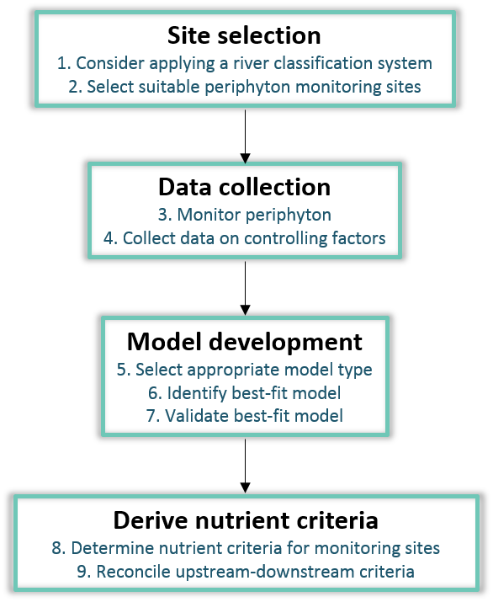

##### Step 1: Consider applying a river classification system

Considering the influence of natural variation in factors controlling periphyton when setting nutrient criteria for periphyton management is important. Natural variations in climate and geology across New Zealand are likely to result in some streams and rivers being naturally more susceptible to periphyton growth than others. This has been partly accounted for in the NPS-FM periphyton attribute by the designation of default and naturally productive river classes. The productive river class has a higher allowable frequency of exceedance criterion for a periphyton objective (17% of time) than the default river class (8% of time). The productive river class includes streams and rivers that are classified as Cool Dry (CD) or Warm Dry (WD), and have Soft Sedimentary (SS), Volcanic Acidic (VA) or Volcanic Basic (VB) geology according to the New Zealand River Environment Classification (REC, Snelder and Biggs, 2002). The rationale for this is that landscapes in dry climates are subject to less rainfall and thus rivers and streams here have less frequent flushing flows to remove periphyton, and streams and rivers in landscapes with soft sediment and volcanic geologies are more likely to be naturally enriched with nutrients, particularly phosphorus, which will enhance growth and accrual of periphyton biomass.

Hence, it might be necessary to apply a further river classification in regions with diverse landscapes. Using a classification facilitates identification of rivers with different environments where periphyton responses to nutrients are expected to differ. As an example, Canterbury rivers draining mountain catchments appear to have different (and simpler) relationships to periphyton than rivers draining hill or lowland catchments. The two river types are generally identifiable from their source-of-flow classification in the REC, but local knowledge could also be applied to separate river types. For example, in the Canterbury region, different models have been developed for rivers in alpine and hill areas (Kilroy et al., 2017).

##### Step 2: Select suitable periphyton monitoring sites

The purpose of this step is to ensure that there are enough monitoring sites in each river class for which a separate periphyton model will be developed, and that an appropriate river reach at each monitoring site is selected for periphyton monitoring. Sites should be selected to cover the anticipated range of values for the factors considered likely to influence periphyton biomass, particularly flow disturbance and nutrient regimes (Biggs, 2000). To develop a robust multivariate model, a common recommendation is to have at least 10 points for every independent variable, so if there are three independent variables in the model then 30 points will be needed (McDonald, 2014). However, there is no strict rule on this and smaller sample sizes than this have been used to develop regional models in Canterbury and Manawatu-Whanganui. Alternatively, a power analysis could be carried out to determine an appropriate sample size. Periphyton monitoring site selection protocols outlined in the New Zealand Periphyton Monitoring Manual (Biggs and Kilroy, 2000) should be consulted. Consider the representativeness of habitat type where periphyton is sampled and standardised across reaches, if possible.

##### Step 3: Monitor periphyton

Periphyton biomass (as chlorophyll *a*) should be monitored at each site in accordance with the requirements of the NPS-FM periphyton attribute. The attribute stipulates monthly monitoring for a minimum period of three years (see MfE, 2018). Comprehensive monitoring protocols for periphyton biomass are available and should be followed (see Biggs and Kilroy 2000). A National Environmental Monitoring Standard for periphyton is in development (see [www.nems.org.nz](https://tepuna.mfe.govt.nz/otcsdav/nodes/13656288/C__Users_perezk_AppData_Roaming_OpenText_OTEdit_EC_tepuna_c13656288_www.nems.org.nz)). Additional useful information on the nature of the periphyton community (eg, filamentous vs. cyanobacteria vs. diatom dominance) can be gathered at minimal cost by assessing percentage periphyton cover by types (Kilroy et al., 2013). At greater expense/effort, measurement of the periphyton C:N:P ratios on the samples collected for chlorophyll *a* analysis also provides insightful information on periphyton nutrient status (eg, nutrient stress/deficiency or sufficiency), and species composition analysis adds to the understanding of effects, since species vary in their growth requirements.

##### Step 4: Collect data on controlling factors

The best models will likely be developed using data on controlling factors (ie, light and nutrient availability, temperature, hydrological disturbances and grazing) that have been measured concurrently with periphyton at periphyton monitoring sites. Most of the periphyton models developed to date using national datasets have used model-extrapolated data for some controlling factors (except Biggs, 2000) because little or no measured data were available. The NPS-FM periphyton attribute requires monthly monitoring of periphyton so concurrent measurement of nutrients and other controlling factors at periphyton monitoring sites can occur at the same time.

We recommend a staged approach to monitoring and inclusion of controlling factors in a periphyton model because the controlling factors are likely to differ in explanatory power between models for different river classes and regions. All controlling factors should be monitored for at least 12 months and then the explanatory power of the controlling factors in statistical models should be determined. Following this, monitoring of only those controlling factors with high explanatory power may be warranted.

The parameters recommended for measurement at periphyton monitoring sites, and to evaluate for inclusion in periphyton models, are:

* days of accrual or effective flushing flow frequency
* dissolved nutrient (DIN, DRP) concentrations
* shade or light at bed
* conductivity
* substrate composition
* water temperature
* density of macroinvertebrate grazers.

##### **Days of accrual or effective flushing flow frequency**

The development of periphyton biomass in any stream or river is strongly controlled by flow events that periodically scour it from the river bed. Therefore, it is essential that a parameter that reflects this factor be included in a periphyton model. This parameter could be the annual average (or summer) frequency of flushing flow events, or the annual average (or summer) days of accrual following a flushing flow event. The annual average days of accrual can be calculated from the former as follows:

Da = (365 – nex) / nev

Where:

Da = annual average days of accrual

nex = annual number of days exceeding flow threshold

nev = annual number of flow events

To determine these parameters monitoring sites need to be linked to a flow record (either near a flow recorder, or a flow record modelled for the site). A flushing flow event greater than or equal to three times the median flow has been considered the most likely sized event to scour periphyton from the river bed and this is the parameter used in past periphyton models (Biggs, 2000, Matheson et al., 2012). However, recent research shows that the magnitude of flow events required to scour periphyton from the bed can differ considerably among rivers. The effective flow at a site can be estimated either using a time-series of periphyton and flow data (Hoyle et al., 2017; Kilroy et al., 2017) or from hydraulic measurements in the field (Hoyle et al., 2017). A comparison of methods and recommendations for their application is in preparation.

##### Dissolved nutrient (DIN, DRP) concentrations

Like all autotrophs, periphyton require inorganic nitrogen (N) and phosphorus (P) for growth, and provided there are no other growth constraining factors, biomass should increase over time in response to increased supplies of N and/or P up to the maximum standing stock for the local constraints, beyond which more nutrients will affect the downstream extent of periphyton more than the local biomass (see box on Temporal and downstream extent of nutrient impacts on periphyton biomass). The concentrations of DIN and DRP in river water at periphyton monitoring sites should be determined monthly using standard river water quality sampling and analysis protocols (see [www.nems.org.nz](https://tepuna.mfe.govt.nz/otcsdav/nodes/13656288/C__Users_perezk_AppData_Roaming_OpenText_OTEdit_EC_tepuna_c13656288_www.nems.org.nz%20) Water Quality – Part 2 Rivers) for a minimum three-year period, and aligned with periphyton sampling (at the same site if possible or at least in the same river segment). DIN and DRP concentrations measured in river water during summer do not necessarily reflect the availability of nutrients to periphyton and concentrations can be lower in the afternoon than the morning due to nutrient uptake associated with photosynthesis. Consequently, it is recommended to use median, geometric mean or mean values in periphyton models and the time of day that samples are collected be noted and considered in model development.

##### Shade or light at bed

Light is essential for the growth of primary producers like periphyton so it is important to consider the influence of this parameter in the development of a periphyton model. A simple indicator of light availability is percent stream shade (see Harding et al. 2009 for semi‑quantitative to quantitative protocols[7]). However, stream shade does not account for any light attenuation by suspended particles in the water. Where the latter is a factor that could constrain periphyton growth (ie, there is some turbidity or dissolved colour in the water) it is recommended to quantify light at bed rather than just simply stream shade. Light at the bed can be (i) measured directly using an underwater light (PAR) sensor or estimated from data on (ii) light at the water surface and the light attenuation (Kd) to the mean depth or (iii) data on solar radiation above any riparian vegetation canopy, stream shade, water depth, water clarity or turbidity, and the absorbance coefficient (g340, a measure of dissolved organic matter/colour). See Matheson et al. (2012) for the protocol to calculate light at bed from these parameters. For all parameters, except solar radiation, it is straight-forward to measure these monthly during site visits. For solar radiation we recommend using data from the nearest available climate monitoring station because time-averaged data is required rather than spot measurements. Measure stream shade and/or light at bed in the areas where periphyton sampling occurs.

##### Conductivity

Electrical conductivity (ie, ionic strength) has been shown to correlate positively and strongly with periphyton biomass (Biggs 2000, Kilroy et al., 2017) so it will be useful to include this parameter in periphyton model development. Conductivity is thought to be a useful general indicator of nutrient/mineral enrichment although the nutrient-conductivity relationship may break down in situations where there is salt spray influence or geologies enriched in certain compounds (eg, sulphur) (Biggs, 2000). Water conductivity should be measured using standard river water quality sampling protocols at periphyton monitoring sites (see [www.nems.org.nz](https://tepuna.mfe.govt.nz/otcsdav/nodes/13656288/C__Users_perezk_AppData_Roaming_OpenText_OTEdit_EC_tepuna_c13656288_www.nems.org.nz%20) Water Quality – Part 2 Rivers).

##### Substrate composition

In hard-bottom rivers, periphyton biomass accrual is usually greatest on the larger, more immobile, substrates. Patches of fine sediment (ie, of sand, silt and clay) and small gravel are more unstable substrates for attachment. Furthermore, fine sediments, particularly sand, mobilised in flow events may contribute to abrasion and scouring of periphyton from other river bed substrates. Consequently, it is likely to be useful to include a substrate composition parameter such as the substrate index (Harding et al., 2009) or percent fine sediments (and gravel) in periphyton models (Kilroy et al., 2017). Substrate composition should be quantified at least annually at periphyton monitoring sites (see Harding et al., 2009 for protocols).

##### Water temperature

Growth rates for periphyton are typically enhanced by warmer water temperatures, and temperature can influence the dominant community type (ie, diatoms, filamentous or cyanobacteria), so including this parameter in a periphyton model may improve the model. Continuous measurement of water temperature at periphyton monitoring sites using loggers is preferred because water temperature can vary substantially on a diurnal basis. Accordingly, a standardised water temperature parameter, aligned with the period of peak periphyton growth (usually summer), such as the annual 95th percentile or summer median, is recommended. Follow the procedures outlined in the National Environmental Monitoring Standard for Water Temperature Recording ([www.nems.org.nz](https://tepuna.mfe.govt.nz/otcsdav/nodes/13656288/C__Users_perezk_AppData_Roaming_OpenText_OTEdit_EC_tepuna_c13656288_www.nems.org.nz)).

##### Density of invertebrate grazers

Invertebrate grazers can regulate periphyton biomass (Welch et al., 1992) so including this parameter in a periphyton model is worth evaluating. Macroinvertebrates are usually sampled annually when river flows are stable during the summer period and periphyton monitoring sites should be suitable for employing standard macroinvertebrate sampling protocols (Stark et al., 2001). If possible, sampling should be carried out in the same locations as periphyton sampling. A quantitative sampling protocol should be used to determine a density of invertebrate grazers per unit area (n/m2). Invertebrate grazer taxa can be identified from the list documented in Matheson et al. (2012). Development of a National Environmental Monitoring Standard for Macroinvertebrates is currently on hold.

##### Step 5: Select appropriate model type

The most straight-forward method to developing a regional periphyton model using a regression approach is to opt for a linear model (eg, Biggs, 2000, Larned et al., 2015, Elliott et al., 2016, Kilroy et al., 2017, Kilroy et al., 2018). Non-linear models (eg, Matheson et al., 2016) are much more difficult to implement and interpret but can be a powerful alternative to linear regression, as long as the following caveats are understood:

* it can be difficult and time-consuming to identify a suitable non-linear equation to fit the data
* an R-squared value cannot be calculated (but S values – the standard deviation of the distance between the data values and the fitted values – and residual vs fitted value plots are alternatives for demonstrating goodness-of-fit for non-linear models)
* the effect that each predictor has on the response can be less intuitive to understand
* p-values are impossible to calculate for the predictors
* it may or may not be possible to calculate confidence intervals.

Consequently, only linear models are covered from this point.

A model is linear when each term is either a constant or the product of a parameter and a predictor variable. A linear equation is constructed by adding the results for each term. This constrains the equation to just one basic form:

Response = constant + parameter * predictor + ... + parameter * predictor

Y = b o + b1X1 + b2X2 + ... + bkXk

Curvature can be produced in linear models by transforming the predictor variables. For example, squared predictor variable can be included to produce a U-shaped curve.

Y = b o + b1X1 + b2X12

To align with the NPS-FM periphyton attribute default river class a model needs to be developed that predicts the 92nd percentile of periphyton biomass. For the productive river class the model must fit the 83rd percentile of periphyton biomass.

##### Step 6: Identify best-fit model

In general, a model fits the data well if the differences between the observed values and the model’s predicted values are small and unbiased. The first step in checking goodness-of-fit for a model is to check the residual versus fitted value plots. These can reveal unwanted residual patterns that indicate biased results. If these show no bias then the next step is to examine goodness-of-fit statistics. For linear models these are the R-squared value, the adjusted R‑squared value and the predicted R-squared value.

##### Step 7: Validate best-fit model

The best approach for validating a periphyton model is to test it with data from an independent set of periphyton monitoring sites. These are sites from the same river class which were not included in the dataset used to develop the model. This approach could entail collecting an entirely new dataset. Alternatively, it could involve randomly selecting a subset (usually 30% recommended) of the available dataset for a river class, excluding these from the dataset used to develop the model, then using this subset to validate the model. However, cross-validation procedures that use the entire dataset can also be used, such as leave-one-out cross-validation (Pickard and Cook, 1984).

##### Step 8: Determine nutrient criteria for monitoring sites

Once a best-fit model for predicting periphyton biomass has been validated, the nutrient criteria required to achieve a periphyton objective for monitoring sites should be determined from the model. If the model is a linear equation, then it can be rearranged to calculate the nutrient concentrations required to achieve a periphyton biomass objective (as either 50, 120 or 200 mg/m2). For example, using the linear model from Biggs (2000) which predicts periphyton biomass from days of accrual and DIN concentration:

Log10 (maximum chl. *a*) = 4.285 x (Log10 days of accrual) – 0.929 x (Log10 days of accrual)2 + (0.504 x Log10 SIN) – 2.946

This can be rearranged to: Log10SIN = [Log10 (maximum chl. *a*) + 2.946 + 0.929 x (Log10 days of accrual)2 – 4.285 x (Log10 days of accrual)]/0.504

Alternatively, or if the model includes both DIN and DRP, then the equation can be used to predict chlorophyll *a* under a range of scenarios. See Kilroy et al. (2017) or Kilroy et al. (2018) for an example of this process. It is important that a model only be used to predict nutrient criteria within the range of the measured data used to develop the model.

##### Step 9: Reconcile upstream-downstream criteria

The nutrient criteria assigned to monitoring sites will need to be checked to ensure that they are consistent with periphyton objectives and nutrient criteria assigned to any sites downstream of them. In some situations, a more stringent nutrient criterion may need to be set for an upstream site than that required to meet its designated periphyton objective (Refer to Steps (b) and (c) below).

A simple hypothetical example of this is where a lower periphyton objective (eg, Band C) is set for a tributary than for the main-stem of a river (eg, Band B). In this case the nutrient criteria for the tributary *may* need to be set to meet a Band B rather than Band C periphyton objective. However, this will depend on the contribution of other tributaries to the main-stem river (see **Error! Reference source not found.**). If the periphyton objective set for another tributary is Band A then the nutrient criteria set to achieve that objective, combined with the nutrient criteria for the Band C tributary, may still allow a Band B periphyton objective to be met for the main-stem of the river. The outcome depends on the relative contribution of the two tributaries to the river discharge observed at the main-stem site.

Figure : An illustration of the process to reconcile periphyton nutrient criteria for hard-bottom streams and rivers using a simple example

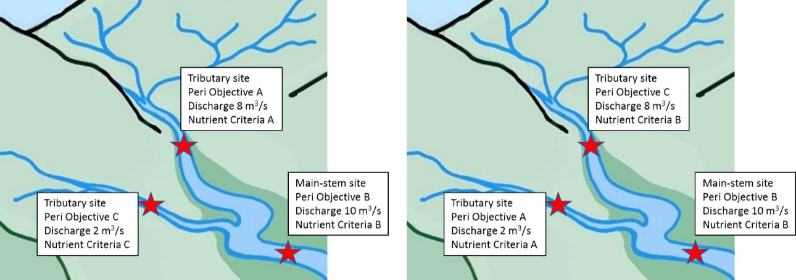

### 3.1.2 Clause 3.13(3)(a)(ii) Soft-bottom streams and rivers

Nutrient concentration targets should still be set for soft bottom streams or other areas where there is no conspicuous periphyton, per 3.13(3)(a)(ii). These streams and rivers are those where macrophytes and phytoplankton are usually the dominant primary producers. Although periphyton can occur in soft-bottom rivers, usually as filaments adhering to or entangled in macrophytes (Biggs, 2000) at present there is limited information available on the ecological effects of this form of periphyton, typically termed epiphyton. The NOF periphyton attribute still applies in these soft bottomed streams and rivers and freshwater objectives, and therefore also nutrient criteria must be set. In soft-bottom streams and rivers the nutrient criteria required must consider those to achieve other freshwater objectives. These objectives must include other relevant NPS-FM appendix 2 attributes and also any regionally-derived attributes for local conditions. The former refers to the nitrate and ammonia river toxicity attributes. The latter could include regional attributes for macrophytes, epiphyton and phytoplankton as well as for dissolved oxygen, fish, macroinvertebrates and ecosystem metabolism. Information relevant to the development of such regional attributes is summarised below.

#### Macrophytes

Nuisance growths of aquatic macrophytes are most common in unshaded, nutrient-rich, lowland streams and rivers (Haslam, 1978). New Zealand provisional guidelines for nuisance macrophyte abundance are >50% channel volume (or clogginess) and >50% water surface cover (Matheson et al., 2012). These provisional guidelines are equivalent to recommendations for United Kingdom rivers (Dawson & Kern-Hansen, 1979) and consistent with a recommended intermediate plant density to support healthy stream invertebrate and fish communities in New Zealand lowland streams (Collier et al., 1999). Nevertheless, the provisional status of these guidelines reflects the need for further testing and evaluation.

Like periphyton, macrophytes require sufficient nutrients for growth but relationships between nutrients and macrophytes are further complicated as macrophytes can acquire nutrients from water, sediments or both depending on their life-form type (Table 2).

Table : Macrophyte life form types with primary nutrient source and example species

| Life-form | Primary nutrient source | Example species in NZ rivers |
| --- | --- | --- |
| Free-floating | Water | Duckweed *(Lemna minor)\**, Mosquito fern (*Azolla pinnata*). |
| Floating-leaved | Sediment | Swamp lily (*Otellia ovalifolia*), Cape pondweed (*Aponogeton distachyos*). |
| Erect emergent | Sediment | Reed canary grass *(Phalaris arundinacea),* Reed sweet grass (*Glyceria maxima*). |
| Sprawling emergent | Sediment and Water | Water pepper (*Persicaria hydropiper)*, Watercress (*Nasturtium* spp.). |
| Submerged | Sediment and Water | Hornwort (*Ceratophyllum demersum*), Starwort (*Callitriche stagnalis*), Smooth-leaved pondweed (*Potamogeton ochreatus*)* |
| Characeans* | Sediment and Water | *Nitella* spp. (*Nitella* aff. *cristata*, *Nitella stuartii*). |

* native species

Like periphyton, macrophyte biomass accrual and community composition is regulated by several factors other than nutrients, in particular light availability and hydrological disturbance parameters (Matheson et al., 2012). Despite this complexity, research indicates that the risk of nuisance macrophyte growth generally increases as water nutrient concentrations increase, at least in the concentration range anticipated for most small to medium-sized watercourses (Table 3). Furthermore, many introduced macrophyte species prefer nutrient-enriched conditions (eg, Ceratophyllum demersum and Callitriche stagnalis, Lacoul and Freedman, 2006; and see Ellenberg N indicator values, Ellenberg, 1988). This aligns with findings from a Canadian study (Carr et al., 2003) which concluded that nutrient abatement programs, especially focused on nitrogen, may be successful in reducing nuisance biomass of macrophytes. At high nutrient concentrations, in larger soft-bottom rivers, the growth of macrophytes is likely to be constrained by velocity, turbid water, competition with phytoplankton and, possibly, toxicity effects.

Table : Nutrient concentrations that may constrain macrophyte growth and biomass

| Nutrient | Concentration (mg/m3) | Growth or biomass response | Reference |
| --- | --- | --- | --- |
| Nitrate | >1000 | Not limiting. | Westlake (1981) |
| DIN | <1000 | Reduction in river macrophyte biomass (*Potamogeton* spp.) following improved N removal from WWTP discharge. | Soziak (2002) |
| DRP | 100 | Data suggests that a reduction in biomass of water crowfoot (*Ranunculus penicillatus*) in UK rivers is likely below this threshold. | O’Hare *et al.* (2010) |
| DIN & DRP | 750 & 15 | Complying with these concentrations is predicted to increase the number of monitoring sites meeting Canterbury regional objective of <50% macrophyte cover. | Booker & Snelder (2012) |
| DIN & DRP | <100 & <10 >1000 & >100 | Approximate low-risk & high-risk water concentrations for nuisance macrophyte growth based on literature review & expert opinion. | Matheson *et al.* (2012) |

#### Epiphyton

In nutrient-enriched, macrophyte dominated watercourses, long filamentous algae can sometimes conspicuously grow, although this may not be common (see Biggs and Price, 1987). Nevertheless, substantial growths of the red filamentous alga, Compsopogon spp. occur amongst beds of macrophytes in the Piako and Waitoa Rivers in Waikato (Matheson et al., 2009; Matheson and Wells, 2017) and elsewhere (Chapman & Cameron, 1967), and the green filamentous alga, Microspora spp., can grow abundantly amongst macrophytes in spring-fed streams (Biggs, 2000). In the Piako River, concentrations of DIN of 200 mg/m3 and DRP 50 mg/m3 have been associated with reduced abundance of Compsopogon (Matheson et al., 2009). However, in general, the occurrence, impact and response to nutrients of epiphytic algal growths in soft-bottom rivers has not been well-studied and requires further investigation.

#### Phytoplankton

Nuisance phytoplankton blooms are generally only considered problematic in large, impounded river systems (eg, Waikato hydrolakes and lower river) with relatively high nutrient levels and water residence times. Consequently, few regional councils systematically measure riverine phytoplankton abundance as part of their state of environment monitoring programmes. All regions that have or could have nuisance phytoplankton blooms should include this in their monitoring programme. In recognition of the lake-fed nature of the Waikato River and the potential influence of hydro lakes along that river system, the Waikato River Collaborative Stakeholder Group have adopted the NPS-FM Lake Phytoplankton, TN and TP attributes for Ecosystem Health along the entire main stem of the Waikato River (excluding Waipa River) (Waikato River Collaborative Stakeholder Group, 2016).

## 3.2 Clause 3.13(3)(b): Are there sensitive downstream receiving environments?

### 3.2.1 Potentially sensitive downstream receiving environments

|  |
| --- |
| Key points  Potentially sensitive downstream receiving environments include:   * rivers – ie, mainstem streams or rivers in downstream FMUs * wetlands – limited to those connected to surface waters of FMUs * lakes – limited to those connected to surface waters of FMUs * estuaries – excludes intermittently closed and open lakes and lagoons (ICOLLS).   Inclusion of qualifying wetland receiving environments is currently limited by a lack of information regarding trophic state and corresponding nutrient criteria.  Ground water environments (even shallow recharge aquifers) are not considered to be nutrient receiving environments in terms of trophic state. An absence of light means groundwater environments cannot support autotrophic communities. In river-recharged groundwaters, nitrate and ammonium toxicity are likely to be the main nutrient considerations regarding ecosystem health. However, care should be taken that nutrient levels do not become higher than desirable for the purpose of Clause 3.13 where groundwater re-emerges into surface waterbodies. |

However, as groundwater is a potential source of nutrients, care should be taken that concentrations are not exceeded where groundwater re-emerges into waterbodies lower in the FMU.

Typically, nutrient sensitive downstream environments may arise because of:

* supply of limiting nutrient (ie, change in nutrient limitation status of the waterbody)
* long (or longer) residence times enabling more time for uptake and proliferation of primary producers
* change in habitat suitability (eg, fresh to marine, lotic to lentic, soft- to hard-bottom substrate).

In addition to lakes and estuaries mentioned as examples in Clause 3.13, other receiving environments that should be considered include:

* larger streams or rivers in downstream FMUs (eg, mainstem rivers)
* wetlands (in some instances) – limited to marshes and swamps (see box below).

|  |
| --- |
| Wetlands and nutrient effects  Wetlands are distinguished by three main components: hydrology, soils, and vegetation. Wetland hydrology effectively determines soil development, the assemblage of plants and animals that inhabit the site, and the type and intensity of biochemical processes (US EPA, 2008). The main functional wetland types in New Zealand are bogs, fens, swamps and marshes (Johnson and Gerbeaux, 2004). The relationship between wetland type and water source is illustrated in the diagram below (relabelled figure 2.2 from US EPA, 2008). As indicated, only wetlands dominated by surface flows (ie, swamps and marshes) are relevant as FMU receiving environments.    Although wetlands are zones of nutrient transformation and removal, excess nutrients are second only to hydrological disturbance as a cause of loss of natural character in wetlands. Despite the progress in recent decades in pollution control in lakes and streams, wetlands are very sensitive to the amount of nutrients they receive, and many New Zealand wetlands continue to suffer excess nutrient inputs (Sorrell, 2010).  Wetlands exhibit trophic responses to increasing nutrient concentrations at multiple levels. The biotic response to nutrient enrichment generally occurs in a sequential manner as nutrient uptake occurs first, followed by increased biomass production, and then followed by a shift in species composition typically dominated by those adapted to high nutrient environments (US EPA, 2008). Nutrient enrichment, therefore, usually causes loss of plant species and the community to change from a diverse multi-species mixture to one that is dominated by a few fast-growing competitors (Sorrell, 2010). |

Clause 3.13Clause 3.13 requires that setting instream nutrient criteria in FMUs must consider, and hence provide for, the trophic outcomes sought for downstream receiving environments. It is therefore implicit that the downstream receiving environments are connected to the flowing waters of the FMU. There is no benefit in setting instream criteria for an upstream FMU if these waters do not directly influence nutrient concentrations/loads in a downstream receiving environment. This is reasonably straightforward for lakes and estuaries, but it is more complicated for wetlands. For example, many wetland systems may only be connected to streams or rivers during high flow events. While certain wetlands should qualify as downstream receiving environments under Clause 3.13, the lack of information regarding nutrient-related responses and corresponding nutrient criteria, currently limits the extent to which these receiving environments can be considered. As such a precautionary approach should be taken. Potentially useful wetland documents include: *Wetland restoration: a handbook for New Zealand freshwater systems* (Clarkson and Peters, 2010), and *Nutrient Criteria Technical Guidance Manual – Wetlands* (US EPA, 2008).

Groundwater is typically a source of nutrients to FMU surface waters. Rivers and streams can recharge shallow aquifers, and so groundwater could be considered as a downstream receiving environment for FMU surface water. However, unlike other surface water receiving environments, the absence of light in ground water environments means that nutrient enrichment from surface waters could not result in plant responses (ie, primary production). Nutrient additions to groundwater may influence heterotrophic communities (ie, nitrification and denitrification), but the main effect is likely to be seen at high concentrations where the nitrate and ammonium toxicity may occur (note that the NPS-FM nitrate and ammonia toxicity attributes only apply to lakes and rivers). Accordingly, groundwaters are not considered further as receiving environments for implementation of Clause 3.13Clause 3.13. However, as groundwater is a potential source of nutrients, care should be taken that concentrations are not exceeded where groundwater re-emerges into waterbodies lower in the FMU.

Water bodies that should not qualify as downstream receiving environments include:

* palustrine wetlands and lakes (eg, dune lakes) that are predominately rain water or ground water fed, and not connected to surface water of the upstream FMU/s
* groundwater (including shallow aquifers recharged by rivers).

Downstream receiving environments that are considered include the following:

* lakes receiving river or stream inflows
* riverine receiving waters (eg, larger mainstem rivers)
* estuaries (includes the four typologies defined in the Estuarine Trophic Index (ETI) tools)
* riverine wetlands.

Nutrient susceptibility and eutrophication of these downstream receiving environments are discussed briefly in the next section.

### 3.2.2 Trophic state measures and corresponding nutrient criteria

|  |
| --- |
| Key points   * Nutrient criteria that correspond to the trophic state objectives (ie, bands) for downstream receiving environments are available for streams and rivers (step (a)), lakes and estuaries, but not wetlands. * Nutrient criteria for lakes (NPS-FM) and indicative nitrogen criteria for estuaries  (ETI – Tool 1) are summarised below. |

Under subcaluse 3(b) of Clause 3.13, to set nutrient criteria for the downstream receiving environments discussed in the previous section, it is necessary to have information on trophic-state responses (ie, different states or bands spanning from good to severely impacted) so that regional councils can define what trophic outcomes are sought for these environments.

Step (a) of this guidance document (Section 3.1) deals with downstream riverine receiving environments.

For wetlands, no trophic state definitions (or bands) have been defined, and so there are no nutrient criteria available for regional councils to apply to these receiving environments. In the United States, the Environment Protection Agency (US EPA) has produced a comprehensive document on how to approach setting nutrient criteria in wetlands (US EPA, 2008), and this is discussed further in the Wetlands section.

For lakes, NPS-FM trophic state objectives have been enumerated and expressed as attribute states for phytoplankton (chl. *a*), total nitrogen (TN) and total phosphorus (TP) concentrations (MfE, 2018). In addition, these three factors are central to the Trophic Level Index (TLI) for lakes that provides a single index of change in lake trophic status. Section 3.3 discusses interconversion between in-river concentrations (ie, inflow concentrations from an FMU) and estimated in-lake concentrations. Because lakes have nitrogen and phosphorus concentration-based criteria, a sensitive lake receiving environment could potentially result in reductions to N and P instream concentrations set to achieve periphyton objectives in upstream FMUs.

For estuary receiving environments, an Envirolink Tools project has developed a national Estuarine Trophic Index (ETI) that has defined trophic-state bands (A, B, C and D) that are comparable to NPS-FM band narratives. Using a combination of modelling and real estuary trophic monitoring data, the ETI (Tool 1) has defined potential TN concentrations that correspond to the different estuary trophic states. Potential TN concentrations are average concentrations predicted for an estuary. They represent a hypothetical, homogenous concentration resulting from the mixing of riverine and oceanic waters, and they do not account for within-estuary nutrient dynamics (ie, sinks and/or sources). As such, potential TN concentrations will be different to measured concentrations, however this does not preclude their use as an initial scoping tool for reconciling estuarine nutrient criteria with instream nutrient concentrations for upstream FMUs. Importantly, the ETI only considers nitrogen because this is generally accepted as being the limiting nutrient in estuaries (Howarth and Marino, 2006). Consideration of estuarine receiving environment nutrient susceptibility, via the ETI process outlined in this guidance, will only result in revisions to FMU instream criteria set for nitrogen; and not phosphorus. Phosphorus criteria are more likely to be more restrictive in river or N limited lake environments rather than estuaries.

Available trophic-state bands, and corresponding nutrient criteria, for downstream receiving environments that should be considered under Clause 3.13Clause 3.13 are summarised in Table 4.

Table : Summary of trophic bands and nutrient criteria for downstream receiving environments

| Receiving environment | Trophic bands | Nutrient criteria | Suitable for implementing Clause 3.13 |
| --- | --- | --- | --- |
| Rivers/streams | NPS-FM trophic state attribute bands (A-D) based on chl-*a* concentrations. | Several existing guideline/ target/trigger values for N and P (refer to section 3.1 of this guidance which deals with step (a)). | **Yes** – although nutrient criteria should be derived at regional-scale in accordance with methods outlined for step (a). |
| Wetlands | Not available. | Not available. | **No** – requires trophic-state objectives and corresponding nutrient criteria to be derived. Precautionary principle is advised. |
| Lake | NPS-FM trophic state attribute bands (A-D) based on chl-*a* concentrations. | NPS-FM trophic state bands (A-D) for both TN and TP concentrations. | **Yes** |
| Estuary | ETI trophic states defined for estuaries susceptible to macroalgal and phytoplankton blooms. | Indicative criteria corresponding to trophic-state susceptibility bands have been developed for nitrogen (expressed as *potential* TN concentrations). | **Yes** – although the suitability of indicative nitrogen criteria at regional/estuary-scale should be evaluated and, where necessary, implemented. |

#### Rivers and streams

Downstream riverine receiving environments need to be considered whether these are within the same FMU or in an adjacent (downstream) FMU. In either case, their consideration in setting instream criteria for FMUs is the same, and the process for this is covered in step (a) (section 3.1).

#### Wetlands

|  |
| --- |
| Figure : Flowchart identifying the recommended process to develop wetland nutrient criteria. |
| Source figure 1 in US EPA, 2008 |

##### General

Destruction of wetlands as a result of land development is the principal cause of wetland loss in New Zealand. However, for remaining wetlands, nutrient enrichment and sediment inputs are the major drivers of change in natural character (Sorrell, 2010). The US EPA produced a substantial document that provides guidance on setting nutrient criteria for wetlands (US EPA, 2008). The document does not provide nutrient criteria, but it is a useful resource for regional councils to develop criteria for wetlands that qualify as downstream receiving environments under Clause 3.13.

The guidance outlines several methods that can be used to develop numeric nutrient criteria for wetlands. The general steps for undertaking this process are illustrated in **Error! Reference source not found.**. One method for deriving criteria is using reference (or estimated reference) condition.

##### Using reference condition to establish nutrient criteria

This approach by the US EPA (2008) involves using relatively undisturbed reference wetlands as examples for the natural or minimally disturbed ecological conditions of a region. The approach is useful for estimating A band conditions for wetlands. Approaches to this include:

* characterizing reference systems for each class within a region using best professional judgment and use these reference conditions to define criteria
* identifying the 75th to 95th percentile of the frequency distribution for a class of reference wetlands (Figure 5)
* calculating a 5th to 25th percentile of the frequency distribution of the general population of a class of wetlands (Figure 5).

Limitations of this approach include a general lack of nutrient monitoring data for wetlands to undertake percentile analyses, and that it is not effects-based. While no existing national guidance on indicative nutrient criteria currently exists for managing the trophic state of wetlands, a precautionary approach should be taken.

Figure : Illustration of the two approaches to inform nutrient criteria using a high percentile (eg, 75th percentile) from a ‘reference site’ population (blue line), or a low percentile (eg, 25th percentile) from a general population

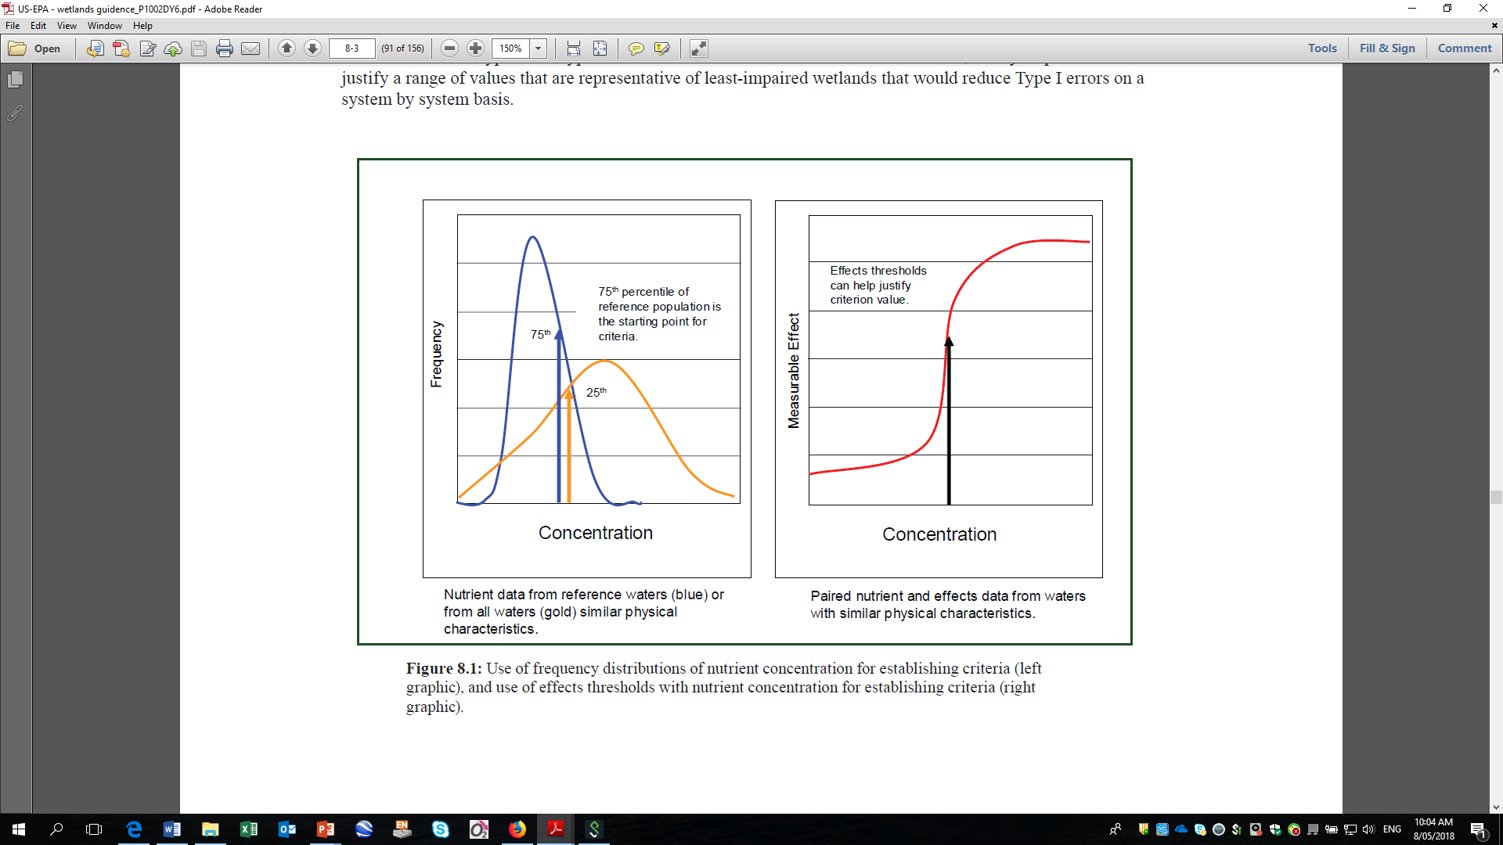

Source modified from figure 8.1 in US EPA, 2008

#### Lakes

Three appendix 2 attributes have been defined to manage the trophic state of lakes:

* phytoplankton biomass (chl-*a* concentration, mg/m3)
* total nitrogen (TN) concentration (mg/m3)
* total phosphorus (TP) concentration (mg/m3).

The concentration of both nitrogen and phosphorus need to be considered when managing for trophic-state in lakes because of seasonal and interannual changes in limitation (Larned et al., 2011).

##### Phytoplankton biomass

Phytoplankton biomass in a lake is the biological expression (ie, primary effect) of nutrients (N and P) within the constraints imposed by water clarity, depth of mixing and residence time. Annual median and annual maximum values of chl-*a* are indicators of lake trophic state. The narrative attribute bands for phytoplankton (trophic state) in lakes are:

1. *healthy and resilient*, similar to near reference condition
2. *slightly impacted* by additional algal and plant growth arising from nutrients levels that are elevated above natural reference conditions
3. *moderately impacted* by additional algal and plant growth arising from nutrient levels that are elevated well above natural reference conditions
4. *severely impacted* – have undergone or are at high risk of a regime shift to a persistent, degraded state, due to impacts of elevated nutrients leading to excessive algal and/or plant growth, as well as from losing oxygen in bottom waters of deep lakes.

##### Total nitrogen and total phosphorus

Regional councils can identify the freshwater objectives for phytoplankton (trophic state) sought for lakes within an FMU, and then select the corresponding TN and TP in-lake concentration criteria (measured as annual medians) required to meet the freshwater objective. In cases where lake attribute TN and/or TP concentrations are known not to provide for the corresponding phytoplankton freshwater objective, the expectation is that more meaningful and site-specific in-lake nutrient criteria will be adopted (or developed) as part of subcaluse 3(b).[8]

The respective A/B, B/C and C/D threshold nutrient values are (expressed as annual medians):

* TN (stratified/brackish) = ≤160, ≤350 and ≤750 mg/m3
* TN (polymictic) = ≤300, ≤500 and ≤800 mg/m3
* TP (all types) = ≤10, ≤20 and ≤50 mg/m3.

#### Estuaries

Estuarine receiving environments are not included in the NPS-FM and consequently there are no trophic state attributes for New Zealand estuaries. Nutrient enrichment threatens many estuaries, but until recently, there has been limited guidance on how to assess the extent of eutrophication in these downstream receiving environments. The ETI was developed to help regional councils in determining the susceptibility of an estuary to eutrophication, assess its current trophic state, and assess how changes to nitrogen load limits (via conversion to concentrations) may alter its current state.

The ETI comprises three separate tools, although only Tool 1 (*Determining susceptibility of estuaries to eutrophication*) is detailed this guidance section on selecting suitable nutrient criteria to meet the trophic states sought for estuarine receiving environments. Tool 1 consists of two separate approaches; the one considered most applicable to New Zealand estuaries is the CLUES estuary approach – this effectively combines data outputs from the Catchment Land Use for Environmental Sustainability (CLUES) model with simple dilution models to predict potential nutrient concentrations. Because nitrogen is generally regarded as being the limiting nutrient in estuaries (as outlined earlier), the ETI only considers nitrogen, and therefore trophic-state objectives and associated nutrient criteria for estuaries determined using the ETI will only influence FMU instream criteria set for nitrogen and not phosphorus.

The ETI is recommended for dealing with trophic state in estuaries because it:

* was developed in response to a need identified by regional council coastal scientists to provide supporting guidance for underpinning the ecological health component of regional plans. It does this by identifying relevant estuary attributes and outcomes. It is a national initiative with >400 estuaries included in Tool 1, incorporating a simple four-category estuary type (Figure 6) specifically suited to the assessment of estuarine eutrophication susceptibility in NZ:
* shallow intertidal dominated estuaries (SIDES, ‘A’ in Figure 6)
* shallow, short residence time tidal river and tidal river with adjoining lagoon estuaries (SSRTREs, ‘B’ in Figure 6)
* deeper subtidal dominated, longer residence time estuaries (DSDEs, ‘C’ in Figure 6);
* coastal lakes (‘D’ in Figure 6)
* provides a process to determine susceptibility of estuaries to both types of plant response to anthropogenic nutrient enrichment, namely:
* macroalgal blooms
* phytoplankton blooms
* defines four bands (A-D), with narratives that are generally consistent with the NPS-FM trophic attribute bands (ie, rivers and lakes):
* macroalgal trophic bands and corresponding nutrient criteria are based on the relationship between the trophic state of real data and potential nutrient concentrations
* phytoplankton trophic bands are based on a simplified modelling approach that accounts for the effects of both potential concentrations and flushing time.

The ETI provides a useful, first step/screening level approach to identify trophic state objectives for an estuary, and to set corresponding potential TN concentrations for New Zealand estuaries (see box below). Some regional councils, for selected estuaries, may be more advanced in their assessment of, and aspirations regarding, trophic state (and corresponding nutrient targets), in which case the ETI approach may be of limited value. It is also emphasised that the ETI generic trophic threshold concentrations of TN are considered indicative only, and these will likely be revised (or substituted) by regional councils using current or future monitoring and local knowledge.

Figure : The four types of estuary used by the ETI for assessing the eutrophic susceptibility of NZ estuaries

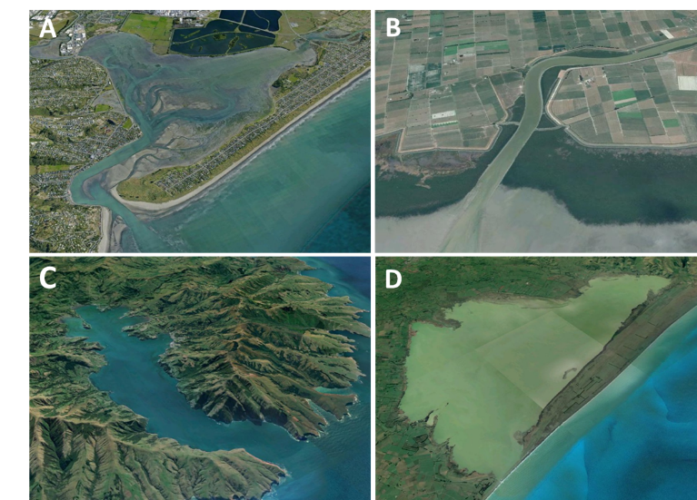

(A) shallow intertidal dominated estuaries (SIDEs); (B) shallow, short residence time tidal river and tidal river with adjoining lagoon estuaries (SSRTREs); (C) deeper subtidal dominated, longer residence time estuaries (DSDEs); and (D) coastal lakes (Plew et al., 2017). Intermittently closed/open estuary states are subtypes of SIDEs and SSRTREs that describe the estuary closure state.

|  |
| --- |
| Some important points about the ETI  *Only deals with nitrogen*  Although dual nutrient management (N and P) is recommended (US EPA 2015), and a requirement of Clause 3.13, the ETI only considers nitrogen (as TN) for estuaries. This is because since the mid-1990’s, strong consensus has developed that solving the problem of eutrophication in estuaries requires controls on N inputs (Howarth and Marino 2006). There will invariably be exceptions to this, and where regional councils know or suspect that phosphorus is a limiting (or co-limiting) nutrient in an estuary, the expectation is that this will trigger more comprehensive assessments, than what the ETI-derived nitrogen screening criteria can provide.  *Annual average model vs. seasonality of macroalgal or phytoplankton blooms*  The ETI uses annual average concentrations for catchment streams and rivers because it uses the annual loads and flow data from the CLUES[9] model. Therefore, a potential limitation is that it may not address estuarine eutrophication at specific, critical times (eg, summer). This may not be an issue for macroalgal-dominated systems because the potential TN vs. measured macroalgal responses are all derived from the summer period, when the maximum growth occurs. As such, the ETI has essentially done a calibration that predicts summer conditions using mean concentration data. To improve the seasonality aspect of ETI-derived criteria further, calibrations would need to be developed between response and seasonal loads (concentration), and these data are not currently available across a sufficient number of estuaries.  *Estuaries as a homogenous system*  The ETI (Tool 1) applies a mixing model to the estuary to yield an estimated average concentration for the entire estuary. In practice, primary producer responses to anthropogenic nutrient enrichment (from upstream FMUs) are more pronounced in areas near the head of the estuary with poor flushing. Estimated potential TN concentrations (discussed below) calculated using ETI dilution factors do not account for heterogenous nutrient environments (and associated expressions of eutrophication). The ETI has been applied at a sub-estuary scale for the Catlins Estuary which has a distinct upper and lower section (Plew and Dudley 2018). Although the ETI approach could, in theory, be pushed to incorporate limited compartment heterogeneity, the strength of the ETI approach is that it provides a rapid method for screening the nutrient susceptibility of estuaries (relative to inputs from upstream FMUs). Potential issues identified from this screening approach would be expected to trigger more in‑depth, site-specific investigations. For example, if spatial resolution is important, then it would be better to use a 3D hydrodynamic model, rather than making an increasingly complicated dilution model.  *Based on potential nitrogen concentrations*  Potential nutrient concentrations are concentrations in the absence of nutrient uptake or losses through biogeochemical processes, representing the trophic pressure on an estuary due to nutrient loading. These concentrations assume full mixing and homogeneity throughout the entire area defining the estuary. Actual measured concentrations will therefore not necessarily correspond to these hypothetical potential concentrations and care will need to be exercised to ensure that the appropriate concentrations are used. For example, a regional council could not substitute measured data for potential concentrations when determining the eutrophication susceptibility using the ETI. However, ETI users can:   * input their own catchment nutrient loads (measured or from models other than the default CLUES catchments loads that are used) and use the ETI to calculate different potential nitrogen concentrations for estuaries |
| * derive their own potential nitrogen concentration thresholds that correspond to the trophic outcome sought for the estuary.   *Macroalgal- vs phytoplankton-based susceptibility banding*  The ETI Tool 1 using the CLUES Estuary approach provides two eutrophication assessments, one based on susceptibility to macroalgal blooms and one based on susceptibility to phytoplankton blooms. The relative importance of each depends on the estuary type under consideration. Macroalgal blooms are most problematic in shallow estuaries with large intertidal areas. These are typically shallow intertidal dominated estuaries (SIDEs). Phytoplankton blooms (and associated eutrophic effects) are usually limited to deeper subtidal dominated estuaries (DSDEs) which have longer residence times and small intertidal areas.  The rules for assigning which susceptibility measure is used by the ETI are as follows:   * estuaries >40% intertidal area (generally SIDEs) = macroalgal susceptibility * estuaries <5% intertidal area (generally DSDEs and SSRTREs[10]) = phytoplankton susceptibility * other estuaries with 5–40% intertidal area = the lower[11] of the two susceptibility bands. |

##### Nitrogen criteria corresponding to trophic susceptibility bands

##### Macroalgal susceptibility

This type of eutrophication susceptibility will generally be dominant in shallow estuaries with large intertidal areas. This includes most SIDE estuaries, and some SSRTRE estuaries, although the latter tend to have relatively low proportions of intertidal area (<20%) which limits available habitat for growth and scope for accumulation of detached macroalgae.

The ETI uses the Opportunistic Macroalgal Blooming Tool (OMBT) developed by the Water Framework Directive – United Kingdom Technical Advisory Group (WFD-UKTAG, 2014) for transitional and coastal waters which have intertidal areas of soft sedimentary substratum (ie, areas for opportunistic macroalgal growth). Adaptation of the OMBT to the New Zealand ETI is explained in detail in the NZ Estuarine Trophic Index Screening Tool 2 (*Determining monitoring indicators and assessing estuary trophic state*) (Robertson et al., 2016b).

Briefly, for macroalgal susceptibility, an ecological quality rating (EQR) is determined from estuary monitoring data. The final EQR score (0 to 1) is an equally weighted average of the following five macroalgal metrics (face values for each metric are provided in Table 5):

* percentage (%) cover of the available intertidal habitat (AIH)
* total extent of area covered by algal mats (affected area (AA) in hectares); or affected area as a percentage (%) of the AIH (AA/AIH)
* biomass of opportunistic macroalgae in AIH (g/m2)
* biomass of opportunistic macroalgae in AA (g/m2)
* presence of entrained algae (percentage of quadrats).

The ETI assigns the overall macroalgal EQR score (equally weighted average) to trophic bands according to the following thresholds (OMBT qualitative descriptor in parentheses):

* Band A EQR ≥0.8 to 1.0 (high)
* Band B EQR ≥0.6 to <0.8 (good)
* Band C EQR ≥0.4 to <0.6 (medium)
* Band D EQR <0.4 (poor/bad[12]).

Indicative nitrogen concentrations that correspond to the EQR band thresholds have been derived from regressions between measured EQR values for New Zealand estuaries and potential TN concentrations calculated from CLUES Estuary (Figure 7). Based on available monitoring data, indicative potential TN thresholds (mg/m3) for the macroalgal trophic susceptibility bands currently used by the ETI (Tool 1) are (Plew et al., 2017):

* Band A <55 mg/m3
* Band B ≥55 to <110 mg/m3
* Band C ≥180 to <350 mg/m3
* Band D ≥350 mg/m3.

Table : Opportunistic macroalgal blooming tool (OMBT, WFD-UKTAG, 2014) values for macrolagal metrics used to assign individual macroalgal ecological quality rating (EQR) scores of “open” estuaries (table 4 in Robertson et al., 2016b)

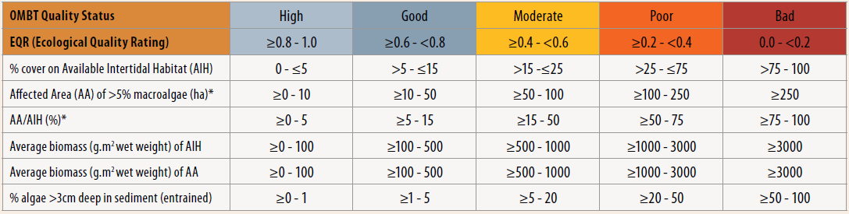

Figure : Regression of measured macroalgal EQR value (NZ estuaries) and potential TN concentrations derived from CLUES Estuaries (Plew et al., 2017)

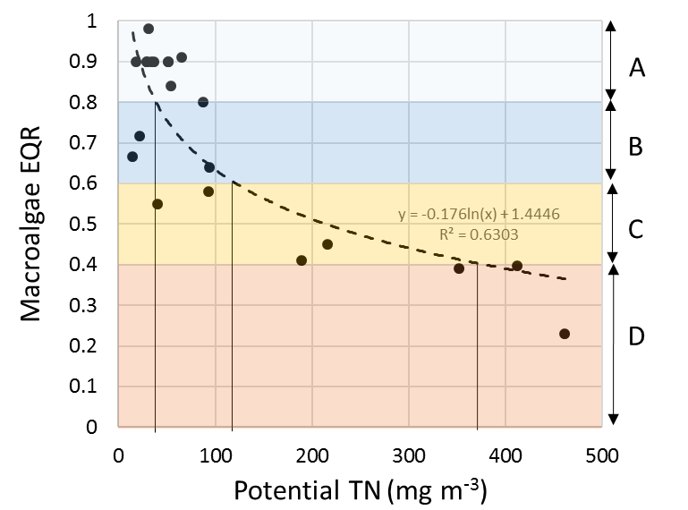

These are indicative potential nitrogen thresholds that are a useful starting point for regional councils undertaking screening-level assessments of nutrient susceptibility of their estuarine receiving environments. It is recommended regional councils (over time) amend or derive relevant estuarine-specific nitrogen criteria for their estuaries; particularly those indicated as having nutrient criteria that will not be met by instream criteria (to meet periphyton and other freshwater objectives) in upstream FMUs (refer to step (c)).

##### Phytoplankton susceptibility

Generally, this type of eutrophication susceptibility will be dominant in deeper subtidal dominated estuaries (DSDEs).

Phytoplankton susceptibility bands are based on predicted phytoplankton biomass (in the form of chl-*a* concentrations) using a simple growth model that incorporates potential nitrogen concentration and flushing time (Eppley et al., 1969; Ferreira et al., 2005). Phytoplankton trophic bands (as chl-*a*) are defined as follows:

* Band A <5 mg/m3 chl-*a*
* Band B ≥5 to <10 mg/m3 chl-*a*
* Band C ≥10 to <16 mg/m3 chl-*a*
* Band D ≥16 mg/m3 chl-*a*.

The predicted bandings are displayed as contours in Figure 8.

Flushing time is an important parameter controlling phytoplankton concentrations. Even in the presence of high nitrogen concentrations (ie, at or above growth saturation), short flushing times do not provide enough time for phytoplankton to assimilate nutrients and reach problematic concentrations. For example, the model predicts no significant growth of phytoplankton (<5 mg/m3 chl-*a*) for short flushing times (eg, 3 days or less) at potential nitrogen concentrations up to 500 mg/m3 (refer to A-band, Figure 8). As flushing times increase to greater than 3–4 days, the band thresholds are predicted to be relatively independent of flushing time, which is evident from the largely horizontal boundaries between the bands in this region shown in Figure 8.

For estuaries with flushing times >3-4 days the indicative potential TN concentrations corresponding to A-D bands for estuarine phytoplankton concentrations are provided alongside the macroalgal TN criteria in Table 6.

Figure : Phytoplankton trophic bands (or ‘zones’) as a function of *potential* TN concentrations and estuary flushing time (days). Taken from Plew et al. (2017)



Table : Indicative *potential* TN threshold concentrations (mg/m3) for macroalgal and phytoplankton trophic-states in New Zealand estuaries. Values derived from   
Plew et al. (2017)

| Trophic-state band | Band narrative | Potential TN concentration (mg/m3) | |
| --- | --- | --- | --- |
| Macroalgal-dominated systems | Phytoplankton-dominated systems |
| A | near reference | <55 | <50 |
| B | slightly impacted | ≥55 to <180 | ≥50 to <100 |
| C | moderately impacted | ≥180 to <350 | ≥100 to <150 |
| D | heavily impacted | ≥350 | ≥150 |

### 3.2.3 Freshwater management unit considerations

|  |
| --- |
| Key points   * Freshwater management units (FMUs) based on catchment or sub-catchment boundaries are conceptually easier to implement for Clause 3.13, compared to FMUs that span multiple watersheds in a region. * Downstream receiving environments should be connected to the surface waters of the FMU so this definition excludes predominately rain or ground water-fed lakes and wetlands. * Most FMUs will have at least an estuarine receiving environment to consider. However, some FMUs may not have any nutrient sensitive downstream receiving environments, for example small stream catchments that discharge directly to the coast. |

When identifying FMUs, regional councils must decide on the most relevant and practical approach for their region. Possible approaches include (MfE, 2016b):

* dividing the whole region into FMUs at once
* defining one FMU at a time
* dividing the region into broader zones or areas early on, followed by a more detailed delineation of FMUs within each zone or area as part of the process of identifying values and potential freshwater objectives and limits.

All regional councils in New Zealand are at least some way through this process (Greenhalgh and Murphy, 2017). Generally, broader areas or zones based on single or multiple catchments are the starting point, which are then subdivided to reflect values, special areas and/or water quality or stream environment classifications relevant to the region or area or zone. Although there are several ways to approach the development of FMUs, it is conceptually more intuitive to consider receiving environments for FMUs based on catchments and/or subcatchment boundaries.

The nature of the FMU determines whether the receiving environments are connected directly or indirectly to it. An indirectly connected receiving environment is one where the FMU discharges to it via one (or more) intermediate FMUs, for example, where a catchment is divided into upper, middle and lower FMUs. In this case, only the lower FMU directly discharges to the estuary, whereas the upper and middle FMUs obviously contribute to the nutrient load, but they discharge to the estuary via one, or more, downstream FMUs (Table 7).

Table : Connectivity of an estuary receiving environment to management units based on upper, middle and lower regions of a hypothetical catchment

| Management unit | Direct | Indirect |
| --- | --- | --- |
| Upper FMU | Middle FMU – mainstem | Lower FMU – mainstem  Estuary |
| Middle FMU | Lower FMU – mainstem | Estuary |
| Lower FMU | Estuary | None |

In the example in table 6, Clause 3.13 requires all three FMUs consider nutrient-related outcomes sought for the estuary when setting instream nutrient criteria.

If meeting the outcomes sought for the estuary requires nutrient concentrations that are lower than those for managing periphyton and other freshwater objectives in the upstream FMUs, then councils must apply (or apportion) nutrient reductions within or across the contributing FMUs. Clause 3.13 does not give direction to councils on how to allocate

##### Hypothetical catchment example

To simplify visualisation of the connectivity between catchment FMUs and potentially sensitive downstream receiving environments, a hypothetical catchment with both catchment-scale FMU (ie, A) and sub-catchment-scale FMUs (B-E) is illustrated (Figure 9).

Potentially sensitive downstream receiving environments, which may influence instream nutrient criteria derived for catchment FMUs, include lakes, wetlands and an estuary. Figure 10 shows the same hypothetical catchment as Figure 9, except that it is separated into two FMUs based on a river classification system – in this example, hill and lowland. Potentially nutrient sensitive downstream receiving environments for the FMUs shown in both examples are summarised in the adjacent table.

Figure : Hypothetical catchment showing examples of catchment and sub-catchment-scale FMUs. Downstream receiving environments include lakes (L), wetlands (W) and a single estuary

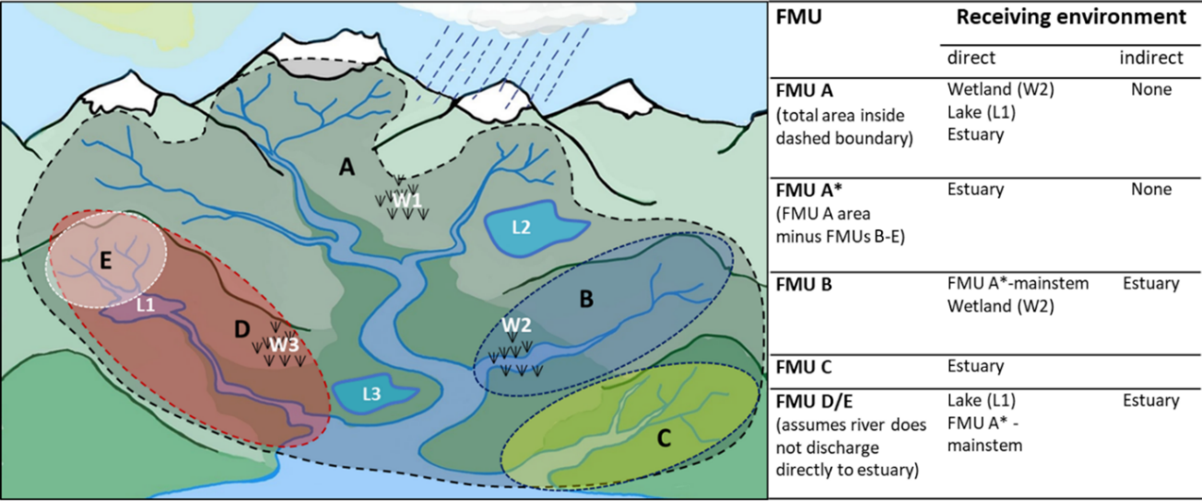

Figure : Hypothetical catchment showing example of river classification-based FMUs – hill (black dashed boundary) and lowland (yellow dashed boundary). Downstream receiving environments include lakes (L), wetlands (W) and a single estuary

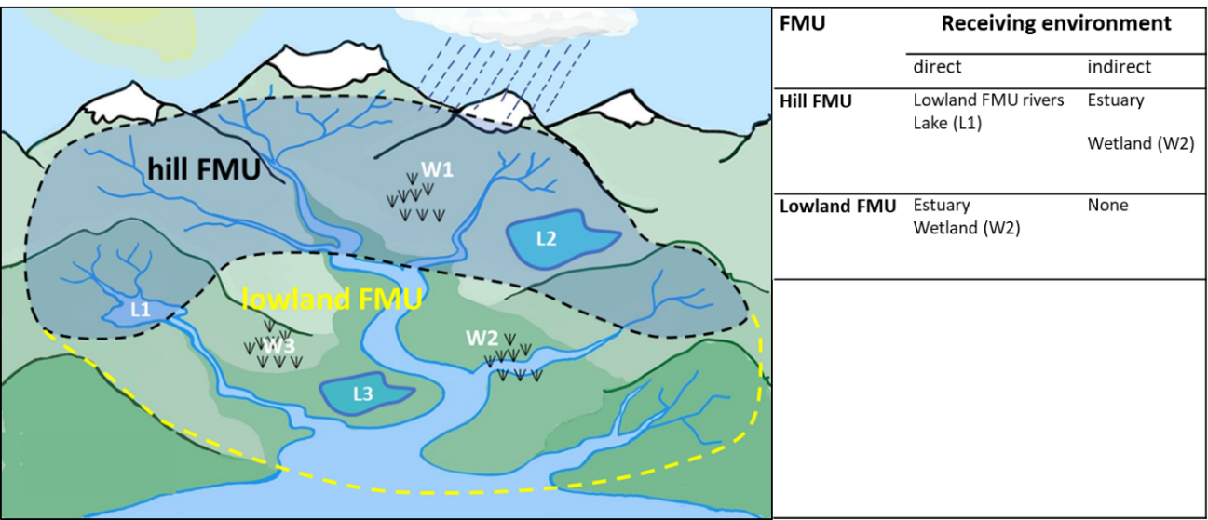

## 3.3 Step (c): How are nutrient criteria reconciled across the FMU and downstream receiving environments?

### 3.3.1 General process

Clause 3.13 requires regional councils to consider any potentially nutrient sensitive downstream environments when setting instream criteria for FMUs. To do this, councils need to carry out an assessment of all potentially sensitive downstream receiving environments to identify which (if any), have lower nutrient requirements than streams or rivers in the FMU[13] to meet their trophic-state objectives. If any are identified, then this would require the setting of instream criteria that are more stringent than those based on meeting periphyton and other freshwater objectives in the upstream FMU.

This process is illustrated in Figure 11 with the FMU instream criteria and a lake receiving environment criteria shown as [X] and [Z], respectively as an example. Conversion of [X] into receiving environment concentration units [Y] is required, which can then be compared with receiving environment criteria [Z], yielding one of two outcomes:

1. Instream nutrient criteria set to meet FMU periphyton or other freshwater objectives also provide for trophic state objectives sought for downstream receiving environments; ie, [Y] < [Z] – in these instances, downstream receiving environments will not require the setting of more stringent nutrient criteria in the FMU (or parts of it).
2. Instream nutrient criteria derived to meet FMU trophic objectives do not provide for trophic state objectives sought for downstream receiving environments ie, [Y] ≥ [Z] – in these instances, the instream nutrient criteria for the FMU will need to be amended to reflect the lower nutrient criteria required for the receiving environment/s.

Figure : Key components and pathways envisaged for implementing step (c) of Clause 3.13

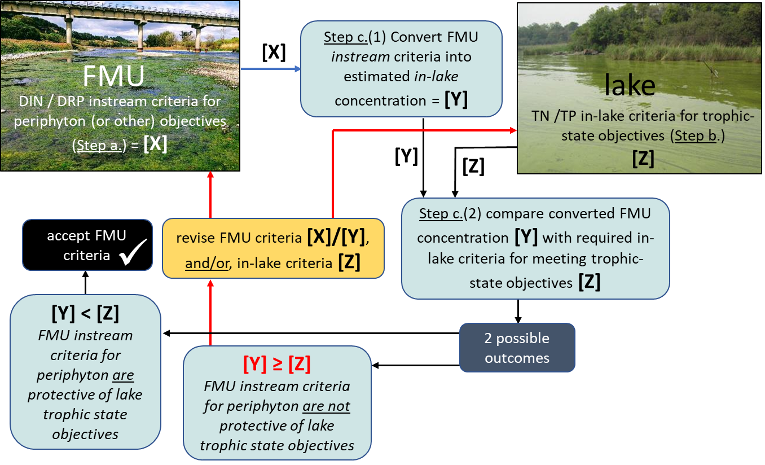

To compare FMU instream to receiving environment nutrient criteria requires:

* nutrient criteria expressed in concentrations, and able to be converted into the same nutrient form. For example, conversion of riverine DIN or nitrate-N criteria into TN-based receiving environment criteria
* FMU instream nutrient concentrations to be converted into corresponding receiving environment concentrations. For example, a river with a median concentration of 100 mg/m3 of TN will not necessarily correspond to an estuary or lake concentration of 100 mg/m3.

These processes are discussed in more detail in section 3.3.3.

### 3.3.2 Nutrient criteria to meet trophic state objectives

Section 3.2.2 summarised available nutrient criteria and thresholds that can be used to define trophic-state objectives for different types of receiving environments. Of the four receiving environment types considered relevant to Clause 3.13, there are indicative values that can be used as screening-level criteria for lakes and estuaries only. Downstream riverine FMUs require instream criteria to be developed under step (a). There are currently no nutrient objectives or criteria available for wetlands in New Zealand, where there are known issues councils should develop their own or take a precautionary approach. Criteria for lakes and estuaries are summarised below (Table 8).

Table : Summary of NPS-FM and other potentially useful nutrient criteria that correspond to the trophic state of downstream receiving environments. Refer to section 3.2.2 for details

| Receiving environment | Nitrogen (TN) criteria (mg/m3) | | | Phosphorus (TP) criteria (mg/m3) | | Additional comments |
| --- | --- | --- | --- | --- | --- | --- |
| Lake |  | Stratified/Brackish | Polymictic |  | | NPS-FM attribute band thresholds (both N & P) |
| **Band A:** | ≤160 | ≤300 | **Band A:** | ≤10 |
| **Band B:** | >160 to ≤350 | >300 to ≤500 | **Band B:** | >10 to ≤20 |
| **Band C:** | >350 to ≤750 | >500 to ≤800 | **Band C:** | >20 to ≤50 |
| **Band D:** | >750 | >800 | **Band D:** | >50 |
| Estuary | Expressed as *potential* TN concentrations (nitrate N also possible).  **Macroalgal-based trophic bands:**  **Band A:** <55  **Band B**: ≥55 to <180  **Band C:** ≥180 to <350  **Band D:** ≥350  **Phytoplankton-based trophic bands:**  *for short flushing times (c. ≤3 days),* *FMU nutrient criteria are unlikely to result in estuary trophic states not being met*  for longer flushing times (c. ≥3-4 days), the following indicative *potential* TN criteria are proposed:  **Band A**: <50  **Band B**: ≥50 to <100  **Band C**: ≥100 to <150  **Band D:** ≥150 | | | No phosphorus criteria as N regarded as limiting nutrient in estuaries | | **Indicative** **criteria only**, expected to be modified based on regional/estuary-specific knowledge and/or monitoring data; furthermore, indicative national ETI thresholds are likely to evolve as more data become available.  Note that the indicative nutrient criteria for phytoplankton trophic susceptibility are **based on the modelled band contour plot** (Figure 8), and have been **estimated** for this guidance document. These criteria **were not derived as part of the development of ETI Tool** **1.** |
| Downstream riverine FMUs | Step (a) of Clause 3.13; or other regulatory limit/order that applies to the water body. | | | Step (a) of Clause 3.13; or other regulatory limit/order that applies to the water body. | |  |

### 3.3.3 Converting FMU nutrient concentrations to receiving environment concentrations

#### Conversion between nutrient forms

Instream criteria for rivers are often expressed as dissolved inorganic forms of N and P (eg, DIN and DRP), whereas total concentrations of nutrients (TN and TP) are used for lakes and estuarine criteria. Converting nutrients into the same form (ie, into either dissolved inorganic concentrations or total concentrations[14]) is a useful first step for reconciling nutrient criteria between riverine FMUs and downstream receiving environments. Fortunately, this is a relatively straight-forward process for most regional councils in New Zealand with TN, TP, NO3‑N, NH4-N and DRP measured at 748 of 832 riverine water quality monitoring sites in the national dataset (Larned et al., 2015). All councils should collect TN and TP at their monitoring sites

Table 9 shows examples from three river monitoring sites of the long-term median concentrations of different nutrient forms and inorganic-to-total nutrient ratios. The examples cover a range of TN and TP concentrations. The associated DIN/TN and DRP/TP ratios vary from 0.6 to 0.74, and 0.10 to 0.56, respectively. The variation illustrates that it is not ideal to use generic conversion ratios derived from national datasets. Accordingly, the collection of total and inorganic nutrient data at FMU monitoring sites is recommended to derive more accurate conversion factors.

Table 9: Three examples of long-term median concentrations of N and P forms, and the corresponding inorganic-to-total nutrient ratios. Dataset from 2004 to 2013

| River site | NO3-N | NH4-N | DIN | TN | DRP | TP | DIN/TN | DRP/TP |
| --- | --- | --- | --- | --- | --- | --- | --- | --- |
| (mg/m3) | | | | | |  |  |
| Waimakariri @ Old HW Bridge | 127 | 1.5 | 129 | 173 | 2 | 19 | **0.74** | **0.10** |
| Waikato @ Rangariri | 343 | 7 | 350 | 582 | 22 | 59 | **0.60** | **0.37** |
| Paiko @ Paeroa-Tahuna Rd Bridge | 1560 | 5 | 1610 | 2345 | 152 | 270 | **0.69** | **0.56** |

Working through an example using the Piako River (using hypothetical nutrient criteria):

If the Piako River had instream criteria of 1,000 mg/m3 DIN and 60 mg/m3 DRP these are converted to corresponding TN and TP concentrations by dividing by the ratios (0.69 and 0.56, respectively – Table 9). This yields respective TN and TP concentrations of 1450 and 107 mg/m3.

Measurement of TN and TP is recommended, but where these data are not available, Unwin et al. (2010) developed a model to predict the fraction of TN present as nitrate-N (or DIN) and similarly, the fraction of TP present as DRP. The ETI (Tool 1) uses these calculated fractions to convert TN and TP (from CLUES catchment load model) into nitrate-N and DRP.

#### Converting FMU nitrogen criteria into predicted estuarine concentrations

##### The dilution factor (ie, how much FMU water is diluted with oceanic water)

The ETI CLUES Estuary module (Tool 1) uses annual loads/flows from the CLUES model, and then depending on the estuary characteristics, applies one of three models to mix the riverine water with oceanic water. The important parameter determined for all estuaries (in Tool 1) is the estimated dilution factor (*D*) of riverine water with oceanic water – the higher the dilution factor, then greater the proportion of oceanic water and hence dilution of nitrogen nutrients from riverine water. The *potential TNestimated* concentration is then readily calculated using Eq. 1 (modified from Plew *et al.,* 2017).

$Potential TN(estimated)=\frac{N_{FMU}+ N_{Ocean}(D-1)}{D}$ Eq. 1

Where *NFMU* is the N concentration for the FMU (ie, river), *NOcean* is the N concentration of the oceanic water, and *D* is the dilution factor.

In the ETI, the *potential* TNestimated (TNest) concentration calculation will be based on current state using average loads and flow outputs from the CLUES model. Step (c) of Clause 3.13 requires regional councils to convert riverine instream criteria from upstream FMUs (ie, [X]; Figure 11) into estimated estuarine concentrations (ie, [Y]; Figure 11) for comparison with indicative estuarine nitrogen criteria (ie, [Z]; Figure 11*).* This is why Eq. 1 has the NFMUterm, which can represent:

* the instream concentration criterion set at a terminal node (or administration point) of the FMU
* the flow-weighted average of instream criterion set through the FMU
* the flow-weighted average of multiple upstream FMUs that contribute nutrients to the receiving environment being considered.

Figure : A simple scenario of an FMU that discharges into a shallow, intertidal dominated estuary (SIDE) that is susceptible to macroalgal blooms.

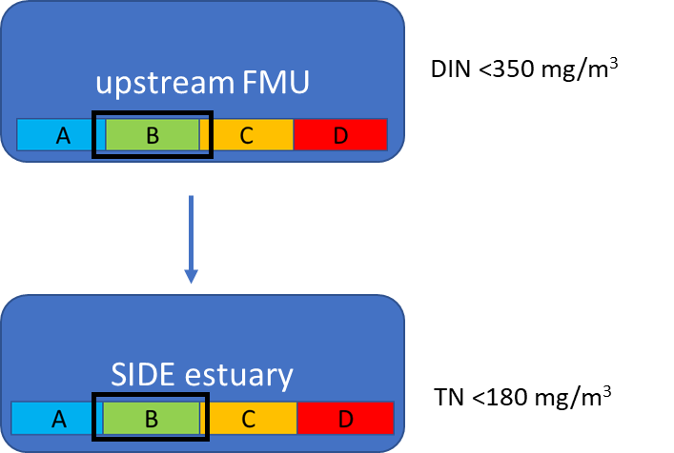

The nitrogen criterion to achieve the trophic-state objectives sought for riverine FMU and estuary (ie, B-band) are <350 mg/m3 of DIN and <180 mg/m3 of *potential* TN, respectively.

| Estuarine worked example 1: Simple example |
| --- |
| Figure 12 shows a simple example consisting of a single FMU instream nitrogen criterion[15] of 350 mg/m3 of DIN[16] discharging to a SIDE-type estuary (refer to Figure 6).  The process to work through is illustrated in figure 11 (although shown for a lake), with the main steps outlined below:   * Convert FMU instream criterion value (usually DIN) into the same nitrogen units as the estuary (usually TN) – this is value [X] in figure 8 and NFMU in Equation 1.   Working: Instream criterion (maximum value) for upstream FMU is 350 mg/m3 of DIN. Assuming a DIN/TN conversion factor of 0.7 (calculated from measured data), the NFMU term (ie, [X]) is calculated as:  NFMU (or [X]) = 350/0.7 = 500 mg/m3 TN   * Convert the NFMU (or [X]) value into the corresponding estimated estuarine concentration using Equation 1 – this provides the potential TNestimated value (Eq. 1), which is also referred to as the [Y] value in figure 11.   Working: The nitrogen concentration in oceanic water (NOcean) is 18 mg/m3 (Plew et al., 2017).  *Scenario 1: dilution factor (D) = 2*  Potential TNest (or [Y]) = (500 + 18*(2-1))/2 = 259 mg/m3 TN  *Scenario 2: dilution factor (D) = 6*  **Potential TNest (or [Y]) = (500 + 18*(6-1))/6 = 98 mg/m3 TN**   * Compare the Potential TNestimated term (referred to as [Y] in figure 11) with the estuarine criteria set for the trophic state objective sought (ie, subcaluse 3(b) of Clause 3.13).   Working: In the example (figure 12), the estuary is a SIDE system which is a macroalgal-dominated system. The trophic state objective for the estuary is a B-band which corresponds to an indicative potential TN concentration band of 55 to 180 mg/m3. The maximum value of the estuarine criterion value (ie, [Z] term in figure 11 is 180 mg/m3, which is compared with the potential TNestimated value (or [Y]) to determine which of the two following outcomes apply:  1. If Potential TNest (ie, [Y]) < 180 mg/m3 (ie, [Z]) then the FMU instream criterion of 350 mg/m3 DIN is likely to be protective of estuarine outcomes sought; or  2. If Potential TNest (ie, [Y]) ≥ 180 mg/m3 (ie, [Z]) then the FMU instream criterion of 350 mg/m3 DIN is not likely to be protective of the trophic-state objective.  The screening level assessment indicated that the FMU instream criterion value of 350 mg/m3 of DIN is protective for an estuarine mixing factor of 6, but not at the lower mixing factor of 2 (table 10).  Table : Results of FMU to estuary scenario shown in Figure 12   |  |  |  |  |  |  |  |  | | --- | --- | --- | --- | --- | --- | --- | --- | | Scenario | *D* | DINFMU | TNFMU or [X] | *TN*estimated [Y] | Estuary criteria [Z] | [Y]≥[Z] | Accept FMU criteriona | | Scenario 1 | 2 | 350 | 500 | 259 | <180 | yes | **no** | | Scenario 2 | 6 | 350 | 500 | 98 | <180 | no | **yes** |   a based on results of the screening-level assessment, and assuming that the estuarine trophic-state objectives cannot be relaxed. |

The importance of the dilution factor (*D*) in determining *potential* TNestimated (ie, [Y]) and hence the outcome of the screening level assessment (ie, whether FMU criteria are protective or not) is shown in Figure 13. For dilution factors (*D*) >3, the *potential* TNestimated (ie, [Y]) is <180 mg/m3 of TN, and therefore the FMU instream criteria of 350 mg/m3 of DIN would probably be protective of the trophic state objective sought for the estuary. Conversely, for dilution factors ≤3 (less dilution of FMU water in the estuary), the *potential TNestimated* (ie, [Y]) in the estuary is >180 mg/m3, and therefore suggests that the upstream FMU criteria would need to be revised (ie, reduced) to provide for the trophic state objectives of the estuary.

Figure : *Potential* TNestimated concentrations (ie, [Y]) in the estuary (shown in Figure 12) as a function of dilution factor (*D*) using a FMU instream criterion value of 500 mg/m3 of TN (ie, [Z])

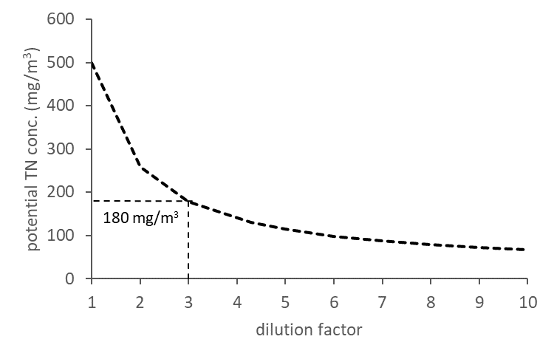

The vertical dash line indicates the dilution factor threshold (c. 3) – that is, for scenarios where *D*>3, the FMU instream criteria is protective of estuary (ie, [Y]<[Z]); and where *D*≤3, the FMU instream nutrient criteria are not (ie, [Y]>[Z]), and may need to be revised.

| Estuarine worked example 2: Effect of estuary trophic banding (ie, A-C) on FMU instream nitrogen criteria |
| --- |
| Using the same FMU to SIDE example shown in Figure 12, it is useful to work through several scenarios to see the outcome of testing different combinations of trophic objectives (ie, A-C) for the FMU and estuary, for a relatively small (2) and large (6) dilution factor.  Threshold concentrations for the estuary are taken from Table 8, while the values for the riverine FMU are hypothetical but cover a plausible range of concentrations for the periphyton attribute band thresholds. It is important to emphasise that **these are not default criteria** – FMU instream criteria need to be developed using the guidance outlined in step (a) of Clause 3.13 (refer to section 3.1).  Table : Nutrient criteria (upper limit of trophic-state band used) for meeting different trophic-state objectives for a FMU to SIDE system represented in Figure 12   |  |  |  |  | | --- | --- | --- | --- | | **Receiving environment** | **Band A (upper limit)b mg/m3** | **Band B (upper limit)b mg/m3** | **Band AC (upper limit)b mg/m3** | | FMUa (TN) | 100 | 500 | 1,150 | | Estuary | 55 | 180 | 350 |   a note these FMU values are entirely hypothetical values to cover a plausible range for the worked example (shown in Figure 12); these are not based on any guideline values and must not be used for setting FMU criteria. Under Clause 3.13, these FMU instream criteria need to be developed under step (a) of Clause 3.13.  b where a band of nutrient criteria (instream FMU or estuary) exist, it is unlikely that a management objective would be based on the upper or lower bound of the range, as this would potentially be overly permissive and stringent, respectively, for achieving the trophic state objectives sought. For simplicity, the worked example uses the upper bound of the concentration range, but this is not the recommended approach taken (ie, management objective set at upper bound). |
| For the two *dilution factor* scenarios (2-fold and 6-fold), estimated *potential* TNest. (ie, [Y]) concentrations were calculated for the three instream criteria defining the upper limits of the A, B and C trophic-state bands (100, 500 and 1150 mg/m3 of TN, respectively) (table 12). In addition, the rearranged Eq. 2 was used to back-calculate the estimated maximum instream criteria for the FMU (ie, [X]) for the values that define the upper limits of the A, B and C estuarine trophic-state bands (ie, 55, 180 and 350 mg/m3 of TN).  Eq. 2  Table : Predicted estuarine TN concentrations (*potential*TNest) using FMU instream criteria for two dilution factors (*D*=2 and 6), and back-calculated FMU criteria that correspond to the upper limits of the A, B and C estuarine band  trophic states   |  |  |  |  |  |  |  | | --- | --- | --- | --- | --- | --- | --- | | Dilution factor (D) | FMU Band A100 mg/m3 TN a (upper limit) b | | FMU Band B 500 mg/m3 TN a (upper limit) b | | FMU Band C 1150 mg/m3 TN a (upper limit) b | | |  | *Potential* TN estuary (mg/m3) | FMU criteria back calc from estuary TN of 55 mg/m3 | *Potential* TN estuary (mg/m3) | FMU criteria back calc from estuary TN of 180 mg/m3 | *Potential* TN estuary (mg/m3) | FMU criteria back calc from estuary TN of 350 mg/m3 | | 2 | 60 | 90 | 260 | 340 | 585 | 680 | | 6 | 35 | 200 | 115 | 825 | 245 | 1,675 | |
| a theoretical TN criteria shown, which would be converted from DIN-based instream criteria for the FMU. TN criteria are readily calculated by dividing by the measured DIN/TN ratio.  b refer to footnote b in table 12. |

The outcome of the analysis is more easily visualised in the two matrices shown in figure 14, with the *potential* TNest values for the estuary (ie, [X] converted to [Y]). The trophic-state objective for the estuary is green if the FMU instream nitrogen criterion value is protective of the downstream receiving environment (ie, [Y]<[Z]). If it is red then the FMU criteria in the upstream FMU is possibly too high (ie, [Y]≥[Z]), and should be revised. Where [Y]>[Z], options include revising the trophic-state objective sought for the estuary (ie, reduce from B- to C-band),[17] or back-calculate the FMU instream N criterion value required to meet the trophic-state objective sought.

The left table (*D*=2, figure 14a) shows that a FMU instream criterion based on the upper limit of A-band (100 mg/m3 TN) trophic-state objectives (eg, for periphyton) is predicted to result in B- and C-band trophic-states in the estuary. The B-band FMU instream nitrogen criterion, 500 mg/m3 TN (upper limit) only affords C-band estuarine trophic states. The upper-limit of C‑band FMU nitrogen criterion (1150 mg/m3 TN) is predicted to afford a D-band trophic state for the estuary.

If an A-band trophic-state objective is sought for the estuary, this would require FMU instream nitrogen criteria to be decreased[18] to a maximum TN value of 90 mg/m3 (table 12). If the trophic-state sought for the estuary corresponded to Band B, then the upper limit of instream N criterion for the FMU would need to be reduced from 500 mg/m3 down to 340 mg/m3 (approximately 30% reduction).[19] The FMU trophic-state objective band would be unchanged from this reduction (still B band).

With a higher dilution factor (*D*=6) (figure 14b) the FMU trophic-states correspond well to estuary trophic-states (ie, A- to A-band, B- to B-band and C to C-band). For this dilution factor (ie, higher dilution of riverine water by oceanic), the screening-level results suggest that it would be possible to attain a B-band trophic state in the estuary from FMU instream criteria based on a C-band trophic state. This would require the FMU instream criterion of 1150 mg/m3 to be decreased to at least 825 mg/m3 (refer to table 12). This would not change the trophic state of the FMU (ie, remains a C-band) but would drop the estuary below the B/C band trophic threshold value of 180 mg/m3.

Figure : Matrix tables showing the outcome of different FMU instream criteria (ie, upper TN limits shown in bold for each band) with respect to different trophic-state objectives for an estuary (in this case macroalgal trophic-state A-, B- and C-bands) in the estuary – both ‘low’ (*D*=2, figure 2a) and ‘high’ (*D*=6), figure 2b) dilution factors scenario shown

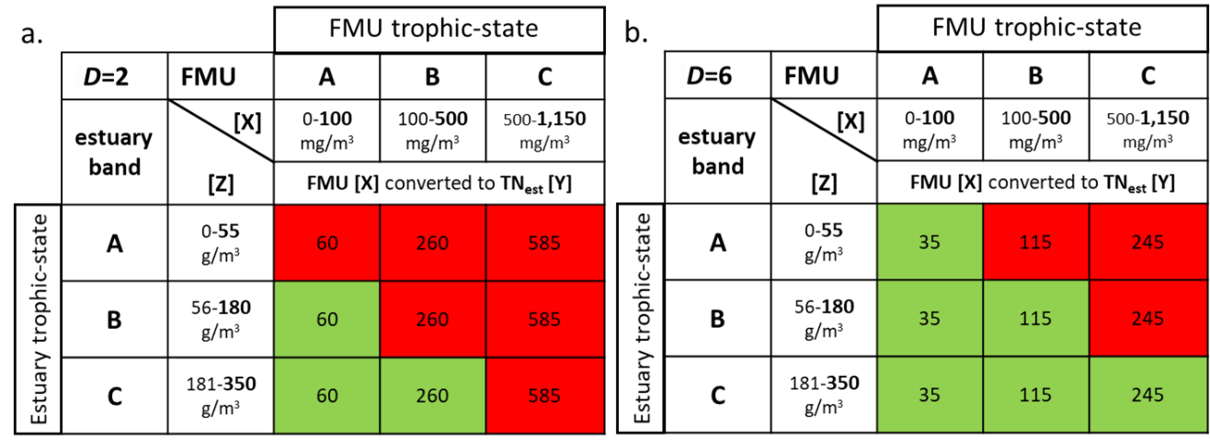

Red shading indicates the specified FMU criterion (upper limit in bold) is likely to not be protective of the estuarine trophic-state ‘band’ (ie, [Y] ≥ [Z]), and green shading indicates the FMU instream criterion value (upper limit in bold) is likely to be protective of the trophic-state objective for the estuary (i.e [Y]<[Z]).

This process provides a relatively simple way for regional councils to undertake screening-level assessments to determine whether nitrogen criteria in upstream FMUs is likely to provide for the trophic-state objectives sought for estuarine receiving environments. An analogous process can be readily applied to any estuary whether the trophic susceptibility is based on macroalgae or phytoplankton.

#### Lake receiving environments

##### Converting FMU instream criteria to required receiving environment concentrations

The same conceptual process outlined in Figure 11, and worked through with estuary example is also applied to lakes. The main difference is that the conversion of FMU instream nutrient criteria to estimate in-lake concentrations (ie, converting [X] to [Y] values – to allow comparison with in-lake criteria [Z]) is done using simple Vollenweider models, or, where data or resources are available, via more complex lake ecosystem models (eg, Spigel et al., 2001; Burger et al., 2008; Hamilton et al., 2011; Trolle et al. 2014).

Considerations for lake receiving environments include:

* both nitrogen and phosphorus need to be considered for lake receiving environments
* lakes do not have a dilution factor as most of the water in ‘qualifying’ lakes (with respect to Clause 3.13) is from surface water flows from the contributing sub-catchments of the FMU
* lakes receive nutrient inflows from streams and/or rivers within the FMU that are upstream of the lake and, therefore, unlike estuaries, many lakes do not receive nutrients from the entire FMU. Accordingly, the FMU nutrient criteria will be a flow-weighted average of contributing sub-catchments within the FMU. However, lakes at the bottom of the FMU (ie, coastal lakes) will be similar to estuaries and the FMU nutrient criteria value will be flow-weighted values representing the entire FMU. In some cases, large lakes may receive inflows from more than one FMU.

As discussed for estuaries, the purpose of this guidance is to provide a simple screening-level assessment method for reconciling instream nutrient criteria in upstream FMUs with in-lake nutrient criteria set for a given trophic-state objective. It is envisaged that where issues are indicated (either from the screening level assessment or local knowledge) that more comprehensive assessments would be undertaken for improved robustness. A useful resource for undertaking more detailed assessments for lake receiving environment is the chapter “Nutrient budgets in lakes” (Verburg et al., 2018) in the Lake Restoration Handbook.

#### Vollenweider empirical lake models

Vollenweider (1976) found that annual average TP concentrations (mg/m3) in lakes could be estimated from lake flushing rates and inflow concentrations (Eq. 3a). OECD (1982) presented modifications of the earlier Vollenweider model to predict annual average lake nutrient concentrations for TN and TP (Eq. 4a and Eq. 5a, respectively):

TPin-lake= [TPinflow / (1 + √*T* )]Eq. 3a

TNin-lake= 5.34[TNinflow / (1 + √*T* )]0.78 Eq. 4a

TPin-lake= 1.55[TPinflow / (1 + √*T* )]0.82Eq. 5a

Where TNin-lake and TPin-lake are the predicted annual average concentrations of TN and TP (mg/m3) respectively. TN­inflow and TPinflow are the respective annual average inflow concentrations of N and P (mg/m3), and *T* is the hydraulic retention time (years) of the lake. It is important to note Eq. 3a and Eq. 4a do not account for lakes with significant internal nutrient loading issues, and therefore if applied to such lakes, they are likely to underestimate lake TN and TP concentrations.

To convert relevant FMU riverine nutrient criteria into estimated in-lake concentrations (ie, converting [X] to [Y]; Figure 11), TNinflow and TPinflow terms in Eq. 3a, 4a and 5a can be replaced with TNFMU and TPFMU to give Eq. 3b, 4b and 5b, respectively. Eq. 3a-5a are for estimating current-state *in-lake* concentrations of TN and TP. As discussed for estuaries, implementing step (c) of Clause 3.13 does not require consideration of current state – only the conversion of FMU criteria to in-lake concentrations (ie, [X] to [Y]) to compare with in-lake criteria to meet a trophic-state objective (ie, [Z]).

TPin-lake= [TPFMU / (1 + √*T* )]Eq. 3b

TNin-lake= 5.34[TNFMU / (1 + √*T* )]0.78 Eq. 4b

TPin-lake= 1.55[TPFMU / (1 + √*T* )]0.82Eq. 5b

The hydraulic residence time (*T*, in years) is calculated by dividing the lake volume (m3) by the annual discharge volume of the outlet (m3/y). Ideally *T* would be calculated from measured data, but estimates of hydraulic retention time (and other lake parameters) are available from the FENZ geodatabase (Leathwick et al., 2010) and have been used for predicting lake concentrations using inflow concentrations derived from CLUES outputs (Kelly et al., 2013).

A benefit of the simple Vollenweider equations (Eq. 3a, 3b) for estimating in-lake TP concentrations is that as the hydraulic residence time (*T*)approaches zero, the predicted in‑lake concentration approaches TPFMU (or TPinflow). The coefficients and exponential terms in the OECD (1982) equations (Eq. 4 and 5) mean that as *T* approaches zero:

* the estimated TNin-lake concentration approaches 5.34*(TNFMU)0.78
* the estimated TPin-lake concentration approaches 1.55*(TNFMU)0.78.

Accordingly, for TNFMU and TPFMU values of 500 and 20 mg/m3, respectively, for a theoretical hydraulic residence time (*T*) of 0 years, the estimated in-lake TNin-lake and TPin-lake would be 680 and 18 mg/m3, respectively. This is not consistent with the expectation that as *T* approaches zero, in-lake concentrations should approach inflow concentrations. Therefore, at low values of *T*, the OECD (1982) Vollenweider equations will tend to overestimate TNin-lakeconcentrations and underestimate TPin-lake concentrations. This and other limitations of Vollenweider-type equations are discussed below.

#### Limitations of Vollenweider empirical lake models

The coefficients in Vollenweider equations Eq.3 and Eq.4 were derived from fitting curves to both TN and TP from a large international lake dataset (OECD, 1982). The basic Vollenweider equation with no coefficients was only applicable to estimating in-lake concentrations of TP. Eq. 3 provides a simple method for estimating in-lake concentrations (hence reconciling FMU instream criteria with in-lake trophic criteria); however, application of the results for predictive purposes requires care. Several limiting conditions were identified under which applicability and transferability (in the Canadian context at least) of OECD results could be questionable and should be done with care (Janus and Vollenweider, 1981).

These include situations where:

* flushing rate is more than twice per year (*T* < 0.5 yr), and/or where lakes have irregular flushing regimes either seasonally or over consecutive years
* high mineral turbidity or a high degree of humic staining exists
* N/P ratios are ≤5 and/or P exceeds 100 mg/m3
* phosphorus is relatively inert (eg, as apatite) or internal loading is substantial
* dynamic equilibrium has not been attained as in the case of increasing or decreasing nutrient loads.

#### Possible alternative approaches for lakes with short residence times (ie, < c. 1 year)

The simple Vollenweider equation (Eq. 3) is based on the general equation that the in-lake concentration is equal to the inflow concentration multiplied by the fraction not retained in the lake sediment, or, in the case of nitrogen, removed by denitrification (1-R) – Eq. 6 (Vollenweider, 1976, Verburg et al., 2018).

Nutrientinlake = (1 - R) * Nutrientinflow Eq. 6

The equation for retention (R) of phosphorus (Vollenweider, 1976), when substituted into Eq. 6, yields Eq. 3, however, nitrogen retention (the sum of sequestration in the sediment and removal by denitrification) in lakes is different to retention of phosphorus (Verburg et al., 2018). In deep and fully oxic lakes, nitrogen retention is usually less efficient than phosphorus retention (Wetzel 2001). The average nitrogen retention found in lakes is 34% (Saunders and Kalff, 2001).

Nitrogen retention can be estimated via Eq. 7 (Harrison et al., 2009), which requires retention time (*Tw,* which is the same as *T*), average lake depth (*z*) and the nitrogen settling velocity (a). Harrison *et al.* (2009) reported a mean nitrogen settling velocity (a) of 6.8.

Eq. 7

Substituting Eq. 6 into Eq. 7 may provide regional councils with another screening-level method for converting TNFMUcriteria (ie, [X]) into TNin-lake concentrations (ie, [Y] values), when the application of equations 4a or 4b are not recommended (eg, when *T* <c. 1 year).

For lakes with a small number of inflows, it is relatively straightforward to measure the retention of nutrients in lakes (Verburg et al., 2018).

#### Look-up graphs for the conversion of TNinflow and TPinflow to corresponding in‑lake nutrient concentrations (TNin-lake and TPin-lake)

Figure 15 is a ‘look-up’ graph based on the Vollenweider (Eq. 3) relationship between TPinflow (0–100 mg/m3) and TPin-lake for lake retention times ranging from 0 to 10 years. The 90th percentile value for median TP concentrations in New Zealand rivers was 80 mg/m3 (n=748, Larned *et al.* 2015). Figure 16 is a look-up graph based on the Vollenweider (Eq. 5) relationship between TPinflow (0-100 mg/m3) and TPin-lake for lake retention times ranging from 0 to 10 years.

Figure 17 is a ‘look-up’ graph based on the Vollenweider (Eq. 4) relationship between TNinflow (0–2000 mg/m3) and TNin-lake for lake retention times ranging from 0 to 10 years. The 90th percentile value for median TN concentrations in New Zealand rivers was 1850 mg/m3 (n=748, Larned et al., 2015).

A cautious (or preferably alternative) approach should be taken when attempting to use the Vollenweider equations (Eq. 3 and Eq. 4) for lakes with either short retention times, or those that have some of the problematic characteristics identified by Janus and Vollenweider (1981).

Figure : Look-up chart of estimated TPin-lake concentrations using Eq. 3 (Vollenweider, 1976) for TPFMU values of 0-100 mg/m3 and lake residence times (*T*) of 0-10 years. Solid black line = 1:1 line (TPFMU = TPinlake)

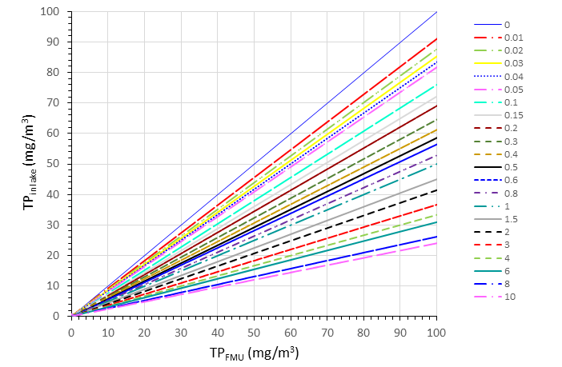

Figure 16: Look-up chart of estimated TPin-lake concentrations using Eq. 5 (OECD, 1982) for TPFMU values of 0-100 mg/m3 and lake residence times (*T*) of 0-10 years. Solid black line = 1:1 line (TPFMU = TPinlake)

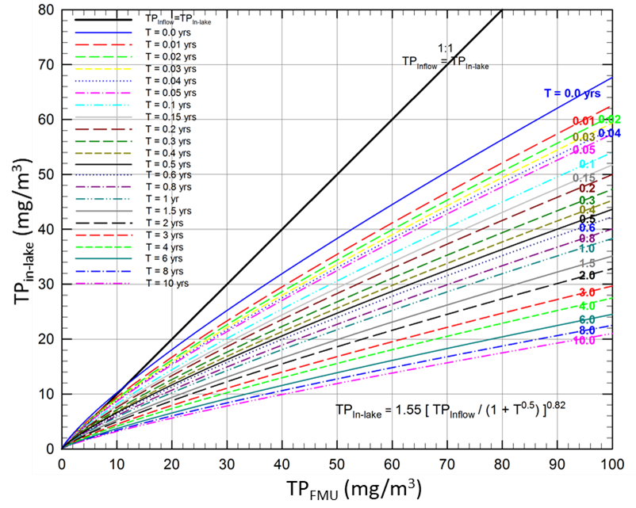

Figure 17: Look-up chart for estimated TNin-lake concentrations using Eq. 4 (OECD, 1982) for TNFMU values of 0-2000 mg/m3 and lake residence times (*T*) of 0-10 years. Solid black line = 1:1 line (TNFMU = TNin-lake)

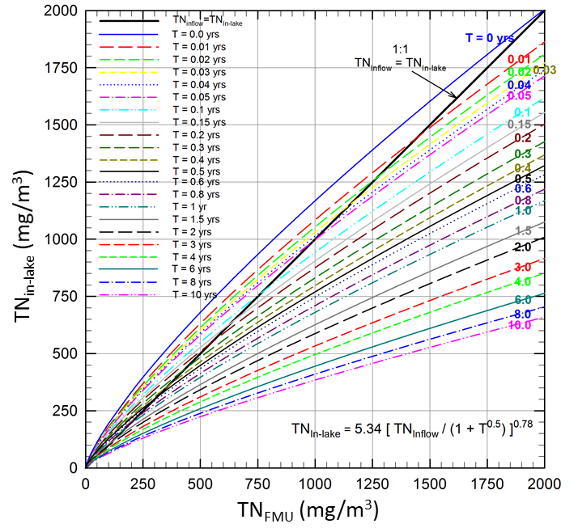

Note the predictions of TNin-lake > TNFMU for *T* <0.6 y (consistent with Janus and Vollenweider, 1981).

#### Examples of national/regional-scale empirical lake models

Kelly *et al.* (2013) also refined the Vollenweider models for TN and TP by optimising the two constants (multiplier and exponent terms) for 18 South Island lakes using a non-linear regression model. In contrast, the terms in Eq. 4a/4b and Eq. 5a/5b (TN and TP, respectively) are derived from a large international lakes dataset. Interestingly, the authors reported the best regression between measured and predicted lake concentrations via non-Vollenweider models. For example, they predicted TP using a polynomial model with an *r2* value of 0.86 (Eq. 9). These types of regional models may be useful for undertaking conversions of TNFMU and TPFMU criteria (ie, [X] values) into estimated in-lake concentrations, TNin-lake and Pin-lake (ie, [Y] values), required for step (c).

TP = exp(0.26 * TPinflow) – (0.0055 * TPinflow)2 + (0.000035 * TPinflow)3 –(1.2 * *T*) Eq. 9

| lake worked example |
| --- |
| Figure 18 shows an example of a FMU (or part of a FMU) discharging nutrients to a polymictic lake. The **hypothetical** FMU instream criterion for nitrogen is 350 mg/m3 of DIN, which is the same value used in the estuary worked examples (refer to table 8). The trophic-state objective set for the lake is A-band, where the NPS-FM attribute specifies an upper limit of 300 and 10 mg/m3 of TN and TP, respectively (refer to Table 8). For this example, residence time (*T*) scenarios of 1 and 5 years are used. The equations used for estimating TNin-lake and TPin-lake concentration values (ie, [Y] values) are Eq. 4b and Eq. 3b, respectively.  Figure : A simple, hypothetical scenario of FMU that discharges to a polymictic lake    Lake criteria are based on the A/B band thresholds in the NPS-FM attribute. Criteria for the FMU are entirely hypothetical values, and are not based on any guideline values. The FMU nutrient criteria are in the form of DIN and DRP, with respective conversion factors of 0.7 and 0.5 for converting to TN and TP.  The process to work through is shown in Figure 11, with the main steps outlined below.   * Convert FMU instream criteria (DIN and DRP) into total nutrient concentrations (TN and TP) to give TNFMU and TPFMU (ie, [X] values shown in figure 11).   *Working:* Instream criteria (maximum values) for upstream FMU are 350 mg/m3 and 10 mg/m3 for DIN and DRP, respectively. Using DIN/TN and DRP/TP conversion factors[20] of 0.7 and 0.5, TN and TP FMU criteria values are calculated as follows:  TPFMU = 10/0.5 = 20 mg/m3 TP  TNFMU = 350/0.7 = 500 mg/m3 TN   * Convert the TPFMU (ie, [X]) concentration into the corresponding estimated in-lake TP concentration using Equation 3b – this provides the estimate TPin-lake concentration (also referred to as [Y] in figure 11).   *Working:* using Eq. 3b (Vollenweider, 1976)  TPin-lake= [TPFMU / (1 + √*T*)]Eq. 3b  Scenario 1: lake residence time (*T*) = 1  TPin-lake = [20 / (1 + √1)] = 10 mg/m3  Scenario 2: lake residence time (*T*) = 5  TPin-lake = [20 / (1 + √5)] = 6.2 mg/m3  Estimated in-lake TP concentrations as a function of lake residence time are shown in Figure 19a. The outputs from both the basic (Eq. 3b) and OECD (Eq.5b) versions of Vollenweider equation are given.   * Convert the TNFMU (ie, [X]) concentration into the corresponding estimated in-lake TN concentration using Equation 4b – this provides the estimated TNin-lake concentration (also referred to as [Y] in figure 11).   *Working:* using Eq. 4b (OECD 1982)  TNin-lake= 5.34[TNFMU / (1 + √*T* )]0.78 Eq. 4b  Scenario 1: lake residence time (*T*) = 1  TNin-lake = 5.34*[500 / (1 + √1)]0.78 = 396 mg/m3  Scenario 2: lake residence time (*T*) = 5  TNin-lake = 5.34*[500 / (1 + √5)]0.78 = 272 mg/m3  Estimated in-lake TN concentrations as a function of lake residence time are shown in Figure 19b.  Figure : Estimated concentrations of TPin-lake (a) and TNin-lake (b) using Eq. 3b and 5b for TP and Eq. 4b for TN using TPFMU and TNFMU values of 20 and 500 mg/m3, respectively    Eq. 4b and 5b are from OECD (1982) and Eq. 3b is from Vollenweider (1976). Dashed sections of the curves are where *T* ≤0.5 y where Vollenweider equations should be used with caution (Janus and Vollenweider, 1981). |
| * Convert the estimated in-lake nutrient concentrations (ie, [Y] values for both TN and TP) with the lake TN and TP criteria set to meet the trophic state objective sought (ie, [Z] value).   *Working:* The lake is a polymictic lake, and the trophic objective sought is A-band (phytoplankton biomass), which corresponds to upper limit TN and TP in-lake criteria values of 300 mg/m3 and 10 mg/m3, respectively (NPS-FM attribute table; refer to Table 8). For TN and TP, there are two possible outcomes:  1. If the estimated in-lake concentrations are less than the in-lake criteria (ie, [Y] < [Z]), the FMU instream criteria are likely **to be** protective of the lake trophic-state sought; or  2. If the estimated in-lake concentrations are greater than (or equal to) the in-lake criteria (ie, [Y] ≥ [Z]), the FMU instream criteria are likely **to not be** protective of the lake trophic-state objectives sought. |

The results of the screening-level analysis are summarised in Table 13. For the shorter lake residence time of 1 year (scenario 1), neither the TP or TN FMU criteria afforded an A-band lake trophic state, although for TP, the estimated in-lake concentration was equal to the in‑lake criteria (ie, [Y] = [Z]). To meet the nitrogen in-lake criterion (ie, 300 mg/m3 TN), the FMU nitrogen criteria would need to be decreased from 350 mg/m3 of DIN down to around 245 mg/m3 of DIN (corresponding to TN decrease from 500 down to 350 mg/m3).

For the 5-year residence time (scenario 2), both FMU criteria for nitrogen and phosphorus were likely to be protective of the A-band trophic state sought for the lake.

The use of Vollenweider equations provides a simple screening-level approach for regional councils to implement step (c).[21] As shown for estuarine receiving environments, matrices showing the outcome of all possible FMU and lake trophic-state bands can also be applied to lakes (refer to figure 14). It is emphasised that this is a screening-level assessment only for reconciling FMU instream criteria with indicative in-lake criteria. Where issues are identified, it is recommended that this will trigger more comprehensive assessments to improve the robustness of the conclusions.

Table : Results of FMU to lake scenario shown in Figure 18 (all concentrations are mg/m3)

| Scenario | Lake retention time (T), years | FMU instream criteria  (DRP & DIN) | [X]  FMU criteria as TP & TN | [Y] estimated in-lake conc. | [Z] in-lake nutrient criteriaa | [Y]≥[Z] | Accept FMU criterionb |
| --- | --- | --- | --- | --- | --- | --- | --- |
| **phosphorus** | | | | | | | |
| 1 | 1 | 10 | 20 | 10 | 10 | yes | **no** |
| 2 | 5 | 10 | 20 | 6.2 | 10 | no | **yes** |
| **nitrogen** | | | | | | | |
| 1 | 1 | 350 | 500 | 396 | 300 | yes | **no** |
| 2 | 5 | 350 | 500 | 272 | 300 | no | **yes** |

a based on NPS-FM TN and TP lake attribute numeric values the define the A/B band threshold; b based on results of the screening-level assessment, and assuming that the estuarine trophic-state objectives cannot be relaxed.

# References

Ausseil, O., Clark, M. (2007) *Recommended Water Quality Standards for the Manawatu-Whanganui Region: Technical Report to Support Policy Development*. Horizons Regional Council, 194p.

Biggs, B.J.F. (1996) Patterns in benthic algae of streams. In: Algal Ecology: *Freshwater Benthic Ecosystems* (Eds. R.J. Stevenson, M.L. Bothwell and R.L. Lowe): 31-56. Academic Press, San Diego.

Biggs, B.J.F. (2000) *New Zealand Periphyton Guideline: Detecting, Monitoring and Managing Enrichment of Streams.* Ministry for the Environment: 122. <http://www.mfe.govt.nz/sites/default/files/nz-periphyton-guide-jun00.pdf>

Biggs, B.J.F., Price, G.M. (1987) A survey of filamentous algal proliferations in New Zealand rivers. *New Zealand Journal of Marine and Freshwater Research*, 21: 175-191.

Biggs, B.J.F., Kilroy, C. (2000) *Stream Periphyton Monitoring Manual*. Ministry for the Environment: 126. <https://www.niwa.co.nz/sites/niwa.co.nz/files/import/attachments/peri_complete.pdf>

Booker, D., Snelder, T. (2012) Development of nutrient criteria for managing macrophytes in lowland and spring-fed Canterbury streams. *NIWA report for Environment Canterbury*.

Burger, D.F., Hamilton D.P., Pilditch, C.A. (2008) Modelling the relative importance of internal and external nutrient loads on water column nutrient concentrations and phytoplankton biomass in a shallow polymictic lake *Ecological Modelling,* 211: 411-423.

Carr, G.M., Bod, S.A.E., Duthie, H.C., Taylor, W.D. (2003) Macrophyte biomass and water quality in Ontario rivers. *Journal of the North American Benthological Society,* 22: 182-193.

Chapman, V.J., Cameron, H. (1967) *Compsopogon* in New Zealand. *New Zealand Journal of Botany,* 5: 548-552.

Chapra, S.C., Flynn, K.F., Rutherford, J.C. (2014). Parsimonious model for assessing nutrient impacts on periphyton-dominated streams. *Journal of Environment Engineering* 140: <https://doi.org/10.1061/(ASCE)EE.1943-7870.0000834>

Clapcott, J.E., Young, R.G., Harding, J.S., Matthaei, C.D., Quinn, J.M., Death, R.G. (2011) *Sediment Assessment Methods: Protocols and guidelines for assessing the effects of deposited fine sediment on in-stream values*. Cawthron Institute*,* Nelson, New Zealand.

Clarkson, B., Peters, M. (2010) Wetland Types. In: *Wetland restoration: a handbook for New Zealand freshwater systems.* Peters, M., Clarkson, B. (eds). Lincoln, N.Z. Manaaki Whenua Press.

Collier, K.J., Champion, P.D., Croker, G.F. (1999) Patch and reach scale dynamics of a macrophyte invertebrate system in a New Zealand lowland stream. *Hydrobiologia*, 392: 89-97.

Davies-Colley, R.J., Meleason, M.A., Hall, R.M.J., Rutherford, J.C. (2009) Modelling the time course of shade, temperature, and wood recovery in streams with riparian forest restoration. *New Zealand Journal of Marine and Freshwater Research,* 43: 673–688.

Dawson, F.H., Kern-Hansen, U. (1979) The effect of natural and artificial shade on the macrophytes of lowland streams and the use of shade as a management technique. *Internationale Revue Gesamten Hydrobiologie*, 64: 437-455.

Ellenberg, H. (1988) *Vegetation ecology of Central Europe*, 4 edition. Cambridge University Press.

Elliott, E., Wadhwa, S., Whitehead, A., Snelder, T, Muirhead, R., Monaghan, R., Bright, J. (2016) *Modelling national land-use capacity. Exploring bottom lines and headroom under the NPS-FM 2014. Update Report*. NIWA Report for the Ministry for the Environment: 102. <http://www.mfe.govt.nz/sites/default/files/media/Fresh%20water/Landuse%20Capacity%20report%202016%20Final%2014%20October%202016.pdf>

Eppley, R.W., Rogers, J.N., McCarthy, J.J. (1969). Half-saturation constants for uptake of nitrate and ammonia by marine phytoplankton. *Limnology and Oceanography*, 14: 912-920.

Ferreira, J.G., W.J. Wolff, T.C. Simas, Bricker, S.B. (2005) Does biodiversity of estuarine phytoplankton depend on hydrology? *Ecological Modelling*, 187: 513-523.

Greenhalgh, S., Murphy, L. (2017) Freshwater contaminant limit assessment of the regions*. Technical Paper, Motu Economic and Public Policy Research*, May 2017: 57.

Hamilton, D.P., Özkundakci, D., McBride, C.G., Ye, W., Luo, L., Silvester, W., White, P. (2011) *Predicting the effects of nutrient loads, management regimes and climate change on water quality of Lake Rotorua. University of Waikato ERI Report 005*, Prepared for Bay of Plenty Regional Council.

Harding, J.S., Clapcott, J.E., Quinn, J.M., Hayes, J.W., Joy, M.K., Greig, H.S., James, T., Beech, M., Ozane, R., Hay, J., Meredith, A., Boothroyd, I.K.G. (2009) *Stream habitat assessment protocols for wadeable rivers and streams of New Zealand*. University of Canterbury Press: 133.

Harrison J.A, Maranger R.J, Alexander R.B, Giblin A.E, Jacinthe P.A, Mayorga E, Seitzinger S.P, Sobota D.J, Wollheim W.M (2009). The regional and global significance of nitrogen removal in lakes and reservoirs. *Biogeochemistry,* 93: 143–157.

Haslam, S.M. (1978) River plants: the macrophytic vegetation of watercourses. Cambridge University Press: 396.

Howarth, R.W., Marino, R. (2006) Nitrogen as the limiting nutrient for eutrophication in coastal marine ecosystems: evolving views over three decades. *Limnology and Oceanography*, 51: 364-376.

Horizons Regional Council (2014) One Plan. The Consolidated Regional Policy Statement, Regional Plan and Regional Coastal Plan for the Manawatu-Wanganui Region.

Hoyle, J.T., Kilroy, C., Hicks, D.M., Brown, L. (2017) The influence of sediment mobility and channel geomorphology on periphyton abundance. *Freshwater Biology*, 62: 258-273.

Kelly, D., Shearer, K., Schallenberg, M. (2013) *Nutrient loading to shallow coastal lakes in Southland for sustaining ecological values*. Cawthron Report prepared for Environment Southland: 41.

Kilroy, C., Biggs, B., Blair, N., Lambert, P., Jarvie, B., Dey, K., Robinson, K., Smale, D. (2006) *Ecological studies on Didymosphenia geminata*. NIWA Report for Biosecurity New Zealand: 66.

Kilroy, C., Leathwick, J., Dey, K., Blair, N., Roulston, H., Sykes, J., Sutherland, D. (2007) *Predicting the suitability of New Zealand rivers and lakes for colonisation and growth of the invasive, non-indigenous diatom, Didymosphenia geminata: an update*. NIWA Report for MAF Biosecurity New Zealand: 88.

Kilroy, C., Biggs, B.J.F., Death, R. (2008) *A periphyton monitoring plan for the Manawatu-Wanganui region*. NIWA Report for Horizons Regional Council: 43.

Kilroy, C., Booker, D., Drummond, L., Wech, J., Snelder, T. (2013) Estimating periphyton standing crop in streams: a comparison of chlorophyll *a* sampling and visual assessments. *New Zealand Journal of Marine and Freshwater Research,* 47: 208-224.

Kilroy, C., Wech, J., Kelly, D., Clarke, G. (2017) *Analysis of a three-year dataset of periphyton biomass and cover in Canterbury Rivers*. NIWA Report (Draft) for Environment Canterbury: 112.

Kilroy, C., Greenwood, M., Wech, J. A., Stephens, T., Brown, L., Matthews, M., Patterson, M. (2018) *Periphyton - environment relationships in the Horizons region.* NIWA Report for Dairy NZ/Horizons Regional Council: 204. <https://www.horizons.govt.nz/publications-feedback/publications/water-quality-and-quantity>

Janus L.L., Vollenweider, R.A. (1981). *Summary Report, The OECD Cooperative Programme on Eutrophication, Canadian Contribution*. Environment Canada, National Water Research Institute, Canada Centre for Inland Waters, Burlington, Ontario: 394.

Johnson, P., Gerbeaux, P. (2004) *Wetland types in New Zealand*. Wellington, Department of Conservation, Te Papa Atawhai.

Lacoul, P., Freedman, B. (2006) *Environmental Influences on Aquatic Plants in Freshwater Ecosystems*. National Research Council, Canada: 38.

Larned, S., Hamilton, D., Zeldis, J., Howard–Williams, C. (2011) *Nutrient–limitation in New Zealand rivers, lakes and estuaries*. Discussion paper prepared for the Land and Water Forum*,* Wellington, New Zealand: 19.

Larned, S., Snelder, T., Unwin, M., McBride, G., Verburg, P., McMillan, H. (2015) *Analysis of Water Quality in New Zealand Lakes and Rivers: Data sources, datasets, assumptions, limitations, methods and results*. NIWA Report for Ministry for the Environment: 17.

Leathwick J.R., Snelder T., Chadderton W.L., Elith J., Julian K., Ferrier S. (2011) Use of generalised dissimilarity modelling to improve the biological discrimination of river and stream classifications. *Freshwater Biology*, 56: 21-38.

Matheson, F., Hickey, C., Costley, K., Smith, J., Taumoepeau, A., Nagels, J., Croker, G., Safi, K. (2009) *Morrinsville wastewater treatment plant outfall effects on the Piako river*. NIWA Report for Matamata Piako District Council: 44.

Matheson, F., Quinn, J., Hickey, C. (2012) *Review of the New Zealand instream plant and nutrient guidelines and development of an extended decision making framework: Phases 1 and 2 final report*. NIWA Report for the Ministry of Science and Innovation Envirolink Fund: 127. <http://www.envirolink.govt.nz/assets/Uploads/Review-of-the-NZ-instream-plant-and-nutrient-guidelines-and-development-of-an-extended-decision-making-framework.pdf>

Matheson, F., Quinn, J., Unwin, M. (2016) *Review of the New Zealand instream plant and nutrient guidelines and development of an extended decision-making framework: Phase 3 final report*. NIWA Report for the Ministry of Science and Innovation Envirolink Fund: 117. <http://www.envirolink.govt.nz/assets/Uploads/R9-3-Instream-plant-and-nutrient-guidelines-Phase-3-report3.pdf>

Matheson, F., Quinn, J., Haidekker, S., Madarasz-Smith, A., Wilding, T., Clapcott, J., Harding, J., Wilcock, B., Young, R., Baker, M., Clode, G., Heath, N., Hicks, A., Rutherford, K. (2017) *Ecosystem health in disturbed lowland catchments: Karamū catchment, Hawkes Bay.* NIWA Report for the Ministry of Science and Innovation Envirolink Fund: 49. <http://www.envirolink.govt.nz/assets/Uploads/1733-HBRC223-Ecosystem-health-in-highly-modified-lowland-catchments-Karamu-catchment-Hawkes-Bay.pdf>

Matheson, F., Wells, R. (2017) *Periphyton and macrophytes in seven Hauraki-Coromandel rivers: initial assessment of seasonal abundance, provisional attribute state and management options*. NIWA Report for Waikato Regional Council: 70.

McAllister, T.G., Wood, S.A., Hawes, I. (2016) The rise of toxic benthic *Phormidium* proliferations: A review of their taxonomy, distribution, toxin content and factors regulating prevalence and increased severity. *Harmful algae,* 55: 282-294.

McDonald, J.H. (2014) *Handbook of Biological Statistics (3rd ed.)*. Sparky House Publishing, Baltimore, Maryland.

McKergow, L.M., Matheson, F.E., Quinn, J.M. (2016) Riparian management: A restoration tool for New Zealand streams. *Ecological Management and Restoration*, 17: 218-227.

Ministry for the Environment (MfE) (1992) *Water Quality Guidelines No. 1. Guidelines for the Control of Undesirable Biological Growths in Water*: 60.

Ministry for the Environment (MfE) (2016a) *A Draft Guide to Communicating and Managing Uncertainty When Implementing the National Policy Statement for Freshwater Management 2014*: Wellington: Ministry for the Environment. <http://www.mfe.govt.nz/sites/default/files/media/Fresh%20water/fresh-water-guidance-on-uncertainty.pdf>

Ministry for the Environment (MfE) (2016b) *A Guide to Identifying Freshwater Management Units Under the national Policy Statement for Freshwater Management 2014*. Wellington: Ministry for the Environment. <http://www.mfe.govt.nz/sites/default/files/media/Fresh%20water/guide-to-freshwater-management-units_0.pdf>

Ministry for the Environment (2017) *A Guide to the National Policy Statement for Freshwater Management 2014 (as amended 2017)*.Wellington: Ministry for the Environment. <http://www.mfe.govt.nz/sites/default/files/media/Fresh%20water/nps-fm-guide-2017-final.pdf>

Ministry for the Environment (2018) *A Draft Guide to Attributes in Appendix 2 of the National Policy Statement for Freshwater Management (as amended 2017)*. Wellington: Ministry for the Environment <http://www.mfe.govt.nz/sites/default/files/media/Fresh%20water/a-draft-guide-to-attributes.pdf>

Ministry for the Environment (MfE) and Ministry of Health (MoH). (2009) *New Zealand Guidelines for Cyanobacteria in Recreational Fresh Waters – Interim Guidelines*. Prepared for the Ministry for the Environment and the Ministry of Health by Wood, S.A., Hamilton, D.P., Paul, W.J., Safi, K.A., Williamson, W.M. Wellington: Ministry for the Environment: 82. <https://www.mfe.govt.nz/sites/default/files/nz-guidelines-cyanobacteria-recreational-fresh-waters.pdf>

Ministry for the Environment. 2020. Action for healthy waterways: Guidance on look-up tables for setting nutrient targets for periphyton. Wellington: Ministry for the Environment. <https://environment.govt.nz/assets/Publications/Files/action-for-healthy-waterways-guidance-on-look-up-tables-for-setting-nutrient-targets-for-periphyton.pdf>

O’Hare, M.T., Clarke, R.T., Bowes, M.J., Cailes, C., Henville, P., Bissett, N., McGahey, C., Neal, M. (2010) Eutrophication impacts on a river macrophyte. *Aquatic Botany*, 92: 173-178.

OECD (1982) *Eutrophication of waters. Monitoring, assessment and control*. OECD, Paris.

Picard, R.R., Cook, R.D. (1984) Cross-validation of regression models. *Journal of the American Statistical Association,* 79: 575-583.

Plew, D., Zeldis, J., Whitehead, A., Storey, R., Burge, O., Madarasz-Smith, A., Oliver, M., Stevens, L., Robertson, B. (2017) *The New Zealand Estuary Trophic Index (ETI) Tools*. CERF2017 - Coastal and Estuarine Research Foundation 24th Biennial Conference. Providence, RI.

Plew, D., Dudley B. (2018) *Eutrophication susceptibility of Pounawea (Catlins) Estuary and Shag River Estuary*. NIWA Report for Otago Regional Council: 32.

Quinn, J.M., Cooper, A.B., Stroud, M.J., Burrell G.P. (1997) Shade effects on stream periphyton and invertebrates: an experiment in streamside channels*. New Zealand Journal of Marine and Freshwater Research,* 31: 665-683

Quinn, J., Rutherford, K., Wilcock, B., Depree, C., Young, R., Schiff, S. (2018) Nutrient-periphyton interactions along a temperate river and response to phosphorus input reduction. Proceedings of 4th International Conference on Water Resources and Wetlands, Tulcea, Romania, 5-9 September 2018.

Robertson, B., Stevens, L., Robertson, B., Zeldis, J., Green, M., Madarasz-Smith, A., Plew, D., Storey, R., Hume, T., Oliver, M. (2016a) *NZ Estuary Trophic Index Screening Tool 1. Determining eutrophication susceptibility using physical and nutrient load data*. Prepared for Envirolink Tools Project: Estuarine Trophic Index, MBIE/NIWA Contract No: C01X1420: 47. http://www.envirolink.govt.nz/envirolink-tools/marine-tools

Robertson, B.M, Stevens, L., Robertson, B., Zeldis, J., Green, M., Madarasz-Smith, A., Plew, D., Storey, R., Oliver, M. (2016b) *NZ Estuary Trophic Index Screening Tool 2. Determining Monitoring Indicators and Assessing Estuary Trophic State.* Prepared for Envirolink Tools Project: Estuarine Trophic Index, MBIE/NIWA Contract No: C01X1420. 68p. <http://www.envirolink.govt.nz/envirolink-tools/marine-tools/>

Rutherford, J.C. (2011). *Computer modelling of nutrient dynamics and periphyton biomass – Model development, calibration and testing in the Tukituki River, Hawkes Bay*. NIWA Report for Central Hawke’s Bay District Council.

Rutherford, J.C. (2012). *Modelling the effects of land use on nutrients entering the Tukituki River, Hawke’s Bay*. NIWA Report for Hawkes Bay Regional Council.

Rutherford, K. (2013a). *Effects of Land Use on Nutrients: Phase 2 Studies in the Tukituki River, Hawke’s Bay*. NIWA Report for Hawkes Bay Regional Investment Company.

Rutherford, K. (2013b). *Effects of Land Use on Streams - Phase 2 Modelling Studies in the Tukituki River, Hawke’s Bay*. NIWA Report for Hawkes Bay Regional Investment Company.

Saunders, D.L., Kalff, J. (2001) Nitrogen retention in wetlands, lakes and rivers. *Hydrobiologia*, 443:   
205-212.

Sorrel, B. (2010) Nutrients, Chapter 8. In: *Wetland Restoration: A handbook for New Zealand freshwater systems*. Peters, M., Clarkson, B. (eds.) Lincoln, N.Z., Manaaki Whenua Press: 273.

Soziak, A. (2002) Long-term response of periphyton and macrophytes to reduced municipal nutrient loading to the Bow River (Alberta, Canada). *Canadian Journal of Fisheries and Aquatic Sciences*,   
59: 987–1001.

Snelder, T.H, Biggs, B.J.F. (2002) Multiscale river environment classification for water resources management. *Journal of the American Water Resources Association*, 38: 1225-1239.

Snelder, T.H., Booker, D.J., Quinn, J.M., Kilroy, C. (2014) Predicting periphyton cover frequency distributions across New Zealand rivers. *Journal of the American Water Resources Association*,   
50: 111–127.

Spigel, R., Howard-Williams, C., James, M., Gibbs, M.M. (2001) A coupled hydrodynamic-ecosystem study of Lake Taupo: A preliminary model. NIWA Report for Environment Waikato, Ministry for the Environment, Genesis Power Ltd., Dairy Research Institute and Tuwharetoa Maori Trust Board.

Stark, J.D., Boothroyd, I.K.G, Harding, J.S., Maxted, J.R., Scarsbrook, M.R. (2001) *Protocols for sampling macroinvertebrates in wadeable streams*. New Zealand Macroinvertebrate Working Group Report No. 1. Prepared for the Ministry for the Environment. Sustainable Management Fund Project, No. 5103: 57. http://www.mfe.govt.nz/publications/fresh-water-environmental-reporting/protocols-sampling-macroinvertebrates-wadeable

Storey, R., Perrie, A., Wood, S., Hicks, M. (2017) *Effects of land and water management on ecological aspects of major rivers in the Ruamahanga River catchment*. NIWA Report for Greater Wellington Regional Council: 113.

Trolle, D., Spigel, B., Hamilton, D.P., Norton, N., Sutherland, D., Plew, D., Allen, M.G. (2014) Application of a three-dimensional water quality model as a decision support tool for the management of land-use changes in the catchemnt of an oligotrophic lake. *Environmental Management*, 54: 479-493.

United States Environmental Protection Agency (US EPA) (2008) *Nutrient Criteria Technical Guidance Manual: Wetlands*. Office of Water, EPA-822-B-08-001: 156. https://nepis.epa.gov/Exe/ZyPDF.cgi/P1002DY6.PDF?Dockey=P1002DY6.PDF

Verburg, P., Elliott, S., Schallenberg, M., McBride, C. (2018). Nutrient budgets in lakes. In: *Lake Restoration Handbook*, Hamilton, D., Collier, K., Howard-Williams, C., Quinn, J. (eds), Springer.

Vollenweider R.A (1976). Advances on defining critical loading levels for phosphorus in lake eutrophication. *Memorie dell’Istituio Italiano di Idrobiologia* 33:53–83.

Waikato River Collaborative Stakeholder Group (2016) *Protecting and restoring our water: Te whakapaipai me te tiaki i ō tātou wai*. Overview of Collaborative Stakeholder Group’s Recommendations for Waikato Regional Plan Change No. 1. Waikato and Waipa River Catchments. March 2016: 78.

Welch, E.B., Quinn, J.M., Hickey, C.W. (1992) Periphyton biomass related to point-source nutrient enrichment in seven New Zealand streams. *Water Research*, 26: 669-675.

Westlake, D.F. (1981) Temporal changes in aquatic macrophytes and their environment. In: Hoestlandt, H. (Ed.), *Dynamique de Populations et Quality de l'Eau, Actes Symp*. Inst. Ecol. Bassin Somme, Chantilly, 1979: 111-138.

Wetzel, R.G. (2001) Limnology, Lake and river ecosystems. Academic Press, 3rd edition.

WFD-UKTAG (2014). UKTAG Transitional and Coastal Water Assessment Method – Macroalgae. *Opportunistic Macroalgal Blooming Tool*. Water Framework Directive – United Kingdom Technical Advisory Group. Stirling, Scotland: 24.

Wood, S.A., Hawes, I., McBride, G., Truman, P., Dietrich, D. (2015) *Advice to inform the development of a benthic cyanobacteria attribute*. Cawthron Report for Ministry for the Environment: 91. http://www.mfe.govt.nz/publications/fresh-water/advice-inform-development-benthic-cyanobacteria-attribute

1. Noting that instream nutrient concentrations are usually expressed in terms of tons per year, while the DRP attribute in the NPS-FM 2020 is measured in milligrams per litre (mg/L), and must be derived from a median of of monthly monitoring over 5 years.
2. It is important that the measure of central tendency used (median, mean or geometric mean) is consistent with that used in the predictive model of periphyton biomass adopted.
3. Note that shading which reduces periphyton biomass will reduce instream nutrient uptake during the period of active growth. The effect that this has on instream nutrient concentrations likely depends on how the level of uptake compares to the flux of nutrients through the waterway at this time – it may or may not be significant (see McKergow et al. 2016 for further discussion).
4. Models were also developed to predict the mean and mean annual maximum periphyton filamentous and mat cover and periphyton cover frequency distributions across New Zealand rivers (Snelder et al., 2014).
5. An effective flow event is the magnitude of flow event sufficient to scour periphyton from the bed.
6. <https://environment.govt.nz/publications/action-for-healthy-waterways-decisions-on-national-direction-and-regulations-for-freshwater-management/>
7. Note that if sprawling macrophytes shade the river bed then this factor needs to be accounted for in measurement or estimation of shade at the water surface.
8. Alternative in-lake concentrations would only be for reconciling FMU instream nutrient criteria against criteria that better relate to the lake trophic-state objective/s sought for particular lakes. NPS-FM lake trophic state for State of Environment reporting would still need to be assessed using the thresholds specified in the lake nutrient attribute tables.
9. Catchment Land-use for Environmental Sustainability.
10. Limited to SSRTREs with longer flushing times.
11. ‘A’-band being the highest and ‘D’-band being the lowest.
12. OMBT define EQR of 0.2-0.4 as ‘poor’ and EQR of <0.2 as ‘bad’.
13. Or more specifically, the flow-weighted average instream nutrient criterion from contributing upstream FMU/s.
14. It is assumed that ‘totals’ are analysed on unfiltered samples and therefore include dissolved inorganic, dissolved organic and particulate nutrients. If analysed on filtered water samples, the ‘total’ would represent the ‘total dissolved nutrient fraction’ (ie, TDN and TDP).
15. This FMU nitrogen criterion of 350 mg/m3 DIN could represent a flow weighted average (for a single or multiple FMUs), or it could be the nitrogen instream criterion set for the mainstem river at the catchment/FMU node (ie, close to where the FMU discharges to the estuary).)
16. FMU nitrogen criteria are likely to be enumerated as dissolved inorganic nitrogen (DIN) or nitrate-N concentrations. In this example, a DIN/TN conversion factor of 0.7 has been applied.
17. Accepting a lower trophic-state objective (ie, lower environmental outcome) for the estuary would only be applicable if the current trophic state was a C band and the B-band objective was aspirational. If the current trophic state of the estuary was a B band then it would not be acceptable to select a lower environmental outcome for the receiving environment as this would result in degradation of current state.
18. Although a single FMU criterion is shown, this will more than likely represent a flow weighted average of different instream nutrient criteria set within single, and in many cases, multiple, contributing upstream FMUs. The way that the regional council approaches reductions to meet receiving environment trophic-state objectives (ie, where [Y]≥[Z]) is outside the scope of Clause 3.13.
19. This guidance section only relates to reconciling nutrient criteria to meet outcomes, it does not include any consideration of current state of the FMU or receiving environment. So, a 30% reduction here refers only to the instream criteria set for the FMU. Whether this reduction translates into catchment nutrient reductions, or not, is dependent on the current state of the FMU and receiving environments.
20. It is recommended that conversion factors be calculated from relevant monitoring data.
21. As long as the lake meets the necessary criteria for application of the Vollenweider equations (Janus and Vollenweider, 1981).