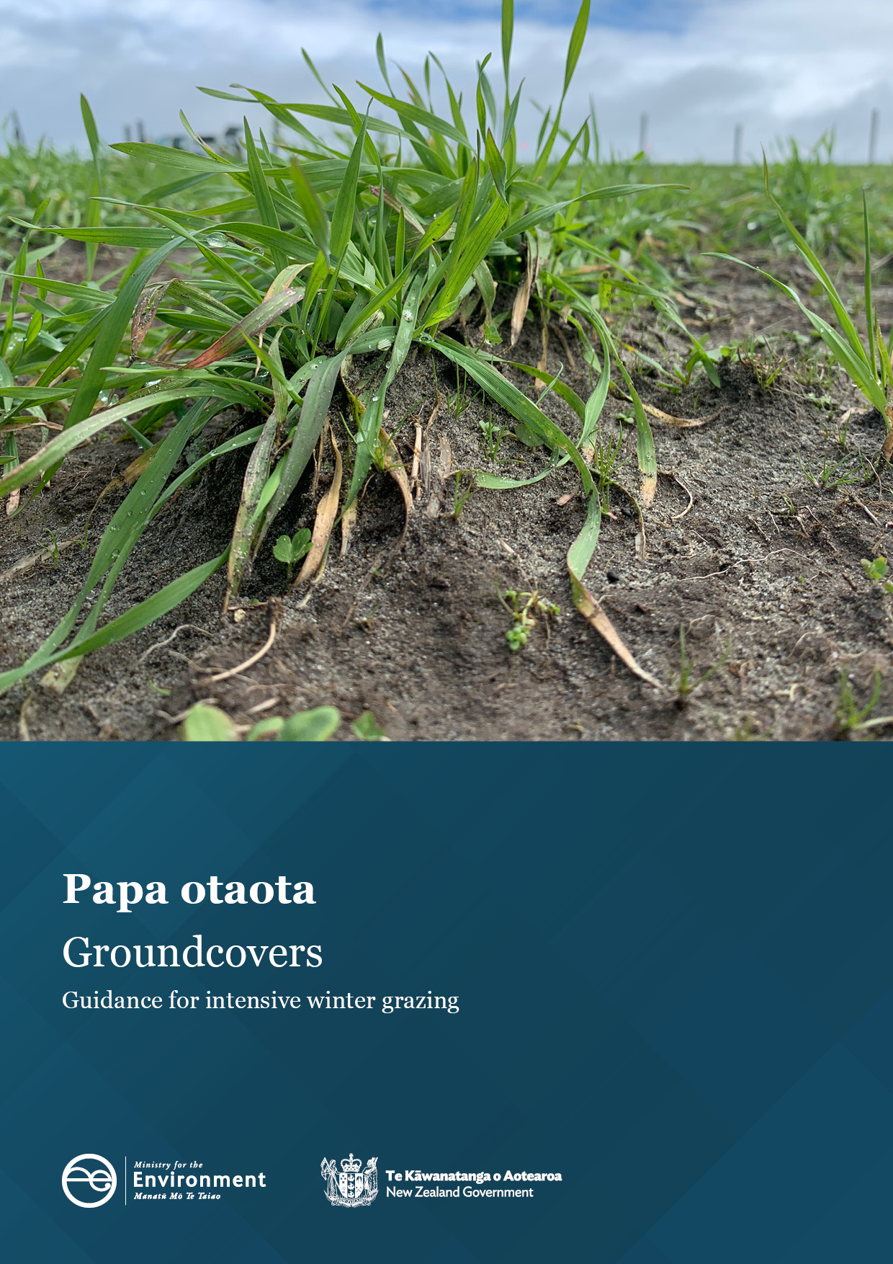

Disclaimer
The information in this publication is, according to the Ministry for the Environment’s best efforts, accurate at the time of publication. The Ministry will make every reasonable effort to keep it current and accurate. However, users of this publication are advised that:
- the information does not alter the laws of New Zealand, other official guidelines, or requirements
- it does not constitute legal advice, and users should take specific advice from qualified professionals before taking any action based on information in this publication
- the Ministry does not accept any responsibility or liability whatsoever whether in contract, tort, equity, or otherwise for any action taken as a result of reading, or reliance placed on this publication because of having read any part, or all, of the information in this publication or for any error, or inadequacy, deficiency, flaw in, or omission from the information in this publication
- all references to websites, organisations or people not within the Ministry are for convenience only and should not be taken as endorsement of those websites or information contained in those websites nor of organisations or people referred to.
Acknowledgements
Prepared for the Ministry for the Environment by B Malcolm, W Hu, M Beare and S Maley, The New Zealand Institute for Plant & Food Research Limited, Lincoln, October 2022. (PFR, SPTS No 23066). The authors are grateful for the important contributions and/or revisions to this report by DairyNZ, Beef + Lamb New Zealand, the Foundation for Arable Research, farmers, AgResearch, Manaaki Whenua – Landcare Research, Lincoln University and Plant & Food Research colleagues.
The Ministry for the Environment would also like to thank the regional council and Ministry for Primary Industries staff who provided feedback during the development of this guidance.

This document may be cited as: Ministry for the Environment. 2023. Groundcovers: Guidance for intensive winter grazing. Wellington: Ministry for the Environment.

Published in March 2023 by the
Ministry for the Environment
Manatū mō te Taiao
PO Box 10362, Wellington 6143, New Zealand
environment.govt.nz
ISBN: 978-1-991077-32-5
Publication number: ME 1745
© Crown copyright New Zealand 2023

Contents
Executive summary 5
1. Groundcover regulations for intensive winter grazing 7
2. Groundcover and why it is important 9
3. Impacts on the environment 10
3.1 Compounding adverse environmental effects 10
3.2 Health risks when contaminants enter waterways 11
3.3 Surface run-off losses 11
3.4 Nitrate leaching losses 12
3.5 Nitrous oxide emissions 12
3.6 Mitigating environmental impacts with an established groundcover 13
4. Implementing the policy 15
4.1 Sowing as soon as practicable 15
4.2 Maximising the benefits of groundcovers during the main risk period 17
4.2.1 Establishment methods for winter forage crops 17
4.2.2 Maintaining groundcover during intensive winter grazing 19
4.2.3 Timing of grazing of winter forage crops 20
4.2.4 Managing livestock to maintain suitable ground conditions for resowing 20
4.2.5 Ground preparation for resowing 21
4.2.6 Catch crops 26
5. Knowledge gaps and limitations 32
References 33

Tables
Table 1: Key soil, weather and operational factors that may contribute to decisions on whether resowing is practicable after grazing in intensive winter grazing systems 16
Table 2: Summary of good management practice options for maintaining or establishing groundcover in intensive winter grazing systems 18
Table 3: Examples of various ground conditions after winter forage crop grazing and potential appropriate actions to either sow or prepare for sowing 24

Figures
Figure 1: Compaction from livestock treading can increase run-off by decreasing infiltration rate 12
Figure 2: Example of plants trapping lateral-moving sediment 13
Figure 3. Example of an establishing (left) and an established (right) winter-sown catch crop after grazing of an annual forage crop in winter 14
Figure 4: Cultivate/graze test to identify if soil is too wet to cultivate 23
Figure 5: Catch crops reduce the risk of leaching and run-off via plant uptake and trapping of water and nutrients (eg, nitrogen) 27

Executive summary
Intensive winter grazing (IWG) refers to grazing livestock on an annual forage crop at any time in the period from 1 May to 30 September. Since 1 November 2022, the National Environmental Standards for Freshwater (NES-F) regulations relating to IWG require vegetation to be established as groundcover over the whole land area used for IWG as soon as practicable after livestock have finished grazing (Regulation 26B, NES-F).
Grazing of annual forages during winter, when soils are usually wet, often results in the complete or near-complete removal of plants. Re-establishing groundcover (plants growing on the soil surface) as soon as practicable after winter grazing is completed can result in significant environmental benefits. These benefits include reduced soil, nutrient and contaminant run-off as well as lower risk of nitrate leaching and nitrous oxide emissions.
To achieve these benefits, a good practice approach is to resow ground left bare after forage crop grazing with an appropriate species (or species mixture) as soon as soil, weather and operational conditions allow. The main factors that can help determine whether sowing is practicable include: soil and weather conditions, paddock contour, availability of machinery and appropriate seed and/or crop rotation implications.
In most circumstances any form of groundcover after grazing is better than bare soil. However, there are several good management practices with the potential to make re-establishing groundcover more successful within the critical winter-spring window after grazing, thus improving environmental outcomes. These include:
- minimum or no-tillage practices to establish winter forage crops. Excess cultivation when establishing winter forage crops can result in more severe soil degradation (eg, pugging) during grazing. This, in turn, has the potential to delay when groundcover can be re-established. On sloping land, cultivating with the contour can help minimise the risk of surface run-off, both during forage crop development and after grazing
- adopting companion planting strategies with winter forages, using species that are capable of withstanding treading damage during grazing and recovering to form sufficient groundcover
- considering the timing of forage crop grazing, particularly for soils and/or forage crops that are most at risk of environmental damage. For instance, delaying grazing a paddock, particularly one that features a critical source area, for as long as possible in winter can reduce the risk of contaminant loss, and increases the effectiveness of subsequent groundcover (due to reduced drainage after grazing and environmental conditions becoming more favourable for establishing groundcover more quickly)
- considering the grazing strategy. Where and when possible, managing livestock to minimise pugging (refer to the Ministry’s Pugging: Guidance for intensive winter grazing document), such as using back-fencing with portable troughs (except with deer) or on-off grazing, can maintain more suitable conditions for resowing
- post-grazing tillage strategy. If resowing is required, adopt the minimum tillage required to enable good soil-to-seed contact and suitable conditions for germination and emergence. Avoiding over-cultivation can reduce the risk of more soil and environmental degradation. While direct drilling might be suitable in some situations, where soils are not too pugged or compacted, often cultivation will be required. Considering the soil moisture content is important, as depending on the method used, that is, cultivation implement, cultivating when conditions are too wet can cause further damage to the soil structure, increasing the likelihood of sediment loss. Conversely, cultivating when soils are particularly dry can require extra cultivation activity. Cultivating with the contour of the paddock will also help minimise subsequent surface run-off losses
- when sowing in winter, use winter-active species with high seed vigour. For cereals such as oats, these can be sown when soil temperatures are 4°C and rising. Ideally, aim for high plant populations and avoid applying nitrogen until soil temperatures are suitable (6°C and rising) and crop growth rates can utilise the nitrogen.
There will be limitations to the different practices for managing or re-establishing groundcovers after grazing across various regions, soils and farm systems. Therefore, decisions made on the most suitable practices used should be carefully considered, farm-specific and assessed on a case-by-case basis.

1. Groundcover regulations for intensive winter grazing
Key points
- Intensive winter grazing refers to grazing of livestock on an annual forage crop any time between 1 May and 30 September of the same year.
- Annual forage crops include crops that are grown specifically for grazing in the paddocks where they were grown. They exclude perennial pastures and crops grown for arable or horticultural land uses.
- Farmers/land owners must ensure vegetation is established as groundcover over the area of land used for IWG as soon as practicable after livestock have finished grazing.
- This document provides guidance in relation to the groundcover standard, Regulation 26B, of the Resource Management (National Environmental Standard for Freshwater) Regulations 2020 (NES-F)
The Essential Freshwater package included the Resource Management (National Environmental Standards for Freshwater) Regulations 2020 (the NES-F), which came into force in September 2020. The NES-F regulations aim to protect and improve the quality of our rivers, streams, lakes, wetlands and estuaries. They include specific requirements for the management of IWG activities to mitigate adverse impacts on fresh water.
Intensive winter grazing (IWG) refers to annual forage crops (eg, kale, fodder beet, swedes, turnips and forage rape) that are grown specifically to provide forage for grazing between 1 May and 30 September. For the purposes of the NES-F regulation specific to IWG (Regulation 26B), annual forage crops exclude perennial pastures or crops grown for arable use (eg, grain and seed) or horticultural use (eg, vegetables and fruit).
The definition of IWG includes farm activities that support IWG and that may occur all year, such as the preparation and sowing of land for grazing and the cultivation of annual forage crops (Ministry for the Environment, 2022).
The IWG regulations in the NES-F took effect from 1 November 2022. The regulations mean that:
- intensive winter grazing can continue without a consent if carried out in accordance with the permitted-activity standards in the regulations
- a regional rule or resource consent can be more stringent than any of the intensive winter grazing regulations. If this is the case, the more stringent regional rule or resource consent prevails over the regulations.
The regulations apply to the following activities and associated discharges:
- the use of land on a farm for IWG
- the discharge of a contaminant into or onto land, including in circumstances that may result in the contaminant (or any other contaminant emanating because of natural processes from the contaminant) entering water, if the discharge is associated with the use of land on a farm for IWG.
This document provides guidance in relation to the following regulation (Regulation 26B, NES-F):
Groundcover Standard
1) A person using land on a farm for intensive winter grazing in accordance with regulation 26 must ensure that vegetation is established as groundcover over the whole area of that land as soon as practicable after livestock have finished grazing the land.
2) A person using land under this regulation must provide any information reasonably required by a regional council enforcement officer for the purpose of monitoring compliance with this regulation.
More detailed information on the IWG regulations is available on the Ministry for the environment website:
- Intensive winter grazing factsheet
- Report and recommendations on IWG amendments.

2. Groundcover and why it is important
Key points
- Groundcover refers to vegetation established and growing on the soil.
- Establishing groundcover as soon as practicable after winter forage crop grazing is finished can markedly reduce the risk of contaminant run-off and nitrate leaching.
- Common types of groundcover for winter grazing can include short rotation catch crops (eg, forage oats, ryecorn and triticale), early-season main crops (eg, wheat and barley) and pasture (eg, annual or perennial ryegrass).
In simple terms, groundcover is defined as vegetation established and growing on the soil surface. In IWG systems, groundcover refers to re-establishment or re-growth of plant cover following the removal, by grazing, of forage crops grown for winter grazing. Intensive grazing of forage crops during winter, when soils are usually wet, often results in the complete or near complete removal of plants (groundcover) and damage (compaction or pugging) to the soil surface due to livestock treading. These conditions, coupled with the high input of livestock excreta (urine and dung) and periods when rainfall exceeds the soil water storage capacity, can greatly increase the risk of sediment and nutrient run-off and nitrate leaching. Re-establishing groundcover as soon as practicable after winter forage crop grazing is finished can markedly reduce these adverse effects on the environment.
Re-establishing groundcover after winter grazing of forage crops usually involves the sowing of a new crop or pasture. Cold-tolerant plants are most effective at early establishment and rapid growth after winter grazing. This is important to stabilise the soil surface, remove excess water and absorb excess mineral nitrogen — all key factors for reducing the risk of contaminant (eg, sediment, nutrients, Escherichia coli [E. coli]) run-off and nitrate leaching. Common forms of groundcover vegetation established after winter grazing are short rotation catch crops (eg, forage oats, ryecorn and triticale), early-season main crops (eg, wheat and barley) and pasture (eg, annual or perennial ryegrass). Where winter forage crops are grazed with lighter stock (eg, sheep), undersowing the forage crops with species capable of re-growing after grazing can also mitigate environmental impacts and may remove the need to resow.
Realising the environmental benefits of groundcover can require achieving relatively uniform plant cover across the entire paddock while avoiding large areas of bare ground, particularly where these are close to waterways or areas of surface water run-off (see Critical source areas: Guidance for intensive winter grazing document).

3. Impacts on the environment
Key points
- Winter grazing of forage crops can result in environmental degradation by damaging soil quality, and increasing surface run-off of contaminants, nitrogen leaching and nitrous oxide emissions.
- An established groundcover after winter forage crop grazing can significantly reduce environmental impacts.
Winter forage crops provide many well-established benefits in livestock farming systems (Edwards et al, 2014). However, the practice of intensively grazing forage crops during the winter can also have significant adverse effects on the environment. Often these effects can be reduced or avoided with appropriate management practices, including establishing groundcover early after grazing is completed.

3.1 Compounding adverse environmental effects
Intensive winter grazing usually involves the grazing of forage crops on relatively wet soils and at high stocking rates, that is, high stock numbers per unit area. These conditions typically result in the complete (or near-complete) removal of plant cover, damage (compaction or pugging) to the soil surface due to livestock treading and the deposition of large amounts of livestock excreta (urine and dung). Soil compaction and pugging tend to restrict the infiltration of water (rainfall) in to soil, increasing the risk that contaminants found in livestock excreta (eg, nitrogen, phosphorus, faecal microbes such as E. coli) and sediment will run off into waterways.
The risk of these impacts is increased by the lack of plant cover and by winter rainfall that often exceeds the soil’s water storage capacity. By changing the porosity of the soil, compaction also tends to lower the soil’s capacity to hold water and slows its rate of drying. This increases the risk of drainage and nitrate leaching, particularly where the concentration of nitrate in the soil is high due to the high input of livestock excreta. The risk of these losses is increased where soils are left fallow for extended periods of time after winter grazing with the associated deposition of urine and dung. This situation is exacerbated by the soil compaction caused by livestock treading. This is because rainfall normally exceeds evapotranspiration in winter and early spring, resulting in greater losses of contaminants (nitrate, nitrous oxide, phosphorus, E. coli and sediment) due to increased soil drainage and surface run-off, particularly where plant groundcover is lacking.

3.2 Health risks when contaminants enter waterways
The loss of nitrogen, phosphorus and sediment into surface waterways, that is, streams, rivers and lakes, can lead to eutrophication, which degrades the freshwater habitat for fish and other aquatic biota. The leaching of nitrate and E. coli below the root zone and into ground water can produce a health risk to people who rely on ground water for drinking. Exposure to high nitrate levels in drinking water can cause methemoglobinemia (blue baby syndrome) in bottle-fed infants younger than six months. The presence of E. coli in a water system suggests recent faecal contamination (eg, from livestock), which can represent a health risk to anyone who drinks it. E. coli is often used as an indicator of the possible presence of other harmful microbes, such as Cryptosporidium, Giardia and norovirus. Diseases acquired from contact with faecal-contaminated water can include gastrointestinal illness and infections of the skin, ear, eye, respiratory and nervous systems, and wounds. Where soil water content is high, soil compaction also tends to create anoxic conditions in the soil that greatly increase the risk of nitrous oxide emissions to the atmosphere, particularly where the input of nitrogen from urine is high. Nitrous oxide is a greenhouse gas that contributes to global warming and climate change.
Early establishment of plant (ground) cover following winter grazing can markedly reduce the risk of nitrate leaching and nitrous oxide emissions. It does this by taking up some of the mineral nitrogen released from livestock excreta (mostly urine) and by helping to lower the soil’s water content via transpiration, which reduces the risk of drainage and anoxic conditions. Groundcover can also help reduce the risk of contaminant run-off by encouraging greater infiltration of water and creating a physical barrier to the transport of water and sediment into waterways.

3.3 Surface run-off losses
Bare, fallow soil conditions, particularly those remaining for long periods after winter forage crop grazing, are susceptible to run-off losses of sediment, phosphorus and faecal microorganisms (eg, E. coli). Suspended sediment loads of up to 3700 kg/ha/year and phosphorus losses of 4 kg/ha/year have been reported (McDowell 2006; McDowell and Houlbrooke, 2009; Burkitt et al, 2017; Monaghan et al, 2017).
These losses are primarily attributed to periods of high rainfall (volume and intensity) on vulnerable soils that are often pugged (degraded) by livestock, restricting water infiltration. Cournane et al (2011), Hu et al (2021) and McDowell et al (2003, 2005) showed how reduced soil infiltration rates as a result of treading damage increased sediment, phosphorus and E. coli in surface run-off, particularly in winter (see figure 1). Monaghan et al (2017) showed that most (about 90 per cent) surface run-off occurred after grazing. Belliss et al (2019) reported that bare ground is the main driver of soil loss, exacerbated by high rainfall, steep and long slopes, and poorly drained soils.
While increasing slope generally increases the risk of surface run-off, significant sediment and phosphorus losses can also occur on relatively flat to gradual hillslopes, especially when soils are severely damaged from grazing and during large rainfall events (Basher et al, 2016).
Figure 1: Compaction from livestock treading can increase run-off by decreasing infiltration rate
Image by Wei Hu, Plant & Food Research.

3.4 Nitrate leaching losses
Livestock urine is usually the major source of nitrogen leached after the winter grazing of forage crops (Selbie et al, 2015). Nitrogen (mainly nitrate-nitrogen) leaching losses of up to 180 kg N/ha/year have been measured following winter forage crop grazing in New Zealand (Shepherd et al, 2012; Smith et al, 2012; Monaghan et al, 2013; Malcolm et al, 2016). These losses are typically greater than those from grazed pasture (Smith and Monaghan, 2020) because of the high-stocking densities over the winter, and the extended fallow periods where there is no plant uptake of urine nitrogen. The scale of losses is largely influenced by crop management, soil type and seasonal factors such as the timing and amount of rainfall (Teixeira et al, 2016; Trolove et al, 2019).

3.5 Nitrous oxide emissions
Nitrous oxide is a greenhouse gas that contributes to global warming. In outdoor grazing systems, livestock urine patches represent a significant source of nitrous oxide emissions (Selbie et al, 2015). Although the number of studies in New Zealand is very limited, current estimates suggest on average about 3.2 per cent of urine-nitrogen may be lost as nitrous oxide from grazed winter forage crop systems (Van der Weerden and Styles, 2012). However, evidence suggests this percentage may vary greatly depending on the soil type and extent of soil compaction following IWG.
Soil compaction (and pugging) due to livestock treading under wet conditions and high returns of nitrogen-rich livestock excreta (urine and dung) during winter grazing create conditions that greatly increase the risk of nitrous oxide emissions to the atmosphere (Beare et al, 2009). A synthesis of data from a wide range of national and international studies showed that compaction from livestock treading can increase nitrous oxide emissions by 51–814 per cent compared with those from non-compacted soils (Hu et al, 2021). Several previous studies have shown that using no-tillage practices to establish forage crops can help reduce the severity of soil compaction and pugging from winter grazing (Thomas et al, 2004; Hu et al, 2018; Hu et al, 2020). This can markedly reduce the risk of nitrous oxide emissions in the weeks immediately after grazing (Thomas et al, 2008; 2013). Less soil compaction and pugging can also improve the soil’s trafficability, ie, the quality of the terrain that permits passage and movement, which enables sowing and establishing subsequent crops or pasture earlier and also earlier removal of some of the soil mineral nitrogen that contributes to high nitrous oxide emissions.

3.6 Mitigating environmental impacts with an established groundcover
Established groundcover during the key risk period (namely winter and early spring) can utilise nutrients from the soil (eg, nitrate) and reduce groundwater degradation. In addition, groundcovers can reduce overland losses of sediment and associated contaminants by:
- protecting the soil surface from the impact of rain and trapping sediments
- reducing the velocity of water and sediment running across the soil surface (figure 2)
- increasing the stability of the soil structure through more root growth
- reducing soil moisture content, which increases the soil’s capacity to store extra water from rainfall, thus decreasing the risk of contaminant losses from both run-off and leaching (McLaren and Cameron, 1996; Kaspar and Singer, 2011; Yi et al, 2022).
Figure 2: Example of plants trapping lateral-moving sediment
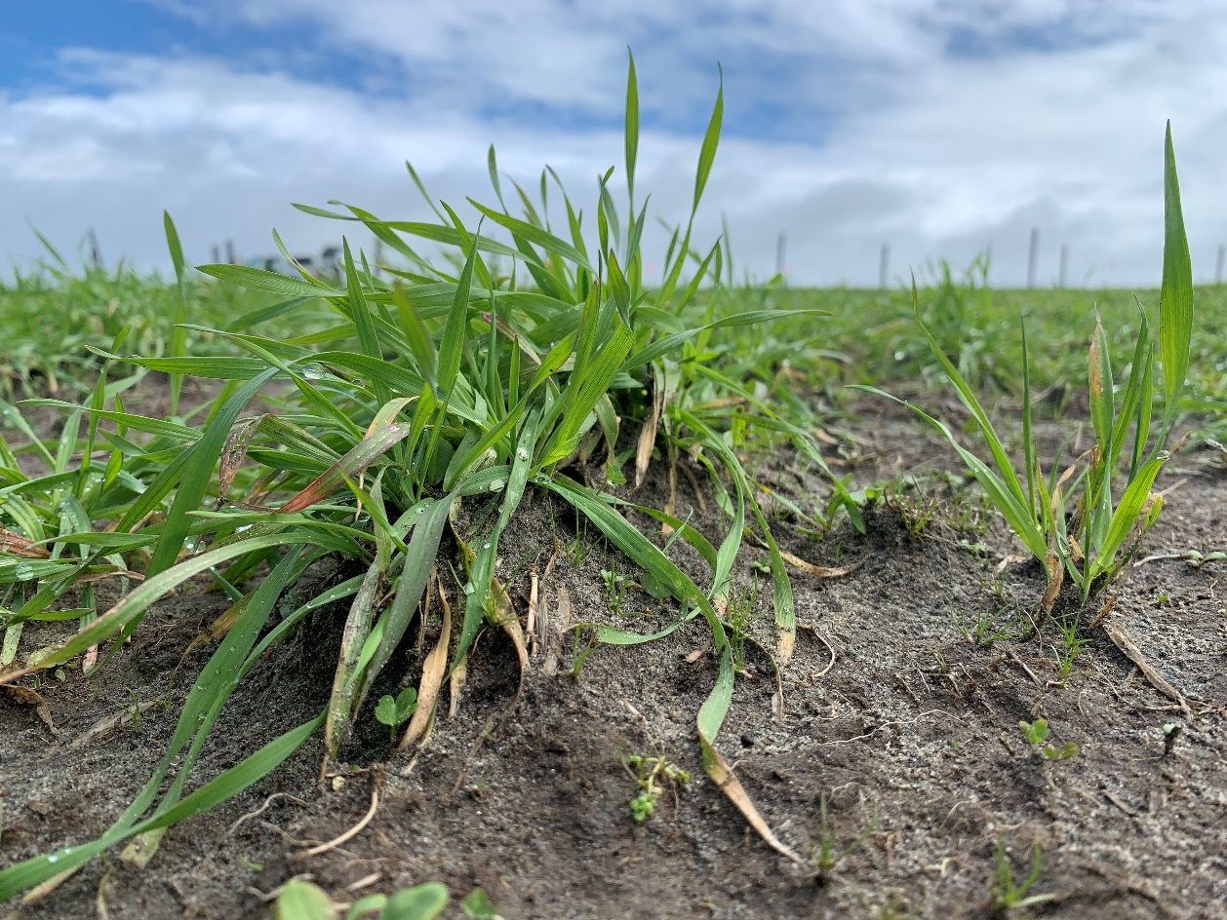
Photograph by Brendon Malcolm, Plant & Food Research.
Sowing a catch crop (a short-term crop established between two main crops or as part of a pasture renewal programme; see figure 3) in winter after forage crop grazing has been shown to significantly reduce the amount of nitrogen leached, and by up to 59 per cent in animal urine patches (Carey et al, 2016; Caradus et al, 2018; Malcolm et al, 2022). The efficacy of catch crops depends on the species used, the time at which winter grazing occurs in relation to winter rainfall and soil temperatures, and the length of the fallow period (Carey et al, 2017; Malcolm et al, 2022). In general, the sooner the catch crop is established after winter grazing, the greater the reduction in nitrate leaching (Teixeira et al, 2016).
Figure 3. Example of an establishing (left) and an established (right) winter-sown catch crop after grazing of an annual forage crop in winter
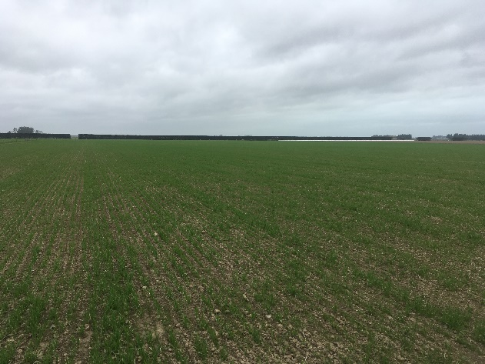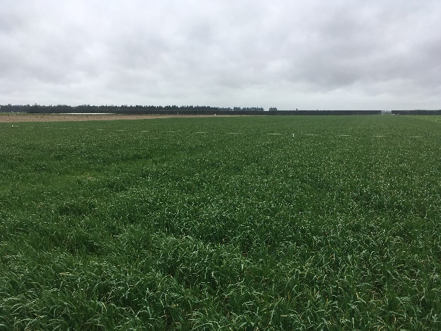
Photographs taken on a Canterbury farm by Brendon Malcolm, Plant & Food Research.

4. Implementing the policy
Key points
- In the absence of an established or recovering groundcover after grazing in IWG systems, ground should be resown with an appropriate species (or species mixture) as soon as soil, weather and operational conditions allow.
- The main factors that determine whether sowing is practicable include: soil and weather conditions, paddock contour, availability of machinery and appropriate seed, and/or crop rotation implications.

Ministry for the Environment guidelines for determining whether sowing is practicable
The groundcover standard requires that vegetation is established as groundcover as soon as practicable following winter grazing. This standard aims to minimise how long ground left bare after IWG is exposed to weather, as this increases the risk of sediment and/or contaminant loss.
Many factors can be considered in determining when sowing is practicable. In practice, this means an enforcement officer would be needed to determine what is practicable on a case-by-case basis.
This guidance provides some key factors and variables that could impact operational decisions when determining what is practicable in any given situation.
The considerations discussed in this document are intended as a guide only and do not limit any other factors which may be relevant to take into account when determining what is practicable on a case-by-case basis.

4.1 Sowing as soon as practicable
If sowing is necessary due to the absence of an already established or recovering groundcover, several variables could dictate when it is practicable to sow (table 1). Current literature and an understanding of the various weather and operational conditions indicate that sowing should occur either when grazing within any given IWG paddock (or part of a paddock of significant size) is completed, or when animals are permanently removed after grazing. Where no plant cover exists, good practice suggests a paddock should be sown with an appropriate species or species mixture that integrates into the whole farm system as soon as soil, weather and operational conditions allow (table 1).
Table 1: Key soil, weather and operational factors that may contribute to decisions on whether resowing is practicable after grazing in intensive winter grazing systems
Variable | Considerations
Soil conditions | Dry, capped, compacted, wet and/or pugged soils. Depending on the state of the soil surface, differing approaches to cultivating and/or sowing may be needed. Some ground conditions might be suitable for direct drilling immediately, while others might need a period of drying before sowing can start. For further guidance see section 4.2.5.  Soil temperature – some species (eg, cereals) can germinate and establish under particularly cool soil temperatures, while other species require higher soil temperature. For further guidance see section 4.2.6.
Weather conditions | Recent heavy rainfall, wet soil conditions and/or extreme weather events can significantly delay operational efforts to re-establish groundcover. Attempting to establish groundcover under such conditions can markedly increase the risk of soil compaction from wheel traffic and soil cultivation.
Region/climate | Regions with high winter rainfall may need different approaches to cultivation and choice of species. Colder and/or wetter regions will probably make it harder to establish covers during the winter or early spring period.
Soil type | Heavy-textured soils may need a longer period of fine weather for conditions to be suitable for cultivation and/or sowing. Also, more intensive cultivation may be needed to establish a suitable seed bed for sowing some crops or pasture, given heavy soils are more susceptible to greater compaction and pugging from livestock treading.
Stock class and winter forage species | Heavier livestock (eg, cattle compared with sheep) can cause more severe pugging, making it more challenging to sow soon after grazing. Also, some winter forage crops naturally produce higher yields, taking longer to graze, and resulting in higher-stocking densities and a greater degree of pugging.
Paddock contour and aspect | As a paddock becomes steeper it will become increasingly hard to establish vegetation as groundcover. This will require a differing set of soil and weather conditions for sowing to be achieved.  Maintaining vegetated buffer strips in critical source areas can help to reduce the run-off risk in sloping paddocks.  South-facing slopes are likely to dry out more slowly, potentially delaying when groundcovers can be established.
Availability of appropriate workers and machinery | A shortage of local contractors and/or the necessary equipment to re-establish groundcover may make its establishment impractical, even where the soil and environmental conditions are suitable. The length of a suitable weather window will also be of importance in this context.
Availability of appropriate seed/cultivars | Not all species are suitable for sowing in winter months, and depending on the season and the demand for seed, sourcing the appropriate seed could be a barrier to sowing when conditions allow. Buying seed early in the season can help to mitigate this risk.
Implications for the crop rotation | In dryland systems and/or in dry winters where soil moisture is not fully replenished, establishing vegetation too early can deplete valuable soil moisture needed to establish high-value crop or pasture in the following spring or early summer, and, in turn, compromise the overall performance of the crop rotation.  A short window between the end of forage crop grazing and the planned sowing date of the next main crop or pasture can mean that sowing an intermediary crop (eg, catch crop) is not viable.

Successfully implementing the practices outlined below (section 4.2) to achieve good groundcover outcomes requires careful planning and execution, followed by a review process to identify where improvements can be made in future. This process should feature as part of Freshwater Farm Plans.
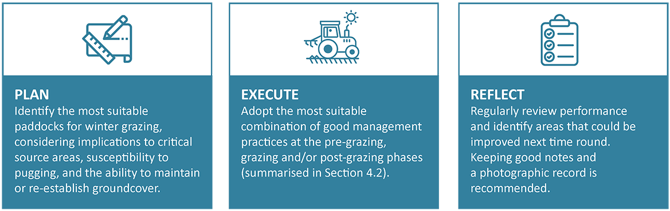

4.2 Maximising the benefits of groundcovers during the main risk period
Establishing an effective groundcover after grazing in IWG systems can be achieved using a range of different approaches, most of which are likely to be driven by individual circumstances. While in most cases any form of plants growing as groundcover is better than bare soil for reducing environmental impacts, there are several good management strategies that could be implemented at various times throughout the winter forage crop rotation to improve the effectiveness of groundcovers. These include practices from the time that winter forage crops are established, through to strategies adopted during and after grazing.
Table 2 below summarises several of these good management practices. It must be noted that the suitability of the different good management practice options would need to be assessed on a case-by-case basis for each individual farm system.

4.2.1 Establishment methods for winter forage crops
Key point
- Establishing winter forage crops using minimum or no tillage can help to mitigate soil structural degradation at grazing, increasing the probability of early groundcover establishment after winter grazing.
Soil structural degradation associated with pugging and compaction from IWG can restrict water infiltration and the drying of surface soils, keeping them excessively wet, which can delay the establishment of groundcover. Some case studies in New Zealand show that establishing winter forage crops using conservation tillage practices (eg, no tillage with direct drilling or strip tillage) can help reduce the severity of pugging and compaction during forage crop grazing. This is beneficial to maintaining soil structure and reducing soil water content, and in turn helps with early establishment of groundcover (Thomas et al, 2004; Burkitt et al, 2017; Lane and Willoughby, 2017; Hu et al, 2018; Hu et al, 2020; Yi et al, 2022). In addition, this can also reduce the risk of drainage and nitrate leaching after grazing (Trolove et al, 2019; Yi et al, 2022) and improve the overall performance and effectiveness of catch crops (eg, oats) in terms of growth and nitrogen uptake. However, further research and practical evidence is needed to confirm the benefits and trade-offs of using conservation tillage practices to establish winter forage crops, particularly for a variety of soil types/conditions and climates.
Table 2: Summary of good management practice options for maintaining or establishing groundcover in intensive winter grazing systems
Management practice |  | Recommendation | Considerations
Pre-grazing | Establishment of winter forage crops  (section 4.2.1) | Minimise cultivation of soil when establishing the winter forage crop. Direct drilling, strip-tillage and/or minimum tillage can help maintain soil strength, which reduces the soil’s vulnerability to pugging damage, leaving it better suited to sowing after grazing. | Some crops and/or soils may be less suited to reduced or no-till establishment methods than others (eg, fodder beet and/or heavy clay soils).
 | Maintaining groundcover during IWG  (section 4.2.2) | Consider using companion cropping strategies. Some winter forage crops are more conducive to undersowing with other species (eg, forage oats sown with Italian ryegrass) than other crops. If managed well, groundcovers can be maintained or re-established after grazing by lighter stock (eg, sheep) without the need to resow. | Regrowth of undersown species is less likely to be successful where high-production forage crops (eg, fodder beet and kale) are grown, particularly when grazed by heavier stock.
Grazing | Timing of grazing  (section 4.2.3) | Where the system might have flexibility, aim to graze the winter forage crops as late as possible within the IWG period. In general, better environmental outcomes are expected when forage crops grown on deeper, fine-textured soils are grazed in late autumn/early winter and when forage crops grown on shallow, free-draining soils or slopes are grazed in late winter. Wherever possible, grazing of forage crops should be avoided when soils are very wet, that is, near or above field capacity water content. | Differences in typical patterns of early vs late winter rainfall may affect the environmental impacts and should be considered when applying these recommendations.
 | Stock management during IWG  (section 4.2.4) | Wherever possible, use back-fencing or on-off grazing to reduce the risk of soil compaction and pugging. Feed pads or stand-off areas can be effective at reducing soil damage when soils are very wet. This will aid in early sowing of new groundcover after grazing. | While avoiding critical source areas, grazing paddocks out quickly (eg, grazing with two mobs from opposing directions) can increase the probability of a paddock being established in groundcover earlier.
Post-grazing | Ground preparation for resowing  (section 4.2.5) | Avoid over-cultivation. More intensive cultivation is likely needed on soils that are more severely compacted and/or pugged. Achieving good soil-to-seed contact and/or sufficient moisture are important for successful germination and early establishment. | In particularly wet environments on heavy clay soils (eg, parts of Westland), a rougher seedbed is probably necessary to minimise the risk of surface capping from heavy rain events.
 | Catch crops  (section 4.2.6) | In winter months if conditions allow, sowing a winter-active crop can have both environmental and productive benefits. On sloping ground, drilling with the contour of the land is the most reliable and effective method for minimising sediment and contaminant run-off.  Do not apply nitrogen fertiliser at sowing in winter. Some nitrogen might be required during later stages of growth and/or when soils have reached 6°C and rising. Other nutrients might also need replenishing — soil testing will confirm other nutrient requirements. | Broadcasting seed, ensuring reasonable soil-seed-contact, may be considered in particularly wet environments and/or in areas where a tractor and drill cannot access. Higher seeding rates when broadcasting can increase the probability of success. Including Italian ryegrass in a mixture with a cereal also increases the likelihood of success, particularly in very wet climates.

4.2.2 Maintaining groundcover during intensive winter grazing
Key points
- Particularly for lighter stock classes, consider a mixture of multi-graze species as part of the winter forage crop. This will encourage regrowth after winter grazing, potentially avoiding the need to resow.
- Manage paddocks and livestock as described in section 4.2.4 to minimise pugging damage.
Successfully establishing an understory crop with the main winter forage crop (sometimes referred to as companion planting, undersowing or intercropping) can negate the requirement for resowing after winter grazing. For example, mixes of forage oats and ryegrass (eg, Italian ryegrass), or single/multi-graze rape and annual ryegrass (sometimes mixed with other species such as clover and herbs) are relatively common winter grazing options, particularly for sheep or other lighter stock classes. This combination of species has the added benefit of regrowth after grazing, acting as established groundcover. This enables rapid uptake of nitrogen, reducing the risk of leaching and surface run-off. Other recent work in New Zealand (mainly in North Island hill country) has been investigating the performance of regrowth from species such as plantain when sown with a brassica (eg, swede). It has shown that, if managed well, this can also be a successful approach (Lane, 2022a).
For high yielding winter forage crops like kale and fodder beet, undersown crops can:
- be shaded out/outcompeted by the main forage crop
- compromise the yield of the main forage crop
- become severely damaged during grazing, and, therefore, not give the desired result.
More work is needed to better understand in what situations companion planting can be effective, both environmentally and economically.

4.2.3 Timing of grazing of winter forage crops
Key points
- Generally, the later annual forages are grazed in winter, the lower the environmental risk, and the greater the effectiveness of subsequent groundcover (eg, catch crops).
- Soils and slopes that are considered of greatest risk of environmental degradation should ideally be grazed as late as possible in winter, to minimise the potential fallow period.
Grazing forage crops later in the winter can increase the effectiveness of subsequent groundcover, including catch crops (Malcolm et al, 2022). Soil temperatures in mid-to-late winter tend to be colder (temperatures in July are cooler than those in May), which slows the conversion of urinary nitrogen to nitrate, and therefore, the accumulation of nitrate that is at risk of leaching or nitrous oxide emissions. Mid-to-late winter grazing also allows less time for rainfall to cause drainage (and associated nitrate leaching) and surface run-off before groundcover can be established and is able to mitigate the risk of these losses.
In general, forage crops on deeper, finely-textured soils are better suited to late autumn/early winter grazing because they can store more water and therefore represent a lower risk of nitrate leaching. Ideally, it would be best for these soils to be grazed when their soil water content is below field capacity to minimise the risk of compaction or pugging. These conditions may allow for early establishment of groundcover (eg, catch crops). In contrast, forage crops on shallow, free-draining soils or on slopes are better suited to late winter grazing to minimise the period when soils are at risk of leaching and surface run-off before establishing new groundcover. An exception to this would be regions that typically receive substantially more rainfall during the late winter/early spring period (compared to late autumn/early winter).

4.2.4 Managing livestock to maintain suitable ground conditions for resowing
Key points
- Minimising pugging damage can help with establishing groundcover after winter grazing. Refer to the Ministry’s Pugging: Guidance for intensive winter grazing for a more detailed discussion.
- Approaches to minimising pugging and compaction might include:
- selecting paddocks carefully as it is good practice to give preference to lighter soil types for IWG
- minimising unnecessary stock movement (eg, through back-fencing or on-off grazing where operationally possible and logical), which has benefits for both re-establishing cover or maintaining it through companion planting
- grazing paddocks quickly, that is, from two directions where appropriate, which can increase the window of opportunity to establish groundcover
- resowing fenced-off areas within a paddock of significant size if soil, weather and operational conditions are practicable.
The ways in which livestock are managed during IWG can have a notable impact on ground conditions, and consequently, the ability to re-establish groundcover. Minimising the extent of soil compaction and pugging will increase the probability of being able to sow soon after grazing.
Key considerations to minimise surface damage:
- Careful selection of paddocks for IWG. Imperfectly or poorly drained soils, combined with a high-stocking density (particularly for heavier stock classes), can result in a greater risk of pugging damage. Lighter, well-drained soils tend to be better suited to IWG; however, they are also most at risk of leaching, and therefore this potential trade-off should be considered.
- Back-fencing livestock (except for deer) to avoid unnecessary stock movement/treading damage (Drewry and Paton, 2005). There are two potential benefits to back-fencing (probably requiring portable troughs) in relation to sowing a crop after grazing:
- less pugging means soil conditions are likely to be workable sooner
- having a fenced-off area of adequate size means that part of the paddock could have groundcover re-established earlier, if conditions were suitable.
- On-off grazing during particularly wet periods (Drewry and Paton, 2005). Saturated soils are more prone to pugging and will subsequently take longer to dry. In the study of Drewry and Paton (2005) involving winter grazing of kale and swede on a pallic soil in Otago, restricting cows to three to four hours of forage crop grazing reduced soil physical damage. Work in Canterbury by Jenkinson et al (2014) showed that more than 75 per cent of the allocated winter forage crop (fodder beet and kale) was consumed by non-lactating dairy cows within the first six hours of offering a new break for grazing.
- Completing the grazing of individual paddocks as quickly as possible (eg, grazing from two directions). This might allow more time for a paddock to be resown when a window of opportunity arises. Importantly, if a paddock has a slope and an associated critical source area of contaminant loss to freshwater, then it would be best practice for the forage crop nearest to the critical source area to be grazed as late as possible to reduce the risk of run-off and to trap sediment before it reaches the critical source area (refer to the Ministry’s Critical source areas: Guidance for intensive winter grazing document).
Additional references on good management practices for wintering livestock can be found at the following links:
- Winter forage crops: Management during grazing factsheet (Beef + Lamb New Zealand)
- Winter grazing and forage crop grazing (Beef + Lamb New Zealand)
- Wintering guidelines (Foundation for Arable Research)
- Breakfed wintering (DairyNZ)

4.2.5 Ground preparation for resowing
Key points
- Aim for as little cultivation as required to remedy any pugging or compaction, and to achieve good soil-to-seed contact.
- Some tillage technology/implements such as non-inversion tillage (eg, grubbers, chisel plough, spaders) can operate, to a point, in wetter soil conditions than other forms of tillage (eg, ploughs) without resulting in soil smearing and further soil damage.
When establishing groundcover after winter grazing, it is important to achieve good soil-to-seed contact while avoiding over-cultivation. Unnecessary or over-cultivation can result in soil damage and the release of organic nitrogen (immobile in soil) into mobile forms through the process of mineralisation (Francis and Knight, 1993). It can also result in a fine seedbed that is more prone to surface capping during heavy rainfall events (Beare and Tregurtha, 2004).
Depending on the conditions, some surface or more intensive cultivation in pugged/compacted soils can help reverse soil compaction and increase soil drying via evaporation (see case study 1). This can help with early establishment of crops after winter forage crop grazing and reduce the risk of nitrogen losses via leaching or nitrous oxide emissions associated with excessively wet soils.
The degree of cultivation and the most suitable establishment method for plants after winter forage crop grazing will depend on several factors, particularly weather conditions at the time of grazing, soil type, crop type, stock class and stock management. Together, these factors can influence the severity of compaction and pugging and consequently the type and intensity of tillage that might be required.
Case study 1
In Malcolm et al’s 2017 study, both direct drilling and non-inversion tillage (Tyne grubbed, power harrowed, Cambridge rolled) followed by drilling (labelled as ‘conventional’) resulted in equally successful stands of winter-sown forage oats after winter-grazed kale. However, after fodder beet grazing there was a significant increase in the performance of the oats after tillage because of the remediation of a severely compacted soil surface from livestock treading.
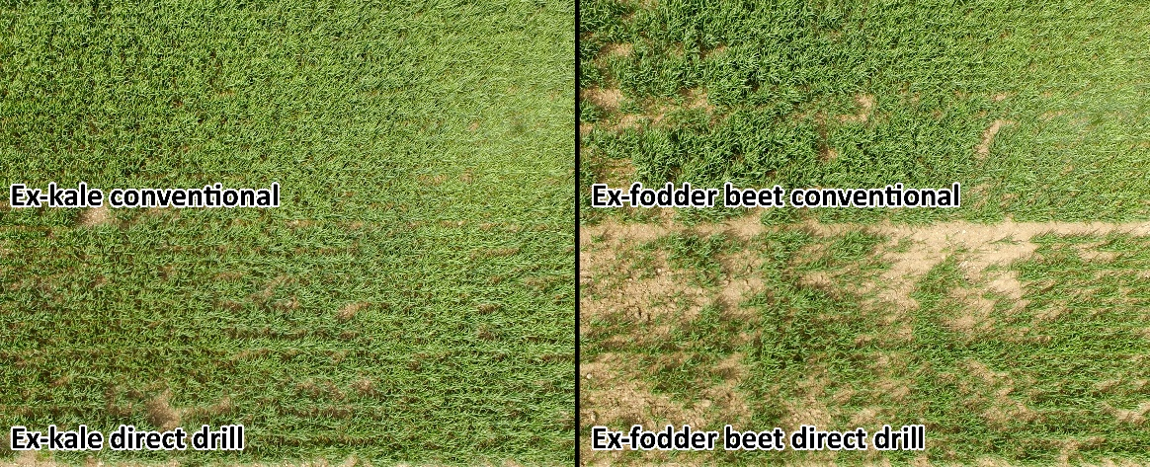
Photographs by Mike George, Plant & Food Research.
Overall, the cultivation/establishment method is not prescriptive when it comes to sowing after winter forage crop grazing and must be assessed under the given set of circumstances at the time. Table 3 serves as a guide to the type of cultivation or establishment method that could be imposed under various soil conditions.
It is necessary to consider the type of tillage that might be required, and the associated soil moisture status. Soil moisture is a key factor determining soil workability. With the wrong implement, tillage under wetter conditions has the risk of smearing, while tillage under particularly dry conditions usually requires more cultivation. While some implements (eg, chisel plough, grubbers, Maxi-till, TopDown, spader-drill) are more suitable under wetter soil conditions than others (eg, inversion tillage), the upper limit of soil moisture for tillage (its ‘plastic limit’) is an important consideration, particularly before inversion tillage (Dexter et al, 2005).
The plastic limit is the soil water content at which a fine-grained soil can no longer be remoulded without cracking. Tillage can start once the soil water content of the tillage depth (the top 20–30 cm) is below the plastic limit. While it is expected that cultivation starts as soon as practicable, tilling soils at the optimum soil moisture content (eg, 80–90 per cent of plastic limit) can minimise damage to soil structure (Mosaddeghi et al, 2009). If conditions allow, soil moisture at its plastic limit can be determined using standard test methods (Daniells and Larsen, 1991; Laurenson and Houlbrooke, 2016) or pedotransfer functions based on clay and organic carbon data (Keller and Dexter, 2012). Alternatively, a simple ‘cultivate/graze test’ (provided below), together with the guidance given in table 3, could be adopted to test if the soil is too wet to cultivate. If the soil moisture is too high, which could potentially delay the sowing of the next crops, practices such as ripping and grubbing can help to aerate and speed up its drying.
The soil moisture requirement for various cultivation methods and soils needs to be studied in New Zealand for ensuring both timely sowing and optimal soil structure for plant emergence and growth.
Figure 4: Cultivate/graze test to identify if soil is too wet to cultivate
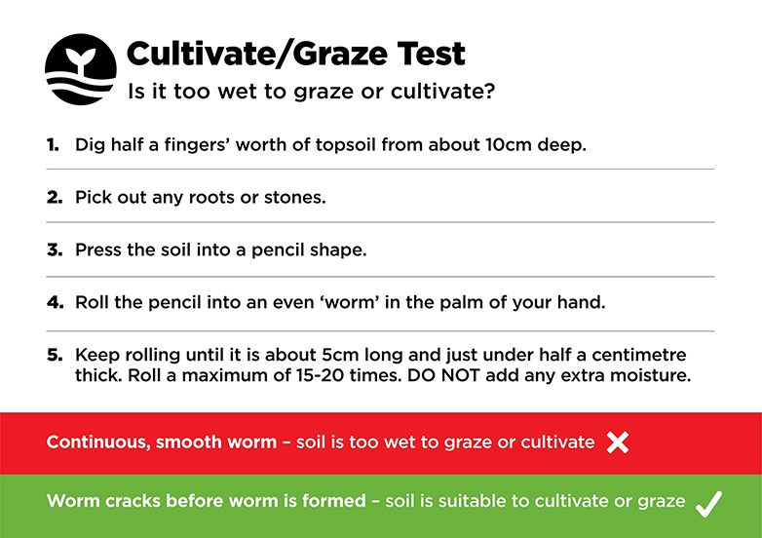
Source: Beef + Lamb New Zealand Farm Planning
Table 3: Examples of various ground conditions after winter forage crop grazing and potential appropriate actions to either sow or prepare for sowing
Ground condition example | Evaluation and possible next steps*
Pugged soil, extreme water ponding  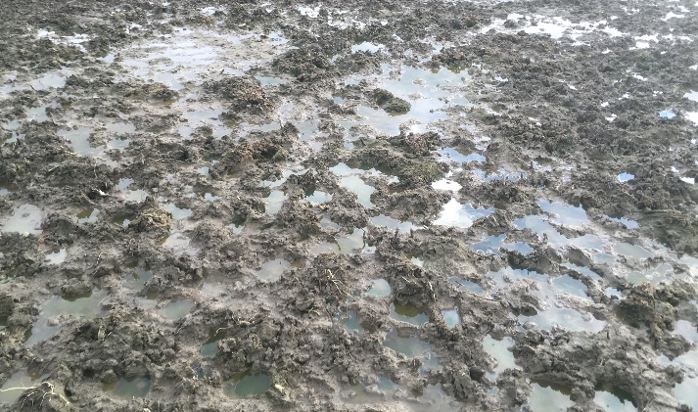 | Ground conditions are not suitable for resowing activity.  When most of the surface water has infiltrated or evaporated, aeration implements (eg, aerators, grubbers) could be considered.
Moderately pugged soil, water ponding  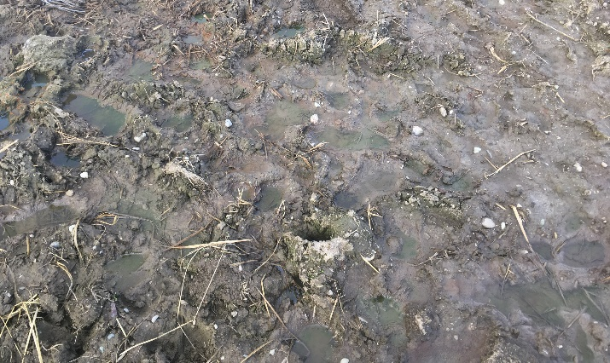 | Ground conditions are not suitable for resowing activity.  When most of the surface water has infiltrated or evaporated, aeration implements (eg, aerators, grubbers) could be considered.
Pugged, wet soil  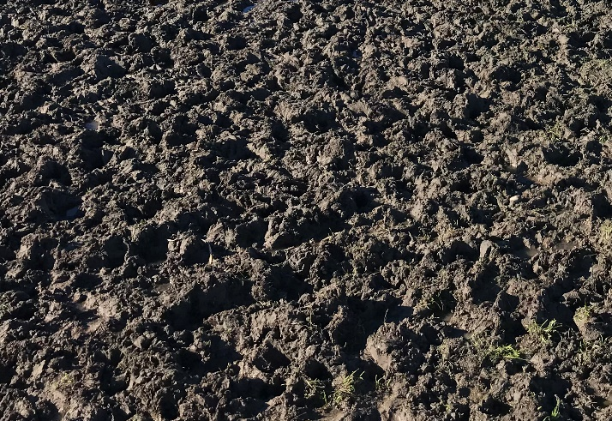 | Ground conditions are probably not suitable for resowing activity.  Requires further drying, but could consider aerating with non-inversion tillage (eg, grubbers) if most of the paddock is in the same state, or better.  Conditions might be adequate for specialised equipment such as a single-pass spader-drill implement.
Heavily pugged, moist soil  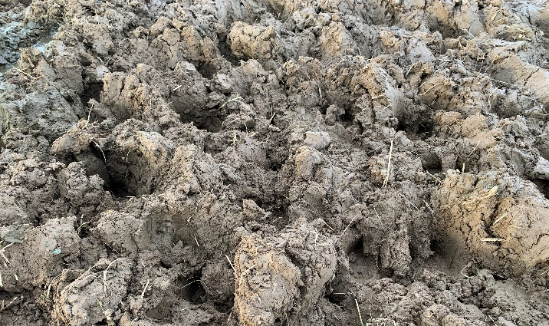 | Ground conditions are suitable for resowing activity.  Surface conditions are probably suitable for aerating and levelling (eg, using grubbers and discs).  If specialised equipment such as a spader-drill is available, then this could be used immediately.
Moderately pugged, moist surface  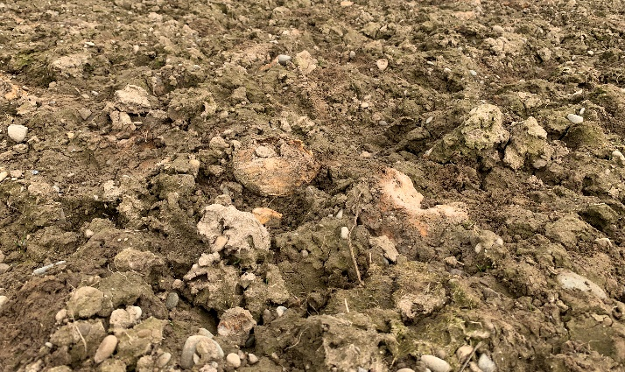 | Ground conditions are suitable for resowing activity.  Tillage is required to prepare a suitable seedbed. Could consider, for example, grubbing and/or discing or using a TopDown, followed by drilling.  Ground conditions are also well suited to a spader-drill, if available.
Heavy surface residue, moist surface  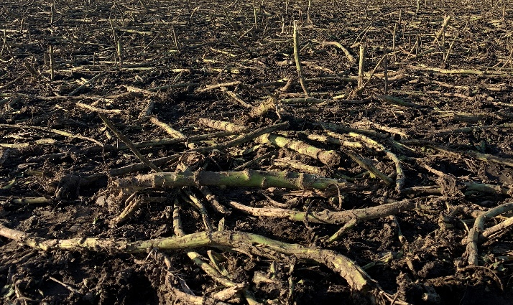 | Ground conditions are suitable for resowing activity.  Next steps will probably require light surface working to break down and incorporate some of the plant residue into the soil (eg, using discs or a TopDown).
Low pugging, moist surface  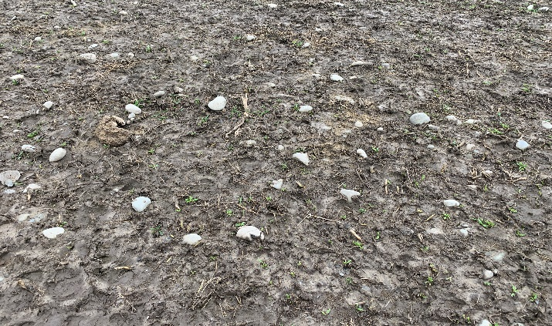 | Ground conditions are suitable for resowing activity.  Next steps might include light surface working in preparation for drilling (eg, discs or Maxi-till), or direct drilling.
Moderately pugged, surface capping, dry surface  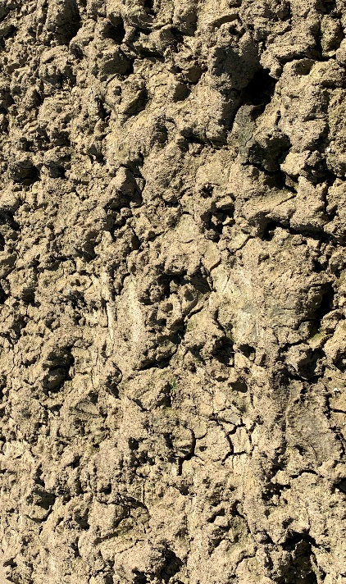 | Ground conditions are suitable for resowing activity.  Surface ground conditions are dry enough for top working.  Requires remediation of compaction (eg, using grubbers, discs and/or a TopDown). If soils are dry, heavy clays, more intensive machinery like a power-harrow might also be required.  Also suitable for drilling using a spader-drill, if available.
Moderate treading damage, dry surface  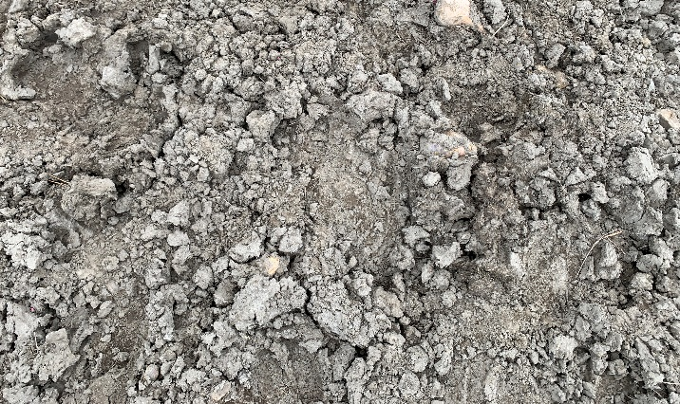 | Ground conditions are suitable for resowing activity.  May require some light surface working, but might also be suitable for direct drilling if surface compaction is not too severe.
Minimal treading damage, light surface residue  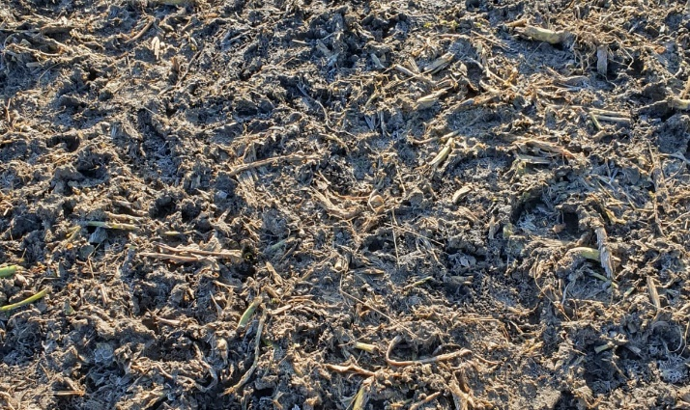 | Ground conditions are suitable for resowing activity.  If soils are not too compacted, conditions are suited to direct drilling or light surface working.
* Photographs do not necessarily capture the full context at a paddock scale, and therefore this serves as a guide only. Alternative actions might be better suited depending on individual circumstances. Not all possible circumstances are covered in the set of photographs given. Photographs taken by staff at Plant & Food Research.

4.2.6 Catch crops
Key points
- Catch crops are short-term crops established between two main crops or as part of a pasture renewal programme. Their main purpose is to reduce nitrate leaching, but they can also reduce surface run-off losses.
- Catch crops work by:
- reducing the concentration of soil nitrogen by taking up soil nitrogen through their root systems
- reducing drainage volume through crop transpiration (Carey et al, 2016; Malcolm et al, 2018; 2022)
- protecting the soil surface from erosion and associated run-off of sediment and contaminants.
- More detailed catch crop guidelines can be found in Horrocks et al (2021) via either of the following links:
- Catch Crops for Reduced Nitrate Leaching (dairynz.co.nz)
- Catch Crops for Reduced Nitrate Leaching (far.org.nz).
Winter-sown catch crops can reduce fallow periods in IWG systems and represent an effective mitigation strategy in sheep, beef, arable and dairy farming systems. They have been shown to significantly reduce the amount of nitrogen leaching after forage crop grazing, while also boosting feed supply in spring (DairyNZ, 2015; Carey et al, 2016; Caradus et al, 2018; Carey et al, 2022; Malcolm et al, 2022).
Research suggests that reductions in nitrate leaching losses from urine patches of up to 59 per cent by catch crops are possible on both deep and shallow silt, loam soils (Carey et al, 2016; Malcolm et al, 2022). The main way of reducing nitrogen leaching via catch crops (and groundcover more generally) is nitrogen uptake by actively growing plants. Crop water use (transpiration) is also important to dry the soil profile, thereby reducing the risk of drainage.
More recently, preliminary results from on-farm trials have shown that catch crops can reduce the amount of sediment and phosphorus run-off when sown in winter. However, further work is required to confirm the range of conditions under which these benefits occur.
‘Catch crops’ and ‘main crops’ could feature interchangeably when referring to winter sowing. For instance, some main crops (eg, cereal grain crops) could be established earlier than they would conventionally be in spring and serve the purpose of both a catch crop and a main crop.
Figure 5: Catch crops reduce the risk of leaching and run-off via plant uptake and trapping of water and nutrients (eg, nitrogen)
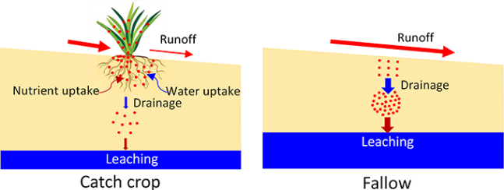
Graphic by Wei Hu, Plant & Food Research.

When catch crops should be sown
Key points
- Plan to sow catch crops as close to the end of grazing as possible.
- For cereal catch crops such as oats, soil temperatures at 5-cm depth should be 4°C or above.
- Perennial grasses should ideally be sown when soil temperatures are 8–10°C and rising.
Catch crops are most effective at capturing nitrogen and reducing leaching when sown immediately after grazing (Carey et al, 2016; Malcolm et al, 2021). This is because the conversion of nitrogen in livestock urine to nitrate can occur rapidly depending on soil temperature (eg, days to weeks) but it can take several weeks (eg, three or more) before newly winter-sown groundcover emerges and is able to take up much mineral nitrogen and stabilise the soil surface to mitigate the risk of contaminant (eg, sediment, E. coli) run-off. Therefore, any delay in sowing a catch crop that extends the time between when contaminants (including nitrate from urine) are deposited (eg, livestock excreta) and when catch crops are well established on the soil surface will increase the risk of contaminant losses.
Computer simulation modelling has shown that for every month that sowings are delayed, there is a notable reduction in effectiveness at reducing nitrate leaching (Malcolm et al, 2019). Sowing catch crops as late as September can still result in an environmental benefit — particularly in colder climates such as Southland where it takes longer for the nitrogen to be converted into nitrate — but the benefits of later establishment are reduced. Should delays in sowing catch crops extend to September/October or beyond, then focus probably needs to be on the establishment of the subsequent spring/summer (main) crop or pasture.
The base soil temperatures (the lowest temperature at 5-cm depth at which plant development stops) established for 75 per cent emergence of oats and Italian ryegrass are 1.6 and 1.8°C, respectively (Yusoff et al, 2012). Leaf emergence can occur at 3°C. Therefore, cereals (eg, oats) can be sown when average daily soil temperatures are 4°C and rising.
When cereal catch crops are sown in winter, emergence is typically slow (eg, 4–5 weeks in Canterbury and Southland). Therefore, where there is only a short period of time before the planned sowing date of the next main crop or pasture, catch crops may not be a viable option.

What species of catch crop should be used
Key points
- When sowing in winter, ideally select winter-active species (eg, cereals). Using multi species in the mix (eg, Italian ryegrass with a cereal) can increase the probability of success, particularly in high-rainfall environments (eg, Westland).
- Seek advice from local seed experts about the various options available and the right combination for your farm system.
Choose the most suitable species based on typical local soil temperatures. Warmer environments support establishing a wider range of crop species. Cool environments are best suited to winter-active species (eg, cereals and Italian ryegrass) that can establish in cooler soil temperatures. Forage oats are a good, well-tested, reliable catch crop option (Malcolm et al, 2018; 2021; Carey et al, 2022). Including Italian ryegrass with a cereal, particularly in high-rainfall environments (eg, Westland), can increase the probability of successfully establishing groundcover and offers multiple grazings or silage cuts.
Growing a catch crop purely as an environmental tool, with no intention to gain a direct economic return (eg, incorporated as green manure), can influence your choice of crop and how it is managed. For instance, crops with lower nutritional value could be used. Legumes could also feature in a winter-sown mixture, but research has shown they are usually less winter-active than non-leguminous species (Thapa et al, 2018). In addition, as atmospheric nitrogen-fixers, legumes might negate some of the environmental benefits that non-leguminous species offer. Further work is required to confirm this.
For green-chop cereal silage, it is generally best to harvest at the booting stage of plant development, that is, when the seed head is just beginning to emerge, for a good balance of high yield and good feed quality. Alternative uses for winter-sown catch crops might include grazing, green manure, whole-crop cereal silage or grain.

Beyond the catch crop phase
In the situation where conditions do not allow for sowing a catch crop in winter-early spring months, and the intention is to sow a winter forage brassica or fodder beet, this should be done as soon as environmental conditions are appropriate. Overall, for winter brassicas and fodder beet crops, soil temperature should be 10°C and rising before sowing starts (Stephen, 1976; Brown et al, 2007; De Ruiter et al, 2009; Chakwizira et al, 2011; Khaembah et al, 2020). If the intention is to sow temperate perennial or short-rotation species such as perennial ryegrass, Italian ryegrass, timothy, chicory, cocksfoot, prairie grass, tall fescue, white clover, red clover, subterranean clover or lucerne, in general these ideally are best sown when soil temperatures are 8–10°C and rising (Moot et al, 2000). However, thermal time requirements for emergence do vary between species, and therefore some species (eg, Italian ryegrass) can be sown at cooler soil temperatures.
Case study 2
Comparison of early September-sown oats and October-sown perennial ryegrass and white clover pasture after winter grazing of fodder beet in Canterbury, on a Templeton soil.
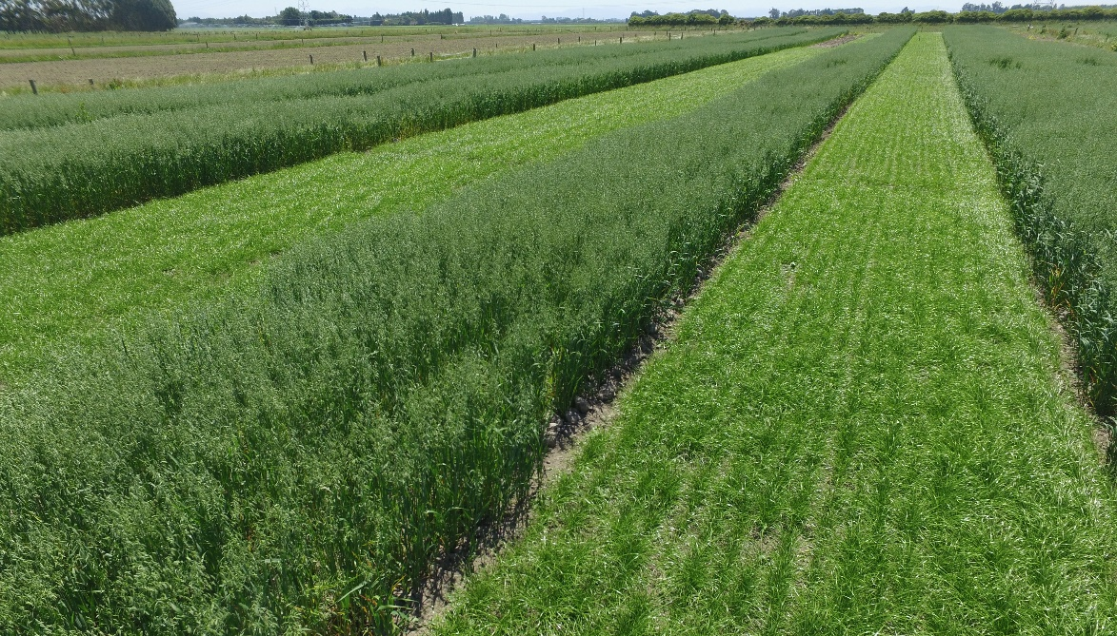
Photograph by Mike George, Plant & Food Research.

How catch crops should be sown
Key points
- For cereal catch crops, drill at 3–4 cm depth, and 1–2 cm for small-seeded crops such as ryegrass.
- Target high plant populations (300 plants/m²). For oats, this is equivalent to 110–120 kg seed/ha, depending on germination test results.
- When mixing Italian ryegrass with a cereal such as oats, suitable sowing rates are approximately 20 and 80 kg seed/ha, respectively.
When conditions allow, drilling as opposed to broadcasting increases the probability of successful emergence and generally results in a more productive crop and greater amounts of nitrogen captured (Malcolm et al, 2017). Broadcasting catch crops can be successful, however, particularly if good soil-seed-contact is achieved with sufficient moisture for germination, and bird damage is kept to a minimum by, for example, using bird repellents (Lane, 2022b). On sloping paddocks, sowing with the contour of the land will help intercept sediment and mitigate surface run-off losses.
When sowing catch crops in winter to maximise early nitrogen uptake, ideally target high plant populations/sowing densities to maximise light interception, early crop canopy development and nitrogen uptake. For cereals, aim for 300 plants/m² (Michel et al, 2022). Typical target populations for cereal grain crops are approximately 150 plants/m², and although this is lower than desired for winter-sown catch crops, environmental benefits can still be achieved at these lower populations.

Nitrogen fertiliser and catch crops
Key points
- Nitrogen fertiliser is generally not needed, or recommended, at sowing during winter months.
- To maximise dry matter production and feed quality of catch crops (eg, oats), some nitrogen fertiliser might be required after the crop has established and soil temperatures are at 6°C and rising.
It is not recommended to apply nitrogen at sowing in winter. Catch crops are used to scavenge for soil nitrogen and applying nitrogen to catch crops when conditions are not suitable risks environmental damage and loss of nitrogen. Some nitrogen fertiliser might be required during the middle stages of growth (eg, at tillering) for winter-sown cereals, or when soil temperatures rise above 6°C (Fertiliser Association, 2013).
Generally, nitrogen requirements fall outside of the drainage/leaching season, and therefore will probably not compromise the environmental gains by the catch crop (Malcolm et al, 2022). Applying nitrogen fertiliser is more likely to be necessary in wetter seasons or on light, shallow soils. Soil testing can help verify if and how much nitrogen or other nutrients might be required.
Generally, if the catch crop is being sown solely as an environmental tool, with no intended return from the crop (eg, used for green manure), then no nitrogen is required.
Case study 3
Catch crop trial plots of oats sown on 11 July (using a single pass, spader-drill) following winter grazing of fodder beet in Southland. Soil temperatures in July were 5–6°C.
Half of each plot received 40 kg N/ha (urea) on 15 October (darker green shading). Oats around the outside of the trial plots were sown on 31 August.
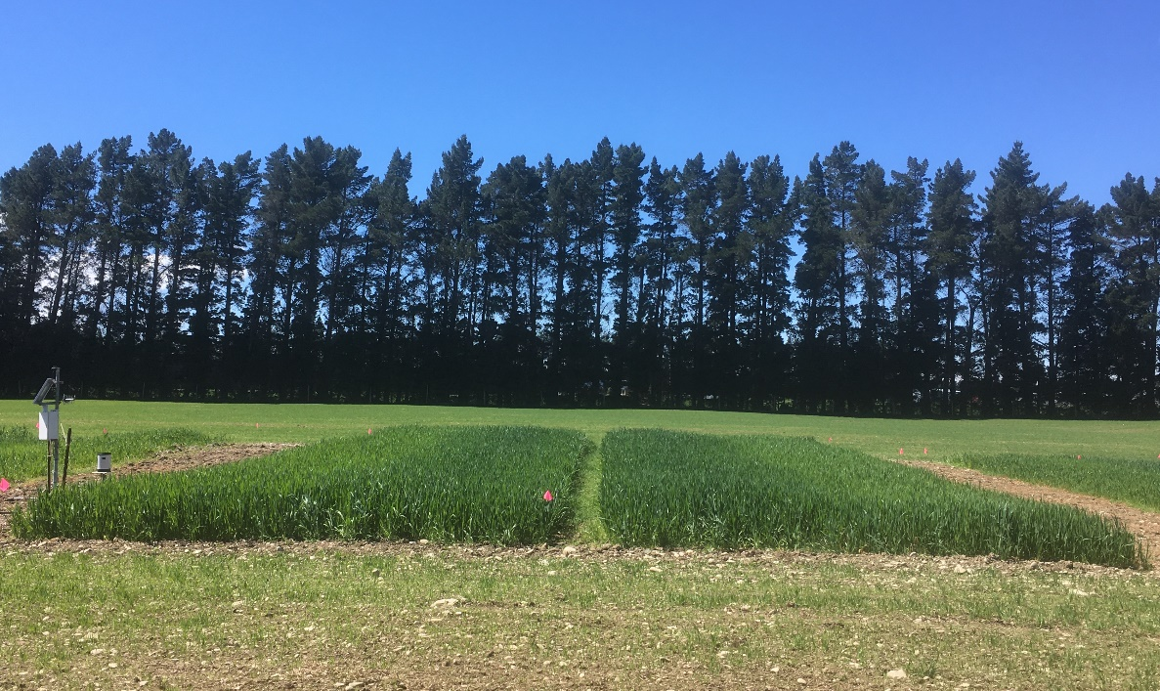
Photograph taken by Brendon Malcolm, Plant & Food Research.

Grass wintering
While grass wintering does not fall under the definition of IWG, and therefore is not covered by the IWG regulations in the NES-F, the high-stocking densities often associated with grass wintering can potentially result in similar outcomes to that of winter grazing of annual forage crops.
However, when managed well together with good farm management practice, this can serve as a potentially suitable strategy to maintain groundcover after wintering. For instance, where grass paddocks are not too damaged by livestock treading, regrowth can occur, acting as a sink for nitrogen and a layer of protection from surface run-off losses of contaminants.
As per the grazing of forage crops, these paddocks should be managed to minimise the intensity of pugging to encourage regrowth. Where severe pugging has been unavoidable owing to adverse weather events or operational constraints, some groundwork and reseeding might be necessary.

5. Knowledge gaps and limitations
In reviewing the current scientific literature and creating this guidance document, the following knowledge gaps and limitations have been identified:
- This guide does not provide universal recommendations for all scenarios, given the complexity and variety in individual IWG systems, such as variable climates, topography and farm operation.
- While different establishment methods (eg, conventional tillage vs no-tillage) of winter forage crops could have implications for re-establishing groundcover after IWG, there are potential trade-offs with different methods that need quantifying (eg, leaching vs nitrous oxide emissions vs production). More research in multiple regions covering various soil types is required.
- When considering different soil types and/or textures for winter grazing, there are trade-offs between suitability for re-establishing groundcovers and nitrogen leaching risk. For example, early grazing of forage crops on shallow (often stony) free-draining soils increases the probability of early groundcover establishment, but these soils also tend to have greater drainage and a higher risk for nitrate leaching. Trade-offs such as these need further assessment.
- The potential to undersow annual forage crops with plants capable of rapid regrowth after grazing could have many benefits for plant production and the environment. However, very few studies have quantified the benefits and trade-offs of undersowing forage crops with groundcover and its application to different IWG systems. More research is needed to identify the most suitable crop species, systems and environments where this strategy might be of benefit.
- When considering the soil moisture content for cultivation purposes, established and recognised upper soil moisture contents for various tillage methods and soil types and/or textures do not feature in literature and this topic therefore requires more research.
- Most of the research in New Zealand on the role of catch crops in IWG systems has focused on the capture of nitrogen to reduce nitrate leaching. More work is needed to determine how effective winter-sown catch crops can be at reducing surface run-off losses of sediment and other contaminants.
- Ground and weather conditions can make it very difficult to sow catch crops in winter using conventional ground-based machinery; therefore, there is need for further research into alternative ways of establishing catch crops in IWG systems (eg, aerial seeding).
- The best outcomes for production and the environment from IWG systems are likely to result by applying a combination of forage crop, winter grazing and groundcover management practices that depend on the soil type, climate and farming system. More research is needed to identify the options for best practice management of IWG systems for different pedo-climatic zones and farm systems in New Zealand.

References
Basher L, Moores J, McLean G. 2016. Scientific basis for erosion and sediment control practices in New Zealand. Prepared for the Tasman District Council by Landcare Research. Richmond: Tasman District Council.
Beare DM, Tregurtha CS. 2004. Soil quality on Southland cropping farms: a guide to monitoring and best management practices. Christchurch: New Zealand Institute for Crop & Food Research Limited.
Beare M, Gregorich E, St-Georges P. 2009. Compaction effects on CO₂ and N₂O production during drying and rewetting of soil. Soil Biology and Biochemistry 41(3): 611621.
Belliss S, Pairman D, Dymond J, Amies A, Zoerner J, Shepherd J, Drewry J, North H. 2019. Identification of high–risk agricultural activities: National mapping of the location, scale and extent of winter forage cropping and intensive grazing on hill country land Lincoln, New Zealand: Prepared for the Ministry for the Environment by Manaaki Whenua–Landcare Research. Wellington: Ministry for the Environment.
Brown H, Maley S, Wilson D. 2007. Investigations of alternative kale management: Production, regrowth and quality from different sowing and defoliation dates. Proceedings of the New Zealand Grassland Association.69: 29–33.
Burkitt L, Winters J, Horne D. 2017. Sediment and nutrient losses under winter cropping on two Manawatu hill country soils. Journal of New Zealand Grasslands 79: 27–33.
Caradus JR, Russell A, Chapman TJ, Wood L, Bowater P. 2018. A new winter active crop to improve soil nitrogen uptake. Journal of New Zealand Grasslands 80: 185–190.
Carey PL, Cameron KC, Di HJ, Edwards GR, Chapman DF. 2016. Sowing a winter catch crop can reduce nitrate leaching losses from winter-applied urine under simulated forage grazing: a lysimeter study. Soil Use and Management 32(3): 329–337.
Carey P, Cameron K, Di H, Edwards G. 2017. Comparison of nitrate leaching from oats and Italian ryegrass catch crops following simulated winter forage grazing: a field lysimeter study. New Zealand Journal of Agricultural Research 60(3): 298–318.
Carey PL, Malcolm BJ, Maley SC. 2022. Tillage practice and sowing time affect yield, nitrogen uptake and profitability of catch crops sown after winter forage grazing in New Zealand. New Zealand Journal of Agricultural Research: 1–25.
Chakwizira E, Moot D, Scott W, Fletcher A, Maley S. 2011. Leaf development, radiation interception and radiation-use efficiency of kale crops supplied with different rates of banded or broadcast phosphorus fertiliser. Crop and Pasture Science 62(10): 840–847.
Cournane FC, McDowell R, Littlejohn R, Condron L. 2011. Effects of cattle, sheep and deer grazing on soil physical quality and losses of phosphorus and suspended sediment losses in surface run-off. Agriculture, Ecosystems & Environment 140(1–2): 264–272.
DairyNZ. 2015. Winter sequence cropping kale and oats on winter support land for increased production and reduced nitrogen leaching. Hamilton: Dairy NZ.
Daniells I, Larsen D. 1991. SOILpak: a soil management package for cotton production on cracking clays. Narrabri: NSW Agriculture.
De Ruiter J, Wilson DR, Maley S, Fletcher AL, Fraser T, Scott WR, Berryman S, Dumbleton A, Nichol W. 2009. Management practices for forage brassicas. Christchurch: Forage Brassica Development Group.
Dexter AR, Czyz EA, Birkas M, Diaz-Pereira E, Dumitru E, Enache R, Fleige H, Horn R, Rajkaj K, de la Rosa D et al. 2005. SIDASS project – Part 3. The optimum and the range of water content for tillage – further developments. Soil and Tillage Research 82(1): 29–37.
Drewry J, Paton R. 2005. Soil physical quality under cattle grazing of a winter-fed brassica crop. Australian Journal of Soil Research 43(4): 525–531.
Edwards GR, de Ruiter JM, Dalley DE, Pinxterhuis JB, Cameron KC, Bryant RH, Malcolm BJ, Chapman DF. 2014. Dry matter intake and body condition score change of dairy cows grazing fodder beet, kale and kale-oat forage systems in winter. Proceedings of the New Zealand Grassland Association 76: 81–87.
Fertiliser Association. 2013. Code of practice for nutrient management (with emphasis on fertiliser use). Wellington: Fertiliser Association.
Francis G, Knight T. 1993. Long-term effects of conventional and no-tillage on selected soil properties and crop yields in Canterbury, New Zealand. Soil and Tillage Research 26(3): 193–210.
Hu W, Tabley F, Beare M, Tregurtha C, Gillespie R, Qiu W, Gosden P. 2018. Short-term dynamics of soil physical properties as affected by compaction and tillage in a silt loam soil. Vadose Zone Journal 17(1): 180115.
Hu W, Beare M, Tregurtha C, Gillespie R, Lehto K, Tregurtha R, Gosden P, Glasson S, Dellow S, George M et al. 2020. Effects of tillage, compaction and nitrogen inputs on crop production and nitrogen losses following simulated forage crop grazing. Agriculture Ecosystems & Environment 289: 106733.
Hu W, Drewry J, Beare M, Eger A, Muller K. 2021. Compaction induced soil structural degradation affects productivity and environmental outcomes: A review and New Zealand case study. Geoderma 395: 115035.
Jenkinson B, Edwards G, Bryant R. 2014. Grazing behaviour, dry matter intake and urination patterns of dairy cows offered kale or fodder beet in winter. Proceedings of the New Zealand Society of Animal Production 74: 23–28.
Kaspar T, Singer J. 2011. The use of cover crops to manage soil. In JL Hatfield, TJ Sauer (eds) Soil management: Building a stable base for agriculture. Madison: American Society of Agronomy and Soil Science Society of America. pp 321–337.
Keller T, Dexter AR. 2012. Plastic limits of agricultural soils as functions of soil texture and organic matter content. Soil Research 50(1): 7–17.
Khaembah EN, Maley S, George M, Chakwizira E, de Ruiter J, Zyskowski R, Teixeira E. 2020. Crop growth and development dynamics of two fodder beet (Beta vulgaris L.) cultivars sown on different dates in New Zealand. New Zealand Journal of Agricultural Research 63(3): 449–466.
Lane P. 2022a. Preventing soil loss from hill country cropping, comparing Helicropping to crops established by cultivation. In CL Christensen, DJ Horne and R Singh (eds) Occasional Report No 34. Adaptive Strategies for future farming. Palmerston North: Farmed Landscapes Research Centre, Massey University.
Lane P. 2022b. Establishing Helicropped cover crops mid-winter by surface sowing bird repellent treated seed. In: Adaptive Strategies for future farming (Eds: CL Christensen, DJ Horne and R Singh) Occasional Report No 34. Farmed Landscapes Research Centre, Massey University, Palmerston North, New Zealand 10 p.
Lane P, Willoughby B. 2017. Helicropping-early adopters' experiences. Journal of New Zealand Grasslands 79: 131–134.
Laurenson S, Houlbrooke DJ. 2016. Identifying critical soil water thresholds to decrease cattle treading damage risk. New Zealand Journal of Agricultural Research 59(4): 444–451.
Malcolm B, Cameron K, Beare M, Carrick S, Payne J, Maley S, Di H, Richards K, Dalley D, de Ruiter J. 2022. Oat catch crop efficacy on nitrogen leaching varies after forage crop grazing. Nutrient Cycling in agroecosystems 122(3): 273–288.
Malcolm B, Cameron K, Edwards G, Di H, de Ruiter J, Dalley D. 2016. Nitrate leaching losses from lysimeters simulating winter grazing of fodder beet by dairy cows. New Zealand Journal of Agricultural Research 59(2): 194–203.
Malcolm B, Carey P, Teixeira E, Johnstone P, Maley S, de Ruiter J. 2018. Potential of catch crops to reduce nitrogen leaching in New Zealand winter grazing systems. Journal of New Zealand Grasslands 80: 207–214.
Malcolm B, Cichota R, Teixeira E. 2019. The power of combining field trials and modelling, Technical Series, Science in Action. Hamilton: DairyNZ.
Malcolm B, Maley S, Teixeira E, Johnstone P, de Ruiter J, Brown H, Armstrong S, Dellow S, George M. 2021. Performance of winter-sown cereal catch crops after simulated forage crop grazing in Southland, New Zealand. Plants 10(1): 108.
Malcolm B, Teixeira E, Johnstone P, Maley S, de Ruiter J, Chakwizira E. 2017. Establishment methods of oat catch crops after winter forage grazing. Agronomy New Zealand 47: 65–77.
McDowell R. 2006. Phosphorus and sediment loss in a catchment with winter forage grazing of cropland by dairy cattle. Journal of Environmental Quality 35(2): 575–583.
McDowell R, Drewry J, Muirhead R, Paton R. 2003. Cattle treading and phosphorus and sediment loss in overland flow from grazed cropland. Australian Journal of Soil Research 41(8): 1521–1532.
McDowell R, Drewry J, Muirhead R, Paton R. 2005. Restricting the grazing time of cattle to decrease phosphorus, sediment and E. coli losses in overland flow from cropland. Australian Journal of Soil Research 43(1): 61–66.
McDowell R, Houlbrooke D. 2009. Management options to decrease phosphorus and sediment losses from irrigated cropland grazed by cattle and sheep. Soil Use and Management 25(3): 224–233.
McLaren RG, Cameron KC. 1996. Soil Science: Sustainable production and environment protection. Auckland: Oxford University Press.
Michel A, Malcolm B, Maley S, Jenkins H. 2021. Sowing strategy of winter-sown oats catch crops affects crop development and nitrogen uptake. Agronomy New Zealand 51: 47–58.
Ministry for the Environment. 2022. Intensive winter grazing factsheet. Wellington: Ministry for the Environment.
Monaghan RM, Smith LC, de Klein CAM. 2013. The effectiveness of the nitrification inhibitor dicyandiamide (DCD) in reducing nitrate leaching and nitrous oxide emissions from a grazed winter forage crop in southern New Zealand. Agriculture Ecosystems & Environment 175: 29–38.
Monaghan R, Laurenson S, Dalley D, Orchiston T. 2017. Grazing strategies for reducing contaminant losses to water from forage crop fields grazed by cattle during winter. New Zealand Journal of Agricultural Research 60(3): 333–348.
Moot DJ, Scott WR, Roy AM, Nicholls AC. 2000. Base temperature and thermal time requirements for germination and emergence of temperate pasture species. New Zealand Journal of Agricultural Research 43(1): 15–25.
Mosaddeghi MR, Morshedizad M, Mahboubi AA, Dexter AR, Schulin R. 2009. Laboratory evaluation of a model for soil crumbling for prediction of the optimum soil water content for tillage. Soil and Tillage Research 105(2): 242–250.
Selbie DR, Buckthought LE, Shepherd MA. 2015. The challenge of the urine patch for managing nitrogen in grazed pasture systems. Advances in Agronomy 129: 229–292.
Shepherd M, Stafford A, Smeaton D. 2012. The use of a nitrification inhibitor (DCnTM) to reduce nitrate leaching under a winter-grazed forage crop in the Central Plateau. Proceedings of the New Zealand Grassland Association 74: 103–107.
Smith LC, Orchiston T, Monaghan RM. 2012. The effectiveness of the nitrification inhibitor dicyandiamide (DCD) for mitigating nitrogen leaching losses from a winter grazed forage crop on a free draining soil in northern Southland. Proceedings of the New Zealand Grassland Association 74: 39–44.
Smith LC, Monaghan RM. 2020. Nitrogen leaching losses from fodder beet and kale crops grazed by dairy cows in southern Southland. Journal of New Zealand Grasslands 82: 61–71.
Stephen R. 1976. The effect of sowing and harvest dates on the leaf and stem yield of marrowsteam kale in relation to feed quality. Proceedings Agronomy Society of New Zealand 6: 43–48.
Teixeira E, Johnstone P, Chakwizira E, de Ruiter J, Malcolm B, Shaw N, Zyskowski R, Khaembah E, Sharp J, Meenken E et al. 2016. Sources of variability in the effectiveness of winter cover crops for mitigating N leaching. Agriculture, Ecosystems & Environment 220: 226–235.
Thapa R, Mirsky SB, Tully KL. 2018. Cover crops reduce nitrate leaching in agroecosystems: A global meta-analysis. Journal of Environmental Quality 47(6): 1400–1411.
Thomas S, Francis G, Barlow H, Beare M, Trimmer L, Gillespie R, Tabley F. 2004. Winter grazing of forages – soil moisture and tillage methods impact nitrous oxide emissions and dry matter production. Proceedings of the New Zealand Grassland Association. pp 135–140.
Thomas S, Beare M, Francis G, Barlow H, Hedderley D. 2008. Effects of tillage, simulated cattle grazing and soil moisture on N₂O emissions from a winter forage crop. Plant and Soil 309(1): 131–145.
Thomas S, Clemens G, Dunlop C, Beare M, Meenken E. 2013. Effects of herbicide application, tillage and winter grazing of a forage crop on nitrous oxide emissions during pasture renewal. Advances in Animal Biosciences 4: 426.
Trolove S, Thomas S, van der Klei G, Beare M, Cichota R, Meenken E. 2019. Nitrate leaching losses during pasture renewal – effects of treading, urine, forages and tillage. Science of the Total Environment 651: 1819–1829.
Van der Weerden T, Styles T. 2012. Reducing nitrous oxide emissions from grazed winter forage crops. Proceedings of the New Zealand Grassland Association. pp 57–62.
Yi J, Hu W, Beare M, Liu J, Cichota R, Teixeira E, Guo L. 2022. Treading compaction during winter grazing can increase subsequent nitrate leaching by enhancing drainage. Soil and Tillage Research 221: 105424.
Yusoff MM, Moot DJ, McKenzie BA, Hill GD. 2012. Quantification of vegetative development of faba bean, oats, and Italian ryegrass. Crop and Pasture Science 63: 1097–1105.

The process by which water is transferred from the land to the atmosphere by evaporation from the soil and by transpiration from plants.
Excessive richness of nutrients in a lake or other body of water, frequently due to run-off from the land, which causes a dense growth of plant life.
The decomposition of the chemical compounds in organic matter, by which the nutrients in those compounds are released in inorganic forms that may be available to plants.
A thin, dense layer developed on the soil surface due to the disintegration of soil aggregates caused by heavy rainfall. This layer can hinder the infiltration of water into the soil and impede the emergence of seedlings.
Predictive functions of certain soil properties (eg, plastic limit) from other easily, routinely, or cheaply measured properties (eg, soil texture, organic carbon content).

