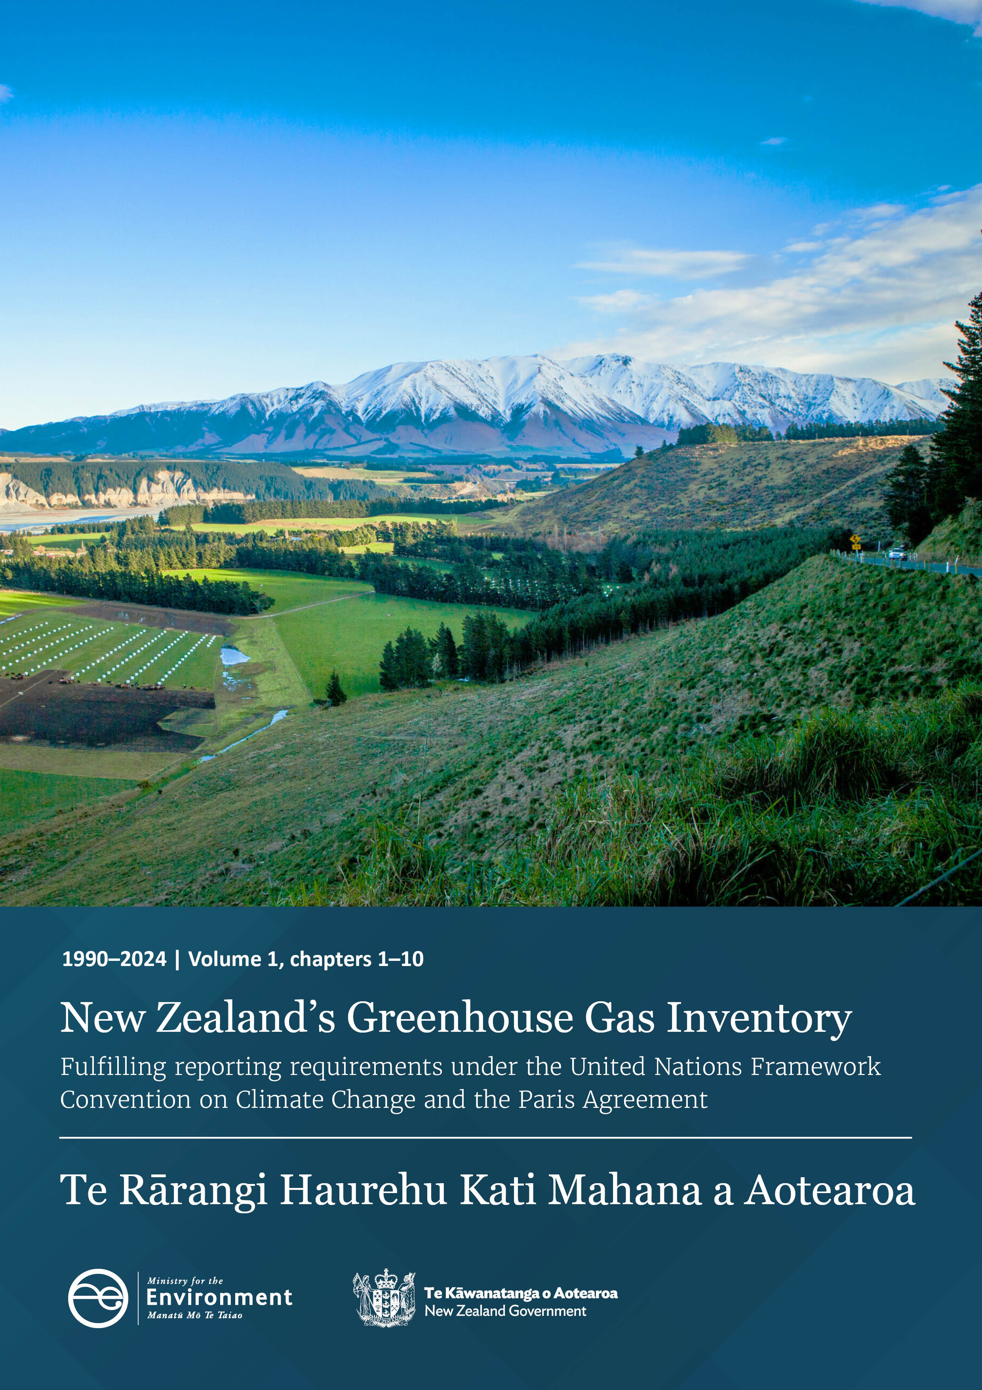

Disclaimer
The information in this publication is, according to the Ministry for the Environment’s best efforts, accurate at the time of publication. The Ministry will make every reasonable effort to keep it current and accurate. However, users of this publication are advised that:
- the information does not alter the laws of New Zealand, other official guidelines, or requirements
- it does not constitute legal advice, and users should take specific advice from qualified professionals before taking any action based on information in this publication
- the Ministry does not accept any responsibility or liability whatsoever whether in contract, tort, equity, or otherwise for any action taken as a result of reading, or reliance placed on this publication because of having read any part, or all, of the information in this publication or for any error, or inadequacy, deficiency, flaw in, or omission from the information in this publication
- all references to websites, organisations or people not within the Ministry are for convenience only and should not be taken as endorsement of those websites or information contained in those websites nor of organisations or people referred to.

This document may be cited as: Ministry for the Environment. 2026. New Zealand’s Greenhouse Gas Inventory 1990–2024. Wellington: Ministry for the Environment.

Volume 1, chapters 1–10
Published in April 2026 by the
Ministry for the Environment
Manatū Mō Te Taiao
PO Box 10-362, Wellington, New Zealand
ISSN: 1179-223X (electronic)
Publication number: ME 1963
© Crown copyright New Zealand 2026

This document is available on the Ministry for the Environment website:
www.environment.govt.nz.

Acknowledgements
The Ministry for the Environment thanks and acknowledges the many experts from central and local government agencies, industry and science organisations who contributed to the development and compilation of this inventory. Members of the Reporting Governance Group (RGG) are also acknowledged for their general advice and guidance over the production of this report.

Key contributors
Ministry for the Environment
Cross-sector and sector compilation
- Dr Andrea Brandon (National Inventory Focal Point, National Inventory Compiler)
- Chris Bean (technical lead, cross-sector analyses, Tokelau sector support)
- Samuel Roper (quality assurance and quality control (QA/QC) lead, GHG Inventory automation lead, cross-sector analyses)
- Parvin Siva (Industrial Processes and Product Use (IPPU) sector lead)
- Dr Ivan Chirino-Valle (Waste sector lead, Waste chapter automation, QA/QC)
- Riki Taylor (Land Use, Land-Use Change and Forestry (LULUCF) sector lead)
- Charissa Billings (Tokelau sector lead, Tokelau chapter automation, chapter compilation lead)
Peer review and quality control
- Dr Ivan Chirino-Valle, Samual Roper, Dr Anne Wekesa, Dom Fyfe, Audrey Lustig, Charissa Billings, Chris Bean, Dr Daniel Boczniewicz, Stephen Piva (QA/QC)
- Alice Ryan, Chris Bean (peer review)
Other contributors
- Frances Barnett (supplementary products lead)
- Clare Browne (project support)
- Deborah Burgess (LULUCF sector lead support)
- Louis Day, Stephen Minchin and Katrina Walsh (communications and publishing)
Governance
- Robyn Crisford (GHG Inventory manager, RGG manager – Tokelau and IPPU)
- Dr Alice Cleland (RGG Chair)
- Dan Elder (RGG manager – LULUCF and Waste)
- Aaron Napier (GHG Inventory general manager)

Ministry for Primary Industries
- Jamie Higgison (Agriculture sector lead)
- Sophie Mead, Catherine Sangster, Rata Lomax (Agriculture inventory team)
- Joel Gibbs (RGG manager – Agriculture)

Ministry of Business, Innovation and Employment
- Dr Michael Smith (Energy sector lead, IPPU: carbon dioxide)
- Dr Jan-Yves Ruzicka (QA/QC, Energy)
- Maria Botes (QA/QC and peer review, Energy)
- Dr Amapola Generosa (RGG manager – Energy)

Environmental Protection Authority
- Johanna Milius (peer review, IPPU)
- Dave Stuart (team leader, Emissions Trading Scheme operations)

Tokelau Government
- Paula Faiva (Tokelau Ministry of Climate, Oceans and Resilience) (general advice and guidance)
- Malama Uaina Kitiona (Tokelau national statistician) (peer review)

Technical contributors and specialists

Industrial Processes and Product Use sector
- Verum Group: Wayne Hennessy

Agriculture sector
- AgResearch: Alison Rutherford, David Stevens, Tony van der Weerden, Jamie Ward, Jiafa Luo, Suzanne Rowe
- AbacusBio: Jude Sise, Fiona Hely, David Kenny
- Lincoln University: Keith Cameron, Tim Clough, Hong Di
- Ministry for Primary Industries: Shania Brooks, Joelle Kuiper, Dr Gerald Rys, Hannah Brooks, Joshua Williams, Ben Morrow (peer review)

Land Use, Land-Use Change and Forestry sector
- Ministry for the Environment: Tom Argyle, Deborah Burgess, Michael Cooper, Dr Nina Koele, Prem Sivakanthan, Riki Taylor, Dr Patrick Kavanagh, Dr Anne Wekesa
- Ministry for Primary Industries: Craig Elvidge (peer review), Asher Cook (peer review)

Waste sector
- Ministry for the Environment: Eric Goodwin, Matthew Potter, Jess Relihan, Briar Wyatt, Kirsteen Pitkin-Douglas, Kara Lok and Dom Fyfe.

Proof reading and formatting
- Jenny Heine

Contents
Acknowledgements iii
Abbreviations xviii
Executive summary xxii
ES.1 Background information on greenhouse gas inventories and climate change xxiv
ES.2 Summary of trends related to national emissions and removals xxv
ES.3 Overview of source and sink category emissions estimates and trends xxix
ES.4 Other information xxxix
ES.5 Key category analysis xxxix
ES.6 Improvements introduced xl
Executive summary: References xliii
Chapter 1: National circumstances, institutional arrangements and cross-cutting information 1
1.1 Background information on greenhouse gas inventories and climate change 1
1.2 A description of national circumstances and institutional arrangements 4
1.3 Brief general description of methodologies (including tiers used) and data sources used 11
1.4 Brief description of key categories 13
1.5 Brief general description of QA/QC plan and implementation 15
1.6 General uncertainty assessment, including data pertaining to the overall uncertainty of inventory totals 20
1.7 General assessment of completeness 21
1.8 Metrics 30
Chapter 1: References 31
Chapter 2: Trends in greenhouse gas emissions and removals 33
2.1 Description of emission and removal trends for aggregated GHG emissions and removals 33
2.2 Description of emission and removal trends by sector and by gas 36
Chapter 2: References 60
Chapter 3: Energy 61
3.1 Sector overview 61
3.2 Fuel combustion (CRT 1.A) 67
3.3 Fugitive emissions from solid fuels and oil and natural gas and other emissions from energy production (CRT 1.B) 98
3.4 Carbon dioxide transport and storage (CRT 1.C) 107
Chapter 3: References 108
Chapter 4: Industrial Processes and Product Use (IPPU) 110
4.1 Sector overview 110
4.2 Mineral industry (2.A) 118
4.3 Chemical industry (2.B) 123
4.4 Metal industry (2.C) 127
4.5 Non-energy products from fuels and solvent use (2.D) 133
4.6 Electronics industry (2.E) 136
4.7 Product uses as substitutes for ODS (2.F) 137
4.8 Other product manufacture and use (2.G) 145
4.9 Other (2.H) 148
Chapter 4: References 150
Chapter 5: Agriculture 151
5.1 Sector overview 151
5.2 Enteric fermentation (3.A) 180
5.3 Manure management (3.B) 190
5.4 Rice cultivation (3.C) 210
5.5 Agricultural soils (3.D) 211
5.6 Prescribed burning of savanna (3.E) 240
5.7 Field burning of agricultural residues (3.F) 240
5.8 Liming (3.G) 244
5.9 Urea application (3.H) 246
5.10 Other carbon-containing fertilisers (3.I) 248
Chapter 5: References 249
Chapter 6: Land Use, Land-Use Change and Forestry (LULUCF) 256
6.1 Sector overview 256
6.2 Land use definitions and the land representation approach(es) used and their correspondence to the LULUCF categories 270
6.3 Country-specific approaches 274
6.4 Forest land (4A) 276
6.5 Cropland (4B) 291
6.6 Grassland (4C) 296
6.7 Wetlands (4D) 302
6.8 Settlements (4E) 306
6.9 Other land (4F) 308
6.10 Harvested wood products (4G) 311
6.11 Non-CO₂ emissions (4(I–IV)) 316
Chapter 6: References 323
Chapter 7: Waste 326
7.1 Sector overview 326
7.2 Solid waste disposal (5.A) 333
7.3 Biological treatment of solid waste (5.B) 350
7.4 Incineration and open burning of waste (5.C) 353
7.5 Wastewater treatment and discharge (5.D) 359
Chapter 7: References 374
Chapter 8: Tokelau (other) sector 376
8.1 Tokelau overview 376
8.2 Energy emissions from Tokelau (6. Tokelau_1) 387
8.3 Stationary combustion: Public electricity and heat production 388
8.4 Stationary combustion: Other sectors – Residential 391
8.5 Mobile combustion: Domestic navigation 393
8.6 Emissions from Industrial Processes and Product Use in Tokelau (6. Tokelau_2) 395
8.7 Emissions from Refrigeration and air conditioning in Tokelau 396
8.8 Emissions from Metered dose inhalers and Medical applications in Tokelau 399
8.9 Emissions from the Agriculture sector in Tokelau (6. Tokelau_3) 400
8.10 Emissions from Enteric fermentation in Tokelau 401
8.11 Emissions from Manure management in Tokelau 403
8.12 Emissions from the Waste sector in Tokelau (6. Tokelau_5) 404
8.13 Emissions from Solid waste disposal in Tokelau 405
8.14 Emissions from Incineration and open burning in Tokelau 407
8.15 Emissions from Wastewater treatment and discharge in Tokelau 409
Chapter 8: References 412
Chapter 9: Indirect carbon dioxide and nitrous oxide emissions 413
Chapter 10: Recalculations and improvements 414
10.1 Explanations and justifications for recalculations, including in response to the review process 414
10.2 Implications for emissions and removal levels 416
10.3 Implications for emissions and removal trends, including time-series consistency 419
10.4 Areas of improvement and/or capacity building in response to the review process 427
10.5 Areas of improvement and/or capacity building related to the flexibility provisions 433
Chapter 10: References 434

Tables
Table ES 2.1 New Zealand’s gross emissions by gas in 1990, 2005 and 2024 xxviii
Table ES 4.1 New Zealand’s indirect greenhouse gas emissions (excluding LULUCF) in 1990, 2005 and 2024 xxxix
Table ES 5.1 Key categories with the largest relative influence on the national trend, compared with the average change in gross emissions from 1990 to 2024 xl
Table ES 5.2 Key categories with the largest relative influence on the national trend, compared with the average change in net emissions from 1990 to 2024 xl
Table 1.4.1 Major contributions to the level analysis of net emissions for 2024 14
Table 1.4.2 Key categories with the largest relative influence on the trend, compared with the average change in net emissions from 1990 to 2024 14
Table 1.4.3 Major contributions to the level analysis of gross emissions for 2024 14
Table 1.4.4 Key categories with the largest relative influence on the trend, compared with the average change in gross emissions from 1990 to 2024 15
Table 1.5.1 Dates for sector entry into the New Zealand Emissions Trading Scheme 19
Table 1.7.1 Summary of ‘NE’ (not estimated) entries in the 2026 submission 22
Table 1.7.2 Emissions reported using the ‘IE’ (included elsewhere) notation key in the 2026 submission 26
Table 2.2.1 New Zealand’s emissions by sector, comparing 1990, 2005 and 2024 40
Table 2.2.2 Emissions from Tokelau, 1990, 2005 and 2024 54
Table 2.2.3 New Zealand’s gross emissions by gas in 1990, 2005 and 2024 56
Table 2.2.4 New Zealand’s indirect greenhouse gas emissions (excluding LULUCF) in 1990, 2005 and 2024 59
Table 3.1.1 Key categories in the Energy sector 63
Table 3.1.2 Use of natural gas as a feedstock in New Zealand 65
Table 3.2.1 Emission factors for gas biomass 70
Table 3.2.2 Net-to-gross calorific value conversion factors 71
Table 3.2.3 Uncertainty for New Zealand’s Energy sector emission estimates for 2024 72
Table 3.2.4 Key categories for 1.A.1 Energy industries 77
Table 3.2.5 Key categories for 1.A.2 Manufacturing industries and construction 81
Table 3.2.6 Solid biomass splits for 2006 that were used to disaggregate the Manufacturing industries and construction category between 1990 and 2024 83
Table 3.2.7 Energy intensity values used to disaggregate liquid fuel use for manufacturing 84
Table 3.2.8 Key categories for 1.A.3 Transport 88
Table 3.2.9 Key categories for 1.A.4 Other sectors 95
Table 3.2.10 Split of fuel oil activity for ‘other primary industry’ 96
Table 3.3.1 Key categories for 1.B Fugitive emissions 98
Table 3.3.2 Details of abandoned underground mines in the North Island 100
Table 4.1.1 New Zealand’s greenhouse gas emissions for the IPPU sector by category in 1990, 2005 and 2024 112
Table 4.1.2 Key categories in the IPPU sector 114
Table 4.1.3 Explanations and justifications for recalculations 116
Table 4.1.4 Summary of ‘NE’ or ‘not estimated’ entries for the IPPU sector in the 2026 submission 118
Table 4.1.5 Emissions reported using the ‘IE’ or included elsewhere notation key in the 2026 submission for the IPPU sector 118
Table 4.2.1 Uncertainty in emissions from mineral products 122
Table 4.3.1 Country-specific emission factors for indirect emissions 126
Table 4.3.2 Uncertainty in emissions from the Chemical industry category 126
Table 4.4.1 Typical analysis from New Zealand Steel Limited of the primary concentrate (provided by New Zealand Steel Limited) 128
Table 4.4.2 Uncertainty in emissions from the metal industry 132
Table 4.4.3 Explanation of variations in New Zealand’s aluminium emissions 133
Table 4.5.1 Calculation of non-methane volatile organic compound (NMVOC) emissions from road paving 135
Table 4.5.2 Fraction of bitumen in road paving material 135
Table 4.5.3 Uncertainty in emissions in non-energy products from fuels and solvent use 136
Table 4.7.1 Average charge (grams) of HFC-134a in mobile air conditioners, 2009 139
Table 4.7.2 Average emissions per dose in metered dose inhalers (milligrams) 140
Table 4.7.3 Summary of methodological tiers by sub-application 142
Table 4.7.4 New Zealand’s uncertainties in Product uses as substitutes for ODS 143
Table 4.8.1 Uncertainty in emissions from Other product manufacture and use 148
Table 5.1.1 Trends and relative contribution of New Zealand’s agricultural greenhouse gas emissions by category between 1990 and 2024 153
Table 5.1.2 Key categories in the Agriculture sector 158
Table 5.1.3 Methods and emission factors in the Agriculture sector 159
Table 5.1.4 Explanations and justifications for recalculations in the Agriculture sector 173
Table 5.1.5 Agriculture sectoral approval process for inventory recalculations and improvements 174
Table 5.1.6 Summary of ‘NE’ or ‘not estimated’ entries for the Agriculture sector in the 2026 submission 179
Table 5.1.7 Emissions reported using the ‘IE’ or ‘included elsewhere’ notation key in the 2026 submission for the Agriculture sector 180
Table 5.2.1 Trends and relative contribution of enteric fermentation (methane expressed in kt CO₂e) from livestock categories between 1990 and 2024 181
Table 5.2.2 Methane emissions and gross energy intake (GEI) from New Zealand measurements and IPCC (2006) default values 183
Table 5.2.3 New Zealand’s implied emission factors for enteric fermentation, from 1990 to 2024 184
Table 5.2.4 Enteric fermentation emissions factors (kg CH₄/year/head) for swine classes, from 1990 to 2024 185
Table 5.2.5 New Zealand’s uncertainty in the annual estimate of enteric fermentation emissions for 1990, 2005 and 2024, estimated using the 95 percent confidence interval (±16 percent) 186
Table 5.2.6 Comparison of the IPCC (2006) default emission factor and country-specific implied emission factors (IEFs) for methane (CH₄) from Enteric fermentation for Dairy cattle, Non-dairy cattle and Sheep 187
Table 5.2.7 Comparison of the 2025 Inventory and a version of the 2025 Inventory updated using default for ostriches and emus from the 2019 IPCC Refinement (IPCC, 2019) for emissions from Enteric fermentation 189
Table 5.2.8 Comparison of model results with and without corrections for emissions from Enteric fermentation 190
Table 5.3.1 Trends and relative contribution of methane and nitrous oxide emissions in the Manure management category between 1990 and 2024 191
Table 5.3.2 Distribution of livestock waste across animal waste management systems in New Zealand in 2024 192
Table 5.3.3 Emission factors and parameter values for use of mitigation technologies 192
Table 5.3.4 Mitigation impact of EcoPond™ on methane emissions from anaerobic lagoons, for 2023 and 2024 194
Table 5.3.5 Regional anaerobic lagoon and solid storage methane conversion factors (MCFs) for dairy 195
Table 5.3.6 Average annual methane emissions factors from manure management systems (kg CH₄/year/head) for swine, 1990 to 2024 196
Table 5.3.7 Manure management methane (CH₄) emission factors for goats, horses and mules and asses 197
Table 5.3.8 Nitrogen excretion rates (N_{ex}) for New Zealand’s major livestock categories, from 1990 to 2024 198
Table 5.3.9 Nitrogen excretion (N_{ex}) rates for New Zealand’s swine and goats, from 1990 to 2024 199
Table 5.3.10 IPCC default values for the fraction of managed manure nitrogen that volatilises as ammonia and oxides (Frac_{GasMS}/100) for livestock categories per manure management system in New Zealand 202
Table 5.3.11 IPCC default values for the fraction of managed manure nitrogen that leaches (Frac_{leach}/100) for livestock categories per manure management system in New Zealand 202
Table 5.3.12 Comparison of IPCC (2006) table 10A-4 default emission factors and country-specific implied emission factors (IEFs) for methane from manure management 204
Table 5.3.13 Proportions of manure deposited on different structures by mature milking cows, 2022 to 2023 206
Table 5.3.14 Division between solid and liquid/slurry for manure from structures 206
Table 5.3.15 Seasonal proportion of total annual manure collected on off-paddock facilities (excluding milking sheds) 207
Table 5.3.16 Comparison of the 2025 Inventory and a version of the 2025 Inventory using revised dairy manure management practices for emissions from Manure management, 1990, 2005 and 2023 207
Table 5.3.17 Revised regional methane conversion factor (MCF) values for anaerobic lagoons 208
Table 5.3.18 Manure management methane emission factors for goats, horses and donkeys 209
Table 5.3.19 Comparison of the 2025 Inventory and a version of the 2025 Inventory using defaults from the 2019 IPCC Refinement for emissions from Manure management 209
Table 5.3.20 Comparison of model results with and without corrections for emissions from Manure management 210
Table 5.5.1 Trends and relative contribution of nitrous oxide emissions from Agricultural soils categories between 1990, 2005 and 2024 213
Table 5.5.2 Nitrous oxide (N₂O) emission factors for Agricultural soils in New Zealand, excluding EF_{3,PRP- URINE} for cattle, sheep and deer 215
Table 5.5.3 Direct nitrous oxide emission factors for urine deposited by cattle, sheep and deer, by livestock type and slope, using values calculated by van der Weerden et al. (2019, 2020) 215
Table 5.5.4 Parameters for indirect nitrous oxide (N₂O) emissions from Agricultural soils in New Zealand 216
Table 5.5.5 Emission factors and parameter values for use of mitigation technologies 216
Table 5.5.6 Number of replicate-level EF₃ values collated by the van der Weerden et al. (2019, 2020) analysis, for each nitrogen source and topography (number of individual trials shown in brackets) 222
Table 5.5.7 Number of replicate-level EF₃ values collated by the van der Weerden et al. (2019, 2020) analysis, for each nitrogen source, season when the trial was undertaken and topography 223
Table 5.5.8 Trends and relative contribution of direct nitrous oxide emissions from urine and dung deposited by grazing animals per livestock category between 1990 and 2024 224
Table 5.5.9 Mitigation impact of urease inhibitors on nitrous oxide emissions from volatilisation, from 2001 to 2024 232
Table 5.5.10 Emission factors, parameters and mitigation for New Zealand’s dicyandiamide inhibitor calculations, from 2007 to 2012 233
Table 5.5.11 Comparison of New Zealand’s implied emission factors (IEFs) for EF₁ (synthetic nitrogen fertiliser) and EF_{3(PRP)} (pasture, range and paddock manure) with the IPCC default and the Australian-specific value 235
Table 5.5.12 Comparison of New Zealand’s country-specific factors for volatilisation (Frac_{GASF}, Frac_{GASM}) and leaching and runoff (Frac_{LEACH-(H)}) with the IPCC default value and the Australian implied emission factor (IEF) 236
Table 5.5.13 Comparison of emissions from Agricultural soils before and after the inclusion of revised EF₁ values for non-urea synthetic fertilisers 237
Table 5.5.14 Comparison of emissions from Agricultural soils before and after including revised dairy manure management practices 237
Table 5.5.15 Comparison of emissions from Agricultural soils before and after updates to align with the 2019 IPCC Refinement (IPCC, 2019) 238
Table 5.5.16 Comparison of emissions from Agricultural soils with and without corrections 239
Table 5.7.1 Emission ratios for agricultural residue burning 241
Table 5.7.2 Values used to calculate New Zealand emissions from burning of agricultural residues 242
Table 6.1.1 New Zealand’s greenhouse gas net emissions for the LULUCF sector by land use category in 2023 and 2024 256
Table 6.1.2 New Zealand’s greenhouse gas net emissions for the LULUCF sector by category in 2005 and 2024 257
Table 6.1.3 New Zealand’s greenhouse gas net emissions for the LULUCF sector by category in 1990 and 2024 258
Table 6.1.4 Land use in New Zealand in 2024 260
Table 6.1.5 Relationships between land use, carbon pool and method of calculation used by New Zealand 261
Table 6.1.6 Land use categories making the greatest contribution to uncertainty in the LULUCF sector 264
Table 6.1.7 Recalculations to New Zealand’s total net LULUCF emissions for 1990 and 2023 265
Table 6.1.8 Recalculations to New Zealand’s net LULUCF emissions for 1990 and 2023 by category 265
Table 6.1.9 Summary of ‘NE’ or ‘not estimated’ entries for the LULUCF sector in the 2026 submission 266
Table 6.1.10 Emissions reported using the ‘IE’ or ‘included elsewhere’ notation key in the 2026 submission for the LULUCF sector 268
Table 6.2.1 New Zealand’s land use categories and land uses 270
Table 6.2.2 New Zealand’s mapping definitions for each land use 271
Table 6.2.3 New Zealand’s land-use change matrix, from 1962 to 1989 (kha) 273
Table 6.4.1 New Zealand’s land-use change for the Forest land category, and associated CO₂e emissions, in 1990 and 2024 276
Table 6.4.2 Change in land area and associated CO₂ emissions from carbon stock change between 1990 and 2024 for New Zealand’s Forest land 277
Table 6.4.3 New Zealand’s net carbon stock change by carbon pool for the Forest land category, from 1990 to 2024 278
Table 6.4.4 New Zealand’s Forest land subject to deforestation, 1990 and 2024 280
Table 6.4.5 Pre-1990 natural forest categories and description 282
Table 6.4.6 Areas of tall and regenerating pre-1990 natural forest in 1990 and 2024 282
Table 6.4.7 New Zealand’s pre-1990 natural forest deforestation area (ha), for natural forest categories, estimated by type, from 1990 to 2024 282
Table 6.4.8 Summary of methods used to calculate New Zealand’s forest biomass carbon stock from plot data 286
Table 6.4.9 Uncertainty in carbon stock change emissions in 2024 from Forest land 288
Table 6.4.10 Recalculations of New Zealand’s estimates for the Forest land category in 1990 and 2023 288
Table 6.5.1 New Zealand’s land-use change by Cropland category, and associated CO₂e emissions, 1990 and 2024 291
Table 6.5.2 New Zealand’s carbon stock change by carbon pool for the Cropland category, from 1990 to 2024 291
Table 6.5.3 New Zealand’s land-use change by Cropland land use, and associated CO₂ emissions from carbon stock change, from 1990 to 2024 292
Table 6.5.4 New Zealand’s land-use change for the Cropland category, from 1990 to 2024 292
Table 6.5.5 Summary of New Zealand’s carbon stock change emission factors for the Cropland category 293
Table 6.5.6 Uncertainty in net carbon stock change emissions in 2024 for the Cropland category 295
Table 6.5.7 Recalculations of New Zealand’s net emissions from the Cropland category in 1990 and 2023 296
Table 6.6.1 New Zealand’s land-use change for the Grassland category, and associated CO₂e emissions, from 1990 to 2024 297
Table 6.6.2 Grassland with woody biomass categories and description 297
Table 6.6.3 New Zealand’s carbon stock change by carbon pool for the Grassland category, from 1990 to 2024 298
Table 6.6.4 Summary of New Zealand’s biomass emission factors for Grassland 298
Table 6.6.5 Uncertainty in carbon stock change emissions in 2024 for Grassland 301
Table 6.6.6 Recalculations of New Zealand’s net emissions from the Grassland category in 1990 and 2023 301
Table 6.7.1 New Zealand’s land-use change for the Wetlands category, and associated CO₂e emissions, in 1990 and 2024 302
Table 6.7.2 New Zealand’s carbon stock change by carbon pool for the Wetlands category, from 1990 to 2024 303
Table 6.7.3 Summary of New Zealand’s biomass emission factors for Wetlands 305
Table 6.7.4 Uncertainty in carbon stock change emissions in 2024 for Wetlands 305
Table 6.7.5 Recalculations for New Zealand’s net emissions from the Wetlands category in 1990 and 2023 306
Table 6.8.1 New Zealand’s land-use change for the Settlements category, and associated CO₂e emissions, from 1990 to 2024 306
Table 6.8.2 New Zealand’s carbon stock change by carbon pool for the Settlements category, from 1990 to 2024 307
Table 6.8.3 Recalculations for New Zealand’s net emissions from the Settlements category in 1990 and 2023 308
Table 6.9.1 New Zealand’s land-use change for the land use category Other land, from 1990 to 2024 309
Table 6.9.2 Summary of New Zealand emission factors for the land use category Other land 309
Table 6.9.3 Recalculations for New Zealand’s net emissions from the Other land category in 1990 and 2023 311
Table 6.10.1 Conversion factors for Harvested wood products produced from New Zealand wood in New Zealand 314
Table 6.10.2 Weighted half-lives for harvested wood products produced in export markets 314
Table 6.10.3 Recalculations for New Zealand’s net emissions from the Harvested wood products category in 1990 and 2023 315
Table 6.11.1 Nitrous oxide emissions from soils associated with land-use change reported in the LULUCF sector, from 1990 to 2024 316
Table 6.11.2 Net N₂O emissions from nitrogen in soils associated with land-use change in 2024 319
Table 6.11.3 Non-CO₂ emissions from Biomass burning in 1990 and 2024 319
Table 6.11.4 Summary of Biomass burning carbon fractions and emission factors 320
Table 6.11.5 Summary of Biomass burning combustion factor values 321
Table 7.1.1 New Zealand’s greenhouse gas emissions for the Waste sector by source category in 1990, 2005, 2023 and 2024 328
Table 7.1.2 Key categories in the Waste sector 330
Table 7.1.3 Explanations and justifications for recalculations 331
Table 7.1.4 Summary of ‘NE’ or ‘not estimated’ entries for the Waste sector in the 2026 submission 333
Table 7.1.5 Emissions reported using the ‘IE’ or ‘included elsewhere’ notation key in the 2026 submission for the Waste sector 333
Table 7.2.1 Landfill emissions in the common reporting tables 334
Table 7.2.2 Emissions from Solid waste disposal (5.A) 336
Table 7.2.3 Number of managed solid waste disposal sites reporting under the Waste Minimisation Act 2008, by landfill gas recovery status in 2024 337
Table 7.2.4 Solid waste deposited to managed and uncategorised solid waste disposal sites, from 1950·to·2024 337
Table 7.2.5 Types of landfills under the Unmanaged solid waste disposal sites category 339
Table 7.2.6 Solid waste deposited to unmanaged solid waste disposal sites, from 1950 to 2024 340
Table 7.2.7 Estimated composition of waste disposed to managed solid waste disposal sites, from 1950 to 2024 344
Table 7.2.8 Parameters by waste type that determine the quantity and rate of methane generation 345
Table 7.2.9 Summary of parameters for managed solid waste disposal sites 346
Table 7.2.10 Estimated composition of waste disposed to unmanaged solid waste disposal sites 347
Table 7.2.11 Summary of parameters for unmanaged solid waste disposal sites and farm fills 348
Table 7.2.12 Uncertainty in emissions from Solid waste disposal 349
Table 7.3.1 Emissions from Biological treatment of solid waste 351
Table 7.3.2 Emission factors applied to estimate emissions from Composting and Anaerobic digestion 352
Table 7.3.3 Uncertainty in emissions from Composting and Anaerobic digestion 352
Table 7.4.1 Emissions from Incineration and Open burning of waste (5.C) 354
Table 7.4.2 Amounts of waste incinerated, from 1990·to·2024 354
Table 7.4.3 Values applied to estimate carbon dioxide emissions from open burning of rural waste 356
Table 7.4.4 Parameter values applied to estimate emissions from Waste incineration 356
Table 7.4.5 Parameters used to estimate emissions from Open burning of waste 357
Table 7.4.6 Uncertainty in emissions from Incineration and open burning of waste 358
Table 7.5.1 Emissions from Wastewater treatment and discharge (5.D) 359
Table 7.5.2 Activity data and key factors for Domestic wastewater from 1990 to 2024 362
Table 7.5.3 Total organic product producing methane from industrial wastewater, from 1990 to 2024 363
Table 7.5.4 Nitrogen (N) in effluent from industrial wastewater, from 1990 to 2024 364
Table 7.5.5 Methods used for calculating emissions from wastewater treatment 366
Table 7.5.6 Parameter values applied by New Zealand for estimating methane emissions for domestic wastewater treatment 367
Table 7.5.7 Parameter values applied by New Zealand for estimating nitrous oxide emissions from domestic and commercial wastewater treatment 369
Table 7.5.8 Parameter values applied by New Zealand for estimating methane emissions from wastewater treatment by the meat industry 369
Table 7.5.9 Parameter values applied by New Zealand for estimating methane emissions for wastewater treatment by the pulp and paper industry 370
Table 7.5.10 Parameter values applied by New Zealand for estimating methane emissions for wastewater treatment by the wine industry 370
Table 7.5.11 Parameter values applied by New Zealand for estimating methane emissions for wastewater treatment by the wool scouring industry 370
Table 7.5.12 Parameter values applied by New Zealand for estimating methane emissions for wastewater treatment by the leather and skins industry 371
Table 7.5.13 Parameter values applied by New Zealand for estimating nitrous oxide emissions for wastewater treatment for the meat industry 371
Table 7.5.14 Parameter values applied by New Zealand for estimating nitrous oxide emissions for wastewater treatment for the dairy processing industry 372
Table 7.5.15 Parameter values applied by New Zealand for estimating nitrous oxide emissions for wastewater treatment for the leather and skins industry 372
Table 7.5.16 Uncertainty in emissions from wastewater 372
Table 8.1.1 Key sources for activity data in Tokelau 380
Table 8.1.2 Common reporting table category names and the equivalent descriptions for activities in Tokelau 381
Table 8.1.3 Gross emissions from Tokelau by gas in 1990, 2005 and 2024 384
Table 8.1.4 Explanations and justifications for recalculations 385
Table 8.1.5 Summary of ‘NE’ or ‘not estimated’ entries for Tokelau’s GHG inventory sources in the 2026 submission 386
Table 8.1.6 Summary of ‘IE’ or ‘included elsewhere’ entries for Tokelau’s GHG inventory sources in the 2026 submission 387
Table 8.3.1 Uncertainties for the Energy industries – Public electricity and heat production category 391
Table 8.4.1 Uncertainties for the Other sectors – Residential category 393
Table 8.5.1 Uncertainties for the Domestic navigation (diesel) category 395
Table 8.7.1 Uncertainties for the Refrigeration and air conditioning category 398
Table 8.8.1 Uncertainties for the Other product manufacture and use category 400
Table 8.10.1 Number of livestock in Tokelau (2016) 402
Table 8.13.1 Summary of parameters for uncategorised landfills in Tokelau 406
Table 8.13.2 Uncertainty in emissions from the Solid waste disposal category 406
Table 8.14.1 Composition data and carbon content used for estimating emissions from Open burning of waste 408
Table 8.14.2 Uncertainty in emissions from Open burning of waste for Tokelau 408
Table 8.15.1 Parameters for estimating methane emissions for Tokelau wastewater treatment 410
Table 8.15.2 Parameter values applied for estimating nitrous oxide emissions for Tokelau wastewater treatment 410
Table 8.15.3 Uncertainty in emissions from Domestic wastewater 411
Table 10.1.1 Explanations and justifications for recalculations 414
Table 10.3.1 Recalculations that led to the greatest increase in emissions estimates in each sector 420
Table 10.3.2 Recalculations that led to the greatest decrease in emissions estimates in each sector 421
Table 10.4.1 New Zealand’s response to the status of the recommendations included in tables 2–7 of UNFCCC (2026b) 427

Figures
Figure ES 2.1 New Zealand’s gross and net emissions (under the Convention), from 1990 to 2024 xxvii
Figure ES 2.2 New Zealand’s gross emissions by gas in 1990, 2005 and 2024 xxix
Figure ES 3.1 Trends in New Zealand’s greenhouse gas emissions by sector, from 1990 to 2024 xxx
Figure 1.2.1 Summary of New Zealand’s inventory planning and preparation 6
Figure 1.2.2 New Zealand’s inventory system at a glance: how different agencies are involved 10
Figure 2.1.1 New Zealand’s gross and net emissions, from 1990 to 2024 36
Figure 2.2.1 New Zealand’s emissions by sector in 2024 37
Figure 2.2.2 New Zealand’s gross emissions by gas in 2024 38
Figure 2.2.3 Trends in New Zealand’s greenhouse gas emissions by sector, from 1990 to 2024 39
Figure 2.2.4 Change in New Zealand’s emissions by sector, comparing 1990, 2005 and 2024 40
Figure 2.2.5 Absolute change in New Zealand’s gross emissions by sector, from 1990 to 2024 41
Figure 2.2.6 Absolute change in net emissions from the LULUCF sector, from 1990 to 2024 42
Figure 2.2.7 New Zealand’s Energy sector emissions, from 1990 to 2024 44
Figure 2.2.8 New Zealand’s IPPU sector emissions, from 1990 to 2024 46
Figure 2.2.9 New Zealand’s Agriculture sector emissions, from 1990 to 2024 47
Figure 2.2.10 New Zealand’s LULUCF sector net emissions, from 1990 to 2024 51
Figure 2.2.11 New Zealand’s Waste sector emissions, from 1990 to 2024 53
Figure 2.2.12 Emissions by sector for Tokelau, from 1990 to 2024 56
Figure 2.2.13 New Zealand’s gross emissions by gas in 1990, 2005 and 2024 57
Figure 2.2.14 Trends in New Zealand’s gross greenhouse gas emissions by gas, from 1990 to 2024 58
Figure 3.1.1 New Zealand’s Energy sector emissions, from 1990 to 2024 63
Figure 3.1.2 Natural gas consumption by end use type, petajoules (PJ), from 1990 to 2024 66
Figure 3.2.1 New Zealand’s emissions from the Fuel combustion categories, 1990 versus 2005 and 2024 67
Figure 3.2.2 Energy sector quality control process map 74
Figure 3.2.3 Liquid fuel combustion, from 1990 to 2024 – carbon dioxide implied emission factor (IEF) (tonnes CH₄ per terajoule (t CH₄/TJ)) 75
Figure 3.2.4 Solid fuel combustion, from 1990 to 2024 – carbon dioxide IEF (t CH₄/TJ) 75
Figure 3.2.5 Gaseous fuel combustion, from 1990 to 2024 – carbon dioxide IEF (t CH₄/TJ) 76
Figure 3.2.6 New Zealand’s electricity generation by source, from 1990 to 2024 77
Figure 3.2.7 Decision tree to identify a main activity electricity generator or an autoproducer 79
Figure 3.2.8 Proportions used for Manufacturing industries and construction category – Gasoline, from 1990 to 2024 84
Figure 3.2.9 Proportions used for Manufacturing industries and construction category – Diesel, from 1990 to 2024 85
Figure 3.2.10 Splicing method decision tree for gasoline emissions 90
Figure 3.3.1 Schematic diagram of the use of geothermal fluid for electricity generation – as at Wairakei and Ohaaki geothermal stations (New Zealand Institute of Chemistry, 1998) 103
Figure 4.1.1 New Zealand’s annual emissions from the IPPU sector, from 1990 to 2024 113
Figure 4.1.2 New Zealand’s emissions from the IPPU sector in 1990, 2005 and 2024 113
Figure 4.1.3 Example: Tier 1 quality checks for the IPPU sector 117
Figure 4.4.1 Simplified schematic of steel production in New Zealand 129
Figure 5.1.1 New Zealand’s emissions from the Agriculture sector by reporting category, 1990, 2005 and 2024 154
Figure 5.1.2 New Zealand’s Agriculture sector emissions, from 1990 to 2024 154
Figure 5.1.3a Populations of New Zealand’s dairy cattle, non-dairy cattle and deer, from 1990 to 2024 (June year ending) 156
Figure 5.1.3b Population of New Zealand’s sheep, from 1990 to 2024 (June year ending) 156
Figure 5.1.4 Dairy milk productivity and implied enteric fermentation methane emission factors for dairy cows, from 1990 to 2024 157
Figure 5.1.5 Simplified methodology for calculating emissions for major ruminant livestock categories 160
Figure 5.1.6 National monthly milk production in New Zealand, from 2022 to 2024 165
Figure 5.1.7 Agriculture sectoral approval process for inventory recalculations and improvements 171
Figure 5.2.1 Schematic diagram showing how New Zealand’s methane emissions from enteric fermentation for dairy and non-dairy (beef) cattle and deer are calculated 181
Figure 5.5.1 Sources of nitrous oxide emissions from Agricultural soils, showing the contribution of each source to emissions through both direct and indirect pathways 211
Figure 5.5.2 Synthetic nitrogen fertiliser use in New Zealand, from 1990 to 2024 218
Figure 5.5.3 Percentage of total synthetic nitrogen fertiliser derived from urea, from 1990 to 2024 218
Figure 5.8.1 Limestone usage on agricultural land in New Zealand, from 1990 to 2024 245
Figure 5.8.2 Dolomite usage on agricultural land in New Zealand, from 1990 to 2024 245
Figure 6.1.1 New Zealand’s annual net emissions from the LULUCF sector from 1990 to 2024 258
Figure 6.1.2 Comparison of afforestation and deforestation rates with the changing NZ ETS unit price, from 2003 to 2024 260
Figure 6.3.1 Land use map of New Zealand as at 31 December 2020 275
Figure 6.4.1 Annual areas of afforestation and reforestation in New Zealand, from 1990 to 2024 278
Figure 6.4.2 New Zealand’s net carbon dioxide removals by post-1989 planted forests, from 1990 to 2024 279
Figure 6.4.3 New Zealand’s area of planted forest harvest (inclusive of deforestation), from 1990 to 2024 280
Figure 6.4.4 New Zealand’s area of deforestation by Forest land category, from 1990 to 2024 281
Figure 6.4.5 Locations of New Zealand’s pre-1990 forest carbon monitoring plots 283
Figure 6.4.6 Locations of New Zealand’s post-1989 forest plots 284
Figure 6.10.1 Volume of roundwood produced and exported, from 1990 to 2024 312
Figure 7.1.1 Sources and destinations of solid waste in New Zealand 327
Figure 7.1.2 Profile of emissions from New Zealand’s Waste sector by source category from 1990 to 2024 329
Figure 7.1.3 New Zealand’s emissions from the Waste sector by source category, from 1990, 2005 to 2024 329
Figure 7.1.4 Tier 1 quality checks for the Waste sector 332
Figure 8.1.1 Map of Tokelau 377
Figure 8.1.2 Tokelau’s emissions by gas in 2024 383
Figure 8.1.3 Tokelau’s emissions by sector in 2024 383
Figure 8.1.4 Emissions by sector for Tokelau, from 1990 to 2024 385
Figure 8.1.5 Data processing, quality-assurance and quality-control processes applied to the Inventory data from Tokelau and their integration into the Inventory 386
Figure 8.2.1 Energy emissions by category for Tokelau, from 1990 to 2024 387
Figure 8.3.1 Cluster block diagram for Tokelau’s solar project 389
Figure 8.6.1 Industrial Processes and Product Use emissions by category for Tokelau from 1990 to 2024 396
Figure 8.9.1 Agriculture emissions by category for Tokelau, from 1990 to 2024 401
Figure 8.12.1 Waste sector emissions by category for Tokelau, from 1990 to 2024 405
Figure 10.3.1 Effect of recalculations on New Zealand’s gross greenhouse gas emissions estimates, from 1990 to 2023 419
Figure 10.3.2 Effect of recalculations on New Zealand’s net greenhouse gas emissions estimates, from 1990 to 2023 420
Figure 10.3.3 Effect of changes to activity data on emissions estimates from New Zealand’s Energy sector, from 1990 to 2023 421
Figure 10.3.4 Effect of recalculations on emissions estimates from the IPPU sector, from 1990 to 2023 422
Figure 10.3.5 Effect of recalculations on emissions estimates from New Zealand’s Agriculture sector, from 1990 to 2023 423
Figure 10.3.6 Effect of improvements on net emissions estimates from New Zealand’s LULUCF sector, from 1990 to 2023 424
Figure 10.3.7 Effect of recalculations on emissions estimates from New Zealand’s Waste sector, from 1990 to 2023 425
Figure 10.3.8 Effect of recalculations on emissions estimates from the Tokelau sector, from 1990 to 2023 426

Abbreviations
AAP | average animal population
AD | activity data
AGB | above-ground biomass
AG_{N} | above-ground nitrogen residue
AIC | Akaike information criterion
ANZSIC | Australian and New Zealand Standard Industrial Classification
APC | Agricultural Production Census
APS | Agricultural Production Survey
BGB | below-ground biomass
BG_{N} | below-ground nitrogen residue
BOD | biochemical oxygen demand
B₀ | maximum CH₄-producing capacity of manure variable by species and diet
C | carbon
C₂F₆ | perfluoroethane
C₃F₈ | perfluoropropane
CaO | calcium oxide
Ca(OH)₂ | calcium hydroxide
CCF_{i} | carbon content factor
CCRA | Climate Change Response Act 2002
CEF | carbon equivalent forests
CF₄ | perfluoromethane
CF | carbon fraction
CFC | chlorofluorocarbon
CH₄ | methane
CNG | compressed natural gas
CO | carbon monoxide
COD | chemical oxygen demand
CO₂ | carbon dioxide
CO₂e | carbon dioxide equivalent
CRA | Calculation and Reporting Application
CRF | common reporting format
CRT | common reporting table
CSC | carbon stock change
CSIRO | Commonwealth Scientific and Industrial Research Organisation
DAP | diammonium phosphate
DC | degradable carbon
DCD | dicyandiamide
DDOC | decomposable degradable organic carbon
DEF | diesel exhaust fluid
dm | dry matter
DMD | dry-matter digestibility
dmf | dry-matter conversion factor
DMI | dry-matter intake
DOC | degradable organic carbon
DOCf | fraction of degradable organic carbon
DPFI | Delivery of Petroleum Fuels by Industry
EF | emission factor
EF₃ | emission factor for N₂O emissions from urine and dung nitrogen
EF_{3,PRP} | emission factor for N₂O emissions from urine and dung nitrogen deposited on pasture, range and paddock by grazing animals
EPA | Environmental Protection Authority
ERT | expert review team
ETS | Emissions Trading Scheme
FAME | fatty acid methyl ester
FAO | Food and Agriculture Organization of the United Nations
FAOSTAT | Database produced by the Statistics Division of the Food and Agriculture Organization of the United Nations
FCF | fossil carbon fraction
FDM | faecal dry matter
FENZ | Fire and Emergency New Zealand
F-gases | fluorinated gases
FOD | first order decay
FRL | forest reference level
GCV | gross calorific value
GDP | gross domestic product
GEI | gross energy intake
Gg | gigagram(s)
GHG | greenhouse gas
GIS | geographic information system
GJ | gigajoule(s)
GPS | global positioning system
GRA | Global Research Alliance on Agricultural Greenhouse Gases
GST | goods and services tax
GWB | grassland with woody biomass
ha | hectare(s)
HCFC | hydrochlorofluorocarbon
h/day | hours per day
HFC | hydrofluorocarbon
HFO | hydrofluoroolefin
HI | harvest index
HWP | harvested wood products
IEA | International Energy Agency
IE | included elsewhere
IEF | implied emission factor
IPCC | Intergovernmental Panel on Climate Change
IPPU | Industrial Processes and Product Use
kg | kilogram(s)
kha | kilohectare(s)
kJ | kilojoule(s)
kt | kilotonne(s)
kt CO₂e | kilotonnes carbon dioxide equivalent
l | litre
LCDB | Land Cover Database
LCDB1 | Land Cover Database version 1
LCDB2 | Land Cover Database version 2
LCDB5 | Land Cover Database version 5
LFG | landfill gas
LIC | Livestock Improvement Corporation
LiDAR | Light Detection and Ranging
LPG | liquefied petroleum gas
LTA | long-term average
LUCAS | Land Use and Carbon Analysis System
LUE | land use effect
LULUCF | Land Use, Land-Use Change and Forestry
LUM | land use map
m^3 | cubic metres
MBIE | Ministry of Business, Innovation and Employment
MCF | methane conversion factor
MCR | methane conversion rate
MDI | metered dose inhaler
MDO | marine diesel oil
ME | metabolisable energy
MfE | Ministry for the Environment
MgO | magnesium oxide
MiCORE | Ministry of Climate, Oceans and Resilience (Tokelau)
MJ | megajoule(s)
MMS | manure management system
MOS | Monthly Oil Supply
MPGs | modalities, procedures and guidelines
MPI | Ministry for Primary Industries
MSW | municipal waste disposal
Mt | megatonne(s) or million tonne(s)
MW | megawatt(s)
N | nitrogen
N₂O | nitrous oxide
NA | not applicable
NDC1 | first Nationally Determined Contribution
NDVI | normalized difference vegetation index
NE | not estimated
NEFD | National Exotic Forest Description
N_{ex} | nitrogen excretion rates
NF₃ | nitrogen trifluoride
NH₃ | ammonia
NIR | national inventory report
NMVOC | non-methane volatile organic compound
NO | not occurring
NO₃ | nitrate
NO_{x} | nitrogen oxides (other than nitrous oxide)
NZAS | New Zealand Aluminium Smelters Limited
NZ ETS | New Zealand Emissions Trading Scheme
NZLRI | New Zealand Land Resource Inventory
NZU | New Zealand Unit
ODS | ozone depleting substances
OECD | Organisation for Economic Co-operation and Development
Ox | oxidation factor
PFC | perfluorocarbon
PJ | petajoule(s)
PFS | polyferric sulphate
PR&P | Pasture, Range and Paddock
PSP | permanent sample plot
PV | photovoltaics
QA | quality assurance
QC | quality control
R_{BG} | ratio of below-ground residues to the harvest yield
RGG | Reporting Governance Group
SA | sulphuric acid
SF₆ | sulphur hexafluoride
SO₂ | sulphur dioxide
SOC | soil organic carbon
Soil CMS | Soil Carbon Monitoring System
SO_{X} | sulfur oxides
SWDS | solid waste disposable sites
t | tonne(s)
t C | tonne(s) carbon
TE | total emissions
TACCC | transparency, accuracy, completeness, consistency and comparability
TERT | technical expert review team
TJ | terajoule(s)
t/kt | tonne(s) per kilotonne
TOW | total organic product in wastewater
UEF | unique emission factor
UNFCCC | United Nations Framework Convention on Climate Change
WMA | Waste Minimisation Act 2008
WWT | wastewater treatment

Executive summary
The 2026 submission of New Zealand’s Greenhouse Gas Inventory (the Inventory) contains national greenhouse gas emissions estimates for the period 1990 to 2024. The estimates are reported for the emissions by calendar year. Because the Inventory is most useful for showing changes in emissions over time, we compare the latest year inventoried with the previous year, 2005 (New Zealand’s nationally determined contribution base year) and 1990 (the United Nations Framework Convention on Climate Change (UNFCCC) base year).
Key points
In the 2024 calendar year
- New Zealand’s gross greenhouse gas emissions were 75,812 kilotonnes carbon dioxide equivalent (kt CO₂e), comprising 41 percent carbon dioxide (CO₂), 48 percent methane (CH₄), 9 percent nitrous oxide (N₂O) and 1 percent fluorinated gases.
- The two largest contributors to gross emissions were the Agriculture sector, at 53 percent, and the Energy sector, at 38 percent.
- The Land Use, Land-Use Change and Forestry (LULUCF) sector offset 28 percent of New Zealand’s gross emissions.
- New Zealand’s net emissions were 54,834 kt CO₂e.
Between the 2023 and 2024 calendar years
- Gross emissions decreased by 0.1 percent or 87 kt CO₂e. This is the overall impact of a range of increases and decreases in emission sources across all sectors.
- The main sources of decreases were:
- Fuel use in Manufacturing industries and construction (CO₂), largely due to decreased methanol production, a decrease of 703 kt CO₂e
- Enteric fermentation from Sheep (CH₄), due to ongoing declines in the sheep population, a decrease of 333 kt CO₂e
- Commercial/institutional energy use (CO₂), largely due to a reduction in liquid fuel use, a decrease of 88 kt CO₂e
- Hydrofluorocarbon emissions mainly in refrigeration and air-conditioning systems, due to the transition to lower emitting alternatives.
- The main sources of increases were:
- Public electricity and heat production (CO₂), due to decreased renewable electricity generation, an increase of 966 kt CO₂e
- Enteric fermentation from Dairy cattle (CH₄) due to increased productivity, an increase of 177 kt CO₂e
- Agricultural soils largely due to increased nitrogenous fertiliser use (N₂O), an increase of 71 kt CO₂e.
- Net emissions decreased by 2 percent (1,098 kt CO₂e). The decrease in net emissions from the LULUCF sector (5 percent or -1,1011 kt CO₂e) was the main driver. The decrease in LULUCF net emissions was mainly driven by a decrease in deforestation and an increase in removals in planted forest.
Between the 2005 and 2024 calendar years
- New Zealand’s gross and net emissions peaked in 2006 at 85,609 kt CO₂e and 64,603 kt CO₂e, respectively.
- Gross emissions decreased by 11 percent (9,553 kt CO₂e), due to decreases in emissions across all sectors (excluding LULUCF). The emission sources that contributed the most to this decrease were:
- Public electricity and heat production (CO₂), due to increased renewable electricity generation, a decrease of 5,283 kt CO₂e
- Enteric fermentation from sheep (CH₄), due to declines in the population, a decrease of 5,123 kt CO₂e
- Enteric fermentation from non-dairy cattle (CH₄), due to declines in the population, a decrease of 1,237 kt CO₂e.
- Petroleum refining, due to the gradual shut down of New Zealand’s sole oil refinery (CO₂), a decrease of 836 kt CO₂e
- Solid waste disposal, due to improved landfill management (CH₄), a decrease of 852 kt CO₂e.
- These decreases were partially offset by increases from:
- Enteric fermentation from dairy cattle (CH₄), due to an increase in the population and increased productivity, an increase of 4,035 kt CO₂e
- Road transportation due to traffic growth (CO₂), an increase of 1,451 kt CO₂e
- Manure management from dairy cattle (CH₄), due to an increase in the population, an increase of 544 kt CO₂e.
- Net emissions decreased by 12 percent (7,391 kt CO₂e), due to the underlying decrease in gross emissions, partially offset by a 9 percent (2,161 kt CO₂e) increase in net emissions from LULUCF.
- The largest change in the LULUCF sector occurred in Forest land, with an increase in emissions of 14,244 kt CO₂e because a larger proportion of planted forests were harvested in 2024 compared with 2005 levels. This increase was partially offset by a decrease in emissions of 11,175 kt CO₂e in Grassland driven by a reduction in conversions from Forest land and a decrease in emissions of 771 kt CO₂e from Harvested wood products.
Between the 1990 and 2024 calendar years
- New Zealand’s gross emissions have increased by 12 percent (8,246 kt CO₂e). The emission sources that contributed the most to this increase were:
- Enteric fermentation from dairy cattle (CH₄), due to an increase in the population and increased productivity, an increase of 8,803 kt CO₂e
- Road transportation due to traffic growth (CO₂), an increase of 5,809 kt CO₂e
- Agricultural soils largely due to increased nitrogenous fertiliser use (N₂O), an increase of 1,667 kt CO₂e
- increasing use of fluorinated alternatives (hydrofluorocarbons) mainly in refrigeration and air-conditioning systems that replaced ozone depleting substances, an increase of 1,043 kt CO₂e
- Manure management from dairy cattle (CH₄), due to an increase in the population, an increase of 896 kt CO₂e
- fuel use in Manufacturing industries and construction (CO₂), due to increased economic activity, an increase of 664 kt CO₂e.
- These increases were partially offset by decreases in:
- Enteric fermentation from sheep (CH₄), due to declines in the population, a decrease of 7,763 kt CO₂e
- Manufacturing of solid fuels and other energy industries (CO₂), primarily due to the ending of synthetic gasoline production in 1997 a decrease of 1,459 kt CO₂e
- Petroleum refining, due to the shut down of New Zealand’s sole oil refinery in 2022 (CO₂), a decrease of 779 kt CO₂e
- Metal industry (perfluorocarbons), due to improved technology in aluminium production, a decrease of 501 kt CO₂e.
- The Waste sector is the only sector to have decreased emissions, with a 10 percent reduction (319 kt CO₂e). Waste emissions peaked in 2002 but have been declining since due to ongoing improvements in the management of solid waste disposal at municipal landfills, particularly in landfill gas recovery.
- New Zealand’s net emissions have increased by 24 percent (10,603 kt CO₂e) due to the underlying increase in gross emissions and an increase in net emissions from the LULUCF sector.
- Net emissions from the LULUCF sector have increased by 10 percent (2,357 kt CO₂e) mainly due to higher rates of timber harvest associated with the cyclical nature of production forestry activities.
Inventory improvements
- Improvements were introduced to the 2026 submission of the Inventory that required emissions estimates to be recalculated across the time series back to 1990.
- The overall impact of improvements on New Zealand’s gross emissions estimates was a decrease of 0.2 percent (114 kt CO₂e) in 1990, a decrease of 0.2 percent (181 kt CO₂e) in 2005 and a decrease of 0.7 percent (517 kt CO₂e) in 2023.
- The overall impact of improvements on New Zealand’s net emissions estimates, which include the LULUCF sector, was an increase of 2 percent (886 kt CO₂e) in 1990, an increase of 2 percent (1,043 kt CO₂e) in 2005 and a decrease of 0.5 percent (250 kt CO₂e) in 2023.

ES.1 Background information on greenhouse gas inventories and climate change
New Zealand’s Greenhouse Gas Inventory (the Inventory) is the official annual estimate of all anthropogenic (human-induced) emissions and removals of greenhouse gases (GHGs) in New Zealand.
The Inventory provides the official basis for measuring New Zealand’s progress under the United Nations Framework Convention on Climate Change (UNFCCC or the Convention) and the Paris Agreement, and for tracking its emissions reduction targets.
New Zealand ratified the Convention on 16 September 1993 and the Paris Agreement on 4 October 2016. This commits New Zealand to submitting the Inventory under the Convention by 15 April of each year. From the 2024 reporting year onwards, the obligations for submitting annual greenhouse gas inventories under the Convention are met by applying the reporting guidelines for greenhouse gas inventories agreed to under the Paris Agreement (decision 1/CP.24).
New Zealand’s ratification of the Convention and the Paris Agreement was extended to include Tokelau on 13 November 2017. Greenhouse gas emissions and removals estimates from Tokelau have been included in the Inventory since the 2019 submission.
The Inventory adheres to the detailed rules that govern how countries must report, review and track their climate actions under the Paris Agreement. These rules are known as the modalities, procedures and guidelines (MPGs) that were formally adopted in decision 18/CMA.1 (UNFCCC, 2018). Guidance for operationalising the MPGs is contained in annexes I and V to decision 5/CMA.3 (UNFCCC, 2021). These MPGs supersede the measurement, reporting and verification system established under the Convention through decisions 1/CP.16 and 2/CP.17.
The Inventory includes a comprehensive and detailed description of the methodologies applied for estimating national sources and sinks of anthropogenic GHGs, in a common and consistent format that enables Parties to the Convention and Paris Agreement to compare the relative contribution of different emissions sources and GHGs to climate change.
The Inventory comprises a national inventory document and a set of common reporting tables (CRTs). The national inventory document is a narrative that presents key findings, major emissions trends, and describes the methodologies used for estimating emissions and removals. It also includes sections on the uncertainties of the emissions estimates, recalculations and improvements. The CRTs contain inventory estimates that cover all emissions and removals from human-induced activities in New Zealand since 1990.
Inventory reporting covers seven direct GHGs: carbon dioxide (CO₂), methane (CH₄), nitrous oxide (N₂O), hydrofluorocarbons (HFCs), perfluorocarbons (PFCs), sulphur hexafluoride (SF₆) and nitrogen trifluoride (NF₃). These are the most important GHGs directly emitted as a result of human activities. Indirect GHGs are also included in this report; however, only emissions and removals of the direct GHGs are included in estimates of total national emissions.
New Zealand’s GHGs are reported under five sectors: Energy; Industrial Processes and Product Use (IPPU); Agriculture; Land Use, Land-Use Change and Forestry (LULUCF); and Waste. Tokelau’s emissions are also reported separately by sector as ‘Other’.

ES.2 Summary of trends related to national emissions and removals

Gross emissions
Gross emissions include those from the Energy, IPPU, Agriculture and Waste sectors, and Tokelau, but do not include emissions and removals from the LULUCF sector.

2023–2024
In 2024, gross emissions were 75,811.6 kilotonnes carbon dioxide equivalent (kt CO₂e). Between 2023 and 2024, New Zealand’s gross emissions decreased by 0.12 percent (87.3 kt CO₂e). Emissions from the Agriculture, IPPU, and Waste sectors decreased between years, however these decreases were mostly offset by an increase in emissions from the Energy sector. The largest decreases occurred in the IPPU sector, taking all categories into consideration, with a 4.1 percent (166.6 kt CO₂e) reduction between years. The largest contributors by category to the overall decrease in emissions were from:
- fuel use in Manufacturing industries and construction (CO₂)
- Enteric fermentation – Sheep (CH₄)
- Commercial/institutional energy use (CO₂)
- Product uses as substitutes for ozone depleting substances (ODS) (HFCs).
Emissions from the Energy sector increased by 0.8 percent (231.4 CO₂e). Emissions from Public electricity and heat production increased (by 970.6 kt CO₂e or 35.5 percent) due to low rainfall resulting in decreased hydro-electricity generation. This increase was partially offset by reductions in emissions from Manufacturing industries and construction, in the Chemical industry category, which decreased by 590.4 kt CO₂e (45.0 percent), largely due to decreased methanol production, and the Food processing, beverages and tobacco category, which decreased by 205.8 kt CO₂e (7.6 percent). Reductions in Commercial/institutional energy use, which decreased by 89.2 kt CO₂e (7.5 percent), were mostly due to reduced use of liquid fuels.
Emissions from the IPPU sector decreased by 4.1 percent, mainly due to reductions in emissions from Product uses as substitutes for ODS, along with reductions in Chemical industry, Mineral industry and Metal industry.
The reduction in emissions from Enteric fermentation from Sheep was due to a decrease in the sheep population. This is a continuation of the long-term trend, which reflects the declining profitability of sheep farming relative to other land uses.
Emissions from the Waste sector decreased by 0.5 percent (14.1 kt CO₂e), mainly due to lower CH₄ emissions from Managed waste disposal sites. This was driven by improved landfill gas (LFG) capture and changes in waste composition, including reduced garden, food and paper waste.
Emissions from Tokelau increased by 0.01 percent, due to the increase in CH₄ emissions from Solid waste disposal.

2005–2024
In 2005, gross emissions were 85,364.3 kt CO₂e. Between 2005 and 2024, New Zealand’s gross emissions decreased by 11.2 percent (9,552.7 kt CO₂e).
From 2005 to 2024, the average annual change in gross emissions was -0.6 percent.
The emissions categories that contributed the most to this decrease in gross emissions were:
- Public electricity and heat production (CO₂)
- Enteric fermentation from Sheep and Non-dairy cattle (CH₄)
- Solid waste disposal (CH₄).

1990–2024
In 1990, New Zealand’s gross GHG emissions were 67,565.2 kt CO₂e. Between 1990 and 2024, GHG emissions increased by 12.2 percent (8,246.4 kt CO₂e) to 75,811.6 kt CO₂e in 2024 (see figure ES 2.1).
From 1990 to 2024, the average annual growth in gross emissions was 0.3 percent.
The emissions categories that contributed the most to this increase in gross emissions were:
- Enteric fermentation from Dairy cattle (CH₄)
- Road transportation (CO₂)
- Agricultural soils (N₂O)
- Product uses as substitutes for ozone depleting substances (ODS) (HFCs)
- Manure management from Dairy cattle (CH₄)
- Manufacturing industries and construction (CO₂).
Figure ES 2.1 New Zealand’s gross and net emissions (under the Convention), from 1990 to 2024
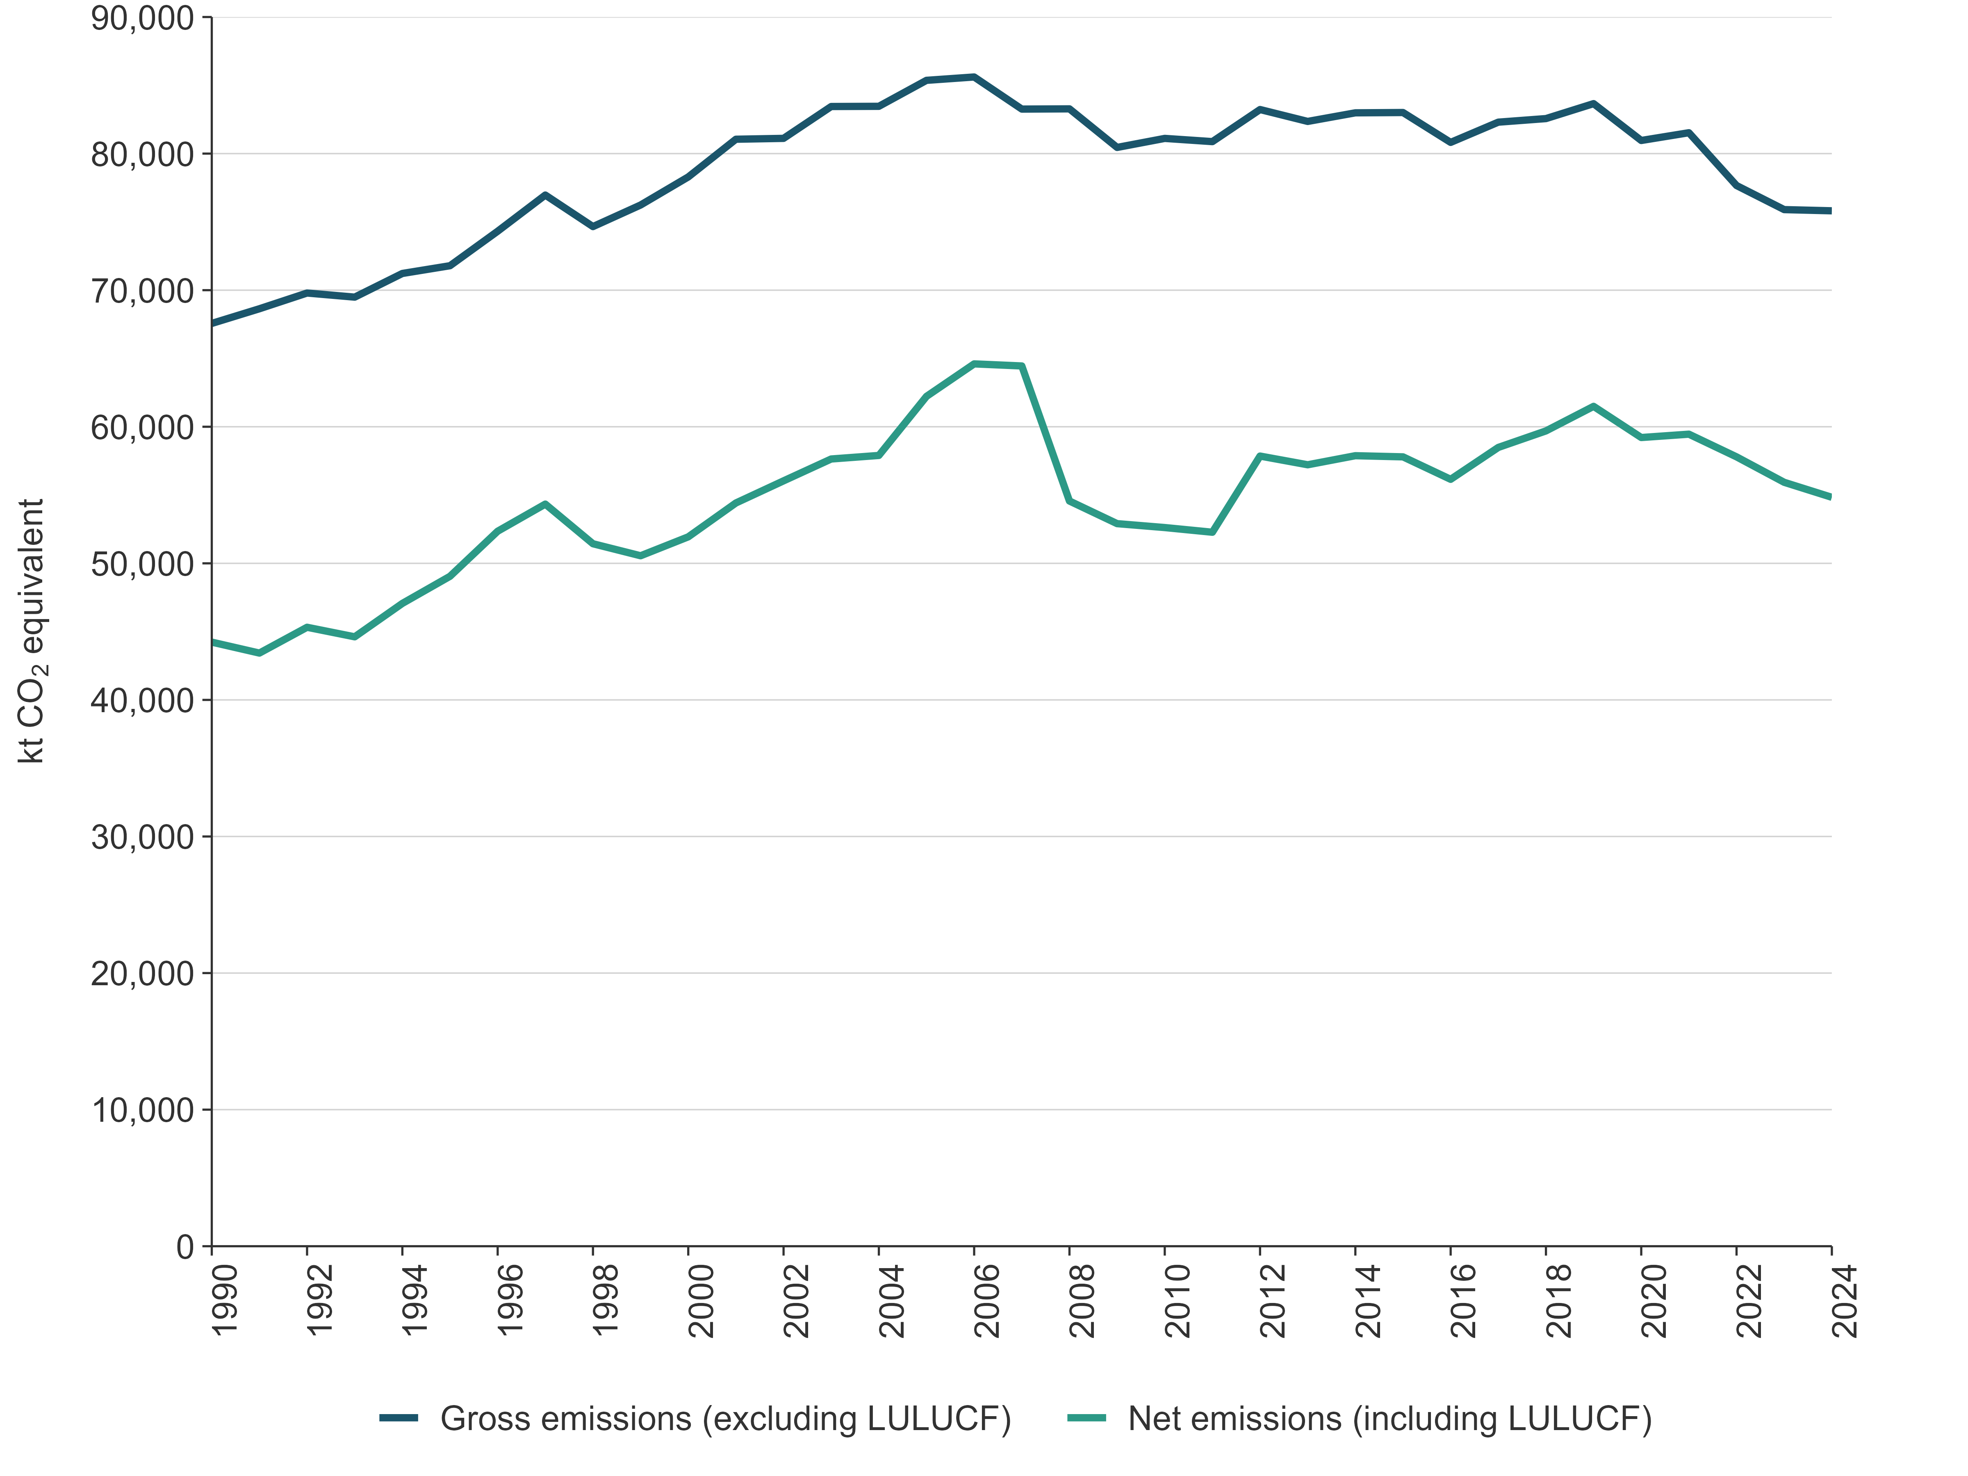

Net emissions
Net emissions include gross emissions, as defined above (i.e., from the Energy, IPPU, Agriculture and Waste sectors, including Tokelau), and net emissions from the LULUCF sector.

2023–2024
In 2024, New Zealand’s net emissions were 54,834.1 kt CO₂e.
Between 2023 and 2024, New Zealand’s net emissions decreased by 2.0 percent (1,098.3 kt CO₂e). This decrease was dominated by the decrease in net emissions of 5.1 percent (-1,011.0 kt CO₂e) from the LULUCF sector. The largest contributors by category to the decrease in net emissions were from:
- Land converted to forest land (CO₂)
- Land converted to grassland (CO₂)
- Manufacturing industries and construction (CO₂)
- Enteric fermentation from Sheep (CH₄)
- Commercial/institutional energy use (CO₂).
The reductions in net emissions from Land converted to forest land were due to an increase in growth-related removals. The reductions in net emissions from Land converted to grassland were driven by lower deforestation rates.

2005–2024
In 2005, New Zealand’s net emissions were 62,225.5 kt CO₂e. Between 2005 and 2024, New Zealand’s net emissions decreased by 11.9 percent (7,391.4 kt CO₂e) to 54,834.1 kt CO₂e (figure ES 2.1).
The categories that contributed the most to the decrease in net emissions between 2005 and 2024 were:
- Land converted to grassland (CO₂)
- Public electricity and heat production (CO₂)
- Enteric fermentation from Sheep (CH₄)
- Forest land remaining forest land (CO₂)
- Enteric fermentation from Non-dairy cattle (CH₄).

1990–2024
In 1990, New Zealand’s net emissions were 44,230.7 kt CO₂e. Between 1990 and 2024, net GHG emissions increased by 24.0 percent (10,603.4 kt CO₂e) to 54,834.1 kt CO₂e (figure ES 2.1).
The categories that contributed the most to the increase in net emissions between 1990 and 2024 were:
- Land converted to forest land (CO₂)
- Enteric fermentation from Dairy cattle (CH₄)
- Road transportation (CO₂)
- Agricultural soils (N₂O)
- Product uses as substitutes for ODS (HFCs).

Greenhouse gas trends
Inventory reporting under the Convention covers the following direct GHGs: CO₂, CH₄, N₂O, SF₆, PFCs, HFCs and NF₃. No NF₃ data are included in this report because NF₃ emissions do not occur in New Zealand.
Table ES 2.1 provides a summary of emissions for each gas in 1990, 2005 and 2024 and the changes since 1990.
Table ES 2.1 New Zealand’s gross emissions by gas in 1990, 2005 and 2024
Direct greenhouse gas emissions | 1990 | 2005 | 2024 | Change from 1990 (kt CO₂e) | Change from 1990 (%) | Change from 2005 (kt CO₂e) | Change from 2005 (%)
CO₂ | 25,521.7 | 37,427.1 | 31,436.2 | 5,914.4 | 23.2 | -5,990.9 | -16.0
CH₄ | 36,318.3 | 40,453.2 | 36,514.1 | 195.8 | 0.5 | -3,939.2 | -9.7
N₂O | 4,886.6 | 6,722.2 | 6,726.5 | 1,839.9 | 37.7 | 4.3 | 0.1
HFCs | Not occurring | 673.1 | 1,042.8 | 1,042.8 | NA | 673.1 | NA
PFCs | 818.0 | 62.4 | 78.1 | -740.0 | -90.5 | 15.7 | 25.1
SF₆ | 20.6 | 26.2 | 14.0 | -6.6 | -32.0 | -12.2 | -46.6
Gross, all gases | 67,565.2 | 85,364.3 | 75,811.6 | 8,246.4 | 12.2 | -9,552.7 | -11.2
Note: Gross emissions exclude net emissions from the LULUCF sector. The percentage change for HFCs is not applicable (NA) because no emissions of hydrofluorocarbons (HFCs) occurred in 1990. Columns may not total due to rounding. Percentages presented are calculated from unrounded values.
Figure ES 2.2 presents the absolute change in gross emissions for each gas (LULUCF is excluded from the estimate of gross emissions), and the change between 1990, 2005 and 2024 estimates in kt CO₂e.
Figure ES 2.2 New Zealand’s gross emissions by gas in 1990, 2005 and 2024
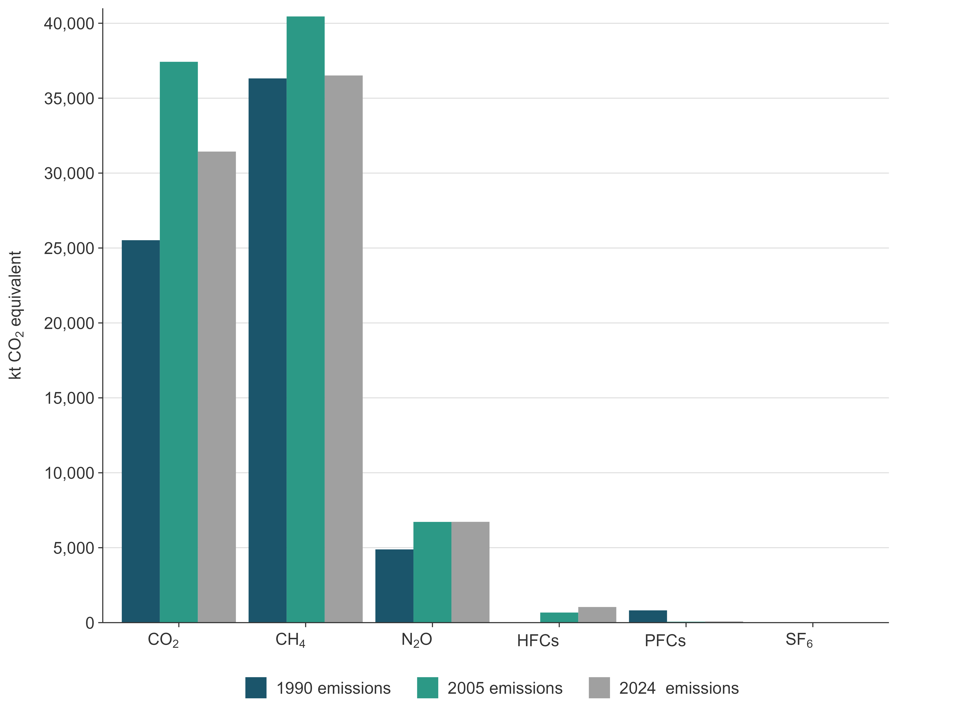
Note: Emissions of sulphur hexafluoride (SF₆) are not visible, due to its small emissions value, and emissions of hydrofluorocarbons (HFCs) did not occur in 1990.
In 1990 and 2024, CH₄ made the greatest contribution to gross emissions (see figure ES 2.2). While emissions of CH₄ have increased between these years, the rate of increase in CH₄ emissions relative to other gases in the Inventory has been lower over the same period. Nitrous oxide and CO₂ emissions have increased at a greater rate between these years than CH₄.
These trends reflect the changes that have occurred in the main livestock types that are farmed in New Zealand and the growth in road transport.
In 2024, net emissions from the LULUCF sector were -20,977.5 kt CO₂e, which offset 27.7 percent of New Zealand’s gross GHG emissions. This comprised net emissions of -21,217.6 kt CO₂, 49.2 kt CO₂e of CH₄ and 191.0 kt CO₂e of N₂O.

ES.3 Overview of source and sink category emissions estimates and trends
Figure ES 3.1 shows the contribution to net emissions that each inventory sector has made since 1990. The Agriculture and Energy sectors have dominated New Zealand’s gross emissions profile. Together, these sectors produced 90.4 percent of New Zealand’s annual gross GHG emissions from 1990 to 2024. The IPPU and Waste sectors produced relatively small amounts of GHGs, each contributing between 4.5 percent and 5.1 percent of annual gross emissions across the time series.
Conversely, the LULUCF sector was a net sink of GHG emissions between 1990 and 2024.
Figure ES 3.1 Trends in New Zealand’s greenhouse gas emissions by sector, from 1990 to 2024
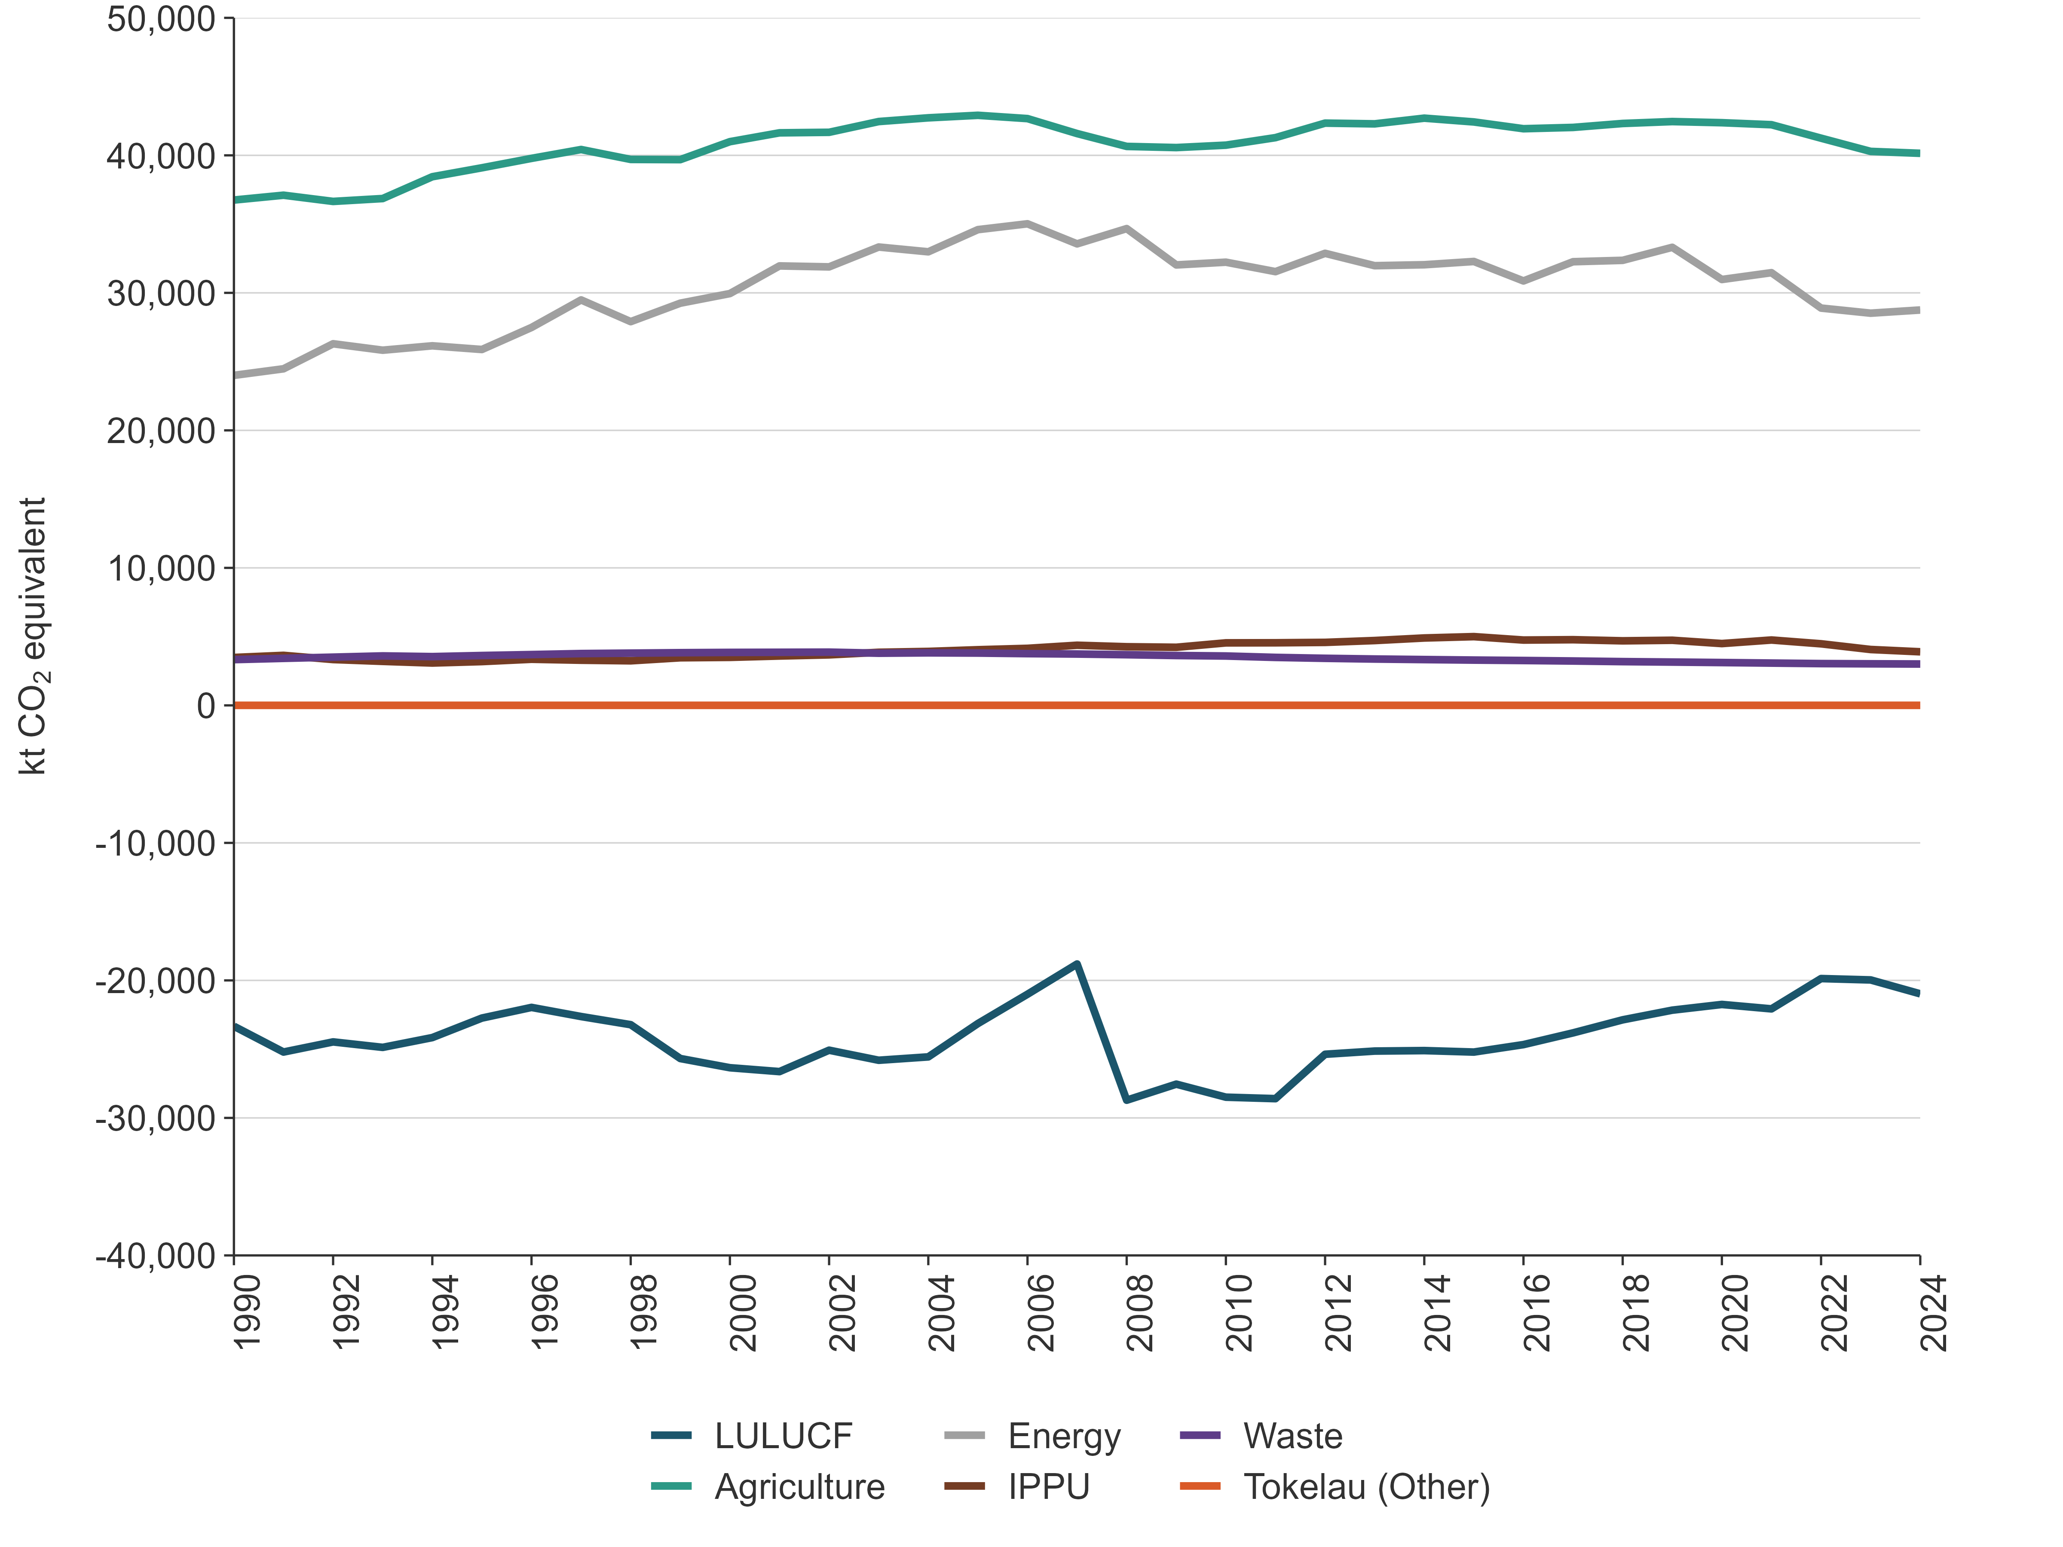

Energy (chapter 3)

2024
In 2024, emissions from the Energy sector were 28,753.2 kt CO₂e, or 37.9 percent of New Zealand’s gross GHG emissions (see figure 2.2.1).
The largest sources of emissions in the Energy sector were the Road transportation category, contributing 12,555.7 kt CO₂e (43.7 percent), and the Manufacturing industries and construction category, contributing 5,396.5 kt CO₂e (18.8 percent) to energy emissions.

2023–2024
Between 2023 and 2024, emissions from the Energy sector increased by 0.8 percent (231.4 kt CO₂e). This was primarily due to an increase in Public electricity and heat production (up 970.6 kt CO₂e or 35.5 percent). This increase was partially offset by the Chemicals category, which decreased by 590.4 kt CO₂e (45.0 percent), and Food processing, beverages and tobacco, which decreased by 205.8 kt CO₂e (7.6 percent). Further information on these changes is provided under the relevant categories of chapter 3, section 3.2.
National energy consumption in 2024 declined 2.1 percent from the 2023 level, and was 9.9 percent below the pre-COVID-19 peak seen in 2019.

2005–2024
Between 2005 and 2024, emissions from the Energy sector decreased by 16.9 percent (5,843.4 kt CO₂e). The largest reduction came from Public electricity and heat production, which decreased by 5,299.7 kt CO2e (58.8 percent). While total electricity generation grew by 6 percent over the same period, the share from renewable sources increased significantly – from 66 percent to 85 percent – driven by expanded geothermal and wind capacity. This reduction in emissions was partially offset by a 1,338.5 kt CO₂e (11.9 percent) increase from Road transportation.
Restrictions on activity and movement as part of the response to the COVID-19 pandemic during the 2020 calendar year brought significant disruption to economic activity throughout New Zealand. The effects on the Energy sector are particularly notable, with national energy consumption remaining below 2019 levels. The sector rebounded slightly during 2021, but energy consumption has remained well below pre-2020 levels in the following years.

1990–2024
Between 1990 and 2024, emissions from the Energy sector increased by 19.8 percent (4,753.4 kt CO₂e). The main contributors to this increase were Road transportation (up 5,727.3 kt CO₂e or 83.9 percent), Food processing, beverages and tobacco (up 823.4 kt CO₂e or 49.3 percent) and Residential (up 407.1 kt CO₂e or 27.9 percent). While the drivers of these changes are complex, key factors include population growth and increased economic activity.
The largest decrease since 1990 occurred in Manufacture of solid fuels and other energy industries, historically a significant source of emissions. Emissions from this category fell by 1,460.3 kt CO₂e (85.7 percent), primarily due to the cessation of synthetic gasoline production in 1997.
Figure ES 3.1 shows the time series of Energy sector emissions from 1990 to 2024. Emissions rose steadily between 1990 and 2006, driven by population and economic growth, which in turn increased demand for transport and industrial energy. Road transportation emissions rose sharply due to high reliance on private vehicles and freight trucking. Manufacturing activity, particularly in energy-intensive sectors such as food processing and chemicals, also contributed to the upward trend.
After 2006, emissions declined slightly and then remained stable until 2019. Since 2019, emissions have decreased mainly due to the effects of the COVID-19 pandemic response and ongoing economic conditions. These factors, combined with lower-than-expected gas supply, have led to reductions in industrial energy use.

IPPU (chapter 4)

2024
In 2024, emissions from the IPPU sector were 3,896.7 kt CO₂e, or 5.1 percent, of New Zealand’s gross greenhouse gas emissions.
The Metal industry was the largest category of emissions, with substantial CO₂ emissions from the Iron and steel production and Aluminium production categories, as well as PFCs from the Aluminium production category in earlier years. The Mineral industry and Chemical industry categories also contributed significant CO₂ emissions, and most of the non-CO₂ emissions were from the Product uses as substitutes for ODS category.
The IPPU sector also produces smaller amounts of CH₄ from methanol production and N₂O used for medical applications in the Other product manufacture and use category.
Coal and natural gas were also used for energy generation in these industries, and related emissions were reported under the Energy sector in the Manufacturing industries and construction category.

2023–2024
Between 2023 and 2024, emissions from the IPPU sector decreased by 166.6 kt CO₂e (4.1 percent).
This change was mainly the result of decreased emissions from the Refrigeration and air conditioning, Chemical industry and Mineral industry categories. Although emissions increased elsewhere, the overall result was a net reduction in total IPPU emissions.

2005–2024
Between 2005 and 2024, emissions from the IPPU sector had decreased by 149.4 kt CO₂e (3.7 percent).
Between 2005 and 2024, while emissions from Product uses as substitutes for ODS rose by 369.5 kt CO₂e (10 percent), this increase was offset by the Mineral industry and Chemical industry categories, which decreased by 272.1 kt CO₂e (6.5 percent) and 174.9 kt CO₂e (4.3 percent), respectively.
Restrictions on activity and movement as part of the response to the COVID-19 pandemic during the 2020 calendar year saw significant disruption to economic activity throughout New Zealand. Activity levels and emissions from the IPPU sector dropped between 2019 and 2020. The IPPU sector saw a rebound in 2021, however, activity and emissions continued to drop in the following years.
In addition to COVID-19 pandemic related restrictions, New Zealand’s methanol production has also been subject to disruption over this period. Methanex New Zealand has operated two methanol production facilities: Motonui and Waitara Valley. In November 2004, production at the Motunui plant was halted following insufficient gas supply in 2003, with operations resuming in late 2008. Output further increased at Motonui in 2012, and production at full capacity resumed in December 2013. The Waitara Valley plant was shut down in early 2021. A shortage of natural gas supply and energy security concerns led to a halt in methanol production between August to October 2024 to free up natural gas for use in electricity generation. As a result, emissions in the Methanol category decreased by 64 percent between 2019 (i.e., pre-COVID-19 levels) and 2024.
There was also a 19 percent reduction in emissions of PFCs due to improved management of anode effects in the Aluminium production category. Emissions of N₂O used for medical applications in the Other product manufacture and use category is nearly four times higher in 2024 compared with 2005. However, several initiatives led by Health New Zealand Te Whatu Ora are seeking to reduce the emissions associated with N₂O by decommissioning reticulated systems to avoid leakage into the atmosphere.

1990–2024
Between 1990 and 2024, emissions from the IPPU sector had increased by 11.9 percent (413.1 kt CO₂e). This increase was mainly driven by increasing emissions from the Product uses as substitutes for ODS category, due to the introduction of HFCs to replace ODS in refrigeration and air conditioning, and the increased use of household and commercial air conditioning.
There were large drops in PFC emissions from the Aluminium production category. The biggest reductions occurred between 1990 and 1993, where emissions decreased by 77 percent. This was due to better operational practices in the industry that decreased anode effects emissions.

Agriculture (chapter 5)

2024
In 2024, emissions from the Agriculture sector were 40,148.4 kt CO₂e, representing 53.0 percent of New Zealand’s gross GHG emissions.
Methane from Enteric fermentation was the main source of Agriculture sector emissions, contributing 78.7 percent (31,558.3 kt CO₂e) of the sector’s emissions. Agricultural soils (15.3 percent) was the second largest source followed by Manure management (4.3 percent). Urea application and Liming CO₂ contributed 1.1 percent and 0.6 percent, respectively. Field burning of agricultural residues contributed less than 0.1 percent.
Methane emissions from Enteric fermentation contributed 41.7 percent of New Zealand’s gross emissions, and N₂O emissions from the Agricultural soils category contributed 8.1 percent of New Zealand’s gross emissions.

2023–2024
Between 2023 and 2024, emissions from the Agriculture sector decreased by 0.3 percent (138.1 kt CO₂e). This change was largely due to a decrease in emissions from sheep and some types of fertiliser application. Specifically:
- sheep emissions decreased by 3.9 percent (364.4 kt CO₂e), due to a continuing reduction in the sheep population
- urea emissions decreased by 8.6 percent (43.0 kt CO₂e), due to a reduction in the mass of nitrogen applied as urea
- limestone emissions decreased by 13.2 percent (36.1 kt CO₂e), due to a reduction in the application of limestone.
These decreases were partially offset by increased emissions from dairy cattle and non-dairy cattle. Specifically:
- dairy cattle emissions increased by 1.1 percent (222.2 kt CO₂e), due to an increase in milk production. Compared with the 2022 to 2023 season, there was a 2.3 percent (about 471 million litres) increase in milk volume and a 2.9 percent (55 million kilograms) increase in milksolids processed (LIC and DairyNZ, 2025). These improvements in productivity occurred alongside a 0.5 percent decrease in the dairy cattle population.
- non-dairy cattle emissions increased by 0.3 percent (25.6 kt CO₂e), due to an increase in the non-dairy (beef) cattle population.
Total emissions from synthetic nitrogen fertiliser (CO₂and N₂O) increased by 1.5 percent (25.0 kt CO₂e). Emissions from non-urea synthetic nitrogen fertilisers increased by 85.2 percent (144.0 kt CO₂e), due to an increase in nitrogen application.

2005–2024
Between 2005 and 2024, emissions from the Agriculture sector had decreased by 6.4 percent (2,763.6 kt CO₂e) (see chapter 5, table 5.1.1).
In 2005, Agriculture sector emissions were 42,912.0 kt CO₂e. By 2007 emissions had dropped by around 1,300 kt CO₂e (3.1 percent below the 2005 value), due to the Global Financial Crisis. By 2008, Agriculture emissions had reduced by another 900 kt CO₂e (5.3 percent below the 2005 value), due to the compounding effect of a nationwide drought. In the following years, Agriculture emissions recovered and most recently peaked in 2014 at 42,704.0 kt CO₂e (0.5 percent below the 2005 value), corresponding with a peak in overall cattle numbers. In the years 2015 to 2021, Agriculture emissions remained slightly below the 2014 peak. In 2022 and 2023, Agriculture emissions dropped significantly. The 2024 level is 0.3 percent below the 2023 level (see chapter 5, figure 5.1.2).
The greatest absolute contributions to the decrease since 2005 are a 2,817 kt CO₂e (8.2 percent) decrease in emissions from Enteric fermentation, a 369.8 kt CO₂e (60.9 percent) decrease in emissions from Liming, and a 65.3 kt CO₂e (1.1 percent) decrease in emissions from Agricultural soils (see chapter 5, table 5.1.1 and figure 5.1.1).
The decrease in emissions from Enteric fermentation and Agricultural soils is primarily a result of decreased livestock populations since 2005.
Sheep populations have fallen by 40.9 percent since 2005, resulting in a 38.4 percent decline in Enteric fermentation emissions (-5,122.6 kt CO₂e) and a 37.2 percent decline in Agricultural soils emissions (-411.6 kt CO₂e).
Non-dairy cattle populations have declined by 16.8 percent since 2005, resulting in a 14.7 percent decrease in Enteric fermentation emissions (1,237.3 kt CO₂e) and a 13.8 percent decrease in Agricultural soils emissions (152.6 kt CO₂e).
These reductions have been partially offset by increases in emissions from dairy cattle. Dairy cattle populations have increased 14.7 percent, leading to a 34.4 percent increase in Enteric fermentation emissions (4,035.1 kt CO₂e) and a 24.0 percent increase in Agricultural soils emissions (478.2 kt CO₂e). There has also been a 68.4 percent increase in emissions from dairy cattle Manure management (588.2 kt CO₂e) between 2005 and 2024, due to both the increasing population of dairy cattle and the increased prevalence of anaerobic lagoons as a manure management system rather than pasture.
Changes in livestock populations reflect relative profitability across animal sectors, with dairy farming becoming more profitable than sheep or non-dairy cattle farming over the reporting period. In addition, average emissions per dairy cow have increased over time due to higher milk production per animal, heavier liveweights and increased feed intake, which increases emissions per head.
The decrease in emissions from Liming is driven by reduced application of lime and dolomite fertilisers.

1990–2024
Between 1990 and 2024, New Zealand’s Agriculture sector emissions had increased by 9.2 percent (3,398.4 kt CO₂e) (chapter 5, table 5.1.1). The greatest contributions to the increase since 1990 were a 1,667.1 kt CO₂e (37.4 percent) increase in emissions from Agricultural soils, an 865.9 kt CO₂e (101.7 percent) increase in emissions from Manure management and a 515.1 kt CO₂e (1.7 percent) increase in emissions from Enteric fermentation (chapter 5, table 5.1.1 and figure 5.1.1).
The increase in N₂O emissions from Agricultural soils was primarily a result of increased application of synthetic nitrogen fertiliser. This had increased by 553.0 percent since 1990. The increased use of nitrogen fertiliser has been largely driven by the growth and intensification of dairy farming, as well as increased use of nitrogen on other farm types, such as sheep and non dairy cattle. The N₂O emissions (direct and indirect) from synthetic nitrogen fertiliser use had increased by 1,000.0 kt CO₂e between 1990 and 2024. This was 60.0 percent of the total increase in emissions from Agricultural soils.
The increase in emissions from Manure management and Enteric fermentation was driven by an increase in dairy cattle numbers. The increase in dairy Enteric fermentation emissions was partially offset by a decline in sheep numbers and a decrease in non-dairy (beef) cattle. The change in animal populations since 1990 reflects the relative financial returns in each sector. It has become more profitable to farm dairy cattle than non-dairy cattle or sheep in New Zealand over the reporting period.

LULUCF (chapter 6)

2024
In 2024, net emissions from the LULUCF sector were -20,977.5 kt CO₂e, or 27.7 percent of New Zealand’s gross GHG emissions. This comprises net emissions of -21,217.6 kt CO₂, emissions of 49.2 kt CO₂e of CH₄ and 191.0 kt CO₂e of N₂O. The category contributing the most to both removals and emissions is Forest land remaining forest land. This is because large removals result from the growth of all forests on this land and there are also large emissions from the sustainable harvest of New Zealand’s plantation forests.
Emissions in the LULUCF sector are primarily driven by the harvest of production forests, deforestation and the decomposition of organic material following these activities. Removals are mainly from the sequestration of carbon that occurs due to plant growth and the production of wood products from harvested timber. Nitrous oxide can be emitted from the ecosystem as a by-product of nitrification and denitrification, and the burning of organic matter. Other gases released during biomass burning include CH₄, carbon monoxide (CO), other oxides of nitrogen (NO_{x}) and non-methane volatile organic compounds (NMVOCs).

2023–2024
Between 2023 and 2024, net emissions from the LULUCF sector had decreased by 1,011.0 kt CO₂e (5.1 percent) (see chapter 6, table 6.1.1).
The largest change occurred in the Grassland category, with a decrease in emissions of 827.1 kt CO₂e, driven by less deforestation in 2024 compared with 2023 (chapter 6, figure 6.4.4). Forest land had the second-largest change, with a decrease in net emissions of 701.2 kt CO₂e. Interannual variation in Forest land is mainly driven by changes within planted forests. In Forest land remaining forest land, changes in growth-related removals, harvest emissions and the deadwood carbon pool, increased net emissions between 2023 and 2024. In Land converted to forest land, this increase was offset by a decrease in net emissions due to decreased harvest emissions and an increase in growth-related removals. Harvested wood products had the third-largest change, with an increase in emissions of 480.5 kt CO₂e due to losses from decay being greater than inputs as harvest stabilised between 2023 and 2024.

2005–2024
Between 2005 and 2024, net emissions had increased by 2,161.3 kt CO₂e (9.3 percent) (see chapter 6, table 6.1.2). The largest change occurred in Forest land, with an increase in net emissions of 14,244.3 kt CO₂e, because a larger proportion of planted forests were harvested in 2024 compared with 2005 levels (chapter 6, figure 6.4.3). The Grassland had the second-largest change, with a decrease in emissions of 11,174.7 kt CO₂e, driven by a reduction in conversions from Forest land to Grassland. Harvested wood products had the third-largest change, with a reduction in emissions of 771.1 kt CO₂e. This was driven by an increase in the inputs to the harvested wood products pool following the increased planted forest harvest.

1990–2024
Between 1990 and 2024, net emissions had increased by 10.1 percent (2,357.0 kt CO₂e) (chapter 6, table 6.1.3 and figure 6.1.1).
This was largely due to an overall increase in net emissions from Forest land compared with 1990 levels. The increase in net emissions from Forest land was driven by relatively high harvest rates (chapter 6, figure 6.4.3), a result of significant afforestation beginning in the 1980s that peaked in the mid-1990s (chapter 6, figure 6.4.1). The planted forests that were established during this period have progressively been reaching harvesting age, so while the total area of forest has increased since 1990, a larger proportion of planted forests were harvested in 2024 compared with 1990 levels. Harvesting and replanting cycles of New Zealand’s planted forests will continue to affect the trajectory of New Zealand’s net emissions in the future, due to their uneven age-class profile. The increase in emissions is compensated for, to some extent, by a reduction in net emissions in Harvested wood products. Carbon losses in Forest land due to the harvest of timber are transferred to Harvested wood products, where the carbon is treated as a gain and its decay and emissions to the atmosphere are estimated based on product type. The net fluxes in Harvested wood products, therefore, represent the balance between the inputs transferred into the pool and the outputs leaving the pool from decay or disposal over time.
Net emissions in the LULUCF sector have been generally increasing over the past decade. The fluctuations in net emissions from the LULUCF sector observed since 1990 (see figure ES 3.1) were primarily influenced by afforestation, harvesting and deforestation rates.
Afforestation and deforestation rates were driven by the profitability of forestry, relative to alternative land uses, and policy impacts.
Harvesting rates are driven by several factors, particularly forest age and log prices. Current harvest rates are at near historically high levels due to the significant land-use changes to forest land that occurred from the 1980s and into the early 1990s.

Waste (chapter 7)

2024
In 2024, emissions from the Waste sector contributed 3,009.1 kt CO₂e or 4.0 percent of New Zealand’s gross GHG emissions. The largest source category is Solid waste disposal, as shown in chapter 7, table 7.1.1.

2023–2024
Between 2023 and 2024, emissions from the Waste sector decreased by 0.5 percent (14.1 kt CO₂e), mainly due to lower CH₄ emissions from the Managed waste disposal sites category. This was driven by improved LFG capture and changes in waste composition, including reduced garden, food and paper waste.

2005–2024
Between 2005 and 2024, emissions from the Waste sector had decreased by 20.9 percent (795.8 kt CO₂e). This sustained reduction in CH₄ emissions reflects the implementation of improved management practices, such as LFG capture, along with a substantial decrease in the amount of organic waste sent to landfills.

1990–2024
Between 1990 and 2024, emissions from the Waste sector had decreased by 9.6 percent (319.4 kt CO₂e).
Annual emissions peaked at 3,871.6 kt CO₂e in 2002 and have generally declined since then. While population growth and increased economic activity since 1990 have driven an overall rise in the volumes of solid waste and wastewater throughout the time series, ongoing improvements in managed waste disposal sites have contributed to a downward pattern in total Waste sector emissions since 2005. This reduction was primarily attributable to increased CH₄ recovery through the installation of LFG capture systems, supported by the introduction of National Environmental Standards for Air Quality in 2004 and the inclusion of the Waste sector in the New Zealand Emissions Trading Scheme in 2013. These legislative tools have been complemented by local government efforts to improve kerbside collections, including for organic waste, across the country, and by a central government waste work programme that includes product stewardship, plastic phase-outs and investment in resource recovery infrastructure for organic materials.
Trends in annual Waste sector emissions are shown in figure ES 3.1.

Other (Tokelau – chapter 8)
New Zealand reports emissions from Tokelau, which is a dependent territory of New Zealand. Due to the application of different methods and the complexity of integrating emissions within the main sectors, Tokelau emissions are reported for all activities under the ‘Other’ sector of the Inventory.

2024
In 2024, emissions from Tokelau contributed 0.006 percent (4.21 kt CO₂e) to New Zealand’s gross emissions.
The largest source category was Domestic navigation (emissions from marine vessels within Tokelau), which contributed 63.2 percent (1.43 kt CO₂e) of all energy emissions and 34.1 percent of gross emissions from Tokelau.
Carbon dioxide dominated emissions from Tokelau, contributing 54.5 percent (2.29 kt CO₂e) of its total emissions in 2024. At 2.25 kt CO₂, the Energy sector contributed 98.3 percent of total CO₂ emissions, mostly from Domestic navigation, with the remaining 1.7 percent (0.04 kt) coming from Open burning of waste in the Waste sector.
Methane emissions contributed 39.3 percent (1.66 kt CO₂e) to the total emissions from Tokelau. The Agriculture sector in Tokelau contributed 55.8 percent of CH₄ emissions (0.92 kt CO₂e), which mostly came from Manure management. A significant portion of CH₄ emissions, 43.9 percent (0.73 kt CO₂e), came from the Waste sector, largely from Solid waste disposal. The Energy sector contributed the remaining 0.4 percent of CH₄ emissions (0.01 kt CO₂e), which mostly came from Domestic navigation.
Nitrous oxide emissions contributed 1.2 percent (0.05 kt CO₂e) to the total emissions from Tokelau. The IPPU sector (Medical applications) contributed the largest amount of N₂O, 55.7 percent (0.03 kt CO₂e) of the total N₂O. The Energy sector contributed a further 24.1 percent (0.01 kt CO₂e), which comes largely from Domestic navigation. The Waste sector contributed the remaining 20.2 percent of N₂O (0.01 kt CO₂e) from Open burning of waste.
Emissions of fluorinated gases from Tokelau consisted of HFC emissions only, contributing 5.0 percent (0.21 kt CO₂e) to the total emissions from Tokelau. These emissions largely result from the use of Stationary air conditioning. Emissions of PFCs, NF₃ and SF₆ do not occur in Tokelau.

2023–2024
Between 2023 and 2024, emissions from Tokelau had increased by 0.01 percent (0.0006 kt CO₂e). Emissions for 2024 were reported as largely unchanged from 2023, due to insufficient quantitative activity data available for the 2024 reporting year. Anecdotal evidence suggests that diesel fuel consumption patterns were similar across these years for energy generation in the Energy industries – Public electricity and heat production category.
While the activity data between these years were unchanged for all categories, the increase in emissions was the result of CH₄ emissions from Solid waste disposal. Emissions from Solid waste disposal are calculated using a first order decay model outlined in volume 5 of the 2006 IPCC Guidelines for National Greenhouse Gas Inventories (IPCC, 2006b) which reflects how buried waste breaks down slowly over time. This means the emissions in any given year depend on the waste disposed in all previous years rather than the waste disposed this year. As a result, emissions change even when the activity data have not changed.

2005–2024
Between 2005 and 2024, emissions from Tokelau had decreased by 10.6 percent (0.50 kt CO₂e). This change was mainly the result of reductions in emissions from the Agriculture sector. This was due to a reduction in the number of both pigs and chickens. Emissions from the Energy sector decreased overall between 2005 and 2024, due to the installation of solar photovoltaic (PV) systems in 2012. The increases and decreases in Energy sector emissions between 2012 and 2024 are further explained in chapter 8, section 8.3.1. Emissions from the IPPU sector increased slightly between 2005 and 2024, primarily due to the growth in the number of air conditioning units during this period. Emissions from the Waste sector for Tokelau have remained steady between 2005 and 2024.

1990–2024
Between 1990 and 2024, emissions from Tokelau had increased by 24.8 percent (0.84 kt CO₂e) (chapter 8, table 8.1.3 and figure 8.1.4). From 1990 to 2024, the average annual increase in gross emissions was 0.87 percent.
The emissions increase was largely due to changes in the Energy sector. The emission categories that contributed the most to this change were Domestic navigation and Electricity generation.
The changes in Domestic navigation were a result of Tokelau gaining ownership and use of the ferry Mataliki in 2016, cargo vessel Kalopaga in 2018 and Fetu o te Moana in 2019, leading to an increasing number of sea voyages between the atolls, which increased transport emissions.
The changes in Tokelau’s Energy sector emissions from Electricity generation drive the overall emissions trend observed across most of the time series. Initially, up until 2003, emissions from this source were relatively stable. A significant increase in emissions (of nearly 400 percent) was then observed between 2003 and 2011, due to an increase in the use of diesel generators for electricity production. This was followed by a significant drop in emissions occurring in 2012 and 2013 (by 82.5 percent), when solar electricity generation began. Toward the end of the time series, diesel generator use increased again as the generation from solar power decreased, with emissions increasing accordingly.
Emissions from Tokelau’s IPPU sector had also increased, mainly due to the introduction of air conditioning after 2006. Emissions from Tokelau’s Agriculture sector had decreased as a result of a reduced population of pigs and chickens.

ES.4 Other information

Indirect gases
New Zealand reports emissions estimates of indirect gases in accordance with the 2006 IPCC Guidelines (volume 1, chapter 7) (IPCC, 2006a). These indirect gases are CO, NO_{X}, NMVOCs and sulphur dioxide (SO₂). These gases are not greenhouse gases themselves and are not included in the national emissions totals; however, CO, NO_{X} and NMVOCs chemically alter the atmosphere, leading to an increase in tropospheric ozone concentrations, and SO₂ contributes to aerosol formation. Table ES 4.1 summarises New Zealand’s indirect GHG emissions in 1990, 2005 and 2024 as well as the change between these years.
Table ES 4.1 New Zealand’s indirect greenhouse gas emissions (excluding LULUCF) in 1990, 2005 and 2024
Indirect greenhouse gas emissions | 1990 | 2005 | 2024 | Change from 1990 (kt CO₂e) | Change from 1990 (%) | Change from 2005 (kt CO₂e) | Change from 2005 (%)
CO | 622.6 | 741.8 | 650.7 | 28.1 | 4.5 | -91.1 | -12.3
NMVOCs | 143.7 | 178.7 | 171.1 | 27.4 | 19.1 | -7.6 | -4.3
NO_{X} | 102.5 | 164.9 | 150.0 | 47.4 | 46.3 | -14.9 | -9.0
SO₂ | 58.6 | 87.8 | 49.8 | -8.8 | -14.9 | -38.0 | -43.3
Note: Columns may not total due to rounding. Percentages presented are calculated from unrounded values.

ES.5 Key category analysis
The 2006 IPCC Guidelines (IPCC, 2006a) identify a key category as one that is prioritised within the national inventory system because its estimate has a significant influence on a country’s total inventory of direct GHGs in terms of the absolute level of emissions, the trend in emissions, or both. Key categories identified within the Inventory are used to prioritise where to improve emissions estimates.
The categories that had the largest relative influence on the national trend in gross emissions are presented in table ES 5.1.
Table ES 5.1 Key categories with the largest relative influence on the national trend, compared with the average change in gross emissions from 1990 to 2024
IPCC category | Gas | Absolute contribution to trend (%) | Trend direction
Enteric fermentation – Sheep | CH₄ | 22.7 | Decrease
Option A – Dairy cattle | CH₄ | 18.6 | Increase
Transport – Road transportation | CO₂ | 12.0 | Increase
Energy industries – Manufacture of solid fuels and other energy industries | CO₂ | 3.9 | Decrease
The categories that had the largest relative influence on the trend in net emissions are presented in table ES 5.2.
Table ES 5.2 Key categories with the largest relative influence on the national trend, compared with the average change in net emissions from 1990 to 2024
IPCC category | Gas | Absolute contribution to trend (%) | Trend direction
Enteric fermentation – Sheep | CH₄ | 16.4 | Decrease
Carbon stock change – Forest land remaining forest land | CO₂ | 15.1 | Decrease
Carbon stock change – Land converted to forest land | CO₂ | 13.9 | Increase
Option A – Dairy cattle | CH₄ | 10.1 | Increase
Details and results of the key category assessments are presented in volume 2, annex 1.

ES.6 Improvements introduced
The Inventory follows a process of continuous improvement consistent with the IPCC principles. The 2006 IPCC Guidelines (IPCC, 2006a) provide guidance on building and maintaining inventories that are consistent, comparable, complete, accurate and transparent in a manner that improves the quality of the Inventory over time. Improvements are made from one year to the next, to address findings from international technical expert reviews, correct errors and implement additional changes planned by the agencies involved in preparing the Inventory.
When improvements are made, it is good practice to recalculate the whole time series back to 1990 to ensure a consistent time series. This means estimates of emissions and/or removals in a given year may differ from emissions and/or removals reported in the previous submission.
A range of improvements has been made to the Inventory since the last submission. The main improvements by sector are outlined below. Chapter 10 provides further information on the recalculations made to the estimates.
The overall impact of improvements on New Zealand’s gross emissions was a decrease of 0.2 percent (113.7 kt CO₂e) in 1990, a decrease of 0.2 percent (180.7 kt CO₂e) in 2005 and a decrease of 0.7 percent (517.4 kt CO₂e) in 2023.
The overall impact of improvements on New Zealand’s net emissions estimates, which include the LULUCF sector, was an increase of 2 percent (885.9 kt CO₂e) in 1990, an increase of 1.7 percent (1,043.1 kt CO₂e) in 2005 and a decrease of 0.5 percent (286.7 kt CO₂e) in 2023.
The emissions impact of improvements introduced are provided in relation to 1990 (the Convention base year), 2005 (New Zealand’s Nationally Determined Contribution base year) and the previous year inventoried, being the last year in the time series that can be compared using previous methods.

Energy (chapter 3)
Improvements and recalculations made to the Energy sector have resulted in a decrease of 1.1 percent (329.1 kt CO₂e) in estimated energy emissions for 2023, an increase of 0.0002 percent (0.1 kt CO₂e) in estimated energy emissions for 2005 and an increase of 0.0004 percent (0.1 kt CO₂e) in estimated energy emissions for 1990.
Revisions to data provided by fuel companies has resulted in changes to the allocation of jet A1 between international and domestic aviation for the period January 2022 to September 2024.
Historical energy demand data in the national energy balance tables are occasionally revised from year to year. This may result in minor revisions to activity data and recalculations to the corresponding emissions for some years in some categories.
Further details on source-specific improvements are provided in the corresponding sections in chapters 3 and 10.

IPPU (chapter 4)
Improvements and recalculations made to the IPPU sector have resulted in an increase of 0.8 percent (31.7 kt CO₂e) in estimated IPPU emissions in 2023, an increase of 0.6 percent (25.9 kt CO₂e) in estimated IPPU emissions in 2005 and an increase of 0.01 percent (0.5 kt CO₂e) in estimated IPPU emissions in 1990.
Improvements made in the Refrigeration and air conditioning category, to better account for changes in stocks held by importers and users, had the largest impact on the sector.
Further details on source-specific improvements are provided in the corresponding sections in chapters 4 and 10.

Agriculture (chapter 5)
Improvements and recalculations made to the Agriculture sector have resulted in a decrease of 0.8 percent (326.5 kt CO₂e) in estimated Agriculture emissions in 2023, a decrease of 0.6 percent (249.7 kt CO₂e) in estimated Agriculture emissions in 2005 and a decrease of 0.4 percent (165.1 kt CO₂e) in estimated Agriculture emissions in 1990.
Several improvements were made to the Agriculture sector for this submission. These include incorporating updates to dairy manure and effluent management practices, updating the emission factor value for non-urea synthetic fertiliser, and alignment with the 2019 Refinement to the 2006 IPCC Guidelines for National Greenhouse Gas Inventories (2019 IPCC Refinement) (IPCC, 2019). A number of error corrections and improvements to the Agriculture inventory model code were undertaken. It is now also possible to include the impact of a new mitigation technology (EcoPond™) in dairy cattle emissions.
Further details on source-specific improvements are provided in the corresponding sections in chapters 5 and 10.

LULUCF (chapter 6)
Improvements and recalculations made to the LULUCF sector have resulted in a decrease of 1.1 percent (230.7 kt CO₂e) in estimated net LULUCF removals in 2023, a decrease of 5 percent (1,223.8 kt CO₂e) in estimated net LULUCF removals in 2005 and a decrease of 4.1 percent (999.5 kt CO₂e) in estimated net LULUCF removals in 1990.
Methodological improvements applied in the LULUCF sector for this submission were an improvement to the modelling of harvest age, and new country-specific emissions in the Grassland category to replace default values.
Activity data improvements occurred in the Forest category - for permanent forest area and areas of deforestation.
Further details on source-specific improvements are provided in the corresponding sections in chapters 6 and 10.

Waste (chapter 7)
Improvements and recalculations made to estimates in the Waste sector have resulted in a 3.7 percent (106.5 kt CO₂e) increase in emissions in 2023, a 1.1 percent (43.0 kt CO₂e) increase in emissions in 2005 and a 1.6 percent (50.9 kt CO₂e) increase in emissions in 1990.
For the 2026 submission, three source categories have undergone significant updates. These include updates to how emissions are estimated in Managed waste disposal sites, Unmanaged waste disposal sites and Waste incineration and open burning of waste.
Further details on source-specific improvements are provided in the corresponding sections in chapters 7 and 10.

Other (Tokelau – chapter 8)
Improvements and recalculations made to emissions estimates for Tokelau have resulted in an increase of 0.1 percent (0.004 kt CO₂e) in 2023, no change in 2005 and no change in 1990.
One minor update was made to Tokelau’s GHG inventory estimates since the 2025 submission. This change reflects updates in New Zealand’s medical emissions data, which are applied to Tokelau on a per capita basis.
Further details on this source-specific improvement are provided in the corresponding section in chapters 8 and 10.

Improvements to national inventory system
No changes were made to the legal or institutional arrangements of the national inventory system.

Executive summary: References
IPCC. 2006a. Eggleston HS, Buendia L, Miwa K, Ngara T, Tanabe K (eds). 2006 IPCC Guidelines for National Greenhouse Gas Inventories. Volume 1. General Guidance and Reporting IPCC National Greenhouse Gas Inventories Programme. Japan: Institute for Global Environmental Strategies for IPCC.
IPCC. 2006b. Eggleston HS, Buendia L, Miwa K, Ngara T, Tanabe K (eds). 2006 IPCC Guidelines for National Greenhouse Gas Inventories. Volume 5. Waste. IPCC National Greenhouse Gas Inventories Programme. Japan: Published for the IPCC by the Institute for Global Environmental Strategies.
IPCC. 2019. Calvo Buendia E, Tanabe K, Kranjc A, Baasansuren J, Fukuda M, Ngarize S, Osako A, Pyrozhenko Y, Shermanau P, Federici S (eds). 2019 Refinement to the 2006 IPCC Guidelines for National Greenhouse Gas Inventories. Published: IPCC, Switzerland.
LIC (Livestock Improvement Corporation Limited) and DairyNZ. 2025. New Zealand Dairy Statistics
2024–25. Hamilton: DairyNZ. Retrieved 17 December 2025.
UNFCCC. 2018. FCCC/PA/CMA/2018/3/Add.2. Report of the Conference of the Parties serving as the meeting of the Parties to the Paris Agreement on the third part of its first session, held in Katowice from 2 to 15 December 2018. Addendum 2. Part two: Action taken by the Conference of the Parties serving as the meeting of the Parties to the Paris Agreement.
UNFCCC. 2021. FCCC/PA/CMA/2021/10/Add.2. Report of the Conference of the Parties serving as the meeting of the Parties to the Paris Agreement on its third session, held in Glasgow from 31 October to 13 November 2021. Addendum Part two: Action taken by the Conference of the Parties serving as the meeting of the Parties to the Paris Agreement at its third session.

Chapter 1: National circumstances, institutional arrangements and cross-cutting information

1.1 Background information on greenhouse gas inventories and climate change
Greenhouse gases (GHGs) in Earth’s atmosphere trap warmth from the sun and make life as we know it possible. The Intergovernmental Panel on Climate Change (IPCC) Sixth Assessment Report (IPCC, 2021) confirms that the evidence showing humans have an influence on the climate system is unequivocal. Human-induced climate change is evident in extreme weather events all around the world. Events such as heatwaves, severe rainfall and droughts have become more frequent and extreme as a result of climate change and will continue to intensify.
Some of the changes to the climate system, including sea-level rise and loss of glaciers, are irreversible over centuries to millennia. The rate and magnitude of these committed changes, however, still depend on future GHG emissions.
Greenhouse gas inventories are essential for understanding humanity’s impact on climate change by measuring how much heat-trapping gas enters or is removed from the atmosphere. They inform climate policy and global stocktakes, and provide evidence for checking the validity of climate commitments.

1.1.1 United Nations Framework Convention on Climate Change and the Paris Agreement
The IPCC was established by the United Nations Environment Programme and the World Meteorological Organization in 1988. Its initial task was to prepare a comprehensive review and recommendations with respect to the state of knowledge of the science of climate change; the social and economic impact of climate change; and potential response strategies and elements for inclusion in a possible future international convention on climate. In 1990, it concluded that human-induced climate change was a threat to our future.
In response, the United Nations General Assembly convened a series of meetings that culminated in the adoption of the United Nations Framework Convention on Climate Change (UNFCCC or the Convention) at the Earth Summit in Rio de Janeiro in May 1992.
The Convention has been signed and ratified by 197 nations, including New Zealand, and took effect on 21 March 1994.
The main objective of the Convention (UNFCCC, 1992, Article 2) is to achieve:
… stabilization of greenhouse gas concentrations in the atmosphere at a level that would prevent dangerous anthropogenic interference with the climate system. Such a level should be achieved within a time-frame sufficient to allow ecosystems to adapt naturally to climate change, to ensure that food production is not threatened and to enable economic development to proceed in a sustainable manner.
All countries that ratified the Convention (the Parties) are required to take action to address climate change, including by monitoring trends in anthropogenic GHG emissions. Producing the annual inventory of GHG emissions and removals fulfils this obligation. Parties are also obliged to protect and enhance carbon sinks and reservoirs, for example, forests, and implement measures that assist in national and/or regional climate change adaptation and mitigation. In addition, Parties listed in Annex II to the Convention commit to providing technology transfer, capacity building and financial assistance to non-Annex I Parties (developing country Parties).
Annex I Parties also agreed to aim to return GHG emissions to 1990 levels by the year 2000. Only a few Annex I Parties made appreciable progress towards achieving this aim. The international community recognised that the existing commitments in the Convention were not enough to ensure GHGs would be stabilised at a safe level. In response, in 1995, Parties launched a new round of talks to provide stronger and more detailed commitments for Annex I Parties. After two-and-a-half years of negotiations, the Kyoto Protocol was adopted in Kyoto, Japan, on 11 December 1997 with the goal of reducing emissions to 5 percent below 1990 levels. New Zealand ratified the Kyoto Protocol on 19 December 2002. The Protocol came into force on 16 February 2005.
The Kyoto Protocol only required Annex I Parties to reduce emissions. While research suggests that most Annex I Parties had met their emissions reduction targets, global emissions were continuing to increase.
To accelerate and intensify the actions and investments needed for a sustainable low-carbon future, Parties to the Convention reached a landmark agreement in Paris, France, on 12 December 2015: the Paris Agreement. New Zealand ratified the Paris Agreement on 4 October 2016.
One result of the extension (as of 13 November 2017) of New Zealand’s ratification of the Convention and the Paris Agreement is that New Zealand’s national inventory now includes GHG emissions and removals estimates from Tokelau.
Although the 1997 Kyoto Protocol technically remains in force, the Paris Agreement has, in effect, superseded the Kyoto Protocol as the principal regulatory instrument governing the global response to climate change.

1.1.2 Inventory reporting
New Zealand’s Greenhouse Gas Inventory (the Inventory) is the official annual report of all anthropogenic GHGs not controlled by the Montreal Protocol that occur in New Zealand and Tokelau.
A complete inventory submission contains two main components: the national inventory document and the common reporting tables (CRT). The Inventory fulfils New Zealand’s national inventory reporting obligations under both the Convention and the Paris Agreement, as agreed in decision 1/CP.24 of the Conference of the Parties to the UNFCCC (UNFCCC, 2018a). The Inventory has been prepared in accordance with chapter II of the Annex to the decision 18/CMA.1 Modalities, procedures and guidelines for the transparency framework for action and support referred to in Article 13 of the Paris Agreement (UNFCCC, 2018b) and decision 5/CMA.3 Guidance for operationalizing the modalities, procedures and guidelines for the enhanced transparency framework referred to in Article 13 of the Paris Agreement (UNFCCC, 2021).
Consistent with the modalities, procedures and guidelines and decision 5/CMA.3, emissions estimates provided in this inventory have been compiled in accordance with the 2006 IPCC Guidelines for National Greenhouse Gas Inventories (2006 IPCC Guidelines) (IPCC, 2006a) and the 2019 Refinement to the 2006 IPCC Guidelines for National Greenhouse Gas Inventories (IPCC, 2019). New Zealand has progressively improved its methods and data sources, and will continue to refine them as new evidence emerges and international practice advances. The aim is to ensure that the estimates of emissions are accurate, transparent, complete, consistent through time, and comparable with those produced in the inventories of other Parties.
Inventories are subject to a technical expert review process facilitated by the United Nations Climate Change (UN Climate Change) secretariat. The results of these reviews are available on the UN Climate Change website.
The Inventory reports on emissions and removals of the gases carbon dioxide (CO₂), methane (CH₄), nitrous oxide (N₂O), hydrofluorocarbons (HFCs), perfluorocarbons (PFCs), sulphur hexafluoride (SF₆) and nitrogen trifluoride (NF₃). The indirect GHGs, carbon monoxide (CO), sulphur dioxide, oxides of nitrogen and non-methane volatile organic compounds, are also reported in the Inventory. Only emissions and removals of the direct GHGs (CO₂, CH₄, N₂O, SF₆, PFCs, HFCs and NF₃) are included in the totals of gross and net emissions under the Convention and the Paris Agreement.
This inventory presents emissions for each of the non-carbon dioxide GHGs by volume and as carbon dioxide equivalents (CO₂e) using the 100-year time horizon global warming potential values contained in the IPCC Fifth Assessment Report (IPCC, 2013). Because GHGs vary in their radiative activity, and in their atmospheric residence time, converting emissions into CO₂e allows the integrated effect of emissions of the various gases to be compared.
The GHGs are reported under five sectors in accordance with those included in the 2006 IPCC Guidelines (IPCC, 2006b). These represent the main human activities that contribute to the release or capture of GHGs into, or from, the atmosphere:
- Energy
- Industrial Processes and Product Use (IPPU)
- Agriculture
- Land Use, Land-Use Change and Forestry (LULUCF)
- Waste.
Greenhouse gas emissions from Tokelau, New Zealand’s overseas dependent territory, are included in the Inventory. Because emissions from Tokelau are small, and the methodology used varies greatly between Tokelau’s inventory and the inventory for New Zealand’s mainland territory, emissions from Tokelau are reported separately in the Other sector.

1.2 A description of national circumstances and institutional arrangements

1.2.1 National entity or national focal point
In 2002, New Zealand enacted the Climate Change Response Act 2002 (CCRA). This enabled New Zealand to meet its international obligations under the Convention and Kyoto Protocol. The Act has subsequently been amended to enable New Zealand to meet its obligations under the Paris Agreement. A Prime Ministerial directive for the administration of the Act named the Ministry for the Environment (MfE) as New Zealand’s ‘inventory agency’. Part 3, section 32, of the Act specifies the following functions and requirements.
1) The primary functions of New Zealand’s inventory agency are to:
a) estimate New Zealand’s human-induced emissions by sources and removals by sinks of greenhouse gases on an annual basis
b) prepare the following reports for the purpose of discharging New Zealand’s obligations:
i) New Zealand’s annual inventory report under Articles 4 and 12 of the Convention
ii) report of information by New Zealand under Article 13 of the Paris Agreement
iii) New Zealand’s national communication (or periodic report) under Article 12 of the Convention.
2) In carrying out its functions, the inventory agency must:
a) identify source categories
b) collect data by means of:
i) voluntary collection
ii) collection from government agencies and other agencies that hold relevant information
iii) collection in accordance with regulations made under this Part (if any)
c) estimate the emissions and removals by sinks for each source category
d) undertake assessments on uncertainties
e) undertake procedures to verify the data
f) retain information and documents to show how the estimates were determined.
Compliance provisions in section 36 of the CCRA authorise inspectors to collect information needed to estimate emissions or removals of GHGs.

1.2.2 National Inventory System
New Zealand has a national system in place for inventorying anthropogenic emissions by sources and removals by sinks of all GHGs not controlled by the Montreal Protocol.
New Zealand maintains a set of guidelines, the National Inventory System Guidelines, in which the tasks required to officially compile and submit the national inventory are documented. These guidelines cover multiple aspects of the production of the inventory, including: inventory management, inventory planning and preparation, quality-assurance and quality-control (QA/QC) processes, communication and error management.

Inventory planning and preparation
Figure 1.2.1 summarises the Inventory planning and preparation process.
Figure 1.2.1 Summary of New Zealand’s inventory planning and preparation
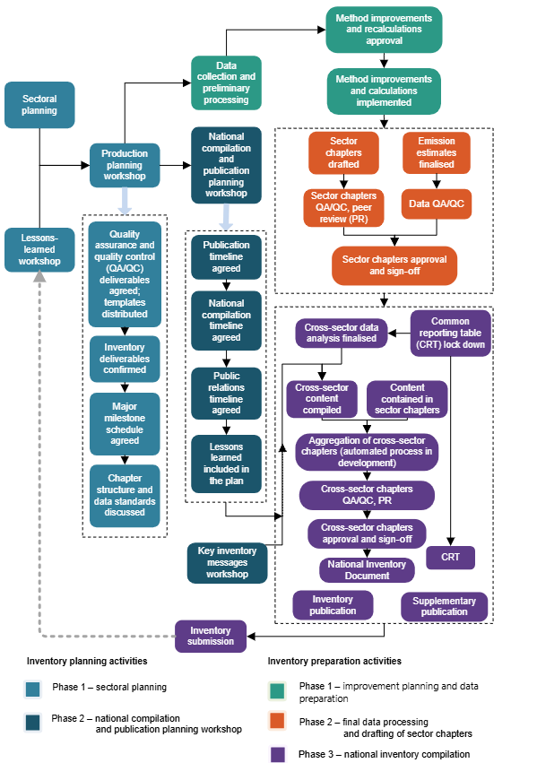

Inventory planning
Inventory planning takes place across two phases. The first phase, sectoral planning, focuses on preparing inventory compilation activities at the sector level. This includes identifying sector-specific technical projects, actions, improvements and procedures. Although this planning is largely sector driven, some elements depend on insights generated during the second phase of inventory planning, which includes lessons-learned reviews and production planning workshops. As a result, sector plans may need to be updated to reflect sector-specific requirements identified through the national compilation planning process.
The second phase, national compilation and publication planning, focuses on coordinating inventory activities across sectors. This phase includes a lessons-learned workshop, held after each inventory submission, followed by a second workshop, held towards the end of each calendar year dedicated to cross-sectoral compilation and publication planning. Participants typically include MfE’s publication and communication teams, sector leads and the inventory production team. During these sessions, participants confirm timelines for:
- national compilation
- publication
- public relations.
Lessons learned are also considered in developing the national compilation plans.
The inventory planning process for Tokelau is governed by a memorandum of understanding between New Zealand and Tokelau. For further information, see chapter 8.

Inventory preparation
The inventory preparation cycle consists of three phases.
Phase 1: Data collection and preliminary processing (June–October)
This phase involves cleansing and checking incoming data, as well as formatting data sets for subsequent analysis. It may also include the assessment of potential methodological improvements and any associated recalculations required for the Inventory.
Phase 2: Final data processing and chapter preparation (October–January)
During this phase, emissions estimates are finalised and undergo final quality control and verification. Data are then uploaded into the GHG Inventory Reporting Tool to populate the CRT. Sector chapters are drafted, updated, reviewed and approved.
Phase 3: National inventory compilation and publication (February–April)
The final phase includes cross-sector analyses, compilation of the Inventory and publication of results. Supplementary material is also prepared for the Minister of Climate Change and for public release.
Tokelau follows the same inventory preparation cycle.
During the inventory planning and preparation cycles, the National Inventory Compiler, technical lead, QA/QC lead and inventory project lead(s) hold regular meetings with sector leads and experts to ensure that requirements are delivered, risks are managed, issues are addressed and the production proceeds as planned. The inventory QA/QC lead also has regular meetings with sector leads to monitor QA/QC processes and procedures that are in place to ensure the quality of the final product meets the Paris Agreement and Convention reporting requirements and the QA/QC deliverables are produced according to the agreed plan.
Once cross-sectoral analyses have been completed, the key messages for the Inventory are developed. The key messages are used in the national inventory document and supplementary inventory summary materials published on MfE’s website.
The National Inventory Compiler, technical lead and the QA/QC lead provide technical support and advice to the sector leads when required.

1.2.3 Archiving of information
To provide data security and file recovery for the Inventory, the information and data are held in secured locations in MfE’s Microsoft 365 environment. MfE’s security policies and settings, including version control and retention, protect against data breach and data loss.
New Zealand’s inventory archiving system reflects the distributed system as follows.
- All files for the Inventory are stored in MfE’s secure file management system and backed up on several different devices held in different locations. This covers all data files and supplementary materials as part of the submission of the inventory document, CRT, database back-up files from the GHG Inventory Reporting Tool, sectoral chapters, the compiled inventory, confirmations of sign-off, communication between New Zealand’s inventory team and the technical expert review team, national inventory system documentation and other related documents for the Inventory.
- Each agency involved in inventory compilation keeps its data in secure file systems, including communication with contractors, activity data, emission factors, preliminary calculations and specific software applications containing sectoral data models.
- Each agency involved in inventory compilation has security procedures in case of natural disasters, fire, flood or other accidents, which are kept at a high standard.

1.2.4 Processes for official consideration and approval of the Inventory
New Zealand applies a hybrid (centralised-distributed) approach to the production of the Inventory. MfE, as New Zealand’s inventory agency, manages and coordinates the production, compilation and publication of the Inventory, and submits it to the UN Climate Change secretariat, in a centralised manner. The National Inventory Compiler is based at MfE. Designated government agencies carry out sector-specific work, which includes obtaining and processing activity data, estimating emissions, preparing sectoral CRT files and writing sectoral inventory chapters. Arrangements with these government agencies have evolved over time and continue to do so, as resources and capacity allow, in response to a growing understanding of the reporting requirements and when those requirements change.
Inventory governance within each sector, as well as sector-level quality control, is managed by the agency responsible for the sector. The Reporting Governance Group (RGG) provides cross-agency governance over New Zealand’s international climate change reporting obligations, including the production of the Inventory and projections of GHG emissions and removals for other international reports. The RGG is chaired by an MfE manager. Its membership includes representation from other teams within MfE, the Ministry for Primary Industries (MPI) and the Ministry of Business, Innovation and Employment (MBIE), as well as observers (Ministry of Foreign Affairs and Trade, Ministry of Transport, the Environmental Protection Authority (EPA), Government of Tokelau and Stats NZ). The RGG’s oversight includes:
- compilation of the Inventory on an annual basis
- compilation of emissions projections developed biennially for New Zealand’s biennial transparency reports
- LULUCF target accounting governance
- endorsement of methodological improvements and other significant improvements to Inventory estimates.
In addition to its overall inventory coordination role, MfE compiles estimates for the IPPU, LULUCF and Waste sectors and for Tokelau. This includes:
- compiling emissions estimates for the IPPU sector (non-CO₂ gases through industry surveys and the coordination of CO₂ emissions estimates with data provided by MBIE and the EPA)
- compiling emissions estimates for the Waste sector (sources of data include mandatory reporting under the Waste Minimisation Act 2008 (WMA) and the New Zealand Emissions Trading Scheme (NZ ETS) or through targeted surveys)
- compiling emissions and removals estimates for the LULUCF sector through a national data collection and modelling programme. The estimates are underpinned by analyses, research and modelling, including that undertaken at New Zealand’s public research organisations, universities and private research companies, or delivered in partnership with other central government agencies, including MPI and the Department of Conservation
- compiling emissions estimates for Tokelau, requiring coordination of the preparation of Tokelau’s inventory data and information with the Tokelau Ministry of Climate, Oceans and Resilience.
MBIE estimates all emissions from the Energy sector based in part on NZ ETS returns.
MPI estimates emissions from the Agriculture sector. The estimates are underpinned by research and modelling undertaken at New Zealand’s public research organisations, universities and private research companies, and by survey data collected by Stats NZ, New Zealand’s key statistics agency, and key sector organisations.
The Tokelau Ministry of Climate, Oceans and Resilience and the Tokelau National Statistics Office coordinate efforts in activity data collection and data processing to estimate emissions from Tokelau for all inventory sectors.
The CCRA establishes the requirement for an emissions trading registry and a registrar. The EPA is the designated agency responsible for managing the administration of the NZ ETS and implementing and operating New Zealand’s national registry, the New Zealand Emissions Trading Register.
The EPA collects and publishes information on emissions. The inventory arrangements are presented in figure 1.2.2, which shows the specific responsibilities of different agencies involved in the inventory production as well as their contribution to the submission.
Figure 1.2.2 New Zealand’s inventory system at a glance: how different agencies are involved
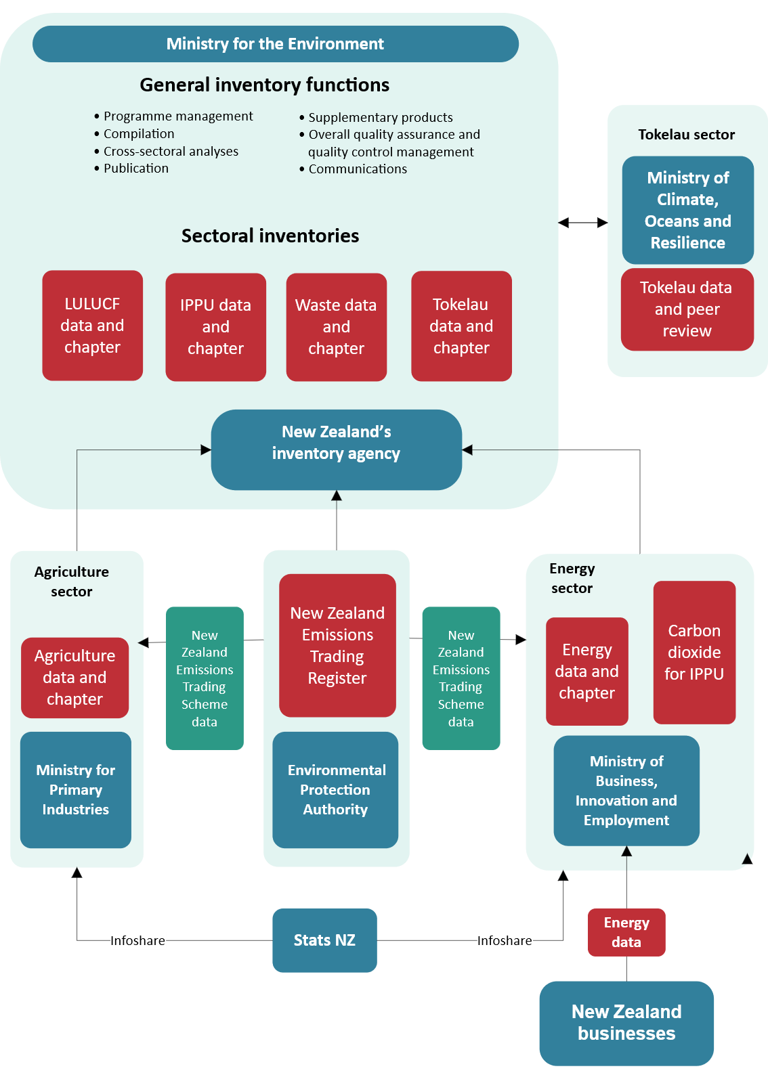
Note: CO₂ = carbon dioxide; IPPU = industrial processes and product use; LULUCF = land use, land-use change and forestry.
The National Inventory Compiler coordinates the calculation of level and trend uncertainties, along with key category assessment, and finalises the Inventory. The Inventory is then approved for publication by New Zealand’s Secretary for the Environment or their delegate before submission to the UN Climate Change secretariat.
The Inventory is published on the MfE and UN Climate Change websites.

1.3 Brief general description of methodologies (including tiers used) and data sources used
The IPCC (2006a, 2019) provides methodologies for calculating emissions or removals by sector and category. The methodologies are provided in a structure of three tiers that describe and connect the various levels of detail at which estimates can be made. The choice of method depends on factors such as the importance of the inventory category and the availability of data. The tiered structure ensures that estimates calculated at a highly detailed level can be aggregated up to a common minimum level of detail for comparison with all other reporting countries. The methods for estimating emissions and/or removals are distinguished between the tiers as follows.
- Tier 1 methods apply IPCC default emission factors and use IPCC default methods.
- Tier 2 methods apply country-specific emission factors and use IPCC default methods.
- Tier 3 methods apply country-specific emission factors and use country-specific methods.
This section provides a brief description of the methodology for each sector in the Inventory. Refer to each sector chapter for more details.

Energy
Greenhouse gas emissions from the Energy sector are calculated using a detailed sectoral approach that applies a mixture of Tier 1, Tier 2 and Tier 3 methods. Higher-tier methods are applied to key categories. This bottom-up approach is demand-based: it involves processing energy data collected on a regular basis through various surveys. For verification, New Zealand also applies the IPCC reference approach to estimate CO₂ emissions from fuel combustion for the time series 1990 to 2024 (see volume 2, annex 3).
The activity data used for the sectoral approach are referred to as observed energy-use figures. These are derived from surveys and questionnaires administered by MBIE. The differences between calculated and observed figures are reported as statistical differences in the energy balance tables released along with Energy in New Zealand (MBIE, 2025). Note that, due to the intervening time between the publication of Energy in New Zealand and the preparation of this submission, some data revisions may have occurred.

IPPU
New Zealand uses a combination of IPCC Tier 1 and Tier 2 methods for the IPPU sector. Tier 2 methods are used for all key categories. Country-specific emission factors are used where available, including for emissions of indirect GHGs.
For the Product uses as substitutes for ODS category, updated activity data are obtained through a detailed annual survey covering the electrical, refrigeration and other industry participants (Verum Group Ltd, unpublished), as well as importers of HFCs and other substances in this category.
For the small amounts of indirect GHG emissions reported in the Chemical industry category and the Other product manufacture and use category, data were obtained by a detailed industry survey and analysis in 2006 (CRL Energy, unpublished). Emissions and activity data have been extrapolated for the years since that time.

Agriculture
New Zealand has developed a largely Tier 2 methodology with country-specific emission factors for a range of emissions sources. This methodology uses detailed data on livestock population and production to calculate energy requirements for four major categories (Dairy cattle, Non-dairy (beef) cattle, Sheep and Deer). Other livestock are classified as ‘minor’ due to their small total contribution to agricultural emissions and are outlined below. Animal population data are collected by Stats NZ. Productivity data are available from the Livestock Improvement Corporation and industry organisations, such as Beef + Lamb New Zealand Ltd and Dairy NZ, which regularly collect animal sector statistics. Statistics on animal carcass weights are collected by MPI and are used to derive live weights.
Other livestock species combined (Swine, Goats, Horses, Llamas and alpacas, Mules and asses and Poultry) account for less than 0.5 percent of New Zealand’s agriculture emissions. Emissions from these minor livestock species are estimated using Tier 1 methods. Where information is available, New Zealand has used country-specific emission methodology and factors. There is no known farming of fur-bearing animals in New Zealand.
For estimating emissions from the Agricultural soils category, New Zealand uses methodologies based on the 2006 IPCC Guidelines (IPCC, 2006d), the outputs of the Tier 2 livestock population characterisation, modelling of the livestock nutrition and energy requirements, and data on the application of nitrogen fertilisers. New Zealand uses a combination of default and country-specific emission factors and parameters to calculate N₂O emissions from the Agricultural soils category.
Details on these emission factors and parameters are given in chapter 5 (tables 5.5.2, 5.5.3 and 5.5.4) and annex 5 (tables A5.1.5, A5.1.6 and A5.1.7). Chapter 5, table 5.5.5 contains the parameters used to estimate emissions where specific mitigation technologies are used. Activity data for the Liming category are obtained from Stats NZ, and activity data on the use of synthetic fertiliser containing nitrogen are provided by the Fertiliser Association of New Zealand. A Tier 2 (model) approach is used to calculate emissions from the Field burning of agricultural residues category. No rice cultivation or CO₂ emissions from other carbon-containing fertilisers occur in New Zealand.

LULUCF
New Zealand uses a combination of Tier 1, Tier 2 and Tier 3 methodologies for estimating emissions and removals for the LULUCF sector. Tier 2 or Tier 3 approaches have been applied to estimate biomass carbon in the categories with the most living biomass at maturity: Forest land (pre-1990 natural forest, pre-1990 planted forest, post-1989 natural forest, post-1989 planted forest), Perennial cropland, Low producing grassland, High producing grassland and Grassland with woody biomass. For all other land use categories, a Tier 1 approach is used for estimating biomass carbon. A Tier 2 modelling approach has also been used to estimate carbon changes in the mineral soil component of the soil organic matter pool, while Tier 1 is used for organic soils. Furthermore, a Tier 2 approach has been used to estimate carbon stock changes in Harvested wood products.
New Zealand has established a data collection and modelling programme for the LULUCF sector called the Land Use and Carbon Analysis System (LUCAS). The LUCAS programme includes:
- use of field plot measurements for natural and planted forests
- use of allometric models and a forest carbon modelling system to estimate carbon stock and carbon stock change in natural and planted forests respectively (Paul et al., 2021, unpublished(a), unpublished(b), unpublished(c); Paul and Wakelin, unpublished)
- wall-to-wall land use mapping for 1990, 2008, 2012, 2016 and 2020 using satellite and aircraft remotely sensed imagery, with additional information on post-1989 forest afforestation and deforestation of planted forest used for estimating the change
- development of databases and applications to store and process all data associated with LULUCF activities.

Waste
New Zealand applies Tier 2 methodologies for estimating emissions from the Solid waste disposal source category, which is a key category, and for some wastewater emissions. Tier 1 methodologies are used to estimate other emissions from the Waste sector.
Activity data are obtained from a variety of sources. Municipal solid waste disposal data are obtained from mandatory reporting under the WMA and the NZ ETS for the years available (2010 onwards). Non-municipal waste disposal data are also derived from mandatory reporting under the WMA from 2022 onwards. For all other sources, activity data are collected through targeted surveys. Interpolation based on gross domestic product or population is used for other years.
Country-specific emission factors are used where available, including parameters for municipal waste (Eunomia, unpublished) and for treatment of some types of industrial wastewater (Cardno, unpublished).
Methodological issues are discussed under each source category in chapter 7.

Tokelau
The Tokelau National Statistics Office collects and processes activity data from Tokelau for the preparation of the Inventory. Chapter 8, table 8.1.1 contains the key sources of the activity data from Tokelau used in Tokelau’s GHG inventory.
Tier 1 methodological approaches with default emission factors were used for estimating emissions from all Tokelau source categories.

1.4 Brief description of key categories
A key category as one that is prioritised within the national inventory system because its estimate has a significant influence on a country’s total inventory of direct GHGs in terms of the absolute level of emissions, the trend in emissions, or both (IPCC, 2006b).
Key categories identified within the Inventory are used to prioritise improvements.
The key categories in the Inventory have been assessed using Approach 1 level (L1) and Approach 1 trend (T1) methodologies from the IPCC (2006b). This is because some categories in the Inventory apply default uncertainty values for emissions estimates, and developing country-specific uncertainty values is resource prohibitive.
The key category analysis identifies the main sources and sinks of emissions by selecting those that make up 95 percent of total emissions (gross or net) in 1990 and the latest reporting year, as well as those that account for 95 percent of the change in emissions between 1990 and the latest reporting year. New Zealand does not currently use qualitative assessment to identify any key categories.
In accordance with the IPCC Guidelines (2006b), the key category analysis is performed on inventory sources excluding the LULUCF sector and then repeated for inventory sources and sinks including the LULUCF sector. Non-LULUCF categories that are identified as key in the first analysis are still included when they are not identified as a key category in the analysis that includes the LULUCF sector.
The GHG Inventory Reporting Tool also provides a key category analysis. The analyses performed for the Inventory differ from the analysis produced in the GHG Inventory Reporting Tool, to better reflect New Zealand’s emissions profile. Specifically, a large proportion of emissions from the Energy and Agriculture sectors is further disaggregated to allow for a more evenly proportioned analysis.
The major contributions to the level analysis of net emissions for 2024 are presented in table 1.4.1.
Table 1.4.1 Major contributions to the level analysis of net emissions for 2024
IPCC category | Gas | Level assessment (%)
Option A – Dairy cattle | CH₄ | 15.3
Carbon stock change – Forest land remaining forest land | CO₂ | 14.3
Transport – Road transportation | CO₂ | 12.1
Enteric fermentation – Sheep | CH₄ | 8.0
The key categories that were identified as having the largest relative influence on the trend, when compared with the average change in net emissions from 1990 to 2024, are presented in table 1.4.2.
Table 1.4.2 Key categories with the largest relative influence on the trend, compared with the average change in net emissions from 1990 to 2024
IPCC category | Gas | Absolute contribution to trend (%) | Trend direction
Enteric fermentation – Sheep | CH₄ | 16.4 | decrease
Carbon stock change – Forest land remaining forest land | CO₂ | 15.1 | decrease
Carbon stock change – Land converted to forest land | CO₂ | 13.9 | increase
Option A – Dairy cattle | CH₄ | 10.1 | increase
For gross emissions, the major contributions to the level analysis for 2024 are presented in table 1.4.3.
Table 1.4.3 Major contributions to the level analysis of gross emissions for 2024
IPCC category | Gas | Level assessment (%)
Option A – Dairy cattle | CH₄ | 20.8
Transport – Road transportation | CO₂ | 16.4
Enteric fermentation – Sheep | CH₄ | 10.8
Option A – Non-dairy cattle | CH₄ | 9.4
The key categories that were identified as having the largest relative influence on the trend, when compared with the average change in gross emissions from 1990 to 2024, are presented in table 1.4.4.
Table 1.4.4 Key categories with the largest relative influence on the trend, compared with the average change in gross emissions from 1990 to 2024
IPCC category | Gas | Absolute contribution to trend (%) | Trend direction
Enteric fermentation – Sheep | CH₄ | 22.7 | decrease
Option A – Dairy cattle | CH₄ | 18.6 | increase
Transport – Road transportation | CO₂ | 12.0 | increase
Energy industries – Manufacture of solid fuels and other energy industries | CO₂ | 3.9 | decrease
The full analyses and results of the key category assessments are provided in annex 1.

1.5 Brief general description of QA/QC plan and implementation
Quality assurance and quality control are integral parts of preparing the Inventory. The QA/QC plan (annex 4), required under the Paris Agreement (UNFCCC, 2018b), formalises the documentation and archiving of the QA/QC procedures. This plan has been updated over time as the QA/QC tools have been developed and, where possible, automated. Details of the QA/QC activities performed during the compilation of the 2026 submission are discussed in the relevant sections below. Examples of QA/QC checks are provided in the Excel spreadsheets accompanying this submission.
The focus of New Zealand’s QA/QC plan is to meet the transparency, accuracy, completeness, consistency and comparability (TACCC) principles while ensuring efficient use of resources, and to mitigate QA/QC-related risks in the inventory planning and preparation process.
The main elements of the plan include:
- revising the QA/QC deliverables to ensure they are fit for purpose, well supported with relevant templates, and adapted to the changes in the inventory software tools
- reinforcing the error-checking process by providing dedicated personnel and support to the sector leads
- applying automated inventory tools, where available, to minimise transcription errors
- adjusting QA/QC tools to accommodate any changes in the GHG Inventory Reporting Tool software that have been introduced since the previous submission
- performing data integrity checks in the GHG Inventory Reporting Tool and adhering to the reporting guidelines once data compilation in each sector is complete
- ensuring the chapters in the Inventory and their structure demonstrate transparency of the methods and incorporate suggestions from previous inventory reviews.
Tier 1 QC check sheets are completed by sector in line with the guidance provided by the IPCC (2006b). Wherever possible, manual checking is replaced by, or supplemented with, automated checks.
The sectoral contributions to the Inventory – that is, sector chapters and data preparation – and Tier 1 QC checks are signed off by the responsible agency before final approval of the Inventory by the national inventory agency (MfE) and its submission under the Convention and the Paris Agreement.
MfE uses the QC-checking procedures included in the GHG Inventory Reporting Tool where available to ensure the data submitted are complete. In addition, data in the GHG Inventory Reporting Tool are checked for anomalies, errors and omissions.
After the CRT are compiled for each inventory sector, the CRT data for each sector and category are reviewed by the inventory compilation project team for data integrity and time-series consistency before sector finalisation. The purpose of this review is to ensure that the CRT do not contain blank entries in the reported categories, and that all instances of using the ‘IE’ (included elsewhere) and ‘NE’ (not estimated) notation keys for GHG emissions, as well as large variations in the implied emission factors, have been explained. The results of these checks are provided to the sector leads so they can make any corrections and include the relevant references and explanations, if required, to finalise the CRT data for each inventory sector.
Annex 4 contains details of the QA/QC plan, including the processes applied during the preparation of the Inventory.

Improvement planning
New Zealand’s QA/QC system includes prioritisation of improvements, processes around accepting improvements into the Inventory, in-depth review of sector inventories or their components every 5 to 10 years, and improving the expertise of key contributors to compiling the Inventory. The government audit agency (Audit New Zealand) makes annual audits of the Inventory including assuring the QA/QC procedures were followed. New Zealand also considers the international technical expert reviews of the Inventory performed by qualified expert reviewers through the Enhanced Transparency Framework under the Paris Agreement as an important element of QA/QC. The main aspects of QA/QC system are explained in detail below.
All sector leads are encouraged to schedule sector-specific QA/QC audits of their systems at least every five years. Sector-specific examples are provided below.
The Energy sector lead discussed sectoral issues with the Danish inventory team during bilateral meetings in 2017 dedicated to different aspects of the Energy sectoral inventory. The specific issues covered were: data sources, data collection and verification processes; using NZ ETS data for higher-tier methods in the Energy sector; applying higher-tier methods for road transport; disaggregation of non-road liquid fuel use; and fugitive emissions from fuels. In 2019, an external consultant was contracted to review and develop a QA/QC plan for the Energy sector. Most recommendations from that review have already been implemented, and work continues on addressing the remaining issues. In 2024, as part of an audit of MBIE’s annual report (MBIE, 2024) – which features published data of GHG emissions from electricity generation as a performance indicator – Audit New Zealand carried out an independent, in-depth review of MBIE’s energy and emissions data process. The auditors examined the completeness and accuracy of MBIE’s emissions estimates and verified the integrity of the entire data processing chain from receipt of raw data to data entry, processing, calculation and reporting.
The Agriculture sector completed a major QA/QC review of its calculation models with an external party in 2013. Since then, other QA/QC activities for the Agriculture sector have included a bilateral review with Australia in 2014 and an external review of equations used to determine metabolisable energy requirements in 2016. From 2022 to 2023, the Agriculture calculation models were migrated from an Excel-based system combined with Visual Basic for Applications code to an R-based system. The attention to detail required to replicate the model also acted as a QA/QC review. The R model and Excel model were run in parallel over the 2023 reporting cycle and compared again in detail. The increased transparency of the R model allows for a greater level of oversight by the analysts in the inventory team, making future QA/QC of the calculations easier.
In 2024, MPI released a standard methodology and codebase for estimating on-farm emissions. The work to develop a farm-level emissions calculation methodology provided additional QA/QC because this work used the inventory model and methodology as a basis. This involved experts at MPI outside of the inventory team going through the calculations in detail to adapt them for the farm-level application. For more information, see chapter 5, section 5.1.6.

Prioritisation of improvements
Priorities for the development of the Inventory are guided by:
- the results of key category analyses (level and trend)
- the degree of improvement to be achieved for existing emissions and removal estimates
- the availability of resources required to implement the change
- recommendations from the technical expert review of the Inventory.
Uncertainties are also considered in prioritising improvements. For example, if a change in a methodological approach may lead to a significant increase in uncertainty of the estimates, then the proposed change may be rejected based on an undesired increase in uncertainty. Otherwise, if the proposed improvement is not expected to affect the uncertainty significantly or will reduce uncertainty, then the change is likely to be prioritised. Sector leads are encouraged to develop annual inventory improvement and QA and QC plans to reflect current and future developments for their sector of the inventory.

Acceptance of improvements and recalculations
All proposed methodological improvements in the Inventory undergo peer review by an independent expert or a group of experts to ensure that the improvement is consistent with IPCC guidelines (IPCC, 2006a; IPCC, 2019).
The RGG is responsible for:
- endorsing all methodological improvements to the Inventory estimates
- endorsing other improvements to the Inventory estimates (including updated activity data and/or error corrections), where the time-series recalculations are over 1 percent of the annual sector total in at least one year of the time series.
Given the significance of the Agriculture sector to New Zealand’s emissions, the Government established the Agriculture Inventory Advisory Panel (the Panel). The Panel is an independent group of experts who assess if proposed improvements and recalculations in the sector’s emissions are scientifically robust enough to include in the inventory. Reports and/or papers on proposed changes must be peer reviewed before they are presented to the Panel. The Panel then advises MPI of its recommendations. Refer to chapter 5, section 5.1.5 for further details.
The recalculations need to be sufficiently explained in terms of improving one or more of the TACCC principles. All improvements that are subject to the RGG endorsement process, including the results of, and justifications for any recalculations, are documented and archived for future reference.

Verification activities
Where relevant, further verification activities carried out for a sector are discussed in the sector-specific chapters of this report.
In the Energy sector, the reference approach is used to verify the emissions estimates for CO₂ obtained from the sectoral approach. Further detail is provided in volume 2, annex 3.

New Zealand Emissions Trading Scheme
The NZ ETS is one of the Government’s primary tools for reducing GHG emissions. This section explains the background of the NZ ETS and how the data collected for the NZ ETS have been used to verify CO₂ emissions in the Energy and IPPU sectors.

New Zealand Units
The NZ ETS is based on trading units that each represent 1 tonne of CO₂e, called New Zealand Units (NZUs), which are created and distributed by the New Zealand Government. The scheme was established through an amendment to the CCRA and came into effect progressively from 2008, with coverage since 2010 of all substantial emissions except agricultural CH₄ and N₂O.
Sectors under the scheme are required to report on their emissions and surrender units to the Government to cover their emissions. The Government supplies units for emissions removals through forestry and exports of emitting products from New Zealand. Units are also supplied as industrial allocation to firms carrying out activities that are emissions intensive and trade exposed, to address the risk of emissions leakage, and via quarterly auctions.
More information on the NZ ETS can be found on the MfE website.

Verification
Participants in the NZ ETS are required to record and report the GHG emissions for which they have obligations or if they are claiming NZUs for removing GHG emissions from the atmosphere. Participants with obligations are also required to annually surrender NZUs to cover their emissions. How participants estimate their emissions is set out in the regulations prescribed under the CCRA. The schedule for sectors entering the NZ ETS is detailed in table 1.5.1.
Data collected for the NZ ETS were used to verify the Inventory estimates for CO₂ emissions in the Energy and IPPU sectors (see chapter 3 and chapter 4 for further detail on the verification). Data from the NZ ETS were used as a primary source in the IPPU sector for the cement and lime industries, and in the Waste sector to verify activity data on municipal waste disposal. Data reported under the WMA have been used as the primary data (see chapter 7 for details).
The NZ ETS data are also used for verifying activity data in the LULUCF sector. Forest age, area and deforestation as reported under the NZ ETS are used for verifying the areas of pre-1990 planted forest, post-1989 forest and deforestation.
Table 1.5.1 Dates for sector entry into the New Zealand Emissions Trading Scheme
Sector | Voluntary reporting | Mandatory reporting | Obligations
Forestry | – | – | 1 January 2008
Transport fuels | – | 1 January 2010 | 1 July 2010
Stationary energy, including electricity production | – | 1 January 2010 | 1 July 2010
IPPU | – | 1 January 2010 | 1 July 2010
Synthetic gases | 1 January 2011 | 1 January 2012 | 1 January 2013
Waste | 1 January 2011 | 1 January 2012 | 1 January 2013
Agriculture | 1 January 2011 | 1 January 2012–November 2024 | –

Treatment of confidentiality issues
When specific emissions and activity data in the Inventory can result in identifying individuals and/or individual businesses and, therefore, affect their wellbeing, commercial interest in trade and/or negotiations, those data are considered to be confidential.
The Inventory is a Tier 1 statistic under New Zealand’s Official Statistics System. The inventory compilation process adheres to the Principles and Protocols for Producers of Tier 1 Statistics (Stats NZ, 2007). The relevant definition of confidentiality (protocol 4) is as follows.
- Confidentiality refers to the protection of individuals’ and organisations’ information, and ensuring that the information is not made available or disclosed to unauthorised individuals or entities.
- The protection of respondents’ information is a cornerstone of maintaining the integrity of the Official Statistics System.
Confidential data are aggregated to draw out the information that is important to the user, without disclosing confidential data (IPCC, 2006b). For New Zealand, confidentiality issues largely apply to sources of emissions in the Energy and IPPU sectors, where an entire industry or source category is often represented by just one or two companies. Therefore, a practice of presenting information as an ‘industry average’ is often not applicable in New Zealand because this would breach business confidentiality. Confidential information is held by the agencies preparing the inventory sector estimates (MPI, MBIE and MfE), and each agency has security procedures (e.g., password-restricted access to files on computers) to keep the data confidential.
To protect the confidentiality of businesses that contribute data to the Inventory, two approaches are used.
- Where emissions cannot be reported without compromising confidentiality, the corresponding activity data are not reported and are marked as confidential in the CRT.
- Where reporting emissions data would risk breaching confidentiality, the emissions data are aggregated with other emissions from a different source category. The notation key ‘IE’ (included elsewhere) is used.

1.6 General uncertainty assessment, including data pertaining to the overall uncertainty of inventory totals
Uncertainty estimates are an important part of producing a complete inventory. Their purpose is not to dispute the validity of the inventory estimates but to help prioritise efforts to improve the accuracy of inventories and guide decisions on methodological choice (IPCC, 2006b).
Inventories prepared in accordance with the IPCC guidelines (IPCC, 2006a; IPCC, 2019) contain a wide range of emissions estimates, varying from those that are well understood through to those that are more challenging to quantify.
New Zealand assesses uncertainty in its aggregated emissions using the IPCC’s Approach 1 (IPCC, 2006b). Uncertainties from individual categories are combined to estimate uncertainty for all emissions for the latest reporting year and the base year, as well as for the trend over time. Annex 2 (volume 2) provides detailed uncertainty results for net emissions (including LULUCF) in table A2.1.1, and for gross emissions (excluding LULUCF) in table A2.1.2.
Most uncertainty values are determined when New Zealand develops country-specific emission factors or collects activity data, using expert judgement from sectoral or industry experts, or by referring to uncertainty ranges provided by the IPCC (IPCC, 2006b, 2019). Uncertainty is first estimated at the lowest level where information and data exist.
These low-level uncertainties are then aggregated by sector up to the second-level category for each gas (CO₂, CH₄, N₂O and SF₆) or for groups of gases (HFCs and PFCs). The aggregated values are submitted to the inventory compilation team, who performing overall uncertainty calculations for gross and net emissions, including both level and trend.
In most cases, to aggregate uncertainties from subcategories, sectoral compilers use the IPCC’s Approach 1 (IPCC, 2006b, equation 3.2, page 3.28).
For more detail, refer to the sector-specific chapters.

Gross emissions

Level uncertainty assessment for 2024
The uncertainty in gross emissions (excluding emissions and removals from the LULUCF sector) in 2024 was ±8.6 percent. This is a decrease of 0.05 percentage points from that reported for 2023 in the previous submission. Emissions contributing the most to the overall uncertainty of gross emissions in 2024 were CH₄ from Agriculture – Enteric fermentation (±16.0 percent), at 6.7 percent, N₂O from Agriculture – Agricultural soils (±55.9 percent), at 4.5 percent, and CH₄ from Waste – Solid waste disposal (±89.4 percent), at 2.7 percent. The uncertainty in these categories reflects the inherent variability when estimating emissions from natural systems.

Level uncertainty assessment for 1990
The uncertainty in gross emissions in 1990 was ±9.0 percent. This is a decrease of 0.1 percentage points from that reported in the previous submission. Emissions of CH₄ from Agriculture – Enteric fermentation contributed 7.4 percent, N₂O from Agriculture – Agricultural soils contributed 3.7 percent and CH₄ from Waste – Solid waste disposal contributed 3.5 percent to the overall uncertainty of gross emissions in 1990.

Trend uncertainty assessment
The trend uncertainty in gross emissions (excluding emissions and removals from the LULUCF sector) from 1990 to 2024 was ±5.3 percent. This is a decrease of 0.1 percentage points from that reported in the previous submission. This decrease is primarily a result of a decrease in the Energy – Combustion of solid fuels uncertainties.

Net emissions

Level uncertainty assessment for 2024
The uncertainty in net emissions (including emissions and removals from the LULUCF sector) in 2024 was ±25.3 percent. There has been an increase of 0.5 percentage points in uncertainty from that reported for 2023 in the previous submission. Emissions contributing the most to the overall uncertainty of net emissions in 2024 were CO₂ from LULUCF – Forest land (±61.9 percent), at -21.2 percent, CH₄ from Agriculture – Enteric fermentation (±16.0 percent) at 9.2 percent and CO₂ from LULUCF – Harvested wood products (±68.2 percent) at -6.6 percent.

Level uncertainty assessment for 1990
The uncertainty in net emissions in 1990 was ±36.1 percent. This is a decrease of 0.8 percentage points from that reported in the previous submission.
Emissions of CO₂ from LULUCF – Forest land contributed -33.0 percent, CH₄ from Agriculture – Enteric fermentation contributed 11.2 percent and N₂O from Agriculture – Agricultural soils contributed 5.6 percent to the overall uncertainty of net emissions in 1990.

Trend uncertainty assessment
When emissions and removals from the LULUCF sector are included, the overall uncertainty in the trend from 1990 to 2024 was ±17.3 percent. This is a decrease of 2.7 percentage points from that reported in the previous submission. This decrease is primarily a result of a decrease in the LULUCF – Forest land uncertainties.

1.7 General assessment of completeness
Under the Paris Agreement, the level of completeness of reported sources in national inventories must be assessed. In accordance with IPCC guidelines (2006b), New Zealand has focused its resources for inventory development on the key and non-key categories that are mandatory.

1.7.1 Information on completeness

Emissions reported as ‘NE’ (not estimated)
The notation key ‘NE’ signifies that emissions and/or removals occur but have not been estimated or reported. According to chapter II of the Annex to the decision 18/CMA.1 (UNFCCC, 2018b), ‘NE’ may be used when the estimates would be insignificant in terms of level according to the following considerations.
- Emissions from a category should only be considered insignificant if the likely level of emissions is below 0.05 percent of the national total GHG emissions, excluding LULUCF, or 500 kt CO₂e, whichever is lower.
- The total national aggregate of estimated emissions for all gases from categories considered insignificant shall remain below 0.1 percent of the national total GHG emissions, excluding LULUCF.
Once emissions or removals have been estimated for a category, they must continue to be reported if they continue to occur.
The notation key ‘NE’ is also used when an activity occurs but the 2006 IPCC Guidelines (IPCC, 2006a) do not provide methodologies to estimate emissions and removals. If this is the case, the category is considered to be non-mandatory, providing the emissions from the category have not been reported previously.
New Zealand’s total (i.e., gross) emissions were 75,811.6 kt CO₂e in 2024. The threshold of 0.1 percent is 75.8 kt CO₂e and the threshold of 0.05 percent is 37.9 kt CO₂e. Both values are below 500 kt CO₂e.
The Inventory is largely complete. A few minor sources are not estimated due to a lack of available information, or because emissions are insignificant or methodologies to estimate emissions are not provided in the 2006 IPCC Guidelines.
Table 1.7.1 summarises New Zealand’s direct GHG emissions reported as ‘NE’ in the 2026 submission.
Table 1.7.1 Summary of ‘NE’ (not estimated) entries in the 2026 submission
CRT category code | Category | Gas | Explanation
Energy
1.B.2.a.5 | Distribution of oil products | CO₂, CH₄ | This category is not mandatory. The 2006 Intergovernmental Panel on Climate Change (IPCC) Guidelines do not provide the default IPCC emission factor for calculating Tier 1 estimates of methane (CH₄) emissions from the distribution of refined oil products (IPCC, 2006c). New Zealand has not reported emission estimates from this category in previous submissions.
1.B.2.b.3 | Processing | CO₂, CH₄ | In accordance with chapter II of the Annex to the decision 18/CMA.1 (UNFCCC, 2018b), this category is not mandatory. Fugitive emissions of carbon dioxide (CO₂) and CH₄ have not been formally estimated, although a rough estimate of the likely level of emissions indicates that they are insignificant.
 |  |  | While emissions from the Kapuni Gas Treatment Plant may include traces of CH₄, the level of these emissions has been determined to be insignificant in comparison with national emissions. A conservative estimate (using default emission factors from the 2006 IPCC Guidelines) gives nearly 1.7 kilotonnes carbon dioxide equivalent (kt CO₂e) per year (IPCC, 2006c).
 |  |  | CH₄: 625 Mm³ (Kapuni field production) * 9.7e-5 * 28 = 1.7 kt CO₂e.
 |  |  | The conservative estimated value is below 0.05 percent of New Zealand’s total emissions. This would keep the national total aggregate of estimated emissions for all gases and categories considered insignificant below 0.1 percent of the national total greenhouse gas emissions.
 |  |  | Carbon dioxide from gas processing is mostly associated with direct venting through a stack and, therefore, is reported under 1.B.2.c.1. However, there is a possibility of the presence of trace amounts of CO₂ from processing due to leakage, which is estimated to be no higher than 0.1 percent of vented CO₂. A conservative estimate of 0.1 percent of vented CO₂ from all categories is 0.26 kt, which is below 0.05 percent of New Zealand’s total emissions and thus can be considered insignificant.
1.B.2.c.i.2 | Venting – Gas | CH₄ | In accordance with chapter II of the Annex to the decision 18/CMA.1 (UNFCCC, 2018b), this category is not mandatory. While direct venting of CH₄ does not occur, the CO₂ stream may include traces of CH₄. The level of these emissions has been determined to be insignificant in comparison with national emissions. A conservative estimate (using default emission factors from the 2006 IPCC Guidelines) gives nearly 1.7 kt CO₂e per year (IPCC, 2006c).
 |  |  | CH₄: 625 Mm³ (Kapuni field production) * 9.7e-5 * 28 = 1.7 kt CO₂e.
 |  |  | The conservative estimated value is below 0.05 percent of New Zealand’s total emissions. This would keep the national total aggregate of estimated emissions for all gases and categories considered insignificant below 0.1 percent of New Zealand’s total emissions.
Industrial Processes and Product Use
2.G.2.e | Medical and other product use | C₂F₆ | In accordance with chapter II of the Annex to the decision 18/CMA.1 (UNFCCC, 2018b), this category is not mandatory. The level of emissions from this source has been determined to be insignificant in comparison with national emissions. No activity data are available before 2011. Based on 2011 to 2022 data, emissions of perfluoroethane (C₂F₆) from Medical and other product use are estimated to be approximately 2.6 t CO₂e per annum, which is below the significance threshold.
2.G.2.e | Medical and other product use | C₃F₈ | In accordance with chapter II of the Annex to the decision 18/CMA.1 (UNFCCC, 2018b), this category is not mandatory. The level of emissions from this source has been determined to be insignificant in comparison with national emissions. No activity data are available before 2011. Based on 2011 to 2022 data, emissions of perfluoropropane (C₃F₈) from Medical and other product use are estimated to be approximately 2.7 t CO₂e per annum, which is below the significance threshold.
Agriculture
3.A.4 | Poultry | CH₄ | This category is not mandatory. The 2006 IPCC Guidelines state (IPCC, 2006d, page 10.27, vol 4-2) that the Tier 1 method for estimating CH₄ emissions from enteric fermentation for poultry is not developed. Also, table 10.10 (IPCC, 2006d, page 10.28, vol 4‑2) indicates that there is insufficient research to establish a CH₄ emission factor for poultry for either developed or developing countries.
3.B(b) | N₂O per manure management system (MMS) – Anaerobic lagoon and daily spread | N₂O | This category is not mandatory. Direct N₂O emissions from the material managed in anaerobic lagoons (dairy and swine) and daily spread (swine) after being spread onto agricultural soils are reported under Agricultural soils. The IPCC guidelines assume that negligible direct N₂O emissions occur in anaerobic lagoons and daily spread, and only occur once the stored effluent is spread onto agricultural soil. For more information see sections 5.3.2 and 5.5.2.
3.D | Agricultural soils | CH₄ | The 2006 IPCC Guidelines do not provide methodologies for calculating CH₄ emissions from Agricultural soils (IPCC, 2006d).
3.I | Other carbon-containing fertilisers | CO₂ | This category is not mandatory. The 2006 IPCC Guidelines do not provide guidance for reporting on other carbon-containing fertilisers (IPCC, 2006d). Other carbon-containing synthetic fertilisers besides limestone, dolomite and urea are not applied to agricultural land in New Zealand.
Land Use, Land-Use Change and Forestry
4.A, 4.B, 4.C, 4.D | Forest land, cropland, grassland and wetlands: Drainage and rewetting and other management of organic and mineral soils | CH₄, N₂O | This category is not mandatory. No methodology is provided in the 2006 IPCC Guidelines for estimating emissions from this source category (IPCC, 2006d).
4.A.2 | Settlements converted to other land uses | CO₂ (losses) | This category is not mandatory. No methodology is provided in the 2006 IPCC Guidelines for calculating Tier 1 estimates of carbon stocks in living biomass for Settlements (IPCC, 2006d). Therefore, with land-use change from Settlements to other land uses, no carbon stock loss is reported. Because New Zealand uses the stock change approach, losses are only reported in years when new land is converted to this category, or where there is harvesting of forest in the year of conversion. When neither of these activities occurs, the losses are reported with biomass gains (stock change approach) and ‘IE’ (included elsewhere) is reported for biomass losses.
4.A.2, 4.C.2 | Other land converted to other land uses | CO₂ (losses) | This category is not mandatory. No methodology is provided in the 2006 IPCC Guidelines for calculating Tier 1 estimates of carbon stocks in living biomass for Other land (IPCC, 2006d). Therefore, with land-use change from Other land to other land uses, no carbon stock loss is reported. Because New Zealand uses the stock change approach, losses are only reported in years when new land is converted to this category, or where there is harvesting of forest in the year of conversion. When neither of these activities occurs, the losses are reported with biomass gains (stock change approach) and IE is reported for biomass losses.
4.A, 4.B, 4.C, 4.D, 4.F | Forest land, Cropland, Grassland, Wetlands and Other land: Rewetting and other management of organic and mineral soils | CO₂ | This category is not mandatory. No methodology is provided in the 2006 IPCC Guidelines for estimating emissions from this source category (IPCC, 2006d).
4.B.1, 4.B.2 | Land converted to cropland, Cropland remaining cropland | CO₂ (deadwood) | This category is not mandatory. No methodology is provided in the 2006 IPCC Guidelines for calculating Tier 1 estimates of carbon stock change in dead organic matter for land-use changes to this land use category (IPCC, 2006d). Any emissions reported are for loss of dead organic matter from the previous land use that occurs in the year of conversion.
4.B.1 | Cropland remaining cropland/4(V) Biomass burning/ Wildfires/ Cropland remaining cropland | CH₄, N₂O | New Zealand does not have sufficient information on biomass burning activities to reliably report on this.
4.B.2 | Land converted to cropland/4(V) Biomass burning/ Wildfires/Land converted to cropland | CH₄, N₂O | New Zealand does not have sufficient information on biomass burning activities to reliably report on this.
4.C.1, 4.C.2 | Land remaining grassland, Land converted to grassland | CO₂ (deadwood) | This category is not mandatory. No methodology is provided in the 2006 IPCC Guidelines for calculating Tier 1 estimates of carbon stock change in dead organic matter for land-use changes to this land use category (IPCC, 2006d). Any emissions reported are for loss of dead organic matter from the previous land use that occurs in the year of conversion.
4.D.1 | Wetlands remaining wetlands/4(V) Biomass burning/ Wildfires/ Wetlands remaining wetlands | CH₄, N₂O | This category is not mandatory. No methodology is provided in the 2006 IPCC Guidelines for calculating Tier 1 estimates of carbon stock changes in organic soils for this land use category (IPCC, 2006d). New Zealand does not have sufficient information on biomass burning activities to reliably report on this.
4.D.1, 4.D.2 | Wetlands remaining wetlands, Land converted to wetlands (except transitions into and out of vegetated wetlands) | CO₂ | This category is not mandatory. No methodology is provided in the 2006 IPCC Guidelines for calculating Tier 1 estimates of carbon stock change in this land use (IPCC, 2006d, volume 4, chapter 7.3.1).
4.D.2 | Land converted to wetlands/Land converted for peat extraction | CO₂ | New Zealand does not have activity data available to report on this activity.
4.E.2 | Land converted to settlements | CO₂ | This category is not mandatory. No IPCC guidance is provided for calculating Tier 1 estimates of carbon stock changes in organic soils for this land use category. Therefore, with land-use change to or from this land use on organic soils, New Zealand reports the notation key ‘NE’ (not estimated).
4.F | 4.F Other land/4(V) Biomass burning/Land converted to other land | CH₄, N₂O | This is a relatively minor activity in New Zealand due to the country’s temperate climate and rainfall distribution, and there is currently insufficient information to reliably report on it.
4.F.2 | Land converted to other land | CO₂ | This category is not mandatory. No IPCC guidance is provided for calculating Tier 1 estimates of carbon stock changes in organic soils for this land use category. Therefore, with land-use change to or from this land use on organic soils, New Zealand reports the notation key NE.
Waste
5.B.2.a | Anaerobic digestion at biogas facilities | N₂O, amount of CH₄ flared and for energy recovery | In October 2022, New Zealand’s first large-scale anaerobic digestion plant began operations, with the capacity to process up to 75,000 tonnes of food scraps annually. Methane that is flared does not contribute to New Zealand’s total greenhouse gas emissions, because it is converted to biogenic CO₂. Nitrous oxide (N₂O) emissions are considered negligible, in accordance with section 4.1.1 and table 4.1 of the 2006 IPCC Guidelines (IPCC, 2006e). Data on energy recovery is unavailable due to commercial sensitivity.
5.C.1.2.a | Waste incineration | CO₂, CH₄ and N₂O | In accordance with chapter II of the Annex to the decision 18/CMA.1 (UNFCCC, 2018b), this category is not mandatory. Around 100–200 rural schools in New Zealand still incinerate their waste production. Emissions are not estimated because New Zealand does not have sufficient information regarding the practice of incinerating waste in schools.
5.D.1 and 5.D.2 | Domestic wastewater and Industrial wastewater | Amount of CH₄ flared and for energy recovery | According to section 6.2.1 of the 2006 IPCC Guidelines (volume 5, chapter 6, page 6.9), emissions from flaring are considered insignificant because the resulting CO₂ is of biogenic origin. Therefore, good practice in the Waste sector does not require their estimation. Furthermore, section 6.2.2.6 (page 6.18) specifies that when CH₄ is recovered for energy use, the associated greenhouse gas emissions should be reported under the Energy sector. As noted in section 6.2.1, good practice in the Waste sector also does not require estimating CH₄ and N₂O emissions from CH₄ recovery and flaring.
Within the Tokelau sector 6, category 3.A.4 | Enteric fermentation from poultry in Tokelau | CH₄ | This category is not mandatory. No IPCC guidance is provided for calculating Tier 1 estimates. Any potential emissions from this activity are expected to be very small, under 0.1 kt CO₂e or less, which is the quantity of emissions for Enteric fermentation from swine in Tokelau.
The estimate of emissions for all of New Zealand’s source categories marked as ‘NE’ is 2.1 kt CO₂e, which is below the 0.1 percent of the total emissions threshold (75.8 kt CO₂e). This value has decreased significantly from previous submissions because the category Other organic fertilisers applied to soils is now estimated.

Emissions reported as ‘IE’ (included elsewhere)
The notation key ‘IE’ (included elsewhere) signifies that emissions and/or removals for this activity or category are estimated and included in the Inventory but not presented separately for this category.
Table 1.7.2 details where the notation key ‘IE’ has been used in this submission of the Inventory.
Table 1.7.2 Emissions reported using the ‘IE’ (included elsewhere) notation key in the 2026 submission
CRT category code | Category | Source category reported under | Notation key explanation
Energy
1.A.2.a | Iron and steel – Liquid fuels | 1.A.2.g.viii – Other – Liquid fuels | Disaggregated data for this category do not exist.
1.A.2.a | Iron and steel – Solid fuels | 2.C.1 – Iron and steel production | All emissions from the use of coal in this category are included in the Industrial Processes and Product Use sector because the primary purpose of the coal is to produce iron.
1.A.2.f | Non-metallic minerals – Biomass | 1.A.2.g.viii – Other – Biomass | Disaggregated data for this category do not exist.
1.A.3.b.ii–iv | Road transportation (other than ‘cars’) – Gasoline, diesel oil, liquefied petroleum gases (LPG) | 1.A.3.b.i – Cars | Disaggregated data do not exist for all years for all fuels.
1.A.4.c.ii–iii | Agriculture/forestry/fishing – Off-road vehicles and other machinery/Gaseous fuels, Liquefied petroleum gases (LPG) | 1.A.4.c.i – Agriculture/ forestry/fishing – Stationary | Agriculture/forestry/fishing has not been disaggregated into stationary, mobile and fishing for some fuels because data are not available.
1.B.2.b.1 | Natural gas/exploration | 1.B.2.a.1 – Oil exploration | In New Zealand, oil exploration is not separated from gas exploration by planning, processes, equipment or resources. The exploratory wells are drilled without distinction of their purpose, that is, whether the expected outcome is oil, gas, both or neither, and there is no reliable way to predict which it would be to estimate proportions of mostly oil and mostly gas wells. Disaggregated data for oil and gas exploration, therefore, do not exist. Considering that available emission factors for well drilling and testing also do not distinguish between oil and gas, all emissions from oil and gas exploration are reported in the oil exploration category.
1.B.2.c.1.i | Venting/oil and Venting/gas | 1.B.2.c.1.iii – Venting/ combined | The fields produce both oil and gas and, therefore, are reported as combined. Disaggregated data do not exist.
1.B.2.c.2.i–ii | Flaring/oil and Flaring/gas | 1.B.2.c.1.iii – Flaring/ combined | The fields produce both oil and gas and, therefore, are reported as combined. Disaggregated data do not exist.
Industrial Processes and Product Use
2.A.3 | Glass production | 2.A.4.b – Other process uses of carbonates/Other uses of soda ash | Carbon dioxide emissions are reported in 2.A.4.b because this aggregates emissions from glass production with other uses of carbonates, due to confidentiality concerns for both glass and aluminium production. A very small number of firms in New Zealand are involved in these activities and using carbonates.
Agriculture
3.E | Prescribed burning of savannas | Biomass burning (table 4(V) of LULUCF), category C Grassland | Prescribed burning of savanna is reported under the Land Use, Land-Use Change and Forestry (LULUCF) sector. See chapter 6, section 6.11.8 (‘Biomass burning’ (table 4(V) of LULUCF), category C Grassland).
Land Use, Land-Use Change and Forestry
4.A.1/4(V) | Controlled burning | Forest land remaining forest land | Carbon dioxide (CO₂) emissions are captured by the general carbon stock change calculation if the fire-damaged area is harvested and replanted. If the stand is allowed to grow on but with a reduced stocking, the CO₂ emissions are reported at the eventual time of harvest.
4.A.1/4(II)  4.B.1/4(II) | Forest land  Cropland | Emissions and removals from drainage and rewetting and other management of organic and mineral soils | These emissions are reported under organic soils.
4.A.1 | Forest land remaining forest land | Forest land remaining forest land | Because New Zealand uses the stock change approach, losses are reported only in years when new land is converted to this category, or when there is harvesting of forest in this year. When neither of these activities occurs, the losses are reported with biomass gains (stock change approach) and ‘IE’ (included elsewhere) is reported for biomass losses.
4.A.2 | Land converted to forest land | Land converted to forest land | Because New Zealand uses the stock change approach, CO₂ emissions from biomass losses are reported only in years when new land is converted to this category, or when there is harvesting of forest in this year. When neither of these activities occurs, the losses are reported with biomass gains (stock change approach) and ‘IE’ is reported for biomass losses.
4.A.1/4.A.2 | Forest land remaining forest land, Land converted to forest land | Included under the Agriculture sector | New Zealand does not disaggregate data on nitrogen fertiliser by land use; therefore, all nitrous oxide (N₂O) emissions are reported in the Agriculture sector.
4.A.2/4(V) | Controlled burning/Land converted to forest land | Land converted to forest land | Carbon dioxide emissions are captured by the general carbon stock change calculation if the fire-damaged area is harvested and replanted. If the stand is allowed to grow on but with a reduced stocking, the CO₂ emissions are reported on at the eventual time of harvest.
 | Wildfires/Land converted to forest land
4.B.1 | Cropland remaining cropland | Cropland remaining cropland | New Zealand uses the stock change approach to estimate biomass emissions; therefore, biomass losses are reported with biomass gains and ‘IE’ is reported.
4.B.2 | Land converted to cropland | Land converted to cropland
4.C.1 | Grassland remaining grassland | Grassland remaining grassland
4.C.2 | Land converted to grassland | Land converted to grassland
4.B.1/4(V) | Controlled burning/ Cropland remaining cropland | Included under the Agriculture sector | Carbon dioxide and methane (CH₄) emissions from burning of crop stubble are reported in the Agriculture sector.
4.B.1/4(V) | Wildfires/Cropland remaining cropland | Cropland remaining cropland | Any CO₂ emissions from wildfires on non-forest land are assumed to be offset by the subsequent carbon stock gain from the regrowth of biomass, which is also not reported. Alternatively, if the wildfire resulted in land-use change, then any CO₂ emissions are captured by the general carbon stock change calculation that is performed when land is converted to a new land use.
4.B.2/4(V) | Wildfires/Land converted to cropland | Land converted to cropland | Any CO₂ emissions from wildfires on non-forest land are assumed to be offset by the subsequent carbon stock gain from the regrowth of biomass, which is also not reported. Alternatively, if the wildfire resulted in land-use change, then any CO₂ emissions are captured by the general carbon stock change calculation that is performed when land is converted to a new land use.
4.C.1/4(V) | Wildfires/Grassland remaining grassland | Grassland remaining grassland
4.C.2/4(V) | Wildfires/Land converted to grassland | Land converted to grassland
4.D.2/4(V) | Wildfires/Land converted to wetlands | Land converted to wetlands
4.A.1/4(I) | Direct N₂O emissions from nitrogen (N) inputs to managed soils | Included under the Agriculture sector | New Zealand does not hold disaggregated activity data on nitrogen fertiliser by land use; therefore, all N₂O emissions from organic and inorganic fertilisers are reported in the Agriculture sector.
4.D.1/4(I) | Inorganic N fertilisers and Direct N₂O emissions from N inputs to managed soils
4.D.2/4(I) | Organic N fertilisers
4.E.1/4(I) | In the following categories:
4.E.2/4(I) | Forest land remaining forest land
 | Wetlands remaining wetlands
 | Land converted to wetlands
 | Settlements remaining settlements
 | Land converted to settlements
 | Settlements remaining settlements
 | Land converted to settlements
4(IV) | Indirect N₂O emissions from managed soils/ Atmospheric deposition | Included under the Agriculture sector | Volatilisation of nitrogen (manure, other organic and fertiliser) on pasture range and paddock is reported under Agriculture. This includes all nitrogen fertiliser used in New Zealand.
4.B.1/4(V) | Controlled burning/ Cropland remaining cropland | Included under the Agriculture sector | All emissions from burning of crop stubble are reported in the Agriculture sector.
4.C.1/4(V) | Controlled burning/ Grassland remaining grassland | Grassland remaining grassland | This is not a significant activity in New Zealand due to the country’s temperate climate and rainfall distribution, and any CO₂ emissions from burning on non-forest land are assumed to be offset by the subsequent carbon stock gain from the regrowth of biomass, which is also not reported. Alternatively, if the fire resulted in land-use change, then any CO₂ emissions are captured by the general carbon stock change calculation that is performed when land is converted to a new land use.
4.D.1/4(V) | Controlled burning/ Wetlands remaining wetlands | Wetlands remaining wetlands
 | Wildfires/Wetlands remaining wetlands | Wetlands remaining wetlands
4.C.2/4(V) | Controlled burning/Land converted to grassland | Land converted to grassland | Carbon dioxide emissions from the controlled burning of land converted to this category are captured by the general carbon stock change calculation that is performed when land is converted to a new land use.
4.D.2/4(V) | Controlled burning/Land converted to wetlands | Land converted to wetlands
4.E/4(V) | Biomass burning/Land converted to settlements | Land converted to settlements
4.F/4(V) | Biomass burning/Land converted to other land | Land converted to other land
4.D.2.2 | Land converted to flooded land | Land converted to open water | New Zealand has not yet identified what area of land converted to open water meets the definition of Land converted to flooded land. Emissions associated with the loss of biomass with land conversion to flooded land will be captured under Land converted to open water.
Waste
5.D.1 | Domestic wastewater | 5.A Solid waste | Activity data – sludge amounts are included under Solid waste disposal because sludge is disposed to landfill.
5.D.2 | Industrial wastewater | 5.A Solid waste | Activity data – sludge amounts are included under Solid waste disposal because sludge is disposed to landfill.
5.D.2 | Industrial wastewater | 1.A.2.e Food processing, beverages and tobacco – Biomass | Emissions of CH₄ from the combustion of biogas from the Tirau dairy processing plant are reported under 1.A.2.e Food processing, beverages and tobacco – Biomass.
Within the Tokelau sector 6, categories 1.A.3.b.i. and 1.A.4.c.iii. were reported elsewhere | Road transport/Gasoline and diesel oil | 1.A.3.d. Domestic navigation – Gas-diesel oil (within Tokelau sector 6) | Tokelau has a small petrol car fleet. In 2018 there were about 40 cars and 30 motorbikes, with an entire road network less than 10 kilometres. Fuel use for road transport cannot be distinguished from fuel use for domestic navigation, which is the main means of private transport in Tokelau. All sources of emissions from road transport are therefore included within Domestic navigation.
Within the Tokelau sector 6, category 1.A.4.b. Residential is reported elsewhere | 1.A.4.b. Residential liquid fuels | 1.A.3.d. Domestic navigation – Gas-diesel oil (within Tokelau sector 6) | The only emission source of liquid fuel occurring in this category is gas used for cooking. The amount of liquid fuel use in this category is small compared with that used for Domestic navigation, therefore all emissions are included in Domestic navigation.

1.7.2 Description of insignificant categories
New Zealand’s omitted insignificant emissions sources are estimated using simple methods, in line with paragraph 32 of the annex to decision 18/CMA.1 (UNFCCC, 2018b).
The data and assumptions New Zealand used to derive the likely emissions levels are presented in table 1.7.1.

1.7.3 Total aggregate emissions considered insignificant, if applicable
The estimate of emissions for all of New Zealand’s source categories considered insignificant is the same as for those reported as ‘NE’ above. The estimate is 2.1 kt CO₂e, which is below the 0.1 percent of the total emissions threshold (75.8 kt CO₂e).

1.8 Metrics
Consistent with decisions 1/CP.24, 18/CMA.1 and 5/CMA.3, this inventory was prepared using 100-year time horizon global warming potential values from the IPCC Fifth Assessment Report (IPCC, 2013).

Chapter 1: References
Cardno. Unpublished. Greenhouse Gas Emissions from Industrial Wastewater Treatment. Report prepared for the Ministry for the Environment in 2015.
CRL Energy Ltd. Unpublished. Hennessy W, Maxwell D. Inventory of HFC, PFC and SF₆ Emissions for New Zealand 2004–2005. Report prepared for the Ministry for the Environment by CRL Energy Ltd in 2006.
Eunomia. Unpublished. Improvements to Estimates of Greenhouse Gas Emissions from Landfills. Report prepared for the Ministry for the Environment in 2020.
IPCC. 2006a. Eggleston HS, Buendia L, Miwa K, Ngara T, Tanabe K (eds). 2006 IPCC Guidelines for National Greenhouse Gas Inventories. Prepared by the National Greenhouse Gas Inventories Programme. Japan: IGES, Japan: Institute for Global Environmental Strategies for IPCC.
IPCC. 2006b. Eggleston HS, Buendia L, Miwa K, Ngara T, Tanabe K (eds). 2006 IPCC Guidelines for National Greenhouse Gas Inventories. Volume 1. General Guidance and Reporting. IPCC National Greenhouse Gas Inventories Programme. Japan: Institute for Global Environmental Strategies for IPCC.
IPCC. 2006c. Eggleston HS, Buendia L, Miwa K, Ngara T, Tanabe K (eds). 2006 IPCC Guidelines for National Greenhouse Gas Inventories. Volume 2. Energy. IPCC National Greenhouse Gas Inventories Programme. Japan: Institute for Global Environmental Strategies for IPCC.
IPCC. 2006d. Eggleston HS, Buendia L, Miwa K, Ngara T, Tanabe K (eds). 2006 IPCC Guidelines for National Greenhouse Gas Inventories. Volume 4. Agriculture, Forestry and Other Land Use. IPCC National Greenhouse Gas Inventories Programme. Japan: Institute for Global Environmental Strategies for IPCC.
IPCC. 2006e. Eggleston HS, Buendia L, Miwa K, Ngara T, Tanabe K (eds). 2006 IPCC Guidelines for National Greenhouse Gas Inventories. Volume 5. Waste. IPCC National Greenhouse Gas Inventories Programme. Japan: Institute for Global Environmental Strategies for IPCC.
IPCC. 2013. Stocker TF, Qin D, Plattner G-K, Tignor M, Allen SK, Boschung J, Nauels A, Xia Y, Bex V, Midgley PM (eds). Climate Change 2013: The Physical Science Basis. Contribution of Working Group I to the Fifth Assessment Report of the Intergovernmental Panel on Climate Change. Cambridge: Cambridge University Press.
IPCC. 2019. Calvo Buendia E, Tanabe K, Kranjc A, Baasansuren J, Fukuda M, Ngarize S, Osako A, Pyrozhenko Y, Shermanau P, Federici S (eds). 2019 Refinement to the 2006 IPCC Guidelines for National Greenhouse Gas Inventories. Switzerland: IPCC.
IPCC. 2021. Masson-Delmotte V, Zhai P, Pirani A, Connors SL, Péan C, Berger C, Caud N, Chen Y, Goldfarb L, Gomis MI, Huang M, Leitzell K, Lonnoy E, Matthews JBR, Maycock TK, Waterfield T, Yelekçi O, Yu R, Zhou B (eds). Climate Change 2021: The Physical Science Basis. Contribution of Working Group I to the Sixth Assessment Report of the Intergovernmental Panel on Climate Change. Cambridge: Cambridge University Press.
MBIE (Ministry of Business, Innovation and Employment). 2024. Annual Report 2023/24. Wellington: Ministry of Business, Innovation and Employment.
MBIE. 2025. Energy in New Zealand 2025. Wellington: Ministry of Business, Innovation and Employment.
Paul TSH, Andersen C, Kimberley MO, Dash J, Beets PN. Unpublished(a). Carbon Stock Changes in New Zealand’s Pre-1990 Planted Forests Based on a Periodic Ground Inventory. Report prepared for the Ministry for the Environment by the New Zealand Forest Research Institute Ltd (trading as Scion) in 2016.
Paul TSH, Beets PN, Kimberley MO. Unpublished(b). Carbon Stocks in New Zealand’s Post-1989 Natural Forest – Analysis of the 2018/2019 forest inventory data. Report prepared for the Ministry for the Environment by the New Zealand Forest Research Institute Ltd (trading as Scion) in 2020.
Paul TSH, Kimberley MO, Beets PN. 2021. Natural Forests in New Zealand – A large terrestrial carbon pool in a national state of equilibrium. Forest Ecosystem 8, 34.
Paul TSH, Kimberley MO, Dodunski C. Unpublished(c). The 2019 NFI Plot Analysis Yield Tables and Carbon Stocks at Measurement. Report prepared for the Ministry for the Environment by New Zealand Forest Research Institute Ltd (trading as Scion) in 2020.
Paul TSH, Wakelin SJ. Unpublished. Yield Tables and Approach for Estimating Historic Carbon Stocks in Pre-1990 Planted Forests for Greenhouse Gas Inventory Reporting. Report prepared for the Ministry for the Environment by New Zealand Forest Research Institute Ltd (trading as Scion) in 2020.
Stats NZ. 2007. Principles and Protocols for Producers of Tier 1 Statistics. Wellington: Stats New Zealand. Retrieved 12 March 2025.
UNFCCC. 1992. FCCC/INFORMAL/84 United Nations Framework Convention on Climate Change Retrieved 12 March 2025.
UNFCCC. 2018a. FCCC/CP/2018/10/Add.1. Decision 1/CP.24 Preparations for the implementation of the Paris Agreement and the first session of the Conference of the Parties serving as the meeting of the Parties to the Paris Agreement.
UNFCCC. 2018b. FCCC/PA/CMA/2018/3/Add.2. Report of the Conference of the Parties serving as the meeting of the Parties to the Paris Agreement on the third part of its first session, held in Katowice from 2 to 15 December 2018. Addendum 2. Part two: Action taken by the Conference of the Parties serving as the meeting of the Parties to the Paris Agreement.
UNFCCC. 2021. CCC/PA/CMA/2021/10/Add.2. Report of the Conference of the Parties serving as the meeting of the Parties to the Paris Agreement on its third session, held in Glasgow from 31 October to 13 November 2021. Addendum Part Two: Action taken by the Conference of the Parties serving as the meeting of the Parties to the Paris Agreement at its third session.
United Nations. 1945. Charter of the United Nations, 1945. Retrieved 12 March 2025.
Verum Group Ltd. Unpublished. Hennessy W. Inventory of HFC, SF₆ and Other Industrial Process Emissions for New Zealand 2024. Report prepared by Verum Group Ltd for the Ministry for the Environment in 2025.

Chapter 2: Trends in greenhouse gas emissions and removals

2.1 Description of emission and removal trends for aggregated GHG emissions and removals

Gross emissions
Gross emissions include those from the Energy, Industrial Processes and Product Use (IPPU), Agriculture and Waste sectors, and from Tokelau, but do not include emissions and removals from the Land Use, Land-Use Change and Forestry (LULUCF) sector.

2023–2024
In 2024, gross emissions were 75,811.6 kilotonnes carbon dioxide equivalent (kt CO₂e). Between 2023 and 2024, New Zealand’s gross emissions decreased by 0.12 percent (87.3 ktCO₂e). Emissions from the IPPU, Agriculture and Waste sectors decreased between years, however, these decreases were mostly offset by an increase in emissions from the Energy sector. The largest decreases occurred in the IPPU sector, taking all categories into consideration, with a 4.1 percent (166.6 kt CO₂e) reduction between years. The largest contributors by category to the overall decrease in emissions were from:
- fuel use in Manufacturing industries and construction (carbon dioxide (CO₂))
- Enteric fermentation – Sheep (methane (CH₄))
- Commercial/institutional energy use (CO₂)
- Product uses as substitutes for ozone depleting substances (ODS) (hydrofluorocarbons (HFCs)).
Emissions from the Energy sector increased by 0.8 percent (231.4 kt CO₂e). Emissions from Public electricity and heat production increased (by 970.6 kt CO₂e or 35.5 percent) due to low rainfall resulting in decreased hydroelectricity generation. This increase was partially offset by reductions in emissions from Manufacturing industries and construction, in the Chemicals category, which decreased by 590.4 kt CO₂e (45.0 percent), largely due to decreased methanol production, and the Food processing, beverages and tobacco category, which decreased by 205.8 kt CO₂e (7.6 percent) mostly due to reduced coal use. Reductions in Commercial/institutional energy use, which decreased by 89.2 kt CO₂e (7.5 percent), were mostly due to reduced use of liquid fuels.
Emissions from the IPPU sector decreased by 4.1 percent (166.6 kt CO₂e), mainly due to reductions in emissions in the Product uses as substitutes for ODS category, along with reductions in Chemical industry, Mineral industry and Metal industry.
Emissions from the Agriculture sector decreased by 0.3 percent (138.1 kt CO₂e), driven by the reduction in emissions from Enteric fermentation – Sheep as the sheep population continued to decline. This is a continuation of the long-term trend, which reflects the declining profitability of sheep farming relative to other land uses.
Emissions from the Waste sector decreased by 0.5 percent (14.1 kt CO₂e), mainly due to lower CH₄ emissions from the Managed waste disposal sites category. This was driven by improved landfill gas (LFG) capture and changes in waste composition, including reduced garden, food and paper waste.
Emissions from Tokelau increased by 0.01 percent, due to the increase in CH₄ emissions from Solid waste disposal.

2005–2024
In 2005, gross emissions were 85,364.3 kt CO₂e. Between 2005 and 2024, New Zealand’s gross emissions decreased by 11.2 percent (9,552.7 kt CO₂e).
From 2005 to 2024, the average annual change in gross emissions was -0.6 percent. The emissions categories that contributed the most to this decrease in gross emissions were:
- Public electricity and heat production (CO₂)
- Enteric fermentation from Sheep and Non-dairy cattle (CH₄)
- Solid waste disposal (CH₄).

1990–2024
In 1990, New Zealand’s gross greenhouse gas (GHG) emissions were 67,565.2 kt CO₂e. Between 1990 and 2024, GHG emissions increased by 12.2 percent (8,246.4kt CO₂e) to 75,811.6 kt CO₂e (see figure 2.1.1).
From 1990 to 2024, the average annual growth in gross emissions was 0.3 percent.
The emissions categories that contributed the most to the increase in gross emissions were:
- Enteric fermentation from Dairy cattle (CH₄)
- Road transportation (CO₂)
- Agricultural soils (nitrous oxide (N₂O))
- Product uses as substitutes for ODS (HFCs)
- Manure management from Dairy cattle (CH₄)
- Manufacturing industries and construction (CO₂).

Net emissions
Net emissions include gross emissions, as defined above (i.e., from the Energy, IPPU, Agriculture and Waste sectors, including Tokelau), and net emissions from the LULUCF sector.
In 2024, net emissions from the LULUCF sector were -20,977.5 kt CO₂e, or 27.7 percent of New Zealand’s gross GHG emissions. This comprised net emissions of -21,217.6 kt CO₂, 49.2 kt CO₂e of CH₄ and 191.0 kt CO₂e of N₂O.

2023–2024
In 2024, New Zealand’s net emissions were 54,834.13 kt CO₂e.
Between 2023 and 2024, New Zealand’s net emissions decreased by 2.0 percent (1,098.3 kt CO₂e). This decrease was dominated by the decrease in net emissions of 5.1 percent (-1,011.0 kt CO₂e) from the LULUCF sector. The largest contributors by category to the decrease in net emissions were from:
- Land converted to forest land (CO₂)
- Land converted to grassland (CO₂)
- Manufacturing industries and construction (CO₂)
- Enteric fermentation from Sheep (CH₄)
- Commercial and institutional energy use (CO₂).
The reductions in net emissions from Land converted to forest land were due to an increase in growth-related removals. The reductions in net emissions from Land converted to grassland were driven by lower deforestation rates.

2005–2024
In 2005, New Zealand’s net emissions were 62,225.5 kt CO₂e. Between 2005 and 2024, New Zealand’s net emissions decreased by 11.9 percent (7,391.4 kt CO₂e) to 54,834.1 kt CO₂e (figure 2.1.1).
The categories that contributed the most to the decrease in net emissions between 2005 and 2024 were:
- Land converted to grassland (CO₂)
- Public electricity and heat production (CO₂)
- Enteric fermentation from Sheep (CH₄)
- Forest land remaining forest land (CO₂)
- Enteric fermentation from Non-dairy cattle (CH₄).

1990–2024
In 1990, New Zealand’s net emissions were 44,230.7 kt CO₂e. Between 1990 and 2024, net GHG emissions increased by 24.0 percent (10,603.4 kt CO₂e) to 54,834.1 kt CO₂e (figure 2.1.1).
The categories that contributed the most to the increase in net emissions between 1990 and 2024 were:
- Land converted to forest land (CO₂)
- Enteric fermentation from Dairy cattle (CH₄)
- Road transportation (CO₂)
- Agricultural soils (N₂O)
- Product uses as substitutes for ODS (HFCs).
Figure 2.1.1 New Zealand’s gross and net emissions, from 1990 to 2024

Net target accounting emissions
New Zealand applies accounting rules to calculate the quantities of net emissions that contribute towards meeting emissions reduction targets. While gross emissions are fully accounted for, the contribution from the LULUCF sector is treated differently. Information on how New Zealand accounts for the contribution from the LULUCF sector towards its first Nationally Determined Contribution under the Paris Agreement is provided in volume 2, annex 9. The LULUCF accounting quantities for the period covered by this inventory are also reported in volume 2, annex 9.

2.2 Description of emission and removal trends by sector and by gas
New Zealand reports emissions and removals for the Energy, IPPU, Agriculture, LULUCF and Waste sectors. Tokelau’s emissions are also reported separately by sector as ‘Other’. New Zealand reports emissions and removals of CO₂, and emissions from CH₄, HFCs, perfluorocarbons (PFCs), sulphur hexafluoride (SF₆) and nitrogen trifluoride (NF₃).

2.2.1 New Zealand’s emissions by sector and by gas in 2024
New Zealand’s emissions by sector reflect the composition of the national economy (figure 2.2.1). In 2024, New Zealand’s gross emissions were composed of:
- 53.0 percent from the Agriculture sector
- 37.9 percent from the Energy sector
- 5.1 percent from the IPPU sector
- 4.0 per from the Waste sector
- 0.006 percent from Tokelau (Other sector).
The LULUCF sector currently represents a sink, with net emissions of -20,977.5 kt CO₂e. In 2024, the LULUCF sector offset 27.7 percent of New Zealand’s gross emissions.
Figure 2.2.1 New Zealand’s emissions by sector in 2024
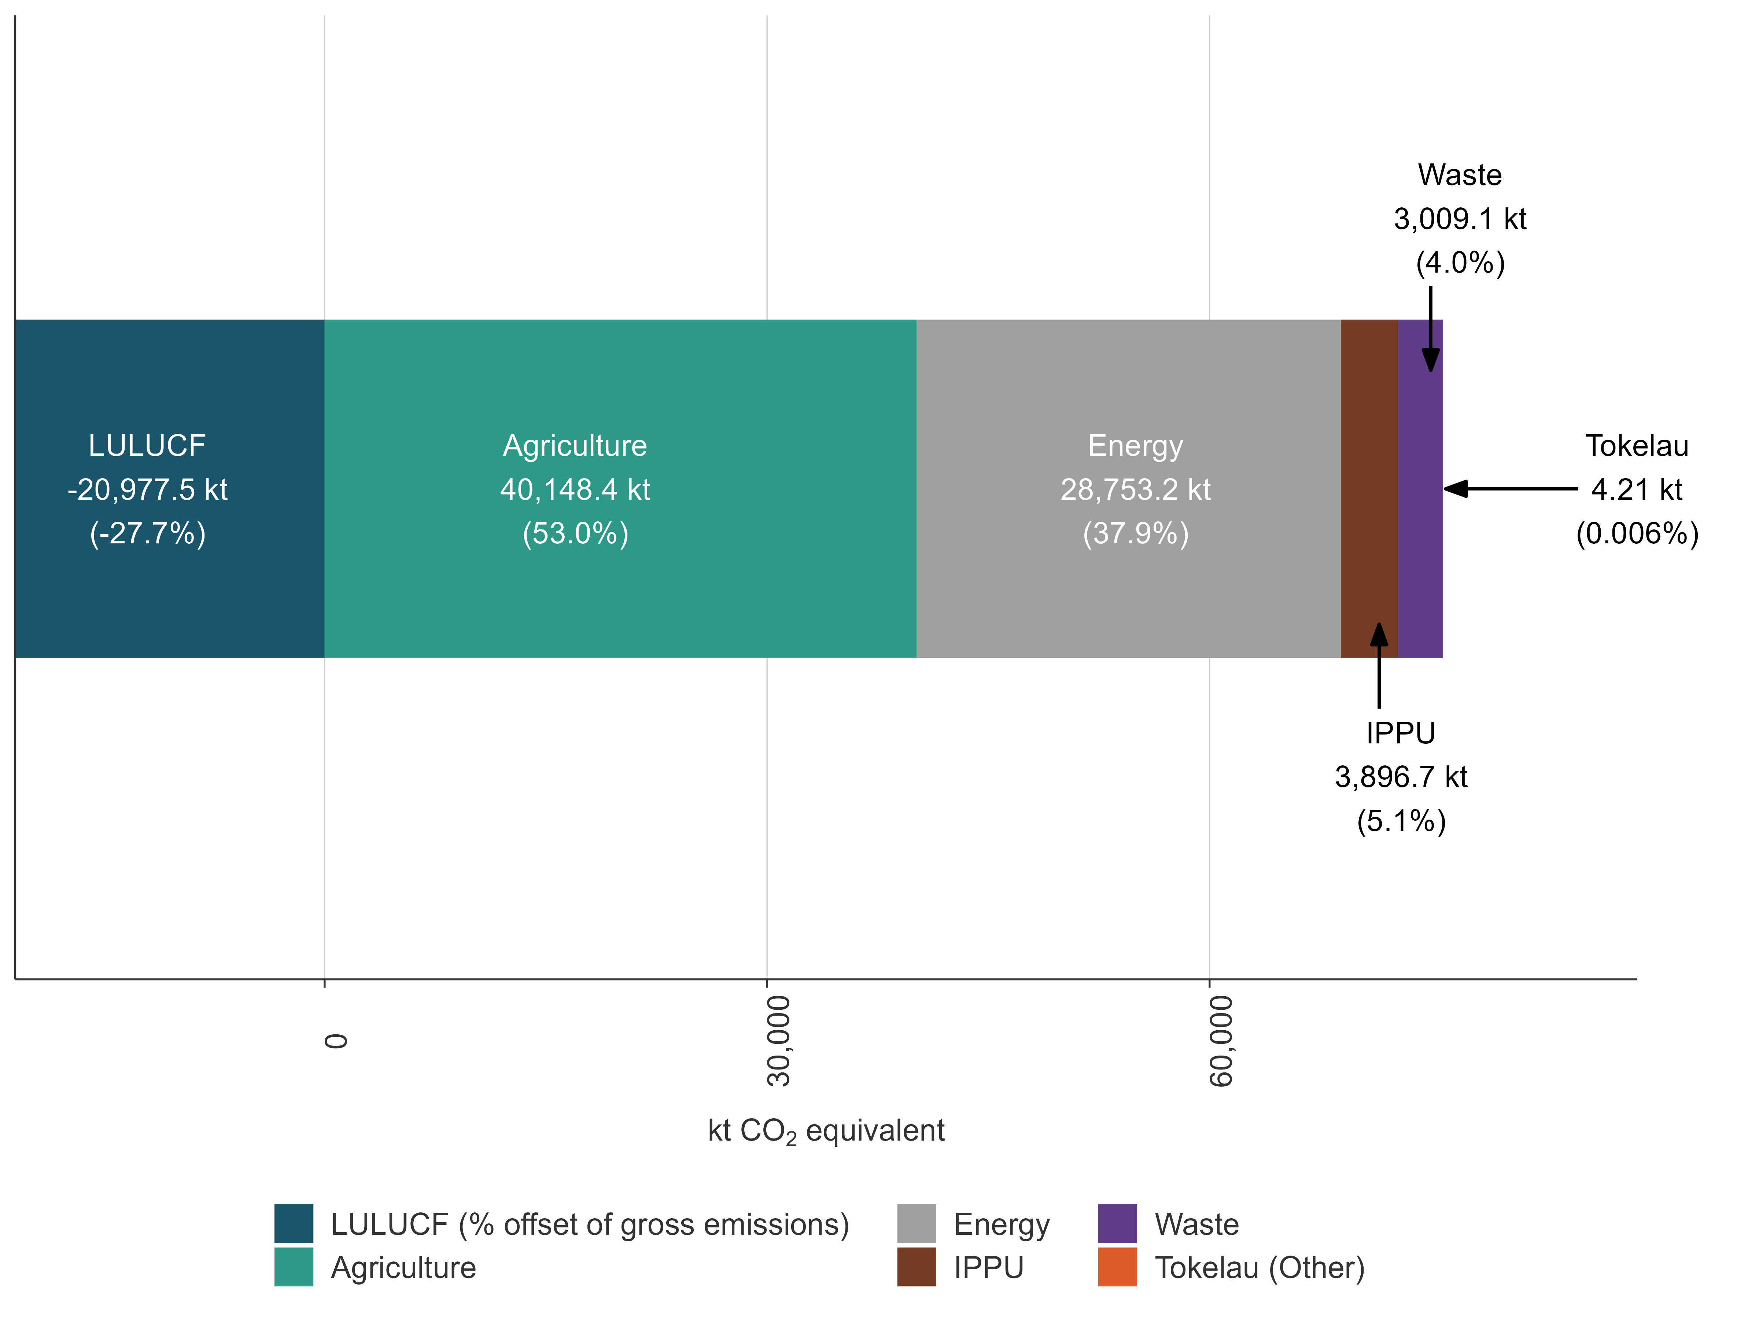
Note: The percentages may not add up to 100 percent due to rounding. The LULUCF sector, which is not a part of gross emissions, is included here as a negative value. The Tokelau sector is not visible due to its small contribution (4.2 kt CO₂e or 0.006 percent of New Zealand’s gross greenhouse emissions).
Each of the sectors is dominated by one or two GHGs. Figure 2.2.2 shows New Zealand’s gross emissions by gas.
Figure 2.2.2 New Zealand’s gross emissions by gas in 2024
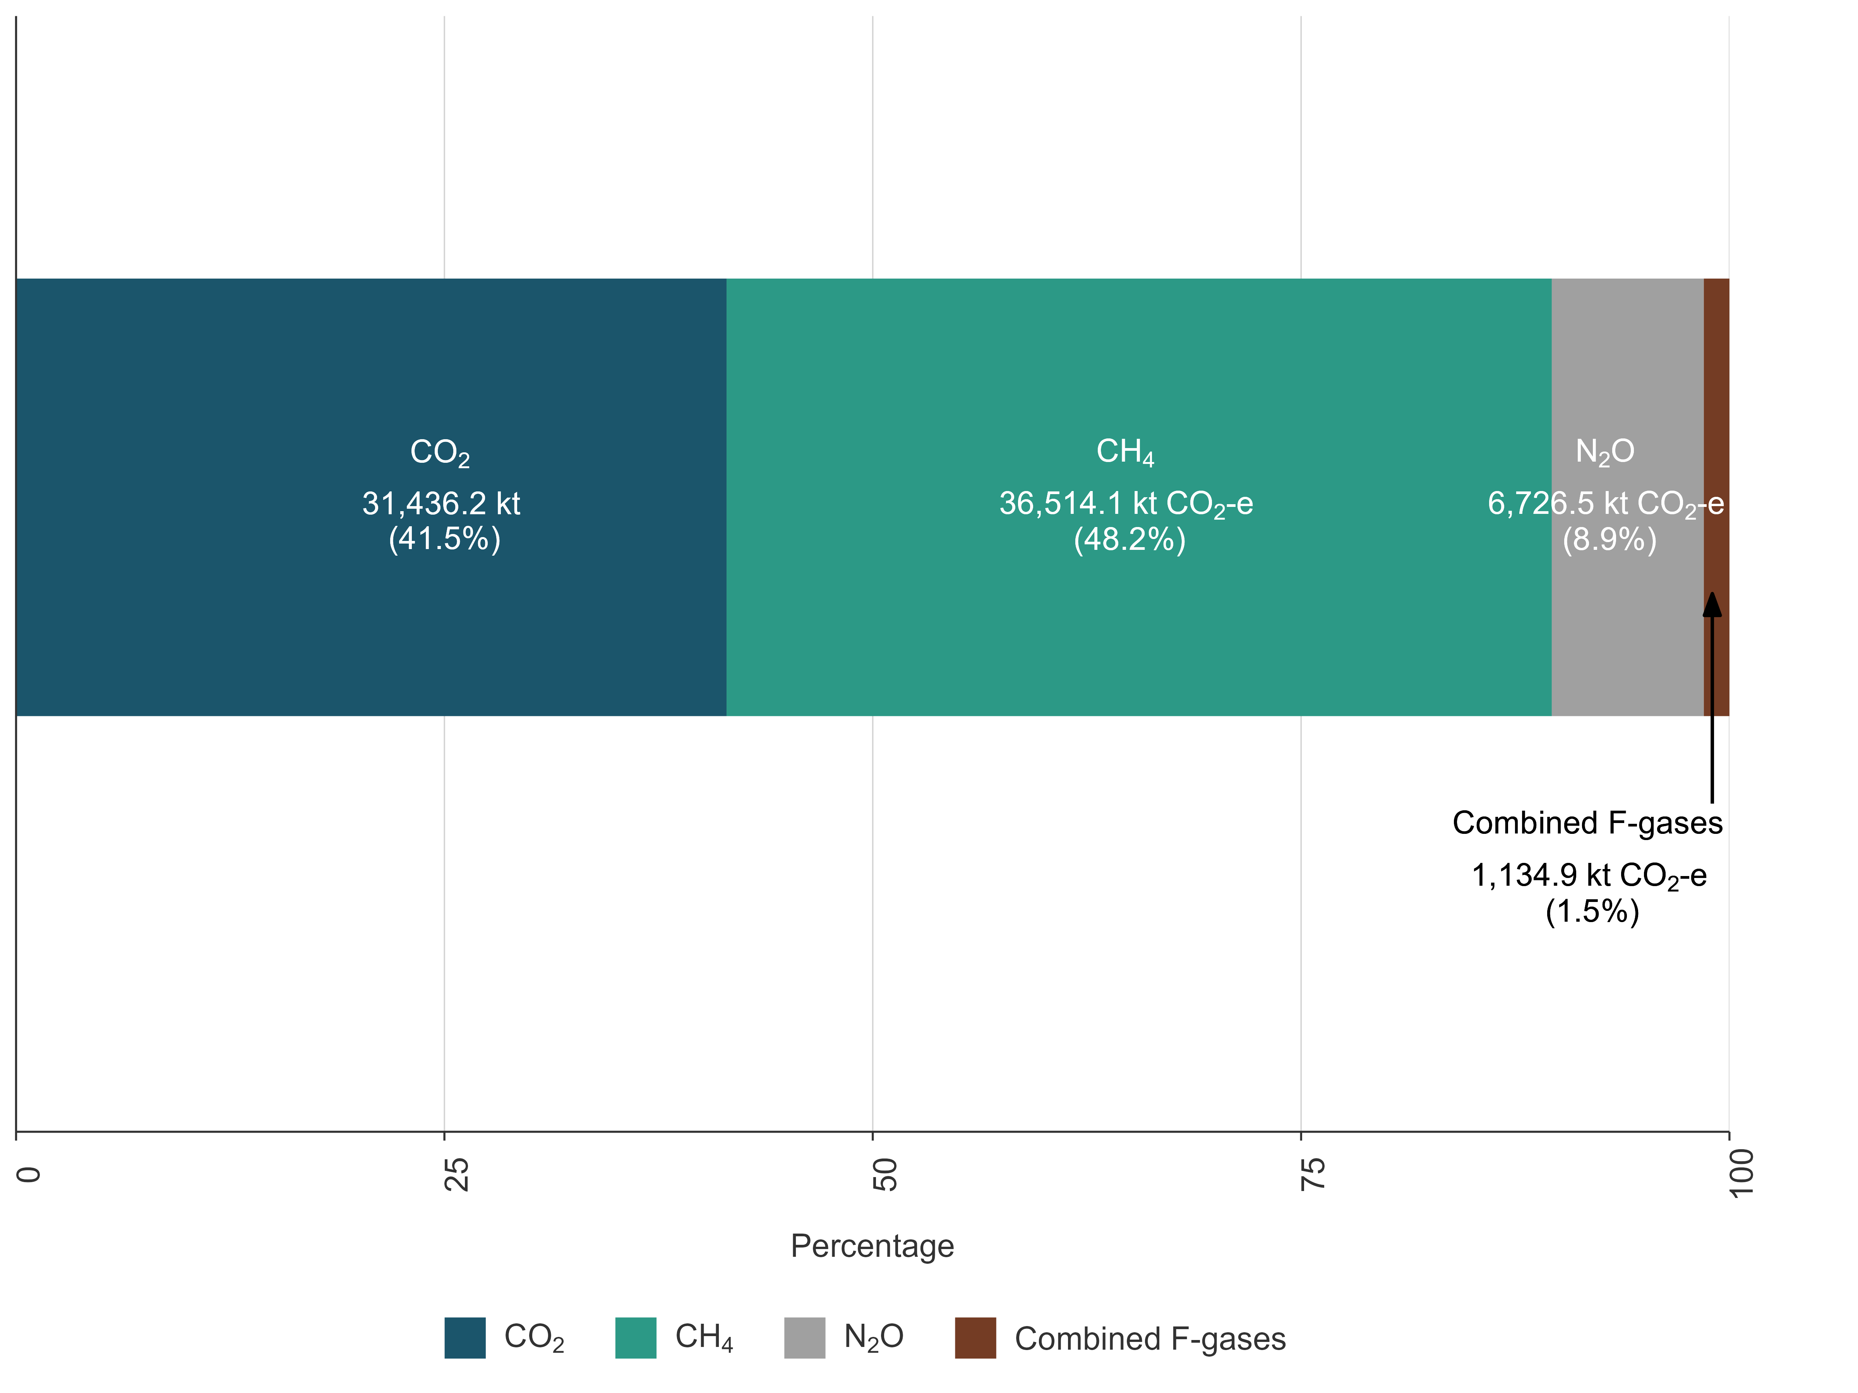
Note: The percentages may not add up to 100 percent due to rounding. F-gases = fluorinated gases.
In 2024, CH₄ dominated New Zealand’s emissions profile, contributing 48.2 percent (36,514.1 kt CO₂e) of gross emissions (figure 2.2.2). In 2024, the Agriculture sector contributed 91.0 percent (33,218.6 kt CO₂e) of New Zealand’s CH₄ emissions. The largest source of CH₄ in the Agriculture sector was Enteric fermentation, producing 86.5 percent (31,588.3 kt CO₂e) of New Zealand’s gross CH₄ emissions. Methane was also the largest component of New Zealand’s Waste sector emissions, contributing 7.5 percent (2,754.1 kt CO₂e) of gross CH₄ emissions.
In 2024, CO₂ contributed 41.5 percent (31,436.2 kt CO₂) towards New Zealand’s gross emissions. In 2024, the Energy sector contributed the largest share of CO₂, producing 89.3 percent (28,061.8 kt) of New Zealand’s gross CO₂ emissions. The categories that contributed most to CO₂ emissions in the Energy sector were Transport (43.4 percent or 13,638.1 kt CO₂) and Manufacturing industries and construction (17.0 percent or 5,340.9 kt CO₂). In 2024, the LULUCF sector was a net CO₂ sink, sequestering 67.5 percent (21,217.6 kt CO₂) of New Zealand’s CO₂ emissions. This resulted in net CO₂ emissions of 10,218.5 kt in 2024.
In 2024, N₂O contributed 8.9 percent (6,726.5 kt CO₂e) of New Zealand’s gross emissions. Emissions from the Agricultural soils category (from adding nitrogen to soil, for example, through manure or fertiliser) were the largest source of New Zealand’s gross N₂O emissions (at 91.1 percent or 6,127.6 kt CO₂e). In 2024, the Agriculture sector contributed 92.7 percent of N₂O towards New Zealand’s gross N₂O emissions totals.
In 2024, fluorinated gases (HFCs, PFCs and SF₆) collectively contributed 1.5 percent to New Zealand’s gross emissions. The IPPU sector is the only source of fluorinated gases in New Zealand. In 2024, HFCs, PFCs and SF₆ collectively emitted 1,134.9 kt CO₂e. New Zealand does not manufacture any fluorinated gases domestically. Emissions of fluorinated gases were dominated by HFCs (91.9 percent of all fluorinated gases). The PFCs and SF₆ contributed 6.9 percent and 1.2 percent to total emissions of fluorinated gases, respectively. Almost all of New Zealand’s PFC emissions (99.99 percent) resulted from aluminium production.

2.2.2 Emission trends by sector from 1990 to 2024
Figure 2.2.3 shows the contribution to net emissions that each inventory sector has made since 1990. The Agriculture and Energy sectors have dominated New Zealand’s gross emissions profile. Together, these sectors produced 90.4 percent of New Zealand’s annual gross GHG emissions from 1990 to 2024. The IPPU and Waste sectors produced relatively small amounts of GHGs, each contributing between 3.8 percent and 6.0 percent of annual gross emissions across the time series.
Conversely, the LULUCF sector was a net sink of GHG emissions between 1990 and 2024.
Figure 2.2.3 Trends in New Zealand’s greenhouse gas emissions by sector, from 1990 to 2024
Note: Net removals from the LULUCF sector are as reported under the United Nations Framework Convention on Climate Change (see chapter 6).
Table 2.2.1 presents New Zealand’s emissions by sector in 1990, 2005 and 2024 and the change between the years in absolute terms and by percentage.
Table 2.2.1 New Zealand’s emissions by sector, comparing 1990, 2005 and 2024
Sector | 1990 | 2005 | 2024 | Change from 1990 (kt CO₂e) | Change from 1990 (%) | Change from 2005 (kt CO₂e) | Change from 2005 (%)
Energy | 23,999.8 | 34,596.7 | 28,753.2 | 4,753.4 | 19.8 | -5,843.4 | -16.9
IPPU | 3,483.6 | 4,046.0 | 3,896.7 | 413.1 | 11.9 | -149.4 | -3.7
Agriculture | 36,750.0 | 42,912.0 | 40,148.4 | 3,398.4 | 9.2 | -2,763.6 | -6.4
Waste | 3,328.5 | 3,804.9 | 3,009.1 | -319.4 | -9.6 | -795.8 | -20.9
Tokelau | 3.4 | 4.7 | 4.2 | 0.8 | 24.8 | -0.5 | -10.6
Gross | 67,565.2 | 85,364.3 | 75,811.6 | 8,246.4 | 12.2 | -9,552.7 | -11.2
LULUCF | -23,334.5 | -23,138.8 | -20,977.5 | 2,357.0 | 10.1 | 2,161.3 | 9.3
Net | 44,230.7 | 62,225.5 | 54,834.1 | 10,603.4 | 24.0 | -7,391.4 | -11.9
Note: Columns may not sum due to rounding. Percentages presented are calculated from unrounded values.
Figure 2.2.4 presents the emissions estimates by sector and the change between 1990, 2005 and 2024 in kt CO₂e.
Figure 2.2.4 Change in New Zealand’s emissions by sector, comparing 1990, 2005 and 2024
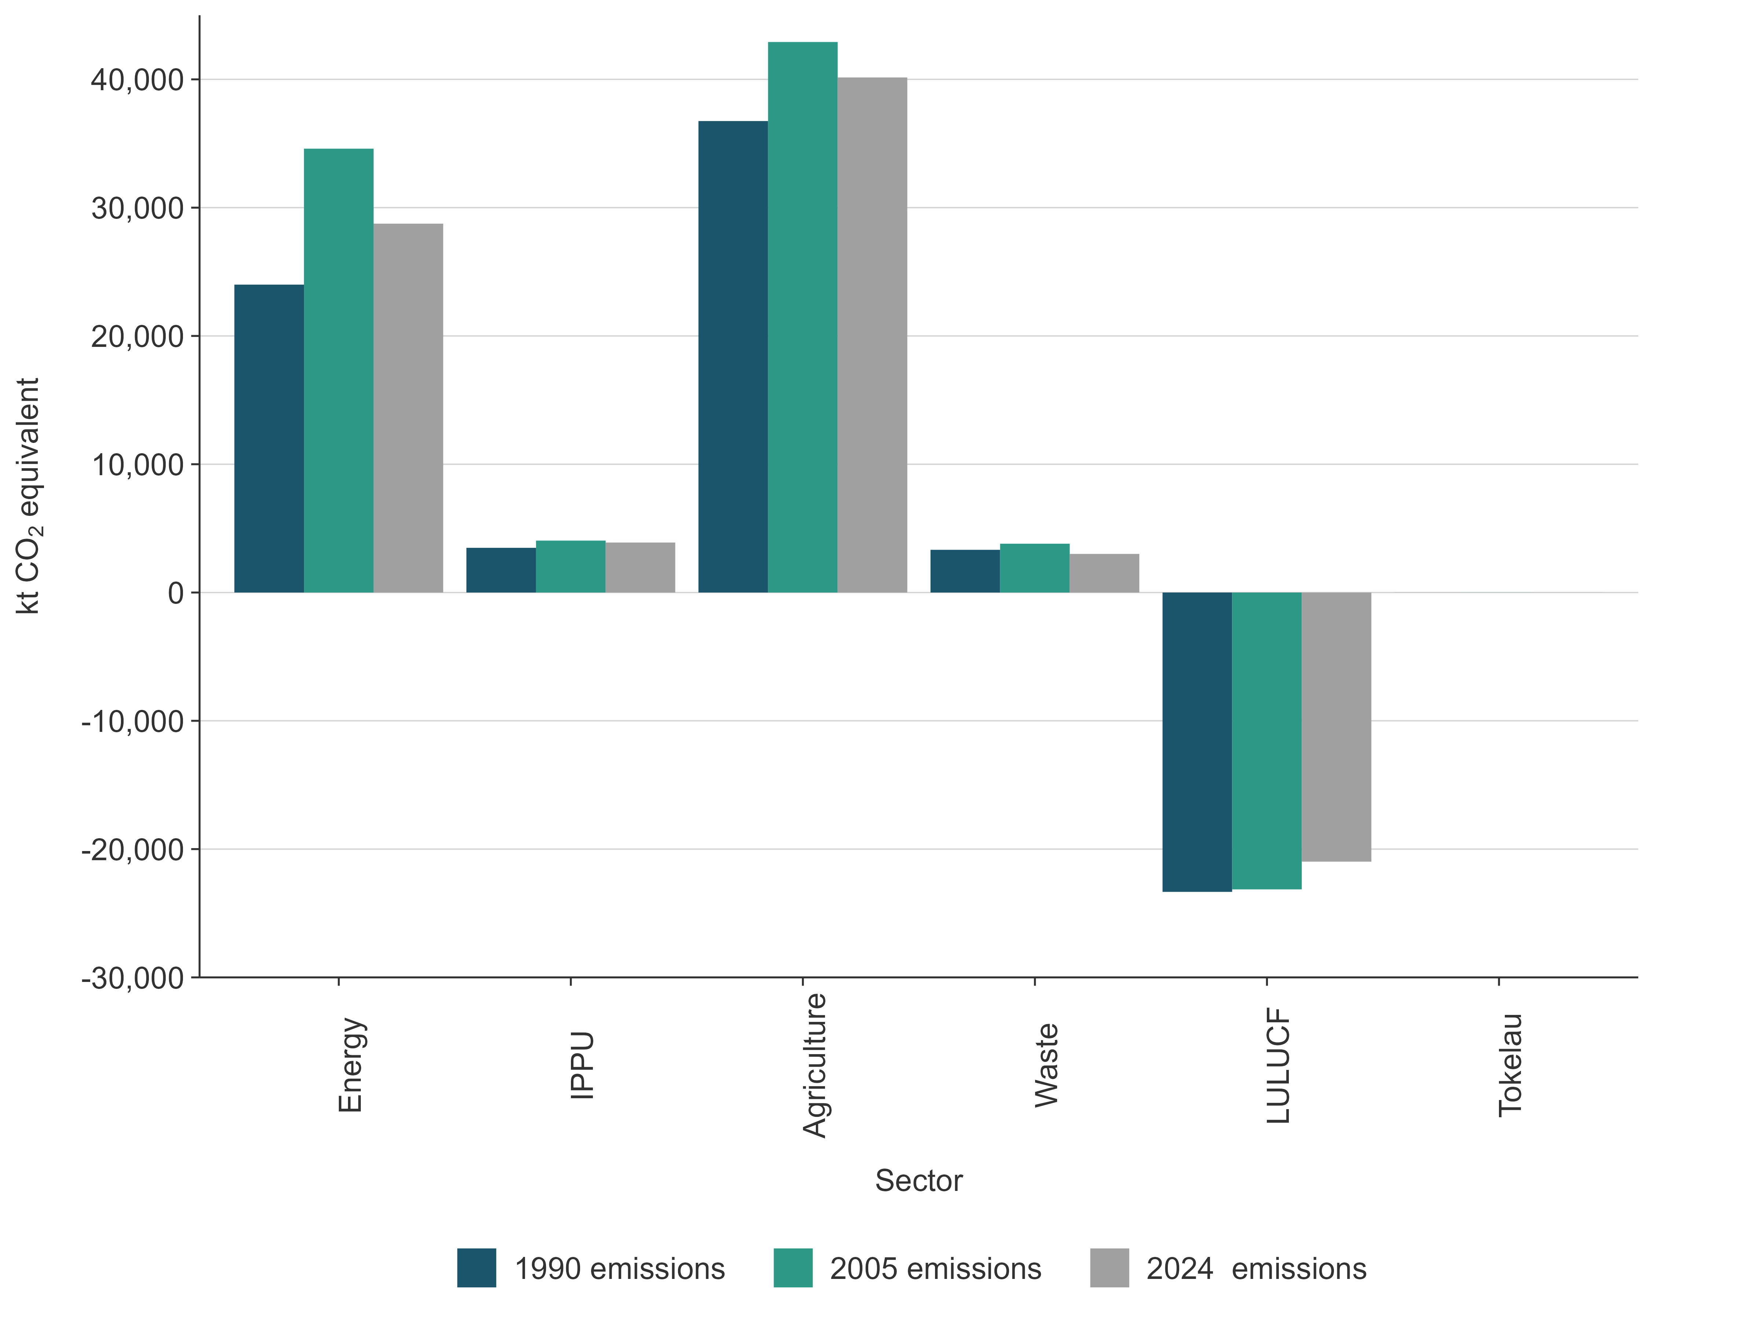
Note: The Tokelau sector is not visible, due to its small total emissions value.
Figure 2.2.5 presents the absolute change in gross emissions for each sector in kt CO₂e (LULUCF is excluded from the estimate of gross emissions).
The figure shows that the main influences on the absolute changes in New Zealand’s gross emissions were changes in the Energy and Agriculture sectors. This is to be expected because they are the largest sectors of the New Zealand economy and show higher sensitivity to changes in global economic conditions, extreme weather conditions and natural disasters.
For example, during droughts, the level of inflow to hydro lakes is low, resulting in lower levels of hydroelectricity production. Consequently, electricity produced from fossil fuels makes a higher contribution to the national electricity grid, resulting in increased emissions from the Energy sector.
Droughts also affect the size of the livestock population and livestock productivity, which usually results in reduced emissions from the Agriculture sector as the population and productivity decline.
Emissions from Tokelau have increased since 1990, mainly due to increases in CO₂ emissions from the Public electricity and heat production category (chapter 8, figure 8.3.1).
Figure 2.2.5 Absolute change in New Zealand’s gross emissions by sector, from 1990 to 2024
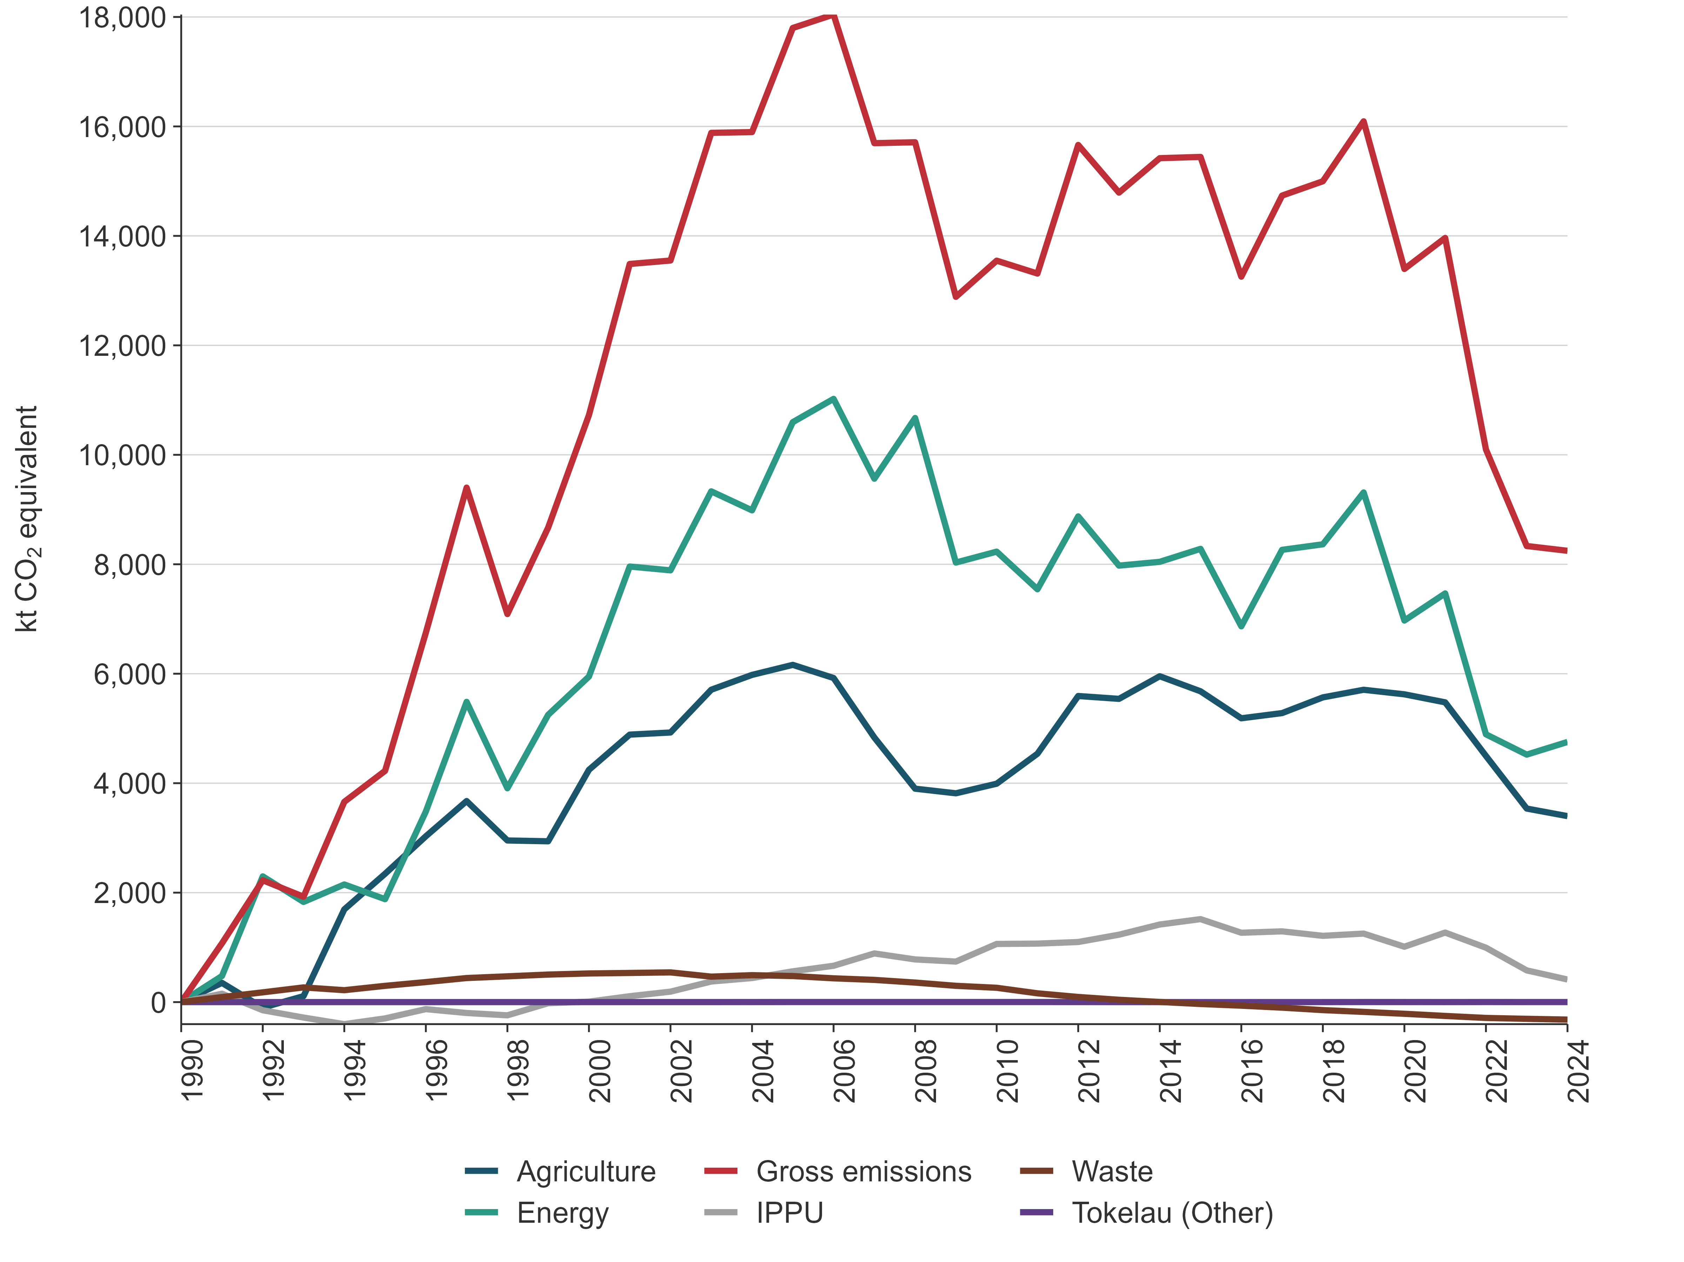
Note: Gross emissions exclude emissions from LULUCF. Because of the small size of the Tokelau sector, the change in emissions over time is not visible in the figure.
Net emissions from the LULUCF sector fluctuated significantly over the time series. These fluctuations (figure 2.2.6) were mainly influenced by harvesting, afforestation and deforestation rates (see the section ‘LULUCF sector’ below).
Figure 2.2.6 Absolute change in net emissions from the LULUCF sector, from 1990 to 2024
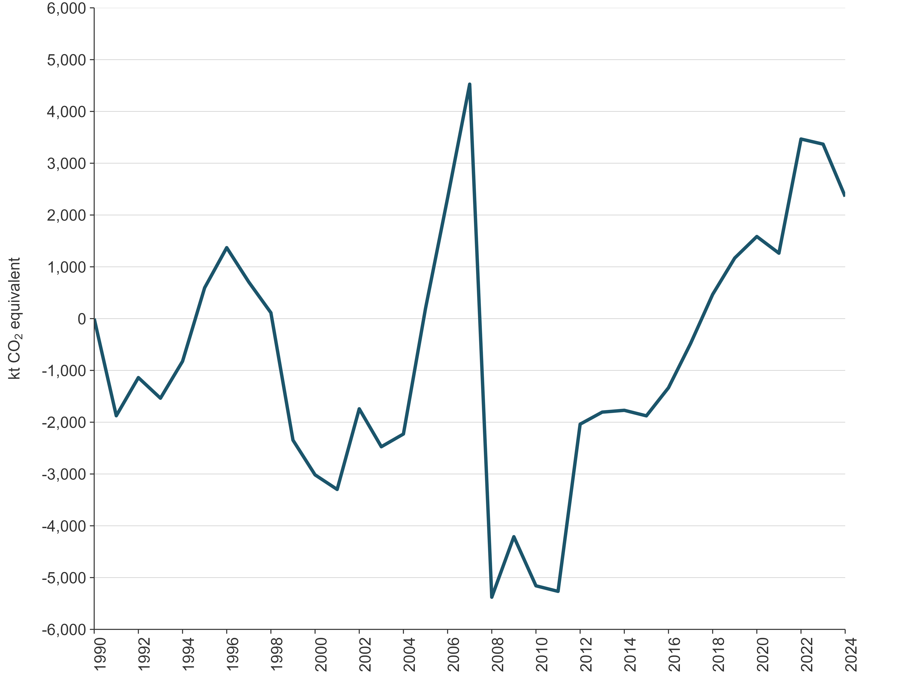

Energy sector
In 2024, emissions from the Energy sector were dominated by CO₂ (97.6 percent of all Energy sector emissions on a CO₂e basis) and smaller amounts of CH₄ and N₂O (around 1.7 percent and 0.7 percent, respectively). The major source categories in the sector were Road transportation and Manufacturing industries and construction.
Emissions in the Energy sector were influenced by not only demand but also climatic conditions. Renewables, mainly hydro power and wind, meet a large proportion of New Zealand’s stationary energy needs. In 2024, electricity generated from renewable energy sources contributed 85 percent of total generation.

2024
In 2024, emissions from the Energy sector were 28,753.2 kt CO₂e, or 37.9 percent of New Zealand’s gross GHG emissions (see figure 2.2.1).
The largest sources of emissions in the Energy sector were the Road transportation category, contributing 12,555.7 kt CO₂e (43.7 percent), and the Manufacturing industries and construction category, contributing 5,396.5 kt CO₂e (18.8 percent) to energy emissions.

2023–2024
Between 2023 and 2024, emissions from the Energy sector increased by 0.8 percent (231.4 kt CO₂e). This was primarily due to an increase in Public electricity and heat production (up 970.6 kt CO₂e or 35.5 percent). This increase was partially offset by the Chemicals category, which decreased by 590.4 kt CO₂e (45.0 percent) and Food processing, beverages and tobacco, which decreased by 205.8 kt CO₂e (7.6 percent). Further information on these changes is provided under the relevant categories of chapter 3, section 3.2.
National energy consumption in 2024 declined 2.1 percent from the 2023 level, and was 9.9 percent below the pre-COVID-19 peak seen in 2019.

2005–2024
Between 2005 and 2024, emissions from the Energy sector decreased by 16.9 percent (5,843.4 kt CO₂e). The largest reduction came from Public electricity and heat production, which decreased by 5,299.7 kt CO₂e (58.8 percent). While total electricity generation grew by 6 percent over the same period, the share from renewable sources increased significantly – from 66 percent to 85 percent – driven by expanded geothermal and wind capacity. This reduction in emissions was partially offset by a 1,338.5 kt CO₂e (11.9 percent) increase from Road transportation.
Restrictions on activity and movement as part of the response to the COVID-19 pandemic during the 2020 calendar year created significant disruption to economic activity throughout New Zealand. The effects on the Energy sector are particularly notable, with national energy consumption remaining below 2019 levels. The sector rebounded slightly during 2021, but energy consumption has remained well below pre-2020 levels in the years following.

1990–2024
In 1990, emissions from the Energy sector were 23,999.8 kt CO₂e. Between 1990 and 2024, GHG emissions increased by 19.8 percent (4,753.4 kt CO₂e). The main contributors to this increase were Road transportation (up 5,727.3 kt CO₂e or 83.9 percent), Food processing, beverages and tobacco (up 823.4 kt CO₂e or 49.3 percent) and Residential (up 407.1 kt CO₂e or 27.9 percent). While the drivers of these changes are complex, main factors include population growth and increased economic activity.
The largest decrease since 1990 occurred in Manufacture of solid fuels and other energy industries, historically a significant source of emissions. Emissions from this category fell by 1,460.3 kt CO₂e (85.7 percent), primarily due to the cessation of synthetic gasoline production in 1997.
Figure 2.2.7 shows the time series of Energy sector emissions from 1990 to 2024. Emissions rose steadily between 1990 and 2006, driven by population and economic growth, which in turn increased demand for transport and industrial energy. Road transportation emissions rose sharply due to high reliance on private vehicles and freight trucking. Manufacturing activity, particularly in energy-intensive sectors such as food processing and chemicals, also contributed to the upward trend.
After 2006, emissions declined slightly and then remained stable until 2019. Since 2019, emissions have decreased, mainly due to the effects of the COVID-19 pandemic response and ongoing economic conditions. These factors, combined with lower-than-expected gas supply, have led to reductions in industrial energy use.
Figure 2.2.7 New Zealand’s Energy sector emissions, from 1990 to 2024
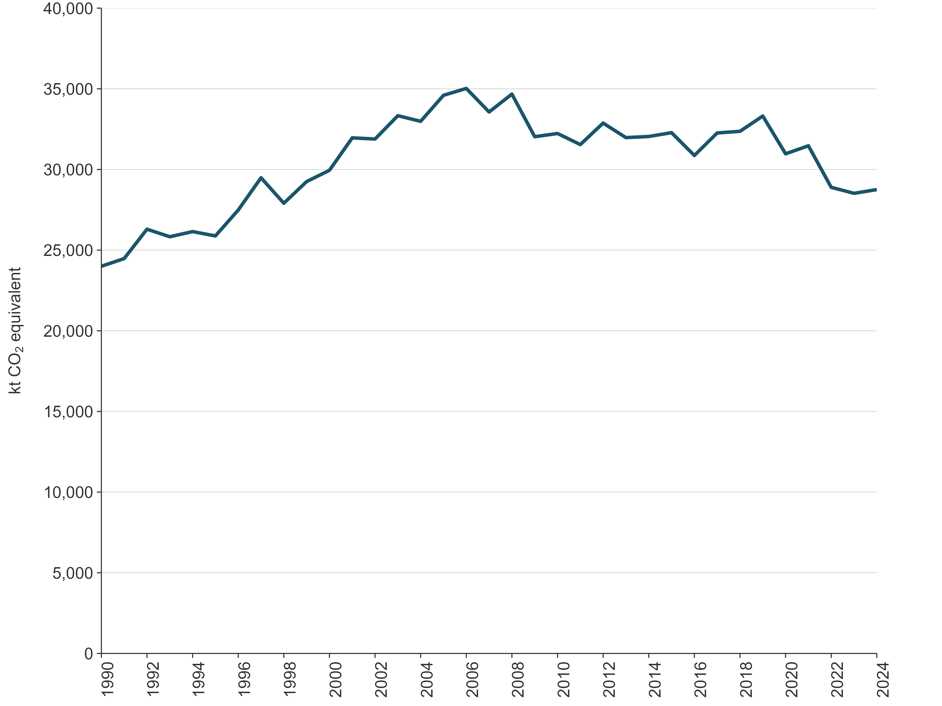

IPPU sector
In 2024, emissions from the IPPU sector were dominated by CO₂ (66.2 percent of all IPPU sector emissions on a CO₂e basis), fluorinated gases (29.1 percent) and smaller amounts of CH₄ and N₂O (around 1.1 percent and 3.6 percent, respectively). The major source categories in the sector were Iron and steel production, Refrigeration and air conditioning, Aluminium production and Cement production. Coal and natural gas were also used on a significant scale for energy in the Mineral industry, Chemical industry and Metal industry categories. Carbon dioxide and any other emissions from combustion of fuels in these industries are reported under the Energy sector.

2024
In 2024, emissions from the IPPU sector were 3,896.7 kt CO₂e, or 5.1 percent, of New Zealand’s gross GHG emissions.
The Metal industry was the largest category of emissions, with substantial CO₂ emissions from the Iron and steel production and Aluminium production categories, as well as PFCs from the Aluminium production category in earlier years. The Mineral industry and Chemical industry categories also contributed significant CO₂ emissions, and most of the non-CO₂ emissions were from the Product uses as substitutes for ODS category.
The IPPU sector also produces smaller amounts of CH₄ from methanol production and N₂O used for medical applications in the Other product manufacture and use category.
Coal and natural gas were also used for energy generation in these industries, and related emissions were reported under the Energy sector in the Manufacturing industries and construction category.

2023–2024
Between 2023 and 2024, emissions from the IPPU sector decreased by 166.6 kt CO₂e (4.1 percent).
This change was mainly the result of decreased emissions from the Refrigeration and air conditioning, Mineral industry, Chemical industry and Metal industry categories. Although emissions increased elsewhere, the overall result was a net reduction in total IPPU emissions.

2005–2024
Between 2005 and 2024, emissions from the IPPU sector decreased by 149.4 kt CO₂e (3.7 percent).
Between 2005 and 2024, emissions from Product uses as substitutes for ODS rose by 369.5 kt CO₂e (10 percent). However, this increase was offset by decreases in the Mineral industry, Chemical industry and Metal industry. Over the same period, emissions from the Mineral industry and Chemical industries decreased by 272.1 kt CO₂e (6.5 percent) and 174.9 kt CO₂e (4.3 percent), respectively.
Restrictions on activity and movement, as part of the response to the COVID-19 pandemic during the 2020 calendar year, significantly disrupted economic activity throughout New Zealand. Activity levels and emissions from the IPPU sector dropped between 2019 and 2020. The IPPU sector rebounded in 2021; however, activity and emissions continued to drop in the following years.
In addition to COVID-19 pandemic-related restrictions, New Zealand also saw the progressive shutdown of Methanex, which operates methanol production plants in New Zealand. Methanex has two production facilities in New Zealand – Motonui and Waitara Valley. In November 2004, production at the Motunui plant was halted following insufficient gas supply in 2003, with operations resuming in late 2008. Output further increased at Motonui in 2012, and production at full capacity resumed in December 2013. The Waitara Valley plant was shut down in early 2021. A shortage of natural gas supply and energy security concerns also led to no methanol production between August to October 2024 to free up natural gas for use in electricity generation. As a result, emissions from the Methanol category decreased by 64 percent between 2024 and pre-COVID-19 levels.
There was also a 19 percent reduction in emissions of PFCs due to improved management of anode effects in the Aluminium production category. Emissions of N₂O used for medical applications in the Other product manufacture and use category are nearly four-times higher in 2024, compared with 2005. However, several initiatives led by Health New Zealand Te Whatu Ora are seeking to reduce the emissions associated with N₂O by removing piped nitrous oxide systems to prevent leakages into the atmosphere.

1990–2024
In 1990, emissions from the IPPU sector were 3,483.6 kt CO₂e. Between 1990 and 2024, GHG emissions increased by 11.9 percent (413.1 kt CO₂e). This increase was mainly driven by increasing emissions from the Product uses as substitutes for ODS category, due to the introduction of HFCs to replace ODS in refrigeration and air conditioning, and the increased use of household and commercial air conditioning.
The trends for the IPPU sector are shown in figure 2.2.8.
Figure 2.2.8 New Zealand’s IPPU sector emissions, from 1990 to 2024
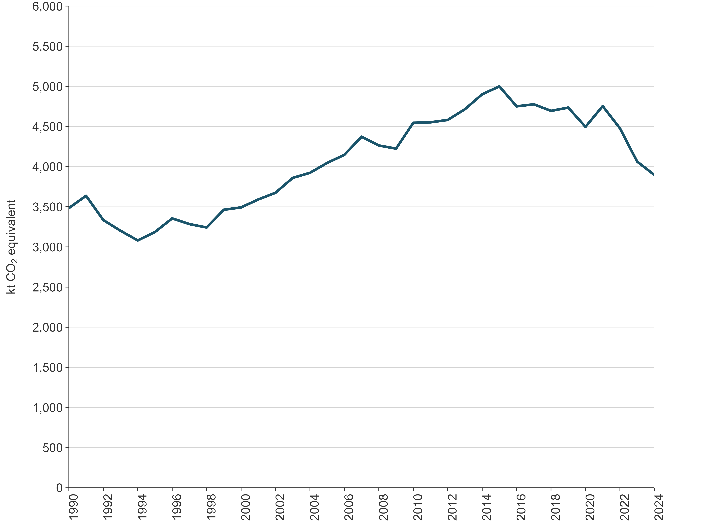

Agriculture sector
The Agriculture sector in New Zealand produces three main GHGs: CH₄, N₂O and CO₂, which comprised 82.7 percent, 15.5 percent and 1.7 percent of all Agriculture sector emissions in 2024, respectively. Trends in Agriculture sector emissions are largely driven by the populations of ruminant livestock (dairy cattle, non-dairy (beef) cattle, sheep and deer). The largest contributing categories in the Agriculture sector were Enteric fermentation and Agricultural soils. Agriculture emissions reflect the total livestock population, the types of livestock and farming systems, and levels of production. Several drivers affected the emission trends for both CH₄ and N₂O in the sector. These include:
- changes over time to populations of the main livestock types farmed in New Zealand. Since 1990, the dairy cattle population has increased, while sheep and non-dairy (beef) cattle populations have decreased as the profitability of dairy products has risen relative to sheep and beef products (see chapter 5, figures 5.1.3a and figure 5.1.3b)
- increases in livestock productivity (for both milk and meat yield per head of livestock), which have been achieved by New Zealand farmers since 1990. This has resulted in increased feed intake per animal to meet higher energy demands of increased production. Increased feed intake increases CH₄ (from increased enteric fermentation) and N₂O emissions (from increased excreta deposited on pasture) per animal
- incidents of severe drought, which have resulted in reduced livestock productivity and livestock populations, which in turn reduced livestock-related emissions. The ‘Situation and Outlook for Primary Industries’ reports produced by the Ministry for Primary Industries summarise the effects of events at a sector level and provide short-term forecasts
- commodity price fluctuations that drive farmer investment decisions in livestock numbers and species as well as production inputs. The ‘Situation and Outlook for Primary Industries’ reports also summarise these decisions at a sector level and provide short-term forecasts
- shifting land use across different types of livestock farming and other agricultural enterprises, including forestry. The Agriculture sector uses around 34 percent of New Zealand’s land area (Stats NZ, 2025), mostly for grazing of pastoral land. Between 1990 and 2024, the area used for sheep, beef and deer grazing has decreased by approximately 41.6 percent (Beef + Lamb New Zealand Ltd, 2025), while the area used for dairy grazing has increased by 66.4 percent (LIC and DairyNZ, 2025). The amount of synthetic nitrogen fertiliser applied to agricultural land has increased by 534 percent since 1990.
The trends for the Agriculture sector are shown in figure 2.2.9.
Figure 2.2.9 New Zealand’s Agriculture sector emissions, from 1990 to 2024
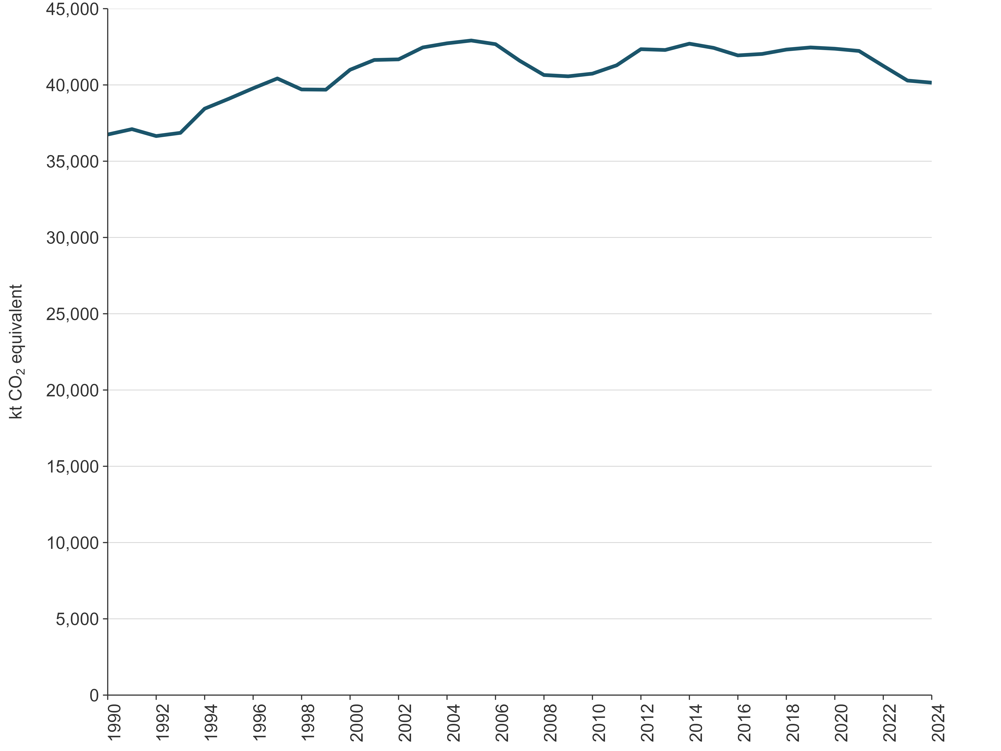

2024
In 2024, emissions from the Agriculture sector were 40,148.4 kt CO₂e, or 53.0 percent, of New Zealand’s gross GHG emissions.
Methane from Enteric fermentation was the main source of Agriculture emissions, contributing 78.7 percent (31,588.3 kt CO₂e) of the sector’s emissions. The Agricultural soils category (15.3 percent) was the second-largest source followed by Manure management (4.3 percent). Carbon dioxide from Urea application and Liming contributed 1.1 percent and 0.6 percent, respectively. Field burning of agricultural residues contributed less than 0.1 percent.
Methane emissions from Enteric fermentation contributed 41.7 percent of New Zealand’s gross emissions, and N₂O emissions from the Agricultural soils category contributed 8.1 percent of New Zealand’s gross emissions.

2023–2024
Between 2023 and 2024, total Agriculture emissions decreased 0.3 percent (138.1 kt CO₂e), largely due to a decrease in emissions from sheep and limestone application. Specifically:
- sheep emissions decreased by 3.9 percent (364.4 kt CO₂e), due to a continuing decrease in the sheep population
- emissions from urea decreased by 8.6 percent (43.0 kt CO₂e), due to a decrease in the mass of nitrogen applied as urea
- emissions from limestone use decreased by 13.2 percent (36.1 kt CO₂e), due to a reduction in the application of limestone.
These decreases were partially offset by increased emissions from dairy cattle and non-dairy cattle. Specifically:
- dairy cattle emissions increased by 1.1 percent (222.2 kt CO₂e), due to an increase in milk production. Compared with the 2022–2023 season, there was a 2.3 percent (about 471 million litres) increase in milk volume and a 2.9 percent (55 million kilogram) increase in milk solids processed (LIC and DairyNZ, 2025). These improvements in productivity occurred alongside a 0.5 percent decrease in the dairy cattle population, due to an increase in productivity per animal
- non-dairy cattle emissions increased by 0.3 percent (25.6 kt CO₂e), due to an increase in the non-dairy (beef) cattle population.
Total emissions from synthetic nitrogen fertiliser (CO₂ and N₂O) increased by 1.5 percent (25.0 kt CO₂e). Emissions from non-urea synthetic nitrogen fertilisers increased by 85.2 percent (144.0 kt CO₂e), due to an increase of nitrogen application.

2005–2024
Between 2005 and 2024, emissions from the Agriculture sector decreased by 6.4 percent (2,763.6 kt CO₂e) (see chapter 5, table 5.1.1).
In 2005, Agriculture emissions were 42,912.0 kt CO₂e. By 2007, emissions had dropped by around 1,300 kt CO₂e (3.1 percent below the 2005 value), due to the Global Financial Crisis. By 2008, Agriculture emissions had reduced another 900 kt CO₂e (5.3 percent below the 2005 value), due to the compounding effect of a nationwide drought. In the following years, Agriculture emissions recovered, and most recently peaked in 2014 at 42,704.0 kt CO₂e (0.5 percent below the 2005 value), corresponding with a peak in overall cattle numbers. In the years 2015 to 2021, Agriculture emissions remained slightly below the 2014 peak. In 2022 and 2023, Agriculture emissions dropped significantly. The 2024 level is 0.3 percent below the 2023 level (see chapter 5, figure 5.1.2).
The greatest absolute contributions to the decrease since 2005 are a 2,817 kt CO₂e (8.2 percent) decrease in emissions from Enteric fermentation, a 369.8 kt CO₂e (60.9 percent) decrease in emissions from Liming, and a 65.3 kt CO₂e (1.1 percent) decrease in emissions from Agricultural soils (see chapter 5, table 5.1.1 and figure 5.1.1).
The decrease in emissions from Enteric fermentation and Agricultural soils is primarily a result of decreased livestock populations since 2005.
Sheep populations have fallen by 40.9 percent since 2005, resulting in a 38.4 percent decline in Enteric fermentation emissions (-5,122.6 kt CO₂e) and a 37.2 percent decline in Agricultural soils emissions (-411.6 kt CO₂e).
Non-dairy cattle populations have declined by 16.8 percent since 2005, resulting in a 14.7 percent decrease in Enteric fermentation emissions (1,237.3 kt CO₂e) and a 13.8 percent decrease in Agricultural soils emissions (152.6 kt CO₂e).
These reductions have been partially offset by increases in emissions from dairy cattle. Dairy cattle populations have increased 14.7 percent leading to a 34.4 percent increase in Enteric fermentation emissions (4,035.1 kt CO₂e) and a 24.0 percent increase in Agricultural soils emissions (478.2 kt CO₂e). There has also been a 68.4 percent increase in emissions from dairy cattle Manure management (588.2 kt CO₂e) between 2005 and 2024, due to both the increasing population of dairy cattle and the increased prevalence of anaerobic lagoons as a manure management system rather than pasture.
Changes in livestock populations reflect relative profitability across animal sectors, with dairy farming becoming more profitable than sheep or non-dairy cattle farming over the reporting period. In addition, average emissions per dairy cow have increased over time due to higher milk production per animal, heavier liveweights and increased feed intake, which increases emissions per head.
The decrease in emissions from Liming is driven by reduced application of lime and dolomite fertilisers.

1990–2024
In 1990, emissions from the Agriculture sector were 36,750.0 kt CO₂e. Between 1990 and 2024, GHG emissions increased by 9.2 percent (3,398.4 kt CO₂e) (chapter 5, table 5.1.1). The greatest contributions to the increase since 1990 are a 1,667.1 kt CO₂e (37.4 percent) increase in emissions from Agricultural soils, an 865.9 kt CO₂e (101.7 percent) increase in emissions from Manure management, and a 515.1 kt CO₂e (1.7 percent) increase in emissions from Enteric fermentation (chapter 5, table 5.1.1 and figure 5.1.1).
The increase in N₂O emissions from Agricultural soils is primarily a result of increased application of synthetic nitrogen fertiliser. This has increased by 553.0 percent since 1990. The increased use of nitrogen fertiliser has been largely driven by the growth and intensification of dairy farming, as well as the increased use of nitrogen on other farm types, such as sheep and non-dairy cattle. The N₂O emissions (direct and indirect) from synthetic nitrogen fertiliser use increased by 1,000.0 kt CO₂e between 1990 and 2024. This is 60.0 percent of the total increase in emissions from Agricultural soils.
The increase in emissions from Manure management and Enteric fermentation has been driven by an increase in dairy cattle numbers. The increase in dairy Enteric fermentation emissions is partially offset by a decline in sheep numbers and a decrease in non-dairy (beef) cattle. The change in animal populations since 1990 reflects the relative financial returns in each sector. It has become more profitable to farm dairy cattle than non-dairy cattle or sheep in New Zealand over the reporting period.

LULUCF sector

2024
In 2024, net emissions from the LULUCF sector were -20,977.5 kt CO₂e, or 27.7 percent of New Zealand’s gross GHG emissions. This comprises net emissions of -21,217.6 kt CO₂, emissions of 49.2 kt CO₂e of CH₄ and 191.0 kt CO₂e of N₂O. The category contributing the most to both removals and emissions is Forest land remaining forest land. This is because large removals result from the growth of all forests on this land and there are also large emissions from the sustainable harvest of New Zealand’s plantation forests.
Emissions in the LULUCF sector are primarily driven by the harvest of production forests, deforestation and the decomposition of organic material following these activities. Removals are mainly from the sequestration of carbon that occurs due to plant growth and the production of Harvested wood products. Nitrous oxide can be emitted from the ecosystem as a by-product of nitrification and denitrification, and the burning of organic matter. Other gases released during biomass burning include CH₄, carbon monoxide (CO), other oxides of nitrogen (NO_{x}) and non-methane volatile organic compounds (NMVOCs).

2023–2024
Between 2023 and 2024, net emissions from the LULUCF sector decreased by 5.1 percent (1,011.0 kt CO₂e) (see chapter 6, table 6.1.1).
The largest change occurred in the Grassland category, with a decrease in emissions of 827.1 kt CO₂e, driven by less deforestation in 2024 compared to 2023 (chapter 6, figure 6.4.4). Forest land had the second-largest change, with a decrease in net emissions of 701.2 kt CO₂e. Interannual variation in Forest land is mainly driven by changes within planted forests. In Forest land remaining forest land, changes in growth-related removals, harvest emissions, and the deadwood carbon pool, increased net emissions in 2024. In Land converted to forest land, this increase was offset by an increase in net removals due to decreased harvest emissions and an increase in growth-related removals. The Harvested wood products category had the third-largest change, with an increase in emissions of 480.5 kt CO₂e due to losses from decay being greater than inputs as harvest stabilised between 2023 and 2024.

2005–2024
Between 2005 and 2024, net emissions from the LULUCF sector increased by 9.3 percent (2,161.3 kt CO₂e) (see chapter 6, table 6.1.2). The largest change occurred in the Forest land category, with an increase in net emissions of 14,244.3 kt CO₂e, because a larger proportion of planted forests were harvested in 2024 compared with 2005 levels (chapter 6, figure 6.4.3). The Grassland category had the second-largest change, with a decrease in emissions of 11,174.7 kt CO₂e driven by a reduction in conversions from Forest land. The Harvested wood products category had the third-largest change, with a reduction in emissions of 771.1 kt CO₂e. This was driven by an increase in the inputs to the harvested wood products pool following the increased planted forest harvest.

1990–2024
In 1990, net emissions from the LULUCF sector were -23,334.5 kt CO₂e. Between 1990 and 2024, net emissions increased by 10.1 percent (2,357.0 kt CO₂e) (see chapter 6, table 6.1.3 and figure 6.1.1).
This is largely due to an overall reduction in net removals from Forest land compared with 1990 levels. The reduction in net removals from Forest land was driven by relatively high harvest rates (chapter 6, figure 6.4.3) that are a result of significant afforestation beginning in the 1980s and reaching a peak in the mid-1990s (chapter 6, figure 6.4.1). The planted forests that were established during this period have progressively been reaching harvesting age, so while the total area of forest has increased since 1990, a larger proportion of planted forests were harvested in 2024 compared with 1990 levels. Harvesting and replanting cycles of New Zealand’s planted forests will continue to affect the trajectory of New Zealand’s net emissions in the future due to their uneven age-class profile. The increase in emissions is compensated for, to some extent, by a reduction in net emissions in Harvested wood products. Carbon losses in Forest land due to the harvest of timber are transferred to Harvested wood products, where the carbon is treated as a gain and its decay and emissions to the atmosphere are estimated based on product type. The net fluxes in Harvested wood products therefore represent the balance between the inputs transferred into the pool and the outputs leaving the pool from decay or disposal over time.
The fluctuations in net emissions from the LULUCF sector since 1990 (see figure 2.2.10) were primarily influenced by afforestation, harvesting and deforestation rates. Harvesting rates are driven by several factors, particularly forest age and log prices.
Net emissions in the LULUCF sector have been generally increasing over the past decade. Current harvest rates are at near historically high levels due to the significant land-use changes to forest land that occurred from the 1980s and into the early 1990s.
Deforestation rates were driven by the profitability of forestry relative to alternative land uses.
Figure 2.2.10 New Zealand’s LULUCF sector net emissions, from 1990 to 2024
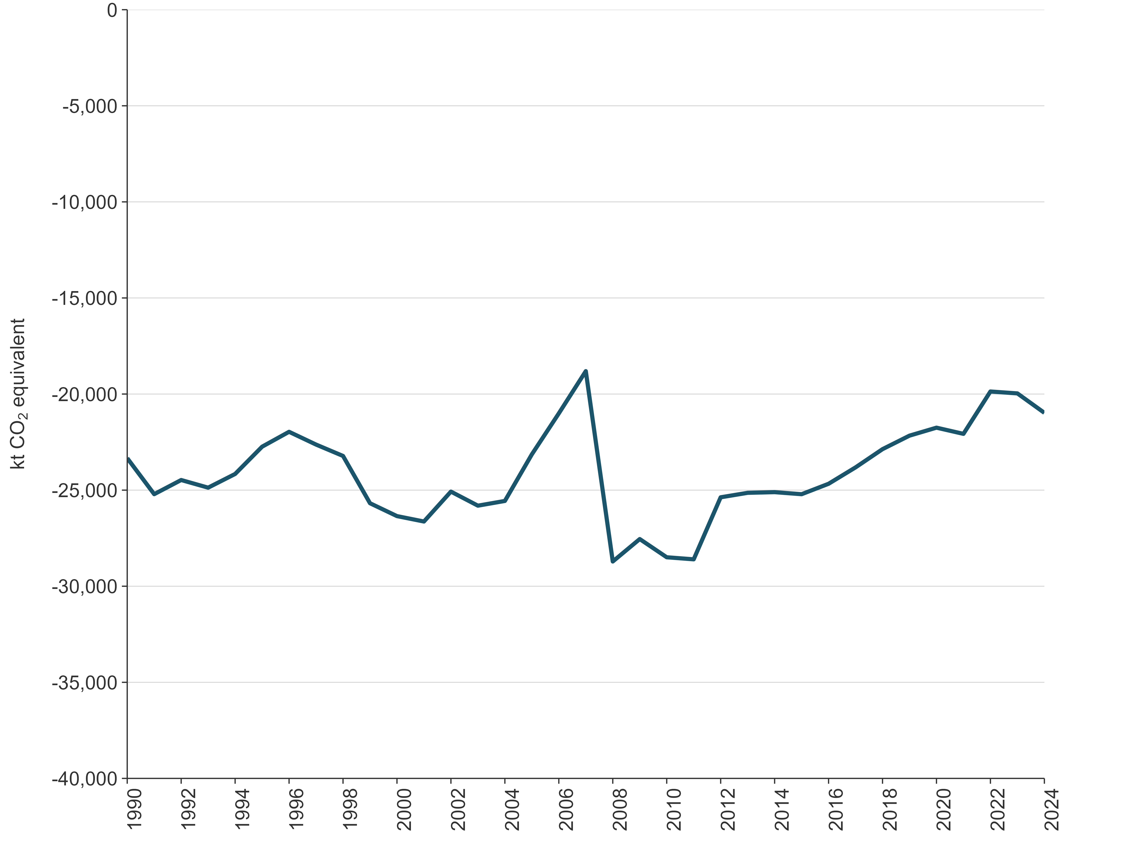

Waste sector
The Waste sector in New Zealand produces mainly CH₄ (91.5 percent) followed by N₂O (5.2 percent) and CO₂ emissions (3.3 percent). The Waste sector produces 7.5 percent of gross CH₄ emissions in New Zealand. There are also emissions of CO₂ from the disposal of solid waste, but these are of biogenic origin and are not reported.

2024
In 2024, emissions from the Waste sector were 3,009.1 kt CO₂e, or 4.0 percent of New Zealand’s gross GHG emissions. The largest source category is Solid waste disposal, as shown in chapter 7, table 7.1.1.

2023–2024
Between 2023 and 2024, emissions from the Waste sector decreased by 0.5 percent (14.1 kt CO₂e), mainly due to lower CH₄ emissions from the Managed waste disposal sites category. This was driven by improved LFG capture and changes in waste composition, including reduced garden, food and paper waste.

2005–2024
Between 2005 and 2024, emissions from the Waste sector decreased by 20.9 percent (795.8 kt CO₂e). This sustained reduction in CH₄ emissions reflects the implementation of improved management practices, such as LFG capture, along with a substantial decrease in the amount of organic waste sent to landfills.

1990–2024
In 1990, emissions from the Waste sector were 3,328.5 kt CO₂e. Between 1990 and 2024, GHG emissions decreased by 9.6 percent (319.4 kt CO₂e) (figure 2.2.11).
Annual emissions peaked at 3,871.6 kt CO₂e in 2002 and have generally declined since then. While population growth and increased economic activity since 1990 have driven an overall rise in the volumes of solid waste and wastewater throughout the time series, ongoing improvements in managed waste disposal sites have contributed to a downward pattern in total Waste sector emissions since 2005. This reduction is primarily attributable to increased CH₄ recovery through the installation of LFG capture systems, supported by the introduction of National Environmental Standards for Air Quality in 2004 and the inclusion of the Waste sector in the New Zealand Emissions Trading Scheme in 2013. These legislative tools have been complemented by local government efforts to improve kerbside collections, including for organic waste, across the country, and by a central government waste work programme that includes product stewardship, plastic phase-outs and investment in resource recovery infrastructure for organic materials.
Figure 2.2.11 New Zealand’s Waste sector emissions, from 1990 to 2024
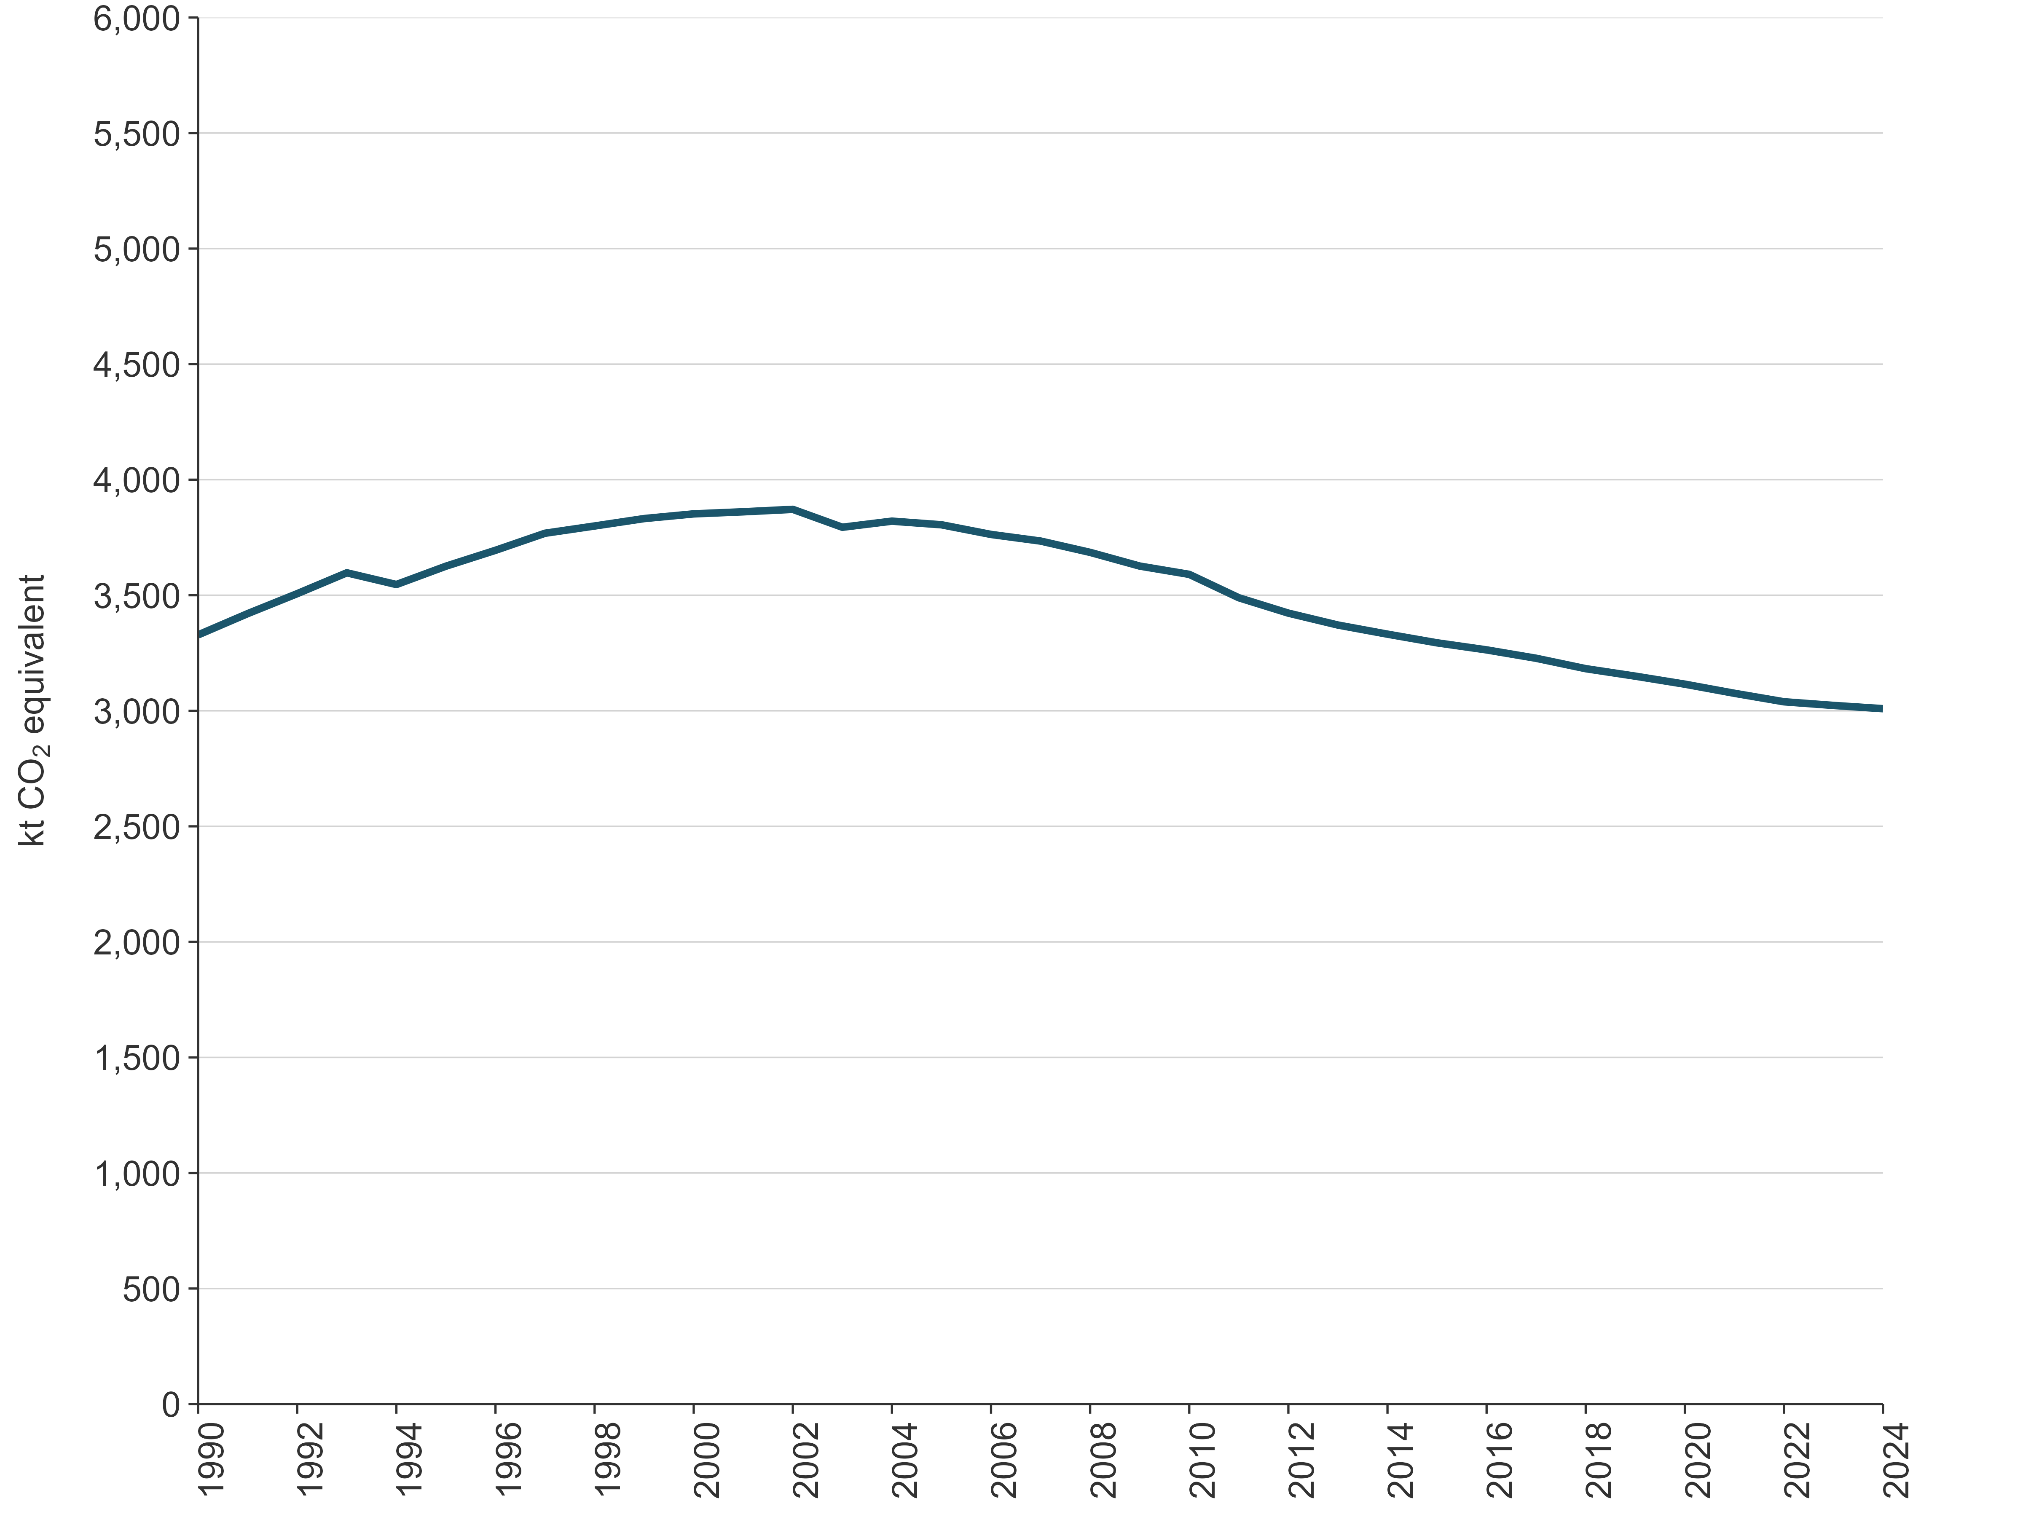

Other sector (Tokelau)
New Zealand ratified the United Nations Framework Convention on Climate Change (the Convention) on 16 September 1993 and the Paris Agreement on 4 October 2016. The extension to Tokelau (as of 13 November 2017) of New Zealand’s ratification of the Convention and of the Paris Agreement requires the reporting of Tokelau’s emissions in the Inventory.
Since the 2019 submission, the Inventory has included emissions from Tokelau, an overseas dependent territory of New Zealand. Tokelau is the only such dependent territory of New Zealand. Net and gross emissions are reported by sector from New Zealand’s mainland territory (mainland New Zealand), with Tokelau’s emissions reported separately. Emissions from Tokelau are small, and the methodology used varies greatly between Tokelau’s GHG inventory and the sectoral inventories for mainland New Zealand. This means emissions from Tokelau are reported in the Other sector (CRT sector 6). Tokelau’s contribution to the Inventory in relation to New Zealand’s mainland emissions is provided in table 2.2.2.
The methods used for compiling Tokelau’s GHG inventory are detailed in chapter 8. Annex 7 (volume 2) provides the common reporting tables of the time series for emissions and activity data, and information on methods and emission factors for each sector and category contributing to the gross emissions from Tokelau.
Due to the small land size area, small population and absence of industry, Tokelau has a very low impact on the environment and emits very small amounts of GHGs. In relative terms, emissions have increased overall since 1990, driven by higher per capita consumption despite a declining population. Tokelau produces mainly CO₂ emissions (54.5 percent) and CH₄ emissions (39.3 percent) followed by HFCs (5.0 percent) and N₂O emissions (1.2 percent). Emissions from HFCs largely come from the use of air conditioning.
Table 2.2.2 Emissions from Tokelau, 1990, 2005 and 2024
Sector | 1990 | 2005 | 2024 | Change from 1990 (kt CO₂e) | Change from 1990 (%) | Change from 2005 (kt CO₂e) | Change from 2005 (%) | Contribution to gross for Tokelau (%) | Contribution to gross NZ (incl Tokelau) (%)
Agriculture for Tokelau | 1.29 | 1.44 | 0.92 | -0.36 | -28.29 | -0.52 | -36.01 | 21.93 | 0.001
Energy for Tokelau | 1.26 | 2.43 | 2.27 | 1.01 | 79.75 | -0.16 | -6.43 | 53.98 | 0.003
IPPU for Tokelau | 0.04 | 0.08 | 0.24 | 0.20 | 484.36 | 0.16 | 192.78 | 5.67 | 0.0003
Waste for Tokelau | 0.78 | 0.76 | 0.77 | -0.005 | -0.62 | 0.02 | 2.51 | 18.42 | 0.001
Gross emissions for Tokelau | 3.37 | 4.71 | 4.21 | 0.84 | 24.81 | -0.50 | -10.61 | 100.00 | 0.006
Note: The 2026 submission includes emissions from Tokelau’s largest contributing sectors, which are the Energy, IPPU, Agriculture and Waste sectors. The LULUCF sector is not estimated. Tokelau has no planted or managed forests; therefore, the LULUCF sector is expected to be insignificant. The percentages may not add up to 100 percent due to rounding.

2024
In 2024, emissions from Tokelau were 4.21 kt CO₂e, or 0.006 percent of New Zealand’s gross GHG emissions.
The largest source category was Domestic navigation (emissions from marine vessels within Tokelau), which contributed 63.2 percent (1.43 kt CO₂e) of all energy emissions and 34.1 percent of gross emissions from Tokelau.
Carbon dioxide dominated emissions from Tokelau, contributing 54.5 percent (2.29 kt CO₂e) of its total emissions in 2024. At 2.25 kt CO₂, the Energy sector contributed 98.3 percent of total CO₂ emissions, mostly from Domestic navigation; with the remaining 1.7 percent (0.04 kt) coming from Open burning of waste in the Waste sector.
Methane emissions contributed 39.3 percent (1.66 kt CO₂e) to the total emissions from Tokelau. The Agriculture sector in Tokelau contributed 55.8 percent of CH₄ emissions (0.92 kt CO₂e), which mostly came from Manure management. A significant portion of CH₄ emissions, 43.9 percent (0.73 kt CO₂e), came from the Waste sector, largely from Solid waste disposal. The Energy sector contributed the remaining 0.4 percent of CH₄ emissions (0.01 kt CO₂e), which mostly came from Domestic navigation.
Nitrous oxide emissions contributed 1.2 percent (0.05 kt CO₂e) to the total emissions from Tokelau. The IPPU sector (Medical applications) contributed the largest amount of N₂O, 55.7 percent (0.03 kt CO₂e) of the total N₂O. The Energy sector contributed a further 24.1 percent (0.01 kt CO₂e), which comes largely from Domestic navigation. The Waste sector contributed the remaining 20.2 percent of N₂O (0.01 kt CO₂e) from Open burning of waste.
Emissions of fluorinated gases from Tokelau consisted of HFC emissions only, contributing 5.0 percent (0.21 kt CO₂e) to the total emissions from Tokelau. These emissions largely result from the use of Stationary air conditioning. Emissions of PFCs, NF₃ and SF₆ do not occur in Tokelau.

2023–2024
Between 2023 and 2024 emissions from Tokelau increased by 0.01 percent (0.0006 kt CO₂e). Emissions for 2024 are reported as largely unchanged from 2023 due to insufficient quantitative activity data available for the 2024 reporting year. There is anecdotal evidence suggesting that diesel fuel consumption patterns were similar across these years for energy generation in the Energy industries – Public electricity and heat production category.
While the activity data between these years were unchanged for all categories, the increase in emissions is the result of CH₄ emissions from Solid waste disposal. Emissions from Solid waste disposal are calculated using a first order decay model outlined in volume 5 of the 2006 IPCC Guidelines for National Greenhouse Gas Inventories (IPCC, 2006), which reflects how buried waste breaks down slowly over time. This means the emissions in any given year depend on the waste disposed in all previous years rather than the waste disposed this year. As a result, emissions change even when the activity data have not changed.

2005–2024
Between 2005 and 2024, emissions from Tokelau decreased by 10.6 percent (0.50 kt CO₂e) This change was mainly the result of reductions in emissions from the Agriculture sector. This was due to a reduction in the number of both pigs and chickens. Emissions from the Energy sector decreased overall between 2005 and 2024, due to the installation of solar photovoltaic systems in 2012. The increases and decreases in Energy emissions between 2012 and 2024 are further explained in chapter 8, section 8.3.1. Emissions from IPPU increased slightly between 2005 and 2024 primarily due to the growth in the number of air conditioning units during this period. Emissions from the Waste sector for Tokelau have remained steady between 2005 and 2024.

1990–2024
In 1990, Tokelau’s gross emissions were 3.37 kt CO₂e. Between 1990 and 2024, total emissions increased by 24.8 percent (0.84 kt CO₂e) to 4.21 kt CO₂e (chapter 8, table 8.1.3 and figure 8.1.4). From 1990 to 2024, the average annual increase in gross emissions was 0.87 percent.
The emissions increase was largely due to changes in the Energy sector. The emission categories that contributed the most to this change were Domestic navigation and Electricity generation.
The changes in Domestic navigation are a result of Tokelau gaining ownership and use of the ferry Mataliki in 2016, cargo vessel Kalopaga in 2018 and Fetu o te Moana in 2019, leading to an increasing number of sea voyages between the atolls, which increased transport emissions.
The changes in Tokelau’s Energy sector emissions from Electricity generation drive the overall emissions trend observed across most of the time series. Initially, up until 2003, emissions from this source were relatively stable. A significant increase in emissions (of nearly 400 percent) was then observed between 2003 and 2011 due to an increase in the use of diesel generators for electricity production. This was followed by a significant drop in emissions occurring in 2012 and 2013 (by 82.5 percent), when solar electricity generation began. Toward the end of the time series, diesel generator use increased again as the generation from solar power decreased, with emissions increasing accordingly.
Emissions from Tokelau’s IPPU sector have also increased mainly due to the introduction of air conditioning after 2006. Emissions from Tokelau’s Agriculture sector decreased as a result of a reduced population of pigs and chickens.
Figure 2.2.12 Emissions by sector for Tokelau, from 1990 to 2024
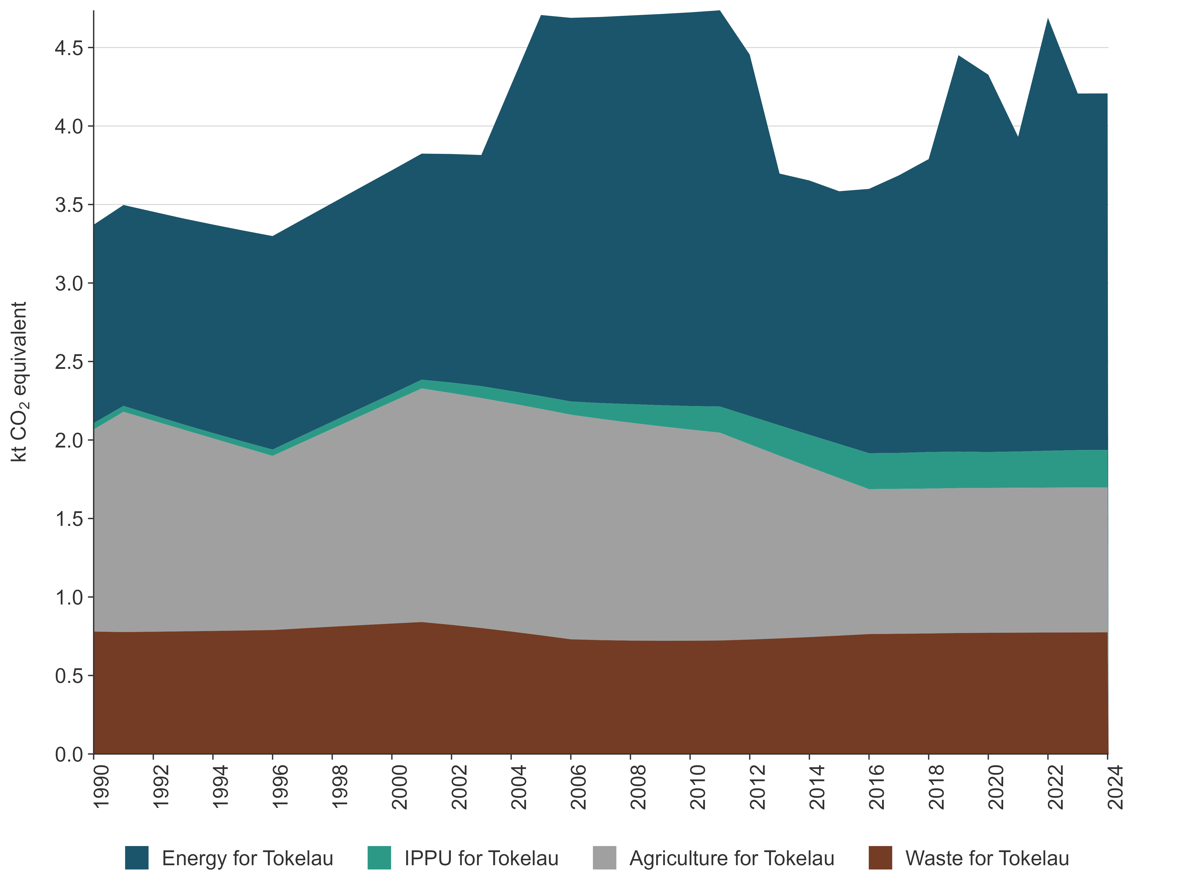

2.2.3 Emission trends by gas from 1990 to 2024
Inventory reporting under the Paris Agreement and the Convention covers the following direct GHGs: CO₂, CH₄, N₂O, SF₆, PFCs, HFCs and NF₃. No NF₃ data are included in this report because NF₃ emissions do not occur in New Zealand.
Table 2.2.3 provides a summary of gross emissions for each gas in 1990, 2005 and 2024 and the changes since 1990 and 2005.
Table 2.2.3 New Zealand’s gross emissions by gas in 1990, 2005 and 2024
Direct greenhouse gas emissions | 1990 | 2005 | 2024 | Change from 1990 (kt CO₂e) | Change from 1990 (%) | Change from 2005 (kt CO₂e) | Change from 2005 (%)
CO₂ | 25,521.7 | 37,427.1 | 31,436.2 | 5,914.4 | 23.2 | -5,990.9 | -16.0
CH₄ | 36,318.3 | 40,453.2 | 36,514.1 | 195.8 | 0.5 | -3,939.2 | -9.7
N₂O | 4,886.6 | 6,722.2 | 6,726.5 | 1,839.9 | 37.7 | 4.3 | 0.1
HFCs | Not occurring | 673.1 | 1,042.8 | 1,042.8 | NA | 673.1 | NA
PFCs | 818.0 | 62.4 | 78.1 | -740.0 | -90.5 | 15.7 | 25.1
SF₆ | 20.6 | 26.2 | 14.0 | -6.6 | -32.0 | -12.2 | -46.6
Gross, all gases | 67,565.2 | 85,364.3 | 75,811.6 | 8,246.4 | 12.2 | -9,552.7 | -11.2
Note: Gross emissions exclude net emissions from the LULUCF sector. The percentage change for HFCs is not applicable (NA) because no emissions of HFCs occurred in 1990. Columns may not total due to rounding. Percentages presented are calculated from unrounded values.
In 1990, 2005 and 2024, CH₄ made the greatest contribution to gross emissions (see table 2.2.3 and figure 2.2.13). While emissions of CH₄ have increased between these years, the rate of increase in CH₄ emissions relative to other gases in the Inventory has been lower over the same period. Nitrous oxide and CO₂ emissions have increased at a greater rate between these years than CH₄.
These trends reflect the changes that have occurred in the main livestock types that are farmed in New Zealand and the growth in road transport.
Figure 2.2.13 New Zealand’s gross emissions by gas in 1990, 2005 and 2024
Note: Emissions of sulphur hexafluoride (SF₆) are not visible due to its small emissions value and emissions of hydrofluorocarbons (HFCs) did not occur in 1990.
A summary of the Inventory by GHG for the period 1990 to 2024 is provided in figure 2.2.14. The LULUCF sector is excluded from this figure because it is a net sink across the time series. The LULUCF sector and its GHG trends are explained in detail in chapter 6.
Figure 2.2.14 Trends in New Zealand’s gross greenhouse gas emissions by gas, from 1990 to 2024
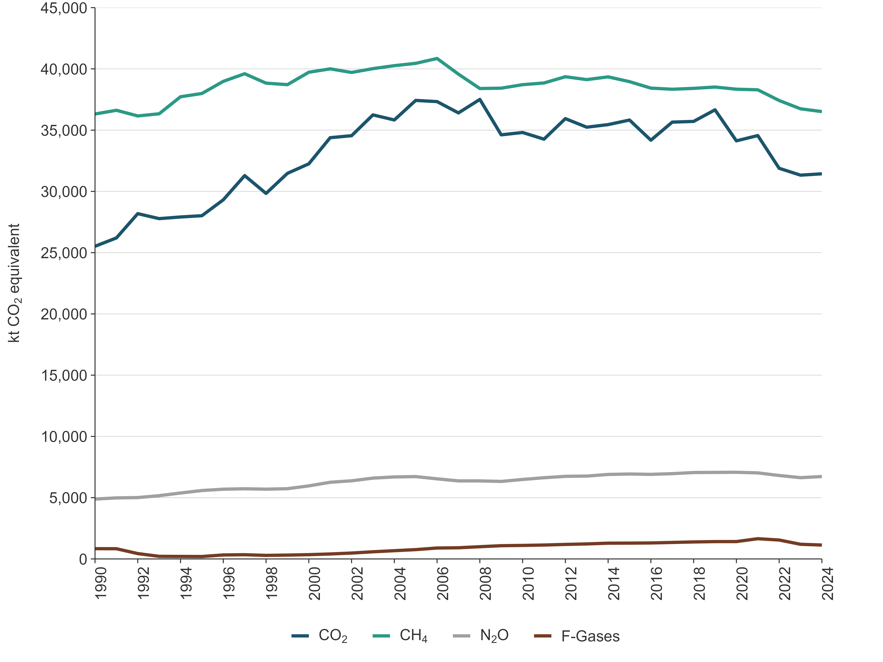
Note: F-gases = fluorinated gases.
Methane emissions represent the largest source of New Zealand’s gross anthropogenic GHG emissions since 1990 (figure 2.2.14). Most CH₄ emissions are produced through enteric fermentation, reported in the Agriculture sector. Carbon dioxide emissions are the second-largest source of gross emissions for New Zealand. Most CO₂ emissions are produced through combustion of fossil fuels in the Energy sector.
Between 1990 and 2024 CH₄ emissions increased by 0.5 percent. Methane emissions generally tracked upwards between 1990 and 2006, when they reached their peak. Despite fluctuations, CH₄ emissions have generally been tracking downwards since 2006 and have been declining year on year since 2019. The changes observed in CH₄ emissions have largely been due to increasing dairy cattle numbers, which have been partially offset by decreasing numbers of non-dairy (beef) cattle and sheep since 1990.
Between 1990 and 2024, CO₂ emissions have increased by 23.2 percent, peaking in 2008 (figure 2.2.14). Since 2019, the main drivers of the changes observed in gross CO₂ emissions have been the COVID-19 pandemic, the closure of New Zealand’s sole oil refinery and fluctuating levels of hydro power generation.
Between 1990 and 2024, N₂O emissions have increased by 37.7 percent, most recently peaking in 2020. Emissions from N₂O have generally been tracking upwards since 1990, although levels have remained stable since peaking in 2020. The overall increase in N₂O emissions is primarily a result of the increased use of synthetic nitrogen fertiliser since 1990, due to an increase in dairy farming, as well as increased use on other farm types.
Between 1990 and 2024, combined fluorinated gas emissions have increased by 35.3 percent. This increase was mainly due to the introduction of HFCs to replace ODS in refrigeration and air conditioning and the increased use of household and commercial air conditioning.

Indirect gases
New Zealand reports emissions estimates of indirect gases in accordance with IPCC (2006, volume 1, chapter 7). These indirect gases are CO, NO_{X}, NMVOCs and sulphur dioxide (SO₂). These gases are not GHGs themselves and are not included in the national emissions totals; however, CO, NO_{X} and NMVOCs chemically alter the atmosphere, leading to an increase in tropospheric ozone concentrations, and SO₂ contributes to aerosol formation. Table 2.2.4 summarises New Zealand’s indirect GHG emissions in 1990, 2005 and 2024 as well as the change between these years.
Table 2.2.4 New Zealand’s indirect greenhouse gas emissions (excluding LULUCF) in 1990, 2005 and 2024
Indirect greenhouse gas emissions | 1990 | 2005 | 2024 | Change from 1990 (kt CO₂e) | Change from 1990 (%) | Change from 2005 (kt CO₂e) | Change from 2005 (%)
CO | 622.6 | 741.8 | 650.7 | 28.1 | 4.5 | -91.1 | -12.3
NMVOCs | 143.7 | 178.7 | 171.1 | 27.4 | 19.1 | -7.6 | -4.3
NO_{X} | 102.5 | 164.9 | 150.0 | 47.4 | 46.3 | -14.9 | -9.0
SO₂ | 58.6 | 87.8 | 49.8 | -8.8 | -14.9 | -38.0 | -43.3
Note: Columns may not total due to rounding. Percentages presented are calculated from unrounded values.

Chapter 2: References
Beef + Lamb New Zealand Ltd. 2025. Annual Report 2024. Retrieved 17 November 2025.
IPCC. 2006. Eggleston HS, Buendia L, Miwa K, Ngara T, Tanabe K (eds). 2006 IPCC Guidelines for National Greenhouse Gas Inventories. Volume 1. General Guidance and Reporting. IPCC National Greenhouse Gas Inventories Programme. Japan: Institute for Global Environmental Strategies for IPCC.
LIC (Livestock Improvement Corporation Limited) and DairyNZ. 2025. New Zealand Dairy Statistics
2024–25. Hamilton: DairyNZ. Retrieved 7 December 2025.
Stats NZ. 2025. Agricultural production statistics: Year to June 2024 (final). Retrieved 21 November 2025.

Chapter 3: Energy

3.1 Sector overview

3.1.1 Introduction
The Energy sector covers:
- combustion emissions – emissions from burning fuel to produce useful energy
- fugitive emissions, such as:
- emissions from the production, transmission and storage of fuels
- emissions from non-productive combustion
- venting of carbon dioxide (CO₂) at natural gas treatment plants
- emissions from geothermal fields.
Combustion emissions from the Road transportation category account for the largest share of domestic Energy sector emissions in New Zealand. The country has one of the highest rates of car ownership in the world, as well as a relatively old vehicle fleet. Most freight is moved by trucks, and these factors mean New Zealand’s domestic transport emissions per capita are high compared with many other Annex I countries.
New Zealand’s electricity generation system relies heavily on renewable energy sources but is supported by coal-, oil- and gas-fired generation. In 2024, fossil fuel thermal plants provided 14.5 percent of the county’s total electricity, a comparatively low share by international standards. Over half of New Zealand’s electricity comes from hydroelectric power generation, and this means that electricity emissions remain sensitive to rainfall in key catchment areas. New Zealand also has relatively low hydro lake storage compared with other hydro-dependent countries.
Fugitive emissions form a small share of New Zealand’s energy emissions profile. The main sources are coal mining operations, natural gas production and processing (venting and flaring), and geothermal operations (primarily electricity generation).
New Zealand reports emissions from Tokelau, which is a dependent territory of New Zealand. Emissions from Tokelau are calculated using significantly different methods, and integrating these with New Zealand’s emissions would be prohibitively complex. Thus, emissions from Tokelau for all activities are reported in chapter 8 and volume 2, annex 7, and within the ‘Other’ sector in the common reporting tables (CRTs). All emissions reported under the Energy sector are from New Zealand only and exclude Tokelau. Please see chapter 8 for details of methods applied and the emissions for Tokelau.

2024
In 2024, emissions from the Energy sector contributed 28,753.2 kilotonnes carbon dioxide equivalent (kt CO₂e), or 37.9 percent of New Zealand’s gross greenhouse gas emissions (see chapter 2, figure 2.2.1).
The largest sources of emissions in the Energy sector were the Road transportation category, contributing 12,555.7 kt CO₂e (43.7 percent), and the Manufacturing industries and construction category, contributing 5,396.5 kt CO₂e (18.8 percent) to energy emissions.

2023–2024
Between 2023 and 2024, emissions from the Energy sector increased by 231.4 kt CO₂e (0.8 percent). This was primarily due to an increase in Public electricity and heat production (up 970.6 kt CO₂e or 35.5 percent). This increase was partially offset by the Chemicals category, which decreased by 590.4 kt CO₂e (45.0 percent) and Food processing, beverages and tobacco, which decreased by 205.8 kt CO₂e (7.6 percent). Further information on these changes is provided under the relevant categories of section 3.3.
National energy consumption in 2024 declined 2.1 percent from the 2023 level, and was 9.9 percent below the pre-COVID-19 peak seen in 2019.

2005–2024
Between 2005 and 2024, emissions from the Energy sector decreased by 5,843.4 kt CO₂e (16.9 percent). The largest reduction came from Public electricity and heat production, which decreased by 5,299.7 kt CO₂e (58.8 percent). While total electricity generation grew by 6 percent over the same period, the share from renewable sources increased significantly, from 66 percent to 85 percent driven by expanded geothermal and wind capacity. This reduction in emissions was partially offset by a 1,338.5 kt CO₂e (11.9 percent) increase from Road transportation.
Restrictions on activity and movement as part of the response to the COVID-19 pandemic during the 2020 calendar year saw significant disruption to economic activity throughout New Zealand. The effects on the Energy sector are particularly notable, with national energy consumption over 2020-2024 still remaining below 2019 levels. The sector saw a slight rebound during 2021, but energy consumption has remained well below pre-2020 levels in the following years.

1990–2024
In 2024, emissions from the Energy sector were 4,753.4 kt CO₂e (19.8 percent) higher than the 1990 level of 23,999.8 kt CO₂e. The main contributors to this increase were Road transportation (up 5,727.3 kt CO₂e or 83.9 percent), Food processing, beverages and tobacco (up 823.4 kt CO₂e or 49.3 percent), and Residential (up 407.1 kt CO₂e or 27.9 percent). While the drivers of these changes are complex, key factors include population growth and increased economic activity.
The largest decrease since 1990 occurred in the Manufacture of solid fuels and other energy industries category, historically a significant source of emissions. Emissions from this category fell by 1,460.3 kt CO₂e (85.7 percent), primarily due to the cessation of synthetic gasoline production in 1997.
Figure 3.1.1 shows the time series of Energy sector emissions from 1990 to 2024. Emissions rose steadily between 1990 and 2006, driven by population and economic growth, which in turn increased demand for transport and industrial energy. Road transportation emissions rose sharply due to high reliance on private vehicles and freight trucking. Manufacturing activity, particularly in energy-intensive sectors such as food processing and chemicals, also contributed to the upward trend.
After 2006, emissions declined slightly and then remained stable until 2019. Since 2019, emissions have decreased mainly due to the effects of the COVID-19 pandemic response and ongoing economic conditions. These factors, combined with lower-than-expected gas supply, have led to reductions in industrial energy use.
Figure 3.1.1 New Zealand’s Energy sector emissions, from 1990 to 2024
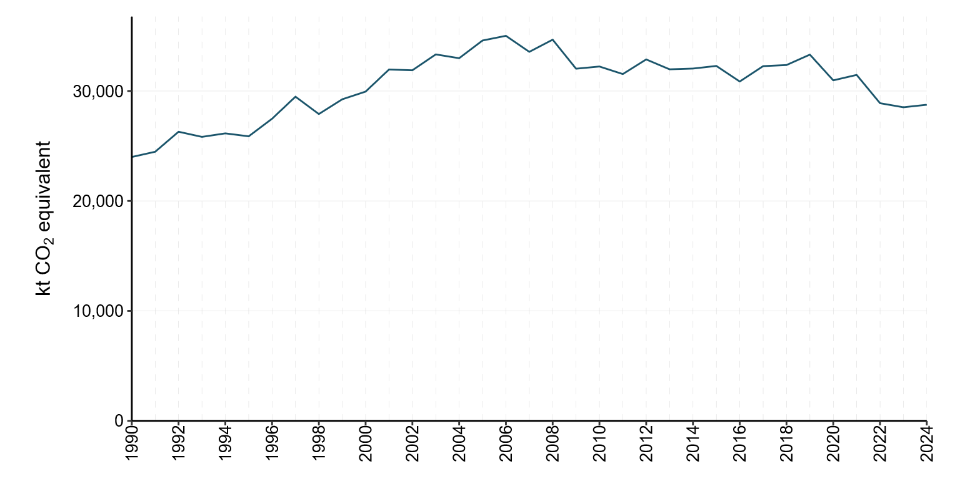

3.1.2 Key categories for Energy sector emissions
Details of New Zealand’s key category analysis are provided in volume 2, annex 1. The key categories in the Energy sector are listed in table 3.1.1.
Table 3.1.1 Key categories in the Energy sector
CRT category code | IPCC categories | Gas | Criteria for identification
1.A.1.a. | Energy industries – Public electricity and heat production – Gaseous fuels | CO₂ | L1, T1
1.A.1.a. | Energy industries – Public electricity and heat production – Solid fuels | CO₂ | L1, T1
1.A.1.b. | Energy industries – Petroleum refining – Liquid fuels | CO₂ | T1
1.A.1.c. | Energy industries – Manufacture of solid fuels and other energy industries – Gaseous fuels | CO₂ | T1
1.A.2.c. | Manufacturing industries and construction – Chemicals – Gaseous fuels | CO₂ | L1, T1
1.A.2.d. | Manufacturing industries and construction – Pulp, paper and print – Gaseous fuels | CO₂ | L1, T1
1.A.2.d. | Manufacturing industries and construction – Pulp, paper and print – Solid fuels | CO₂ | T1
1.A.2.e. | Manufacturing industries and construction – Food processing, beverages and tobacco – Solid fuels | CO₂ | L1
1.A.2.e. | Manufacturing industries and construction – Food processing, beverages and tobacco – Gaseous fuels | CO₂ | L1, T1
1.A.2.e. | Manufacturing industries and construction – Food processing, beverages and tobacco – Liquid fuels | CO₂ | L1
1.A.2.f. | Manufacturing industries and construction – Non-metallic minerals – Solid fuels | CO₂ | L1, T1
1.A.2.g.iii. | Other – Mining (excluding fuels) and quarrying – Liquid fuels | CO₂ | L1, T1
1.A.2.g.v. | Other – Construction – Liquid fuels | CO₂ | L1, T1
1.A.2.g.viii. | Other – Other (please specify) – Liquid fuels | CO₂ | L1, T1
1.A.2.g.viii. | Other – Other (please specify) – Solid fuels | CO₂ | T1
1.A.3.a. | Domestic aviation – Jet kerosene | CO₂ | L1, T1
1.A.3.b. | Transport – Road transportation – Liquid fuels | CO₂ | L1, T1
1.A.3.b. | Transport – Road transportation – Gaseous fuels | CO₂ | T1
1.A.3.d. | Domestic navigation – Residual fuel oil | CO₂ | T1
1.A.4.a. | Other sectors – Commercial/institutional – Liquid fuels | CO₂ | L1, T1
1.A.4.a. | Other sectors – Commercial/institutional – Gaseous fuels | CO₂ | L1, T1
1.A.4.a. | Other sectors – Commercial/institutional – Solid fuels | CO₂ | T1
1.A.4.b. | Other sectors – Residential – Liquid fuels | CO₂ | L1, T1
1.A.4.b. | Other sectors – Residential – Gaseous fuels | CO₂ | L1, T1
1.A.4.b. | Other sectors – Residential – Solid fuels | CO₂ | T1
1.A.4.c. | Other sectors – Agriculture/forestry/fishing – Liquid fuels | CO₂ | L1
1.A.4.c. | Other sectors – Agriculture/forestry/fishing – Solid fuels | CO₂ | T1
1.B.1.a.i. | Coal mining and handling – Underground mines | CH₄ | T1
1.B.2.b.v. | Natural gas – Distribution | CH₄ | T1
1.B.2.c.i.2. | Venting – Gas | CO₂ | L1, T1
1.B.2.c.i.3. | Venting – Combined | CH₄ | T1
1.B.2.d. | Other (please specify) – Geothermal | CO₂ | L1, T1
Note: L1 means a key category is identified under the level analysis – approach 1 and T1 is trend analysis
– approach 1. See chapter 1 for more information.

3.1.3 New Zealand sectoral methodology
Greenhouse gas emissions from the Energy sector are calculated using a detailed sectoral approach. This bottom-up approach is demand-based and involves processing energy data collected on a regular basis through various surveys. For verification, New Zealand also applies the Intergovernmental Panel on Climate Change (IPCC) reference approach to estimate CO₂ emissions from fuel combustion for the time series 1990 to 2024 (see volume 2, annex 3).
The activity data used for the sectoral approach are referred to as observed energy-use figures. These are derived from surveys and questionnaires administered by the Ministry of Business, Innovation and Employment (MBIE). The differences between calculated and observed figures are reported as statistical differences in the energy balance tables published along with Energy in New Zealand (MBIE, 2025a). Note that, due to the intervening time between the publication of Energy in New Zealand and the preparation of this submission, data revisions may have occurred.

3.1.4 International bunker fuels
Fuel-use data for international transportation are collected and published online by MBIE (2024a). These data use information from oil company returns through two surveys conducted by MBIE:
- Delivery of Petroleum Fuels by Industry (DPFI) – a quarterly survey that collects data on observed demand (actual sales figures) by industrial sector
- Monthly Oil Supply (MOS) – a monthly survey that collects a liquid fuels supply balance from companies selling fuel.
Some international bunker data in CRT 1.A(b) are sourced from the MOS survey, while data in CRT 1.D come from the DPFI survey. Companies responding to the DPFI are asked to reconcile their figures with those reported in the MOS. Discrepancies between the surveys are generally very small and are attributed to differences in methodology: the MOS uses a top-down approach, while the DPFI uses a bottom-up approach. Additionally, the surveys are usually completed by different sections within each fuel company. Note that the Other fuels category is not covered by the DPFI, so these data are obtained from the MOS.

3.1.5 Feedstock and other non-energy use of fuels
Some industrial fuels are used both for combustion and as feedstocks. For these cases, process-related emissions are calculated by subtracting the fraction of carbon stored in the final product – based on industry production and the chemical composition of the product – from the total fuel supplied. This remaining carbon is assumed to be emitted as CO₂ and is reported under the Industrial Processes and Product Use (IPPU) sector and in CRT 1.AD. Other fuel materials, such as bitumen, also contribute to emissions that are reported under the IPPU sector and, where applicable, in CRT 1.AD.
Key non-energy uses in New Zealand include the following.
- Methanol production: All carbon in natural gas feedstock is stored in the product so there are no associated CO₂ emissions. Emissions from fuel used for energy are reported in CRT category 1.A.2.c.
- Ammonia/urea production: Carbon dioxide emissions from the use of natural gas in ammonia production (feedstock) are reported under the IPPU sector and are included in CRT 1.AD. Emissions from fuel used for energy are reported in CRT category 1.A.2.c.
- Bitumen: Because it is used as a construction material, there are no direct emissions.
- Steel production: Coal is used as a reductant, which is a part of an industrial process, so emissions reported are under the IPPU sector.
For the four industries using natural gas as feedstock, the fraction of carbon stored is given in table 3.1.2. Emissions for individual products are withheld because of confidentiality concerns.
Table 3.1.2 Use of natural gas as a feedstock in New Zealand
Product | Percentage of carbon stored | Energy use reported under | Non-energy use reported under
Methanol | 100 | 1.A.2.c | NA
Urea | 80–93¹ | 1.A.2.c | 2.B.1
Hydrogen | 0 | 1.A.2.c | 2.B.10
Steel | 0 | 1.A.2.a | 2.C.1
Notes: 1. For urea production, the fraction of carbon stored varies across the time series, depending on the composition of the feedstock gas. NA = not applicable.
All ammonia produced in New Zealand is processed into urea, and the split of feedstock gas and fuel gas used in producing urea is provided by the company. Although most of the carbon in feedstock gas used for urea production is stored in the product, this carbon is later emitted when the urea is used on farms as fertiliser. These emissions are reported under urea application in the Agriculture sector.
Emissions from synthetic gasoline production are reported in the Manufacture of solid fuels and other energy industries category. Synthetic gasoline production in New Zealand ceased in 1997.
The allocation of natural gas consumed for energy use versus non-energy use across time is shown in figure 3.1.2, and a table giving the energy versus non-energy use data for natural gas is included in volume 2, annex 5. The trend in natural gas use in the Chemicals category can be explained partly by events in the methanol production industry in New Zealand.
Methanex New Zealand operates methanol production plants and has historically been the country’s single largest user of natural gas. Methanex has two production facilities in New Zealand: Motonui and Waitara Valley. In November 2004, production at the Motunui plant was halted following insufficient gas supply in 2003, with operations resuming in late 2008. Output further increased at Motonui in 2012, and production at full capacity resumed in December 2013. The Waitara Valley plant was mothballed in early 2021. Lower natural gas deliverability saw Methanex cease production completely between August and October 2024 to free up natural gas for use in electricity generation.
Details of natural gas use for the various non-energy uses are covered in chapter 4 (IPPU sector).
Figure 3.1.2 Natural gas consumption by end use type, petajoules (PJ), from 1990 to 2024
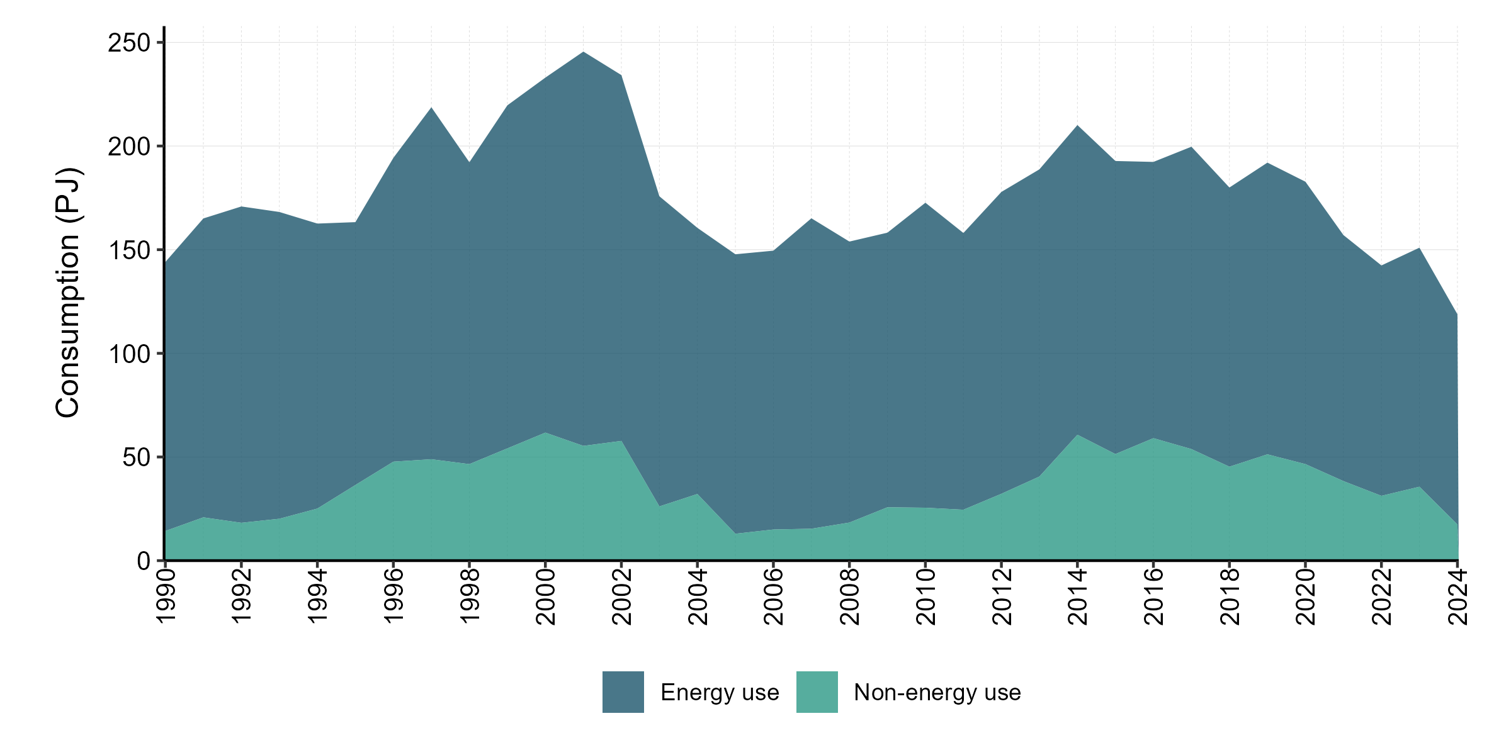

3.1.6 New Zealand energy balance
New Zealand’s energy balance, along with comprehensive information and analysis of energy supply and demand, is published annually in Energy in New Zealand (MBIE, 2025a). It covers energy statistics and includes supply and demand by fuel types, energy balance tables, pricing information and international comparisons. An electronic copy of this report is available online at: www.mbie.govt.nz/building-and-energy/energy-and-natural-resources/energy-statistics-and-modelling/energy-publications-and-technical-papers/energy-in-new-zealand.
For the most part, categories and fuels from the energy balance correspond directly with the categories and fuels in CRT 1.A(b). A few special cases occur, as follows, where the structure of the CRT does not align with New Zealand’s energy balance.
- In the New Zealand energy balance table, crude oil and refinery feedstocks are combined, whereas in CRT 1.A(b), these are separate line items.
- In New Zealand, liquefied petroleum gas (LPG) is considered a primary fuel and indigenous production is included in the national energy balance as such. The CRT does not allow entry of LPG production, so it is included in natural gas production and then allocated to LPG via stock change.
- New Zealand’s energy balance includes the production of synthetic gasoline from natural gas under energy transformation. The CRT does not allow entry of synthetic gasoline transformation, so it is included in natural gas production and then allocated to gasoline via stock change.
These allocations allow a more meaningful comparison with the sectoral approach data for liquid and gaseous fuels.

3.2 Fuel combustion (CRT 1.A)

3.2.1 Sector-wide description
The Fuel combustion category reports all fuel combustion activities from 1.A.1 Energy industries, 1.A.2 Manufacturing industries and construction, 1.A.3 Transport and 1.A.4 Other sectors categories (figure 3.2.1). These categories use common activity data sources and emission factors. The CRTs require energy emissions to be reported by category. Apportioning energy activity data across categories is not as accurate as apportioning activity data by fuel type because of difficulties in allocating liquid fuel to the appropriate categories.
Information about methodologies, emission factors, uncertainty, and quality control and assurance for each of the categories is discussed below.
Figure 3.2.1 New Zealand’s emissions from the Fuel combustion categories, 1990 versus 2005 and 2024
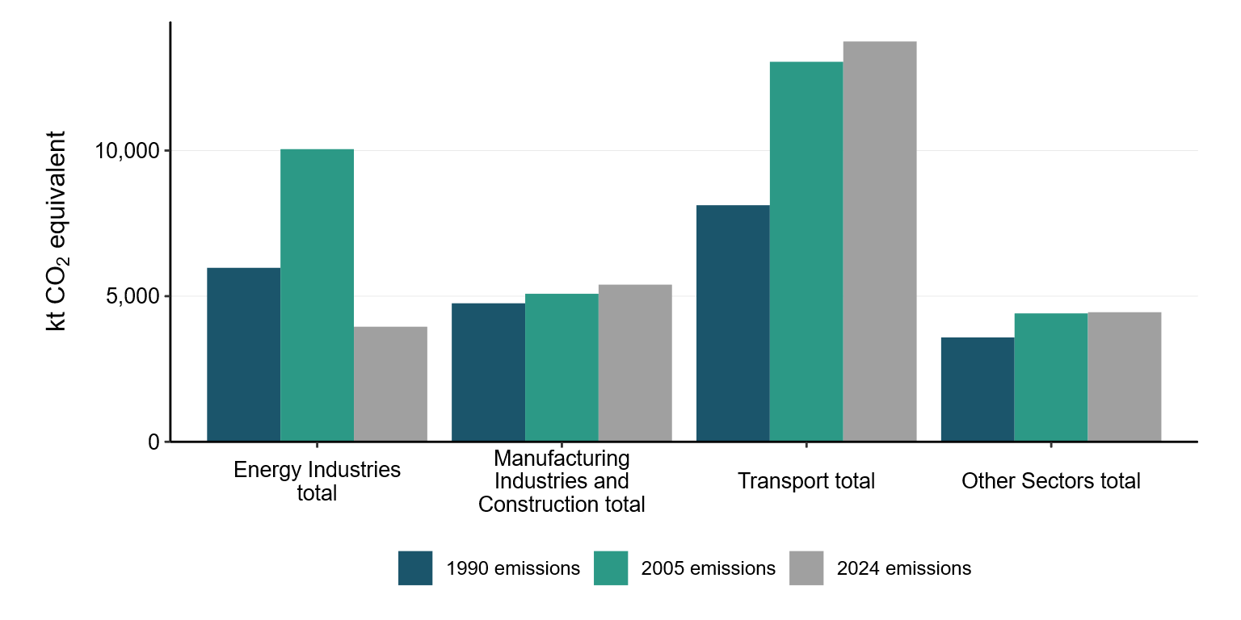

3.2.2 Methodology and data sources
This section outlines the methodologies used to estimate emissions from fuel combustion in New Zealand’s Energy sector. It describes the data sources and calculation approaches for liquid, solid, gaseous and biomass fuels, as well as electricity auto-production. The section explains how activity data are collected through national energy surveys and industry reporting, and how emission factors are applied using Tier 1 and Tier 2 methods. It also covers adjustments for fuel properties, treatment of international bunker fuels, and improvements made to ensure time-series consistency and sectoral disaggregation. Finally, it details the assumptions and conversion factors used for calorific values and emission factor calculations.
Energy emissions are compiled using MBIE’s energy statistics, along with relevant New Zealand-specific emission factors. Unless otherwise noted in the relevant section, CO₂ emissions are calculated by multiplying a country-specific emission factor for the given fuel by the relevant activity data using an IPCC (2006) Tier 2 method. Non-CO₂ emissions are calculated using IPCC (2006) default emission factors, unless otherwise noted.

Activity data

Liquid fuels
Liquid fuel consumption data for the Energy sector are taken from MBIE’s national energy balance tables. Most of those data are sourced from the DPFI. This quarterly survey includes liquid fuel sales data collected from the five oil companies importing and/or selling fuel. The purpose of the survey is to collect data on the amount of fuel delivered by all oil companies to end users and other distribution outlets. Each oil company in New Zealand supplies MBIE with the volume of petroleum fuels delivered to resellers and the industrial, commercial and residential sectors. The survey was originally conducted by Stats NZ, but MBIE took over responsibility for conducting the survey in 2009.
Petroleum fuels data are currently collected in volume units (thousand litres). Before 2009, data were collected in metric tonnes. Year-specific calorific values are used for all liquid fuels, reflecting changes in liquid fuel properties over time. Annual fuel property data were formerly provided by New Zealand’s sole refinery (the Marsden Point Oil Refinery), which ceased operations in March 2022. The properties of imported fuels are now obtained from companies that import fuel and from a national average value calculated using a weighted average of imported fuel properties.
Emissions from fuel sold for use in international transport (e.g., international bunker fuels) are reported separately as a memo item, as required (IPCC, 2006).
An MBIE-commissioned survey (MBIE, 2008) identified that fuel resales by independent fuel distribution companies were being over-allocated to the Transport category, although most of the fuel was used in the Agriculture/forestry/fishing category. In response, the Annual Liquid Fuel Survey began in 2009 to capture sector-specific deliveries of gasoline and diesel. Survey results showed that independent distributions accounted for approximately 18 percent of national total diesel consumption and 3 percent of gasoline consumption. Historical deliveries (1990–2006) were estimated using backcasting methods, as detailed in Delivering the Diesel – Liquid Fuel Deliveries in New Zealand 1990–2008 (MBIE, 2010). The survey is now conducted annually, and the results are used to allocate fuel sales across industry subsectors.

Solid fuels
Since 2009, MBIE has conducted the New Zealand Quarterly Statistical Return of Coal Production and Sales, previously conducted by Stats NZ. The survey covers coal mined and sold by coal producers in New Zealand. The three grades of coal surveyed are bituminous, subbituminous and lignite. This survey categorises coal sales by industry, recognising over 20 industries using the Australian and New Zealand Standard Industrial Classification (ANZSIC) 2006 (Australian Bureau of Statistics and Statistics New Zealand, 2006). Before 2009, when Stats NZ ran the survey, coal sales were surveyed for only seven high-level sectors.
All solid fuel used for iron and steel manufacture is reported under the IPPU sector, to avoid double counting.

Gaseous fuels
MBIE receives activity data on gaseous fuels from various sources. Individual natural gas field operators provide information on the amount of gas extracted, vented, flared and for own use at each gas field. The operator of the Kapuni Gas Treatment Plant provides information on processed gas (including at the Kapuni gas field), while gas distribution networks provide information on gas transmission and distribution throughout New Zealand.
Large users of gas, including electricity generation companies, provide their activity data directly to MBIE. Additionally, MBIE surveys retailers and wholesalers on a quarterly basis to obtain data on sales to industrial, commercial and residential natural gas users.
In response to expert review team (ERT) recommendations, all fuel combustion for electricity auto-production was disaggregated into the appropriate sector, rather than reported in category 1.A.2.g Manufacturing industries and construction – Other. This improvement was implemented in the 2013 submission and resulted in a reduction in unallocated industrial emissions and increases in various manufacturing and construction categories. For further information, see section 3.2.8.

Biomass
Activity data for the use of biomass come from several different sources. MBIE receives electricity and co-generation data from electricity generators.
- New Zealand reports emissions from landfill gas, sewage waste gas, sludge gas (derived from cattle effluent at the Tirau dairy processing facility) and commercial biogas use. Before 2013, New Zealand only reported emissions from landfill gas, sewage waste gas and commercial biogas use.
- New Zealand’s gas biomass emissions are estimated based on electricity generation data (some of which are also estimated). No direct data are available on gas biomass emissions from landfills or sewage treatment facilities. See below for details of the estimation methodology of landfill gas and sewage waste gas.
- Gas biomass is known to be used by some local government councils, however, exploratory data collection in the past has indicated that such use occurs only in small quantities and produces insignificant emissions. Because MBIE is aware of some use, it continues to report a standard estimate introduced in 2006 to avoid any under-reporting.
- No information is collected on flared gas biomass.
- The only gas biomass direct-use data that have been collected are for the Tirau dairy processing facility (and only one data point, which has been used for all years when it is believed the plant has produced emissions).

Gas biomass emissions estimates are based on electricity generation data
Biomass electricity generation data are collected for 14 individual plants. As of 31 December 2024, New Zealand’s gas biomass generation was known to include the following.
- Eleven landfill facilities, totalling 40.7 megawatts (MW). These facilities are electricity only. (Some landfill gas was used to heat a swimming pool in Christchurch before the Canterbury earthquake of February 2011, but that facility suffered major earthquake damage and has been removed. A new trigeneration facility has since been built.)
- Three wastewater treatment facilities, totalling 10.7 MW. These are all co-generation facilities that provide heat and electricity for processing sewage. No information is held on the exact type of generation plant used at these individual facilities, although they are known to be a combination of gas turbines, internal combustion engines and some steam turbine facilities.
Generation data are collected for each year ending 31 March, with generation assumed to be distributed equally across quarters to estimate December year-end generation. Generation data are usually collected from all these plants. However, in some years, estimates are made based on the previous year’s generation.
Fuel input information from small generators (those less than 10 MW) is not currently used within the electricity generation data system. Instead, estimates of fuel input are made on the assumption of 30 percent efficiency based on gross generation.
All generation data collected are assumed to be net generation (i.e., excluding parasitic load). These values are scaled up using default net-to-gross generation factors sourced from the International Energy Agency. For all thermal generation, the net-to-gross factor is assumed to be 1.07 (i.e., an additional 7 percent of electricity is generated but used within the plant itself). Fuel input estimates are then calculated based on the gross generation using a default electrical efficiency factor of 30 percent. This estimated quantity of biogas is used as total biogas for energy purposes. Biogas use estimates for landfill gas and sewage waste gas are calculated and reported in petajoules (PJ).
Energy quantities of gas biomass are then converted into greenhouse gas emissions using emission factors derived from the default IPCC (2006) emission factors (table 3.1.3).
Table 3.2.1 Emission factors for gas biomass
Gas | Tonnes per PJ
Carbon dioxide | 49,170
Methane | 0.9
Nitrous oxide | 0.09
The CO₂ emission factor is derived from the IPCC (2006) default net emission factor; it is assumed that the net emission factor is 10 percent lower than the gross emission factor.
Emissions from gas biomass comprise a very small part of New Zealand’s emissions inventory. Given this situation, MBIE believes the current process is sufficient for estimating emissions from gas biomass and that efforts to improve the quality estimates are better focused on other areas.

Solid biomass
Residential and industrial solid biomass activity data are taken from the annual Energy in New Zealand publication (MBIE, 2025a).

Liquid biomass
Liquid biofuel activity data are based on information collected under the Petroleum or Engine Fuel Monitoring Levy, as reported in MBIE quarterly online data releases.

Electricity auto-production
All combustion activity for electricity auto-production is allocated into the appropriate manufacturing category.

Emission factors
New Zealand emission factors are based on gross calorific values. A list of emission factors for CO₂, methane (CH₄) and nitrous oxide (N₂O) for all fuel types is provided in volume 2, annex 5. The characteristics of liquid, solid and gaseous fuels and biomass used in New Zealand are described under each of the fuel sections below. Where a New Zealand-specific value is not available, MBIE uses either the IPCC (2006) value that best reflects New Zealand conditions or the mid-point value from the IPCC (2006) range. All emission factors from the IPCC (2006) are converted from net calorific value basis to gross calorific value basis. New Zealand adopts the following assumptions (table 3.1.4) from the Organisation for Economic Co-operation and Development and International Energy Agency to make these conversions.
Table 3.2.2 Net-to-gross calorific value conversion factors
Fuel type | Factor
Gaseous | 0.90
Liquid | 0.95
Solid | 0.95
Wood | 0.80

Liquid fuels
Where possible, CO₂ emission factors for liquid fuels are calculated on an annual basis. Carbon dioxide emission factors for 1990 to 2021 were calculated from Refining New Zealand data on the carbon content and calorific values of the fuels that they produced at the country’s only oil refinery. Due to the closure of the refinery, collection of fuel property data from fuel importers started in 2022. For non-CO₂ emissions, IPCC (2006) default values are used unless otherwise specified in the relevant section. Volume 2, annex 5 provides further information on liquid fuel emission factors, including a time series of gross calorific values.

Solid fuels
Emission factors for solid fuels were updated for the 2016 submission across the time series from 1990 to 2008, in response to a 2013 ERT recommendation (FCCC/ARR/2013/NZL, paragraph 32) (UNFCCC, 2014). A comprehensive list of carbon content by coal mine is not available. A review of New Zealand’s coal emission factors in preparation for the New Zealand Emissions Trading Scheme (NZ ETS) (CRL Energy Ltd, 2009) recommended reweighting the current default emission factors to 2007 production rather than continuing with those in the New Zealand Energy Information Handbook (Baines, 1993). However, following the recommendation of the ERT review of New Zealand’s 2013 submission (FCCC/ARR/2013/NZL, paragraph 32) (UNFCCC, 2014), the emission factors between 1990 and 2008 have been interpolated.
The emission factor used to calculate emissions from coal use in the public electricity and heat production sector has been weighted to reflect the combustion of imported coal. A time series of the effect of this weighting is included in volume 2, annex 5.

Gaseous fuels
New Zealand’s gaseous fuel emission factors are above the IPCC (2006) default range because New Zealand natural gas fields tend to have a higher CO₂ content than most international gas fields. This is verified by regular gas composition analysis. Emission factors for 2024 from all fields, along with the production-weighted average, are included in volume 2, annex 5.
The annual gaseous fuel emission factor is calculated as an average of the emission factors of all natural gas fields in New Zealand, weighted by each field’s relative production for the year. This method provides increased accuracy because it considers trends in gas fields’ production rates over time (e.g., the decline in production from both the Māui and Kapuni gas fields). This emission factor fluctuates slightly from year to year, mainly due to the relative production volume at different gas fields.
Natural gas from the Kapuni gas field has a particularly high CO₂ content. Historically, this field has been valued by the petrochemicals industry as a feedstock. However, most of the gas from this field is now treated, and the excess CO₂ is removed at the Kapuni Gas Treatment Plant. Consequently, separate emission factors were used to calculate emissions from Kapuni treated and untreated gas, due to the difference in carbon content (see volume 2, annex 5). Carbon dioxide removed from raw Kapuni gas (which is then vented) is reported in category 1.B.2.c Venting and flaring.

Biomass
Emission factors for wood combustion are calculated from an IPCC (2006) default emission factor and assume that the net calorific value is 20 percent lower than the gross calorific value (IPCC, 2006). Carbon dioxide emissions from wood used for energy production are reported as a memo item and are not included in the estimate of New Zealand’s total greenhouse gas emissions (IPCC, 2006). Carbon dioxide emission factors for liquid biofuels are sourced from the New Zealand Energy Information Handbook (Baines, 1993), while CH₄ and N₂O emission factors are IPCC (2006) default emission factors.

3.2.3 Uncertainty assessment and time-series consistency
Uncertainty in greenhouse gas emissions from fuel combustion varies, depending on the type of greenhouse gas. The uncertainty in CO₂ emissions is relatively low. This is important because CO₂ emissions comprise around 96 percent to 97 percent of CO₂e emissions from fuel combustion in New Zealand. In comparison, emissions of the non-CO₂ gases are much less certain because emissions of these gases vary with combustion conditions. Uncertainties for CO₂, CH₄ and N₂O activity data and emission factors are supplied in table 3.2.1. Many of the non-CO₂ emission factors used by New Zealand are the IPCC (2006) default values. Further detailed information around uncertainties for each fuel type can be found in volume 2, annex 5.
Table 3.2.3 Uncertainty for New Zealand’s Energy sector emission estimates for 2024
 | Category | Activity data uncertainty (%) | Emission factor uncertainty (%)
CO₂ | Gaseous fuels | ±7.3 | ±2.4
CO₂ | Liquid fuels | ±0.9 | ±0.5
CO₂ | Other fossil fuels | ±5.0 | ±5.0
CO₂ | Solid fuels | ±4.8 | ±2.2
CO₂ | Fugitive – Oil exploration | ±0.9 | ±100.0
CO₂ | Fugitive – Oil production | ±0.9 | ±100.0
CO₂ | Fugitive – Oil transport | ±0.9 | ±100.0
CO₂ | Fugitive – Gas production | ±7.3 | ±100.0
CO₂ | Fugitive – Gas transmission and storage | ±7.3 | ±100.0
CO₂ | Fugitive – Gas distribution | ±7.3 | ±100.0
CO₂ | Fugitive – Venting and flaring | ±7.3 | ±2.4
CO₂ | Fugitive – Other forms of energy production (geothermal) | ±5.0 | ±5.0
CH₄ | Gaseous fuels | ±7.3 | ±50.0
CH₄ | Liquid fuels | ±0.9 | ±50.0
CH₄ | Other fossil fuels | ±5.0 | ±50.0
CH₄ | Solid fuels | ±4.8 | ±50.0
CH₄ | Biomass | ±50.0 | ±50.0
CH₄ | Fugitive – Coal handling | ±4.8 | ±50.0
CH₄ | Fugitive – Oil exploration | ±0.9 | ±50.0
CH₄ | Fugitive – Oil production | ±0.9 | ±50.0
CH₄ | Fugitive – Oil transport | ±0.9 | ±50.0
CH₄ | Fugitive – Oil refining | ±0.9 | ±50.0
CH₄ | Fugitive – Gas production | ±7.3 | ±50.0
CH₄ | Fugitive – Gas transmission and storage | ±7.3 | ±100.0
CH₄ | Fugitive – Gas distribution | ±7.3 | ±100.0
CH₄ | Fugitive – Venting and flaring | ±7.3 | ±50.0
CH₄ | Fugitive – Other forms of energy production (geothermal) | ±5.0 | ±5.0
N₂O | Gaseous fuels | ±7.3 | ±50.0
N₂O | Liquid fuels | ±0.9 | ±50.0
N₂O | Other fossil fuels | ±5.0 | ±50.0
N₂O | Solid fuels | ±4.8 | ±50.0
N₂O | Biomass | ±50.0 | ±50.0
N₂O | Fugitive – Venting and flaring | ±7.3 | ±100.0
To estimate activity data uncertainty, we use the percentage difference between annual calculated consumer energy from supply-side surveys and annual observed consumer energy from demand-side surveys. As a result, activity data uncertainty can vary significantly from year to year.

3.2.4 Sector-wide QA/QC and verification
In the preparation of this inventory, the Fugitive emissions category underwent Tier 1 quality-assurance and quality-control checks, as recommended in the 2006 IPCC Guidelines for National Greenhouse Gas Inventories (2006 IPCC Guidelines) (volume 2, Energy) (IPCC, 2006). These include regular control sums throughout systems to verify system integrity, time-series consistency checks on activity data and consistency checks on implied emission factors at the industry–plant level, where possible. Figure 3.2.2 presents the quality control process map for the Energy sector.
Figure 3.2.2 Energy sector quality control process map
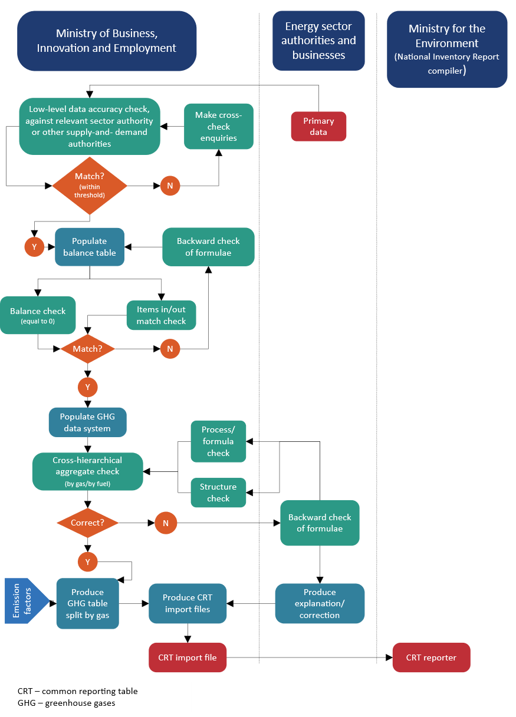
As discussed in section 3.1, the reference approach provides a good, high-level quality check for activity data. A significant deviation (greater than 5 percent) indicates a likely issue.
Implied CO₂ emission factors for combustion of liquid, solid and gaseous fuels from this inventory were compared with those in the IPCC Emission Factor Database and converted to gross values for comparability with the New Zealand energy system.
Figures 3.2.3, 3.2.4 and 3.2.5 show the upper, lower and middle IPCC (2006) emission factor ranges for liquid, solid and gaseous fuel combustion, and compare the implied emission factors according to observed fuel consumption in New Zealand for the given year. Each fuel type falls within the IPCC (2006) default range, except for gaseous fuels. This is because, as discussed in section 3.2.2, CO₂ emission factors for New Zealand natural gas fields are established through gas composition analysis and are known to be high by international standards.
Figure 3.2.3 Liquid fuel combustion, from 1990 to 2024 – carbon dioxide implied emission factor (IEF) (tonnes CH₄ per terajoule (t CH₄/TJ))
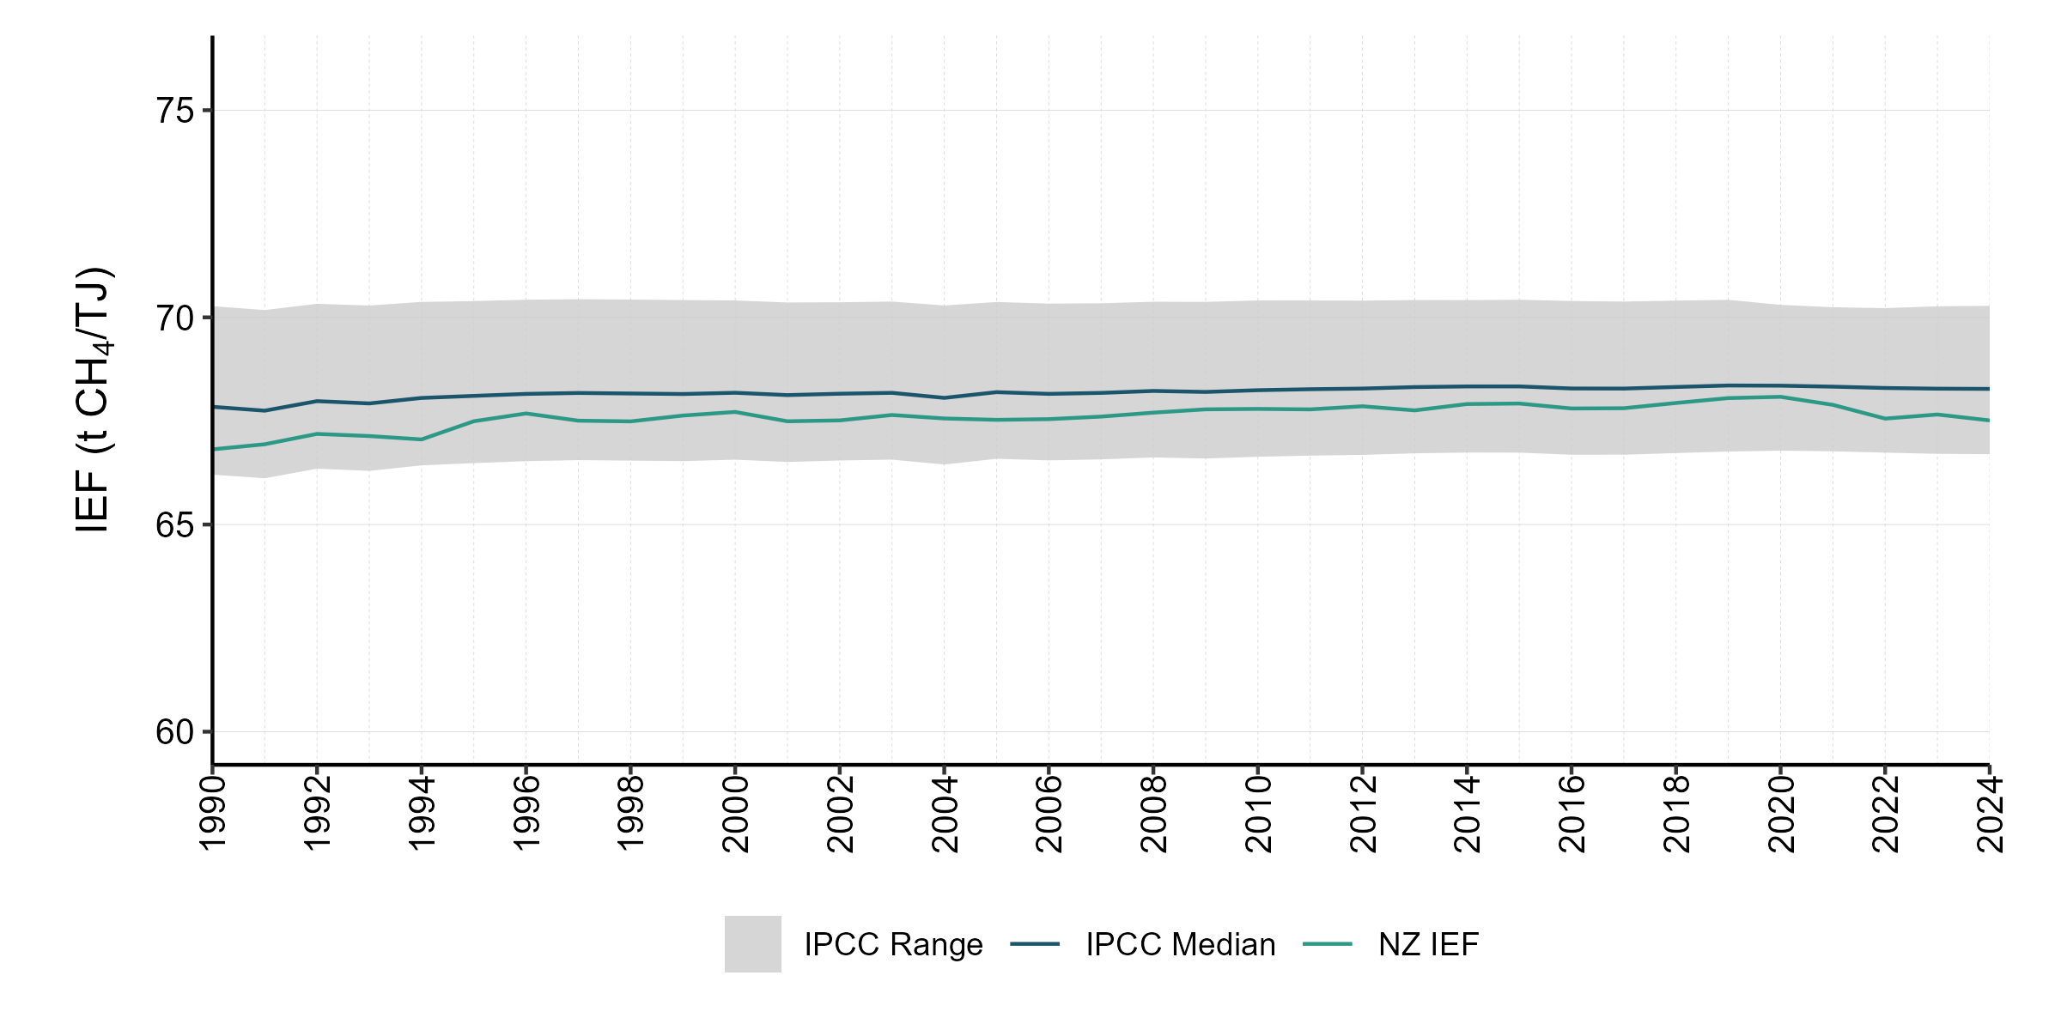
Figure 3.2.4 Solid fuel combustion, from 1990 to 2024 – carbon dioxide IEF (t CH₄/TJ)
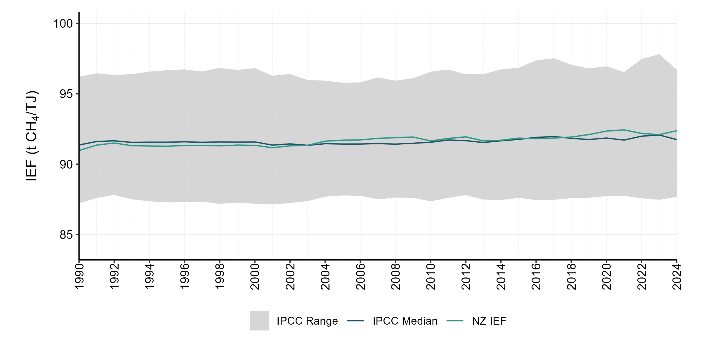
Figure 3.2.5 Gaseous fuel combustion, from 1990 to 2024 – carbon dioxide IEF (t CH₄/TJ)
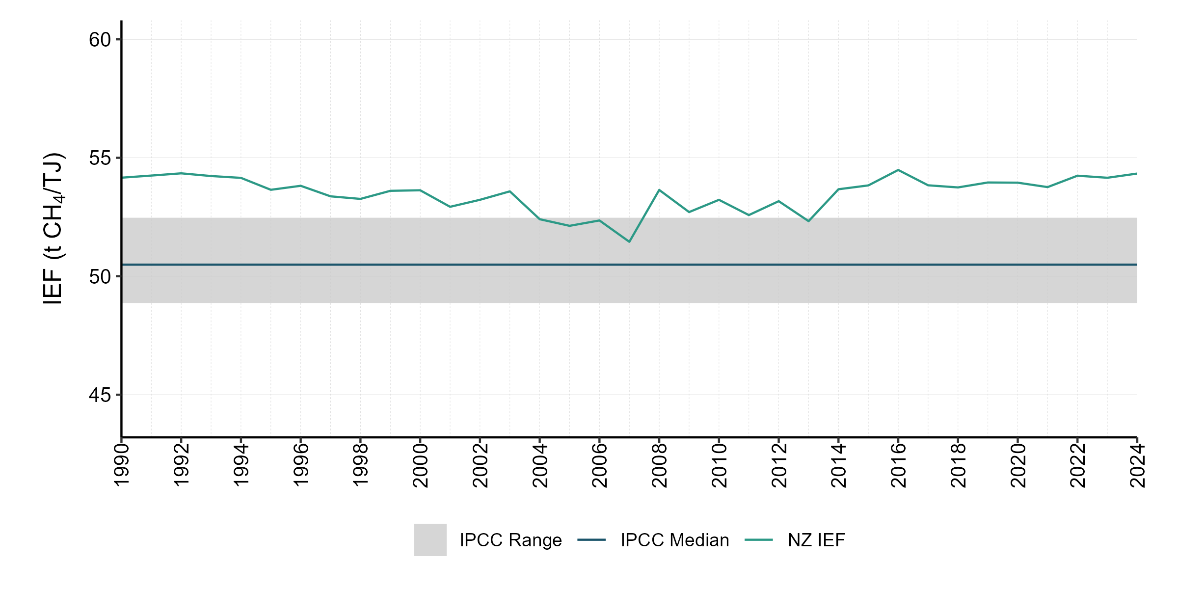
Note: As discussed in section 3.2.2 under ‘Emission factors’, carbon dioxide emission factors for New Zealand natural gas fields are established through gas composition analysis and are known to be high by international standards.

3.2.5 Sector-wide recalculations
There have been no sector-wide recalculations. Any category-specific recalculations are described in their relevant sections.

3.2.6 Sector-wide planned improvements
There are no sector-wide planned improvements. All category-specific planned improvements are discussed in their corresponding sections.

3.2.7 Fuel combustion: Energy industries (CRT 1.A.1)

Category description
This category includes combustion for public electricity and heat production, petroleum refining, the manufacture of solid fuels and other energy industries. The latter category includes estimates for natural gas in oil and gas extraction and from natural gas used in synthetic gasoline production.
In 2024, emissions in category 1.A.1 Energy industries totalled 3,951.9 kt CO₂e (13.7 percent of the Energy sector emissions). Emissions from energy industries in 2024 were 2,022.2 kt CO₂e (33.8 percent) lower than the 1990 level of 5,974.1 kt CO₂e and 6,096.1 kt CO₂e (60.7 percent) lower than the 2005 level of 10,048.1 kt CO₂e. Category 1.A.1.a Public electricity and heat production was the largest contributor to this sector, accounting for 3,708.0 kt CO₂e of emissions from the Energy industries category in 2024. This is 218.1 kt CO₂e (6.2 percent) higher than the 1990 level of 3,489.9 kt CO₂e and 5,299.7 kt CO₂e (58.8 percent) lower than the 2005 level of 9,007.6 kt CO₂e.

Changes in emissions between 2023 and 2024
Between 2023 and 2024, emissions from 1.A.1.a Public electricity and heat production increased by 970.6 kt CO₂e (35.5 percent). The share of electricity generated from renewable energy sources decreased from 88 percent to 85 percent over this period, due mainly to lower hydro generation in response to reduced hydro inflows. The drop in renewable generation necessitated an increase in gas and coal-fired generation, which together rose 23 percent from 2023.
Key categories identified in the 2024 level and trend assessment for the Energy industries category are given in table 3.2.2.
Table 3.2.4 Key categories for 1.A.1 Energy industries
Category | Liquid fuels | Solid fuels | Gaseous fuels
Public electricity and heat production – CO₂ | – | Level | Level, trend
Petroleum refining – CO₂ | Trend | – | –
Manufacture of solid fuels and other energy industries – CO₂ | – | – | Trend
Electricity generation in New Zealand is dominated by hydroelectric generation. For the 2024 calendar year, hydro generation provided 53.5 percent of New Zealand’s electricity generation. A further 19.9 percent came from geothermal, 8.9 percent from wind, 1.7 percent from biomass and 1.4 percent from solar. The remaining 14.5 percent was provided by fossil fuel thermal generation plants using natural gas, coal and oil (MBIE, 2025a).
Greenhouse gas emissions from the Public electricity and heat production category show large year-to-year fluctuations between 1990 and 2024. These fluctuations can also be seen over the time series of New Zealand’s gross emissions. The fluctuations are influenced by the close inverse relationship between thermal and renewable generation (see figure 3.2.6). In a dry year, when low rainfall reduces most of New Zealand’s hydro lake levels, any shortfall in hydroelectric generation is made up by increased thermal electricity generation. New Zealand’s hydro resources have limited storage capacity; total reservoir storage is only around 10 percent of New Zealand’s annual demand. Hence, regular rainfall throughout the year is needed to sustain a high level of hydro generation. Electricity generation in a ‘normal’ hydro year does not require significant use of natural gas and coal, while a ‘dry’ hydro year requires greater use of natural gas and coal.
Figure 3.2.6 New Zealand’s electricity generation by source, from 1990 to 2024
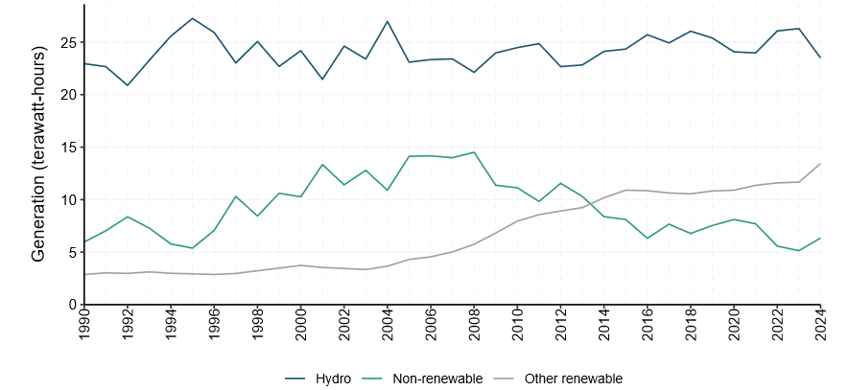

Methodological issues

1.A.1.c Manufacture of solid fuels and other energy industries
Methanex New Zealand produced synthetic gasoline until 1997. A Tier 2 methodology was used to estimate CO₂ emissions based on the annual weighted average gas emission factor.
Domestically produced liquid CO₂ is reported as CO₂ capture under category 1.A.1 Energy industries. The consumption of domestically produced liquid CO₂ is reported under the IPPU sector, consistent with the treatment of imported liquid CO₂.
Liquid CO₂ is used in a variety of applications, including brewing and the production of dry ice. Dry ice is commonly used for applications such as preserving perishable goods during shipping – including food, flowers and human organs for transplant – creating fog effects for entertainment and for the freeze-branding of livestock. Emissions from the consumption of products derived from liquid CO₂ are reported under IPPU category 2.H.3 Other (carbon dioxide consumption).

Activity data

1.A.1.a Public electricity and heat production
All thermal electricity generators report to MBIE the quantities of coal, natural gas and oil used for electricity generation. Greenhouse gas emissions from geothermal electricity generation are reported in category 1.B.2.d Fugitive emissions – Geothermal.
Around 5 percent of New Zealand’s electricity is supplied by co-generation (also known as combined heat and power) (MBIE, 2025a). Most major co-generation plants are attached to large industrial facilities that consume most of the generated electricity and heat.
Six co-generation plants that fit the IPCC (2006) definition of public electricity and heat production produce electricity as their primary purpose. The emissions from these plants are included in category 1.A.1.a Public electricity and heat production, while emissions from other co-generation plants are included in category 1.A.2 Manufacturing industries and construction (section 3.2.8).
To establish a consistent approach to on-site generation, MBIE developed a decision tree to guide the allocation of associated fuel consumption and identify whether the plant is a main activity electricity generator or an autoproducer (figure 3.2.7).
Figure 3.2.7 Decision tree to identify a main activity electricity generator or an autoproducer
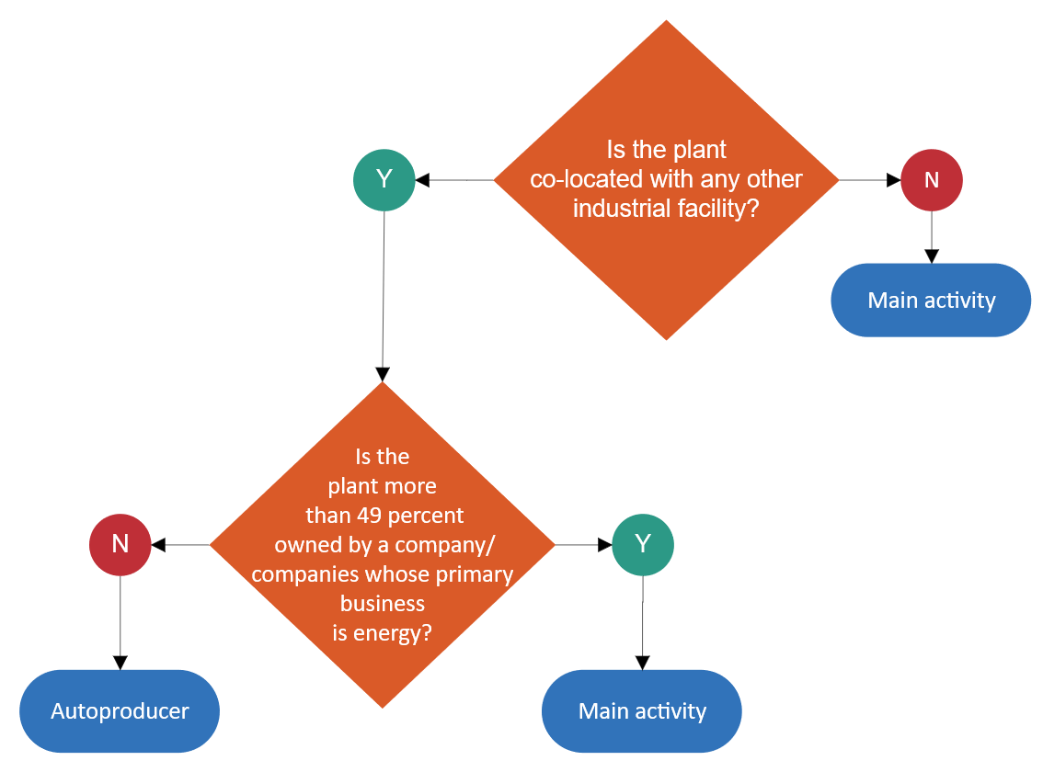

1.A.1.b Petroleum refining
Petroleum refining in New Zealand occurred up until March 2022 at only one site: the Marsden Point Oil Refinery, owned by Refining New Zealand. Refining New Zealand formerly provided annual activity data and emission factors for each type of fuel consumed at the site.

1.A.1.c.ii Manufacture of solid fuels and other energy industries – Other energy industries
Activity data for the own-use combustion of natural gas during oil and gas extraction are reported to MBIE by individual gas and/or oil field operators. Some crude oil is also combusted for own use during oil and gas extraction, and these quantities are reported in NZ ETS returns.
Emissions from natural gas combustion for natural gas transmission are reported directly to MBIE by the transmission network operator. Similarly, emissions from natural gas combustion for natural gas processing are reported directly to MBIE by the plant operator.
Losses and own use of coal by coal mining entities are reported as a single aggregated item, so data on on-site coal use are unavailable. Historically, coal mines would use their own coal to fuel on-site water boilers. However, the last such boiler at the Stockton mine closed in the mid-1980s, and the expert opinion of coal industry specialists indicates that any remaining on-site boilers are now fuelled by natural gas or electricity.

Emission factors

Gaseous fuels
As mentioned in section 3.2.2, New Zealand’s CO₂ emission factor for natural gas fluctuates from year to year, reflecting the relative amount of gas produced from the various gas fields each year. New Zealand gas fields also have higher CO₂ content than most international gas fields. This is particularly evident in category 1.A.1.a Public electricity and heat production.

Uncertainty assessment and time-series consistency
Uncertainties in emissions and activity data estimates for this category are relevant to the entire Fuel combustion category (see table 3.2.1).

Category-specific QA/QC and verification
In the preparation of this inventory, the Energy industries category underwent Tier 1 quality-assurance and quality-control checks as recommended in the 2006 IPCC Guidelines (IPCC, 2006). These include regular control sums throughout systems to verify system integrity and consistency checks on implied emission factors.

Category-specific recalculations
Some historical data on fuel consumption for electricity generation have been revised in the national energy balance tables. This has resulted in minor revisions to activity data and recalculations of the corresponding emissions for some recent years.

Category-specific planned improvements
There are no planned improvements for this category.

3.2.8 Fuel combustion: Manufacturing industries and construction (CRT 1.A.2)

Category description
This category comprises emissions from fossil fuels combusted in the manufacture of iron and steel, other nonferrous metals, chemicals, pulp, paper and print, food processing, beverages and tobacco, and in other manufacturing-related activities. Emissions from cogeneration plants that do not meet the definition of cogeneration as provided in the 2006 IPCC Guidelines are included in this category (IPCC, 2006).
In 2024, emissions from the 1.A.2 Manufacturing industries and construction category accounted for 5,396.5 kt CO₂e (18.8 percent) of emissions from the Energy sector. The largest contributors were Food processing (2,495.1 kt CO₂e) and Chemicals (722.2 kt CO₂e).

Changes in emissions between 1990 and 2024
Between 1990 and 2024, emissions from this category increased by 640.5 kt CO₂e (13.5 percent) compared with the 1990 level of 4,756.0 kt CO₂e. The largest contributors to this rise were Food processing, which grew by 823.4 kt CO₂e (49.3 percent) and Mining, which increased by 318.4 kt CO₂e (268.0 percent).
A decline in methanol production from 2003 to 2004 caused a significant reduction in emissions from this category. Methanol production was the largest source of emissions in category 1.A.2.c Chemicals. Methanex New Zealand restarted previously mothballed plants in 2012/13 (the resulting increase in gas use can be seen in figure 3.1.2), but then mothballed the Waitara Valley plant in early 2021.
Energy use in the Wood, pulp and paper subsector has declined since 2016, driven by the closure of several processing facilities. Following a pause in operations in August 2024, Winstone Pulp International announced the closure of its Karioi pulp mill and Tangiwai sawmill in September 2024. Oji Fibre Solutions also shut its Penrose paper recycling mill in December 2024.

Changes in emissions between 2005 and 2024
Emissions from this category were 311.8 kt CO₂e (6.1 percent) higher than the 2005 level of 5,084.7 kt CO₂e. The most significant categories contributing to this increase were Food processing (up 524.7 kt CO₂e or 26.6 percent) and Chemicals (up 270.2 kt CO₂e or 59.8 percent).

Changes in emissions between 2023 and 2024
Between 2023 and 2024, emissions from the Manufacturing industries and construction category decreased by 729.7 kt CO₂e (11.9 percent). The main driver was a reduction in emissions from the Chemicals category, which fell by 590.4 kt CO₂e (45.0 percent) compared with 2023. This decline was primarily due to lower methanol production. In 2024, production was reduced following a temporary shutdown of operations at Methanex New Zealand from August to October, during which contracted natural gas was redirected to the New Zealand electricity market under short-term commercial arrangements in response to low gas deliverability.
Key categories identified in the 2024 level and trend assessment for the Manufacturing industries and construction category are given in table 3.2.3.
Table 3.2.5 Key categories for 1.A.2 Manufacturing industries and construction
Category | Liquid fuels | Solid fuels | Gaseous fuels
Chemicals – CO₂ | – | – | Level, trend
Pulp, paper and print – CO₂ | – | Trend | Level, trend
Food processing, beverages and tobacco – CO₂ | Level | Level, trend | Level, trend
Non-metallic minerals – CO₂ | – | Trend | –
Other – Mining and quarrying – CO₂ | Level, trend | – | –
Other – Construction – CO₂* | Level, trend | – | –
Other – Other non-specified – CO₂ | Level, trend | Trend | –
Note: * This key category is calculated using emissions that do not distinguish by fuel type; however, it is known to be primarily liquid fuels.

Methodological issues
Some emissions from the use of solid fuels and gaseous fuels are excluded from the Manufacturing industries and construction category because they are accounted for under the IPPU sector. These include the following.
- New Zealand Steel Limited uses coal as a reducing agent in the steel-making process. In accordance with the 2006 IPCC Guidelines (IPCC, 2006), the emissions from this are included under the IPPU sector rather than the Energy sector.
- In several instances, natural gas is excluded from the Manufacturing industries and construction category because it is accounted for under the IPPU sector. Among the emissions excluded are those from urea production, hydrogen production and some of the natural gas used by New Zealand Steel (New Zealand Steel separately reports its emissions from natural gas as part of the combustion process and natural gas as part of the chemical process).

Activity data
Energy balance tables released with Energy in New Zealand (MBIE, 2025a) categorise industrial uses of energy using ANZSIC 2006. From 2009, MBIE started to collect more detailed information on the industry of fuel use in the various surveys used to compile its balance tables, and this has allowed MBIE to further disaggregate the Manufacturing industries and construction category. Where actual survey data are not available at the required level, estimates of the energy use across these categories have been made to ensure time-series consistency. These are described in further detail below.

Solid fuels
Prior to 2010, coal use in the Manufacturing industries and construction category could not be further disaggregated, because no data existed to allow for more detailed categorisation. However, in 2010, MBIE implemented disaggregation for coal use in this category based on the improved industry use data mentioned above. This disaggregation was applied from 2009 onwards, and the percentage splits (based on 2009 data) were applied to activity data for the annual inventory submission across the whole time series (back to 1990). However, during 2014, the coal data system at MBIE was revised to internally disaggregate manufacturing industries based on a 2011 survey of major coal users. Therefore, applying the disaggregation procedure previously used within the greenhouse gas data system is no longer necessary.
From 2009 onwards, the coal sales survey conducted by MBIE provides data at a more disaggregated level.

Solid biomass
The activity data for the industrial use of solid biomass are taken from the annual Energy in New Zealand publication (MBIE, 2025a). This dataset is estimated based on several sources. The main source used is a database of wood processors in New Zealand, which is maintained by Scion. Scion is a group that operates under the New Zealand Institute for Bioeconomy Science and specialises in forestry, wood products and other biomaterial sectors. Scion’s wood processing database covers the majority of large-scale wood processors in the country and contains a range of information, including estimates of energy demand by sites. Annual estimates of wood residue and black liquor use are sourced from the database. Because these data are collected every couple of years, estimated data are carried forward using data published by the Ministry for Primary Industries on activity by wood processors for years when MBIE has not received an updated wood processing database.
The Bioenergy Association of New Zealand conducted the 2006 Heat Plant Survey of New Zealand (Bioenergy Association of New Zealand, 2011) to gain information on heat plant (boiler) capacity and use in New Zealand. One area this survey examined was solid biomass use in New Zealand industrial companies (see table 3.2.4). The survey showed that most solid biomass in New Zealand is used by the wood processing industry. The industrial allocations from the survey were used to separate out solid biomass activity data for the inventory. These splits were applied across the whole time series (back to 1990) for activity data and CO₂, CH₄ and N₂O emissions.
Table 3.2.6 Solid biomass splits for 2006 that were used to disaggregate the Manufacturing industries
and construction category between 1990 and 2024
CRT category code | Manufacturing industries and construction category | Percent
1.A.2.a | Iron and steel | NO
1.A.2.b | Non-ferrous metals | NO
1.A.2.c | Chemicals | NO
1.A.2.d | Pulp, paper and print | 99.94
1.A.2.e | Food processing, beverages and tobacco | 0.05
1.A.2.g | Other – Mining and construction | NO
1.A.2.g | Other – Textiles | NO
1.A.2.f | Other – Non-metallic minerals | NO
1.A.2.f | Other – Manufacturing of machinery | NO
1.A.2.g | Other – Not specified | 0.01
Note: NO = not occurring. Survey data indicate that solid biomass combustion does not occur in the sectors.

Gas biomass
Sludge gas is produced at the Tirau dairy processing facility. Cattle effluent is used to produce sludge gas that is used to raise heat for the milk processing facility, which is open from September through to December each year. See section 3.2.2 (Biomass) for further information.
Sludge gas is not metered or analysed at the site, but estimates of flow rate and CH₄ content were obtained from the facility manager for the 2011 reporting year. MBIE then used these data to calculate an estimate of the total energy content, which was then confirmed by the facility manager.
The facility has operated in the same fashion since its construction in the late 1980s. Therefore, this estimate is assumed to be valid across the time series.

Liquid fuels
As mentioned in section 3.2.2 (‘Liquid fuels’), New Zealand uses the Annual Liquid Fuel Survey to capture sales by independent distributors. With this information, some liquid fuel demand that would otherwise be allocated to national transport is reallocated to the correct sector. As a result of this reallocation, emissions attributed to category 1.A.3 Transport decreased by around 20 percent, and emissions attributed to other categories, such as 1.A.4.c Agriculture/forestry/fishing, increased significantly.
Following ERT recommendations (in the 2007 in-country review), New Zealand began to disaggregate liquid fuel combustion in the 1.A.2 Manufacturing industries and construction category for the 2011 inventory. Diesel and gasoline consumption were disaggregated for the 2012 submission, and the method was subsequently extended to include fuel oil.
While data are not collected at this level of detail in energy surveys for liquid fuels, New Zealand has produced estimates based on Stats NZ survey data. Stats NZ conducted an industrial and trade energy use survey (Stats NZ, 2018), which assessed energy consumption and end use across manufacturing industries for the 2016 calendar year. Proportions of liquid energy end use were then determined across the manufacturing industries. These proportions, along with category gross domestic product (GDP) data from Stats NZ for the period, were used to calculate implied energy intensities (PJ per unit of GDP) for each category for diesel, gasoline and fuel oil (table 3.2.5). These intensities were then applied to Stats NZ GDP data across the time series and scaled to match the fuel sales reported for all manufacturing industries and construction, to estimate activity data for each category.
Table 3.2.7 Energy intensity values used to disaggregate liquid fuel use for manufacturing
 | Gasoline | Diesel | Fuel oil
Category | Gigajoules per gross domestic product index
Mining | 2.4 | 1,117.9 | 19.6
Building and construction | 30.5 | 334.8 | 2.7
Food processing | 1.4 | 475.6 | 243.5
Textiles | 0.9 | 12.8 | 158.6
Wood, pulp, paper and printing | 1.1 | 199.5 | 43.7
Chemicals | 0.2 | 36.3 | 2.0
Non-metallic minerals | 0.7 | 587.4 | 263.9
Basic metals | 1.2 | 88.1 | 0.4
Mechanical/electrical equipment | 2.6 | 23.6 | 0.9
Industry unallocated | 0.7 | 2.7 | 0.5
By disaggregating into categories, more accurate estimates of stationary versus mobile combustion for diesel were also able to be made, resulting in small changes to the emissions from manufacturing industries and construction.
Disaggregating the Manufacturing industries and construction category for solid fuels, solid biomass, gasoline and diesel has led to a significant decrease in the Other – not specified category (1.A.2.g) under Manufacturing industries and construction. The proportions are shown in figure 3.2.8 and figure 3.2.9.
Figure 3.2.8 Proportions used for Manufacturing industries and construction category – Gasoline, from 1990 to 2024
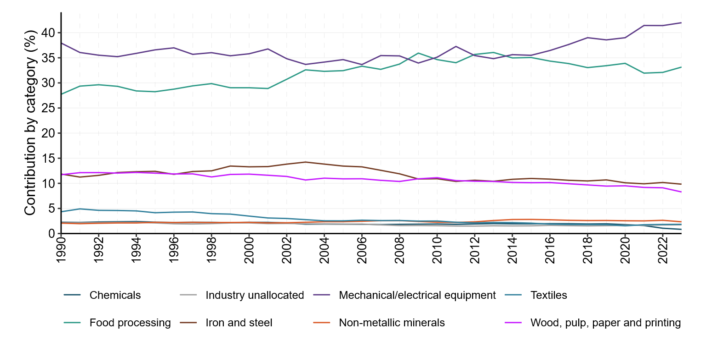
Figure 3.2.9 Proportions used for Manufacturing industries and construction category – Diesel, from 1990 to 2024
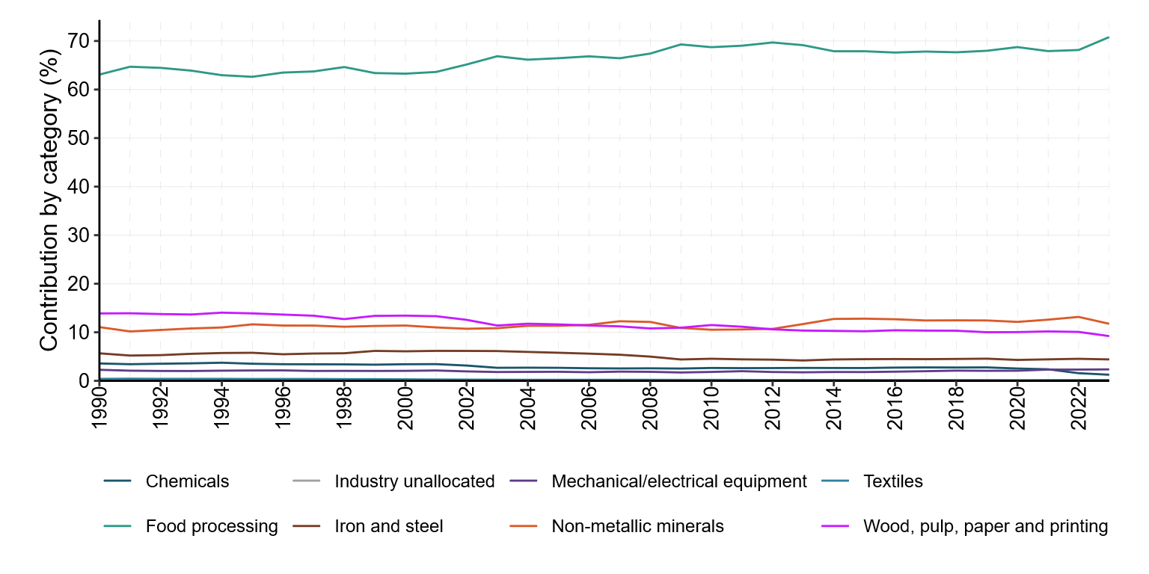

Gaseous fuels
Annual natural gas consumption statistics are published by MBIE (2025a). In 2011, MBIE undertook a review of the allocation of natural gas consumption data to address time-series discontinuities in sectoral breakdowns prior to 2006. The review identified inconsistencies in sector reporting and gaps in sectoral data. Discrepancies from 2003 to 2005 were attributed to changes in survey design, while inconsistencies and missing data before 2003 were reworked and re-estimated. These missing data represented around 40 percent of total natural gas use; total consumption was not altered, with adjustments applied only to sectoral allocations.
Where necessary, new estimates of gas consumption were made, depending on data availability. The chosen data source in order of preference was as follows.
- Data from major consumers of natural gas were used if available because these data are more reliable and accurate, and more easily classified by sector.
- Where these data were not available, natural gas retailers’ reported sales by sector were used.
- If these data were also not available, then estimates based on regressions using GDP data were used. GDP output and production data were used along with assumptions about energy intensity and consumption of categories (to the most detailed level possible).
Several categories are represented by only one or two major natural gas consumers: for some of these cases, data from major consumers were directly used. Where there are industries with many major natural gas consumers, gas retailers’ reported sales by sector were used, though these can, at times, exhibit data quality issues.
A review was also undertaken in 2014 by MBIE covering data going back to 1999. Several sales previously identified as wholesale sales (i.e., gas bought to be on-sold) were, in fact, sold to consumers, but at ‘wholesale’ (lower) prices. Work was done to correct the classifications of these sales, based on customer name, to reflect their relevant sectors.

Other fossil fuels
This category includes waste oil and tyre-derived fuel. Activity data are sourced from the NZ ETS. A Tier 2 methodology was used to estimate CO₂ emissions based on an emission factor of 1,668 kilograms CO₂ per tonne (the Annex I average), while Tier 1 methodologies were used for CH₄ and N₂O based on default IPCC (2006) emission factors for industrial wastes.

1.A.2.a Iron and steel
Activity data for coal used in iron and steel production are reported to MBIE by New Zealand Steel Limited. A considerable amount of coal is used in the production of iron. Most of the coal is used in the direct reduction process to remove oxygen from iron-sand. However, all emissions from the use of coal are reported under the IPPU sector because the primary purpose of the coal is to produce iron (IPCC, 2006). A small amount of natural gas is used in the production of iron and steel to provide energy for the process: this is reported under the Energy sector in category 1.A.2.a Iron and steel.

1.A.2.c Chemicals
The Chemicals category includes estimates from the following sub-industries:
- industrial gases and synthetic resin
- organic industrial chemicals
- inorganic industrial chemicals, other chemical production, rubber and plastic products.
The quantity of natural gas used for the production of methanol and ammonia (and, subsequently, urea) has been split into energy-use gas (which is included in category 1.A.2.c Chemicals) and feedstock gas (which is included in the IPPU sector under 2.B.8.a for methanol and 2.B.1 for ammonia). See chapter 4 for further information.
Activity data for methanol production are provided directly by Methanex New Zealand. For a detailed description of historical trends in methanol production, refer to section 3.1.5.
Methanex New Zealand is the sole methanol producer in New Zealand and considers its natural gas consumption to be commercially sensitive information. New Zealand takes a Tier 2 (IPCC, 2006) approach to estimating emissions from methanol production. This approach uses natural gas consumption at the plant along with country- and field-specific emission factors to calculate potential emissions before deducting the carbon sequestered in the end product.
The major non-fuel-related emissions from the methanol process are CH₄ (reported under the IPPU sector) and non-methane volatile organic compounds.
Superphosphate fertiliser is commonly used in New Zealand to ensure that soil has a sufficiently high phosphorous content. It is manufactured from the reaction between sulphuric acid and phosphate rock. During the process, the heat generated by the exothermic reaction between molten sulphur and oxygen is recovered in a waste-heat boiler to produce steam that is then used for process heating and to drive a steam turbine that produces electricity. The electricity is used on site, and generally any excess is exported to the local power supplier. Because the exothermic reaction is not based on the combustion of fossil fuels, there are no associated emissions to report in the Energy sector.

On-site electricity generation
As mentioned in section 3.2.2, on-site electricity generation is allocated to either the Public electricity and heat production category or the sector in which the associated plant operates, using the decision tree shown in figure 3.2.7.

Uncertainty assessment and time-series consistency
Uncertainties in emission and activity data estimates are those relevant to the entire Energy sector (volume 2, annex 5).

Category-specific QA/QC and verification
In the preparation of this inventory, the Manufacturing industries and construction category underwent Tier 1 quality-assurance and quality-control checks, as recommended in the 2006 IPCC Guidelines (IPCC, 2006). These include regular control sums throughout systems, to verify system integrity, and time-series consistency checks.

Category-specific recalculations
Historical energy demand data in the national energy balance tables are occasionally revised from year to year. This may result in minor revisions to activity data and recalculations to the corresponding emissions for some years in some categories.

Category-specific planned improvements
There are no planned improvements for this category.

3.2.9 Fuel combustion: Transport (CRT 1.A.3)

Category description
This category includes emissions from fuels combusted during domestic transportation, such as civil aviation, road, rail and domestic marine transport. Emissions from international marine and aviation bunkers are reported as memo items and are not included in New Zealand’s total emissions.
In 2024, category 1.A.3 Transport accounted for 13,744.8 kt CO₂e, representing 47.8 percent of Energy sector emissions. Road transportation dominated this profile, contributing 12,555.7 kt CO₂e or 91.3 percent of total transport emissions. New Zealand has a relatively old vehicle fleet, with the average age of the light passenger vehicles around 15 years, consistently two to four years older than in comparable countries. The country has one of the highest rates of car ownership in the world, driven by its dispersed population, rural-based economy and limited public transport infrastructure. Most freight is moved by trucks, with smaller volumes transported by rail and coastal shipping. These factors mean New Zealand’s domestic transport emissions per capita are high compared with many other Annex I countries.
Since 1990, transport emissions have risen by 5,621.3 kt CO₂e (69.2 percent) from 8,123.5 kt CO₂e. Road transportation alone increased by 5,727.3 kt CO₂e (83.9 percent) over the same period, driven by factors such as population growth and increased economic activity.
Compared with 2005, transport emissions in 2024 were 697.9 kt CO₂e (5.3 percent) higher than the 13,046.9 kt CO₂e reported for that year. Road transportation contributed most of this change, climbing by 1,338.5 kt CO₂e (11.9 percent), reflecting similar underlying drivers.

Changes in emissions between 2023 and 2024
Between 2023 and 2024, emissions from transport decreased by 64.2 kt CO₂e (0.5 percent). This was primarily due to decreases in Road transportation (down 44.0 kt CO₂e or 0.3 percent) and Domestic aviation (down 14.2 kt CO₂e or 1.5 percent). The factors behind these movements vary by mode, but a key contributor is lower fuel consumption, driven by reduced travel demand and improvements in vehicle efficiency.
Key categories identified in the 2024 level and trend assessment for the Transport category are given in table 3.2.6.
Table 3.2.8 Key categories for 1.A.3 Transport
Category | Liquid fuels | Solid fuels | Gaseous fuels
Domestic aviation – CO₂ | Level, trend | – | –
Road transportation – CO₂ | Level, trend | – | Trend
Domestic navigation – CO₂ | Trend | – | –

Methodological issues

1.A.3.a Civil aviation
A Tier 1 approach (IPCC, 2006) that does not use landing and take-off cycles has been taken to estimate emissions from the Civil aviation category. Given the uncertainty surrounding CH₄ and N₂O emission factors for landing and take-off cycles, a Tier 2 approach to estimating non-CO₂ emissions would not necessarily reduce uncertainty (IPCC, 2006).
Hot air ballooning is considered a form of adventure aviation rather than transport and is included in category 1.A.4.a Commercial/institutional.

1.A.3.b Road transportation
The IPCC (2006) Tier 2 approach was used to calculate CO₂ emissions from Road transportation using New Zealand-specific emission factors. Emission factors for oil products were derived from refinery data (up until 2021) and fuel importer data (from 2022 onwards). The emission factor for compressed natural gas (CNG) is based on the weighted average emission factor of New Zealand natural gas fields.
Methane and N₂O emissions are estimated using a Tier 3 approach. Volume 2, annex 5 provides information on non-CO₂ emission factors.
Data collected by New Zealand’s Ministry of Transport provide comprehensive information on vehicle-kilometres-travelled by vehicle class and fuel type from 2001 onwards. Vehicle-kilometres-travelled were sourced from national warrant of fitness inspections. These were further split into travel type (urban, rural, highway, motorway) using New Zealand’s Road Assessment and Maintenance Management system. The New Zealand Travel Survey (Ministry of Transport, 2010) is used to further split the ‘urban’ travel type into cold and hot starts. This survey provides detailed trip-by-trip information on travel type. These data were used to establish the percentages of light-vehicle urban travel that comprise cold starts and hot starts. Before 2001, insufficient data were available, so good practice guidance was used in choosing the splicing method to ensure time-series consistency.
The current New Zealand vehicle fleet is split relatively evenly between vehicles:
- imported for sale as new vehicles
- produced and used in Japan and then imported into New Zealand.
For this reason, estimates of emissions from road transport split the New Zealand vehicle fleet into sub-fleets: the ‘new vehicle fleet’ and the ‘used vehicle fleet’. This allocation is based on a vehicle’s year of manufacture rather than when it was first added to the New Zealand fleet.
New vehicles are allocated an appropriate vehicle class from the COPERT 4 model (European Environment Agency, 2007), and used Japanese vehicles are allocated emission factors as per categories from the Japanese Ministry of the Environment. These emission factors are broken down by:
- vehicle type
- fuel type
- vehicle weight class
- year of manufacture.
Due to the presence of expensive catalysts, many used vehicles imported into New Zealand have their catalytic converters removed before being exported from Japan. The Ministry of Transport undertook several testing studies to determine the proportion of catalytic converters that are removed in Japan before export.
For the 2018 submission, the Ministry of Transport implemented several improvements for its estimates of non-CO₂ emissions from road transport. First, new emission factors for Euro 5 and 6 vehicles have been used, where previously these vehicles were treated as Euro 4/IV. Second, the European Monitoring and Evaluation Programme/European Environment Agency emission inventory guidebook was updated in late 2016 (European Environment Agency, 2016). Some of the emission factors for Euro 4 and earlier vehicles were also updated in this version of the guidebook. Moreover, detailed emission factors were provided for heavy-duty trucks in different gross vehicle mass bands.

Time-series consistency
Insufficient data exist to apply the Tier 3 methodology before 2001. To maintain time series consistency, New Zealand combined methods following IPCC (2006) guidance on splicing techniques (volume 1, section 5.3.3). Emissions for 2001 to 2016 were calculated using both Tier 1 and Tier 3 approaches to establish the relationship between the two series (figure 3.2.10). This analysis informed the selection of the most appropriate splicing method, in line with IPCC guidelines (IPCC, 2006, volume 2, table 5.1).

Figure 3.2.10 Splicing method decision tree for gasoline emissions
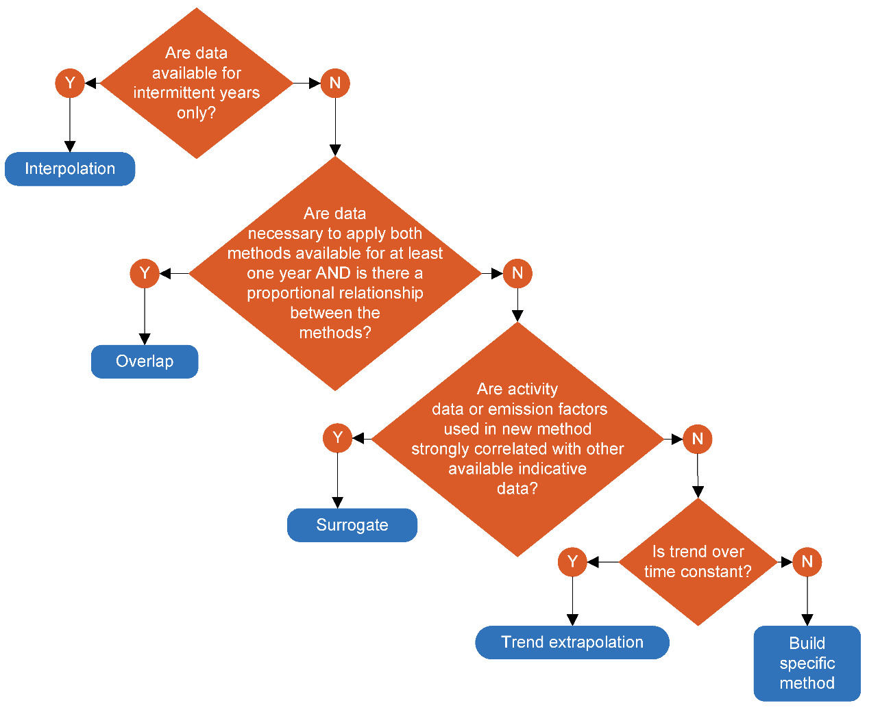
For all fuels, interpolation was considered inappropriate due to the size of the block of unavailable data and the lack of data from before the missing block (1990–2000).
For emission estimates from LPG, the relationship between Tier 1 and Tier 3 appears nearly constant for both N₂O and CH₄ from 2001 until 2002. As a result, the overlap method was used (IPCC, 2006), with:
$$y_{t}=x_{t}\left(\sum_{i=m}^{n}{y_{i}}/\sum_{i=m}^{n}{x_{i}}\right)$$
Where: y_{t} is the recalculated emission estimate computed using the overlap method
x_{t} is the estimate developed using the previous method
y_{i} and x_{i} are the estimates prepared using the new and previously used methods during the period of overlap, as denoted by years m through n.
However, for gasoline and diesel vehicles, the ratio Tier 3:Tier 1 appears to change approximately linearly with time. While surrogates for Ministry of Transport data were available (fuel consumption), their use resulted in a step change that is unlikely to be representative of road transport emissions for the period. While the trend in emissions was not consistent over time, the trend of the Tier 3:Tier 1 ratio emission estimates showed a strong linear relationship with time. As a result, a hybrid method of overlap and trend extrapolation was chosen with:
$$y_{t}=(at+b)x_{t}$$
Where: t is the year for which a new estimate is required
a is the slope of the line achieved by regressing Tier 3:Tier 1 for the overlap period
b is the intercept of the line achieved by regressing Tier 3:Tier 1 for the overlap period
x_{t} is the estimate for year t using the previous methodology.
The relationship between Tier 3 and Tier 1 emissions is linear from 2001 to 2005 (inclusive) for both CH₄ and N₂O. This relationship was extrapolated back to the beginning of the time series to derive a factor by which to multiply the Tier 1 estimate for a given year.

Dual-fuel vehicles
Historically, the New Zealand Government encouraged the production and use of dual fuels (CNG–gasoline and LPG–gasoline) in transport as a strategy to reduce New Zealand’s dependence on imported oil. New Zealand saw significant use of dual fuels in vehicles until 1987, when government subsidies were removed. Since then, dual fuel use has decreased, due both to the removal of subsidies and to falling oil prices. The last recorded use of dual fuels in New Zealand was a Hamilton bus company, which continued using CNG in its bus fleet until 2017. Use of CNG or LPG for transport has not been recorded since.
The vehicle-kilometres-travelled data provided by the Ministry of Transport allocate all vehicles using dual fuels (LPG–gasoline and CNG–gasoline) to the Gasoline category. Historically, non-CO₂ emission factors have been lower for LPG than for gasoline, and correctly allocating dual fuel activity data between gasoline and LPG would result in a slight decrease in overall emissions. As a result, activity data for LPG–gasoline dual-fuel vehicles were not reallocated due to a desire to be conservative when applying methods that would lead to net emission reductions.
To ensure that emissions were not underestimated, an estimate of the fuel used in CNG buses was also made. The remaining natural gas was then assumed to be combusted in converted light passenger vehicles, and an IPCC default emission factor was used to estimate the associated emissions.

Blended biofuels
Since 2007, some fuel retailers have sold small volumes of biogasoline and biodiesel blended with fossil oil products (data on these exist from 2007 onwards). These fuels are categorised under 1.A.3.b Road transportation. To ensure that liquid biofuel combustion is considered correctly in the inventory, the energy split (i.e., gasoline as a share of combined gasoline and biogasoline or mineral diesel as a share of mineral diesel and biodiesel) was calculated first, and then the new estimate was multiplied by this factor to account for the biofuel proportion of the fuel. The emissions from the combustion of biofuels were then estimated using a Tier 1 methodology, as in previous inventories.

Biodiesel
Blended biodiesel has been disaggregated into biogenic and fossil fractions in our reporting. The biodiesel biogenic fraction continues to be classified as Biomass, while the biodiesel fossil fraction is classified as Other fossil fuels.
Biodiesel produced and consumed in New Zealand is generally fatty acid methyl ester (FAME). To produce FAME, vegetable oil or animal fat is trans-esterified with methanol, which is assumed to be of fossil origin. Consequently, every single molecule of FAME contains one fossil carbon atom. While the exact fraction of fossil carbon in FAME depends on the nature of the feedstock oil, a value of 5.4 percent is assumed based on measurements of a range of biodiesels from Reddy et al. (2008). As a result, part of the CO₂ emissions previously reported as biomass memo items are now included in the national total emissions.

1.A.3.c Railways
Non-CO₂ emissions from the Railways category (including both liquid and solid fuels) were estimated using a Tier 1 approach (IPCC, 2006).

1.A.3.d Navigation (domestic marine transport)
Non-CO₂ emissions from the Navigation category in New Zealand were estimated using a Tier 1 approach (IPCC, 2006).

1.A.3.e Other transportation
Combustion related to pipeline transport has been recategorised from 1.A.1.c Manufacture of solid fuels and other energy industries to 1.A.3.e.i Pipeline transport, in response to feedback received from the ERT during the 2018 centralised review.
A recent development in New Zealand is the emergence of a growing aerospace industry, with the number of rockets launched from New Zealand increasing from 3 in 2019 to 16 in 2024 (MBIE, 2025c). In New Zealand, space-related activities (launches into outer space, launch facilities, high-altitude vehicles and payloads) are overseen by the New Zealand Space Agency, based within MBIE, as regulated in legislation by the Outer Space and High-altitude Activities Act 2017. Currently, one private company, Rocket Lab, is operating an ongoing programme of launching rockets from a launch complex on the Māhia Peninsula (on the east coast of New Zealand’s North Island) to put small satellites in orbit around Earth. The rockets use liquid oxygen and RP-1 (a form of highly refined kerosene) as propellants.
The specific categorisation of aerospace activity within energy statistics is yet to be determined, although this type of kerosene is likely classified as jet kerosene under ANZSIC code I49 Air and Space Transport, and so would be included in category 1.A.3.a Civil aviation. While the combustion characteristics of rocket engines are likely to differ somewhat from other jet-fuelled activities, no specific emission factors are provided in the 2006 IPCC Guidelines (IPCC, 2006).
The 2006 IPCC Guidelines cover emissions from civil aviation but do not specifically refer to aeronautics or aerospace. Ballistic vehicles, such as rockets, are usually considered to be included under aeronautics but not aviation. While the 2006 IPCC Guidelines (IPCC, 2006, volume 2, table 3.1.1) state that emissions from all remaining transport activities should be reported in category 1.A.3.e Other transportation, as mentioned above, the aerospace fuel activity data are currently included in category 1.A.3.a Civil aviation. Further justification for not disaggregating the category is that commercial data confidentiality is a concern due to the small number of companies operating in the sector.

Activity data

1.A.3.a Civil aviation
MBIE currently collects data on domestic and international aviation fuel use through the DPFI. The respondents to this survey are New Zealand’s five main oil companies, namely: BP, Z Energy, ExxonMobil, Timaru Oil Services Limited and Gull. (Gull and Timaru Oil Services Limited do not supply fuel for aviation.)
Our distinction between domestic and international flights is based on refuelling at the domestic and international terminals of New Zealand airports. The allocation of aviation fuels between domestic and international segments has previously been raised by the ERT. A previous centralised review stated (UNFCCC, 2009):
The National Inventory Report (NIR) reports that the allocation of fuel consumption between domestic and international air transport is based on refuelling at the domestic and international terminals of New Zealand’s airports. Currently splitting the domestic and international components of fuels used for international flights with a domestic segment was not considered; however, the number of international flights with a domestic segment is considered to be negligible. The Expert Review Team (ERT) notes that in 2006, New Zealand began consultations with the airlines to clarify the situation and improve the relevant Activity Data (AD), and is currently working on a methodology that will allow for better international and domestic fuel use allocation. New Zealand is encouraged to adopt the new approach and report the outcome in its 2010 submissions.
In the DPFI, the oil companies report quantities of different fuels (jet A1, aviation gasoline and kerosene, among others) used for the purposes of international and domestic transport. The companies have indicated that they allocate the fuel to international or domestic transport based on whether they are legally required to charge goods and services tax (GST) on the activity (GST is zero rated when the destination of a flight is outside of New Zealand).
Historically, some international flights from New Zealand contained a domestic leg, for example, Christchurch–Auckland–Tokyo. Industry practice is to refuel at both points with sufficient fuel to reach the next destination so that the domestic leg will be coded appropriately. By this logic, the domestic leg will attract GST so the fuel use will therefore be coded as domestic, and the international leg, which does not attract GST, will be coded as international.
This sales-based approach is appropriate because just three companies (BP, Z Energy and ExxonMobil) supply 100 percent of the aviation fuels market in New Zealand, and the accuracy of the international–domestic split relies solely on the reporting from these three respondents.

1.A.3.b Road transportation
Activity data for the Road transportation category are provided by the Ministry of Transport’s six-monthly fleet data and MBIE’s national energy statistics. For more information on the use of vehicle fleet data for estimating non-CO₂ emissions, see ‘Methodological issues’ above.
Activity data for the Transport category were sourced from the DPFI conducted by MBIE. LPG and CNG consumption figures are reported online by MBIE.
As mentioned in section 3.2.2, this inventory continues to use the results of the Annual Liquid Fuel Survey that began in 2009. The purpose of this survey is to capture the allocation of fuel resold by small independent resellers. In recent years, these independent resellers have accounted for around 30 percent of national diesel sales and around 8 percent of national gasoline sales.
As a result of resale data captured by this survey, emissions that would otherwise be reported in category 1.A.3.b Road transportation are allocated to their correct category. For time-series consistency, these reallocations were also made from 1990 to 2008, before the collection of data on the resale of liquid fuel by independent distributors.
The diesel activity data for the Road transport category are assumed to be the diesel reported for domestic transport, less that reported by KiwiRail, the operator of national rail services in New Zealand, in the categories 1.A.3.c Railways and 1.A.3.d Domestic navigation, discussed below.
The fuel sold data have been validated against estimated fuel consumption derived from vehicle-kilometres-travelled using a vehicle fleet model. Over the past decade, the fuel quantities from fuel-use data have consistently exceeded estimates based on kilometres travelled. This discrepancy can be attributed to factors such as fuel sold for off-road use and differences between real-world vehicle fuel efficiencies and model assumptions.
Across the 2001 to 2015 time series, the average difference was 1.5 percent for gasoline and 4.8 percent for diesel, indicating close alignment between the two methods. This level of agreement compares favourably with the fuel data of other countries.
MBIE receives import–export and excise data on liquid biofuels from the New Zealand Customs Service and sales data from major fuel companies. In December 2012 the Biofuel Sales Obligation was abolished and in June 2012 the Biodiesels Grant Scheme was removed. Following the removal of these initiatives, biodiesel use fell significantly and has remained relatively stagnant since.

1.A.3.c Railways
Activity data for fuel used in this category are obtained directly from KiwiRail. This category also includes diesel sold to the metropolitan service operated in Auckland.

1.A.3.d Domestic navigation
Activity data for fuel oil use in domestic transport are sourced from the quarterly DPFI conducted by MBIE. KiwiRail (as the operator of the Interislander ferry service) provides data on diesel consumption each year. New Zealand-specific emission factors have been used to estimate CO₂ emissions and, because of insufficient data, the IPCC (2006) default emission factors have been used to estimate CH₄ and N₂O emissions.
Fuel sales to international marine bunkers are reported separately in national energy data surveys.
Historically, the Marsden Point Oil Refinery produced marine diesel oil (MDO). Production of MDO at the refinery stopped in late 2006. Data collected from the operators of the Interislander ferry service (KiwiRail) have not included MDO use since 2006. The end of the collection of these data coincided with this operator ceasing a ‘fast ferry’ service (which ran on MDO) between the North Island and South Island.
It is difficult to quantify the precise volume of diesel used for commercial domestic navigation in New Zealand. Currently, the DPFI only differentiates sales of diesel to the level of domestic transport. MBIE’s oil data system subcategorises diesel sold for domestic transport as being used for road transport.

Uncertainty assessment and time-series consistency
Uncertainties in emission estimates from the Transport category are relevant to the entire Fuel combustion category (see table 3.2.1).

Category-specific QA/QC and verification
In the preparation of this inventory, the Transport category underwent Tier 1 quality-assurance and quality-control checks as recommended in the 2006 IPCC Guidelines (IPCC, 2006). These include regular control sums throughout systems, to verify system integrity, and time-series consistency checks.
Comparisons of international implied emission factors across the time series (1990–2012), and those resulting from the new Tier 3 methodology for CH₄ and N₂O emissions from road transport, were made using data from the United Nations Framework Convention on Climate Change website.

Category-specific recalculations
Revisions to data provided by fuel companies have resulted in changes to the allocation of jet A1 between international and domestic aviation for the period January 2022 to September 2024.
Historical energy demand data in the national energy balance tables are occasionally revised from year to year. This may result in minor revisions to activity data and recalculations to the corresponding emissions for some years in some categories.

Category-specific planned improvements
MBIE and the Ministry of Transport are considering incorporating the results of a new aviation emissions model in the inventory estimates (for CH₄ and N₂O emissions). This will require time and resources to progress if it is deemed to be a worthwhile improvement.

3.2.10 Fuel combustion: Other sectors (CRT 1.A.4)

Category description
The category 1.A.4 Other sectors comprises emissions from fuels combusted in the Commercial/institutional, Residential and Agriculture/forestry/fishing categories.
In 2024, the Fuel combustion – Other sectors category accounted for 4,449.6 kt CO₂e (15.5 percent of the emissions from the Energy sector). This was 865.7 kt CO₂e (24.2 percent) higher than the 1990 value of 3,583.9 kt CO₂e. The main contributors to these increases were Residential (up 407.1 kt CO₂e or 27.9 percent) and Agriculture/forestry/fishing (up 237.1 kt CO₂e or 19.1 percent). Since 2005, the Other sectors category has increased by 40.2 kt CO₂e (0.9 percent).

Changes in emissions between 2023 and 2024
Between 2023 and 2024, emissions from 1.A.4 Other sectors decreased by 6.0 kt CO₂e (0.1 percent). A decrease of 89.2 kt CO₂e from Commercial/institutional was partially offset by a 59.5 kt CO₂e increase from Agriculture/forestry/fishing.
Key categories identified in the 2024 level and trend assessment for the Other sectors category are given in table 3.2.7.
Table 3.2.9 Key categories for 1.A.4 Other sectors
Category | Liquid fuels | Solid fuels | Gaseous fuels
Commercial/institutional – CO₂ | Level, trend | Trend | Level, trend
Residential – CO₂ | Level, trend | Trend | Level, trend
Agriculture/forestry/fishing – CO₂ | Level, trend | Trend | –

Methodological issues

Solid biomass
Outdoor combustion of biomass (e.g., bonfires, barbecues, campfires, pizza ovens, braziers, chimeneas, or in preparation for traditional methods of cooking food such as hāngī, umu and lovo) is common in New Zealand. These activities are distinct from open burning of unwanted biomass that is not used for energy purposes, and that would be reported under the Waste sector. Activity data are not available; however, expert judgement indicates that the likely level of activity is relatively minor compared with indoor residential biomass combustion. Therefore, emissions associated with these outdoor activities have not been estimated.

Solid fossil fuels
Several synthetic solid fuels are used as lightweight cooking fuels by hikers and the military. Examples include hexamethylenetetramine, metaldehyde and trioxane, which are derived from chemical feedstocks, such as aldehydes and ammonia, and contain fossil carbon. These fuels are not covered by the national energy balance, and the emissions associated with their combustion have not been estimated.

Other fossil fuels
Chafing fuels, typically containing methanol, ethanol or diethylene glycol, are used for food warming in the commercial sector and occasionally for emergency heating or outdoor cooking. These fuels are often sold in small canisters and burned directly within them. A source of appropriate activity data is being investigated, and an update will be provided in future submissions.

Activity data

Liquid fuels
As mentioned in section 3.2.2, this inventory uses the results of the Annual Liquid Fuel Survey that began in 2009. The purpose of the survey is to capture the allocation of fuel resold by small independent resellers. In recent years, these independent resellers accounted for around 30 percent of national diesel deliveries and around 8 percent of national gasoline deliveries.
As the result of resale data captured by the Annual Liquid Fuel Survey, emissions that would otherwise be reported in category 1.A.3.b Road transportation are allocated to their correct category. For time-series consistency, these reallocations are also made from 1990 to 2008, before the collection of data on the resale of liquid fuel by small, independent distributors began.
Historical national energy sales surveys captured fuel use by mining operations under ‘other primary industry’. For consistency with the 2006 IPCC Guidelines (IPCC, 2006), this inventory uses data provided by Stats NZ’s Energy Use Survey (Stats NZ, 2018) to estimate the split of historical ‘other primary industry’ activity for fuel oil between forestry and logging, and mining (table 3.2.8). The historical data are insufficient to extrapolate a historical trend for this split: instead, activity splits are interpolated between the two surveys and assumed to be constant for the period 1990 to 2008.
Table 3.2.10 Split of fuel oil activity for ‘other primary industry’
Activity | Energy Use Survey 2008 (%) | Energy Use Survey 2016 (%)
Forestry and logging | 51.3 | 9.1
Mining | 48.7 | 90.9

Solid biomass
Residential solid biomass includes imported charcoal and domestically produced firewood. The residential combustion of firewood is estimated by MBIE using household number estimates from Stats NZ, along with five-yearly census figures estimating the percentage of households using biomass for heating. Interpolation is used to estimate shares for intermediate years. The average energy content of biomass burned in each household that uses wood for heating was estimated by the study Energy Use in New Zealand Households (BRANZ, 2002). The census data indicate that the popularity of woodburners is decreasing slowly over time.

Gaseous fuels
Annual natural gas consumption statistics are published by MBIE (2025a). Reviews of all natural gas consumption data were undertaken in 2011 and 2014 by MBIE. For further information, see section 3.2.8 (‘Gaseous fuels’ under ‘Activity data’).

Other fossil fuels
Mixtures of fossil fuels are combined with a wide range of metal, organic and non-organic compounds in the formulation of fireworks. In New Zealand, most towns and cities hold public fireworks displays for Guy Fawkes Night (5 November) and increasingly on other days to celebrate religious and cultural festivals, such as Diwali, Matariki and the Lunar New Year, as well as at major sporting events. Fireworks are imported from overseas, generally China, and there is no domestic production. Common fossil–carbon based fuels include carbon black, coal, asphaltum and gilsonite. In addition to CO₂, greenhouse gas emissions also include CH₄ and N₂O.
The annual gross weight of imported fireworks was used as activity data. Emission factors were sourced from the Danish national inventory report.

Uncertainty assessment and time-series consistency
Uncertainties in emission estimates for data from other sectors are relevant to the entire Energy sector (see table 3.2.1).

Category-specific QA/QC and verification
In the preparation of this inventory, the Other sectors category underwent Tier 1 quality-assurance and quality-control checks as recommended in the 2006 IPCC Guidelines (IPCC, 2006). These include regular control sums throughout systems, to verify system integrity, and consistency checks of implied emission factors.

Category-specific recalculations
Historical energy demand data in the national energy balance tables are occasionally revised from year to year. This may result in minor revisions to activity data and recalculations to the corresponding emissions for some years in some categories.

Category-specific planned improvements
No improvements are planned for this category.

3.3 Fugitive emissions from solid fuels and oil and natural gas and other emissions from energy production (CRT 1.B)

Category description
Fugitive emissions arise from the production, processing, transmission, storage and use of fossil fuels, and from non-productive combustion. This category comprises two categories: Solid fuels and Oil and natural gas.
In 2024, Fugitive emissions from fuels accounted for 1,210.5 kt CO₂e (4.2 percent) of emissions from the Energy sector. This was 351.9 kt CO₂e (22.5 percent) lower than the 1990 level of 1,562.4 kt CO₂e and 797.1 kt CO₂e (39.7 percent) lower than the 2005 level of 2,007.6 kt CO₂e.

Changes in emissions between 2023 and 2024
Between 2023 and 2024, Fugitive emissions from fuels increased by 38.1 kt CO₂e (3.2 percent). This was primarily the result of increased activity in category 1.B.2.c. Venting and flaring.
Key categories identified in the 2024 level and trend assessment for the Fugitive emissions category are given in table 3.3.1.
Table 3.3.1 Key categories for 1.B Fugitive emissions
Category | CO₂ | CH₄
Coal mining and handling – Underground mines | – | Trend
Natural gas – Distribution | – | Trend
Venting – Gas | Level, trend | –
Venting – Combined | – | Trend
Flaring – Combined | Trend | –
Other – Geothermal | Level, trend | –

3.3.1 Fugitive emissions from fuels: Solid fuels (CRT 1.B.1)

Category description
In 2024, fugitive emissions from the Solid fuels category accounted for 61.2 kt CO₂e (5.1 percent) of emissions from the Fugitive emissions category. This is 306.2 kt CO₂e (83.3 percent) lower than the 367.4 kt CO₂e reported for 1990. The factors behind this decrease include changes in the amount and type of coal produced, as well as in its method of extraction (open-cast versus underground).
Between 2023 and 2024, fugitive emissions from the Solid fuels category decreased by 2.2 kt CO₂e (3.5 percent) due to decreased coal production.
New Zealand’s fugitive emissions from the Solid fuels category are a by-product of coal mining operations. Methane is created during coal formation and released when coal is mined. The amount of CH₄ released during coal mining is dependent on the coal grade and the depth of the coal seam. Emissions also occur due to post-underground mining activities, such as coal processing, transportation and use.
In 2024, New Zealand’s total coal production was 2.5 million tonnes. Twelve active coal mines were operating, and, as of 2024, none were underground. The two largest open-cast operations, at Stockton and Rotowaro, account for most of the national production. For further information and data on the coal mining industry, refer to Energy in New Zealand (MBIE, 2025a).
At the end of 2024, no known flaring or capture of CH₄ was occurring at coal mines in New Zealand. Pilot schemes of both coal seam gas and underground coal gasification began in 2012, but these projects have not progressed.

Methodological issues
The New Zealand-specific emission factor for underground mining of sub-bituminous coal is used to calculate CH₄ emissions (Beamish and Vance, 1992). The sub-bituminous emission factor derived from Beamish and Vance is considered to be reliable because the emission factor (12.1 tonnes of CH₄ per kilotonne of coal (t/kt)) is:
- well within the IPCC (2006) default range of 6.7–16.75 t/kt
- largely based on data for the most significant sub-bituminous coal mine in New Zealand (Huntly East mine), which was in continuous operation from 1988 to 2017 and the most significant producing mine.
The emission factor for underground mining of bituminous coal is taken from the 2006 IPCC Guidelines (IPCC, 2006). It is noted that any bituminous emission factor derived from Beamish and Vance (1992) would not be reliable, and should not be used, for the following reasons.
1. The derived emission factor (35.28 t CH₄/kt) is more than double the high default IPCC (2006) value. Using such an emission factor that is so far out of line with the default values would require a strong justification.
2. New Zealand already has the highest implied emission factor for underground mining among Annex I Parties. Dramatically increasing the emission factor further still would not be in the interests of comparability.
3. The bituminous data are based on production (in 1988) of only 125 kt and so represent a very small sample size (compared with the sub-bituminous mines, where the data are based on production of 655 kt). The small sample size significantly increases the uncertainty.
4. Beamish and Vance’s (1992) study is based on data from 1988, for just eight bituminous coal mines. These data are out of date because all of these mines are no longer producing, and bituminous coal production comes from entirely different underground mines, to which the suggested emission factors may not be applicable.
Emission factors for the other categories, for example, surface mining, are sourced from the 2006 IPCC Guidelines (IPCC, 2006).

Activity data
Activity data for this category are collected from MBIE’s coal production survey. This survey gathers quarterly data on coal production by mine type (underground and/or surface) and rank (coking, bituminous, sub-bituminous, lignite).

Abandoned underground mines (1.B.1.a.1.iii)
MBIE has investigated whether there was any activity in this category. According to the 2006 IPCC Guidelines, mines of only a few acres in size should be disregarded, and, additionally, non-gassy mines and flooded mines are presumed to have negligible emissions (IPCC, 2006). Most New Zealand mines are small by European standards and can be disregarded. The first stage of the project was completed in 2016 and concluded that the activity is not occurring (NO) in the North Island: details are given in table 3.3.2. The second stage of the project, focusing on collating and digitising mine data for the South Island, commenced in December 2019. A mine plans database has been made available online (WorkSafe et al., no date), although this is still a work in progress. An online exploration database is also available (New Zealand Petroleum and Minerals, no date).
During 2021, a contractor was employed to review all the coal reports within MBIE’s online coal mine databases and record the following details:
- mine name
- mine number
- coalfield
- mining method
- location of the mine (grid reference or coordinates)
- mine start year
- mine closure year
- details of production
- whether the mine was gassy (mentions of problems with gas)
- whether the mine was flooded or had water problems that would indicate it is now flooded.
A long list of historical mines was collated. Only 63 mines had information on whether the mine is now flooded and only 30 mines had information on whether the mine was gassy. Further data collection and processing are required before we can make a meaningful assessment of fugitive emissions. In particular, we still need to collect:
- elevation data to determine likely flooded or unflooded status
- data on mine size to be used in applying a cut-off threshold.
Activity data in the form of CH₄ output derived from mine ventilation measurements have been obtained from mine operators for those mines where data exist. Those mines have now closed and are flooded. Category-specific details are not provided, to maintain confidentiality. Recovery and/or flaring of CH₄ from abandoned mines does not occur.
Table 3.3.2 Details of abandoned underground mines in the North Island
Region/coalfield | Significant mine(s) | Status
Northland | Kamo | Only one significant mine; flooded
Waikato | Rotowaro mines | Underground mines either flooded or subsequently open-cast mined
 | Huntly West | Flooded
 | Taupiri/Ralphs | Mines under Huntly township; flooded
Taranaki | Tatu | Only one significant mine; flooded

Uncertainty assessment and time-series consistency
Uncertainties in fugitive emissions are relevant to the entire Energy sector (see table 3.2.1).

Category-specific QA/QC and verification
In the preparation of this inventory, the Fugitive emissions category underwent Tier 1 quality-assurance and quality-control checks, as recommended in the 2006 IPCC Guidelines (IPCC, 2006). These include regular control sums throughout systems, to verify system integrity, and consistency checks of implied emission factors.

Category-specific recalculations
Some historical geothermal emissions data have been revised due to updated data provided by plant operators. This has resulted in minor recalculations to emissions for some years.

Category-specific planned improvements
There are no planned improvements for this category.

3.3.2 Fugitive emissions from fuels: Oil and natural gas and other emissions from energy production (CRT 1.B.2)

Category description
In 2024, fugitive emissions from the Oil and natural gas category were 1,149.3 kt CO₂e (94.9 percent). This was 45.7 kt CO₂e (3.8 percent) lower than the 1990 level of 1,195.0 kt CO₂e.
A source of emissions from the production and processing of natural gas is the Kapuni Gas Treatment Plant. The plant removes CO₂ from a portion of the Kapuni gas (a natural gas high in CO₂ when untreated) before it enters the national transmission network. This activity is reported in CRT 1.B.2.c.2.
The large increase in CO₂ emissions from the Kapuni plant between 2003 and 2005 is related to the drop in methanol production. Carbon dioxide previously sequestered during this separation process was instead released as fugitive emissions from venting at the plant.
While emissions from the Kapuni plant may include traces of CH₄, the level of these emissions has been determined to be insignificant in comparison with national emissions: a conservative estimate (using default emission factors from the 2006 IPCC Guidelines (IPCC,2006)) gives nearly 1.5 kt CO₂e per year.
Carbon dioxide is also produced when natural gas is flared at the wellheads of other fields. The combustion efficiency of flaring is 95 percent to 99 percent, leaving some fugitive CH₄ emissions due to incomplete combustion.
Fugitive emissions also occur in transmission and distribution within the natural gas transmission pipeline system. However, these emissions are relatively minor compared with those from venting and flaring.
The Oil and natural gas and other emissions from energy production category also includes estimates of emissions from geothermal operations. While some of the energy from geothermal fields is transformed into electricity, emissions from geothermal electricity generation are reported in the Fugitive emissions category because they are not the result of fuel combustion. Geothermal facilities supplying geothermal fluid for generating electricity or industrial heat are subject to the Climate Change (Stationary Energy and Industrial Processes) Regulations 2009 and are required to participate in the NZ ETS. Geothermal sites whose geothermal steam is not used for energy production have been excluded from the Inventory. Operations falling outside the scope of the regulations are not included in the Inventory due to a lack of data, methodology and emission factors. Besides this, such sites – rather than using high-temperature geothermal steam – use low-temperature hot water, which does not carry high levels of dissolved gases, and any emissions are considered negligible. Naturally occurring sites do not contribute any anthropogenic emissions.
In 2024, emissions from geothermal operations were 478.4 kt CO₂e, which is 188.5 kt CO₂e (65.0 percent) higher than the 1990 level of 289.9 kt CO₂e. Over the same period, electricity generation from geothermal sources more than quadrupled. A steady decline in emissions occurred between 2015 and 2023 as newer fields underwent degassing. Degassing is a commonly observed natural process in geothermal reservoirs where dissolved gases in geothermal fluids are gradually released over time, leading to lower emissions as the system reaches equilibrium. Further details on the degassing of New Zealand geothermal fields are provided in McLean and Richardson (2019).
Between 2023 and 2024, emissions from geothermal sources increased by 3.1 kt CO₂e (0.7 percent). Geothermal generation reached a record 8,741 gigawatt hours in 2024, up 13 percent from 2023. This growth was supported by the commissioning of two new geothermal power plants: Tauhara, which began operating in May 2024, and Te Huka 3, which came online in October 2024. Together, these plants added approximately 225 MW of generation capacity.

Methodological issues
Unless noted otherwise, CO₂ and CH₄ emissions from sources within this category have been calculated using the IPCC Tier 2 approach, and N₂O emissions were calculated using the default Tier 1 approach (IPCC, 2006).

Ozone precursors and sulphur dioxide from oil refining
New Zealand had only one oil refinery, which closed in March 2022. This refinery used a hydro cracker rather than a catalytic cracker and thus produced no emissions from fluid catalytic cracking. However, emissions were produced from sulphur recovery plants and storage and handling.

1.B.2.c Venting and flaring
Oil and natural gas fields in New Zealand produce a mixture of natural gas, crude oil, condensate and natural gas liquids (at varying ratios). Hence, emissions for this category are reported under ‘combined’. The activity data are directly reported by field operators.
Venting of CO₂ resulting from hydrogen production at oil refineries is included under the IPPU sector, to protect the confidentiality of individual companies (see chapter 4 for further information).

1.B.2.d Geothermal
When geothermal fluid is discharged, some CO₂ and small amounts of CH₄ are also released. The emissions released during electricity generation using geothermal fluid are reported in this inventory. Figure 3.3.1 shows a schematic diagram of a typical New Zealand geothermal flash power station.
Estimates of CO₂ and CH₄ emissions for the Geothermal category are obtained directly from geothermal power companies. New Zealand currently has around 15 geothermal power stations and most of these are owned (or partly owned) by two major power companies. Two examples of methodologies used to estimate emissions by these companies are explained below.
Figure 3.3.1 Schematic diagram of the use of geothermal fluid for electricity generation – as at Wairakei and Ohaaki geothermal stations (New Zealand Institute of Chemistry, 1998)
Emissions from geothermal activities increased up until around 2015. The increases were related to electricity generation, particularly with the additions of the 100 MW Kawerau geothermal plant since late 2008, Nga Awa Purua and Te Huka since 2010, Nga Tamariki since 2013 and Te Mihi since 2014.
The schedules to the Climate Change Response Act 2002 create obligations for people carrying out certain activities to report greenhouse gas emissions as part of the NZ ETS. The Climate Change (Stationary Energy and Industrial Processes) Regulations 2009 and Climate Change (Liquid Fossil Fuels) Amendment Regulations 2009 set out the data-collection requirements and methods for participants in those sectors to calculate their emissions, including prescribed default emission factors.
The Climate Change (Unique Emissions Factors) Regulations 2009 outline requirements for participants in certain sectors to calculate a unique emission factor (UEF) and apply for approval to use it in place of a default emission factor to calculate and report on emissions. Users of geothermal fluid are eligible to apply for a UEF.
Operators could first apply for UEFs in 2010. MBIE received five applications relating to the use of UEFs for geothermal fluid for that calendar year. These five approved UEFs were then adopted for the Inventory after careful assessment of the impact on the level of emissions and the time-series consistency.
Because 2010 was the introduction year, MBIE decided that the UEF would apply only to years for which sufficient data are available, that is, from 2010 onward. This submission continues with this approach. From 1990 to 2009, emissions are calculated using field-specific default emission factors. Emissions from 2010 onwards are calculated using UEFs where available and field-specific default emission factors otherwise.
When a sufficient number of years of UEF data are available for comparison, the 1990 to 2009 emission factors for each affected field will be reviewed.
Geothermal methodology for Company A
At Company A, quarterly gas sampling analysis is conducted to measure the amount of carbon dioxide (CO₂) and methane (CH₄) in the steam. Gas samples are collected at the inlet to the electricity generation station and at the extraction process when gas is dissolved in the condensate (wastewater).
The concentration of CO₂ (e.g., 0.612 percent) and CH₄ (e.g., 0.0029 percent) by weight of discharged steam is then calculated by carrying out a mass balance.
‘Gas discharged to atmosphere’ = ‘Gas to electricity generation station’ – ‘Gas dissolved in condensate’
Company A also collects information on the average steam flow (tonnes of steam per hour) to the electricity generation station. This average steam flow is based on an annual average (e.g., 582.3 tonnes of steam per hour).
Therefore, working out CO₂ emissions discharged to the atmosphere involves the following calculations.
Average discharge per hour is calculated as:
$$582.3\frac{tonnes of steam}{hour}×\frac{0.612}{100}\frac{tonnes of CO_{2}}{tonnes of steam}=3.565\frac{tonnes of CO_{2}}{hour}$$
And the total discharge per year is:
$$3.565\frac{tonnes of CO_{2}}{hour}×8,760\frac{hours}{year}=31,230 tonnes of CO_{2}$$
Using the same methodology above will yield 149 tonnes of CH₄. The overall emission for Company A is therefore 35,402 tonnes of CO₂e emissions.

Geothermal methodology for Company B
At Company B, spot measurements of both carbon dioxide and methane concentrations are taken at the inlet steam when the power stations are operating normally. The net megawatt hours of electricity generated that day are then used to calculate the emission factor. This implied emission factor is then multiplied by the annual amount of electricity generated to work out the annual emissions for each power station.

Activity data

1.B.2.a.1 Exploration
Activity data are the number of wells drilled in each year as reported by New Zealand Petroleum and Minerals (MBIE, 2025b). Data were only available for the years from 2001 onwards, so estimates were made by extrapolation for the years preceding 2001.

1.B.2.a.3 Transport
The activity data are New Zealand’s total production of crude oil (MBIE, 2025a).

1.B.2.a.4 Refining
Activity data are total intake at New Zealand’s Marsden Point Oil Refinery (MBIE, 2025a).

1.B.2.a.5 Distribution of oil products
Activity data are New Zealand’s total consumption of gasoline (MBIE, 2025a).

1.B.2.b.3 Processing
Venting of CO₂ is reported in CRT category 1.B.2.c.2, in accordance with a previous ERT recommendation. No activity data are available.

1.B.2.b.4 Transmission and 1.B.2.b.5 Distribution
Carbon dioxide and CH₄ emissions from gas leakage primarily occur in low-pressure distribution pipelines rather than from high-pressure transmission pipelines. Emissions from transmission and distribution are reported separately.
Data on emissions from the high-pressure transmission system were provided by the system operator. Transmission losses include both direct leakage of CH₄ and CO₂ and gas lost or used during compressor start-up. Data are reported in gigajoules (GJ) of CH₄ and tonnes of CO₂, with CH₄ converted to tonnes using a factor of 55.6 GJ/t.
New Zealand’s high-pressure transmission network is nearly 3,500 kilometres in length, connecting most North Island cities (reticulated natural gas is available only in the North Island). No time series of the total length of the transmission lines is available; however, expert opinion is that it has remained nearly constant since 1990.
Distribution loss emissions are estimated based on administrative data collected at the ‘gas gate’ for gas entering the distribution network. New Zealand does not use the alternative approach of using survey data from gas retailers on metered sales to individual customers.
For the 2023 submission, New Zealand improved its estimation of leakage from distribution networks by moving from a Tier 2 methodology to a Tier 3 approach using industry-derived data. The previous methodology assumed a constant leakage rate of 1.75 percent of total reticulated natural gas, based on a mid-1990s estimate by the Natural Gas Corporation. A 2022 review found this rate outdated. Engagement with industry experts indicated that leakage from modernised distribution pipelines averaged 0.35 percent from 2017 to 2021.
The new Tier 3 approach uses facility-level emission factors and an industry-developed model based on the Marcogaz estimating template. It incorporates internationally published emission rates (American Petroleum Institute Compendium) and company-specific asset data to provide a bottom-up estimate. Industry now conducts annual asset-level leakage measurements to validate the emissions rates and estimates.
The Tier 3 methodology applies from 2017 onwards. To maintain time-series consistency and avoid discontinuities, data splicing was applied: leakage rates were interpolated back to the 1990 value of 1.75 percent for earlier years.

1.B.2.b.4 Natural gas storage
Natural gas storage occurs at the Ahuroa gas storage facility. Ahuroa is a depleted gas field that can hold 5 PJ to 10 PJ of natural gas at any one point. A significant portion of this gas is used to run Contact Energy’s Stratford gas peaking plant, which consists of two 100 MW open-cycle gas turbine units.

1.B.2.c Venting and flaring
Data on natural gas flaring, losses and own use are reported directly by gas field operators.
The operator of the Kapuni Gas Treatment Plant supplies estimates of CO₂ vented during the processing of natural gas.
In response to an ERT recommendation, flaring of refinery gas has been reallocated from 1.B.2.a Oil to 1.B.2.c Venting and flaring.

Emission factors
Unless noted otherwise, default IPCC (2006) emission factors have been used.

Uncertainty assessment and time-series consistency
Time-series data from various geothermal fields vary in completeness, and some historical data are not available. Individual geothermal fields each produce varying levels of output and emissions, so the overall implied emission factors display a certain amount of natural variation.

Category-specific QA/QC and verification
In the preparation of this inventory, the Fugitive emissions category underwent Tier 1 quality-assurance and quality-control checks as recommended in the 2006 IPCC Guidelines (IPCC, 2006). These include regular control sums throughout systems, to verify system integrity, and consistency checks of implied emission factors.

Category-specific recalculations
Historical energy production and processing data in MBIE’s oil and gas data system are occasionally revised from year to year. This may result in minor revisions to activity data and recalculations to the corresponding emissions for some years in some categories.
Updated data sourced from field operators have been used to improve the accuracy of emission estimates for geothermal activities.

Category-specific planned improvements
Updated estimates of distribution losses will be incorporated as and when Tier 3 estimates from industry models become available. This is dependent on sufficiently detailed and disaggregated information on the historical state of distribution network infrastructure and assets.
As the dataset of verified UEFs for individual geothermal fields and coal mines obtained from the NZ ETS grows, New Zealand will consider methods of incorporating these data to improve the accuracy of estimates.

3.4 Carbon dioxide transport and storage (CRT 1.C)
In New Zealand, CO₂ is transported in bulk by ship. Pipeline transport does not occur. The total quantity of international trade (reported in kilotonnes) is used as the activity data. As default IPCC (2006) emission factors for fugitive emissions from CO₂ transport by ship have not been provided, these emissions have not been estimated.
No known CO₂ storage occurred in New Zealand between 1990 and 2024. During 2024, the Government proposed a regulatory regime for carbon capture, utilisation and storage (MBIE, 2024).

Chapter 3: References
Australian Bureau of Statistics and Statistics New Zealand. 2006. Australian and New Zealand Standard Industrial Classification Revision 1.0. Canberra: Australian Bureau of Statistics.
Baines JT. 1993. New Zealand Energy Information Handbook. Christchurch: Taylor Baines and Associates.
Beamish BB, Vance WE. 1992. Greenhouse gas contributions from coal mining in Australia and New Zealand. Journal of the Royal Society of New Zealand 22(2).
Bioenergy Association of New Zealand. 2011. Heat Plant in New Zealand. Retrieved 20 February 2025.
BRANZ. 2002. Energy Use in New Zealand Households. Porirua, Wellington: Building Research Association of New Zealand.
CRL Energy Ltd. 2009. Review of Default Emission Factors in Draft Stationary Energy and Industrial Processes: Coal. Contract report prepared for the Ministry for the Environment. Wellington: Ministry for the Environment. Retrieved 20 February 2025.
European Environment Agency. 2007. EMEP/CORINAIR Emission Inventory Guidebook – 2007. Copenhagen: European Environment Agency.
European Environment Agency. 2016. EMEP/EEA Air Pollutant Emission Inventory Guidebook 2016: Technical guidance to prepare national emission inventories. Copenhagen: European Environment Agency.
IPCC. 2006. Eggleston HS, Buendia L, Miwa K, Ngara T, Tanabe K (eds). 2006 IPCC Guidelines for National Greenhouse Gas Inventories. Volume 2. Energy. IPCC National Greenhouse Gas Inventories Programme. Japan: Published for the IPCC by the Institute for Global Environmental Strategies for IPCC.
MBIE (Ministry of Business, Innovation and Employment). 2008. Liquid Fuel Use in New Zealand. Wellington: Ministry of Business, Innovation and Employment. Retrieved 20 February 2025.
MBIE. 2010. Delivering the Diesel – Liquid Fuel Deliveries in New Zealand 1990–2008. Wellington: Ministry of Business, Innovation and Employment. Retrieved 20 February 2025.
MBIE. 2025a. Energy in New Zealand. Wellington: Ministry of Business, Innovation and Employment. Retrieved 20 December 2025.
MBIE. 2025b. Petroleum Reserves Data. Retrieved 20 December 2025.
MBIE. 2025c. Innovation for growth: Charting the Space and Advanced Aviation sectors. Wellington: Ministry of Business, Innovation and Employment. Retrieved 14 January 2026.
MBIE. 2024. Proposed Regulatory Regime for Carbon Capture, Utilisation, and Storage (CCUS). Retrieved 20 February 2025.
McLean K, Richardson I. 2019. Greenhouse gas emissions from New Zealand geothermal power generation in context. In: Proceedings of the 41st New Zealand Geothermal Workshop, 25–27 November 2019. Auckland.
Ministry of Transport. 2010. New Zealand Travel Survey. Wellington: Ministry of Transport. Retrieved 20 February 2025.
New Zealand Institute of Chemistry. 1998. Chemical Processes in New Zealand. Auckland: New Zealand Institute of Chemistry.
New Zealand Petroleum and Minerals. No date. Geodata Catalogue. Retrieved 20 February 2025.
Reddy CM, DeMello JA, Carmichael CA, Peacock EE, Xu L, Arey JS. 2008. Determination of biodiesel blending percentages using natural abundance radiocarbon analysis: Testing the accuracy of retail biodiesel blends. Environmental Science Technology 42(7): 2476–2482.
Stats NZ. 2018. Energy Use Survey. Retrieved 20 February 2025.
UNFCCC. 2009. FCCC/ARR/2008/NZL. Report of the Individual Review of the Greenhouse Gas Inventories of New Zealand Submitted in 2007 and 2008. Centralised Review.
UNFCCC. 2014. FCCC/ARR/2013/NZL. Report of the individual review of the annual submission of New Zealand submitted in 2013. Centralised Review.
WorkSafe, New Zealand Petroleum and Minerals, MBIE. No date. NZ Mine Plans. Retrieved
20 February 2025.

Chapter 4: Industrial Processes and Product Use (IPPU)

4.1 Sector overview
The Industrial Processes and Product Use (IPPU) sector reports greenhouse gas emissions as by-products of chemical, metal and mineral productions. The sector also covers emissions of synthetic greenhouse gases used in products such as refrigerators, air conditioners and aerosols.

4.1.1 IPPU sector in New Zealand
New Zealand has a relatively small number of industrial processing plants that emit non-energy related greenhouse gases. Carbon dioxide (CO₂), methane (CH₄) and nitrous oxide (N₂O) emissions from eight distinct industrial processes in New Zealand are reported under the IPPU sector. These are:
- calcination of limestone in cement production
- calcination of limestone in burnt and slaked lime production
- production of ammonia, which is further processed into urea
- production of methanol
- production of hydrogen in oil refining and for making hydrogen peroxide
- production of steel, from iron sand and scrap steel
- oxidation of anodes in aluminium smelting
- use of soda ash and limestone in glass making.
Hydrofluorocarbons (HFCs) and perfluorocarbons (PFCs) are used in many products, including refrigeration and air conditioning equipment. Some recovered HFCs are exported for destruction. Perfluorocarbons are also emitted because of anode effects in aluminium smelting. Sulphur hexafluoride (SF₆) is used in the electricity distribution sector and for small-scale medical and scientific applications. Historically, a very small amount of SF₆ has been used for magnesium casting. No fluorinated chemicals are produced in New Zealand; they are all imported.
Small amounts of CO₂ are reported from the use of lubricants and paraffin wax, imported calcium carbide, carbonates in kaolin clay used for ceramics production, and secondary lead production (recycling of lead-acid batteries). No other emission sources for direct greenhouse gases are applicable to New Zealand, and no other activity data are available. Some indirect greenhouse gas emissions are reported from fertiliser, formaldehyde and other industries.
New Zealand reports emissions from Tokelau, which is a dependent territory of New Zealand. Due to the application of different methods, and the complexity of integrating emissions within the main sectors, Tokelau emissions are reported for all activities under the ‘Other’ sector of the Inventory. Therefore, all emissions reported in this sector exclude Tokelau. See chapter 8 and annex 7 for details of methods applied and the emissions for Tokelau.

4.1.2 Emissions summary
The IPPU sector in New Zealand produces CO₂ emissions (66.2 percent of total IPPU sector emissions), fluorinated gases (29.1 percent of total IPPU sector emissions) and smaller amounts of CH₄ and N₂O (1.1 percent and 3.6 percent, respectively). The major categories in the IPPU sector are Iron and steel production, Refrigeration and air conditioning, Aluminium production and Cement production. Coal and natural gas are also used on a significant scale for energy in the Mineral industry, Chemical industry and Metal industry categories. Carbon dioxide and any other emissions from combustion of fuels in these industries are reported under the Energy sector.

2024
In 2024, emissions from the IPPU sector were 3,896.7 kilotonnes carbon dioxide equivalent (kt CO₂e), or 5.1 percent, of New Zealand’s gross greenhouse gas emissions.
The Metal industry was the largest category of emissions, with substantial CO₂ emissions from the Iron and steel production and Aluminium production categories, as well as PFCs from the Aluminium production category in earlier years. The Mineral industry and Chemical industry categories also contributed significant CO₂ emissions, and most of the non-CO₂ emissions were from the Product uses as substitutes for ozone depleting substances (ODS) category.
The IPPU sector also produces smaller amounts of CH₄ from methanol production and N₂O used for medical applications in the Other product manufacture and use category.
Coal and natural gas were also used for energy generation in these industries, and related emissions were reported under the Energy sector in the Manufacturing industries and construction category.
The emissions by category are shown in table 4.1.1.

2023–2024
Between 2023 and 2024, emissions from the IPPU sector decreased by 166.6 kt CO₂e (4.1 percent).
This change was mainly the result of decreased emissions from the Refrigeration and air conditioning, Chemical industry, Mineral industry and Metal industry categories. Although emissions increased elsewhere, the overall result was a net reduction in total IPPU emissions.

2005–2024
Between 2005 and 2024, emissions from the IPPU sector decreased by 149.4 kt CO₂e (3.7 percent).
Between 2005 and 2024, while emissions from Product uses as substitutes for ODS rose by 369.5 kt CO₂e, this increase was offset by the Mineral industry and Chemical industry categories, which decreased by 272.1 kt CO₂e and 174.9 kt CO₂e , respectively.
Restrictions on activity and movement, as part of the response to the COVID-19 pandemic during the 2020 calendar year, significantly disrupted economic activity throughout New Zealand. Activity levels and emissions from the IPPU sector dropped between 2019 and 2020. The IPPU sector rebounded in 2021, however, activity and emissions continued to drop in the years following.
In addition to COVID-19 pandemic-related restrictions, New Zealand’s methanol production has also been subject to disruption over this period. Methanex New Zealand has operated two methanol production facilities: Motonui and Waitara Valley. In November 2004, production at the Motunui plant was halted following insufficient gas supply in 2003, with operations resuming in late 2008. Output further increased at Motonui in 2012, and production at full capacity resumed in December 2013. The Waitara Valley plant was shut down in early 2021. A shortage of natural gas supply and energy security concerns led to a halt in methanol production between August to October 2024 to free up natural gas for use in electricity generation. As a result, emissions from the Methanol category decreased by 64 percent between 2019 (i.e., pre-COVID-19 levels) and 2024.
There was also a reduction in emissions of PFCs by 25.1 percent due to improved management of anode effects in the Aluminium production category. Emissions of N₂O used for medical applications in the Other product manufacture and use category is nearly four times higher in 2024 compared with 2005. However, several initiatives led by Health New Zealand Te Whatu Ora are seeking to reduce the emissions associated with N₂O by removing piped nitrous oxide systems to prevent leaks into the atmosphere.

1990–2024
In 2024, emissions from the IPPU sector were 413.1 kt CO₂e (11.9 percent) higher than emissions in 1990 (3,483.6 kt CO₂e). This increase was mainly driven by increasing emissions from the Product uses as substitutes for ODS category, due to the introduction of HFCs to replace ODS in refrigeration and air conditioning, and the increased use of household and commercial air conditioning.
There were large drops in PFC emissions from the Aluminium production category. The biggest reductions occurred between 1990 and 1993, where emissions decreased by 77 percent. This was due to better operational practices in the industry that decreased anode effects emissions.
The trends are shown in figure 4.1.1 and figure 4.1.2.
Table 4.1.1 New Zealand’s greenhouse gas emissions for the IPPU sector by category in 1990, 2005 and 2024
 | Emissions (kt CO₂e) |  |  | Difference (kt CO₂e) |  | Change (%) |  | Share (%)
Source category | 1990 | 2005 | 2024 | 1990–2024 | 2005–2024 | 1990–2024 | 2005–2024 | 1990 | 2005 | 2024
Mineral industry (2.A) | 561.9 | 756.2 | 484.0 | -77.8 | -272.1 | -13.9 | -36.0 | 16.1 | 18.7 | 12.4
Chemical industry (2.B) | 206.3 | 251.2 | 76.3 | -130.0 | -174.9 | -63.0 | -69.6 | 5.9 | 6.2 | 2.0
Metal industry (2.C) | 2,578.3 | 2,247.8 | 2,077.8 | -500.5 | -170.0 | -19.4 | -7.6 | 74.0 | 55.6 | 53.3
Non-energy products from fuels and solvent use (2.D) | 18.0 | 15.8 | 31.2 | 13.2 | 15.4 | 73.2 | 98.0 | 0.5 | 0.4 | 0.8
Product uses as substitutes for ODS (2.F) | – | 673.1 | 1,042.6 | 1,042.6 | 369.5 | – | 54.9 | – | 16.6 | 26.8
Other product manufacture and use (2.G) | 106.5 | 65.8 | 154.2 | 47.7 | 88.4 | 44.7 | 134.3 | 3.1 | 1.6 | 4.0
Other (2.H) | 12.5 | 36.2 | 30.5 | 18.0 | -5.7 | 144.0 | -15.8 | 0.4 | 0.9 | 0.8
Total | 3,483.6 | 4,046.0 | 3,896.7 | 413.1 | -149.4 | 11.9 | -3.7 | – | – | –
Note: Columns may not sum to total due to rounding.
Figure 4.1.1 New Zealand’s annual emissions from the IPPU sector, from 1990 to 2024
Figure 4.1.2 New Zealand’s emissions from the IPPU sector in 1990, 2005 and 2024
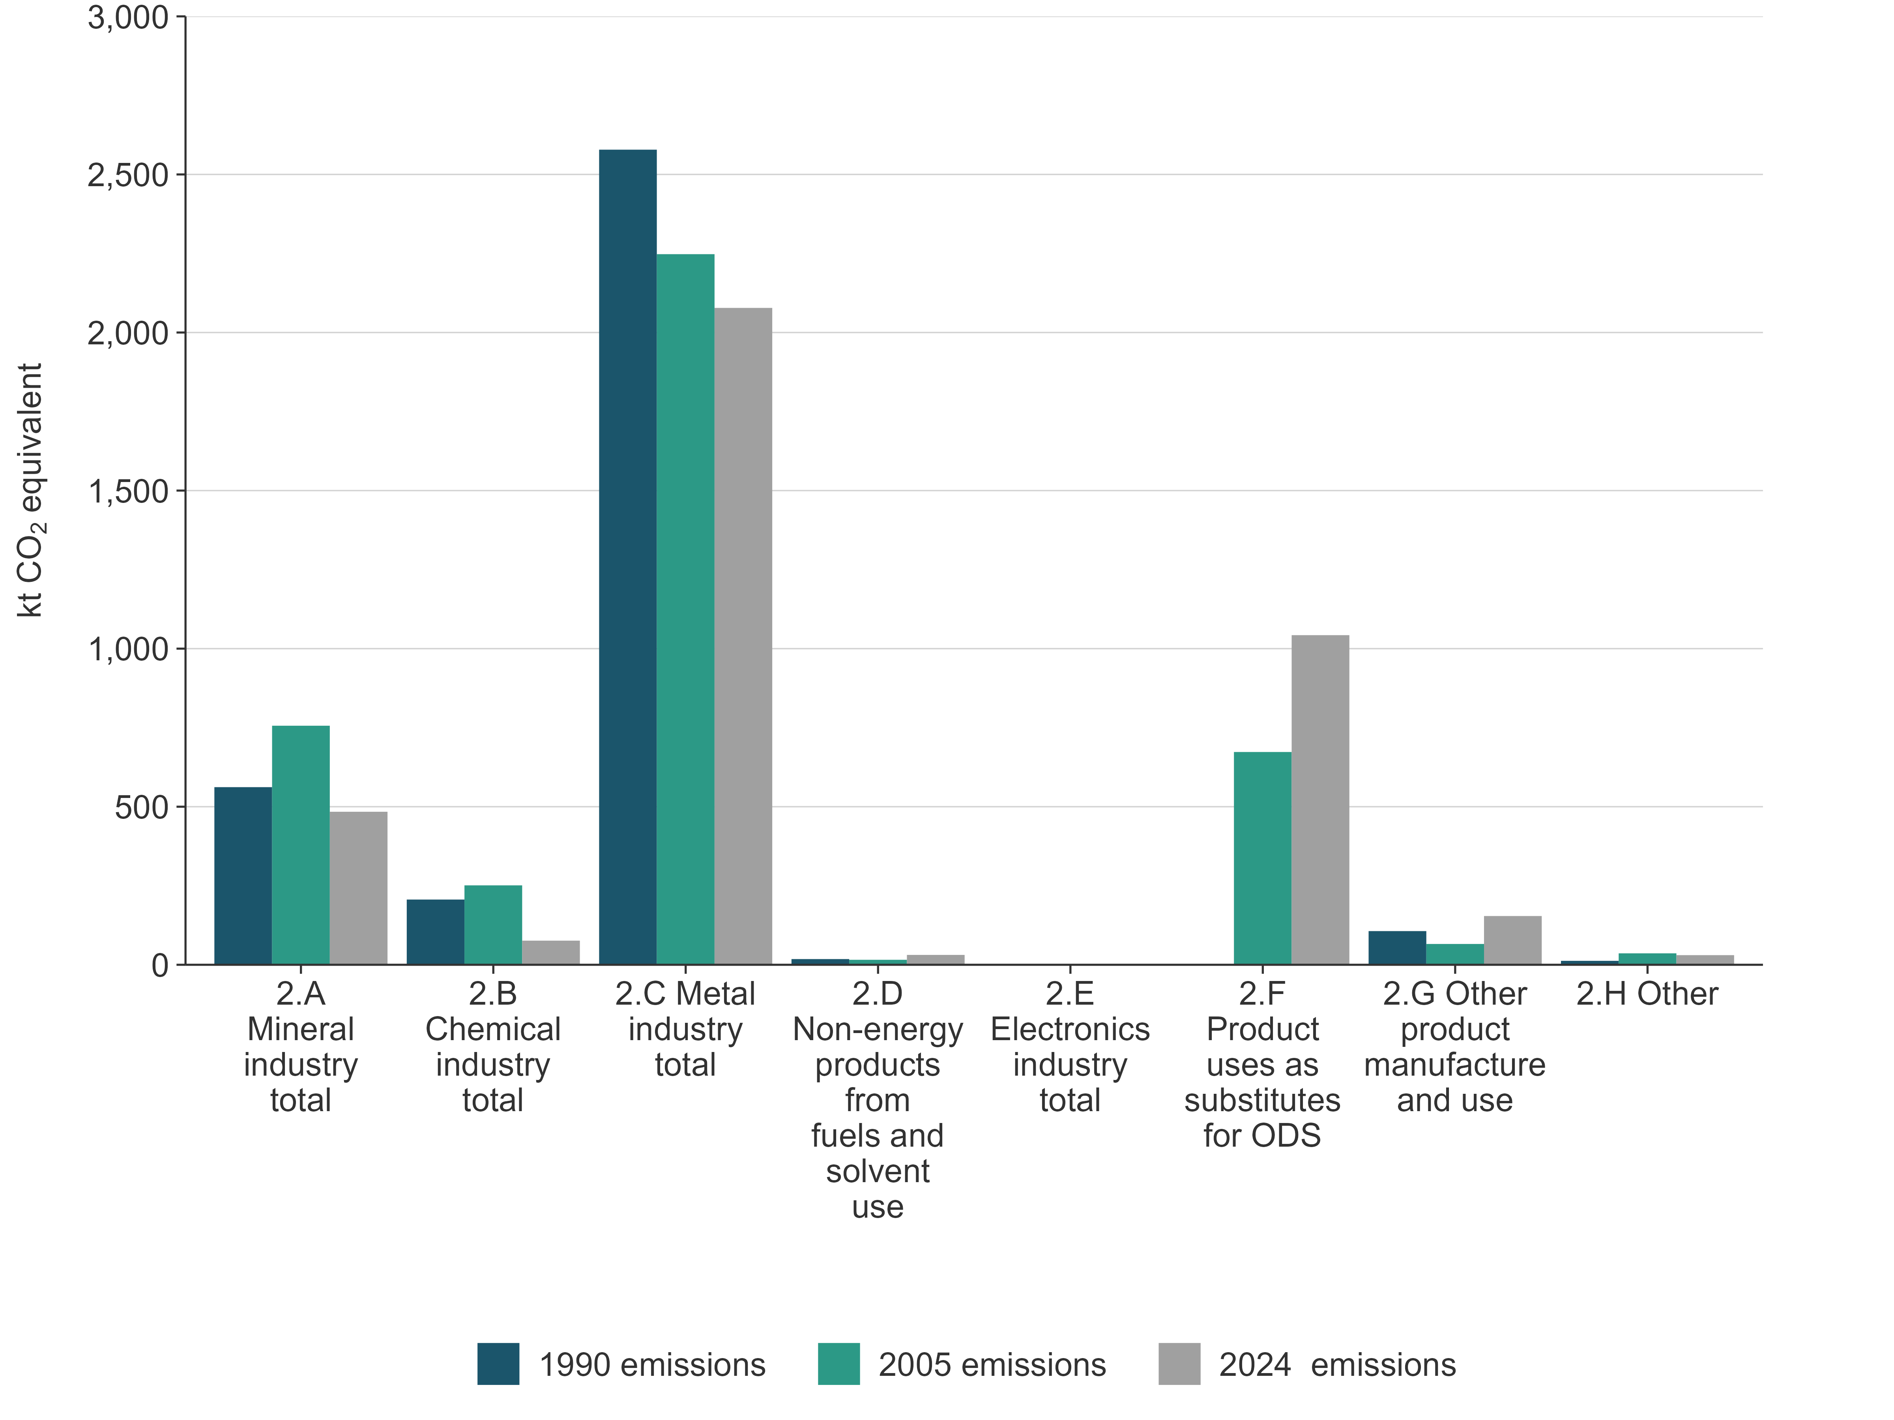
Note: Emissions from the Electronics industry are not occurring (NO).

4.1.3 Key categories for IPPU sector emissions
Details of New Zealand’s key category analysis are given in chapter 1, section 1.4. The key categories in the IPPU sector are listed in table 4.1.2.
Table 4.1.2 Key categories in the IPPU sector
CRT category code | IPCC categories | Gas | Criteria for identification
2.A.1. | Mineral industry – Cement production | CO₂ | L1, T1
2.B.10. | Chemical industry – Other | CO₂ | T1
2.C.1. | Metal industry – Iron and steel production | CO₂ | L1
2.C.3. | Metal industry – Aluminium production | CO₂ | L1
2.C.3. | Metal industry – Aluminium production | PFCs | T1
2.F.1. | Product uses as substitutes for ODS – Refrigeration and air-conditioning | HFCs | L1, T1
Note: L1 means a key category is identified under the level analysis – approach 1 and T1 is trend analysis – approach 1. See chapter 1, section 1.4, for more information.

4.1.4 Methodological issues for the IPPU sector
Activity data in the IPPU sector have been derived from a variety of sources. In the Mineral industry category, the primary data source is emissions data reported under the New Zealand Emissions Trading Scheme (NZ ETS). For the Chemical industry and Metal industry categories, data (including activity data) are provided to the Ministry of Business, Innovation and Employment (MBIE) in response to an annual survey.
The small scale of New Zealand’s industry sector means some activities are carried out by only one or two companies. As a result, the data and emissions information supplied by these companies, in response to surveys, are frequently bound by confidentiality obligations, preventing the publication of their specific activity. The implications for reporting of activity data and emissions are as follows:
- activity data for cement, steel and glass production are reported as confidential in the common reporting tables (CRT)
- emissions data for Glass production (2.A.3) are reported in Other process uses of carbonates category (2.A.4)
- emissions from gas used for energy purposes in ammonia production are reported in the Manufacturing industries and construction category in the Energy sector (1.A.2.c) where this information can be aggregated with other companies. Only chemical feedstock gas is reported in the Chemical industry category. Total energy use for the ammonia–urea plant is not disclosed
- fuel-related emissions from ammonia production are reported in the Energy sector.
New Zealand uses a combination of Intergovernmental Panel on Climate Change (IPCC) Tier 1 and Tier 2 methods for the IPPU sector. Tier 2 methods are used for all key categories. Country-specific emission factors are used where available, including for emissions of indirect greenhouse gases.
For the Product uses as substitutes for ODS category, updated activity data are obtained through a detailed annual survey covering the electrical, refrigeration and other industry participants (Verum Group Ltd, unpublished), as well as importers of HFCs and other substances in this category.
For small amounts of indirect greenhouse gas emissions reported in the Chemical industry category and Other product manufacture and use category, data were obtained by a detailed industry survey and analysis in 2006 (CRL Energy, unpublished(a)). Emissions and activity data have been extrapolated for the years since that time.

4.1.5 Uncertainties
Each category addresses specific uncertainties, with the default uncertainties from the IPCC being applied in almost all instances.
Country-specific estimates of uncertainty have been made in the Product uses as substitutes for ODS category, reflecting the quality of data provided by survey respondents, and have been updated as needed for this submission.

4.1.6 Verification
The inventory agency (the Ministry for the Environment) verified information on CO₂ emissions reported in the Iron and steel production category against information provided by these industries as participants in the NZ ETS.
For PFCs in the Aluminium production category and for CO₂ in the Mineral industry category, the NZ ETS is used as the primary data source. Verification is done over time as ETS returns are verified by the Environmental Protection Authority (EPA), the agency that administers the NZ ETS.
All data supplied in response to annual surveys (for the Chemical industry, Metal industry and Product uses as substitutes for ODS categories) were verified against national totals or other publicly available information. Where possible, anomalous data were followed up and checked.

4.1.7 Recalculations and improvements
Improvements and recalculations made to the IPPU sector since the last submission have resulted in an increase of 0.01 percent (0.5 kt CO₂e) in estimated IPPU emissions in 1990, an increase of 0.6 percent (25.9 kt CO₂e) in estimated IPPU emissions in 2005 and an increase of 0.8 percent (31.7 kt CO₂e) in estimated IPPU emissions in 2023 (see chapter 10, figure 10.3.4).
Several improvements in the Refrigeration and air conditioning category were made, to better account for changes in stocks held by importers and users. These included:
- changes to activity data for the early retirement of dairy farm systems and coolstores (an increase)
- reassessment of historical emissions between 1994 and 2024
- changes to HFC refrigerant imports between 2020 and 2024 (an increase)
- changes to refrigerant mix of new installations between 2019 and 2023
- changes to leakage rate for commercial refrigeration in 2023 (a reduction)
- changes to transport refrigeration net equipment stock adjustments (a reduction).
Other minor changes were made to:
- cement production with more accurate numbers reported between 2018 and 2023
- lime production with minor corrections between 2021 and 2023
- ammonia production with minor corrections for 2020 and 2023
- aluminium production with minor corrections for 2016 and 2020
- correction to Other uses of non-energy products from fuels and solvent use of Non‑Methane Volatile Organic Compounds (NMVOC) values for 2021.
Table 4.1.3 provides explanations and justifications for the recalculations.
Table 4.1.3 Explanations and justifications for recalculations
CRT | Explanation of recalculation | Underpinning IPCC principle | Additional justification
2.D.1 | Updated lubricant activity data. | Accuracy | Improved data availability
2.F.1 | Correction of minor calculation errors for hydrofluorocarbon foam blowing manufacturing chemicals re-exported. | Accuracy | Correction of errors
2.F.1.a | Error correction in commercial refrigerant-related emissions. | Accuracy | Correction of errors
2.F.1.f | Minor error correction in stationary refrigerant-related emissions. | Accuracy | Correction of errors
2.F.1.d | Transport refrigeration net equipment stock adjustments. | Accuracy | Improved data availability
2.F.1.d | Minor error correction in transport refrigerant-related emissions. | Accuracy | Correction of errors

4.1.8 Quality-assurance/quality-control (QA/QC) processes
Tier 1 quality checks were carried out on all data collected for this sector, with minor exceptions where data did not require updating. Figure 4.1.3 describes the quality control process map for the IPPU sector. Verification against independent data sources was possible only in specific cases, such as the comparison of NZ ETS returns against data submitted in response to surveys.
Figure 4.1.3 Example: Tier 1 quality checks for the IPPU sector
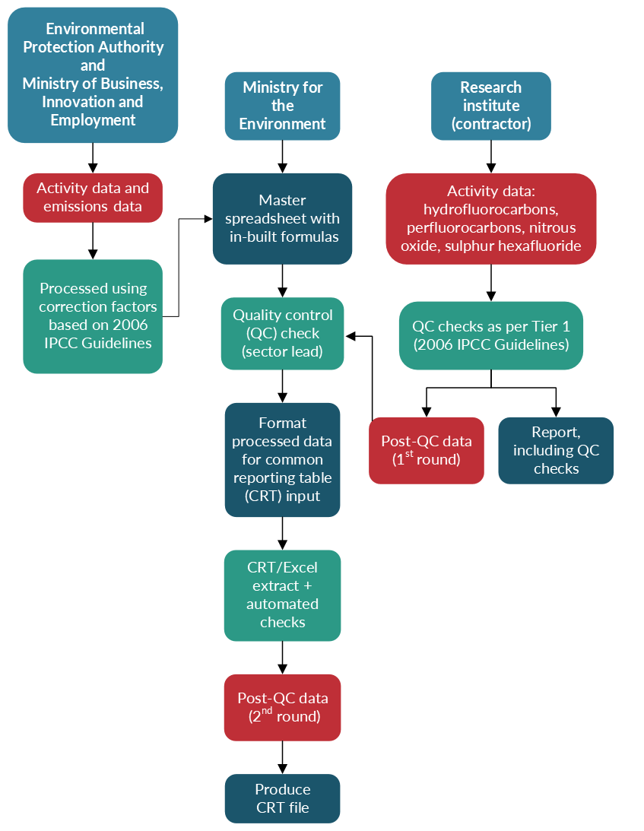
Note: IPCC = Intergovernmental Panel on Climate Change.

4.1.9 Information on completeness

Emissions reported as ‘NE’ or ‘not estimated’
Table 4.1.4 summarises New Zealand’s direct greenhouse emissions for the IPPU sector reported as ‘NE’ in the 2026 submission.
Table 4.1.4 Summary of ‘NE’ or ‘not estimated’ entries for the IPPU sector in the 2026 submission
CRT category code | Category | Gas | Explanation
Industrial Processes and Product Use
2.G.2.e | Medical and other product use | C₂F₆ | In accordance with chapter II of the Annex to the decision 18/CMA.1 (UNFCCC, 2018), this category is not mandatory. The level of emissions from this source has been determined to be insignificant in comparison with national emissions. No activity data are available before 2011. Based on 2011 to 2022 data, emissions of perfluoroethane (C₂F₆) from Medical and other product use are estimated to be approximately 2.6 tonnes carbon dioxide equivalent (t CO₂e) per annum, which is below the significance threshold.
2.G.2.e | Medical and other product use | C₃F₈ | In accordance with chapter II of the Annex to the decision 18/CMA.1 (UNFCCC, 2018), this category is not mandatory. The level of emissions from this source has been determined to be insignificant in comparison with national emissions. No activity data are available before 2011. Based on 2011 to 2022 data, emissions of perfluoropropane (C₃F₈) from Medical and other product use are estimated to be approximately 2.7 t CO₂e per annum, which is below the significance threshold.

Emissions reported as ‘IE’ or included elsewhere
Table 4.1.5 details where the notation key ‘IE’ or ‘included elsewhere’ has been used in this submission of the Inventory for the IPPU sector.
Table 4.1.5 Emissions reported using the ‘IE’ or included elsewhere notation key in the 2026 submission for the IPPU sector
CRT category code | Category | Source category reported under | Notation key explanation
Industrial Processes and Product Use
2.A.3 | Glass production | 2.A.4.b – Other process uses of carbonates/ Other uses of soda ash | Carbon dioxide emissions are reported in 2.A.4.b because this aggregates emissions from glass production with other uses of carbonates, due to confidentiality concerns for both glass and aluminium production. A very small number of firms in New Zealand are involved in these activities and using carbonates.

4.2 Mineral industry (2.A)

4.2.1 Description
Emissions from the Mineral industry category include CO₂ from the calcination of limestone for cement and lime, and from the use of soda ash and limestone in the production of glass, aluminium, and iron and steel. Only CO₂ from calcination is reported here. Any emissions from the combustion of fuel to provide heat for these activities are reported under the Energy sector.
Only one cement production facility is now operating in New Zealand, a dry-process plant operated by Golden Bay Cement Ltd near Whangārei. Holcim New Zealand Ltd operated a wet process cement plant at Cape Foulwind, on the West Coast of the South Island, but this plant was closed at the end of June 2016 and Holcim is now marketing cement made from imported clinker. Another smaller cement company (Lee Cement Ltd) operated only from 1995 to 1998. The New Zealand cement industry produces clinker from the calcination of limestone and processes it into Portland cement or general-purpose cement.
Three companies (McDonald’s Lime Ltd, Websters Hydrated Lime Company and Perry Resources Ltd) have a history of making burnt and slaked lime at five different facilities in New Zealand. The industry has been consolidated over time and two companies (Graymont New Zealand and Websters Hydrated Lime Company) now produce most of New Zealand’s burnt and slaked lime. Another company (Lee Processors Limited) reported a small amount of emissions for the 2024 year.
Small amounts of indirect emissions (sulphur dioxide (SO₂) only) from the Cement production category are also reported. Some emissions of SO₂ from the Lime production category were estimated in 2006 (CRL Energy, unpublished(a)), but there is currently no provision in the CRTs to report this. Some additional SO₂ is derived from sulphur in coal or waste oil used as fuel in cement and lime kilns, and this is reported under the Energy sector.
Two companies make glass in New Zealand, with emissions from the use of soda ash and limestone generated in the process. VISY Glass (formerly O-I) New Zealand makes container glass and Tasman Insulation New Zealand Ltd makes smaller amounts of glass for building insulation products.
Limestone and soda ash are also used in the steel and aluminium industries and would normally be reported in the Metal industry category. Emissions from this use of mineral inputs are reported in the Mineral industry category (see section 4.2.2); the data are aggregated to protect the confidentiality of data provided by these two glass companies.
A very small amount of CO₂ is reported from the use of kaolin clays in ceramics production.
The only key category in the Mineral industry category is CO₂ emissions from the Cement production category (level and trend assessment).
In 2024, emissions from the Mineral industry category were 484.0 kt CO₂e, or 12.4 percent of emissions from the IPPU sector. This is 77.8 kt (13.9 percent) below the 1990 emissions and 272.1 kt (36.0 percent) below the emissions level in 2005. Production of cement, lime and glass containers had previously increased over time, with a peak in 2015 of 869.3 kt CO₂e. Emissions decreased after 2015 due to the closure of the Holcim cement plant.

4.2.2 Methodological issues

Choice of activity data

Use of NZ ETS data
Firms that use limestone or soda ash in the production of clinker, cement, burnt or slaked lime, or glass have had emission reporting obligations under the NZ ETS since 2010. The emission returns submitted by participants in the NZ ETS are the primary source of data for CO₂ emissions from these categories.
The EPA administers and audits the emission returns submitted by participants. Data submitted by NZ ETS participants are protected by stringent provisions relating to commercial confidentiality. However, under section 32 and section 149 of the Climate Change Response Act 2002, the inventory agency may request information from the EPA for the purpose of compiling New Zealand’s annual National Inventory Report.
All NZ ETS participants must report their emissions in the calendar year but not all receive or apply for ETS units. This encompasses production of clinker, container glass and burnt lime, including any burnt lime that is subsequently made into slaked lime (calcium hydroxide).

Cement production (2.A.1)
In 2024, emissions from the Cement production category were 349.8 kt CO₂e, or 72.3 percent, of emissions from the Mineral industry category. The activity data used are the amounts of clinker produced by the cement plants. Calculation of emissions from clinker production is done on a plant-specific basis by the companies in preparing their NZ ETS returns. Because historically only two companies have been making cement in New Zealand, and now there is only one, the activity data for the Cement production category are not reported and have been shown as confidential in the CRTs. For the years up to 2009, activity and emissions data were supplied by the cement companies to MBIE. From 2010, the companies’ NZ ETS returns have been used as the data source.

Lime production (2.A.2)
In 2024, emissions from the Lime production category were 79.6 kt CO₂e, or 16.4 percent, of emissions from the Mineral industry category. The activity data used are the amounts of burnt lime produced, reported as tonnes of pure calcium oxide (CaO), as required in NZ ETS returns. This measure is used regardless of whether the lime is subsequently hydrated to make calcium hydroxide (Ca(OH)₂).
Activity and emissions data were supplied annually by the lime companies to MBIE until 2009. This included the amount of burnt lime produced each year. From 2010, lime companies have reported CO₂ emissions and the amounts of pure CaO in the lime that they produce in their reporting to the EPA.

Glass production (2.A.3)
Activity and emissions data for the Glass production category are not reported in 2.A.3. Instead, emissions from the use of soda ash and limestone in glass making are reported in the Other process uses of carbonates (2.A.4) category due to confidentiality concerns. These are aggregated with other relatively small amounts of CO₂ emissions that derive from the calcination of limestone and soda ash.

Other process uses of carbonates (2.A.4)
The data reported in the Glass production category have been aggregated, as follows, and reported in the Other process uses of carbonates category.
- Emissions from a relatively small amount of soda ash used by New Zealand Aluminium Smelters Ltd (NZAS) at the Tiwai Point smelter are reported in 2.A.4.b (Other uses of soda ash) and aggregated with the CO₂ emissions from soda ash used in glass making.
- Emissions from a relatively small amount of limestone used by New Zealand Steel Limited are reported in 2.A.4.d (Other) and aggregated with emissions from limestone used in glass making.
The amounts of soda ash and limestone used are reported as activity data in these two CRTs. Also, because the limestone emissions cannot be fully disaggregated in early data provided by New Zealand Steel Limited, an extremely small amount of CO₂ from coke and electrode use at the steel plant is also included (see section 4.4.2).
Data on glass making for the years up to 2006 were provided by the companies and updated for the years 2007 to 2009 by survey requests from MBIE. Data on limestone and soda ash use were based on the companies’ records where available. In the case of one glass-making facility, some historical emissions data had to be estimated based only on glass production rates, because actual limestone and soda ash use was not recorded before 2006.
From 2010 to 2024, the glass companies’ NZ ETS returns are used.
A very small amount of CO₂ is reported from the use of kaolin clays in ceramics production (2.A.4.a). The activity data used are the approximate amount of kaolin clay produced for this purpose (Christie et al., 1999). In the absence of better data, the rate of production is assumed constant for the whole time series. Emissions from ground limestone used in liming agricultural soils are reported under the Agriculture sector.

Choice of methods
For the years up to 2009, cement emissions were calculated using the methodology specified in the Cement CO₂ Protocol (World Business Council for Sustainable Development, 2005), which uses plant-specific emission factors based on the CaO and magnesium oxide (MgO) content of clinker produced. This also includes an adjustment for emissions due to cement kiln dust. This calculation is consistent with the IPCC Tier 2 method (IPCC, 2006b).
Emissions for lime up to 2009 were calculated using the IPCC Tier 1 method and the default emission factor of 0.75 tonnes CO₂ per tonne of burnt lime produced. For glass making, the IPCC Tier 1 method and default emission factors were also used for the years up to 2009.
For NZ ETS reporting in the Mineral industry category (from 2010), the methods used are specified in the Climate Change (Stationary Energy and Industrial Processes) Regulations 2009. These methods require firms making clinker or burnt lime to report CO₂ emissions calculated from the amount of pure product made from calcination. In calculating their emissions, NZ ETS participants who make clinker or lime are required to determine and report the amounts of pure CaO and MgO in the clinker or burnt lime produced, and in kiln dust, if relevant. The emissions are calculated from this chemical composition. The calculation of total emissions (TE) can be summarised as:
$$\text{TE} =0.7848 ×\text{A}+1.0919 × \text{B} +0.7848× \text{C}$$
Where: A is the amount of CaO in clinker or burnt lime produced
B is the amount of MgO in clinker or burnt lime produced
C is the amount of calcium oxide and magnesium oxide in kiln dust produced.
Similarly, based on the Climate Change (Stationary Energy and Industrial Processes) Regulations 2009, NZ ETS participants who make glass report the amounts of pure limestone, dolomite and soda ash that they use in the process. This is consistent with the Tier 3 methods in the 2006 IPCC Guidelines for National Greenhouse Gas Inventories (2006 IPCC Guidelines) (volume 3, Industrial Processes and Product Use) (IPCC, 2006b) but is described as country specific in the CRT because of a minor discrepancy: NZ ETS participants are not required to report separately very small amounts of kiln dust or MgO.
NZ ETS participants in this category are not required to report annually on the specific methods that they have used to determine the amounts of pure CaO, MgO and other compounds that they report in their NZ ETS returns. They are required to keep this information available and it can be requested and verified by the EPA as required.
All other emissions estimates use Tier 1 methods. This includes the small amount of SO₂ emissions reported for cement production. Emissions of SO₂ from lime production were also estimated (CRL Energy, unpublished(a)). These used a country-specific emission factor of 0.5 kilograms SO₂ per tonne of burnt lime produced, derived from plant measurements carried out in earlier years. There is no provision, however, in the CRT to report these emissions.

Choice of emission factors and parameters
All calculations made for NZ ETS reporting and used in the Mineral industry category are based on plant-specific analysis.
The small amounts of SO₂ emitted in the Cement production category are estimated using plant-specific emission factors taken from mass balance data derived for the two cement plants in 2002 and 2005 (CRL Energy, unpublished(a)).
For the very small emissions of CO₂ from the Ceramics (2.A.4.a) category, a country-specific emission factor of 0.1 percent of carbonates (as equivalent calcium carbonate) in local kaolin clay is used.
Other emission factors used are IPCC defaults.

4.2.3 Uncertainty assessment and time-series consistency

Uncertainties
IPCC default uncertainties have been used for all CO₂ emissions from the Mineral industry category (see table 4.2.1), except ceramics for which there is substantial uncertainty in the activity data and in the composition of clay. Cement kiln dust is not relevant for 2017 to 2024 because the cement plant now operating reports no significant kiln dust produced. For SO₂ emissions in the Cement production category, an uncertainty of ±40 percent was estimated based on the variance between surveys when these emissions were determined (CRL Energy, unpublished(a)).
Table 4.2.1 Uncertainty in emissions from mineral products
Mineral product | Uncertainty in activity data (%) | Uncertainty in emission factors (%)
Cement (CO₂) | ±1 | ±1
Cement kiln dust (CO₂) | ±1 | ±5
Cement (SO₂) | ±1 | ±40
Lime (CO₂) | ±2 | ±2
Glass (SO₂) | ±5 | ±10
Glass (NMVOC) | ±5 | ±50
Ceramics (CO₂) | ±50 | ±20
Other uses of soda ash (CO₂) | ±3 | ±2
Other uses of limestone (CO₂) | ±3 | ±2

Time-series consistency
In previous inventory submissions, the reported activity data for lime production have not been fully consistent through the time series because of the change to using NZ ETS data and the use of different calculation methods for these emissions. A consistent approach, based on the methods that companies are required to use for NZ ETS reporting, is now applied for the entire time series.

4.2.4 Category-specific QA/QC verification
For this submission, data for all CO₂ emissions in the Mineral industry category underwent Tier 1 quality checks in the preparation of this inventory. The only key category in the Mineral industry category is CO₂ emissions from Cement production (level and trend assessment).
Verification of activity data from independent sources is not currently possible. The EPA carries out verification of NZ ETS participants’ submitted data on a rotating basis and, as these verifications occur, the inventory agency (the Ministry for the Environment) will make use of the resulting information to verify the emissions data where possible.

4.2.5 Category-specific recalculations
There are no recalculations of direct gases for this category. There are some minor recalculations of SO₂ averaging 0.02 tonne per annum between 1990 and 2023.

4.2.6 Category-specific planned improvements
The inventory agency has worked with the companies in the Mineral industry category to improve transparency and robustness in the data provided. Concerns about the confidentiality of data provided by the glass industry remain a barrier to improving transparency further.

4.3 Chemical industry (2.B)

4.3.1 Description
The significant chemical processes occurring in New Zealand are the production of urea, methanol, superphosphate fertiliser, hydrogen peroxide, formaldehyde and ethanol. In addition, a substantial amount of hydrogen was made at the Marsden Point Oil Refinery until the refinery closed in March 2022. Carbon dioxide emissions from this process are reported in the Chemical industry category. No other relevant chemical products (such as nitric acid, adipic acid, ethylene or fluorochemicals) are produced in New Zealand.
Ammonia is made at one site in Taranaki by the catalytic steam reforming of natural gas. The ammonia produced is further processed into urea. The emissions of CO₂ reported in this category arise from the fraction of chemical feedstock CO₂ that is not recovered for urea production. Emissions from combustion at this site are reported separately under the Energy sector (1.A.2.c). Nearly all of the urea produced is used as a fertiliser in New Zealand. The emissions associated with agricultural use of urea (both manufactured in New Zealand and imported) are reported under the Agriculture sector (3.H). A small amount of urea is also used for catalytic reduction of diesel exhaust emissions. The emissions of CO₂ from this use of urea are reported in the Non-energy products from fuels and solvent use category (2.D.3).
Methane emissions are reported from the production of methanol, which is made from natural gas feedstock at two sites in Taranaki. From 1990 to 1997, a large proportion of the methanol made in New Zealand was processed into synthetic gasoline for transport use. All emissions associated with the production of gasoline, including the synthetic gasoline produced from 1990 to 1997, are reported under the Energy sector (1.A.1). From 1998, all methanol made in New Zealand has been chemical methanol for export and, therefore, all process emissions from the methanol plants have been reported under the IPPU sector.
A small amount of CO₂ is reported from the use of imported calcium carbide, which is used to produce acetylene for welding. No carbides are manufactured in New Zealand.
Some indirect emissions (oxides of nitrogen (NO_{x}), carbon monoxide (CO), NMVOCs and SO₂) are reported from methanol, formaldehyde, ethanol and superphosphate fertiliser production.
In 2024, emissions from the Chemical industry category were 76.3 kt CO₂e, or 2.0 percent of emissions from the IPPU sector. This is 130.0 kt CO₂e (63.0 percent) below the 1990 level and 174.9 kt CO₂e (69.6 percent) below the 2005 level. The reduction occurred from 2020 and was driven by a decrease in emissions from the Marsden Point Oil Refinery. The refinery company outputs remained low as it prepared for its closure in March 2022 and due to COVID-19 pandemic restrictions. Additionally, Methanex New Zealand, which operates methanol production plants, shut down its Waitara Valley plant in early 2021 due to natural gas supply constraints.
The only key category in the Chemical industry category is CO₂ emissions from the Other category (trend assessment).

4.3.2 Methodological issues

Choice of activity data

Ammonia and urea (2.B.1)
Data on the production of urea are supplied to MBIE by Ballance Agri-Nutrients Limited, which operates the ammonia–urea production plant. The activity data reported are the production of ammonia, which is back-estimated from the amount of urea produced on the basis of a site-specific conversion factor that reflects the actual rate of conversion of ammonia to urea achieved in this plant. From 2020 onwards, urea output is estimated using feedstock gas and a conversion factor.

Calcium carbide (2.B.5.b)
A small amount of calcium carbide is imported to New Zealand and used to produce acetylene gas for welding. The approximate amount of calcium carbide imported is assumed to be fully consumed, and therefore used as activity data.

Methanol (2.B.8.a)
Data on methanol production (chemical methanol produced for export) are supplied to MBIE by Methanex.

Hydrogen (2.B.10)
With the closure of Refining New Zealand Ltd at the Marsden Point Oil Refinery in March 2022, Evonik Limited has become the only company that produces a small amount of hydrogen, which is converted to hydrogen peroxide. The hydrogen is produced from CH₄ (from refinery gas and natural gas) and steam. Carbon dioxide is a by-product of the reaction and is vented to the atmosphere.
The activity data reported are the amounts of hydrogen produced, as reported to MBIE by the plant operators.

Fertiliser, formaldehyde and ethanol (2.B.10)
Some indirect emissions (SO₂ and NMVOCs) are also reported from the production of ethanol for purposes other than food and drink, superphosphate fertiliser and formaldehyde.

Choice of methods

Ammonia and urea (2.B.1)
The CO₂ emissions are estimated from a Tier 2 carbon balance, based on the feedstock gas used. The emissions are derived from all carbon in the feedstock gas used, less carbon recovered for urea production and remaining in the urea product (IPCC, 2006b). Note that only gas used as feedstock is included in this calculation. There are also significant CO₂ emissions from gas used for combustion, which are reported under the Energy sector in the Manufacturing industries and construction category (1.A.2.c) and aggregated with other data. This method has been used to allow data on the total gas used at the plant to remain confidential.

Calcium carbide (2.B.5.b)
The Tier 1 method was used.

Methanol (2.B.8 and 2.B.8.a)
Data on the natural gas used for methanol production are also supplied to MBIE by the plant operators. However, the available data on gas supplied to the methanol plants do not allow for any separate feedstock to be clearly distinguished from gas used for combustion. Also, close to 100 percent of the carbon in feedstock gas is converted to methanol. Therefore, no significant CO₂ emissions can be clearly related to the process. The 2006 IPCC Guidelines do not provide a method for estimation of any CO₂ emissions from this process (IPCC, 2006b). Any small amounts of chemical process CO₂ emissions from the methanol production process are included under the Energy sector (1.A.2), along with the much larger amount of combustion-related emissions from the methanol plants.
Fugitive CH₄ from the methanol manufacturing process is estimated using the Tier 1 method. Emissions of NO_{x}, CO and NMVOC are also reported.

Hydrogen (2.B.10)
Emissions of CO₂ from hydrogen production are calculated using the Tier 2 methodology, based on feedstock composition (IPCC, 2006b). The required data are supplied by MBIE.

Choice of emission factors

Carbon dioxide and methane
For ammonia production, the carbon content of each type of natural gas (up to three types taken from different natural gas fields, and mixed pipeline gas) used as feedstock determines country-specific CO₂ emission factors.
In some years, these emission factors are higher than Tier 1 default emission factors, due to the use of untreated high-CO₂ gas from the Kapuni field as part of the feedstock at this plant. This gas has a carbon content factor (CCF_{i}) of approximately 22.5 kilograms per gigajoule in comparison with the default of 15.3 kilograms per gigajoule. Kapuni gas has not been used since 2014.
For hydrogen production, site-specific (for refinery gas) and field-specific (for natural gas) emission factors are used to determine the CO₂ emissions from the feedstock gas streams used.
IPCC default emission factors are used to estimate emissions of CH₄ from methanol manufacture and CO₂ from calcium carbide use (IPCC, 2006b). No other information on these emission sources is available.

Indirect emissions
Indirect emissions of NO_{x}, CO and NMVOC from methanol production are reported (2.B.8) with emission factors estimated by Methanex (CRL Energy, unpublished(a)). The emission factors for NO_{x} and CO were derived from site measurements, and the emission factor for NMVOC is based on American Petroleum Institute methods for estimating vapour emissions from storage tanks. Some indirect greenhouse gas emissions are also reported for superphosphate fertiliser, formaldehyde and ethanol production (2.B.10). The emission factors used are country specific (CRL Energy unpublished(a)) and are as shown in table 4.3.1.
Table 4.3.1 Country-specific emission factors for indirect emissions
Activity | Type of gas | Emission factor
Superphosphate fertiliser production | SO₂ | 1.5 kg per tonne of H₂SO₄
Formaldehyde production | NMVOCs | 1.5 kg per tonne of formaldehyde
Ethanol production | NMVOCs | 6 g NMVOC per litre of ethanol

4.3.3 Uncertainty assessment and time-series consistency

Uncertainties
The IPCC default uncertainties have been used for CO₂ and most non-CO₂ emissions from this category, as shown in table 4.3.2.
Table 4.3.2 Uncertainty in emissions from the Chemical industry category
Product | Uncertainty in activity data (%) | Uncertainty in emission factors (%)
Ammonia (CO₂) | ±2 | ±6
Calcium carbide | ±50 | ±50
Formaldehyde (NMVOCs) | ±2 | ±50
Hydrogen | ±2 | ±6
Methanol (NO_{x} and CO) | ±2 | ±50
Methanol (NMVOCs) | ±2 | ±30
Methanol (CH₄) | ±2 | ±80
Superphosphate (varies by site) | ±10 | ±25–60
Sulphuric acid | ±10 | ±15

Time-series consistency
The implied emission factor for CO₂ in ammonia production has reduced by about 5.0 percent through the time series, reflecting higher plant utilisation and some improvements in plant efficiency. Because ammonia is made at a single site in New Zealand, the implied emission factor may also vary from year to year as a result of maintenance shutdowns and other events that affect plant performance.
The implied emission factor for hydrogen production (2.B.10) also varies from year to year mainly due to changes in refinery gas composition. Other implied emission factors in this category only reflect the default emission factors used.

4.3.4 Category-specific QA/QC and verification
For this submission, data for all CO₂ emissions in the Chemical industry category underwent Tier 1 quality checks in the preparation of this inventory. The only key category in the Chemical industry category is CO₂ emissions from Other (hydrogen production) (trend assessment).

4.3.5 Category-specific recalculations
There were no recalculations for this category.

4.3.6 Category-specific planned improvements
There are no planned improvements for this category.

4.4 Metal industry (2.C)

4.4.1 Description
The main emissions in the Metal industry category in New Zealand are from iron and steel production (from iron sand and historically from recycled scrap steel) and from aluminium production. New Zealand has no production of coke, sinter or ferroalloys.
New Zealand Steel Limited produces iron using an ‘alternative iron-making process’, from titanomagnetite iron sand (Ure, 2000). This iron-making process involves the direct reduction of iron oxide contained in the sand, with sub-bituminous coal (which forms a reactive char) as the reductant. There is no coke production and no use of blast furnaces. The iron produced is then processed into steel.
Until 2015, Pacific Steel Limited operated an electric arc furnace at a separate site to process recycled scrap steel. The owners of New Zealand Steel Limited bought the Pacific Steel Limited production assets in 2015, and all of New Zealand’s steel-making capacity is now integrated at the New Zealand Steel site. Steel billet production at the Pacific Steel plant, using recycled scrap, stopped in October 2015. As a result, production in New Zealand is now focused on newly produced iron rather than recycled steel scrap.
Limestone and soda ash are also used in the steel and aluminium industries and would normally be reported in the Metal industry category. Emissions from this use of mineral inputs are reported in the Mineral industry category (see section 4.2.2); the data have been aggregated to protect the confidentiality of data provided by these two glass companies.
There is one aluminium smelter in New Zealand, operated by NZAS. The plant produces aluminium by smelting imported bauxite using centre-work prebake technology, resulting in CO₂ and PFC emissions.
Very small amounts of emissions are also reported from secondary lead production (from the recycling of lead-acid batteries) from 1990 to 2015 and from use of SF₆ in a magnesium foundry from 1990 to 1999.
Key categories in the Metal industry category are CO₂ emissions from Iron and steel production (level and trend assessment) and Aluminium production (level assessment), and PFCs from Aluminium production (trend assessment).
In 2024, emissions from the Metal industry category were 2,077.8 kt CO₂e, or 53.3 percent of emissions from the IPPU sector. This is 500.5 kt CO₂e (19.4 percent) below the 1990 level and 170.0 kt CO₂e (7.6 percent) below the 2005 level. The decrease was driven by a reduction in emissions of PFCs in aluminium smelting, which has been partly offset by increasing CO₂ emissions due to increasing production of steel and aluminium. A small decrease in emissions occurred in 2016 due to the closure of the Pacific Steel plant and the cessation of lead battery recycling.
The New Zealand Steel site was closed from 26 March to 27 April 2020, due to COVID-19 pandemic restrictions.
The New Zealand Aluminium Smelter (Tiwai Point) is New Zealand’s largest electricity user. During winter 2024, Tiwai Point reduced its activities due to an electricity fuel shortage. The reduced consumption of electricity from Tiwai Point allowed New Zealand to conserve hydro storage during periods of low rainfall and declining gas production. Tiwai Point was part of a demand response effort in 2023 as well, therefore, New Zealand did not see large reductions in emissions in 2024 in the Aluminium production category.

4.4.2 Methodological issues

Choice of activity data

Iron and steel production (2.C.1 and 2.C.1.a)
In 2024, emissions from the Iron and steel production category were 1,524.6 kt CO₂e, or 73.4 percent of emissions from the Metal industry category. The activity data (tonnes of steel produced) provided to MBIE came from two steel producers up to 2015 and now come from one; they are regarded as commercially confidential and are reported as confidential in the CRT.
Most of the CO₂ emissions from the Iron and steel production category are produced through the production of iron from titanomagnetite iron sand. Nearly all of the emissions in this process come from the use of sub-bituminous coal as a reducing agent. There is no carbon in the iron sand used by New Zealand Steel Limited (see table 4.4.1). Figure 4.4.1 shows a simplified illustration of steel production in New Zealand.
Table 4.4.1 Typical analysis from New Zealand Steel Limited of the primary concentrate
(provided by New Zealand Steel Limited)
Element | Result (%)
Fe₃O₄ | 81.4
TiO₂ | 7.9
Al₂O₃ | 3.7
MgO | 2.9
SiO₂ | 2.3
MnO | 0.6
CaO | 0.5
V₂O₃ | 0.5
Zn | 0.1
Na₂O | 0.1
Cr | 0.0
P | 0.0
K₂O | 0.0
Cu | 0.0
Total | 100.0
Figure 4.4.1 Simplified schematic of steel production in New Zealand
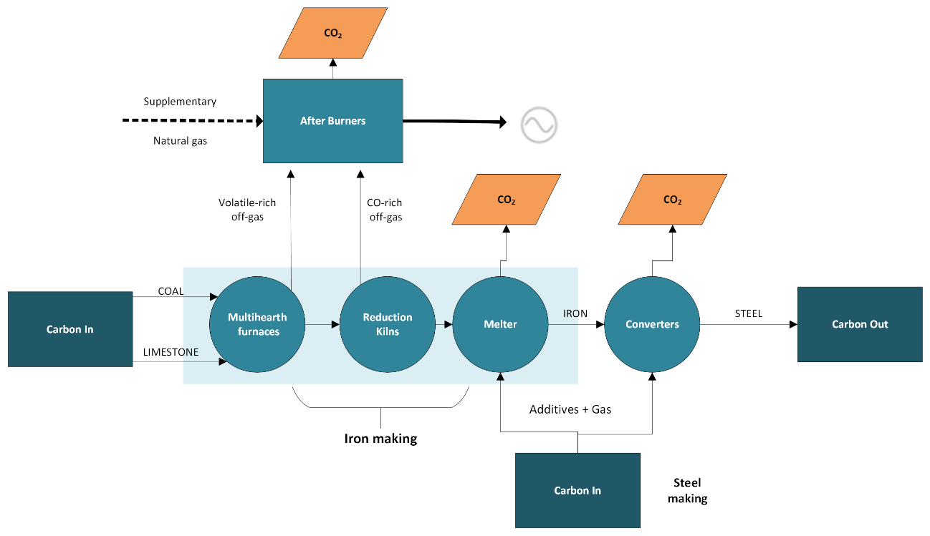
Nearly all the carbon entering the process is from coal used as a reductant in the iron-making process, and nearly all of this is emitted as CO₂ in two waste gas streams:
- gas generated in multi-hearth furnaces used to heat and dry concentrated iron sand and coal – this gas contains excess volatiles from the coal
- gas generated in rotary reduction kilns used to convert oxide in the iron sand to iron – this gas is rich in CO.
All this waste gas is combusted in ‘afterburners’ and used for electricity production. It would not be acceptable for gas containing coal volatiles or CO to be emitted without this combustion stage. There is no other flaring or disposal mode for the waste gases. Emissions from supplementary natural gas used in this plant are reported under the Energy sector (1.A.2.a). New Zealand Steel reported in the past (CRL Energy Ltd unpublished(b)) that there were no detectable CH₄ emissions from this plant. No updated information is currently available.
Much smaller amounts of CO₂ are derived from limestone added to the multi-hearth furnaces, and from additives and natural gas used in melters and steel making.
New Zealand Steel’s iron and steel manufacturing processes do not generate or emit CH₄.

Aluminium production (2.C.3)
Carbon dioxide is emitted during the oxidation of carbon anodes. The two PFCs perfluoromethane (CF₄) and perfluoroethane (C₂F₆) are emitted from the reduction cells used for smelting during anode effects. An anode effect occurs when the aluminium oxide concentration in the cell is low. The emissions from combustion of various fuels used in aluminium production (heavy fuel oil, liquefied petroleum gas, petrol and diesel) are reported under the Energy sector.
In 2024, the Aluminium production category accounted for 553.2kt CO₂e (26.6 percent) of emissions from the Metal industry category. Activity data (production of hot metal aluminium from the smelter) and estimates of CO₂ and PFC emissions were supplied by NZAS to MBIE until 2010. From 2011 to 2024, the CO₂ and PFC emissions data and activity data were sourced from the company’s NZ ETS reporting.

Magnesium and other metal production
From 1990 to 1999 a very small amount of SF₆ was used as a cover gas in a magnesium foundry. Emissions are estimated based on an approximate estimate of the amount of SF₆ that was used (2.C.4). No other activity data are available (CRL Energy, unpublished(b)).
A very small amount of CO₂ emissions was also reported from secondary lead production between 1990 and 2015, with the approximate recycled lead output as the activity data. This production has now stopped. The only other metal production that occurs in New Zealand is gold and silver mining. No emissions are reported from these activities.

Choice of methods

Iron and steel production (2.C.1 and 2.C.1.a)
The IPCC Tier 2 approach is used for calculating CO₂ emissions from the iron and steel plant operated by New Zealand Steel Limited. Emissions from pig iron and steel production are not estimated separately because all of the iron made is processed into steel. This is a mass balance approach in which all carbon in the inputs are assumed to be emitted, except the small amount sequestered in the steel produced.
Most of the input carbon comes from the coal used as a reductant. There are also some CO₂ emissions from the use of limestone in iron and steel production. These emissions are reported in the Mineral industry category (2.A.4.d), to preserve the confidentiality of data on limestone use supplied by companies in the Glass production category. A very small amount of CO₂ from other carbon-containing inputs (coke and electrodes) is also included, and the carbon in steel produced is subtracted.
Emissions from the production of steel by Pacific Steel Limited were also estimated using a Tier 2 mass balance approach. The average carbon content (0.2 percent by mass) in the finished product is subtracted from the total carbon in the inputs to obtain the amount of carbon emitted. Due to limited process data collected and retained by Pacific Steel Limited in the past, emissions for the years 1990 to 1999 were calculated using the average of the implied emission factors for 2000 to 2008 based on production volume.

Aluminium production (2.C.3)
NZAS calculates the process CO₂ emissions using the International Aluminium Institute’s Tier 3 method (International Aluminium Institute, 2006, equations 1–3), which is compliant with the IPCC Tier 2 method (IPPC, 2006a). The same method is used in NZ ETS reporting for aluminium smelting. This method breaks the prebake anode process into three stages: baked anode consumption, pitch volatiles consumption and packing coke consumption.
Also, NZAS adds soda ash to the reduction cells to maintain the electrolyte chemical composition. This results in CO₂ emissions as a by-product. These emissions are reported in the Mineral industry category (2.A.4.b) to preserve the confidentiality of data on soda ash use supplied by companies in the Glass production category.
Data on the duration of anode effects at the smelter are available for 1993 and later years. Perfluorocarbon (CF₄ and C₂F₆) emissions from aluminium production are estimated using:
- the IPCC Tier 1 method for the years 1990 and 1991. The data needed to apply a Tier 2 method are not available
- interpolation for 1992; at this time, there was still no recording of anode effect duration
- the IPCC Tier 2 method (using slope coefficients) from 1993 to 2024. This method is applied in the reporting requirements the company now uses in its NZ ETS returns.
There is no history of direct measurement of PFC emissions at the smelter, so site-specific slope coefficients (required for the use of Tier 3) are not currently available.

Magnesium production (2.C.4)
Emissions are estimated based on an approximate estimate of the amount of SF₆ that was used as cover gas and on the basis that all SF₆ used is emitted. The method is Tier 1.

Lead production (2.C.5)
The Tier 1 method was used.

Choice of emission factors

Carbon dioxide
Plant-specific emission factors are applied for the sub-bituminous coal used as a reducing agent in iron and steel production. For the early years, the coal emission factor was 0.0937 tonnes of CO₂ per gigajoule, as supplied by the steel company. Plant-specific emission factors are also used for other carbon-containing inputs in both the Iron and steel production and Aluminium production categories.
The changes of implied emission factors for steel production across the time series are mainly caused by the changes of input mixture from year to year.
For secondary lead production, the IPCC default emission factor (0.2 tonnes of CO₂ per tonne of lead recycled) is used.

Perfluorocarbons and sulphur hexafluoride
Default emission factors (slope coefficients) are used for emissions of CF₄ and C₂F₆ from aluminium production. Data on the duration of anode effects are not available for the years 1990 to 1992 and for those years a Tier 1 method is used, with the default emission factors of 0.4 kilograms CF₄ and 0.04 kilograms C₂F₆ per tonne of aluminium.
Emissions of SF₆ used in magnesium casting are immediate.

Indirect emissions
Emissions of indirect greenhouse gases (CO, SO₂ and NO_{x}) are reported for the Iron and steel production and Aluminium production categories. These are based on a mass balance calculation (for SO₂) and a mix of plant-specific emission factors and IPCC defaults for other gases (CRL Energy, unpublished(a)).

4.4.3 Uncertainty assessment and time-series consistency

Uncertainties
IPCC default uncertainties have been used for activity data (see table 4.4.2). For the CO₂ emission factors in the Iron and steel production category, an uncertainty of ±7 percent was assessed to reflect some uncertainty in the carbon content of the product. An uncertainty of ±30 percent was assessed for PFCs reflecting the use of Tier 1 methods for the first three years. The uncertainties for indirect gases were assessed on a site-specific basis at the time the data were collected (CRL Energy, unpublished(a)). For magnesium casting, the uncertainty of ±100 percent represents the approximate activity data (SF₆ usage) available. This activity was already historical when the data were collected.
Table 4.4.2 Uncertainty in emissions from the metal industry
Category | Uncertainty in activity data (%) | Uncertainty in emission factors (%)
Iron and steel (CO₂) | ±5 | ±7
Iron and steel (CO) | ±5 | ±30
Iron and steel (NO_{x}) | ±5 | ±70
Aluminium (CO₂) | ±5 | ±2
Aluminium (PFCs) | ±5 | ±30
Aluminium (SO₂) | ±5 | ±5
Aluminium (CO) | ±5 | ±40
Aluminium (NO_{x}) | ±5 | ±50
Magnesium (SF₆) | ±100 | ±30
Lead (CO₂) | ±50 | ±50

Time-series consistency
The implied emission factors for PFC emissions from aluminium production fluctuated over the time series between 1990 and 1998. The introduction of monitoring at the aluminium smelter in 1993 contributed to process and management improvements that reduced the frequency and duration of anode effects. This improvement process continued until about 1998. Since that time, emissions have been lower and relatively stable, due to the much better control of anode effects (see table 4.4.3).
Table 4.4.3 Explanation of variations in New Zealand’s aluminium emissions
Variation in emissions | Reason for variation
Increase in CO₂ and PFC emissions in 1996 | Commissioning of Line 4 cells.
Decrease in CO₂ emissions in 1995 | Good anode performance, compared with 1994 and 1996.
Decrease in CO₂ emissions in 1998 | Good anode performance.
Decrease in CO₂ emissions in 2001, 2003 and 2006 | Fewer cells operating from reduced aluminium production due to reduced electricity supply.
 | Good anode performance contributed in 2001.
Decrease in CO₂ emissions in 1996 | All cells operating, including introduction of additional cells.
 | Increasing aluminium production rate from the cells.
Decrease in PFC emissions in 1995 | Reduced anode frequencies.
 | The implementation of the change control strategy to all reduction cells.
 | Repairs made to cells exerting higher frequencies.
Perfluorocarbon emissions remained high in 1997 | Instability over the whole plant as the operating parameters were tuned for the material coming from the newly commissioned dry scrubbing equipment (removes the fluoride and particulate from the main stack discharge).
Decrease in PFC emissions in 1998 | Cell operating parameter control from the introduction of modified software. This software has improved the detection of an anode-effect onset and will initiate actions to prevent the anode effect.
Perfluorocarbons emissions remained relatively static in 2001, 2003 and 2006 | Increased emissions from restarting the cells.
The activities of lead-acid battery recycling and use of SF₆ in a magnesium foundry ceased during the time series resulting in zero emissions after 1999 and 2015 respectively.

4.4.4 Category-specific QA/QC and verification
The three key categories in the Metal industry category are CO₂ emissions from Iron and steel production (level and trend assessment), Aluminium production (level assessment) and PFCs from Aluminium production (trend assessment). The data for all direct emissions in this category underwent Tier 1 quality checks in the preparation of this inventory.

4.4.5 Category-specific recalculations
There were no recalculations for this category.

4.4.6 Category-specific planned improvements
There were no planned improvements for this category.

4.5 Non-energy products from fuels and solvent use (2.D)

4.5.1 Description
In 2024, emissions reported in the Non-energy products from fuels and solvent use category include CO₂ from the use of lubricants and a very small amount from the use of paraffin wax, some of which is likely to be used for candles.
In addition, a small amount of CO₂ is reported from the use of urea-based catalysts in diesel exhaust fluid (DEF) for control of NO_{x} emissions in diesel engine exhaust gas. These emissions are associated with transport, and the method used is given in volume 2, Energy, of the 2006 IPCC Guidelines (IPCC, 2006a); however, the CRT does not appear to allow for them to be reported under the Energy sector, so they are placed in 2.D.3.
Some emissions of indirect greenhouse gases (mainly NMVOCs) are estimated and reported from:
- the use of asphalt in road paving and roofing applications
- painting
- degreasing and dry cleaning
- use of solvents in printing
- general domestic and commercial use of solvents.
In 2024, emissions from the Non-energy products from fuels and solvent use category were 31.2 kt CO₂e, or 0.8 percent of emissions from the IPPU sector. This is 13.2 kt CO₂e (73.2 percent) above the 1990 level and 15.4 kt CO₂e (98.0 percent) above the 2005 level.
No key categories were identified in this category.

4.5.2 Methodological issues

Choice of activity data

Lubricant use (2.D.1)
Activity data for the years between 2018 and 2024 are provided by MBIE. However, this information is not available for the years before 2018. For earlier years, the activity data have been estimated by assuming that the amount of lubricant used was proportional to the amount of ‘other petroleum products’ used in New Zealand in the year.

Paraffin wax use (2.D.2)
A small amount of paraffin wax is imported into New Zealand. There were no reliable data on import volumes, so the activity data have been estimated from an estimate of the value of imports. This is only available for 2005 to 2011, and the activity data for other years have been assumed to be the same.

Use of urea-based catalysts in transport (2.D.3)
The activity data (quantity of DEF used) are estimated from total sales of diesel, with the assessment that 33 percent of fuel is used in heavy vehicles and 51 percent of the heavy vehicle fleet currently uses DEF. The amounts for years up to 2016 are estimated by back casting the uptake of vehicles that require DEF over time. There was no use of urea catalysts before 2008.

Asphalt paving and roofing and solvent use (2.D.3)
Three main bitumen production companies that provide materials for road paving are operating in New Zealand. Data on bitumen production and emission rates were provided by these companies (CRL Energy, unpublished(a)). One company is also manufacturing asphalt roofing in New Zealand.
Solvent use was estimated in 2006 (CRL Energy, unpublished(a)) and, for all of these sources, activity data for the years up to 2005 have been extrapolated for 2006 to 2024 in the absence of any updated information.

Choice of methods
Tier 1 methods (IPCC, 2006a, 2006b) are used to estimate all emissions in this category. Only approximate activity data are available, with no country-specific information on the amounts of lubricant and paraffin wax used for specific applications.

Choice of emission factors

Lubricant use (2.D.1) and paraffin wax use (2.D.2)
Default emission factors (carbon content and ‘oxidised during use’ factor) are used for these categories.

Use of urea-based catalysts in transport (2.D.3)
Default emission factors are used. DEF sold in New Zealand conforms with international norms and contains 32.5 percent urea, which is the default value.

Asphalt paving and roofing and solvent use (2.D.3)
The bitumen content of road paving used in New Zealand is about 6 percent, which is lower than commonly used in most countries. The NMVOC emissions from road paving are calculated using a country-specific method based on the fraction of bitumen in asphalt used in road paving material, the fraction of solvent added to bitumen and an assessment that 75 percent of the solvent added will be emitted (see table 4.5.1).
Table 4.5.1 Calculation of non-methane volatile organic compound (NMVOC) emissions from road paving
Calculation of NMVOC emissions from road paving
NMVOC emitted = A × B × C × D
Where:
A = road paving material used (kilotonnes)
B = fraction by weight of bitumen in asphalt
C = fraction of solvent added to bitumen (0.04)
D = fraction of solvent emitted (0.75)
The fraction of bitumen in asphalt used in road paving materials was reduced over time as methods of laying roading improved (see table 4.5.2).
Table 4.5.2 Fraction of bitumen in road paving material
Reporting years | Fraction by weight of bitumen in asphalt (B above, in table 4.5.1)
1990–2001 | 0.8
2002–2003 | 0.7
2004–2024 | 0.6
For asphalt used as roofing material, IPCC default emission factors of 0.05 kilograms NMVOC and 0.0095 kilograms CO per tonne of product have been used.

4.5.3 Uncertainty assessment and time-series consistency

Uncertainties
IPCC default uncertainty is estimated for CO₂ from lubricant use. The uncertainties used for indirect emissions in this category are a mix of defaults and country specific. These uncertainties are shown in table 4.5.3.
Table 4.5.3 Uncertainty in emissions in non-energy products from fuels and solvent use
Category | Uncertainty in activity data (%) | Uncertainty in emission factors (%)
Lubricant use | ±20 | ±50
Paraffin wax use | ±20 | ±100
Use of urea-based catalysts in transport | ±50 | ±10
Asphalt road paving | ±40 | ±40
Asphalt roofing | ±50 | ±40
Paint application | ±40 | ±50
Degreasing and dry cleaning | ±40 | ±60
Printing | ±50 | ±50
Domestic and commercial solvent use | ±50 | ±60

Time-series consistency
For CO₂ emissions in this category, the activity data have been extrapolated and emission factors are defaults. The implied emission factors and time-series consistency reflect this.

4.5.4 Category-specific QA/QC and verification
Verification of the data from independent sources was not feasible.

4.5.5 Category-specific recalculations
Changes made in the lubricant activity data have led to a decrease of average annual emissions by 16.7 kt in this category between 1990 and 2023.

4.5.6 Category-specific planned improvements
This category is not a priority for improvement, due to the small scale of emissions. The inventory agency will make use of improved activity data where possible, particularly for lubricants and urea-based catalysts.

4.6 Electronics industry (2.E)
New Zealand has no significant industry engaged in the manufacture of electronic products, and no emissions are reported in this category.

4.7 Product uses as substitutes for ODS (2.F)

4.7.1 Description
Hydrofluorocarbons are used in a wide range of equipment and products, including refrigeration and air conditioning systems and aerosols. Small amounts of PFCs have also been used in these applications in some years. No HFCs or PFCs are manufactured in New Zealand. Perfluorocarbons are also emitted from the aluminium-smelting process and these emissions are reported in the Metal industry category (2.C.3.b).
The use of HFCs in New Zealand began in 1992 and has increased since the mid-1990s when chlorofluorocarbons (CFCs) and hydrochlorofluorocarbons (HCFCs) began to be phased out under the Montreal Protocol. The Ozone Layer Protection Act 1996 set out a programme for phasing out the use of ODS in New Zealand. New Zealand is a signatory to the Kigali Amendment to the Montreal Protocol and is now phasing down the consumption of HFCs. The phase-down is being implemented through a permitting system for imports, which began on 1 January 2020.
In 2024, emissions from the Product uses as substitutes for ODS category were 1,042.6 kt CO₂e or 26.8 percent of emissions from the IPPU sector. This was an increase of 369.5 kt CO₂e (54.9 percent) from the 2005 level of 673.1 kt CO₂e. No HFCs or PFCs were used in 1990. The first consumption of HFCs in New Zealand was reported in 1992 and the first consumption of PFCs in 1995.
Most of these emissions come from the use of HFCs in the Refrigeration and air conditioning category. Emissions from the use of HFCs in the Refrigeration and air conditioning category (level and trend assessment) were identified as a key category.

4.7.2 Methodological issues

Choice of activity data
New Zealand imports substantial amounts of new HFCs, mainly for use as refrigerants, both in bulk and in factory-charged equipment. Both bulk chemicals and equipment charged in New Zealand are exported, but on a much smaller scale.
Most of the activity data for the Product uses as substitutes for ODS category are collected using annual surveys of companies that import, distribute and export refrigerants and other synthetic gases, manufacture or import products containing them or use them on a significant scale (Verum Group, unpublished).
Data on bulk imports and exports of refrigerant, and factory-charged imported and exported equipment, were obtained using a survey. Detailed information on the supplies and banks of chemical in each sub-application was obtained from survey questionnaires and follow-up calls to request specific data. The survey included:
- 14 companies known to be significant importers and distributors of HFCs and PFCs
- approximately 50 manufacturers, exporters, importers and significant users of air conditioning and refrigeration systems and equipment
- importers, service agents and installers of vehicle air conditioners, and their trade association
- the three companies that supply fire protection equipment
- five foam blowing companies and their suppliers
- the government pharmaceutical purchasing agency (Pharmac)
- aerosol importers
- four past importers of SF₆
- eighteen main SF₆ electrical users.
Equipment sales data are also sourced from the Energy Efficiency and Conservation Authority for equipment reported under New Zealand’s mandatory energy efficiency labelling scheme. Import data are sourced from Stats NZ and the EPA for information derived from the NZ ETS and climate change levy.

Refrigeration and air conditioning (2.F.1)
Data are used to estimate the annual sales of new refrigerant and the total charge of new equipment, for input into the mass balance equation used to estimate emissions of each compound for each sub-application.
This information has been used to assess the mass balance for each sub-application. However, the attribution of bulk chemical to individual sub-applications is less accurate than the data on total amounts of each chemical imported. It is consistently challenging to attribute bulk chemical accurately to each of the six specific sub-applications.
The accurate attribution of bulk chemical to a specific year of use is also challenging, due to large year-to-year variations in the amounts imported. Imports to New Zealand are variable at any time, due to the small amounts of some refrigerants that are used. In addition, import volumes have fluctuated at various times. Significant stockpiling of refrigerant gases occurred in anticipation of NZ ETS obligations in 2013. Stockpiling also appears to have occurred in other years, in response to various price and policy changes. Stock changes are an important factor in applying the mass balance approach to calculate emissions.
Care is also needed to avoid double counting of chemical that is sold more than once by wholesalers and other owners before it is used.
Additionally, the data on the imports of refrigerant in pre-charged equipment are incomplete and inaccurate. Total reported imports do not appear to fully account for the quantities in equipment that is sold, as indicated by New Zealand’s mandatory product labelling scheme. The number of vehicles imported is known accurately (Mobile air conditioning) but there is significant uncertainty in the quantities of refrigerant in each vehicle due to the variety of new and second-hand models imported.
As a result of these challenges, several expert judgements were made to attribute activity data for each HFC over time and across sub-applications. These are documented in the report by Verum Group (unpublished) and in the stock models used to calculate emissions.
For the Mobile air conditioning sub-application, only HFC-134a is used in New Zealand and has been since 1994. Data on vehicle registrations and fleet numbers are provided by the New Zealand Transport Agency. Estimates of the annual amount added to the bank, and first fill emissions, are based on information on the number of new cars, trucks and buses with air conditioning added to the fleet each year. The results of the survey of bulk importers and distributors were also used to help determine the amount of HFC-134a sold for mobile air conditioning.
In 2009, the average charge of HFC-134a in vehicle air conditioning systems added to the bank at that time was estimated to be as shown in table 4.7.1, based on IPCC defaults and information from the industry.
Table 4.7.1 Average charge (grams) of HFC-134a in mobile air conditioners, 2009
Charge for cars and vans (g) | Charge for heavy trucks (g) | Charge for buses (g)
600 | 800 | 4,000
These amounts were higher in earlier years, with the charge in a car air conditioner at approximately 700 grams in 2000. New Zealand imports a wide variety of vehicles, many of them used cars, and it is not feasible to obtain accurate and up-to-date statistics on their refrigerant charge. Based on this earlier trend, the average charges in new vehicles added to the fleet were assessed to reduce by 2.0 percent per year for 2010 to 2024. Discussion with importers in 2018 indicated that the ongoing trend to reduce these charges has continued (Verum Group, unpublished).

Foam blowing agents (2.F.2)
Only closed-cell foams are produced in New Zealand. Companies importing and using HFCs for foam blowing have provided data on the gas imported and used, in response to the annual survey. Survey data showed a growing trend in the utilisation of commercial HFC blends up until 2019. During 2021 and 2023, foam companies have moved to the increasing use of hydrofluoroolefin (HFO) blowing agents. Small quantities of HFC-245fa are estimated to be contained in insulating foam in refrigerators and freezers that are imported from Mexico and the United States of America. Imported items from other source countries are unlikely to contain HFCs.

Fire protection (2.F.3)
Three companies in New Zealand have imported and supplied fire protection equipment that contains HFC-227ea, with two other firms installing small amounts in marine fire protection systems. This gas has been used since 1994 as a substitute for ODS. No other HFCs or PFCs are used. The companies have provided data on the amount imported in equipment, in response to the annual survey. There have been no new installations in recent years. Current stocks and recovered chemical are used to replace leakage.

Aerosols (2.F.4)
Most of the HFC use and emissions in this category are for medical use in metered dose inhalers (MDIs). MDIs that use HFC-134a were introduced in 1995, and all MDIs sold in New Zealand from 2012, if they have used any propellant, have used HFCs. Most of the MDIs imported and sold in New Zealand contain either 200 or 120 doses and either 15 grams or 9.5 grams of HFC-134a propellant per inhaler. A small proportion use HFC-227ea. Also, approximately 12.0 percent of MDIs now sold do not use a propellant at all.
All MDIs used in New Zealand are imported. Pharmac supplies annual data on the sales of MDIs, measured as millions of doses for HFC and non-propellant inhalers.
An approximate weighted average is used to estimate emissions per dose for each propellant. This average amount of propellant per dose has changed over time due to a changing mix of inhaler types (120 and 200 dose inhalers) as shown in table 4.7.2.
Table 4.7.2 Average emissions per dose in metered dose inhalers (milligrams)
Propellant | Inhalers using HFC-134a | Inhalers using HFC-227ea
1995–2015 | 81.4 | 66.9
2016 | 80.2 | 68.1
2017 | 79.5 | 68.5
2018 | 78.3 | 70.3
2019 | 77.9 | 73.5
2020 | 77.5 | 83.2
2021 | 76.9 | 87.8
HFC-134a is the predominant HFC propellant used in non-medical aerosols in New Zealand. A small amount of HFC-152a has been used from 2015. A very small amount of HFC-43-10mee was reported between 2020 and 2024, mixed with HFC-134a in a specialised aerosol product.
All non-MDI aerosols used in New Zealand now are imported, with the propellant charge already in place. Up until 2014, one company loaded specialised aerosols in New Zealand with HFC-134a as the propellant. This activity is no longer carried out.
Nearly all the aerosol cans that are imported and sold in New Zealand use hydrocarbon propellants, while only a few specialised applications use HFCs.
Information on the importation, manufacture and use of non-MDI aerosol products has been sourced from the survey data, which has been supplied by importers, from the one New Zealand aerosol manufacturer that previously used HFC-134a and from their industry association.
Import data, irrespective of the source, are not complete or reliable due to the diffuse nature of the aerosol market. The available data do not clearly differentiate aerosols containing HFCs from the significantly larger number that contain hydrocarbons.
Survey data have provided some incomplete estimates of imports containing HFCs, for example, they accounted for 6.6 tonnes of HFC-134a in 2006. By combining this information with data from the New Zealand manufacturer, an assessment has been made of the proportions of HFC-134a in aerosol products sold in New Zealand:
- zero from 1990 to 1995, when HFC propellant had not yet been introduced
- phased in from 1996 to 2000, reaching 1 percent in 2000
- 1 percent (approximately 17 tonnes of HFC-134a annually) from 2001 to 2016
- phasing down by 0.1 percent each year from 2017 to 2019, driven by introduction of HFOs
- remaining at 0.7 percent for 2020
- 0.6 percent in 2024 due to a further increase in the use of HFOs.
For all non-MDI aerosol products using HFC-134a as the propellant, the average propellant charge is assessed to be 84 grams.

Choice of methods

Refrigeration and air conditioning (2.F.1)
A mix of Tier 2a and Tier 2b methods was used to estimate emissions from the Refrigeration and air conditioning category. Commercial refrigeration HFC-143a, industrial refrigeration HFC-134a, stationary air conditioning HFC-32 and mobile air conditioning HFC-134a use a Tier 2b approach based on equipment retirement models. Other sub-applications use a Tier 2a approach.
Annual sales and the charge in new equipment are calculated as shown in box 7.3 in the 2006 IPCC Guidelines (IPCC, 2006b) (see box 4.1). Total charge of new equipment includes equipment that is later exported.
Box 4.1
IPCC (2006b) first equation in box 7.3
Annual Sales of New Refrigerant
= Domestically Manufactured Chemical
+ Imported Bulk Chemical ― Exported Bulk Chemical
+ Chemical Contained in Factory Charged Imported Equipment
– Chemical Contained in Factory Charged Exported Equipment.
Total Charge of New Equipment
= Chemical to Charge Domestically Manufactured Equipment that is not Factory Charged
+ Chemical to Charge Domestically Manufactured Equipment that is Factory Charged
+ Chemical to Charge Imported Equipment that is not Factory Charged
+ Chemical Contained in Factory Charged Imported Equipment
– Chemical Contained in Factory Charged Exported Equipment.
The mass balance approach uses equation 7.9 in the 2006 IPCC Guidelines (IPCC, 2006b) (box 4.2).
Box 4.2
IPCC (2006b) equation 7.9
Emissions = Annual Sales of New Refrigerant ― Total Charge of New Equipment + Original Total Charge of Retiring Equipment ― Amount of Intentional Destruction
Spreadsheet models have been used to represent the refrigerant consumption and banks. Estimates have been made for the six sub-applications: Household refrigeration, Commercial refrigeration, Industrial refrigeration, Transport refrigeration, Stationary air conditioning and Mobile air conditioning. For commercial and industrial refrigeration, where the required data are available, the models distinguish and calculate separately:
- recovery for destruction
- recovery for reuse of the refrigerant.
Country-specific assessments for the lifetime of equipment have been made to calculate the ‘original total charge of retiring equipment’. These assessments include progressive retirement of air conditioning equipment in years 8 to 19, and dehumidifiers in years 6 to 15. The analysis also takes into account the impact of the 2011 Canterbury earthquake, which resulted in emissions from demolition of damaged buildings in the years following.
There is currently no facility for the intentional destruction of HFCs or PFCs from this application operating in New Zealand. Some HFCs are exported for destruction in Australia, and the amounts recovered for destruction are reported.
Table 4.7.3 summarises the methodological tiers that are used for each sub-application.
Table 4.7.3 Summary of methodological tiers by sub-application
Sub-application | Chemical | Method used (Tier)
Household refrigeration | HFC-134a | 2a
Commercial refrigeration | HFC-32 | 2a
 | HFC-125 | 2b to 2006, 2a for 2007–2021
 | HFC-134a | 2a
 | HFC-143a | 2b
Industrial refrigeration | HFC-32 | 2a
 | HFC-125 | 2a
 | HFC-134a | 2b
 | HFC-143a | 2a
Transport refrigeration | HFC-32 | 2a
 | HFC-125 | 2a
 | HFC-134a | 2a
 | HFC-143a | 2a
Stationary air conditioning | HFC-32 | 2b
 | HFC-125 | 2a to 2006, 2b for 2007–2021
 | HFC 134a | 2a
Mobile air conditioning | HFC-134a | 2b

Other (2.F.2, 2.F.3 and 2.F.4)
The IPCC Tier 1a method was used for foam blowing agents and fire protection equipment.
Aerosol emissions are calculated using the IPCC Tier 1a and Tier 2a method (IPCC, 2006b, equation 7.6). Tier 2a requires subdividing these emissions by sub-application. In this submission, emissions from MDIs are reported separately as a sub-application (2.F.4.a). Insufficient data are available to further subdivide aerosol products by sub-application and all other aerosol products are reported together (2.F.4.b).

Choice of emission factors

Refrigeration and air conditioning (2.F.1)
The emission factors used in each sub-application (other than Mobile air conditioning) were assessed using a combination of IPCC defaults, information from the New Zealand industry and expert judgement.
In addition, the annual leakage rates were adjusted in some cases, to ensure that the total results for all sub-applications were consistent with the much more complete and accurate data available to estimate the total mass balance (for all five sub-applications) for each chemical. For each chemical, use of the Tier 2b method means that emission factors only affect the attribution of emissions among these five sub-applications, not the total emissions. Attribution to any one sub-application is subject to high uncertainties and may, consequently, be subject to significant apparent year-to-year variations.
These emission factors are detailed in the report by Verum Group (unpublished) and in the stock models used to calculate emissions.
For Mobile air conditioning, the model distinguishes between leakage that is replaced in regular servicing (3.0 percent of the bank each year) and refrigerant that leaks but is not replaced because owners do not have the air conditioning units serviced. The overall average amount of loss for the fleet is assessed to be 15±10 percent; that is, at any time a notional ‘average vehicle’ will have 85±10 percent of the charge that it would have if there was no leakage. There is also some uncertainty in the proportion of bulk imports of HFC-134a used in Mobile air conditioning as opposed to the other sub-applications.

Foam blowing agents (2.F.2)
The IPCC default emission factors for closed-cell foam are used, that is, assuming 10.0 percent loss in the first year of use and 4.5 percent in each of the following 20 years.

Fire protection (2.F.3)
For fire protection equipment, a country-specific emission factor of 0.015 (1.5 percent of the charge lost in leakage each year (Verum Group, unpublished)) is used. This estimate is based on information from one major supplier of these systems, which was able to supply records of the amount of HFC-227ea it used to replace leakage and accidental discharges. Fire protection systems have a long life and retirements are rare. Based on information from the system suppliers, it is assessed that all refrigerant present on decommissioning is recovered.

Aerosols (2.F.4)
Aerosol emissions are considered to be prompt (emitted in the first year or two after manufacture or import) and so the default emission factor of 50.0 percent of the initial charge emitted per year is applied.

4.7.3 Uncertainty assessment and time-series consistency

Uncertainties
Data on bulk imports of refrigerant gases in the Refrigeration and air conditioning category are complete and accurate, with uncertainty of ±5 percent. Data on the amount imported in factory-charged equipment, and the amount in retired equipment, are much less accurate, and uncertainties are estimated with some use of expert judgement.
Table 4.7.4 summarises the uncertainties for each category. For the Refrigeration and air conditioning category, uncertainty is attributed only to the activity data and is updated annually to reflect the share of different equipment types in the latest reported year. Uncertainties in this category have also been estimated for each sub-application. However, these reflect the uncertain attribution of emissions between sub-applications, which does not contribute to the overall uncertainty given for this category.
Table 4.7.4 New Zealand’s uncertainties in Product uses as substitutes for ODS
Category | Uncertainty in activity data (%) | Uncertainty in emission factors (%)
Refrigeration and air conditioning | ±24 | NA
Foam blowing agents | ±12 | ±50
Aerosols | ±25 | ±10
Fire protection | ±30 | ±30
Note: NA = not applicable.

Time-series consistency
There is substantial variation over the time series due to the introduction and increasing use of HFCs as replacements for CFCs and HCFCs. In previous submissions, year-to-year variation in the calculated emissions from refrigeration and air conditioning has been driven by changes in stocks from year to year. Recalculations made for this submission have reduced this apparent variance.
Calculated annual HFC emissions have increased at a consistent rate from 1,010.5 kt CO₂e in 2010 to 1,042.6 kt CO₂e in 2024. The banks of HFCs in operating equipment are also increasing over time, particularly in air conditioners. Future emissions will depend on the maintenance and eventual retirement of this equipment.

4.7.4 Category-specific QA/QC and verification

Refrigeration and air conditioning (2.F.1)
Use of HFCs in Refrigeration and air conditioning was a key category (level and trend assessment). In the preparation of this inventory, the data on HFCs underwent Tier 1 quality checks. During data collection and calculation, activity data provided by industry were verified against national totals where possible, and unreturned questionnaires and anomalous data were followed up and verified to ensure a complete and accurate record of activity data.
For the years up to 2001, the survey data supplied by importers on bulk HFC imports were verified by comparison with import data supplied by Stats NZ. The former Ministry of Economic Development compiled a detailed breakdown of bulk HFCs using these data and information from import licences for a range of mixtures, such as HFCs and HCFCs. This analysis has not been carried out since 2001, due to restricted access to commercially sensitive import data. Consequently, this independent check on the total imports reported by bulk chemical suppliers became unavailable after that year.
Survey data provided by Fisher and Paykel Limited (the largest importer and manufacturer in New Zealand) were used to compare with total import data, where possible. In addition, bulk importers submit NZ ETS returns, which are used to verify survey information on import volumes where possible.
No other key categories were identified in Product uses as substitutes for ODS. The data underwent Tier 1 quality checks.

4.7.5 Category-specific recalculations
In this submission, the following was recalculated.
- Illegal HFC refrigerant imports estimates were reassessed. The estimate for 2023 was revised from 3 tonnes to 15 tonnes of HFC-134a, This affects CRT 2.F.1.a and 2.F.1.f.
- Commercial refrigeration used in dairy farms and small to medium scale non-supermarket coolstores were recalculated. From 2022 onwards, the refrigerant mix was revised from 90/10 split between R407F and R404A to a 50/50 split. This affects CRT 2.F.1.a. The direct impact of this change reduced the size of the coolstores equipment HFC bank, and consequently the amount of leakage.
- Corrections were applied to annual stock calculations of HFC-134a for commercial refrigeration. This affects CRT 2.F.1.a.
- The fast rate of conversion of HFC Industrial refrigeration plants and large commercial coolstores were reassessed. For 2023, the retirement for HFC-134a was revised from 5 tonnes to 12 tonnes; HFC-407f was revised from 5 tonnes to 8 tonnes. This affects CRT 2.F.1.a.
- The default rate of average annual equipment stocks was revised from 15 percent to 13 percent. This affects CRT 2.F.1.a and 2.F.1.c.
- The manager of one of the two major suppliers of refrigerated trucks and trailers in New Zealand has provided assessments of the total New Zealand market for the calendar years 2006 to 2022. From 2023 that company has provided only its own data while the other company has regularly responded to our survey since 2020. There has been an increasing disparity between the two estimates in recent years. We have assessed that the best compromise is from 2022 to shift the proportion of imported trailers and self-powered units from 75 percent to 50 percent pre-charged, with the consequent increase of those units filled in New Zealand (with bulk refrigerants) from 25 percent to 50 percent from 2022. Of the pre-charged trailers, 90 percent were filled with R452A and the remainder with R404A in used vehicles until 2021 (transitioning to a 95/5 split from 2022 to 2024). There appeared to be no shift in the lower pre-charged proportion for smaller off engine refrigerated trucks and vans (imported new and used), which are assessed to continue at 25 percent pre-charged and 75 percent filled in New Zealand (the last filling with a small proportion of R404A in 2022). This affects CRT 2.F.1.d
- The methodology for estimating stationary air conditioning was changed. The previous submissions used an approach that resulted in a disparity between the air conditioning equipment bank accumulating to about 240 tonnes of under-estimation of R410a when compared with EPA data. By altering the theoretical sales and refrigerant mix for 2018 to 2023 and applying different correction factors from ones used in the past, we managed to reduce the under-estimate to just 40 tonnes (2.2 percent of the 900 tonne R410A bank remaining by the end of 2024). This affects CRT 2.F.1.e.
- The total stationary air conditioning emissions of each of the four main HFCs were reassessed to smooth discontinuities in the emissions trend by estimating the bulk refrigerant stock levels.

4.7.6 Category-specific planned improvements
No specific improvements are planned for this category. There are still some unexplained year-to-year variations in emissions from the Refrigeration and air conditioning category, which is an indication that further improvements can be made by better accounting for stockpiling of bulk chemical. Future submissions will continue to address this issue.

4.8 Other product manufacture and use (2.G)

4.8.1 Description
The Other product manufacture and use category in New Zealand comprises emissions from:
- use of SF₆ as an insulant and arc-extinguishing agent in electrical switchgear
- use of SF₆ in eye surgery
- use of PFCs (C₂F₆ and perfluoropropane (C₃F₈)) in eye surgery
- use of SF₆ as a tracer gas in scientific experiments
- possible other uses of SF₆, such as in vehicle tyres and industrial equipment
- medical uses of N₂O.
There were no emissions of nitrogen trifluoride (NF₃) in New Zealand.
No key categories were identified in this category.
In 2024, emissions from the Other product manufacture and use category were 154.2 kt CO₂e or 4.0 percent of emissions from the IPPU sector. This is an increase of 47.7 kt (44.7 percent) from the emissions in 1990, driven by a slight increase in the importation and use of N₂O in 2024 and an increase of 88.4 kt (134.3 percent) from the emissions in 2005.

4.8.2 Methodological issues

Choice of activity data
Companies importing or using SF₆ and N₂O provided data on their imports and holdings in response to an annual survey. This included all significant electricity companies, equipment manufacturers and industrial electricity users. In addition, companies report their holdings and emissions in NZ ETS returns if they use SF₆ in electrical equipment and have at least 1 tonne of the gas in operating equipment.

Electrical equipment (2.G.1)
Data on bulk imports of SF₆ and the charge in installed equipment were supplied by New Zealand’s only manufacturer of relevant electrical equipment (ABB Limited) and by the electricity transmission and generation companies. The transmission and generation companies import SF₆ for their own use.

Sulphur hexafluoride and perfluorocarbons from other product use (2.G.2)
One company (BOC Limited) imported SF₆ into New Zealand (for uses other than electrical switchgear) until 2012. There is no other known importer, and some users appear to have been using previously imported supplies since that time. The current usage rate is assessed (from earlier importation rates) to be approximately 120 kilograms per year. This is made up of 30 kilograms for medical use, 50 kilograms for scientific use and 40 kilograms for other uses.
Extremely small amounts of C₂F₆ and C₃F₈ have been imported into New Zealand from 2011, for use in a specialised type of eye surgery. The importer provided information on the amount imported: between 0.1 kilograms and 0.3 kilograms per year. Enquiries to importers and the tyre industry have indicated that there is no use of SF₆ in New Zealand for other applications such as double-glazed windows, tyres and shoes.

Nitrous oxide from product uses (2.G.3)
Data on the import quantities of N₂O were available from the New Zealand Customs Service and Stats NZ from 2005, but some of these are considered unreliable due to classification errors by importers. Survey responses from companies that sell N₂O and from import data have been assessed together to estimate the total imports, which vary between 181 tonnes and 205 tonnes per year (CRL Energy, unpublished(b)).

Choice of methods

Electrical equipment (2.G.1)
The national grid company, Transpower, and several of the larger electricity generation companies have supplied stocks and usage data that are detailed enough to allow the use of a Tier 3 approach for the years 2003 to 2019. This uses a mass balance calculation for closed pressure equipment and an emission factor calculation for sealed pressure equipment.
For all data prior to 2003, and for the other distribution companies that do not have ETS reporting obligations and have not provided detailed data, a Tier 1 approach is used.
Both approaches account for emissions from the operation and disposal of equipment.

Other
Because the quantities are small and the emissions are all considered to be prompt, Tier 1 methods are used for all other emissions in this category. All SF₆ or N₂O that is imported is assumed to be sold and emitted.

Choice of emission factors

Electrical equipment (2.G.1)
Default loss rates have been used, where required, for sealed pressure equipment and where a Tier 1 method has had to be used. Factors based on Europe have been used, because these are based on a study that distinguished between sealed and closed equipment types (IPCC, 2006b).
Improved information from surveys has allowed the use of these two different equipment types in New Zealand to be better disaggregated over time, and the choice of emission factors has become progressively more accurate (Verum Group, unpublished). However, this distinction is not always clear and remains a source of uncertainty. Units that are described as sealed can sometimes be topped up with SF₆ in service.
Losses on disposal are assessed as 95.0 percent if a service agent is not used, and 5.0 percent when service agents carry out the disposal and implement good recovery practices. No recovery of SF₆ was reported before the year 2000.

Other
Emissions of SF₆ and other gases for all other applications are assumed to be prompt, and an emission factor of either 50.0 percent or 100.0 percent is used, as appropriate.

4.8.3 Uncertainty assessment and time-series consistency

Uncertainties
A mix of expert judgement and IPCC default uncertainties has been used for emissions in this category (see table 4.8.1). The IPCC (2006b) recommends the use of expert judgement for sources such as N₂O from product uses, because the uncertainties vary from country to country. For categories other than Electrical equipment, there is no uncertainty in emission factors because emissions are immediate.
Table 4.8.1 Uncertainty in emissions from Other product manufacture and use
Category | Uncertainty in activity data (%) | Uncertainty in emission factors (%)
Electrical equipment | ±20 | ±30
Medical and other product use (SF6) | ±80 | –
Medical and other product use (PFCs) | ±80 | –
Nitrous oxide from other product uses | ±15 | –

Time-series consistency
The implied emission factors for the Electrical equipment category have declined, due to improvements both in data quality and in the actual management of SF₆ utilisation and recovery by Transpower and other users over time. Recovery did not occur before 2000. Imports of SF₆ and N₂O for other purposes have varied over time.

4.8.4 Category-specific QA/QC and verification
No key categories were identified in the Other product manufacture and use category.

4.8.5 Category-specific recalculations
There were no recalculations for the 2026 submission.

4.8.6 Category-specific planned improvements
For the Electrical equipment category, it is expected that further improved activity data and more detailed reporting on stocks of SF₆ will become available over time from NZ ETS reporting and from surveys, as SF₆ handling practices in the industry improve. Better information may enable the consistent use of Tier 2 or Tier 3 methods for this category in future submissions.

4.9 Other (2.H)

4.9.1 Description
This is a new category for New Zealand.
The Other category in New Zealand comprises emissions from:
- pulp and paper production
- food and beverage production
- fibreboard production
- particleboard production
- liquid CO₂ consumption.
Pulp and paper production, food and beverage production, fibreboard production and particleboard production were reported under 2.G Other product manufacture and use in previous inventories and now are moved under 2.H to comply with the CRT format.
Small amounts of indirect emissions (NMVOCs and SO₂) are reported from the manufacture of food and drink, pulp and paper, and board products (fibreboard and particleboard).
Imported liquid CO₂ has now been added in the national inventory, along with domestic production of liquid CO₂ that was previously included under the Energy sector category 1.A.1 Energy industries.
In 2024, emissions from the 2.H Other category were 30.5 kt CO₂e, or 0.8 percent of emissions, from the IPPU sector. This is an increase of 18.0 kt (144.0 percent) from the emissions in 1990 and a decrease of 5.7 kt (15.8 percent) from the emissions in 2005.
No key categories were identified in this category.

4.9.2 Methodological issues

Choice of activity data

Carbon dioxide consumption (2.H.3)
The activity data (tonnes of liquid CO₂) are provided by MBIE. The data is the sum of imported liquid CO₂ and domestic production of liquid CO₂, which was previously included as an emission at the point of manufacture and reported under the Energy sector category 1.A.1 Energy industries.

Choice of methods

Carbon dioxide consumption (2.H.3)
No set method was provided by the IPCC (2006b). In this case, no calculation was needed.

Choice of emission factors

Carbon dioxide consumption (2.H.3)
Carbon dioxide has a default of emission factor of 1.

4.9.3 Uncertainty assessment and time-series consistency

Uncertainties and time-series consistency
No IPCC default uncertainties were given. Imports of liquid CO₂ for consumption have varied over time.

4.9.4 Category-specific QA/QC and verification
No key categories were identified in this category.

4.9.5 Category-specific recalculations
There are no recalculations for the 2026 submission.

4.9.6 Category-specific planned improvements
There were no planned improvements for this category.

Chapter 4: References
Christie T, Thompson B, Brathwaite B. 1999. Mineral Commodity Report 20 – Clays. Wellington: Institute of Geological and Nuclear Sciences.
CRL Energy Ltd. Unpublished(a). Hennessy W, Maxwell D. Inventory of HFC, PFC and SF₆ Emissions for New Zealand 2004–2005. A report by CRL Energy Ltd to the Ministry for the Environment in 2006.
CRL Energy Ltd. Unpublished(b). Hennessy W, Maxwell D. Inventory of Non-CO₂ Greenhouse Gas Emissions from Industrial Sources and Solvents for New Zealand 2004–2005. A report by CRL Energy Ltd to the Ministry for the Environment in 2006.
International Aluminium Institute. 2006. The Aluminium Sector Greenhouse Gas Protocol. London: International Aluminium Institute.
IPCC. 2006a. Eggleston HS, Buendia L, Miwa K, Ngara T, Tanabe K (eds). 2006 IPCC Guidelines for National Greenhouse Gas Inventories. Volume 2. Energy. IPCC National Greenhouse Gas Inventories Programme. Japan: Institute for Global Environmental Strategies for IPCC.
IPCC. 2006b. Eggleston HS, Buendia L, Miwa K, Ngara T, Tanabe K (eds). 2006 IPCC Guidelines for National Greenhouse Gas Inventories. Volume 3. Industrial Processes and Product Use. IPCC National Greenhouse Gas Inventories Programme. Japan: Institute for Global Environmental Strategies for IPCC.
UNFCCC. 2018. FCCC/PA/CMA/2018/3/Add.2. Report of the Conference of the Parties serving as the meeting of the Parties to the Paris Agreement on the third part of its first session, held in Katowice from 2 to 15 December 2018. Addendum 2. Part two: Action taken by the Conference of the Parties serving as the meeting of the Parties to the Paris Agreement.
Ure CR. 2000. Alternative Iron-making at BHP New Zealand Steel. In: 58th Electric Furnace Conference and 17th Process Technology Conference Proceedings. Orlando, FL: Iron and Steel Society.
12–15 November 2000. pp 535–546.
Verum Group Ltd. Unpublished. Hennessy W. Inventory of HFC, SF₆ and Other Industrial Process Emissions for New Zealand 2024. A report by Verum Group Ltd to the Ministry for the Environment in 2024.
World Business Council for Sustainable Development. 2005. The Cement CO₂ Protocol: CO₂ Accounting and Reporting Standard for the Cement Industry. Switzerland: World Business Council for Sustainable Development.

Chapter 5: Agriculture

5.1 Sector overview

Emissions summary

2024
In 2024, emissions from the Agriculture sector totalled 40,148.4 kilotonnes carbon dioxide equivalent (kt CO₂e), representing 53.0 percent of New Zealand’s gross emissions.
Methane from Enteric fermentation was the main source of Agriculture emissions, contributing 78.7 percent (31,588.3 kt CO₂e) of the sector’s emissions. The Agricultural soils category (15.3 percent) was the second-largest source followed by Manure management (4.3 percent). Urea application and Liming contributed 1.1 percent and 0.6 percent respectively. Field burning of agricultural residues contributed less than 0.1 percent.
Methane (CH₄) emissions from Enteric fermentation contributed 41.7 percent of New Zealand’s gross emissions, and nitrous oxide (N₂O) emissions from the Agricultural soils category contributed 8.1 percent of New Zealand’s gross emissions.
New Zealand reports emissions from Tokelau, which is a dependent territory of New Zealand. Due to the application of different methods and the complexity of integrating emissions within the main sectors, Tokelau emissions are reported for all activities under the ‘Other’ sector of New Zealand’s Greenhouse Gas Inventory (the Inventory). All emissions reported in the Agriculture sector exclude Tokelau. Please refer to chapter 8 and Volume 2, annex 7 for details of methods applied and the emissions for Tokelau.

2023–2024
Between 2023 and 2024, total Agriculture emissions decreased 0.3 percent (138.1 kt CO₂e), largely due to a decrease in emissions from sheep and limestone application. Specifically:
- sheep emissions decreased by 3.9 percent (364.4 kt CO₂e) due to a continuing decrease in the sheep population
- emissions from urea decreased by 8.6 percent (43.0 kt CO₂e), due to a decrease in the mass of nitrogen applied as urea
- emissions from limestone use decreased by 13.2 percent (36.1 kt CO₂e) due to a reduction in the application of limestone.
These decreases were partially offset by increased emissions from dairy cattle and non-dairy (beef) cattle. Specifically:
- dairy cattle emissions increased by 1.1 percent (222.2 kt CO₂e) due to an increase in milk production. Compared with the 2022 to 2023 season, there was a 2.3 percent (about 471 million litres) increase in milk volume and a 2.9 percent (55 million kilograms) increase in milksolids processed (LIC and DairyNZ, 2025). These improvements in productivity occurred alongside a 0.5 percent decrease in the dairy cattle population.
- non-dairy (beef) cattle emissions increased by 0.3 percent (25.6 kt CO₂e) due to an increase in the non-dairy (beef) cattle population.
Total emissions from synthetic nitrogen fertiliser (carbon dioxide and nitrous oxide) increased by 1.5 percent (25.0 kt CO₂e). Emissions from non-urea synthetic nitrogen fertilisers increased by 85.2 percent (144.0 kt CO₂e), due to an increase in nitrogen application.

2005–2024
In 2024, New Zealand’s Agriculture sector emissions were 6.4 percent (2,763.6 kt CO₂e) below the 2005 level (42,911.9 kt CO₂e) (table 5.1.1).
In 2005, Agriculture emissions were 42,911.9 kt CO₂e. By 2007, emissions dropped by around 1,300 kt CO₂e (3.1 percent below the 2005 value) due to the Global Financial Crisis. By 2008, Agriculture emissions had reduced by another 900 kt CO₂e (5.3 percent below the 2005 value) due to the compounding effect of a nationwide drought. In the following years, Agriculture emissions recovered, and most recently peaked in 2014 at 42,704.0 kt CO₂e (0.5 percent below the 2005 value), corresponding with a peak in overall cattle numbers. In the years 2015 to 2021, Agriculture emissions remained slightly below the 2014 peak. In 2022 and 2023, Agriculture emissions dropped significantly. The 2024 level is 0.3 percent below the 2023 level (figure 5.1.2).
The greatest absolute contributions to the decrease since 2005 are a 2,817 kt CO₂e (8.2 percent) decrease in emissions from Enteric fermentation, a 369.8 kt CO₂e (60.9 percent) decrease in emissions from Liming, and a 65.3 kt CO₂e (1.1 percent) decrease in emissions from Agricultural soils (table 5.1.1 and figure 5.1.1).
The decrease in emissions from Enteric fermentation and Agricultural soils is primarily a result of decreased livestock populations since 2005.
- Sheep populations have fallen by 40.9 percent since 2005, resulting in a 38.4 percent decline in Enteric fermentation emissions (-5,122.6 kt CO₂e) and a 37.2 percent decline in Agricultural soils emissions (-411.6 kt CO₂e).
- Non-dairy (beef) cattle populations have declined by 16.8 percent since 2005, resulting in a 14.7 percent decrease in Enteric fermentation emissions (-1,237.3 kt CO₂e) and a 13.8 percent decrease in Agricultural soils emissions (-152.6 kt CO₂e).
These reductions have been partially offset by increases in emissions from dairy cattle. Dairy cattle populations have increased 14.7 percent leading to a 34.4 percent increase in Enteric fermentation emissions (4,035.1 kt CO₂e) and a 24.0 percent increase in Agricultural soils emissions (478.2 kt CO₂e). There has also been a 68.4 percent increase in emissions from dairy cattle Manure management (588.2 kt CO₂e) between 2005 and 2024 due to both the increasing population of dairy cattle and the increased prevalence of anaerobic lagoons as a manure management system rather than pasture.
Changes in livestock populations reflect relative profitability across animal sectors, with dairy farming becoming more profitable than sheep or non-dairy cattle farming over the reporting period. In addition, average emissions per dairy cow have increased over time due to higher milk production per animal, heavier liveweights and increased feed intake, which increases emissions per head.
The decrease in emissions from Liming is driven by reduced application of lime and dolomite fertilisers.

1990–2024
In 2024, New Zealand’s Agriculture sector emissions were 9.2 percent (3,398.4 kt CO₂e) above the 1990 level (36,750.0 kt CO₂e) (table 5.1.1).
Table 5.1.1 Trends and relative contribution of New Zealand’s agricultural greenhouse gas emissions by category between 1990 and 2024
 | Emissions  (kt CO₂e) |  |  |  |  | Change  (%) |  |  | Difference  (kt CO₂e) |  |  | Share (%) of sector
Category |  | 1990 | 2005 | 2024 | 1990–2024 |  | 2005–2024 | 1990–2024 |  | 2005–2024 | 1990 |  | 2005 | 2024
Enteric fermentation (3.A) |  | 31,073.2 | 34,405.3 | 31,588.3 | 1.7 |  | -8.2 | 515.1 |  | -2,817.0 | 84.6 |  | 80.2 | 78.7
Manure management (3.B) |  | 851.1 | 1,221.2 | 1,717.0 | 101.7 |  | 40.6 | 865.9 |  | 495.9 | 2.3 |  | 2.8 | 4.3
Rice cultivation (3.C) |  | NO | NO | NO | – |  | – | – |  | – | – |  | – | –
Agricultural soils (3.D) |  | 4,460.4 | 6,192.9 | 6,127.6 | 37.4 |  | -1.1 | 1,667.1 |  | -65.3 | 12.1 |  | 14.4 | 15.3
Prescribed burning of savanna (3.E) |  | IE | IE | IE | – |  | – | – |  | – | – |  | – | –
Field burning of agricultural residues (3.F) |  | 29.6 | 28.5 | 20.3 | -31.4 |  | -28.9 | -9.3 |  | -8.3 | 0.1 |  | 0.1 | 0.1
Liming CO₂ emissions (3.G) |  | 296.5 | 607.5 | 237.7 | -19.8 |  | -60.9 | -58.8 |  | -369.8 | 0.8 |  | 1.4 | 0.6
Urea application CO₂ emissions (3.H) |  | 39.2 | 456.6 | 457.5 | 1,067.3 |  | 0.2 | 418.3 |  | 0.9 | 0.1 |  | 1.1 | 1.1
Other carbon-containing fertilisers (3.I) |  | NE | NE | NE | – |  | – | – |  | – | – |  | – | –
Total |  | 36,750.0 | 42,912.0 | 40,148.4 | 9.2 |  | -6.4 | 3,398.4 |  | -2,763.6 | 100.0 |  | 100.0 | 100.0
Note: IE = included elsewhere; NE = not estimated; NO = not occurring. Columns may not sum due to rounding. Percentages presented are calculated from unrounded values. Liming (3.G) includes dolomite.
The greatest contributions to the increase since 1990 are a 1,667.1 kt CO₂e (37.4 percent) increase in emissions from Agricultural soils, an 865.9 kt CO₂e (101.7 percent) increase in emissions from Manure management, and a 515.1 kt CO₂e (1.7 percent) increase in emissions from Enteric fermentation (table 5.1.1 and figure 5.1.1).
The increase in N₂O emissions from Agricultural soils is primarily a result of increased application of synthetic nitrogen fertiliser. This has increased by 553.0 percent since 1990. The increased use of nitrogen fertiliser has been largely driven by the growth and intensification of dairy farming, as well as increased use of nitrogen on other farm types, such as sheep and non-dairy (beef) cattle. The N₂O emissions (direct and indirect) from synthetic nitrogen fertiliser use increased by 1,000.0 kt CO₂e between 1990 and 2024. This is 60.0 percent of the total increase in emissions from Agricultural soils.
The increase in emissions from Manure management and Enteric fermentation is driven by an increase in dairy cattle numbers. The increase in dairy Enteric fermentation emissions is partially offset by a decline in sheep numbers and a decrease in non-dairy (beef) cattle. The change in animal populations since 1990 reflects the relative financial returns in each sector. It has become more profitable to farm dairy cattle than non-dairy (beef) cattle or sheep in New Zealand over the reporting period.
Figure 5.1.1 New Zealand’s emissions from the Agriculture sector by reporting category, 1990, 2005 and 2024
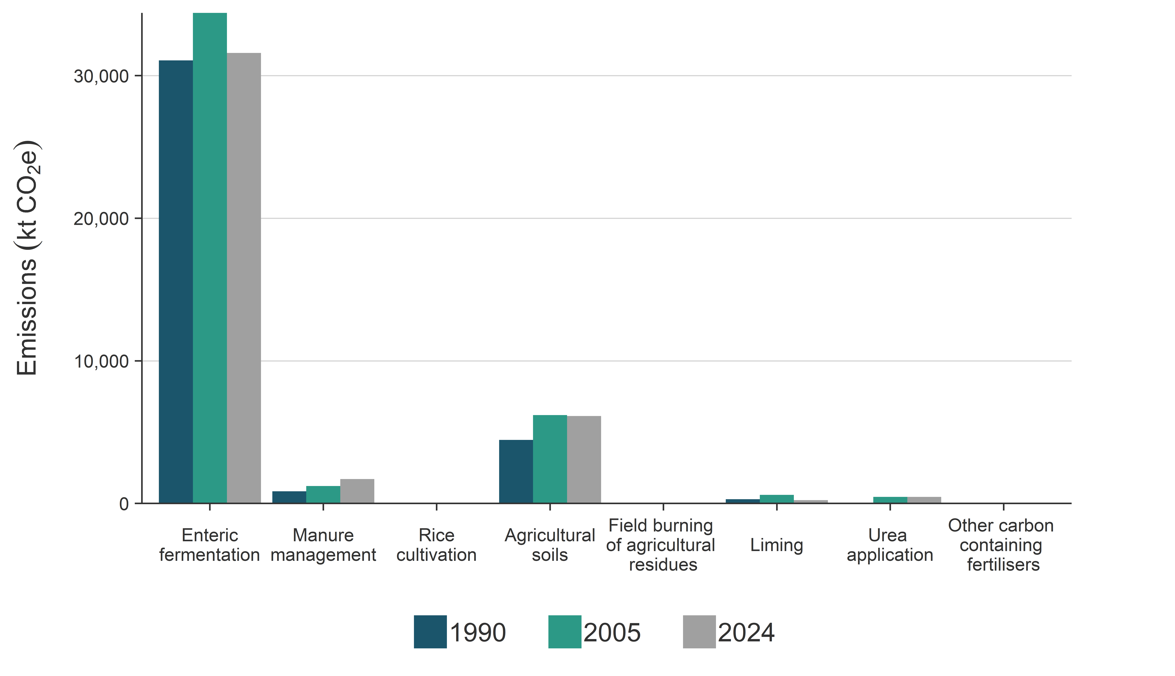
Notes: Rice cultivation does not occur (NO) in New Zealand. Emissions from other carbon-containing fertilisers are not estimated (NE).
Figure 5.1.2 New Zealand’s Agriculture sector emissions, from 1990 to 2024
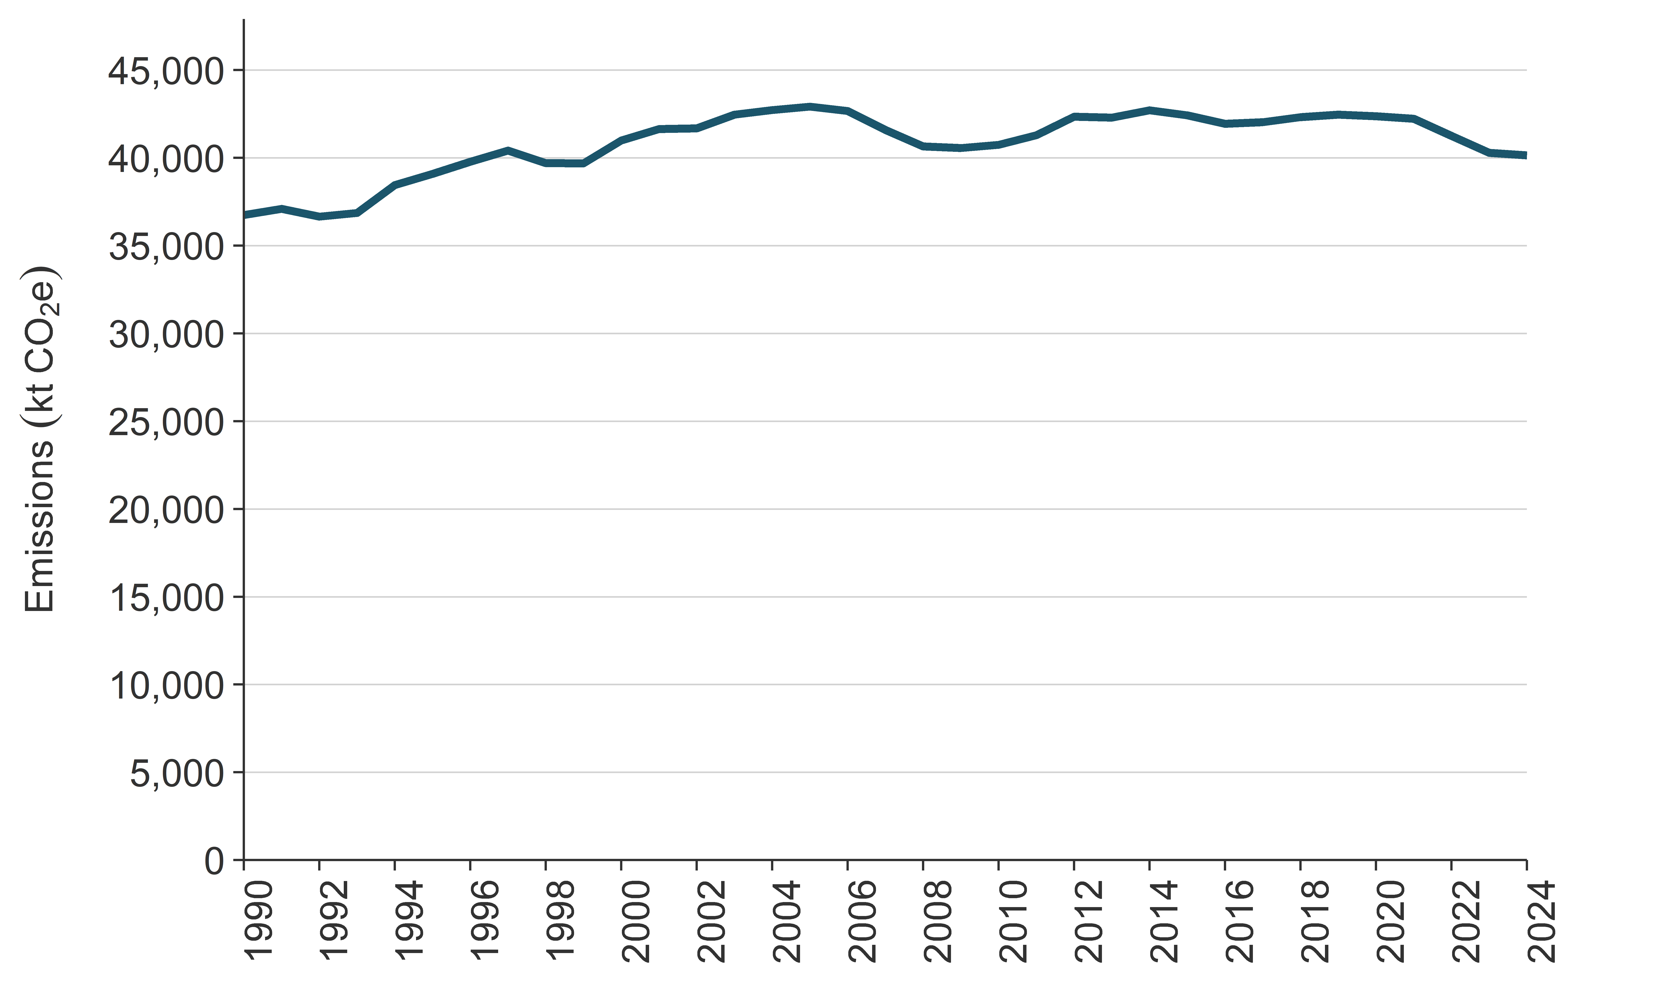

5.1.1 New Zealand farming practices and trends
Agriculture is a major component of the New Zealand export economy. Exports from food and fibre products comprised around 82.9 percent of New Zealand’s merchandise exports and delivered $60.4 billion in export earnings in the year to 30 June 2025 (MPI, 2025b). The production of agricultural products in New Zealand is supported by the favourable temperate climate and access to abundant freshwater and productive soils. Typical farming practices in New Zealand include the use of year-round outdoor pastoral grazing systems and nitrogen inputs through nitrogen fixation by legumes, particularly white clover (Trifolium repens), complemented (if required) by synthetic nitrogen fertiliser and supplementary feeds. The widespread use of outdoor pastoral grazing systems means New Zealand’s agricultural production is more sensitive to climatic variation affecting feed production than countries that use intensive grain-fed systems and/or indoor feedlots.
Intensive housing of major ruminant livestock species rarely occurs in New Zealand. Farmers may temporarily take animals off regular grazing areas to prevent damage to soils and limit any subsequent loss in pasture growth, although most off-paddock areas are also outdoors. This means New Zealand has a much lower proportion of Agriculture emissions from Manure management, compared with other Annex I Parties, because most manure is deposited directly onto pastures. For further information about New Zealand’s agricultural farming practices and conditions, see section 2.1.6.4 (National circumstances, Agriculture) of New Zealand’s first Biennial Transparency Report under the Paris Agreement (Ministry for the Environment, 2024).
Trends in emissions from the Agriculture sector are largely driven by the populations of the ruminant livestock categories: Dairy cattle, Non-dairy cattle, Sheep and Deer. In 1990 and 2024 respectively, 95.5 percent and 93.0 percent of Agriculture emissions originated from these ruminant livestock categories.
Agricultural livestock activities use around 42 percent of New Zealand’s total land area (Stats NZ, 2023). Since 1990, the proportions of the main livestock categories farmed in New Zealand have changed (see figure 5.1.3a and figure 5.1.3b). The population of dairy cattle has increased while the populations of sheep, non-dairy (beef) cattle and deer have decreased. Between 1990 and 2024, the land area used for sheep and non-dairy (beef) cattle grazing has decreased by 40.0 percent (5.0 million hectares), from 12.5 million hectares to 7.5 million hectares (based on data provided by Beef + Lamb), while the area used for dairy farming has increased by 66.5 percent (680,637 hectares) (LIC and Dairy NZ, 2025, table 2.2). Dairy farming has also intensified over this period, with the average number of cows per hectare increasing by 16.6 percent. However, since 2015, both the total land under dairy production and the national herd size have decreased 2.7 percent and 6.4 percent respectively (LIC and Dairy NZ, 2025, table 2.2).
The use of synthetic nitrogen fertiliser in the Agriculture sector has increased by 553 percent since 1990, although total use has decreased in recent years. Total emissions from synthetic nitrogen fertiliser (including CO₂ from urea) have increased from 0.5 percent of Agriculture emissions in 1990 to a peak of 3.4 percent in 2020. Since 2020, synthetic nitrogen fertiliser use has decreased. Total emissions from synthetic nitrogen fertiliser (including CO₂ from urea) contributed 3.0 percent of Agriculture emissions in 2024.
Figure 5.1.3a Populations of New Zealand’s dairy cattle, non-dairy cattle and deer, from 1990 to 2024
(June year ending)
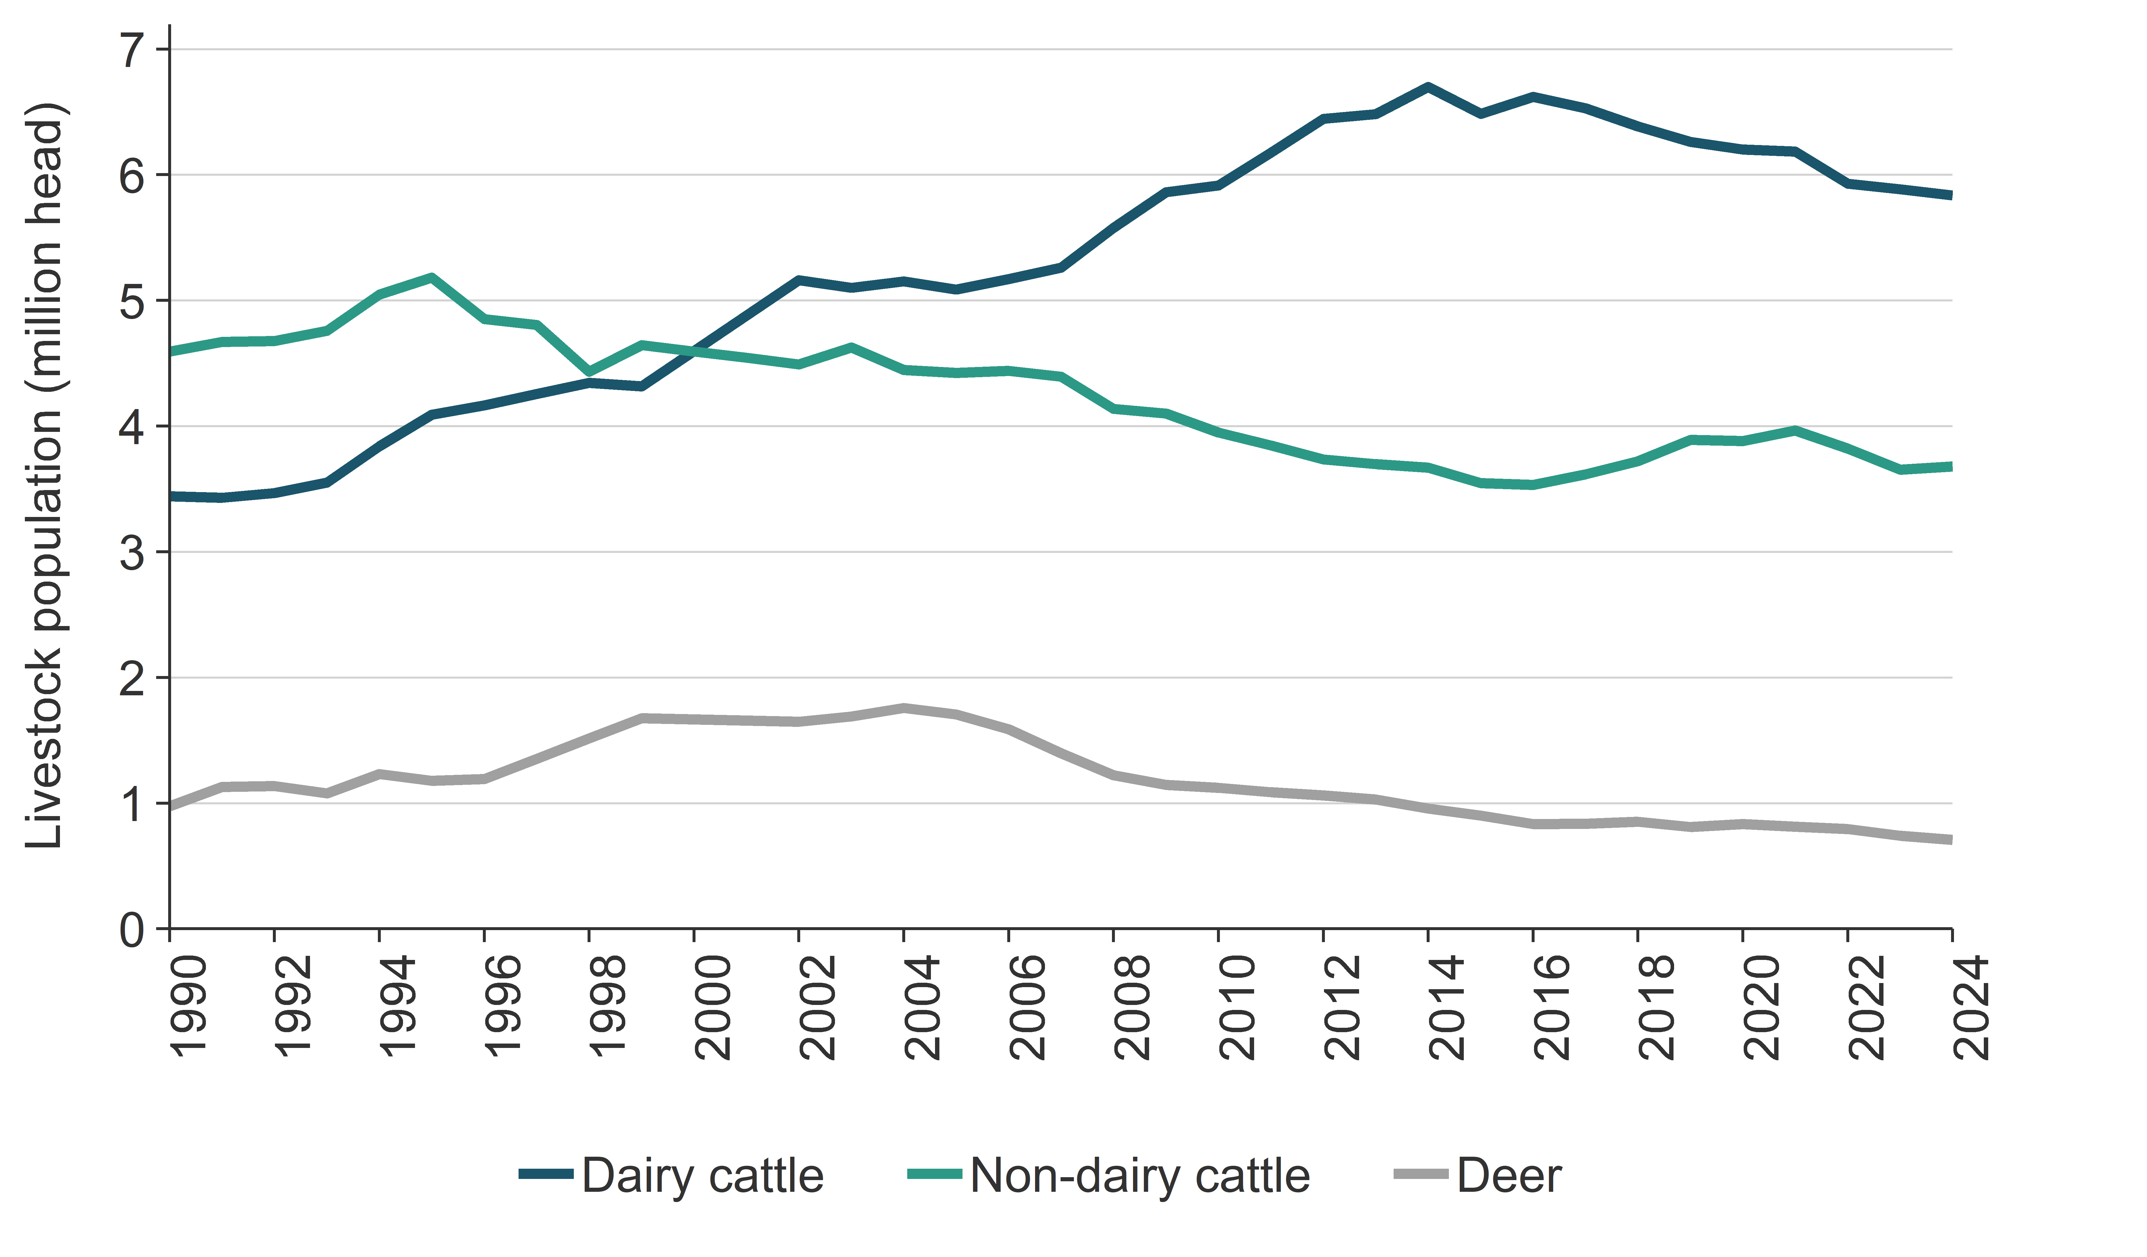
Source: Stats NZ
Figure 5.1.3b Population of New Zealand’s sheep, from 1990 to 2024 (June year ending)
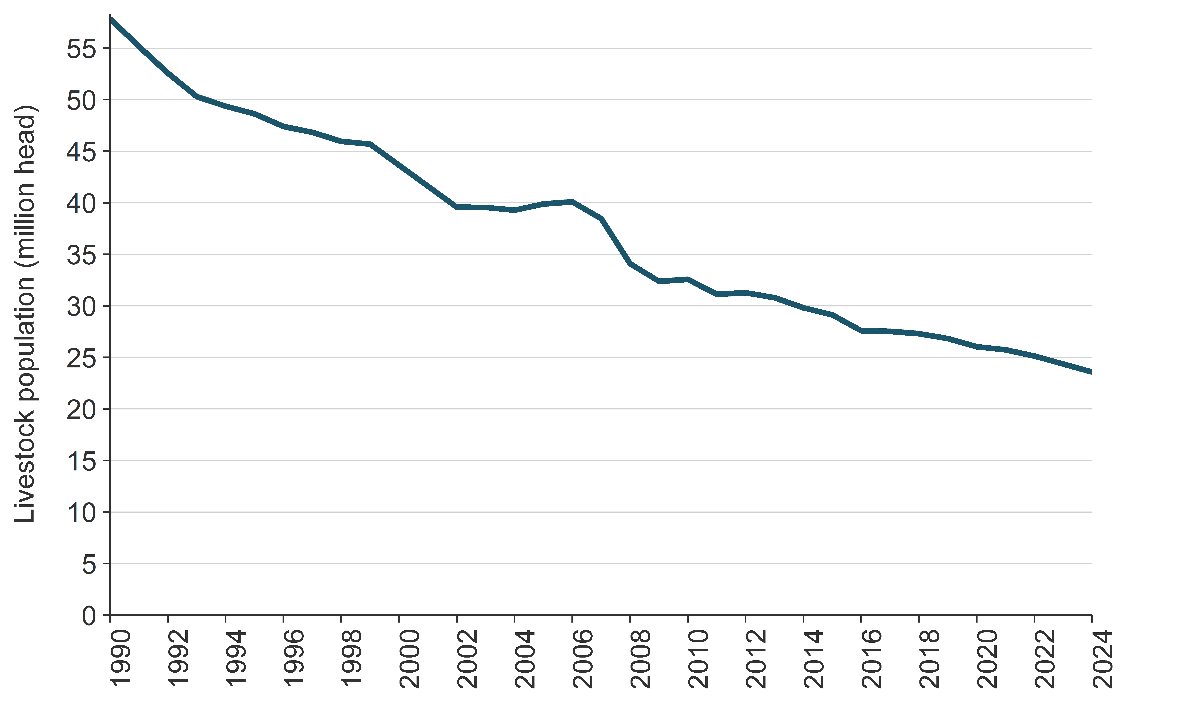
Source: Stats NZ

Effect of productivity improvements and climatic events on implied emission factors
From 1990 to 2024, a gradual increase has occurred in the implied CH₄ and N₂O emission factors per head of the major livestock species and types farmed in New Zealand. This trend reflects the increased levels of productivity (milk and meat yield per head) achieved by New Zealand farmers between 1990 and 2024. Increases in animal liveweight and milk yield per animal require increased feed intake to meet higher energy demands, which results in higher CH₄ and N₂O emissions per animal (i.e., higher implied emission factors (IEFs)). The increased levels of productivity have also caused emissions per unit of product (i.e., milk and meat emissions intensity) to steadily decrease since 1990.
The use of year-round outdoor pastoral grazing systems means New Zealand’s animal production is largely dependent on the quantity and quality of pasture grown on land managed by farmers, as well as the use and/or availability of any supplementary feeds and fertiliser inputs. Pasture growth is influenced by weather and climatic events, such as droughts and floods, however, the temperate maritime climate is generally favourable for pastoral agriculture. These factors can cause changes in per-animal productivity and mean that IEFs can be noticeably different in adjacent years. For example, in 2008, a major nationwide drought affected both livestock numbers and animal performance, resulting in lower livestock emissions and overall Agriculture emissions (see figure 5.1.2). The livestock population and IEFs started to increase after the drought, once seasonal growing conditions improved, and farmers restored herd and flock numbers.
An example of this is included in figure 5.1.4, which overlays milk production per milking dairy cow with the IEFs (enteric fermentation) for all dairy cattle from 1990 to 2024. The figure shows that, while per cow productivity has trended upward, there is a large amount of inter-annual variability (mainly influenced by climatic conditions and international product prices). It also shows that the IEFs are affected by these changes in productivity.
Figure 5.1.4 Dairy milk productivity and implied enteric fermentation methane emission factors for dairy cows, from 1990 to 2024
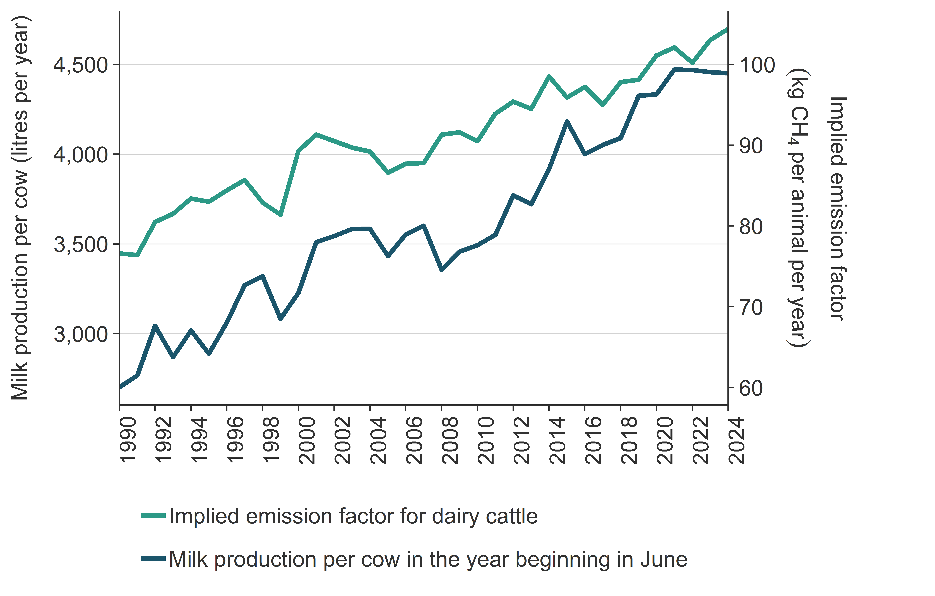
Note: Milk production per cow is calculated by dividing total milk production by the milking dairy cattle population (i.e., excluding replacements and breeding bull numbers).

5.1.2 Key categories for Agriculture sector emissions
Details of New Zealand’s analysis of key categories are in chapter 1, section 1.4. The key categories in the Agriculture sector are listed in table 5.1.2.
Table 5.1.2 Key categories in the Agriculture sector
CRT category code | IPCC categories | Gas | Criteria for identification
3.A.1.a. | Option A – Dairy cattle | CH₄ | L1, T1
3.A.1.b. | Option A – Non-dairy cattle | CH₄ | L1, T1
3.A.2. | Enteric fermentation – Sheep | CH₄ | L1, T1
3.A.4.c. | Other livestock – Deer | CH₄ | L1, T1
3.A.4.d. | Other livestock – Goats | CH₄ | T1
3.B(a). | CH₄ emissions – 3.B.2. Sheep | CH₄ | T1
3.B.1.a. | Option A – Dairy cattle | CH₄ | L1, T1
3.D.1.a. | Direct N₂O emissions from managed soils – Inorganic N fertilizers | N₂O | L1, T1
3.D.1.c. | Direct N₂O emissions from managed soils – Urine and dung deposited by grazing animals | N₂O | L1, T1
3.D.1.f. | Direct N₂O emissions from managed soils – Cultivation of organic soils | N₂O | L1, T1
3.D.2.a. | Indirect N₂O emissions from managed soils – Atmospheric deposition | N₂O | L1
3.D.2.b. | Indirect N₂O emissions from managed soils – Nitrogen leaching and run-off | N₂O | L1
3.G. | Agriculture – Liming | CO₂ | L1, T1
3.H. | Agriculture – Urea application | CO₂ | L1, T1
Note: L1 means a key category is identified under the level analysis – approach 1 and T1 is trend analysis
– approach 1. See chapter 1 for more information.

5.1.3 Methodological issues for the Agriculture sector
The Agriculture sector includes emissions of CH₄ and N₂O from livestock industries (estimated in Enteric fermentation (CH₄) and Manure management (CH₄ and N₂O)). In New Zealand, the most populous species are sheep, followed by dairy cattle, non-dairy (beef) cattle and deer. The majority of New Zealand animals are selected to perform under outdoor pastoral farming systems.
Other agricultural emission sources include N₂O from Agricultural soils, CH₄ and N₂O from Field burning of agricultural residues and CO₂ from Liming and Urea application.
New Zealand uses a range of models and IPCC tiers appropriate to the size of the different emission categories for calculating emissions. For example, in 2024, 93.0 percent of emissions from the Agriculture sector come from Dairy cattle, Non-dairy cattle, Sheep and Deer (‘major’ livestock categories). Emissions from major livestock categories are estimated using Intergovernmental Panel on Climate Change (IPCC) Tier 2 methodologies. Other livestock species, including Swine, Goats, Horses, Llamas and alpacas, Mules and asses, Ostriches and Poultry (‘minor’ livestock categories), account for only 0.4 percent of Agriculture emissions, and are estimated using Tier 1 methodologies with some Tier 2 components. As such, most of New Zealand’s reported Agriculture emissions are calculated using a Tier 2 methodology. A partial Tier 3 methodology is used for calculating emissions from Agricultural soils for Urine and dung deposited by grazing animals. Table 5.1.3 summarises methods and emission factors for Agriculture categories.
Table 5.1.3 Methods and emission factors in the Agriculture sector
Source category |  | CH₄ |  | N₂O |  | CO₂
 |  | Method applied | Emission factor | Method applied | Emission factor | Method applied | Emission factor
A | Enteric fermentation
1 | Cattle | - | - | - | - | - | -
1 | Dairy cattle | T2 | CS | -– | -– | -– | -–
1 | Non-dairy cattle | T2 | CS | -– | -– | -– | -–
2 | Sheep | T2 | CS | -– | -– | -– | -–
3 | Swine | T1 | CS | -– | -– | -– | -–
4 | Other livestock (camels, deer, goats, horses, mules and asses, poultry) | T1, T2 | CS, D | -– | -– | -– | -–
B | Manure management | - | - | - | - | - | -
1 | Cattle | - | - | - | - | - | -
1 | Dairy cattle | T2 | CS | T2 | CS | -– | -–
1 | Non-dairy cattle | T2 | CS | NA | NA | -– | -–
2 | Sheep | T2 | CS | NA | NA | -– | -–
3 | Swine | T1 | CS | T1 | CS | -– | -–
4 | Poultry | T1 | D | T1 | CS | -– | -–
4 | Other livestock (camels, deer, goats, horses, mules and asses) | T1, T2 | CS, D | NA | NA | -– | -–
C | Rice cultivation | NA | NA | -– | -– | -– | -–
D | Agricultural soils | - | - | - | - | - | -
1 | Direct emissions | - | - | - | - | - | -
1 | Synthetic fertilisers | - | - | T2 | CS | -– | -–
1 | Animal manure applied to soils | - | - | T1, T2 | CS | -– | -–
1 | Sewage sludge applied to soils | - | - | NA | NA | -– | -–
1 | Other organic fertilisers applied to soils | - | - | T1 | D | -– | -–
1 | Urine and dung deposited by grazing animals | - | - | T1, T2, T3 | CS | -– | -–
1 | Crop residues | - | - | T2 | CS | -– | -–
1 | Mineralisation associated with loss of soil organic matter | - | - | T1 | D | -– | -–
1 | Cultivation of organic soils | - | - | T1 | D | -– | -–
2 | Indirect emissions | - | - | - | - | - | -
2 | Atmospheric deposition | - | - | T1, T2 | D | -– | -–
2 | Nitrogen leaching and runoff | - | - | T1, T2 | CS | -– | -–
E | Prescribed burning of savannas | NA | NA | NA | NA | -– | -–
F | Field burning of agricultural residues | T2 | CS | T2 | CS | -– | -–
G | Liming | -– | -– | -– | -– | T1 | D
H | Urea application | -– | -– | -– | -– | T1 | D
I | Other carbon-containing fertilisers | -– | -– | -– | -– | NA | NA
Note: CS = country specific; D = IPCC Guidelines (2006) default; NA = not applicable; T1 = Tier 1; T2 = Tier 2.
Further technical details on emissions calculations are provided in the Agriculture inventory methodology document (Pickering et al., 2025) and in the methodological issues section for each category in this document. The approach for determining livestock nutritional and energy requirements, which is required to calculate Enteric fermentation emissions and nitrogen excreted by livestock as the precursor for calculating Manure management (and some Agricultural soils emissions), is described in the following paragraphs.

Description of the Tier 2 model for determining emissions from energy requirements for major ruminant livestock categories
New Zealand uses a Tier 2, process-based model to calculate emissions from the major livestock categories (Clark et al., 2003). Components of the national Agriculture inventory model are constantly being improved through findings from new international and commissioned domestic research. The thoroughly researched country-specific emission factors and monthly data for livestock populations, animal productivity and feed quality mean New Zealand’s model is close to a Tier 3 inventory. However, data that inform pasture and non-pasture feed quality are not as comprehensive as would be required to report at a Tier 3 level. Figure 5.1.5 outlines the current Tier 2 methodology used to estimate emissions for the four major livestock categories.
Agricultural production (meat, milk and wool) and livestock population data are combined in the model with data on the total metabolisable energy (ME) content of the animal’s diet. To calculate CH₄ emissions from enteric fermentation, the production data are used to determine the dry-matter intake (DMI) required to meet total annual productivity levels for each of the livestock categories and are then multiplied by a country-specific CH₄ emission factor per unit of DMI. Manure management emissions are primarily CH₄ from manure dung and urine deposited directly onto pasture, but also N₂O as that manure breaks down due to the processes of nitrification, denitrification, volatilisation and leaching. Information on the nitrogen content of feed is multiplied with the DMI previously calculated to determine quantity of animal nitrogen intake and subsequent nitrogen excretion after allowing for nitrogen in growth and milk production.
Figure 5.1.5 Simplified methodology for calculating emissions for major ruminant livestock categories
Note: CH₄ = methane; DMI = dry-matter intake; kg = kilogram; MJ = megajoule; N₂O = nitrous oxide; NZ = New Zealand.
The main emissions from ruminant livestock are CH₄ from enteric fermentation and N₂O from manure (urine and dung). The quantity of livestock emissions has a linear relationship with DMI, which is a function of livestock energy requirements and the energy concentration of the feed:
$$DMI=\frac{ME_{TOTAL}}{E}$$
Where: DMI is the dry-matter intake (kg/year)
ME_{TOTAL} is the total metabolisable energy requirement of the animal (kJ), and
E is the energy concentration in the feed (kJ/kg DMI).

Calculating metabolisable energy requirements (ME_{TOTAL})
For dairy cattle, non-dairy (beef) cattle and sheep, the approach for calculating total ME requirements was developed in Australia by the Commonwealth Scientific and Industrial Research Organisation (CSIRO, 1990). The CSIRO algorithms have been chosen because they specifically include methods to estimate the energy requirements of grazing ruminants outdoors, which is the predominant feeding method used in New Zealand. Further, the CSIRO algorithms consider animal liveweight and production requirements based on the rate of liveweight gain, gender, milk yield and physiological state. All calculations are performed monthly. The equation below is derived from the general equation used in the Australian feeding standards and adjusted to suit New Zealand conditions.
The total energy required (ME_{TOTAL}) is made up of:
- energy required to maintain animal weight, which is a function of the animal’s liveweight gender, breed, stage of maturity and physiological state (e.g., growing or lactating) (ME_{m})
- energy required for the production of milk, wool, velvet, and live weight gain (ME_{p})
- energy required for gestation or growth of the conceptus at any given time during pregnancy (ME_{c})
- the additional amount of energy expended during grazing, compared with similar housed animals (ME_{GRAZE}).
$$ME_{TOTAL}={ME}_{m}+{ME}_{P}+{ME}_{GRAZE}+{ME}_{c}$$
Where: ME_{m} is the energy requirement for maintenance
ME_{P} is the energy used directly for production (meat, milk, wool and so on)
ME_{GRAZE} is the additional energy required by grazing livestock, and
ME_{c} is the energy used for gestation or growth of the conceptus (MJ/day).
The ME_{m} requirement for an animal of a defined weight is not constant and will vary with energy costs of production. Increased productivity requires higher feed intakes and this affects the proportion of viscera and costs associated with respiration, cardiac output and so on. The Agriculture inventory model accounts for this by adding 10 percent of the dietary ME allocated to production (ME_{p}) to ME_{m} (CSIRO, 1990). The addition of the term 0.1 × ME_{p} is used to account for this.
The Agriculture inventory model uses a generic equation to calculate ME_{m} for dairy and non-dairy (beef) cattle, sheep and deer, but equations used to calculate ME_{p} and ME_{GRAZE} differ for each animal category:
$${ME}_{m}=K×S×\frac{0.28LW^{0.75}×e^{-0.03A}}{k_{m}}+0.1×{ME}_{p}$$
Where: ME_{m} = metabolisable energy required to maintain animal weight (MJ/d)
K = coefficient that accounts for differences in fasting heat production across species (CSIRO, 1990, p 22). This value is 1.0 for sheep and 1.4 for cattle and deer (CSIRO, 2007)
S = coefficient that accounts for differences in basal metabolic rate between males and females. This value is 1.0 for mature females and castrates or 1.15 for entire mature males (CSIRO, 2007)
LW = live weight of animal (kg)
A = age in years
k_{m} = efficiency of utilisation of ME for maintenance, or the factor used to convert ME to NE for maintenance
ME_{p} = ME required for production (MJ/d).
For further details, refer to the Agriculture inventory methodology document (Pickering et al., 2025).

Monthly diet energy (E) concentration
In New Zealand, dairy cattle, non-dairy (beef) cattle, sheep and deer are predominantly fed on pasture all year round. Data sets of estimated monthly energy concentrations of pasture consumed by different livestock species are used in the Agriculture inventory model. This diet is typically supplemented with feeds of various types, such as pasture hay and silage, and a range of different crops and crop wastes. Data on the energy concentration and composition of pasture and supplementary feed are reported in the Agriculture inventory methodology document (Pickering et al., 2025, appendices 3, 6, 7) and are derived from published and unpublished research trial data and supplemented with additional data from farm surveys on commercial cattle and sheep farms.
To ensure consistency across the livestock emission source categories, a single enhanced livestock population characterisation and DMI estimate is produced by the Tier 2 model for each livestock class. The enhanced livestock characterisation and DMI are used to estimate CH₄ emissions for the Enteric fermentation category, CH₄ and N₂O emissions derived from the nitrogen concentration of the feed DMI for the Manure management category, and N₂O emissions for urine and dung deposited by grazing animals onto pasture in the Agricultural soils category.

5.1.4 Activity data

Major livestock categories
The Tier 2 methodology developed by New Zealand uses data on livestock population and productivity to calculate livestock energy requirements and DMI. Animal population data are collected by Stats NZ, New Zealand’s official data agency. Productivity data for dairy are provided jointly by the Livestock Improvement Corporation (LIC) (a farmer-owned cooperative genetics improvement organisation) and DairyNZ (an industry-good research, statistics and advisory body for dairy). Other data are provided by industry organisations such as Beef + Lamb New Zealand Ltd (an industry-good research, survey and advisory body for non-dairy (beef) cattle and sheep) and Deer Industry New Zealand (an industry-good research and advisory body for deer), which regularly collect animal sector statistics. Statistics on animal carcass weights are collected by the Ministry for Primary Industries (MPI) from all major meat processors and are used to derive animal liveweights for the Inventory.
A challenge for New Zealand activity data is that the Inventory is calculated on a calendar year basis for international comparability purposes, while the New Zealand agricultural sector largely uses a June year-end basis for animal statistics because this reflects the natural biological annual cycle for animals in the southern hemisphere. New Zealand developed a Tier 2 model that estimates livestock emissions on a monthly time step, beginning on 1 July of one calendar year and ending on 30 June of the next year. To calculate emissions for a single calendar year (1 January to 31 December), the calculated emissions data from the last six months of a July–June year are combined with the first six months’ emissions of the next July–June year. This approach enables comparisons with the agricultural inventories of other countries.
Dairy cattle are the only livestock type where emissions are currently calculated on a sub-national regional area basis represented by regional council boundaries. This allows the Agriculture inventory model to account for regional differences in productivity of dairy livestock as a result of New Zealand’s different climatic conditions and management systems (Clark, 2008a). A regional emissions assessment is not carried out for other livestock types because regional productivity data are currently unable to be accurately collected at the sub-national level and integrated into the national population data.

Animal population data
Stats NZ collects animal population data on a sub-national territorial authority basis. Animal population data are collected on an annual basis through the Agricultural Production Census and Agricultural Production Survey. The census occurs every five years (the most recent occurred in 2022) and the survey is conducted in the interim years. The only difference between these two processes is the sample size. The census attempts to gather information from the entire target population, and the survey attempts to gather information from a representative random sample of that population. Further details about the scope and accuracy of the Stats NZ agricultural production data collection are provided in volume 2, annex 5, section A5.1.
Livestock population data for 2025 are needed to estimate emissions for the 2024 year. The timing of Stats NZ final data releases (June the year after the survey) and the inventory submission deadlines mean that actual 2025 population data are not available for this inventory submission. Projections based on figures published in New Zealand’s first Biennial Transparency Report under the Paris Agreement (Ministry for the Environment, 2024) have been used as a replacement for 2024 data.
The New Zealand Agriculture inventory model uses a country-specific population characterisation for pasture-based livestock compared with the default recommended by the IPCC for Tier 2 inventories (IPCC, 2000, 2006, 2019). The full list of categories for the major livestock populations can be found in volume 2, annex 5, table A5.1.2, and in the Agriculture inventory methodology document (Pickering et al., 2025).
For the purposes of emissions data reporting, the Dairy cattle category encompasses all cattle that support the milking dairy herd. In addition to dairy heifers, this includes calves, young growing non-lactating heifers, dry cows and dairy bulls. All other cattle in New Zealand are characterised as non-dairy cattle. These include non-dairy breeding lactating cows used for producing slaughter animals, such as calves, dry cows, bulls and all slaughter classes. A proportion of male and female dairy calves not required for dairy replacements are transferred into the non-dairy herd and are slaughtered for meat consumption, generally at 24 months to 36 months of age.
A detailed livestock population model is used to calculate monthly populations of dairy cattle, non-dairy cattle, sheep and deer (see volume 2, annex 5, table A5.1.2, for the full list of categories).
This monthly population delineation has been developed by using industry knowledge and assumptions, as detailed in Burggraaf et al. (2022), Clark (2008b), Stevens and Ward (2023), Stevens et al. (2022), Suttie (2012) and Thomson et al. (2010). Populations within a given year are adjusted on a monthly basis to account for births, deaths and transfers between age groups. For example, because most lambs are born and slaughtered between August and May, their numbers do not appear in the June census or survey data. Additionally, male and female dairy calves not necessary for replacements are usually slaughtered at four days of age or transferred to the non-dairy herd. The monthly population model ensures that the calculated feed demand more accurately reflects the status of each livestock category at a particular time of the year. Average national estimates of monthly birth and death dates and rates are used, which are based on expert opinion and limited published data. In reality, these vary across the country, due to differences in climate and farming systems in different parts of New Zealand.

Animal productivity data
Animal productivity data are obtained from LIC and DairyNZ, Beef + Lamb New Zealand Ltd and Deer Industry New Zealand. Slaughter statistics are collected by MPI and used as a proxy to establish changes in animal liveweight over time (MPI, 2025a). Animal liveweight is derived from published slaughter-weight statistics and general nationally derived killing-out percentages (Clark et al., 2003; Muir et al., 2008; Muir and Thomson, 2010).
The same data sources are used each year to ensure time-series consistency. Other information, such as the liveweight of non-dairy (beef) cattle and breeding bulls, is collected at irregular intervals from small survey populations. For years when data are not available, expert opinion and extrapolation from existing data are used.
Dairy cattle – milk production: Regional data on milk production, proportions of dairy cattle breeds and animal liveweights are provided in the New Zealand dairy statistics reports. These data are collectively compiled by LIC and DairyNZ.
Data on New Zealand’s total milk production are taken from the amount of milk processed through New Zealand dairy factories for both the export and domestic markets. Data on individual animal production are sourced from the Dairy Industry Good Animal Database, maintained by DairyNZ. Dairy farmers are paid on total kilograms of milk solids (fat and protein) collected. Tankers that collect the milk also meter the milk collected from individual farms. These meters are regularly calibrated and audited. Each time a tanker picks up milk (daily or every other day, depending on the season; B Bills, pers. comm., 2024), milk samples from individual farms are independently tested for milk solids, milk fat percentage and protein content.
LIC and DairyNZ provide annual milk production data (milk yield and composition), but the Tier 2 livestock model operates on a monthly time step. Monthly milk production is determined by multiplying the assessed proportion of annual milk production for each month by the total annual milk production (see volume 2, annex 5, table A5.1.3). Milk production commences from mid-July to early August every year, peaking around October–November and declines during autumn (April–May in the southern hemisphere). Milk production is low to non-existent in June and July in most herds (see figure 5.1.6). Some farms may milk during June–July to provide fresh milk for domestic consumers in winter.
New Zealand’s dairy production per animal is lower than in other developed countries. This is because New Zealand has predominantly pasture-based dairy systems rather than the housed grain-fed systems used in Europe and North America.
Annual milk yields per animal have been obtained and reported as additional data in the common reporting table (CRT) by dividing the total milk produced by the total number of milking dairy cows and heifers.
Figure 5.1.6 National monthly milk production in New Zealand, from 2022 to 2024
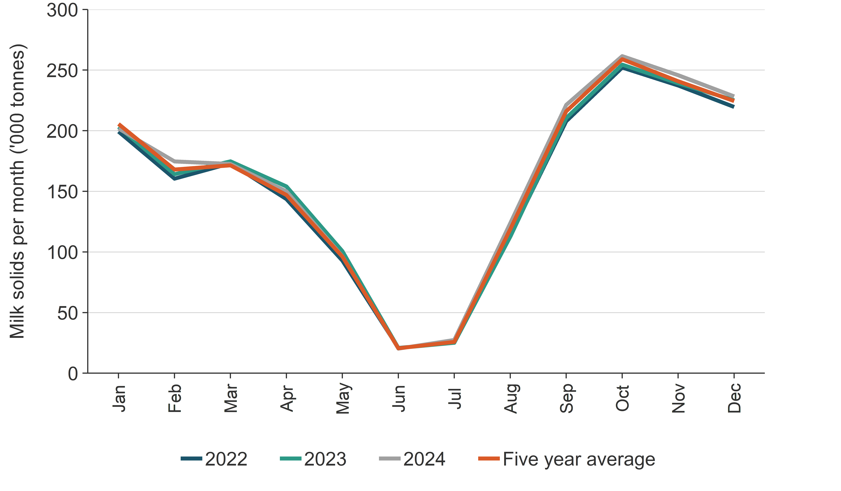
Source: Dairy Companies Association of New Zealand (2024)
Before 1993, no productivity data were collected at a territorial authority level, so pre-1993 data have been estimated by extrapolating the trends observed in existing data from 1994 to 2008.
Before 2004, not all productivity data required could be collected from LIC at a territorial authority level. From 1993 to 2003, annual milk yield per cow was determined by the following equation:
$$Litres per cow= \frac{mean milk fat \left(\frac{kg}{cow}\right)×100}{\%milk fat}$$
From 2004 onwards, productivity data have been collected by LIC and DairyNZ at a similar regional level as the livestock population data collected by Stats NZ. In some instances, the regional level data provided by LIC and DairyNZ are disaggregated more than required. MPI officials allocate this to other regions so that it lines up with the population data, for example, districts identified under the region ‘Central Plateau’ are allocated to the ‘Bay of Plenty’. This is a straightforward process because the districts provided by LIC and DairyNZ clearly fall within the specified regional boundaries that the Stats NZ data are based upon.
In the 2024/25 season, 82 percent of all dairy cattle in milk were tested by LIC for milk production, along with milk fat and protein levels (LIC and DairyNZ, 2025). LIC also does genetic testing to identify superior stock for breeding. Genetic improvement has contributed to the productivity improvements in the New Zealand dairy cattle herd (LIC, 2009).
Dairy cattle – liveweight: Average liveweight data for dairy cows are obtained by considering the proportion of each breed in the national herd and its age structure based on LIC, Dairy Industry Good Animal Database and DairyNZ data. Dairy cow liveweight data are only available from LIC and DairyNZ from 1996 onwards and have been disaggregated into eight regions, some of which comprise several regional council regions. Data from the livestock improvement regions were appropriately apportioned to regional council areas. Liveweights before 1996 were estimated using the trend in liveweights from 1996 to 2008, together with data on the breed composition of the national herd (LIC, 2009).
The inventory assumes that all dairy calves are born on 13 August and have a birth weight equal to 9 percent of an adult dairy cow weight (described above). The weight of these animals increases linearly until they are 687 days old, at which point their weight is assumed to be 100 percent of an adult dairy cow’s weight (Clark et al., 2003).
No data are available on the liveweights and performance of most breeding dairy bulls, which can range from the small Jersey breeds through to larger European non-dairy breeds. It is assumed, based on expert opinion and industry data (Clark et al., 2003), that the average mature weight of a breeding dairy bull is 500 kilograms as of 1 January and that they grow at 0.5 kilograms per day. This gives an average liveweight (at the mid-point of the year) of 592 kilograms. This is almost 25 percent higher than the average weight of a New Zealand breeding dairy cow but is supported by expert opinion, given that some of the bulls will be of a heavier breed (e.g., Friesian and some non-dairy breeds). Total emissions are not sensitive to these assumed liveweight values because breeding bulls in the dairy herd are low in number and contribute less than 0.1 percent of emissions to the dairy sector.
LIC and DairyNZ (2025) reported the proportions of different breeds in the New Zealand dairy herd in 2024 as:
- Holstein–Friesian/Jersey crossbreed (61.1 percent)
- Holstein–Friesian (23.4 percent)
- Jersey (7.5 percent)
- Ayrshire (0.4 percent)
- other breeds (7.6 percent).
The Holstein–Friesian/Jersey crossbreed has been developed specifically for New Zealand’s pasture-based systems. This breed is 7.7 percent lighter on average than a Holstein–Friesian cow (LIC and DairyNZ, 2025) and has lower maintenance feed requirements. It does less damage to pasture during wet periods due to its lower liveweight. It also has higher milk volumes than the Jersey breed while maintaining a high percentage of milk solids.
Non-dairy cattle: The principal source of information for estimating productivity for non-dairy (beef) cattle is livestock slaughter statistics provided to MPI by meat processors. This information is also used to estimate the liveweight of non-dairy (beef) cattle at slaughter, assuming killing-out percentages of 42 percent for breeding non-dairy cows and 50 percent for heifers, steers and bulls (Thomson et al., 2010). Non-dairy (beef) cattle are assumed to be slaughtered at various ages, depending on the sex and reproductive status of the animal (Stevens et al., 2022). Liveweights at birth are assumed to be around 7 percent of an average adult cow liveweight for heifers and 7 percent for steers and bulls (Clark et al., 2003). As with dairy cattle, growth rates of all growing animals are divided into two periods in the model: birth to weaning and weaning to slaughter. Higher growth rates are applied before weaning because animals also receive milk as part of their diet. Within each period, the same daily growth rate is applied for the entire period.
MPI slaughter statistics only began to separate carcass weights of adult dairy cows and adult non-dairy cows in 2016. Therefore, several assumptions are made to estimate the liveweights of breeding non-dairy cows. A total milk yield of 824 litres per year is assumed to be produced per breeding non-dairy cow, which is then consumed by non-dairy calves (Clark et al., 2003).
Sheep: Livestock slaughter statistics provided to MPI by meat processors are used to estimate the liveweights of adult sheep and lambs at slaughter, assuming killing-out percentages of around 40 percent for ewes and 45 percent for lambs (Thomson et al., 2010). Lamb liveweights at birth are assumed to be 9 percent of the average adult ewe weight, with all lambs assumed to be born on 11 September (Thomson et al., 2011). Growing breeding and non-breeding ewe hoggets are assumed to reach full adult size when subsequently mated at an age of 20 months. Adult wethers (castrated male sheep) are assumed to be the same weight as adult breeding females. No within-year pattern of liveweight change is assumed for either adult wethers or adult ewes. All ewes rearing a lamb are assumed to have a total milk yield of 103 litres per year. Breeding rams are assumed to weigh 40 percent more than adult ewes (Clark et al., 2003). Wool growth (greasy fleece) is assumed to grow at a rate twice as fast as mature sheep (ewes, rams and wethers) than in growing sheep and lambs. Beef + Lamb New Zealand Ltd provides estimates of the total wool production from 1990 to 2024 from which the individual fleece weight is estimated (Beef + Lamb New Zealand Ltd, 2025).
Deer: Liveweights of growing hinds and stags are estimated from Deer Industry New Zealand statistics, assuming a killing-out percentage of 55 percent. A fawn birth weight of 9 percent of the adult female weight and a common birth date of mid-November are assumed. Liveweights of breeding stags and hinds are based on a report by Suttie (2012). Research by Stevens and Ward (2023) has shown that hind liveweights have not risen above 110 kilograms, so a cap to liveweight is applied. It is assumed there is no pattern of liveweight change within any given year for mature deer. The lactation assumptions are 204 litres of milk over 120 days, an average daily lactation yield of 1.7 litres of milk per day (Suttie, 2012).

Minor livestock categories
Tier 1 methodology is used for goats, horses, mules and asses, swine, poultry, and alpacas, using a combination of country-specific and IPCC default emission factors (volume 2, annex 5, section A5.1.2, table A5.1.4).
The populations of goats, horses and swine are reported using data from the Stats NZ Agricultural Production Census and the inter-census Agricultural Production Survey. Data on the population of alpacas before 2009 are provided by Henderson and Cameron (2010) based on data from the Alpaca Association New Zealand. Alpaca populations for 2009 to 2022 are based on modelling by Sise (2023). From 2023 onwards, registration numbers from the Alpaca Association of New Zealand and the Llama Association of New Zealand are used assuming a 51 percent registration rate (Sise, 2023).
A small number of buffalo are farmed in New Zealand, with 699 animals being reported (Stats NZ, 2025). Because the buffalo livestock are largely used for producing milk they are reported within the dairy herd.
Mules and asses are not farmed commercially or used as working animals in New Zealand. A constant population of 1,500 donkeys has been included in the Agriculture inventory model under mules and asses (Sise, 2023). The emissions from these populations of animals are extremely small relative to the major livestock categories.
Poultry is further classified into three categories: broiler chicken, layer hens and other poultry. Stats NZ provides estimates of average annual broiler chicken flock sizes using industry data on the numbers of broilers processed every year since 1990. Mortality rates and days alive are used as suggested by Fick (2010). Stats NZ also obtains estimates of the number of layer hens and other poultry (e.g., ducks, turkeys) from the Agricultural Production Census and Agricultural Production Survey. Other poultry manure management emissions are included and calculated. Enteric fermentation is negligible and therefore not estimated.
The average annual flock size of chickens is determined by the following equation:
$$Average annual flock size= \frac{days alive}{365} ×annual number of birds processed ×(1-mortality rate)$$
Beginning in 2007, Stats NZ also obtains estimates of the number of ostrich and emu in New Zealand. In 2015, it was estimated only 768 ostriches and emus were in the country. In 2024, it was estimated there were 260 ostriches and emus. In the absence of other information prior to 2007, the emu and ostrich population is assumed to be constant.
Rabbits are considered an agricultural pest, and only a very small number are farmed in New Zealand (R. Sanson, pers. comm., 2019). Because of this, emissions from farmed rabbits are reported as ‘not estimated’ (NE) because their emissions are insignificant. There is no known farming of platypus or other fur-bearing animals.

5.1.5 Recalculations

Agricultural emissions research
New Zealand invests in a comprehensive research programme to develop technologies and practices to reduce biological greenhouse gas emissions from Agriculture. This is facilitated through the following.
- The Ag Emissions Centre (formerly known as the New Zealand Agricultural Greenhouse Gas Research Centre), which was established in 2009. It aims to contribute to agricultural greenhouse gas understanding and mitigation through research programmes and international collaboration, and to enhance New Zealand’s research capability and infrastructure in understanding livestock farming greenhouse gas emissions.
- The Pastoral Greenhouse Gas Research Consortium, which was established in 2003 by New Zealand agricultural sector organisations and private companies in partnership with the Government through the Ministry of Business, Innovation and Employment. It funds research, primarily into mitigation technologies and management practices for ruminants but also to provide information to improve on-farm greenhouse gas inventories. Funding from the Ministry of Business, Innovation and Employment has since ceased and the Consortium now largely operates on funding from industry alone.
- New Zealand is one of the founding members of the Global Research Alliance on Agricultural Greenhouse Gases (GRA), which facilitates international research collaboration to study ways of increasing global food production while reducing agricultural greenhouse gas emissions. The GRA achieves this through building capability, improving greenhouse gas inventories in developing countries, and facilitating the transfer of technologies and knowledge between members. New Zealand has hosted the GRA Secretariat since its establishment in 2009 and coordinates New Zealand’s contribution of research, knowledge transfer and capability building largely through the Ag Emissions Centre.
- New Zealand’s Greenhouse Gas Inventory Research Fund supports continuous improvement of the Agricultural Greenhouse Gas Inventory to improve the accuracy and reduce uncertainty of emissions reporting and forecasting. This follows the IPCC’s guidelines for the preparation and continuous improvement of national greenhouse gas inventories (IPCC, 2000, 2006). The fund has supported greenhouse gas agricultural inventory research since 2004.
- The Centre for Climate Action on Agricultural Emissions was established in 2022 to accelerate the research, development and commercialisation of tools and technology to reduce emissions. It aims to achieve this via two main investment programmes:
- AgriZeroNZ: a joint venture partnership between the Government and key agricultural industry organisations to drive a targeted research programme and support the pathway and uptake of new mitigation tools and technologies
- enhancing the Ag Emissions Centre via additional investment to accelerate research.
Research and data from these sources feed into New Zealand’s improvement of the Agriculture inventory, and these research activities allow New Zealand to share technical skills and expertise internationally.

Recalculation and improvement approval process in the Agriculture inventory
The process for developing improvements and agreeing methodological changes to the Agriculture inventory is shown in figure 5.1.7.
Domestically, New Zealand has a network of scientific experts in the fields of CO₂, CH₄ and N₂O emissions. Research findings are presented annually at the Greenhouse Gas Inventory Research Workshop. New inventory research ideas raised by the research community including industry, and government inventory compilers inform decisions for future inventory research. Final decisions on research priorities are made by MPI, following discussions between the network leaders and Ministry for the Environment (MfE) staff. Research is contracted to address specific questions relating to gaps in New Zealand’s knowledge base and to review, test and improve current model parameters. Draft research reports are peer reviewed by internal and at least one external independent expert with knowledge in the field and are assessed for their scientific robustness and suitability to be included in the Agriculture inventory model. A standard peer review report template is used.
If the report recommends changes, a briefing and the final report including the draft results of changes are provided to the Agriculture Inventory Advisory Panel, which currently meets annually to review proposed changes to the Agriculture inventory model. The Panel comprises expert representatives from MPI and MfE and nominated science representatives from the Methanet and NzOnet expert advisory groups. The Panel is independent of policy and industry influences and has been formed to give independent advice on whether changes to the Agriculture sector of the Inventory are scientifically robust, justifiable and internationally defensible. The Panel assesses if the proposed changes have been appropriately researched, using recognised scientific methods, principles and practices, and if there is sufficient scientific evidence to support recommended changes.
Changes recommended by the Panel must be approved by the Deputy Director-General Policy and Trade at MPI, as well as receive endorsement from the Reporting Governance Group (RGG), which is chaired by MfE and leads the reporting, modelling and projections of emissions and removals across government for all sectors. Further details on the RGG are provided in chapter 1, section 1.2.4.
Figure 5.1.7 Agriculture sectoral approval process for inventory recalculations and improvements
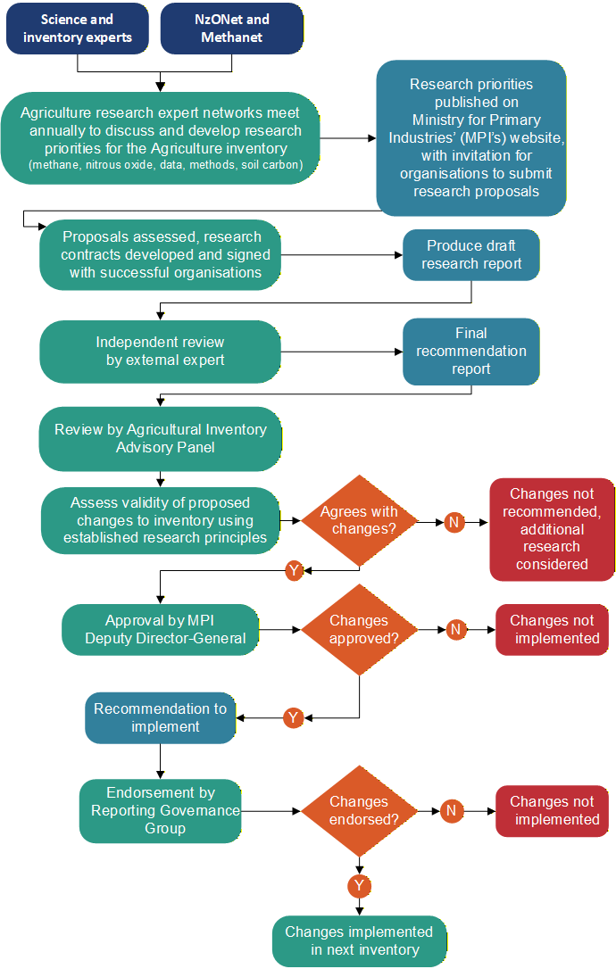

Agriculture Inventory Advisory Panel meeting – October 2025
The Panel met on 30 October 2025 and considered the following potential inventory changes:
1. inclusion of the EcoPond™ mitigation technology for dairy cattle
2. updates to dairy manure and effluent management practices
3. updating the emissions factor (EF₁) values for all other non-urea synthetic fertilisers to use the same value as urea
4. aligning with the 2019 Refinement to the 2006 IPCC Guidelines for National Greenhouse Gas Inventories (2019 IPCC Refinement) (IPCC, 2019)
5. corrections to the Agriculture inventory model code and incorporation of new activity data.
The Panel considered the inclusion of EcoPond™ for dairy cattle based on the peer reviewed published work of Cameron and Di (2021) and reports to MPI by Cameron and Di (unpublished) and Clough, et al. (unpublished). EcoPond™ is an effluent treatment system intended to reduce CH₄ emissions from dairy effluent ponds. The Panel also considered the inclusion of EcoPond™ in 2023 and 2024. In 2024, the Panel concluded that the research and trial results demonstrated clearly that the EcoPond™ technology significantly reduces CH₄ from effluent ponds by more than 90 percent. However, during the 2024 meeting, the Panel recommended that EcoPond™ should only be included in the Inventory after further research is carried out using the standard operating procedure for the technology that would be specified for commercial use. The recommended trials were completed in late 2024 and early 2025. The Panel recommended adopting the proposed methodology for including EcoPond™ in the Inventory, including a 92 percent mitigation factor for treated effluent and a six-week efficacy period based on the presented trial data.
Based on the work of Luo, et al. (unpublished(a)), the Panel recommended updated annual proportions of dairy manure entering manure management systems and seasonal allocation of total annual manure collected on off-paddock structures, such as feed pads, stand-off pads and housing. The Panel also recommended the use of default emission factors for solid storage. This change results in a decrease of 0.3 percent (114.9 kt CO₂e) of reported agricultural greenhouse gas emissions in 2023.
The Panel recommended that the EF₁ values for all non-urea synthetic fertiliser to take the same value as New Zealand’s country-specific urea EF₁ (0.59 percent) based on the work of Luo, et al. (2023, unpublished(b), unpublished(c)). In the Panel’s opinion, it is scientifically defensible to group all ammonium nitrogen fertiliser emissions together, and the impact of treating nitrate nitrogen separately is small. The Panel also proposed that activity data be reviewed regularly to monitor if the impact of treating nitrate nitrogen separately remains small enough to defensibly ignore. This change results in a decrease of 0.5 percent (186.1 kt CO₂e) of reported agricultural greenhouse gas emissions in 2023.
The Panel also recommended several improvements to align the Inventory with the 2019 IPCC Refinement (IPCC, 2019). These changes included:
- inclusion of enteric fermentation emissions for ostriches and emus
- updating the CH₄ conversion factor used to calculate CH₄ emissions from dairy anaerobic lagoons
- updating the CH₄ emission factors for manure management for goats, horses and donkeys
- updating the fraction of managed manure nitrogen that volatilises as ammonia and oxides (the Frac_{GasMS} parameter) for poultry
- revising EF₁ where the IPCC (2006) default is used (organic amendments, crop residues and nitrogen mineralised from mineral soil as a result of loss of soil carbon)
- updating EF₃ (pasture range and paddock) for minor species where the default value is used.
The total impact of these changes is a decrease of 0.4 percent (168.5 kt CO₂e) of reported Agriculture emissions in 2023.
Each year, the team responsible for the Agriculture inventory sector preparation within MPI identifies improvements to Agriculture inventory model code and input data, and identifies errors and corrections in the codebase. As a result of this work, the Panel recommended a suite of minor changes to be implemented. The total impact of these changes is a decrease of 0.01 percent (4.4 kt CO₂e) of reported Agriculture emissions in 2023.
All of the changes made have been backdated to the 1990 baseline. Further details on these changes are outlined in sections 5.2.5, 5.3.5 and 5.5.5 (category-specific recalculations), as well as chapter 10 (all recalculations).
The Panel also discussed progress towards including low CH₄ sheep in the inventory. The Panel recommended adopting the proposed methodological approach to accounting for low CH₄ genetics in sheep. While the Panel members were confident in recommending the methodological approach, they require more information on the activity data used to inform the geneflow model, before the data can be recommended for use in the inventory.
The briefings, reports, supporting documentation and minutes of the 2025 Panel meeting (as well as Panel meetings for previous years) are available on the MPI website (www.mpi.govt.nz/news-and-resources/statistics-and-forecasting/greenhouse-gas-reporting/agricultural-inventory-advisory-panel).

Recalculations approved for the 2026 National Inventory Report submission in the Agriculture sector
Following the recommendations from the Agriculture Inventory Advisory Panel and approval from the Deputy Director-General Policy and Trade at MPI and the RGG, New Zealand has implemented all of the recommendations in its 2026 annual inventory submission.
The implementation of these improvements results in a 1 percent decrease in the estimate of Agriculture sector emissions in 2023. Table 5.1.4 provides a summary of explanations and justifications for recalculations in Agriculture sector.
Table 5.1.4 Explanations and justifications for recalculations in the Agriculture sector
Sector | Explanation of recalculation | Underpinning IPCC principle | Additional justification
Agriculture | Recognising the impact of EcoPond™ on reducing emissions from anaerobic lagoons when treated following the Standard Operating Procedure, with a 92 percent mitigation factor for treated effluent and a six-week efficacy period. | Accuracy
 | Improvements to activity data and methodology for calculating emissions from dairy manure management:  - updated annual proportions of dairy manure entering manure management systems  - introduction of solid storage as a manure management system for dairy, with default emission factors  - seasonal allocation of total annual manure collected on structures. | Accuracy | Improved data availability
 | Updating the EF₁ values for all non-urea synthetic fertiliser to take the same value as urea (0.59 percent). | Accuracy
 | Bringing the Inventory up to date with the latest IPCC advice (2019 IPCC Refinement) (IPCC, 2019):  - inclusion of enteric fermentation emissions for ostriches and emus  - updating the CH₄ conversion factor used to calculate CH₄ emissions from dairy anaerobic lagoons  - updating the CH₄ emission factors for manure management for goats, horses and donkeys  - updating the Frac_{GasMS} parameter for poultry  - revising EF₁ where the IPCC (2006) default is used (organic amendments, crop residues and nitrogen mineralised from mineral soil as a result of loss of soil carbon)  - updating EF₃ (pasture range and paddock) for minor species where the default value is used. | Accuracy | Completeness
 | Error corrections and improvements to model code. | Accuracy | Correction of errors

5.1.6 Quality assurance and quality control (QA/QC)
The MPI Agriculture inventory team maintains close contact with the teams responsible for the collation of primary industries (agriculture, horticulture, forestry and fishing) data. These teams liaise with Stats NZ and provide analysis and forecasts of primary industries’ activity and performance. This arrangement ensures that the MPI Agriculture inventory team has a good understanding of activity data and agricultural performance.
The connection with Stats NZ ensures that statistical data are aligned with changes in agricultural management practices in the primary industries sector. This allows the Agriculture inventory model to estimate changes in emissions when farms adopt mitigation measures or new management practices.
The MPI Agriculture inventory team also maintains relationships with industry bodies that provide additional data, such as Beef + Lamb New Zealand Ltd, DairyNZ, LIC, Deer Industry New Zealand, the Poultry Industry Association New Zealand and Fertiliser Association of New Zealand.
As part of the quality-control procedures, the Agriculture inventory sector is reviewed by MPI personnel with expertise in climate change policy, international policy, climate change science and livestock farming policy. The review ensures that the Agriculture inventory sector clearly explains the sources of Agriculture emissions in New Zealand as well as the trends in emissions from year to year. The results from the Agriculture inventory sector also inform domestic and international climate change policy.
MPI’s Agriculture inventory sector experts meet regularly with the national inventory compilation team at MfE that is responsible for compiling the annual submission. MfE monitors MPI progress in implementing recommendations from previous expert review reports and on meeting timelines during the year.
MPI participates in a debrief session, coordinated by MfE, following the annual submission of the Inventory. This is to ensure the National Inventory Compiler and each sector lead understand what is working well and where improvements could be made.
In 2016, an external audit firm (Deloitte), with specialist skills in quality-assurance and quality-control management, was engaged to evaluate and improve quality-assurance and quality-control processes for the Agriculture inventory sector. The MPI Agriculture inventory team has used this feedback to update and improve the quality-assurance and quality-control methodology.
A process of quality-control checks is mandated in the 2006 IPCC Guidelines for National Greenhouse Gas Inventories (IPCC, 2006) and the internal compilation process is provided in table 5.1.5.
Table 5.1.5 Agriculture sectoral approval process for inventory recalculations and improvements
QA/QC area | Details of QA/QC procedure
Activity data | - Data collection, requests, inputs and checks are recorded in a data check table, which is signed by the individual staff members performing the data input and checks.  - A comprehensive list of all external data to be collected annually from internal and external sources is included as a part of the data check sheet.  - New activity data and a sample of historical data are cross checked for accuracy and completeness by someone who did not input that data.  - The data check table is included with the managerial sign-off materials before delivery to the Ministry for the Environment (MfE).
Emissions | - Implied emission factors are checked over time (1990 to most recent year) and against previous submissions. Any anomalies are investigated.  - Some key category emissions are compared against Tier 1 default methodologies and against similar parties, particularly Australia. A challenge for New Zealand is the lack of countries with similar agricultural circumstances and management practices. For example, New Zealand’s major livestock types are almost all kept outdoors on pasture in all seasons.  - Total emissions and each row of activity data from the common reporting tables are checked for accuracy against total emissions and activity outputs from the model. Category totals are also checked. Latest data points (2022) as well as 1990 and a random sample of years are checked.  - An automated tool is run on the common reporting tables that identifies blank inputs, duplicates, changes in data type, implied emission factor time-series consistency, included elsewhere (IE) and not estimated (NE) inputs and instances where a country-specific emission factor is used with a Tier 1 methodology. Each resulting occurrence is investigated to determine if there is an issue or error, and a justification is provided if the result is expected.
Recalculations | - Recalculations are agreed with MfE and the Reporting Governance Group every year before the Agriculture inventory sectoral compilation commences.  - Recalculations are compared with previous submissions and, as far as possible, explained and confirmed by the changes in method or activity data.  - The cumulative effect of any recalculations is investigated (the impact will not always be the sum of the impact of the changes, due to interactions between changes) and the level of interaction between changes is assessed.  - Anomalous results from recalculations are checked and corrected, if necessary.  - The Agriculture inventory sector compiler completes recalculation forms, signs the forms and forwards them to MfE.
Periodic reviews | - Periodic reviews are completed on different aspects of the Agriculture inventory sector. Examples of these reviews are below.  - The livestock population models and productivity parameters have been reviewed (e.g., Thomson et al., 2011). These reviews have also been used to update and improve the Tier 2 model.  - During the 2012 submission, new crops were included in the National Inventory Report and a new complex methodology was implemented. For the 2013 submission, Plant and Food Research, a Crown research institute that has expertise in this area, was hired to review the workbooks, check the formulae and model parameters.  - During the 2015 submission, a mutual bilateral greenhouse gas inventory review was held between Australia and New Zealand, which included the Agriculture sector (Australian Government, unpublished).  - In 2018, the population models in the Agriculture inventory model were reviewed. Small errors in the implementation of the population equations in the Agriculture inventory model were found and corrected for in the 2019 (1990–2017) submission.  - From 2022 to 2023, the Agriculture inventory model was migrated from Excel to a model built using the R programming language. For the 2023 (1990–2021) submission, the R model was run in parallel with the Excel model. During this process, the results between the two models were reviewed in detail. Some differences were identified and resulted in corrections of errors in the workings of the original model. The R model is now the active working model and was used for the 2024 (1990–2022) submission.  - From 2023 onwards, in parallel with the Agriculture inventory model, MPI has been developing an on-farm emissions calculation methodology and model. As part of this process, many of the calculations in the Agriculture inventory model have been replicated in a way that could be implemented (and suitable) at the farm level. Errors that were identified and the resulting corrections made to the Agriculture inventory model for the 2025 submission have been reviewed and verified internally by the team developing the on-farm emissions calculator.
Error checking and reporting | - Errors confirmed during the year are recorded, and the National Inventory Compiler is notified. The factors contributing to the error are assessed.  - A checklist of quality-control activities is followed during data collection and entry into the model, data upload to the common reporting table (via the Enhanced Transparency Framework Greenhouse Gas Inventory Reporting Tool) and the Inventory chapter preparation.  - The Agriculture sector chapter of the Inventory, and the data exported to the Enhanced Transparency Framework Greenhouse Gas Inventory Reporting Tool, are signed off by the Agriculture sector compiler, people involved in data checking and the responsible manager.
Documentation | - Internal working instructions are maintained, to allow for staff movements.  - Workbooks and calculations are kept on an MPI electronic archiving and management system, enabling the wider team access to all workbooks.  - The R model is stored in a Git repository, code commits (updates) are accompanied by descriptions of changes, and good comment etiquette is followed, which allows for effective version management, change control and diagnostic testing.  - Hyperlinks between check sheets, sign-off documents and workbooks are used to link relevant files on the document management system.

5.1.7 Planned improvements and research
MPI has planned and commissioned several projects aimed at further improving New Zealand’s Agriculture inventory.
Ongoing and recently completed research projects include:
- improving organic soils activity data and providing for the implementation of the IPCC 2013 Wetland Supplement (IPCC, 2014) (see section 5.5.6)
- increasing measurements of N₂O emissions in spring and summer to develop N₂O emission factors for dung and urine (EF₃), which vary by season (see section 5.5.6)
- developing a process-based N₂O emissions model (see section 5.5.6)
- developing country-specific emission factors for lime applied to pastoral soils (see section 5.8.7)
- modelling liveweight change in growing dairy heifers and dairy cows due to seasonality or disease (below)
- improving liveweight estimates for dairy cattle across their lifespans, from birth to first calving, within lactation and across lactations (below)
- improving the modelling of liveweight and growth parameters applied to sheep and non-dairy (beef) cattle, and differentiating the growth and diet parameters applied to dairy (beef) cattle (below)
- evaluating the intake prediction equations to improve the estimation of energy requirements for different livestock classes (below)
- quantifying regional and monthly feed consumption by dairy cattle to improve the accuracy of feed data and emission estimates (below)
- improving the activity data and parameters for deer (below)
- improving the accuracy of emission estimates by including low CH₄ sheep genetics (below)
- quantifying greenhouse gas emissions in cropland, and grassland biomass carbon stock dynamics (below)
- continuing work to improve activity data, including through the annual collection of agricultural data by Stats NZ.
A number of changes have been made for the 2026 submission to align the Agriculture inventory model methodology with the 2019 IPCC Refinement (IPCC, 2019) (see table 5.1.4 for details on recalculations). Further review of the 2019 IPCC Refinement is planned to investigate where improvements to methodology and emission factors for the Agriculture sector could be made. Ongoing research into organic soils is being conducted, with the aim of enabling the implementation of the IPCC 2013 Wetland Supplement (IPCC, 2014).
Some of this research and potential improvements cover multiple categories of the Agriculture inventory sector and are described below. The remaining improvements relate only to a single Agriculture inventory sector category and are discussed in further detail in the relevant planned improvement sections 5.2.6 (Enteric fermentation (3.A)), 5.3.6 (Manure management (3.B)), 5.5.6 (Agricultural soils (3.D)) and 5.8.7 (Liming (3.G)).

Modelling liveweight change in growing dairy heifers and dairy cows
The Agriculture inventory has relatively simple assumptions about dairy cattle liveweight and liveweight change. With additional data and modelling, these estimates can be made more accurate, by accounting for key genetic and environmental factors, and time of year. The primary objective of this project is to improve liveweight estimates for dairy cattle, from birth to first calving, within lactation and across lactations. This work will allow for regional and genetic (breed, genetic potential) differences and will consider differences in environment and management, such as feeding level, which correlate with different farm systems. The long history of data in the Dairy Industry Good Animal Database should allow robust estimates from 1990 to the present with appropriate documentation to allow for transparency and consistency for updating future inventory years.

Improving liveweight estimates for dairy cattle across their lifespans
The New Zealand Agriculture inventory model assumes that dairy heifers grow linearly, and mature dairy cows have a constant weight throughout the year. However, growing and lactating cattle have a non-linear growth curve affected by physiology and life stage, season and health of animals. This project aims to determine typical body weight change patterns for growing heifers and dairy cows. The project will also investigate liveweight change for dairy cattle during a disease event and determine their impact on predicted greenhouse gas emissions.

Improving the modelling of liveweight and growth parameters for different livestock classes
The first part of this project will deliver new models for predicting the liveweight and growth parameters applied to sheep and non-dairy (beef) cattle within the Agriculture inventory model. Currently, a linear growth profile for beef and sheep cattle between birth and slaughter or maturity is used. This does not account for non-linear seasonal growth patterns of each animal class, nor differences between early and latter growth rates as animals approach maturity. This project will identify suitable activity datasets and model enhancements that can support more robust modelling of liveweight and growth profiles of non-dairy (beef) cattle and sheep, enabling better estimations of emissions.
The second part of this project will deliver new models and suitable activity datasets to differentiate the growth and diet parameters applied to dairy beef cattle. Currently, the Agriculture inventory model does not estimate the number of dairy beef and traditional beef cattle, only the total non-dairy (beef) cattle. The current method does not account for key differences in early-life management, and potential differences in finishing systems and subsequent growth profiles. This project will identify suitable activity datasets and model enhancements that can differentiate between these two classes. These enhancements will enable more robust estimation of emissions associated with dairy beef cattle.

Improving energy requirement estimations for different livestock classes
The Agriculture inventory model uses a set of equations and parameters to estimate energy requirements and intake for cattle, sheep and deer. These equations and feed intake are foundational to the calculation of agricultural greenhouse gas emissions. The primary objective of this project is to evaluate the intake prediction equations with data and literature from prior research and, provide recommendations on how energy requirement estimations could be improved for different livestock classes. This work will allow for a more accurate estimation of greenhouse gas emissions from agriculture.

Quantifying regional and monthly feed consumption by dairy cattle
The inventory model includes monthly variations in feed quality; however, it does not include regional differences. This project will quantify the regional and monthly feed eaten by dairy cattle, to ensure estimated feed intake and quality are reflective of regional and temporal variations within the national dairy herd. This project aims to estimate the proportion of annual feed used monthly in the eight New Zealand dairy regions and estimate diet composition. This will improve the accuracy of feed data and emission estimates and, provide a pipeline for future data incorporation and analyses using a robust and consistent approach.

Improving activity data and parameters for deer
This project will deliver updated, more accurate data and methodology to estimate greenhouse gas emissions from deer. This project will deliver updated information on the composition of deer diet, sources of data on mature liveweights, average birth weights and changes over time, rate of liveweight gain change for growing deer, and estimates of the impact of proposed changes on emissions from the deer industry.

Inclusion of low methane sheep genetics
Research into low CH₄-emitting genetic traits in sheep has been underway for almost 20 years, and a breeding programme has existed for over 10 years. Under this recently completed project, a new model to calculate the impact of low CH₄ genetics on the New Zealand sheep flock has been developed. This project also considered activity data for breeding values used and the effect of uncertainty on sampling size and strategy, to support more accurate emissions estimates from low CH₄-emitting sheep. Further work is underway to compile necessary activity data and measurement requirements to enable robust inclusion of low CH₄ sheep genetics in the Agriculture inventory.

Quantifying greenhouse gas emissions in cropland, and grassland biomass carbon stock dynamics
This work was completed in mid-2025 and had two contributing projects. The first project provided a meta-analysis of estimates of the vegetation biomass carbon stocks for grassland types and the impacts of environment and management. This project used a combination of literature, databases and modelling to better represent the way in which grassland biomass carbon stocks vary in space and time, and to respond to management manipulations (e.g., grazing intensity, irrigation and fertiliser). This will allow a more accurate assessment of the impact of land use change within the grassland biome on carbon stocks for the purpose of inventory monitoring.
The second project reviewed estimates of biomass carbon stocks for croplands. The completed research included recommendations on methods, parameters, improved data sources and emission factors to improve emissions estimates from cropland burning and vegetable and arable systems. These recommendations will be proposed for inclusion in a future version of the Agriculture inventory.

Completed research and research priorities
Refer to MPI’s website for published reports on completed Agricultural Greenhouse Gas Inventory-related research projects (www.mpi.govt.nz/science/open-data-and-forecasting/greenhouse-gas-reporting/agricultural-greenhouse-gas-inventory-reports).
Refer to MPI’s website for a list of projects approved from the most recent funding round on the Greenhouse Gas Inventory Research fund page (www.mpi.govt.nz/funding-rural-support/environment-and-natural-resources/greenhouse-gas-inventory-research-fund).

Future proposed research
MPI has proposed research on new topics that would begin in 2026 or 2027. Refer to MPI’s Greenhouse Gas Inventory Research funding page for more information on these topics and the 2025/26 funding round (www.mpi.govt.nz/funding-rural-support/environment-and-natural-resources/greenhouse-gas-inventory-research-fund/applying-for-greenhouse-gas-inventory-research-funding).

5.1.8 Assessment of completeness

Emissions reported as ‘NE’ or ‘not estimated’
Table 5.1.6 summarises New Zealand’s direct greenhouse gas emissions for the Agriculture sector reported as ‘NE’ in the 2026 submission.
Table 5.1.6 Summary of ‘NE’ or ‘not estimated’ entries for the Agriculture sector in the 2026 submission
CRT category code | Category | Gas | Notation key explanation
Agriculture
3.A.4.g. | Poultry | CH₄ | According to footnote 6 to paragraph 37(b) of the United Nations Framework Convention on Climate Change reporting guidelines, this category is not mandatory for reporting. The 2006 Intergovernmental Panel on Climate Change (IPCC) Guidelines for National Greenhouse Gas Inventories state that a Tier 1 method for estimating methane (CH₄) emissions from Enteric fermentation for Poultry has not been developed (IPCC, 2006, p 10.27, vol 4-2). Also, table 10-10 on p 10.28, vol 4-2 IPCC (2006) indicates that the data is insufficient to establish a CH₄ emission factor for Poultry for either developed or developing countries.
3.B(b). | Nitrous oxide per manure management system (MMS) – Anaerobic lagoon and Daily spread | N₂O | Direct nitrous oxide (N₂O) emissions from the material managed in anaerobic lagoons (Dairy and Swine) and daily spread (Swine) after being spread onto agricultural soils are reported under Agricultural soils. The 2006 IPCC Guidelines assume that negligible direct N₂O emissions occur in anaerobic lagoons and daily spread, and only occur once the stored effluent is spread onto agricultural soil (IPCC, 2006). For more information, see sections 5.3.2 and 5.5.2 below. According to footnote 6 to paragraph 37(b) of the UNFCCC reporting guidelines, this category is not mandatory for reporting.
3.D. | Agricultural soils | CH₄ | The 2006 IPCC Guidelines do not provide methodologies for calculating CH₄ emissions from Agricultural soils (IPCC, 2006).
3.I. | Other carbon-containing fertilizers | CO₂ | According to footnote 6 to paragraph 37(b) of the UNFCCC reporting guidelines, this category is not mandatory for reporting. The 2006 IPCC Guidelines do not provide guidance for reporting on other carbon-containing fertilisers (IPCC, 2006). Other carbon-containing synthetic fertilisers besides limestone, dolomite and urea are not applied to agricultural land in New Zealand.

Emissions reported as ‘IE’ or ‘included elsewhere’
Table 5.1.7 details where the notation key ‘IE’ or ‘included elsewhere’ has been used in this submission of the Inventory for the Agriculture sector.
Table 5.1.7 Emissions reported using the ‘IE’ or ‘included elsewhere’ notation key in the 2026 submission for the Agriculture sector
CRT category code | Category | Source category reported under | Notation key explanation
Agriculture
3.E. | Prescribed burning of savannas | 4(IV) Biomass burning | Prescribed burning of savannas is reported under the Land Use, Land-Use Change and Forestry sector (4(IV)), to be consistent with Land Use, Land-Use Change and Forestry reporting and to avoid double counting. See chapter 6, section 6.11.5.

5.2 Enteric fermentation (3.A)

5.2.1 Category description
Methane is produced predominantly by ruminants as a by-product of enteric fermentation, which is the digestive process that breaks down consumed plant material in the rumen under anaerobic conditions. A portion of the plant material is fermented in the rumen to simple fatty acids, hydrogen, CO₂ and CH₄. The gases from this process are released by eructation (burping) and exhalation by the animal. The amount of CH₄ released is dependent on the type, quality and quantity of feed consumed, and energy expenditure of the animal. Energy expenditure depends on the type, age, weight, health and production of the animal, and whether the animal is pregnant (and the stage of pregnancy) or lactating.
Methane is also produced in smaller amounts by non-ruminant herbivores (e.g. swine, horses, ostriches and emus) and pseudo-ruminants (e.g., llamas and alpacas).
Methane emissions from the Enteric fermentation category from Dairy cattle, Non-dairy cattle, Sheep and Deer were identified as among the largest key categories for New Zealand in the 2025 level assessment, and were also assessed as key categories in the trend assessment. The methodology used by New Zealand for calculating CH₄ emissions from enteric fermentation in domestic livestock is a Tier 2 modelling approach.
Enteric fermentation contributed an estimated 31,588.3 kt CO₂e, representing 41.7 percent of New Zealand’s gross emissions and 78.7 percent of Agriculture emissions in 2024. The major livestock categories contributing to Enteric fermentation are:
- Dairy cattle (49.9 percent)
- Sheep (26.0 percent)
- Non-dairy cattle (22.7 percent)
- Deer (1.3 percent).

Trends
Emissions from Enteric fermentation increased 1.7 percent (by 515.1 kt CO₂e) between 1990 and 2024. Since 1990, there have been changes in the relative sources of emissions within the Enteric fermentation category (see table 5.2.1). A large increase in CH₄ emissions from Dairy cattle (by 8,803.1 kt CO₂e or 126.5 percent increase in Enteric fermentation emissions between 1990 and 2024) has been partially offset by decreases in Enteric fermentation emissions from Sheep (by 7,763.2 kt CO₂e or 48.6 percent decrease) as well as Non-dairy cattle (by 241.1 kt CO₂e or 3.3 percent decrease) and minor livestock species, such as Goats, Horses and Swine (by 230.2 kt CO₂e or 82.0 percent decrease).
Between 2005 and 2024, emissions from Enteric fermentation decreased 8.2 percent (by 2,817.0 kt CO₂e). An increase in CH₄ emissions from Dairy cattle (34.4 percent increase in Enteric fermentation emissions between 2005 and 2024) has been partially offset by decreases in Enteric fermentation emissions from Sheep (38.4 percent decrease), as well as Non-dairy cattle (14.7 percent decrease), and minor livestock species, such as Goats, Horses and Swine (38.5 percent decrease).
Table 5.2.1 Trends and relative contribution of enteric fermentation (methane expressed in kt CO₂e) from livestock categories between 1990 and 2024
Livestock category | Emissions (kt CO₂e) |  |  | Change from 1990–2024 |  | Change from 2005–2024 |  | Share of Enteric fermentation category (%) |  |  | Share of total Agriculture sector (%)
Livestock category | 1990 | 2005 | 2024 | % | kt CO₂e | % | kt CO₂e | 1990 | 2005 | 2024 | 1990 | 2005 | 2024
Dairy cattle | 6,960.4 | 11,728.5 | 15,763.6 | 126.5 | 8,803.1 | 34.4 | 4,035.1 | 22.4 | 34.1 | 49.9 | 18.9 | 27.3 | 39.3
Non-dairy cattle | 7,400.7 | 8,396.8 | 7,159.5 | -3.3 | -241.1 | -14.7 | -1,237.3 | 23.8 | 24.4 | 22.7 | 20.1 | 19.6 | 17.8
Sheep | 15,982.0 | 13,341.4 | 8,218.8 | -48.6 | -7,763.2 | -38.4 | -5,122.6 | 51.4 | 38.8 | 26.0 | 43.5 | 31.1 | 20.5
Deer | 449.5 | 856.7 | 396.0 | -11.9 | -53.5 | -53.8 | -460.7 | 1.4 | 2.5 | 1.3 | 1.2 | 2.0 | 1.0
Minor livestock | 280.6 | 81.9 | 50.4 | -82.0 | -230.2 | -38.5 | -31.5 | 0.9 | 0.2 | 0.2 | 0.8 | 0.2 | 0.1
Total | 31,073.2 | 34,405.3 | 31,588.3 | 1.7 | 515.1 | -8.2 | -2,817.0 | 100.0 | 100.0 | 100.0 | 84.6 | 80.2 | 78.7
Note: Percentages presented are calculated from unrounded values.

5.2.2 Methodological issues

Emissions from Non-dairy cattle, Dairy cattle and Deer
The total amount of enteric CH₄ emitted by Non-dairy cattle, Dairy cattle and Deer is calculated using a CH₄ conversion factor for emissions per unit of dry matter feed intake in kilograms of DMI per livestock category (figure 5.2.1). The enhanced livestock population characterisation and DMI per head is calculated by New Zealand’s Tier 2 Inventory model (see section 5.1.3). A more complex algorithm has been used to calculate enteric CH₄ emissions for Sheep and is discussed in the next section.
Figure 5.2.1 Schematic diagram showing how New Zealand’s methane emissions from enteric fermentation for dairy and non-dairy (beef) cattle and deer are calculated
Note: CH₄ = methane; DMI = dry-matter intake; GEI = gross energy intake.
The equation for the production of enteric CH₄ for cattle and deer is:
$${CH}_{4-enteric}=\sum_{livestock type}{{Pop}_{livestock type} ×} DMI×\frac{MCR}{1000}$$
Where: CH_{4-enteric} = enteric methane emissions per day (kg)
Pop_{livestock type} = population of each livestock category (head)
DMI = dry-matter intake (kg per animal per day)
MCR = methane conversion rate.
Published and unpublished data were used to derive a New Zealand-specific MCR of 21.6 grams (g) of CH₄ per kilogram (kg) of DMI for dairy cattle (Clark et al., 2003). Non-dairy (beef) cattle are assumed to have the same MCR value as dairy cattle. The MCR value for deer is the average of the MCR value currently used for cattle (21.6 g of CH₄ per kg of DMI) and the (now defunct) MCR value used for adult sheep until 2016 (20.9) resulting in 21.25 g of CH₄ per kg of DMI (Clark, 2003).

Emissions from Sheep
Enteric CH₄ emissions from Sheep are calculated using the methodology outlined in a peer reviewed paper published by Swainson et al. (2016). The study confirmed that DMI alone has the largest influence on CH₄ emissions and that pasture quality (as measured by the ME content) has a small but statistically significant effect on emissions from sheep less than one year of age.
Swainson et al. (2016) concluded that two log-transformed linear regressions (one for sheep less than one year of age and one for sheep greater than one year of age) provided the best fit for the data and recommended that these equations be used in the National Inventory Report.
The equation for the total production of enteric CH₄ for sheep less than one year of age is:
$${CH}_{4-enteric}= \sum_{class }{\sum_{month}{d_{m}}{Lamb}_{cm}\frac{11.705}{1000}}{e^{0.05×ME}DMI}^{0.734}$$
The equation for the total production of enteric CH₄ for sheep greater than one year of age is:
$${CH}_{4-enteric}= \sum_{class }{\sum_{month}{d_{m}}{Sheep}_{cm}\frac{21.977}{1000}}{DMI}^{0.765}$$
Where: CH_{4-enteric} = total CH₄ from enteric fermentation (kg CH₄/year)
d_{m} = number of days in month m
Lamb_{cm} = population of sheep in class c during month m (head), less than one year of age (i.e., lambs)
Sheep_{cm} = population of sheep in class c during month m (head), greater than one year of age
ME = metabolisable energy concentration of diet during month m (megajoules of metabolisable energy per kg of dry matter)
DMI = daily dry-matter intake of an individual sheep of class c in month m (kg dry matter/day/head)
class refers to the different categories of sheep greater than one year of age (e.g., dry ewes, wethers, rams) used in the Agriculture inventory model, and
month refers to the 12 months of the calendar year.
Dry-matter intake per sheep per day is calculated by New Zealand’s Tier 2 Inventory model (see section 5.1.3). Monthly values of ME concentration for total diet (pasture and non-pasture feed) are calculated using New Zealand’s Tier 2 Inventory model (see section 5.1.3).

Methane measurement and modelling
New Zealand uses country-specific methodology and emission factors for estimating enteric fermentation CH₄ emissions per kilogram of dry matter feed intake (i.e., DMI) for several reasons. First, the data requirements for existing digestion models are less relevant to New Zealand’s predominantly outdoor pasture-based systems. Existing digestion models have been largely derived from housed animals on diets unlike the grass-based diets fed to New Zealand livestock. Further, these existing models have a lower predictive power when compared with empirical experimental data derived from New Zealand research (Clark et al., 2003).
Since 1996, New Zealand scientists have been measuring CH₄ emissions from grazing (non-housed) cattle and sheep initially using the sulphur hexafluoride (SF₆) tracer technique (Lassey et al., 1997; Ulyatt et al., 1999). In recent years, New Zealand-based research has used closed-circuit respiration chambers, which are considered the benchmark for assessing CH₄ emissions from livestock. These have been used to derive respiration-chamber-based measurements of CH₄ emissions for sheep and, more recently, an expanded programme for dairy and non-dairy cattle.
To obtain New Zealand-specific values (or algorithms for sheep emissions), all relevant published and unpublished New Zealand-specific data were collated and used to derive average values for CH₄ emissions from different categories of livestock (Clark et al., 2003; Swainson et al., 2016). The associated data are presented in table 5.2.2 together with the IPCC (2006, tables 10.12 and 10.13) default values for percent gross energy intake used to calculate CH₄. The New Zealand values for cattle fall within the IPCC range and are applied in this submission.
Table 5.2.2 Methane emissions and gross energy intake (GEI) from New Zealand measurements and IPCC (2006) default values
 | Adult cattle | Adult sheep (> 1 year) | Young sheep (< 1 year)
New Zealand CH₄ emission rates from Clark et al. (2003) and Swainson et al. (2016) (g CH₄/kg DMI) | 21.6 × DMI | 21.977 × DMI^{0.765} | 11.705 × e^{0.5ME} × DMI^{0.734}
New Zealand data (GEI, %) | 6.5 | – | –
IPCC (2006) default Y_{m} values (GEI, %) | 6.5 ± 1.0 | 6.5 ± 1.0 | 4.5 ± 1.0
Note: DMI = dry-matter intake; ME = metabolisable energy; Y_{m} = methane yield.
The adult cattle value is applied to all dairy and non-dairy cattle, irrespective of age. The value for deer is calculated based on the average value for adult cows and the (now defunct) CH₄ emission rate for adult ewes (Clark et al., 2003). This is due to: (i) a lack of country-specific data for deer and (ii) that their liveweights are around halfway between cattle and sheep, both of which have emission factors based on robust, country-specific research. No CH₄ emissions are assumed to arise from very young animals during the time that their diet only consists of milk (first two months for dairy calves, non-dairy calves and lambs, first four months for fawns).
Table 5.2.3 shows a time series of CH₄ IEFs (total emissions produced per species or class, divided by the population of animals for each category) for dairy cattle, non-dairy cattle, sheep and deer. New Zealand experiences large inter-annual variability in these IEFs, which is explained further in section 5.1.1. In table 5.2.3, Milking dairy cattle is a subset of All dairy cattle and only includes mature dairy cows that are being milked. All dairy cattle includes milking cows as well as calves, dairy bulls and other dairy cattle not being milked.
Table 5.2.3 New Zealand’s implied emission factors for enteric fermentation, from 1990 to 2024
Year | All dairy cattle  (kg CH₄ per animal per year) | Milking dairy cattle (kg CH₄ per animal per year) | Non-dairy cattle (kg CH₄ per animal per year) | Sheep, all  (kg CH₄ per animal per year) | Deer  (kg CH₄ per animal per year)
1990 | 72.2 | 76.6 | 57.5 | 9.9 | 16.4
1995 | 75.3 | 83.0 | 60.4 | 10.5 | 18.3
2000 | 79.6 | 89.3 | 64.0 | 11.6 | 18.1
2005 | 82.3 | 86.6 | 67.8 | 11.9 | 17.9
2010 | 82.7 | 90.5 | 66.4 | 11.8 | 18.3
2015 | 89.8 | 95.9 | 64.9 | 12.2 | 18.9
2020 | 93.2 | 101.1 | 66.1 | 12.7 | 19.2
2024 | 96.5 | 104.4 | 69.5 | 12.4 | 20.0

Emissions from minor livestock categories
A Tier 1 approach is adopted for the minor livestock categories of Goats, Horses, Swine, Llamas and alpacas, and Mules and asses, using either IPCC (2006) default emission factors (horses, llamas and alpacas, and mules and asses) or New Zealand country-specific emission factors (goats and swine). These minor livestock species comprised 0.2 percent of the total Enteric fermentation emissions in 2024. The populations of goats, horses, swine, llamas and alpacas, and mules and asses are reported using the statistics and assumptions described in section 5.1.4.
Goats: New Zealand uses a Tier 1 approach with country-specific emission factors to determine enteric fermentation emissions from goats. From 1990 to 2024, the goat population declined from 1,062,900 to 72,095. This was largely driven by a decrease in demand for goat fibre and meat. New Zealand uses a country-specific emission factor for goats for enteric fermentation of 7.4 kg CH₄/year/head for 1990 and 8.5 kg CH₄/year/head for 2009 due to the differing population characteristics for those two years (Lassey, 2012). For the intermediate years between 1990 and 2009 and for 2010 to 2018, the emission factor is calculated based on the goat population, with the assumption that the dairy goat population has remained relatively consistent over time while the rest of the goat population has declined (Burggraaf et al., 2019). From 2019 onward, a constant value of 9.0 kg CH₄/year/head is used. This will be updated when this research is reviewed. This is higher than the IPCC (2006) default value for goats for developed countries, which is 5.0 kg CH₄/year/head.
Swine: New Zealand uses a Tier 1 approach with country-specific emission factors to determine enteric fermentation emissions from swine. Gross energy data from swine diets were used in the Tier 2 IPCC equation (equation 10.21, IPCC, 2006) to determine the country-specific enteric fermentation emission factors for breeding pigs and growing pigs (see table 5.2.4). Surveys of commercial swine diets were conducted in 2009 (Hill, 2012) and 2022 (Ritchie, 2024). For years between the surveys, the emission factors are interpolated. These factors are then multiplied by population data to obtain the total CH₄ emissions produced by swine from enteric fermentation for a given inventory year.
Table 5.2.4 Enteric fermentation emissions factors (kg CH₄/year/head) for swine classes, from 1990 to 2024
Year | Breeding pigs (kg CH₄ per animal per year) | Growing pigs (kg CH₄ per animal per year)
1990 | 2.21 | 0.89
1995 | 2.21 | 0.89
2000 | 2.21 | 0.89
2005 | 2.21 | 0.89
2010 | 2.19 | 0.89
2015 | 2.10 | 0.85
2020 | 2.01 | 0.82
2023 | 1.97 | 0.81
2024 | 1.97 | 0.81
The country-specific emission factors were developed from industry data on gross energy intake (Hill, 2012; Ritchie, 2024) in which data on the composition of swine diets and industry practices in place to manage waste from production systems were obtained from representative surveys of swine farms in 2009 and 2022. Nutritional information was available for different swine age classes and categories. Additionally, the average value of gross energy intake was adjusted for population and further verified against national animal welfare standards.
The New Zealand emission factors for swine are lower than the IPCC (2006) default for developed countries. The IPCC (2006) default value for swine is based on average values derived from 1980s Western German swine production and population statistics, and is not representative of New Zealand swine systems. In particular, the default value does not reflect changes in production systems due to improvements in genetic selection, reproductive cycle performance, housing and feed, animal husbandry and herd management. Further information on these factors is provided in the reports by Hill (2012) and Ritchie (2024).
Horses: The IPCC (2006) default value (18 kg CH₄/year/head) is used to estimate CH₄ emissions from this livestock category.
Llamas and alpacas: The IPCC (2006) default value (8 kg CH₄/year/head) is used to estimate CH₄ emissions from this livestock category.
Mules and asses: The IPCC (2006) default value is used (10 kg CH₄/year/head) to estimate CH₄ emissions from this livestock category.
Ostriches and emus: The IPCC (2019) default value is used (5 kg CH₄/year/head) to estimate CH₄ emissions from this livestock category.

5.2.3 Uncertainty assessment and time-series consistency
To ensure consistency across emission categories, a single enhanced livestock population characterisation and feed-intake estimate is produced by the Tier 2 model (see volume 2, annex 5, table A5.1.2). It is used in different parts of the calculations for the National Inventory Report to estimate: CH₄ emissions for the Enteric fermentation category, CH₄ and N₂O emissions for the Manure management category and N₂O emissions for the Pasture, range and paddock manure category.

Livestock numbers
The calculations for total enteric fermentation require livestock population data. Information on the uncertainties and time-series consistency for the livestock population data is included in section 5.1.4 and volume 2, annex 5, section A5.1.

Uncertainty of methane emissions from enteric fermentation in sheep and cattle
Kelliher et al. (2011) calculated the uncertainty of enteric fermentation CH₄ emissions for sheep and cattle using a Monte Carlo approach. This superseded a previous analysis undertaken by Clark et al. (2003). Kelliher et al. (2011) calculated the uncertainty by expressing the coefficient of variation according to the standard deviation of the CH₄ yield using a larger sample of measurements (relative to the previous analysis). The analysis was restricted to grass–legume pasture, the predominant diet of sheep and cattle in New Zealand. The resulting overall uncertainty of the enteric CH₄ emissions inventory, expressed as a 95 percent confidence interval, was ±16 percent (see table 5.2.5).
Table 5.2.5 New Zealand’s uncertainty in the annual estimate of enteric fermentation emissions for 1990, 2005 and 2024, estimated using the 95 percent confidence interval (±16 percent)
Year | Enteric CH₄ emissions  (kt CH₄/year) | 95% confidence interval minimum (kt CH₄/year) | 95% confidence interval maximum (kt CH₄/year) | Range of uncertainty (kt CH₄/year)
1990 | 1,109.8 | 932.2 | 1,287.3 | 355.1
2005 | 1,228.8 | 1,032.2 | 1,425.4 | 393.2
2024 | 1,128.2 | 947.6 | 1,308.7 | 361.0
Note: The CH₄ emissions used in the Monte Carlo analysis exclude those from swine, horses, goats, mules and asses, and llamas and alpacas, which represent a very small proportion of total CH₄ emissions.
Uncertainty in the annual CH₄ estimate is dominated by variance in the measurements of the ‘CH₄ per unit of intake’ factor. This uncertainty is predominantly due to natural variation from one animal to the next due to genetic, farm management and environmental factors. Uncertainties in the estimates of livestock energy requirements, forage quality and animal population data are much smaller (Clark et al., 2003).

5.2.4 Category-specific QA/QC and verification
Methane from Enteric fermentation from Dairy cattle, Non-dairy cattle, Sheep and Deer was identified as a key category (level and trend assessment). In the preparation of this inventory, the data for this category underwent Tier 1 and Tier 2 quality checks.
Enteric CH₄ emission rates per animal have been verified using micrometeorological techniques. Laubach and Kelliher (2004) used the integrated horizontal flux technique and the flux gradient technique to measure CH₄ emission flux above a dairy herd. Both techniques are comparable, within estimated errors, to scaled-up dairy cattle emissions. The emissions from the dairy cattle measured by integrated horizontal flux (averaged over three trials) were 329 (±153) g CH₄/day/head, compared with 365 (±61) g CH₄/day/head for the scaled-up measurements reported by Waghorn et al. (2003a, 2003b) using the SF₆ technique for CH₄ measurement.
Enteric CH₄ emissions from lactating dairy cattle have also been measured using the New Zealand SF₆ tracer method compared with the respiration chamber techniques (Grainger et al., 2007). Total CH₄ emissions were similar when measured using respiration chambers (322 g CH₄/day/head) or the SF₆ tracer technique (331 g CH₄/day/head) but the uncertainty of the SF₆ technique measurements was greater.
The calculations in New Zealand’s Agriculture inventory model for all cattle, sheep and deer are Tier 2 and are based on the 2006 IPCC Guidelines (IPCC, 2006). Table 5.2.6 shows a comparison of the New Zealand-specific 2024 IEFs for enteric fermentation with the IPCC Tier 1 Oceania default value, the IPCC Tier 2 net energy-based value and the Australian-specific 2023 IEF for dairy cattle, non-dairy cattle and sheep.
The IPCC Tier 2 net energy-based values are determined from the net energy algorithms in the 2006 IPCC Guidelines (equation 10.16) for dairy cattle, non-dairy (beef) cattle and sheep (IPCC, 2006). New Zealand’s Agriculture inventory model calculates emissions for sheep (one year of age and older) and lambs (less than one year old) separately. Therefore, to provide an appropriate comparison between the New Zealand-specific IEF and the IPCC Tier 2 net energy-based values for sheep, the gross energy values determined using the IPCC Tier 2 energy equations were obtained for both sheep and lambs.
Table 5.2.6 Comparison of the IPCC (2006) default emission factor and country-specific implied emission factors (IEFs) for methane (CH₄) from Enteric fermentation for Dairy cattle,
Non-dairy cattle and Sheep
 | Dairy cattle  (kg CH₄/year/head) | Non-dairy cattle  (kg CH₄/year/head) | Sheep  (kg CH₄/year/head)
IPCC (2006) Tier 1 Oceania default value | 90.0 | 60.0 | 8.0
IPCC (2006) Tier 2 net energy-based value | 72.5 | 51.6 | 8.9
Australian-specific IEF 2023 value | 94.5 | 50.8 (pasture)  29.3 (feedlot) | 6.7
New Zealand-specific IEF 2024 value | 96.5 (all dairy cattle, including calves)  104.4 (mature milking cattle only) | 69.5 | 12.5
Note: The IPCC (2006) value for sheep is for developed countries.
Dairy cattle: New Zealand’s 2024 IEF for all dairy cattle, including calves, is higher than the IPCC Tier 1 Oceania default value and similar to the Australian-specific IEF. New Zealand’s 2024 IEF for mature milking cattle is higher than the IPCC Tier 1 Oceania default value and the 2023 Australian-specific IEF.
Although New Zealand’s predominantly outdoor pasture-based system is similar to Australian dairy cattle management, differences in IEF values could be explained by differences in proportions of different cattle breeds (with different liveweights). The 2024 Australian dairy herd comprised 69.9 percent Holstein; other breeds include Jersey, Brown Swiss, Ayrshire, the Australian Red and Illawarra (DataGene Limited, 2024). In 2024, 61.1 percent of New Zealand’s cow population comprised a Holstein–Friesian/Jersey crossbreed, 23.4 percent are
Holstein–Friesian, and 7.5 percent are Jersey (LIC and DairyNZ, 2025).
In New Zealand’s Tier 2 Inventory model, dairy cattle encompass all cattle that support the milking dairy herd. This includes calves, young growing non-lactating heifers, dry cows and bulls. Because the emissions from these animals are included in the IEF calculations, the IEF will be lower than if only mature milking cows had been considered.
New Zealand’s dairy cattle 2024 IEF is higher than the IPCC Tier 2 net energy-based value. This could be because of the different energy intakes and requirements of housed animals, compared with animals grazing on pasture, or differences in per-animal productivity in New Zealand compared with other countries. The feeding algorithms within New Zealand’s national inventory use New Zealand-specific activity data and methodology that better reflect the outdoor pastoral-based farming systems in New Zealand.
Non-dairy cattle: The New Zealand-specific 2024 IEF for Non-dairy cattle is greater than the IPCC Tier 1 Oceania default value, the IPCC Tier 2 net energy-based value and Australian-specific IEFs. Differences, such as feed type and quality, breed and which animals are characterised as non-dairy, will influence the IEFs. As explained for dairy cattle above, the main difference between the IPCC Tier 2 value and the New Zealand-specific value (apart from the different energy equations determining them) is that the feeding algorithms within New Zealand’s national inventory use New Zealand-specific activity data and methodology that better reflect New Zealand’s outdoor pastoral-based farming systems.
Sheep: New Zealand’s 2024 IEF for sheep is greater than the IPCC Tier 1 default value, the Tier 2 net energy-based value and the 2023 Australian-specific IEF. This is in part because the annual sheep population figure used to calculate the IEF is based on the June population, in mid-winter. This count excludes most lambs, born in spring (August–September) and raised and slaughtered during summer and early autumn (February, March and April). New Zealand does take lambs into account when determining total annual enteric CH₄ emissions because emissions are calculated monthly, but it does not include the lamb population slaughtered during summer and early autumn when estimating the IEF. Differences in how lambs are accounted for when calculating the IEF are likely to contribute to differences between the New Zealand IEF and Australian IEF, and IPCC default values.
The same rationale around the impact of feed type and quality, breed, and New Zealand’s outdoor pastoral-based farming systems as put forward for cattle is also a contributing factor to the difference between the New Zealand IEF and IPCC values.

5.2.5 Category-specific recalculations
Emissions estimates in the Enteric fermentation category reported in the 2026 submission have been affected by methodological improvements pertaining to: (i) updates in the 2026 Agriculture inventory model aimed at aligning it with the 2019 IPCC Refinement (IPCC, 2019) and (ii) small error corrections to model code.

Aligning with the 2019 Refinement to the 2006 IPCC Guidelines for National Greenhouse Gas Inventories
The New Zealand Inventory has been changed to include an estimate of emissions from enteric fermentation by ostriches and emus using the default emission factor of 5 kg CH₄/head/year provided in the 2019 IPCC Refinement (IPCC, 2019).
The 2006 IPCC Guidelines do not include default enteric fermentation emission factors for poultry of any kind (IPCC, 2006). The 2019 IPCC Refinement developed a default enteric fermentation CH₄ emission factor for ostriches of 5 kg CH₄/head/year.
Previously the New Zealand Inventory reported emissions from ostriches and emus as a part of poultry. Enteric fermentation from poultry is not estimated. To implement this change, ostriches and emus were disaggregated from poultry. The Agricultural Production Survey reports on the ostrich and emu population from 2007 onwards. In the absence of other information prior to 2007, the emu and ostrich population is assumed to be constant, taking the 2007 population value.
Implementing these changes caused emissions from the Enteric fermentation category to increase by 1.0 kt CO₂e in 1990 and 0.1 kt CO₂e in 2023 (see table 5.2.7).
Table 5.2.7 Comparison of the 2025 Inventory and a version of the 2025 Inventory updated using default for ostriches and emus from the 2019 IPCC Refinement (IPCC, 2019) for emissions from Enteric fermentation
 |  |  |  |  | Change in emissions between  1990 and 2023 |  | Change in emissions between  2005 and 2023
 |  | 1990 (kt CO₂e) | 2005 (kt CO₂e) | 2023 (kt CO₂e) | (kt CO₂e) | (%) |  | (kt CO₂e) | (%)
Total emissions from Enteric fermentation | 2025 (1990–2023) emissions estimate | 31,034.9 | 34,373.0 | 31,661.7 | 626.8 | 2.0 |  | -2,711.3 | -7.9
Total emissions from Enteric fermentation | 2025 (1990–2023) emissions estimate with improvement | 31,036.0 | 34,374.1 | 31,661.8 | 625.8 | 2.0 |  | -2,712.3 | -7.9
Total emissions from Enteric fermentation | Difference in emissions estimates | 1.04 | 1.04 | 0.08
Total emissions from Enteric fermentation | Percentage difference in emissions estimates (%) | 0.0 | 0.0 | 0.0
Note: Columns may not sum due to rounding. Percentages presented are calculated from unrounded values.

Corrections to Inventory model
Each year, the MPI Agriculture inventory team identifies changes to improve alignment between the model code and the written methodology (Pickering et al., 2025).
The corrections identified in 2025 for inclusion in the 2026 Inventory relate to four areas.
- Units for nitrogen retained in milk: The model works on a monthly, population-level basis, so values need to be converted correctly to match this approach. Some incorrect conversions were identified and have been corrected.
- Lamb growth period: The model was using a 396-day (13-month) growth period from lamb to mature sheep. However, the methodology (equation 4.64) specifies 365 days (12 months). This has been corrected.
- Mature stag liveweight: The model was erroneously assigning mature stags the weight of two- to three-year old stags. According to the methodology, mature stags should use a separate set of liveweights, which are about 21 kilograms heavier on average. This has been corrected.
- Fertiliser activity data: Minor revisions affecting only 2021 to 2023.
Implementing these changes caused emissions from the Enteric fermentation category to increase by 37.2 kt CO₂e in 1990 and by 13.8 kt CO₂e in 2023 (see table 5.2.8).
Table 5.2.8 Comparison of model results with and without corrections for emissions from Enteric fermentation
 |  | 1990 (kt CO₂e) | 2005 (kt CO₂e) | 2023 (kt CO₂e) | Change in emissions between  1990 and 2023 |  | Change in emissions between  2005 and 2023
 |  |  |  |  | (kt CO₂e) | (%) | (kt CO₂e) | (%)
Total emissions from Enteric fermentation | 2025 (1990–2023) emissions estimate | 31,034.9 | 34,373.0 | 31,661.7 | 626.8 | 2.0 | -2,711.3 | -7.9
Total emissions from Enteric fermentation | 2025 (1990–2023) emissions estimate with correction | 31,072.1 | 34,401.0 | 31,675.6 | 603.4 | 1.9 | -2,725.4 | -7.9
Total emissions from Enteric fermentation | Difference in emissions estimates | 37.2 | 27.9 | 13.8
Total emissions from Enteric fermentation | Percentage difference in emissions estimates (%) | 0.1 | 0.1 | 0.0

5.2.6 Category-specific planned improvements
New Zealand is carrying out ongoing research to improve estimates of CH₄ emissions from Enteric fermentation. Currently there is no research focused specifically on the Enteric fermentation reporting category of the Agriculture inventory sector, although several cross-cutting, broader projects that will improve the accuracy of emissions estimates in multiple categories (including Enteric fermentation, Manure management and Agricultural soils) are described in section 5.1.7.

5.3 Manure management (3.B)

5.3.1 Category description
Most emissions from the Manure management category are from CH₄ produced during the storage and treatment of manure, and from manure deposited on pasture. The category also includes N₂O emissions produced during the storage and treatment of manure. It does not include N₂O emissions from the spreading of animal manure and from manure deposited directly onto pasture by grazing livestock. Instead, emissions from these sources are included in the Agricultural soils category (under Organic nitrogen fertilisers and Urine and dung deposited by grazing animals respectively).
Methane is produced when manure decomposes in the absence of oxygen (anaerobic conditions). When manure is stored or treated as a liquid (e.g., in lagoons or ponds), it decomposes anaerobically and can produce CH₄. The temperature and the length of time spent in storage also affect the cumulative amount of CH₄ produced over the calendar year. When manure is handled as a solid or deposited directly on pastures, it tends to decompose under aerobic conditions (in the presence of oxygen) and less CH₄ is produced overall.
The main factors affecting total reported CH₄ emissions from Manure management are the amount of manure produced and the proportion of the manure that decomposes anaerobically. If more manure is produced, more manure decomposes and produces a greater quantity of CH₄. If a larger proportion of manure decomposes anaerobically more CH₄ will also be produced.
Nitrous oxide emissions from managed manure occur directly through the processes of nitrification and denitrification of the nitrogen contained in the manure. Nitrous oxide is also emitted indirectly through diffusion of oxides of nitrogen (NO_{x}) into the surrounding air (volatilisation) or via leaching and runoff. As with CH₄, the amount of manure N₂O emissions produced depends on the system of waste management and the duration of storage. In New Zealand, most manure is deposited directly on pasture by grazing animals, with only a small proportion going into manure management systems.
New Zealand has also incorporated country-specific emission factors and country-specific parameters for calculating emissions from the use of the following mitigation technology (see table 5.3.3):
- EcoPond™ (a mixture of polyferric sulphate (PFS) and sulphuric acid (SA) used to treat anaerobic lagoons).
In 2024, no commercial treatments of EcoPond™ were applied. Commercial treatments began in 2025.
Methane from Manure management from Dairy cattle (level and trend assessment) and Sheep (trend assessment) were identified as key categories for New Zealand in 2024.
Manure management contributed an estimated 1,717.0 kt CO₂e, representing 4.3 percent of Agriculture emissions in 2024. Estimated emissions from this category consist of:
- CH₄ emissions (93.9 percent of Manure management emissions)
- N₂O emissions (6.1 percent of Manure management emissions).
In 2024, N₂O emissions from Manure management totalled 104.2 kt CO₂e (0.3 percent of gross emissions from the Agriculture sector) (see table 5.3.1). In comparison, the combined direct and indirect N₂O emissions from spreading animal manure as fertiliser and manure deposited directly by grazing livestock reported in the Agricultural soils category in 2024 totalled 4,194.9 kt CO₂e (10.4 percent of emissions from the Agriculture sector).
Table 5.3.1 Trends and relative contribution of methane and nitrous oxide emissions in the Manure management category between 1990 and 2024
Manure management category | Emissions (kt CO₂e) |  |  | Change from 1990 |  | Change from 2005 |  | Share of Manure management category (%) |  |  | Share of total Agriculture sector (%)
Manure management category | 1990 | 2005 | 2024 | % | kt CO₂e | % | kt CO₂e | 1990 | 2005 | 2024 | 1990 | 2005 | 2024
Methane (CRF 3.B.(a)) | 813.5 | 1,162.0 | 1,612.8 | 98.3 | 799.3 | 38.8 | 450.8 | 95.6 | 95.2 | 93.9 | 2.2 | 2.7 | 4.0
Nitrous oxide (CRF 3.B.(b)) | 37.6 | 59.2 | 104.2 | 177.0 | 66.6 | 76.1 | 45.0 | 4.4 | 4.8 | 6.1 | 0.1 | 0.1 | 0.3
Table 5.3.2 shows the distribution of livestock waste across animal waste management systems in New Zealand. The New Zealand Inventory assumes all non-dairy cattle, sheep and deer manure is deposited directly onto pasture (there are minor instances where this does not occur, where animals are fully or partially housed).
A small amount of excreta from dairy cattle (6.5 percent) is stored in anaerobic lagoon waste systems, and a very small amount (1.3 percent) is stored in solid storage (Luo et al., unpublished(a); Rollo et al., 2017). This is based on the proportion of time dairy cattle spend on pasture compared with the time they spend in the milking shed, surrounding yards and off-paddock structures that transfer animal excreta to anaerobic lagoons or solid storage.
The minor livestock categories of Goats, Horses, Mules and asses, and Llamas and alpacas are assumed to graze outdoors all year and deposit all their manure directly onto pastures. Estimates of the proportions of different waste management systems for swine and poultry in the manure management systems in New Zealand have been provided by Hill (2012) (swine), Ritchie (2024) (swine) and Fick et al. (2012) (poultry).
Table 5.3.2 Distribution of livestock waste across animal waste management systems in New Zealand in 2024
Livestock category | Anaerobic lagoon (%) | Solid storage (%) | Daily spread (%) | Pit storage (%) | Deep bedding (%) | Pasture, range and paddock (%) | Composting (%) | Digesters (%) | Other (%)
Dairy cattle | 6.5 | 1.3 | 0.0 | 0.0 | 0.0 | 92.3 | 0.0 | 0.0 | 0.0
Non-dairy cattle | 0.0 | 0.0 | 0.0 | 0.0 | 0.0 | 100.0 | 0.0 | 0.0 | 0.0
Sheep | 0.0 | 0.0 | 0.0 | 0.0 | 0.0 | 100.0 | 0.0 | 0.0 | 0.0
Deer | 0.0 | 0.0 | 0.0 | 0.0 | 0.0 | 100.0 | 0.0 | 0.0 | 0.0
Goats | 0.0 | 0.0 | 0.0 | 0.0 | 0.0 | 100.0 | 0.0 | 0.0 | 0.0
Horses | 0.0 | 0.0 | 0.0 | 0.0 | 0.0 | 100.0 | 0.0 | 0.0 | 0.0
Swine | 16.0 | 0.0 | 7.6 | 18.0 | 32.7 | 14.5 | 1.9 | 9.4 | 0.0
Poultry – broilers | 0.0 | 0.0 | 0.0 | 0.0 | 0.0 | 4.9 | 0.0 | 0.0 | 95.1
Poultry – layers | 0.0 | 0.0 | 0.0 | 0.0 | 0.0 | 5.8 | 0.0 | 0.0 | 94.2
Poultry – other | 0.0 | 0.0 | 0.0 | 0.0 | 0.0 | 3.0 | 0.0 | 0.0 | 97.0
Ostriches and emus | 0.0 | 20.0 | 0.0 | 0.0 | 0.0 | 80.0 | 0.0 | 0.0 | 0.0
Llamas and alpacas | 0.0 | 0.0 | 0.0 | 0.0 | 0.0 | 100.0 | 0.0 | 0.0 | 0.0
Mules and asses | 0.0 | 0.0 | 0.0 | 0.0 | 0.0 | 100.0 | 0.0 | 0.0 | 0.0
Table 5.3.3 Emission factors and parameter values for use of mitigation technologies
Description | Parameter value (%) | Source
Efficacy of EcoPond™ technology at reducing methane emissions in a treated anaerobic lagoon. | 92 | Cameron and Di, 2025

5.3.2 Methodological issues

Methane from manure management systems (3.B.(a))
New Zealand uses a Tier 2 approach to calculate CH₄ emissions from ruminant animal wastes from the major livestock categories in New Zealand (Dairy cattle, Non-dairy cattle, Sheep and Deer). This approach is based on the methods recommended by (Saggar et al., 2003) and is consistent with the 2006 IPCC Guidelines (IPCC, 2006).
Because New Zealand has detailed information on the dairy cattle population and its characteristics (such as feed intake), the IPCC (2006) Tier 2 methodology for dairy anaerobic lagoons and solid storage is used. New Zealand uses a Tier 1 methodology with country-specific and IPCC (2006) default emission factors for estimating emissions from the various manure management systems for minor livestock categories.

Manure methane from the major livestock categories
The approach for calculating manure CH₄ emissions from the major livestock categories relies on:
1. an estimation of the total quantity of faecal material produced, split into dung and urine
2. allocating the faecal material to the appropriate manure management system based on the distributions in table 5.3.2
3. New Zealand-specific emission factors for the quantity of CH₄ produced per unit of faecal dry-matter (FDM) output.
The following equation is used to determine the monthly FDM output for each livestock category (Dairy cattle, Non-dairy cattle, Sheep and Deer):
FDM = DMI × (1 – DMD)
Where: FDM is faecal dry matter (kg/month/head)
DMI is dry-matter intake (kg/month/head), and
DMD is dry-matter digestibility (decimal proportion).
The DMI and dry-matter digestibility estimates in this calculation are the same as those used to calculate CH₄ from Enteric fermentation and nitrogen in excreta. These Tier 2 model calculations are based on livestock performance statistics (see section 5.1.4).

Methane from dairy effluent anaerobic lagoons
Each year, a proportion of manure from dairy cows is stored in anaerobic lagoons (Luo et al., unpublished(a)). A Tier 2 methodology derived from the 2006 IPCC Guidelines (equations 10.23 and 10.24, IPCC, 2006) linking volatile solids to FDM is used for calculating CH₄ emissions from this activity.

EcoPond™
The CH₄ emissions reported in the Manure management category consider the use of EcoPond™, a greenhouse gas mitigation technology. EcoPond™ is a technology designed to reduce CH₄ emissions from anaerobic lagoons. EcoPond™ uses a combination treatment of PFS and SA to suppress methanogens and promote sulphate-reducing bacteria.
The core technology for EcoPond™ was developed by Lincoln University scientists. Research by Lincoln University testing the efficacy of this technology has been published in a peer reviewed scientific journal (Cameron and Di, 2021) and in unpublished reports to MPI (Cameron and Di, unpublished; Clough et al., unpublished).
EcoPond™ uses regular truck-based treatments that do not require significant on-farm infrastructure. The treatment ensures the target redox value is achieved throughout the lagoon. There is no need to treat the fresh effluent entering the anaerobic lagoon because the methanogens in the anaerobic lagoon have been deactivated. This method is referred to as shock dosing.
EcoPond™ mitigation is included in New Zealand’s Agriculture inventory model by adjusting the value of the existing CH₄ emissions from anaerobic lagoons. Cameron and Di (unpublished) and Clough et al. (unpublished) assessed the mitigating effect of EcoPond™. Cameron and Di (unpublished) showed that the CH₄ emissions from an anaerobic lagoon could be reduced by 92 percent when treated using EcoPond™. This finding was based on trials conducted in a full-scale anaerobic lagoon using the same treatment methodology as will be used commercially. Cameron and Di (unpublished) showed EcoPond™ was effective at reducing CH₄ emissions for a minimum of six weeks.
The following equation is used to determine CH₄ emissions (CH_{4-MM}) from dairy cattle manure in anaerobic lagoons:
$${CH}_{4AL-dairy}= FDM×\left(1-ASH\right)×B_{0}×0.67×MCF×MS ×(1-{EcoPond}_{mitigation})$$
Where: FDM is the faecal dry matter excreted by dairy cows (on pasture and stored) (kg/month/head)
ASH is the ash content of manure, 0.08 (IPCC, 2006, default value)
B₀ is the maximum CH₄-producing capacity of manure variable by species and diet, 0.24 (IPCC, 2006; Oceania default value, verified by Pratt et al., 2012)
0.67 is the conversion factor for converting CH₄ from cubic metres to kilograms (IPCC, 2006)
MCF is the CH₄ conversion factor, see table 5.3.5 for the regional MCF (IPCC, 2019, table 10.17)
MS is the fraction of total dairy manure excreted that ends up in anaerobic lagoons
EcoPond_{mitigation} is the impact of EcoPond™.
A region-specific impact from the use of EcoPond™ (${EcoPond}_{mitigation})$ is calculated based on records of the treatments applied. The region-specific impact is used to reduce the CH₄ estimated from anaerobic lagoons in each region.
$${EcoPond}_{mitigation} =Proportion treated ×EcoPond Efficacy$$
Where: Proportion treated is the proportion of dairy cattle manure stored in anaerobic lagoons that was treated using EcoPond™, and
EcoPond™ Efficacy is the percent reduction in CH₄ produced when the EcoPond™ treatment is applied, 92 percent (Cameron and Di, unpublished).
The proportion of treated dairy cattle manure stored in anaerobic lagoons is calculated based on treatment data supplied by Agnition, the company that owns and distributes EcoPond™. These activity data record the date when each treatment is applied, the region, an anonymous farm ID, the number of mature milking cows on farm producing waste that goes into the lagoon, and if a lagoon waste stirrer was used.
Estimates of the mitigation impact of EcoPond™ on CH₄ emissions from anaerobic lagoons for the calendar years 2023 and 2024 are shown in table 5.3.4.
Table 5.3.4 Mitigation impact of EcoPond™ on methane emissions from anaerobic lagoons,
for 2023 and 2024
Year | Percentage of dairy cattle manure stored in anaerobic lagoons that was treated using EcoPond™ | EcoPond™ mitigation factor (EcoPond_{mitigation}) | Estimated greenhouse gas mitigation from using EcoPond™ (kt CO₂e)
2023 | 0 | 0 | 0
2024 | 0 | 0 | 0

Methane from dairy effluent solid storage
Each year, a proportion of manure from dairy cows is stored in solid storage (Luo et al., unpublished(a)). A Tier 2 methodology derived from the 2006 IPCC Guidelines (equations 10.23 and 10.24, IPCC, 2006) linking volatile solids to FDM is used for calculating CH₄ emissions from this activity.
The following equation is used to determine CH₄ emissions (CH_{4-MM}) from dairy cattle manure in solid storage:
$${CH}_{4Solid-dairy}= FDM×\left(1-ASH\right)×B_{0}×0.67×MCF×MS$$
Where: FDM is the faecal dry matter excreted by dairy cows (on pasture and stored) (kg/month/head)
ASH is the ash content of manure, 0.08 (IPCC, 2006, default value)
B₀ is the maximum CH₄-producing capacity of manure variable by species and diet, 0.24 (IPCC, 2006; Oceania default value, verified by Pratt et al., 2012)
0.67 is the conversion factor for converting CH₄ from cubic metres to kilograms (IPCC, 2006)
MCF is the CH₄ conversion factor, table 5.3.5 has the regional MCF used (IPCC, 2019, table 10.17), and
MS is the fraction of total dairy manure excreted that ends up in solid storage.
Table 5.3.5 Regional anaerobic lagoon and solid storage methane conversion factors (MCFs) for dairy
Region | Dominant climate zone | Anaerobic lagoon MCF | Solid storage MCF
Northland | Warm temperate, moist | 0.73 | 0.04
Auckland | Warm temperate, moist | 0.73 | 0.04
Waikato | Warm temperate, moist | 0.73 | 0.04
Bay of Plenty | Warm temperate, moist | 0.73 | 0.04
Gisborne | Warm temperate, moist | 0.73 | 0.04
Hawke’s Bay | Warm temperate, moist | 0.73 | 0.04
Taranaki | Warm temperate, moist | 0.73 | 0.04
Manawatu–Whanganui | Warm temperate, moist | 0.73 | 0.04
Wellington | Warm temperate, moist | 0.73 | 0.04
West Coast | Warm temperate, moist | 0.73 | 0.04
Canterbury | Warm temperate, dry | 0.76 | 0.04
Otago | Warm temperate, dry | 0.76 | 0.04
Southland | Cool temperate, moist | 0.6 | 0.02
Tasman | Warm temperate, moist | 0.73 | 0.04
Nelson region | Warm temperate, moist | 0.73 | 0.04
Marlborough region | Warm temperate, dry | 0.76 | 0.04
Source: IPCC (2019), table 10.17

Methane emissions from manure deposited on pasture for the major livestock categories
The following equation is used to determine CH₄ emissions (CH_{4-PRP}) from non-dairy cattle, sheep and deer manure deposited onto pasture:
$${CH}_{4PRP-dairy}= FDM×{MS}_{PRP}×Y_{m}$$
Where: FDM is the faecal dry matter (kg/month/head)
MS_{PRP} = proportion of manure excreted on pasture, and
Y_{m} is the CH₄ yield value (kg CH₄/kg FDM).
Country-specific CH₄ yield values have been developed from New Zealand studies. Details on the values used for each of the major livestock categories are provided below.
Dairy cattle: The quantity of CH₄ produced per kilogram of FDM is 0.98 g CH₄/kg for manure deposited on pasture. This value is obtained from New Zealand studies on dairy cows and varies from around 0.92 g CH₄/kg to 1.04 g CH₄/kg (Saggar et al., 2003; Sherlock et al., 2003).
Non-dairy cattle: The value of 0.98 g CH₄/kg per unit of FDM is based on New Zealand studies on dairy cattle manure (Saggar et al., 2003; Sherlock et al., 2003). No specific studies have been conducted in New Zealand on CH₄ emissions from non-dairy cattle manure.
Sheep: The quantity of CH₄ produced per unit of sheep FDM is 0.69 g CH₄/kg. This value was obtained from a New Zealand study on sheep in which values ranged from 0.34 g CH₄/kg to 1.29 g CH₄/kg over six sampling periods (Carran et al., 2003).
Deer: The quantity of CH₄ produced per unit of FDM is assumed to be 0.91 g CH₄/kg. This is the average value between sheep and dairy derived from New Zealand studies on sheep (Carran et al., 2003) and dairy cattle (Saggar et al., 2003; Sherlock et al., 2003). No New Zealand studies have been completed on CH₄ emissions from deer manure. Deer are not housed in New Zealand, and all faecal material is deposited directly onto pasture. Further information on the calculation of the manure CH₄ emission factor for deer is contained in section 7.1.4 of the Agriculture inventory methodology (Pickering et al., 2025).

Methane emissions from minor livestock categories
Manure CH₄ emissions from the minor livestock categories are calculated per head, using a combination of country-specific and IPCC default emission factors.
Swine: New Zealand uses country-specific emission factors (Ritchie, 2024) for estimating CH₄ emissions from swine manure management. Industry data on swine diets (to determine digestible energy of the swine feed and volatile solid excretion levels) and the use of waste management systems used by New Zealand swine producers were used to determine a country-specific manure management emission factor for growing pigs and breeding pigs. The manure management CH₄ emission factors were calculated using the CH₄ conversion factors for each manure management system provided by the 2019 IPCC Refinement (IPCC, 2019). Further information on this is provided by Ritchie (2024). For consistency, CH₄ emission factors from manure management systems prior to 2010 are calculated using data from Hill (2012) using the CH₄ conversion factors recommended in the 2019 IPCC Refinement (IPCC, 2019). For years 2010 to 2021, the values are linearly interpolated (table 5.3.6).
Table 5.3.6 Average annual methane emissions factors from manure management systems (kg CH₄/year/head) for swine, 1990 to 2024
Year | Breeding pigs | Growing pigs
1990 | 11.3 | 5.4
1995 | 11.3 | 5.4
2000 | 11.3 | 5.4
2005 | 11.3 | 5.4
2010 | 11.2 | 5.4
2015 | 10.9 | 5.4
2020 | 10.6 | 5.4
2022 | 10.6 | 5.5
2023 | 10.6 | 5.5
2024 | 10.6 | 5.5
Poultry: Methane emissions from poultry manure management use New Zealand-specific emission factor values derived from Fick et al. (2012). These are based on New Zealand-specific volatile solids and proportions of poultry faeces in each manure management system for each production category. The poultry population has been disaggregated into three different categories, and the manure management emission factor values for each category are: Broiler birds 0.022 kg CH₄/year/head, Layer hens 0.016 kg CH₄/year/head and Other 0.117 kg CH₄/year/head. The overall IEF for poultry is affected by the change over time in the population proportions of these different poultry categories.
Ostriches and emus: New Zealand uses the IPCC (2019, table 10.15) default emission factor for CH₄ emissions from manure management of ostriches and emus of 5.7 kg CH₄ per head per year.
Goats, Horses and Mules and asses: New Zealand uses IPCC (2019) default emission factors for CH₄ emissions from manure management for Goats, Horses, Mules and asses (table 10.13A and 10.14 of the 2019 IPCC Refinement). The emission factors are 0.1 kg CH₄/year/head for Goats, 0.5 kg CH₄/year/head for Horses and 0.2 kg CH₄/year/head for Mules and asses. These are the IPCC values for pasture range and paddock for all animals and all climates. The 2019 IPCC Refinement gives the g CH₄ per kg volatile solids (VS) rather than a per head per year value. Table 5.3.7 shows the provided values and calculated annual manure management CH₄ emissions factors.
Table 5.3.71 Manure management methane (CH₄) emission factors for goats, horses and mules and asses
Species | kg VS per 1,000 kg animal mass per day  Table 10.13A | g CH₄ per kg VS (pasture range and paddock)  Table 10.14 | Animal mass (kg) | Annual VS (kg) | Annual CH₄ (kg per head per year) 2019 IPCC Refinement | Annual CH₄ (kg per head per year) 2006 IPCC Guidelines
Goats | 9 | 0.6 | 38 | 124.8 | 0.1 | 0.2
Horses | 5.6 | 0.6 | 377 | 777.5 | 0.5 | 2.3
Mules and asses | 7.2 | 0.6 | 130 | 341.6 | 0.2 | 1.1
Note: VS = volatile solids. References to table 10.13A and table 10.14 are from the 2019 IPCC Refinement (IPCC, 2019).
The calculated values are much lower than the IPCC (2006) default values. This is because the manure management system is now specified as pasture range and paddock, which has a lower CH₄ emission factor than most other systems
Llamas and alpacas: No IPCC default value is available for CH₄ emissions from manure management for Llamas and alpacas. The emissions are calculated by assuming that the CH₄ emission factor from manure management for Llamas and alpacas for all years is equal to the CH₄ manure management IEF for Sheep in 1990. The Llamas and alpacas emission factor (0.10 kg CH₄/year/head) is not indexed to sheep over time because there are no data indicating that alpacas or llamas have had the productivity increases over time seen in sheep.

Nitrous oxide from manure management systems (3.B.(b))
Nitrous oxide emissions from manure management can be classified as either direct or indirect. Direct N₂O emissions occur from nitrification and denitrification of nitrogen contained in the manure. Indirect N₂O emissions result from volatile nitrogen losses in the forms of ammonia (NH₃) and NO_{x} that are emitted via diffusion into the surrounding air (volatilisation) or via leaching and runoff.
Nitrous oxide emissions from manure are calculated for each livestock category based on:
1. livestock population characterisation data (consistent with section 5.1.3)
2. the average nitrogen excretion rate (kg/year/head)
3. an estimation of the total quantity of faecal material produced (consistent with the calculations in the previous section for CH₄ from manure management) split into dung and urine
4. the partitioning of this faecal material between manure management systems (based on the manure distributions in table 5.3.2)
5. the total amount of nitrogen managed in each system multiplied by an emission factor (IPCC, 2006).

Nitrogen excretion rates for the major livestock categories
The nitrogen excretion (N_{ex}) rates for the main livestock categories in New Zealand are calculated from the nitrogen intake less the nitrogen retained through digestion and contained within animal products, such as liveweight gain, milk, wool and velvet. Nitrogen intake is determined from the dry-matter feed intake and the nitrogen content of the feed eaten. Feed intake and animal productivity values are the same as those used in the Tier 2 model for determining DMI (Clark et al., 2003; and section 5.1.3). Monthly values for the nitrogen content of feed are provided by Giltrap and McNeill (2020) for dairy cattle and sheep and non-dairy (beef) cattle separately.
The nitrogen content of animal products is derived from industry data. For lactating dairy cows, the nitrogen content of milk is derived from the protein content of milk, which is published annually by LIC. The nitrogen content of sheep meat, milk and wool, as well as non-dairy meat, and the nitrogen retained in deer velvet, is taken from New Zealand research (Bown et al., 2013).
Table 5.3.8 shows the N_{ex} rates for the major livestock categories. These rates have increased over time, reflecting the increases in animal productivity and animal DMI in New Zealand since 1990. Nitrogen excretion rates are also affected by adverse weather events, which affect the amount of DMI and can cause changes in productivity and N_{ex} rates in subsequent years (see section 5.1.1). The N_{ex} rates presented in table 5.3.8 for dairy cattle are representative values and not used in the emissions calculations. Instead, region-specific N_{ex} values are calculated and used to estimate emissions per manure management system.
Table 5.3.8 Nitrogen excretion rates (N_{ex}) for New Zealand’s major livestock categories, from 1990 to 2024
Year | Dairy cattle N_{ex} (kg/year/head) | Non-dairy cattle N_{ex} (kg/year/head) | Sheep N_{ex} (kg/year/head) | Deer N_{ex} (kg/year/head)
1990 | 100.1 | 75.0 | 12.8 | 24.2
1995 | 103.6 | 78.8 | 13.6 | 26.6
2000 | 107.3 | 83.6 | 15.6 | 26.2
2005 | 108.8 | 88.4 | 16.2 | 25.7
2010 | 106.8 | 86.4 | 15.9 | 25.5
2015 | 112.6 | 84.2 | 16.7 | 26.3
2020 | 116.8 | 85.7 | 17.5 | 26.9
2024 | 120.7 | 90.0 | 17.2 | 27.9

Nitrogen excretion rates for the minor livestock categories
Swine: A New Zealand-specific N_{ex} rate for breeding pigs and growing pigs is calculated for each year (see table 5.3.9) based on the 2022 value of 24.25 kg nitrogen (N)/year/head for breeding pigs and 5.89 kg N/year/head for growing pigs (Ritchie, 2024). The 2022 values are based on the weighted average of the distribution of animal liveweights by swine category. Estimates of N_{ex} rates for all other years are indexed relative to 2022 for the average pig carcass weights for each year.
Average pig weights have increased since 1990 due to improvements in productivity. Data on pig carcass weights are collected by MPI from meat processors.
Goats: New Zealand uses country-specific N_{ex} rates for goats of 10.6 kg N/year/head for 1990 and 12.1 kg N/year/head for 2009 based on the differing population characteristics for those two years (Lassey, 2012). As explained in section 5.2.2 for Enteric fermentation, for the intermediate years between 1990 and 2009 and for later years, the excretion rate was interpolated based on assumptions that the dairy goat population has remained in a near constant state over time while the rest of the goat population has declined (see table 5.3.9).
Poultry: New Zealand-specific and IPCC default N_{ex} rates are used for poultry (Fick et al., 2012).These are the country-specific values of 0.39 kg N/year/head for broiler birds and 0.42 kg N/year/head for layer hens. Ducks, turkeys and other poultry types, such as ducks, make up around 1 percent of New Zealand’s poultry population, and flock sizes are uncertain because they are reported by Stats NZ under ‘other poultry’. Therefore, the value of 0.60 kg N/year/head for ducks and turkeys recommended by Fick et al. (2012) is retained. These values are used for all years from 1990. The overall N_{ex} rate for poultry is affected by the change over time in the population proportions of these different poultry categories.
Ostriches and emus: The IPCC (2019, table 10.19) default N_{ex} rate of 15.6 kg N per head per year is used.
Horses and Mules and asses: New Zealand-specific N_{ex} rates are not available for horses or mules and asses, and the default N_{ex} rate for Oceania of 0.3 kg N per 1,000 kg of animal mass per day is used (IPCC, 2006, table 10.19).
Llamas and alpacas: Because there is no IPCC default N_{ex} rate for Llamas and alpacas, this was calculated by assuming a default N_{ex} rate for llamas and alpacas for all years that is equal to the per-head value of the average sheep in 1990 (i.e., 12.7 kg/year/head). The llama and alpaca emission factor is not indexed to sheep over time because there are no data indicating that alpacas or llamas have had the productivity increases over time seen in sheep. Sheep were used, rather than the IPCC default value for ‘other animals’, because the literature indicates that alpacas have a nitrogen intake close to that of sheep and no significant difference in the partitioning of nitrogen (Pinares-Patino et al., 2003).
Table 5.3.9 Nitrogen excretion (N_{ex}) rates for New Zealand’s swine and goats, from 1990 to 2024
Year | Goat N_{ex} (kg/year/head) | Growing pigs N_{ex} (kg/year/head) | Breeding pigs N_{ex} (kg/year/head)
1990 | 10.6 | 4.6 | 23.9
1995 | 11.0 | 5.0 | 22.8
2000 | 11.4 | 5.3 | 23.5
2005 | 11.8 | 5.5 | 25.5
2010 | 12.2 | 5.6 | 28.4
2015 | 12.6 | 5.9 | 28.5
2020 | 12.7 | 5.9 | 26.2
2024 | 12.7 | 6.0 | 27.2

Direct nitrous oxide emissions from manure management
Major livestock categories: For the major livestock categories (Dairy cattle, Non-dairy cattle, Sheep and Deer), most manure is deposited directly onto pasture by grazing animals (see table 5.3.2). Direct and indirect N₂O emissions from the manure deposited by grazing animals are reported in the Agricultural soils category (Urine and dung deposited by grazing animals (3.D.1.3)).
A proportion of dairy manure is managed in anaerobic lagoons. The 2006 IPCC Guidelines note that the production of emissions of direct N₂O from managed manure requires aerobic conditions for the formation of oxidised forms of nitrogen but assumes that negligible direct N₂O emissions occur during storage in anaerobic lagoons (IPCC, 2006, table 10.21). Direct N₂O emissions from dairy effluent anaerobic lagoons are reported in the Agricultural soils category (Organic nitrogen fertilisers (3.D.1.2)) when the stored effluent is spread onto agricultural land.
A report by Rollo et al. (2017) found that only 8 percent of dairy farms use land application of manure. Manure is applied by direct pumping from a sump. In all cases, manure that was collected was stored for at least one or two days before spreading to pasture via irrigation. Therefore, it does not meet the IPCC definition of daily spread, and the notation key ‘NO’ (not occurring) is reported in 3.B(b) of the CRT.
A small proportion of dairy manure is managed in solid storage. The IPCC (2019, table 10.21) default emission factor for EF₃ of 0.010 kg N₂O-N/kg N for solid storage is assumed.
Swine: Swine manure is managed under various types of waste management systems (see table 5.3.2). The 2006 IPCC Guidelines assume that negligible direct N₂O emissions occur in anaerobic lagoons and daily spread (IPCC, 2006, table 10.21). Nitrous oxide emissions from manure from these systems occur once the stored effluent is spread onto agricultural land and are reported in the Agricultural soils category (Organic nitrogen fertilisers (3.D.1.2)). Nitrous oxide emissions from the manure management of swine are estimated using the IPCC (2019) default emission factors for direct N₂O emissions from manure management (EF₃) for each manure management system.
Poultry: Direct N₂O emissions from poultry manure deposited directly on pasture are reported in the Agricultural soils category (Urine and dung deposited by grazing animals (3.D.1.3)). For other manure management systems, the IPCC (2006, table 10.21) default emission factor for EF₃ of 0.001 kg N₂O-N/kg N for poultry manure with and without litter is assumed.
Ostriches and emus: Direct N₂O emissions from ostrich and emu manure deposited directly on pasture are reported in the Agricultural soils category (Urine and dung deposited by grazing animals (3.D.1.3)). For solid storage, the IPCC (2019, table 10.21) default emission factor for EF₃ of 0.010 kg N₂O-N/kg N for solid storage is assumed.
Goats, Horses, Llamas and alpacas and Mules and asses: All faecal material from these livestock is deposited directly onto pasture, and direct N₂O emissions from grazing animals are reported in the Agricultural soils category (Urine and dung deposited by grazing animals (3.D.1.3)).

Indirect nitrous oxide emissions from manure management
Indirect N₂O emissions from manure management result from diffusion into the surrounding air (volatilisation) and from leaching and runoff.
All indirect N₂O emissions for the pasture, range and paddock manure management systems are reported in the Agricultural soils category.
The IPCC (2006) Tier 1 methodology is used for calculating N₂O emissions resulting from volatilisation:
$$N_{2}O_{MM-volatilisation}=\frac{44}{28}\left(N_{volatilisation-MMS}∙{EF}_{4}\right)$$
And:
$$N_{vol-MMS}=\sum_{S}{\left[\sum_{T}{\left[\left(N_{T}∙{Nex}_{T}∙{MS}_{T,S}\right)∙{\left(\frac{{Frac}_{GasMS}}{100}\right)}_{T,S}\right]}\right]}$$
Where: N_{vol – MMS} is the amount of manure nitrogen that is lost due to volatilisation (kg/year)
EF₄ is the emission factor for N₂O emissions from volatilisation; the IPCC (2006) default value of 0.01 kg N₂O-N/(kg NH₃-N + NO_{x}-N volatilised) is used
N_{T} is the number of livestock per category (head), detailed in section 5.1.4
Nex_{T} is the average nitrogen excretion for each livestock category, T, detailed above
MS_{T,S} is the fraction of total nitrogen excretion per livestock category, T, per manure management system, S, derived from table 5.3.2, and
Frac_{GasMS} is the percent of managed manure nitrogen for each livestock category, T, which volatilises as NH₃ and NO_{x} per manure management system, S. New Zealand uses default values for Frac_{GasMS} detailed in table 5.3.10.
There have been no country-specific emission factors derived for leaching and runoff from manure management systems in New Zealand (e.g., Hill, 2012), and available data are extremely limited (IPCC, 2006).
Indirect N₂O emissions from leaching and runoff are calculated for dairy solid storage, swine for deep bedding, and composting passive windrow, and emus and ostriches for solid storage. Leaching and runoff from dairy anaerobic lagoons is likely to be an insignificant activity in New Zealand (T Wilson, pers. comm., 2014). All other indirect N₂O emissions from leaching and runoff are reported in the Agricultural soils category.
The IPCC (2019) Tier 1 methodology is used for calculating N₂O emissions resulting from leaching and runoff:
$$N_{2}O_{MM-leaching}=\frac{44}{28}\left(N_{leaching-MMS}∙{EF}_{5}\right)$$
And:
$$N_{leach-MMS}=\sum_{S}{\left[\sum_{T}{\left[\left(N_{T}∙{Nex}_{T}∙{MS}_{T,S}\right)∙{\left(\frac{{Frac}_{LeachMS}}{100}\right)}_{T,S}\right]}\right]}$$
Where: N_{leach – MMS} is the amount of manure nitrogen that is lost due to leaching and runoff (kg/year)
EF₅ is the emission factor for N₂O emissions from nitrogen leaching and runoff; the IPCC (2006) default value of 0.0075 kg N₂O-N/kg N leached and runoff is used
N_{T} is the number of livestock per category (head), detailed in section 5.1.4
Nex_{T} is the average nitrogen excretion for each livestock category, T, detailed above
MS_{T,S} is the fraction of total nitrogen excretion per livestock category, T, per manure management system, S, derived from table 5.3.2, and
Frac_{LeachMS} is the percent of managed manure nitrogen for each livestock category, T, which leaches per manure management system, S. New Zealand uses default values for Frac_{LeachMS} detailed in table 5.3.11.
Table 5.3.10 IPCC default values for the fraction of managed manure nitrogen that volatilises as ammonia and oxides (Frac_{GasMS}/100) for livestock categories per manure management system in New Zealand
Manure management system | Livestock category | Value (fraction)
Anaerobic lagoons | Dairy | 0.35
Anaerobic lagoons | Swine | 0.40
Solid storage | Dairy | 0.30
Solid storage | Ostriches | 0.40
Daily spread | Swine | 0.07
Anaerobic digester | Swine | 0.25
Deep bedding | Swine | 0.4
Composting passive windrow | Swine | 0.6
Pit storage | Swine | 0.25
Other | Poultry – broilers | 0.40
Other | Poultry – layers | 0.40
Other | Poultry – other | 0.40
Source: IPCC (2019) table 10.22
Table 5.3.11 IPCC default values for the fraction of managed manure nitrogen that leaches (Frac_{leach}/100) for livestock categories per manure management system in New Zealand
Manure management system | Livestock category | Value (fraction)
Anaerobic lagoons | Dairy | 0
Anaerobic lagoons | Swine | 0
Solid storage | Dairy | 0.02
Solid storage | Ostriches | 0.02
Daily spread | Swine | 0
Anaerobic digester | Swine | 0
Deep bedding | Swine | 0.035
Composting passive windrow | Swine | 0.04
Pit storage | Swine | 0
Other | Swine | 0
Other | Poultry – broilers | 0
Other | Poultry – layers | 0
Other | Poultry – other | 0
Source: IPCC (2019) table 10.22

5.3.3 Uncertainty assessment and time-series consistency
To ensure consistency, a single enhanced livestock population characterisation and feed-intake estimate is produced by the Tier 2 model for the major livestock categories. It is used in different parts of the calculations to estimate CH₄ emissions for the Enteric fermentation category, CH₄ and N₂O emissions for the Manure management category and N₂O emissions for the Agricultural soils category.

Methane emissions
The major sources of uncertainty in CH₄ emissions from Manure management are the accuracy of emission factors for manure management system distribution, livestock population numbers, and the classification and use of the various manure management systems (IPCC, 2006). The ranges for measured emissions for the major livestock categories have been stated where available.
The IPCC (2006) states that emission factor estimates are likely to have uncertainties of ±30 percent for Tier 1 methodologies and ±20 percent for Tier 2 methodologies. New Zealand does not currently have country-specific uncertainty values for CH₄ from Manure management. Because around 95 percent of CH₄ from Manure management is calculated using Tier 2 methodologies, an uncertainty value of ±20 percent has been used instead for the Tier 1 Manure management CH₄ emissions uncertainty value.
Uncertainties for the livestock characterisation are also discussed in section 5.1.4 and volume 2, annex 5, section A5.1.1.

Nitrous oxide emissions
The main factors causing uncertainty in direct and indirect N₂O emissions from manure management are the N_{ex} rates, the emission factors for manure and manure management systems, activity data on the livestock population, and the classification and use of the various manure management systems (IPCC, 2006).
Uncertainty ranges for the default N_{ex} values are estimated at about ±50 percent (IPCC, 2006) and may be substantially smaller for the values for the livestock whose N_{ex} rates were derived from in-country statistics on productivity. New Zealand uses the default values for EF_{3,PRP} for direct N₂O emissions from the manure management of swine and poultry, which have uncertainties ranging from -50 percent to +100 percent (IPCC, 2006, table 10.21). An uncertainty value range of ±100 percent has been used for the Manure management N₂O emissions uncertainty (Giltrap et al., 2016).
As above, uncertainties for the livestock characterisation are discussed in section 5.1.4 and volume 2, annex 5, section A5.1.1.

5.3.4 Category-specific QA/QC and verification
Methane from Manure management from Dairy cattle was identified as a key category for New Zealand in the 2024 level and trend assessment. Methane from Manure management from Sheep was identified as a key category for New Zealand in the 2024 trend assessment.
In the preparation of this inventory submission, the data for this category underwent Tier 1 and Tier 2 quality checks.
Table 5.3.12 shows a comparison of the New Zealand-specific 2024 IEF for CH₄ from Manure management with the IPCC (2006) Tier 1 Oceania default, the IPCC Tier 2 net energy-based value and the 2023 Australian-specific IEF for Dairy cattle, Non-dairy cattle and Sheep (Australian Government, 2025a). The IPCC Tier 2 value was determined from net energy equations to determine gross energy for each of New Zealand’s major livestock categories. This information is then used to determine volatile solid excretion and the annual CH₄ emission factors for each livestock category, as per the equations described in the 2006 IPCC Guidelines (i.e., equations 10.16, 10.23 and 10.24, IPCC, 2006).
New Zealand has lower IEFs for CH₄ from Manure management for dairy cattle, non-dairy cattle and sheep than the IPCC Tier 1 Oceania default emission factors. New Zealand has higher IEFs for dairy and non-dairy cattle and a lower IEF for sheep than the IPCC Tier 2 net energy-based emission factors. Additionally, New Zealand has lower dairy and non-dairy IEFs for CH₄ from Manure management than the Australian-specific 2023 IEFs. Differences between New Zealand’s IEFs, the IPCC Tier 1 and Tier 2 and the Australian-specific IEFs are due to the reasons outlined under Enteric fermentation (see section 5.2.4): that is, size and productivity of the animals, the age classes of livestock included in New Zealand’s modelling and the use of different algorithms to determine energy intake. The New Zealand-specific IEF from Manure management for dairy cattle also reflects the activity data on the use of dairy effluent management systems in New Zealand (see section 5.3.2).
The IEF for dairy cattle is much higher than the IEFs for non-dairy cattle and sheep. All manure for non-dairy cattle and sheep is deposited onto pasture. In contrast, 6.5 percent of dairy cattle manure is captured by anaerobic lagoons (see table 5.3.2). When manure is stored in anaerobic lagoons, it decomposes anaerobically and can produce CH₄. When manure is deposited directly on pastures it tends to decompose under aerobic conditions and less CH₄ is produced overall. Therefore, because some dairy cattle manure is captured by anaerobic lagoons, more CH₄ is produced by dairy cattle manure management than non-dairy cattle or sheep manure management. Hence, the IEF is higher.
Table 5.3.12 Comparison of IPCC (2006) table 10A-4 default emission factors and country-specific implied emission factors (IEFs) for methane from manure management
 |  | kg CH₄/year/head
 | Dairy cattle |  | Non-dairy cattle | Sheep
IPCC Tier 1 Oceania default value (average temperature 15°C (cattle)/developed temperate default value (sheep)) | 27.00 |  | 2.00 | 0.28
IPCC Tier 2 net energy-based value | 5.97 |  | 0.82 | 0.18
Australian-specific IEF 2023 value | 13.86 |  | 4.65 (pasture)  3.24 (feedlot) | 0.34
New Zealand-specific IEF 2023 value | 8.35 (all dairy cattle, including calves)  10.34 (mature milking cows only) |  | 0.95 | 0.13

5.3.5 Category-specific recalculations
Emissions estimates in the Manure management category reported in the 2026 submission have been affected by methodological improvements to: (i) inclusion of the EcoPond™ mitigation technology for dairy cattle, (ii) updates to dairy manure and effluent management practices, (iii) aligning with the 2019 IPCC Refinement (IPCC, 2019) and (iv) small error corrections to model code.

Inclusion of the EcoPond™ mitigation technology for dairy cattle
EcoPond™ is a technology designed to reduce CH₄ emissions from dairy farm effluent ponds (anaerobic lagoons). EcoPond™ uses a combination treatment of PFS and SA to suppress methanogens and promote sulphate-reducing bacteria.
The core technology for EcoPond™ was developed by Lincoln University scientists. Recent research carried out by Lincoln University has extensively tested the efficacy of this technology (Cameron and Di, 2021, 2025; Clough et al., 2024).
There are four mechanisms of action (Cameron and Di, 2021).
1. Addition of PFS and SA increases the oxidation state (redox value) above the value for methanogenesis. Methane production by CH₄-producing organisms (methanogens) requires highly anaerobic conditions.
2. Addition of PFS and SA adds sulphate into the anaerobic lagoon, which stimulates the growth and activity of sulphate-reducing bacteria. These bacteria derive more energy from organic matter degradation than methanogens, therefore they outcompete the methanogens for organic matter substrate.
3. Addition of PFS and SA stimulates the production of sulphide in the effluent, which is toxic to the methanogens.
4. Addition of PFS and SA stimulates the anaerobic oxidation of CH₄ due to a consortium of anaerobic oxidising archaea working with the sulphate-reducing bacteria.
The methanogen population is much greater in an anaerobic lagoon than in the fresh effluent added to the anaerobic lagoon. Independent research by Habtewold et al. (2018) reported that there were between around 11 percent to 458 percent more methanogen mcrA genes and transcripts copy numbers per gram of manure (log10 transformed) in one-year old dairy slurry than in fresh dairy slurry.
EcoPond™ uses regular truck-based treatments that do not require significant on-farm infrastructure. The treatment ensures the target redox value is achieved throughout the lagoon. There is no need to treat the fresh effluent entering the anaerobic lagoon because the methanogens in the anaerobic lagoon have been deactivated. This method is referred to as shock dosing.
The parameters for inclusion in the Inventory are drawn from a trial designed to test the truck-mounted EcoPond™ treatment system and the standard operating procedure in a commercial dairy farm pond (Cameron and Di, unpublished). The trial was conducted on the Lincoln University dairy farm. The farm has a 1 million litre effluent anaerobic lagoon.
The pond was treated on 12 November 2024, 22 January and 18 March 2025. Following each of the three treatments, regular twice-daily additions of fresh effluent were added into the pond following each milking. Effluent was not pumped out and irrigated for 5 to 7 days following the dosage of the pond. After this period, the pond was maintained normally by staff.
- Treatment from 12 November reduced the pond’s CH₄ emission flux by 91 percent during the subsequent six weeks following the dosage.
- In the eight weeks following the second dosage of the pond (January 2025), the CH₄ emission flux decreased by over 94 percent.
- In the nine weeks following the third dosage of the pond (March 2025), the CH₄ emission flux decreased by over 91 percent.
The mean reduction across the three treatments was 92 percent.
The parameters for including EcoPond™ treatment in the Inventory are:
a) a 92 percent reduction in CH₄ from anaerobic lagoons when treated
b) a six-week efficacy period.
There is at present no impact on emissions from including this technology. We expect to see emission reductions as uptake increases.
For more information on the methodology, see section 5.3.2.

Updates to dairy manure and effluent management practices
The 2025 inventory submission assumed that 8.5 percent of the manure from lactating cattle was directed to anaerobic lagoons. No other manure management systems were considered for dairy cattle. The 2025 inventory submission did not account for seasonal variation in the use of manure management systems.
Research conducted by AgResearch (Luo et.al., unpublished(a)) has provided updated data on dairy manure management practices. The assessment included farm distribution, the number of lactating cows, and the presence of three types of off-paddock facilities: feed pads, stand-off loafing pads and livestock housing. Proportions of manure deposited on different structures were suggested for mature milking cows for 2022 to 2023 (table 5.3.13). Expert opinion was used to derive divisions between liquid and solid forms by collection structure (table 5.3.14).
Table 5.3.13 Proportions of manure deposited on different structures by mature milking cows, 2022 to 2023
Structure | Annual proportion of mature milking cow manure (%)
Feed pad | 1.54
Stand-off loafing pad | 0.30
Housing | 0.85
Milking shed | 6.41
Total | 9.10
Table 5.3.14 Division between solid and liquid/slurry for manure from structures
Structure | Total (%) | Solid (solid storage) (%) | Liquid/slurry (anaerobic lagoon) (%)
Feed pad | 1.54 | 0.77 | 0.77
Stand-off loafing pad | 0.30 | 0.30 | 0.00
Housing | 0.85 | 0.43 | 0.43
Milking shed | 6.41 | 0.00 | 6.41
Total | 9.10 | 1.50 | 7.61
The analysis found seasonal patterns in the use of off-paddock facilities. Usage was highest in winter, lowest in summer and moderate in spring and autumn. Livestock housing and loafing pads were used most during winter, while feed pads were used evenly throughout the year.
The annual proportions of manure collected in each facility are used to calculate the total annual manure collected in each facility. These annual totals are then allocated by month using the relative seasonal distribution (table 5.3.15). This method ensures that seasonal allocation remains consistent with the annual proportions. Manure collected in milking sheds is allocated using a similar procedure. The proportion of annual milk collected in each month is used to allocate the total annual manure to month.
Table 5.3.15 Seasonal proportion of total annual manure collected on off-paddock facilities (excluding milking sheds)
 | Winter (Jun–Aug) (%) | Spring (Sept–Nov) (%) | Summer (Dec–Feb) (%) | Autumn (Mar–May) (%)
Feed pad | 32 | 26 | 17 | 25
Stand-off loafing pad | 73 | 20 | 0 | 7
Housing | 66 | 15 | 5 | 14
Solid storage is a new manure management system for dairy in the Inventory. Appropriate emission factors are required to estimate CH₄ and N₂O emissions. In the absence of country-specific data, default values from the 2019 IPCC Refinement (IPCC, 2019). See section 5.2.2 for more detail on the emission factors.
Implementing these changes caused emissions from the Manure management category to increase by 1.6 kt CO₂e in 1990 and decrease by 124.6 kt CO₂e in 2023 (table 5.3.16).
Table 5.3.16 Comparison of the 2025 Inventory and a version of the 2025 Inventory using revised dairy manure management practices for emissions from Manure management, 1990, 2005 and 2023
 |  | 1990 | 2005 | 2023 | Change in emissions between 1990 and 2023 |  | Change in emissions between 2005 and 2023
 |  | (kt CO₂e) | (kt CO₂e) | (kt CO₂e) | (kt CO₂e) | (%) | (kt CO₂e) | (%)
Total emissions from Manure management | 2025 (1990–2023) emissions estimate | 859.8 | 1,252.1 | 1,861.5 | 1,001.7 | 116.5 | 609.4 | 48.7
Total emissions from Manure management | 2025 (1990–2023) emissions estimate with improvement | 861.3 | 1,234.5 | 1,736.9 | 875.6 | 101.7 | 502.5 | 40.7
Total emissions from Manure management | Difference in emissions estimates | 1.6 | -17.6 | -124.6
Total emissions from Manure management | Percentage difference in emissions estimates (%) | 0.2 | -1.4 | -6.7

Aligning with the 2019 Refinement to the 2006 IPCC Guidelines for National Greenhouse Gas Inventories
Several changes have been made to the New Zealand Inventory to align with the 2019 IPCC Refinement that affect emissions from manure management (IPCC, 2019). These are: (i) updating the CH₄ conversion factor for dairy anaerobic lagoons to account for regional climates, (ii) inclusion of ostriches and emus as a separate category, (iii) revised CH₄ emission factors for manure management for goats, horses and donkeys, and (iv) revised Frac_{GasMS} for poultry.
The New Zealand Inventory has been changed to use the climate specific methane conversion factor (MCF) disaggregation for dairy anaerobic lagoons provided in the 2019 IPCC Refinement (IPCC, 2019).
Previously, the New Zealand Inventory used an MCF of 0.74 to calculate CH₄ from anaerobic lagoons. This is the default value for uncovered anaerobic lagoons and an average annual temperature of 15 degrees Celsius in the 2006 IPCC Guidelines (IPCC, 2006, table 10.17, chapter 10, volume 4).
The 2019 IPCC Refinement revises MCFs for manure management systems. The revised values are desegregated by climate zone rather than average annual temperature. The guidance states that, in cases in which countries lie in multiple climate zones, it is good practice for compilers, if possible, to disaggregate livestock populations by climate zone (IPCC, 2019).
To implement this change, climate zones were determined by consulting the regional climatologies published by Earth Sciences New Zealand and based on the guidance in figure 3A.5.2 in the 2019 IPCC Refinement (IPCC, 2019). The dominant climate zone and anaerobic lagoon MCF value used for each region is listed in table 5.3.17.
Table 5.3.17 Revised regional methane conversion factor (MCF) values for anaerobic lagoons
Region | Dominant climate zone | Anaerobic lagoon MCF
Northland | Warm temperate, moist | 0.73
Auckland | Warm temperate, moist | 0.73
Waikato | Warm temperate, moist | 0.73
Bay of Plenty | Warm temperate, moist | 0.73
Gisborne | Warm temperate, moist | 0.73
Hawke's Bay | Warm temperate, moist | 0.73
Taranaki | Warm temperate, moist | 0.73
Manawatu–Whanganui | Warm temperate, moist | 0.73
Wellington | Warm temperate, moist | 0.73
West Coast | Warm temperate, moist | 0.73
Canterbury | Warm temperate, dry | 0.76
Otago | Warm temperate, dry | 0.76
Southland | Cool temperate, moist | 0.60
Tasman | Warm temperate, moist | 0.73
Nelson | Warm temperate, Moist | 0.73
Marlborough | Warm temperate, dry | 0.76
The New Zealand Inventory has been changed to include an estimate of emissions from manure management of ostriches and emus using default emission factors. Ostriches and emus are a new species in the 2026 submission. The following IPCC 2019 default values were applied:
a) methane emissions from manure management: 5.67 kg CH₄/head/year (IPCC 2019, table 10.15)
b) nitrogen excretion rate: 15.6 kg N/head/year (IPCC 2019, table 10.19)
c) manure management system distribution (IPCC 2019, table 10.19, footnote 11):
i) 80 percent assumed to be deposited on pasture and range
ii) 20 percent assumed to be managed in solid-based systems.
For all other emission sources (e.g., indirect N₂O emissions), the same emission factors used for ‘other poultry’ were applied to ostriches and emus.
The New Zealand Inventory has adopted revised default CH₄ emission factors for manure management for goats, horses and donkeys. Previously, the New Zealand Inventory used IPCC (2006) default CH₄ emission factors for manure management for goats, horses and donkeys (table 10.15).
The default manure management CH₄ values have been revised in the 2019 IPCC Refinement (IPCC, 2019). The 2019 IPCC Refinement gives the g CH₄ per kg volatile solids (VS) rather than a per head per year value. Table 5.3.18 shows the provided values and calculated annual manure management CH₄ emissions factors. The calculated values are much lower than the 2006 default values. This is because the manure management system is now specified as pasture range and paddock, which has a lower CH₄ emission factor than most other systems.
Table 5.3.18 Manure management methane emission factors for goats, horses and donkeys
Species | kg VS per 1,000 kg animal mass per day  Table 10.13A | g CH₄ per kg VS (pasture range and paddock)  Table 10.14 | Animal mass (kg) | Annual VS (kg) | Annual CH₄ (kg per head per year) 2019 IPCC Refinement | Annual CH₄ (kg per head per year)  2006 IPCC Guidelines
Goats | 9 | 0.6 | 38 | 124.8 | 0.1 | 0.2
Horses | 5.65 | 0.6 | 377 | 777.5 | 0.5 | 2.34
Donkeys | 7.2 | 0.6 | 130 | 341.6 | 0.2 | 1.1
Note: VS = volatile solids. References to table 10.13A and table 10.14 are from the 2019 IPCC Refinement (IPCC, 2019).
The New Zealand Inventory has adopted the revised default Frac_{GasMS} for ‘other’ manure management systems for poultry. Poultry is the only species that sends manure to the ‘other’ manure management system in New Zealand. ‘Other’ accounts for 94 percent to 97 percent of poultry emissions, depending on the subtype.
Previously, Frac_{GasMS(other)} for poultry was set at 0.25. This is the value from IPCC (2006) table 10.22 for an animal type of ‘other’ (‘other’ includes sheep, horses and fur-bearing animals) and a manure management system of deep bedding.
Fick (2012) states only two systems are used in the poultry industry in New Zealand: PR&P (Pasture, Range and Paddock)/free range and solid storage/dry lot litter management – other. The 2019 IPCC Refinement provides a Frac_{GasMS} for poultry manure in solid storage of 0.4 and poultry manure with litter of 0.4 (IPCC, 2019). Therefore, the poultry Frac_{GasMS} for the ‘other’ manure management system has been changed from 0.25 to 0.4.
Implementing these changes caused emissions from the Manure management category to decrease by 12.9 kt CO₂e in 1990 and 50.3 kt CO₂e in 2023 (table 5.3.19).
Table 5.3.19 Comparison of the 2025 Inventory and a version of the 2025 Inventory using defaults from the 2019 IPCC Refinement for emissions from Manure management
 |  | 1990 | 2005 | 2023 | Change in emissions between 1990 and 2023 |  | Change in emissions between 2005 and 2023
 |  | (kt CO₂e) | (kt CO₂e) | (kt CO₂e) | (kt CO₂e) | (%) | (kt CO₂e) | (%)
Total emissions from Manure management | 2025 (1990–2023) emissions estimate | 859.8 | 1,252.1 | 1,861.5 | 1,001.7 | 116.5 | 609.4 | 48.7
Total emissions from Manure management | 2025 (1990–2023) emissions estimate with improvement | 846.9 | 1,229.7 | 1,811.2 | 964.3 | 113.9 | 581.5 | 47.3
Total emissions from Manure management | Difference in emissions estimates | -12.9 | -22.4 | -50.3
Total emissions from Manure management | Percentage difference in emissions estimates (%) | -1.5 | -1.8 | -2.7

Corrections to inventory model
For more detail on these changes, see section 5.2.5.
Implementing these changes caused emissions from the Manure management category to increase by 0.5 kt CO₂e in 1990 and decrease by 5.9 kt CO₂e in 2023 (table 5.3.20).
Table 5.3.20 Comparison of model results with and without corrections for emissions from Manure management
 |  | 1990  (kt CO₂e) | 2005  (kt CO₂e) | 2023  (kt CO₂e) | Change in emissions between 1990 and 2023 |  | Change in emissions between 2005 and 2023
 |  |  |  |  | (kt CO₂e) | (%) | (kt CO₂e) | (%)
Total emissions from Manure management | 2025 (1990–2023) emissions estimate | 859.8 | 1,252.1 | 1,861.5 | 1,001.7 | 116.5 | 609.4 | 48.7
Total emissions from Manure management | 2025 (1990–2023) emissions estimate with corrections | 860.3 | 1,251.5 | 1,855.5 | 995.3 | 115.7 | 604.1 | 48.3
Total emissions from Manure management | Difference in emissions estimates | 0.5 | -0.6 | -5.9
Total emissions from Manure management | Percentage difference in emissions estimates (%) | 0.1 | -0.1 | -0.3
Note: Columns may not sum due to rounding. Percentages presented are calculated from unrounded values.

5.3.6 Category-specific planned improvements
The following section covers the planned improvements being undertaken for Manure management. These findings may be incorporated in future annual inventory submissions.

Influence of diet and livestock species on manure B₀
This project aims to improve the understanding of the influence of diet and livestock species on manure B₀ (the maximum CH₄-producing capacity of manure). Currently, the Agriculture inventory uses an IPCC default value for B₀. The project is part of an international initiative to improve on-farm CH₄ emissions estimates from manure management from Global South countries. As part of this, a systematic evaluation of the manure B₀ values from a variety of animal classes fed a variety of diets as well as different manure streams will be conducted.

5.4 Rice cultivation (3.C)

5.4.1 Category description
At present, there is no commercial rice cultivation in New Zealand. This has been confirmed with experts from Plant and Food Research, a New Zealand Crown research institute (Thomas et al., unpublished). The ‘NO’ (not occurring) notation is reported in the CRT.

5.5 Agricultural soils (3.D)

5.5.1 Category description
Several categories contribute to N₂O emissions from Agricultural soils through both direct and indirect pathways; these are summarised in figure 5.5.1.
Figure 5.5.1 Sources of nitrous oxide emissions from Agricultural soils, showing the contribution of each source to emissions through both direct and indirect pathways
Direct N₂O emissions come from soils that have had nitrogen-based fertilisers applied in either organic (animal excreta or other plant or animal derivative) or inorganic (synthetic nitrogen fertiliser) form. Indirect emissions come from the volatilisation (evaporation or sublimation) of nitrogen from the land and water. A fraction of this volatilised nitrogen returns to the ground during rainfall and is then re-emitted as N₂O. Indirect emissions also arise from nitrogen lost through leaching and runoff. This nitrogen enters the groundwater, riparian areas and wetlands, rivers and, eventually, the ocean, where it enhances biogenic production of N₂O (IPCC, 2006).
Indirect emissions from livestock waste management systems are reported in section 5.3 (Manure management). Carbon dioxide emissions from lime and dolomite fertilisers are reported in section 5.8 (Liming), and CO₂ emissions from urea fertiliser are reported in section 5.9 (Urea application).
Agricultural soils contributed an estimated 6,127.6 kt CO₂e, representing 8.1 percent of New Zealand’s gross emissions and 15.3 percent of Agriculture emissions in 2024. The Agricultural soils category was the source of 91.1 percent of New Zealand’s total 2024 N₂O emissions.
The categories that contribute the most to emissions from Agricultural soils and that are identified as key categories are outlined below in order of significance:
- direct emissions from urine and dung deposited by grazing animals (pasture, range and paddock manure) (level and trend assessment): 51.9 percent of emissions from Agricultural soils
- direct emissions from synthetic nitrogen fertiliser (level and trend assessment): 15.5 percent of emissions from Agricultural soils
- indirect emissions from volatilisation (level assessment): 12.1 percent of emissions from Agricultural soils
- direct emissions from managed organic soils (level and trend assessment): 9.6 percent of emissions from Agricultural soils
- indirect emissions from leaching and runoff (level assessment): 7.8 percent of emissions from Agricultural soils
- direct emissions from crop residues (level assessment): 2.1 percent of emissions from Agricultural soils.

Trends
Emissions from Agricultural soils increased 37.4 percent (1,667.1 kt CO₂e) between 1990 and 2024 and decreased 1.1 percent (65.3 kt CO₂e) between 2005 and 2024. Increases in the use of synthetic nitrogen fertiliser and in the dairy cattle population are the predominant drivers of increasing emissions from Agricultural soils, which have been partially offset by decreases in the sheep and non-dairy cattle populations.
Trends from 1990 to 2024 across the key categories in Agricultural soils are detailed below:
- direct emissions from urine and dung deposited by grazing animals (pasture, range and paddock manure) (level and trend assessment): 22.8 percent (591.3 kt CO₂e) increase
- direct emissions from synthetic nitrogen fertiliser (level and trend assessment): 553.0 percent (805.2 kt CO₂e) increase
- indirect emissions from volatilisation (level assessment): 16.6 percent (105.3 kt CO₂e) increase
- direct emissions from management of organic soils (level and trend assessment): 1.1 percent (6.4 kt CO₂e) increase
- indirect emissions from leaching and runoff (level assessment): 21.6 percent (84.6 kt CO₂e) increase
- direct emissions from crop residues (level assessment): 39.9 percent (37.4 kt CO₂e) increase.
Trends from 2005 to 2024 across the key categories in Agricultural soils are detailed below:
- direct emissions from urine and dung deposited by grazing animals (pasture, range and paddock manure) (level and trend assessment): 1.2 percent (38.2 kt CO₂e) decrease
- direct emissions from synthetic nitrogen fertiliser (level and trend assessment): 9.0 percent (78.6 kt CO₂e) increase
- indirect emissions from volatilisation (level assessment): 10.7 percent (88.7 kt CO₂e) decrease
- direct emissions from management of organic soils (level and trend assessment): 0.5 percent (3.0 kt CO₂e) increase
- indirect emissions from leaching and runoff (level assessment): 7.4 percent (38.3 kt CO₂e) decrease
- direct emissions from crop residues (level assessment): 2.6 percent (3.6 kt CO₂e) decrease.
Table 5.5.1 shows the trends and relative contribution of N₂O emissions from these categories between 1990 and 2024.
Table 5.5.1 Trends and relative contribution of nitrous oxide emissions from Agricultural soils categories between 1990, 2005 and 2024
 |  | Emissions  (kt CO₂e) |  |  | Change from  1990–2024 |  | Change from  2005–2024 |  | Share of Agricultural soils category | Share of total  Agriculture sector
Agricultural soils category |  | 1990 | 2005 | 2024 | kt CO₂e | (%) | kt CO₂e | % | 2024 (%) | 2024 (%)
Direct | Synthetic nitrogen fertilisers | 145.6 | 872.2 | 950.8 | 805.2 | 553.0 | 78.6 | 9.0 | 15.5 | 2.4
Direct | Organic fertilisers | 22.7 | 37.7 | 59.5 | 36.8 | 162.1 | 21.8 | 57.9 | 1.0 | 0.1
Direct | Pasture, range and paddock manure | 2,588.4 | 3,218.0 | 3,179.7 | 591.3 | 22.8 | -38.2 | -1.2 | 51.9 | 7.9
Direct | Crop residue | 93.6 | 134.5 | 131.0 | 37.4 | 39.9 | -3.6 | -2.6 | 2.1 | 0.3
Direct | Cropland nitrogen mineralisation from soil organic matter loss | 0.0 | 0.1 | 0.1 | 0.1 | 509.0 | 0.0 | 8.1 | 0.0 | 0.0
Direct | Management of organic soils | 583.1 | 586.6 | 589.6 | 6.4 | 1.1 | 3.0 | 0.5 | 9.6 | 1.5
Indirect | Volatilisation | 635.3 | 829.2 | 740.6 | 105.3 | 16.6 | -88.7 | -10.7 | 12.1 | 1.8
Indirect | Leaching and runoff | 391.7 | 514.6 | 476.3 | 84.6 | 21.6 | -38.3 | -7.4 | 7.8 | 1.2
Total Agricultural soils |  | 4,460.4 | 6,192.9 | 6,127.6 | 1,667.1 | 37.4 | -65.3 | -1.1 | 100.0 | 15.3
Note: Columns may not add due to rounding. Percentages presented are calculated from unrounded values.

5.5.2 Methodological issues
New Zealand uses methodologies based on the 2006 IPCC Guidelines (IPCC, 2006), outputs of the Tier 2 livestock population characterisation, modelling of the livestock nutrition and energy requirements, and some country-specific equations to calculate N₂O emissions from Agricultural soils. A combination of default and country-specific emission factors and parameters is also used to calculate emissions from this category. Details on these emission factors and parameters are listed in tables 5.5.2 and 5.5.3; volume 2, annex 5, tables A5.1.5, A5.1.6 and A5.1.7; and in table 5.5.5 for mitigation technologies.
The largest inputs of nitrogen to agricultural soils are manure (urine and dung) from grazing livestock and synthetic nitrogen fertilisers, which together contribute just over two thirds of emissions from the Agricultural soils category. The following paragraphs provide an overview of the ongoing country-specific improvements made to the Agricultural soils category.

Overview of research and improvements in the Agricultural soils category
Considerable research effort has gone into establishing New Zealand-specific emission factors for emissions from synthetic fertiliser application (EF₁) and emissions from manure deposition onto pasture by grazing livestock (EF_{3,PRP}). In New Zealand, most livestock waste is excreted directly onto pasture during grazing (see table 5.3.2).
Direct N₂O emission factors for dung and urine are separated based on livestock type (for Dairy cattle, Non-dairy cattle, Sheep and Deer) and hill slope category based on research by Saggar et al. (2015) and van der Weerden et al. (2019, 2020) (see table 5.5.3). A ‘nutrient transfer model’ developed by Saggar et al. (2015) is used to calculate the amount of dung and urine deposited on different hill slope categories. Around 79 percent of sloped land on sheep, non-dairy and deer farms is classed as medium (12–24 degrees) or steep (greater than 24 degrees) sloped land (see volume 2, annex 5, figure A5.1.3).
For minor livestock categories, such as Horses, Llamas and alpacas, Poultry, Swine, Goats and Mules and asses, New Zealand uses IPCC default emission factors and methodology. Research conducted in New Zealand confirmed that the IPCC default emission factors and methodology for direct N₂O emissions from manure deposited on soil (EF_{3,PRP-MINOR}) are appropriate for New Zealand conditions (Carran et al., 1995; de Klein et al., 2003; Muller et al., 1995).
The EF_{1(UREA)} value was changed to 0.0059 in 2017, following a recommendation from the Agriculture Inventory Advisory Panel in 2016. The Panel agreed that the value of 0.0059, based on research by van der Weerden et al. (2016a), was more representative of New Zealand farming practices and conditions, where only small (30–50 kg N/ha/application) urea dressings are applied but on several occasions during a year. The lower value of EF_{1(UREA)}, compared with the IPCC default of 0.01, is comparable with studies conducted in Australia (Chen et al., 2010; Galbally et al., 2005) and The Netherlands (Kuikman et al., 2006), which have found EF₁ urea fertiliser values of around 0.005.
Other synthetic fertilisers took the same EF₁ value as urea in 2026, following a recommendation from the Agriculture Inventory Advisory Panel in 2025. Research by Luo et al. (unpublished(c)) found the difference in EF₁ values between urea, diammonium phosphate and ammonium sulphate fertilisers was not statistically significant. The Panel agreed that the country-specific urea EF₁ value of 0.0059 was more appropriate for non-urea synthetic fertilisers than the IPCC default of 0.01. In the Panel’s opinion, it is scientifically defensible to group all ammonium N together. This is supported by international research (Gebremichael et al., 2021). The impact of treating nitrate N separately is small because these make up less than 3 percent of synthetic fertiliser N sold in New Zealand (Fertiliser Association of New Zealand, pers. comm., 2025).
New Zealand uses a country-specific emission factor for dairy cattle effluent manure (0.0025) applied to soils (van der Weerden et al., 2016a and 2016b). The IPCC (2019) wet climate default value of 0.006 is used for other organic nitrogen inputs, including animal manure from minor livestock species applied to soils, non-manure organic fertilisers, nitrogen mineralisation and crop residues.
The emission factor for indirect N₂O emissions from leaching and runoff (EF₅) for rivers, lakes and estuaries has also been reviewed (Clough and Kelliher, 2014). The review concluded that further research is required to develop a country-specific value, and that the IPCC (2006) default emission factor (0.0075) is appropriate for New Zealand in the meantime.
In addition to these country-specific emission factors, New Zealand has developed country-specific parameters for volatilisation, leaching and nitrogen input from crop residue burning and pasture renewal (see table 5.5.4). New Zealand has also incorporated country-specific emission factors and country-specific parameters for calculating emissions from the use of the following N₂O mitigating technologies (see table 5.5.5):
- urease inhibitors such as N-butyl thiophosphoric triamide
- dicyandiamide (DCD), a nitrification inhibitor.
Table 5.5.2 Nitrous oxide (N₂O) emission factors for Agricultural soils in New Zealand,
excluding EF_{3,PRP- URINE} for cattle, sheep and deer
Category | Emission factor |  |  | Source
3.D.1 Direct N₂O emissions
Synthetic nitrogen fertiliser | EF_{1-Synthetic} | 0.0059 | kg N₂O-N/kg N | van der Weerden et al. (2016a, 2016b)  Luo et al. (unpublished(c))
Organic fertiliser (dairy cattle manure) | EF_{1-DAIRY} | 0.0025 | kg N₂O-N/kg N | van der Weerden et al. (2016a, 2016b)
Organic nitrogen (non-manure organic fertilisers, organic fertiliser (swine and poultry manure) crop residue, nitrogen loss due to soil organic matter mineralisation, organic soil mineralisation due to cultivation) | EF_{1-ORGANIC} | 0.006 | kg N₂O-N/kg N | IPCC (2019, table 11.1)
Cultivation of organic soils | EF₂ | 8.0 | kg N₂O-N/ha/kg N | IPCC (2006, table 11.1)
Manure (dung and urine) from alpacas and llamas, mules and asses, horses and goats in pasture, range and paddock systems | EF_{3,PRP-MINOR} | 0.003 | kg N₂O-N/kg N | IPCC (2019, table 11.1)
Manure (dung and urine) from poultry, emus and ostriches and swine in pasture, range and paddock systems | EF_{3,PRP-MINOR} | 0.006 | kg N₂O-N/kg N | IPCC (2019, table 11.1)
Dung from grazing cattle, sheep and deer in pasture, range and paddock systems | EF_{3,PRP-DUNG} | 0.0012 | kg N₂O-N/kg N | van der Weerden et al. (2019, 2020)
3.D.2 Indirect N₂O emissions
Volatilisation | EF₄ | 0.010 | kg N₂O-N/kg N | IPCC (2006, table 11.3)
Leaching and runoff | EF₅ | 0.0075 | kg N₂O-N/kg N | IPCC (2006, table 11.3), confirmed by Clough and Kelliher (2014)
Table 5.5.3 Direct nitrous oxide emission factors for urine deposited by cattle, sheep and deer, by livestock type and slope, using values calculated by van der Weerden et al. (2019, 2020)
 | Emission factors by slope
Livestock type | Flat and low sloped land  (less than 12° gradient)  EF_{3,PRP-FLAT} | Medium and steep sloped land (greater than 12° gradient)  EF_{3,PRP-STEEP}
All cattle (includes dairy and non-dairy) | 0.0098 | 0.0033
Deer | 0.0074 | 0.0020
Sheep | 0.0050 | 0.0008
Table 5.5.4 Parameters for indirect nitrous oxide (N₂O) emissions from Agricultural soils in New Zealand
Category | Parameter |  |  | Source
3.D.2 Indirect N₂O emissions
Fraction of volatilisation from synthetic fertiliser | Frac_{GASF} | 0.1 | kg NH₃-N + NO_{x}-N/kg N | IPCC (2006), verified by Sherlock et al. (2011)
Fraction of volatilisation from organic nitrogen additions including pasture manure | Frac_{GASM} | 0.1 | kg NH₃-N + NO_{x}-N/kg N | Sherlock et al. (2011)
Fraction of leaching and runoff from all nitrogen applied to soil | Cropland Frac_{LEACH – (H)} | 0.1 | kg N/kg N | Welten et al. (2021)
 | Grassland Frac_{LEACH – (H)} | 0.08 | kg N/kg N | Welten et al. (2021)
 | Synthetic N fertiliser Frac_{LEACH-(H)} | 0.082 | kg N/kg N | Calculated based off of Welten et al. (2021)
Fraction of crop residue burned in the field | Frac_{BURN} | Crop-specific | kg N/kg crop-N | Thomas et al. (2011, table 14)
Fraction of legume crop residue burning in the field | Frac_{BURNL} | 0 (not burned in NZ) | kg N/kg crop-N | Thomas et al. (2011)
Fraction of land undergoing pasture renewal | Frac_{RENEW} | Year-specific |  | Beare et al. (2012); Thomas et al. (2014)
Fraction of nitrogen in above-ground residues removed for bedding, feed or construction | Frac_{REMOVE} | 0 | kg N/kg crop-N | Thomas et al. (2014)
Table 5.5.5 Emission factors and parameter values for use of mitigation technologies
Category | Parameter and value (%) |  | Source
Urine from grazing dairy cattle in pasture, range and paddock systems with application of dicyandiamide (DCD) | EF_{3(PRP-DCD)} | 0.67 | Clough et al. (2011)
Fraction of nitrogen from leaching and runoff with application of DCD (used 2007–2012) | Frac_{LEACH – (H)-DCD} | 0.53 | Clough et al. (2011)
Volatilisation from synthetic nitrogen fertiliser (urea only) coated with urease inhibitor (nBTPT) | Frac_{GASF-UI} | 0.055 | Saggar et al. (2013)

Direct nitrous oxide emissions from managed soils (3.D.1)
Emissions from the Direct N₂O emissions from managed soils category arise from:
- synthetic nitrogen fertiliser use (F_{SN})
- organic fertilisers (which in New Zealand are solely the spreading of animal manure, F_{AM})
- manure deposited by grazing livestock in pasture, range and paddock (F_{PRP})
- decomposition of crop residues left on fields (F_{CR})
- nitrogen mineralisation associated with loss of soil organic matter (F_{SOM})
- management of organic soils.
Many of these sources of emissions have N₂O emissions from indirect pathways as well, and these calculations are described in detail in the section below on indirect N₂O emissions from managed soils.
New Zealand’s methodology for determining the values for nitrogen inputs to soils for F_{AM} and F_{PRP} is consistent with other parts of the Agriculture inventory sector. The underlying values for N_{ex} and for the allocation of excreta to animal waste management systems are the same as in the Manure management category. These N_{ex} values have been calculated based on the same animal intake and animal productivity values used for calculating CH₄ emissions for the different livestock categories and species in the Tier 2 model (see section 5.1.3). This ensures the same base DMI values are used for both the CH₄ and N₂O emission calculations.

Synthetic nitrogen fertiliser (3.D.1.1)
Nitrous oxide emissions from synthetic nitrogen fertiliser are a small proportion of total N₂O emissions, but have grown since 1990. Most synthetic nitrogen fertiliser used in New Zealand is urea fertiliser applied to dairy pastures to increase pasture growth during spring (September to November) and autumn (March to May).
In accordance with IPCC 2006 Guidelines (IPCC, 2006), the following equation is used to determine direct N₂O emissions from the application of nitrogen-based fertiliser:
$$N_{2}Odirect= \frac{44}{28}×F_{SN}×{EF}_{1\left(Synthetic\right)}$$
Where: 44/28 is the molecular conversion factor used to convert nitrogen to N₂O
F_{SN} is the total annual amount of synthetic nitrogen fertiliser applied to soils (urea-based and other fertilisers), and
EF_{1(Synthetic)} is the proportion of direct N₂O emissions from nitrogen input to the soil for synthetic fertilisers (0.0059; table 5.5.2).
Data on synthetic fertiliser use are provided by the Fertiliser Association of New Zealand, which provides sales records for 1990 to 2024. Two major fertiliser companies comprise approximately 98 percent of the total tonnage used, with fertiliser use estimates from smaller companies added (Fertiliser Association of New Zealand, 2018).
New Zealand uses a country-specific emission factor for synthetic nitrogen fertiliser (0.0059). This emission factor was determined for urea based on the report by van der Weerden et al. (2016a). Analysis of data from New Zealand field trials found the difference in EF₁ values between urea, ammonium sulphate and diammonium phosphate fertilisers was not statistically significant (Luo et al., unpublished(c)).
Since 1990, a large increase in nitrogen applied through synthetic fertiliser has occurred, from 59,265 tonnes in 1990, increasing significantly to 355,000 tonnes in 2005 and to 387,000 tonnes in 2024 (figure 5.5.2). The proportion of urea fertiliser applied increased from just over 41.5 percent in 1990 to 80.7 percent in 2005 and 91.7 percent in 2007. In 2024, the applied tonnage of urea was 74.2 percent of all synthetic nitrogen fertiliser applied (figure 5.5.3).
The nitrogen fertiliser applied has decreased significantly (17.7 percent) since peak levels in 2020 in part due to higher fertiliser prices.
Figure 5.5.2 Synthetic nitrogen fertiliser use in New Zealand, from 1990 to 2024
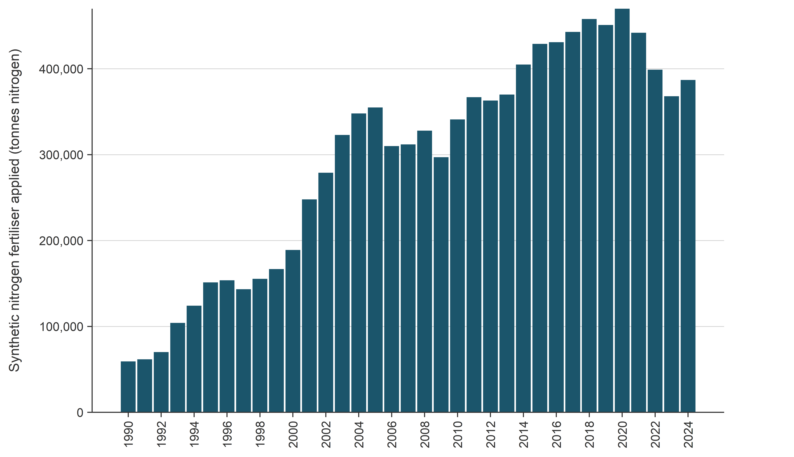
Source: Fertiliser Association of New Zealand
Figure 5.5.3 Percentage of total synthetic nitrogen fertiliser derived from urea, from 1990 to 2024
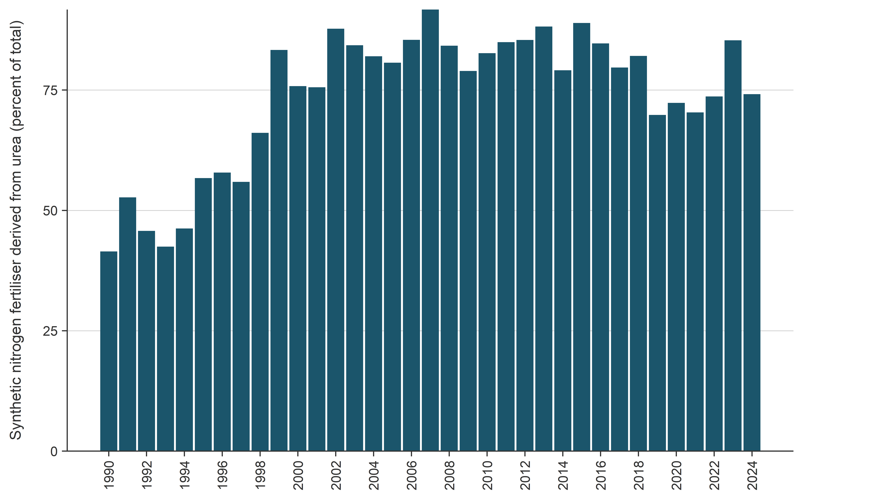
Source: Fertiliser Association of New Zealand
The increase in synthetic nitrogen fertiliser use since 1990 has resulted in an increase in emissions from this category, from 145.6 kt CO₂e in 1990 (0.4 percent of total Agriculture emissions), 872.2 kt CO₂e in 2005 (2.2 percent of total Agriculture emissions) to 950.8 kt CO₂e in 2024 (2.4 percent of Agriculture emissions).

Organic nitrogen fertilisers (3.D.1.2)
In New Zealand, emissions from organic nitrogen fertilisers are mainly from animal manure that is spread onto pasture after collection in manure management systems. While most animal manure in New Zealand is excreted directly onto pasture, some manure from dairy farms is collected in manure management systems and applied to soils as an organic fertiliser (see table 5.3.2). A report by Rollo et al. (2017) found that only 8 percent of dairy farms use land application of manure, through the use of direct pumping from a sump. In all cases, manure that was collected was stored for at least one or two days before spreading to pasture largely via irrigation. Therefore, it does not meet the definition of daily spread and the notation key ‘NO’ is reported in 3.B(b) of the CRT. The emissions calculation in this category (Organic nitrogen fertilisers) excludes manure deposited directly on pasture by grazing livestock, which is covered in the next section (Urine and dung deposited by grazing animals (3.D.1.3)). Animal manure is not used for fuel or construction in New Zealand.
New Zealand has developed a country-specific emission factor for N₂O from dairy cattle manure applied to soils of 0.0025 (van der Weerden et al., 2016a, 2016b). This value was based on a meta-analysis of field trials carried out in New Zealand that measured emissions from dairy cattle manure on soil. This emission factor was changed to 0.0025 in 2017, following a recommendation from the Agriculture Inventory Advisory Panel in 2016. The Panel agreed that the new value was more representative of New Zealand farming practices and conditions. Given that dairy cattle manure is a mixture of urine and dung (combined with water), the value of 0.0025 is consistent with the EF₃ emission factors used in New Zealand for dairy cattle urine (0.0098 and 0.0033 for flat and medium to steep sloped land respectively) and dung (0.0012) (van der Weerden et al., 2016a). Direct N₂O emissions from dairy cattle manure applied as organic fertiliser in 2023 (using the EF₃ of 0.0025) were 0.128 kt N₂O.
Manure from poultry and swine spread onto soil has an emission factor of 0.006, which is consistent with the IPCC default.
The following equation is used to determine direct N₂O emissions from the application of animal manure to soil:
$$N_{2}O emissions= \frac{44}{28} × \left(\left(F_{AM }×{EF}_{1(Organic)}\right)+(F_{AM(Dairy)}×{EF}_{1(Dairy)}\right)$$
Where: 44/28 is the molecular conversion factor used to convert nitrogen to N₂O
F_{AM} is the total amount of animal manure nitrogen (swine and poultry) applied to soils from manure management systems (other than pasture, range and paddock), which is derived as a fraction of the nitrogen excretion rates, N_{ex}, described in section 5.3.2
EF_{1(organic)} is the proportion of direct N₂O emissions from animal manure (swine and poultry) applied to soils (0.006; table 5.5.2)
F_{AM(DAIRY)} is the total amount of animal manure nitrogen (dairy) applied to soils from manure management systems (other than pasture, range and paddock), which is derived as a fraction of the nitrogen excretion rates, N_{ex}, described in section 5.3.2, and
EF_{1(DAIRY)} is the proportion of direct N₂O emissions from animal manure (dairy cattle) applied to soils (0.0025; table 5.5.2).
New Zealand also accounts for emissions from non-manure organic fertilisers. Sources include dairy processing wastewater, compost sold to the rural sector, meat processing wastewater, grape marc, vegetable processing wastewater and sewage sludge applied to land. The amount of nitrogen from these sources between 1990 and 2022 has been estimated (van der Weerden and Rutherford, 2024). In 2022, 82 tonnes nitrogen sewage sludge and 4,890 tonnes nitrogen from other non-manure organic fertiliser was applied to soils. For the years after 2022, the latest available value is used. A review of this data is intended in 2027.
The 2019 IPCC Refinement retained the default value of 1 percent for nitrogen additions to agricultural soils (IPCC, 2019). However, the 2019 IPCC Refinement also provides additional EF values disaggregated by nitrogen type and climate, where climate is disaggregated into wet and dry. New Zealand falls into this ‘wet climate’ category according to the IPCC definition. Therefore, New Zealand uses the IPCC (2019) disaggregated EF₁ of 0.6 percent to ensure calculations are employing the latest scientific knowledge. This provides a more appropriate value for organic nitrogen amendments to soils in wet climates rather than remaining with the aggregated value of 1 percent that is applied to all nitrogen inputs, across all climatic zones.

Urine and dung deposited by grazing animals (3.D.1.3)
Most livestock in New Zealand are grazed outdoors on pasture, with around 92.3 percent of dairy cattle excreta and 100 percent of non-dairy cattle, sheep and deer excreta deposited on pasture (see table 5.3.2). In New Zealand, dairy cattle are kept close to the milking shed and dairy farming tends to be on flatland. Sheep, non-dairy and deer farming predominantly occur on hill country and less frequently on flatland.
The following equations are used to determine direct N₂O emissions from grazing livestock manure.
For urine deposited on flatland and low slopes by sheep, cattle and deer only:
$$N_{2}O emissions= \frac{44}{28}\left(N_{2}O-N\right)=\frac{44}{28}\left(\sum_{T}{N_{T}∙\left({Nex}_{URINE,FLAT}+{Nex}_{URINE,LOW}\right)∙{MS}_{T}}\right)∙{EF}_{3(PRP-FLAT)}$$
For urine deposited on medium and steep slopes by sheep, cattle and deer only:
$$N_{2}O emissions= \frac{44}{28}\left(N_{2}O-N\right)=\frac{44}{28}\left(\sum_{T}{N_{T}∙\left({Nex}_{URINE,MED}+{Nex}_{URINE,STEEP}\right)∙{MS}_{T}}\right)∙{EF}_{3(PRP-STEEP)}$$
For all dung from sheep, cattle and deer:
$$N_{2}O emissions= \frac{44}{28}\left(N_{2}O-N\right)=\frac{44}{28}\left(\sum_{T}{N_{T}∙{Nex}_{DUNG,T}∙{MS}_{T}}\right)∙{EF}_{3(PRP-DUNG)}$$
For urine and dung from other livestock categories (swine, goats, horses, llamas and alpacas, mules, asses, emus, ostriches and poultry):
$$N_{2}O emissions= \frac{44}{28}\left(N_{2}O-N\right)=\frac{44}{28}\left(\sum_{T}{N_{T}∙{Nex}_{T}∙{MS}_{T}}\right)∙{EF}_{3(PRP-MINOR)}$$
Where: N_{T} is the population of the livestock category (sheep, cattle, deer or other)
T is the population as calculated in section 5.1.3
Nex_{URINE,FLAT} is the annual urinary nitrogen excretion per head deposited on flatland (kg N/year/head)
Nex_{URINE,LOW} is the annual urinary nitrogen excretion per head deposited on low slopes (kg N/year/head)
Nex_{URINE,MED} is the annual urinary nitrogen excretion per head deposited on medium slopes (kg N/year/head)
Nex_{URINE,STEEP} is the annual urinary nitrogen excretion per head deposited on steep slopes (kg N/year/head)
Nex_{DUNG,T} is the annual average excretion per head (kg N/year/head)
Nex_{T} is the annual average nitrogen excretion per head (kg N/year/head) (see section 5.3)
MS_{T} is the proportion of manure excreted directly onto pasture, range and paddock (see table 5.3.2)
EF_{3(PRP-FLAT)} is the emission factor for urinary nitrogen deposited on flatland and low slopes by sheep, deer and cattle (note that emission factors vary by animal category, see table 5.5.2)
EF_{3(PRP-STEEP)} is the emission factor for urinary nitrogen deposited on medium and steep slopes, for sheep, deer and cattle (note emission factors vary by animal category, see table 5.5.2)
EF_{3(PRP-DUNG)} is the emission factor for dung nitrogen excreta deposited by sheep, deer and cattle on pasture, range and paddock (0.0012, see table 5.5.2), and
EF_{3(PRP-MINOR)} is the emission factor for dung from minor animal categories deposited on pasture, range and paddock (see table 5.5.2).
For cattle, sheep and deer, the estimated N_{ex} values are separated into urine and dung components using the methodology outlined by Pacheco et al. (2018).
The Agriculture inventory model assumes that all dairy cattle graze on flatland, due to New Zealand farming practices, therefore, all dairy urinary nitrogen is allocated to Nex_{URINE,FLAT}.
Urinary nitrogen from non-dairy cattle, sheep and deer is allocated to the different slope types: Nex_{URINE,LOW}, Nex_{URINE,MED} and Nex_{URINE,STEEP}. However, there is zero land allocated to flatland (Nex_{URINE,FLAT}), which is generally used for grazing dairy cattle.

EF₃ emission factors for excreta deposited by cattle, sheep and deer on sloped land
New EF₃ emission factors were incorporated in the 2020 Inventory and are detailed in table 5.5.2 (EF_{3(PRP-DUNG)}) and table 5.5.3. These EF₃ emission factors used to calculate N₂O emissions from cattle (dairy and non-dairy cattle), sheep and deer are based on a meta-analysis undertaken by van der Weerden et al. (2019, 2020) based on field studies carried out in the past decade (de Klein et al., 2014; Hoogendoorn et al., 2013; Luo et al., 2013, 2016, 2019; Saggar et al., 2015). The research collectively shows (see table 5.5.6):
- a statistically significant difference in urine emission factors between cattle and sheep
- that emissions from sheep, non-dairy cattle and dairy cattle excreta deposited on medium (between 12 degrees and 24 degrees) and steep (greater than 24 degrees) sloped land are significantly lower than corresponding emissions on land that is flat or of a low gradient (between 0 degrees and 12 degrees).

Evidence and meta-analysis for EF₃ emission factors for excreta deposited on sloped land
The meta-analysis (van der Weerden et al., 2020), built on a previous study by Kelliher et al. (2014), calculated new emission factors based on animal type, season and slope. This was based on an expanded data set of 1,217 replicate-level emission factors from 236 field experiments conducted over the past decade, largely measured using the same standardised experimental methods for N₂O (see table 5.5.7).
The meta-analysis included results of studies from dung and urine deposited onto flatland and steep sloped land both published in scientific journals (Hoogendoorn et al., 2008; Ledgard et al., 2014; Luo et al., 2013; van der Weerden et al., 2011) and reported to the MPI Agriculture inventory team (Hoogendoorn et al., 2013; Luo et al., 2016, 2019). These data were compiled to contribute to existing data on emissions from dung and urine deposited on low and medium sloped land from the Kelliher et al. (2014) study.
Additional evidence conducted overseas supporting the use of emission factors that vary by land slope has been provided in a study in the United Kingdom by Marsden et al. (2018), who found that sheep EF₃ values are lower on upland and hill areas compared with intensively managed lowlands.
Table 5.5.6 Number of replicate-level EF₃ values collated by the van der Weerden et al. (2019, 2020) analysis, for each nitrogen source and topography (number of individual trials shown in brackets)
Nitrogen source | Flatland  (0–12º) | Low sloped land (0–12º) | Medium sloped land (12–24º) | Steep sloped land (>24º) | Total
Dairy cattle urine | 341 (57) | 108 (22) | 20 (4) |  | 469 (83)
Dairy cattle dung | 84 (19) | 46 (9) | 20 (4) |  | 150 (32)
Non-dairy cattle urine | 8 (1) | 40 (8) | 60 (12) | 20 (4) | 128 (25)
Non-dairy cattle dung |  | 76 (16) | 60 (12) | 20 (4) | 156 (32)
Sheep urine | 40 (7) | 64 (12) | 60 (12) | 20 (4) | 184 (35)
Sheep dung | 54 (13) | 36 (8) | 20 (4) | 20 (4) | 130 (29)
Total urine | 389 (65) | 212 (42) | 140 (28) | 40 (8) | 781 (143)
Total dung | 138 (32) | 158 (33) | 100 (20) | 40 (8) | 436 (93)
Total excreta | 527 (97) | 370 (75) | 240 (48) | 80 (16) | 1,217 (236)
Table 5.5.7 Number of replicate-level EF₃ values collated by the van der Weerden et al. (2019, 2020) analysis, for each nitrogen source, season when the trial was undertaken and topography
Nitrogen source | Topography class | Autumn | Winter | Spring | Summer | Total
Dairy cattle urine | Flatland (0º) | 128 | 105 | 88 | 12 | 333
 | Low slope (0–12º) | 34 | 34 | 28 | 20 | 116
 | Medium slope (12–24º) |  | 20 |  |  | 20
 | Steep slope (>24º)
Dairy cattle dung | Flatland (0º) | 14 | 34 | 36 |  | 84
 | Low slope (0–12º) |  | 26 |  | 20 | 46
 | Medium slope (12–24º) |  | 20 |  |  | 20
 | Steep slope (>24º)
Non-dairy cattle urine | Flatland (0º) |  | 8 |  |  | 8
 | Low slope (0–12º) |  | 20 |  | 20 | 40
 | Medium slope (12–24º) | 10 | 30 |  | 20 | 60
 | Steep slope (>24º) | 10 | 10 |  |  | 20
Non-dairy cattle dung | Flatland (0º)
 | Low slope (0–12º) | 20 | 28 | 8 | 20 | 76
 | Medium slope (12–24º) | 10 | 30 |  | 20 | 60
 | Steep slope (>24º) | 10 | 10 |  |  | 20
Sheep urine | Flatland (0º) | 8 | 8 | 20 |  | 36
 | Low slope (0–12º) | 24 |  | 44 |  | 68
 | Medium slope (12–24º) | 30 | 10 | 20 |  | 60
 | Steep slope (>24º) | 10 | 10 |  |  | 20
Sheep dung | Flatland (0º) | 10 | 16 | 28 |  | 54
 | Low slope (0–12º) | 20 | 8 | 8 |  | 36
 | Medium slope (12–24º) | 10 | 10 |  |  | 20
 | Steep slope (>24º) | 10 | 10 |  |  | 20
Total urine |  | 254 | 255 | 200 | 72 | 781
Total dung |  | 104 | 192 | 80 | 60 | 436
Total excreta |  | 358 | 447 | 280 | 132 | 1,217
The meta-analysis used arithmetic means to calculate new average EF₃ values (categorised by animal, slope and excreta type). Because the differences between some of these values were not statistically significant, some of the arithmetic means were pooled. This resulted in the dung EF₃ averages being combined into a single value (0.0012). The urine EF₃ values were pooled into four categories:
- cattle urine on flatland/low slopes (0.0098)
- cattle urine on medium/steep slopes (0.0033)
- sheep urine on flatland/low slopes (0.005)
- sheep urine on medium/steep slopes (0.0008).
The lower emission factors observed for urine on steeper slopes are thought to be due to these soils having lower soil fertility, nitrogen status and moisture content compared with less steep slopes (Luo et al., 2013).
The new urine emission factor values for each livestock type by slope are lower than the current IPCC default EF₃ value. The default value is based on common international farming systems where, on average, livestock farmed land is on less sloped terrain than much of the farmland in New Zealand. In addition to the large proportion of farmed hill country, New Zealand’s climate and soil characteristics contribute to differences between international default emission factors and New Zealand’s country-specific emission factors. When using these emission factors, the IEF for direct N₂O from dung and urine was 0.0054 in 2020. This value is comparable with that calculated for the United Kingdom (0.0037) and Australia (0.0040) in their respective inventory submissions for 2021.
Nitrous oxide emissions have not been measured for deer excreta, therefore, deer EF₃ values were calculated using average EF₃ values from cattle and sheep.
To apply these emission factors, estimates of the amount of urine and dung deposited onto different slope categories are needed. A nutrient transfer model developed by Saggar et al. (2015) is used to allocate total excreta (N_{ex}, calculated using the methods described in section 5.3) by livestock type to the different slope categories. The nutrient transfer model uses data on the national area of farmland for each slope category, and accounts for animal behaviour where livestock spend relatively more time on lower slopes, and so deposit more excreta on these lower slopes and flat land. For more information on this model, see volume 2, annex 5, section A5.1.3.
The use of these revised EF₃ emission factors and the nutrient transfer model was recommended by the Agriculture Inventory Advisory Panel in 2019.

Direct nitrous oxide emission factors for minor livestock types
Minor livestock types, including Swine, Goats, Horses, Llamas and alpacas, Mules and asses, Emus and ostriches and Poultry, make up a small proportion of total Agriculture emissions. New Zealand uses the IPCC default (2019) values for minor livestock types (EF_{3(PRP-MINOR)}). These values are 0.006 for poultry, emus and ostriches and swine, and 0.003 for other animals (alpacas and llamas, mules and asses, horses and goats).
In 2024, direct N₂O emissions from Urine and dung deposited by grazing animals (pasture, range and paddock manure from all livestock categories) contributed 51.9 percent (3,179.7 kt CO₂e) of emissions from Agricultural soils, or 7.9 percent of total Agriculture emissions. Emissions from this category have increased by 22.8 percent since 1990, and decreased by 1.2 percent since 2005. Emissions for each livestock category are given in table 5.5.8. Emissions from Urine and dung deposited by grazing animals were identified as a key category (level and trend assessment).
Table 5.5.8 Trends and relative contribution of direct nitrous oxide emissions from urine and dung deposited by grazing animals per livestock category between 1990 and 2024
Livestock category | Emissions  (kt CO₂e) |  |  | Change from  1990–2024 |  | Change from 2005–2024 |  | Share of  Agricultural soils category | Share of total  Agriculture sector
Livestock category | 1990 | 2005 | 2024 | kt CO₂e | % | kt CO₂e | % | 2024 (%) | 2024 (%)
Dairy cattle | 1,019.9 | 1,612.3 | 1,979.7 | 959.8 | 94.1 | 367.5 | 22.8 | 32.3 | 4.9
Non-dairy cattle | 740.1 | 849.0 | 736.4 | -3.7 | -0.5 | -112.6 | -13.3 | 12.0 | 1.8
Sheep | 767.5 | 675.7 | 425.5 | -342 | -44.6 | -250.2 | -37.0 | 6.9 | 1.1
Deer | 38.9 | 72.4 | 31.8 | -7.1 | -18.2 | -40.5 | -56.0 | 0.5 | 0.1
Minor livestock | 22.1 | 8.7 | 6.4 | -15.7 | -71.2 | -2.3 | -26.9 | 0.1 | 0.0
Total | 2,588.4 | 3,218.0 | 3,179.7 | 591.3 | 22.8 | -38.2 | -1.2 | 51.9 | 7.9
Note: Percentages presented are calculated from unrounded values.

Nitrous oxide from crop residue returned to soil (3.D.1.4)
This emissions category includes emissions from nitrogen added to soils by above-ground and below-ground crop residue (including residue left behind by crop burning), and the nitrogen added as a result of mineralisation of forages during pasture renewal. It includes both nitrogen-fixing and non-nitrogen-fixing crop species. Crop residues are materials left in an agricultural field after the crop has been harvested. Pasture renewal is the destruction of low-quality pasture followed by the sowing of improved pasture species and varieties to increase farm productivity. The direct emissions from agricultural residue burning are reported in section 5.7.
New Zealand does not include an adjustment for crop residue removed for feed and bedding, which is estimated to be minor by Thomas et al. (2011).
Nitrogen from crop residue: The major non-nitrogen-fixing crops grown in New Zealand are barley, wheat, oats, potatoes, maize for seed, and other seed crops. From the 2012 submission onwards, New Zealand has reported emissions from additional cropping activity not previously estimated, such as onions, squash and sweetcorn (Thomas et al., 2012). The nitrogen-fixing crops grown in New Zealand include peas grown for both processing and seed markets as well as lentil production, and forage legume seeds (Trifolium repens) grown for pasture production.
A country-specific methodology is used to calculate emissions from crop residue (Thomas et al., 2011):
$$N_{2}O_{FCR} emissions=\frac{44}{28}{\left(N_{2}O-N\right)}_{FCR}=\frac{44}{28}\left({AG}_{N}+{BG}_{N}\right)∙{EF}_{1}$$
Where: AG_{N} and BG_{N} are the annual nitrogen residue returned to soils from above- and below-ground crop residue, and crop-specific values are given in volume 2, annex 5, table A5.1.8, and
EF₁ is the proportion of direct N₂O emissions from crop residues applied to soils (default value of 0.006; table 5.5.2).
$${AG}_{N}={AG}_{DM}∙N_{AG} {BG}_{N}=\left({AG}_{DM}+{Crop}_{T}\right)∙R_{BG}∙N_{BG}$$
Where: AG_{DM} is the mass of the above-ground residue dry matter (explained in the equation below)
Crop_{T} is the crop yield, or mass, removed during harvest
N_{AG} and N_{BG} are the above- and below-ground crop-specific nitrogen concentration factors, and
R_{BG} is the crop-specific root:shoot ratio of below-ground dry matter against the total above-ground crop biomass (crop gathered, Crop_{T}, plus above-ground residue dry matter, AG_{DM}), 0.1 (see volume 2, annex 5, table A5.1.8).
$${AG}_{DM}=\left(\frac{{Crop}_{T}}{HI}\right)-{Crop}_{T}∙{Frac}_{BURN}∙C_{f}$$
Where: HI is the crop-specific harvest index or fraction of the crop that is harvested (see volume 2, annex 5, table A5.1.8)
Frac_{BURN} is the fraction of residue burned in the field (see table 5.5.4), and
C_{f} is the combustion factor; a value of 0.7 is applied (Thomas et al., 2011).
The country-specific value for Frac_{BURN}, the fraction of residue burned in the field, was derived from Stats NZ data and farmer surveys (Thomas et al., 2012). The parameters used to estimate the nitrogen added by above- and below-ground crop residues were compiled from published and unpublished reports for New Zealand-grown crops (Cichota et al., 2010) and ‘typical’ values derived for use in the OverseerFM nutrient budget model for New Zealand. The OverseerFM model provides average estimates of the fate of nitrogen for a range of pastoral, arable and horticultural systems (www.overseer.org.nz).
The per-year harvested tonnage of most non-nitrogen-fixing crops in New Zealand is supplied by Stats NZ from its Agricultural Production Census and Agricultural Production Survey. Additional information on potatoes is provided by Potatoes New Zealand, and updated information on seed crops is provided by AsureQuality, which provides verification and certification services for the seed industry (Thomas, 2010; S Thomas, pers. comm., 2014). The tonnage of nitrogen-fixing crops is supplied by Stats NZ from its Agricultural Production Census and Agricultural Production Survey (lentils and legumes) and Horticulture New Zealand (peas) (S Thomas, pers. comm., 2014).
Nitrogen from pasture renewal: Of the four categories of perennial forage that the IPCC (2006) lists for pasture renewal, only two categories are appropriate for New Zealand (Thomas et al., 2014): these are grass-clover pastures and lucerne, a nitrogen-fixing perennial forage. New Zealand has calculated emissions from pasture renewal per plant species type, T, separately:
$$F_{CR-RENEW}= \sum_{T}{\left[{Crop}_{T}×{Area}_{T}×{Frac}_{RENEW(T)}×\left[R_{AG(T)}×N_{AG(T)}×\left(1-{Frac}_{REMOVE\left(T\right)}\right)+R_{BG(T)}×N_{BG(T)}\right]\right]}$$
Where: Area_{T} is the total annual area harvested (hectares per year). No burning is used for pasture renewal in New Zealand
Frac_{RENEW(T)} is the fraction of the area under each crop that is renewed
R_{AG(T)} is the ratio of above-ground residue dry matter (DM) to harvested yield (kg N/kg DM)
N_{AG(T)} is the nitrogen content of above-ground residue (kg N/kg DM)
Frac_{REMOVE (T)} is the fraction of above-ground residue removed annually for feed, assumed zero for New Zealand
R_{BG(T)} is the ratio of below-ground residue DM to harvest yield (kg N/kg DM), and
N_{BG(T)} is the nitrogen content of below-ground residue (kg N/kg DM).
The areas for each perennial forage crop were obtained from the Stats NZ Agricultural Production Census and Agricultural Production Survey, which include the area of grassland and annual crops from 1990 to 2023. The disaggregation of grass-clover systems has been considered, but there is insufficient activity data for pastures of different compositions in New Zealand because the proportion of clover varies widely due to the variability of nitrogen inputs to various farming systems, climate soil, fertility and management variables. This means that disaggregated data on the nitrogen content is not currently available.
The contribution of crop residues and pasture renewal to overall Agriculture emissions is small, with 93.6 kt CO₂e (0.3 percent of total Agriculture emissions) in 1990, 134.5 kt CO₂e (0.3 percent of total Agriculture emissions) in 2005 and 131.0 kt CO₂e (0.3 percent of total Agriculture emissions) in 2024.

Nitrogen mineralisation from loss of soil organic matter in mineral soils (3.D.1.5)
Nitrogen mineralisation is the process by which organic nitrogen is converted to plant-available inorganic forms. Nitrogen mineralisation occurs when soil carbon is lost due to land-use or management change. Most of New Zealand’s emissions from nitrogen mineralised during the loss of soil organic matter are covered under the Land Use, Land-Use Change and Forestry (LULUCF) sector. The exception is for activities in the Cropland remaining cropland land use category, which are reported under the Agriculture sector (IPCC, 2006).
The following equations are used to determine emissions from this activity:
$$N_{2}O_{FSOM}=\frac{44}{28}\left(F_{SOM}∙{EF}_{1}\right)∙{10}^{-6}$$
Where: N₂O_{FSOM} is the N₂O emitted as a result of nitrogen mineralisation from loss of soil organic matter in mineral soils (kt)
F_{SOM} is the nitrogen mineralisation from loss of soil organic matter in mineral soils through land management for Cropland remaining cropland (kg), and
The emission factor EF₁ is 0.006 (see table 5.5.2).
And:
$$F_{SOM}=\frac{∆C_{Mineral,CrC}}{R}∙{10}^{3}$$
Where: ∆C_{Mineral,CrC} is the loss of soil carbon (C) in mineral soil during management of cropland (kt), and
R is the C:N ratio. The IPCC (2006) default value of 10 is used.
Activity data on the soil carbon loss that is associated with cropland since 1990 were provided using calculations under the LULUCF sector (see chapter 6, section 6.5).
The contribution of direct N₂O emissions from nitrogen mineralisation from loss of soil organic matter to overall Agriculture emissions is small, with 0.02 kt CO₂e in 1990 and 0.09 kt CO₂e in 2005 and 2024.

Cultivation (management) of organic soils (3.D.1.6)
The management of organic soils is a source of N₂O emissions. The area of managed organic soils (histosols) in New Zealand includes both the area of managed organic soils (as reported under the LULUCF sector) and the area of mineral agricultural soils with a peaty layer that is cultivated (Dresser et al., 2011). Mineral soils with a peaty layer are included in the definition of organic soils because these soils have similar emissions behaviour to that of organic soils (Dresser et al., 2011). The full definition used in the Agriculture sector for organic soils (plus mineral soils with a peaty layer) is:
- at least 17 percent organic matter content (includes slightly peaty, peaty and peat soils)
- 0.1 metres of this depth occurring within 0.3 metres of the surface.
The total area of managed organic soils in New Zealand in 2024 was 176,976 hectares. It is estimated that 95 percent of this area is on grassland and 5 percent on cropland (Pronger et al., 2022). It is assumed that all of this area meets the definition of ‘managed’ for the purpose of estimating emissions. The estimate of managed organic soils on cropland and grassland is consistent with data and methodology used for the LULUCF sector. The total area of managed organic soils has increased slightly by 1.1 percent (1,934 hectares) since 1990 and 0.5 percent (894 hectares) since 2005.
Emissions from organic soils are calculated using the Tier 1 methodology for all years of the time series by multiplying the area of managed organic soils by the default value of emission factor EF₂ of 8 kg N₂O-N/ha (IPCC, 2006).
In 2024, direct N₂O emissions from the management of organic soils contributed 9.6 percent (589.6 kt CO₂e) of emissions from Agricultural soils, or 1.5 percent of total Agriculture emissions). This is an increase of 1.1 percent since 1990 and 0.5 percent since 2005. Emissions from Cultivation of organic soils were identified as a key category (level and trend assessment).

Indirect nitrous oxide emissions from managed soils (3.D.2)
In addition to direct N₂O emissions from managed soils, emissions of N₂O also occur through two indirect pathways: volatilisation, and leaching and runoff.

Volatilisation (3.D.2.1)
Some of the nitrogen deposited or spread on agricultural land is emitted into the atmosphere through volatilisation in the form of NH₃ and NO_{x}. A fraction of this volatilised nitrogen returns to the ground during rainfall and is then re-emitted as N₂O. The fraction of nitrogen that becomes N₂O during this process is calculated using the parameters Frac_{GASF} for synthetic nitrogen fertiliser and Frac_{GASM} for organic inputs from animal excreta. New Zealand uses country-specific values for both of these parameters.
In New Zealand, nitrogen added to agricultural soils from synthetic nitrogen fertiliser (F_{SN}), organic nitrogen fertiliser from the spreading of managed manure (F_{ON}), and excreta from grazing livestock on pasture (F_{PRP}) all contribute to N₂O emissions from volatilisation. The collection of activity data for F_{SN}, F_{ON} and F_{PRP} is described above (see Direct N₂O emissions from managed soils (3.D.1)). Volatilisation from manure stored in manure management systems (before application to land) is reported in the Manure management category (see section 5.3.2).
New Zealand uses a Tier 1 methodology with country-specific emission factors for Frac_{GASF} and Frac_{GASM} and a default value for the EF₄ emission factor to calculate emissions from volatilisation:
$$N_{2}O_{ATD} emissions=\frac{44}{28}\left(N_{2}O_{ATD}-N\right)=\frac{44}{28}\left[\left(F_{SN}∙{Frac}_{GASF}\right)+\left(\left(F_{ON}+F_{PRP}\right)∙{Frac}_{GASM}\right)\right]∙{EF}_{4}$$
Where: N₂O_{ATD}–N is the annual amount of N₂O-N produced by atmospheric deposition of volatilised nitrogen from agricultural soils (kg N₂O-N/year)
F_{SN}, F_{ON} and F_{PRP} are defined above (kg N/year)
Frac_{GASF} is the fraction of nitrogen from synthetic fertiliser that volatilises as NH₃ and NO_{x} (see table 5.5.4)
Frac_{GASM} is the fraction of nitrogen from manure spreading and pasture, range and paddock manure that volatilises as NH₃ and NO_{x} (see table 5.5.4), and
EF₄ is the emission factor for N₂O emissions from atmospheric deposition of nitrogen on soils and water (kg N₂O-N/kg N).
New Zealand has a country-specific value of 0.1 for Frac_{GASF}, the fraction of volatilised nitrogen from synthetic nitrogen fertiliser. This value is based on a review by Sherlock et al. (2011) of relevant New Zealand and international research. The review determined that a value of 0.096 for Frac_{GASF} was suitable for New Zealand conditions. Because this value of 0.096 is almost identical to the IPCC default value of 0.1, the value of 0.1 was adopted by New Zealand as a country-specific value for Frac_{GASF}.
The review by Sherlock et al. (2011) also recommended that New Zealand adopt a country-specific value of 0.1 for Frac_{GASM}, the fraction of volatilised nitrogen from manure spreading and pasture, range and paddock manure. The review showed that the default value of 0.2 for Frac_{GASM} (IPCC, 2006) was too high for New Zealand circumstances and that 0.1 was more appropriate. This value was also confirmed by subsequent field experiments (Laubach et al., 2012).
The New Zealand Inventory applies the aggregated default value of 0.01 for EF₄ presented in the 2019 IPCC Refinement (IPCC, 2019). This approach differs from other default emission factor selections, where the wet climate disaggregation is used to reflect New Zealand’s climatic conditions. New Zealand uses country-specific emission factors for processes related to N₂O emissions from volatilisation. New Zealand uses a country-specific EF₁ of 0.0059 and country-specific EF₃ of 0.0008 to 0.0098, depending on the source (see section 5.5.2). Nitrous oxide emissions from volatilisation occur when volatilised nitrogen is redeposited onto the soil during rainfall, a process analogous to direct emissions. Consequently, the aggregated EF₄ default of 0.01 provides a more representative estimate for New Zealand conditions, because it aligns more closely with observed EF₁ and EF₃ values (T. van der Weerden, pers. comm., 2025).
In 2024, N₂O emissions from volatilisation contributed 1.8 percent (740.6 kt CO₂e) to total Agriculture emissions, an increase of 16.6 percent from the 1990 value of 635.3 kt CO₂e, and a decrease of 10.7 percent from the 2005 value of 829.2 kt CO₂e.

Leaching and runoff (3.D.2.2)
Nitrous oxide emissions from leaching and runoff originate from the following sources:
- synthetic nitrogen fertiliser (F_{SN})
- organic nitrogen additions from the spreading of animal manure (F_{ON}), above- and below-ground crop residues (F_{CR})
- nitrogen mineralisation associated with loss of soil organic matter from cropland land management (F_{SOM})
- excreta from grazing livestock on pasture, range and paddock (F_{PRP}) (IPCC, 2006).
The collection of activity data for F_{SN}, F_{ON}, F_{CR}, F_{PRP} and F_{SOM} is described above (see Direct N₂O emissions from managed soils (3.D.1)).
New Zealand reports all emissions from leaching in the Agricultural soils category. As discussed under Manure management (see section 5.3.1), New Zealand livestock are predominantly grazed outdoors (see table 5.3.2). New Zealand uses a Tier 1 methodology with country-specific default parameters to calculate indirect N₂O emissions from nitrogen leaching. The general equation is:
$$N_{2}O_{L} emissions=\frac{44}{28}\left(N_{2}O_{L}-N\right)$$
The following are specific equations used to calculate indirect N₂O emissions from nitrogen leaching for cropping systems, grassland and synthetic nitrogen fertilisers:
$$N_{2}O_{L} emissions (cropping systems)=\frac{44}{28}∙\left(F_{CR}+F_{SOM}\right)∙{Frac}_{LEACH-H(CROPPING)}∙{EF}_{5}$$
$$N_{2}O_{L} emissions (grassland)=\frac{44}{28}∙\left(F_{CR}+ F_{ON}+ F_{PRP}\right)∙{Frac}_{LEACH-H(GRASSLAND)}∙{EF}_{5}$$
$$N_{2}O_{L} emissions (synthetic N fertiliser)=\frac{44}{28}∙\left(F_{SN}\right)∙{Frac}_{LEACH-H(FERTILISER)}∙{EF}_{5}$$
Where: N₂O_{L}–N is the annual amount of N₂O-N from runoff and leaching from agricultural soils (kg N₂O-N/year)
F_{SN}, F_{ON}, F_{PRP}, F_{CR} and F_{SOM} are defined above (kg N/year)
Frac_{LEACH-H(CROPPING)} is the fraction of nitrogen added to, or mineralised from, cropping systems that is lost from soil through leaching and runoff (see table 5.5.4)
Frac_{LEACH-H(GRASSLAND)} is the fraction of nitrogen added to, or mineralised from, grassland that is lost from soil through leaching and runoff (see table 5.5.4)
Frac_{LEACH-H(FERTILISER)} is the fraction of nitrogen added to, or mineralised from, synthetic nitrogen fertiliser that is lost from soil through leaching and runoff, and
EF₅ is the IPCC (2006) default factor for N₂O emissions from leaching and runoff.
New Zealand uses differing Frac_{LEACH} parameters that are dependent on the type of agricultural system the nitrogen has been applied to. These values were derived using measured values, as well as modelled values from OverseerFM, a New Zealand-specific nutrient budgeting model. The Frac_{LEACH} value is 0.10 for nitrogen applied to cropland and 0.08 for grassland (Welten et al., 2021). The Frac_{LEACH} value for synthetic nitrogen fertiliser applied to grassland and cropland is 0.082. This is a weighted average of nitrogen applied to cropland and grassland based on data from Stats NZ (2021) indicating that this is applied at a 90:10 ratio to grassland and cropland. Data back to 1990 show minimal fluctuations in this ratio, so it has been assumed that this nitrogen application remains static for the current inventory submission. Future inventory submissions may modify this Frac_{LEACH} value, if there is evidence the 90:10 ratio has changed.
The OverseerFM model provides average estimates of the leaching and runoff of nitrogen for a range of pastoral, arable and horticultural systems. In pastoral systems, OverseerFM-derived nitrate (NO₃–) leaching is determined by rainfall, soil type and the amount of nitrogen entering the farm system (from nitrogen-based fertilisers, dung and urine applied as farm dairy effluent or directly excreted by grazing animals). Dung and urine output from animals is calculated from the difference between nitrogen intake by grazing animals and nitrogen retained in animal products, such as milk, meat, wool and velvet. This is based on user inputs of stocking rates and production using an internal database with information on the nitrogen content of pasture and animal products. Resulting values are calibrated against empirical field measurements. In cropping systems, two years (previous and reporting) of monthly crop and management data are required for modelling NO₃ leaching in OverseerFM. This data includes nitrogen applied as fertiliser and effluent, as well as factors influencing or indicating the water content of soil, such as temperature, irrigation, rainfall, drainage and field capacity.
In 2024, N₂O emissions from leaching and runoff made up 1.2 percent (476.3 kt CO₂e) of total Agriculture emissions. There has been an increase of 21.6 percent from 1990 (391.7 kt CO₂e) and a decrease of 7.4 percent (514.6 kt CO₂e) from 2005.

Incorporation of nitrous oxide mitigation technologies into the Agriculture inventory model

Urease inhibitors
The N₂O emissions reported in the Agricultural soils category take into account the use of urease inhibitors, a greenhouse gas mitigation technology. Urea is the main type of synthetic nitrogen fertiliser applied to pastures. Urease inhibitors restrict the action of the urease enzyme. Urease is a catalyst for the volatilisation of the nitrogen contained in urea fertiliser and urine into NH₃ gas.
Urease inhibitor mitigation is included in New Zealand’s Agriculture inventory model by adjusting the value of the existing country-specific N₂O parameter: Frac_{GASF}. Saggar et al. (2013) assessed the mitigating effect of the urease inhibitor nBTPT (sold as ‘Agrotain’), the most widely used urease inhibitor. Saggar et al. (2013) showed that the presently recommended country-specific value of Frac_{GASF} of 0.1 should be reduced to 0.055 for urease-treated urea fertiliser. This finding was based on field and laboratory studies conducted both in New Zealand and worldwide.
Indirect N₂O emissions from volatilisation from all synthetic nitrogen fertilisers (including urea and other nitrogen fertilisers, with and without urease inhibitors applied to the urea component) are calculated as shown below:
$$N_{2}O_{ATD-FSN} emissions=\frac{44}{28}\left(N_{2}O_{ATD-FSN}-N\right)=\frac{44}{28}\sum_{S}{\left[F_{SN}∙{Frac}_{GASF}\right]}∙{EF}_{4}$$
Where: N₂O_{ATD-FSN} is the annual amount of N₂O-N produced by atmospheric deposition of volatilised nitrogen from all synthetic nitrogen fertiliser applied to agricultural soils (kg N₂O-N/year)
S is urea fertiliser (untreated), urea fertiliser (treated) or non-urea nitrogen fertiliser
F_{SN} is the total annual amount of synthetic nitrogen fertiliser applied (kg N/year) per fertiliser type, S
Frac_{GASF} is the fraction of nitrogen from synthetic nitrogen fertiliser that volatilises as NH₃ and NO_{x}; 0.055 for treated urea fertiliser and 0.1 for untreated urea and other nitrogen fertiliser, and
EF₄ is the emission factor for N₂O emissions from atmospheric deposition of nitrogen on soils and water; 0.01 [kg N–N₂O (kg NH₃–N + NO_{x}–N volatilised)⁻¹].
All other emission factors and parameters relating to animal excreta and synthetic nitrogen fertiliser use (Frac_{GASM}, Frac_{LEACH} and EF₁) do not change as a result of including urease inhibitors in the calculations. An adjustment for Frac_{GASM} was not recommended because the effect of urease inhibitors on reducing NH₃ volatilisation from animal excreta could not be accurately assessed (Saggar et al., 2013).
Urea fertiliser coated with urease inhibitors was first used commercially in New Zealand in 2001. Activity data on urease inhibitor usage are provided by the Fertiliser Association of New Zealand from sales records. These activity data record the total amount of nitrogen in urea fertiliser that has been treated with a urease inhibitor. Some urea fertiliser coated with urease inhibitors is also blended into other non-nitrogen fertiliser products. No data are available on the amount used in this manner.
Estimates of the mitigation impact of urease inhibitors on N₂O emissions from volatilisation for the calendar years 2001 to 2024 are shown in table 5.5.9. The use of urease inhibitors was low between 2001 and 2013, averaging 6.1 percent, with only a slight upwards drift. In 2014, this jumped significantly to 20.2 percent, marking the beginning of a strong upwards trend. The percentage of urea fertiliser applied with urease inhibitor passed 50 percent in 2023 and dropped to 47.7 percent in 2024.
Table 5.5.9 Mitigation impact of urease inhibitors on nitrous oxide emissions from volatilisation,
from 2001 to 2024
Year | Percentage of urea fertiliser applied that included urease inhibitor (urea treated/total urea) | Estimated greenhouse gas mitigation from using urease inhibitor (kt CO₂e)
2001 | 5.6 | 2.0
2002 | 3.8 | 1.7
2003 | 4.6 | 2.3
2004 | 8.1 | 4.3
2005 | 1.6 | 0.9
2006 | 8.4 | 4.2
2007 | 5.0 | 2.7
2008 | 5.2 | 2.7
2009 | 9.4 | 4.2
2010 | 6.9 | 3.6
2011 | 5.3 | 3.1
2012 | 7.0 | 4.0
2013 | 8.6 | 5.3
2014 | 20.2 | 12.1
2015 | 16.2 | 11.6
2016 | 22.2 | 15.2
2017 | 22.4 | 14.8
2018 | 30.3 | 21.4
2019 | 29.2 | 17.2
2020 | 40.9 | 26.0
2021 | 45.7 | 26.6
2022 | 44.2 | 24.4
2023 | 58.3 | 34.3
2024 | 47.7 | 25.7
Source: Fertiliser Association of New Zealand and Ballance Agri-Nutrients Limited

Nitrification inhibitor dicyandiamide
The N₂O emissions reported in the Agricultural soils category take into account the use of nitrification inhibitors on dairy farms using the methodology described in Clough et al. (2011). Greenhouse gas mitigation estimates from DCD are reported in the Agriculture inventory sector only up until 2012, because sales were suspended that year due to the detection of low levels of DCD residues in milk.
Research has shown that DCD reduces N₂O emissions and nitrate (NO₃–) leaching in pastoral grassland systems grazed by ruminant animals. The Agriculture inventory model methodology incorporates DCD use by modifying the emission factors EF_{3(PRP)} and the parameter Frac_{LEACH} (see table 5.5.5). These were modified based on comprehensive field-based research that showed significant reductions in direct and indirect N₂O emissions and NO₃– leaching where the DCD was applied. It was determined that, on a national basis, reductions in EF_{3(PRP)} and Frac_{LEACH} of 67 percent and 53 percent respectively could be made (Clough et al., 2011).
Limited research has been conducted concerning the effect of DCD on dung (EF_{3(PRP-DUNG)}); this research was inconclusive, and further work needs to be carried out before incorporating the impact of dung emissions into the Agriculture inventory model. Application of this inhibitor was found to have no effect on NH₃ volatilisation, which is supported by the results of field studies (Clough et al., 2011; Sherlock et al., 2011). Therefore, the parameter for volatilisation remains unchanged.
The DCD weighting factors are calculated based on reductions in emission factors and parameters, and the fraction of dairy land treated with the inhibitor, as follows:
$DCD weighting factor=\left(1-\frac{\% reduction in EF_{x}}{100}∙\frac{DCD area treated}{Total area of dairy land}\right)$
The appropriate weighting factor is then used as an additional multiplier in the current methodology for calculating indirect and direct emissions of N₂O from grazed pastures, in effect creating a modified EF_{3(PRP)} and Frac_{LEACH} for the dairy grazing area in the months that the inhibitor is applied and is effective (May to September). The modified emission factors (see table 5.5.10) are based on information from the Stats NZ Agricultural Production Survey that 2.9 percent of the effective dairy land area in New Zealand received DCD in 2012. The inhibitor was applied to pastures as either a slurry or DCD-coated granule to maximise N₂O emission reductions. Mitigation estimates for the calendar years 2007 to 2012 are shown in table 5.5.10.
Table 5.5.10 Emission factors, parameters and mitigation for New Zealand’s dicyandiamide inhibitor calculations, from 2007 to 2012
 | 2007 | 2008 | 2009 | 2010 | 2011 | 2012
Percentage of dairy area applied with inhibitor | 3.5 | 4.5 | 3.1 | 2.2 | 3.0 | 2.9
Final modified emission factor or parameter for dairy cattle, EF_{3(PRP)} (kg N₂O-N/kg N) | 0.00970 | 0.00967 | 0.00971 | 0.00974 | 0.00971 | 0.00972
Final modified emission factor or parameter for dairy cattle, Frac_{LEACH} (kg N₂O-N/kg N) | 0.0794 | 0.0792 | 0.0794 | 0.0796 | 0.0795 | 0.0795
Mitigation (kt CO₂e) | 15.6 | 21.4 | 15.2 | 11.6 | 16.4 | 16.6
Note: EF_{3(PRP)} = 0.0098 and Frac_{LEACH} = 0.10 for cropland and 0.08 for grassland when the inhibitor is not applied. All other emission factors and parameters relating to animal excreta and fertiliser use (Frac_{GASM}, Frac_{GASF}, EF₄ and EF₅) remain unchanged when the inhibitor is used as a nitrous oxide mitigation technology.

5.5.3 Uncertainty assessment and time-series consistency
To ensure consistency in the calculations involving animal manure, a single enhanced livestock population characterisation and feed-intake estimate is produced by the Tier 2 model for each of the major livestock categories. This is used in different parts of the calculations to estimate: CH₄ emissions for the Enteric fermentation category, CH₄ and N₂O emissions for the Manure management category and N₂O emissions for the Urine and dung deposited by grazing animals (pasture, range and paddock manure) category.
Uncertainties in N₂O emissions from Agricultural soils are calculated using an analytical method developed by Kelliher et al. (2017). This method estimated the uncertainty of the Agricultural soils category to be ±55.9 percent for 2024.
The benefit of using the analytical method is that it can be updated annually by the Agriculture inventory compilers. Kelliher et al. (2017) also compared the analytical method with the Monte Carlo method used for previous years and found that both produced similar results.
Uncertainties were assessed for the 1990, 2002 and 2012 inventories using the Monte Carlo method. For the 1990 and 2002 inventories, the uncertainties were assessed using a Monte Carlo simulation of 5,000 scenarios with the @RISK software (Kelliher et al., 2017)
The overall inventory uncertainty analysis shown in volume 2, annex 2 demonstrates that the uncertainty in annual emissions from Agricultural soils is a major contributor to uncertainty in New Zealand’s total greenhouse gas emissions. The uncertainty between years is assumed to be correlated, and therefore the uncertainty is mostly associated with the emission factors. The uncertainty associated with the trend in emissions from Agricultural soils is much lower than the uncertainty for an annual estimate.
The uncertainty in emissions from Agricultural soils is largely due to the parameter EF_{3(PRP)} and emissions from urine and dung deposited by grazing animals. This uncertainty reflects natural variance in EF₃ due to weather, climate and soil type (Kelliher et al., 2017).

5.5.4 Category-specific QA/QC and verification
In preparation for this inventory submission, the data underwent Tier 1 and Tier 2 quality checks.

Verification of activity data
Research has been carried out to verify the activity data for crops. In 2008 and 2011, MPI commissioned reports investigating N₂O emission factors and activity data for crops (Thomas et al., 2011, 2012). The reports compared activity data from the Stats NZ Agricultural Production Survey with the Foundation for Arable Research production database. Data for wheat and maize between the two data sources were very similar, although differences were evident for some of the other crops.
The accuracy of synthetic nitrogen fertiliser data has also been assessed by comparing fertiliser sales data received from the Fertiliser Association of New Zealand with data collected from the Agricultural Production Survey.
The Fertiliser Association sales data are used rather than the Stats NZ Agricultural Production Survey data because the sales data are considered to be more comprehensive and accurate. Nearly 98 percent of New Zealand synthetic nitrogen fertiliser is sold by two large companies that provide sales data to the Fertiliser Association (Fertiliser Association of New Zealand, 2018). The Fertiliser Association provides an estimate of the additional synthetic nitrogen fertiliser sold by other companies (around 2 percent). In contrast, the Agricultural Production Survey data are collected from a sampling frame of around 49,300 individual farms. Some farmers use contract fertiliser spreading companies (including aerial spreading) and may not have an accurate estimate of the tonnes of fertiliser applied or are unsure on how to fill in the questionnaire accurately, given the number of different fertilisers used and their varying names. The Agricultural Production Census and Agricultural Production Survey data verified the long-term trend of the increasing use of synthetic nitrogen fertiliser.

Comparison of New Zealand emission factors and parameters with IPCC default values
Table 5.5.11 compares New Zealand’s IEFs for EF₁ (synthetic nitrogen fertiliser) and EF_{3(PRP)} (urine and dung deposited by grazing animals) with the 2006 IPCC default values and emission factors used by Australia. The New Zealand EF₁ value is lower than the IPCC default due to the use of a country-specific emission factor for urea fertiliser and incorporation of the effect of urease inhibitors. For EF₃, the New Zealand value is also lower than the IPCC default. This reflects research that has allowed for the development of country-specific emission factors for dung and urine from trials summarised by van der Weerden et al. (2019) (see section 5.5.2).
Table 5.5.11 Comparison of New Zealand’s implied emission factors (IEFs) for EF₁ (synthetic nitrogen fertiliser) and EF_{3(PRP)} (pasture, range and paddock manure) with the IPCC default and the Australian-specific value
 | EF₁ (kg N₂O-N/kg N) | EF₃ (kg N₂O-N/kg N excreted)
IPCC (2006) developed temperate climate/Oceania default value | 0.01 | 0.02 (cattle, poultry and swine)  0.01 (sheep and other animals)
Australian-specific IEF 2023 value | 0.0042 | 0.0040
New Zealand-specific IEF 2024 value | 0.0059 | 0.0054
Table 5.5.12 compares the New Zealand-specific values Frac_{GASF}, Frac_{GASM} and Frac_{LEACH-H} with the 2006 IPCC default and fractions used by Australia.
New Zealand has taken a country -specific value for Frac_{GASF} of 0.1 for uncoated urea and 0.055 for urease inhibitor coated urea. For more information on urease inhibitors see section 5.5.2.
The Frac_{GASF} value for uncoated urea is the same as the 2006 IPCC default and almost identical to that of Australia (0.11). Research showed that the 0.1 value was appropriate for New Zealand conditions (Sherlock et al., 2011). This research also showed that the previously used 2006 IPCC default value of 0.2 for Frac_{GASM} was too high and a lower value of 0.1 was adopted after an extensive review of scientific literature (Sherlock et al., 2011), which was also confirmed by subsequent field experiments (Laubach et al., 2012). The reduction in Frac_{GASM} is due to the proportion of the different sources that make up this value. In New Zealand, over 90 percent of animal excreta is deposited onto pasture and only a small proportion is managed in waste management systems. In contrast, the 2006 IPCC default value was calculated based on systems where a much higher percentage of manure management and storage is normal. Manure management and storage results in a much higher proportion of nitrogen being volatilised and, hence, the higher Frac_{GASM} for the default value compared with the country-specific New Zealand value.
New Zealand also has much lower values of Frac_{LEACH-H}. Research suggests that New Zealand applies a much lower rate of nitrogen fertiliser at each application than was assumed when the IPCC default value was developed (Thomas et al., 2005). When the OverseerFM nutrient budget model (Wheeler et al., 2003) took this lower rate into account, the extent of leaching was much lower than when compared with farms with greater nitrogen fertiliser rates, which can be typical in other developed countries.
Table 5.5.12 Comparison of New Zealand’s country-specific factors for volatilisation (Frac_{GASF}, Frac_{GASM}) and leaching and runoff (Frac_{LEACH-(H)}) with the IPCC default value and the Australian implied emission factor (IEF)
 | Frac_{GASF} (kg NH₃-N and NO_{x}-N/kg of N input) | Frac_{GASM} (kg NH₃-N and NO_{x}-N/kg of N excreted) | Frac_{LEACH-(H)} (kg N/kg fertiliser or manure N)
IPCC (2006) default value | 0.1 | 0.2 | 0.3
Australian-specific 2023 value | 0.11 | 0.21 | 0.24
New Zealand-specific IEF 2024 value | 0.1 (uncoated urea)  0.055 (coated urea) | 0.1 | 0.10 (cropland)  0.08 (grassland)  0.082 (nitrogen fertiliser)

5.5.5 Category-specific recalculations
Emissions estimates in the Agricultural soils category reported in the 2025 submission have been affected by methodological improvements to: (i) EF₁ values for non-urea synthetic fertilisers, (ii) updates to dairy manure and effluent management practices, (iii) aligning with the 2019 IPCC Refinement (IPCC, 2019), and (iv) small error corrections to model code. The effects of these changes on emission estimates in the Agricultural soils category are set out below.

EF₁ values for non-urea synthetic fertilisers
Emissions estimates in Agricultural soils have been changed by an update to the EF₁ value for non-urea synthetic fertiliser.
Previously, direct N₂O emissions from inorganic N fertilisers were calculated using the IPCC default EF₁ value of 0.01 for non-urea fertilisers and a country-specific EF₁ value of 0.0059 for urea. Recent analysis of data from New Zealand field trials found the difference in EF₁ values between urea, ammonium sulphate and diammonium phosphate fertilisers was not statistically significant (Luo et al., unpublished(c)).
In the opinion of the Agricultural Inventory Advisory Panel, it is scientifically defensible to group all ammonium nitrogen together (supported by international research (Gebremichael et al. 2021)), and the impact of treating nitrate nitrogen separately is small. Considering the administrative burden of collecting additional activity data on the form (ammonium or nitrate) of fertiliser nitrogen used, the Panel recommended using a single EF₁ value for all synthetic nitrogen fertiliser. The EF₁ value used for urea (0.0059) is now recommended for all synthetic fertilisers.
The implementation of these changes caused emissions from the Agricultural soils category to decrease by 59.2 kt CO₂e in 1990 and 186.1 kt CO₂e in 2023 (table 5.5.13).
Table 5.5.13 Comparison of emissions from Agricultural soils before and after the inclusion of revised EF₁ values for non-urea synthetic fertilisers
 |  | 1990 (kt CO₂e) | 2005 (kt CO₂e) | 2023 (kt CO₂e) | Change in emissions between 1990 and 2023 |  | Change in emissions between 2005 and 2023
 |  |  |  |  | (kt CO₂e) | (%) | (kt CO₂e) | (%)
Total emissions from Agricultural soils | 2025 (1990–2023) emissions estimate | 4,655.1 | 6,443.9 | 6,372.4 | 1,717.3 | 36.9 | -71.5 | -1.1
Total emissions from Agricultural soils | 2025 (1990–2023) emissions estimate with improvement | 4,595.9 | 6,326.8 | 6,186.3 | 1,590.4 | 34.6 | -140.5 | -2.2
Total emissions from Agricultural soils | Difference in emissions estimates | -59.2 | -117.1 | -186.1
Total emissions from Agricultural soils | Percentage difference in emissions estimates (%) | -1.3 | -1.8 | -2.9
Note: Columns may not sum due to rounding. Percentages presented are calculated from unrounded values.

Updates to dairy manure and effluent management practices
Research conducted by AgResearch (Luo et.al., unpublished(a)) has provided updated data on dairy manure management practices. This research has led to improvements in the activity data and methodology for calculating emissions from dairy manure:
- updated annual proportions of dairy manure entering manure management systems
- introduction of solid storage as a manure management system for dairy, with default emission factors
- seasonal allocation of total annual manure collected on structures.
For more detail on these changes, see section 5.3.5.
The implementation of these changes caused emissions from the Agricultural soils category to decrease by 0.2 kt CO₂e in 1990 and increase by 9.6 kt CO₂e in 2023 (table 5.5.14).
Table 5.5.14 Comparison of emissions from Agricultural soils before and after including revised dairy manure management practices
 |  | 1990  (kt CO₂e) | 2005  (kt CO₂e) | 2023  (kt CO₂e) | Change in emissions between 1990 and 2023 |  | Change in emissions between 2005 and 2023
 |  |  |  |  | (kt CO₂e) | (%) | (kt CO₂e) | (%)
Total emissions from Agricultural soils | 2025 (1990–2023) emissions estimate | 4,655.1 | 6,443.9 | 6,372.4 | 1,717.3 | 36.9 | -71.5 | -1.1
Total emissions from Agricultural soils | 2025 (1990–2023) emissions estimate with improvement | 4,655.0 | 6,445.9 | 6,382.0 | 1,727.1 | 37.1 | -63.9 | -1.0
Total emissions from Agricultural soils | Difference in emissions estimates | -0.2 | 2.0 | 9.6
Total emissions from Agricultural soils | Percentage difference in emissions estimates (%) | 0.0 | 0.0 | 0.2
Note: Columns may not sum due to rounding. Percentages presented are calculated from unrounded values.

Aligning with the 2019 Refinement to the 2006 IPCC Guidelines for National Greenhouse Gas Inventories
Several changes have been made to the New Zealand Inventory to align with the 2019 IPCC Refinement that affect emissions from Manure management that also affect emissions from Agricultural soils (IPCC, 2019). These are: (i) inclusions of ostriches and emus as a separate category, (ii) revised Frac_{GasMS} for poultry.
For more detail on these changes, see section 5.3.5.
In addition to the changes above, EF₁ for organic N inputs has been updated to reflect the 2019 IPCC Refinement (IPCC, 2019), and the EF₃ (pasture, range and paddock) for poultry, swine, alpacas, donkeys and horses have been updated.
New Zealand uses country-specific EF₁ values for urea fertiliser (0.0059) and dairy cattle effluent manure (0.0025) applied to soils (van der Weerden et al., 2016a and 2016b). Previously, the IPCC default value of 0.01 was used for other nitrogen. This emissions factor of 0.01 was verified as suitable for New Zealand conditions by Kelliher and de Klein (2006). However, the Kelliher and de Klein (2006) research focused on urea, rather than organic nitrogen sources, when verifying EF₁ in New Zealand conditions.
The 2019 IPCC Refinement provides emission factor values disaggregated by nitrogen type and climate (IPCC, 2019, table 11.1). New Zealand falls into the ‘wet climate’ category, according to the IPCC definition. In wet climates, the default value has been set at 0.006 percent of organic N inputs.
The value for EF_{1,organic} has been updated from 0.01 to 0.006, to reflect the 2019 IPCC Refinement wet climate value (IPCC, 2019). This applies to organic fertiliser (other than dairy), crop residues, and nitrogen mineralisation.
The 2025 inventory submission used the IPCC (2006) default value of 0.01 to calculate direct N₂O emissions from manure deposited on soil. The 2019 IPCC Refinement suggests an updated value of 0.006 for wet climates for poultry and swine, and 0.003 for other animals (alpacas, donkeys, and horses) (IPCC, 2019). These values have been adopted in the 2026 inventory submission.
The implementation of these changes caused emissions from the Agricultural soils category to decrease by 142.7 kt CO₂e in 1990 and 118.3 kt CO₂e in 2023 (table 5.5.15).
Table 5.5.15 Comparison of emissions from Agricultural soils before and after updates to align with the 2019 IPCC Refinement (IPCC, 2019)
 |  | 1990 (kt CO₂e) | 2005 (kt CO₂e) | 2023 (kt CO₂e) | Change in emissions between  1990 and 2023 |  | Change in emissions between  2005 and 2023
 |  |  |  |  | (kt CO₂e) | (%) | (kt CO₂e) | (%)
Total emissions from Agricultural soils | 2025 (1990–2023) emissions estimate | 4,655.1 | 6,443.9 | 6,372.4 | 1,717.3 | 36.9 | -71.5 | -1.1
Total emissions from Agricultural soils | 2025 (1990–2023) emissions estimate with improvement | 4,512.5 | 6,319.2 | 6,254.2 | 1,741.7 | 38.6 | -65.0 | -1.0
Total emissions from Agricultural soils | Difference in emissions estimates | -142.7 | -124.7 | -118.3
Total emissions from Agricultural soils | Percentage difference in emissions estimates (%) | -3.1 | -1.9 | -1.9
Note: Columns may not sum due to rounding. Percentages presented are calculated from unrounded values.

Corrections to inventory model
For more detail on these changes, see section 5.2.5.
The implementation of these changes caused emissions from the Agricultural soils category to decrease by 14.3 kt CO₂e in 1990 and 12.3 kt CO₂e in 2023 (table 5.5.16).
Table 5.5.16 Comparison of emissions from Agricultural soils with and without corrections
 |  | 1990 (kt CO₂e) | 2005 (kt CO₂e) | 2023 (kt CO₂e) | Change in emissions between  1990 and 2023 |  | Change in emissions between  2005 and 2023
 |  |  |  |  | (kt CO₂e) | (%) | (kt CO₂e) | (%)
Total emissions from Agricultural soils | 2025 (1990–2023) emissions estimate | 4,655.1 | 6,443.9 | 6,372.4 | 1,717.3 | 36.9 | -71.5 | -1.1
Total emissions from Agricultural soils | 2025 (1990–2023) emissions estimate with corrections | 4,640.8 | 6,430.0 | 6,360.1 | 1,719.3 | 37.0 | -69.9 | -1.1
Total emissions from Agricultural soils | Difference in emissions estimates | -14.3 | -13.9 | -12.3
Total emissions from Agricultural soils | Percentage difference in emissions estimates (%) | -0.3 | -0.2 | -0.2
Note: Columns may not sum due to rounding. Percentages presented are calculated from unrounded values.

5.5.6 Category-specific planned improvements
New Zealand is carrying out ongoing research to improve estimates of N₂O emissions from the Agricultural soils category. The projects described below outline research focused specifically on the Agricultural soils component of the Agriculture inventory sector. Several cross-cutting, broader projects that will improve the accuracy of emissions in multiple categories (including Enteric fermentation, Manure management and Agricultural soils) are described in section 5.1.7.

Nitrous oxide emissions from nitrogen fertilisers
This research project will investigate whether more disaggregated emission factors for different types of nitrogen fertilisers are needed. The Agriculture inventory model estimates direct N₂O emissions from the application of synthetic nitrogen fertiliser, and currently has separate emission factor (EF₁) values for urea and non-urea fertiliser. The field trials were completed in 2024, with the results to be added to a wider meta-analysis (including Irish research partners) before any recommendations are made.

Measurements of nitrous oxide emissions in spring and summer to develop EF₃ values that vary by season
The database used to produce country-specific N₂O EF₃ values has historically been unbalanced by season, with (prior to this research) summer data representing only 11 percent of the dataset and spring data also being partially under-represented. A series of summer and spring-based N₂O EF₃ field studies across New Zealand was conducted, with key soil and climate data also reported on. The MPI Agriculture inventory team is reviewing the findings of this work, which may inform future inventory improvements. In addition, this research has expanded on the collection of the existing set of soil and climate data, which will be used for future development of Tier 3 emissions factors via processed-based N₂O emissions modelling.

Improving organic soil activity data
This project was focused on improving data on the area of New Zealand’s organic soils. A separate project has been commissioned by MfE looking at mineral soils. Once this research is complete, the Ministry will use the research outputs and data to update the mineral soils and organic soils components of the LULUCF inventory.

Developing a process-based nitrous oxide emissions model
This research will investigate the potential of a process-based N₂O emissions model suitable for inventory compilation. Process-based models require more inputs (e.g., weather, soil) than the existing Tier 2 methods. Such models are also likely to have a differing sensitivity to activity data than Tier 2 methods. This project will undertake a systematic and comprehensive analysis of the needs for any process-based model and the implications (benefits and challenges, quantitatively where possible) for implementing a process-based model.

5.6 Prescribed burning of savanna (3.E)

5.6.1 Category description
Prescribed burning of savanna is reported under the LULUCF sector from the 2016 submission onwards.

5.7 Field burning of agricultural residues (3.F)

5.7.1 Category description
Field burning of agricultural residues contributed an estimated 20.3 kt CO₂e in 2024, which accounted for 0.05 percent of Agriculture sector emissions. Emissions from Field burning of agricultural residues decreased 31.4 percent (9.3 kt CO₂e) between 1990 and 2024 and decreased 28.9 percent (8.3 kt CO₂e) between 2005 and 2024.
New Zealand reports emissions from burning barley, wheat and oats residue in this category. Maize, legume, sunflower and other crop residues are not routinely burned in New Zealand.
The area of burning of residues varies between years due to climatic conditions, fire risk restrictions and the amount of residue removed before burning straw (Thomas et al., 2012). Burning of crop residues is not considered to be a net source of CO₂, because the CO₂ released into the atmosphere was absorbed by those crops earlier in the year. However, burning is a source of emissions of CH₄, carbon monoxide (CO), N₂O and NO_{x} (IPCC, 2006).
Field burning of agricultural residues was not identified as a key category in 2024.

5.7.2 Methodological issues
The emissions from burning agricultural residues are estimated using country-specific methodology and parameters (Thomas et al., 2011, 2012). A modification of the IPCC (1996) methodology considers differences in the available crop activity data from 1990 to 2004 compared with 2005 to 2024.
The parameters used in both estimates of emissions from crop residues and crop burning take the same country-specific values in both parts of the model. This provides consistency between the two emissions estimates for crop residue and crop burning.
Following the IPCC (1996) methodology, CH₄, CO, N₂O and NO_{x} emissions are calculated from the carbon and nitrogen released from the burned live and dead biomass residue using the ratios in table 5.7.1. The nitrogen released is derived from the carbon released using a carbon-to-nitrogen ratio. The Agriculture inventory model also assumes that farmers generally aim to have as close to complete combustion as possible.
Table 5.7.1 Emission ratios for agricultural residue burning
Gas | Emission ratio  (Revised IPCC 1996 Guidelines) | Conversion ratio from carbon or nitrogen to specified greenhouse gas  (Revised IPCC 1996 Guidelines)
CH₄ | 0.005 | 16/12
CO | 0.06 | 28/12
N₂O | 0.007 | 44/28
NO_{x} | 0.121 | 46/14
The total emissions (CH₄, CO, N₂O and NO_{x}) are calculated as shown below:
$${Emissions}_{BURN}={AG}_{BURN}∙{Frac}_{OX}∙ER∙GCR$$
Where: AG_{BURN} is the above-ground biomass burned (kt)
Frac_{OX} is the fraction oxidised (see table 5.7.2)
ER is the gas-specific emission ratio, and
GCR is the gas-conversion ratio (see table 5.7.1).
The calculation for AG_{BURN} is different for 1990 to 2004 and 2005 to 2023, to account for changes in the availability of activity data over these periods. Stats NZ did not collect data on crop residue burning before 2005. Therefore, from 1990 to 2004, calculation of the amount of biomass residue burned (AG_{BURN}) was based on the total mass of crop production (from the Stats NZ Agricultural Production Census and Agricultural Production Survey) and assumed fractions burned for each crop, where:
$${{AG}_{BURN}=AG}_{DM}∙{Frac}_{AREA-BURN}∙{Frac}_{RESIDUE}∙{Frac}_{BURN}∙{10}^{-3}$$
Where: AG_{DM} is the above-ground residue (defined below)
Frac_{AREA–BURN} is the proportion of crop area burned of the total production area (discussed further below)
Frac_{RESIDUE} is the proportion of residue remaining after harvest (see table 5.7.2), and
Frac_{BURN} is the proportion of remaining residue burned (see table 5.7.2).
The above-ground residue, AG_{DM} (tonnes), is:
$${AG}_{DM}=\frac{{Prod}_{DM}}{HI}-{Prod}_{DM}$$
Where: HI is the harvest index (crop-specific, table 5.7.2), that is, the mass harvested over the total mass of above-ground biomass.
The dry matter, Prod_{DM} (tonnes), available to be burned is:
$${{Prod}_{DM}=Crop}_{PROD}∙{Frac}_{DM}$$
Where: Crop_{PROD} is the annual crop production (tonnes) (Stats NZ Agricultural Production Census and Agricultural Production Survey), and
Frac_{DM} is the fraction of crop that is dry matter (crop specific, table 5.7.2).
Table 5.7.2 Values used to calculate New Zealand emissions from burning of agricultural residues
 | Barley | Wheat | Oats
Fraction oxidised | 0.9 | 0.9 | 0.9
Residue remaining in field | 1 | 1 | 1
Fraction of residue actually burned | 0.7 | 0.7 | 0.7
Harvest index | 0.46 | 0.41 | 0.30
Dry-matter fraction | 0.86 | 0.86 | 0.86
Fraction of nitrogen in biomass | 0.005 | 0.005 | 0.005
Fraction of carbon in biomass | 0.4567 | 0.4853 | 0.4567
Source: Thomas et al. (2012)
From 2005 to 2024, calculation of the amount of biomass residue burned was based on information about the area of crop residue burning from the Stats NZ Agricultural Production Census and Agricultural Production Survey.
Biomass burned from 2005, AG_{BURN} (as previously defined), is:
$${{AG}_{BURN}=AG}_{DM}∙{Frac}_{RESIDUE}∙{Frac}_{BURN}∙{10}^{-3}$$
Where: AG_{DM} is the amount of above-ground residue (tonnes)
Frac_{RESIDUE} is the proportion of residue remaining after harvest (see table 5.7.2), and
Frac_{BURN} is the proportion of remaining residue burned.
The above-ground residue, AG_{DM} (tonnes), is:
$${AG}_{DM}=\frac{{Prod}_{DM}}{HI}-{Prod}_{DM}$$
Where: HI is the harvest index (crop specific, table 5.7.2); that is, the mass harvested over the total mass of above-ground biomass, and
Prod_{DM} (measured in tonnes) is the dry-matter production of the area burned and is determined as follows:
Where: Area_{BURN} is the annual area burned (hectare)
Y is the average crop yield (tonnes per hectare), and
Frac_{DM} is the fraction of crop that is dry matter (crop specific, table 5.7.2).
The country-specific parameters for the proportion of residue burned, harvest indices, dry-matter fractions, the fraction oxidised, and the carbon and nitrogen fractions of the residue (table 5.7.2) are derived from the OverseerFM nutrient budget model for New Zealand (Wheeler et al., 2003). These parameters are the same as those used for estimates of emissions from crop residues (see section 5.5.2). Further detail is provided in Thomas et al. (2012).
The recommended proportion of crop area burned for 1990 to 2004 was determined by a farmer survey and assumed to be 70 percent of wheat, 50 percent of barley and 50 percent of oat crops (Thomas et al., 2012). These values are in alignment with Stats NZ data for 2005 to 2007 (2005 being the first year Stats NZ gathered these data) and are, therefore, applied to the years 1990 to 2004. From 2005, data on the total area of crop residues burned in New Zealand were collected but, while the data show total residue burned at a regional and national level, they do not differentiate between cereal crop types.
For 2005 onwards, the same proportions of crop area burned for wheat (70 percent), barley (50 percent) and oats (50 percent) were used. However, these areas were then multiplied by a constant factor K such that the total area burned is consistent with the Stats NZ Agricultural Production Survey. This captures year-to-year variability, such as reduced burning during very dry and very wet years.
$$K= \frac{Total Area Burnt}{{0.7×Area Burnt}_{Wheat}+{0.5×Area Burnt}_{Barley}+{0.5×Area Burnt}_{Oats}}$$
Thomas et al. (2012) sought expert opinion that suggested, if crop residue is to be burned, there is generally no prior removal for feed and bedding. Therefore, 100 percent of residue is left for burning after the harvested proportion has been removed (i.e., Frac_{REMOVE} is assumed to be zero; Thomas et al., 2012). This is consistent with section 5.5.2.

5.7.3 Uncertainty assessment and time-series consistency
The largest contributor to uncertainty in the estimated emissions is the fraction of agricultural residue burned in the field. Expert opinion for the fraction of crops burned in fields between 1990 and 2004 was taken from farmer surveys in the Canterbury area, where approximately 60 percent of cereal production occurs. Between 2005 and 2009, an average of 86 percent of total residue burning occurred in Canterbury. Estimates of crop burning for 2024 were approximately 24 percent (calculated as a percentage of total wheat, barley, oat and maize grain crop area), and the proportion of the total cereal growing area burned has fallen from around 60 percent to around 30 percent (Thomas et. al., unpublished), reflecting variations in annual weather patterns.
Although country-specific parameters have been developed, a conservative approach to uncertainty is taken, using the IPCC (2000) value of ±20 percent for the emission factor uncertainty. Given that emissions from field burning are low, compared with emissions from the rest of Agriculture inventory sector, the uncertainties from field burning have little impact on total emission uncertainties.

5.7.4 Category-specific QA/QC and verification
Plant and Food Research reviewed the implementation of the methodology to estimate emissions of N₂O from crop residues, nitrogen-fixing crops and Field burning of agricultural residues (Thomas et al., 2011, 2012).

5.7.5 Category-specific recalculations
All activity data were updated with the latest available Stats NZ data.

5.7.6 Category-specific planned improvements
During 2024 and 2025, MPI commissioned research to review and update, if necessary, the parameters, emission factors and data used to calculated emissions from cropping systems in New Zealand, including emissions from field burning (Thomas et al., unpublished). Recommendations from this report will be incorporated into a future inventory.

5.8 Liming (3.G)

5.8.1 Category description
Emissions from Liming (the application of limestone and dolomite fertilisers) contributed an estimated 237.7 kt CO₂, representing 0.3 percent of New Zealand’s gross emissions and 0.6 percent of Agriculture emissions in 2024.
In New Zealand, lime and dolomite fertilisers are mainly applied to acidic grassland and cropland soils to reduce soil acidity and maintain or increase production of pasture and crops. Before the 2015 submission, emissions from lime and dolomite fertilisers were reported under chapter 6, LULUCF.
Liming was identified as a key category for the Agriculture sector in 2024 (level and trend assessment).
From 1990 to 2024, emissions from Liming decreased by 19.8 percent (58.8 kt CO₂). Although emissions increased between 1990 and 2005, they subsequently declined by 60.9 percent (369.8 kt CO₂) from 2005 to 2024.

5.8.2 Methodological issues
Data on the tonnage of agricultural lime (limestone and dolomite) application are collected by Stats NZ, as a part of its five-yearly Agricultural Production Census and annual Agricultural Production Survey in the intervening years. Analysis of the data indicates that, each year, around 90 percent of agricultural lime used in New Zealand is applied to grassland, with the remaining 10 percent applied to cropland.
New Zealand has not yet developed a country-specific methodology for calculating CO₂ emissions from the application of limestone and dolomite. Emissions from Liming are currently estimated by following the Tier 1 methodology (equation 11.12; IPCC, 2006), using default emission factors for carbon conversion of 0.12 and 0.13 for limestone and dolomite respectively.

5.8.3 Activity data
Limestone is more commonly applied than dolomite in New Zealand. Limestone is extracted widely in New Zealand whereas dolomite is only available from a small, localised source. Activity data sourced from the Stats NZ Agricultural Production Census show that limestone application has declined since 2002, while dolomite use peaked in 2010 and has since fallen. The quantity of lime applied as limestone and dolomite varies each year and is influenced by several factors, including farm profitability (see figures 5.8.1 and 5.8.2). A correction factor of 0.82 is applied to the gross weight (tonnes) of lime use reported by Stats NZ. This correction factor is specified using research from Thomson et al. (2021) and accounts for impurities in the agricultural lime applied, as well the moisture content, so that emissions are based on the dry weight of calcium carbonate applied.
Figure 5.8.1 Limestone usage on agricultural land in New Zealand, from 1990 to 2024
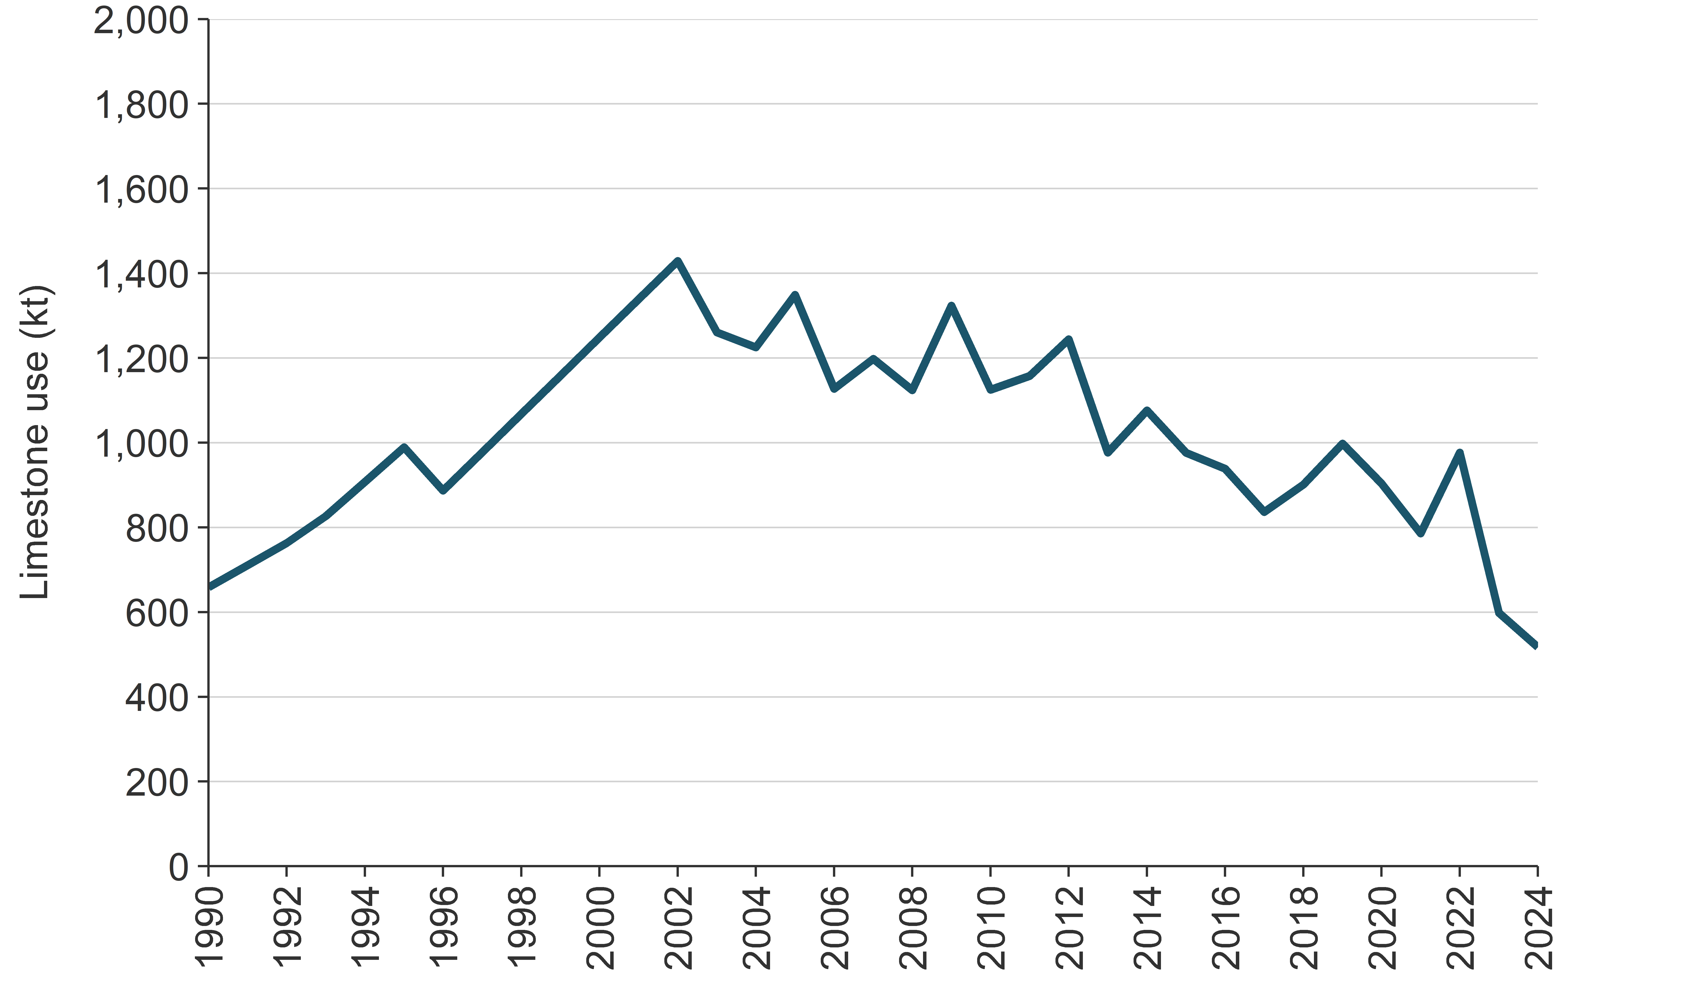
Figure 5.8.2 Dolomite usage on agricultural land in New Zealand, from 1990 to 2024
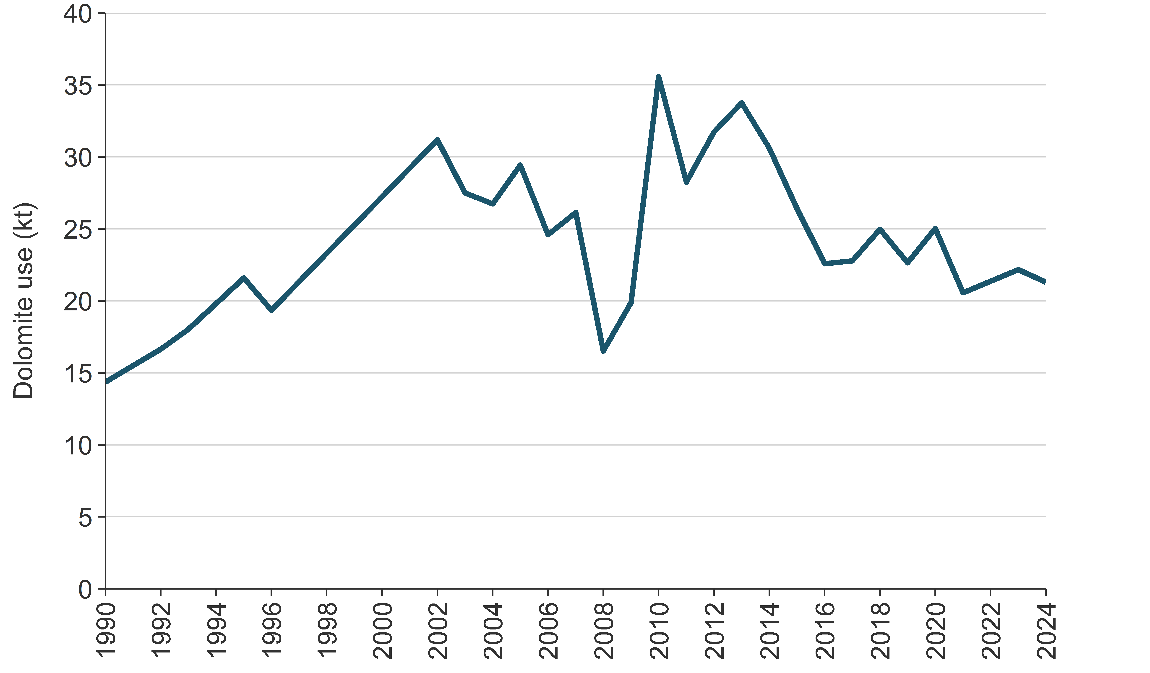

5.8.4 Uncertainty assessment and time-series consistency
Using the IPCC (2006) Tier 1 methodology, default emission factors are used, which are based on the chemical formula of lime and assume all carbon in lime is emitted as CO₂ into the atmosphere. However, the 2006 IPCC Guidelines state that the maximum available carbon is not necessarily lost and that the emissions could be up to 50 percent lower than estimated (IPCC, 2006). The uncertainty applied is the IPCC default -50 percent (IPCC, 2006). The uncertainty cannot exceed the emission factors because these values represent the absolute maximum emissions associated with liming.
The Agricultural Production Census and Agricultural Production Survey data used in the Agriculture inventory model have gaps in the time series: no data are available for 1991 or between 1997 and 2001. In the absence of other supporting data, linear interpolation has been used to estimate the data for these years.

5.8.5 Category-specific QA/QC and verification
In the preparation of this inventory, the data for Liming underwent Tier 1 quality checks. Stats NZ, the agency that collects the activity data for Liming, also carries out a series of quality-assurance and quality-control procedures as part of the data collection carried out each year.

5.8.6 Category-specific recalculations
No recalculations have been performed for CO₂ emissions from Liming in the 2025 (1990 to 2024) submission.

5.8.7 Category-specific planned improvements
New Zealand has invested in developing country-specific Tier 2 emission factors for emissions arising from lime applied to pastoral soils that can be used in the New Zealand Inventory. The New Zealand Inventory currently uses the IPCC default emission factor of 0.12 kg CO₂-C/kg CaCO₃ for lime applied to land (IPCC, 2006, chapter 11, section 11.3.2). This default assumes that 100 percent of the carbon in lime is emitted as CO₂, however, international research suggests that the actual emissions might be much lower than this estimate. Undertaking field trials that measure CO₂ emissions from lime application will deliver data on the emission factors for lime when applied to representative pastoral soils with different levels of soil carbon. This information will be analysed to develop recommendations for New Zealand-specific emission factors for lime. This work is planned to conclude in June 2027.

5.9 Urea application (3.H)

5.9.1 Category description
Urea fertiliser accounts for the majority of synthetic nitrogen fertiliser used in New Zealand. It is mainly applied to dairy pastureland to boost pasture growth during the autumn and spring months (see figure 5.5.3).
Urea application was identified as a key category for the Agriculture sector in 2024 (level and trend assessment).This section considers only the CO₂ emissions from the application of urea fertiliser onto pasture and crop land. Nitrous oxide emissions from urea are accounted for under section 5.5, Agricultural soils.
Urea application contributed an estimated 457.5 kt CO₂, representing 0.6 percent of New Zealand’s gross emissions and 1.1 percent of Agriculture emissions in 2024.
Emissions from Urea application increased 1,067.3 percent between 1990 and 2024 and 0.2 percent between 2005 and 2024. Emissions decreased by 8.6 percent (43.0 kt CO₂e) between 2023 and 2024.
Urea use peaked in 2015 and has since fallen by 24.8 percent. Since 1990, the proportion of urea fertiliser applied (relative to total synthetic nitrogen fertiliser use) increased from around 41.5 percent in 1990 to a high of 91.7 percent in 2007. In 2024, urea was 73.8 percent of all synthetic nitrogen fertiliser applied (see figure 5.5.3).

5.9.2 Methodological issues
There is no country-specific methodology on CO₂ emissions from Urea application for New Zealand. Emissions associated with the application of urea are estimated using a Tier 1 methodology (IPCC, 2006, equation 11.13), using the default emission factor for carbon conversion of 0.20.
Research into urease inhibitors (see section 5.5.2) has demonstrated they are effective in slowing down the activity of the urease enzyme that hydrolyses urea to ammonium (as reported in section 5.5.2), but urease inhibitors do not reduce the release of CO₂ (S Saggar, pers. comm., 2014).

5.9.3 Activity data
Data on the volume of synthetic nitrogen fertiliser used are provided by the Fertiliser Association of New Zealand from fertiliser company sales records from 1990 to 2023. From 1990 to 2013, data on the percentage of synthetic nitrogen fertiliser derived from urea were sourced from the International Fertilizer Industry Association online database and were used to calculate the amount of applied urea fertiliser. Since 2014, data for total nitrogen from synthetic nitrogen fertiliser derived from urea have been provided by the Fertiliser Association of New Zealand.
From 1990 to 2024, there has been over a ten-fold increase in nitrogen applied to agricultural land as urea fertiliser, from 24,586 tonnes nitrogen in 1990 to 287,000 tonnes in 2024. The use of urea fertiliser over this period has increased at a faster rate than the increase in non-urea synthetic nitrogen fertiliser. From 1990 to 2024, the nitrogen applied as non-urea synthetic nitrogen fertiliser has increased by 188.4 percent.
In more recent years, urea fertiliser use has generally trended downwards, having peaked at 381,527 tonnes of total urea in 2015. For more information on urea and nitrogen fertiliser application, see section 5.5, Agricultural soils, specifically figure 5.5.2 and figure 5.5.3.

5.9.4 Uncertainty assessment and time-series consistency
Under the IPCC (2006) Tier 1 methodology, default emission factors are used, which are based on the chemical formula of urea and assume all carbon in urea is emitted as CO₂ into the atmosphere. However, the 2006 IPCC Guidelines state that the maximum available carbon is not necessarily lost and that the emissions could be up to 50 percent lower (IPCC, 2006). This gives a lower uncertainty estimate of -50 percent and an upper uncertainty estimate of 0 percent.
Sales data for synthetic nitrogen fertiliser have been supplied for all years by the Fertiliser Association of New Zealand, but the uncertainties in this data are not known.

5.9.5 Category-specific QA/QC and verification
In the preparation of this inventory, the data for urea fertiliser underwent Tier 1 quality checks. The Fertiliser Association of New Zealand is the organisation that collects sales activity information for synthetic nitrogen fertiliser. As a part of the data collection, a series of quality-assurance and quality-control procedures are carried out each year, and this data is provided to the Internation Fertilizer Industry Association.

5.9.6 Category-specific recalculations
Besides the revision of recent (2022, 2023 and 2024) data on urea use, no recalculations have been performed for CO₂ emissions from urea in the 2026 (1990 to 2024) submission.

5.9.7 Category-specific planned improvements
New Zealand will continue to update activity data on urea as the data become available from the Fertiliser Association of New Zealand. Where possible, it will be cross referenced with data collected in the annual Stats NZ Agricultural Production Survey.

5.10 Other carbon-containing fertilisers (3.I)

5.10.1 Category description
Other carbon-containing synthetic fertilisers besides limestone, dolomite and urea (see section 5.8 and section 5.9) are not applied to agricultural land in New Zealand (T van der Weerden and C de Klein, pers. comm., 2015).

Chapter 5: References
Some references may be downloaded directly from: mpi.govt.nz/news-and-resources/statistics-and-forecasting/greenhouse-gas-reporting/agriculture-greenhouse-gas-inventory-reports.
MPI is progressively making reports used for compiling the Agriculture inventory sector available on this page, where copyright permits.
Australian Government. Unpublished. Mutual Review of Components of National Inventory Systems: A Review between Australia and New Zealand. Provided by the Australian Government in 2014.
Australian Government. 2025a. 2025 Common Reporting Table (CRT). Retrieved 11 December 2025.
Australian Government, Department of Climate Change, Energy, the Environment and Water. 2025b. National Inventory Report 2023, Volume I. The Australian Government Submission to the United Nations Framework Convention on Climate Change Australian National Greenhouse Accounts. Retrieved 18 February 2026.
Beare M, Thomas S, Clemens G, Hernandez-Ramirez G. 2012. Contributions of Pasture Renewal and N Mineralisation to N₂O Emissions from Pastoral Farming Systems. Report prepared for the Ministry for Primary Industries by Plant and Food Research. Wellington: Ministry for Primary Industries.
Beef + Lamb New Zealand Ltd. 2025. New Season Outlook 2025–26. Wellington: Beef + Lamb New Zealand Ltd. Retrieved 16 December 2025.
Bown MD, Thomson BC, Muir PD. 2013. Evaluation of the Values for Pasture ME and N Content used in the National Greenhouse Gas Inventory. Report prepared for the Ministry for Primary Industries by On-Farm Research. Wellington: Ministry for Primary Industries.
Burggraaf V, Benson C, Rollo M. 2022. Dairy Cattle Population Model: Improving estimates of within-year population changes used in the inventory. Report prepared for the Ministry for Primary Industries. Wellington: Ministry for Primary Industries.
Burggraaf V, Rollo M, de Klein CAM, Lio, J. 2019. A Review of Greenhouse Gas Emissions Inventory Methodology for Farmed Goats in New Zealand. Report prepared for the Ministry for Primary Industries by AgResearch. Wellington: Ministry for Primary Industries.
Cameron K, Di H. Unpublished. Report to the MPI Agricultural Inventory Advisory Panel on EcoPond Generation#2 Results. Report prepared for the Ministry for Primary Industries by Lincoln University in 2025.
Cameron KC, Di HJ. 2021. Discovery of a new method to reduce methane emissions from farm dairy effluent. Journal of Soils and Sediments 21: 3543–3555.
Carran RA, Dewar D, Theobald PW. 2003. Methane and Nitrous Oxide Emissions from Sheep Dung. Report prepared for the Ministry of Agriculture and Forestry by the New Zealand Pastoral Agricultural Research Institute. Wellington: Ministry for Primary Industries.
Carran RA, Theobald PW, Evans JP. 1995. Emissions of nitrous oxide from some grazed pasture soils in New Zealand. Australian Journal of Soil Research 33: 341–352.
Chen D, Li Y, Kelly K, Eckard R. 2010. Simulation of N₂O emissions from an irrigated dairy pasture treated with urea and urine in Southeastern Australia. Agriculture, Ecosystems & Environment
136(3–4): 333–342.
Cichota R, Brown H, Snow VO, Wheeler DM, Hedderley D, Zyskowski R, Thomas S. 2010. A nitrogen balance model for environmental accountability in cropping systems. New Zealand Journal of Crop and Horticultural Science 38: 189–207.
Clark H, Brookes I, Walcroft A. 2003. Enteric Methane Emissions from New Zealand Ruminants
1990–2001 Calculated Using an IPCC Tier 2 Approach. Report prepared for the Ministry of Agriculture and Forestry by AgResearch and Massey University. Wellington: Ministry of Agriculture and Forestry.
Clark H. 2008a. A Comparison of Greenhouse Gas Emissions from the New Zealand Dairy Sector Calculated Using either a National or a Regional Approach. Report prepared for the Ministry of Agriculture and Forestry by AgResearch. Wellington: Ministry of Agriculture and Forestry.
Clark H. 2008b. Guidelines to Accompany Computerised Inventory. Report prepared for the Ministry of Agriculture and Forestry by AgResearch. Wellington: Ministry of Agriculture and Forestry.
Clough T, Cameron K, Di H. Unpublished. The Case for Including EcoPond® Generation#2 in the New Zealand Greenhouse Gas Inventory as a Methane Mitigation Tool for Dairy Cattle Manure Management. Report prepared for the Ministry for Primary Industries by Lincoln University in 2024.
Clough TJ, Kelliher FM, Clark H, van der Weerden TJ. 2011. Incorporation of the Nitrification Inhibitor DCD into New Zealand’s 2009 National Inventory. Report prepared for the Ministry of Agriculture and Forestry by Lincoln University and AgResearch. Wellington: Ministry of Agriculture and Forestry.
Clough TJ, Kelliher FM. 2014. Literature Review of EF5. Report prepared for the Ministry for Primary Industries by Lincoln University. Wellington: Ministry for Primary Industries.
CSIRO. 1990. Ruminants: Feeding Standards for Australian Livestock. Victoria, Australia: Commonwealth Scientific and Industrial Research Organisation.
CSIRO. 2007. Nutrient Requirements of Domesticated Ruminants. Victoria, Australia: Australian Agricultural Council, Ruminants Sub Committee.
Dairy Companies Association of New Zealand. 2024. Latest New Zealand Milk Production Data Report. Retrieved from dcanz.com (13 December 2024).
DataGene Limited. 2024. Australian Dairy Herd Improvement Report 2024. Melbourne: DataGene Limited. Retrieved 11 December 2025.
de Klein CAM, Barton L, Sherlock RR, Li Z, Littlejohn RP. 2003. Estimating a nitrous oxide emission factor for animal urine from some New Zealand pastoral soils. Australian Journal of Soil Research 41: 381–399.
de Klein CAM, Luo J, Woodward KB, Styles T, Wise B, Lindsey S, Cox N. 2014. The effect of nitrogen concentration in synthetic cattle urine on nitrous oxide emissions. Agriculture Ecosystems & Environment 188: 8–92.
Dresser M, Hewitt A, Willoughby J, Bellis S. 2011. Area of Organic Soils. Report prepared for the Ministry of Agriculture and Forestry by Landcare Research. Wellington: Ministry of Agriculture and Forestry.
Earth Sciences New Zealand. Regional climatologies. Retrieved 15 February 2026.
Fertiliser Association of New Zealand. 2018. About. Retrieved 15 January 2026.
Fick J. 2010. Emission Estimations for the Commercial Chicken, Non-chicken and Layer Industries within New Zealand. Report prepared for the Ministry of Agriculture and Forestry by the Poultry Industry Association and Egg Producers Federation of New Zealand. Wellington: Ministry of Agriculture and Forestry.
Fick J, Saggar S, Hill J, Giltrap D. 2012. Poultry Management in New Zealand: Production, Manure Management and Emissions Estimations for the Commercial Chicken, Turkey, Duck and Layer Industries within New Zealand. Report prepared for the Ministry of Agriculture and Forestry by Poultry Industry Association, Egg Producers Association, Landcare Research and Massey University. Wellington: Ministry of Agriculture and Forestry.
Galbally I, Meyer C, Bentley S, Weeks I, Leuning R, Kelly K, Phillips F, Barker-Reid F, Gates W, Baigent R, Eckard R, Grace P. 2005. A study of environmental and management drivers of non-CO₂ greenhouse gas emissions in Australian agroecosystems. Environmental Sciences 2(2­3): 133–142.
Gebremichael A.W., Rahman N., Krol D.J., Forrestal P.J., Lanigan G.J., Richards K.G. 2021. Ammonium-based compound fertilisers mitigate nitrous oxide emissions in temperate grassland. Agronomy 11, 1712.
Giltrap D, McNeill S, Vickers S. 2016. Development of infrastructure to calculate agricultural greenhouse gas inventory emissions uncertainty in-house. Report prepared for the Ministry for Primary Industries by Landcare Research and RSV Consulting Ltd. Wellington: Ministry for Primary Industries.
Giltrap D, McNeill S. 2020. Revised Pasture Quality Analysis in the Agricultural Greenhouse Gas Inventory. Report prepared for the Ministry for Primary Industries by Manaaki Whenua – Landcare Research. Wellington: Ministry for Primary Industries.
Grainger C, Clarke T, McGinn SM, Auldist MJ, Beauchemin KA, Hannah MC, Waghorn GC, Clark H, Eckard RJ. 2007. Methane emissions from dairy cows measured with sulphur hexafluoride (SF6) tracer and chamber techniques. Journal of Dairy Science 90(6): 2755–2766.
Habtewold J, Gordon R, Sokolov V, VanderZaag A, Wagner-Riddle C, Dunfield K. 2018. Targeting bacteria and methanogens to understand the role of residual slurry as an inoculant in stored liquid dairy manure. Appl Environ Microbiology 84:e02830-17.

Henderson H, Cameron C. 2010. Review of the Methodology for Alpaca Population Estimations Used in the National Greenhouse Gas Inventory. Report prepared for the Ministry for Primary Industries. Wellington: Ministry for Primary Industries.
Hill J. 2012. Recalculate Pork Industry Emissions Inventory. Report prepared for the Ministry of Agriculture and Forestry by Massey University and the New Zealand Pork Industry Board. Wellington: Ministry of Agriculture and Forestry.
Hoogendoorn CJ, de Klein CAM, Rutherford AJ, Letica S, Devantier BP. 2008. The effect of increasing rates of nitrogen fertiliser and a nitrification inhibitor on the nitrous oxide emissions from urine patches on sheep grazed hill country pasture. Australian Journal of Experimental Agriculture 48(2): 147–151.
Hoogendoorn CJ, Luo J, van der Weerden T, Saggar S, Wise B, Lloyd-West C, Judge A. 2013. Evaluation of beef cattle excreta nitrous oxide emission factors. Report prepared for the Ministry for Primary Industries by AgResearch in 2013. Wellington: Ministry for Primary Industries.
IPCC. 1996. Houghton JT, Meira Filho LG, Lim B, Treanton K, Mamaty I, Bonduki Y, Griggs DJ, Callender BA (eds). IPCC/OECD/IEA. Revised 1996 IPCC Guidelines for National Greenhouse Gas Inventories. Bracknell: United Kingdom Meteorological Office.
IPCC. 2000. Penman J, Kruger D, Galbally I, Hiraishi T, Nyenzi B, Emmanuel S, Buendia L, Hoppaus R, Martinsen T, Meijer J, Miwa K, Tanabe K (eds). Good Practice Guidance and Uncertainty Management in National Greenhouse Gas Inventories. IPCC National Greenhouse Gas Inventories Programme. Published for the IPCC by the Institute for Global Environmental Strategies: Japan.
IPCC. 2006. Eggleston HS, Buendia L, Miwa K, Ngara T, Tanabe K (eds). 2006 IPCC Guidelines for National Greenhouse Gas Inventories. Volume 4. Agriculture, Forestry and Other Land Use. IPCC National Greenhouse Gas Inventories Programme. Published for the IPCC by the Institute for Global Environmental Strategies: Japan.
IPCC. 2013. Stocker TF, Qin D, Plattner G-K, Tignor M, Allen SK, Boschung J, Nauels A, Xia Y, Bex V, Midgley PM (eds). Climate Change 2013: The Physical Science Basis. Contribution of Working Group I to the Fifth Assessment Report of the Intergovernmental Panel on Climate Change. Cambridge: Cambridge University Press.
IPCC. 2014. Hiraishi T, Krug T, Tanabe K, Srivastava N, Baasansuren J, Fukuda M, Troxler TG (eds). 2013 Supplement to the 2006 IPCC Guidelines for National Greenhouse Gas Inventories: Wetlands. Switzerland: IPCC.
IPCC. 2019. Calvo Buendia E, Tanabe K, Kranjc A, Baasansuren J, Fukuda M, Ngarize S, Osako A, Pyrozhenko Y, Shermanau P, Federici S (eds). 2019 Refinement to the 2006 IPCC Guidelines for National Greenhouse Gas Inventories. Switzerland: IPCC.
Kelliher FM, Clark H, Smith MH, Lassey KR, Sedcole R. 2009. Reducing Uncertainty of the Enteric Methane Emissions Inventory. Report prepared for the Ministry of Agriculture and Forestry by Lincoln University, National Institute of Water and Atmospheric Research and AgResearch. Wellington: Ministry of Agriculture and Forestry.
Kelliher FM, Cox N, van der Weerden TJ, de Klein CAM, Luo J, Cameron KC, Di HJ, Giltrap D, Rys G. 2014. Statistical analysis of nitrous oxide emission factors from pastoral agriculture field trials conducted in New Zealand. Environmental Pollution 186: 63–66.
Kelliher FM, de Klein CAM. 2006. Review of New Zealand’s Fertiliser Nitrous Oxide Emission Factor (EF1) Data. Report prepared for the Ministry for the Environment by Landcare Research and AgResearch. Wellington: Ministry for Primary Industries.
Kelliher FM, Henderson H and Cox N. 2017. The uncertainty of nitrous oxide emissions from grazed grasslands: A New Zealand case study. Atmospheric Environment 148: 329–336.
Kuikman PJ, van der Hoek KW, Smit A, Zwart K. 2006. Update of emission factors for nitrous oxide from agricultural soils on the basis of measurements in the Netherlands. Alterra Report 1217. Wageningen, The Netherlands: Alterra.
Lassey K. 2012. Methane Emissions and Nitrogen Excretion Rates for New Zealand Goats. Report for the Ministry of Agriculture and Forestry, National Institute of Water and Atmospheric Research. Wellington: National Institute of Water and Atmospheric Research.
Lassey KR, Ulyatt MJ, Martin RJ, Walker CF, Shelton ID. 1997. Methane emissions measured directly from grazing livestock in New Zealand. Atmospheric Environment 31: 2905–2914.
Laubach J, Grover SPP, Taghizadeh-Toosi A, Sherlock RR, Gibbs J, Kelliher FM. 2012. Ammonia from Animal Excreta. Report prepared for the Ministry for Primary Industries by Landcare Research. Wellington: Ministry for Primary Industries.
Laubach J, Kelliher FM. 2004. Measuring methane emission rates of a dairy cow herd by two micrometeorological techniques. Agricultural and Forest Meteorology 125: 279–303.
Ledgard SF, Luo J, Sprosen MS, Wyatt J, Balvert S, Lindsey S. 2014. Effects of the nitrification inhibitor dicyandiamide (DCD) on pasture production, nitrous oxide emissions and nitrate leaching in Waikato, New Zealand. New Zealand Journal of Agricultural Research 57(4): 294–315.
LIC (Livestock Improvement Corporation Limited) and DairyNZ. 2025. New Zealand Dairy Statistics
2024–25. Hamilton: DairyNZ. Retrieved 17 December 2025.
LIC. 2009. 100 Years of Herd Testing. Hamilton: Livestock Improvement Corporation Limited. Retrieved 5 January 2022.
Luo J, Hoogendoorn C, van der Weerden T, Saggar S, de Klein C, Giltrap D. 2016. Nitrous oxide emission factors for animal excreta deposited on hill country steep slopes. Report prepared for the Ministry for Primary Industries by AgResearch Ltd. Wellington: Ministry for Primary Industries.
Luo J, Hoogendoorn C, van der Weerden TJ, Saggar S, de Klein CAM, Giltrap D, Rollo M, Rys G. 2013. Nitrous oxide emissions from grazed hill land in New Zealand. Agriculture Ecosystems & Environment 181: 58–68.
Luo J, Joyce E, Ouyang L, Longhurst B, Grala T, Lei Q, Judge A, Rollo M. Unpublished(a). Manure Management Systems – Final report. Report prepared for the Ministry for Primary Industries by AgResearch Ltd in 2025.
Luo J, Saggar S, van der Weerden T, de Klein C. 2019. Quantification of nitrous oxide emissions and emission factors from beef and dairy cattle excreta deposited on grazed pastoral hill lands. Agriculture, Ecosystems & Environment 270–271: 103–113.
Luo J, van der Weerden T, Saggar S, Di H, Lindsey S, Ouyang L, Luo D. 2023. N₂O emission factors EF1 for fertilisers. Report prepared for the Ministry for Primary Industries by AgResearch Ltd. Wellington: Ministry for Primary Industries.
Luo J, Lindsey S, van der Weerden T. Unpublished(b). N₂O emissions from nitrogen fertilisers – Final report for EF₁ relativity trial. Report prepared for the Ministry for Primary Industries by AgResearch Ltd in 2021.
Luo J, van der Weerden T, Saggar S, Di H, Podolyan A, Lindsey S, Ouyang L, Luo D, Berben P, Srey F, Palmada T. Unpublished(c). N₂O emission factors (EF₁) for fertilisers – Autumn 2024 EF₁ trial. Report prepared for the Ministry for Primary Industries by AgResearch Ltd in 2024.
Marsden KA, Holmberg JA, Jones DL, Chadwick DR. 2018. Sheep urine patch N₂O emissions are lower from extensively-managed than intensively-managed grasslands. Agriculture Ecosystems & Environment 265: 264–274.
Ministry for the Environment. 2024. New Zealand’s first Biennial Transparency Report under the Paris Agreement. Wellington: Ministry for the Environment. Retrieved 6 January 2025.
MPI (Ministry for Primary Industries). 2025a. Data. Retrieved 26 January 2026.
MPI. 2025b. Situation and Outlook for Primary Industries (SOPI) December 2025. Retrieved 16 December 2025.
Muir PD, Thomson BC, Askin DC. 2008. A Review of Dressing Out Percentage in New Zealand Livestock. Report prepared for the Ministry of Agriculture and Forestry by On-Farm Research and Kilu Consulting. Wellington: Ministry of Agriculture and Forestry.
Muir PD, Thomson BC. 2011. Better Estimation of National Ewe and Beef Cow Liveweights. Report prepared for the Ministry of Agriculture and Forestry by On-Farm Research. Wellington: Ministry of Agriculture and Forestry.
Muller C, Sherlock RR, Williams PH. 1995. Direct field measurements of nitrous oxide emissions from urine-affected and urine-unaffected pasture in Canterbury. In: Proceedings of the Workshop on Fertilizer Requirements of Grazed Pasture and Field Crops: Macro and Micronutrients. Currie LD, Loganathan P (eds). Occasional Report No. 8. Palmerston North: Massey University. pp 243–34.
Pacheco D, Waghorn G, Rollo M. 2018. Methodology for Splitting Nitrogen between Livestock Dung and Urine. Report prepared for the Ministry for Primary Industries by AgResearch. Wellington: Ministry for Primary Industries.
Pickering A, Gibbs J, Wear S, Fick J, Tomlin H. 2026. Methodology for Calculation of New Zealand’s Agricultural Greenhouse Gas Emissions. Version 12. Wellington: Ministry for Primary Industries.
Pinares-Patino CS, Ulyatt MJ, Waghorn GC, Lassey KR, Barry TN, Holmes CW, Johnson DE. 2003. Methane emission by alpaca and sheep fed on lucerne hay or grazed on pastures of perennial ryegrass/white clover or birdsfoot trefoil. Journal of Agricultural Science 140: 215–226.
Pratt C, Walcroft A, Shilton A, Guieysse B, Chung M, Craggs R, Heubeck S. 2012. Revised Methane Emission Factors and Parameters for Dairy Effluent Ponds. Report prepared for the Ministry for Primary Industries by Landcare Research, Massey University and the National Institute of Water and Atmospheric Research. Wellington: Ministry for Primary Industries.
Pronger J, Glover-Clark G, Price R, Campbell D, Schipper L. 2022. Improving accounting of emissions from drained Organic Soils. Report prepared for the Ministry for Primary Industries by Manaaki Whenua – Landcare Research. Wellington: Ministry for Primary Industries.
Ritchie H. 2024. Updating emissions calculations for pigs in the New Zealand Greenhouse Gas Inventory Report. Report prepared for the Ministry for Primary Industries by NZ Pork. Wellington: Ministry for Primary Industries.
Rollo M, Ledgard S, Longhurst B. 2017. Final Report: Trends in Dairy Effluent Management. Report prepared for the Ministry for Primary Industries by AgResearch. Wellington: Ministry for Primary Industries.
Saggar S, Clark H, Hedley C, Tate K, Carran A, Cosgrove G. 2003. Methane emissions from animal dung and waste management systems, and its contribution to the national methane budget. Prepared for the Ministry of Agriculture and Forestry by Landcare Research. Wellington: Ministry for Primary Industries.
Saggar S, Giltrap DL, Davison R, Gibson R, de Klein C, Rollo M, Ettema P, Rys G. 2015. Estimating direct N₂O emissions from sheep, beef, and deer grazed pastures in New Zealand hill country: Accounting for the effect of land slope on the N₂O emission factors from urine and dung. Agriculture Ecosystems & Environment 205: 70–78.
Saggar S, Singh J, Giltrap DL, Zaman M, Luo J, Rollo M, Kim D-G, Rys G, van der Weerden TJ. 2013. Quantification of reductions in ammonia emissions from fertiliser urea and animal urine in grazed pastures with urease inhibitors for Agriculture inventory: New Zealand as a case study. Science of the Total Environment 465: 136–146.
Sherlock RR, de Klein C, Li Z. 2003. Determination of the N₂O and CH₄ emission factors from animal excreta, following a summer application in 3 regions of New Zealand. A final report of an NzOnet study prepared for the Ministry of Agriculture and Forestry by Landcare Research, AgResearch and Lincoln University in 2003. Wellington: Ministry of Agriculture and Forestry.
Sherlock RR, Jewell P, Clough T. 2011. Review of New Zealand Specific Frac_{GASM} and Frac_{GASF} Emissions Factors. Report prepared for the Ministry of Agriculture and Forestry by Landcare Research and AgResearch. Wellington: Ministry of Agriculture and Forestry.
Sise J. 2023. Minor animal categories. Report prepared for the Ministry for Primary Industries by AbacusBio. Wellington: Ministry for Primary Industries.
Stats NZ. 2021. Fertilisers – nitrogen and phosphorus. Retrieved 12 January 2024.
Stats NZ. 2023. Agricultural production statistics: Year to June 2022 (final). Retrieved 21 January 2026.
Stats NZ. 2025. Agricultural production statistics: Year to June 2024 (final). Retrieved 16 December 2025.
Stevens D, Rollo M, Vibart R, Chrystal J, Speirs B, Davison R, Burtt A. 2022. Sheep and Cattle Birth and Slaughter Dates. Final report prepared for the Ministry for Primary Industries. Wellington: Ministry for Primary Industries.
Stevens D, Ward J. 2023. Splitting Emissions Intensity Values between Venison and Velvet Antler in the Deer Industry. Report prepared for the Ministry for Primary Industries by AgResearch. Wellington: Ministry for Primary Industries.
Suttie J. 2012. Report to the Deer Industry New Zealand: Estimation of Deer Population and Productivity Data 1990 to 2012. Dunedin: Suttie Consulting Limited.
Swainson N, Muetzel S, Clark H. 2016. Updated predictions of enteric methane emissions from sheep suitable for use in the New Zealand national greenhouse gas inventory. Animal Production Science 58: 973–979. Retrieved 5 January 2022.
Thomas S, Fraser T, Curtin D, Brown H, Lawrence E. 2011. Review of Nitrous Oxide Emission Factors and Activity Data for Crops. Report prepared for the Ministry of Agriculture and Forestry by Plant and Food Research. Wellington: Ministry of Agriculture and Forestry.
Thomas S, Gentile R, Wakelin SJ, Dias de Olivera E, McNally S, Paul T, Gee M. Unpublished. Quantifying greenhouse gas emissions from New Zealand cropping systems. Report prepared for the Ministry for Primary Industries by Plant and Food Research in 2025. Wellington: Ministry for Primary Industries.
Thomas S, Hume E, Fraser T, Curtin D. 2012. Factors and Activity Data to Estimate Nitrous Oxide Emissions from Cropping Systems, and Stubble and Tussock Burning. Report prepared for the Ministry of Agriculture and Forestry by Plant and Food Research (formerly Crop and Food Research). Wellington: Ministry of Agriculture and Forestry.
Thomas S, Wallace D, Beare M. 2014. Pasture Renewal Activity Data and Factors for New Zealand. Report prepared for the Ministry for Primary Industries by Plant and Food Research. Wellington: Ministry for Primary Industries.
Thomas SM, Ledgard SF, Francis GS. 2005. Improving estimates of nitrate leaching for quantifying New Zealand’s indirect nitrous oxide emissions. Nutrient Cycling in Agroecosystems 73: 213–226.
Thomas T. 2010. Assessment of the methodology of potato area and yield activity estimations used in the NZ national GHG inventory. Report prepared for the Ministry of Agriculture and Forestry by Plant and Food Research in 2010. Wellington: Ministry of Agriculture and Forestry.
Thomson BC, Muir PD, Davison R, Clark H. 2010. Review of Population Models within the National Methane Inventory (2010). Technical paper prepared for the Ministry of Agriculture and Forestry by On‑Farm Research (with cooperation by Meat and Wool New Zealand and AgResearch Ltd). Wellington: Ministry of Agriculture and Forestry.
Thomson BC, Ward KR, Muir PD. 2021. Purity of agricultural lime and dolomite used in New Zealand. Final report prepared for the Ministry for Primary Industries. Wellington: Ministry for Primary Industries.
Ulyatt MJ, Baker SK, McCrabb GJ, Lassey KR. 1999. Accuracy of the SF6 tracer technology and alternatives for field measurements. Australian Journal of Agricultural Research 50: 1329–1334.
van der Weerden T, Cox N, Luo J, Di HJ, Podolyan A, Phillips RL, Saggar S, de Klein CAM, Ettema P, Rys G. 2016a. Refining the New Zealand nitrous oxide emission factor for urea fertiliser and farm dairy effluent. Agriculture Ecosystems & Environment 222: 133–137.
van der Weerden T, Luo J, Cox N, Di HJ, Podolyan A, Phillips RL, Saggar S, de Klein CA, Ettema P, Rys G. 2016b. Nitrous oxide emissions from urea fertiliser and effluent with and without inhibitors applied to pasture. Agriculture Ecosystems & Environment 219: 58–70.
van der Weerden T, Noble A, Giltrap D, Luo S, Saggar S. 2019. Meta-analysis of nitrous oxide emission factors for excreta deposited onto pasture: Final report. Report prepared for the Ministry for Primary Industries by AgResearch in 2019. Wellington: Ministry for Primary Industries.
van der Weerden TJ, Luo J, de Klein CA, Hoogendoorn CJ, Littlejohn RP, Rys GJ. 2011. Disaggregating nitrous oxide emission factors for ruminant urine and dung deposited onto pastoral soils. Agriculture Ecosystems & Environment 141(3–4): 426–436.
van der Weerden TJ, Noble AN, Luo J, de Klein CAM, Saggar S, Giltrap D, Gibbs J, Rys G. 2020. Meta-analysis of New Zealand’s nitrous oxide emission factors for ruminant excreta supports disaggregation based on excreta form, livestock type and slope class. Science of The Total Environment 732.
van der Weerden T, Rutherford A. 2024. Nitrous oxide emissions from non-manure organic amendments to soils. Report prepared for the Ministry for Primary Industries by AgResearch. Wellington: Ministry for Primary Industries.
Waghorn G, Molano G, Cavanagh A. 2003a. An estimate of whole herd methane production from cows at the Lincoln University dairy farm in October 2003. Prepared for the Ministry for Primary Industries. Wellington: Ministry for Primary Industries.
Waghorn G, Molano G, Lassey K. 2003b. Estimates of whole herd methane production from cows at the Lincoln University dairy farm in January and March 2002. Prepared for the Ministry for Primary Industries. Wellington: Ministry for Primary Industries.
Welten B, Mercer G, Smith C, Sprosen M, Ledgard S. 2021. Refining estimates of nitrogen leaching for the New Zealand agricultural greenhouse gas inventory. Report prepared for the Ministry for Primary Industries.
Wheeler DM, Ledgard SF, de Klein CAM, Monaghan PL, Carey PL, McDowell RW, Johns KL. 2003. OVERSEER® Nutrient budgets – moving towards on-farm resource accounting. In: Proceedings of the New Zealand Grassland Association 2003. Palmerston North: New Zealand Grassland Association Inc.

Chapter 6: Land Use, Land-Use Change and Forestry (LULUCF)
This chapter reports New Zealand’s emissions and removals from the Land Use, Land-Use Change and Forestry (LULUCF) sector using the methods and guidance described in the 2006 Intergovernmental Panel on Climate Change (IPCC) Guidelines for National Greenhouse Gas Inventories (2006 IPCC Guidelines) (volume 4, Agriculture, Forestry and Other Land Use) (IPCC, 2006a). For information on how New Zealand accounts for the contribution of the LULUCF sector towards its Nationally Determined Contribution under the Paris Agreement, see volume 2, annex 9.

6.1 Sector overview

Net emissions summary

2024
In 2024, net emissions from the LULUCF sector were -20,977.5 kilotonnes carbon dioxide equivalent (kt CO₂e) or -27.7 percent of New Zealand’s gross greenhouse gas emissions. This comprises net emissions of -21,217.6 kt CO₂, and emissions of 49.2 kt CO₂e of methane (CH₄) and 191.0 kt CO₂e of nitrous oxide (N₂O). The category contributing the most to both removals and emissions is Forest land remaining forest land. This is because large removals result from the growth of all forests on this land while there are also large emissions from the sustainable harvest of New Zealand’s plantation forests.

2023–2024
Net emissions from the LULUCF sector decreased between 2023 and 2024 by 1,011.0 kt CO₂e (5.1 percent) (table 6.1.1). The largest difference was seen in the Grassland category, with a decrease in emissions of 827.1 kt CO₂e, driven by less deforestation in 2024 compared with 2023 (figure 6.4.4). Forest land had the second-largest difference, with a decrease in net emissions of 701.2 kt CO2e, mainly driven by increasing removals in Land converted to Forest land due to increasing growth rates in forests planted from 2019 onwards. The Harvested wood products category had the third-largest difference, with an increase in emissions of 480.5 kt CO₂e due to losses from decay being greater than inputs due to harvest stabilising between 2023 and 2024.
Table 6.1.1 New Zealand’s greenhouse gas net emissions for the LULUCF sector by land use category in 2023 and 2024
 | (kt CO₂e) |  | Difference (kt CO₂e) | Change (%)
Category | 2023 | 2024 | 2023–2024 | 2023–2024
Forest land | -17,910.3 | -18,611.5 | -701.2 | -3.9
Cropland | 539.4 | 580.0 | 40.6 | 7.5
Grassland | 3,014.0 | 2,186.9 | -827.1 | -27.4
Wetlands | 6.4 | 5.8 | -0.6 | -9.0
Settlements | 115.8 | 115.2 | -0.7 | -0.6
Other land | 76.9 | 74.3 | -2.6 | -3.4
Harvested wood products | -5,808.7 | -5,328.1 | 480.5 | 8.3
Total LULUCF | -19,966.5 | -20,977.5 | -1,011.0 | -5.1

2005–2024
In 2024, net emissions had increased by 2,161.3 kt CO₂e (9.3 percent) from 2005 levels (table 6.1.2). The largest difference was seen in the Forest land category, with an increase in emissions of 14,244.3 kt CO₂e, because a larger proportion of planted forests were harvested in 2024 compared with 2005 levels (see figure 6.4.3). The Grassland category had the second-largest difference, with a decrease in emissions of 11,174.7 kt CO₂e driven by a reduction in conversions from Forest land. The Harvested wood products category had the third-largest difference, with a reduction in emissions of 771.1 kt CO₂e. This was driven by an increase in the inputs to the harvested wood products pool following the increased planted forest harvest.
Table 6.1.2 New Zealand’s greenhouse gas net emissions for the LULUCF sector by category in 2005 and 2024
 | (kt CO₂e) |  | Difference (kt CO₂e) | Change (%)
Category | 2005 | 2024 | 2005–2024 | 2005–2024
Forest land | -32,855.8 | -18,611.5 | 14,244.3 | 43.4
Cropland | 576.1 | 580.0 | 3.9 | 0.7
Grassland | 13,361.6 | 2,186.9 | -11,174.7 | -83.6
Wetlands | 20.3 | 5.8 | -14.4 | -71.3
Settlements | 203.4 | 115.2 | -88.2 | -43.4
Other land | 112.7 | 74.3 | -38.4 | -34.1
Harvested wood products | -4,557.0 | -5,328.1 | -771.1 | -16.9
Total LULUCF | -23,138.8 | -20,977.5 | 2,161.3 | 9.3

1990–2024
In 2024, net emissions had increased by 2,357.0 kt CO₂e (10.1 percent) from 1990 levels of
-23,334.5 kt CO₂e (table 6.1.3 and figure 6.1.1). This is largely due to an overall reduction in net removals from Forest land compared with 1990 levels. The reduction in net removals from Forest land was driven by relatively high harvest rates (figure 6.4.3), which are a result of significant afforestation beginning in the 1980s and reaching a peak in the mid-1990s (figure 6.4.1). The planted forests that were established during this period have progressively been reaching harvesting age, so while the total area of forest has increased since 1990, a larger proportion of planted forests were harvested in 2024 compared with 1990 levels. Harvesting and replanting cycles of New Zealand’s planted forests will continue to affect the trajectory of New Zealand’s net emissions in the future due to their uneven age-class profile. The increase in emissions is compensated for, to some extent, by a reduction in net emissions in Harvested wood products. Carbon losses in Forest land due to the harvest of timber are transferred to Harvested wood products, where the carbon is treated as a gain and its decay and emissions to atmosphere are estimated based on product type. The net fluxes in Harvested wood products therefore represent the balance between the inputs transferred into the pool and the outputs leaving the pool from decay or disposal over time.
Table 6.1.3 New Zealand’s greenhouse gas net emissions for the LULUCF sector by category
in 1990 and 2024
 | Net emissions (kt CO₂e) |  | Difference (kt CO₂e) | Change (%)
Category | 1990 | 2024 | 1990–2024 | 1990–2024
Forest land | -23,400.1 | -18,611.5 | 4,788.6 | 20.5
Cropland | 436.8 | 580.0 | 143.2 | 32.8
Grassland | 1,990.1 | 2,186.9 | 196.7 | 9.9
Wetlands | -8.1 | 5.8 | 14.0 | 171.6
Settlements | 69.8 | 115.2 | 45.4 | 65.0
Other land | 14.7 | 74.3 | 59.6 | 405.4
Harvested wood products | -2,437.8 | -5,328.1 | -2,890.4 | -118.6
Total LULUCF | -23,334.5 | -20,977.5 | 2,357.0 | 10.1
Notes: Net emissions are expressed as a negative value in the table to help the reader in clarifying that the value is a removal (of carbon dioxide from the atmosphere) and not an emission. Columns may not total due to rounding. Percentages presented are calculated from unrounded values.
Figure 6.1.1 New Zealand’s annual net emissions from the LULUCF sector from 1990 to 2024
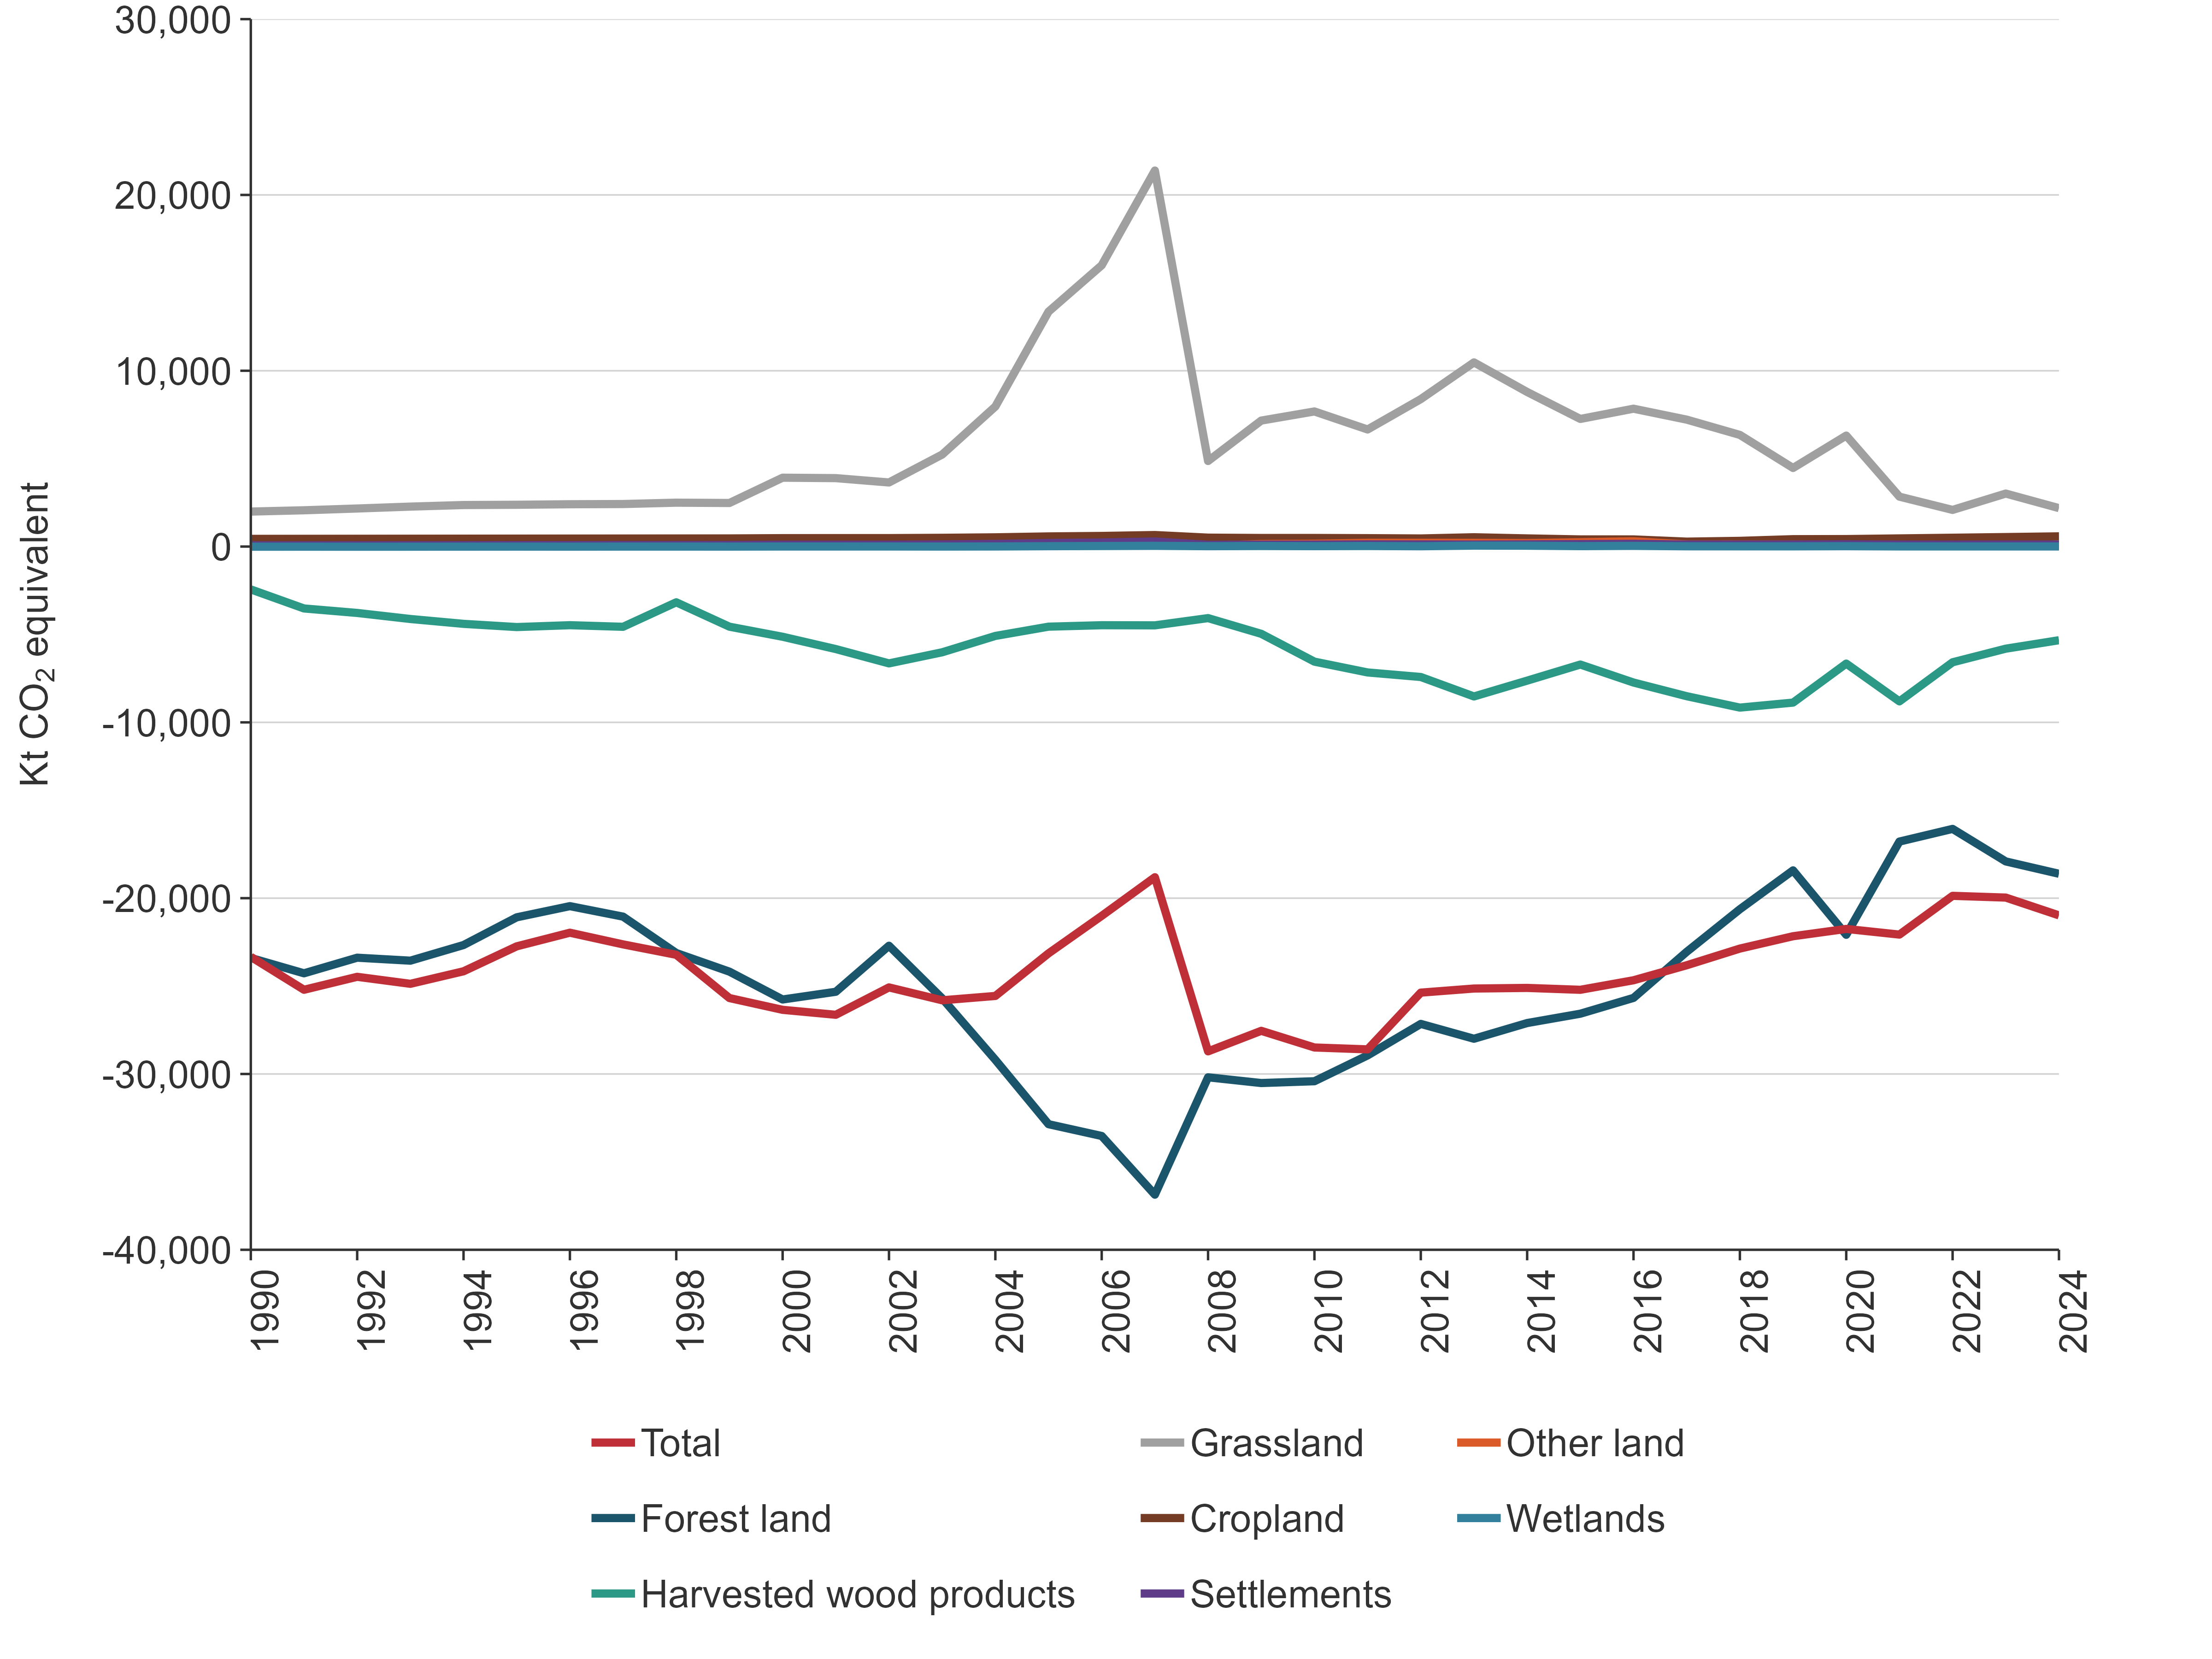
Emissions in the LULUCF sector are primarily driven by the harvest of production forests, deforestation, and the decomposition of organic material following these activities. Removals are mainly from the sequestration of carbon that occurs due to plant growth and the production of harvested wood products. Nitrous oxide can be emitted from the ecosystem as a by-product of nitrification and de-nitrification, and the burning of organic matter. Other gases released during biomass burning include CH₄, carbon monoxide (CO), other oxides of nitrogen (NO_{x}) and non-methane volatile organic compounds.

6.1.1 National circumstances
New Zealand has a land area of nearly 270,000 square kilometres with extensive coastlines (approximately 19,800 kilometres). This land mass is made up of two main islands, the North Island and the South Island, as well as smaller outlying islands. New Zealand has a temperate climate, highly influenced by the surrounding ocean. Around 60 percent of the land is hilly or mountainous, with around 425,000 kilometres of rivers and streams, and almost 4,000 lakes that are larger than 1 hectare (Ministry for the Environment and Stats NZ, 2017).
Since 1990, approximately 11.5 percent of New Zealand’s total land area has undergone land-use change. Before human settlement, natural forests were New Zealand’s predominant land cover, estimated at 85 percent to 90 percent of total land area (McGlone, 2009). Natural forest now covers approximately 29 percent of New Zealand’s total land area, having been replaced predominantly by agricultural land uses (Ewers et al., 2006). Demand for productive land has also led to the modification of a large proportion of New Zealand’s vegetated wetland areas to pastoral land cover. Just over 10 percent of the wetlands present across New Zealand before European settlement now remain (McGlone, 2009). For a summary of land use area in 2024 in New Zealand, see table 6.1.4.
New Zealand forests are either held on privately owned land or in public conservation land (an area of approximately 8.5 million hectares; Ministry for the Environment and Stats NZ, 2018). Consequently, all forests in New Zealand meet the 2006 IPCC Guidelines definition of managed land, which is “land where human interventions and practices have been applied to perform production, ecological or social functions” (IPCC, 2006a). Therefore, both forests planted for timber production and natural forests managed for conservation purposes are considered managed forests.
No timber is legally harvested from natural forests in public conservation land other than in exceptional circumstances where legislation allows. Most other harvesting of natural forests is required by law to be undertaken on a sustainable basis (Forests Act 1949).
Plantation forestry and agricultural activities form the core of New Zealand’s export economy and are the main determinants of New Zealand’s LULUCF emissions profile. Intensive forest management, enabled by a temperate climate, fertile soils and high rainfall, means New Zealand has one of the highest rates of exotic forest growth among Annex I countries.
New Zealand’s exotic forest plantation estate is intensively managed for production forestry, with rapid-growing genotypes selected and enhanced for optimum growth. Rates of afforestation, reforestation, harvest and deforestation are strongly influenced by market conditions for harvested timber, competition for land use and the introduction of new government policies. One such policy is the New Zealand Emissions Trading Scheme (NZ ETS) introduced in 2008, and the inclusion of forestry within the scheme (Ministry for Primary Industries, 2015). The forestry component of the NZ ETS was included to encourage new forest planting and disincentivise deforestation. An unintended consequence of this policy was that large-scale deforestation of pre-1990 planted forest occurred in the years before the policy’s introduction (30,233 hectares in 2007) as land owners deforested to avoid potential future liabilities (figure 6.1.1 and figure 6.1.2). Changes in afforestation and deforestation rates show they correlate strongly with fluctuations in the NZ ETS carbon price (figure 6.1.2). However, afforestation and deforestation rates are also affected by other market conditions and other government initiatives, which are summarised in volume 2, annex 5, section A5.2.5 ‘Forest land methodologies’.
Table 6.1.4 Land use in New Zealand in 2024
Category | Land use | Area (kha) | Proportion of total area (%)
Forest land | Pre-1990 natural forest | 7,743.646 | 28.8
Forest land | Pre-1990 planted forest | 1,435.366 | 5.3
Forest land | Post-1989 planted forest | 953.066 | 3.5
Forest land | Post-1989 natural forest | 122.163 | 0.5
Forest land | Subtotal | 10,254.242 | 38.1
Cropland | Annual | 396.478 | 1.5
Cropland | Perennial | 108.463 | 0.4
Cropland | Subtotal | 504.940 | 1.9
Grassland | High producing | 6,720.087 | 25.0
Grassland | Low producing | 6,189.857 | 23.0
Grassland | With woody biomass | 1,337.134 | 5.0
Grassland | Subtotal | 14,247.078 | 52.9
Wetlands | Open water | 537.801 | 2.0
Wetlands | Vegetated | 239.931 | 0.9
Wetlands | Subtotal | 777.732 | 2.9
Settlements |  | 244.182 | 0.9
Other land |  | 896.910 | 3.3
Total |  | 26,925.085 | 100.0
Note: Areas as at 31 December 2024. Columns may not total due to rounding. Percentages presented are calculated from unrounded values.
Figure 6.1.2 Comparison of afforestation and deforestation rates with the changing NZ ETS unit price, from 2003 to 2024
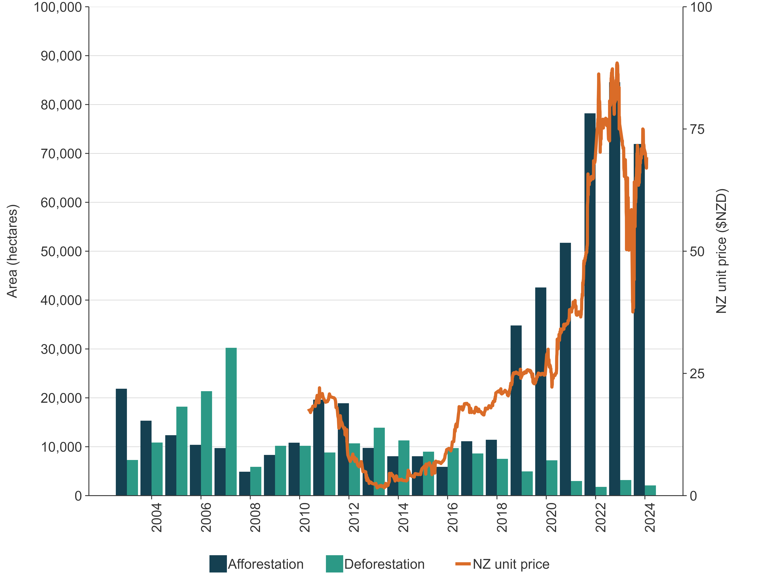

6.1.2 Methodological tiers and coverage of pools applied in the LULUCF sector
New Zealand uses a combination of Tier 1, Tier 2 and Tier 3 methods, as described in volume 1 of the 2006 IPCC Guidelines (IPCC, 2006b), for estimating net emissions for the LULUCF sector. A Tier 1 approach has been used to estimate carbon stock change in the four biomass pools (above-ground and below-ground biomass, dead wood and litter) for all land uses except Forest land, Perennial cropland, Vegetated wetland and Grassland with woody biomass, which use Tier 2 or Tier 3 approaches.
For all land uses, Tier 1 approaches are used to estimate carbon stock changes in organic soils, and a Tier 2 modelling approach is applied to estimate soil organic carbon (SOC) changes from mineral soils. This model is described in more detail in volume 2, annex 5, section A5.2.4 ‘Mineral soils’.
New Zealand’s forests are disaggregated into four reporting categories, to represent the different growth characteristics of the forest types more accurately: pre-1990 planted forest, pre-1990 natural forest, post-1989 planted forest and post-1989 natural forest. The terms ‘post-1989’ and ‘pre-1990’ distinguish between forests growing on land that was forested as of 31 December 1989 and those growing on land that was not forested at that date. The terms ‘natural’ and ‘planted’ forest are used to identify whether the trees were established from natural regeneration or from managed planting. The term ‘harvesting’ refers to temporary destocking of forest as part of ongoing forestry land use, whereas ‘deforestation’ refers to permanent removal of forest as a result of land-use change. Further detail on the characterisation and analysis of forest land is given in volume 2, annex 5, section A5.2.5 ‘Forest land methodologies’.
Similarly, the species compositions reported in the Grassland category are diverse, ranging from different grass types to woody trees that do not meet New Zealand’s forest definition. To allow for this, the Grassland category is divided into four types for modelling the net emissions from land-use change.

Calculation of national emission estimates
The methods used to estimate carbon by pool for each land use are summarised in table 6.1.5. Biomass carbon stocks in each land use before conversion, emission factors to estimate carbon stock changes, and annual growth in biomass carbon stocks after land use conversion are summarised in the relevant category sections in this chapter. Activity data are estimated using wall-to-wall mapping from satellite imagery and other ancillary data sets and are described in more detail in section 6.3.1 and volume 2, annex 5, section A5.2.1 ‘Land use mapping methodology’.
Table 6.1.5 Relationships between land use, carbon pool and method of calculation used by New Zealand
Reporting category | Living biomass |  | Dead organic matter |  | Soils
Land use | Above-ground biomass | Below-ground biomass | Dead wood | Litter | Soil organic matter
 |  |  |  |  | Mineral soils | Organic soils
Pre-1990 natural forest | Plot measurements; allometric equations | Estimated as the ratio of below-ground biomass to above-ground biomass | Modelled from plot measurements; allometric equations | Plot samples; laboratory analysis of samples collected at plots | Tier 2, country-specific data and model | Not applicable
Pre-1990 planted forest | Modelled through allometric equations, then included in national yield tables | Estimated as the ratio of below-ground biomass to above-ground biomass | Allometric model using plot measurements, included in national yield tables. Harvest residues added to dead wood pool through CRA | Allometric model and percentage of above-ground biomass | Tier 2, country-specific data and model | IPCC Tier 1 default parameters
Post-1989 natural forest | Allometric model | Estimated as the ratio of below-ground biomass to above-ground biomass | Modelled from plot measurements; allometric model | Allometric model and percentage of above-ground biomass | Tier 2, country-specific data and model | IPCC Tier 1 default parameters
Post-1989 planted forest | Modelled through allometric equations, then included in national yield tables | Estimated as the ratio of below-ground biomass to above-ground biomass | Allometric model using plot measurements, included in national yield tables. Harvest residues added to dead wood pool through CRA | Allometric model and percentage of above-ground biomass | Tier 2, country-specific data and model | IPCC Tier 1 default parameters
Cropland –annual | IPCC Tier 1 default parameters | IPCC Tier 1 default parameters (NE) | Tier 2, country-specific data and model | IPCC Tier 1 default parameters
Cropland – perennial | Country-specific emission factor |  | IPCC Tier 1 default parameters (NE) |  | Tier 2, country-specific data and model | IPCC Tier 1 default parameters
Grassland (high and low producing) | Country-specific emission factor |  | IPCC Tier 1 default parameters (NE) |  | Tier 2, country-specific data and model | IPCC Tier 1 default parameters
Grassland with woody biomass – transitional | Country-specific emission factor |  |  |  | Tier 2, country-specific data and model | IPCC Tier 1 default parameters
Grassland with woody biomass –permanent | Country-specific emission factor |  |  |  | Tier 2, country-specific data and model | IPCC Tier 1 default parameters
Wetlands – open water | IPCC Tier 1 default parameters (NE) |  |  |  | Tier 2, country-specific data and model | IPCC Tier 1 default parameters
Wetlands – vegetated | Country-specific emission factor |  | IPCC Tier 1 default parameters (NE) |  | Tier 2, country-specific data and model | IPCC Tier 1 default parameters
Settlements | IPCC Tier 1 default parameter (NE) |  |  |  | Tier 2, country-specific data and model | NE
Other land | IPCC Tier 1 default parameter (NE) |  |  |  | Tier 2, country-specific data and model | NE
Note: CRA = Calculation and Reporting Application; NE = not estimated. See the methodology sections for an explanation of soil carbon calculations (volume 2, annex 5, section A5.2.4) and forest models, C_Change and Forest Carbon Predictor (volume 2, annex 5, section A5.2.5).
To calculate emissions for the New Zealand LULUCF sector, the following data are used:
- land use and land-use change area data from 1962 to 1989, which provide land in a transition state as at 1990 for each land use (see volume 2, annex 5, section A5.2.2)
- annual land use and land-use change area data from 1990 to 2024 (see volume 2, annex 5, section A5.2.2)
- biomass carbon stocks per hectare before land use conversion, and annual growth in biomass carbon stocks per hectare following conversion (described in more detail under each land use category)
- estimates of planted forest harvest area and harvest age-class distribution (see section 6.4 and volume 2, annex 5, section A5.2.5)
- a forest age profile for pre-1990 planted forests and post-1989 planted forests
- age-based biomass carbon yield tables for pre-1990 planted forests and post-1989 planted and natural forests (see section 6.4.2)
- growth increment for pre-1990 natural forest (see section 6.4.2)
- emission factors and country-level activity data on biomass burning (see section 6.11.8)
- IPCC default conversion factors for converting carbon (C) to CO₂.
The formula used to calculate emissions from biomass changes on land use conversion is:
( | Loss of biomass present in previous crop | × | Activity data (Area) | ) | + | ( | Annual growth in biomass carbon stocks in new land use | × | Activity data (Area) | ) | (1)
The formula used to calculate emissions from mineral soil changes on land use conversion is:
Mineral soil carbon at steady state in the new land use | — | Mineral soil carbon at steady state in the previous land use | × | ( | Activity data (Area) | ) | (2)
________________________________________________
20 years (transition period)
For example, the annual change in carbon stock in the first year of conversion of 100 hectares of low producing grassland to perennial cropland would be calculated as follows:
Biomass change = (–2.867 × 100) + (0.67 × 100) = –219.7 tonnes C (1)
Mineral soil change = ((88.44 – 105.98) / 20) × 100 = –87.7 tonnes C (2)
Total carbon stock change = –307.4 tonnes C
Total emissions = (carbon stock change / 1,000 × –1) × (44/12)
Total emissions = 1.127 kt CO₂
These calculations have been performed to produce estimates of annual carbon stock and carbon stock changes since 1990.
Note: New Zealand applies the 2006 IPCC Guidelines (IPCC, 2006a) default transition period of 20 years. The area of all land use categories is reported in the conversion status for 20 years, after which it is reported in the land remaining land categories.

New Zealand Land Use and Carbon Analysis System
New Zealand’s LULUCF estimates are calculated using a programme of data collection and modelling called the Land Use and Carbon Analysis System (LUCAS). This data management system stores, manages and retrieves data for international greenhouse gas reporting for the LULUCF sector. Further details on LUCAS, as well as the databases and applications it draws on, are provided in volume 2, annex 5, section A5.2.9.

6.1.3 Uncertainties in LULUCF
Uncertainty for the LULUCF sector has been calculated as 58.6 percent using the Approach 1 – propagation of error method as specified in volume 1, chapter 3 of the 2006 IPCC General Guidance and Reporting (IPCC, 2006b). These uncertainties incorporate natural variability, measurement error and model prediction error. Given this uncertainty, net emissions from the LULUCF sector could range from -8,682.6 kt CO₂e to -33,272.4 kt CO₂e. Table 6.1.6 shows the three land use categories within the LULUCF sector that make the greatest contribution to uncertainty in the net carbon emissions for the sector. These are given in descending order.
Table 6.1.6 Land use categories making the greatest contribution to uncertainty in the LULUCF sector
Land use category | Uncertainty introduced into emissions for LULUCF (%)
Pre-1990 planted forest | ± 46.1
Post-1989 planted forest | ± 25.5
Harvested wood products | ± 17.3
The greatest contribution of uncertainty to the LULUCF sector arises from pre-1990 planted forest in the Forest land category. The age structure of the pre-1990 planted forest estate results in large removals from growth and large emissions from harvesting. The uncertainty is calculated by combining the uncertainty of both the emissions from harvest and those from forest growth. This results in a high uncertainty relative to the net emissions estimate from both the carbon gains and losses.
The second-greatest contribution of uncertainty to the LULUCF sector comes from the post-1989 planted forest in the Forest land category. The age structure of the post-1989 planted forest estate also results in large removals from growth and large emissions from harvesting. Because of the uncertainty in these two factors, combined with the large scale of emissions and removals in this category, post-1989 planted forest makes a high contribution to uncertainty in the LULUCF sector.
The Harvested wood products category provides the third-greatest contribution to uncertainty in the LULUCF sector. This is driven by large removals in the category and relatively high uncertainty associated with the end-use and discard rates of New Zealand wood (±68.2 percent).
Further information on uncertainties and the reasons for their relative contributions to the LULUCF sector, as well as details on emission factor and activity data uncertainties for specific land uses and non-CO₂ emissions, are given within the relevant category sections of this chapter.

6.1.4 Recalculations in LULUCF
For the 2026 submission, New Zealand has recalculated its emissions estimates for the LULUCF sector from 1990 to 2023. The recalculations incorporate new activity data in the forest category for permanent forest area and areas of deforestation, improvement of harvest age modelling, and new country-specific emissions in the Grassland category to replace default values. These recalculations have improved the accuracy, consistency and completeness of the LULUCF estimates.
As a result of the recalculations, estimates of net emissions in 2023 have increased by 1.1 percent (table 6.1.7). The impact of these recalculations on net CO₂e emissions in each land use category is provided in table 6.1.8.
Table 6.1.7 Recalculations to New Zealand’s total net LULUCF emissions for 1990 and 2023
 | Reported net emissions (kt CO₂e) |  | Change in estimate
Year | 2025 submission | 2026 submission | (kt CO₂e) | (%)
1990 | -24,334.1 | -23,334.5 | 999.5 | 4.1
2023 | -20,197.1 | -19,966.5 | 230.7 | 1.1
Table 6.1.8 Recalculations to New Zealand’s net LULUCF emissions for 1990 and 2023 by category
 | Net emissions (kt CO₂e)
Land use category | 2025 submission: 1990 estimate | 2026 submission: 1990 estimate | 2025 submission: 2023 estimate | 2026 submission: 2023 estimate | Change in 1990 estimate (%) | Change in 2023 estimate (%)
Forest land | -23,279.5 | -23,400.1 | -18,235.7 | -17,910.3 | -0.5 | 1.8
Cropland | 478.3 | 436.8 | 749.8 | 539.4 | -8.7 | -28.1
Grassland | 819.9 | 1,990.1 | 2,884.2 | 3,014.0 | 142.7 | 4.5
Wetlands | -8.3 | -8.1 | 7.5 | 6.4 | 1.8 | -14.5
Settlements | 78.5 | 69.8 | 119.3 | 115.8 | -11.1 | -2.9
Other land | 14.8 | 14.7 | 86.1 | 76.9 | -0.5 | -10.7
Harvested wood products | -2,437.8 | -2,437.8 | -5,808.3 | -5,808.7 | 0.0 | 0.0
Total | -24,334.1 | -23,334.5 | 4.1 | -20,197.1 | -19,966.5 | 1.1
Note: Net emissions are expressed as a negative value in the table to help clarify that the value is a removal (of carbon dioxide equivalent from the atmosphere) and not an emission. Columns may not total due to rounding.
More information on the recalculations is provided in the relevant category-specific recalculations sections below and in chapter 10.

6.1.5 LULUCF planned improvements
The LULUCF sector has a plan of continuous improvement and has introduced several improvements in this submission. Once a year, potential category-specific improvements are ranked in order of priority according to technical expert review team findings, key category analysis and contribution to uncertainty in the sector. The improvement priority list is then compared with available resources and capability before a final improvements plan, for the current national inventory report (NIR) and – in the case of the long-term improvements – future NIRs, is agreed on.
Category-specific planned improvements for future submissions are reported separately under each of the relevant category sections of this chapter. The major themes are to:
- continue with method development to implement the 2006 IPCC Guidelines (IPCC, 2006a)
- continue to re-measure the pre-1990 natural forest plot inventory on a continuous basis (on a 10-year cycle) and update the analytical approach to estimating emissions. The methods to be used to calculate carbon stock and stock change are currently being developed, and the data collected during the now-complete third measurement cycle will be integrated into future submissions as they become available
- continue to re-measure the post-1989 natural forest plot inventory on a continuous basis (on a 5-year cycle) and update the analytical approach to measuring forest plots and estimating emissions. The methods used to calculate carbon stock and stock change, as well as the field measurement programme, are planned to be redeveloped to meet the continued growth seen in this category, and the data will be integrated into future submissions as they become available
- continue to re-measure the complete planted forest plot network (pre-1990 and post-1989) on a continuous basis (on a five-year cycle). The data will be incorporated into the NIR as they become available
- continue to improve land use mapping by using information collected through the NZ ETS. The NZ ETS provides an ongoing source of mapping information on forest extent and age, along with information on deforestation activity and carbon equivalent forest activities. This will be used as part of a continuous improvement programme to update the 1989, 2007, 2012, 2016 and 2020 land use maps
- confirm mapped areas of deforestation for areas cleared during 2023 and 2024
- incorporate research that refines the extent and identifies nutrient status and drainage depth of drained organic soils, as well as develops suitable emission factors for them, to enable the application of the 2013 Wetlands supplement (IPCC, 2014)
- improve the SOC reference stock values for Cropland and Grassland through data being collected as part of a 12-year longitudinal study to measure the impact of management practices on agricultural soils
- improve the Soil Carbon Monitoring System (Soil CMS). This work will improve New Zealand’s soil carbon stock change estimates by developing a new modelling approach and addressing key measurement gaps. This work will substantially improve the accuracy of soil carbon estimates and provide a framework to include management effects within land uses. Data will be incorporated into the NIR as they become available.

6.1.6 Assessment of completeness

Emissions reported as ‘NE’ or ‘not estimated’
Table 6.1.9 summarises New Zealand’s direct greenhouse gas emissions for the LULUCF sector reported as ‘NE’ in the 2026 submission.
Table 6.1.9 Summary of ‘NE’ or ‘not estimated’ entries for the LULUCF sector in the 2026 submission
CRT category code | Category | Gas | Explanation
Land Use, Land-Use Change and Forestry
4.A, 4.B, 4.C, 4.D | Forest land, Cropland, Grassland and Wetlands: Drainage and rewetting and other management of organic and mineral soils | CH₄, N₂O | This category is not mandatory. No methodology is provided in the 2006 IPCC Guidelines for estimating emissions from this source category (IPCC, 2006a).
4.A.2 | Settlements converted to other land uses | CO₂ (losses) | This category is not mandatory. No methodology is provided in the 2006 IPCC Guidelines for calculating Tier 1 estimates of carbon stocks in living biomass for Settlements (IPCC, 2006a). Therefore, with land-use change from Settlements to other land uses, no carbon stock loss is reported. Because New Zealand uses the stock change approach, losses are only reported in years when new land is converted to this category, or where there is harvesting of forest in the year of conversion. When neither of these activities occurs, the losses are reported with biomass gains (stock change approach) and ‘IE’ (included elsewhere) is reported for biomass losses.
4.A.2, 4.C.2 | Other land converted to other land uses | CO₂ (losses) | This category is not mandatory. No methodology is provided in the 2006 IPCC Guidelines for calculating Tier 1 estimates of carbon stocks in living biomass for Other land (IPCC, 2006a). Therefore, with land-use change from Other land to other land uses, no carbon stock loss is reported.  Because New Zealand uses the stock change approach, losses are only reported in years when new land is converted to this category, or where there is harvesting of forest in the year of conversion. When neither of these activities occurs, the losses are reported with biomass gains (stock change approach) and IE is reported for biomass losses.
4.A, 4.B, 4.C, 4.D, 4.F | Forest land, Cropland, Grassland, Wetlands and Other land: Rewetting and other management of organic and mineral soils | CO₂ | This category is not mandatory. No methodology is provided in the 2006 IPCC Guidelines for estimating emissions from this source category (IPCC, 2006a).
4.B.1, 4.B.2 | Land converted to cropland, cropland remaining cropland | CO₂ (dead wood) | This category is not mandatory. No methodology is provided in the 2006 IPCC Guidelines for calculating Tier 1 estimates of carbon stock change in dead organic matter for land-use changes to this land use category (IPCC, 2006a). Any emissions reported are for loss of dead organic matter from the previous land use that occurs in the year of conversion.
4.B.1 | Cropland remaining cropland/4(V) Biomass burning/Wildfires/Cropland remaining cropland | CH₄, N₂O | New Zealand does not have sufficient information on biomass burning activities to reliably report on it.
4.B.2 | Land converted to cropland/4(V) Biomass burning/Wildfires/Land converted to cropland | CH₄, N₂O | New Zealand does not have sufficient information on biomass burning activities to reliably report on it.
4.C.1, 4.C.2 | Land remaining grassland, Land converted to grassland | CO₂ (dead wood) | This category is not mandatory. No methodology is provided in the 2006 IPCC Guidelines for calculating Tier 1 estimates of carbon stock change in dead organic matter for land-use changes to this land use category (IPCC, 2006a). Any emissions reported are for loss of dead organic matter from the previous land use that occurs in the year of conversion.
4.D.1 | Wetlands remaining wetlands/4(V) Biomass burning/Wildfires/Wetlands remaining wetlands | CH₄, N₂O | This category is not mandatory. No methodology is provided in the 2006 IPCC Guidelines for calculating Tier 1 estimates of carbon stock changes in organic soils for this land use category (IPCC, 2006a). New Zealand does not have sufficient information on biomass burning activities to reliably report on it.
4.D.1, 4.D.2 | Wetlands remaining wetlands, Land converted to wetlands (except transitions into and out of vegetated wetlands) | CO₂ | This category is not mandatory. No methodology is provided in the 2006 IPCC Guidelines for calculating Tier 1 estimates of carbon stock change in this land use (IPCC, 2006a, volume 4, chapter 7.3.1).
4.D.2 | Land converted to wetlands/Land converted for peat extraction | CO₂ | New Zealand does not have activity data available to report on this activity.
4.E.2 | Land converted to settlements | CO₂ | This category is not mandatory. No IPCC guidance is provided for calculating Tier 1 estimates of carbon stock changes in organic soils for this land use category. Therefore, with land-use change to or from this land use on organic soils, New Zealand reports the notation key NE.
4.F | 4.F Other land/4(V) Biomass burning/Land converted to other land | CH₄, N₂O | This is a relatively minor activity in New Zealand due to the country’s temperate climate and rainfall distribution, and there is currently insufficient information to reliably report on it.
4.F.2 | Land converted to other land | CO₂ | This category is not mandatory. No IPCC guidance is provided for calculating Tier 1 estimates of carbon stock changes in organic soils for this land use category. Therefore, with land-use change to or from this land use on organic soils, New Zealand reports the notation key NE.

Emissions reported as ‘IE’ or ‘included elsewhere’
Table 6.1.10 details where the notation key ‘IE’ has been used in this submission of the Inventory for the IPPU sector.
Table 6.1.10 Emissions reported using the ‘IE’ or ‘included elsewhere’ notation key in the 2026 submission for the LULUCF sector
CRT category code | Category | Source category reported under | Notation key explanation
Land Use, Land-Use Change and Forestry
4.A.1/4(V) | Controlled burning | Forest land remaining forest land | Carbon dioxide (CO₂) emissions are captured by the general carbon stock change calculation if the fire-damaged area is harvested and replanted. If the stand is allowed to grow on but with a reduced stocking, the CO₂ emissions are reported at the eventual time of harvest.
4.A.1/4(II) | Forest land | Emissions and removals from drainage and rewetting and other management of organic and mineral soils | These emissions are reported under organic soils.
4.B.1/4(II) | Cropland |  | These emissions are reported under organic soils.
4.A.1 | Forest land remaining forest land | Forest land remaining forest land | Because New Zealand uses the stock change approach, losses are reported only in years when new land is converted to this category, or when there is harvesting of forest in this year. When neither of these activities occurs, the losses are reported with biomass gains (stock change approach) and ‘IE’ is reported for biomass losses.
4.A.2 | Land converted to forest land | Land converted to forest land | Because New Zealand uses the stock change approach, CO₂ emissions from biomass losses are reported only in years when new land is converted to this category, or when there is harvesting of forest in this year. When neither of these activities occurs, the losses are reported with biomass gains (stock change approach) and ‘IE’ is reported for biomass losses.
4.A.1/4.A.2 | Forest land remaining forest land, Land converted to forest land | Included under the Agriculture sector | New Zealand does not disaggregate data on nitrogen fertiliser by land use; therefore, all nitrous oxide emissions are reported in the Agriculture sector.
4.A.2/4(V) | Controlled burning/ Land converted to forest land | Land converted to forest land | Carbon dioxide emissions are captured by the general carbon stock change calculation if the fire-damaged area is harvested and replanted. If the stand is allowed to grow on but with a reduced stocking, the CO₂ emissions are reported on at the eventual time of harvest.
4.A.2/4(V) | Wildfires/Land converted to forest land | Land converted to forest land
4.B.1 | Cropland remaining cropland | Cropland remaining cropland | New Zealand uses the stock change approach to estimate biomass emissions; therefore, biomass losses are reported with biomass gains and ‘IE’ is reported.
4.B.2 | Land converted to cropland | Land converted to cropland
4.C.1 | Grassland remaining grassland | Grassland remaining grassland
4.C.2 | Land converted to grassland | Land converted to grassland
4.B.1/4(V) | Controlled burning/ Cropland remaining cropland | Included under the Agriculture sector | Carbon dioxide and methane (CH₄) emissions from burning of crop stubble are reported in the Agriculture sector.
4.B.1/4(V) | Wildfires/Cropland remaining cropland | Cropland remaining cropland | Any CO₂ emissions from wildfires on non-forest land are assumed to be offset by the subsequent carbon stock gain from the regrowth of biomass, which is also not reported. Alternatively, if the wildfire resulted in land-use change, then any CO₂ emissions are captured by the general carbon stock change calculation that is performed when land is converted to a new land use.
4.B.2/4(V) | Wildfires/Land converted to cropland | Land converted to cropland | Any CO₂ emissions from wildfires on non-forest land are assumed to be offset by the subsequent carbon stock gain from the regrowth of biomass, which is also not reported. Alternatively, if the wildfire resulted in land-use change, then any CO₂ emissions are captured by the general carbon stock change calculation that is performed when land is converted to a new land use.
4.C.1/4(V) | Wildfires/Grassland remaining grassland | Grassland remaining grassland
4.C.2/4(V) | Wildfires/Land converted to grassland | Land converted to grassland
4.D.2/4(V) | Wildfires/Land converted to wetlands | Land converted to wetlands
4.A.1/4(I) | Direct N₂O emissions from nitrogen (N) inputs to managed soils | Included under the Agriculture sector | New Zealand does not hold disaggregated activity data on nitrogen fertiliser by land use; therefore, all N₂O emissions from organic and inorganic fertilisers are reported in the Agriculture sector.
4.D.1/4(I) | Inorganic N fertilisers and Direct N₂O emissions from N inputs to managed soils | Included under the Agriculture sector
4.D.2/4(I) | Organic N fertilisers | Included under the Agriculture sector
4.E.1/4(I) | In the following categories: | Included under the Agriculture sector
4.E.2/4(I) | Forest land remaining forest land | Included under the Agriculture sector
 | Wetlands remaining wetlands | Included under the Agriculture sector
 | Land converted to wetlands | Included under the Agriculture sector
 | Settlements remaining settlements | Included under the Agriculture sector
 | Land converted to settlements | Included under the Agriculture sector
 | Settlements remaining settlements | Included under the Agriculture sector
 | Land converted to settlements | Included under the Agriculture sector
4(IV) | Indirect N₂O emissions from managed soils/ Atmospheric deposition | Included under the Agriculture sector | Volatilisation of nitrogen (manure, other organic and fertiliser) on pasture range and paddock is reported under Agriculture. This includes all nitrogen fertiliser used in New Zealand.
4.B.1/4(V) | Controlled burning/ Cropland remaining cropland | Included under the Agriculture sector | All emissions from burning of crop stubble are reported in the Agriculture sector.
4.C.1/4(V) | Controlled burning/ Grassland remaining grassland | Grassland remaining grassland | This is not a significant activity in New Zealand due to the country’s temperate climate and rainfall distribution, and any CO₂ emissions from burning on non-forest land are assumed to be offset by the subsequent carbon stock gain from the regrowth of biomass, which is also not reported. Alternatively, if the fire resulted in land-use change, then any CO₂ emissions are captured by the general carbon stock change calculation that is performed when land is converted to a new land use.
4.D.1/4(V) | Controlled burning/ Wetlands remaining wetlands | Wetlands remaining wetlands
 | Wildfires/Wetlands remaining wetlands | Wetlands remaining wetlands
4.C.2/4(V) | Controlled burning/ Land converted to grassland | Land converted to grassland | Carbon dioxide emissions from the controlled burning of land converted to this category are captured by the general carbon stock change calculation that is performed when land is converted to a new land use.
4.D.2/4(V) | Controlled burning/ Land converted to wetlands | Land converted to wetlands
4.E/4(V) | Biomass burning/Land converted to settlements | Land converted to settlements
4.F/4(V) | Biomass burning/Land converted to other land | Land converted to other land
4.D.2.2 | Land converted to flooded land | Land converted to open water | New Zealand has not yet identified what area of land converted to open water meets the definition of Land converted to flooded land. Emissions associated with the loss of biomass with land conversion to flooded land will be captured under Land converted to open water.

6.2 Land use definitions and the land representation approach(es) used and their correspondence to the LULUCF categories

6.2.1 Land use category definitions
New Zealand has subdivided the IPCC land use categories into 13 land use classes for reporting, as shown in table 6.2.1.
Table 6.2.1 New Zealand’s land use categories and land uses
IPCC category | New Zealand land use
Forest land | Pre-1990 natural
 | Pre-1990 planted
 | Post-1989 natural¹
 | Post-1989 planted¹
Cropland | Annual
 | Perennial
Grassland | High producing
 | Low producing
 | With woody biomass
Wetlands | Open water
 | Vegetated
Settlements | Settlements
Other land | Other land
The land uses were chosen for their conformance with the dominant types in New Zealand, while still enabling reporting under the land use categories specified in the 2006 IPCC Guidelines (IPCC, 2006a). The division of forest land uses into pre-1990 and post-1989 classes was made to support accounting under the Kyoto Protocol and the Paris Agreement (see volume 2, annex 9, for further information on New Zealand’s approach to LULUCF accounting under the Paris Agreement).
The national thresholds used by New Zealand to define Forest land are:
- a minimum area of 1 hectare
- a crown cover of at least 30 percent
- a minimum height of 5 metres at maturity in situ (Ministry for the Environment, 2006)
- a minimum forest width of 30 metres from canopy edge to canopy edge.
The definitions of New Zealand’s land uses, as they have been mapped, are provided in table 6.2.2. Further details are included in Land Use and Carbon Analysis System: Satellite imagery interpretation guide for land use classes (2nd edition) (Ministry for the Environment, 2012).
Table 6.2.2 New Zealand’s mapping definitions for each land use
Land use | Definition
Pre-1990 natural forest | Areas that, on 1 January 1990, were and presently include:  - tall indigenous forest  - self-sown exotic trees, such as wilding pines and grey willows (where managed as forest)  - broadleaved hardwood shrubland, kānuka–mānuka (Leptospermum scoparium–Kunzea spp.) shrubland and other woody shrubland (≥30 percent cover, with potential to reach ≥5 metres at maturity in situ under current land management within 30–40 years)  - areas of bare ground of any size that were previously forested but, due to natural disturbances (e.g., erosion, storms, fire), have temporarily lost vegetation cover  - areas that were planted forest at 1990 but are subsequently managed to regenerate with natural species that will meet the forest definition  - roads and tracks less than 30 metres in width and other temporarily unstocked areas associated with a forest land use.
Pre-1990 planted forest | Areas that, on 1 January 1990, were and presently include:  - radiata pine (Pinus radiata), Douglas fir (Pseudotsuga menziesii), eucalypts (Eucalyptus spp.) or other planted species (with potential to reach ≥5 metre height at maturity in situ) established before 1 January 1990 or replanted on land that was forest land as at 31 December 1989  - exotic forest species that were planted after 31 December 1989 on land that was natural forest  - riparian or erosion control plantings that meet the forest definition and that were planted before 1 January 1990  - harvested areas within pre-1990 planted forest (assuming these will be replanted, unless deforestation is later detected)  - roads, tracks, skid sites and other temporarily unstocked areas less than 30 metres in width associated with a forest land use  - areas of bare ground of any size that were previously forested at 31 December 1989 but, due to natural disturbances (e.g., erosion, storms, fire), have lost vegetation cover.
Post-1989 forest | Includes post-1989 planted forest, which consists of:  - exotic forest (with the potential to reach ≥5 metre height at maturity in situ) planted or established on land that was non-forest land as at 31 December 1989 (e.g., radiata pine, Douglas fir, eucalypts or other planted species)  - riparian or erosion control plantings that meet the forest definition and that were planted after 31 December 1989  - harvested areas within post-1989 forest land (assuming these will be replanted, unless deforestation is later detected).  Includes post-1989 natural forest, which consists of:  - forests arising from natural regeneration of indigenous tree species as a result of management change after 31 December 1989  - self-sown exotic trees, such as wilding conifers or grey willows, established after 31 December 1989 (where managed as forest).  Includes areas within post-1989 natural forest or post-1989 planted forest that are:  - roads, tracks, skid sites and other temporarily unstocked areas associated with a forest land use  - areas of bare ground of any size that were previously forested (established after 31 December 1989) but, due to natural disturbances (e.g., erosion, storms, fire), have lost vegetation cover.
Annual cropland | Includes:  - all annual crops  - all cultivated bare ground  - linear shelterbelts associated with annual cropland.
Perennial cropland | Includes:  - all orchards and vineyards  - linear shelterbelts associated with perennial cropland.
High producing grassland | Includes:  - grassland with high-quality pasture species  - linear shelterbelts that are <1 hectare in area or <30 metres in mean width (larger shelterbelts are mapped separately as grassland with woody biomass)  - areas of bare ground of any size that were previously grassland but, due to natural disturbances (e.g., erosion), have lost vegetation cover.
Low producing grassland | Includes:  - low-fertility grassland and tussock grasslands (e.g., Chionochloa and Festuca spp.)  - mostly hill country  - montane herbfields either at an altitude higher than above-timberline vegetation or where the herbfields are not mixed up with woody vegetation  - linear shelterbelts that are <1 hectare in area or <30 metres in mean width (larger shelterbelts are mapped separately as grassland with woody biomass)  - other areas of limited vegetation cover and significant bare soil, including erosion and coastal herbaceous sand-dune vegetation.
Grassland with woody biomass | Includes:  - grassland with matagouri (Discaria toumatou) and sweet briar (Rosa rubiginosa), broadleaved hardwood shrubland (e.g., māhoe – Melicytus ramiflorus), wineberry (Aristotelia serrata), Pseudopanax spp., Pittosporum spp.), kānuka–mānuka (Leptospermum scoparium–Kunzea spp.) shrubland, coastal and other woody shrubland (<5 metres tall and any percentage of cover) where, under current management or environmental conditions (climate and/or soil), it is expected that the forest criteria will not be met over a 30- to 40-year period  - above-timberline shrubland vegetation intermixed with montane herbfields (does not have the potential to reach >5 metres in height in situ)  - grassland with tall tree species (<30 percent cover), such as golf courses in rural areas (except where the Land Cover Database has classified these as settlements)  - grassland with riparian or erosion control plantings (<30 percent cover)  - linear shelterbelts that are >1 hectare in area and <30 metres in mean width  - areas of bare ground of any size that previously contained grassland with woody biomass but, due to natural disturbances (e.g., erosion, fire), have lost vegetation cover.
Open water | Includes:  - lakes, rivers, dams and reservoirs  - estuarine–tidal areas including mangroves.
Vegetated wetland | Includes:  - herbaceous and/or non-forest woody vegetation, including trees of any stature, in a wetland context (periodically or permanently flooded)  - areas under peat extraction  - estuarine–tidal areas including mangroves.
Settlements | Includes:  - built-up areas and impervious surfaces  - grassland within ‘settlements’ including recreational areas, urban parklands and open spaces that do not meet the forest definition  - major roading infrastructure  - airports and runways  - dam infrastructure  - urban subdivisions under construction.
Other land | Includes:  - montane rock and/or scree  - river gravels, rocky outcrops, sand dunes and beaches, coastal cliffs, mines (including spoil), quarries  - permanent ice and/or snow and glaciers  - any other remaining land that does not fall into any of the other land use categories as described in volume 4, section 3.2 of the 2006 IPCC Guidelines (IPCC, 2006a).

6.2.2 Land representation approaches
New Zealand uses a combination of approaches 2 and 3 to determine annual land-use changes occurring between 1 January 1990 and 31 December 2024 (section 2.2.4, IPCC, 2014). This includes wall-to-wall mapping of all land use classes described in table 6.2.3 every four to five years (Approach 3), combined with other non-spatial activity data sets to infer the timing of land-use change between major mapping updates (Approach 2).
An Approach 2 method is used to estimate gross land use transitions before 1990 using a variety of different sources and following the methodology described in Watts (unpublished) and reviewed in Hunter and McNeill (unpublished). This is further described in volume 2, annex 5, section A5.2.2. Applying this methodology allows for the land use transition matrix for the period 1962 to 1989 to be obtained (see table 6.2.3).

Table 6.2.3 New Zealand’s land-use change matrix, from 1962 to 1989 (kha)
 |  | Forest land |  |  |  | Cropland |  | Grassland |  |  | Wetlands
1989 land use | 1962 land use | Pre-1990 natural | Pre-1990 planted | Post-1989 planted | Post-1989 natural | Annual | Perennial | High producing | Low producing | With woody biomass | Open water | Vegetated | Settlements | Other land | Net area 31 Dec 1989 (kha)
Forest land | Pre-1990 natural | 7,771 | – | – | – | – | – | – | – | 42 | – | – | – | – | 7,813
Forest land | Pre-1990 planted | 302 | 453 | – | – | – | – | – | 399 | 393 | – | – | – | – | 1,547
Forest land | Post-1989 planted | – | – | 0 | – | – | – | – | – | – | – | – | – | – | 0
Forest land | Post-1989 natural | – | – | – | 0 | – | – | – | – | – | – | – | – | – | 0
Cropland | Annual | – | – | – | – | 325 | – | 21 | 9 | – | – | – | – | – | 355
Cropland | Perennial | – | – | – | – | 1 | 59 | 5 | 5 | – | – | – | – | – | 69
Grassland | High producing | 84 | – | – | – | 23 | 20 | 4,809 | 461 | 346 | – | 98 | – | – | 5,840
Grassland | Low producing | 428 | – | – | – | – | – | – | 7,447 | 30 | – | – | – | – | 7,905
Grassland | With woody biomass | 78 | – | – | – | – | – | – | 492 | 942 | – | – | – | – | 1,512
Wetlands | Open water | 14 | – | – | – | – | – | – | – | – | 513 | – | – | – | 527
Wetlands | Vegetated | – | – | – | – | – | – | – | – | – | – | 254 | – | – | 254
Settlements | Settlements | 5 | – | – | – | 7 | 0 | 7 | 4 | 1 | – | – | 185 | – | 208
Other land | Other land | – | – | – | – | – | – | – | – | – | – | – | – | 896 | 896
Area as at 1 Jan 1962 (kha) |  | 8,683 | 453 | – | – | 355 | 78 | 4,842 | 8,816 | 1,752 | 513 | 352 | 185 | 896 | 26,925
Net change 1 Jan 1962–31 Dec 1989 |  | -870 | 1,094 | – | – | 0 | -9 | 998 | -912 | -241 | 14 | -98 | 23 | 0 | 0
Net change 1962–1989 (%) |  | -10.0 | 241.4 | – | – | 0.0 | -11.8 | 20.6 | -10.3 | -13.7 | 2.8 | -27.9 | 12.6 | 0.0 | 0.0

6.3 Country-specific approaches

6.3.1 Information on approaches used for representing land areas and on land use databases used for the Inventory preparation

General approach
Areas of land use and land-use change between 1990 and 2024 are based on five wall-to-wall land use maps derived from satellite imagery at nominal mapping dates of 31 December 1989, 31 December 2007, 31 December 2012, 31 December 2016 and 31 December 2020 (see figure 6.3.1). Information on the methods used to compile these land use maps can be found in volume 2, annex 5, section A5.2.1.
These maps are managed in a single spatial database to ensure consistency in the tracking of land-use change and to ensure any corrections to land use classifications are replicated through the entire time series. Information on the spatial data management system can be found in volume 2, annex 5, section A5.2.9.
Area information from these maps is interpolated and extrapolated to obtain a complete time series of land-use change occurring between 1990 and 2024 (see volume 2, annex 5, section A5.2.2). Ancillary data – including aerial photography, additional satellite imagery, data from the NZ ETS and other national survey data – are used to support data interpolation and map production. Further information on the mapping methodology and imagery used, as well as the interpolation and extrapolation process to obtain a complete time series of land-use change occurring between 1990 and 2024 can be found in volume 2, annex 5, section A5.2.2.
Figure 6.3.1 Land use map of New Zealand as at 31 December 2020
Note: The inset map is of the Chatham Islands, which lie approximately 660 kilometres south-east of the south-eastern corner of the North Island.

Updates for this submission
For this submission, minor improvements to the 2020 land use map have been made. Improvements have also been made to the 1989, 2007, 2012 and 2016 land use maps. This year, improvements have focused on:
- updates to mapping of new post-1989 forest areas based on areas added to Ministry for Primary Industries (MPI) forestry schemes including the NZ ETS
- updates to deforestation mapping based on a review of post-1989 forest areas withdrawn from the NZ ETS
- updates to the sub-classification of pre-1990 natural forest, particularly in relation to identifying tree weeds (wilding pines).

Quality assurance/quality control (QA/QC) and verification
Quality-control and quality-assurance procedures (QA/QC) have been adopted for all data collection and data analyses, consistent with the 2006 IPCC Guidelines (IPCC, 2006a) and New Zealand’s inventory quality-control and quality-assurance plan. Data quality and data assurance plans are established for each type of data used to determine carbon stock and stock changes, as well as for the mapping of the areal extent and spatial location of land-use changes. Further information on QA/QC procedures specific to mapping can be found in volume 2, annex 5, section A5.2.1.

Planned improvements
By October 2026, the following improvements will be made to land use activity data:
- confirmation of mapped areas of deforestation for areas cleared during 2023 and 2024
- updates to the 2020 land use map based on forestry mapping entered into the NZ ETS.
An accuracy assessment of the 2020 land use map will also be completed by October 2026, and this will be used to inform further mapping improvement planning.

6.3.2 Information on approaches used for reporting harvested wood products
New Zealand applies the production approach to report on the Harvested wood products category. To do this, New Zealand has adapted the default Harvested wood products model and uses a Tier 2 method (IPCC, 2006a, section 12.2.1.2), which involves using country-specific activity data and parameters.
Further information is provided in section 6.10.

6.4 Forest land (4A)

6.4.1 Description
In 2024, Forest land contributed -18,611.5 kt CO₂e of net emissions. Net emissions from Forest land have increased by 4,788.6 kt CO₂e (20.5 percent) from the 1990 level of -23,400.1 kt CO₂e (table 6.4.1). Between 1990 and 2024, Forest land is the most significant contributor to carbon stock changes in the LULUCF sector. In 2024, forests comprised 38.1 percent (10.3 million hectares) of New Zealand’s total land area. Note that emissions for the Harvested wood products category are reported separately within the common reporting tables (CRTs) and are described further in section 6.10.
In 2024, Forest land remaining forest land and Land converted to forest land were key categories (based on a trend and level assessment).
Table 6.4.1 New Zealand’s land-use change for the Forest land category, and associated
CO₂e emissions, in 1990 and 2024
 | Net area (ha) |  |  | Net emissions (kt CO₂e)
Land use category | 1990 | 2024 | Change from 1990 (%) | 1990 | 2024 | Change from 1990 (%)
Forest land remaining forest land | 8,538,648 | 9,738,392 | 14.1 | -5,413.3 | -14,736.2 | -172.2
Land converted to forest land | 821,319 | 515,850 | -37.2 | -17,986.8 | -3,875.3 | 78.5
Total | 9,359,968 | 10,254,242 | 9.6 | -23,400.1 | -18,611.5 | 20.5
Note: Net area in 1990 is as at 1 January 1990; net area in 2024 is as at 31 December 2024. The area of Land converted to forest land includes land converted up to 20 years earlier, and net area values include land in a state of conversion (due to land-use change before 1990) and afforestation since 1990. Net emission estimates are for the whole year indicated. Columns may not total due to rounding, and percentages presented are calculated from unrounded values.
New Zealand has applied the following parameters for land to be classified as Forest land:
- minimum area of 1 hectare
- potential to reach a minimum height of 5 metres
- potential to reach a minimum crown cover of 30 percent
- a minimum forest width of 30 metres from canopy edge to canopy edge.
Where the height and canopy cover parameters are not met at the time of mapping, the land has been classified as Forest land if the land-management practice(s) and local site conditions (including climate) are such that the forest parameters will be met over a 30- to 40-year timeframe. Note that New Zealand does not report linear shelterbelts under the Forest land category because they are not on land managed as forest. They form part of non-forest land uses, namely Cropland and Grassland (as shelter for crops and/or animals).
New Zealand uses four Forest land types: pre-1990 natural forest (predominantly native forest), pre-1990 planted forest (predominantly Pinus radiata), post-1989 planted forest and post-1989 natural forest (where post-1989 forests are those established after 31 December 1989). The definitions used for mapping these land uses are given in table 6.2.2.
Table 6.4.2 shows land-use change by Forest land category since 1990 and the associated CO₂ emissions from carbon stock change (note: non-CO₂ emissions are reported elsewhere).
Table 6.4.2 Change in land area and associated CO₂ emissions from carbon stock change
between 1990 and 2024 for New Zealand’s Forest land
 | Net area (ha) |  | Change from | Net emissions (kt CO₂ only) |  | Change from
Land use | 1990 | 2024 | 1990 (%) | 1990 | 2024 | 1990 (%)
Pre-1990 natural forest | 7,812,913 | 7,743,646 | -0.9 | -1,360.2 | -1,438.8 | -5.8
Pre-1990 planted forest | 1,547,055 | 1,435,366 | -7.2 | -22,398.3 | -14,804.4 | 33.9
Post-1989 planted forest | 0 | 953,066 | – | 171.7 | -1,677.3 | -1,077.0
Post-1989 natural forest | 0 | 122,163 | – | 6.1 | -855.2 | -14,137.4
Total | 9,359,968 | 10,254,242 | 9.6 | -23,580.7 | -18,775.7 | 20.4
Note: Net area in 1990 is as at 1 January 1990; net area in 2024 is as at 31 December 2024. Net area values include land in a state of conversion to forest (due to land-use change before 1990) and afforestation since 1990. Net emissions estimates are for the whole year indicated. Columns may not total due to rounding. Emissions associated with the conversion of forest to other land uses are reported in the land use category the land is converted to.
Table 6.4.3 shows New Zealand’s carbon stock change by carbon pool and forest land type within the Forest land category from 1990 to 2024. Over this period, the total carbon stock stored in Forest land has increased by 238,190.1 kt C, equivalent to emissions of
-873,363.8 tonnes CO₂ since 1990.
Table 6.4.3 New Zealand’s net carbon stock change by carbon pool for the Forest land category,
from 1990 to 2024
 | Net carbon stock change 1990–2024 (kt C) |  |  |  | Emissions 1990–2024
Land use | Living biomass | Dead organic matter | Soils | Total | (kt CO₂)
Pre-1990 natural forest | 11,782.3 | 1,159.4 | -135.8 | 12,805.8 | -46,954.7
Pre-1990 planted forest | 120,834.3 | 16,409.8 | -4,390.3 | 132,853.8 | -487,130.7
Post-1989 planted forest | 80,880.2 | 16,838.9 | -8,425.9 | 89,293.2 | -327,408.5
Post-1989 natural forest | 4,050.3 | 45.9 | -859.0 | 3,237.2 | -11,869.9
Total | 217,547.1 | 34,453.9 | -13,810.9 | 238,190.1 | -873,363.8
Note: Emissions associated with the conversion of forest are reported in the land use category the land is converted to. Columns may not total due to rounding.
New Zealand’s emissions profile in the LULUCF sector is predominantly influenced by plantation forestry. The rapid growth rates of plantation forest relative to natural forest, and the timing of afforestation and harvesting cycles drive the emissions profile and will continue to do so in the future.

6.4.2 Methodological issues

Afforestation and reforestation
Afforestation and reforestation areas of planted and natural forests are derived from a combination of land use mapping, national statistics and forestry scheme data. Annual rates of afforestation and reforestation are shown in figure 6.4.1 and are influenced greatly by market and policy conditions at the time, as described in section 6.1.1. Further details on how the area of afforestation is calculated are provided in volume 2, annex 5, section A5.2.2.
Figure 6.4.1 Annual areas of afforestation and reforestation in New Zealand, from 1990 to 2024
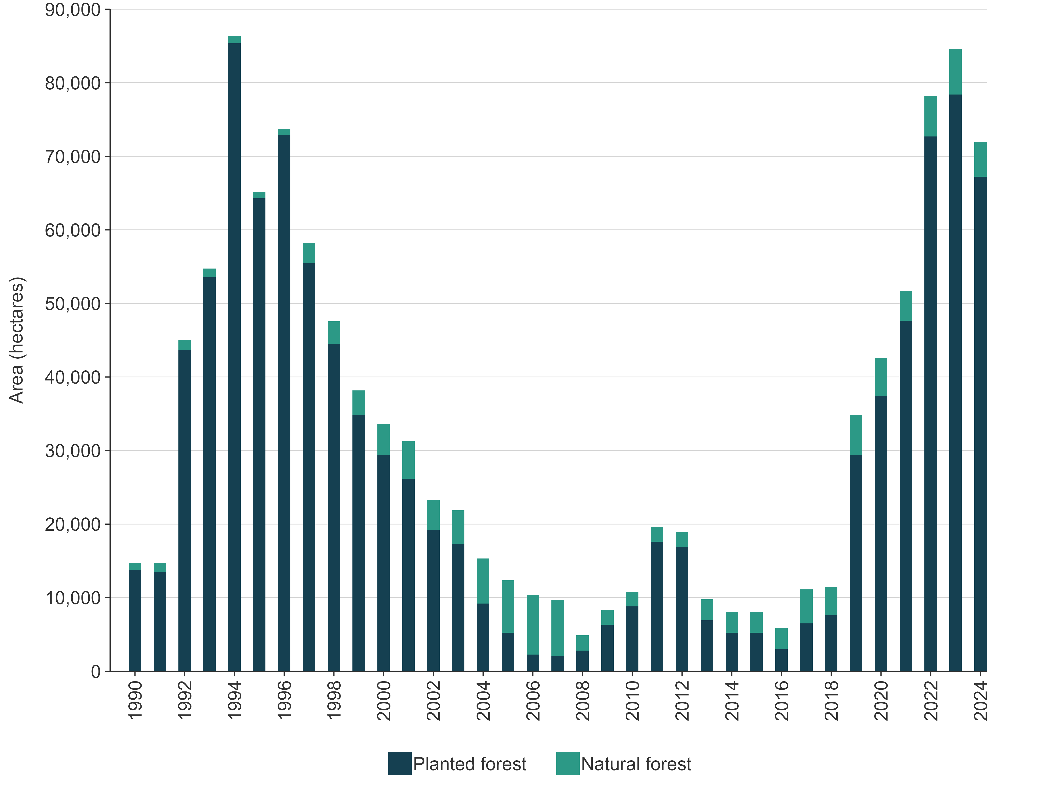
Note: Details on how the afforestation area is calculated are provided in volume 2, annex 5, section A5.2.2.
Post-1989 planted forests did not become a net sink until 1996 (figure 6.4.2) when net removals from forest growth surpassed net emissions. These emissions were due to the loss of biomass in carbon stocks associated with the previous land use before conversion, in addition to the loss of soil carbon associated with a land-use change to forestry.
Figure 6.4.2 New Zealand’s net carbon dioxide removals by post-1989 planted forests, from 1990 to 2024
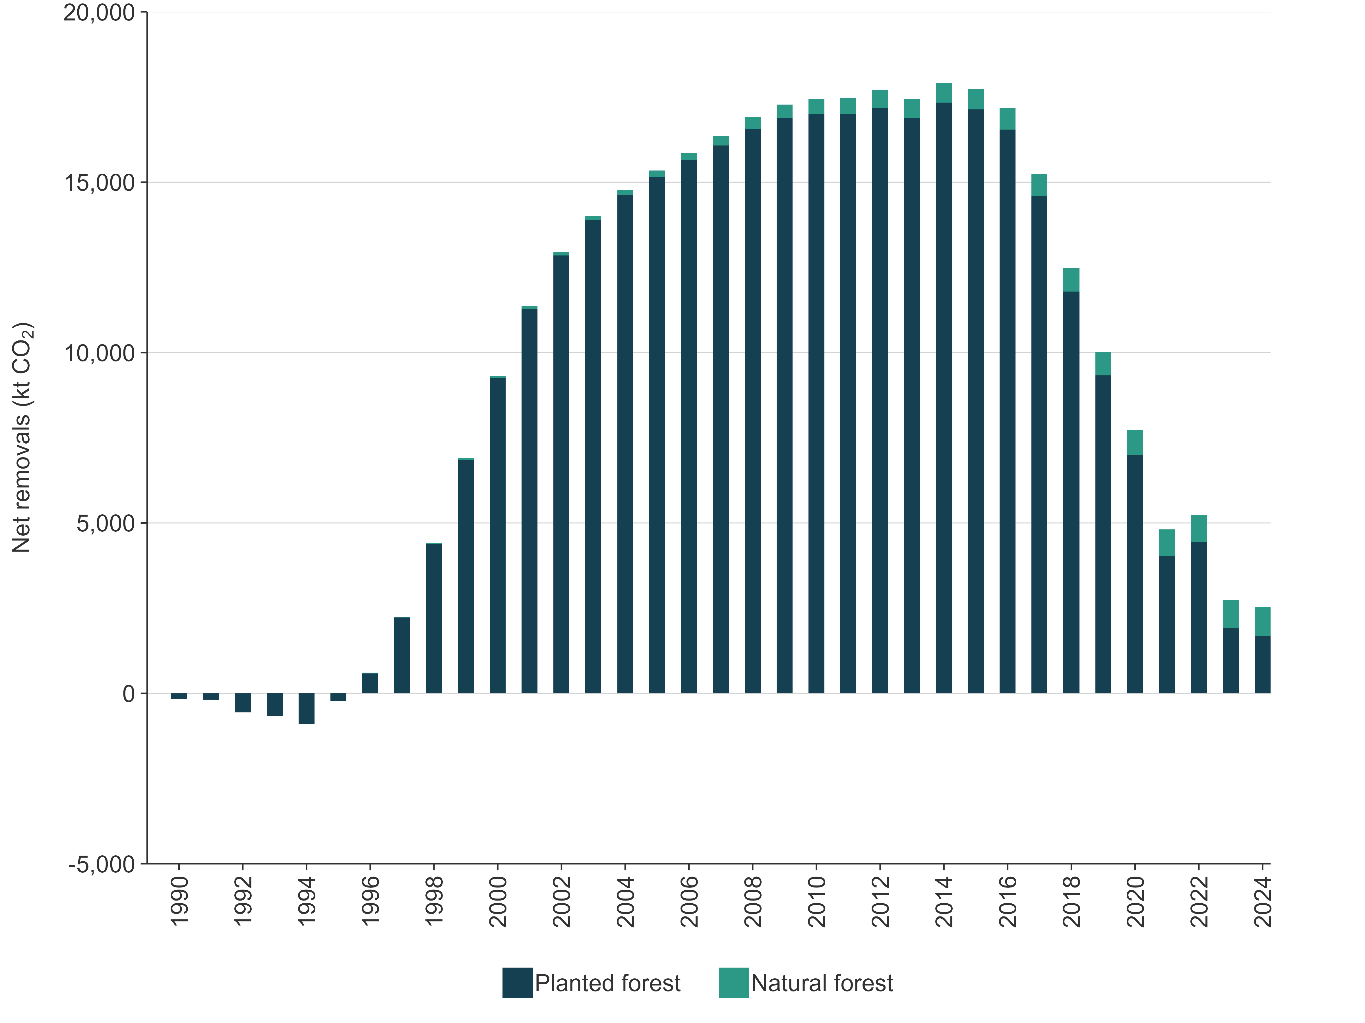

Harvesting
The annual planted forest harvest area (both pre-1990 and post-1989 planted forest combined) from 1990 to 2024 is shown in figure 6.4.3. The method used to calculate the harvest area is outlined in volume 2, annex 5, section A5.2.5 ‘Calculation of harvest area’. Emissions from harvesting are dependent on the age of the forest being harvested. To accurately reflect the actual harvest ages that occur, and therefore the associated emissions, a harvest age profile is applied to the harvest area to determine the harvest area by age. Detailed methodology on how the harvest age profile is calculated for post-1989 planted forest and pre-1990 planted forest can be found in volume 2, annex 5, section A5.2.5 ‘Calculation of harvest area by age and forest age profile’.
Only a minimal proportion of timber harvested is from natural forests. In 2024, an estimated 0.03 percent of New Zealand’s total forest timber production was from the harvesting of natural forests (Ministry for Primary Industries, 2025b).
Figure 6.4.3 New Zealand’s area of planted forest harvest (inclusive of deforestation), from 1990 to 2024
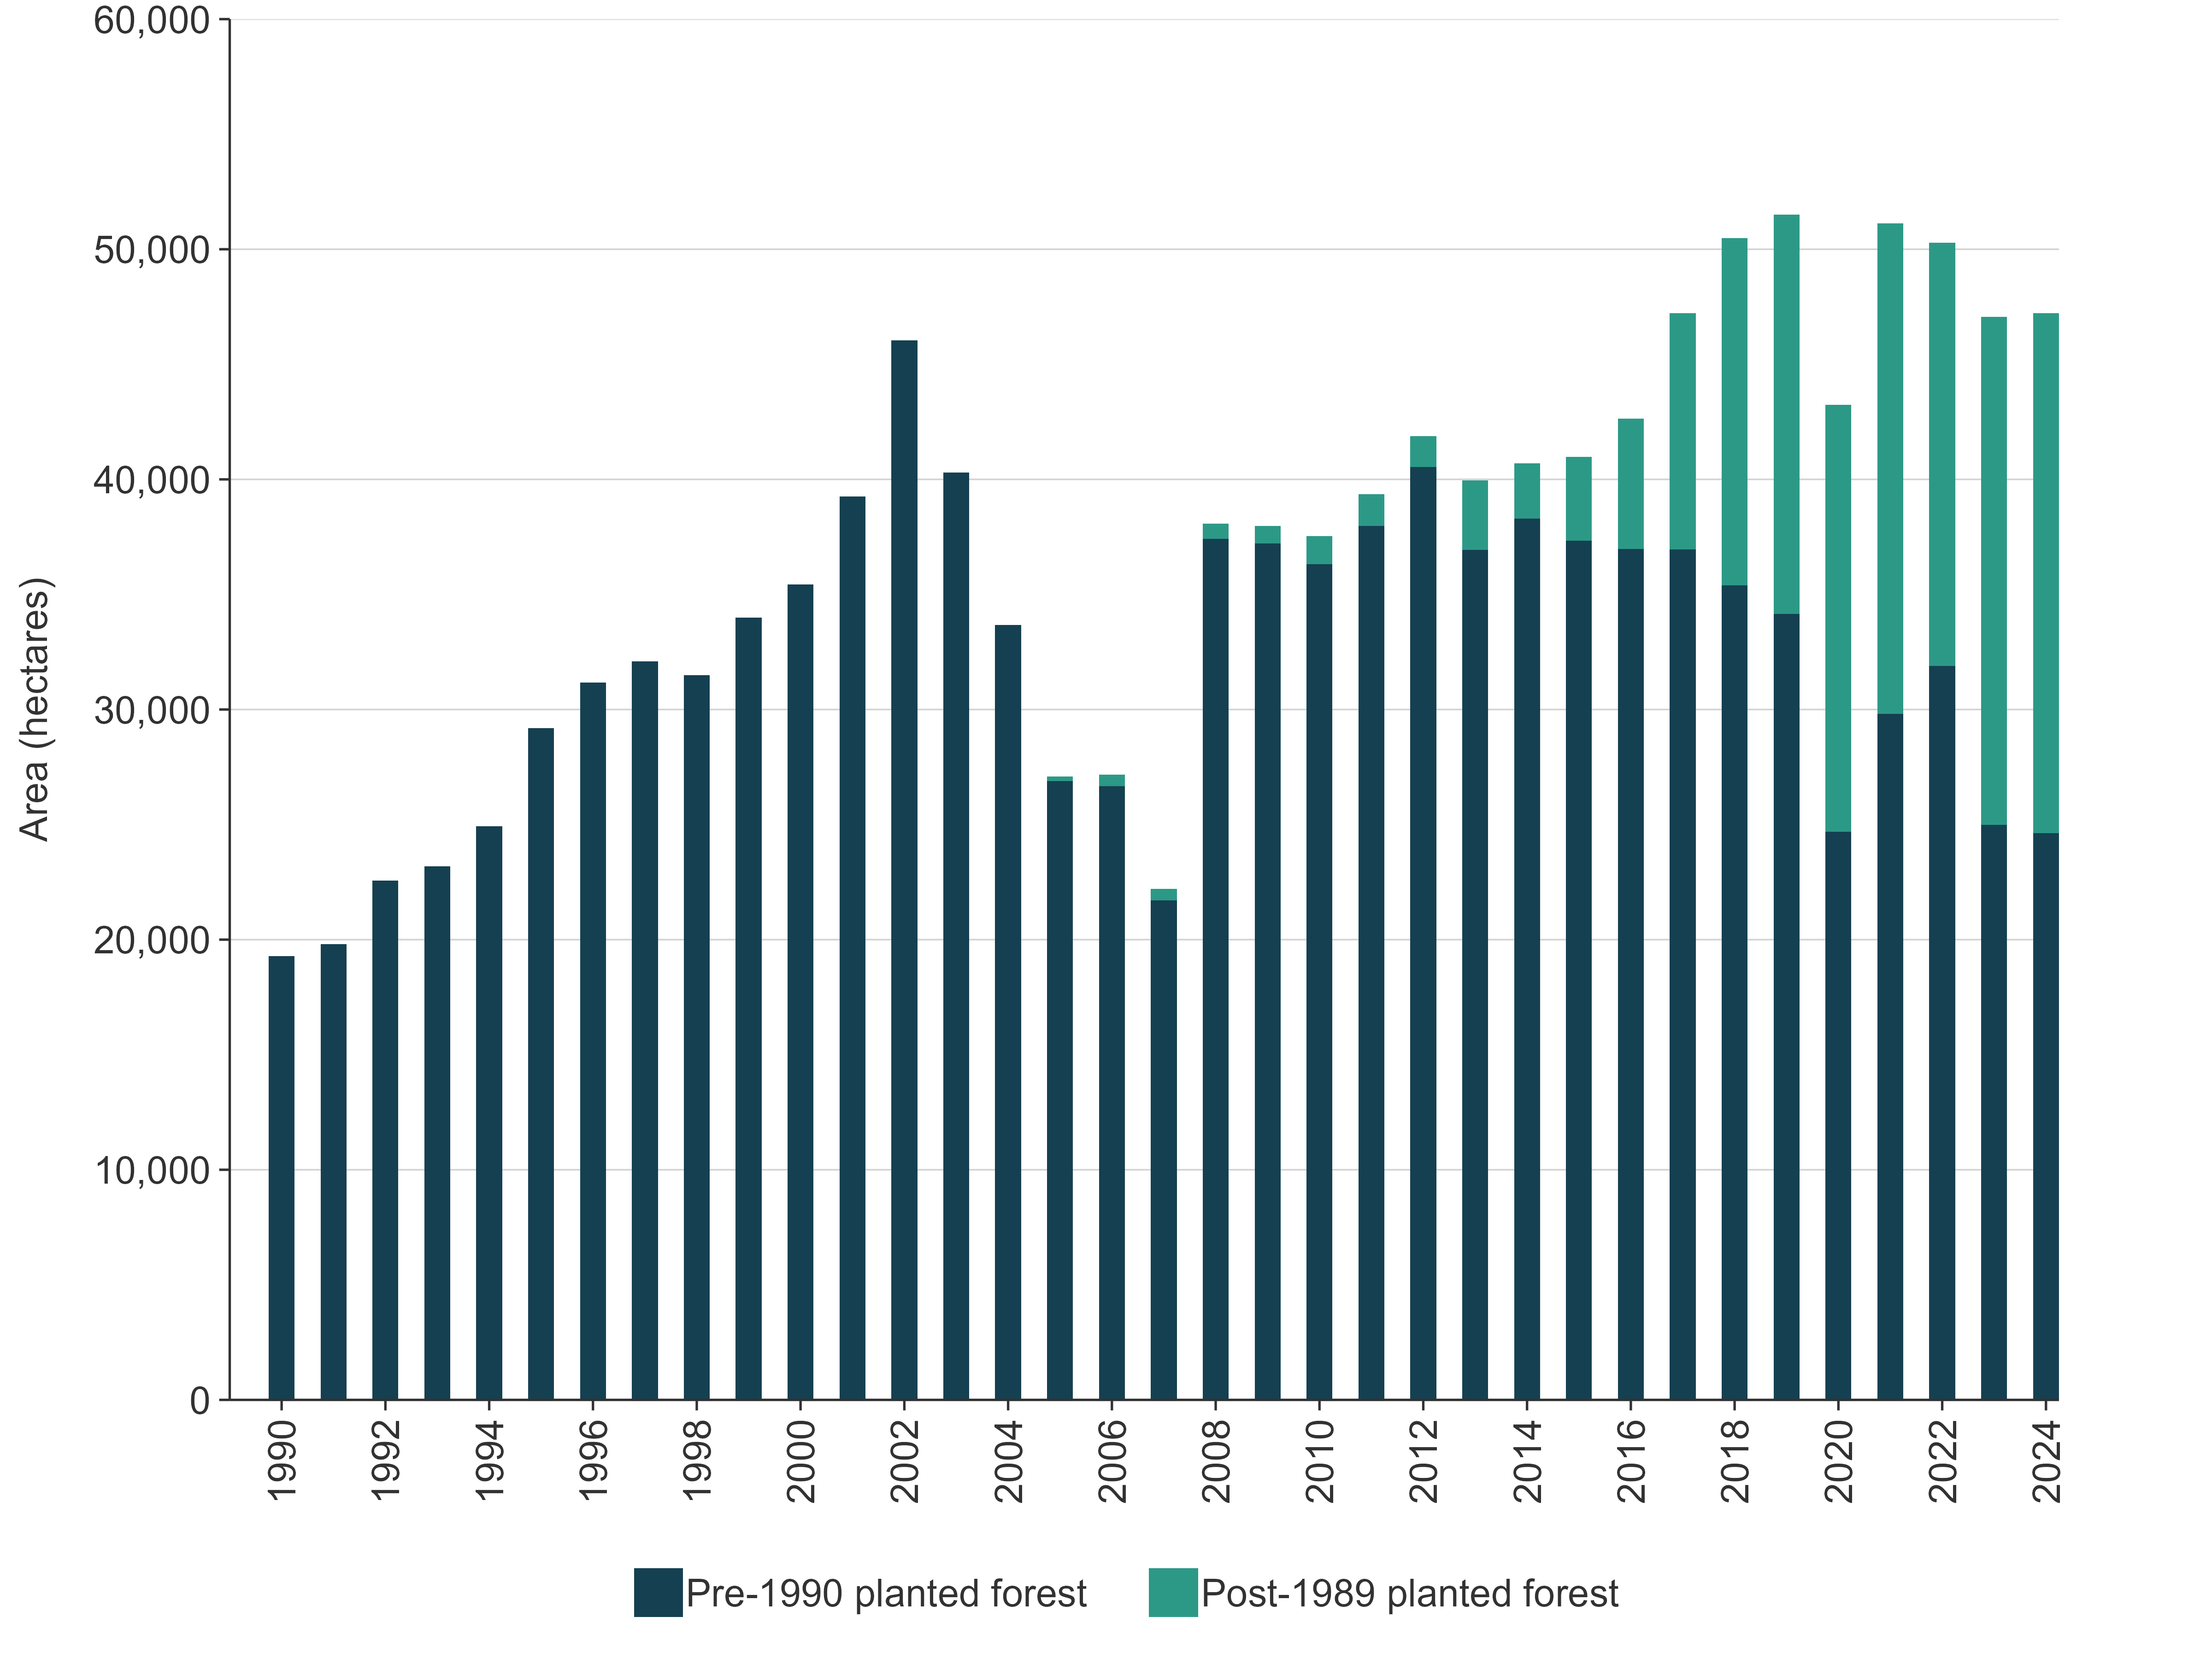

Deforestation
In 2024, an estimated 2,083 hectares of Forest land were converted to other land uses, primarily Grassland. Table 6.4.4 and figure 6.4.4 show the areas of Forest land subject to deforestation since 1990 and in 2024. Figure 6.4.4 also illustrates how planted forest deforestation increased leading up to 2008 and then decreased after the introduction of the NZ ETS in 2008.
Table 6.4.4 New Zealand’s Forest land subject to deforestation, 1990 and 2024
 | Deforestation since 1990 |  |  | Deforestation in 2024
Land use | Area of forest in 1990 (ha) | Area (ha) | Proportion of 1990 area (%) | Area (ha) | Proportion of 1990 area (%)
Pre-1990 natural forest | 7,812,913 | 48,222 | 0.62 | 429 | 0.01
Pre-1990 planted forest | 1,547,055 | 136,042 | 8.79 | 262 | 0.02
Post-1989 planted forest | 0 | 59,177 | – | 1,149 | –
Post-1989 natural forest | 0 | 2,458 | – | 243 | –
Total | 9,359,968 | 245,898 | 2.63 | 2,083 | 0.02
Note: The 2024 areas are as at 31 December 2024; 1990 areas are as at 1 January 1990 and, therefore, differ from 1990 area values in the common reporting tables, which are as at 31 December 1990. Columns may not total due to rounding.
Figure 6.4.4 New Zealand’s area of deforestation by Forest land category, from 1990 to 2024
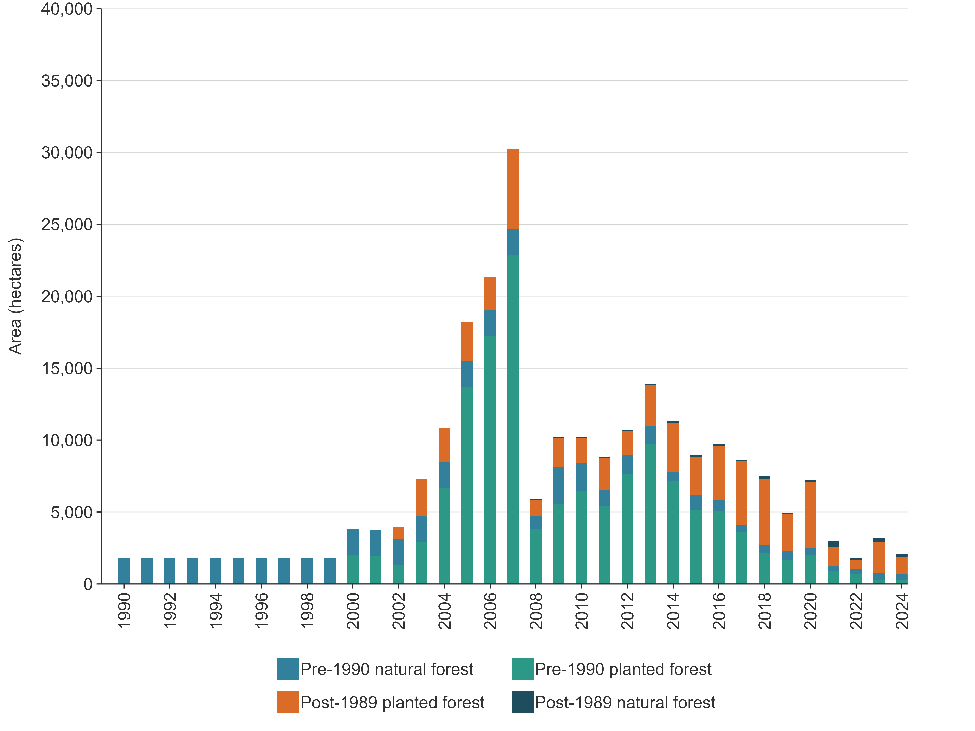
New Zealand assumes instant emissions of all biomass carbon at the time of deforestation, based on the following.
- The majority of deforestation since 2000 has resulted from land conversion to Grassland, leading to the rapid removal of all biomass as the land is prepared for farming.
- It is not practical to estimate emissions from residues following deforestation activity, given the rapid conversion from one land use to another and the multiple methods of removing residues. Furthermore, estimating biomass residue and decay rates for multiple disposal methods is difficult and costly.
Estimates of deforestation emissions for pre-1990 natural forest are based on the type of vegetation deforested, classed as tall forest or regenerating. This is done using spatial data on land cover (sourced from the Land Cover Database version 5 using the 2008 map year). These forest categories are defined in table 6.4.5. Tall forest deforestation emissions are determined from the average biomass carbon stock, per hectare, for tall forests. Regenerating forest deforestation emissions are determined from the average biomass carbon stock, per hectare, for regenerating forests. All carbon in biomass, for both tall and regenerating forest, is assumed in the calculations to be an instantaneous emission at the time of deforestation, because no information on the time lag of emissions from dead organic matter or below-ground biomass is currently available. Table 6.4.6 shows the areas of these two forest categories and table 6.4.7 shows the areas of pre-1990 natural forest deforestation split by these two forest types.
Table 6.4.5 Pre-1990 natural forest categories and description
Natural forest category | Description
Tall | Made up of two LCDB5 classes: 1. indigenous forest; tall forest dominated by indigenous conifer, broadleaved or beech species; 2. broadleaved indigenous hardwoods; lowland scrub communities dominated by indigenous mixed broadleaved shrubs.
Regenerating | All other areas mapped as pre-1990 natural forest that fall outside the two LCDB5 classes above. Represents areas recovering from previous disturbances.
Note: LCDB5 = Land Cover Database version 5.
Table 6.4.6 Areas of tall and regenerating pre-1990 natural forest in 1990 and 2024
Pre-1990 forest sub-classification | Area of forest in 1990 (ha) | Area of forest in 2024 (ha)
Tall forest | 6,688,119 | 6,666,867
Regenerating forest | 1,124,793 | 1,076,780
Total | 7,812,913 | 7,743,646
Table 6.4.7 New Zealand’s pre-1990 natural forest deforestation area (ha), for natural forest categories, estimated by type, from 1990 to 2024
Natural forest type | 1990–2007 | 2008–2012 | 2013–2017 | 2018–2022 | 2023 ^{P} | 2024 ^{P}
Tall forest | 9,596 | 2,683 | 1,884 | 1,050 | 193 | 193
Regenerating | 23,257 | 5,154 | 2,325 | 1,413 | 237 | 237
Total | 32,853 | 7,837 | 4,209 | 2,463 | 429 | 429
Note: The 2024 areas are as at 31 December 2024; 1990 areas are as at 1 January 1990 and, therefore, differ from 1990 area values in the common reporting tables, which are as at 31 December 1990. P = provisional estimate. Columns may not total due to rounding.
Estimates of biomass burning emissions associated with deforestation are provided in section 6.11.8.
Deforestation emissions are reported in the relevant Land converted to category, as are all emissions from land-use change.

National forest inventory
New Zealand has established a sampling framework for forest inventory purposes based on an 8-kilometre national grid system (8 kilometres north–south by 8 kilometres east–west). The grid has a randomly selected origin and provides an unbiased framework for establishing plots for field and/or Light Detection and Ranging (LiDAR) measurements. The network is subdivided into a 4-kilometre grid for measurement of post-1989 forest. Forest monitoring plots are established and measured where a grid point falls on land mapped as Forest land. Figure 6.4.5 and figure 6.4.6 show the distribution of carbon monitoring plots for pre-1990 and post-1989 natural and planted forest throughout New Zealand. A further description of the plot network can be found in volume 2, annex 5, section A5.2.5 ‘National forest inventory’.
Figure 6.4.5 Locations of New Zealand’s pre-1990 forest carbon monitoring plots
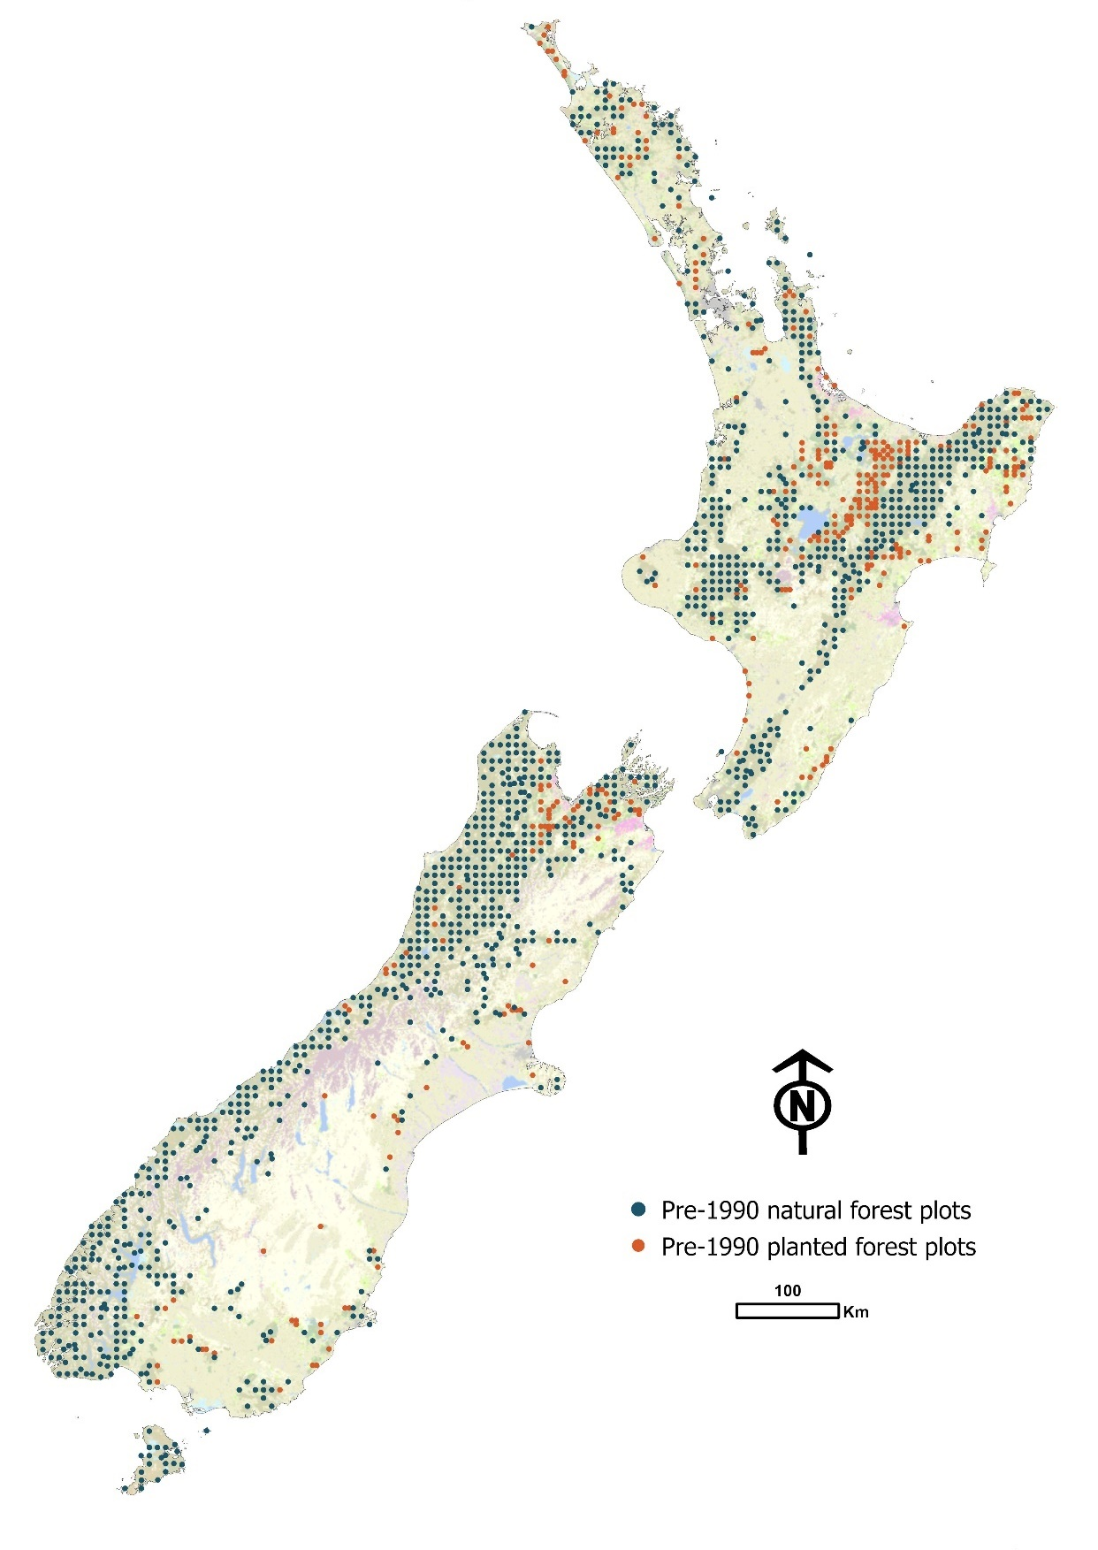

Figure 6.4.6 Locations of New Zealand’s post-1989 forest plots
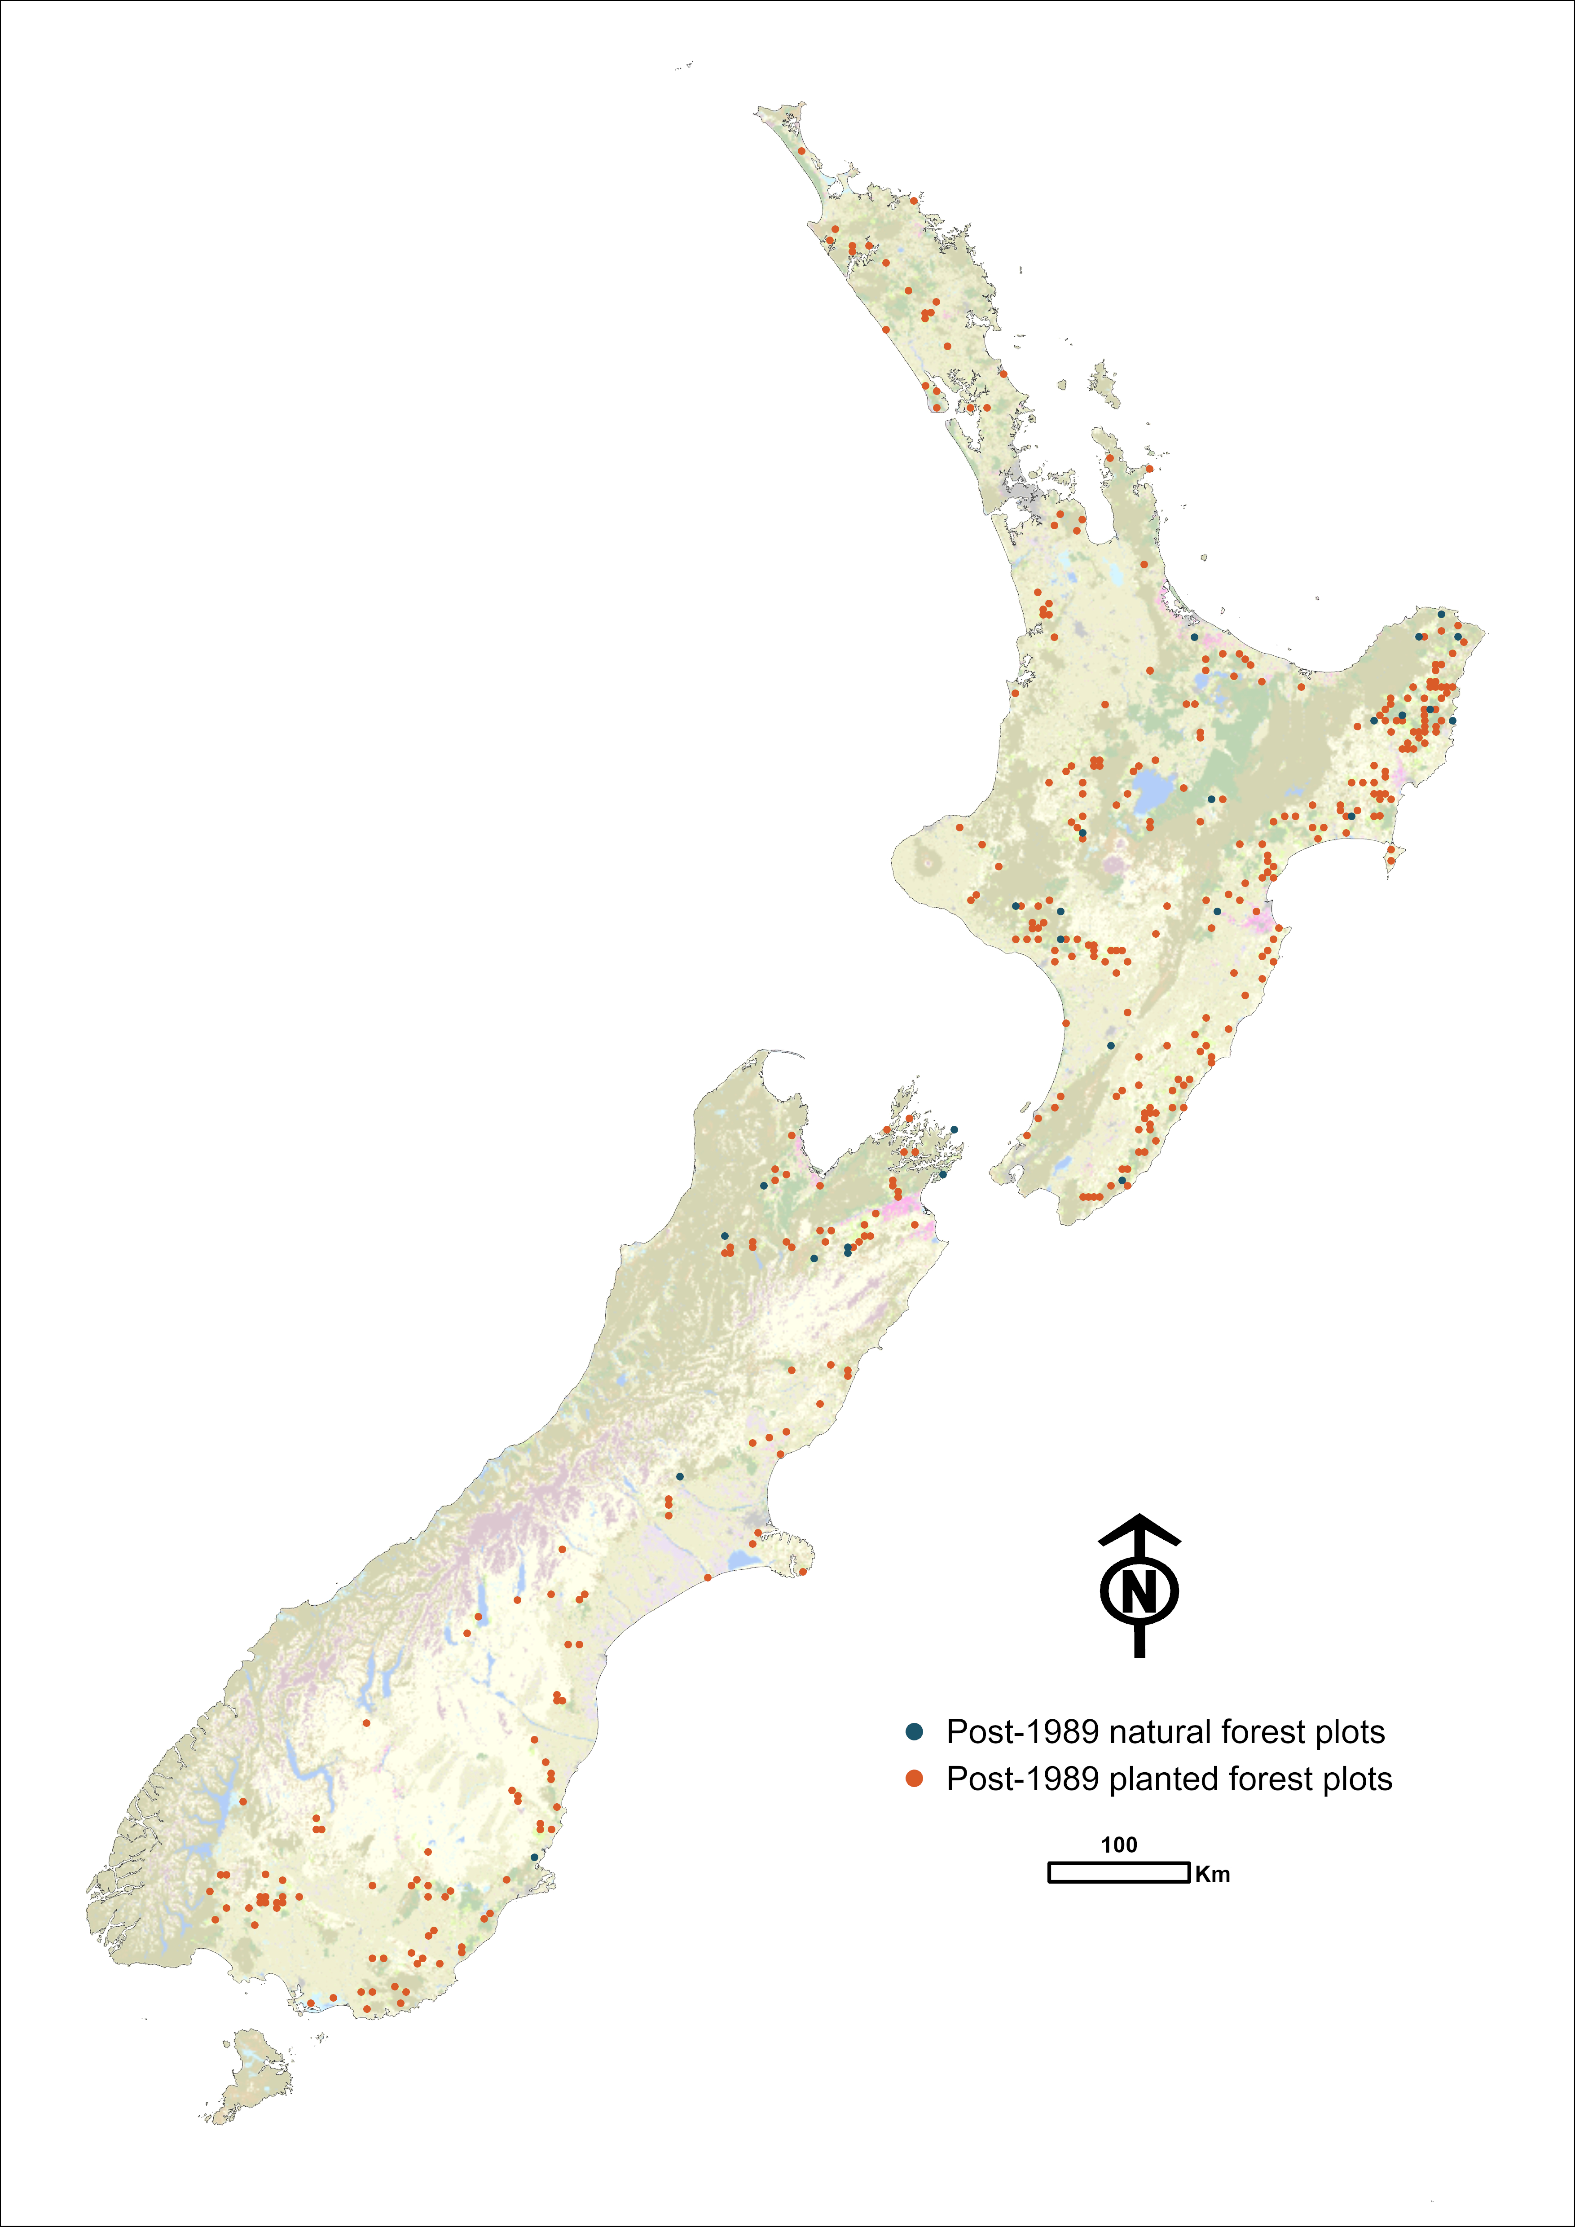

Forest land remaining forest land (4.A.1)

Living biomass and dead organic matter
Emissions and removals for the living biomass and dead organic matter pools have been calculated using Tier 2 and Tier 3 methods. At each forest plot, data are collected to calculate the volumes of trees, shrubs and dead organic matter present. These measurements are then used to estimate the carbon stocks for the biomass pools of:
- living biomass (comprising above-ground biomass and below-ground biomass)
- dead organic matter (comprising dead wood and litter).
The method used to calculate the carbon stock in each biomass pool, for each forest classification, is summarised in table 6.4.8.
Carbon stocks in natural forest are estimated directly from the inventory plots. Further detail on methods can be found in volume 2, annex 5, section A5.2.5 ‘National forest inventory’.
The carbon stocks for pre-1990 and post-1989 planted forest are calculated from yield tables derived from plot measurements, which are then applied to an estimated age-class distribution. The yield tables are based on data from all plots measured for the planted forest field inventory from 2007 to 2022, with carbon stocks across the full time series calculated using interpolation between measurements (Paul et al., 2024)
A single yield table is applied to the post-1989 planted forest estate and two period-specific yield tables are applied to the pre-1990 planted forest estate based on plant date: pre-1990 forest planted before 1990 and pre-1990 forest planted from 1990 onwards.
The use of period-specific yield tables allows for a more accurate estimate of carbon stock gains and losses from planted forests through time. The planted forest yield tables (presented in volume 2, annex 5, section A.5.2.5 ‘Planted forest yield tables’) show that pre-1990 planted forests planted after 1990 have the highest total biomass yield when compared with similarly aged pre-1990 planted forests planted before 1990, and post-1989 forests. In general, re-planted pre-1990 forests with younger trees show greater productivity (fast early growth), due to genetic improvements in stock planted recently, relative to stock planted more than 20 years ago (Paul et al., 2024). However, plots with slower growing tree species, such as Douglas fir, cypresses, coastal redwood and slower growing Eucalyptus species, are an increasing part of the post-1989 estate, reducing the overall sequestration rate for this forest type, compared with pre-1990 planted forests. Less productive species are likely to be managed on longer rotations, and this can result in older age classes being dominated by relatively slow-growing plots, lowering the combined species yield trajectory (Paul et al., 2024).
Where there has been a land-use change between natural forest and planted forest, the associated carbon changes are reported under Forest land remaining forest land, provided the forest has already been established for 20 years.
Where pre-1990 forest has undergone a deforestation event, changed to a different land use (such as Grassland), and then subsequently undergone another land-use change back to Forest land, the land use will be classified as pre-1990 forest. This is in line with the category definitions outlined in table 6.2.2.
Detailed methodology for the plot network, sampling and yield table derivation, as well as validation of the yield tables with the measured plot data, can be found in volume 2, annex 5, section A5.2.5 ‘National forest inventory’ and section A5.2.5 ‘Forest land model validations’.
Table 6.4.8 Summary of methods used to calculate New Zealand’s forest biomass
carbon stock from plot data
 | Pool |  | Method | Source
Pre-1990 natural forest | Living biomass | Above-ground biomass | Plot measurements; allometric equations | Paul et al. (2021)
Pre-1990 natural forest | Living biomass | Below-ground biomass | Estimated as the ratio of below-ground biomass to above-ground biomass | Paul et al. (2021); Easdale et al. (2019)
Pre-1990 natural forest | Dead organic matter | Dead wood | Modelled from plot measurements; allometric equations | Garrett et al. (2019); Paul et al. (2021); Kimberley et al. (2019)
Pre-1990 natural forest | Dead organic matter | Litter | Plot samples; laboratory analysis of samples collected at plots | Paul et al. (2021); Garrett (unpublished)
Post-1989 natural forest | Living biomass | Above-ground biomass | Plot measurements; allometric equations | Paul et al. (2021)
 |  | Below-ground biomass | Estimated as the ratio of below-ground biomass to above-ground biomass | Paul et al. (unpublished); Easdale et al. (2019)
 | Dead organic matter | Dead wood | Modelled from plot measurements; allometric model | Garrett et al. (2019); Paul et al. (unpublished); Kimberley et al. (2019)
 |  | Litter | Allometric model and percentage of above-ground biomass | Paul et al. (unpublished); Garrett (unpublished)
Pre-1990 planted forest | Living biomass | Above-ground biomass | Modelled through allometric equations, then included in national yield tables | Paul et al. (2024)
 |  | Below-ground biomass | Estimated as the ratio of below-ground biomass to above-ground biomass | Paul et al. (2024)
 | Dead organic matter | Dead wood | Allometric model using plot measurements, included in national yield tables. Harvest residues added to dead wood pool through the LUCAS Calculation and Reporting Application | Paul et al. (2024)
 |  | Litter | Allometric model and percentage of above-ground biomass | Paul et al. (2024)
Post-1989 planted forest | Living biomass | Above-ground biomass | Modelled through allometric equations, then included in national yield tables | Paul et al. (2024)
 |  | Below-ground biomass | Estimated as the ratio of below-ground biomass to above-ground biomass | Paul et al. (2024)
 | Dead organic matter | Dead wood | Allometric model using plot measurements, included in national yield tables. Harvest residues added to dead wood pool through the LUCAS Calculation and Reporting Application | Paul et al. (2024)
 |  | Litter | Allometric model and percentage of above-ground biomass | Paul et al. (2024)

Soil organic carbon
Soil organic carbon stocks in Forest land remaining forest land are estimated using a Tier 2 method for mineral soils, as described in volume 2, annex 5, section A5.2.4 ‘Mineral soils’.
For organic soils, IPCC good practice guidance is limited to the estimation of CO₂ emissions associated with the drainage of organic soils in managed forests (IPCC, 2006a, section 4.2.3.1). In New Zealand, natural forests are not drained and, therefore, oxidation processes associated with drainage are not occurring. It is therefore assumed that there are no CO₂ emissions from organic soils in pre-1990 natural forest land remaining pre-1990 natural forest land. A Tier 1 approach for pre-1990 planted, post-1989 planted and post-1989 natural Forest land remaining forest land is applied and is described further in volume 2, annex 5, section A5.2.4 ‘Organic soils’.

Non-CO₂ emissions for Forest land
Direct and indirect N₂O emissions from fertilisation of forest land and disturbance associated with land use management conversion are described in section 6.11. Note that the calculations of indirect N₂O are not disaggregated by category and are therefore not included in the emission subtotals for Forest land.

Land converted to forest land (4.A.2)
All Land converted to forest land since 1 January 1990, either by planting or as a result of human-induced changes in land-management practices (e.g., removing grazing stock and actively facilitating the regeneration of tree species), is included as post-1989 forest. Post-1989 forest is split into two sub-categories for calculating emissions and removals: post-1989 natural forest and post-1989 planted forest.
The area of land converted to natural and planted forests is derived from a combination of land use mapping, national statistics and forestry scheme data. Further details on how the area of new forest establishment is calculated are provided in volume 2, annex 5, section A5.2.2.
When non-forest land is converted to forest land, all carbon in living biomass that was present at the time of forest establishment is assumed to be instantly emitted as a result of forest establishment preparation, with the exception of Grassland with woody biomass conversion to Post-1989 natural forest. Conversions from Grassland with woody biomass to post-1989 natural forest represent ecological succession and do not involve the clearance of vegetation. A special case yield table (see volume 2, annex 5, section A5.2.5, table A5.2.18) is used in these instances. This yield table has the same starting carbon stock as transitional Grassland with woody biomass, therefore, resulting in no net emissions occurring from biomass in the first year after conversion. This does not affect net CO₂ removals by the time the forest reaches the age of 30 years, but affects the year in which reported emissions and removals occur.
Of the non-forest land converted to post-1989 forest between 1990 and 2024, approximately 56.5 percent has been converted from Low producing grassland, 18.2 percent from Grassland with woody biomass and a further 24.5 percent from High producing grassland. Note that the grassland type allocated to afforestation in non-mapped years is proportionally based on previously mapped years. Grassland with woody biomass provides the largest source of emissions associated with land-use change to planted forest, due to the amount of biomass present before land use conversion.
Details on the methods, plot network, sampling framework and biomass pools for both post-1989 planted and post-1989 natural forest are provided in volume 2, annex 5, section A5.2.5 ‘National forest inventory’.

6.4.3 Uncertainty assessment and time-series consistency
The uncertainty in net carbon dioxide emissions from Forest land was 61.9 percent in 2024, accounting for 55.4 percent of the total uncertainty in emissions from the LULUCF sector. The uncertainty associated with the emissions from each forest class is shown in table 6.4.9.
Time-series consistency is ensured by applying consistent methods and full recalculations in the event of any refinement or improvement to the methodology. The methods used to calculate the uncertainty values are further described in volume 2, annex 5, section A5.2.8.
Table 6.4.9 Uncertainty in carbon stock change emissions in 2024 from Forest land
 | Emissions (kt CO₂e) | Uncertainty in emissions (%) | Contribution to LULUCF uncertainty (%)
Pre-1990 planted forest | -14,804.4 | 65.3 | 46.1
Post-1989 planted forest | -1,677.3 | 319.0 | 25.5
Pre-1990 natural forest | -1,438.8 | 250.3 | 17.2
Post-1989 natural forest | -855.2 | 35.4 | 1.4
Total | -18,775.7 | 61.9 | 55.4

6.4.4 Category-specific QA/QC and verification
Carbon dioxide emissions from both Forest land remaining forest land and Land converted to forest land are key categories for both level and trend assessments. In the preparation of this inventory, the data for these emissions underwent Tier 1 QA/QC checks as well as Tier 2 category-specific QA/QC checks. Details of these checks are provided in volume 2, annex 5, section A5.2.5 ‘National forest inventory’.

6.4.5 Category-specific recalculations
In this submission, New Zealand has recalculated its emission estimates for the whole LULUCF sector from 1990, including the Forest land category. These recalculations used improved activity data, incorporating minor updates to the 2020 land use map, and new data on the proportion of standing permanent forest versus forest planned for harvest used to improve harvest age modelling. The impact of the recalculations on net CO₂e emission estimates for the Forest land category is provided in table 6.4.10. The differences shown are a result of recalculations for all carbon pools required in reporting for Forest land under the LULUCF sector.
Table 6.4.10 Recalculations of New Zealand’s estimates for the Forest land category in 1990 and 2023
 | 2025 submission | 2026 submission | Change from 2025 submission | Change (%)
Net emissions (kt CO₂e)
1990 | -23,279.5 | -23,400.1 | -120.6 | -0.5
2023 | -18,235.7 | -17,910.3 | 325.4 | 1.8
Area (hectares)
1990 | 9,372,869 | 9,372,881 | 12 | 0.0
2023 | 10,172,865 | 10,184,388 | 11,523 | 0.1
Note: Areas are as at the end of the year indicated.
For Forest land, a number of improvements made to both the planted and natural forest activity data led to a recalculation across the time series. These are described in more detail below.

Activity data
The area estimates of afforestation and deforestation were updated for this submission, following updates to forestry scheme data and mapping improvements (see volume 2, annex 5, section A5.2.2).
All deforestation is mapped up to 2020 and incorporated into the 2020 land use map. Minor corrections to deforestation mapping across the time series were made, leading to minor changes in total deforestation area for each year from 2008 to 2020 inclusive.
For pre-1990 natural forest and post-1989 natural forest, deforestation has been mapped for 2021 and 2022. Estimates of the area deforested in 2023 and 2024 were calculated as the average deforestation area for the last three mapped years (2020 to 2022), the same method applied in previous submissions.
Planted forest deforestation occurring in 2021 and 2022 has been mapped. Deforestation area estimates for 2023 and 2024 were estimated as described in volume 2, annex 5, section A5.2.2. The overall impact on emissions from changes to activity data for 2023 is an increase of approximately 325.4 kt CO₂e.

Planted forest – updates to yield tables and emissions calculations.
In this submission, there are no recalculations associated with planted forest yield tables. Yield tables for both pre-1990 planted forest and post-1989 planted forest were last updated for the 2023 submission (see volume 2, annex 5, section A.5.2.5 ‘Planted forest yield tables’).

Natural forest – updates to yield tables and emissions calculations
In this submission, there are no recalculations associated with natural forest yield tables. Yield tables for both pre-1990 natural forest and post-1989 natural forest were last updated for the 2022 submission (see volume 2, annex 5, section A5.2.5 ‘Natural forest carbon stock change estimates and yield tables’).

6.4.6 Category-specific planned improvements

Plot networks and yield tables
New Zealand will continue to measure the pre-1990 natural forest plot network on a 10-year cycle and analyse the data collected as they become available. Updated emissions estimates, using updated analytical methods, will be incorporated into future submissions as they become available.
The current post-1989 natural forest plot network was re-measured in 2023/24, and the methodological approaches for both re-measurement and analysis have been identified as an improvement priority. When sufficient data are available, an additional yield table will be developed for post-1989 natural forest. This will be produced by disaggregating data from plots dominated by exotic vegetation (typically Pinus spp. or ‘wilding pines’) from those dominated by native vegetation communities. The current method of including both vegetation types in the one yield table, due to a low sample size for the post-1989 natural forest (a total of 25 plots), limits its applicability in reporting carbon stock change and other areas of conservation and environmental management. At present, these yield tables should always be reported clearly as being the combination of both native and exotic post-1989 natural forest. Providing sufficient funding can be attained, the number of post-1989 natural forest plots surveyed will be increased in future to provide an overall sample large enough to separate into native and exotic communities and two respective yield tables.
The complete planted forest plot network (pre-1990 and post-1989) is being re-measured on a continuous basis (at five-year intervals). These data will be incorporated as they become available.

Natural forest plot data
Work has recently been undertaken to improve the quality of the LUCAS pre-1990 natural forest plot data through a data checking and correction project (Arnst and Vickers, unpublished; Arnst et al., unpublished). These corrections will enhance the robustness and repeatability of all subsequent analyses undertaken using these data. Further work is currently under way towards increased transparency and reproducibility of analysis, in addition to a sensitivity analysis to better tailor the analytical approach to the pre-1990 natural forest inventory. Following completion of these analyses, data collected during the most recent 10-year measurement cycle, carried out from 2014 to 2024, will be incorporated into the subsequent submission.
Electronic data capture by field teams was implemented from 2020 to 2021, supplementing the paper plot sheets previously used. Subsequently, QA/QC on the entire set of stem-related data (i.e., diameter, height, species) has been possible prior to upload into the database, improving on the 10 percent previously checked manually. Electronic data capture has markedly improved data quality, and any errors in tree stem-related data can be readily identified when data are uploaded to the database.

Mapping and activity data
Mapping of forest areas will be improved through updates to the 2020 land use map. Planned forest-specific mapping improvements include mapping of newly planted forests through data supplied from government-funded forestry scheme mapping, including the NZ ETS, and identified in Sentinel-2 satellite imagery, as well as biennial deforestation mapping updates.

Planted forest model
Quality-assurance and quality-control processes for checking and improving consistency between different data sets are planned for a future submission. Currently, a few inconsistencies require further investigation and remediation. These inconsistencies include:
- the estimated annual volume removed from planted forests, based on the Calculation and Reporting Application model, is not entirely consistent with estimated annual roundwood volume statistics produced by MPI (Ministry for Primary Industries, 2023) for part of the time series (1990 to 2015). Note that a comparison between the two data sources across the time series was carried out and is further described in volume 2, annex 5, section A5.2.5 ‘Forest land model validations’
- the pre-1990 planted forest average carbon stock per hectare estimated from the Calculation and Reporting Application model is greater than the average carbon stock per hectare estimated from plots in the forest inventory (further described in volume 2, annex 5, section A5.2.5 ‘Forest land model validations’)
- the pre-1990 planted forest yield tables have higher carbon stock per hectare estimates on average than plots measured in the planted forest inventory (further described in volume 2, annex 5, section A5.2.5 ‘Forest land model validations’).

6.5 Cropland (4B)

6.5.1 Description
In 2024, the net emissions from Cropland were 580.0 kt CO₂e, comprising 550.2 kt CO₂ from carbon stock change and 0.11 kt N₂O (29.8 kt CO₂e) from the nitrogen mineralisation on Land converted to cropland. Net emissions from Cropland have increased by 143.2 kt CO₂e (32.8 percent) from the 1990 level when net emissions were 436.8 kt CO₂e (table 6.5.1).
Table 6.5.1 New Zealand’s land-use change by Cropland category, and associated CO₂e emissions, 1990 and 2024
 | Net area (ha) |  |  | Net emissions (kt CO₂e)
Land use category | 1990 | 2024 | Change from 1990 (%) | 1990 | 2024 | Change from 1990 (%)
Cropland remaining cropland | 395,790 | 365,015 | -7.8 | 352.9 | 251.3 | -28.8
Land converted to cropland | 28,306 | 139,925 | 394.3 | 83.9 | 328.6 | 291.6
Total | 424,097 | 504,940 | 19.1 | 436.8 | 580.0 | 32.8
Note: Net area in 1990 is as at 1 January 1990; net area in 2024 is as at 31 December 2024. Land converted to cropland includes land converted up to 20 years earlier. Net emission values are for the whole year indicated. Values include carbon dioxide equivalent emissions from nitrous oxide from cultivation of land.
The Land converted to cropland category is responsible for the majority of Cropland emissions. This category comprised 27.7 percent of all Cropland area in 2024.
Most emissions due to carbon stock change that have occurred in the Cropland category since 1990 are in the SOC pool (5,145.0 kt C) (table 6.5.2). Within the SOC pool, the majority of changes in carbon stocks result from drained organic soils (3,535.0 kt C). This is because organic soils continue to lose carbon even after the 20-year transition period (IPCC, 2006a).
Table 6.5.2 New Zealand’s carbon stock change by carbon pool for the Cropland category, from 1990 to 2024
 | Net carbon stock change 1990–2024 (kt C) |  |  |  | Emissions 1990–2024
Land use | Living biomass | Dead organic matter | Soils | Total | (kt CO₂)
Annual cropland | 214.6 | -13.9 | -3,588.1 | -3,387.4 | 12,420.6
Perennial cropland | 564.4 | -9.4 | -1,556.9 | -1,001.8 | 3,673.4
Total | 779.0 | -23.3 | -5,145.0 | -4,389.3 | 16,094.0
Note: This table includes carbon dioxide emissions from carbon stock change only (so it does not include emissions from nitrous oxide disturbance). The reported dead organic matter losses result from the loss of dead organic matter of woody land use categories on conversion to cropland. Columns may not total due to rounding.
Table 6.5.3 shows land-use change by Cropland land use since 1990, and the associated CO₂ emissions from carbon stock change. The Cropland category in New Zealand is separated into two land use types: annual and perennial. In 2024, annual cropland accounted for 1.5 percent of total land area, and perennial cropland accounted for 0.4 percent of total land area in New Zealand.
Annual crops include cereals, grains, oil seeds, vegetables, root crops and forages. Perennial crops include orchards, vineyards and their associated shelterbelts except where these shelterbelts meet the criteria for the Forest land category.
The amount of carbon stored in, emitted by or removed from Cropland depends on crop type, management practices, soil properties and climate variables. Annual crops are harvested each year, with little long-term storage of carbon in biomass. Woody vegetation in orchards stores more carbon in biomass, with the amount largely determined by the crop species and presence of shelterbelts.
Table 6.5.3 New Zealand’s land-use change by Cropland land use, and associated CO₂ emissions from carbon stock change, from 1990 to 2024
 | Net area (ha) |  | Change from  1990 (%) | Net emissions (kt CO₂ only) |  | Change from  1990 (%)
Land use | 1990 | 2024 | Change from  1990 (%) | 1990 | 2024 | Change from  1990 (%)
Annual cropland | 355,073 | 396,478 | 11.7 | 327.1 | 489.7 | 49.7
Perennial cropland | 69,023 | 108,463 | 57.1 | 103.0 | 60.5 | -41.2
Total | 424,097 | 504,940 | 19.1 | 430.1 | 550.2 | 27.9
Note: Net area in 1990 is as at 1 January 1990; net area in 2024 is as at 31 December 2024. This table includes carbon dioxide emissions from carbon stock change only. Columns may not total due to rounding.
A summary of land-use change within the Cropland category, by land use type and land conversion status, is provided in table 6.5.4. This shows that land-use change within the Cropland category has been dominated by conversions to annual cropland.
Table 6.5.4 New Zealand’s land-use change for the Cropland category, from 1990 to 2024
Cropland category |  | Net area (ha) as at 1990 | Net area (ha) as at 2024 | Change from 1990 (%)
Cropland remaining cropland | Annual remaining annual | 333,588 | 266,729 | -20.0
 | Perennial remaining perennial | 61,557 | 93,055 | 51.2
 | Annual to perennial | 645 | 4,287 | 564.6
 | Perennial to annual | 0 | 944 | –
 | Subtotal | 395,790 | 365,015 | -7.8
Land converted to cropland | Annual cropland | 21,485 | 128,804 | 499.5
 | Perennial cropland | 6,821 | 11,121 | 63.0
 | Subtotal | 28,306 | 139,925 | 394.3
Total |  | 424,097 | 504,940 | 19.1
Note: This table shows the change between 1 January 1990 and 31 December 2024. Columns may not total due to rounding.
In 2024, Cropland remaining cropland and Land converted to cropland were identified as key categories for the level and trend assessment.

6.5.2 Methodological issues
Emissions and removals for the living biomass and dead organic matter pools have been calculated using IPCC Tier 1 emission factors for annual cropland, Tier 2 emission factors for perennial cropland (Davis and Wakelin, unpublished) and activity data as described in section 6.2. Emissions and removals by the SOC pool are estimated using a Tier 2 method for mineral soils and IPCC Tier 1 defaults for organic soils, as described in volume 2, annex 5, section A5.2.4.
A summary of the New Zealand emission factors and other parameters used to estimate greenhouse gas emissions for the Cropland category is provided in table 6.5.5.
Table 6.5.5 Summary of New Zealand’s carbon stock change emission factors for the Cropland category
Land use | Carbon pool | Steady state carbon stock  (t C ha^{–1}) | Annual carbon stock change  (t C ha^{–1}) | Years to reach steady state | Source
Annual | Biomass
 | Living biomass | 5.0 | NA | 1 | IPCC default (table 5.9, IPCC, 2006a)
 | Dead organic matter | NE | NE | NA | No IPCC guidelines
 | Soils
 | Mineral | 89.77 | * | 20 | New Zealand-specific EF (McNeill and Barringer, unpublished)
 | Organic | NE | -5.0 or -10.0** |  | IPCC Tier 1 default (table 5.6, IPCC, 2006a)
Perennial | Biomass
 | Living biomass | 18.76 | 0.67 | 28 | New Zealand-specific EF (Davis and Wakelin, unpublished)
 | Dead organic matter | NE | NE | NA | No IPCC guidelines
 | Soils
 | Mineral | 88.44 | * | 20 | New Zealand-specific EF (McNeill and Barringer, unpublished)
 | Organic | NE | -5.0 or -10.0** |  | IPCC Tier 1 default (table 5.6, IPCC, 2006a)
Note: EF = emission factor; NA = not applicable; NE = not estimated. * Annual carbon stock change in mineral soils on land undergoing land-use change will depend on the land use category the land has been converted to or from; see volume 2, annex 5, section A5.2.4 ‘Mineral soils’. ** The emission factor for organic soils is -5.0 tonnes carbon (C) ha^{–1} yr^{–1} for cold temperate regions and -10.0 tonnes C ha^{–1} yr^{–1} for warm temperate regions.

Cropland remaining cropland (4.B.1)
For Cropland remaining cropland, the Tier 1 assumption is that for annual cropland there is no change in biomass carbon stocks after the first year (IPCC, 2006a, section 5.2.1). The rationale is that the increase in biomass stocks in a single year is equal to the biomass losses from harvest and mortality in that same year. For perennial cropland, there is a change in carbon stocks associated with a land-use change. Where land-use change has occurred between the Cropland land use categories, carbon stock changes are reported in Cropland remaining cropland.

Living biomass
To estimate carbon stock change in living biomass for annual cropland converted to perennial cropland, New Zealand uses Tier 1 defaults for biomass carbon stocks at harvest (IPCC, 2006a, table 5.9). The Tier 1 method for estimating carbon change assumes carbon stocks in biomass immediately after conversion are zero; that is, the land is cleared of all vegetation before planting crops (5.0 tonnes carbon (C) ha^{–1} is instantly oxidised in the year of conversion).
To estimate growth after conversion of annual cropland to perennial cropland, New Zealand uses the biomass accumulation rate of 0.67 tonnes C ha^{–1} yr^{–1}. This value is based on the New Zealand-specific value of 18.76 tonnes C ha^{–1} sequestered over 28 years (Davis and Wakelin, unpublished). It is assumed any biomass gains after this 28-year period are compensated for by biomass loss from pruning and other management practices, resulting in a net zero change in biomass stock of perennial cropland remaining perennial cropland.
The available activity data do not provide information on areas of perennial cropland temporarily destocked; therefore, no losses in carbon stock due to temporary destocking are reported. Consequently, no gains in these areas are reported either when they are restocked.

Dead organic matter
New Zealand does not report estimates of dead organic matter in this category. The notation key NE (not estimated) is used in the CRTs, in accordance with paragraph 37(b) of Decision 24/CP.19 (UNFCCC, 2014). There is insufficient information to provide a basic approach with default parameters to estimate carbon stock change in dead organic matter pools in Cropland remaining cropland and, consequently, no Tier 1 method is provided (IPCC, 2006a).

Soil organic carbon
Soil organic carbon stocks in mineral soil for Cropland remaining cropland are estimated using a Tier 2 method (see volume 2, annex 5, section A5.2.4 ‘Mineral soils’). For organic soils, loss of soil carbon is estimated using the Tier 1 method as described in volume 2, annex 5, section A5.2.4 ‘Organic soils’.
Mineral soil carbon change for annual cropland converted to perennial cropland and vice versa is estimated using the IPCC default method of applying a linear rate of change over 20 years (IPCC, 2006a, equation 2.25).

Non-CO₂ emissions
All direct and indirect N₂O emissions occurring from management activities in Cropland remaining cropland are reported under the Agriculture sector.

Land converted to cropland (4.B.2)

Living biomass
New Zealand uses a Tier 1 method, and a combination of IPCC default and New Zealand-specific emission factors, to calculate emissions for Land converted to cropland. The Tier 1 method multiplies the area of Land converted to cropland annually by the carbon stock change per area for that type of conversion.
The Tier 1 method assumes carbon in living biomass and dead organic matter immediately after conversion is zero; that is, the land is cleared of all vegetation before planting crops. The amount of biomass cleared when land at steady state is converted is dependent on the land use category undergoing the conversion and is described further under each category-specific section in this chapter.
The Tier 1 method also includes changes in carbon stocks from one year of growth in the year conversion takes place, as outlined in equation 2.5 of the 2006 IPCC Guidelines (IPCC, 2006a).
To estimate growth after conversion to annual cropland, New Zealand uses the IPCC default biomass accumulation rate of 5.0 tonnes C ha^{–1} for the first year following conversion (IPCC, 2006a, table 5.9). After the first year, any increase in biomass stocks in annual cropland is assumed equal to biomass losses from harvest and mortality in that same year and, therefore, after the first year there is no net accumulation of biomass carbon stocks in annual cropland remaining annual cropland (IPCC, 2006a, section 5.2.1).
To estimate growth after conversion to perennial cropland, New Zealand uses the biomass accumulation rate of 0.67 tonnes C ha^{–1} yr^{–1} until 18.76 tonnes C ha^{–1} is reached, as described in the Cropland remaining cropland section above. The final eight years of biomass gain are reported in Cropland remaining cropland because the 2006 IPCC Guidelines (IPCC, 2006a) default transition period of 20 years has been applied across the entire LULUCF sector.

Dead organic matter
New Zealand reports only losses in dead organic matter associated with the previous land use for this category. The losses are calculated based on the carbon in dead organic matter at the site before conversion to Cropland. It is assumed that, immediately after conversion, dead organic matter is zero (all carbon in dead organic matter before conversion is instantly oxidised in the year of conversion). There is insufficient information to estimate gain in carbon stock in dead organic matter pools after land is converted to Cropland (IPCC, 2006a). Consequently, where there are no dead organic matter losses associated with the previous land use, the notation key NA (not applicable) is used in the CRTs in accordance with Decision 24/CP.19 (UNFCCC, 2014) because a given source and/or sink category does not result in emissions or removals of a specific gas.

Soil organic carbon
Soil organic carbon stocks in Land converted to cropland are estimated using a Tier 2 method for mineral soils and a Tier 1 method for organic soils (see volume 2, annex 5, section A5.2.4, for further information).

Non-CO₂ emissions
Nitrous oxide emissions from disturbance associated with land use conversion to Cropland and land use management are described in section 6.11.

6.5.3 Uncertainty assessment and time-series consistency
The uncertainty in net CO₂ emissions from Cropland was 61.4 percent in 2024. The uncertainty in net CO₂ emissions from Cropland accounted for 1.6 percent of the total uncertainty in emissions from the LULUCF sector. The uncertainty associated with the emissions from each Cropland class is shown in table 6.5.6. The methods used to calculate the uncertainty are further described in volume 2, annex 5, section A5.2.8.
Time-series consistency is ensured by applying consistent methods and full recalculations in the event of any refinement or improvement to methodology.
Table 6.5.6 Uncertainty in net carbon stock change emissions in 2024 for the Cropland category
Land use | Emissions (kt CO₂e) | Uncertainty in emissions (%) | Contribution to LULUCF uncertainty (%)
Annual cropland | 489.7 | 66.3 | 1.5
Perennial cropland | 60.5 | 152.8 | 0.4
Total | 550.2 | 61.4 | 1.6

6.5.4 Category-specific QA/QC and verification
Cropland remaining cropland and Land converted to cropland were identified as key categories for the level and trend assessment in 2024. As part of verification of the New Zealand-specific above-ground biomass emission factor for perennial cropland, this factor has been compared with the IPCC default for temperate perennial cropland (IPCC, 2006a, table 5.1). The New Zealand value for above-ground biomass of 18.76 tonnes C ha^{–1} is much lower than the default value of 63 tonnes C ha^{–1} provided in the 2006 IPCC Guidelines (IPCC, 2006a). Further research into the differences between the values has shown the IPCC default value is based on just four studies of agroforestry systems where crops are grown in rotation with trees, and none of these studies is New Zealand specific. The country-specific emission factor used is based on a New Zealand study, taking into account that New Zealand’s main perennial crops are not grown in rotation with trees (i.e., are not part of an agroforestry system) and that a significant proportion of New Zealand’s main perennial crops are vine fruit, such as kiwifruit and grapes (Davis and Wakelin, unpublished). This means the country-specific value has lower carbon stocks per hectare in living biomass at maturity than the Cropland types included in the study on which the IPCC default value is based.

6.5.5 Category-specific recalculations
Recalculations of the entire time series were carried out for the Cropland category as a result of updated activity data resulting from minor improvements to land use mapping. The magnitude of change in this category is largely attributable to revised emission factors for Grassland, which exert a strong influence on cropland estimates due to the close interaction between these land use classes. Consequently, updates applied to Grassland parameters have resulted in a cascading effect on Cropland emissions. The impact of recalculations on net CO₂e emission estimates for the Cropland category is shown in table 6.5.7.
Table 6.5.7 Recalculations of New Zealand’s net emissions from the Cropland category in 1990 and 2023
 | 2025 submission | 2026 submission | Change from 2025 submission | Change (%)
Net emissions (kt CO₂e)
1990 | 478.3 | 436.8 | -41.5 | -8.7
2023 | 749.8 | 539.4 | -210.4 | -28.1
Area (hectares)
1990 | 426,841 | 426,833 | -8 | -0.0
2023 | 497,239 | 497,472 | 233 | 0.0
Note: Columns may not total due to rounding.

6.5.6 Category-specific planned improvements
A longitudinal study on the impact of management practices on Grassland and Cropland soils is under way (Manaaki Whenua Landcare Research, 2020). This study will collect time-series data on a network of 500 soil sample plots over 12 years. This is likely to improve the SOC reference values for Cropland. These data are expected to be available for the updated soil carbon stock estimates and model and are planned to be incorporated into the 2027 submission.
This work will substantially improve the accuracy of soil carbon estimates and provide a framework to include management effects within land uses. The data will be incorporated into inventory submissions as they become available.

6.6 Grassland (4C)

6.6.1 Description
In 2024, the net emissions from Grassland were 2,186.9 kt CO₂e (table 6.6.1). These emissions comprise 2,150.6 kt CO₂ emissions from carbon stock change, 0.05 kt N₂O (13.2 kt CO₂e) and 0.8 kt CH₄ (23.1 kt CO₂e) emissions from Biomass burning and nitrogen mineralisation on Land converted to grassland.
Net emissions from Grassland have increased by 196.7 kt CO₂e (9.9 percent) from the 1990 level of 1,990.1 kt CO₂e (table 6.6.1). The majority of this change occurred in pre-1990 planted forest that has since been converted to high producing grassland and is the result of deforestation that involves large losses in the living biomass pool.
The Grassland remaining grassland and Land converted to grassland categories were identified as key categories for the level and trend assessment in 2024.
Table 6.6.1 New Zealand’s land-use change for the Grassland category, and associated
CO₂e emissions, from 1990 to 2024
 | Net area (ha) |  |  | Net emissions (kt CO₂e)
Land use category | 1990 | 2024 | Change from 1990 (%) | 1990 | 2024 | Change from 1990 (%)
Grassland remaining grassland | 14,904,741 | 13,960,997 | -6.3 | 1,464.2 | 1,379.6 | -5.8
Land converted to grassland | 351,543 | 286,080 | -18.6 | 526.0 | 807.3 | 53.5
Total | 15,256,284 | 14,247,078 | -6.6 | 1,990.1 | 2,186.9 | 9.9
Note: Net area in 1990 is as at 1 January 1990; net area in 2024 is as at 31 December 2024. Land converted to grassland includes land converted up to 20 years earlier. Net emission estimates are for the whole year indicated. Columns may not total due to rounding.
In New Zealand, the Grassland category is used to describe a range of land cover types. In this submission, three types of Grassland are used: high producing, low producing, and with woody biomass. Detailed descriptions of each Grassland type can be found in table 6.2.2 and are briefly summarised below:
- High producing grassland – intensively managed pasture land
- Low producing grassland – low-fertility grasses on hill country, areas of native tussock and areas composed of low, shrubby vegetation, both above and below the timberline
- Grassland with woody biomass – grassland areas where the cover of woody species is less than 30 percent and/or does not meet, nor has the potential to meet, the New Zealand forest definition due to the current management regime (e.g., periodically cleared for grazing), or due to characteristics of the vegetation or environmental constraints (e.g., alpine shrubland).
Grassland with woody biomass is a diverse land use and has therefore been disaggregated into two types: permanent (51.1 percent) and transitional (48.9 percent), as described in table 6.6.2. A grid-based assessment of Grassland with woody biomass was used to determine this disaggregation; this was done through a combination of plot measurements and virtual assessments of grid points where plots did not exist (Wakelin and Beets, 2013). Separate emission factors for each type of Grassland with woody biomass are derived from the LUCAS national plot network (Wakelin and Beets, 2013). Within the CRTs, reporting on Grassland with woody biomass is at the aggregate level.
Table 6.6.2 Grassland with woody biomass categories and description
Grassland with woody biomass categories | Description | Expected occurrence
Transitional | Areas of woody shrublands within farmland that do not become forest over a 30- to 40-year timeframe (Trotter and MacKay, unpublished). | Where livestock grazes areas of woody shrubland or where woody shrubland is managed in other ways (e.g., spraying) to prevent it from becoming forest.
Permanent | Land covered by woody vegetation that does not meet the forest definition and is not expected to do so under current ecological, management or environmental conditions. | Where abiotic conditions at a site are conducive to low-stature vegetation; for example, vegetation growing at high altitudes, on low-fertility soil or on frost flats.
In 2024, there were 6,720,087 hectares of High producing grassland (25.0 percent of total land area), 6,189,857 hectares of Low producing grassland (23.0 percent of total land area) and 1,337,134 hectares of Grassland with woody biomass (5.0 percent of total land area). The area of Grassland with woody biomass comprises 479,266 hectares of permanent and 857,868 hectares of transitional Grassland with woody biomass.
From 1990 to 2024, the net carbon stock change attributed to Grassland was a loss of 54,061.1 kt C, equivalent to 198,224.1 kt CO₂ emissions (table 6.6.3). The majority of these emissions are due to the loss of living biomass carbon stock associated with Forest land conversion to Grassland (deforestation).
Table 6.6.3 New Zealand’s carbon stock change by carbon pool for the Grassland category,
from 1990 to 2024
 | Net carbon stock change 1990–2024 (kt C) |  |  |  | Emissions 1990–2024
Land use | Living biomass | Dead organic matter | Soils | Total | (kt CO₂)
Grassland – high producing | -25,969.9 | -2,312.6 | -9,740.4 | -38,022.8 | 139,417.1
Grassland – low producing | -10,120.0 | -1,394.9 | 740.7 | -10,774.1 | 39,505.2
Grassland – with woody biomass | -3,664.7 | -638.8 | -960.6 | -5,264.1 | 19,301.8
Total | -39,754.6 | -4,346.3 | -9,960.2 | -54,061.1 | 198,224.1
Note: Columns may not total due to rounding.

Grassland remaining grassland
There were 13,960,997 hectares of Grassland remaining grassland as at 2024, equivalent to 51.9 percent of New Zealand’s total land area.

Land converted to grassland
In 2024, an estimated 9,045 hectares of land were converted to Grassland, while 86,663 hectares of Grassland were converted to other land use categories.
The majority (67.7 percent) of Land converted to grassland since 1 January 1990 is land that was previously Forest land. The 239,201 hectares of Forest land converted to Grassland since 1 January 1990 comprise an estimated 132,689 hectares of pre-1990 planted forest, 58,051 hectares of post-1989 planted forest, 46,020 hectares of pre-1990 natural forest and 2,442 hectares of post-1989 natural forest. For more information on deforestation, see volume 2, annex 5, section A5.2.2. Land-use change of Forest land to Grassland resulted in net emissions of 968.4 kt CO₂ in 2024.

6.6.2 Methodological issues
Emissions and removals in the Grassland category have been calculated using country-specific factors for all carbon pools representing living biomass, while dead organic matter is only included for Grassland with woody biomass due to the absence of guidelines for the other grassland types (table 6.6.4). Emissions and removals from mineral soils are estimated using a Tier 2 method, whereas organic soils are estimated using a Tier 1 method (see volume 2, annex 5, section A5.2.4).
Table 6.6.4 Summary of New Zealand’s biomass emission factors for Grassland
Land use | Carbon pool | Steady state carbon stock  (t C ha^{–1}) | Annual carbon accumulation  (t C ha^{–1}) | Years to reach steady state | Source
High producing | Total biomass | 2.341 | 2.341 | 1 | Vibart et al. (2025)
High producing | Living biomass |  |  |  | Vibart et al. (2025)
High producing | AGB | 0.996 | 0.996 | 1 | Vibart et al. (2025)
High producing | BGB | 1.345 | 1.345 | 1 | Vibart et al. (2025)
High producing | Dead organic matter | NE | NE | NA | No IPCC guidelines
Low producing | Total biomass | 4.481 | 4.481 | 1 | Vibart et al. (2025)
Low producing | Living biomass |  |  |  | Vibart et al. (2025)
Low producing | AGB | 0.966 | 0.966 | 1 | Vibart et al. (2025)
Low producing | BGB | 3.515 | 3.515 | 1 | Vibart et al. (2025)
Low producing | Dead organic matter | NE | NA | NA | No IPCC guidelines
With woody biomass –transitional | Total biomass | 13.05 | 0.48 | 20 | Wakelin and Beets (2013)
With woody biomass –transitional | Living biomass |  |  |  | Wakelin and Beets (2013)
With woody biomass –transitional | AGB | 9.35 | 0.36 | 20 | Wakelin and Beets (2013)
With woody biomass –transitional | BGB | 3.05 | 0.08 | 20 | Wakelin and Beets (2013)
With woody biomass –transitional | Dead organic matter |  |  |  | Wakelin and Beets (2013)
With woody biomass –transitional | Dead wood | 0.10 | 0.004 | 20 | Wakelin and Beets (2013)
With woody biomass –transitional | Litter | 0.55 | 0.02 | 20 | Wakelin and Beets (2013)
With woody biomass – permanent | Total biomass | 60.57 | NO | NO | Wakelin and Beets (2013)
With woody biomass – permanent | Living biomass |  |  |  | Wakelin and Beets (2013)
With woody biomass – permanent | AGB | 45.18 | NO | NO | Wakelin and Beets (2013)
With woody biomass – permanent | BGB | 11.71 | NO | NO | Wakelin and Beets (2013)
With woody biomass – permanent | Dead organic matter |  |  | NO | Wakelin and Beets (2013)
With woody biomass – permanent | Dead wood | 3.68 | NO | NO | Wakelin and Beets (2013)
With woody biomass – permanent | Litter | 0.00 | NO | NO | Wakelin and Beets (2013)
Note: AGB = above-ground biomass; BGB = below-ground biomass; NA = not applicable; NE = not estimated; NO = not occurring. Columns may not total due to rounding. Note that the annual accumulation rates for Grassland with woody biomass – transitional do not equal the total biomass steady state carbon stock value over 20 years because the starting stock value at year 1 is 3.54 tonnes carbon ha^{–1}.

Grassland remaining grassland (4.C.1)
For Grassland remaining grassland, it is assumed that there is no change in carbon stocks for Grassland remaining in the same Grassland category (IPCC, 2006a, section 6.2.1.1). The rationale is that, where management practices are static, carbon stocks will be in an approximately steady state; that is, carbon gain through plant growth is roughly balanced by losses from management. New Zealand has reported NA in the CRTs where there is no land-use change at the category level because no emissions or removals are assumed to have occurred. However, a significant area (370,318 hectares) is currently in a state of conversion from one Grassland type to another. The carbon stock changes for these land-use changes are reported under Grassland remaining grassland.

Living biomass
To calculate carbon stock change in living biomass on land converted from one Grassland category to another (e.g., Low producing grassland converted to High producing grassland), it is assumed the carbon in living biomass immediately after conversion is zero; that is, the land is cleared of all vegetation. In the same year, carbon stocks in living biomass increase by the amount given in table 6.6.4, representing the annual growth in biomass for land converted to another land use.

Dead organic matter
New Zealand does not report estimates of dead organic matter for High producing grassland or Low producing grassland. There is insufficient information to develop default coefficients for estimating the dead organic matter pool for these two categories (IPCC, 2006a). The notation key NE is used in the CRTs.
For Grassland with woody biomass, an estimate of dead organic matter is derived from the LUCAS national plot network (Wakelin and Beets, 2013) and estimates of changes in dead organic matter stocks with conversion to and from this land use are reported.

Soil organic carbon
Soil organic carbon stocks in Grassland remaining grassland are estimated using a Tier 2 method for mineral soils and a Tier 1 method for organic soils (see volume 2, annex 5, section A5.2.4).

Non-CO₂ emissions
Direct and indirect N₂O emissions occurring as a result of nitrogen inputs, as well as drainage of managed soils, in Grassland remaining grassland are reported under the Agriculture sector.

Land converted to grassland (4.C.2)

Living biomass
New Zealand applies a Tier 2 method to calculate emissions for Land converted to grassland. The Tier 2 method multiplies the area of Land converted to grassland annually by the carbon stock change per area for that type of conversion, using New Zealand-specific emission factors.
The Tier 2 method assumes carbon in living biomass immediately after conversion is zero; that is, the land is cleared of all vegetation at conversion and is instantly oxidised. The Tier 2 method also includes changes in carbon stocks from one year of growth from the Grassland category that land was converted to in the year conversion takes place, as outlined in equation 2.9 of the 2006 IPCC Guidelines (IPCC, 2006a).

Dead organic matter
For land conversion to High producing grassland and Low producing grassland, New Zealand reports only losses in dead organic matter. The losses are calculated based on the carbon in dead organic matter at the site before conversion to Grassland. It is assumed that, immediately after conversion, the carbon in the dead organic matter pool is zero (all carbon in dead organic matter before conversion is instantly oxidised in the year of conversion). New Zealand applies the Tier 1 default method to high and low producing grassland land uses, which assumes there is no dead wood or litter accumulating in Land converted to grassland (IPCC, 2006a). Therefore, where there are no dead organic matter losses associated with the previous land use, the notation key NE is used in the CRTs, in accordance with Decision 24/CP.19 (UNFCCC, 2014).
Where land is converted to Grassland with woody biomass, dead organic matter accumulates to 0.65 tonnes C ha^{–1} (see table 6.6.4) over 20 years (the IPCC default period for land to reach steady state (IPCC, 2006a)).

Soil organic carbon
Soil organic carbon stocks in Land converted to grassland are estimated using a Tier 2 method for mineral soils and a Tier 1 method for organic soils (see volume 2, annex 5, section A5.2.4).

Non-CO₂ emissions
Nitrous oxide emissions from disturbance associated with land use conversion to Grassland and land use management are described in section 6.11.

6.6.3 Uncertainty assessment and time-series consistency
The uncertainty in net CO₂ emissions from Grassland was 52.5 percent in 2024. The uncertainty in net CO₂ emissions from Grassland accounted for 5.4 percent of the total uncertainty in emissions from the LULUCF sector. The uncertainty associated with the emissions from each Grassland class is shown in table 6.6.5. The methods used to calculate the uncertainty are further described in volume 2, annex 5, section A5.2.8.
Time-series consistency is ensured by applying consistent methods and full recalculations in the event of any refinement or improvement to methodology.
Table 6.6.5 Uncertainty in carbon stock change emissions in 2024 for Grassland
 | Emissions (kt CO₂e) | Uncertainty in emissions (%) | Contribution to LULUCF uncertainty (%)
Grassland – low producing | 1,613.4 | 69.1 | 5.3
Grassland – high producing | 300.0 | 34.3 | 0.5
Grassland – with woody biomass | 237.2 | 61.1 | 0.7
Total | 2,150.6 | 52.5 | 5.4

6.6.4 Category-specific QA/QC and verification
Emissions from the Grassland remaining grassland and Land converted to grassland categories are key categories (level and trend). In the preparation of this inventory, the data for these emissions underwent Tier 1 quality checks.

6.6.5 Category-specific recalculations
Recalculations of the entire time series were carried out for this category as a result of updates to emission factors. The impact of recalculations on net CO₂e emission estimates for the Grassland category is shown in table 6.6.6. The recalculation indicates a 4.5 percent increase in emissions for 2023.
Table 6.6.6 Recalculations of New Zealand’s net emissions from the Grassland category in 1990 and 2023
 | 2025 submission | 2026 submission | Change from 2025 submission | Change (%)
Net emissions (kt CO₂e)
1990 | 819.9 | 1,990.1 | 1,170.2 | 142.7
2023 | 2,884.2 | 3,014.0 | 129.8 | 4.5
Area (hectares)
1990 | 15,239,673 | 15,239,672 | -1 | -0.0
2023 | 14,333,242 | 14,324,696 | -8,546 | -0.1

6.6.6 Category-specific planned improvements
A longitudinal study on the impact of management practices on soil carbon stocks in Grassland and Cropland is under way, along with improvements to the Soil CMS. This is further described in section 6.5.6.

6.7 Wetlands (4D)

6.7.1 Description
In 2024, there were 5.8 kt CO₂e net emissions from Wetlands, compared with net emissions of -8.1 kt CO₂e from Wetlands in 1990 (table 6.7.1). This changing trend, from net remover in 1990 to net emitter in 2024, is due to a shift in land-use change patterns that has been observed since 1990, when compared with the changes that had occurred before 1990.
As of 2024, there were 7,245 hectares in a state of conversion to Wetlands (table 6.7.1). These lands have been converted to Wetlands during the previous 20 years but have not yet reached steady state.
Removals from the Wetlands category are driven by increases to mineral soil carbon stocks following conversions to wetland (4.6 kt CO₂e of removals in 2024 from mineral soils), while emissions are driven by the extraction of peat each year.
Table 6.7.1 New Zealand’s land-use change for the Wetlands category, and associated
CO₂e emissions, in 1990 and 2024
 | Net area (ha) |  |  | Net emissions (kt CO₂e)
Land use category | 1990 | 2024 | Change from 1990 (%) | 1990 | 2024 | Change from 1990 (%)
Wetlands remaining wetlands | 770,742 | 770,487 | 0.0 | 11.5 | 22.6 | 95.5
Land converted to wetlands | 10,276 | 7,245 | -29.5 | -19.7 | -16.7 | 14.9
Total | 781,018 | 777,732 | -0.4 | -8.1 | 5.8 | 171.6
Note: Net area in 1990 is as at 1 January 1990; net area in 2024 is as at 31 December 2024. Land converted to wetlands includes land converted up to 20 years earlier. Net emission values are for the whole year indicated. Columns may not total due to rounding.
New Zealand’s Wetlands are currently mapped into two types: open water, which includes artificially flooded lands, lakes and rivers; and vegetated wetland, which includes herbaceous vegetation that is periodically flooded, and estuarine and tidal areas. Flooded lands, a category of Wetlands, are defined in the 2006 IPCC Guidelines (IPCC, 2006a, p 7.19) as:
… water bodies where human activities have caused changes in the amount of surface area covered by water, typically through water level regulation. … Regulated lakes and rivers that do not have substantial changes in water area in comparison with the pre-flooded ecosystem are not considered as Flooded Lands.
The majority of New Zealand’s hydroelectric schemes are based on rivers and lakes where the main pre-flooded ecosystem was a natural lake or river; therefore, they are not defined as flooded lands.
In 2024, there were 537,801 hectares of open water and 239,931 hectares of vegetated wetlands. Together, these two land use types make up 2.9 percent of the total New Zealand land area.
In 2016, a study was commissioned to identify and map current and historical (from 1990) horticultural peat mining areas, peat type and quantity, and post-mining activities (Clarkson, unpublished). This work estimated there were 273 hectares under peat extraction in 2015. Due to a lack of further information, this area is assumed to be constant from 1990 to 2024. The results of this study have been incorporated into New Zealand’s land use maps.
From 1990 to 2024, the net carbon stocks in Wetlands decreased by 4.4 kt C, equivalent to emissions of -16.3 kt CO₂ in total since 1990 (table 6.7.2).
Table 6.7.2 New Zealand’s carbon stock change by carbon pool for the Wetlands category, from 1990 to 2024
 | Net carbon stock change 1990–2024 (kt C) |  |  |  | Emissions 1990–2024
Land use | Living biomass | Dead organic matter | Soils | Total | (kt CO₂)
Wetlands – vegetated | -17.8 | -2.7 | 15.3 | -5.2 | 19.0
Wetlands – open water | -102.5 | -7.2 | 119.2 | 9.6 | -35.2
Total | -120.3 | -9.8 | 134.6 | 4.4 | -16.3
Note: Columns may not total due to rounding.

6.7.2 Methodological issues

Wetlands remaining wetlands (4.D.1)

Living biomass and dead organic matter
New Zealand applies Tier 1 methods for estimating CO₂ emissions in Wetlands remaining wetlands (following the guidance provided in section 7.1 of the 2006 IPCC Guidelines (IPCC, 2006a)). Improvements planned for methods in the Wetlands category are outlined in section 6.7.6. Chapter 7 of the 2006 IPCC Guidelines (IPCC, 2006a) provides guidance for estimating emissions from flooded land and extraction from peat land. Recultivation of peat land is included under the Agriculture sector.
Due to the current lack of data on biomass carbon stock change in Wetlands remaining wetlands, New Zealand has not prepared estimates for change in living biomass or dead organic matter for this category. New Zealand reports the notation key NE in the CRT for this category. However, carbon stock changes associated with changes between the two wetland sub-categories (Wetlands – vegetated and Wetlands – open water) are reported under Wetlands remaining wetlands.

Soil organic carbon
Soil organic carbon stocks in Wetlands remaining wetlands are estimated using a Tier 2 method for mineral soils and Tier 1 methods for organic soils (see volume 2, annex 5, section A5.2.4). For open water, the SOC stock at equilibrium is assumed to be the same value as that of low producing grassland.
For mineral soils, as with living biomass and dead organic matter, there are no emissions for wetlands in steady state, so the notation key NE is used, in accordance with Decision 24/CP.19 (UNFCCC, 2014).
For organic soils, IPCC good practice guidance is limited to the estimation of CO₂ emissions associated with peat extraction. In New Zealand, oligotrophic Sphagnum peat is mined for horticultural use (Clarkson, unpublished). Carbon dioxide emissions from the extraction of horticultural peat are estimated from two sources: on-site emissions from peat production and off-site emissions from its subsequent use. Tier 1 default emission factors are applied. Non-CO₂ emissions are not estimated because there is no method for estimating N₂O emissions from the extraction of nutrient-poor peat and no CH₄ emissions occur from this activity. New Zealand is following the methodology for reporting N₂O emissions from Wetlands remaining wetlands, in line with volume 4, section 7.2.1.2 of the 2006 IPCC Guidelines (IPCC, 2006a).

Activity data
The Vegetated wetland category includes areas of forest that are part of the wetland ecosystem. Where the forest area has been judged to be part of the wetland ecosystem, it has been classed as vegetated wetland.

Land converted to wetlands (4.D.2)
Between 1990 and 2024, 11,215 hectares of land were converted to Wetlands, while 14,501 hectares of Wetlands were converted to other land uses (mainly Grassland, at 8,817 hectares). This resulted in a net decrease in total area reported under Wetlands of 3,286 hectares. The wetland losses were mainly related to the conversion of vegetated wetland to grassland (8,277 hectares). Increases in the area of wetland open water (11,243 hectares) are mainly due to the development of irrigation ponds in the Canterbury and Otago regions. However, on visual inspection of the 2020 land use map, it was determined that approximately 1,000 hectares of new open water have resulted from new lakes forming within the Southern Alps, often at the foot of glaciers.
Emissions from Land converted to peat extraction are reported in the CRTs as NE because the areas under peat extraction have remained static since 1990. For Land converted to flooded land, the area is included in the area mapped as Land converted to open water (this category includes naturally occurring open water (natural lakes) as well as intentionally flooded land). This means emissions for Land converted to flooded land are reported as IE (included elsewhere), and these emissions are captured under Land converted to open water instead.

Living biomass and dead organic matter
New Zealand uses a combination of Tier 1 and Tier 2 methods to calculate emissions from Land converted to wetlands (IPCC, 2006a, equation 7.10). The Tier 1 method assumes the carbon in living biomass and dead organic matter present before conversion is lost in the same year as the conversion takes place. All emissions from land-use change to Wetlands from the removal of the previous vegetation are instantly emitted.
For open water wetlands, the carbon stocks in living biomass and dead organic matter following conversions are equal to zero. For Vegetated wetlands, a Tier 2 method is used that includes changes in carbon stocks from the year of conversion into this category, as outlined in equation 2.9 of the 2006 IPCC Guidelines (IPCC, 2006a). When land is converted to Vegetated wetlands, living biomass accumulates 1.4 tonnes C ha^{–1} yr^{–1} (table 6.7.3) over 20 years (the IPCC default period for land to reach steady state (IPCC, 2006a)). This rate of accumulation is based on a literature review of carbon stocks in New Zealand wetland vegetation (Easdale et al., 2022). Due to the methods used in the review, the above-ground component of the estimated accumulation rate is based on biomass estimates of living and dead plant material as well as coarse dead wood for the woody vegetation types that are included in the Vegetated wetland category (Easdale et al., 2022).
Table 6.7.3 Summary of New Zealand’s biomass emission factors for Wetlands
Land use | Carbon pool | Steady state carbon stock  (t C ha^{–1}) | Annual carbon accumulation  (t C ha^{–1}) | Years to reach steady state | Source
Open water | Total biomass | NE | NE | NE | No IPCC guidelines
Open water | Living biomass |  |  |  | No IPCC guidelines
Open water | AGB | NE | NE | NE | No IPCC guidelines
Open water | BGB | NE | NE | NE | No IPCC guidelines
Open water | Dead organic matter | NE | NE | NE | No IPCC guidelines
Vegetated | Total biomass | 27.6 | 1.4 | 20 | Easdale et al. (2022)
Vegetated | Living biomass |  |  |  | Easdale et al. (2022)
Vegetated | AGB | 20.2 | 1 | 20 | Easdale et al. (2022)
Vegetated | BGB | 7.4 | 0.4 | 20 | Easdale et al. (2022)
Vegetated | Dead organic matter |  |  |  | Easdale et al. (2022)
Vegetated | Dead wood | NE | NE | NE | Easdale et al. (2022)
Vegetated | Litter | NE | NE | NE | Easdale et al. (2022)
Note: AGB = above-ground biomass; BGB = below-ground biomass; NE = not estimated. Columns may not total due to rounding.

Soil organic carbon
Soil organic carbon stocks in Land converted to wetlands are estimated using a Tier 2 method, as described in volume 2, annex 5, section A5.2.4.

Non-CO₂ emissions

Non-CO₂ emissions from drainage of soils and wetlands
New Zealand has not prepared estimates for this category. The notation key NE is used in the CRTs where either no activity data are available to report on this activity or no Tier 1 methodology exists within the accepted guidelines for providing estimates. Use of this notation key is in accordance with Decision 24/CP.19 (UNFCCC, 2014).

6.7.3 Uncertainty assessment and time-series consistency
The uncertainty in net CO₂ emissions from Wetlands was 114.9 percent in 2024 and accounted for 0.03 percent of the total uncertainty in emissions from the LULUCF sector. The uncertainty associated with the emissions from each Wetland class is shown in table 6.7.4. The methods used to calculate the uncertainty are further described in volume 2, annex 5, section A5.2.8.
Time-series consistency is ensured by applying consistent methods and full recalculations in the event of any refinement or improvement to methodology.
Table 6.7.4 Uncertainty in carbon stock change emissions in 2024 for Wetlands
 | Emissions (kt CO₂e) | Uncertainty in emissions (%) | Contribution to LULUCF uncertainty (%)
Wetlands – open water | -7.1 | 195.6 | 0.07
Wetlands – vegetative | -5.1 | 40.0 | 0.01
Peat extraction | 17.9 | 18.9 | 0.02
Total | 5.7 | 114.9 | 0.03

6.7.4 Category-specific QA/QC and verification
In the preparation of this inventory, the activity data and emission factor for carbon change underwent Tier 1 quality checks.

6.7.5 Category-specific recalculations
The impact of recalculations on net CO₂e emission estimates for Wetlands is shown in table 6.7.5.
Table 6.7.5 Recalculations for New Zealand’s net emissions from the Wetlands category in 1990 and 2023
 | 2025 submission | 2026 submission | Change from 2025 submission | Change (%)
Net emissions (kt CO₂e)
1990 | -8.3 | -8.1 | 0.1 | 1.8
2023 | 7.5 | 6.4 | -1.1 | -14.5
Area (hectares)
1990 | 780,896 | 780,892 | -4 | -0.0
2023 | 781,338 | 778,223 | -3,115 | -0.4

6.7.6 Category-specific planned improvements
Research is under way to identify activity data, nutrient status, drainage depth and suitable emission factors for drained organic soils to enable the application of the 2013 Wetlands supplement in future submissions. Additional soil sampling is under way to improve the estimates of mineral SOC stocks in vegetated wetlands.

6.8 Settlements (4E)

6.8.1 Description
In 2024, the net emissions from Settlements were 115.2 kt CO₂e, an increase of 65.0 percent from net emissions in 1990 (table 6.8.1). This change in emissions is mainly from the category of Land converted to settlements and results from the drainage of organic soils. Settlements was not a key category in 2024.
Table 6.8.1 New Zealand’s land-use change for the Settlements category, and associated CO₂e emissions, from 1990 to 2024
 | Net area (ha) |  |  | Net emissions (kt CO₂e)
Land use category | 1990 | 2024 | Change from 1990 (%) | 1990 | 2024 | Change from 1990 (%)
Settlements remaining settlements | 191,414 | 224,484 | 17.3 | 70.7 | 85.4 | 20.9
Land converted to settlements | 16,624 | 19,698 | 18.5 | -0.8 | 29.7 | 3,617.1
Total | 208,038 | 244,182 | 17.4 | 69.8 | 115.2 | 65.0
Note: Net area at 1990 is as at 1 January 1990; net area at 2024 is as of 31 December 2024. Land converted to settlements includes land converted up to 20 years earlier. Net emission values are for the whole year indicated. Columns may not total due to rounding.
From 1990 to 2024, the net carbon stock change for Settlements decreased by 1,072.6 kt C, equivalent to emissions of 3,932.7 kt CO₂ in total since 1990 (table 6.8.2). These carbon stock losses are predominantly due to the loss of carbon from organic soils associated with drainage when land is converted to Settlements.
Table 6.8.2 New Zealand’s carbon stock change by carbon pool for the Settlements category,
from 1990 to 2024
 | Net carbon stock change 1990–2024 (kt C) |  |  |  | Emissions 1990–2024
Land use | Living biomass | Dead organic matter | Soils | Total | (kt CO₂)
Settlements | -365.0 | -34.4 | -673.2 | -1,072.6 | 3,932.7
The Settlements land use category, as described in volume 4, chapter 3.2 of the 2006 IPCC Guidelines, includes “all developed land, including transportation infrastructure and human settlements of any size, unless they are already included under other categories” (IPCC, 2006a, p 3.7). Settlements include trees grown along streets, in public and private gardens, and in parks associated with urban areas.
In 2024, there were 244,182 hectares of Settlements in New Zealand, an increase of 36,145 hectares since 1990. This category comprised 0.9 percent of New Zealand’s total land area in 2024. The largest area of change to Settlements between 1990 and 2024 came from High producing grassland, with 27,600 hectares between 1990 and 2024.
The emissions in the Settlements remaining settlements category are all from anthropogenic drainage of organic soils for establishment of settlements. Carbon in living biomass and dead organic matter for this land use category is estimated as zero but, because zero is not a valid entry for biomass gains in the Greenhouse Gas Inventory Reporting Tool, the notation key NA is reported for biomass gains instead. The carbon stock in mineral soil for this land use is assumed to be in steady state, so this is also reported as zero.

6.8.2 Methodological issues

Settlements remaining settlements (4.E.1)
New Zealand applies Tier 1 methods for estimating emissions from the Settlements remaining settlements category. The assumptions are that there is no change in carbon stocks for living biomass, dead organic matter or mineral soils. The Tier 1 method for organic soils conversely assumes emissions are constant if they are drained. Where organic soils occur in this category, they are assumed to be drained. See volume 2, annex 5, section A5.2.4 ‘Organic soils’, for further information on the methods applied to organic soils.
Because this is not a key category, New Zealand is not currently investigating methods to move to a higher tier of reporting for this category.

Land converted to settlements (4.E.2)

Living biomass and dead organic matter
New Zealand has applied a Tier 1 method for estimating carbon stock change with land conversion to Settlements (IPCC, 2006a, equation 2.16). This is the same as that used for other areas of land use conversion (e.g., Land converted to cropland). The default assumptions for a Tier 1 estimate are that all living biomass and dead organic matter present before conversion are lost in the same year as the conversion took place. Furthermore, carbon stocks in living biomass and dead organic matter following conversion are equal to zero (IPCC, 2006a, section 8.3.1 and section 8.3.2).

Soil organic carbon
Soil organic carbon stocks in mineral soil for Land converted to settlements are estimated using a Tier 2 method (see volume 2, annex 5, section A5.2.4 ‘Mineral soils’). For organic soils, loss of soil carbon is estimated using the Tier 1 method applied to Settlements remaining settlements.

6.8.3 Uncertainty assessment and time-series consistency
The uncertainty in net CO₂e emissions from Settlements was 71.7 percent in 2024. The uncertainty in net CO₂e emissions from Settlements accounted for 0.4 percent of the total uncertainty in emissions from the LULUCF sector. The methods used to calculate the uncertainty are further described in volume 2, annex 5, section A5.2.8.
Time-series consistency is ensured by applying consistent methods and full recalculations in the event of any refinement or improvement to methodology.

6.8.4 Category-specific QA/QC and verification
In the preparation of this inventory, the activity data for these emissions underwent Tier 1 quality checks.

6.8.5 Category-specific recalculations
Recalculations were carried out for this category (table 6.8.3). Recalculations in the Settlements category are largely due to emissions associated with small mapping changes to the areas of deforestation that have been converted to Settlements as well as the introduction of the 2020 land use map.
Table 6.8.3 Recalculations for New Zealand’s net emissions from the Settlements category in 1990 and 2023
 | 2025 submission | 2026 submission | Change from 2025 submission | Change (%)
Net emissions (kt CO₂e)
1990 | 78.5 | 69.8 | -8.7 | -11.1
2023 | 119.3 | 115.8 | -3.4 | -2.9
Area (hectares)
1990 | 209,166 | 209,166 | 0 | 0.0
2023 | 243,451 | 243,420 | -31 | -0.0

6.8.6 Category-specific planned improvements
Improvements to the estimation of the carbon stock changes in soil organic carbon on conversion to Settlements are planned for the 2028 submission. These improvements will be based on mapping of impervious surface areas, which is being completed as part of the development of an urban greenspace indicator for New Zealand. The average proportion of impervious surfaces across New Zealand towns and cities will be used to estimate the soil organic carbon losses resulting from land-use change to Settlements.

6.9 Other land (4F)

6.9.1 Description
In 2024, the net emissions from Other land were 74.3 kt CO₂e (table 6.9.1). This is 59.6 kt CO₂e (405.4 percent) higher than the 1990 level of 14.7 kt CO₂e. The majority of these emissions occur in the Land converted to other land category. This is primarily because the area of land estimated as having been converted to Other land has been steadily increasing since 1990.
Other land is defined in section 3.2 of the 2006 IPCC Guidelines (IPCC, 2006a) as including bare soil, rock, ice and all land areas that do not fall into any of the other five land use categories. This means this category includes any land that has not been actively classified into one of the other categories. It consists mostly of steep, rocky terrain at high elevation, often covered in snow or ice. This category is 3.3 percent of New Zealand’s total land area.
Analysis of the change in area between 1990 and 2024 shows that of the 8,162 hectares converted from Other land to other land use categories, 2,946 hectares were converted to post-1989 planted forest, 687 hectares to post-1989 natural forest and 1,424 hectares to Grassland with woody biomass. Land converted to other land is dominated by quarries, with the largest individual site in the region of Otago measuring approximately 1,400 hectares. Also included in this change are coastal areas where sand dunes have advanced into previously vegetated areas, some areas of new rural roading not associated with settlements, and areas that have been cleared of vegetation but where the future land use is uncertain. In some cases, these uncertain areas undergo a subsequent land-use change to Settlements.
Between 1 January 1990 and 31 December 2024, there were 9,391 hectares of Land converted to other land; most (5,895 hectares) of this was from the Grassland categories. This is likely to be mainly due to conversion of Grassland to roads, mines and quarries.
In 2024, Land converted to other land was not a key category.
Table 6.9.1 New Zealand’s land-use change for the land use category Other land, from 1990 to 2024
 | Net area (ha) |  |  | Net emissions (kt CO₂e)
Land use category | 1990 | 2024 | Change from 1990 (%) | 1990 | 2024 | Change from 1990 (%)
Other land remaining other land | 895,681 | 890,530 | -0.6 | 0.1 | 3.6 | 3,127.0
Land converted to other land | 0 | 6,381 | 0.0 | 14.6 | 70.7 | 384.7
Total | 895,681 | 896,910 | 0.1 | 14.7 | 74.3 | 405.4
Note: Net area at 1990 is as at 1 January 1990; net area at 2024 is as of 31 December 2024. Land converted to other land includes land converted up to 20 years earlier. The net emission values for Other land remaining other land are due to nitrous oxide emissions from nitrogen mineralisation as a result of land-use change. Columns may not total due to rounding.

6.9.2 Methodological issues

Other land remaining other land (4.F.1)
A summary of the New Zealand emission factors and other parameters used to estimate greenhouse gas emissions for Other land is provided in table 6.9.2.
Table 6.9.2 Summary of New Zealand emission factors for the land use category Other land
Other land  greenhouse gas source category | Steady state carbon stock  (t C ha^{–1}) | Years to reach steady state | Carbon stock change on conversion to Other land  (t C ha^{–1}) | Reference
Biomass | NE | NA | Instantaneous loss of previous land use carbon stock | IPCC Tier 1 default assumption (section 9.3.1, IPCC, 2006a)
Soils (mineral) | 58.37 | 20 | Linear change over the conversion period between new and previous stock values | Volume 2, annex 5, section A5.2.4 of this submission
Note: NA = not applicable; NE = not estimated.

Living biomass and dead organic matter
All of New Zealand’s land area in the Other land category is classified as ‘managed’. New Zealand considers all land to be managed, because all land is under some form of management plan, regardless of the intensity and/or type of land-management practices. Reporting for the category Other land remaining other land is not mandatory. New Zealand applies the Tier 1 approach to this category, which assumes carbon accumulation and loss for the biomass pool is zero in all years following the year of conversion (IPCC, 2006a, section 9.3.1).

Soil organic carbon
Soil organic carbon stocks in Other land remaining other land are estimated using a Tier 2 method for mineral soils (see volume 2, annex 5, section A5.2.4 ‘Mineral soils’). The steady state mineral SOC stock in Other land is estimated to be 58.37 tonnes C ha^{–1}. This is based on only three samples so has an associated uncertainty of ±70.7 percent (McNeill and Barringer, unpublished). The 2006 IPCC Guidelines provide a default value for soil carbon in Other land of 0 tonnes C ha^{–1} ( IPCC, 2006a, section 9.3.3.2). However, due to the hierarchical structure of defining land use classes, Other land is defined as “any other remaining land that does not fall into any of the other land use categories”, which can result in the SOC measured potentially being greater than zero.

Land converted to other land (4.F.2)

Living biomass and dead organic matter
New Zealand uses a Tier 1 method to calculate emissions for Land converted to other land (IPCC, 2006a, equation 2.16). This is the same as the method used for other areas of land use conversion (e.g., Land converted to cropland). The Tier 1 method assumes the carbon in living biomass and dead organic matter present before conversion is lost and instantly oxidised in the same year as the conversion takes place and that carbon stocks in living biomass and dead organic matter following conversion are equal to zero. There is no Tier 1 method for calculating carbon accumulation in living biomass or dead organic matter for Land converted to other land.

Soil organic carbon
Soil organic carbon stocks in Land converted to other land before conversion are estimated using a Tier 2 method (see volume 2, annex 5, section A5.2.4 ‘Mineral soils’). The IPCC default method of a linear change over a 20-year period is used to estimate the change in SOC stocks between the original land use and other land for any given period.

6.9.3 Uncertainty assessment and time-series consistency
The uncertainty in net carbon emissions from Other land was 85.5 percent in 2024. Emissions from Other land accounted for 0.3 percent of the net emissions from the LULUCF sector. The methods used to calculate the uncertainty are further described in volume 2, annex 5, section A5.2.8.
Time-series consistency is ensured by applying consistent methods and full recalculations in the event of any refinement or improvement to methodology.

6.9.4 Category-specific QA/QC and verification
In the preparation of this inventory, the data for these emissions underwent Tier 1 quality checks.

6.9.5 Category-specific recalculations
The impact of recalculations on net CO₂e emission estimates for the Other land category is shown in table 6.9.3. Recalculations were carried out for this category as a result of mapping data, as described section 6.2 and volume 2, annex 5, section A5.2.2. Recalculations in the Other land category are due to corrections incorporated into the 2020 land use map that improve mapping of Other land where it transitions unrealistically to a land use class with a high soil carbon value. Additionally, emissions associated with small mapping changes to the areas of deforestation that have been converted to Other land have increased the 2021 emission estimate.
Table 6.9.3 Recalculations for New Zealand’s net emissions from the Other land category in 1990 and 2023
 | 2025 submission | 2026 submission | Change from 2025 submission | Change (%)
Net emissions (kt CO₂e)
1990 | 14.8 | 14.7 | -0.1 | -0.5
2023 | 86.1 | 76.9 | -9.2 | -10.7
Area (hectares)
1990 | 895,640 | 895,641 | 0 | 0.0
2023 | 896,950 | 896,887 | -63 | -0.0

6.9.6 Category-specific planned improvements
The reference SOC value, based on only three estimates, is high compared with the default value given in the IPCC Guidelines (IPCC, 2006a) and has a relatively high uncertainty. Further soil sampling in land classified as Other land is under way to improve soil carbon estimates in this land use category. Comparison of land mapped as Other land with land cover mapping from the latest update to New Zealand’s national land cover map (Land Cover Database version 6) has identified areas where another land use classification would be more appropriate than Other land. These areas will be reclassified as part of mapping improvements included with the next update to the LUCAS land use map (LUM 2025). This map will to be completed by June 2027, providing updated activity data for the 2028 Inventory submission.

6.10 Harvested wood products (4G)

6.10.1 Description
In 2024, the net emissions from Harvested wood products were -5,328.1 kt CO₂e. This is 2,890.4 kt CO₂e (138.3 percent) lower than the 1990 level of -2,437.8 kt CO₂e. The decrease in emissions in the Harvested wood products category is driven by the increase in harvesting and production of roundwood that has occurred since 1990, as shown in figure 6.10.1.
Net emissions in the Harvested wood products category are driven by the harvesting of planted forests to produce roundwood, resulting in changes to the carbon stock of this pool. The harvested wood products pool gains carbon as new harvested wood products are created. Losses from the harvested wood products pool occur due to products being discarded. To account for these losses through time, a decay profile, or half-life, is applied for each product type.
Between 2023 and 2024 net emissions in the Harvested wood products category increased by 480.5 kt CO₂e. The reason for this change was that harvest stabilised at a level lower than previous years (figure 6.4.3), resulting in the inputs into the harvested wood products pool being surpassed by the emissions from this pool through the decay of the carbon allocated to it.
Figure 6.10.1 Volume of roundwood produced and exported, from 1990 to 2024
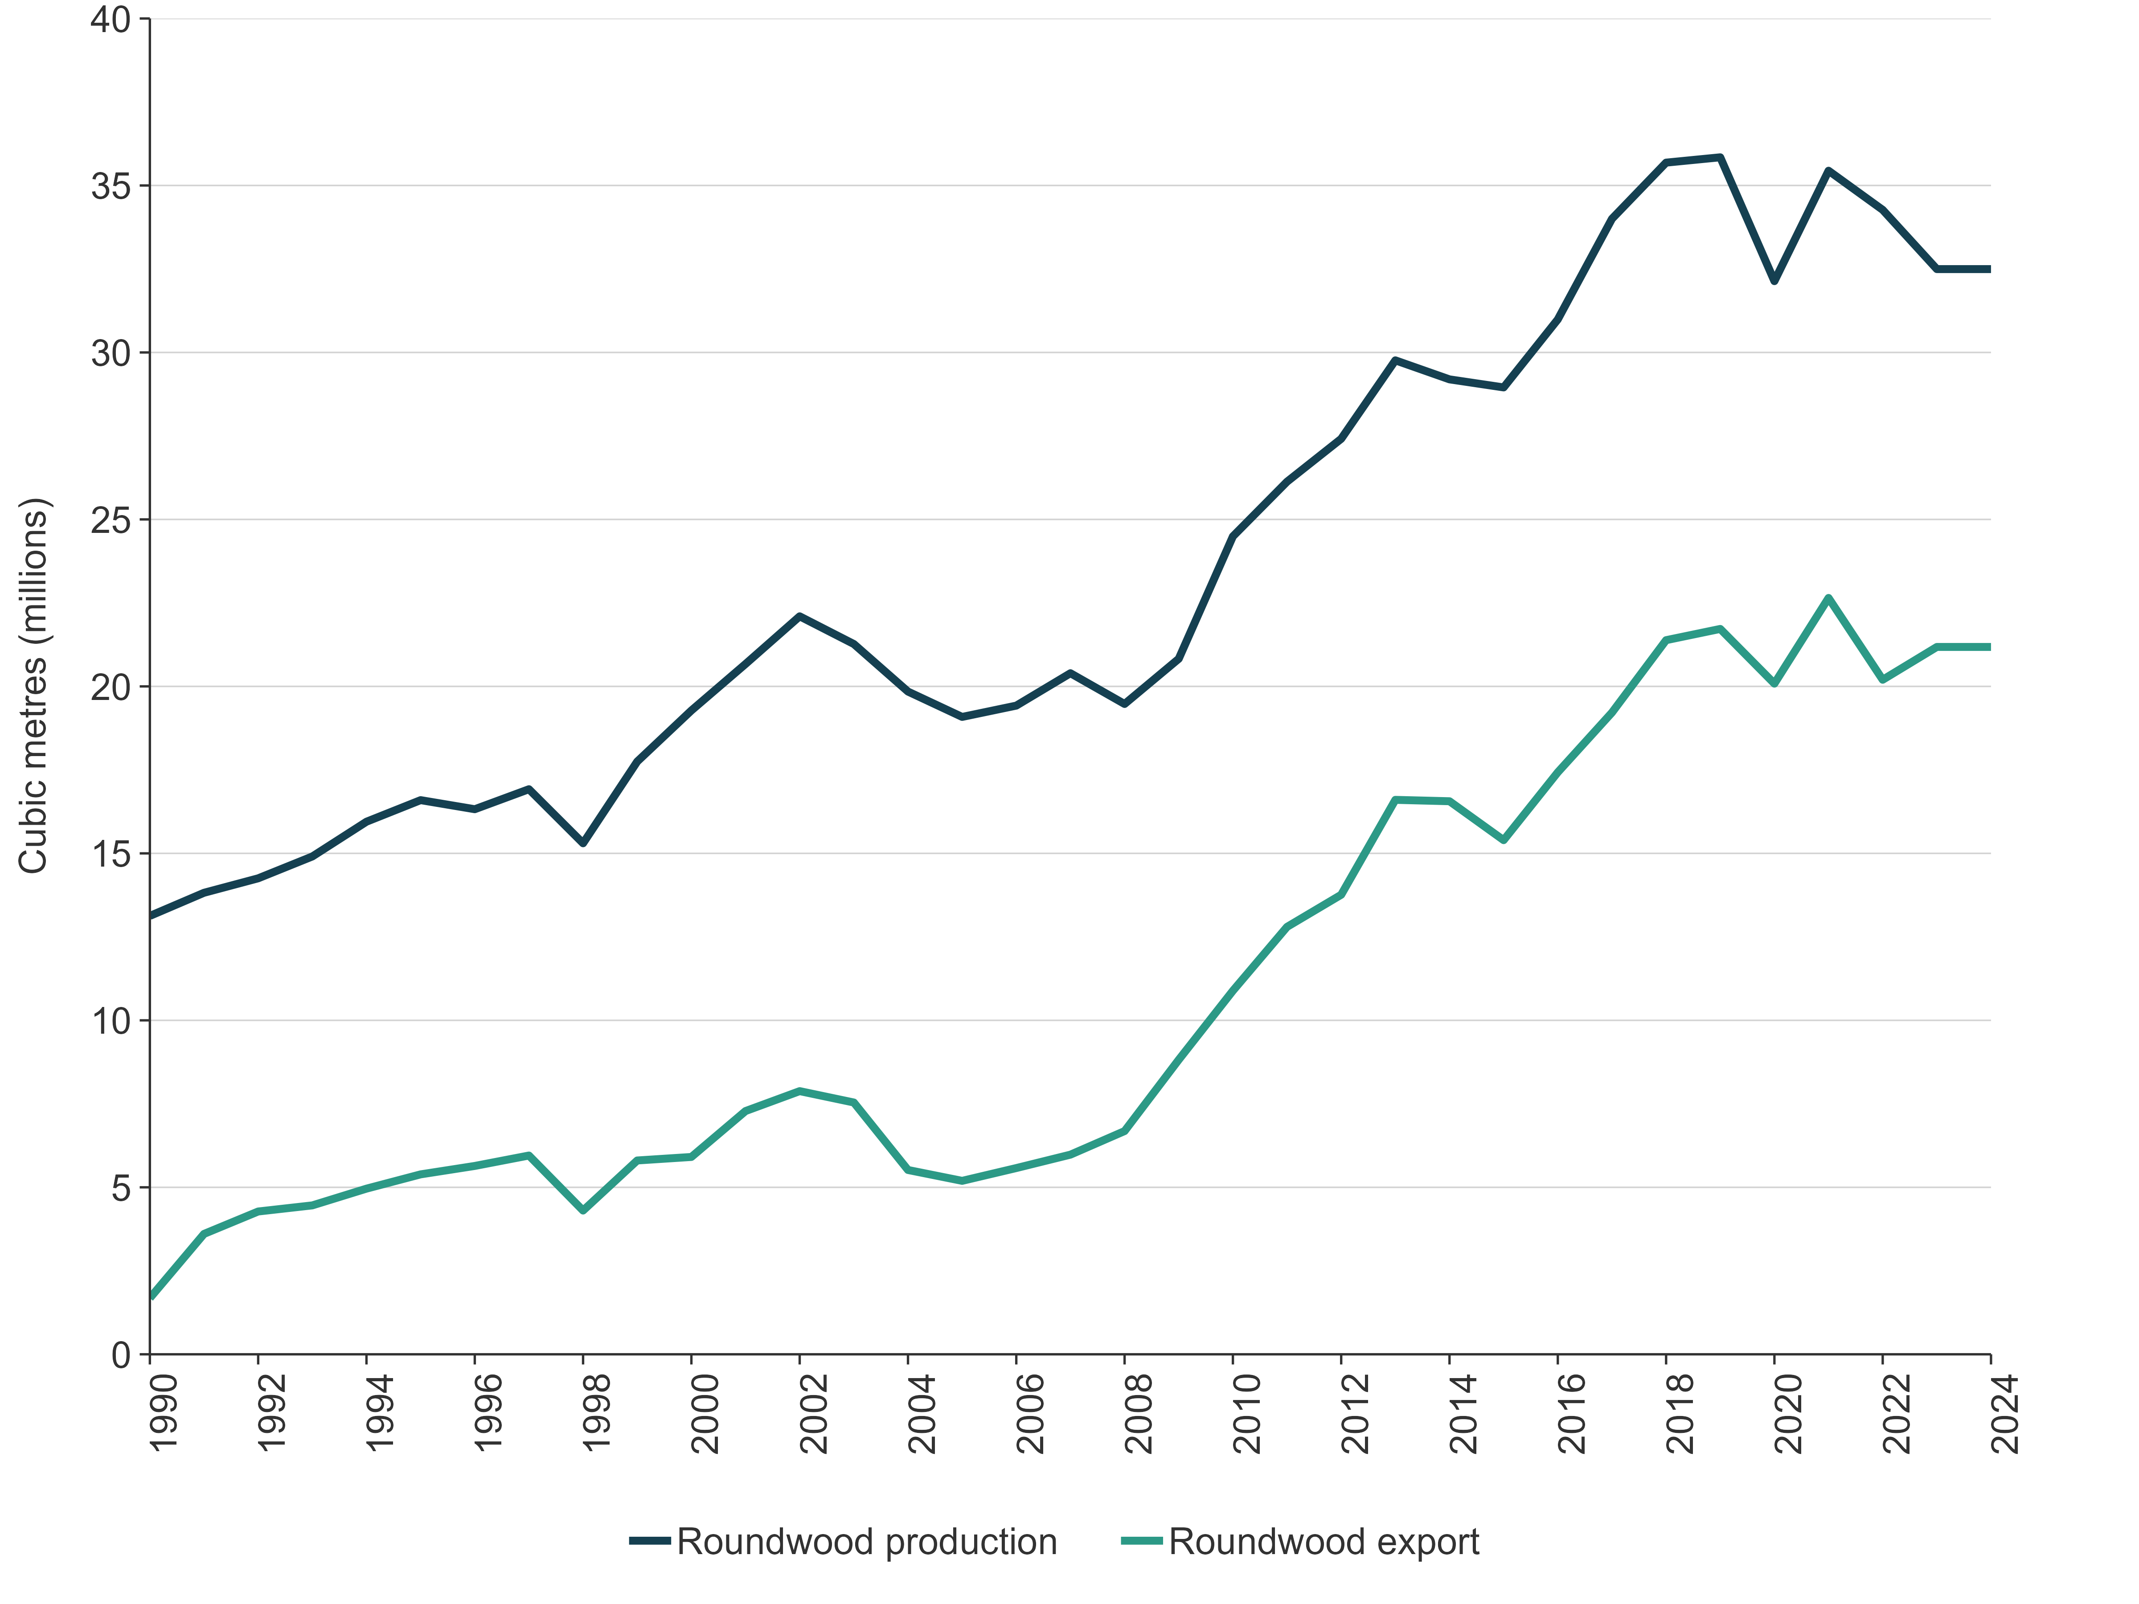
New Zealand has a large planted-forest estate that provides the majority of wood products consumed domestically and exported in either product or raw material form. New Zealand currently processes around 40 percent of its annual harvest (Ministry for Primary Industries, 2025b). The remaining harvest is exported in raw material form. In 2023, New Zealand was the largest exporter of industrial roundwood followed by Germany and the United States of America (Food and Agriculture Organization, 2025). New Zealand’s planted forests are dominated by radiata pine (Pinus radiata), which is used in a wide range of applications including timber-frame construction, packaging, furniture, joinery and interior fittings, decking, general external outdoor products, concrete formwork, printing and writing paper, corrugated materials, tissue products, newsprint, kitchen and bathroom cabinets, flooring, posts and poles (Wekesa, 2022; Wekesa et al., 2022).
In 2024, Harvested wood products was a key category (level and trend assessment).

6.10.2 Methodological issues
New Zealand has selected the production approach to report Harvested wood products in the NIR. To do this, New Zealand has adapted the default Harvested wood products model and uses a Tier 2 method (IPCC, 2006a, section 12.2.1.2), which involves using country-specific activity data and parameters (Wakelin et al., 2020).

Activity data
Activity data on roundwood production volume, roundwood export volume and the production of New Zealand processed wood products are sourced from MPI (Ministry for Primary Industries, 2025a, 2025b, 2025c; Wekesa et al., 2022). Additional data on New Zealand wood product production and export that are not available from the published MPI statistics are sourced from the Food and Agriculture Organization of the United Nations (FAO) statistical database (the FAOSTAT database), which contains data that MPI provides to the FAO. The FAOSTAT database provides more granular breakdowns of semi-finished wood products produced in New Zealand, to which specific carbon fractions can then be applied.
Activity data for the period 1900 to 1960 are populated using the IPCC model method, which assumes that consumption is correlated with population growth. New Zealand used the default value for Oceania for the annual rate of increase for the period 1900 to 1960. This information is used to initialise Harvested wood products stocks at 1 January 1990.
A large proportion (approximately 60 percent) of New Zealand’s harvest was exported as raw materials in the form of logs or wood chips in 2024 (Ministry for Primary Industries, 2025b). Note that the exported volume of Harvested wood products described in CRT 4.Gs2 does not sum to 60 percent of all exported products. This is because this table includes only products produced in New Zealand and does not include the volume of raw logs exported that are then processed offshore.
MPI provides data on the export quantity of raw materials but provides no information on the conversion of these materials to products or their expected half-lives. Research was completed in 2016 to provide information on harvested wood products from exported logs in New Zealand’s three main export markets (China, South Korea and India). This research provides activity data for the conversion of New Zealand-produced raw materials to harvested wood products in export markets (Manley and Evison, 2016).
Further research was commissioned in 2017 to update the model assumptions that are used for calculating harvested wood product volume and associated emissions to include the activity data and half-lives of the 2016 report (Wakelin and Kimberley, unpublished). Note that the model also includes export variables to Japan, which was historically a large export market but has reduced and is projected to continue to reduce over time. It also includes ‘Other countries’, which account for a small volume of exports that are sold to other markets. Details of product volume and half-lives for these export markets can be found in volume 2, annex 5, section A5.2.6.
Activity data for exported log volumes and Harvested wood products to individual countries are periodically published by MPI (Ministry for Primary Industries, 2025b, 2025c). The proportion of exported roundwood to product type in these export markets is obtained by applying the ratios of product type produced (sawnwood, wood panels or paper), as identified in the 2016 report (Manley and Evison, 2016), to the volume of timber exported to each of the export markets.

Emission factors
The default wood carbon content value of 50 percent, from table 12.4 of the 2006 IPCC Guidelines (IPCC, 2006a), is used in the Harvested wood products model (IPCC, 2006a). This value is consistent with the planted forest model that uses a country-specific value of 50 percent. A country-specific wood density value of 420 kilograms per cubic metre is used for sawnwood produced from coniferous species (Jones, 2005). This value is used to reflect coniferous species’ contribution to New Zealand roundwood, which makes up around 98 percent of annual harvest. A country-specific wood density value of 500 kilograms per cubic metre is used for sawnwood produced from non-coniferous species (Jones, 2005). Non-coniferous species (mainly Eucalyptus) make up around 2 percent of annual harvest. The default IPCC bark factor (11 percent; IPCC, 2006a, annex 4A.1) is used for conifers and is considered appropriate for New Zealand. Wood-based panels and paper products all use IPCC defaults because no country-specific value is available (table 6.10.1).
Exported raw logs are first converted to tonnes of carbon, based on the carbon fractions for coniferous species and for non-coniferous species, as outlined above. This carbon is then apportioned into each export market and wood product combination (sawnwood, panels and paper).
Table 6.10.1 Conversion factors for Harvested wood products produced from New Zealand wood in New Zealand
Category | Factor (t C/m³ or t C/t*) | Source
Sawnwood, other industrial roundwood (coniferous) | 0.210 | Country specific (Jones, 2005)
Sawnwood, other industrial roundwood (non-coniferous) | 0.250 | Country specific (Jones, 2005)
Veneer sheets | 0.210 | Country specific (Jones, 2005)
Plywood | 0.267 | IPCC default (IPCC, 2014)
Particle board | 0.269 | IPCC default (IPCC, 2014)
Fibreboard (compressed) | 0.315 | IPCC default (IPCC, 2014)
Insulating board/other fibreboard | 0.075 | IPCC default (IPCC, 2014)
Paper products | 0.450* | IPCC default (IPCC, 2014)
Note: * Indicates where factors are given in tonnes of carbon per tonne of product.

Half-lives
Half-lives determine the discard rate of products from service in the Harvested wood products category. Overall, sawnwood and wood-based panels made and consumed in New Zealand are used to manufacture long-lived wood products, whereas short-lived products are manufactured overseas (Wekesa, 2022; Wekesa et al., 2022). These findings are used in this submission instead of default half-life values used previously. New Zealand uses a weighted half-life of 33.6 years for Sawnwood, 32.4 years for Wood-based panels for domestically processed and consumed harvested wood products, whereas weighted half-life values of 23.6 years for Sawnwood and 20.7 years for Sawnwood panels are used for harvested wood products produced in New Zealand and exported overseas (Wakelin, unpublished (f)). A default half-life value of two years was used for domestically produced and processed Paper and paperboard consumed in the domestic and export markets (IPCC, 2014). These half-lives are used to increase the accuracy of the estimates over the default categories (Solid wood and Paper and paperboard) (IPCC, 2006a, table 12.2).
Most of New Zealand’s exported logs are converted into construction and packaging material (Manley and Evison, 2016). The weighted half-lives for China and India are significantly lower than the IPCC default half-lives for Sawnwood and Panels, as demonstrated in table 6.10.2. These findings are included in New Zealand’s Harvested wood products estimates and provide an improvement on the default assumption where exported raw materials were discarded at the same rate as domestic production. Further information on the half-lives for conversions of exported logs is provided in volume 2, annex 5, section A5.2.6.
Table 6.10.2 Weighted half-lives for harvested wood products produced in export markets
Country | Weighted half-lives (years)
Country | Sawnwood | Wood panels | Paper
China | 8.3 | 8.3 | 2
India | 1.4 | 10.4 | 2
South Korea | 15.5 | 23.9 | 2
Japan | 3.1 | 2.8 | 2
Other | 8.3 | 8.3 | 2
IPCC default | 35 | 25 | 2

6.10.3 Uncertainty assessment and time-series consistency
The uncertainty in net CO₂ emissions from Harvested wood products was 68.2 percent in 2024, which accounted for 17.3 percent of the total uncertainty in emissions from the LULUCF sector. Uncertainty in the Harvested wood products estimates is introduced by activity data, conversion factors and decay parameters. The contribution to total uncertainty is driven by large removals in this pool and high uncertainty associated with the end-use and discard rates of New Zealand wood. The methods used to calculate the uncertainty are further described in volume 2, annex 5, section A5.2.8.
Time-series consistency is ensured by applying consistent methods and full recalculations in the event of any refinement or improvement to the methodology.

6.10.4 Category-specific QA/QC and verification
Activity data for roundwood are sourced from annual statistics produced by MPI. However, as section 6.4 describes, the methodology for estimating above-ground biomass losses on harvest uses the LUCAS model, which combines harvest area by age with yield table carbon values. To ensure consistency between MPI roundwood volume statistics and LUCAS harvest estimates, a comparison between the two data sources across the time series was carried out and is further described in volume 2, annex 5, section A5.2.5 ‘Forest land model validations’.
The results show a relatively good match between the two data sources between 2013 and 2020. This is because roundwood volume is now used to determine the total destocking area over this period. However, the two data sources deviate in earlier years. LUCAS above-ground biomass losses from harvest are greater than those estimated from roundwood volume statistics from 1996 to 2012 and are slightly lower from 1990 to 1994.
The implications of these earlier differences are that New Zealand may be reporting more carbon losses from harvesting and deforestation than carbon gains from roundwood creation and inputs into the harvested wood products pool across most of the time series.
Work is under way to determine the most effective approach to address this inconsistency through the time series, with updates planned for inclusion in the next submission to ensure full alignment and accuracy.

6.10.5 Category-specific recalculations
Recalculations of the entire time series were carried out for this category as a result of updated activity data. The impact of recalculations on net CO₂e emission estimates for Harvested wood products is shown in table 6.10.3.
Table 6.10.3 Recalculations for New Zealand’s net emissions from the Harvested wood products
category in 1990 and 2023
 | 2025 submission | 2026 submission | Change from 2025 submission | Change (%)
Net emissions (kt CO₂e)
1990 | -2,437.8 | -2,437.8 | 0.0 | 0.0
2023 | -5,808.3 | -5,808.7 | -0.4 | 0.0

6.10.6 Category-specific planned improvements
Data are now available on country-specific end-use products and half-lives of roundwood logs processed and consumed in New Zealand (Wekesa, 2022; Wekesa et al., 2022). These data should be incorporated into the uncertainty model to improve the accuracy of estimates. This enhancement should be prioritised for inclusion in future submissions.
The half-life and market proportion data for exported wood products will be updated as soon as new market data sets become available. This update is a priority for future inventory improvements to ensure estimates reflect current export structures and end-use patterns.

6.11 Non-CO₂ emissions (4(I–IV))
In 2024, net N₂O emissions from soils associated with land-use change reported in the LULUCF sector were 169.0 kt CO₂e (table 6.11.1). This is 37.3 kt CO₂e (18.1 percent) lower than the 1990 level of 206.3 kt CO₂e. This is primarily due to a reduction in direct emissions from nitrogen mineralisation/immobilisation.
Table 6.11.1 Nitrous oxide emissions from soils associated with land-use change reported in the LULUCF sector, from 1990 to 2024
 | Net emissions (kt N₂O) |  | Net emissions (kt CO₂e) |  | Change from 1990 (%)
Emissions source | 1990 | 2024 | 1990 | 2024 | Change from 1990 (%)
Direct emissions from nitrogen mineralisation/ immobilisation | 0.6 | 0.5 | 165.1 | 132.8 | -19.6
Direct emissions from drainage of organic and mineral soils | 0.0 | 0.0 | 4.0 | 6.3 | 57.0
Indirect emissions from leaching and runoff | 0.1 | 0.1 | 37.2 | 29.9 | -19.6
Total | 0.8 | 0.6 | 206.3 | 169.0 | -18.1
Note: Columns may not total due to rounding. Direct nitrous oxide emissions reported in this table are for Forest land only. Nitrous oxide emissions on Cropland and Grassland are reported under the Agriculture sector.

6.11.1 Direct N₂O emissions from nitrogen fertilisation of forest land and other land (4(I))
New Zealand’s activity data on nitrogen fertilisation are not currently disaggregated by land use and, therefore, all direct N₂O emissions from nitrogen fertilisation of Forest land and Other land are reported in the Agriculture sector under the category Direct N₂O emissions from managed soils (3.D.a). The notation key IE is reported in the CRTs for the LULUCF sector.

6.11.2 Emissions from drainage and rewetting of organic and mineral soils (4(II))

Description
New Zealand reports on N₂O emissions, as a result of oxidation of organic matter, from the drainage of organic soils. Nitrous oxide emissions on Cropland and Grassland are reported under the Agriculture sector. Direct N₂O emissions from drained organic soils in Forest land are estimated to be 0.0004 kt N₂O in 2024, compared with 0.0003 kt N₂O in 1990. Direct N₂O emissions from drained organic soils in Settlements are estimated to be 0.02 kt NO in 2024, compared with 0.01 kt NO in 1990. The notation key NE is reported in the CRTs for rewetted mineral soils.

Methodological issues
To estimate N₂O emissions associated with the drainage of organic soils on Forest land, New Zealand uses the Tier 1 method outlined in the 2006 IPCC Guidelines (IPCC, 2006a, equation 11.1). The Tier 1 default value for temperate, nutrient-poor forest soils of 0.1 kilograms (kg) N₂O-N ha^{–1} is applied. Note that the area of pre-1990 natural forest remaining pre-1990 natural forest on organic soils is assumed to be in its natural, undisturbed state, and therefore is presumed to be undrained.

6.11.3 Direct N₂O emissions from nitrogen mineralisation/immobilisation (4(III))

Description
Direct N₂O emissions from nitrogen mineralisation/immobilisation are minor in New Zealand, estimated at 0.5 kt N₂O in 2024, compared with 0.6 kt N₂O in 1990. Note that N₂O emissions on Cropland remaining cropland from nitrogen mineralisation/immobilisation are reported under the Agriculture sector. Direct N₂O emissions from nitrogen mineralisation/immobilisation associated with land-use change for all other land use categories are reported under the LULUCF sector.
Nitrous oxide emissions result from the mineralisation of soil organic matter associated with land-use change. This mineralisation results in an associated conversion of nitrogen previously in the soil organic matter to ammonium and nitrate. Microbial activity in the soil converts some of the ammonium and nitrate present to N₂O. A net decrease in soil organic matter increases the microbial substrate and is therefore expected to increase net N₂O emissions (IPCC, 2006a, section 11).

Methodological issues
To estimate N₂O emissions from disturbance associated with land-use change, New Zealand uses the method outlined in the 2006 IPCC Guidelines (IPCC, 2006a, equation 11.2 and equation 11.8).
The inputs to these equations are:
- loss of carbon in mineral soils
- EF₁ – the emission factor for calculating emissions of N₂O from nitrogen (N) in the soil. New Zealand uses a country-specific value of 0.01 kg N₂O – N/kg N (Kelliher and de Klein, 2006)
- C:N ratio – the IPCC default ratio of carbon to nitrogen in soil organic matter (15:1) is used (IPCC, 2006a, p 11.16).
Where an area of land is converted to a land use with a higher original mineral SOC stock than the category it is converted from, no N₂O emissions have been estimated as occurring because there is no associated loss of SOC. For instance, Cropland converted to Forest land is estimated not to result in net N₂O emissions because this land use conversion is associated with a net gain in SOC in New Zealand (see volume 2, annex 5, section A5.2.4, table A5.2.8). In these situations, the notation key NO (not occurring) is reported in the CRTs.

6.11.4 Indirect N₂O emissions from leaching and runoff (4(I))
Indirect N₂O emissions from leaching and runoff are associated with mineralisation of nitrogen from loss of soil carbon in mineral and drained and/or managed organic soils through land-use change or management practices. Emissions on Cropland remaining cropland from leaching and runoff are reported under the Agriculture sector. Indirect N₂O emissions from leaching and runoff for all other land use categories are reported under the LULUCF sector.
Indirect emissions from leaching and runoff in all land use categories excluding Cropland remaining cropland were estimated as 0.1 kt N₂O in 2024, which is 19.6 percent lower than reported in 1990.

Methodological issues
New Zealand applies the Tier 1 method outlined in the 2006 IPCC Guidelines (IPCC, 2006a, equation 11.10) for estimating N₂O emissions from leaching and runoff. The following are the inputs to this equation.
- F_{SOM} – annual amount of N mineralised in mineral soils associated with loss of soil C from soil organic matter as a result of changes to land use or management in regions where leaching and runoff occur, kg N yr^{–1}, calculated using the method described in section 6.11.3.
- EF₅ – emission factor for N₂O emissions from N leaching and runoff, kg N₂O–N (kg N leached and runoff)^{–1} using the default emission factor of 0.0075 provided in table 11.3 of the IPCC Guidelines (IPCC, 2006a).
- Frac_{LEACH-(H)} – fraction of all N added to and/or mineralised in managed soils in regions where leaching and runoff occur that is lost through leaching and runoff, kg N (kg of N additions)^{–1} using the default value of 0.30 provided in table 11.3 of the IPCC Guidelines (IPCC, 2006a).

6.11.5 Indirect N₂O emissions from atmospheric deposition of N volatilised from managed soil (4(I))

Description
New Zealand cannot separate the sources of nitrogen between Cropland, Grassland and Other land uses. For this reason, it reports all Indirect N₂O emissions from atmospheric deposition of N volatilised from managed soil within CRT 3.D.b in the Agriculture sector and uses the notation key IE within CRT 4(I) of the LULUCF sector.

6.11.6 Uncertainty assessment and time-series consistency for N₂O emissions in soils associated with land-use change
The uncertainty in net N₂O emissions from nitrogen in soils associated with land-use change in 2024 is outlined in table 6.11.2. The methods used to calculate the uncertainty are further described in volume 2, annex 5, section A5.2.8.
Table 6.11.2 Net N₂O emissions from nitrogen in soils associated with land-use change in 2024
 | Emissions  (kt CO₂e) | Uncertainty in emissions (%) | Contribution to LULUCF uncertainty (%)
Direct N₂O emissions from N mineralisation/immobilisation | 132.8 | 85.5 | 0.5
Direct N₂O emissions from drainage and rewetting | 6.3 | 86.5 | 0.0
Indirect emissions from leaching and runoff | 29.9 | 126.9 | 0.2
Time-series consistency is ensured by applying consistent methods and full recalculations in the event of any refinement or improvement to methodology.

6.11.7 Category-specific planned improvements for N₂O emissions in soils associated with land-use change

6.11.8 Biomass burning (4(IV))

Description
Non-CO₂ emissions from Biomass burning in 2024 were 1.8 kt CH₄ (49.2 kt CO₂e) and 0.1 kt N₂O (22.0 kt CO₂e) (table 6.11.3).
Table 6.11.3 Non-CO₂ emissions from Biomass burning in 1990 and 2024
Emissions | 1990 | 2024 | Change from 1990 (%)
CH₄ emissions (kt CH₄) | 2.8 | 1.8 | -37.1
N₂O emissions (kt N₂O) | 0.1 | 0.1 | -7.0
Biomass burning includes wildfires or controlled burning and results in emissions of CO₂, CH₄, N₂O, CO and NO_{x}. Biomass burning is not a significant source of emissions for New Zealand because the practice of controlled burning is limited, and wildfires are not common due to New Zealand’s temperate climate and vegetation.
The two types of biomass burning (wildfire and controlled burning) that occur in New Zealand are reported in two main land use categories: Forest land and Grassland. Emissions reported in Forest land are further separated by forest type, and emissions from Grassland are reported from the controlled burning of tussock land (in ecosystems dominated by Chionochloa spp.) and from wildfires in exotic pasture grassland.

Methodological issues
New Zealand employs Tier 2 methodologies to estimate emissions from Biomass burning. A combination of country-specific carbon fractions (Beets, unpublished), emission factors (Thomas et al., 2011) and combustion factors (Payton and Pearce, 2009; Wakelin, unpublished(a), (e)) is employed along with the 2006 IPCC Guidelines default carbon fractions, emission factors, combustion factors and equations to derive emissions (IPCC, 2006a, sections 2.4, 4.2.4 and 6.2.4). These variables are summarised in table 6.11.4 and table 6.11.5, and further information on their application is provided in volume 2, annex 5, section A5.2.7.

Table 6.11.4 Summary of Biomass burning carbon fractions and emission factors
 | Biomass burning implied emission factors derived from 2006 IPCC Guidelines (IPCC, 2006a) and New Zealand-specific carbon fractions
 | Grassland/savannah |  | Grassland with woody biomass/shrubland |  | Forest land
 | Controlled burning | Wildfire | Controlled burning | Wildfire | Controlled burning |  | Wildfire
 |  |  |  |  | Planted forest | Natural forest | Planted forest | Natural forest
Carbon fraction | 0.44 | 0.44 | 0.44 | 0.44 | 0.51* | 0.47 | 0.51* | 0.47
C:N ratio | 0.01 | 0.01 | 0.01 | 0.01 | 0.01 | 0.01 | 0.01 | 0.01
CO emission factor | 0.06 | 0.06 | 0.06 | 0.06 | 0.09 | 0.10 | 0.09 | 0.10
CH₄ emission factor | 0.00 | 0.00 | 0.00 | 0.00 | 0.01 | 0.01 | 0.01 | 0.01
N₂O emission factor | 0.03 | 0.03 | 0.03 | 0.03 | 0.03 | 0.04 | 0.03 | 0.04
NO_{x} emission factor | 0.27 | 0.27 | 0.27 | 0.27 | 0.18 | 0.19 | 0.18 | 0.19
Note: Values are rounded to two decimal places. *0.51 New Zealand-specific carbon fraction for planted forests (Beets, unpublished).

Table 6.11.5 Summary of Biomass burning combustion factor values
Combustion factor values (proportion of pre-fire biomass consumed) for fires (IPCC, 2006a, table 2.6)
Vegetation type |  |  | Value
Forest | Other temperate forests | Post-logging slash burn | 0.62
Forest | Other temperate forests | Felled and burned (land clearing fire) | 0.51
Forest | All ‘other’ temperate forests |  | 0.45
GWB and shrubland | Shrubland (general) |  | 0.95
GWB and shrubland | All shrubland |  | 0.72
GWB and shrubland | GWB New Zealand specific |  | 0.70*
Grassland | All savannah/grasslands (early dry season burns) |  | 0.74
Grassland | All savannah/grasslands (mid/late dry season burns) |  | 0.77
Grassland | Average of IPCC savannah/grasslands |  | 0.755
Grassland | Controlled grassland burn New Zealand specific |  | 0.555**
Note: GWB = grassland with woody biomass. *Wakelin (unpublished(e)), **Payton and Pearce (2009).
For all land uses, CO₂ emissions are captured in the general stock change calculation following the 2006 IPCC Guidelines (IPCC, 2006a). Carbon dioxide emissions resulting from Biomass burning are reported as IE, where emissions are captured in the stock change calculation within the land use category.
In Grassland, CO₂ emissions from biomass burning are assumed to be equal to subsequent regrowth. The assumption of equivalence is accepted as reasonable in this scenario as per the 2006 IPCC Guidelines, section 2.4 and section 6.2.4 (IPCC, 2006a).
In Cropland, CH₄ and N₂O emissions from controlled burning are reported as IE. This is because emissions from the burning of crop stubble associated with controlled burning in Cropland are reported under the Agriculture sector and reported within 3.F.
Both CO and NO_{x} are also released from biomass burning and are reported in relevant aggregate land use categories. Carbon monoxide and NO_{x} emissions from biomass burning are captured as part of the biomass burning model and reported in the CRTs.
Controlled burning emissions are reported within:
- Grassland converted to Forest land (due to site preparation for conversion)
- Forest land remaining forest land (from the clearing of vegetation (natural forest) before the establishment of exotic planted forest and the burning of post-harvest slash before restocking)
- Forest land converted to Grassland (from controlled burning associated with deforestation)
- Grassland remaining grassland (due to savanna (tussock) and pastureland management practices).
Emissions of CO₂ from wildfires in Forest land remaining forest land are included in the general stock change calculation. In Forest land remaining forest land, burned stands are either harvested (so emissions are included with the harvesting emissions) or left to grow on at reduced stocking. Carbon dioxide emissions are reported when the stand is harvested or deforested (with no reduction in stock when compared with an unburned stand). For both natural and planted forests, emissions from areas burned are captured within the forest plot networks that New Zealand uses to estimate carbon stock change. In these cases, to avoid double counting of CO₂ emissions, the notation key IE is used.
Wildfire activity data are sourced from Fire and Emergency New Zealand (FENZ). Historically, burned areas were estimated and allocated by field staff to vegetation types: grass, tussock, gorse, scrub, wetland, plantation forest and indigenous forest. The process (since 2017) now involves mapping the burn area. This area is overlaid on the 2020 land use map to determine what type of land cover has been burned.
Activity data for controlled burning for Forest land are estimated based on a 2011 survey of forest owners (Wakelin, unpublished(d)). Activity data (area of land-use change) for Grassland with woody biomass converted to forest are based on annual land-use changes, as estimated in section 6.2, and an estimate of area burned from a survey of forest owners. Earlier estimates of controlled burning in planted forest (Forest Industry Training and Education Council, 2005; Robertson, 1998) were used, in addition to the 2011 survey, to provide activity data throughout the time series. Further details of the survey findings and extrapolation can be found in volume 2, annex 5, section A5.2.7.
Activity data are combined with emission factors derived from the national forest plot network (see table 6.4.8) to estimate non-CO₂ emissions from burning associated with the clearing of vegetation before the establishment of exotic planted forest. Below-ground biomass is assumed not to burn. Further detailed information on the methodology applied can be found in volume 2, annex 5, section A5.2.7.
Biomass burning is not a key category for New Zealand.

Uncertainties and time-series consistency
The uncertainty in CH₄ and N₂O net emissions from Biomass burning was 51.4 percent in 2024. Emissions from Biomass burning accounted for 0.1 percent of the net emissions from the LULUCF sector.
Time-series consistency is ensured by applying consistent methods and full recalculations in the event of any refinement or improvement to methodology.

Category-specific QA/QC and verification
Quality-control and quality-assurance measures are applied to the Biomass burning activity data and emission factors. The biomass burning data set is verified whenever new data are supplied. The Biomass burning parameters (burning and emission factors), assumptions and data set have been reviewed (Payton and Pearce, 2009; Thomas et al., 2011; Wakelin, unpublished(b), (c), (d), (e); Wakelin et al., unpublished).

Category-specific recalculations
Wildfire activity data for 2018 to 2024 have been updated for this submission, to incorporate mapping of the 2024 wildfire extent, and updates have been made to the vegetation classification from the land use map. New estimates for controlled burning in Grassland remaining grassland have required recalculations across the time series.

Category-specific planned improvements
The assumption that controlled burning of post-harvest residues on afforested land does not occur will be revisited in a future submission, due to the increasing harvest rate in these forests as they reach maturity.

Chapter 6: References
Arnst E, Hayman E, Richardson S. Unpublished. Natural Forest Plot Data Corrections 2023–2024. Contract report LC4306 prepared for the Ministry for the Environment by Manaaki Whenua Landcare Research New Zealand Ltd in 2024.
Arnst E, Vickers S. Unpublished. Natural Forest Plot Data Corrections 2022–2023. Contract report LC4306 prepared for the Ministry for the Environment by Manaaki Whenua Landcare Research New Zealand Ltd in 2023.
Beets PN. Unpublished. Carbon Fraction of Radiata Pine Biomass Components. Contract report prepared for the Ministry for the Environment by New Zealand Forest Research Institute Ltd (trading as Scion) in 2017.
Clarkson B. Unpublished. Peat Extraction in New Zealand Wetlands. Contract report LC2710 prepared for the Ministry for the Environment by Landcare Research New Zealand Ltd in 2016.
Davis MR, Wakelin SJ. Unpublished. Perennial Cropland Biomass: Sampling Requirements. Contract report prepared for the Ministry for the Environment by New Zealand Forest Research Institute Limited (trading as Scion).
Easdale TA, Burge OR, Wiser S, Richardson SJ. 2022. Carbon Assessment of Wetland Vegetation. Contract report LC4173 prepared for the Ministry for the Environment by Landcare Research New Zealand Ltd. Wellington: Ministry for the Environment.
Easdale TA, Richardson SJ, Marden M, England JR, Gayoso-Aguilar J, Guerra-Carcamo JE, Brandon AM. 2019. Root biomass allocation in southern temperate forests. Forest Ecology and Management 453: 117542.
Ewers RM, Kliskey AD, Walker S, Rutledge D, Harding JS, Didham RK. 2006. Past and future trajectories of forest loss in New Zealand. Biological Conservation 133(3): 312–325.
Food and Agriculture Organization of the United Nations. 2025. Forestry Production and Trade Data. Retrieved 17 December 2025.
Forest Industry Training and Education Council. 2005. Best Practice Guidelines for Land Preparation. Revised edn. Rotorua: Forest Industry Training and Education Council.
Garrett LG. Unpublished. Natural Forests Soils: Data Checking and Carbon Content of the Mineral Soil. Contract report prepared for the Ministry for the Environment by New Zealand Forest Research Institute Ltd (trading as Scion).
Garrett LG, Kimberley MO, Oliver GR, Parks M, Pearce SH, Beets PN, Paul TSH. 2019. Decay rates of above- and below-ground coarse woody debris of common tree species in New Zealand’s natural forest. Forest Ecology and Management 438: 96–102.
Hunter G, McNeill S. Unpublished. Review of LUCAS Land Use Backcasting 1962–1989. Contract report prepared for the Ministry for the Environment by Landcare Research New Zealand Ltd in 2010.
IPCC. 2006a. Eggleston HS, Buendia L, Miwa K, Ngara T, Tanabe K (eds). 2006 IPCC Guidelines for National Greenhouse Gas Inventories. Volume 4. Agriculture, Forestry and Other Land Use. IPCC National Greenhouse Gas Inventories Programme. Japan: Institute for Global Environmental Strategies for IPCC.
IPCC. 2006b. Eggleston HS, Buendia L, Miwa K, Ngara T, Tanabe K (eds). General Guidance and Reporting. Volume 1. Japan: Institute for Global Environmental Strategies for IPCC.
IPCC. 2014. Hiraishi T, Krug T, Tanabe K, Srivastava N, Baasansuren J, Fukuda M, Troxler TG (eds). 2013 Revised Supplementary Methods and Good Practice Guidance Arising from the Kyoto Protocol. Switzerland: IPCC.
Jones T. 2005. Wood properties of commercial tree species. In: M Colley (ed.) NZIF 2005 Forestry Handbook. Wellington: New Zealand Institute of Forestry. pp 204–207.
Kelliher FM, de Klein CAM. 2006. Review of New Zealand’s Fertiliser Nitrous Oxide Emission Factor (EF1) Data. Report prepared for the Ministry for the Environment by Landcare Research and AgResearch. Wellington: Ministry for Primary Industries.
Kimberley MO, Beets PN, Paul TSH. 2019. Comparison of measured and modelled change in coarse woody debris carbon stocks in New Zealand’s natural forest. Forest Ecology and Management 434 (2019): 18–28.
Manaaki Whenua Landcare Research. Land Cover Database v6.0 – Land Cover Database version 6.0, Mainland, New Zealand. Retrieved 23 February 2026.
Manaaki Whenua Landcare Research. Land Cover Database v5.0 – Land Cover Database version 5.0, Mainland, New Zealand. Retrieved 18 December 2025.
Manaaki Whenua Landcare Research. 2020. A National Soil Carbon Monitoring System for Agricultural Land. Retrieved 4 December 2020.
Manley B, Evison D. 2016. Material Flow and End-use of Harvested Wood Products Produced from New Zealand Log Exports. Wellington: Ministry for Primary Industries.
McGlone MS. 2009. Postglacial history of New Zealand wetlands and implications for their conservation. New Zealand Journal of Ecology 33: 1–23.
McNeill SJ, Barringer JRF. Unpublished. Respecification and Reclassification of the 2013 MfE Soil CMS Model. Prepared for the Ministry for the Environment by Landcare Research New Zealand Ltd.
Ministry for Primary Industries. 2015. Forestry in the emissions trading scheme. Retrieved 12 February 2022.
Ministry for Primary Industries. 2023. Wood processing data: Quarterly production, stock and roundwood removals, June 2023 quarter production. Wellington: Ministry for Primary Industries. Retrieved 15 August 2023.
Ministry for Primary Industries. 2025a. Wood processing data: Roundwood removals, year ended 31 March, 1951 to most recent. Wellington: Ministry for Primary Industries. Retrieved 11 November 2025.
Ministry for Primary Industries. 2025b. Wood processing data: Quarterly production, stock and roundwood removals, June 2025 quarter production. Wellington: Ministry for Primary Industries. Retrieved 11 November 2025.
Ministry for Primary Industries. 2025c. Wood Product Markets: Quarterly trade, June 2024 quarterly exports. Retrieved 11 November 2025.
Ministry for the Environment. 2006. New Zealand’s Initial Report under the Kyoto Protocol. Wellington: Ministry for the Environment. Retrieved 14 July 2011.
Ministry for the Environment. 2012. Land Use and Carbon Analysis System: Satellite imagery interpretation guide for land use classes (2nd edn). Wellington: Ministry for the Environment.
Ministry for the Environment and Stats NZ. 2017. New Zealand’s Environmental Reporting Series: Our fresh water 2017. Retrieved 16 February 2024.
Ministry for the Environment and Stats NZ. 2018. New Zealand’s Environmental Reporting Series: Our land 2018. Retrieved 16 February 2024.
Paul TSH, Beets PN, Kimberley MO. Unpublished. Carbon Stocks in New Zealand’s Post-1989 Natural Forest: Analysis of the 2018/2019 forest inventory data. Contract report prepared for the Ministry for the Environment by the New Zealand Forest Research Institute Ltd (trading as Scion) in 2020.
Paul TSH, Kimberley MO, Beets PN. 2021. Natural forests in New Zealand: A large terrestrial carbon pool in a national state of equilibrium. Forest Ecosystems 8(1): 1–21.
Paul TSH, Wakelin SJ, Dodunski C. 2024. The National Forest Inventory 2018–2022 Analysis: Yield tables and carbon stocks in planted forests in New Zealand based on a five-year inventory cycle. Contract report prepared for the Ministry for the Environment by New Zealand Forest Research Institute Ltd (trading as Scion). Rotorua: Scion.
Payton IJ, Pearce HG. 2009. Fire-induced changes to the vegetation of tall-tussock (Chionochloa rigida) grassland ecosystems. Science for Conservation 290. Wellington: Department of Conservation.
Robertson KA. 1998. Loss of organic matter and carbon during slash burns in New Zealand exotic forests. New Zealand Journal of Forestry Science 28(2): 221–241.
Thomas S, Hume E, Fraser T, Curtin D. 2011. Factors and Activity Data to Estimate Nitrous Oxide Emissions from Cropping Systems, and Stubble and Tussock Burning. Report prepared for the Ministry of Agriculture and Forestry by Plant and Food Research (formerly Crop and Food Research) technical paper no. 2012/16. Wellington: Ministry of Agriculture and Forestry.
Trotter C, MacKay A. Unpublished. Potential Forest Land. Contract report 04/05-0410-L prepared for Landcare Research New Zealand Ltd.
UNFCCC. 2014. FCCC/CP/2013/10/Add.3. Report of the Conference of the Parties on its nineteenth session, held in Warsaw from 11 to 23 November 2013: Addendum – Part 2: Action taken by the Conference of the Parties at its nineteenth session.
Vibart R, Dodd M, Bowatte S, Mackay A, Hutchinson K. 2025. Grassland biomass carbon stock dynamics. Prepared for the Ministry for Primary Industries by AgResearch.
Wakelin SJ. Unpublished(a). Scientific Research Underpinning New Zealand’s Carbon Inventory in Planted Forests. Objective 9 – UNFCCC planted forest carbon inventory methodology. Milestone 2
– Review of shrubland clearance assumptions in the national carbon inventory. Contract report prepared for the Ministry for the Environment by New Zealand Forest Research Institute Ltd (trading as Scion) in 2004.
Wakelin SJ. Unpublished(b). Review of LULUCF Biomass Burning Assumptions in New Zealand’s Greenhouse Gas Inventory. Contract report prepared for the Ministry for the Environment by Ensis in 2006.
Wakelin SJ. Unpublished(c). Apportioning Wildfire Emissions to Forest Sub-categories in the National Greenhouse Gas Inventory. Contract report prepared for the Ministry for the Environment by New Zealand Forest Research Institute Ltd (trading as Scion) in 2011.
Wakelin SJ. Unpublished(d). Controlled Biomass Burning Emissions for the 2011 Greenhouse Gas Inventory. Contract report prepared for the Ministry for the Environment by New Zealand Forest Research Institute Ltd (trading as Scion) in 2012.
Wakelin SJ. Unpublished(e). Review of Emissions from Prescribed Burning of Standing Vegetation in New Zealand. Contract report prepared for the Ministry for the Environment by New Zealand Forest Research Institute Ltd (trading as Scion) in 2018.
Wakelin SJ. Unpublished(f). Annual Updating of the Harvested Wood Products Carbon Accounting Model. Contract report prepared for the Ministry for the Environment by New Zealand Forest Research Institute Ltd (trading as Scion) in 2023.
Wakelin SJ, Beets PN. 2013 Emission Factors for Managed and Unmanaged Grassland with Woody Biomass. Contract report prepared for the Ministry for the Environment by New Zealand Forest Research Institute Ltd (trading as Scion) in 2013.
Wakelin SJ, Clifford VR, Anderson SAJ, Pearce HG. Unpublished. Review of LULUCF Non-carbon Emissions in New Zealand’s Greenhouse Gas Inventory. Contract report 17342 prepared for Ministry for the Environment by New Zealand Forest Research Institute Ltd (trading as Scion) in 2009.
Wakelin SJ, Kimberley M. Unpublished. Harvested Wood Products Model for UNFCCC and Kyoto Protocol Reporting. Contract report prepared for the Ministry for the Environment by New Zealand Forest Research Institute Ltd (trading as Scion) in 2017.
Wakelin SJ, Searles N, Lawrence D, Paul TSH. 2020. Estimating New Zealand’s harvested wood products carbon stocks and stock changes. Carbon Balance and Management 15(10).
Watts D. Unpublished. Land Use Backcasting: Data and methodology. Wellington: Ministry for the Environment.
Wekesa A. 2022. The Estimation and Modelling of Carbon Stocks from Harvested Wood Products in New Zealand. Doctoral thesis, University of Canterbury. Retrieved 24 February 2023.
Wekesa A, Manley B, Evison D. 2022. Improved Data on Harvested Wood Products. Wellington: Ministry for Primary Industries. Retrieved 1 August 2023.

Chapter 7: Waste

7.1 Sector overview

7.1.1 The Waste sector in New Zealand
In 2024, the Waste sector contributed 4.0 percent of New Zealand’s total gross greenhouse gas emissions, the majority of which was biogenic methane (CH₄) from solid waste disposal sites (SWDS). Emissions from this sector are estimated across four categories: Solid waste disposal, Biological treatment of solid waste, Incineration and open burning of waste and Wastewater treatment and discharge.
In New Zealand, the Solid waste disposal category (5.A) was the largest source of emissions in 2024, accounting for 77.3 percent of the Waste sector’s total emissions. Most household, commercial and industrial waste continues to be disposed of in managed and unmanaged SWDS. Unmanaged SWDS include a variety of landfill types, such as farm dumps and sites used for construction, demolition or industrial waste. A notable exception to land disposal is farm waste management, where an estimated half of the waste is disposed of through open burning. Prior to 2010, some household waste was also disposed of in uncategorised SWDS. Figure 7.1.1 shows the sources of solid waste in New Zealand and the disposal practices used.
Emissions from the Biological treatment of solid waste category (5.B) accounted for 2.9 percent of the Waste sector’s emissions in 2024. New Zealand currently has one large-scale anaerobic digestion plant processing municipal organic waste, which began operating in late 2022. No other sources of direct greenhouse gas emissions are applicable to this category in New Zealand for the 2024 reporting year.
The Incineration and open burning of waste category (5.C) accounted for 6.4 percent of the sector’s emissions. Municipal solid waste is not incinerated in New Zealand. Incineration occurs only on a small scale, primarily for hazardous waste, clinical waste and sewage sludge, and its use has declined over time due to stricter environmental regulations and the availability of alternative disposal options.
Emissions from the Wastewater treatment and discharge category (5.D) contributed 13.3 percent of the Waste sector’s total emissions in 2024. Most wastewater treatment systems in New Zealand are aerobic and process both domestic and industrial wastewater, all of which generate CH₄ and nitrous oxide (N₂O) emissions. Biogenic methane emissions from domestic wastewater primarily arise from the use of rural septic tanks. Wastewater emissions are also produced by some municipal treatment plants, which operate semi-aerobic processes, as well as from specific industries, in particular, the meat processing and pulp and paper sectors.
In 2024, emissions from the Waste sector decreased by 9.6 percent compared with 1990 and decreased by 20.9 percent from 2005. This reduction is largely driven by government policies, including the introduction of a waste disposal levy under the Waste Minimisation Act 2008 (WMA), the inclusion of most municipal landfills (Class 1) in the New Zealand Emissions Trading Scheme (NZ ETS) and resource consent requirements for certain landfills.
The Government is working with the sector to reduce emissions through the second emissions reduction plan (Ministry for the Environment, 2024). In 2024, the Ministry for the Environment published this plan, outlining the actions required to meet New Zealand’s second emissions budget for 2026–30. Chapter 13 of the plan specifically addresses measures for the Waste sector, and any resulting impacts will be reflected in future greenhouse gas inventories. Work is underway on these actions.
New Zealand reports emissions from Tokelau, which is a dependent territory of New Zealand. Due to the application of different methods and the complexity of integrating emissions within the main sectors, Tokelau emissions are reported for all activities under the ‘Other’ sector of the Inventory. Therefore, all emissions reported under this sector exclude Tokelau. Please see chapter 8 and annex 7 for details of methods applied and the emissions for Tokelau.
Figure 7.1.1 Sources and destinations of solid waste in New Zealand
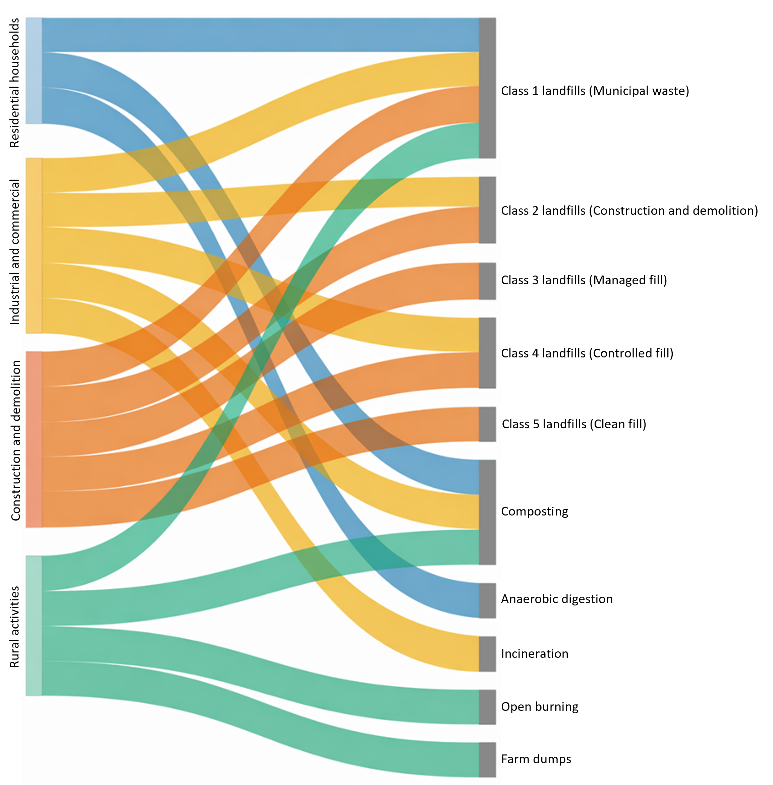

7.1.2 Emissions summary
The Waste sector in New Zealand produces mainly CH₄ (91.5 percent) followed by nitrous oxide (N₂O) (5.2 percent) and carbon dioxide (CO₂) emissions (3.3 percent). The Waste sector produces 7.5 percent of gross CH₄ emissions in New Zealand. There are also emissions of CO₂ from the disposal of solid waste, but these are of biogenic origin and are not reported.

2024
In 2024, emissions from the Waste sector contributed 3,009.1 kilotonnes carbon dioxide equivalent (kt CO₂e) or 4.0 percent of New Zealand’s gross greenhouse gas emissions. The largest source category is Solid waste disposal, as shown in table 7.1.1.

2023–2024
Between 2023 and 2024, emissions from the Waste sector decreased by 0.5 percent (14.1 kt CO₂e), mainly due to lower CH₄ emissions from the Managed waste disposal sites category. This was driven by improved landfill gas (LFG) capture and changes in waste composition, including reduced garden, food, and paper waste.

2005–2024
Over the longer term, between 2005 and 2024, emissions from the Waste sector decreased by 20.9 percent (795.8 kt CO₂e). This sustained reduction in CH₄ emissions reflects the implementation of improved management practices, such as LFG capture, along with a substantial decrease in the amount of organic waste sent to landfills.

1990–2024
As of 2024, emissions from the Waste sector decreased by 9.6 percent (319.4 kt CO₂e), from 1990 levels of 3,328.5 kt CO₂e.
Annual emissions peaked at 3,878.6 kt CO₂e in 2002 and have generally declined since then. While population growth and increased economic activity since 1990 have driven an overall rise in the volumes of solid waste and wastewater throughout the time series, ongoing improvements in managed waste disposal sites have contributed to a downward pattern in total Waste sector emissions since 2005. This reduction is primarily attributable to increased CH₄ recovery through the installation of LFG capture systems, supported by the introduction of National Environmental Standards for Air Quality in 2004 and the inclusion of the Waste sector in the NZ ETS in 2013. These legislative tools have been complemented by local government efforts to improve kerbside collections, including for organic waste, across the country, and by a central government waste work programme that includes product stewardship, plastic phase-outs and investment in resource recovery infrastructure for organic materials.
Table 7.1.1 New Zealand’s greenhouse gas emissions for the Waste sector by source category in 1990, 2005, 2023 and 2024
 | Emissions (kt CO₂e) |  |  |  | Difference (kt CO₂e) |  |  | Change (%) |  |  | Share (%)
Source category | 1990 | 2005 | 2023 | 2024 | 1990–2024 | 2005–2024 | 2023–2024 | 1990–2024 | 2005–2024 | 2023–2024 | 1990 | 2005 | 2024
Solid waste disposal (5.A) | 2,646.8 | 3,178.8 | 2,348.3 | 2,327.1 | -319.7 | -851.7 | -21.2 | -12.1 | -26.8 | -0.9 | 79.5 | 83.5 | 77.3
Biological treatment of solid waste (5.B) | 4.8 | 6.5 | 81.6 | 87.5 | 82.7 | 81.1 | 6.0 | 1,721.0 | 1,253.0 | 7.3 | 0.1 | 0.2 | 2.9
Incineration and open burning of waste (5.C) | 350.2 | 272.3 | 194.6 | 193.0 | -157.3 | -79.4 | -1.6 | -44.9 | -29.1 | -0.8 | 10.5 | 7.2 | 6.4
Wastewater treatment and discharge (5.D) | 326.6 | 347.3 | 398.7 | 401.5 | 74.8 | 54.2 | 2.8 | 22.9 | 15.6 | 0.7 | 9.8 | 9.1 | 13.3
Total | 3,328.5 | 3,804.9 | 3,023.1 | 3,009.1 | -319.4 | -795.8 | -14.1 | -9.6 | -20.9 | -0.5 | — | — | —
Note: Percentages presented are calculated from unrounded values. Columns may not total due to rounding.
Figure 7.1.2 Profile of emissions from New Zealand’s Waste sector by source category from 1990 to 2024
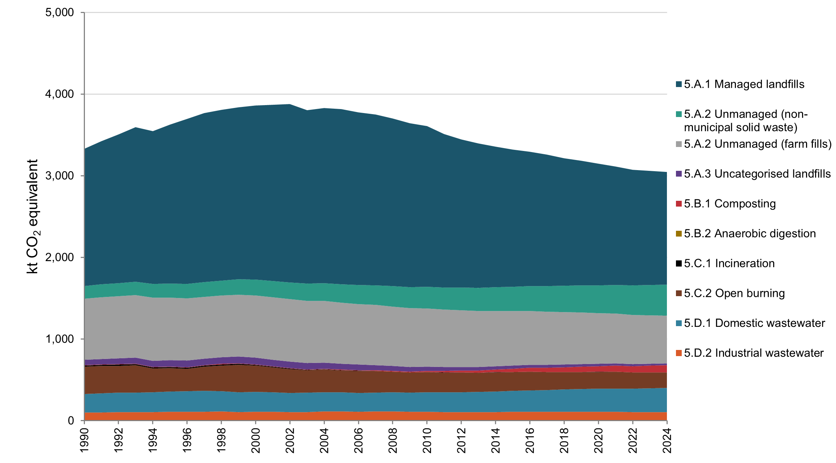
Figure 7.1.3 New Zealand’s emissions from the Waste sector by source category, from 1990, 2005 to 2024
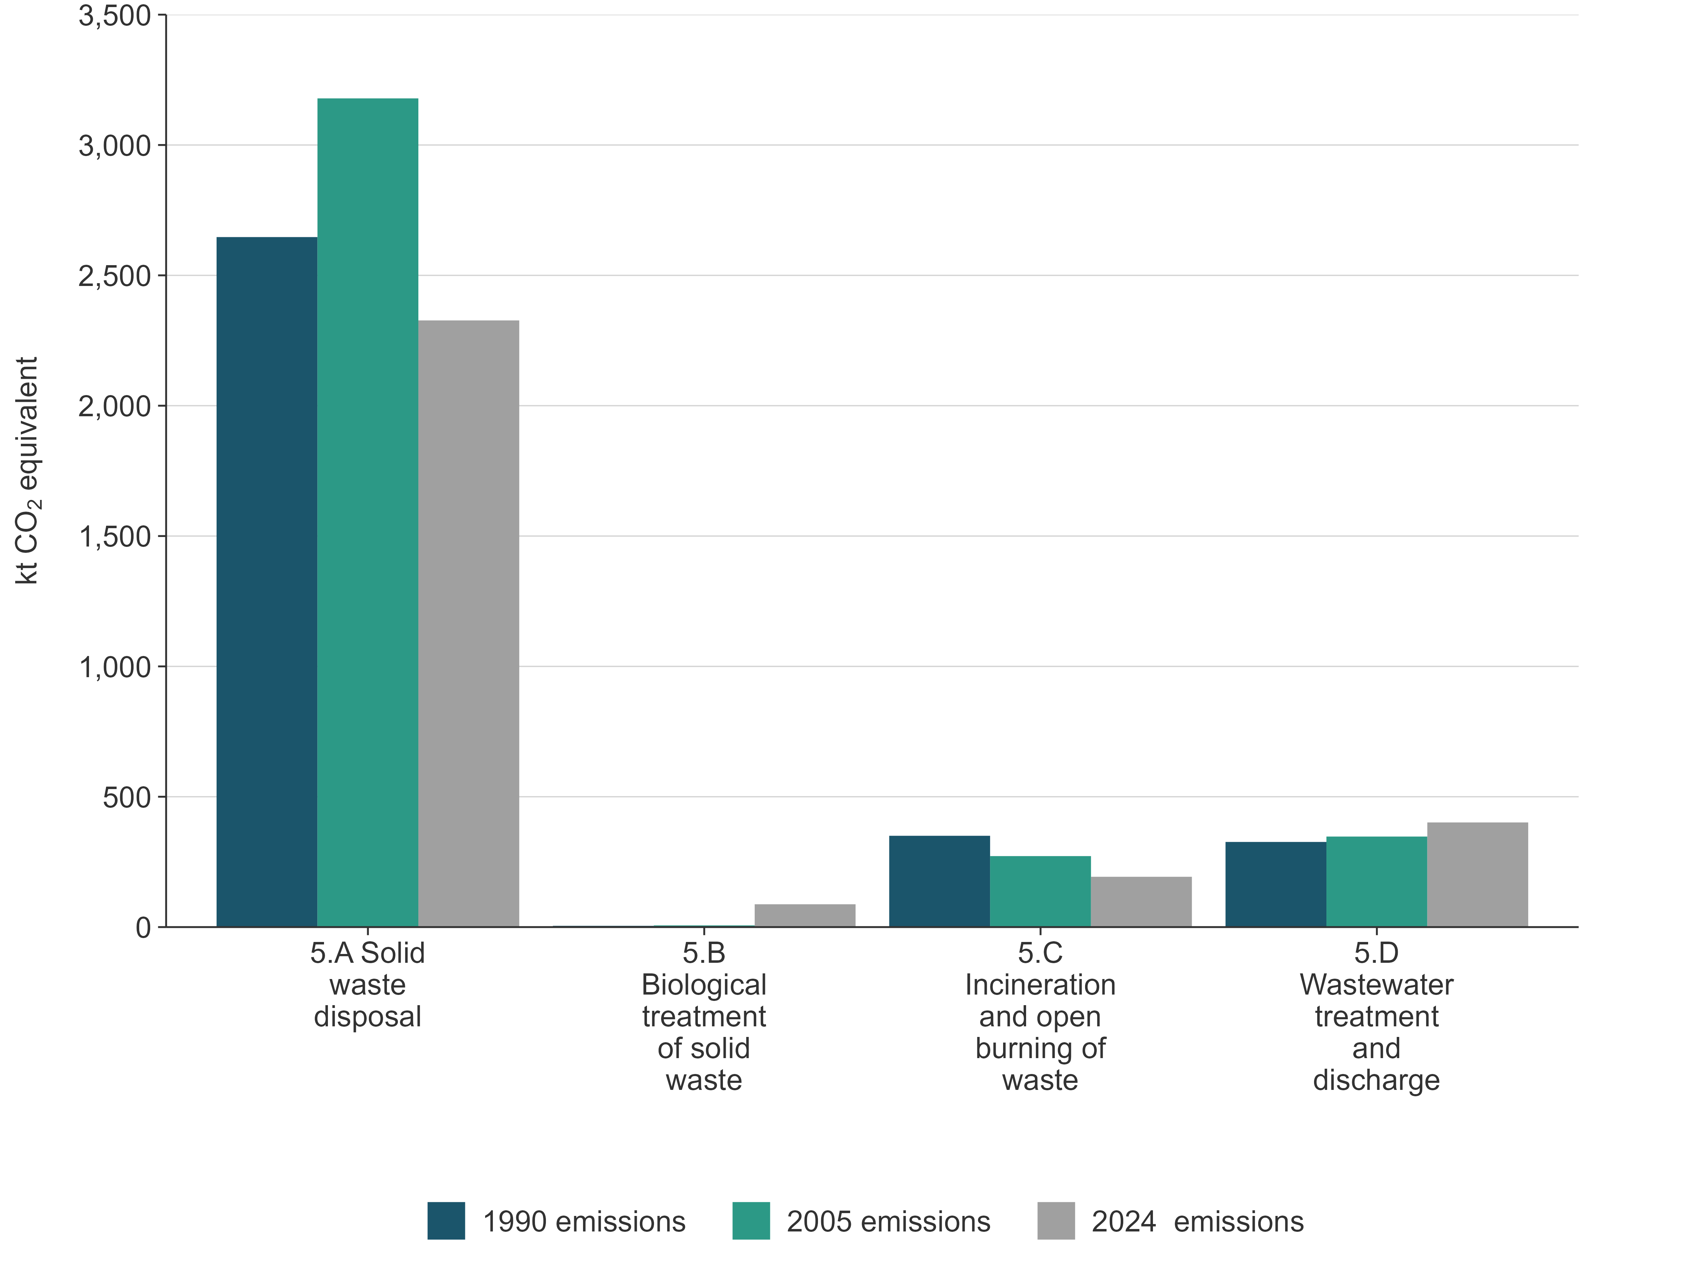

7.1.3 Key categories for Waste sector emissions
Details of New Zealand’s key category analysis are in chapter 1, section 1.4. The key categories in the Waste sector are listed in table 7.1.2.
Table 7.1.2 Key categories in the Waste sector
CRF category code | IPCC category | Gas | Criteria for identification
5.A | Waste– Solid waste disposal | CH₄ | L1, T1
5.C | Waste– Incineration and open burning of waste | CO₂ | T1
5.C | Waste– Incineration and open burning of waste | CH₄ | T1
5.D | Waste– Wastewater treatment and discharge | CH₄ | L1
Note: L1 means a key category is identified under the level analysis – approach 1, and T1 is trend analysis –approach 1. See chapter 1, for more information.

7.1.4 Methodological issues for the Waste sector
New Zealand uses Tier 2 methodologies for estimating emissions from the Solid waste disposal source category, which is a key category, and for some wastewater emissions. Tier 1 methodologies are used to estimate other emissions from the Waste sector.
Activity data are obtained from a variety of sources. Municipal solid waste disposal data are obtained from mandatory reporting under the WMA and the NZ ETS for the years available (2010 onwards). Non-municipal waste disposal data are also derived from mandatory reporting under the WMA from 2022 onwards. For all other sources, activity data are collected through targeted surveys. Interpolation based on GDP or population is used for other years.
Human population and animal production statistics provided by Stats NZ are also used for estimating emissions from the Waste sector.
Country-specific emission factors are used where available, including parameters for municipal waste (Eunomia, unpublished(a)) and for treatment of some types of industrial wastewater (Cardno, unpublished).
Specific methodological issues are discussed under each source category in this chapter.

7.1.5 Uncertainties
The uncertainties for emission estimates are discussed under each category in this chapter. For most sources, they conform to the default scale of uncertainties in the 2006 Intergovernmental Panel on Climate Change (IPCC) Guidelines for National Greenhouse Gas Inventories (2006 IPCC Guidelines) (volume 5, Waste) (IPCC, 2006a). Higher uncertainties are reported for wastewater going into rivers and seawater due to uncertainty in the emission factors associated with indirect N₂O emissions.

7.1.6 Verification
Where available, data from different sources were used for verification. All managed and unmanaged SWDS report their activity data either monthly, quarterly or annually under the requirements of the WMA. In addition, most municipal landfills also report activity data and estimated emissions (by mass balance) under the NZ ETS. These data sources are used as primary sources or for verification, as appropriate.

7.1.7 Recalculations and improvements
Improvements and recalculations made to estimates in the Waste sector have resulted in a 3.7 percent (106.5 kt CO₂e) increase in emissions in 2023, a 1.1 percent (43.0 kt CO₂e) increase in emissions in 2005 and a 1.6 percent (50.9 kt CO₂e) increase in emissions in 1990. Explanations for recalculations are provided in table 7.1.3.
For the 2026 submission, three source categories have undergone significant updates.
- Managed waste disposal sites (5.A.1): A methodological issue was identified in the implementation of the instantaneous gas-capture rate equation, where the calculation incorrectly estimated an absolute loss rather than a proportional loss of generated landfill gas. This has now been corrected. In addition, emission factors and model parameters have been updated to incorporate revised k-values in accordance with the 2019 Refinement to the 2006 IPCC Guidelines for National Greenhouse Gas Inventories (volume 5, Waste) (2019 IPCC Refinement) (IPCC, 2019). Implementing these changes has improved the accuracy and transparency of the model.
- Unmanaged waste disposal sites (5.A.2): An issue was identified in the application of decomposable degradable organic carbon (DDOC) parameters. In the model, DDOC values for most waste types were calculated as the product of country‑specific degradable organic carbon (DOC) and fraction of degradable organic carbon (DOCf) values. However, in the model used for the 2025 inventory submission, a general DOCf value (0.5) was also applied to the waste‑type‑specific DDOC values, resulting in the DOCf parameter being applied twice. This error approximately halved estimated emissions from Class 2–5 sites and monofills across the entire 1990–2023 time series. In addition, updates to DOCf values for sludge, rubber, and municipal solid waste, as well as k-values for nappies and rubber, have been implemented in accordance with the 2019 IPCC Refinement (IPCC, 2019). Correcting the model error and updating these parameters improved the accuracy, comparability and transparency of the Inventory model.
- Waste incineration and open burning of waste (5.C): Updates to the fossil carbon fraction (FCF), carbon fraction (CF) and oxidation factor values have been implemented, in accordance with the 2019 IPCC Refinement. In particular, the FCF value for sludge has been revised to 30 percent, as recommended by the 2019 IPCC Refinement (IPCC, 2019). These changes enhanced the accuracy and transparency of the model.
Further details can be found under methodological issues within this chapter for each source category and in chapter 10.
Table 7.1.3 Explanations and justifications for recalculations
Sector | Explanation of recalculation | Underpinning IPCC principle | Additional justification
Waste | Estimated emissions from Managed waste disposal sites – Anaerobic (5.A.1.a) increased by 5.6 kilotonnes carbon dioxide equivalent (t CO₂e) (0.3 percent) in 1990 and decreased by 33.2 kt CO₂e (2.4 percent) in 2023. These changes result from corrections to the instantaneous gas-capture rate calculation and updates to Tier 1 defaults for half-lives (k-values) for sludge and nappies, in line with the 2019 IPCC Refinement. Previously, emissions were estimated using Tier 1 k-value defaults from the 2006 Intergovernmental Panel on Climate Change (IPCC) Guidelines for National Greenhouse Gas Inventories (IPCC, 2006a). | Accuracy, comparability | Key category improvement: Solid waste disposal
 | Estimated emissions from Unmanaged waste disposal sites (5.A.2) increased by 72.7 kt CO₂e (89.0 percent) in 1990 and by 174.0 kt CO₂e (89.3 percent) in 2023. These changes result from correcting an error in the application of decomposable degradable organic carbon values, where the fraction of degradable organic carbon parameter had previously been applied twice, leading to underestimation in the 2025 submission. These also reflect the adoption of updated Tier 1 defaults for the fraction of degradable organic carbon that decomposes and k-values for sludge, nappies, and rubber, in accordance with the 2019 IPCC Refinement. Previously, emissions were estimated using Tier 1 defaults from the 2006 IPCC Guidelines (IPCC, 2006a). | Accuracy, comparability, transparency. | Key category improvement: Solid waste disposal
 | Estimated emissions from Unmanaged waste disposal sites – Farm fills (5.A.2) decreased by 61.9 kt CO₂e (0.08 percent) in 1990 and by 49.3 kt CO₂e (0.08 percent) in 2023. These changes reflect the incorporation of previously unaccounted regional activity and compositional data, as well as the adoption of updated fossil carbon fraction and carbon fraction values in line with the 2019 Refinement to the 2006 IPCC Guidelines for National Greenhouse Gas Inventories (volume 5, Waste) (2019 IPCC Refinement) (IPCC, 2019). Previously, emissions were estimated using Tier 1 defaults from the 2006 IPCC Guidelines (IPCC, 2006a). | Accuracy, consistency, completeness, comparability, transparency. | Key category improvement: Solid waste disposal
 | Estimated emissions from Waste incineration (5.C.1) decreased by 0.4 kt CO2e (2.7 percent) in 1990 and by 0.4 kt CO2e (20.5 percent) in 2023. This is due to the adoption of updated fossil carbon fraction (FCF) and carbon fraction (CF) values and is proposed, in accordance with the 2019 IPCC Refinement. Specifically, the carbon fraction (i.e. total carbon content in percentage of dry weight) for sludge has been updated to 30 percent in the 2019 IPCC Refinement (IPCC, 2019). | Accuracy, comparability
 | Estimated emissions from Open burning of waste (5.C.2) increased by 31.6 kt CO₂e (0.1 percent) in 1990 and by 18.1 kt CO₂e (0.1 percent) in 2023. These changes reflect the adoption of an updated oxidation factor for carbon dioxide in accordance with the 2019 IPCC Refinement. Previously, emissions were estimated using the oxidation factor value from the 2006 IPCC Guidelines (IPCC, 2006a). | Accuracy, comparability

7.1.8 Quality-assurance/quality-control (QA/QC) processes
Figure 7.1.4 shows a flow diagram for data in the Waste sector, including quality-assurance and quality-control processes. Tier 1 quality checks were carried out on all data for key categories in this sector.
Figure 7.1.4 Tier 1 quality checks for the Waste sector
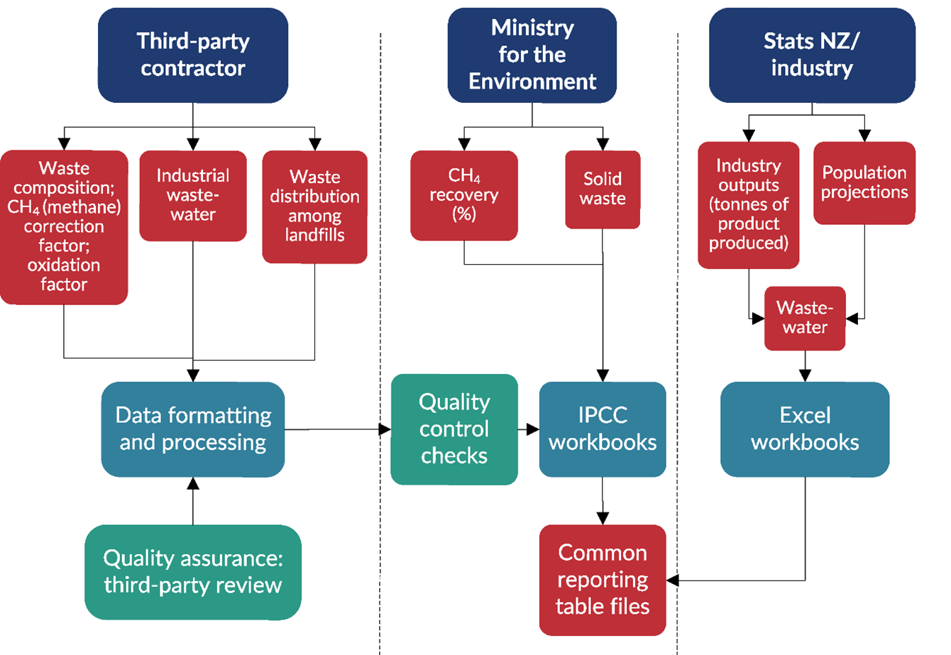
Note: IPCC = Intergovernmental Panel on Climate Change.

7.1.9 Information on completeness

Emissions reported as ‘NE’ or ‘not estimated’
Table 7.1.4 summarises New Zealand’s direct greenhouse gas emissions for the Waste sector reported as ‘NE’ in the 2026 submission.
Table 7.1.4 Summary of ‘NE’ or ‘not estimated’ entries for the Waste sector in the 2026 submission
CRT category code | Category | Gas | Explanation
Waste
5.B.2.a | Anaerobic digestion at biogas facilities | N₂O, amount of CH₄ flared and for energy recovery | In October 2022, New Zealand’s first large-scale anaerobic digestion plant began operations, with the capacity to process up to 75,000 tonnes of food scraps annually. Methane (CH₄) that is flared does not contribute to New Zealand’s total greenhouse gas emissions, because it is converted to biogenic carbon dioxide (CO₂). Nitrous oxide (N₂O) emissions are considered negligible, in accordance with section 4.1.1 and table 4.1 of the 2006 Intergovernmental Panel on Climate Change (IPCC) Guidelines (IPCC, 2006a). Data on energy recovery is unavailable due to commercial sensitivity.
5.C.1.2.a | Waste incineration | CO₂, CH₄ and N₂O | In accordance with chapter II of the Annex to the decision 18/CMA.1 (UNFCCC, 2018), this category is not mandatory. Around 100 to 200 rural schools in New Zealand still incinerate their waste production. Emissions are not estimated because New Zealand does not have sufficient information regarding the practice of incinerating waste in schools.
5.D.1 and 5.D.2 | Domestic wastewater and Industrial wastewater | Amount of CH₄ flared and for energy recovery | According to section 6.2.1 of the 2006 IPCC Guidelines (volume 5, chapter 6, p. 6.9, IPCC, 2006a), emissions from flaring are considered insignificant because the resulting CO₂ is of biogenic origin. Therefore, good practice in the Waste sector does not require their estimation. Furthermore, section 6.2.2.6 (p. 6.18, IPCC, 2006a) specifies that when CH₄ is recovered for energy use, the associated greenhouse gas emissions should be reported under the Energy sector. As noted in section 6.2.1, good practice in the Waste sector also does not require estimating CH₄ and N₂O emissions from CH₄ recovery and flaring (p. 6.9, IPCC, 2006a).

Emissions reported as ‘IE’ or ‘included elsewhere’
Table 7.1.5 details where the notation key ‘IE’ has been used in this submission of the Inventory for the Waste sector.
Table 7.1.5 Emissions reported using the ‘IE’ or ‘included elsewhere’ notation key in the 2026 submission for the Waste sector
CRT category code | Category | Source category reported under | Notation key explanation
Waste
5.D.1 | Domestic wastewater | 5.A Solid waste | Activity data – sludge amounts are included under Solid waste disposal because sludge is disposed to landfill.
5.D.2 | Industrial wastewater | 5.A Solid waste | Activity data – sludge amounts are included under Solid waste disposal because sludge is disposed to landfill.
5.D.2 | Industrial wastewater | 1.A.2.e Food processing, beverages and tobacco – Biomass | Emissions of CH4 from the combustion of biogas from the Tirau dairy processing plant are reported under 1.A.2.e Food processing, beverages and tobacco – Biomass.

7.2 Solid waste disposal (5.A)

7.2.1 Description
In New Zealand, the majority of solid waste generated by household, industrial and commercial sectors is disposed of in landfills. In contrast, approximately half of all farm waste continues to be managed through open burning. The current types of landfill sites operating in New Zealand are described below:
- Managed SWDS (5.A.1): These correspond to New Zealand’s Class 1 landfills. They are municipal disposal facilities that primarily accept household and commercial waste but also receive industrial and other solid waste streams. These landfills involve controlled waste-placement, including directing waste to designated deposition areas, applying cover, implementing capping, mechanical compacting, and managing fire and water controls (WasteMINZ, 2023). This classification aligns with the definition of anaerobic managed SWDS in the 2006 IPCC Guidelines (volume 5, table 3.1, IPCC, 2006a).
- Unmanaged SWDS (5.A.2): These sites include several landfill types that predominantly accept construction and demolition waste, inert materials, and industrial waste. In New Zealand, these facilities align with Class 2, Class 3–4 and Class 5 landfills, as well as industrial monofills, with classification based on the waste types received. Further detail on these facilities is provided later in this chapter. Most of these sites do not meet the control waste placement criteria described for Managed SWDS, and they exhibit variable landfill depths, although most are relatively shallow. Based on these characteristics, this category aligns with the definition of Unmanaged SWDS provided in the 2006 IPCC Guidelines (volume 5, table 3.1, IPCC, 2006a).
- Unmanaged SWDS — Farm fills (5.A.2): These rural disposal sites are used for both household and farm waste. Their use occurs alongside the widespread practice of open burning on farms. As with other Unmanaged SWDS, they do not meet the control waste-placement criteria outlined for Managed SWDS. Therefore, they also fall under the Unmanaged SWDS category as defined in the 2006 IPCC Guidelines (volume 5, table 3.1, IPCC, 2006a).
- Uncategorised SWDS (5.A.3): These are pre‑2010 landfill sites for which insufficient information exists on waste types received, design, or management practices. Because they cannot be reliably assigned to any current domestic landfill class, they are classified as Uncategorised SWDS in accordance with the 2006 IPCC Guidelines (volume 5, table 3.1, IPCC, 2006a).
Table 7.2.1 presents the correspondence between landfill categories in the 2006 IPCC Guidelines (IPCC, 2006a) and New Zealand’s domestic landfill classification system.
Table 7.2.1 Landfill emissions in the common reporting tables
CRF category code | Landfill type using New Zealand terminology | Comment
Managed SWDS – anaerobic (5.A.1.a) | Class 1 landfills | Includes all currently operational municipal landfill sites and all sites with gas recovery
Managed SWDS – semi-aerobic (5.A.1.b) | – | No semi-aerobic landfill sites identified in New Zealand
Unmanaged SWDS (5.A.2) | Classes 2–5 landfills | Includes industrial monofills. These landfills are not equipped with gas recovery systems
Unmanaged SWDS (5.A.2) | Farm fills | Disposal of about half of farm waste
Uncategorised SWDS (5.A.3) | Other municipal landfills (now closed) | Although waste disposal at these sites occurred only prior to 2010, emissions continue to be reported due to ongoing decomposition over time. These landfills are not equipped with gas recovery systems
Since 1990, a range of initiatives have been implemented to improve solid waste management practices in New Zealand, including:
- resource consent requirements: all municipal landfills must meet the conditions set under the Resource Management Act 1991
- National Environmental Standards for Air Quality (2004): enacted under the Resource Management Act 1991, these standards require large landfills to capture LFG, significantly increasing the adoption of LFG recovery technology
- New Zealand Waste Strategy: initially published in 2002 and updated in 2010 and 2023, this strategic document provides guidance for local governments and the Waste sector (Ministry for the Environment, 2002a, 2010, 2023)
- Solid Waste Analysis Protocol (2002): this protocol, updated in 2022, provides a consistent system for classifying, sampling and estimating the composition of solid waste (Ministry for the Environment, 2002b)
- Waste Minimisation Act 2008: this Act introduced a levy on the disposal of municipal solid waste disposal, it was initially set at NZ$10 per tonne in 2009 and progressively increased to NZ$60 per tonne by July 2024. Since 2022, the levy has also applied to non-municipal landfills. Additionally, from 1 July 2024, new waste data regulations came into effect under the WMA
- local government waste management plans: under the WMA, local governments are required to prepare waste management and minimisation plans every six years, supported by funding for waste minimisation services.
In addition, most municipal landfills are mandatory participants in the NZ ETS, with obligations to report and surrender emission units for CH₄ emissions, estimated through mass balance methods.
These initiatives have led to significant improvements in waste management since 1990. Many small, poorly located and substandard municipal landfills have been closed, with municipalities now relying on larger, more modern regional facilities. In 2024, there were 40 active managed SWDS, a significant reduction from 327 in 1995 and 563 in 1971. This shift has been driven by the policy initiatives outlined above, which have encouraged consolidation into fewer, better-managed landfills. The overall volume of waste disposed of in landfills has increased over time, largely due to population growth, especially in unmanaged SWDS (see table 7.2.4 and table 7.2.6). The increased disposal activity and reduction in the number of landfills mean the operating facilities are larger.
Unmanaged SWDS and farm fills are required to comply with regional policies and plans under the Resource Management Act 1991. Historically, these facilities were not required to monitor or report the waste they accepted, nor were they required to pay the waste levy or participate in the NZ ETS. However, since July 2022, unmanaged SWDS have been included in the waste levy system.
In 2024, the Solid waste disposal source category contributed 2,327.1 kt CO₂e (77.3 percent) of total emissions from the Waste sector (see table 7.2.2).
Emissions from Solid waste disposal in 2024 were 21.2 kt CO₂e (0.9 percent) below the 2023 level of 2,348.3 kt CO₂e, 851.7 kt CO₂e (26.8 percent) below the 2005 level of 3,178.8 kt CO₂e and 319.7 kt CO₂e (12.1 percent) below the 1990 level of 2,646.8 kt CO₂e.
While there is year-to-year variation, this net decrease is the result of two key drivers. First, population and economic growth have driven ongoing increases in the total amount of municipal waste generated. Secondly, changing composition over time and improved landfill management practices, particularly LFG recovery, have offset this increase, resulting in emissions peaking in 2002.
Table 7.2.2 Emissions from Solid waste disposal (5.A)
 | Emissions  (kt CO₂e) |  |  |  | Difference  (kt CO₂e) |  |  | Change (%)
Source category | 1990 | 2005 | 2023 | 2024 | 1990–2024 | 2005–2024 | 2023–2024 | 1990–2024 | 2005–2024 | 2023–2024
Managed SWDS – anaerobic (5.A.1.a) | 1,679.5 | 2,132.8 | 1,362.0 | 1,341.2 | -338.3 | -791.6 | -20.7 | -20.1 | -37.1 | -1.5
Unmanaged SWDS (5.A.2) | 903.3 | 974.3 | 962.6 | 963.4 | 60.1 | -10.9 | 0.8 | 6.7 | -1.1 | 0.1
Uncategorised SWDS (5.A.3) | 64.0 | 71.7 | 23.8 | 22.5 | -41.5 | -49.2 | -1.3 | -64.9 | -68.6 | -5.4
Total (5.A) | 2,646.8 | 3,178.8 | 2,348.3 | 2,327.1 | -319.7 | -851.7 | -21.2 | -12.1 | -26.8 | -0.9
Note: SWDS — solid waste disposal sites.
Methane emissions from Solid waste disposal were identified as a key category in the 2024 level assessment and trend assessment.

7.2.2 Methodological issues

Choice of activity data
The quality and availability of activity data for Solid waste disposal vary considerably. For managed SWDS prior to 2010, tonnages of waste disposed of were primarily derived from periodic surveys rather than from consistent annual data collection. Since 2010, however, high-quality tonnage data have been reported on both a monthly and annual basis through the waste levy system.
For unmanaged SWDS, the tonnages of waste disposed of used in this report were sourced exclusively from the levy system. This represents a significant improvement over the previous survey-based data collection approach, which was of limited quality and resulted in substantial overestimation of waste quantities.

Managed and uncategorised solid waste disposal sites (5.A.1.a and 5.A.3)
Annual waste placement data for managed SWDS have been estimated using the following methods:
- back-casting from a 1982 national survey, using real (inflation-adjusted) GDP, for the years before 1982
- national surveys conducted in 1982, 1995, 1998, 2002 and 2006
- linear interpolation for the years between these surveys
- linear interpolation for the years 2007 to 2009
- annual data collected under the WMA since 2010.
A regression analysis established that there was a correlation between real GDP and the amount of waste landfilled up to 2002. The transition from national surveys to using data collected under the WMA involves linear interpolation. Other methods were explored, but this approach gave the most robust estimates (Eunomia Research and Consulting and Waste Not Consulting, unpublished).
Additional data for landfill emissions were collected through a 2009 survey (SKM, unpublished(b)) of 25 landfills operating at the time, all of which either had or planned to install LFG recovery systems by 2012. These sites provided annual waste placement data.
While some of these landfills have since closed and no longer accept waste, they continue to generate CH₄ emissions. Since 2009, one large landfill has opened and an existing site installed an LFG recovery system in 2018. These sites are included in the emissions estimates. From 2010 onwards, all managed SWDS report waste placement volumes under the WMA.
As of 2024, there were 66 managed SWDS, comprising 40 open and 26 closed landfills. Of these, 27 sites (both open and closed) had LFG recovery systems, while 39 did not. The number and status of managed landfills are provided in table 7.2.3.
Table 7.2.3 Number of managed solid waste disposal sites reporting under the Waste Minimisation Act 2008, by landfill gas recovery status in 2024
Landfill type | Sites with LFG recovery | Sites without LFG recovery | Total
Open landfills under the NZ ETS and waste levy | 17 | 23 | 40
Closed landfills (still emitting) | 10 | 16 | 26
Total | 27 | 39 | 66
Note: LFG = landfill gas; NZ ETS = New Zealand Emissions Trading Scheme.
For the period from 1950 to 1995, waste placement at uncategorised SWDS (5.A.3) is estimated as a fixed fraction (10 percent) of the difference between the national total and sites with LFG recovery, as shown in the equation below:
$$\text{disposal} \text{for} 5.A.3= 10\%×\left(\text{national} \text{total}-\text{disposal} \text{for} \text{LFG} \text{sites}\right)$$
Between 1995 and 2010, the 10·percent fraction gradually declines to zero. From 2010 onwards, activity data for uncategorised SWDS are reported as ‘not occurring’.
Waste placement from 1950 to 2024 is presented in table 7.2.4. Landfill sites that have had LFG recovery systems at any point since 1950 are categorised as ‘sites with LFG recovery’, even though no sites had such systems before 1985.
Table 7.2.4 Solid waste deposited to managed and uncategorised solid waste disposal sites, from 1950·to·2024
Year | Managed SWDS with LFG recovery (kt) | Managed SWDS without LFG recovery (kt) | Uncategorised SWDS (kt) | Total (kt)
1950 | 33.7 | 74.7 | 8.3 | 116.6
1951 | 77.5 | 164.7 | 18.3 | 260.6
1952 | 77.5 | 118.7 | 13.2 | 209.4
1953 | 77.5 | 127.3 | 14.1 | 219.0
1954 | 77.5 | 195.3 | 21.7 | 294.5
1955 | 181.7 | 180.3 | 20.0 | 382.1
1956 | 181.7 | 202.7 | 22.5 | 407.0
1957 | 181.7 | 241.8 | 26.9 | 450.4
1958 | 181.7 | 267.1 | 29.7 | 478.5
1959 | 181.7 | 281.5 | 31.3 | 494.5
1960 | 181.7 | 349.3 | 38.8 | 569.9
1961 | 181.7 | 438.5 | 48.7 | 668.9
1962 | 181.7 | 447.2 | 49.7 | 678.6
1963 | 447.9 | 297.3 | 33.0 | 778.2
1964 | 447.9 | 369.1 | 41.0 | 858.0
1965 | 447.9 | 477.2 | 53.0 | 978.1
1966 | 447.9 | 566.8 | 63.0 | 1,077.6
1967 | 495.8 | 486.0 | 54.0 | 1,035.8
1968 | 495.8 | 485.2 | 53.9 | 1,034.9
1969 | 495.8 | 489.1 | 54.3 | 1,039.2
1970 | 654.1 | 497.4 | 55.3 | 1,206.9
1971 | 654.1 | 554.4 | 61.6 | 1,270.1
1972 | 672.5 | 746.9 | 83.0 | 1,502.5
1973 | 672.5 | 889.1 | 98.8 | 1,660.4
1974 | 844.5 | 839.4 | 93.3 | 1,777.1
1975 | 844.5 | 736.6 | 81.8 | 1,662.9
1976 | 984.9 | 578.2 | 64.2 | 1,627.4
1977 | 984.9 | 713.0 | 79.2 | 1,777.2
1978 | 984.9 | 588.6 | 65.4 | 1,639.0
1979 | 984.9 | 581.8 | 64.6 | 1,631.4
1980 | 984.9 | 572.1 | 63.6 | 1,620.6
1981 | 984.9 | 581.8 | 64.6 | 1,631.4
1982 | 984.9 | 937.7 | 104.2 | 2,026.8
1983 | 984.9 | 1,017.6 | 113.1 | 2,115.7
1984 | 1,156.5 | 943.2 | 104.8 | 2,204.5
1985 | 1,259.1 | 930.9 | 103.4 | 2,293.4
1986 | 1,259.1 | 1,010.9 | 112.3 | 2,382.3
1987 | 1,342.7 | 1,015.6 | 112.8 | 2,471.1
1988 | 1,432.6 | 1,014.7 | 112.7 | 2,560.0
1989 | 1,432.6 | 1,094.7 | 121.6 | 2,648.9
1990 | 1,432.6 | 1,174.7 | 130.5 | 2,737.8
1991 | 1,432.6 | 1,254.7 | 139.4 | 2,826.6
1992 | 1,432.6 | 1,334.7 | 148.3 | 2,915.5
1993 | 1,650.5 | 1,218.5 | 135.4 | 3,004.4
1994 | 1,687.5 | 1,265.2 | 140.6 | 3,093.2
1995 | 1,687.5 | 1,345.2 | 149.5 | 3,182.1
1996 | 1,735.0 | 1,186.0 | 122.1 | 3,043.1
1997 | 1,671.2 | 1,126.0 | 106.8 | 2,904.1
1998 | 1,605.0 | 1,067.2 | 92.8 | 2,765.0
1999 | 1,605.0 | 1,134.5 | 89.8 | 2,829.3
2000 | 1,605.0 | 1,202.6 | 85.9 | 2,893.5
2001 | 1,748.3 | 1,136.9 | 72.6 | 2,957.8
2002 | 1,797.0 | 1,159.7 | 65.3 | 3,022.0
2003 | 1,694.9 | 1,297.1 | 63.5 | 3,055.5
2004 | 1,746.2 | 1,289.1 | 53.7 | 3,089.0
2005 | 1,954.3 | 1,129.2 | 38.9 | 3,122.5
2006 | 2,384.2 | 751.2 | 20.6 | 3,156.0
2007 | 2,244.9 | 739.8 | 15.1 | 2,999.8
2008 | 2,189.3 | 645.4 | 8.7 | 2,843.5
2009 | 2,143.9 | 539.8 | 3.6 | 2,687.3
2010 | 2,338.7 | 193.8 | NO | 2,532.5
2011 | 2,330.1 | 182.4 | NO | 2,512.5
2012 | 2,335.8 | 179.1 | NO | 2,515.0
2013 | 2,524.2 | 161.2 | NO | 2,685.4
2014 | 2,776.8 | 156.2 | NO | 2,933.1
2015 | 3,053.9 | 168.5 | NO | 3,222.4
2016 | 3,232.9 | 172.1 | NO | 3,404.9
2017 | 3,349.1 | 145.2 | NO | 3,494.3
2018 | 3,610.1 | 95.1 | NO | 3,705.3
2019 | 3,405.8 | 92.4 | NO | 3,498.2
2020 | 3,297.5 | 85.8 | NO | 3,383.3
2021 | 3,425.4 | 112.3 | NO | 3,537.7
2022 | 3,472.4 | 127.8 | NO | 3,600.2
2023 | 3,371.2 | 138.6 | NO | 3,509.8
2024 | 2,818.9 | 174.0 | NO | 2,992.9
Note: LFG = landfill gas; SWDS = solid waste disposal sites; NO = not occurring. Columns may not total due to rounding.

Unmanaged solid waste disposal sites and farm fills (5.A.2)
Unmanaged SWDS primarily accept construction and demolition, commercial, inert and industrial waste. While household waste is not intended to be accepted, some may receive incidental amounts of green waste or putrescibles. These landfills are categorised under the Waste Disposal Levy as follows:
- Class 2: Construction and demolition disposal facilities
- Class 3–4: Controlled fill facilities, receiving inert waste material from construction and demolition, including earthworks
- Class 5: Cleanfill facilities, receiving natural excavated material such as clay, soil and rock
- Industrial monofills: Waste from a single industrial process.
In previous submissions, activity data for unmanaged SWDS were derived from a limited number of facilities, obtained through direct contact with landfill operators and regional councils. Large data gaps were addressed by correlating waste quantities with regional GDP. However, mandatory reporting under the WMA has improved data collection. As of January 2022, Class 2 landfills began reporting waste volumes, with other landfill classes starting in January 2023 (see table 7.2.5). These data revealed that earlier estimates for unmanaged SWDS significantly underestimated disposal volumes, particularly for Class 3–4, Class 5 and industrial monofills.
Table 7.2.5 Types of landfills under the Unmanaged solid waste disposal sites category
Landfill type | Total
Class 2 landfills | 18
Class 3–4 landfills | 155
Class 5 landfills | 160
Monofills | 29
Total | 362
A regression analysis demonstrated a strong correlation between real GDP and waste volumes. Consequently, real GDP is now used as a proxy to estimate waste disposal volumes since 1950, relying exclusively on data collected through the levy. Waste quantities are calculated for each landfill class and aggregated to provide a national total.
Regional regulations differ on what materials may be disposed of at farm fills, but they may allow the disposal of a range of agricultural waste, including scrap metal, timber, plastic wraps, batteries and demolition materials. Farmers may also dispose of household waste, green waste, offal and crops.
The data used to estimate activity and emissions from farm fills stem from surveys conducted in the Canterbury region (2012 to 2013) and in the Waikato and Bay of Plenty regions (2014) (GHD, 2013, 2014; Tonkin and Taylor Ltd, unpublished(b)). These survey results were extrapolated to estimate national waste quantities based on the number of farms in each region and year. Farming practices across the country are similar, so this extrapolation is unlikely to introduce significant bias. However, the sample size is limited, and changes in farm sizes and waste disposal practices (e.g., the introduction of the levy) have not been fully accounted for.
Waste quantities were averaged for surveyed farm types: dairy, livestock, arable, viticulture and other horticulture. These regional estimates were combined to provide a national total, with adjustments for differences in farm type prevalence over time (Tonkin and Taylor Ltd, unpublished(b)).
The number and type of farms were estimated using data from the Agriculture Production Survey, ensuring consistency with data from the Agriculture sector, including livestock numbers.
Farm waste disposal methods assume that farm waste is evenly split between disposal in farm fills and open burning, with each method accounting for 47 percent of the total, while 6 percent is disposed of by other means. Open burning is a prevalent practice in New Zealand, supported by frequent complaints to regional councils and survey findings from GHD (2013, 2014), which indicated that almost every farm has a burn pile or similar setup.
Because wood waste constitutes a large proportion of CH₄ emissions from farm fills, it is crucial to account for wood waste that is burned rather than buried.
In 2022, Eunomia (unpublished(c)) consulted experts nationwide and confirmed that the assumption of an even split between burial and burning remains valid.
Table 7.2.6 presents the waste placement data for farm fills (excluding open burning or other disposal methods) and unmanaged SWDS from the beginning of the model in 1950 to 2024.
Table 7.2.6 Solid waste deposited to unmanaged solid waste disposal sites, from 1950 to 2024
Year | Unmanaged SWDS – Farm fills (kt) | Unmanaged SWDS (kt) | Total waste disposed (kt)
1950 | 854.4 | 3,635.9 | 4,490.2
1951 | 853.8 | 3,769.3 | 4,623.1
1952 | 854.3 | 3,907.6 | 4,761.9
1953 | 856.6 | 4,050.8 | 4,907.4
1954 | 867.6 | 4,199.3 | 5,066.9
1955 | 874.3 | 4,353.1 | 5,227.3
1956 | 801.5 | 4,512.4 | 5,313.9
1957 | 800.5 | 4,677.5 | 5,478.0
1958 | 785.6 | 4,848.5 | 5,634.1
1959 | 788.7 | 5,025.7 | 5,814.4
1960 | 727.9 | 5,209.3 | 5,937.2
1961 | 692.3 | 5,399.5 | 6,091.9
1962 | 688.4 | 5,596.6 | 6,285.0
1963 | 684.1 | 5,800.7 | 6,484.8
1964 | 678.4 | 6,012.2 | 6,690.6
1965 | 666.8 | 6,231.2 | 6,898.0
1966 | 661.4 | 6,458.1 | 7,119.5
1967 | 645.1 | 6,693.2 | 7,338.3
1968 | 632.7 | 6,936.6 | 7,569.4
1969 | 628.1 | 7,188.9 | 7,817.0
1970 | 618.2 | 7,450.1 | 8,068.3
1971 | 613.9 | 7,720.7 | 8,334.6
1972 | 594.1 | 8,001.0 | 8,595.1
1973 | 598.0 | 8,291.3 | 8,889.3
1974 | 600.4 | 8,592.0 | 9,192.4
1975 | 634.6 | 8,903.4 | 9,538.0
1976 | 641.3 | 9,226.0 | 9,867.3
1977 | 648.8 | 9,560.0 | 10,208.9
1978 | 656.7 | 9,906.0 | 10,562.7
1979 | 666.6 | 9,937.6 | 10,604.2
1980 | 676.6 | 10,155.4 | 10,832.0
1981 | 686.2 | 10,285.8 | 10,971.9
1982 | 699.5 | 10,764.7 | 11,464.2
1983 | 716.7 | 10,864.7 | 11,581.5
1984 | 725.1 | 11,244.1 | 11,969.2
1985 | 745.7 | 11,783.0 | 12,528.7
1986 | 755.3 | 11,973.3 | 12,728.6
1987 | 764.5 | 12,297.3 | 13,061.8
1988 | 776.5 | 12,416.6 | 13,193.2
1989 | 782.4 | 12,372.7 | 13,155.1
1990 | 769.4 | 12,392.7 | 13,162.1
1991 | 763.6 | 12,411.7 | 13,175.3
1992 | 754.3 | 12,276.3 | 13,030.6
1993 | 769.3 | 12,410.6 | 13,179.9
1994 | 659.9 | 13,203.8 | 13,863.7
1995 | 653.3 | 13,879.7 | 14,533.1
1996 | 627.7 | 14,535.2 | 15,162.8
1997 | 674.1 | 15,060.1 | 15,734.2
1998 | 720.4 | 15,373.3 | 16,093.7
1999 | 766.8 | 15,505.3 | 16,272.1
2000 | 733.8 | 16,339.1 | 17,072.9
2001 | 700.8 | 16,808.0 | 17,508.8
2002 | 667.8 | 17,381.3 | 18,049.2
2003 | 627.5 | 18,200.6 | 18,828.1
2004 | 632.3 | 19,061.1 | 19,693.5
2005 | 613.1 | 19,840.4 | 20,453.4
2006 | 614.6 | 20,505.6 | 21,120.2
2007 | 602.7 | 21,075.6 | 21,678.3
2008 | 576.4 | 21,719.8 | 22,296.2
2009 | 564.3 | 21,498.9 | 22,063.2
2010 | 569.8 | 21,490.8 | 22,060.6
2011 | 552.1 | 21,804.3 | 22,356.3
2012 | 553.5 | 22,260.7 | 22,814.3
2013 | 539.5 | 22,787.5 | 23,327.0
2014 | 540.1 | 23,377.6 | 23,917.7
2015 | 526.1 | 24,272.1 | 24,798.2
2016 | 528.2 | 25,167.8 | 25,696.1
2017 | 498.7 | 26,119.0 | 26,617.7
2018 | 483.8 | 27,001.5 | 27,485.3
2019 | 472.4 | 27,938.6 | 28,410.9
2020 | 470.0 | 28,586.0 | 29,056.0
2021 | 474.3 | 28,498.2 | 28,972.5
2022 | 449.9 | 29,790.7 | 30,240.6
2023 | 441.6 | 30,859.6 | 31,301.1
2024 | 437.8 | 14,874.5 | 15,312.4
Note: Columns may not total due to rounding. It is assumed that an equal and additional amount of farm waste that is buried in farm fills is burned (see section 7.4).

Choice of methods
Estimations of CH₄ emissions from Solid waste disposal to land were calculated using the first order decay (FOD) model, in accordance with the Tier 2 method outlined in the 2006 IPCC Guidelines (IPCC, 2006a). This method assumes that the degradable organic component in waste decays slowly over decades, during which CH₄ and CO₂ are emitted.

Managed solid waste disposal sites (5.A.1.a)
Managed SWDS employ a multi-phase FOD model consistent with the IPCC (2006a) Guidelines, using country-specific parameters.
For each of the 27 landfill sites that had LFG recovery at any point, the multi-phase FOD model has been applied to estimate CH₄ emissions. This model incorporates site-specific data, such as waste placement volumes, decay rates (k-values) based on local climate conditions, and LFG recovery efficiency rates that reflect the landfill’s operational status (either open or closed). These 27 sites, still operational, account for approximately 90 percent of the waste disposed at managed SWDS, as shown in table 7.2.3.
Municipal waste at sites outside of these 27 landfills is typically disposed of in smaller landfills that have never had gas recovery systems. In 1990, more than 300 such sites existed, and by 2024, approximately 23 were still in operation. This number includes very small sites serving small and remote communities. The FOD model has also been applied to estimate the total CH₄ emissions from these landfills as a whole, using the same approach as the sites with LFG recovery, except that all of these sites are assumed to have a wet climate and zero LFG recovery.

Unmanaged solid waste disposal sites and farm fills (5.A.2)
Most unmanaged SWDS and privately owned industrial landfills are permitted to receive inert materials, although some may also accept limited quantities of green waste, typically up to 5 percent to 10 percent, depending on local resource consent conditions. While the WMA allows the disposal of organic waste at industrial monofills, some construction and demolition landfills may accept a broader range of waste types, including those with a higher organic content. Information on historical waste acceptance and management practices at these sites remains limited. The FOD model has been applied to estimate total CH₄ emissions from unmanaged SWDS.
For farm fills, the FOD model has been used to estimate CH₄ emissions based on the proportion of farm waste landfilled. Survey data on waste composition from dairy, livestock, arable and viticulture operations (GHD, 2013, 2014) were used to determine weighted average values for the DOC content of waste from these agricultural sectors. Data for viticulture and arable farms were used to estimate the DOC content for other horticultural farm types (GHD, 2013).

Uncategorised waste disposal sites (5.A.3)
Emissions from this category were estimated using a Tier 1 methodology. Under the Tier 1 approach, default parameter values provided in the IPCC Guidelines are applied. The First Order Decay (FOD) model was used to estimate total CH₄ emissions from uncategorised solid waste disposal sites.

Choice of emission factors and parameters

Managed solid waste disposal sites (5.A.1.a)

Waste composition
Many managed SWDS in New Zealand accept both commercial and industrial waste, in addition to household waste. However, there are insufficient data to determine the exact proportion of waste disposed of at managed SWDS that originates from commercial and industrial sources. While government regulations requiring disposal facility operators to report the source of waste they receive were agreed upon in 2023, these regulations came into effect in 2024, and the first full set of data was available in 2025. Where composition surveys have been conducted at sites that accept commercial and industrial waste, these data have been incorporated into the overall waste composition estimates.
Waste composition estimates have been derived from national surveys conducted in 1995 and 2004 (Ministry for the Environment, 1997; Waste Not Consulting, unpublished(a)). Further estimates have been made for the years 2006, 2008, 2012, 2016, 2018 to 2019 and 2021 to 2024, based on individual landfill surveys (Eunomia, unpublished(a), unpublished (d); MWH, 2017; Waste Not Consulting, unpublished(b), unpublished(c)). These surveys were conducted using the Solid Waste Analysis Protocol (Ministry for the Environment, 2002b), adapted to landfill type, to ensure consistent sampling and analysis methodologies. The 2018 surveys, conducted by territorial authorities at 18 disposal facilities and transfer stations, covered 66 percent of the total waste disposed of at the surveyed managed SWDS that year.
No reliable waste composition data are available for the period prior to 1995. For the years 1950 to 1994, the 1995 survey data were used, with adjustments made to account for the introduction of disposable nappies in the 1960s (Eunomia Research and Consulting and Waste Not Consulting, unpublished). Linear interpolation was applied for the years between survey years, and waste composition from 2018 onwards is assumed to be consistent with the 2018 data. Additional individual landfill surveys conducted after 2018 were used to refine the composition estimates, though the impact of these adjustments was minimal.
Table 7.2.7 presents the estimated waste composition data for the period from 1950 to 2024, which have been applied to all managed SWDS.
Table 7.2.7 Estimated composition of waste disposed to managed solid waste disposal sites,
from 1950 to 2024
Year | Food (%) | Garden (%) | Paper  (%) | Wood  (%) | Textile  (%) | Nappies  (%) | Sludge  (%) | Inert  (%) | Notes
1950–60 | 17.2 | 11.0 | 16.3 | 7.1 | 0.5 | 0.0 | 2.9 | 45.0 | No nappies
1961–69 | 17.2 | 11.0 | 16.3 | 7.1 | 0.5 | 1.0 | 2.9 | 44.0 | Based on interpolation
1970–79 | 17.2 | 11.0 | 16.3 | 7.1 | 0.5 | 2.0 | 2.9 | 43.0 | Interpolation
1980–94 | 17.2 | 11.0 | 16.3 | 7.1 | 0.5 | 2.7 | 2.9 | 42.3 | As for 1995
1995 | 17.2 | 11.0 | 16.3 | 7.1 | 0.5 | 2.7 | 2.9 | 42.3 | National survey
1996 | 16.9 | 10.8 | 16.1 | 7.9 | 0.9 | 2.7 | 2.9 | 41.9 | Based on interpolation
1997 | 16.5 | 10.6 | 16.0 | 8.6 | 1.3 | 2.7 | 2.9 | 41.4 | Based on interpolation
1998 | 16.2 | 10.4 | 15.8 | 9.4 | 1.6 | 2.7 | 2.9 | 41.0 | Based on interpolation
1999 | 15.9 | 10.1 | 15.7 | 10.1 | 2.0 | 2.7 | 2.9 | 40.6 | Based on interpolation
2000 | 15.5 | 9.9 | 15.5 | 10.9 | 2.4 | 2.7 | 2.9 | 40.1 | Based on interpolation
2001 | 15.2 | 9.7 | 15.4 | 11.6 | 2.8 | 2.7 | 2.9 | 39.7 | Based on interpolation
2002 | 14.9 | 9.5 | 15.2 | 12.4 | 3.1 | 2.7 | 2.9 | 39.3 | Based on interpolation
2003 | 14.5 | 9.3 | 15.1 | 13.1 | 3.5 | 2.7 | 2.9 | 38.8 | Based on interpolation
2004 | 14.1 | 9.2 | 14.9 | 13.9 | 3.9 | 2.7 | 2.9 | 38.4 | National survey
2005 | 14.9 | 9.2 | 13.4 | 13.4 | 3.9 | 2.9 | 2.9 | 39.4 | Based on interpolation
2006 | 15.6 | 9.3 | 12.0 | 13.0 | 3.9 | 3.0 | 2.9 | 40.4 | Based on survey data
2007 | 16.4 | 9.3 | 10.5 | 12.5 | 3.9 | 3.2 | 2.9 | 41.4 | Based on interpolation
2008 | 17.1 | 9.4 | 9.0 | 12.0 | 3.8 | 3.3 | 2.9 | 42.4 | Based on survey data
2009 | 17.0 | 9.1 | 9.4 | 12.0 | 4.3 | 3.2 | 3.2 | 41.8 | Based on interpolation
2010 | 16.9 | 8.9 | 9.8 | 11.9 | 4.7 | 3.2 | 3.4 | 41.1 | Based on interpolation
2011 | 16.9 | 8.6 | 10.3 | 11.9 | 5.2 | 3.1 | 3.7 | 40.5 | Based on interpolation
2012 | 16.8 | 8.3 | 10.7 | 11.9 | 5.6 | 3.0 | 3.9 | 39.9 | Based on survey data
2013 | 15.5 | 7.9 | 9.9 | 12.0 | 5.5 | 2.9 | 3.6 | 42.8 | Based on interpolation
2014 | 14.2 | 7.5 | 9.1 | 12.1 | 5.4 | 2.8 | 3.2 | 45.7 | Based on interpolation
2015 | 12.9 | 7.0 | 8.3 | 12.2 | 5.3 | 2.7 | 2.9 | 48.6 | Based on interpolation
2016 | 11.6 | 6.6 | 7.5 | 12.4 | 5.2 | 2.6 | 2.6 | 51.5 | Based on survey data
2017 | 10.3 | 6.2 | 6.7 | 12.5 | 5.1 | 2.6 | 2.3 | 54.4 | Based on interpolation
2018 | 9.0 | 5.7 | 5.9 | 12.6 | 5.0 | 2.5 | 1.9 | 57.3 | Based on survey data
2019 | 9.0 | 5.7 | 5.9 | 12.6 | 5.0 | 2.5 | 1.9 | 57.3 | Based on survey data
2020 | 9.0 | 5.7 | 5.9 | 12.6 | 5.0 | 2.5 | 1.9 | 57.3 | Assumed same as 2019
2021 | 9.0 | 5.7 | 5.9 | 12.6 | 5.0 | 2.5 | 1.9 | 57.3 | Based on survey data
2022 | 9.0 | 5.7 | 5.9 | 12.6 | 5.0 | 2.5 | 1.9 | 57.3 | Based on survey data
2023 | 9.0 | 5.7 | 5.9 | 12.6 | 5.0 | 2.5 | 1.9 | 57.3 | Based on survey data
2024 | 9.0 | 5.7 | 5.9 | 12.6 | 5.0 | 2.5 | 1.9 | 57.3 | Based on survey data
Changes in waste composition over time result in varying amounts of DDOC being introduced into landfills. See table 7.2.8 for the specific values used for DDOC and other relevant variables.

Methane correction factor, oxidation factor and fraction of methane in landfill gas (F)
The CH₄ correction factor used is 1.0 for all managed landfill sites, both landfills with LFG recovery and those without. A default IPCC oxidation factor of 10 percent has been applied to these sites.
For sites other than managed landfills, where the mix of shallow and deep disposal areas is unknown, a survey conducted in 1971 estimated that larger operational sites at the time were approximately half deep (over 5 metres) and half shallow. The application of cover material at these sites was also variable. Therefore, for uncategorised SWDS, a CH₄ correction factor of 0.6 and an oxidation factor of zero have been applied.
The fraction of CH₄ in LFG (F) is set at 50 percent for both managed and uncategorised SWDS. In the absence of country-specific analyses to account for CO₂ absorption in seepage water, the default IPCC value is used for the fraction of CH₄ in LFG.

Methane generation rates
The parameters used to determine the quantity and rate of CH₄ generation are provided in the study by Eunomia (unpublished(a)). Table 7.2.8 outlines these parameters in detail.
Table 7.2.8 Parameters by waste type that determine the quantity and rate of methane generation
Parameter | Food | Garden | Paper | Wood | Textile | Nappies | Sludge^{b}
DDOC | 0.11ª | 0.09 | 0.16 | 0.06 | 0.20 (1950s) to 0.08 (2020 onwards) | 0.04 | 0.025
DOCf^{c} | 0.7 | 0.56 | 0.50 | 0.14 | 0.5 | 0.50 | 0.500
DOC (=DDOC/DOCf) | 0.16 | 0.16 | 0.32 | 0.43 | 0.40 (1950s) to 0.16 (2020 onwards) | 0.08 | 0.050
k-value wet sites (>700 mm rain/year) | 0.185 | 0.10 | 0.06 | 0.03 | 0.06 | 0.10 | 0.185
k-value dry sites | 0.06 | 0.05 | 0.04 | 0.02 | 0.04 | 0.05 | 0.060
Note: DDOC = decomposable degradable organic carbon; DOC = degradable organic carbon; DOCf = DOC fraction. All parameters are from Eunomia (unpublished(a)) except: (a) DDOC for food is from IPCC (2019); (b) all values for sludge are from IPCC (2006a) default wet temperate; and (c) all DOCf values are from IPCC (2019) except for garden waste (Eunomia, unpublished(a)).
Eunomia recommended the use of DOC fraction (DOCf) values that align with the 2019 IPCC refinement (IPCC, 2019), with one adjustment for garden waste to account for the presence of woody branches (Eunomia, unpublished(a)). DOC values are derived from the ratio of DDOC to DOCf, rather than being explicitly provided. The DDOC values for all materials differ from the IPCC (2006a) defaults, reflecting global patterns in material characteristics.
- For food waste, the most appropriate DDOC is the IPCC default (IPCC, 2019).
- For paper, the DDOC value is lower than the IPCC (2006a) default to reflect variations in DOCf values and the half-life of different paper types. For example, more resistant paper, such as magazines and newsprint, degrade more slowly than plain paper due to its higher lignin content.
- For wood, the DDOC is specific to New Zealand and significantly lower than the IPCC (2006a) defaults but closer to the values from the 2019 IPCC refinement (IPCC, 2019). This adjustment accounts for the mix of treated and untreated wood disposed of in New Zealand landfills, as well as the varying degradability of these materials.
- For textiles, DDOC values are adjusted to reflect the increasing prevalence of synthetic fibres over time.
- For nappies, the DDOC value is based on data modelled by Eunomia, which incorporates carbon content estimates from the Swedish anaerobic digestion model ORWARE.
Decay rates (k-values) are determined by climate and material composition, using the IPCC default values (2006a).

Methane recovery
Country-specific CH₄ recovery rates were gathered from a range of open and closed facilities, varying in size from small to large. These data were provided to the Ministry for the Environment through a voluntary survey conducted in 2024. To estimate LFG collection efficiency for each site, several assumptions were made regarding the following parameters.
- Cover type and capture rate: Coverage and capture rate assumptions were primarily derived from survey responses. Kate Valley Landfill, located in Canterbury on the South Island, was selected as the reference site because it reflects the median site coverage, expressed as a percentage of total area, across all small sites. Coverage characteristics were adopted directly from this site and were not calculated or modelled, and were applied to sites that did not respond to the relevant survey questions on site coverage. For non‑participating landfills, or for sites where data quality was insufficient, a default gas recovery rate of 20 percent was applied, in accordance with IPCC default values (IPCC, 2006a). Capture rates for each cover type, excluding system losses, were assumed based on international landfill gas modelling studies (Gregory, 2017).
- Capture rate losses: Assumptions were made regarding loss rates at each site’s LFG system at different stages of its life cycle. A 10 percent loss in capture rate was assumed once gas collection begins but before flaring is introduced. This loss increases from 10 percent to 20 percent after flaring starts. After LFG collection ceases (assumed to be 15 years after flaring begins), the loss rate drops to zero.
- Cover type losses after filling: Expert judgement was applied to assumptions regarding the transition from operational areas to permanently capped areas once landfill operations cease. It is assumed that operational areas reduce by 100 percent (to 0 hectares) in the year following the cessation of operations. The area covered by temporary caps is expected to decrease to zero over time, while the area covered by permanent caps is expected to increase to 100 percent.
- Capture rate before operations: A capture rate of 0 percent is assumed before the implementation of LFG systems.
In general, higher recovery rates are associated with modern, large and well-managed facilities that have more efficient systems compared with other sites. While the Ministry for the Environment aims to collect additional country-specific capture data regularly, to revise these assumptions, it is important to note these data cannot be made publicly available because they are commercially sensitive.

Summary of parameters used
Table 7.2.9 summarises the parameter values applied for estimating CH₄ emissions for solid waste disposed to managed SWDS.
Table 7.2.9 Summary of parameters for managed solid waste disposal sites
Parameter | Values | Source | Reference
Managed SWDS
k-value (wet sites >700mm rain/year) | 0.030–0.185 | IPCC default | IPCC (2006a)
k-value (dry sites <700mm rain/year) | 0.02–0.06 | IPCC default | IPCC (2006a)
Methane correction factor | 1 | IPCC default | IPCC (2006a)
Oxidation factor | 10 percent | IPCC default | IPCC (2006a)
Recovery efficiency | 20–80 percent (site specific)  0 percent (no recovery) | Site specific | Eunomia (unpublished(d))
DDOC (kt C/kt waste) | 0.025–0.20 | Country specific | Eunomia (unpublished(a)), IPCC (2006a)
DOCf that decomposes | 0.14–0.7 | Country specific | Eunomia (unpublished(a)), IPCC (2006a)
Fraction of methane in landfill gas (F) | 0.5 | Country specific | IPCC (2006a)
Uncategorised SWDS
k-value (multi-phase by waste type) | 0.030–0.185 | IPCC default | IPCC (2006a)
Methane correction factor | 0.6 | IPCC default | IPCC (2006a)
Oxidation factor | 0 | IPCC default | IPCC (2006a)
DOC (kt C/kt waste) (by waste type) | 0.15–0.43 | IPCC default | IPCC (2006a)
DOCf that decomposes | 0.5 | IPCC default | IPCC (2006a)
Fraction of methane in landfill gas (F) | 0.5 | IPCC default | IPCC (2006a)
All landfill sites
Starting year | 1950 | IPCC default | IPCC (2006a)
Delay time | 6 months | IPCC default | IPCC (2006a)
Note: DDOC = decomposable degradable organic carbon; DOC =degradable organic carbon; DOCf = DOC fraction; IPCC = Intergovernmental Panel on Climate Change; SWDS = solid waste disposal sites.

Unmanaged solid waste disposal sites and farm fills (5.A.2)

Waste composition
Waste composition estimates for unmanaged SWDS (Class 2–5 landfills and industrial monofills) are derived from voluntary waste survey data compiled in 2024 (Eunomia, unpublished(d)) and expert judgement. The waste survey follows the updated version of the Solid Waste Analysis Protocol (Ministry for the Environment, 2002b), adapted to unmanaged SWDS, and the waste categories were mapped to the corresponding IPCC waste types (see table 7.2.10) (IPCC, 2006a).
Table 7.2.10 Estimated composition of waste disposed to unmanaged solid waste disposal sites
Landfill type | Food (%) | Garden (%) | Paper (%) | Wood (%) | Textile (%) | Nappies (%) | Sludge (%) | Inert (%)
Class 2 landfills | 0.0 | 3.0 | 5.5 | 32.7 | 9.9 | 0.0 | 0.1 | 48.8
Class 3-4 landfills | 0.0 | 0.7 | 0.0 | 0.3 | 0.2 | 0.0 | 0.0 | 98.8
Class 5 landfills | 0.0 | 1.9 | 0.0 | 0.0 | 0.0 | 0.0 | 0.0 | 98.1
Monofills | 0.2 | 0.0 | 0.3 | 1.7 | 0.0 | 0.0 | 2.6 | 95.3
The primary waste types disposed of in unmanaged SWDS include soil, rubble, concrete, wood and green waste. Custom DOC values were applied (Eunomia, unpublished(c)), with the exception of rubber and sludge, which used the IPCC default values. Wood waste, which uses a custom DDOC value, consists largely of wood processing waste. Studies have shown that this type of waste contains a higher lignin content, which breaks down more slowly and less completely (Eunomia, unpublished(a)), leading to lower CH₄ generation.
For farm fills, the DOC for bulk municipal solid waste is applied to some farm waste, based on results from the non-natural rural waste survey (GHD, 2013). This approach is appropriate because the farm waste is expected to be a mixture of domestic refuse, inert materials (e.g., scrap metal and glass) and waste specific to the farming activities. Because this mixture is similar to municipal solid waste, using the DOC values for bulk municipal solid waste is considered suitable (Tonkin and Taylor Ltd, unpublished(b)).

Other parameters
The majority of unmanaged SWDS and farm fills are shallow, with less than 5 metres depth of waste. These are estimated to account for 90 percent of the waste disposed, with a CH₄ correction factor value of 0.4. The other 10 percent (approximately) of waste goes to fills that are assumed to be:
- for unmanaged SWDS, an unknown mix that would have an average CH₄ correction factor value of 0.6; this gives an overall average of 0.4 for these sites
- for farm fills with deeper pits that have an average depth greater than 5 metres, the CH₄ correction factor value is 0.8, and the average for all farm fills is 0.4.
Default k-values for a wet temperate climate are used. No oxidation is assumed to occur in the cover for these unmanaged sites.

Summary of parameters used
Table 7.2.11 summarises the parameter values applied for estimating CH₄ emissions for solid waste disposed to unmanaged SWDS and farm fills.
Table 7.2.11 Summary of parameters for unmanaged solid waste disposal sites and farm fills
Parameter | Values | Source | Reference
Non-municipal SWDS
k-value | 0.020–0.185 | IPCC default | IPCC (2006a)
Methane correction factor | 0.42 | Country specific | Tonkin and Taylor Ltd (unpublished(b))
DDOC (kt C/kt waste) | 0.04–0.16 | Country specific and IPCC derived | Eunomia (unpublished(c)), IPCC (2006a)
Farm fills
k-value | 0.09 | IPCC default | IPCC (2006a)
Methane correction factor | 0.44 | Country specific | Tonkin and Taylor Ltd (unpublished(b))
DOC (kt C/kt waste) | 0.203–0.410 | Country specific | GHD (2013, 2014)
All sites
Oxidation factor | 0 | IPCC default | IPCC (2006a)
Starting year | 1950 | IPCC default | IPCC (2006a)
Delay time | 6 months | IPCC default | IPCC (2006a)
Fraction of DOC that decomposes | 0.5 | IPCC default | IPCC (2006a)
Fraction of methane in gas | 0.5 | IPCC default | IPCC (2006a)
Note: DDOC = decomposable degradable organic carbon; DOC = degradable organic carbon; SWDS = solid waste disposal sites.

7.2.3 Uncertainty assessment and time-series consistency

Uncertainties
For emission factors and activity data used for most of the Solid waste disposal category, the uncertainty estimate is ±40 percent (see table 7.2.12). This is consistent with the ranges provided in the 2006 IPCC Guidelines (IPCC, 2006a).
For managed SWDS, the emission factor uncertainty is set at this level because, while better-quality parameters are used in this category, most of the parameters are based on international data and are not site specific.
For unmanaged SWDS, uncertainty in activity data is estimated at ±90 percent. Although country-specific activity data are now available, these are limited to a small number of reporting years. As reporting requirements expand in coming years, this uncertainty is expected to decrease. In contrast, data on the volume of waste disposed of in farm fills remains sparse, reflecting the informal nature of their management and reporting.
For farm fills, the uncertainty in activity data is estimated to be ±140 percent. Information on the amount of waste placed in these sites is limited, given the nature of the management of such fills.
The overall uncertainty in activity data for Solid waste disposal is calculated using approach 1 for adding uncertainties together. The overall uncertainty in the emission factor is set as the same as the uncertainty for the underlying categories because they are consistent.
Table 7.2.12 Uncertainty in emissions from Solid waste disposal
Emissions category | Uncertainty in activity data (%) | Uncertainty in emission factors (%)
Managed SWDS | ±40 | ±40
Unmanaged SWDS (Class 2-5 and monofills) | ±90 | ±40
Unmanaged SWDS (farm fills) | ±140 | ±40
Uncategorised SWDS | ±40 | ±40
Overall uncertainty in CH₄ emissions | ±80 | ±40

Time-series consistency
As a result of substantial changes in waste disposal practices over time, the basis for calculating emissions has changed significantly. Notable changes include closure of the majority of the smaller landfill sites that were operating in 1990, the move to waste levy and NZ ETS reporting, and the ongoing improvement in the quality and completeness of activity data for Solid waste disposal. These changes have occurred gradually and affect CH₄ emissions over a long period. Therefore, there is little effect on the apparent consistency of data or the implied emission factors.

7.2.4 Category-specific QA/QC verification
Solid waste disposal is a key category. In the preparation of this submission, the data for this category underwent Tier 1 quality checks.

7.2.5 Category-specific recalculations
Recalculations are included in the 2026 submission. Updates to the Managed waste disposal sites – Anaerobic (5.A.1.a) include:
- updates to the Tier 1 default half-lives (k-values) for sludge and nappies, in line with the 2019 IPCC Refinement. Previously, emissions estimated relied on the default k-values from the 2006 IPCC Guidelines for National Greenhouse Gas Inventories (IPCC, 2006a).
Updates to the Unmanaged waste disposal sites (5.A.2) include:
- correction of an error in the application of DDOC values, where the DOCf parameter had previously been applied twice, resulting in an underestimation in the 2025 submission
- adoption of updated Tier 1 defaults for the fraction of DOCf and k-values for sludge, nappies, and rubber, in line with the 2019 IPCC Refinement. Previously, emissions were estimated using Tier 1 defaults from the 2006 IPCC Guidelines (IPCC, 2006a)
- incorporation of previously unaccounted regional activity and compositional data for farm fills
- adoption of updated FCF and CF values for farm fills, consistent with the 2019 IPCC Refinement. Previously, emissions were estimated using Tier 1 defaults from the 2006 IPCC Guidelines (IPCC, 2006a).
Improvements and recalculations to estimates in the Solid waste disposal category have resulted in a 0.6 percent (16.4 kt CO₂e) increase in emissions in 1990, a 0.5 percent (17.3 kt CO₂e) increase in 2005 and a 4.1 percent (91.5 kt CO₂e) increase in 2023.

7.2.6 Category-specific planned improvements
Two areas within the Solid waste disposal category are being considered for future improvements.
- Solid waste management data surveys are currently being conducted as part of the National Waste Data Reporting Programme, with results expected in 2026. The findings will enhance understanding of solid waste generation, treatment methods (including recycling, composting, incineration and disposal) and how these practices influence the composition of solid waste.
- Emissions of carbon monoxide, nitrogen oxides and non-methane volatile organic compounds from landfills have not been estimated in this or previous submissions. These emissions are considered likely to be immaterial, but the inventory agency will consider estimating them for future submissions. This improvement will depend on the availability of budget, resources and data.

7.3 Biological treatment of solid waste (5.B)

7.3.1 Description
New Zealand has experienced an increase in commercial-scale composting of solid waste in recent years. Anecdotal evidence also suggests a rise in household and community-scale composting, in some cases supported by local government waste minimisation programmes, like the Compost Collective. These initiatives educate and empower communities to adopt composting practices. Emissions from composting were first reported in the 2019 submission under category 5.B.1.
In October 2022, the country’s first large-scale anaerobic digestion plant commenced operations, with the capacity to process up to 75,000 tonnes of food scraps annually.
In 2024, Biological treatment of solid waste accounted for 87.5 kt CO₂e (2.9 percent) of Waste sector emissions (see table 7.3.1).
This was 6.0 kt CO₂e (7.3 percent) above the 2023 level of 81.6 kt CO₂e, 81.1 kt CO₂e (1,253.0 percent) above the 2005 level of 6.5 kt CO₂e and 82.7 kt CO₂e (1,721.0 percent) above the 1990 level of 4.8 kt CO₂e.
Table 7.3.1 Emissions from Biological treatment of solid waste
 | Emissions (kt CO₂e) |  |  |  | Difference (kt CO₂e) |  |  | Change (%)
Source category | 1990 | 2005 | 2023 | 2024 | 1990–2024 | 2005–2024 | 2023–2024 | 1990–2024 | 2005–2024 | 2023–2024
Composting (5.B.1) | 4.8 | 6.5 | 80.9 | 86.2 | 81.4 | 79.8 | 5.3 | 1,693.9 | 1,232.9 | 6.6
Anaerobic digestion (5.B.2) | – | – | 0.7 | 1.3 | 1.3 | 1.3 | 0.6 | – | – | 97.2
Total (5.B) | 4.8 | 6.5 | 81.6 | 87.5 | 82.7 | 81.1 | 6.0 | 1,721.0 | 1,253.0 | 7.3

7.3.2 Methodological issues

Choice of activity data

Composting (5.B.1.)
Activity data for composting are estimated using expert judgement, with reference to evidence of commercial-scale composting operating across New Zealand. In 1990, it is estimated that an equivalent of 1 percent of total municipal solid waste was composted. Between 1991 and 2008, composting activity was assumed to have grown by 2 percent per annum. From 2009 to 2018, growth rates were estimated to have increased significantly (ranging from 10 percent to 40 percent per annum), to align with reported volumes for 2019 (Eunomia, unpublished(b)), reflecting the expansion of commercial-scale composting. Activity data for composting can be derived using the total tonnage reported for 1990 in Table 7.2.4, in accordance with the description provided.
The decline in the proportion of food and garden waste disposed of at managed SWDS between 2012 and 2018 (see table 7.2.7) is consistent with increased composting activity, although a causal relationship has not been established.

Anaerobic digestion (5.B.2)
New Zealand’s first large-scale anaerobic digestion plant, located in Reporoa in the central North Island, began operations in October 2022. The facility is projected to process up to 75,000 tonnes of food scraps annually at full capacity, generating energy in the form of electricity, heat and biogas.
Waste volumes processed at the facility were provided by the plant operator for the years since the plant has been functioning. In its first year of operation (from October 2022), 792 tonnes of wet waste were processed, increasing to 58,116 tonnes in 2024, marking a growth of 7,238 percent.

Choice of methods
Direct emissions from Composting and Anaerobic digestion are estimated using the Tier 1 default methodology outlined in the 2006 IPCC Guidelines (IPCC, 2006a).
Default CH₄ emission factors already account for CH₄ recovery in Anaerobic digestion, while default N₂O emission factors are assumed negligible and are not estimated (IPCC, 2006a).

Choice of emission factors
IPCC default parameters are used, as detailed in table 7.3.2.
Table 7.3.2 Emission factors applied to estimate emissions from Composting and Anaerobic digestion
Emission factor for each category | Emission factor (g/kg) | Source
Compost (CH₄) | 4 | IPCC (2006a)
Anaerobic digestion (CH₄) | 0.8 | IPCC (2006a)
Compost (N₂O) | 0.24 | IPCC (2006a)
Anaerobic digestion (N₂O) | Assumed negligible | IPCC (2006a)
The emission factors are sourced from table 4.1, chapter 4 of volume 5 of the 2006 IPCC Guidelines (IPCC, 2006a).

7.3.3 Uncertainty assessment and time-series consistency

Uncertainties
In accordance with the 2006 IPCC Guidelines (IPCC, 2006a), uncertainties in activity data can exceed ±>100 percent when data quality is poor or limited. For Composting, an uncertainty of ±100 percent is applied, reflecting the limited availability of high-quality data. For Anaerobic digestion, an uncertainty in activity data of ±90 percent has been estimated, consistent with the approach used for the Managed and Unmanaged SWDS subcategories, because data were obtained directly from the facility operator.
Uncertainties in emission factors are derived from the variability of the emission factors relative to the IPCC default (IPCC, 2006a). For Composting and Anaerobic digestion, the default CH₄ emission factor has an uncertainty of approximately ±100 percent. The N₂O emission factor for composting exhibits a range of +150 percent to -75 percent, so the uncertainty is given as ±150 percent. In contrast, the N₂O emission factor for anaerobic digestion is considered negligible, and its uncertainty is reported as ‘not applicable’.
Table 7.3.3 summarises the uncertainties associated with Composting and Anaerobic digestion.
Table 7.3.3 Uncertainty in emissions from Composting and Anaerobic digestion
Emissions category | Uncertainty in activity data (%) | Uncertainty in emission factors (%)
Composting (CH₄) | ±100 | ±100
Composting (N₂O) | ±100 | ±150
Anaerobic digestion (CH₄) | ±90 | ±100
Anaerobic digestion (N₂O) | NA | NA
Note: NA = not applicable.

Time-series consistency
Time-series consistency is maintained by applying consistent models and parameters across the entire reporting period.

7.3.4 Category-specific QA/QC and verification
Given the relatively small contributions of these emissions, basic quality-assurance and quality-control checks were applied. Detailed quality-assurance and quality-control efforts for the Waste sector are primarily focused on categories such as Solid waste disposal to land and Wastewater treatment and discharge.

7.3.5 Category-specific recalculations
Improvements and recalculations to estimates in the Biological treatment of solid waste category have not changed in 1990 and 2005, and have decreased by 0.1 (0.1 kt CO₂e) in 2023, compared with the previous submission.

7.3.6 Category-specific planned improvements
No specific improvements are currently planned for the Composting and Anaerobic digestion source categories.

7.4 Incineration and open burning of waste (5.C)

7.4.1 Description
There is no incineration of municipal waste in New Zealand for energy production or otherwise. Incineration is used on a small scale for disposal of clinical waste, hazardous waste and sewage sludge. The practice of incinerating clinical waste has declined throughout the time series, due to more stringent environmental regulation and the use of alternative technologies, such as sterilisation. In the context of New Zealand’s greenhouse gas inventory, the term ‘clinical waste’ refers to a combination of clinical, medical and quarantine waste.
Waste incineration is regulated under the Resource Management Act 1991. In addition, in 2004, a national environmental standard was introduced that required consents for all existing low-temperature incinerators, such as those historically used in schools and sometimes in hospitals.
There is no open burning of waste at managed and unmanaged SWDS facilities in New Zealand. It is common for farms to practise open burning of rural waste (GHD, 2014) and, while limited information is available on the extent of the practice, emissions from open burning are reported here. It is assumed an equal amount of farm waste that is buried (see table 7.2.4) is burned.
On its website, the Ministry of Education indicates that waste incineration is still practised in a small number of primary schools located in remote rural areas (Ministry of Education, 2021). Although information is not available on the exact number of schools practising waste incineration, it is estimated that around 10 percent of the total number of schools in New Zealand still incinerate their waste production (P Guiney, Ministry of Education, pers. comm., 4 December 2019). Emissions from this source are not estimated for this submission and are reported as ‘not estimated’. See chapter 1, section 1.7, for more information.
Where data are available, the burning of waste materials, including waste oil, wood chips and tyres for fuelling boilers and cement kilns, is reported under the Energy sector in the Manufacturing industries and construction category.
In 2024, Incineration and open burning of waste accounted for 193.0 kt CO₂e (6.4 percent) of Waste sector emissions (see table 7.4.1).
This was 1.6 kt CO₂e (0.8 percent) below the 2023 level of 194.6 kt CO₂e, 79.4 kt CO₂e (29.1 percent) below the 2005 level of 272.3 kt CO₂e, and 157.3 kt CO₂e (44.9 percent) below the 1990 level of 350.2 kt CO₂e.
Table 7.4.1 Emissions from Incineration and Open burning of waste (5.C)
 | Emissions (kt CO₂e) |  |  |  | Difference  (kt CO₂e) |  |  | Change (%)
Source category | 1990 | 2005 | 2023 | 2024 | 1990–2024 | 2005–2024 | 2023–2024 | 1990–2024 | 2005–2024 | 2023–2024
Incineration (5.C.1) | 13.9 | 4.3 | 1.6 | 1.6 | -12.3 | -2.8 | 0.0 | -88.8 | -63.9 | 0.0
Open burning (5.C.2) | 336.4 | 268.0 | 193.0 | 191.4 | -145.0 | -76.6 | -1.6 | -43.1 | -28.6 | -0.8
Total (5.C) | 350.2 | 272.3 | 194.6 | 193.0 | -157.3 | -79.4 | -1.6 | -44.9 | -29.1 | -0.8
Note: Percentages presented are calculated from unrounded values.
Carbon dioxide emissions from the Incineration and open burning of waste source category were identified as a key category in the 2024 trend assessment.

7.4.2 Methodological issues

Choice of activity data

Waste incineration (5.C.1)
Limited information was available from individual site operators on the amount of waste burned between 1990 and 2008. For most sites, these activity data needed to be inferred because the only evidence available was the capacity of equipment and the amounts allowed by consent conditions. For the years after 2008, it has generally been assumed that facilities are continuing in operation at the same rates, in the absence of better information.
Table 7.4.2 presents activity data for incineration.
Table 7.4.2 Amounts of waste incinerated, from 1990·to·2024
Year | Clinical waste (kt) | Hazardous waste (kt) | Sewage sludge (kt) | Total waste incinerated (kt)
1990 | 21.5 | 0.3 | 4.4 | 26.2
1991 | 21.5 | 0.3 | 4.4 | 26.2
1992 | 21.5 | 0.3 | 4.3 | 26.2
1993 | 21.3 | 0.3 | 4.4 | 26.0
1994 | 21.3 | 0.3 | 4.3 | 26.0
1995 | 21.0 | 0.3 | 4.3 | 25.7
1996 | 20.3 | 0.3 | 4.4 | 25.0
1997 | 20.3 | 0.3 | 4.3 | 25.0
1998 | 20.0 | 0.3 | 4.2 | 24.7
1999 | 18.9 | 0.3 | 4.2 | 23.6
2000 | 17.8 | 0.3 | 2.7 | 22.4
2001 | 9.3 | 0.3 | 4.1 | 13.9
2002 | 8.2 | 0.3 | 4.0 | 12.9
2003 | 7.3 | 0.3 | 4.3 | 12.0
2004 | 7.2 | 0.3 | 3.7 | 11.9
2005 | 5.3 | 0.3 | 3.4 | 10.0
2006 | 3.2 | 0.3 | 2.9 | 7.9
2007 | 0.6 | 0.3 | 4.5 | 5.3
2008 | 0.6 | 0.3 | 4.5 | 5.4
2009 | 0.6 | 0.3 | 4.5 | 5.4
2010 | 0.6 | 0.3 | 4.5 | 5.4
2011 | 0.6 | 0.3 | 4.5 | 5.4
2012 | 0.6 | 0.3 | 4.5 | 5.4
2013 | 0.6 | 0.3 | 4.5 | 5.4
2014 | 0.6 | 0.3 | 4.5 | 5.4
2015 | 0.6 | 0.3 | 4.5 | 5.4
2016 | 0.6 | 0.3 | 4.5 | 5.4
2017 | 0.6 | 0.3 | 4.5 | 5.4
2018 | 0.6 | 0.3 | 4.5 | 5.4
2019 | 0.6 | 0.3 | 4.5 | 5.4
2020 | 0.6 | 0.3 | 4.5 | 5.4
2021 | 0.6 | 0.3 | 4.5 | 5.4
2022 | 0.6 | 0.3 | 4.5 | 5.4
2023 | 0.6 | 0.3 | 4.5 | 5.4
2024 | 0.6 | 0.3 | 4.5 | 5.4
Note: Columns may not total due to rounding.

Open burning of waste (5.C.2)
Little information is available on the quantities of farm waste burned. A change introduced in the 2021 submission is that the methods of disposal of farm waste are evenly split between disposal to land in farm fills and disposal by open burning, at 47 percent farm fills, 47 percent open burning and 6 percent other.
See section 7.2.2 for a discussion on farm waste landfilling and open burning. In summary, because open burning is a significant and common practice (GHD, 2013, 2014) it is being considered to be equal in volume to disposal to land. The amount of waste disposed to farm fills reported in table 7.2.4 is additional and equal to the amount that is disposed by open burning.

Choice of methods

Waste incineration (5.C.1)
Estimates of direct emissions from the incineration of waste are made using the default Tier 1 methodology (IPCC, 2006a). The data used were collected and collated in 2007, and the sources used included information previously collected for purposes of air quality regulation and consent data from regional councils and site operators (SKM, unpublished(a)).

Open burning of waste (5.C.2)
Estimates of direct emissions from the open burning of rural waste are made using the default Tier 1 methodology (IPCC, 2006a). Farm waste comprises a mix of household and other waste, which have a composition and diversity similar to general municipal solid waste (Tonkin and Taylor Ltd, unpublished(b)). Therefore, emissions from CH₄ and N₂O were estimated using default emission factors for bulk municipal solid waste.
Emissions of CO₂ were calculated using the same composition of farm waste as is landfilled, for consistency. Table 7.4.3 shows the parameters that determine dry-matter content, total carbon content and fossil carbon content (IPCC defaults), which are then weighted against composition.
Table 7.4.3 Values applied to estimate carbon dioxide emissions from open burning of rural waste
Waste type | Composition (%) | Dry–matter content (%) | Total carbon content (%) | Fossil carbon content of total carbon (%)
Paper/card | 1.0 | 90 | 46 | 1
Textiles | 19.7 | 80 | 50 | 20
Food waste | 15.2 | 40 | 38 | 0
Wood | 41.0 | 85 | 50 | 0
Garden and park waste | NA | 40 | 49 | 0
Nappies | NA | 40 | 70 | 10
Rubber and leather | 0.3 | 84 | 67 | 20
Plastics | 10.4 | 100 | 75 | 100
Metal | 2.4 | 100 | NA | NA
Glass | 0.4 | 100 | NA | NA
Other, inert | 9.6 | 90 | 3 | 100
Weighted average | NA | 79.7 | 44.8 | 24.0
Source: Dry-matter content, total carbon content and fossil carbon content values are from table 2.4 in IPCC, 2006a
Note: NA = not applicable.

Choice of emission factors

Waste incineration (5.C.1)
The parameters used to calculate emissions from incineration are detailed in table 7.4.4.
Table 7.4.4 Parameter values applied to estimate emissions from Waste incineration
Parameter | Hazardous waste | Clinical waste | Sewage sludge | Source
Dry-matter content in waste (%) | 50  (table 2.6) | 65  (table 2.6) | 10  (section 2.3.2) | IPCC (2006a)
Fraction of carbon | NA | 0.6 (dry)  (table 5.2) | 0.45 (dry)  (table 5.2) | IPCC (2006a)
Fraction of fossil carbon in total carbon | 0.275  (table 2.6) | 0.4  (table 5.2) | 0  (table 5.2) | IPCC (2006a)
Oxidation factor | 1 | 1 | 1 | IPCC (2006a), table 5.2
Molar ratio to convert from carbon to carbon dioxide | 44/12 | 44/12 | 44/12
Overall carbon dioxide emission factor (kg/kt) | 0.504 | 0.572 | 0.165 | Estimated based on above values
Methane emission factor (kg/kt) as directly referenced | NA | NA | 9.7  (section 5.4.2) | IPCC (2006a)
Methane energy factor (kg gas/TJ) | 30  (table 2.3, Industrial waste) | 300  (table 2.4, Municipal/ Industrial waste) | NA | IPCC (2006b)
Methane (MJ/kg waste) | 12.8 | 16.8 | NA | Ministry of Commerce (1993)
Methane emission factor (kg/kt) calculated as a quotient of the above parameters | 2.34 | 17.86 | NA
Nitrous oxide emission factor (kg/kt) | 100 | 60 | 900 | IPCC (2006b), table 5.6
Note: NA = not applicable; MJ = megajoules; TJ = terajoules.
These parameters are as given in the 2006 IPCC Guidelines (IPCC, 2006a, 2006b), noting that:
- some parameters have been chosen as the closest available to the specific type of waste
- where a range is given, the mid-point is used
- methane emission factors for hazardous and clinical waste (IPCC, 2006b) have been converted from a terajoule basis to a kt basis using factors from the New Zealand Energy Information Handbook (Ministry of Commerce, 1993), which only had gross calorific values.
While the incineration of clinical waste has decreased over time, it remains a significant proportion of the material incinerated in New Zealand (SKM, unpublished(a)). There is no IPCC default category that specifies medical or quarantine waste. The composition of medical and quarantine waste is closest to clinical waste, so the emission factors for clinical waste have been used and the activity data for these waste types are combined into the category for clinical waste.

Open burning of waste (5.C.2)
Parameters are used as detailed in table 7.4.5.
Table 7.4.5 Parameters used to estimate emissions from Open burning of waste
Parameter | Value | Source
Carbon dioxide
Dry-matter content (%) | 79.7 | Calculated (see table 7.4.3)
Total carbon content (%) | 44.8 | Calculated (see table 7.4.3)
Fossil carbon content (%) | 24.0 | Calculated (see table 7.4.3)
Oxidation factor (%) | 71 | IPCC default
Conversion factor | 44/12
Other gases
Methane emission factor (kg/kt wet waste) | 6,500 | IPCC default
Nitrous oxide emission factor (kg/kt dry waste) | 150 | IPCC default
To calculate N₂O emissions, the activity data are converted using the weighted average dry‑matter content in table 7.4.3 because the default emission factor is presented in terms of dry waste.

7.4.3 Uncertainty assessment and time-series consistency

Uncertainties
Consistent with the IPCC recommendation for uncertainties relating to activity data (IPCC, 2006a), estimated uncertainty for the amount of wet waste incinerated ranges from ±10 percent to ±50 percent, and uncertainty of ±50 percent is applied (see table 7.4.6).
The data collected for the composition of waste are not detailed. Therefore, following the recommendation for uncertainties relating to emission factors (IPCC, 2006a), the estimated uncertainty for default CO₂ factors is ±40 percent. Default factors used in the calculation of CH₄ and N₂O emissions have a much higher uncertainty (IPCC, 2006a); for this reason, the estimated uncertainty for default CH₄ and N₂O factors is ±100 percent.
Table 7.4.6 Uncertainty in emissions from Incineration and open burning of waste
Emissions category | Uncertainty in activity data (%) | Uncertainty in emission factors (%)
Waste incineration and open burning (CO₂) | ±50 | ±40
Waste incineration and open burning (CH₄) | ±50 | ±100
Waste incineration and open burning (N₂O) | ±50 | ±100

Time-series consistency
Time-series consistency is ensured by the use of consistent models and parameters across the period. Where changes to methodologies or emission factors have occurred, a full time-series recalculation is conducted.

7.4.4 Category-specific QA/QC and verification
Quality-assurance and quality-control checks are carried out where possible. Detailed quality-assurance and quality-control efforts for the Waste sector focus on the Solid waste disposal to land and Wastewater treatment and discharge categories. Activity data for the Open burning of waste category are derived from the landfill data.

7.4.5 Category-specific recalculations
Improvements and recalculations to estimates in the Incineration and open burning of waste category have resulted in a 9.8 percent (31.2 kt CO₂e) increase in emissions in 1990, a 10.0 percent (24.7 kt CO₂e) increase in 2005, and a 10.0 percent (17.7 kt CO₂e) increase in 2023. This reduction reflects updates to the FCF and CF values to align with the 2019 IPCC Refinement. Specifically, the FCF value for sludge has been revised to 30 percent, as recommended by the 2019 IPCC Refinement.

7.4.6 Category-specific planned improvements
No specific improvements are planned for this category. Over time, surveys by local authorities on disposal of waste in the farm sector may provide a better understanding of open burning in the farm sector. Further work is needed to understand the ratio of farm waste disposed to open burning or landfills. Anecdotal evidence suggests that incineration of medical waste may be occurring at lower volumes than is assumed (M Geesink, Northland District Health Board, pers. comm., 11 November 2020). Changes will be made when evidence becomes available to confirm this, noting that emissions from incineration are under 1·percent of the Waste sector and that other incineration sources (e.g., rural schools) are currently not estimated.

7.5 Wastewater treatment and discharge (5.D)

7.5.1 Description
In 2024, Wastewater treatment and discharge contributed 401.5 kt CO₂e (13.3 percent) of emissions from the Waste sector (see table 7.5.1).
This was an increase of 2.8 kt CO₂e (0.7 percent) from the 2023 level of 398.7 kt CO₂e, an increase of 54.2 kt CO₂e (15.6 percent) from the 2005 level of 347.3 kt CO₂e and an increase of 74.8 kt CO₂e (22.9 percent) from the 1990 level of 326.6 kt CO₂e. This is due to increases in the volume of industrial and domestic wastewater handled over this period.
Small amounts of industrial wastewater are applied as organic amendments to agricultural soils, as well as an extremely small amount of sewage sludge (van der Weerden et al., 2014). Any emissions from this practice are likely to be insignificant and are reported as ‘not estimated’ under the Agriculture sector (see chapter 5, section 5.5.2). Table 7.5.1 presents emissions from Wastewater treatment and discharge.
Sludge amounts are reported as ‘included elsewhere’ for domestic and industrial wastewater because most of the sludge is sent to landfills, and activity data and emissions from its disposal are reported in the Solid waste disposal source category (Tonkin and Taylor Ltd, unpublished(a)).
Table 7.5.1 Emissions from Wastewater treatment and discharge (5.D)
 | Emissions  (kt CO₂e) |  |  |  | Difference  (kt CO₂e) |  |  | Change (%)
Source category | 1990 | 2005 | 2023 | 2024 | 1990–2024 | 2005–2024 | 2023–2024 | 1990–2024 | 2005–2024 | 2023–2024
Domestic wastewater (5.D.1) | 226.3 | 232.8 | 293.6 | 295.9 | 69.5 | 63.1 | 2.3 | 30.7 | 27.1 | 0.8
Industrial wastewater (5.D.2) | 100.3 | 114.4 | 105.1 | 105.6 | 5.3 | -8.9 | 0.5 | 5.3 | -7.7 | 0.5
Total (5.D) | 326.6 | 347.3 | 398.7 | 401.5 | 74.8 | 54.2 | 2.8 | 22.9 | 15.6 | 0.7
Note: Percentages presented are calculated from unrounded values.
Methane emissions from the Wastewater treatment and discharge source category were identified as a key category in the 2024 level assessment.

Domestic wastewater (5.D.1)
Domestic wastewater in New Zealand is predominantly managed through municipal wastewater treatment systems. Wastewater from almost all towns with populations greater than 1,000 people is collected and treated at municipal wastewater treatment plants. Nationally, there are an estimated 317 municipal plants, with a further 50 government or privately operated facilities serving populations above 1,000 (SCS Wetherill Environmental, unpublished).
For emissions estimation, the population is categorised in accordance with the 2006 IPCC Guidelines using two population groups: urban high income and rural. No portion of New Zealand’s population is classified as urban low income, because this category is intended for developing-country contexts where large urban settlements lack sewerage infrastructure (IPCC, 2006a).
Because a nationally consolidated estimate of wastewater volumes treated by large wastewater treatment plants is not published for New Zealand, activity data must be compiled using information from major metropolitan systems, which account for the majority of national wastewater flows. Based on data reported by Watercare, large wastewater treatment plants in New Zealand treat at least 400 million litres of wastewater per day, with Auckland representing the largest single contributor to this total (Watercare, 2024).
Overall, New Zealand’s domestic wastewater treatment is predominantly aerobic, meaning CH₄ generation is generally negligible under normal operations. However, some systems incorporate partially anaerobic conditions, which may result in CH₄ emissions, typically at low levels and sometimes with partial destruction of CH₄ within the system.
Key treatment types and pathways are summarised below.
- Aerobic wastewater treatment plants: Most wastewater is treated in aerobic systems (e.g., activated sludge, trickling filters, aerated ponds). These plants represent 30 percent of facilities but treat 75 percent of wastewater. Under normal operation, aerobic processes do not generate CH₄, except under severe malfunction. Any CH₄ associated with anaerobic sludge handling is addressed separately in emissions accounting (SCS Wetherill Environmental, unpublished).
- Oxidation ponds: Approximately 57 percent of domestic wastewater treatment plants use oxidation ponds as the first treatment stage, collectively treating 8 percent of wastewater. While often operated with aerobic and facultative characteristics, these lagoon-based systems can develop anaerobic zones, and therefore may generate CH₄, although emissions may remain low and/or be partially oxidised or destroyed within the system (SCS Wetherill Environmental, unpublished).
- Septic tanks: Small rural communities and individual dwellings frequently rely on septic tanks followed by soakage trenches. An unpublished assessment by SCS Wetherill Environmental indicates that, among rural centres not connected to council-owned or other treatment plants, 90 percent are served by septic tanks, with the remaining 10 percent assumed to use small-scale aerobic package plants (e.g., serving camps, hotels, or minor residential facilities). Although the population using septic tanks is a relatively small share nationally, septic tanks contribute the largest proportion of CH₄ emissions from domestic wastewater, reflecting the inherently anaerobic environment in tanks and the limited capacity for CH₄ oxidation and destruction in these systems (SCS Wetherill Environmental, unpublished).
- Other anaerobic treatment: Outside septic tanks, anaerobic treatment of domestic wastewater is uncommon. Some towns have anaerobic ponds, and several small communities operate Imhoff tanks. No other municipal treatment plants are known to use anaerobic processes as the primary treatment method (SCS Wetherill Environmental, unpublished).
- Milliscreening: Some towns and cities discharge milliscreened or untreated wastewater directly to the sea. In the marine environment, organic material is predominantly aerobically degraded, and CH₄ is not generated. Screenings captured by milliscreens are disposed of to landfills and are accounted for under the Solid waste disposal category (SCS Wetherill Environmental, unpublished).

Industrial wastewater (5.D.2)
Industrial wastewater emissions in New Zealand arise primarily from high‑strength wastewater streams generated by primary processing industries. In general, industrial wastewater is treated using aerobic processes or, where anaerobic treatment is used, CH₄ is often captured and flared. However, a significant number of uncovered anaerobic ponds remain, particularly in parts of the meat processing sector, where CH₄ is not collected and is therefore emitted to the atmosphere (SCS Wetherill Environmental, unpublished).
Overall, the meat processing and pulp and paper industries are the principal sources of industrial wastewater CH₄ emissions in New Zealand, with meat processing identified as the largest contributor (SCS Wetherill Environmental, unpublished).
Key industrial sources and treatment practices are summarised below.
- Meat processing: The meat processing industry is the largest source of CH₄ emissions from industrial wastewater. SCS Wetherill Environmental (unpublished) reports approximately 80 licensed abattoirs exist in New Zealand. Around 29 abattoirs operate wastewater treatment ponds, of which 26 are anaerobic. These anaerobic pond systems, particularly where CH₄ collection is not installed, are a significant driver of emissions. Other facilities either discharge to the marine environment with minimal treatment, use aerobic treatment, or discharge to municipal sewers (SCS Wetherill Environmental, unpublished). Rapid growth in poultry meat production has been reported, with most production consumed domestically. Approximately 80 percent of poultry wastewater is treated using aerobic systems or discharged to municipal sewers. The remaining wastewater is typically treated in anaerobic ponds, which may contribute to CH₄ emissions where capture is not implemented (SCS Wetherill Environmental, unpublished).
- Pulp and paper: The largest wastewater flows in this sector are treated in aerated ponds; however, some anaerobic decomposition may occur in pond sediments. Some plants use upflow anaerobic sludge blanket treatment, but CH₄ generated through these systems is captured and flared prior to release. Other processors in this sector use aerobic treatment (SCS Wetherill Environmental, unpublished).
- Beverage production: Breweries generally use aerobic treatment or discharge to the sewer network. Some CH₄ generation has been reported from wine production wastewater, although this is not considered a dominant source relative to meat processing and pulp and paper (SCS Wetherill Environmental, unpublished).
- Wool scouring: Nearly all wool scouring wastewater treatment has shifted from anaerobic ponds to aerobic treatment systems, based on information from the Wool Research Organisation of New Zealand. As a result, CH₄ emissions from this source are low (SCS Wetherill Environmental, unpublished).
- Dairy processing: The dairy sector produces large volumes of high chemical oxygen demand (COD) wastewater; however, treatment is predominantly aerobic. Where anaerobic treatment is used, CH₄ is collected and flared, and therefore CH₄ emissions from dairy wastewater are not considered significant (SCS Wetherill Environmental, unpublished).
- Leather and skins: The remaining tanneries have transitioned from anaerobic to aerobic treatment, primarily for odour control. Methane emissions are assumed to be negligible (SCS Wetherill Environmental, unpublished).

7.5.2 Methodological issues

Choice of activity data

Domestic wastewater (5.D.1)
Estimates for CH₄ emissions are derived from combining the population connected to each treatment plant in New Zealand with the treatment methods for each plant (Beca Infrastructure Ltd, unpublished).
The population using each municipal treatment plant and an estimation of the population using septic tanks were determined (Beca Infrastructure Ltd, unpublished; SCS Wetherill Environmental, unpublished). Emissions from the wastewater treatment plants are calculated for 1997, 2001, 2006 and every year from 2013 onward. Emissions from the years before 1997 are calculated based on a fixed aggregate methane correction factor from 1997. Emissions from the remaining years are interpolated.
Emissions are proportional to the population treated by each plant, and population data are updated based on the population growth rate of the district in which the plant is located, using the latest population data. This information is obtained from Stats NZ. For intermediate years, data are interpolated. Years before 1997 are driven by national population growth using the methane correction factor from 1997.
In 2024, the population connected to treatment plants was estimated to be about 4.2 million. The connected population excludes people connected to rural septic tanks, estimated at 515,034 people in 2024, and approximately 57,268 people using other aerobic plants. The total population of New Zealand was 5.2 million, therefore, the remaining population of 369,961 people is not accounted for. This is a result of incomplete data on the wastewater treatment plants in New Zealand and the populations connected to each of these plants being estimated. To account for emissions from the remaining population, CH₄ emissions for the Domestic wastewater source category were scaled up proportionately based on the population for which emissions are known. An assumption is made to apply the average emission factor for wastewater treatment for this otherwise unaccounted-for population.
Indirect N₂O emissions from the disposal of treated domestic wastewater are estimated using per–capita protein consumption and national population estimates, less the population using septic tanks because there is no liquid effluent from septic tanks. Activity data for Domestic wastewater are reported in table 7.5.2. Also included in table 7.5.2 is an aggregate CH₄ correction factor that is determined by the sum of the CH₄ correction factor for various treatment types, weighted by the population served by each type.
Table 7.5.2 Activity data and key factors for Domestic wastewater from 1990 to 2024
Year | National population | Aggregate methane correction factor | Domestic wastewater total organic product (kt)
1990 | 3,410,400 | Same as 1997 | 140.8
1991 | 3,516,000 | Same as 1997 | 145.1
1992 | 3,552,200 | Same as 1997 | 146.8
1993 | 3,597,800 | Same as 1997 | 148.9
1994 | 3,648,300 | Same as 1997 | 151.2
1995 | 3,706,700 | Same as 1997 | 153.7
1996 | 3,762,300 | Same as 1997 | 156.2
1997 | 3,802,700 | 0.0425 | 158.0
1998 | 3,829,200 | Interpolated | 156.9
1999 | 3,851,100 | Interpolated | 155.8
2000 | 3,873,100 | Interpolated | 154.7
2001 | 3,916,200 | 0.0378 | 153.5
2002 | 3,989,500 | Interpolated | 156.7
2003 | 4,061,600 | Interpolated | 159.9
2004 | 4,114,300 | Interpolated | 163.2
2005 | 4,161,000 | Interpolated | 166.5
2006 | 4,209,100 | 0.032 | 168.0
2007 | 4,245,700 | Interpolated | 171.4
2008 | 4,280,300 | Interpolated | 173.1
2009 | 4,332,100 | Interpolated | 174.7
2010 | 4,373,900 | Interpolated | 176.4
2011 | 4,399,400 | Interpolated | 178.1
2012 | 4,425,900 | Interpolated | 179.8
2013 | 4,477,400 | 0.0316 | 181.7
2014 | 4,564,400 | 0.0316 | 185.2
2015 | 4,663,700 | 0.0318 | 189.2
2016 | 4,767,600 | 0.0317 | 193.3
2017 | 4,859,500 | 0.0318 | 196.8
2018 | 4,936,700 | 0.0319 | 199.8
2019 | 5,027,100 | 0.0321 | 203.2
2020 | 5,081,400 | 0.0322 | 205.6
2021 | 5,085,400 | 0.0325 | 205.7
2022 | 5,120,700 | 0.033 | 206.8
2023 | 5,263,400 | 0.0329 | 211.8
2024 | 5,311,100 | 0.0329 | 213.5

Industrial wastewater (5.D.2)
The following industries are identified as having organic-rich wastewaters that are treated anaerobically (in order of significance): meat processing, pulp and paper, and other industries described below. Table 7.5.3 reports the activity data for the amount of total organic product in wastewater (TOW) across the main industries.
Table 7.5.3 Total organic product producing methane from industrial wastewater, from 1990 to 2024
Year | Meat industries TOW (kt) | Pulp and paper industry TOW (kt) | All other industries TOW (kt) | Total industrial TOW (kt)
1990 | 54.8 | 76.7 | 21.2 | 152.7
1991 | 58.5 | 76.3 | 19.6 | 154.4
1992 | 63.8 | 72.7 | 18.0 | 154.5
1993 | 59.2 | 79.3 | 16.4 | 155.0
1994 | 62.0 | 80.0 | 15.0 | 157.1
1995 | 64.5 | 83.3 | 13.8 | 161.7
1996 | 65.8 | 79.9 | 12.4 | 158.1
1997 | 66.5 | 82.7 | 10.7 | 159.9
1998 | 68.5 | 81.1 | 9.4 | 159.0
1999 | 61.4 | 81.9 | 8.0 | 151.3
2000 | 66.0 | 89.4 | 6.5 | 161.9
2001 | 67.7 | 84.2 | 4.9 | 156.8
2002 | 64.9 | 87.1 | 5.5 | 157.6
2003 | 70.1 | 80.2 | 5.0 | 155.3
2004 | 73.7 | 90.5 | 6.1 | 170.4
2005 | 72.6 | 91.9 | 5.9 | 170.3
2006 | 71.3 | 86.5 | 6.4 | 164.2
2007 | 72.7 | 86.7 | 6.7 | 166.2
2008 | 72.9 | 85.8 | 7.7 | 166.3
2009 | 68.3 | 87.0 | 7.7 | 163.0
2010 | 66.6 | 91.2 | 7.5 | 165.4
2011 | 65.6 | 87.9 | 8.3 | 161.8
2012 | 65.7 | 84.9 | 7.6 | 158.2
2013 | 67.9 | 79.1 | 4.3 | 151.2
2014 | 68.7 | 77.5 | 5.5 | 151.8
2015 | 72.4 | 78.6 | 4.0 | 155.0
2016 | 69.2 | 78.4 | 5.4 | 153.0
2017 | 71.2 | 78.6 | 4.9 | 154.7
2018 | 72.7 | 77.2 | 5.2 | 155.2
2019 | 73.0 | 77.7 | 5.1 | 155.8
2020 | 73.8 | 71.8 | 5.7 | 151.2
2021 | 74.6 | 68.2 | 4.6 | 147.4
2022 | 72.7 | 61.0 | 6.6 | 140.3
2023 | 74.2 | 50.6 | 6.2 | 131.0
2024 | 73.3 | 56.6 | 4.9 | 134.8
Note: TOW = total organic product in wastewater. Columns may not total due to rounding.
Table 7.5.4 reports the activity data for the total nitrogen in effluent from industrial wastewater.
Table 7.5.4 Nitrogen (N) in effluent from industrial wastewater, from 1990 to 2024
Year | Meat industries (excl poultry) N in effluent (kt) | Poultry N in effluent (kt) | Dairy processing N in effluent (kt) | Leather & skins N in effluent (kt) | Total industrial N in effluent (kt)
1990 | 1.3 | 0.1 | 0.2 | 1.2 | 2.8
1991 | 1.4 | 0.1 | 0.2 | 1.2 | 2.9
1992 | 1.6 | 0.1 | 0.2 | 1.2 | 3.0
1993 | 1.4 | 0.1 | 0.2 | 1.2 | 2.9
1994 | 1.5 | 0.1 | 0.2 | 1.2 | 3.0
1995 | 1.6 | 0.1 | 0.2 | 1.2 | 3.1
1996 | 1.6 | 0.1 | 0.2 | 1.2 | 3.2
1997 | 1.6 | 0.1 | 0.2 | 1.2 | 3.2
1998 | 1.6 | 0.1 | 0.2 | 1.2 | 3.2
1999 | 1.5 | 0.1 | 0.3 | 1.2 | 3.1
2000 | 1.6 | 0.1 | 0.3 | 1.2 | 3.2
2001 | 1.6 | 0.1 | 0.3 | 1.2 | 3.3
2002 | 1.5 | 0.2 | 0.3 | 0.6 | 2.6
2003 | 1.6 | 0.2 | 0.3 | 0.6 | 2.7
2004 | 1.7 | 0.2 | 0.3 | 0.6 | 2.8
2005 | 1.7 | 0.2 | 0.3 | 0.6 | 2.8
2006 | 1.7 | 0.2 | 0.3 | 0.6 | 2.8
2007 | 1.7 | 0.2 | 0.3 | 0.6 | 2.8
2008 | 1.7 | 0.2 | 0.4 | 0.6 | 2.9
2009 | 1.6 | 0.2 | 0.4 | 0.6 | 2.7
2010 | 1.5 | 0.2 | 0.4 | 0.6 | 2.7
2011 | 1.5 | 0.2 | 0.4 | 0.6 | 2.7
2012 | 1.5 | 0.2 | 0.4 | 0.6 | 2.7
2013 | 1.5 | 0.2 | 0.5 | 0.6 | 2.8
2014 | 1.5 | 0.2 | 0.5 | 0.6 | 2.9
2015 | 1.6 | 0.2 | 0.5 | 0.6 | 2.9
2016 | 1.5 | 0.3 | 0.5 | 0.6 | 2.9
2017 | 1.5 | 0.3 | 0.5 | 0.6 | 2.9
2018 | 1.6 | 0.3 | 0.5 | 0.6 | 3.0
2019 | 1.6 | 0.3 | 0.5 | 0.6 | 3.0
2020 | 1.6 | 0.3 | 0.5 | 0.6 | 3.0
2021 | 1.6 | 0.3 | 0.5 | 0.6 | 3.0
2022 | 1.6 | 0.3 | 0.5 | 0.6 | 2.9
2023 | 1.6 | 0.3 | 0.5 | 0.6 | 3.0
2024 | 1.6 | 0.3 | 0.5 | 0.6 | 3.0
Note: Columns may not total due to rounding.

Meat industry
Methane emissions from the meat industry are calculated from an estimate of the wastewater output from meat processing. This estimate is based on the total production (kills) from the different producers in the meat industry and uses data that is as consistent as possible with the data for kills used in the Agriculture sector.
Poultry processing is calculated separately from other meat processing because its fraction of waste treated in anaerobic ponds and the unit COD load are higher than for other meat processing (Cardno, unpublished).
Rendering loads are not separated out to simplify the inventory calculations because there are only a few standalone rendering plants in New Zealand, and the rest are combined with meat processing plants. Therefore, the unit COD load only includes rendering operations (Cardno, unpublished).
Nitrous oxide emissions from the meat industry are calculated using the same activity data as for CH₄ emissions.

Pulp and paper industry
Estimated pulp and paper wastewater output is based on paper, paperboard and pulp production. This information is obtained from the Ministry for Primary Industries.

Wine industry
Methane emissions from wastewater for the wine industry are based on the outputs obtained from New Zealand Wine, which reports on the grape and wine sector. For this assessment, an average industry wastewater discharge metric of 2.7 cubic metres of water per tonne of grapes processed is assumed. This value is derived from national data. Note that this value is significantly lower than IPCC default values (Beca Ltd, unpublished).

Wool scouring industry
Methane emissions from wastewater for the wool scouring industry are based on the outputs obtained by SCS Wetherill Environmental (unpublished) for the years up to 2000. From 2001 to 2012, the SCS estimates have been prorated against the industry’s output data and applied to the output data for these years. After 2012, the wool scouring industry used only aerobic treatment of wastewater and, consequently, no emissions are reported for 2013 onwards (Beca Ltd, unpublished).

Dairy processing industry
The dairy processing industry predominantly uses aerobic treatment. Only one factory uses anaerobic treatment. The emissions from the wastewater treatment process are recovered, and most of the captured biogas (consisting of 55 percent CH₄) is used in boilers. The remainder is flared (Beca Infrastructure Ltd, unpublished). Emissions from the biogas recovered from the Tirau dairy processing plant (Industrial wastewater) for energy recovery are reported as ‘included elsewhere’ under the Waste sector, and actual emissions are reported in 1.A.2.e – Biomass under the Energy sector.
Nitrous oxide emissions from dairy industry wastewater are included, based on the review of methods for industrial wastewater by Cardno (unpublished). Emission estimates are based on the total litres of milk processed, consistent with data reported under the Agriculture sector. The production data are then converted from litres to kilograms by multiplying by 1.031 (the weight of 1 litre of milk) for the activity data used in the emissions calculations.

Leather and skins industry
Methane emissions from wastewater for the leather and skins industry, also known as tanneries and fellmongers, are based on the outputs obtained by SCS Wetherill Environmental (unpublished) for the years up to 2001. From 2002, all wastewater from the tanneries is accounted for in domestic wastewater because all tanneries now discharge to the municipal wastewater system; however, some fellmongers still use aerobic treatment (Cardno, unpublished).
Nitrous oxide emissions from wastewater for the leather and skins industry are based on the outputs obtained by SCS Wetherill Environmental (unpublished). Emissions reduced in 2002 to account for the tanneries that discharge entirely to the domestic system.

Choice of methods
Methods used to calculate emissions from wastewater handling are summarised in table 7.5.5. For domestic wastewater, the TOW is estimated for each treatment plant based on the population in the district served by the plant.
Table 7.5.5 Methods used for calculating emissions from wastewater treatment
Emissions category | Gas | Comment | Method | Source
Domestic wastewater (5.D.1) | CH₄ |  | Tier 2 | SCS Wetherill Environmental (unpublished), Beca Infrastructure Ltd (unpublished)
Domestic wastewater (5.D.1) | N₂O | Based on average per-capita protein intake | Tier 1 | IPCC (2006a)
Industrial wastewater (5.D.2) – Meat industry | CH₄ |  | Tier 1 | IPCC (2006a)
Industrial wastewater (5.D.2) – Pulp and paper industry | CH₄ |  | Tier 1 | IPCC (2006a)
Industrial wastewater (5.D.2) – Wine industry | CH₄ |  | Tier 2 | Beca Ltd (unpublished)
Industrial wastewater (5.D.2) – Wool scouring industry | CH₄ |  | Tier 1 | IPCC (2006a)
Industrial wastewater (5.D.2) | N₂O | Based on chemical oxygen demand from CH₄ emissions | Tier 2 | Cardno (unpublished)

Wine industry
A Tier 2 approach is used to estimate emissions from the wine industry. Information on the wastewater treatment practices of the industry was obtained from a survey (Beca Ltd, unpublished). Default values from the 2006 IPCC Guidelines (IPCC, 2006a) are used where New Zealand-specific information is not available.

Nitrous oxide emissions
Direct emissions of N₂O from domestic wastewater plants are typically minor and only occur in advanced centralised treatment plants. Good practice guidelines (IPCC, 2006a) advise that the estimation of direct N₂O emissions is only necessary where advanced centralised treatment plants account for a major proportion of wastewater treatment. Although one wastewater treatment plant in Auckland serves about a million people, direct N₂O emissions are not estimated because they are likely to be small.
However, indirect emissions of N₂O may occur after disposal of effluent into waterways, lakes or the ocean. New Zealand reports indirect emissions of N₂O from domestic wastewater.
The 2006 IPCC Guidelines (IPCC, 2006a) indicate that, compared with domestic wastewater, the N₂O emissions from industrial wastewater are believed to be insignificant. Yet, in New Zealand, these emissions have greater significance because the meat and dairy processing industries produce nitrogen-rich wastewaters.
The IPCC does not provide a method for calculating N₂O emissions from industrial wastewater and, consequently, a New Zealand-derived method has been applied. The total nitrogen load is calculated by adopting the COD load, as determined in calculating CH₄ emissions from the same wastewater, and using an estimated ratio of COD to nitrogen in the wastewater for each of the different producers in the meat, dairy processing and leather and skins industries.

Choice of emission factors

Domestic wastewater (5.D.1)

Methane emissions from domestic wastewater treatment
Table 7.5.6 summarises the parameter values applied for estimating CH₄ emissions from domestic wastewater treatment.
Table 7.5.6 Parameter values applied by New Zealand for estimating methane emissions for domestic wastewater treatment
Parameter | Value | Source | Reference
Methane correction factors
Handling systems methane correction factor | Range of 0–0.65 | New Zealand specific | SCS Wetherill Environmental (unpublished)
Aggregated methane correction factor | Range of 0.032–0.043 | New Zealand specific | SCS Wetherill Environmental (unpublished)
BOD (kg BOD/person/year) | 26 | New Zealand specific | Beca Infrastructure Ltd (unpublished)
Correction factor for BOD | Range of 1.0–14.9 | New Zealand specific | Beca Infrastructure Ltd (unpublished)
Maximum methane-producing capacity (kg CH₄/kg BOD) | 0.625 | New Zealand specific | SCS Wetherill Environmental (unpublished)
Note: BOD = biochemical oxygen demand.

Methane correction factors for handling systems
Methane correction factors for the different handling systems in New Zealand were estimated by SCS Wetherill Environmental (unpublished). These factors range from zero up to 0.65 for the different types of anaerobic treatment. The different treatment types are added together, weighted by the population for each type of treatment, to give an aggregated CH₄ correction factor ranging between 0.032 and 0.043. Table 7.5.2 shows the aggregate CH₄ correction factor applied across the time series.

Adjustments to biochemical oxygen demand
New Zealand uses a value of 26 kilograms biochemical oxygen demand (BOD) per person per year. This is equivalent to the IPCC high-range default value for the Oceania region of about 70 grams per person per day (IPCC, 2006a). This value has been determined as a typical value for wastewater treatment methods adopted in New Zealand (Beca Infrastructure Ltd, unpublished).
This value has been increased by 25 percent for most treatment plants, to allow for the additional wastewater that they take from commercial and industrial activity within the municipal area. Ten of the treatment plants have been identified as accepting much larger amounts of industrial and/or commercial wastewater. The correction factor for BOD for these plants ranges from 77 percent to 1,390 percent above the amount of domestic wastewater (Beca Infrastructure Ltd, unpublished). No adjustment to the BOD is made for septic tanks.

Recovery
Methane removal through flaring or energy recovery is undertaken at eight wastewater treatment plants in New Zealand. Each facility incorporates anaerobic digesters within its treatment processes.
Under the 2006 IPCC Guidelines, these facilities are classified as centralised, well‑managed aerobic treatment plants (IPCC, 2006a). This classification assigns a CH₄ emission factor of zero, indicating that no CH₄ emissions are expected under normal operating conditions. Consequently, the presence of anaerobic digesters, and the associated CH₄ generation, is considered outside the assumptions of this category.
Despite this, all CH₄ produced by the anaerobic digesters at these plants is either combusted via flaring or utilised for energy generation. As a result, the net CH₄ emissions from these facilities remain at zero. Accordingly, volumes of CH₄ flared are not included in the emissions calculation (Beca Infrastructure Ltd, unpublished).

Nitrous oxide emissions from domestic wastewater
Table 7.5.7 summarises the parameter values applied for estimating N₂O emissions from domestic and commercial wastewater treatment.
Table 7.5.7 Parameter values applied by New Zealand for estimating nitrous oxide emissions from domestic and commercial wastewater treatment
Parameter | Value | Source | Reference
Per capita protein consumption (kg/person/year) | 36.135 | New Zealand specific | Beca Infrastructure Ltd (unpublished)
Fraction of nitrogen in protein | 0.16 | IPCC default | IPCC (2006a)
Fraction of non –consumed protein | 1.4 | IPCC default | IPCC (2006a)
Fraction of industrial and commercial co‑discharged protein | 1.25 | IPCC default | IPCC (2006a)
Nitrogen removed with sludge (kg) | 0 | IPCC default | IPCC (2006a)
Emission factor | 0.005 | IPCC default | IPCC (2006a)
Direct N₂O emissions from wastewater treatment plants | 0 | IPCC default | IPCC (2006a)
A value of 36.135 kilograms of protein per person per year is used. This figure was the maximum value reported by New Zealand to the Food and Agriculture Organization of the United Nations.

Recovery
There is no recovery of emissions reported for this source.

Industrial wastewater (5.D.2)

Methane emissions from industrial wastewater treatment – Meat industry
Table 7.5.8 summarises the parameter values applied for estimating CH₄ emissions from wastewater treatment by the meat industry.
Table 7.5.8 Parameter values applied by New Zealand for estimating methane emissions from wastewater treatment by the meat industry
Parameter | Value | Source | Reference
Degradable organic component (kg COD/tonne of product) | 50 | New Zealand specific | Cardno (unpublished)
Methane correction factor | Range of 0–0.55 | New Zealand specific | Cardno (unpublished)
Maximum methane-producing capacity (kg CH₄/kg COD) | 0.25 | IPCC default | IPCC (2006a)
Overall emission factor | Range of 1.719–1.788 | New Zealand specific | Derived from Cardno (unpublished)
Note: COD = chemical oxygen demand.

Recovery
There is no recovery of emissions reported for this source.

Methane emissions from industrial wastewater treatment – Pulp and paper industry
Table 7.5.9 summarises the parameter values applied for estimating CH₄ emissions from wastewater treatment by the pulp and paper industry.
Table 7.5.9 Parameter values applied by New Zealand for estimating methane emissions for wastewater treatment by the pulp and paper industry
Parameter | Value | Source | Reference
Degradable organic component (kg COD/tonne of product) | 36 | New Zealand specific | Cardno (unpublished)
Methane correction factor | Range of 0–0.8 | New Zealand specific | Cardno (unpublished)
Maximum methane-producing capacity (kg CH₄/kg COD) | 0.25 | IPCC default | IPCC (2006a)
Overall emission factor | 0.421 | New Zealand specific | Derived from Cardno (unpublished)
Note: COD = chemical oxygen demand.

Recovery
There is no recovery of emissions reported for this source.

Methane emissions from industrial wastewater treatment – Wine industry
Table 7.5.10 summarises the parameter values applied for estimating CH₄ emissions from wastewater treatment by the wine industry.
Table 7.5.10 Parameter values applied by New Zealand for estimating methane emissions for wastewater treatment by the wine industry
Parameter | Value | Source | Reference
Degradable organic component (kg COD/tonne of product) | 12.42 | New Zealand specific | Cardno (unpublished)
Methane correction factor | Range of 0–0.5 | New Zealand specific | Cardno (unpublished)
Maximum methane-producing capacity (kg CH₄/kg COD) | 0.25 | IPCC default | IPCC (2006a)
Overall emission factor | 0.207 | New Zealand specific | Derived from Cardno (unpublished)
Note: COD = chemical oxygen demand.

Recovery
There is no recovery of emissions reported for this source.

Methane emissions from industrial wastewater treatment – Wool scouring industry
Table 7.5.11 summarises the parameter values applied for estimating CH₄ emissions from wastewater treatment by the wool scouring industry.
Table 7.5.11 Parameter values applied by New Zealand for estimating methane emissions for wastewater treatment by the wool scouring industry
Parameter | Value | Source | Reference
Degradable organic component (kg COD/tonne of product) | 22 | New Zealand specific | SCS Wetherill Environmental (unpublished)
Methane correction factor | 0.29 | New Zealand specific | SCS Wetherill Environmental (unpublished)
Maximum methane-producing capacity (kg CH₄/kg COD) | 0.25 | IPCC default | IPCC (2006a)
Overall emission factor | 0.144 | New Zealand specific | Derived from SCS Wetherill Environmental (unpublished)
Note: COD = chemical oxygen demand.

Recovery
There is no recovery of emissions reported for this source.

Methan e emissions from industrial wastewater treatment – Leather and skins industry
Table 7.5.12 summarises the parameter values applied for estimating CH₄ emissions from wastewater treatment by the leather and skins industry.
Table 7.5.12 Parameter values applied by New Zealand for estimating methane emissions for wastewater treatment by the leather and skins industry
Parameter | Value | Source | Reference
Degradable organic component (kg COD/tonne of product) | 180 | New Zealand specific | Cardno (unpublished)
Methane correction factor | Range of 0–0.55 | New Zealand specific | Cardno (unpublished)
Maximum methane-producing capacity (kg CH₄/kg COD) | 0.25 | IPCC default | IPCC (2006a)
Overall emission factor | 0.012 | New Zealand specific | Derived from Cardno (unpublished)
Note: COD = chemical oxygen demand.

Recovery
There is no recovery of emissions reported for this source.

Nitrous oxide emissions from industrial wastewater treatment – Meat industry
Table 7.5.13 summarises the parameter values applied for estimating N₂O emissions from wastewater treatment by the meat industry.
Table 7.5.13 Parameter values applied by New Zealand for estimating nitrous oxide emissions for wastewater treatment for the meat industry
Parameter | Value | Source | Reference
Degradable organic component (kg COD/tonne of product) | 50 | New Zealand specific | Cardno (unpublished)
Ratio of total nitrogen to biodegradable COD (TN:CODb) | 0.09 | New Zealand specific | Cardno (unpublished)
Overall emission factor | Range of 0.0095–0.0136 | New Zealand specific | Derived from Cardno (unpublished)
Note: COD = chemical oxygen demand; COD_{b} = COD of total biodegradable material; TN = total nitrogen.

Recovery
There is no recovery of emissions reported for this source.

Nitrous oxide emissions from industrial wastewater treatment – Dairy processing industry
Table 7.5.14 summarises the parameter values applied for estimating N₂O emissions from wastewater treatment by the dairy processing industry.
Table 7.5.14 Parameter values applied by New Zealand for estimating nitrous oxide emissions for wastewater treatment for the dairy processing industry
Parameter | Value | Source | Reference
Degradable organic component (kg COD/tonne of product) | 2 | New Zealand specific | Cardno (unpublished)
Ratio of total nitrogen to biodegradable COD (TN:COD_{b}) | 0.044 | New Zealand specific | Cardno (unpublished)
Overall emission factor | 0.0004 | New Zealand specific | Derived from Cardno (unpublished)
Note: COD = chemical oxygen demand; COD_{b} = COD of total biodegradable material; TN = total nitrogen.

Recovery
There is no recovery of emissions reported for this source.

Nitrous oxide emissions from industrial wastewater treatment – Leather and skins industry
Table 7.5.15 summarises the parameter values applied for estimating N₂O emissions from wastewater treatment by the leather and skins industry.
Table 7.5.15 Parameter values applied by New Zealand for estimating nitrous oxide emissions for wastewater treatment for the leather and skins industry
Parameter | Value | Source | Reference
Degradable organic component (kg COD/tonne of product) | 180 | New Zealand specific | Cardno (unpublished)
Ratio of total nitrogen to biodegradable COD (TN:COD_{b}) | 0.08 | New Zealand specific | Cardno (unpublished)
Overall emission factor | 0.002 | New Zealand specific | Derived from Cardno (unpublished)
Note: COD = chemical oxygen demand; COD_{b} = COD of total biodegradable material; TN = total nitrogen.

Recovery
There is no recovery of emissions reported for this source.

7.5.3 Uncertainty assessment and time-series consistency

Uncertainties
Uncertainties in the assessment of CH₄ emissions from domestic and industrial wastewater are set out in table 7.5.16.
Table 7.5.16 Uncertainty in emissions from wastewater
Emissions category | Uncertainty in activity data (%) | Uncertainty in emission factors (%)
Domestic and industrial wastewater (CH₄) | ±10 | ±40
Domestic and industrial wastewater (N₂O) | ±10 | ±90

Methane emissions
The parameters used to estimate CH₄ emissions from domestic and industrial wastewater (see table 7.5.16) have an estimated uncertainty of ±40 percent (SCS Wetherill Environmental, unpublished). This stems from uncertainties in:
- the factors used to calculate emissions from the different wastewater treatment processes
- the quantities of wastewater handled by the different wastewater treatment plants
- the accuracy and completeness of the data relating to each plant
- the factors used to calculate the degradable organic content in the wastewater
- the wastewater treatment methods.

Nitrous oxide emissions
Large uncertainties are associated with the IPCC default emission factors for N₂O emissions from wastewater treatment effluent (IPCC, 2006a). The uncertainty is estimated to be ±90 percent based on the ranges experienced in collecting and applying similar data internationally, and expert judgement on the application of this experience to New Zealand (Law et al., 2012).

Time-series consistency
Time-series consistency is ensured by the use of consistent models and parameters across the period. Where changes to methodologies or emission factors have occurred, the entire time series has been recalculated.

7.5.4 Category-specific QA/QC and verification
In the preparation for this inventory submission, the data for the Wastewater treatment and discharge category underwent Tier 1 quality checks.

7.5.5 Category-specific recalculations

Emissions from domestic and industrial wastewater treatment
Improvements and recalculations to estimates in the Wastewater treatment and discharge category have resulted in a 1.0 percent (3.3 kt CO₂e) increase in 1990, a 0.3 percent (1.0 kt CO₂e) increase in 2005 and a 0.7 percent (2.6 kt CO₂e) decrease in 2023. This is the result of revising population data using the latest estimates available and applying these consistently across the time series where possible.

7.5.6 Category-specific planned improvements
Three areas within the Wastewater treatment and discharge category have been identified for potential future improvements.
- Methane recovery and flaring from the Domestic and Industrial wastewater sub-categories have not been estimated in this or previous submissions due to the limited and inconsistent data on recovery volumes. The inventory agency will aim to include estimates in future submissions, subject to the availability of budget, resources and suitable data.
- Information on nutrient-removal technologies installed at major wastewater treatment plants outside Auckland has not been supplied in this or previous submissions. The inventory agency will aim to incorporate additional information in the next submission, depending on data availability.
- Country-specific protein consumption values used to estimate N₂O emissions for category 5.D (Wastewater treatment and discharge) are out of date. An update to these values is required, and the inventory agency will aim to provide revised information in the next submission, subject to the availability of data appropriate data.

Chapter 7: References
Beca Infrastructure Ltd. Unpublished. National Greenhouse Gas Inventory from Wastewater Treatment and Discharge. Report commissioned by the Ministry for the Environment in 2007.
Beca Ltd. Unpublished. Industrial Wastewater Greenhouse Gas (GHG) Estimates from the Pulp and Paper, Wool Scouring and Wine Industries for New Zealand’s GHG Inventory. Report commissioned by the Ministry for the Environment in 2013.
Cardno. Unpublished. Greenhouse Gas Emissions from Industrial Wastewater Treatment. Report commissioned by the Ministry for the Environment in 2015.
Eunomia Research and Consulting and Waste Not Consulting. Unpublished. Incorporating Waste Minimisation Act Data into New Zealand’s Greenhouse Gas Estimates. Report commissioned by the Ministry for the Environment in 2014.
Eunomia. Unpublished(a). Improvements to Estimates of Greenhouse Gas Emissions from Landfills. Report commissioned by the Ministry for the Environment in 2020.
Eunomia. Unpublished(b). Data updated from National Resource Recovery Project situational analysis report (2019). Commissioned by the Ministry for the Environment in 2020.
Eunomia. Unpublished(c). Waste Data Improvements for Non-Municipal Landfills and Farm Waste. Report commissioned by the Ministry for the Environment in 2022.
Eunomia. Unpublished(d). New Zealand’s National Recycling Rate: Options and estimates. Report commissioned by the Ministry for the Environment in 2024.
GHD. 2013. Non-natural Rural Wastes: Site survey analysis. GHD Ltd for the Canterbury Regional Council, published as Canterbury Regional Council Report No R13/52. Retrieved 9 November 2017.
GHD. 2014. Rural Waste Surveys Data Analysis: Waikato and Bay of Plenty. GHD Ltd for the Waikato Regional Council, published as Waikato Regional Council Report No 3114554. Retrieved 9 November 2017.
Gregory RG. 2017. Landfill gas modelling: combining scientific rigour and commercial key performance indicators for reliable forecasting. International Waste Working Group, Conference Proceedings Sardinia, TUHH 2017.
IPCC. 2006a. Eggleston HS, Buendia L, Miwa K, Ngara T, Tanabe K (eds). 2006 IPCC Guidelines for National Greenhouse Gas Inventories. Volume 5. Waste. IPCC National Greenhouse Gas Inventories Programme. Japan: Institute for Global Environmental Strategies for IPCC.
IPCC. 2006b. Eggleston HS, Buendia L, Miwa K, Ngara T, Tanabe K (eds). 2006 IPCC Guidelines for National Greenhouse Gas Inventories. Volume 2. Energy. IPCC National Greenhouse Gas Inventories Programme. Japan: Institute for Global Environmental Strategies for IPCC.
IPCC. 2019. Calvo Buendia E, Tanabe K, Kranjc A, Baasansuren J, Fukuda M, Ngarize S, Osako A, Pyrozhenko Y, Shermanau P, Federici S (eds). 2019 Refinement to the 2006 IPCC Guidelines for National Greenhouse Gas Inventories. Volume 5. Waste. IPCC National Greenhouse Gas Inventories Programme. Switzerland: Intergovernmental Panel on Climate Change.
Law Y, Ye L, Pan Y, Yuan Z. 2012. Nitrous oxide emissions from wastewater treatment processes. Philosophical Transactions of the Royal Society ‘B’ 367(1593): 1265–1277.
Ministry of Education. 2021. Waste management in schools, Information, resources and operational advice (www.education.govt.nz: 19 April 2021); archived at Wayback Machine (www.education.govt.nz/school/property-and-transport/school-facilities/energy-water-and-waste-management/waste-management); citing a capture dated 9 September 2025.
Ministry for the Environment. 1997. National Waste Data Report. Wellington: Ministry for the Environment.
Ministry for the Environment. 2002a. The New Zealand Waste Strategy. Wellington: Ministry for the Environment.
Ministry for the Environment. 2002b. Solid Waste Analysis Protocol. Wellington: Ministry for the Environment.
Ministry for the Environment. 2010. The New Zealand Waste Strategy: Reducing Harm, Improving Efficiency. Wellington: Ministry for the Environment.
Ministry for the Environment. 2023. Te rautaki para / Waste Strategy: Getting rid of waste for a circular Aotearoa New Zealand. Wellington: Ministry for the Environment.
Ministry for the Environment. 2024. Our journey towards net zero: New Zealand’s second emissions reduction plan 2026–30. Wellington: Ministry for the Environment.
Ministry of Commerce. 1993. New Zealand Energy Information Handbook: Energy Data, Conversion Factors, Definitions. Taylor Baines and Associates.
MWH. 2017. National Waste Disposal Survey. Final Report. MWH for the Ministry for the Environment, published as National Waste Disposal Survey Final Report 2017 No CR275. Retrieved 9 November 2017.
SCS Wetherill Environmental. Unpublished. National Greenhouse Gas Inventory from the Waste Sector 1990–2020. Report commissioned by the Ministry for the Environment in 2002.
SKM. Unpublished(a). Greenhouse Gases from the Waste Incineration Sector. Report commissioned by the Ministry for the Environment in 2007.
SKM. Unpublished(b). Estimates of Landfill Methane Recovered in New Zealand 1990–2012. Report commissioned by the Ministry for the Environment in 2009.
Tonkin and Taylor Ltd. Unpublished(a). National Greenhouse Gas Emissions from Wastewater Sludge. Report commissioned by the Ministry for the Environment in 2011.
Tonkin and Taylor Ltd. Unpublished(b). GHG Estimates from Non-municipal Landfills in New Zealand. Report commissioned by the Ministry for the Environment in 2014.
UNFCCC.2018. FCCC/PA/CMA/2018/3//Add.2. Report of the Conference of the Parties serving as the meeting of the Parties to the Paris Agreement on the third part of its first session, held in Katowice from 2 to 15 December 2018. Addendum 2. Part two: Action taken by the Conference of the Parties serving as the meeting of the Parties to the Paris Agreement.
van der Weerden A, de Klein C, Kelliher R, Rollo M. 2014. Reporting to 2006 IPCC Guidelines for N₂O Emissions from Additional Sources of Organic N: Final report. Wellington: Ministry for Primary Industries.
WasteMINZ. 2023. Technical Guidelines for Disposal to Land. Revision 3.1. Auckland: Waste Management Institute New Zealand.
Waste Not Consulting. Unpublished(a). Waste Composition and Construction Waste Data. Report commissioned by the Ministry for the Environment in 2006.
Waste Not Consulting. Unpublished(b). Reviewing the 2008 National Waste Composition Estimate and Producing a 2012 Estimate. Report commissioned by the Ministry for the Environment in 2013.
Waste Not Consulting. Unpublished(c). Update of National Average Waste Composition for Class 1 Landfills. Report commissioned by the Ministry for the Environment in 2020.
Watercare. 2024. Wondering about wastewater? (citing a capture dated 10 October 2025). Retrieved 25 March 2026.

Chapter 8: Tokelau (other) sector
New Zealand ratified the United Nations Framework Convention on Climate Change (the Convention) on 16 September 1993 and the Paris Agreement on 4 October 2016. The extension to Tokelau (as of 13 November 2017) of New Zealand’s ratification of the Convention and of the Paris Agreement requires the reporting of Tokelau’s emissions in New Zealand’s Greenhouse Gas Inventory (the Inventory).
Since the 2019 submission, the Inventory has included emissions from Tokelau, an overseas dependent territory of New Zealand. Tokelau is the only such dependent territory of New Zealand. Net and gross emissions are reported by sector from New Zealand’s mainland territory (mainland New Zealand), with Tokelau’s emissions reported separately. Emissions from Tokelau are small, and the methodology used varies greatly between Tokelau’s greenhouse gas (GHG) inventory and the sectoral inventories for New Zealand’s mainland territory. This means emissions from Tokelau are reported in the Other sector (CRT sector 6). Tokelau’s contribution to the Inventory in relation to New Zealand’s mainland emissions is provided in chapter 2, table 2.2.2.
This chapter provides an overview of Tokelau’s economy and industry. It includes information on Tokelau’s GHG emissions and trends, roles and responsibilities for compilation, quality-assurance and quality-control planning and methodological notes in regard to Tokelau’s GHG inventory. The methods used for compiling Tokelau’s GHG inventory are detailed in chapter 8, separately from the sectoral chapters that focus on the methods used in inventorying emissions from New Zealand’s mainland territory. Annex 7 provides the common reporting tables (CRTs) of the time series for emissions and activity data, and information on methods and emission factors for each sector and category contributing to the gross emissions from Tokelau.
To maintain transparency of the inventory and visibility of Tokelau’s GHG emissions, CRT sector 6 (Other) is used to present emissions from Tokelau’s sectors.

8.1 Tokelau overview

8.1.1 Geography
Tokelau is a non-self-governing territory of New Zealand and is made up of three small coral atolls: Atafu, Nukunonu and Fakaofo. The total land area is 12 square kilometres within an Exclusive Economic Zone covering 318,990 square kilometres. Atafu, the northern atoll, has a surface area of 3.5 square kilometres; Nukunonu, the central atoll, is 4.7 square kilometres and Fakaofo, the southern atoll, is 4 square kilometres (figure 8.1.1).
Figure 8.1.1 Map of Tokelau
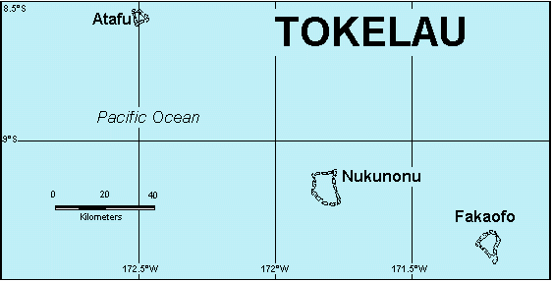
Source: Tokelau Islands Maps
From Atafu in the north to Fakaofo in the south, Tokelau extends for less than 200 kilometres. The atolls are about 3 to 5 metres above sea level. The maximum width of any island (motu) on the atolls’ rims is 200 metres. Tokelau is, therefore, particularly vulnerable to natural hazards.

8.1.2 Preparing the Tokelau inventory estimates

Censuses of dwellings and population
Tokelauans have New Zealand citizenship.
Tokelau has carried out independent censuses of population and dwellings five yearly; detailed data are available on the number of inhabitants, livestock, housing and some appliances. Only the past four censuses in Tokelau (2006, 2011, 2016 and the 2019 mini census) have used a precise definition of who is a ‘de jure Tokelauan’ and the people who actually lived in Tokelau during the Census night (‘de facto’ population). The de facto population has been used for the purposes of estimating emissions, which was 1,295 people in 2019 (Tokelau National Statistics Office, 2020). From 1990 to 2019, the population was fluctuating but generally declined for both de facto and de jure measures. Around 15,000 of the people who identify as Tokelauan live overseas, mostly in New Zealand.
Tokelau has a subsistence economy in which the sharing (inati) of essential resources plays an important and significant role. The inhabitants are dependent on local natural resources, particularly fishing in the lagoon and deep sea, growing coconuts and breadfruit, and keeping domesticated pigs and chickens.
The coral atolls provide a subsistence lifestyle within a fragile environment. Tokelau imports most of its foodstuffs from Samoa. The Tokelau economy is dependent on two major financial resources: economic and administrative assistance from New Zealand, and income from fisheries. New Zealand provides general budget support to help the delivery of essential services, consistent with its constitutional and United Nations Charter obligations.

Reporting arrangements
The development of a robust reporting system to enable the inclusion of Tokelau’s emissions in the Inventory is an ongoing process. Expertise and capacity continue to be strengthened through the establishment of connections with the various organisations and businesses in Tokelau involved in data collection and processing. Tokelau’s GHG inventory includes emissions from four sectors of Tokelau’s economy, which are the Energy, Industrial Processes and Product Use (IPPU), Agriculture and Waste sectors. Tier 1 methodologies with default emission factors from the 2006 Intergovernmental Panel on Climate Change (IPCC) Guidelines for National Greenhouse Gas Inventories (2006 IPCC Guidelines) are used for all reported categories (IPCC, 2006a–d). The Land Use, Land-Use Change and Forestry sector is excluded from Tokelau’s GHG inventory. Tokelau has no planted or managed forest, and the area of each land use category is unknown. Due to the small terrestrial land area and the geographic nature of Tokelau, being three low-lying coral atolls, the opportunity for land-use change is limited. Emissions are expected to be negligible because the size of the area that could support vegetation and soil establishment would be unable to significantly influence emissions from these sources, even if land-use change were possible or occurring.
New Zealand and Tokelau signed a memorandum of understanding on 18 January 2018 to establish the relationship between Tokelau and New Zealand regarding the governance of international climate change reporting relating to the inclusion of Tokelau in New Zealand’s national inventory system. According to the memorandum of understanding, both New Zealand’s central inventory agency (the Ministry for the Environment) and Tokelau’s Ministry of Climate, Oceans and Resilience have roles to enable Tokelau’s GHG inventory reporting.
New Zealand’s Ministry for the Environment takes responsibility for:
- coordination of communications between New Zealand and Tokelau officials, and with project consultants in New Zealand and overseas
- coordination with other New Zealand government agencies participating in the compilation of the Inventory, should their consulting or advice be required
- initial consultation on developing a national inventory system for Tokelau, together with the relevant instructive materials, including methodological guidance for Tokelau’s GHG inventory compilation
- technical advice on various aspects of Tokelau’s GHG inventory compilation regarding the subject matter, the legal background (reporting obligations under the Paris Agreement and the Convention), software use issues, and the quality-assurance and quality-control considerations associated with any changes to Tokelau’s national inventory system
- production of the complete set of the data tables in agreed common reporting formats
- final integration of Tokelau’s GHG inventory component into the Inventory
- submission of the Inventory under the Paris Agreement and the Convention, and coordinating communication with the United Nations Climate Change secretariat associated with the Inventory submission and review
- publication of the Inventory online, as well as all supplementary materials.
Tokelau’s Ministry of Climate, Oceans and Resilience takes responsibility for:
- coordinating the project implementation in Tokelau by communicating with the relevant agencies, organisations and individuals involved in Tokelau’s GHG inventory compilation; coordinating their efforts and delegating responsibilities to ensure sufficient information and support are provided to those agencies, organisations and individuals to enable Tokelau’s GHG inventory production
- providing timely advice on all cultural aspects of Tokelau’s GHG inventory compilation and helping to resolve any matters associated with potential cultural issues
- ensuring that the agreed compilation schedule is fully complied with, and the relevant timeframes are met, which includes submission of Tokelau’s GHG inventory data and information to New Zealand’s national inventory compiler within the agreed timeframe
- coordinating Tokelau’s efforts in activity data collection and data processing
- producing a peer-reviewed draft of the Tokelau chapter that is consistent with Paris Agreement reporting requirements as agreed under the Convention (UNFCCC, 2018a), chapter II of the Paris Agreement’s modalities, procedures and guidelines (UNFCCC, 2018b), including the use of the 2006 IPCC Guidelines (IPCC, 2006a–d) and following the common reporting tables in Annex I to decision 5/CMA.3 (UNFCCC, 2021).
Both the Ministry for the Environment and Ministry of Climate, Oceans and Resilience are responsible for adhering to the principles and protocols for producers of Tier 1 statistics (Stats NZ, 2007).
For the 2026 submission, there were insufficient quantitative activity data available for the 2024 reporting year. The Ministry for the Environment and Ministry of Climate, Oceans and Resilience agreed to use activity data from the 2023 reporting year for 2024. An assessment of the time series and the general trend in emissions fed into the decision. In the absence of significant disruptive events, only marginal changes in Tokelau’s emissions occur for most categories year to year. Anecdotal evidence confirmed that similar consumption patterns of diesel fuel use occurred in 2024. This is the major driver of change in Tokelau’s GHG inventory, affecting emissions from energy generation in the Energy industries – Public electricity and heat production category. This decision means there are no changes in reported emission values between 2023 and 2024. New Zealand intends to provide actual activity data for the 2024 and 2025 data years in the 2027 submission.

Methodological issues

Methods and emission factors
Tier 1 methodological approaches with default emission factors were used for estimating emissions from all Tokelau source categories.
Tokelau’s climate zone, way of life, economic base and technological infrastructure differ significantly from that of New Zealand. There are also differences in the scale of operations, especially in the Agriculture sector, meaning New Zealand’s definition of a farm does not apply to Tokelau. For estimating emissions from Tokelau, the 2006 IPCC default emission factors for Oceania with a warm climate are used, whereas New Zealand uses emission factors relevant for a temperate climate.
The calorific values for fuels used for Tokelau are also different from those used for New Zealand because those fuels are obtained from different sources. Relevant emission factors used for estimating emissions and references to the methods are detailed in sections 8.2 to 8.15.

Activity data
The Tokelau National Statistics Office collects and processes activity data from Tokelau for the preparation of the Inventory. Table 8.1.1 contains the key sources of the activity data from Tokelau used in Tokelau’s GHG inventory.
Table 8.1.1 Key sources for activity data in Tokelau
Item | Name/abbreviation | Explanation | Used where
1 | Census | Tokelau Census of Population and Dwellings 2006, 2011, 2016, 2019 (mini census).  www.tokelau.org.nz/Stats.html | Census data; interpolations for populations of people and livestock; solid and water waste disposal (flush toilets), number of private aluminium boats and outboard motors, home appliances.
2 | Archives NZ | Archives New Zealand, Wellington | Historic Census records going back to 1951, at five-year intervals (Tokelau National Statistics Office collation and analysis).
3 | HIES | Tokelau Household Income and Expenditure Survey 2015/16  www.tokelau.org.nz/Stats.html | Population and dwellings data supplementary to Census, in partnership with Pacific Community (SPC).
4 | SNZ, Stats NZ | Stats NZ, Wellington  www.stats.govt.nz | Major partner in collection, analysis and publication of Tokelau Census data.
5 | TNSO | Tokelau National Statistics Office, Apia  www.tokelau.org.nz/Stats.html | Joint collection, analysis and publication of Tokelau Census data.
6 | DoE | Tokelau Department of Energy | Estimate of diesel use for 24/7 power generation in 2004, plus before and after installation of solar panels in July–September 2012 (personal communication Mr Robin Pene, DoE director).
7 | PPS | Petroleum Product Supplies Ltd Apia | Fuel prices and volumes supplied for shipping and on-atoll use of diesel, petrol, kerosene and lubricant oil.
8 | DoF | Tokelau Department of Finance | Paid invoices and payment records to PPS, Origin, and on-atoll stores.
9 | 2018 vehicle survey | Photo survey of Tokelau motorised vehicles on-atoll, August–December 2018 | Personal communication JA Jasperse, TNSO.
10 | Origin | Origin Energy Samoa Ltd, Apia | Prices and volumes supplied for on-atoll use of propane for cooking.
11 | PCTrade-Green | Excel version of PCTrade package developed by Stats NZ, Christchurch | Used for analysing cargo shipping manifests, providing number of return voyages Apia–Tokelau over time, imports of goods, and exports of recyclables to date (2014 – June 2019 data available).
12 | DoH | Tokelau Department of Health | Anecdotal information on inhalers, laser gas, fire extinguishers.
13 | TSS | Tokelau Department of Transport and Support Services, Apia | Cargo shipping manifests for analysis of imports of all goods, and export of recyclables.
14 | 2014 Imports study | Jasperse, 2016. | Various Energy and Waste sector data, for example, calculation of per capita protein consumption.  www.tokelau.org.nz/Bulletin/September+2016/2014+imports+final.html
15 | EDNRE | Tokelau Department of Economic Development, Natural Resources and Environment | Anecdotal information on waste disposal and export.
16 | PCRAFI | Koroisamanunu et al, 2014. | Information on drinking water, wastewater and sanitation.
17 | MiCORE | Tokelau Ministry of Climate, Oceans and Resilience | Partner to Memorandum of Understanding with New Zealand Ministry for the Environment leading to the present inventory.

Tokelau’s data and information in the common reporting tables
The methodologies for estimating emissions in Tokelau and New Zealand differ, so adding Tokelau and New Zealand’s activity data at a category level and estimating combined emissions within each category are currently not possible. Due to limitations of the CRT, including specific categories for Tokelau consistently across all inventory sectors is also not possible.
Tokelau requested that visibility of the data from Tokelau’s GHG inventory be maintained in the CRT, enabling Tokelau officials to use the data for other reporting and policy purposes. Reporting Tokelau as a different inventory sector provides this visibility.
Therefore, CRT sector 6 (Other) is used to present emissions from Tokelau by sector in the CRT. Currently, the CRT environment does not allow the creation of lower-level categories in sector 6. To avoid double counting in the CRT, the data and information are aggregated for each of the Energy, IPPU, Agriculture and Waste sectors. In addition, annex 7 includes detailed tables with time series from 1990 to 2024 for each category reported for Tokelau. For comparability reasons, these tables are presented in a similar format to the CRT entry tables, and the table names follow the CRT naming convention for source categories.
The category names in Tokelau’s GHG inventory follow Annex I of Decision 5/CMA.3 (UNFCCC, 2021). From the CRT category names alone, it is not always clear which activities these categories refer to in the Tokelau context. To ensure the Inventory is understandable to all readers, Tokelau-specific activity descriptions have been developed for each category.
Table 8.1.2 presents these technical category names alongside plain‑language descriptions of the corresponding activities in Tokelau.
Table 8.1.2 Common reporting table category names and the equivalent descriptions for activities in Tokelau
Category number | Category name | Description of activities in Tokelau
1.A.1.a | Energy industries – Public electricity and heat production | Energy – Diesel use for generators and machinery
1.A.3 | Transport | Energy – Fuel use for fishing boats, domestic ferries and cars
1.A.3.b | Road transportation | Energy – Fuel use for cars
1.A.3.b.i | Cars | Energy – Fuel use for cars
1.A.3.d | Domestic navigation | Energy – Fuel use for fishing boats and domestic ferries
1.A.4.b | Other sectors – Residential | Energy – Kerosene and propane use for cooking
1.A.4.c | Agriculture/forestry/fishing | Energy – Fuel use for fishing boats
2.F.1 | Refrigeration and air-conditioning | Industrial – Fridge gas and air conditioning gas
2.F.1.b | Domestic refrigeration | Industrial – Fridge gas
2F.1.f | Stationary air-conditioning | Industrial – Air-conditioning gas
2.F.4.a | Metered dose inhalers | Industrial – Asthma inhalers
2.G.3.a | Medical applications | Industrial – Laughing gas
3.A | Enteric fermentation | Agriculture – Digestive systems of livestock
3.A.3 | Swine | Agriculture – Digestive systems of pigs
3.B | Manure management | Agriculture – Manure from livestock
3.B.3 | Manure management – methane emissions – Swine | Agriculture – Manure from pigs
5.A | Solid waste disposal | Waste – Buried
5.A.3 | Solid waste disposal – Uncategorised waste disposal sites | Waste – Buried
5.C | Incineration and open burning of waste | Waste – Burned
5.C.2 | Open burning of waste | Waste – Burned
5.D | Wastewater treatment and discharge | Waste – Wastewater
5.D.1 | Domestic wastewater | Waste – Wastewater
5.D.2 | Industrial wastewater | Waste – Wastewater
The executive summary and chapter 2 of this National Inventory Report include comparisons between Tokelau and New Zealand’s emissions.

8.1.3 Emissions reporting
Due to the small land size area, small population and absence of industry, Tokelau has a very low impact on the environment and emits very small amounts of GHGs. In relative terms, emissions have increased overall since 1990, driven by higher per capita consumption despite a declining population. Tokelau produces mainly carbon dioxide (CO₂) emissions (54.5 percent) and methane (CH₄) emissions (39.3 percent), followed by hydrofluorocarbons (HFCs) (5.0 percent) and nitrous oxide (N₂O) emissions (1.2 percent). Emissions from HFCs largely come from the use of air conditioning.
In 2024, Tokelau’s emissions were 4.21 kilotonnes carbon dioxide equivalent (kt CO₂e), contributing around 0.006 percent to New Zealand’s gross emissions. This is below the significance threshold in accordance with paragraph 32, chapter II of the Annex to the decision 18/CMA.1 (UNFCCC, 2018b).
Emissions from Tokelau have increased since 1990, mainly due to increases in CO₂ emissions from the Public electricity and heat production category (see figure 8.3.1).
The emissions in Tokelau are limited to:
- CO₂ from boat engines and vehicles
- CO₂ from back-up power generators
- fluorinated gases from the use of refrigerants
- CH₄ and N₂O from livestock (pigs and poultry)
- CH₄, CO₂ and N₂O from waste.

2024
In 2024, emissions from Tokelau contributed 0.006 percent (4.21 kt CO₂e) to New Zealand’s gross emissions.
The largest source category was Domestic navigation (emissions from marine vessels within Tokelau), which contributed 63.2 percent (1.43 kt CO₂e) of all energy emissions and 34.1 percent of gross emissions from Tokelau.
Carbon dioxide dominated emissions from Tokelau, contributing 54.5 percent (2.29 kt CO₂e) of its total emissions in 2024. At 2.25 kt CO₂, the Energy sector contributed 98.3 percent of total CO₂ emissions, mostly from Domestic navigation, with the remaining 1.7 percent (0.04 kt) coming from Open burning of waste in the Waste sector.
Methane emissions contributed 39.3 percent (1.66 kt CO₂e) to the total emissions from Tokelau. The Agriculture sector in Tokelau contributed 55.8 percent of CH₄ emissions (0.92 kt CO₂e), which mostly came from Manure management. A significant portion of CH₄ emissions, 43.9 percent (0.73 kt CO₂e), came from the Waste sector, largely from Solid waste disposal. The Energy sector contributed the remaining 0.4 percent of CH₄ emissions (0.01 kt CO₂e), which mostly came from Domestic navigation.
Nitrous oxide emissions contributed 1.2 percent (0.05 kt CO₂e) to the total emissions from Tokelau. The IPPU sector (Medical applications) contributed the largest amount of N₂O, 55.7 percent (0.03 kt CO₂e) of the total N₂O. The Energy sector contributed a further 24.1 percent (0.01 kt CO₂e), which comes largely from Domestic navigation. The Waste sector contributed the remaining 20.2 percent of N₂O (0.01 kt CO₂e) from Open burning of waste.
Emissions of fluorinated gases from Tokelau consisted of HFC emissions only, contributing 5.0 percent (0.21 kt CO₂e) to the total emissions from Tokelau. These emissions largely result from the use of Stationary air conditioning. Emissions of perfluorocarbons (PFCs), nitrogen trifluoride and sulphur hexafluoride do not occur in Tokelau.
Figure 8.1.2 and figure 8.1.3 show emissions from Tokelau by gas and by sector.
Figure 8.1.2 Tokelau’s emissions by gas in 2024
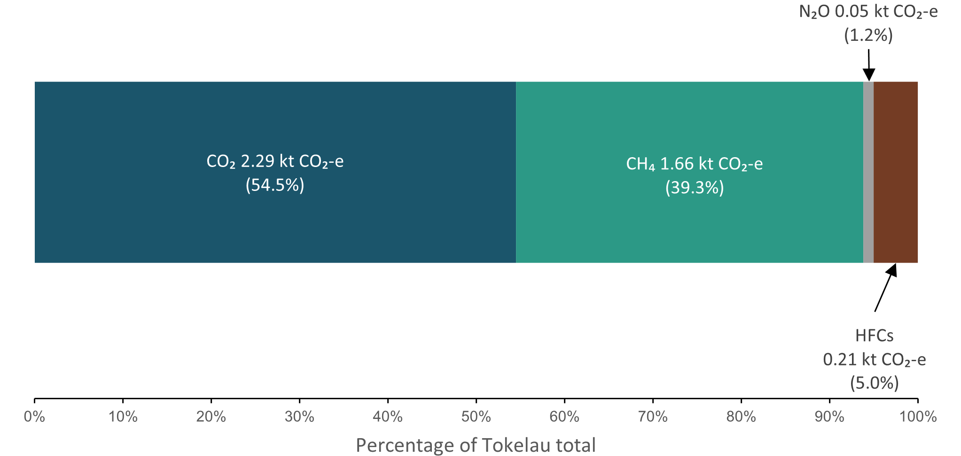
Figure 8.1.3 Tokelau’s emissions by sector in 2024
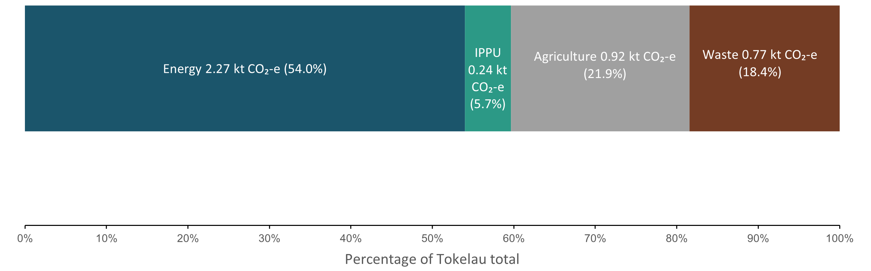

2023–2024
Total Tokelau emissions in 2024 were 0.0006 kt CO₂e (0.01 percent) higher than emissions in 2023. Emissions for 2024 are reported as largely unchanged from 2023 due to insufficient quantitative activity data available for the 2024 reporting year. There is anecdotal evidence suggesting that diesel fuel consumption patterns were similar across these years for energy generation in the Energy industries – Public electricity and heat production category.
While the activity data between these years were unchanged for all categories, the increase in emissions is the result of CH₄ emissions from Solid waste disposal. Emissions from Solid waste disposal are calculated using a first order decay model outlined in the 2006 IPCC Guidelines (IPCC, 2006a), which reflects how buried waste breaks down slowly over time. This means the emissions in any given year depend on the waste disposed in all previous years rather than the waste disposed this year. As a result, emissions change even when the activity has not changed.

2005–2024
Tokelau’s gross emissions in 2024 were 0.50 kt CO₂e (10.6 percent) lower than in 2005. This change was mainly the result of reductions in emissions from the Agriculture sector. This was due to a reduction in the number of both pigs and chickens. Emissions from the Energy sector decreased overall between 2005 and 2024, due to the installation of solar photovoltaic (PV) systems in 2012. The increases and decreases in Energy sector emissions between 2012 and 2024 are further explained in section 8.3.1. Emissions from the IPPU sector increased slightly between 2005 and 2024, primarily due to the growth in the number of air conditioning units during this period. Emissions from the Waste sector for Tokelau have remained steady between 2005 and 2024.

1990–2024
In 1990, Tokelau’s gross emissions were 3.37 kt CO₂e. Between 1990 and 2024, total emissions increased by 24.8 percent (0.84 kt CO₂e) to 4.21 kt CO₂e (table 8.1.3 and figure 8.1.4). From 1990 to 2024, the average annual increase in gross emissions was 0.87 percent.
The emissions increase was largely due to changes in the Energy sector. The emission categories that contributed the most to this change were Domestic navigation and Electricity generation.
The changes in Domestic navigation are a result of Tokelau gaining ownership and use of the ferry Mataliki in 2016, cargo vessel Kalopaga in 2018 and Fetu o te Moana in 2019, leading to an increasing number of sea voyages between the atolls, which increased transport emissions.
The changes in Tokelau’s Energy sector emissions from Electricity generation drive the overall emissions trend observed across most of the time series. Initially, up until 2003, emissions from this source were relatively stable. A significant increase in emissions (of nearly 400 percent) was then observed between 2003 and 2011 due to an increase in the use of diesel generators for electricity production. This was followed by a significant drop in emissions occurring in 2012 and 2013 (by 82.5 percent), when solar electricity generation began. Toward the end of the time series, diesel generator use increased again as the generation from solar power decreased, with emissions increasing accordingly.
Emissions from Tokelau’s IPPU sector have also increased mainly due to the introduction of air conditioning after 2006. Emissions from Tokelau’s Agriculture sector decreased as a result of a reduced population of pigs and chickens.
Table 8.1.3 Gross emissions from Tokelau by gas in 1990, 2005 and 2024
 | Emissions (kt CO₂e) |  |  | Difference (kt CO₂e) |  | Change (%)
Direct greenhouse gas emissions | 1990 | 2005 | 2024 | 1990–2024 | 2005–2024 | 1990–2024 | 2005–2024
CO₂ | 1.30 | 2.45 | 2.29 | 0.99 | -0.15 | 76.65 | -6.27
CH₄ | 2.00 | 2.16 | 1.66 | -0.34 | -0.50 | -17.15 | -23.27
N₂O | 0.08 | 0.03 | 0.05 | -0.03 | 0.01 | -34.82 | 43.64
HFCs | NO | 0.07 | 0.21 | 0.21 | 0.14 | NA | 201.79
PFCs | NO | NO | NO | NA | NA | NA | NA
SF₆ | NO | NO | NO | NA | NA | NA | NA
NF₃ | NO | NO | NO | NA | NA | NA | NA
Gross, all gases | 3.37 | 4.71 | 4.21 | 0.84 | -0.50 | 24.81 | -10.61
Note: Emissions from the Land Use, Land-Use Change and Forestry sector are not estimated for Tokelau. The percentage change for hydrofluorocarbons (HFCs) is not applicable (NA) because HFC production or use was not occurring (NO) in 1990. Columns may not total due to rounding. Presented percentages are calculated from unrounded values.
Figure 8.1.4 Emissions by sector for Tokelau, from 1990 to 2024
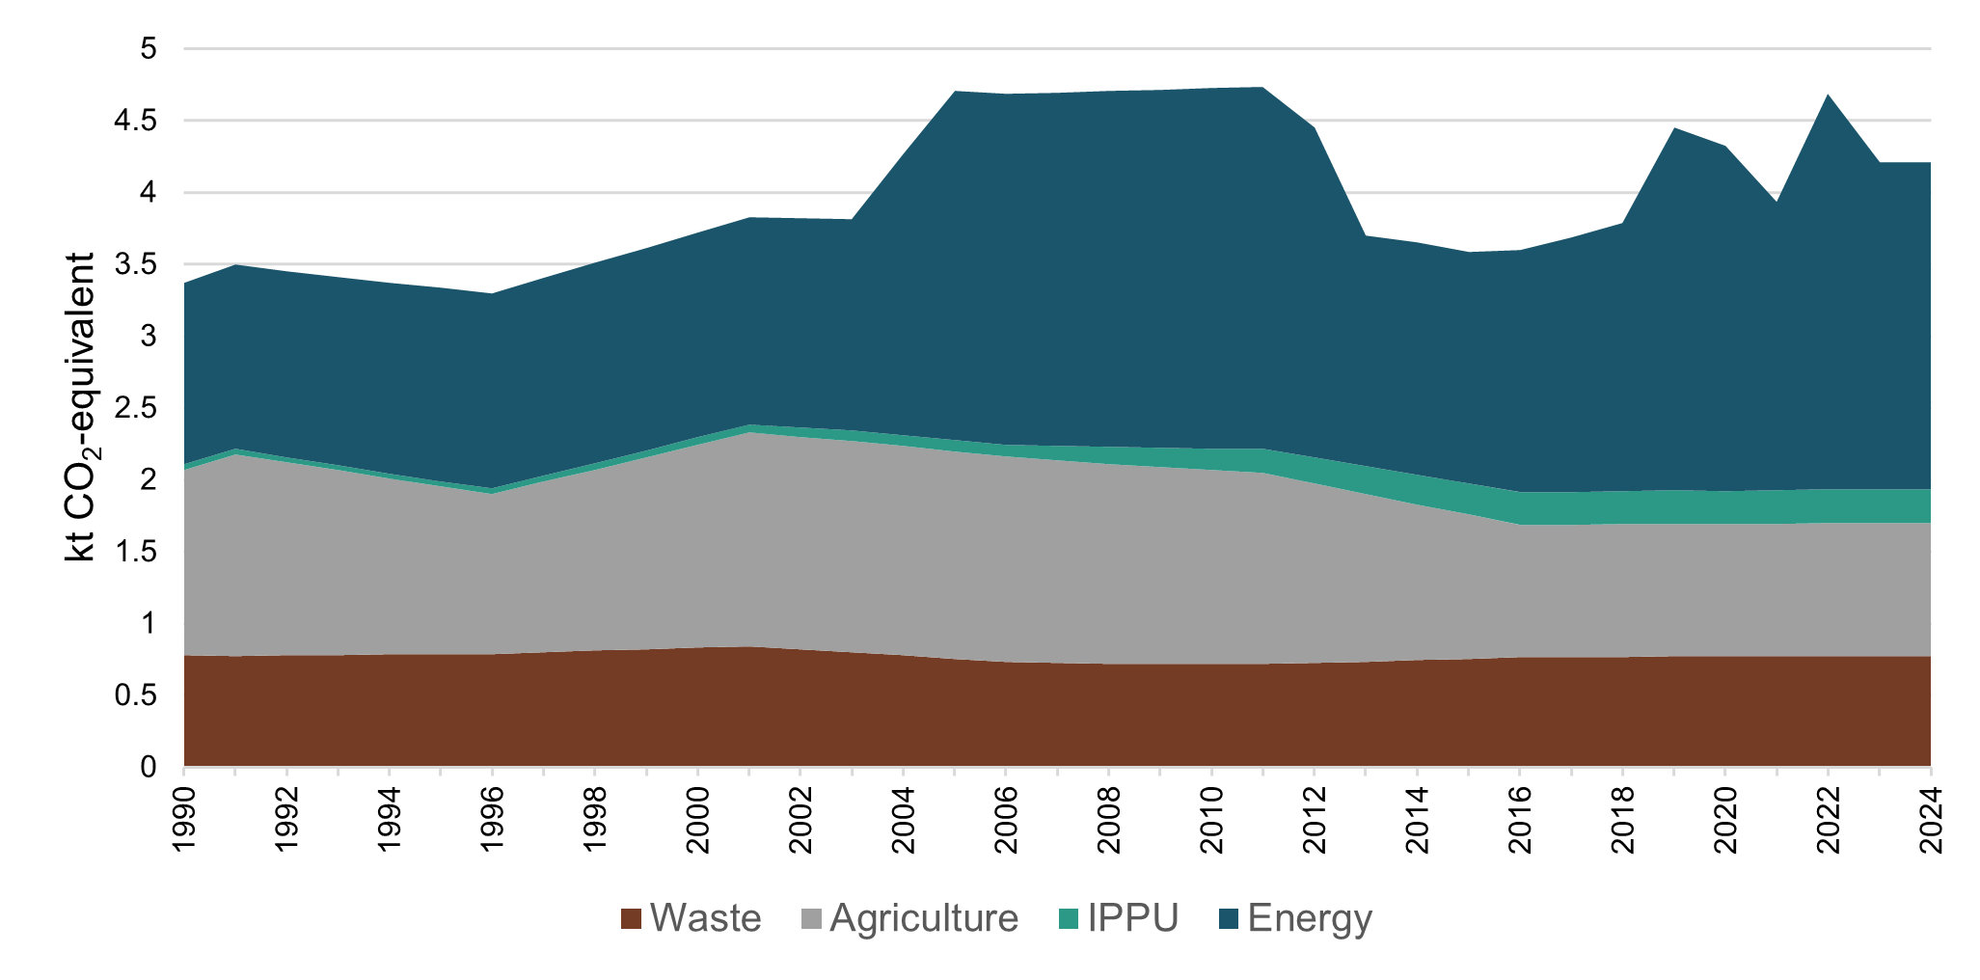

Key categories
Emission categories from Tokelau have been included in the key category analysis, along with all categories reported in New Zealand’s inventory. None of the emission categories from Tokelau are key categories (either level or trend) in the 2026 submission.

8.1.4 Recalculations and improvements
One minor recalculation has been made to Tokelau’s GHG inventory estimates since the 2025 submission. Improvements made to Tokelau’s GHG inventory estimates have resulted in no change in 1990, no change in 2005 and an increase of 0.1 percent (0.004 kt CO₂e) in 2023. This change is due to updates in New Zealand’s medical emissions data, which are applied to Tokelau on a per capita basis.
Table 8.1.4 Explanations and justifications for recalculations
Sector | Explanation of recalculation | Underpinning IPCC principle | Additional justification
Tokelau – IPPU | The recalculation is due to passing through updates in New Zealand’s medical emissions data, which are assumed to apply equally to Tokelau (see chapter 10, figure 10.3.8). | Accuracy

8.1.5 Quality-assurance/quality-control (QA/QC) processes
Tokelau’s activity data undergo quality-control processes at the Tokelau National Statistics Office. Tokelau’s GHG inventory estimates undergo quality-assurance and quality-control processes that are similar to those of other inventory sectors.
Figure 8.1.5 presents an overview of the compilation process for Tokelau and its integration into the Inventory. It also shows where quality-assurance and quality-control steps are applied.
Figure 8.1.5 Data processing, quality-assurance and quality-control processes applied to the Inventory data from Tokelau and their integration into the Inventory
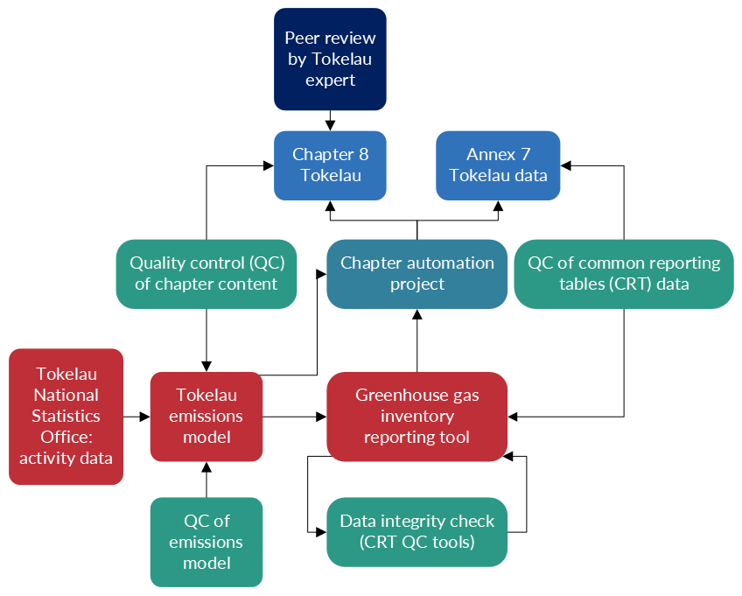

8.1.6 Information on completeness

Emissions reported as ‘NE’ or ‘not estimated’
Table 8.1.5 lists Tokelau’s direct GHG emission sources that are reported as ‘NE’ in the 2026 submission.
Table 8.1.5 Summary of ‘NE’ or ‘not estimated’ entries for Tokelau’s GHG inventory sources in the 2026 submission
CRT category code | Category | Gas | Explanation
Tokelau
Within the Tokelau sector 6, category 3.A.4 Enteric fermentation for poultry | Enteric fermentation from poultry in Tokelau | CH₄ | This category is not mandatory. IPCC guidance is not provided for calculating Tier 1 estimates. Any potential emissions from this activity are expected to be very small, under 0.1 kt CO₂e or less, which is the quantity of emissions for Enteric fermentation from swine in Tokelau.

Emissions reported as ‘IE’ or ‘included elsewhere’
Table 8.1.6 lists Tokelau’s direct GHG emission sources that are reported as ‘IE’ in this submission.
Table 8.1.6 Summary of ‘IE’ or ‘included elsewhere’ entries for Tokelau’s GHG inventory sources in the 2026 submission
CRT category code | Category | Source category reported under | Notation key explanation
Tokelau
Within the Tokelau sector 6, categories 1.A.3.b.i. and 1.A.4.c.iii. were reported elsewhere | Road transport/ Gasoline and diesel oil | 1.A.3.d. Domestic navigation – Gas-diesel oil (within Tokelau sector 6) | Tokelau has a small petrol car fleet. In 2018 there were about 40 cars and 30 motorbikes, with an entire road network less than 10 kilometres. Fuel use for road transport cannot be distinguished from fuel use for domestic navigation, which is the main means of private transport in Tokelau. All sources of emissions from road transport are therefore included within Domestic navigation.
Within the Tokelau sector 6, category 1.A.4.b. Residential is reported elsewhere | 1.A.4.b. Residential liquid fuels | 1.A.3.d. Domestic navigation – Gas-diesel oil (within Tokelau sector 6) | The only emission source of liquid fuel occurring in this category is gas used for cooking. The amount of liquid fuel use in this category is small compared with that used for Domestic navigation, therefore all emissions are included in Domestic navigation.

8.2 Energy emissions from Tokelau (6. Tokelau_1)

8.2.1 Overview of Tokelau’s Energy sector
In 2024, emissions from Tokelau’s Energy sector were 2.27 kt CO₂e. This contributed 54.0 percent of Tokelau’s gross emissions and 0.003 percent to New Zealand’s gross emissions.
In Tokelau, the Energy sector covers the Domestic navigation, Public electricity and heat production and Other – Residential categories (see figure 8.2.1).
Figure 8.2.1 Energy emissions by category for Tokelau, from 1990 to 2024
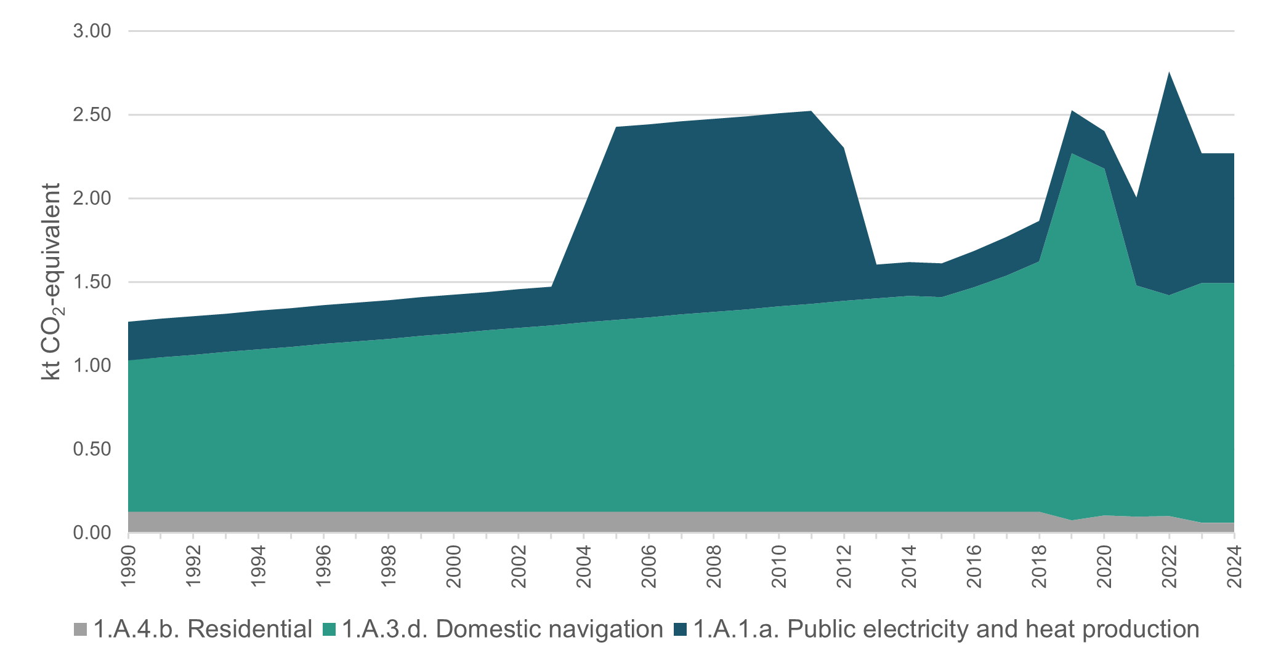
For all energy categories, emissions were estimated using the IPCC Tier 1 methodological approach with IPCC default emission factors (IPCC, 2006a). Default IPCC uncertainty values were used for all estimates (IPCC, 2006a).
Tokelau predominately uses diesel oil and petrol (for back-up generators and transport) and liquefied petroleum gas (LPG) (for cooking purposes). Solid fuels are not used in Tokelau, other than on a small scale (e.g., the husks of locally grown coconuts). Emissions from solid fuels are, therefore, not estimated.
Small amounts of other fossil fuels imported by Tokelau are assumed to be combusted. These include gasoline, other kerosene and lubricants. Their combustion is accounted for under Domestic navigation – Gas/diesel oil. Around 40 drums (205-litre capacity per drum) of oil are imported annually, the bulk of which is assumed to be mixed with petrol for ‘outboard’ engine use and combusted, with only a few drums used to lubricate cars and other engines. Because none of those are recycled, combustion is the most likely outcome. After every five roundtrips, oil changes carried out in Apia during servicing of the ferries Mataliki and Kalopaga have the more significant amount of waste oil but this remains in Samoa.
For consistency with New Zealand’s Energy sector, gross calorific values were used for Energy sector estimates from Tokelau. The relevant IPCC default emission factors were adjusted accordingly by multiplying them by 0.95 and 0.90 for liquid and gaseous fuels respectively.

8.2.2 Reference approach
The reference approach calculations were performed according to the methods described in the 2006 IPCC Guidelines (IPCC, 2006a). Equations 6.1 to 6.4 (volume 2, chapter 6, IPCC, 2006a) were used for calculating consumption and estimating emissions. Gross calorific values were used for all calculations.
In 2024, total CO₂ emissions estimated using the reference approach were 2.22 kt, which differs from the sectoral approach by 1.7 percent. The average variation of differences between the sectoral and reference approach across the time series was 2.2 percent.

8.2.3 International bunker fuels
All fuel imported or sold in Tokelau is for domestic voyages. All international voyages operate exclusively on fuel loaded in Samoa, no refuelling takes place in Tokelau for international shipping routes.
Tokelau has no domestic or international aviation transportation.

8.3 Stationary combustion: Public electricity and heat production

8.3.1 Description
In Tokelau, the main source of emissions from this category is electricity production from back-up generators. These generators operate exclusively on liquid fossil fuels, and only liquid fossil fuels are reported in the Energy industries – Public electricity and heat production category.
Like most small Pacific Island nations and territories, Tokelau has been heavily reliant on the importation of fossil fuels for energy generation. Imports increased significantly in 2004, when electric power became available for households 24 hours a day, 7 days a week. Before that, electricity was generated between 6 pm and 10 pm daily, and annual diesel consumption was about 20 percent of the value in 2011.
In 2012, the installation of 4,000 solar PV systems across the three atolls was completed (figure 8.3.1). Each of the three Tokelau atolls now has solar PV systems that provide a significant proportion of local electricity demand.
Figure 8.3.1 Cluster block diagram for Tokelau’s solar project
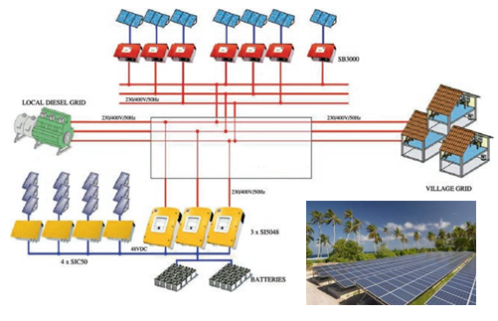
Source: International Renewable Energy Agency (2013)
Tokelau received wide media coverage for its installation of solar PV units. The change resulted in a significant drop in liquid fossil fuels consumption for electricity production in Tokelau (by around 82.5 percent) and a decrease in the total energy emissions by 36.4 percent between 2011 and 2013. However, some power generation using diesel remains necessary as a back up, during the failure of solar PV units, prolonged cloudy spells, and to meet the steadily increasing demand from households and the public sector. Since 2022, Tokelau’s reliance on diesel generators has increased in part due to Nukunonu’s solar panel batteries overheating. A project that was planned to upgrade the solar panel batteries was deferred due to COVID-19.

Energy emission trends
In Tokelau, the Public electricity and heat production category accounted for 100 percent of the emissions from the Energy industries category for the entire time series. In 2024, emissions totalled 0.78 kt CO₂e (34.2 percent of all energy emissions from Tokelau). Emissions from Public electricity and heat production increased by 0.54 kt CO₂e (136.1 percent) since the 1990 level of 0.23 kt CO₂e.

8.3.2 Methodological issues

Activity data
The sources of activity data for the Energy industries – Public electricity and heat production category are included in table 8.1.1. Key sources for the energy supply and consumption data are the Tokelau Department of Energy and Petroleum Product Supplies Ltd (Apia, Samoa). The Tokelau Department of Energy provided background data for estimates of diesel use for power generation around the time that electricity became available 24 hours a day, 7 days a week in Tokelau in 2004 (item 6 in table 8.1.1). Based on purchase information, the Department of Finance provided the data on fuel prices and volumes supplied by Petroleum Product Supplies Ltd for shipping and on-atoll use of diesel, petrol, kerosene and lubricant oil (item 7 in table 8.1.1). Only liquid fossil fuels (i.e., gas and diesel oil) are used in the Public electricity and heat production category. All fossil fuels in Tokelau are imported and activity data are mostly obtained from analysis of invoices from main suppliers and shipping manifests.
In the course of the analysis of available data, discrepancies were discovered between the fuel imports shown on shipping manifests and the more reliable financial fuel purchase data that were audited. Detailed data were not available for each year from 1990 to 2024 (or data reliability was not high), so a trade-off was made between data granularity and data quality. The biggest and most reliably recorded data variations are reflected in the time series.
For electricity generation, two important events occurred: first, the changeover to 24 hour, 7 days a week electricity in 2004 (from 6 pm to 10 pm before that, at an estimated 20 percent of the 24 hour, 7 days a week value in 2011); and second the introduction of solar PV-powered plants in 2012. The change during 2012, due to the installation of solar PV-powered plants, was reasonably well documented and, therefore, reflected in the time series. For the years 1990 to 2003, 2005 to 2011 and 2013 to 2015, the activity data (and corresponding emissions) are shown as constant. In 2022, Tokelau’s reliance on diesel generators increased due to an increase in demand and a decrease in the availability of solar power. Use of diesel generators subsequently decreased in 2023 due to fuel conservation initiatives and problems with the generators. In the absence of updated activity data for diesel generator use in 2024, emissions have been maintained at 2023 levels.
The diesel data for 2013 to 2015 were entirely based on analysis during 2018 of fuel purchases, when, for the first time, Tokelau’s analysts could clearly separate out the diesel used on-atoll and for shipping. The methodology for such analyses that was put in place for the 2019 inventory submission has been refined in each subsequent submission.
Diesel is delivered on ‘dangerous goods sailings’ to Tokelau in the ships’ fuel bunkers. On arrival, it is pumped into drums on a barge, for shipping to shore and transport to the generator sites.

Methods and emission factors
An IPCC Tier 1 method was applied for estimating emissions from the Public electricity and heat production category. The method required data on the amount of diesel combusted in the source category and a default emission factor from table 2.2, section 2.3.2.1, volume 2 of the 2006 IPCC Guidelines (IPCC, 2006a). Default emission factors from the 2006 IPCC Guidelines were converted from net calorific values to gross calorific values using the Organisation for Economic Co-operation and Development (OECD) and International Energy Agency (IEA) assumptions to make these conversions:
$$\text{Gross} \text{Emission} \text{Factor} \left(liquid fuels\right)= 0.95×\text{Net} \text{Emission} \text{Factor}$$
Equations 2.1 and 2.2 from section 2.3.1.1 in the 2006 IPCC Guidelines were used for estimating emissions (IPCC, 2006a).

8.3.3 Uncertainty assessment and time-series consistency
The default uncertainty values for emission factors provided in the 2006 IPCC Guidelines were used for CO₂ and CH₄ (for public power, co-generation and district heating) (IPCC, 2006a). The 2006 IPCC Guidelines do not provide a quantified default emission factor for N₂O, therefore New Zealand’s emission factor uncertainty across the Energy sector was applied to the N₂O emissions from this category.
For activity data, the upper level of the default uncertainty range for the main activity of electricity and heat production was applied from the 2006 IPCC Guidelines (IPCC, 2006a). This is because of the lack of detailed pre-2018 fuel data, requiring data to be extrapolated back across the time series. Table 8.3.1 shows the uncertainties applied to the source emissions reported under the Energy industries – Public electricity and heat production category.
Table 8.3.1 Uncertainties for the Energy industries – Public electricity and heat production category
Gas | Fuel type | Activity data (AD) uncertainty (%) | Emission factor (EF) uncertainty (%) | Source
CO₂ | Liquid fuels | 10 | ±7 | AD: page 2.41, IPCC, 2006a (table 2.15)  EF: page 2.38, IPCC, 2006a
CH₄ | Liquid fuels | 10 | ±50.0 | AD: page 2.41, IPCC, 2006a (table 2.15)  EF: page 2.38, IPCC, 2006a (table 2.12)
N₂O | Liquid fuels | 10 | ±50.0 | AD: page 2.41, IPCC, 2006a (table 2.15)  EF: New Zealand’s value is used (table 3.2.1, chapter 3)
For the Public electricity and heat production category, time-series consistency is maintained by using a combination of actual and inferred data for diesel consumed depending on the information available. For all years before 2019, except 2011 and 2015, diesel use is based on typical diesel electricity generator use.

8.3.4 Category-specific QA/QC and verification
Quality control of the activity data and calculations was applied to each category for Tokelau. No verification was possible because no alternative data were available.

8.3.5 Category-specific recalculations
There were no changes to estimates for the Energy industries – Public electricity and heat production category.

8.3.6 Category-specific planned improvements
No improvements are planned for the Energy industries – Public electricity and heat production category. Some areas identified for possible improvements are better monitoring of diesel fuel landing on-atoll at the power sites, and clearly separating fuel used for power generation from heavy machinery and diesel-powered vehicles. Data on gross electricity production from oil were acquired in late 2019 from the International Renewable Energy Agency; these could provide additional detail and verification of energy use back to their base year 2000. Future imports of coolants (ethylene glycol) for the solar PV-powered plants may also be considered in future.

8.4 Stationary combustion: Other sectors – Residential

8.4.1 Description
Tokelau has no significant manufacturing industry. Fuel combustion other than for electricity generation occurs in some domestic and fishing activities, and community–government activities (e.g., meeting halls and offices, village freezers, building projects, stevedoring). Emissions associated with these activities in Tokelau (except fishing) are included in the category Other sectors – Residential. The small amount of emissions associated with communal activities are not easily distinguishable from those coming from residential activities and are therefore reported together in the Other sectors – Residential category. Emissions from fishing are included in Domestic navigation. This is because it is difficult to distinguish fuel use for fishing from fuel use for domestic navigation in Tokelau, because families use the same boats for both purposes.
According to the 2016 Tokelau Census, every household has a fridge and a freezer, and some households now have air conditioning. Most households (over 60 percent) also own a washing machine, a computer and a television. The United Nations Development Programme, under the Tokelau Energy Sector Support Project, has in the past funded a programme of replacing old inefficient fridges and freezers with new ones. Home appliances in Tokelau mainly use the power provided by solar PV-powered plants, supplemented as needed by back-up diesel-powered generators. Emissions associated with the use of diesel-powered back-up generators are included in the Energy industries – Public electricity and heat production category.
Gas cooking using imported natural gas (LPG) is the preferred method used by about 72.0 percent of households, replacing kerosene stoves. The use of kerosene stoves dropped from 56.6 percent of households in 2006 to 23.6 percent in 2016 (2016 Tokelau Census). Associated activity data and emissions are included in the Other sectors – Residential category.
In 2024, emissions from the Other sectors – Residential category were 0.06 kt CO₂e (2.7 percent of all energy emissions from Tokelau).

8.4.2 Methodological issues

Activity data
The sources of activity data for the Other sectors – Residential category are included in table 8.1.1. The key data source for the category is paid invoices from Origin Energy Samoa Ltd (Apia, Samoa) providing prices and volumes of propane supplied on-atoll for cooking.

Methods and emission factors
An IPCC Tier 1 method was applied for estimating emissions from the Other sectors – Residential category. The method requires data on the amount of LPG combusted in the source category and a default emission factor from table 2.2, section 2.3.2.1, volume 2 of the 2006 IPCC Guidelines (IPCC, 2006a). Default emission factors from the 2006 IPCC Guidelines were converted from net calorific values to gross calorific values using the OECD and IEA assumptions to make these conversions:
$$\text{Gross} \text{Emission} \text{Factor} \left(gaseous fuels\right)= 0.90×\text{Net} \text{Emission} \text{Factor}$$
Equations 2.1 and 2.2 from section 2.3.1.1 in the 2006 IPCC Guidelines were used for estimating emissions (IPCC, 2006a).

8.4.3 Uncertainty assessment and time-series consistency
For this submission, it was not possible to develop Tokelau-specific uncertainty values, therefore, for emission factors, default uncertainty values provided in the 2006 IPCC Guidelines were used for CO₂ and CH₄ (for commercial, institutional and residential combustion) (IPCC, 2006a). The 2006 IPCC Guidelines do not provide a quantified default emission factor for N₂O, therefore New Zealand’s emission factor uncertainty across the Energy sector was applied to the N₂O emissions from this category.
For activity data, a mid-range level default uncertainty was applied (IPCC, 2006a). Table 8.4.1 shows the use of uncertainties for the Other sectors – Residential category.
Table 8.4.1 Uncertainties for the Other sectors – Residential category
Gas | Fuel type | Activity data (AD) uncertainty (%) | Emission factor (EF) uncertainty (%) | Source
CO₂ | Liquid fuels | 20 | ±7 | AD: page 2.41, IPCC, 2006a (table 2.15)  EF: page 2.38, IPCC, 2006a
CH₄ | Liquid fuels | 20 | ±50.0 | AD: page 2.41, IPCC, 2006a (table 2.15)  EF: page 2.38, IPCC, 2006a (table 2.12)
N₂O | Liquid fuels | 20 | ±50.0 | AD: page 2.41, IPCC, 2006a (table 2.15)  EF: New Zealand’s value (table 3.2.1, chapter 3)
For the Other sectors – Residential category, time-series consistency is maintained by keeping activity data from 1990 to 2018 constant at 2018 levels and using actual data since 2018 where available.

8.4.4 Category-specific QA/QC and verification
Quality control of the activity data and calculations was applied to each category for Tokelau. No verification was possible because no alternative data were available.

8.4.5 Category-specific recalculations
There were no changes to estimates for the Other sectors – Residential category.

8.4.6 Category-specific planned improvements
No improvements are planned for the Other sectors – Residential category. One area identified for possible future improvement is to consider additional LPG imports purchased from Aute Gas (Apia, Samoa), for Nukunonu. However, the difference is likely to be small, compared with the current approach (where Nukunonu is taken as the average between the fuel purchases from Origin, by Atafu and Fakaofo). For future submissions, further analysis of activity data from Tokelau, to reflect year-to-year variations, will be considered as resources allow.

8.5 Mobile combustion: Domestic navigation

8.5.1 Description
The only means of transport to and from Tokelau is by sea because there is no air transportation. All travel and supplies to Tokelau originate and terminate in Samoa, Tokelau’s closest neighbour. A direct trip from any of the three atolls to the nearest port, Apia, usually takes between 26 hours and 40 hours. There are no ports and terminals in Tokelau, and no offshore anchorage is available; barges that can enter the fringe reef are used for loading and offloading ships.
The passenger ferries and cargo ships arriving from Apia (distance around 500 kilometres) generally visit the three atolls in succession: they are 60 kilometres and 90 kilometres apart, respectively. A round trip is about 1,300 kilometres using diesel from Apia. Up until 2018, the fraction (300/1300) is used to estimate Domestic navigation within Tokelau. Between 2019 and 2023, actual data on the number of inter-atoll trips were used.
Until recently, the main forms of road transport on the atolls were trucks, pick-ups, motorbikes and a range of golf carts. Some vehicles are electric, fuelled by solar PV energy. Solar-powered streetlights ensure safety on the roadways. The private importation of other vehicles has increased recently.
The road transport vehicle fleet remains very small in Tokelau. Census 2001 and prior recorded only four registered cars. In 2024, there were about 40 cars (in addition to the vehicles above) and 30 motorbikes, with the entire network of unsealed roads being about 10 kilometres.
Aluminium boats with an outboard motor are widely used by families. Emissions from fuels used for road transport are orders of magnitude lower than from boats, and it was not possible to distinguish the small amounts of fuel used for road transport from the total amount used for all forms of transport. Emissions from road transport are therefore included under the Domestic navigation category.
According to its 2016 census, Tokelau has 176 aluminium boats with 160 outboard motors, which use most of the imported petrol to travel within and outside the large lagoons. Most of the diesel use is by the ferries travelling to and from Samoa. Fetu o te Moana is a new search and rescue vessel delivered in 2019 that also provides general inter-atoll transport.
For Tokelau, all emissions from Transport are reported in the Domestic navigation category across the entire time series. In 2024, emissions from the Domestic navigation category totalled 1.43 kt CO₂e (63.2 percent of all energy emissions from Tokelau).

8.5.2 Methodological issues

Activity data
The sources of activity data for the Transport category are included in table 8.1.1. Activity data sources for the category are:
- paid invoices from Petroleum Product Supplies Ltd (Apia, Samoa) with data on fuel prices and volumes supplied for shipping and on-atoll use: diesel, petrol, kerosene and lubricant oil
- the Tokelau Department of Finance’s invoices and payment records to Petroleum Product Supplies Ltd, Origin and on-atoll stores
- a photo survey of Tokelau motorised vehicles on-atoll, August to December 2018.
Additional energy data related to cargo manifests were obtained from Jasperse (2016). Only liquid fossil fuels (gas and diesel oil) are used for fuelling Tokelau’s transport.
Due to large discrepancies between different sources of raw data, reliable statistics on fuel consumption across the full reporting period 1990 to 2024 are not available. Some anecdotal transport data exist for the number of roundtrips Apia–Tokelau during the years 1990 to 2014. Actual records are available after this period.

Methods and emission factors
A Tier 1 method was applied for estimating emissions from the Domestic navigation category. The method requires data on the amount of fuel combusted in the source category and a default emission factor from tables 3.5.2 (for CO₂) and 3.5.3 (for non-CO₂ gases), section 3.5.1.2, volume 2 of the 2006 IPCC Guidelines (IPCC, 2006a). Default emission factors from the 2006 IPCC Guidelines were converted from net calorific values to gross calorific values using the OECD and IEA assumptions to make these conversions:
$$\text{Gross Emission} \text{Factor} \left(liquid fuels\right)= 0.95×\text{Net} \text{Emission} \text{Factor}$$
Equation 3.5.1 in section 3.5.1.1 in the 2006 IPCC Guidelines was used for estimating emissions (IPCC, 2006a).

8.5.3 Uncertainty assessment and time-series consistency
For this submission, it was not possible to develop Tokelau-specific uncertainty values, therefore, for emission factors, default uncertainty values provided in the 2006 IPCC Guidelines were used for CO₂ (for diesel) and CH₄ (upper value) (IPCC, 2006a). For N₂O, New Zealand’s emission factor uncertainty across the Energy sector was used for this category, which is within the default uncertainty range.
For activity data, due to discrepancies between different data sources, an upper level of default uncertainty range associated with incomplete surveys from the 2006 IPCC Guidelines was applied (IPCC, 2006a). Table 8.5.1 shows the use of uncertainties for Domestic navigation (diesel).
Table 8.5.1 Uncertainties for the Domestic navigation (diesel) category
Gas | Fuel type | Activity data (AD) uncertainty (%) | Emission factor (EF) uncertainty (%) | Source
CO₂ | Liquid fuels | ±50 | ±1.5 | Section 3.5.1.7, IPCC, 2006a
CH₄ | Liquid fuels | ±50 | ±50.0 | Section 3.5.1.7, IPCC, 2006a
N₂O | Liquid fuels | ±50 | ±50.0 | New Zealand’s value is used (table 3.2.1, chapter 3), section 3.5.1.7, IPCC, 2006a
For the Domestic navigation category, time-series consistency is maintained by estimating activity data for the years before 2018 when detailed data became available.

8.5.4 Category-specific QA/QC and verification
Quality control of the activity data and calculations was applied to each category for Tokelau. No verification was possible because no alternative data were available.

8.5.5 Category-specific recalculations
There were no changes to estimates for the Domestic navigation category.

8.5.6 Category-specific planned improvements
No improvements are planned for Transport. For future submissions, further analysis of activity data to reflect year-to-year variations will be considered as resources allow.

8.6 Emissions from Industrial Processes and Product Use in Tokelau (6. Tokelau_2)

8.6.1 Overview of Tokelau’s Industrial Processes and Product Use sector
Tokelau has no significant industry. The emissions associated with the IPPU sector come from the following activities:
- use of refrigeration and air conditioning – HFCs
- use of metered dose inhalers – HFC-134a and HFC-227ea
- medical applications of N₂O.
Thus, the source categories included in this report are Refrigeration and air conditioning (2.F.1), Metered dose inhalers (2.F.4) and Medical applications (2.G.3).
In 2024, emissions from Tokelau’s IPPU sector were 0.24 kt CO₂e. The IPPU sector contributed 5.7 percent to Tokelau’s gross emissions and 0.0003 percent to New Zealand’s gross emissions. The biggest contributor to the total IPPU HFC emissions is Stationary air conditioning followed by Domestic refrigeration, with 65.6 percent and 17.0 percent of IPPU emissions from Tokelau, respectively. Figure 8.6.1 shows emission trends in the IPPU sector by category for Tokelau.
Figure 8.6.1 Industrial Processes and Product Use emissions by category for Tokelau from 1990 to 2024
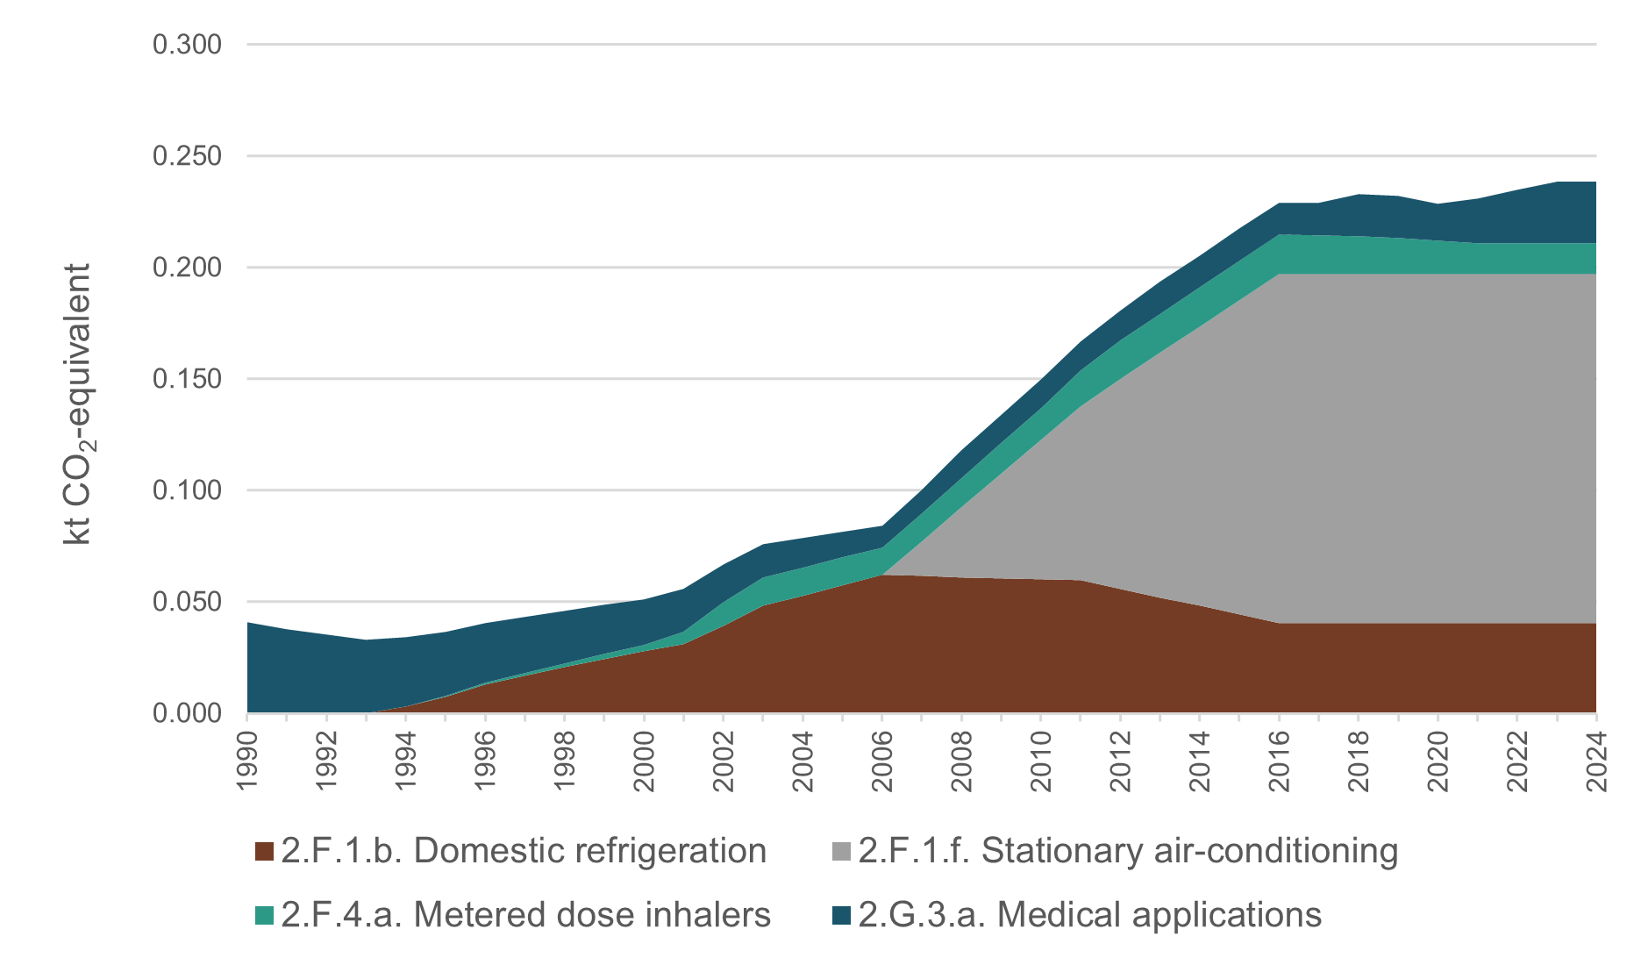

8.7 Emissions from Refrigeration and air conditioning in Tokelau

8.7.1 Description
Due to a very small number of air-conditioned vehicles in Tokelau, all emissions from this category are reported in Stationary air conditioning (2.F.1.f).
Because most fridge and freezer appliances are installed in households, the emissions associated with refrigeration are reported in Domestic refrigeration (2.F.1.b). Emissions from fridge and freezer appliances are based on the number of those appliances, however, no HFCs were used before 1994. To account for the phase-in of HFCs, it has been assumed that the proportion of appliances using HFCs increased 10 percent per year, starting at 10 percent of appliances in 1994 and reaching 100 percent of appliances in 2003. This phase-in is reflected in figure 8.6.1. Emissions continue to change after 2003 due to changes in the overall number of appliances.

8.7.2 Methodological issues

Activity data
The data for the number of appliances are sourced from:
- Tokelau Census of Population and Dwellings (2006, 2011, 2016) (item 1 in table 8.1.1) for 2006 to 2016 data points
- Archives New Zealand (Wellington, New Zealand) for historic Census records going back to 1950, mostly at five-year intervals
- Tokelau Household Income and Expenditure Survey 2015/16 for population and dwellings data supplementary to the Census
- Tokelau Department of Health for anecdotal information on inhalers, laser gas and fire extinguishers
- Tokelau Department of Transport and Support Services (Apia, Samoa) for cargo shipping manifests for analysis of imports of all goods
- Stats NZ (Wellington, New Zealand), which helped in the collection, analysis and publication of Tokelau Census data
- Tokelau National Statistics Office, which performed collection, analysis and publication of Tokelau Census data with subsequent data collation and analyses.
The raw data on the number of appliances used in Tokelau obtained from the Census have been further analysed and cross-referenced through other sources (e.g., see those listed in table 8.1.1); available data points are increased by equal increments between the data collection years.

Method and emission factors
For both air conditioning and domestic refrigeration, the following assumptions were made:
- no chemicals are imported or exported, except as a component of each sort of equipment; emissions are assumed to be derived from current equipment only
- HFCs and PFCs are neither produced nor exported or disposed of in Tokelau, therefore, the net consumption is essentially equal to imports
- a composite default emission factor of 15 percent can be used for estimating emissions for both domestic refrigeration and stationary air conditioning
- assumed percentage of new equipment exported (0 percent for Tokelau)
- assumed percentage of new equipment imported (100 percent for Tokelau)
- the HFC emissions from stationary air conditioning did not occur until 2006
- the HFC emissions from domestic refrigeration did not occur until 1994 (the same as for New Zealand)
- the average charge for fridges and freezers has the upper limit of the mass of gas of 0.5 kilograms (from table 7.9 of volume 3 of the 2006 IPCC Guidelines (IPCC, 2006b))
- the average charge for an air conditioning unit is 10 kilograms of refrigerant gas (default value from the 2006 IPCC Guidelines (IPCC, 2006a))
- for air conditioning units and fridges and freezers, Tokelau reports the same set of HFCs as New Zealand. These are HFC-32, HFC-125 and HFC-134a for air conditioning units, and HFC-134a for refrigeration.
The Tier 1a method from the 2006 IPCC Guidelines is used for estimating emissions from category 2.F.1 in Tokelau (IPCC, 2006b). In this method, activity data are represented by a net consumption value (equation 7.1 from volume 3 of the 2006 IPCC Guidelines), while the emission factor is a value that represents a weighted average of several parameters, as shown in table 7.9 in volume 3 of the 2006 IPCC Guidelines (IPCC, 2006b).
The calculation formula for net consumption within the Tier 1a method is as follows.
$$\text{EQUATION 7.1}$$
$$\text{CALCULATION OF NET CONSUMPTION OF A CHEMICAL IN A SPECIFIC APPLICATION}$$
$$\text{Net} \text{Consumption} =\text{Production} +\text{Imports}-\text{Exports} -\text{Destruction}$$
Net consumption values for each HFC are then used to calculate annual emissions for applications exhibiting prompt emissions, as follows.
$$\text{EQUATION 7.2A}$$
$$\text{CALCULATION OF EMISSIONS OF A CHEMICAL FROM A SPECIFIC APPLICATION}$$
$$\text{Annual} \text{Emissions} =\text{Net} \text{Consumption}*\text{Composite} \text{EF}$$

8.7.3 Uncertainty assessment and time-series consistency
Because a composite emission factor was used for both the 2.F.1.b and 2.F.1.f categories, the uncertainty level for activity data is assumed at a level of ±24 percent (see table 8.7.1). The 2006 IPCC Guidelines (IPCC, 2006b) do not provide a default value for the composite factors, so New Zealand’s value for uncertainties to describe refrigerant leakages was used for both categories.
Table 8.7.1 Uncertainties for the Refrigeration and air conditioning category
Gas | Category | Activity data uncertainty (%) | Emission factor uncertainty (%) | Source
HFCs | 2.F.1 | ±24 | Not applicable | New Zealand’s value is used (table 4.7.4, chapter 4)
Time-series consistency is maintained by interpolating the number of air conditioning and refrigeration units in between census years (which are generally five years apart).

8.7.4 Category-specific QA/QC and verification
Quality control of the activity data and calculations was applied to each category for Tokelau. No verification was possible because no alternative data were available.

8.7.5 Category-specific recalculations
There were no changes to estimates for the Stationary air conditioning and Domestic refrigeration categories.

8.7.6 Category-specific planned improvements
No improvements are planned for the next inventory submission.

8.8 Emissions from Metered dose inhalers and Medical applications in Tokelau

8.8.1 Description
The Metered dose inhalers (2.F.4.a) and Medical applications categories (2.G.3.a) contribute negligible amounts of HFC (HFC-134a and HFC-227ea) and N₂O emissions respectively to the total emissions from the IPPU sector in Tokelau. They are reported by scaling mainland New Zealand’s emissions from the same category by Tokelau’s de facto population.
In 2024, the Metered dose inhalers category contributed 5.8 percent to total IPPU emissions from Tokelau, and the category Medical applications contributed 11.5 percent to the sector, which amounted to 0.04 kt CO₂e from both categories.

8.8.2 Methodological issues

Activity data
Only anecdotal evidence associated with the activity data for both categories is available from Tokelau’s Department of Health (see table 8.1.1). They are reported by scaling mainland New Zealand’s emissions from the same category by Tokelau’s de facto population for the entire time series to each gas.

Method and emission factors
A Tier 1a methodology was applied to estimating emissions from 2.F.4.a Metered dose inhalers and a Tier 1 methodology was applied to estimating emissions from 2.G.3.a Medical applications (IPCC, 2006b). Population ratios were calculated for each year of the time series using population statistics for Tokelau and New Zealand, excluding the years prior to emissions occurring (pre-1995 for HFC-134a and pre-2011 for HFC-227ea).
For 2.F.4.a Metered dose inhalers, a product life factor of 100 percent was used. For 2.G.3a Medical applications, it was assumed that N₂O is used as a propellant in pressurised and aerosol food products, none of the N₂O is reacted during the process and all of the N₂O is emitted to the atmosphere. Therefore, a default emission factor of 1.0 was used for this category.

8.8.3 Uncertainty assessment and time-series consistency
For consistency of reporting, the same uncertainty values for category 2.G.3.a Medical applications were applied for Tokelau and New Zealand (see section 4.8.3 in chapter 4 and table 8.8.1). The same uncertainty for 2.F.1.a Refrigeration and air conditioning has also been applied to 2.F.4.a Metered dose inhalers, in the absence of further information.
Table 8.8.1 Uncertainties for the Other product manufacture and use category
Category | Uncertainty in activity data (%) | Uncertainty in emission factors
Nitrous oxide from other product uses | ±30 (2002–2012)  ±5 (2013–2018)  For simplicity, an average of 15% has been used | Not applicable
Time-series consistency is maintained by scaling mainland New Zealand data on a per capita basis across the entire time series.

8.8.4 Category-specific QA/QC and verification
Quality control of the activity data and calculations was applied to each category for Tokelau. No verification was possible because no alternative data were available.

8.8.5 Category-specific recalculations
For the Metered dose inhalers category, there was no change in estimates for 1990 and a 1.0 percent (0.00014 kt CO₂e) decrease in 2023. For the Medical applications category, there was no change in 1990 and a 15.4 percent (0.004 kt CO₂e) increase in 2023. Both changes were due to updates in the emissions data for New Zealand, which is assumed to be the same per capita for Tokelau.

8.8.6 Category-specific planned improvements
No improvements are planned for the next inventory submission.

8.9 Emissions from the Agriculture sector in Tokelau (6. Tokelau_3)
Seafood, rather than locally produced plants or animals, is the most important food source in Tokelau. The low fertility of the coral soil means few crops are supported. Food needs are not met by locally grown produce and are heavily supplemented by imports.
Cultivated food crops are limited to breadfruit (Artocarpus altilis), giant swamp taro ‘pulaka’ (Cyrtosperma chamissonis), taro palagi (Xanthosoma sagittifolium), giant taro (Alocasia macrorrhizos), banana (Musa sp. [2 varieties]), papaya (Carica papaya), pumpkin (Cucurbita sp.) and coconut (Cocos nucifera).
A small amount of subsistence agriculture occurs in Tokelau. Coconuts are used for human and livestock consumption. Fakaofo grows small amounts of swamp taro. The villages have breadfruit trees and some banana patches; the women’s committees run community gardens and grow pandanus ‘fala’ (Pandanus odoratissimus) for traditional crafts (e.g., mats, hats, fans).
A previous United Nations Development Programme-sponsored project for the establishment of keyhole gardens by Tokelau youth has been abandoned.
No industrial-scale farming occurs in Tokelau. Tokelau atolls do not have any large agricultural and horticultural development that would fall under New Zealand’s definition of a farm. There are no cows, sheep or deer, with agricultural livestock represented by small numbers of pen-kept pigs and free range chickens only.
Tokelau also has no pasture and no managed agricultural soils, therefore, emissions from the Direct N₂O emissions from managed soils and Indirect N₂O emissions from managed soils categories are discounted and reported as ‘not occurring’ (NO). However, it may be possible to estimate emissions from agricultural soils in a future submission.
Tokelau’s GHG inventory includes agricultural emissions associated with enteric fermentation and manure management from swine and poultry.
In 2024, emissions from the Agriculture sector in Tokelau were 0.92 kt CO₂e. The Agriculture sector was the second-largest source of emissions, contributing 21.9 percent of Tokelau’s gross emissions and 0.001 percent of New Zealand’s gross emissions. Figure 8.9.1 shows emission trends in the Agriculture sector by category for Tokelau.
Figure 8.9.1 Agriculture emissions by category for Tokelau, from 1990 to 2024
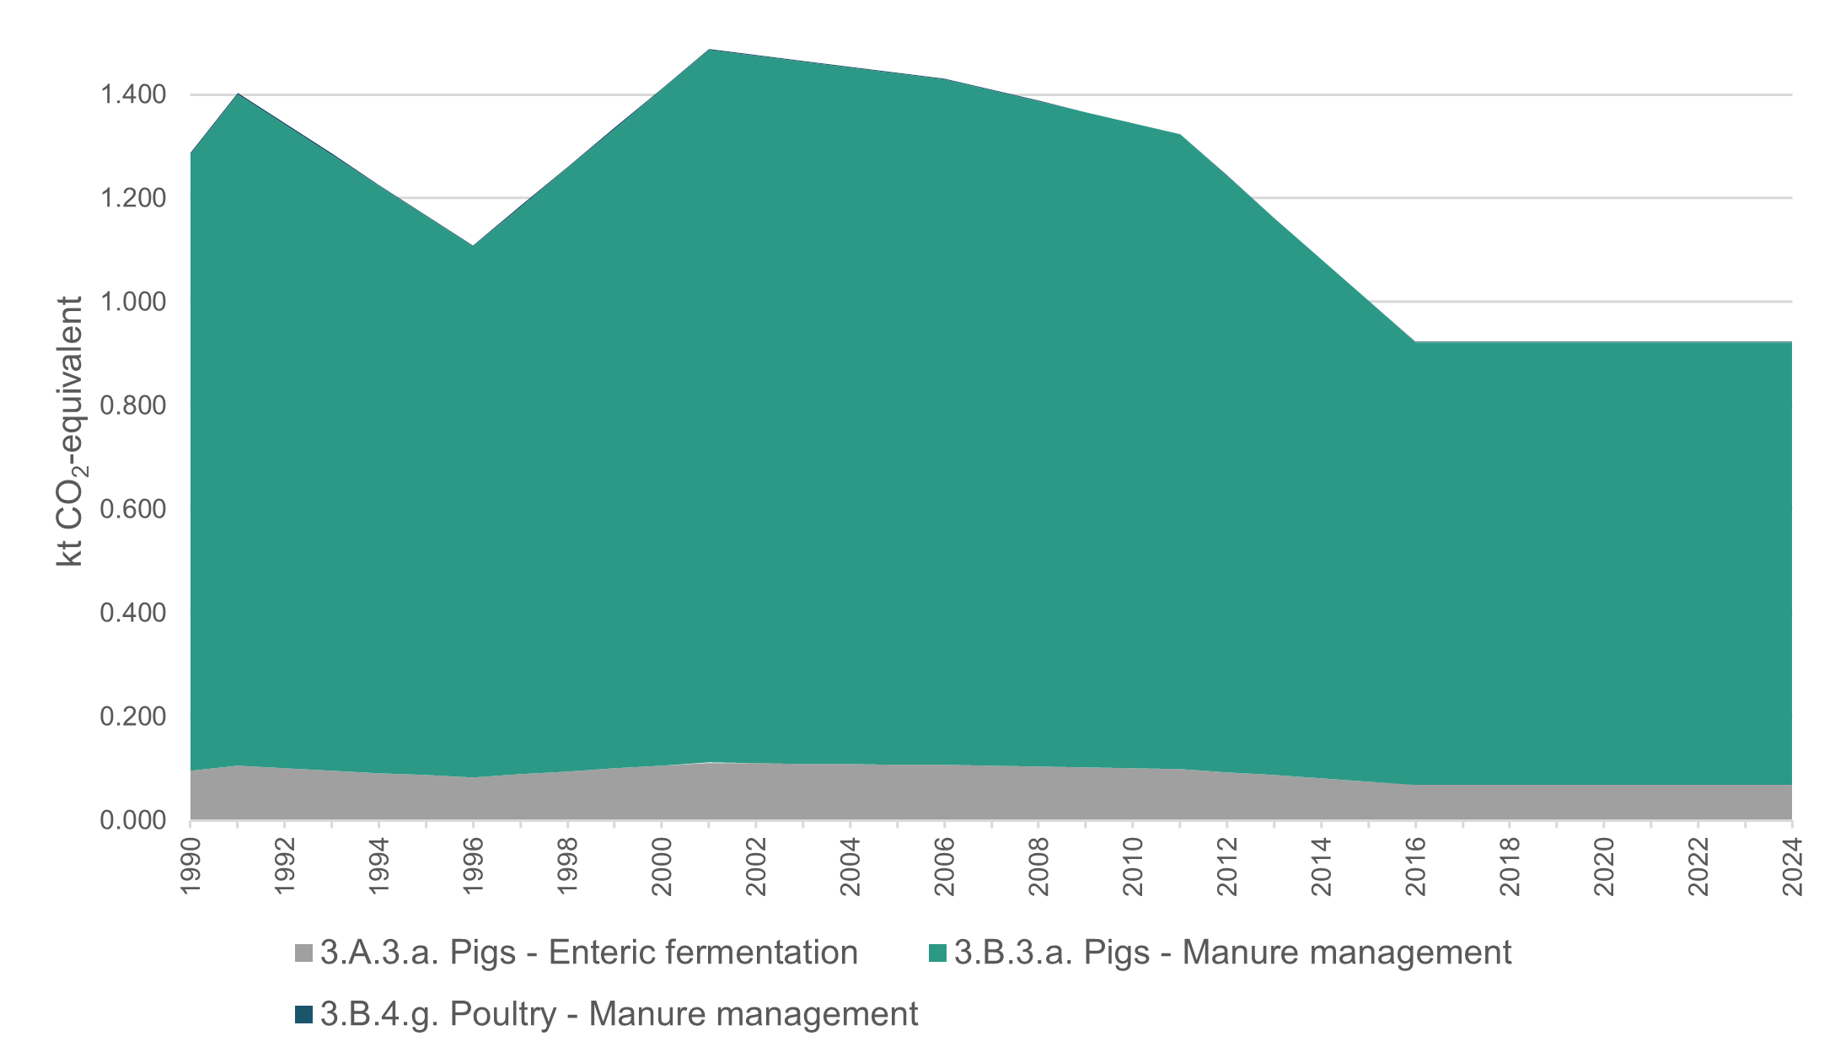
Note: The emissions contribution from 3.B.1.4 Manure management – Poultry is too small to be shown in the figure.

8.10 Emissions from Enteric fermentation in Tokelau

8.10.1 Description
The only domestic farm animals kept are pigs (in community pens) and chickens (free range) (table 8.10.1). There is potential to manage emissions by generating energy and reducing effluent from the piggery operations.
Table 8.10.1 Number of livestock in Tokelau (2016)
Atoll | Households | Pigs | Chickens
Atafu | 88 | 742 | 270
Fakaofo | 85 | 419 | 50
Nukunonu | 83 | 536 | 305
Tokelau | 256 | 1,697 | 625
The 2006 IPCC Guidelines (IPCC, 2006a) do not provide a default emission factor for enteric fermentation for poultry, so this category is reported as ‘not estimated’ (NE). Therefore, only swine (pigs) are included under the Enteric fermentation (3.A.3) category.
The Enteric fermentation – Swine category contributed 7.5 percent to the total Agriculture emissions in Tokelau in 2024, and amounted to 0.07 kt CO₂e.

8.10.2 Methodological issues

Activity data
Animal population figures were obtained from the 2016 Tokelau Census data (see table 8.1.1). The animal population between the census years is calculated by equal increments between the data collection points, to obtain the average animal population per year.
An average pig weight of 80 kilograms is used.

Methods and emission factors
Tier 1 methodology with a default emission factor of 1.5 kilograms (kg) CH₄/head/year from table 10.10 in volume 4, chapter 10 of the 2006 IPCC Guidelines was used for calculating emissions from this category (IPCC, 2006c). Tokelau’s allocation is wholly assigned to the warm climate zone.
The following equation was used for calculating emissions from swine.
$$\text{Emissions (kt CH 4 )} =\text{AAP (Swine)} \text{1.5 [kg CH 4 head-1 year-1]} \text{/10^6[kg/kt]}$$
Note: AAP = average animal population.

8.10.3 Uncertainty assessment and time-series consistency
Section 10.2.3 (volume 4, chapter 10) of the 2006 IPCC Guidelines states that the uncertainty associated with animal populations will vary widely, depending on the source, but should be within ±20 percent (IPCC, 2006c). The default emission factor uncertainty is ±30 percent to 50 percent (default mid-range is ±40 percent).
For this category, the default uncertainty value of ±20 percent for activity data and an upper range default emission factor uncertainty of ±50 percent were used.
Time-series consistency was maintained by interpolating the number of animals in between census years (which are generally five years apart).

8.10.4 Category-specific QA/QC and verification
Quality control of the activity data and calculations was applied to each category for Tokelau. No verification was possible because no alternative data were available.

8.10.5 Category-specific recalculations
There were no changes to estimates for the Enteric fermentation categories.

8.10.6 Category-specific planned improvements
No improvements are planned for the next inventory submission.

8.11 Emissions from Manure management in Tokelau

8.11.1 Description
The 2006 IPCC Guidelines provide default emission factors for Manure management (3.B.1) for both swine and poultry, therefore, both animal types are included in reporting from this category (IPCC, 2006c).
Manure management – Swine contributed 92.4 percent to the total Agriculture emissions in Tokelau in 2024 and amounted to 0.85 kt CO₂e. Manure management – Poultry was very small, at 0.1 percent (0.0005 kt CO₂e).

8.11.2 Methodological issues

Activity data
The activity data entries for Manure management are the same as for Enteric fermentation (see section 8.10).
All poultry are assumed to be dry layers.

Methods and emission factors
A Tier 1 methodology with default emission factors provided in table 10.15 in volume 4, chapter 10 of the 2006 IPCC Guidelines was used for estimating emissions from the Manure management category (IPCC, 2006c). The Tier 1 method is based on animal population data and does not require distinguishing between different manure management systems. Equation 10.22 from volume 4, chapter 10 of the 2006 IPCC Guidelines was applied, in conjunction with the default emission factors from table 10.14 in volume 4, chapter 10 of 2006 IPCC Guidelines for Oceania with a warm climate. These are 18.5 kg CH₄/head/year for swine and 0.03 kg CH₄/head/year for poultry (IPCC, 2006c).

8.11.3 Uncertainty assessment and time-series consistency
Default uncertainty values for activity data and emission factors were used for this category. Section 10.2.3 in volume 4, chapter 10 of the 2006 IPCC Guidelines states that the uncertainty associated with populations will vary widely, depending on the source, but should be within ±20 percent (IPCC, 2006c). The default emission factor uncertainty for Manure management is ±30 percent.
Time-series consistency was maintained by interpolating the number of animals in between census years (which are generally five years apart).

8.11.4 Category-specific QA/QC and verification
Quality control of the activity data and calculations was applied to each category for Tokelau. No verification was possible because no alternative data were available.

8.11.5 Category-specific recalculations
There were no changes to estimates for the Manure management category.

8.11.6 Category-specific planned improvements
No improvements are planned for the next inventory submission.

8.12 Emissions from the Waste sector in Tokelau (6. Tokelau_5)
In 2024, emissions from Tokelau’s Waste sector were 0.77 kt CO₂e. The Waste sector was the third-largest source of emissions, contributing 18.4 percent to Tokelau’s gross emissions and 0.001 percent to New Zealand’s gross emissions.
In Tokelau, the Waste sector covers the Solid waste disposal, Wastewater treatment and Incineration and open burning of waste categories, which contributed 44.8 percent, 38.4 percent and 16.8 percent, respectively, to the total emissions from the Waste sector in Tokelau.
The raw data related to the Waste sector were obtained from multiple sources (see items 1 to 5, 11, and 13 to 16 in table 8.1.1). The data were compiled, analysed and processed by the Tokelau National Statistics Office to produce activity data. The human population data were used as a driver for estimates in all of the Waste sector categories.
Emissions from all categories reported in the Waste sector for Tokelau were estimated using a Tier 1 methodological approach (IPCC, 2006d). Figure 8.12.1 shows emission trends in the Waste sector by category for Tokelau.
Figure 8.12.1 Waste sector emissions by category for Tokelau, from 1990 to 2024
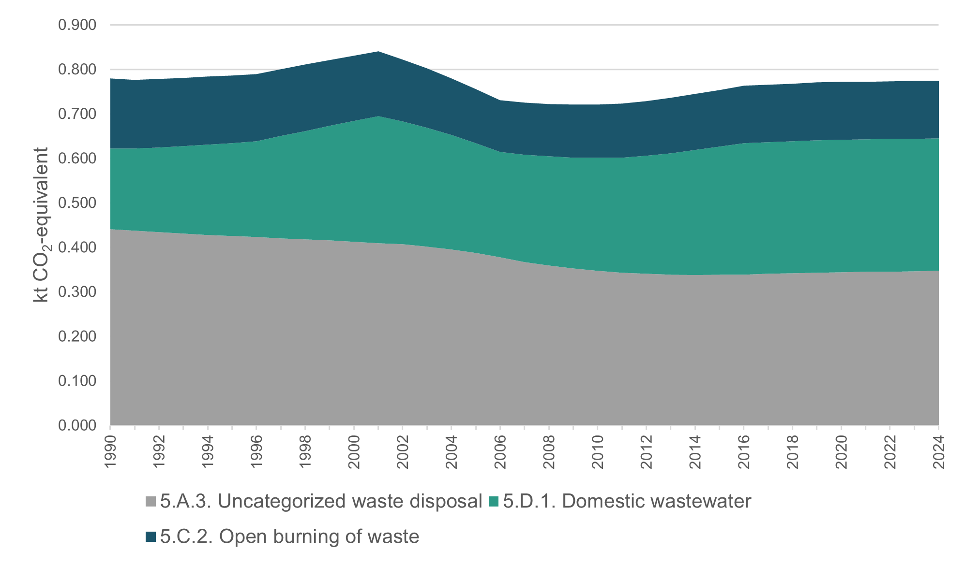

8.13 Emissions from Solid waste disposal in Tokelau

8.13.1 Description
According to the 2016 Tokelau Census, most household rubbish is collected by village workers. Fakaofo had the highest proportion of households where all rubbish was collected (72.9 percent). Of all private occupied dwellings, 98.8 percent had at least some of their household rubbish collected. Most of the rubbish collected is either burned on the reef or buried in centralised areas of the islands. Exceptions are the organic waste, which is fed daily to pigs, large beer bottles that are exported for recycling to Apia (Samoa) and metal waste that is collected and sold as scrap in Apia under a memorandum of understanding with a Samoan company.
Where village workers do not collect household rubbish, households use alternative methods for disposal. The most common methods are burning, burial and disposing of in the garden. Tokelau has no dedicated categorised landfills, therefore, Solid waste disposal is reported for uncategorised landfills only.
Emissions from the Solid waste disposal category were 0.35 kt CO₂e, contributing 44.8 percent to Tokelau’s Waste sector emissions in 2024.

8.13.2 Methodological issues

Activity data
- The total amount of solid waste is based on the IPCC default of 690 kg/person/year for Oceania (IPCC, 2006d). This is likely to be an overestimate; however, a country-specific value is not available.
- Solid waste is assumed to be half buried and the other half burned. As above, this does not account for exported solid waste or organic waste fed to pigs and will be an overestimate.
- The composition of solid waste for the landfill calculations is based on the IPCC default (67.5 percent food, 6 percent paper/cardboard, 2.5 percent wood, and the remaining 24 percent is ‘inert’) (IPCC, 2006d). This does not take into account the food waste that is fed to animals or used for composting and gardens, nor data on waste composition, such as disposable nappies, and will likely be an overestimate overall.

Methods and emission factors
A Tier 1 methodology has been applied to estimate emissions from this category. The Tier 1 approach is to use all default values. It is assumed that 50 percent of waste is buried (landfilled) and the other 50 percent is burned. Any amounts of waste shipped offshore are additional and are not counted. Table 8.13.1 sums up the information about parameters used for calculating emissions from this category.
Table 8.13.1 Summary of parameters for uncategorised landfills in Tokelau
Parameter | Values | Source | Reference
Bulk MSW DOC (kt C/kt waste) | 0.14 | IPCC default | IPCC, 2006d (worksheets for SWDS)
k-value | 0.17 | IPCC default | Table 3.2, IPCC, 2006d
Methane correction factor | 0.6 | IPCC default | Table 3.1, IPCC, 2006d
Oxidation factor | 0 percent | IPCC default | Table 3.2, IPCC, 2006d
Starting year | 1950 | IPCC default | Section 3.6, p 3.24, IPCC, 2006d
Delay time | 6 months | IPCC default | Section 3.2.3, p 3.19, IPCC, 2006d
Fraction of DOC that decomposes | 0.5 | IPCC default | Section 3.2.3, p 3.13, IPCC, 2006d
Fraction of CH₄ in gas | 0.5 | IPCC default | Section 3.2.3, p 3.15, IPCC, 2006d
Amount of waste per person per year | 690 kg | IPCC default for Oceania | Annex 2A.1, IPCC, 2006d
Amount of waste landfilled | 50 percent | Assumption
Note: DOC = degradable organic carbon; MSW = municipal solid waste; SWDS = solid waste disposal sites.

8.13.3 Uncertainty assessment and time-series consistency
The same uncertainty data for Solid waste disposal were used for Tokelau (see table 8.13.2) and New Zealand (see table 7.2.9, chapter 7, for methodological notes, and refer to the uncertainties for the Solid waste disposal category in section 7.2.3, chapter 7).
Table 8.13.2 Uncertainty in emissions from the Solid waste disposal category
Emissions category | Uncertainty in activity data (%) | Uncertainty in emission factors (%)
Solid waste disposal | ±140 | ±40
Time-series consistency is maintained by interpolating the population data in between census years (which are generally five years apart).

8.13.4 Category-specific QA/QC and verification
Quality control of the activity data and calculations was applied to each category for Tokelau. No verification was possible because no alternative data were available.

8.13.5 Category-specific recalculations
There were no changes to estimates for the Solid waste disposal category.

8.13.6 Category-specific planned improvements
No improvements are planned for the next inventory submission.

8.14 Emissions from Incineration and open burning in Tokelau

8.14.1 Description
Tokelau has no major incineration facilities. All emissions associated with waste burning are reported in the Open burning of waste category. Carbon dioxide, CH₄ and N₂O are reported in this category.
The composition of solid waste used to estimate CO₂ emissions from open burning is the same as the composition used for Solid waste disposal. The only difference is that the 24 percent classified as ‘inert’ in Solid waste disposal is grouped entirely under ‘other inert’ for open burning, rather than being broken down into types such as glass, metal or plastic. Using a single ‘other inert’ classification is a conservative choice likely to slightly overestimate emissions.
The emission factors for open burning of solid waste for CH₄ and N₂O are the IPCC defaults for municipal solid waste and are based on a generic waste composition. It is not clear if this will over- or under-estimate emissions.
Emissions from the Open burning of waste category were 0.13 kt CO₂e, contributing 16.8 percent to Tokelau’s Waste sector emissions in 2024.

8.14.2 Methodological issues

Activity data
The calculations are based on Tokelau’s population data and assume that 50 percent of the waste is landfilled and the other 50 percent is burned. This information is reported as ‘non-biogenic’ open burning because only fossil carbon is reported, and the emission factors for CH₄ and N₂O are for municipal solid waste, which does not distinguish biogenic and non-biogenic waste.

Methods and emission factors
A Tier 1 methodology with default IPCC Tier 1 parameters was used for calculating emissions from this category.
The emission factor for CO₂ was the weighted average of calculated factors from table 8.14.1 and a 58 percent oxidation factor for open burning. For other gases, the following IPCC default emission factors were used: for CH₄, the default emission factor for municipal solid waste in volume 5, chapter 5, section 5.4.2 (6,500 kg CH₄/gigagrams (Gg) wet waste); for N₂O, the default emission factor for open burning of municipal solid waste from table 5.6 (150 kg N₂O/Gg dry waste) (IPCC, 2006d). Converted waste volume to dry weight by using dry-matter conversion was calculated for CO₂ (56.1 percent). Table 8.14.1 shows waste type and the composition data based on default IPCC Tier 1 parameters used in estimating emissions from Open burning of waste (IPCC, 2006d).
Table 8.14.1 Composition data and carbon content used for estimating emissions from Open burning of waste
Waste type | Landfill composition (%) | CO₂ incineration composition (%) | Dry matter (%) | Total carbon (%) | Fossil carbon (%)
Paper/card | 6.0 | 6.0 | 90 | 43 | 1
Textiles | 0 | 0 | 80 | 50 | 20
Food waste | 67.5 | 67.5 | 40 | 38 | 0
Wood | 2.5 | 2.5 | 85 | 50 | 0
Garden and park waste | 0 | 0 | 40 | 49 | 0
Nappies | 0 | 0 | 40 | 70 | 10
Rubber and leather | part of inert | 0 | 84 | 67 | 20
Plastics | part of inert | 0 | 100 | 75 | 100
Metal | part of inert | 0 | 100 | NA | NA
Glass | part of inert | 0 | 100 | NA | NA
Other, inert | 24.0 | 24.0 | 90 | 3 | 100
Calculated weighted average |  |  | 56.13 | 30.20 | 24.06
Note: NA = not applicable.
Percentages in table 8.14.1 are defaults from table 2.3 and table 2.4 in volume 5, chapter 2 of the 2006 IPCC Guidelines (IPCC, 2006d).
An assumption was made that ‘inert’ waste for landfills is classified entirely as ‘other inert’ waste for incineration (the impact of this assumption is that emissions are slightly higher than distributing the 24 percent over the various inert types due to the high fossil carbon percentage).

8.14.3 Uncertainty assessment and time-series consistency
The same uncertainty data for Open burning of waste were used for Tokelau (see table 8.14.2) and New Zealand (see table 7.4.6, chapter 7, for methodological notes, and refer to uncertainties in emissions from Incineration and open burning, section 7.4.3, chapter 7).
Table 8.14.2 Uncertainty in emissions from Open burning of waste for Tokelau
Emissions category | Uncertainty in activity data (%) | Uncertainty in emission factors (%)
Waste open burning (CO₂) | ±50 | ±40
Waste open burning (CH₄) | ±50 | ±100
Waste open burning (N₂O) | ±50 | ±100
Time-series consistency was maintained by interpolating the population data in between census years (which are generally five years apart).

8.14.4 Category-specific QA/QC and verification
Quality control of the activity data and calculations was applied to each category for Tokelau. No verification was possible because no alternative data were available.

8.14.5 Category-specific recalculations
There were no changes to estimates for the Open burning of waste category.

8.14.6 Category-specific planned improvements
No improvements are planned for the next inventory submission.

8.15 Emissions from Wastewater treatment and discharge in Tokelau

8.15.1 Description
In the absence of industrial plants in Tokelau, all emissions associated with wastewater treatment and discharge are reported in the Domestic wastewater category (5.D.1). The category uses the same population values as in the Solid waste disposal and Open burning of waste categories (see above). The category includes emissions of CH₄ and N₂O.
Emissions from the Domestic wastewater category were 0.30 kt CO₂e, contributing 38.4 percent to Tokelau’s Waste sector emissions in 2024.

8.15.2 Methodological issues
A Tier 1 methodology with the IPCC default emission factors (except the protein consumption value) for all gases was applied for estimating emissions from this category (IPCC, 2006d).
Assumptions for estimating CH₄ emissions from wastewater:
- 60 grams biochemical oxygen demand (BOD) per person per day (as for Canada, Europe, Russia and Oceania), which calculates as 21.9 kg/person/year
- for population, the same time series as in categories 5.A.3 and 5.C.2 was used
- despite having no wastewater collection system, a correction factor for industrial BOD discharged in sewers of 1.25 is used (default for collected systems) to account for any industrial and commercial activity in Tokelau, such as fishing. No other estimates of industrial wastewater are made (effectively 5.D.2 Industrial wastewater is ‘included elsewhere’ (IE) and included in 5.D.1 Domestic wastewater)
- in 2016, most Tokelauans had access to a private toilet in their homes using septic tanks: 72.9 percent of private occupied dwellings had an indoor flush toilet, and 21.6 percent of dwellings had an outdoor flush toilet. Atafu had the highest proportion of dwellings with an indoor toilet (87.4 percent), and Nukunonu had the highest proportion of households with an outdoor toilet (34.9 percent) (Census 2016, similar to values for 2011 and 2006). The percentage of open-water toilets gradually reduced from 65 percent of dwellings in 1991 to nil by 2016.
Table 8.15.1 sums up default parameters used for estimating CH₄ emissions for Tokelau wastewater treatment. The default BOD correction factor for collected systems is used to account for industrial and commercial water because there is no separate estimate.
Table 8.15.1 Parameters for estimating methane emissions for Tokelau wastewater treatment
Parameter | Value | Source | Reference
Methane correction factors
Septic system | 0.50 | IPCC default | Table 6.3, section 6.2.2.2, IPCC, 2006d
Sea, river and lake discharge | 0.10 | IPCC default | Table 6.3, section 6.2.2.2, IPCC, 2006d
Weighted average methane correction factor | 0.23 | Calculated
Maximum methane producing capacity (kg CH₄/kg BOD) | 0.60 | IPCC default | Table 6.2, section 6.2.2.2, IPCC, 2006d
Biochemical oxygen demand (kg BOD/person/year) | 21.90 | IPCC default for Oceania | IPCC, 2006d (worksheets for SWDS)
Correction factor for BOD | 1.25 | IPCC default for collected systems | Section 6.2.2.3, p 6.14, IPCC, 2006d
Note: BOD = biochemical oxygen demand; SWDS = solid waste disposal sites.

Assumptions for estimating nitrous oxide emissions from wastewater
Table 8.15.2 shows the parameters used to calculate N₂O emissions from wastewater. It is assumed that septic tanks do not discharge to the sea and that only the population using open-water toilets contribute to the nitrogen in effluent calculation.
Protein consumption of 32.45 kg/person/year has been calculated based on known consumption compiled by the Tokelau National Statistics Office. The fraction of industrial and commercial co-discharged protein accounts for any commercial and industrial activities because there is no separate estimate.
Table 8.15.2 Parameter values applied for estimating nitrous oxide emissions for Tokelau wastewater treatment
Parameter | Value | Source | Reference
Per capita protein consumption (kg/person/year) | 32.448 | Tokelau specific | Developed by Tokelau’s National Statistics Office using imports data (see table 8.1.1)
Fraction of nitrogen in protein | 0.160 | IPCC default | Section 6.3.1.3, p 6.25, IPCC, 2006d
Fraction of non-consumed protein | 1.100 | IPCC default for developing countries | Table 6.11, section 6.3.3, IPCC, 2006d
Fraction of industrial and commercial co‑discharged protein | 1.250 | IPCC default | Table 6.11, section 6.3.3, IPCC, 2006d
Nitrogen removed with sludge (kg) | 0.000 | IPCC default | Section 6.3.1.3, p 6.25, IPCC, 2006d
Emission factor | 0.005 | IPCC default | Table 6.11, section 6.3.3, IPCC, 2006d
Emissions from wastewater treatment plants | 0.000 | IPCC default | IPCC (2006d)

8.15.3 Uncertainty assessment and time-series consistency
The same uncertainty data for Domestic wastewater were used for Tokelau and New Zealand (see table 7.5.16, chapter 7, for methodological notes, and refer to uncertainties in emissions from Domestic wastewater in section 7.5.3, chapter 7). Table 8.15.3 shows uncertainties for activity data and emission factors used by Tokelau for Domestic wastewater.
Table 8.15.3 Uncertainty in emissions from Domestic wastewater
Emissions category | Uncertainty in activity data (%) | Uncertainty in emission factors (%)
Domestic and industrial wastewater (CH₄) | ±10 | ±40
Domestic and industrial wastewater (N₂O) | ±10 | ±90
Time-series consistency is maintained by interpolating the population data and the use of open-water toilets in between census years (which are generally five years apart).

8.15.4 Category-specific QA/QC and verification
Quality control of the activity data and calculations was applied to each category for Tokelau. No verification was possible because no alternative data were available.

8.15.5 Category-specific recalculations
There were no changes to estimates for the Domestic wastewater category.

8.15.6 Category-specific planned improvements
No improvements are planned for the next inventory submission.

Chapter 8: References
Government of Tokelau. 2017. Solid Waste Management: MOU Signed between Tokelau EDNRE and Pacific Recycle Co. Ltd. Retrieved 9 March 2018.
IPCC. 2006a. Eggleston HS, Buendia L, Miwa K, Ngara T, Tanabe K (eds). 2006 IPCC Guidelines for National Greenhouse Gas Inventories. Volume 2. Energy. IPCC National Greenhouse Gas Inventories Programme. Japan: Institute for Global Environmental Strategies for IPCC.
IPCC. 2006b. Eggleston HS, Buendia L, Miwa K, Ngara T, Tanabe K (eds). 2006 IPCC Guidelines for National Greenhouse Gas Inventories. Volume 3. Industrial Processes and Product Use. IPCC National Greenhouse Gas Inventories Programme. Japan: Published for the IPCC by the Institute for Global Environmental Strategies.
IPCC. 2006c. Eggleston HS, Buendia L, Miwa K, Ngara T, Tanabe K (eds). 2006 IPCC Guidelines for National Greenhouse Gas Inventories. Volume 4. Agriculture, Forestry and Other Land Use. IPCC National Greenhouse Gas Inventories Programme. Japan: Published for the IPCC by the Institute for Global Environmental Strategies.
IPCC. 2006d. Eggleston HS, Buendia L, Miwa K, Ngara T, Tanabe K (eds). 2006 IPCC Guidelines for National Greenhouse Gas Inventories. Volume 5. Waste. IPCC National Greenhouse Gas Inventories Programme. Japan: Published for the IPCC by the Institute for Global Environmental Strategies.
International Renewable Energy Agency. 2013. Renewable energy opportunities and challenges in the Pacific Islands region. Retrieved 31 January 2019.
Jasperse JA. 2016. Analysis of 2014 imports into Tokelau from Samoa, Part 2: Stores’ invoices reconciled with cargo manifests, and quality of life implications. Apia, Samoa: Tokelau National Statistics Office. Retrieved 28 February 2019.
Koroisamanunu I, Papao J, Ketewai M and Sokota A. 2014. Mission Preliminary Report (Fieldwork undertaken from 8 August – 2 September 2013). SOPAC technical note (PR193), May 2014. Suva, Fiji: Water and Sanitation Programme and Disaster Reduction Programme. Applied Geoscience and Technology Division (SOPAC).
Roorda M, Carpenter D, Laing A, McGillivray M. 2015. Evaluation of the Tokelau Country Programme. Prepared for the Ministry of Foreign Affairs and Trade by Adam Smith International. Retrieved 31 January 2019.
Stats NZ. 2007. Principles and Protocols for Producers of Tier 1 Statistics. Retrieved 31 January 2019.
Tokelau Islands Maps. South Pacific Literatures and Cultures. Retrieved 31 January 2019.
Tokelau National Statistics Office. 2020. Final count: 2019 Tokelau Population Count. Retrieved 31 January 2022.
UNFCCC. 2018a. FCCC/CP/2018/10/Add.1. Decision 1/CP.24 Preparations for the implementation of the Paris Agreement and the first session of the Conference of the Parties serving as the meeting of the Parties to the Paris Agreement.
UNFCCC. 2018b. FCCC/PA/CMA/2018/3/Add.2. Report of the Conference of the Parties serving as the meeting of the Parties to the Paris Agreement on the third part of its first session, held in Katowice from 2 to 15 December 2018. Addendum 2. Part two: Action taken by the Conference of the Parties serving as the meeting of the Parties to the Paris Agreement.
UNFCCC. 2021. CCC/PA/CMA/2021/10/Add.2. Report of the Conference of the Parties serving as the meeting of the Parties to the Paris Agreement on its third session, held in Glasgow from 31 October to 13 November 2021. Addendum Part two: Action taken by the Conference of the Parties serving as the meeting of the Parties to the Paris Agreement at its third session.
United Nations. 1945. Charter of the United Nations, 1945. Retrieved 31 January 2019.

Chapter 9: Indirect carbon dioxide and nitrous oxide emissions
New Zealand elected not to report indirect carbon dioxide emissions in its 2026 inventory submission. Indirect nitrous oxide emissions are reported in the Agriculture sector (chapter 5) and the Land Use, Land-Use Change and Forestry sector (chapter 6).

Chapter 10: Recalculations and improvements
This chapter summarises the recalculations and improvements made to New Zealand’s Greenhouse Gas Inventory (1990–2024) (the Inventory) following the 2025 submission. Further details on the recalculations and improvements for each sector are provided in chapters 3 to 8.
Recalculations of estimates reported in previous submissions of the Inventory are carried out for several reasons, including:
- improved activity data
- updated parameters for estimating emissions, including methodologies
- incorporating new evidence that enables the reporting of previously unreported emissions because of insufficient data
- correcting errors.
It is good practice to recalculate the whole time series from 1990 to the latest reporting year, to ensure consistency across the time series. This means some estimates of emissions and/or removals reported in this submission are different from estimates reported in the previous submission. There may be exceptions to recalculating the entire time series and, where this has occurred, explanations are provided.

10.1 Explanations and justifications for recalculations, including in response to the review process
The main reasons for recalculations in the 2026 submission of the Inventory are given in the sectoral chapters and summarised in table 10.1.1.
Table 10.1.1 Explanations and justifications for recalculations
Sector | Explanation of recalculation | Underpinning IPCC principle | Additional justification
Energy | Updated jet A1 aviation fuel allocation between international and domestic aviation | Accuracy | Improved data availability
IPPU | Updated lubricant activity data. | Accuracy | Improved data availability
 | Correction of minor calculation errors for hydrofluorocarbon foam-blowing manufacturing chemicals re-exported. | Accuracy | Correction of errors
 | Error correction in commercial refrigerant-related emissions. | Accuracy | Correction of errors
 | Minor error correction in stationary refrigerant-related emissions. | Accuracy | Correction of errors
 | Transport refrigeration net equipment stock adjustments. | Accuracy | Improved data availability
 | Minor error correction in transport refrigerant-related emissions. | Accuracy | Correction of errors
Agriculture | Recognising the impact of EcoPond™ on reducing emissions from anaerobic lagoons when treated following the Standard Operating Procedure, with a 92 percent mitigation factor for treated effluent and a 6-week efficacy period. | Accuracy
 | Improvements to activity data and methodology for calculating emissions from dairy manure management:  - updated annual proportions of dairy manure entering manure management systems  - introduction of solid storage as a manure management system for dairy, with default emission factors  - seasonal allocation of total annual manure collected on structures | Accuracy | Improved data availability
 | Updating the emission factor (EF₁)values for all non-urea synthetic fertiliser to take the same value as urea (0.59 percent). | Accuracy
 | Aligning the Agriculture Inventory to the latest Intergovernmental Panel on Climate Change (IPCC) advice (IPCC, 2019). | Accuracy | Completeness
 | Error corrections and improvements to model code. | Accuracy | Correction of errors
LULUCF | For the 2026 submission, New Zealand has recalculated its emissions estimates for the Land Use, Land-Use Change and Forestry sector from 1990 to 2023. The recalculations incorporate new activity data in the Forest land category for permanent forest area and areas of deforestation, improvement of harvest age modelling, and new country-specific emissions in the Grassland category to replace default values. | Accuracy, consistency, completeness
Waste | Estimated emissions from Managed waste disposal sites – Anaerobic (5.A.1.a) increased by 5.6 kilotonnes carbon dioxide equivalent (kt CO₂e) (0.3 percent) in 1990 and decreased by 33.2 kt CO₂e (2.4 percent) in 2023. These changes result from corrections to the instantaneous gas-capture rate calculation and updates to Tier 1 defaults for half-lives (k-values) for sludge and nappies, in line with the IPCC (2019). Previously, emissions were estimated using Tier 1 k-value defaults from the 2006 Intergovernmental Panel on Climate Change Guidelines for National Greenhouse Gas Inventories (2006 IPCC Guidelines) (IPCC, 2006). | Accuracy, comparability | Key category improvement: Solid waste disposal
 | Estimated emissions from Unmanaged waste disposal sites (5.A.2) increased by 72.7 kt CO₂e (89.0 percent) in 1990 and by 174.0 kt CO₂e (89.3 percent) in 2023. These changes result from correcting an error in the application of decomposable degradable organic carbon values, where the fraction of degradable organic carbon parameter had previously been applied twice, leading to underestimation in the 2025 submission. These also reflect the adoption of updated Tier 1 defaults for the fraction of degradable organic carbon that decomposes and k-values for sludge, nappies and rubber, in accordance with the IPCC (2019). Previously, emissions were estimated using Tier 1 defaults from the 2006 IPCC Guidelines (IPCC, 2006). | Accuracy, comparability, transparency | Key category improvement: Solid waste disposal
 | Estimated emissions from Unmanaged waste disposal sites – Farm fills (5.A.2) decreased by 61.9 kt CO₂e (0.08 percent) in 1990 and by 49.3 kt CO₂e (0.08 percent) in 2023. These changes reflect the incorporation of previously unaccounted regional activity and compositional data, as well as the adoption of updated fossil carbon fraction and carbon fraction values, in line with the 2019 Refinement to the 2006 IPCC Guidelines for National Greenhouse Gas Inventories (volume 5, Waste) (2019 IPCC Refinement) (IPCC, 2019). Previously, emissions were estimated using Tier 1 defaults from the 2006 IPCC Guidelines (IPCC, 2006). | Accuracy, consistency, completeness, comparability, transparency | Key category improvement: Solid waste disposal
 | Estimated emissions from Waste incineration (5.C.1) decreased by 0.4 kt CO₂e (2.7 percent) in 1990 and by 0.4 kt CO₂e (20.5 percent) in 2023. This is due to the adoption of updated fossil carbon fraction and carbon fraction values and is proposed, in accordance with the IPCC (2019). Specifically, the carbon fraction (i.e., total carbon content in percentage of dry weight) for sludge has been updated to 30 percent in the 2019 Refinement (IPCC, 2019). | Accuracy, comparability
 | Estimated emissions from Open burning of waste (5.C.2) increased by 31.6 kt CO₂e (0.1 percent) in 1990 and by 18.1 kt CO₂e (0.1 percent) in 2023. These changes reflect the adoption of an updated oxidation factor for carbon dioxide (IPCC, 2019). Previously, emissions were estimated using the oxidation factor value from the 2006 IPCC Guidelines (IPCC, 2006). | Accuracy, comparability
Tokelau (IPPU) | The recalculation is due to passing through updates in New Zealand’s medical emissions data, which are assumed to apply equally to Tokelau. | Accuracy

10.2 Implications for emissions and removal levels

10.2.1 New Zealand’s gross emissions
Recalculations have resulted in a decrease of 0.7 percent (517.4 kilotonnes carbon dioxide equivalent (kt CO₂e)) in gross emissions in 2023, a decrease of 0.2 percent (180.7 kt CO₂e) in gross emissions in 2005, and a decrease of 0.2 percent (113.7 kt CO₂e) in gross emissions in 1990.
The decrease in reported gross emissions was a result of improvements to nitrous oxide (N₂O) emissions estimates from agricultural soils (1990 and 2005), methane (CH₄) emissions from manure management (2005) and jet kerosene use for domestic aviation (2023).

10.2.2 New Zealand’s net emissions
There was a decrease of 0.5 percent (286.7 kt CO₂e) in net emissions in 2023, an increase of 1.7 percent (1,043.1 kt CO₂e) in net emissions in 2005 and an increase of 2 percent (885.9 kt CO₂e) in net emissions in 1990.
The changes in net emissions were a result of the combined effect of the improvements made to gross emissions estimates, described above, and to the Land Use, Land-Use Change and Forestry (LULUCF) sector estimates. The improvements to the LULUCF sector that made the greatest contribution to the recalculations for net emissions were a result of the combined impacts of several improvements to how emissions from planted forests are estimated and the move to country-specific emission factors for the Low producing grassland and High producing grassland categories.
Table 10.3.1 and table 10.3.2 show the category that had the largest impact on the recalculations across the time series by sector.

10.2.3 Energy
Improvements and recalculations made to the Energy sector have resulted in a decrease of 1.1 percent (329.1 kt CO₂e) in estimated energy emissions for 2023, an increase of 0.0002 percent (0.1 kt CO₂e) in estimated energy emissions for 2005 and an increase of 0.0004 percent (0.1 kt CO₂e) in estimated energy emissions for 1990 (figure 10.3.3).
Revisions to data provided by fuel companies have resulted in changes to the allocation of jet A1 between international and domestic aviation for January 2022 to September 2024.
Historical energy demand data in the national energy balance tables are occasionally revised from year to year. This may result in minor revisions to activity data and recalculations to the corresponding emissions for some years in some categories. Further details on source-specific improvements are provided in their corresponding sections in chapter 3.

10.2.4 Industrial Processes and Product Use
Improvements and recalculations made to the Industrial Processes and Product Use (IPPU) sector have resulted in an increase of 0.8 percent (31.7 kt CO₂e) in estimated IPPU emissions in 2023, an increase of 0.6 percent (25.9 kt CO₂e) in estimated IPPU emissions in 2005 and an increase of 0.01 percent (0.5 kt CO₂e) in estimated IPPU emissions in 1990 (figure 10.3.4).
The improvements made to better account for changes in stocks held by importers and users in the Refrigeration and air conditioning category had the largest impact on emissions. These included updates to:
- activity data for dairy farm systems and coolstores
- HFC refrigerant imports between 2020 and 2024
- refrigerant mix of new installations between 2019 and 2023
- annual leakage rate for commercial refrigeration in 2023
- transport refrigeration stock adjustments.
Further detail on all improvements is provided in chapter 4, section 4.1.7.

10.2.5 Agriculture
Improvements and recalculations made to the Agriculture sector have resulted in a decrease of 0.8 percent (326.5 kt CO₂e) in estimated agriculture emissions in 2023, a decrease of 0.6 percent (249.7 kt CO₂e) in estimated agriculture emissions in 2005 and a decrease of 0.4 percent (165.1 kt CO₂e) in estimated agriculture emissions in 1990 (figure 10.3.5).
The following improvements and corrections were made to the Agriculture sector:
- inclusion of the EcoPond™ mitigation technology for dairy cattle
- updates to dairy manure and effluent management practices
- update to the EF₁ value for non-urea synthetic fertiliser
- alignment to the 2019 Refinement to the 2006 IPCC Guidelines for National Greenhouse Gas Inventories (IPCC, 2019)
- a number of error corrections and improvements to the model code have been made.
Further detail is provided in chapter 5, section 5.3.5.

10.2.6 Land use, land-use change and forestry
Improvements made to the LULUCF sector have resulted in a decrease of 1.1 percent (230.7 kt CO₂e) in estimated net LULUCF removals in 2023, a decrease of 5 percent (1,223.8 kt CO₂e) in estimated net LULUCF removals in 2005 and a decrease of 4.1 percent (999.5 kt CO₂e) in estimated net LULUCF removals in 1990 (figure 10.3.6).
Methodological improvements applied in the LULUCF sector for this submission were an improvement to the modelling of harvest age, and new country-specific emissions in the Grassland category to replace default values.
Activity data improvements occurred in the Forest land category for permanent forest area and areas of deforestation.

10.2.7 Waste
Improvements and recalculations made to estimates in the Waste sector have resulted in a 3.7 percent (106.5 kt CO₂e) increase in emissions in 2023, a 1.1 percent (43.0 kt CO₂e) increase in emissions in 2005 and a 1.6 percent (50.9 kt CO₂e) increase in emissions in 1990. Explanations for recalculations are provided in chapter 7, table 7.1.3.
For the 2026 submission, three source categories have undergone significant updates.
- Managed waste disposal sites (5.A.1): A methodological issue was identified in the implementation of the instantaneous gas-capture rate equation, where the calculation incorrectly estimated an absolute loss rather than a proportional loss of generated landfill gas. This has now been corrected. In addition, emission factors and model parameters have been updated to incorporate revised k-values in accordance with the IPCC 2019 Refinement. Implementing these changes has improved the accuracy and transparency of the model.
- Unmanaged waste disposal sites (5.A.2): An issue was identified in the application of decomposable degradable organic carbon (DDOC) parameters. In the model, DDOC values for most waste types were calculated as the product of country‑specific degradable organic carbon (DOC) and fraction of degradable organic carbon (DOCf) values. However, in the model used for the 2025 inventory submission, a general DOCf value (0.5) was also applied to the waste‑type‑specific DDOC values, resulting in the DOCf parameter being applied twice. This error approximately halved estimated emissions from Class 2–5 sites and monofills across the entire 1990 to 2023 time series. In addition, updates to DOCf values for sludge, rubber and municipal solid waste, as well as k-values for nappies and rubber, have been implemented in accordance with IPCC guidance (2019, volume 5). Correcting the model error and updating these parameters improved the accuracy, comparability and transparency of the Inventory model.
- Waste incineration and open burning of waste (5.C): Updates to the fossil carbon fraction, carbon fraction and oxidation factor values have been implemented in accordance with the IPCC guidance (2019). In particular, the fossil carbon fraction value for sludge has been revised to 30 percent, as recommended by the IPCC (2019). These changes enhanced the accuracy and transparency of the model.

10.2.8 Other sector (Tokelau)
One minor recalculation has been made to Tokelau’s GHG inventory estimates since the 2025 submission. Improvements made to Tokelau’s GHG inventory estimates have resulted in no change in 1990, no change in 2005 and an increase of 0.1 percent (0.004 kt CO₂e) in 2023. This change is due to updates in New Zealand’s medical emissions data, which are applied to Tokelau on a per capita basis.

10.3 Implications for emissions and removal trends, including time-series consistency

10.3.1 New Zealand’s gross emissions
The impact of recalculations on New Zealand’s gross emissions is shown in figure 10.3.1.
The greatest contribution to a decrease in gross emissions estimates across the time series came from improvements made in the Waste sector. This decrease is mainly the result of improving emissions estimates for Solid waste disposal – Unmanaged waste disposal sites.
Figure 10.3.1 Effect of recalculations on New Zealand’s gross greenhouse gas emissions estimates, from 1990 to 2023
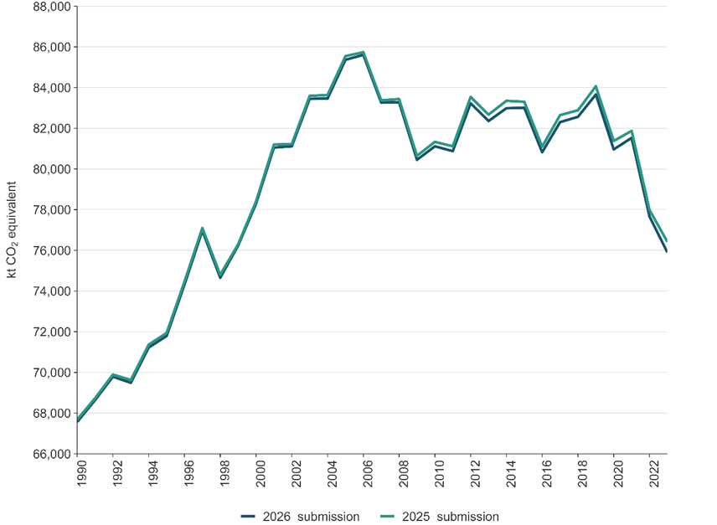

10.3.2 New Zealand’s net emissions
The effect of recalculations on net emissions estimates, which include the LULUCF sector, is shown in figure 10.3.2.
Figure 10.3.2 Effect of recalculations on New Zealand’s net greenhouse gas emissions estimates, from 1990 to 2023
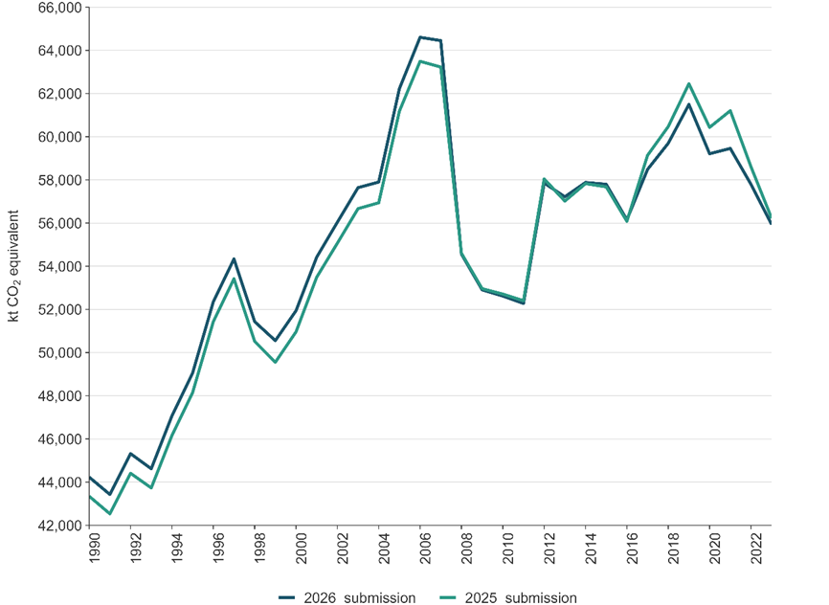
Table 10.3.1 shows the recalculations for the category that increased emissions estimates the most for each sector.
Table 10.3.1 Recalculations that led to the greatest increase in emissions estimates in each sector
Sector | CRT category | Category with the largest increase in estimated emissions across the entire time series | Largest single increase in emissions for the category (kt CO₂e) | Year of the largest increase in estimated emissions
Energy | 1.A.1.c. | Energy industries – Manufacture of solid fuels and other energy industries | 30.4 | 2014
IPPU | 2.F.1.f. | Stationary air-conditioning – HFC-125 | 41.0 | 2023
Agriculture | 3.H. | Agriculture – Urea application | 84.5 | 2022
LULUCF | 4.A.1. | Forest land remaining forest land – Post-1989 forest remaining post-1989 forest | 2341.0 | 2021
Waste | 5.A.2. | Solid waste disposal – Unmanaged waste disposal sites | 124.8 | 2023
Tokelau | 6. Tokelau 2. | Other (please specify) – Tokelau_2. Industrial Processes and Product Use | 0.004 | 2023
Table 10.3.2 shows the recalculations for the category that reduced emissions estimates the most for each sector.
Table 10.3.2 Recalculations that led to the greatest decrease in emissions estimates in each sector
Sector | CRT category | Category with the largest reduction in estimated emissions across the entire time series | Largest single decrease in emissions for the category (kt CO₂e) | Year of the largest decrease in estimated emissions
Energy | 1.A.3.a. | Domestic aviation – Jet kerosene | -346.6 | 2023
IPPU | 2.C.1.a. | Iron and steel production – Steel | -31.8 | 1998
Agriculture | 3.B.1.a. | Option A – Dairy cattle | -260.3 | 2014
LULUCF | 4.A.1. | Forest land remaining forest land – Pre-1990 planted forest remaining pre-1990 planted forest | -1279.4 | 2021
Waste | 5.A.1.a. | Managed waste disposal sites – Anaerobic | -33.2 | 2023
Tokelau | 6. Tokelau 2. | Other (please specify) – Tokelau_2. Industrial Processes and Product Use | -0.00003 | 2022
The following sections detail the effect of and reasons for recalculations for each sector and summarise the improvements.

10.3.3 Energy
Improvements and recalculations made to the Energy sector have not significantly changed the emissions trends for the Energy sector. The impact of recalculations on New Zealand’s Energy sector emissions across the time series is shown in figure 10.3.3.
Figure 10.3.3 Effect of changes to activity data on emissions estimates from New Zealand’s Energy sector, from 1990 to 2023
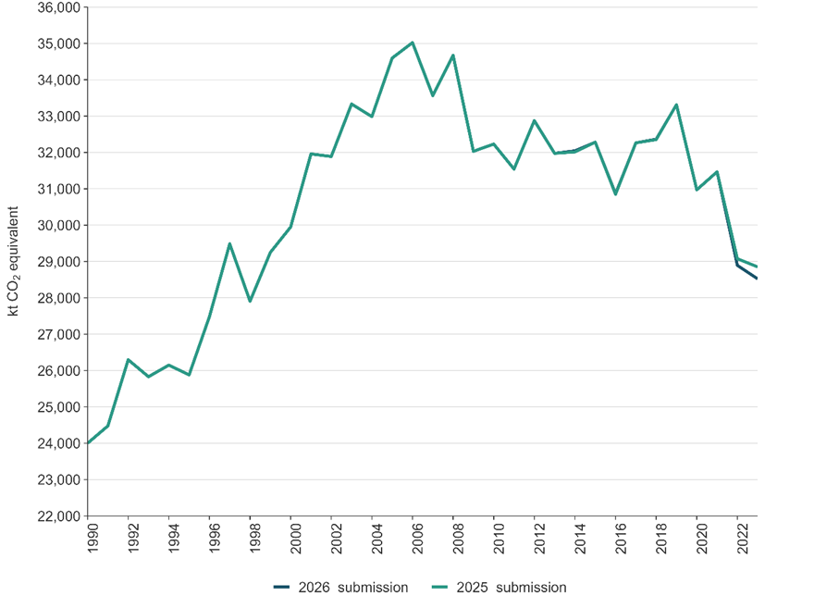

10.3.4 Industrial Processes and Product Use
Improvements and recalculations made to the IPPU sector have not significantly changed the emissions trends for the IPPU sector. The impact of recalculations on New Zealand’s IPPU sector emissions across the time series is shown in figure 10.3.4.
Figure 10.3.4 Effect of recalculations on emissions estimates from the IPPU sector, from 1990 to 2023
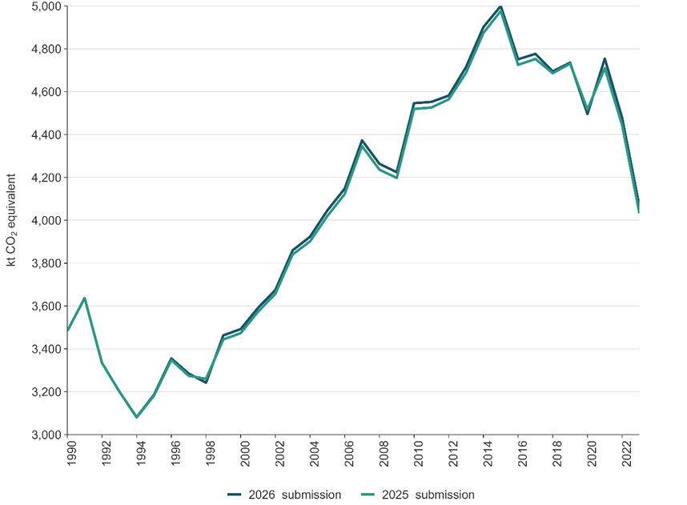

10.3.5 Agriculture
Improvements and recalculations made to the Agriculture sector have not significantly changed the emissions trends for the Agriculture sector. The impact of recalculations on New Zealand’s Agriculture sector emissions across the time series is shown in figure 10.3.5.
Figure 10.3.5 Effect of recalculations on emissions estimates from New Zealand’s Agriculture sector, from 1990 to 2023
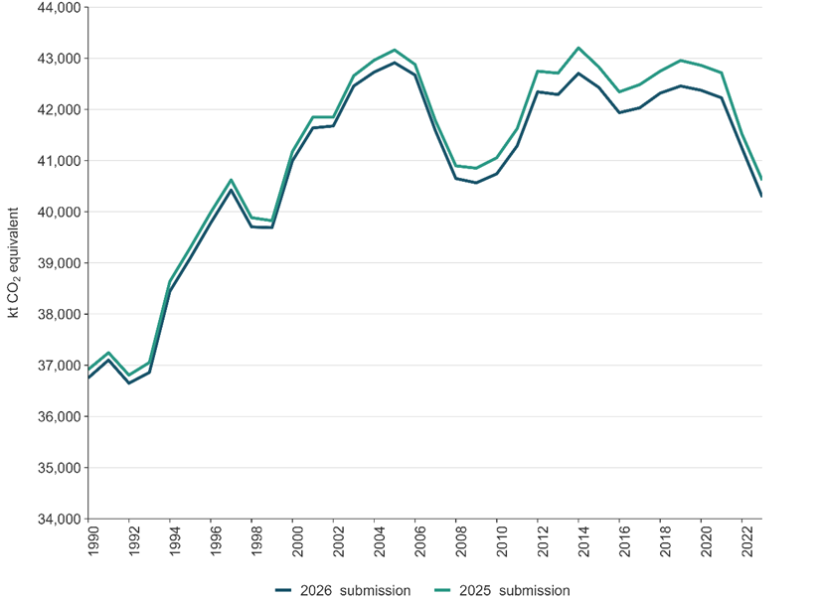

10.3.6 Land use, land-use change and forestry
Improvements and recalculations made to the LULUCF sector have not significantly changed the emissions trends for the LULUCF sector. The impact of recalculations on New Zealand’s LULUCF sector emissions across the time series is shown in figure 10.3.6.
Between 1990 and 2007 annual emissions have increased by approximately 1 megatonne CO₂e as a result of moving to country-specific emission factors for Low producing grassland and High producing grassland. This change has meant that the conversion of low-producing grassland to high-producing grassland, which occurred due to grazing intensification during in that period, has switched from a sink to a source of emissions.
Recalculations from 2012 onwards are mainly due to updates to activity data and improvements to harvest-age modelling, with changes to grassland emission factors having a small impact on emissions due to changes to and from Forest land.
Figure 10.3.6 Effect of improvements on net emissions estimates from New Zealand’s LULUCF sector, from 1990 to 2023
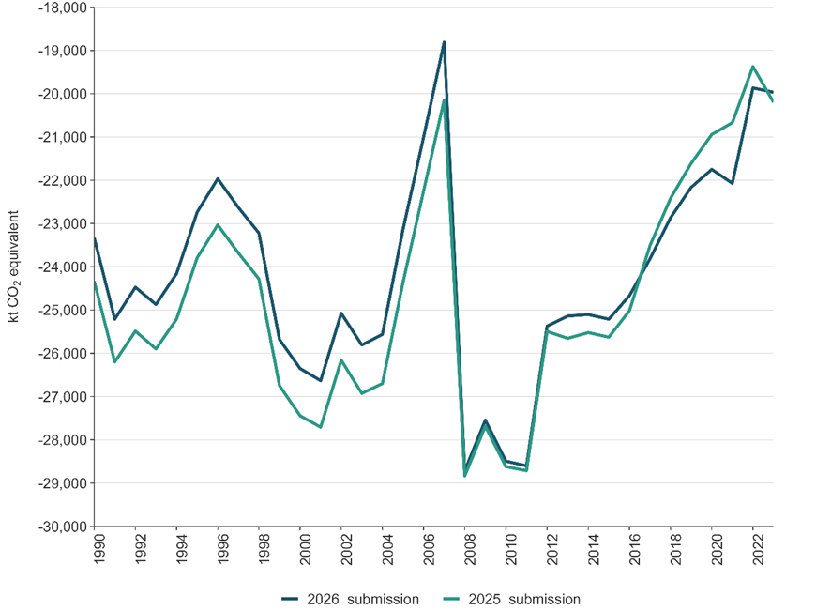
Note: Net emissions are expressed as a negative value to clarify that the value is a removal and not an emission.

10.3.7 Waste
Improvements and recalculations made to the Waste sector have not significantly changed the emissions trends for the Waste sector. The impact of recalculations on New Zealand’s Waste sector emissions across the time series is shown in figure 10.3.7.
Figure 10.3.7 Effect of recalculations on emissions estimates from New Zealand’s Waste sector, from 1990 to 2023
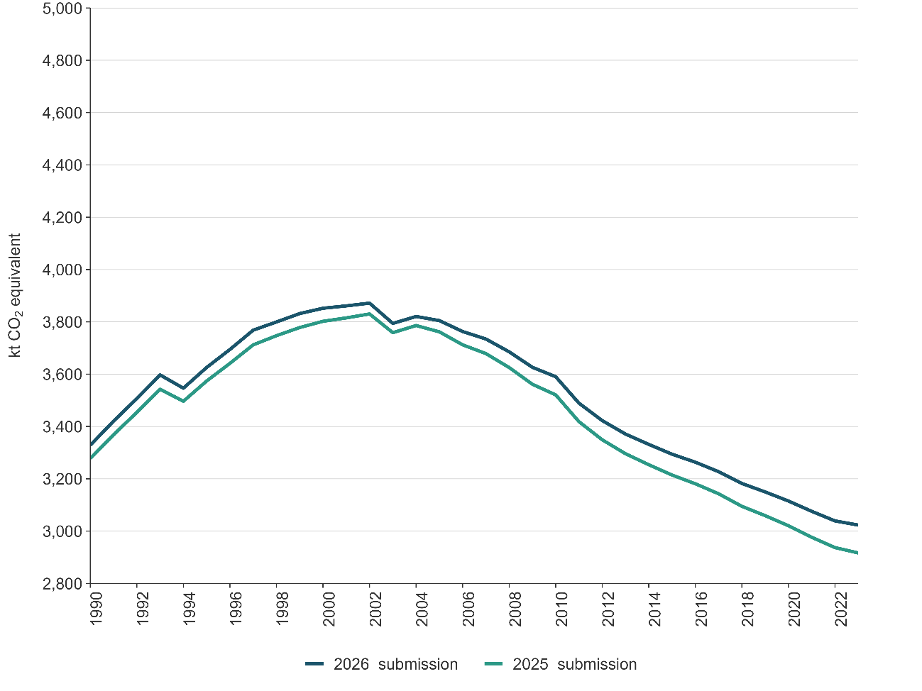

10.3.8 Other sector (Tokelau)
Improvements and recalculations made for Tokelau emissions have not significantly changed the emissions trends for Tokelau. The impact of recalculations on Tokelau emissions across the time series is shown in figure 10.3.8.
Figure 10.3.8 Effect of recalculations on emissions estimates from the Tokelau sector, from 1990 to 2023
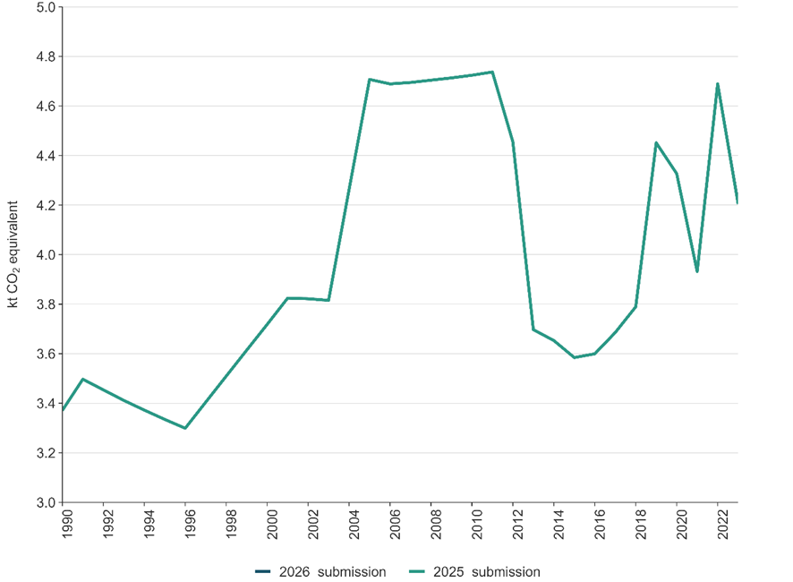
Note: Due to the small size of the recalculation, the 2026 submission line is obscured by the 2025 submission line.

10.4 Areas of improvement and/or capacity building in response to the review process
New Zealand has made improvements to the 2026 submission of the Inventory, although these are yet to take the findings from the review process under the Paris Agreement specifically into account. This is because the findings from the review of New Zealand’s first biennial transparency report have only recently become available.
Table 1 of the Report on the technical expert review of the first biennial transparency report of New Zealand (UNFCCC, 2026a, p 5), which can be found here, contains summarised information reported in New Zealand’s national inventory report and the findings from the review of consistency with the modalities, procedures and guidelines. The findings related to the Inventory are detailed in tables 2-7 in the addendum to the report (UNFCCC, 2026b), which can be found here, and summarised in table 10.4.1 along with New Zealand’s responses to the findings.
Table 10.4.1 New Zealand’s response to the status of the recommendations included in tables 2–7 of UNFCCC (2026b)
Sector | ID# | Reporting requirement | Description of area of improvement with recommendation or encouragement | New Zealand response
General | NA | NA | NA | NA
Energy | 3.E.1 | Specified in paragraph 31 of the MPGs  1. General (energy sector) – CO₂, CH₄ and N₂O | The TERT recommends that New Zealand apply the appropriate notation keys for reporting GHG emissions for subcategories 1.A.3.b.ii–iv road transportation other than cars for all fuels other than gasoline and diesel and CH₄ emissions for subcategory 1.B.1.a.1.iii abandoned underground mines, and ensure that the same notation keys are reported consistently in the CRTs and the NID. | Resolved.
 | 3.E.2 | Specified in paragraph 31 of the MPGs  Fuel combustion – reference approach – other fossil fuels – CO₂ | The TERT recommends that New Zealand apply the appropriate notation keys for reporting GHG emission estimates for other fossil fuels under the reference approach (e.g. “IE” if such emissions are included under other fuel types).
 | 3.E.3 | Specified in paragraph 36 of the MPGs  Fuel combustion – reference approach – other fossil fuels – CO₂ | The TERT encourages the Party to explore the possibility of collecting data sourced from national statistics for estimating CO₂ emissions from combustion of other fossil fuels and to calculate the effects on the estimates made using the reference approach and on the difference in estimates between the reference and sectoral approaches. The TERT notes that improved availability of apparent consumption data for this fuel type could reduce the difference between estimates made using the two approaches.
IPPU | 4.I.1 | Specified in paragraph 29 of the MPGs  2. General (industrial processes and product use) – HFCs | The TERT recommends that the Party report the qualitative information, such as that provided during the review, to explain the respective uncertainties reported for subcategories 2.F.2 foam-blowing agents, 2.F.3 fire protection and 2.F.4 aerosols in the NID.
 | 4.I.2 | Specified in paragraph 40 of the MPGs  2.B.9 Fluorochemical production – HFCs, PFCs, SF₆ and NF₃ | The TERT recommends that the Party explicitly report that no fluorinated gases have been manufactured in New Zealand in the section of the NID on category 2.B chemical industry.
 | 4.I.3 | Specified in paragraph 40 of the MPGs  2.F.5 Solvents – HFCs and PFCs | The TERT recommends that the Party transparently report that there is no use of solvents in New Zealand in the section of the NID on category 2.F product uses as substitutes for ODS.
Agriculture | 5.A.1 | Specified in paragraphs 21 and 39 of the MPGs  3.A.1 Cattle – CH₄ | The TERT recommends that the Party review the relevance and representativeness of the assumed milk yield and lactation length parameters for breeding beef cows and heifers, and update the parameters as necessary using national data or other sources (e.g. literature, expert judgment or regional values) as relevant. The TERT also recommends that the Party clearly document in the NID the rationale for selecting the milk yield and lactation length parameters for breeding beef cows, in accordance with the 2006 IPCC Guidelines (vol. 4, chap. 10), and include descriptions and assumptions, as well as references for sources of information used, related to methodology. | Addressing. We intend to progress work on this recommendation, with the aim of including revised information and data in the 2027 inventory submission.
 | 5.A.2 | Specified in paragraph 39 of the MPGs  3.B.1 Cattle – N₂O | The TERT recommends that the Party clearly explain in the NID why the Nex values reported in the NID and CRT 3.B(b) are different; clarify in the NID and the CRT (e.g. in an explanatory note or footnote) that these representative values are not used in the emission calculations; and consider providing more detailed Nex values (by region and subcategory) in either the NID or other supporting documentation. | Resolved. More details on N_{ex} values (by region and subcategory) are provided in section 5.3 of the NID and in supporting NID documentation.
 | 5.A.3 | Specified in paragraph 39 of the MPGs  3.B.5 Indirect N₂O emissions – N₂O | The TERT recommends that the Party clarify in the NID and CRT 3.D that subcategory 3.D.2.b indirect N₂O emissions from managed soils (N leaching and run-off) does not include indirect N₂O emissions from actively managed manure systems. | Resolved. Information provided in section 5.5 of the NID, and CRT 3.D subcategory 3.D.2.b indirect N₂O from managed soils (N leaching and run-off) has been updated to clarify these emissions do not include indirect emissions from actively managed manure systems.
 | 5.A.4 | Specified in paragraphs 22 and 39 of the MPGs  3.D.2.a Atmospheric deposition – N₂O | The TERT recommends that the Party provide transparent information in the NID on how mitigation technologies, such as urease inhibitors, are incorporated into the estimates reported in the CRT for subcategory 3.D.2.a indirect N₂O emissions from managed soils – atmospheric deposition. | Resolved. The text in section 5.2.2 has been revised to increase transparency.
LULUCF | 6.L.1 | Specified in paragraphs 21, 35 and 39 of the MPGs  4. General (LULUCF) – all carbon pools – CO₂, CH₄ and N₂O | The TERT recommends that the Party assess the accuracy of all the land-use maps used for generating AD on land use and land-use change (e.g. the 2016 and 2020 maps), and that it use the results of these assessments to correct any biases in land classification. The TERT also recommends that the Party include transparent information in the NID on all such accuracy assessments of land-use maps. The TERT encourages the Party to include such assessments in the sector-specific quality control procedures. | Addressing. The Party will complete an accuracy assessment on the 2016 and 2020 land use maps during 2026.
 | 6.L.2 | Specified in paragraphs 35 and 39 of the MPGs  4. General (LULUCF) – all carbon pools – CO₂, CH₄ and N₂O | The TERT recommends that the Party:  (a) Clearly document the robust validation protocol for any machine learning-based corrections to the land-use matrix used to derive the AD on land use and land-use change and apply it before the model results are integrated into the estimations;  (b) Include transparent information in the NID on the strategies employed to avoid any biases when using an existing land-use map as a training source (i.e. how the model identifies actual errors rather than reinforcing existing biases from an earlier map). | Addressing. Accuracy assessment of the 2020 land use map will be completed in 2026. This will identify any biases in the mapping of land use classes.
 | 6.L.3 | Specified in paragraphs 26–28 and 57 of the MPGs  4. General (LULUCF) – all pools – CO₂, CH₄ and N₂O | The TERT recommends that the Party report a consistent time series of emissions. The TERT encourages the Party to investigate methods that will enable time-series consistency or use the data-splicing techniques provided in the 2006 IPCC Guidelines (vol. 1, chap. 5.3.3) to derive a consistent time series (e.g. by overlap or extrapolation techniques). | Addressing. The Party will investigate options for introducing data-splicing techniques when incorporating data from new sources into the time series.
 | 6.L.4 | Specified in paragraphs 21 and 39 of the MPGs  4. General (LULUCF) – soil organic matter – CO₂ | The TERT recommends that the Party estimate carbon stock changes in mineral soils for relevant land-use categories by enhancing the representation of underrepresented land-use categories in the sampling design to calibrate the soil carbon stock model (e.g. by implementing the four-year soil carbon stock improvement research programme), and include detailed information thereon in the NID. | Addressing. Research and development are under way to improve the mineral soil carbon stock model through increased stratification by soil type and climate zone, and increased sampling of underrepresented land use classes.
 | 6.L.5 | Specified in paragraph 39 of the MPGs  4.A.1 Forest land remaining forest land –all pools – CO₂, CH₄ and N₂O | The TERT recommends that the Party document this expert elicitation procedure in accordance with the 2006 IPCC Guidelines (vol. 1, chap. 2, annex 2A.1), including relevant information (e.g. the contact person, the basis of the estimate (e.g. “from internal harvest ledgers”) and a quantitative uncertainty range (e.g. ±20 percent)). | Resolved. Text added to the NID.
 | 6.L.6 | Specified in paragraphs 26–28 and 57 of the MPGs  4.A.1 Forest land remaining forest land – all pools – CO₂, CH₄ and N₂O | The TERT recommends that the Party report a consistent time series of emissions. The TERT encourages the Party to use the data-splicing techniques provided in the 2006 IPCC Guidelines (vol. 1, chap. 5.3.3) to derive a consistent time series (e.g. overlap or extrapolation). | Addressing. The Party will investigate options for introducing data-splicing techniques when incorporating data from new sources into the time series.
 | 6.L.7 | Specified in paragraph 21 of the MPGs  4.A.1 Forest land remaining forest land – biomass – CO₂ | The TERT recommends that the Party estimate the carbon stock changes in biomass in forest land by revising the sampling method (e.g. by stratifying the post-1989 natural forest category into separate homogeneous forest types, such as native regeneration and wilding exotic species, and increasing the number of sample plots) so that it produces unbiased estimates representing the natural variability with lower uncertainties than current estimates. | Addressing. The Party is investigating options to stratify and increase the sampling of post-1989 forests.
 | 6.L.8 | Specified in paragraphs 21 and 39 of the MPGs  4.E Settlements – soil organic matter – CO₂ | The TERT recommends that the Party estimate the carbon stock changes in soil organic carbon in settlements by refining its estimation methods (e.g. by modelling the soil organic carbon stocks with the help of percentage-based topsoil data, a national map of impervious surface areas developed using readily available satellite imagery and geospatial techniques (such as geographic indication system analysis), and classified urban land-cover information derived using machine learning). The TERT also recommends that the Party include transparent information in the NID on the method used for estimating carbon stock changes in soil organic carbon in settlements. | Addressing. The Party is investigating methods to estimate impervious surface percentages within settlements and apply this to the modelling of Settlement soil organic carbon stocks.
 | 6.L.9 | Specified in paragraph 21 of the MPGs  4.G HWP – CO₂ | The TERT recommends that the Party estimate carbon stock changes in the HWP pool using half-lives and market proportions for exported wood products that reflect potentially significant shifts in export market structures, product types or end-use patterns (e.g. by developing a detailed, time-bound plan to collect and incorporate recent data on trade and end-use of HWP into the estimation methodology). | Addressing. Updates to market proportions are planned for the coming year.
 | 6.L.10 | Specified in paragraphs 21 and 39 of the MPGs  4(IV) Biomass burning – CH₄ and N₂O | The TERT recommends that the Party update the information in the NID to clarify its assumptions for how emissions from biomass burning have been estimated and encourages the Party to obtain updated AD on controlled burning activities occurring in forest land conversions to reflect actual practices. | Addressing. The Party is investigating options to update estimates of the proportion of land which is burnt at the time of deforestation.
Waste | 7.W.1 | Specified in paragraphs 39–40 of the MPGs  5.A Solid waste disposal on land – CH₄ | The TERT recommends that the Party provide transparent and comprehensive descriptions of its landfills (covering, e.g., categorization, management practices and status) and the methods and assumptions used (e.g. tiers, models and approaches) to estimate CH₄ emissions from solid waste disposal on land. | Resolved. Additional detail on New Zealand landfill types and management practices has been included in section 7.2.1, as well as in table 7.2.1. Further information on the selection of methods and the applicable Tier is provided in section 7.2.2, ‘Choice of methods’.
 | 7.W.2 | Specified in paragraphs 21 and 47 of the MPGs  5.A.3 Uncategorized waste disposal sites – CH₄ | The TERT recommends that the Party ensure that its definition of uncategorized solid waste disposal sites is consistent with the definition provided in the 2006 IPCC Guidelines (vol. 5, chap. 3.2.3, table 3.1), and include transparent information on the categorization of solid waste disposal sites in the NID. | Resolved. Additional information on uncategorised landfill types has been incorporated into section 7.2.1, as well as tables 7.2.1 and 7.2.5. Further detail on the methodological selection and the applicable Tier is provided in section 7.2.2, ‘Choice of methods’.
 | 7.W.3 | Specified in paragraphs 31, 45 and 47 of the MPGs  5.B.2 Anaerobic digestion at biogas facilities – CH₄ and N₂O | The TERT recommends that the Party report quantitative estimates for CH₄ emissions for subcategory 5.B.2 anaerobic digestion at biogas facilities and a notation key (e.g. “NE”) for N₂O emissions that is in line with the 2006 IPCC Guidelines. | Resolved. Methane emissions from the Anaerobic digestion subcategory (5.B.2) are now included in the Inventory. The notation key ‘NE’ is applied for N₂O emissions, consistent with table 4.1 in chapter 4 of volume 5 of the 2006 IPCC Guidelines.
 | 7.W.4 | Specified in paragraph 31 of the MPGs  5.C Incineration and open burning of waste – CH₄ and N₂O | The TERT recommends that the Party report emissions as “NO” for subcategory 5.C.1.b.i incineration of municipal solid waste. | Resolved. The Party has reported emissions from the Open burning of municipal solid waste subcategory (5.C.1.b.i) as ‘NO’ since the 2025 NID submission, replacing the previous use of the notation key ‘NE’.
 | 7.W.5 | Specified in paragraphs 31, 45 and 47 of the MPGs  5.C.2 Open burning of waste – CO₂, CH₄ and N₂O | The TERT recommends that the Party report emissions from open burning of waste at remote rural schools under subcategory 5.C.2.b.ii other in CRT 5.C. If it is not possible to do so owing to a lack of data, the TERT recommends that the Party report the emissions as “NE” under subcategory 5.C.2.b.ii other in CRT 5.C. | Resolved. The Party has established a new subcategory for Open burning at rural schools (5.C.2.b.ii). Due to the absence of activity data and emission factors, emissions for this subcategory are currently reported as ‘NE’.
 | 7.W.6 | Specified in paragraphs 39–40 of the MPGs  5.D Wastewater treatment and discharge – CH₄ and N₂O | The TERT recommends that the Party include in the NID a transparent description of the country’s wastewater treatment plants and practices, including the volume of wastewater treated in large plants, and the CH₄ recovery and nutrient-removal capacities of the plants, as well as information on the methods and data used to estimate CH₄ and N₂O emissions from the plants and septic tanks. | Resolved. Additional information on wastewater treatment plant management practices and treated volumes has been added to section 7.5.1. Details on the methods and data used to estimate CH₄ and N₂O emissions are provided in tables 7.5.5, 7.5.6 and 7.5.7.
 | 7.W.7 | Specified in paragraph 47 of the MPGs  5.D Wastewater treatment and discharge – CH₄ | The TERT encourages the Party to collect the necessary data to estimate and report CH₄ recovery for subcategory 5.D.1 domestic wastewater and clearly indicate the subcategory of the energy sector where CH₄ recovered for energy purposes from subcategory 5.D.2 industrial wastewater is included. | Not resolved. Further investigation  is required to estimate and report CH₄ recovery for the Domestic wastewater subcategory (5.D.1).
 | 7.W.8 | Specified in paragraph 47 of the MPGs  5.D Wastewater treatment and discharge – N₂O | The TERT encourages the Party to identify whether nutrient-removal technologies are installed at the large wastewater treatment plants other than in Auckland, and to report direct N₂O emissions from subcategory 5.D.1 domestic wastewater including all such plants. | Not resolved. Further investigation is required to determine the type and number of nutrient-removal technologies installed at large wastewater treatment plants. This information is necessary to enable the estimation and reporting of direct N₂O emissions under the Domestic wastewater subcategory (5.D.1).
 | 7.W.9 | Specified in paragraphs 21 and 39 of the MPGs  5.D Wastewater treatment and discharge – N₂O | The TERT recommends that the Party estimate N₂O emissions for category 5.D wastewater treatment and discharge using appropriately updated values for country-specific annual protein consumption that reflect the national circumstances relevant to specific years in the time series and clearly describe the assumptions behind the estimates. | Not resolved. Further investigation is required to obtain updated country‑specific annual protein consumption values. These data are necessary to accurately estimate N₂O emissions in the time series for the Wastewater treatment and discharge category (5.D).
Note: AD = activity data; CH₄ = methane; CO₂ = carbon dioxide; CRT = common reporting table; GHG = greenhouse gas; HFCs = hydrofluorocarbons; IE = included elsewhere; IPCC = Intergovernmental Panel on Climate Change; HWP = harvested wood products; IPPU = Industrial Processes and Product Use; LULUCF = Land Use, Land-Use Change and Forestry; MPGs = modalities, procedures and guidelines; N = nitrogen; NA = not applicable; NE = not estimated; N_{ex} = nitrogen excretion rates; NF₃ = nitrogen trifluoride; NID = National Inventory Document; NO = not occurring; N₂O = nitrous oxide; ODS = ozone depleting substances; PFCs = perfluorocarbons; SF₆ = sulphur hexafluoride; TERT = technical expert review team; UNFCCC = United Nations Framework Convention on Climate Change.

10.5 Areas of improvement and/or capacity building related to the flexibility provisions
Not applicable to New Zealand.

Chapter 10: References
IPCC. 2006. Eggleston HS, Buendia L, Miwa K, Ngara T, Tanabe K (eds). 2006 IPCC Guidelines for National Greenhouse Gas Inventories. IPCC National Greenhouse Gas Inventories Programme. Japan: Institute for Global Environmental Strategies for IPCC.
IPCC. 2019. Calvo Buendia E, Tanabe K, Kranjc A, Baasansuren J, Fukuda M, Ngarize S, Osako A, Pyrozhenko Y, Shermanau P, Federici S (eds). 2019 Refinement to the 2006 IPCC Guidelines for National Greenhouse Gas Inventories. Switzerland: IPCC.
UNFCCC. 2026a. FCCC/ETF/TERR.1/2024/NZL. Report on the technical expert review of the first biennial transparency report of New Zealand. In-country review.
UNFCCC. 2026b. FCCC/ETF/TERR.1/2024/NZL/Add.1 Report on the technical expert review of the first biennial transparency report of New Zealand. Addendum.

Annex II to the Convention (a subset of Annex I) lists the Organisation for Economic Co-operation and Development (OECD) member countries at the time the Convention was agreed.
Annex I to the Convention lists the countries included in Annex II, as defined above, together with countries defined at the time as undergoing the process of transition to a market economy, commonly known as ‘economies in transition’.
United Nations Climate Change. www.unfccc.int. Retrieved 13 March 2026.
Because nitrogen trifluoride emissions do not occur in New Zealand, they are not included in this report.
Indirect greenhouse gases are the gases that have indirect radiative effects in the atmosphere. This may happen either through conversion of an indirect gas to a direct greenhouse gas in the atmosphere (for example, where carbon monoxide is converted to carbon dioxide) or when chemical reactions in the atmosphere involving these gases change the concentrations of direct greenhouse gases.
In the United Nations Charter (United Nations, 1945), a non-self-governing territory is defined as a territory “whose peoples have not yet attained a full measure of self-government”. Tokelau has been on the United Nations list of non-self-governing territories since 1946, following the declaration of the intention by New Zealand to transmit information on the Tokelau Islands under Article 73e of the United Nations Charter.
The Climate Change Response Act 2002 has been amended several times since 2002. The Climate Change Response (Emissions Trading Reform) Amendment Act 2020, among other things, added reporting under the Paris Agreement to the functions of the inventory agency.
Inserted, on 23 June 2020, by section 56(1) of the Climate Change Response (Emissions Trading Reform) Amendment Act 2020 (2020 No 22).
Environmental Protection Authority. Emissions returns report. Retrieved 13 March 2026.
Quality assurance (QA) is a planned system of review procedures conducted by personnel not directly involved in the Inventory compilation and development process.
Quality control (QC) is a system of routine technical activities to assess and maintain the quality of the Inventory as it is being compiled. It is performed by personnel compiling the Inventory.
See Ministry for Primary Industries, Estimating on-farm emissions, for more details and a link to the codebase on GitHub. Retrieved 13 March 2026.
Climate Change Response (Emissions Trading) Amendment Act 2008.
Ministry for the Environment. New Zealand Emissions Trading Scheme. Retrieved 12 March 2025.
‘MMS’ stands for ‘manure management system’ (see chapter 5).
Methane emissions produced from the digestive process in ruminant livestock.
For more information, see Ministry for Primary Industries. Situation and Outlook for Primary Industries. Retrieved 20 March 2025.
Phosphate rock: rock rich in the mineral fluorapatite, Ca₅(PO₄)₃F.
Includes bitumen, lubricants, solvents, waxes, petroleum coke, white spirit and other liquid fuels.
Implied emission factors (IEFs) are calculated by dividing the total emissions of a particular animal species and sector (e.g., enteric fermentation from sheep) by the number of animals in that species and sector.
See the Ministry for Primary Industries (MPI) website for the Agriculture inventory methodology document: www.mpi.govt.nz/dmsdocument/13906-Detailed-methodologies-for-agricultural-greenhouse-gas-emission-calculation.
See the MPI website for slaughter statistics: www.mpi.govt.nz/resources-and-forms/economic-intelligence/data.
Percentage of carcass weight in relation to liveweight.
The number of beef cows slaughtered is assumed to be 17 percent of the total beef cow herd, with other adult cows slaughtered assumed to be dairy cows. The carcass weight of dairy cattle slaughtered was estimated using the adult dairy cow liveweights and a killing-out percentage of 42 percent (Thomson et al., 2010). The total weight of dairy cattle slaughtered was calculated (carcass weight × number slaughtered) and then deducted from the national total carcass weight of slaughtered adult cows. This figure was then divided by the number of beef cows slaughtered, to obtain an estimate of the carcass weight of adult beef cows. Liveweights were calculated assuming a killing-out percentage of 42.6 percent (Thomson et al., 2010).
Also known as ‘meat chickens’, which tend to be larger breeds with higher muscle content.
Methanet and NzOnet contain experts on methane (CH₄) and nitrous oxide (N₂O) respectively. These advisory groups have been running since the early 2000s. The groups were formed to identify the main direction of research needed to improve the CH₄ and N₂O inventory accounts and mitigation, develop a collaborative approach to improve the quality of CH₄ and N₂O emissions data, and build and maintain inventory research capability.
The equation displayed here is a rearranged form of the equation displayed in Swainson et al. (2016): Ln(CH₄) = 0.734 × In(DMI) + 0.05 × ME + 2.46.
The equation displayed here is a rearranged form of the equation displayed in Swainson et al. (2016): Ln(CH₄) = 0.765 × In(DMI) + 3.09.
For example, Blaxter and Clapperton (1965); Moe and Tyrrel (1975); Baldwin et al. (1988); Djikstra et al. (1992) and Benchaar et al. (2001), all cited in Clark et al. (2003).
The IPCC (2006) default emission factor for swine is identical to the IPCC (1996) emission factor.
As reported in Australia’s 2025 Common Reporting Table. Retrieved 11 December 2025. Note that the Australian-specific beef cattle implied emission factor (IEF) value is calculated from a population-based weighted average of pasture and feedlot IEF values from beef cattle.
Reported under Agricultural soils, under Organic nitrogen fertilisers (3.D.1.2).
Reported under Agricultural soils, under Urine and dung deposited by grazing animals (3.D.1.3).
Rollo et al. (2017), Luo et al. (unpublished).
Hill (2012), Ritchie (2024).
Fick et al. (2011) and pers. comm. (2010).
Fick et al. (2011) and pers. comm. (2010).
IPCC (1996) default waste management proportions for Oceania.
For full details of how nitrogen excretion rates are derived for each livestock category, see the technical detail provided in the Agriculture inventory model methodology document on the MPI website (www.mpi.govt.nz/dmsdocument/13906-Detailed-methodologies-for-agricultural-greenhouse-gas-emission-calculation).
Mid-point in IPCC (2019) range.
As reported in Australia’s 2025 Common Reporting Table, table3.B(a). Retrieved 16 December 2025. Note that the Australian-specific beef cattle IEF value is calculated from a population-based weighted average of pasture and feedlot IEF values from beef cattle.
Earth Sciences New Zealand. Regional climatologies. Retrieved 15 February 2026.
Flatland is classified as flat pastoral land or plains with a gradient lower than 12 degrees (i.e., equivalent to low slopes).
Low slopes are classified as hill country pastoral land with a gradient on average lower than 12 degrees.
Medium slopes are classified as hill country pastoral land with a gradient on average between 12 degrees and 24 degrees.
Steep slopes are classified as hill country pastoral land with a gradient on average greater than 24 degrees.
Activity data on urease inhibitor usage before 2016 was provided by Ballance Agri-Nutrients Limited.
As reported in Australia’s 2025 Common Reporting Table, table 3.D. Retrieved 16 December 2025. Table 5.21 in the Australian National Inventory Report 2023 breaks EF₁ down by production system. Retrieved 18 February 2026.
As reported in Australia’s 2025 Common Reporting Table, table 3.D. Retrieved 16 December 2025.
An exception occurred in the creation of the Clyde Dam. The Clutha River in the South Island was dammed, creating Lake Dunstan. The area flooded was mostly low producing grassland.
More information can be found about the new waste strategy and other developments at environment.govt.nz/what-government-is-doing/areas-of-work/waste/waste-legislation-review
Ministry for the Environment. Waste statistics. Retrieved 4 February 2025.
The approach 1 is based upon error propagation and is used to estimate uncertainty in individual categories, in the inventory as a whole, and in trends between a year of interest and a base year.
For more information, see compostcollective.org.nz. Retrieved 6 March 2023.
For more information, see www.ecogas.co.nz/reporoa. Retrieved 5 February 2025.
In the United Nations Charter (United Nations, 1945), a non-self-governing territory is defined as a territory “whose peoples have not yet attained a full measure of self-government”. Tokelau has been on the United Nations list of non-self-governing territories since 1946, following the declaration of the intention by New Zealand to transmit information on the Tokelau Islands under Article 73e of the United Nations Charter.
A ‘de jure’ census tallies people according to their regular or legal residence.
Formerly known as the Climate Change Division within the Office of the Council for the Ongoing Government of Tokelau.
See Roorda et al. (2015) Evaluation of the Tokelau Country Programme, page 46.
Where emissions occur within the first two years, they are usually referred to as ‘prompt’ emissions (e.g., aerosols).
A keyhole garden is a small (around 2.5 metre diameter) circular raised garden with a keyhole-shaped indentation on one side. Moisture and nutrients flow from an active compost pile placed in the centre of a round plant bed.
See Government of Tokelau. 2017. Solid Waste Management: MOU Signed between Tokelau EDNRE and Pacific Recycle Co. Ltd. Retrieved 9 March 2018.

