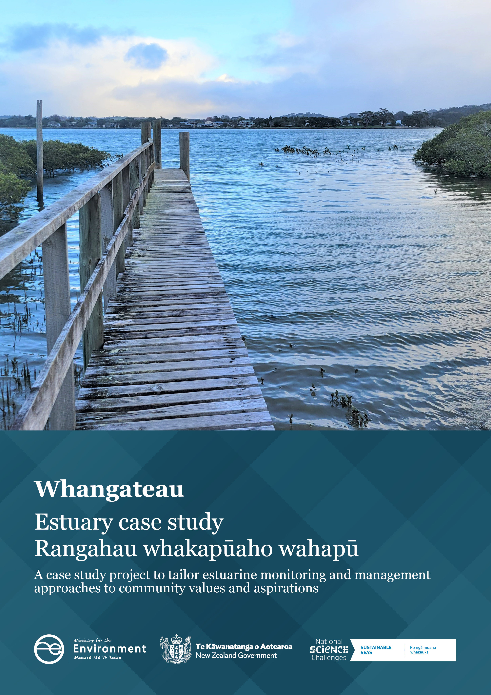
Disclaimer
The information in this publication is, according to the Ministry for the Environment’s best efforts, accurate at the time of publication. The Ministry will make every reasonable effort to keep it current and accurate. However, users of this publication are advised that:
- the information does not alter the laws of New Zealand, other official guidelines, or requirements
- it does not constitute legal advice, and users should take specific advice from qualified professionals before taking any action based on information in this publication
- the Ministry does not accept any responsibility or liability whatsoever whether in contract, tort, equity, or otherwise for any action taken as a result of reading, or reliance placed on this publication because of having read any part, or all, of the information in this publication or for any error, or inadequacy, deficiency, flaw in, or omission from the information in this publication
- all references to websites, organisations or people not within the Ministry are for convenience only and should not be taken as endorsement of those websites or information contained in those websites nor of organisations or people referred to.
Acknowledgements
We would like to express our sincere gratitude to the Sustainable Seas National Science Challenge for their invaluable partnership in this project. Their support, guidance, and commitment to ecosystem-based management has been instrumental to this case study.
We also extend our deepest appreciation to Ngati Mauhiri Settlement Trust and local community members whose participation and insights have enriched this report. Their knowledge, perspectives, and active involvement have been crucial in shaping our work, and we are truly grateful for the opportunity to collaborate with them.

This document may be cited as: Ministry for the Environment. 2024. Whangateau – Estuary case study | Rangahau whakapūaho wahapū. Wellington: Ministry for the Environment.

Published in December 2024 by the
Ministry for the Environment
Manatū mō te Taiao
PO Box 10362, Wellington 6143, New Zealand
environment.govt.nz
ISBN: 978-1-991140-61-6
Publication number: ME 1870
© Crown copyright New Zealand 2024

Contents
Overview 4
Estuaries 4
The project 4
Whangateau Estuary 5
What we heard during engagement 6
How the estuary is currently used 7
Pressures on the estuary 7
Insights specific to Ngāti Manuhiri 8
The toolbox 9
Participatory processes 9
Monitoring and data 10
Management and restoration 10
Mapping and modelling 11
Appendix 1: The tools 13
Appendix 2: Practical examples from Sustainable Seas projects 16

Overview

Estuaries
Estuaries are complex and dynamic ecosystems of ecological, recreational, cultural, economic and spiritual value to New Zealanders. As the interface of fresh and salt water, estuary health is influenced by the quality of fresh water that flows into them, the activities that occur within or around them and coastal processes. Land use activities in the catchment, such as forestry, agriculture and horticulture, urban development and waste management can lead to the input of sediment, toxicants and nutrients into an estuary. The resilience of an estuary to stressors is dependent on the estuary type, freshwater flow, tidal influence, geographical location and catchment land use.
Every estuary may have its own tipping points (where the cumulative effect of stressors will negatively affect the health of an estuary), making it difficult to set national standards and regulations for estuarine health. Estuaries tend to fall through the cracks in Aotearoa New Zealand’s environmental legislation due to a lack of integration between freshwater and coastal policies. This can leave councils, iwi and communities with having to develop their own frameworks.

The project
In 2022, the Ministry for the Environment joined forces with the Sustainable Seas National Science Challenge (Sustainable Seas) to explore how it might manage Aotearoa New Zealand estuaries in a more nuanced way. An objective of Sustainable Seas was to develop tools and guidance for ecosystem-based management (EBM). The aim of EBM is to manage the marine environment in a holistic and inclusive way that balances use and protection to better inform coastal monitoring and management across Aotearoa.
Officials corresponded with regional authorities and selected three case study estuaries. These case studies were based on data availability, community interest and ecological features, to test the outputs of Sustainable Seas in a real-world setting. The three estuaries selected were:
- Whangateau Estuary (Auckland)
- Kakanui Estuary (Otago)
- Te Whanganui-a-Orotū/Ahuriri Estuary (Hawke’s Bay).
The intention of the project was to encourage and support estuarine management at place by providing a tailored ‘toolbox’ to help iwi and hapū, councils and communities. In 2023 and 2024, we held virtual hui with iwi and hapū, regional authorities and community members to discuss their values and aspirations for their estuary. The Ministry then generated a high-level summary of the values and aspirations raised. Sustainable Seas drew on the guidance and methodologies for EBM developed over the past 8 years to assemble a toolbox for each estuary. Officials presented the draft toolboxes at place and discussed with attendees their concerns around implementation and barriers to the management of their estuaries.

Whangateau Estuary
The Whangateau Estuary is a permanently open tidal lagoon on the northeast coast of the Auckland region. The Omaha River forms the western arm of Whangateau Estuary and the outer estuary is partially enclosed by a 4 kilometre sand spit that opens north of the Hauraki Gulf. The harbour itself is 7.5 kilometres-squared; it is one of the largest estuaries in the district and was once used as a port. Features of the estuary include a permanently exposed sandbar (Horseshoe Island), seagrass, mangroves, saltmarsh and coastal kahikatea swamp forest (the Omaha Taniko Wetlands Scientific Reserve), and an ecologically intact sandstone reef. Freshwater inputs to the estuary are low and over 90 per cent of the estuary’s volume is flushed during each outgoing tide. The northern end of the catchment is steep hillside covered in native vegetation (Mount Tamahunga), while the rest of the catchment is gently graded and used for either horticulture, agriculture or urban development. The estuary is highly valuable for wildlife, providing rich feeding grounds for many shore birds. It was historically a mahinga kai site for Ngāti Manuhiri and is now a popular holiday destination. Figure 1 summarises why Whangateau Estuary was selected and figure 2 shows a view of mangroves in the estuary.
Figure 1: Reasons we selected Whangateau Estuary
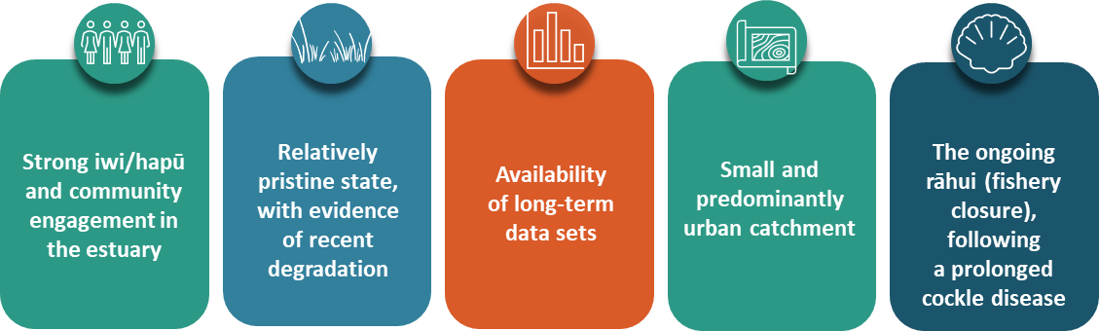
Figure 2: Mangroves growing in Whangateau Estuary
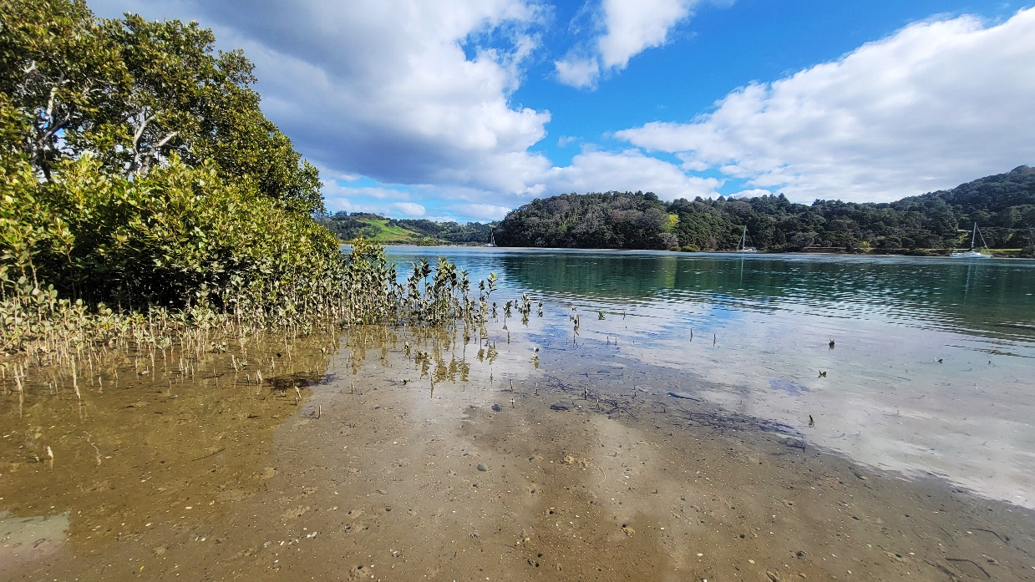

What we heard during engagement
In 2023 and 2024, officials held online hui with Ngāti Manuhiri, community groups, industry and local authorities to discuss their values and aspirations for their estuary. Through these high-level discussions, we were able to identify common values and aspirations across stakeholders. It became clear there is a shared desire to work as a community to improve the water quality and restore the ecological health of the estuary for present and future generations. Figure 3 summarises the main values and aspirations raised in engagement.
Figure 3: Summary of values (headings) and aspirations (bullet points) heard during engagement with Whangateau stakeholders
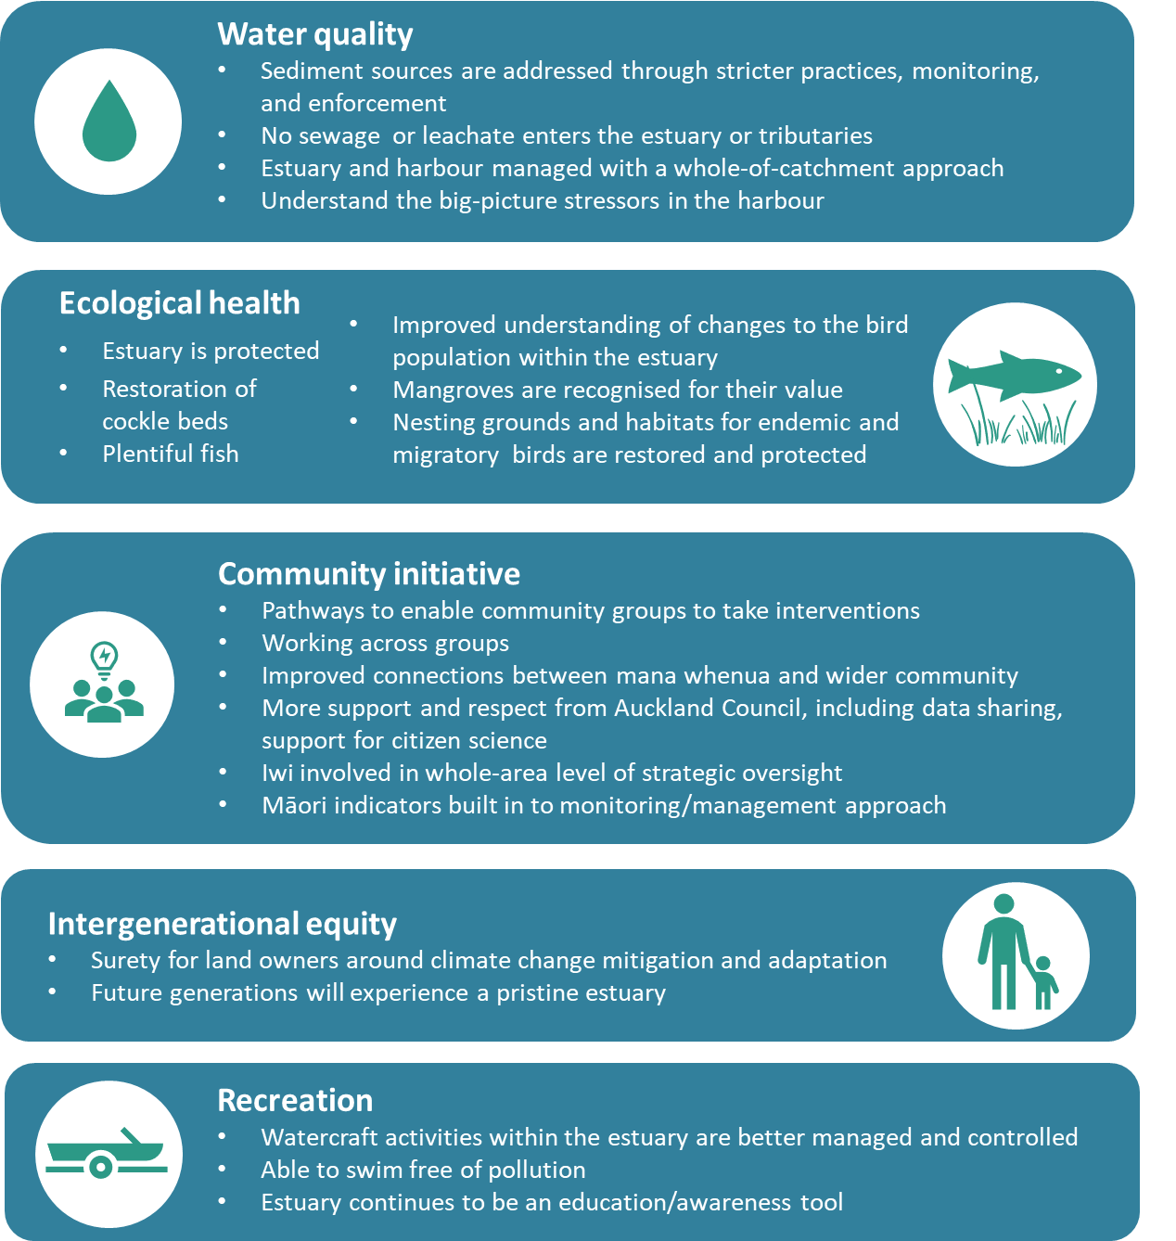

How the estuary is currently used
The Whangateau Harbour is a popular holiday destination for locals and tourists alike. The sandstone reef is a popular spot for snorkelling, and groups such as Mountains to Sea run educational programmes there. Many people also enjoy snorkelling around the mangroves or swimming in the shallows. Paddle boards, kayaks, jet skis and boats are also commonly enjoyed in the harbour. Many people walk around the area or relax on the beach.
The estuary is home to many animals, including flounder, snapper and eagle rays, as well as endangered birds such as the New Zealand fairy tern, banded dotterels and Australasian bitterns. Dolphins also visit the harbour occasionally.

Pressures on the estuary

Water quality
Sedimentation, attributed to poor practices by forestry and urban-development businesses, has increased in recent years. Residents have had some success in alerting the Auckland Council compliance team when developers are not taking sediment control measures (required as part of resource consents), but this relies on activities being photographable. In 2023, residents reported that the ‘ankle depth, gluggy mud’ was occurring in more areas of the harbour. This was likely exacerbated by severe weather events of that year. Sedimentation has contributed to mangrove expansion in the harbour; mangroves naturally grow in the estuary, but they now grow in areas where they did not previously. Mangroves are a great habitat for animals and are an important part of the ecosystem but can be a contentious issue when they spread to new areas.
Sewage inputs, attributed to leaky septic tanks (either damaged or poorly maintained) within the catchment, are another stressor in the harbour. While a health risk at a beach popular with young families, sewage inputs also contribute nutrients and other pollutants that can negatively affect the estuary ecosystem. There are concerns that sewage pipes could be vulnerable to damage under combined sea level rise and higher frequency of severe storms. Residents also reported that partially treated sewerage is discharged to Omaha River due to ‘lack of facility’.
Another point of concern is the closed landfills at the northwestern end of the harbour (in particular Whangateau Landfill on Leigh Road). Three landfills were referred to as being active here during the 1970s and early 1980s taking rubbish from Leigh and Warkworth. People remember years when 10 gallon tins of printers ink from the Rodney Times were dumped here. While Auckland Council has undertaken some work to seal closed landfills in this area, Ngāti Manuhuri and the wider community are concerned that leachate is entering the harbour from these sites and has gone unmonitored.

Shellfish decline
Collection of cockles and pipis has been banned in Whangateau Estuary since 2010. This is because a wasting disease associated with poor water quality caused a large population decline. A rāhui (fishery closure) to protect both species has been in place since March 2013. Though cockle densities have increased since 2010, large individuals are still uncommon and the reasons for this are unclear. There are also concerns that fishing activities – both within the harbour and in the Hauraki Gulf/Tīkapa Moana – are placing too much pressure on fish stocks.

Human interaction
The popularity of the beach was also discussed as a pressure, especially during peak visitor periods. One person described the impact as ‘death by one hundred cuts’. Small acts, like taking shortcuts down to the beach through sand dunes, littering or disturbing birds, all add up to a large impact on the environment.
A related concern was water vehicles being driven close to shore at speeds greater than 5 knots, posing a risk to people, wildlife and bank stability. This was raised by almost every group engaged with. This behaviour is mostly attributed to visitors who are not aware of the rules, and most groups want to see better enforcement and signage.
While evidence exists of recent degradation, Whangateau Harbour is considered a relatively pristine estuary. The community is engaged in the wellbeing of the estuary, and recent pest-trapping has led to more birdlife and release of kiwi nearby.

Insights specific to Ngāti Manuhiri
Staff had the opportunity to meet with and participate in a cultural induction with Ngāti Manuhiri at place (along with Auckland Council and Whangateau HarbourCare Group). Through our initial hui with Ngāti Manuhiri staff and in-person discussions, we learned about the deep connection of mana whenua to the Whangateau Estuary and the concern that this connection will be lost if action is not taken. The shores of the estuary are historical sites of Ngāti Manuhiri settlements and urupa (burial grounds), while the waters and vegetation are an important source of mahinga kai and other cultural materials.
Concerns were expressed that the connection to the estuary will continue to deteriorate because:
- recognition or protection of heritage sites are limited
- mana whenua are forced to live away from the area, with costs of living increasing and housing availability limited
- the human pressure during peak season will overwhelm the estuary’s ability to cope with stressors
- Ngāti Manuhiri are not able to engage in cultural practices, like the harvesting of shellfish, due to declining stocks.
Ngāti Manuhiri voiced their desire to work collaboratively with community groups and councils to achieve better outcomes for the estuary and to revitalise their connection to the catchment as a whole.

The toolbox
Based on the values and aspirations raised through engagement and an assessment of the main pressures on the Whangateau Estuary, Sustainable Seas created a subset of tools and guidance to help achieve the shared aspirations and overall mauri (life force) of the estuary. The tools and guidance have been categorised into broad topics that can be mixed and matched, depending on a group’s goals (see summary in figure 4). A high-level description of the toolkit is set out below. Appendix 1 details the purpose and target audience of each tool. Appendix 2 provides practical examples of other projects that have managed estuaries and catchments for recovery and restoration.
Figure 4: Toolbox for Whangateau Estuary
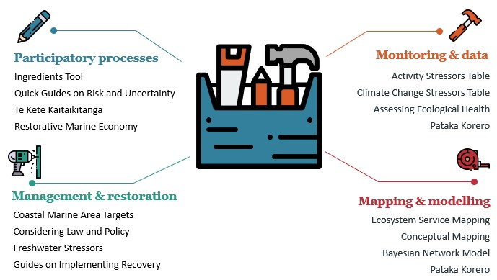

Participatory processes
For local communities, businesses and iwi, the first step is often getting around the table, understanding where various groups are coming from and what they want for (and from) the estuary. The various participatory process tools enable constructive conversation and improve the collective understanding of each other’s world views. The tools selected guide users on how to navigate change through discussions that consider social, cultural, political and environmental processes and contexts.
The Ingredients Tool presents a set of critical questions to guide people involved in a collective process, from getting people in the room to considering your own and other’s world views. This is supported by a series of five Quick Guides around Risk and Uncertainty, which help users explore why people argue about risk and uncertainty, and how to incorporate risk and uncertainty into EBM.
Te Kete Kaitiakitanga is a simple toolkit to guide councils and communities to provide for critical elements required for Mana Moana engagement. These tools focus on relationship building, transparency and accountability, to better incorporate te ao Māori principles such as rangatiratanga (leadership), mātauranga (knowledge) and tikanga (best practices) into marine management. Through a framework that integrates holistic, place-based methods shaped by iwi and hapū, Te Kete Kaitiakitanga strives to enable both kaitiakitanga and EBM for transformative change.
A Restorative Marine Economy is one that combines business activities with environmentally sustainable and restorative practices that respond to community needs and iwi aspirations. This may evolve slowly over time, starting with minimising ongoing harm (ie, weak sustainability) to doing no new harm to redressing harm (restorative economy). Finance and investment are vital to enable the shifts toward a restorative economy, requiring new frameworks that are still being developed in Aotearoa New Zealand.

Monitoring and data
Estuaries are one of the more complicated environmental domains. They are affected by the land around them, the freshwater flowing into them and the ocean. Even for an estuary as well studied as Whangateau, collecting environmental data can help to build a big picture of the estuary, its health and the stressors affecting it. This, in turn, can help inform actions to recover estuary health or to support using the estuary as an educational resource.
Auckland Council regularly monitors the estuary (see LAWA website), but other organisations and individuals can also provide useful information. For example, consistent changes in animal or plant species over time may indicate a shift in ecological health. The Assessing Present Health tool lists both simple and more technical measures and provides information on other indicators that are already being used around Aotearoa New Zealand (including those presently used in monitoring Whangateau by Auckland Council). This information can be usefully supplemented by the guides on implementing recovery (see ‘Implementing Recovery for Councils’ and ‘Implementing Recovery for Community Groups’ in appendix 1).
Knowing likely impacts of stressors can help when considering what to include in monitoring programmes. The Activity Stressor Table lists activities (terrestrial and marine) that create stressors on the marine environment, which includes estuaries. Used in conjunction with the Climate Change Stressors Table, it can help build a picture of the relative effects of the activities in and around the estuary.
For data storage, there is Pātaka Kōrero, a digital tool designed for storing and organising scientific and mātauranga-derived information and data that is usable in marine ecosystem management. The pātaka supports a vast range of content formats, including documents, audiovisuals and web-hosted links. The Pātaka Kōrero guidance describes the tool, how it can be used and its unique features. It provides an insight into the design process and can help others who want to create a similar resource.

Management and restoration
Several documents from the ‘Roadmaps to EBM’ series provide guidance to support the other tools in this toolkit (see appendix 1). Topics include how to consider what your local council can or cannot do (Considering Law and Policy), co-producing robust coastal marine targets (Coastal Marine Area Targets), considering the effects of Freshwater Stressors, and Guides on Implementing Recovery of an estuary for councils and community groups. Figuring out what actions to take requires finding the right tools and expertise to support the restoration goals. The best of intentions can be undermined because actions are not possible, whether it is because they are not supported by legal or policy frameworks, or because the restoration is happening at the wrong place or time.

Mapping and modelling
Sustainable Seas has developed multiple mapping tools that groups may find useful, but three were highlighted for the Whangateau Estuary. Pātaka Kōrero, mentioned in the Monitoring and data section, also has the ability to generate maps using publicly available GIS layers. This is in addition to custom layers generated by users with their unique data sets, which allow community groups to map their own monitoring and management efforts.
Marine ecosystems provide many services that are less obvious and may go unnoticed, yet the value and importance of these are poorly understood and difficult to measure. Ecosystem Service Mapping can help us understand and identify the multiple uses of marine ecosystems, where they happen, and why they are important to preserve beyond monetary value.
All the information generated from this, and the sections above, can be organised through a Conceptual Mapping exercise. This involves sitting around a table as a group and drawing connections between different components in the estuary that different people in the group think of as important. It is vital all opinions are captured, whether commonly held or not. Various ways can be used to achieve this and, for Whangateau, we recommend working with the Estuaries Bayesian Network Model (developed using expert ecological knowledge) as the central map.
A Bayesian Network Model can represent how a marine ecosystem is likely to respond to various management interventions. It links components by the likely outcomes of changes to one component or another. The Estuaries Bayesian Network Model was originally developed under funding from the Parliamentary Commissioner for the Environment. The model has been adapted for this case study project (figure 5), and guidance explaining how the model was constructed and could be further developed can be found here: Management for estuary values and aspirations – Sustainable Seas National Science Challenge (sustainableseaschallenge.co.nz).
Groups can run various scenarios with custom input components to predict the likelihood of desired outcomes (eg, how water clarity might change under more or less frequent marine heat waves). You can add ‘intermediate’ components that you think occur between the environmental drivers (eg, heat waves) and the outcomes (eg, water clarity) you want. These may include cockles (which filter sediment out of the water) and bird roosting and fish nursery areas (because birds and fish feed on cockles), for example.

Figure 5: Estuaries Bayesian Network model diagram for Whangateau Estuary
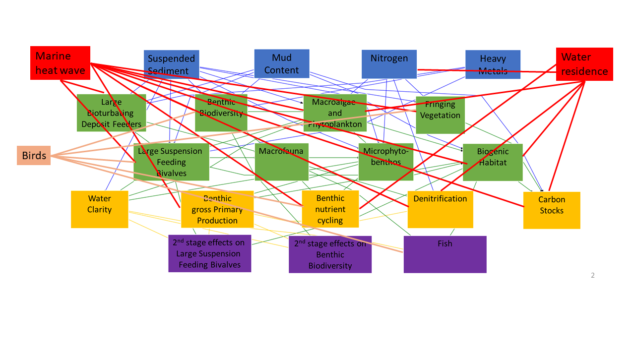

Source: Adapted from Management for estuary values and aspirations – Sustainable Seas National Science Challenge (sustainableseaschallenge.co.nz)

Appendix 1: The tools
Table 1: Tools in the Whangateau Estuary toolbox
Tool and link | Target audience of guidance | Purpose of the tool
Assessing Present Health | - Anyone can use the tool | Consistent changes in fauna, flora or other indicators over time may indicate a shift in ecological health. These changes may be measured through council monitoring programmes over time or local observations, for example, fewer birds nesting, more muddy areas in the estuary. This document presents two methods: one for technical practitioners (eg, council scientists) another for non-technical groups (eg, community groups or iwi) to assess present estuary health.
Activity Stressor Table | - Anyone can use this tool | A single human activity can produce more than one stressor, which can produce more than one direct effect, resulting in indirect effects. For example, a direct effect of mid-water fishing is the removal of species, but indirect effects include plastic pollution (through broken fishing lines) and altered behaviour of other animals (eg, sharks, birds, dolphins). This table helps the user to think through the direct and indirect effects that may occur due to one activity, and how these add up as more activities are considered. This can be used alongside the Climate Change Stressors Table (described below).
Bayesian Network Models | - Anyone can use the Whangateau model designed by Sustainable Seas, although specific software is required | Bayesian Network Models can bridge data gaps, where information from Western science is lacking, with expert knowledge, mātauranga Māori and other local knowledge (eg, residents noticing a decline in nesting birds). Sustainable Seas developed a Bayesian Network Model for Aotearoa New Zealand estuaries for the Parliamentary Commissioner for the Environment. This model has been adapted for the Whangateau Estuary as part of the Ministry for the Environment and Sustainable Seas case study estuary project. You can find more information here Management for estuary values and aspirations – Sustainable Seas National Science Challenge (sustainableseaschallenge.co.nz).
Climate Change Stressors Table | - Community groups and individuals  - Councils working with community groups and individuals | Similarly to the Activity Stressor Table (described above), this table helps the user to think through the likely direct and indirect effects of climate change on estuarine systems. This should be used alongside the Activity Stressor Table to consider how the impacts of climate change are likely to exacerbate the direct and indirect effects of existing activities. The table also demonstrates how these effects are likely to stack up due to climate change alone, for example, more frequent rainfall has many direct and indirect effects, but the effects of warmer air and water temperatures and sea level rise will almost certainly occur at the same time.
Coastal Marine Area Targets (Roadmaps to EBM) | - Anyone can use this to inform goals, plans or conversations  - Regional council (implementation) | Targets for estuary health should be developed in partnership between local councils, local iwi and hapū, and the community. This document outlines recommendations on how to set robust targets for estuary health and maximise the likelihood of success.
Conceptual mapping and how likely actions are to benefit others (Roadmaps to EBM) | - Anyone can develop a conceptual map using this guidance | This document summarises how a conceptual map can be used to consider how likely actions are to benefit the environment. This can help users to think through the pros and cons of decisions before committing to them.
Considering law and policy when assessing, monitoring and restoring estuaries (Roadmaps to EBM) | - Iwi  - Communities  - Business and industry  - eNGOs | Targeted at iwi, communities, businesses and industry, this document summarises how law and policies may affect efforts to assess, monitor or restore estuaries. For example, the council may have monitoring data you can use to inform your efforts or may already be planning a restoration activity as part of the regional plan. Alternatively, you may need to obtain a permit before conducting the activity.
Ecosystem Service Mapping | - Regional council  - Anyone can use this to inform goals, plans or conversations, for example, in collaboration with regional council scientists to identify the ‘best’ site for community-led surveys | This summary document discusses how ecosystem services (eg, mussels can filter suspended sediment out of the water column) can help us understand and communicate multiple uses of marine ecosystems, which can go far beyond making money and providing food. Marine ecosystems provide many services that are less obvious and may go unnoticed; the value and importance of these are poorly understood and difficult to measure.
Freshwater Stressors (Roadmaps to EBM) | - Anyone can use this to inform goals, plans or conversations  - Regional council (implementation) | Estuaries sit at the bottom of a catchment, receiving inputs carried in by rivers and streams. One way to improve estuary health is to manage the stressors carried in from the catchment, such as by setting limits in fresh water that can be monitored and managed. If the source of the stressor is not from fresh water, however, then setting limits that affect activities done on land may not have the desired effects (eg, if the dominant stressors enter from storm drains or activities (such as boating) occurring in the estuary). This document sets out a series of questions for decision-makers to consider when setting limits in freshwater systems (eg, rivers and streams) to protect estuary health.
Implementing Recovery for Councils (Roadmaps to EBM) | - Anyone can use this to inform goals, plans or conversations  - Regional council (implementation) | This document summarises a proposed process for determining recovery outcomes and developing a plan.
Implementing Recovery for Community Groups (Roadmaps to EBM) | - Community groups  - eNGOs | Guidance for community groups that want to recover the health of their estuary.
Ingredients Tool  (Ingredients to catalyse participation in decision-making) | - Decision-makers (primarily)  - Anyone can use this to inform goals, plans or conversations | Questions grouped into themes, to help people think about their own circumstances and the actions they can take. This guidance can help when preparing to get a group of people in the room for engagement, talking about and understanding their own and other's world views. The tool guides users on how to navigate change through participatory processes that consider social, cultural, political and environmental processes and contexts. Ingredients to catalyse participation in marine decision-making are presented as a set of critical questions to guide people involved in a collective process. Having participants consider these questions at the start of a collaboration (eg, stakeholder engagement on a plan) can catalyse conversations and help determine agreed goals.
Pātaka Kōrero | - Anyone looking to collate and share data  - eNGOs | This is a digital tool designed specifically for a set of iwi and hapū groups for storing and organising information and data. The pātaka supports a vast range of content formats, including documents, audiovisuals and web-hosted links. The guidance describes the tool, how it can be used and its unique features.
Quick Guides Around Risk and Uncertainty | - Anyone can use this to inform goals, plans or conversations | Five quick guides that help users explore why people argue about risk and uncertainty. They provide guidance on navigating discussions of risk and uncertainty, including how people differ in their perception or understanding of ‘risk’ and ‘uncertainty’.
Restorative Marine Economy | - Investors  - Central and local government  - eNGOs | This summary document explains the main concepts of restorative economies. Restorative economies combine business activities with environmentally sustainable and restorative practices that respond to community needs and iwi aspirations.
Te Kete Kaitiakitanga | - Non-Māori collaborating with iwi | A simple toolkit that aims to provide guidance and a means of assessment to help ensure kaitiakitanga is appropriately provided for alongside ecosystem-based management. It has been designed in collaboration with a range of partners for the use of agencies, organisations, iwi and hapū wishing to improve marine governance and management outcomes.

Appendix 2: Practical examples from Sustainable Seas projects
Below are practical examples of the Sustainable Seas outputs in action. The tools behind these examples may not have made it into the ‘toolbox’ for this estuary but are useful examples of managing for recovery and restoration. Links are provided to the recently launched Tohorā search engine, which summarises outputs of Sustainable Seas using artificial intelligence.
- Ngā tohu – Te Korowai examines Maramataka as a framework for managing coastal environments, emphasising restoration based on indigenous ecological knowledge and a structured research approach.
- Ōhiwa Harbour case study summarises the success of a mātauranga Māori-led research restoration project between iwi, hapū, researchers, local councils and the Ōhiwa Harbour Implementation Forum. Collaboration with kaumatua was an integral part of the restoration, which has seen 16 million ‘teenage’ kuku (mussels) now growing successfully in a traditional kuku bed in Ōhiwa Harbour. This is an example of principles from te ao Māori, ecosystem-based management and the blue economy working together.
- Disturbance recovery dynamics inform seafloor management for recovery details the species dynamics and external factors that influence successful restoration. In particular, it focuses on whether recovery can happen by ‘turning off the tap’ of contaminants and how long natural recovery might take.
- Guidance and tools to help navigate marine restoration projects as part of ecosystem-based management in the top of the South Island summarises guidance and tools mapped to restoration goals identified by a group of stakeholders for marine ecosystems. It is the result of a collaboration with a ‘restoration by design’ process facilitated by Nature Conservancy New Zealand with Kotahitanga mō te Taiao Alliance.
- Designing long-term monitoring programmes offers insights on designing marine monitoring programmes to detect environmental changes using long-term data from Aotearoa New Zealand’s Manukau Harbour Ecological Monitoring Programme. It suggests ways that cost-effectiveness can be improved by monitoring multiple variables and using sites that have been monitored continuously to interpret changes at other less frequently monitored locations.
- Monitoring for marine tipping points provides strategies for monitoring marine ecosystem changes and detecting critical tipping points. It highlights the need for monitoring over at least 15 years to account for natural cyclic patterns like El Niño/El Niña. Furthermore, the guidance demonstrates how use of expert and local knowledge can compensate for data gaps.

A catchment, or whaitua, is an area of land where rain flows into a common river, lake or other body of water.
Improving estuary health requires buy-in from many groups, likely with different world views and priorities. While each tool in table 1 is targeted towards particular groups, other groups can encourage the use of the tool. For example, the ‘Restorative Marine Economy’ tool is targeted to investors and central or local government, but individuals can encourage them to use the tool.
Environmental non-governmental organisation (eg, Forest and Bird, Mountains to Sea).

