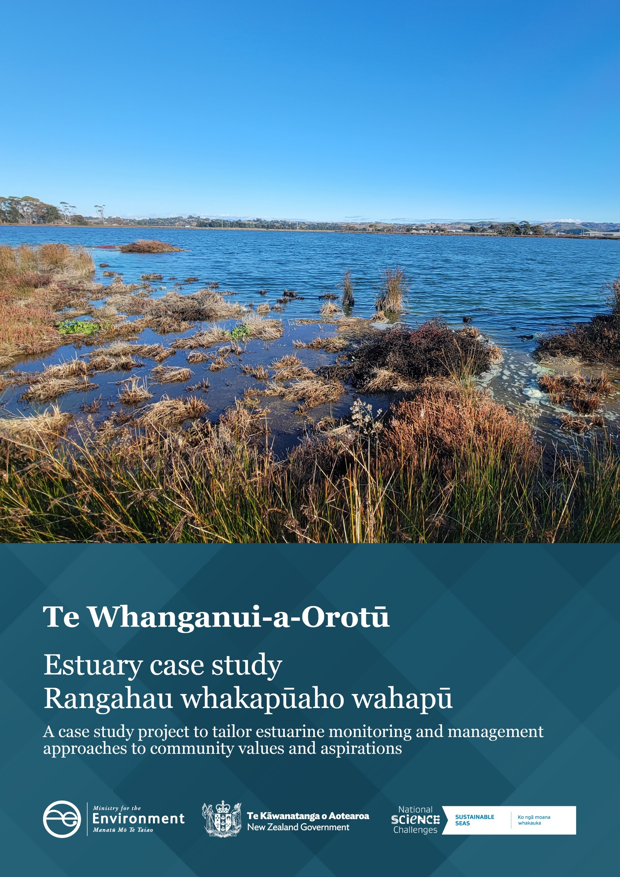

**Disclaimer**

The information in this publication is, according to the Ministry for the Environment’s best efforts, accurate at the time of publication. The Ministry will make every reasonable effort to keep it current and accurate. However, users of this publication are advised that:

* the information does not alter the laws of New Zealand, other official guidelines, or requirements
* it does not constitute legal advice, and users should take specific advice from qualified professionals before taking any action based on information in this publication
* the Ministry does not accept any responsibility or liability whatsoever whether in contract, tort, equity, or otherwise for any action taken as a result of reading, or reliance placed on this publication because of having read any part, or all, of the information in this publication or for any error, or inadequacy, deficiency, flaw in, or omission from the information in this publication
* all references to websites, organisations or people not within the Ministry are for convenience only and should not be taken as endorsement of those websites or information contained in those websites nor of organisations or people referred to.

**Acknowledgements**

We would like to express our sincere gratitude to the Sustainable Seas National Science Challenge for their invaluable partnership in this project. Their support, guidance, and commitment to ecosystem-based management has been instrumental to this case study.

We also extend our deepest appreciation to Mana Ahuriri Settlement Trusti and local community members whose participation and insights have enriched this report. Their knowledge, perspectives and active involvement have been crucial in shaping our work, and we are truly grateful for the opportunity to collaborate with them.

This document may be cited as: Ministry for the Environment. 2024. *Te Whanganui-a-Orotū* *– Estuary case study | Rangahau whakapūaho wahapū.* Wellington: Ministry for the Environment.

Published in December 2024 by the  
Ministry for the Environment  
Manatū mō te Taiao  
PO Box 10362, Wellington 6143, New Zealand  
[environment.govt.nz](https://environment.govt.nz/)

ISBN: 978-1-991140-59-3  
Publication number: ME 1868

© Crown copyright New Zealand 2024

# Contents

Overview 4

Estuaries 4

The project 4

Te Whanganui-a-Orotū/Ahuriri Estuary 5

What we heard during engagement 6

How the estuary is currently used 7

Pressures on the estuary 7

Insights specific to Mana Ahuriri 7

The toolbox 9

Participatory processes 9

Monitoring and data 10

Management and restoration 10

Mapping and modelling 10

Appendix 1: The tools 12

Appendix 2: Practical examples from Sustainable Seas projects 15

# Overview

## Estuaries

Estuaries are complex and dynamic ecosystems of ecological, recreational, cultural, economic and spiritual value to New Zealanders. As the interface of fresh and salt water, estuary health is influenced by the quality of fresh water that flows into them, the activities that occur within or around them and coastal processes. Land use activities in the catchment,[1] such as forestry, agriculture and horticulture, urban development and waste management, can lead to the input of sediment, toxicants and nutrients into an estuary. The resilience of an estuary to stressors is dependent on the estuary type, freshwater flow, tidal influence, geographical location and catchment land use.

Every estuary may have its own tipping point (where the cumulative effect of stressors will negatively affect the health of an estuary), making it difficult to set national standards and regulations for estuarine health. Estuaries tend to fall through the cracks in Aotearoa New Zealand’s environmental legislation due to a lack of integration between freshwater and coastal policies. This can leave councils, iwi and communities with having to develop their own frameworks.

## The project

In 2022, the Ministry for the Environment joined forces with the Sustainable Seas National Science Challenge (Sustainable Seas) to explore how it might manage Aotearoa New Zealand estuaries in a more nuanced way. The mission of Sustainable Seas was to develop tools and guidance for ecosystem-based management (EBM). The aim of EBM is to manage the marine environment in a holistic and inclusive way that balances use and protection to better inform coastal monitoring and management across Aotearoa.

Officials corresponded with regional authorities and selected three case study estuaries. These case studies were based on data availability, community interest and ecological features, to test the outputs of Sustainable Seas in a real-world setting. The three estuaries selected were:

* Whangateau Estuary (Auckland)
* Kakanui Estuary (Otago)
* Te Whanganui-a-Orotū/Ahuriri Estuary (Hawke’s Bay).

The intention of the project was to encourage and support estuarine management at place by providing a tailored ‘toolbox’ to help iwi and hapū, councils and communities. In 2023–24 we held virtual hui with mana whenua and stakeholders to discuss their values and aspirations for their estuary. The Ministry for the Environment then generated a high-level summary of the values and aspirations raised. Sustainable Seas drew on the guidance and methodologies for EBM developed over the past 8 years to assemble a toolbox for each estuary. Officials presented the draft toolboxes at place and discussed attendees’ concerns around implementation and barriers to the management of their estuary to inform this report.

# Te Whanganui-a-Orotū/ Ahuriri Estuary

Te Whanganui-a-Orotū/Ahuriri Estuary is located within Napier’s central business district and is surrounded by urban, industrial and farmed land. Uplift from the 1931 Napier Earthquake and subsequent human changes within the catchment have left the estuary considerably altered. These changes included diverting the Esk and Tutaekurī rivers away from the estuary and draining and reclaiming land in other areas. Additionally, the estuary and catchment have been subject to recent extreme weather events, such as Cyclone Gabrielle. Te Whanganui-a-Orotū is a tidal river estuary where the river mouth connects to a shallow lagoon before meeting the ocean. Around 60 per cent of the estuary drains at low tide, exposing mud, coarse sand and shingle intertidal habitats. It is recognised as a nationally significant wildlife and fisheries habitat and is a taonga to Mana Ahuriri whose hapū have lived along its shores for generations. Its central location and extensive use made it a prime candidate for the case study. Figure 1 summarises why it was selected. Figure 2 shows an example of the salt marsh habitat in the upper intertidal area.

Figure 1: Reasons we selected Te Whanganui-a-Orotū Estuary

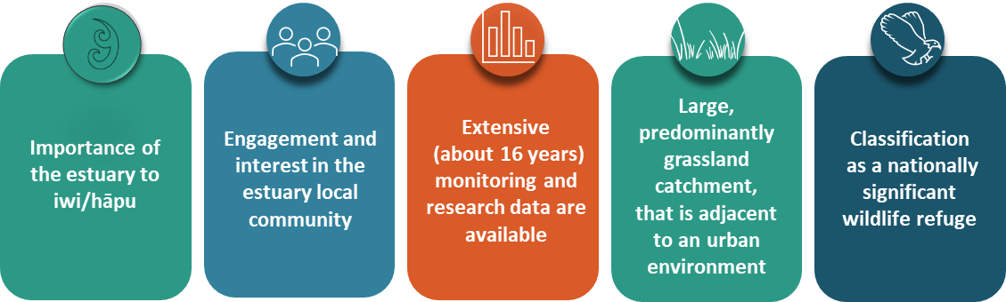

Figure 2: Salt marsh habitat in Te Whanganui-a-Orotū Estuary

# What we heard during engagement

In 2023 and 2024, officials held online hui with Mana Ahuriri, community groups, industry and local authorities to discuss their values and aspirations for their estuary. Through these high-level discussions, we were able to identify common values and aspirations across our Treaty partners and stakeholders. It became clear that community-wide concern exists regarding the ongoing decline of water quality and biodiversity throughout the estuary. Figure 3 summarises the main values (headings) and aspirations (bullet points) raised in engagement.

Figure 3: Summary of values and aspirations heard during engagement with  
Te Whanganui‑a-Orotū stakeholders

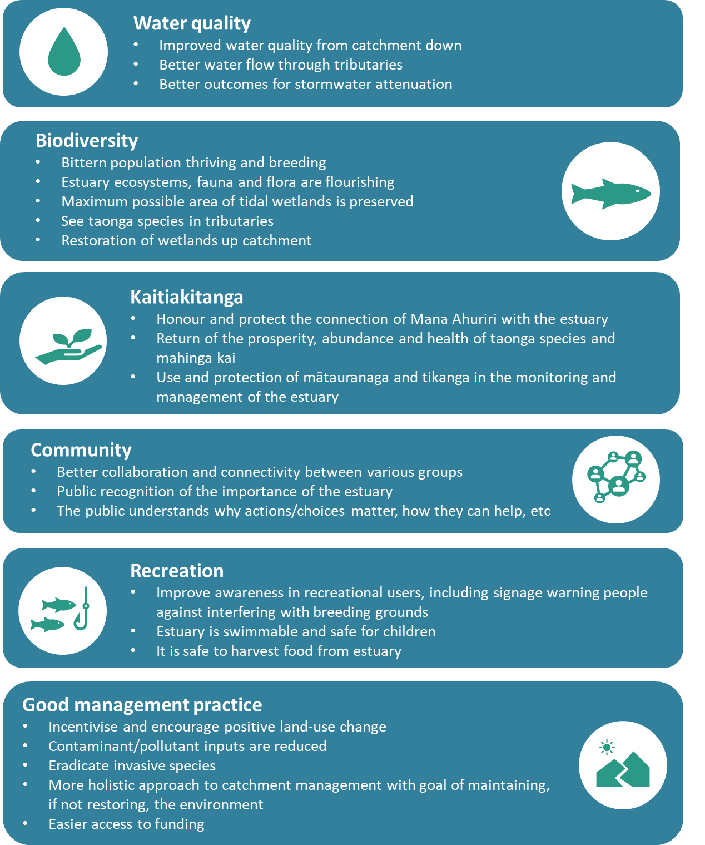

## How the estuary is currently used

The estuary was historically a significant food source, but shellfish are now considered unsafe for human consumption. It remains an important habitat for migratory and endemic birds and is recognised as a wetland of international importance (Ramsar site[2]). The estuary is also an important habitat for fish and other marine species. Many groups run outreach activities, helping visitors and locals alike to learn more about the many birds living within the estuary and the important role the estuary has as their habitat.

The estuary is a popular spot for activities, such as swimming and windsurfing, though concerns for water quality have curbed this. The estuary has a walking track around it, which is popular with locals. We heard how the estuary helps people feel more connected to the natural world, especially through events such as the welcoming of the godwits.

## Pressures on the estuary

Historic industrial pollution – back when people thought that contaminants would be flushed out of the harbour – means the sediment contains ‘legacy’ pollutants that are difficult to address. Today, sediment and nutrients (particularly nitrogen and phosphorous) from the land are carried to the estuary via streams within the catchment. Napier City Council is introducing environment plans for businesses operating within the catchment that aim to improve practices around discharges to the stormwater network.

Untreated stormwater is another source of contaminants, and shellfish are often unsafe to eat following heavy rain. Modern industrial pollutants occasionally enter the estuary due to accidental spills, though the local businesses and Napier City Council have protocols in place for when this happens. The planned wetland at Lagoon Farm is intended to enhance the biodiversity of the area, provide ‘polishing’ of stormwater, and increase the intertidal area of the estuary.

## Insights specific to Mana Ahuriri

Mana Ahuriri hold mana moana and mātauranga for te Muriwai o Te Whanga.[3] Te Whanganui-a-Orotū refers to the estuarine environment at the mouth of Te Whanga (also referred to as Ahuriri Estuary) where the tidal flow from the sea meets the freshwater inflows from surrounding rivers and streams. Ahuriri Hapū, Ngāti Pāhauwera and Maungaharuru–Tangitū, as Treaty settlement entities, share deep whakapapa (ancestral) connections to Te Whanganui-a-Orotū. For Ahuriri Hapū, this estuary holds immense cultural and spiritual significance, being a vital part of their identity and heritage.

Historically, Te Muriwai o Te Whanga has been a taonga (treasured resource) for local hapū, providing mahinga kai (food gathering opportunities) and serving as a site of cultural importance. The estuary’s unique environment supports indigenous species and offers a space where traditional practices such as fishing, gathering of kai moana (seafood) and other customary activities take place. However, the ongoing pressures on the estuary has impacted Mana Ahuriri’s customary practices and connection to the estuary.

As colonisation of Te Matau-a-Māui (Hawke’s Bay) progressed, much of the land surrounding Te Whanga was unjustly sold or taken. In 1860, the Crown’s development of the estuary for a harbour severely affected the natural environment, disrupting wildlife habitats and exploiting the area’s resources. These actions, along with the processes of drainage and reclamation after the 1931 earthquake, further damaged the estuary. The diversion of the Tūtaekurī River to the sea reduced Te Whanganui-a-Orotū to a narrow tidal channel, significantly altering its original state.

In March 2022, Ahuriri Hapū reached a milestone with the settlement of their Treaty of Waitangi claim. An important outcome of this settlement was the establishment of Te Komiti Muriwai o Te Whanga (Te Komiti), a permanent co-governance committee responsible for the stewardship of the Ahuriri Estuary and its catchment areas. Te Komiti, chaired by Mana Ahuriri Trust, includes representatives from the Department of Conservation, Hawke's Bay Regional Council, Napier City Council and Hastings District Council.

Te Komiti provides oversight, coordination and guidance to manage the estuary, ensuring that its ecological and cultural health is preserved for present and future generations. It also supported the development of the Te Muriwai o Te Whanga Plan, a comprehensive management plan that outlines strategies to restore and enrich the estuary. This plan seeks to address the environmental degradation of the past and secure the future vitality of the estuary through a collaborative and culturally grounded approach.[4]

# The toolbox

Sustainable Seas has pulled together a subset of tools and guidance to help achieve the shared aspirations and overall mauri (life force) of the estuary (figure 4). These values and aspirations were raised through the engagement process and an assessment of the main pressures on Te Whanganui-a-Orotū estuary. The tools and guidance have been categorised into broad topics, which can be mixed and matched depending on a group’s goals. A high-level description of the toolkit is set out in figure 4, and appendix 1 details the purpose and target audience of each tool. Appendix 2 provides practical examples of other projects that aim to restore or better manage estuaries and catchments.

Figure 4: Toolbox for Te Whanganui-a-Orotū

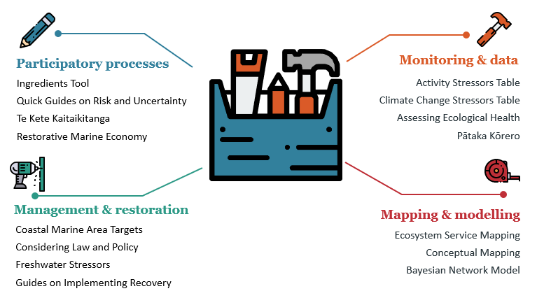

## Participatory processes

Getting around the table is often the first step for local communities, businesses and iwi to understand where various groups are coming from and what they want for (and from) the estuary. The participatory process tools enable constructive conversations and improve the collective understanding of each other’s world views. The tools guide users on how to navigate change through discussions that consider social, cultural, political and environmental processes and contexts.

The Ingredients Tool presents a set of critical questions to guide people involved in a collective process, from getting people in the room to considering your own and other’s world views. This is supported by five Quick Guides Around Risk and Uncertaint**y**, which help users explore why people argue about risk and uncertainty, and how to incorporate risk and uncertainty into EBM.

Te Kete Kaitiakitanga is a simple toolkit to guide councils and communities to provide for critical elements required for mana moana engagement. These tools focus on relationship building, transparency and accountability, to better incorporate te ao Māori principles such as rangatiratanga (leadership), mātauranga (knowledge) and tikanga (best practices) into marine management. Through a framework that integrates holistic, place-based methods shaped by iwi and hapū, Te Kete Kaitiakitanga strives to enable both kaitiakitanga and EBM for transformative change.ye

A restorative marine economy is one that combines business activities with environmentally sustainable and restorative practices that respond to community needs and iwi aspirations. This may evolve slowly over time, starting with minimising ongoing harm (ie, weak sustainability) to doing no *new* harm to redressing harm (restorative economy). Finance and investment are vital, to enable the shifts toward a restorative economy, requiring new frameworks that are still being developed in Aotearoa New Zealand.

## Monitoring and data

Estuaries are a complicated environmental domain. They are affected by the land around them, the freshwater flowing into them and the ocean. Collecting environmental data can help to build a big picture of the estuary, its health and the stressors affecting it. This helps inform actions to recover estuary health or to support using the estuary as an educational resource.

The Hawke’s Bay Regional Council regularly monitors the estuary (see [LAWA](https://www.lawa.org.nz/explore-data/hawkes-bay-region/estuaries/ahuriri-estuary) website), but other organisations and individuals can also provide useful information. For example, consistent changes in animal or plant species over time may indicate a shift in ecological health. The Assessing Present Health tool lists both simple and more technical measures and provides information on other indicators that are already being used around Aotearoa (including those presently used in monitoring Ahuriri by Hawke’s Bay Regional Council). This information can be usefully supplemented by documents from the ‘Roadmaps to EBM’ series aimed at starting actions. One of these (‘Implementing Recovery for Community Groups’, appendix 1) is aimed at starting action, including how to incorporate a wider range of local knowledge about what ‘health’ may be.

Knowing likely impacts of stressors can help when considering what to include in monitoring programmes. The Activity Stressor Table lists activities (terrestrial and marine) that create stressors on the marine environment, which includes estuaries. Used in conjunction with the Climate Change Stressors Table, it can help build a picture of the relative effects of the activities in and around the estuary.

[Pātaka Kōrero](https://www.sustainableseaschallenge.co.nz/tools-and-resources/pataka-matauranga-to-empower-kaitiaki/) is a digital tool designed for storing and organising scientific and mātauranga-derived information and data, usable in marine ecosystem management. The pātaka supports a range of content formats including documents, audiovisuals and web-hosted links. The [Pātaka Kōrero guidance](https://tohora.org.nz/documents/84) describes the tool, how it can be used and its unique features. It provides an insight into the design process and can help others who want to create a similar resource.

## Management and restoration

Several documents from the ‘Roadmaps to EBM’ series provide guidance to support the other tools in this toolkit. Topics include how to consider what your local council can or cannot do (law and policy), co-producing robust coastal marine area targets (Coastal Marine Area targets), considering the effects of freshwater stressors, and how to implement recovery of an estuary (for councils and community groups). Figuring out what actions to take requires finding the right tools and expertise to support the restoration goals. Good intentions can be undermined if actions are not possible because they are not supported by legal or policy frameworks, or because the restoration is happening at the wrong place or time.

## Mapping and modelling

Sustainable Seas has developed multiple useful mapping tools. Three of these were highlighted for Te-Whanganui-a-Orotū. Pātaka Kōrero, mentioned in the Monitoring and data section, also has the ability to generate maps using publicly available GIS layers in addition to custom layers generated by users with their unique data sets, so community groups can map their own monitoring and management efforts.

Marine ecosystems provide many services that are less obvious and may go unnoticed, yet the value and importance of these are poorly understood and difficult to measure. The ecosystem service mapping can help us understand and identify the multiple uses of marine ecosystems, where they happen, and why they are important to preserve beyond monetary value.

All the information generated from this, and the sections above, can be organised through a conceptual mapping exercise. This involves sitting around a table as a group and drawing connections between different components in the estuary that people in the group consider important. It is vital that all opinions are captured, whether commonly held or not. Various ways can be used to achieve this and, for Te Whanganui-a-Orotū, we recommend working with the Estuaries Bayesian Network Model (developed using expert ecological knowledge) as the central map.

A Bayesian Network Model can represent how a marine ecosystem is likely to respond to various management interventions. It links components by the likely outcomes of changes to one component or another. The Estuaries Bayesian Network Model was originally developed under funding from the Parliamentary Commissioner for the Environment and later validated for estuaries in the Hawke’s Bay Regional Council area including Te Whanganui-a-Orotū. The model has been adapted for this case study project (figure 5), and guidance explaining how the model was constructed and how it could be further developed is available here: [Management for estuary values and aspirations – Sustainable Seas National Science Challenge](https://www.sustainableseaschallenge.co.nz/tools-and-resources/estuaries-bayesian-network/) ([sustainableseaschallenge.co.nz](https://www.sustainableseaschallenge.co.nz/tools-and-resources/estuaries-bayesian-network/)).

Groups can run various scenarios with custom input components to predict the likelihood of desired outcomes (eg, how water clarity might change under more or less frequent marine heat waves). You can add ‘intermediate’ components that you think occur between the environmental drivers (eg, heat waves) and the desired outcomes (eg, water clarity). These may include cockles (which filter sediment out of the water), and bird roosting and fish nursery areas (because birds and fish feed on cockles), for example.

Figure 5: Sustainable Seas Estuaries Bayesian Network Model diagram for  
Te Whanganui-a-Orotū Estuary

Source: Adapted from [Management for estuary values and aspirations – Sustainable Seas National Science Challenge](https://www.sustainableseaschallenge.co.nz/tools-and-resources/estuaries-bayesian-network/) ([sustainableseaschallenge.co.nz](https://www.sustainableseaschallenge.co.nz/tools-and-resources/estuaries-bayesian-network/))

# Appendix 1: The tools

Table 1: Tools in Te Whanganui-a-Orotū/Ahuriri Estuary toolbox

| Tool and link | Target audience of guidance[5] | Purpose of the tool |
| --- | --- | --- |
| [Assessing Present Health](https://www.sustainableseaschallenge.co.nz/tools-and-resources/assessing-present-health/) | * Anyone | Consistent changes in fauna, flora or other indicators over time may indicate a shift in ecological health. These changes may be measured through council monitoring programmes over time or local observations, for example, fewer birds nesting or more muddy areas in the estuary. This document presents two methods: one for technical practitioners (eg, council scientists) another for non-technical groups (eg, community groups or iwi) to assess present estuary health. |
| [Activity Stressor Table](https://www.sustainableseaschallenge.co.nz/tools-and-resources/activity-stressor-table/) | * Anyone | A single human activity can produce more than one stressor, which can produce more than one direct effect, resulting in indirect effects. For example, a direct effect of mid-water fishing is the removal of species, but indirect effects include plastic pollution (through broken fishing lines) and altered behaviour of other animals (eg, sharks, birds, dolphins). This table helps the user to think through the direct and indirect effects that may occur due to one activity and how these add up as more activities are considered. This can be used alongside the Climate Change Stressors Table (described below). |
| [Bayesian Network Models](https://www.sustainableseaschallenge.co.nz/tools-and-resources/estuaries-bayesian-network/) | * Anyone can use the Ahuriri model designed by Sustainable Seas, although specific software is required | Bayesian Network Models can bridge data gaps where information from Western science is lacking with expert knowledge, mātauranga Māori and other local knowledge (eg, residents noticing a decline in nesting birds). Sustainable Seas developed a Bayesian Network Model for Aotearoa New Zealand estuaries for the Parliamentary Commissioner for the Environment. This model has been adapted for the Ahuriri Estuary as part of the Ministry for the Environment and Sustainable Seas estuary case study project. You can find more information here: [Management for estuary values and aspirations – Sustainable Seas National Science Challenge (sustainableseaschallenge.co.nz)](https://www.sustainableseaschallenge.co.nz/tools-and-resources/estuaries-bayesian-network/). |
| [Climate Change Stressors Table](https://www.sustainableseaschallenge.co.nz/tools-and-resources/climate-change-stressors/) | * Community groups and individuals * Councils working with community groups and individuals | Similarly to the Activity Stressors Table (described above), this table helps the user to think through the likely direct and indirect effects of climate change on estuarine systems. This should be used alongside the activity stressor table to consider how the impacts of climate change are likely to exacerbate the direct and indirect effects of existing activities. The table also demonstrates how these effects are likely to stack up due to climate change alone, for example, more frequent rainfall has many direct and indirect effects, but the effects of warmer air and water temperatures and sea level rise will almost certainly occur at the same time. |
| [Coastal Marine Area Targets (Roadmaps to EBM)](https://www.sustainableseaschallenge.co.nz/assets/dms/Other-TR/Roadmaps/How-do-we-decide-on-robust-locally-generated-CMA-targets-that-incorporate-climate-change.pdf) | * Anyone can use this to inform goals, plans or conversations * Regional council (implementation) | Targets for estuary health should be developed in partnership between local councils, local iwi and hapū, and the community. This document outlines recommendations on how to set robust targets for estuary health and to maximise the likelihood of success. |
| [Conceptual mapping and how likely actions are to benefit others (Roadmaps to EBM)](https://www.sustainableseaschallenge.co.nz/public/assets/dms/Other-TR/Roadmaps/How-likely-is-it-that-the-action-we-want-will-benefit-others.pdf) | * Anyone can develop a conceptual map using this guidance | This document summarises how a conceptual map can be used to consider how likely actions are to benefit the environment. This can help users to think through the pros and cons of decisions before committing to them. |
| [Considering Law and Policy when Assessing, Monitoring and Restoring Estuaries (Roadmaps to EBM)](https://www.sustainableseaschallenge.co.nz/public/assets/dms/Other-TR/Roadmaps/Why-should-we-consider-law-and-policy-when-assessing-monitoring-and-restoring-the-ecological-health-of-our-estuaries.pdf) | * Iwi * Community * Business and industry * eNGOs[6] | Targeted at iwi, communities, businesses and industry, this document summarises how laws and policies may affect efforts to assess, monitor or restore estuaries. For example, the council may have monitoring data you can use to inform your efforts, or may already be planning a restoration activity as part of the regional plan. Alternatively, you may need to obtain a permit before conducting the activity. |
| [Ecosystem Service Mapping](https://www.sustainableseaschallenge.co.nz/tools-and-resources/utilising-ecosystem-services-to-support-marine-ecosystem-management/) | * Regional council * Anyone can use this to inform goals, plans or conversations, for example, in collaboration with regional council scientists, to identify the ‘best’ site for community-led restoration | This summary document discusses how ecosystem services (eg, how mussels can filter suspended sediment out of the water column) can help us understand and communicate multiple uses of marine ecosystems, which can go far beyond making money and providing food. Marine ecosystems provide many services that are less obvious and may go unnoticed, yet the value and importance of these are poorly understood and difficult to measure. |
| [Freshwater Stressors (Roadmaps to EBM)](https://www.sustainableseaschallenge.co.nz/public/assets/dms/Other-TR/Roadmaps/Will-the-freshwater-limits-we-set-protect-our-estuarine-waters.pdf) | * Anyone can use this to inform goals, plans or conversations * Regional council (implementation) | Estuaries sit at the bottom of a catchment, receiving inputs carried in by rivers and streams. One way to improve estuary health is to manage the stressors carried in from the catchment, such as by setting limits in fresh water that can be monitored and managed. If the source of the stressor is not from fresh water, however, then setting limits that affect activities done on land may not have the desired effects; for example, if the dominant stressors enter from storm drains or activities (such as boating) occurring in the estuary. This document sets out a series of questions for decision-makers to consider when setting limits in freshwater systems (eg, rivers and streams) to protect estuary health. |
| [Implementing Recovery for Community Groups (Roadmaps to EBM)](https://www.sustainableseaschallenge.co.nz/public/assets/dms/Other-TR/Roadmaps/We-are-interested-in-recovering-health-of-an-area-how-do-we-go-about-it.pdf) | * Community groups * eNGOs | Guidance for community groups that want to recover the health of their estuary. |
| [Implementing Recovery for Councils (Roadmaps to EBM)](https://www.sustainableseaschallenge.co.nz/assets/dms/Other-TR/Roadmaps/We-have-recovery-highlighted-in-our-plans-how-do-we-go-about-it.pdf) | * Anyone can use this to inform goals, plans or conversations * Regional council (implementation) | This document summarises a proposed process for determining recovery outcomes and developing a plan. |
| [Ingredients Tool](https://www.sustainableseaschallenge.co.nz/tools-and-resources/ingredients-tool/)  (Ingredients to catalyse participation in decision-making) | * Decision-makers (primarily) * Anyone can use this to inform goals, plans or conversations | Questions grouped into themes, to help people think about their own circumstances and the actions they can take. This guidance can help when preparing to get a group of people in the room for engagement, talking about and understanding their own and others’ world views. The tool guides users on how to navigate change through participatory processes that consider social, cultural, political and environmental processes and contexts. Ingredients to catalyse participation in marine decision-making are presented as a set of critical questions to guide people involved in a collective process. Having participants consider these questions at the start of a collaboration (eg, stakeholder engagement on a plan) can catalyse conversations and help determine agreed goals. |
| [Pātaka Kōrero](https://www.sustainableseaschallenge.co.nz/assets/dms/Other-TR/Pataka-Korero/System-use-and-key-learnings/Pataka-Korero-System-Use-and-Key-Learnings.pdf) | * Anyone looking to collate and share data * eNGOs | This is a digital tool designed specifically for iwi and hapū groups for storing and organising information and data. The pātaka supports a vast range of content formats including documents, audiovisuals and web-hosted links. The guidance describes the tool, how it can be used and its unique features. |
| [Quick Guides Around Risk and Uncertainty](https://www.sustainableseaschallenge.co.nz/tools-and-resources/quick-guides-risk-and-uncertainty/) | * Anyone can use this guide to inform goals, plans or conversations | Five quick guides that help users explore why we are always arguing about risk and uncertainty. They provide guidance on navigating discussions of risk and uncertainty, including how people differ in their perception or understanding of ‘risk’ and ‘uncertainty’. |
| [Restorative Marine Economy](https://www.sustainableseaschallenge.co.nz/tools-and-resources/restorative-marine-economies-framework/) | * Investors * Central and local government * eNGOs | This summary document explains the main concepts of restorative economies. Restorative economies combine business activities with environmentally sustainable and restorative practices that respond to community needs and iwi aspirations. |
| [Te Kete Kaitiakitanga](https://www.sustainableseaschallenge.co.nz/tools-and-resources/te-kete-kaitiakitanga/) | * Non-Māori collaborating with iwi | A simple toolkit that aims to provide guidance and a means of assessment to help ensure kaitiakitanga is appropriately provided for alongside ecosystem-based management. It has been designed in collaboration with a range of partners for the use of agencies, organisations, iwi and hapū wishing to improve marine governance and management outcomes. |

# Appendix 2: Practical examples from Sustainable Seas projects

Below are practical examples of the Sustainable Seas outputs in action. The tools behind these examples may not have made it into the ‘toolbox’ for this estuary but are useful examples of managing for recovery and restoration. Links are provided to the recently launched Tohorā search engine, which summarises outputs of Sustainable Seas using artificial intelligence.

* [Ngā tohu – Te Korowai](https://tohora.org.nz/documents/126) examines Maramataka as a framework for managing coastal environments, emphasising restoration based on indigenous ecological knowledge and a structured research approach.
* [Ōhiwa Harbour case study](https://tohora.org.nz/case-studies/ohiwa-harbour) summarises the success of a mātauranga Māori-led research restoration project between iwi, hapū, researchers, local councils and the Ōhiwa Harbour Implementation Forum. Collaboration with kaumatua was an integral part of the restoration, which has seen 16 million ‘teenage’ kuku (mussels) now growing successfully in a traditional kuku bed in Ōhiwa Harbour. This is an example of principles from te ao Māori, ecosystem-based management and the blue economy working together.
* [Disturbance recovery dynamics inform seafloor management for recovery](https://tohora.org.nz/documents/161) details the species’ dynamics and external factors that influence successful restoration. In particular, it focuses on whether recovery can happen by ‘turning off the tap’ of contaminants and how long natural recovery might take.
* [Guidance and tools to help navigate marine restoration projects as part of ecosystem-based management in the top of the South Island](https://tohora.org.nz/documents/158) summarises guidance and tools mapped to restoration goals identified by a group of stakeholders for marine ecosystems. It is the result of a collaboration with a ‘restoration by design’ process facilitated by Nature Conservancy New Zealand with Kotahitanga mō te Taiao Alliance.
* [Designing long-term monitoring programmes](https://tohora.org.nz/documents/48) offers insights on designing marine monitoring programmes to detect environmental changes using long-term data from Aotearoa New Zealand’s Manukau Harbour Ecological Monitoring Programme. It suggests ways that cost-effectiveness can be improved by monitoring multiple variables and using sites that have been monitored continuously to interpret changes at other less frequently monitored locations.
* [Monitoring for marine tipping points](https://storage.googleapis.com/sustainable-seas-documents-prod/EBM%2033%20Guidance-Monitoring-for-marine-tipping-points.pdf) provides strategies for monitoring marine ecosystem changes and detecting critical tipping points. It highlights the need for monitoring over at least 15 years to account for natural cyclic patterns like El Niño/El Niña. Furthermore, the guidance demonstrates how use of expert and local knowledge can compensate for data gaps.

1. A catchment, or whaitua, is an area of land where rain flows into a common river, lake or other body of water.
2. A Ramsar site is a wetland site designated to be of international importance under the Ramsar Convention, also known as ‘The Convention on Wetlands’.
3. Te Muriwai o Te Whanga: As defined in the settlement, encompasses both the Ahuriri Estuary and its catchment areas.
4. Text provided by Mana Ahuriri Settlement Trust.
5. Improving estuary health requires buy-in from many groups, likely with different world views and priorities. While each tool in table 1 is targeted towards particular groups, other groups can encourage use of the tool. For example, the ‘Restorative Marine Economy’tool is targeted to investors and central or local government, but individuals can encourage them to use the tool.
6. Environmental non-governmental organisation (eg, Forest and Bird, Mountains to Sea).