**Disclaimer**

The information in this publication is, according to the Ministry for the Environment’s best efforts, accurate at the time of publication. The Ministry will make every reasonable effort to keep it current and accurate. However, users of this publication are advised that:

* the information does not alter the laws of New Zealand, other official guidelines, or requirements
* it does not constitute legal advice, and users should take specific advice from qualified professionals before taking any action based on information in this publication
* the Ministry does not accept any responsibility or liability whatsoever whether in contract, tort, equity, or otherwise for any action taken as a result of reading, or reliance placed on this publication because of having read any part, or all, of the information in this publication or for any error, or inadequacy, deficiency, flaw in, or omission from the information in this publication
* all references to websites, organisations or people not within the Ministry are for convenience only and should not be taken as endorsement of those websites or information contained in those websites nor of organisations or people referred to.

This document may be cited as: Ministry for the Environment. 2023. *Addressing risks associated with nitrates in drinking water*. Wellington: Ministry for the Environment.

Published in May 2023 by the  
Ministry for the Environment   
Manatū Mō Te Taiao  
PO Box 10362, Wellington 6143, New Zealand  
[environment.govt.nz](http://www.environment.govt.nz)

ISBN: 978-1-991077-48-6  
Publication number: ME 1760

© Crown copyright New Zealand 2023

# Contents

Executive summary 6

Definitions and abbreviations 10

Chapter one – Introduction 12

The issue of nitrates and key risks 13

Constraints and scope 13

Ecosystem health impact of nitrates 14

Engagement 15

What we mean by nitrates 15

Existing regulatory framework 17

Regulation and legislation 19

The health risks posed by nitrates 24

Chapter two – Scale of nitrates in our source waters and public health impacts 28

Data source 28

Freshwater is under pressure from increased nitrogen leaching activities 29

The state and trend of nitrate concentrations in our freshwater sources 32

Canterbury specific data 40

Case studies 41

Unregistered drinking water supplies 45

Public health data 46

Chapter three – What’s already underway or planned? 47

Policies and other measures already in place 47

Recent policy changes 49

Monitoring and supporting research into the public health impacts of nitrates in drinking water 53

Chapter four – What do we need to do more of? What else can we consider? 54

Methods to reduce nitrate concentrations 54

Situational outlook 56

Chapter five – Potential risks associated with nitrates in drinking water 60

Risk one – A fragmented approach to nitrate monitoring and management in drinking water 60

Risk two – Loss of existing drinking source water sites due to increasing nitrate contamination exceeding the current drinking water maximum acceptable values 60

Risk three – Regulatory gaps in the new drinking water regime 61

Risk four – Current initiatives to manage nitrates in drinking water may not do enough 62

Chapter six – Conclusions and recommendations 63

Conclusion 63

Broad recommendations 63

# Tables

Table 1. Glossary of terms 10

Table 2. Selected relevant nitrate limits 15

Table 3. Maximum acceptable values (MAV) for inorganic determinands of health significance 21

Table 4: Monitoring regime for nitrate 23

Table 5: Types of nitrate notifications received (15 November 2021 – 31 August 2022) 24

Table 6. Estimated costs of denitrification treatment in Christchurch 55

# Figures

Figure 1: Total number of livestock throughout New Zealand from 1970–2019 29

Figure 2 Change in the number of dairy cattle between 1990–2019, by region 30

Figure 3 Percentage change in dairy cattle numbers between 1990–2019, per region 30

Figure 4. Dairy cattle density (animals per km2) on farms, 1994–2017 31

Figure 5: Estimates of fertiliser application to land from sales, 1991–2019 31

Figure 6: Groundwater state of environment sites, median nitrate-nitrogen concentrations categorised by maximum acceptable value (MAV), 2016–2020 32

Figure 7: Groundwater state of environment sites, percentage of total samples that exceeded the nitrate maximum acceptable value (MAV), 2014–18 33

Figure 8: Groundwater state of environment sites, nitrate-nitrogen trends, 2011–2020 34

Figure 9. Groundwater state of environment sites – forecasted nitrate-nitrogen trends, assuming current trends of concentrations continue unchanged. 36

Figure 10: River state of environment sites, median nitrate-nitrogen concentrations categorised by maximum acceptable value (MAV), 2016–20 37

Figure 11: River state of environment sites, nitrate-nitrogen trends, 2012–21. 38

Figure 12. River state of environment sites forecasted nitrate-nitrogen trends, assuming current trends continue unchanged 39

Figure 13: Summary of nitrate-nitrogen concentrations sampled in the 2021 annual survey for each Canterbury Water Management Strategy (CWMS) zone 40

Figure 14: Ten-year trends (2012–21) in nitrate-nitrogen concentrations in annual survey wells 44

Figure 15. Hekeao / Hinds Plains median annual nitrate-nitrogen concentrations, 2006–20 59

# Executive summary

### Introduction

Ministers have requested a report on the risks associated with nitrate levels in drinking water and how those risks can be addressed, particularly for South Canterbury bores.0F[1] This report reviews the risks of nitrates in drinking water, either from surface water or ground water in relation to human health impacts. The risks explored go beyond public health risks.

While the specific risks of nitrates to ecological health is not in scope of this report, the report recognises the holistic approach needed for nitrate management. Risks relating to ecological health occur at a far lower nitrate level than the impact on human health and are considered through the Essential Freshwater work programme.

This report includes domestic self-suppliers, where possible, due to the higher probability that some of these consumers are drinking water from high nitrate water sources. The scope and findings of this report has been limited by the availability of comprehensive data. It is difficult to estimate nitrate exposure nationally even for registered water supplies, and data for unregistered water supplies is almost non-existent.

In the development of this report we have engaged with the Department of Internal Affairs, the Ministry for Primary Industries, Environment Canterbury, the Selwyn and Ashburton district councils, and Ngāi Tahu.

### Increasing trend in nitrate level in source water

There is no time series data for nitrate levels in source water for drinking water. However, the state of the environment (SOE) monitoring data for surface water (rivers and lakes) and groundwater provides the best estimate of the trend in nitrate levels in source water.

Concentrations of nitrates in groundwater and river water, by location, have been both increasing and decreasing for the past few decades with 45.7 per cent of the monitored groundwater sites increasing and 44.8 per cent of sites decreasing over the past 10 years.

This creates localised nitrate hotspots within regions where nitrate levels are increasing. There are similarly locations within a region where the nitrate levels are decreasing. While increasing levels of nitrate is a national issue, the regions where the increasing trend is most prevalent are Canterbury, Southland, Hawke’s Bay and Wairarapa. Within these regions there are localised hotspots. For example, in Canterbury these hotspots are Seadown, northeast Ashburton, Tinwald and the lower Hekeao/Hinds plains. Plus, localised bores where the level of nitrate is decreasing.

In 2021, the annual survey of Canterbury Water Management Strategy 2009 (CWMS) bores (which are not necessarily drinking water bores) found that 10 per cent of the sites sampled had nitrate levels greater than the nitrate maximum acceptable value (MAV) for drinking water. From the 10 years from 2012 to 2021, it was found that 30 per cent of the sites surveyed showed ‘very likely increasing’ trends in nitrate concentrations.

The key issue is that if the increasing nitrate trends continue then there is the potential that drinking water within a nitrate hot spot will exceed the MAV and the water supplier would need to stop supplying drinking water, identify other water sources, or incur significant additional costs (or some combination of these). These exceedance events have occurred twice in 2022 resulting in residents not being able to drink their reticulated water.

Due to long lag times in nitrates moving to groundwater, some of these trends are locked in and above-ground short-term interventions will have little short-term effect.

### The MAV for nitrates in drinking water

The MAV for nitrates in drinking water is set at 50mg/L NO3 (or 11.3mg/L NO3-N) and is consistent with the guidance from the World Health Organization, and the values set by the European Union, and Australia. This nitrate MAV is set at a level intended to prevent Blue-Baby Syndrome (a condition caused by reduced oxygen availability). There are also other causes of Blue-Baby Syndrome, such as congenital heart defects and genetic factors.

In New Zealand, preliminary analysis based on hospitalisation data, indicates that Blue-Baby Syndrome is rare (two hospitalisations between 2012–21). It is not possible from this preliminary analysis to determine whether the two hospitalisations were caused by nitrates or other causes.

There is a growing interest in potential health risks associated with nitrates in drinking water and whether the MAV is set at an appropriate level. This interest has been sparked by a small number of studies focused on investigating potential associations between nitrates in drinking water and colorectal cancer and adverse reproductive outcomes. These studies had varied degrees of rigour and no causal links were established in any study. The Prime Minister’s Chief Science Advisor’s 2022 published web content ‘Nitrates in drinking-water’1F[2] which summarised the current evidence on the health impacts of nitrates in drinking water and did not make any recommendations on amending the MAV.

During 2022, Taumata Arowai publicly consulted on the drinking water standards. While there was no proposal to adjust the nitrate MAV, Taumata Arowai received submissions advocating for a lower MAV. Taumata Arowai engaged with the Ministry of Health about the submissions and the Ministry of Health explained that currently there is no robust and sufficient evidence to support lowering the nitrate MAV. The Ministry of Health will continue monitoring emerging evidence and will inform Ministry for the Environment and Taumata Arowai of any recommended changes to the MAV.

#### Water Services Act 2021

With the enactment of the Water Services Act 2021, a more comprehensive regulatory regime (excluding domestic self-supply) is being established for the monitoring and reporting of determinands (including nitrate) in drinking water. Water suppliers will transition into the new regime from November 2021 through to 2028.

The Water Services Act 2021 regulates the water suppliers previously registered under the Health Act 1956, plus an approximate 75,000 additional water suppliers who were not previously registered under the Health Act 1956.

Some of the impact of this reform is that by 2025 all water suppliers, other than domestic self-supplies, will be registered and from 2028 subject to a more comprehensive monitoring and reporting regime for nitrates in source water (excluding roof water). While this monitoring and reporting will not solve the issues associated with increasing nitrate levels in source water it will provide valuable data on nitrate levels in source water across New Zealand.

#### Regulatory gaps

Domestic self-supplies are not subject to any monitoring or reporting regime for their drinking water. This creates a risk to public health as they are potentially at a higher risk of nitrate exposure due to generally being in a rural environment and typically abstract water from a shallow depth. Water quality for domestic self-supplies is a key data gap which limits our understanding of the extent of any health impacts.

Under the Health Act 1956, a Medical Officer of Health could require a territorial authority or regional council to investigate source water contamination (including for excess levels of nitrate). This provision was repealed and was not transferred to the Water Services Act 2021. The Department of Internal Affairs is aware of this regulatory gap and has work underway through the three waters reform legislative programme to address this issue.

### Current initiatives

In addition to the requirements under the Resource Management Act 1991 (RMA), the Government has national direction instruments which aim to improve water quality, such as the National Policy Statement for Freshwater Management (NPS-FM), National Environmental Standards for Freshwater (NES-F), and the National Environmental Standards for Sources of Human Drinking Water (NES-DW). The NES-DW set requirements for councils to protect sources of human drinking water from becoming contaminated.

Work is underway to strengthen the existing NES-DW. The proposed changes would support the reduction of nitrates in drinking water by helping councils, resource users, and water suppliers to better understand and manage activities that pose risks to source water.

Some district councils have proactively increased the frequency and scale of monitoring of drinking water supplies in their areas, above and beyond what legislation requires. This was partly in response to concerns from their communities about the uncertainty of health effects from nitrates.

The CWMS recognises, in relation to nitrates, that water quality is an important component of freshwater ecosystems and for human and stock uses. The CWMS includes 2020 targets for source water quality and catchment nutrient targets that were not achieved.

It is predicted that, even with the existing policies and initiatives, nitrates in ground and surface waters will continue to increase in close to half of the monitored sites with respect to. This trend has been persistent over the past few decades, and there is little evidence of the situation getting better. This could either be because existing policies have not been in place long enough to make a difference, are not stringent or ambitious enough, or because lag times prevent monitoring data from showing a demonstrable effect, or without current initiatives there could be a larger issue.

### Key risks

The key risks identified in the report are:

* a fragmented approach to nitrates in drinking water as the responsibility for setting nitrate MAVs, regulating nitrate usage, management, and monitoring sits across different portfolios
* loss of existing source water sites for drinking water (resulting in increased costs) due to increasing nitrate concentrations exceeding the drinking water MAV
* a regulatory gap in the new drinking water regulatory regime means that drinking water domestic self-supply situations have no regulatory oversite for nitrate levels in drinking water and there is no ability to investigate source water contamination. There is already work underway to resolve this issue
* there is a significant lag time to see the effect of initiatives to protect source water from nitrate leaching.

### Recommendations

**Note** that the Ministry of Health will continue monitoring and reviewing the body of evidence on nitrates in drinking water and will update Ministers and existing policy advice on the recommended MAV should emerging evidence suggest a need to do so.

**Note** that the Department of Internal Affairs has work underway, through the three waters reform legislative programme, to amend the Water Services Act 2021 to include a provision for a Medical Officer of Health or Taumata Arowai to be able to issue a notice about water contamination that may affect domestic self-supplies by way of a notice issued to a water services entity or regional council. The water services entity or regional council will be required to issue a notice warning domestic self-supply users of contamination, which may include an excess level of nitrates. The notice will include the exercise of power to take any action to remedy the situation.

**Agree** to establish an inter-agency working group that will work together to support the regional working groups to monitor, assess and respond to nitrate contamination in drinking water. This group will be comprised of officials from the Ministry of Health (who will chair the group), Taumata Arowai, the Ministry for Primary Industries, and the Ministry for the Environment. We would also invite membership from the Department of Internal Affairs and Te Puni Kōkiri. This group is to take a Te Mana o te Wai approach to all issues.

**Agree** that the Ministry of Environment, Ministry of Health, and Taumata Arowai will work together to standardise and share any monitoring and reporting of nitrates that would relate to drinking water, and that this information is made accessible for other departments, local government, and researchers, unless privacy rules apply.

# Definitions and abbreviations

The report uses the following definitions and abbreviations:

Table 1. Glossary of terms

| Term or abbreviation | Definition |
| --- | --- |
| CWMS | Canterbury Water Management Strategy (2009).  Note that CWMS refers to ‘wells’ rather than ‘bores’; they mean the same thing. |
| Determinands | **A substance or characteristic that is determined or estimated in drinking water, as listed in the Water Services (Drinking Water Standards for New Zealand) Regulations 2022.** |
| DIN | Dissolved inorganic nitrogen. |
| Domestic self-supply | A stand-alone domestic dwelling that has its own supply of drinking water Refer to [section 10 of the Water Services Act 2021](https://www.legislation.govt.nz/act/public/2021/0036/latest/LMS374671.html). |
| Drinking water | Water that is used for:   * human consumption * oral hygiene * preparing food, drink, or other products for human consumption * washing utensils that are used for eating and drinking, or for preparing, serving, or storing food or drink for human consumption.   It does not include:   * bottled water that is prepared or manufactured by a food business, and is regulated, under the [Food Act 2014](https://www.legislation.govt.nz/act/public/2014/0032/latest/DLM2995811.html#DLM2995802) * water, if its use is regulated under the [Food Act 2014](https://www.legislation.govt.nz/act/public/2014/0032/latest/DLM2995811.html#DLM2995802), the [Animal Products Act 1999](https://www.legislation.govt.nz/act/public/1999/0093/latest/DLM33502.html#DLM33501), or the [Wine Act 2003](https://www.legislation.govt.nz/act/public/2003/0114/latest/DLM222447.html#DLM222446).   Refer to [section 6 of the Water Services Act 2021](https://www.legislation.govt.nz/act/public/2021/0036/latest/LMS374659.html). |
| Drinking water standards | Drinking water standards set the maximum acceptable values, or MAVs, for a range of contaminants which can affect the safety and quality of drinking water.  From 14 November 2022 the drinking water standards are Water Services (Drinking Water Standards for New Zealand) Regulations 2022 established under the Water Services Act 2021. |
| Groundwater | Groundwater is rainwater that has travelled through the soil, or from river and lake beds to aquifers. Aquifers are underground rock formations that are sufficiently permeable to contain or conduct significant amounts of water. |
| Maximum acceptable value or MAV | The MAV of a chemical determinand is the highest concentration of a determinand in drinking water that, based on present knowledge, is considered not to cause any signiﬁcant risk to the health of the consumer. This is normally based on consumption of 2 litres per day of water over 70 years; however, where there is the potential for acute harm determinands have a short-term MAV. |
| NES-DW | Resource Management (National Environmental Standards for Sources of Human Drinking Water) Regulations 2007. |
| NES-F | Resource Management (National Environmental Standards for Freshwater) Regulations 2020. |
| Nitrate | Nitrate is a common, naturally occurring chemical compound made of the elements nitrogen (N) and oxygen (O). |
| Nitrate-nitrogen | The term ‘nitrate-nitrogen’ refers to the nitrogen portion of the total nitrate in a sample. It is a highly soluble form of nitrogen that is both a nutrient and, in excess quantities, a toxic substance. |
| NPS-FM | National Policy Statement for Freshwater Management 2020. |
| PMCSA | Prime Minister’s Chief Science Advisor. |
| Public heath | The health of:   * all the people of New Zealand * a population group, community, or section of people within New Zealand.   Refers to [section 4 of the Pae Ora (Healthy Futures) Act 2022](https://www.legislation.govt.nz/act/public/2022/0030/latest/LMS575481.html). |
| Public Health Agency | Established on 1 July 2022, the Public Health Agency is part of the Ministry of Health and leads all public health and population health policy, strategy, regulatory, intelligence, surveillance, and monitoring functions, and provides advice to Ministers on all public health matters. |
| RMA | Resource Management Act 1991. |
| Safe in relation to drinking water | Drinking water that is unlikely to cause a serious risk of death, injury, or illness:   * immediately or over time * whether or not the serious risk is caused by: * the consumption or use of drinking water * other causes together with the consumption or use of drinking water.   Refer to [section 7 of the Water Services Act 2021](https://www.legislation.govt.nz/act/public/2021/0036/latest/LMS374661.html). |
| Source water | Source water is potential raw water, ie, it is natural fresh water that could be abstracted and processed for drinking purposes.  This report does not consider drinking water when the source water is either roof water or water supplied by a tanker by a registered water supplier. The report also does not consider bottled drinking water. |
| Surface water | Water present on the land surface, including streams, rivers, creeks, drains, lakes and wetlands (ie, where water is present on top of the ground). Does not include any geothermal water or coastal water. |
| WHO | World Health Organization. |

# Chapter one – Introduction

This report responds to a recommendation in the Cabinet Legislation Committee Minute of Decision on the Water Services (Drinking Water Standards for New Zealand Regulations) 2022 that:2F[3]

|  |
| --- |
| ⏩ directed the Ministry for the Environment and the Ministry of Health in consultation with Taumata Arowai, to report back to the Minister of Local Government, Minister for the Environment, Associate Minister of Health, and Associate Minister for the Environment with further advice on the risks associated with nitrate/nitrite levels in water and how those risks can be addressed, particularly for South Canterbury bores, by October 2022. ⏪ |

The public health risk of nitrates in drinking water was raised during the consultation on drinking water standards undertaken by Taumata Arowai.3F[4] The Ministry for the Environment also received similar feedback during public consultation on the proposed amendments to the National Environmental Standards for Sources of Human Drinking Water 2007.4F[5]

There is growing interest in the public health risks associated with increasing nitrate levels in drinking water and whether the existing limits for nitrates in the drinking water standards are appropriate to protect public health.5F[6] This interest has been sparked by a small number of studies (with varying degrees of rigour) on the association between nitrates in drinking water and other potential adverse health outcomes. There was particular interest in a 2018 Danish6F[7] study on colorectal cancer and a 2022 Californian study on pre-term births.7F[8]

## The issue of nitrates and key risks

This report looks at the risks of nitrates in source water that is used for drinking, either from surface water or groundwater.8F[9] For the purpose of this report a wide definition of ‘risk’ has been adopted to address the risks from nitrate in drinking water, the risks from the management of nitrates from source to tap, and other potential consequences from the way nitrates are managed.

The key risks identified in the report are:

* a fragmented approach to nitrates in drinking water as the responsibility for informing and setting nitrate MAVs, regulating nitrate usage, management, and monitoring sits across different portfolios (Ministry for Environment, Ministry for Primary Industries, Ministry of Health, Department of Internal Affairs, and Taumata Arowai)
* loss of existing source-water sites for drinking water (resulting in increased costs) due to increasing nitrate concentrations exceeding the current maximum acceptable value (MAV) if intervention to stop nitrate leaching does not occur9F[10]
* a regulatory gap in the new drinking water regulatory regime means that drinking water domestic self-supply situations have no regulatory oversite for nitrate levels in drinking water10F[11]
* there is a significant lag time to see the effect of initiatives to protect source water from nitrate leaching.

## Constraints and scope

As directed by Cabinet, the focus of this report will be on nitrates in drinking water and not on other contaminants in drinking water. It will also focus on Canterbury bores, while noting that increasing concentrations of nitrates in source water, and therefore drinking water, is not limited just to Canterbury or South Canterbury.

This report is not limited to water supplies as defined in the Water Services Act 2021;11F[12] domestic self-suppliers are included in the report,12F[13] where possible, due to the higher probability that some of these consumers are drinking water from high nitrate water sources. These supplies are generally in rural areas and the water is likely to be sourced from shallow bore water which is more susceptible to nitrate leaching than deeper aquifer water.

This report considered the nitrate monitoring evidence of water sites (bores) in a district or region. It is not known which of these sites are drinking water sites.13F[14],14F[15]

The scope and findings of this report have also been limited by the availability of comprehensive national-level data. It is difficult to estimate nitrate exposure nationally even for registered water supplies, and data for unregistered water supplies is almost non-existent.

## Ecosystem health impact of nitrates

|  |
| --- |
| In scope  This report considers:   * nitrates in drinking water sourced from ground and surface water * the roles of Taumata Arowai, the Ministry for the Environment, and the Ministry of Health in relation to nitrate in drinking water * the existing regulatory framework to address public health issues associated with nitrates in drinking water * health evidence on nitrates in drinking water (colorectal cancer and adverse reproductive outcomes) * current initiatives to address the risks associated with nitrates in drinking water * gaps and constraints in addressing the risks associated with nitrates in drinking water.   Out of scope  This report does not consider:   * nitrates that occur naturally in the environment * impact on ecosystem health * issues associated with water used in food processing or bottled water * the efficiency of any treatment option for removal of nitrates. |

This report acknowledges that excess nitrates in our freshwaters15F[16] can have an impact on both ecological and human health.16F[17] Ecological health impacts include increased agal and plant growth, loss of sensitive macroinvertebrate and fish fauna, and high rates of respiration and decay.17F[18] However, ecosystem health impacts are not in scope of this report which focuses on human health.

## Engagement

In preparing this report, we engaged with staff from Environment Canterbury, Selwyn District Council, Ashburton District Council, and the Ministry for Primary Industries. We received inter-agency feedback from the Department of Internal Affairs and Ministry for Primary Industries. This feedback has been incorporated into this report. We also received feedback from Te Rūnanga o Ngāi Tahu which is reflected in this report.

## What we mean by nitrates

Nitrate is a common, naturally occurring chemical compound made of the elements nitrogen (N) and oxygen (O). Nitrate is an important source of nitrogen for plant growth. It is derived from the decay of organic matter, or it can be manufactured as nitrogen fertiliser. Humans ingest nitrates through food and water, as well as producing nitrate endogenously (within the body). Typically, around 90 per cent of human nitrate consumption is from fruits and vegetables.

Nitrogen exists in different forms other than nitrate, such as nitrite, ammonia, organic nitrogen, and nitrogen gas. Scientists are sometimes interested in the different forms of nitrogen in water to understand the level of nutrients available to different organisms in the environment, among other reasons. To compare these different forms directly, scientists convert the different forms of nitrogen into ‘equivalent units’. The ‘equivalent unit’ for nitrogen containing compounds (like nitrate, nitrite, ammonia) is ‘mg/L as nitrogen’ also known as ‘nitrate-nitrogen"’. For example, 50 mg/L of nitrate when expressed in its ‘equivalent unit’ is 11.3 mg/L as nitrogen (or 11.3 mg/L nitrate-nitrogen). This conversion is akin to converting a distance between different units of measurement (eg, 1 kilometre = 1,000 meters).

For environmental monitoring, scientists commonly record nitrate concentrations as nitrate-nitrogen so they can compare the values to nitrogen in other forms that might also be present, such as nitrite, ammonia nitrogen, organic nitrogen, or nitrogen gas. For this reason, there are two common measures used to describe nitrate concentrations, which are covered in table 2.

Table 2. Selected relevant nitrate limits

| Measure | Nitrate (mg/L) | Nitrate  (mg/L as nitrogen) | Footnote Reference |
| --- | --- | --- | --- |
| WHO guidance level | 50 | 11.3 | [18F[19]] |
| New Zealand Drinking Water Standards MAV for nitrates | 50 | 11.3 | [19F[20]] |
| NPS-FM attribute for ecosystem health toxicity | 10.6 | 2.4 | [20F[21]] |

This report will refer to ‘nitrate’ as ‘nitrate-nitrogen’ measured in mg/L unless specified otherwise.

Nitrate is highly soluble in water. As it forms in soil from the decay or oxidation of other nitrogen compounds, nitrate dissolves readily into the water in the soil pores. From there, plants can draw the nitrate in through their roots and use it to build proteins and amino acids that they need to grow. However, if there is more nitrate present than the plants can take up, the excess remains in the soil. Then, when it rains, that nitrate is washed into surface water, or leached, downward through the soil and into the underlying groundwater.

Therefore, nitrate contamination of groundwater and surface water occurs as a result of excess nitrate in the soil. Anthropogenic (originating in human activity) increases in nitrate leaching have multiple causes; it can result from farm effluent, human wastewater, or soil cultivation. Nitrogen fertiliser can be used to promote plant growth for multiple purposes, including supporting higher stocking rates, or reducing forage deficits. Animal urine is a primary contributor to increases in nitrate leaching.21F[22]

Nitrates do not exist in isolation; they are part of an inter-connected and changing ecosystem. Te ao Māori describes this balanced natural order of ecosystems as ‘ki uta ki tai’ – the inseparable relationship of land and water as it falls from the sky, flows over land, and eventually out to sea. Human activity has caused a significant increase in the amount of nitrogen within this cycle, which has upset the natural functioning. Elevated concentrations of nitrates in surface water can lead to secondary impacts and therefore jeopardise the safety and acceptability of drinking water sourced from these waters in multiple ways.22F[23] The increased addition of nitrogen into the system also has far reaching impacts; many Aotearoa estuaries are at higher risk of eutrophication as a direct result of anthropogenic increases in nitrogen loads to freshwater23F[24],24F[25] our coastal waters and marine environment have suffered anoxic events,25F[26] and nitrous oxide (N2O) is a powerfully warming greenhouse gas and atmospheric ozone depleting substance.26F[27]

In some areas, land-use intensification and other issues (eg, wastewater disposal, fertiliser, animal urine, landfills) have caused nitrate levels to increase to the point where excess nitrates are washed through the soil to groundwater.

This can cause:

* excess plant growth, algal blooms, and toxicity for fish and invertebrates in streams and lakes (ecosystem health)27F[28]
* contamination of ground source water supplies that provide drinking water to a limited range of people (those who do not access deep aquifer source water, which is older).

## Existing regulatory framework

### Government agencies with responsibilities related to nitrates

#### Taumata Arowai

Taumata Arowai is a Crown entity established by the Water Services Regulator Act 2020. Taumata Arowai is the water services regulator for New Zealand with responsibility for the regulatory system to provide safe and reliable drinking water and to provide oversight of and advice on the delivery of wastewater and stormwater.

Water supplies that are ‘domestic self-supply’ are not part of the regulatory framework that Taumata Arowai is responsible for,28F[29] except for drinking water emergency situations.

The operating principles that Taumata Arowai must be guided by include Te Mana o te Wai.29F[30]

As part of establishing a new regulatory framework for providing safe drinking water (which includes source water) Taumata Arowai must publicly consult on:30F[31]

* drinking water standards that can be established by Order in Council (which includes nitrate)31F[32]
* drinking water compliance rules that Taumata Arowai can establish by *Gazette* notice (which includes processes for monitoring nitrate levels in source water).32F[33] The regulatory framework is based on both a risk management approach to water safety and requiring a minimum level of monitoring, testing and reporting.

Taumata Arowai has begun registering drinking water suppliers33F[34] and has established, effective from 14 November 2022, new drinking water standards (including nitrates),34F[35] and monitoring and reporting protocols for water suppliers.35F[36]

#### Ministry of Health

On 15 November 2021, the responsibility for being the drinking water regulator transferred from the Ministry of Health to Taumata Arowai. At the same time, the responsibility for setting the drinking water standards (including the MAV for nitrates) transferred from the Minister of Health to regulations made by Order in Council on the recommendation of the Minister of Local Government.36F[37]

The Ministry of Health remains the lead agency on public health drinking water policy. This includes active monitoring and reviewing of new evidence and changes to the MAV in different jurisdictions, supporting research on the public health impacts of nitrates in drinking water, and advising Taumata Arowai, the Ministry for the Environment, and Health Ministers of any significant findings and recommended changes to the drinking water MAV for nitrate.

The Ministry of Health is also responsible for supporting the health response to an incident caused by unsafe drinking water and liaising with international bodies such as the World Health Organisation (WHO).

#### Ministry for the Environment

The Resource Management Act 1991 (RMA) regulates activities in source water catchments that could impact water quality or quantity.

The current National Environment Standards for Sources of Human Drinking Water 2007 (NES-DW) specifies technical details for regional plan rules and consenting decisions, where activities are likely to result in certain drinking water supplies breaching national drinking water standards after treatment.

Since the enactment of the NES-DW, more national direction instruments have been added:

* the National Policy Statement for Freshwater Management 2020 (NPS-FM),37F[38] which requires regional councils to recognise drinking water as a value within a catchment, where appropriate
* the National Environmental Standard for Freshwater 2020 (NES-F), which sets standards for farming activities, and activities that pose risks to wetland and river loss, and impact fish passage
* the Resource Management (Stock Exclusion) Regulations 2020, which aim to reduce nutrient and sediment inputs from farming activities to water and reduces bacterial loadings in water due to stock
* the Water Services Act 2021 has also amended the RMA requiring consenting authorities to consider risks and effects on source water for registered water supplies (new section 104G).

#### Local government

Regional councils and unitary authorities are responsible for integrated management of the natural and physical resources of their region, including by implementing national direction under the RMA. Though national direction sets bottom lines, councils can opt for stricter outcomes through regional planning to give effect to community aspirations.

## Regulation and legislation

### Water Services Act 2021

The Water Services Act 2021 commenced on the 15 November 2021 with transition arrangements through to 2028. The Water Services Act 2021 repealed Part 2A of the Health Act 1956, which relates to drinking water, and replace it with a stand-alone Act.

The purpose of the Water Services Act 2021 is to ensure that drinking water suppliers provide safe drinking water to consumers. It does this by providing a regulatory framework for drinking water that is consistent with internationally accepted best practice. The framework includes a duty for drinking water suppliers to register, to have a drinking water safety plan and consistently comply with legislative requirements including drinking water standards (which include a standard for nitrate).

The Water Services Act 2021 also provides a risk management framework for source water that will enable risks to be identified, monitored and managed.

A consequence of the Water Services Act 2021 is that approximately 75,000 more water suppliers will be regulated than were regulated previously. The Water Services Act 2021 does not regulate domestic self-supply situation – unless it is an emergency situation.

There is a requirement for water suppliers to develop and publish source water risk management plans (SWRMPs) under the Water Services Act 2021. Once suppliers begin to implement and action their source water risk management plans this is likely to support the reduction of nitrates in drinking water through better understanding of risk.38F[39]

The Water Services Act 2021 strengthens the obligations on water suppliers to share information with consumers, on Taumata Arowai to share information, and on regional councils to publish information about source water.

### Drinking water standards

The Water Services Act 2021 (previously Part 2A of the Health Act 1956) provides for the establishment of drinking water standards.39F[40] The purpose of the drinking water standards is to set MAVs or water quality standards, which define the quality specifications for all drinking water and covers substances that may be present in drinking water, and chemical, radiological, microbiological, and other characteristics of drinking water (including nitrates).

In 1960, New Zealand’s former Board of Health adopted the WHO International Standards for Drinking-water as the criteria for drinking water quality. In 1984, New Zealand enacted its first formal drinking water standards, also based, in part, on the WHO guidelines. Compliance with drinking water standards was voluntary until 2007 when the Health Act 1956 was amended to make them mandatory for some drinking water suppliers. The WHO has issued a number of editions of its drinking water guidelines since 1984. The last WHO revision was in 2017. Historically, and with the 2022 revision of the New Zealand drinking water standards, wherever possible, MAVs have been based on the latest WHO guideline values and all available other information.

The Ministry of Health chaired a drinking water advisory group which informed the revision of the drinking water standards following the 2016 Havelock North *Campylobacter* outbreak. These drinking water standards remain in force and have continued legal status as part of the Water Services Act 2021 transitional arrangements (Schedule 1), until the 2022 drinking water standards made by Order in Council come into effect on the 14 November 2022.40F[41]

As part of the 2022 review of drinking water standards, and to ensure the WHO guidelines remain fit for the New Zealand environment, science and technical advice was received from Environmental Sciences Research Limited and the Cawthron Institute provided technical advice on cyanotoxins. During 2022, Taumata Arowai publicly consulted on updated drinking water standards.41F[42] The following revised drinking water standards for nitrate and nitrite have been established by the Water Services (Drinking Water Standards for New Zealand) Regulations 2022 effective from 14 November 2022.

Table 3. Maximum acceptable values (MAV) for inorganic determinands of health significance

| Determinand | MAV (mg/L) | |
| --- | --- | --- |
|  | Pre-14 Nov 2022 | Post 14 Nov 202242F[43] |
| Nitrate, short-term43F[44] | 50 (11.3mg/L NO3-N) | 50 (11.3mg/L NO3-N) |
| Nitrite, long-term44F[45] | 0.2 | N/A45F[46] |
| Nitrite, short term | 3 | 3 |
| Nitrate and nitrite | The sum of the ratio of the concentrations of nitrate and nitrite to each of their respective MAVs must not exceed one | Σ ratio < 1 |

Although there was no consultation proposal to adjust the MAV for nitrates, Taumata Arowai received submissions expressing concern about the current MAV for nitrates in drinking water and whether it was pre-cautionary given emerging epidemiological evidence.

Taumata Arowai has held initial discussions about the content of the nitrate related submissions with the Ministry of Health. The Chief Executive of Taumata Arowai wrote to the Ministry of Health to seek confirmation that the Ministry:

* is satisfied that there is insufficient evidence to support a reduction in the maximum acceptable value for nitrates at this time
* will continue to assess the health risks from nitrates in drinking water as new research is published and advise Taumata Arowai accordingly.46F[47]

The Ministry of Health has advised that, based on the current evidence, the MAV value for nitrates does not need amending.

It noted that:

* In October 2019, the Ministry of Health wrote to the WHO about its guideline value for nitrates. The WHO indicated that they did not intend to review the MAV for nitrates as there is insufficient and robust evidence and no causal link has been identified in studies.
* In 2021, the Institute of Environmental Science and Research produced a report on nitrates in food and water47F[48]. The report noted that a low overall percentage of nitrates come from water consumption and a very small proportion is from consumption of drinking water as a beverage – 2.6 per cent of nitrate consumption for adults and 0.7 per cent for children is from drinking water consumed on its own and not in close (less than one hour) proximity to eating.
* In 2021, the Liggins Institute produced a report into the impact of nitrates in drinking water on foetal outcomes.48F[49] The report noted there was insufficient evidence to suggest an association between nitrates in drinking water and adverse infant health outcomes.

### Future monitoring and reporting on nitrate levels in drinking water

With the enactment of the Water Services Act 2021, a more comprehensive regulatory regime (excluding domestic self-supply) is being established for the monitoring and reporting of determinands (including nitrates) in drinking water. Water suppliers will transition into the new regime from November 2021 through to 2028.

The impact of this reform is that by 2025 all water suppliers, other than domestic self-suppliers, will be registered and subject to a more comprehensive monitoring and reporting regime for nitrates in source water (excluding roof water). While this monitoring and reporting will not solve the issues associated with increasing nitrate levels in source water, it will provide valuable data on nitrate levels in source water across New Zealand.

There are three elements to the new monitoring and reporting regime:

1. **Registration**

The Water Services Act 2021 regulates the water suppliers previously registered under the Health Act 1956, plus an approximate 75,000 additional water suppliers who were not previously registered under the Health Act. There are transition arrangements through to November 2025 for existing water suppliers that were not previously registered to become registered.

1. **Monitoring**

From 14 November 2022 new drinking quality assurance rules will apply.49F[50] The new monitoring regime for nitrate is outlined in table 4:50F[51]

Table 4: Monitoring regime for nitrate

| Type of water supplier | Nitrate testing | Additional monitoring if any test result exceeds 50% of MAV |
| --- | --- | --- |
| VSC – Very small communities  (<25 people) | Nil | N/A |
| S1 – Source water monitoring  (26 – 100 people) | Every 3 years | Monitoring must be quarterly. Monitoring can reduce to three yearly when six consecutive results are less than 50% of the MAV. |
| S2 – Source water monitoring  (101 – 500 people) | Annually | Monitoring must be quarterly.  Monitoring reduces to annually after six consecutive samples are less than 50% of the MAV. |
| S3 – Source water monitoring  (> 500 people) | Monthly | N/A |
| Temporary drinking water supply | Source waters being proposed for use as drinking water must be tested for nitrates before being used as a drinking water source. | N/A |

1. **Reporting**

Under the Health Act 1956, there was no requirement for suppliers to undertake regular source water testing, although some suppliers did test source water for nitrates.

Under the Water Services Act 2021, there is a compressive obligation to test and report results that exceed the MAV of a drinking water determinand (including nitrate). This system includes an obligation on laboratories, who must be accredited, to additionally report results that exceed the MAV of a drinking water determinand (including nitrate). There is no obligation for laboratories to report on test results for source water. Requiring notifications from both suppliers and the laboratories provides an additional level of assurance that Taumata Arowai will be informed if drinking water is unsafe and allows Taumata Arowai to monitor where obligations are not being met.

These obligations are supported in the Water Services Act 2021 by information sharing provisions with other Crown and Local Authority agencies and a range of enforcement options.

The new approach aligns with international best practice for regulators to ensure that:

1. water suppliers are collecting an appropriate number of samples and are having those samples analysed by an accredited laboratory
2. there is a robust system for reporting results to the regulator
3. laboratories and registered suppliers are required under law to notify MAV exceedances to the regulator.

Table 5 summarises the notifications of MAV exceedances for nitrate and nitrite Taumata Arowai has received since 15 November 2021.

Table 5: Types of nitrate notifications received (15 November 2021 – 31 August 2022)51F[52]

| Category | Nitrate, short-term | Nitrite, long term | Nitrite, short-term |
| --- | --- | --- | --- |
| MAV exceedance notifications received from supply only (not laboratory) | 0 | 0 | 0 |
| MAV exceedance notifications received from laboratory only (not registered supply) | 0 | 0 | 0 |
| MAV exceedance notifications received from laboratory only (for unregistered supply) | 9 | 0 | 0 |
| MAV exceedance notifications received from supply and laboratory | 2 | 1 | 0 |

## The health risks posed by nitrates

#### The MAV for nitrates in drinking water in New Zealand

The MAV for nitrates in drinking water in New Zealand is 50mg/L in line with the recommendation from the World Health Organisation (WHO)52F[53]. This is consistent with the nitrate MAV set in the European Union53F[54] and Australia.54F[55]

The WHO derived a short-term guideline value for nitrates in drinking water based on the absence of methemoglobinemia (blue-baby syndrome) and thyroid effects at concentrations below 50mg/L in epidemiological studies.55F[56]

Methaemoglobinemia can affect babies less than six months old who are formula fed and the foetus of pregnant women. Methaemoglobinemia may prevent the blood from delivering oxygen effectively in the body and, as a result, an infant may develop a blue colour, especially around the eyes, lips, and fingers. In severe cases, methemoglobinemia can be life-threatening. There are also other causes of methaemoglobinemia such as congenital heart defects and genetic factors.

#### Nitrates in drinking water and potential adverse health outcomes

Nitrates in drinking water has received increasing attention in recent years and there is a growing body of research focused on investigating potential links between nitrates in drinking water and colorectal cancer and adverse reproductive outcomes. There has been particular interest in a 2018 Danish56F[57] study on colorectal cancer and a 2022 Californian study on pre-term births.57F[58]

On 22 July 2022, the Prime Minister’s Chief Science Advisor (PMCSA) released a review of the evidence on nitrates and drinking water and the potential impact on human health.58F[59] The Ministry of Health had also earlier reviewed both the Danish and Californian study, as well as the Liggins Institute’s report on nitrates in drinking water and birth outcomes over the last p0 years (2011–21) and systematic reviews and meta-analysis on cancer risk.59F[60],60F[61],61F[62]

#### Potential risk of colorectal cancer

The PMCSA’s review noted that while a small number of studies report a correlation on the relationship between nitrates in drinking water and colorectal cancer62F[63],63F[64], cumulative evidence to date is inconclusive. Further, the findings of the studies undertaken to date should be interpreted with caution as correlation does not infer causality. Determining a causal link between nitrates in drinking water and cancer is challenging due to the range of factors involved, including different dietary sources of nitrates, presence of antioxidants, and the time lag between ingestion of nitrates and development of cancer. These findings are in line with the Ministry of Health’s review of the evidence in 2021.

The Ministry of Health’s earlier review also noted the current evidence is largely based on retrospective case-control and cohort studies with an inconsistent adjustment for known risks factors such as smoking, dietary intake, alcohol consumption, genetic predisposition, and pre-existing chronic conditions. Further New Zealand research, such as a longitudinal case-control study, would be needed to determine the true risk of colorectal cancer to New Zealanders from ingesting nitrates in drinking water and the extent to which nitrate concentrations may contribute to this risk. However, current evidence does not justify a longitudinal case-control study.

#### Potential adverse reproductive outcomes

The PMCSA’s review included the Liggins Institute’s 202164F[65] report on nitrates and drinking water and potential adverse infant outcomes.

The Liggins Institute’s report involved a meta-analysis of studies focused on nitrates in drinking water and birth outcomes over the past 10 years (2011–21).65F[66] The report found no consistent evidence of a relationship between nitrates in drinking water and adverse outcomes. Specifically, the report found:

* no association between nitrates in drinking water and pre-term births, low birth weight, or congenital heart defects
* an inconsistent association between nitrates in drinking water and neural tube defects, with significantly increased odds of spina bifida, but not anencephaly
* an association between nitrates in drinking water and increased risk of limb deficiencies and oral cleft defects. However, this evidence was not strong, and any causal link remains uncertain.

Out of the outcomes of interest, only pre-term birth was incorporated into a formal meta-analysis to determine the overall association. There was insufficient data on other outcomes of interest to enable meta-analysis.

There are limitations to the findings of the Liggins Institute’s report. The studies included in the report did not account for certain risk factors consistently, such as nitrostable66F[67] drug use and maternal diet, body mass index, and the duration of nitrate exposure varied considerably across the studies. All the studies included in the report were also carried out in the United States or Europe. Given the wide variability of nitrate levels in drinking water among countries, findings from these studies should be interpreted with caution when extrapolating to New Zealand.

The Liggins Institute recommended that New Zealand should continue to regularly review emerging scientific research on nitrates in drinking water and ongoing monitoring of nitrates in drinking water. It also recommended ongoing monitoring of nitrates in drinking water, in particular saying:67F[68]

|  |
| --- |
| ⏩ This country should expand the monitoring of reporting of levels of nitrates in drinking water to help gather the evidence…. our limited monitoring means it would be very difficult to discover any statistical associations between nitrate in drinking water and pregnancy-related problems here. ⏪ |

#### Reviewing the MAV

The PMCSA’s report did not make any recommendations on the MAV for nitrates. The Ministry of Health does not consider there is robust and sufficient evidence to currently support lowering the nitrate MAV.

However, the Ministry of Health recognises the importance of continuing to actively monitor and review new evidence as evidence may change over time and indicate that the current nitrate MAV may need to be lowered. The Office of the Chief Science Advisor and the Public Health Agency, both within the Ministry of Health, will continue to jointly monitor and review new evidence on public health issues associated with nitrate levels in drinking water. The Ministry of Health may seek additional expertise to evaluate research or provide technical advice on the recommended MAV should emerging evidence suggest a need to do so.

The Public Health Agency will also continue to maintain strong relationships with the WHO and overseas health bodies, such as the Australian National Health and Medical Research Council, to monitor any changes to the MAV for nitrates in different jurisdictions.

# Chapter two – Scale of nitrates in our source waters and public health impacts

This chapter outlines the increasing concentrations of nitrate-nitrogen in groundwater across New Zealand, including Canterbury, and the factors contributing to increased nitrate leaching, such as increasing dairy cattle numbers and increased sales and application of nitrogen fertilisers.

This chapter also outlines the rare public health impacts of nitrates in drinking water based on currently available hospitalisation data for methaemoglobinaemia and cyanosis. However, this chapter also identifies that while the current public health impact is low, the increasing concentration of nitrate-nitrogen in groundwater is concerning. If no successful intervention to prevent nitrate leaching occurs and current trends of nitrate-nitrogen continues:

* New Zealand could lose existing groundwater sites (both sites covered by the Water Services Act 2021 and domestic self-supply) for drinking water as the levels of nitrates in these sites may breach the MAV that is set to protect human health. This loss could be short term due to an adverse weather event or long term due to increasing nitrate levels
* those drinking water sites where the nitrate exceeds the MAV will have increased treatment costs or costs associated with an alternative water supply
* drinking water consumers could be exposed to health risks from drinking water that has high levels of nitrates from water sources that are not monitored.

## Data source

New Zealand’s state of the environment (SOE) monitoring data for surface water (rivers and lakes) and groundwater provides helpful evidence about the intensification of nitrate leaching activities over time, the current state of nitrate concentrations, and recent trends in concentrations. SOE data has widespread (national) coverage and has a long timeseries; however, it is limited in its ability to draw specific conclusions to public health impacts because it covers a wider range of water uses other than just drinking water. However, for some types of supplies and locations it can provide the best estimate of their drinking water quality in the absence of better exposure data.

Water quality for unregistered drinking water supplies and domestic self-supplies is a key data gap which limits our understanding of their compliance with drinking water standards and any health impacts.68F[69]

## Freshwater is under pressure from increased nitrogen leaching activities

Land use in New Zealand has changed significantly over the past 50 years, with a consequential impact of increased leaching of nitrates to groundwater.

Higher milk prices and export of dairy products have caused a change in land use from sheep and beef to dairy farming. Increased milk prices helped make dairy farming more economically viable on land that was previously considered unsuitable for dairy farming.69F[70] The intensification of dairy from the early 1980s also resulted in more milk produced per hectare through the use of fertiliser, irrigation and supplementary feed.70F[71]

Dairy cattle numbers have more than doubled since the 1980s, rising from 3 million to almost 7 million in 2015, with more than 6 million in 2019 (Figure 1)

Figure 1: Total number of livestock throughout New Zealand from 1970–2019

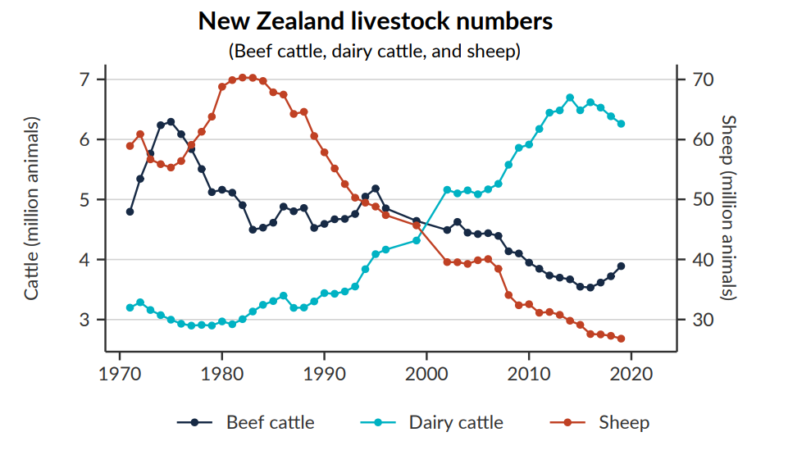

Source: [Our land 2021](https://environment.govt.nz/assets/Publications/our-land-2021.pdf)

This rise in dairy cattle numbers has not been evenly distributed throughout the regions.

In absolute numbers, the regions with the largest increases have been Canterbury, Southland and Waikato (Figure 2 and Figure 4) with more than 2.2 million dairy cattle added to these three regions in total. The regions with the highest percentage change in dairy cattle numbers have been Southland, Canterbury and Otago. Southland had a 1,584 per cent increase in dairy cattle numbers (from 37,800 in 1990) and is now the region with the second highest number of dairy cattle.

Figure 2 Change in the number of dairy cattle between 1990–2019, by region

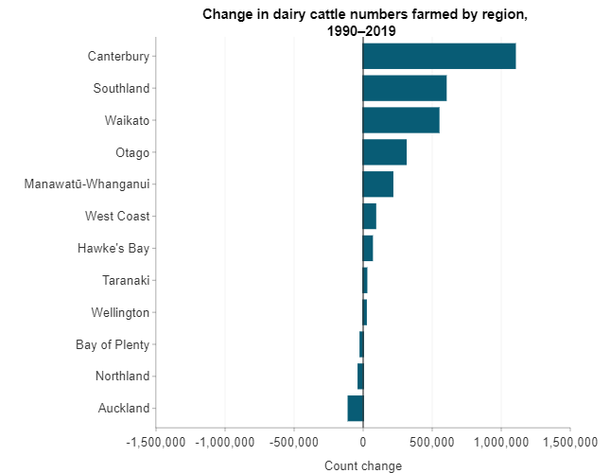

Source: [Livestock numbers](https://www.stats.govt.nz/indicators/livestock-numbers), Stats NZ website

Figure 3 Percentage change in dairy cattle numbers between 1990–2019, per region

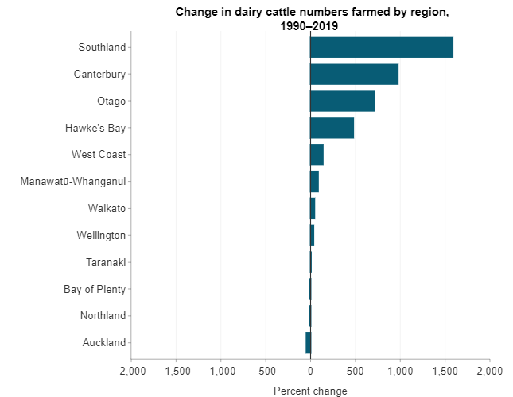

Source: [Livestock numbers](https://www.stats.govt.nz/indicators/livestock-numbers), Stats NZ website

Figure 4. Dairy cattle density (animals per km2) on farms, 1994–2017

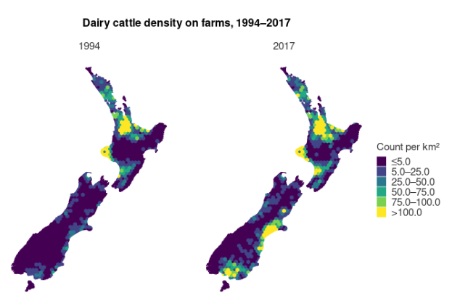

Source: [Livestock numbers](https://www.stats.govt.nz/indicators/livestock-numbers), Stats NZ website

Between 1991 and 2019 estimates from sales data of nitrogen applied as fertilizer increased 629per cent, from 62,000 to 452,000 tonnes (Figure 5). Before 1990 pastoral systems were almost solely reliant on clover to fix nitrogen – hence the start of the data record around this date.

Of the different farm types, farms that were predominantly dairy had the largest amount of nitrogen applied (67 per cent of the New Zealand total).71F[72] Canterbury and Waikato dairy farms had the largest amount of nitrogen applied (53,000 tonnes each). For Canterbury, this was an increase of 306 per cent from 2002 to 2019.

Figure 5: Estimates of fertiliser application to land from sales, 1991–2019

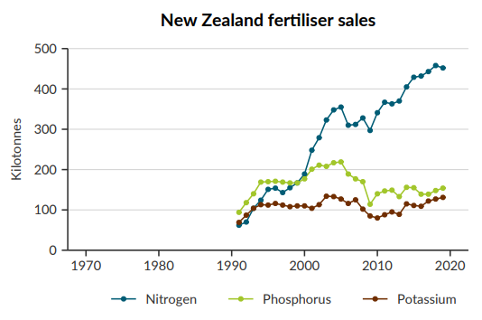

Source: [Our land 2021](https://environment.govt.nz/assets/Publications/our-land-2021.pdf).

## The state and trend of nitrate concentrations in our freshwater sources

### Groundwater

Groundwater state of the environment sites with median concentrations of nitrate-nitrogen greater than half of the drinking water MAV, are distributed throughout most regions in New Zealand (Figure 6). They are particularly numerous in Canterbury, Southland and Waikato. The Canterbury situation is explored in more detail below.

Figure 6: Groundwater state of environment sites, median nitrate-nitrogen concentrations categorised by maximum acceptable value (MAV), 2016–2020

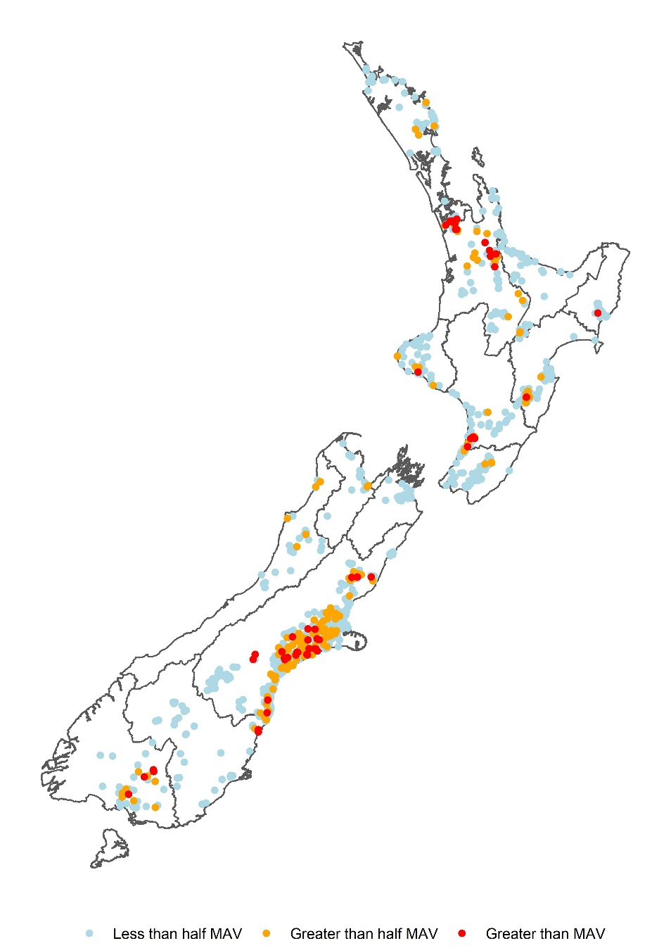

Data source: LAWA

Nitrate concentrations in groundwater are not constant throughout the year. Nitrate levels respond strongly (increasing) to high rainfall events transporting nitrate through the soil. The figures presented here represent average values across the entire year, so would be higher if just looking at the winter season.

For a trend analysis, by the time a particular site’s median nitrate concentration reaches the MAV, half of the observations are greater than the MAV and half are below. Health compliance with the drinking water standard is not based on medians; one exceedance means the drinking water supply has failed and the water cannot be drunk until the monitoring indicates that the nitrate level is below the MAV.

As an ‘early warning’ it can be useful to assess sites at a threshold lower than the MAV – this threshold is often arbitrarily chosen to be half of MAV (Figure 6) and can be a trigger for extra monitoring.

A more precise measure is to assess the percentage of observations at a given site that meet the MAV (Figure 7), or inversely do not meet the MAV. This produces a similar geographic pattern (to bores in excess of the MAV), but the location of sites of concern is more widespread across the country and within regions.

Figure 7: Groundwater state of environment sites, percentage of total samples that exceeded the nitrate maximum acceptable value (MAV), 2014–18

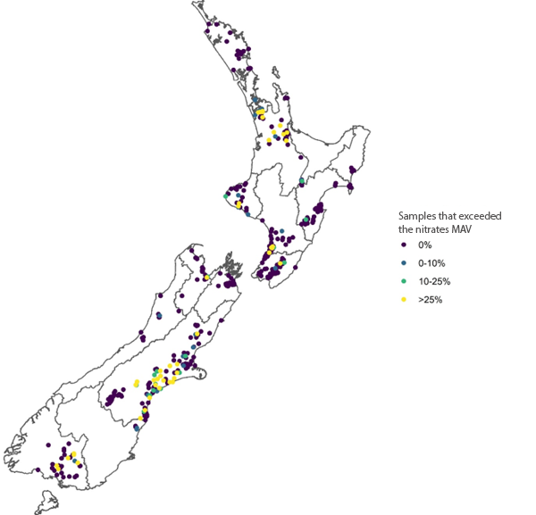

Data source: Stats NZ, regional councils and unitary authorities

Across the country concentrations of nitrate-nitrogen in groundwater have been increasing for the past few decades (Figure 8), with 45.7% of sites increasing and 44.8% of sites decreasing over the last ten years. Hawkes Bay stands out as the region with the highest proportion of increasing trends (75%). Northland on the other hand is the region with the highest proportion of decreasing trends (83%).

Figure 8: Groundwater state of environment sites, nitrate-nitrogen trends, 2011–2020

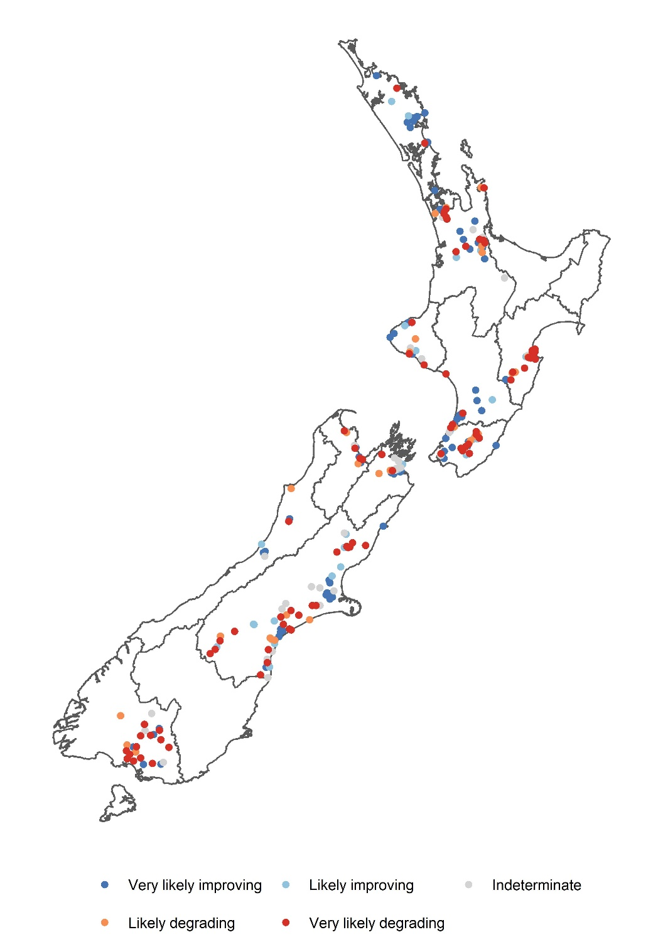

Note: Regions with no sites displayed had insufficient data to calculate robust trends.

Data source: LAWA

#### Future groundwater state – nitrate-nitrogen trend

It would be valuable to estimate future nitrate-nitrogen groundwater concentrations. In the absence of a sophisticated modelling approach, we can adopt a set of assumptions to explore possible scenarios. Below we explored what would happen if current trends continued unabated (Figure 9) ie, if the trends of concentrations we saw over the past 10 years continued 10 or 30 years into the future. This assumption does not require information about changing intensification patterns because it simply looks at current trends (of recorded concentrations) continuing into the future. Care must be taken in relying on these results because various factors will either improve or worsen the recent trends. These factors may include land-use change, climate change, policy interventions (including the implementation of the NPS-FM), non-policy interventions, and adoption of different land-management practices.

It is possible that in 30 years we may see more groundwater sites breaching the drinking water nitrate MAV and the number of these breaches could be greater if the nitrate MAV is lowered. This is mostly attributable to sites which are currently close to the MAV continuing to increase.

Due to long lag times in groundwater, some of these trends are locked in and above-ground interventions will have little effect until they move through the system. In fast moving systems this could be as quick as 5 years, and in slow moving systems this could be 80 years.

Figure 9. Groundwater state of environment sites – forecasted nitrate-nitrogen trends, assuming current trends of concentrations continue unchanged.

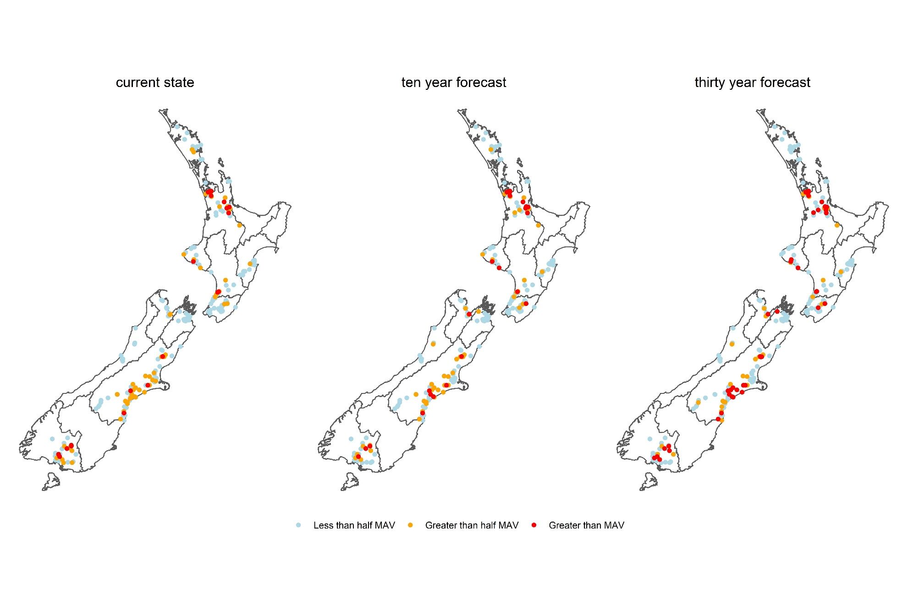

Data source: Ministry for the Environment analysis of LAWA data

### Rivers

In contrast to groundwater (where denitrification processes are not as strong), riverine concentrations of nitrate are generally low relative to the drinking water MAV (Figure 10), although isolated hotspots do occur where surface water reaches MAV or close to MAV. Surface water nitrate hotspots are often associated with groundwater re-emerging as springs.

Figure 10: River state of environment sites, median nitrate-nitrogen concentrations categorised by maximum acceptable value (MAV), 2016–20

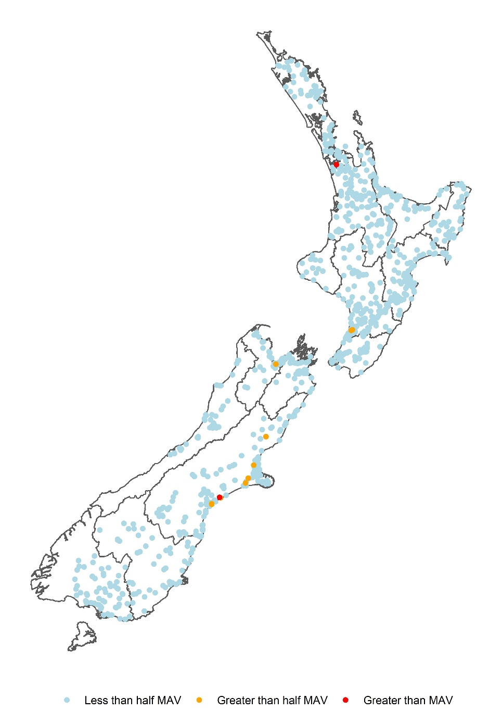

Note: Auckland, Waikato and Bay of Plenty are displayed using total oxidised nitrogen (nitrite-nitrogen + nitrate-nitrogen) as a proxy for nitrate-nitrogen because nitrate-nitrogen was not available for these regions. The nitrite-nitrogen component of total oxidised nitrogen is relatively low by weight, so this is a reasonable proxy. And even when considering the extra contribution of nitrite, compliance is still high.

Data source: LAWA

Concentrations of nitrogen in rivers and streams have also been increasing for the past few decades at least (Figure 11), with 44.5% of sites increasing and 41.9% of sites decreasing over the last ten years. On a regional basis Gisborne stands out as the region with the highest proportion of increasing trends (91%). Wellington, on the other hand, is the region with the highest proportion of decreasing trends (53.5%).

Figure 11: River state of environment sites, nitrate-nitrogen trends, 2012–21.

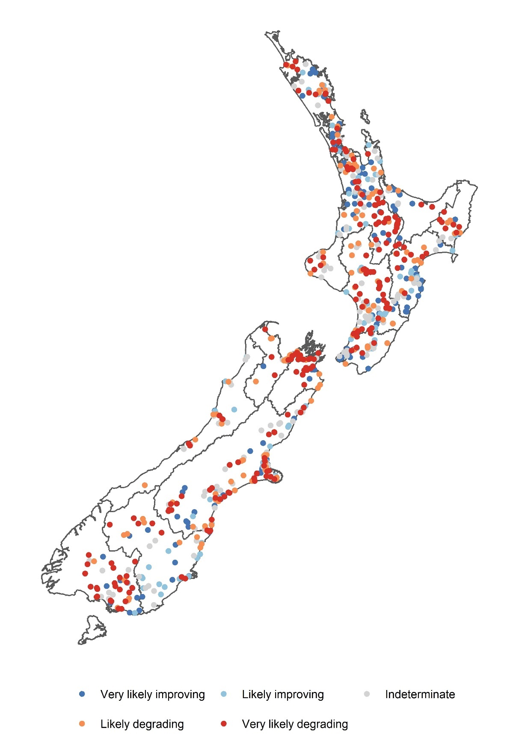

Note: Where nitrate-nitrogen was not available, total oxidised nitrogen (nitrite-nitrogen + nitrate-nitrogen) was substituted as a proxy.

Data source: LAWA

#### Future river state – nitrate-nitrogen trend

Although many rivers and streams across the country are increasing in respect of nitrate, their relatively lower starting concentration means that there are limited areas likely to breach the drinking water nitrate MAV. Using information about potential future concentrations of nitrate in rivers (Figure 12), we estimated that a few more sites will breach the drinking water nitrate MAV in the future, as the rate of change is relatively slow.

These predictions suffer the same caveats as highlighted above in the groundwater section, that is, it relies on the assumption that current trends continued unabated. This assumption could be incorrect in either direction; interventions could slow the increasing of nitrate concentrations and flip them to improving, or nitrogen polluting activities could continue, and these trends get worse even more rapidly.

The NPS-FM requires councils to maintain or improve current surface water quality (to at least the national bottom line of 2.4mg NO3-N/L).

Figure 12. River state of environment sites forecasted nitrate-nitrogen trends, assuming current trends continue unchanged

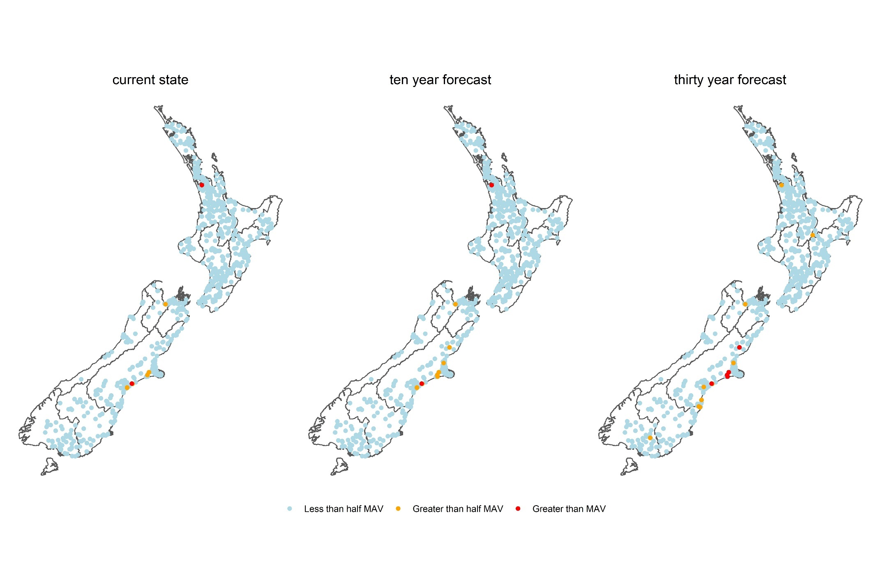

Data source: Ministry for the Environment analysis of LAWA data

## 

## Canterbury specific data

### Current state of nitrate-nitrogen in groundwater

Figure 13 summarises the nitrate-nitrogen concentrations found in the 2021 groundwater quality survey by Canterbury Water Management Strategy zone.72F[73] Note that this data is for all groundwater SOE bores, not only drinking water sources. Areas around and downstream of intensive agricultural land use tended to have higher nitrate-nitrogen concentrations in the groundwater than other areas.

The Ashburton zone, followed by Hurunui-Waiau, Selwyn-Waihora, Ōrari-Temuka-Ōpihi-Pareora, and Lower Waitaki – South Coastal Canterbury zones had the greatest number of bores which recorded an exceedance of the nitrates MAV.

**Not all of these bores are used as a source of drinking water**. However, in the absence of more specific data, this SOE data provides a realistic approximation of the water quality in source water bores.

Figure 13: Summary of nitrate-nitrogen concentrations sampled in the 2021 annual survey for each Canterbury Water Management Strategy (CWMS) zone

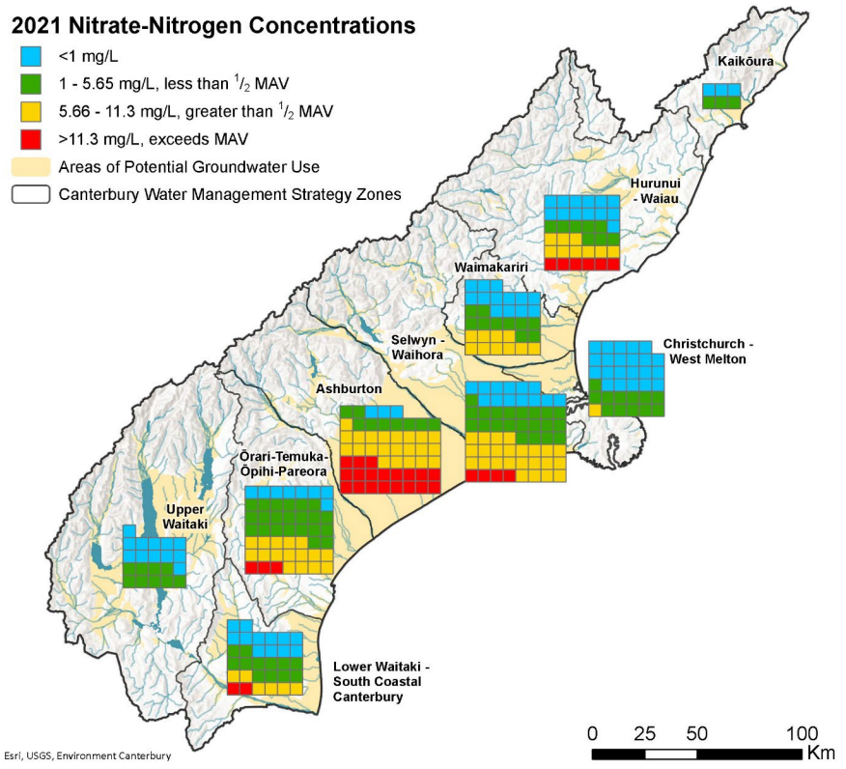

Note: One square represents one well

Data source: ECan

In the 2021 annual survey of CWMS bores it was found that:73F[74]

* the samples from 99 wells (30 per cent of the wells sampled) had nitrate-nitrogen concentrations below 1 mg/L (*shown by blue squares*)
* the samples from 106 (32 per cent) wells had nitrate-nitrogen concentrations greater than or equal to 1 mg/L but less than half of the MAV (*5.65 mg/L; shown by green squares*)
* the samples from 88 (27 per cent) wells had nitrate-nitrogen concentrations above half of the MAV (5.65 mg/L) but less than or equal to the MAV (*11.3 mg/L; shown by yellow squares*)
* the samples from 34 (10 per cent) wells had nitrate-nitrogen concentrations above the MAV (*> 11.3 mg/L; shown by red squares*).

In general, nitrate-nitrogen concentrations tended to decrease with depth when samples were compared from different depths at a given location. At a regional scale, this pattern becomes less clear.

## Case studies

|  |
| --- |
| Lower Waihao rural drinking water supply  On 10 August 2022, Waimate District Council advised residents of the Lower Waihao Rural (including Waikakahi East) Water Scheme that nitrate concentrations had been rising and then exceeded the drinking water MAV by 1.3mg/L at 51.3mg/L of NO3-N. They attributed this to a recent period of high rainfall and environmental factors. The scheme draws water from a shallow bore next to the Waitaki River, in an area of intensive farming, where nitrate concentrations had been increasing over the past 20–30 years.  Aside from warning residents of the risks of drinking high nitrate water, the council also installed water tanks at various locations to supply emergency drinking water. It is expected the 600 residents will be filling water bottles from these tanks until May or June 2023.  Waimate District Council intends to build a denitrification plant to address the increased nitrate concentrations. This plant “will take many months to finalise design, build and get required consents”. The nearby Selwyn district estimated that building a small denitrification plant could cost $6.31m plus operating costs of $360,000 per year. The plant would produce waste brine that would be difficult to dispose of safely.  There are a lot of permitted private bores in this region. |

|  |
| --- |
| Pareora township drinking water supply  The township of Pareora is 14 km south of Timaru.  Testing of the raw water for Pareora township by Timaru District Council on the 8 September 2022 showed the nitrate level was 62 (the MAV value is 50).  Timaru District Council advised all residents that their water is not safe to be used for drinking water, and is of particular risk to pregnant women, young children (eg., including bottle-fed infants) and immune-compromised persons. Residents were advised to use the tanker water for drinking until further notice, this includes pets. They were advised that boiling the water will not remove high levels of nitrates.  The Pareora township water supply had not experienced high nitrate levels before and attributed the elevated levels to recent extreme wet weather events. The previous heavy rainfall likely flushed nitrate from land and soils into the groundwater.  The expectations were that follow up tests will show reduced levels of nitrate.  Water was diverted from the Downlands water scheme to dilute the nitrate levels at Pareora to below the nitrate MAV. The population of Pareora is too large to use Downlands as a sole source of water.  The results of nitrate testing on 20 September 2022 showed that the water being supplied to Pareora township customers is within the Drinking Water Standards, so it is now suitable for drinking once again. |

|  |
| --- |
| Farm worker hypothetical – *where the worker lives in separate accommodation on the farm that is supplied water from the farm rather than reticulated water*  Water suppliers (if they are not a domestic self-supply situation) have a duty to provide safe drinking water which complies with the standards in the Water Services (Drinking Water Standards for New Zealand) Regulations 2022.  The date which water suppliers need to register varies; suppliers previously registered with Ministry of Health have been automatically transferred over to the Taumata Arowai register and must comply with all the new regulatory requirements. Suppliers who were unregistered will need to register by November 2025 and fully comply with the requirements of the Water Services Act by November 2028. Domestic self-suppliers do not fall within the water services regulatory regime.  The Water Services Act 2021 requires that a drinking water supplier must ensure that the drinking water they supply is safe74F[75], and requires that a drinking water supplier must ensure that drinking water they supply complies with the drinking water standards75F[76]. If either of these requirements are not met, or there is a reasonable likelihood they are not met, the water supplier must take immediate action to ensure public health (ie, the farm worker’s health) is protected, notify Taumata Arowai of the non-compliance, investigate the cause of non-compliance, and take actions to rectify the situation now and in the future.  In addition, water suppliers must, subject to some limitations, have a drinking water safety plan based on their circumstances. If nitrates in the source water is a possible risk, then the risk and how the water supplier will mitigate this risk should be part of this plan.  The requirement on the water supplier to monitor and report nitrate concentrations in source water depends on the size of the drinking water supply. The Drinking Water Quality Assurance Rules 2022 do not require water supplies that are ‘very small communities’ (up to 25 people) to monitor for nitrate but supplies larger than 25 people have a requirement to monitor for nitrate and report this at various frequencies ranging from every month to every three years (depending on their size, risk, and previous monitoring results).  So where does that leave a farm worker who was concerned about the concentrations of nitrate in their drinking water, whose employer supplied less than 25 people (but is more than a domestic self-supply situation), and thus did not have to monitor for nitrate? The primary obligation on the drinking water supplier is to ‘ensure’ that the drinking water supplied is safe. This positive obligation may require the supplier to undertake more testing than is required by the Drinking Water Quality Assurance Rules 2022. If there is a ‘reasonable likelihood’ that a supplier’s drinking water is, or may be, unsafe, the supplier must take immediate action to ensure that public health is protected. This obligation could be triggered by high nitrate levels in adjacent farms rather than actual testing of the source water on the farm.  The website of Taumata Arowai has a section where consumers who are concerned about their drinking water can register their concerns. |

### Long-term trend of nitrate-nitrogen in groundwater (2012–21)

Environment Canterbury conducts a statistical analysis each year to look for long-term trends in nitrate-nitrogen concentrations.

Figure 14: Ten-year trends (2012–21) in nitrate-nitrogen concentrations in annual survey wells

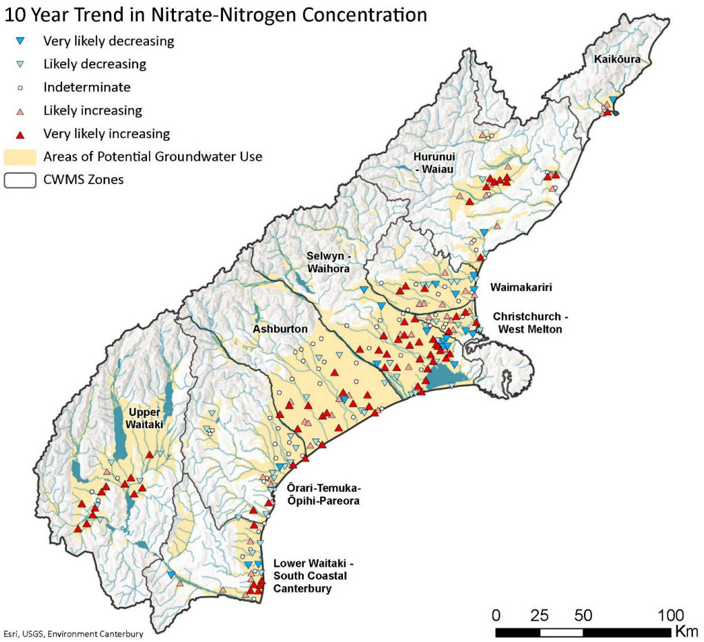

Data source: ECan

From the 2012 to 2021 annual surveys, it was found that:

* 264 of the 327 wells sampled in 2021 had enough data to analyse trends (at least 8 samples from each well over the past 10 years)
* 79 wells (30 per cent) showed ‘very likely increasing’ trends in nitrate-nitrogen concentrations
* 44 wells (17 per cent) showed ‘likely increasing’ trends in nitrate-nitrogen concentrations
* 47 wells (18 per cent) showed ‘likely decreasing’ trends in nitrate-nitrogen concentrations
* 23 wells (9 per cent) showed ‘very likely decreasing’ nitrate-nitrogen concentration trends
* 71 wells (27 per cent) had no decreasing or increasing trend in nitrate-nitrogen concentrations.

These trends results indicate that a greater number of sites can be established with certainty to be worsening (47 per cent) than sites which are improving (27 per cent ).

### Ashburton zone

Nitrate-nitrogen concentrations in groundwater across most of the Ashburton-Hinds Plain are unnaturally high and almost certainly reflect contamination from human activities specifically diffuse leaching from agricultural sources rather than point source discharges.

Concentrations in Ashburton-Hinds Plains are comparable across most of the Canterbury Plains, but the area surrounding Tinwald is relatively high even compared to the rest of Canterbury.

Extensive areas of groundwater with nitrate-nitrogen concentrations above the drinking water MAV have been recorded elsewhere in Canterbury. Among these are the area between the Ashburton River/Hakatere and the Rakaia River (Abraham and Hanson, 2004; Hayward and Hanson, 2004), and the area between the Rangitata River and the Orari River (Hanson, 2002; unpublished Environment Canterbury data).

### Te Rūnanga o Ngāi Tahu

Given the Canterbury focus of this report we shared a draft copy and invited comment from Te Rūnanga o Ngāi Tahu (Te Rūnanga). Te Rūnanga noted that Ngāi Tahu communities are disproportionately affected, as a number of papakāinga are located within high-risk areas for elevated nitrate concentrations, particularly in Canterbury. They also noted that freshwater is a taonga woven into the identity, history and customary practices of Ngāi Tahu.

Te Rūnanga raised some concerns with the report which covered technical aspects of nitrate contamination and provided valuable understanding of te ao Māori. Te Rūnanga expressed the view that the scope of this report was too narrow and risks to human health should be expanded to include the full range of environmental, social, cultural, health and economic outcomes that support hauora. They would also like to see an analysis of the populations most likely to be affected by nitrate contamination both now and in the future.

This report has since been refined to reflect or incorporate the views and feedback that Te Rūnanga has shared.

## Unregistered drinking water supplies

There is no historic specific monitoring data to determine the exposure to nitrates in unregistered drinking water supplies. This leads to a significant limitation in our ability to estimate the scale of the issue. Unregistered drinking water supplies were historically not required to monitor or report on their water quality.76F[77]

However, multiple lines of evidence (SOE monitoring, adhoc private bore testing) lead us to believe that nitrate concentrations in unregistered supplies are higher than that in registered supplies both in terms of concentrations, and the proportion of sites with concentrations higher than MAV. Up to 10 per cent of unregistered supplies probably have median concentrations in excess of the nitrates MAV.

## Public health data

The public health impact of nitrates in drinking water is currently rare in New Zealand. During 2012–21, there were 476 hospitalisations of which two were due to methaemoglobinaemia and rest due to cyanosis77F[78] as the presenting symptom among those aged six months and younger. There was an average of 87 hospitalisations (primarily cyanosis) per year nationally and 2.9 hospitalisations per District Health Board per year.

This preliminary analysis is based on discharge data from the National Minimum Dataset and National Health Index Register and contains the following limitations:

* nearly all hospitalisations in the analysis were related to cyanosis, which is a symptom of a broad range of conditions, such as heart failure, pneumonia, and asthma, rather than methaemoglobinaemia alone
* the analysis only captures severe cases of cyanosis as only hospitalisation data was used rather than data from primary care, emergency department presentations, treatment dispensing, and calls to the National Poisons Centre
* it is not possible to determine whether hospitalisations for methaemoglobinaemia and cyanosis were caused by nitrates (food or drinking water) or other factors.

Diagnoses that referred to congenital and genetic issues were excluded from the analysis.

# Chapter three – What’s already underway or planned?

This chapter explores work to reduce the risks associated with nitrate in drinking water. This includes actions to:

* decrease nitrate contamination in source water at a national level through the RMA, NPS-FM, Freshwater NES, and NES-DW
* decrease nitrate contamination in source water in Canterbury through the Canterbury regional Land and Water Plan
* improve national monitoring of nitrate levels in source water for drinking water under the Water Services Act 2021
* actively monitor, review, and support research into public health impacts of nitrates in drinking water.

## Policies and other measures already in place

### National – NPS-FM, Freshwater NES, NES-DW

Under the RMA, regional councils are tasked with managing water quality. In addition to requirements under the RMA, the Government has national direction instruments which are aimed at improving water quality, such as the National Policy Statement for Freshwater Management (NPS-FM), National Environmental Standards for Freshwater (NES-F) and the National Environmental Standards for Sources of Human Drinking Water (NES-DW).

**NPS-FM** – Nutrients are managed under the NPS-FM in the following ways:

* the nitrate (toxicity) national bottom line of 2.4 mg/L NO3-N applies in rivers
* the total nitrogen national bottom lines of 0.75 or 0.8 mg/L apply in lakes
* the requirement to at least maintain current attribute state wherever it is better than national bottom lines
* the requirement on councils (Policy 3.13 and related policies) to set limits on resource use to reduce dissolved inorganic nitrogen concentrations, to the point that they achieve:
* target attribute states for periphyton,78F[79] at a minimum of the national bottom line, or current state if better
* target attribute states for macroinvertebrates,79F[80] at a minimum of the national bottom lines, or current state if better
* target states for any other attribute affected by nitrogen (at a minimum of the national bottom lines, or current state if better), including dissolved oxygen, submerged plants, fish, and ecosystem metabolism
* objectives for downstream receiving environments (eg, estuaries) sensitive to nitrogen.

**NES-F** – sets requirements for carrying out certain activities that pose risks to freshwater and freshwater ecosystems. A number of these policies were aimed, either in full or in part, at reducing nitrogen levels in waterways:

* limiting the discharge of synthetic nitrogen fertiliser to land, and requiring reporting of fertiliser use by dairy farmers
* restricting further agricultural intensification until the end of 2024
* setting minimum requirements for feedlots and other stockholding areas
* improving poor practice intensive winter grazing of forage crops.

**NES-DW** – sets requirements for councils to protect sources of human drinking water from becoming contaminated. These regulations complement the Drinking Water Standards and source water protection is the first barrier in the multi-barrier approach to drinking water.80F[81]

Work is underway to strengthen the existing NES-DW. The proposed changes would support the reduction of nitrates in drinking water by helping councils, resource users and water suppliers to better understand and manage activities that pose risks to source water. The NES-DW will also retain the current requirement that councils must manage activities to ensure there is no breach of the nitrate levels as set out in the NZ Drinking-water Standards 2022.

#### Other work that relates to nitrate management

Management of nitrates for ecosystem health limits is likely to have co-benefits for public health, because the ecosystem health limits are much lower (eg, nitrate toxicity limit of 2.4 mg/L) than the current drinking water nitrate MAV. However, groundwater would only need to be directly managed to these lower levels where it re-emerges as springs. This is because there are no current ecosystem health limits for groundwaters, which requires further scientific understanding.

The Ministry for the Environment has an ongoing programme of work to support councils’ implementation of the NPS-FM. This policy reform is likely to materially decrease the concentrations of nitrates in sources of human drinking water; however, the timeframes will be long (perhaps a generation) and the situation will deteriorate in some places before it gets better.

### Regional – Canterbury Land and Water Regional Plan

Environment Canterbury is responsible for managing their region’s water and the Canterbury Water Management Strategy (2009) provides a collaborative framework to manage the multiple demands on this resource though a zoned approach.

The Canterbury Water Management Strategy (CWMS) recognises, in relation to nitrates, that water quality is an important component of freshwater ecosystems and for its human and stock uses. In terms of land management, the CWMS recognises that:

* diffuse discharges of nitrates and other contaminants are highly dependent on water and land management practices and land use
* one of the prime concerns with land-use intensification is the potential for water quality impairment, in particular, nitrate contamination of surface water and groundwater. Water quality is an important component of freshwater
* nitrate concentrations in leachate can be significantly reduced by good pasture, irrigation, fertiliser and stock management practices while maintaining above average production
* addressing irrigation efficiency at property-scale also provides the opportunity to improve the design and management of farm irrigation systems, thus reducing the total amount of nutrient leaching into groundwater. Reduction of nitrate discharge by improving existing practices has the most effect on the availability of safe drinking water from shallow groundwater.

The CWMS also included targets81F[82] for source water quality and catchment nutrient targets that were not achieved.

* the CWMS did not achieve a source water quality target which included a 2020 goal that there is a demonstrable decrease in nitrate concentrations in shallow groundwater in priority areas. Nitrate concentrations are increasing in many wells in Canterbury, including in high-risk areas like Seadown, northeast Ashburton, Tinwald, and the lower Hekeao / Hinds plains. Environment Canterbury’s 2020 Groundwater Survey shows no demonstrable decrease in nitrate concentrations, in fact, nitrate concentrations are more likely to be increasing in most of these areas.
* the CWMS also did not achieve catchment nutrient loads targets which included a 2020 goal of achieved nutrient efficiency targets for the zone on all new irrigated land and 80 per cent of other land in major rural land uses (pasture, major arable and major horticulture crops), and have 100 per cent of rural properties working towards those targets (and of properties within urban boundaries that apply nutrients over significant areas).82F[83]

## Recent policy changes

### Te Mana o te Wai in the NPS-FM

Te Mana o te Wai is a holistic concept for freshwater management in the NPS-FM. It refers to the vital importance of the water and imposes a hierarchy of obligations for freshwater management. This hierarchy means prioritising:

* first, the health and well-being of the water
* secondly the health needs of people such as drinking water
* lastly, the ability of people and communities to provide for their social, economic, and cultural wellbeing.

Te Mana o te Wai can, if implemented correctly, help reduce the public health impacts of nitrates in drinking water. This is because the nitrate limit to protect the health and wellbeing of the water is prioritised and is much lower than the current MAV for drinking water. Unlike the Water Services Act 2021 and NES-DW, this would benefit all water supplies – not just larger registered ones.

A requirement of the Water Services Act 2021 is for Taumata Arowai to give effect to Te Mana o te Wai, to the extent it applies to the functions and duties of Taumata Arowai.

Te Mana o te Wai was first included in the NPS-FM in 2014, and further refined and strengthened in subsequent versions in 2017 and 2020. Te Mana o te Wai must now inform how the NPS-FM is implemented. It provides national direction for councils to translate into action on the ground through their regional or district plans. Through engagement and discussion, regional councils, communities and tangata whenua will determine how Te Mana o te Wai is applied locally in freshwater management.

The six principles that inform the implementation of Te Mana o te Wai in the NPS-FM are:

* mana whakahaere: the power, authority, and obligations of tangata whenua to make decisions that maintain, protect, and sustain the health and well-being of, and their relationship with, freshwater
* kaitiakitanga: the obligation of tangata whenua to preserve, restore, enhance, and sustainably use freshwater for the benefit of present and future generations
* manaakitanga: the process by which tangata whenua show respect, generosity, and care for freshwater and for others
* governance: the responsibility of those with authority for making decisions about freshwater to do so in a way that prioritises the health and well-being of freshwater now and into the future
* stewardship: the obligation of all New Zealanders to manage freshwater in a way that ensures it sustains present and future generations
* care and respect: the responsibility of all New Zealanders to care for freshwater in providing for the health of the nation.

The strengthening of the principles in the NPS-FM provides a framework of priorities when considering the impact of nitrate through a whole of system approach.

Te Mana o te Wai connects different regulatory regimes (RMA and Water Services Act 2021) through a common vision and set of principles.

### Regional plans to give effect to NPS-FM 2020

Regional councils are currently reviewing their regional plans and establishing what changes are needed to give effect to the NPS-FM. This includes new requirements for wetlands, setting environmental outcomes, targeting attribute states and limits under the National Objectives Framework, and establishing monitoring programmes. They will have to engage with communities and tangata whenua to determine how Te Mana o te Wai applies to freshwater in their region and based on this engagement, develop long-term visions for freshwater in their regions.

By 31 December 2024, councils will have to notify changes to regional policy statements, regional plans, and district plans to give effect to the new NPS-FM 2020. Changes to regional policy statements and plans will be progressed using the freshwater planning process in subpart 4 of the Resource Management Act 1991.

Giving effect to the NPS-FM will provide direct and indirect improvements to the levels of nitrates in drinking water. Unlike the Water Services Act 2021 (and NES-DW, with a focus on drinking water) these changes could benefit all water supplies – not just larger registered ones.

### Improvements in monitoring and reporting of nitrate levels

In New Zealand, there was limited monitoring of nitrates in drinking water before the Water Services Act 2021’s regime began on 14 November 2022. Routine monitoring is not required if nitrate levels in a water supply are below 25 milligrams per litre, which is half of the MAV for nitrates.

Some district councils have proactively increased the frequency and scale of monitoring of drinking water supplies in their areas,83F[84] above and beyond what legislation requires. This was partly in response to concerns from their communities about the uncertainty of health effects from nitrates. As nitrate monitoring is relatively cheap, this is a positive and proactive step to reassuring their communities and being able to detect increasing trends early.

Nitrate testing has also been made available to domestic self-suppliers who are concerned about their water quality, or who live in high nitrate risk zones.84F[85] This service has been provided by both district councils and interest groups. This helps consumers with cost or information barriers to make an informed decision about the safety of their suppliers.

GNS Science has recently launched the NitrateWatch initiative to help “communities look after their drinking water by offering a free, confidential testing service to measure nitrate levels in drinking water”85F[86] The programme has been funded by the Ministry for Business, Innovation and Employment’s Strategic Science Investment Fund from July 2022 to June 2025 and will also generate a geospatial database of nitrate concentrations.

### Water Services Act 2021

Under the Water Services Act 2021, a comprehensive registration, monitoring and reporting regime by water suppliers under the Water Services Act 2021 (excluding domestic self-supply) of the determinands in drinking water, including nitrates, is being implemented.

Under the Health Act 1956, monitoring of nitrates was limited. These limitations and the situation under the Water Services Act 2021 are listed below.

* Monitoring was limited to situations where a registered water supply had previously recorded concentrations in drinking water greater than half of MAV. Due to the variability of nitrate concentrations (eg, fluctuations during the year or after heavy rainfall) this monitoring regime could have been under representative of situations where the supply is generally below half of MAV in drinking water and then it fluctuates to temporarily be greater than MAV for events like excessive rainfall.

*The new regulatory regime under the Water Services Act 2021 requires regular monitoring by registered water suppliers of nitrates in source water with testing by an accredited laboratory. More frequent monitoring is required if nitrate levels in source water increase above a certain level*.86F[87]

* There were no obligations to report results of the monitoring to the monitoring agency.

*The new regulatory regime under the Water Services Act 2021 requires regular reporting of testing results for drinking water, but not source water, by both the water supplier and the testing laboratory to the monitoring agency.*

* Only large drinking water suppliers (more than 100 consumers) were monitored and included in their annual reporting.

*The new regulatory regime under the Water Services Act 2021 will register an estimated extra 75,000 water suppliers who were unregistered in the previous regulatory regime. These new water suppliers will transition into the new regime over the next three years.*

* There was no monitoring of self-suppliers.87F[88]

*The new regulatory regime under the Water Services Act 2021 does not monitor or regulate domestic self-supply.*

* Under the Health Act 1956,88F[89] a Medical Officer of Health could require a territorial authority or regional council to investigate source water contamination (including for excess levels of nitrate).

*The power of a Medical Officer of Health to require a territorial authority or regional council to investigate source water contamination was repealed and there is no similar power in the Water Services Act 2021. This has resulted in a regulatory gap around who monitors, and who can subsequently act, in relation to domestic self-supply source water contamination issues (including excess nitrate).*

Increased monitoring, after the Water Services Act 2021 is fully transitioned, including monitoring of co-variates such as microbiological contamination, will allow for better designed research to detect health impacts of drinking water contamination.89F[90] This is in line with the recommendation from the Liggins report to increase monitoring and reporting of nitrates in drinking water.

## Monitoring and supporting research into the public health impacts of nitrates in drinking water

The Health Research Council (HRC) is the Government’s principal funder of health research. And considers the views of the Minister of Health and the Ministry of Health in commissioning specific research.

With the reformed health system, it is anticipated that the Ministry of Health and the HRC will work to identify greater opportunities for alignment between the Ministry of Health’s system priorities and HRC’s funding opportunities.

However, the Ministry of Health can encourage and support research by signalling areas of interest and providing researchers with information and advice as appropriate. Recently, the Ministry of Health supported a successful application for HRC funding ($1.2 million) by a University of Otago research team which will focus on investigating whether there is an association between nitrates in drinking water and pre-term births.

The study is expected to take three years to complete and will involve mapping pregnant people’s exposure to nitrates during pregnancy to determine if there are any links to premature births. This will require creating a drinking water database that contains information from 57 local councils and mapping this against 700,000 births over 15 years to measure nitrate exposure levels.

The Ministry of Health supported this application by providing data on drinking-water supplies and advising on earlier drafts of the funding application. Ministry of Health staff are listed as advisors in the application and will provide advice during the research.

The Ministry for the Environment is providing in-kind support to the project team by contributing environmental modelling expertise and facilitating access to national land-use pressure geospatial datasets.

# Chapter four – What do we need to do more of? What else can we consider?

This chapter outlines methods that can be used to reduce nitrate concentrations in drinking water such as nitrate leaching mitigations, treatment and dilution of nitrates in water supplies, and seeking alternative water supplies.

This chapter also summarises that nitrates in ground and surface water are increasing in some areas despite existing national nitrate reduction policies and the Canterbury Land and Water Regional Plan. This could either be because existing policies are not stringent or ambitious enough, or because lag times prevent monitoring data from showing a demonstrable effect. We are also limited in available data, and the ability to analyse complex scenarios to demonstrate an effect.

## Methods to reduce nitrate concentrations

### Nitrate leaching mitigations

Overseer is a NZ-developed software tool that models the nutrient flows onto and off farms and farm blocks.90F[91] It aims to provide a quantitative description of farm nutrient dynamics for a range of farm system types. It combines data on farm management, topography, soil and climate.

Overseer, and its predecessors, have been used for 30 years by many New Zealand firms, farmers and consultants to estimate nutrient budgets and understand how nutrients are cycled on-farm. Recently, it has been used by a number of regional councils for regulatory purposes as part of their plans and consent processes to manage nutrient loss to rivers and groundwater.

In 2021, a government appointed independent Science Advisory Panel identified shortcomings with the current version of Overseer software and concluded that it did not have confidence in its ability to estimate nitrogen lost from farms in its current form.91F[92]

Part of the Government’s response to the findings of the report was to announce that it will help develop improved tools to manage and estimate total on-farm nutrient loss.92F[93] These tools will help farmers and regulators to meet future Essential Freshwater planning requirements set out in [Essential Freshwater: Healthy Water, Fairly Allocated](https://environment.govt.nz/assets/Publications/Files/essential-freshwater.pdf).93F[94]

This work is currently underway and has found several mitigations that farmers could apply to reduce their nitrate leaching. These mitigations include riparian management, restoring or constructing wetlands, detainment bunds, denitrification walls, catch cropping, direct drilling, changing stock type and density, genetic improvement, variable rate precision irrigation, precision fertiliser application and more.

#### Treatment of nitrates in water supplies

Nitrate removal from source water in drinking water supplies in New Zealand is uncommon.

Internationally, the three most viable options for nitrate removal from drinking source water are reverse osmosis, ion exchange and biological denitrification. These methods are not without their own risks.

Some treatment processes require large amounts of energy, create a large volume of waste brine (typically 0.5 per cent of the treated water volume, which needs to be discharged to a sewer or treated further to be discharged elsewhere), or produce incomplete denitrification. All treatment processes have limitations to their effectiveness and very high concentrations of nitrates in raw source water may not be able to be removed.

Beca Group Limited, on behalf of Selwyn District Council, estimated construction costs to build denitrification water treatment plants ranging from $19.5m for a large plant, $10.4m for a medium plant, and $6.31m for a small plant. Annual operating costs would range from $2.5m a year for a large plant to $360,000 for a small scheme. If all of Selwyn’s water treatment plants were upgraded to treat nitrates “retrofit costs could be in the order of $322m”.

WSP (NZ) Limited, on behalf of Christchurch City Council, estimated costs to reduce nitrate concentrations in Christchurch drinking water from 7.9mg/L NO3-N to meet three different target levels (5.65, 3.8, and 1mg/L).94F[95] If the initial concentration was higher than 7.9mg/L then a two-stage treatment process may be required which would increase costs further. They assessed ion exchange as the most cost-effective and practicable method.

Table 6. Estimated costs of denitrification treatment in Christchurch

| Target NO3-N concentration (from initial 7.9mg/L) | Capital cost | Annual operating cost |
| --- | --- | --- |
| 5.65 mg/L | $347m | $13m |
| 3.8 mg/L | $461m | $18m |
| 1 mg/L | $610m | $24m |

Household under bench treatment options range from $650 – $1500 per unit. Maintenance costs are approximately $150 for filters annually and $150 every three years for membrane replacement.95F[96]

#### Dilution

For some supplies, it may be an option to dilute higher nitrate water with water from another low nitrate source. The scenario this could happen is if a groundwater supply (with high nitrate) was located sufficiently close to a surface water source (which generally have low nitrate) which could be blended to reduce the overall concentration.96F[97]

This option would generally be cheaper and have a lower environmental impact than many treatment options. However, it relies on there being a sufficient allocation of low nitrate water available. It also doesn’t solve the problem of high nitrates in the long term. If concentrations were to continue to increase, an ever-greater quantity of low nitrate water would be needed for dilution.

#### Seeking alternative water supplies

For some suppliers, especially smaller ones which is likely to include unregistered domestic self-supply sites, it may not be economically viable or efficient to reduce nitrate leaching, treat nitrates, or dilute. If these supplies sustain nitrate concentrations above the drinking water MAV, they will face the option of shutting down or sourcing an alternative supply.

In some situations, they may be able to connect to an existing reticulated supply, and often this is a natural progression as urban growth enables development of reticulated networks. However, in other situations they may have to seek another river, stream or lake to abstract water from or use alternatives such as rainwater or tank delivered water (or a mix of supply options). The feasibility of this is very context dependant.

For groundwater supplies, it may be an option to drill the bore deeper to access less impacted groundwater – this could be expensive on a small scale and if nitrate trends are increasing in the aquifer generally, it may not be a long-term solution as the deeper water may breach the drinking MAV in the future.

#### Other options

Other options for nitrate removal can include engineered wetlands. These options require that the appropriate land is available.

## Situational outlook

### Will things get worse before they get better?

Nitrate concentrations in rivers across the country are generally not in excess of the drinking water nitrates MAV based on the monitoring sites used for SOE purposes. But the result may be different looking at just drinking source water sites. There are likely to be local hotspots of surface water nitrate contamination present in many regions, especially for small spring fed streams or other surface water bodies which are hydraulically connected to groundwaters.97F[98]

A large number of river water sites across the country are increasing with respect of nitrates, so the situation could get worse. The sites with concentrations close to the drinking water nitrate MAV and rapidly increasing trends are the sites of greatest concern.

However, if action is taken to reduce nitrate leaching on land, the results of reducing in-stream concentrations will show up relatively quickly (at least for rivers, compared with groundwater). Research indicates that the lag time between farm management decisions to reduce nitrogen loss and the resulting improvement in river health take on average 4.5 years to show up.98F[99] Lag times varied between 1–12 years, with water in larger rivers and more steeply sloped catchments taking longer to reflect upstream land management changes. This is a positive aspect of surface water management compared to groundwater management.

In groundwater, the overall situation is worse in some regions. Many sites have nitrate concentrations in excess of the drinking water nitrate MAV and some of these are continuing to increase every year.

Even more concerning is that the concentrations in groundwater reflect a legacy of past land uses (ranging in time from a few years to a few decades) so these long lag times mean groundwater concentrations will continue to increase into the future. For example, most of Southland’s shallow groundwater is expected to show some response to a change in farming practices within five years,99F[100] whereas in some areas of the Waikato catchment, deep groundwater could have an average travel time of 50 – 80 years.100F[101]

### Are existing policies or initiatives strong enough?

#### Trends are not reversing, but interventions take time to show

Although some nitrate reduction policies are implemented and operational, and some others are operational but are not yet fully implemented, trends continue to worsen with respect to nitrates in both ground and surface waters.

These trends have been persistent over the past few decades, and there is little evidence of the situation getting better. This could either be because existing policies are not stringent or ambitious enough or not properly implemented, or because lag times prevent monitoring data from showing a demonstrable effect. Lag times work both ways. There may be a contaminant load ‘still to come, or improved management may not have worked its way through the system. It is likely that both these options influence observed nitrate concentrations.

The NPS-FM 2020 and NES-F contain provisions that are expected to significantly reduce nitrate leaching loads over time. Likewise, when councils notify new regional plans by 2024 which are consistent with the NPS-FM 2020, these will have to be much more ambitious than current plans to meet new nutrient criteria (especially the 2.4 mg/L bottom line in rivers, but in some places, nutrient-effected criteria such as periphyton may be more stringent).

The timeframes of the NPS-FM may not be acceptable for drinking water supplies. The NPS-FM is not prescriptive of the timeframes that bottom lines must be achieved within, but it is assumed that some locations will require decades or a generation to generate results.

#### NPS-FM is not explicit about managing groundwater

The NPS-FM has National Objective Framework attributes for nitrogen in rivers and lakes, and other attributes for surface waters more generally. However, it is not so explicit regarding management of groundwater.

Where groundwater remerges as surface water, it is obvious that the upstream groundwater will need to be managed to achieve objectives in the surface water. But where groundwaters do not remerge, (eg, because they flow out into the ocean) national bottom lines would not apply. In many instances, nutrient management to protect surface waters will have a co-benefit of reducing nitrate leaching generally, and thus groundwaters could benefit also.

#### Canterbury Land and Water Regional Plan

In 2012, nitrate pollution limits were introduced through the Canterbury, and subsequent stricter limits imposed in areas with the highest nitrate concentrations (including Selwyn, Ashburton-Hinds, and South Coastal Canterbury).

An independently audited farm environment plan is required for farmers in the region, and farmers are required to adhere to industry agreed good management practices.

These initiatives have perhaps resulted in some slowing or reversal of increasing nitrate trends in rivers or streams; however, there is little evidence of this for groundwaters.

Environment Canterbury noted in 2019 that:101F[102]

|  |
| --- |
| ⏩ Because of the time it takes for farming practices to change and for nitrate to travel through our groundwater, we do not expect to see clear improvements in groundwater quality for at least another 15 to 20 years. In some cases, we can expect the situation to get worse before it gets better. ⏪ |

##### Plan Change 2 – Hinds

In some of the Lower Hinds/Hekeao Plains Area, concentrations of nitrate-nitrogen in shallow groundwater exceed the drinking water nitrate-nitrogen MAV of 11.3mg/L. The Zone Committee set a target nitrate-nitrogen concentration of 6.9 mg/L for shallow groundwater by 2035.102F[103]

To achieve the 6.9 mg/L nitrate-nitrogen target, a 45 per cent reduction in nitrogen losses is required. The plan change helps towards this outcome by requiring all farms to operate good management practice by 2017, and by requiring farms subject to a resource consent, to further reduce nitrogen losses by 15 per cent by 2025, 25 per cent by 2030 and 36 per cent by 2035, or until they reduce to 20 kg/ha/yr (figure 15).

Figure 15. Hekeao / Hinds Plains median annual nitrate-nitrogen concentrations, 2006–20

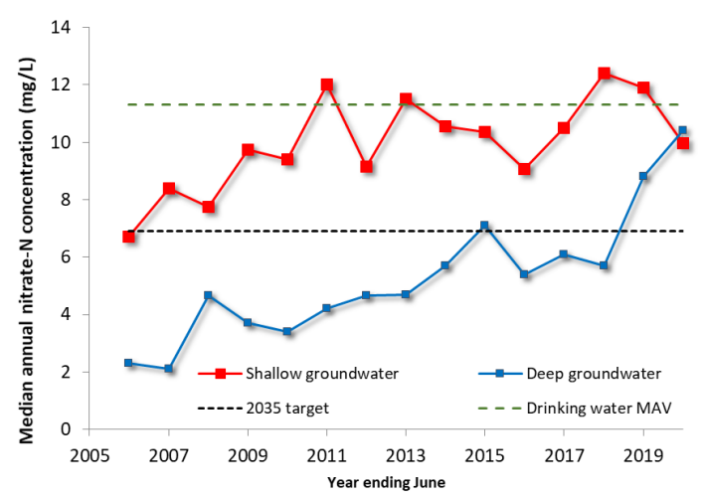

Data source: Hekeao/Hinds Water Enhancement Trust (HHWET)103F[104]

# Chapter five – Potential risks associated with nitrates in drinking water

This chapter identifies five potential risks associated with increasing nitrates in drinking water. These risks go beyond public health risks. An in-depth analysis of the probability, consequence, and mitigation options of each of these risks is beyond the scope of this report.

The recommendations that follow this chapter do provide an opportunity to address some of these issues or to undertake further work.

## Risk one – A fragmented approach to nitrate monitoring and management in drinking water

The responsibility for setting nitrate MAVs, regulating nitrate usage, management, and monitoring is shared across multiple regulatory regimes and government and local authority agencies. As the issue of nitrates becomes more topical and as trends continue to increase, this may result in additional work, requirements and restrictions being placed on water supplies and resource users. This increases the potential for nitrate management to be overly complicated with a multitude of rules and regulations that aren’t designed to work together.

There is a significant amount of change underway across the broader water system and while all of this work is focused on improving water quality, it will be critical that central and local government take a collaborative and unified approach to address nitrate issues.

## Risk two – Loss of existing drinking source water sites due to increasing nitrate contamination exceeding the current drinking water maximum acceptable values

The risk of losing existing drinking source water sites due to increasing levels of nitrate contamination exceeding the current drinking water MAV is an actual risk as shown by the recent events in Waimate District Council and Timaru District Council. The predicted long-term trend in nitrate levels in source water for drinking water, (as outlined above) implies that these exceedance events (whether short-term or part of a longer-term trend) will become more frequent. Also, as the longer-term average nitrate levels increase, there will be more short-term exceedance spikes due to short-term weather events.

This risk will be exacerbated if the emerging science on the health impacts of nitrates in drinking water results in a recommendation to reduce the MAV for nitrates in drinking water. Lowering the drinking water nitrate MAV would mean that a number of existing water supplies would be non-compliant and if they could not mitigate this through treatment, dilution, etc, they would need to stop supply.104F[105]

There is no direct link between the risk exacerbators (those that most contribute to increasing nitrate levels) and those who would bear the cost of the consequences of increasing nitrate levels in drinking water sources (regional councils, water suppliers and the public).

If the MAV were to be lowered, the consequence of this risk would result in water suppliers (registered and unregistered) looking for either alternative source water options or investing in treatment options.

If the ‘investment in removal’ option is considered, or is the only viable option, then:

* the capital cost will be significant105F[106]
* there are environmental issues to consider with the by-product of the nitrate removal process.

Mitigation options already exist for nitrate leaching to source water at a farm, local authority, regional council, and Ministry for the Environment level. Continued increasing trends for nitrate levels in source water raises the issue of the effectiveness of these initiatives.

Monitoring, reporting and sharing of data on nitrate levels in source water will increase with the implementation of the new regulatory regime under the Water Services Act 2021 providing a richer data base of this issue and the effectiveness of regional council’s initiatives. But this richer data will not, by itself, mitigate the risk of loss of a source water site.

Also, as a geographic area becomes a nitrate exceedance hotspot, there is no monitoring, reporting or ability to take remedial action for local domestic self-supplies within the hotspot unless it is a drinking water emergency.

## Risk three – Regulatory gaps in the new drinking water regime

The policy decision to exclude domestic self-suppliers (a single supply to a single domestic dwelling) from regulation by the Water Services Act 2021, unless it is a drinking water emergency related to insufficient supply in a limited area, means there is a regulatory gap around who monitors, and can subsequently act, in relation to domestic self-supply source water contamination issues (including excess nitrate).106F[107]

The risks from this policy gap are:

* There is no monitoring and reporting of the nitrate levels in drinking water supplied by a domestic self-supplier. As a class of drinking water supplier, domestic self-supply is suspected to be at higher risk of abstracting from higher nitrate source water, as these supplies are generally in rural areas and the source water is likely to be surface water or a shallow bore which is more susceptible to nitrate leaching than deeper aquifer water. The number of domestic self-supply situations in New Zealand is unknown; but anecdotally it is a significant number.
* The quality and completeness of the monitoring information on nitrate levels in source water is important to protect the consumers of drinking water. Also, there are additional benefits from the ability to improve the detection of health impacts of nitrates at concentrations below MAV, if they existed, from the monitoring data.
* There is a limited ability for a Crown agency or local authority to act where there is a health risk associated with contaminated water. It is recommended an approach consistent with the repealed Health Act 1956 is adopted. A Medical Officer of Health could require a territorial authority or regional council to investigate source water contamination (including for excess levels of nitrate) for any source of drinking water.

The Department of Internal Affairs is aware of the issue and has a programme of work to address the issue in the near future.

## Risk four – Current initiatives to manage nitrates in drinking water may not do enough

Overall, the levels of nitrates in a range of water sources are increasing over the long term, with short-term spikes due to adverse weather events. Already in place, and incoming, are a range of central and local government initiatives to minimise nitrate leaching caused by land-use activities, such as the NPS-FM, NES-F, and WSA.

Based on current evidence it is not certain whether the existing initiatives are not effective, or have not been implemented effectively, have not been in place for long enough to make a difference, or that without the initiatives, the levels of nitrates in water sources would be worse. Ongoing monitoring of the implementation of existing initiatives will be important to better understand their effectiveness, particularly after 2024 once regional plans have given effect to the NPS-FM.

Given that the nitrate levels are trending towards the nitrate MAV for drinking water in particular regions, and in some cases there are exceedances, the system is close to a tipping point where drinking water from bores, springs and rivers in particular places will not be safe to drink without extra treatment.

Due to the ‘effect’ time lags that relate to nitrate levels in various water sources there is a risk that:

* there is no short-term ability to alter the trend in nitrate levels
* the impact/success of the current initiatives will not be known for a long period of time.

# Chapter six – Conclusions and recommendations

## Conclusion

Overall nitrate trends continue to increase across the country in some areas. Some parts of the country, such as Canterbury, have much higher concentrations of nitrates mainly because of land use. Because of lag times, even with best practice management, it is expected that the issue of nitrates will get worse before it gets better.

This report explored nitrate as it relates to health impacts rather than ecological health. Currently the Ministry of Health does not consider there is robust and sufficient evidence to support lowering the MAV for nitrates in drinking water.

To date there have been only a small number of studies investigating whether there is an association between nitrates in drinking water and colorectal cancer and adverse reproductive outcomes and these studies have varying degrees of rigour and no causal links have been established.

The Ministry of Health continues to actively monitor and review emerging health evidence on nitrates in drinking water. If, in the future, the evidence did support a reduction in the nitrate short-term MAV, this would be likely to result in many drinking water suppliers needing to find alternative water sources or undertaking difficult and costly treatment.

There is some good research underway that supports a pre-emptive approach to managing nitrates. Of note was the work of the two councils we spoke to (Selwyn and Ashburton) that are going above and beyond what is required by legislation to improve the monitoring and evidence base of nitrate concentrations in their areas.

A range of existing policies and initiatives will support better management of nitrates; however, these have not yet been embedded for long enough to show improvements or effectiveness. There is also a lack of baseline evidence that could be used to predict effectiveness of existing programmes and to help determine what else we could be doing to address nitrate issues in the future.

## Broad recommendations

### Continued monitoring of health risks

Epidemiological evidence of the health impacts of nitrates is evolving and this should continue to be monitored to reassure communities.

**Note** that the Ministry of Health will continue monitoring and reviewing the body of evidence on nitrates in drinking water and will update Ministers and existing policy advice on the recommended MAV should emerging evidence suggest a need to do so.

### Regulatory gap

The transition to the Water Services Act 2021 has removed the ability for a Medical Officer of Health to investigate source water contamination in domestic self-supply and to direct a local authority to act.

**Note** that Department of Internal Affairs has work underway, through the three waters reform legislative programme, to amend the Water Services Act 2021 to include a provision for a Medical Officer of Health or Taumata Arowai to issue notices about water contamination that may affect domestic self-supplies by way of a notice issued to a water services entity or regional council. The water services entity or regional council will be required to issue a notice warning domestic self-supply users of contamination, which may include an excess level of nitrates. The notice will include the exercise of power to take any action to remedy the situation.

### Nitrates for human health officials’ working group

Management of nitrates is complex and is governed by many different pieces of legislation. A more joined-up approach should create better connectivity and to reduce complexity. Regional working groups focused on drinking water safety already exist; however, better linkages are needed between them, central and local government.

**Agree** to establish an inter-agency working group that will work together to support the regional working groups to monitor, assess and respond to nitrate contamination in drinking water. This group will be comprised of officials from the Ministry of Health (who will chair the group), Taumata Arowai, the Ministry for Primary Industries, and the Ministry for the Environment. We would also invite membership from the Department of Internal Affairs, and Te Puni Kōkiri. This group is to take a Te Mana o te Wai approach to all issues.

### Nitrate monitoring and information sharing should be enhanced

Improving our nitrate monitoring system both regionally and nationally will help to reduce uncertainty and to improve our understanding of the impact of nitrates.

**Agree** that the Ministry for the Environment, Ministry of Health, and Taumata Arowai will work together to standardise and share any monitoring and reporting of nitrates that would relate to drinking water, and that this information is made accessible for other departments, local government, and researchers, unless privacy rules apply.

1. CAB-22MIN-0216.
2. [Nitrates in drinking-water | Prime Minister's Chief Science Advisor (pmcsa.ac.nz)](https://www.pmcsa.ac.nz/topics/nitrates/).
3. Cabinet Minute – CAB-22MIN-0216.
4. Taumata Arowai [Summary of submissions on Drinking Water Standards](https://www.taumataarowai.govt.nz/assets/Uploads/Rules-and-standards/Taumata-Arowai-Summary-of-Submissions-received-on-Standards.pdf).
5. Ministry for the Environment [Summary of submissions](https://environment.govt.nz/assets/publications/nes-dw-summary-of-submissions.pdf) received through the consultation to amend the National Environmental Standards for Sources of Human Drinking Water to protect drinking water sources is available online.
6. Water Services (Drinking Water Standards for New Zealand) Regulations 2022.
7. Schullehner J, Hansen B, Thygesen M, Pedersen CB, Sigsgaard T. Nitrate in drinking water and colorectal cancer risk: A nationwide population-based cohort study. Int J Cancer. 2018 Jul 1;143(1):73-79. doi: 10.1002/ijc.31306. Epub 2018 Feb 23. PMID: 29435982.
8. Sherris AR, Baiocchi M, Fendorf S, Luby SP, Yang W, Shaw GM. Nitrate in Drinking Water during Pregnancy and Spontaneous Preterm Birth: A Retrospective Within-Mother Analysis in California. Environ Health Perspect. 2021 May;129(5):57001. doi: 10.1289/EHP8205. Epub 2021 May 5. PMID: 33949893; PMCID: PMC8098122.
9. This report does not consider drinking water when the source water is either roof water or water supplied by a tanker by a registered water supplier. Rainwater has very little nitrate content and so is not at risk of exceeding the nitrate MAV for drinking water. The report also does not consider bottled drinking water.
10. This assumes that treating source water to reduce the nitrate levels is not efficient or effective. There is a high risk that exceeding the nitrate MAV will cause the water supplier to stop supplying if only for a short time.
11. The Department of Internal Affairs is aware of the issue and has a programme of work to address the issue in the near future.
12. Sections 8 and 9, Water Services Act 2021.
13. Domestic self-supplier is a defined in section 8 Water Services Act 2021 and apart from a drinking water emergency ‘domestic self-supply’ and domestic ‘self-suppliers’ are not regulated by the Water Services Act 2021 or by Taumata Arowai.
14. Water bores may be drilled for irrigation, monitoring quality of ground water, as well as drinking water purposes. Bore may be drilled for ‘ground source heat loops’ for harvesting natural energy for heating.
15. Under the Health Act 1956 there was no reported monitoring of nitrate in source water used for drinking water.
16. *Freshwater* or *fresh water* means all water except coastal water and geothermal water.
17. Excess in relation to drinking water is greater than the nitrate MAV.
18. [Freshwater Science and Technical Advisory Group report](https://environment.govt.nz/assets/Publications/Files/freshwater-science-and-technical-advisory-group-report.pdf).
19. [Nitrate and nitrite in Drinking-water](https://apps.who.int/iris/bitstream/handle/10665/75380/WHO_SDE_WSH_04.03_56_eng.pdf).
20. [Water Services (Drinking Water Standards for New Zealand) Regulations](https://www.legislation.govt.nz/regulation/public/2022/0168/latest/whole.html) 2022. Based on the drinking water standards effective from 14 November 2022.
21. [National Policy Statement for Freshwater Management](https://environment.govt.nz/assets/publications/National-Policy-Statement-for-Freshwater-Management-2020.pdf).
22. [Nitrate leaching from livestock](https://www.stats.govt.nz/indicators/nitrate-leaching-from-livestock) web page.
23. Elevated concentrations of nitrates in surface waters can promote the rapid, opportunistic growth of cyanobacteria (sometimes referred to as blue-green algae). Blooms of cyanobacteria can affect drinking water safety in other ways. After the rapid growth phase of a bloom, a rapid die-off can occur resulting in a sudden and dramatic drop in dissolved oxygen. This reduction in dissolved oxygen means that certain metals present in sediment, such as manganese, can dissolve more easily, thereby leading to increased concentrations of these metals and attendant aesthetic and health concerns. Blooms of cyanobacteria can also affect the pH and turbidity of surface waters, which can impact the efficacy of different water treatment processes. Finally, elevated levels of nitrates in surface waters can promote the growth of aquatic weeds. While these species generally aren’t harmful themselves, they can disrupt the equilibrium of aquatic ecosystems. This is significant as water sourced from impaired aquatic ecosystems is generally of a poorer quality, requiring more treatment to make it safe.
24. [Assessment of the eutrophication susceptibility of New Zealand Estuaries](https://environment.govt.nz/assets/Publications/Files/assessment-of-eutrophication-susceptibility-in-nz-estauries.pdf).
25. [Nitrogen yields from New Zealand coastal catchments to receiving estuaries](https://ref.coastalrestorationtrust.org.nz/site/assets/files/8369/nitrogen_yields_from_new_zealand_coastal_catchments_to_receiving_estuaries.pdf).
26. [Aquatic Environment and Biodiversity Annual review – Chapter 12: Land-based effects on the coastal environment](https://www.mpi.govt.nz/dmsdocument/42150-15-Land-based-Effects).
27. [Refining the New Zealand nitrous oxide emission factor for urea fertiliser and farm dairy effluent](https://www.mpi.govt.nz/dmsdocument/20966-Refining-the-New-Zealand-nitrous-oxide-emission-factor-for-urea).
28. [Evidence for the effects of land use on freshwater ecosystems in New Zealand](https://www.tandfonline.com/doi/full/10.1080/00288330.2019.1695634)
29. Domestic self-supply and domestic self-supplier are defined by section 10 of the Water Services Act 2021.
30. Section 18(2)(e)(i) of the Taumata Arowai–the Water Services Regulator Act 2020.
31. Until 15 November 2021 the Ministry of Health was responsible for the regulatory system for drinking water.
32. The drinking water standards include setting maximum acceptable values for nitrate and nitrite. New drinking water standards were Gazetted on 7 June 2022 and are effective from 14 November 2022.
33. The drinking water compliance rules can require water suppliers to:

    • test both source water and drinking water for elements including nitrate and nitrite

    • report the results to Taumata Arowai.

    Taumata Arowai has Gazetted these new compliance rules, Drinking Water Quality Assurance Rules 2022, which are effective from 14 November 2022.
34. The definition of water supplier in the Water Services Act means that an estimated additional 75,000 water suppliers will be registered over the transition period up to 2025. These water suppliers will be subject to the new monitoring and reporting regime for nitrate.
35. Water Services (Drinking Water Standards for New Zealand) Regulations 2022.
36. Drinking Water Quality Assurance Rules (2022).
37. Section 47 of the Water Services Act 2021.
38. This National Policy Statement was approved by the Governor-General under section 52(2) of the Resource Management Act 1991 on 3 August 2020 and is published by the Minister for the Environment under section 54 of that Act. This National Policy Statement replaces the National Policy Statement for Freshwater Management 2014 (as amended in 2017), which came into force on 7 September 2017.
39. Drinking water supplies who aren’t registered with Ministry of Health will not need to prepare a source water risk management plan until after they are registered. Supplies have until November 2025 to register and up until November 2028 to provide a source water risk management plan.
40. Section 47 of the Water Services Act 2021. Under section 47(1) a drinking water supplier must ensure that the drinking water supplied by the supplier complies with the drinking water standards.
41. Water Services (Drinking Water Standards for New Zealand) Regulations 2022.
42. Some of the proposed changes followed WHO revisions to its health impact calculation based on current scientific and technical evidence. For example, the removal of the provisional long-term maximum acceptable value for nitrite was because WHO removed the provisional maximum acceptable value due to the uncertainty about its derivation.
43. The determinands for nitrate and nitrite are based on WHO guidelines.
44. Now short-term only. The short-term exposure MAVs for nitrate and nitrite have been established to protect against methaemoglobinaemia in bottle-fed infants. Note: this footnote only applies to the pre-14 November 2022 MAV.
45. The MAV of a chemical determinand is the highest concentration of a determinand in drinking water that, based on present knowledge, is considered not to cause any signiﬁcant risk to the health of the consumer over 70 years of consumption of 2 litres per day of that water.
46. WHO has removed the provisional nitrite long-term MAV due to uncertainty about its derivation. The long-term nitrite level in the existing New Zealand Drinking Water Standard was a provisional MAV, indicating that for some time there has been uncertainty about the accuracy of the WHO provisional guideline value. The WHO has now indicated that there is no longer a justification for providing a guideline value for nitrite.
47. The Ministry of Health’s response also advised that Health Research Council had agreed to fund research into any associations between nitrate and nitrite levels in drinking water and pre-term births. The research will be undertaken by the University of Otago and the results are due in 2025.
48. ESR. Nitrates in Food and Water Report. 2021
49. A summary of the findings was published on November 2021 on the University of Auckland’s website: [Nitrate risks for babies assessed in Liggins report for government](https://www.auckland.ac.nz/en/news/2021/11/18/nitrate-risks.html#:~:text=There's%20no%20conclusive%20evidence%20that,government%20by%20the%20Liggins%20Institute).
50. Drinking Water Quality Assurance Rules 2022. Under s 3(1)(c) the Drinking Water Quality Assurance Rules 2022 must be proportionate to the scale, complexity and risk profile of each drinking water supply.
51. The acceptable solutions that Taumata Arowai will issue under section 50 of the Water Services Act 2021 where appropriate will require testing of source water for nitrate.
52. Note: Notifications on exceedances relating to the Drinking-water Standards for New Zealand 2005 (Revised 2018). New Drinking Water Standards and Water Quality Assurance Rules will came into effect on 14 November 2022.
53. Fourth Edition of the WHO Guidelines for Drinking-water Quality (GDWQ).
54. European Commission Drinking Water Directive 98/83/EC.
55. 2011 Australian Drinking Water Guidelines.
56. [Nitrate and Nitrite in Drinking-water](https://cdn.who.int/media/docs/default-source/wash-documents/wash-chemicals/nitrate-nitrite-background-jan17.pdf?sfvrsn=1c1e1502_4).
57. Schullehner J, Hansen B, Thygesen M, Pedersen CB, Sigsgaard T. Nitrate in drinking water and colorectal cancer risk: A nationwide population-based cohort study. Int J Cancer. 2018 Jul 1;143(1):73-79. doi: 10.1002/ijc.31306. Epub 2018 Feb 23. PMID: 29435982.
58. Sherris AR, Baiocchi M, Fendorf S, Luby SP, Yang W, Shaw GM. Nitrate in Drinking Water during Pregnancy and Spontaneous Preterm Birth: A Retrospective Within-Mother Analysis in California. Environ Health Perspect. 2021 May;129(5):57001. doi: 10.1289/EHP8205. Epub 2021 May 5. PMID: 33949893; PMCID: PMC8098122.
59. [Nitrates in drinking-water](https://www.pmcsa.ac.nz/topics/nitrates/).
60. Essien EE, Said Abasse K, Côté A, Mohamed KS, Baig MMFA, Habib M, Naveed M, Yu X, Xie W, Jinfang S, Abbas M. [Drinking-water nitrate and cancer risk: A systematic review and meta-analysis](https://pubmed.ncbi.nlm.nih.gov/33138742/). Arch Environ Occup Health. 2022;77(1):51-67. Epub 2020 Nov 3. PMID: 33138742.
61. Temkin A, Evans S, Manidis T, Campbell C, Naidenko OV. [Exposure-based assessment and economic valuation of adverse birth outcomes and cancer risk due to nitrate in United States drinking water](https://www.sciencedirect.com/science/article/pii/S001393511930218X). Environ Res. 2019 Sep;176:108442. Epub 2019 Jun 11. PMID: 31196558.
62. Hosseini F, Majdi M, Naghshi S, Sheikhhossein F, Djafarian K, Shab-Bidar S. [Nitrate-nitrite exposure through drinking water and diet and risk of colorectal cancer: A systematic review and meta-analysis of observational studies](https://pubmed.ncbi.nlm.nih.gov/33298332/). Clin Nutr. 2021 May;40(5):3073-3081. Epub 2020 Nov 28. PMID: 33298332.
63. Espejo-Herra, N., Gràcia-Lavedan, E., Boldo, E., et al. (2016) [Colorectal cancer risk and nitrate exposure through drinking water and diet](https://onlinelibrary.wiley.com/doi/10.1002/ijc.30083). International Journal of Cancer, 139(2):334-346.
64. Schullehner, J. (2018). [Nitrate in drinking water and colorectal cancer risk: A nationwide population-based cohort study](https://onlinelibrary.wiley.com/doi/10.1002/ijc.31306), International Journal of Cancer, 143(1):73-79.
65. [Nitrate risks for babies assessed in Liggins report for government](https://www.auckland.ac.nz/en/news/2021/11/18/nitrate-risks.html).
66. A meta-analysis is a statistical analysis that combines the results of multiple scientific studies.
67. Nitrosatable drugs such as secondary or tertiary amines and amides, form N-nitroso compounds in the presence of nitrite.
68. [Nitrate risks for babies assessed in Liggins report for government](https://www.auckland.ac.nz/en/news/2021/11/18/nitrate-risks.html).
69. Under the Water Services Act 2021 all water suppliers and supplies, excluding domestic self-supply, need to be registered with Taumata Arowai. Transition arrangements for unregistered water supplies under the Health Act 1956 mean that unregistered suppliers (except water carriers) will need to register by November 2025 and have seven years to provide a drinking water safety plan under the Water Services Act 2021. The owner(s) of a new drinking water supply that is going to start supplying water after the commencement of the Water Services Act 2021 must register the supply before starting to operate the supply.
70. [Our land 2021](https://environment.govt.nz/assets/Publications/our-land-2021.pdf).
71. [Our land 2021](https://environment.govt.nz/assets/Publications/our-land-2021.pdf).
72. [Fertilisers – nitrogen and phosphorus](https://www.stats.govt.nz/indicators/fertilisers-nitrogen-and-phosphorus#:~:text=Between%201991%20and%202019%2C%20estimates,in%20nitrogen%20applied%20from%20fertiliser), Stats NZ website.
73. [New groundwater quality reports released](https://www.ecan.govt.nz/get-involved/news-and-events/2022/new-groundwater-quality-reports-released/), ECAN website.
74. Note that CWMS refers to ‘wells’ rather than ‘bores’; they mean the same thing.
75. Section 21(1) WSA.
76. Section 21(1) WSA.
77. With the enactment of the Water Services Act 2021 it is estimated that an additional 75,000 water suppliers will become registered through the transition period from 2021 to 2025. Those ‘domestic self-suppliers’ who were unregistered before 2021 will not be registered under the Water Services Act 2021 and there is no monitoring of their nitrate levels.
78. Cyanosis is characterised by blue-purple coloured skin caused by little oxygen in the blood.
79. Periphyton is a complex mixture of algae, cyanobacteria, heterotrophic microbes, and detritus that is attached to submerged surfaces in most aquatic ecosystems.
80. Macrobenthos consists of the organisms that live at the bottom of a water column.
81. Fundamental Principles of Drinking Water Safety in NZ, produced by the Government Inquiry into Havelock North Drinking Water. Principle 2: Protection of source water is of paramount importance.
82. [Canterbury Water Management Strategy Targets and Goals](https://www.ecan.govt.nz/document/download?uri=3732128).
83. Nutrient efficiency targets on all farming activities are set as nutrient management rules in Plan Change 5 and sub-region sections of the Canterbury Land and Water Regional Plan (LWRP). These rules set industry-agreed good management practice (GMP) as the minimum standard for all farming activities on properties larger than 10 hectares. Primary industry sector organisations have worked together to describe what GMP looks like for different farming types. The LWRP requires the implementation of GMP on farm to achieve water quality outcomes.
84. [Council Encourages Private Well Testing](https://www.waimakariri.govt.nz/your-council/news-and-information/2021/04/council-encourages-private-well-testing), Waimakariri District Council website.
85. It is not known if this date has been collated in a usable source.
86. [NitrateWatch](https://www.gns.cri.nz/research-projects/nitratewatch/), GNS Science website.
87. Elevated nitrate levels in drinking water in New Zealand are directly related to source water. There are very few water treatment systems where the treatment processes would increase nitrate level.
88. The definition of ‘self-supplier’ in the Health Act 1956 is a wider concept that the definition of ‘domestic self-supplier’ in the Water Services Act 2021.
89. Section 69ZZP, repealed from 15 November 2021.
90. In their review, the Liggins Institute highlighted this as an important data gap that needs addressing, and a key reason why the status quo would not even allow researchers to detect health impacts of nitrates at concentrations below MAV – if they existed.
91. The Overseer intellectual property is jointly owned by the Ministry of Primary Industries, the Fertiliser Association of NZ and AgResearch.
92. [Overseer whole-model review: Assessment of the model approach](https://www.mpi.govt.nz/dmsdocument/46360-Overseer-whole-model-review-Assessment-of-the-model-approach).
93. [Working on improving tools to manage nutrient losses from farms](https://www.beehive.govt.nz/release/work-improving-tools-manage-nutrient-losses-farms), Beehive website.
94. This document (published in 2018 by the Ministry for the Environment and the Ministry for Primary Industries) sets out the Government’s plan to restore and protect freshwater in New Zealand. It outlines the work programme that will set New Zealand on the path to turning around water quality trends and make long-term improvements in freshwater.
95. [Statement of Evidence for the Christchurch City Council](https://api.ecan.govt.nz/TrimPublicAPI/documents/download/3909177)
96. Waimakariri land and water solutions programme: Options and Solutions Assessment Economic assessment.
97. Note Timaru District Council used dilution in the Pareora township drinking water supply September 2020 nitrate event.
98. [Estimated Age in Surface Water and Changes in Nitrogen Concentration in Groundwater in the Upper Waikato Catchment](https://environment.govt.nz/assets/Publications/Files/aqualinc-surface-water-nitrogen-upper-waikato.pdf).
99. [Nitrate Takes Less Than 5 Years to Travel from Farm to River, on Average](https://ourlandandwater.nz/news/nitrate-takes-less-than-5-years-to-travel-from-farm-to-river-on-average/), Our Land and Water web page.
100. [Estimating Time Lags for Nitrate Response in Shallow Southland Groundwater](https://www.es.govt.nz/repository/libraries/id:26gi9ayo517q9stt81sd/hierarchy/environment/science/science-summary-reports/estimating_time_lags_for_nitrate_response_in_shallow_southland_groundwater.pdf).
101. [Estimation of lag time of water and nitrate flow through the Vadose Zone: Waikato and Waipa River Catchments](https://www.waikatoregion.govt.nz/assets/PageFiles/37532/3%2520-%2520Final%2520Draft%2520LincolnAg_Unsaturated%2520Lag%2520time%2520in%2520the%2520Waikato%2520catchment.pdf)
102. [Nitrates in waterways – what’s the story?](https://www.ecan.govt.nz/get-involved/news-and-events/2019/nitrate-in-waterways-whats-the-story/), ECAN website.
103. Plan Change 2 (Hinds/Hekeao) to the Canterbury Land and Water Regional Plan was approved at a Council meeting on 12 May 2018 and made operative 1 June 2018.
104. [Hekeao / Hinds managed aquifer recharge](https://www.hhwet.org.nz/wp-content/uploads/2020/11/Hinds-MAR-Brochure-2020.pdf).
105. Currently there is no estimate of what percentage of supply would be non-compliant for what percentage decrease in the drinking water nitrate MAV.
106. An indicative capital cost for Christchurch City Council is $347m to $610m.
107. There is limited powers to act under the Building Act 2004.