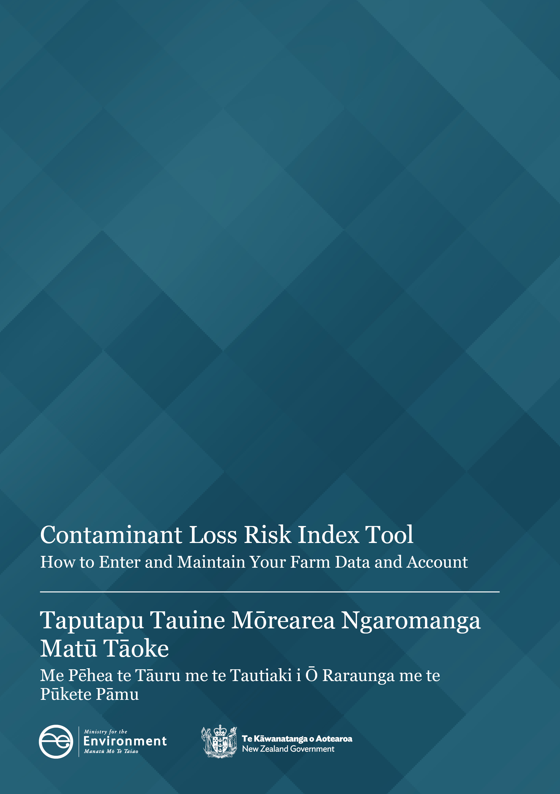

Disclaimer
The information in this publication is, according to the Ministry for the Environment’s best efforts, accurate at the time of publication. The Ministry will make every reasonable effort to keep it current and accurate. However, users of this publication are advised that:
- the information does not alter the laws of New Zealand, other official guidelines, or requirements
- it does not constitute legal advice, and users should take specific advice from qualified professionals before taking any action based on information in this publication
- the Ministry does not accept any responsibility or liability whatsoever whether in contract, tort, equity, or otherwise for any action taken as a result of reading, or reliance placed on this publication because of having read any part, or all, of the information in this publication or for any error, or inadequacy, deficiency, flaw in, or omission from the information in this publication
- all references to websites, organisations or people not within the Ministry are for convenience only and should not be taken as endorsement of those websites or information contained in those websites nor of organisations or people referred to.
Acknowledgements
We would like to thank Backstory Ltd for drafting this user guide.

This document may be cited as: Ministry for the Environment. 2025. Contaminant Loss Risk Index Tool: How to Enter and Maintain Your Farm Data and Account. Wellington: Ministry for the Environment.

Published in July 2025 by the
Ministry for the Environment
Manatū mō te Taiao
PO Box 10362, Wellington 6143, New Zealand
environment.govt.nz
ISBN: 978-1-991404-00-8
Publication number: ME 1908
© Crown copyright New Zealand 2025

Contents
Introduction 5
Steps to using the Risk Index Tool 5
Reading this document 5
Definitions 6
Before you start using the Risk Index Tool 7
Creating and managing your account 8
Registration 8
Logging in 9
Two-factor authentication 9
Logging out 13
Your account 13
Adding a delegated user 14
Overview of the Risk Index Tool home screen 17
Creating your farm 18
Create your farm 18
Define your farm boundary 18
Expand your mapping area 20
Adjust farm boundary 20
Create your blocks 21
Edit and delete block 24
Complete farm creation 25
Creating your report 26
Create report 26
Input stock information 26
Choose block to enter data 28
Block level information 28
Input crop information 29
Input fertiliser information 32
Select relevant modifiers 33
Running your report 34

Reading and exporting your report 35
Report sections 36
Block section of the report 37
Subsequent reports 39
Reviewing your farm 39
Prepopulating data 41
Scenario planning 41
Run your scenario 43
View scenario results 44
Errors in scenarios 44
Managing your farm 47
Accessing farm details 47
Managing users 48
Viewing reports 48

Introduction
Welcome to the Risk Index Tool user guide.
This guide will help anyone using the Risk Index Tool to use the tool accurately to generate a Risk Index Score, heat map, and related report or scenario.

Steps to using the Risk Index Tool
There are three steps to using the Risk Index Tool.
The first step is creating your farm. This involves mapping the boundary of your farm then segmenting it into blocks based on consistent land-management practices.
The second step is creating the report which includes the Risk Index Score. This step includes entering data about the farm over the reporting period then triggering the calculation engine to calculate the scores and heat map.
The third step is creating scenarios against your reports. This step includes changing your data, previously entered (eg, stocking rates, modifiers, land use) to test how different scenarios impact your score.
All steps can be saved as drafts at any time to be completed later. Once the step is complete, it can no longer be edited.

Reading this document
The numbers on the images correspond to the step described below it. In some instances, not all steps will be present on the image of the screen so not all numbers will be shown.
Blue text indicates a link to a related part of this guide. You can click on that link as a shortcut to the relevant place.
Due to ongoing development, there may be minor discrepancies between the images shown and what is onscreen in the tool.

Definitions

Key terms in the Risk Index Tool
Table 1: Key terms in the Risk Index Tool
Term | Definition
Aggregated score | Scores are not weighted by area
Blocks | Areas of the farm that have similar and consistent land-management practices.
Crop | Any planting present on the farm.
Delegated user | A user invited to edit the farm and run reports on behalf of the primary user.
Farm boundary | The boundary of the entire farm system being reported. This may include leased land.
Fertiliser | Artificial fertiliser or manure added to the land to boost growth.
Ineffective area | Areas of the farm that aren’t productive and sit outside of the blocks. Examples of ineffective areas are buildings and laneways.
Mitigation | A change that reduces the quantity of nitrogen being applied to the block.
Modifier | A farming practice that impacts the nitrogen loss risk of the farm system.
Per hectare score | Total risk for the polygon (or block, or farm) divided by the total area of the polygon (or block, or farm).
Primary user | The original creator of the farm and owner of the entered data.
Report | The output that includes both the Risk Index Score, heat map and summarises the data used to generate those scores.
Reporting period | The twelve-month period selected by the user for the report to cover.
Risk Index Score | The nitrogen risk score calculated by the tool based on the information provided about the farm system and the underlying biophysical data identified through mapping the farm.
Risk Index Tool | The whole application used to map the farm and generate the Risk Index Score.
Scenario | Leverages previous completed reports. Allows users to test different scenarios by changing inputs (mitigations, modifiers and land-use change) to test how this impacts their score.
Stock | Any livestock present on the farm.

Before you start using the Risk Index Tool
- Review the ‘before you start’ checklist before you begin your assessment. This checklist lists the data you need to enter into the tool.
- When you get the Adjust farm boundary screen, practice with the pen tool to get a feel for how it works before you start your mapping. Use the undo button to undo your practice. The undo button will go back up to 10 steps.
- Read the guidance on how to create your blocks. Getting this step right will make the rest of the process much easier so it pays to take your time here. Spending some time sketching it with pen and paper first will help you think this through and save time figuring it out onscreen.
Regularly save your progress on each screen
This will reduce the risk of losing any information should you accidently close your browser or are inactive for a period and get timed out.

Creating and managing your account

Registration
To use the Risk Index Tool, you need to register for an account.
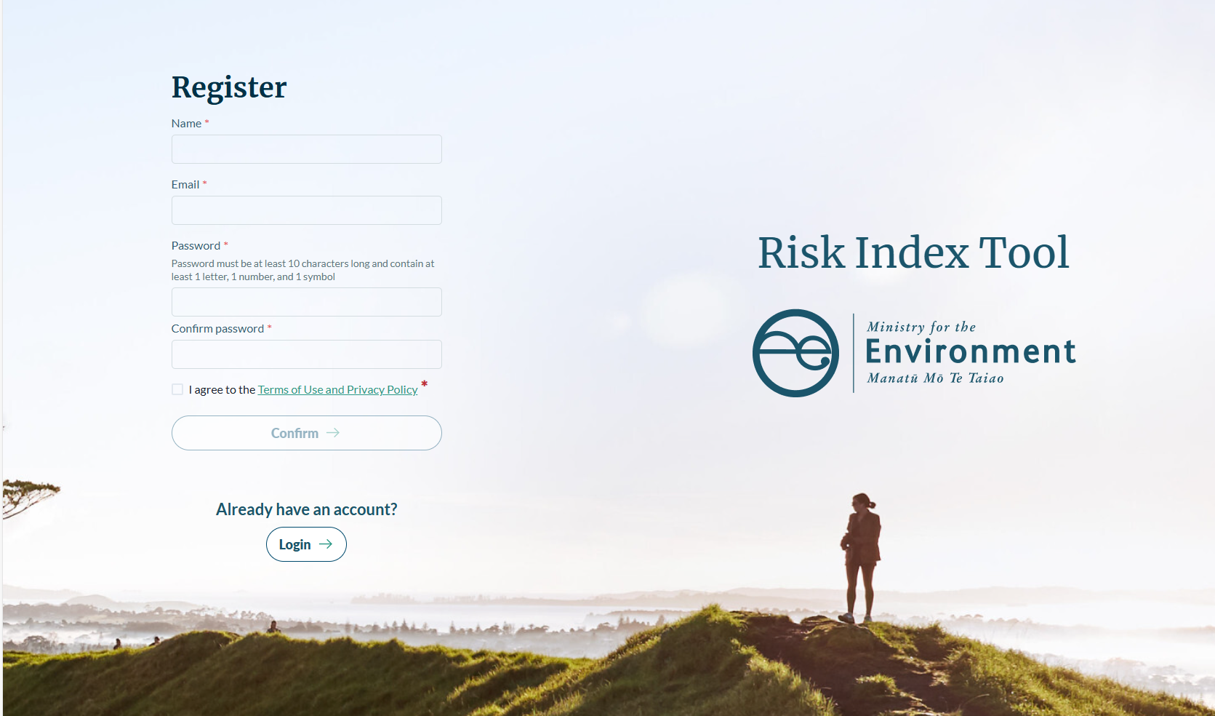
1
2
3
4
5
Access the registration screen by clicking ‘Register’ on the login screen.
- Enter your name and email address.
- Create a password that is at least 10 characters long, and contains at least:
- one letter
- one number
- one symbol.
- Click on the link to read the Terms of Use and Privacy Policy. Click the checkbox to agree to these terms for using the Risk Index Tool. You must agree to these Terms of Use and Privacy Policy to complete your registration.
- When you click ‘Confirm’, you will be sent an email to the email address you provided. Click the link in that email to verify your email address and complete your registration.
Note: If you do not verify your email within 10 calendar days, the details you used to register will be deleted from the tool and you will need to register again.
- You can now login to the Risk Index Tool.

Logging in
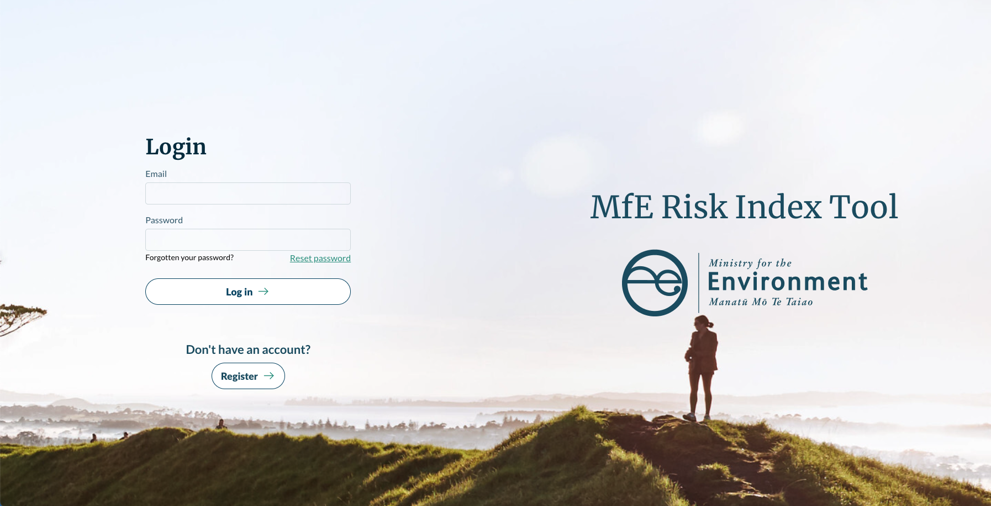
3
2
1
- Enter the email and password used to register your account.
- If you have forgotten your password, or have entered the incorrect password three times, you can reset your password using the reset password link.
Note: If you enter your password incorrectly more than three times, your account will be locked. Please contact the Risk Index Tool Helpdesk if you need support.
- Click ‘Register’ if you need to register a new account.

Two-factor authentication
When you first log into the Risk Index Tool you will be prompted to setup two-factor authentication.
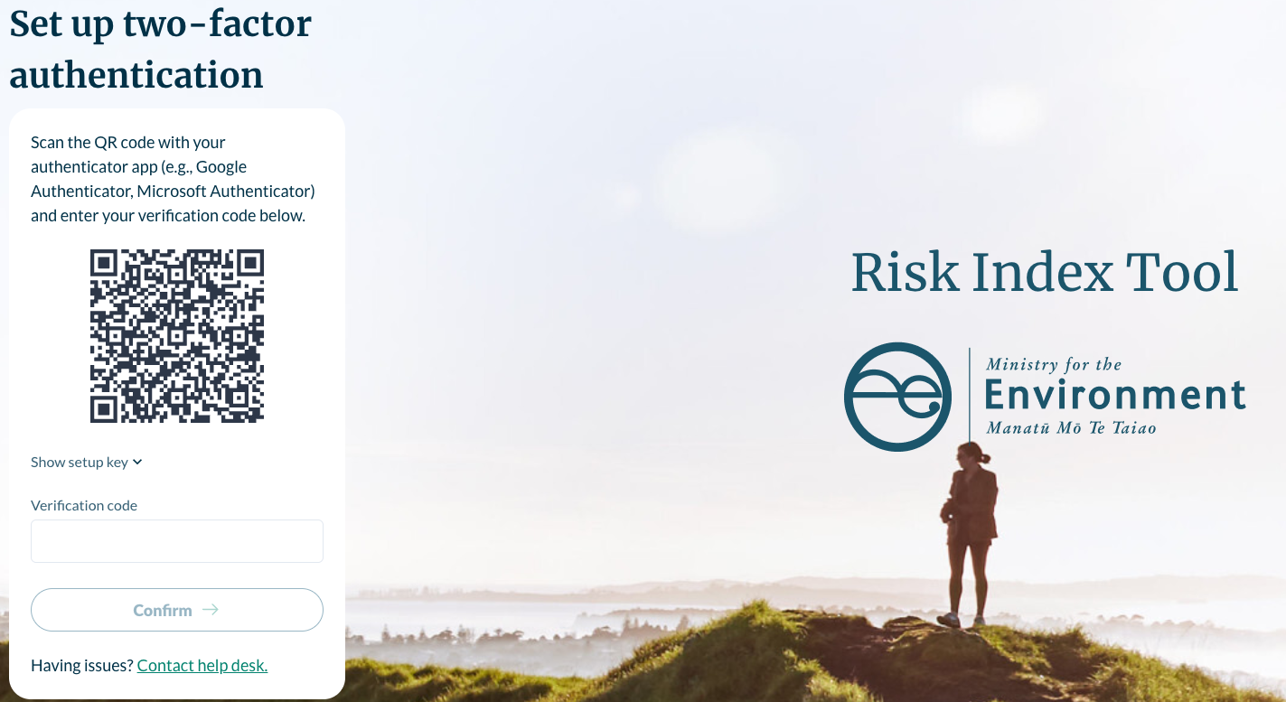
We recommend using Microsoft Authenticator as your two-factor authenticator app. The example shown below is for Microsoft Authenticator. You can use another authenticator app should you choose.
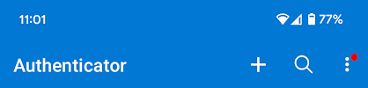
2
- When prompted to set up two-factor authentication, open the Microsoft Authenticator app on your mobile device.
- Click ‘+’ icon and select the type of account you wish to add – for example, ‘Other account’.
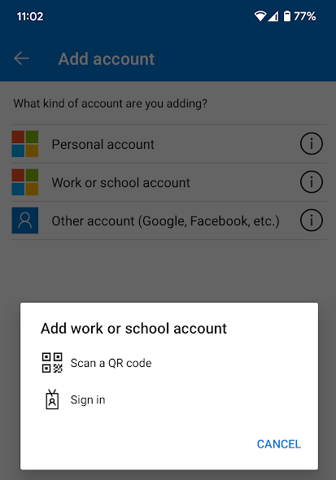
3
- Click ‘Scan a QR code’.
- Use the camera on your mobile device to scan the QR code on the screen. A Risk Index Tool account will be added to Microsoft Authenticator automatically.
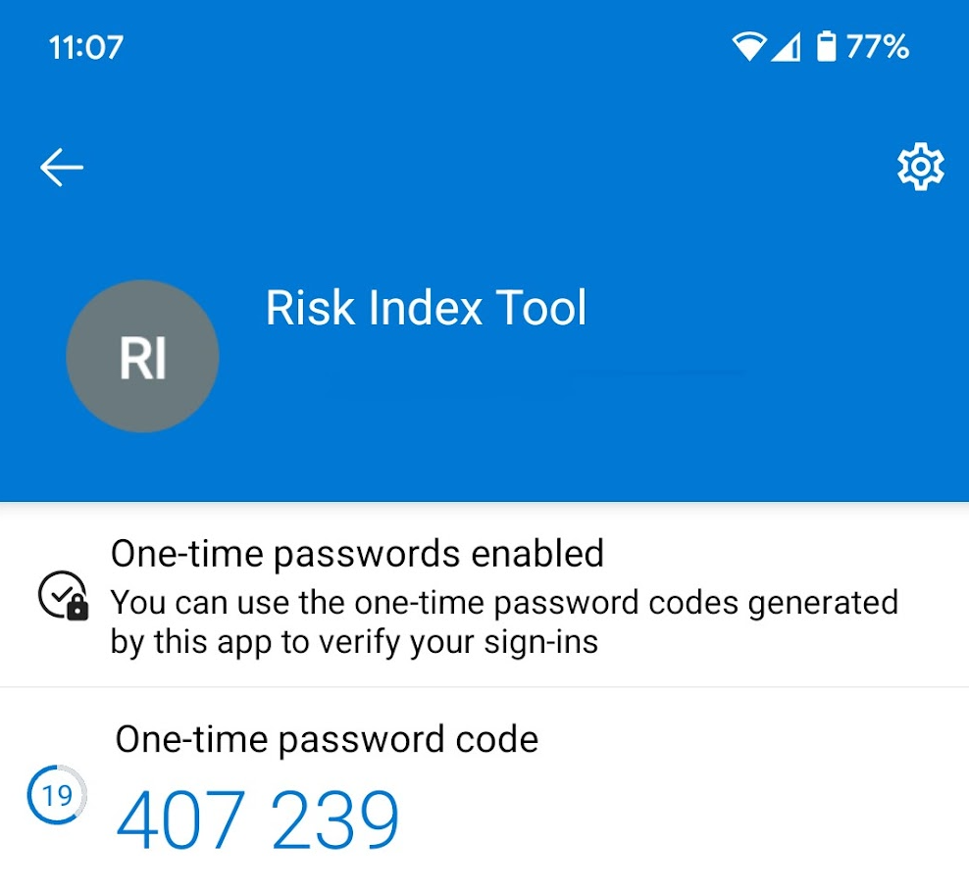
- Open the ‘Risk Index Tool’ account in Microsoft Authenticator to view ‘One-time password code’.
3
2
- Enter the one-time password code into the ‘Verification code’ field on the screen.
- Click ‘Confirm’.
Tip: One-time password codes are time sensitive. If there is a delay in your code being recognised by the tool but the Risk Index Tool is not recognising this when you first enter it, check the time zone settings for your mobile device. Make sure this is set to use the automatic time zone provided by your mobile network.
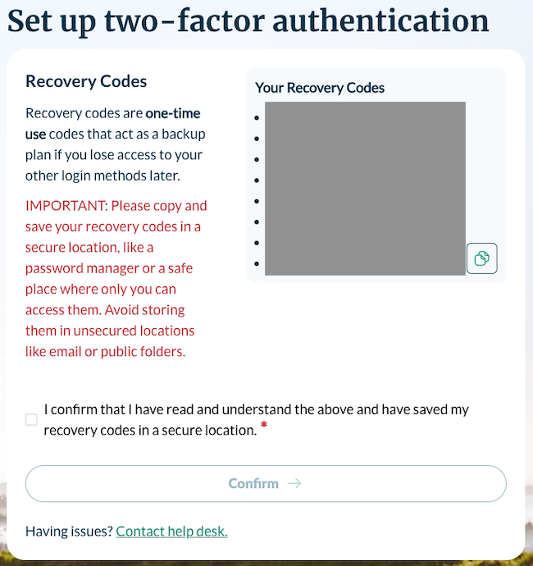
1
3
4
On successfully entering your one-time password code you will be presented with your recovery codes. A recovery code is a one-time code that can be used instead of the code generated by your two-factor authenticator app. If your mobile device is lost or damaged, you can use this code to access your account and set up two-factor authentication on a new device.
- Click the ‘copy’ icon to copy your recovery codes.
- Save your recovery codes to a secure location.
- Click checkbox to confirm these have been copied and saved.
- Click ‘Confirm’ to complete your two-factor authentication set up.

Logging out
1
- Click ‘Log out’ to log out.

Your account
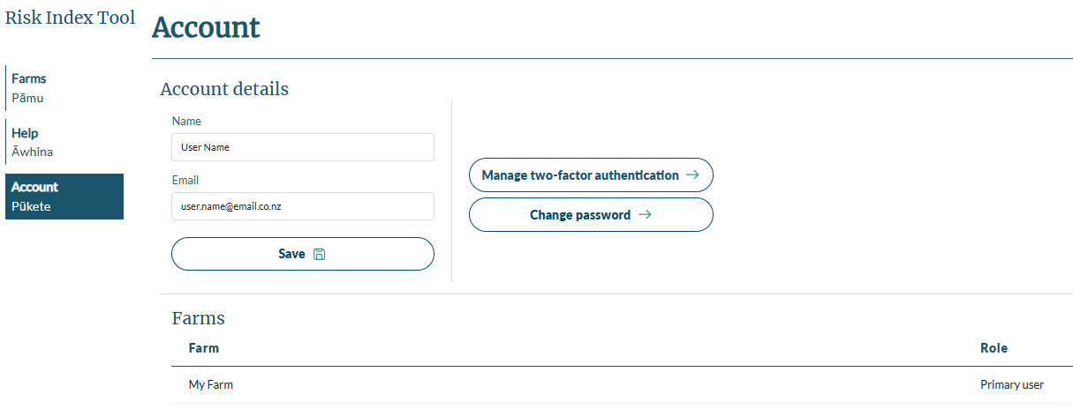
2
3
4
1
- Update your name and email details if necessary.
Note: If you change your email, you will receive an automated email to verify your new email address. Until the new email is verified, your old email will still be used for logging in. You have 10 calendar days to verify the new email address.
After verifying your email, if you have since logged out of the tool, you will need to log in using your old credentials, after which your new email will be saved.
- Manage your two-factor authentication. You can register a new mobile device for two-factor authentication or generate new recovery codes.
- Change your password if necessary.
- View the farms you have access to edit (if still in draft), to create reports or scenarios, and to view reports or scenarios. If you have been granted delegated access to a farm created by another user of the Risk Index Tool, that farm will also appear in this list.

Adding a delegated user
A primary user may invite someone to complete the Risk Index Score report on their behalf. This invited user is known as a delegated user.
To delegate a user, the primary user will need to first create a farm.
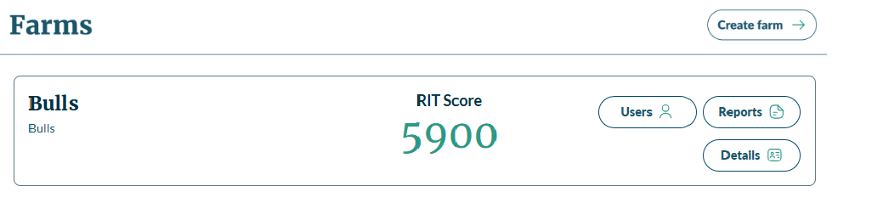
1
- Delegating a user can be done from the home screen or farms screen by clicking ‘Users’.
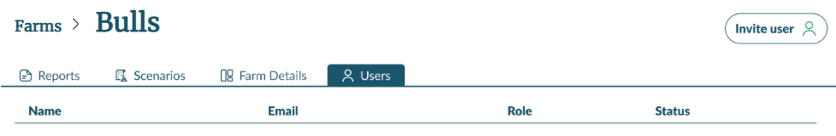
2
- From the Users screen click ‘Invite user’.
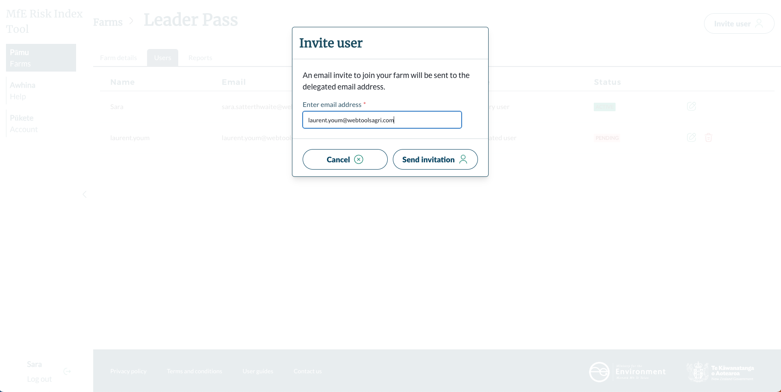
3
- Input the email of the user you want to invite to your farm and click ‘Send invitation’.
Tip: Check if your delegated user is already a registered user with the Risk Index Tool. If they are, we recommend using the same email address.

The invitation email that a delegated user receives:
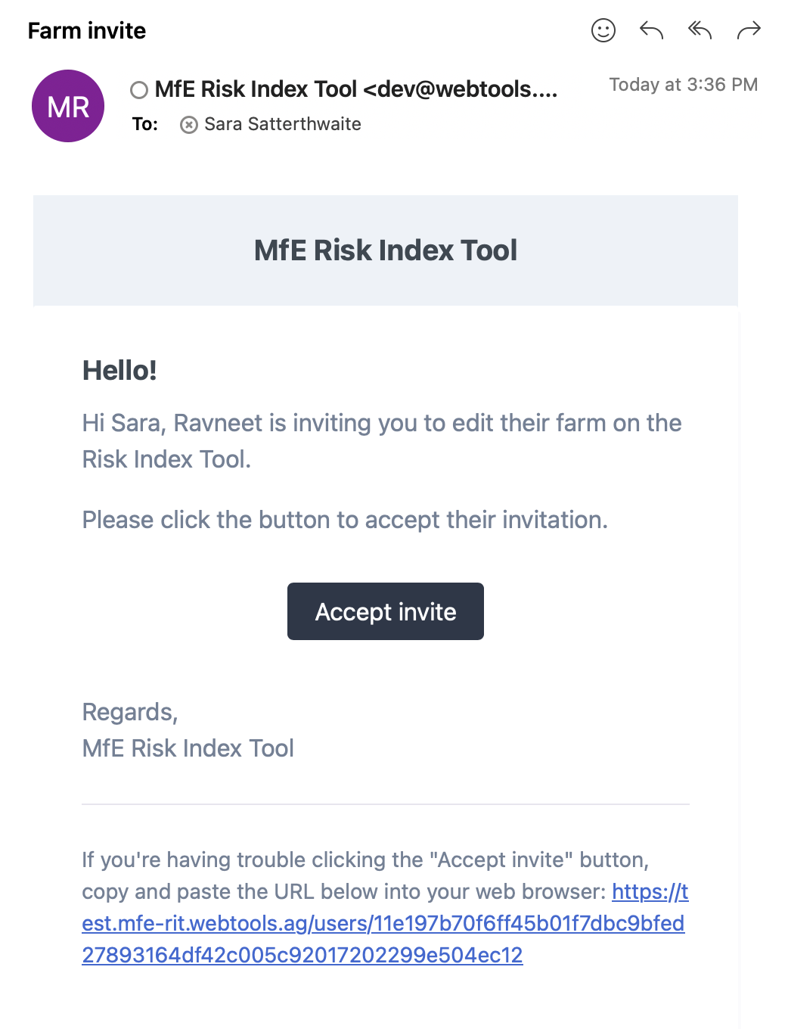
1
- Click ‘Accept invite’ to accept the invite.
If you have already registered to use the Risk Index Tool with the email address used to invite you, you will be asked to login to your account. The farm you have been invited to edit, will appear in your list of farms.
If you aren’t a registered user, you will need to create an account to access the farm.
Note: You have 10 calendar days to accept the invitation. After this period the invitation will expire and the primary user will need to send you a new invitation.
In your account details, you can view which farms your account has access to.
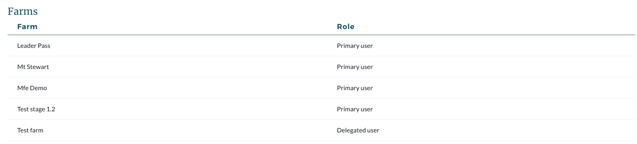

See manage users for more information.

Overview of the Risk Index Tool home screen
2
1
3
4
5
6
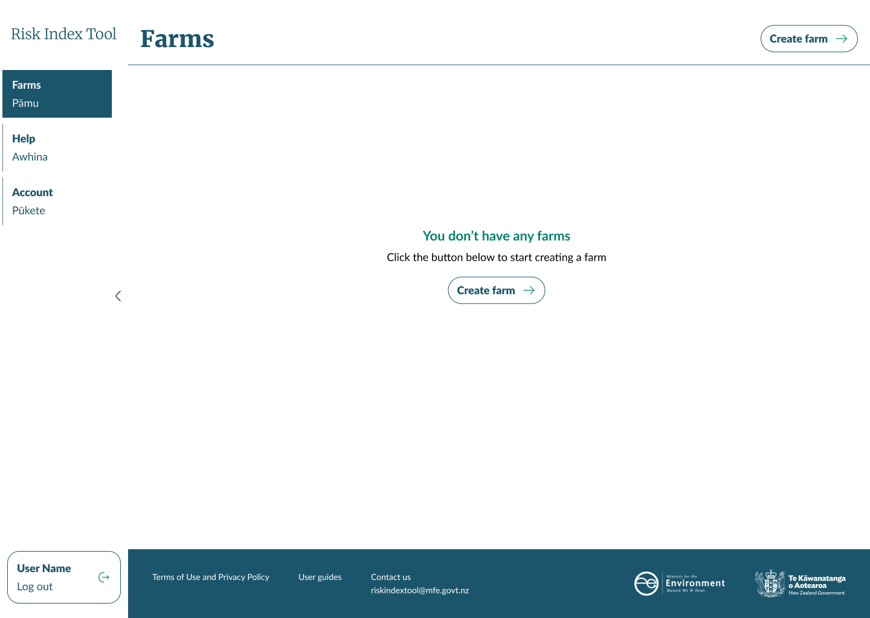
- Click on ‘Risk Index Tool’ from any screen to return to this home screen. This screen shows your farms, both draft and completed, and is where you can start creating a farm.
- Click on ‘Farms’ to also return to this home screen.
- Click on ‘Help’ or ‘User guides’ to access this User Guide which provides guidance on how to use the Risk Index Tool.
- Click on ‘Account’ to view your account details.
- Click on ‘Terms of Use and Privacy Policy’ to access and read the terms you have agreed to and how your data is managed.
- View ‘Contact us’ for the Risk Index Tool Helpdesk details. You can contact our helpdesk during business hours:
Phone: 0800 222 578
Email: RIThelpdesk@backstorytech.com

Creating your farm

Create your farm
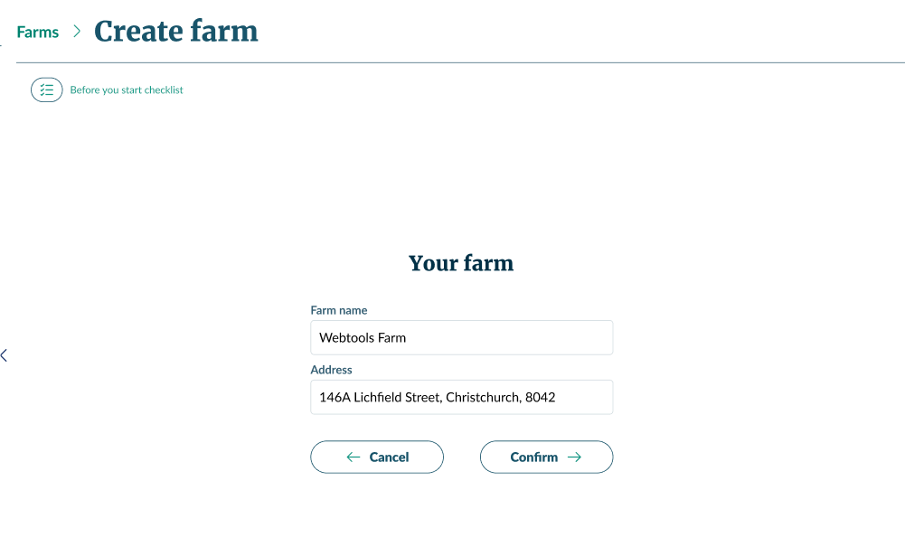
2
3
4
5
- From the home screen, click ‘Create farm’.
- Review the ‘Before you start checklist’ to ensure you have everything you will need to reference during farm creation.
- Enter the name of the farm you want to create a Risk Index Score for.
- Enter the street address. This will be used to locate your farm on the map in future steps.
- Click ‘Confirm’.
Note: Once you have completed this step, you can add a delegated user to this farm. That enables someone else – for example, a farm consultant, to complete the mapping of your farm and generate the Risk Index Score report on your behalf.

Define your farm boundary
The map will centre over the address entered in the ‘Create farm’ step and be overlaid with land parcels. There will be a pin indicating the address entered.
Select the land parcels that correspond to the farm you are mapping. In the next step you will be able to refine the boundary to be an accurate mapping of your farm.
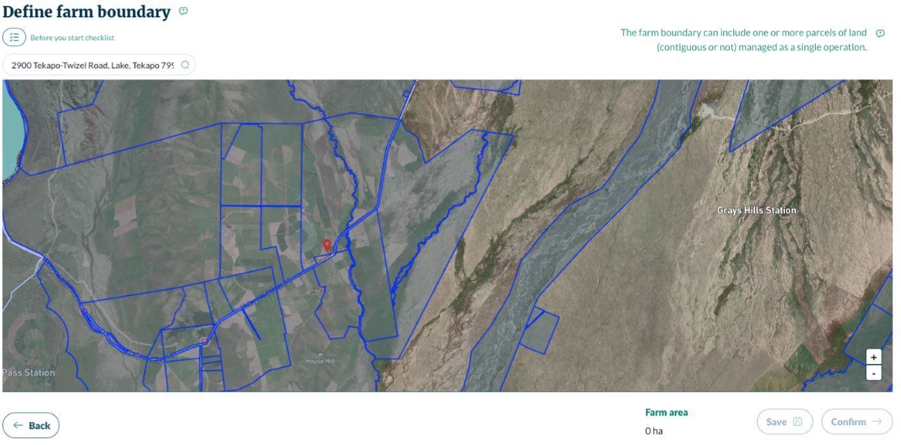
6
4
3
2
1
5
- Use the address bar to update the location showing on the map. You can also search on latitude and longitude coordinates.
Note: What you enter here, for example latitude and longitude, will be what’s shown as the farm’s address on your risk assessment report.
- The land parcel will highlight with a white border when you hover your mouse over it. Click on the land parcel to select it. The land parcel selected will be highlighted red. Click on it again to unselect it.
Note: The land parcels you select do not need to be next to each other. Additionally, more than one registered user can use the same parcel of land for their assessment. This may be particularly relevant for cropping rotations.
- Click ‘Back’ to return to the Farms screen.
- Farm area will update to show the hectares covered by the selected land parcel.
- Click ‘Save’ to save your progress.
- Click ‘Confirm’ to move to the next step. When you confirm your selection, you won’t be able to return to this screen.

Expand your mapping area
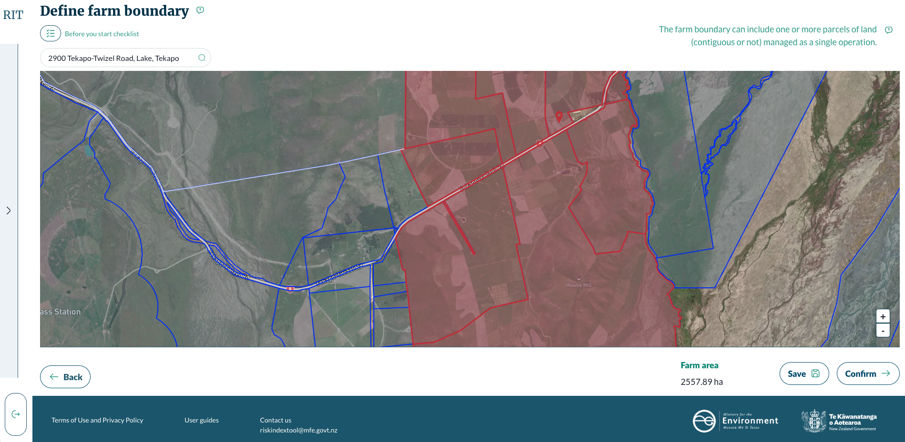
1
- Use the arrow to collapse the left-hand menu and expand the mapping area.

Adjust farm boundary
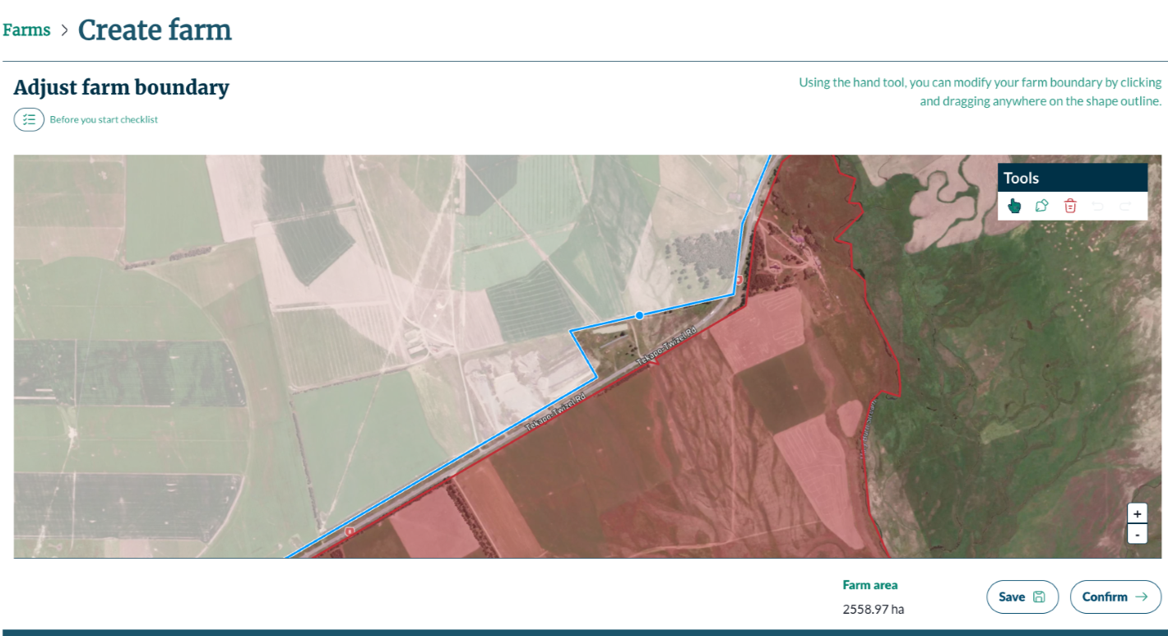
3
1
2
4
5
6
- Click on the part of the farm where you want to adjust the boundary. Hover over the blue line until a blue dot appears, click and hold on the blue dot to drag the line.
- Your tools:
- Use the hand tool to select your farm. You can also click and drag to move yourself around the map.
- Use the pen tool to draw new shapes by clicking where you want a point on the shape, then clicking where the next point is to go. There will be a line between the points. These shapes need to be complete, so join the final point to the first point. These new shapes do not need to join or overlap the existing farm.
Tip: If you draw a new shape overlapping the existing farm, the boundary will automatically incorporate the new shape into the exiting shape in a continuous boundary.
- Use the ‘bin’ icon to delete a selected shape (highlighted in blue).
- Undo and redo buttons. These undo whole shapes, not individual points in the shape.
- Buttons to zoom in and out on the map. You can also scroll on your mouse.
Tip: Zoom in closer to see features on your farm to help with drawing shapes or dragging lines for your mapping.
- The farm area covered by your mapping automatically updates as you adjust the boundary.
- Click ‘Save’ to save your progress.
- Click ‘Confirm’ to move the step. When you confirm your boundary, you can’t come back to this step.

Create your blocks
The next step is to segment the farm into blocks based on consistent land-management practices. Those practices include what stock, if any, is grazed in that area, what crops are grown, fertiliser, water, and effluent application.
These blocks are the foundation of your Risk Index Score and so spend some time thinking about the ways you use different parts of your farm.
Things to consider with blocking:
- Stock: If you have a part of the farm that is dedicated to a stock type, for example an area fenced for deer, that can be a block (depending on other practices such as what crops are growing or irrigation). Also think about grazing patterns, for example stock might be excluded from steep hill country so you would block hills separately from flats.
- Crops: Areas that are planted in one crop that isn’t sown or harvested in the reporting period, such as pasture or forestry, can be one block.
- Irrigated or not: Irrigated land should be blocked separately from non-irrigated land. All irrigation types are treated as the same management practice, so can be blocked together.
- Effluent or not: Land that has effluent applied should be blocked separately from non-effluent land even if all other land-management practices are the same.
- Fertiliser: Areas that receive fertiliser should be blocked separately from land that doesn’t even if all other land-management practices are the same.
Example
You are a drystock farmer with two irrigated areas, a mix of flat land and hills, plus some forestry blocks. The hill area is only used for grazing stock. One irrigated area is used for growing stock feed (maize) plus grazing. The other irrigated area is used for potatoes and onions.
- Block out the forestry areas. Separate blocks for native and exotic forestry.
- Block out the hill.
- Block out the first irrigated area, with separate blocks for fertilised and not fertilised (this is two blocks, not individual paddocks).
- Block out the second irrigated area as one block for horticulture.
- Block out the dryland.
- Leave ineffective areas (driveways, buildings) unblocked.

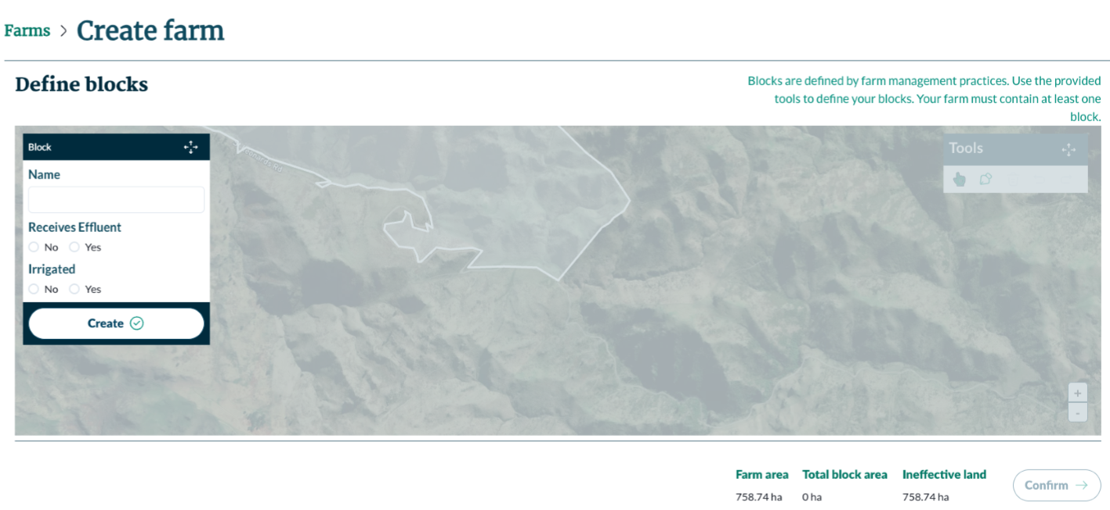
1
2
3
- Name your block something meaningful so you know what area of your farm it is referring to.
- Indicate whether this block receives effluent or is irrigated.
- Click ‘Create’ to enable the map.
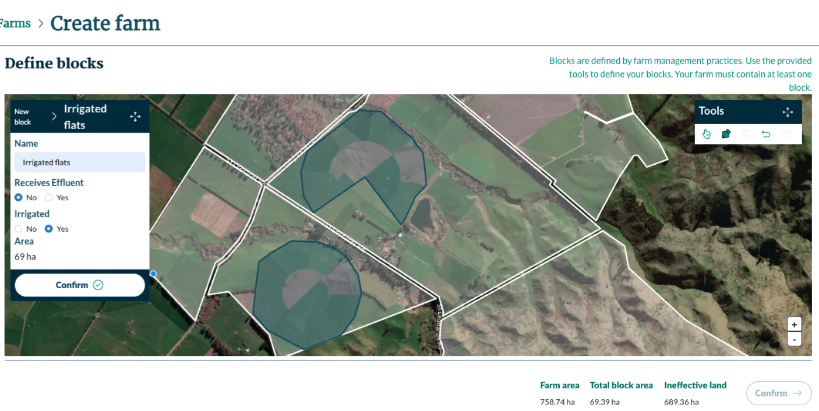
4
5
1
2
3
The above mapping is showing two centre pivots that cover land that is used in the same way.
- You have the same drawing tools as for creating your boundary. Use the pen tool to draw shapes.
Tip: You can draw your block shape over the edge of your farm boundary, and it will automatically snap back to the boundary. You can also draw over the top of existing blocks and the new block will snap around it. This is why we recommend starting with the easiest blocks.
Note: If you go over multiple boundary lines (in the above map you can see that the farm hasn’t merged into one single block), the drawing will only snap back to one.
Important
To ensure clean, continuous coverage, always extend your drawing slightly over the farm boundary or adjacent blocks so the snapping activates. This helps prevent slivers of land from being unintentionally excluded.
- The area you have blocked appears here. Use this to check the accuracy of your drawing.
- When you’re happy with your block, click ‘Confirm’. When you confirm the block, you are also saving it.
- The breakdown of your blocking:
- Farm area: total hectares within your boundary.
- Total block area: area that is covered by all blocks.
- Ineffective area: area that isn’t covered by blocks. This remaining area should reflect laneways, buildings, holding pens and yards and other unproductive parts of the farm.
- When you have an unconfirmed (incomplete) block, the ‘Confirm’ button to complete your blocking is greyed out so you can’t continue with a partial block.
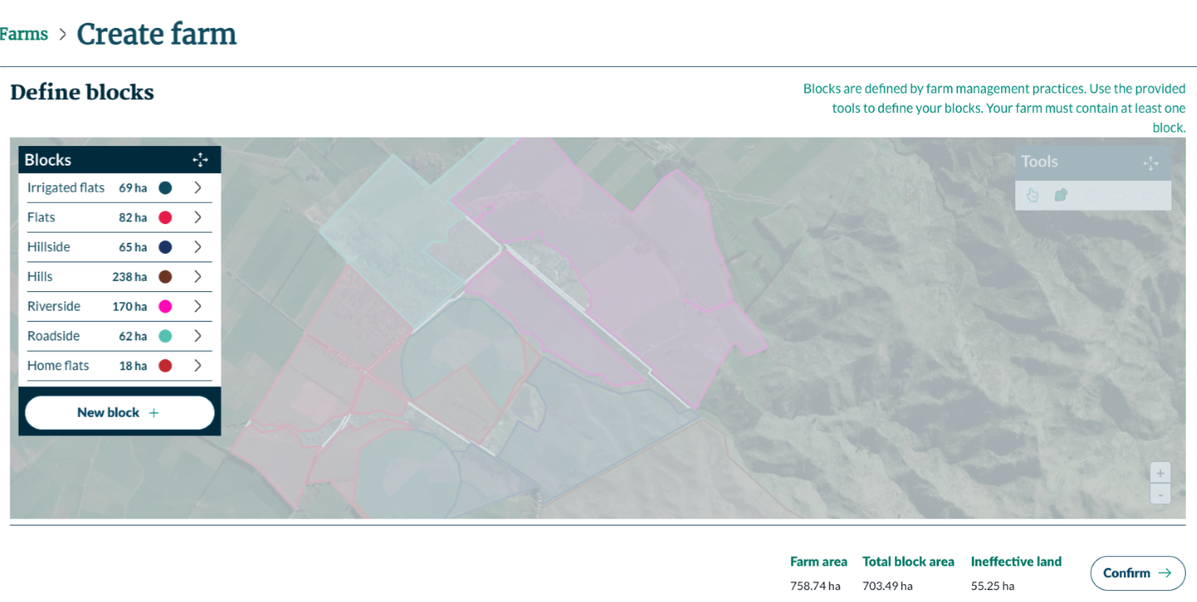
2
1
3
4
- Full list of blocks.
- Click on ‘New block’ to add another block.
- Click on the relevant block to view the details (next image).
- When you are happy that your blocking reflects your farm accurately, click ‘Confirm’ to complete your farm creation.

Edit and delete block
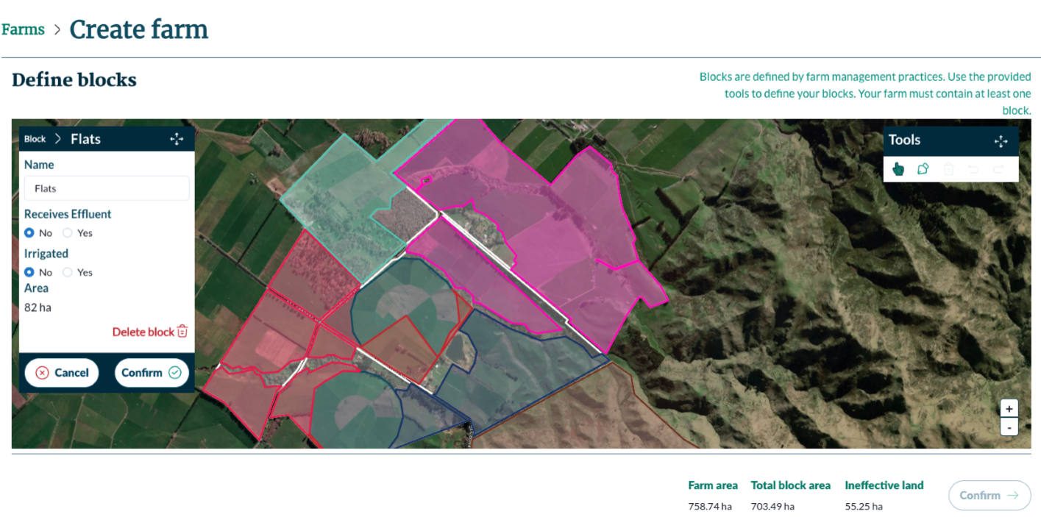
1
2
3
4
- Edit the block details.
- Use the mapping tools to edit the block boundaries.
- Click ‘Delete block’ to delete your block.
- Click ‘Confirm’ to save your changes or ‘Cancel’ to discard your changes and return to the list of blocks.

Complete farm creation
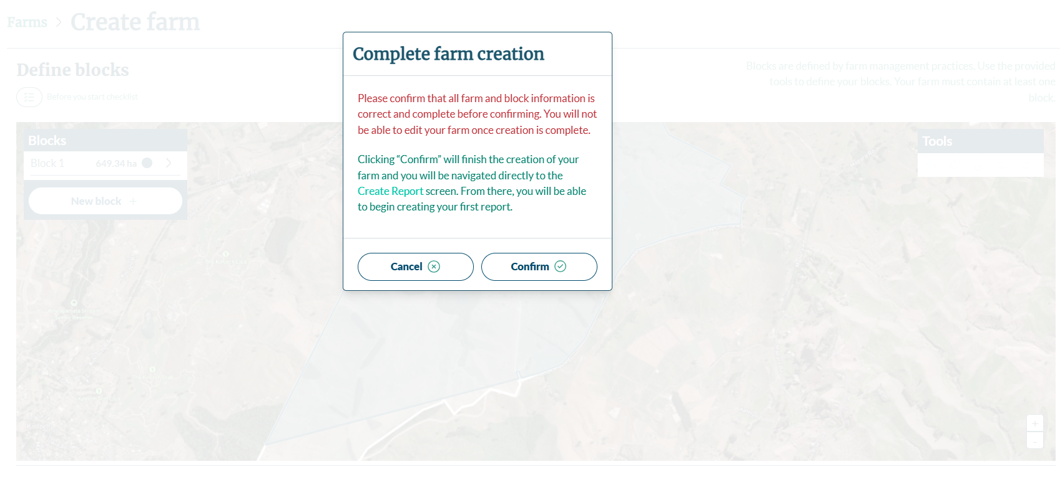
1
2
Important
When you click ‘Confirm’, you will see this warning. Once you click confirm, you cannot come back and edit your farm or blocks.
- Click ‘Confirm’ to complete your farm creation.
- Click ‘Cancel’ to return to the blocking screen.
Congratulations. You have successfully created your farm.

Creating your report

Create report
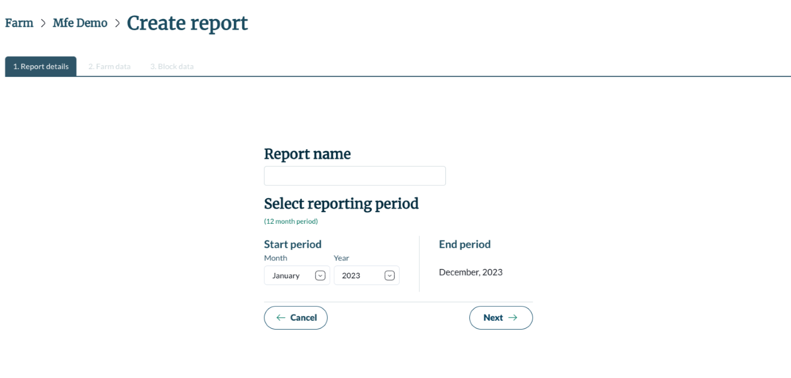
2
1
3
4
- Enter your report name.
- Use the dropdowns to select the month and year that starts your reporting period. All reports are for 12 months so the end period will automatically update based on the start you choose.
Note: You are only able to create one report for each 12-month period.
- Click ‘Next’ to start entering the report data. This will create the draft of your report.
- Click ‘Cancel’ to discard without saving.

Input stock information
Use this screen to input all stock present on your farm during the reporting period. If you don’t have stock on your farm, you can skip this screen using the ‘Save & continue’ button.
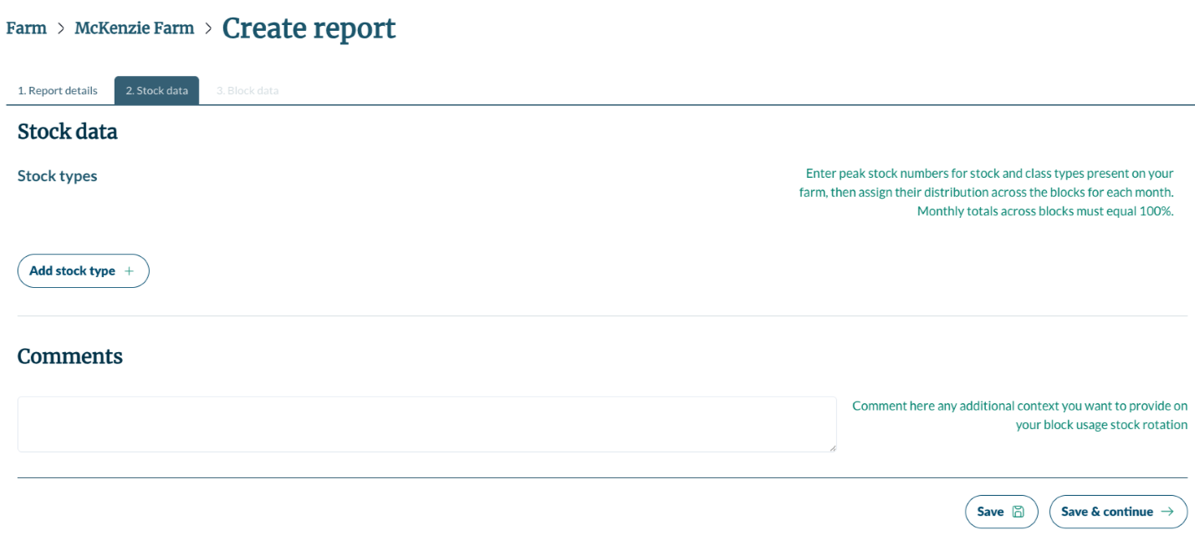
1
2
4
3
- Click ‘Add stock type’ to select the type and class of stock you want to enter stock numbers for.
- Use the comments field to share additional context about the stock headcounts you entered.
- Click ‘Save’ to save your progress.
- Click ‘Save & continue’ when you have captured all your stock information and are ready to move to the next data entry screen.
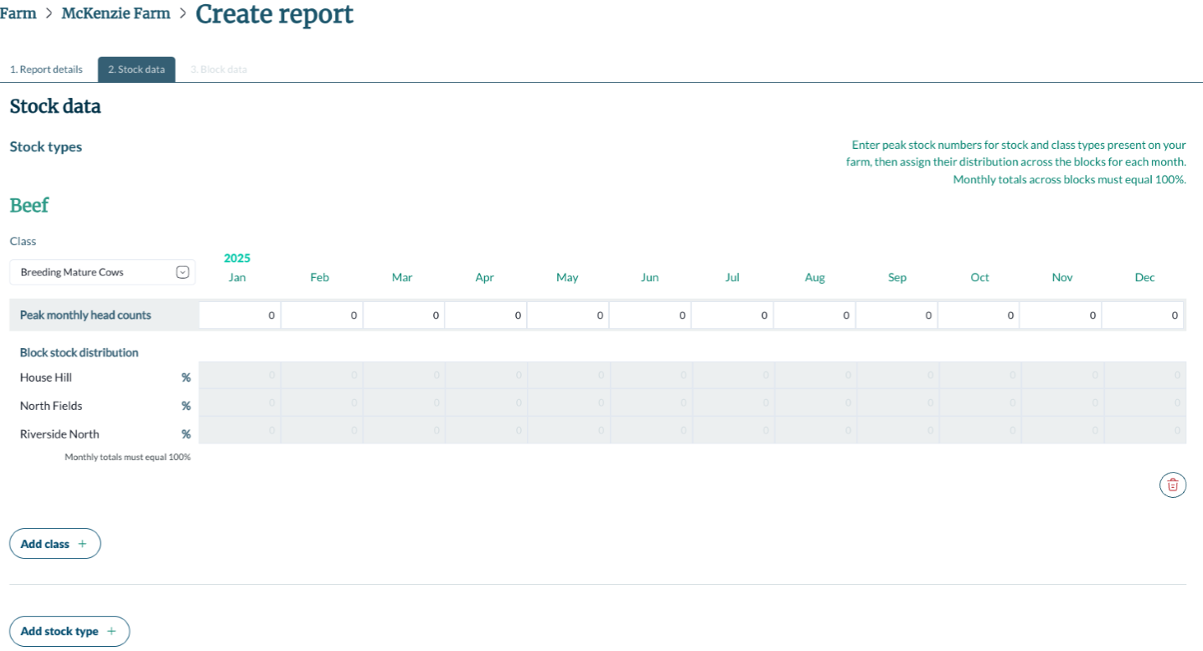
2
1
3
4
5
- In the example the selected stock type is beef and the stock class is breeding mature cows. You can change this dropdown to another class of beef, which will reset the input fields (point 2).
- Enter the peak monthly stock head count for each month, then enter the block stock distribution. This is the proportion of stock that were present on the block as a percentage, for each month. If stock moves between blocks in one month, enter the block stock distribution (proportion stock were present as a percentage) for both blocks in that month.
Tip: If stock are moving on or off the farm completely in any given month, you can reduce the peak monthly head to account for this. For example, a herd of 400 cows only spends half of July on farm, you could enter this as 200 head for the month and then distribute them across blocks. Make a note of this in the comment field.
Note: Use the comment box to make a note of the stock movements between blocks.
- Click ‘Add class’ to add another stock class.
- Use the ’bin’ icon to delete the stock class.
- Click ‘Add stock type’ to add a different group of stock, for example sheep.

Choose block to enter data
Stock data is entered for the entire farm on one screen. The other inputs (crop, fertiliser and modifiers) are entered block by block. In this screen, select the block to enter that information.
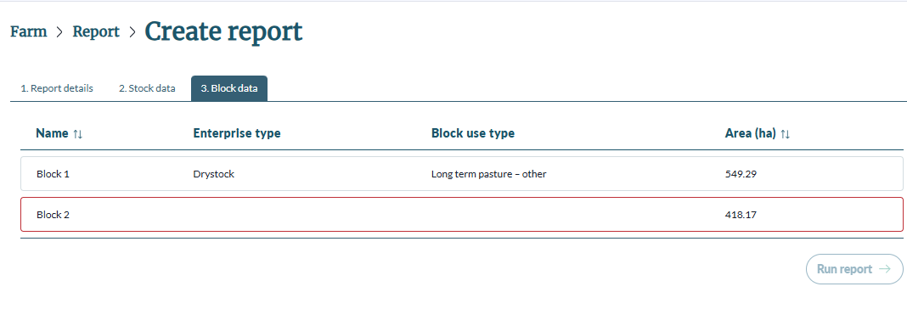
1
6
2
3
4
5
- This block’s data entry is complete and ready for the report to be run.
- This block has incomplete data, shown by the red edge. It’s data entry needs to be finished before the report can be run.
- Click ‘Stock data’ tab to return to the Stock input screen.
- The ‘enterprise type’ for the block is determined by the data entered.
- The ‘block use type’ is selected on the Crop input screen.
- Once the data entry is complete for all blocks, click ‘Run report’ to calculate your Risk Index Score.

Block level information
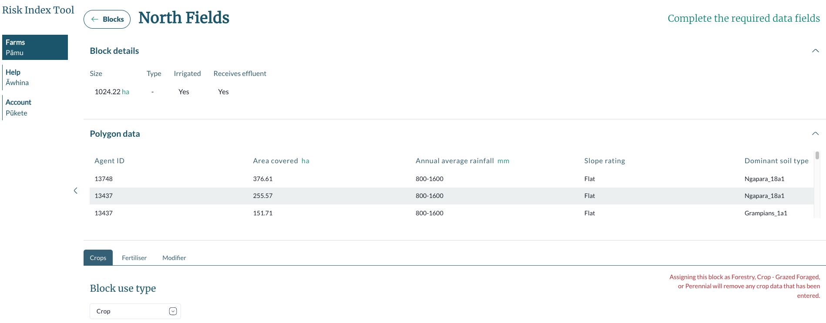
2
1
3
4
- Click ‘Blocks’ to return to the list of Blocks screen.
Note: The block details and polygon data sections are hidden by default.
- Block details displays information about your block based on your mapping.
- Polygon data displays the underlying biophysical data that corresponds with your block.
- Data can be entered for the block in the ‘Crops’, ‘Fertiliser’, and ‘Modifier’ tabs.

Input crop information
While inputting your crop information you need to allocate all hectares of the block for each month with some kind of planting or leave as fallow (unplanted).
Crops you need to enter are:
- Crops that have been harvested the year before the reporting period and during the reporting period.
- Crops in the ground at the end of the reporting period. This could be long-term planting such as forestry or pasture or short-term planting that hasn’t been harvested yet.
The Crop input screen is the only screen that must be filled in because all farm systems have some kind of planting.
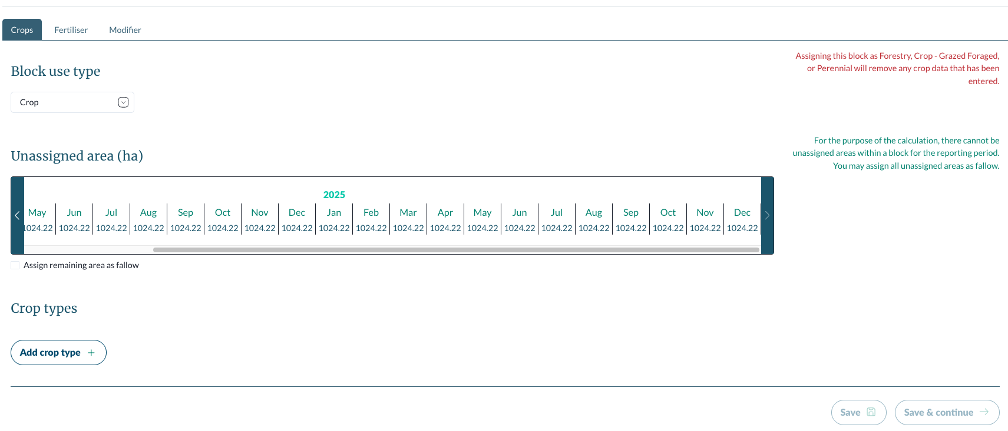
5
1
2
4
3
6
- Click the ‘Block use type’ dropdown to select what is growing on the block. If you are sowing and harvesting in the block, select ‘Crop’. Otherwise select the appropriate option.
Tip: If the block is in pasture for only part of the reporting period, then select ‘Crop’. For example, if you have maize planted for part of the year and replace it with grazing after harvest (or vice versa).
- Shows the unallocated area in the block by month. You will need to get this row to 0 to move to the next screen.
- Assign remaining area as fallow checkbox. Takes whatever hectares are left in the unassigned area and allocates them as fallow or unplanted area.
- Click ‘Add crop type’ to start adding your crops.
- Click ‘Save’ to save your progress. The button is greyed out in this image because there is no new data to save.
- Click ‘Save & continue’ to progress to entering fertiliser information for the block. The button is greyed out in this image because the unassigned area is not at zero. Anytime this button is greyed out, the system is saying the cropping information is incomplete so review your entries.

Changing block use type
This shows what happens when you select a block use type that isn’t crop.
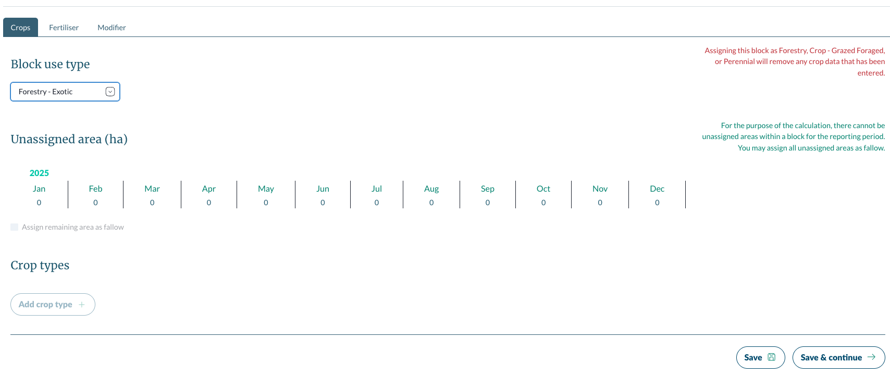
3
1
2
4
- All other options, aside from crop, assign the entire block to that block use. In this example, the block is being assigned as ‘Forestry – Exotic’.
- Unassigned area is zero because the entire block is allocated.
- The ‘Add crop type’ button is greyed out because you cannot add any other crop. If you need to allocate multiple crops to the block, select the crop option in the ‘Block use type’ drop down.
- The ‘Save & continue’ button is active because all the area is assigned.

Adding multiple crop types
You might have two paddocks within the same block that have the same crop. Provided these paddocks are sown and harvested in the same months, they can be entered as one crop.
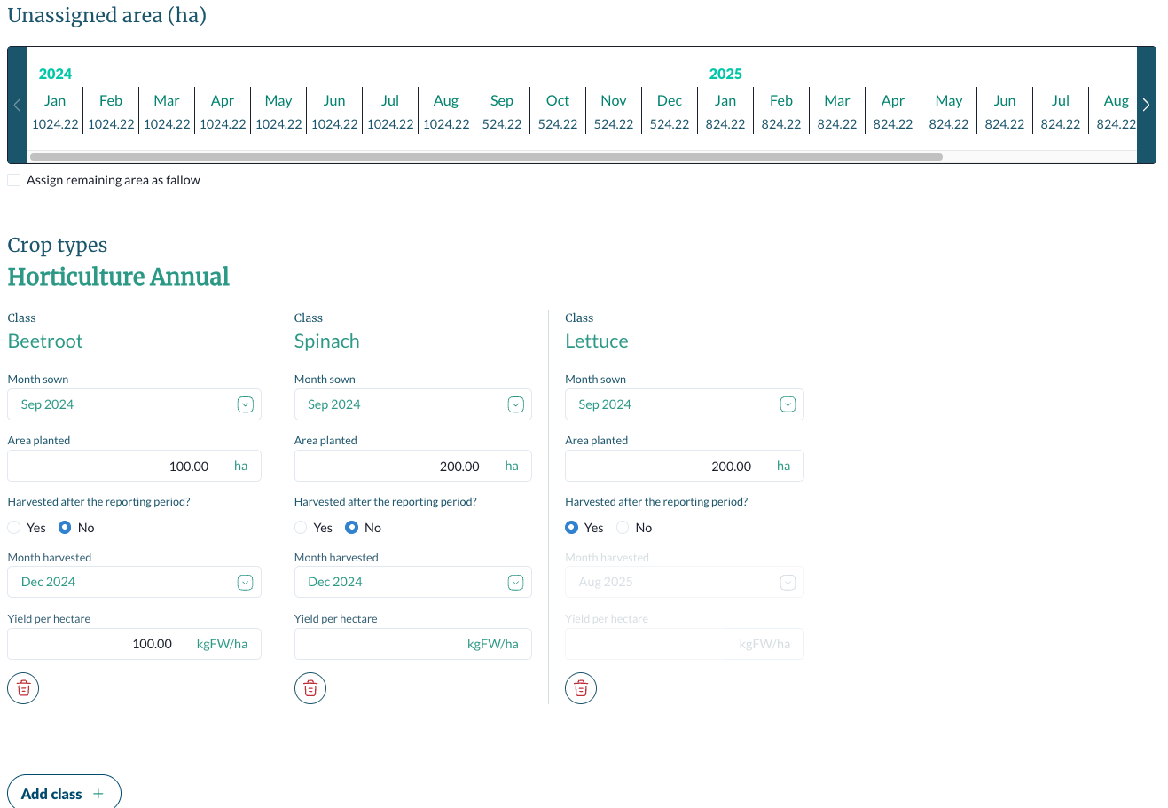
6
5
1
2
3
4
- There are three crop types:
- Annual and arable
- Pasture
- Green manure.
- Crop class options are based on the selected crop type
- Enter in the month sown and area planted in hectares.
Note: You can enter the month sown for up to a year before the reporting period. This is to allow for crops that are already in the ground at the start of your reporting period. If your crop was sown more than a year before the reporting period, select the oldest month.
- Select whether the crop was or will be harvested after the reporting period or not. If no, enter the month harvested and the yield per hectare.
- Use the ‘bin’ icon to delete the crop class.
- Click ‘Add class’ to add another crop.
Note: You can enter the same crop more than once.

Area exceeds total block area
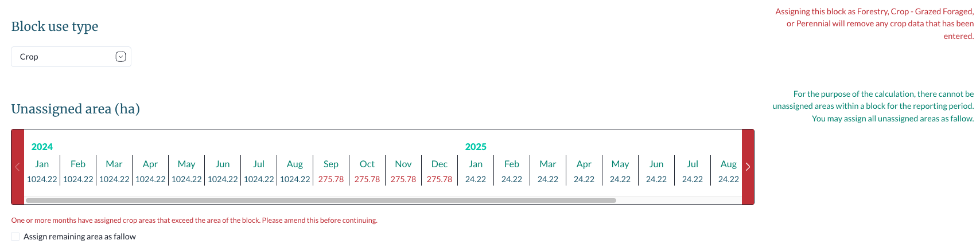
Red numbers for unassigned area show how many hectares over the total block size have been sown for that month. Review what crops you have entered and adjust so the total sown area doesn’t exceed the block size.
You won’t be able to move to the next screen while the sown area exceeds the size of the block.

Assigning area as fallow
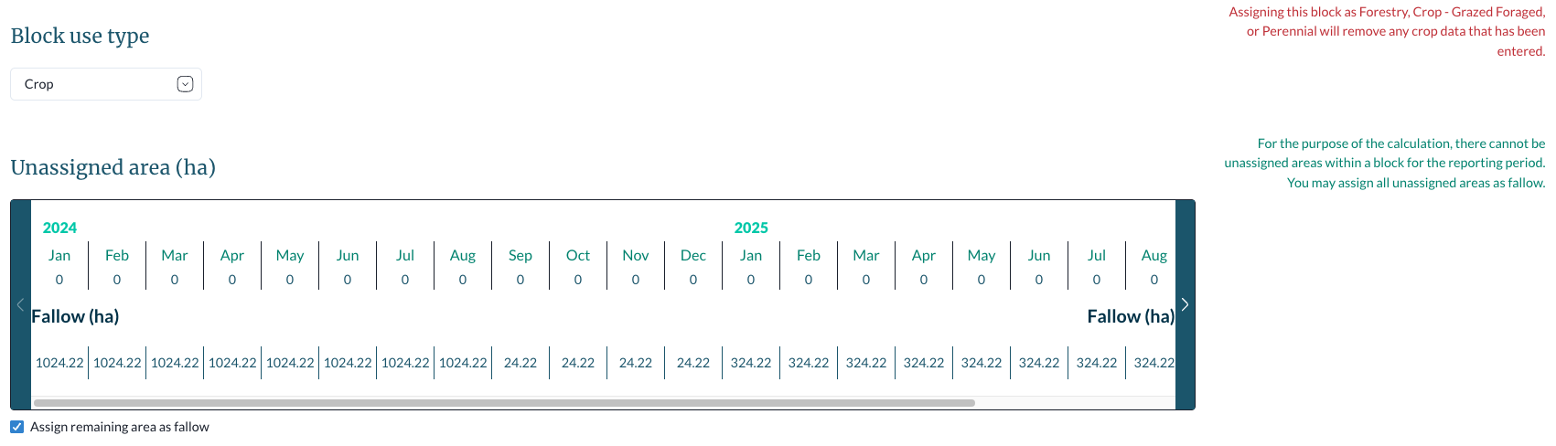
Click the checkbox to assign the remaining area in the block as fallow (unplanted). You can still add more crops when this checkbox is selected.
Assigning the remaining area as fallow means the ‘Save & continue’ button will be enabled and you can move to the next screen.

Input fertiliser information
Fertiliser is not compulsory. If you don’t apply fertiliser on your farm, click ‘Save & Continue’ to move to the next step.
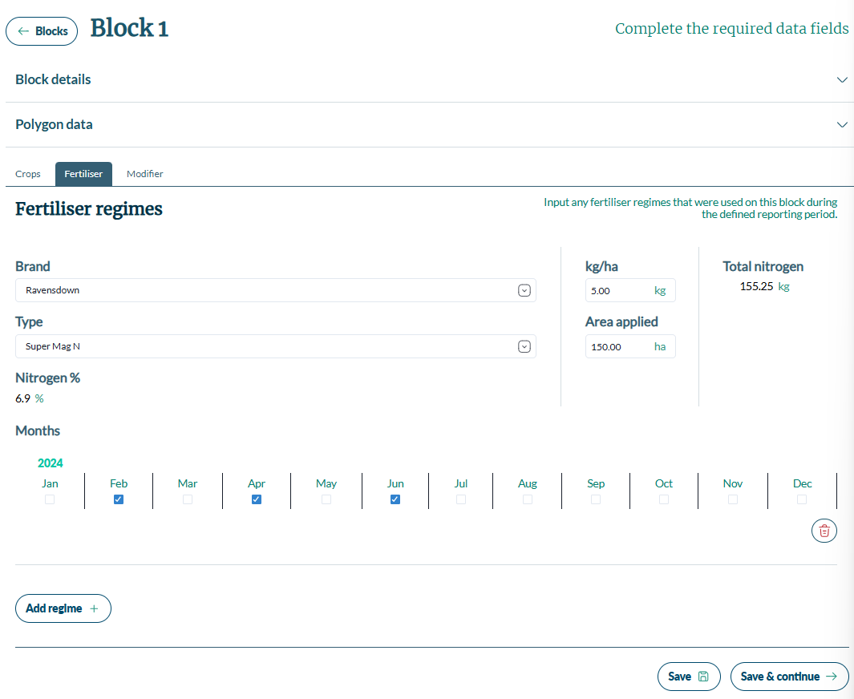
8
6
2
5
1
3
4
7
9
10
- Select the brand of fertiliser from the dropdown or select ‘other’ if the brand isn’t shown. There is also an option for adding manure. Compost can be entered as ‘other’.
- If a brand or manure is selected, choose the type of fertiliser.
- For brands and manure, the nitrogen percentage will automatically update. For ’other’, enter the nitrogen percentage of the product applied.
- Enter the application rate of the fertiliser in kilograms per hectares.
Note: This is the quantity of fertiliser as a whole, not the quantity of nitrogen. This is the fertiliser application rate per month
- Enter the area the fertiliser was applied to in hectares. This can’t exceed the total block area.
Note: It doesn’t matter where in the block the fertiliser is applied to, as long as it is within the block.
- Select the months the fertiliser was applied.
- The total nitrogen applied automatically updates as the form is complete.
- Click ‘Add regime’ to add another fertiliser to the block.
- Click ‘Save’ to save your progress.
- Click ‘Save & continue’ to move to the next step.

Select relevant modifiers
Modifiers are farm practices that impact the nitrogen risk of your system. The modifiers presented are based on the information you have entered so will be different for each block.
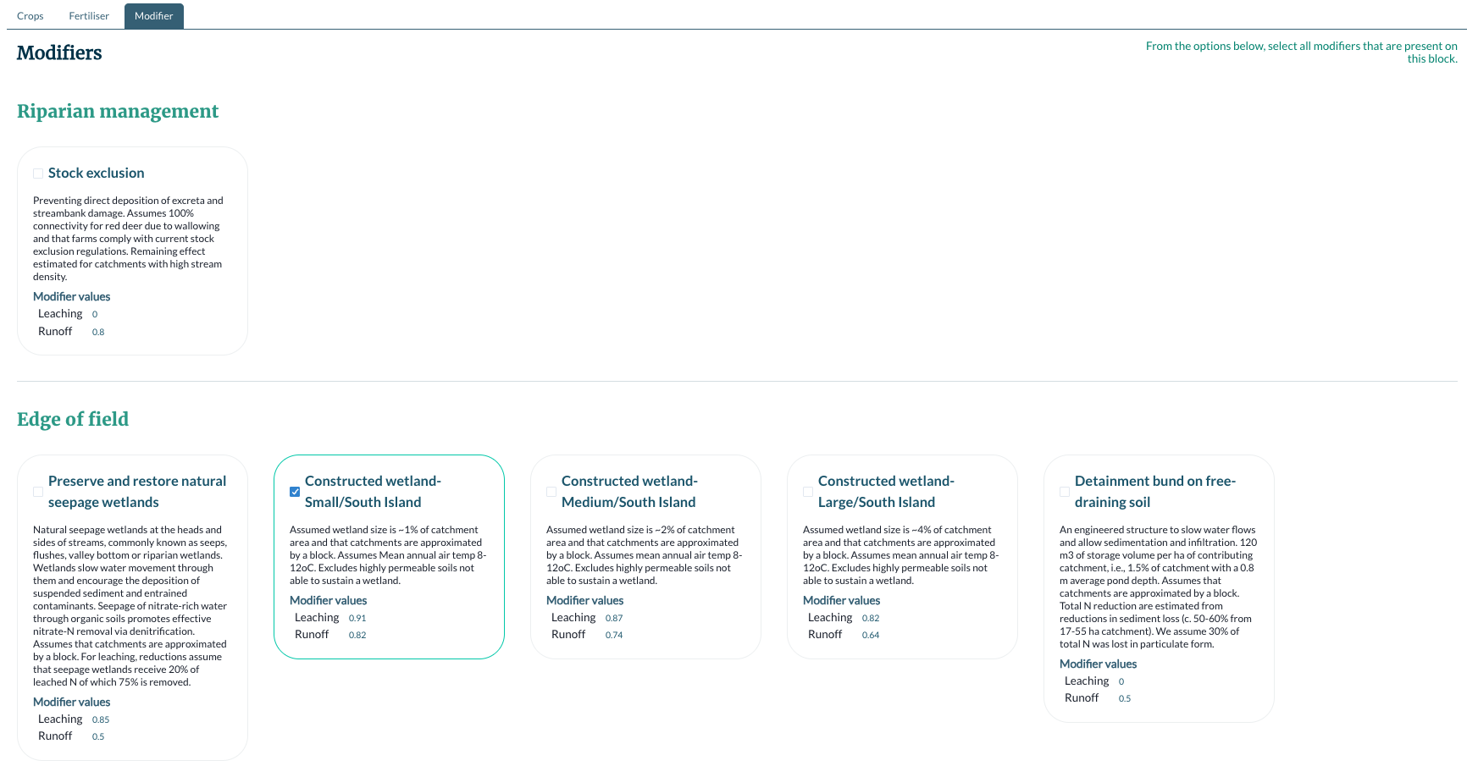
1
- A selected modifier.
Note: Modifiers that appear are based on the information such as stock and crops you selected for your farm as well as the soil type of your farm and other biophysical factors depending on your farm location. The tool will automatically apply modification factors.
At the bottom of the modifiers screen, click ‘Save & close’ to return to the list of blocks.

Running your report
When you have entered the information for each of the blocks, you can run your report. Once you run your report, you can’t change any of the inputs, so make sure your data is accurate and complete first.
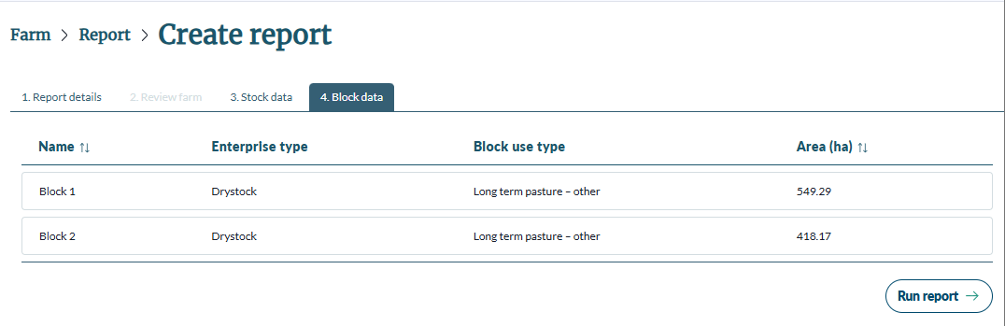
1
- Click ‘Run report’ to start your report and generate your Risk Index Score.
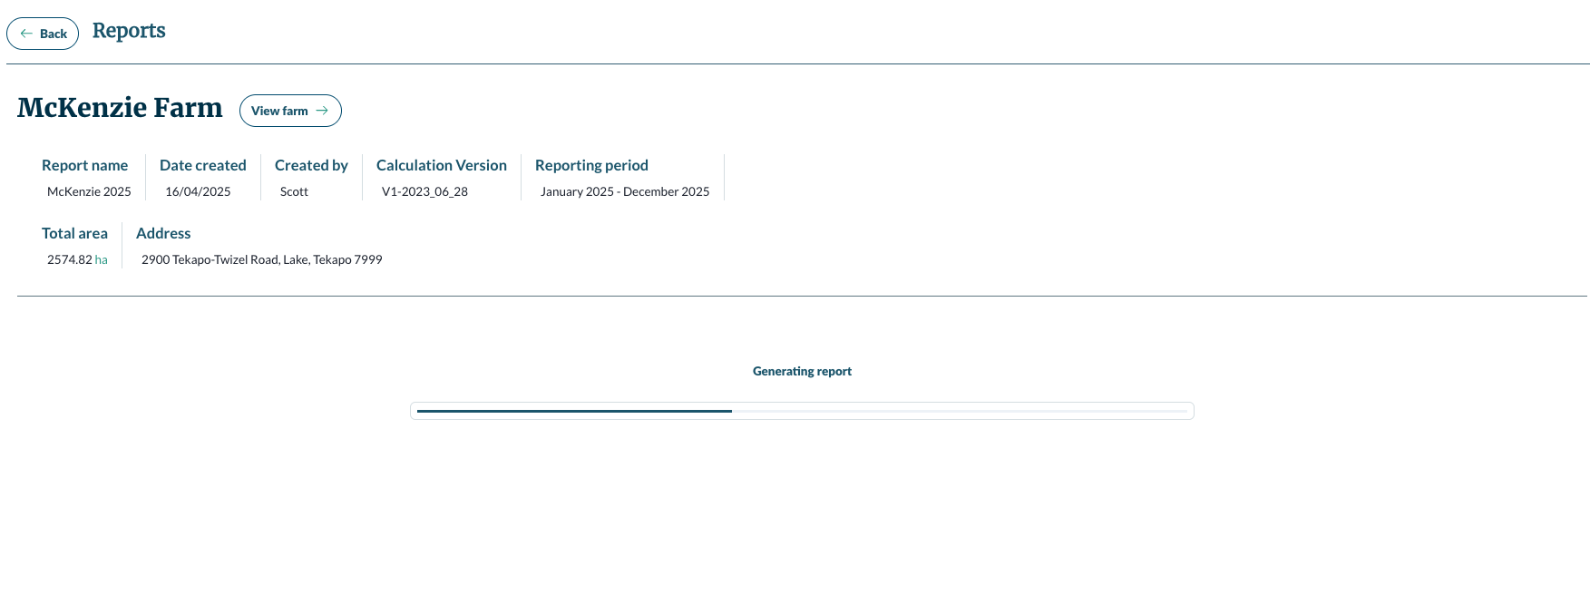
2
1
3
- Click ‘View farm’ to go to the farm overview.
- The report details from when you created the report.
- The loading bar. Reports can take 30 seconds to generate (there’s a big calculation running) so please be patient.

Reading and exporting your report
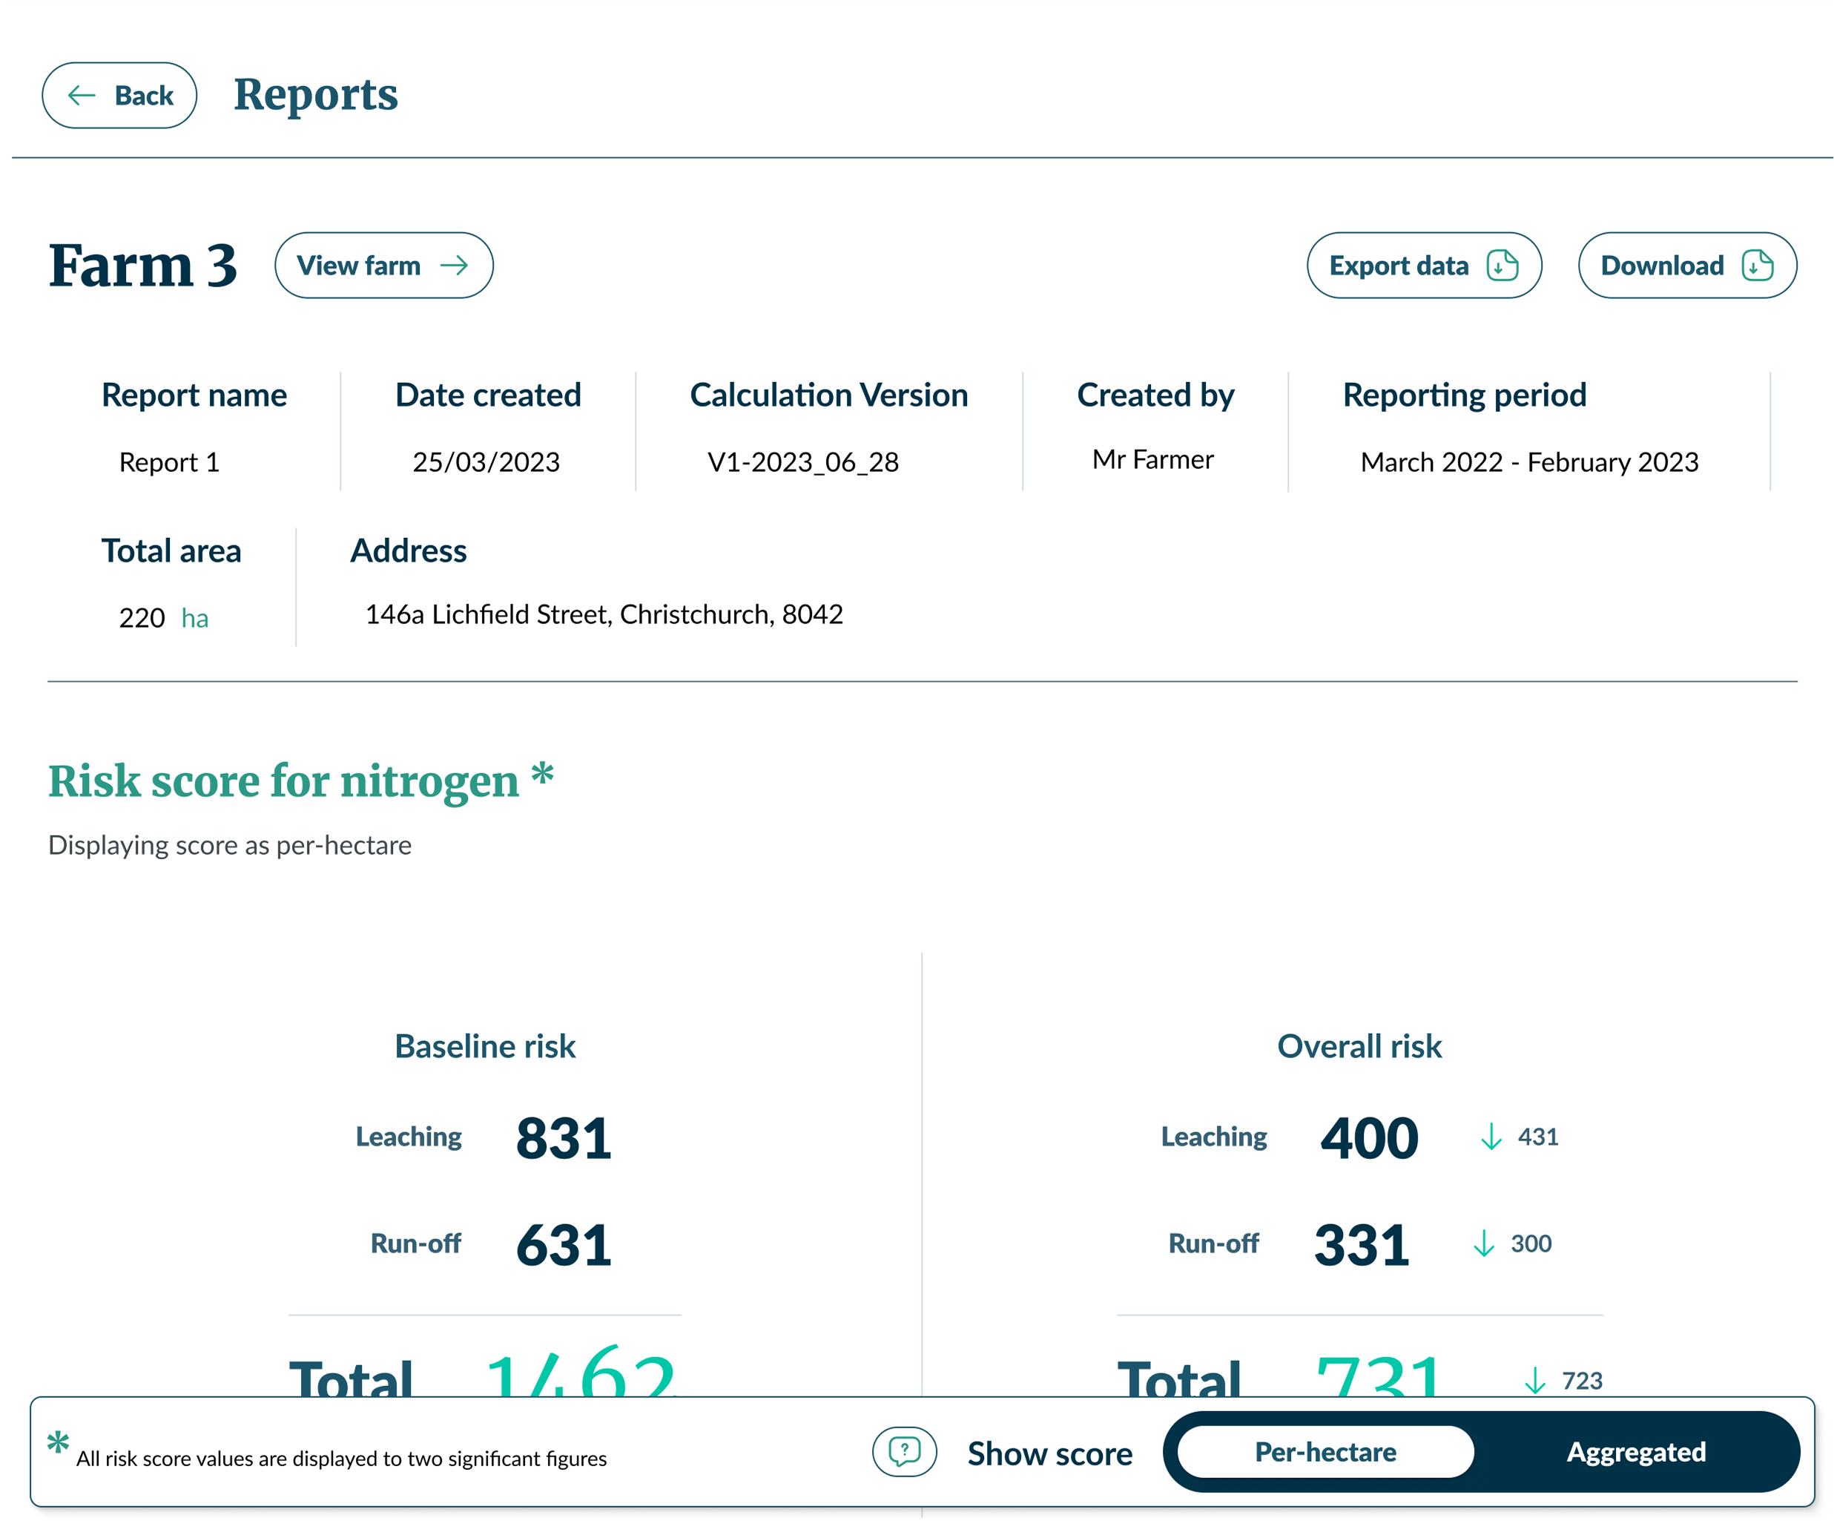
1
2
3
4
Important
By default, all sections of the report will show ‘Per-hectare risk scores’, this can be changed to an ‘Aggregated risk scores’ view using the floating toggle at the bottom of the page.
- Risk score per hectare – This map shows the different level of risk for each polygon on a per hectare scale. Risk score per hectare = total risk for the polygon ÷ total area of the polygon.
- Aggregated risk score – This heat map shows the level of risk for each polygon by total score. Scores are not weighted by area. This may result in the larger polygons having the highest risk colouring.
For more information, see the Contaminant Risk Index Tool: Understanding Risk Scores and Heatmaps.
- Baseline risk is the total nitrogen risk based on your farm system. This is split into leaching and runoff scores.
- Overall risk shows the impact of the modifiers selected on your score. If no modifiers were selected, then the overall risk will be the same as the baseline risk.
Note: All risk score values are displayed to two significant figures. For example:
- 0.36
- 3.6
- 3600
- 0.30
- Click ‘Export data’ to get an Excel spreadsheet of all of the data used to calculate your Risk Index Score.
- Click ‘Downland as PDF’ to get a PDF report containing your Risk Index Score and breakdown by block.

Report sections
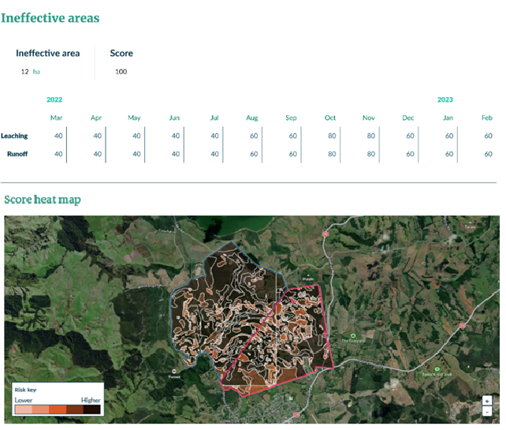
2
1
3
- The contribution of ineffective areas to the Risk Index Score.
- Heat map of the farm. The blocks are subdivided into polygons of matching biophysical characteristics (slope, soil, rainfall). Each polygon is colour coded based on their relative level of risk.
- Legend showing meaning of the colours.
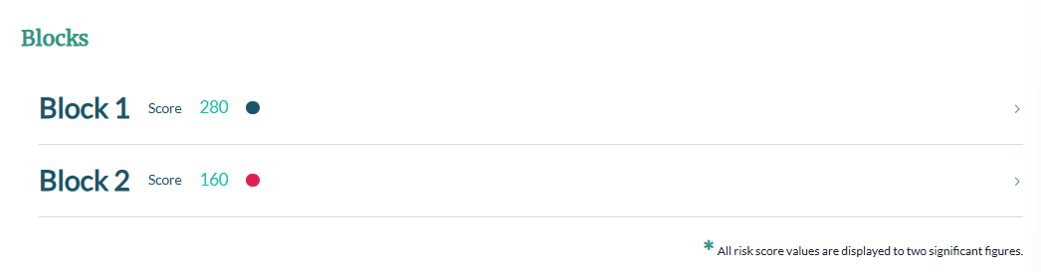
1
- The blocks in the report. Click on the block name to open its section. The coloured dots correspond with the coloured edging of the block on the heat map.

Block section of the report
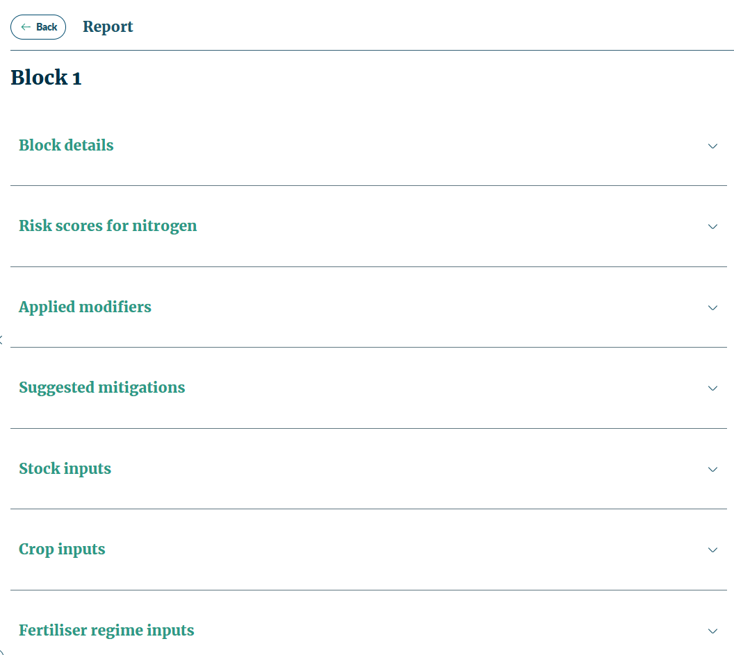
1
2
3
4
5
6
7
This screen provides an overview of the key block details and all inputs for the block within the report. Click on each heading to expand the section.
- Block details – This summarises the key details of the selected block, as entered in the report and based on the area. It includes a breakdown by month, and by leaching / runoff the risk amounts.
- Risk scores for nitrogen – This provides a breakdown by month, and by leaching / runoff the risk amounts. The overall risk shows the impact of any modifiers.
- Applied modifiers – Shows any modifiers selected in the report.
- Suggested mitigations – Lists relevant modifiers for the block which are not currently being used.
- Stock inputs – Shows the inputs for stock for the selected block by total head count and proportion assigned to the block.
- Crop inputs – Displays the crop inputs for the selected block.
- Fertiliser regime inputs – Displays the fertiliser inputs for the selected blocks.

Subsequent reports
After you have created your first report, the report creation steps change slightly.
- You can review your farm map to make updates to reflect changes in your farm system. If you want to review and change your farm map, you will need to create a new report.
- If the reporting period of the new report overlaps with the reporting period of an existing report, then the data will prepopulate for the overlapping months, so you don’t have to enter it again.

Reviewing your farm
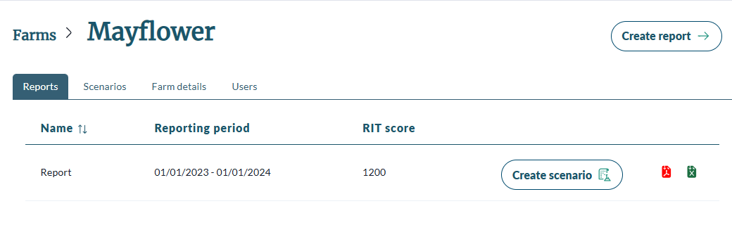
1
- For any subsequent reports created for a farm, follow the steps to create a new report.
- You can update your farm map to reflect any changes in the boundary and blocks. If your farm hasn’t changed, click ‘Save & continue’ to move onto inputting your report data.
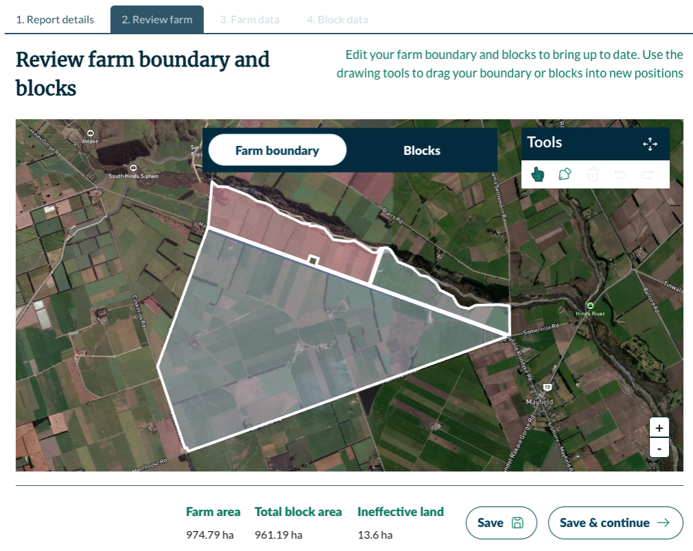
1
2
- By default the review farm map will be set to edit ‘Farm boundary’ mode. You can select and drag the boundary in the same way as the other mapping screens.
- If you shrink your boundary, it will also shrink the relevant block.
- If you extend your boundary, it won’t automatically extend the relevant block.
- Click on the ‘Blocks’ toggle to edit your blocks.
- Click on the block you want to edit. You can change any of the details including the block area. Confirm the changes.
- You can toggle back and forth between editing the boundary and blocks.

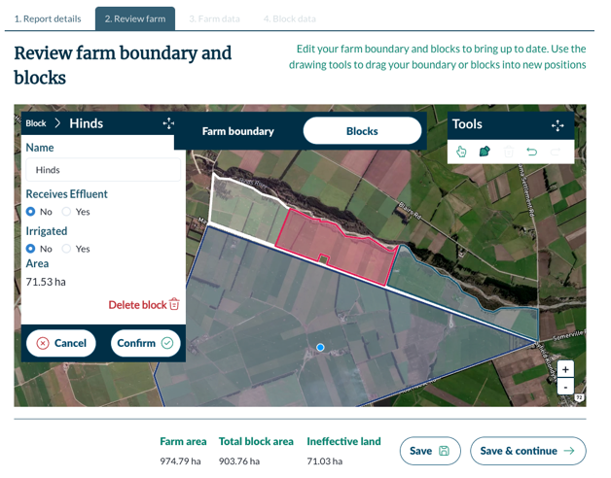
1
2
- Click ‘Save’ to save your edits and keep editing your farm map.
- Click ‘Save & continue’ to confirm your edits and move to inputting report data.

Prepopulating data
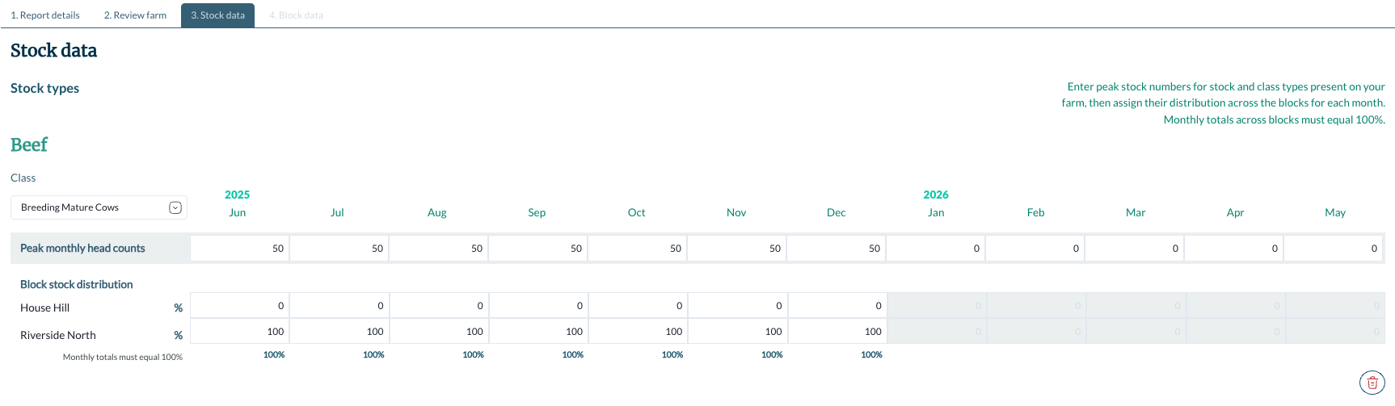
The data is matched based on block, year and month.
If multiple reports covering the same period exist, the system uses the data from the most recently created report.

Scenario planning
You can run scenarios, based on your reports, to see the impact different changes to your farm system will have on your risk score.
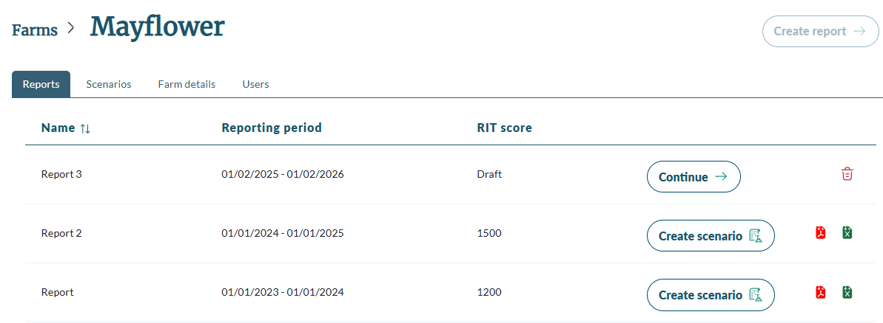
1
- On the Reports screen, click the ‘Create scenario’ button of the report you want to copy as the basis of your scenario.
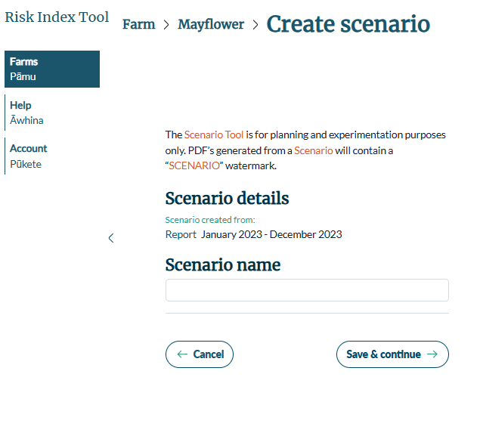
1
2
3
- Enter the name of your scenario.
- Click ‘Cancel’ to return to the Reports screen without creating the scenario.
- Click ‘Save & continue’ to confirm the creation.
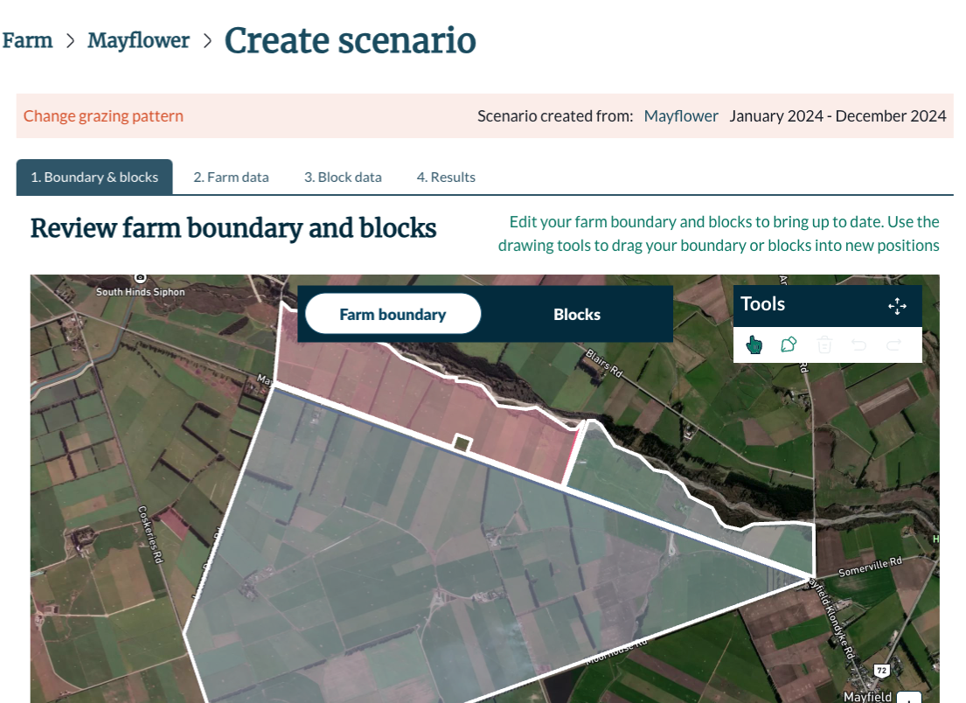
1
- Navigate to the part of the report you want to edit. The map and input screens all function the same as reports.
In scenarios you can change inputs in any order. It is recommended that you make edits to the farm map first before changing inputs.
Important
Save your changes before using the tabs to navigate to another screen. This will reduce the risk of losing any information if you accidently close your browser or are inactive for a period and get timed out.

Run your scenario
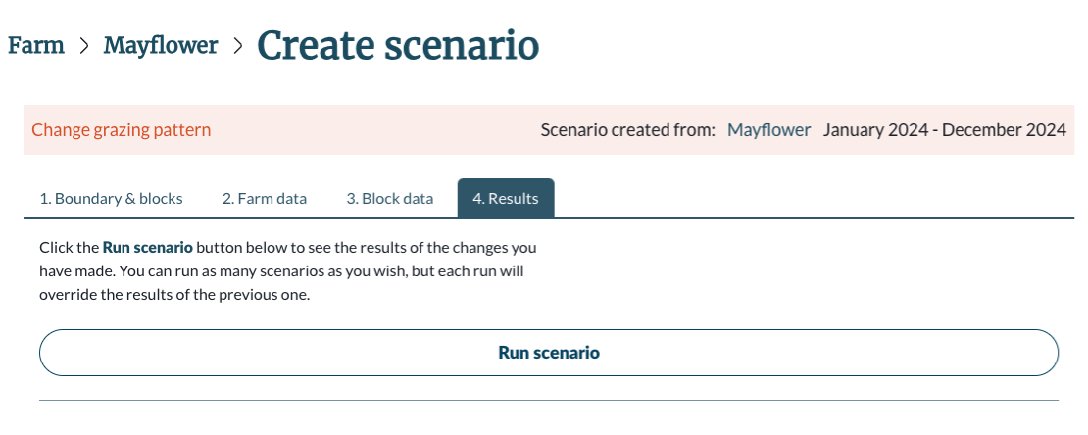
1
2
- Click the ‘Results’ tab.
- Click ‘Run scenario’.

View scenario results
After running the scenario, you will see both the scenario results and the original report results.
The rest of the results are laid out the same as the report.
By default, all sections of the report will show ‘Per-hectare risk scores’. This can be changed to an ‘Aggregated risk score’ view using the floating toggle at the bottom of the page.
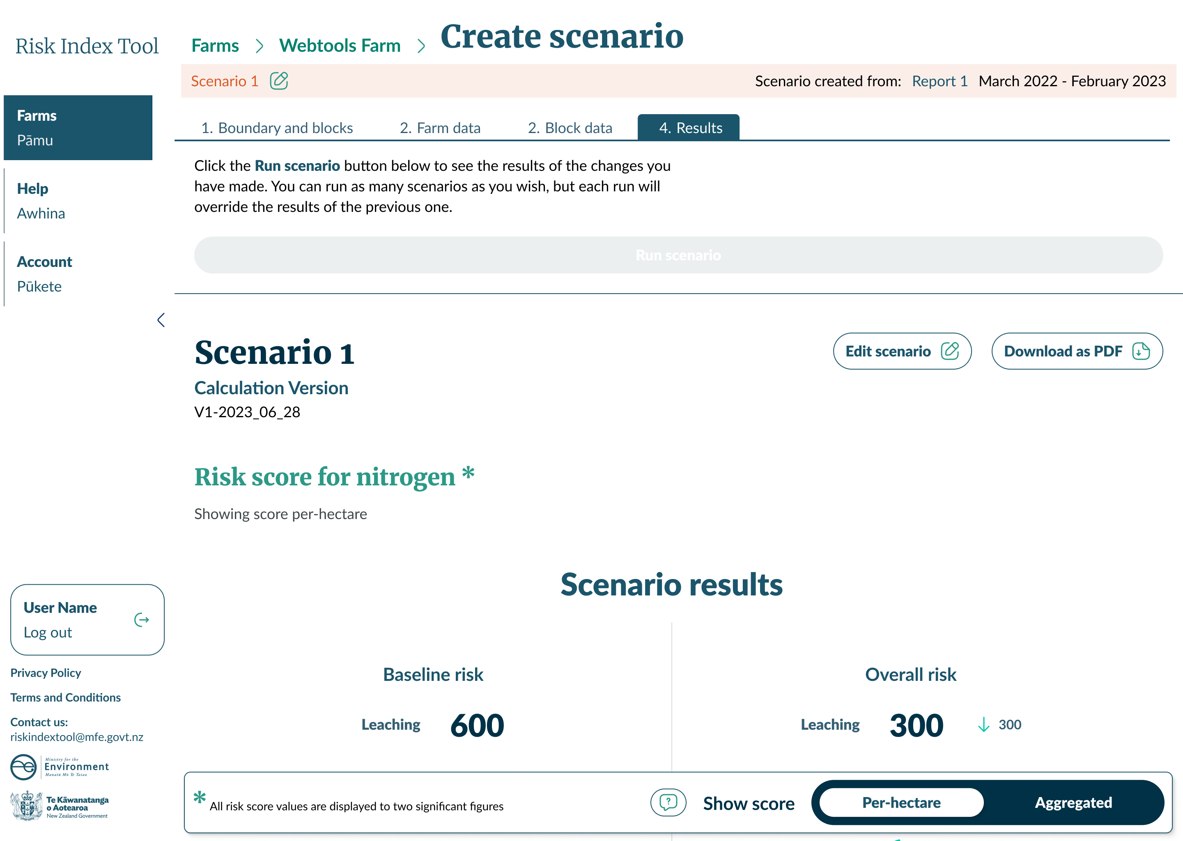
Results are presented to two significant figures for baseline risk and overall risk.

Errors in scenarios
If your scenario edits have broken any rules (usually an input area exceeds the block area), then your ‘Run scenario’ button will be inactive, and you will get an error message that looks like this:
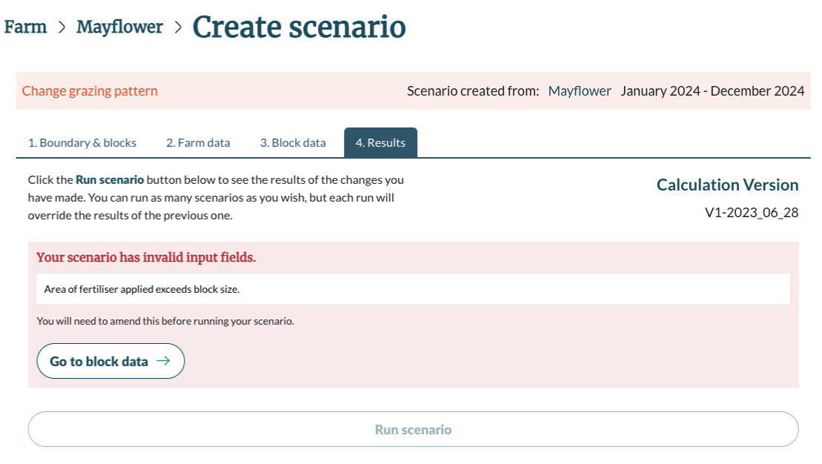
1
2
- Read the error message to know what input needs to be edited. In this example, it is the fertiliser applied area.
- Click ‘Go to block data’ to return to the list of blocks.
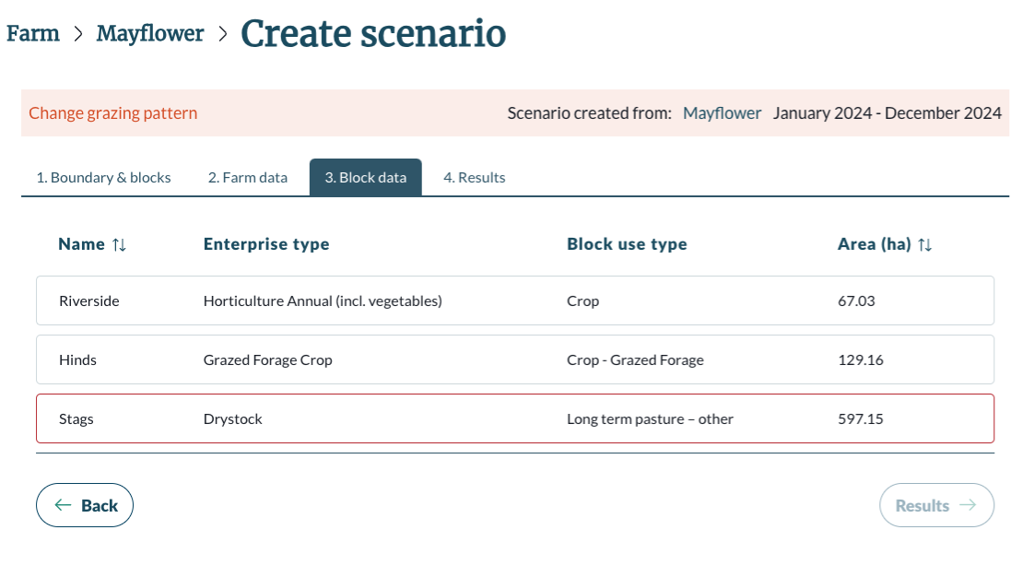
1
- Click on the block highlighted in red.
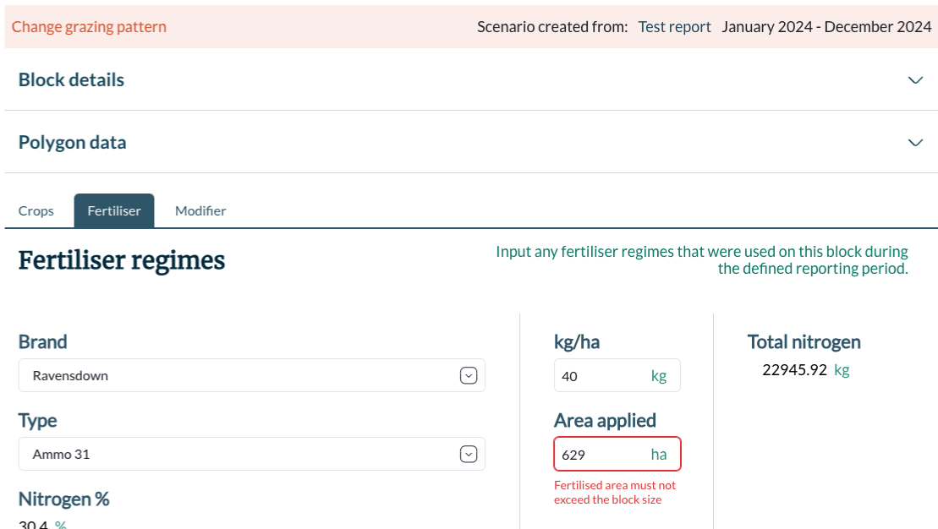
1
2
- Navigate to the Input mentioned in the error message. See example of error above.
- Update the necessary fields to correct the error.
Tip: Check the block details at the top of the screen to find your exact block area.
- Click ‘Save’ to save your changes.
- Navigate back to the ‘Results’ tab to run your scenario.

Managing your farm
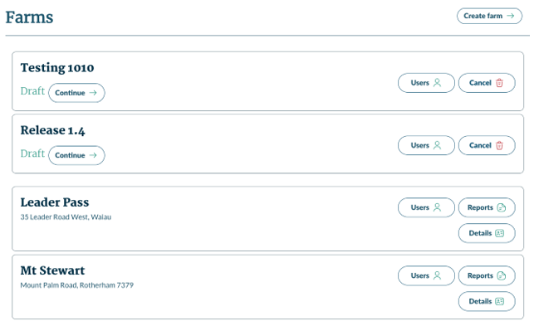
3
4
1
2
5
6
- Click ‘Create Farm’ to start a new farm.
- This is a draft farm. Click ‘Continue’ to resume mapping out the farm.
- Click the ‘Users’ button to view and manage the users associated with this farm.
- Click ‘Cancel’ to delete the farm. This is only possible for farms that are in the draft state.
- Click ‘Reports’ to access the Risk Index Score reports that have been created for this farm.
- Click ‘Details’ to access the overview for this farm including address and details.

Accessing farm details
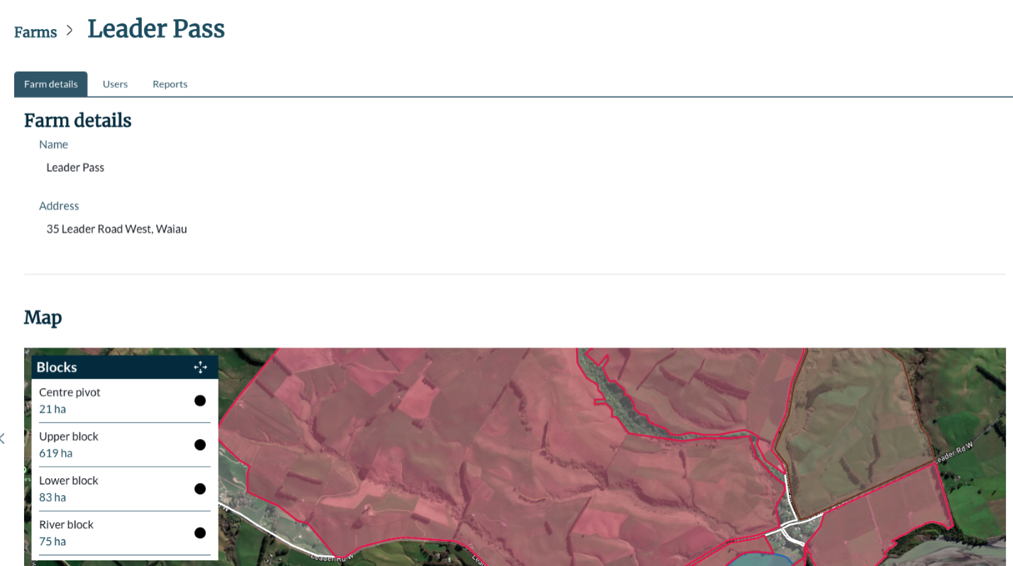
- Farm information entered by user when creating the farm.
- Interactive, read only map of the farm including the blocks.
- List of blocks created by the user.

Managing users
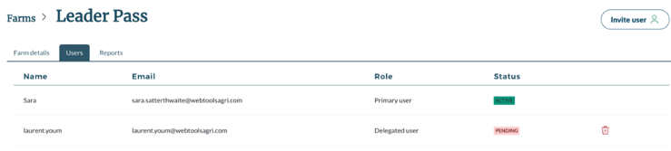
1
2
3
4
- Primary user: The original creator of the farm in the Risk Index Tool. This relationship between the farm and the user that created it cannot be broken.
- Delegated user: Invited by primary user to map the farm and create the Risk Index Score report on behalf of the primary user.
Important
If you choose to delegate access to your farm it is your responsibility, as the primary user to manage the delegated user’s access.
- Use the ‘bin’ icon to remove the delegated user from the farm.
- Click ‘Invite user’ to add a delegated user to your farm.

Viewing reports
1
2
3
5
4
- Click on the name of the report to open the report and view your Risk Index Score onscreen.
Note: You can only have one draft report in progress. In the above image, the ‘Create report’ button is greyed out because a draft report already exists (the top row).
- Click ‘Create report’ to start a new report and generate your Risk Index Score.
- Click ‘Continue’ to keep working on your draft report.
- Use the ‘bin’ icon to delete your draft report. You cannot delete completed reports.
- Use the ‘PDF’ icon to download the PDF version of your report or ‘Excel’ icon to download a spreadsheet of the report data.

