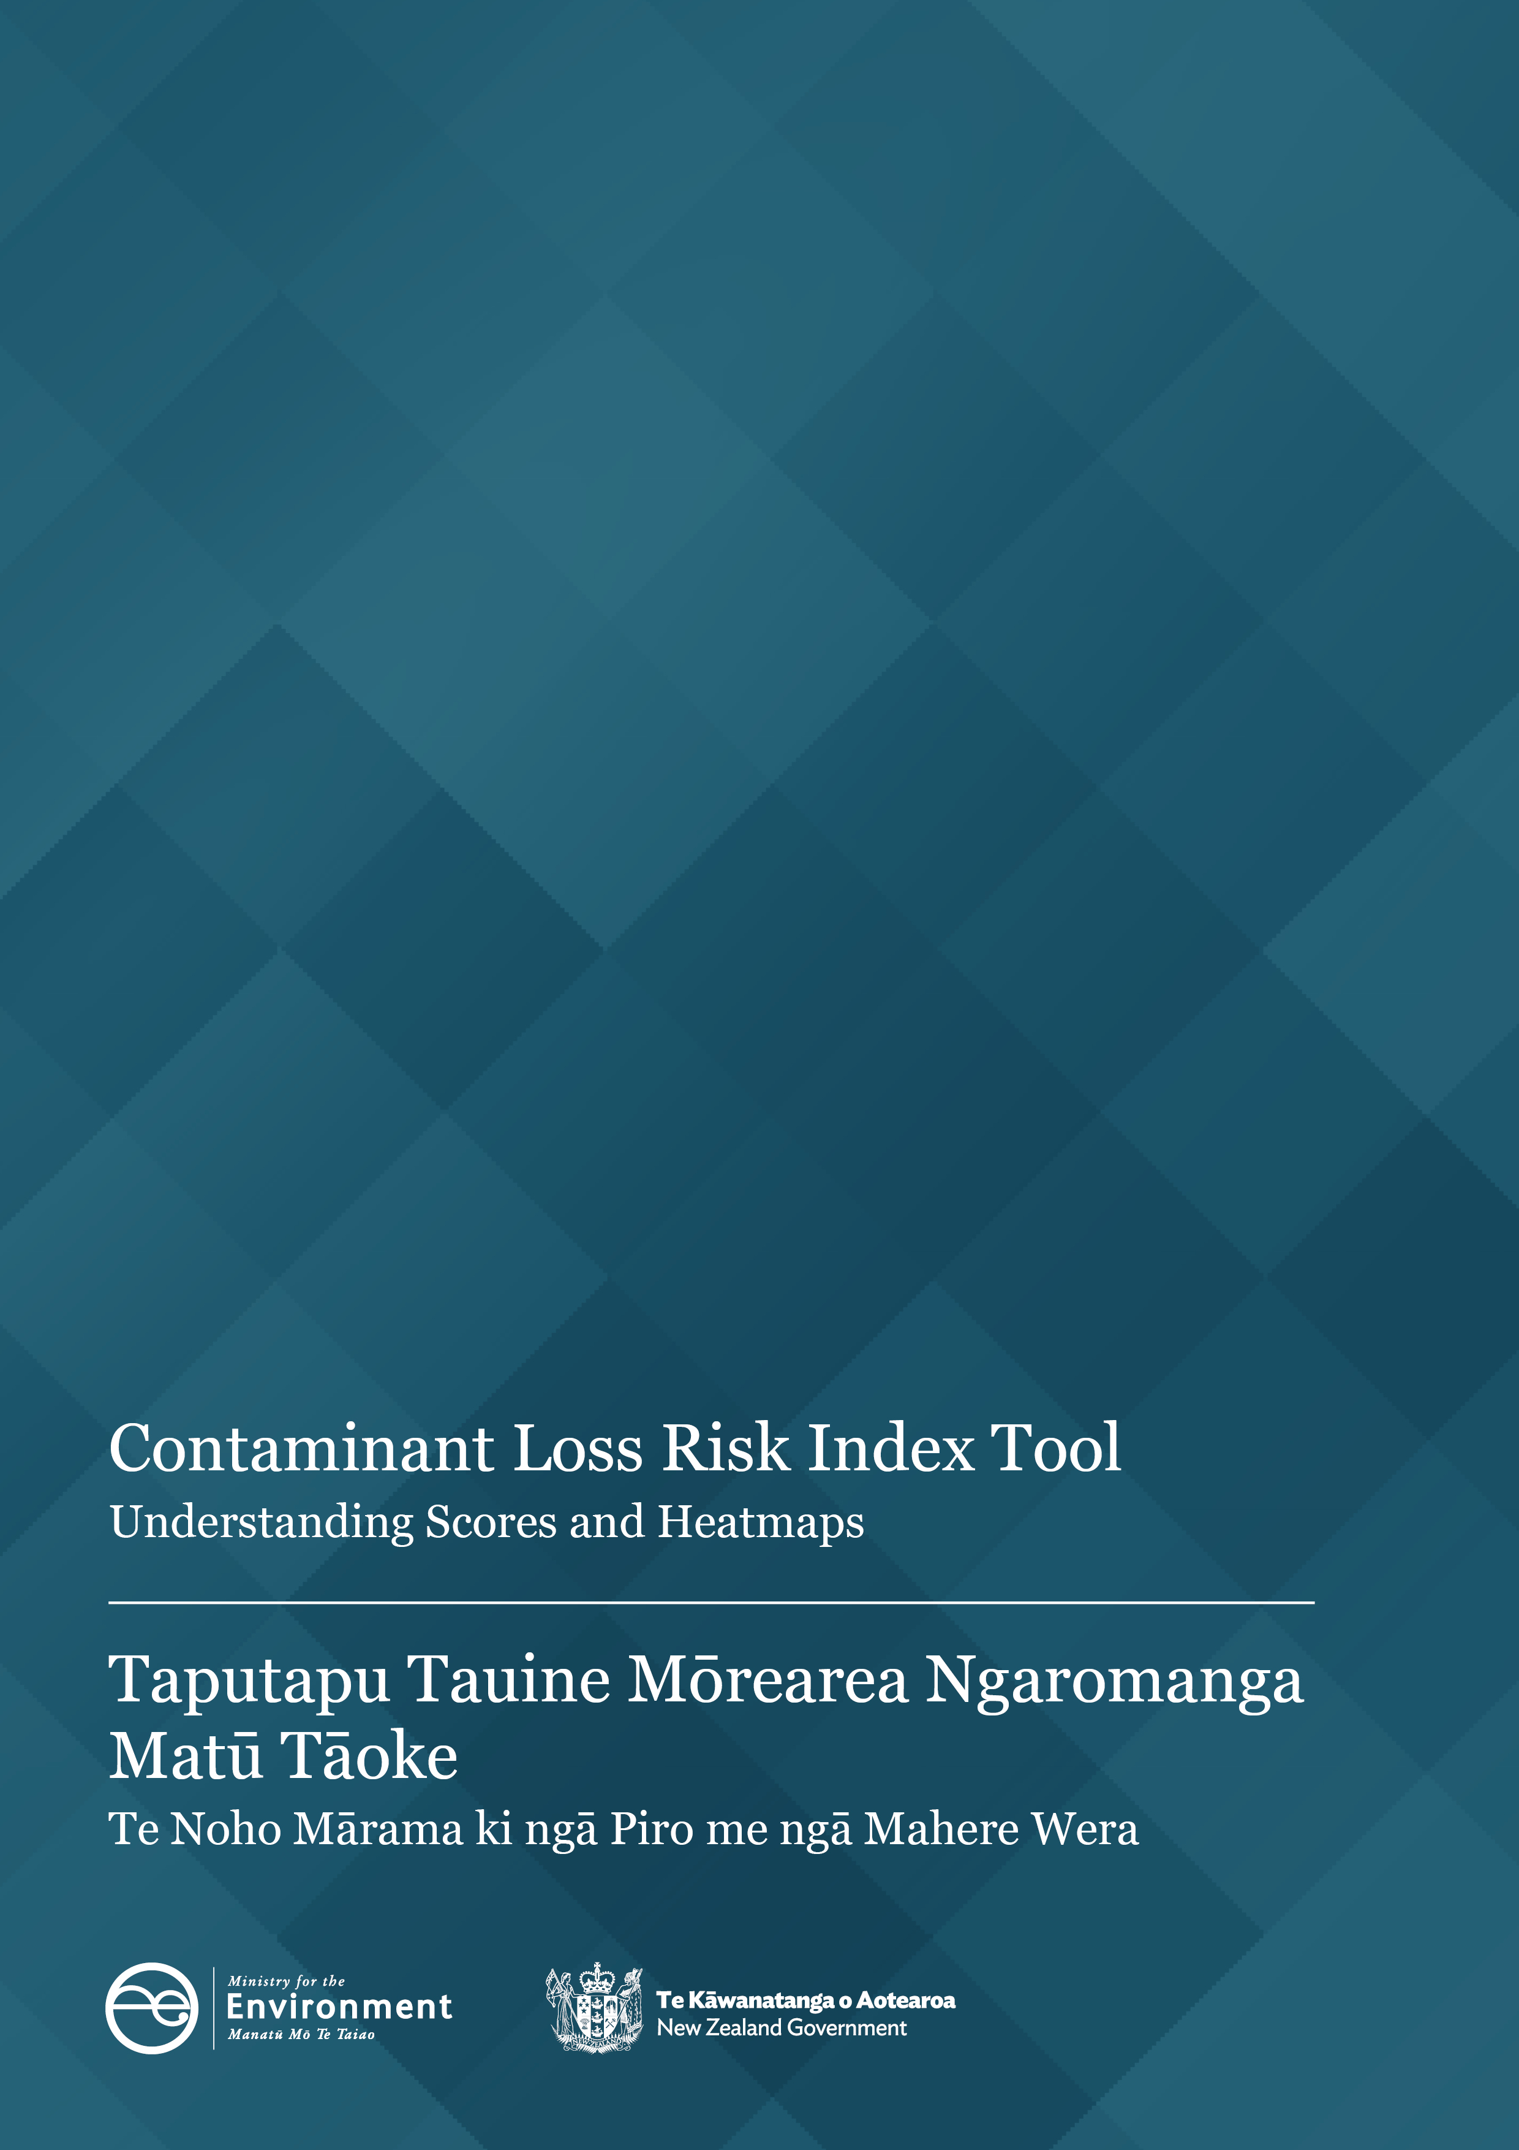
Disclaimer
The information in this publication is, according to the Ministry for the Environment’s best efforts, accurate at the time of publication. The Ministry will make every reasonable effort to keep it current and accurate. However, users of this publication are advised that:
- the information does not alter the laws of New Zealand, other official guidelines, or requirements
- it does not constitute legal advice, and users should take specific advice from qualified professionals before taking any action based on information in this publication
- the Ministry does not accept any responsibility or liability whatsoever whether in contract, tort, equity, or otherwise for any action taken as a result of reading, or reliance placed on this publication because of having read any part, or all, of the information in this publication or for any error, or inadequacy, deficiency, flaw in, or omission from the information in this publication
- all references to websites, organisations or people not within the Ministry are for convenience only and should not be taken as endorsement of those websites or information contained in those websites nor of organisations or people referred to.

Acknowledgements
We would like to thank the following for their feedback and contributions to the development of this guidance:
Mike Scarsbrook and Jon Palmer, Waikato Regional Council
Kate Proctor, Hawke’s Bay Regional Council
Olivia Cook, Environment Canterbury
Jane Carroll, Environment Southland
Ian McNab, Horizons Regional Council
Jackson Efford, Bay of Plenty Regional Council
Richard McDowell, Lincoln University
Val Snow, AgResearch
Gerald Rys, Ministry for Primary Industries

This document may be cited as: Ministry for the Environment. 2025. Contaminant Loss Risk Index Tool: Understanding Scores and Heatmaps. Wellington: Ministry for the Environment.
Published in September 2025 by the
Ministry for the Environment
Manatū mō te Taiao
PO Box 10362, Wellington 6143, New Zealand
environment.govt.nz
ISBN: 978-1-991404-05-3
Publication number: ME 1916
© Crown copyright New Zealand 2025

Contents
Background 5
Audience 5
Overview 6
How the tool works 6
Calculating risk scores and their definitions 8
Baseline risk 8
Overall risk 8
Aggregated scores 9
Per hectare scores 9
Heatmaps 10
Score interpretation 11
Scores are ‘unbounded’ 11
Deciding if risk is low, medium or high 14
Use cases 15
Councils 15
Risk accounting 15
Catchment risk hotspots for planning purposes 16
Consenting 17
Tool users 19
Tool users 19
Freshwater farm plans 19
Consenting 20
Non-regulatory purposes 21

Tables
Table 1: An Excel format table showing the baseline and overall risks for leaching,
runoff and the whole farm score (total) 15

Figures
Figure 1: Tool workflow diagram and data sources 6
Figure 2: Baseline risk calculation 8
Figure 3: Overall block risk calculation 8
Figure 4: Leaching and runoff risk score components of the baseline and overall risk score 9
Figure 5: Example overall score heatmap 10
Figure 6: Heatmap of per hectare risk 10

Background
Development of the Risk Index Tool (RIT) began in early 2022 and is ongoing in 2024. Councils chose nitrogen as the priority contaminant. Phase 1 is a functional tool for farmers, growers and councils to understand the risk of nitrogen loss (N loss) on farms.
The RIT does not estimate the amount of N loss measured in kilograms per hectare per year (kg/ha/yr); rather, it indicates the risk of N loss from the farm system. Scores are not a direct measure of the risk of the nitrogen ending up in the receiving environment (such as streams or groundwater).
Using the RIT is not a legal requirement through any central government policy. Councils may mandate use of the RIT in their regions as part of a multi-evidence approach for understanding on-farm risks, but it is just one possible tool people may use to model risks and actions to mitigate risks. We acknowledge that this first phase is not a ‘one size fits all’ solution, and further refinement will be required.

Audience
This guide is intended for regional councils, unitary authorities (councils) and tool users (farmers/growers/advisors), to help them understand the reports, how scores and heatmaps can be used, and where they should not be used.

Overview
The RIT is an online farm decision-support tool. Adaptable across sectors, it provides an N-loss risk score based on farm activity and biophysical characteristics – soil, slope, climate (precipitation) and irrigation (which is included at this first stage).
RIT risk assessments work as part of a multi-evidence approach to inform users about the risk of N loss from agricultural land use. This will help to achieve improved outcomes for freshwater quality.

How the tool works
Biophysical factors such as soil, slope and climate, alongside management practices, have a strong influence on N loss. Figure 1 presents a diagram of the RIT’s workflow, which includes the underlaying data and user inputs that are entered into the tool’s calculation service, as well as the outputs for reports and scenarios.
Figure 1: Tool workflow diagram and data sources
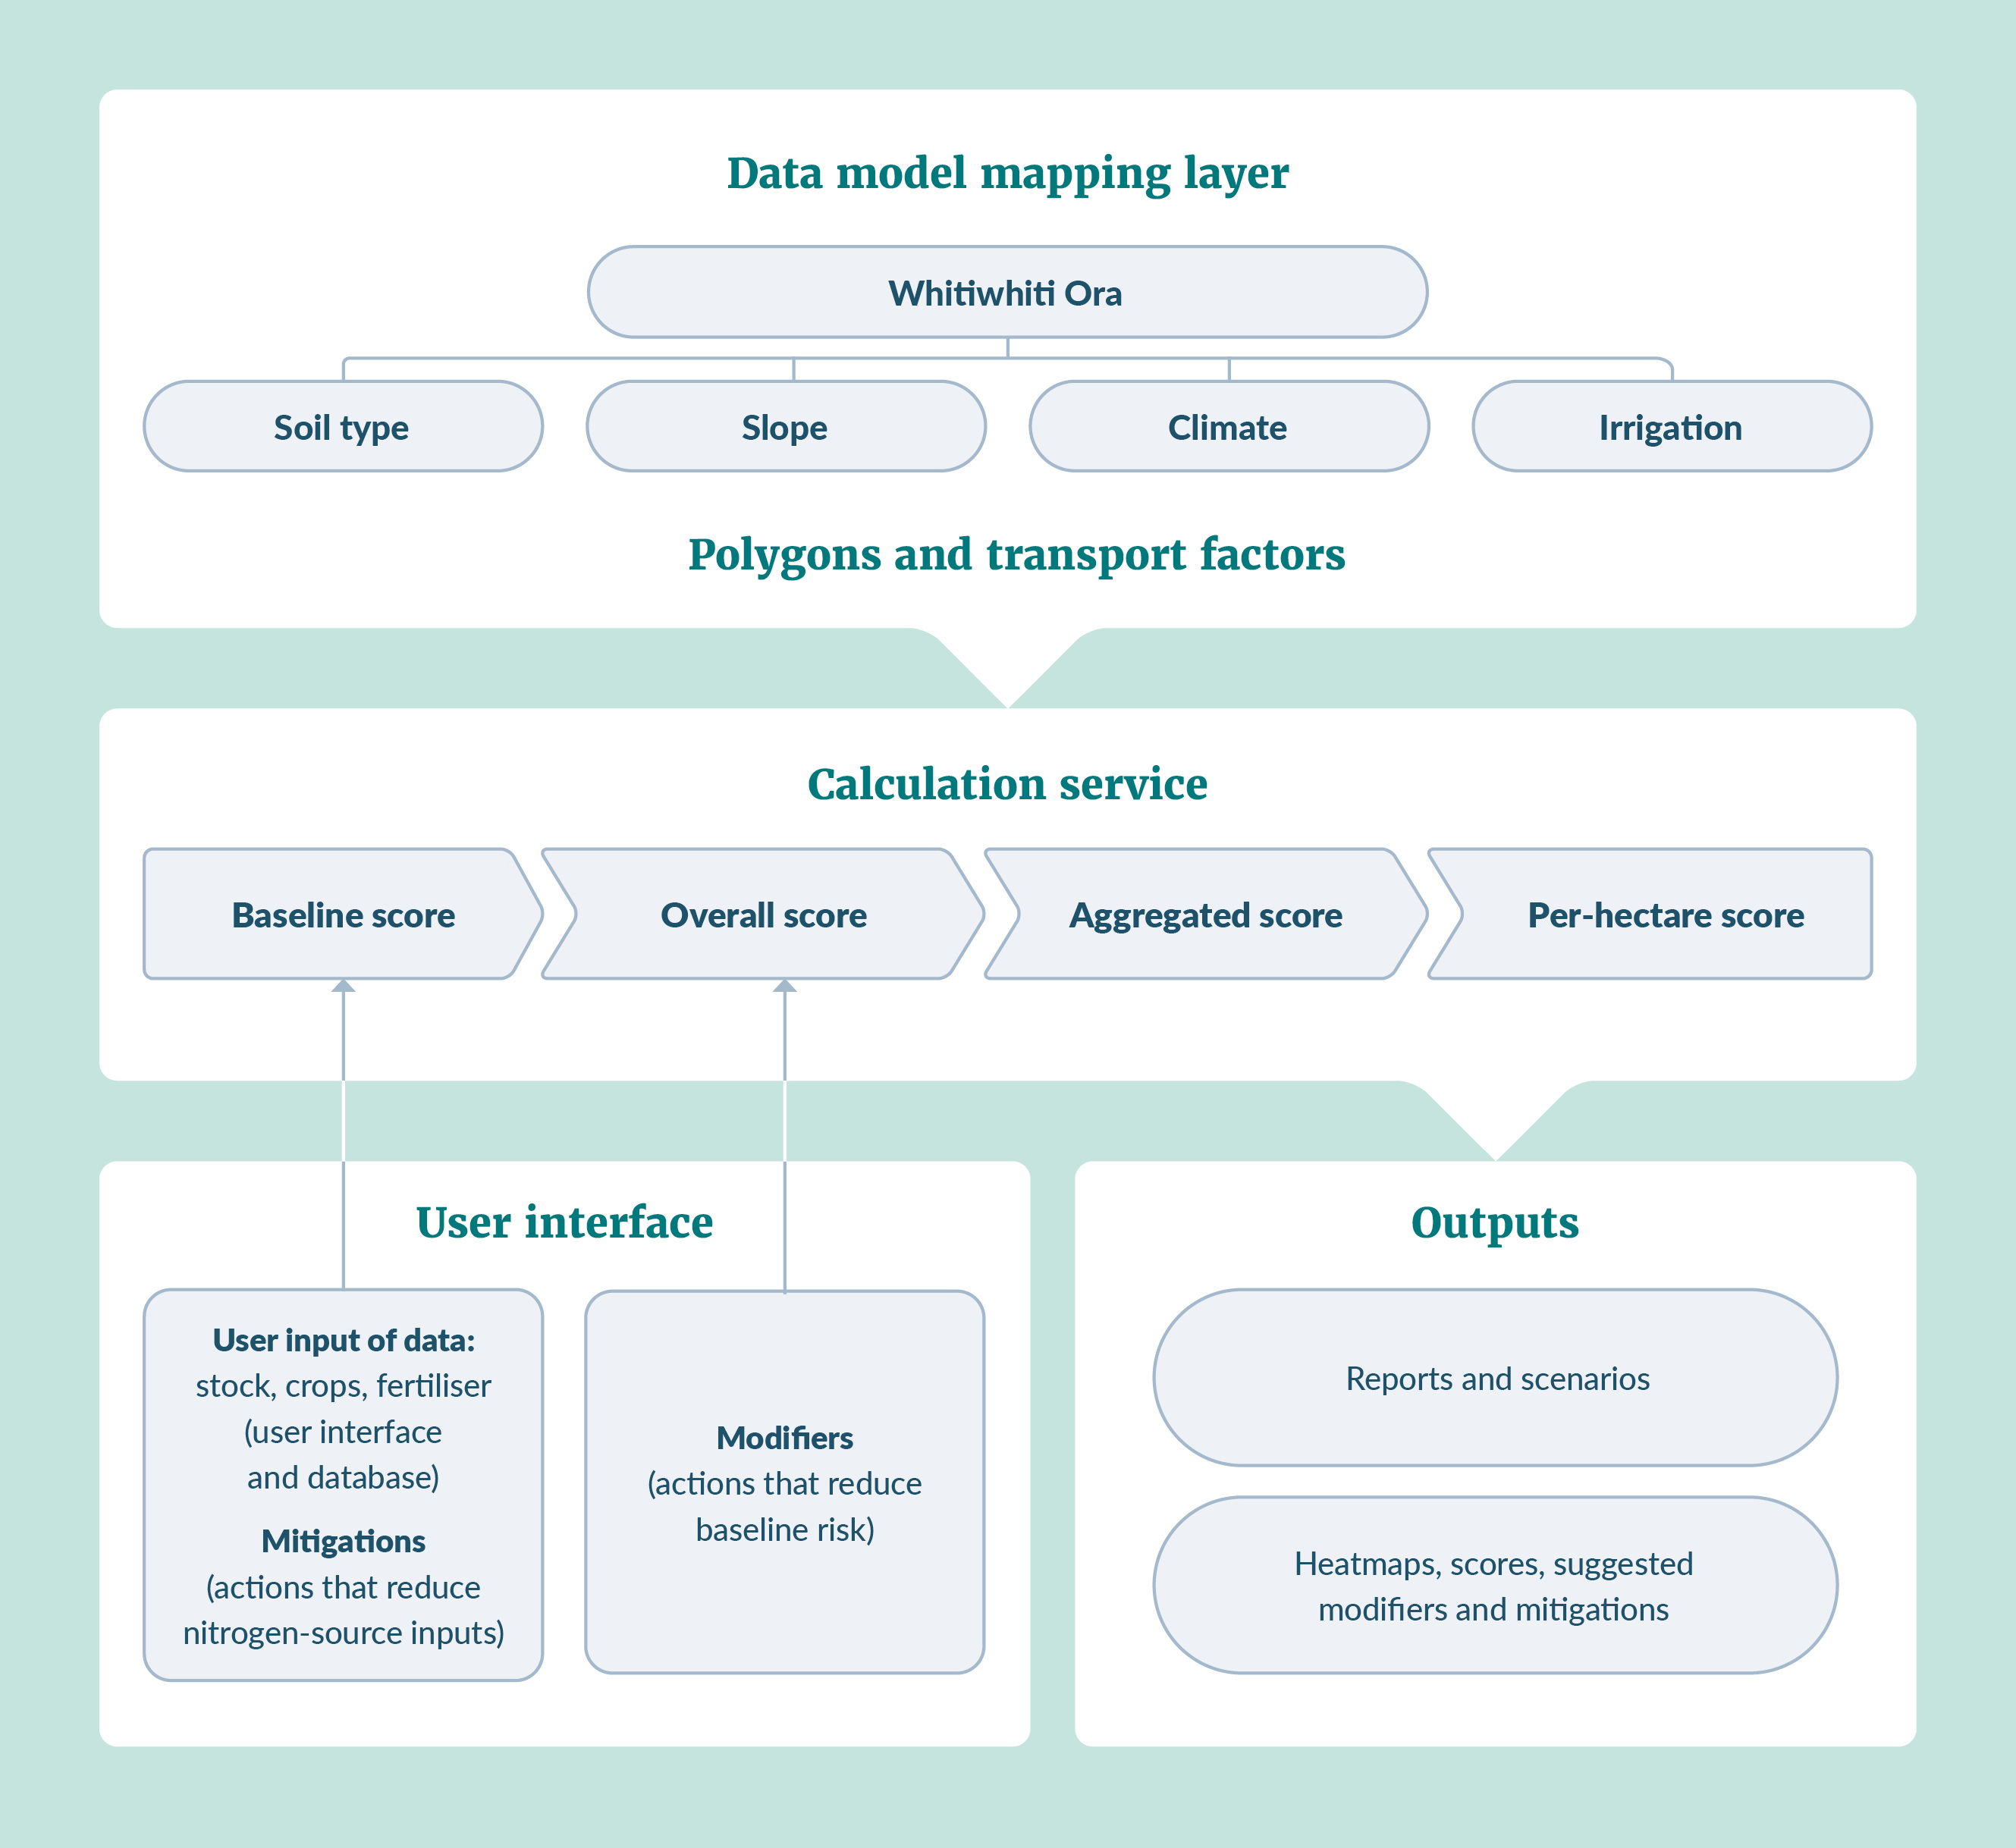

Polygons and transport factors
The RIT uses an underpinning map layer which contains soil type, slope and climate data. This map layer is produced using Agricultural Production System Simulator (APSIM) modelling and provides transport factors for runoff and leaching for different combinations of soil, slope and climate (drawn as polygons in the map layer). Two factors are given for each of the two transport pathways (leaching and runoff) – one for ‘with irrigation’ and one for ‘without irrigation’. The user tells the tool if the land is irrigated or not when they create their farm blocks, and the tool uses the corresponding transport factor.
Users do not need to see the polygons when blocking their land. The tool is designed for users to block land into areas they manage consistently (eg, stocking rate, fertiliser, crops, irrigation, effluent application, and adopted farm practices). They do not need to block by biophysical characteristics (ie, soil, slope, climate and irrigation area).

User interface
Users map their farms into management blocks and inform the RIT if the land is irrigated or receives effluent. Users then enter their N source data (ie, stock, fertiliser, crops, effluent) for each block. They may also select, from a pre-populated list, any modifiers that are applicable to the block. These modifiers only reduce risk; no modifiers increase risk.

Calculation service
The RIT then uses the underpinning maps and transport factors, as well as the user’s N source inputs, to estimate the baseline risk for each polygon. The tool then uses the selected modifiers to reduce the risk of N loss for each of the polygons. These modifiers act on the baseline risk to produce an overall risk for each polygon within the block.
The RIT adds the risk scores of each polygon within the block to give a block score. It then adds block scores and ineffective land risk scores together to provide a farm score. These initial scores are called aggregated scores. The aggregated scores are then divided by area to create a per hectare score for each polygon, for each block, and for the farm.

Outputs
Finally, the RIT presents users with PDF reports (risk based on real farm data). The reports contain heatmaps (at the polygon level), risk scores for the blocks and farm, and suggest other modifiers and mitigations that could be adopted.
The tool also provides an Excel spreadsheet with the inputs for each block, so users have an editable copy of inputs. Users can then run ‘scenarios’ to experiment with how risk changes as land use and practice change.

Calculating risk scores and their definitions

Baseline risk
The baseline risk assesses the initial risk of N loss from land at a block scale within a farm. This is calculated as the sum of the products of nitrogen source(s) and nitrogen transport factors for both leaching and runoff (figure 2) as they interact with biophysical characteristics (soil type, slope, climate (ie, precipitation), and irrigation).
Users manually change the nitrogen source inputs if they are adopting, or scenario modelling, any of the RIT’s suggested mitigations.
Figure 2: Baseline risk calculation
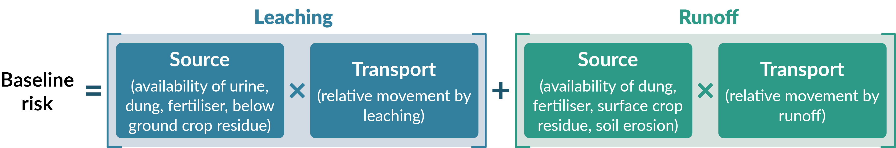

Overall risk
Overall risk is the risk of N loss from land relevant to management blocks within a farm, after N-loss modifiers are applied.
The overall risk is calculated as the sum of the products of the baseline risk after modifiers are applied (figure 3).
Figure 3: Overall block risk calculation
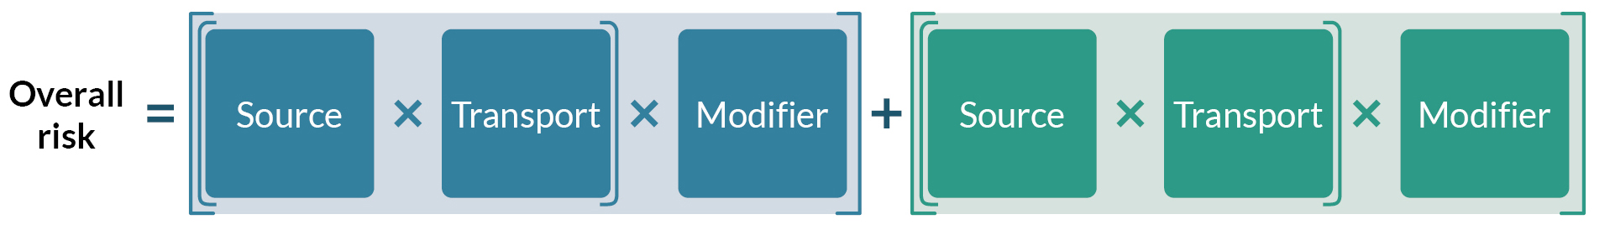
Leaching and runoff scores are also presented, so the user can see how each pathway is contributing to the risk score (figure 4).
Figure 4: Leaching and runoff risk score components of the baseline and overall risk score
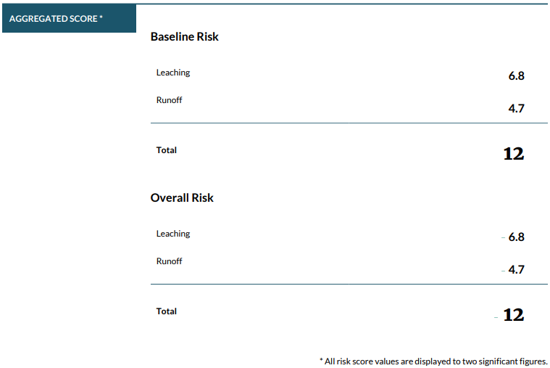
Other scores are presented at block and farm level and shown as aggregated scores and per hectare scores.
All scores have their own purpose and provide consumers of the reports with different insights into N-loss risks on farm.
The different scores produced by the tool are described below.

Aggregated scores
Aggregated scores are total scores presented at block level and farm level as seen in figure 4.
Block score (aggregated): calculated as the total N-loss risk of all polygons, or parts of polygons, contained within the area of that block.
Farm score (aggregated): the total score of all blocks within the farm, including the ineffective land.

Per hectare scores
Per hectare scores are presented at block level and farm level.
Block score (per hectare): calculated as the aggregated block score divided by the area of the block in hectares.
Farm score (per hectare): calculated using the aggregated farm score divided by the area of the farm (including ineffective land).

Heatmaps
Risk scores are used to create heatmaps of risk, using polygon scores. Two different heatmaps are produced.
Heatmap of overall risk per polygon: shows all the polygons within the report area, shaded according to the overall risk of each polygon. Larger polygons are likely to be higher risk, due to their larger area. An example heatmap of the overall risk is shown in figure 5.
Figure 5: Example overall score heatmap
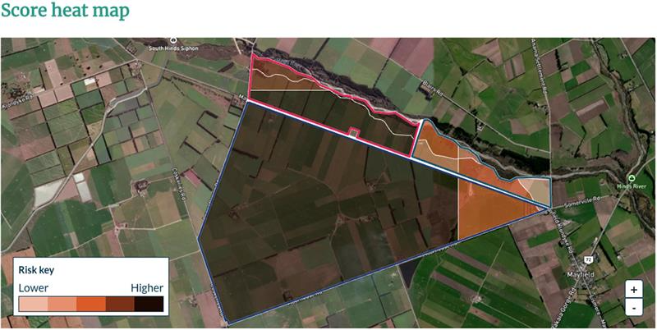
Note: This heatmap was generated using fictitious data that has no relevance to the real land use at this location.
Heatmap of risk per hectare: shows all the polygons within the report area, shaded according to the risk per hectare of each polygon (ie, the total risk of each polygon divided by its area in hectares). Figure 6 shows the per hectare risk – note the colour change between overall risk and per hectare risk.
Figure 6: Heatmap of per hectare risk
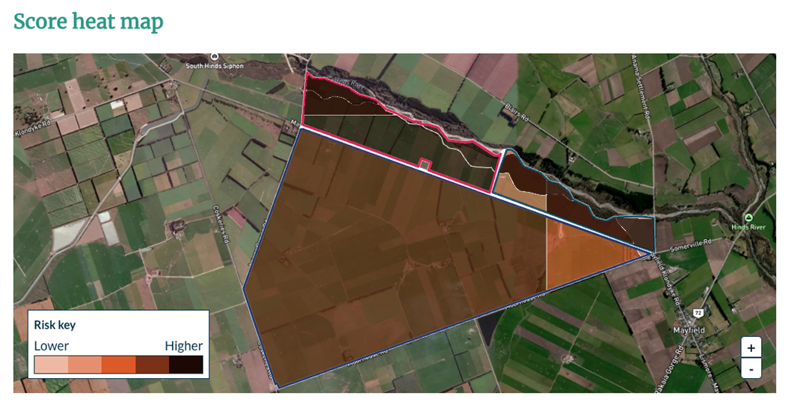
Note: This heatmap was generated using fictitious data that has no relevance to the real land use at this location.

Score interpretation
The RIT produces an index of N-loss risk from agricultural land use. The index is a measure of relative magnitude and likelihood. It is important to note that the RIT does not try to balance mass of nitrogen, and risk is not expressed as kg/N/ha.
Scores represent the risk of nitrogen being lost from the plant root zone via leaching or leaving the farm via runoff. It is not a measure of the risk of the nitrogen ending up in the receiving environment (eg, surface water bodies or groundwater).
Lower scores relate to lower N losses and higher scores to higher N losses (kg) – this linear relationship is between ranked scores and losses.
For example, a farm with a score of 500 has half the likelihood of loss compared to a farm with a score of 1,000. However, the farm with the score of 500 may not necessarily contribute half the amount of nitrogen (in kg) compared to the farm with score of 1,000.
Importantly, the risk score does not give a full indication of the farm’s impact on the receiving environment. Rather, this will be influenced by:
- the likelihood that the nitrogen leaving the root zone reaches a water body
- the state of the receiving environment (eg, whether it is overallocated for nitrogen)
- the sensitivity of the receiving environment to nitrogen inputs
- cultural and social factors (eg, cultural significance of the receiving environment).

Scores are ‘unbounded’
Scores are a number between zero and infinity (technically, although limited by practicality) and are termed ‘unbounded’.
Scores of fixed numerical categories were deemed unsuitable. This was because farms from the same sector (land-use type) may have received the same score even though they were managing their farms differently, so have a different risk profile. For example, a score spread of 1 to 5 could have seen all viticulture receive a score of 1 and all dairying and vegetable production receive scores of 4 or 5. Applying the risk profiles in this way would be unhelpful for both farmers and councils, because it would not recognise or reward those farmers who were undertaking the activity in a less risky way.
It was also deemed unsuitable to apply risk score categories of low, medium or high, because the RIT does not consider catchment contexts. For example, a lower numerical risk score could be considered a high risk in an overallocated catchment.

Why scores are presented at polygon, block and farm levels
Presenting scores at all levels is a critical component of the RIT. Polygon and block scores allow users to understand which areas of their farm are riskier, given the combination of biophysical attributes (soil, climate, slope and irrigation) and management activities.
Presenting score at a farm level allows users to understand their contribution of risk to the environment. Although users cannot currently see other scores for neighbouring properties, users could share their reports with their community and with their trusted advisors to understand where they fit.
The Ministry for the Environment is also planning to implement a portal where users could choose to publish their reports, to contribute to a ‘catchment view’. This portal is intended to be restricted to specified consumers and would not be publicly available.

Why provide aggregated and per hectare scores
Aggregated and per hectare scores are both important. The environment is impacted by the total risk, not an average of risk. However, understanding an average risk per hectare helps people compare scores between blocks on individual farms, and scores between different farms.

Comparison between polygons and blocks on farm
The heatmaps will use both the aggregated score and the per hectare score at the polygon level. Presenting the heatmap risk at polygon level, rather than block level, means the tool will not hide areas of risk within a single block.
Using both overall scores and per hectare scores is crucial, as testing has found that using overall scores shows the biggest polygons as the riskiest. Although this is true for total contribution to N loss, there may be riskier, smaller areas where attention should be focused (eg, areas with leakier soils or steeper slopes).
Note: The colour selection of the heatmap is related to the distribution of a farm’s polygon scores and does not consider other farms mapped within the RIT.
Blocks will have their scores presented numerically, to allow them to be compared. This allows users to understand how their different blocks contribute to the overall farm risk.

Comparison between farms
Although the RIT does not currently allow for comparison between farms within the tool, this should be possible in the future. For now, users can provide their reports or scores to others, for comparison outside the RIT.
Presentation of only an aggregated score could result in large but low-intensity properties having high scores, based on their larger size. This could give the false impression they have more opportunities to reduce their risk through practice change, when in fact they may only be able to change their risk by reducing effective hectares.
By contrast, small but intensive properties may have a lower score, leading to the false impression they do not need to act, as their risk contribution is smaller. However, on a per hectare basis, they may be able to make the greatest improvement through practice change.

Deciding if risk is low, medium or high
With the way scores and heatmaps are presented, and without a council portal, it is difficult for councils to set scores in a catchment context as low, medium or high. Such categorisation is discouraged until the future development phases allow for catchment views.
However, as an initial starting point, councils and tool users should consider the catchment context. Councils should give directions as to which contaminants require the greatest efforts – nitrogen, phosphorous, sediment or E. coli. If nitrogen is not the priority contaminant, farmers and growers should still work toward continuous improvement and reduce the risk of N loss whenever possible.
This approach fits with freshwater farm plan regulations, which require risks to be identified, and actions undertaken to reduce those risks. Farm plans are not expected to address all risks in their initial development and implementation – rather, they seek a change over a generation, focusing on areas with the greatest risk.
Councils are already creating documents covering catchment contexts, challenges and values under the freshwater farm plan regulations. These could be used to inform tool users whether N loss is a concern within their catchment.

Use cases

Councils
Planning and design of a council portal began in 2025. Until it is developed, users will need to supply councils with PDF reports and Excel spreadsheets, produced within the RIT. The key purposes for the RIT are to help councils:
- track the direction of travel for water quality in catchments (eg, degrading, hold the line, improving)
- understand their catchment risks for planning purposes
- identify properties with higher risks within catchments which require additional review of risk drivers and more support
- assist with the resource consent process.
The RIT reports can be used to support council purposes, as outlined below.

Risk accounting
While the scores do not represent N loss in kg/ha, risk scores are related to N loss in kg/ha. Lower risk scores indicate properties that have lower N loss in kg/ha than properties with higher risk scores. Therefore, understanding whether scores are increasing or decreasing will allow councils to understand the direction of travel for water quality.
Note: Scores are not a direct measure of the risk of the nitrogen ending up in the receiving environment (eg, streams or groundwater).

Tool score output
The RIT produces a simple table in Excel format (table 1). Councils could take data from the table and manually collate scores into their own databases, to track what is happening within a catchment.
Table 1: An Excel format table showing the baseline and overall risks for leaching, runoff and the whole farm score (total)
Farm name  PCEJuly01 | Report name  PCEJuly01 | Date created  1/07/2024 | Created by  NMT Team
 | Farm | Block A | Block B
Baseline leaching risk | 8,400 | 2,800 | 5,400
Baseline runoff risk | 100 | 3.7 | 0.018
Baseline total risk | 8,500 | 2,900 | 5,400
Overall leaching risk | 7,200 | 2,400 | 4,600
Overall runoff risk | 100 | 2.9 | 0.009
Overall total risk | 7,300 | 2,400 | 4,600
Owing to the way measured losses and the risk of loss were aligned, the Technical Working Group (which provided scientific oversight and development of the tool) has advised that if scores in a catchment are trending down, N loss and loads on the catchment are likely going down. However, this cannot be quantified as a kg/N load change.
Note: The farm system information and the extent to which mitigations and modifiers are adopted would be valuable inputs to catchment modelling.

Tracking farm baseline risk
Baseline risk considers the biophysical characteristics and the nitrogen source inputs – fertiliser, urine, dung and crop residues. If councils track baseline risk, this will help them track intensification within a catchment. Baseline risk could go up or down over time, depending on farmers’ management choices.

Tracking farm overall risk
Tracking overall risk will allow councils to monitor the change in risk in the catchment, in general. This change may be up or down, depending on land-use changes, intensity changes and the adoption or reduction of mitigations and modifiers over time.

Tracking farm runoff and leaching risk
Alongside the tracking of baseline and overall risk, the RIT provides risk scores for runoff and leaching risk. Keeping track of these pathways of loss and their risk scores could help councils understand whether and how the risk profile is changing in a catchment.
Councils could use this information to determine whether they need to focus on a particular pathway of loss risk (ie, runoff or leaching). This may help inform plans and the preparation of catchment contexts, challenges and values for informing freshwater farm plan preparation.

Catchment risk hotspots for planning purposes

Heatmaps
The council portal and the catchment heatmaps have not yet been developed, so councils cannot view and identify areas of greater risk in a catchment in a spatial format. This is noted for future consideration in the council portal development.
Councils should not attempt to create their own heatmaps based on the individual report heatmaps. These are not comparable between farms, but only between that particular farm’s polygons.

Comparing farm scores
Councils can compare risk between different farms and blocks by using the per hectare score. This could help councils identify farms with proportionally higher risks than others.
This comparison ensures farms of all sizes and land-use types are being compared on an even footing. The data can then be assessed to determine whether a certain location or land-use type may have a higher impact than another. Understanding the source of risk may help councils determine where they may want to concentrate initial efforts to reduce risk in a catchment.
Until the council portal is available, this remains a manual process for councils to complete.

Consenting

Determining activity status
The RIT implementation guidance states that it is inadvisable to determine activity status (eg, permitted, discretionary, non-complying) by using the RIT. However, the RIT could be used to help triage properties, by identifying those with higher risk as needing additional attention or investigation.

Assessment of environmental effects
The RIT report produces both numbered scores and a heatmap of polygon areas of higher and lower risk (relative to other polygons on the farm). It also provides context for how scores were generated, by reporting the:
- soil type
- slope
- precipitation
- presence of irrigation
- source of nitrogen inputs (and mitigations)
- any modifiers that users have adopted to reduce risk.
The scores and heatmaps may help determine areas on farms where additional monitoring may be required. For example, the entry and exit of a stream running through an area of higher risk may be a suitable location for water monitoring/sampling conditions, to track the water quality and measure the impact of that area of risk on the waterway.
The results of any scenario modelling might help councils determine conditions of consent, to ensure adoption of mitigations and modifiers to reduce the risk during the consent term.

Writing scores into consent conditions
Councils could require in the consent conditions that the consent holder update and provide further RIT reports throughout the consented period. This would allow councils to gather information about practices on farm and track the direction of travel.
Councils should not use the numeric scores as hard numbers in consent conditions, requiring that the number not be exceeded or reduced. This would be an inappropriate use of the RIT, which should only be used at the ‘softer’ end of regulation. For more information about compliance and enforcement, see the implementation guidance.

Tool users

Tool users
Users are people who input information into the RIT for a risk assessment – likely farmers/landowners, nutrient advisors and/or farm advisors.

Freshwater farm plans
The freshwater farm plan regulations require farm operators to produce a farm plan if certain conditions are met (ie, size of operation depending on land-use type). Councils must produce a catchment context challenges and values document, which provides farm operators context for freshwater resources and contaminants within the catchment they are farming in.
For catchments that have identified nitrogen as a contaminant of concern, farm operators could use the RIT to identify risks in each block for N loss and create an action plan to reduce their N loss.
The RIT can be used to identify areas of higher risk (heatmap) and to produce scenario modelling to test what actions (ie, mitigations and modifiers) might be employed to reduce the risk.

Initial scores
The whole farm score and block scores do not mean much in an initial report – the number does not indicate whether the risk is low, medium or high in a catchment context. Users can, however, see which blocks have higher risk scores. Scores become more meaningful as additional reports are run (either through scenario modelling or running reports in later years). These can show how the on-farm risk is changing over time, or when different mitigations and modifiers are adopted.

Heatmap
By producing heatmaps, an initial RIT report will assist farm operators to determine which polygons and blocks have the highest risks in their specific farm context. This will help tool users who are writing freshwater farm plans understand areas of risk and where to focus ‘actions’.
Users should use both heatmaps (see examples in figure 5 and figure 6) to understand both overall risk and per hectare risk. It is likely the overall risk will be shaded by polygon size, whereas the per hectare score will typically show riskier small areas.

Scenario modelling
The RIT gives users the opportunity to undertake scenario modelling. Through this, users can determine how the risk score can be increased or decreased by changing inputs and practices. Using the RIT, users can model actions they are considering adopting in their freshwater farm plan.
Heatmaps may or may not change during scenario modelling, so scores become important during the scenario-modelling processes, to see the numeric change (up or down) and quantify the degree of change.

Consenting

Assessment of environmental effects
The RIT reports could help farmers and growers when preparing consent applications, by highlighting areas of risk and, through scenario modelling, by identifying practices they could adopt to reduce their on-farm risks.
Using this information as they start to prepare a consent application can empower farmers and growers to make decisions and propose conditions or changes, rather than these coming as directives from councils.

Non-regulatory purposes
From a non-regulatory perspective, catchment groups, irrigation schemes and other farmer/grower collectives could use the RIT to identify areas of risk or collective risk, as they work toward their common goals of environmental enhancement.
These collectives could collate risk scores and undertake accounting of risk, to aid understanding of their overall risk as a group and their individual contributions to that risk. The RIT could also help them identify areas where modifiers could be applied for collective good.
Such groups are also well placed to talk to farmers and help them understand how they compare with nearby properties, using the per hectare score. This will empower farmers to understand how they are performing in relation to their peers – whether they are doing as well as they thought, or whether there is room to improve.
As part of the 2025 catchment view consultation, these groups are being considered and consulted, alongside regional councils, about what they would find helpful.

Scores were designed to align (via linear regression) to the mass of nitrogen being lost measured in field studies of different land uses and land management practices around Aotearoa New Zealand. However, for statistical reasons, this alignment was between the rank order of measured losses against the rank order of risk scores.
Ministry for the Environment. 2024. Risk Index Tool: Phase 1 draft implementation guidance: Estimating the risk of farm-level nitrogen loss. Wellington: Ministry for the Environment.
Ministry for the Environment. 2023. Developing, adapting and applying environmental models in a regulatory context in in New Zealand. Wellington: Ministry for the Environment.
Ministry for the Environment. 2024. Risk Index Tool: Phase 1 draft implementation guidance: Estimating the risk of farm-level nitrogen loss. Wellington: Ministry for the Environment.

