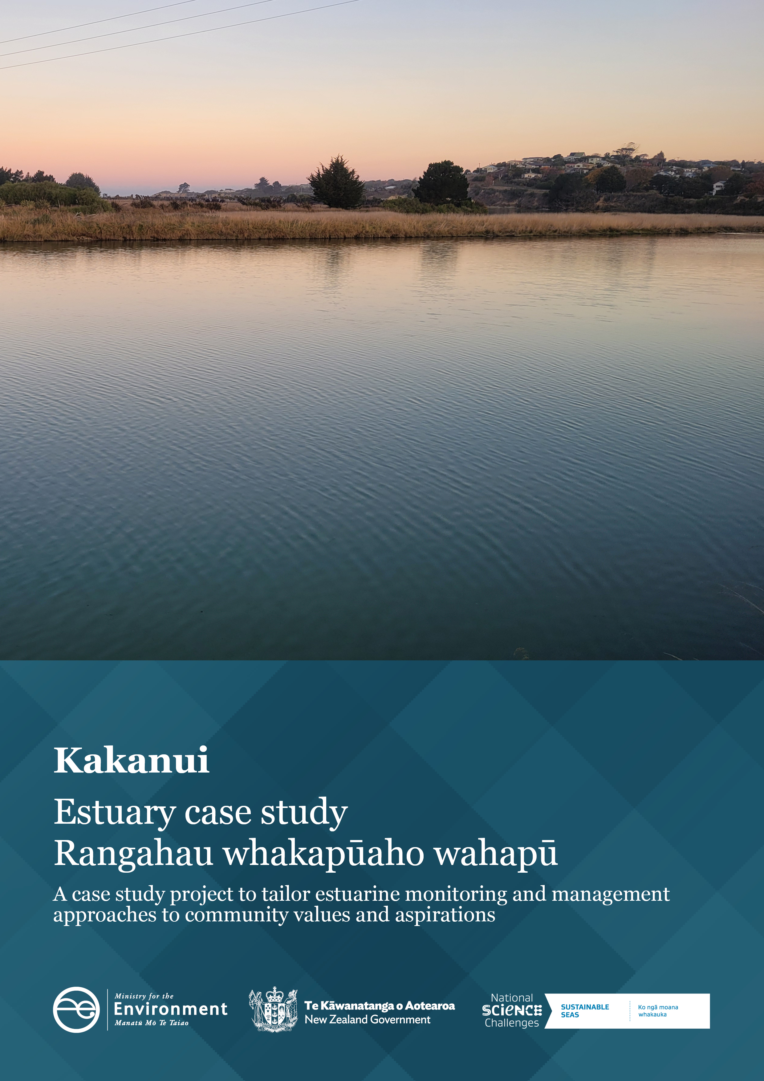

**Disclaimer**

The information in this publication is, according to the Ministry for the Environment’s best efforts, accurate at the time of publication. The Ministry will make every reasonable effort to keep it current and accurate. However, users of this publication are advised that:

* the information does not alter the laws of New Zealand, other official guidelines, or requirements
* it does not constitute legal advice, and users should take specific advice from qualified professionals before taking any action based on information in this publication
* the Ministry does not accept any responsibility or liability whatsoever whether in contract, tort, equity, or otherwise for any action taken as a result of reading, or reliance placed on this publication because of having read any part, or all, of the information in this publication or for any error, or inadequacy, deficiency, flaw in, or omission from the information in this publication
* all references to websites, organisations or people not within the Ministry are for convenience only and should not be taken as endorsement of those websites or information contained in those websites nor of organisations or people referred to.

**Acknowledgements**

We would like to express our sincere gratitude to the Sustainable Seas National Science Challenge for their invaluable partnership in this project. Their support, guidance, and commitment to ecosystem-based management has been instrumental to this case study.

We also extend our deepest appreciation to Te Rūnanga o Moeraki and local community members whose participation and insights have enriched this report. Their knowledge, perspectives, and active involvement have been crucial in shaping our work, and we are truly grateful for the opportunity to collaborate with them.

This document may be cited as: Ministry for the Environment. 2024. *Kakanui* *– Estuary case study | Rangahau whakapūaho wahapū.* Wellington: Ministry for the Environment.

Published in December 2024 by the  
Ministry for the Environment   
Manatū mō te Taiao  
PO Box 10362, Wellington 6143, New Zealand  
[environment.govt.nz](https://environment.govt.nz/)

ISBN: 978-1-991140-60-9  
Publication number: ME 1869

© Crown copyright New Zealand 2024

# Contents

Overview 4

Estuaries 4

The project 4

The Kākaunui/Kakanui Estuary 5

What we heard during engagement 6

How the estuary is currently used 7

Pressures on the estuary 7

Insights specific to Te Rūnanga o Moeraki 7

The Toolbox 9

Participatory processes 9

Monitoring and data 10

Management and restoration 10

Mapping and modelling 11

Appendix 1: The tools 12

Appendix 2: Practical examples from Sustainable Seas projects 15

# Overview

## Estuaries

Estuaries are complex and dynamic ecosystems of ecological, recreational, cultural, economic and spiritual value to New Zealanders.As the interface of fresh and salt water, estuary health is influenced by the quality of fresh water that flows into them, the activities that occur within or around them and coastal processes. Land use activities in the catchment,[1] such as forestry, agriculture and horticulture, urban development and waste management, can lead to the input of sediment, toxicants and nutrients into an estuary. The resilience of an estuary to stressors is dependent on the estuary type, freshwater flow, tidal influence, geographical location and catchment land use.

A large proportion of the population live around and use estuaries, thus they are areas where cumulative effects arise and non-monetary values are high. Every estuary may have its own tipping points, where the cumulative effect of stressors will negatively affect the health of an estuary. This makes it difficult to set national standards and regulations for estuarine health. Estuaries tend to fall through the cracks in Aotearoa New Zealand’s environmental legislation due to a lack of integration between freshwater and coastal policies. This can leave councils, iwi and communities having to develop their own frameworks.

## The project

In 2022, the Ministry for the Environment joined forces with the Sustainable Seas National Science Challenge (Sustainable Seas) to explore how it might manage Aotearoa New Zealand estuaries in a more nuanced way. Sustainable Seas’ objective was to develop tools and guidance for ecosystem-based management (EBM). EBM aims to manage the marine environment in a holistic and inclusive way that balances use and protection to better inform coastal monitoring and management across Aotearoa.

Officials corresponded with regional authorities and selected three case study estuaries. These case studies were based on data availability, community interest and ecological features to test the outputs of Sustainable Seas in a real-world setting. The three estuaries selected were:

* Whangateau Estuary (Auckland)
* Kakanui Estuary (Otago)
* Te Whanganui-a-Orotū/Ahuriri Estuary (Hawke’s Bay).

The intention of the project was to encourage and support estuarine management at place by providing a tailored ‘toolbox’ to help iwi and hapū, councils and communities. In 2023–24, we held virtual hui with iwi and hapū,[2] regional authorities and community members to discuss their values and aspirations for their estuary. The Ministry then generated a high-level summary of the values and aspirations raised and Sustainable Seas drew on the guidance and methodologies for EBM developed over the past 8 years to assemble a toolbox for each estuary. Officials presented the draft toolboxes at place and discussed attendees’ concerns around implementation and barriers to the management of their estuaries.

# The Kākaunui/Kakanui Estuary

Situated on the east coast of the South Island of Aotearoa New Zealand, the Kakanui River meets coastal waters to form an estuary. The river, estuary and surrounding coastal area (All Day Bay to the south and Kakanui Beach to the north) are popular destinations for recreation such as watercraft, fishing, swimming, surfing and birdwatching. Te Rūnanga o Moeraki are the regional Papatipu Rūnanga of Ngāi Tahu, with mana whenua status in the Kakanui (Kākaunui) area. The Kakanui River and its main tributaries (Kauru River, Island Stream and Waiareka Creek) drain a large catchment of 894 square kilometres (km2) into a relatively small estuary (0.27 km2 and less than 230 metres wide). The high volume of fresh water makes the Kakanui a ‘river-dominated’ estuary, with a small intertidal area. While 77 per cent of land within the catchment is used for agriculture, the steeper slopes are predominantly native forest. This native forest, and the small (less than 1 per cent) proportion of urban land use, may be why the Kakanui Estuary has few contaminants of concern, unlike many other estuaries across Aotearoa. Figure 1 summarises why it was selected. Figure 2 shows the lower estuary, estuary mouth and coast.

Figure 1: Why we selected Kakanui Estuary

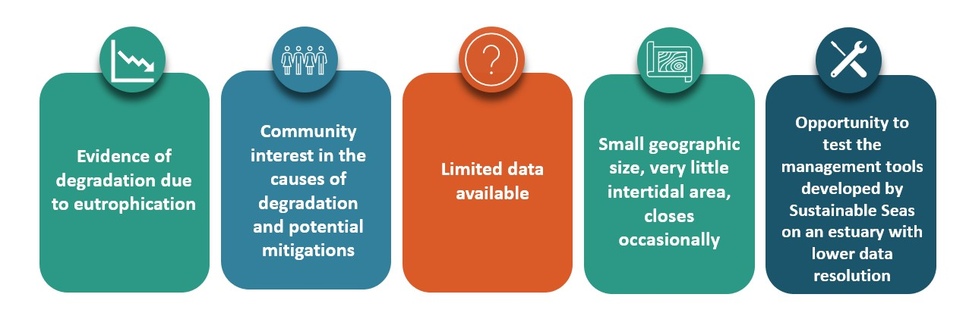

Figure 2: View of Kakanui Estuary mouth from land looking toward the coast

# What we heard during engagement

In 2023–24 officials held online hui with community groups, industry and local authorities to discuss their values and aspirations for their estuary. Through these high-level discussions, we were able to identify common values and aspirations across stakeholders (figure 3). Unfortunately, we were unable to meet with Te Rūnanga o Moeraki. We have included information sourced from regional management plans, the Ngāi Tahu Claims Settlement Act 1998 and journal articles. This information should not be considered to represent the current priorities or opinions of Te Rūnanga o Moeraki or any other iwi groups. Note that the te reo Māori name for the estuary is Kākaunui (not Kakanui). Where tangata whenua values are discussed, this is the spelling that is used.

Figure 3: Summary of values and aspirations heard during engagement with Kakanui stakeholders

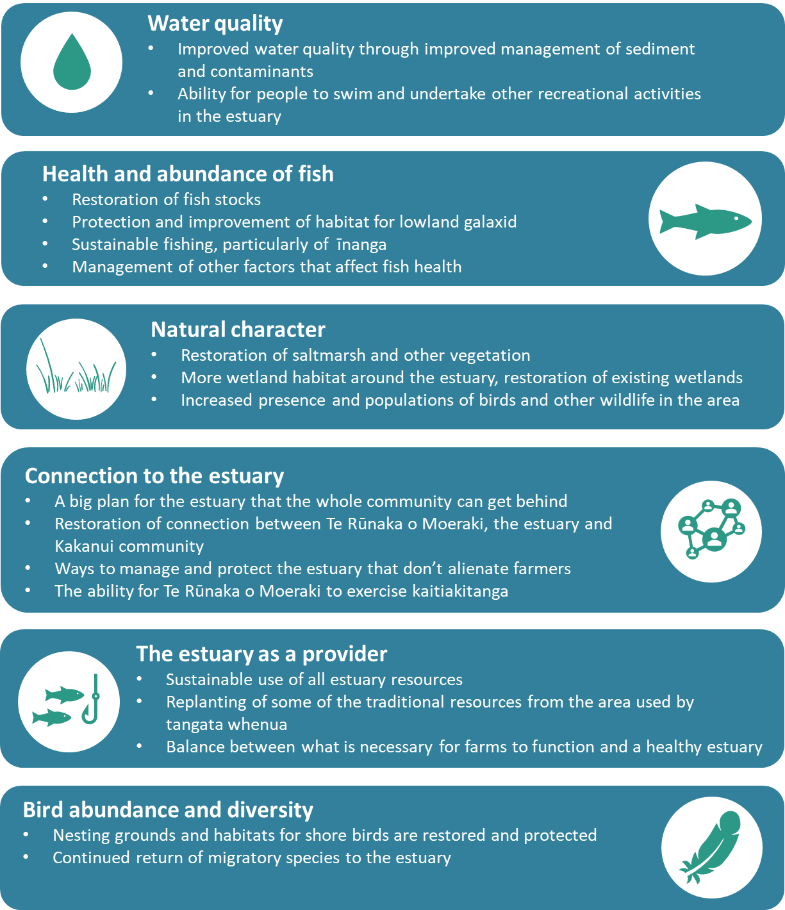

## How the estuary is currently used

Several endemic species are found in the Kakanui River and estuary, including Aotearoa New Zealand’s rarest native fish, the lowland longjaw galaxias. The estuary and lower reaches of the Kakanui River are īnanga spawning grounds and popular sites for the harvesting of whitebait during the whitebaiting season (1 September to 30 October). Conservation efforts, such as riparian and wetland planting, by community groups have been occurring for several years. Unfortunately, local residents report that these efforts are sometimes damaged or destroyed by offroad vehicle users.

Locals swim at the coast (All Day Bay), rather than in the estuary, due to the narrow swimming channel and concerns for water quality. Some people use watercraft, such as kayaks, in the estuary and river. The area is also a popular spot for bird watching and nature walks.

## Pressures on the estuary

To facilitate irrigation of local farms, water is taken from the Waitaki River and discharged to Waiareka Creek, where water can be collected by land owners. This has supported land change towards agriculture, including recent changes in dairy farming and vegetable growing. The regional council oversees three minimum-flow sites within the Kakanui River to manage water quantity. The ability to irrigate these farms is critical to their functioning as viable businesses, particularly in the drier months. Many farmers in the catchment aim to improve sustainable farming and understand the impacts of farming and irrigation activities on the estuary and catchment more broadly.

Algal blooms and *Escherichia* *coli* are increasingly reported in the estuary, potentially linked to the nutrients (nitrogen and phosphorous) delivered by the Kakanui River and its tributaries. As bank erosion releases sediment into the rivers, creeks and streams of the Kakanui Catchment, the naturally phosphorous-rich sediment and any added nitrogen are carried to the estuary.

Water quality can be improved by regular ‘flushing’ of the estuary, where water within the estuary is replaced by fresh and/or coastal water from outside the estuary. If the estuary is regularly flushed, contaminants, such as nitrogen, phosphorous or *E. coli*, are less likely to cause issues because they are carried out to sea. For the Kakanui Estuary, a greater degree of flushing will occur if the river flows are higher or if the estuary has a wide mouth at the coast.

## Insights specific to Te Rūnanga o Moeraki

As stated above, the following information was sourced from regional management plans, the Ngāi Tahu Claims Settlement Act 1998, and journal articles. This information should not be considered to represent the current priorities or opinions of Te Rūnanga o Moeraki, or any other iwi groups.

Changes in the river – since my childhood, I have noticed many changes in the rivers that I am familiar with. The Waianakarua River, the Taieri River at Outram and the Kākaunui at Gemmel’s Crossing are much shallower today than they used to be, and they all seem to have much more algae in them. There’s also didymo in the Kākaunui River.   
– Myra Tipa, Te Rūnanga o Moeraki[3]

The value of connection to and through the estuary is particularly strong for tangata whenua. Te Rūnanga o Moeraki and the broader iwi of Ngāi Tahu have strong historical connections to the estuary.[4] The original name for the river, estuary and township given by Te Rūnanga o Moeraki is Kākaunui and is thought to refer to swimming in the river.[5] The hapū, and broader Ngāi Tahu iwi, continue to refer to it as Kākaunui to this day.

A whakapapa connection exists to the Kākaunui River for Te Rūnanga o Moeraki – ‘Ko Kākaunui te awa’ meaning the value of the connection is intergenerational and integral – a part of who people are. The estuary was once a nohoanga (seasonal occupation site), pā (settlement) and tauranga waka site (waka launching site) that was an integral part of trading routes across Te Waipounamu (the South Island). The significance of the Kākaunui River to Ngāi Tahu is recognised in the Ngāi Tahu Claims Settlement Act 1988*.*

For Te Rūnanga o Moeraki, the mauri (essence/life force) of the river and estuary is reduced by poor water quality, and this affects the mauri of Te Rūnanga o Moeraki in turn.[6] Te Rūnanga o Moeraki have noted the importance of recognising the interconnectedness of the natural character of the area; fish eat algae, birds eat fish and riparian plants, riparian plants need nutrients, and fish and plants are used as mahinga kai (food) and for resources.[7] Te Rūnanga o Moeraki value the estuary as a provider of mahinga kai, and of resources such as raupō (cattail), harakeke (flax) and kōwhitiwhiti (watercress).[8] The richness of resources is also associated with the value of connection to the estuary and of the natural character of the area, because these resources have been harvested from the estuary and used sustainably for many generations.

Unfortunately, we were unable to engage with Te Rūnanga o Moeraki beyond the initial stages of this case study to include their input in this report. However, the Ministry will update the report, at the request of Te Rūnanga o Moeraki.

# The Toolbox

Based on the values and aspirations raised through engagement and an assessment of the main pressures on Kakanui Estuary, Sustainable Seas pulled together a subset of tools and guidance to help achieve the shared aspirations and overall mauri of the estuary. The tools and guidance have been categorised into broad topics that can be mixed and matched, depending on a group’s goals (summarised in figure 4). A high-level description of the toolkit is set out below and appendix 1 details the purpose and target audience of each tool. Appendix 2 provides practical examples of other projects that have managed estuaries and/or catchments for recovery and restoration.

Figure 4: Toolbox for Kakanui Estuary

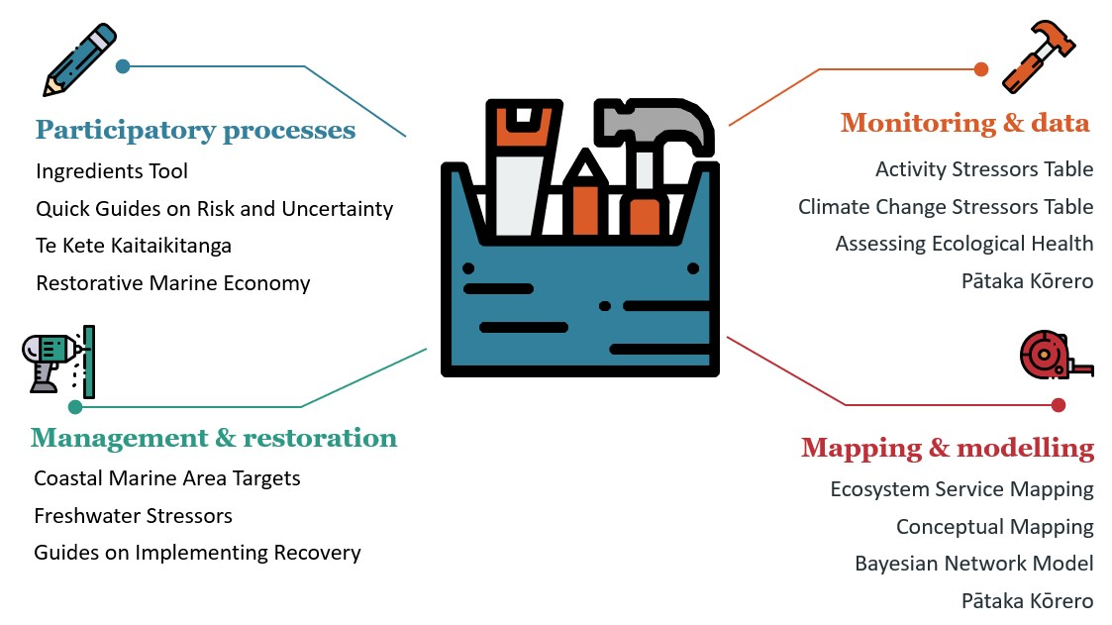

## Participatory processes

Getting around the table is often the first step for local communities, businesses and iwi to understand where various groups are coming from and what they want for (and from) the estuary. The participatory process tools enable constructive conversations and improve the collective understanding of each other’s world views. The tools guide users on how to navigate change through discussions that consider social, cultural, political and environmental processes and contexts.

The Ingredients Tool presents a set of critical questions to guide people involved in a collective process, from getting people in the room to considering your own and other’s world views. This is supported by a series of five Quick Guides Around Risk and Uncertainty, which help users explore why people argue about risk and uncertainty, and how to incorporate risk and uncertainty into EBM.

Te Kete Kaitiakitanga is a simple toolkit to guide councils and communities to provide for critical elements required for Mana Moana engagement. These tools focus on relationship building, transparency and accountability, to better incorporate te ao Māori principles such as rangatiratanga (leadership), mātauranga (knowledge) and tikanga (best practices) into marine management. Through a framework that integrates holistic, place-based methods shaped by iwi and hapū, Te Kete Kaitiakitanga strives to enable both kaitiakitanga and EBM for transformative change.

A restorative marine economy is one that combines business activities with environmentally sustainable and restorative practices that respond to community needs and iwi aspirations. This may evolve slowly over time, starting with minimising ongoing harm (ie, weak sustainability) to doing no *new* harm, to redressing harm (restorative economy). Finance and investment are vital to enable the shifts toward a restorative economy, requiring new frameworks that are still being developed in Aotearoa New Zealand.

## Monitoring and data

Estuaries are one of the more complicated environmental domains, being affected by the land around them, the fresh water flowing into them and the ocean. Collecting environmental data can help to build a big picture of the estuary, its health and the stressors affecting it. This helps inform actions to recover estuary health or to support using the estuary as an educational resource.

The Assessing Ecological Health tool lists both simple and more technical measures and provides information on other indicators that are already being used around Aotearoa New Zealand. This information can be usefully supplemented by documents from the ‘Roadmaps to EBM’ series aimed at starting actions: see ‘Implementing Recovery for Councils’ and ‘Implementing Recovery for Community Groups’ (appendix 1).

Knowing the likely effects of stressors can help when considering what to include in monitoring programmes. The Activity Stressor Table lists activities (terrestrial and marine) that create stressors on the marine environment, which includes estuaries. Used in conjunction with the Climate Change Stressor Table, it can help build a picture of the relative effects of the activities in and around the estuary.

For data storage, there is [Pātaka Kōrero](https://www.sustainableseaschallenge.co.nz/tools-and-resources/pataka-matauranga-to-empower-kaitiaki/), a digital tool designed for storing and organising scientific and mātauranga-derived information and data, usable in marine ecosystem management. The pātaka supports a vast range of content formats including documents, audiovisuals and web-hosted links. The [Pātaka Kōrero guidance](https://tohora.org.nz/documents/84) describes the tool, how it can be used and its unique features. It provides an insight into the design process and can help others who want to create a similar resource.

## Management and restoration

Several documents from the ‘Roadmaps to EBM’ series provide guidance to support the other tools in this toolkit. Topics include co-producing robust coastal marine targets (Coastal Marine Area targets), considering the effects of freshwater stressors, and how to implement recovery of an estuary (for councils and community groups). Figuring out what actions to take requires finding the right tools and expertise to support the restoration goals. Good intentions can be undermined if actions are not possible because they are not supported by legal or policy frameworks, or because the restoration is happening at the wrong place or time.

## Mapping and modelling

Sustainable Seas has developed multiple mapping tools that groups may find useful, but three were highlighted for Kakanui. Pātaka Kōrero, mentioned in the Monitoring and data section, also has the ability to generate maps using publicly available GIS layers in addition to custom layers generated by users with their unique data sets. This allows community groups to map their own monitoring and management efforts.

Marine ecosystems provide many services that are less obvious and may go unnoticed, yet the value and importance of these are poorly understood and difficult to measure. The ecosystem services map can help us understand and identify the multiple uses of marine ecosystems, where they happen and why they are important to preserve beyond monetary value.

All the information generated from this, and the sections above, can be organised through a conceptual mapping exercise. This involves sitting around a table as a group and drawing connections between different components in the estuary that people in the group consider important. It is vital all opinions are captured, whether commonly held or not. Various ways can be used to achieve this and, for Kakanui Estuary, we recommend working with the Estuaries Bayesian Network Model as the central map.

A Bayesian Network Model can represent how a marine ecosystem is likely to respond to various management interventions. It links components by the likely outcomes of changes to one component or another. The Estuaries Bayesian Network Model was originally developed under funding from the Parliamentary Commissioner for the Environment. The model has been adapted for this case study project (figure 5), and guidance explaining how the model was constructed and could be further developed can be found here: [Management for estuary values and aspirations – Sustainable Seas National Science Challenge (sustainableseaschallenge.co.nz)](https://www.sustainableseaschallenge.co.nz/tools-and-resources/estuaries-bayesian-network/).

Groups can run various scenarios with custom input components to predict the likelihood of desired outcomes (eg, how īnanga abundances might change under more or less frequent marine heatwaves). You can add ‘intermediate’ components that you think occur between the environmental drivers (eg, heat waves) and the outcomes (eg, īnanga) you want. For example, these may include fringing vegetation (which may be affected by heatwaves and provide nursery habitat for īnanga).

Figure 5: Estuaries Bayesian Network diagram for Kakanui Estuary

Source: Adapted from [Management for estuary values and aspirations – Sustainable Seas National Science Challenge](https://www.sustainableseaschallenge.co.nz/tools-and-resources/estuaries-bayesian-network/) ([sustainableseaschallenge.co.nz](https://www.sustainableseaschallenge.co.nz/tools-and-resources/estuaries-bayesian-network/)

# Appendix 1: The tools

Table 1: Tools in the Kakanui Estuary toolbox

| Tool and link | Target audience of guidance[9] | Purpose of the tool |
| --- | --- | --- |
| [Assessing Ecological Health](https://www.sustainableseaschallenge.co.nz/tools-and-resources/assessing-present-health/) | * Anyone can use this tool | Consistent changes in fauna, flora or other indicators over time may indicate a shift in ecological health. These changes may be measured through council monitoring programmes over time or through local observations, for example, fewer birds nesting or more muddy areas in the estuary. This document presents two methods: one for technical practitioners (eg, council scientists) and another for non-technical groups (eg, community groups or iwi) to assess present estuary health. |
| [Activity Stressor Table](https://www.sustainableseaschallenge.co.nz/tools-and-resources/activity-stressor-table/) | * Anyone can use this tool | A single human activity can produce more than one stressor, which can produce more than one direct effect, resulting in indirect effects. For example, a direct effect of mid-water fishing is the removal of species, but indirect effects include plastic pollution (through broken fishing lines) and altered behaviour of other animals (eg, sharks, birds, dolphins). This table helps the user to think through the direct and indirect effects that may occur due to one activity, and how these add up as more activities are considered. This can be used alongside the Climate Change Stressor Table (described below). |
| [Bayesian Network Models](https://www.sustainableseaschallenge.co.nz/tools-and-resources/estuaries-bayesian-network/) | * Anyone can use the Kakanui model designed by Sustainable Seas, although specific software is required | Bayesian Network Models can bridge data gaps where information from Western science is lacking with expert knowledge, mātauranga Māori and other local knowledge (eg, residents noticing a decline in nesting birds). Sustainable Seas developed a Bayesian Network Model for Aotearoa New Zealand estuaries for the Parliamentary Commissioner for the Environment. This model has been adapted for the Kakanui Estuary as part of the Ministry for the Environment and Sustainable Seas case study estuary project. You can find more information here [Management for estuary values and aspirations – Sustainable Seas National Science Challenge (sustainableseaschallenge.co.nz)](https://www.sustainableseaschallenge.co.nz/tools-and-resources/estuaries-bayesian-network/). |
| [Climate Change Stressor Table](https://www.sustainableseaschallenge.co.nz/tools-and-resources/climate-change-stressors/) | * Community groups and individuals * Councils working with community groups and individuals | Similarly to the Activity Stressor Table (described above), this table helps the user to think through the likely direct and indirect effects of climate change on estuarine systems. This should be used alongside the Activity Stressor Table to consider how the impacts of climate change are likely to exacerbate the direct and indirect effects of existing activities. The table also demonstrates how these effects are likely to stack up due to climate change alone, for example, more frequent rainfall has many direct and indirect effects, but the effects of warmer air and water temperatures and sea level rise will almost certainly occur at the same time. |
| [Coastal Marine Area Targets (Roadmaps to EBM)](https://www.sustainableseaschallenge.co.nz/assets/dms/Other-TR/Roadmaps/How-do-we-decide-on-robust-locally-generated-CMA-targets-that-incorporate-climate-change.pdf) | * Anyone can use this to inform goals, plans or conversations * Regional council (implementation) | Targets for estuary health should be developed in partnership between local councils, local iwi and hapū, and the community. This document outlines recommendations on how to set robust targets for estuary health and to maximise the likelihood of success. |
| [Conceptual mapping and how likely actions are to benefit others (Roadmaps to EBM)](https://www.sustainableseaschallenge.co.nz/public/assets/dms/Other-TR/Roadmaps/How-likely-is-it-that-the-action-we-want-will-benefit-others.pdf) | * Anyone can develop a conceptual map using this guidance | This document summarises how a conceptual map can be used to consider how likely actions are to benefit the environment. This can help users to think through the pros and cons of decisions before committing to them. |
| [Ecosystem Service Mapping](https://www.sustainableseaschallenge.co.nz/tools-and-resources/utilising-ecosystem-services-to-support-marine-ecosystem-management/) | * Regional council * Anyone can use this to inform goals, plans or conversations, for example, in collaboration with regional council scientists to identify the ‘best’ site for community-led surveys | This summary document discusses how ecosystem services (eg, how mussels can filter suspended sediment out of the water column) can help us understand and communicate multiple uses of marine ecosystems, which can go far beyond making money and providing food. Marine ecosystems provide many services that are less obvious and may go unnoticed, yet the value and importance of these are poorly understood and difficult to measure. |
| [Freshwater Stressors (Roadmaps to EBM)](https://www.sustainableseaschallenge.co.nz/public/assets/dms/Other-TR/Roadmaps/Will-the-freshwater-limits-we-set-protect-our-estuarine-waters.pdf) | * Anyone can use this to inform goals, plans or conversations * Regional council (implementation) | Estuaries sit at the bottom of a catchment, receiving inputs carried in by rivers and streams. One way to improve estuary health is to manage the stressors carried in from the catchment, such as by setting limits in fresh water that can be monitored and managed. If the source of the stressor is not from fresh water, however, then setting limits that affect activities done on land may not have the desired effects; for example, if the dominant stressors enter from storm drains or activities (such as boating) occurring in the estuary. This document sets out a series of questions for decision-makers to consider when setting limits in freshwater systems (eg, rivers and streams) to protect estuary health. |
| [Implementing Recovery – Assisting Community Groups (Roadmaps to EBM)](https://www.sustainableseaschallenge.co.nz/assets/dms/Other-TR/Roadmaps/Local-groups-are-interested-in-recovering-the-health-of-an-area-how-do-we-go-about-helping-them-move-forward.pdf) | * Community groups * Local or regional council * eNGOs4 | Guidance for councils and decision-makers on how they can support community groups with their efforts to recover estuary health. |
| [Implementing Recovery for Councils (Roadmaps to EBM)](https://www.sustainableseaschallenge.co.nz/assets/dms/Other-TR/Roadmaps/We-have-recovery-highlighted-in-our-plans-how-do-we-go-about-it.pdf) | * Anyone can use this to inform goals, plans or conversations * Regional council (implementation) | This document summarises a proposed process for determining recovery outcomes and developing a plan. |
| [Implementing Recovery for Community Groups (Roadmaps to EBM)](https://www.sustainableseaschallenge.co.nz/public/assets/dms/Other-TR/Roadmaps/We-are-interested-in-recovering-health-of-an-area-how-do-we-go-about-it.pdf) | * Community groups * eNGOs | Guidance for community groups who want to recover the health of their estuary. |
| [Ingredients Tool](https://www.sustainableseaschallenge.co.nz/tools-and-resources/ingredients-tool/)  (Ingredients to catalyse participation in decision-making) | * Decision-makers (primarily) * Anyone can use this to inform goals, plans or conversations | Questions grouped into themes, to help people think about their own circumstances and to consider the actions they can take. Having participants consider these questions at the start of a collaboration (eg, stakeholder engagement on a plan) can catalyse conversations and help determine agreed goals. |
| [Pātaka Kōrero](https://www.sustainableseaschallenge.co.nz/assets/dms/Other-TR/Pataka-Korero/System-use-and-key-learnings/Pataka-Korero-System-Use-and-Key-Learnings.pdf) | * Anyone looking to collate and share data * eNGOs | This is a digital tool designed specifically for a set of iwi and hapū groups for storing and organising information and data. The pātaka supports a vast range of content formats including documents, audiovisuals and web-hosted links. The guidance describes the tool, how it can be used and its unique features. |
| [Quick Guides Around Risk and Uncertainty](https://www.sustainableseaschallenge.co.nz/tools-and-resources/quick-guides-risk-and-uncertainty/) | * Anyone can use this guide to inform goals, plans or conversations | Five quick guides that help users explore why people argue about risk and uncertainty. They provide guidance on navigating discussions of risk and uncertainty, including how people differ in their perception or understanding of ‘risk’ and ‘uncertainty’. |
| [Restorative Marine Economy](https://www.sustainableseaschallenge.co.nz/tools-and-resources/restorative-marine-economies-framework/) | * Investors * Central and local government * eNGOs | This summary document explains the main concepts of restorative economies. Restorative economies combine business activities with environmentally sustainable and restorative practices that respond to community needs and iwi aspirations. |
| [Te Kete Kaitiakitanga](https://www.sustainableseaschallenge.co.nz/tools-and-resources/te-kete-kaitiakitanga/) | * Non-Māori collaborating with iwi | A simple toolkit that aims to provide guidance and a means of assessment to help ensure that kaitiakitanga is appropriately provided for alongside ecosystem-based management. It has been designed in collaboration with a range of partners for the use of agencies, organisations, iwi and hapū wishing to improve marine governance and management outcomes. |

# Appendix 2: Practical examples from Sustainable Seas projects

Below are practical examples of the Sustainable Seas outputs in action. The tools behind these examples may not have made it into the ‘toolbox’ for this estuary but are useful examples of managing for recovery and restoration. Links are provided to the recently launched Tohorā search engine, which summarises outputs of Sustainable Seas using artificial intelligence.

* [Ngā tohu – Te Korowai](https://tohora.org.nz/documents/126) examines Maramataka as a framework for managing coastal environments, emphasising restoration based on indigenous ecological knowledge and a structured research approach.
* [Ōhiwa Harbour case study](https://tohora.org.nz/case-studies/ohiwa-harbour) summarises the success of a mātauranga Māori-led research restoration project between iwi, hapū, researchers, local councils and the Ōhiwa Harbour Implementation Forum. Collaboration with kaumatua was an integral part of the restoration, which has seen 16 million ‘teenage’ kuku (mussels) now growing successfully in a traditional kuku bed in Ōhiwa Harbour. This is an example of principles from te ao Māori, ecosystem-based management and the blue economy working together.
* [Disturbance recovery dynamics inform seafloor management for recovery](https://tohora.org.nz/documents/161) details the species dynamics and external factors that influence successful restoration. In particular, it focuses on whether recovery can happen by ‘turning off the tap’ of contaminants and how long natural recovery might take.
* [Guidance and tools to help navigate marine restoration projects as part of ecosystem-based management in the top of the South Island](https://tohora.org.nz/documents/158) summarises guidance and tools mapped to restoration goals identified by a group of stakeholders for marine ecosystems. It is the result of a collaboration with a ‘restoration by design’ process facilitated by Nature Conservancy New Zealand with Kotahitanga mō te Taiao Alliance.
* [Designing long-term monitoring programmes](https://tohora.org.nz/documents/48) offers insights into designing marine monitoring programmes to detect environmental changes using long-term data from Aotearoa New Zealand’s Manukau Harbour Ecological Monitoring Programme. It suggests ways that cost-effectiveness can be improved by monitoring multiple variables and using sites that have been monitored continuously to interpret changes at other less frequently monitored locations.
* [Monitoring for marine tipping points](https://storage.googleapis.com/sustainable-seas-documents-prod/EBM%2033%20Guidance-Monitoring-for-marine-tipping-points.pdf)provides strategies for monitoring marine ecosystem changes and detecting critical tipping points. It highlights the need for monitoring over at least 15 years to account for natural cyclic patterns like El Niño/La Niña. Furthermore, the guidance demonstrates how use of expert and local knowledge can compensate for data gaps.

1. A catchment, or whaitua, is an area of land where rain flows into a common river, lake or other body of water.
2. While we were able to have high-level conversations with Ngāti Manuhiri and Mana Ahuriri, we were not able to connect with Te Rūnanga o Moeraki.
3. *Otago Regional Council v Te Rūnanga o Moeraki, Kāti Huirapa Rūnaka ki Puketeraki, Te Rūnanga o Ōtākau and Hokonui Rūnanga* [2021] ENV-CHC 127 at appendix 1, p 1.
4. Kāi Tahu ki Otago – Natural Resource Management Plan 2005, DD11112 KTKO ResourceG.qxd (waitaki.govt.nz) [at 7.1], p 101 and Ngāi Tahu Claims Settlement Act 1998, sch 23.
5. Patterson G. 2019. [Road name could be first step](https://www.odt.co.nz/regions/north-otago/road-name-could-be-first-step). *Otago Daily Times* 17 August.
6. Tipa G, Nelson K. 2012. Identifying cultural flow preferences: Kakaunui River Case Study. *Journal of Water Resources Planning and Management* 138(6): 660–670.
7. Tipa G, Nelson K. 2012. Identifying cultural flow preferences: Kakaunui River Case Study. *Journal of Water Resources Planning and Management* 138(6): 660–670.
8. [*Kāi Tahu ki Otago – Natural Resource Management Plan*](https://www.waitaki.govt.nz/files/assets/public/files/our-services/planning-and-resource-consents/kai-kahu-ki-otago-natural-resources-management-plan-2005.pdf). 2005. [Waitaki District Council (waitaki.govt.nz)](https://www.waitaki.govt.nz/files/assets/public/files/our-services/planning-and-resource-consents/kai-kahu-ki-otago-natural-resources-management-plan-2005.pdf) [at 7.1], p 101.
9. Improving estuary health requires buy-in from many groups, likely with different world views and priorities. While each tool in table 1 is targeted towards particular groups, other groups can encourage the use of the tool. For example, the ‘Restorative Marine Economy’tool is targeted to investors and central or local government, but individuals can encourage them to use the tool.