2024 Update of the national groundwater
quality indicator
M Moreau | M Herpe | ME Santamaria Cerrutti

GNS Science Consultancy Report 2024/90

February 2025

Disclaimer
This report has been prepared by the Institute of Geological and Nuclear Sciences Limited (GNS Science) exclusively for and under contract to the Ministry for the Environment. Unless otherwise agreed in writing by GNS Science, GNS Science accepts no responsibility for any use of or reliance on any contents of this report by any person other than the Ministry for the Environment and shall not be liable to any person other than the Ministry for the Environment, on any ground, for any loss, damage or expense arising from such use or reliance.
Use of Data:
Date that GNS Science can use associated data: June 2025
Bibliographic Reference
Moreau M, Herpe M, Santamaria Cerrutti ME. 2025. 2024 Update
of the national groundwater quality indicator. Wairakei (NZ):
GNS Science. 83 p. Consultancy Report 2024/90.

CONTENTS
Executive Summary iii
1.0 INTRODUCTION 1
1.1 New Zealand Groundwater Resources 1
1.2 Groundwater Quality Monitoring 6
1.2.1 Inorganic Chemistry and Microbiology 6
1.2.2 Man-made Compounds 7
1.2.3 Spatial Distribution of Monitoring Sites 7
1.3 Previous National Reports 9
1.3.1 Inorganic Chemistry and Microbiology 9
1.3.2 Man-made Compounds 9
1.4 This Report 10
2.0 METHODS 12
2.1 Report Co-design 12
2.2 Selected Variables 12
2.3 Data Sources and Processing 14
2.4 Reported Statistics 16
2.5 Statistical Analysis Settings and Implementation 18
2.6 Limitations 18
3.0 RESULTS 20
3.1 Datasets 20
3.2 State 20
3.2.1 In-situ Physico-chemical Conditions 20
3.2.2 Groundwater Processes 25
3.2.3 Human Influence 28
3.3 Temporal Patterns 30
4.0 RECOMMENDATIONS 40
5.0 CONCLUSION 43
6.0 ACKNOWLEDGEMENTS 44
7.0 REFERENCES 44

FIGURES
Figure 1.1 New Zealand hydrogeological system types and location (Moreau et al. 2019). 4
Figure 1.2 New Zealand hydrogeological-unit map (White et al. 2019). 5
Figure 1.3 Location of groundwater quality monitored sites presented in this report compared to the location of takes where the primary source is groundwater 8
Figure 3.1 Median concentrations for nitrate (mg/L as N) between 2019 and 2024. 29
Figure 3.2 Percentage of significant trends at monitoring sites across New Zealand at which trend tests could be performed for the 10-, 20- and 30-year periods. 32
Figure 3.3 Summary of detection for successive pesticides surveys (1990–2022), per hydrogeological system. 38
Figure 3.4 Pesticide detections distribution over time, for each of the pesticide surveys (1990–2022). 39
TABLES
Table 1.1 Hydrogeological systems with examples of system names and equivalent published aquifer names (adapted from Moreau et al. 2019). 3
Table 1.2 Summary of the number of monitored systems and sites per hydrogeological system type. 7
Table 2.1 Selected variables to inform national reporting, excluding man-made compounds. 13
Table 2.2 Variable aggregation used in this report. 16
Table 3.1 Calculated percentiles and maximum values for inorganic chemistry groundwater variables at SoE sites (NGMP and SoE), based on site-specific median values for the period 2019–2024. 23
Table 3.2 Percentage of New Zealand monitoring sites at which the MAV, AV and/or reference value was exceeded at least on one occasion and by the median value calculated for the period
2019–2024. 26
Table 3.3 Number of sites (n) and percentage of significant increasing (% inc.) and decreasing (% dec.) trends at monitoring sites across New Zealand for the 10-, 20- and 30-year periods. 33
Table 3.4 Absolute rates of change in inorganic chemistry variables at SoE sites (SoE and NGMP) with statistically significant 10-year trends. 34
Table 3.5 Relative rates of change in inorganic chemistry variables at SoE sites (SoE and NGMP) with statistically significant 10-year trends. 35
Table 3.6 Number of sites at which a significant nitrate concentration trend was observed and percentage of sites where rates are increasing faster that the reference range for the 10-, 20-year and
30-year time periods per hydrogeological system type. 36
Table 3.7 Percentage of sites where the E. coli MAV was exceeded at least once per 5-year time window from 1994 to 2019, per hydrogeological system type. 36
Table 3.8 Maximum concentrations (µg/L) over time for detected compounds for all pesticides surveys (1990–2022). 37

APPENDICES
APPENDIX 1 DATA REQUEST 51
APPENDIX 2 DATA HARVESTING PILOT RECOMMENDATIONS FOR LAWA IMPROVEMENT 52
APPENDIX 3 MEDIAN VALUES FOR INORGANIC CHEMISTRY VARIABLES
(2019–2024) 53

ATTACHMENTS
GNS CR2024-90 Appendix 1
GNS CR2024-90 Appendix 2
GNS CR2024-90_groundwater_quality_sites_details.csv
GNS CR2024-90_groundwater_quality_time_series.csv
GNS CR2024-90_groundwater_quality_site_names_vocabulary.csv
GNS CR2024-90_groundwater_quality_data_dictionary.csv
GNS CR2024-90_groundwater_quality_statistics.csv

Executive Summary
Under the 2015 Environmental Reporting Act, the Ministry for the Environment and Statistics
New Zealand have a responsibility to report on the state of different aspects of our environment every six months. These domain reports use technical information analysed by Stats NZ and presented in the form of Indicators. To inform the 2025 national reporting on the environment, the Ministry for the Environment commissioned GNS Science to provide a summary of the current status of groundwater quality in New Zealand, while addressing shortcomings identified in an independent review of the Stats NZ 2020 Groundwater Quality Indicator. The latter task involved co-design of this report, development of associated output datasets and testing of data harvesting to inform future Indicator updates.
Groundwater quality data was collated from regional and national state of the environment monitoring programmes operated by 17 organisations, including GNS Science. Data processing included reformatting, data cleansing, harmonisation, non-detect handling and statistical analyses. The final dataset consists of time series for 33 inorganic and 213 organic variables collected at 2008 sites between 1990 and 2024. Trend analysis was performed using statistical tests (Kruskall-Wallis, Mann-Kendall, Sen Slope estimator), with settings and methods adapted to be suitable for groundwater quality.
Groundwater quality state was defined using a 5-year period (ending in February 2024). Collected monitoring data illustrate the range of hydrochemical conditions throughout
New Zealand. This reflects the range of hydrogeological settings occurring around the country, with over 100 aquifers of varying extents, thicknesses, lithologies and hydraulic properties. These data also highlighted that nitrate contamination remains a long-standing issue, and E. coli bacteria are regularly encountered in groundwater, nationwide. Naturally occurring exceedances of the New Zealand drinking-water maximum acceptable values for manganese, arsenic, boron and fluoride are associated with geogenic or geothermal sources.
Groundwater quality trend assessments were performed for 10-, 20- and 30-year time periods. Nationwide, increases and decreases were common for most variables and could occur concurrently between variables at a given site. Increases were dominant for most variables over the 10-yr period with the exception of dissolved oxygen, ammonia and pH. The temporal pattern of nitrate concentrations was contrasted with a comparable number of increases (45% of 662 sites) and decreases (40% of the sites) over the 10- year period. This pattern was similar for the 20-year period and dominated by increases for the 30-yr period. The percentage of sites exhibiting increasing nitrates has remained similar for the 10-, 20- and 30-year periods. Exceedances of E. coli have also remained consistent through time. Four-yearly testing of pesticides shows isolated and limited cases of detections with generally low concentrations below the maximum acceptable values, where these exist.
The data harvesting pilot study involved the development of a script using data feeds set up for councils to provide data to Land Air Water Aotearoa (LAWA) in one region. Harvested data was compared to the dataset provided by the council in response to the data request. The test highlighted shortcomings in this process, and recommendations were provided to LAWA for consideration if these feeds were to be used in the future to source groundwater quality data for national reporting.

Recommendations provided in this report aim to: continue monitoring to provide independent measurements; continue to engage in and support the development of a national framework to enhance the representativeness, transparency and efficiencies of current monitoring programmes; enhance future indicator reporting, and ensure fit-for-purpose state of the environment monitoring data is made available for data science.

INTRODUCTION
Under the Environmental Reporting Act (2015), the Ministry for the Environment and Statistics New Zealand (Stats NZ) have a responsibility to report on five environmental domains every six months and synthesise these reports every three years. Domain reports are supported by Indicators published by Stats NZ.
To inform the 2025 national reporting on the environment, the Ministry for the Environment commissioned GNS Science (GNS) to:
- Collect, cleanse, analyse and report groundwater quality state and trends for selected variables using data collected as part of State of the Environment (SoE) monitoring programmes from national and regional programmes.
- Undertake a case study assessment of collecting the same data for one regional authority via data feeds set up for councils to provide data to Land Air Water Aotearoa (LAWA).
- Provide recommendations to automate the data compilation for future groundwater quality reporting. Produce a brief technical report and summary statistics that can be used as the primary basis for national reporting, including the implementation of technical improvements recommended by an independent review of the 2020 Groundwater Quality Indicator (Moreau 2023).
This report is structured to first provide an up-to-date background on groundwater monitoring in New Zealand and understanding from previous reports. Next, the data sources, processing methods and limitations are presented. Finally, findings and recommendations for future Groundwater Quality Indicators and data collection are provided.

New Zealand Groundwater Resources
Groundwater is an essential part of our environment and our economy. In the environment, groundwater naturally occurs as springs and seeps supporting river flows, lakes and wetlands, especially through drier periods. Baseflow to rivers is essential to aquatic health. Groundwater is used for drinking (from single household to city supplies) by 40% of the population, more than 30% for the primary sector and contributes 80% of spring, stream and wetland baseflows (LAWA 2022; ESR 2024).
In 2017–2018, groundwater resources represented 24% of NZ’s annual water allocation for consumptive use (3.1 billion Mm³/year (Booker and Henderson, 2019). There were variations on the percentage of annual water allocation sourced from groundwater between regions, from 0.5% (Southland) to 60.7% (Tasman). Groundwater contribution to the NZ economy through irrigation was estimated at $2 billion per annum during that period (Corong et al. 2014).
Groundwater is hosted in geological formations that may be qualified as: aquifer, aquitard
or aquiclude. In this report, aquifers are defined as hydrogeological units that are formations containing sufficient saturated permeable material to yield significant quantities of water
to wells and springs; unconsolidated sands and gravels are a typical example. Aquitards are hydrogeological units defined as saturated but poorly permeable stratum that impedes groundwater movement and does not yield water freely to wells. They may, however, transmit appreciable quantities of water to or from adjacent aquifers and, where sufficiently thick, may constitute an important groundwater storage zone; sandy clay is an example. Aquicludes are hydrogeological units defined as saturated but relatively impermeable material that does
not yield appreciable quantities of water to wells; clay is an example (Moreau 2023).
The concept of aquifers, aquitard and aquicludes is relative, for instance what is regarded
as an aquifer in one region may be regarded as an aquitard where more productive lithologies occur.
New Zealand aquifers are numerous (>200), diverse in nature (e.g. geology, flow-characteristics, hydraulic properties and extent). They are also unevenly distributed between regions. The first and only nationally consistent aquifer map was released 23 years ago
(White 2001). Knowledge of our aquifers has since deepened and, with the increasing availability of digital datasets, GNS has been working to update this map of groundwater resources. A revised aquifer map was released in 2015, however, this dataset encapsulated inconsistencies between regions in the delineation methods used to define boundaries (Moreau and Bekele 2015). In 2019, GNS developed two datasets:
- The New Zealand Hydrogeological Systems map (Figure 1.1) is a 2-D GIS dataset representing geographical areas with broadly consistent hydrogeological properties, and similar resource pressures and management challenges (Moreau et al. 2019). In the 2023 review of the 2020 Groundwater Quality Indicator, it was recommended to use the hydrogeological systems as a spatial reporting unit to better represent groundwater resource distribution than the regional, territorial or catchment boundaries used to date.
- The New Zealand Hydrogeological Unit Map (Figure 1.2) is a 2.5-D GIS dataset (overlapping, stacked polygons) that represents hydrogeological units (i.e. aquifers, aquitards, aquicludes and basement) developed in a nationally consistent manner and that illustrates geological layering (White et al. 2019). The Hydrogeological Unit Map dataset continues to be refined by GNS (latest release 2022) and will ultimately become a 3D, digital, aquifer map. Current work includes depositional facies mapping and 3D modelling.
Hydrogeological systems may include multiple aquifers. They were delineated at the 1:250,000 scale and grouped into eight types (Table 1.1):
- Coastal and inland basin systems, which are large systems where the dominant outcropping units are of sedimentary origin.
- Coastal and inland volcanic systems, which are large systems where the dominant outcropping units are of volcanic origin.
- Inland river valley, which are small systems that contribute to larger systems.
- Coastal independent systems, which are smaller systems that discharge at the coast and do not contribute water to a larger system.
- Basement infill systems, which are small systems that are fully enclosed within basement. In this classification Basement is defined as Cretaceous and older geological units and is generally associated with very low hydraulic permeability.
- Basement hard rock systems, which are regarded as an aquiclude at the national scale.
Although a total of 1896 individual systems were delineated, individual names were only attributed to larger systems based on geographical location (e.g. Southland Plains Coastal Basin and Ettrick Inland Basin), resulting in unique identification of approximately 220 systems in New Zealand (Table 1.1). The remaining systems consist of numerous disaggregated systems, which were grouped together for practical reasons. Inland, these systems were assigned the region’s name (e.g. Waikato Inland River Valley system), whereas at the coast, disaggregated systems were named by marine weather zones to reflect their connection to the coast (e.g. Brett Coastal Independent systems).
Table 1.1 Hydrogeological systems with examples of system names and equivalent published aquifer names (adapted from Moreau et al. 2019).
Aggregated systems are highlighted with an asterisk.
System Type | System Overview | # of  Systems | Onshore New Zealand Area
Coastal Basin | Groundwater is a key water supply for municipal, industrial and agricultural uses. | 99 | 30%
Inland Basin | Groundwater is a very important supply for agricultural uses. | 61 | 11%
Coastal Volcanic | Locally-important supplies. | 26 | 4%
Inland Volcanic | Locally-important supplies. | 6 | 4%
Inland River Valley* | Local supplies to independent users (e.g. rural drinking-water). | 15 | 2%
Coastal Independent* | Largely unexplored. | 19 | 1%
Basement Infill* | Largely unexplored. | 1 | 3%
Basement Hard Rock* | Water supplies from Basement fractures are rarely used. | 1 | 44%
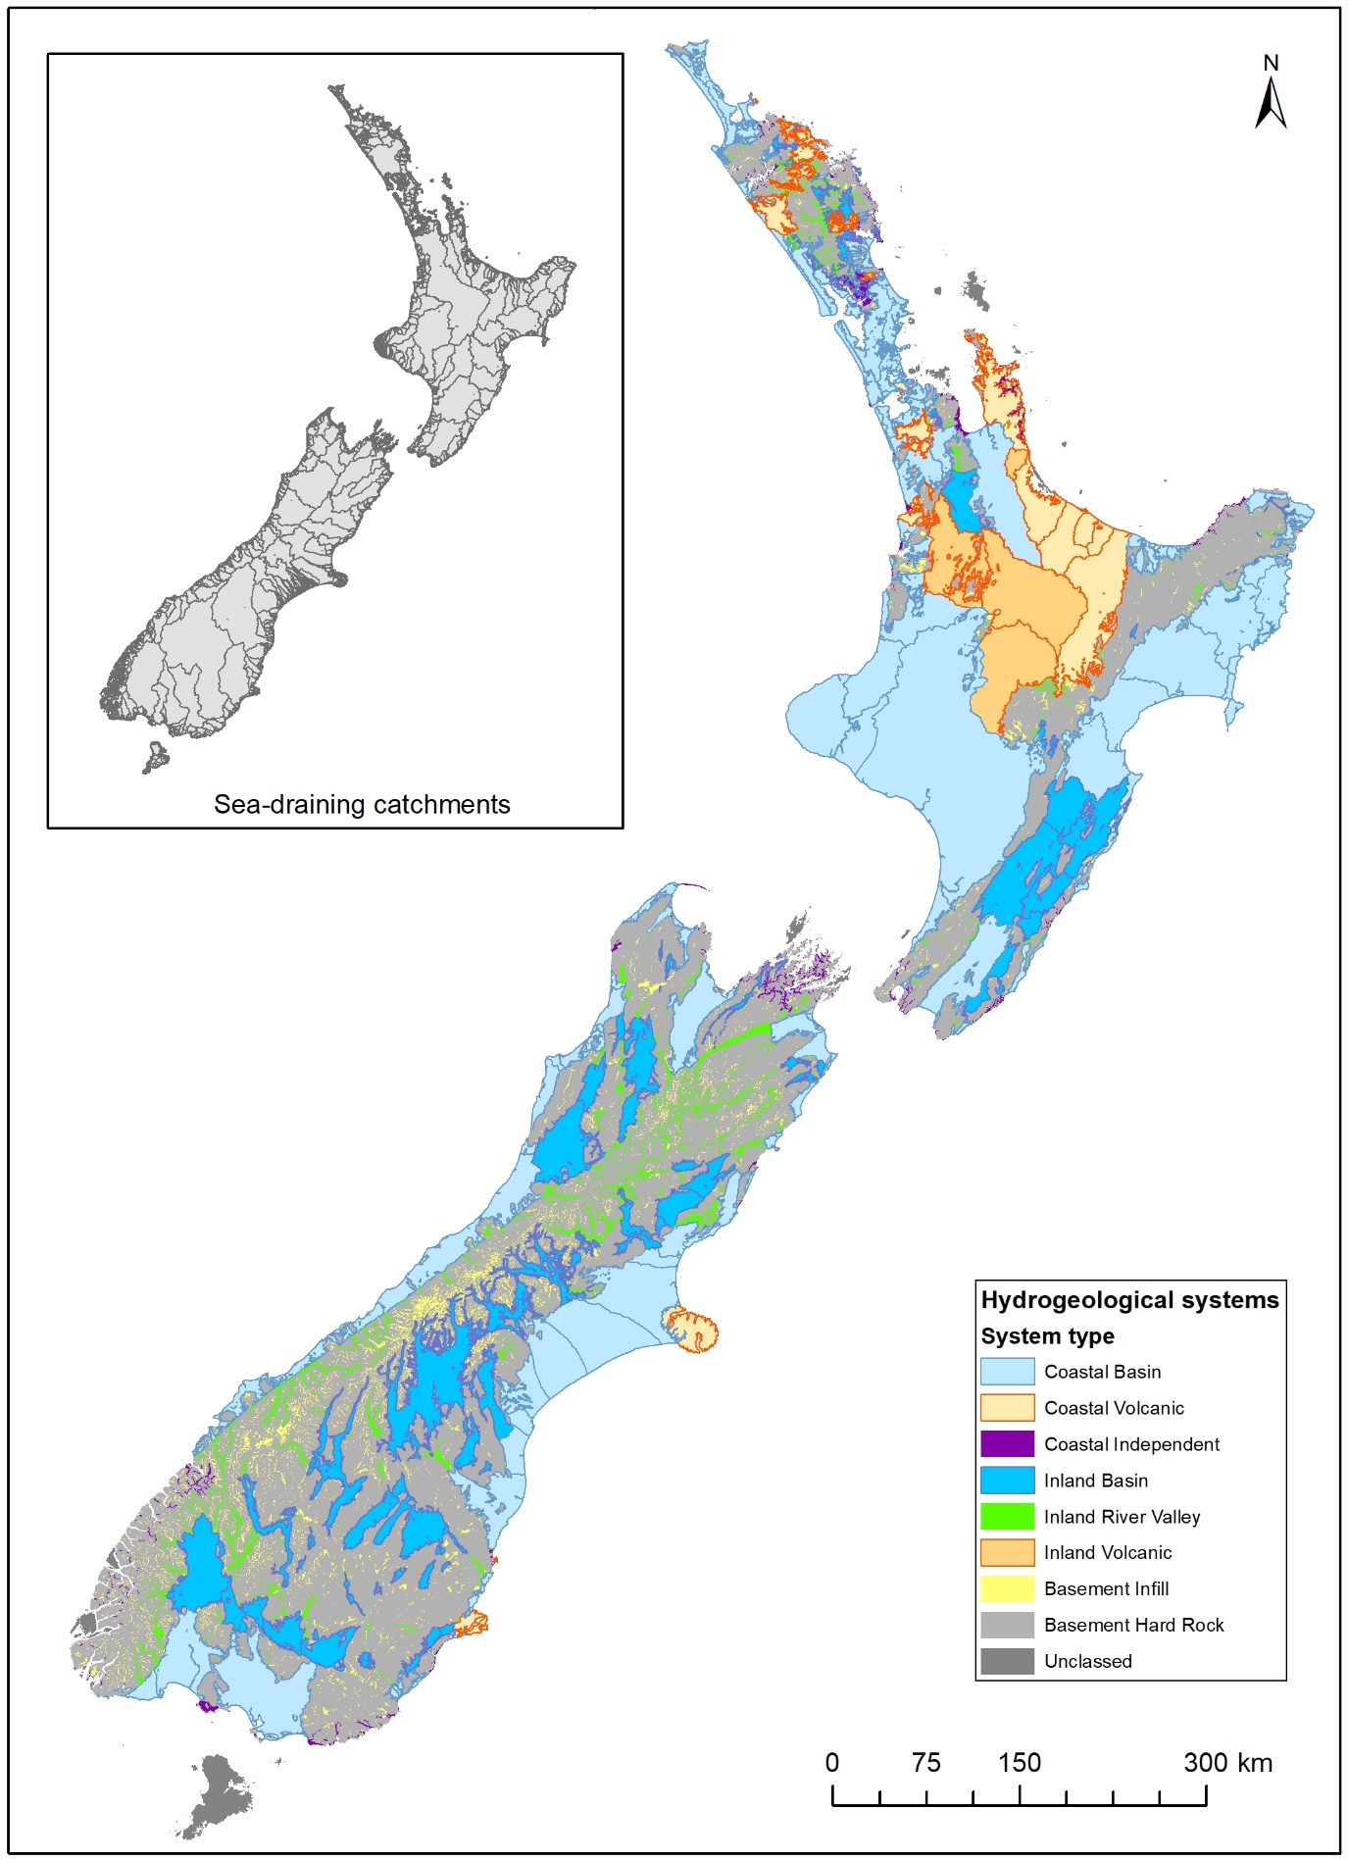
Figure 1.1 New Zealand hydrogeological system types and location (Moreau et al. 2019).
The inset depicts the sea-draining catchment boundaries used in the 2020 Indicator (Ministry for the Environment 2019). In this report, systems are trialled as spatial reporting units to better represent NZ’s groundwater systems.

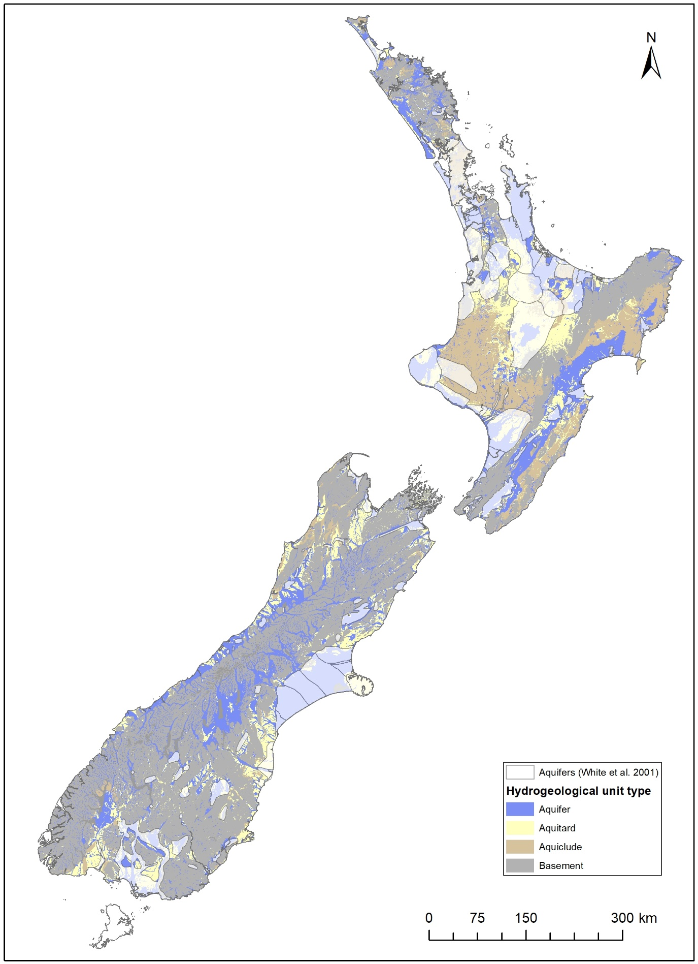
Figure 1.2 New Zealand hydrogeological-unit map (White et al. 2019).
The mapping currently excludes smaller islands (e.g. Stewart Island). Note that aquifers are three dimensional layers, and it is common in New Zealand for aquifer systems to be multi-layered (e.g. Canterbury Plains, White et al. 2001). This map only represents outcropping aquifers.

Groundwater Quality Monitoring
In New Zealand, SoE groundwater quality monitoring is undertaken at the national scale through two programmes – the National Groundwater Monitoring Programme (NGMP) co-ordinated by GNS, which focuses on inorganic chemistry; and the Pesticides Survey co-ordinated by the Institute of Environmental Science Research (ESR), which focuses on man-made compounds. Both programmes are long-standing collaborations with regional and district councils initiated in 1990. At the regional scale, regional and district councils run dedicated SoE monitoring programmes. Some regions also undertake their own more intensive man-made compounds monitoring programmes as part of SoE activities (Close and Skinner 2011).
Data collection on Emerging Organic Contaminants (EOCs) (e.g. personal care products, pharmaceuticals) is an active and recent research area. Although these man-made compounds have been recently added to the Pesticides Survey (Close and Banasiak 2023b), pilot studies are being undertaken to understand the occurrence, transport and fate of these compounds and therefore the need for long-term monitoring at smaller scale (e.g. Hadfield 2017; Moreau et al. 2019).

Inorganic Chemistry and Microbiology
State and trends in groundwater quality are reported both at the regional and national scale at varying frequencies (e.g. quarterly for NGMP). National monitoring started in 1990 with quarterly samples and attained national coverage in 1998. Although there have been changes in sites, the national network size, sampling frequency and analytical suite have remained mostly constant since 1998 (c.110 sites). In contrast, regional networks have grown over time with site selection, sampling frequency, and analytical suites variably evolving between regions. Network reviews are undertaken independently by all organisations, and the most recent reviews may have resulted in a reduction of sites and monitoring frequencies for cost-effectiveness. In 2019, national reporting included 901 active sites from the regional network, with 105 sites shared with the national network (Parliamentary Commissioner for the Environment 2019).
Groundwater samples are collected according to a sampling protocol that has been available in New Zealand since 1999, although it has been subsequently updated to be consistent with National Environmental Monitoring Standards (Rosen et al. 1999, Daughney et al. 2006; Milne et al. 2019). Quality assurance methods vary between networks, but generally include the collection of field blanks, sample replicates and the comparison of results with historical records. Quality assurance is part of the Standards and applied by all SoE monitoring agencies.
Analytical suites used for groundwater quality monitoring generally include a wide array of variables that are tied to underground processes specific to groundwater (e.g. cation exchange and mineral dissolution). These variables include major, minor and trace constituents, typically including calcium, chloride, bicarbonate, potassium, magnesium, nitrate, sodium, silica, boron, bromide, fluoride, iron, manganese, ammonia, phosphorus, lithium, aluminium, arsenic, cadmium, chromium, copper, nickel, nitrite, lead, tin, and zinc. Budget constraints may limit the number of monitored variables and/or sampling frequency. Collected data is publicly accessible from council databases, and for the NGMP dataset through the freely accessible Geothermal Groundwater (GGW) database. State and trends at selected SoE sites are also made publicly available on the LAWA website, grouped by “groundwater zones”.

Man-made Compounds
National pesticide surveys have been undertaken and reported on by ESR at four-yearly intervals since 1990 (Close and Banasiak 2023a). The initial national network comprised 82 wells (throughout six regions) and gained national coverage in 1998 (95 wells). In 2022, 184 wells were sampled and the collected data was complemented by regional data from
41 Waikato wells collected through a regional programme. Surveyed wells were selected and sampled based on multiple factors including: the relative regional importance of an aquifer; the known application and storage of pesticides in the area, and the perceived aquifer vulnerability to pesticide contamination. Unconfined aquifer conditions are preferably selected as they are more vulnerable to surface contamination (Close and Banasiak 2023a).
Samples are collected using a dedicated sampling protocol, and each sampling survey includes the collection of duplicate samples for quality assurance (e.g. 5% of the wells in 2011 (Close and Skinner 2011) and 7.6% of the wells in 2022 (Close and Banasiak 2023)). The list of tested compounds has grown as laboratory capability has advanced and become more cost effective. The 2022 analytical suite included 25 organochlorine pesticides, 88 organonitrogen and phosphorus pesticides, 25 acid herbicides and 57 multiresidue pesticides. It was extended to EOCs in 2018 and per- and polyfluoralkyl substances (PFAS) in 2022 (Close and Banasiak 2023). PFAS are man-made compounds used domestically or industrially (e.g. degradation
of non-stick, and stain-resistant consumer products; paper food packaging; use of class B fire-fighting foam etc.). The detection limits from 1998 onwards were significantly lower than the 1990 and 1994 surveys (between 5 and 10 times lower; Close and Humphries 2011). Collected data is included in council databases.

Spatial Distribution of Monitoring Sites
The distribution of groundwater quality monitoring sites is uneven between and within regions, and generally reflects aquifer location and groundwater use (Figure 1.3, Table 1.2).
The majority of monitoring sites are located in Coastal Basin and Coastal Volcanic systems (Table 1.2). For a given year, the number of monitored sites may vary due to unforeseen circumstances (e.g. the bore pump is not working on the day of the visit).
Table 1.2 Summary of the number of monitored systems and sites per hydrogeological system type.
Aggregated systems are highlighted with an asterisk.
System Type | #  Systems | % Monitored Systems | #  Monitoring Sites | Individual Monitored System Area (km²) |  | #  Sites per Monitored System
 |  |  |  | Min | Max | Min | Max
Coastal Basin | 55 | 56% | 1108 | 29 | 17250 | 1 | 151
Inland Basin | 33 | 54% | 367 | 25 | 3836 | 1 | 61
Coastal Volcanic | 13 | 50% | 207 | 38 | 3655 | 1 | 71
Inland Volcanic | 5 | 83% | 24 | 100 | 4321 | 3 | 8
Inland River Valley | 5 | 33% | 25 | 441 | 1594 | 1 | 18
Coastal Independent* | 5 | 26% | 94 | 85 | 345 | 1 | 52
Basement Infill* | 1 | 100% | 6 | 6844 | 6844 | 6 | 6
Basement Hard Rock* | 1 | 100% | 13 | 115175 | 115175 | 13 | 13
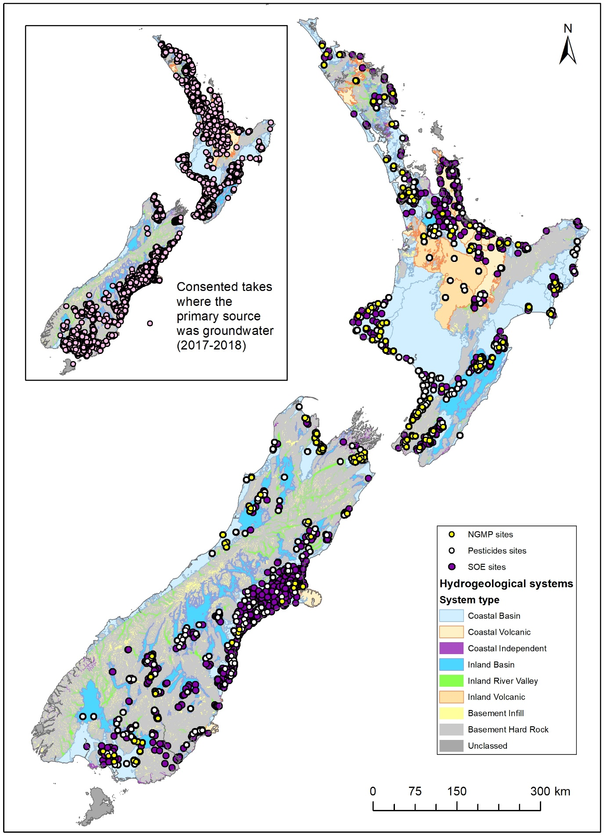
Figure 1.3 Location of groundwater quality monitored sites presented in this report compared to the location of takes where the primary source is groundwater
(inset, source: Booker and Henderson 2019). Note that some sites belong to multiple networks, and this map also displays retired or occasionally sampled sites. Some sites from the Pesticides survey coincide with SoE locations where the regional dataset was incorporated to the national one (e.g. Waikato).

Previous National Reports

Inorganic Chemistry and Microbiology
The main conclusions for the 2016 Indicator, which uses a dataset similar to this report, were (Moreau et al. 2016 and references therein):
- Groundwater state and trends for the 2005–2015 period were in general agreement with state and trends found for the 1995–2008 period.
- Although the national median nitrate-nitrogen concentration was 1.5 mg/L (n=912), concentrations of up to 36.7 mg/L were found mostly in shallow wells with unconfined conditions. Most sites did not exhibit any statistically significant trends for nitrate-nitrogen concentration, however where occurring increases were more frequent than decreases. Concurrent upwards and downwards trends were commonly observed within the same region.
- The national median dissolved reactive phosphorus concentration was 0.01 mg/L (n=825), although there were regional variations. Elevated dissolved reactive phosphorus median concentrations were associated with high concentrations of dissolved iron and manganese. In the limited instance where statistically trends were found, these were of low magnitudes (of the order of 0.001 mg/L per year).
- Dissolved iron and manganese were mostly found in low concentrations, with occasional high medians values (up to 25 mg/L) indicative of reducing conditions. Median dissolved manganese concentrations exceeded the drinking-water standards at 9% of the sites (n=837). Where trends were detected, their magnitudes were low, typical of the natural evolution of groundwater.
- There were large regional variations in conductivity, with regional medians ranging from 105 μS/cm (West Coast) to 968 μS/cm (Gisborne). Regions characterised by dominating dilute groundwaters were: Bay of Plenty, Canterbury, Marlborough, Southland, Waikato, West Coast and Wellington. Where trends were observed, decreases in conductivity were more common than increases.
- E. coli levels were recorded below detection at the majority of the sites (61% out of 685 sites). Median E. coli levels exceeding the drinking-water standards at individual wells, however, occurred in all but two regions.
- Pesticides were detected at 24% of the wells in the 2010 survey; most detections were herbicides. Typically, analyses included a large number (66) of pesticide species and detections were below the drinking-water standards. While single pesticide species detections were common, there were occurrences of concurrent detections of up to five compounds. Nitrate-nitrogen concentrations at wells where pesticides were detected were statistically significantly higher than those at wells without detection (t-test
p-value=0.03).

Man-made Compounds
The main conclusions for the 2022 national pesticide survey were (Close and Banasiak 2023a and b):
- Pesticides were detected in 17 out of 225 sampled wells, with six wells exhibiting two or more pesticide compounds (up to six). There were no detections in four regions (Auckland, Bay of Plenty, Hawke’s Bay and Wellington).
- Herbicides were the most frequently detected pesticide group (19 detections of
12 different herbicides and their metabolites). The most commonly detected compounds were terbuthylazine and desethyl terbuthylazine. The highest measured concentration was clopyralid (1.1 μg/L). There was a single occurrence of exceedance of the drinking water Maximum Acceptable Value (MAV) for dieldrin (0.04 μg/L, Water Services Regulations 2022) which was measured at 0.053 μg/L. Concentrations of other detected pesticides were less than 4% of their respective MAV.
- Data from the 2022 survey indicate a decrease in the frequency and concentration of pesticide residues detected in groundwater relative to previous surveys (4-yearly since 1990, with an increasing number of tested wells).
- The 2022 survey was also the first time that PFAS were tested. Samples were collected at 131 wells nationwide with varying spatial distribution, from 2 to 17 wells per region, and much more densely in the Waikato (53 wells). PFAS were detected at 15 wells, with two or more compounds (maximum of eight compounds) detected at six of these wells. Detected compounds included: perfluoroalkylcarboxylic acids (PFCAs) including perfluoro-n-pentanoic acid (PFPeA), perfluoroalkylsulfonic acids (PFSAs) and fluorotelomer sulfonic acids (FTSAs). The highest concentration was measured at 16.5 ng/L for the sum of perfluorohexanesulfonic (PFHxS) and perfluorooctane sulfonate (PFOS). All detected PFAS were below the available MAV. Note that there is currently limited knowledge of the fate and effect of PFAS on ecological systems. These results indicate that some PFAS compounds, and therefore possibly their degradation products, leach to groundwater systems.
- EOCs were also analysed during the 2022 survey, however, at the time of writing this report, the results were not available.

This Report
This report is an update to previous national reports on groundwater quality, whose format and content have evolved over time (e.g. the number of reported variables). The first national reports were technical reports commissioned by the Ministry for the Environment (Daughney and Wall 2007; Daughney and Randall 2009, Moreau and Daughney 2015). Since the Environmental Reporting Act (2015), indicators are published by Stats NZ to inform the Environmental Domain reports (StatsNZ 2019, StatsNZ 2020). In 2020, the GWQ Indicator was for the first time compiled using data harvesting techniques developed as part of, and for, the LAWA collaboration, which represents all 16 regional and district councils. In this process, data was sourced by a third party from regional and unitary council databases.
In 2023, MfE and Stats NZ commissioned an independent technical review of the
2020 Indicator to ensure the environmental information produced is based on the best scientific practices and statistical methods. This review highlighted shortcomings around data harvesting, representation of the national monitoring networks (NGMP and Pesticides), and data processing (Moreau 2023). In this current report, the following 2023 recommendations have been directly addressed:
- Updating of site and variable selection using expert knowledge.
- Inclusion of national networks (NGMP and Pesticides).
- Modification of the technical implementation for state and trend analysis to reflect best practice and methods relevant to groundwater data.
- Change in spatial reporting units to better represent NZ’s groundwater systems.
- Improved use of reference values to provide context for statistical reporting.
- Advance the development of automated data harvesting by developing controlled vocabularies (i.e. standardised words which provide a consistent way to describe data between sources) and undertaking a regional-scale, data harvesting pilot study.
Another change in this report, compared to the previous Indicator report, is that the microbiological variable (E. coli) is not reported in terms of trends. Instead, the number of exceedances of the drinking-water standard is presented by 5-year time windows. E. coli is a bacteria living in warm-blooded animals that is monitored as a proxy for pathogens. Once released in groundwater, E. coli can be affected by multiple processes, including dilution, filtration and die-off. International and New Zealand guidelines for the delineation of microbial protection zones using Time-Of-Travel criteria range from 50-days (based on E. coli) to 1-year (based on viruses) (Moreau et al. 2014; Lough et al. 2018). Most SoE sampling frequencies are quarterly or lower, and therefore, trend analysis of E. coli is not regarded as suitable.

METHODS

Report Co-design
This report was co-designed between the Ministry for the Environment, Stats NZ and
GNS through a series of online meetings. These meetings were held between May and October 2024, and each had a defined agenda. Generally, material was circulated in advance, and meetings focussed on feedback on the provided material. Topics and outcomes of these meetings were:
- Agreement on data sources and the data collection process. An official data request was drafted by GNS, reviewed by the Ministry for the Environment and Stats NZ, and issued by GNS to all regional councils and ESR. An anonymised copy of the data request is provided in Appendix 1.
- For the data harvesting pilot, agreement on the region selection, pilot test design, facilitation and reporting pathways. The region (Canterbury) was selected in consultation with Te Uru Kahika National Project Manager EMaR / LAWA programme. Environment Canterbury staff provided guidance to GNS staff to build the data harvesting scripts as well as a data extract for comparison. Findings were discussed and reported to council staff, Stats NZ and MfE, and a summary and recommendations for potential improvements is provided in Appendix 2.
- Agreement on the trend assessment methodology and time periods to use, which included considerations for consistency with surface water quality reporting. The selected methods are detailed in this section. They are consistent with best-practices and are considered fit-for-purpose for groundwater quality monitoring.
- Identification of data output requirements to ensure they are suitable to inform the development of the 2025 Indicator by the Ministry for the Environment and Stats NZ.
As part of the process, draft data outputs were circulated, reviewed, and agreed upon by all parties. Data outputs are described in Section 3.1.
- Redesigning the state and trend assessment report content to provide a greater sense of the location and diversity of New Zealand groundwater resources. Items of discussion included: testing of hydrogeological systems as spatial reporting units; use of reference values to provide context to reported statistical metrics for each variable; removal of trend assessment for E. coli; and development of context information on data limitations, representativeness and hydrochemical processes. The outcome of these discussions is this report structure, content and accompanying datasets.

Selected Variables
The Ministry for the Environment provided a list of 33 inorganic variables (including the six variables reported on in 2020, Table 2.1) and man-made compounds from the national surveys, informed by the recommendations in the independent review (Moreau 2023). Some of the listed inorganic variables are not consistently monitored in regional networks, and the sampling frequency may vary for minor and trace variables. For instance, NGMP does not include E. coli and tin in its analytical suite, and heavy metals have only been measured as part of pilot surveys: copper and lead in March 2001 and December 2022; boron, cadmium, chromium, lithium, nickel and zinc only in December 2022. This means that there are inconsistencies in the spatial distribution and temporal extent between variables.
Table 2.1 Selected variables to inform national reporting, excluding man-made compounds.
MAV indicates the New Zealand Drinking-Water Standard Maximum Acceptable Value, where applicable (Water Services Regulations 2022). Variables reported in 2020 are indicated in bold. cfu stands for colony-forming unit. Two sets of reference values are provided: concentration ranges derived through hierarchical cluster analysis corresponding to the 5th and 95th from all clusters but 1A from Daughney and Reeves (2005) denoted with an asterisk and for nitrate-nitrogen reference conditions estimated using the 80th and 95th percentiles (Daughney et al. 2023), denoted with a double asterisk. Where applicable variable forms are indicated by D for dissolved, DR for dissolved reactive and T for total. Variable form used for MAVs are total, using a conservative approach for intake (Graham 2025).
 | Variable | Abbreviation | Units | Comment | MAV | Reference
Physical | Conductivity | EC | μS/cm | Indicative of the total dissolved solids content of groundwater. | - | -
 | Oxygen (D) | DO | mg/L | Controls the mobility of some variables. | - | -
 | pH | pH | pH unit | Controls the mobility of some variables. | - | -
 | Temperature | T | ⁰C | Controls the mobility of some variables. | - | -
Major | Bicarbonate (D) | HCO₃ | mg/L |  | - | 27.4–686*
 | Calcium (D) | Ca | mg/L |  | - | 4–170*
 | Carbonate (D) | CO₃ | mg/L |  | - | -
 | Chloride (D or T) | Cl | mg/L | In coastal areas, may indicate saltwater intrusion. | - | 1.2–233*
 | Magnesium (D or T) | Mg | mg/L |  | - | 1.2–27.9*
 | Nitrate-nitrogen (D or T) | NO₃N | mg/L | Absent in low oxygen environments, limited natural sources. | 11.3 (T) | <3.46*  <1.65 (80th)**  <1.97 (90th)** <2.32 (95th)**
 | Potassium (D or T) | K | mg/L |  | - | 0.65–12.5*
 | Silica (D) | SiO₂ | mg/L |  | - | 8–69.4*
 | Sodium ((D or T) | Na | mg/L |  | - | 3–130*
 | Sulphate ((D or T) | SO₄ | mg/L | Absent in low oxygen environments. May indicate human influence. | - | <49*
Minor | Ammonia-nitrogen ((D or T) | NH₃N | mg/L | Accumulates in low oxygen environments. | - | <6.01*
 | Boron (D) | B | mg/L |  | 2.4 (T) | -
 | Bromide (D) | Br | mg/L |  | - | <0.79*
 | Phosphorous (DR) | DRP | mg/L | DRP is the mobile, non-colloidal form of phosphorous in groundwater. | - | <0.88*
 | Fluoride (D) | F | mg/L |  | 1.5 (T) | 0.01—0.41*
 | Iron (D) | Fe | mg/L | Mobile in low oxygen environments. | - | <10.2*
 | Manganese (D) | Mn | mg/L | Mobile in low oxygen environments. | 0.4 (T) | <1.05*
Trace | Aluminium (D) | Al | mg/L | Mobilised in acidic or alkaline environments. | 1 (T) | -
 | Lithium (D) | Li | mg/L |  | - | -
 | Arsenic (D) | As | mg/L | Mobile in low oxygen environments. | 0.01 (T) | -
 | Cadmium (D) | Cd | mg/L |  | 0.004 (T) | -
 | Chromium (D) | Cr | mg/L |  | 0.05 (T) | -
 | Copper (D) | Cu | mg/L |  | 2 (T) | -
 | Lead (D) | Pb | mg/L |  | 0.01 (T) | -
 | Nickel (D) | Ni | mg/L |  | 0.08 (T) | -
 | Nitrite (D or T) | NO₂N | mg/L | Present in low oxygen environments, limited natural sources. | 3 (T) | -
 | Tin (D) | Sn | mg/L |  | - | -
 | Zinc (D) | Zn | mg/L |  | - | -
Microbiological | Escherichia coli | E. coli | cfu per 100 mL** | Proxy for pathogens, may not adequately represent viruses. | <1 | -

Data Sources and Processing
Groundwater quality and site data were collated via a targeted, nationwide data request issued to groundwater experts at councils, GNS Science and ESR (total of 16 organisations, Appendix 1). This process ensured that the sites used were the best estimate of SoE representativeness at the time the data request was issued. PFAS and EOCs data were not provided.
Sixteen datasets were received as .csv or .xlsx files with varying information details, format and file types between each organisation. To generate a single, consistent, aggregated data file, the following tasks were undertaken:
- Reformatting from wide to long format. All received files required some form of reformatting. Site-specific data (files or worksheets) were aggregated into a single file using a combination of manual data transfers and custom scripts (R, Python).
- Site mapping to develop consistent naming for each dataset. Site names and information vary between sources and within a particular source, for example, there were instances where site nomenclature evolved with time and/or differed between site data and chemistry datasets. Historical site mapping required a range of resources, including a 2010 reference list assembled by GNS during the 2007 and 2009 SoE data aggregation for national reporting of inorganic variables (Moreau-Fournier et al. 2010); the currently available mapping of NGMP sites recording site aliases and against the LAWA IDs (on-going, curated by GNS as part of NGMP operations); and the national pesticide surveys data that recorded site name changes in 2010. A number of councils have recently changed their site nomenclature to use LAWA-IDs, which complicated the site mapping, requiring to check multiple sets of information (e.g. site name, site description, site depth). There were instances where unique sites IDs were generated by GNS as part of the processing because source data did not include a unique ID field.
- Site details harmonisation. Site details (location, depth, screen interval) frequently differed between the national and regional datasets, likely to reflect historical use of different coordinate systems and recent changes and checks in the regional councils’ databases. Where differences occurred, regional councils’ data was preferred, but national data were sometimes used to fill gaps, for instance to provide lithology.
- Variable mapping to develop consistent naming and enable aggregation.
A common difficulty was to separate parameters into dissolved or total forms. Particularly for metals, the dissolved form represents the mobile component whereas total forms might include colloidal forms. For each variable, multiple analytical methods are available to measure the relevant chemical concentrations in water samples. Analytical methods are selected by laboratories from standard methods considering the sample type
(e.g. contaminated site, groundwater, etc.), expected concentration range, health and safety, and operational aspects (e.g. equipment available, running costs). Laboratory results are therefore reported in differing forms depending on the analytical technique used by different laboratories. In turn, these names may be changed or captured differently in databases. An added complication is linked to the way a groundwater sample is collected. The New Zealand protocol for SoE monitoring recommends the monitoring of dissolved species, preferably field-filtered since 2006 (Daughney et al. 2006; Milne et al. 2019). This means that a method measuring total form, applied to a field-filtered sample essentially provides a reading for a dissolved form. It is unclear whether this information is translated into regional databases. As part of this study, the separation between dissolved and total forms was mapped using the variables analytical method description. However, the dissolved form might refer to either field or laboratory filtration. It was beyond the scope of this report to link sampling protocols to analytical methods, and therefore, where the analytical method was missing or did not provide this information, variables were defaulted to the total form.
- Data harmonisation. Sites and variables were mapped across regional to national data sources. Variables were also mapped between all sources for variables (e.g. Table 2.2). R and Python scripts were used to undertake site and variable mapping. Sites that were not attributed to chemistry data were removed from the dataset through R scripts. In addition, groundwater quality commonly includes non-detects. Once the dataset was aggregated, values below the detection limit were reformatted using customised R scripts and the LWP library (Snelder and Fraser 2021).
- Data cleansing. To remove non-sensical values and avoid statistical bias induced by the collection of replicate groundwater samples on a daily basis, the following rules were applied:
  - Removal of readings of “zero” concentration, except for dissolved oxygen.
  - Removal of non-sensical values defined as: pH<4.5, unless time series supports these values, pH>14, and negative dissolved oxygen reading or above 14 mg/L (>100% saturated).
  - Editing of conductivity values where time series suggest a conversion error within the site variability (e.g. <25 uS/cm), by converting to the appropriate units. Data edition is flagged in the output files.
  - Editing the censoring sign recorded as “<” to “>” when E. coli numerical result exceeded 100.
  - Identification and removal of replicate analyses for the same variable, site and day. Where available, sample IDs from source data were used, elsewhere IDs were created and the selection was based on the analysis that contained the larger number of results.
- Man-made compounds dataset extension to capture non-detects. The pesticide dataset was provided as detections only (1990 to 2022), accompanied with a list of tested compounds with detection limits (1998 to 2022). For the 1998 surveys onwards, the variable readings below the detection limit were generated to complete the dataset using the sites and variable list provided for each survey. For the 1990 and 1994 surveys, the list of tested compounds was not provided and therefore the dataset was only extended to reported variables using the minimum detection as a limit or the highest reported detection limit for this variable. Data provided for the 2018 survey included analyses collected at 41 Waikato and 71 Canterbury sites, where it was assumed that the analytical suites were similar and had identical detection limits (Close and Humphries 2019). Similarly, data provided for the 2022 Survey included 21 Waikato sites and an identical analytical suite was assumed (Close and Banasiak 2023a). The dataset extension was performed using customised R scripts.
Table 2.2 Variable aggregation used in this report.
Variable Type | Variable(s) | Reported Forms
Physical | Conductivity, dissolved oxygen, pH, temperature | Field measurement only.
Major | Bicarbonate, calcium, carbonate, chloride, magnesium, nitrate, potassium, sodium, sulphate | Aggregated dissolved and total.
Major | Silica | Aggregated dissolved and dissolved reactive.
Minor | Bromide, fluoride | Aggregated dissolved and total.
Minor | Iron, manganese | Dissolved form only.
Minor | Dissolved reactive phosphorous | Dissolved reactive form only.
Trace | Aluminium, arsenic, cadmium, chromium, copper, lead, lithium, nickel, tin, zinc, man-made compounds | Dissolved form only.
Trace | Nitrite | Aggregated dissolved and total.
Micro | E. coli | Combined cfu/100ml and mpn per 100ml.

Reported Statistics
The following statistics are reported for the dataset, in accordance with previous indicators:
- Percentage of censoring: censored results are measurements reported below
the detection limit. Censoring is common when monitoring variables present in very low quantities such as minor variables, trace metals and organic compounds. Multiple censoring levels are common in long-term datasets, as measurement resolution improves with technology. The ability to derive descriptive statistics or detect trend decreases where censoring occurs, especially if multiple censoring levels affect the time series (Helsel et al. 2020).
- Median and Median Absolute Deviation (MAD): the median is a measure of central tendency. It is a more resistant measure than mean values because it is not affected by outliers. The MAD gives an indication of the data spread around the median; it is likewise more robust than the standard deviation (Helsel et al. 2020).
- Percentiles (5th, 25th, 50th, 75th, 95th): these also inform the data spread around the median. The median is the 50th percentile (Helsel et al. 2020).
- Number of exceedances for all time periods: this statistic provides context to state and trend descriptive metrics with regard to published environmental guidance relevant to ecosystem or human health. It is limited to groundwater quality data and consists of a comparison between either individual measurements or calculated median measurement values and a defined threshold. Exceedances are reported against: the drinking-water MAVs and Aesthetic Values (AVs), which apply to total form (Water Services Regulations 2022, Taumata Arowai 2022, Graham 2025), and referenced groundwater quality values, where applicable. For state reporting, two set of reference values are provided: concentration ranges derived using hierarchical cluster analysis corresponding to the 5th and 95th from all clusters but 1A from Daughney and Reeves (2005), except for nitrate-nitrogen, where more recent reference conditions estimated using the 80th and 95th percentiles are used (Daughney et al. 2023). For trends, the range in rates of changes for unimpacted clusters are used (Moreau and Daughney 2021). These references represent peer-reviewed and pertinent context information and are not aimed at defining “natural state” for the purpose of groundwater resources management.
- Statistical test p-values: in this report, several statistical tests were conducted to assess either the statistical significance of a trend, seasonality or distribution difference. For each test, a hypothesis is formulated and test statistics are calculated. An acceptable error rate is arbitrarily set to reject or accept the hypothesis, based on a data-calculated probability value (p-value). For this report, the significance level was arbitrarily set as α=0.05 for all tests, which is a common threshold used in environmental statistics reporting. Detailed information about the use of hypothesis tests in general and the tests used in this report can be found in Helsel et al. (2020).
- Trend magnitudes: the rate of change in each parameter. In this report, the trend magnitudes are provided as Sen’s slopes, which is commonly used for environmental reporting (Helsel et al. 2020), and as percentage annual change in slope. The latter is calculated by dividing the Sen slope by the median. In this instance, the median is calculated over the same time period as the slope and is subject to the same minimum data requirement.
- Trend category: the decreasing or increasing trend diagnostic is informed by levels
of confidence applied to the probability that the trend is decreasing (Cd), as calculated using the Mann-Kendall trend test (Whitehead et al. 2022). Descriptors are assigned using the following thresholds: “Very likely decreasing” (Cd < 0.90); “Likely decreasing” (0.66 < Cd ≤ 0.90); “Indeterminate” (0.33 ≤ Cd ≤ 0.66); “Likely increasing” (0.10 ≤ Cd <0.33) and “Very likely increasing” (Cd < 0.01). These thresholds are consistent with those used by the Intergovernmental Panel on Climate Change and Stats NZ reporting (Stocker et al. 2013, Stats NZ 2024).
- Sen slope confidence interval and confidence that the trend is decreasing: the first metric informs on whether the true trend slope differs from zero and the second qualifies the confidence on the trend direction.

Statistical Analysis Settings and Implementation
Four time-periods were defined: five years to define State (March 2019 to February 2024) and 10- (March 2014 to February 2024), 20- (March 2004 to February 2024) and 30- year (March 1994 to February 2024) periods to define trends.
Descriptive statistics indicative of state were derived from uncensored and censored time series combining the R standard package (version 3.6.2) with the Non-Detects and Data Analysis (NADA version 1.6–1.1) library (Helsel et al. 2020). Median, MAD and percentiles were estimated using statistical formulas for uncensored values. For time series affected by less than 25% censoring, median and MAD were estimated using Regression on Order Statistics (ROS) models and percentiles were calculated using statistical formulas. Above 25% and below 80% censoring, no percentiles were calculated; and median and MAD were computed using ROS models. At and above 80% censoring, no estimates were made of median, MAD or percentiles; and values are shown as below the highest detection limit. Where the MAD generated by ROS models was null, it was replaced by a ‘not available’, as it is unlikely that no variations occur for a given variable at a site.
The LWP-Trends library (version 2101; Snelder and Fraser 2021) was used to compute the Kruskall-Wallis seasonality tests, Mann-Kendall trend test and Sen’s slope estimations.
The number of seasons considered for in the Kruskall-Wallis test was four (autumn, winter, spring and summer). The annual time period commenced on 1 March of the first year (the start of autumn). The Mann-Kendall and Sen slope tests were seasonally adjusted based on the result of the Kruskall-Wallis test. For time series were censoring occurred, a filter was applied to replace all observations below the highest detection limit by the highest detection limit (Whitehead et al. 2022).
Minimum data point requirements were set as follows:
- Descriptive statistics: no minimum requirement were applied, as one aim of this report was to include low frequency monitored variables such as cadmium or chromium.
- Kruskal-Wallis test: all seasons must have at least one observation, and individual seasons require at least two data points.
- Mann-Kendall test and Sen’s Slope estimator: the time series must contain at least eight data points, and the maximum censored values must be smaller than the maximum observed values. Data requirements set within the LWP library also applied: greater than three number of unique values, number of uncensored values greater than five and number of data points per unique seasons is greater than two.
- Trend analysis: the time series must contain at least eight data points per 10-year time window to avoid temporal bias. This means that sites at which a 30-year trend is calculated must have eight data points for each of the 10-year intervals.

Limitations
Some of the reported inorganic variables are not consistently monitored in regional networks, and sampling frequency may vary for minor and trace variables. For instance, NGMP does not include E. coli and tin in its analytical suite, and heavy metals have only been measured as part of pilot surveys: copper and lead in March 2001 and December 2022; boron, cadmium, chromium, lithium, nickel and zinc only in December 2022. This means that there are inconsistencies in the spatial distribution and temporal extent between variables.
There are more variables monitored at the regional scale than those included in this report. For example, total arsenic is routinely monitored to inform on drinking-water security as opposed to dissolved arsenic. Similarly, variables indicative of groundwater quality point source contamination are not typically included in SoE monitoring programmes and are not included in this report, for instance, petroleum hydrocarbons.
The summary statistics presented in this report are useful to provide an overview of groundwater quality, which can be used as context for groundwater quality studies. They represent an aggregation of 108 monitored hydrogeological systems with numerous aquifers of varying hydraulic properties and connectivity to surface water. At the sub-regional-scale, regional or system-specific statistics will be more appropriate to use and should be accompanied by maps to illustrate spatial variations.
Groundwater quality may be influenced by the land use at the time of recharge, within the groundwater source capture zone. Groundwater age dating informs on the lag-time for contaminants to reach a well and is routinely measured at NGMP sites and at the regional scale, and some regions are actively undertaking age dating at SoE sites. However, for most monitoring sites (NGMP, SoE, pesticides), groundwater capture zones for the wells have not yet been delineated.
It is important to note that data collected as part of SoE programmes (including NGMP) is
not representative of drinking-water quality for all of New Zealand (Daughney and Wall, 2007; Daughney and Randall, 2009; Moreau and Daughney 2015). Further information on the subject can be obtained from the Annual Review of Drinking Water Quality up to 2021 (e.g. Ministry of Health, 2021) and the Performance summary of the Water Services System reports
(e.g. Taumata Arowai 2023).
In this report, regional and national monitoring sites are included to provide a more up-to-date representation of New Zealand groundwater resources. This is an artifact of the current fragmented resourcing model, which has historically led to a static NGMP network compared to a growing Pesticide national network, and disconnected network reviews (Parliamentary Commissioner for the Environment 2019; Moreau 2023). The inclusion of regionally monitored sites introduces possible bias in the site selection due to variable monitoring objectives and density of coverage, and data inconsistencies (e.g. varying variable forms and analytical methods between regions) which complicate dataset aggregation (Parliamentary Commissioner for the Environment in 2019; Moreau 2023).
To address these inconsistencies, collaborative work to develop a national groundwater quality framework led by Waikato Regional Council and GNS Science is underway. This work is undertaken with the Groundwater Forum Special Interest Group and ESR. To date, the following common aims have been recently agreed on: developing national views consistent with regional views through national programmes; fostering knowledge transfer across regions and research institutes; and clarifying trade-offs between resourcing and monitoring at regional and national scales (Moreau 2024). However, implementation under the current resourcing system is expected to take several years and to be staged between regions.

RESULTS

Datasets
Data files are provided as digital attachments to this report to summarise:
- Site details (ID, site type, region, hydrogeological system name and type, coordinates, monitoring network, well depth, screen top and length) for the sample locations (CR2024_90_groundwater_quality_site_details.csv).
- Groundwater quality time series (CR2024_90_groundwater_quality_time_series.csv).
- Summary of groundwater chemistry state and trend metrics calculated over the time period available at each site, on a per site per parameter basis. (CR2024_90_groundwater_quality_statistics.csv).
- Groundwater quality analytical variable vocabulary (CR2024_90_groundwater_quality_variable_vocabulary.csv).
- Groundwater quality site names vocabulary (CR2024_90_groundwater_quality_site_names_vocabulary.csv).
- Groundwater quality data dictionary (CR2024_90_groundwater_quality_data_dictionary.csv).
An annotated R script for use by Stats NZ (CR2024_90_groundwater_state_ trend_calculations.R). This script reproduces the state and trend processing described in this report using the provided groundwater quality time series (CR2024_90_
groundwater_quality_time_series.csv) as an input file. Although the script includes comments for guidance on its use, it is not documented to any publishing standard and therefore is not suitable to disseminate for public use as is.

State
In this section, summary statistics from all SoE sites (including NGMP and Pesticides)
are presented and grouped by characteristics and processes to illustrate the diversity of
New Zealand’s groundwaters. These statistics are useful to provide an overview of groundwater quality to provide context for groundwater quality studies. For pesticides (4-yearly surveys) and the microbiology variable E. coli, only exceedances were calculated
(as discussed in Section 1.4). To complement this section, maps of 5-year median values for inorganic variables (i.e. major, minor and trace variables) are provided in Appendix 3.

In-situ Physico-Chemical Conditions
The ambient physical and chemical conditions of aquifers (e.g. oxygenated, acidic) can control the form, solubility and transport of ions and man-made compounds. For instance, oxidised groundwater may contain nitrate, but would not contain significant concentrations of any elements or compounds that only accumulate in groundwater in their reduced forms, such as iron, manganese, arsenic or ammonia. In highly reduced groundwaters, sulphate is also usually absent and methane can accumulate.
Generally, recently recharged groundwaters are oxygen-rich (i.e. oxidised) due to contact with the atmosphere. In contrast, evolved groundwaters may be oxygen-poor (i.e. reduced), due to natural processes of microbial respiration which deplete oxygen. However, these statements may not apply to local conditions (Daughney and Wall 2007).
Field-measured variables informing on the aquifers’ conditions are: temperature, pH, electrical conductivity and dissolved oxygen. Other relevant variables include dissolved iron, manganese, arsenic and ammonia.
There is a range of oxygenated conditions in New Zealand from anoxic to oxygenated. This is demonstrated by low dissolved oxygen but also occurrence of high dissolved iron, manganese, arsenic and ammonia concentrations (Table 3.1). Groundwater temperatures range from
11 to 18°C, with the maximum median temperature of 51°C (2% of the sites exhibit a median temperature above 20°C, which reflect some geothermal warming which may or may not be associated with fluid exchanges). Median temperatures are generally (69.4%) below the AV (15°C). Median pH ranges from 5.6 to 7.2 pH units, with 33.8% of the sites within the AV range (7.0–8.5 pH units). These values reflect the focus of monitoring networks on “cold” groundwater, as opposed to hot geothermal waters. Conductivity is a proxy to measure the total dissolved solids content in groundwaters. This variable exhibits a very wide range nationwide (81 to 36100 uS/cm). Naturally, groundwater conductivity increases with prolonged contact with aquifer minerals and lack of dilution by rainfall. The highest values are likely to be associated with either long residence time and increased water rock interaction or saltwater intrusion (in coastal areas).
SoE networks summary statistics for conductivity, pH and temperature over the 2019–2024 period are consistent with previously reported values (e.g. 1995–2006, Daughney and
Wall 2007).

This page left intentionally blank.

Table 3.1 Calculated percentiles and maximum values for inorganic chemistry groundwater variables at SoE sites (NGMP and SoE), based on site-specific median values for the period 2019–2024.
“Censoring” refers to the percentage of times a variable was reported below the detection limit. Median and maximum values for the 1995–2006 period, and global averages were sourced by Daughney and Randall and references therein (2009) and are indicated by an asterisk.
 |  | 2019–2024 |  |  |  |  |  |  |  |  | 1995–2008* |  | Global Average*
Variable Type | Variable | n | Censoring | 5th | 25th | 50th | 75th | 95th | Max. | MAD | 50th | Max. | River Water | Groundwater
Field | Conductivity (uS/cm) | 1149 | 0.0% | 81.84 | 142 | 224 | 357 | 988.2 | 36100 | 141 | 204 | 27500 | - | -
 | Dissolved oxygen (mg/L) | 1144 | 0.0% | 0.05 | 0.541 | 4.38 | 7.313 | 9.559 | 12.6 | 5.09 |  |  | - | -
 | ph (pH units) | 716 | 0.0% | 5.658 | 6.2 | 6.7 | 7.263 | 8.09 | 11.2 | 0.778 | 6.7 | 9.81 | - | -
 | Temperature (deg C) | 1174 | 0.0% | 11.065 | 12.5 | 13.8 | 15.4 | 18.535 | 51 | 2.08 | 14.4 | 63 | - | -
Major | Bicarbonate (mg/L) | 1165 | 3.1% | 15.88 | 43 | 68 | 126 | 427 | 1500 | 46.6 | 59.8 | 900 | 58 | 200
 | Calcium (mg/L) | 1151 | 0.0% | 3.6 | 11.4 | 18.7 | 31.5 | 115.5 | 1140 | 13.8 | 14.6 | 546 | 15 | 50
 | Chloride (mg/L) | 1159 | 0.5% | 2.1 | 6.7 | 13.8 | 29 | 124.3 | 14400 | 12.9 | 14 | 1852 | 7.8 | 20
 | Magnesium (mg/L) | 1186 | 0.0% | 1.313 | 3 | 5.5 | 9.2 | 22 | 890 | 4.15 | 4.5 | 616 | 4.1 | 7
 | Nitrate (mg/L) | 1173 | 11.6% | 0.002 | 0.05 | 1.09 | 4.7 | 12.84 | 28 | 1.61 | 1.7 | 33 | 0.2–20 | -
 | Potassium (mg/L) | 1184 | 0.0% | 0.671 | 1.12 | 1.64 | 3.1 | 8.543 | 280 | 1.01 | 1.4 | 37.8 | 2.3 | 3
 | Silica (mg/L) | 938 | 0.0% | 10.3 | 15.6 | 20 | 38 | 80 | 146 | 10.4 | 18 | 161 | 14 | 16
 | Sodium (mg/L) | 1184 | 0.0% | 4 | 9 | 14.8 | 28 | 99.7 | 7100 | 11 | 14 | 800 | 6.3 | 30
 | Sulphate (mg/L) | 1170 | 7.3% | 0.5 | 2.76 | 7.08 | 15.1 | 39 | 2100 | 7.67 | 7.2 | 995 | 3.7 | 30
Minor | Ammonia (mg/L) | 1144 | 55.7% | <0.1 | <0.1 | 0.006 | <0.1 | <0.1 | 25 | 0.007 | 0.01 | 18.2 | - | -
 | Bromide (mg/L) | 749 | 13.1% | 0.02 | 0.05 | 0.06 | 0.106 | 0.353 | 32 | 0.037 | 0.09 | 28 | - | <100–2000
 | Dissolved reactive phosphorous (mg/L) | 1121 | 7.1% | 0.002 | 0.005 | 0.012 | 0.04 | 0.26 | 4.48 | 0.013 | 0.01 | 4.94 | - | <100–1000
 | Fluoride (mg/L) | 813 | 9.3% | 0.04 | 0.065 | 0.097 | 0.15 | 0.36 | 2.9 | 0.059 | 0.09 | 21 | 0.1–5 | -
 | Iron (mg/L) | 753 | 42.3% | <0.4 | <0.4 | 0.03 | <0.4 | <0.4 | 168 | 0.037 | 0.03 | 68.4 | 0.05 | 0.7
 | Manganese (mg/L) | 1065 | 23.8% | 0.0004 | 0.0008 | 0.003 | 0.05 | 0.7184 | 23 | 0.0043 | 0.01 | 12.7 | <0.01 | 0.03
Trace | Aluminium (mg/L) | 508 | 71.6% | <0.3 | <0.3 | 0.001 | <0.3 | <0.3 | 5.3 | 0 | 0.007 | 0.349 | - | -
 | Arsenic (mg/L) | 906 | 66.5% | <0.1 | <0.1 | 0.0002 | <0.1 | <0.1 | 0.79 | 0 | 0.0005 | 0.613 | - | -
 | Boron (mg/L) | 720 | 3.5% | 0.009 | 0.018 | 0.023 | 0.05 | 0.18 | 33 | 0.015 | 0.03 | 13.5 | - | 20–1000
 | Cadmium (mg/L) | 351 | 99.3% | <0.001 | <0.001 | <0.001 | <0.001 | <0.001 | 0.001 | NA | <10–4 | 0.0005 | - | <1
 | Chromium (mg/L) | 382 | 86.3% | <0.001 | <0.001 | <0.001 | <0.001 | <0.001 | 0.07 | NA | 0.0001 | 0.003 | - | <1–220
 | Copper (mg/L) | 644 | 52.2% | <0.001 | <0.001 | 0.001 | <0.001 | <0.001 | 0.32 | 0.001 | 0.0012 | 0.044 | - | <1–30
 | Lead (mg/L) | 403 | 80.0% | <0.005 | <0.005 | 0.0001 | <0.005 | <0.005 | 0.006 | NA | 0.0003 | 0.12 | - | <15
 | Lithium (mg/L) | 130 | 17.0% | <0.005 | <0.005 | 0.004 | <0.005 | <0.005 | 2 | 0.003 | 0.01 | 6.63 | 1–150 | -
 | Nickel (mg/L) | 227 | 81.3% | <0.001 | <0.001 | 0.0004 | <0.001 | <0.001 | 0.04 | 0.0001 | 0.0009 | 0.0065 | - | <10–50
 | Nitrite (mg/L) | 973 | 69.8% | <0.1 | <0.1 | 0.0005 | <0.1 | <0.1 | 5.4 | 0 | 0.0062 | 1.3 | - | -
 | Zinc (mg/L) | 778 | 14.4% | 0.001 | 0.002 | 0.004 | 0.009 | 0.052 | 1.29 | 0.004 | 0.011 | 1.14 | - | <10–2000

This page left intentionally blank.

Groundwater Processes
Along flow paths, groundwater quality naturally evolves through a range of hydrochemical processes such as mineral dissolution, mineral precipitation, mixing, ion exchange and leaching of land surface established contaminants, such as nutrients, to the groundwater. For instance, it is common to see a gradual transition in groundwater quality from a calcium- bicarbonate type to a sodium-sulphate/chloride type, due to the dissolution of minerals (Daughney and Wall 2007). Variables indicative of groundwater processes include most of the major (bicarbonate, calcium, chloride, magnesium, potassium, silica and sulphate), minor (ammonia, bromide, dissolved reactive phosphorous, fluoride, iron and manganese) and trace inorganic variables (aluminium, arsenic, boron, cadmium, chromium, copper, lead, lithium, nickel, zinc).
Between 2019 and 2024, the concentrations of major ions were similar to that reported between 1995 and 2006 (Table 3.1). The high concentrations demonstrated in the maximum values highlight localised brackish groundwaters which may occur naturally through long residence times and/or may be influenced by abstraction (e.g. saltwater intrusion). The maximum iron, manganese, arsenic and ammonia concentrations were higher than reported previously, with significantly higher values for iron and manganese (168 mg/L and 23 mg/L compared to 68.4 mg/L and 12.7 mg/L, respectively; Daughney and Wall 2007). The higher values are linked to newer sites, capturing more local conditions (e.g. new monitoring sites in the East Coast aquifers, Gisborne).
E. coli bacteria originates from the gut of warm-blooded animals and is monitored as a proxy for pathogens, although it may not adequately represent viruses (Davidson and Wilson 2011; Moreau et al. 2014). The natural ability of aquifers to filter E. coli varies depending on their permeability and groundwater velocity, because once outside bodies, E. coli counts will decline with time. E. coli may also enter aquifers more rapidly through anthropogenic pathways, for instance if a well head is not adequately protected by a cap, raised entry and concrete pad. Instances of high E. coli counts attributed to poor wellhead protection are common (Hadfield 2022, Levy 2021). During the 2019–2024 time period, E. coli MAV exceedances (1 cfu per 100 mL) were common (46% of 1007 sites, at least on one occasion) and widespread nationwide (Table 3.2).
Most minor and trace variables exhibited low median concentrations nationwide
(e.g. cadmium, lithium), although the median concentrations exceeded the MAV for the following variables: manganese (10% of 1065 sites); arsenic (4.6% of 906 sites); boron (2.4% of 720 sites); aluminium (0.4% of 508 sites) and fluoride (0.2% of 813 sites; Table 3.2).
Manganese is naturally occurring and ubiquitous in the environment. Concentrations in groundwaters can become elevated in anaerobic conditions or peaty environments usually in association with iron. Elevated manganese concentrations are common in New Zealand’s groundwaters, particularly in gravel and sand aquifers (Daughney 2003). Between 2019 and 2024, the maximum median manganese concentration was 23 mg/L. There are two AVs for manganese: one for the staining of laundry (0.04 mg/L) and a higher threshold for taste
(0.1 mg/L). Median manganese concentrations exceeded these respective thresholds at 26.3% and 19.4% of the sites. Median iron concentrations exceeded the AV for staining of laundry at 30.0% of the sites.
Elevated arsenic concentrations in groundwater may occur naturally through water-rock interaction with arsenic-rich lithologies such as altered greywacke (e.g. Otago Schist)
or volcanics, particularly where geothermal heating occurs (Piper and Kim 2006).
Median arsenic concentrations exceeding the MAV (0.1 mg/L) are widespread across the country, consistent with:
- Reported contribution from greywacke basement or schist in: Manawatu-Wanganui (Tangimoana); Canterbury (Woolston-Heathcote, Brighton Spit, Woodend-Waikuku-Saltwater Creek, Kaikoura Plain); Hawke’s Bay (Breckenridge, Pukahu and Poraiti Hill); Marlborough (Rarangi); Otago (Upper Clutha/Wakatipu Basin); Wellington (Wairarapa, Kapiti) (Piper and Kim 2006; Davidson and Wilson 2011; Levy et al. 2021; Hawke’s Bay Regional Council 2024).
- Contributions from geothermal activity and geology have been reported in the Bay of Plenty (Waihi beach, Rotorua, Rangitaiki Plains) and Waikato (Reporoa Basin, Taupo and Coromandel) regions (Gordon 2002; Piper and Kim 2006; Hadfield 2022).
Elevated boron concentrations have been associated with layers of peat and organic materials in sedimentary aquifers in the Bay of Plenty, water-rock interaction with greywacke basement in Marlborough, and possible association with geothermal fluids (Gordon 2002; Davidson and Wilson 2011 and Mroczek et al. 2015). The four sites at which the median boron concentration exceeds the MAV (2.4 mg/L) are located in the Wellington and Bay of Plenty regions. Between 2019 and 2024, the maximum median boron concentration was 33 mg/L.
Aluminium is naturally abundant in most rock-forming minerals and has low solubility and reactivity. It can however be mobilised under highly acidic or alkaline conditions (Driscoll and Schecher 1990). Exceedances of the MAV (1 mg/L) based on median values occurred at two sites: one 221 m deep well (BN-100130, Bay of Plenty) with an alkaline pH (median value of 8.97 pH units) and a 6 m deep well (K38/2200, Canterbury) where pH information was not available. The maximum median aluminium concentration was 5.3 mg/L (BN-100130) between 2019 and 2024.
Fluoride in groundwater is sourced by the dissolution of minerals, such as apatite, in siliceous, igneous formations, and associated compounds are common in geothermal fluids.
For instance, in the Waikato region, higher concentrations are associated with geothermally influenced groundwater (Hadfield 2022). Over the 2019–2024 period, concentrations have been low (95th of 0.36 mg/L, Table 3.2).
Table 3.2 Percentage of New Zealand monitoring sites at which the MAV, AV and/or reference value was exceeded at least on one occasion and by the median value calculated for the period 2019–2024.
Thirty-two pesticide compounds with a MAV but no detection in any of the 184 tested sites were omitted from this table. Sources are indicated by a subscript symbol as follows: *Water Services Regulations 2022; ^Taumata Arowai 2022; **Daughney and Reeves 2005 and ***Daughney et al. 2023. Highlighted cells indicate exceedances. Note that variables may be measured outside reference values under local naturally-occurring conditions and are therefore not systematically signs of contamination.
Variable | n | MAV*  (AV^) | % Sites Exceeding (one or more occasion) | % Sites Exceeding (median values) | Range | % Sites Outside Range
Inorganic Chemistry
Aluminium (mg/L) | 508 | 1 (0.1) | 0.4 (2.6) | 0.4 (2.4) | - | -
Ammonia (mg/L) | 1144 | - (1.5) | - (1.5) | - (5.5) | 0–6.01** | 1
Arsenic (mg/L) | 906 | 0.01 | 5.3 | 4.6 | - | -
Bicarbonate (mg/L) | 1165 | - | - | - | 27.4–686** | 13.3
Boron (mg/L) | 720 | 2.4 | 0.7 | 0.6 | - | -
Bromide (mg/L) | 749 | - | - | - | 0–0.79** | 1.6
Cadmium (mg/L) | 351 | 0.004 | 0 | 0 | - | -
Calcium (mg/L) | 1151 | - | - | - | 4–170** | 7.6
Chloride (mg/L) | 1159 | - (250) | - (2.8) | - (2.2) | 1.2–233.1** | 3.9
Copper (mg/L) | 644 | 2 (1) | 0 | 0 | - | -
Chromium (mg/L) | 382 | 0.05 | 0.3 | 0.3 | - | -
Dissolved reactive phosphorous (mg/L) | 1121 | - | - | - | 0–0.88** | 1.2
Fluoride (mg/L) | 813 | 1.5 | 0.2 | 0.2 | 0.01–0.41** | 3.4
Iron (mg/L) | 753 | - (0.3) | - (38.6) | - (30.0) | 0–10.23** | 4.4
Lead (mg/L) | 403 | 0.01 | 0 | 0 | - | -
Magnesium (mg/L) | 1186 | - | - | - | 1.2–27.9** | 7.4
Manganese (mg/L) | 1065 | 0.4  (0.01, 0.4) | 11.9  (34.5, 24.3) | 10  (26.3, 19.4) | 0–1.05** | 3.3
Nickel (mg/L) | 227 | 0.08 | 0 | 0 | - | -
Nitrate (mg/L) | 1173 | 11.3 | 12.4 | 6.2 | 0–1.97*** | 41.2
Nitrite (mg/L) | 973 | 3 | 0.7 | 0.4 | - | -
Potassium (mg/L) | 1184 | - | - | - | 0.65–12.5** | 6.5
Silica (mg/L) | 938 | - | - | - | 8–69.4** | 9.5
Sodium (mg/L) | 1184 | - (200) | - (2.8) | - (2.0) | 3–130** | 5.5
Sulphate (mg/L) | 1170 | - (250) | (0.4) | (0.2) | 0–49** | 3.4
Zinc (mg/L) | 778 | - (1.5) | - (0.4) | - (0)
Microbiology
E. coli (cfu or mpn) | 1007 | 1 | 45.9 | - | - | -
Pesticides
Alachlor (µg/L) | 183 | 0.02 | 0.5 | - | - | -
Dieldrin (µg/L) | 182 | 0.00004 | 1.1 | - | - | -
Metolachlor (µg/L) | 183 | 0.01 | 0.5 | - | - | -
Metribuzin (µg/L) | 183 | 0.07 | 0.5 | - | - | -
Picloram (µg/L) | 182 | 0.2 | 1.1 | - | - | -
Terbuthylazine (µg/L) | 178 | 0.008 | 3.3 | - | - | -

Human Influence
In New Zealand, the onset of industrial agriculture in the 1950s is correlated with anthropogenic impacts on groundwater quality (Morgenstern and Daughney 2012). Contamination by other anthropogenic sources may lead to localised elevated concentrations of other variables that are not picked up by SoE sites. For instance, localised arsenic contamination in many areas of New Zealand has been found to be associated with timber treatment plants, old sheep dip sites, old orchards (from use of lead arsenate sprays), sulphide mine drainage, and leaching from treated timber posts in orchards and vineyards (Piper and Kim 2006).
The main variable indicative of diffuse agricultural activity influence is nitrate, which is sometimes accompanied with relatively high concentrations of calcium, bicarbonate, potassium, sulphate and/or chloride. Anthropogenic sources of nitrate or nitrite include fertilizers, urine and septic tank waste, livestock manure and erosion of natural deposits.
Between 2019 and 2023, elevated nitrate concentrations were widespread in New Zealand. Median nitrate concentrations ranged from less than 0.002 mg/L to 28 mg/L (as N). The MAV (11.3 mg/L as N) was exceeded at 6.2% of the sites (1173 sites across 108 systems and 15 regions) (Figure 3.1, Table 3.2). The reference value for unimpacted groundwaters (1.97 mg/L as N) was exceeded at 41% of the sites (median values). It should be noted that nitrogen is present in the form of nitrate in oxygen-rich groundwaters, whereas, in oxygen-poor groundwaters, nitrogen exists as ammonia. The conversion from one form to another occurs under natural processes. Where microbial fauna exists, nitrate can be removed by microbial respiration (denitrification). It is therefore possible that nitrate leachate may affect more than 41% of the sites but may be naturally removed or converted to ammonia. The reduction/oxidation framework, based on dissolved oxygen, nitrate-nitrogen, dissolved iron and manganese and sulphate concentrations can only be applied at 333 sites from the medians dataset (McMahon and Chapelle 2008; Chapelle et al. 2009). In this framework, oxic conditions are met at 124 sites, with exceedances of nitrate MAV and reference values at 5% and 46% of the sites, respectively. Anoxic conditions where the predominant process is nitrate reduction occur at 16 of 333 sites.
In November 2022, the MAVs for organic compounds were updated (Water Services Regulations 2022) and, when compared to the 2022 pesticide survey results, six compounds were measured above their respective MAV: alachlor, dieldrin, metolachlor, metribuzin, picloram and terbuthylazine (Table 3.2).
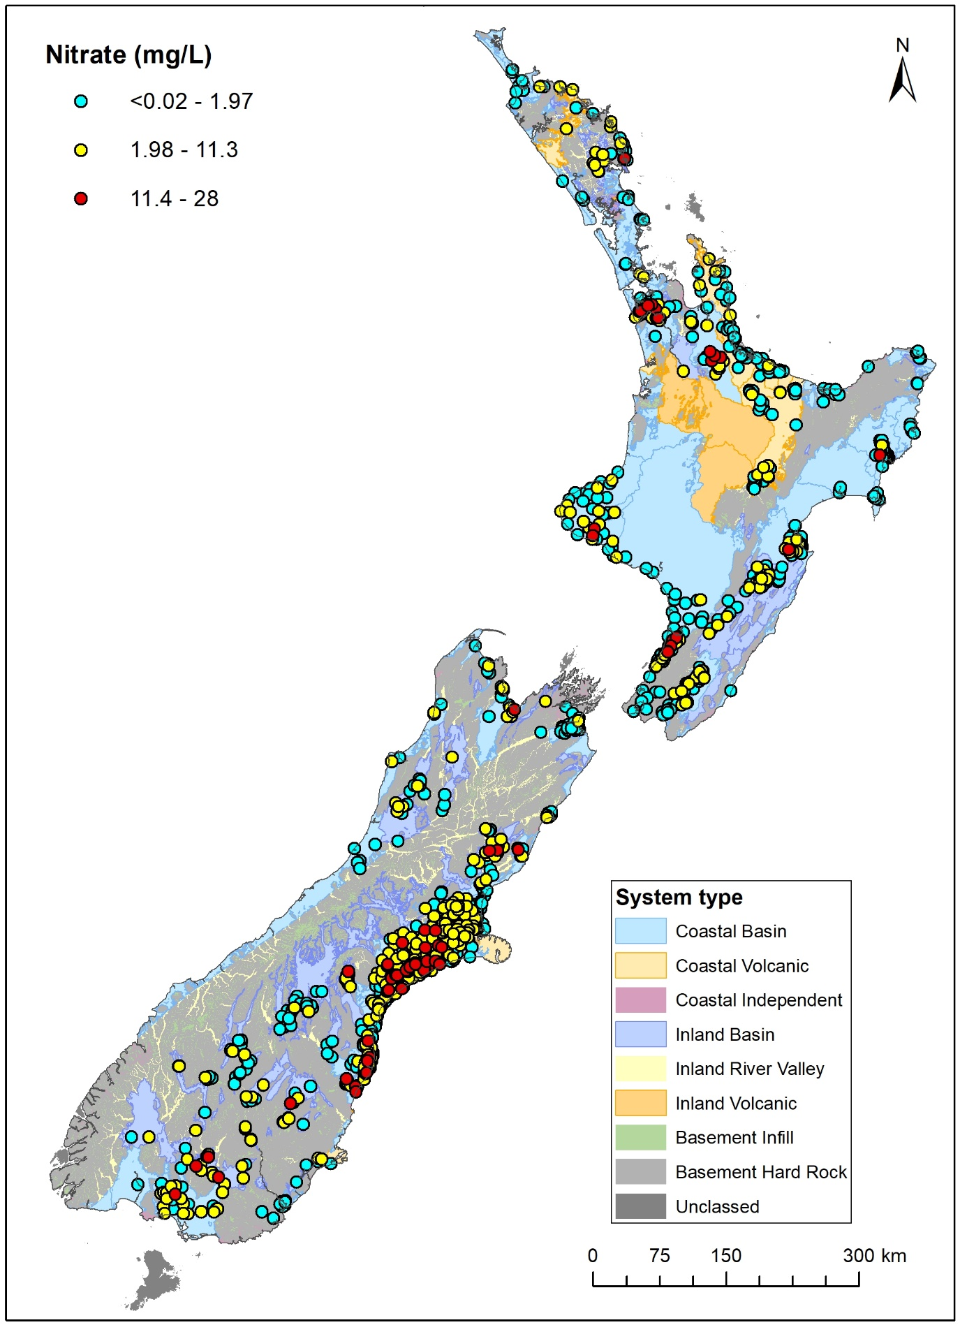
Figure 3.1 Median concentrations for nitrate (mg/L as N) between 2019 and 2024.

Temporal Patterns
Natural processes are generally slow in groundwater (Moreau and Daughney 2021), and rapid changes may indicate anthropologically induced processes such as saltwater intrusion, contamination or land use management.
Trend assessments for the 10-, 20- and 30-year periods show that, at most sites, monitored variable measurements are either increasing or decreasing (Table 3.3). The large detection of trends represents a departure from previously reported (e.g. Daughney and Wall 2007).
This is due to a change in method for trend assessment which reflects recent developments in statistical analysis and reporting of environmental data (McBride 2019; Helsel et al. 2020).
In this report, trends were identified on the complete dataset (i.e. no outlier removal) by applying levels of confidence to a decreasing trend direction metric calculated as part of the Mann-Kendall trend test (Section 2.4; Whitehead et al. 2022). This method is an alternate approach to identifying statistically significant trends via a confidence threshold on the Mann-Kendall test p-value (Helsel et al. 2020). This method is consistent with the most recent river quality state and trend assessments in New Zealand and Stats NZ methods (Whitehead et al. 2022; Stats NZ 2024).
Field temperature, conductivity and most inorganic variable concentrations exhibited dominant increases (50 to 60% of the sites) over the 10-year period (Table 3.3). For these variables, the trend pattern was consistent across time periods, with generally more increases but less sites over the longer time period (e.g. calcium concentration increases represented 55%, 70% and 67% for the 10-, 20- and 30-year time period).
Trend reversal between the 10- and 20-year periods occurred generally between at c. 12% of the sites. Major variables and conductivity changes may be caused by dilution through increased recharge (e.g. irrigation) or salinisation which could be caused by multiple factors such as drawing of older, more saline water through lack of recharge, saltwater intrusion (particularly for sodium and chloride), or contamination.
Decreases were dominant for dissolved oxygen, ammonia and dissolved reactive phosphorous concentrations and pH (46 to 57% of the sites). Changes for dissolved oxygen and pH indicate a change in the physio-chemical properties of the aquifers, which may impact the mobility of other variables in particular: nitrite, iron, manganese and dissolved reactive phosphorous.
Nitrate concentrations exhibited a similar frequency of increases (45% of 662 sites) and decreases (40% of the sites) over the 10-year period. A similar split in trend direction was observed for nitrate concentrations over the 20-year period, however increases were dominant over the 30-year time period (54% of 242 sites). Nitrate concentration trend reversal occurred at 53 sites between the 10-year and 20-year period (9% of the trending sites). Drivers of changing nitrate concentrations are likely to be multiple (e.g. increased leaching from soils, land use management, and oxygenation of the aquifer).
Aluminium, chromium, nickel and lead concentration trends occurred at a limited number of sites (<15) and therefore are regarded as localised. Increasing copper concentrations occurred at 26 sites, mostly located in Otago, with concentrations up to 0.04 mg/L which is well below the MAV (2 mg/L). Arsenic concentration increases (27 sites) were isolated occurrences within the Bay of Plenty, Canterbury, Gisborne, Hawke’s Bay, Manawatu-Wanganui, Marlborough and Otago regions. At these sites, arsenic concentrations (up to 0.054 mg/L) also remained well below the MAV (0.01 mg/L).
In this assessment, negative trend magnitudes indicate decreases and positive magnitudes indicate increases. Generally, trend magnitudes were low with isolated high extreme values (Table 3.4). For instance, the minimum and maximum rates of change for conductivity were -152 µS/cm and 680 µS/cm per year, respectively but the 5th and 95th percentiles were -14 µS/cm and -15 µS/cm per year, respectively. This is consistent with previous reporting (e.g. Daughney and Wall 2007).
Temperature, pH, conductivity and major variables (except nitrate) interquartile ranges were less than 5% per year (Table 3.5). Variables exhibiting the widest interquartile range, i.e. the faster relative changes, were zinc, nitrite, iron, nitrate, dissolved oxygen, manganese and dissolved reactive phosphorous concentrations. Zinc may occur naturally in rock-forming minerals, however, increases in zinc concentrations have been linked to urban sources in Auckland (Foster and Johnson 2021) and stormwater in Christchurch (Poudyal 2022).
Over the 10-year period, nitrate concentrations increased as fast as 4.1 mg/L per year
and decreased as rapidly as 2.57 mg/L per year, however the 5th and 95th percentiles were -0.4 mg/L and 0.49 mg/L per year, respectively (Table 3.4). At most sites, rates of change were faster than expected through natural processes, particularly in Coastal Basins
(Table 3.6).
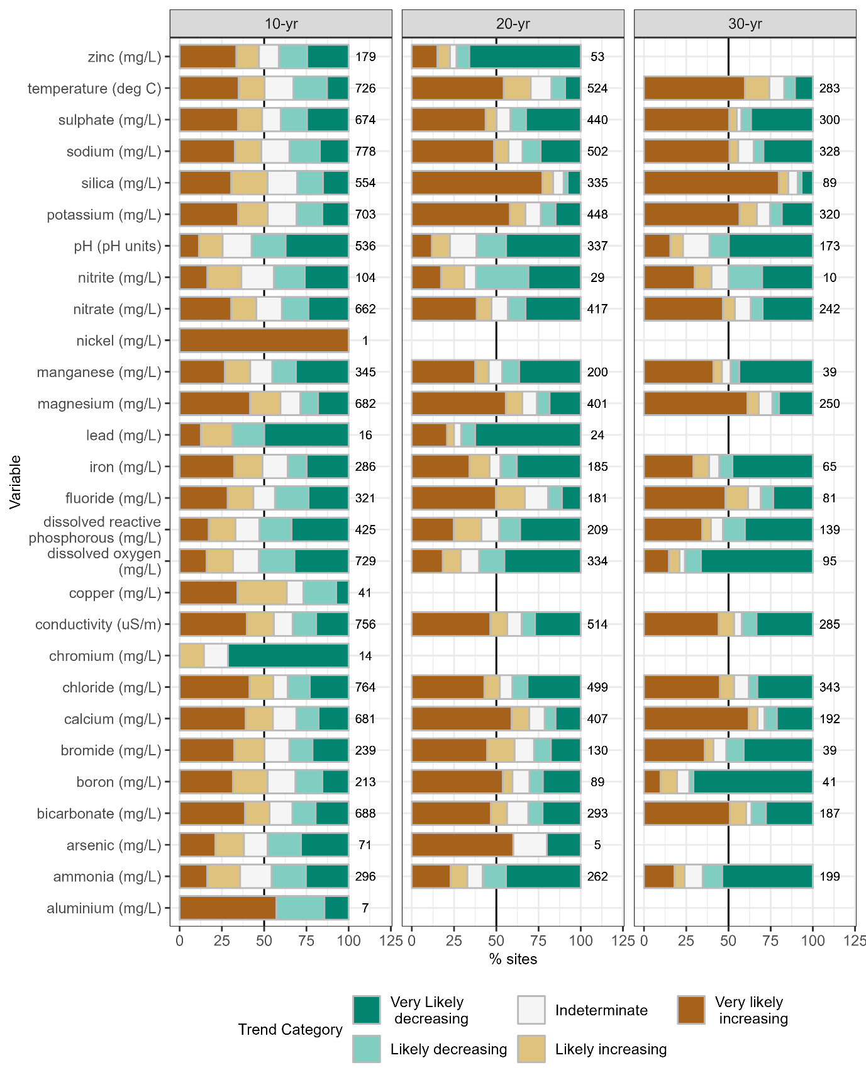
Figure 3.2 Percentage of significant trends at monitoring sites across New Zealand at which trend tests could be performed for the 10-, 20- and 30-year periods.
The numbers shown on each portion of the bar graph represent the number of sites per category per variable.

Table 3.3 Number of sites (n) and percentage of significant increasing (% inc.) and decreasing (% dec.) trends at monitoring sites across New Zealand for the 10-, 20- and 30-year periods.
Note that negative trend magnitudes indicate decreases and positive magnitudes indicate increases.
 | 10-year |  |  | 20-year |  |  | 30-year
Variable | n | % inc. | % dec. | n | % inc. | % dec. | n | % inc. | % dec.
Aluminium (mg/L) | 7 | 57 | 43 | - | - | - | - | - | -
Arsenic (mg/L) | 296 | 36 | 46 | 262 | 33 | 58 | 199 | 24 | 65
Boron (mg/L) | 71 | 38 | 48 | 5 | 60 | 20 | - | - | -
Bromide (mg/L) | 688 | 53 | 33 | 293 | 56 | 31 | 187 | 60 | 36
Calcium (mg/L) | 213 | 52 | 31 | 89 | 60 | 30 | 41 | 20 | 73
Chloride (mg/L) | 239 | 50 | 35 | 130 | 61 | 28 | 39 | 41 | 51
Copper (mg/L) | 681 | 55 | 31 | 407 | 70 | 21 | 192 | 67 | 29
Dissolved oxygen (mg/L) | 764 | 55 | 36 | 499 | 52 | 40 | 343 | 53 | 38
Dissolved reactive phosphorous (mg/L) | 14 | 14 | 71 | - | - | - | - | - | -
Conductivity (us/cm) | 756 | 56 | 33 | 514 | 56 | 35 | 285 | 53 | 42
Fluoride (mg/L) | 41 | 63 | 27 | - | - | - | - | - | -
Iron (mg/L) | 729 | 32 | 53 | 334 | 29 | 60 | 95 | 21 | 76
Bicarbonate (mg/L) | 425 | 33 | 53 | 209 | 41 | 48 | 139 | 40 | 53
Potassium (mg/L) | 321 | 44 | 44 | 181 | 67 | 19 | 81 | 62 | 31
Magnesium (mg/L) | 286 | 49 | 36 | 185 | 46 | 48 | 65 | 38 | 55
Manganese (mg/L) | 16 | 31 | 69 | 24 | 25 | 71 | - | - | -
Sodium (mg/L) | 682 | 60 | 29 | 401 | 65 | 26 | 250 | 68 | 24
Ammonia (mg/L) | 345 | 42 | 45 | 200 | 46 | 47 | 39 | 46 | 49
Nitrite (mg/L) | 1 | 100 | 0 | - | - | - | - | - | -
Nitrate (mg/L) | 662 | 45 | 40 | 417 | 47 | 43 | 242 | 54 | 37
Lead (mg/L) | 104 | 37 | 44 | 29 | 31 | 62 | 10 | 40 | 50
pH (pH units) | 536 | 25 | 57 | 337 | 23 | 62 | 173 | 23 | 61
Silica (mg/L) | 703 | 52 | 31 | 448 | 67 | 24 | 320 | 67 | 25
Sulphate (mg/L) | 554 | 52 | 31 | 335 | 84 | 10 | 89 | 85 | 9
Temperature (deg C) | 778 | 48 | 35 | 502 | 57 | 34 | 328 | 56 | 35
Zinc (mg/L) | 674 | 49 | 40 | 440 | 50 | 42 | 300 | 55 | 42

Table 3.4 Absolute rates of change in inorganic chemistry variables at SoE sites (SoE and NGMP) with statistically significant 10-year trends.
Greyed cells indicate localised changes.
Variable | n | Min. | 5th | 50th | 95th | Max.
Aluminium (mg/L per year) | 7 | -0.0088 | -0.0063 | 0.0002 | 0.20 | 0.28
Ammonia (mg/L per year) | 241 | -0.28 | -0.055 | 0 | 0.021 | 0.39
Arsenic (mg/L per year) | 61 | -0.040 | -0.0017 | 0 | 0.0011 | 0.025
Bicarbonate (mg/L per year) | 595 | -37 | -3.3 | 0.21 | 3.2 | 25
Boron (mg/L per year) | 178 | -0.028 | -0.0033 | 0.0002 | 0.0048 | 0.031
Bromide (mg/L per year) | 204 | -0.021 | -0.0085 | 0 | 0.013 | 0.28
Calcium (mg/L per year) | 587 | -17 | -1.4 | 0.066 | 1.7 | 13
Chloride (mg/L per year) | 698 | -76 | -1.5 | 0.050 | 2.2 | 446
Chromium (mg/L per year) | 12 | -0.0001 | -0.0001 | <-0.0001 | 0 | 0
Conductivity (us/cm per year) | 672 | -152 | -14 | 0.99 | 15 | 680
Copper (mg/L per year) | 37 | -0.0065 | -0.0005 | <0.0001 | 0.0007 | 0.0013
Dissolved oxygen (mg/L per year) | 618 | -5.0 | -0.47 | -0.028 | 0.20 | 3.4
Dissolved reactive phosphorous  (mg/L per year) | 365 | -0.19 | -0.018 | -0.0002 | 0.0063 | 0.17
Fluoride (mg/L per year) | 280 | -0.20 | -0.0078 | 0 | 0.0052 | 0.16
Iron (mg/L per year) | 243 | -2.0 | -0.26 | 0 | 0.30 | 7.2
Lead (mg/L per year) | 16 | -0.0006 | -0.0002 | <-0.0001 | 0.00 | 0.0002
Magnesium (mg/L per year) | 602 | -5.6 | -0.27 | 0.038 | 0.39 | 14
Manganese (mg/L per year) | 300 | -0.28 | -0.024 | 0 | 0.024 | 0.51
Nickel (mg/L per year) | 1 | 0.0001 | 0.0001 | 0.0001 | 0.0001 | 0.0001
Nitrate (mg/L per year) | 562 | -2.6 | -0.40 | 0.0003 | 0.49 | 4.1
Nitrite (mg/L per year) | 84 | -0.44 | -0.046 | -0.0002 | 0.039 | 0.27
pHh (pH units per year) | 444 | -0.40 | -0.11 | -0.017 | 0.067 | 0.79
Potassium (mg/L per year) | 584 | -6.4 | -0.060 | 0.0051 | 0.13 | 6.2
Silica (mg/L per year) | 457 | -2.9 | -0.51 | 0.025 | 0.67 | 2.7
Sodium (mg/L per year) | 649 | -18 | -0.90 | 0.031 | 1.3 | 144
Sulphate (mg/L per year) | 600 | -22 | -1.1 | 0.022 | 1.5 | 60
Temperature (°C per year) | 602 | -2.7 | -0.14 | 0.025 | 0.16 | 4.2
Zinc (mg/L per year) | 158 | -0.17 | -0.0060 | <0.0001 | 0.0040 | 0.030

Table 3.5 Relative rates of change in inorganic chemistry variables at SoE sites (SoE and NGMP) with statistically significant 10-year trends.
* Relative rates could not be estimated at nine sites (median was null). Greyed cells indicate localised changes.
Variable | n | Min. | 5th | 50th | 95th | Max.
Aluminium (mg/L per year) | 7 | -8.8 | -8.0 | 3.8 | 22 | 27
Ammonia (mg/L per year) | 241 | -407 | -18 | 0.00 | 29 | 161
Arsenic (mg/L per year) | 61 | -54 | -18 | 0.00 | 20 | 134
Bicarbonate (mg/L per year) | 595 | -18 | -3.2 | 0.33 | 4.6 | 72
Boron (mg/L per year) | 178 | -59 | -19 | 0.50 | 6.2 | 14
Bromide (mg/L per year) | 204 | -36 | -6.5 | 0.00 | 6.9 | 32
Calcium (mg/L per year) | 587 | -59 | -4.6 | 0.55 | 6.1 | 52
Chloride (mg/L per year) | 698 | -73 | -7.1 | 0.59 | 8.8 | 50
Chromium (mg/L per year) | 12 | -11 | -11 | -5.8 | 0.0 | 0.0
Conductivity (us/cm per year) | 672 | -40 | -4.2 | 0.52 | 4.6 | 31
Copper (mg/L per year) | 37 | -35 | -30 | 9.9 | 103 | 145
Dissolved oxygen (mg/L per year) | 608 | -389 | -38 | -0.98 | 25 | 75
Dissolved reactive phosphorous  (mg/L per year) | 365 | -140 | -22 | -0.55 | 18 | 86
Fluoride (mg/L per year) | 280 | -24 | -5.1 | 0.00 | 4.0 | 43
Iron (mg/L per year) | 243 | -841 | -36 | 0.00 | 34 | 367
Lead (mg/L per year) | 16 | -60 | -55 | -16 | 13 | 22
Magnesium (mg/L per year) | 602 | -41 | -3.8 | 0.82 | 5.1 | 45
Manganese (mg/L per year) | 300 | -1091 | -33 | 0.00 | 24 | 777
Nickel (mg/L per year) | 1 | 50 | 50 | 50 | 50 | 50
Nitrate (mg/L per year) | 562 | -321 | -18 | 0.50 | 26 | 496
Nitrite (mg/L per year) | 84 | -311 | -53 | -0.99 | 24 | 437
pH (pH units per year) | 444 | -6.2 | -1.7 | -0.24 | 1.0 | 13
Potassium (mg/L per year) | 584 | -42 | -2.6 | 0.40 | 3.6 | 30
Silica (mg/L per year) | 457 | -7.7 | -1.4 | 0.17 | 1.7 | 7.2
Sodium (mg/L per year) | 649 | -36 | -2.9 | 0.25 | 5.4 | 48
Sulphate (mg/L per year) | 600 | -63 | -8.4 | 0.46 | 9.7 | 84
Temperature (°C per year) | 602 | -22 | -0.92 | 0.16 | 1.1 | 37
Zinc (mg/L per year) | 158 | -283 | -47 | 1.7 | 67 | 117

Table 3.6 Number of sites at which a significant nitrate concentration trend was observed and percentage of sites where rates are increasing faster that the reference range for the 10-, 20-year and 30-year time periods, per hydrogeological system type.
Similar tables may be generated for variables for which trend references were established (i.e. ammonia, bicarbonate, calcium, chloride, conductivity, dissolved reactive phosphorous, iron, magnesium, manganese, potassium, sodium and sulphate).
 |  | 10-year |  | 20-year |  | 30-year
System Type | # of systems | n | % Outside Range  (% faster) | n | % Outside Range (% faster) | n | % Outside Range (% faster)
Coastal Basin | 99 | 321 | 38 (28) | 253 | 30 (21) | 160 | 26 (21)
Inland Basin | 61 | 134 | 33 (17) | 78 | 21 (13) | 36 | 11 (11)
Coastal Volcanic | 26 | 62 | 35 (16) | 21 | 52 (33) | 19 | 68 (53)
Inland Volcanic | 6 | 3 | 0 (0) | 3 | 0 (0) | - | -
Inland River Valley* | 15 | 12 | 50 (33) | 3 | 33 (33) | - | -
Coastal Independent* | 19 | 14 | 14 (14) | 18 | 6 (6) | 4 | 0 (0)
Basement Infill* | 1 | 1 | 0 (0) | - | - | - | -
Basement Hard Rock* | 1 | 1 | 100 (100) | - | - | - | -
Exceedances of E. coli have remained a common occurrence (between 20 and 67%) across non-Basement systems and remain broadly consistent through time (Table 3.7).
Table 3.7 Percentage of sites where the E. coli MAV was exceeded at least once per 5-year time window from 1994 to 2019, per hydrogeological system type.
n represents the number of sites for each time period. Highlighted cells indicate exceedances.
 | 1994–1999 |  | 1999–2004 |  | 2004–2009 |  | 2009–2014 |  | 2014–2019 |  | 2019–2024
System Type | n | % | n | % | n | % | n | % | n | % | n | %
Coastal Basin | 3 | 33.3 | 308 | 36 | 447 | 38.7 | 511 | 42.3 | 565 | 45 | 642 | 45.8
Coastal Independent | - | - | 8 | 62.5 | 29 | 58.6 | 28 | 53.6 | 31 | 67.7 | 31 | 58.1
Coastal Volcanic | 5 | 20 | 1 | 100 | 21 | 42.9 | 17 | 47.1 | 64 | 43.8 | 93 | 39.8
Inland Basin | 0 | - | 44 | 56.8 | 82 | 45.1 | 139 | 42.4 | 191 | 45 | 205 | 46.3
Inland River Valley | - | - | 1 | 100 | 2 | 100 | 3 | 100 | 11 | 81.8 | 4 | 75
Inland Volcanic | - | - | 2 | 50 | 5 | 40 | 4 | 50 | 5 | 60 | 4 | 50
Basement Infill | 1 | 100 | 3 | 33.3 | 1 | 100 | 4 | 50 | 1 | 100 | 2 | 100
Basement Hard Rock | - | - | 2 | 50 | 1 | 0 | 4 | 25 | - | - | 6 | 16.7
Isolated pesticide detections have been widespread in New Zealand through the repeated surveys, particularly in Coastal and Inland basins and Coastal Volcanic systems (Figure 3.3). As the surveys were repeated, an increasing amount of sites and compounds were tested (Figure 3.4, Close and Banasiak 2023a and b). Between 1990 and 2022, the maximum detected concentrations vary between variables, some generally decreasing (e.g. mecoprop, terbuthylazine), whereas others remain stable at low concentrations (e.g. metolachlor,
Table 3.8).
Table 3.8 Maximum concentrations (µg/L) over time for detected compounds for all pesticides surveys
(1990–2022).
Highlighted cells indicate detections.
Variable | 1990 | 1994 | 1998 | 2002 | 2006 | 2010 | 2014 | 2018 | 2022
2-Hydroxyatrazine | - | - | - | - | - | - | - | 0.22 | -
2,4-Dichlorophenoxyacetic acid | 0.07 | - | 0.9 | <0.1 | <0.1 | <0.1 | <0.1 | <0.1 | <0.4
2,4-Dichlorophenoxybutyric acid | - | - | <0.1 | <0.1 | <0.1 | <0.1 | <0.1 | 0.08 | <0.4
4,4'-dde | - | - | - | - | - | - | <0.01 | 0.002 | 0.006
4,4'-ddt | - | - | - | 0.01 | - | 0.033 | - | 0.02 | <0.01
Acetochlor | - | - | <0.02 | <0.02 | <0.02 | 0.091 | 0.071 | <0.02 | <0.04
Alachlor | - | 0.8 | 0.25 | 0.048 | 34 | 12 | <0.02 | 0.59 | 0.1
Atrazine-desethyl | - | - | 0.01 | 0.15 | - | 0.023 | 0.08 | 0.015 | <0.04
Atrazine-desisopropyl | - | - | - | 0.17 | - | - | - | 0.02 | <0.08
Atrazine | 37 | 0.9 | 0.08 | 0.058 | 0.094 | 0.042 | <0.01 | 0.032 | 0.06
Bentazone | - | - | <0.1 | 0.18 | 0.16 | 0.24 | 0.17 | 0.36 | <0.4
Bromacil | - | - | <0.03 | 0.56 | <0.03 | 0.057 | 3.4 | 2 | <0.04
Chlorpyrifos | 0.03 | - | <0.02 | <0.02 | <0.02 | 0.056 | <0.02 | - | <0.04
Clopyralid | - | - | - | - | - | - | - | - | 1.1
Diazinon | 0.03 | - | 0.03 | 0.023 | 0.062 | <0.01 | <0.01 | 0.01 | <0.02
Dieldrin | - | - | <0.02 | <0.02 | <0.02 | 0.13 | 0.043 | 0.025 | 0.04
Dinoseb | - | - | <0.1 | <0.1 | <0.1 | <0.1 | 0.23 | <0.1 | 0.46
Diuron | - | - | - | 0.8 | - | - | 0.21 | <0.04 | <0.04
Endosulfan i | - | - | <0.02 | 0.031 | 0.008 | <0.02 | 0.01 | 0.016 | <0.01
Endosulfan ii | - | - | <0.04 | <0.04 | 0.019 | <0.04 | 0.022 | 0.061 | <0.01
Endosulfan sulphate | - | - | <0.02 | <0.02 | 0.081 | <0.02 | 0.075 | 0.068 | <0.01
Hexazinone | - | - | 0.23 | 0.22 | <0.02 | 0.74 | 0.21 | 0.15 | 0.1
Linuron | - | - | <0.04 | <0.04 | <0.04 | 0.043 | - | <0.1 | <0.05
Mcpa | - | - | 61 | <0.1 | <0.1 | <0.1 | - | - | -
Mcpb | - | - | 2.1 | <0.1 | <0.1 | <0.1 | - | - | -
Mecoprop | - | 3.2 | 420 | 0.51 | 0.2 | <0.1 | <0.1 | <0.1 | <0.4
Metalaxyl | - | - | <0.01 | <0.01 | 0.085 | 0.091 | 0.17 | 0.06 | 0.08
Metolachlor | - | 0.1 | 0.21 | 0.056 | 0.1 | 0.096 | 0.057 | 0.05 | 0.102
Metribuzin | - | - | 1.2 | 0.27 | 0.088 | 1.7 | 0.06 | <0.02 | 0.14
Norflurazon | - | - | <0.02 | <0.02 | 0.096 | 0.04 |  | <0.1 | <0.08
Oxadiazon | - | - | <0.01 | 0.021 | 0.018 | <0.01 | <0.01 | <0.01 | <0.04
Pendimethalin | - | - | 0.03 | 0.046 | <0.02 | 0.055 | <0.02 | <0.02 | <0.04
Phenyl.phenol | - | 0.1 | - | - | - | - | - | - | -
Picloram | - | - | 0.3 | <0.1 | <0.1 | 0.36 | <0.1 | 0.91 | 0.7
Pirimiphos-methyl | 0.06 | - | 0.01 | <0.02 | 0.053 | <0.02 | <0.02 | <0.1 | <0.04
Procymidone | - | - | 0.17 | 0.12 | 0.19 | 0.056 | 0.08 | - | 0.14
Propazine | - | 2 | 2.5 | 1.2 | 0.2 | 0.24 | 3.1 | 0.062 | 0.055
Simazine | - | 1.6 | 0.32 | 0.42 | 0.088 | 0.13 | 0.099 | 0.067 | 0.05
Terbacil | - | - | <0.02 | 4 | 2.5 | 0.051 | 0.84 | 3.8 | <0.04
Terbuthylazine-desethyl | - | - | - | - | - | - | 0.71 | 0.39 | 0.07
Terbuthylazine | - | 3.2 | 3.5 | 2 | 0.42 | 5.8 | 1.39 | 0.35 | 0.31
Triclopyr | - | 0.02 | 0.3 | <0.1 | <0.1 | <0.1 | <0.1 | <0.1 | <0.4
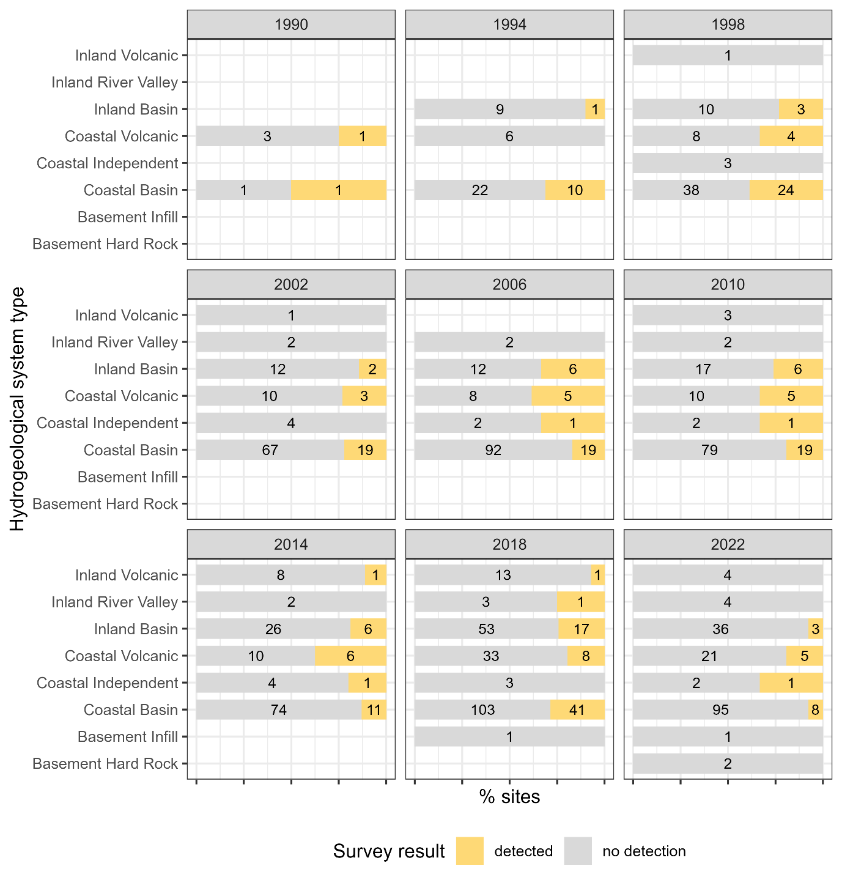
Figure 3.3 Summary of detection for successive pesticides surveys (1990–2022), per hydrogeological system.
Note that the survey size is underestimated for the 1990 survey, as the only sites represented are those where pesticides were detected. Numbers within each bar graph indicate the number of sites per category.
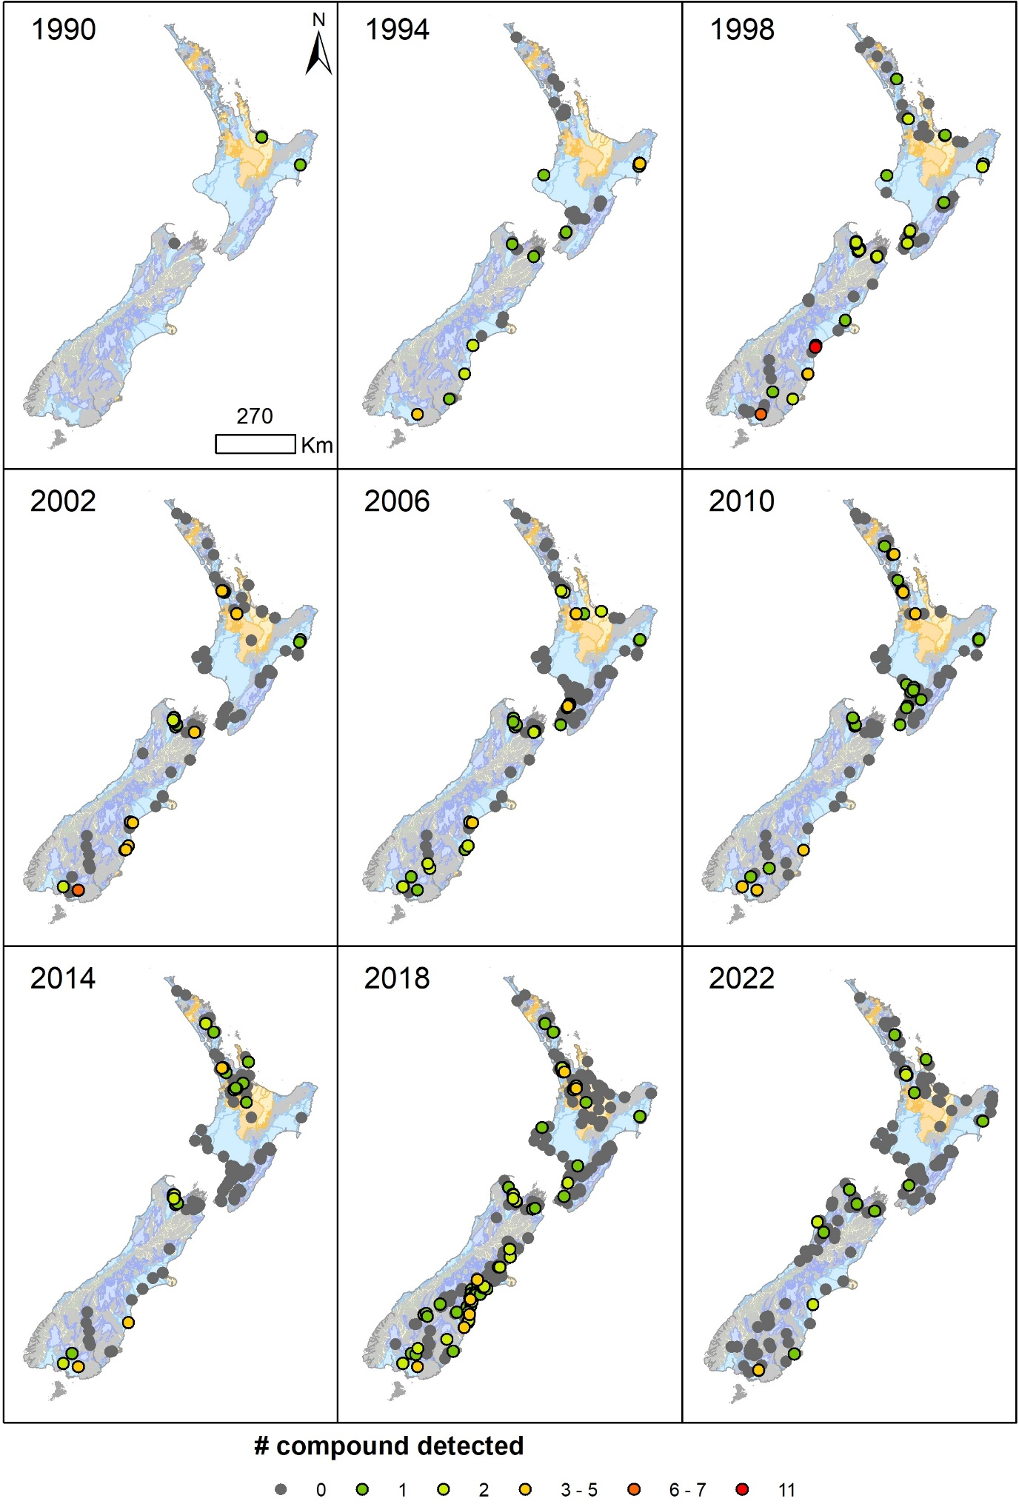
Figure 3.4 Pesticide detections distribution over time, for each of the pesticide surveys (1990–2022).
Note that the survey size is underestimated for the 1990 survey, as the only sites represented are those where pesticides were detected.

RECOMMENDATIONS
To ensure the continuation of independent observations that can be used to develop understanding, calibrate/validate models, and assist with designing and monitoring outcomes of management interventions to restore/sustain freshwater quality and quantity, it is recommended to:
- Continue monitoring groundwater quality at regional and national scales, with practical considerations for cost-effectiveness. The continued long-term data collection has successfully enabled characterisation of multiple groundwater bodies and identified groundwater quality issues. Long-term data collection is required to monitor changes and identify arising issues, including potential climate-change impacts on freshwater.
- Continue to engage with, and where possible support, the development of the national groundwater quality monitoring framework to ensure data collection is connected and relevant to national reporting. This framework is supported by the Groundwater Forum and is key to addressing the inconsistencies identified by the Parliamentary Commissioner for the Environment (2019). Of particular relevance to national reporting are: the long-term aim to clarify the purpose of monitoring, review national networks to better represent regional views, identity criteria to report evaluative monitoring at the national scale, and facilitate site and variable selection (Moreau 2024).
- Redox (of or relating to oxidation-reduction) conditions of aquifer systems are key
to interpret and manage nitrate- contamination which remains a long-standing and widespread issue. However, redox conditions could only be assessed at 28% of 1172 sites monitored for nitrate. Consolidating data acquisition by measuring dissolved oxygen and concentrations of iron (dissolved form), manganese (dissolved form) and sulphate at least once at all missing sites would enable nationwide classification of redox status. This in turn will enable better reporting against reference values which may not apply in reduced environments. This could also be further complimented by the use of predicted groundwater redox state layers (5m, 15m, 30m and 50m depth below the groundwater table; Sarris et al. 2025) to provide contextual information.
To enable data harvesting and open data collected for SoE purposes for data science, it is recommended to develop:
- Processes to curate and maintain data vocabularies to support automated data harvesting and processing. As part of this study, two vocabularies were prepared. Ensuring these are maintained will require defining accountability for this task and coordination to ensure efficient updates across multiple organisations. These processes should include input from groundwater quality experts who are familiar with the data cycle to ensure practical and efficient solutions are developed. Such process will also require long-term resourcing plans. Practical recommendations to enhance data harvesting have been provided in Appendix 2.
- Concise metadata to support national reporting and groundwater datasets. Currently, national groundwater quality and quantity datasets are not connected to aquifers systematically. Rather, when available, data is connected to groundwater management zones, inconsistent aquifer names and/or lithologies. In this report, we have used nationally-consistent hydrogeological systems as 2D spatial units. However, aquifers are 3D dimensional and may also connect with surface water. This information has implications on how data should be used (e.g. interpolation of nitrate concentrations nationwide between disconnected aquifers would be meaningless). The most up-to-date and comprehensive overview of New Zealand groundwaters is the overview chapter from White (2001). In the 20+ years since this chapter was written, many site investigations involving new techniques have been developed, which have enabled a more thorough understanding of our groundwater systems in areas where these have been applied. Updating this chapter will be a relatively modest task, however, it will require coordination of regional authorities and CRIs. Doing so would provide a succinct and up-to-date overview of our resources, which will not only be worthwhile to include in national reporting but will also enable metadata to be attached to groundwater datasets while GNS’ SSIF-funded nationally-consistent aquifer mapping is underway.
To enhance future Indicator updates, it is recommended to:
- Investigate the feasibility of including groundwater residence time as a variable, which has been shown to link land use with impacts on groundwater quality (Morgenstern and Daughney, 2012) and informs on time scales for groundwater management. It is possible that previous reports did not include this due to limited availability. However, groundwater age data is now available at all NGMP sites and a growing number of SoE sites, to the extent that a national dataset is currently being developed.
- Investigate the feasibility of connecting indicators to:
  - Groundwater ecosystems, which are largely unknown. An initial step was proposed to start by assessing whether a groundwater ecosystem classification should be based on groundwater quality variables, biotic variables or both (Houghton 2024).Surface water monitoring, particularly where groundwater-surface interactions are common meaning that water bodies may act in turn as source or sink along flow paths. An initial step may be to test conjunctive reporting at the regional scale.
  - Land-use pressures, groundwater capture zones (Moreau et al. 2014) and power of detection, which incorporate factors such as confinement as well as sampling frequency to support the assessment of policy effectiveness (Dumont et al. 2024).
- Clarify the connection between SoE monitoring with groundwater-sourced drinking-water monitoring, which is a large groundwater use. A feasibility assessment on using either Taumata Arowai’s national reports or datasets could be undertaken. This should include work to understand the difference between the drinking-water and the SoE networks.
- Continue the collaborative refinement of the hydrogeological systems to incorporate regional authorities’ knowledge, as some basins cover large areas with varying geologies. For example, a draft classification of aquifer systems was developed for the Waikato region to review and prioritise monitoring, clarifying differences between regional and national scale monitoring (Hadfield et al. 2024). This classification was derived from combining hydrogeological systems and groundwater use, an approach consistent with the UK groundwater protection classification (UK Environment Protection Agency 2024; Hadfield et al. 2024). Extending this approach to other regions is in scope within the national monitoring framework.

CONCLUSION
This technical report summarises monitoring data collected at both regional and national levels more comprehensively than previous versions of the Groundwater Quality Indicators. It also incorporates recommendations and an up-to-date understanding of groundwater quality
in New Zealand. It has been designed to illustrate the diversity of groundwater quality in
New Zealand, which is linked to the diversity of our aquifers.
The presented data analysis confirms a large-scale nitrate contamination issue, based on observed exceedances of reference and MAV values, and local detection of pesticides, although MAV exceedances are rare. Other MAV exceedances for inorganic chemistry variables are occurring, however in most cases, these have been investigated by regional councils and attributed to natural geogenic sources.
Recommendations provided in this report aim to: enhance future Indicator updates; enhance data harvesting to ultimately enable the consumption of SoE data for robust data science; and enhance the representativeness of our monitoring networks to ensure these continue to provide independent and transparent measurements to assess the state and trends of groundwater quality in our environment.

ACKNOWLEDGEMENTS
The author is grateful to personnel who contributed groundwater quality data, in particular: Laura Buckthought (Auckland Council), Rochelle Gardner (Bay of Plenty Regional Council), Jennifer Tregurtha and Shaun Thomsen (Environment Canterbury), Etsuko Yoshino (Environment Southland), Julia Kendall (Gisborne District Council), Rob van der Raaij (Greater Wellington Regional Council), Ale Cocimano (Hawke’s Bay Regional Council), Sivee Chawla and Huma Saeed (Horizons), Emma Chibnall (Marlborough District Council), Kirsty Griggs (Northland Regional Council), Sam Yeo (Otago Regional Council), Monique Harvey (Tasman District Council), David Ge (Taranaki Regional Council), Serena Sun (West Coast Regional Council), Debbie Eastwood (WRC) and Laura Banasiak (ESR).
This report was co-designed with Sean Hudgens (Ministry for the Environment), as well as Bonnie Farrant, Sonja Miller, and Lance Morell (Stats NZ). Jennifer Tregurtha, Shaun Thomsen (Environment Canterbury) and Abi Loughnan (Te Uru Kahika) are also thanked for their constructive collaboration to undertake the data harvesting pilot.
The authors also thank Zara Rawlinson (Senior Hydro-Geophysicist) and Conny Tschritter (Senior Groundwater Scientist) of GNS Science and John Hadfield (Waikato Regional Council) for their reviews of this report.

REFERENCES
Booker DJ, Henderson RD. 2019. National water allocation statistics for environmental reporting: 2018. Christchurch (NZ): National Institute of Water & Atmospheric Research. 33 p. Client Report 2019049CH. Prepared for Ministry for the Environment. https://environment.govt.nz/publications/national-water-allocation-statistics-for-environmental-reporting-2018/
Chapelle FH, Bradley PM, Thomas MA, McMahon PB. 2009. Distinguishing iron-reducing from sulfate-reducing conditions. Groundwater. 47(2):300–305. https://doi.org/10.1111/j.1745-6584.2008.00536.x
Close M. 2015. Personal communication. Principal Scientist, Institute of Environmental Science and Research; Christchurch, NZ.
Close M, Skinner A. 2011. National survey of pesticides in groundwater 2010. [Christchurch (NZ)]: Institute of Environmental Science and Research. 18 p. Client Report CSC1102. Prepared for Regional and District Councils.
Close M, Humphries B. 2019. National survey of pesticides and emerging organic contaminants (EOCs) in groundwater 2018. [Christchurch (NZ)]: Institute of Environmental Science and Research. 54 p. Client Report CSC19016. Prepared for Regional Councils. https://doi.org/10.26091/esrnz.9937304.v1
Close M, Banasiak L. 2023a. National survey of pesticides in groundwater 2022. [Christchurch (NZ)]: Institute of Environmental Science and Research. 32 p. Client Report CSC23010. Prepared for Regional and Unitary Authorities.
Close M, Banasiak L. 2023b. National survey of per- and polyfluoroalkyl substances (PFAS) in groundwater 2022. [Christchurch (NZ)]: Institute of Environmental Science and Research. 42 p. Client Report CSC23006. Prepared for Environmental Protection Agency and Regional and Unitary Authorities.
Corong E, Hensen M, Journeaux P. 2014. Value of irrigation in New Zealand: an economy-wide assessment. Wellington (NZ): NZ Institute of Economic Research. 55 p. Prepared for Ministry of Primary Industries.
Daughney CJ. 2003. Iron and manganese in New Zealand’s groundwater. Journal of Hydrology (New Zealand). 42(1):11–26. https://www.hydrologynz.org.nz/journal/journal-42
Daughney C, Wall M. 2007. Groundwater quality in New Zealand: state and trends 1995–2006. Lower Hutt (NZ): GNS Science. 65 p. Consultancy Report 2007/23. Prepared for Ministry for the Environment.
Daughney C, Randall M. 2009. National groundwater quality indicators update: state and trends 1995–2008. Lower Hutt (NZ): GNS Science. 55 p. Consultancy Report 2009/145. Prepared for Ministry for the Environment.
Daughney CJ, Reeves RR. 2005. Definition of hydrochemical facies in the New Zealand National Groundwater Monitoring Programme. Journal of Hydrology (New Zealand). 44(2):105–130.
Daughney C, Jones A, Baker T, Hanson C, Davidson P, Zemansky G, Reeves R, Thompson M. 2006. A national protocol for state of the environment groundwater sampling in New Zealand. Wellington (NZ): Ministry for the Environment. 52 p. (GNS Science miscellaneous series; 5).
Daughney CJ, Morgenstern U, Moreau M, McDowell RW. 2023. Reference conditions for nitrate-nitrogen in New Zealand groundwaters. Journal of the Royal Society of New Zealand. https://doi.org/10.1080/03036758.2023.2221034
Davidson P, Wilson S. 2011. Groundwaters of Marlborough. [Blenheim] (NZ): Marlborough District Council. 302 p.
Driscoll CT, Schecher WD. 1990. The chemistry of aluminum in the environment. Environmental Geochemistry and Health. 12(1):28–49. https://doi.org/10.1007/BF01734046
Dumont M, Etheridge Z, McDowell RW. 2024. Determining the likelihood and cost of detecting reductions of nitrate‑nitrogen concentrations in groundwater across New Zealand. Science of The Total Environment. 927:171759. https://doi.org/10.1016/j.scitotenv.2024.171759
Environment Agency. 2024. Guidance: protect groundwater and prevent groundwater pollution. Rotherham (GB): Environment Agency. https://www.gov.uk/government/publications/protect-groundwater-and-prevent-groundwater-pollution/protect-groundwater-and-prevent-groundwater-pollution
Environmental Reporting Act 2015; [accessed 2024 Sep]. https://www.legislation.govt.nz/act/public/2015/0087/latest/DLM5941105.html
[ESR] Institute of Environmental Science and Research. 2024. Groundwater science. [Christchurch] (NZ): ESR; [accessed 2024 Nov]. https://www.esr.cri.nz/expertise/water-environment/groundwater-science/
Foster C, Johnson K. 2021. Groundwater quality state and trends in Tāmaki Makaurau / Auckland 2010–2019. Revised October 2021. Auckland (NZ): Auckland Council. 63 p. Technical report 2021/03–2.
Gordon D. 2002. Groundwater resources of the Bay of Plenty. Whakatāne (NZ): Environment Bay of Plenty. 48 p. (Environmental publication; 2002/10).
Graham J. 2025. Personal communication. Chief Advisor Water Science, Water Services Authority Taumata Arowai; Wellington, NZ.
Hadfield J. 2017. Glyphosate occurrence in Waikato groundwater survey, Hamilton, New Zealand. Hamilton (NZ): Waikato Regional Council. Memo File 47 03 25. 12 p.
Hadfield J. 2022. Waikato groundwater quality: state of the environment to 2020.
Hamilton (NZ): Waikato Regional Council. 129 p. (Technical report; 2022/23).
Hadfield J, Moreau M, Wilson N. 2024. Progressing groundwater quality monitoring optimisation: Waikato pilot study [abstract]. In: Securing our water future, embracing adaptation and collaborative solutions: NZHS Conference 2024; 2024 Nov 26–29; Blenheim, NZ. Wellington (NZ): New Zealand Hydrological Society. p. 180–181.
Hawke’s Bay Regional Council. 2024. Arsenic concentrations. Napier (NZ): Hawke’s Bay Regional Council; [accessed 2024 Nov]. https://www.hbrc.govt.nz/services/water-management/bore-security/arsenic-concentrations/
Helsel DR, Hirsch RM, Ryberg KR, Archfield SA, Gilroy EJ. 2020. Statistical methods in water resources. Reston (VA): U.S. Geological Survey. 458 p. (Techniques and methods; 4-A3). https://doi.org/10.3133/tm4A3
Houghton KM, Bolton A, Weaver L. 2024. Roadmap to an updated ecosystem typology for groundwater. Lower Hutt (NZ): GNS Science. 19 p. (GNS Science report; 2024/35). https://doi.org/10.21420/1EWP-C334
[LAWA] Land Air Water Aotearoa. 2022. Q&A: LAWA groundwater quality. [Place unknown] (NZ): LAWA; [accessed 2024 Nov]. https://www.lawa.org.nz/get-involved/news-and-stories/national-news/2022/march/qa-lawa-groundwater-quality
Levy A, Ettema M, Lu X. 2021. State of the Environment: groundwater quality in Otago. Dunedin (NZ): Otago Regional Council. 192 p.
Lough H, Clemens H, Love N. 2018. Technical guidelines for drinking water source protection zones. Christchurch (NZ): Pattle Delamore Partners Ltd. Prepared for Ministry for the Environment. https://environment.govt.nz/assets/Publications/Files/technical-guidelines-for-delineating-drinking-water-source-protection-zones.pdf
McBride GB. 2019. Has water quality improved or been maintained? A quantitative assessment procedure. Journal of Environmental Quality. 48(2):412–420. https://doi.org/10.2134/jeq2018.03.0101
McMahon PB, Chapelle FH. 2008. Redox processes and water quality of selected principal aquifer systems. Groundwater. 46(2):259–271. https://doi.org/10.1111/j.1745-6584.2007.00385.x
Milne J. 2019. Water quality: part 1 of 4: sampling, measuring, processing and archiving of discrete groundwater quality data. [Wellington (NZ)]: National Environmental Monitoring Standards. 77 p.
Ministry of Health. 2022. Annual report on drinking-water quality 2020–2021. Wellington (NZ): Ministry of Health. 98 p.
Moreau M. 2023. Technical review of the 2020 groundwater quality indicator to support methodological improvements. Wairakei (NZ): GNS Science. 32 p. Consultancy Report 2023/19. Prepared for Ministry for the Environment.
Moreau M. 2024. Development of a national framework for groundwater monitoring. Lower Hutt (NZ): GNS Science. 20 p. Consultancy Report 2024/56. Prepared for Ministry for the Environment.
Moreau M, Daughney CJ. 2015. Update of national groundwater quality indicators: state and trends, December 2004–2013. Wairakei (NZ): GNS Science. 32 p. Consultancy Report 2015/16. Prepared for Ministry for the Environment.
Moreau M, Bekele M. 2017. Groundwater component of the Water Physical Stock Account (WPSA). Rev. Lower Hutt (NZ): GNS Science. 31 p. Consultancy Report 2014/290. Prepared for Ministry for the Environment.
Moreau M, Daughney CJ. 2021. Defining natural baselines for rates of change in New Zealand's groundwater quality: dealing with incomplete or disparate datasets, accounting for impacted sites, and merging into state of the environment reporting. Science of the Total Environment. 755(2):143292. https://doi.org/10.1016/j.scitotenv.2020.143292
Moreau M, Cameron S, Daughney C, Gusyev M, Tschritter C. 2014. Envirolink Tools Project: capture zone delineation – technical report. Wairakei (NZ): GNS Science. 91 p. (GNS Science report; 2013/57).
Moreau M, Riedi MA, Aurisch K. 2016. Update of national groundwater quality indicators: state and trends 2005–2014. Wairakei (NZ): GNS Science. 36 p. Consultancy Report 2015/107. Prepared for Ministry for the Environment.
Moreau M, Hadfield J, Hughey J, Sanders F, Lapworth DJ, White D, Civil W. 2019. A baseline assessment of emerging organic contaminants in New Zealand groundwater. Science of the Total Environment. 686:425–439. https://doi.org/10.1016/j.scitotenv.2019.05.210
Moreau M, White PA, Mourot F, Rawlinson Z, Tschritter C, Cameron SG, Westerhoff RS. 2019. Classification of New Zealand hydrogeological systems. Lower Hutt (NZ): GNS Science. 28 p. (GNS Science report; 2018/35). https://doi.org/10.21420/42QW-MC74
Mroczek E, Climo M, Evans D. 2017. The composition of high temperature geothermal fluids in New Zealand producing geothermal fields. Rev. Lower Hutt (NZ): GNS Science. 21 p. (GNS Science report; 2014/68). https://doi.org/10.21420/G2335Z
Parliamentary Commissioner for the Environment. 2019. Focusing Aotearoa New Zealand’s environmental reporting system. Wellington (NZ): Parliamentary Commissioner for the Environment. 100 p. https://pce.parliament.nz/publications/focusing-aotearoa-new-zealand-s-environmental-reporting-system
Piper J, Kim N. 2006. Arsenic in groundwater of the Waikato Region. Hamilton (NZ): Environment Waikato. 45 p. (Technical report; 2006/14). https://www.waikatoregion.govt.nz/assets/WRC/WRC-2019/TR06-14.pdf
Poudyal S. 2022. Groundwater quality state and quantity annual report 2021. Christchurch (NZ): Christchurch City Council. 17 p.
Rosen MR, Cameron SG, Taylor CB, Reeves RR. 1999. New Zealand guidelines for the collection of groundwater samples for chemical and isotopic analyses. Lower Hutt (NZ): Institute of Geological & Nuclear Sciences. 81 p. (Institute of Geological & Nuclear Sciences science report; 99/9).
Sarris TS, Wilson SR, Close ME, Abraham P, Kenny A. 2025. Reducing uncertainty of groundwater redox condition predictions at national scale, for decision making and policy. Environmental Management. 75(2):307–329. https://doi.org/10.1007/s00267-024-02098-7
Schofield JC. 1960. Boron in some New Zealand ground waters. New Zealand Journal of Geology and Geophysics. 3(1):98–104. https://doi.org/10.1080/00288306.1960.10423148
Snelder T, Fraser C, Larned S, Whitehead A. 2021. Guidance for the analysis of temporal trends in environmental data. [Christchurch] (NZ): National Institute of Water & Atmospheric Research. 99 p. Client report 2021017WN. Prepared for Horizons Regional Council and MBIE Envirolink.
Stats NZ. 2019. Groundwater quality. Wellington (NZ): Stats NZ; [accessed 2023 Mar]. https://www.stats.govt.nz/indicators/groundwater-quality-published-april-2019
Stats NZ. 2020. Groundwater quality. Wellington (NZ): Stats NZ; [accessed 2023 Mar]. https://www.stats.govt.nz/indicators/groundwater-quality
Stats NZ. 2024. River water quality – heavy metals: data to 2022. Wellington (NZ): Stats NZ; [accessed 2025 Feb]. https://www.stats.govt.nz/indicators/river-water-quality-heavy-metals-data-to-2022/
Stocker TF, Qin D, Plattner G-K, Tignor MMB, Allen SK, Boschung J, Nauels A, Xia Y, Bex V, Midgley PM, editors. 2013. Climate change 2013: the physical science basis. Working Group I contribution to the Fifth Assessment Report of the Intergovernmental Panel on Climate Change. Cambridge (GB): Cambridge University Press. 1535 p.
Taumata Arowai. 2022. Aesthetic Values for Drinking Water Notice 2022. Wellington (NZ): Taumata Arowai; [accessed 2025 Feb]. https://www.taumataarowai.govt.nz/assets/Uploads/Rules-and-standards/Taumata-Arowai-Aesthetic-Values-for-Drinking-Water-2022.pdf
Taumata Arowai. 2024. Performance summary of the water services system 2023. Wellington (NZ): Taumata Arowai; [accessed 2024 Oct]. https://www.taumataarowai.govt.nz/about/water-services-insights-and-performance/
Tidswell S, Conwell C, Milne JR. 2012. Groundwater quality in the Wellington region: state and trends. Wellington (NZ): Greater Wellington Regional Council. 122 p.
Water Services (Drinking Water Standards for New Zealand) Regulations 2022; [accessed 2024 Sep]. https://www.legislation.govt.nz/regulation/public/2022/0168/latest/whole.html
White PA. 2001 Groundwater resources in New Zealand. In: Rosen MR, White PA, editors. Groundwaters of New Zealand. Wellington (NZ): New Zealand Hydrological Society. p. 45–75.
White PA, Moreau M, Mourot F, Rawlinson ZJ. 2019. New Zealand Groundwater Atlas: hydrogeological-unit map of New Zealand. Rev. 2022. Wairakei (NZ): GNS Science. 97 p. Consultancy Report 2019/144. Prepared for Ministry for the Environment.
Whitehead A, Fraser C, Snelder T, Walter K, Woodward S, Zammit C. 2022. Water quality state and trends in New Zealand rivers: analyses of national data ending in 2020. Christchurch (NZ): National Institute of Water & Atmospheric Research. 73 p. Client Report 2021296CH. Prepared for Ministry for the Environment; [accessed 2025 Feb]. https://environment.govt.nz/assets/publications/river-water-quality-state-and-trends.pdf

Appendices

This page left intentionally blank.

DATA REQUEST
Inserted as an attachment in the PDF.

DATA HARVESTING PILOT RECOMMENDATIONS FOR LAWA IMPROVEMENT
Inserted as an attachment in the PDF.

MEDIAN VALUES FOR INORGANIC CHEMISTRY VARIABLES (2019–2024)
Each map was generated using the following colour scheme:
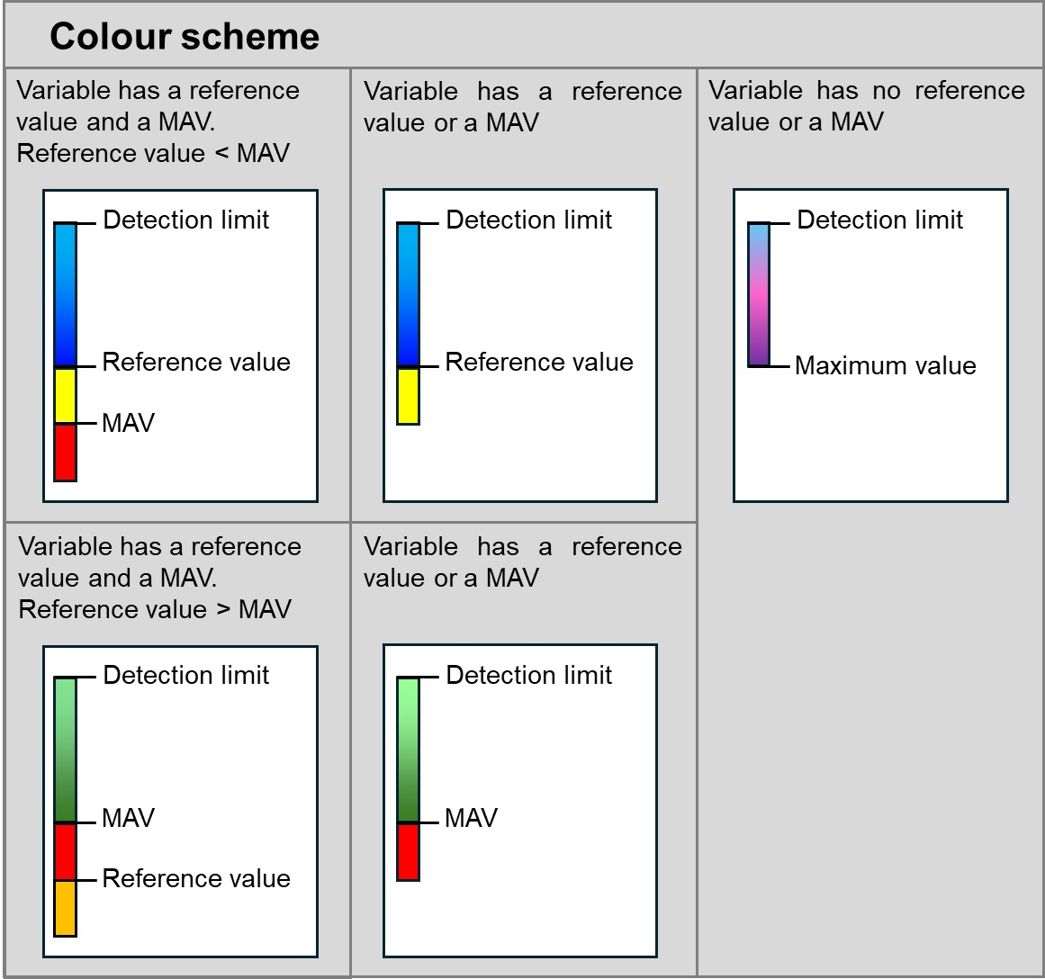
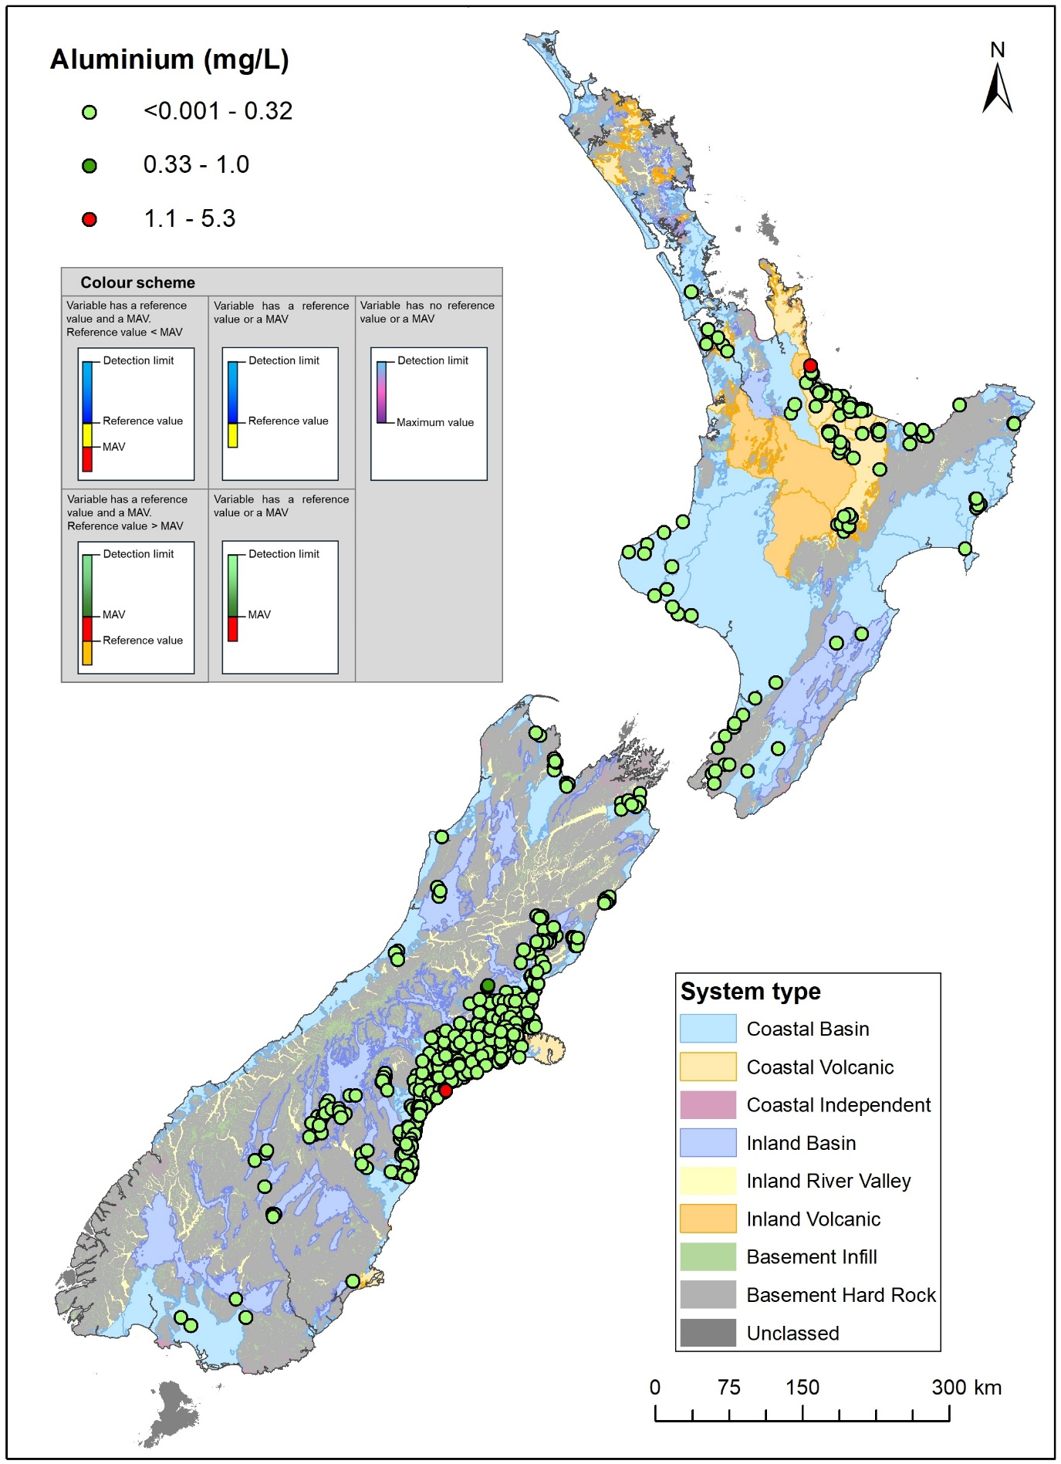
Figure A3.1 Median concentrations for aluminium (mg/L) between 2019 and 2024.
In this map, the plotting order is consistent with increasing values (i.e. higher values plotted last/at the top).
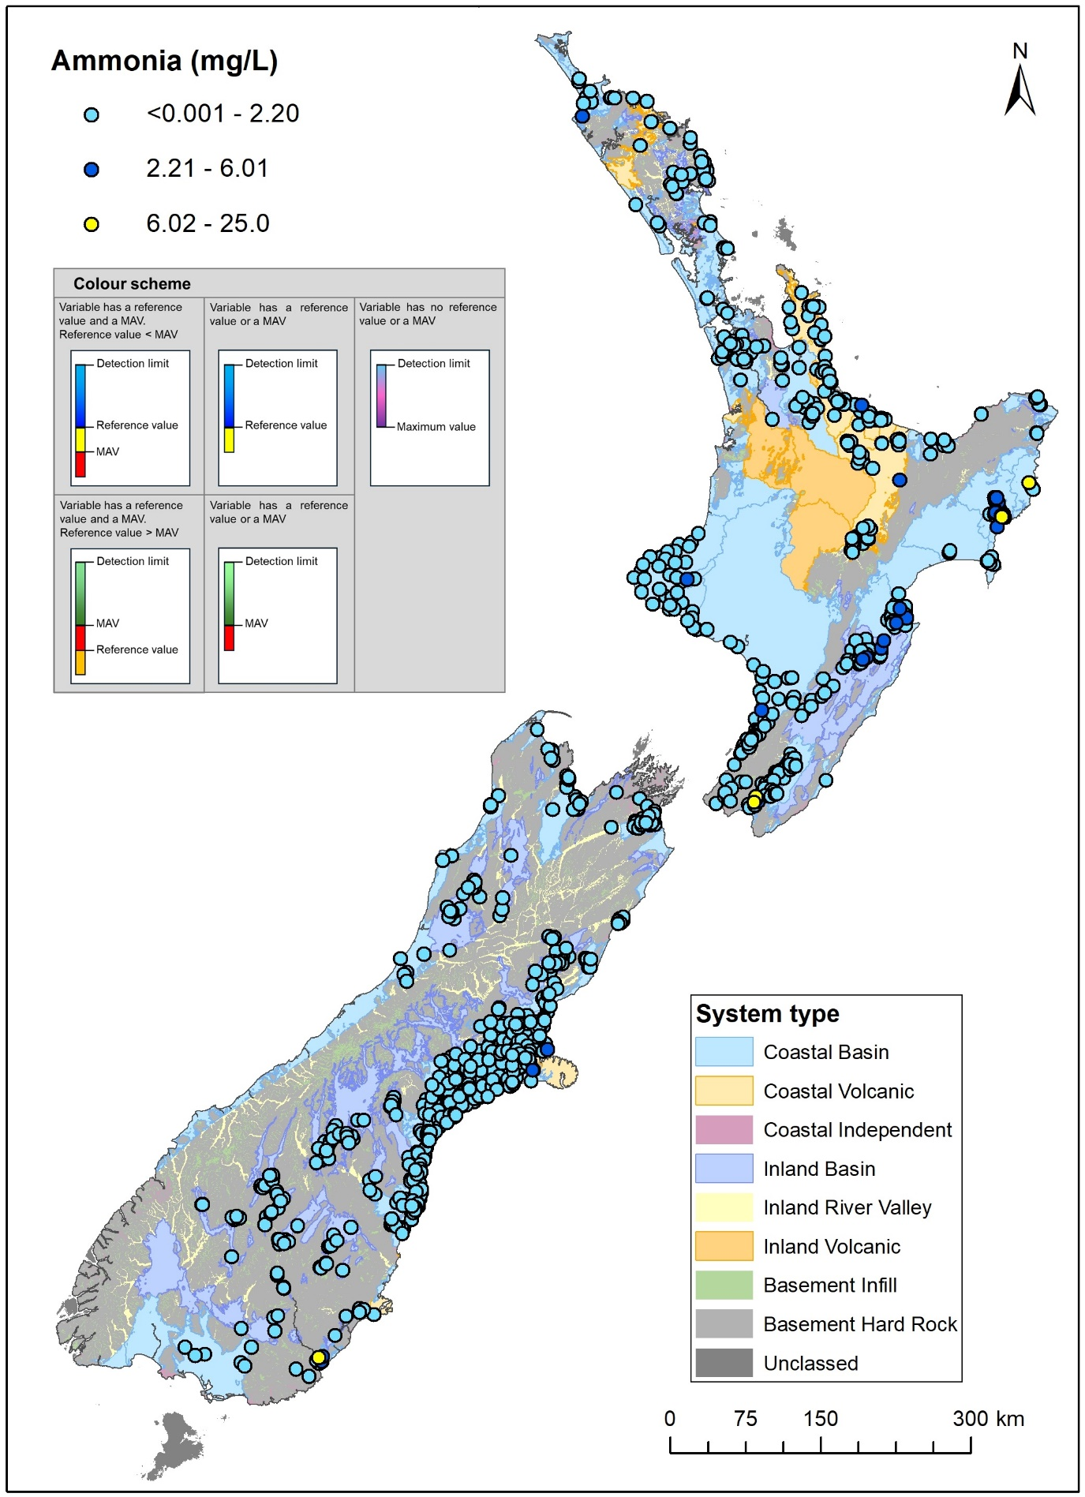
Figure A3.2 Median concentrations for ammonia (mg/L as N) between 2019 and 2024.
In this map, the plotting order is consistent with increasing values (i.e. higher values plotted last/at the top).
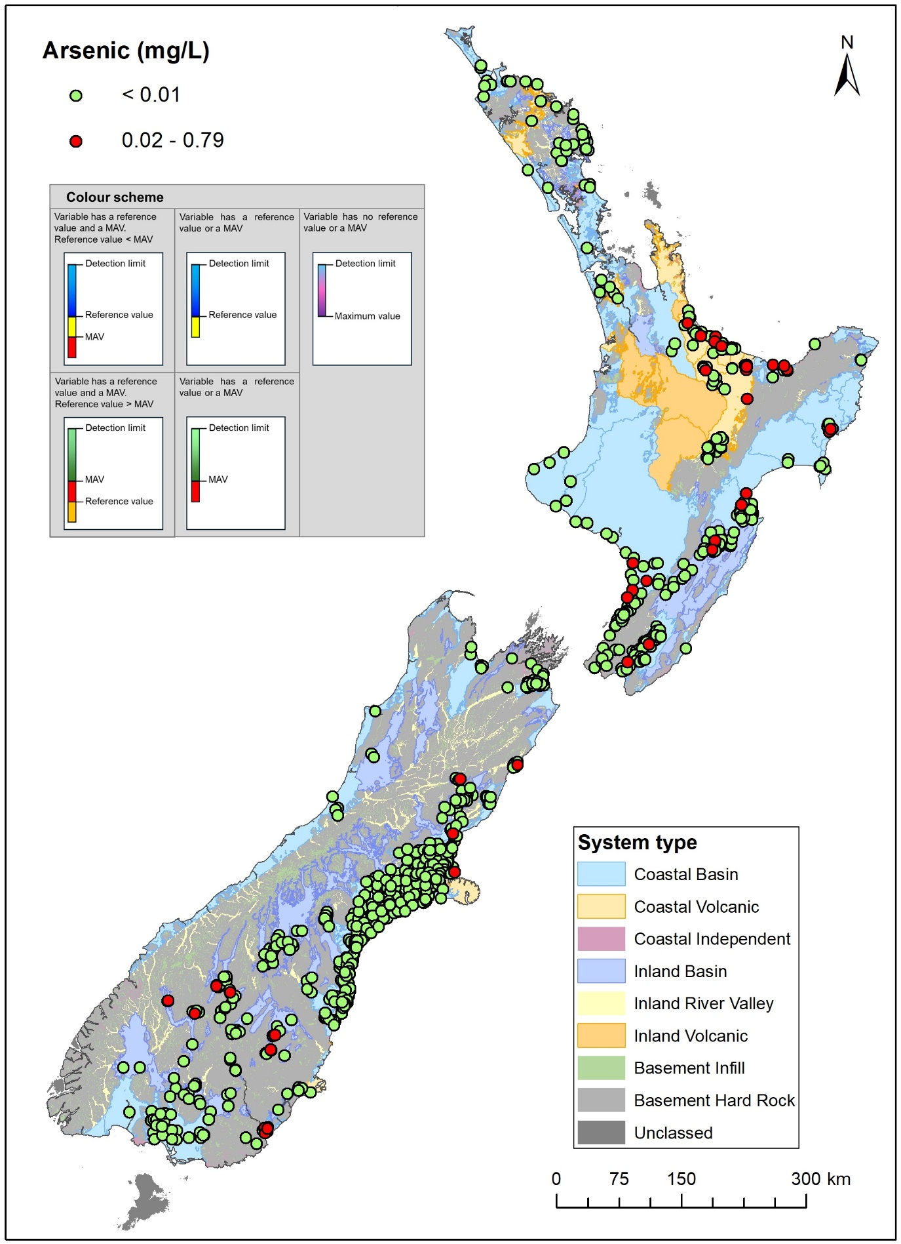
Figure A3.3 Median concentrations for arsenic (mg/L) between 2019 and 2024.
In this map, the plotting order is consistent with increasing values (i.e. higher values plotted last/at the top).
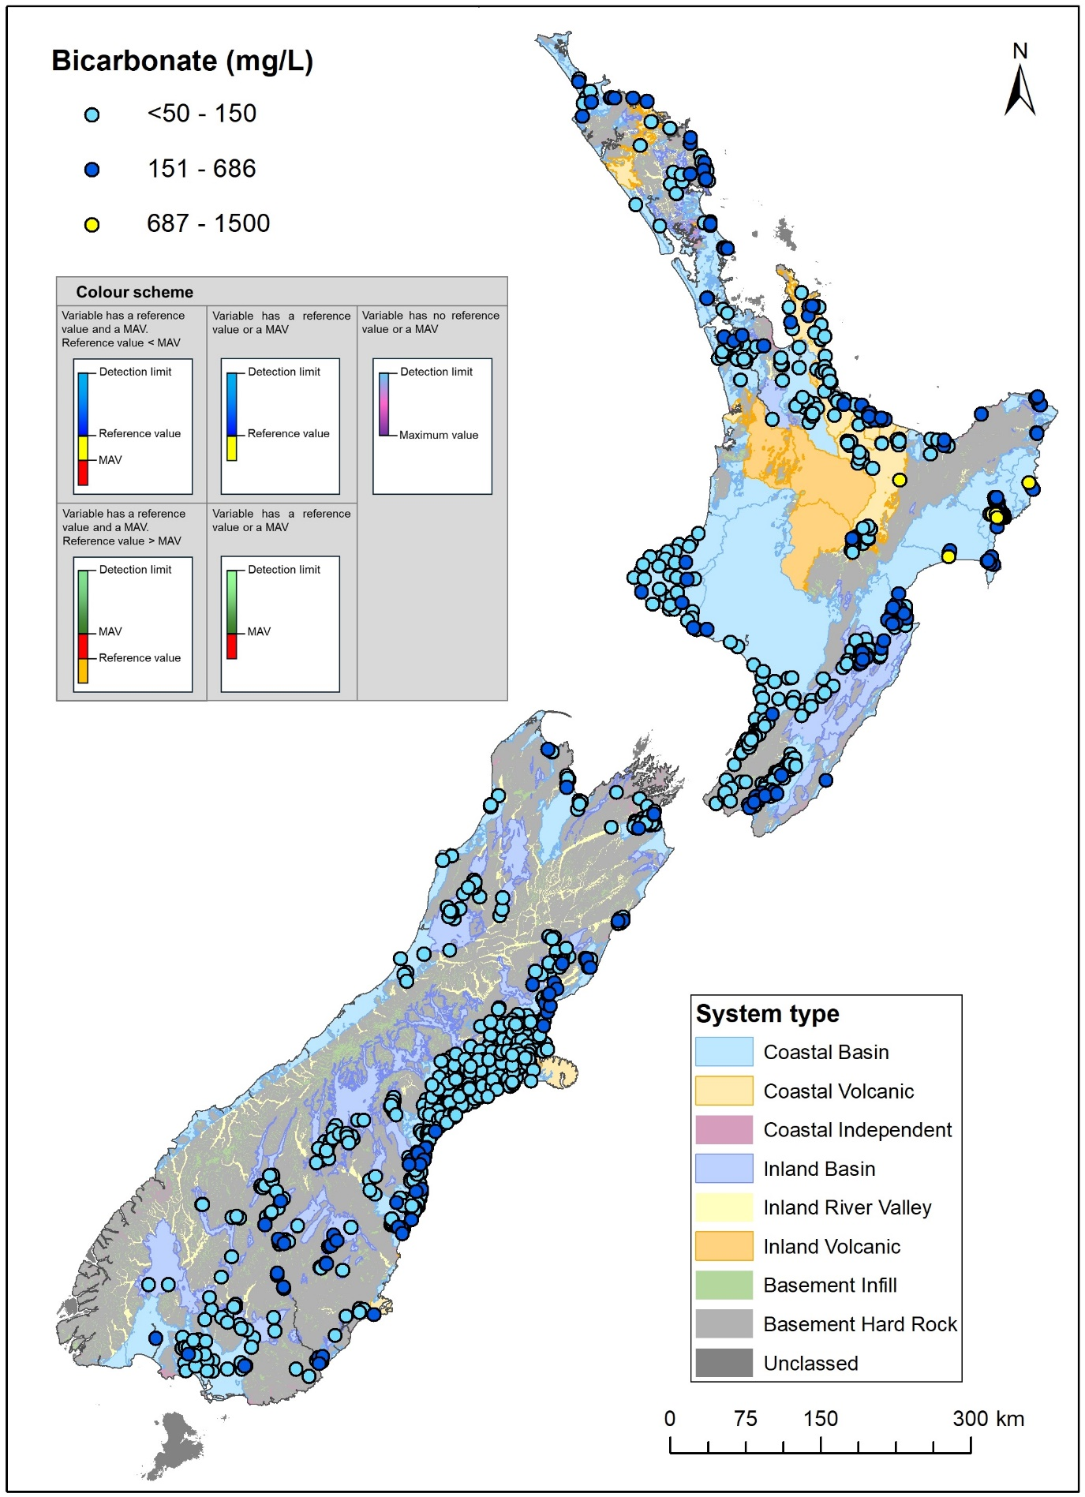
Figure A3.4 Median concentrations for bicarbonate (mg/L) between 2019 and 2024.
In this map, the plotting order is consistent with increasing values (i.e. higher values plotted last/at the top).
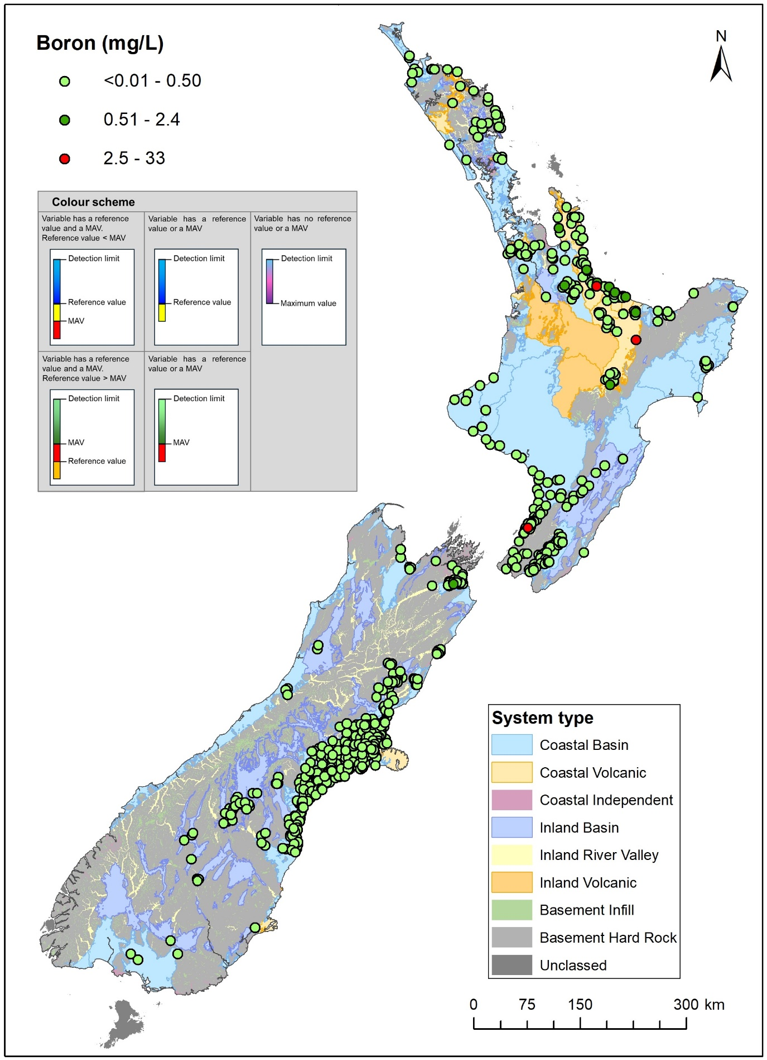
Figure A3.5 Median concentrations for boron (mg/L) between 2019 and 2024.
In this map, the plotting order is consistent with increasing values (i.e. higher values plotted last/at the top).
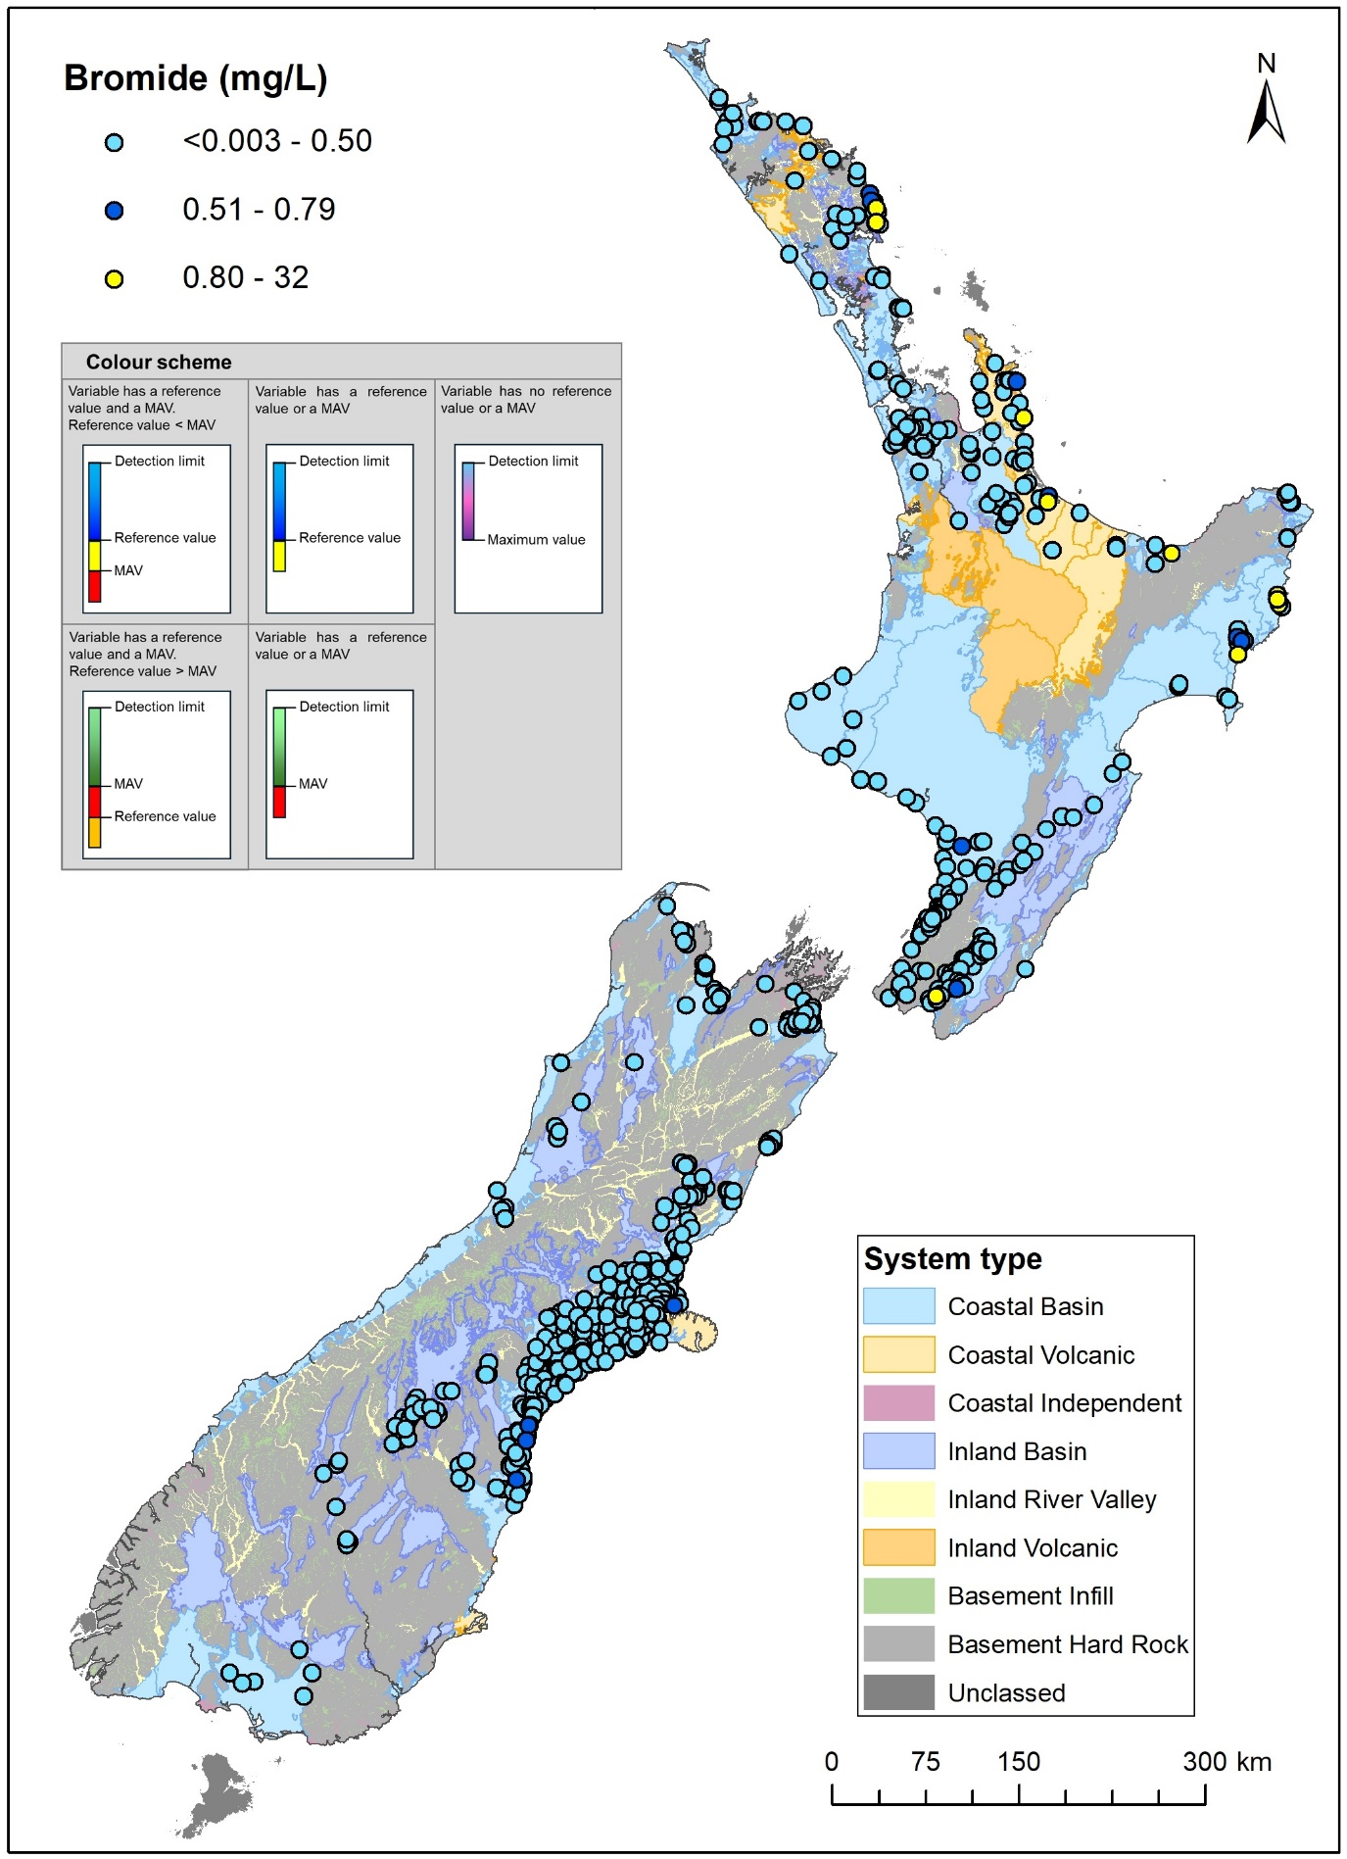
Figure A3.6 Median concentrations for bromide (mg/L) between 2019 and 2024.
In this map, the plotting order is consistent with increasing values (i.e. higher values plotted last/at the top).
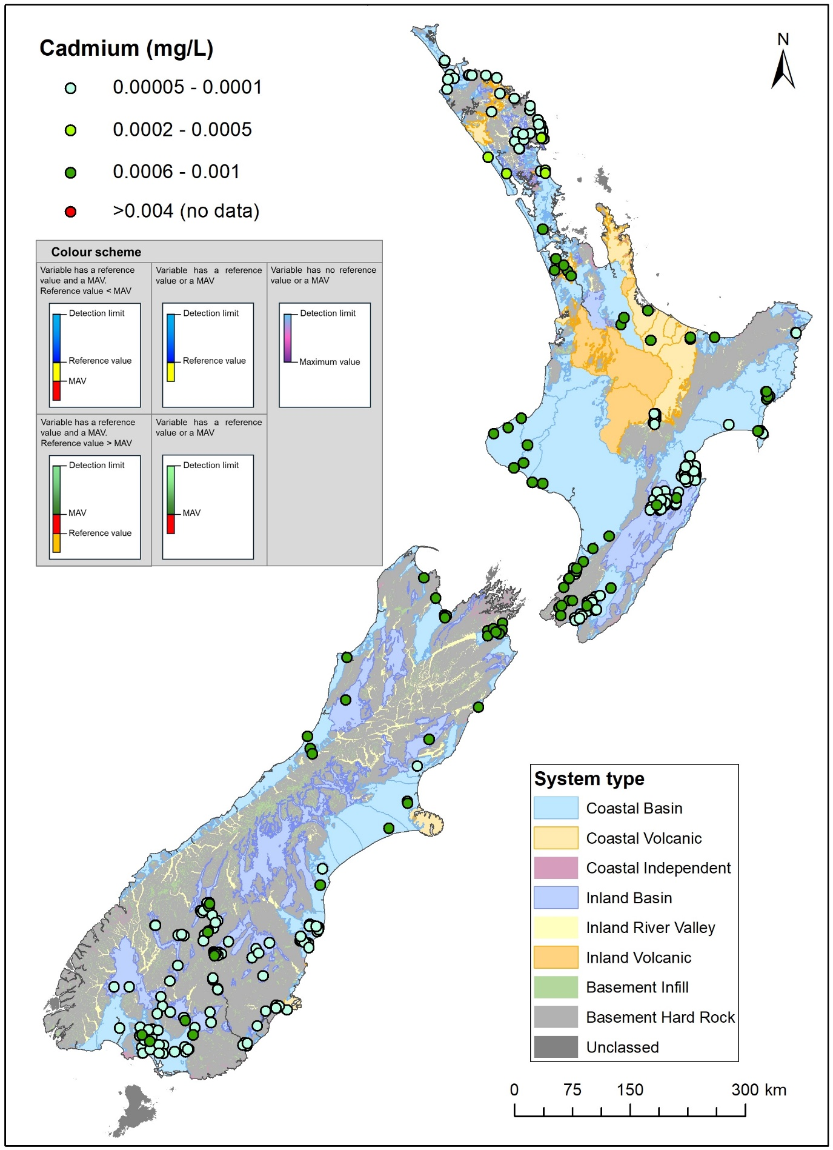
Figure A3.7 Median concentrations for cadmium (mg/L) between 2019 and 2024.
In this map, the plotting order is consistent with increasing values (i.e. higher values plotted last/at the top).
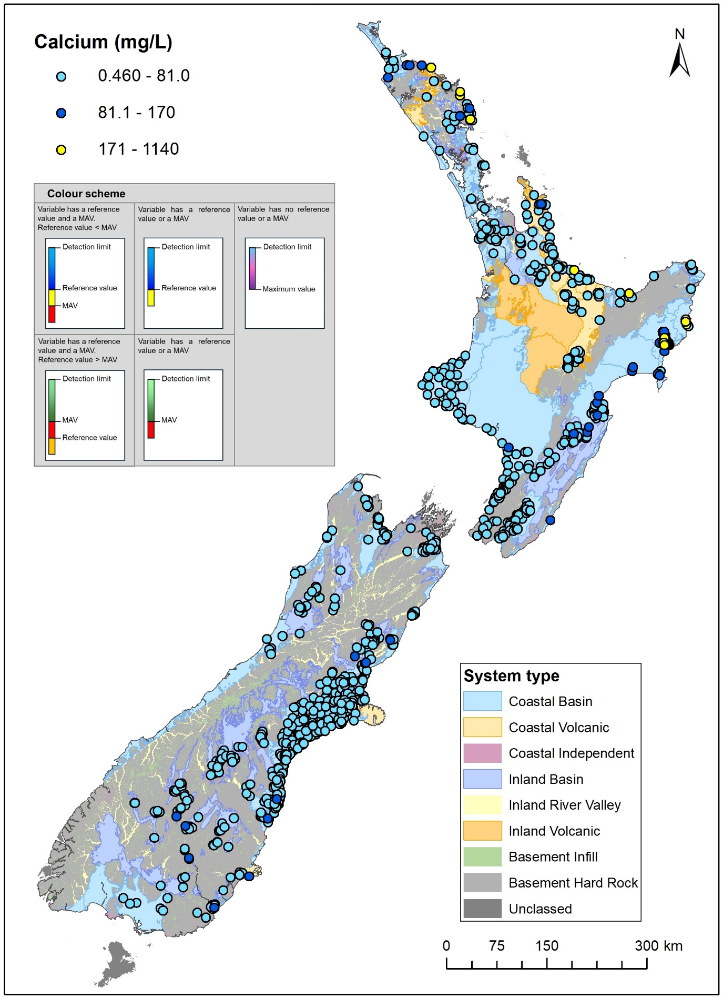
Figure A3.8 Median concentrations for calcium (mg/L) between 2019 and 2024.
In this map, the plotting order is consistent with increasing values (i.e. higher values plotted last/at the top).
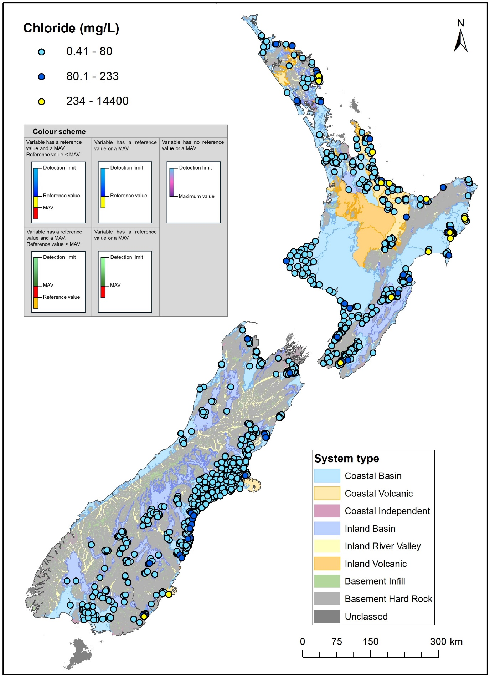
Figure A3.9 Median concentrations for chloride (mg/L) between 2019 and 2024.
In this map, the plotting order is consistent with increasing values (i.e. higher values plotted last/at the top).
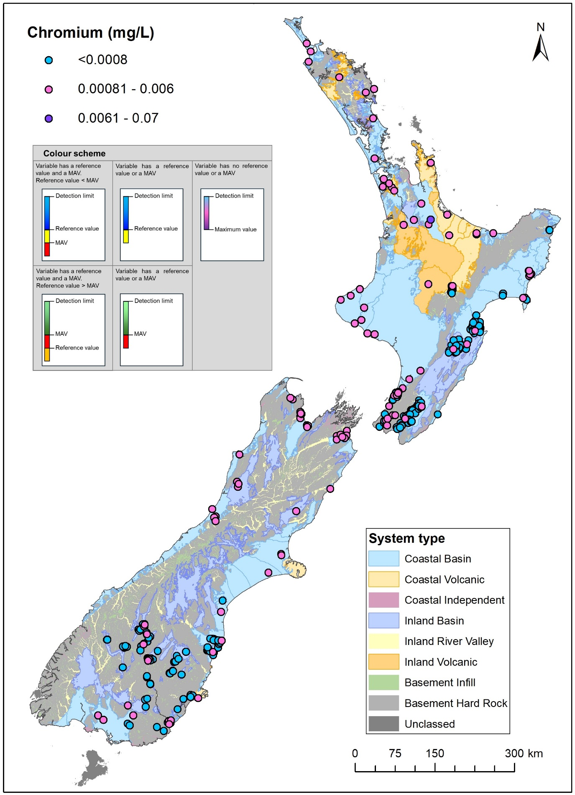
Figure A3.10 Median concentrations for chromium (mg/L) between 2019 and 2024.
In this map, the plotting order is consistent with increasing values (i.e. higher values plotted last/at the top).
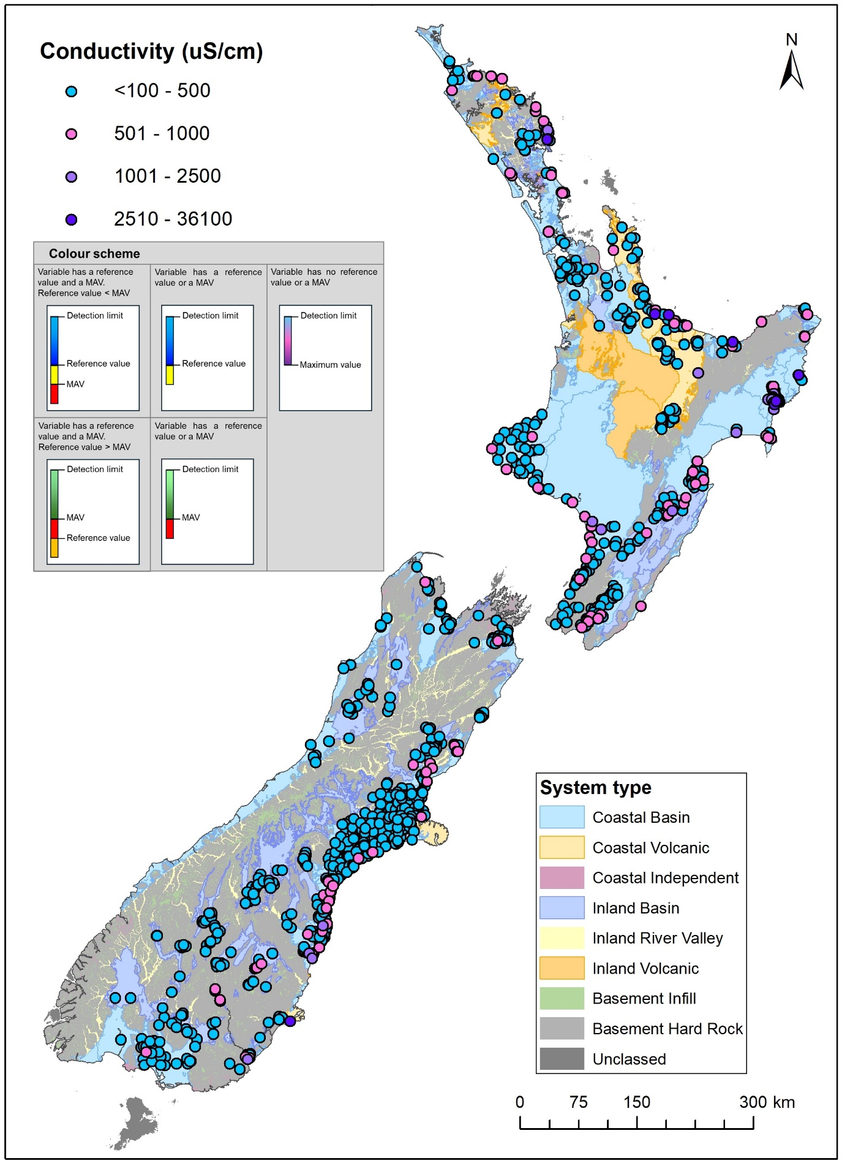
Figure A3.11 Median values for conductivity (µS/cm) between 2019 and 2024.
In this map the plotting order is consistent with increasing values (i.e. higher values plotted last/at the top).
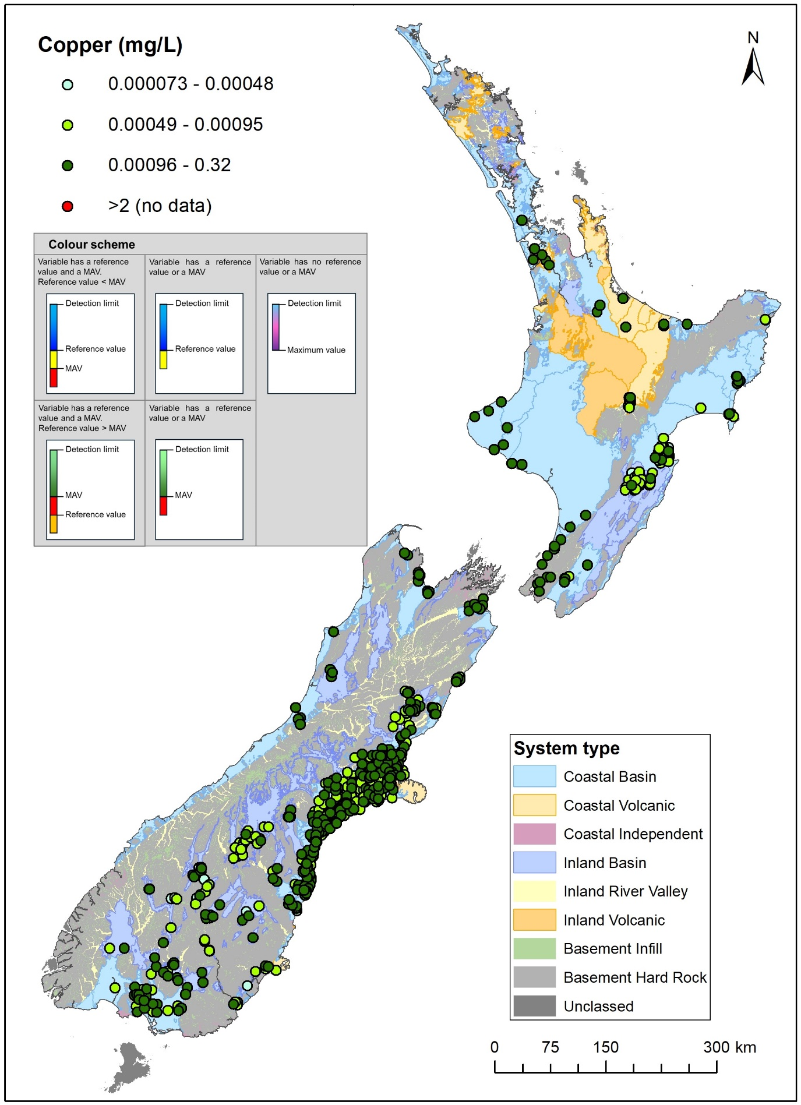
Figure A3.12 Median concentrations for copper (mg/L) between 2019 and 2024.
In this map, the plotting order is consistent with increasing values (i.e. higher values plotted last/at the top).
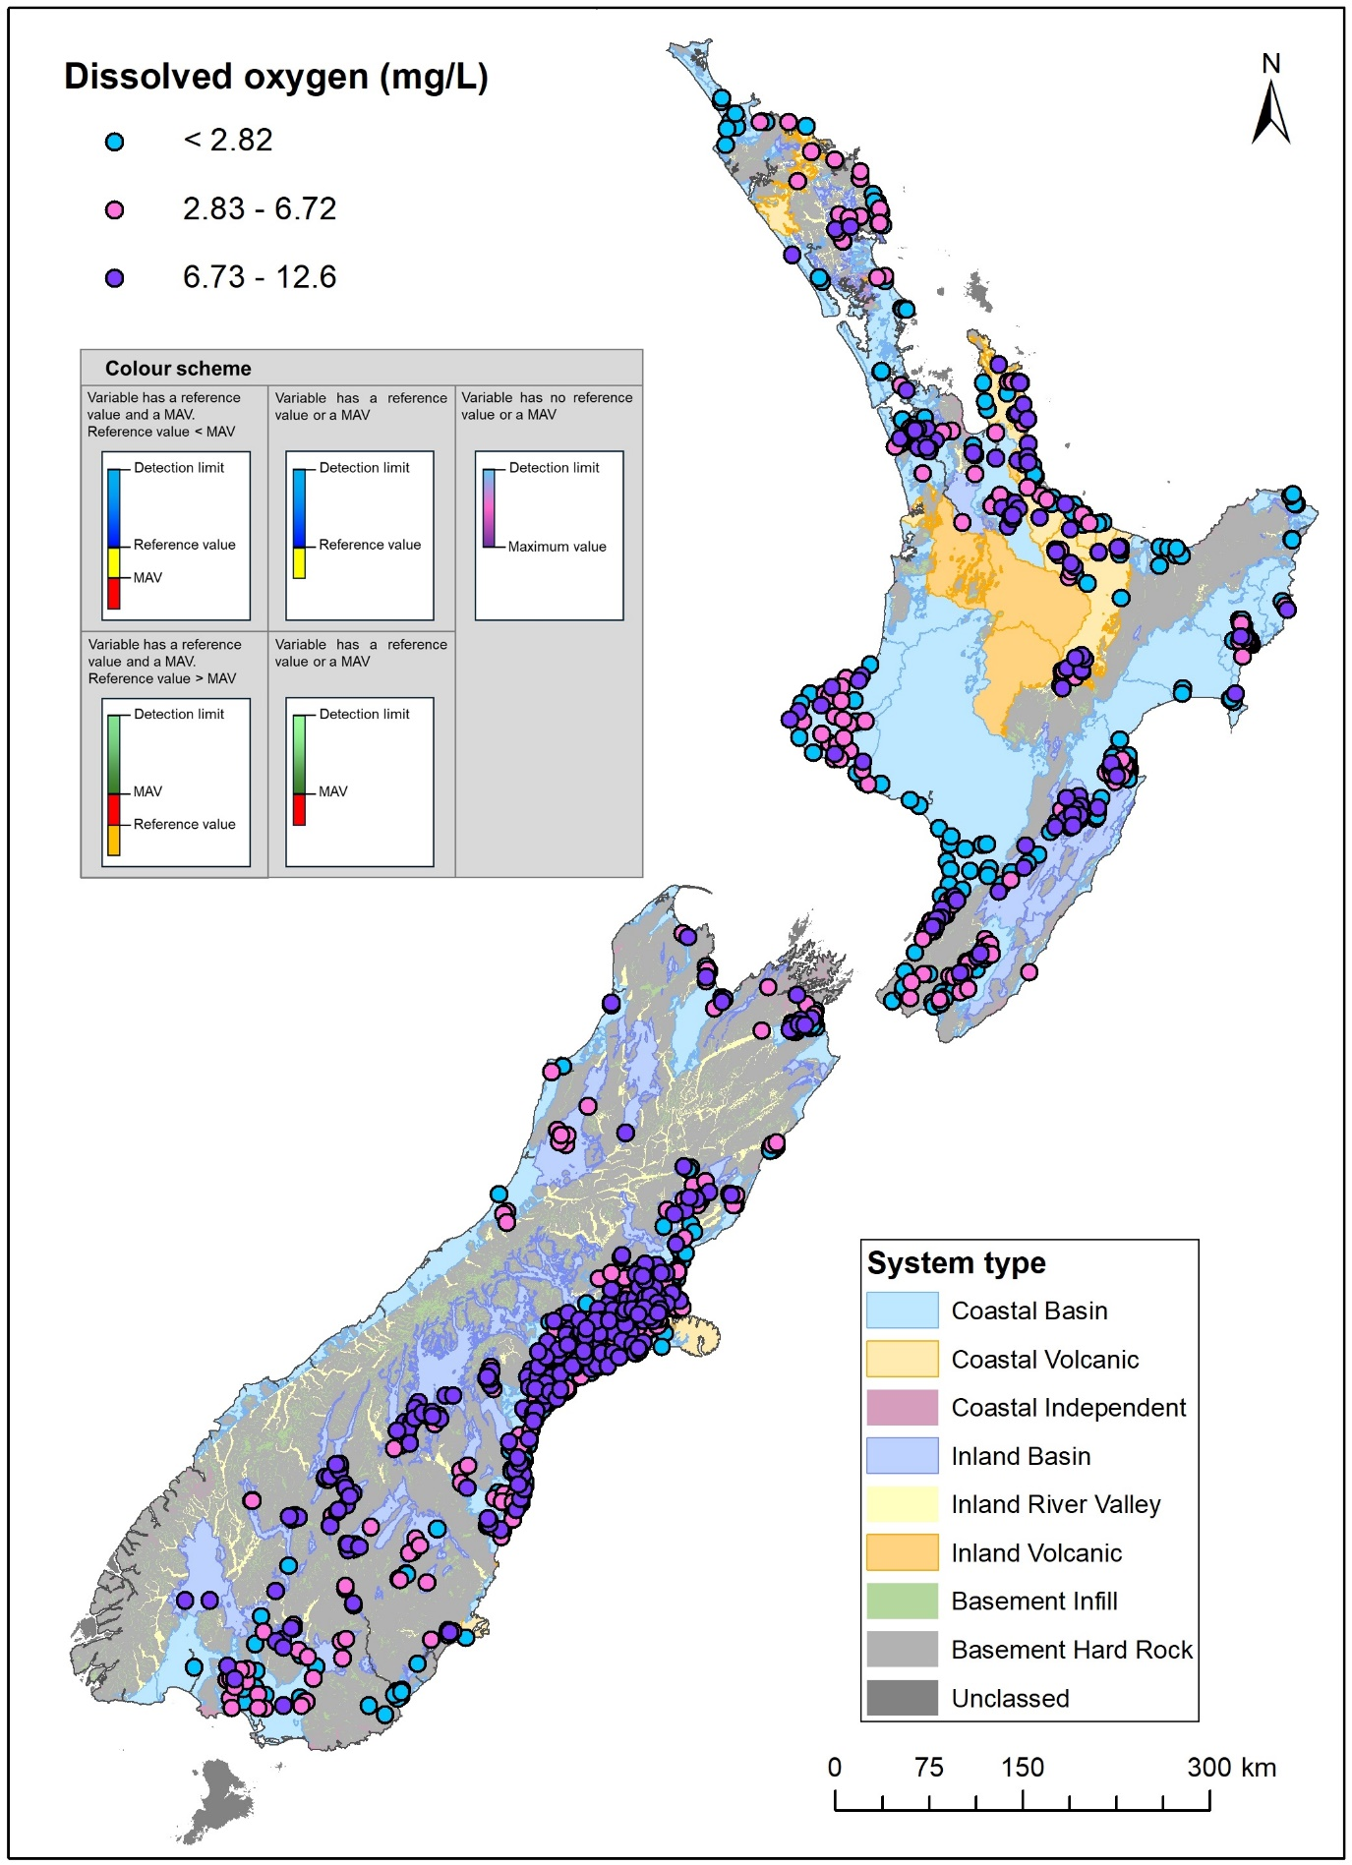
Figure A3.13 Median concentrations for dissolved oxygen (mg/L) between 2019 and 2024.
In this map, the plotting order is consistent with increasing values (i.e. higher values plotted last/at the top).
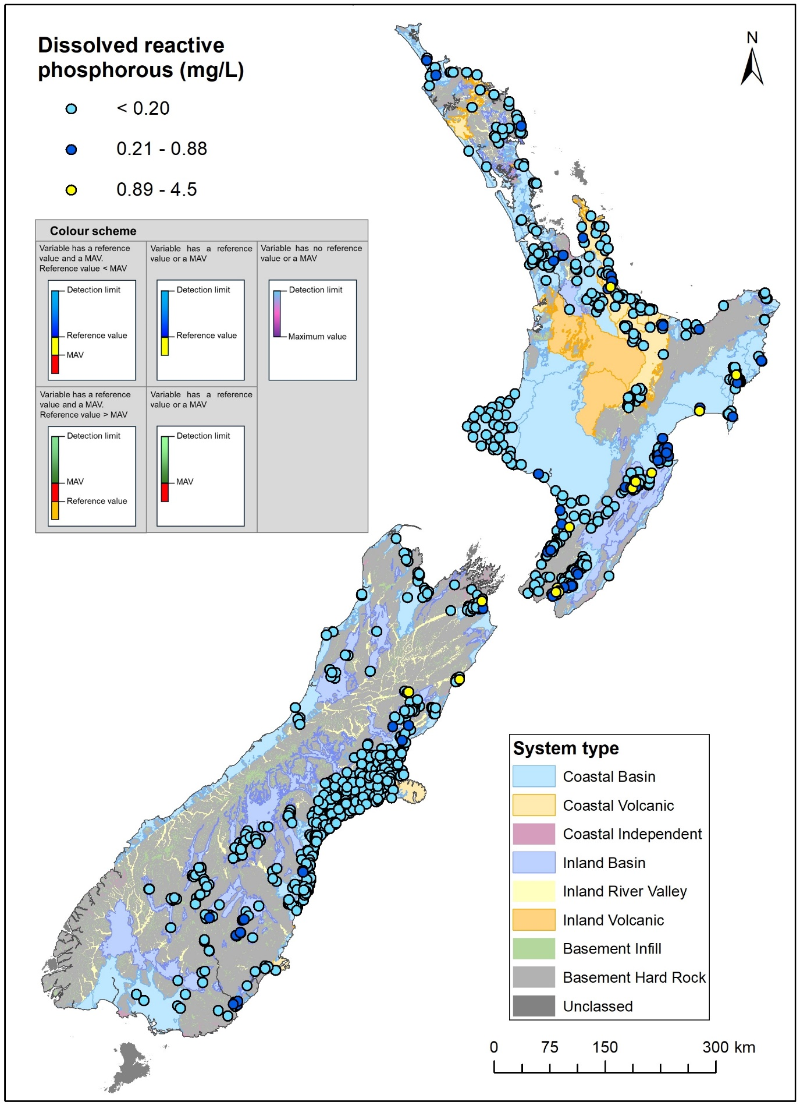
Figure A3.14 Median concentrations for dissolved reactive phosphorous (mg/L) between 2019 and 2024.
In this map the plotting order is consistent with increasing values (i.e. higher values plotted last/at the top).
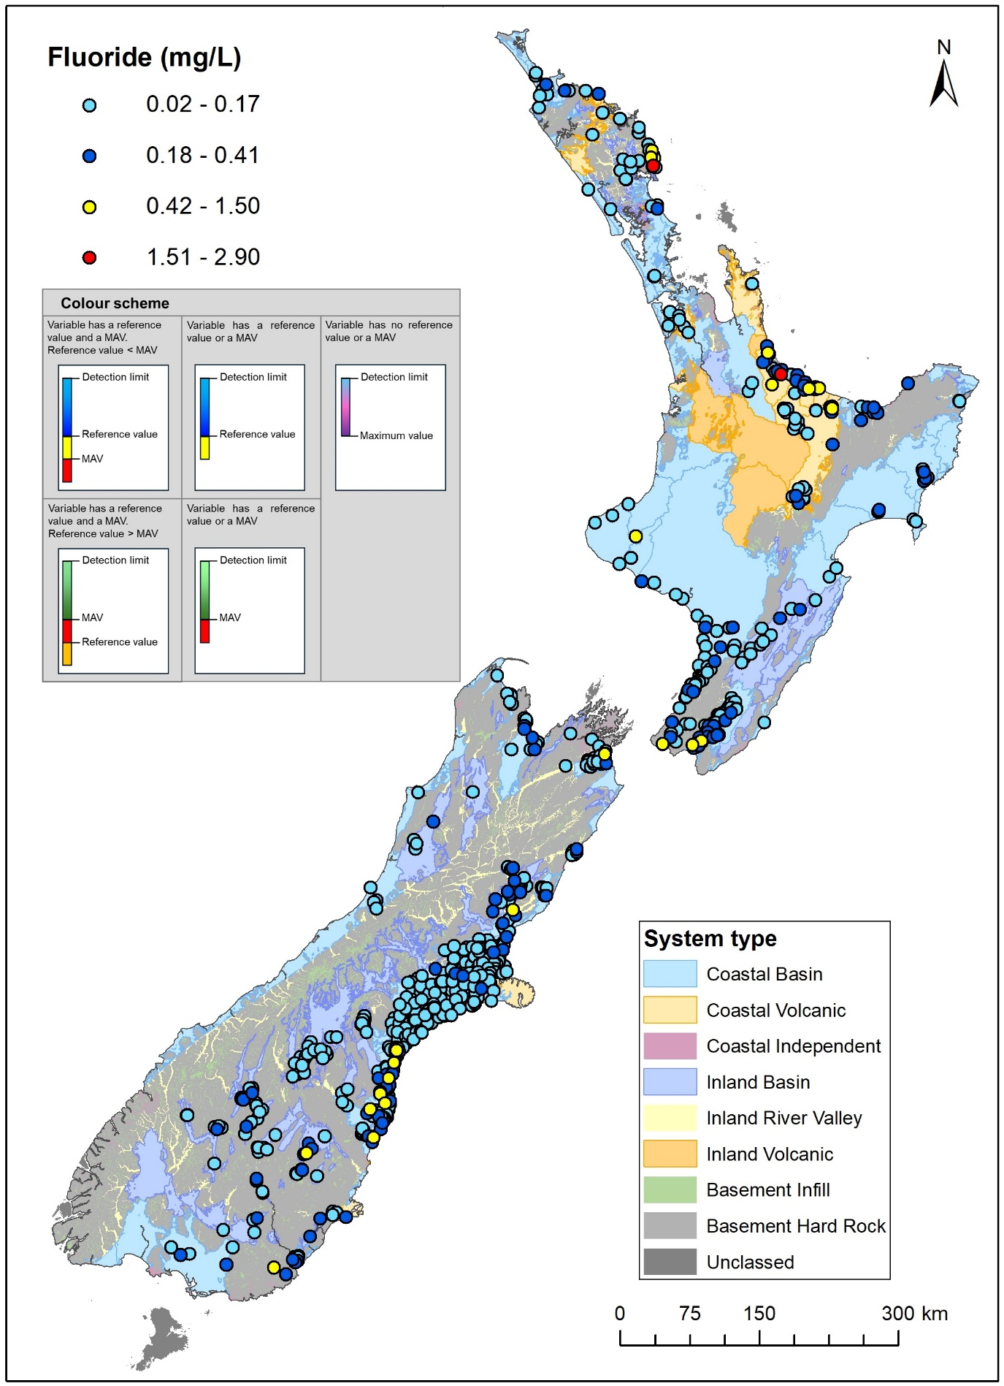
Figure A3.15 Median concentrations for fluoride (mg/L) between 2019 and 2024.
In this map, the plotting order is consistent with increasing values (i.e. higher values plotted last/at the top).
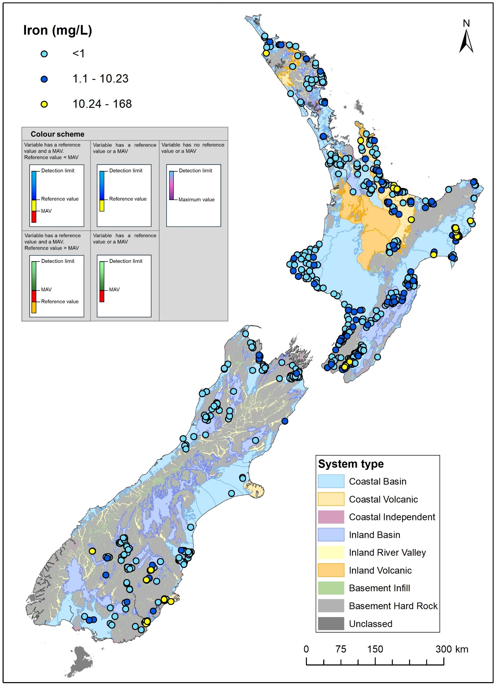
Figure A3.16 Median concentrations for iron (mg/L) between 2019 and 2024.
In this map, the plotting order is consistent with increasing values (i.e. higher values plotted last/at the top).
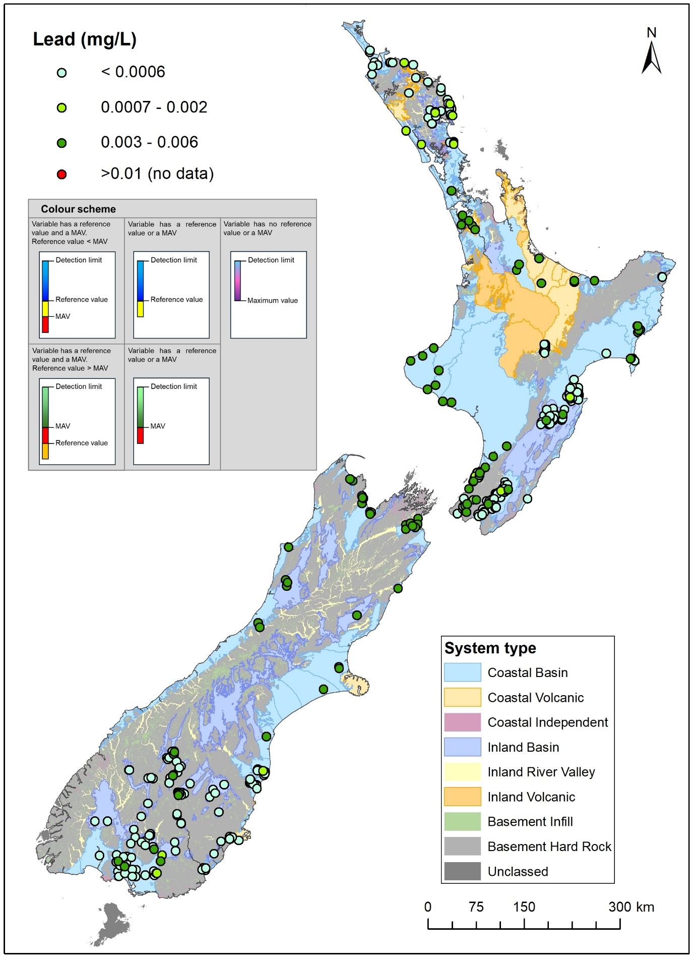
Figure A3.17 Median concentrations for lead (mg/L) between 2019 and 2024.
In this map, the plotting order is consistent with increasing values (i.e. higher values plotted last/at the top).
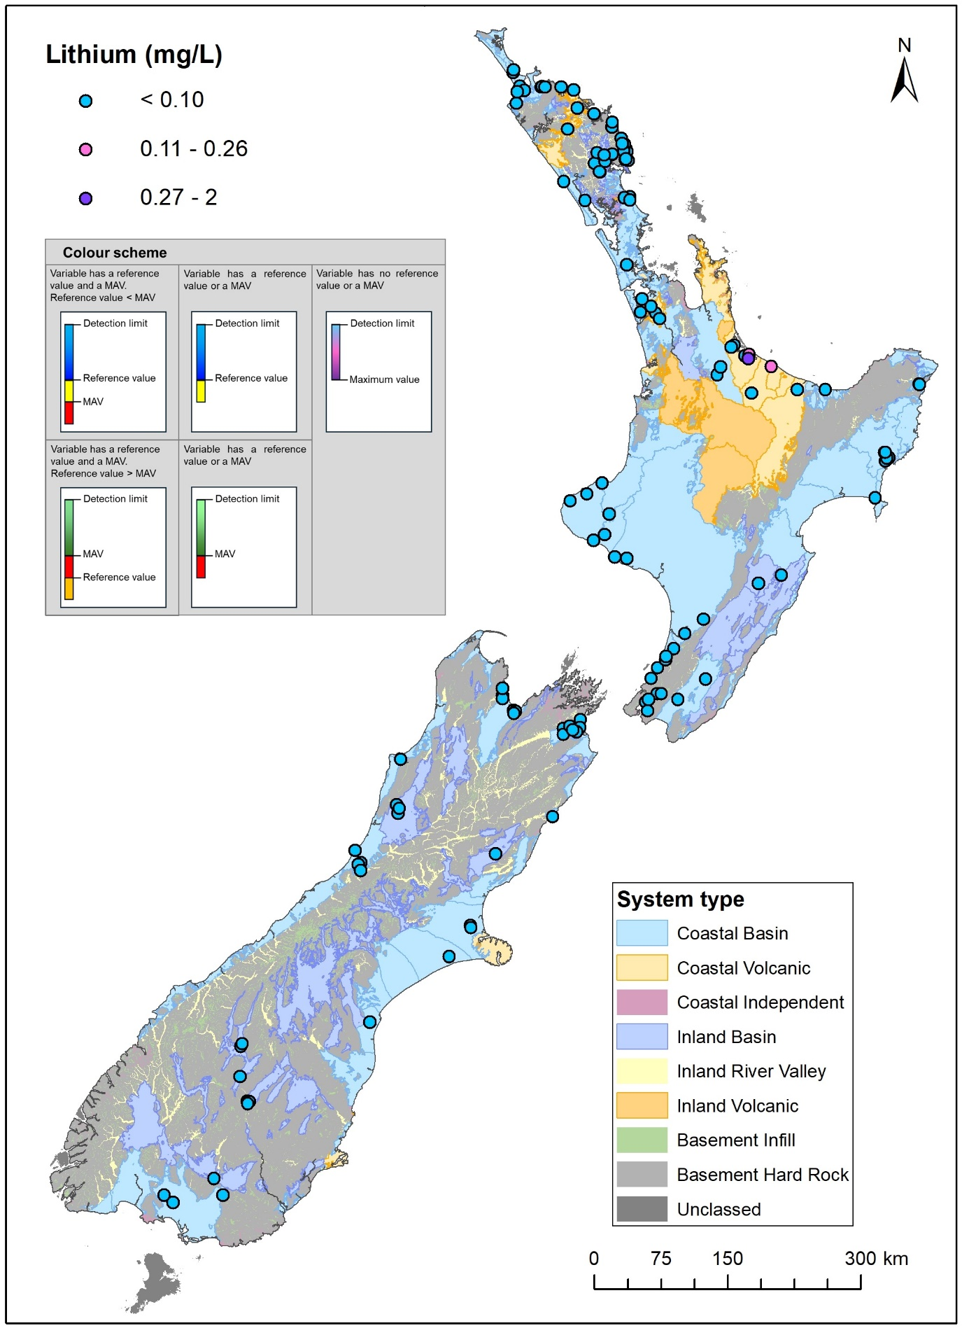
Figure A3.18 Median concentrations for lithium (mg/L) between 2019 and 2024.
In this map, the plotting order is consistent with increasing values (i.e. higher values plotted last/at the top).
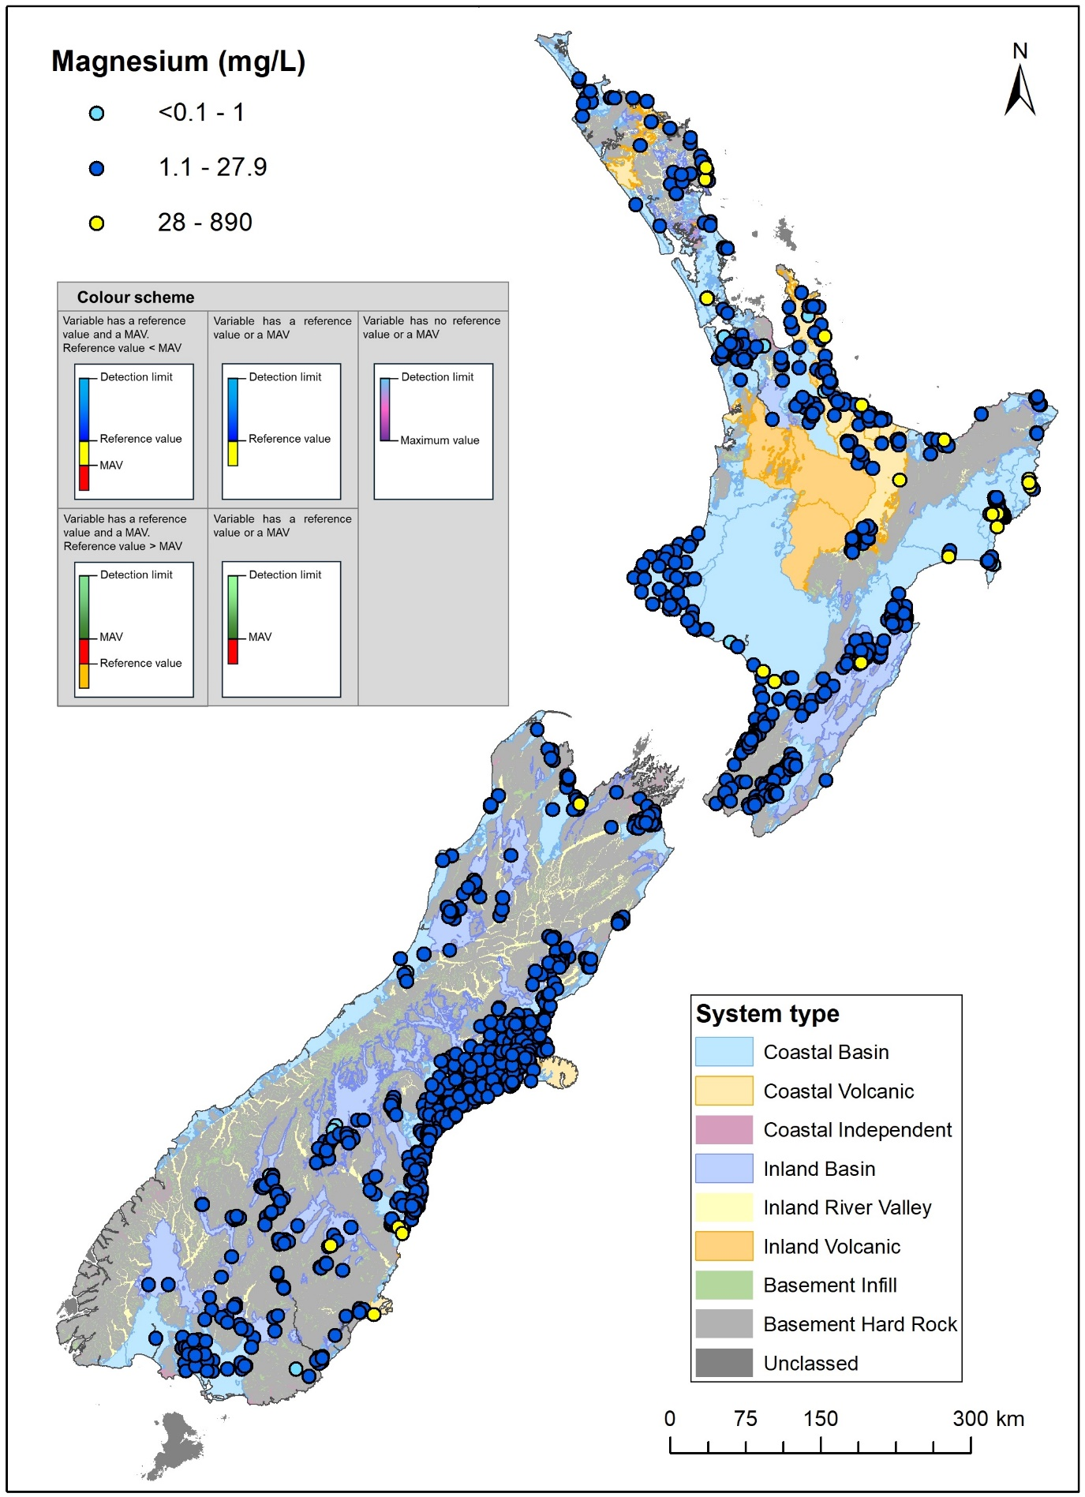
Figure A3.19 Median concentrations for magnesium (mg/L) between 2019 and 2024.
In this map, the plotting order is consistent with increasing values (i.e. higher values plotted last/at the top).
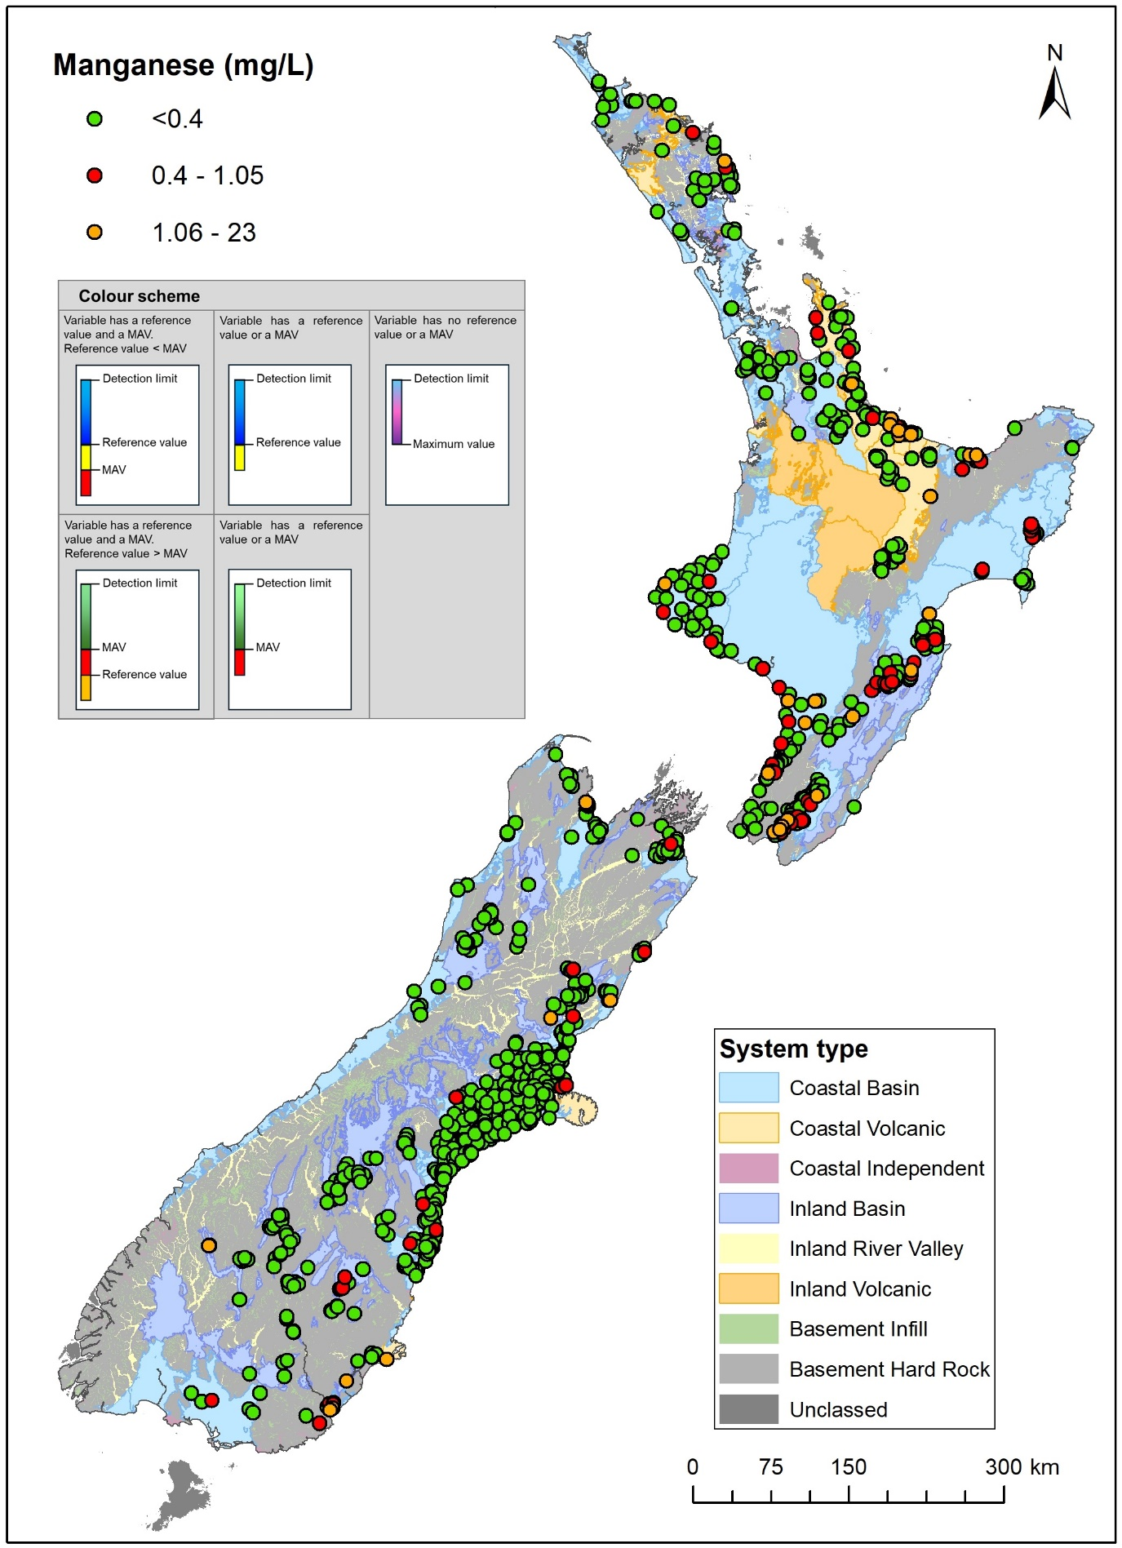
Figure A3.20 Median concentrations for manganese (mg/L) between 2019 and 2024.
In this map, the plotting order is consistent with increasing values (i.e. higher values plotted last/at the top).
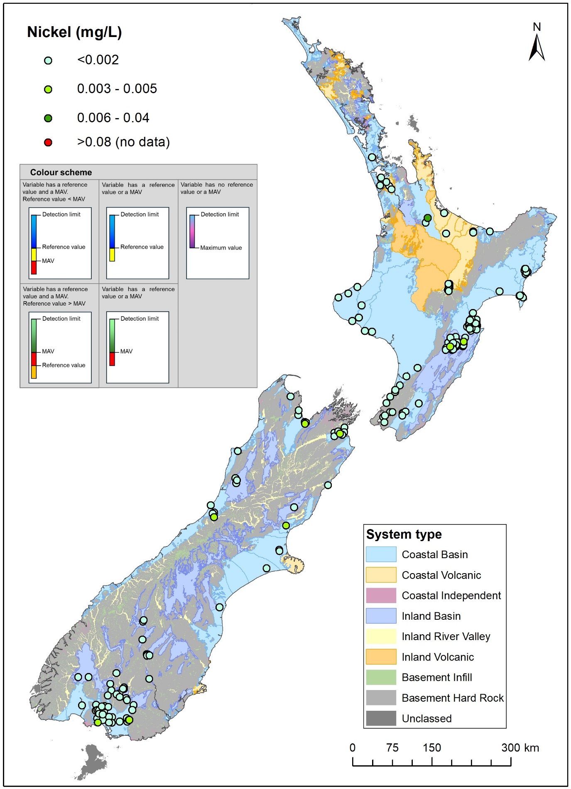
Figure A3.21 Median concentrations for nickel (mg/L) between 2019 and 2024.
In this map, the plotting order is consistent with increasing values (i.e. higher values plotted last/at the top).
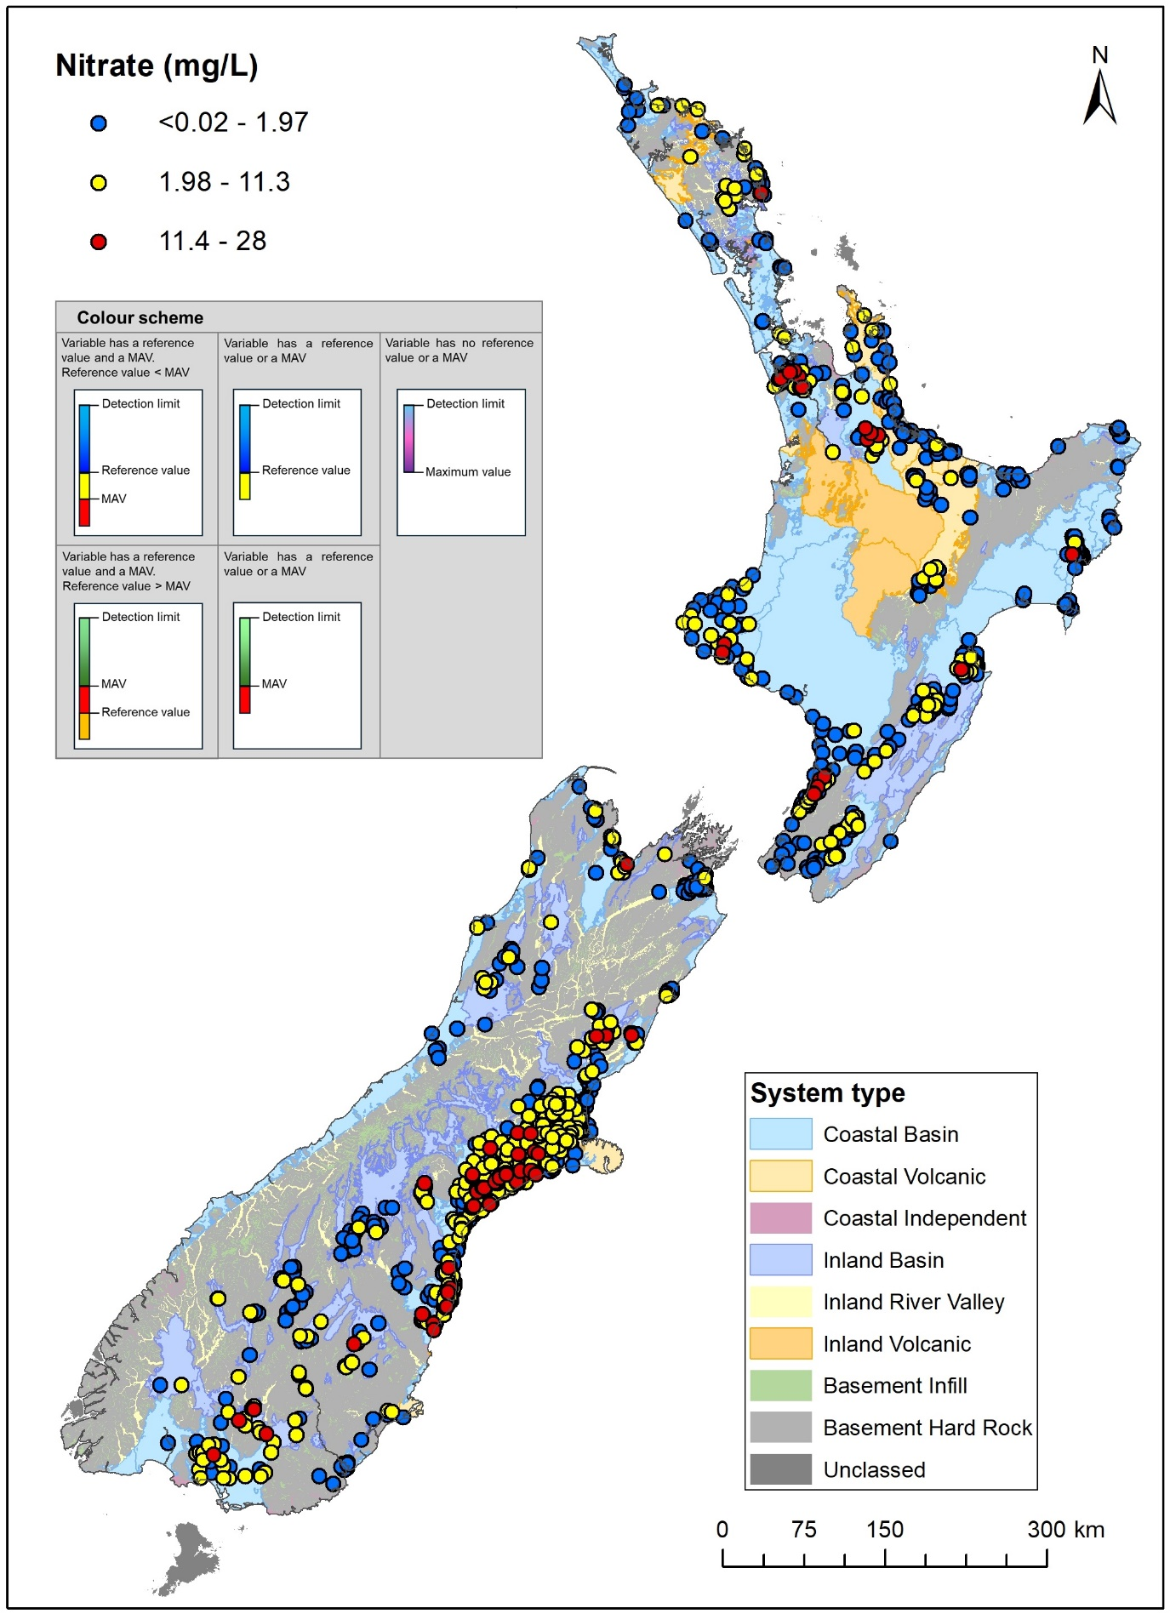
Figure A3.22 Median concentrations for nitrate (mg/L as N) between 2019 and 2024.
In this map, the plotting order is consistent with increasing values (i.e. higher values plotted last/at the top).

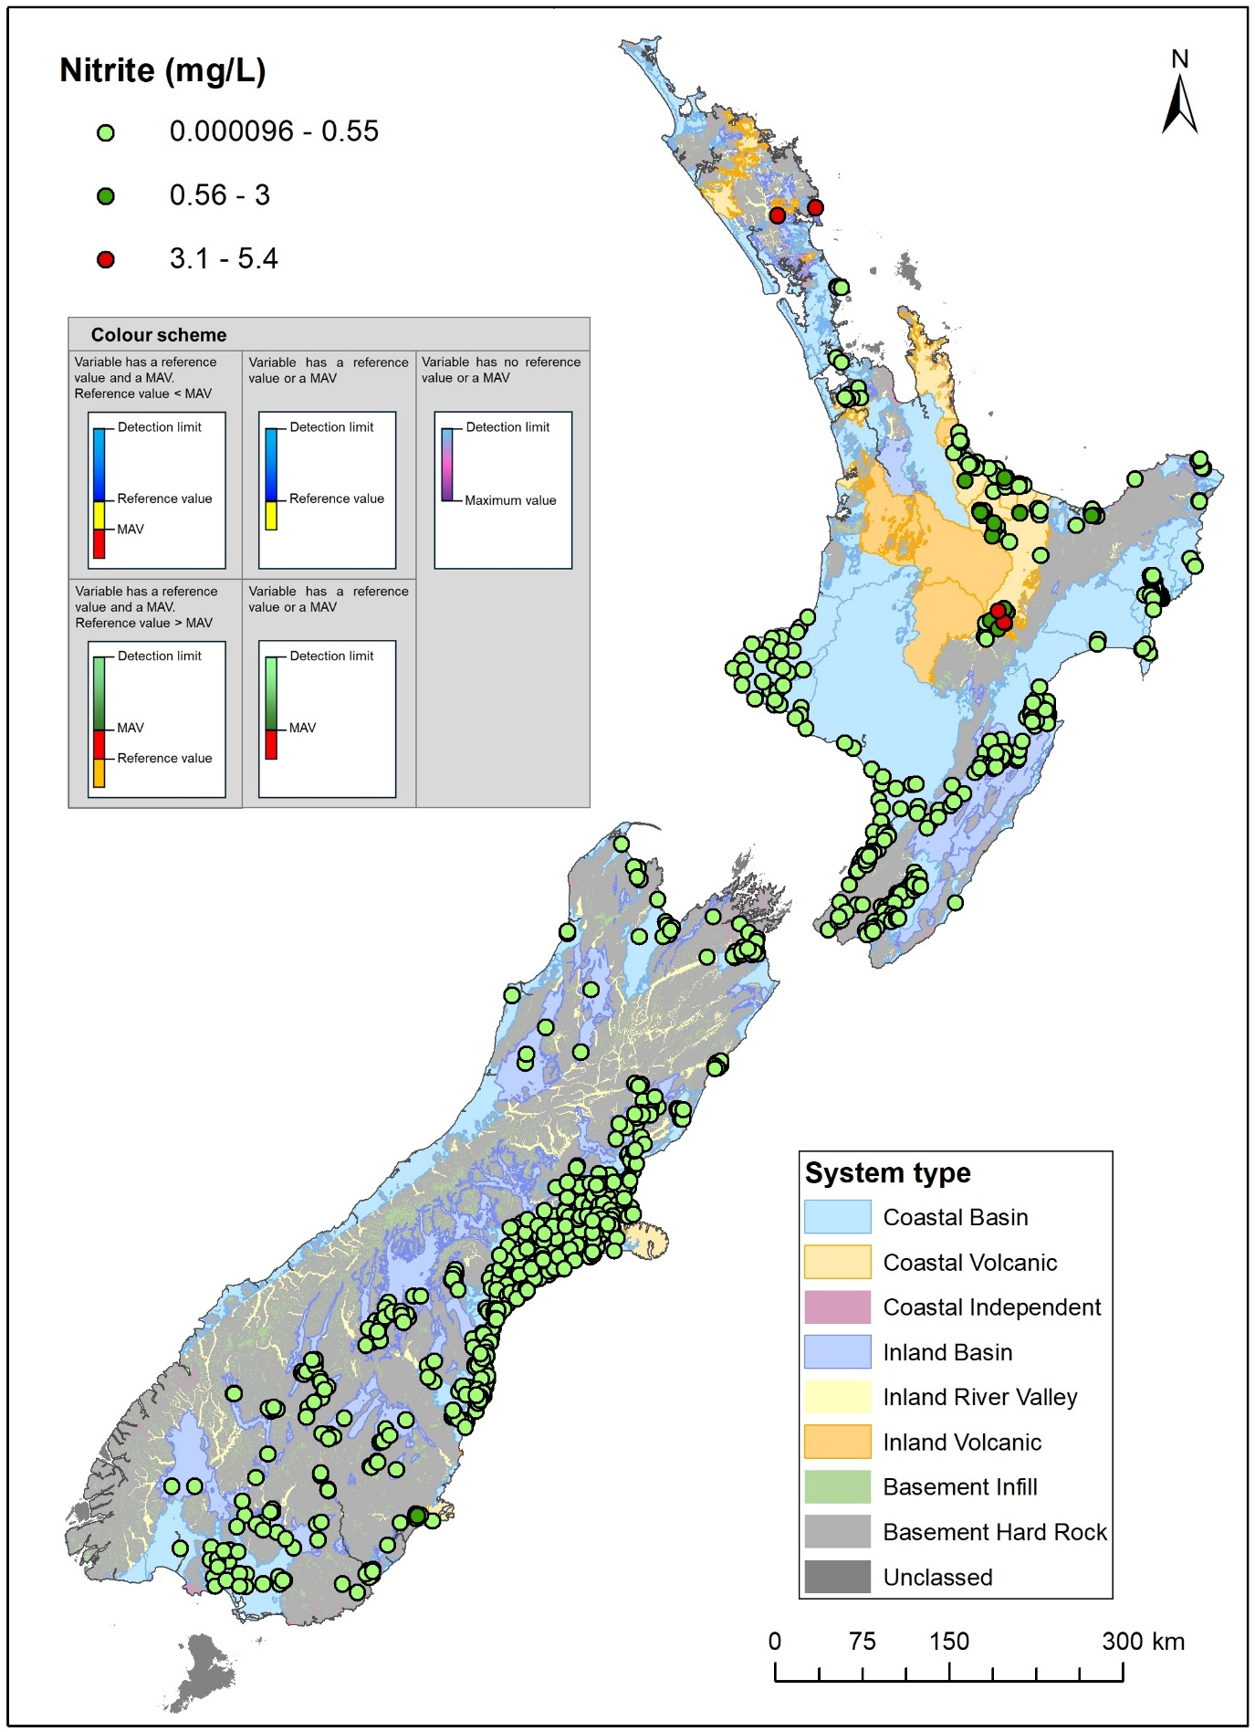
Figure A3.23 Median concentrations for nitrite (mg/L as N) between 2019 and 2024.
In this map, the plotting order is consistent with increasing values (i.e. higher values plotted last/at the top).
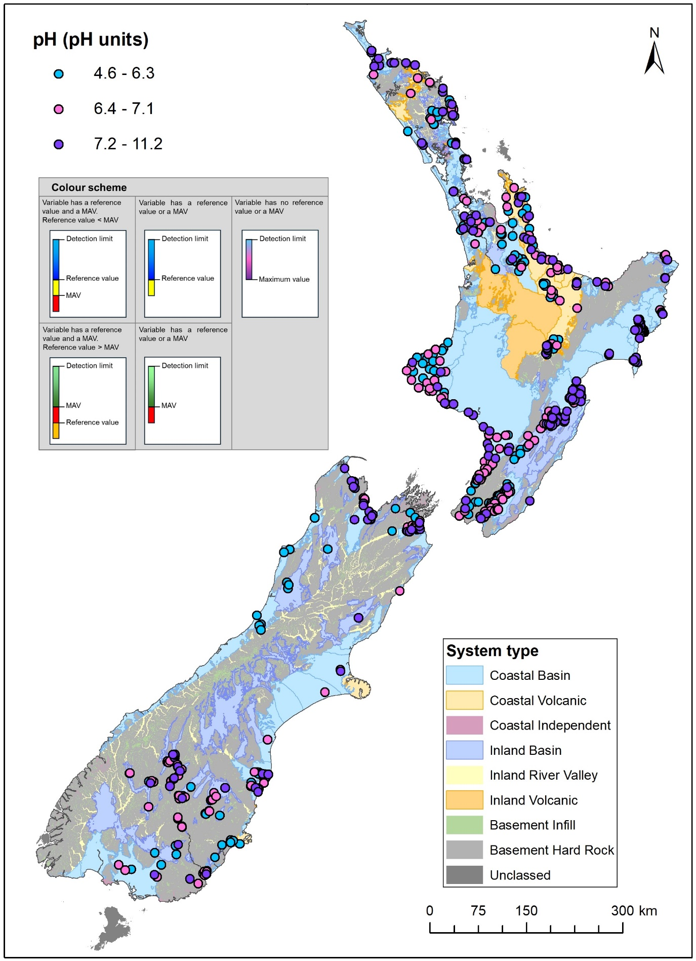
Figure A3.24 Median values for pH (pH units) between 2019 and 2024.
In this map, the plotting order is consistent with increasing values (i.e. higher values plotted last/at the top).
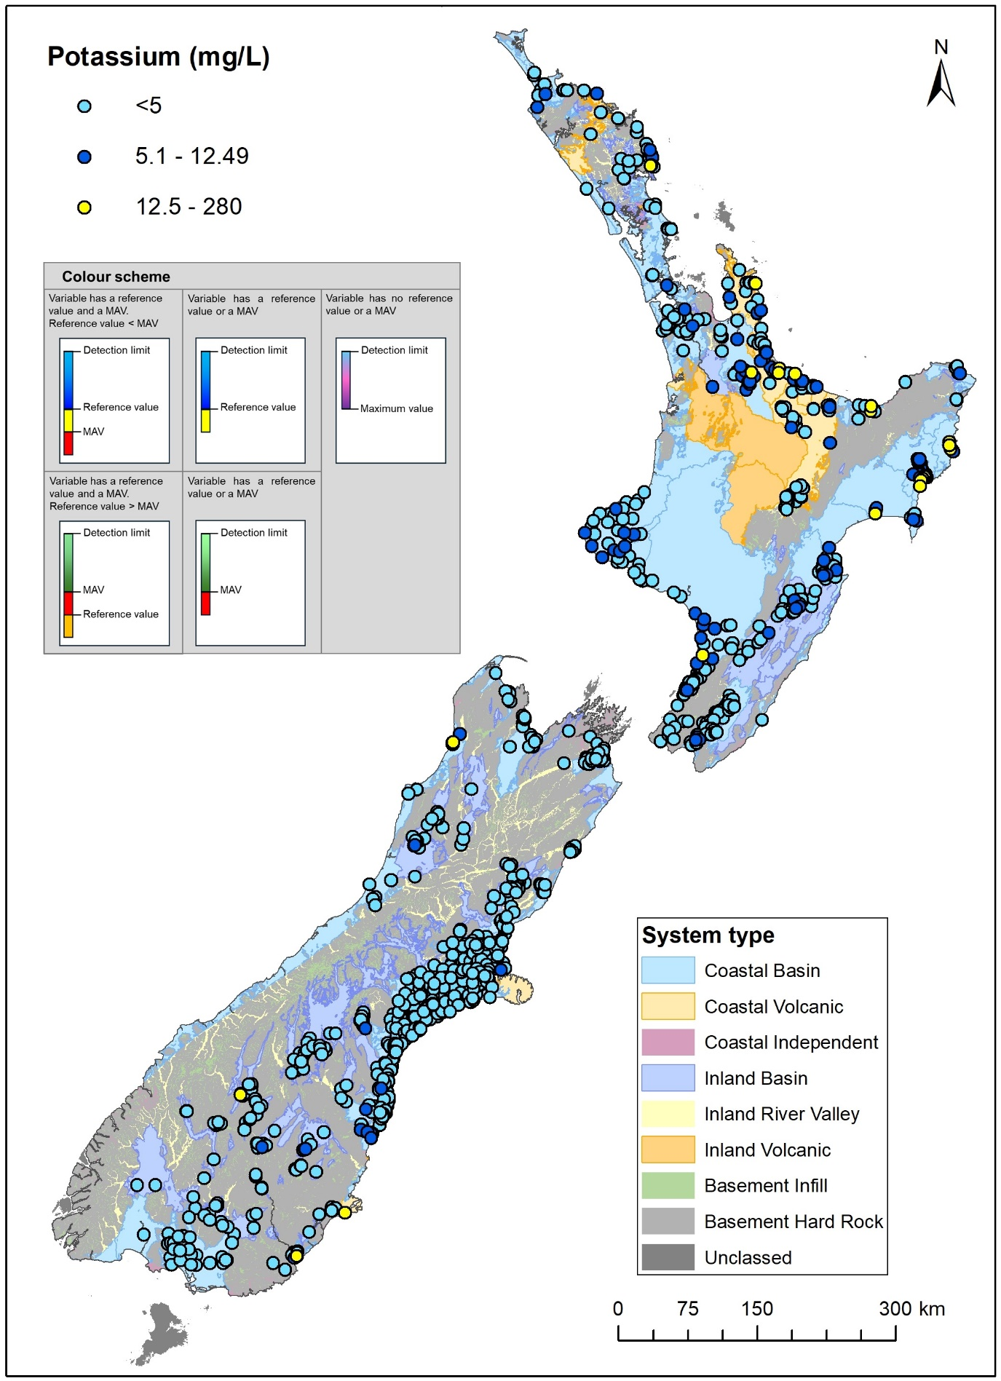
Figure A3.25 Median concentrations for potassium (mg/L) between 2019 and 2024.
In this map, the plotting order is consistent with increasing values (i.e. higher values plotted last/at the top).
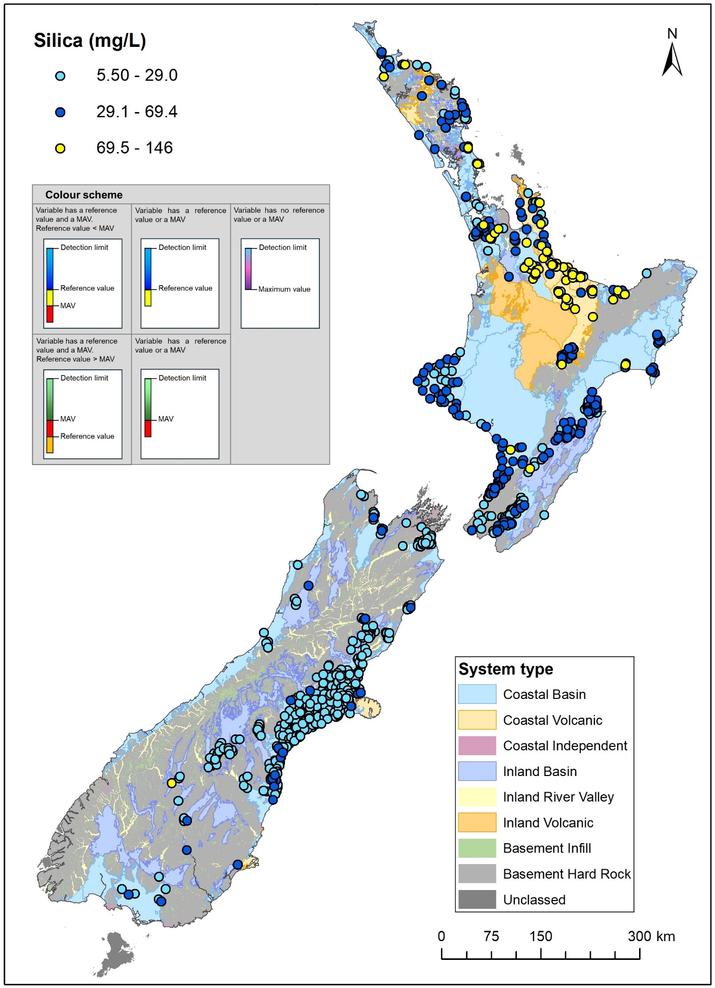
Figure A3.26 Median concentrations for silica (mg/L) between 2019 and 2024.
In this map, the plotting order is consistent with increasing values (i.e. higher values plotted last/at the top).
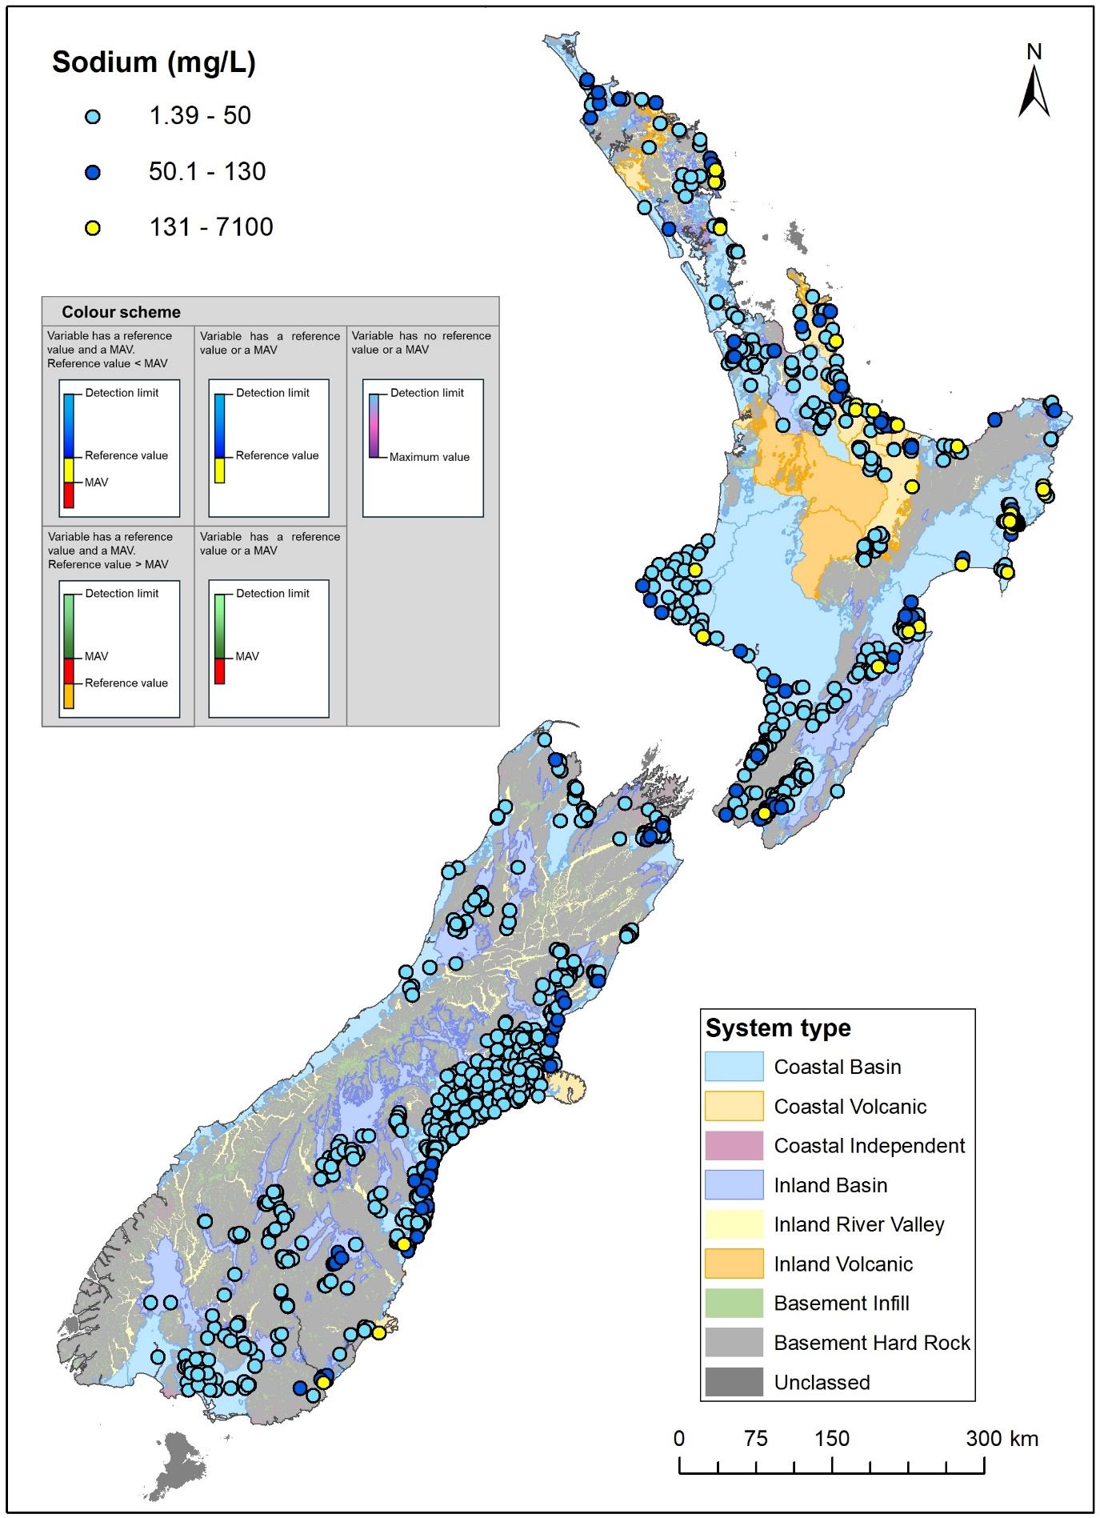
Figure A3.27 Median concentrations for sodium (mg/L) between 2019 and 2024.
In this map, the plotting order is consistent with increasing values (i.e. higher values plotted last/at the top).
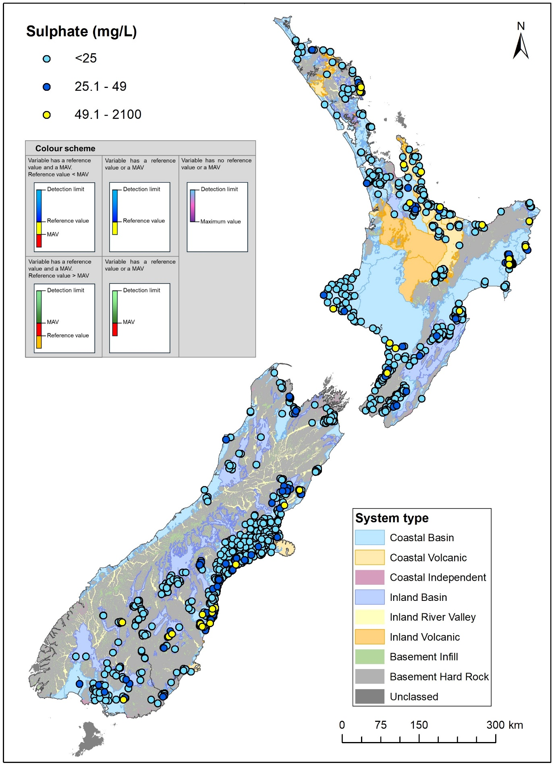
Figure A3.28 Median concentrations for sulphate (mg/L) between 2019 and 2024.
In this map, the plotting order is consistent with increasing values (i.e. higher values plotted last/at the top).
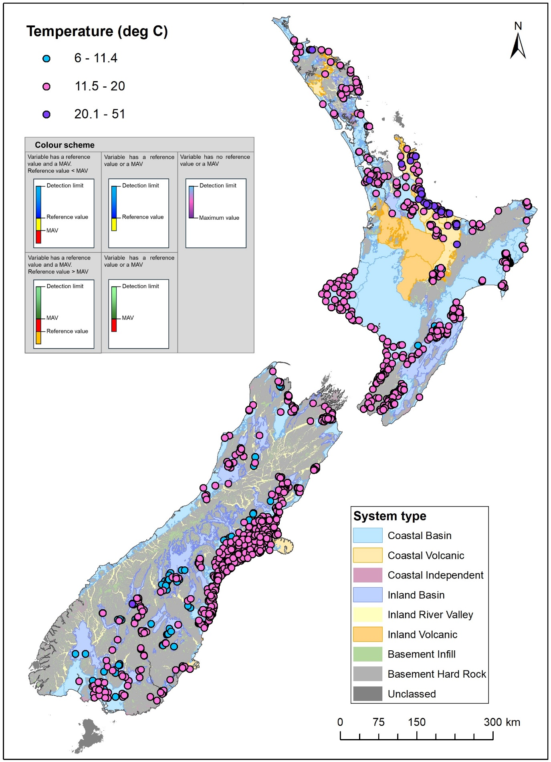
Figure A3.29 Median values for temperature (⁰C) between 2019 and 2024.
In this map, the plotting order is consistent with increasing values (i.e. higher values plotted last/at the top).
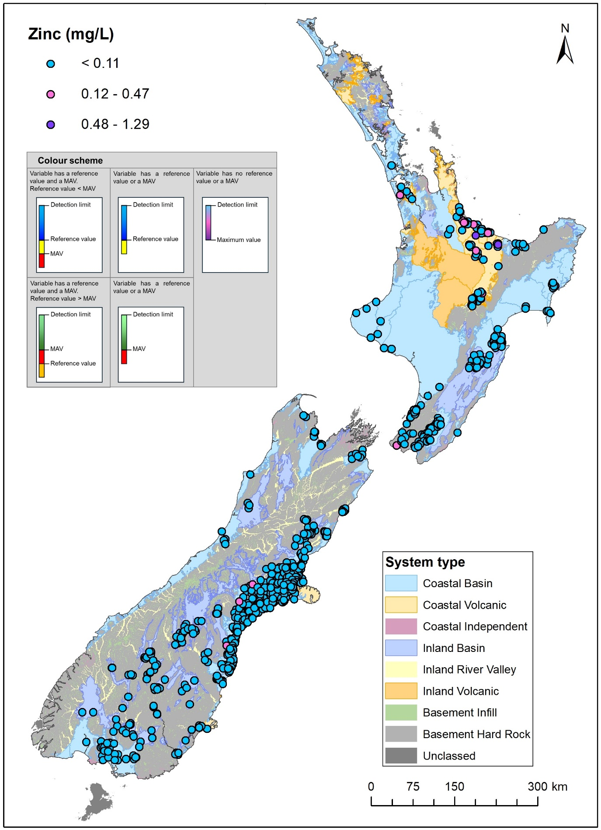
Figure A3.30 Median concentrations for zinc (mg/L) between 2019 and 2024.
In this map, the plotting order is consistent with increasing values (i.e. higher values plotted last/at the top).

