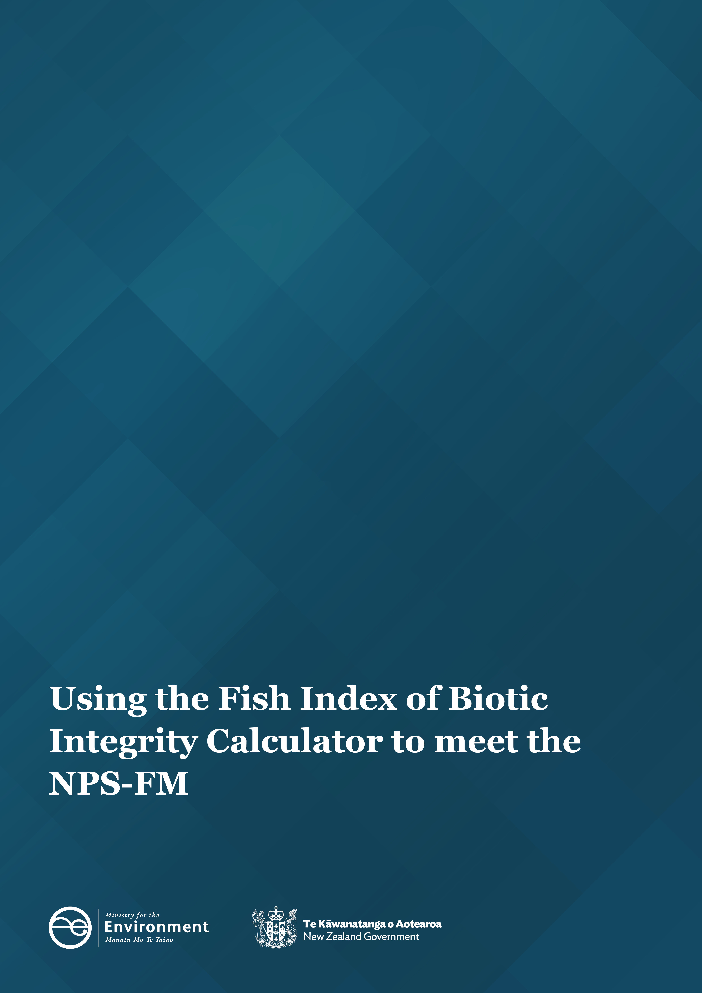

Disclaimer
The information in this publication is, according to the Ministry for the Environment’s best efforts, accurate at the time of publication. The Ministry will make every reasonable effort to keep it current and accurate. However, users of this publication are advised that:
- the information does not alter the laws of New Zealand, other official guidelines, or requirements
- it does not constitute legal advice, and users should take specific advice from qualified professionals before taking any action based on information in this publication
- the Ministry does not accept any responsibility or liability whatsoever whether in contract, tort, equity, or otherwise for any action taken as a result of reading, or reliance placed on this publication because of having read any part, or all, of the information in this publication or for any error, or inadequacy, deficiency, flaw in, or omission from the information in this publication
- all references to websites, organisations or people not within the Ministry are for convenience only and should not be taken as endorsement of those websites or information contained in those websites nor of organisations or people referred to.
Acknowledgements
This report was prepared by Dragonfly Data Science, with key contributions from Dr Adam Canning (James Cook University), Dr Mike Joy (Victoria University), Alba Jelicich (Ministry for the Environment) and Andy Hicks (Ministry for the Environment), Lillian Lu (Ministry for the Environment). The Fish IBI app was developed by Dr Ignatius Menzies, Michael Parkin, Dr Yvan Richard, Nikki Wilkinson, and Pep Zuijderwijk from Dragonfly Data Science.
The Ministry for the Environment supports and endorses the use of the Fish IBI Calculator to help councils to report on Fish IBI and track progress to meeting objectives and visions in Aotearoa New Zealand.
The Ministry would like to acknowledge the members of the Surface Water Integrated Management (SWIM) Fish group, for their involvement in testing and providing feedback on the Fish IBI Calculator.

This document may be cited as: Ministry for the Environment. 2023. Using the Fish Index of Biotic Integrity Calculator to meet the NPS-FM. Wellington: Ministry for the Environment.

Published in July 2023 by the
Ministry for the Environment
Manatū Mō Te Taiao
PO Box 10362, Wellington 6143, New Zealand
environment.govt.nz
ISBN: 978-1-991077-71-4
Publication number: ME 1782
© Crown copyright New Zealand 2023

Contents
Introduction 5
Who this information for 5
What is the Fish Index of Biotic Integrity? 5
The Fish IBI as an attribute in the NPS-FM 6
The Fish IBI Calculator 9
About the tool 9
How to use the Fish IBI Calculator 11
Appendix 1: Fish species from the New Zealand Freshwater Fish Database and their metric classification 25
Appendix 2: Maximum species richness lines 27
Appendix 3: Distribution of Fish IBI scores 28
Appendix 4: Species codes 29
References 33

Tables
Table 1: Fish species from the New Zealand Freshwater Fish Database (NZFFD) and their metric classification 25
Table 2: Maximum Species Richness Lines 27
Table 3: Distribution of fish IBI scores by region for deriving regional fish IBI bands from Canning and Joy, 2021 28
Table 4: Look up table mapping species codes from Joy and Death 2004 with contemporary species codes from the NZ Freshwater Fish Database 30

Figures
Figure 1: How to select a region for regional IBI analysis 11
Figure 2: Example input data for the Fish IBI Calculator 12
Figure 3. How to upload user data or select example demonstration data 12
Figure 4: How to match data headers to the mandatory fields in the Fish IBI Calculator 13
Figure 5: How to select a mandatory field when matching data headers in the Fish IBI Calculator 14
Figure 6: A selected mandatory field in the Fish IBI Calculator. 15
Figure 7: An applied mandatory field in the Fish IBI Calculator 15
Figure 8: A missing mandatory field 16
Figure 9: All mandatory fields in the data headers 17
Figure 10: How to filter issues shown in the ‘check input data’ stage 18
Figure 11: Resolved issues 19
Figure 12: An example set of results 20
Figure 13: How to download results and images 21
Figure 14: How to expand the interactive map 21
Figure 15: Tooltip with site-specific results 22
Figure 16: Example results displayed by national bands 23
Figure 17: Example results displayed by regional bands 23
Figure 18: Example results by site visit 24
Figure 19: Example results by site 24

Introduction

Who this information for
- Regional council or unitary authority staff who are responsible for identifying attributes and their baseline states, and to monitor and report on these over time.
- Treaty partners, consultants, contractors, community groups, citizen scientists and others who are working with their regional council to monitor and report on the health of local waterways.

What is the Fish Index of Biotic Integrity?
A Fish Index of Biotic Integrity (IBI) was developed for Aotearoa New Zealand in 2004 to account for the unique attributes of New Zealand freshwater fish, such as low species diversity and a high proportion of migratory species (Joy and Death, 2004).
A Fish IBI, based off Joy and Death (2004), was incorporated as an attribute in the National Policy Statement for Freshwater Management (NPS-FM) in 2020. The NPS-FM requires regional councils to:
- monitor fish communities to calculate IBI scores
- at a minimum, develop action plans to achieve target states determined in consultation with communities.
The Fish IBI is a multi-metric indicator that takes into account natural gradients in species richness (altitude and distance from sea). It is a composite index composed of six metrics of fish community composition:
- total number of native species
- number of native riffle-dwelling species
- number of native benthic pool-dwelling species
- number of native pelagic species
- number of intolerant or sensitive native species
- proportion of non-native species.

The Fish IBI as an attribute in the NPS-FM

The purpose of the NPS-FM
The NPS-FM establishes the regulatory framework for the long-term management and improvement of freshwater in Aotearoa. Regional councils implement the objectives and policies of the NPS-FM through regional plans, including Fish IBI action plans, that seek to improve the ecosystem health of our waterways.
The NPS-FM requires that regional councils monitor the state of freshwater. The regional council must analyse trends and take action if the current plan settings are not achieving the environmental outcome set for each value (Clause 3.9) and ultimately the long-term vision set.
Subpart 2 of the NPS-FM provides the overarching objective relevant to all compulsory attributes (including Fish IBI) required by the National Objectives Framework. Subpart 3 of the NPS-FM (Clause 3.30) relates to the assessing and reporting requirements of all monitoring data obtained by regional councils.
For further information on Subpart 3 of the NPS-FM see the Ministry for the Environment guidance on Implementing the National Objective Framework.

How the national Fish IBI scores are calculated
Fish IBI scores and the associated A–D bands in the NPS-FM attribute table were calculated in accordance with the Joy and Death (2004) methods.
Fish observations at each site visit are converted to an IBI score by summing a score for each of the six metrics above. Final scores can range from 0 to 60 for each site visit, with higher scores indicating a healthier native fish community. Site visits where no fish species were observed are given a ‘No species’ score. Joy and Death (2004) and the associated excel file has a table of common species codes from the New Zealand Freshwater Fish Database (NZFFD) with a classification of each species for each of the six metrics above (see appendix 1).
Each of the first five metrics were scored using two sub-metrics representing potential species richness, relative to a) elevation and b) distance from the sea. The Fish IBI Calculator uses the same maximum species richness lines (MSRL) derived by Joy and Death (2004) to indicate potential species richness (see appendix 2). A site’s richness for a given metric was compared to the metric’s MSRL for a given elevation and the corresponding MSRL for a given distance from the coast. A site scored 5 points when it was greater than 66 per cent of the MSRL, 3 points when between 33 per cent and 66 per cent of the MSRL inclusive, and 1 point for below 33 per cent.
Metric 6 was scored based on the proportion of native species. The maximum score of 5 was given to sites at which native species accounted for greater than 66 per cent of all species observed. A score of 3 was assigned to sites at which native species accounted for between 33 and 66 per cent of all species observed. The minimum score of 1 was assigned to sites at which native species accounted for less than 33 per cent of the total number of observed species. The score from metric 6 was doubled to provide a score of between 2 to 10 for each site (as this metric was assumed to not be associated with elevation or distance to sea).
A final score (out of 60) for each site visit can then be converted to either a national NPS-FM attribute band (see page 55 of the National Policy Statement for Freshwater Management 2020); or a regional score using the per-region quartiles from Canning and Joy, 2021 (see appendix 3).

How the A–D band thresholds were generated in the NPS-FM
The thresholds were derived from the quartiles of the full dataset of IBIs available from the New Zealand Freshwater Fish Database (NZFFD), collating surveys conducted between 2010 and 2017. This means that grades are presented as equal quantiles, such that sites falling in the A-band fell within the top 25 per cent nationally, B-band in the highest 50 per cent nationally, C-band in the top 75 per cent nationally, and D-band in the lowest 25 per cent. With reference to these grades, the NPS-FM does not mandate a bottom line. Grades provide an approximation of state and are by no means definitive. Instead, councils have full discretion to set their own target states so long as the current state is maintained (or improved). Any new observations are compared to the thresholds that were derived from the original dataset.

Monitoring sites
Each freshwater management unit (FMU) should have one or more monitoring sites for Fish IBI. Councils are required to monitor and report on the achievement of long-term visions and target attribute states (TASs), so will need monitoring sites to do this. The sites must be representative of all or part of the FMU.
Fish IBI is one of the attributes that must be managed to meet the ‘aquatic life’ component of ecosystem health. Ecosystem health is a compulsory value of the NPS-FM.
The ecological values and fish communities within an FMU will vary in different catchments and as such, it will not be practical or possible to monitor every drop of water in a region. The Freshwater NPS-FM requires selective monitoring to be undertaken:
- at sites the council has identified which represent the water environment for that FMU or part thereof;
- and/or are representative of one or more primary contact sites in the FMU.

Identifying monitoring sites in an FMU
When selecting representative monitoring sites, a council, among other factors, should consider:
- the freshwater values and objectives that have been set (ie, ecosystem health, amenity or recreational values, mahinga kai), as this will help determine the appropriate location
- ease of access
- efficiency – it will be more efficient to monitor multiple attributes at each monitoring site (noting that multiple monitoring sites may be required depending on the complexity of the FMU).

Reporting on Fish IBI data where there is more than one monitoring site in an FMU
Reporting on the FMU’s overall (or average) attribute state will not always provide an accurate assessment of ecosystem health. This will be true in the case where councils already have more than one monitoring site established and/or have determined the need for multiple monitoring sites for the purpose of monitoring a single attribute within a given FMU. Averaging across monitoring sites may overlook a problem at one or more of the sites.
To assess progress in this scenario, councils will need to set a TAS for each monitoring site. TASs can be based on the baseline state or better, depending on objectives and long-term visions determined alongside communities and tangata whenua. The purpose of setting a TAS for each monitoring site is so you can monitor progress as to whether your policies or interventions (ie, rules/action plan) are having an effect and achieving the TAS over time.
The policies or intervention(s) should be targeted at the most stringent TAS in the FMU, noting that an action plan can be tailored towards a finer scale than rules generally provide for. Baseline states must be established as well as a timeline to achieve the target state for each site (if improvement, rather than maintaining, is required).
For example, if a council has identified four key Fish IBI monitoring sites in an FMU, and they are graded A, B, C and D, respectively, then the FMU would need to have four discrete target attribute states. The action plan and/or rules (on resource use and water takes) and consent conditions should, where appropriate (based on costs and effort), be tailored towards achieving the most limiting TAS.
For further information on FMUs, scale for target attribute states and limits see the NOF guidance ‘Clause 3.8: Identifying FMUs and special sites and features’. This guide also provides more information on ‘Clause 3.19: Assessing trends’ and ‘Clause 3.20: Responding to degradation’.

The Fish IBI Calculator

About the tool
The Fish IBI Calculator was developed to assist practitioners in calculating and reporting Fish IBI scores at a national and regional level. This document contains guidance for users of the Fish IBI calculator.
The Fish IBI Calculator was derived using the specific methods developed by Joy and Death (2004) for application to New Zealand fish communities.

When to use the Fish IBI Calculator
The national IBI provides a useful measure of national consistency across all regionals. It is not a requirement that councils use the Ministry for the Environment’s calculator, so long as they are consistent with the approach specified in the NPS-FM.
- The Fish IBI Calculator may be used as the basis to report on ‘baseline state/current state’ (as defined in the NPS-FM) and required by 3.10 (3).
- This will allow councils to understand the starting point for monitoring against. Calculating baseline state would mean inputting at least three years of data, ideally five (for each FMU), then for each specific site, taking the median IBI score from sampling across the three to five years.
- The app may also be used to understand the state of the attribute for any given year (ie, annual sampling as per the NPS-FM). This supports the NPS-FM reporting requirements of ecosystem health (see 3.30 Assessing and Reporting).
- The app may be used to view IBI scores based on a region’s bands. This provides a useful comparison, to account for regional characterises, particularly if a region may perform consistently worse or better than the national average due to natural, regional drivers.
The value of regionally specific Fish IBIs
It is important to consider any results from regionally derived models alongside the national IBI model.
While calculating a regional IBI score is not a requirement of the NPS-FM, regional fish IBI scores may be used to inform non-regulatory actions to identify areas of fish declines (or improvements) and develop immediate and ongoing management plans. A regionally developed IBI model, or other types of ecological models, may form part of the best available information that councils rely on to assess a site’s performance against the NPS-FM IBI bands.
A major benefit of a national Fish IBI is that it provides a nationally consistent indicator that can be used for the purposes of inter-regional comparisons and national environmental reporting. Regional IBIs, or other types of ecological models, on the other hand, may have particular merit where a region has natural characteristics that influence fish communities and differ from the national norm. For example, climatic drivers, catchment and river typologies or differences in coastal processes that affect recruitment. These broader environmental differences may alter the general relationship between fish communities and elevation or distance inland and so affect how a local site compares with the national IBI bands. A combination of national and regional findings may therefore benefit the interpretation of results and the development of appropriate action plans, when responding to poor grading or a decline of fish IBI scores. Noting that, under the NPS-FM, regional councils must prepare an action plan for achieving the target attribute state within a specified timeframe for all NPS-FM Appendix 2B attributes, which includes fish IBI.
Several councils, including Northland, Auckland, Southland, Manawatū–Whanganui, Wellington and Tasman, have developed regionally specific Fish IBI methods (Joy, 2004a, 2004b, 2010, 2014, 2015, 2019; Joy and Henderson, 2007).
For more information on comparison between national and regional scoring see (Canning and Joy, 2021).

Where to access it
The Fish IBI Calculator is free to use on the Ministry for the Environment website: Fish IBI Calculator.

How to access the data
The code for the calculator is open sourced and can be viewed on the Ministry for the Environment GitHub.

How to use the Fish IBI Calculator

Regional vs national calculation
Users can select a region if they wish to be able to view their results using their region’s ‘bands’ as well as the NPS-FM bands. If coordinate information is provided, and there are points that fall outside of a selected region’s boundary, then these points are excluded from the results.
Figure 1: How to select a region for regional IBI analysis
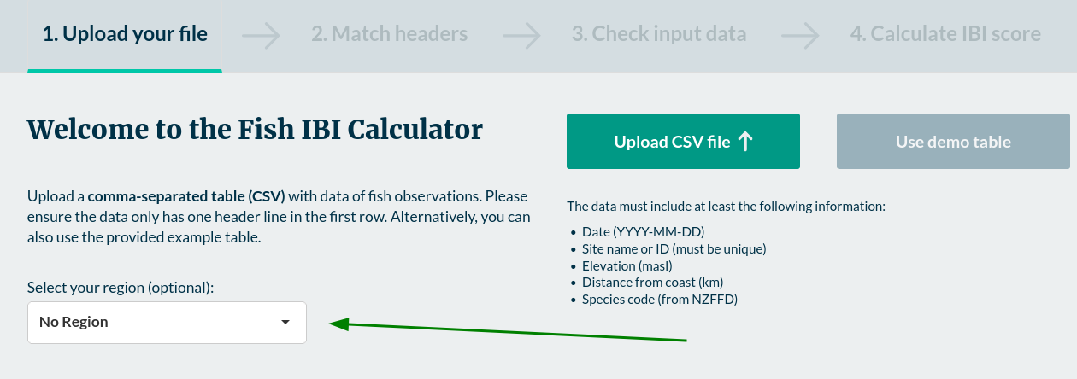

Input data format
The calculator is designed to make it easy for users to upload existing fish monitoring datasets. The calculator requires a comma-separated values (CSV) data file where each row equates to a single fish observation. To reduce the need for users to change their existing data files, the Fish IBI Calculator accepts input datasets with many extra columns and the columns are not required to have specific headers.
The requirements for the input data are:
- CSV file
- single header line in the first row
- one row per fish observation.

Input data content
To calculate Fish IBI results, a minimum set of five variables are required per observation. The input dataset must include columns that contain information for each of these variables. To be included in the analysis each row must have data recorded for each of these variables:
- date (ideally YYYY-MM-DD) to distinguish between separate site visits
- site name or ID (must be unique between sites)
- elevation in metres above sea level (altitude)
- distance from coast in kilometres (penetration)
- species code (from the New Zealand Freshwater Fish Database; download the full list from the NIWA website).
The tool calculates the Fish IBI score for each unique site visit. A unique site visit is calculated based upon concatenating together the site name, date, altitude and penetration values. This includes altitude and penetration controls for the situation where site names are not unique (for example, multiple measurements from different locations along the same river). To check how the tool has calculated unique site visits for your data, the downloadable results table includes a column called ‘stratum’.
The Fish IBI Calculator results can also include maps. To include maps in your Fish IBI results, the input data requires two additional columns (NZ Map Grid EPSG:27200):
- northing
- easting.
An example of what the input data could look like is given below:
Figure 2: Example input data for the Fish IBI Calculator
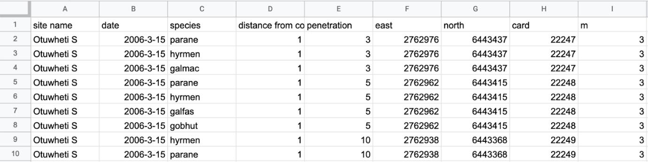
To help users understand the input data requirements, and explore how the Fish IBI Calculator works, there is a ‘Use demo table’ button (see figure 3).
Figure 3. How to upload user data or select example demonstration data
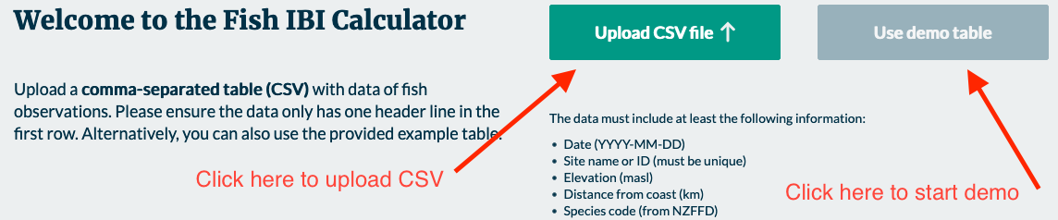

Match headers
On this page the user is given a preview of what their uploaded data looks like. From here they are able to specify which column relates to each of the mandatory fields required for the calculation.
Figure 4: How to match data headers to the mandatory fields in the Fish IBI Calculator
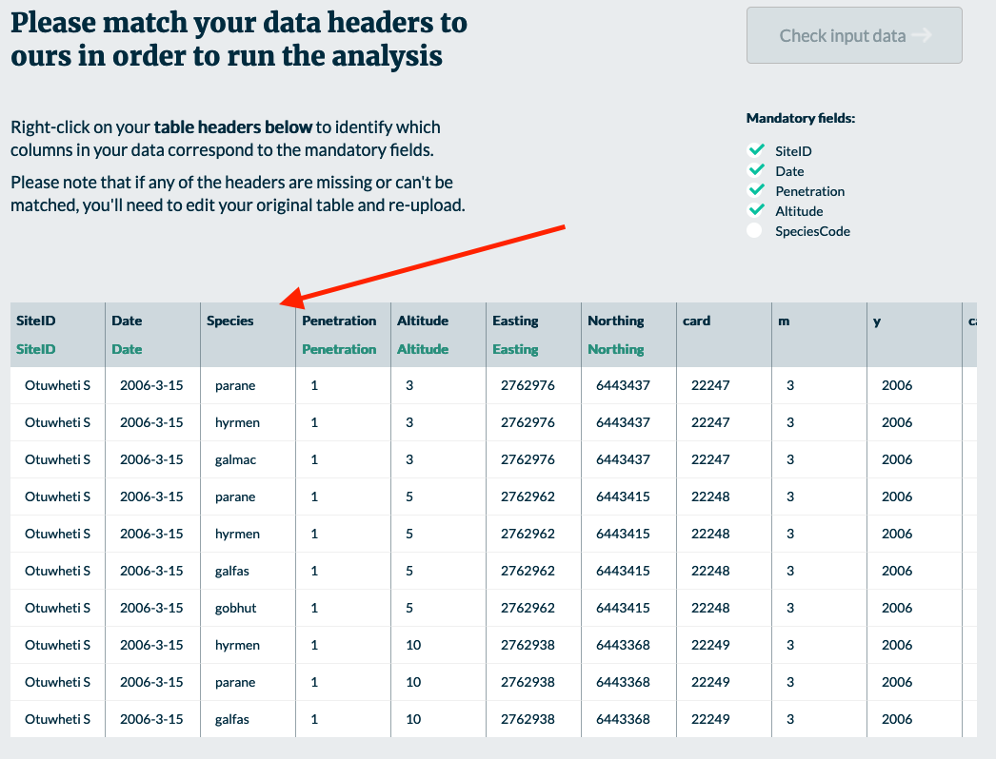
In the picture above it can be seen that the mandatory field SpeciesCode has not been automatically identified as present in the data. In the example above, the column that contains this information is called ‘Species’.
To specify that this column contains SpeciesCode information, right click on the header ‘Species’ in dark blue. From there a pop-up menu will appear as shown in the picture below:
Figure 5: How to select a mandatory field when matching data headers in the Fish IBI Calculator
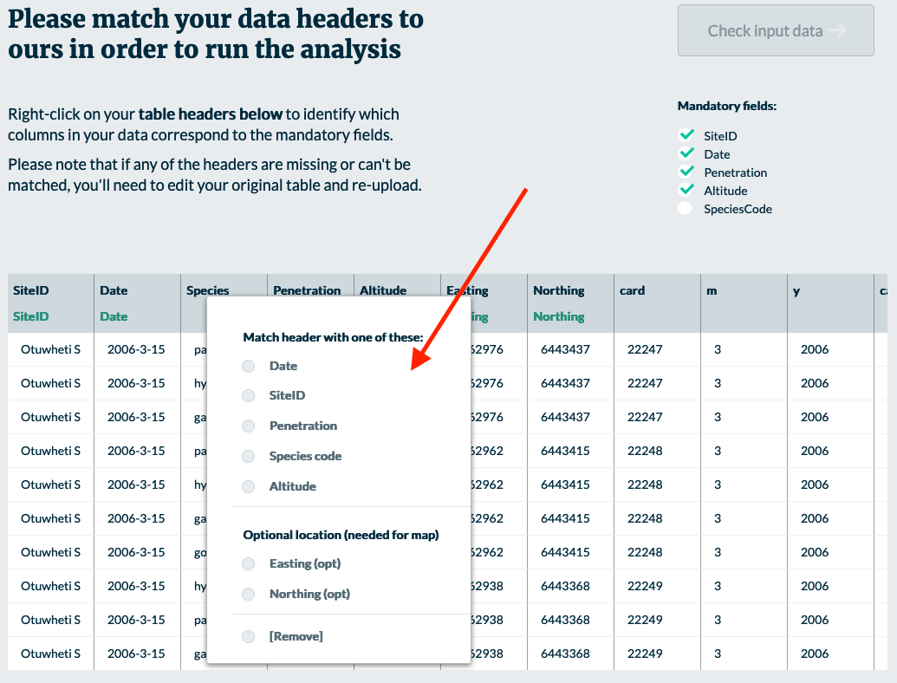
Within this menu select the relevant field which the column matches, in this case that field is SpeciesCode:
Figure 6: A selected mandatory field in the Fish IBI Calculator.
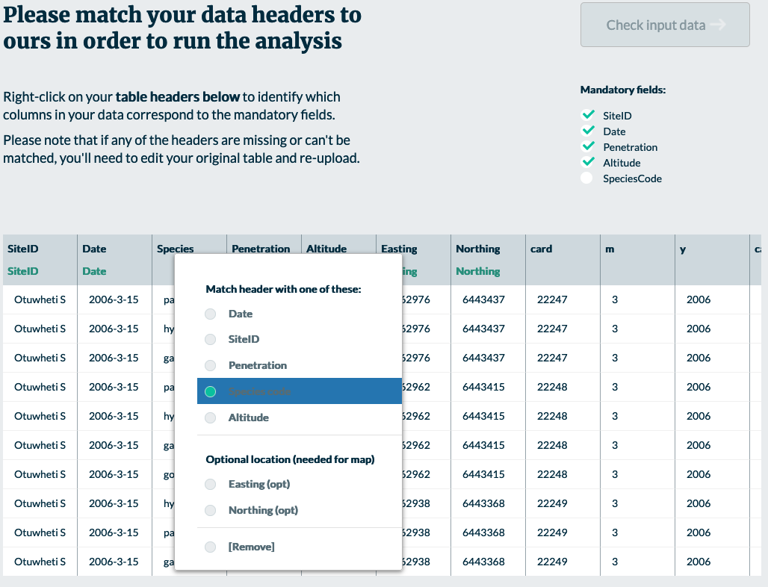
Click outside of the pop-up menu to close it. The user will see that beneath the column name that was supplied in the CSV there is a green column name which relates to the field the user selected:
Figure 7: An applied mandatory field in the Fish IBI Calculator
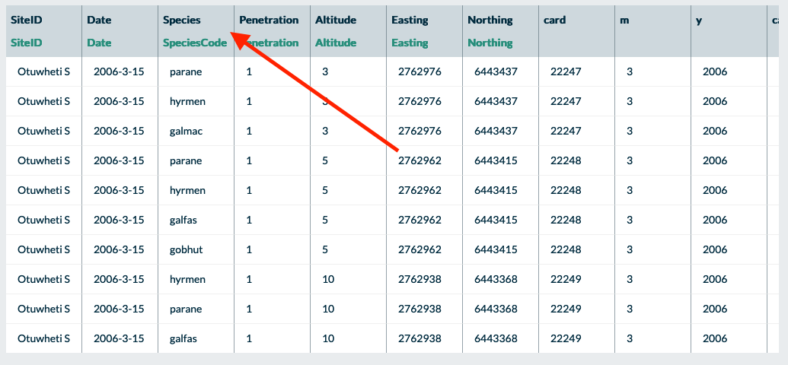
When all of the mandatory fields have been specified, all fields in the mandatory fields checklist will have a tick beside them:
Figure 8: A missing mandatory field
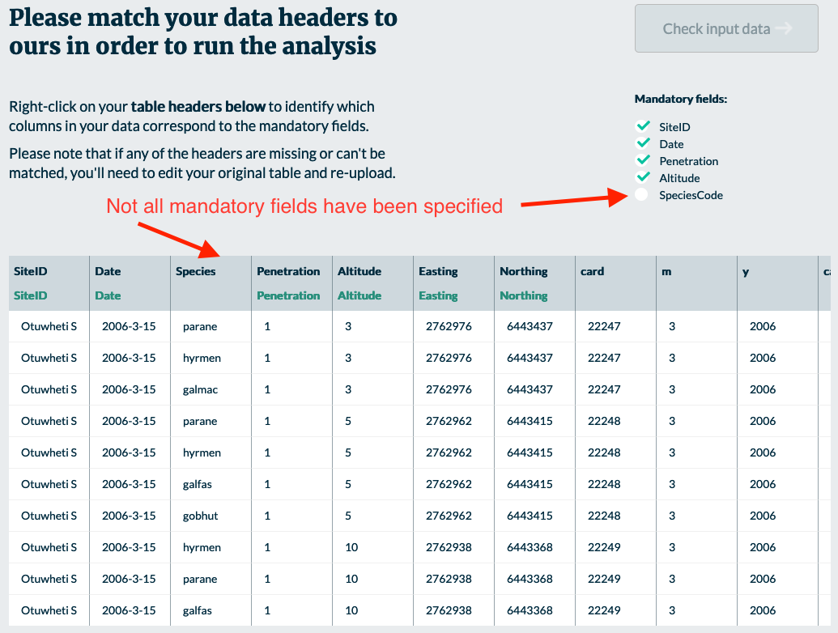
Figure 9: All mandatory fields in the data headers
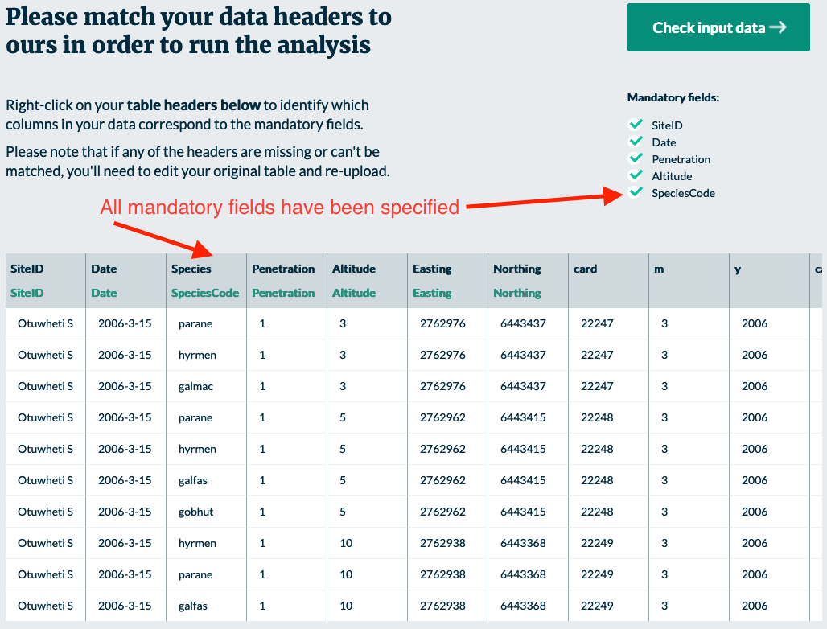
Click the ‘Check input data’ button to proceed to the next page.

Check input data
This page informs the user of any issues that exist in the uploaded data set. The number of issues is reported and a table showing rows with issues.
The app detects two categories of issues: errors and warnings. Warnings are coloured blue/grey and errors are coloured red. Users can hover their mouse over coloured cells to find more information about the issues. Users can also filter the table of issues using a drop-down menu.
There is a button to download a full list of issues as a CSV file. This file includes a field showing the rows in the user’s original data where issues can be found.
The intention is for users to correct the issues in their data and then re-upload the file to the Fish IBI Calculator app. However, there is also an option to exclude the issues, in order to proceed to the results page. Excluding issues removes individual records for warnings (such as non-fish code issues). For errors, the entire site visit is excluded from the analysis.
Figure 10: How to filter issues shown in the ‘check input data’ stage
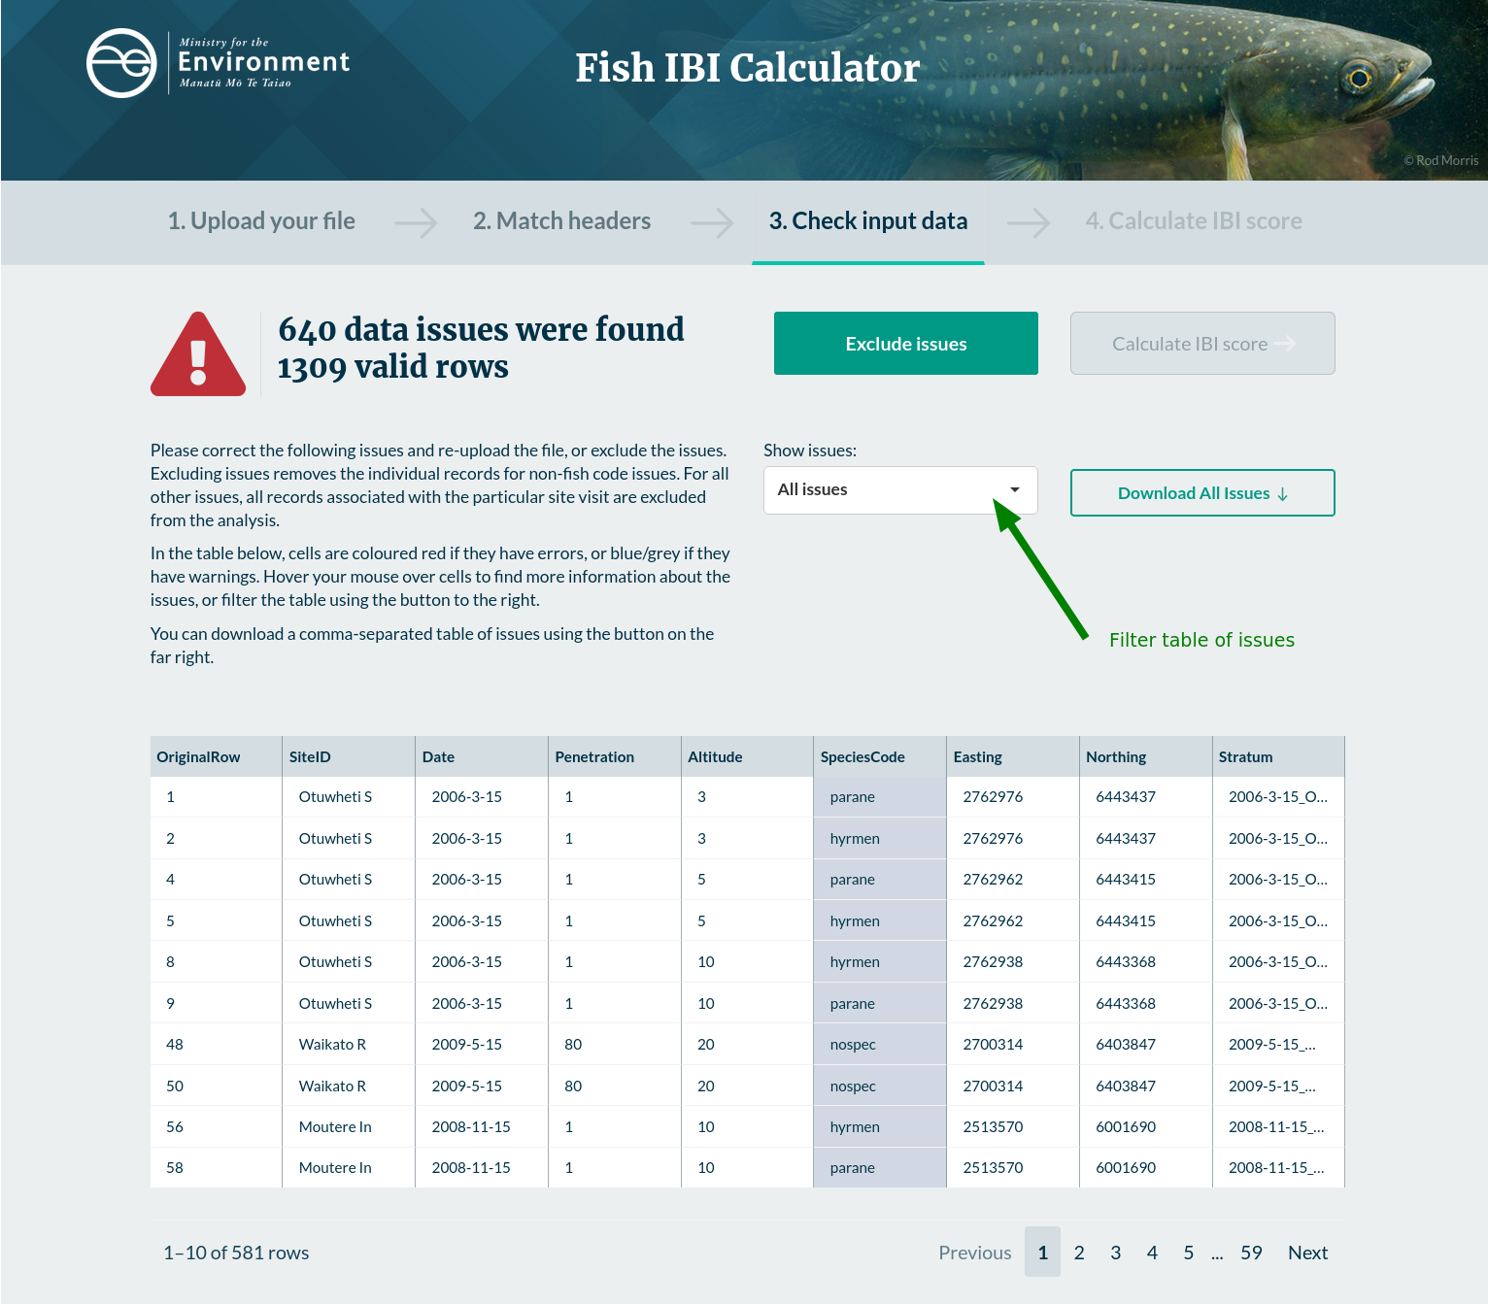
Once there are no issues (or if the user has chosen to exclude issues), the app shows a table with the data that will be submitted to the Fish IBI calculator and a summary of the final number of valid rows and the number of rows that were excluded.
Figure 11: Resolved issues
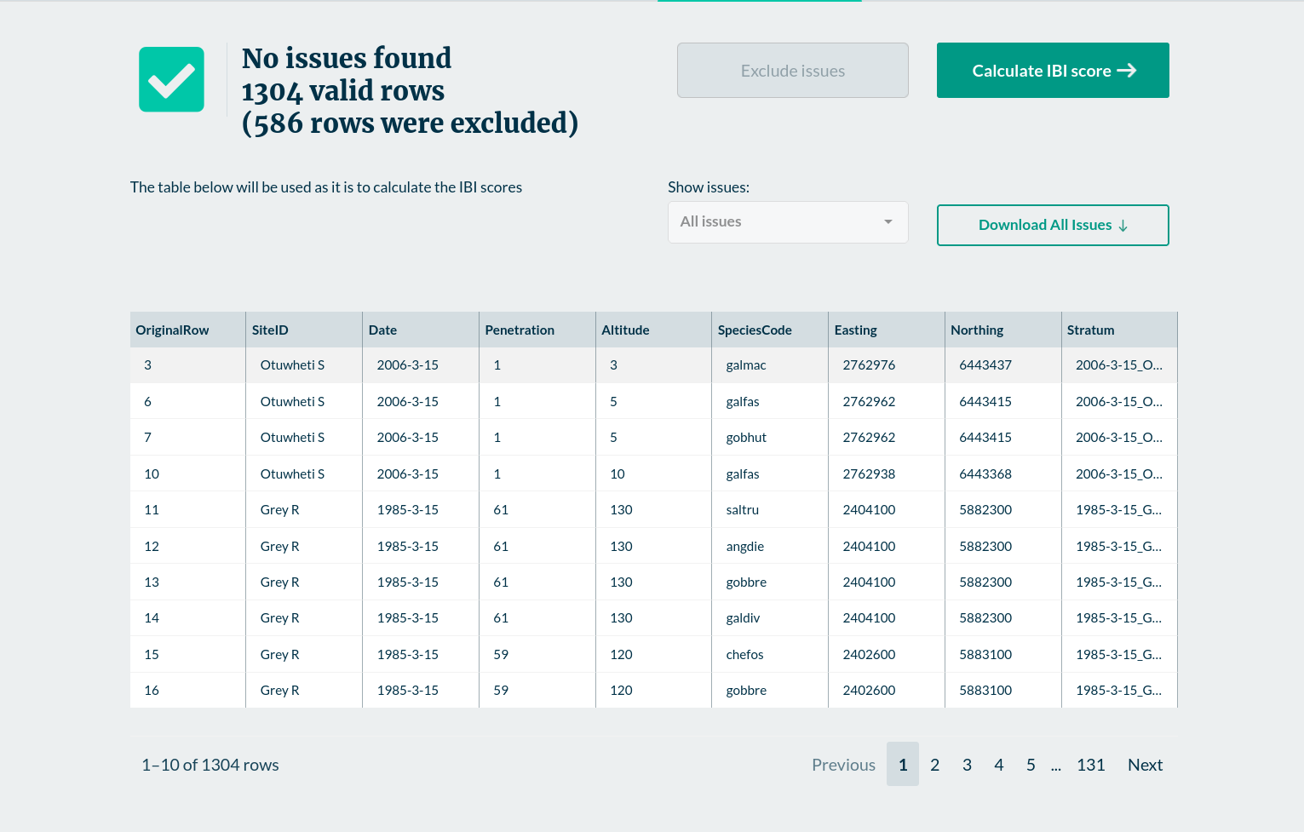
From here the user can now click the ’Calculate IBI score’ button to proceed to the final page.

Calculate IBI score
The app calculates Fish IBI scores for each site visit (following the method outlined in Joy and Death, 2004), and presents the scores for each site visit according to the categories set out in the National Policy Statement for Freshwater Management 2020, with the addition of a ‘No Species’ category to reflect site visits where it was recorded that no species were found.
Figure 12 picture depicts an example set of results:
Figure 12: An example set of results
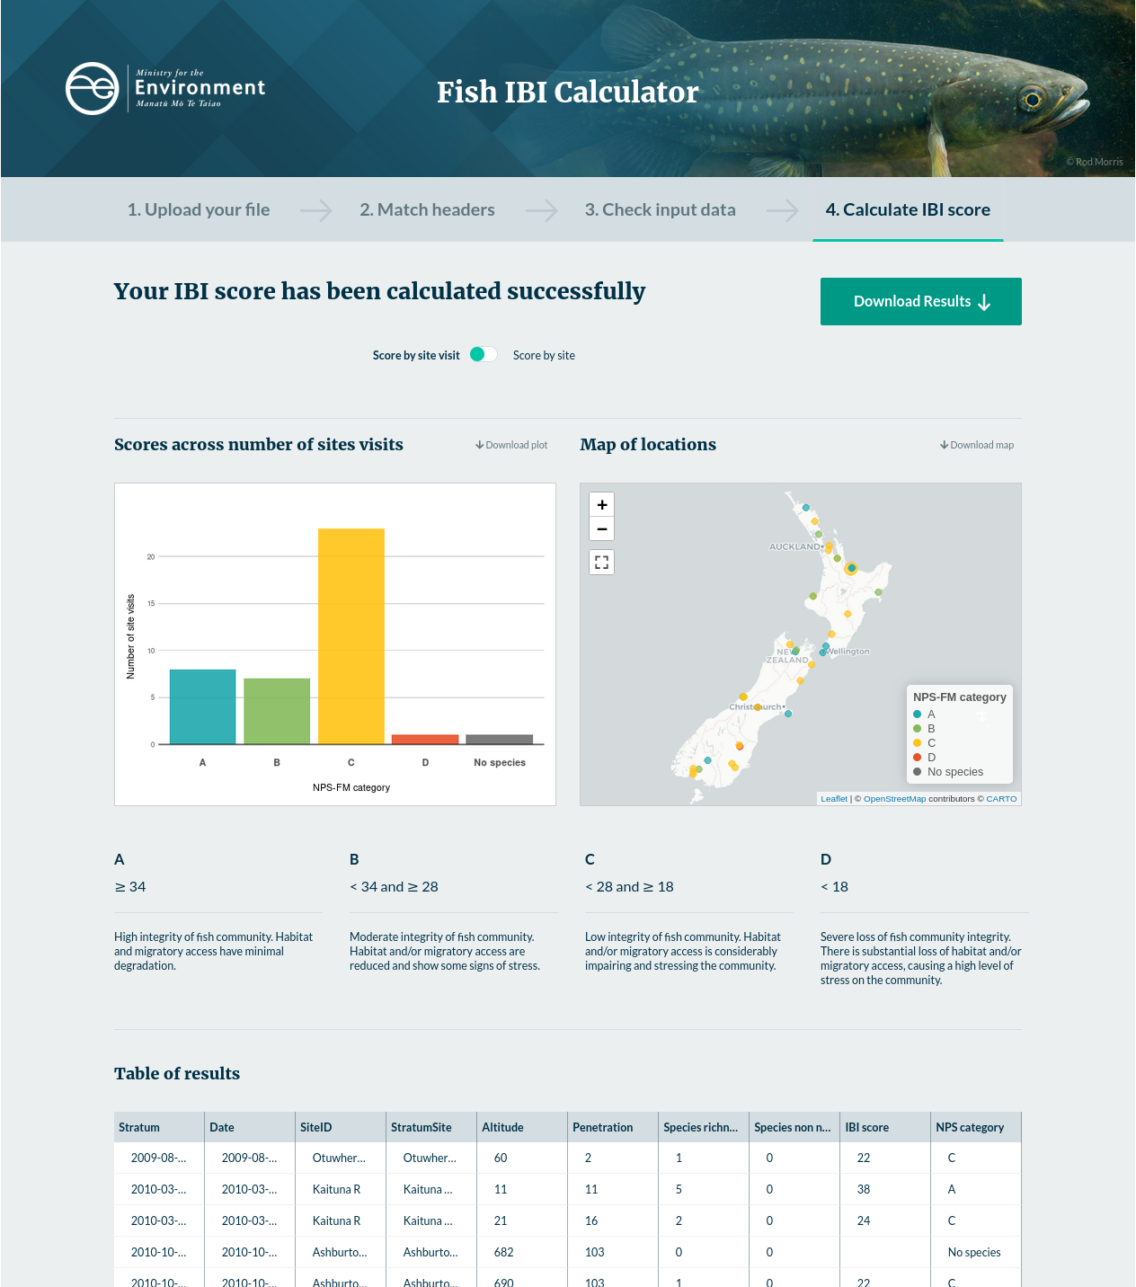

Download results and images
The full table of results, ‘Scores across number of sites’ bar graph and ‘Map of locations’ can each be individually downloaded.
Figure 13: How to download results and images
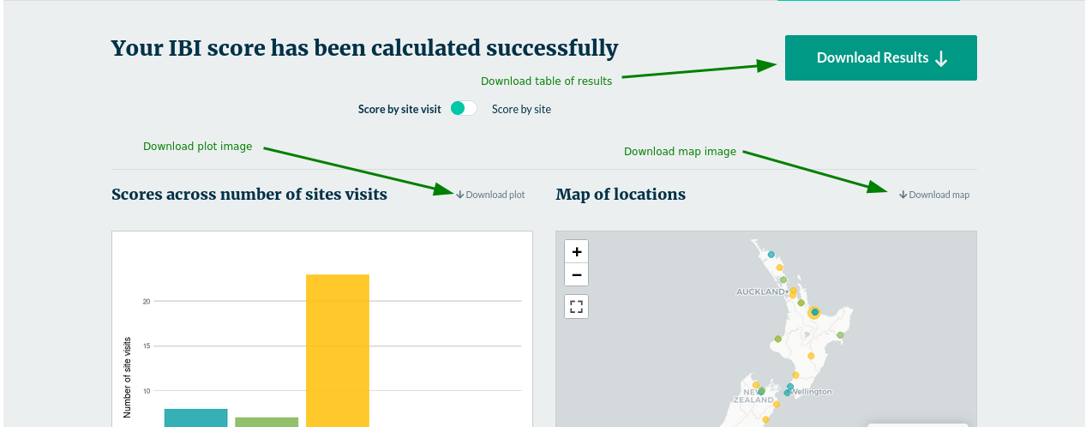

Interactive map
The map is interactive (can move and zoom) and can be expanded to full screen.
Figure 14: How to expand the interactive map
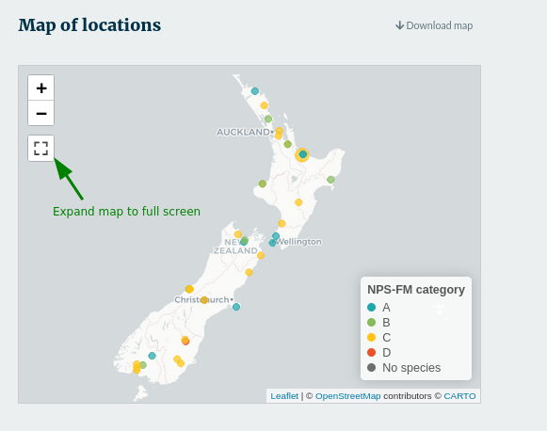
Where there are multiple visits to a site with the same coordinates, the map displays a larger point marker. Clicking on this marker displays a tooltip with scores for both site visits and the median score for that site.
Figure 15: Tooltip with site-specific results
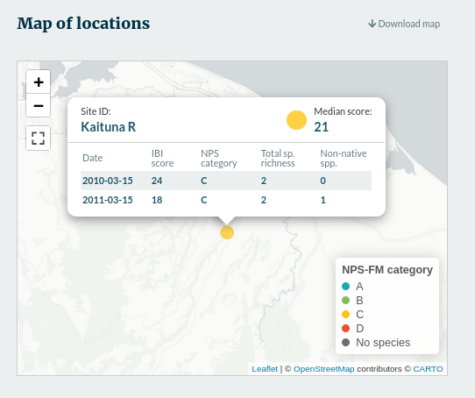

National vs regional results
If the user selected a region on the first page of the Fish IBI calculator, then the results page includes a toggle to display the results by national vs regional bands.
Figure 16: Example results displayed by national bands
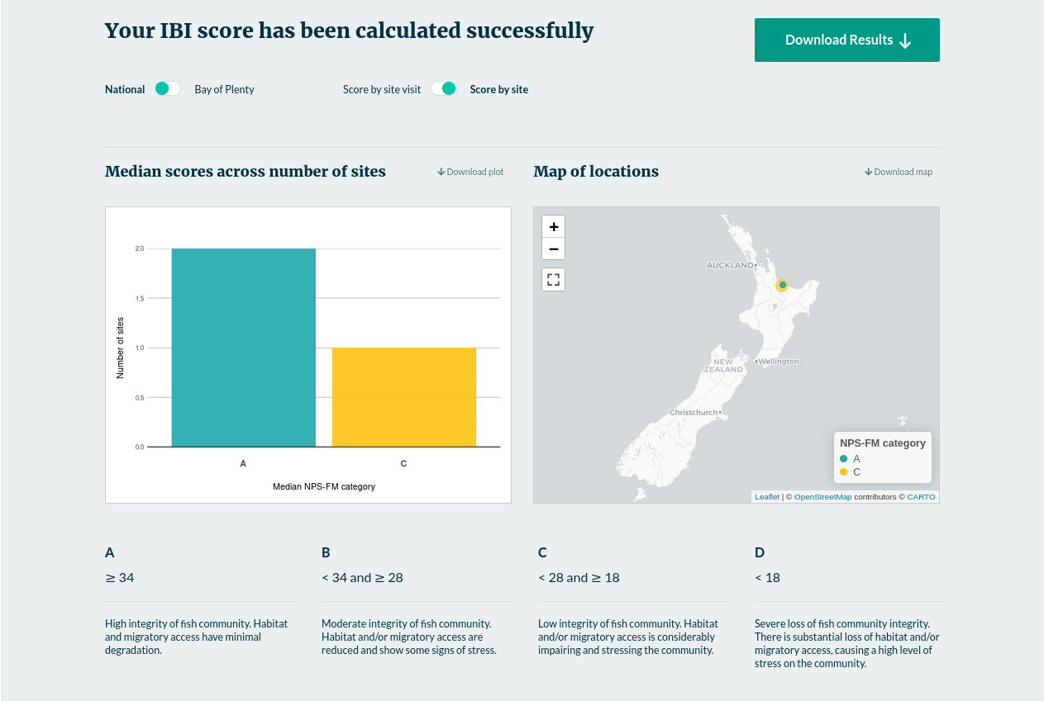
When the region is selected, the site scores are compared against the regional rather than national bands. The regional bands are displayed under the charts.
Figure 17: Example results displayed by regional bands
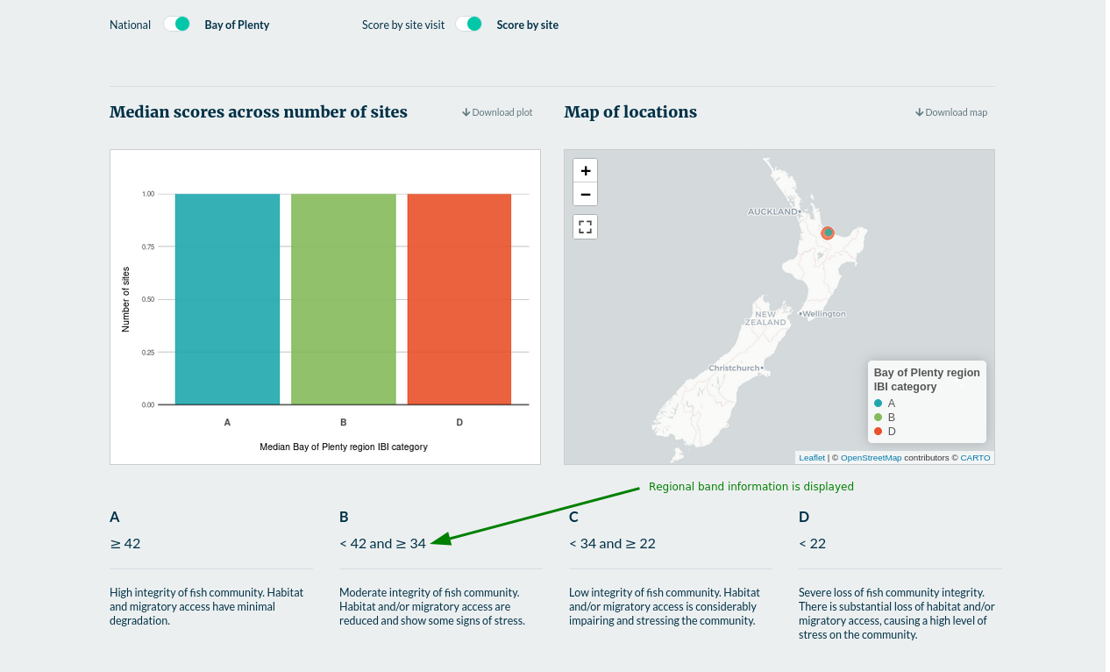

Results by site visit, or by site
The Fish IBI Calculator includes a toggle for users to change the chart to show either counts of scores by unique site visit, or counts of median score by site.
Figure 18: Example results by site visit
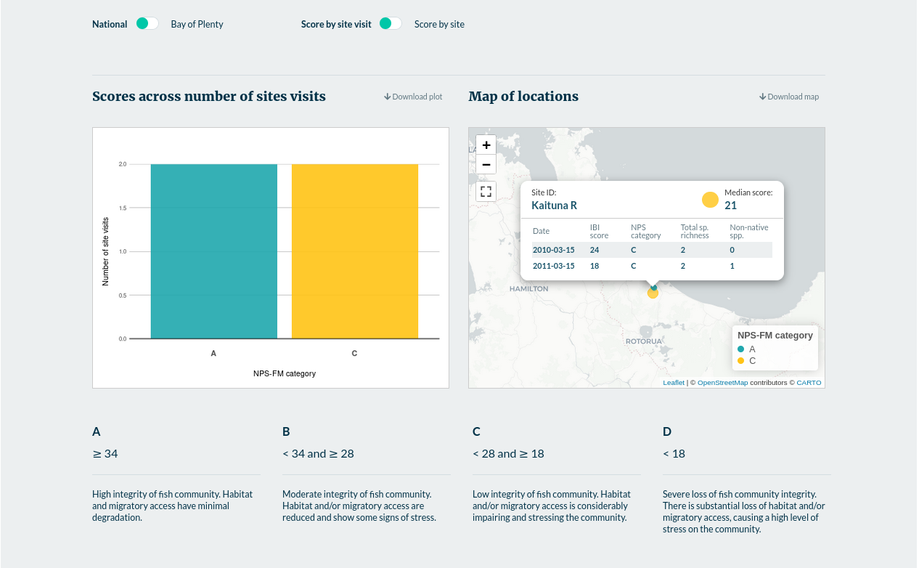
Figure 19: Example results by site
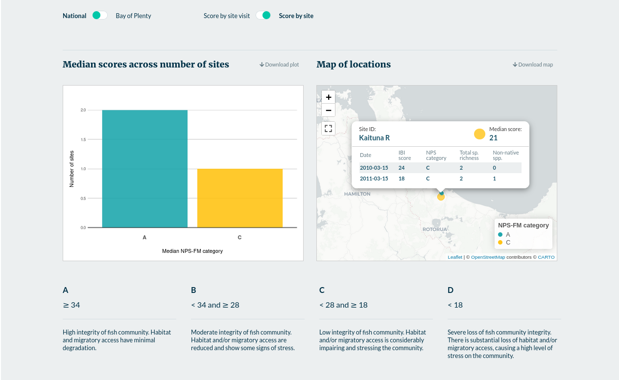

Appendix 1: Fish species from the New Zealand Freshwater Fish Database and their metric classification
Table 1: Fish species from the New Zealand Freshwater Fish Database (NZFFD) and their metric classification
spcode | native | benthic_riffle | benthic_pool | pelagic_pool | intolerant | non_native
aldfor | 1 | 0 | 0 | 1 | 0 | 0
angaus | 1 | 0 | 1 | 0 | 0 | 0
angdie | 1 | 1 | 1 | 0 | 0 | 0
chefos | 1 | 1 | 0 | 0 | 0 | 0
galarg | 1 | 0 | 0 | 1 | 1 | 0
galbre | 1 | 1 | 1 | 0 | 1 | 0
galdiv | 1 | 1 | 0 | 0 | 1 | 0
galfas | 1 | 0 | 1 | 1 | 1 | 0
galmac | 1 | 0 | 0 | 1 | 0 | 0
galspp | 1 | 1 | 0 | 0 | 1 | 0
galpau | 1 | 1 | 0 | 0 | 1 | 0
galpos | 1 | 0 | 1 | 1 | 1 | 0
galpro | 1 | 1 | 0 | 0 | 1 | 0
galvul | 1 | 1 | 0 | 0 | 1 | 0
geoaus | 1 | 0 | 1 | 0 | 0 | 0
gobbas | 1 | 0 | 1 | 0 | 0 | 0
gobbre | 1 | 0 | 1 | 0 | 0 | 0
gobcot | 1 | 0 | 1 | 0 | 0 | 0
gobgob | 1 | 0 | 1 | 0 | 1 | 0
gobhub | 1 | 1 | 0 | 0 | 1 | 0
gobhut | 1 | 1 | 0 | 0 | 1 | 0
mugcep | 1 | 0 | 0 | 1 | 0 | 0
neoapo | 1 | 0 | 1 | 0 | 1 | 0
neobur | 1 | 0 | 1 | 0 | 1 | 0
neodiv | 1 | 0 | 1 | 0 | 1 | 0
retret | 1 | 0 | 0 | 1 | 0 | 0
rhoret | 1 | 0 | 1 | 0 | 1 | 0
stoani | 1 | 0 | 0 | 1 | 0 | 0
ameneb | 0 | 0 | 0 | 0 | 0 | 1
caraur | 0 | 0 | 0 | 0 | 0 | 1
cteide | 0 | 0 | 0 | 0 | 0 | 1
gamaff | 0 | 0 | 0 | 0 | 0 | 1
oncmyk | 0 | 0 | 0 | 0 | 0 | 1
oncner | 0 | 0 | 0 | 0 | 0 | 1
onctsh | 0 | 0 | 0 | 0 | 0 | 1
perflu | 0 | 0 | 0 | 0 | 0 | 1
poeret | 0 | 0 | 0 | 0 | 0 | 1
salfon | 0 | 0 | 0 | 0 | 0 | 1
saltru | 0 | 0 | 0 | 0 | 0 | 1
scaery | 0 | 0 | 0 | 0 | 0 | 1
tintin | 0 | 0 | 0 | 0 | 0 | 1
galano | 1 | 1 | 0 | 0 | 1 | 0
galaxi | 1 | 1 | 0 | 0 | 1 | 0
galcob | 1 | 1 | 0 | 0 | 1 | 0
galdep | 1 | 1 | 0 | 0 | 1 | 0
galeld | 1 | 1 | 0 | 0 | 1 | 0
galgol | 1 | 1 | 0 | 0 | 1 | 0
galmar | 1 | 1 | 0 | 0 | 1 | 0
galpul | 1 | 1 | 0 | 0 | 1 | 0
galspd | 1 | 1 | 0 | 0 | 1 | 0
galspn | 1 | 1 | 0 | 0 | 1 | 0
galsps | 1 | 1 | 0 | 0 | 1 | 0
galspt | 1 | 1 | 0 | 0 | 1 | 0
Note: From Joy and Death (2004) and ‘allnzIBI_NPS.xlsm’ macro-enabled spreadsheet.

Appendix 2: Maximum species richness lines
Table 2: Maximum Species Richness Lines
Fish type | scale | x intercept | y intercept
Native | Elevation | 1600 | 5.334
Native | Distance | 500 | 6
Benthicriffle | Elevation | 1600 | 3.555
Benthicriffle | Distance | 500 | 3.333
Benthicpool | Elevation | 1600 | 3.333
Benthicpool | Distance | 500 | 4
Pelagicpool | Elevation | 1600 | 2
Pelagicpool | Distance | 500 | 2.667
Intolerant | Elevation | 1600 | 2.667
Intolerant | Distance | 500 | 2.667
Note: From Joy and Death (2004) and Canning and Joy (2021) and ‘allnzIBI_NPS.xlsm’ macro-enabled spreadsheet.

Appendix 3: Distribution of Fish IBI scores
Table 3: Distribution of fish IBI scores by region for deriving regional fish IBI bands from Canning and Joy, 2021
Region | Q1 | mean | Q3
Auckland | 16 | 20 | 26
Bay of Plenty | 22 | 34 | 42
Canterbury | 18 | 24 | 34
Gisborne | 18 | 24 | 28
Hawke's Bay | 22 | 27 | 36
Manawatū–Whanganui | 16 | 24 | 32
Marlborough | 18.5 | 25 | 32
Nelson | 16 | 23 | 36
Northland | 16 | 22 | 31.5
Otago | 12 | 18 | 24
Southland | 10 | 16 | 26
Taranaki | 14 | 22 | 32
Tasman | 16 | 23 | 36
Waikato | 20 | 26 | 34
Wellington | 16 | 20 | 30
West Coast | 16 | 23 | 34
Note: In the NPS-FM attribute table, the A-band corresponds to Q3 or above, B-band is mean-Q3, C-band is Q1-mean and D-band is less than Q1.

Appendix 4: Species codes

How are non-specific species dealt with in the Fish IBI Calculator?
During some surveys, fish will be observed that cannot be identified to species level. These individuals will get recorded as a genus-level entry, rather than as a species. For example, if an anguillid eel is observed but could not be confidently identified as either Anguilla australis (angaus) or Anguilla dieffenbachii (angdie), then it would be recorded as an unidentified anguillid eel (anguil).
The IBI scoring is very sensitive to the detection of each additional species. Genus-level records (ie, anguil) may pose a problem if there were also some larger eels present that could be identified, and this gave the impression of two species being present because a genus-level entry (anguil) is entered as well as a species-level record (angaus), despite only one species of eel being present at the site.
Conversely, if only one eel was observed and it could not be identified, that eel observation should contribute to the IBI score. To be able to utilise genus-level taxa records for IBI calculations, but avoid the risk of double counting, we recommend that genus-level records are only included if there are no other individuals from the genus present that may be of the same species as the genus-level entry. If genus-level entries are included as well as species-level entries that may be from the same species, then the genus-level entries should be ignored for the purposes of calculating the IBI.
In table 4 below, many of the more recently recognised native taxa, more recently arrived colonisers, and some exotic species are not represented by specific codes in the Fish IBI Calculator.
‘Work-arounds’ have been built into the current version of the IBI calculator to accommodate these additional taxa, and include:
- green highlighted cells are for genus-level entries have the same metric scores as the most common expected species for that genus
- yellow highlighted cells are those unlisted native species that have been mapped to a species that will have the same metric scores
- blue highlighted cells are unlisted exotic species have been mapped to a matching exotic, which is insensitive to phylogeny because all exotics get the same metric scores
- purple highlighted cells are species that are ignored for the IBI, because they are:
- not fish species (for example, Paranephrops spp/koura)
- not considered freshwater species for the Fish IBI (for example, Grahamina sp./triplefin)
- otherwise extinct (for example, Prototroctes oxyrhynchus/New Zealand grayling).
All of the non-migratory species that have been derived from Galaxias brevipinnis will get the same metric scores as each other, and so have been coded as Galaxias vulgaris.
Any recently described species that is not listed in Table 4, and does not have its own IBI code, should be treated in the same manner – ie, choose a code for a species that will score the same across the six metrics, and use that as a dummy code.
Table 4: Look up table mapping species codes from Joy and Death 2004 with contemporary species codes from the NZ Freshwater Fish Database
nzffd_spp_code | spp_code_2004
aldfor | Aldfor
ameneb | Ameneb
angaus | Angaus
angdie | Angdie
angrei | Angdie
anguil | Angdie
caraur | Caraur
chefos | Chefos
cteide | Cteide
cypcar | Perflu
galano | Galano
galarg | Galarg
galaxi | Galaxi
galbre | Galbre
galcob | Galcob
galdep | Galdep
galdiv | Galdiv
galeld | Galeld
galfas | Galfas
galgol | Galgol
galgra | Galmac
galmac | Galmac
galmar | Galmar
galpau | Galpau
galpos | Galpos
galpro | Galpro
galpul | Galpul
galspd | Galspd
galspn | Galspn
galsps | Galsps
galspt | Galspt
galvul | Galvul
gamaff | Gamaff
geoaus | Geoaus
gobalp | Gobbre
gobbas | Gobbas
gobbre | Gobbre
gobcot | Gobcot
gobgob | Gobgob
gobhub | Gobhub
gobhut | Gobhut
gobiom | Gobbre
graham | nospec
hypmol | Perflu
hyrmen | nospec
leuidu | Perflu
marine | nospec
mugcep | Mugcep
mugil | Mugcep
neoapo | Neoapo
neobur | Neobur
neodiv | Neodiv
neohel | Neodiv
neorek | Neodiv
oncmyk | Oncmyk
oncner | Oncner
onctsh | Onctsh
parane | nospec
parcur | nospec
parmar | nospec
perflu | Perflu
poelat | Poeret
poeret | Poeret
prooxy | nospec
retret | Retret
rhombo | Rhoret
rhoret | Rhoret
salfon | Saltru
salmo | Saltru
salsal | Onctsh
saltru | Saltru
scaery | Scaery
stoani | Stoani
tintin | Tintin
galspp | Galspp
Note: Developed by Andy Hicks (Ministry for the Environment).

References
Canning A, Joy MK. 2021, unpublished. Derivation of the NPS-FM 2020 Fish Index of Biotic Integrity attribute table. Wellington: Ministry for the Environment.
Joy MK, Death RG. 2004. Application of the index of biotic integrity methodology to New Zealand freshwater fish communities. Environmental Management 34:415-428
Joy M. 2004a. A Fish Index of Biotic Integrity (IBI) for the Auckland Region. Palmerston North, New Zealand.
Joy M. 2004b. A Fish Index of Biotic Integrity (IBI) for the Wellington Region. Palmerston North, New Zealand.
Joy M. 2014. A Fish Index of Biotic Integrity (IBI) for the Tasman-Nelson Region. Palmerston North, New Zealand.
Joy M. 2015. A Fish Index of Biotic Integrity (IBI) for Horizons Regional Council. Palmerston North, New Zealand.
Joy M. 2019. A Fish Index of Biotic Integrity (IBI) for the Northland Region. Wellington, New Zealand.
Joy M. 2010. A Fish Index of Biotic Integrity (IBI) For the Southland Region.
National Institute of Water and Atmospheric Research [NIWA]. 2023. NZ Freshwater Fish Database. Retrieved from niwa.co.nz/information-services/nz-freshwater-fish-database.

See Ministry for the Environment. 2019. Fish Index of Biotic Integrity in New Zealand Rivers 1999–2018. Wellington: Ministry for the Environment.
See Ministry for the Environment 2020. Limit setting and action plans factsheet. Wellington: Ministry for the Environment.
See Ministry for the Environment 2020. Limit setting and action plans factsheet. Wellington: Ministry for the Environment.

