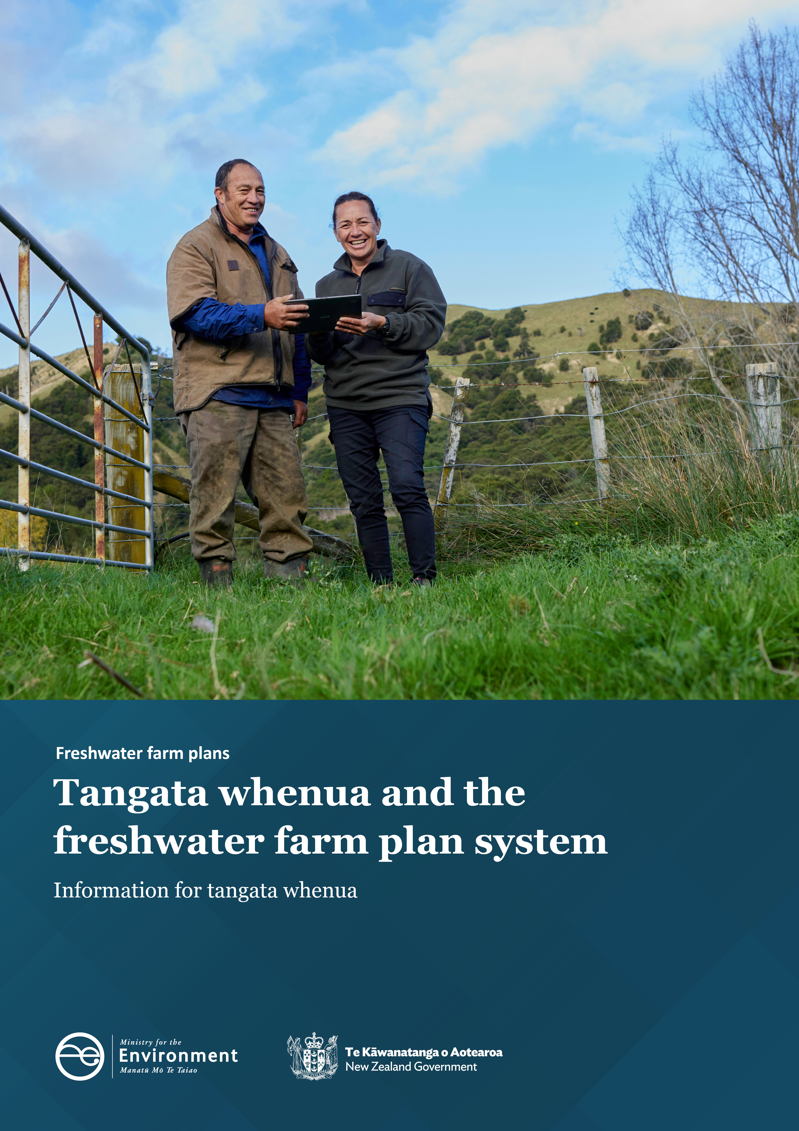

**Disclaimer**

The information in this publication is, according to the Ministry for the Environment’s best efforts, accurate at the time of publication. The Ministry will make every reasonable effort to keep it current and accurate. However, users of this publication are advised that:

* the information does not alter the laws of New Zealand, other official guidelines, or requirements
* it does not constitute legal advice, and users should take specific advice from qualified professionals before taking any action based on information in this publication
* the Ministry does not accept any responsibility or liability whatsoever whether in contract, tort, equity, or otherwise for any action taken as a result of reading, or reliance placed on this publication because of having read any part, or all, of the information in this publication or for any error, or inadequacy, deficiency, flaw in, or omission from the information in this publication
* all references to websites, organisations or people not within the Ministry are for convenience only and should not be taken as endorsement of those websites or information contained in those websites nor of organisations or people referred to.

This document may be cited as: Ministry for the Environment. 2023. *Tangata whenua and the freshwater farm plan system: Information for tangata whenua*. Wellington: Ministry for the Environment.

Published in July 2023 by the  
Ministry for the Environment   
Manatū mō te Taiao  
PO Box 10362, Wellington 6143, New Zealand  
[environment.govt.nz](http://www.environment.govt.nz)

ISBN: 978-1-991077-72-1

Publication number: ME 1783

© Crown copyright New Zealand 2023

# Contents

Purpose of this information 4

Freshwater planning processes that feed into the freshwater farm plan system 5

Te Mana o Te Wai and the NPS‑FM 6

Preparation of catchment context information 7

System oversight 8

Certifier and auditor appointment 9

Resourcing and support 10

Resourcing 10

Support and tools 10

Other support and funding 11

Other guidance 11

# **Purpose of this information**

Tangata whenua have an integral role in the freshwater management system to help to ensure water quality outcomes are being met in a way that reflects the principles of Te Tiriti o Waitangi (Treaty of Waitangi), and the concept of Te Mana o Te Wai (TMoTW).

This document is intended to show how tangata whenua can participate across the freshwater farm plan system, and how tangata whenua values and outcomes can be expressed across the system.

This information is intended for tangata whenua and should be read alongside other [freshwater farm plan guidance documents](https://environment.govt.nz/acts-and-regulations/freshwater-implementation-guidance/freshwater-farm-plans/).

# Freshwater planning processes that feed into the freshwater farm plan system

Freshwater farm plans are a key delivery tool, part of the 2020 *Essential Freshwater* package. The package was introduced to:

* stop further decline to the health of our freshwater
* improve water quality
* reverse past damage
* bring our waterways to a healthy state within a generation.

Freshwater farm plans have been legislated under Part 9A of the [Resource Management Act (RMA) 1991](https://www.legislation.govt.nz/act/public/1991/0069/latest/LMS375842.html) and the [Resource Management (Freshwater Farm Plans) Regulations 2023](https://aus01.safelinks.protection.outlook.com/?url=https%3A%2F%2Fwww.legislation.govt.nz%2Fregulation%2Fpublic%2F2023%2F0113%2Flatest%2Fwhole.html&data=05%7C01%7CGemma.Freeman%40mfe.govt.nz%7C9e67bf1f6ebe41df82f508db670f6723%7C761dd003d4ff40498a728549b20fcbb1%7C0%7C0%7C638217088081222930%7CUnknown%7CTWFpbGZsb3d8eyJWIjoiMC4wLjAwMDAiLCJQIjoiV2luMzIiLCJBTiI6Ik1haWwiLCJXVCI6Mn0%3D%7C3000%7C%7C%7C&sdata=Cu2%2BUtoNVjJf1WWrY2rYEEXVI7TJNQhgewe9wj%2Fga2s%3D&reserved=0) (the regulations).

Freshwater Farm Plans work in combination with the other Essential Freshwater regulations which includes the:

* [National Policy Statement for Freshwater Management 2020](https://environment.govt.nz/publications/national-policy-statement-for-freshwater-management-2020-amended-february-2023/) (NPS-FM)
* [Resource Management (National Environmental Standards for Freshwater) Regulations 2020](https://environment.govt.nz/acts-and-regulations/regulations/national-environmental-standards-for-freshwater/)
* [Resource Management (Stock Exclusion) Regulations 2020](https://environment.govt.nz/acts-and-regulations/regulations/stock-exclusion-regulations/).

The central concept of Essential Freshwater is Te Mana o Te Wai – healthy freshwater supports healthy communities, a healthy environment and a healthy economy. Te Mana o Te Wai prioritises the health and wellbeing of freshwater ecosystems, then the health of people, followed by commercial use.

Freshwater farm plans are designed to be both a tool and a process for farmers and growers to manage on-farm risks to freshwater and freshwater ecosystems arising from the inherent natural features and vulnerabilities of their farm landscape, and the farming and growing activities they undertake.

They will need to ensure farming practices contribute to restoring the health of our waterways and reflect regional planning processes, including the local approach to TMoTW.

Tangata whenua’s role in the freshwater farm plan system is to:

* support and influence the preparation of catchment information that informs individual freshwater farm plans
* help build the capability of the freshwater farm plan workforce.

Farmers and growers are not required to identify and engage with tangata whenua about their freshwater farm plans.

# Te Mana o Te Wai and the NPS‑FM

The role of tangata whenua is significant across the wider freshwater management system. This reflects the principles of the Treaty of Waitangi (Te Tiriti o Waitangi, and also the principles of TMoTW.

The NPS-FM provides national direction on freshwater management across Aotearoa. TMoTW is the central concept in the NPS-FM for all freshwater management. Regional councils need to give effect to TMoTW by working alongside tangata whenua and engaging with the local community to maintain or improve the state of freshwater in the region and if necessary, update their regional policy statements or regional plans.

Revised regional plans and/or policy statements giving effect to the NPS-FM and TMoTW will be notified by the end of 2024. This process has a series of steps that involves setting long-term visions, identifying values, setting environmental outcomes, and establishing the baseline and target attribute states for a suite of water quality and ecosystem attributes.

Achieving this will involve assessing the options available to deliver the amount and rate of change needed. This includes how much improvement can reasonably be expected to be delivered through the freshwater farm plan system and determining the mix of additional methods needed.

Freshwater farm plans are just one of the tools available in the *Essential Freshwater* package to deliver better freshwater outcomes and are designed to interact and align with other regionally specific rules and regulations.

Under the NPS- FM, local authorities must actively involve tangata whenua in freshwater management (including decision-making processes) and in identifying the local approach to giving effect to TMoTW (to the extent they wish to be involved). Given this, it makes sense to use and where necessary strengthen existing regional processes and relationships affecting outcomes for freshwater farm plans. Doing so will also help the freshwater farm plan system reflect mahi that tangata whenua have undertaken or are undertaking alongside regional councils, to manage freshwater in their rohe.

# Preparation of catchment context information

The local approach to giving effect to TMoTW, content of regional plans and other catchment related sources and information will be reflected in freshwater farm plan through the catchment context, challenges and values (catchment context) requirements.

Catchment context information will be collated by regional councils to provide interpreted and tailored catchment information that can be easily explained and applied at the farm scale for the purposes of freshwater farm plans. Councils will utilise existing regional processes and relationships to ensure tangata whenua are involved in the development of the catchment context.

The plan developer and/or the farm operator will need to have regard to the catchment context information relevant to the farm when conducting the risk identification and assessment and deciding on actions. Preparing freshwater farm plans in this way will mean that TMoTW is reflected as it is developed through regional planning processes which are then collated in catchment context information.

Catchment context information will be used by farmers and growers in their freshwater farm plan to:

* develop an understanding of the cultural and community significance of their catchment, and the health of freshwater in their catchment
* inform the risk identification and assessment process
* inform the selection of actions and action implementation timeframes to manage risks to freshwater.

Values and matters of importance to tangata whenua that are relevant to freshwater will form an important part of the catchment context. Catchment context is intended to reflect tangata whenua and community vision, values, and outcomes (included as ‘objectives’ in regional plans) for the catchment as well as other values and matters of importance to tangata whenua that are relevant to freshwater and publicly available and if desired to be shared by tangata whenua.

Every catchment is different. A catchment’s biophysical features such as landform, waterbodies and climate result in different sensitivities to different contaminants. A catchment’s unique values need to be managed and preserved in different ways. Such values include a catchment’s cultural significance, sites of significance to tangata whenua, taonga species, indigenous ecosystem, threatened species and recreational use.

Considering catchment context when preparing a freshwater farm plan ensures that the risk assessment process considers the wider local area beyond the farm gate. Linking on-farm actions to the catchment is critical to improving environmental and cultural outcomes for freshwater and helps put water at the centre of the freshwater farm plan. Using the catchment context in the freshwater farm plan risk assessment also helps ensure freshwater farm planning reflects Te Mana o Te Wai and the wider objectives and values for freshwater management in the region identified through the regional planning process.

|  |
| --- |
| Meaning of catchment context, challenges, and values  In these regulations, unless the context otherwise requires, **catchment context, challenges, and values** includes the following information (without limitation) in relation to a local area:   1. existing information on landforms, soil data, climate data, freshwater data, freshwater bodies, contaminants, sites that are significant to the community, and significant species or ecosystems: 2. identified cultural matters of importance to tangata whenua, including: 3. the cultural significance of the local area; and 4. the traditional names of freshwater bodies in the local area; and 5. sites and species in the local area that are significant to tangata whenua: 6. any objectives, policies, and rules relevant to the management of freshwater or freshwater ecosystems in policy statements or the regional plan: 7. any relevant freshwater matters in planning documents that are recognised by iwi authorities and lodged with the regional council: 8. the National Policy Statement for Freshwater Management and any action plans made by the regional council: 9. any secondary legislation under the Act that is relevant to the management of freshwater or freshwater ecosystems (other than secondary legislation made under Part 9A of the Act). |

Many existing regional plans and/or relevant documents (ie, iwi management plans) contain information and direction for catchments that will inform the catchment context information prior to and alongside information from new regional freshwater plans.

# System oversight

The Ministry for the Environment (the Ministry) and the regional sector provide national leadership and oversight of the freshwater farm plan system. This involves working with tangata whenua and helping co-ordinate the processes, people and information involved in implementing the freshwater farm plan system, including reviewing, and monitoring how implementation is tracking.

Tangata whenua are represented on the steering group overseeing the implementation of the freshwater farm plan system. In addition, tangata whenua perspectives are being provided through being part of a technical advisory group that advises the appointment process for freshwater farm plan certifiers and auditors.

Regional councils are responsible for making the appointments of certifiers and auditors.

Responsibility for engaging with tangata whenua on freshwater farm planning sits with regional councils. The NPS-FM also requires councils to give effect to Te Mana o Te Wai. Therefore, it is expected that tangata whenua will be involved in the ongoing oversight of the development and delivery of certifier and auditor training, to the extent they wish to be involved. This is necessary for certifiers and auditors to be successful in their roles.

# Certifier and auditor appointment

Freshwater farm plans are required to be certified and audited by freshwater farm plan certifiers and auditors. Regional councils are responsible for appointing freshwater farm plan certifiers and auditors to operate within their region.

To be appointed into the role, prospective certifiers and auditors must be able to demonstrate an understanding of the following competencies.

* the freshwater farm planning regulations and certification requirements
* any objectives, policies, and rules relevant to the management of freshwater or freshwater ecosystems in policy statements or regional plans
* any relevant freshwater matters in planning documents that are recognised by iwi authorities and lodged with regional councils
* the Treaty of Waitangi (Te Tiriti o Waitangi)
* te ao Māori
* Te Mana o Te Wai
* sites or species of cultural significance as defined by tangata whenua
* actions to manage the impacts of farming on freshwater and freshwater ecosystems.

Certifiers need to demonstrate an understanding of two additional competencies:

* contaminants and their impacts on freshwater and freshwater ecosystems
* impacts of farming on freshwater and freshwater ecosystems.

Some matters will be covered in national training and apply generally across the country before certifiers and auditors begin regional training that is more tailored to the needs of the catchment and tangata whenua in each region.

Many of these matters are regional or catchment specific, in whole or part. Many are matters that only tangata whenua can provide information on.

The regional appointment process needs to provide confidence that certifiers and auditors understand key considerations in the region, including the catchment context information, and that they can apply this knowledge effectively when certifying or auditing freshwater farm plans. This will help ensure appropriate management of the effects of farming activities on freshwater.

Many certifiers and auditors will need to upskill and improve their understanding of matters of importance to tangata whenua in the region. Training for certifiers on catchment context will help them demonstrate understanding of the catchment context, including the values of importance to tangata whenua in each catchment, and how they can be considered and reflected in the freshwater farm plan risk assessment and choice of actions. Training is also important for auditors.

Regional councils are required to engage with tangata whenua in the preparation and delivery of training for certifiers and auditors on catchment context, and on the competencies for certifiers, as required by the regional council. Regional councils must also engage with tangata whenua regarding practical assessments of certifiers if practical assessments are required by the regional council as part of the certifier appointment process.

The importance of building the capability of those in different roles across the freshwater farm plan system in catchment context information and understanding of the Treaty of Waitangi (Te Tiriti o Waitangi), te ao Māori and TMoTW is critical. The freshwater farm plan system will achieve this through ongoing quality assurance, reviews, training, guidance, and support given to certifiers and auditors, farmers, and growers and tangata whenua.

# Resourcing and support

Support has been developed to assist tangata whenua in their roles across the system, and to help express tangata whenua values and outcomes through the system.

## Resourcing

The importance of building the capability of those in different roles across the freshwater farm plan system in catchment context information and understanding of the Treaty of Waitangi (Te Tiriti o Waitangi), Te Ao Māori, and TMoTW is critical.

The Ministry has allocated funding and resourcing to develop the capacity and capability of the freshwater farm plan developers including farm operators, certifiers, and auditor workforce. Part of this funding allocation will support implementation from a tangata whenua perspective and will help build the capacity and capability of tangata whenua to undertake roles in the system.

Funding and resourcing will be distributed across a number of initiatives at both regional and national levels. These initiatives will be focussed on supporting tangata whenua to provide input into national and regional appointment processes for certifiers and auditors and assessment processes and enable tangata whenua to uptake roles within the freshwater farm plan developer, certifier and auditor workforces.

## Support and tools

The need for practical support and information for farmers and growers and Māori landowners has been recognised with the implementation of freshwater farm plans. In particular, noting the specific challenges faced by Māori Landowners and associated with their land blocks due to complex ownership and governance arrangements and the implications of Te Ture Whenua Māori Act 1993.

The Ministry is working to identify what support is available and needed for farmers and growers and Māori landowners to develop and implement freshwater farm plans.

## Other support and funding

Other initiatives, funding and support targeted at freshwater management are being rolled out by the Ministry and can work in tandem and support the freshwater farm plan system.

The Ministry of Primary Industries, regional councils, and rural professional and industry groups will also provide training and support for the freshwater farm plan system.

# Other guidance

To find out more or to discuss implementation of the system in your region please talk to your regional council in the first instance.

For further information on specific parts of the freshwater farm plan system see the [freshwater farm plan webpage](https://environment.govt.nz/acts-and-regulations/freshwater-implementation-guidance/freshwater-farm-plans/) on the Ministry for the Environment website.

If you have any further questions, please get in touch with the freshwater farm plan team at [freshwaterfarmplans@mfe.govt.nz](mailto:freshwaterfarmplans@mfe.govt.nz).