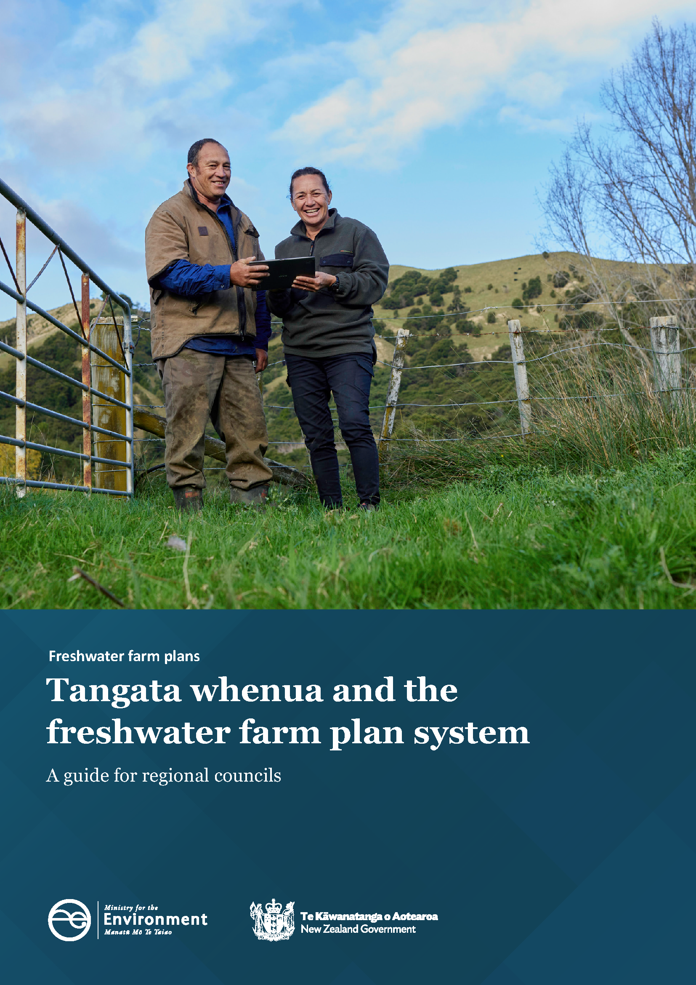

Disclaimer
The information in this publication is, according to the Ministry for the Environment’s best efforts, accurate at the time of publication. The Ministry will make every reasonable effort to keep it current and accurate. However, users of this publication are advised that:
- the information does not alter the laws of New Zealand, other official guidelines, or requirements
- it does not constitute legal advice, and users should take specific advice from qualified professionals before taking any action based on information in this publication
- the Ministry does not accept any responsibility or liability whatsoever whether in contract, tort, equity, or otherwise for any action taken as a result of reading, or reliance placed on this publication because of having read any part, or all, of the information in this publication or for any error, or inadequacy, deficiency, flaw in, or omission from the information in this publication
- all references to websites, organisations or people not within the Ministry are for convenience only and should not be taken as endorsement of those websites or information contained in those websites nor of organisations or people referred to.

This document may be cited as: Ministry for the Environment. 2023. Tangata whenua and the freshwater farm plan system: A guide for regional councils. Wellington: Ministry for the Environment.

Published in June 2023 by the
Ministry for the Environment
Manatū mō te Taiao
PO Box 10362, Wellington 6143, New Zealand
environment.govt.nz
ISBN: 978-1-991077-60-8
Publication number: ME 1770
© Crown copyright New Zealand 2023

Contents
Tangata whenua and the freshwater farm plan system 4
Why freshwater farm plans? 4
Te Mana o Te Wai and existing roles for tangata whenua in freshwater management 5
Key roles for tangata whenua in the freshwater farm plan system 6
Preparation of catchment context information 6
Appointing and training certifiers and auditors 7
System oversight 8

Tangata whenua and the freshwater farm plan system
This publication describes the roles for tangata whenua in the freshwater farm plan system, including how to consider and reflect tangata whenua values and Te Mana o Te Wai. It is intended to assist regional council staff involved in freshwater farm planning and will also be of interest to tangata whenua.

Why freshwater farm plans?
Freshwater farm plans are a key part of the 2020 Essential Freshwater package. The package was introduced to:
- stop further decline to the health of our freshwater
- improve water quality
- reverse past damage
- to bring our waterways to a healthy state within a generation.
The central concept of Essential Freshwater is Te Mana o Te Wai – healthy freshwater supports healthy communities, a healthy environment and a healthy economy. Te Mana o Te Wai prioritises the health and wellbeing of freshwater ecosystems, then the health of people, followed by commercial use.
Freshwater farm plans work in combination with the National Policy Statement for Freshwater Management 2020 (NPS-FM), the Resource Management (National Environmental Standards for Freshwater) Regulations 2020 (NES-F) and the Resource Management (Stock Exclusion) Regulations 2020 (stock exclusion regulations) to achieve the Essential Freshwater aims.

Te Mana o Te Wai and existing roles for tangata whenua in freshwater management
The NPS-FM provides national direction on freshwater management across Aotearoa New Zealand. Regional councils translate this direction into action on the ground, through regional policy statements and regional plans. Regional councils need to notify revised regional plans that give effect to the NPS-FM by the end of 2024.
Te Mana o Te Wai is the central concept in the NPS-FM for all freshwater management. Read the Ministry for the Environment’s Essential Freshwater: Te Mana o Te Wai factsheet in conjunction with this publication.
The role of tangata whenua is significant across the wider freshwater management system. This reflects the principles of te Tiriti o Waitangi (the Treaty of Waitangi) and also the principles of Te Mana o Te Wai.
Councils are working with tangata whenua to identify the local approach to giving effect to Te Mana o Te Wai and engaging with communities. To give effect to Te Mana o Te Wai, regional plans:
- set visions
- identify values
- set outcomes (included as ‘objectives’ in regional plans)
- set a baseline and target state for a suite of water quality and ecosystem indicators.
Some of these matters are already in regional plans, but most will be set or reviewed over the next few years.
Regional councils partner with tangata whenua to make decisions about regional freshwater management, to give effect to Te Mana o Te Wai and to meet the requirements for active involvement of tangata whenua (to the extent they wish to be involved).
It makes sense to use and strengthen these existing regional processes and relationships to support freshwater farm planning. Doing so will also help the freshwater farm plan system reflect mahi that tangata whenua have undertaken or are undertaking, alongside regional councils, to manage freshwater in their rohe.

Key roles for tangata whenua in the freshwater farm plan system
Under the NPS-FM, councils will involve tangata whenua, as well as others, in the regional freshwater planning process. The content of regional plans needs to be reflected in freshwater farm plans, with catchment context, challenges and values information being a key way for this to happen.
Tangata whenua input into the freshwater farm plan system focusses on the system that influences the preparation and delivery of freshwater farm plans in the region. Important areas for tangata whenua involvement in the freshwater farm plan system are:
- contributing to the collation of catchment context information
- preparing and delivering certifier and auditor training on:
- catchment context
- competencies for certifiers and auditors
- oversight of the system, including review and monitoring of system effectiveness, in delivering objectives and outcomes.

Preparation of catchment context information
Clause 46 of the Resource Management (Freshwater Farm Plans) Regulations 2023 (the regulations) requires regional councils to collate existing information about the catchment context of their region.
Catchment context should reflect both tangata whenua and community vision, values and outcomes (included as ‘objectives’ in regional plans) for the catchment. Clause 9 of the regulations requires farm operators to have regard to the regional council’s catchment context material (if available) when undertaking a freshwater farm plan risk assessment. Considering and applying the catchment context at the farm level when undertaking the freshwater farm plan risk assessment will help identify actions to improve freshwater.
Values and matters of importance to tangata whenua that are relevant to freshwater form an important part of the catchment context. The majority of the catchment context information will be sourced from regional policy statements, regional plans, and the supporting data and information informing these documents. Planning documents recognised by an iwi authority that have been lodged with the council are also important.
Using existing information means the catchment context should reflect Te Mana o Te Wai, particularly once regional plans have been updated to give effect to the NPS-FM and its strengthened requirements around Te Mana o Te Wai.
Refer to the Ministry for the Environment’s guidance document Catchment context, challenges and values information for more information on the purpose of catchment context information. The guidance makes suggestions on how to compile catchment context information, what to include and the role of tangata whenua in its development, including in preparing and delivering training for certifiers and auditors.

Appointing and training certifiers and auditors
Regional councils are responsible for appointing freshwater farm plan certifiers and auditors to operate within their region.
Schedule 2 of the regulations sets out the appointment processes and criteria for certifiers and auditors.
To be appointed, certifiers must be able to demonstrate an understanding of the following competencies:
- the freshwater farm planning regulations and certification requirements
- any objectives, policies, and rules relevant to the management of freshwater or freshwater ecosystems in policy statements or regional plans
- any relevant freshwater matters in planning documents that are recognised by iwi authorities and lodged with regional councils
- the Treaty of Waitangi (te Tiriti o Waitangi)
- te ao Māori
- Te Mana o Te Wai
- sites or species of cultural significance as defined by tangata whenua
- actions to manage the impacts of farm activities on freshwater and freshwater ecosystems.
Auditors are required to have an understanding of the above competencies.
Certifiers need to demonstrate an understanding of two additional competencies:
- contaminants and their impacts on freshwater and freshwater ecosystems
- impacts of farming on freshwater and freshwater ecosystems.
Many of these matters are regional or catchment specific, in whole or part. Many are matters that only tangata whenua can provide information on.
The regional appointment process needs to provide confidence that certifiers and auditors understand key considerations in the region, including the catchment context information, and can apply this knowledge effectively when certifying or auditing freshwater farm plans. This will help ensure appropriate management of the effects of farming activities on freshwater.
Some matters will be covered in national training and apply generally across the country. National training will be supported with regional training that is more tailored to the needs of the catchment and tangata whenua in each region.
Many certifiers and auditors will need to upskill and improve their understanding of matters of importance to tangata whenua in the region. Training for certifiers on catchment context will help them demonstrate understanding of the catchment context, including the values of importance to tangata whenua in each catchment, and how it can be considered and reflected in the freshwater farm plan risk assessment and choice of actions. Training will also be important for auditors.
Clause 5 in Schedule 2 of the regulations requires regional councils to engage with tangata whenua in the preparation and delivery of training for certifiers on catchment context, and on the competencies for certifiers, as required by the regional council. Regional councils must also engage with tangata whenua regarding practical assessments of certifiers, if practical assessments are required by the regional council as part of the certifier appointment process.
Clause 12 in Schedule 2 has the same requirement regarding auditor training, except that there is no requirement for practical assessments for auditors.

System oversight
The Ministry for the Environment and the regional sector provide national leadership and oversight of the freshwater farm plan system. This involves working with tangata whenua and helping co-ordinate the processes, people and information involved in implementing the freshwater farm plan system, including reviewing and monitoring how implementation is tracking.
Tangata whenua are represented on the steering group overseeing the implementation of the freshwater farm plan system. In addition, tangata whenua perspectives are being provided through being part of a technical advisory group reporting to the steering group.
In partnership with tangata whenua, regional councils provide critical regional leadership of the system in implementing the freshwater farm plan system in each region, including monitoring and reporting on progress.
Regional councils need to involve tangata whenua in the regional appointment process for certifiers and auditors. Regional councils are responsible for making the appointments.
Responsibility for engaging with tangata whenua on freshwater farm planning sits with regional councils. The NPS-FM also requires councils to give effect to Te Mana o Te Wai. Therefore, it is expected that tangata whenua will be involved in the on-going oversight of the development and delivery of certifier and auditor training, to the extent they wish to be involved. This is necessary in order for certifiers and auditors to be successful in their roles.

