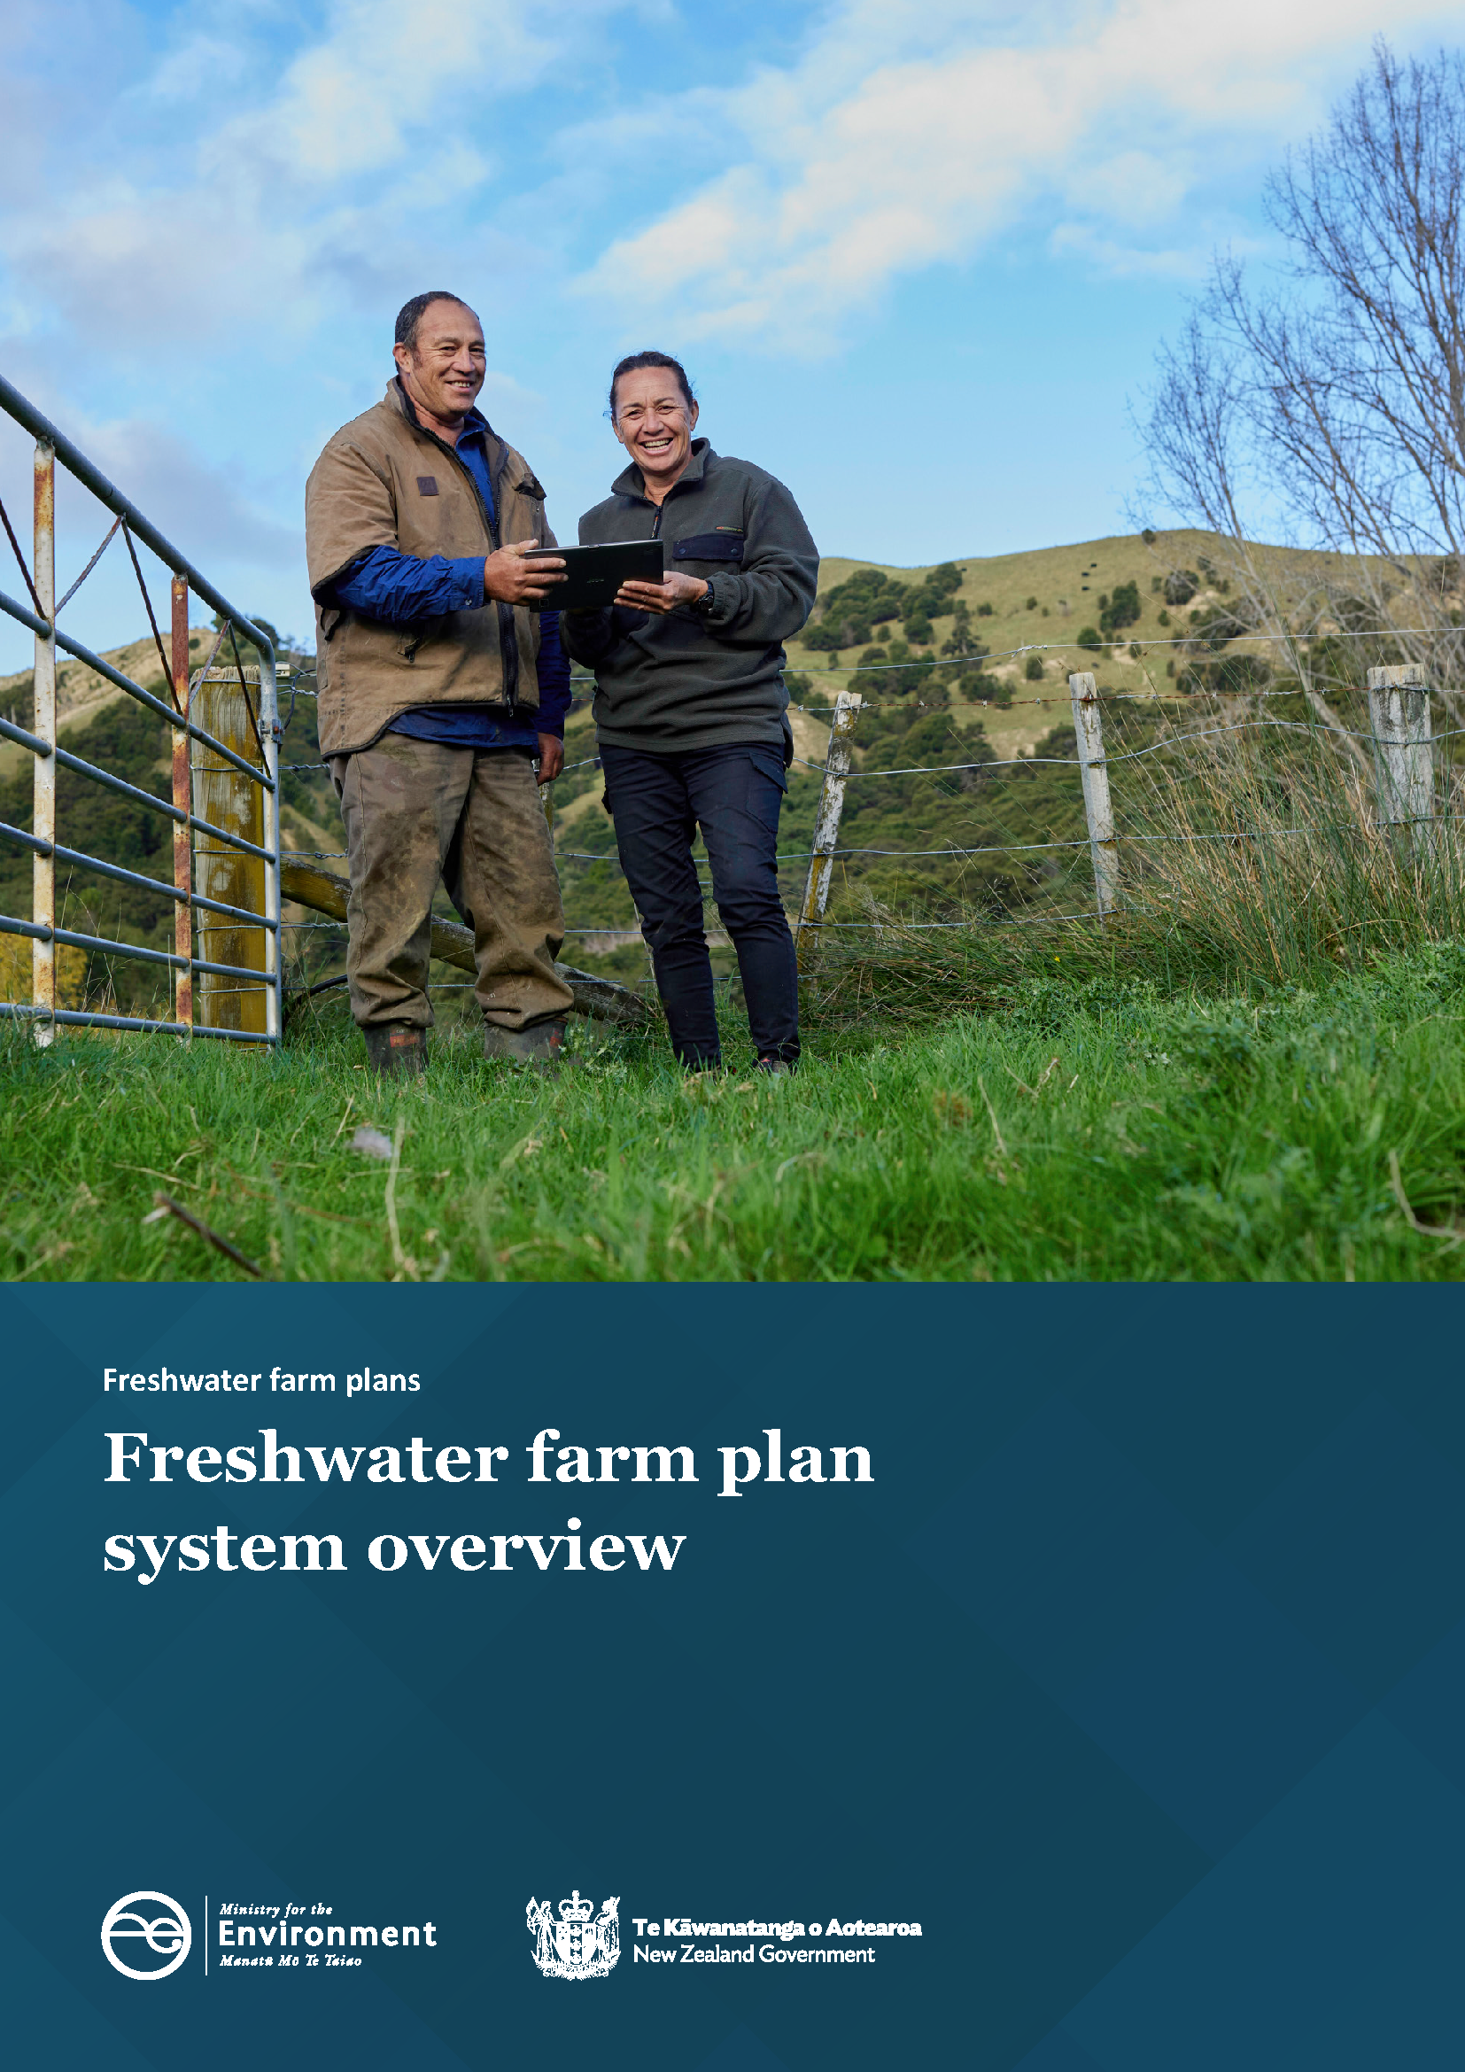

Disclaimer
The information in this publication is, according to the Ministry for the Environment’s best efforts, accurate at the time of publication. The Ministry will make every reasonable effort to keep it current and accurate. However, users of this publication are advised that:
- the information does not alter the laws of New Zealand, other official guidelines, or requirements
- it does not constitute legal advice, and users should take specific advice from qualified professionals before taking any action based on information in this publication
- the Ministry does not accept any responsibility or liability whatsoever whether in contract, tort, equity, or otherwise for any action taken as a result of reading, or reliance placed on this publication because of having read any part, or all, of the information in this publication or for any error, or inadequacy, deficiency, flaw in, or omission from the information in this publication
- all references to websites, organisations or people not within the Ministry are for convenience only and should not be taken as endorsement of those websites or information contained in those websites nor of organisations or people referred to.

This document may be cited as: Ministry for the Environment. 2023. Freshwater farm plan system overview. Wellington: Ministry for the Environment.

Published in June 2023 by the
Ministry for the Environment
Manatū mō te Taiao
PO Box 10362, Wellington 6143, New Zealand
environment.govt.nz
ISBN: 978-1-991077-61-5
Publication number: ME 1771
© Crown copyright New Zealand 2023

Contents
Introduction 5
1. Do I need a freshwater farm plan? 6
2. The freshwater farm plan 8
3. How do I prepare a certified freshwater farm plan? 10
4. How do I get my plan certified? 12
5. How do I get my plan audited? 15
6. When is recertification required? 18
7. What happens to my data? 19
8. What happens if I don’t meet obligations? 20
Appendix 1: Glossary 21
Appendix 2: Farm operator examples 24
Appendix 3: Second certification 26
Appendix 4: Collecting and storing evidence 27
Appendix 5: Information requirements 28

Introduction

What are freshwater farm plans?
Freshwater farms plans are a regulated farm planning process for farmers and growers. They provide a practical way to identify, manage and reduce the impact of farming on the freshwater environment. Freshwater farm plans have been legislated under Part 9A of the Resource Management Act 1991 (RMA) and the Resource Management (Freshwater Farm Plans) Regulations 2023 (the regulations).
Freshwater farm plans are a key part of the 2020 Essential Freshwater package. The package was introduced to:
- stop further decline to the health of our freshwater
- improve water quality
- reverse past damage
- bring our waterways to a healthy state within a generation.
The central concept of Essential Freshwater is Te Mana o te Wai – healthy freshwater supports healthy communities, a healthy environment and a healthy economy. Te Mana o te Wai prioritises the health and wellbeing of freshwater ecosystems, then the health of people, followed by commercial use.
Freshwater farm plans are intended to work in combination with the Essential Freshwater package, which includes:
- the National Policy Statement for Freshwater Management 2020 (NPS-FM)
- the Resource Management (National Environmental Standards for Freshwater) Regulations 2020 (NES-F)
- the Resource Management (Stock Exclusion) Regulations 2020.
Over time, freshwater farm plans are expected to become a key tool for farmers and growers to manage their freshwater requirements. They will also help farmers to understand and apply the concept of Te Mana o te Wai in the context of their farming operation, and to ensure their farming practices contribute to restoring the health of our waterways.

Why freshwater farm plans?
Having a freshwater farm plan will help you to build on the work you are already doing to improve the health of freshwater and freshwater ecosystems in your catchment.
Your freshwater farm plan will be:
- a farm planning process that puts the health of the whenua (land) and wai (water) at the centre of your decision-making
- a way to plan for all on-farm freshwater risk management practices, including actions to meet existing regulatory requirements, including council rules
- tailored to your unique set of circumstances, based on your local catchment, your farm landscape and climate, and your farming system
- a record of the practical steps you’re taking now and into the future to improve freshwater quality in your local catchment.

1. Do I need a freshwater farm plan?
A farm, orchard or block must have a freshwater farm plan if it has:
- 20 or more hectares in arable or pastoral land use, or
- 5 or more hectares in horticultural land use, or
- 20 or more hectares in mixed use (of any two or more of the above).
If your property meets one or more of the land-use thresholds above, you must have a freshwater farm plan (a plan). The farm operator is responsible for ensuring the farm has a certified plan.
The freshwater farm plan system will be commenced region by region, across the country. Each region will determine how the system is rolled out within their region. This may mean that sub-regions are commenced at different times. Your regional council will advertise key dates for your region or sub-region.
You will have 18 months from the day of the system commencement to submit your plan for certification.

1.1 Who is the farm operator?
The farm operator is the person with the ultimate responsibility for the operation of a farm.
The farm operator must:
- prepare (or arrange the preparation of) a freshwater farm plan
- arrange for the plan to be certified
- ensure the farm operates in compliance with the freshwater farm plan
- arrange for the farm to be audited
- keep the freshwater farm plan fit for purpose (make any necessary amendments)
- arrange for recertification and audit within prescribed timeframes.
Your plan must identify the farm operator.
In some farming arrangements, it may not be immediately clear who the farm operator is.
See appendix 2 for guidance on how to identify the farm operator in complex management or ownership scenarios.

1.2 What if I already have a farm environment plan or another farm plan?
If you have an existing farm environment plan or other farm plan you are likely to be able to adapt it to meet freshwater farm plan certification requirements.
You can use much of the information included in a farm environment plan (eg, information about landscape features and farming or growing activities) in your freshwater farm plan.
You may need to add, amend or update information in the following areas:
- catchment context information
- the risk assessment approach
- the selected actions to manage identified risks.
Many existing farm environment plan providers will update, or have already updated, their programmes to meet freshwater farm plan certification requirements by the time the freshwater farm plan regulations apply.
It is the responsibility of the farm operator to ensure that the freshwater farm plan meets certification requirements. See the Ministry for the Environment’s (the Ministry) guidance document Developing a freshwater farm plan for further information.

1.3 How does this fit with my other regulatory requirements?
You must comply with all regulatory requirements related to freshwater on your farm.
In some instances, you will be able to use your freshwater farm plan to meet other freshwater regulatory requirements (eg, regional plan rules, national environmental standards, regulations under section 360 of the RMA). This applies only to requirements where that regulation specifically allows for a freshwater farm plan pathway to be used.
See Developing a freshwater farm plan for further information.

2. The freshwater farm plan
Figure 1 gives an overview of the key steps involved in creating a freshwater farm plan. For more detailed information on what must be included in your Plan see Developing a freshwater farm plan.
Figure 1: Process for developing a freshwater farm plan
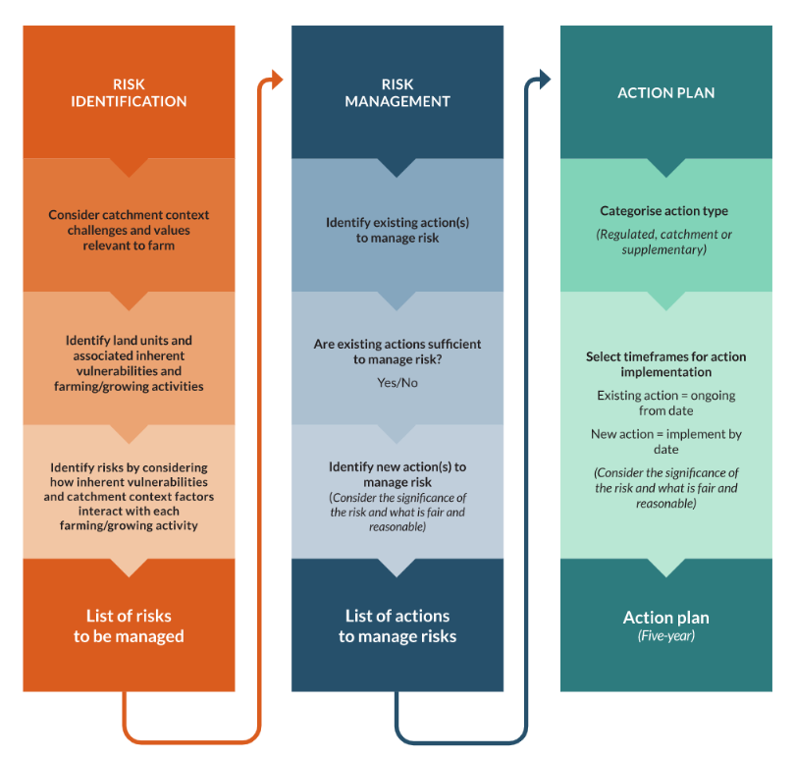

2.1 Catchment context, challenges and values
Catchment context, challenges and values (catchment context) is about understanding your farming or growing operation as a part of your local catchment or sub-catchment.
Your regional council will make catchment context information available. The information will help you to understand the unique environmental features, current environmental health status, cultural values and practices, and recreational sites of your catchment.
You will apply your catchment context information to consider how your farm’s natural landscape and the farming/growing activities you undertake impact the health of freshwater and freshwater ecosystems in your catchment.
You will also apply your catchment context information to help to identify how best to manage or reduce those impacts, to protect the health of your catchment for future generations.
See appendix 1 for the definition of catchment context, challenges and values as it appears in the regulations.
See section 3 Risks to freshwater in Developing a freshwater farm plan for more information on how to include catchment context in your plan.

2.2 Identifying and assessing risks to freshwater
You will need to consider the whole risk profile to identify the risks to freshwater on your farm. This means considering how your catchment context, inherent vulnerabilities and farming/growing activities interact and create risks to freshwater. You will also need to assess the significance of that risk.
See section 3 Risks to freshwater in Developing a freshwater farm plan for more information.

2.3 Identifying actions
Actions are the things you do to manage risks to freshwater.
You will identify actions by considering whether your identified risks are adequately managed.
For each risk, you will identify what actions you are already doing to manage the risk (if any), and which risks are partly managed or unmanaged.
Once you have identified risks that are partly managed or unmanaged, you will identify new actions to manage those risks. Once you have identified actions to manage each of your identified risks you will create your action plan.
For more information on identifying actions, including writing clear and measurable actions and fair and reasonable actions, see section 4.1 in Developing a freshwater farm plan.

2.4 Action plan
Your action plan will be a record of your selected actions, the category of those actions and the timeframes for implementation.
A certifier will ensure that your action plan meets certification requirements.
Your progress towards implementing the actions as they are set out in the action plan is what will determine your grade when your farm is audited.
For more information on recording, categorising actions and selecting timeframes for implementation, see section 5 in Developing a freshwater farm plan.

3. How do I prepare a certified freshwater farm plan?
You can prepare a freshwater farm plan yourself, or you can arrange for a rural professional (farm advisor or freshwater farm plan certifier) to prepare it for you.
To prepare the plan yourself, you will need to:
1. develop your plan using available guidance and resources to assist you. You could:
- use your existing farm environment plan (or similar) as a starting point
- refer to Developing a freshwater farm plan
- refer to relevant regional council and/or industry resources
2. engage a certifier to certify the plan
3. provide the certifier with necessary information and support to complete the certification process.
If a farm advisor (who is not a certifier) prepares your plan, you will need to:
1. engage a competent advisor
2. provide the advisor with the necessary information and support required to develop the plan
3. ensure you have a clear understanding of the content of your plan, particularly the actions and timeframes in your action plan
4. engage a certifier
5. provide the certifier with necessary information and support to complete the certification process.
If a freshwater farm plan certifier prepares your plan, you will need to:
1. engage a certifier
2. provide the certifier with the necessary information and support required to develop the plan
3. ensure you have a clear understanding of the content of your plan, particularly the actions and time frames in your action plan
4. provide the certifier with necessary information and support to complete the certification process.

3.1 What are certification requirements?
Certification requirements are the pieces of information that your freshwater farm plan must contain for your plan to be certified.
However you choose to approach the plan development process (see section 3), it is the responsibility of the farm operator to ensure that the freshwater farm plan meets certification requirements.
See the Ministry’s guidance on Developing a freshwater farm plan for a full list of certification requirements.

4. How do I get my plan certified?
Your freshwater farm plan must be submitted for certification within 18 months of (whichever comes later):
- the regulations being applied in your region, district or catchment, or
- the farm meeting the land use thresholds (see section 1).
The purpose of certification is to ensure that your freshwater farm plan meets certification requirements, including:
- having regard to catchment context information
- identification and assessment of risks, including inherent vulnerabilities and farming/growing activities
- identification of appropriate actions to manage the identified risks
- an action plan with clear and measurable actions that are categorised and assigned an implementation timeframe.
You can read the certification requirements in the Ministry’s guidance Developing a freshwater farm plan.

4.1 How does the certification process work?

4.1.1. Engaging a certifier
The farm operator must choose a freshwater farm plan certifier, and engage and pay for their services.
Your regional council will appoint certifiers and make a list of certifiers available on their website.
Your chosen certifier will check for any conflicts of interest at the start of your relationship and, if necessary, make a plan to manage them.

4.1.2. Desktop assessment
The certifier will ask you to provide your freshwater farm plan and any supporting material.
At this stage, the certifier will:
- assess whether your plan contains the information required by the certification requirements
- check that the actions in your action plan are clear and measurable
- consider any areas of the plan where more information may be required to make an accurate assessment
- arrange a time for an on-farm visit.

4.1.3. On-farm assessment
Your certifier must complete an on-farm assessment for your first certification.
During the on-farm assessment, your certifier will:
- seek physical evidence to assess whether inherent vulnerabilities, farming/growing activities and risks have been accurately identified and assessed
- ensure the actions and timeframes identified in your action plan are appropriate to manage the identified risks
- ensure that actions and timeframes identified in the action plan are fair and reasonable.

4.1.4. Certification assessment report
Following the on-farm assessment your certifier will provide you (the farm operator) with a draft decision and assessment report detailing the reasons your plan meets (or does not meet) the certification requirements. This must be completed within 30 working days of the farm operator submitting their plan to the certifier for certification.
You have 10 working days to provide written comments on any aspect of the draft decision and/or assessment report that you disagree with.
If you chose to provide comments, the certifier must consider your comments and provide you with a preliminary (revised) decision and assessment report within five working days.
If you are not happy with the certifier’s preliminary decision and/or assessment report, you have 10 working days to notify the certifier that you wish to engage a second certifier (enter the review process).
For information on the second certification (review process) see appendix 3.

4.1.5 Final assessment report and decision, and notification of regional council
If you are happy with the certifier’s draft decision and assessment report and do not provide any comments, the draft decision and assessment report will become the final decision and assessment report.
Your certifier will notify you and your regional council that your plan has (or has not been) certified as soon as practicable.
If you provided comments on the draft decision and assessment report, and were happy with the subsequent preliminary decision and assessment report, the preliminary decision and assessment report will become the final decision assessment report.
Your certifier will notify you and your regional council that your plan has (or has not been) certified as soon as practicable.

4.2. What do I do once my plan has been certified?
Once your plan has been certified, you must:
- ensure your plan is stored securely in a format that is able to be accessed and updated as necessary
- implement your identified actions within the timeframes set out in the action plan.
You will also need to collect and record evidence to demonstrate that actions (both new and existing) are being implemented.
Your auditor will refer to your collected evidence and records to inform their assessment. Keeping high quality evidence will assist your auditor in making their assessment quickly and accurately.
See appendix 4 for more information on collecting and storing evidence.

5. How do I get my plan audited?
The purpose of the audit is to assess that actions have been or are being implemented as described and within the assigned timeframes in the certified action plan.
You (the farm operator) must arrange for an initial audit of your plan within 12 months of your first certification.
The auditor will assign an audit grade of A, B, C or D. The audit grade will determine when your next audit is required by (see section 5.2).
Following your initial audit (and subsequent audits) you must arrange for your next audit within the timeframe specified by your audit grade.
Following recertification of your plan, you must arrange for an audit within 12 months. This applies only for a full recertification.
For a part recertification, the timeframe for your next audit will remain the same as determined by your most recent audit grade or full recertification.
If you have taken over a farm and adopted the existing certified plan from the previous farm operator you must arrange for an audit within 12 months of taking over the farm.

5.1 How does the audit process work?

5.1.1. Engaging an auditor
The farm operator must choose an auditor, and then engage and pay for their services.
Your regional council will appoint auditors in your region and publish a list of auditors on their website.
Your auditor will first check for any conflicts of interest and, if necessary, make a plan to manage them.

5.1.2. Desktop assessment
Provide your auditor with your certified freshwater farm plan and any other relevant information reasonably required by the auditor to make their assessment.
At this stage, the auditor will:
- read over your action plan to develop an understanding of the actions and timeframes set out in your plan
- consider what evidence will be necessary for them to assess whether actions are being or have been implemented within the required timeframes
- arrange a time for an on-farm assessment (if applicable).

5.1.3. On-farm assessment
Your auditor will likely carry out an on-farm assessment for your first audit. Depending on the nature of the actions in the certified farm plan, the auditor may also carry out an on-farm assessment for subsequent audits.
During the on-farm assessment, the auditor will seek physical evidence to assess whether actions have been, or are being, implemented, as set out in the certified plan.

5.1.4. Audit report
Following the on-farm assessment, your auditor will provide you with an audit report that:
- describes whether the individual actions identified in your action plan have been implemented in the specified timeframe
- assigns an audit grade and outlines why this particular grade is being given.
If the auditor finds that the farm operator has not implemented the actions as set out in their freshwater farm plan (ie, they were given a B, C or D grade) the audit report must:
- include the reason(s) why the farm did not achieve an A grade
- provide the timeframe for subsequent audit (based on the assigned B, C or D audit grade)
- may include recommendations on how compliance may be achieved.
The first audit report must be provided to the farm operator within 20 working days of the auditor being engaged by the farm operator.
The auditor must give the farmer a reasonable opportunity to provide comment on the report.
Once the auditor has considered any comments from the farm operator, they have 15 working days from the day that the first audit report was provided to the farm operator to provide the farm operator and the regional council with the final audit report.

5.2 Audit grades
The grading criteria are set out below. Your audit grade will determine when you next need to audit your plan.
Table 1: Audit grading criteria
Grade | Description | Next audit arranged within
A | All actions categorised in the action plan as regulated actions, catchment actions and supplementary actions have been implemented within the timeframes required under the action plan. | 3 years
B | All actions categorised in the action plan as regulated actions and catchment actions have been implemented within the timeframes required under the action plan, but one or more actions categorised as supplementary actions have not been implemented within the required timeframes. | 2 years
C | All actions categorised in the action plan as regulated actions have been implemented within the timeframes required under the action plan, but one or more actions categorised as catchment actions have not been implemented within the required timeframes. | 1 year
D | One or more actions categorised in the action plan as regulated actions have not been implemented within the timeframes required under the action plan.  One or more actions categorised in the action plan as catchment actions or supplementary actions have still not been implemented within the timeframes required under the action plan following a subsequent audit. | 6 months

6. When is recertification required?
Your freshwater farm plan must be updated and submitted for recertification not more than five years after it was last certified.
The certifier will undertake an on-farm assessment unless there are no new regulated actions included in the action plan.
You must also update and resubmit your freshwater farm plan for recertification within 12 months if the farm:
- has new significant inherent vulnerabilities
- adds additional land that has different relevant catchment context information
- you (the farm operator) undertake significant changes in farming or growing activities
- the farm changes farm operator and the new farm operator does not adopt the existing plan.
You may update and submit your plan, or part of your plan, for recertification at any other time.
You can choose to submit only the part of the plan related to the recertification trigger for recertification, if the recertification triggers above only relate to:
- part of the farm area
- part of a farming/growing activity.
This is known as ‘part recertification.’ The part recertification will follow the same process and timeframes set out in section 4.1.
If you undertake a part recertification, this does not reset the required timeframes for the next full recertification or audit. These still apply based on your last full certification.

7. What happens to my data?

7.1 Certification
The certifier must submit the following information to your regional council within five working days of notifying the council of the final certification decision:
- your administrative details (see section 1 in Developing a freshwater farm plan)
- your certified action plan
- the conflict of interest declaration
- a statement identifying instances where you intend to use your plan to meet other freshwater regulatory requirements
- a map of the spatial extent of the farm.
The regional council must keep the information set out above, and a record of:
- whether the farm has a certified freshwater farm plan
- the date the plan was last certified
- any complaints you may make about a certifier and any resulting actions.
Your certifier will keep all information received and prepared in relation to the certification of your freshwater farm plan for seven years. That information will include:
- comments received from the farm operator
- any draft, preliminary and final assessment reports and decisions
- administrative information.

7.2 Audit
Within five working days of completing an audit, your auditor will provide the regional council with the following information:
- your farm administrative details (see section 1 in Developing a freshwater farm plan)
- the final audit report
- the conflict of interest declaration.
The regional council must keep the information set out above, and a record of:
- the date the farm was last audited
- any complaints you may make about an auditor and any resulting actions.
Your auditor will keep your audit report for seven years.
For more information on what data is collected see appendix 5.

8. What happens if I don’t meet obligations?
The regional council is the compliance monitoring and enforcement agency for the freshwater farm plan system.
The regional council may require you (the farm operator) to produce your certified freshwater farm plan for inspection (under section 217I of the RMA). You must provide the certified freshwater farm plan within 20 working days.
You must also provide any information reasonably required by a regional council enforcement officer for the purpose of monitoring and compliance.
The following are infringement offences under the Resource Management (Infringement Offences) Regulations 1999:
- farm operator does not submit their freshwater farm plan for certification within the specified timeframe (see section 4.1)
- farm operator does not submit their freshwater farm plan for recertification within five years of their last certification (see section 6)
- farm operator does not submit their freshwater farm plan for recertification within 12 months of a recertification criterion being triggered (see section 6)
- farm operator does not implement one or more actions within the timeframes specified in their certified action plan (see section 5.2)
- farm operator does not arrange for their plan to be audited within 12 months of the initial certification (see section 5.1)
- farm operator does not arrange for their plan to be audited within 12 months after their plan is recertified (see section 5.1)
- farm operator does not arrange for their plan to be audited within the timeframe required by their most recent audit grade (see section 5.1)
- farm operator does not arrange for their plan to be audited within 12 months of taking over a farm and adopting the previous farm operator’s plan (see section 5.1)
- farm does not have a certified freshwater farm plan (see section 1).
The infringement fee for the above offences is NZ$1,500.

Appendix 1: Glossary
The following definitions are those included in Part 9A of the Resource Management Act 1991 and the Resource Management (Freshwater Farm Plans) Regulations 2023.
Act means the Resource Management Act 1991.
Action, in relation to an action plan,—
- means the way in which a farm operator avoids, remedies, or mitigates 1 or more adverse effects on freshwater and freshwater ecosystems; and
- includes (without limitation)—
  - a physical work (for example, fencing or planting):
  - a practice (for example, how an activity is undertaken):
  - a process or procedure (for example, training staff in how to undertake an activity).
Action plan means the plan set out in a certified freshwater farm plan under regulation 10 (see appendix 3).
Arable land use means the use of land to grow any of the following crops for harvest:
- grain cereal, legumes, or pulse grain:
- herbage seed:
- oilseed:
- maize grain, maize silage, cereal silage, or mangels:
- crops grown for seed multiplication:
- a crop prescribed in regulations made under section 217M(1)(a) of the Act.
Auditor means a person who—
- is appointed under section 217K of the Act; and
- meets the criteria prescribed in regulations made under section 217M(1)(h) of the Act.
Catchment actions means action(s) that address risks to freshwater and freshwater ecosystems that directly relate to catchment context, challenges and values but exclude regulated actions.
Catchment context, challenges, and values includes (without limitation) the following:
- existing local area information (for example, landforms, soil data, climate data, freshwater data, freshwater bodies, priority contaminants, significant sites to the community, significant species or ecosystems):
- identified cultural matters of importance to tangata whenua, including:
  - the cultural significance of the local area
  - the traditional name(s) of freshwater bodies
  - significant sites and species to tangata whenua.
- any freshwater objectives, policies, rules in relevant regional policy statements and regional plans
- any relevant freshwater matters in planning documents that are recognised by each iwi authority and lodged with the relevant regional council
- the National Policy Statement for Freshwater Management and any action plans made by the regional council
- any other secondary legislation made under the RMA relevant to the management of freshwater or freshwater ecosystems.
Certified freshwater farm plan means a freshwater farm plan certified under section 217G of the Act, as amended from time to time in accordance with section 217E(2) or (3) of the Act.
Certifier means a person who—
- is appointed under section 217K of the Act; and
- meets the criteria prescribed in regulations made under section 217M(1)(h) of the Act.
Certification requirements means the requirements for the contents of a freshwater farm plan set out in section 217F of the Act.
Critical source area has the meaning given in regulation 3 of the Resource Management (National Environmental Standards for Freshwater) Regulations 2020.
Farm means a farm where all or part of the farm is—
- arable land use; or
- horticultural land use; or
- pastoral land use; or
- other agricultural land use prescribed in regulations made under section 217M(1)(b) of the Act; or
- any combination of the above.
Farm operator means the person with ultimate responsibility for the operation of a farm.
Horticultural land use means the use of land to grow food or beverage crops for human consumption (other than arable crops) or flowers for commercial supply.
Inherent vulnerabilities means risks to freshwater and freshwater ecosystems from the biophysical features of the land including from irrigation or drainage.
Intensive winter grazing has the meaning given in regulation 3 of the Resource Management (National Environmental Standards for Freshwater) Regulations 2020.
Land unit means an area of contiguous or non-contiguous land with similar biophysical features.
National Policy Statement for Freshwater Management means the National Policy Statement for Freshwater Management whose approval under section 52 of the Act was notified in August 2020 (as amended or replaced from time to time).
Pastoral land use means the use of land for the grazing of livestock.
Regulated actions means action(s) that –
- address risks to freshwater and freshwater ecosystems; and
- relate to a relevant requirement under a specified instrument.
Relevant regional council means the regional council (as defined in section 2) in whose jurisdiction the farm is located.
Specified instrument means any designation, national environmental standard, national planning standard, regulations made under Part 14, resource consent, rule in a plan, or water conservation order.
Stockholding area has the meaning given in regulation 3 of the Resource Management (National Environmental Standards for Freshwater) Regulations 2020.
Supplementary action means action(s) that address risks to freshwater or freshwater ecosystems but exclude catchment and regulated actions ecosystems and also relate to a relevant requirement under a specified instrument.
Te Mana o te Wai has the meaning set out in the National Policy Statement for Freshwater Management.

Appendix 2: Farm operator examples
The farm operator is the person with ultimate responsibility for the operation of a farm.
For owner-operators, identifying the farm operator is straightforward as the owner will be the farm operator. In more complex farm business arrangements, it may not be immediately clear who the farm operator is.
Key considerations for identifying the farm operator in more complex arrangements are provided below.
Note this information is a guide only and may apply differently to each farm. Where necessary, seek your own legal advice to determine who is the farm operator for your farm for the purposes of freshwater farm plans.

Private lease land
Many lease agreements identify who is responsible for meeting regulatory requirements. This may be sufficient to determine who the farm operator is.
If the lease agreement does not sufficiently identify who is responsible, the lessor and lessee (the parties) will need to make the decision together.
When making this decision the parties should consider:
- the area of the farm covered by the lease (eg, single paddock, part-farm, whole farm)
- the length of the lease (eg, short-term, long-term)
- whether the lessee’s freshwater farm plan already provides appropriate actions for the catchment context, farm inherent risks and farming/growing activities being undertaken on the leased land (eg, where the lessee has an existing plan for a neighbouring property).

Management agreements
A management agreement will usually list the tasks or services the landowner is contracting out to a third party (the manager(s)).
The landowner retains overall decision-making responsibility for the farm. The landowner would likely be the farm operator unless the parties agreed otherwise in the management agreement.

Sharemilker
Usually, the landowner retains overall management control of the farm in a sharemilking agreement. The landowner would likely be the farm operator unless the parties agreed otherwise in the sharemilking agreement.

Contract grazing
A grazing contract between a livestock owner and landowner (grazier) usually specifies livestock performance and management targets for the time they spend on the grazier’s property.
The grazier is responsible for the decision-making around how these targets are achieved on their farm and retains overall decision-making responsibility for the farm. The landowner would likely be the farm operator.

Appendix 3: Second certification
If you are not happy with the certifier’s preliminary decision and/or assessment report, you have 10 working days to:
- notify the certifier that you wish to engage a second certifier (start the review process), and
- engage a second certifier to complete a second certification.
You must provide your second certifier with:
- all the information you provided to your first certifier
- the draft and preliminary assessment reports and decisions from your first certifier.
Your first certifier must notify the regional council that the review process has been initiated within five working days.
The second certifier will conduct a certification assessment following the same process as your first certifier (see section 4.1), to determine if the plan meets (or does not meet) the certification requirements.
Following the on-farm assessment, the second certifier will provide you (the farm operator) with a draft decision and assessment report detailing the reasons your plan meets (or does not meet) the certification requirements. This must be completed within 30 working days of the second certifier being engaged.
If you do not agree with the second certifier’s draft decision or assessment report, you may provide written comment to the certifier within 10 working days.
The second certifier must consider the comments and produce a final decision and assessment report within five working days.
If you do not provide comments, the draft decision and assessment report become the final assessment report and decision.
The decision of the second certifier is final.
If the second certifier assesses that the plan does not meet certification requirements and cannot be certified, the farm operator needs to amend the plan and begin the certification process again.
The regional council may bring enforcement action if the farm does not have a certified freshwater farm plan within the required timeframe.
The farm operator is responsible for the cost of the second certification.

Appendix 4: Collecting and storing evidence
Your auditor will refer to your collected evidence and records to inform their assessment. Keeping high quality evidence will assist your auditor in making their assessment quickly and accurately.
There are many ways you (the farm operator) can collect evidence, the most practical option will depend on both the specific action and your farm circumstances. Examples include:
- invoices and receipts
- time-stamped photographs and videos of actions undertaken
- real-time data from sensors
- third party assessments and/or reports
- training logs demonstrating staff awareness of policies and procedures
- maintenance logs and associated invoices and receipt.
You should also consider how you will store your recorded evidence. It is suggested that the following digitally based options are used whenever possible:
- digital records stored within the business computer system
- digital records held in a cloud-based system that allows third-party access
- farm management software used for farm decision-making.

Appendix 5: Information requirements
As a part of the freshwater farm plan system, data related to your plan will be provided to different parties and may be kept by them.

Information regional councils can ask a farm operator to provide
The regional council may require you (the farm operator) to provide your certifier’s draft, preliminary, or final decision or assessment report in relation to your plan for the purposes of compliance monitoring and enforcement. You must provide the requested report or decision within 20 working days of receiving the request.
The regional council may require you to produce your certified freshwater farm plan for inspection. You must provide the certified freshwater farm plan within 20 working days of receiving the request.
You must provide any information reasonably required by the regional council enforcement officer for the purposes of monitoring and compliance.

Information certifiers and auditors must provide to regional councils
Your certifier must provide the following information to the regional council within five working days of notifying the council of a certification decision:
- the farm administrative information
- the action plan
- the conflict of interest declaration
- statement identifying any instances where the farm operator intends to use the freshwater farm plan to meet another regulatory requirement
- map of the spatial extent of the farm.
Your auditor must provide the following information to the regional council within five working days of completing the audit process:
- the farm administrative information
- the audit report
- the audit grade
- the conflict of interest declaration.

Requirements for keeping information
Your certifier will keep all information received and prepared in relation to the certification of your freshwater farm plan for seven years. That information will include:
- comments received from the farm operator
- any draft, preliminary and final assessment reports and decisions
- administrative information.
Your auditor must keep your audit report(s) for seven years.
The regional council will keep and maintain (digitally) the following information:
- whether the farm has a certified freshwater farm plan
- the date the plan was last certified
- the date the farm was last audited for compliance with the plan
- the farm administrative information
- the action plan
- certification decisions
- audit reports
- conflict of interest declarations
- statements identifying whether a farm operator intends to rely on the freshwater farm plan to meet other regulatory requirements
- a map of the spatial extent of the farm.
- records of any complaints you may make about a certifier or an auditor and any resulting actions.

