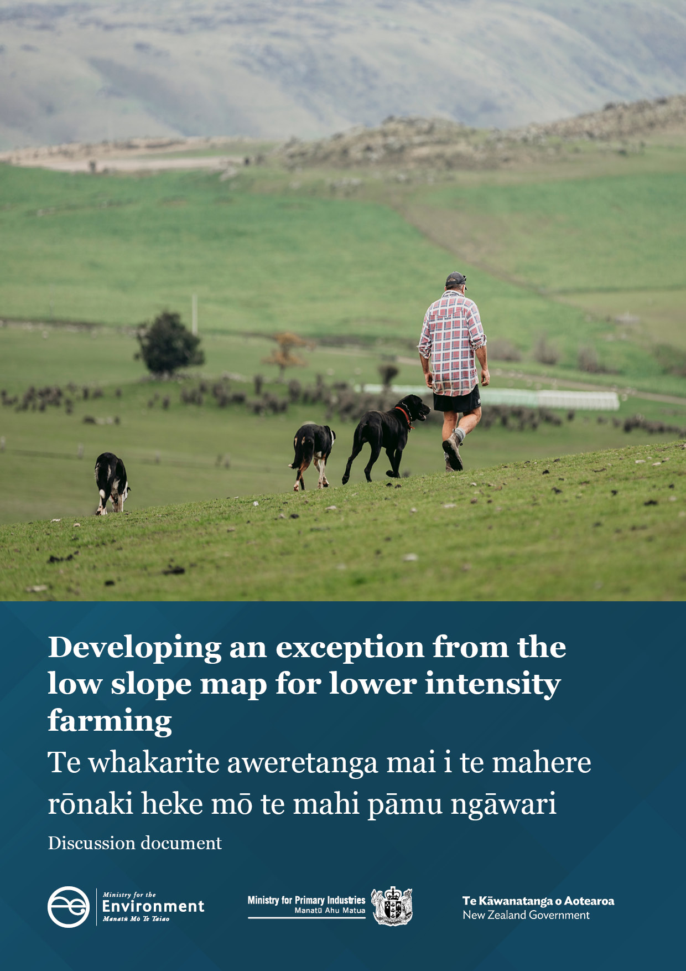

**Disclaimer**

The information in this publication is, according to the Ministry for the Environment’s best efforts, accurate at the time of publication. The Ministry will make every reasonable effort to keep it current and accurate. However, users of this publication are advised that:

* the information does not alter the laws of New Zealand, other official guidelines, or requirements
* it does not constitute legal advice, and users should take specific advice from qualified professionals before taking any action based on information in this publication
* the Ministry does not accept any responsibility or liability whatsoever whether in contract, tort, equity, or otherwise for any action taken as a result of reading, or reliance placed on this publication because of having read any part, or all, of the information in this publication or for any error, or inadequacy, deficiency, flaw in, or omission from the information in this publication
* all references to websites, organisations or people not within the Ministry are for convenience only and should not be taken as endorsement of those websites or information contained in those websites nor of organisations or people referred to.

This document may be cited as: Ministry for the Environment. 2023. *Developing an exception from the low slope map for lower intensity farming: Discussion document*. Wellington: Ministry for the Environment.

Published in June 2023 by the  
Ministry for the Environment and the Ministry for Primaries Industries   
Manatū mō te Taiao  
PO Box 10362, Wellington 6143, New Zealand  
[environment.govt.nz](http://www.environment.govt.nz)

ISBN: 978-1-991077-46-2   
Publication number: ME 1758

© Crown copyright New Zealand 2023

# Contents

Section 1: Introduction and context 4

Recent changes to the map of low slope land 4

Remaining issues with the map 5

Proposals for consultation 5

Have your say 6

Information to support your feedback 6

Section 2: Defining lower intensity farming for the purpose of an exception 7

Proposed approach: Defining lower intensity farming according to stock units per hectare 7

What is the appropriate threshold for defining lower intensity farming? 8

Situations where an exception is not appropriate 10

Compliance, monitoring and enforcement by regional councils 10

Section 3: Using certified freshwater farm plans 12

Section 4: Stock exclusion for natural wetlands 14

Section 5: Other issues 16

Adjusting the definition of a permanent fence to recognise other fence types 16

Clarifying what happens if land above 10 degrees is still captured by the map of low slope land 16

Section 6: Preliminary regulatory impact analysis 18

Section 7: How to have your say 19

Timeframes 19

How to provide feedback 19

More information 20

Publishing and releasing submissions 20

Section 8: Glossary 21

Section 9: Consultation questions 22

Appendix: Data analysis methodology 24

# Section 1: Introduction and context

The Resource Management (Stock Exclusion) Regulations 2020 (the regulations) require the exclusion of stock from water bodies in a range of situations. The purpose of the regulations is to reduce damage to waterways as a result of livestock accessing them.

The [map of low slope land](https://mfe.maps.arcgis.com/apps/instant/sidebar/index.html?appid=42c325f726354d78a38893983432aa65) (the map) is incorporated by reference in the regulations, and determines where non-intensively grazed beef cattle and deer must be excluded from lakes and wide rivers (ie, those with a bed wider than 1 metre), and where all stock must be excluded from natural wetlands with an area more than 500 square metres, from 1 July 2025.[1]

The regulations include a range of other activity-based requirements that apply regardless of the map. For example, the requirement that beef cattle and deer which are intensively grazing[2] on any terrain be excluded from water bodies from 1 July 2023.

More information about the regulations is available on the [Ministry for the Environment website](https://environment.govt.nz/acts-and-regulations/regulations/stock-exclusion-regulations/).

## Recent changes to the map of low slope land

Following the introduction of the regulations in 2020, feedback indicated the map needed improvement to address concerns about accuracy and its unintended capture of lower intensity farming in the high country. From August to October 2021, the Government publicly consulted on changes to the map that would:

* improve how the map identifies low slope land, and
* address the map’s unintended capture of lower intensity farming in the high country.

As result of that consultation, the Government agreed in December 2022 to amend the map to:

* use a more advanced mapping methodology to identify low slope land without averaging across land parcels
* use a more conservative 5 degree threshold to identify low slope land and avoid capturing steeper land above 10 degrees, with the expectation that stock will be excluded on slopes between 5 and 10 degrees subject to farm planning processes and individual circumstances, and
* introduce an altitude threshold of 500 metres to the map to avoid capturing high country farms.

The above changes to the map took effect on 5 January 2023.

## Remaining issues with the map

Recent changes have improved how the map identifies low slope land, and have addressed how it captures lower intensity farming in the high country. However, the map still captures some lower intensity farming systems (ie, on flat land below the altitude threshold).

Based on the area of low-producing grassland, officials estimate the map could be capturing approximately 0.37 million hectares of lower intensity farming.[3]

At lower stocking rates, the marginal environmental benefit of excluding stock is reduced while cost is increased (eg, the cost of fencing per stock unit). Therefore, it may be appropriate for lower intensity farming to be exempt from the map and associated requirements to exclude stock.

The Government has agreed to develop and undertake further consultation on an exception for lower intensity farming systems to resolve these issues.

## Proposals for consultation

The Ministry for the Environment is now seeking your feedback on the proposals set out in this discussion document. Your feedback will guide further analysis and consideration, feeding into final decisions on implementing solutions for lower intensity farming and some other issues.

**Section 2: Defining lower intensity farming for the purpose of an exception**

This section proposes an approach for defining lower intensity farming for the purpose of an exception, based on stocking rates.

**Section 3: Using certified freshwater farm plans**

This section sets out options for using certified freshwater farm plans as an alternative to the map of low slope land and all associated requirements to exclude stock.

**Section 4: Stock exclusion for wetlands**

This section seeks feedback on excluding stock from wetlands on lower intensity farming systems, where this could lead to unintended outcomes for weed management.

**Section 5: Other issues**

This section seeks feedback on the definition of a permanent fence and clarification of land above 10 degrees.

## Have your say

We welcome your feedback on all elements set out in this document, at: <https://consult.environment.govt.nz/freshwater/>low-slope-map-for-lower-intensity-farming.

The questions throughout the document are given as a guide only. You do not have to answer them all, and any comments are encouraged.

## Information to support your feedback

Please refer to the [Regulatory Impact Statement: Changes to the map of low slope land in stock exclusion regulations](https://www.treasury.govt.nz/publications/risa/regulatory-impact-statement-changes-map-low-slope-land-stock-exclusion-regulations) for more information about recent changes to the map, as well as detailed information on the benefits and costs of excluding stock from water bodies. This includes up-to-date cost estimates for fencing.

Data from Stats NZ’s Agricultural Production Survey can be used to estimate the average stocking rate per hectare across different farm types and regions. This provides an insight into the regions, and proportions of farms and farm types that could benefit under an exception for lower intensity farming. Further details, including a visual representation of this information, are discussed in section 2. Additional information, such as the data analysis methodology, is available in the appendix.

View the [Stats NZ Agricultural Survey data 2018 – 2021](https://environment.govt.nz/assets/publications/20182021-Stocking-units-per-hectare-by-regions-and-farm-types.xlsx)

We have also developed a map to highlight where low producing grassland intersects the current low slope map. This indicates areas where lower intensity farming is likely captured by the map. These areas may be most affected by proposals in this discussion document.

View the [Low-producing grassland map for the North Island](https://environment.govt.nz/assets/publications/North-Island-low-producing-grassland-map.pdf).

View the [Low-producing grassland map for the South Island](https://environment.govt.nz/assets/publications/South-Island-low-producing-grassland-map.pdf).

# Section 2: Defining lower intensity farming for the purpose of an exception

This section sets out a proposed approach for defining lower intensity farming for the purpose of an exception to the map and associated requirements to exclude stock. This is based on an annualised threshold of stock units per hectare, applied to the farm as a whole. We are seeking feedback on whether this is adequate to define lower intensity farming, or whether we should consider other options.

An exception would mean that if a farm meets a definition of lower intensity farming, then there is no requirement to exclude non-intensively grazed beef cattle or deer from water bodies, despite the farm being captured by the map.

This would not affect any other requirements to exclude stock. Dairy cattle, pigs, dairy support cattle, and intensively grazed beef cattle and deer, would continue to be covered by the regulations, as the requirements to exclude these types of stock apply to all terrain. Farm planning or other processes (eg, regional plan rules, which may be more stringent) could still determine it is appropriate to exclude non-intensively grazed beef cattle or deer in the circumstances.

## Proposed approach: Defining lower intensity farming according to stock units per hectare

Stock units (SU) are a means of calculating stocking rate across different species and age groups of animals, based on their relative feed demands.[4] Established methods for calculating stock units are available and widely used in the primary sector.[5]

We propose relying on stock units per hectare (SU/ha) as a proxy for intensity (ie, the higher the stock units per hectare, the more intensive the farming system) and define lower intensity farming according to an annualised threshold that would be applied to the farm as a whole. This is intended to focus the exception on the overall intensity of a farming system and minimise complexity (eg, where stock are regularly moved).

Alternatively, it may be more appropriate to calculate stocking rate over a shorter time period (rather than being annualised) and/or apply a threshold per grazed hectare or other area (as opposed to the farm as a whole). This could account for situations where short-term increases in stocking rates will have a significant effect, or parts of a farm are actually operating more intensively over a smaller area. However, we anticipate this would also make an exception more difficult to apply in practice and exacerbate difficulties with compliance, monitoring and enforcement (discussed in the section on Compliance, monitoring and enforcement by regional councils.

We are seeking feedback on whether you consider stock units per hectare to be an appropriate measure to define lower intensity farming, and how you think the threshold should be applied (eg, whether it should be annualised and applied to the farm as a whole), and why.

## What is the appropriate threshold for defining lower intensity farming?

What is considered ‘lower intensity’ farming can vary significantly in terms of stocking rate. For example, high country stations can operate with as little as 1 SU/ha, while some regional plan provisions aimed at low-intensity farming systems are based on a threshold of 8 SU/ha.

Although there are no established thresholds defining lower intensity farming, it is possible to target a threshold so that it applies to a specific proportion of farms (eg, the least intensive 10 per cent of farms). Figure 1 shows the distribution of stocking rates across Aotearoa New Zealand, based on data collected by Stats NZ through the [Agricultural Production Survey](https://www.stats.govt.nz/help-with-surveys/list-of-stats-nz-surveys/about-the-agricultural-production-survey/). The data provides an insight into the regions, and proportions of farms and farm types that could benefit under different thresholds.

For example, under a threshold of 3 SU/ha, we estimate between 5 to 10 per cent of Northland farms could benefit from an exception. Waikato farms typically have higher stocking rates than Northland farms, and we estimate fewer than 5 per cent could benefit under the same threshold. The methodology used for analysing this data can be found in the appendix.

What is considered lower intensity farming can also differ between beef cattle and deer farms, meaning that one specific threshold may not be appropriate for all stock types. However, setting different thresholds for different stock types may have implications on the practicalities of implementation, for example for farms that run both beef cattle and deer.

We are seeking feedback on what you consider is an appropriate threshold for defining lower intensity farming, and why.

Figure 1: Distribution of stocking rates across Aotearoa New Zealand in 2021

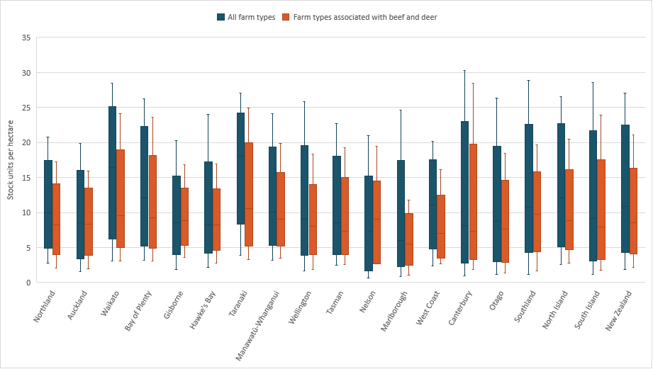

|  |
| --- |
| Questions – Defining lower intensity farming for the purpose of an exception   1. Do you consider stocking rate (ie, SU/ha) is an appropriate measure to define lower intensity farming or do you recommend a different approach? Why?   If you do agree with basing the exception on stocking rate:   1. What do you think is the appropriate stocking rate threshold (in SU/ha) for the definition of lower intensity farming and how do you think it should be calculated (eg, 2 SU/ha, per year, over the whole farm)? Why? 2. Do you think there should be different stocking rate thresholds for beef cattle and deer, or one threshold for all stock types? Why? 3. Is there any other information that you think we should consider in relation to developing an exception for lower intensity farming? |

## Situations where an exception is not appropriate

An exception to the map for lower intensity farming may be inappropriate in some situations. For example, where beef cattle and deer entering particularly sensitive water bodies could cause significant harm, even at lower stocking rates. This could include spring-fed streams and lakes, and inanga spawning sites which are less able to cope with stock breaking down the streambank, sediment runoff and damage to their habitat.

We are seeking feedback on whether there are specific situations where an exception for lower intensity farming should not apply, and how these situations should be identified (eg, according to mapping and spatial data, specific criteria, or otherwise).

|  |
| --- |
| Questions – Situations where an exception may not be appropriate   1. Do you consider that there are any situations where an exception for lower intensity farming should not apply, and the map should continue to apply (eg, where specific sensitive water bodies are present)? If yes, what do you consider these to be and why? If no, why not?   If you do agree that there are situations where an exception may not be appropriate:   1. Do you have any views on how those specific situations should be identified? |

## Compliance, monitoring and enforcement by regional councils

We anticipate it could be difficult to monitor compliance and enforce regulatory requirements that rely on stocking rates. This is because stocking rates vary over time and depend on a number of factors, such as the age or sex of the animals and total area of land to which they have access.

It is expected that farmers are familiar with stock movements on their farm and already collect information that may help demonstrate compliance if needed. For example, farmers already have to report stock movements as part of the [National Animal Identification and Tracing (NAIT) programme](https://www.mpi.govt.nz/animals/national-animal-identification-tracing-nait-programme/). While we do not propose relying on data collected for other purposes, it is important to note that relevant information is being collected by farmers. It should be possible for farmers to demonstrate how they have complied with an exception based on stocking rate if needed.

However, regional councils would still have a limited ability to detect non-compliance with regulatory requirements that rely on stocking rates. This is because the regulations do not currently require farmers to supply the above information (eg, as a condition of an exception applying). In practice, detecting non-compliance would rely on the availability of this information (eg, through local planning requirements, being voluntarily supplied by farmers or the public, or otherwise), technological advances and/or targeted monitoring.

We are seeking feedback on ways to better enable compliance, monitoring and enforcement.

We anticipate that any compliance requirements can be minimised by only collecting information that is necessary for the purpose of the exception, and we expect it will only impact a small proportion of farmers (ie, those that are subject to the map and who meet the relevant threshold of an exception).

Longer term, we expect certified freshwater farm plans and associated audits can complement compliance, monitoring and enforcement efforts.

|  |
| --- |
| Questions – Compliance, monitoring and enforcement by regional councils   1. Is there information that is readily available to farmers and councils to support the implementation of an exception based on stocking rates? How is/should this information be used or shared by farmers and councils? |

# Section 3: Using certified freshwater farm plans

By the end of 2025, we expect regulations requiring farmers to have a certified freshwater farm plan to be in place in all regions – and sooner than that for some.[6]

Certified freshwater farm plans will need to identify the adverse effects of activities carried out on farm, and specify requirements to avoid, remedy, or mitigate them. We expect the effects of stock entering water bodies will be addressed and, in many cases, will mean fencing is required to exclude stock.

An important difference to the regulations is that certified freshwater farm plans can also require other mitigations alongside or instead of fencing (eg, more targeted exclusion and riparian management tailored to the individual farm’s circumstances). This ability to develop bespoke mitigations through these plans could provide a desirable alternative to complying with the map and associated requirements to exclude stock, or any exception for lower intensity farming.

One option is to create an exception from the map and associated requirements to exclude stock for farmers who have obtained a certified freshwater farm plan. This could be subject to conditions so that it only applies in specific circumstances.

However, this would only have an impact for farmers who can obtain a certified farm plan early, before having to invest in efforts to comply with the map and associated requirements to exclude stock by 1 July 2025. It is also important to note that any exception needs to be clear and specific as to how it applies. It cannot be discretionary (eg, decided on a case-by-case basis by a farm planner).

Another option is to use certified freshwater farm plans more broadly, and entirely replace the map and associated requirements to exclude stock.

The practical effect of these options would be that certified freshwater farm plans determine whether various stock types need to be excluded from water bodies on low slope land. This could create some uncertainty for farmers, as certified freshwater farm plans are not yet available. For example, if farmers are unsure whether stock will need to be excluded once certified freshwater farm plans do become available, it could undermine investment in efforts to exclude stock in the short term.

Further support (eg, guidance) for farm planning may be needed to ensure stock are excluded as expected. For example, at lower slopes and higher stocking rates. The development and certification of a plan could also take time, with actions not commencing until 2027 for some, potentially delaying environmental improvements.

|  |
| --- |
| Questions – Using certified freshwater farm plans   1. Do you consider that certified freshwater farm plans should be used as the basis for an exception, or an alternative, to the map and associated requirements to exclude stock? Why/why not? 2. Is there any other information that you think we should consider? |

# Section 4: Stock exclusion for natural wetlands

Section 2 relates to the map of low slope land and associated requirements to exclude stock from lakes and wide rivers (ie, those with a bed wider than 1 metre), and natural wetlands with an area more than 500 square metres.[7]

The regulations also contain other requirements to exclude stock from natural wetlands, irrespective of the low slope map[8], where:

* the wetland is identified in a regional or district plan or regional policy statement ([Regulation 16](https://www.legislation.govt.nz/regulation/public/2020/0175/latest/LMS379922.html))
* the wetland supports a population of threatened species ([Regulation 17](https://www.legislation.govt.nz/regulation/public/2020/0175/latest/LMS379923.html)).

We understand these other requirements to exclude stock from natural wetlands may be similarly problematic when applied to lower intensity farming, and could lead to reduced weed management and poor outcomes for some wetlands.

Many wetlands exist in their current state as part of a farming system and benefit from ongoing weed management. However, at very low stocking rates, it may not be feasible to exclude stock and farmers could instead choose to destock and/or operate more intensively on smaller areas of land. There is a risk this could lead to:

* reduced weed management of the wetland area and a negative outcome to wetlands (eg, relatively impenetrable thatch of pasture grasses to the detriment of smaller, low-growing and threatened indigenous plants), and
* adverse effects on water quality where farmers choose to operate more intensively on smaller areas of land.

We are seeking feedback on whether:

* any exception to stock exclusion requirements for lower intensity farming (as described in Section 2), or
* any of the alternative approaches of relying on certified freshwater farm plans (as described in Section 3) –

should also apply to requirements to exclude stock from natural wetlands, and under what circumstances, if any. For example, only in relation to non-intensively grazed beef cattle and deer.

Information to support these proposals is currently anecdotal. Stock entering wetlands could still cause a range of adverse effects, including damage to native vegetation and habitat. We are seeking feedback to inform our understanding of the risks associated with these proposals, and to ensure changes (if any) will improve outcomes for wetlands.

|  |
| --- |
| Questions – Stock exclusion for natural wetlands   1. Do you consider that an exception for lower intensity farming systems, or the alternative approach using certified freshwater farm plans, should apply more broadly to natural wetlands? Why/why not? 2. Are there any situations where any exception, or the alternative approach using certified freshwater farm plans, should not apply? If yes, what do you consider these situations to be and why? How can they be identified? 3. Is there any other information that you think we should we consider in relation to wetlands within lower intensity farming systems? |

# Section 5: Other issues

In addition to the questions outlined in the sections above, there are two smaller issues that we would also like your feedback on:

* whether the definition of a permanent fence should be adjusted to recognise other types of fence, and
* clarifying what happens if land above 10 degrees is still captured by the map of low slope land.

## Adjusting the definition of a permanent fence to recognise other fence types

The regulations define a ‘permanent fence’, which in turn determines whether the 3 metre setback requirements apply.[9]

The definition of a ‘permanent fence’ was originally developed in response to consultation, and concerns that existing fences would need to be moved to comply with the new 3 metre setback requirement. Replacing this fencing would impose significant costs on farmers with limited additional benefit (ie, they already effectively excluded stock).

Recent feedback from stakeholders has highlighted that the definition of ‘permanent fence’ in the regulations could be unnecessarily prescriptive. Some common fence types (eg, post and netting, post and rail, etc) are excluded by the definition, but are nonetheless permanent and effective at excluding stock.

We are seeking feedback on whether the definition of a ‘permanent fence’ is too narrow and should be adjusted, for example, by specifying additional fence types or amending the definition to simply require driven or dug fence posts.

|  |
| --- |
| Questions – Definition of a permanent fence   1. Do you consider the definition of a permanent fence is too prescriptive, and that other fence types should be included? Why/why not? |

## Clarifying what happens if land above 10 degrees is still captured by the map of low slope land

When the map of low slope land was introduced in 2020, it was intended to apply to land with an average slope of 10 degrees or less.

In 2022, the Government amended the map to:

* use a more advanced mapping methodology to identify low slope land without averaging across land parcels, and
* use a more conservative 5 degree threshold to identify low slope land and avoid capturing steeper land above 10 degrees, with the expectation that stock will be excluded on slopes between 5 and 10 degrees subject to farm planning processes and individual circumstances, and
* introduce an altitude threshold of 500 metres to the map to avoid capturing high country farms.

These changes have largely addressed the map’s unintended capture of steeper land. The area of land with an average slope greater than 10 degrees has decreased to approximately 0.02 per cent of the map (which corresponds to approximately 1,160 hectares).

While this is a relatively small area, we propose to clarify that the map and associated requirements to exclude stock do not apply on slopes that are in fact greater than 10 degrees.

We note there will also be instances where the map applies to land with an average slope greater than the 5 degree threshold used to develop the map, but less than 10 degrees. This is not an error – the purpose of using a more conservative 5 degree threshold when developing the map, was to avoid capturing land steeper than 10 degrees. We have not proposed further changes to the map in this respect.

|  |
| --- |
| Questions – Land above 10 degrees captured by the map   1. Do you agree that amendments to the stock exclusion regulations should clarify that the map and associated requirements to exclude stock do not apply on slopes that are greater than 10 degrees? Why/why not? |

|  |
| --- |
| Questions – Other issues   1. Are you aware of any other issues with the stock exclusion regulations that should be addressed? And if so, why? |

# Section 6: Preliminary regulatory impact analysis

The [preliminary regulatory impact analysis](https://environment.govt.nz/what-government-is-doing/cabinet-papers-and-regulatory-impact-statements/regulatory-impact-statement-options-to-amend-stock-exclusion-regulations/) is available on the Ministry for the Environment website.

# Section 7: How to have your say

The Government welcomes your feedback on this discussion document. Section 9 contains a complete list of the questions posed throughout the document. They are a guide only and all comments are welcome. You do not have to answer all the questions.

To ensure your point of view is clearly understood, please explain your rationale and provide supporting evidence where appropriate.

## Timeframes

We are accepting submissions via [Citizen Space](https://consult.environment.govt.nz/freshwater/low-slope-map-for-lower-intensity-farming), our consultation hub from 19 June until 16 July 2023.

When the consultation period has ended, we will analyse feedback and provide advice to Ministers on next steps.

## How to provide feedback

You can make a submission in two ways:

* via Citizen Space, our consultation hub, available at <https://consult.environment.govt.nz/freshwater/low-slope-map-for-lower-intensity-farming>
* write your own submission.

If you want to provide your own written submission, you can supply this as an uploaded file in Citizen Space.

We ask please that you don’t email or post submissions because this makes analysis more difficult. However, if you need to, please send written submissions to *Stock Exclusion Regulations: exception from the low slope map*, Ministry for the Environment, PO Box 10362, Wellington 6143 and include:

* your name or organisation
* your postal address
* your telephone number
* your email address.

If you are emailing your feedback, send it to [stockexclusion@mfe.govt.nz](mailto:stockexclusion@mfe.govt.nz) as a:

* PDF, or
* Microsoft Word document (2003 or later version).

Submissions close at 5 pm, Sunday 16 July 2023.

## More information

Please direct any queries to:

* Email: [stockexclusion@mfe.govt.nz](mailto:stockexclusion@mfe.govt.nz)
* Postal: Stock Exclusion Regulations: proposed changes to the low slope map consultation Ministry for the Environment, PO Box 10362, Wellington 6143.

## Publishing and releasing submissions

All or part of any written comments (including names of submitters) may be published on the Ministry for the Environment’s website, environment.govt.nz. Unless you clearly specify otherwise in your submission, the Ministry will consider that you have consented to website posting of both your submission and your name.

Contents of submissions may be released to the public under the Official Information Act 1982 following requests to the Ministry for the Environment. Please advise if you have any objection to the release of any information contained in a submission and, in particular, which part(s) you consider should be withheld, together with the reason(s) for withholding the information. We will take into account all such objections when responding to requests for copies of, and information on, submissions to this document under the Official Information Act.

The Privacy Act 2020 applies certain principles about the collection, use and disclosure of information about individuals by various agencies, including the Ministry for the Environment. It governs access by individuals to information about themselves held by agencies. Any personal information you supply to the Ministry in the course of making a submission will be used by the Ministry only in relation to the matters covered by this document. Please clearly indicate in your submission if you do not wish your name to be included in any summary of submissions that the Ministry may publish.

# Section 8: Glossary

|  |  |
| --- | --- |
| Term | Definition |
| **Freshwater farm plans** | A legal instrument established under regulations made under Part 9A of the Resource Management Act 1991. |
| **Livestock** | Dairy cattle, dairy support cattle, pigs, beef cattle, and deer (unless otherwise specified) regulated under the stock exclusion regulations (it does not include feral animals). |
| **Lower intensity farming** | Areas used for low-intensity pastoral systems which are generally stocked at a low rate. The parameters that determine what is classified as a ’low’ stocking rate have yet to be defined. |
| **Permanent fence** | In the Resource Management (Stock Exclusions) Regulations 2020 (Schedule 1, Part 1), permanent fence is defined as:   1. a post and batten fence with driven or dug fence posts; or 2. an electric fence with at least 2 electrified wires and driven or dug fence posts; or 3. a deer fence. |
| **Wide river** | This is defined in the stock exclusion regulations as a river (as defined in the Resource Management Act 1991) with a bed that is wider than 1 metre anywhere in a land parcel.  Some confusion has occurred about the definition of wide river, and related concerns have been raised about what it means for stock exclusion requirements.  The definition of wide river only means that a river with a bed that is at any point in a land parcel wider than 1 metre is a wide river.  For the avoidance of doubt, the definition of wide river does not, on its own, trigger a requirement to exclude beef cattle and deer.  The requirement to exclude beef cattle and deer from waterways applies only on land that is included in the low slope map: it does not apply to sections of a wide river that are outside the low slope map (ie, the map only requires stock to be excluded from accessing a wide river along the length of that river that is inside the map).  This means that requirements may apply to a river with a bed less than 1 metre wide in the low slope map, if the bed of that river is wider than 1 metre within the land parcel.  This gives effect to the intent of the low slope map, which is to protect waterways that are likely to be under the most pressure from stock.  The intent is also to avoid the opposite problem: capturing waterways that are unlikely to be under high pressure from stock. These could, for example, be areas of a land parcel at altitudes over 500 metres, and/or with depleted grassland or tall tussock land covers |

# Section 9: Consultation questions

|  |
| --- |
| **List of all questions**  **Defining lower intensity farming for the purpose of an exception**   1. Do you consider stocking rate (ie, SU/ha) is an appropriate measure to define lower intensity farming or do you recommend a different approach? Why?   If you do agree with basing the exception on stocking rate:   1. What do you think is the appropriate stocking rate threshold (in SU/ha) for the definition of lower intensity farming and how do you think it should be calculated (eg, 2 SU/ha, per year, over the whole farm)? Why? 2. Do you think there should be different stocking rate thresholds for beef cattle and deer, or one threshold for all stock types? Why? 3. Is there any other information that you think we should consider in relation to developing an exception for lower intensity farming?   **Situations where an exception may not be appropriate**   1. Do you consider that there are any situations where an exception for lower intensity farming should not apply, and the map should continue to apply (eg, where specific sensitive water bodies are present)? If yes, what do you consider these to be and why? If no, why not?   If you do agree that there are situations where an exception may not be appropriate:   1. Do you have any views on how those specific situations should be identified?   **Compliance, monitoring and enforcement by regional councils**   1. Is there information that is readily available to farmers and councils to support the implementation of an exception based on stocking rates? How is/should this information be used or shared by farmers and councils?   **Using certified freshwater farm plans**   1. Do you consider that certified freshwater farm plans should be used as the basis for an exception, or an alternative, to the map and associated requirements to exclude stock? Why/why not? 2. Is there any other information that you think we should consider?   **Stock exclusion for natural wetlands**   1. Do you consider that an exception for lower intensity farming systems, or the alternative approach using certified freshwater farm plans, should apply more broadly to natural wetlands? Why/why not? 2. Are there any situations where any exception, or the alternative approach using certified freshwater farm plans, should not apply? If yes, what do you consider these situations to be and why? How can they be identified? 3. Is there any other information that you think we should we consider in relation to wetlands within lower intensity farming systems?   **Definition of a permanent fence**   1. Do you consider the definition of a permanent fence is too prescriptive, and that other fence types should be included? Why/why not?   **Land above 10 degrees captured by the map**   1. Do you agree that any amendment to the stock exclusion regulations should clarify that the map and associated requirements to exclude stock do not apply on slopes that are greater than 10 degrees? Why/why not?   **Other issues**   1. Are you aware of any other issues with the stock exclusion regulations that should be addressed? And if so, why? |

# Appendix: Data analysis methodology

Stats NZ provided officials with stocking rate data (stocking unit per hectare (SU/ha)). The data is presented in the form of percentile distribution to identify the impact of different stocking rates across regions. View the [Stats NZ stocking rate data set](https://environment.govt.nz/assets/publications/20182021-Stocking-units-per-hectare-by-regions-and-farm-types.xlsx) on the Ministry for the Environment website.

The data collected indicates the distribution of stocking rates (SU/ha) across:

1. All farm types (blue boxes) – inclusive of all farms in Aotearoa
2. Farm types associated with beef and deer (orange boxes) – five farm types were identified as containing a significant proportion of beef and deer stock. These stocking rates were combined to give the most accurate representation of stocking rates specific to beef and deer (“Combined 5 types”). The farm types in question were:
   1. A014200. Beef Cattle Farming (Specialised)
   2. A014400. Sheep-Beef Cattle Farming
   3. A014500. Grain-Sheep or Grain-Beef Cattle Farming
   4. A018000. Deer Farming
   5. A014100. Sheep Farming (Specialised).

The ‘stock units’ used can be found on the ‘definitions’ tab of the Beef + Lamb benchmarking tool: <https://beeflambnz.com/data-tools/benchmarking-tool>.

Figure 1 shows the distribution of stocking rates across regions, based on data collected by Stats NZ through the Agricultural Production Survey for 2021. Because Officials were not provided the raw data, the lower and upper bounds (ends of the ‘whiskers’) are the 5th and 95th percentiles respectively. The coloured box represents the 25th percentile, 50th percentile (or median) and 75th percentile.

Using “All farm types” in Waikato region as an example, we can see that the:

* lower bound (5th percentile) is 3.1 SU/ha
* lower end of the blue box (25th percentile) is 9.4 SU/ha
* middle of the blue box (50th percentile, median) is 16.4 SU/ha
* upper end of the blue box (75th percentile) is 21.7 SU/ha
* upper bound (95th percentile) is 28.5 SU/ha.

The data provides an insight into the regions, and proportions of farms and farm types that could benefit under different thresholds. For example, under a threshold of 3 SU/ha, we estimate between 5 to 10 per cent of Northland farms could benefit from an exception. Waikato farms typically have higher stocking rates than Northland farms, and we estimate fewer than 5 per cent could benefit under the same threshold.

1. Resource Management (Stock Exclusion) Regulations 2020, regulations 14, 15 and 18. These provisions are referred to throughout this document as *the map and associated requirements to exclude stock*.
2. ‘Intensively grazing’ is defined in the regulations to mean (a) break feeding, or (b) grazing on annual forage crops, or (c) grazing on pasture that has been irrigated with water in the previous 12 months.
3. It is important to note the map is based on the fundamental characteristics of land (ie, slope and altitude). It is not based on land cover or the intensity of land use because these change over time.
4. For instance, a breeding bull might amount to 5.5 stock units while a steer under 1 year old might amount to 4.5 stock units.
5. For example, see definitions provided as part of the [Beef + Lamb benchmarking tool for stock unit values](https://beeflambnz.com/data-tools/benchmarking-tool).
6. Further detail about the freshwater farm plan system and its development is available on the [Ministry for the Environment website](https://environment.govt.nz/acts-and-regulations/freshwater-implementation-guidance/freshwater-farm-plans/).
7. [Resource Management (Stock Exclusion) Regulations 2020](https://www.legislation.govt.nz/regulation/public/2020/0175/latest/LMS379869.html), regulations 14, 15 and 18.
8. [Resource Management (Stock Exclusion) Regulations 2020](https://www.legislation.govt.nz/regulation/public/2020/0175/latest/LMS379869.html), regulations 16 and 17.
9. Refer to Part 1 of Schedule 1, in the Resource Management (Stock Exclusion) Regulations 2020.