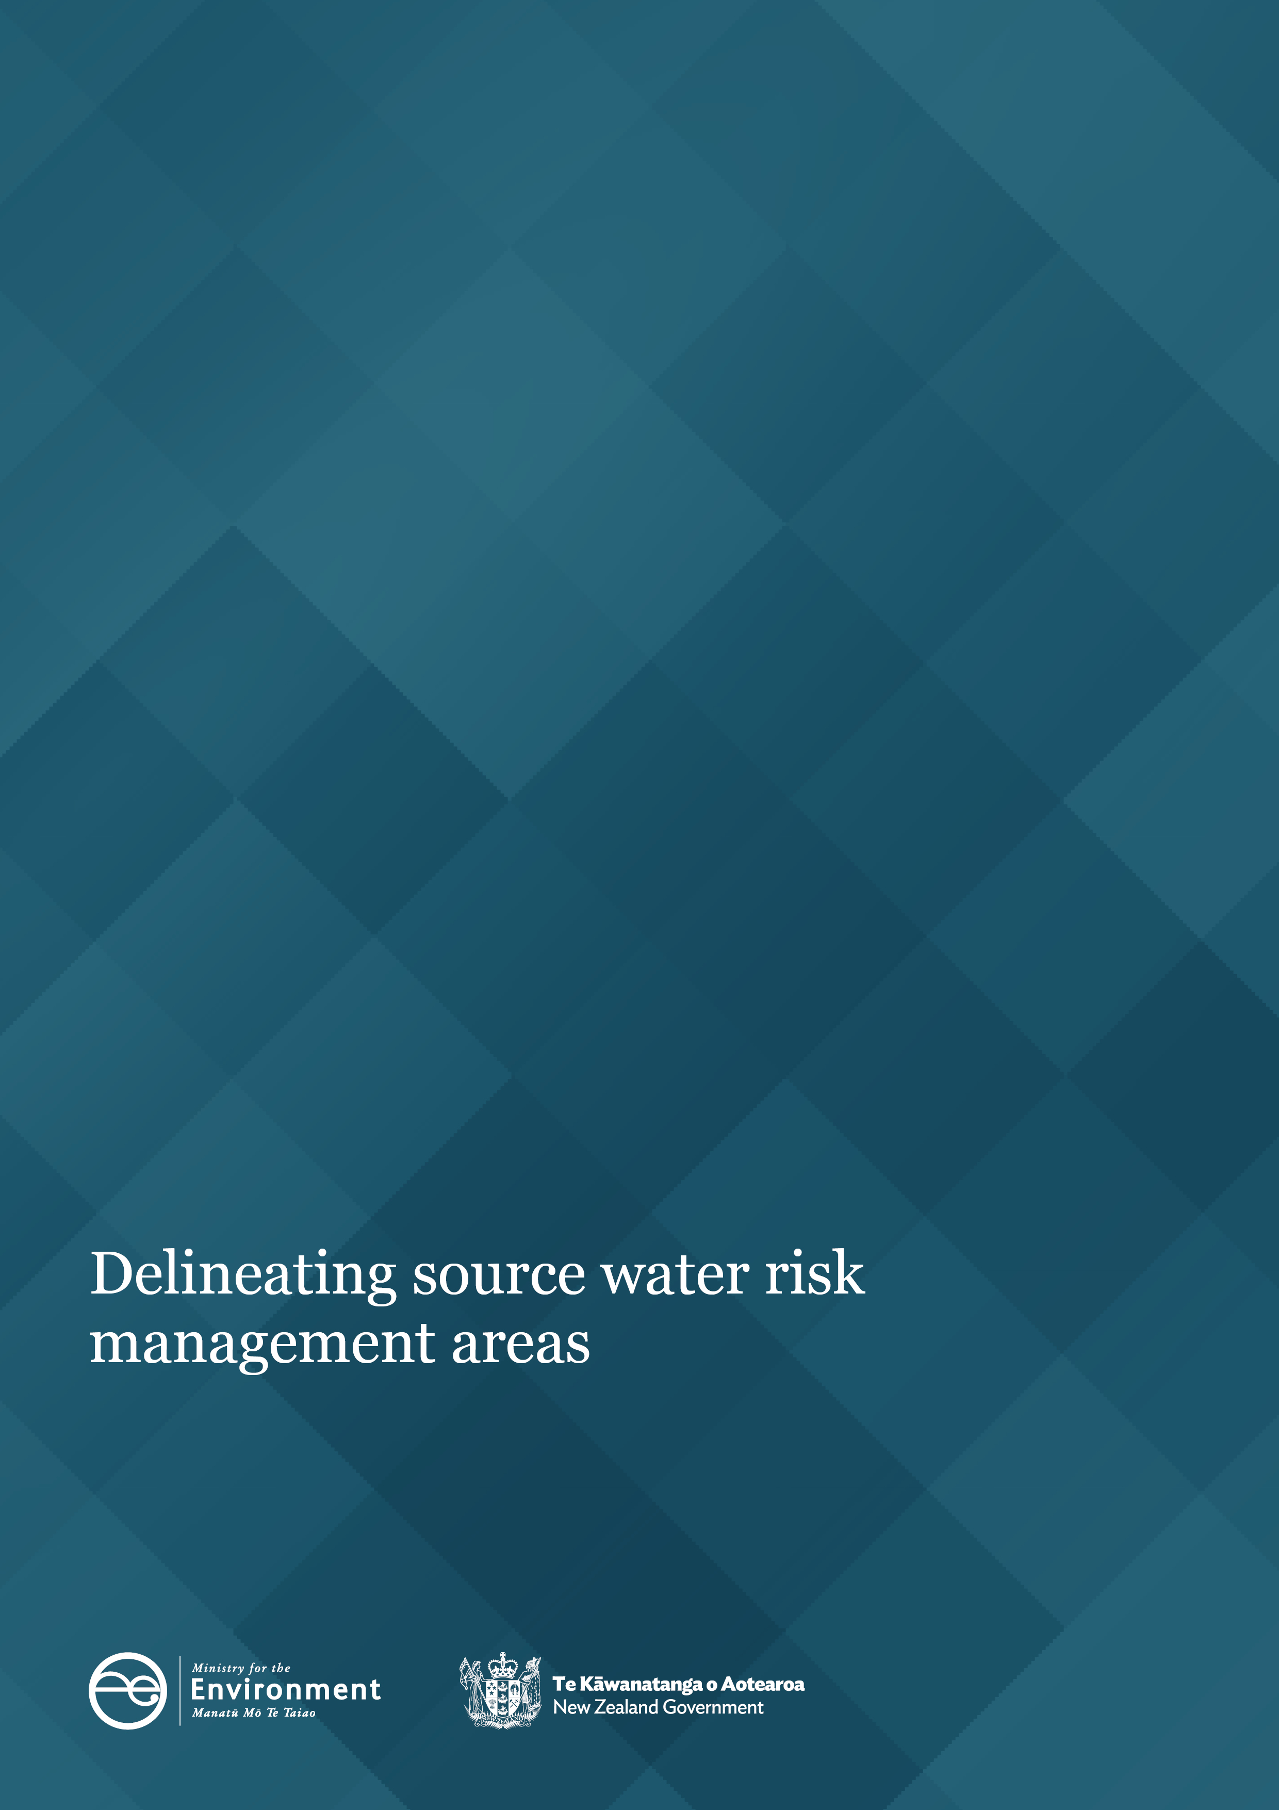
Delineating source water risk management areas

Disclaimer
The information in this publication is, according to the Ministry for the Environment’s best efforts, accurate at the time of publication. The Ministry will make every reasonable effort to keep it current and accurate. However, we advise users of this publication that:
- the information does not alter the laws of New Zealand, other official guidelines, or requirements
- it does not constitute legal advice, and users should take specific advice from qualified professionals before taking any action based on information in this publication
- the Ministry does not accept any responsibility or liability whatsoever whether in contract, tort, equity, or otherwise for any action taken as a result of reading, or reliance on this publication because of having read any part, or all, of the information in this publication or for any error, or inadequacy, deficiency, flaw in, or omission from the information in this publication
- all references to websites, organisations or people not within the Ministry are for convenience only and should not be taken as endorsement of those websites or information contained in those websites nor of organisations or people referred to.
Acknowledgements
Prepared for the Ministry for the Environment by Hilary Lough, Ben Throssell, James Scouller, Neil Thomas, Nic Love, Peter Callander and Eoghan O’Neill of Pattle Delamore Partners (PDP).
The Ministry for the Environment thanks the following organisations for their contribution to these guidelines: Bay of Plenty Regional Council, Gisborne District Council, Taranaki Regional Council, Horizons Regional Council, Hawke’s Bay Regional Council, Greater Wellington, Tasman District Council, Nelson City Council, Environment Canterbury, West Coast Regional Council, Otago Regional Council and Wellington Water.

This document may be cited as: Ministry for the Environment. 2023. Delineating source water risk management areas. Wellington: Ministry for the Environment.

Published in September 2023 by the
Ministry for the Environment
Manatū mō te Taiao
PO Box 10362, Wellington 6143, New Zealand
environment.govt.nz
ISBN: 978-1-991077-80-6
Publication number: ME 1790
© Crown copyright New Zealand 2023

Contents
Introduction 5
Default and bespoke SWRMAs 7
Default SWRMAs 8
Bespoke SWRMAs 11
Conjunctive sources 11
Updating a default SWRMA 11
Delineating a bespoke SWRMA 12
Process for updates and delineating bespoke SWRMAs 14
Principles for mapping SWRMAs 15
Understanding the purpose of SWRMAs 15
Applying the fundamental principles of drinking water safety for Aotearoa 16
Allowing for uncertainty in contaminant pathways 16
Mapping surface water SWRMAs 18
Surface water SWRMA input data 18
Intake protection zone (surface water SWRMA 1) 23
Intermediate protection zone (surface water SWRMA 2) 25
Entire catchment zone (surface water SWRMA 3) 27
Mapping groundwater SWRMAs 29
Groundwater SWRMA input data 29
Wellhead protection zone (groundwater SWRMA 1) 32
Microbial protection zone (groundwater SWRMA 2) 34
Entire capture zone (groundwater SWRMA 3) 38
Mapping conjunctive SWRMAs (bespoke areas) 41
Intake protection zone (bespoke conjunctive SWRMA 1) 41
Intermediate protection zone (bespoke conjunctive SWRMA 2) 42
Entire catchment zone (bespoke conjunctive SWRMA 3) 43
Glossary 44
References 45

Tables
Table 1: Specifications for default SWRMAs 8
Table 2: Default river velocities 23
Table 3: Standard methods for calculating groundwater travel to the intake (well) within 1 year 35

Figures
Figure 1: SWRMAs for rivers 9
Figure 2: SWRMAs for lakes 9
Figure 3: SWRMAs for groundwater 10
Figure 4: Examples of a riverbed 19
Figure 5: SWRMA 1 for surface water intakes – mapping process 24
Figure 6: SWRMA 2 for surface water intakes – mapping process 26
Figure 7: SWRMA 3 for surface water intakes – mapping process 28
Figure 8: SWRMA 1 for groundwater wells – mapping process 33
Figure 9: SWRMA 2 for groundwater wells – mapping process 37
Figure 10: SWRMA 3 for groundwater wells – mapping process 39
Figure 11: Example SWRMAs for groundwater supply receiving river recharge 43

Introduction
These guidelines outline recommended methods to delineate source water risk management areas (SWRMAs).
The extent of the SWRMAs in these guidelines is based on the recommendations in the Technical guidelines for drinking water source protection zones (Lough et al, 2018). These are referred to here as ‘the 2018 technical guidelines’. We commissioned the 2018 technical guidelines to inform the potential use of source protection zones (SPZs), which we now refer to as SWRMAs, as an improvement to the spatial criterion in the Resource Management (National Environmental Standards for Sources of Human Drinking Water) Regulations 2007 (NES-DW).
The criterion in the current NES-DW is ‘upstream’. This covers the full source water catchment, equivalent to SPZ3 in the 2018 technical guidelines. The recommendations in the 2018 technical guidelines include sub-zones, SPZ1 (now SWRMA 1) and SPZ2 (now SWRMA 2), as well as SPZ3 (now SWRMA 3), to help manage activities. These recommendations were based on national and international best practice for delineating and implementing protection zones for drinking water sources.
In this document, we extend the recommendations in the 2018 technical guidelines on delineating each SWRMA. SWRMA delineation involves defining an area within which risks to a drinking water supply intake from contaminant sources are identified and managed.
Regional councils can delineate SWRMAs in their regions to help manage activities in accordance with the current NES-DW.
Mapped SWRMAs can also help:
- regional councils fulfil their requirement under section 104G of the Resource Management Act 1991 (RMA) (equivalent section 226 of the Natural and Built Environment Bill). This requires them to have regard to the effects of proposed activities on the source of drinking water supplies registered under the Water Services Act 2021
- regional councils consider impacts on drinking water supplies under the National Policy Statement for Freshwater Management 2020 (NPS-FM). This includes the health needs of people (such as drinking water) as a second priority in the hierarchy of obligations in Te Mana o te Wai. The NPS-FM requires drinking water to be a value that regional councils must consider for freshwater management units
- drinking water suppliers fulfil their responsibilities under the Water Services Act 2021, to understand the source of their water, and to identify and manage risks to that water as part of source water risk management plans. The Water Services Act 2021 requires a multi-barrier approach to drinking water safety, including preventing hazards from entering the raw water.

The best method for delineating an SWRMA depends on the local hydrology and hydrogeology, the available information, and the necessary degree of accuracy for each supply. We recommend starting with a simple and conservative method. SWRMAs can be refined with additional information or more complex methods. Their delineation requires a careful evaluation of uncertainty and all SWRMAs must be shown to provide enough protection to supplies.

Default and bespoke SWRMAs
The 2018 technical guidelines specify default SWRMAs for surface water and groundwater supplies. They also discuss replacing these with site-specific (bespoke) SWRMAs.
The purpose of the SWRMAs (for both default and bespoke) is set out in Box 1.
Box 1: SWRMAs – Purpose
SWRMA 1: This is a zone directly surrounding the source water intake, where there is an immediate risk of contamination. There is little time for attenuation, or to respond to any contamination, before it enters the water supply.
For surface water sources, the aim is to manage the risk of contaminants entering the supply via a rapid pathway overland, through surface water, or through the subsurface.
For groundwater sources, the aim is to manage the risk of contaminants entering the supply in or around the well casing.
SWRMA 2: This is a larger area where activities need to be appropriately managed, to mitigate the risk of contamination.
For surface water sources, the size is based on:
- providing a minimum warning time for potential contamination from activities beyond this area (in SWRMA 3)
- limiting the concentrations of microbial pathogens in surface water before abstraction and treatment.
Travel times within surface water SWRMA 2 may not allow for a water supplier to be notified and respond to a contamination event. All activities with a risk of spills or other immediate contamination need careful evaluation in SWRMA 2.
For groundwater sources, the size is based on:
- limiting the potential for microbial pathogens to reach the water supply in an infective state, which limits the risk from many other contaminant sources.
SWRMA 3: This encompasses the entire upper catchment for surface water sources and the entire capture zone or catchment for groundwater sources.
This zone extends upstream of SWRMA 2. The aim is to address the cumulative effects of activities and persistent contaminants that may not reduce significantly before reaching a water supply. For surface water sources, it also allows time for a water supplier to be notified and respond to a contamination event in the catchment that is occurring upstream of the SWRMA 2 boundary.

Default SWRMAs
The 2018 technical guidelines recommend three default SWRMAs. These are shown in table 1 and figures 1 to 3, with some further modifications made here to simplify the definitions for consistency with other legislation.
In this document, we recommend methods for delineating these default areas.
Table 1: Specifications for default SWRMAs
Zone | Surface water source | Groundwater source
SWRMA 1 | Rivers – the river and its bed 1,000 metres upstream and 100 metres downstream of the intake, extending 5 metres into land from the edge of the riverbed, including all tributaries within that distance.  Lakes – the lake and its bed within a 500-metre radius of the intake, extending 5 metres into land from the edge of the lake bed. | 5-metre radius around wellhead.
SWRMA 2 | Rivers – the river and its bed within an 8-hour travel time upstream and 100 metres downstream of the intake, and 100 metres landward of the edge of the riverbed, including all tributaries within that distance.  Lakes – the entire lake area, extending 100 metres landward from the edge of the lake bed, and 100 metres either side of all tributaries where water travels to the lake within an 8-hour period. | Land area above where groundwater travels to the intake (well) within a 1-year period, out to a maximum distance of 2.5 kilometres.
SWRMA 3 | The entire source water catchment, above a point 100 metres downstream of the intake or lake outlet. | The entire source water catchment for the well.

Figure 1: SWRMAs for rivers
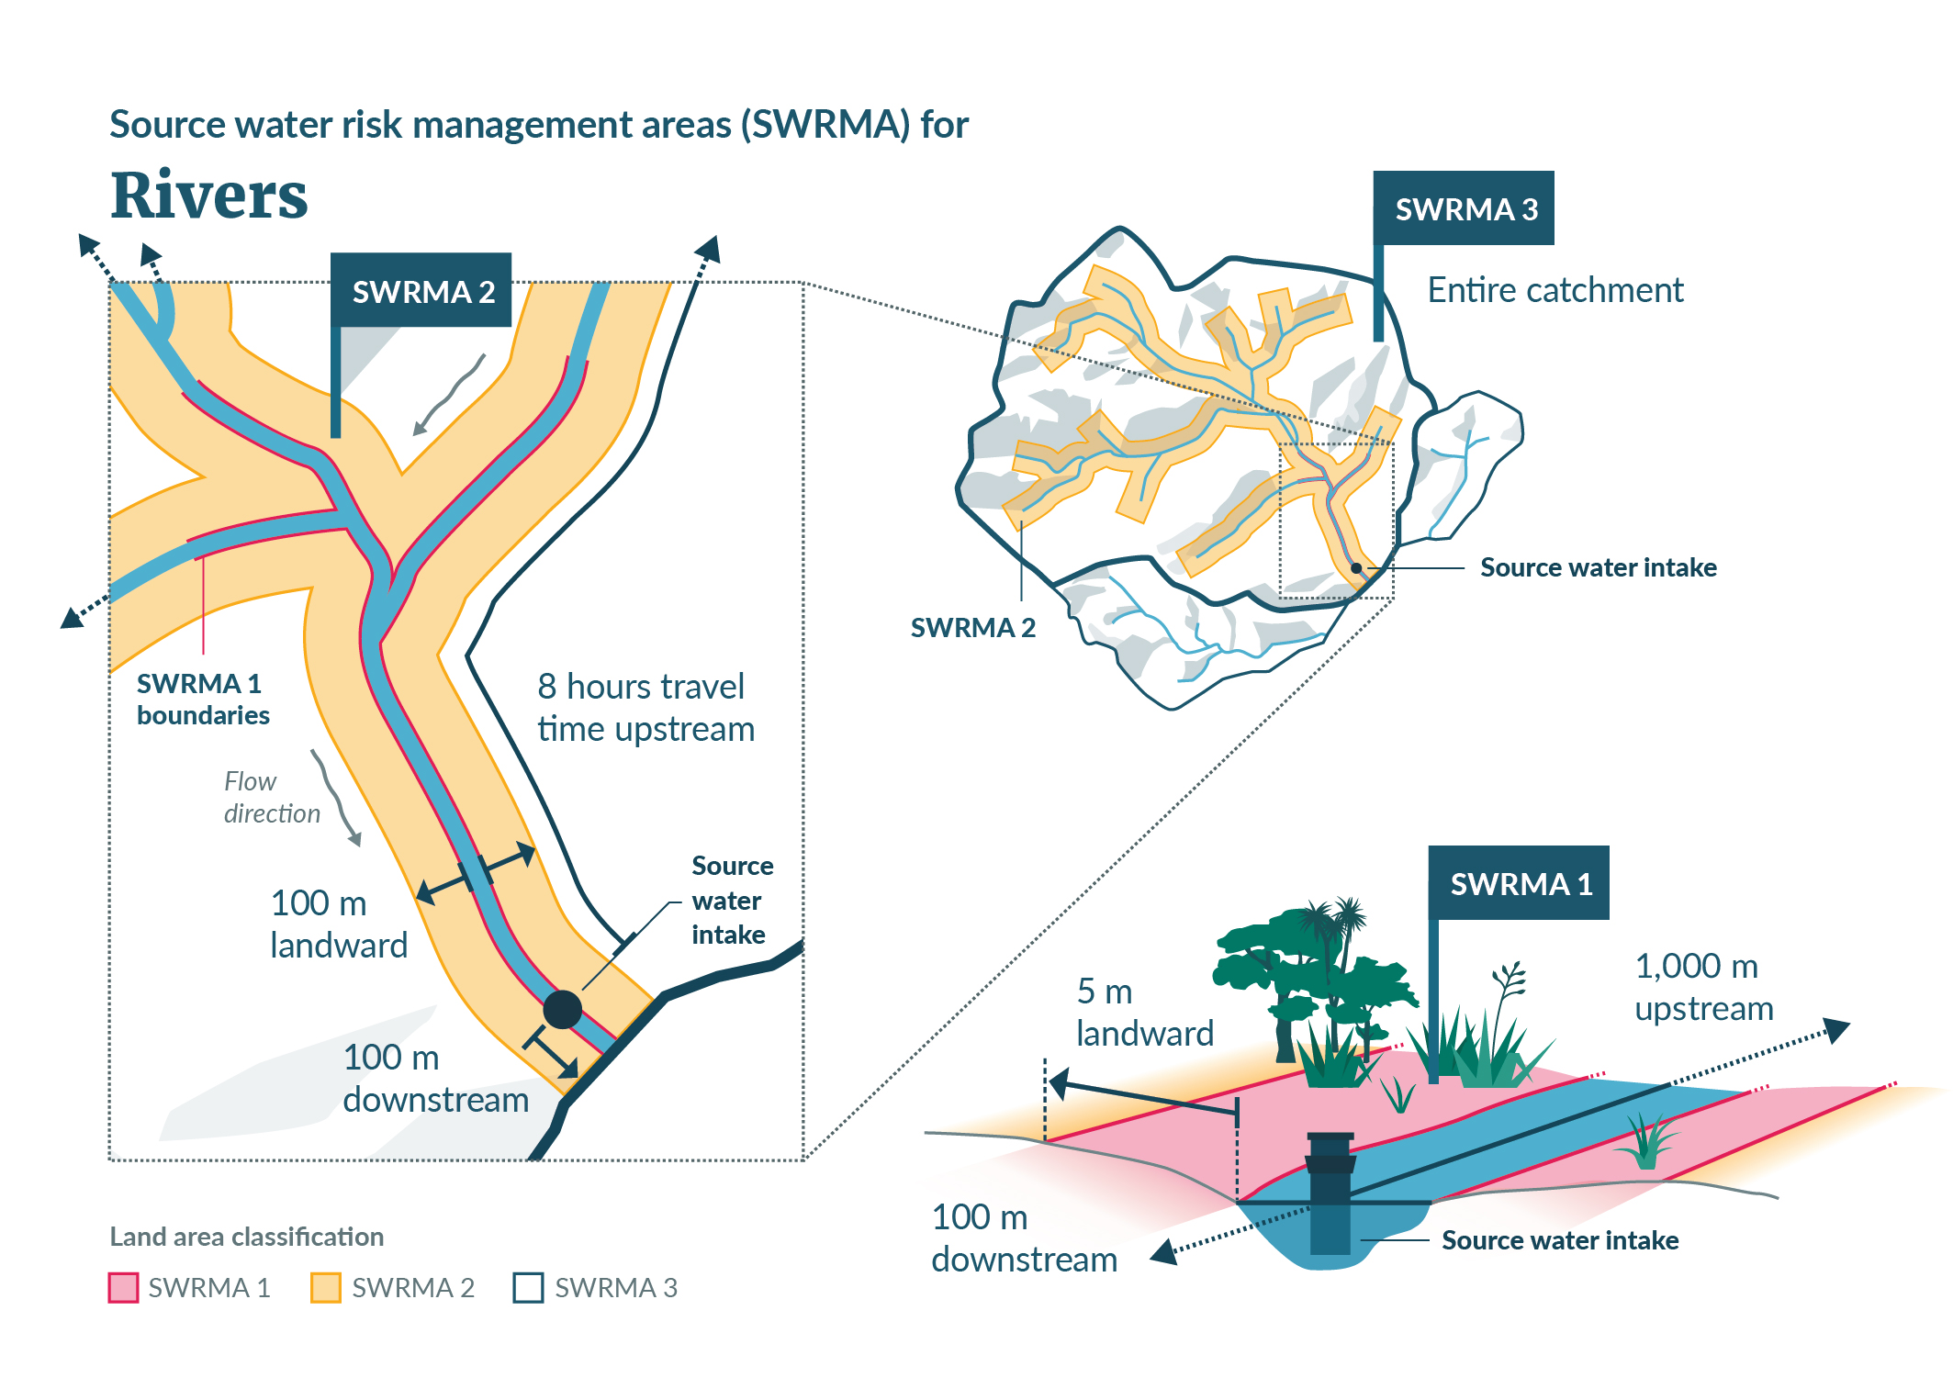
Figure 2: SWRMAs for lakes
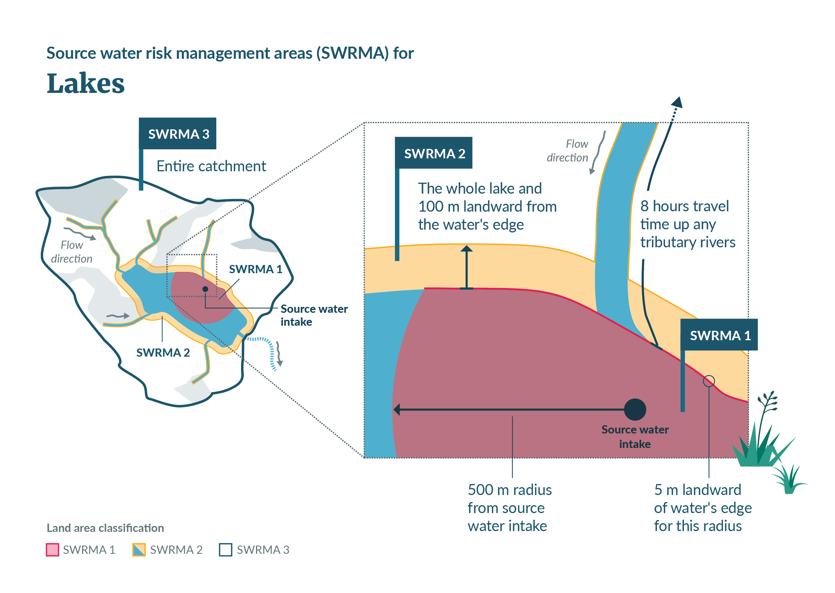

Figure 3: SWRMAs for groundwater
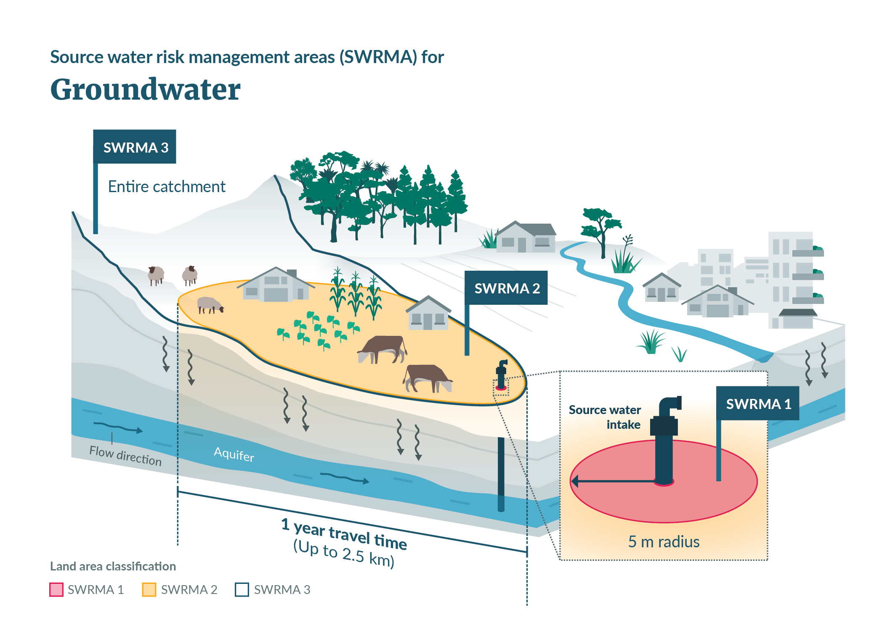

Bespoke SWRMAs
The 2018 technical guidelines discuss replacing default SWRMAs with site-specific (bespoke) SWRMAs. As outlined in those guidelines, methods to develop bespoke SWRMAs need to involve a careful assessment of contamination risk and contaminant attenuation along migration pathways towards a particular water supply.
We provide further advice in these guidelines on delineating bespoke SWRMAs. We recommend replacement of default SWRMAs with bespoke areas where either:
- the default SWRMAs are considered too restrictive and a lesser area can be shown to provide adequate protection, or
- the default SWRMAs are not considered to provide enough protection.

Conjunctive sources
The term ‘conjunctive’ relates to situations where groundwater and surface water are in hydraulic connection, and both sources are drawn into an intake (eg, a shallow groundwater abstraction near a river that receives river recharge or an abstraction from a spring). Conjunctive sources are not included in the default definitions (table 1, page 8) and require bespoke SWRMAs. The 2018 technical guidelines include recommendations for conjunctive SWRMAs, and we expand on these here.

Updating a default SWRMA
For many water supplies, the default SWRMAs will not need replacing with a bespoke area, but they may need to be updated with new site-specific information or a more complex assessment.
Example situation requiring updated SWRMA
A common scenario for a groundwater supply SWRMA 2 might be as follows.
- The area encompassing a 1-year time of travel from the land surface for SWRMA 2 for a groundwater supply is initially estimated using a simple analytical approach, based on limited information.
- This results in a conservatively large area that restricts many activities.
- Further field investigations improve understanding of the strata and refine the hydrogeological parameter values.
- This information is used in a more complex numerical model to refine the area encompassing a 1-year travel time, allowing for uncertainty; this results in a smaller SWRMA 2.
- The revised area still meets the default criterion of a 1-year travel time, so would not be considered a bespoke zone.

Delineating a bespoke SWRMA
Although the default zones can be updated, some water supplies will need bespoke SWRMAs (see example situations below).
We further describe situations where bespoke zones can be delineated in place of default zones and discuss the information requirements for this (see the mapping SWRMA sections of these guidelines).

Example situations requiring bespoke SWRMAs
Conjunctive sources: Conjunctive sources are where the source water consists of both groundwater and surface water. Bespoke areas are required for conjunctive sources. However, the default SWRMA 3 for groundwater and surface water sources is the entire source water catchment, so it already encompasses both groundwater and surface water. For conjunctive sources, separate bespoke zones will be required for SWRMA 1 and SWRMA 2.
Flood risk: The default SWRMA extent for rivers and lakes is from the edge of the lake bed or riverbed. This is based on the section 2(1) RMA definition of the space of land a river covers at its “fullest flow without overtopping its banks” and a lake covers “at its highest level without exceeding its margin” (see glossary). The 2018 technical guidelines refer to the “flood plain edge”, which could cover a greater area beyond the banks, depending on the size of the flood. Consider the risk of flooding, within or beyond the default extent of the SWRMAs for each supply, against the applicable planning restrictions on activities in these areas, and risk of contamination to the water supply. This may result in larger bespoke areas for some supplies, if the depth or velocity of flooding would increase the risk of contamination from activities in the flood zone. Regardless of the mapped extent of SWRMAs, councils must evaluate the risk of any activity in an area of potential flooding on downstream drinking water supplies, including in consent processing and rule development.
Rapid travel times: The maximum extent of SWRMA 2 for groundwater supplies is 2.5 kilometres. This is based on viral risk assessments for on-site wastewater treatment systems in coarse gravel aquifers (Blaschke et al, 2016). A larger extent may be required for karst aquifers where more rapid transport can occur, supported by travel time calculations and microbial attenuation calculations or other evidence.
Catchment topography and geology: The default SWRMAs for rivers extend laterally 5 metres and 100 metres either side of the riverbed for SWRMA 1 and 2, respectively. These are considered the minimum distances appropriate to land with a gentle or moderate gradient slope towards the surface water body, with established vegetation on topsoil. Specific catchment topography or geology may require larger buffer distances (eg, a steep-sided lake or river with slopes of more than 20 degrees and exposed bedrock where contaminants could rapidly enter the waterbody over a larger buffer distance). Direct run-off risk from impervious surfaces in built environments will typically be covered by consents to discharge stormwater to surface waterways. However, larger zones may be needed in some urban locations.
River flow reversal: The default SWRMAs for rivers extend 100 metres downstream of the intake point. This is to allow for the possibility of flow reversal, for example, from eddies. This will be too restrictive for some supplies (eg, where the intake is above a waterfall or steep river reach, flow reversal may not be possible over 100 metres downstream). In other cases, 100 metres could be insufficient (eg, where tidal effects cause backflow over more than 100 metres). Those situations would require bespoke SWRMAs.
Lake outlet flow reversal: SWRMA 1 for lakes is defined as a 500-metre radius from the intake, extending 5 metres landward from the edge of the lake bed. If a lake outlet is within 500 metres of an intake, the 100 metre downstream threshold for SWRMA 1 for rivers would not apply to the outlet. For rivers, that distance allows for flow reversal. Where a supply intake is near a lake outlet, consider whether flow reversal in the lake outlet could occur. If so, SWRMA 1 should be extended downstream. For SWRMA 2, the buffer distance is 100 metres. This will encompass 100 metres downstream of the lake outlet but, as for rivers, a greater distance may be required in some instances.

Process for updates and delineating bespoke SWRMAs
For both default and bespoke areas, the information and process used to define the areas and any updates should be well documented and peer reviewed. Robust evidence is required to support any decrease in the extent of the areas. The process should involve people with a sound knowledge of groundwater and surface water environments, to make an expert judgement on the delineation.
A report should be made publicly available, describing the information and SWRMA delineation process, including uncertainty assessments, with readily accessible maps and shapefiles. We recommend publishing this on regional council websites, and using the New Zealand Transverse Mercator 2000 (NZTM2000) projection for mapping in geographic information systems, for consistency.

Principles for mapping SWRMAs
This section sets out the main principles for mapping SWRMAs.

Understanding the purpose of SWRMAs
When mapping SWRMAs, first recognise the purpose of each area (see box 1, page 7).
The mapped SWRMAs, together with planning provisions, must achieve the purpose of each area and provide for effective management of different contaminant sources.
Default SWRMAs may require replacement bespoke areas to achieve this. For example, the default SWRMA 2 for groundwater is based on limiting the potential for microbial contaminants to reach the water supply in an infective state. This is based on a 1-year travel time from the land surface. The default area allows management of other contaminant sources for many supplies, particularly where the 1-year travel distance is large in higher velocity aquifers.
However, in parts of Aotearoa New Zealand where groundwater velocities are low, the 1-year travel distance will be small. For example, the estimated 1-year travel distance for protection from microbial contaminants in a uniform sand aquifer with a low groundwater gradient could be 100 metres or less. Beyond this relatively short distance, up-gradient discharges of non-microbial contaminants with low attenuation characteristics and less distance available for dilution could still affect a supply. Effective control of activities within the larger mapped SWRMA 3 will be particularly important in these cases.
If regional councils are concerned that regional and national regulations will not adequately address the risks from those activities, they may need to increase the size of SWRMA 2 as a bespoke zone, or define a bespoke sub-zone within SWRMA 3 that allows greater control. For example, the UK Environment Agency has a default 400-day travel time from below the water table to the source for source protection zone 2, but also has a minimum size of 250 metres or 500 metres depending on abstraction size (Environment Agency, 2019).
Default surface water SWRMAs may also need to be replaced with bespoke areas, to achieve the purpose. For example, surface water SWRMA 2 is sized to limit activities with a risk of spills or other rapid contamination potential. This is because there may not be enough time to respond to an event in SWRMA 2 (less than 8 hours).
For many catchments, SWRMA 2 will extend to the headwaters. For large catchments where this is not the case, regional councils must carefully manage the risk of spills from activities beyond the 8-hour travel distance in SWRMA 3, and ensure response plans are in place. Regional councils may need to consider whether a bespoke sub-zone should apply to SWRMA 3 to help manage activities, depending on current controls within SWRMA 3. This sub-zone may not cover the entire catchment but rather extend a set distance from the rivers or lakes, similar to SWRMA 2.

Applying the fundamental principles of drinking water safety for Aotearoa
When mapping SWRMAs, consider the fundamental principles related to drinking water. The Report of the Havelock North drinking water inquiry: Stage 2 identifies the following six fundamental principles of drinking water safety for Aotearoa (Government Inquiry into Havelock North Drinking Water, 2017, pp 8–9).
Principle 1: A high standard of care must be embraced  Principle 2: Protection of source water is of paramount importance  Principle 3: Maintain multiple barriers against contamination  Principle 4: Change precedes contamination  Principle 5: Suppliers must own the safety of drinking water  Principle 6: Apply a preventative risk management approach |  | 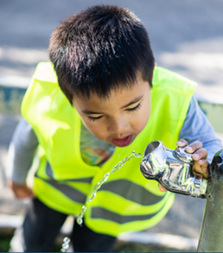
Principles 1 and 2 are particularly relevant to delineating SWRMAs. Define areas in a conservative and careful manner, recognising that protecting the source of drinking water is the first barrier against contamination in the multi-barrier approach (Principle 3). Also allow for changes in conditions, such as floods (Principle 4).
When mapping SWRMAs for a drinking water supply, if the default SWRMAs will not provide enough protection, replace these with bespoke areas. Conversely, if a lesser area is considered appropriate for a bespoke area, robust evidence is required to show it will be at least as protective as the default area.

Allowing for uncertainty in contaminant pathways
The source-pathway-receptor concept applies to SWRMA delineation. The receptors are the drinking water supply intakes. A range of potential sources of contamination will exist in different catchments, as summarised in the 2018 technical guidelines. SWRMA delineation involves considering potential pathways over land, through surface water and the subsurface environment that would allow contaminants to reach the water supply intakes.
The default SWRMA 3 areas cover the entire source water catchment and are designed to encompass all potential pathways. The default SWRMA 1 and SWRMA 2 areas terminate contaminant pathways at set distances, or distances based on travel times, which are based on expected attenuation. The zone size is intended to either exclude activities (where direct pathways are present and there is not enough time to respond to a contamination event) or allow for contaminants to attenuate.
Travel time calculations to set the distances should be based on reliable input data and allow for uncertainty in both surface water and groundwater velocities. For every water supply, consider the default distances for the SWRMAs in relation to the catchment’s characteristics. To offer enough protection, a bespoke area may need to have different distances.
Allow for pathway variability and uncertainty, when calculating the extent of the zone. This should include uncertainty about groundwater flow direction, pumping interference impacts and dispersion for mapping groundwater SWRMAs. Sources of uncertainty in groundwater SWRMAs are discussed in more detail in Lough et al (2018), Moreau et al (2014a, 2014b), and Rutter and Moore (2021). This includes assumptions in the method for modelling pathways.
If a default area is being reduced, demonstrate that the pathways still give enough protection over a shorter distance. For example, if the downstream distance is reduced below a surface water take for a bespoke SWRMA, it must be shown that there is no risk of a pathway via backflow occurring from that area under different hydrological conditions.
Obtain further information to reduce uncertainty where it would result in an adverse outcome: either insufficient protection or undue restrictions on activities. This may involve detailed information such as light detection and ranging (LiDAR) for catchment mapping; aerial imagery review or physical walkovers to establish riverbank position; flow gauging to calculate flow velocities; piezometric contour mapping for groundwater flow directions; and aquifer testing or tracer tests to obtain parameters for estimating vertical and lateral groundwater velocities.
Contaminant pathways may change over time (eg, due to changes in groundwater levels, floods altering river locations, or excavations over confining layers above an aquifer). Allow for variability and regularly review and update SWRMAs.
See box 3 for the main principles for mapping SWRMAs.
Box 3: Main principles for mapping SWRMAs
- Consider the intent of the SWRMA (eg, reduce spill risk, protect against microbial pathogens).
- Recognise the importance of protecting source water, applying a high standard of care and allowing for changing conditions (fundamental principles of drinking water safety for Aotearoa New Zealand).
- Allow for uncertainty in contaminant pathways and gather further information to reduce uncertainty when required.
- Use a bespoke SWRMA if the default SWRMA will not give enough protection.
- Only reduce the size of default and bespoke SWRMAs if there is robust evidence to demonstrate that this will not reduce the level of protection.
- Clearly document all SWRMA mapping with good supporting evidence.

Mapping surface water SWRMAs
This section sets out the definitions of each default surface water SWRMA (from box 1, page 7) and the recommended steps for mapping them. We provide further examples of when bespoke areas are required.
Mapping of all surface water SWRMAs requires a range of input data. In many cases, this will not be readily available. We first make recommendations here on different input data.

Surface water SWRMA input data

Riverbed and lake bed extents
The definitions for surface water SWRMA 1 and SWRMA 2 specify distances from the edge of the riverbed or lake bed. These are equivalent to the section 2(1) RMA definitions (see glossary for all definitions).
A riverbed is the space of land the river covers at its “fullest flow without overtopping its banks”.
A lake bed is the space of land the lake covers “at its highest level without exceeding its margin”.
The case of Canterbury Regional Council v Dewhirst Land Company Limited [2019] NZCA 486 confirms that large floods beyond a river’s banks do not determine riverbed extent under the RMA definitions. Figure 4 shows examples of a riverbed. For SWRMA mapping, the area must achieve its purpose. As outlined in the Default and bespoke SWRMAs section, a larger bespoke zone may be required, to cover the flood risk for specific rivers and lakes.
Figure 4: Examples of a riverbed
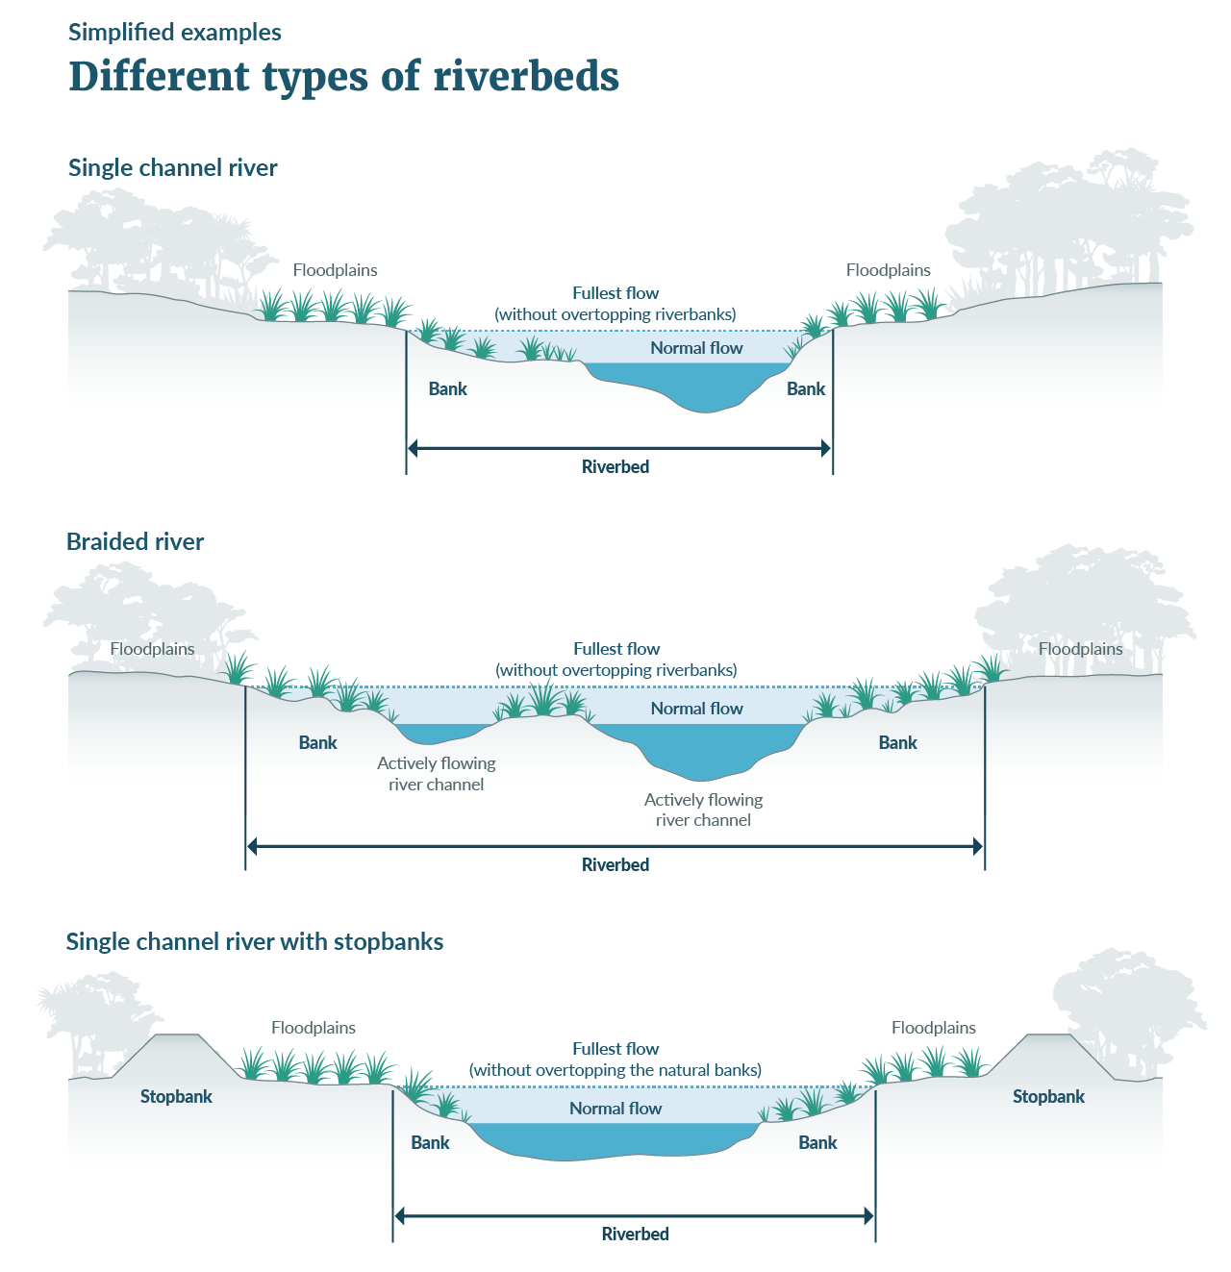

Defining the extent of a bed
In most locations, the edge of the riverbed or lake bed has not been mapped. Before mapping an SWRMA, the first step is to delineate the bed, using available information. Based on the current and readily available datasets across Aotearoa, the recommended method of defining the bed extents is as follows.

Defining riverbed extent based on ‘fullest flow without overtopping its banks’
- Make a preliminary estimate of the river centreline, based on readily available data (including River Environment Classification (REC), NZ River Name Lines) or from LiDAR-generated flow paths.
- Make a preliminary estimate of any polygons included in the river that supplement the River Name Lines layer (eg, braided rivers) from readily available data (including NZ River Name Polygons, NZ Topo50 Polygons, Fundamental Soil Layers New Zealand Soil Classification, New Zealand Land Cover Database).
- Where multiple data sources exist, overlay the different datasets and follow the outer edge (conservatively assume largest extent), to generate an outline.
- Draw a preliminary bed extent from the river centreline that encapsulates all relevant polygons. A minimum width can be assumed based on the specific river and will be required where there are no relevant polygons.
- If LiDAR elevation data is available, you can refine the extents further.
- Given the inaccuracies in current datasets, even with additional LiDAR data, we recommend checking the mapped riverbed extents against aerial and satellite imagery, to ensure the result is reasonable, then manually adjusting the mapped extents where necessary.
- You may need to update the mapped extents following additional information, such as field investigations, to determine where the riverbanks are, or assessments of the width of the river at its fullest flow (see below).

Defining ‘fullest flow’ for riverbed extent
The fullest flow is not defined in the RMA. A simple approach would be to assume flow from bank to bank as a conservative initial estimate, but this can also be estimated from flood modelling or satellite imagery (the highest flood that does not result in overtopping the riverbanks).
As a starting point, review the extent of the 1 in 2-year or 1 in 5-year annual return interval floods. If these do not result in overtopping of the banks, consider larger events to evaluate the width. National flood datasets include flood maps (eg, the CoreLogic NZ FloodMap) and modelled flood statistics (eg, Henderson and Collins, 2018). Semadeni-Davies et al (2020) also present a method for calculating river width for mean annual floods.

Defining lake bed extent based on ‘at its highest level without exceeding its margin’
- Obtain a preliminary outline of the water body based on any readily available data (including NZ Topo50 Polygons, New Zealand Land Cover Database, Fundamental Soil Layers New Zealand Soil Classification). NZ Primary Parcels may help in some locations.
- Draw a preliminary water body outline, based on satellite and aerial imagery (being sure to select an image covering a period where the water body is likely to be at its highest level).
- Where multiple data sources exist, overlay the different datasets and follow the outer edge (conservatively assume largest extent), to generate an outline.
- If LiDAR elevation data is available, you can refine the extents further.
- Given the inaccuracies in current datasets, even with additional LiDAR data, we recommend checking the mapped lake bed extents against aerial and satellite imagery, to ensure the result is reasonable, then manually adjusting the mapped extents where necessary.
- You may need to update the mapped extents following additional information, such as field investigations, to determine where the lake margins are, or assessments of the lake extent at its highest level (see below).

Defining ‘highest level’ for lake bed extent
The highest level is not defined in the RMA. A simple approach would be to assume the lake extends to its margins as a conservative initial estimate, but this can also be estimated from flood modelling or satellite imagery (the highest flood that does not result in the lake exceeding its margin).
As a starting point, review the extent of the 1 in 2-year or 1 in 5-year annual return interval floods. If these do not result in the lake exceeding its margins, consider larger events to evaluate the width. National flood datasets include flood maps (eg, the CoreLogic NZ FloodMap) and modelled flood statistics (eg, Henderson and Collins, 2018).

River extent
The definitions for river and lake surface water SWRMA 1 and SWRMA 2 include tributaries, in addition to the lake or river the water is taken from.
Many of these tributaries, or the river the intake is located on, are likely to terminate at less than the initially calculated 8-hour travel distance or, in some cases, the 1,000 metres upstream distance.
It can be difficult to determine the starting point of flow for any of these rivers (the tributaries or river the intake is located on). The definition for rivers in the glossary is based on the RMA definition and covers continually or intermittently flowing freshwater bodies.
SWRMA delineation should consider ephemeral streams. Guidance provided by the Ministry for the Environment and Ministry for Primary Industries (2020) for the Resource Management (Stock Exclusion) Regulations 2020 clarifies that those regulations, which also have an exclusion zone around rivers, do not apply to ephemeral flows. In that guidance, ephemeral flows are defined as temporary flows that exist briefly and immediately only after a period of rainfall or snow melt.
Activities that pose a risk to a water supply must not occur in areas where overland flow could result in rapid migration of contaminants to a water supply. To minimise the risk from activities, we recommend that the SWRMAs cover all intermittent and some ephemeral rivers. Intermittent rivers are those that may dry out occasionally but have a defined bed.
To decide which rivers to include, refer to the intent of the SWRMAs and principles for mapping (Principles for mapping SWRMAs). Unless there is documented evidence for a less conservative method, use the following approach to determine river extent (length).
- Review readily available river datasets described above (including the REC, NZ River Names and NZ Topo50 data) or LiDAR-generated flow paths.
- Where multiple data sources exist, overlay the different datasets and conservatively assume the largest extent, to generate an outline.
- You may consider justifying the exclusion of small ephemeral flow paths based on the REC stream order or a minimum contributing catchment area, but also consider the impacts of this on activity controls and subsequent risks to the supply.
- Given the inaccuracies in current datasets, even with additional LiDAR data, we recommend checking the mapped river extents against aerial and satellite imagery, to ensure the result is reasonable, then manually adjust the mapped extents where necessary. At a minimum, include any rivers that are considered ephemeral but have a clearly defined bed.
- You may need to update the mapped extents following additional information, such as field investigations.

River velocity
The definition of surface water SWRMA 2 includes an 8-hour travel distance. This requires an estimate of the median surface water flow velocity (at median flow), including for tributaries. Some iteration may be required to estimate the 8-hour travel distance and the median velocity of the river over that distance upstream, based on catchment characteristics including slope.
You can estimate velocities from flow gauging information or from standard hydraulic equations (eg, Manning’s equation), based on the river slope, hydraulic radius and roughness coefficients. LiDAR, where available, can be used to provide parameters such as river slope for the hydraulic equations. If LiDAR is unavailable, you can obtain parameters from the REC layer.
Also consider variability in velocities at different flows. Where velocity variability is high, a travel distance based on median flow velocity (at median flow) may not allow enough time for water suppliers to respond to a contamination event that occurs beyond SWRMA 2. Conversely, contaminant attenuation can increase via dilution at higher flows, so you can consider both velocity variation and dilution for the expected contaminant sources in a catchment. The recommendation for calculating travel time based on the median flow velocity (at median flow) considers these factors, but the median flow velocity may not be sufficient for some catchments.
If there is no available information to calculate velocities for a catchment, you can use the following default initial values (table 2) to estimate the 8-hour travel distance, with careful consideration of whether these are likely to be representative of the catchment.
Table 2: Default river velocities
River gradient | River slope (metre per metre) | Default velocity (metres per second)
Flat | < 1 in 100 | 1.0
Moderate | 1 in 100 to 1 in 20 | 2.0
Steep | >1 in 20 | 3.0

Surface water catchments
The definition of surface water SWRMA 3 covers the whole catchment upstream of a point 100 metres downstream of a river intake, or 100 metres downstream of a lake outlet.
You can use topographic maps for the catchment boundaries, such as the REC information. These will need to be terminated at the downstream point. You can do this by following the intersecting overland flow path 100 metres downstream (either REC stream or LiDAR-generated flow path line) and then using the terrain (either LiDAR or a digital elevation model (DEM)) to delineate the new catchment divide. Also consider whether groundwater flow across surface catchment boundaries is relevant.

Intake protection zone
(surface water SWRMA 1)

Default surface water SWRMA 1
Box 4 and box 5 set out the definition and information requirements for SWRMA 1 for surface water intakes.
Box 4: Definition of SWRMA 1 for surface water intakes
Rivers – the river and its bed 1,000 metres upstream and 100 metres downstream of the intake, extending 5 metres into land from the edge of the riverbed, including all tributaries within that distance.
Lakes – the lake and its bed within a 500-metre radius of the intake, extending 5 metres into land from the edge of the lake bed.

Box 5: Information requirements for SWRMA 1 for surface water intakes
- The location of the intake.
- Maps of all contributing surface water features and the edge of the bed of each river or lake and all tributaries.
Figure 5 outlines the recommended mapping process for SWRMA 1.
Figure 5: SWRMA 1 for surface water intakes – mapping process
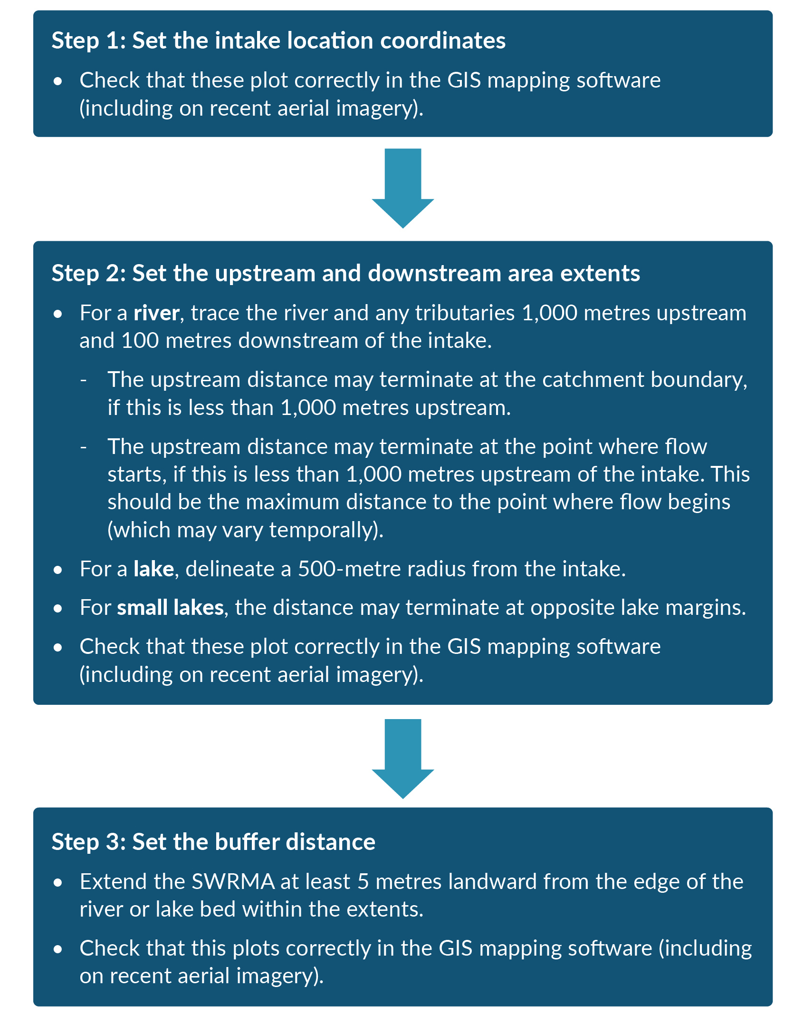

Bespoke surface water SWRMA 1
You may need to change the default extent of surface water SWRMA 1 to a bespoke area in some locations.
Examples where a larger bespoke surface water SWRMA 1 is required
- An intake on a lake close to its outlet, where flow reversal from the outlet may be expected, in which case you may need to increase the default 5-metre downstream zone.
- Where tributaries are entering a lake within SWRMA 1 near an intake, you may need to extend SWRMA 1 to include these tributaries, similar to SWRMA 1 for a river (1,000 metres upstream and 5 metres either side of the tributary). Consider the distance to the tributary and expected dilution in the lake in this decision.
- A river where flow reversal may occur over a greater downstream distance than the 100-metre downstream buffer, for example, due to eddies, tidal influences or the risk of temporary river damming (from flood debris, landslips).
- Where the topography and geology indicate that a buffer distance greater than 5 metres from the river or lake edge is necessary. For example, a steep-sided lake or river with exposed bedrock, where contaminants could rapidly enter the water body over a greater distance.

Examples where a smaller bespoke surface water SWRMA 1 may be acceptable
- A river where there is no risk of flow reversal within the default 100-metre downstream buffer, due to its gradient. In this case, a lesser downstream zone may be established, with supporting evidence and allowance for climatic and other variability.
- A very wide river, where it can be shown that there is no potential contaminant pathway from sections of the opposite side of the river to the supply intake, under a range of hydrological conditions.

Intermediate protection zone
(surface water SWRMA 2)

Default surface water SWRMA 2
Box 6 and box 7 set out the definition and information requirements for SWRMA 2 for surface water intakes.
Box 6: Definition of SWRMA 2 for surface water intakes
- Rivers – the river and its bed within an 8-hour travel time upstream and 100 metres downstream of the intake, and 100 metres landward of the edge of the riverbed, including all tributaries within that distance.
- Lakes – the entire lake area, extending 100 metres landward from the edge of the lake bed, and 100 metres either side of all tributaries where water travels to the lake within an 8-hour period.

Box 7: Information requirements for SWRMA 2 for surface water intakes
- The location of the intake.
- Maps of all contributing surface water features and the edge of the bed of each river or lake and all tributaries.
- An estimate of median surface water flow velocity (at median flow), including for tributaries. Some iteration may be required to estimate the 8-hour travel distance and the median velocity of the river over that distance upstream.
Figure 6 outlines the recommended mapping process for SWRMA 2.
Figure 6: SWRMA 2 for surface water intakes – mapping process
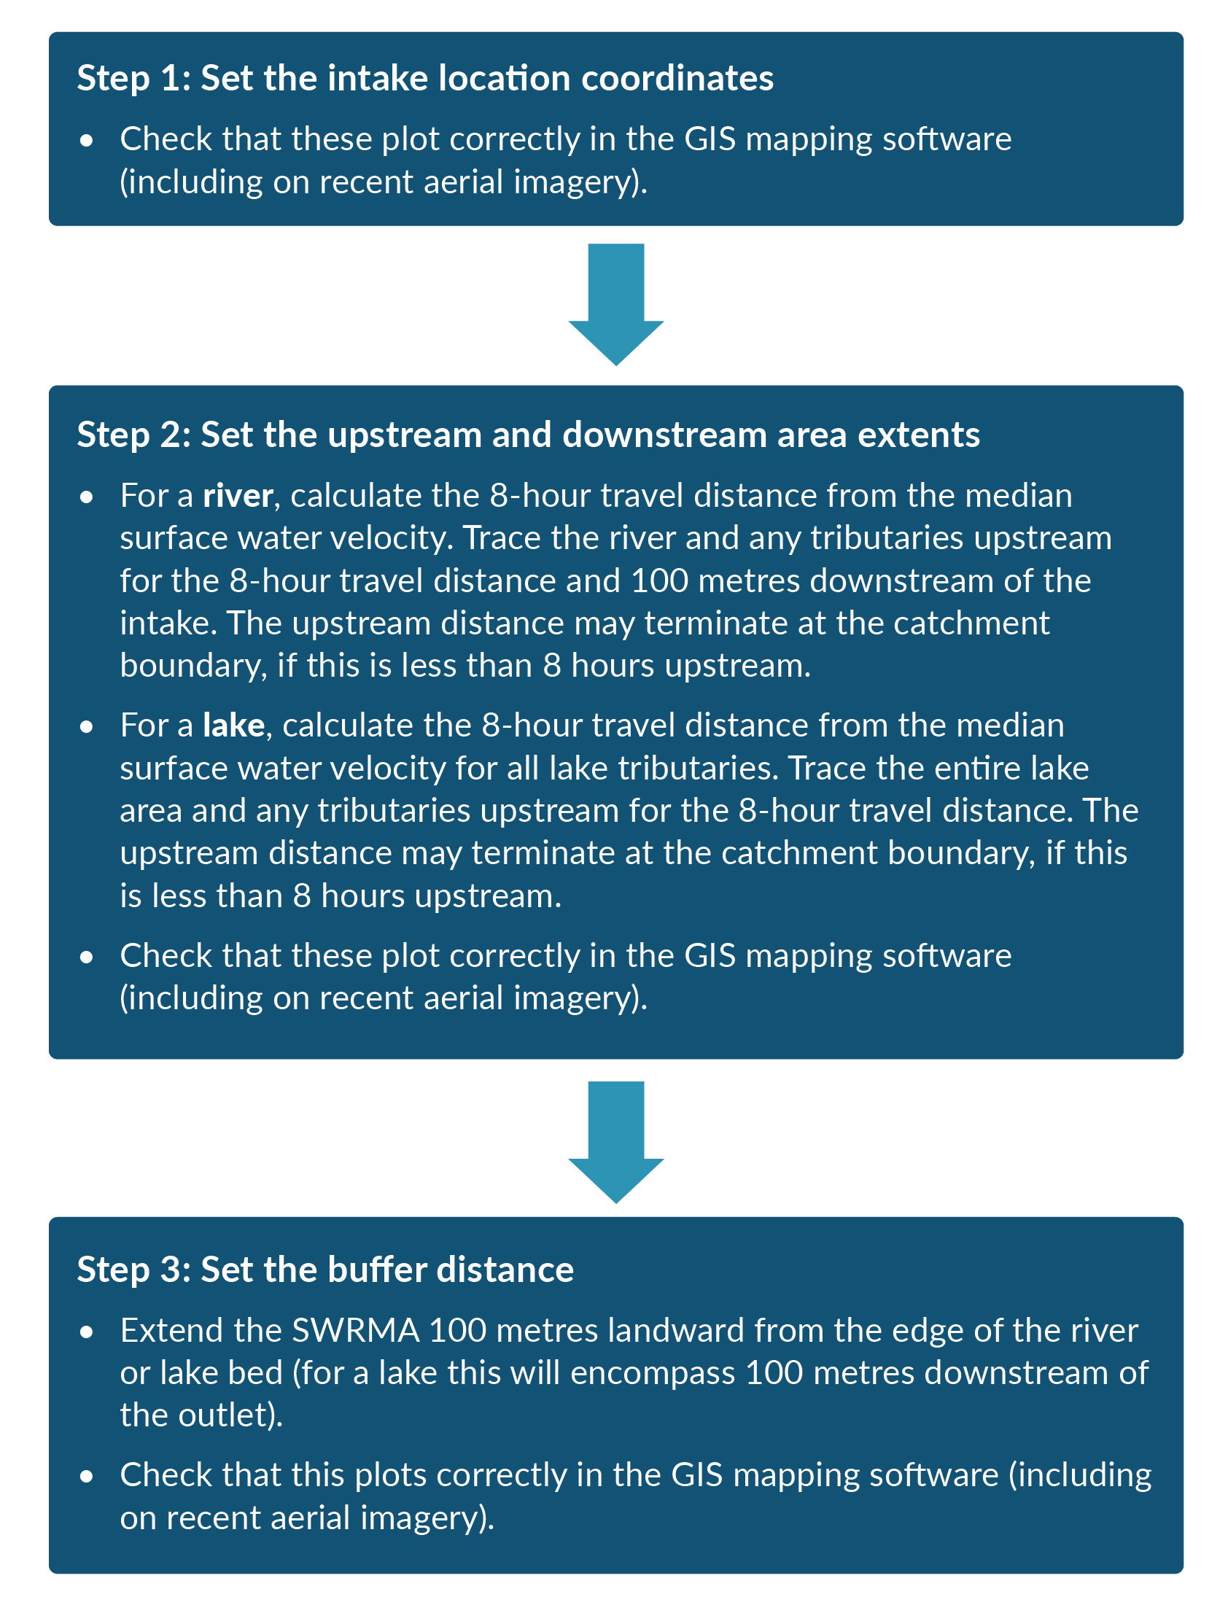

Bespoke surface water SWRMA 2
You may need to change the default extent of surface water SWRMA 2 to a bespoke area in some locations.
Examples where a larger bespoke surface water SWRMA 2 is required
- The examples set out for SWRMA 1, related to a river where flow reversal may occur over a greater downstream distance than the 100-metre downstream buffer, or where the topography and geology indicate that a buffer distance greater than the 100 metres from the river or lake edge is necessary.
- Situations where velocity variability is high and a travel distance based on median flow velocity may not allow enough time for water suppliers to respond to a contamination event. Consider attenuation via dilution at higher flows in the specific catchment as part of this.
- Situations where a water supplier requires more than 8 hours from a spill event to be notified and adequately manage the impact on the supply.

Examples where a smaller bespoke surface water SWRMA 2 may be acceptable
- The examples set out for SWRMA 1, where there is no risk of flow reversal within the default 100-metre downstream buffer, or a lake intake above a dam, in which case a distance of less than 100 metres may be appropriate if the dam crest is less than 100 metres from the water in the lake.
- Lakes where the time of travel to the intake from parts of the lake can be shown to be greater than 8 hours for a range of hydrological conditions.
- Where there are areas within the 100-metre buffer with no potential contaminant pathway to the river or lake, via overland or subsurface flow. For example, where the land slope and groundwater flow directions are away from a river.

Entire catchment zone
(surface water SWRMA 3)

Default surface water SWRMA 3
Box 8 and box 9 set out the definition and information requirements for SWRMA 3 for surface water intakes.
Box 8: Definition of SWRMA 3 for surface water intakes
The entire source water catchment, above a point 100 metres downstream of the intake or lake outlet.

Box 9: Information requirements for SWRMA 3 for surface water intakes
- The location of the intake.
- Maps of all contributing surface water features and catchment boundaries.
- Maps of surface elevation to delineate the catchment above a point 100 metres downstream of the intake.
Figure 7 outlines the recommended mapping process for SWRMA 3.
Figure 7: SWRMA 3 for surface water intakes – mapping process
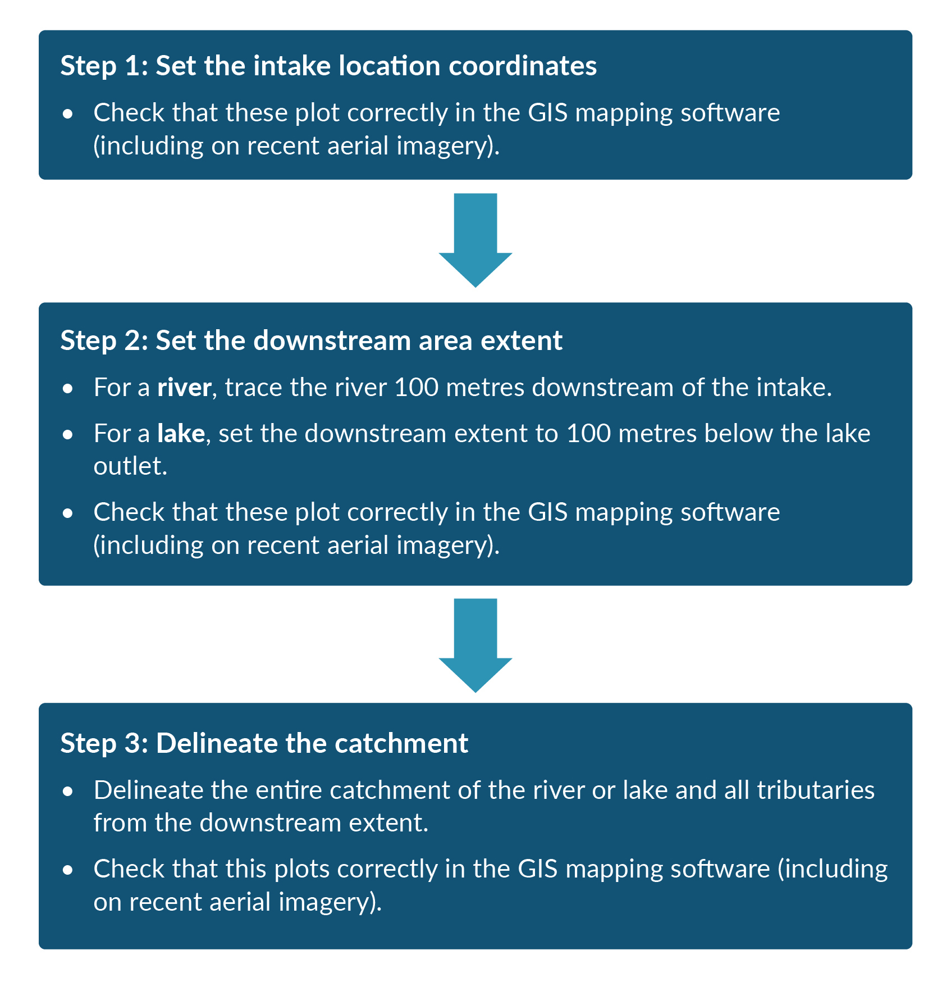

Bespoke surface water SWRMA 3
You may need to change the default extent of surface water SWRMA 3 to a bespoke area in some locations.
Examples where a larger bespoke surface water SWRMA 3 is required
- The examples for SWRMA 1, related to a river where flow reversal may occur over a downstream distance greater than the 100-metre downstream buffer. In this case, define the catchment above that revised downstream extent.

Examples where a smaller bespoke surface water SWRMA 3 may be acceptable
- The examples set out for SWRMA 3, where there is no risk of flow reversal within the default 100-metre downstream buffer. In this case, define the catchment above that revised downstream extent.

Mapping groundwater SWRMAs
This section sets out the definitions of each default groundwater SWRMA (from box 1, page 7) and the recommended steps for mapping these. We provide further examples of when bespoke zones are required.
Mapping of all groundwater SWRMAs requires a range of input data. In many cases, this will not be readily available. We first make recommendations here on different input data. For discussion in other literature see Lough et al (2018), Moreau et al (2014a, 2014b) and Rutter and Moore (2021).

Groundwater SWRMA input data

Pumping rate
The pumping rate is a requirement for SWRMA 2 delineation, unless SWRMA 2 is set to a circle with a radius of 2.5 kilometres in the absence of any groundwater flow information. The average annual pumping rate is most relevant to the 1-year travel time assessments. However, you should consider the influence of a range of pumping rates for the SWRMA size (eg, peak abstraction, average weekly abstraction, seasonal or other periods of higher demand). Also consider predicted changes over time (eg, due to population growth, climate change). Depending on the location, you may need to allow for pumping effects from other wells.

Groundwater flow direction
The definitions of groundwater SWRMA 2 and SWRMA 3 relate to areas from which water travels to the well. Understanding this requires an understanding of the groundwater flow direction.
Groundwater flow direction can be interpreted from piezometric contour maps. These are generated from groundwater level measurements in wells and levels in hydraulically connected surface waterways, where relevant. In many locations, groundwater flows in a similar direction to topography (downslope).
When using groundwater flow direction information to map SWRMAs, ensure you do the following.
- Account for spatial variability in the flow. The flow direction around the intake may differ from that further up-gradient. The flow direction should be relevant to the pumped aquifer and flow directions in other strata considered in terms of contaminant pathways to the pumped aquifer, including in overlying aquifers. Flow directions can vary in aquifers at different depths.
- Account for temporal variability in the flow. The flow direction can vary over time due to changes in recharge to and discharge from the aquifer, both natural and anthropogenic. Pumping effects from other groundwater abstractions can alter flow directions.
- Provide for uncertainty, particularly where monitoring of an aquifer spatially and temporally is limited. This may need to be 5 degrees or more either side of the expected flow direction, with the degree of uncertainty allowance depending on what information is available. If the method of mapping does not allow for dispersion, it may also be appropriate to accommodate this in a similar manner.
If no flow direction information is available for SWRMA 2, and you cannot estimate this within a reasonable range based on topography, you would need to define a circular area with a radius of up to 2.5 kilometres for a default zone, until groundwater flow information is collected.
SWRMA 3 is more difficult to define in the absence of flow direction information. At a minimum, the default zone should cover all upstream surface water catchments to a point up to 2.5 kilometres or greater downstream (relative to surface water flow directions) from the well.

Groundwater velocity and associated parameter values
The definition of groundwater SWRMA 2 is based on a 1-year travel time from the land surface. The groundwater velocity is required to calculate the distance travelled to the well in one year. If there is insufficient information to assess velocity, use a default distance of 2.5 kilometres, the maximum extent for the default groundwater SWRMA 2.
The velocity is not usually a specific input to the equations or models used for SWRMA mapping. Instead, individual parameters that influence velocity are required as part of the travel time assessment. You will usually need to estimate these for different strata, including confining strata and overlying aquifers. These same parameters also help calculate the shape of groundwater SWRMA 3:
- hydraulic gradient
- hydraulic conductivity
- effective porosity.
You will need to consider preferential flow paths. For example, tracer tests around Aotearoa, including alluvial gravels in Hawke’s Bay and Canterbury, have shown velocities of more than 200 metres per day. This is much greater than the average rate of groundwater flow (average linear velocity), due to zones of higher permeability strata. Karst aquifers can have even higher velocities, and we recommend bespoke zones for these.
If there is a large vadose (unsaturated) zone, it may be appropriate to allow for the vertical velocity through this zone in the overall calculation of the 1-year travel distance from the land surface. This should involve consideration of the expected depth of contaminant sources, which may be below the land surface (eg, stormwater soakage devices). The travel time through the vadose zone depends on the strata hydraulic conductivity (eg, contaminants will travel faster through a vadose zone comprising permeable gravel than one of the same thickness comprising less permeable silty strata).

Hydraulic gradient
You can calculate the horizontal hydraulic gradient (the change in groundwater level over a given distance) from the piezometric contour maps (see previous section). Vertical gradients can be inferred from monitored wells across a range of depths.

Hydraulic conductivity
Hydraulic conductivity provides a measure of the ease at which groundwater flows through different strata. Constant rate pumping tests with observation wells usually provide the best information for hydraulic conductivity values for the pumped aquifer and any confining strata, although there may be considerable variability in hydraulic conductivity within an SWRMA.
Moreau et al (2014a, 2014b) recommend that, when there is no information about a plausible range of input values, input variables should be set to +/–25 per cent of the average or median values used for the base calculation. The UK Environment Agency (2019) recommends a sensitivity assessment based on +/–30 per cent. However, uncertainty in inferred values and natural variability can mean the potential range in hydraulic conductivity could be much larger and over several orders of magnitude in some locations.

Effective porosity
Effective porosity is the volume of the voids through which water can travel as a proportion of the total volume of the rock or sediment. Effective porosity is often estimated from literature values, unless tracer tests are available. Rutter and Moore (2021) quote a range of 0.1 to 0.4 for published effective porosity values. This parameter varies over a smaller range, compared with hydraulic conductivity, but the recommendations in other literature described above for
+/–25 per cent and +/–30 per cent variation will not necessarily cover the full potential variation.
Dann et al (2008) report measured porosities in alluvial gravels at a site in Canterbury, in the general aquifer matrix and in permeable channels. From this they estimated an effective porosity of 0.15 for the matrix and 0.315 for permeable channels (assuming the effective porosity was 90 per cent of the average total porosity). They also applied a concept to estimate a much lower ‘bulk or profile effective porosity’ of 0.0032 for the aquifer, assuming flow through permeable channels of 98 per cent of total aquifer flow. Note it is not actually the effective porosity that is lower in the channels, it is the hydraulic conductivity that is much higher (around 8,400 metres per day for the tracer tests in Dann et al, 2008).
Using an artificially low effective porosity in the methods for SWRMA delineation for alluvial aquifers will result in higher velocities. A more realistic alternative is to increase the hydraulic conductivity to allow the preferential flow paths to achieve the same high velocity. However, hydraulic conductivity is not an input in the calculated fixed radius method (see table 3). For that method, you could lower the effective porosity to simulate the potential impact of preferential flow paths, to conservatively calculate the contributing area for a 1-year travel time for SWRMA 2.

Parameter uncertainty
Consider uncertainty in the input parameters over a plausible range for all SWRMA mapping methods. Moreau et al (2014b) also propose this approach for SWRMA mapping, on the basis that uncertainty needs to be assessed using an easily applied, robust and consistent approach.
More sophisticated methods of uncertainty calculations, such as Monte Carlo methods, can be useful, particularly for more complex analytical element modelling or numerical modelling. Rutter and Moore (2021) describe a range of these for SWRMA mapping. Table 1 in their report summarises ways to present uncertainty for different components of a model.

Other information
Developing a good conceptual model is a fundamental process before delineating groundwater SWRMAs. You should review a range of other information to inform the conceptual model. This information includes:
- geological information: including maps and borelogs, to inform the composition and extent of strata, including any low permeability confining strata
- hydraulic boundaries: such as bedrock and hydraulically connected surface waterways, together with uncertainty in these
- storage parameters: these are required for some groundwater modelling approaches
- estimates of groundwater recharge: these are required for some SWRMA delineation methods. Allow for uncertainty and variability in these calculations
- groundwater quality monitoring data for the supply well and other wells: E. coli and total coliform monitoring are particularly helpful to indicate whether rapid pathways are present from the land surface. Other parameters, such as nitrate, chloride and electrical conductivity, can also be useful
- isotopes and age dating techniques: these should not be relied on as the sole determinant of travel times, as discussed in Lough et al (2018). Consider them alongside other hydrogeological information.

Wellhead protection zone (groundwater SWRMA 1)

Default groundwater SWRMA 1
Box 10 and box 11 set out the definition and information requirements for SWRMA 1 for groundwater wells.
Box 10: Definition of SWRMA 1 for groundwater wells
- 5-metre radius around wellhead.

Box 11: Information requirements for SWRMA 1 for groundwater wells
- The location of the intake.
For all SWRMA 1 delineation, we recommend reviewing additional details to determine whether a larger bespoke zone may be necessary, including:
- well construction details
- conceptual model, including composition and extent of low permeability confining strata, and understanding of hydraulic gradients (including vertical if aquifer is not unconfined)
- potential for flooding and ponding around well
- the extent of land around the intake that is owned by the water supplier, and the location of security fencing for that land.
Figure 8 outlines the recommended mapping process for SWRMA 1.
Figure 8: SWRMA 1 for groundwater wells – mapping process
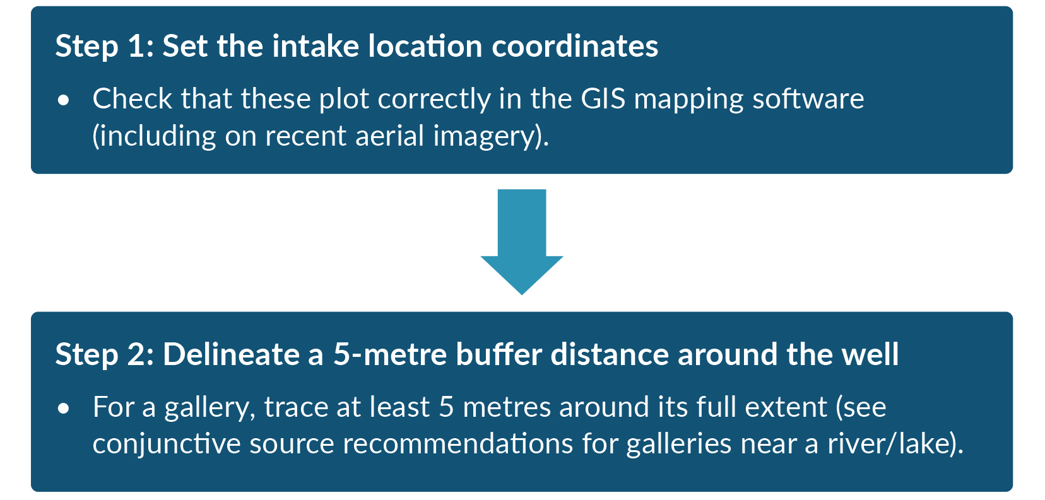

Bespoke groundwater SWRMA 1
You may need to change the default extent of groundwater SWRMA 1 to a bespoke area in some locations.
Examples where a larger bespoke groundwater SWRMA 1 is required
- The default zone is included to ensure that a sanitary bore head is not the only barrier to direct ingress. If a well does not have a sanitary bore head that meets the definition from Taumata Arowai (eg, if it is “below the surrounding ground level such that ponding could occur around the bore head during rainfall”), increase the area to encompass the area from where flow ingress may occur.
- If the water supplier owns and manages a larger area around the intake zone, it would be prudent to extend the zone from the minimum 5 metres to cover a larger area. The 2018 technical guidelines recommend a larger zone of at least 30 metres, where practicable. We recommend providing a larger area, where possible, particularly where contamination risks are high.

Examples where a smaller bespoke groundwater SWRMA 1 may be acceptable
- A zone of less than 5 metres should be strongly avoided, unless:
- there are unacceptable implications for surrounding activities, and
- it can be clearly shown that there is a very low risk (eg, a deep well, with continuous thick confining strata, a strong upwards gradient and robust construction methods with a sanitary bore head).

Microbial protection zone
(groundwater SWRMA 2)

Default groundwater SWRMA 2
Box 12 and box 13 set out the definition and information requirements for SWRMA 2 for groundwater wells.
Box 12: Definition of SWRMA 2 for groundwater wells
Land area above where groundwater travels to the intake (well) within a 1-year period, out to a maximum distance of 2.5 kilometres.

Box 13: Information requirements for SWRMA 2 for groundwater wells
- The location of the intake.
- Conceptual model, including composition and extent of low permeability confining strata, and understanding of hydraulic gradients (including vertical if aquifer is not unconfined).
- Location of potential preferential vertical pathways created by other wells (including abandoned wells) and excavations.
- Pumping rate.
- Groundwater flow direction and variability in pumped aquifer (and for all strata above the pumped aquifer if not unconfined).
- Hydrogeological parameter values:
- hydraulic gradient (including vertical, where relevant, and consideration of changes with abstraction)
- hydraulic conductivity (including for all other strata if not unconfined)
- effective porosity (including for all other strata if not unconfined).
- You can calculate groundwater velocities based on the above parameters, but must also consider preferential flow paths.
- You will need additional information for more complex models, including boundaries.
- Simpler methods may not require all this information.

Methods available for 1-year travel time assessment
Various methods are available for delineating the area of land from where water could reach the well within 1 year, using the above information. These range from a calculated fixed radius, where there is an absence of groundwater flow information, and simple analytical equations, through to numerical groundwater flow models. Moreau et al (2014a, 2014b) review different methods in detail and make recommendations on selection. GNS Science has made two of these methods available for mapping in ArcGIS software. The UK Environment Agency (2019) presents a variety of methods. These are also presented in Lough et al (2018) and Rutter and Moore (2021).
All SWRMA delineation methods simplify the true pathways between contaminant sources and the supply well. Outputs from more complex methods are still dependent on the quality of the input data and conceptualisation. Many of the methods do not account for different factors that influence these pathways, such as dispersion. Selecting the method and delineation should involve people with a sound knowledge of groundwater and surface water environments.
Table 3 summarises standard methods for mapping SWRMAs based on travel time. The best method for each supply depends on the local hydrogeology, the level of hydrogeological knowledge of the aquifer system and the degree of accuracy required. Limitations include resource constraints and the cost of different methods (Lough et al, 2018; Moreau et al, 2014b).
If a conservatively sized zone using a simple method would not have adverse consequences for local activities, this may be acceptable, particularly as a first step to defining SWRMA 2. For more details of the methods, recommendations on use and examples of where these have been applied around Aotearoa, see Lough et al (2018), Moreau et al (2014a, 2014b) and Rutter and Moore (2021).
Before mapping, develop a good conceptual model based on all the available information. This informs the choice of method. You may be able to use this to show that no SWRMA 2 is required. For example, it is a deep confined aquifer where there is clear evidence and calculations to support a greater than 1-year time of travel from the land surface to the intake or no pathway due to an upwards flow (maintained during pumping), including allowance for confining strata extent, preferential flow paths and short-circuiting via other wells. Robust evidence is needed to support no requirement for SWRMA 2 based on all available data and should include water quality information (particularly E. coli and total coliform monitoring).
Larger supplies may warrant more complex methods for SWRMA 2 delineation in some instances, but a simple method will still suit simple situations. Again, use robust evidence to show that SWRMA 2 is not required for large supplies (with a greater than 1-year travel time from the land surface).
Table 3: Standard methods for calculating groundwater travel to the intake (well) within 1 year
Method | Information required | Suitability
Calculated fixed radius | Requires pumping rate (Q), aquifer effective porosity (n) and aquifer thickness (b) to estimate distance over which water is drawn to the well over time (t). This can be mapped using the tools outlined in Toews et al (2013).  $$r=\sqrt{\frac{Qt}{πnb}}$$ | Does not allow for groundwater flow direction, so suitable as initial default method for aquifers with no information available, or aquifers with low hydraulic gradient.  As outlined in Moreau et al (2014a), for unconfined aquifers, check the area is less than the calculated recharge area based on the recharge rate (R).  $$r=\sqrt{\frac{Q}{πR}}$$  For confined aquifers, this method calculates flow from that confined aquifer, not the land surface. This means it is usually of limited use for risks from surface activities, but can be helpful for considering the risk of short-circuiting from other wells.
Uniform flow equation (one of the available analytical methods) | Requires pumping rate (Q), groundwater flow direction, coordinates from the origin (x,y), hydraulic gradient (i), aquifer thickness (b), hydraulic conductivity (k) and the gradient (i).  $$x=\frac{-y}{\tan{\frac{2πkbiy}{Q}}}$$  The up-gradient extent can be terminated based on travel time (t). The equations for this are in Toews et al (2013). | Well suited to unconfined aquifers with simple hydrogeology, boundary conditions and flow conditions. To allow for uncertainty, simulate a range of velocities and flow directions, with the final SWRMA encompassing areas from all scenarios.  As with the calculated fixed radius, for confined aquifers, this method calculates flow from that confined aquifer, not the land surface. This means it is usually of limited use for risks from surface activities, but can be helpful for considering the risk of short-circuiting from other wells.
Analytical element model (AEM) | These are based on analytical functions and can allow for different boundary conditions and aquifer properties. A good conceptual model is required to build an AEM, with various hydrogeological parameter values defined. Various AEM packages are available. | Suited to a range of simple aquifers with variable boundary conditions and spatial parameter variability. In many cases, a simple numerical model may be as helpful.  It is important to address model uncertainty, to ensure the SWRMA gives enough protection.
Numerical model | A numerical model can be useful for more complex settings, particularly abstractions from semi-confined or confined aquifers where a desktop review indicates a travel time of less than 1 year from the land surface. As with an AEM, a good conceptual model is required to build a numerical model, with various hydrogeological parameter values defined. | Suitable for all settings. Generally requires a large amount of data, but a simple numerical model can provide helpful information if a more basic approach (eg, calculated fixed radius, uniform flow equation) does not meet the purpose.  It is important to address model uncertainty. Without adequate uncertainty assessments, numerical models can provide unrealistically small areas for the 1-year time of travel. As with any model, consider them against real world heterogeneity. Modelling a range of scenarios is important.
Figure 9 outlines the recommended mapping process for SWRMA 2.
Figure 9: SWRMA 2 for groundwater wells – mapping process
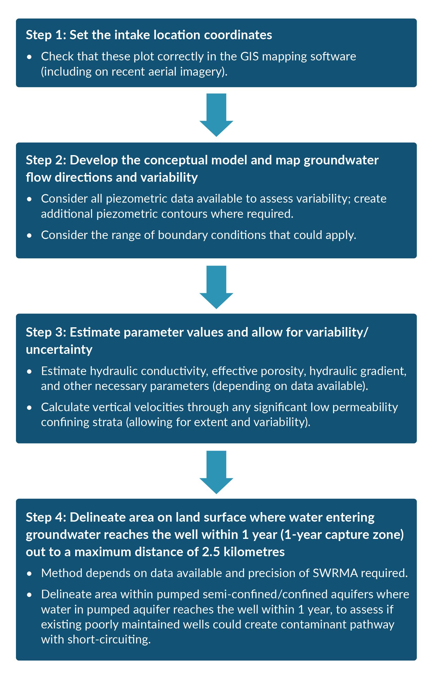

Bespoke groundwater SWRMA 2
You may need to change the default extent of groundwater SWRMA 2 to a bespoke area in some locations.
Examples where a larger bespoke groundwater SWRMA 2 is required
- If the 1-year travel distance is small (eg, low permeability aquifers) or non-existent (eg, some deep confined aquifers), consider whether the control of non-microbial contaminants with low attenuation characteristics and less distance available for dilution will be sufficient within the larger mapped SWRMA 3. If not, a larger SWRMA 2 may be required.
- A bespoke zone for deep groundwater abstractions with a travel time of greater than 1 year from the land surface may be necessary to manage the risk of short-circuiting from other deep wells or direct discharges to the deep aquifer (eg, managed aquifer recharge via injection wells). Special zones for confined aquifers are applied internationally to specifically manage the risk of subsurface activities resulting in short-circuiting, including drilling (eg, Environment Agency, 2019).
- Karst aquifers with the potential for flows faster than in coarse alluvial gravels may require larger zones.

Examples where a smaller bespoke groundwater SWRMA 2 may be acceptable
- Using a travel time of less than 1 year should be avoided for SWRMA 2. This would increase the risk of ineffective management of microbial contamination sources outside the SWRMA. However, in some locations it may be possible to demonstrate that the strata type provides for significant microbial attenuation (eg, a pumice sand aquifer) and a smaller travel time for calculating the extent of SWRMA 2 is warranted. Section 4.3 and appendix C of the 2018 technical guidelines include an overview of attenuation processes for microbial and other contaminants.
- If a smaller bespoke SWRMA 2 is shown to be acceptable for microbial contaminants, consider the effectiveness of controls for other contaminants before reducing the size of an area.

Entire capture zone
(groundwater SWRMA 3)

Default groundwater SWRMA 3
Box 14 and box 15 set out the definition and information requirements for SWRMA 3 for groundwater wells.
Box 14: Definition of SWRMA 3 for groundwater wells
The entire source water catchment for the well.

Box 15: Information requirements for SWRMA 3 for groundwater wells
- Maps of all contributing surface water features that provide groundwater recharge and catchment boundaries.
- The other information requirements are the same as for SWRMA 2, except the assessment of the 1-year travel distance.
Figure 10 outlines the recommended mapping process for SWRMA 3.
Figure 10: SWRMA 3 for groundwater wells – mapping process
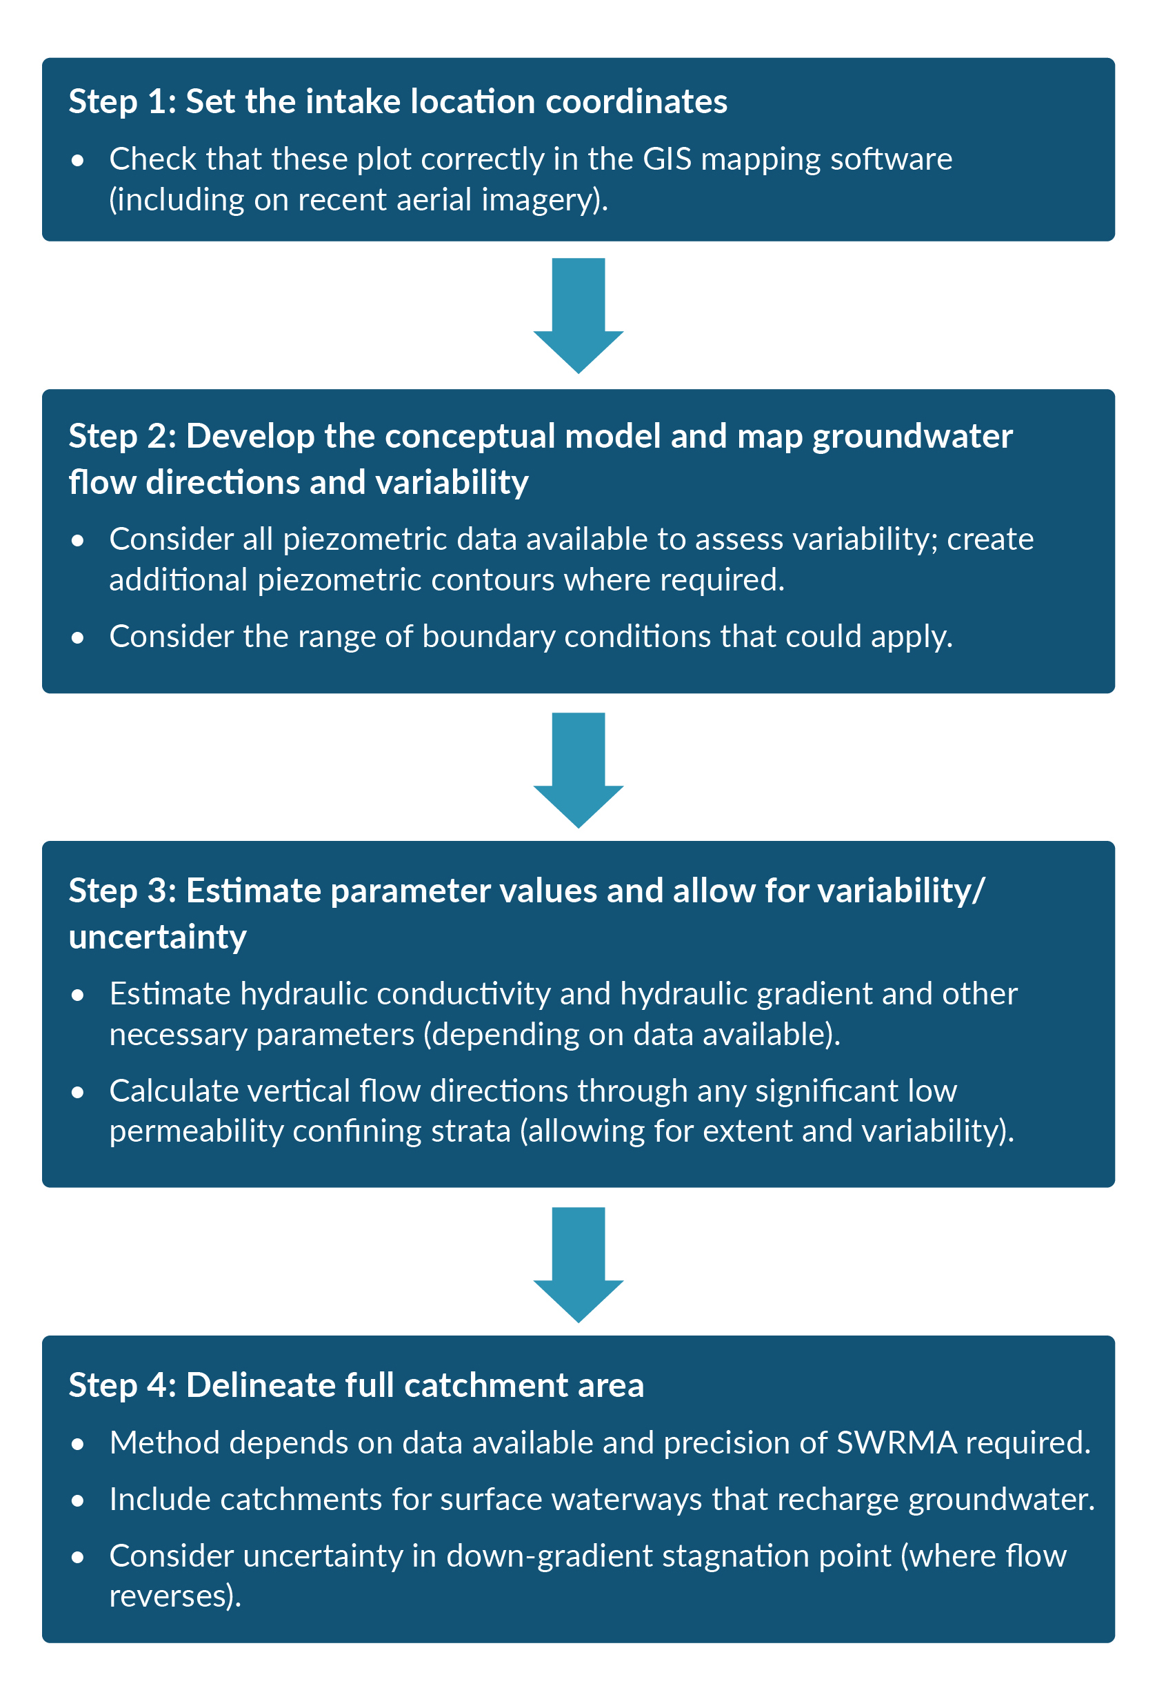

Bespoke groundwater SWRMA 3
You may need to change the default extent of groundwater SWRMA 3 to a bespoke area in some locations.
Examples where a larger bespoke groundwater SWRMA 3 is required
- SWRMA 3 is intended to extend as far as the ultimate boundary of the capture zone or catchment. Where groundwater flow across surface catchment boundaries is relevant, the SWRMA 3 should include the extent of that area. This is technically covered by the definition of the entire source water catchment, so can be covered as a default zone.

Examples where a smaller bespoke groundwater SWRMA 3 may be acceptable
- Defining an area less than the entire source catchment should be avoided for SWRMA 3, except in limited circumstances where the long-term risk from current and future activities can be shown to be low. In groundwater catchments with slow-moving groundwater flows, it may be appropriate to limit the extent of SWRMA 3 to a travel time, for example, 50 years. However, as outlined in the 2018 technical guidelines, it is best not to define time limits, for long-term protection of drinking water sources.

Mapping conjunctive SWRMAs (bespoke areas)
Conjunctive sources are not included in the default definitions (table 1, page 8) and require bespoke SWRMAs. The term ‘conjunctive’ relates to situations where groundwater and surface water are in hydraulic connection and both sources are drawn into an intake (eg, a shallow groundwater abstraction near a river that receives river recharge, or an abstraction from a spring).
Separate bespoke zones will be required for SWRMA 1 and SWRMA 2, for conjunctive sources, and may be required for SWRMA 3 in some instances. The default SWRMA 3 for groundwater and surface water sources is the entire source water catchment, so is already considered to encompass both groundwater and surface water.
Groundwater commonly flows into rivers and lakes. The default SWRMAs for surface water consider this potential contaminant pathway. However, there may be instances where a catchment requires larger bespoke SWRMAs for surface water, to address the risks from activities via groundwater recharge. For example, where groundwater discharge from a particular area to a small stream used for a drinking water supply represents a large proportion of total stream flow.
We make recommendations on bespoke conjunctive zones below. You can amend these recommended bespoke zones as required for specific catchments, based on robust evidence with good documentation.
These recommendations cover natural surface water and groundwater sources. Different bespoke SWRMAs will be required where sources are conjunctive due to modified pathways. An example of a modified pathway would be a managed aquifer recharge scheme, where water sourced from a river is piped and discharged to an aquifer used for drinking water supply. For that example, disconnected SWRMAs around the river may be required, in addition to the groundwater SWRMAs, to protect the groundwater-sourced supply.

Intake protection zone
(bespoke conjunctive SWRMA 1)
Based on the recommendations in the 2018 technical guidelines, we recommend the following bespoke SWRMAs for the intake and wellhead protection zone for conjunctive sources.
Those guidelines recommend a minimum buffer of 5 metres, but ideally 30 metres or more, from the riverbed or lake margin for surface water SWRMA 1, or around a well for groundwater SWRMA 1. Based on this, a 30-metre distance applies in the recommendations below, to allow for the rapid transport that can occur in many river or lake beds. However, you may choose to apply a larger buffer, for adequate protection.
Recommendations for bespoke SWRMA 1 for conjunctive sources
- For galleries and shallow wells within a riverbed (or 30 metres of), the same intake zone as for a surface water take should apply. This should be the river and its bed 1,000 metres upstream and 100 metres downstream of the intake, extending at least 5 metres into land from the edge of the riverbed, and a minimum of at least 5 metres landward of the gallery or well, including all tributaries within that distance.
- For galleries and shallow wells within a lake bed (or 30 metres of), the same intake zone as for a surface water take should apply. This should be the lake and its bed within a 500-metre radius of the intake, extending at least 5 metres into land from the edge of the bed, and a minimum of at least 5 metres landward of the gallery or well.
- For springs, the same intake zone as for a groundwater water take should apply, which is at least a 5-metre radius around the spring. If the spring is within a riverbed or lake bed (or 30 metres of), the recommendations for galleries and wells above should apply.

Intermediate protection zone
(bespoke conjunctive SWRMA 2)
Based on the recommendations in the 2018 technical guidelines, we recommend the following bespoke SWRMAs for the intermediate protection zone for conjunctive sources.
Recommendations for bespoke SWRMA 2 for conjunctive sources
- For wells where groundwater SWRMA 2 intersects a surface waterway that recharges groundwater, the mapping should include both the groundwater SWRMA 2 (area for a 1-year time of travel from the land surface out to 2.5 kilometres) and the surface water SWRMA 2 (8-hour travel distance in surface waterway 100 metres either side of surface waterway above a point 100 metres downstream of where the recharge could occur). This acknowledges that surface water and any contaminants entrained within it could reach the well with a travel time of less than 1 year (and potentially from a greater area within the surface water catchment if surface water SWRMA 2 does not extend to the headwaters). However, when considering specific activities, note that a contamination event would take longer to reach the supply than a surface water take, so the response actions will be different. Include all surface waterways that recharge groundwater. Cover wetlands that interact with groundwater but do not have an inlet or outlet, as part of the land surface area in SWRMA 2.
- For springs (or small groundwater-fed lakes), apply the same SWRMA 2 zones as for wells (area for a 1-year time of travel from the land surface out to 2.5 kilometres). If this intersects a surface waterway that recharges groundwater, follow the same process outlined above for a well.

Entire catchment zone
(bespoke conjunctive SWRMA 3)
The default SWRMA 3 for groundwater and surface water sources is the entire source water catchment (see box 1, page 7), so is already considered to encompass both groundwater and surface water. Surface water recharge to groundwater is an important consideration for the default zone. When mapping the default zones, also consider whether groundwater flow across surface catchment boundaries is relevant. If so, the SWRMA 3 should include the extent of those areas. As outlined previously, there may be situations where it would be appropriate to adjust the down-gradient distance for surface water SWRMA 3 (via a bespoke zone).
Figure 11 shows an example delineation of three SWRMAs for a groundwater supply that receives some recharge from a river. In this example, the river has minimal impact on groundwater flow directions.
Figure 11: Example SWRMAs for groundwater supply receiving river recharge
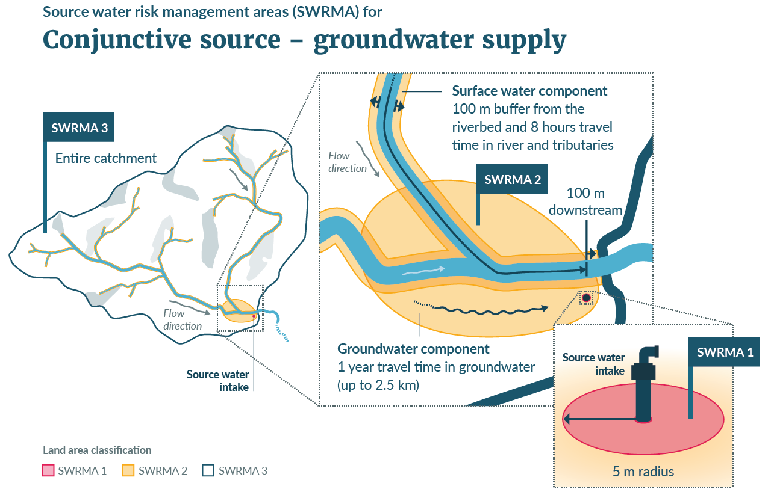

Glossary
Bed | a) In relation to any river, the space of land which the waters of the river cover at its fullest flow without overtopping its banks; and  b) In relation to any lake, except a lake controlled by artificial means, the space of land which the waters of the lake cover at its highest level without exceeding its margin; and  c) In relation to any lake controlled by artificial means, the space of land which the waters of the lake cover at its maximum permitted operating level.
Intermittent river | A river that may dry out occasionally but has a defined bed.
Ephemeral river | A river with temporary flows that exist briefly and immediately only after a period of rainfall or snow melt.
Lake²¹ | A body of freshwater which is entirely or nearly surrounded by land.
River | A continually or intermittently flowing body of fresh water; including a stream and modified watercourse and any artificial watercourse (including an irrigation canal, water supply race, canal for the supply of water for electricity power generation, and farm drainage canal).

References
Blaschke AP, Derx J, Zessner M, Kirnbauer R, Kavka G, Strelec H, Farnleitner AH, Pang L. 2016. Setback distances between small biological wastewater treatment systems and drinking water wells against virus contamination in alluvial aquifers. Science of the Total Environment 573: 278–289.
Christchurch City Council. 2020. Waterways wetlands and drainage guide: Part B – Chapter 21 – Updated June 2020. Christchurch: Christchurch City Council.
Dann R, Close M, Pang L, Flintoft M, Hector R. 2008. Complementary use of tracer and pumping tests to characterize a heterogeneous channelized aquifer system in New Zealand. Hydrogeology Journal 16: 1177–1191.
Environment Agency. 2019. Manual for the production of Groundwater Source Protection Zones. Bristol, United Kingdom: Environment Agency.
Government Inquiry into Havelock North Drinking Water. 2017. Report of the Havelock North drinking water inquiry: Stage 2. Auckland: Department of Internal Affairs.
Henderson R, Collins D. 2018. Regional Flood Estimation Tool for New Zealand Part 2. Prepared for Envirolink by the National Institute of Water and Atmospheric Research. Christchurch: National Institute of Water and Atmospheric Research.
Lough H, Clemens H, Love N, Callander C. 2018. Technical guidelines for drinking water source protection zones. Prepared for the Ministry for the Environment by Pattle Delamore Partners Ltd. Wellington: Ministry for the Environment.
Ministry for the Environment and Ministry for Primary Industries. 2020. Stock exclusion fact sheet. Wellington: Ministry for the Environment.
Moreau M, Nokes C, Cameron S, Hadfield J, Gusyev M, Tschritter C, Daughney C. 2014a. Capture zone guidelines for New Zealand. GNS Science Report 2013/56. Wellington: GNS Science.
Moreau M, Cameron S, Daughney C, Gusyev M, Tschritter C. 2014b. Envirolink tools project – Capture zone delineation – Technical report. GNS Science Report 2013/57. Wellington: GNS Science.
Rutter H, Moore C. 2021. Guidelines for modelling source water risk management areas. Prepared for the Ministry for the Environment by Aqualinc Limited. Wellington: Ministry for the Environment.
Semadeni-Davies A, Haddadchi A, Booker D. 2020. Modelling the impacts of the Draft Stock Exclusion Section 360 Regulations on river water quality. Prepared for the Ministry for Primary Industries and the Ministry for the Environment by the National Institute of Water and Atmospheric Research. Auckland: National Institute of Water and Atmospheric Research.
Snelder T, Biggs B, Weatherhead M. 2010. New Zealand river environment classification user guide. 2nd edition. Prepared for the Ministry for the Environment by the National Institute of Water and Atmospheric Research. Wellington: Ministry for the Environment.
Taumata Arowai. 2022. Drinking water quality assurance rules 2022. Wellington: Taumata Arowai.
Toews M, Gusyev M. 2013. GIS tools to delineate groundwater capture zones. GNS Science Report 2012/06. Wellington: GNS Science.

The 2018 technical guidelines specify groundwater SWRMA 1 as ‘5 m radius around well head, or a larger zone of at least 30 m (where this can be achieved in a practical manner)’. For surface water SWRMA 1 and 2 those guidelines refer to the water’s edge (instead of the edge of the riverbed or lake bed). Conjunctive sources have also been removed from the default SWRMA definitions here and require bespoke areas.
Current version REC2 (version 5) available at NIWA, River Environment Classification. Retrieved 26 June 2023. Background described in Snelder et al (2010).
Pilot dataset derived from the NZ Topo50 map series. Available at Land Information New Zealand, NZ River Name Lines and Polygons (pilot) Data Dictionary, Introduction. Retrieved 26 June 2023.
Pilot dataset derived from the NZ Topo50 map series. Available at Land Information New Zealand, NZ River Name Lines and Polygons (pilot) Data Dictionary, Introduction. Retrieved 26 June 2023.
Various NZ Topo50 layers with water polygon details including NZ Coastlines, NZ Island Polygons, NZ Lagoon Polygons, NZ Lake Polygons, NZ Pond Polygons and NZ Swamp Polygons. Links to each dataset are at Land Information New Zealand, NZ River Name Lines and Polygons (pilot) Data Dictionary, Related data. Retrieved 26 June 2023.
Includes layers showing larger rivers. Available at Manaaki Whenua Landcare Research, Maps of Fundamental Soil Layers. Retrieved 26 June 2023.
Land Cover Database v5 described here and includes some rivers. Available at Manaaki Whenua Landcare Research, Land Cover Database v5 launched in 2020 and LCDB v5.0 – Land Cover Database version 5.0, Mainland, New Zealand. Retrieved 26 June 2023.
Based on existing field information, aerial imagery or modelled (eg, as estimated in Semadeni-Davies et al, 2020).
Example from Greater Wellington, New detailed streams datasets released. Retrieved 26 June 2023.
CoreLogic, NZ FloodMap and FloodScore. Retrieved 26 June 2023.
Various NZ Topo50 layers with water polygon details including NZ Coastlines, NZ Island Polygons, NZ Lagoon Polygons, NZ Lake Polygons, NZ Pond Polygons and NZ Swamp Polygons. Links to each dataset are at Land Information New Zealand, NZ River Name Lines and Polygons (pilot) Data Dictionary, Related data. Retrieved 26 June 2023.
Land Cover Database v5 described here and includes many lakes. Available at Manaaki Whenua Landcare Research, Land Cover Database v5 launched in 2020 and LCDB v5.0 – Land Cover Database version 5.0, Mainland, New Zealand. Retrieved 26 June 2023.
Includes layer showing some lakes. Available at Manaaki Whenua Landcare Research, Maps of Fundamental Soil Layers. Retrieved 26 June 2023.
Some lakes are shown on Land Information New Zealand. NZ Primary Parcels. Retrieved 26 June 2023.
Available at CoreLogic, NZ FloodMap and FloodScore. Retrieved 26 June 2023.
The median surface water velocity required is equivalent to the mean cross-sectional velocity at median flow (eg, the median flow divided by the cross-sectional area of flow).
Based on table 21-4 in Christchurch City Council (2020) with independent checks using hydraulic model.
See section 4.9.2 S3 of Drinking Water Quality Assurance Rules 2022 (Taumata Arowai, 2022).
GNS Science. Groundwater capture zone GIS toolkit. Retrieved 22 June 2023.
Including WhAEM. United States Environmental Protection Agency. Wellhead Analytic Element Model (WhAEM). Retrieved 22 June 2023.
Based on the definitions in the Resource Management Act 1991 section 2(1) and Natural and Built Environment Bill (section 7).
Based on the definitions in the Resource Management Act 1991 section 2(1) and Natural and Built Environment Bill (section 7), but including artificial watercourses.

