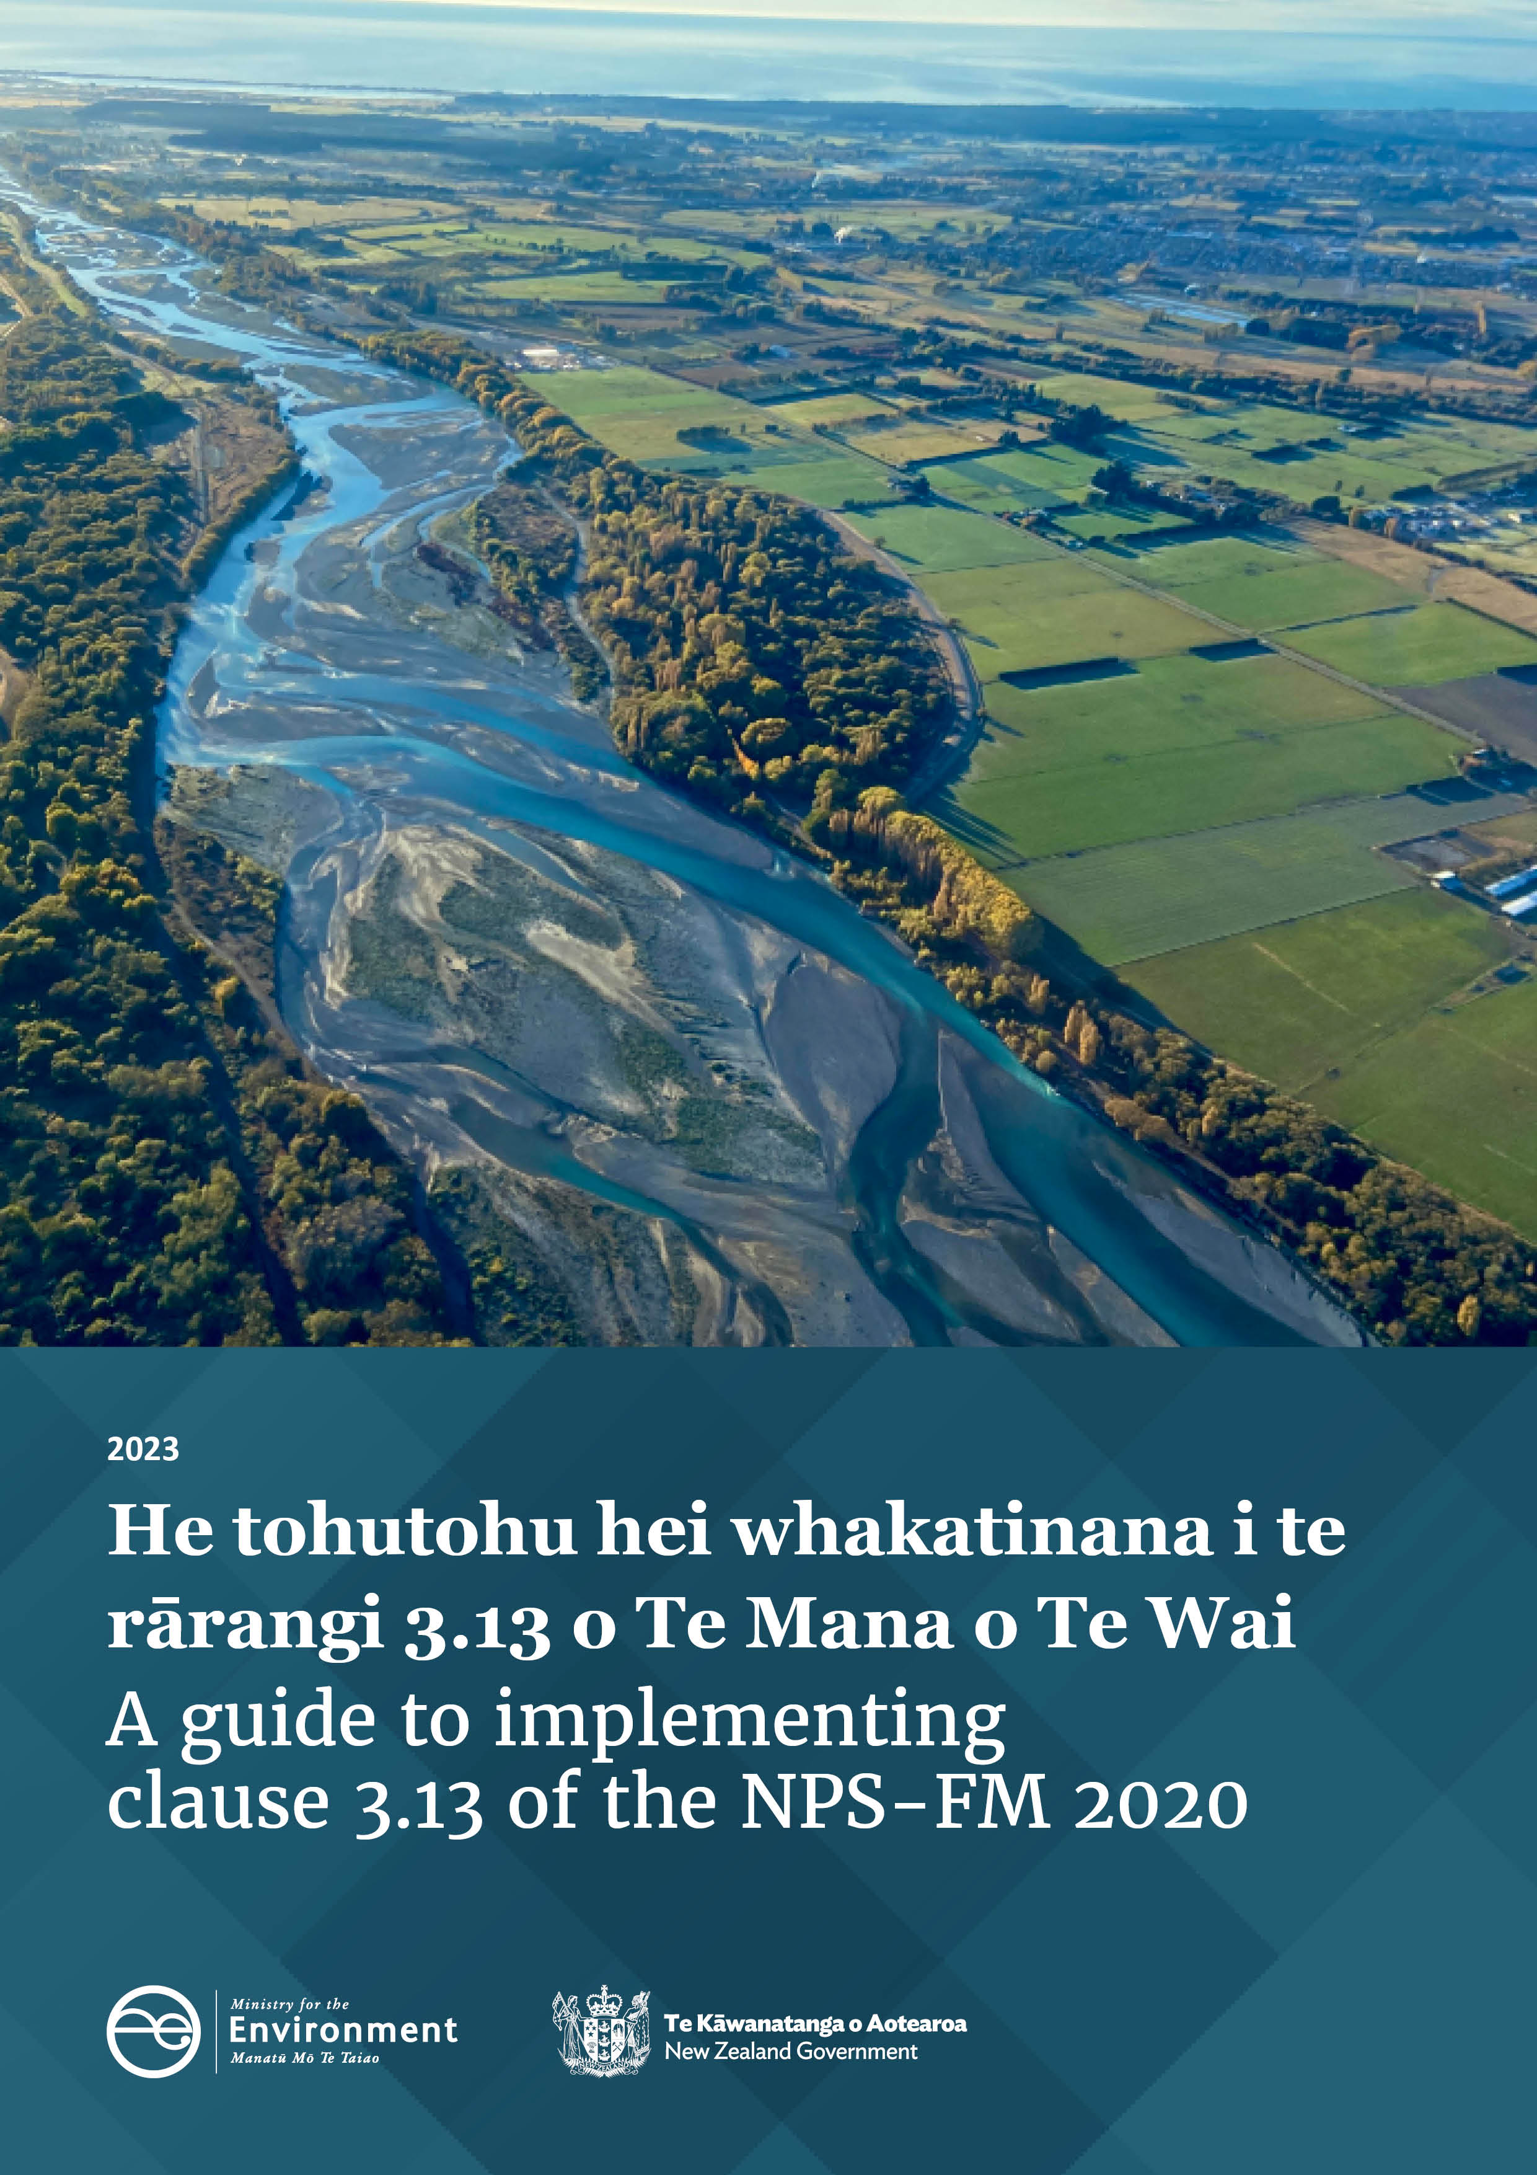
Disclaimer
The information in this publication is, according to the Ministry for the Environment’s best efforts, accurate at the time of publication. The Ministry will make every reasonable effort to keep it current and accurate. However, users of this publication are advised that:
- the information provided has no official status and so does not alter the laws of Aotearoa New Zealand, other official guidelines or requirements
- it does not constitute legal advice, and users should take specific advice from qualified professionals before taking any action as a result of information obtained from this publication
- the Ministry for the Environment does not accept any responsibility or liability whatsoever whether in contract, tort, equity or otherwise for any action taken as a result of reading, or reliance placed on this publication because of having read any part, or all, of the information in this publication or for any error, or inadequacy, deficiency, flaw in or omission from the information provided in this publication
- all references to websites, organisations or people not within the Ministry for the Environment are provided for convenience only and should not be taken as endorsement of those websites or information contained in those websites nor of organisations or people referred to.

Acknowledgements
The Ministry acknowledges Dr Cathy Kilroy (National Institute of Water and Atmospheric Research) and Ned Norton (Land Water People) for their review and drafting support during the update of this guide. The Ministry is grateful for feedback provided by: Coral Grant (Auckland Council); Nicola Green (Bay of Plenty Regional Council); Olivia Cook and Shirley Hayward (Environment Canterbury); Karen Wilson, Katie Blakemore and Nuwan DeSilva (Environment Southland); Michael Patterson (Horizons Regional Council); and Mike Scarsbrook (Waikato Regional Council).

This document may be cited as: Ministry for the Environment. 2023. A guide to implementing clause 3.13 of the NPS-FM 2020. Wellington: Ministry for the Environment.

Published in August 2023 by the
Ministry for the Environment
Manatū Mō Te Taiao
PO Box 10362, Wellington 6143, New Zealand
environment.govt.nz
ISBN: 978-1-991077-57-8 (online)
Publication number: ME 1768
© Crown copyright New Zealand 2023

Contents
Glossary 5
Executive summary 7
Guidance rationale 9
1 Introduction 10
1.1 About this document 10
1.2 Document structure 12
1.3 Document scope 12
1.4 Other guidance for the National Policy Statement for Freshwater Management 12
2 About clause 3.13: Special provisions for attributes affected by nutrients 13
2.1 Policy intent 13
3 Implementing clause 3.13 21
3.1 General approach for setting nutrient criteria under clause 3.13 21
3.2 Relationship of clause 3.13 to limits and action plans 24
3.3 Deriving nutrient criteria for rivers 25
3.4 Deriving nutrient criteria for nutrient-sensitive downstream receiving environments 35
3.5 Reconciling nutrient criteria across the freshwater management unit and downstream receiving environments 40
References 41

Tables
Table 1: Nutrient-affected attributes, including those introduced in the National Policy Statement for Freshwater Management 2020 27
Table 2: Nutrient criteria for each trophic group and the overall average 30
Table 3: Indicative potential total nitrogen threshold concentrations (milligrams per cubic metre) for macroalgal and phytoplankton trophic states in Aotearoa estuaries 39

Figures
Figure 1: Overview of recent updates to the National Policy Statement for Freshwater Management 2020 (NPS-FM) 9
Figure 2: Timeline of guidance on nutrient or nutrient-affected attributes (document titles link to guidance) 11
Figure 3: General approach to implementing clause 3.13 23
Figure 4: Simple conceptual model of the linkages between nutrients and constituents of river ecosystems 26
Figure 5: Factors that mediate the relationship between periphyton and nutrients (in this case represented as the nutrient forms dissolved inorganic nitrogen and dissolved reactive phosphorus) 33
Figure 6: Water source and wetland type 36

Glossary
Term | Definition
Chl-a | Chlorophyll a, the photosynthetic pigment present in plants. In fresh waters used as a surrogate measure to quantify the biomass of phytoplankton (lakes) and the algae in periphyton (streams)
DIN | Dissolved inorganic nitrogen
DRP | Dissolved reactive phosphorus
DSDE | Deeper subtidal dominated, longer residence time estuaries
Ecosystem constituent | Biotic and abiotic factors (fish, plants, microbes, water chemistry) in an ecosystem that are responsible for or involved with the functioning of that ecosystem. Ecosystem constituents may or may not be represented by NPS-FM attributes
Epistemic uncertainty | Uncertainty arising from lack of knowledge about the basic causal mechanisms by which – in this case – nutrients affect river ecology
EQR | Ecological quality rating
ETI | Estuary trophic index
Exceedance criterion (plural: criteria) | The number of times individual observations of a nutrient concentration are allowed to exceed a defined instream concentration threshold over a defined period. An exceedance criterion is specified by the statistic (eg, median) used to summarise a time series and defines tolerance to temporal variation in nutrient concentration
FMU | Freshwater management unit
ICT | Instream concentration threshold (ie, the concentration part of “instream concentrations and exceedance criteria” in clause 3.13)
MCI | Macroinvertebrate community index
mg/L | Milligrams per litre
mg/m³ | Milligrams per cubic metre
Ministry | Ministry for the Environment
N | Nitrogen
NOF | National Objectives Framework
NPS-FM | National Policy Statement for Freshwater Management 2020
Nutrient criteria | Instream concentrations and exceedance criteria, or instream loads, for nitrogen and phosphorus (that are required to achieve specific environmental outcomes such as target attribute states)  (Note: Used in this guidance as the abbreviation for the full clause 3.13 wording, for brevity.)
Nutrient outcomes needed to achieve target attribute states | The instream concentrations and exceedance criteria, or instream loads, for nitrogen and phosphorus, adopted under clause 3.13(4)
Nutrient-affected attributes | The ecosystem health attributes affected by nutrients. They are associated with ecological functioning in water bodies
P | Phosphorus
REC | River environment classification
STAG | Science and Technical Advisory Group
TAS | Target attribute state
TLI | Trophic level index
TN | Total nitrogen
TP | Total phosphorus
Trophic state | The potential and actual biological productivity of a waterbody. Trophic state can be used as a measure of lake health as in the NPS-FM.

Executive summary
The Ministry for the Environment (the Ministry) has produced this guidance to help regional councils set instream concentrations and exceedance criteria, or instream loads, for nitrogen and phosphorus for specific environmental outcomes, as required under clause 3.13 of the National Policy Statement for Freshwater Management (NPS-FM). Clause 3.13 is consistent with a ki uta ki tai (from the mountains to sea) integrated resource management approach, ensuring water is managed in catchments, water bodies and receiving environments.
Clause 3.13 helps achieve environmental outcomes under the National Objectives Framework (NOF) in subpart 2 of Part 3 of the NPS-FM. Clause 3.13 clarifies that the concentrations or loads of nitrogen (N) and phosphorus (P) in water bodies and their contributing catchments must be managed as part of achieving the NOF compulsory value of ecosystem health.
Regional councils must set instream concentrations and exceedance criteria, or instream loads, (simplified to ‘nutrient criteria’ in this guidance) to achieve target attribute states (TASs) for nutrient attributes or attributes affected by nutrients. A ki uta ki tai approach needs to be taken when setting nutrient criteria. This means local authorities must look at the interconnectedness of rivers, lakes, wetlands, groundwater, estuaries and coastal environments when setting nutrient criteria and managing catchments.
Uncertainty around which nutrient criteria are most appropriate will need to be navigated by following the NPS-FM clause 1.6 requirement to use the best information available at the time. The NPS-FM also requires engagement with tangata whenua and consultation with the community. The Ministry recognises setting nutrient criteria is challenging because of the complexity of aquatic ecosystems, which are made up of many parts (ie, the biological and physical parts of aquatic ecosystems that are represented by attributes) that interact with one another and with environmental factors, including nutrients.
Policy 5 of the NPS-FM requires that the health of degraded freshwater ecosystems be improved, where degraded means (among other things) a national bottom line or TAS is not being achieved. It also requires that the health of all other freshwater ecosystems be at least maintained and improved. TASs for ecosystem health must be set at or above national bottom lines and baseline states for each attribute. When nutrient attributes and attributes affected by nutrients can be demonstrated to meet national bottom lines and the baseline state defined for a freshwater management unit (FMU), and where the community has not chosen to improve those attributes, then it may be appropriate to adopt the baseline nutrient concentrations as nutrient criteria.
When a TAS for a nutrient attribute or an attribute affected by nutrients is not being met in an FMU (ie, it is degraded), then nutrient criteria expected to achieve the TAS will need to be established. Typically, more information is available for setting nutrient criteria in rivers and lakes than in wetlands, groundwater, estuaries and coastal waters. Greater availability of information in some habitat types does not diminish the importance of considering management of the potential effects of nutrients on other but less well understood parts of the ki uta ki tai continuum.
An important aspect of implementing clause 3.13 is to set nutrient criteria that will protect all ecosystem constituents, including those most sensitive to nutrient enrichment. Ensuring the needs of all attributes will be met includes:
          - identifying attributes in the system likely to be sensitive to nutrients
          - determining the nutrient criteria that will achieve the TAS for each of those attributes
          - determining the nutrient criteria required to ensure that all TASs, including the most sensitive TAS in each catchment, is achieved (ie, determining the most restrictive criteria to achieve the most sensitive and therefore all TASs in each catchment).
Those nutrient criteria must then be adopted by regional councils as ‘nutrient outcomes’, to achieve TASs. Subsequent steps require managing catchments to achieve those nutrient outcomes (clause 3.12) by requiring regional councils to identify limits to resource use (clause 3.14). These steps may also require the preparation of action plans (clause 3.15) and imposing conditions on resource consents (clause 3.12).
The most appropriate approach for deriving nutrient criteria depends on the context. It may be appropriate to consider dissolved nutrients for nutrient criteria in rivers, in some cases, but total nitrogen and phosphorus will need to be considered for lakes. Estimates of loss of nutrients from the catchment are often quantified as concentrations or loads of total nutrient rather than of dissolved forms. The ki uta ki tai approach requires a reconciliation of any nutrient criteria identified as different forms of nutrients at the catchment scale. Regional councils are responsible for determining the appropriate forms of nutrients to consider, as well as the setting of chosen nutrient criteria, based on local circumstances.

Guidance rationale
This guidance relates to clause 3.13 of the National Policy Statement for Freshwater Management 2020 (NPS-FM). Its purpose is to explain the policy intent, propose good practice guidelines and synthesise the best available information on setting instream nutrient concentrations and exceedance criteria.
Implementing clause 3.13 is just one requirement of the NPS-FM. The timeline in figure 1 outlines changes to the NPS-FM that have occurred to clarify the overall intent of both clause 3.13 and the broader NPS-FM.
Figure 1: Overview of recent updates to the National Policy Statement for Freshwater Management 2020 (NPS-FM)

This guidance applies to the NPS-FM 2020. Policy guidance on the NPS-FM is available at He Ārahitanga mō Te Anga Whāinga ā-Motu o te NPS-FM: Guidance on the National Objectives Framework of the NPS-FM (Ministry for the Environment, 2023).

Introduction

About this document
The purpose of this guidance is to help regional councils achieve environmental outcomes under clause 3.13 of the National Policy Statement for Freshwater Management 2020 (NPS-FM). Regional councils are required to achieve these outcomes by setting instream concentrations and exceedance criteria for nitrogen and phosphorus.
Clause 3.13 is consistent with a ki uta ki tai (from the mountains to sea) integrated resource management approach to ensure water is managed in catchments, water bodies and receiving environments. The integrated management approach is set out in policy 3, clause 3.5 and clause 3.13 of the NPS-FM.
This guidance is intended to help regional council staff and their technical advisors. This guidance may also help iwi and hapū, water users or community members who are participating in regional freshwater planning processes.
This guidance is an update to A guide to setting instream nutrient concentrations under clause 3.13 of the National Policy Statement for Freshwater Management 2020 (Ministry for the Environment, 2021). It relies heavily on the material provided in Guidance on look-up tables for setting nutrient targets for periphyton (Ministry for the Environment, 2022a) and Setting instream nutrient concentration thresholds for nutrient-affected attributes in rivers: Guidance on implementing clause 3.13 of the NPS-FM (Ministry for the Environment, 2022b), both of which should be referred to alongside this overarching document. For the sake of brevity and to avoid duplication, some of the detail in the 2021 document is not repeated here. The earlier version may still be a useful source of details to consider when implementing clause 3.13.
Figure 2 outlines a timeline of the guidance on nutrient or nutrient-affected attributes.

Figure 2: Timeline of guidance on nutrient or nutrient-affected attributes
(document titles link to guidance)

1 – Attributes included: Periphyton (rivers), Lake phytoplankton, Lake TN, Lake TP, Nitrate toxicity, Ammonia toxicity, Dissolved oxygen (below point source), E. coli, Planktonic cyanobacteria. Guidance first published September 2015, last updated March 2018; 2 – Attributes explored: Dissolved oxygen (rivers), dissolved oxygen (lakes), Ecosystem metabolism, Periphyton (rivers), Fish Biotic Integrity, Macroinvertebrates, Macrophytes (lakes), Nutrients (rivers, DIN and DRP); 3 – More details on STAG process here: Science and Technical Advisory Group | Ministry for the Environment; 4 – Updates the June 2021 guidance: A guide to setting instream nutrient concentrations: Under clause 3.13 of the National Policy Statement for Freshwater Management 2020.

1.2 Document structure
This document is structured as follows:
- section 1 (this section) introduces the guidance
- section 2 explains the policy intent of clause 3.13, clarifies the intended meaning of the terms used and introduces related terms
- section 3 describes the general approach and a process regional councils could follow when implementing the nutrient policies in the NPS-FM.

1.3 Document scope
The good practice process for setting instream concentrations and exceedance criteria (or instream loads) offered in this document is based on the best available information. This document does not, however, mandate a single correct method, because this would be impractical due to the evolving nature of the science and variations in local environments.
This guidance considers only the technical aspects of deriving and setting instream concentrations and exceedance criteria, or instream loads, for nitrogen and phosphorus. It does not discuss economic, social, cultural or other considerations that underpin policy and decision-making around nutrients.
This guidance does not discuss how limits could be set or action plans created to achieve nutrient outcomes for any nutrient-affected attributes.

1.4 Other guidance for the National Policy Statement for Freshwater Management
- All factsheets on policies and regulations in the Essential Freshwater package.
- He Ārahitanga mō Te Anga Whāinga ā-Motu o te NPS-FM: Guidance on the National Objectives Framework of the NPS-FM (Ministry for the Environment, 2023).
- Guidance on look-up tables for setting nutrient targets for periphyton: Second edition (Ministry for the Environment, 2022a).
- Setting instream nutrient concentration thresholds for nutrient-affected attributes in rivers: Guidance on implementing clause 3.13 of the NPS-FM (Ministry for the Environment, 2022b).
- Guidance for implementing the NPS-FM sediment requirements (Ministry for the Environment, 2022c).
- A kete for implementing mahinga kai as a Māori freshwater value in the context of the National Policy Statement for Freshwater Management 2020 (Ruru et al, 2022).

2 About clause 3.13: Special provisions for attributes affected by nutrients
3.13 Special provisions for attributes affected by nutrients
(1) To achieve a target attribute state for any nutrient attribute, and any attribute affected by nutrients, every regional council must, at a minimum, set appropriate instream concentrations and exceedance criteria, or instream loads, for nitrogen and phosphorus.
(2) Where there are nutrient-sensitive downstream receiving environments, the instream concentrations and exceedance criteria, or the instream loads, for nitrogen and phosphorus for the upstream contributing water bodies must be set so as to achieve the environmental outcomes sought for the nutrient-sensitive downstream receiving environments.
(3) In setting instream concentrations and exceedance criteria, or instream loads, for nitrogen and phosphorus under this clause, the regional council must determine the most appropriate form(s) of nitrogen and phosphorus to be managed for the receiving environment.
(4) Every regional council must adopt the instream concentrations and exceedance criteria, or instream loads, set under subclauses (1) and (2) as nutrient outcomes needed to achieve target attribute states.
(5) Examples of attributes affected by nutrients include: periphyton, dissolved oxygen (appendix 2A, tables 2 and 7 and appendix 2B, tables 17, 18 and 19), submerged plants (invasive species) (appendix 2B, table 12), fish (rivers) (appendix 2B, table 13), macroinvertebrates (appendix 2B, tables 14 and 15) and ecosystem metabolism (appendix 2B, table 21).

2.1 Policy intent
Clause 3.13 is part of the overall process for achieving environmental outcomes under the National Objectives Framework (NOF) in subpart 2 of the National Policy Statement on Freshwater Management 2020 (NPS-FM). The policy requires that the amounts of nitrogen (N) and phosphorus (P) in water bodies must be managed as part of achieving the compulsory value of ecosystem health.
The NPS-FM requires regional councils to manage attributes in freshwater environments by setting a target attribute state (TAS) to provide for the compulsory values, including ecosystem health. As a part of achieving TASs for nutrient attributes and attributes affected by nutrients, regional councils must, at a minimum, set appropriate instream nutrient concentrations and exceedance criteria and/or instream loads (or both) for N and P. They must set instream nutrient concentrations and exceedance criteria, or instream loads, for upstream contributing water bodies, to achieve the environmental outcomes sought for nutrient-sensitive downstream receiving environments, as well as for the upstream environments.
Regional councils must determine the health of freshwater ecosystems by using attributes found in appendix 2A and 2B of the NPS-FM. An attribute is defined in the NPS-FM as a “measurable characteristic that can be used to assess the extent to which a particular value is provided for.” Ecosystem health is a compulsory value. Attributes used to define ecosystem health are not restricted to those included in appendix 2A or 2B; regional councils may identify other attributes for any of the four compulsory values listed in the NPS-FM appendix 1A, or for any other council-identified values.
The following sections provide:
- information on the attributes to which clause 3.13 applies, and the nutrients N and P
- explanations of the meaning of instream concentrations and exceedance criteria and related terms
- interpretations of upstream contributing water bodies and downstream receiving environments.
For information on how a TAS is determined under the NOF process, see He Ārahitanga mō Te Anga Whāinga ā-Motu o te NPS-FM: Guidance on the National Objectives Framework of the NPS-FM (Ministry for the Environment, 2023).

2.1.1 Attributes

Nutrient attributes
Nutrient attributes referred to in clause 3.13(1) are measures of different forms of N and P in the water column. They were included in appendix 2A and 2B on the basis of sufficient evidence of their effects on ecosystem health. They are:
- total nitrogen (TN) (appendix 2A, table 3, applicable to lakes)
- total phosphorus (TP) (appendix 2A, table 4, applicable to lakes)
- ammonia (toxicity) (appendix 2A, table 5, applicable to rivers and lakes)
- nitrate (toxicity) (appendix 2A, table 6, applicable to rivers)
- dissolved reactive phosphorus (appendix 2B, table 20, applicable to rivers).
Setting a TAS for these nutrient attributes usually requires selecting the relevant numeric metrics to define a band from the specific attribute table. The numeric metrics selected must achieve the defined environmental outcomes, including meeting any relevant national bottom lines, as a minimum.
Under clause 3.13(3), regional councils may adopt nutrient forms not listed in the appendix 2A or 2B attribute tables, such as dissolved inorganic nitrogen (DIN), or TN and TP in rivers. Regional councils may also identify TASs for these forms of nutrients (N and P) in freshwater body types not covered by the current nutrient attributes, such as for integrated management of aquifers, wetlands, estuaries or other coastal environments.
Nitrate and ammonia attributes: Protection against toxicity not ecosystem health
Nitrate (toxicity) and ammonia (toxicity) are nutrient toxicity attributes in appendix 2A to manage toxicity impacts on freshwater species. This means limits on resource use must be set (under clause 3.12) to achieve the target attribute states (TASs) identified for them (under clause 3.11). However, the concentrations in appendix 2A, tables 5 and 6, and especially the bottom lines, are not intended to protect other and all aspects of ecosystem health. Other aspects of ecosystem health are addressed through ensuring other TAS are achieved, such as those for trophic state attributes and other attributes affected by nutrients. Instream concentrations and exceedance criteria set under clause 3.13 for nitrogen, to achieve TASs for trophic state attributes (eg, periphyton), will always be lower than the bottom line TASs for nitrate (toxicity) and ammonia (toxicity).

Attributes affected by nutrients
Clause 3.13 applies to all attributes that could be affected by nutrients. Examples of nutrient-affected attributes are given in clause 3.13(5):
- periphyton (appendix 2A, table 2, applicable to rivers)
- dissolved oxygen (appendix 2A, table 7 and appendix 2B, table 17, applicable to rivers and appendix 2B tables, 18 and 19, applicable to lakes)
- submerged plants (invasive species) (appendix 2B, table 12, applicable to lakes)
- fish (rivers) (appendix 2B, table 13, applicable to wadeable rivers)
- macroinvertebrates (appendix 2B, tables 14 and 15, applicable to wadeable rivers)
- ecosystem metabolism (appendix 2B, table 21, applicable to rivers).
Each attribute represents a component of either lake or river ecosystem health, as listed in appendix 1A of the NPS-FM (ie, water quality, aquatic life or ecosystem processes). Each attribute is represented by an ecosystem constituent (ie, a biological assemblage or process that is part of a river or lake ecosystem, such as fish, macroinvertebrates, metabolism). Ultimately, all are affected by nutrient enrichment either directly or indirectly.
See section 3.3 Deriving nutrient criteria for rivers, for more information on these attributes.
Relative to earlier versions, the February 2023 version of clause 3.13 has an expanded and clearer emphasis on other attributes, as well as periphyton, to manage the effects of elevated nutrients on freshwater systems and downstream receiving environments. In setting the nutrient criteria for a water body, regional councils should identify criteria that achieve the TAS for the attribute that is most sensitive to the effects of nutrient enrichment.

Attributes other than those listed in the NPS-FM as being nutrient affected
Regional councils and communities may identify attributes other than those listed in the NPS-FM (clause 3.13(5)) as attributes affected by nutrients and may adopt nutrient criteria to manage them. An example could be the coverage of stream beds by macrophytes. Similarly, other compulsory values linked to ecosystem health outcomes may also be affected by nutrient management, such as mahinga kai and traditional gathering of freshwater species.

2.1.2 Nitrogen and phosphorus

Nitrogen and phosphorus in freshwaters
Nitrogen (N) and phosphorus (P) are the focus of clause 3.13 because they are essential nutrients for both primary (eg, phytoplankton, periphyton) and secondary (eg, macroinvertebrates, fish) production in fresh waters. Natural (ie, reference) concentrations of N and P in Aotearoa New Zealand’s freshwaters vary across regions depending on (among other things) catchment climate, landcover and geology (McDowell et al, 2013). Natural water body concentrations are usually low compared with those water bodies associated with land-use intensification over the past two to three decades (Snelder et al, 2018, 2022).
Elevated N and P concentrations in freshwater systems typically stimulate excess primary production. Excessive primary production can, in turn, have consequences for the whole aquatic ecosystem.
For example, under suitable growth conditions in rivers (eg, when flows are low and stable and under high light and warm temperatures) excessive accumulation of plant biomass (periphyton or macrophytes) can alter habitat conditions for macroinvertebrates and fish. Increased primary production causes changes to diurnal dissolved oxygen fluctuations, which may lead to levels low enough to impact on aquatic life.
Sustained enrichment of rivers with nutrients can also change the nutrient composition of periphyton, leading to reduced food quality for macroinvertebrates. It can also lead to changes in the species composition of periphyton that will affect habitat, grazer food sources and the natural biodiversity of the river. Overall, along with other impacts of human activities (eg, fine sediment deposition, increasing temperature), the effects of elevated N and P can reduce habitat quality and the capacity of the river to support aquatic life.
Similarly, the habitat quality and life-supporting capacity of other receiving environments including groundwater, wetlands, lakes and estuaries can be compromised by elevated nutrient levels.

Forms of nitrogen and phosphorus
Clause 3.13(3) states the regional council must determine the most appropriate form(s) of N and P to be managed for the receiving environment.
Forms of N and P include:
- DIN, measured as the sum of nitrite-nitrogen (NO2-N), nitrate-nitrogen (NO3-N) and ammoniacal nitrogen (NH4-N). DIN is the most bioavailable form of nitrogen for plants and algae, including periphyton and aquatic plants
- TN, measured as the sum of all types of N found in a water sample, including DIN and the N in organic substances like amino acids and plant tissues, and in suspended small organisms (including algae)
- dissolved reactive phosphorus (DRP), which comprises mainly the P in dissolved phosphate ions (PO4^{3–}). Most P initially enters rivers attached (adsorbed) to sediment runoff. While DRP in the water column is the most immediately bioavailable form of P, the P attached to sediment can be released within periphyton mats under certain conditions
- total dissolved phosphorus includes DRP and the P attached to small particles (that pass through a 0.45 μm filter) in the water column
- TP is a measure of all forms of P present in a sample and includes the phosphate bound to sediment and the P incorporated into organic molecules (like fats and nucleic acids) and small organisms (eg, phytoplankton and zooplankton), as well as DRP.
It is possible to set DIN and DRP target attribute states for rivers, while downstream receiving environments often require concentrations to be set as TN and TP. Interconversions between the nutrient forms are straightforward using regression relationships derived from regional or national water quality datasets. Worked examples of interconversions are provided in the previous version of this guidance Setting instream nutrient concentration thresholds for nutrient-affected attributes in rivers: Guidance on implementing clause 3.13 of the NPS-FM (Ministry for the Environment, 2022b).

2.1.3 Terminology related to nutrients

Instream concentrations and exceedance criteria, and related terms
Clause 3.13 directs regional councils to set “instream concentrations and exceedance criteria” for nutrients. The aim is to achieve the environmental outcomes sought for nutrient-sensitive downstream receiving environments by setting appropriate TASs for nutrient attributes and for attributes affected by nutrients.
The term “instream concentrations” refers to a numeric measure (with units specified, eg, milligrams per litre (mg/L)) of the amount of N and P in a defined volume of water.
In the context of clause 3.13 and this guidance, the number of times individual observations of a nutrient concentration are allowed to exceed a defined instream concentration threshold (ICT) should be considered (eg, exceedance criteria). An ICT separates concentrations associated with desirable attribute states from concentrations associated with undesirable attribute states.
Exceedance criteria are needed because nutrient concentrations vary over time at most river sites. For example:
- N concentrations are typically higher in winter and spring (when there is low biological instream uptake and high runoff from land during winter rain) than in summer and autumn (when instream biological uptake is higher and runoff is low during low flows). In some rivers, the range of observed concentrations over time is wide (eg, DIN could range from <0.01 mg/L to >1 mg/L)
- P concentrations (especially TP) are often correlated with river flow because of the P attached to fine sediment, more of which is mobilised as flows increase.
Regional councils should summarise a time series of instream concentrations to characterise the nutrient supply in a river (either as dissolved or total N or P), including a descriptor of variability, where appropriate. To summarise a time series in a consistent way, it is necessary to define:
- the interval at which observations (of concentrations) are made (eg, monthly)
- the period over which the time series of observations should be summarised
(eg, three years)
- the metric (or statistic) used to summarise the data (eg, median, 90th percentile)
- other conditions, such as a minimum number of observations to accept if some data points are missing, and a definition of when a year starts and ends (eg, calendar year, January to December; hydrological year, July to June).
Use of exceedance criteria accounts for natural variability and the uncertainty involved in measuring nutrient concentrations over time. The choice of statistic for summarising the time series specifies the exceedance criterion, which refers to temporal exceedance. The exceedance criteria box (outlined below) shows that exceedance criteria define the tolerance a regional council has for individual concentration measurements to exceed an ICT.
Exceedance criteria
An exceedance criterion as used in clause 3.13 means the proportion of observations that are allowed to exceed an appropriate instream concentration threshold (ICT) over the course of a defined measurement period (eg, over 12 months). Exceedance criteria in clause 3.13 therefore refer to temporal exceedances.
As an example, in the NPS-FM attribute for dissolved reactive phosphorus (DRP) (appendix 2B, table 20), the concentration identifying those streams in B and A from Band B (ie, ICTs) is 0.006 milligrams per litre (mg/L), if calculated as a median value, and 0.021 mg/L if calculated as the 95th percentile, as shown below.
 | Median | 95th percentile
A  Ecological communities and ecosystem processes are similar to those of natural reference conditions. No adverse effects attributable to DRP enrichment are expected. | ≤0.006 | ≤0.021
Based on a monthly monitoring regime where sites are visited on a regular basis regardless of weather and flow conditions. Record length for grading a site based on five years.
For a hypothetical freshwater management unit (FMU), assume the threshold of the DRP A band for rivers was determined as the most appropriate nutrient outcome to achieve the environmental outcomes in that FMU (ie, for connected receiving environments (such as estuaries and lakes), periphyton biomass, macroinvertebrate community index, dissolved oxygen).
For the ICT of:
- 0.006 mg/L, the choice of this median threshold metric to summarise the time series means the regional council has determined observations of DRP at appropriate sites in the FMU can exceed 0.006 mg/L for no more than half the time (ie, no more than 30 monthly observations >0.006 mg/L in a continuous record over five years will be tolerated)
- 0.21 mg/L, choice of the 95th percentile threshold means observations of DRP can exceed 0.021 mg/L for no more than 5 per cent of the time (ie, no more than three monthly observations >0.021 mg/L in a continuous record over five years will be tolerated).
Note that setting exceedance criteria (ie, tolerances to temporal variation in nutrient concentration) is just half of the tolerance issue associated with clause 3.13. Tolerances of spatial variation are at least as important as those of temporal variation. See section 3.3.6 Periphyton and the look-up tables for an explanation of under-protection risk, which deals with tolerances of spatial exceedance. See section 3.1 in Setting instream nutrient concentration thresholds for nutrient-affected attributes in rivers: Guidance on implementing clause 3.13 of the NPS-FM (Ministry for the Environment, 2022b), for a detailed explanation of exceedance criteria (both temporal and spatial).

Nutrient loads
A nutrient load is the total mass of a nutrient transported to a particular point over a period of time. Loads can be measured at a specific point in time (ie, instantaneous load) or as a summed accumulation over time (eg, annual load). A load calculation at a defined point in a waterway integrates the load from upstream water bodies at that point (ie, a catchment load). In lakes, loads can be calculated from external sources (eg, from catchment runoff) or from internal sources (eg, the legacy load in sediments, Kowalczewska-Madura et al, 2022).
Estimation of an instream nutrient load requires a times series of nutrient concentrations and a corresponding flow record. Often, the nutrient times series interval (eg, monthly) is much coarser than that for the flow record (eg, hourly or less). Various methods have been used to calculate loads from such data, all of which have uncertainties (Snelder et al, 2016).

Use of the term ‘nutrient criteria’
For brevity, over the rest of this guidance, the term ‘nutrient criteria’ refers to “instream concentrations and exceedance criteria, or instream loads.” For the purposes of this guidance, nutrient loads are considered part of nutrient criteria, despite not carrying implicit exceedance criteria. Nutrient criteria can be developed for any water body type, with the term ‘instream’ relating to the flow of water along the ki uta ki tai (from the mountains to sea) continuum. The term ‘instream’ is not exclusive to river habitats.

Nutrient outcomes needed to achieve the target attribute states
Nutrient outcomes are needed to achieve the target attribute states, defined in clause 1.4 of the NPS-FM as “the instream concentrations and exceedance criteria, or instream loads, for nitrogen and phosphorus, adopted under clause 3.13(4)”.

2.1.4 Upstream contributing water bodies
The upstream contributing water bodies referred to in clause 3.13(2) are any freshwater bodies to which clause 3.13(1) applies. The main points are:
- clause 3.13 applies to every attribute affected by nutrients identified for a water body
- the nutrient criteria for the water body are necessarily constrained by the attribute that requires the most stringent nutrient criterion.

2.1.5 Nutrient-sensitive downstream receiving environments
Clause 3.13(2) requires that nutrient criteria for upstream contributing water bodies must consider the environmental outcomes sought for nutrient-sensitive downstream receiving environments. Downstream receiving environments include all parts of the interconnected aquatic network downstream of a specified site, such as rivers, lakes, wetlands, aquifers, estuaries and coastal environments. For further information, see section 3.1 General approach.
Clause 3.13(2) addresses the risk that TASs (and their associated instream nutrient concentrations and exceedance criteria) set for upstream contributing water bodies, while good enough to protect those water bodies, may not sufficiently protect the environments downstream. Clause 3.13 outlines that TASs for instream nutrient concentrations must be stringent enough to account for the effects of these concentrations on nutrient-sensitive downstream receiving environments.
It is important to consider the environmental outcomes for downstream receiving environments as integral to the process of nutrient criteria setting. Structured decision-making approaches are useful tools for integration of nutrient criteria in line with the NPS-FM. See section 3 Implementing clause 3.13.

3 Implementing clause 3.13

3.1 General approach for setting nutrient criteria under clause 3.13
While this section outlines a general approach, detailed technical information to inform good practice can be found in:
- Guidance on look-up tables for setting nutrient targets for periphyton (Ministry for the Environment, 2022a)
- Setting instream nutrient concentration thresholds for nutrient-affected attributes in rivers: Guidance on implementing clause 3.13 of the NPS-FM (Ministry for the Environment, 2022b).
The nutrient guidance products provide approaches that may help councils and communities to set nutrient criteria to achieve environmental outcomes. See He Ārahitanga mō Te Anga Whāinga ā-Motu o te NPS-FM: Guidance on the National Objectives Framework of the NPS-FM (Ministry for the Environment, 2023) for additional policy overview of clause 3.13 and how it fits alongside the broader National Objectives Framework.
Technical guidance provided by the Ministry for the Environment can neither be considered government policy nor a mandated set of regulatory tools that regional councils must follow.
The effects of nutrients on aquatic ecosystems are complicated by a large set of causal pathways and a lack of information on how these pathways interact. Councils must approach this problem using the best available information (clause 1.6 of the National Policy Statement on Freshwater Management (NPS-FM)), and cannot delay action.
A five-step approach is shown in Error! Reference source not found.figure 3, and outlined below.
- Identify water bodies in the freshwater management unit (FMU) that could be influenced by excessive nutrients.
A ki uta ki tai (from the mountains to sea) approach requires consideration of all parts of the continuum, including rivers, lakes, wetlands, groundwater, estuaries and other coastal environments. The NPS-FM has so far only included details for river and lake nutrient attributes, but this does not mean other water body types can be ignored when implementing clause 3.13.
- Identify values that may be compromised by excessive nutrients for all water body types.
Values are specified in appendices 1A and 1B of the NPS-FM. All four of the NPS-FM compulsory values may be relevant: ecosystem health; human contact; threatened species; and mahinga kai. Another nine values must be considered under the NPS-FM, some of which may be relevant for nutrient management: natural form and character; drinking water supply; wai tapu; transport and tauranga waka; fishing; hydro-electric power generation; animal drinking water; irrigation, cultivation and production of food and beverages; commercial and industrial use.
- Select attributes that represent identified values.
Some attributes for rivers and lakes are detailed in appendices 2A and 2B of the NPS-FM. Other attributes will need to be defined according to the best available information. Some options to consider and further references for estuaries, wetlands and groundwater are outlined in section 3.4 Deriving nutrient criteria for nutrient-sensitive downstream receiving environments.
- Set nutrient criteria for relevant forms of nitrogen and phosphorus to achieve target attribute states (TASs) for all nutrient attributes, and nutrient-affected attributes, and to achieve environmental outcomes for all nutrient-sensitive downstream receiving environments.
States for NPS-FM nutrient and nutrient-affected attributes are described in a ‘band’ format, from A to D, to reflect a gradient from low impact to high impact. These bands can help guide selection of target attribute states. For consistency and to simplify the process for community engagement, it may be helpful to present additional NPS-FM nutrient criteria using the same band approach.
A requirement to ‘maintain or improve’ applies to all attribute states, including nutrient or nutrient-affected attributes, and means TASs cannot be set below the baseline state (see NPS-FM clause 1.4 (1) for interpretation of baseline state). Some nutrient attributes or nutrient-affected attributes have national bottom lines, and TASs cannot be set below (worse than) a national bottom line, unless there are exemptions, such as naturally occurring processes, which prevent the bottom line being achieved (see NPS-FM clause 3.32).
If values were being achieved at the baseline state, then a simple approach would be to set nutrient criteria at these baseline levels. If evidence indicates outcomes are not being achieved, then nutrient criteria will need to be set to achieve outcomes using the best available science.
If a water body has multiple attributes, then nutrient criteria must be set to achieve the TAS for all nutrient, or nutrient-affected, attributes. This may mean considering potentially different nutrient criteria for different types of water bodies (eg, different types of rivers, lakes, estuaries and groundwater) in different parts of an FMU, and then reconciling how to achieve all of those nutrient criteria at their required locations.
- Determine what nutrient reductions, if any, are needed to achieve all the identified nutrient criteria.
The scale of nutrient reduction needed to achieve all the nutrient criteria may require a reconciliation between different forms of nutrients, relevant to TASs for different water bodies. This should be considered in the context of where nutrient reductions need to occur to achieve the most restrictive nutrient criteria in each part of the ki uta ki tai continuum. See section 3.5 Reconciling nutrient criteria across the freshwater management unit and downstream receiving environments. Identifying the scale of nutrient reductions required in an FMU or part of an FMU forms the basis for investigating actions needed to achieve the nutrient reductions. That step leads into the process of setting limits on resource use (clause 3.14) and developing action plans (clause 3.15), as described in section 3.2 Relationship of clause 3.13 to limits and action plans. Consideration of the effects of climate change may be required.
Figure 3: General approach to implementing clause 3.13
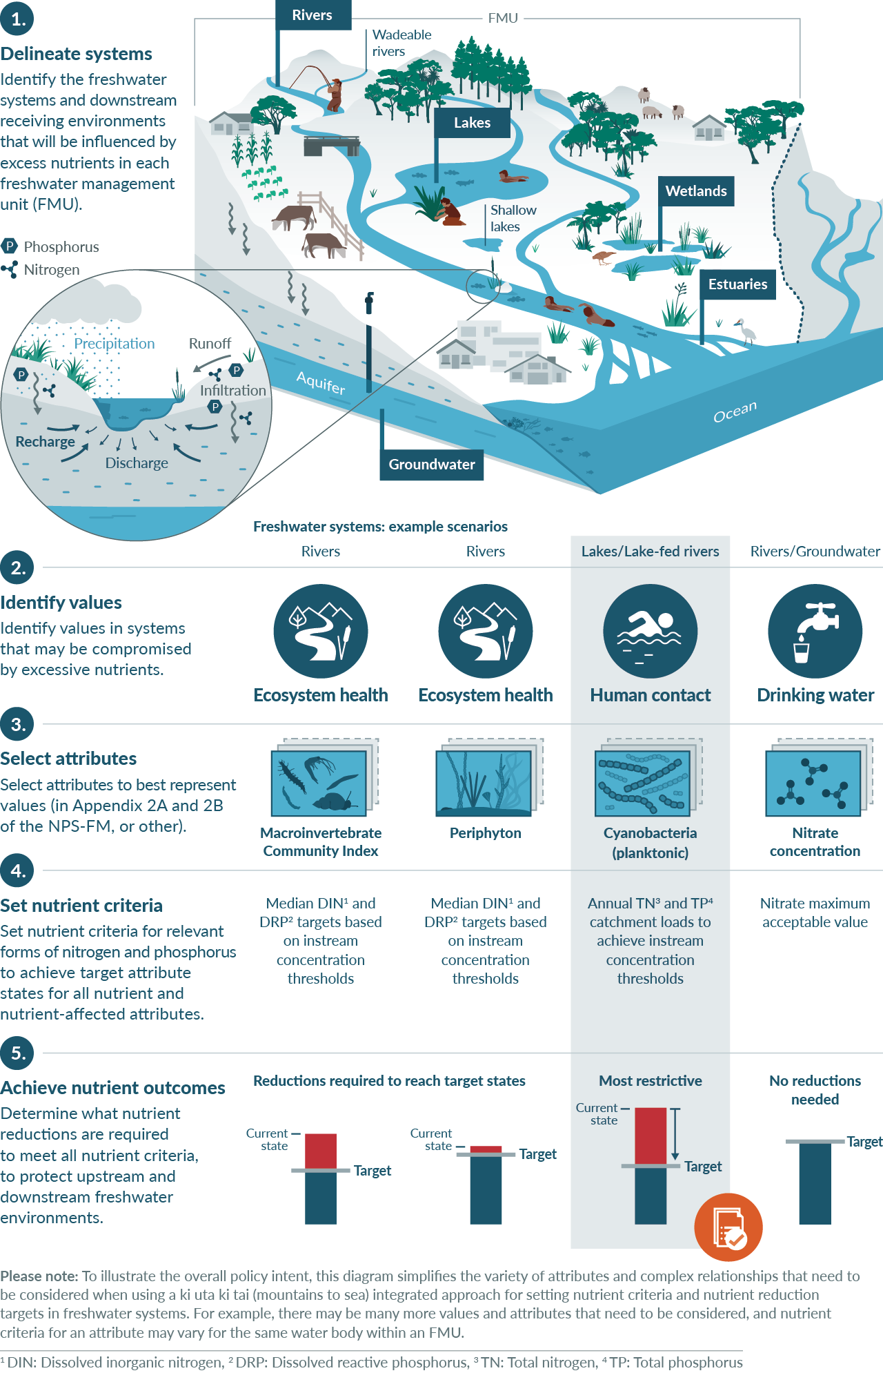

3.2 Relationship of clause 3.13 to limits and action plans
For attributes in appendix 2A, councils must set limits on resource use and the nutrient outcomes needed to achieve the TAS. They may also prepare action plans and impose conditions on resource consents to help with this (clause 3.12).
For attributes in appendix 2B, councils must prepare action plans to achieve the TAS and may also set limits and impose conditions on resource consents to help with this (clause 3.12). For further guidance around setting limits (clause 3.14) and preparing action plans (clause 3.15), see He Ārahitanga mō Te Anga Whāinga ā-Motu o te NPS-FM: Guidance on the National Objectives Framework of the NPS-FM (Ministry for the Environment, 2023).
One main difference between limits and action plans is that a limit may be expressed as one of three types of regulatory controls (that is, land use, output or input controls), while action plans are more flexible. Action plans allow many non-regulatory (such as ecosystem restoration by partnering with community and tangata whenua groups) as well as regulatory measures (including amending regional policy statements or plans).
For any attribute, limits and action plans are not mutually exclusive and are often complementary. For example, limits may be used to help reach a macroinvertebrate community index (MCI) TAS alongside the compulsory action plans. Similarly, action plans may be prepared to help achieve a periphyton TAS alongside compulsory limits.
Regional councils must use limits and action plans (where required) to achieve the nutrient outcomes adopted under clause 3.1.3. It is implicit that regional councils will need to establish a way to justify the limits (and maybe actions) deemed necessary. To do that, councils will need to develop ways of testing the effectiveness of various options for limits and actions in achieving draft nutrient outcomes. That is beyond the scope of this guidance. A current best practice approach broadly includes the following steps.
- Consider the loads of nitrogen and phosphorus that can be accommodated in a catchment while achieving the nutrient outcomes (where the nutrient outcomes are defined initially as concentrations rather than loads).
- Estimate what reductions (eg, percentage change) in catchment loads, if any, are needed compared with current loads.
- Estimate the effectiveness (eg, percentage load reductions that may be achieved) of various options for limits and actions, individually and then cumulatively for the catchment, typically using a scenario-testing approach.
- Consider the full implications of the options for limits and actions, as part of fully implementing the National Objectives Framework (NOF) process to finalise the setting of TAS, nutrient outcomes, limits and any actions, and associated timeframes for achieving them.
- Consider non-nutrient-related attributes or aspects (eg, sediment or flow regimes) that will be required to meet TASs for nutrient-affected attributes.

3.3 Deriving nutrient criteria for rivers
Main points
- Clause 3.13(1) applies to all attributes affected by nutrients across all water bodies. Nutrient criteria must be set to both achieve target attribute states (TASs) in all river types, as well as TASs in all downstream receiving environments.
- Clause 3.13(5) contains examples of nutrient-affected attributes in rivers, including periphyton, dissolved oxygen, fish, macroinvertebrates, and ecosystem metabolism.
- If TASs for nutrient or nutrient-affected attributes are being met, it may be appropriate to set nutrient criteria at the baseline state. Where TASs are not being met, nutrient criteria that are expected to achieve the TAS will need to be established.
- The technical guidance provided in Setting instream nutrient concentration thresholds for nutrient-affected attributes in rivers: Guidance on implementing clause 3.13 of the NPS-FM (Ministry for the Environment, 2022b) provides several strategies for identifying appropriate nutrient criteria; strategy 1 presents a short-term solution, where instream nutrient criteria are obtained from the existing literature.
- Three sources of nutrient criteria that can be considered alongside strategy 1 are:
- from the literature review provided in Setting instream nutrient concentration thresholds for nutrient-affected attributes in rivers: Guidance on implementing clause 3.13 of the NPS-FM (Ministry for the Environment, 2022b)
- from the NPS-FM attribute tables or Freshwater Science and Technical Advisory Group reports
- the tables contained in Guidance on look-up tables for setting nutrient targets for periphyton (Ministry for the Environment, 2022a).
As part of the process of implementing the NOF within an FMU, clause 3.13(1) directs that nutrient outcomes to achieve the TAS must be derived for all relevant affected attributes. The attributes may be from appendix 2A (requiring limits on resource use) or appendix 2B (requiring action plans), or can be other non-compulsory attributes included in regional plans. Derivation of instream concentration thresholds (ICTs) is more challenging for some attributes than others (Ministry for the Environment, 2022b). The final choice of ICT for the FMU, or relevant part of an FMU, will always be the lowest among the attributes relevant for that part of the FMU, to protect the attributes or water bodies most sensitive to nutrient enrichment and, therefore, achieve all TASs.
While the adverse effects of nutrient enrichment are often clear (see section 2.1.2 Nitrogen and phosphorus), the mechanisms by which they affect the ecosystem constituents represented by the attributes in appendices 2A and 2B are complex. This is because every ecosystem constituent interacts not only with nutrients, but also with other constituents and site-specific factors. Site-specific factors include shade (light), temperature, local hydrology and hydraulics, streambed substrate composition, geomorphology of the surrounding land, and water chemistry. Figure 4 shows a conceptual model of interactions among ecosystem constituents.
The complexity of ecosystems and the many interactions between constituents means identifying relationships between nutrient concentrations and ecosystem constituents is challenging (see reviews in section 2 of Ministry for the Environment (2022b)).
Figure 4: Simple conceptual model of the linkages between nutrients and constituents of river ecosystems
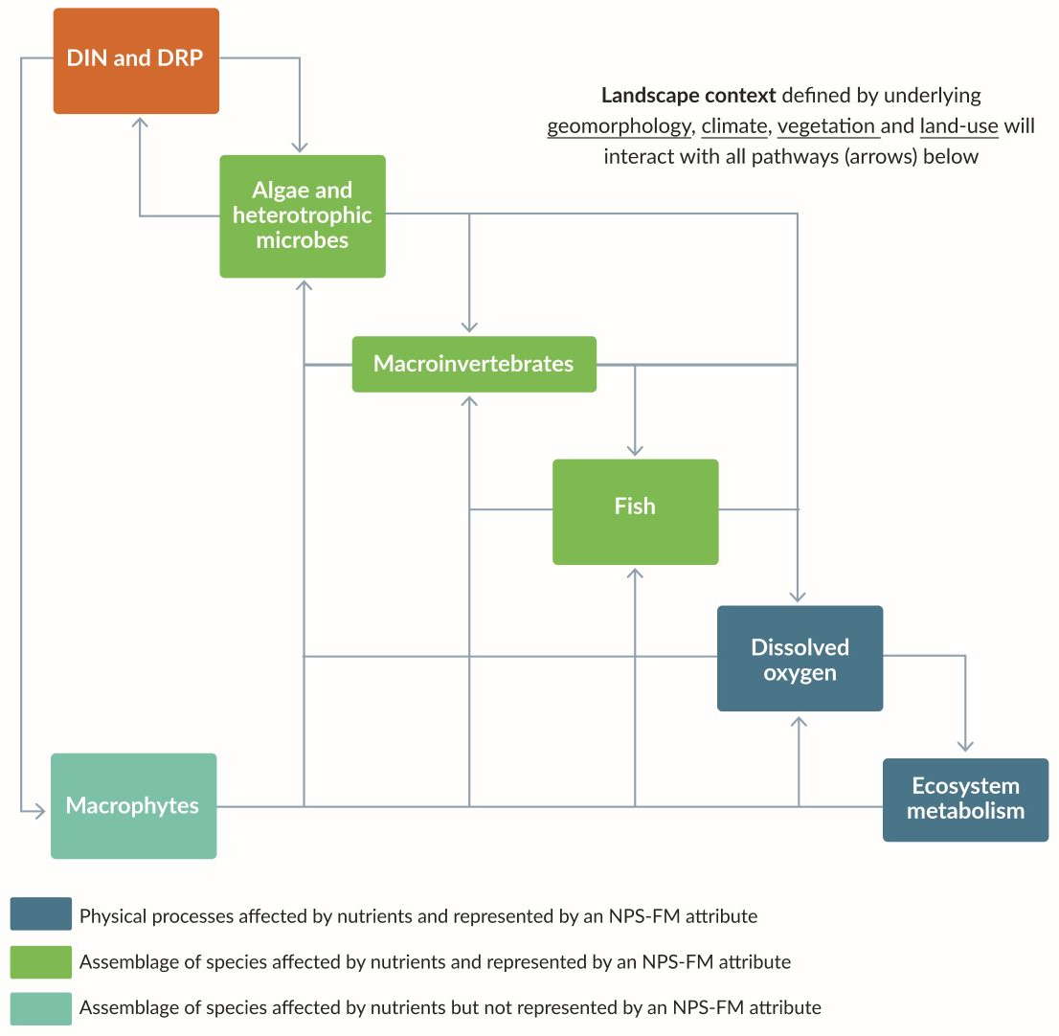
Note: DIN = dissolved inorganic nitrogen; DRP = dissolved reactive phosphorus; NPS-FM = National Policy Statement for Freshwater Management 2020.
Source: Adapted from Ministry for the Environment (2022b)

3.3.1 Applicability of clause 3.13(1)
Clause 3.13(1) applies to all water bodies, and therefore all rivers, across Aotearoa.
River sites used to represent an FMU may range from small alpine streams to large lowland rivers, from wholly wadeable to wholly unwadeable, and may be hard bottomed or soft bottomed. Stream size and type will dictate which attributes are relevant for implementing clause 3.13(1).
For example, hard-bottomed river sites – where more than 50 per cent of the bed is made up of gravel or larger bed particles – typically support periphyton growth (Clapcott et al, 2011). Data exclusively from hard-bottomed rivers were used to develop the periphyton attribute, and the periphyton attribute and corresponding ICTs will generally be relevant in hard-bottomed rivers that are also wadeable.
Soft-bottomed river sites – where more than 50 per cent of the bed is made up of sand or silt – can sometimes support conspicuous growth of periphyton on the bed after long periods of stable flows, or macrophyte communities. Cover by macrophytes, or by the epiphytic algae associated with macrophytes, could be adopted as additional attributes at these sites. Dissolved oxygen may also be a relevant attribute.

3.3.2 Attributes to consider
Nutrient management must consider nutrient-affected attributes in a river system. Periphyton biomass (chlorophyll a (chl-a)) has been an attribute in the NPS-FM since 2014, and dissolved oxygen below point source discharges since 2017. The NPS-FM 2020 introduced seven new compulsory attributes, representing ecosystem constituents in rivers such as macroinvertebrates, fish and ecosystem metabolism (table 1).
Table 1: Nutrient-affected attributes, including those introduced in the National Policy Statement for Freshwater Management 2020
Year | Attribute | Attribute unit | NPS-FM reference
2014 | Periphyton | Chlorophyll a (milligrams per square metre) | Appendix 2A, table 2
2017 | Dissolved oxygen below point sources | Dissolved oxygen (milligrams per litre) | Appendix 2A, table 7
2020 | Fish (rivers) | Fish index of biotic integrity | Appendix 2B, table 13
2020 | Macroinvertebrates | Macroinvertebrate community index | Appendix 2B, table 14
2020 | Macroinvertebrates | Quantitative macroinvertebrate community index | Appendix 2B, table 14
2020 | Macroinvertebrates | Macroinvertebrate average score per metric | Appendix 2B, table 15
2020 | Ecosystem metabolism | Gross primary production (grams of dissolved oxygen per square metre per day) | Appendix 2B, table 21
2020 | Ecosystem metabolism | Ecosystem respiration (grams of dissolved oxygen per square metre per day) | Appendix 2B, table 21
2020 | Dissolved oxygen (all rivers) | Dissolved oxygen (milligrams per litre) | Appendix 2B, table 17

3.3.3 Situations where it may be appropriate to use baseline concentrations as nutrient criteria
Policy 5 of the NPS-FM requires that the health of degraded freshwater ecosystems be improved, where degraded means (among other things) a national bottom line or TAS is not being achieved. It also requires that the health of all other freshwater ecosystems be at least maintained and improved. TASs for ecosystem health must be set at or above national bottom lines and the baseline state for each attribute. When nutrient attributes and attributes affected by nutrients can be demonstrated to meet national bottom lines and the baseline state defined for an FMU, and where the community has not chosen to improve those attributes, it may be appropriate to adopt the baseline nutrient concentrations as nutrient criteria.
When a TAS for a nutrient attribute or an attribute affected by nutrients is not being met in an FMU (ie, it is degraded), the regional council will need to establish nutrient criteria expected to achieve the TAS.

3.3.4 Options for nutrient criteria for other attributes
The guidance in Ministry for the Environment (2022b) sets out first steps towards managing nutrient impacts on, and setting nutrient criteria for, nutrient or nutrient-affected attributes.
Ministry for the Environment (2022b) is divided into two sections.
- Attributes and their relationship with nutrients: this section gives an overview of the relationships between instream nutrient concentrations and attributes affected by nutrients. It contains information needed to understand the non-trivial nature of developing ICTs to satisfy clause 3.13 of the NPS-FM. It also highlights lack of knowledge about the basic causal mechanisms by which nutrients affect river ecology.
- Setting nutrient exceedance criteria: this section presents strategies to set ICTs for attributes affected by nutrients in rivers.
Ministry for the Environment (2022b) presents a qualitative and subjective evaluation of factors affecting the sensitivity of individual attributes to nutrient enrichment, based on established and recent research on ecosystem constituents represented by the NPS-FM attributes.
Ministry for the Environment (2022b) first provides a brief literature review of the effects of nutrients on the ecosystem constituents represented by the NPS-FM attributes affected by nutrients (ie, periphyton (algae and heterotrophic microbes), macroinvertebrate and fish communities, dissolved oxygen, ecosystem metabolism). The second step focuses on the metric defined in the attributes (eg, 92nd percentile of chl-a, median MCI and quantitative macroinvertebrate community index). Based on the literature review, the report considered how each attribute metric is related to nutrient concentrations.
As shown in Figure 4, periphyton may be the NOF attribute most directly affected by nutrient concentrations in waterways, although the relationship is far from straightforward (see section 3.3.4 Options for nutrient criteria for other attributes). Nevertheless, most ecosystem constituents relate to periphyton in some way.
Section 3 of Ministry for the Environment (2022b) focuses on:
- describing four strategies that could be implemented to set ICTs for dissolved inorganic nitrogen (DIN) and dissolved reactive phosphorus (DRP) within regions
- outlining the consequences and trade-offs of choosing one strategy over another
- presenting methods that may facilitate implementing individual strategies, as well as choosing among other strategies
- offering recommendations on how each strategy might be implemented, as well as recommending a pragmatic strategy as a starting point for implementing clause 3.13 of the NPS-FM.
The choice of strategies recognises that the amount of information available to councils varies across regions (clause 1.6 of the NPS-FM), as do technical capability and fiscal capacity to implement clause 3.13 (that is, to set ICTs) before regional plan notification by December 2024.
For councils not already well advanced in developing nutrient criteria for rivers, one approach for developing 2024 plans is to follow strategy 1, outlined in Ministry for the Environment (2022b), to use ICTs that have already been developed or published for a nutrient-affected attribute. Implementing strategy 1 is straightforward and involves obtaining peer-reviewed, published ICTs from Aotearoa technical reports and papers. Given the complexities related to nutrient processing and cycling mentioned above, however, the use of ICTs developed at a national or even regional scale carries a higher risk that the desired outcomes may not be met, compared with using river- or site-specific approaches.
Strategy 1
Strategy 1 is a short-term solution in view of the lack of national-scale instream concentration thresholds (ICTs) available for many nutrient-affected attributes. Four of the potential sources of nutrient criteria to consider when implementing strategy 1 are as follows.
1. Band thresholds included for attributes in the National Policy Statement for Freshwater Management 2020 (NPS-FM) or those included in reports from the Freshwater Science and Technical Advisory Group (STAG, see section 3.3.53.3.5 Freshwater Science and Technical Advisory Group and dissolved inorganic nitrogen). Most attributes proposed during the STAG process were incorporated as NPS-FM attributes; also see section 3.3.5 for a discussion on dissolved inorganic nitrogen.
2. Results from an extensive literature review summarised in section 2.2.6. of Ministry for the Environment (2022b).
3. The periphyton look-up table approach described in section 3.3.6 Periphyton and the look-up tables and explained in full in Derivation of nutrient criteria for periphyton biomass objectives (Snelder et al, 2022) and Guidance on look up tables for setting nutrient targets for periphyton (Ministry for the Environment, 2022a).
4. ICTs from the Estuarine Trophic Index toolkit developed by Zeldis et al (2017).
See section 3.4.5 Estuaries.

3.3.5 Freshwater Science and Technical Advisory Group and dissolved inorganic nitrogen
The 19-member Freshwater Science and Technical Advisory Group (STAG) oversaw the scientific evidence used to develop the NPS-FM and helped interpret the science for policy development. This included using the best information available at the time to develop recommendations for appropriate attributes and banding. The group provided options for bands for DIN and DRP attributes. Most STAG members recommended those numbers for DIN into the NPS-FM, while a minority considered the evidence insufficient to justify setting nationally applicable bands and bottom lines (Supplementary report to the Minister for the Environment, Freshwater Science and Technical Advisory Group, 2020). These numbers remain useful for guidance and for councils to consider alongside those provided more recently in Ministry for the Environment (2022a and 2022b) when implementing strategy 1.
Table 2: Nutrient criteria for each trophic group and the overall average
 | Band | Periphyton | Invertebrates | Fish | Ecosystem processes | Average
DIN (mg/L) | A | 0.11 | 0.01 | 0.5 | 0.35 | 0.24
 | B | 0.53 | 0.33 | 0.63 | 0.50 | 0.50
 | C | 1.00 | 1.47 | 0.76 | 0.77 | 1.00
DRP (mg/L) | A | 0.004 | 0.001 | 0.013 | 0.008 | 0.006
 | B | 0.009 | 0.009 | 0.016 | 0.009 | 0.010
 | C | 0.016 | 0.028 | 0.019 | 0.010 | 0.018
Note: mg/L = milligram per litre.
Source: Canning (2020)
Full details on how the numbers in table 2 were derived are in Canning (2020) and reproduced in appendix 6 of the Supplementary report to the Minister for the Environment (Freshwater Science and Technical Advisory Group, 2020). Note that the DIN and DRP dissolved nutrient bands originally proposed by the STAG in its first report for the NPS-FM are the figures in the ‘average’ column in table 2 (Report to the Minister for the Environment, Freshwater Science and Technical Advisory Group, 2019). Canning (2020, p 4) describes these average figures as a “multiple lines of evidence” approach for determining nutrient criteria to manage risk to overall ecosystem health. This identification of a single set of criteria for overall ecosystem health is distinctive. Compared with the multiple options for periphyton criteria provided in Ministry for the Environment (2022a) and for other individual attributes in Ministry for the Environment (2022b), this is potentially an advantage in terms of being simple. When comprehensive datasets and understanding are lacking, a simple approach may reflect the best available information.
Disadvantages of the criteria presented in table 2 are discussed in a summary of the perspectives of the minority group of STAG members provided in appendix 7 in the Supplementary report to the Minister for the Environment (Freshwater Science and Technical Advisory Group, 2020). Significant among their concerns is that the criteria were derived based on weak relationships that vary substantially from river to river. On this basis, it may not be appropriate to apply a ‘one-size-fits-all’ approach for an attribute for which the influence is known to vary substantially across sites and habitat types.
Recognition of the limitations of a ‘one-size-fits-all’ approach led to the development of the periphyton look-up tables, explained in section 3.3.6 Periphyton and the look-up tables. The use of periphyton criteria and combinations of other attribute criteria in Ministry for the Environment (2022b) requires assumptions that those individual attribute criteria will also provide for other attributes and overall ecosystem health; these assumptions could potentially be made at this time based on the established ecosystem linkages shown in figure 4.

3.3.6 Periphyton and the look-up tables

Periphyton biomass and nutrient enrichment
Periphyton comprises a mixture of algae (including cyanobacteria), heterotrophic microbes (eg, bacteria) and other organic–inorganic material, with algae usually dominating. Periphyton grows on the substrate of rivers and is an important component of healthy river ecosystems. Low-to-moderate levels of periphyton biomass support river food webs and contribute to ecosystem services (eg, carbon and nutrient cycling, biodiversity). Appropriate nutrient management mitigates the risk of periphyton proliferations that may have undesirable effects on ecosystem health (eg, oxygen and pH fluctuations that can be harmful to macroinvertebrates and fish, smothering of habitat used by macroinvertebrates) and water uses (eg, reducing suitability for swimming and angling, increasing risk of blocking water abstraction equipment) (Biggs, 2000).
During periods of stable river flows, periphyton growth (primarily driven by photosynthesis in algae) involves nutrient uptake accompanying carbon fixation. This increases biomass through cell division until other resources, such as available space on hard substrates, become limiting.
In many rivers, high nutrient uptake rates during summer low flows can lower the dissolved nutrient concentration in the water and alter the downstream nutrient concentrations (see box on temporal and downstream extent of nutrient impacts on periphyton biomass). This has two main implications.
- Relationships between instantaneous nutrient concentrations and periphyton biomass may reflect the effect of periphyton on nutrient concentrations rather than the converse (eg, they are often negative). Therefore, relationships between nutrient concentrations and periphyton biomass should be established using data summarised over time (eg, monthly concentrations over a year or longer).
- High nutrient uptake rates in one part of the stream highlight the downstream spatial extent of nutrient-input effects on periphyton biomass, and the spatial variability of both nutrient concentrations and periphyton biomass at a single point in time.
Temporal and downstream extent of nutrient impacts on periphyton biomass
The conceptual diagram below shows how dissolved inorganic nitrogen (DIN) and periphyton biomass can vary downstream of a source of enrichment (eg, upwelling enriched groundwater or sewage treatment plant input) at three times during a flow recession. The diagram is based on Tukituki River observations (Quinn et al, 2018) and the model of Chapra et al (2014).
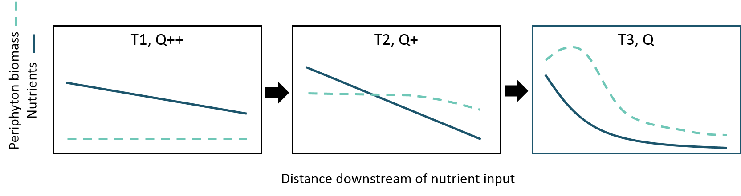
At T1, the flow (Q++) is moderate and travel time along the reach is short, resulting in lower initial nutrient concentrations that decline slowly downstream in response to early growth of periphyton that is not limited by concentrations along the whole river reach length.
At T2, the flow is low–moderate (Q+), resulting in reduced dilution of inputs (giving higher upstream concentrations) but more rapid decline of DIN and dissolved reactive phosphorus (DRP) along the reach. This is driven by (1) higher uptake by higher periphyton biomass that has accrued over time, and (2) longer travel times enabling more time for uptake. Periphyton biomass begins to decline at the downstream end of the reach where nutrients are low, but the biomass remains moderate due to earlier growth.
At T3, at low flow (Q), high nutrient concentrations occur near the upstream end of the reach (low dilution of inputs), where high biomass has accrued with continued rapid growth in response to maintained high nutrients. Both DIN and DRP decrease rapidly with distance downstream due to the combined effects of high uptake rates, long travel times and shallower depth (ie, greater bed surface area-to-volume ratio than at higher flows). Consequently, nutrient concentrations decrease to levels that limit periphyton growth, and biomass declines downstream as losses from grazing and self-sloughing are not replaced by new growth.
In the periphyton attribute, biomass is represented by measurements of chl-a, which is a photosynthetic pigment found in all algae. The positive dose-response relationship between nutrients (nitrogen (N) and phosphorus (P)) and periphyton chl-a is well established in descriptive as well as experimental studies, both in Aotearoa and overseas (Biggs, 2000; Elser et al, 2007; Iannino et al, 2020; Ministry for the Environment, 2022a). The relationship is mediated by environmental factors, such as shading, water temperature, local hydraulics and catchment hydrology.
Efforts to develop predictive models for chl-a in Aotearoa have been ongoing since before periphyton chl-a was included in the first version of the NOF in 2014. In most cases, the models used time-averaged data for nutrient predictors (eg, median DIN, DRP) to predict time-averaged chl-a (eg, mean or 92nd percentiles). Several factors justify these efforts.
- Periphyton occupies the lowest trophic level in river ecosystems and is composed of algae and heterotrophic microbes that directly take up dissolved N and P. After controlling for environmental factors, such as shading, water temperature and the effects of flow variability, periphyton biomass is the ecosystem constituent most directly affected by changes in nutrient concentrations.
- As the lowest trophic level in river ecosystems, periphyton community composition and abundance (ie, biomass) directly and indirectly affect the community composition and abundances of higher trophic levels (macroinvertebrates and fish) (see Figure 4).
- Inclusion of periphyton in the NPS-FM in 2014, and existence of a periphyton guideline and monitoring manual before that (Biggs, 2000; Biggs and Kilroy, 2000), have led to establishment of regional periphyton monitoring programmes across Aotearoa, all using comparable methodologies. The combined regional data have provided sufficient reliable data to develop national correlational models of periphyton biomass.
At low concentrations, a large increase in periphyton biomass occurs with each unit increase in N or P concentration. At higher concentrations, the same unit increase in N or P concentration is associated with a smaller increase in periphyton biomass. Further, analysis by Snelder et al (2022) indicated the biomass response reaches a ‘ceiling’ beyond which there appears to be no evidence for any further biomass response to increasing nutrient concentrations. This nutrient concentration at this point is referred to as the ‘saturating concentration.’
Represented graphically, the relationship between periphyton biomass and nutrient concentrations increases until they approach an asymptote. Snelder et al (2022) found that this biomass ceiling occurred at about 150 milligrams chl-a per square metre. This underlying relationship is further complicated by the various mediating factors in the stream ecosystem, which can up- or down-regulate the precise periphyton biomass (see Figure 5).
Figure 5: Factors that mediate the relationship between periphyton and nutrients (in this case represented as the nutrient forms dissolved inorganic nitrogen and dissolved reactive phosphorus)
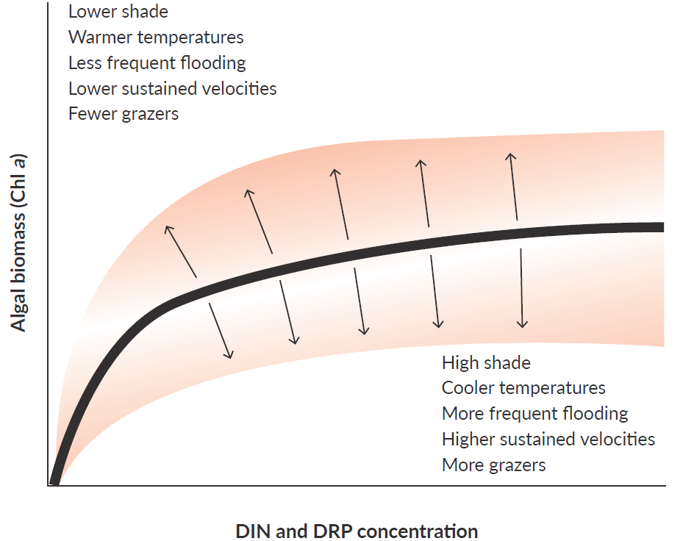
Note: Chl a = chlorophyll a; DIN = dissolved inorganic nitrogen; DRP = dissolved reactive phosphorus.
Source: Adapted from Ministry for the Environment (2022b)

Periphyton look-up tables
The periphyton look-up tables are based on a study (Snelder et al, 2022) that derived instream nutrient concentrations and exceedance criteria for periphyton biomass objectives using regional council monitoring data. This study updated earlier work (Snelder et al, 2019) used for the regulatory impact statement for the NPS-FM.
A detailed history of this model can be found in section 3.5 Reconciling nutrient criteria across the freshwater management unit and downstream receiving environments. Significant features of the look-up tables derived from the model include:
- the nutrient criteria in the look-up tables apply to all hard-bottomed (ie, cobble- or gravel-bed) streams and rivers
- chl-a refers to the 92nd percentile of chl-a calculated from at least three years of monthly data, which is the metric specified in the periphyton attribute
- the tables provide nutrient criteria that apply to different levels of under-protection risk, which is the percentage risk that a randomly chosen location will exceed a specified biomass threshold despite nutrient concentrations being compliant with the specified nutrient criteria. In other words, it is a spatial exceedance criterion; the table provides nutrient targets for under-protection risks of 5, 10, 15 and 20 per cent (for illustrated explanations of under-protection risk, see Ministry for the Environment 2022a and 2022b)
- the look-up tables include targets for total nitrogen (TN), total phosphorus (TP), DIN and DRP concentrations for the upper limit of band A, B and C in the periphyton attribute (ie, respectively 50, 120 and 200 milligrams chl-a per square metre)
- stream types are defined using the National Institute of Water and Atmospheric Research’s river environment classification (REC) at the source-of-flow level (21 classes), divided into shaded and unshaded sites
- alternative criteria should be used where:
- current nutrient concentrations are less than the nutrient criterion from the look-up table, or where the nutrient exceedance criteria for DRP or TP are zero, the requirement to at least maintain water quality applies. In these situations, replace an identified criterion by the current measured or modelled concentration
- the identified criteria are higher than levels to achieve other attribute states at the site (eg, the nitrate toxicity target attribute). In this situation, the more sensitive TAS should be applied
- there are sensitive downstream receiving environments that require nutrient concentrations or loads that imply the identified criterion is too high. In this situation, more stringent TASs should be factored in.
If the look-up tables are used, these should only be considered as a starting point for managing nutrient concentrations for periphyton. The direct output of the model should not be used without verification, because the criteria in the tables are risk based and apply to populations of sites. Therefore, once nutrient criteria are assigned from the look-up tables to sites across a region (following the steps in Ministry for the Environment (2022a)), regional councils should apply a procedure for assessing confidence in (ie, verifying) the criteria.
Regional councils need to assess the nutrient criteria by determining how well these predict the proportion of sites in a population that would exceed a nominated biomass threshold. They cannot interpret the look-up table criterion for a site as a prediction of the associated biomass threshold.
The features of the model on which the look-up tables are based, complicate interpretation of the nutrient criteria generated from it. A real-life example of the saturating concentration effect was documented by Suplee et al (2012).
Further cautions are as follows.
- The biomass ceiling in some REC source-of-flow classes, even at high percentiles of the predicted cumulative probability distribution (eg, the 80th percentile, which corresponds to the 20 per cent under-protection risk), may be lower than the NOF B- and C-band thresholds of 120 milligrams chlorophyll m⁻² and 200 milligrams chlorophyll m^{–2}. In other words, the models indicate that factors other than nutrient concentration limit the maximum biomass in these REC classes so that thresholds will not be reached, no matter how high the nutrient concentration.
- Shifts in periphyton community composition in response to nutrient enrichment may occur without a significant change in periphyton biomass (Ministry for the Environment, 2022b). Therefore, any nutrient criteria based on chl-a may not be protective of nutrient-affected attributes higher up the food chain. In such circumstances, other attributes such as MCI may be worth greater consideration when setting nutrient concentrations in upstream contributing water bodies, because research indicates they are more sensitive to the effects of nutrient enrichment than periphyton (Canning et al, 2021).
The national periphyton dataset continues to expand as sites are added to monitoring programmes in different regions, and time series are being extended. Other statistical methodologies for analysing the data and extracting nutrient criteria are also being explored. The current look-up tables are therefore a work in progress, with potential for future refinement and improvement.
More technical details and older models on periphyton biomass can be found in Setting instream nutrient concentration thresholds for nutrient-affected attributes in rivers: Guidance on implementing clause 3.13 of the NPS-FM (Ministry for the Environment, 2022b).

Links to the periphyton look-up tables
- Guidance on look-up tables for setting nutrient targets for periphyton: Second edition (Ministry for the Environment, 2022a).
- Derivation of nutrient criteria for periphyton biomass objectives (Snelder et al, 2022).
- The dataset used to inform the look-up tables: NZ Freshwater Nutrient and Biomass Measurements for Periphyton 2012–2020 (Ministry for the Environment).

3.4 Deriving nutrient criteria for nutrient-sensitive downstream receiving environments

3.4.1 What are nutrient-sensitive downstream receiving environments?
Main points
Nutrient-sensitive downstream receiving environments include rivers, lakes, wetlands, aquifers, estuaries and coastal environments.
Relatively more relevant information is available to help with nutrient criteria for rivers, lakes and estuaries.
The relative lack of information for wetlands, groundwater and coastal receiving environments, like lagoons or the broader coastal marine area, does not mean these water bodies should be ignored when setting nutrient criteria. The best available information should be used.
Clause 3.13 requires that when councils set nutrient criteria in FMUs, they must ensure environmental outcomes are achieved for nutrient-sensitive downstream receiving environments. Downstream receiving environments include any aquatic environment that may be affected by the discharge of water from upstream, including coastal marine areas (including estuaries).
Downstream receiving environments may be nutrient sensitive when, for example:
- a limiting nutrient is supplied from upstream, which changes the nutrient limitation status of the downstream water body
- long residence times in a lake enable primary producers (eg, phytoplankton) to take up additional nutrients from upstream and proliferate
- the receiving environment represents a different habitat, with biological communities that differ from those upstream (including having different responses to changes in nutrient concentrations).
A ki uta ki tai approach applies to water flowing through all parts of the landscape. The connections and flow paths can be intricate and complicated, and consideration must be given to ensuring nutrient management protects all types of water bodies in an FMU.

3.4.2 Wetlands
Wetlands are distinguished by three main components: hydrology, soils and vegetation. Wetland hydrology determines soil development, the assemblage of plants and animals that inhabit the site, and the type and intensity of biochemical processes (US EPA, 2008). The main wetland types in Aotearoa are bogs, fens, swamps and marshes (Johnson and Gerbeaux, 2004). The relationship between wetland type and water source is shown in figure 6.
Figure 6: Water source and wetland type
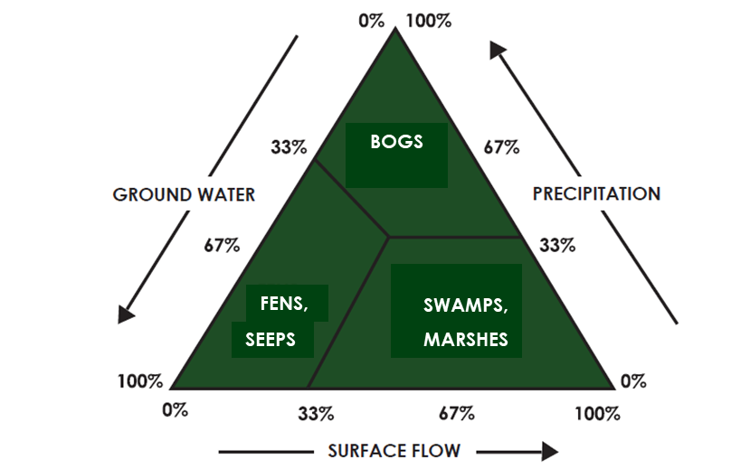
Source: US EPA (2008)
Hydrological disturbance is the primary cause of loss of natural character in wetlands. As zones of nutrient transformation and removal, wetlands are also sensitive to the amount of nutrients they receive. Many Aotearoa wetlands continue to suffer from excess nutrient inputs, causing increased biomass of vascular plants, followed by shifts in plant community composition to species adapted to high nutrient environments (US EPA, 2008). Nutrient enrichment typically leads to replacement of diverse multi-species communities with those dominated by a few fast-growing competitors (Burge et al, 2020; Sorrell, 2010). Thus, while there is no national guidance on indicative nutrient criteria for managing the trophic state of wetlands, a precautionary approach should be taken to ensure nutrient inputs do not degrade wetland values.

3.4.3 Groundwater
From a nutrient perspective, groundwater can be both an upstream contributing environment and a downstream receiving environment. It is a source of nutrients to FMU surface waters (McDowell et al, 2015; Morgenstern and Daughney, 2012), while rivers and streams can recharge shallow aquifers.
Nutrient additions to groundwater from any source may influence heterotrophic processes (ie, nitrification and denitrification), and could potentially affect groundwater invertebrate communities (ie, biodiversity of stygofauna, Fenwick et al (2021)). High concentrations of nitrogen input instream may lead to nitrate and ammonia toxicity (but note the NPS-FM nitrate and ammonia toxicity attributes only apply to the effects on river and lake aquatic life). Concentrations of nutrients (specifically nitrate-nitrogen) in Aotearoa groundwaters are, on average, almost five times higher than those in surface waters (Rogers et al, 2023). Care should be taken that instream values are not compromised where groundwater re-emerges into downstream water bodies.

3.4.4 Lakes
Three attributes have been defined to manage the trophic state of lakes:
- phytoplankton biomass (chl-a concentration, milligrams per cubic metre) (appendix 2A, table 1)
- TN concentration (milligrams per cubic metre) (appendix 2A, table 3)
- TP concentration (milligrams per cubic metre) (appendix 2A, table 3).
Numeric values of the three attributes can be combined to calculate the trophic level index (TLI), which is a useful single index for assessing lake water quality. The protocol for calculating TLI is set out in Burns et al (2000). For recent insights and recommendations on the use of TLI in Aotearoa, see Schallenberg and van der Zon (2019).
Section 3.5 Reconciling nutrient criteria across the freshwater management unit and downstream receiving environments discusses interconversion between in-river concentrations (ie, inflow concentrations from an FMU) and estimated in-lake concentrations (where lakes are a potential nutrient-sensitive downstream receiving environment). The concentration of both N and P need to be considered when managing for a trophic state outcome in lakes, because of seasonal and interannual changes in nutrient limitation (Larned et al, 2011).

Phytoplankton biomass
Phytoplankton biomass in a lake is represented by measurements of chl-a. It is the biological expression (as primary production) of nutrients N and P in the water column, within the constraints imposed by factors such as water clarity, stratification, residence time, water temperature (season) and other aspects of water quality (eg, water colour).
Annual median and annual maximum values of chl-a, measured from samples collected using a recommended methodology (eg, Burns et al, 2000; Schallenberg and van der Zon, 2019, are indicators of lake trophic state.

Total nitrogen and total phosphorus
Having identified the freshwater objectives for phytoplankton (trophic state) sought for lakes in an FMU, regional councils can then select the corresponding TN and TP in-lake concentration criteria (measured as annual medians from samples collected using the recommended methodology as for chl-a) required to meet the freshwater objective. While chl-a, TN and TP are usually highly correlated across lakes, the three trophic state indicators can vary independently of each other within lakes. This depends on factors such as growth-limitation by one nutrient, or whether nitrogen-fixing phytoplankton taxa are present in the lake (see discussion in Schallenberg and van der Zon, 2019). Where lake attribute TN or TP concentrations are known not to provide for the corresponding phytoplankton TAS, it is expected that more meaningful and site-specific in-lake nutrient criteria will be adopted (or developed) as part of clause 3.13(2). For example, in lakes that are light-limited through high turbidity, or have short residence times (both of which limit chl-a), the TAS for chl-a could be set in a different band from that for TN or TP.

3.4.5 Estuaries
The NPS-FM specifies that downstream receiving environments include estuaries. Recognising that nutrient enrichment threatens many estuaries, a national estuary trophic index (ETI) has been developed through an Envirolink Tools project (Zeldis et al, 2017). The ETI was developed as three separate tools that help regional councils to:
- determine the susceptibility of an estuary to eutrophication
- assess its current trophic state
- assess how changes to N load (via conversion to concentrations) may alter its current state.
The ETI deals with N enrichment only because, since the mid-1990s, strong consensus has developed that solving the problem of eutrophication in estuaries requires controls on N inputs only (Howarth and Marino, 2006). Phosphorus is not considered to be a limiting nutrient in Aotearoa estuaries (Plew et al, 2020).
Details of the ETI and how to apply it are available on NIWA’s website at Estuarine trophic index toolkit.
The ETI is recommended for dealing with trophic states in estuaries. Its advantages include:
- development in response to a need identified by regional council coastal scientists
- a national initiative using data from more than 400 estuaries (tool 1) and distinguishing four different types of estuary (shallow intertidal dominated estuaries; shallow, short residence time tidal river and tidal river with adjoining lagoon; deeper subtidal dominated, longer residence time; coastal lakes)
- provision of a process to determine susceptibility of estuaries to both macroalgal blooms and phytoplankton blooms
- definition of ETI trophic state bands (A, B, C and D) comparable to those in NPS-FM attributes applicable to rivers and lakes:
- macroalgal trophic bands and corresponding nutrient criteria derived from real data
- phytoplankton trophic bands derived using a modelling approach.
Features of the ETI that may be limitations include the following.
- It deals only with N because, as noted above, most estuaries in Aotearoa are N-limited, not P-limited; see Plew et al (2020) for a discussion.
- Outputs are annual average concentrations, because the input includes annual average concentrations and flows from the catchment land use for environmental sustainability model (note that summer maximum concentrations can be predicted from annual averages).
- Because estuary trophic index tool 1 assumes the whole estuary is homogeneous, it does not account for heterogenous nutrient environments within estuaries.
- Estuary trophic index output is ‘potential’ N concentrations, which are concentrations in the absence of nutrient uptake or losses through biogeochemical processes.
- The ETI may not be appropriate for all estuary types (eg, estuaries dominated by mangroves).
The ETI may provide a useful first step and screening level approach to identifying trophic state objectives for Aotearoa estuaries, and to setting corresponding potential TN concentrations. Because its approach is generic, more detailed local investigations may be preferred.
Nitrogen criteria corresponding to trophic state bands as defined in the ETI are summarised in table 3.
Table 3: Indicative potential total nitrogen threshold concentrations (milligrams per cubic metre) for macroalgal and phytoplankton trophic states in Aotearoa estuaries
Trophic state band | Macroalgal dominated systems |  | Phytoplankton dominated systems
Applies to: | Shallow intertidal dominated estuaries, some shallow, short residence time (tidal river and tidal river with adjoining lagoon) estuaries |  | Deeper subtidal dominated, longer residence time estuaries (DSDEs)
Variable | Ecological quality rating (EQR) | Potential total nitrogen (TN) | Chlorophyll a (chl-a) | Potential TN
Unit | Score (range 0 to 1) | Milligrams per cubic metre (mg/m³) | mg/m³ | mg/m³
A | ≥0.8 to 1.0 | <55 | <5 | <50
B | ≥0.6 to <0.8 | ≥55 to <180 | ≥5 to <10 | ≥50 to <100
C | ≥0.4 to <0.6 | ≥180 to <350 | ≥10 to <16 | ≥100 to <150
D | <0.4 | ≥350 | ≥16 | ≥150
References and notes | Robertson et al (2016) (derivation of EQR using opportunistic macroalgal blooming tool | Zeldis et al (2017) (derivation of TN bands equivalent to EQR) | Eppley et al (1969); Ferreira et al (2005) (models for predicting chl-a) | Zeldis et al (2017) (derivation of TN bands, applicable when flushing time >3–4 days)
Note: Total nitrogen and chlorophyll a concentrations are annual mean values.

3.5 Reconciling nutrient criteria across the freshwater management unit and downstream receiving environments
Clause 3.13 requires regional councils to set nutrient criteria that achieve all identified TASs and environmental outcomes in all water bodies in the FMU. Some nutrient criteria will be expressed as instream concentrations and exceedance criteria, while others may be expressed as instream loads.
Nutrient criteria may be expressed in different forms of N and P that best suit the characteristics of the relevant water bodies (see section 2.1.2 Nitrogen and phosphorus). Nutrient criteria are likely to vary in their stringency, depending on what is required to achieve TASs in different parts of the river network, lakes, groundwater, wetlands, estuaries or other coastal environments.
One of the final steps, as outlined in section 3.1 General approach, will involve a reconciliation process to ensure nutrient criteria outcomes will achieve TASs in all parts of the FMU. Councils may undertake this reconciliation process in various ways. It needs to be done in a transparent manner, to identify whether any nutrient reductions are required to achieve TASs throughout the FMU. This then forms the basis for investigating limits and action plans that may be needed to achieve the required nutrient reductions.
The reconciliation process should therefore transparently demonstrate linkages between environmental outcomes, TAS, and the identified nutrient concentrations needed to achieve them, any nutrient load reductions required, and the resource use limits and action plans needed to achieve those reductions.

References
Biggs BJF. 2000. New Zealand periphyton guideline: detecting, monitoring and managing enrichment of streams. Prepared for the Ministry for the Environment by the National Institute of Water and Atmospheric Research. Wellington: Ministry for the Environment.
Biggs BJF, Kilroy C. 2000. Stream periphyton monitoring manual. Prepared for the Ministry for the Environment by the National Institute of Water and Atmospheric Research. Wellington: Ministry for the Environment.
Burge OR, Clarkson BR, Bodmin KA, Bartlam S, Robertson HA, Sukias JPS, Tanner CC. 2020. Plant responses to nutrient addition and predictive ability of vegetation N:P ratio in an austral fen. Freshwater Biology 65(4): 646–656.
Burns NM, Bryers G, Bowman E. 2000. Protocol for monitoring trophic levels of New Zealand lakes and reservoirs. Prepared for the Ministry for the Environment by Lakes Consulting. Wellington: Ministry for the Environment.
Canning AD. 2020. Nutrients in New Zealand rivers and streams: An exploration and derivation of national nutrient criteria. Report to the Minister for the Environment. Wellington: Essential Freshwater Science and Technical Advisory Group.
Canning AD, Joy MK, Death RG. 2021. Nutrient criteria to achieve New Zealand’s riverine macroinvertebrate targets. PeerJ 9: e11556.
Chapra SC, Flynn KF, Rutherford JC. 2014. Parsimonious model for assessing nutrient impacts on periphyton-dominated streams. Journal of Environment Engineering 140(6): 04014014.
Clapcott JE, Young RG, Harding JS, Matthaei CD, Quinn JM and Death RG. 2011. Sediment Assessment Methods: Protocols and guidelines for assessing the effects of deposited fine sediment on in-stream values. Nelson: Cawthron Institute.
Elser JJ, Bracken MES, Cleland EE, Gruner DS, Harpole WS, Hillebrand H, Ngai JT, Seabloom EW, Shurin JB, Smith JE. 2007. Global analysis of nitrogen and phosphorus limitation of primary producers in freshwater, marine and terrestrial ecosystems. Ecology Letters 10(12): 1135–1142.
National Institute of Water and Atmospheric Research (NIWA). The New Zealand Estuary Trophic Index. Retrieved 31 July 2023.
Eppley RW, Rogers JN, McCarthy JJ. 1969. Half-saturation constants for uptake of nitrate and ammonia by marine phytoplankton. Limnology and Oceanography 14(6): 912–920.
Fenwick GD, Greenwood MJ, Hogg ID, Meyer SJ. 2021. High diversity and local endemism in Aotearoa New Zealand’s groundwater crustacean fauna. Ecology and Evolution 11(22): 15664–15682.
Ferreira JG, Wolff WG, Simas TC, Bricker SB. 2005. Does biodiversity of estuarine phytoplankton depend on hydrology? Ecological Modelling 187(4): 513–523.
Freshwater Science and Technical Advisory Group. 2019. Report to the Minister for the Environment. Wellington: Freshwater Science and Technical Advisory Group.
Freshwater Science and Technical Advisory Group. 2020. Supplementary report to the Minister for the Environment. Wellington: Freshwater Science and Technical Advisory Group.
Howarth RW, Marino R. 2006. Nitrogen as the limiting nutrient for eutrophication in coastal marine ecosystems: evolving views over three decades. Limnology and Oceanography 51(1, part 2): 364–376.
Iannino A, Vosshage ATL, Weitere M, Fink P. 2020. Taxonomic shift over a phosphorus gradient affects the stoichiometry and fatty acid composition of stream periphyton. Journal of Phycology 56(6): 1687–1695.
Johnson P, Gerbeaux P. 2004. Wetland types in New Zealand. Wellington: Department of Conservation Te Papa Atawhai.
Kowalczewska-Madura K, Dondajewska-Pielka R, Goldyn R. 2022. The assessment of external and internal nutrient loading as a basis for lake management. Water 14(18): 2844.
Larned S, Hamilton D, Zeldis J, Howard–Williams C. 2011. Nutrient–limitation in New Zealand rivers, lakes and estuaries. Discussion paper prepared for the Land and Water Forum, September 2011, Wellington, New Zealand.
McDowell RW, Cox N, Daughney CJ, Wheeler D, Moreau M. 2015. A national assessment of the potential linkage between soil, and surface and groundwater concentrations of phosphorus. Journal of the American Water Resources Association 51(4): 992–1002.
McDowell RW, Snelder TH, Cox N, Booker DJ, Wilcock RJ. 2013. Establishment of reference or baseline conditions of chemical indicators in New Zealand streams and rivers relative to present conditions. Marine and Freshwater Research 64(5): 387–400.
Ministry for the Environment. 2021. A guide to setting instream nutrient concentrations under Clause 3.13 of the National Policy Statement for Freshwater Management 2020. Wellington: Ministry for the Environment.
Ministry for the Environment. 2022a. Guidance on look-up tables for setting nutrient targets for periphyton: Second edition. Wellington: Ministry for the Environment.
Ministry for the Environment. 2022b. Setting instream nutrient concentration thresholds for nutrient-affected attributes in rivers: Guidance on implementing clause 3.13 of the NPS-FM. Wellington: Ministry for the Environment.
Ministry for the Environment. 2022c. Guidance for implementing the NPS-FM sediment requirements. Wellington: Ministry for the Environment.
Ministry for the Environment. 2023. He Ārahitanga mō Te Anga Whāinga ā-Motu o te NPS-FM: Guidance on the National Objectives Framework of the NPS-FM. Wellington: Ministry for the Environment.
Ministry for the Environment. NZ Freshwater nutrient and biomass measurements for periphyton
2012–2020. Retrieved 15 July 2023.
Morgenstern U, Daughney CJ. 2012. Groundwater age for identification of baseline groundwater quality and impacts of land-use intensification – the National Groundwater Monitoring Programme of New Zealand. Journal of Hydrology 456: 79–93.
Plew DR, Zeldis JR, Dudley BD, Whitehead AL, Stevens LM, Robertson BM, Robertson B. 2020. Assessing the eutrophic susceptibility of New Zealand estuaries. Estuaries and Coasts 43(8): 2015–2033.
Quinn J, Rutherford K, Wilcock B, Depree C, Young R, Schiff S. 2018. Nutrient-periphyton interactions along a temperate river and response to phosphorus input reduction. In: Proceedings of 4th International Conference on Water Resources and Wetlands. Tulcea, Romania: Romanian Limnogeographical Association. pp 10–18.
Robertson BM, Stevens L, Robertson B, Zeldis J, Green M, Madarasz-Smith A, Plew D, Storey R, Oliver M. 2016. NZ estuary trophic index screening tool 2. Determining monitoring indicators and assessing estuary trophic state. Prepared for Envirolink Tools Project: Estuarine Trophic Index, MBIE/NIWA Contract No: C01X1420.
Rogers KM, van der Raaij R, Phillips A, Stewart M. 2023. A national isotope survey to define the sources of nitrate contamination in New Zealand freshwaters. Journal of Hydrology 617: 13.
Ruru I, Kanz W, Afoa E, Clarke C, Nutsford D, Lowe M, Jelicich A, Shivnan S. 2022. A kete for implementing mahinga kai in the context of the National Policy Statement for Freshwater Management 2020. Prepared for the Ministry for the Environment by Maumahara Consultancy Services Ltd and Awamoana Ltd. Wellington: Ministry for the Environment.
Schallenberg M, van der Zon KA. 2019. Review of the lake trophic level index. Prepared for the Regional Council Lakes Focus Group. Dunedin: University of Otago.
Snelder TH, Kilroy C, Booker DJ. 2022. Derivation of nutrient criteria for periphyton biomass objectives using regional council monitoring data. Prepared for the Ministry for the Environment by Land and Water People Limited. Wellington: Ministry for the Environment.
Snelder TH, Larned ST, McDowell RW. 2018. Anthropogenic increases of catchment nitrogen and phosphorus loads in New Zealand. New Zealand Journal of Marine and Freshwater Research 52(3):
336–361.
Snelder TH, McDowell RW, Fraser CE. 2016. Estimation of catchment nutrient loads in New Zealand using monthly water quality monitoring data. JAWRA Journal of the American Water Resources Association 53(1): 158–178.
Snelder TH, Moore C, Kilroy C. 2019. Nutrient concentration targets to achieve periphyton biomass objectives incorporating uncertainties. JAWRA Journal of the American Water Resources Association 55(6): 1443–1463.
Sorrell B. 2010. Nutrients. In: M Peters, B Clarkson (eds) Wetland Restoration: A handbook for New Zealand freshwater systems. Lincoln: Manaaki Whenua Press. pp 100–121.
Suplee MW, Watson V, Dodds WK, Shirley C. 2012. Response of algal biomass to large-scale nutrient controls in the Clark Fork River, Montana, United States. Journal of the American Water Resources Association 48(5): 1008–1021.
US EPA (United States Environmental Protection Agency). 2008. Nutrient criteria technical guidance manual: Wetlands. Washington, DC: Office of Water, United States Environmental Protection Agency, EPA-822-B-08-001.
Zeldis J, Plew D, Whitehead A, Madarasz-Smith A, Oliver M, Stevens L, Robertson B, Burge O, Dudley B. 2017. The New Zealand estuary trophic index (ETI) tools: Web tool 1 – determining eutrophication susceptibility using physical and nutrient load data. Wellington: Ministry of Business, Innovation and Employment Envirolink Tools: C01X1420.

Councils must engage with their wider communities to identify values and actively involve tangata whenua to identify Māori values. For more information, see the guidance on clause 3.9: Identifying values and setting environmental outcomes as objectives.
Noting certified copies of technical documents ‘incorporated by reference’ in the NPS-FM 2020 have the same legal effect as the NPS-FM.
For example, wadeable and/or non-wadeable; hard-bottomed and/or soft-bottomed; upland and/or lowland.
See figure 2.
As described in He Ārahitanga mō Te Anga Whāinga ā-Motu o te NPS-FM: Guidance on the National Objectives Framework of the NPS-FM (Ministry for the Environment, 2023).
Strategy 1: Use ICTs that have already been developed for a nutrient-affected attribute. Strategy 2: Model ICTs for the most sensitive attribute. Strategy 3: Model ICTs of a subset of attributes for which we have sufficient data. Strategy 4: Implement monitoring to obtain data to refine ICTs for a subset of attributes.
Ministry for the Environment (2022b) was written in relation to the version of clause 3.13 in the NPS-FM (2020 initial policy release version) that specified DIN and DRP. The general principles also apply to total nitrogen (TN) and total phosphorus (TP).
The DRP table was adopted into the NPS-FM.
This is a pattern noted in a recent modelling study (Snelder et al, 2022), and also observed in numerous experiments and data analyses in Aotearoa and overseas (Ministry for the Environment, 2022b).
Numbers provided in the periphyton look-up table, or nutrient management approaches in general, may not be appropriate for managing atypical situations like didymo infestations.
Steps for model verification can be found on page 34 of Guidance on look up tables for setting nutrient targets for periphyton (Ministry for the Environment, 2022a).
Outlines the existence of a biomass ceiling and a saturating nutrient concentration beyond which no further response to nutrients is observed; see Ministry for the Environment, 2022a).
Alternative in-lake concentrations would only be for reconciling FMU instream nutrient criteria against criteria that better relate to the lake trophic state objective(s) sought for particular lakes. NPS-FM lake trophic state for State of Environment reporting would still need to be assessed using the thresholds specified in the lake nutrient attribute tables.

