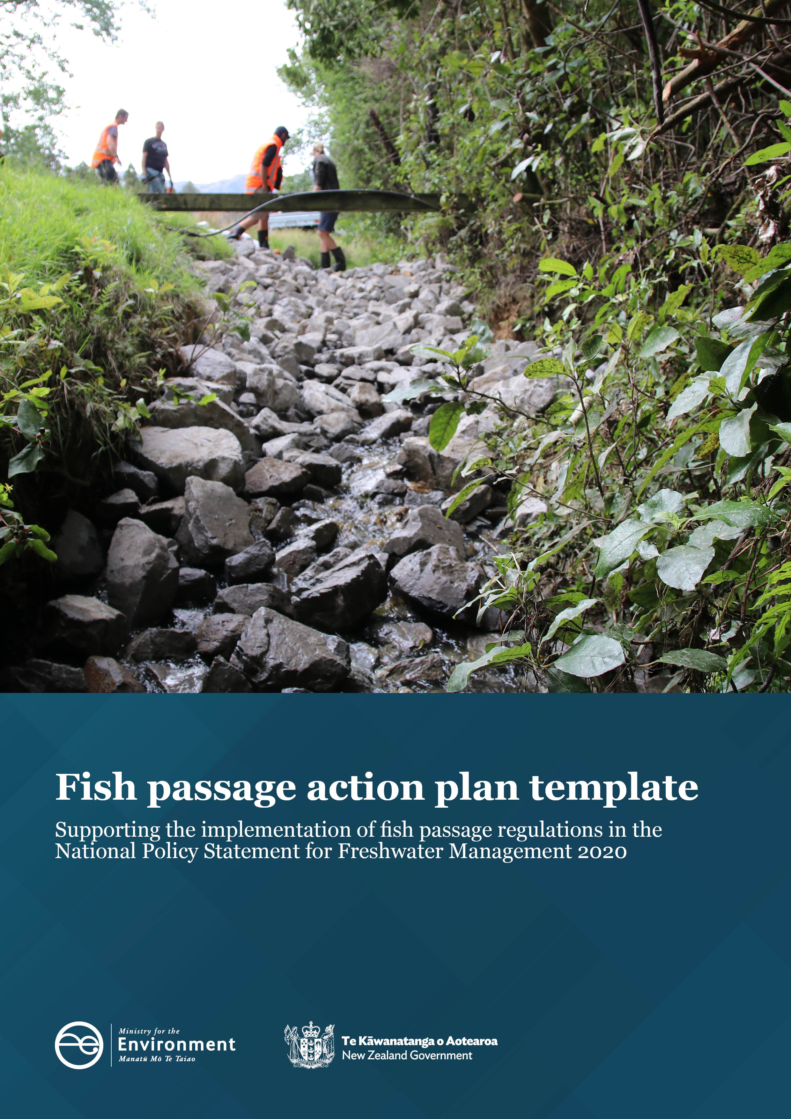

Disclaimer
The information in this publication is, according to the Ministry for the Environment’s best efforts, accurate at the time of publication. The Ministry will make every reasonable effort to keep it current and accurate. However, users of this publication are advised that:
- The information does not alter the laws of New Zealand, other official guidelines, or requirements.
- It does not constitute legal advice, and users should take specific advice from qualified professionals before taking any action based on information in this publication.
- The Ministry does not accept any responsibility or liability whatsoever whether in contract, tort, equity, or otherwise for any action taken as a result of reading, or reliance placed on this publication because of having read any part, or all, of the information in this publication or for any error, or inadequacy, deficiency, flaw in, or omission from the information in this publication.
- All references to websites, organisations or people not within the Ministry are for convenience only and should not be taken as endorsement of those websites or information contained in those websites nor of organisations or people referred to.

Acknowledgements
Prepared for the Ministry for the Environment by the Cawthron Institute.
Cover image: Rock ramp fish pass construction in progress in Shannon, Horowhenua. Source: Horizons Regional Council
This document may be cited as: Ministry for the Environment. 2022. Fish passage action plan template: Supporting the implementation of fish passage regulations in the National Policy Statement for Freshwater Management 2020. Wellington: Ministry for the Environment.

Published in April 2022 by the
Ministry for the Environment
Manatū Mō Te Taiao
PO Box 10362, Wellington 6143, New Zealand
ISBN: 978-1-99-102511-1
Publication number: ME 1624
© Crown copyright New Zealand 2022
This document is available on the Ministry for the Environment website: environment.govt.nz.
Contents
Purpose of the fish passage action plan template 5
How this template works 5
STEP 1 – Identify and document 8
Identify freshwater management units and associated management strategies 8
Identify and document instream structures 8
STEP 2 – Categorise and prioritise fish passage barriers 10
Critical Step A: Is the barrier natural or intentionally built? 13
Critical Step B: Assess occurrence and completeness of FPAT records 13
Critical Step C: Complete FPAT record and assign FPAT priority score 14
Critical Step D: Manual adjustments of FPAT priority scores 14
STEP 3 – Improve and remediate fish passage barriers 16
STEP 4 – Monitor and maintain fish passage success 18
References 20

Figures
Figure 1: Adaptive management cycle for fish passage assessment and remediation 6
Figure 2: Recommended process to help regional councils prioritise fish passage barriers 12

Purpose of the fish passage action plan template
The fish passage work programme template aims to:
- provide a tool to standardise the fish passage action plan steps to identify and document, categorise, prioritise and remediate fish passage barriers, and monitor and maintain fish passage success
- provide regional councils (including unitary authorities) with guidance on how to develop region-specific fish passage management action plans to fulfil fish passage requirements set out by the National Policy Statement for Freshwater Management (NPS-FM) 2020 (see the Fish passage action plan guidance document for further information).
The work programme is not intended to:
- be a guidance document on physical works for structure remediation
- be a policy document
- standardise the outputs, but rather the processes to be followed to create council-specific action plans.

How this template works
The template sets out a four-step process for developing effective fish passage action plans:
STEP 1: Identify and document fish passage barriers
STEP 2: Categorise and prioritise fish passage barriers
STEP 3: Improve and remediate fish passage barriers
STEP 4: Monitor and maintain fish passage remediation.
These steps follow the principles of the adaptive management cycle (DPIPWE, 2014 after Jones, 2009), to allow for learnings to be incorporated along the way (see figure 1). The flexibility of the cycle is relevant for medium to long-term fish passage barrier remediation, because the status quo and strategies are likely to change over time.
Figure 1: Adaptive management cycle for fish passage assessment and remediation
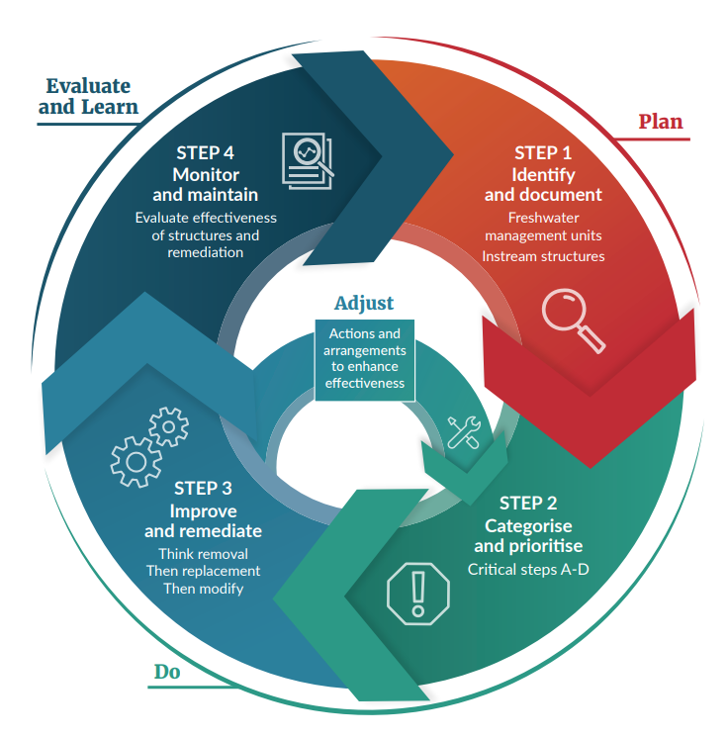
Source: Altered from Department of Primary Industries, Parks, Water and Environment, 2014 after Jones, 2009
To ensure councils have the best information available to prepare robust fish passage action plans, a guidance document providing background information has been developed alongside the template. We refer to the guidance document where relevant.
Links to relevant advice (eg, webpages, legislation, factsheets or lessons learnt) are provided via the Fish Passage Hub, which forms the base for recommendations made in this action plan. Providing supplementary information in this way means the work programme and guidance document can be kept as brief and practicable as possible.
FISH PASSAGE ACTION PLAN: MAIN STEPS
☐ STEP 1 – Identify and document
- Identify freshwater management units (FMUs) and associated management strategies.
- Identify and document instream structures.
☐ STEP 2 – Categorise and prioritise fish passage structures
- Critical Step A: Is the barrier natural or intentionally built?
- Critical Step B: Assess occurrence and completeness of Fish Passage Assessment Tool (FPAT) records.
- Critical Step C: Complete FPAT record and assign FPAT priority score.
- Critical Step D: Manual adjustment of FPAT priority scores.
☐ STEP 3 – Improve and remediate fish passage barriers
- Determine the kind of remediation needed, acknowledging the order of:
1) remove
2) replace
3) modify.
☐ STEP 4 – Monitor and maintain fish passage success
- I am aware why monitoring is critical.
- I understand whose responsibility it is to monitor.
- I understand what should be monitored.
- I am familiar with recommended monitoring methods to evaluate the effectiveness of fish passage solutions.
- I am familiar with standard reporting requirements to ensure target attribute states are met.

STEP 1 – Identify and document
STEP 1 – Quick check
Identify freshwater management units (FMUs) and associated management strategies
☐ I understand that a fish passage action plan can be prepared for all or part of an FMU.
☐ I understand how to identify an FMU, including:
- cultural and social characteristics of a region
- freshwater values.
Identify and document instream structures
☐ I understand an initial assessment of instream structures is useful for assessing the task ahead.
☐ I will need to combine all structure information within my region into one place.
☐ The recommended tool for this is the Fish Passage Assessment Tool (FPAT).
☐ I am aware of the limitations the FPAT has.
☐ I understand that people undertaking barrier assessments should have had basic training, to ensure data quality and consistency across field surveyors.
☐ I know where to look to find more information:
- New Zealand Fish Passage Guidelines (Franklin et al, 2018)
- Fish Passage Assessment Protocol mobile application – User Guide (Franklin, 2018)
- council examples and supplementary information on the Fish Passage Hub
- STEP 1 in the Fish passage action plan guidance document.

Identify freshwater management units and associated management strategies
The first step to developing a fish passage action plan is to identify and document freshwater management units (FMUs) and fish passage management strategies within an FMU. Every regional council must identify FMUs for its region, and every water body in a region must be located within at least one FMU. An action plan can be prepared for all or part of an FMU.
Further information on identifying FMUs relevant to fish passage can be found in the guidance document. Once FMUs are defined and established, your council will need to establish a system to document and identify instream structures within an FMU.

Identify and document instream structures
When FMUs and management strategies are defined, instream structures in your region need to be identified and documented (see the guidance document (pp 18–22) for detailed information on the steps outlined below).

Combine all structure information within a region into one place
Many councils have already established their own documentation processes with extensive geospatial databases. Examples of existing council processes are shown on the Fish Passage Hub. For councils that have not already established a robust system or would like to change or adapt theirs, we propose using the Fish Passage Assessment Tool (FPAT).

Fish Passage Assessment Tool
We recommend use of the FPAT to record structures and their relevant details to assess whether they provide river connectivity. Detailed information about how to acquire, install and use the tool is given in the Fish Passage Assessment Protocol mobile application – User Guide (Franklin, 2018).
The tool currently records the following metrics, which align with the NPS-FM 2020 recommendations:
- date and time of a survey, survey location, NZSegment number, organisation entering the data
- river conditions (ie, flow, tidal, stream width, bankfull width)
- structure generic information (ie, structure type, asset ID number and asset owner)
- structure-specific information for culverts, fords, weirs, dams, flap gates, pump stations, natural barriers, bridges
- structures that have been removed or had any structural add-ons, such as aprons, ramps, wingwalls and screens (the FPAT has the option to identify structures that may have already been remediated; this includes replacement, alterations or removal of the original structure)
- photos of structures and stream conditions
- risk to fish passage (priority, calculated and observed risk)
- FPAT ID and Parent ID (see ‘FPAT upgrades’ (p 20) in the guidance document).
Should your council not use the FPAT tool, the metrics listed above will need to be collected in an alternative system that allows for robust storage and data management.
See the guidance document (pp 18–19) for important considerations when using the FPAT application (ie, calculation of barrier prioritisation score, barrier risk assessment, privacy considerations, open-source data, FPAT upgrades, and training considerations).

STEP 2 – Categorise and prioritise fish passage barriers
STEP 2 – Quick check
☐ I am familiar with the Fish Passage Assessment Tool and how the application prioritises barriers.
☐ No one size fits all: some councils may have different prioritisation processes than other councils because of regional contexts. Other tools to record and prioritise structures may be used, if all relevant information has been considered.
☐ I can take four critical steps to effectively prioritise fish passage barriers in my region.
- Critical Step A categorises structures into natural or intentionally built barriers.
- If a barrier is either natural or intentionally built, the structure should be placed into Category 1.
- Critical Step B assesses the occurrence and completeness of the FPAT records.
- If a barrier is not assessed or the record is incomplete, the structure should be placed into Category 3.
- Critical Step C requires me to complete FPAT records and assign FPAT prioritisation scores based on risk.
- Critical Step D ensures any manual adjustments to prioritisation scores have been made and the structure should be placed into Category 2.
☐ I understand that manual adjustments are council specific and should consider:
- D-1 Additional information in fish distribution (eg, regional and national fish distribution data, additional sampling)
- D-2 Supplementary structure information (ie, hydrological datasets, council infrastructure databases, expert knowledge)
- D-3 Other important prioritisation criteria (ie, freshwater management unit criteria, practical considerations, consenting and compliance).
☐ I know where to look to find more information:
- Fish Passage Assessment Protocol mobile application User Guide (Franklin, 2018)
- council examples and supplementary information on the Fish Passage Hub
- STEP 2 in the Fish passage action plan guidance document.

Once FMUs and instream structures have been identified (STEP 1), the next step is to categorise and prioritise fish passage barriers. Structures must be prioritised, to help understand the potential ecological benefits of improving passage, and the extent to which and why a structure may not be fulfilling relevant ecological objectives and performance standards.
Various factors influence how councils prioritise barrier identification and subsequent remediation, including ecological, economic, community value, ownership, and practical considerations such as site access. This means councils will have different prioritisation objectives, depending on their regional context.
Figure 2 outlines the process councils can follow to prioritise fish passage barriers. It emphasises the complexity of and the aspects to be considered for an effective fish passage barrier prioritisation process.
Because councils will have different prioritisation criteria to suit regional contexts (eg, aquatic biodiversity strategies, cultural values, priority catchments, regional plans) and regional fish passage management objectives under national obligations (eg, exemplar catchments, Department of Conservation ecological management units or species management units), the process in figure 2 is recommended as a guide for effective barrier prioritisation in your region.
At the end of the prioritisation process, your instream structures will have been categorised into one of the following three categories:
- the instream structures that should be maintained, these include natural and intentionally built barriers (Category 1)
- the instream structures that have a complete FPAT record and should not be maintained but removed, modified or replaced (Category 2)
- the instream structures that have an incomplete FPAT record and should not be maintained but removed, modified or replaced (Category 3).
Figure 2: Recommended process to help regional councils prioritise fish passage barriers
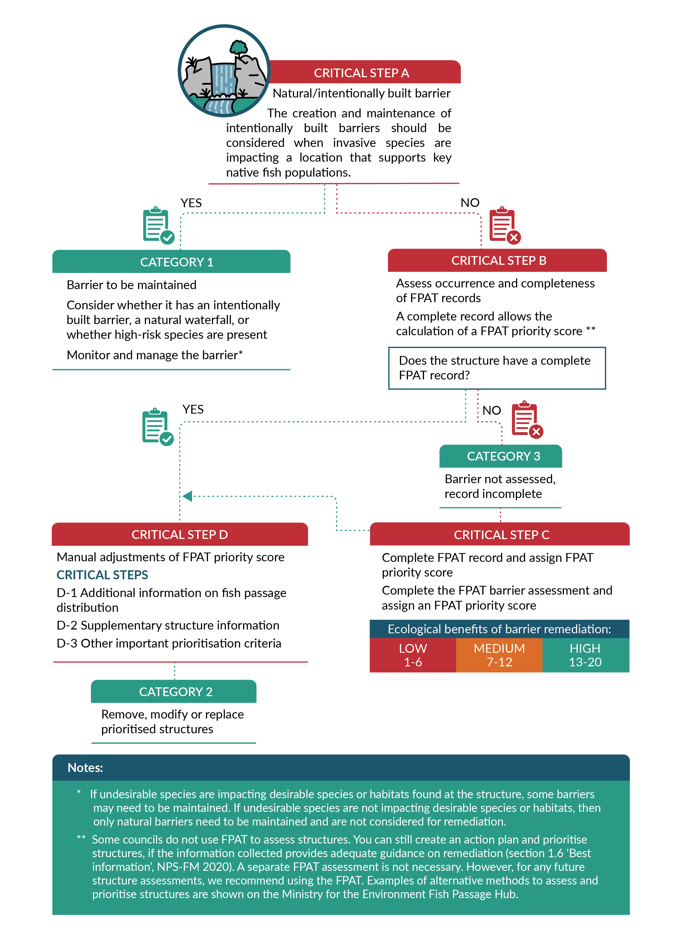
Source: Cawthron Institute
Note: FPAT = Fish Passage Assessment Tool.

Critical Step A: Is the barrier natural or intentionally built?
If invasive species are negatively affecting a location that supports important native fish populations, you should consider creating intentionally built fish passage barriers, and ensure known barriers are maintained. You should also consider whether excluding exotic species will result in the protection or recovery of at-risk species and/or habitats (eg, aquatic plant protection from invasive fish), prevent new fish invasions, and if barriers are viable in the prevailing environment.
Natural barriers to fish passage should generally not be removed or altered, unless conditions have changed and invasive species have gained access to a vulnerable habitat that is subsequently being affected. The Department of Conservation has identified undesirable species that could be considered at a local scale to see what is applicable to the region, catchment and waterway (see section 6.1, p 98, in the New Zealand Fish Passage Guidelines (Franklin et al, 2018)). Also listed in the New Zealand Fish Passage Guidelines are the main native desirable fish species likely to benefit and gain increased protection from a natural or intentionally built barrier to exclude invasive fish (see table 6.1, p 101). Specific design criteria and implications of intentionally built barriers on fish communities are covered in STEP 3 and in section 6 (p 98) in the New Zealand Fish Passage Guidelines (Franklin et al, 2018).
We have categorised all barriers that are either natural or intentional as Category 1.

Critical Step B: Assess occurrence and completeness of FPAT records
All structures that made it to Critical Step B are neither natural nor intentional barriers. This means these structures might pose a risk to fish passage. To find out the risk level of each structure, a complete record on structure information is necessary. Critical Step B addresses this question and categorises as Category 3 all instream structures that do not have an FPAT record (or equivalent) or have an incomplete record.

Identify risk of assessed structures
To quantify the magnitude of pressure on freshwater ecosystems that results from instream structures, it is important to understand the extent and likelihood to which fish passage may be impeded. This is commonly done through risk assessments where risk categorisation is based on the features of a structure.
The FPAT provides two approaches to evaluating the risk to fish passage: rule-based assessment and visual assessment.
Detailed information on these two risk assessments is given in the guidance document (p 23).
All structures assessed and uploaded through the FPAT app are considered ‘complete’ and include structure information collected following the FPAT standardised protocol, such as relevant water and structure measurements, and photographs. Within the FPAT web interface are current FPAT-assessed structures (coloured squares) and additional historical structure information collated from multiple organisations (some structures include an assessment of risk to fish passage that has been translated (coloured circles) while others have limited information that a possible structure is present at a location or simply that a structure type is present (grey circle)).
Although the FPAT is the recommended tool for structure assessments and prioritisation, some councils have developed their own prioritisation process (see the Fish Passage Hub). Depending on your council’s prioritisation process, structure information may need to be transferred into the FPAT. However, external records may vary in the amount and consistency of information provided about a structure, ranging from just the potential location of a structure (eg, river–road intersects) to details and notes regarding the structure and its risk to fish passage.
Further information on supplementary datasets and how to add them into the FPAT can be found under ‘D-2 Supplementary Structure Information’ (pp 31–32) in the guidance document.

Critical Step C: Complete FPAT record and assign FPAT priority score
Structures that do not have a complete FPAT record that allows the calculation of a priority score will be categorised as Category 3 and must fulfil Critical Step C. In this step, missing structure information must be filled, and a priority score assigned.
The New Zealand Fish Passage Assessment Tool has a built-in ecological prioritisation score to help guide you on where remediation should be prioritised and to understand the relative potential ecological benefits of improving passage at different barriers (Franklin et al, 2018). Possible ecological prioritisation criteria for fixing instream barriers are listed in figure 3 (p 28) in the guidance document. While we recommend considering as many as possible of the criteria in table 3 when prioritising structures, not all can be addressed at a structure at the same time. This means ecological prioritisation should be seen in context with other prioritisation criteria, including economic, social and logistical criteria.
More information on how the FPAT prioritises structures is given in the guidance document (pp 28–29) and appendix H (p 71) of the FPAT User Guide (Franklin, 2018).

Critical Step D: Manual adjustments of FPAT priority scores
Critical Step D is the final step to ensure robust instream structure prioritisation. All structures must include this step, regardless of whether the FPAT application has been used, to ensure all available information has been considered. Structures that have been through this final filter will be categorised as Category 2 and need to be removed, modified or replaced.

Why do I need to adjust the priority scores?
Once FPAT prioritisation scores have been calculated, a manual adjustment is recommended for every record on a structure-by-structure basis. This is necessary because the FPAT prioritisation score provides only a simplistic indicator of the potential ecological value that may result from remediating a structure. However, if the value is considered as not representative of the potential ecological benefits of remediating a structure, manual adjustment is needed. This requires the assessor to be familiar with the structure of interest (such as through a photograph or site visit) and the characteristics of the catchment (eg, geology, morphology and land cover). This allows priority structures to be revised and adjusted to more appropriate (either higher or lower) scores.
Revisions may include manual assignments of priority scores, reduction of priority scores or an increase in priority scores. Detailed information about these revisions is given in the guidance document (pp 29–33).

Manual adjustment criteria
Criteria that may need to be considered to complete and update FPAT prioritisation scores are listed below. These are highly council specific and may not all be relevant or need to be included in every council’s adjustment process. Detailed information about each criterion can be found in the guidance document (pp 29–33).
D-1 Additional information on fish distribution:
- regional fish distribution data
- national fish distribution data
- additional sampling
- other metadata.
D-2 Supplementary structure Information:
- inclusion of historical data into the FPAT.
D-3 Other important prioritisation criteria:
- FMU criteria
- practical considerations (ie, ease of access to the site, health and safety, costs)
- consenting and compliance.

STEP 3 – Improve and remediate fish passage barriers
STEP 3 – Quick check
☒ I have completed STEP 1 and STEP 2.
☐ I will make sure appropriate remediation techniques match the problems encountered at barriers.
☐ I need to determine the kind of remediation needed, and priority should be given in the following order: 1) removal; 2) replacement; 3) modification of existing structure.
☐ I understand that structure remediation should be based on the principles of good fish passage design.
☐ I am familiar with design considerations for new instream structures:
- the order of preference (from highest to lowest) is: 1) bridge; 2) culvert: stream simulation; 3) culvert: single barrel circular or box, hydraulic design; 4) culvert: multi-barrel; 5) ford.
☐ I am familiar with design considerations for remediation of existing instream structures.
- Good practice remediation designs include:
- removal or replacement
- ramp fishways (eg, ‘nature-like’ rock ramps, concrete rock ramps, artificial substrate ramps)
- baffles and mussel spat ropes (for culverts, weirs)
- bypass structures (nature-like fishways, technical fishways)
- fish-friendly tide and flood gates
- combinations of remediation techniques for stormwater management ponds and vertical risers.
☐ I am familiar with design considerations for built and intentional barriers.
- Before I design any intentional barriers, I know my objectives and performance standards (eg, why selective fish passage is required, which fish species will benefit from a built barrier, biological characteristics and behaviours of target fish species are known).
- Design considerations for intentionally built barriers include barrier location, barrier height, barrier profile, design flow, downstream zone.
- In this step, you should reassess the effect your improvements have had on fish passage and make any changes needed to enhance their effectiveness.
☐ I know where to find more information:
- the New Zealand Fish Passage Guidelines for new instream structures (section 4), existing instream structures (section 5), intentionally built barriers (section 6)
- council examples and supplementary information on the Fish Passage Hub
- STEP 3 in the Fish passage action plan guidance document (p 35), specifically table 4 (p 37)
- case studies of successful passage remediations and how remediations have been monitored are given on the Department of Conservation webpage Fish passage resources under ‘Lessons learnt case studies’.
Once a fish migration barrier has been identified (STEP 1) and prioritised (STEP 2), the next step is remediation. To ensure changes to a structure are long lasting, their design, installation and management should be thorough. All sites are unique, so a case-by-case approach will be needed to remediate instream structures to meet fish passage requirements.
Your decision on what kind of remediation is necessary should follow thorough planning and design considerations. Often, several mitigation options exist based on the significant variations in biological and hydrological requirements. In this step, you should reassess the effect your improvements have on fish passage and make any changes needed to enhance their effectiveness.
Possible remediation techniques for common problems encountered at barriers can be found in table 5 (p 38) in the guidance document and on the Fish Passage Hub. Section 3 of the New Zealand Fish Passage Guidelines (Franklin et al, 2018) specifically covers the planning and design considerations for fish passage at instream structures.

STEP 4 – Monitor and maintain fish passage success
STEP 4 – Quick check
WHY monitor?
☐ I am aware monitoring is critical to evaluate whether a structure is compliant and to check that a structure remains in good condition and is functioning as intended.
☐ Monitoring and maintenance are particularly important where:
- high-value fish communities and/or ecosystems are present
- unproven designs are being used
- proven designs are being used in novel situations
- retrofit solutions form only one part of an instream structure
- multiple structures exist within a waterway causing cumulative effects
- selective barriers are being used to manage the movement of undesirable species.
WHO should monitor?
☐ I am aware it is mostly the structure’s owner, occupier and/or consent holder’s responsibility to ensure fish passage is provided over the life of a structure.
WHAT should be monitored?
☐ I know that monitoring and maintenance actions analyse:
- the type of structure, date and effectiveness of existing remediations (eg, rock ramp, backwatering, artificial ramp)
- identification of the risk of the structure to fish passage, does the structure protect native species or desirable habitat?
☐ I am aware monitoring should encompass fish communities and structure integrity.
☐ I know of the recommended monitoring methods for evaluating fish passage success:
For fish communities:
- before-after-control-impact (BACI) surveys
- in situ mark and recapture studies
- environmental DNA sampling.
For structure integrity:
- Fish Passage Assessment Tool
- compliance monitoring.
☐ At a minimum, all instream structures should be checked annually or after significant natural events to ensure they are still meeting the required objectives of structure and fish passage.
☐ I am aware:
- standard reporting requirements include risk assessment as a pressure metric
- standard reporting requirements include river connectivity as a state metric
- I will have to specify a timeframe for achieving river connectivity
- my action plan (or parts of it) will need to be reviewed within five years after it was published.
☐ I know where to look to find more information:
- New Zealand Fish Passage Guidelines (section 7)
- STEP 4 in the Fish passage action plan guidance document
- council and Department of Conservation examples on monitoring of remediated barriers on the Fish Passage Hub.
Further information on freshwater fish sampling protocols can be found in the New Zealand Freshwater Fish Sampling Protocols (Joy et al, 2013) and on the Department of Conservation’s Freshwater Fish Inventory and Monitoring website.
Once structures have been remediated (STEP 3), you will need to check they are functioning as intended and fish passage is provided into the future. By completing STEP 4, your council will have covered all necessary steps to develop a robust fish passage action plan.
The fish passage action plan guidance document provides detailed information on why monitoring is critical, who should be monitoring and maintaining remediated structures, what should be monitored, monitoring methods, tools and processes, monitoring frequency, and standard reporting requirements.

References
Franklin P. 2018. Fish Passage Assessment Protocol mobile application – User Guide. Prepared for Envirolink Tools. Hamilton: National Institute of Water and Atmospheric Research. Retrieved from https://niwa.co.nz/sites/niwa.co.nz/files/User%20guide%20v1.3%20FINAL.pdf (19 January 2022).
Franklin P, Gee E, Baker C, Bowie S. 2018. New Zealand Fish Passage Guidelines for Structures up to 4 metres. Hamilton: National Institute of Water and Atmospheric Research. Retrieved from https://environment.govt.nz/publications/new-zealand-fish-passage-guidelines-for-structures-up-to-four-metres/
Instream Consulting Ltd. 2021. Prioritisation of fish barriers for remediation in Christchurch. Prepared for Christchurch City Council. Christchurch: Instream Consulting Ltd.
Jones G. 2009. The Adaptive Management System for the Tasmanian Wilderness World Heritage Area. Linking Management Planning with Effectiveness Evaluation. In: C Allan and G Stankey (eds) Adaptive Environmental Management: A Practitioner’s Guide. Dordrecht, The Netherlands and Collingwood, Australia: Springer and CSIRO Publishing.
Joy M, David B, Lake M. 2013. New Zealand Freshwater Fish Sampling Protocols. Palmerston North: Massey University.

