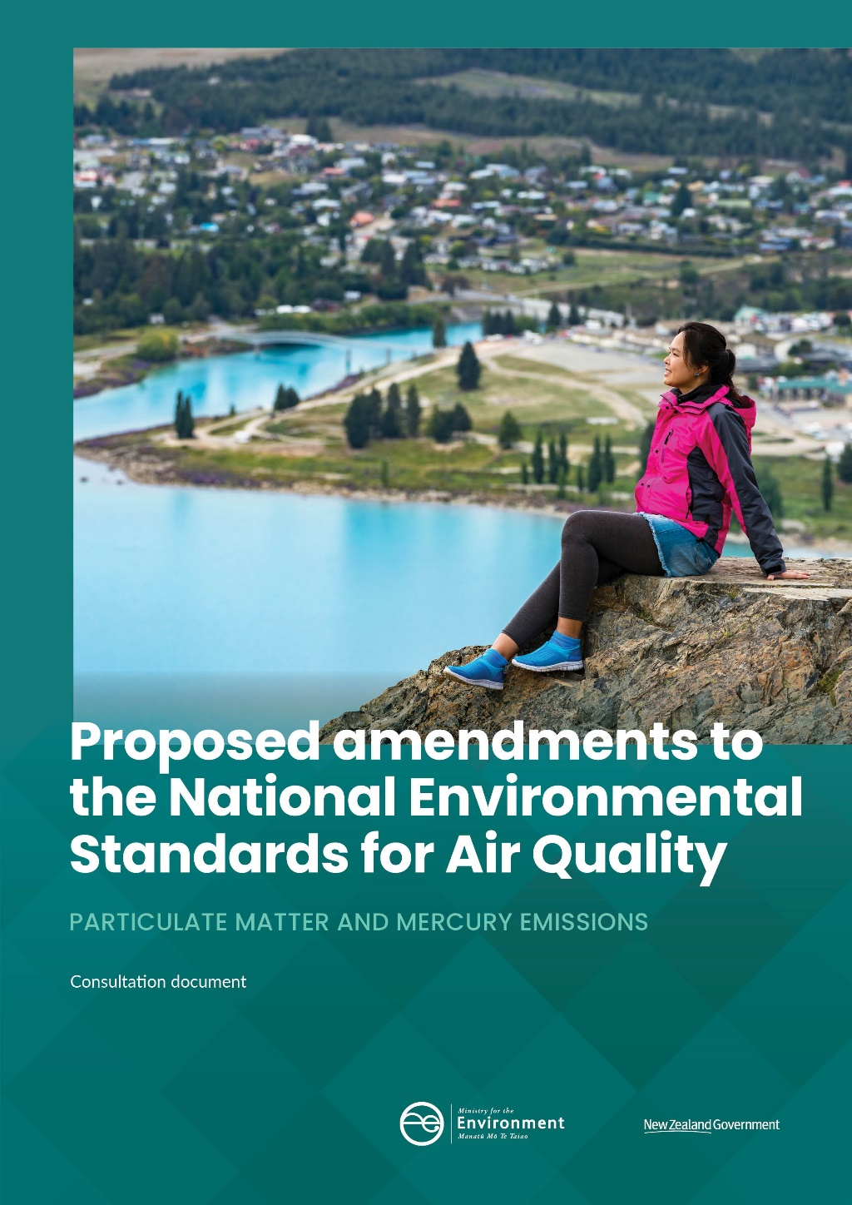

Disclaimer
The opinions and options contained in this document are for consultation purposes only and do not reflect final Government policy. Please seek specific legal advice from a qualified professional person before undertaking any action based on the contents of this publication. The contents of this discussion document must not be construed as legal advice.

This document may be cited as: Ministry for the Environment. 2020. Proposed amendments to the National Environmental Standards for Air Quality: particulate matter and mercury emissions – consultation document. Wellington: Ministry for the Environment.

Published in February 2020 by the
Ministry for the Environment
Manatū Mō Te Taiao
PO Box 10362, Wellington 6143, New Zealand
ISBN: 978-1-98-857961-0
Publication number: ME 1478
© Crown copyright New Zealand 2020
This document is available on the Ministry for the Environment website: www.mfe.govt.nz.
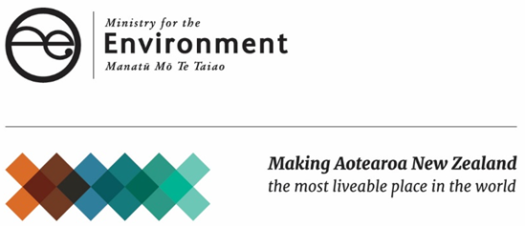

Contents
Message from the Minister 6
Executive summary 7
Introduction and context 9
Air as taonga 9
Health effects of air pollution 9
Impact of particulate matter pollution 9
Air quality in New Zealand 12
Home heating: the largest source of PM emissions 13
Managing air quality in New Zealand 15
The Resource Management Act 1991 15
National Environmental Standards for Air Quality 15
Ambient air quality guidelines 17
Role of local authorities 17
Managing transport emissions 18
World Health Organization guidelines 19
Minamata Convention on Mercury 20
Other national direction under the RMA 20
Why change the standards? 21
Better indicator of health effects 21
Focusing on controllable sources 21
Progressive improvements 22
Balancing better air quality with affordable heating 22
What is being proposed – particulate matter 24
Introducing PM_{2.5} as the primary regulatory tool to manage ambient particulate matter 24
Retain the PM₁₀ standard with reduced mitigation requirements for breaches 25
Polluted airsheds and resource consents 26
What is being proposed – domestic solid-fuel burners 29
Emissions standard 29
All domestic solid-fuel burners covered 30
What is being proposed – mercury emissions 31
Timing, implementation and transitional provisions 33
Summary of current and proposed provisions 34
Impact of the proposals 36
Particulate matter and solid-fuel burners 36
Mercury emissions 37
Consistency with the purpose of the Resource Management Act 1991 39
Consultation process 40
Timeframes and next steps 40
How to make a submission 40
Publishing and releasing submissions 41
Consultation questions 42
Bibliography 44

Tables
Table 1: Overview of proposed amendments to the NESAQ 8
Table 2: Summary of particulate matter standards and guidelines 19
Table 3: Summary of current and proposed provisions 34
Table 4: National level costs and benefits 37
Table 5: Impact of controlling industrial emissions of mercury to air 38

Figures
Figure 1: Relative sizes of particulate matter 10
Figure 2: The impact of particulate matter on the human body 11
Figure 3: Emissions of PM₁₀ by source, 2015 12
Figure 4: Emissions of PM_{2.5} by source, 2015 13
Figure 5: Factors that affect the amount of emissions from home heating 23

Message from the Minister
Purea nei e koe i ngā hau ā Tāwhirimātea
Let yourself be purified in the winds of Tāwhirimātea
Our relationship to air is intrinsic to our livelihood. The quality of our air has a direct relationship to the wellbeing of our people and our ecosystems. As such, we must find ways to enhance, safeguard and manage the impact of development, industry and population growth on the resource we too often take for granted – the air that we breathe.
We can do more to monitor the impacts of our day-to-day activities as a society on the health of our environment and our people. I want to recognise the important role of regional councils, our scientists, researchers and specialist technicians who are committed to monitoring and evaluating these activities to inform our behaviours and industry practices and guide policy setting.
In Aotearoa New Zealand, we are lucky our air quality is generally good most of the time. However, in winter, some of us live in polluted environments where poor air quality is affecting our health. The numbers are not good. Research shows that exposure to PM_{2.5} (fine airborne particles) can be associated with over 600 premature adult deaths per year and 1.6 million days where activities are restricted.
As more people move into our urban centres, our transport behaviours and industry practices can also impact air quality. As our climate changes, it is more important than ever to be diligent as the prevalence of fires and disasters can have a localised and harmful impact for communities.
It is important to treat clean air as a taonga. While we can continue to improve our practices and behaviours, we must collectively do more to restore and preserve its quality.
In New Zealand, the National Environmental Standards (NES) for Air Quality are a key tool for managing air quality. The standards were introduced in 2004 to set a guaranteed minimum level of health protection for all New Zealanders. In the 16 years since then, we have seen improvements in air quality in many urban areas in New Zealand. We have gained a better understanding of air contaminants and their effects on human health. Wood burner technology has also become much more efficient.
The focus of this consultation is threefold. First, to ensure the NES reflects up-to-date research on the health effects of particulate matter, specifically the role of PM_{2.5}. Second, to propose amendments to further reduce the impacts of household solid-fuel burners. Finally, to enable us to meet our international obligations in relation to mercury emissions to air.
I invite you to have your say so we can continue to improve air quality in New Zealand.
Rire Rire Hau Pai Mārire!
Hon Nanaia Mahuta
Associate Minister for the Environment

Executive summary
The Government is consulting on proposed amendments to some provisions of the National Environmental Standards on Air Quality (NESAQ). This consultation document sets out the proposals and calls for submissions from interested parties.
In New Zealand, air pollution from particulate matter can affect human health. Exposure to particulate matter, particularly fine particles (PM_{2.5}), can cause disease and premature death from respiratory and cardiovascular causes, and exacerbate asthma and emphysema. These particles are mainly created by human activities. In New Zealand, the main source of PM_{2.5} is burning wood and coal for home heating during winter.
The NESAQ currently regulate particulate matter but with a focus on PM₁₀, which includes the finer PM_{2.5} particles, as well as other coarser material. Some of these coarser particles come from natural sources, over which we have no control.
The Government is proposing changes to the NESAQ to take into account improved scientific understanding and evidence about the health impacts of particulate matter and to better target controllable sources of air pollution.
We need to balance our approach to improving air quality with not unduly exposing New Zealanders to other health effects of cold homes. Government programmes, such as Warmer Kiwi Homes, supports communities to move to less-polluting forms of home heating.
The ambient outdoor air quality standards in the NESAQ are just one aspect of improving air pollution. Changing behaviour, educating people about the impacts of certain actions, and promoting good practice for using solid-fuel burners would form part of an integrated approach to reducing air pollution.
New Zealand signed the Minamata Convention on Mercury in 2013. One of the three key steps we need to take to ratify the Convention is to set controls on emissions to air from mercury. This requires amendments to the NESAQ that will:
- prohibit the use of mercury in certain listed industrial processes
- incorporate international best practice guidance that decision-makers must consider for listed mercury emissions sources.
Table 1 sets out all the proposed amendments to the NESAQ.
Submissions on the proposals close on 24 April 2020. We will prepare a summary of the submissions and recommend changes. We will then seek agreement from ministers to the changes and to subsequently approve the amendments.
Table 1: Overview of proposed amendments to the NESAQ
Proposed amendments
Particulate matter
PM_{2.5} | Daily average PM_{2.5} standard – 25 µg/m³ (three or fewer exceedances allowed in a 12-month period)  Annual average PM_{2.5} standard – 10 µg/m³  Monitoring required in all airsheds  Publicly notify breaches  Replace PM₁₀ with PM_{2.5} for ‘offset’ and open fires provisions
PM₁₀ | PM₁₀ standard retained  Publicly notify breaches
‘Offset’ discharges in polluted airsheds | Reflect change from PM₁₀ standard to PM_{2.5} standards  ‘Polluted’ if either daily or annual PM_{2.5} standard is breached, averaged where possible over previous five years  Meaningful data required to calculate average exceedances  PM₁₀ standard used where airshed does not have adequate meaningful PM_{2.5} data  Decline new applications for consent to discharge PM_{2.5} in a polluted airshed, unless offset within the same airshed
Solid-fuel burners
Emissions standard for burners | No more than 1.0g/kg  Updated and/or appropriate methods for measuring
Thermal efficiency standard for burners | No less than 65 per cent (retained)  Updated and/or appropriate methods for calculating
Application of standard for burners | Applies to all newly installed domestic burners including: open fires, wood, coal, pellet and multi-fuel burners, space heaters, cookers, water boilers on properties less than two hectares in size
Solid-fuel burning open fires prohibited | Reflect change from PM₁₀ standard to PM_{2.5} standards  Applies indefinitely when either daily or annual PM_{2.5} standard is breached
Monitoring
Monitoring methods | Updated and/or appropriate methods for monitoring PM
Mercury
Use of mercury in industrial processes | Prohibit use of mercury in industrial processes specified in Annex B of the Minamata Convention
Emissions that may contain mercury | Incorporate by reference international best practice guidelines for emissions sources specified in Annex D of the Minamata Convention
* A NESAQ airshed is a defined geographic area for air quality management which extends upwards from ground level, with no upper limit.

Introduction and context
This document proposes:
- amendments to the standards for ambient particulate matter and burner design in the current National Environmental Standards for Air Quality (NESAQ)
- new standards for mercury emissions to air.
Other aspects of the NESAQ are not part of this consultation.

Air as taonga
Air, like all other natural resources, is considered by Māori to be a taonga – an invaluable treasure – which has been gifted by their tipuna (ancestors) for the benefit and use of descendants. This gift imposes a responsibility on us as kaitiaki (guardians) to ensure we maintain good air quality now and for future generations.

Health effects of air pollution
Air pollution has been described as the biggest environmental risk to human health globally.
Exposure to moderate to low concentrations of air pollutants may not be immediately obvious but can be dangerous to our health. Serious adverse health effects can occur after short-term (acute) exposure to air pollutants. However, the most important impacts at a population level are associated with the cumulative effects of long-term (chronic) exposure.
Chronic exposure can result in premature deaths, hospital admissions, sick days and restricted-activity days. This puts a burden on the health system, the economy, carers, whānau and society as a whole. Air pollution has other impacts, including:
- damaging natural ecosystems, biodiversity and crops
- limiting our enjoyment of outdoor facilities and scenic areas
- harming cultural values and quality of life.

Impact of particulate matter pollution
The most significant health impacts from poor air quality are associated with exposure to airborne particles, or particulate matter (Health Effects Institute, 2018).
At the less-severe end, breathing PM can cause mild and reversible effects, such as shortness of breath, coughing or chest pain. At the other end of the scale, there is strong evidence that exposure to PM is the source of much more severe effects. It can cause diseases such as heart attack and stroke, and premature death from cardiovascular and respiratory causes. It can also cause lung cancer and exacerbate asthma and emphysema. Recent studies point to an increase in inflammation due to PM as possible causes of diabetes and atherosclerosis.

What is particulate matter?
Particulate matter (PM) is a collective term for solid and liquid particles suspended in the air and small enough to be inhaled. PM varies greatly in structure and chemical composition, depending on where it comes from. It also varies in the harm it can cause.
PM comes from human activities and natural sources. It is often classified according to its size because size determines how PM interacts with the environment and human body.
- PM₁₀ has a diameter of 10 micrometres (µm) or less.
- PM_{2.5} has a diameter of less than 2.5µm and is a subset of the PM₁₀ range.
- Ultrafine particles are even smaller (less than 0.1µm or 25 times smaller than PM_{2.5}).
Figure 1 shows these relative sizes.
Figure 1: Relative sizes of particulate matter
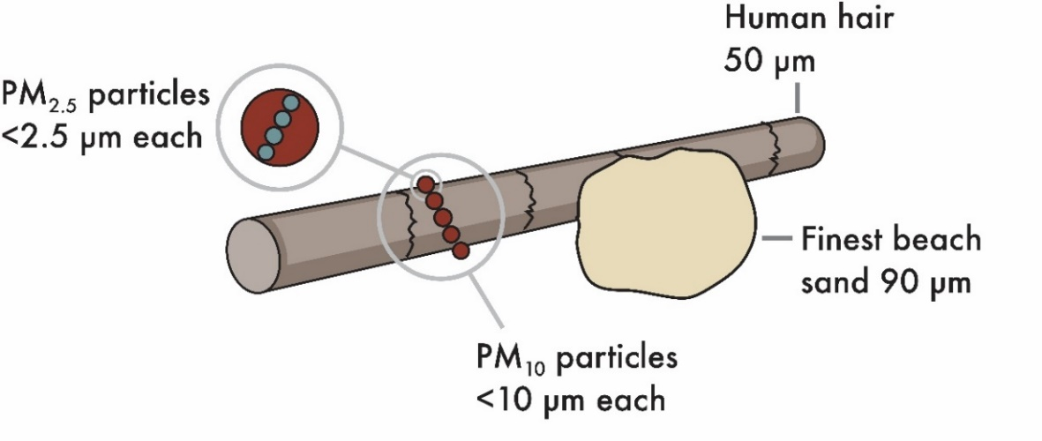
Modelling of the health effects from exposure to human-generated PM₁₀ for all of New Zealand in 2016 (Kuschel et al. 2012) estimated there were:
- 27 premature adult deaths per 100,000 people
- 5 cardiac hospital admissions per 100,000 people
- 9 respiratory hospital admissions per 100,000 people
- 31,800 restricted activity days per 100,000 people.
In 2018, the estimated health outcomes attributable to PM_{2.5} in New Zealand were 646 premature adult deaths, 215 cardiac hospital admissions, 422 respiratory hospital admissions, and 1.6 million restricted activity days (NIWA, 2019).
People with pre-existing heart or lung disease, young children, and the elderly are the most likely to suffer adverse health effects. Exposure can be especially serious for the very young. PM has been associated with premature birth, low birth weight and infant bronchiolitis. Research has also shown associations between PM exposure and respiratory infections, asthma, and reduced lung growth in young children.
These effects depend on factors which include:
- the size of the particles
- the amount of particles
- the length of time exposed to the particles
- their composition
- individual susceptibility.
However, there is insufficient evidence to differentiate which of these parameters are more specifically related to certain health outcomes.

The smaller the particle, the greater the health impact
Different sizes of particulate matter can result in differing health effects. This is because they reach different parts of the respiratory tract, come from diverse sources and can interact partly through different biological mechanisms.
Larger, coarse PM (2.5-10µm) generally deposits in the nose, throat and upper airways.
Fine PM (2.5µm and smaller) deposits deep in the lungs. These particles are recognised as having the highest health risk and are mainly produced by human activities (Ministry for the Environment and Stats NZ, 2018, p22).
Ultrafine particles (0.1µm and smaller) are small enough to cross from the lungs into the blood and circulate throughout the body.
Figure 2: The impact of particulate matter on the human body
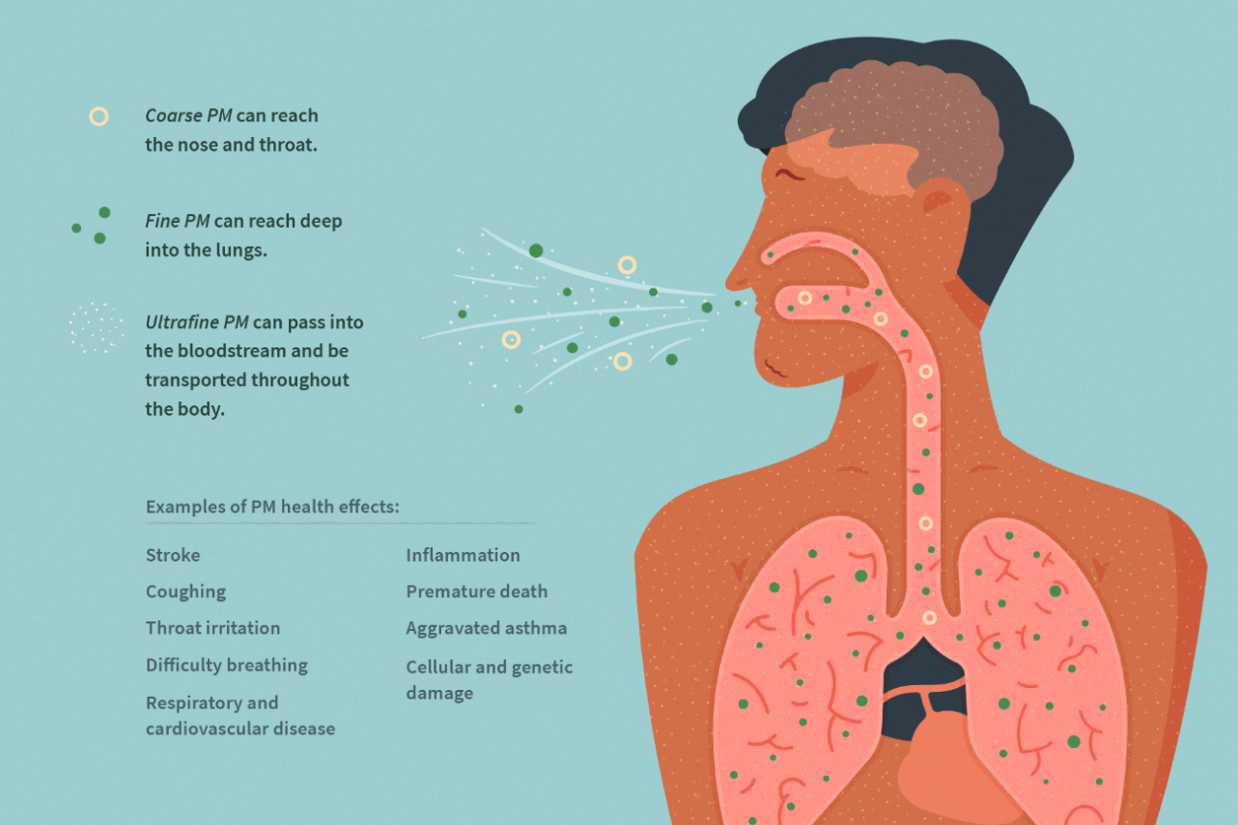
Source: Ministry for the Environment and Stats NZ (2018), p23

Amount and length of exposure
The amount (concentration) of PM and length of time someone is exposed to it contributes to the health consequences.
Higher concentrations of PM lead to a higher risk of damage to health. Physiological changes can occur within hours of exposure to high concentrations. These changes can be associated with premature death and illness immediately after exposure and in the following days.
There is strong evidence for effects from long-term exposure (years) to fine PM and this evidence continues to build (Ministry for the Environment and Stats NZ, 2018, p24). The risk of premature death from heart and lung disease are higher for long-term exposure.
Short-term exposure can also have a significant impact, even in people with no pre-existing health issues. Some symptoms such as coughing are reversible, but repeated exposure can cause chronic inflammation, leading to respiratory and cardiovascular disease. Short-term exposure to fine PM can even cause premature death in vulnerable people.

Air quality in New Zealand
The Our air 2018 report shows air quality in New Zealand is generally good in most places at most times of the year and that the overall trend is slightly improving. However, the report also shows activities in certain parts of the country and at certain times of the year, mainly winter, are an issue (Ministry for the Environment and Stats NZ, 2018).
Our air quality profile is different from most of the rest of the world. New Zealand has two main causes of air pollution: burning wood and coal in winter for home heating, and traffic all year round.
Figure 3 (PM₁₀) and figure 4 (PM_{2.5}) show national emissions for 2015. They do not account for the seasonal nature of home-heating emissions, how sources are distributed or varying regional patterns.
Figure 3: Emissions of PM₁₀ by source, 2015
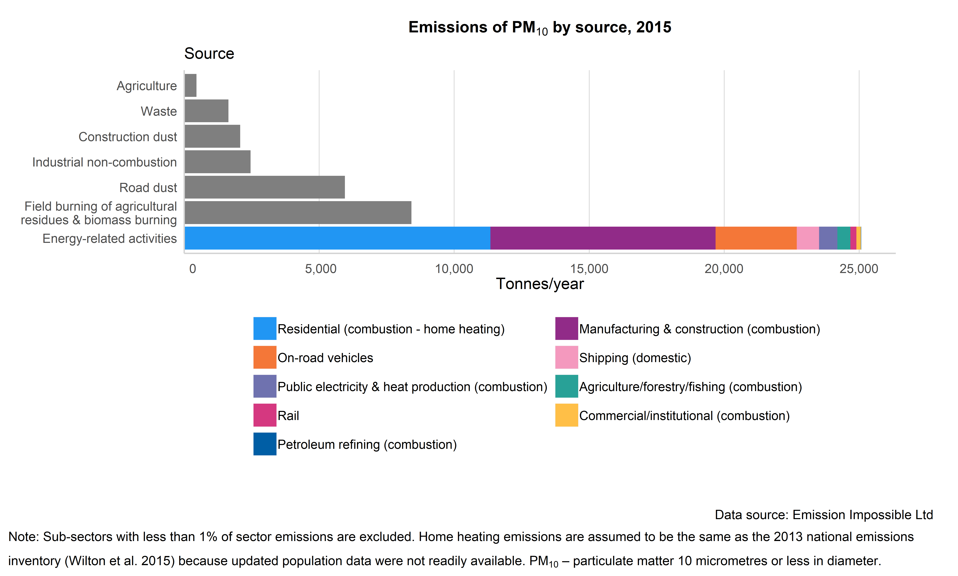
Source: Ministry for the Environment and Stats NZ (2018), p28
Figure 4: Emissions of PM_{2.5} by source, 2015
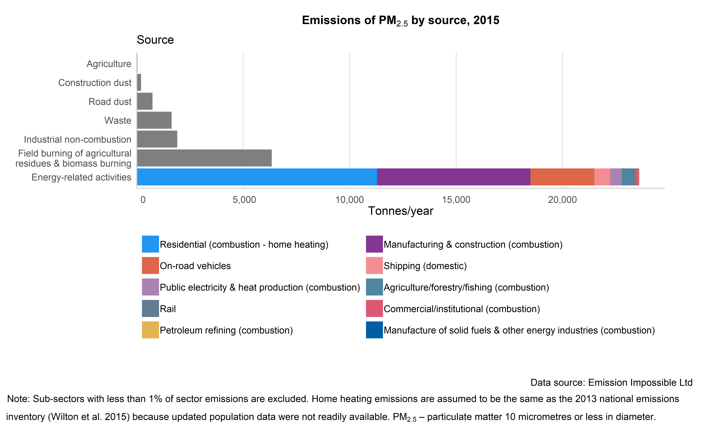
Source: Ministry for the Environment and Stats NZ (2018), p24

Home heating: the largest source of PM emissions
In New Zealand, burning wood and coal for home heating is the biggest, single human-made source of PM. Over time, fewer homes have been burning wood and coal, but it is still an important way to keep warm.
Most PM from wood and coal smoke is the smaller PM_{2.5}, and most of it is emitted in winter.
In 2015, residential emissions, mainly burning wood for heating, accounted for 25 per cent of annual emissions of PM₁₀ and 33 per cent of annual emissions of PM_{2.5} (see figures 3 and 4 above). However, regional councils’ inventories show that on winter days home heating can account for up to 90 per cent of total PM₁₀ and 91 per cent of PM_{2.5}.
Most breaches of the PM thresholds occur during these winter months.
The amount and type of PM people are exposed to is highly dependent on how well the wood burns. This, in turn, depends on:
- the wood burner
- the temperature of the fire
- the moisture content of the wood
- what is being burnt (for example, treated timber offcuts or painted timber)
- how quickly the smoke disperses.
Some towns and cities are more prone to winter air pollution than other areas. It can vary because of other factors including geography, topography, weather, time and season. Therefore, air pollution can be very local.
Temperature inversions exacerbate air pollution during the cooler months. An inversion occurs when a layer of cool air close to the ground is covered by a layer of warmer air which acts as a lid, trapping pollutants and allowing them to build up. Topography, such as valleys and basins, can act as extra barriers.

Other significant sources

Combustion
Other important sources of PM emissions are burning wood in construction and manufacturing processes, such as wood-fired boilers. In 2015, this accounted for 15 per cent of PM₁₀ and 17 per cent of PM_{2.5}.
Open burning produced 18 per cent of both PM₁₀ and PM_{2.5}.

Vehicles
Emissions from vehicles are the most important non-biomass combustion source of PM, most of which is PM_{2.5}. As well as vehicle exhausts, traffic also generates PM through abrasion of pavement, tyres and brake pads.
Emissions from exhausts are regulated by the Vehicle Exhaust Emissions Rule 2007, administered by the Ministry of Transport. This sets the minimum (harmful) exhaust emissions standards for all vehicles entering the fleet. This rule, and the changes in fuel quality standards, have led to measurable improvements in roadside air quality.
While Our air 2018 shows us a national picture, in some areas, particularly in our bigger towns and cities, transport produces a higher proportion of PM.
The Government Policy Statement on Land Transport 2018/19–2027/28 commits resources to reducing transport’s negative effects on the local environment and public health, including reducing air pollution.

Dust
Another important source of PM is dust from unsealed roads, which is mainly larger particles. Road dust can contain traces of minerals and metals from tyre and brake wear. All vehicles can cause dust to be suspended in the air near unsealed roads, but heavy vehicles can generate particularly large amounts. Dry periods and higher vehicle speeds can exacerbate the problem (Emission Impossible, 2019). Nationally, road dust is estimated to contribute 12 per cent of PM₁₀, but only 2 per cent of PM_{2.5}. Road dust is mostly an issue in rural areas where exposure for people is low, but it can be a significant issue locally.

Natural
Sea salt is the largest source of natural PM in New Zealand (Ministry for the Environment and Stats NZ, 2018, p38) and contributes mostly to the coarse part of PM₁₀. Other natural sources include windblown dust (airborne soil not caused by human activity), pollen, volcanic ash and particles formed from gaseous precursors (such as secondary sulphate from sulphur-containing gases produced by phytoplankton in the ocean, or volcanic emissions).

Managing air quality in New Zealand

The Resource Management Act 1991
The Resource Management Act 1991 (RMA) promotes the sustainable management of natural and physical resources, including safeguarding the life-supporting capacity of the air. Local and central government have roles and responsibilities for managing the sources of air pollutants.
Through the RMA, the Government can set national environmental standards (NES), regulations made under Section 43 of the RMA. NES ensure a consistent standard for an activity or use of a resource.

National Environmental Standards for Air Quality
The National Environmental Standards for Air Quality (NESAQ) set an acceptable minimum level of health protection for all New Zealanders and the environment.
The NESAQ were introduced in 2004 and last amended in 2011. These interlinked standards regulate air quality, covering particulate matter (PM) and other pollutants.
The NESAQ currently manage PM pollution through:
- a daily ambient air quality standard for PM₁₀ of 50 µg/m³ (micrograms per cubic metre)
- a maximum number of times per year the standards can be exceeded
- emissions and thermal efficiency standards for wood burners newly installed in properties less than two hectares in size
- an indefinite ban on newly installed domestic, solid-fuel burning open fires (open fires) in airsheds that have breached the PM₁₀ standard
- a requirement for councils to decline new resource consent applications for PM₁₀ discharges in PM₁₀ polluted airsheds, unless the applicant will offset the discharge within the same airshed
- the ability for councils to introduce more stringent provisions through regional plans and bylaws.
For more detail, see the box below.
Current NESAQ standards
Ambient (outdoor) particulate matter is controlled by a set of standards for PM₁₀.
PM₁₀ standard
A maximum concentration of PM₁₀ of 50 µg/m³ (micrograms per cubic metre) applies as a 24-hour (daily) average.
Regional councils and unitary authorities must monitor areas where PM₁₀ concentrations are likely (or known) to exceed the PM₁₀ standard.
All breaches of the PM₁₀ standard must be publicly notified.
An airshed is considered to be ‘polluted’ when the PM₁₀ standard has been exceeded more than once per year, averaged where possible over the previous five years. The airshed continues to be polluted until it has demonstrated compliance (by not breaching the PM₁₀ standard) for five years. (See box on page 19 for further information on airsheds.)
Airsheds that frequently exceeded the PM₁₀ standard in 2011, when the NESAQ was last amended, were provided transitional air quality targets. This allowed more exceedances of the standard when determining whether an airshed is ‘polluted’. However, from 1 September 2020, all airsheds are only permitted one exceedance in a 12-month period.
The NESAQ sets out:
- how to calculate and measure exceedances, using an average exceedance per year calculation based on meaningful data requirements to determine polluted status
- methods for monitoring PM₁₀, including Australian/New Zealand Standards
- a ban on discharges from domestic, solid-fuel burning open fires, newly installed in breached airsheds.
Exceptional circumstances
A regional council may apply to the Minister for the Environment for an exceedance of the PM₁₀ standard to be formally recognised as caused by an exceptional circumstance. Exceptional circumstance exceedances are ignored when determining whether the regulations for open fires and resource consent applications to discharge PM₁₀ have been triggered. Exceptional circumstances must be beyond the reasonable control of the regional council, for example, volcanic eruptions, wildfires and storm-driven sea salt.
Resource consents in polluted airsheds
Resource consent applications for activities that will contribute more than 2.5 µg/m³ of PM₁₀ to a polluted airshed must be declined by a regional council or unitary authority. An exception is when the applicant will ‘offset’ the discharge by a corresponding reduction in discharge elsewhere in the same airshed.
Newly installed, solid-fuel burners
The current solid-fuel burner standards only apply to wood burners for home heating, newly installed on properties under two hectares in size. The standards are:
- a discharge of no more than 1.5g of particulate per kilogram of dry wood burnt (the emission standard)
- at least a 65 per cent ratio of useable heat energy output to energy input (the thermal efficiency standard).
The methods for measuring and calculating the emission and thermal efficiency standards are specified by reference to Australian/New Zealand Standards or functionally equivalent methods.

Supporting material for NESAQ
There are a range of guidance documents to help implement the NESAQ:
- the National Air Quality Compliance Strategy (Ministry for the Environment, 2011a) sets out the practices regional councils and unitary authorities must follow to comply with the current PM₁₀ standard
- a users’ guide for the revised NESAQ (Ministry for the Environment, 2011b) explains the provisions of the NESAQ up to, and including, the 2011 amendments
- a series of good practice guides for managing air quality.

Ambient air quality guidelines
New Zealand has Ambient Air Quality Guidelines (Ministry for the Environment, 2002). The guideline values are minimum requirements that all outdoor air quality should meet to protect people and ecosystems from significant adverse effects. The guidelines promote both ecosystem and human health, whereas the NESAQ are based on human health only. The guidelines were last updated in 2002. Regional councils may have their own local guidelines.
The national air quality guidelines for PM₁₀ are 50 µg/m³ (24-hour average) and 20 µg/m³ (annual average).
For PM_{2.5} a monitoring value of 25 µg/m³ (24-hour average) is recommended.

Role of local authorities
The primary responsibility for managing air quality under the RMA lies with regional councils (including unitary authorities). Regional councils have responsibilities for the control of discharges of contaminants to air, and for the integration of infrastructure with land use and regional transport planning (under the Local Government Act 2002).
The NESAQ require regional councils to ensure the air quality standards are met in their regions. Councils must identify and monitor areas where air quality is likely, or known, to exceed the NESAQ (see box on page 19).
Regional councils can use several tools to manage air quality to meet the standards. These will be different for each region, reflecting different local air quality issues. For example councils can:
- set policies, methods and rules through their regional plans (these can be more stringent than the NESAQ)
- regulate discharges to air from industrial and trade premises through resource consents
- establish bylaws
- set public transport and active transport (such as walking and cycling) investments in Regional Land Transport Strategies
- monitor and report ambient concentrations
- investigate and respond to public concerns
- run education campaigns
- provide incentives for people to use cleaner forms of home heating.
Territorial authorities (city and district councils) do not have a specific air quality management function under the RMA but have the primary responsibility for land use (for example, the location of activities that may discharge contaminants to air). However, territorial authorities are able to make bylaws under the Local Government Act 2002.
Territorial authorities also issue consents under the Building Act relating to (amongst other things) domestic fires. They need to ensure these are compliant with the NESAQ.

Managing transport emissions
The Ministry of Transport and the Waka Kotahi New Zealand Transport Agency can influence emissions and exposure to PM from transport through their respective policy and delivery functions.
Ensuring the land transport system enables better environmental outcomes is a supporting priority of the Government Policy Statement on Land Transport: 2018/19–27/28. This includes an objective to reduce transport’s negative effects on the local environment and public health.
Some important ways to influence transport-related PM exposure are through route selection, buffer distances and integrated planning approaches (such as transport and land-use planning in conjunction with territorial authorities). The PM₁₀ standard is used to inform the significance of effects from large infrastructure projects, along with regional air quality targets.
Other relevant policy, regulatory and delivery functions include:
- the National Land Transport Programme which gives effect to the Government Policy Statement on Transport 2018. This sets a strategic direction to reduce adverse effects from transport on the local environment and health
- entry and certification requirements to ensure vehicles entering New Zealand meet emissions standards
- Vehicle Exhaust Emissions Rule 2007 which prohibits removal of, or tampering with, a vehicle's emissions control equipment, and requires vehicles to pass a five-second, visible smoke check during a Warrant of Fitness/Certificate of Fitness inspection
- Road User Rule 2004 which prohibits a vehicle from emitting visible smoke for 10 seconds or more while it is being driven on a road
- vehicle and fuel quality standards
- electric vehicle programme to encourage (and remove barriers for) the uptake of electric vehicles
- public transport standards, strategies, planning and investment
- walking and cycling standards, strategies, planning and investment
- travel demand management.

Airsheds and monitoring sites
Airsheds
A NESAQ airshed is a geographic area for air quality management. It extends upwards from ground level with no upper limit and includes coastal marine areas.
Under the NESAQ, the geographic boundary of each regional council or unitary authority defines their airshed. However, the local authority may apply to the Minister for the Environment to partition off a part of their region as a separate airshed for air quality management. These sub-airsheds are specified by notice in the Gazette and are commonly known as ‘gazetted airsheds’.
There are 89 airsheds in New Zealand: 73 gazetted airsheds and 16 airsheds defined by the regional council and unitary authority boundaries.
Monitoring sites
While everywhere within New Zealand is an airshed, monitoring is not required where an airshed is unlikely to breach an ambient standard.
Monitoring is needed where people are likely to be exposed to PM and where the standards are most likely to be breached by the greatest margin.
Airsheds may have more than one monitoring site. Individual sites often do not represent the entire airshed and different sources of pollutants may need to be monitored.

World Health Organization guidelines
The World Health Organization (WHO) air quality guidelines (World Health Organization, 2006) were developed in response to the threat that air pollution poses to public health globally.
The guidelines are not standards or legally binding criteria, but they offer guidance for reducing the health impacts of air pollution, based on the ongoing expert evaluation of scientific evidence.
The WHO has four guidelines for levels of PM in the air. They cover long- and short-term exposure to both PM₁₀ and PM_{2.5}.
A 2015 review showed the need to re-evaluate the guideline levels in light of an improved evidence base. The revised guidelines are expected to be published in late 2020.
Table 2 sets out the standards and guidelines.
Table 2: Summary of particulate matter standards and guidelines
 | NESAQ  (2011) | Ambient air quality guidelines (NZ)  (2002) | WHO guidelines  (2005)
 | all standards in µg/m³
PM₁₀ daily | 50 | 50 | 50
PM₁₀ annual | – | 20 | 20
PM_{2.5} daily | – | 25 | 25
PM_{2.5} annual | – | – | 10

Minamata Convention on Mercury
In 2013, New Zealand signed the Minamata Convention on Mercury – an international environmental treaty addressing the global threat to human health and the environment from anthropogenic (human-made) mercury pollution.
One of the steps New Zealand needs to take to ratify the Convention is to set controls on emissions to air from mercury, including from certain, specified industrial processes. This requires two amendments to the NESAQ:
- introduce new standards to prohibit the use of mercury in certain, listed processes
- incorporate international best practice guidance that decision-makers must consider for listed mercury emissions sources.
The most significant human-made releases of mercury globally are through emissions to air.
Anthropogenic mercury is not a significant pollutant in New Zealand, as many of the activities and processes controlled by the Convention do not take place here, and mercury use is minor.
Parties must also control and reduce mercury emissions from five source categories. The categories currently carried out in New Zealand mainly relate to coal combustion through coal-fired boiler plants and industrial coal-fired boilers.

Other national direction under the RMA
The Government consulted on a range of national direction instruments in the latter half of 2019. Created under the RMA, these instruments support decision-making on environmental, social, cultural and economic wellbeing.
Most relevant to the NESAQ is the proposed National Policy Statement on Urban Development (NPS-UD). Urban development is closely linked to managing air quality, as most discharges to air occur in areas where most New Zealanders live. One purpose of the NPS-UD is to ensure growth is strategically planned and leads to well-functioning cities that contribute positively to our wellbeing. Strategic planning can influence:
- communities’ exposure to air pollution, particularly for vulnerable groups such as children and the elderly
- the type of contaminants communities are exposed to because of land-use decisions such as zoning and consenting.
This is particularly important where policies encourage intensification along major transport corridors.

Why change the standards?
We are proposing changes to the NESAQ to:
- take into account improved scientific understanding and evidence about the health impacts of particulate matter
- better target controllable sources of air pollution.
Currently, the NESAQ deals with particulate matter pollution by regulating PM₁₀. However, there are two main issues with this approach:
- current science shows that PM₁₀ is not the best indicator of the health impacts of particulate matter pollution. Reducing exposure to PM_{2.5} is found to be of greatest benefit in terms of human health impacts, specifically a better way of reducing respiratory and cardiovascular disease and premature death
- the coarse component of PM₁₀ includes naturally-occurring particles over which we have no control. Most of the PM₁₀ that is of concern to human health in New Zealand is made up of smaller, PM_{2.5} particles from burning solid-fuel for home heating, industrial bio-mass combustion and vehicle combustion.

Better indicator of health effects
Research shows that particles in the air smaller than 2.5 micrometres in diameter (PM_{2.5}) are more hazardous to people’s health than coarse, larger particles (particles in the PM_{2.5}-₁₀ range) (World Health Organization, 2013). Coarse particles can cause health issues but are generally filtered out in the nose and throat. Fine particles (PM_{2.5}) can travel deep into the lungs and enter the bloodstream, which can cause respiratory and cardiovascular disease and premature death.
In 2015, the Parliamentary Commissioner for the Environment released the report The state of air quality in New Zealand. The Commissioner called for a review of the NESAQ to bring it up to date with recent scientific findings, notably on particulate matter. The report concluded the most important ambient air guideline is for long-term exposure to PM_{2.5}. This conclusion is consistent with the 2013 WHO review of health impacts of particulate matter.
In 2019, in response to Our air 2018, the Commissioner for the Environment built on that recommendation by requesting the NESAQ include both an annual average and a 24-hour national standard for PM_{2.5}. Their reasons were that health effects of exposure to fine particulate are associated with both short- and long-term exposure. The Commissioner stated that, “it is no longer acceptable for New Zealand to continue to be without standards for this pollutant.”

Focusing on controllable sources
PM_{2.5} is a better indicator than PM₁₀ for combustion emissions (from home heating, industry, and transport tailpipe emissions). Measuring PM₁₀ can capture naturally-sourced particles such as sea salt and pollen.
The local environment can have a significant impact on councils’ ability to influence particulate matter concentrations, as councils are only able to manage human-made sources.
Some exceedances of the existing daily average PM₁₀ standard have a large component of natural particulate matter which is usually comprised of coarser particles (PM_{2.5-10}). Regional councils can apply to the Minister for the Environment for a decision that an exceedance was caused by exceptional circumstances and can, therefore, be excluded from contributing to a breach of the standards (see page 16 for further information). However, this can create an administrative burden that is not directed at improving air quality.
As PM_{2.5} is a subset of PM₁₀, PM₁₀ could be considered as a proxy for PM_{2.5}. However, this would rely on an assumption that PM_{2.5} is a consistent proportion of PM₁₀. The natural background source contributions are not constant around the country or throughout the year. To achieve similar health outcomes, areas with higher contributions from natural sources would have to over-regulate human-made sources, and areas with lower natural source contributions would need to adequately manage human-made sources.
PM_{2.5} is considered a more effective measure of air quality than PM₁₀ as it excludes the larger, naturally occurring particles. Natural occurrences are not usually a significant component of PM_{2.5}. Moving to a PM_{2.5} standard as the primary regulation for particulate matter management would avoid the need to comply with something that is not under councils’ control.

Progressive improvements
Air quality has been improving since the introduction of the NESAQ and some areas have made significant gains. However, in other areas pollution still regularly exceeds the PM₁₀ standard.
There is no safe level of particulate matter pollution, so it is important to keep making improvements even though our air is generally good most of the time.

Balancing better air quality with affordable heating
We need to balance our approach to improving air quality and associated health impacts with not unduly exposing New Zealanders to health problems linked to cold homes.
Adequate home heating has a number of public-health benefits. Heating can directly reduce illness by helping maintain a minimum indoor air temperature. Also warmer houses control humidity, lowering dampness and inhibiting the growth of mould and fungi. Exposure to mould and fungi is associated with illnesses such as asthma and respiratory infections.
Fewer homes are burning wood or coal for heat, but these are still important home heating methods in New Zealand. Wood burners heated 33 per cent of North Island homes and 47 per cent of South Island homes in 2013. In the same year, coal burners heated 2 per cent of North Island homes and 10 percent of South Island homes (Statistics New Zealand, 2014).
The proposals attempt to balance the affordability of solid-fuel burners against a transition to progressively lower PM emissions from homes. Strengthening design standards to encourage the supply and uptake of low-emission heaters (domestic burner appliances emitting low levels of particulate matter) is a practical option that will enable households to continue using solid fuels while transitioning to a progressively healthier level of indoor and outdoor air quality.
Government programmes are in place to reduce home-heating emissions and help communities move to cleaner heating. Recent measures include Warmer Kiwi Homes home heating and insulation grants and the Residential Tenancies (Healthy Homes Standards) Regulations 2019 under the Healthy Homes Guarantees Act 1986. The regulations came into effect in July 2019 and supplement the NESAQ by ensuring rental properties are warm, dry and more energy efficient, which means less need to burn fuel.

Influencing behaviour
Burner design standards are just one aspect of reducing air pollution from home heating. Housing policies, funding and loans, behaviour change and public education are also required. Regional councils already play a big role in this space with incentives programmes or funding schemes in several places throughout the country to help people transition to less-polluting forms of heating.
These programmes collectively lead to reductions in PM emissions from home heating and improve the quality of our housing. Figure 5 shows the many factors that can affect the amount of emissions from home heating.
Figure 5: Factors that affect the amount of emissions from home heating
Subsequent non-regulatory programme
Proposed regulatory changes
An integrated approach is necessary to continue to drive progressive improvements in home-heating performance and ambient air quality. It is proposed these amendments to the NESAQ are followed by non-regulatory tools to change behaviour, educate people about the impact of certain actions, promote good practice for using burners and discourage:
- burning wet wood
- burning treated timber and plastic
- modifying factory settings on solid-fuel burners
- burning waste outdoors.

What is being proposed – particulate matter

Introducing PM_{2.5} as the primary regulatory tool to manage ambient particulate matter

Summary and rationale
We propose to introduce both an annual and a daily standard for PM_{2.5} (fine particulate matter) into the current ambient air quality standards framework of the NESAQ. The new standards would be set at the levels recommended by the World Health Organization.
The annual average limit of 10 µg/m³ would manage long-term impacts from exposure.
To complement the annual average limit, the daily (24-hour) average limit of 25 µg/m³ (including no more than three exceedances per 12-month period) would manage the health effects from short-term exposure to fine particulate matter. In particular, this would address the seasonal nature of PM_{2.5} emissions from home heating (high winter levels versus low summer levels).
These two standards would replace the existing PM₁₀ standard as the main regulatory tool for managing ambient particulate matter. International science shows most health effects are the result of exposure to the smaller PM_{2.5} particles that form a subset of PM₁₀. In New Zealand, PM_{2.5} comprises the vast majority of PM₁₀ (Ministry for the Environment and Stats NZ, 2018).
Setting the standards in line with the WHO guidelines provides a minimum level of health protection balanced with feasibility, acknowledging there is no safe limit of exposure to PM. Regional councils may continue to make rules or bylaws that are more stringent than these proposals.
The new PM_{2.5} standards would retain all the requirements of the current PM₁₀ standard, including monitoring, meaningful data, public notification of breaches and mitigation measures for breaching the standards (declining or offsetting resource consents for PM_{2.5} discharges and prohibiting open fires).
A transition period will be provided to allow councils to purchase equipment and implement PM_{2.5} monitoring. The ambient PM_{2.5} standards will then apply.
To support the new standards, we propose to work with regional councils to update the National Air Quality Compliance Strategy. This could include a framework for councils to set and report on air quality targets. We do not propose to include target dates in the regulations for meeting the PM_{2.5} threshold concentrations or achieving the allowable number of exceedances.
Under regulation 17, councils must decline resource consent applications for certain discharges of PM₁₀ that could affect a polluted airshed, unless the applicant will offset them by reducing another discharge in the airshed. We would take a similar approach with PM_{2.5}.

Proposal
- Introduce ambient air quality standards for short- and long-term PM_{2.5} threshold concentration, set at the levels recommended by the World Health Organization:
- set the daily (24-hour) average PM_{2.5} limit at 25 µg/m³, with three or fewer exceedances allowed in a 12-month period
- set the annual average PM_{2.5} limit at 10 µg/m³.
- Require regional councils and unitary authorities to monitor PM_{2.5} and publicly notify any breaches.
- PM_{2.5} would replace PM₁₀ as the ‘trigger’ for the current mitigation measures, including:
- the provision to decline new resource consent applications for PM discharges in polluted airsheds unless the discharge would be offset (regulation 17)
- prohibiting discharges from newly installed, domestic solid-fuel open fires in airsheds that have breached a PM standard (regulation 24A).
Questions
Q1. Do you agree the proposed PM_{2.5} standards should replace the PM₁₀ standard as the primary standard for managing particulate matter?
Q2. Do you agree we should include both a daily and an annual standard for PM_{2.5}?
Q3. Do you agree the standards should reflect the WHO guidelines?
Q4. Do you consider your airshed would meet the proposed PM_{2.5} standards? If not, what emissions sources do you expect to be most problematic?

Retain the PM₁₀ standard with reduced mitigation requirements for breaches

Summary and rationale
As discussed above, we propose to replace the current PM₁₀ standard with PM_{2.5} standards as the primary measure for managing air quality. We propose:
- retaining the PM₁₀ standard, along with requirements to monitor and publicly notify any breaches
- removing the mitigation requirements that a breach of the PM₁₀ standard triggers. These would instead be triggered by a breach of either the daily or annual PM_{2.5} standard:
  - prohibiting discharges from open fires installed after the breach (regulation 24A)
  - declining new resource consent applications for PM₁₀ discharges in polluted airsheds (regulation 17).
Shifting the mitigation requirements to the PM_{2.5} standards ensures efforts are focused on controllable, human-generated sources of PM.
The PM₁₀ data set remains valuable information, and we consider it would be premature to discontinue monitoring or managing it at this stage. It will help inform future policy once the WHO ambient air guidelines are updated.
Exposure to the coarse particles can still cause health effects. We understand a large portion of the coarse particles (PM_{2.5-10}) in New Zealand occur naturally, for example, as sea salt and pollen, and cannot be controlled. Some coarse particles relate to road dust, which is a common issue that councils and transport authorities are already managing. Dust from roads, and other activities such as quarrying or earthworks, is generally a localised issue in rural and semi-rural areas, and ambient air quality monitoring does not always capture it.

Proposal
- Amend the ambient air quality standard for PM₁₀ to:
- remove the requirement to decline or offset new resource consent applications for PM₁₀ discharges in polluted airsheds
- remove the requirements to prohibit discharges from newly installed open fires in airsheds where the PM₁₀ standard is breached (existing bans will still apply)
- Retain requirements to monitor PM₁₀ if a breach of the PM₁₀ standard is likely, and to publicly notify any breach.
Questions
Q5. Do you agree councils should be required to keep monitoring and managing PM₁₀?
Q6. What would be the additional costs involved in retaining PM₁₀ monitoring alongside PM_{2.5} monitoring, versus the potential loss of valuable monitoring information?

Polluted airsheds and resource consents

Summary and rationale
Moving from a PM₁₀ standard to PM_{2.5} standards means we need to amend the way we determine if airsheds are polluted. A polluted airshed currently ‘triggers’ a mitigation requirement for regional councils to not allow more than minor increases in consented PM₁₀ discharges into the relevant airshed.
An airshed is classified as polluted under the current NESAQ if the airshed’s average exceedances of the PM₁₀ standard over the previous five years was more than one per year (or if there is less than five years data, then averaged over the one or more 12-month periods within the previous five years for which there is data). An airshed continues to be polluted until the PM₁₀ standard has not been breached in the previous five years.
If the airshed is considered polluted, the regional council must decline any new resource consent application for a discharge of more than 2.5 µg/m³ of PM₁₀ (five per cent of the standard) within the affected airshed, unless the applicant will offset the discharge within the same airshed (regulation 17). This provision applies to discharges controlled, or not permitted, by the regional plan. We understand the modelling to determine the level of discharge, as measured outside the site of the resource consent, is problematic to implement and does not consider the cumulative impact of multiple discharges.
We propose transitioning this provision to the PM_{2.5} regime. The PM_{2.5} standards would be used to determine an airshed’s polluted status. Where possible, the determination would retain the requirement to use an average of the previous five years to smooth the inter-annual effects of meteorology and the requirement for the calculation to be based on meaningful data. The meaningful data provision requires a minimum proportion of data captured and validated. This is to ensure compliance calculations are based on sufficient and appropriate data.
A polluted airshed would require the regional council to decline consent applications for new PM_{2.5} discharges into the polluted airshed, unless the applicant would offset the discharge within the same airshed. We understand a minimum PM_{2.5} discharge of 1.25 µg/m³ (five per cent of the proposed standard) might not be a practical minimum to implement. We propose using the consultation period to further explore practical options to transition the offsets provision to the PM_{2.5} regime.
A breach of the PM₁₀ would no longer trigger the polluted status. However, the current polluted status of an airshed would be carried over on the basis that, with New Zealand’s emissions profile, most airsheds that are currently polluted in terms of PM₁₀ are highly likely to also be polluted under a PM_{2.5} standard.
Initially, not all airsheds will have enough history of PM_{2.5} monitoring data to determine if they are polluted (a minimum of 12 months is required). As a transitional provision, PM₁₀ data and the PM₁₀ standard would continue to be used until there is adequate PM_{2.5} data.
The proposal would also retain:
- existing gazetted airsheds and the ability for a regional council to define part of their region to be a separate airshed by notice in the Gazette
- the requirement for an airshed to remain classified as polluted for five years from the most recent breach
- the ability for councils to make rules or bylaws that are more stringent than these proposals.

Proposal
- Transition the ‘offsets’ provision from PM₁₀ to the PM_{2.5} regime:
- An airshed would be classified as polluted if on average it exceeded the permissible exceedances allowed by the daily PM_{2.5} standard, or the annual PM_{2.5} limit. This average would be calculated using a minimum of 12 months of meaningful data within the previous five years. The airshed would continue to be polluted until the daily and annual PM_{2.5} standards had not been breached in the previous five years.
- The polluted status of an airshed would require the regional council to decline new resource consent applications for PM_{2.5} discharges into the polluted airshed (discharge threshold to be considered), other than the site on which the consent would be exercised, unless the applicant would offset the discharge within the same airshed.
- Where an airshed does not yet have adequate meaningful PM_{2.5} monitoring data, the PM₁₀ standard would continue to be used to determine its ‘polluted’ status.
Questions
Q7. Do you agree an airshed should be deemed polluted if it breaches either the annual or the daily PM_{2.5} standard?
Q8. If all new resource consent application to discharge PM_{2.5} into a polluted airshed must be offset or declined, how would this affect your activities, or activities in your region?
Q9. Can you identify a more appropriate, measurable threshold for controlling consented discharges in a PM_{2.5} context?
Q10. Do you agree that if a council does not have adequate PM_{2.5} data, the airshed’s classification under the PM₁₀ standards should continue to apply?

What is being proposed – domestic
solid-fuel burners

Emissions standard

Summary and rationale
We propose an emissions standard for newly installed, solid-fuel burners that is stricter than the current standard of 1.5g/kg.
Since the current wood-burner emission standards were set in 2004, wood-burner technology has improved. We consider reducing the emissions standard will drive continued innovation to reduce emissions from solid-fuel burners.
Some councils have already set lower (stricter) emissions standards for specific airsheds. The industry has responded with burners that comply with these.
Solid-fuel burners currently available in New Zealand would meet the proposed new standard. A list of all approved burners is available on the Ministry for the Environment website.
The thermal efficiency standard of 65 per cent will be retained. Councils may continue to make rules or bylaws that are more stringent than this proposal.

Proposal
- Lower the emissions design standard for domestic burners to no more than 1.0g/kg.
Questions
Q11. Do you agree with the proposal to reduce the emissions standard to no more than 1.0g/kg? If not, what do you think the standard should be?
Q12. Are there areas where a lower (more stringent) standard could be applied?

All domestic, solid-fuel burners covered

Summary and rationale
The current burner standards do not equitably target all household PM emissions. They only apply to domestic woodburners used for space heating. Emissions from other uses of household burners and other types of fuel that contribute to PM pollution are not controlled.
We propose extending these regulations to include discharges from all types of domestic, solid-fuel burners newly installed in a building on properties less than two hectares in size. This would include wood, coal, multi-fuel and pellet burners, and would cover burners used for space heating, cooking, water heating and open fires.
This proposal would result in more appliances (new, used and refurbished) being deemed non-compliant. For example, no coal burners or open fires currently on the market would meet either the new emissions standard or the current emissions standard.
See the Ministry’s website for a list of solid-fuel burners that have been assessed under the NESAQ.
This proposal would only apply to burners installed after the amended regulations come into effect. It would cover new, used, and refurbished burners. Existing burners could continue to be operated if they were installed legally, unless otherwise restricted by local council rules.
Properties over two hectares in size would remain excluded from the burner regulations.
Councils may continue to make rules or bylaws that are more stringent than this proposal.

Proposal
- Include all types of solid-fuel burners under the existing burner regulations that prohibit discharges from newly installed, domestic burners unless they meet the emissions limit and thermal efficiency standards. This would include all types of domestic, solid-fuel burners such as wood burners, coal burners, multi-fuel burners, pellet burners, open fires, space heaters, cookers and water boilers.
Question
Q13. Do you agree the new emissions standard should apply to all domestic, solid-fuel burners newly installed in properties less than two hectares in size?
Q14. Do the current methods to measure emissions and thermal efficiency need updating or changing? For example, to address any trade-off between thermal efficiency and emissions, or to test other types of burners or burner modifications that seek to reduce emissions?

What is being proposed – mercury emissions
The Government proposes to amend the NESAQ to control emissions to air and prohibit certain industrial processes to ratify the Minamata Convention on Mercury.

Summary and rationale
New Zealand signed the Minamata Convention on Mercury in 2013 but has not yet ratified it. To address the obligations under Articles 5(6) and 8 of the Convention, and take one of the steps to ratify the Convention, we propose two amendments to the NESAQ:
- prohibit the use of mercury in certain, listed processes known as Annex B processes. These have not been carried out in New Zealand, and they are not likely to be as technology has improved, removing the need for mercury
- require applications for specified, new activities involving emissions of mercury to air, known as Annex D sources, to consider international best practice guidance (a combination of best available techniques and best environmental practice).
Article 8 of the Convention identifies five emissions point source categories known as Annex D sources, such as coal-fired power plants and industrial boilers. The Convention requires consideration of international best practice guidance when deciding on controls for these sources.
For our purposes, this Convention guidance provides the range of methods that will apply and identifies tools available. All guidance is available on the Minamata Convention website.
Following best practice guidance aims to control and reduce (where feasible) emissions of mercury to air from Annex D source categories. As long as a facility uses one or more of the measures in the guidance for each source category, this will achieve the purpose of controlling or reducing mercury emissions to air.
No change is needed for existing Annex D activities, but any new (or substantially modified) source must use the guidelines. Small boilers (under 2MW) will not be affected.
In New Zealand, current best practice is unlikely to result in significantly stricter controls than the RMA and resource consents require.

Proposal
- Introduce new standards that prohibit the use of mercury in facilities being used in the manufacturing processes below to reduce the possibility of emitting mercury to air:
- chlor-alkali production
- acetaldehyde production in which mercury or mercury compounds are used as a catalyst
- vinyl chloride monomer production
- sodium or potassium methylate or ethylate
- production of polyurethane using mercury-containing catalysts.
- Incorporate international best practice guidance, in accordance with Article 8(8)(a) of the Minamata Convention on Mercury, as a mandatory consideration for councils when making planning or consenting decisions about the discharges of mercury from the Annex D sources listed, ie:
- coal-fired power plants
- coal-fired industrial boilers
- smelting and roasting processes used in the production of non-ferrous metals
- waste incineration facilities
- cement clinker production facilities.
Questions
Q15. Do you support the proposed amendments to the NESAQ to support ratification of the Minamata Convention on Mercury?
Q16. Do you agree with how these amendments will affect industry?
Q17. What additional guidance do you think will be needed to support implementation of the proposed amendments? Will industry need help to interpret the best practice guidance for the New Zealand context?
Q18. Do you use any of the manufacturing processes in Proposal 9? If so, does this process use mercury?
Q19. Do you agree with the Government’s proposed approach to regulate the source categories in Proposal 10? If not, why not?
Q20. What air pollution control technologies are currently required for existing source categories listed in Proposal 10?

Timing, implementation and transitional provisions
The amendments to the NESAQ would come into immediate effect at the timethey are gazetted.
Regional councils and unitary authorities would need to amend their plans as soon as practicable to remove any duplicate or conflicting provisions. However, they may keep provisions that are more stringent than the NESAQ. Councils may also develop new plan provisions through standard processes that are more stringent than, or complement, the NESAQ.
To allow time for compliance, transitional provisions may be needed. For example, some councils may need to purchase additional monitoring equipment.

Proposal
- Transitional provisions are needed for:
- regional councils and unitary authorities to start monitoring PM_{2.5} if they do not already do so.
- newly non-compliant burners that have been purchased, but not yet installed.
Questions
Q21. Do you agree that lead-in times are required for starting to monitor PM_{2.5} and for burners that will no longer be compliant? What lead-in times would you suggest and why?
Q22. Are there any other matters you think would require transitional provisions? If so, what?

Summary of current and proposed provisions
Table 3: Summary of current and proposed provisions
Note: This table only includes the provisions we expect to amend
Proposed amendments | Current NESAQ provisions | Proposed provisions
Particulate matter
PM_{2.5} | None | Daily average PM_{2.5} standard – 25 µg/m³ (three or fewer exceedances allowed in a 12-month period)  Annual average PM_{2.5} standard – 10 µg/m³  Monitoring required in all airsheds  Publicly notify breaches  Replace PM₁₀ with PM_{2.5} for ‘offset’ and open fires provisions
PM₁₀ | Daily average PM₁₀ standard – 50 µg/m³  One exceedances of daily PM₁₀ allowed from 1 September 2020 | PM₁₀ standard retained  Monitoring requirements retained  Publicly notify breaches
‘Offset’ discharges in polluted airsheds | ‘Polluted’ if daily PM₁₀ standard breached, averaged where possible over previous five years  Polluted until PM₁₀ standard not breached in previous five years  New resource consent applications that will increase PM₁₀ by more than 2.5 µg/m³ in a polluted airshed must be declined, unless discharges will be offset elsewhere in airshed | Reflect change from PM₁₀ to PM_{2.5} standards  ‘Polluted’ if either daily or annual PM_{2.5} standards breached, where possible averaged over previous five years  Meaningful data required to calculate average exceedances  Polluted until neither PM_{2.5} standard has been breached in previous five years  PM₁₀ standard used where airshed does not yet have adequate meaningful PM_{2.5} data  Decline new consent applications to discharge PM_{2.5} in a polluted airshed, unless offset within the same airshed
Solid-fuel burners
Emissions standard for burners | No more than 1.5g/kg |  | No more than 1.0g/kg  Specify updated and/or appropriate methods for measuring
Thermal efficiency standard for burners | No less than 65 per cent |  | No less than 65 per cent (no change)  Specify updated and/or appropriate methods for calculating
Application of standard for burners | Applies to new wood burners |  | Applies to all new domestic solid-fuel burners including open fires, wood, coal, pellet, and multi-fuel burners, cookers and water boilers
Application of standard for burners | Applies only to properties of less than two hectares |  | Applies only to properties of less than two hectares (no change)
Solid-fuel burning, open fires prohibited | Prohibit discharges indefinitely from newly installed, solid-fuel open fires when PM₁₀ standard is breached |  | Reflect change from PM₁₀ standard to PM_{2.5} standards  Applies indefinitely when either daily or annual PM_{2.5} standard is breached
Monitoring
Monitoring methods | Specified in Schedule 2 of the NESAQ  Various Australian/New Zealand standards and United States Code of Federal Regulations for monitoring PM₁₀ |  | Specify updated and appropriate methods for monitoring PM₁₀ and PM_{2.5} in Schedule 2 of the NESAQ
Mercury
Use of mercury in industrial processes |  | None | Prohibit use of mercury in certain industrial processes specified in Annex B of the Minamata Convention
Emissions that may contain mercury |  | None | Incorporate by reference international best practice guidelines for emissions sources specified in Annex D of the Minamata Convention

Impact of the proposals

Particulate matter and solid-fuel burners
This section describes the type of costs and benefits to different groups. It includes a summary of the main findings of a cost-benefit analysis (CBA). The CBA was prepared for the proposed amendments to the particulate matter standards (Market Economics, 2019) to assess their national impact.

Costs to households
Installing a solid-fuel burner would be a one-off cost with ongoing fuel costs. The proposal does not require any burners to be replaced and only applies when a household chooses to install or replace a burner.
The one-off costs are the difference between the cost of purchasing and installing an appliance that complies with the proposed emissions standard and what a household would have spent on their preferred heating source if the policy was not in effect. In most areas, this means the difference between a 1.0g/kg burner (the proposed emission standard) and a 1.5g/kg burner (the current emission standard).

Costs to local and central government
Regional councils and unitary authorities would need to buy new equipment that can monitor PM_{2.5} if they do not already have this. Other costs include updating plans and public education.
Central government would have costs to cover implementation assistance to councils, such as producing written guidance and holding workshops.
The total costs of the proposed amendments are estimated at $97.7 million over 10 years.

Benefits
When air quality improves, the harm to health decreases, and therefore health costs decrease. This reduced or avoided cost is interpreted as a benefit to society. It is calculated on the number of premature deaths, respiratory and cardiac hospitalisations, and days people are restricted from usual activities attributable to exposure to PM_{2.5}.
The CBA assessed the total benefits in terms of avoided health costs as $820.2 million over 10 years.

Cost-benefit ratio
Table 4 sets out the costs and benefits.
The expected cost benefit ratio is 8.4. For every dollar spent, there would be $8.40 of health cost savings.
Table 4: National level costs and benefits
 |  | $m | Cost benefit ratio
Total | Costs: public and private costs | $159.6
Total | Benefits: avoided health costs | $1,409.4
Net present value | Costs: public and private costs | $97.7
Net present value | Benefits: avoided health costs | $820.2 | 8.4

Distribution of costs
In addition to the total costs and benefits at a national level, it is important to consider the distribution of costs and benefits across communities.
A community’s ability and willingness to pay was not directly assessed as part of the cost-benefit analysis. However, the costs were viewed in terms of the level of deprivation in each airshed. Affordability may be an issue for the most deprived areas. It will, therefore, be important to:
- consider how to ease the burden on households where there is both high air pollution and high deprivation
- ensure in these areas the health costs don’t shift to the impacts of living in cold houses.
Government programmes can help moderate these impacts (see page 22).

Impacts for Māori
We do not yet have a complete picture of the impacts for Māori. We propose further, targeted engagement with Māori, particularly in areas where the impact is likely to be higher. It is a difficult trade-off between affordable energy and improved air quality.
We are also aware that some papakāinga (communal housing) and marae rely on solid-fuel burning for heating, water heating and cooking. We propose further investigation to how these should be addressed by the regulations over the consultation period, including targeted engagement with iwi.

Mercury emissions
None of the Annex B manufacturing processes in Proposal 9 of the Minamata Convention on Mercury are used in New Zealand and alternative mercury-free processes are available. We do not think there will be any impact for industry.
We consider the proposed mercury emissions regulations in Proposal 11 of the Minamata Convention on Mercury will have a minimal impact because they only apply to new or substantially modified sources. Few point sources fall within these source categories (except coal-fired industrial boilers). It is highly unlikely there will be many resource consent applications to operate a new facility.
Currently, a discharge consent is required to operate any Annex D source categories. This contains measures such as air pollution control that would comply with international best practice guidance. In our view, future compliance for all categories would be business as usual. Councils may incur costs when assessing whether a resource consent applicant is proposing to adopt a measure from the international best practice guidance. See the appendix for more detail.
Table 5: Impact of controlling industrial emissions of mercury to air
Process or source category | Use in New Zealand | Expected impact of regulation
Minamata Convention on Mercury Annex B processes
Chlor-alkali production  Acetaldehyde production in which mercury or mercury compounds are used as a catalyst  Vinyl chlorine monomer production  Sodium or potassium methylate or ethylate  Production of polyurethane using mercury containing catalysts | None of these processes are carried out in New Zealand as they have been replaced with newer technology that does not use mercury | Minimal to none
Minamata Convention on Mercury Annex D sources
Coal-fired power plants | One – Huntly power station | Minimal  This station already meets the best practice criteria so no change is needed
Coal-fired industrial boilers | Less than 400 coal-fired boilers, of which around half are less than 1 MW | Low  New or substantially modified facilities over 2 MW would require best practice
Smelting and roasting processes used in the production of non-ferrous metals | Gold smelting at six mines. No primary smelting of other non-ferrous metals (zinc, copper and lead)  One aluminium smelting plant at Tiwai Point | Low  Current facilities would not be affected. Best practice would be required for any new or substantially modified operation involving smelting and roasting  The alumina imported for use at Tiwai Point is already highly refined and believed not to include any significant mercury content
Waste incineration facilities | One high temperature waste incinerator  One medical waste incinerator  One sewage sludge incinerator  Less than60 school incinerators (this is declining)  One quarantine waste incinerator | Low  Waste incineration is already regulated by the Air Quality Standards to control emissions. Most existing facilities are likely to meet best practice (but would not be in scope of the regulation). Any new or substantially modified facility would require best practice
Cement clinker production facilities | One: Golden Bay Cement, Whangarei. | Minimal. The plant uses bag filters to control emissions which already meet best practice criteria

Consistency with the purpose of the Resource Management Act 1991
Under section 46(4)(a)(ii) of Resource Management Act 1991 (RMA), the Minister for the Environment is required to state why they consider any proposed changes to a national environmental standard are consistent with the purpose of the RMA.
The purpose of the RMA, as stated in section 5, is to promote the sustainable management of natural and physical resources. Sustainable management means managing the use, development and protection of natural and physical resources in a way, or at a rate, which enables people and communities to provide for their social, economic, and cultural wellbeing and for their health and safety, while:
- sustaining the potential of natural and physical resources (excluding minerals) to meet the reasonably foreseeable needs of future generations
- safeguarding the life-supporting capacity of air, water, soil, and ecosystems and
- avoiding, remedying, or mitigating any adverse effects of activities on the environment.
The proposals are consistent with this purpose as the new standards are designed to provide for communities’ health and wellbeing, as well as sustaining the life-supporting capacity of air.

Consultation process

Timeframes and next steps
This consultation ends at 5pm on Friday 24 April 2020.

Process following consultation
The feedback from this consultation will inform the Government’s final decisions about amendments to the National Environmental Standard on Air Quality (NESAQ).
In accordance with the requirements of section 46A of the RMA, the Minister has decided to use the ‘alternative’ process for amendments. When consultation has ended:
- we will prepare a summary of the submissions and recommend changes to the amendments in response
- the Minister will receive the report and recommendations
- we will then seek agreement from the Minister and Cabinet to make the amendments and recommended changes.
If the Minister and Cabinet approve, the amendments are likely to take effect in late 2020.

How to make a submission
The Government welcomes your feedback on the proposed amendments. The questions in this document are a guide only. You do not have to answer all the questions, and all comments are welcome.
To ensure others clearly understand your point of view, you should explain the reasons for your views and give supporting evidence if needed.
You can make a submission in two ways.
- Use our online submission tool, available at www.mfe.govt.nz/consultations/improving-our-air
This is our preferred way to receive submissions.
- Write your own submission.
If you are posting your submission, send it to:
Air Quality NES consultation
Ministry for the Environment
PO Box 10362
Wellington 6143
Include:
- the title of the consultation Amendments to the National Environmental Standards on Air Quality: particulate matter and mercury emissions
- your name and/or organisation
- your postal address
- your telephone number
- your email address.
If you are emailing your submission, send it to AirQualityNESsubmissions@mfe.govt.nz as a
- PDF, or
- Microsoft Word document (2003 or later version).
Submissions close at 5pm on Friday 24 April 2020.

For more information
Please send any queries to:
Email: AirQualityNESsubmissions@mfe.govt.nz
Postal: Ministry for the Environment, PO Box 10362, Wellington 6143

Publishing and releasing submissions
All or part of any written submission the Ministry for the Environment receives electronically or in printed form, including your name, may be published on our website, www.mfe.govt.nz. Unless you clearly specify otherwise in your submission, the Ministry will consider that you have consented to website posting of both your submission and your name.
Submissions may be released to the public under the Official Information Act 1982 following requests to the Ministry for the Environment (including by email). Please advise if you object to the release of any information contained in your submission and, in particular, which part(s) you consider should be withheld, together with the reason(s) for withholding the information.
Any personal information you supply to the Ministry when making a submission will only be used by the Ministry in relation to the consultation covered in this document. You have the right to request access to or to correct any personal information you supply to the Ministry.
If you have any questions about the publishing and releasing of submissions, or if you would like to access or correct any personal information you have supplied, please email info@mfe.govt.nz.

Consultation questions
The box below sets out the full list of questions in this document.
Questions
Introduce PM_{2.5} as the primary regulatory tool to manage particulate matter pollution
Q1. Do you agree the proposed PM_{2.5} standards should replace the PM₁₀ standard as the primary standard for managing particulate matter?
Q2. Do you agreed we should include both a daily and an annual standard for PM_{2.5}?
Q3. Do you agree the standards should reflect the WHO guidelines?
Q4. Do you consider that your airshed would meet the proposed PM_{2.5} standards? If not, what emissions sources do you expect to be most problematic?
Retain the PM₁₀ standard with reduced mitigation requirements
Q5. Do you agree councils should be required to keep monitoring PM₁₀?
Q6. What would be the additional costs involved in retaining PM₁₀ monitoring alongside PM_{2.5} monitoring, versus the potential loss of valuable monitoring information?
Polluted airsheds
Q7. Do you agree an airshed should be deemed polluted if it exceeds either the annual or the daily PM_{2.5} standard?
Q8. If all new resource consent application to discharge PM_{2.5} into a polluted airshed must be offset or declined, how would this affect your activities, or activities in your region?
Q9. Can you identify a more appropriate, measurable threshold for controlling consented discharges in a PM_{2.5} context?
Q10. Do you agree that if councils do not have adequate PM_{2.5} data, the airshed’s classification under the PM₁₀ standards should apply?
Domestic solid-fuel burner emissions standard
Q11. Do you agree with the proposal to reduce the emissions standard to no more than 1.0g/kg? If not, what do you think the standard should be?
Q12. Are there areas where a lower (more stringent) standard could be applied?
All domestic solid-fuel burners covered
Q13. Do you agree the new emissions standard should apply to all new domestic, solid-fuel burners newly installed on properties less than two hectares in size?
Q14. Do the current methods to measure emissions and thermal efficiency need updating or changing? For example, to address any trade-off between thermal efficiency and emissions, or to test other types of burners or burner modifications that seek to reduce emissions?
Mercury emissions
Q15. Do you support the proposed amendments to the NESAQ to support ratification of the Minamata Convention on Mercury?
Q16. Do you agree with how these amendments will affect industry?
Q17. What guidance do you think will be needed to support implementation of the proposed amendments? Will industry need help to interpret the best practice guidance for the New Zealand context?
Q18. Do you use any of the manufacturing processes listed in Proposal 9? If so, does this process use mercury?
Q19. Do you agree with the Government’s proposed approach to regulate the source categories in Proposal 10? If not, why not?
Q20. What air pollution control technologies are currently required for existing source categories listed in Proposal 10?
Timing, implementation and transitional provisions
Q21. Do you agree that lead-in times are required for starting to monitor PM_{2.5} and for burners that will no longer be compliant? What lead-in times do you suggest and why?
Q22. Are there any matters you think would require transitional provisions? If so, what?
Other comments
Q23. Do you have any other comments you wish to make?

Bibliography
Emission Impossible. 2019. Health impacts of PM₁₀ from unsealed roads in Northland. Prepared for Ministry of Health. Auckland
Health Effects Institute. 2018. State of global air 2018. Special Report. Boston, USA: Health Effects Institute.
Kuschel et al. 2012. Updated health and air pollution in New Zealand study – HAPINZ update exposure model. Prepared for Health Research Council of New Zealand, Ministry of Transport, Ministry for the Environment and the New Zealand Transport Agency.
Market Economics. 2019. Air Quality Cost-Benefit Analysis – update: Review of the National Environmental Standards for Air Quality – policy options. Prepared for the Ministry for the Environment.
Ministry for the Environment. 2002. Ambient Air Quality Guidelines: 2002 update. Wellington: Ministry for the Environment.
Ministry for the Environment. 2011a. Clean healthy air for all New Zealanders: The National Quality Compliance Strategy to meet the PM₁₀ standard. Wellington: Ministry for the Environment.
Ministry for the Environment. 2011b (updated 2014). 2011 users’ guide to the revised National Environmental Standards for Air Quality. Wellington: Ministry for the Environment.
Ministry for the Environment and Stats NZ. 2018. New Zealand’s Environmental Reporting Series: Our air 2018. Wellington: Ministry for the Environment.
National Institute of Water and Atmospheric Research Ltd (NIWA). 2019. PM_{2.5} in New Zealand: Modelling the current (2018) levels of fine particulate air pollution. Prepared for the Ministry for the Environment.
Statistics New Zealand. 2014. 2013 Census QuickStats about housing. Retrieved 05/11/2019, from http://www.stats.govt.nz/Census/2013-census/profile-and-summary-reports/quickstats-about-housing.aspx.
World Health Organization. 2006. WHO Air quality guidelines for particulate matter, ozone, nitrogen dioxide and sulphur dioxide: global update 2005: summary of risk assessment. Geneva: World Health Organization.
World Health Organization. 2013. Health effects of particulate matter. Policy implications for countries in Eastern Europe, Caucus and Central Asia. Geneva: World Health Organization.
World Health Organisation. 2013a. Review of evidence on the health aspects of air pollution – REVIAAP project: technical report. Denmark: World Health Organization Regional Office for Europe.

Environment Canterbury has identified ultra-low emission burners that are permitted in all areas indefinitely. These have emissions of 38mg/MJ of usable heat, equivalent to 0.5g/kg emissions and 65 per cent efficiency. Environment Canterbury’s low-emission burners (which are allowable for most areas but being phased out of the ‘clean air zones’) have maximum emissions of 1.0g/kg. Environment Bay of Plenty has set out in Plan Change 13 (currently subject to appeals) an emissions threshold of 0.60g/kg for low-emission burners in its Rotorua airshed. Nelson Air Quality Plan specifies problem airsheds where certain older burners have been phased out, and allows only approved ultra-low-emission burners (ULEBs). ULEBs are tested under strict, real-life operating conditions to meet an emissions and efficiency standard of 38mg/MJ, equivalent to emissions less than 0.5g/kg and a thermal efficiency of 65 per cent or greater. In other areas, the NESAQ emissions and thermal standards are applied to all small-scale, solid-fuel burners.
BAT options include taking measures to reduce mercury content in fuel (through washing, selecting or blending), reduce mercury emissions during combustion, and remove mercury as a co-benefit by conventional pollution control systems and mercury control techniques (such as activated carbon injection). Both BAT and BEP should be used together to form best practice. This could include maintaining pollution control strategies and environmentally-sound management of the plant and coal combustion residues.
Bingham A, Graham B. 2017. Mercury Inventory for New Zealand: 2016. Prepared for the Ministry for the Environment by JCL Air & Environment Limited and Graham Environmental Consulting Limited. Wellington: Ministry for the Environment, p 20.

