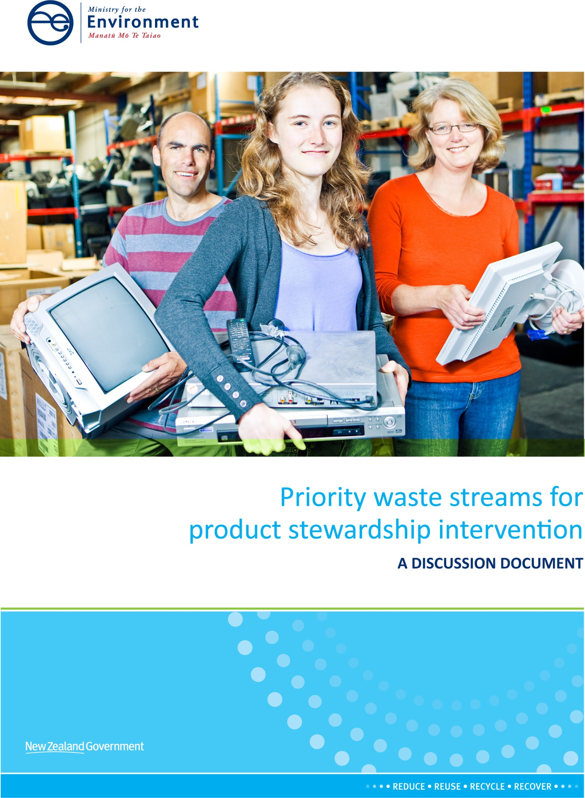
Disclaimer
The opinions and options contained in this document are for consultation purposes only and do not reflect final Government policy. The contents of this discussion document must not be construed as legal advice. Please seek specific legal advice from a qualified professional before undertaking any action based on the contents of this document. The Government does not accept any responsibility or liability whatsoever for an action taken as a result of reading, or reliance placed because of having read any part, or all, of the information in this document, or for any error, inadequacy, deficiency, flaw in or omission from this document.

This document may be cited as:
Ministry for the Environment. 2014. Priority waste streams for product stewardship intervention: A discussion document. Wellington: Ministry for the Environment.

Published in May 2014 by the
Ministry for the Environment
Manatū Mō Te Taiao
PO Box 10362, Wellington 6143, New Zealand
ISBN: 978-0-478-41244-4 (print)
978-0-478-41245-1 (online)
Publication number: ME 1152
© Crown copyright New Zealand 2014
This document is available on the Ministry for the Environment’s website: www.mfe.govt.nz.

Contents
Message from the Minister for the Environment 1
Introduction 3
Purpose of this document 3
What is the overall problem? 5
What is product stewardship? 6
Voluntary product stewardship schemes 7
Consultation theme 1: Product stewardship priorities 8
Current context 8
Previous consultations 8
Objectives and evaluation criteria 9
Proposed priority waste streams 11
Product stewardship priorities consultation questions 12
Consultation theme 2: Priority product declaration 13
What is a priority product? 13
Other intervention tools in the Waste Minimisation Act 14
Electrical and electronic equipment 15
Tyres 19
Agrichemicals and farm plastics 23
Refrigerants and other synthetic greenhouse gases 27
Priority product declaration consultation questions 30
Next steps 31
How to make a submission 31
Contact for queries and lodging submissions 32
Publishing and releasing submissions 32
What happens next 32
Summary of questions for consultation 33
Appendices
Appendix 1: Legislative framework 35
Appendix 2: Indicative process – product stewardship decisions 37
Appendix 3: Accredited voluntary product stewardship schemes 38
Appendix 4: Assessment of waste streams for potential product stewardship intervention 39
Appendix 5: Tests for WMA product stewardship intervention 40

Message from the Minister for the Environment

Waste means different things to different people. This document looks at better ways to manage products which no longer have value to the owner, but can cause harm to the environment if they are not managed properly. Many of these products can also provide opportunities for other valuable uses. The Waste Minimisation Act 2008 (WMA) provides tools to minimise waste and its harmful effects and maximise benefits from resource recovery.
Since passing the WMA five years ago, the Government has encouraged voluntary product stewardship efforts as a first priority. Over this time, 11 voluntary product stewardship schemes have been accredited by the Minister for the Environment. Nearly 34,000 tonnes of waste per year is being diverted from landfill for recycling or safe destruction under these schemes. This is an excellent start, but in quantity is equivalent to only 1.4 per cent of the total waste stream going to disposal facilities which pay the waste disposal levy.
There is an opportunity to foster greater progress in waste minimisation and resource reuse through improved producer responsibility. In my view, the time has come to consider appropriate mandatory approaches for selected priority waste streams.
I want to hear your views on what the most important product waste streams are for the Government to focus attention on, and whether we should move toward declaring some or all of the four products we have identified as priority products under the WMA. The proposed priority products are:
- electrical and electronic equipment
- tyres
- agricultural chemicals and farm plastics
- refrigerants and other synthetic greenhouse gases.
A number of industry groups support priority product declaration for each of these product groups. Each product offers a slightly different mix of opportunities to:
- reduce risk of harm to human health and ecosystems from waste
- reduce waste of resources and create new business opportunities
- create a level playing field without advantages to polluters
- uphold our trade obligations, in terms of better chain of custody data
- keep up with trading partners who are reducing these wastes as a foundation for ‘green growth’
- encourage shared responsibility.
If these product groups are declared as priority products or WMA regulations are developed for them, it will be the first time mandatory tools of this nature have been used in New Zealand. Therefore, I want to ensure that analysis is robust. Historically our waste data has been limited, so information and perspectives gained through this and subsequent consultations will be invaluable to inform policy development and sound decision-making.
I want to make it clear that final decisions on regulations or product stewardship scheme design will not be made solely as a result of this consultation. The Government wants the decision process to be deliberate, well-informed, and transparent.
The first step, this consultation, is seeking feedback on whether we should go further and whether we have picked the right products.
The second step will be to consider in detail a range of options, including those recommended by industry working groups. This process would include close analysis of short-term and long-term economic, environmental and social costs and benefits, and consultation with potentially affected parties. Only after that would the Government consider what interventions, if any, to propose.

The consultation questions are only a guide and all comments are welcome. I look forward to your responses and ideas on how to improve the management of these important waste streams.

Hon Amy Adams
Minister for the Environment

Introduction

Purpose of this document
The Government is considering whether it should intervene to improve the management of four product waste streams: electrical and electronic equipment; tyres; agrichemicals and farm plastics; and refrigerants and other synthetic greenhouse gases.

Step 1
The first step in this process is to consult on whether we have correctly identified the four waste streams above as priorities for action, or whether there are other priorities the Government should focus on.
This includes consulting on whether any of these waste streams should be declared as priority products under the Waste Minimisation Act 2008 (WMA), and if so, when. Should this occur now (as requested by several industry groups), only after all regulatory framework and scheme design options have been explored in future discussion documents, or not at all? Declaration of a priority product brings with it a requirement to develop and gain accreditation for a product stewardship scheme. Such a scheme could be developed in association with, or independently of, regulations set under the WMA.

Step 2
The second step, not part of this discussion document, is consultation with potentially affected parties on the detail of possible interventions for each selected priority waste stream. This will be based on detailed discussion documents, prepared in consultation with stakeholders, to outline in more detail the status quo, problem definition, regulatory and non-regulatory options, overseas models, and cost-benefit analysis. If any priority product had been declared after Step 1, this step could look at supporting regulations to improve outcomes and/or scheme accreditation criteria.

Scope of this discussion document
Regulatory options proposed to the Government recently by industry and other stakeholders are summarised in this document for your information. These are not the only options available to improve the management of these waste streams, and others can be considered in Step 2. Options for intervention include regulations under the WMA, targeted Waste Minimisation Fund (WMF) support, and/or use of appropriate tools under other legislation (Appendix 1). Non-regulatory options could be considered (eg, increased enforcement of existing regulations, education and training, standards).
This discussion document is designed to seek feedback and information to inform the selection of product stewardship priorities and the possibility of priority product declaration for them. It is not designed to determine the form of any mandated product stewardship scheme, nor prejudge decisions the Minister for the Environment or Cabinet may make. Appendix 2 shows a diagram of an indicative process.
If the Minister decides at any stage to declare any priority products, this is done through notice in the New Zealand Gazette. Such a declaration triggers the requirement to develop and gain accreditation for a product stewardship scheme. This can be done separately from or in conjunction with regulations, in conformance with the decision criteria in the WMA.
If the Government decides to proceed with considering regulatory options under the WMA, such as mandatory product stewardship schemes, consultation will be undertaken with potentially affected parties and final decisions will be made by Cabinet.
Feedback is welcome from all interested parties, including councils, businesses, industry associations, iwi, community groups, and the general public. This document is the first critical step in a longer process to improve the management of significant product waste streams.
Information provided represents the most accurate data from our records. If you have additional data, or dispute any data presented, we welcome your feedback.
There are a number of consultation questions in the text, summarised in the last section for your convenience. These questions are intended as a guide only and your submission may address any aspect of the discussion document. All comments are welcome. Further information on how to provide feedback can be found in the Next steps section.

What is the overall problem?
Each year New Zealanders send approximately 2.5 million tonnes of waste to disposal facilities. Significant quantities of waste are also disposed of in cleanfills, commercial and industrial disposal facilities, and in farm dumps. While modern landfills are usually highly engineered and professionally operated to minimise environmental effects, older landfills with much poorer design still operate. In addition, whether of new or old design, the “not in my backyard” response is common in communities, and landfills are increasingly obsolete in many developed nations.
Some wastes are of more concern than others. For example, waste streams containing asbestos, mercury, or persistent organic pollutants such as polychlorinated biphenyls (PCBs) can have catastrophic and enduring effects on human health and ecosystems. Toxic components in waste products are more likely to be released into the environment when not disposed of correctly, such as burning or burial in unlined pits. For example, burning of copper-chrome-arsenic (CCA) treated timber for firewood has been linked to elevated levels of arsenic in the air in a number of New Zealand communities.
In addition, potentially valuable reuse products and the industries they supply are not being capitalised on.
New Zealand has a relative abundance of undeveloped land and landfilling remains generally cheaper than other waste management methods. The intense pollution and landfill scarcity that has driven stronger environmental regulations in other OECD nations has not been experienced to the same extent here. Nonetheless, New Zealand needs to plan for a resilient economy in the longer term.
To do this, more waste needs to be diverted away from landfills or other forms of discharge into the environment through use of strategies that sit higher up the waste hierarchy (figure 1).
Some resources have a strong market value which drives collection, for example the collection of waste cars is influenced by the value of scrap steel. For most wastes however, the future benefit of resource use or harm reduction is not reflected in current market prices, and does not cover the cost to collect and process the waste responsibly. In some cases, the viability of reuse businesses is dependent on the security of an affordable supply of raw material. Without such security, investment in the necessary infrastructure is unlikely to be made. Many resources in the products we dispose of here come from other countries so direct policy interventions to improve resource productivity are not necessarily in our control.
The cost of preventing or reducing the risk of harm from toxic materials in waste products is also not generally included in prices for products, disposal or recycled materials. Overseas this has been addressed in regulated product stewardship (or ‘extended producer responsibility’) frameworks by ensuring all producers and importers have the same obligations to reduce harm from their products.
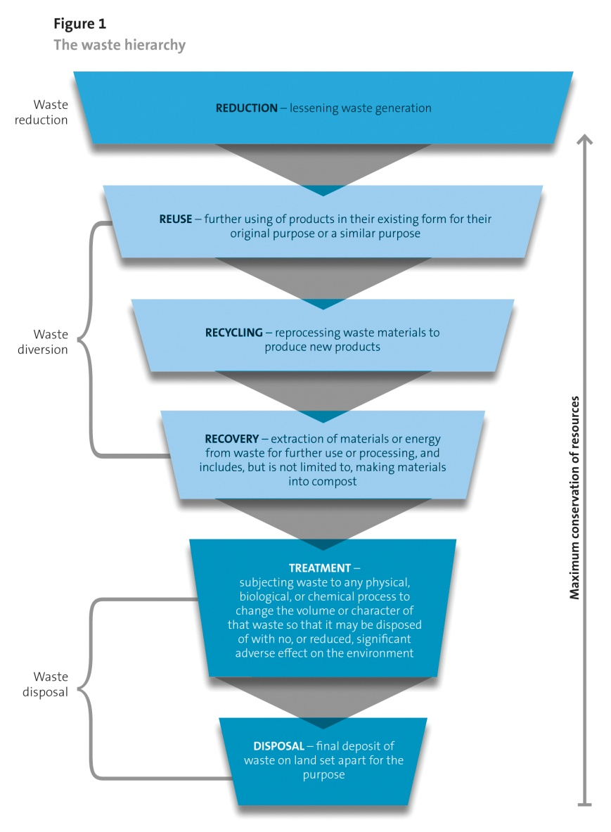
Source: OAG 2007.

What is product stewardship?
Product stewardship is when responsibility for the environmental effects that products can cause in their life cycle is shared among all sectors involved with the product. Product stewardship scheme participants can include producers, brand owners, importers, retailers, and consumers.
Mandated product stewardship implemented overseas usually includes shifting some of the physical and financial responsibility for end-of-life product impacts from ratepayers and taxpayers to those involved in the production and supply of the product.
Under the WMA, product stewardship may be voluntary or mandatory, and the term ‘product’ can include classes of products and product packaging.
Well-designed product stewardship frameworks can improve incentives for better product design, waste minimisation, harm reduction, and resource efficiency. Poorly designed frameworks could add costs without delivering expected benefits. There are models used overseas that New Zealand can learn from and improve on.

Voluntary product stewardship schemes
To allow time for voluntary measures to demonstrate their effectiveness under the WMA, the Government has encouraged industry to take the opportunity to develop robust and effective voluntary product stewardship schemes for their products.
The WMA provides for accreditation of voluntary product stewardship schemes by the Minister for the Environment. To date 11 such schemes have been accredited. These cover aspects of waste oil, refrigerants, paint, agrichemicals, farm plastics, packaging, disposable nappies, and carpet. A summary of these schemes is shown in Appendix 3, and more information can be found on the Ministry for the Environment website.
Schemes accredited under the WMA are required to annually report progress against their own targets. Annual reports indicate that to date just over 33,795 tonnes of waste is being diverted from landfill through these schemes each year. This is equivalent to 1.4 percent of the waste going to official disposal facilities (Appendix 3).
Most of the accredited voluntary product stewardship schemes experience problems with participation rates, as participation cannot be enforced. For example:
- A recycling collector (for example, of tyres or e-waste) does not follow environmentally sound practices and can therefore charge less. They not only can contribute to pollution but gain a competitive advantage while doing so.
- A brand owner (for example, of agrichemicals or products using refrigerants) does not take part in a product stewardship scheme which places a voluntary levy on products to cover responsible waste product management. Their competitors who do participate in the scheme have to charge more for their products or make less profit to cover the levy and thus face a market disadvantage for doing the right thing.
- A farmer stores obsolete agrichemicals on their farm and burns or buries recent agrichemical containers in their farm pit rather than paying to have the wastes safely collected. They risk polluting the environment for future generations and endangering New Zealand’s clean and green reputation which jeopardises selling our products overseas.
Voluntary product stewardship has also been fostered to some extent through use of the Waste Minimisation Fund (WMF). Examples include eDay, the TV TakeBack programme,
e-waste recycling infrastructure, PCB collection, and exploration of innovations for managing tyres and disposable nappies.

Consultation theme 1:
Product stewardship priorities

Current context
Five years after the passage of the Waste Minimisation Act (WMA) a range of voluntary product stewardship schemes are in place. Some companies, industry associations, and user groups have shown strong leadership, and many have not. The accredited voluntary product stewardship schemes are delivering mixed results in waste minimisation and harm reduction from their target waste streams (Appendix 3).
Two accredited schemes, Agrecovery and Refrigerant Recovery, have approached Government asking for regulatory intervention to create a ‘level playing field’ so the schemes can be more effective. Similarly, for e-waste and tyres, after various attempts with voluntary schemes industry representatives have advised Government that they will not set up voluntary schemes due to difficulty in getting full participation, and prefer a mandatory product stewardship framework instead.

Previous consultations
The Ministry has sought views from the public in the past about potential priority waste streams.
Public submissions were sought in 2009 on priority waste streams, for investigation to determine whether mandatory product stewardship schemes were needed. Government’s proposed investigation shortlist (agricultural chemicals, waste oil, and refrigerant gases) was endorsed by the majority of the submissions which had addressed this topic. Many of these submitters also recommended additional priorities, most frequently e-waste, tyres, and packaging. This was in line with previous public submissions on product stewardship priorities in 2005, which had most commonly mentioned e-waste, batteries, tyres, waste oil, end-of-life vehicles, and packaging as their preferred waste stream priorities for action.
Work on potential mandatory product stewardship was not progressed in 2009 because Government wanted to allow time for voluntary measures to demonstrate their effectiveness under the WMA which had just been passed in 2008. The results of subsequent voluntary product stewardship experience underpin this discussion document.
The current national waste strategy, New Zealand Waste Strategy: Reducing Harm, Improving Efficiency, has a high level focus on risk and harm reduction and better resource efficiency. This replaced aspirational and difficult to enforce targets set in the 2002 national strategy, New Zealand Waste Strategy: Towards zero waste and a sustainable New Zealand. The 2002 targets had been set in consultation with a working party of territorial authorities and waste sector stakeholders. These targets included aspects of hazardous wastes (with specific targets for organochlorines), construction and demolition wastes, organic wastes, and trade wastes.

Objectives and evaluation criteria
To progress a priority list for potential action at this time, the Government proposes the following objectives and criteria.
The first step in considering appropriate priority waste streams for potential regulatory intervention under the WMA is to address the purpose of the Act.
The purpose of the WMA is to encourage waste minimisation and a decrease in waste disposal to:
- protect the environment from harm
- provide environmental, social, economic and cultural benefits.
To consider appropriate action to foster product stewardship, the objectives specific to those WMA tools (Part 2 of the WMA) must also be considered.
These are to encourage (and, in certain circumstances, require) the people and organisations involved in the life of a product to share responsibility for:
- ensuring there is effective reduction, reuse, recycling or recovery of the product
- managing any environmental harm arising from the product when it becomes waste.
If the WMA’s priority product declaration tool is to be exercised, specific additional considerations are required, as shown in Box 1.
Box 1: Waste Minimisation Act Section 9: Declaration of priority products
…(2) – The Minister must not make the declaration unless he or she is satisfied that—
(a) either— (i) the product will or may cause significant environmental harm when it becomes waste; or (ii) there are significant benefits from reduction, reuse, recycling, recovery, or treatment of the product; and
(b) the product can be effectively managed under a product stewardship scheme.
(3) – Before the Minister makes the declaration, he or she—
(a) must obtain and consider the advice of the Waste Advisory Board; and
(b) must consider any public concerns about environmental harm associated with the product when it becomes waste (including concerns about its disposal); and
(c) must provide the public with an opportunity to comment on the proposal; and
(d) must consider the effectiveness of any relevant voluntary product stewardship scheme in terms of the criteria set out in subsection (2); and
(e) may consider any other matters that he or she thinks relevant.
This document proposes the following waste stream evaluation criteria.
- Risk of harm: The relative risk of harm the product waste stream, as currently managed in New Zealand, poses to the environment.
- Resource efficiency opportunities: The degree to which the product waste stream, as currently managed in New Zealand, is being maximised for resource efficiency or supporting new business opportunities in resource recovery, compared to demonstrated results in other jurisdictions where data is available (social and economic benefit).
- Voluntary measures insufficient: A voluntary approach has been undertaken in New Zealand and participation rates and waste minimisation has been low.
- Industry readiness: There is significant New Zealand industry buy-in and willingness to engage to find better solutions. Significant sectors of the industry have approached Government seeking effective regulation to ensure a level playing field.
- Current producers: The waste stream is from a class of products which are currently entering the market in New Zealand, and can be connected to producers and manufacturers for the purposes of designing product stewardship schemes (not just orphan or legacy products).
These criteria are compared against a range of waste streams in Appendix 4. Comments are welcome on this analysis, as it underpins the proposals in this document for priority waste streams.
Building on the results of this discussion document, further consultation is likely to be undertaken on intervention options for priority waste streams. For this stage, additional criteria will be employed for deciding between options. The options will be compared on short-term and long-term economic, environmental and social costs and benefits. The criteria for deciding the best option will be set out in subsequent documents, and are likely to include: net benefit, regulatory effectiveness, fairness and support for competition, affordability, accessibility, waste minimisation effectiveness, enforceability, and alignment with trading partners.

Proposed priority waste streams
As shown in Appendix 4, there are many waste streams which pose risk of harm and benefits from resource recovery or treatment. However, the Government considers that those with the best prospect for improved outcomes through product stewardship should meet two additional criteria:
- voluntary measures have been tried with good engagement by willing players, but those voluntary measures suffer from significant levels of non-participation and low rates of recovery of the targeted waste stream
- industry and other stakeholders involved in those initiatives have indicated to the Government that intervention is required to remove free-rider behaviour, provide a level playing field, and enable greater waste minimisation and reduction of harm.
Therefore, the Government has identified four product groups as priorities at this time for interventions supporting product stewardship. These are:
- electrical and electronic equipment
- tyres
- agrichemicals and farm plastics
- refrigerants and other synthetic greenhouse gases.
There are a number of waste streams that are significant by volume, risk of harm, or both, which are difficult to link directly to current products and thus to effective product stewardship frameworks. These include organic wastes (eg, greenwaste, household organic waste, sewage sludge), construction and demolition wastes, and obsolete products
(eg, asbestos, polychlorinated biphenyls (PCBs)). Omission of these wastes from proposals in this document for regulatory intervention does not indicate that these wastes are unimportant or that the door is closed to other types of appropriate interventions to effectively address them.
Waste data in New Zealand is incomplete, and this assessment is based on information currently available to the Government. Information to improve this assessment is welcome.

Product stewardship priorities consultation questions
Consultation question 1 – Priority waste streams
1a The following waste stream criteria are being proposed:
– risk of harm
– resource efficiency opportunities
– voluntary measures insufficient
– industry readiness
– current producers (not just legacy products).
Do you agree that these waste stream evaluation criteria are suitable to select product stewardship priorities, consistent with WMA objectives? If not, please suggest alternatives.
1b Do you agree with the assessment of waste streams against these criteria in Appendix 4? If not, please provide information or propose improvements.
1c The following four product groups have been identified by the Government as priorities at this time:
– electrical and electronic equipment
– tyres
– agrichemicals and farm plastics
– refrigerants and other synthetic greenhouse gases.
Do you agree that these four product groups should be a priority for the Government to consider regulatory interventions? Do you think others should be included? Why or why not?
1d Do you have or know of any other information that can improve this assessment? If so, please advise.

Consultation theme 2:
Priority product declaration

What is a priority product?
Under the Waste Minimisation Act (WMA), a product may be declared a priority product by the Minister for the Environment. This means that a product stewardship scheme for the defined product must be developed and accredited as soon as practicable after declaration. This tool is given effect by the Minister through a Gazette notice. This power has not yet been used.
Declaration of a priority product alone also does not automatically compel participation in an accredited product stewardship scheme, set fees or require a deposit, place landfill bans, or specify product labelling. The WMA provides powers to establish these by regulation.
The WMA sets out tests that must be met before these powers are exercised (Appendix 5). The Minister must not make a priority product declaration unless he or she:
- is satisfied that either (a) the product will or may cause significant environmental harm when it becomes waste, or (b) there are significant benefits from reduction, reuse, recycling, recovery, or treatment of the product (section 9(2)(a))
- is satisfied that the product can be effectively managed under a product stewardship scheme (section 9(2)(b))
- has considered the effectiveness of any voluntary product stewardship schemes in relation to these matters (section 9(3)(d))
- has considered public concerns about environmental harm associated with the product when it becomes waste and provided the public with an opportunity to comment on the proposal (section 9(3)(b)and (c))
- has obtained and considered the advice of the Waste Advisory Board (section 9(3)(a)).
This discussion document is a vehicle for public consultation on the prospect of declaring the four waste products identified as priority products. The first three matters above are summarised for each of the proposed priority waste products in the following sections. The consideration of the fourth matter will include submissions on this document. The timing of the last matter will be at the discretion of the Minister for the Environment.
Waste data in New Zealand is incomplete, and this assessment is based on information currently available to the Government. Data gaps specific to the priority product decision criteria are noted in the following sections. Information to improve this assessment is welcome.

Other intervention tools in the Waste Minimisation Act
Declaration of a priority product is only one of a range of intervention tools provided by the WMA to potentially deal with waste problems. Other available tools are summarised below.

Waste levy funding
The WMA imposes a levy on waste disposed of at a disposal facility. Half of the waste disposal levy collected under the WMA is allocated to territorial authorities on a population basis, and half (minus administrative costs) goes to create the Government’s Waste Minimisation Fund (WMF). The territorial authority share must be spent on waste minimisation and in accordance with each council’s published waste minimisation and management plan. The Minister for the Environment makes decisions on allocation of funds from the WMF.
Examples of current WMF-funded projects include the collection and safe destruction of legacy polychlorinated biphenyls (PCBs), development of innovative technology for recovery of resources from sewage sludge, infrastructure development for onshore recycling of e-waste, and the TV TakeBack programme for end of life TVs in 2012–2014.
A summary of the results from waste levy expenditure will be part of the 2014 Review of the Waste Disposal Levy that is currently underway and due to be completed by July 2014.

Guidelines for accredited product stewardship schemes
Targets, scheme design, and other expectations for accredited schemes for priority products may be set through guidelines published in the Gazette under the WMA.
These may be specific to certain product groups or generic. Consideration of suitable guidelines will be part of subsequent discussion documents and consultations.

Regulations relating to products
The WMA provides regulatory powers for potential controls relating to products. These include:
- requirement to participate in an accredited scheme (through prohibiting the sale of a priority product, except in accordance with an accredited scheme)
- requirements for scheme accreditation (eg, manner of application, fees payable, monitoring charges for accredited schemes)
- controls or prohibitions on disposal, controls or prohibitions on manufacture or sale of products containing specified materials, or product labelling
- product take-back services, management fees for products, product deposits and refunds, quality standards for reusing, recycling, or recovery
- collection and reporting of information.
Consideration of various regulatory options will be part of subsequent discussion documents and consultations.

Electrical and electronic equipment
Priority waste stream
evaluation criteria

Risk of harm ++
Resource inefficiency ++
Voluntary unsuccessful ++
Industry readiness ++
Current products +

‘E-waste’ refers to electrical and electronic equipment which enters the waste stream. Most broadly defined, e-waste (or ‘WEEE’ – ‘waste electrical and electronic equipment’) includes everything that uses electric current, such as computers, all types of electrical appliances including air conditioners, washing machines, refrigerators, small household appliances and tools, mobile devices including phones, medical equipment, lamps, and batteries. The term e-waste can also refer to a subset, such as computers, computer peripherals, and televisions.
New Zealand disposes of some 72,000–85,500 tonnes of e-waste per year. With increasing use of electrical products that have short life spans, e-waste is a growing concern. The future adverse effects of hazardous materials and resource shortages need to be avoided.
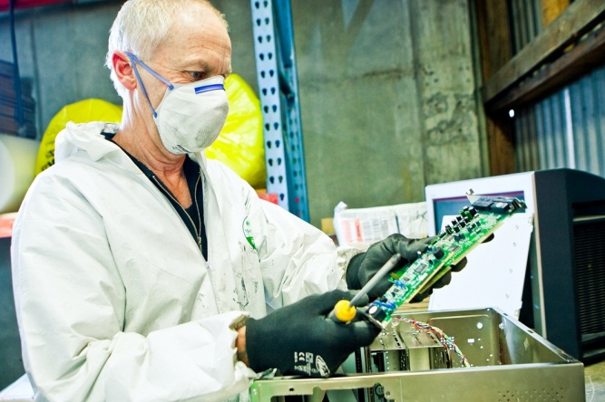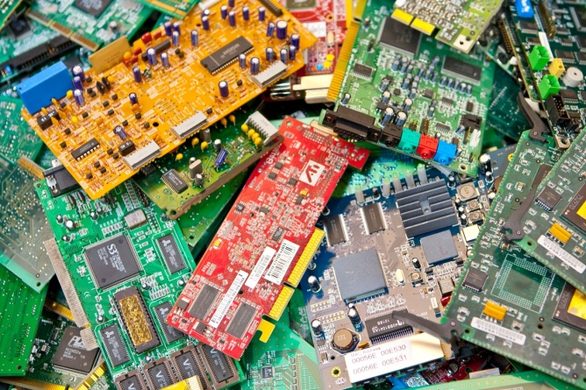

Photo credits: Ministry for the Environment.

Risk of environmental harm
E-waste can contain toxic substances, including lead, cadmium, mercury and brominated flame retardants (BFRs), posing risk to the environment and human health. These are bio-accumulative toxins which means they do not biodegrade and accumulate up the food chain. Direct connection to immediate health impacts is difficult to prove due to potential interaction between multiple toxins. BFRs are present in New Zealand human blood serum and breast milk samples similar to levels in other developed countries.
New Zealand exports most of its e-waste which has been diverted from landfill, and toxic materials in e-waste are covered by one or more international agreements which New Zealand is a party to: the Stockholm, Basel, Waigani and Minamata conventions. These encourage best practise in managing toxic wastes, including reducing waste and establishing treatment facilities onshore in preference to exporting waste.
When e-waste is landfilled, toxic substances in it will, over time, leach out and mix with any water in the landfill. The time it takes for e-waste to leach out all its toxic substances varies considerably from product to product and landfill to landfill. Some products will still be at risk of leaching toxic substances in hundreds of years.
Modern landfill engineering techniques use liners and leachate collection systems. This can greatly reduce the risk of harm arising from disposal of e-waste in landfills in the short- to medium-term. There are a number of older landfills still operating that do not use modern engineering techniques like liners. It is widely accepted that all landfill liners have a limited lifespan after which holes develop. When this happens, any toxic substances remaining in the landfill may leach out and contaminate the soil and water. Therefore, the risks associated with landfilling e-waste increase over time, creating a potential burden for future generations.
E-wastes processed without adequate attention to harmful components can contribute to health risks to employees and environmental pollution. This is particularly a concern where e-waste is exported to communities which do not have access to safe e-waste dismantling and recycling technologies. Export consents under the Basel Convention are a way to help ensure appropriate processing at the destination country.

Waste minimisation benefits
E-waste contains valuable materials in trace amounts such as gold and ‘rare earth’ metals. More abundant resources in e-waste include steel, aluminium, copper, plastic resins and glass. However, the embodied energy and material value and environmental benefits of recycling e-waste are not reflected in the market value of the whole unit at end of life. Typically, products go to landfill, or the most valuable materials (eg, copper, circuit boards) are recovered and the remainder (including toxic materials) is landfilled.
If we squander non-renewable resources, we may limit future options to develop technologies and some current technologies may become more expensive and less accessible to the public. Globally it has been estimated that of 60 key metals, 34 had recycling rates of less than 1 per cent. Of these 14 were ‘rare earth’ metals which are essential in the manufacture of many new and emerging technologies, from touch screens to wind turbines. Recycled materials also generally have much lower environmental impacts than raw materials, as they avoid the resource extraction and refining phases.

Likelihood of effective management under a product stewardship scheme
Mandatory e-waste product stewardship is effectively diverting significant volumes of e-waste from landfill in the European Union, Scandinavia, Switzerland, several USA states, most Canadian provinces, Japan, Korea, Taiwan, and Australia. In 2007, the OECD recommended that New Zealand increase regulatory support for recovery and recycling of electronic goods, building on the extended producer responsibility principle.
In Australia, a ‘co-regulatory’ approach has been taken. Suppliers of computers and televisions into the Australian market, above a minimum volume, are legally obliged to be part of a scheme that offers free and accessible take-back of e-waste for consumers, and to meet recovery targets which increase over time. Funding is through membership in a scheme and is based on volume sold to market. The product stewardship schemes compete against each other for target share, and currently there are five schemes accredited by the Australian Government.
The computer and TV brand owners and e-waste recycling industry in New Zealand were engaged by the Ministry from 2006 to 2008 to design an improved product stewardship framework for e-waste. Industry made it clear to the Government that given small profit margins and multiple small players, product stewardship for e-waste would only work if participation was mandatory.
In 2008, two possible mandatory frameworks were proposed by brand owners, differing in how to cover the costs of environmentally sound e-waste disposal. The TV industry requested an advanced disposal levy at the border, and the computer industry requested a scheme model based on costs shared amongst producers proportional to volume of product to market and volume in the waste stream. Once the WMA was enacted in 2008, a voluntary product stewardship approach was encouraged by Government. No voluntary e-waste scheme has been accredited to date.
If New Zealand were to follow a similar model to Australia, under the WMA this would involve a number of interventions. These would include declaration of e-waste as a priority product, a regulation obliging producers to participate and cover the costs of post-consumer e-waste collection and recycling, and collection and recycling targets which must be met to retain scheme accreditation. To pursue this path it would be necessary to renew engagement with industry stakeholders to develop a cost-effective scheme for New Zealand, update data on product volumes and life spans, and analyse likely costs and benefits of options. The Government is currently considering proposals from suppliers for such a process which will be supported by the Waste Minimisation Fund (WMF).
Projected collection and recycling costs per product, based on the current Australian experience and converted to New Zealand dollars, would be $19 per computer screen, $30 per TV, and $6 per computer peripheral. This could on average represent up to a 5 per cent price increase for TVs and computers and about 20 per cent for peripherals, but to date in Australia there has not been a visible impact on consumer prices.

Effectiveness of voluntary schemes to date
An annual national free collection of e-waste at eDay ran from 2007 to 2010. These had good participation from the public and involved many volunteers, but are estimated to have diverted only about 1 per cent of e-waste from landfills.
The TV TakeBack programme was run by the Government in support of the Digital Switchover. It provided a subsidy to e-waste recyclers from the WMF to cover the majority of the collection and recycling costs. From October 2012 to March 2014, over 222,000 unwanted TVs were diverted from landfill for recycling, representing over 4000 tonnes.

What would be in scope?
If electrical and electronic products are to be declared as priority products under the WMA, it is important to know exactly which type of products will be covered. The brand owners, retailers and consumers of the priority product(s) would need to know whether or not they had a role to play in a mandated product stewardship scheme.
The two main options are to start with computer equipment (computers and peripherals) and televisions to align with the Australian scheme, or broaden the scope to also include other
e-waste such as mobile devices, lamps containing mercury and/or batteries. This document proposes the first option, while leaving open the opportunity to move to the second option over time as onshore collection and recycling infrastructure matures.
Most developed countries have mandated product stewardship schemes for e-waste. A key difference is the scope of which products are covered. For example, Australia has focused on TVs, computers and computer peripherals; Japan’s programme covers refrigerators, air conditioners, computers, and CRT TVs; and the European Union includes household appliances and a range of e-waste categories.
A narrow scope would affect a smaller number of producers and retailers and potentially a smaller range of consumers. Thus the costs are likely to be lower, but the benefits, in terms of reduced harm and increased recovery of resources, are also likely to be smaller. In turn, a broader scope would increase the number and range of affected parties, and potentially the costs, but the benefits may be larger.
Submissions are welcome on the appropriate electrical and electronic equipment product scope for potential e-waste priority product declarations in New Zealand.

Tyres
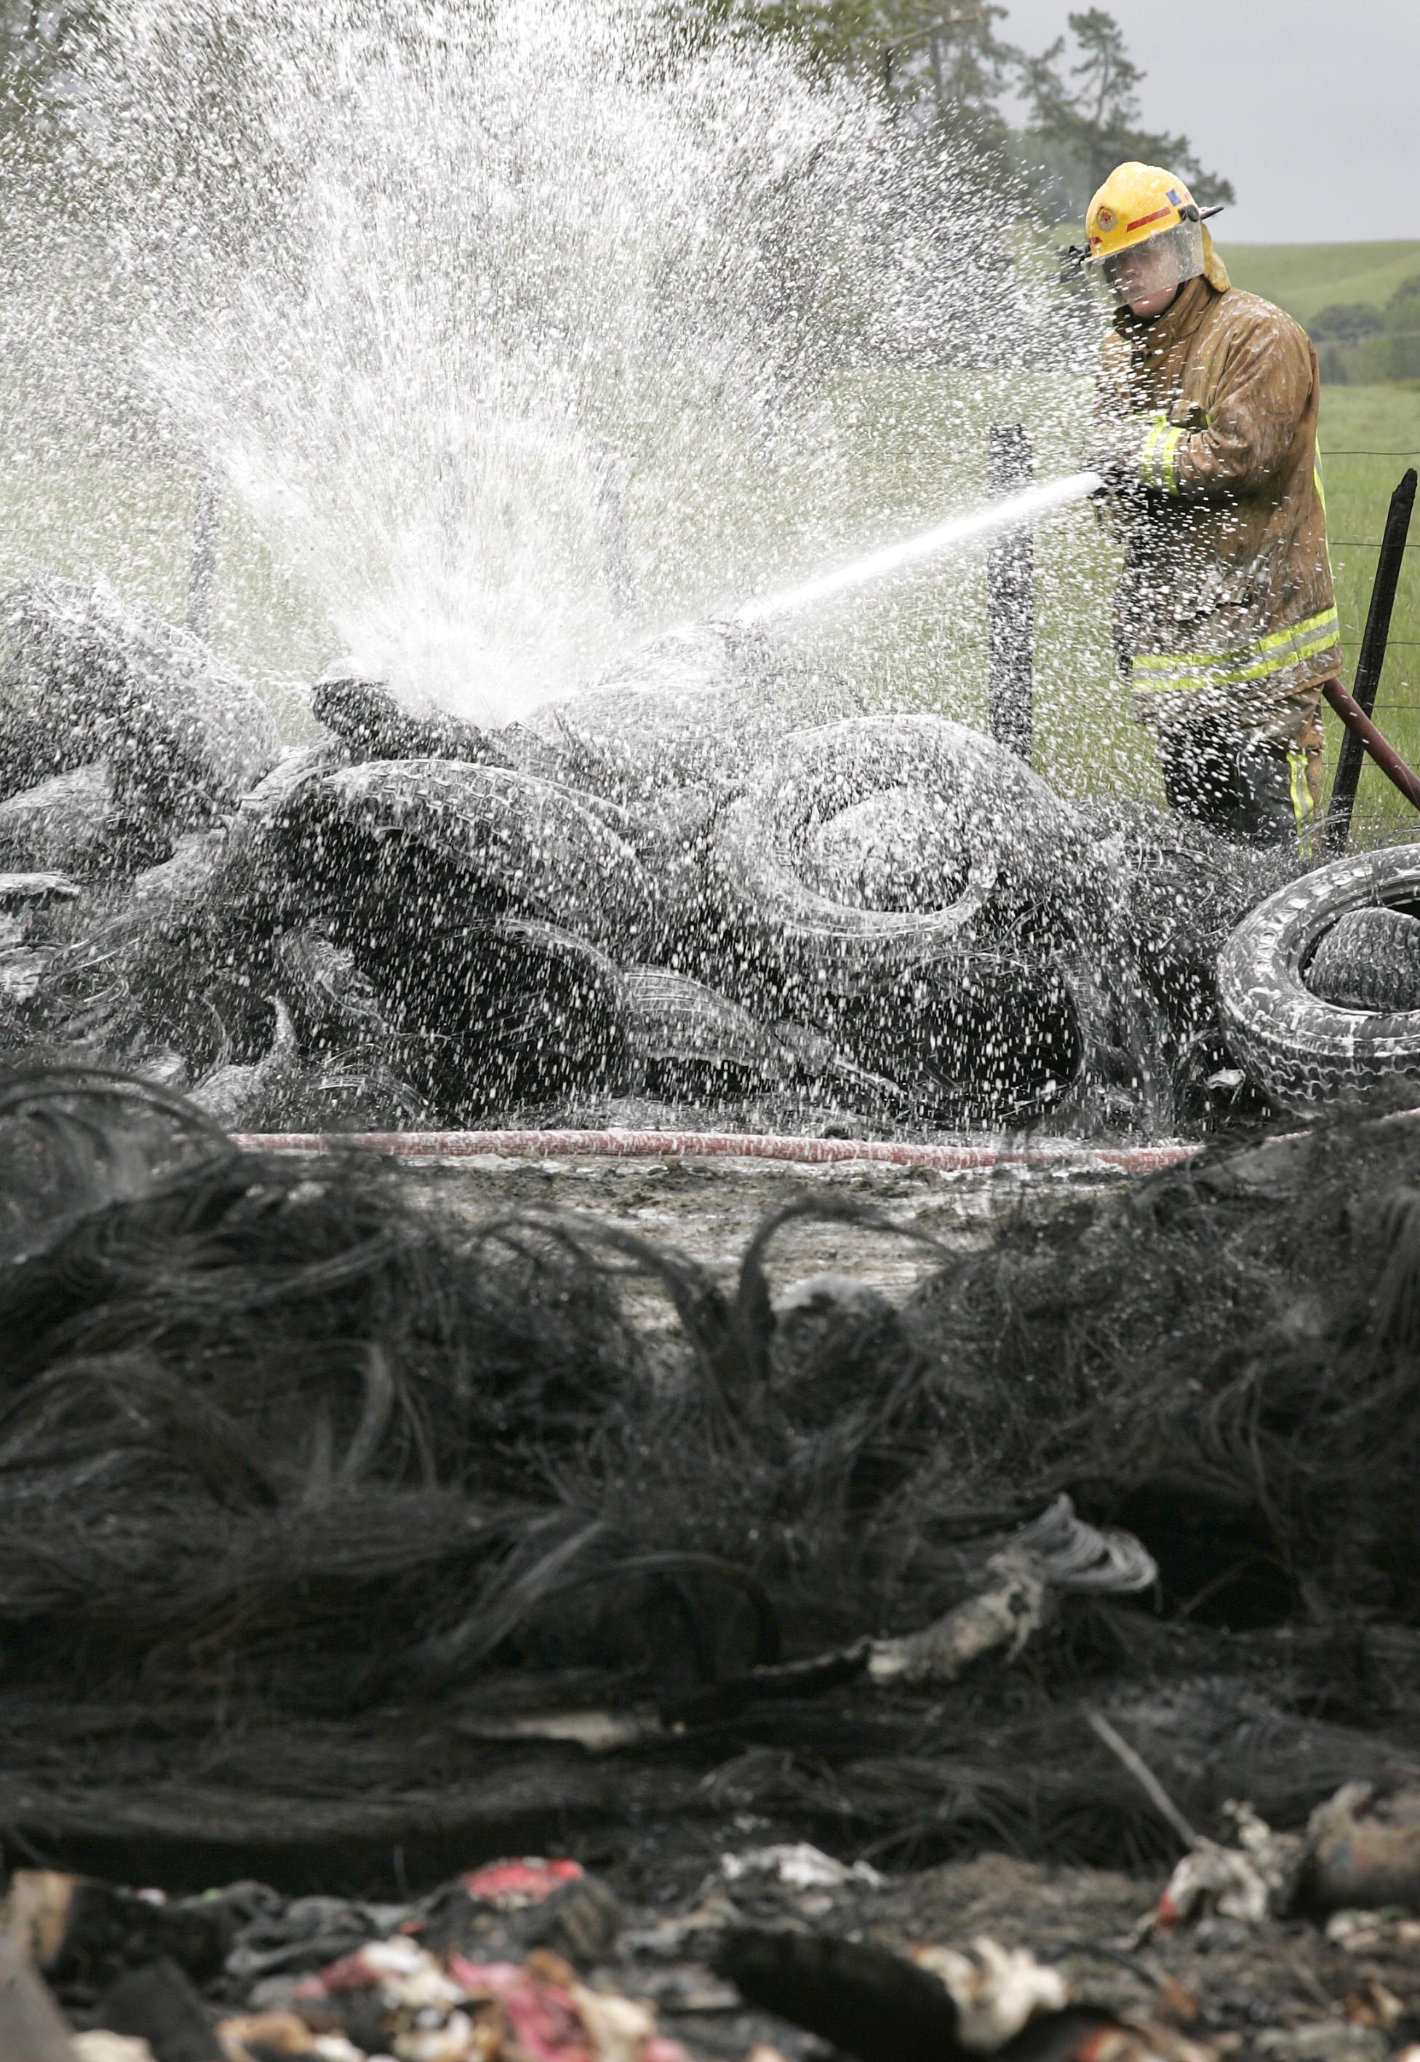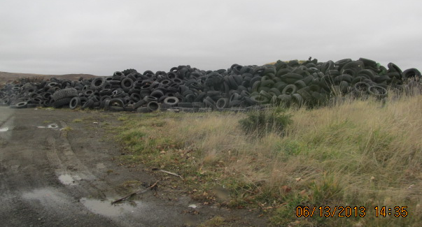
Photo courtesy of Waikato Times Photo credit: Ministry for the Environment.

Priority waste stream
evaluation criteria
Risk of harm +
Resource inefficiency ++
Voluntary unsuccessful ++
Industry readiness ++
Current products +

New Zealand imports 5.1 million tyres every year including car, truck, bus, motorcycle, all terrain vehicle, tractor, aircraft and off-road vehicle tyres. This is 62,000 tonnes of tyres or the equivalent of 7.7 million passenger car tyres. These imported tyres replace worn tyres which then enter the waste stream, 70 per cent of which go to some form of land disposal (consented or otherwise).
Tyre dumping and stockpiling can impose costs on ratepayers and land owners and detract from visual amenity. Whole tyres in landfills can cause stability issues by capturing gas and rising to the surface. Waste tyres pose risk of environmental harm, and opportunities for business creation through resource efficiency.

Risk of environmental harm
In addition to visual amenity and imposed costs, stockpiles and illegal dumping of tyres pose the risk of pollution from fire and toxic materials leaching into soil and water. Conditions on resource consents for bulk storage of tyres are typically designed to reduce fire and leachate risk. Some recently reported tyre dumping and stockpiling issues are summarised in Box 2.
Large tyre fires have occurred in tyre stockpiles in New Zealand, for example in Hamilton in 2003 and Invercargill in 2012. Tyre fires create toxic smoke, are difficult to extinguish, and can create pollution to soil and waterways through oily effluent and run-off. The compounds found in the smoke from uncontrolled tyre fires can create significant acute (short-term) and chronic (long-term) health hazards to firefighters and nearby residents including respiratory effects, central nervous system depression, and cancer.

Box 2: Some examples of stockpiling and illegal tyre dumping
- In 2003, a large tyre fire in the Waikato took 16 hours to put out, required evacuation of 10 households, discharged over 30,000 litres of oil to waterways, and cost ratepayers and taxpayers an estimated $90,000. The fire involved a stockpile of an estimated 30,000 tyres.
- An abandoned tyre pile of an estimated 2000 tonnes of tyres (equivalent to over 200,000 car tyres) was created in Napier on public land near a wetland and residential areas. The tyres had been collected for a business venture which failed, and the person responsible left the country. Clearance of the pile in 2010 cost ratepayers and taxpayers an estimated $2 million.
- Up to a million tyres were dumped on a 61-hectare Huntly property over six years. The Waikato Regional Council prosecuted the company and person responsible on charges of discharging contaminants to land without consent, and convictions were made in 2011. The company was fined $77,600 in January 2013, but the business owner has left the country. Prosecution costs for the regional council were in the order of $200,000.
- A tyre stockpile of more than 4000 tyres has accumulated on a 2-hectare property in Wanganui while the company responsible pursues an undisclosed tyre recycling solution. In August 2013, the Horizons Regional Council asked the company to stop adding to the pile and to provide documentation on how the tyres would be recycled.
- In 2013, a volunteer litter clean up removed 600 abandoned tyres from the Waimea Estuary between Nelson and Mapua in the South Island.
Tyres contain about 1.5 per cent by weight of hazardous compounds, which are bound into the rubber. Tyres are designed to be resilient, and degrade slowly in the environment. Leaching of toxic material from tyres is more likely if the tyres are submerged in water over time and/or cut into small pieces, exposing more surface area. The materials most often found in tyre leachate include manganese, iron, aluminium, zinc, cadmium, lead, and volatile organic compounds (eg, benzene, benzonthiazole).
Large tyre piles may also create a human health risk through creating mosquito breeding grounds for species that may spread serious diseases. Alien mosquito species capable of carrying diseases such as Ross River virus and dengue fever and known to breed in places like water collected in tyres have been discovered by officials in or near ports and airports relatively often. Future establishment of a population of such mosquitoes in New Zealand and their spread through tyre stockpiles is possible. If establishment of a population occurred, all above-ground tyre piles near urban centres would be a significant concern, and spraying them against mosquitoes would be costly and ineffective. Areas of habitat suitable for tropical disease-carrying mosquitoes are also likely to expand over time in New Zealand with climate change.

Waste minimisation benefits
Tyres contain significant energy (greater than coal), and can be converted to crumb rubber and engineering products. Currently in New Zealand this comes at a cost that is greater than landfilling, discouraging investment in onshore value-added processing. Less than a third is currently diverted from disposal (14 per cent exported, 18 per cent used or processed onshore). In contrast, countries with mandated product stewardship schemes have more than 80 per cent of waste tyres diverted from disposal for material or energy recovery.
The most common use of waste tyres overseas are tyre-derived fuel and rubber crumb products (eg, roading, roofing, flooring). Emerging technologies which may also develop in New Zealand with an adequate tyre diversion framework include pyrolysis (extraction of liquid fuels, steel and carbon black) and devulcanisation (recovery of flexible rubber for new products).

Effectiveness of voluntary schemes to date
Tyre Track was a voluntary product stewardship scheme operating from 2004 to 2009, co-funded by the Motor Trade Association and the Ministry for the Environment. It encouraged trading between registered tyre generators and collectors and tracked collection and declared destination of waste tyres. By the end of the scheme about 30 per cent of waste tyres were covered but rates of recycling and illegal dumping were not affected. The Motor Trade Association and major tyre companies indicated unwillingness to participate in a voluntary scheme due to the risk that disreputable operators stand to gain by receiving the benefits of a scheme without being compelled to collect or pay a levy.
Currently many tyre sellers charge an ad hoc tyre disposal fee when new tyres are fitted; however, the use of that fee and the final destination of the worn tyres are often unclear. Data indicates that in many cases a price is charged sufficient to cover environmentally sound processing, but only a fraction of that is used to cover disposal, resulting in cheaper options such as landfilling or illegal dumping, with the balance retained as a profit.
Currently, in the absence of an active product stewardship scheme for tyres, about a third of waste tyres are diverted from disposal (estimated 14 per cent exported whole for reuse and recovery, 13 per cent processed onshore, 4 per cent used as silage covers, and 1 per cent in pyrolysis trials). It is unknown what proportion of the remaining two-thirds of waste tyres goes to legal disposal.

Likelihood of effective management under a product stewardship scheme
In 2012, the Product Stewardship Foundation received support from the Waste Minimisation Fund to seek consensus with major stakeholders on a mandatory product stewardship framework for waste or tyres. The resulting Tyrewise working party made recommendations to the Minister for the Environment in 2013.
The Tyrewise recommendations are for priority product designation for a range of on-road and off-road pneumatic tyres, and a regulated levy/fee/deposit at the border to cover end-of-life management costs for loose tyres and at point of first registration for affixed tyres.
If the Tyrewise preferred model were to be implemented, tyre disposal fees would be collected on tyres at point of entry into the market for payment to registered tyre collectors and processors on proof of delivery to approved destinations, and to support clearance of illegal stockpiles. The goal would be to create a stable market for waste tyres and sustainable private investment in onshore processing industries over a transition period of several years, after which the fee could be reduced.
An onshore tyre processing infrastructure investment strategy and business case for meeting this goal would need to be developed. It is important that any subsidy be cost-efficient, not used to prop up unsustainable or environmentally unsound activities, or create windfall profits.
The cost to consumers per car tyre at the outset in the Tyrewise model is anticipated to be $5.50 while legacy stockpiles are dealt with, reducing to $2 per tyre long term. This represents about 7 per cent of the new price for a tyre initially and 2.5 per cent longer term. This would replace the disposal fee that consumers currently pay tyre retailers of between $2 and $7 per tyre, with no product stewardship scheme in place and no guarantee of outcome. The fee would likely be imposed at the point of importation or manufacture and thus absorbed into the initial tyre price to the consumer.
Many of our trading partners have adopted mandatory product stewardship schemes for waste tyres and more effectively convert this waste stream to beneficial use. These countries include Canada, USA, Japan, Taiwan, Korea, European Union, Scandinavia and South Africa. Diversion of waste tyres from landfill is approximately 30 per cent in New Zealand, whereas it is more than 80 per cent in the USA, Europe and Japan, and over 90 per cent in Canada and South Korea for example.

What would be in scope?
The Tyre Track programme included primarily passenger vehicle (car, van and small truck) tyres. The Tyrewise model proposes all pneumatic (air filled) tyres: those for cars, motorcycles, trucks, buses, off-road vehicles, aircraft, and certain solid tyres (forklifts), but not bicycle tyres. The Government proposes for consultation the Tyrewise recommendation for scope, as it is appropriately comprehensive.

Agrichemicals and farm plastics
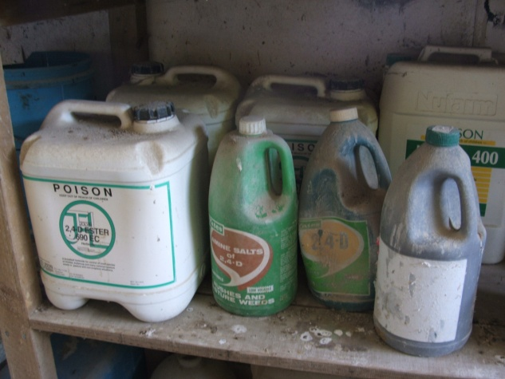 | 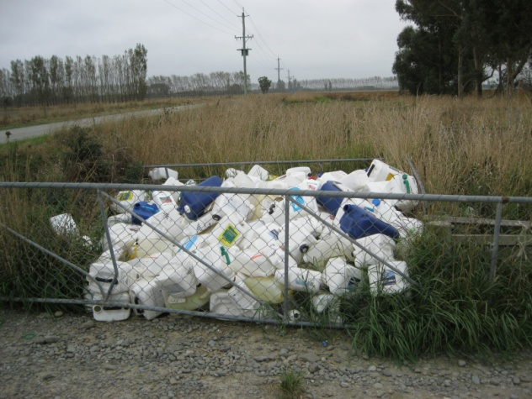
Photo credit: Agrecovery Foundation. | Photo credit: Environment Canterbury.

Many New Zealand farmers regularly use chemicals for controlling pests, weeds and diseases. Agricultural chemicals (agrichemicals) primarily refer to herbicides, insecticides, and fungicides. Other chemicals used in farming are veterinary medicines, vertebrate toxic agents (eg, rodenticides) and disinfectants. Agrichemicals can become surplus when farming methods or farm owners change, chemicals expire, or chemicals previously in use are deregistered.
Priority waste stream
evaluation criteria
Risk of harm ++
Resource inefficiency +
Voluntary unsuccessful ++
Industry readiness ++
Current products +
Use of agrichemicals generates plastic containers on a regular basis. Other plastic wastes are also generated from farming.

Risk of environmental harm
Agrichemicals are by intent toxic, and can pose risk to human health and the environment if inappropriately used, stored or disposed of. Agrichemical containers, also potentially toxic until adequately cleaned, are generated regularly with product use. The majority of these wastes, if not appropriately disposed of, are thought to be going into unlined farm dumps or landfills, burnt on-farm, or stored. Over time stored waste agrichemicals can enter the environment from perished containers.
Some agrichemicals, mostly older generation chemistries but also some modern chemicals, can contain persistent organic pollutants (POPs). POPs do not degrade in biological systems (in plants or animals or the physical environment) and thus can accumulate up the food chain and pose long-term health risk to humans and ecosystems. The most serious of these are controlled internationally by the Stockholm Convention, and these have been deregistered for use in New Zealand. They still arise from farm agrichemical collections, particularly when properties change farming systems or ownership. Our ability to give effect to our international obligations under the Stockholm Convention relies in part on effective collection mechanisms for POPs.
Farm plastics in general, including silage wrap, non-agrichemical containers, crop protection netting, and feed sacks, do not pose the same risk of harm as waste agricultural chemical containers. However, the holders of such waste and the logistics of collection are likely to overlap with that for agrichemical containers, and potentially influence the economics of collection in rural areas.
A farm plastics waste study in 2002 found burning and burial were the most common methods of farm plastic waste disposal. These methods risk non-compliance with regional and unitary councils, ash residue, and leachate (which can get into waterways affecting aquatic life and livestock) and health and safety issues. Moving to a more environmentally sound option of collection and recycling would be heavily dependent on the transport costs and value of any recovered materials from recycling. The study calculated an economic shortfall of 10 to 23 cents per container plus levy administration.
In 2013, Environment Canterbury released results of a study on non-natural rural wastes. They found that farms were disposing large quantities of waste through burning or burying, potentially creating long-term impacts on public health, land productivity, land values, and streams, rivers and groundwater. Surveyed farmers said that agrichemicals were far too expensive to waste and they only bought what they needed, yet survey data suggests that waste agrichemicals amount to about 24.4 tonnes per year in that region. The most recent Agrecovery collection in Canterbury obtained 11.6 tonnes of waste agrichemicals.
The same types of plastic resins used in farm activities are also present in household and commercial packaging and products. However, the majority of these wastes are generally sent to consented landfills rather than buried or burnt on site.

Waste minimisation benefits
Waste agrichemicals cannot be recycled. If they cannot be used legally for their intended purpose, then they need to be safely neutralised or destroyed.
Farm plastics on the other hand are a recoverable resource currently being wasted. Calculations based on the collections of current voluntary schemes and estimates of volumes of product placed on the market suggest that 90 per cent of bale wrap and agrichemical containers, and nearly 100 per cent of twine and feed bags and crop protection netting, are not being collected for recycling.
Projection of data from 53 farms in Canterbury suggests that about 2400 tonnes of bale wrap, 23,000 tonnes of plastic bags, and 1800 tonnes of twine and crop protection netting are disposed of per year in the region. Farm waste surveys being planned for other rural regions (eg, Waikato, Taranaki) will help clarify the situation nationwide.

Effectiveness of voluntary schemes to date
A legacy waste agrichemical problem accumulated in New Zealand until regional councils organised collections to prevent adverse impacts to water and land under the Resource Management Act 1991. This led to the Rural Agricultural Chemical Collection Programme 2003–2009, co-sponsored by regional and central government. Over 640 tonnes of legacy agrichemicals were collected from farms at a cost of $4 million to central government.
Data indicated that most regions would be ‘substantially cleared’ of legacy agrichemicals by 2009, so Government asked industry and councils to step up with a product stewardship programme to deal with wastes generated from current agrichemicals. The voluntary Agrecovery Rural Recycling Programme product stewardship scheme started in 2009, and was accredited under the WMA in 2010 for collection of agrichemicals and their containers. An interim Government subsidy in 2009–2013 provided transitional support for offshore treatment of agrichemicals collected by Agrecovery which were unable to be treated in New Zealand (total $0.4 million).
Agrecovery has buy-in from many agricultural companies and user groups, but has experienced significant problems with free-riders and non-participation. Non-participating agrichemical producers receive a significant market advantage in point of sale product pricing by not paying the voluntary Agrecovery levy. There are threats of withdrawal by some major members and a risk of scheme collapse if these issues cannot be resolved. Many farmers choose not to participate when there are user-pays charges for non-member brands or legacy agrichemicals.
Plasback is a scheme for agricultural plastic waste collection and recycling. This is a user-pays scheme and there is no levy on producers to support the cost of collection. It is owned and operated by a major supplier of crop packaging products, Agpac Ltd, and was accredited under the WMA in 2010. The scheme covers silage wrap (about 90 per cent of collected material) as well as vine nets, agrichemical containers, and plastic feed bags. The scheme’s success is currently hampered by low participation rates and free-riding by other farm plastic producers. Agrecovery did collect silage wrap but in 2013 announced it would phase this out and give its collection network to Plasback in 2014. It is estimated that about
50 per cent of farm plastic producers are not participating in either Agrecovery or Plasback.
Agrecovery collects an estimated 26 per cent of available waste agrichemicals, and 29 per cent of the agrichemical packaging from members’ levied products. Agrecovery and Plasback together recycle an estimated 10 per cent of all agrichemical containers (both members’ and non-members’ products).

Likelihood of effective management under a product stewardship scheme
Effective agrichemical diversion schemes are in place in a number of our major trading partners, for example, the European Union, Canada, and Australia. In Brazil, there are strong penalties for non-participation and over 90 per cent of farmers participate in their agrichemical product stewardship scheme.
In the European market, a strong driver for farmer participation in product stewardship schemes is Good Agricultural Practise requirements in the private standards used by major purchasers. In the New Zealand market this driver is strongly felt in the horticulture sector, which has a high participation rate in the voluntary Agrecovery programme compared to other primary production sectors.
Agrichemical Review 2012, a stakeholder-led working group part-funded by the Waste Minimisation Fund, made recommendations to the Minister for the Environment in 2013 for improved product stewardship for agrichemicals and their containers. The Agrichemical Review recommended ‘priority product’ designation for agrichemicals and their containers, further consultation on means to incentivise consumer participation, and supporting regulation (participation requirement for agrichemical producers, and a new requirement to declare to end-of-life product neutralisation information as part of Agricultural Chemical and Veterinary Medicine (ACVM) registration). ACVM registration is administered by the Ministry of Primary Industries under the ACVM Act 1997. If these proposals were given effect, participation in an accredited product stewardship scheme would be mandatory for brand owners of products with ACVM registration.
The anticipated cost on products, based on the Agrecovery data, would be about 14.5 cents per litre for capped collections, or 35 cents per litre for 100 per cent collection. This would equate to $3 to $7 per 20 litre container, or on average about 1 to 2 per cent of product price. The current levy for members is 12 cents per litre. The price increase would be more significant for products from companies that are not currently members of Agrecovery and thus do not pay the levy.

What would be in scope?
The scope of the Agrecovery Rural Recycling accredited voluntary product stewardship scheme is agrichemicals and their containers. The scope of the Plasback accredited voluntary product stewardship scheme is farm plastics (mostly silage wrap, and also prop protection netting, sacks, twine, and bulk containers).
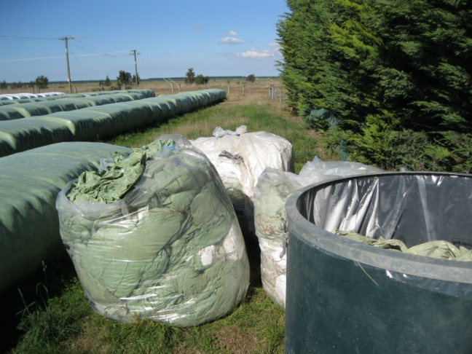 | 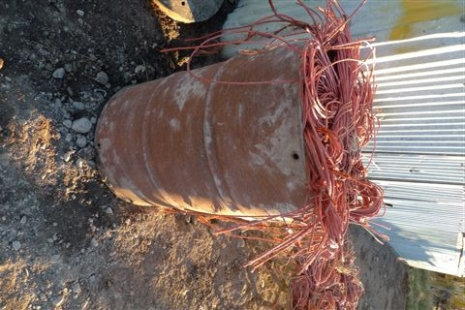
Photo credits: Environment Canterbury.
The Agrichemical Review proposed that the scope of a mandatory scheme be all chemicals which require ACVM registration and their containers. This would expand coverage to veterinary medicines and some farming disinfectants.
The Government proposes that the scope for a priority product declaration should be all chemicals which require ACVM registration and their containers.
The Government also proposes to support rural waste surveys in more regions and engage with rural plastic products suppliers, before addressing the option of priority product declaration for a wider scope of farm plastics at a later date.

Refrigerants and other synthetic greenhouse gases
Refrigerant gases are used in the cooling systems of refrigerators and freezers, heat pumps, and air conditioning systems in vehicles. While large volumes are used in commercial and industrial units they are also used in household appliances. The gases are not consumed during their use. They are either lost to the atmosphere through leaks, accidental or deliberate release, or collected for reuse or destruction.
Priority waste stream
evaluation criteria
Risk of harm ++
Resource inefficiency -
Voluntary unsuccessful +
Industry readiness ++
Current products +
New Zealand has committed to phasing out the importation and controlling wilful release of ozone depleting chemicals. Under the Ozone Layer Protection Act 1996 (OLPA), it is an offence to deliberately release the substances listed in the Act. Some of these substances have already been phased out and others are still in use.
Synthetic greenhouse gases (SGG) include these refrigerants, non-ozone depleting replacement refrigerants such as hydrofluorocarbons (HFCs), and some non-refrigerant synthetic gases. Under the Climate Change Response Act 2002 (CCRA) the wilful release of SGG from particular sources and activities is prohibited.
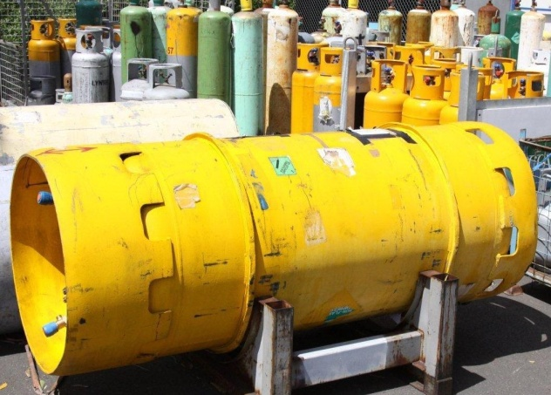 | 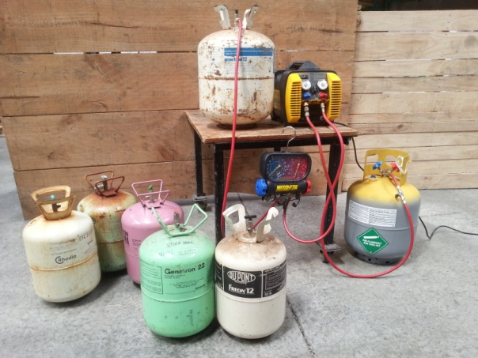
 | Photo credits: NZ Recovery.

Risk of environmental harm
There are three primary risks from poorly managed refrigerants and other SGGs:
- contribution to depletion of the ozone layer (ozone-depleting substances (ODSs),
eg chlorofluorocarbons (CFCs) and hydrochlorofluorocarbons (HCFCs).
- contribution to climate change (HFCs, perfluorocarbons (PFCs) and sulphur hexafluorine (SF₆ ) are very potent greenhouse gases)
- increased risk of fire from the use of flammable hydrocarbon refrigerants in some applications as HCFCs are phased out.
Even with low recovery rates, the current voluntary scheme has significant ozone layer and climate change benefits (73,000 tonnes of ozone saved and 55,000 tonnes of CO₂ equivalent captured over the past two years). This highlights the magnitude and risk of what is not captured by the scheme.
Similar issues for ozone depletion and climate change impact are posed by non-refrigerant synthetic greenhouse gases, such as those used in fire-fighting equipment (halons), fumigating imports and exports (methyl bromide), or electrical supply equipment (sulphur hexafluorine).

Waste minimisation benefits
Some waste refrigerants and other synthetic greenhouse gases can be recovered for reuse, as well as canisters used for gas storage. However, certain refrigerants must be safely destroyed and not put back into circulation. Reduction of harm is the primary rationale for selecting this waste stream as a priority.

Likelihood of effective management under a product stewardship scheme
Refrigerant and SGG recovery programmes are mandated in Japan, Australia, USA and Europe. Compared to New Zealand’s recovery rate of an estimated 5 per cent, their recovery rates are much higher, for example, Norway 40 per cent, Japan 56 per cent, and Australia up to 61 per cent.
The industry approached the Government in late 2012 seeking regulatory support to reduce free-riders and fund effective recovery. This would involve, for example, priority product declaration and a participation requirement for refrigerant importers and installers. Estimated prices per product passed onto consumers would vary by gas content. Preliminary estimates suggest a cost range of $2 per domestic refrigerator to $133 per refrigerated truck (about 0.3 to 0.5 per cent price increase).
An effective scheme would also need to be linked to training and certification of installers and other handlers of equipment using the target gases, certification of safely captured target gases, and public education.

Effectiveness of voluntary schemes to date
The Ozone Protection Company was established by wholesale refrigerant importers in late 1993, which evolved into the Refrigerants Recovery scheme which was accredited under the WMA as a voluntary product stewardship scheme in 2010. It is based on a voluntary product levy on imported bulk refrigerants and now covers the six major importers. Importers of smaller bulk amounts or pre-charged gas canisters, or downstream installers and refillers, have not joined and are not covered, although some do bring refrigerants in to the scheme to be destroyed. The scheme actively promotes an industry code of good practice to reduce risks of harm from refrigerants, but has found poor uptake and low levels of training in the industry.
The Ozone Layer Protection Act enables New Zealand to meet our international obligations under the Montreal Protocol. It guides a phase out of ozone depleting substances (ODS) through import and export controls and places legal obligations on ODS handlers to ensure the gases are not released to atmosphere.
The Ministry’s 2009 discussion document Waste Minimisation in New Zealand noted the then Ozone Protection Company’s recommendation that a levy be applied to all fluorine-based refrigerants which would cover the costs of the collection and safe destruction of these chemicals, and training for refrigeration engineers. It was acknowledged that this may require declaration of refrigerant gases as a priority product to ensure full coverage and/or other regulation to impose a levy.
During the review of the NZ Emissions Trading Scheme (ETS) in 2012, a submission from the major refrigerant industry association (Institute of Refrigeration Heating and Air Conditioning Engineers) requested a mandatory levy on SGGs to cover costs of safe collection and disposal.
The SGG levy came into effect on 1 July 2013 and provides a cost-effective method for SGG importers to participate in the NZ Emissions Trading Scheme. The SGG levy goes into the consolidated fund, and thus is not directly available to fund collection and destruction of waste refrigerants. New Zealand emission trading units are available to the Refrigerant Recovery scheme for their destruction of the gases, and they are registered to collect these. However, with low market prices for carbon, this is not sufficient to cover costs. Future allocation of the SGG levy for funding for safe SGG disposal is a potential option for consideration.
The voluntary accredited Refrigerants Recovery scheme estimates that about 5 per cent of available eligible refrigerants are being collected for safe disposal. The voluntary scheme for halon recovery operated by Halon Recycling (NZ) Ltd is not an accredited scheme and the Government does not have comparative data on halon collections.

What would be in scope?
As currently operating, the voluntary Refrigerant Recovery scheme covers refrigerant gases only. A number of SGGs are potent greenhouse gases and deplete ozone, but are not refrigerants. These include:
- halons – used in fire extinguishing equipment
- methyl bromide – used in fumigation for pests in traded goods
- sulphur hexafluorine (SF₆) – used in high voltage switchgear.
There are no formal collection systems in place for these gases to prevent loss to the atmosphere and ensure reuse or destruction.
If the intent of mandating product stewardship for refrigerants is to protect the ozone layer and reduce climate change, then logically non-refrigerant SGGs could be included in scope as well.
The synthetic greenhouse gas levy under the Climate Change Response Act is on containers or products that hold the gases, rather than the gases themselves. While this approach could also be used to define scope for product stewardship interventions, many containers are already recovered for refill and the primary risk is posed by the contents not the container. The range of products using ODSs and SGGs is wide, for example vehicle air conditioning units, fire extinguisher cartridges, fishing boat refrigeration units, and domestic heat pump units.
Another potentially complementary approach could be to expand the scope of mandated
e-waste product stewardship to include equipment that contains ODS and/or SGGs. For example, e-waste product stewardship in South Korea and Japan covers air conditioners and refrigerators.
The Government proposes that ‘ozone depleting and other synthetic greenhouse gases’ be the scope for declaration of priority products, rather than just ‘refrigerants’. This would include explicit specification of products or containers that contain these gases.

Priority product declaration consultation questions
Submissions are welcome on whether the necessary conditions can be met at this time for the declaration of priority products as proposed, and if not what other considerations are required.
Consultation question 2 – Priority product declaration
2a Do you think the Minister should declare any product groups as a priority product under the Waste Minimisation Act? If so, which ones?
2b If you support priority product declaration, what timing do you think is appropriate? Should it be done soon, or wait until all regulatory framework and scheme design options are explored in a future discussion document? Please explain your reasons why.
2c Please provide information to improve this assessment if you are able to. For example:
- any costs your business, industry or council may face if mandatory product stewardship schemes are required for priority products, and
- possible benefits that would arise from product stewardship for priority products.
2d The scope of any declaration of priority product (or regulations) would need to be defined. What products do you think should be covered?
Electrical and electronic equipment: Should New Zealand start with the same scope as Australia (TVs, computers, and computer peripherals) or include other electronic wastes as well? Please specify which e-waste you think most important to include, and why.
Tyres: Should the scope be all pneumatic (air filled) tyres: those for cars; motorcycles; trucks; buses; off-road vehicles; aircraft; and certain solid tyres (forklifts); but not bicycle tyres? Please specify which tyres you think most important to include, and why.
Agrichemicals and farm plastics: Should the scope be all chemicals which require an Agricultural Chemicals and Veterinary Medicines (ACVM) registration and their plastic containers? Should wider farm plastics (such as silage wrap, twine, crop protection netting) be included? Please specify which agrichemicals and farm plastics you think most important to include, and why.
Refrigerants and synthetic greenhouse gases: Should the defined product be containers holding the target gases, rather than the gases themselves? Do you agree that other synthetic gases which deplete ozone and contribute to climate change should be included? Please specify which gases you think most important to include, and why.

Next steps

How to make a submission
The Government welcomes your feedback on this discussion document. Anyone can make a submission on the matters raised.
Your submission may address any aspect of the discussion document, but we would appreciate you paying particular attention to the questions posed as a guide for your feedback. These questions appear at the end of the main chapters, and are collated at the end of this section. You may answer some or all of the questions.
The Government would also like to hear whether there are alternative proposals you think would better improve waste management and resource efficiency outcomes.
To ensure your point of view is clearly understood, you should explain your rationale and provide supporting evidence where appropriate.
There are three ways you can make a submission:
Use our online submission tool available at http://consultation.mfe.govt.nz/content/priority-waste-products-product-stewardship-intervention.
- Download a writable version of the submission form to complete and return to us.
- This is available at www.mfe.govt.nz/publications/waste/priority-waste-streams-may14/index.html. If you do not have access to a computer, the Ministry can post or fax a copy of the submission form to you.
- Prepare your submission in a separate document.
Please ensure you provide the following information with your submission:
- contact information:
- name of submitter/organisation
- address
- telephone
- email
- the title of the discussion document
- your submission, with reasons for your views
- any further information you wish the Minister for the Environment to consider.
The Ministry asks that electronic submissions be submitted as a PDF, Microsoft Word document (2003 or later version), or other compatible format.
The closing time and date for submissions is 5:00pm on 2 July 2014.
After receiving submissions, the Ministry will evaluate them and may, where necessary, seek further comments. After this, policy recommendations would be developed for the Minister, and then Cabinet, to consider.

Contact for queries and lodging submissions
Please direct all submissions and any queries to:
Freephone: 0800 499 700
Phone: +64 4 439 7400
Facsimile: +64 4 439 7700
Email: waste@mfe.govt.nz
Postal: Priority Waste Streams Consultation, Ministry for the Environment, PO Box 10362,
Wellington 6143

Publishing and releasing submissions
The Ministry may publish all or part of any written submission on its website, www.mfe.govt.nz. Unless you clearly specify otherwise in your submission, the Ministry would consider that you have consented to website posting.
Contents of submissions provided to the Ministry may have to be released to the public under the Official Information Act 1982 following requests to the Ministry (including via email). Please advise if you have any objection to the release of any information contained in a submission, and, in particular, which part(s) you consider should be withheld, together with the reason(s) for withholding the information. The Ministry would take into account all such objections when responding to requests for copies of, and information on, submissions to this document under the Official Information Act.
The Privacy Act 1993 establishes certain principles with respect to the collection, use and disclosure of information about individuals by various agencies, including the Ministry. It governs access by individuals to information about themselves held by agencies. Any personal information you supply to the Ministry in the course of making a submission would be used by the Ministry only in conjunction with the matters covered by this document. Please clearly indicate in your submission if you do not wish your name to be included in any summary of submissions that the Ministry may publish.

What happens next
Submissions will be collated and summarised, and the Minister will decide the nature and timing of the next steps. A summary of submissions will be posted on the Ministry website, www.mfe.govt.nz.
This discussion document is designed to look at the selection of product stewardship priorities and the possibility of priority product declaration for them. It is not designed to determine the precise form of any mandated scheme. This could be set by regulations, guided by gazetted scheme guidance, or decided by industry if priority product declaration is made without regulations or gazetted scheme guidance.
If the Minister decides to declare any priority products, this is done through notice in the Gazette. Declaration of priority product brings with it a requirement to develop and gain accreditation for a product stewardship scheme. Such a scheme could be developed in association with, or independently of, regulations set under the Waste Minimisation
Act (WMA).
If the Government decides to proceed with considering regulatory options, further consultation will be undertaken with potentially affected parties. At this stage options will be explored and more detail on the status quo, successful international models, and cost-benefit analysis will be provided. Final decisions would be made by Cabinet.

Summary of questions for consultation
The consultation questions are only a guide and all comments are welcome.
Consultation question 1 – Priority waste streams
1a The following waste stream criteria are being proposed:
- risk of harm
- resource efficiency opportunities
- voluntary measures insufficient
- industry readiness
- current producers (not just legacy products).
Do you agree that these waste stream evaluation criteria are suitable to select product stewardship priorities, consistent with WMA objectives? If not, please suggest alternatives.
1b Do you agree with the assessment of waste streams against these criteria in Appendix 4? If not, please provide information or propose improvements.
1c The following four product groups have been identified by the Government as priorities at this time:
- electrical and electronic equipment
- tyres
- agrichemicals and farm plastics
- refrigerants and other synthetic greenhouse gases.
Do you agree that these four product groups should be a priority for the Government to consider regulatory interventions? Do you think others should be included? Why or why not?
1d Do you have or know of any other information that can improve this assessment? If so, please advise.
Consultation question 2 – Priority product declaration
2a Do you think that the Minister should declare any product groups as priority product under the Waste Minimisation Act? If so, which ones?
2b If you support priority product declaration, what timing do you think is appropriate? Should it be done soon, or wait until all regulatory framework and scheme design options are explored in a future discussion document? Please explain your reasons why.

2c Please provide information to improve this assessment if you are able to. For example:
- any costs your business, industry or council may face if mandatory product stewardship schemes are required for priority products, and
- possible benefits that would arise from product stewardship for priority products.
2d The scope of any declaration of priority product (or regulations) would need to be defined. What products do you think should be covered?
- Electrical and electronic equipment: Should New Zealand start with the same scope as Australia (TVs, computers, and computer peripherals) or include other electronic wastes as well? Please specify which e-waste you think most important to include, and why.
- Tyres: Should the scope be all pneumatic (air filled) tyres: those for cars; motorcycles; trucks; buses; off-road vehicles; aircraft; and certain solid tyres (forklifts); but not bicycle tyres? Please specify which tyres you think most important to include, and why.
- Agrichemicals and farm plastics: Should the scope be all chemicals which require an Agricultural Chemicals and Veterinary Medicines Act (ACVM) registration and their plastic containers? Should wider farm plastics (such as silage wrap, twine, crop protection netting) be included? Please specify which agrichemicals and farm plastics you think most important to include, and why.
- Refrigerants and synthetic greenhouse gases: Should the defined product be containers holding the target gases, rather than the gases themselves? Do you agree that other synthetic gases which deplete ozone and contribute to climate change should be included? Please specify which gases you think most important to include, and why.

Appendix 1: Legislative framework

Waste Minimisation Act
The purpose of the Waste Minimisation Act 2008 (WMA) is to encourage waste minimisation to protect the environment from harm and obtain environmental, economic, social and cultural benefits. Additionally, the purpose of the product stewardship section of the WMA is to encourage (and, in certain circumstances, require) the people and organisations involved in the life of a product to share responsibility for:
- ensuring there is effective reduction, reuse, recycling or recovery of the product
- managing any environmental harm arising from the product when it becomes waste.
The WMA introduced tools including waste management and minimisation plan obligations for territorial authorities, a waste disposal levy to fund waste minimisation initiatives at local and central government levels, and regulatory powers for products and product stewardship for specified ‘priority products’.
A national strategy was published in October 2010, The New Zealand Waste Strategy – Reducing harm, improving efficiency. This set the WMA in the wider context of the legislative toolkit available to manage and minimise waste and proposed a focus on wastes that pose the highest risk or provide opportunities to improve resource efficiency.

Other legislation
Legislation in addition to the WMA which relates to waste management and/or reduction of harm or improved resource efficiency from waste products includes the Local Government Act 2002, Resource Management Act 1991, Hazardous Substances and New Organisms Act 1996, Ozone Layer Protection Act 1996, Climate Change Response Act 2002, and the Agricultural Chemicals and Veterinary Medicines Act 1997.
The key functions relating to waste and waste products of the above pieces of legislation are set out on the following page.

Appendix 2: Indicative process – product stewardship decisions
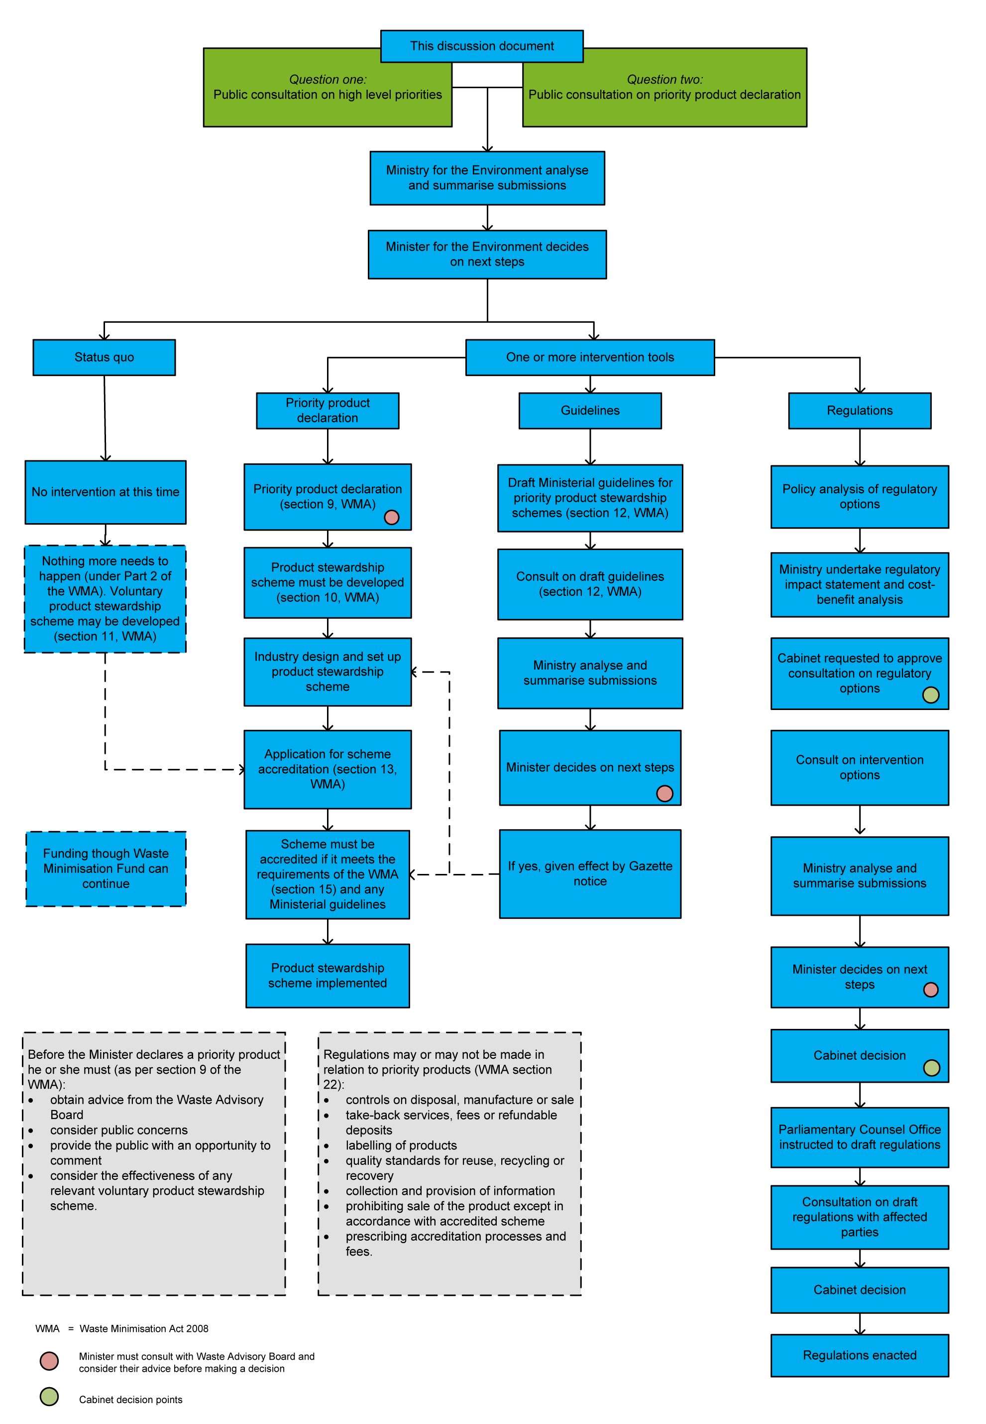

Appendix 3: Accredited voluntary product stewardship schemes
Accredited scheme  (date accredited) and scope of scheme | Waste diverted – tonnes/ year (from latest annual report) | Reduction in targeted waste stream | Total waste diverted since accreditation – tonnes  (up to latest annual report)
Holcim / Geocycle Used Oil Recovery Programme (December 2008)  Used oil collected and used as fuel at cement plant | 12,016 a | 36% | 34,707ª
R.O.S.E. (Recovery of Oil Saves the Environment) (June 2011)  Collection of waste oil for use as a fuel | 12,016 a | 36% | 34,707ª
Glass Packaging Forum (May 2010)  Levy collected from companies that make, import, fill or sell glass containers. Fund for projects related to diversion of glass packaging from landfill | 20,549 | 7% | 41,752
Plasback (May 2010)  Agricultural plastics collection (eg, silage wrap, drums, vine netting, sacks) | 850 | 9% | 2,039
Agrecovery Rural Recycling Programme (September 2010)  Collection of waste agrichemicals and their containers | 182.3 plastic  15.9 chemicals | 28.8% plastic  26% chemicals | 475.8 plastic  42.4 chemicals
Refrigerant Recovery (September 2010)  Collection of ozone depleting and global warming potential refrigerant gases from refrigeration and air conditioning industries | 34.4 | 3% | 101
Resene Paintwise (April 2011)  Collection of waste paint and their containers, creating new products for reuse of paint and recycling containers | 147ª | 6% | 261
ReEntry (May 2013)  Collection of Interface carpet tiles for reuse and remanufacturing | Recently accredited – no reported data
EnviroComp (September 2013)
Disposable nappy collection and composting – Christchurch and Wellington
Public Place Recycling – Glass Packaging Forum (October 2013)
Recycling bins in public places to offer a recycling option for away-from-home wastes
Milk in Schools – Fonterra (October 2013)
Collection and recycling of Tetrapack packaging from milk in schools programme
TOTALS rounded | 33,795 |  | 79,378
Indicative proportion of annual national waste generation  Annual waste to landfills that pay the waste levy = 2.5 million tonnes  This does not include waste deposited in industrial landfills, cleanfills, or farm dumps | 1.4%
Waste diversion and targeted waste streams data is as reported by the scheme in their annual reports. The estimated diversion is compared to the amount of waste going to official landfills which pay the landfill levy under the WMA. The waste in question may however go elsewhere, for example, farm wastes may be placed in farm pits or burnt.
ª Proxy factor for conversion of liquid waste litres to tonnes generally is: 1000 litres per tonne (1 kg per litre). The R.O.S.E. scheme uses a factor of 0.91 kg/litre. The two oil schemes’ data is combined on request to provide some commercial confidentiality.

Appendix 4: Assessment of waste streams for potential product stewardship intervention
Waste stream | Waste stream evaluation criteria
Waste stream | Risk of harm | Resource efficiency opportunity | Voluntary measures insufficient | Industry readiness | Current products^{c}
Agrichemicals and containers | ++ | + | ++ | ++ | +
Refrigerants and other SGGsª | ++ | – | ++ | ++ | +
E-waste | ++ | ++ | ++ | ++ | +
Tyres | + | ++ | ++ | ++ | +
Used motor oil | ++ | ++ | + | ? | +
Other farm plastics | + | ++ | + | ? | +
End-of-life vehiclesª | + | ++ | + | + | +
Contaminated soil | ++ | – | ++ | – | –
Industrial hazardous wastes | ++ | ? | + | ? | +
Primary sector hazardous wastes | ++ | ? | + | ? | +
CCA treated timber (copper chrome arsenic) | ++ | + | ++ | ? | +
Asbestos | ++ | – | + | – | –
Medical waste | ++ | – | + | ? | +
PCBs (polychlorinated biphenyls) | ++ | – | + | – | –
Paint | ++ | + | ++ | ? | +
Batteries | ++ | + | ++ | ? | +
Construction and demolition wastes | + | ++ | + | ? | +
Nappies and sanitary^{b} | + | ? | ++ | ? | +
Primary sector organic waste^{b} | + | ++ | + | ? | –
Household organic waste^{b} | + | ++ | ++ | – | –
Biosolids (sewage sludge)^{b} | + | ++ | ++ | ? | –
Lamps containing mercury | + | + | ++ | ? | +
Commercial greenwaste^{b} | + | ++ | + | ? | –
Packaging | - | ++ | ++ | –^{d} | +
++ very high/definitely + high/probably – no, or not applicable ? unknown
As New Zealand’s waste data is incomplete, this assessment is qualitative rather than quantitative.
ª End-of-life vehicles can include a range of wastes (eg, metals, plastics, tyres, oil, solvents, refrigerants from air conditioning, mercury-containing switches, e-waste). The current value of scrap steel incentivises good recovery of waste vehicles but treatment of hazardous liquids and solid residuals (flock) is very poor.
^{b} The risk from organic wastes going to landfill is the generation of methane (a greenhouse gas) from decomposition in the absence of oxygen, and loss of nutrients and humus which otherwise could maintain soil health.
^{c} If waste streams are not derived at least in part from current products, then product stewardship is unlikely to be effective.
^{d} The packaging industry in New Zealand has consistently opposed mandatory product stewardship for packaging.

Appendix 5: Tests for WMA product stewardship intervention
WMA test | ‘Priority product’ declaration  WMA s9 | Guidelines for priority product schemes  WMA s12 | Regulations: priority products and accredited schemes  WMA s22 | Regulations: products materials, and waste  WMA s23
The product will or may cause significant environmental harm when it becomes waste. | s 9(2)(a)
There are significant benefits from reduction, reuse, recycling, recovery, or treatment of the product. | s 9(2)(a)
The product can be effectively managed under a product stewardship scheme. | s 9(2)(b)
The effectiveness of any relevant voluntary product stewardship scheme in terms of s 9(2) criteria has been considered. | s 9(3)(d)
The public has had an opportunity to comment on the proposal. | s 9(3)(c)
Public concerns about environmental harm associated with the product when it becomes waste (including concerns about its disposal) have been considered. | s 9(3)(b)
Advice of the Waste Advisory Board has been obtained and considered. | s 9(3)(a) | s 12(4)(a) | s 22(2)(a) | s 23(3)(a)
Adequate consultation has occurred with persons or organisations that may be significantly affected. |  | s 12(4)(b) | s 22(2)(b)(i) | s 23(3)(b)(i)
Benefits expected from implementing the regulations exceed the costs expected from implementing the regulations. |  |  | s 22(2)(b)(iii) | s 23(3)(b)(ii)
The regulations are consistent with New Zealand’s international obligations. |  |  | s 22(2)(b)(iv) | s 23(3)(b)(iii)
Without the regulations, the objectives of any relevant accredited scheme, or reductions in harm or waste minimisation from the scheme, or scheme guidelines published under the WMA cannot be met. |  |  | s 22(2)(b)(ii)
For disposal controls – that adequate infrastructure and facilities are in place to provide a reasonably practicable alternative to disposal or, if not, that a reasonable time is provided before the regulations come into force for adequate infrastructure and facilities to be put in place. |  |  |  | s 23(2)(a)
For product sale controls – that a reasonably practicable alternative to the specified materials is available. |  |  |  | s 23(2)(b)

Disposal facilities are defined under section 7 of the WMA. They are facilities, including landfills, at which waste is disposed of which includes household wastes and which operate at least in part as a business. Under the WMA disposal facilities are subject to a waste disposal levy and tonnage reporting requirements.
PCBs are one of the persistent organic pollutants (POPs) declared under the Stockholm Convention. Mercury is one of a group of toxic metals (including lead, arsenic and chromium) which can also persist in the food chain.
Office of the Auditor General 2007, Performance Audit Report: Waste Management Planning by Territorial Authorities. Retrieved from www.oag.govt.nz/2007/waste-management.
Ministry for the Environment. 2009. Waste Minimisation in New Zealand; 2010, Waste Minimisation in New Zealand Discussion Document Summary of Submissions. Wellington: Ministry for the Environment.
Ministry for the Environment. 2005. Discussion Document: Product Stewardship and Water Efficiency Labelling. Wellington: Ministry for the Environment and Ministry for the Environment. 2006. Product Stewardship and Water Efficiency Labelling: New Tools to Reduce Waste – Summary of Submissions. Wellington: Ministry for the Environment.
This estimate is arrived at by multiplying a per person e-waste generation rate from studies in Europe, the United Kingdom, Denmark, Germany, and the USA (16 to 19 kilograms per person per year) by the estimated resident New Zealand population in January 2014.
This is thought to come from breathing in or ingesting BFRs in dust, which can arise in indoor environments from in-use products such as electrical and electronic equipment, carpets, and upholstery. Waste products are not thought to be the major source of BFRs in humans in New Zealand.
United Nations Environment Programme (UNEP). 2011. Decoupling natural resource use and environmental impacts from economic growth: a report of the working group on decoupling to the International Resource Panel. Retrieved from www.unep.org/resourcepanel/decoupling/files/pdf/ Decoupling_Report_English.pdf.
Organisation for Economic Co-Operation and Development (OECD). 2007. OECD Environmental Performance Reviews: New Zealand.
Consumer Electronics Association of New Zealand. Unpublished. Product Stewardship New Zealand Televisions: The Proposed Advance Fee Scheme to Fund Recycling and Recovery of Televisions in the New Zealand Market.
IT brand members of the TV IT Product Stewardship (TVITPS) Working Group. Unpublished. The Proposed Scheme for Recycling and Recovery of Information Technology Products in the New Zealand Market.
Roughly equivalent to the TV TakeBack subsidy per TV in 2012–2014.
Tyrewise Working Group. 2012. Investigation into the collection and disposal of used tyres in New Zealand and internationally. Retrieved from http://www.tyrewise.co.nz/wp-content/uploads/2012/06/Tyrewise-Scoping-Report-1-Current-ELT-Situation-V3.pdf.
Waste tyres are also termed ‘end-of-life tyres’, or ELT.
Retrieved from www.mfe.govt.nz/publications/waste/tyre-storage-enforcement-action-jul04/html/page14.html.
US Environmental Protection Agency. 1997. Air Emissions from Scrap Tire Combustion. Retrieved from http://www.epa.gov/ttn/catc/dir1/tire_eng.pdf.
Retrieved from: www.mfe.govt.nz/publications/waste/management-end-of-life-tyres-jan04, (pages 6, 11); Gardiner. 2011. The Taming of Mt Tyre, paper presented at WasteMINZ Conference, Rotorua, 5–7 October 2011 www.mwhglobal.com/files/1913/1895/3895/WasteMINZ_paper_L_Gardiner_FINAL_21-9-11.pdf; www.stuff.co.nz/business/industries/8187432/Waikatos-million-tyre-mountain; www.nzherald.co.nz/wanganui-chronicle/ news/article.cfm?c_id=1503426&objectid=11106598; www.radionz.co.nz/news/regional/224897/volunteers-remove-600-tyres-from-nelson-estuary.
MWH. 2004. End-of-Life Tyre Management: Storage Options. Final report for the Ministry for the Environment. http://www.mfe.govt.nz/publications/waste/end-of-life-tyre-management-jul04/.
Working party reports are available on www.tyrewise.co.nz/milestones. The working party included major tyre importers and retailers, vehicle importers, the Motor Trade Association, a large fleet manager, local government, and two representatives from the New Zealand Tyre Recyclers and Collectors Association.
Five per cent of current Agrecovery collections, 15.5 tonnes over 2010–2012, have been POPs covered by the Stockholm Convention, including legacy POPs such as DDT and dieldrin and more recent POPs such as the insecticide endosulphan (see http://chm.pops.int/TheConvention/ThePOPs).
URS and NZEIR. 2003. Life Cycle Analysis of the Management of Waste Farm Plastics and Economic Analysis of Waste Farm Plastic Management Options. Prepared for the Ministry for the Environment.
Retrieved from http://ecan.govt.nz/publications/Reports/NNRW-survey-summary-report-2013.pdf.

