Managing our oceans

A discussion document on the regulations proposed under the Exclusive Economic Zone and Continental Shelf (Environmental Effects) Bill

This report may be cited as:

Ministry for the Environment. 2012. Managing our oceans: A discussion document on the regulations proposed under the Exclusive Economic Zone and Continental Shelf (Environmental Effects) Bill. Wellington: Ministry for the Environment.

Published in May 2012 by the
Ministry for the Environment
Manatū Mō Te Taiao
PO Box 10362, Wellington 6143, New Zealand

ISBN: 978-0-478-37277-9 (print)
978-0-478-37279-3 (electronic)
Publication number: ME 1090
© Crown copyright New Zealand 2012
This document is available on the Ministry for the Environment’s website:
www.mfe.govt.nz



Acknowledgements
The Iwi Chairs Forum oil and gas technical team engaged with the Ministry for the Environment during the preparation of this discussion document. We would like to acknowledge their valuable work and time put into this process. The proposals presented in this discussion document do not necessarily represent the position of the Iwi Chairs Forum.

Photo Credits

Cover images (small) by Cornel de Ronde, GNS Science. From left: (1) Launch of Pisces V Submarine, Kermadec Arc; (2) Viewing underwater at the Kermadec Trench; and (3) Calder site, Brothers Volcano.

Part three title page image by Kareen Schnabel, NIWA. Scientists on the deck of NIWA research vessel Tangaroa launch the WHOI underwater camera system during investigations of mineral deposits and hydrothermal systems in the Kermadec Arc.

Contents
Acknowledgements iii
Foreword vii
Executive Summary ix
Part One: Introduction and proposed policy framework 1
1 Background and context 3
2 Current situation and future potential 6
3 Issues and objectives 9
4 Assessment criteria 11
5 Net impact of the proposals 18
Part Two: Proposals for regulations: classifying activities and cost recovery 23
6 Grouping activities for assessment 26
7 How conditions for permitted activities are considered 29
8 Seismic surveying 32
9 Submarine cabling 38
10 Marine scientific research 43
11 Oil and gas 52
12 Seabed mining 62
13 Summary of proposed permitted and discretionary activities 74
14 Cost recovery 75
15 Implementation 80

Part Three: Making a submission 83
16 Making a submission 85
17 Consultation questions 86
References 91
Appendices 92

Figures
Figure 1: Extent of New Zealand’s territorial sea, EEZ and continental shelf 3
Figure 2: Overview of legislation for New Zealand’s oceans 7
Figure 3: Assessment criteria for classifying activities 11
Figure 4: Illustration of a seismic surveying operation 32
Figure 5: Phosphorite nodules: dark, gravel-sized nodules exposed on the Chatham Rise seafloor, with feathery starfish, deepwater corals and small clumps of brachiopods. Source: NIWA, 2012. 63

Tables
Table 1: A description of how the assessment criteria relate to the objectives 12
Table 3: Summary of the types of costs and benefits associated with different classifications 18
Table 2: Assessment of options for grouping activities for assessment 27
Table 4: Summary of proposed permitted and discretionary activities 74
Table 5: A comparison of international environmental marine management regimes 98

Foreword
The Government is working to put in place a regulatory regime to manage the environmental effects of activities in New Zealand’s exclusive economic zone (EEZ). This work includes the new legislation that is currently before Parliament and the regulatory proposals in this discussion document.

The zone concerned covers an area 20 times the size of New Zealand’s land area. It includes 400 million hectares of EEZ and 170 million hectares of extended continental shelf, and spans the subtropics to the subantarctic.

This huge area supports our $1.53 billion-a-year fishing industry and is the conduit for 99 per cent of our exports and imports. It is also an area of increased interest for minerals development as new technologies develop and the demand for resources grows globally.

The measures proposed for the new regulatory regime are designed to cover unregulated activities beyond the 12 nautical mile jurisdiction of the Resource Management Act 1991 (RMA). It is not intended to duplicate controls that regulate the fishing industry, maritime transport, the allocation of petroleum resources, and our response to oil spills. As we have seen from the Rena incident, oil spills are already regulated and managed under the Maritime Transport Act, and are not regulated by the proposed new legislation or the regulations outlined in this document.

The new law and regulations are focused on activities with limited environmental regulations such as seabed mining and the construction of structures for oil and gas exploration, seismic surveying and cable laying. The proposals contained in this document have been carefully designed to ensure a balanced approach. The aim is to maximise the economic opportunities while minimising the environmental risks.

The EEZ legislation provides a regulatory framework for classifying certain activities as permitted, discretionary or prohibited. This classification will depend on the potential environmental risks and impacts of the activity involved. Marine consent applications will be considered by the Environmental Protection Authority.

The Government has already put in place voluntary measures that are providing environmental protection in the interim. Once passed by Parliament, the EEZ legislation will come into effect after a complete set of regulations is developed. In order to retain the momentum on this important initiative, I have taken the step of releasing this discussion document to seek your views on the details of the proposed regulations in parallel with the progress of the Bill through the Parliamentary process. Your feedback is important. You have here an opportunity to shape and improve the proposed regulations so that we all benefit: the environment, the economy and New Zealand.

I encourage you to have your say.

Hon Amy Adams
Minister for the Environment

Executive Summary
New Zealand’s ocean area is 20 times the size of its land mass and is one of the largest of any nation. There are opportunities and responsibilities that go with being a globally significant maritime nation, particularly as our ocean resources are coming under increased development pressure from a growing global population, depletion of resources on land, and advances in technology that are making ocean resources more accessible.

Part One: Introduction and proposed policy framework

Purpose
The purpose of this discussion document is to seek feedback and gather information on proposals for regulations under the Exclusive Economic Zone and Continental Shelf (Environmental Effects) Bill (the Bill). Feedback is sought across the following two key areas:
- the proposed policy framework
- proposals for regulations: classifying activities and cost recovery of some of the Environmental Protection Authority’s functions.

Context for change
Current levels of activity in New Zealand’s EEZ and continental shelf are relatively low compared to its size. However, such activities are likely to increase with advances in technology and as cost barriers diminish. There are significant economic opportunities for New Zealand from minerals and oil and gas development in the EEZ, but these opportunities need to be taken in an environmentally responsible way.

The Resource Management Act 1991 (RMA) regulates natural resource management activities on land and in the territorial sea out to 12 nautical miles. Fishing and shipping are already regulated. However, beyond 12 nautical miles New Zealand historically has had limited or no means to assess and regulate the environmental effects of other activities such as seabed mining, oil and gas development, scientific research, and the laying of submarine cables.

The issue
These gaps in the environmental management regime mean there are no statutory processes in place to assess environmental effects and grant approval for some activities. As a result, there is the potential for unregulated activities to cause environmental harm, affecting marine life, habitats and biodiversity.

Existing framework to address the issue: EEZ Bill
The Bill will establish the general framework for the EEZ regulatory system and allow the classification of activities to be set out in regulations as permitted, discretionary or prohibited. As a gap-filling environmental management regime, the Bill and regulations will not duplicate existing legislation. The environmental effects of activities already regulated by other legislation, such as fishing and shipping activity, will not be in the scope of the proposed regulations.

Submissions on the Bill have been heard by the Local Government and Environment Select Committee. The Bill is currently going through the Parliamentary process and is not being consulted on through this discussion document. Policy proposals for the EEZ regulations are being released before the Bill has passed through Parliament to provide further detail on how the regulatory regime may be implemented. Since the Bill is subject to change through the Parliamentary process this may affect the policy proposals and drafting of the final regulations.

EEZ regulations
The Bill will establish an environmental consenting regime for activities in the EEZ and will enable the detail to be set through regulations. The proposals in this discussion document set out the proposed content for these regulations. Regulations will classify activities as:
- permitted – able to be undertaken as of right following notification to the Environmental Protection Authority (EPA) and compliance with any relevant conditions set in regulations, or
- discretionary – able to be undertaken if a marine consent has been granted by the EPA, or
- prohibited – unable to be undertaken under any circumstances.

The proposed regulations focus on activities that are currently occurring in the EEZ or are likely to occur there in the next five years. The proposed regulations are designed to fill the gap of unregulated environmental effects of activities beyond the 12 nautical mile jurisdiction of the RMA. They are not intended to duplicate controls that regulate the fishing industry, maritime transport or the allocation of petroleum resources, and our response to oil spills. The default setting in the Bill is that all activities are discretionary unless permitted or prohibited through regulations.

This discussion document also sets out how the EPA will recover its costs.

Proposed policy framework for regulations
To address the issues set out above, any preferred options for classifying activities in the EEZ regulations must take into account the considerations in the Bill. They should also contribute to achieving the following objectives:
- adverse environmental effects are effectively managed
- New Zealand acts within its rights and fulfils its obligations under relevant international law, such as the United Nations Convention on the Law of the Sea (UNCLOS)
- classifications and conditions are cost effective, with the cost to government and users proportional to the level of environmental effect being addressed
- non-environmental impacts, including on existing interests, iwi and other matters set out in the Bill, are effectively managed.

In this document the following criteria are used to assess whether an activity should be classed as permitted, discretionary or prohibited.

Proposal to assess appropriate classifications
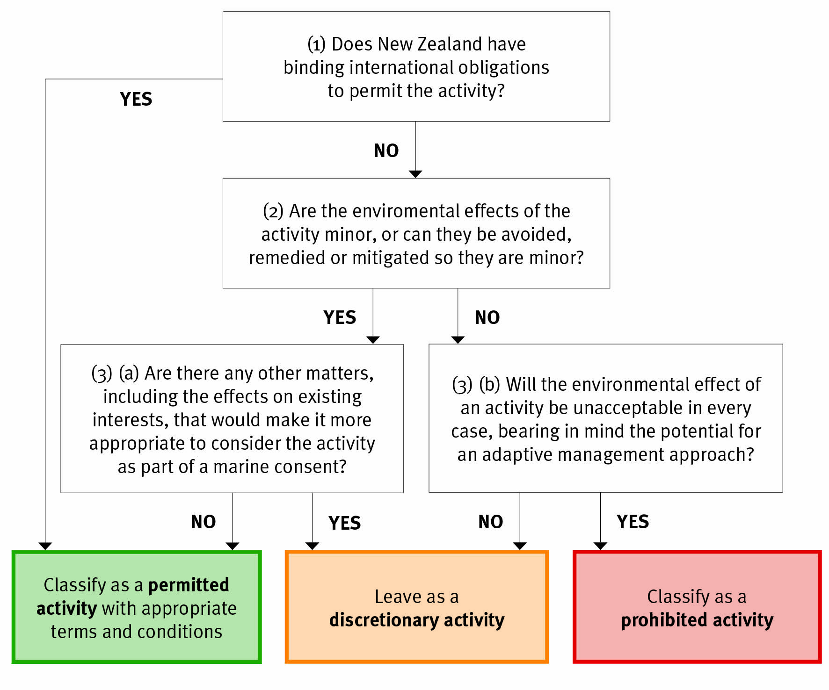

Part Two: Proposals for regulations: classifying activities and cost recovery

Classification of activities
After applying the above assessment criteria to the activities currently occurring or likely to occur in the EEZ over the next five years, the following activities are proposed to be permitted with conditions:
- seismic surveying
- submarine cabling
- marine scientific research
- prospecting for oil and gas
- prospecting for seabed mining.

This means that the following activities are left as discretionary (ie, they require a marine consent before commencing the activity):
- any permitted activity that is conducted outside the thresholds set by the conditions on permitted activities
- activities relating to exploration, production and decommissioning for oil and gas and seabed mining.
There are no activities proposed to be prohibited at this time because of the limited information available on the environmental effects of some industries. It would be pre-emptive to prohibit any of these activities before the methods to implement them have been fully developed, tested and monitored through an adaptive management programme.

The package of classifications will result in a low-cost, low-risk regime. This is because the majority of activities assessed are proposed to be permitted. The administrative cost associated with a permitted activity is relatively low. Activities can only be permitted if they have minor environmental effects and therefore carry a low level of risk.

The classifications that are proposed in this document are in line with the level of risk management and regulatory controls implemented by other nations.

Cost recovery
The discussion document also proposes that the EPA recover its costs for administering the regime through a mix of refundable deposits, hourly rates and other actual and reasonable costs.
The EPA has two funding avenues available to it: funding from the Crown, and provisions in the Bill for it to directly recover costs from those to whom it provides services.

The EPA may only recover costs where there is a direct (eg, pre-application assistance) or partial (eg, monitoring of marine consent conditions) private benefit. Where there is only a public benefit (eg, enforcement), these costs must be covered by the Crown. (The framework within which charges are to be set across the EPA’s functions is set out in chapter 15 of this discussion document.)

Part Three: Making a submission

Written submissions
The Ministry for the Environment welcomes written submissions on the policy proposals for the EEZ regulations. These are due by 5pm on Wednesday 20 June 2012.

You must send your submission to the Ministry for the Environment either by:
- completing the online feedback form at www.mfe.govt.nz/issues/oceans/eez-regulations-consultation
- emailing it to EEZregulations@mfe.govt.nz, or
- posting it to:
Submission on proposed EEZ regulations policy proposals
Ministry for the Environment
PO Box 10362
Wellington 6143.

Following analysis of the written submissions and iwi engagement, the Ministry for the Environment will prepare a report with recommendations on the regulations for the Minister for the Environment, including a regulatory impact statement. If the Minister approves development of the EEZ regulations, the final proposal will be prepared and presented to Cabinet to seek approval to draft regulations. The Minister may consider releasing an exposure draft of the regulations. Final regulations will be signed by the Governor General and published in the New Zealand Gazette.

Part One: Introduction and proposed policy framework

Contents – Part One
1 Background and context 3
1.1 Overview 3
1.2 Purpose 4
1.3 Scope of the proposals 4
2 Current situation and future potential 6
2.1 Context for change 6
2.2 History of environmental management in the EEZ 6
2.3 Gaps in the management of environmental effects in the EEZ 8
3 Issues and objectives 9
3.1 Issue: potential for unregulated activities to cause environmental harm 9
3.2 Existing framework to address the issue: EEZ Bill 9
3.3 EEZ regulations 9
3.4 Objectives 10
4 Assessment criteria 11
4.1 Alignment of criteria with objectives and the Bill 12
5 Net impact of the proposals 18
5.1 Costs and benefits of different classifications 18
5.2 Net impact of proposed assessment criteria 19

Background and context

1.1 Overview
New Zealand’s ocean area is 20 times the size of its land mass and is one of the largest of any nation. There are opportunities and responsibilities that go with being a globally significant maritime nation, particularly as our ocean resources are coming under increased development pressure from a growing global population, depletion of resources on land, and advances in technology that are making ocean resources more accessible.

The Exclusive Economic Zone and Continental Shelf (Environmental Effects) Bill (the Bill) will set up a legislative framework for managing the environment beyond the territorial sea, covering the 400 million hectares in the exclusive economic zone (EEZ) and the 170 million hectares on the continental shelf (figure 1).

Figure 1: Extent of New Zealand’s territorial sea, EEZ and continental shelf
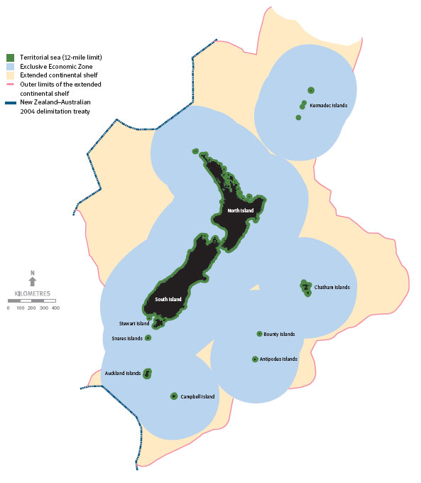

Source: National Institute of Water and Atmospheric Research

The Bill will establish regulations that set out the technical detail of the regime, including how activities are classified (ie, whether activities should be classified as permitted, discretionary or prohibited; see section 1.3 for more information on this). The policy proposals contained in this discussion document are the first step in developing these regulations.

Purpose
The purpose of this discussion document is to seek feedback and gather information on proposals for regulations under the Bill. Questions are inserted throughout the discussion document to seek your feedback across the following two key areas (discussed in Parts 1 and 2):
- the proposed policy framework
- proposals for regulations: classifying activities and cost recovery of some of the EPA’s functions.

Part 3 sets out how to make a submission.

1.3 Scope of the proposals
Once the Bill has been passed by Parliament, regulations will bring it into force. The Bill (Part 2, Subpart 1) sets out what regulations can be made. These include regulations to:
- prescribe standards, methods or requirements, forms, and amounts of charges payable
- classify activities, and areas of the EEZ or continental shelf, and activities.

The scope of the proposals in this discussion document is for regulations:
- to classify activities as:
- permitted – able to be undertaken as of right following notification to the Environmental Protection Authority (EPA) and compliance with any relevant conditions set in regulations, or
- discretionary – able to be undertaken if a marine consent has been granted by the EPA (see Appendix 2 for information on the consent process), or
- prohibited – unable to be undertaken under any circumstances
- to set out how the EPA will recover its costs.

Note that the classifications presented above are prescribed in the Bill and are not for consultation. The default setting of the Bill is that all activities are discretionary unless permitted or prohibited through regulations.

The full range of regulatory tools provided in the Bill have not been considered at this stage, given the limited information on the baseline environment in the EEZ and the limited number of activities that currently occur in the EEZ and are likely to occur in the next five years.

Subsequent regulations may be considered, as more information becomes available, on:
- sensitive ecosystems and habitats
- new and emerging activities in the EEZ
- closures of areas in the EEZ under other legislation to activities also regulated by the Bill
- standard terms and conditions that could be applied to discretionary activities.
Monitoring and review processes for the regulatory regime are currently being developed. They will ensure that as more information becomes available and technologies develop, so does the regulation of activities.

On 3 October 2011, Cabinet approved policy proposals to transfer the regulation of discharges from offshore installations and dumping in the EEZ and continental shelf from Maritime New Zealand (under the Maritime Transport Act 1994) to the EPA (under the Bill). This is not currently reflected in the Bill and will require changes to the Bill through the Parliamentary process. Following the transfer of functions, the Maritime Transport Act will continue to regulate, and Maritime New Zealand continue to be responsible for, marine oil spill contingency planning, preparedness and response, and discharges from ships.

Current situation and future potential
In order to assess and comment on the proposed regulations, it is important to understand the current environmental management regime in the EEZ. This section outlines the context for change, including what legislation is in place to manage the environmental effects in the EEZ (before the EEZ Bill becomes law) as well as the gaps.

Context for change
Current levels of activity in the EEZ and continental shelf are relatively low compared to its size. About 30 per cent of New Zealand’s marine environment is thought to experience some degree of disturbance from human activities (Ministry for the Environment, 2007), but the levels of activity are likely to be lower in the EEZ compared to New Zealand’s coastal waters. Fishing and shipping are the predominant uses of the EEZ.

The oil and gas industry is relatively immature in the EEZ, with only five producing oil and gas fields. Seabed mineral resources in the EEZ are in the very early stages of exploration and have not progressed to the production phase. There is also a range of other activities being carried out in the EEZ, such as research operations and laying submarine cables. All of these activities are important socially, culturally and economically, and all have an impact on the environment.

New activities in the EEZ and continental shelf may develop as technology advances and cost barriers diminish. For example, New Zealand is an under-explored oil and gas destination by international standards. All of New Zealand’s current and historical oil and gas production has come from just one basin, the Taranaki Basin, although 14 other basins could contain commercial deposits of oil and gas (Ministry of Economic Development, 2010). There are significant economic opportunities for New Zealand from minerals and oil and gas development in New Zealand’s EEZ, but these opportunities need to be taken in an environmentally responsible way.

History of environmental management in the EEZ
Before the introduction of the EEZ Bill, environmental effects in the EEZ and on the continental shelf were managed on a sectoral basis, as follows (see figure 2 below for a summary).
- The Fisheries Act 1996 provides for the management of fisheries, including the environmental impacts of fishing.
- Marine pollution issues such as discharges from ships and offshore installations, oil spills, and dumping of waste such as dredged material are covered by Marine Protection Rules under the Maritime Transport Act 1994.
- Safety inspections for offshore petroleum structures are covered by the Health and Safety in Employment Act 1992.
- Licences granted under the Continental Shelf Act 1964 can specify environmental obligations, although there is no guidance in the Act on how to do so.

The Resource Management Act 1991 (RMA) applies to the territory of New Zealand, including the territorial sea, which reaches 12 nautical miles offshore. Under the RMA, regional councils have environmental management functions in the territorial sea.

Figure 2: Overview of legislation for New Zealand’s oceans

Gaps in the management of environmental effects in the EEZ
There are gaps in New Zealand’s environmental management regime for a range of activities, such as seabed mining, oil and gas development, scientific research, and the laying of submarine cables. These gaps limit the Government’s ability to:
- assess the effects of activities (other than fishing) on seafloor habitats and biodiversity (eg, the effects of seabed mining)
- assess the effects of activities (other than fishing) on biodiversity in the water column (eg, the effects of seismic surveys on marine life)
- assess the effects of new activities on existing interests (eg, the effects of an oil and gas platform on fishing and shipping)
- manage the cumulative effects of all activities in the EEZ and continental shelf, given that they are regulated under multiple regimes with variable ability to take other sorts of activities into account in decision-making.

Issues and objectives
The gaps in the current environmental management regime in the EEZ (outlined in chapter 2) create the following issue.

Issue: potential for unregulated activities to cause environmental harm
The gaps in the environmental management regime mean there is a lack of statutory process to assess environmental effects and grant approval for some activities. As a result, there is the potential for unregulated activities to cause environmental harm, affecting marine life, habitats and biodiversity. Due to the nature of the activities, these effects could be severe (eg, destruction of significant benthic communities).

Existing framework to address the issue: EEZ Bill
The Bill addresses the gaps by setting up an environmental management regime in the EEZ. The Bill will set up the general framework for the EEZ regulatory system and will allow the classification of activities as permitted, discretionary or prohibited to be set out in regulations. The default situation in the Bill is that all activities are discretionary (requiring a marine consent) unless classified as permitted or prohibited through regulations.

As a gap-filling environmental management regime, the Bill and regulations will not duplicate existing legislation. Activities already regulated by other legislation, such as fishing and shipping activity, are not covered within the scope of the proposed regulations.

The Local Government and Environment Select Committee considered the Bill and reported back to Parliament on 15 May 2012. Following passage by Parliament, the Bill will come into effect once the first set of regulations is developed. This discussion document seeks consultation on the proposed regulations. Policy proposals for the EEZ regulations are being released before the Bill has passed through Parliament to provide further detail on how the regulatory regime may be implemented. Since the Bill is subject to change through the Parliamentary process this may affect the policy proposals and drafting of the final regulations.

EEZ regulations
The Bill allows for a detailed set of regulations to establish a management system of rules and standards. The Bill (Part 2, Subpart 1) sets out what regulations can be made. These include regulations to:
- prescribe standards, methods or requirements, forms, and amounts of charges payable
- classify areas of the EEZ or continental shelf, and activities.

In the absence of other classifications in regulations, all activities regulated by the EEZ Bill are discretionary by default. However, the Bill allows for the classification of activities as:
- permitted – able to be undertaken as of right following notification to the EPA and compliance with relevant conditions set in regulations, or
- discretionary – able to be undertaken if a marine consent has been granted by the EPA, or
- prohibited – unable to be undertaken under any circumstances.

The classification will primarily depend on the degree of potential environmental effect from an activity. For discretionary activities, operators in the EEZ will have to submit an impact assessment to the EPA. Without the EPA’s approval, the activity will not be able to go ahead in the EEZ.

The proposals in Part 2 of this discussion document set out the proposed content of these regulations.

Objectives
In addressing the issue identified above, any preferred options for classifying activities in the EEZ regulations must take into account the considerations in the Bill. The following objectives are taken from the Bill:
- adverse environmental effects are effectively managed
- New Zealand acts within its rights, and fulfils its obligations under relevant international law (such as UNCLOS)
- classifications and conditions are cost-effective, with the cost to government and users proportional to the level of environmental effects addressed
- non-environmental impacts, including on existing interests, iwi and other matters set out in the Bill, are effectively managed.

A detailed list of considerations for decision-makers under the Bill (including for the development of regulations) is set out in Appendix 1.

Assessment criteria
The following criteria will be used to assess whether an activity should be classed as permitted, discretionary or prohibited. The design of the assessment criteria aims to reflect the objectives set out above and also ensures the considerations in the EEZ Bill are taken into account. How and whether a criterion is satisfied has a flow-on effect for the next criterion, and for this reason the criteria are set out in a flow diagram (figure 3).

Figure 3: Assessment criteria for classifying activities

Questions
- Do you agree with the proposed assessment criteria and the way that they have been arranged? If not, please explain alternative assessment criteria and arrangements/weightings, and how these might perform against the stated objectives.
- Do you agree that international obligations should be considered first, environmental effects second, and other matters third? If not, why? How else would you order or weigh the criteria?

Alignment of criteria with objectives and the Bill
Table 1 below shows how each of the assessment criteria relate to the objectives in section 3.4. The table demonstrates that all of the objectives will be addressed if activities are assessed against the criteria.

Table 1: A description of how the assessment criteria relate to the objectives
 |  |  | Assessment criteria
 |  |  | (1) | (2) | (3)(a) | (3)(b)
Objectives | - Adverse environmental effects are effectively managed. |  |  | ✓ |  | ✓
Objectives | - New Zealand acts within its rights and fulfils its obligations under relevant international law (such as UNCLOS). |  | ✓ | ✓
Objectives | - Classifications and conditions are cost-effective, with the cost to government and users proportional to the level of environmental effect being addressed. |  |  | ✓ | ✓ | ✓
Objectives | - Non-environmental impacts, including on existing interests, iwi and matters set out in the Bill, are effectively managed. |  |  |  | ✓

Criterion 1: Does New Zealand have binding international obligations to permit the activity?
This criterion identifies whether New Zealand has any binding international obligations to permit an activity in the EEZ. If it does, this results in the activity being permitted. Satisfying this criterion ensures New Zealand acts within its rights and fulfils its obligations under relevant international law (such as UNCLOS), which ensures that objective 2 is addressed.

New Zealand does not have full sovereignty over the EEZ and continental shelf and cannot exercise the same jurisdiction there as it can on land and in the territorial sea. The Bill acknowledges New Zealand’s rights and obligations under UNCLOS (clause 11). Coastal states have the sovereign right to explore and exploit the natural resources in their EEZ and continental shelf, as well as an obligation to protect and preserve the marine environment.

Other states have the right to undertake various activities, including most scientific research and the laying of submarine cables. While exercising our rights in the EEZ and continental shelf (eg, through regulating certain activities), we must be mindful that the rights of other states are not unreasonably restricted. This does not preclude conditions (eg, to manage environmental effects or effects on existing interests) if these conditions are consistent with New Zealand’s international obligations.

Potential impacts of this criterion
This criterion will affect those operators carrying out activities that are subject to New Zealand’s international obligations (ie, laying submarine cables and foreign marine scientific research). In order to adhere to international obligations, these activities will be permitted subject to any conditions set through the EEZ regulations. The impact to operators is they will have to comply with any conditions attached to these permitted activities.

Questions
- Do you agree with the proposed criterion for considering international obligations and how it is arranged within the assessment criteria? What other criterion would you use to meet the objectives?

- Do you agree with the impacts of this criterion? How would you describe the impacts? How would you assess the impacts of an alternative criterion?

Criterion 2: Are the environmental effects of the activity minor, or can they be avoided, remedied or mitigated so they are minor?
This criterion seeks to address the objective to manage environmental effects in a cost-effective and proportional manner by setting an environmental threshold. The Bill sets a limit that an activity cannot be permitted “if it has or is likely to have adverse effects on the environment or an existing interest that are significant in the circumstances and it is more appropriate for the activity to be considered in relation to a marine consent application” (clause 29[4]). However, the Bill does allow some discretion for the decision-maker to determine what level of adverse effects on the environment would be appropriate for an activity to be permitted.

This criterion contains the proposal that “minor effects” should be the highest level of effect allowed for permitted activities. The minor effect threshold distinguishes between a low level of effect that can be adequately managed through standard terms and conditions, and a higher level of effect that should be subject to more thorough assessment specific to the circumstances of the activity (through a marine consent application).

In making this distinction, the minor effect threshold also ensures the cost to government and users is proportional to the level of environmental effect of the activity. This aligns with the Bill’s requirement to avoid, remedy and mitigate the adverse effects of activities on the environment (clause 10[c]) with the cautious approach in the Bill (clause 10 [b]), and with the UNCLOS obligation to protect and preserve the marine environment and the sovereign right to explore and exploit the natural resources in the EEZ and continental shelf.

The threshold of ‘minor’ is proposed because this level of environmental effect carries low environmental risk in relation to:
- the time for the environment to recover if the activity stops
- impacts on key species
- impacts on protected species
- ecosystem functional impact
- the proportion of habitat affected by an activity.

With effective monitoring, the minor effect threshold also allows multiple activities to occur without significant cumulative effects. The following text box explains how environmental effects have been assessed and the cumulative effects considered.

How are environmental effects assessed?
The National Institute of Water and Atmospheric research (NIWA) was contracted by the Ministry for the Environment to provide an assessment of the activities that may occur in the EEZ and the environmental risk associated with those activities. The report can be found on the Ministry’s website (www.mfe.govt.nz). Note that while NIWA used “environmental risk” for its assessment, “environmental effect” is used in the discussion document to align with the wording of the Bill.

In the NIWA report, the environmental risk of activities was assessed by a panel of subject matter experts, who assigned levels of consequence and likelihoods to various threats associated with the activities. NIWA did not consider measures to avoid, remedy or mitigate the effects.

The Ministry for the Environment then gathered further information on any additional risks and appropriate measures to avoid, remedy and mitigate the environmental risks to provide an overall assessment of the likely environmental effect of an activity, given appropriate controls.

The level of environmental effect was considered using the continuum below, drawn from the Quality Planning website (www.qualityplanning.org.nz). The continuum on the Quality Planning website serves as guidance for councils and resource management practitioners when considering adverse effects.

- Nil effects – no effects at all.
- Less than minor adverse effects – effects that are discernible day-to-day effects but are too small to adversely affect the environment.
- Minor adverse effects – effects that are noticeable and may have some adverse affect on the environment.
- Significant adverse effects that could be remedied or mitigated – effects that are noticeable and will have a serious adverse impact on the environment but could potentially be mitigated or remedied.
- Unacceptable adverse effects – extensive adverse effects that cannot be avoided, remedied or mitigated.

How are cumulative effects assessed?
The definition of ‘effects’ in the Bill includes cumulative effects. Cumulative effects for discretionary activities will be considered by the EPA on a case-by-case basis when considering applications for consent. However, for permitted activities, cumulative effects may not be apparent when the regulations are being made. The safeguard against this is that the Minister has the power to change regulations if monitoring or other information suggests that classifications or conditions should be revisited.

Provision of information to the EPA can be made a condition of a permitted activity to assist with the assessment of cumulative effects. Future regulations could also close off certain geographical areas to activities covered by the Bill if it is considered that cumulative effects are likely to be a problem for those areas. No proposals have been made in this discussion document to close off any geographical areas. As proposed in chapter 15, monitoring data will be collected on cumulative effects and fed into ongoing reviews of regulations.

The alternative options are to set the environmental effect threshold higher or lower on the continuum of adverse effects (resulting in a higher or lower tolerance for environmental risk). If the environmental threshold were set at nil, or less than minor, effects, this would not be cost-effective because the level of environmental effects would not justify the cost of a marine consent process. Conversely, if the environmental threshold was set at more than minor or significant effects, then conditions on permitted activities might be able to adequately manage environmental effects in some circumstances, but assessment of cumulative effects would not be able to be built in through standard conditions.

In addition, iwi and the public have an interest in the activities that occur in the EEZ and their impacts. The marine consent process allows a thorough examination of all factors relating to the activity, including the baseline environment, the likely impacts and measures to avoid remedy and mitigate, and for iwi and the public to submit on proposals and for any hearings to be held, if applicable.

Potential impacts of this criterion
This criterion will have the greatest impact on those operators who wish to carry out activities that have more than minor environmental effects. If an activity has more than minor environmental effects it will be classified as either discretionary or prohibited. If it is classified as discretionary, operators will incur the administrative costs of needing to be assessed through the marine consent process (described in section 5.1) as well as costs incurred through loss of time. If it is prohibited the operators will face the opportunity costs of not being able to carry out the activity.

Setting the criterion on the level of “minor environmental effect” means that most small-scale activities will be permitted activities. Small-scale activities are often conducted either for research purposes or for the very early stages of oil and gas or minerals exploration.

Questions
- Do you agree with the proposed environmental threshold for a permitted activity being minor environmental effect (after the consideration of conditions to avoid, remedy or mitigate)? How would you assess the impacts of this proposal?
- Is there a different threshold you consider would better manage the environmental effects of a permitted activity and result in classifications proportionate to the level of environmental effect?
- Do you agree with the impacts of this criterion? How would you describe the impacts? How would you assess the impacts of alternative thresholds?

Criterion 3(a) Are there any other matters, including the effects on existing interests, that would make it more appropriate to consider the activity as part of a marine consent?
This criterion seeks to ensure that all impacts are considered when determining the most appropriate activity classification. Other matters that decision-makers must consider include:
- the economic well-being of New Zealand
- the efficient use and development of natural resources
- the effects of activities on existing interests
- the effects on human health that may arise from adverse effects on the environment
- the nature and effect of other marine management regimes
- comments on the proposed subject matter of the regulations from the public, iwi authorities and persons whose existing interests are likely to be affected
- best practice in relation to an industry or activity
- compliance with international obligations.

In addition, iwi have cultural interests in the EEZ and continental shelf. In particular, iwi may have areas of customary fishing grounds or wāhi tapu sites.

The magnitude of these other matters determines whether an activity with minor environmental effects is more appropriate to be considered as a part of a marine consent application rather than as a permitted activity. What is appropriate and proportional is assessed on an activity basis.

Potential impacts of this criterion
If the answer to the question 3(a) is “yes”, then the activity would be classified as discretionary and face the associated costs even though it has minor potential environmental effects.

The benefits of this criterion are that it allows for all “other matters” that are listed in the Bill to be appropriately considered, both when regulations are being made and when activities are being considered through the marine consent process (where applicable).

Questions
- Do you agree with how non-environmental impacts are considered in the assessment criteria?
- Do you agree with the potential impacts of this criterion? How would you describe the impacts? How would you assess the impacts of an alternative criterion?

Criterion 3(b) Will the environmental effect of an activity be unacceptable in every case, bearing in mind the potential for an adaptive management approach?
This criterion seeks to address the objectives to (a) manage environmental effects and (b) do so in a cost-effective and proportional manner by setting a threshold of unacceptable environmental effect (“unacceptable” environmental effect is referred to on the continuum of effects in the text box on page 14 and correlates with “extreme” environmental risk in NIWA’s risk assessment). This threshold distinguishes between a discretionary and a prohibited activity. It also meets the Bill’s requirement that “if favouring caution and environmental protection means that an activity is likely to be a prohibited activity ... the person must first consider whether taking an adaptive management approach would allow the activity to be undertaken” (clause 13[3]).

This approach is proportional because prohibited classifications carry a high opportunity cost; that is, any benefit that might have been gained from carrying out the activity will be lost. Accordingly, it is appropriate that a high threshold for prohibiting activities is set, particularly because the EPA may set conditions through the marine consent process that avoid, remedy or mitigate environmental effects to an acceptable level, such as by applying an adaptive management approach.

Activities should only be classified as prohibited if there is enough information to determine that the effects of the activity would be unacceptable in every case. Evidence about the effects could be gathered through the marine consent process, and activities with unacceptable levels of environmental effect could still be declined. A lower threshold would have high opportunity costs and might also be inconsistent with the requirement of the Bill to consider whether adaptive management could allow the activity to be undertaken.

Adaptive management is a tool the EPA may use to grant a marine consent with strict monitoring and review conditions, based on the idea that the marine consent and conditions may be modified over time. This tool could also be used to manage activities with lower effects. This is consistent with the EPA’s duty under the Bill to take a cautious approach and to seek to avoid, remedy or mitigate adverse effects.

Potential impacts of this criterion
There is a high opportunity cost to any operators who wish to carry out an activity that has an unacceptable level of environmental effects, as the activity would be prohibited.

Conversely, the environmental benefit of this criterion is that any activities with unacceptable levels of effects would not take place.

Questions
- Do you agree with the proposed environmental threshold for a prohibited activity being unacceptable environmental effect? How would you assess the impacts of this proposal?
- Is there a different threshold you consider would be more appropriate for prohibited activities?
- Do you agree with the impacts of this criterion? How would you describe the impacts? How would you assess the impacts of alternative thresholds?

Net impact of the proposals
The Ministry for the Environment has prepared a preliminary analysis of the impact of the preferred mix of activity classifications and conditions for permitted activities. Your feedback is sought on the assessment of the impacts, and a full impact analysis will be undertaken following public consultation. This assessment weighs up the results of the assessment of activities in chapters 8–12. A summary of all the classifications of activities can be found in chapter 13.

Costs and benefits of different classifications
The net impact weighs up the costs and benefits of the proposed mix of classifications resulting from the assessment criteria. Before the net impact of the proposals can be assessed, the types of costs and benefits of the different classifications need to be described. These costs and benefits are set out in table 3 below (the details of these costs and benefits are outlined in sections 5.2.2 and 5.2.3).

Table 3: Summary of the types of costs and benefits associated with different classifications
Classification | Costs | Benefits
Permitted (subject to conditions) | - A known level of risk to the environment and existing interests – the level of risk depends on what degree of effects is permitted through regulations. | - Low administration costs because activities do not need to be considered through a marine consent process (see details in 5.2.2).  - Certainty about the conditions under which an activity can proceed.
Discretionary | - Administration costs associated with the marine consent process (see details in 5.2.3).  - Potential for some activities to be declined consent.  - Some uncertainty of timing and outcome due to the marine consent process. | - Managed level of risk to the environment and existing interests because the EPA can decide on individual activities and manage effects through consent conditions.  - More flexibility than a prohibited classification because some activities that might otherwise be prohibited can be consented using adaptive management.  - Opportunity for public and iwi views to be taken into account through the marine consent process.
Prohibited | - Prohibited activities cannot take place. | - No effects to the environment or existing users.  - No administration costs.

To assess the net impact of the proposals, these costs and benefits need to be considered against the outcomes of the assessment criteria given in chapter 4. A key decision in applying the assessment criteria is that activities with more than minor environmental effects should be classified as discretionary. This means that any activities classed as permitted will carry a low level of environmental risk. This decision affects the proportion of activities that are proposed to be either permitted or discretionary.

For example, if the criterion were that activities with more than significant effects should be discretionary, then more activities would end up being classified as permitted than might otherwise be the case, and some of these activities would carry a higher level of risk. If the criterion were set at negligible effects, more activities would end up being classified as discretionary, and permitted activities would carry a very low level of environmental risk.

The proposed assessment criteria, when applied to the activities in part 2 of this discussion document, have lead to a balance of classifications that result in:
- a higher proportion of activities in part 2 classed as permitted
- a lower proportion of activities in part 2 classed as discretionary
- no activities in part 2 classed as prohibited.

Questions
- Do you agree with the assessment of costs and benefits of different classifications? What evidence do you have to support an alternative assessment?
- What costs and benefits are you aware of that have not been included? How should these be assessed?

Net impact of proposed assessment criteria
The majority of activities assessed against the proposed assessment criteria are determined to be permitted. The benefits of this outcome are that the regime as it currently stands will carry low administration costs.

The level of environmental risk of this outcome is also low. This is because it has been proposed that only those activities with minor (or less than minor) environmental effects should be permitted. Some costs are possible if users need to conduct activities outside the limits set in the conditions on activities. However, these costs are outweighed by the fact that most activities are able to be conducted within the permitted limits. The limits set on permitted activities have been developed in consultation with New Zealand Petroleum and Minerals and NIWA. These organisations have provided advice on standard limits for activities that would manage environmental effects to a minor level.

The net impact of the proposed mix of classifications is a low-cost, low-risk outcome. This outcome is only valid in the context of the range of activities that are likely to occur in the EEZ over the next five years. If more activities arise that are likely to be classed as discretionary under the proposed assessment criteria, then the administrative costs of the regime would increase. The level of environmental risk would stay the same.

Question
- What do you consider to be the net impacts of the proposed classifications criteria? How should we value those impacts? What evidence do you have to support this assessment?

Potential volume of activities
The projected volume of different activities also gives an indication of the likely impacts of the regime both now and in the future.

The level of activity proposed to be permitted is generally greater than that proposed to be discretionary. For example, marine scientific research and seismic surveying (proposed permitted activities) are relatively common in the EEZ, whereas for oil and gas production (a proposed discretionary activity) there are currently only five producing fields in the EEZ. This means that the net impact of the proposals is likely to be low cost and low environmental risk.

However, it is expected there may be an increase in discretionary activities beyond five years, as technology advances and cost barriers diminish. For example, all of New Zealand’s current and historical oil and gas production has come from just one basin, the Taranaki Basin, but 14 other basins could contain commercial deposits of oil and gas (Ministry of Economic Development, 2010). This may result in an increase in the administrative costs of the regime.

Questions
- What do you consider to be the potential volume of activities in the EEZ? What evidence do you have to support this assessment?

Detailed costs and benefits of the proposed permitted classifications
The benefits associated with the proposed permitted classification derive from the following.
- Low environmental risk – the threshold of effects for a permitted activity is proposed to be “minor effect”. This threshold results in low environmental risk.
- Time and cost savings – as long as the activity meets the conditions prescribed in regulations, the activity can be carried out without a marine consent. This avoids the time and cost of the application process. Iwi and the public have input into the regulations rather than individual proposals, which avoids having multiple minor-effect proposals.
- Certainty – users have certainty they can carry out an activity and under what conditions. This in turn encourages economic investment, which is particularly important in the early stages of a project, or for low-return activities such as scientific research.
- Adherence to international obligations – because New Zealand does not have full sovereignty.

The costs associated with this classification derive from the following.
- Limited iwi and public participation – iwi and the public cannot be involved in assessing activities on a case-by-case basis (except where iwi have the opportunity to assess activities that have an impact on wāhi tapu). They can, however, provide input into which activities should be classed as permitted (eg, through this discussion document).
- Non-recoverable costs to the EPA – Some of the EPA’s costs to monitor permitted activities will be funded by the Crown and some by the person doing the activity because they have a mixture of private and public benefits. For example, monitoring of cumulative effects is likely to be non-recoverable by the EPA due to the public benefit.
- Users complying with conditions – the proposed conditions vary by permitted activity, and the nature of these conditions will determine the compliance costs. Compliance costs include those relating to:
- environmental conditions, such as having a marine mammal observer on board in accordance with the Department of Conservation (DOC) Code of Conduct when undertaking seismic surveying
- notification, monitoring and reporting to the EPA and other relevant parties, such as iwi, DOC and territorial authorities, of the nature and location of the activity and any baseline data that is required.

Options for notification include self-reporting, third-party audit, and checks by EPA-authorised compliance officers. The remote location of activities taking place in the EEZ will need to be taken into account when considering appropriate monitoring conditions. The EPA may seek to recover the cost of its functions (such as monitoring) in relation to the applicant’s activity (see chapter 14 for cost-recovery proposals).

Question
- Do you agree with the assessment of costs and benefits of the proposed permitted classifications? What evidence do you have to support an alternative assessment?
- Are you aware of any costs and benefits that have not been included? How should these be assessed?

Detailed costs and benefits of the proposed discretionary classifications
The benefits associated with this classification derive from the following.
- The environment – the marine consent process provides for the assessment of environmental effects, including future and cumulative effects in relation to the specific circumstances of an individual application. Accordingly, this approach will be more appropriate for managing cumulative impacts, providing for adaptive management, and considering site-specific geology than the permitted classification, which can only manage effects through standard conditions.
- Existing interests and other matters – the marine consent process provides for the impact on existing interests and other matters (such as the economic benefit of the activity to New Zealand) to be considered on a case-by-case basis.
- Iwi and public participation – iwi and other interested parties will be involved in the process from the beginning, and will have an opportunity to make submissions and, where applicable, be heard on whether and how applications should proceed.

The costs associated with this classification derive from the following.
- Non-recoverable costs to the EPA –it is proposed the EPA will recover the costs for marine consents. This will vary depending on the complexity of the application. Some of the costs, such as environmental scanning and monitoring to assess cumulative effects, will not be recoverable.
- Marine consent process costs to applicants
- All marine consent applications require an impact assessment. An impact assessment is estimated to cost between $100,000 and $500,000.
- Low complexity applications with minimal submissions and no hearing are estimated to cost around $350,000.
- Average complexity applications with around 200 submissions and a two-week hearing are estimated to cost between $350,000 and $600,000, depending on the number of submissions and whether a hearing has been requested.
- Highly complex applications (eg, those that cross the boundary between the territorial sea and the EEZ) are likely to cost more. For example, similarly complex applications under the RMA (eg, nationally significant applications) considered by a board of inquiry can cost around $1–2 million.
- Timing uncertainty for applicants – processing a consent application is estimated to take between three and six months. Timing uncertainty may deter investment; for example, where specialist technology needs to be contracted with long lead times.
- Costs to comply with conditions as part of the marine consent – when granting a marine consent, the EPA may set conditions, including to avoid, remedy and mitigate environmental effects, and the effect on existing interests and wāhi tapu. The EPA may seek to recover the cost of its functions, such as monitoring, in relation to the applicant’s activity (see chapter 14 for cost-recovery proposals).

Question
- Do you agree with the assessment of costs and benefits of the proposed discretionary classifications? What evidence do you have to support an alternative assessment?
- Are you aware of costs and benefits that have not been included? How should these be assessed?

Part Two: Proposals for regulations: classifying activities and cost recovery

Contents – Part Two
6 Grouping activities for assessment 26
6.1 Issue 26
6.2 Criteria 26
6.3 Options for grouping activities 26
7 How conditions for permitted activities are considered 29
7.1 Objectives and options for conditions on permitted activities 29
7.2 Monitoring of activities by the EPA 30
7.3 Involvement of iwi 30
7.4 Notification of activities to relevant regional councils or unitary authorities 31
8 Seismic surveying 32
8.1 What is marine seismic surveying? 32
8.2 How is seismic surveying currently managed in the EEZ? 33
8.3 What seismic surveying activities will be covered by the EEZ regulations? 34
8.4 What seismic surveying activities are outside the scope of the EEZ regulations? 34
8.5 Proposed permitted activities for seismic surveying 34
8.6 Specific costs associated with the conditions on this proposal 36
9 Submarine cabling 38
9.1 What is submarine cabling? 38
9.2 How is submarine cabling currently managed in the EEZ? 38
9.3 What cabling activities will be covered by the EEZ regulations? 38
9.4 What cabling activities are outside the scope of the EEZ regulations? 39
9.5 Proposed permitted activities for submarine cabling 39
9.6 Specific costs associated with the conditions on this proposal 42
10 Marine scientific research 43
10.1 What is marine scientific research? 43
10.2 How is marine scientific research currently managed in the EEZ? 43
10.3 What marine research activities will be covered by the EEZ regulations? 43
10.4 What marine research activities are outside the scope of the EEZ regulations? 44
10.5 Proposed permitted activities with appropriate conditions for marine scientific research 45
10.6 Specific costs associated with the conditions on this proposal 49
10.7 Proposed discretionary activities for marine scientific research 49
11 Oil and gas 52
11.1 What is the oil and gas industry? 52
11.2 How is the oil and gas industry currently managed in the EEZ? 52
11.3 What oil and gas activities will be covered by the EEZ regulations? 53
11.4 What oil and gas activities are outside the scope of the EEZ regulations? 54
11.5 Proposed permitted activities, with appropriate conditions for the oil and gas industry 55
11.6 Specific costs associated with the conditions on this proposal 58
11.7 Proposed discretionary activities for the oil and gas industry 58
12 Seabed mining 62
12.1 What is seabed mining? 62
12.2 How is the seabed mining industry currently managed in the EEZ? 64
12.3 What seabed mining activities will be covered by the EEZ regulations? 64
12.4 What seabed mining activities are outside the scope of the EEZ regulations? 65
12.5 Proposed permitted activities for the seabed mining industry 66
12.6 Specific costs associated with the conditions on this proposal 70
12.7 Proposed discretionary activities for the seabed mining industry 70
13 Summary of proposed permitted and discretionary activities 74
14 Cost recovery 75
14.1 Purpose 75
14.2 Background 75
14.3 How will the EPA’s functions/services be funded? 75
14.4 Who benefits from these functions/ services? 76
14.5 What are the methods available for recovering costs and how should they be applied? 77
14.6 What is the preferred framework within which the EPA will set charges? 78
15 Implementation 80
15.1 How will activities be monitored and enforced? 80
15.2 How will compliance with conditions be enforced? 80
15.3 How will regulations and marine consents be reviewed? 81
15.4 Are there any transitional provisions? 82

Grouping activities for assessment

Issue
The Bill sets out what activities will be restricted under the legislation in clause 15, but does not say how those activities should be grouped for assessment. They can either be grouped according to the effects that the activities have on the environment (eg, disturbance to the seafloor) or according to industries (eg, oil and gas and marine scientific research). There are advantages and disadvantages to each type of grouping. The options for grouping activities are discussed below.

Criteria
The following criteria were adapted from the objectives set out in section 3.4 and used to determine which option should be preferred. The preferred option for how activities are grouped:
- must be consistent with the regulation-making powers, purpose, principles and considerations of the Bill
- should be fit for purpose to enable the approach to be proportional to the level of effects and contribute to cost-efficiency to users and government agencies
- should provide a clear and transparent process for users
- should be adaptable to future activities in the EEZ and continental shelf that have not yet been anticipated
- should support the use of good practice and avoid the duplication of existing regimes.

Question
- Do you agree with the proposed criteria for how the activities should be grouped for assessment? If not, what other criteria would you suggest?

Options for grouping activities
Two options for grouping the regulations have been assessed against the above objectives.
- Environmental effects-based regulations. Regulations would be grouped according to the effects the activities have on the environment (eg, disturbance to the seabed, vibrations in the water column). This option would not differentiate between different industries.
- Industry-based regulations. Regulations would be grouped according to industry activities (eg, oil and gas or seabed mining), while ensuring that all the activities under clause 15 are still captured.

A third option of no regulations was considered and discounted because it would result in classifications that are inconsistent with our international obligations and would not provide the flexibility to apply classifications proportional to the level of environmental effects and other impacts.

Question
- Do you agree with the options for how activities will be grouped for assessment? Are there any other options that should be considered?

Assessment of options
The options are assessed against the criteria below.

Table 2: Assessment of options for grouping activities for assessment
 | Consistent with Bill | Fit for purpose | Clear process | Adaptable | Able to utilise good practice
Option 1: Grouped by Bill’s restricted activities | ✓  Uses language of clause 15 of the Bill. | ✓  Permitting activities with minor effects would be proportional and save time and money for users and the EPA. | ✗  Users will need to assess which regulations apply to their proposed actions. This may create uncertainty and result in greater pre-application work and non-statutory guidance for the EPA. | ✓  This option is better capable of adapting to new activities because they may automatically be addressed by thresholds or methods set out in regulations. Regulations will need to be updated if the rationale changes for conditions set in regulation. | ✓  Within this structure good practice can be adopted in the regulations (eg, the grouping under vibrations in the water column will be able to adopt the Department of Conservation seismic guidelines).
Option 2: Grouped by industries | ✓  Will need to link industry-grouped activities back to clause 15 of the Bill. | ✓  Permitting activities with minor effects would be proportional and save time and money for users and the EPA. Any new activity not described in the regulations would require a marine consent. This could create unnecessary costs for users. | ✓  There would be clearer processes for the public and industry because regulations for each type of industry would be in one place. | –  Any new activity not described in the regulations would require a marine consent. Regulations may need to be updated as new activities arise or the rationale for existing conditions changes. | ✓  Much existing good practice (particularly on mitigation methods) refers to specific industry activities. Therefore it will be easy to adopt such models into the structure of this option.

Question
- Do you agree with the assessment of the options for grouping activities? How would you assess these options differently?

Preferred option and impacts
The preferred option is Option 2: regulations grouped by industries. There is little difference in impact between the two options: the activities that will be restricted as a result of assessment against the criteria will be the same, however, Option 2 will be clearer for users, iwi and the public because all the classifications and conditions relating to each industry can be found in one place. It will also be easier to adopt good practice and account for international obligations using Option 2, because these tend to relate to industries rather than effects. Also, because there is a limited range of current and future potential activities in the EEZ, grouping by industry will be relatively straightforward.

Question
- Do you agree with the preferred option for grouping activities? What alternative option would you prefer?
- What do you consider are the net impacts of the proposed grouping? What are the net impacts of an alternative grouping option?

Industries proposed to be classified
It is proposed the first set of regulations only cover those industries currently operational in the EEZ or which are likely to be operational within the next five years. These have been identified as:
- seismic surveying (grouped by convenience because this activity occurs across many different industries)
- marine scientific research
- submarine cables
- oil and gas
- seabed mining
- rock phosphate
- ironsand
- massive sulphides.

Note that any unexpected activities not included within these regulations will by default remain as a discretionary activity and will require a marine consent from the EPA. As technology advances and other activities in the EEZ develop, further regulations may be developed. Iwi and the public will be given adequate time and opportunity to comment on any future regulations.

Question
- Do you know of any other activities that should be covered under the scope of this discussion document (ie, that are currently occurring in the EEZ or are likely to be operative over the next five years and are not covered by other legislation)?

How conditions for permitted activities are considered
Regulations can set conditions on permitted activities. These conditions will set the limits for the activities and any other matters that need to be considered to ensure the activity meets the test for being permitted.

For discretionary activities, the EPA will build in conditions through the marine consent process. The EPA will consider conditions on a case-by-case basis, and may approve the application with or without conditions. Consideration of any standard conditions for marine consents is outside the scope of this discussion document. The following sections will only discuss the options for conditions on permitted activities.

Objectives and options for conditions on permitted activities
The following objectives have been considered when identifying options for conditions for permitted activities. The conditions should:
- ensure the operation of the activity is consistent with New Zealand’s binding international obligations
- ensure the environmental effects of the activity are no more than minor
- minimise effects related to other matters, including existing interests and effects on sites of cultural significance (as listed in the Bill or raised in discussion document submissions)
- support the EPA in carrying out its functions, including monitoring compliance with the Bill and assessing cumulative effects of current and future activities
- ensure the cost of conditions is proportional to the level of effect of the activity.

Question
- Do you agree with the objectives for setting conditions on permitted activities? What objectives would you set?

Conditions on permitted conditions can either be specific to the activity in question, or generic across all activities. The specific conditions will be considered in the following chapters (8–12) as each activity is assessed. Options for the generic conditions are considered below. There are three kinds of generic conditions that could be applied across all activities:
- monitoring of activities by the EPA
- involvement of iwi in permitted activities
- notification to relevant regional councils or unitary authorities.

These generic conditions have been proposed to meet objectives 2, 3, 4 and 5. Objective 1 is addressed by specific conditions for those activities that are subject to international obligations.

Monitoring of activities by the EPA
The following options for notifying the EPA reflect different potential levels of environmental effects from activities. For example, an activity with a high level of environmental effect should have stricter requirements for notifying the EPA. Conditions on a permitted activity could require one or more of the following:
- notification of the activity and location to the EPA
- formal monitoring and reporting of the activity to the EPA, including information about the baseline environment and the effects of the activity
- records relating to the permitted activity to be available for audit
- an observer to monitor the activity for compliance with the conditions of a permitted activity and its effects on the environment.

These options are ordered by least cost and least oversight of information. The provision of good information will help the EPA to monitor compliance with conditions and to assess the cumulative impact of activities. There will be a trade-off between cost and the level of oversight of the information provided to the EPA. Which option is preferred will depend on the nature of the individual activity. You are invited to make a submission on what you consider to be the appropriate monitoring options in chapters 8–12.

Questions
- What information do you consider is important for the EPA to collect?
- How should this information be collected?
- Have all feasible monitoring options been identified? What other options should be considered?
- What are the potential impacts of these options? How should we value these impacts?

Involvement of iwi
Engagement with iwi is important for both permitted and discretionary activities. As tangata whenua it is important that iwi be notified of all permitted activities occurring in the EEZ. Where wāhi tapu exist in the EEZ, there needs to be a way for iwi/Māori to engage with operators where these sites or areas may be affected by permitted activities. For discretionary activities, iwi/Māori will be involved in the process for considering an application for a marine consent. How wāhi tapu are dealt with will be considered through this discretionary process.

It is proposed that iwi will be notified of permitted activities, with operators formally notifying relevant iwi of the nature and location of the activity. Further, iwi leaders have requested that consent should be given from relevant iwi if a permitted activity may affect a known wāhi tapu. Therefore, there are two proposals for how operators would be required to engage with iwi/Māori when conducting permitted activities, and where wāhi tapu may be affected:
- operators must formally notify relevant iwi of the nature and location of the activity, or
- operators must formally notify relevant iwi of the nature and location of the activity, and consent must be given from relevant iwi if the activity proposed will affect a known wāhi tapu site or area.

For either of these options, operators could seek information about known wāhi tapu from iwi through the formal notification process. Alternatively, the EPA could hold a list of known wāhi tapu supplied by iwi.

Questions:
- Which of the two proposals for operators to engage with iwi/Māori for permitted activities do you prefer, ie, formally notify iwi, or formally notify iwi and receive consent from iwi about known wāhi tapu? What other options should be considered?
- Of the two proposals to seek information on wāhi tapu, what would be your preferred approach? What other options should be considered?
- What are the potential impacts of these options? How should we value these impacts?

Notification of activities to relevant regional councils or unitary authorities
Conditions could require operators to notify relevant regional councils and unitary authorities about the nature and location of activities where effects may occur across the boundary between the EEZ and the territorial sea.

Question
- Do you agree that regional councils and unitary authorities should be notified where the effects of a permitted activity might cross the boundary with the territorial sea?
- What are the potential impacts of this option?

Seismic surveying

What is marine seismic surveying?
Marine seismic surveying is a method used for gathering information about the shape of the seafloor and the layers of rock, oil and gas below the seafloor. It is used primarily by the oil and gas industries, but also by marine scientific research organisations.

The information is gathered by a survey ship sending acoustic sound waves towards the seafloor and receiving the reflected sound waves through hydrophones on streamers that trail behind the ship. The acoustic source can be generated either by electronic sources, or by ‘air guns’ that use compressed air to blast sound waves through the water (see figure 4). The sound waves from these different sources penetrate deep layers below the seafloor, and the reflected sound waves are received and processed to provide an image of the different layers of the seafloor and any potential petroleum deposits. Seismic surveys can be conducted at three levels of power. Level 1 uses high-capacity, high-energy air guns; level 2 uses smaller-capacity air guns; level three uses low-energy, electronic acoustic sources and small, low-capacity airguns.

Seismic surveying is often the first stage in making serious investigations into the potential for mining petroleum or other valuable seafloor deposits. It can also be used in the process of marine scientific research.

Figure 4: Illustration of a seismic surveying operation
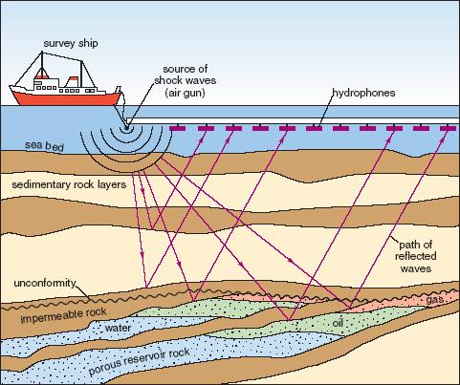
Source: www.epa.gov/esd/cmb/GeophysicsWebsite/pages/reference/methods/Marine_Geophysical_Methods/Marine_Seismic_Methods.htm

Seismic surveying has been conducted in New Zealand waters since the 1960s. Every year there may be up to seven or eight surveys conducted off the coast. Seismic surveying in New Zealand could increase as international interest in our offshore petroleum reserves grows.

How is seismic surveying currently managed in the EEZ?
Seismic surveying is currently managed in New Zealand through a voluntary code of conduct administered by DOC. The Guidelines for Minimising Acoustic Disturbance to Marine Mammals from Seismic Survey Operations and its supplementary reference document were originally established by DOC in 2006 in conjunction with the Petroleum Exploration and Production Association of New Zealand (PEPANZ).

Since 2010, DOC has been working with stakeholders to review the guidelines and is in the final stages of developing the Code of Conduct for Minimising Disturbance to Marine Mammals from Seismic Survey Operations (the Code of Conduct), in addition to a revised reference document, which provides context and assists with interpretation.

Stakeholders who were involved in the review process included representatives from the scientific community, government agencies, industry, professional observers and environmental groups (from within New Zealand and internationally). There is a high level of agreement across the stakeholder group for the general direction taken, with feedback indicating the final outcome is the most comprehensive framework available for protecting marine mammals from the potential impacts of seismic survey operations. The Code of Conduct has been endorsed as industry best practice in New Zealand by PEPANZ.

The primary objectives of the Code of Conduct are to:
- minimise disturbance to marine mammals from seismic survey activities
- minimise noise in the marine environment arising from seismic survey activities
- contribute to the body of scientific knowledge on the physical and behavioural impacts of seismic surveys on marine mammals through improved standardised observation and reporting
- provide for the conduct of seismic surveys in New Zealand continental waters in an environmentally responsible and sustainable manner
- build effective working relationships between government, industry and research stakeholders.

When survey operations are being carried out, the Code of Conduct requires that marine mammal observers and passive acoustic monitoring observers must be present during the operation. Reports must be made about each survey, including any marine mammal sightings and any instances of non-compliance with the Code of Conduct.

The Code of Conduct is scheduled for implementation in the second quarter of 2012. It will be in effect for a period of three years, at which point there will be a performance review prior to the consideration of mandatory regulations. Some activities that occur as part of seismic surveying are currently regulated under other legislation (see section 8.4 for more information).

What seismic surveying activities will be covered by the EEZ regulations?
Regulations are proposed for the following activities, which are restricted activities in clause 15 of the Bill because of their potential environmental effects and the fact that they are not regulated by other legislation:
- use of air guns
- use of high-resolution, electronic acoustic sources (ie, chirp and boomer).

What seismic surveying activities are outside the scope of the EEZ regulations?
Regulations are not proposed for the following activities, because they are not restricted activities in clause 15 of the Bill as they are unlikely to have adverse effects or are currently regulated by other legislation:
- use of a vessel for carrying out a surveying operation, including using surface lights (regulated for navigation purposes by the Maritime Transport Act)
- use of streamers to receive seismic survey information (lights on streamers are regulated for navigation purposes by the Maritime Transport Act)
- use of low-power echo sounders (ie, swath mapping of the seafloor), because this is not considered to have an adverse effect on the marine environment.

Question
- Do you consider the activities listed for seismic surveying to cover the current seismic surveying activities in New Zealand? If not, what isn’t included in this list?

Proposed permitted activities for seismic surveying
The following activities are proposed to be permitted:
- use of air guns
- high-resolution, electronic source seismic surveys (ie, chirp and boomer).

8.5.1 Proposed conditions for seismic surveying
The above activities are proposed to be permitted subject to the following conditions.

Use of airguns and high-resolution electronic source seismic surveys
- Usage must comply with the DOC’s Code of Conduct for Minimising Acoustic Disturbance to Marine Mammals from Seismic Surveying Operations (the Code of Conduct) (see Appendix 5 for a summary). Compliance with the Code of Conduct will, in the first case, be monitored by DOC. This information will also be passed on to the EPA and relevant iwi.
- Prior to commencing the activity, operators must formally notify the EPA and relevant iwi about:
- the nature of the activities (including their location); an option is that consent must also be sought from relevant iwi if the activity is likely to affect a known wāhi tapu area (see section 7.3)
- evidence that DOC is satisfied that the Code of Conduct will be complied with.
- Prior to commencing the activity, operators must formally notify relevant regional councils if the activity is within 1 nautical mile of the boundary of the territorial sea.

8.5.2 Rationale for proposed permitted classification
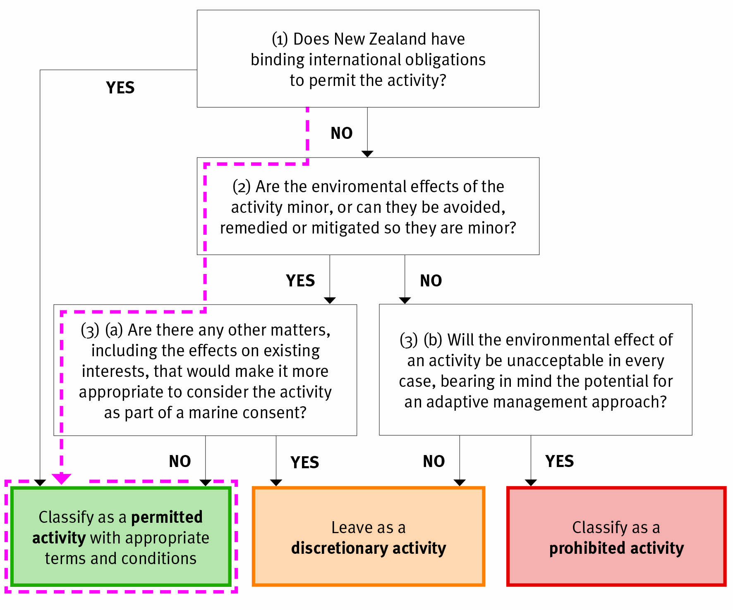

(1) Does New Zealand have binding international obligations to permit the activity?
No.

There are no binding international obligations that require us to regulate any seismic surveying operations in any particular way.

(2) Are the environmental effects of the activity minor, or can they be avoided, remedied, or mitigated so they are minor?
Yes.

The potential environmental effects of the following activities could be avoided, remedied or mitigated so that they are minor:
- use of air guns – this carries a high level of potential effect on marine animals (NIWA, 2012), although the effects can be sufficiently mitigated if the Code of Conduct is followed
- use of electronic acoustic sources – this carries a low to moderate level of potential effect on marine animals (NIWA, 2012), although the effects can be sufficiently mitigated if the Code of Conduct is followed.

(3)(a) Are there any other matters, including the effects on existing interests, that would make it more appropriate to consider the activity as part of a marine consent?
No.

There are no other matters that would make it more appropriate for any seismic surveying activities to be considered in an application for a marine consent.

Questions
- Do you agree that seismic surveying should be a permitted activity? If not, how else would you classify the activity and why?
- Do you agree with the potential conditions for seismic surveying? If not, what changes would you propose? What evidence supports changes to the conditions?

Specific costs associated with the conditions on this proposal
The cost of complying with the DOC Code of Conduct will vary according to the specified power level (see 8.1 What is marine seismic surveying?) of the survey equipment that is used. Under the Code, increased power levels require increased mitigation measures. Compliance costs for high power surveys typically associated with oil and gas exploration are likely to be between 1–4 per cent of total costs. Operating costs for surveys in this sector are high, sometimes in excess of NZ$400,000 per day. While costs to comply with the Code are significant they are considered reasonable as a proportion of total costs and low relative to the potential profits that may come as a result of the survey. Medium power surveys which are more often used for research, or for activities like seafloor mapping, have fewer requirements under the Code. They can use scientific crew for observation duties which limits compliance cost impacts. Low power operations are exempt and therefore have no compliance costs.

It should be noted that many industry stakeholders, especially those operating internationally, have already adopted similar ranges of mitigation measures as standard business practice. In such instances implementation of the Code of Conduct will have very little, if any, additional financial impacts.

Question
- Do you agree with the estimated costs to comply with the DOC Code of Conduct? What would you estimate the costs to be? How would you value the benefits?

Submarine cabling

What is submarine cabling?
Submarine cables are defined as wires or conductors of any kind used or intended to be used for the transmission or reception of signs, signals, impulses, power, writing, images, sounds, instruction, information, or intelligence of any nature, by means of any electromagnetic system, that lie beneath the waters of the EEZ, high seas and territorial sea.

The use of submarine cables can generally be broken down into four distinct phases:
- route exploration
- cable laying and maintenance
- cable operation
- abandonment.

How is submarine cabling currently managed in the EEZ?
There are currently no mandatory requirements to manage the adverse environmental effects of submarine cabling in the EEZ. However, there are some activities that occur as part of submarine cabling that are currently regulated under other legislation (see section 9.4 for more information).

The Ministry of Transport works closely with pipeline and cable owners and operators to protect undersea pipelines and cables through the Submarine Cables and Pipelines Protection Act 1996. Fishing or anchoring around submarine cables can potentially cause them serious damage.

What cabling activities will be covered by the EEZ regulations?
Regulations are proposed for the following activities because they are restricted activities in clause 15 of the Bill due to their potential environmental effects and the fact that they are not regulated by other legislation.

Route exploration
This includes:
- use of high-resolution electronic acoustic sources (ie, chirp, boomer)
- use of air guns (refer to ‘Seismic surveying’, chapter 8)
- seabed sampling.

Cable laying, maintenance and operation
This includes:
- cable lowering and raising
- cable trenching and installation
- cable maintenance.

What cabling activities are outside the scope of the EEZ regulations?
Regulations are not proposed for the following activities, because they are not restricted activities in clause 15 of the Bill as they are unlikely to have adverse effects or are currently regulated by other legislation:
- use of streamers to receive seismic surveying data (regulated for navigation purposes by the Maritime Transport Act)
- use of low-power echo sounders (ie, swath mapping of the seafloor) because it is not considered to have an adverse effect on the marine environment
- use of surface lights for navigational purposes from vessels (regulated under the Maritime Transport Act)
- use of a vessel for carrying out cabling activities, including using surface flood lights, (currently regulated under the Maritime Transport Act 1994)
- underwater light and noise from remotely operated vehicles (ROVs) and submersibles because it is not considered to have an adverse effect on the marine environment
- biofouling, which will be regulated under the Biosecurity Law Reform Bill
- cable abandonment (regulated under the Maritime Transport Act)
- the cable route exclusion zone (regulated under the Submarine Cables and Pipeline Protection Act).

Note the installation and maintenance of pipelines is discussed in the oil and gas section (chapter 11), whereby pipelines are laid from the installation out to vessels. Pipelines being laid from shore to an installation in the EEZ are unlikely to be operative over the next five years and so are not discussed here.

Question
- Do you consider the activities listed in submarine cabling cover current cabling activities in New Zealand? If not, what isn’t included in this list?

Proposed permitted activities for submarine cabling
The following activities are proposed to be permitted:
- use of air guns
- high-resolution electronic source seismic surveys (ie, chirp and boomer)
- collection of small surface samples
- cable lowering and raising
- cable trenching and installation
- cable maintenance (effects related to lowering and raising).

Proposed conditions for submarine cabling
The above activities are proposed to be permitted subject to the following conditions.
- Use of high-resolution acoustic sources and air guns for seismic surveying – this must comply with DOC’s Code of Conduct (see Appendix 5 for a summary). Refer to section 8.2 for details on monitoring.
- Collection of small surface samples – this should not be more than 10 kg per hectare.
- Cable lowering and raising – the cabling area should be checked for marine mammals before cable lowering or raising, and equipment should not be deployed if marine mammals are sighted (this includes for maintenance purposes).
- Trenching and installation of cables – this is not permitted on massive sulphide depositsError: Reference source not found.
- Written approval must be given from the existing cable owner if the proposed cable activity crosses an existing cable. However, the agreement of the existing cable owner cannot be unreasonably withheld.
- Written approval must be given from any mineral or oil and gas licence or permit holder if cabling activity is proposed in a production/exploration area. However, the agreement of the permit/licence holder cannot be unreasonably withheld (ie, the laying of the cable actually has to interfere with the exploration/production activity).
- Prior to commencing the activity, operators must formally notify the EPA and relevant iwi of:
- the nature and the purpose of the activities (including their general location)
- how the activities will adhere to the conditions specified above
- evidence that DOC is satisfied that the Code of Conduct will be complied with.
- Operators must provide the EPA and iwi with a monitoring management plan about how they intend to monitor compliance with the conditions and a reporting schedule that sets out how often they will report compliance to the conditions. Monitoring data must be provided to the EPA and iwi as set out in this plan.

Rationale for proposed permitted classification
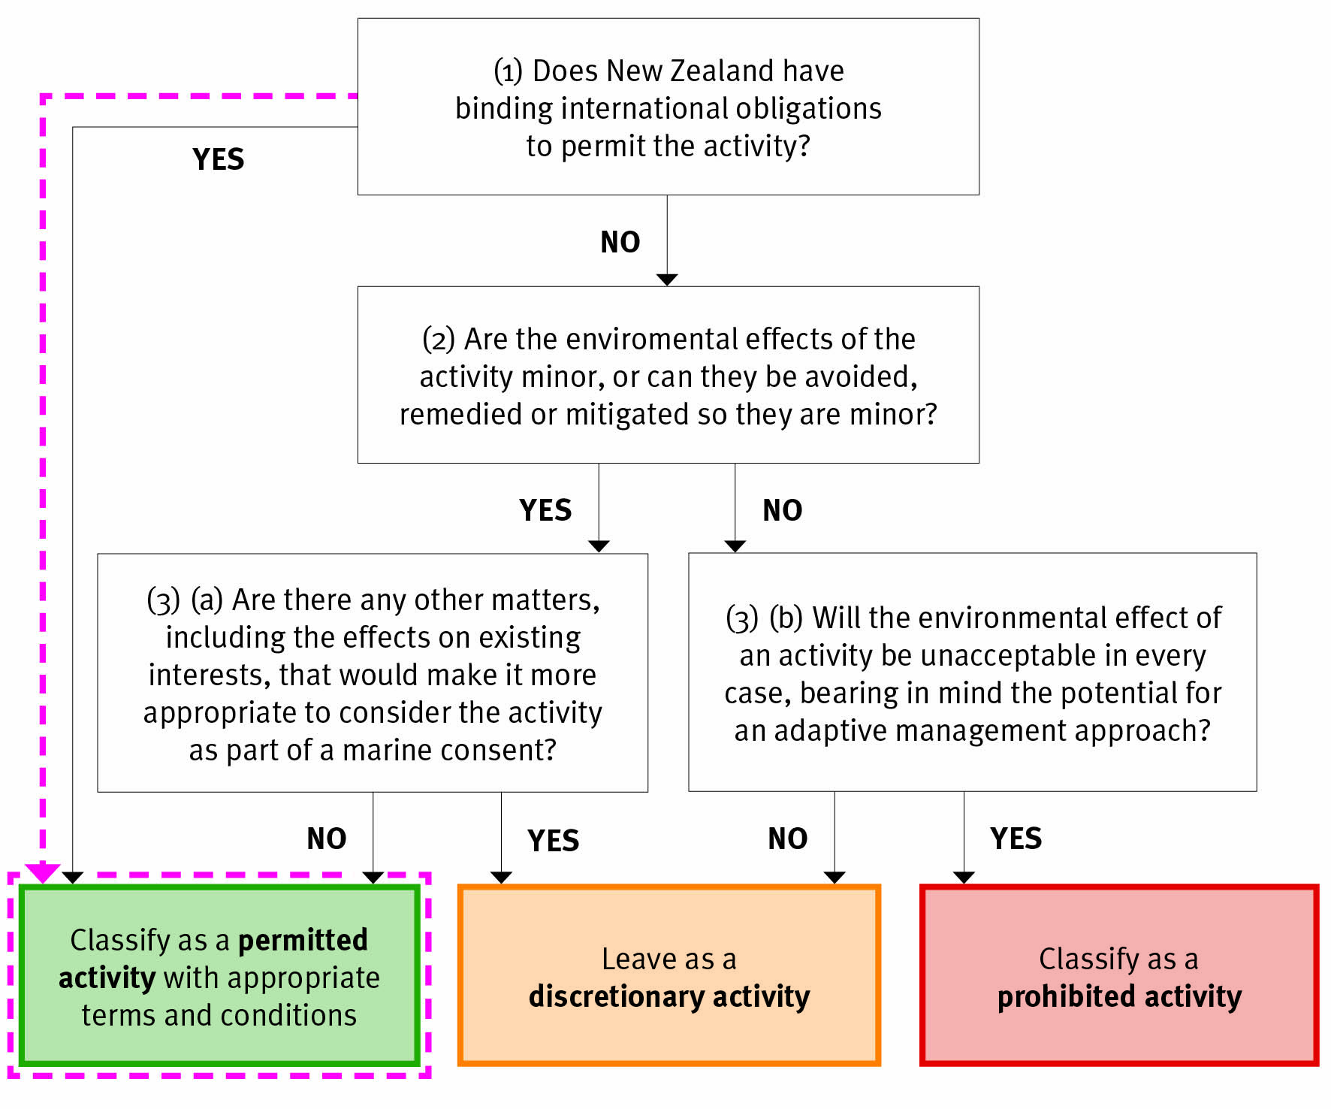

(1) Does New Zealand have binding international obligations to permit the activity?
Yes.

New Zealand cannot unreasonably impede the laying of submarine cables on the continental shelf beyond the territorial sea (article 79[1]).

Although New Zealand cannot unreasonably restrict the right of other states to lay submarine cables on the continental shelf within our waters, this obligation must be balanced against New Zealand’s duty to protect and preserve the marine environment. As such, it is reasonable for New Zealand to request that states intending to lay submarine cables on New Zealand’s continental shelf take certain precautions to mitigate clear environmental risks (eg, following marine mammal protection guidelines when undertaking seismic surveys).

Cable routes are generally chosen to avoid areas of reef, steep bathymetry, active volcanoes, active faults and deep trenches, which are typically correlated with high levels of biodiversity. Nonetheless, environmental risks are associated with laying cables, particularly in relation to the use of seismic surveying, possible entanglement of marine mammals and impact on the seabed.

Habitats related to massive sulphide deposits have been identified as particularly sensitive (NIWA, 2012). For this reason, it has been proposed that laying cables can be a permitted activity in all areas except for on massive sulphide deposits. This means the activity will be discretionary if cable laying is to be conducted on massive sulphide deposits.

If it were proposed that a cable go through an area with an existing petroleum or minerals exploration permit/licence, or mining permit/licence, the cable owner would need to obtain approval from the licence/permit holder before commencing the activity. However, the approval of the permit/licence holder cannot be unreasonably withheld (ie, the laying of the cable will actually have to interfere with the exploration activity).

In addition, if it were proposed that a cable go through an area where existing cables were present, written approval would be required from the existing cable owner. This is currently best practice among cable operators and aligns with UNCLOS obligations.

In the territorial sea, cable routes generally have a zone of restricted access around them that prevents fishing activity. If exclusion zones were to be applied for existing cables in the EEZ, any impact on existing interests is likely to be minor. There is a low impact on existing interests given that the area of a fishing zone affected is likely to be small (less than 1– 5 per cent) and fishing effort would likely be diverted. Exclusion zones are notified through the Submarine Cable and Pipeline Protection Act.

Question
- Do you agree that the above submarine cabling activities should be permitted? If not, how else would you classify the activities and why?
- Do you agree with the potential conditions for the above submarine cabling activities? If not, what changes would you propose? What evidence supports these changes to the conditions?

Specific costs associated with the conditions on this proposal
There will be a cost to operators from obtaining written approval from any permit/licence holders. This will depend on the number of permits/licences the proposed cable will impinge on. Costs over and above the current situation are unlikely to be significant given that it is general best practice to identify potential existing interests across potential cable routes.

The impacts associated with notification and monitoring condition options for permitted activities are discussed in chapter 7.

Question
- What impacts do you consider result from obtaining written consent for submarine cabling from existing permit/licence holders?

Marine scientific research

What is marine scientific research?
Marine scientific research is broken down into three broad groups:
- sampling and surveying conducted while a vessel is moving
- water column sampling and instrumentation
- seabed exploration, sampling and instrumentation.

How is marine scientific research currently managed in the EEZ?
All research involving the catching, taking, surveying or harvesting of fish, aquatic life or seaweed is currently regulated under the Fisheries Act 1996 (ie, a special permit is required to undertake investigative research). Research focusing on marine mammals or protected species is also currently regulated under the Marine Mammals Protection Act 1978 and/or the Wildlife Act 1953.

There are also some activities that occur as part of marine scientific research that are currently regulated under other legislation (see section 10.4 for more information).

What marine research activities will be covered by the EEZ regulations?
Regulations are proposed for the following activities, because they are restricted activities in clause 15 of the Bill due to their potential environmental effects and the fact they are not regulated by other legislation.

Sampling and surveying conducted while a vessel is moving
This includes:
- use of high-resolution electronic acoustic sources (ie, chirp, boomer), air guns (refer to ‘Seismic surveying’, chapter 8)
- conductivity, temperature and depth (CTD) data collection methods
- seafloor explosives.

Water column sampling and instrumentation
This includes:
- use of moored arrays or buoys.

Seabed exploration, sampling and instrumentation
This includes:
- research dredging
- seabed and subsoil sampling (sleds, box cores, multi-cores, piston cores or directed sampling from ROVs or submersibles)
- research drilling (only for gathering data about sub-seafloor rock and sediments, not for oil and gas)
- installations of structures on the seabed.

What marine research activities are outside the scope of the EEZ regulations?
Regulations are not proposed for the following activities, because they are not restricted activities in clause 15 of the Bill as they are unlikely to have adverse effects or are currently regulated by other legislation:
- all research involving the catching, taking, surveying or harvesting of fish, aquatic life or seaweed (regulated under the Fisheries Act 1996)
- research focusing on marine mammals or protected species (regulated under the Marine Mammals Protection Act 1978 and/or the Wildlife Act 1953)
- use of streamers to receive seismic surveying data
- surface lights for navigational purposes from vessels (regulated under the Maritime Transport Act)
- use of a vessel for carrying out research activities, including using surface lights (regulated for navigation purposes by the Maritime Transport Act)
- use of magnetometers, gravity meters, continuous plankton recorders (CPRs), and nets
- use of Argo floats/gliders, autonomous vehicles (if the seabed is undisturbed)
- perturbation experiments (eg, iron fertilisation experiments, which are currently regulated by the Marine Protection Rules of Maritime Transport Act)
- research bottom trawling (and any other research method) where the primary purpose of the research is to catch, take or harvest fish, aquatic life or seaweed (currently regulated by the Fisheries Act)
- bioprospecting (regulated under the Fisheries Act 1996)
- use of low-power echo sounders (ie, swath mapping of the seafloor), because it is not considered to have an adverse effect on marine environment
- use of chemical tracers and discharges, including rotenone (currently regulated under the Maritime Transport Act)
- remote sensing.

Question
- Do you consider the activities listed in marine scientific research cover current marine research activities in New Zealand? If not, what isn’t included in this list (the question relates to both lists of in-scope and out-of-scope activities)?

Proposed permitted activities with appropriate conditions for marine scientific research
The following activities are proposed to be permitted:
- use of high-resolution electronic acoustic sources (ie, chirp, boomer) and air guns
- conductivity, temperature and depth (CTD) data collection methods
- use of moored arrays or buoys
- research dredging
- seabed and subsoil sampling (sleds, box cores, multi-cores, piston cores or directed sampling from ROVs or submersibles)
- research drilling
- installation of structures on the seabed.

Proposed conditions for marine scientific research
The above activities are proposed to be permitted subject to the following conditions.
- Use of high-resolution acoustic sources and air guns for seismic surveying – this must comply with DOC’s Code of Conduct (see Appendix 5 for a summary). Refer to section 8.2 for details on monitoring.
- Use of conductivity, temperature and depth (CTD) data collection methods and moored arrays or buoys – the research area must be checked for marine mammals before deploying CTDs, installations, or moored arrays or buoys, and deployment should be avoided if marine mammals are sighted.
- The area of the seabed affected by installations, CTDs, or moored arrays or buoys must not exceed 2 m for each object.
- Use of ROVs or submersibles – this is not permitted on massive sulphide deposits if the vehicle travels along the seafloor.
- Any moorings or installation on the seabed must be removed upon completion of the research activity.
- Seabed and subsoil sampling – collection of core samples must not exceed:
- a core depth of 70 m
- a core diameter of 15 cm
- one core per hectare (equals 10,000m²) over the research area
- collection of small surface samples of not more than 10 kg per hectare.
- Research drilling – drilling must not exceed:
- a depth of 100 m
- a drill diameter of 30 cm
- one drill hole per hectare over the research area.
- Research dredging – collecting samples using a dredge must not exceed:
- a dredge width of 2 m
- a total sample of 20 m³ over the research area
- one dredge sample of a maximum of 1 m³, per hectare.
- Prior to commencing the activity, operators must formally notify the EPA and relevantError: Reference source not found iwi of:
- the nature and purpose of the activities (including their general location); an option is that consent must also be sought from relevant iwi if the activity is likely to affect a known wāhi tapu area (see section 7.3)
- how the activities will adhere to the conditions specified above
- evidence that DOC is satisfied that the Code of Conduct will be complied with.
- Prior to commencing the activity, operators must formally notify relevant regional councils if the research is within 1 nautical mile of the boundary of the territorial sea.
- Operators must provide the EPA and iwi with a monitoring management plan detailing how they intend to monitor compliance with the conditions, and a reporting schedule that sets out how often they will report compliance to the conditions. For example, this could be an annual plan covering multiple research operations. Monitoring data must be provided to the EPA and iwi as set out in this plan.

Rationale for proposed permitted classification
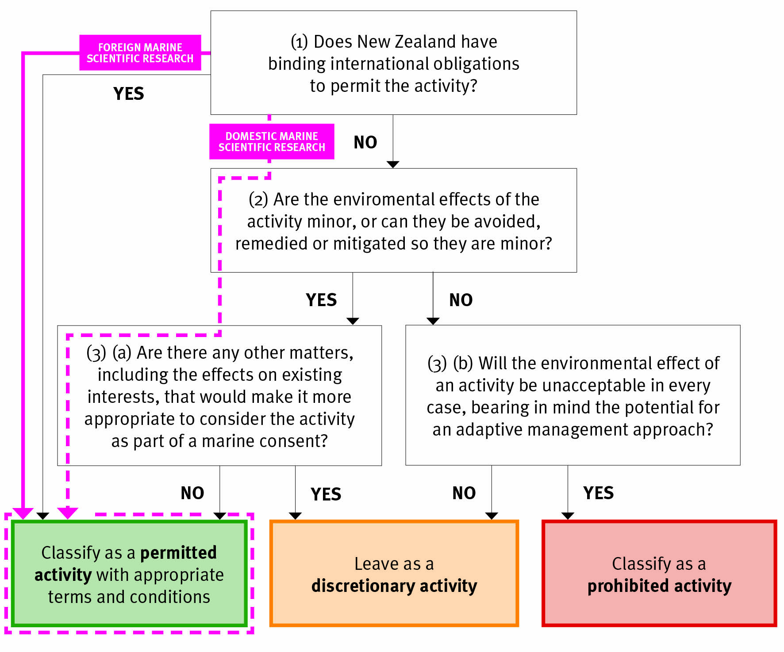

(1) Does New Zealand have binding international obligations to permit the activity?
No, with the exception of foreign marine scientific research.

Domestic marine scientific research
Although as a matter of policy New Zealand strongly supports and promotes marine scientific research, we are not obliged by international law to allow New Zealand citizens to undertake it in our EEZ and continental shelf. As mentioned in the introduction to this discussion document, UNCLOS creates rights and obligations between states rather than between states and their citizens. It is the New Zealand Government’s decision as to what approach it takes to marine scientific research undertaken by New Zealanders.

Foreign marine scientific research
UNCLOS specifies that all states have the right to conduct marine scientific research subject to the rights and duties of other states (article 238). UNCLOS also requires foreign research vessels wanting to conduct research in a coastal state’s EEZ to seek consent from that state before commencing the research (article 246[2]) (see consent process, Appendix 4). Although New Zealand cannot unreasonably withhold that consent, we do have the right to regulate the activity in accordance with our rights and duties under UNCLOS. Most notably, the coastal state can require certain guidelines to be followed to protect the environment, in accordance with UNCLOS.

New Zealand has an established process for considering applications from foreign governments to undertake marine scientific research in New Zealand’s EEZ and continental shelf. This process is coordinated by the Ministry of Foreign Affairs and Trade, in consultation with domestic agencies that have the relevant expertise. When New Zealand receives an application, it is relayed to domestic agencies for comment.

It is during this process that any potential environmental impacts of the proposed marine scientific research would be assessed and New Zealand could seek further information from the foreign state if necessary. In line with New Zealand’s obligation under UNCLOS to protect the marine environment, if it were assessed that the marine scientific research could result in more than minor adverse effects, New Zealand could require the foreign state to take reasonable steps to mitigate these impacts (eg, compliance with the standard conditions for seismic surveys given in chapter 8).

(2) Are the environmental effects of the activity minor, or can they be avoided, remedied, or mitigated so they are minor?
The effects of activities associated with marine scientific research are either minor (NIWA, 2012), or they can be avoided, remedied or mitigated to a level that is minor (except for the use of seafloor explosives and other research activities above the thresholds set out in the previous chapter). The thresholds that have been set for the activities ensure the scale of activities is such that the effects will be minor. The potential effects from seismic surveying are covered in chapter 8.

Habitats related to massive sulphide deposits have been identified as particularly sensitive (NIWA, 2012). For this reason, it has been proposed that the use of ROVs which travel along the seafloor be classed as permitted in all areas except for on massive sulphide deposits. This means the activity will be discretionary if they are to be conducted on massive sulphide deposits.

Rock dredges have also been assessed to have more than minor impacts on the habitats of massive sulphides. However, the scale of the impact has been reduced to a level that will have as minimal impact as possible for the purpose of gathering scientific data.

(3)(a) Are there any other matters, including the effects on existing interests, that would make it more appropriate to consider the activity as part of a marine consent?
No.

There is likely to be minimal impact on existing interests due to the generally short duration and low concentration of the research activity.

Questions
- Do you agree that the above marine scientific research activities should be permitted? If not, how else would you classify the activities and why?
- Do you agree with the proposed conditions for the above marine scientific research activities? If not, what changes would you propose? What evidence supports these changes to the conditions?

Specific costs associated with the conditions on this proposal
There are costs related to the fact that some marine scientific research activities are not permitted on massive sulphide deposits and therefore need to go through a discretionary process.

The impacts associated with notification and monitoring condition options for permitted activities are discussed in chapter 7.

Question
- What do you consider are the impacts of some marine scientific research activities not being permitted on massive sulphide deposits? What would you estimate the scale of these impacts to be?

Proposed discretionary activities for marine scientific research
The following activities are proposed to be discretionary:
- use of seafloor explosives
- other research activities above the thresholds set out in the previous chapter (ie, larger-scale sampling of the seabed and larger-scale disturbance).

If any other activities are not identified above or in the proposed permitted activities, they are also proposed to remain discretionary.

Potential conditions and monitoring
Conditions to mitigate, remedy or avoid potential environmental effects will be developed by the EPA on a case-by-case basis as part of the marine consent process. This could include specific conditions for monitoring and compliance.

Rationale for proposed discretionary classification
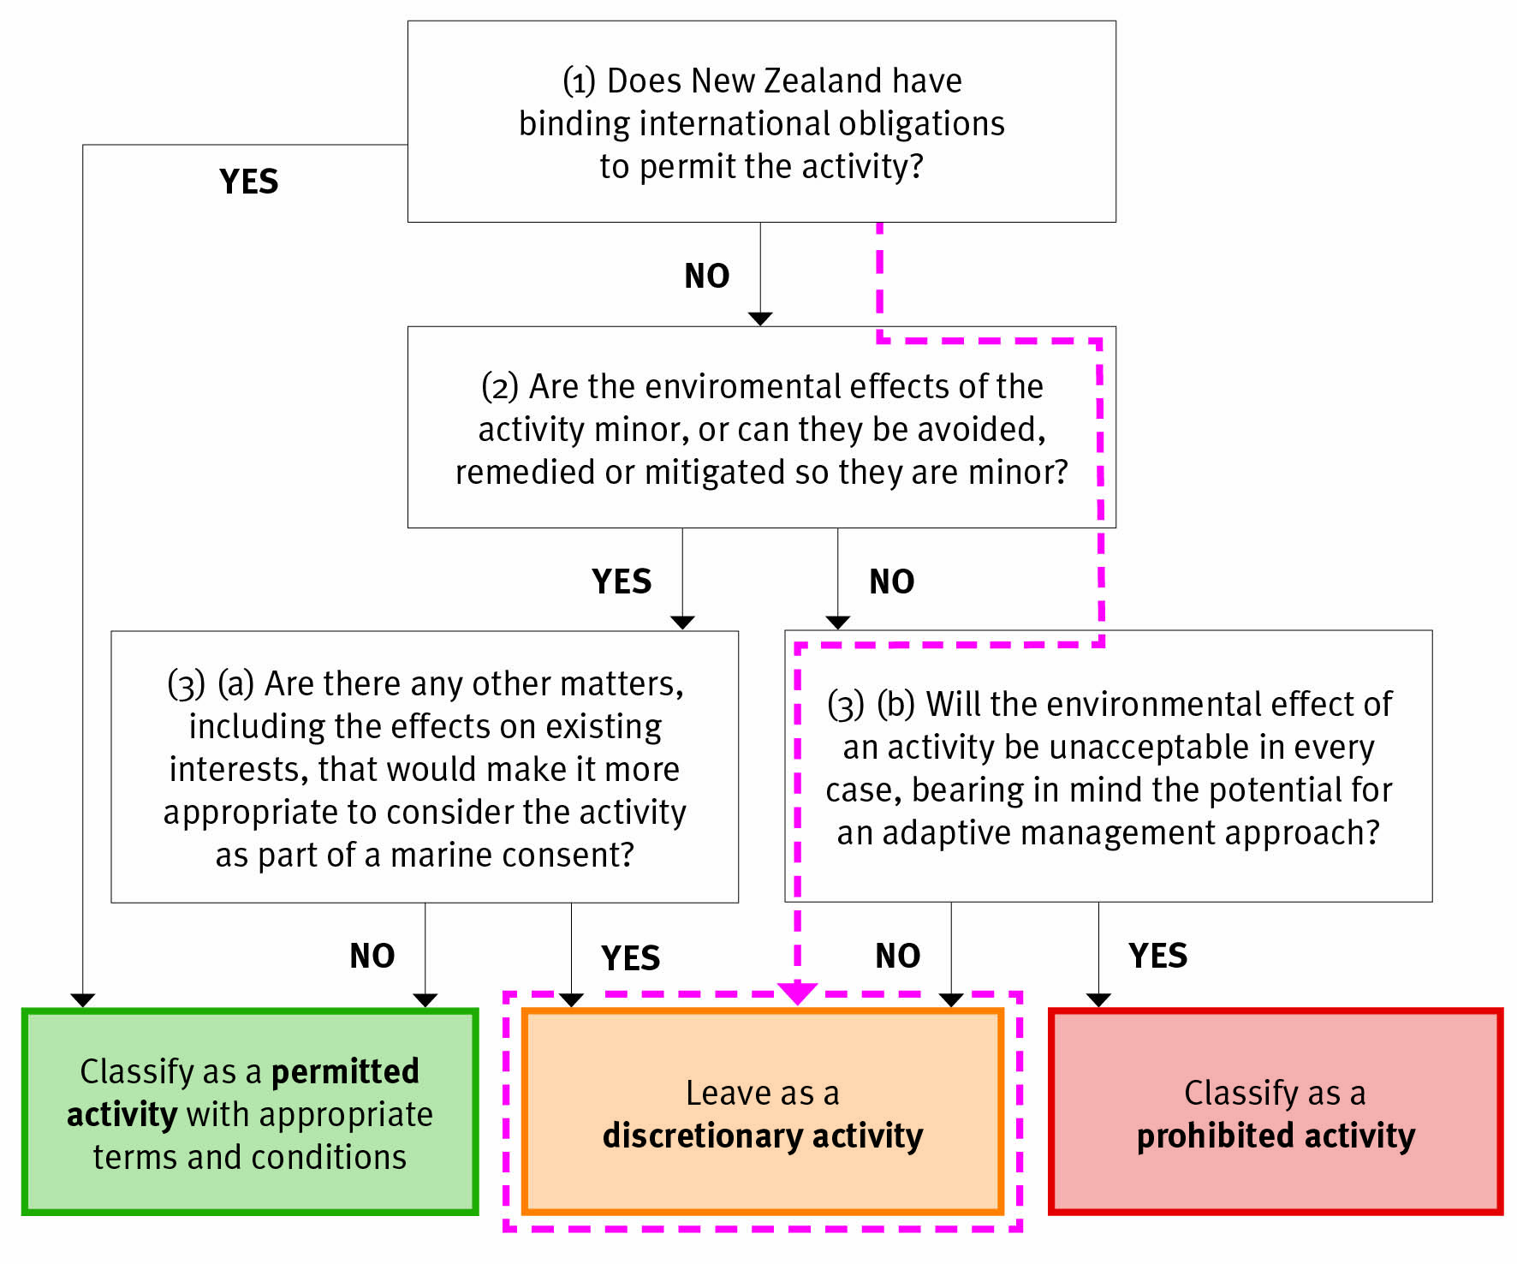

(1) Does New Zealand have binding international obligations to permit the activity?
No.

Domestic marine scientific research
UNCLOS states that signatories shall promote and facilitate the development and conduct of marine scientific research (article 239), but this is not an obligatory requirement to permit domestic marine scientific research.

Foreign marine scientific research
Consent for foreign research can be withheld if the research involves explosives (UNCLOS, article 246[5]).

(2) Are the environmental effects of the activity minor, or can they be avoided, remedied, or mitigated so they are minor?
No.

The following potential environmental effects are likely to be more than minor (NIWA, 2012):
- seabed and acoustic impacts from explosives.

Measures to avoid, remedy or mitigate the effects need to be considered on a case-by-case basis as part of consideration for a marine consent.

(3)(b) Will the environmental effect of an activity be unacceptable in every case, bearing in mind the potential for an adaptive management approach?
No.

For some marine environments the effects of seafloor explosives could be very high. However, a detailed assessment of environmental effects would be likely to determine whether the activity was unacceptable in every case.

Question
- Do you agree that the use of seafloor explosives should be a discretionary activity? If not, how else would you classify the activity and why?

Oil and gas

What is the oil and gas industry?
Oil and gas is a relatively immature industry in New Zealand’s EEZ. The waters around Taranaki are currently the only producing basin in New Zealand, with five producing oil fields in the EEZ. New Zealand is an under-explored petroleum destination by international standards. All of New Zealand’s current and historical oil and gas production has come from just one basin, the Taranaki Basin, although 14 other basins could contain commercial deposits of oil and gas (Ministry of Economic Development, 2010) .

The sequence of oil and gas activities typically includes:
- prospecting – an initial prospecting phase involving shallow seabed sampling and seismic data acquisition
- exploration/appraisal – well-drilling to define potential oil and gas deposits
- production /development – production facilities are installed, development wells are drilled and production takes place
- decommissioning – which includes the plugging of wells and removal of production facilities.

How is the oil and gas industry currently managed in the EEZ?
Operators are required to apply to the Minister of Energy and Resources (through New Zealand Petroleum and Minerals) for a permit under the Continental Shelf Act before commencing any prospecting, exploratory, production or decommissioning activity. In addition, operators will continue to undertake discharge management plans (including oil spill contingency planning) through the Maritime Transport Act, and will submit safety cases to the Secretary of Labour at least two months before construction, operations or abandonment commences. Safety cases focus on addressing the identification and control of major accident hazards while continuing to address the management of occupational health and safety hazards.

On 3 October 2011, Cabinet approved policy proposals to transfer the regulation of discharges from offshore installations and dumping in the EEZ and continental shelf from Maritime New Zealand (under the Maritime Transport Act 1994) to the EPA (under the Bill). This is not currently reflected in the Bill and will require changes to the Bill through the parliamentary process. Once the transfer has taken place the Maritime Transport Act will continue to regulate, and Maritime New Zealand will be responsible for, marine oil spill contingency planning, preparedness and response, and discharges from ships.

Sea disposal of waste in accordance with the 1996 Protocol to the Convention on the Prevention of Marine Pollution by Dumping of Wastes and Other Matter, 1972 (the London Convention) also applies to the abandonment and dumping of oil and gas facilities through the Maritime Transport Act.

What oil and gas activities will be covered by the EEZ regulations?
Regulations are proposed for the following activities, because they are restricted activities in clause 15 of the Bill due to their potential environmental effects and the fact that their effects are not regulated by other legislation.

Prospecting

This includes:
- use of high-resolution acoustic sources for seismic surveying (ie, boomer, chirp)
- use of air guns for seismic surveying
- shallow core sampling at low concentrations
- use of ROVs or submersibles that have an impact on the seafloor or its communities
- spot sampling.

Exploration/appraisal and production/development phases

This includes:
- well-drilling for oil and gas exploration, appraisal and development
- construction of platform structure, including anchors and moorings
- underwater pipeline laying, trenching, inspection and maintenance
- maintenance of structure.

This phase may also include some activities listed under prospecting, such as seismic surveying.

Decommissioning phase

This includes:
- well capping
- removal of all equipment, plant and machinery.

How is fracking considered in the regulations?
Hydraulic fracturing, or fracking, involves pumping a water-sand-chemical mixture into underground rock where the oil or gas is trapped. The pressure of the water creates tiny cracks in the rock. The sand holds the cracks open, freeing the oil or gas to flow up the well. All fluids and materials moving up and down the well are isolated from the surrounding rock by the steel/cement casing of the well.
At present fracking has not been undertaken in New Zealand waters. However, if it does become a viable activity in the future, applications to the EPA for marine consents to undertake oil and gas production will need to identify all actual and potential effects associated with an activity. This means that any environmental effects of hydraulic fracturing will be thoroughly considered by the EPA before operations can begin, along with any measures that will be taken to avoid, remedy or mitigate those effects. In addition, any discharge of fracking fluid into the sea from an installation is regulated under the Maritime Transport Act through the discharge management plan.

The Health and Safety in Employment (Petroleum Exploration and Extraction) Regulations 1999 (HSE(PEE) regulations) require operators to ensure wells are cased with casing materials conforming to generally accepted and appropriate industry practice and with sufficient casing to prevent the uncontrolled release of fluids.

The HSE(PEE) regulations require operators to provide the details of their casing programme to the Secretary of Labour at least 20 days before the commencement of the well-drilling operation. The progress of the casing programme, and any subsequent modification, is then monitored through the daily drilling reports submitted by the operator.

What oil and gas activities are outside the scope of the EEZ regulations?
Regulations are not proposed for the following activities, because they are not restricted activities in clause 15 of the Bill as they are unlikely to have adverse effects or are currently regulated by other legislation.

Prospecting, exploration/appraisal and production/development phases
These cover:
- multi-beam echo sounders (eg, swath mapping)
- use of camera systems
- surface lights for navigational purposes from vessels (regulated under the Maritime Transport Act)
- navigational hazards from aerial or towed magnetometer surveys (regulated under the Maritime Transport Act)
- discharges of drilling muds (currently regulated by the Maritime Transport Act)
- production of water discharges (currently regulated by the Maritime Transport Act)
- use of a vessel for carrying out a surveying operation, including using surface lights (regulated for navigation purposes by the Maritime Transport Act)
- importation of biofouling (will be regulated by the Biosecurity Law Reform Bill)
- use of platform floodlights for navigation (regulated by the Maritime Transport Act).

Decommissioning

Abandonment of all equipment, plant and machinery, and the sinking of platforms and equipment (ie, sea disposal), is currently regulated by the Maritime Transport Act. However, the regulation of discharges from offshore installations and dumping in the EEZ and continental shelf will be transferred from the Maritime Transport Act 1994 to the Bill in the future.

Question
- Do you consider the activities listed in the oil and gas section cover current oil and gas activities in New Zealand? If not, what isn’t included in this list?

Proposed permitted activities, with appropriate conditions for the oil and gas industry
The following activities are proposed to be permitted:
- use of high-resolution acoustic sources for seismic surveying (ie, boomer, chirp)
- use of air guns for seismic surveying
- shallow core sampling at low concentrations
- use of ROVs or submersibles that have an impact on the seafloor or its communities
- spot sampling
- maintenance of structure.

The permitted activities listed above generally occur in the prospecting phase, except for maintenance.

Proposed conditions for oil and gas prospecting phase
The above activities are proposed to be permitted subject to the following conditions.
- Use of high-resolution acoustic sources and air guns for seismic surveying – this must comply with DOC’s Code of Conduct (see Appendix 5 for a summary).. Refer to section 8.2 for details on monitoring.
- Shallow core sampling – collection of core samples must not exceed:
- a core depth of 50 m
- a core diameter of 15 cm
- one core per 1000 m² over the prospecting area, except where cores/samples are being taken to provide information on the siting of oil- and gas-drilling rigs or platforms, where a higher density of sampling will be needed
- collection of small surface samples of not more than 10 kg per hectare.
- Use of ROVs or submersibles – this is not permitted on massive sulphide deposits if the vehicle travels along the seafloor.
- Prior to commencing the activity, the EPA and relevant iwi must be formally notified of:
- the nature and the purpose of the activities (including general location); an option is that consent must also be sought from relevant iwi if the activity is likely to affect a known wāhi tapu area (see section 7.3)
- how the activities will adhere to the conditions specified above
- evidence that DOC is satisfied that the Code of Conduct will be complied with.
- Relevant regional councils must be notified if the research is within 1 nautical mile of the boundary of the territorial sea.
- Operators must provide the EPA and iwi with a monitoring management plan for how they intend to monitor compliance with the conditions, and a reporting schedule that sets out how often they will report compliance to the conditions. Monitoring data will be provided to the EPA and iwi as set out in this plan.

Rationale for proposed permitted classification

(1) Does New Zealand have binding international obligations to permit the activity?
No.

There are no specific UNCLOS obligations to permit exploration drilling. Rather, UNCLOS specifically recognises exclusive rights to authorise and regulate drilling on the continental shelf inside the EEZ (article 81).

(2) Are the environmental effects of the activity minor, or can they be avoided, remedied, or mitigated so they are minor?
Yes.

The effects of activities associated with oil and gas prospecting are either minor (NIWA, 2012), or they can be avoided, remedied or mitigated to a level such that they are minor. The potential effects from seismic surveying are covered in chapter 8. The thresholds that have been set for the activities ensure the scale of activities is such that the effects will be minor.

Habitats related to massive sulphide deposits have been identified as particularly sensitive (NIWA, 2012). For this reason it has been proposed that the use of ROVs that travel along the seafloor be classed as permitted in all areas except for on massive sulphide deposits. This means the activity will be discretionary if it is to be conducted on massive sulphide deposits.

(3)(a) Are there any other matters, including the effects on existing interests, that would make it more appropriate to consider the activity as part of a marine consent?
No.

Existing interests are unlikely to be noticeably affected by seabed prospecting because the activity is only on a very small scale. The possible effects from seismic surveying are covered in chapter 8.

There could be some public and iwi interest in knowing the activity is occurring. This could be acknowledged by requiring notification to iwi and the EPA about the activity.

Question
- Do you agree that oil and gas exploration (surveying the seabed for deposits) should be a permitted activity? If not, how else would you classify the activity and why?

Specific costs associated with the conditions on this proposal
There are no specific costs associated with the conditions on oil and gas activities.

The impacts associated with notification and monitoring condition options for permitted activities are discussed in chapter 7.
Question
- Are you aware of any specific costs that might relate to the conditions for oil and gas activities?

Proposed discretionary activities for the oil and gas industry
It is proposed that the following activities within the exploration/appraisal, development/ production and decommissioning phases of oil and gas remain discretionary, and therefore require an approved marine consent before the activity is commenced:
- well-drilling activities (exploration/appraisal and production/development) with the purpose of discovering, evaluating and producing oil and gas
- construction of platform structure, including anchors and moorings
- underwater pipeline laying, trenching, inspection and maintenance
- well capping (decommissioning)
- removal of all equipment, plant and machinery (decommissioning).

Potential conditions and monitoring
Conditions to mitigate, remedy or avoid potential environmental effects will be developed by the EPA on a case-by-case basis as part of the marine consent process. This could include specific conditions for monitoring and compliance.

Rationale for proposed discretionary classifications

(1) Does New Zealand have binding international obligations to permit the activity?
No.

There are no specific UNCLOS obligations to permit oil- and gas-related activities. Instead, UNCLOS specifically recognises exclusive rights to authorise and regulate drilling on the continental shelf inside the EEZ (article 81).

(2) Are the environmental effects of the activity minor, or can they be avoided, remedied, or mitigated so they are minor?
No.

The following activities are likely to have environmental effects that are more than minor (NIWA, 2012). Measures to avoid, remedy or mitigate the effects need to be considered on a case-by-case basis as part of consideration for a marine consent.

Exploration/appraisal, production/development and decommissioning
This includes:
- direct impacts on the seabed from drilling exploration/appraisal and production wells, platforms and associated structures, and smothering of local benthic habitats from drill cuttings
- marine mammal interactions with production facilities
- cumulative effects on the impact on the seabed from multiple exploration wells
- potential effects from oil spills on the surrounding environment.

Decommissioning
This includes:
- the impact on the seabed from removal of the platform
- marine mammal interaction with the platform during removal of equipment.

Note that existing interests will be considered as part of the marine consent process. There are likely to be high levels of iwi interest associated with the oil and gas industry.

Consideration of potential environmental effects during decommissioning
Consideration of decommissioning at the production phase: Clause 40 of the EEZ Bill sets out the requirements for an impact assessment. Specifically, an impact assessment must identify the actual and potential effects of the activity on the environment and existing interests (40[1][c]), including how impacts are proposed to be avoided, remedied or mitigated. ‘Effect’ is defined in the Bill as including both future and cumulative effects (6[1]).

On this basis, an impact assessment required in the production phase must include the assessment of effects associated with decommissioning the production facilities and any effects associated with marine mammal interactions with the production facilities. The impact assessment for production will indicate the proposed method for decommissioning the facilities (ie, abandonment or removal) and how the impacts are proposed to be avoided, remedied or mitigated. If the production facilities are to be decommissioned via abandonment, these activities will be regulated under the Maritime Transport Act until these functions are transferred to the EPA.

Iwi leaders have requested the environmental impacts of decommissioning be presented in a decommissioning plan that is considered alongside an impact assessment. The requirement of a decommissioning plan would be set out as a standard condition ([29(3)]). A decommissioning plan would describe the actions operators would undertake to decommission the production facilities, the likely impacts, and the proposed measures to avoid, remedy or mitigate these impacts.

Therefore there are two proposals for how the environmental effects of decommissioning are to be considered during the marine consent for oil and gas production:
- environmental impacts of decommissioning are considered as part of the impact assessment (40[1])
- environmental impacts of decommissioning are considered in both a decommissioning plan and the impact assessment.

Question
- How do you consider that operators should provide information on the environmental impacts of decommissioning during the production phase?

Certain existing oil and gas activities to continue
The Bill will exempt some already-established activities from its requirements. Existing oil and gas production platforms in the Taranaki basin will not have to comply with the requirements of the Bill for the duration of their oil and gas permits. Similarly, existing minerals prospecting licences will be exempt for the duration of the licences.

The exemption from the requirements of the Bill only applies to oil and gas platforms and minerals prospecting as currently permitted or licensed. Any alteration, extension, removal or demolition of a structure or pipeline associated with the activity, or alteration of the activities allowed under a licence, will not be exempted. Those changes will require a marine consent from the EPA.

(3)(b) Will the environmental effect of an activity be unacceptable in every case, bearing in mind the potential for an adaptive management approach?
No.

It is unlikely that exploration/appraisal, development well-drilling/production and decommissioning would be unacceptable in every case. Oil and gas activities are currently operating in New Zealand’s EEZ and territorial sea and in other countries. The information on the environmental effects of oil and gas exploration is generally well-known compared to some of the mining industries.

Question
- Do you agree that exploration/appraisal, development well-drilling/production and decommissioning should be discretionary activities? If not, how else would you classify the activities and why?

Seabed mining

What is seabed mining?
Seabed mining is a relatively new industry in New Zealand’s EEZ. Three operations are in the process of exploring the mineral potential of the seafloor around New Zealand. So far none of these operations have progressed to full-scale mining. There is potential for a wide range of minerals to be extracted from the seafloor, but the three most likely mineral types are ironsands, rock phosphates and seafloor massive sulphides.

Ironsands
‘Ironsand’ is a general term for sand-sized grains of heavy iron-rich minerals. The sands can be used for making steel. The majority of New Zealand’s ironsand deposits are found off the West Coast of the North Island. The ironsands are sourced from the West Coast volcanic areas and deposited on the seafloor by rivers (NIWA, 2012). Full-scale ironsand mining would use dredges and possibly suction to remove sand from mining pits on the seafloor. Some processing of the sand would occur on board a stationary floating production vessel. The processed sand would then be shipped to shore.

Rock phosphate
Rock phosphate is a crucial ingredient in the fertilisers manufactured and used in New Zealand. The resource is found in the form of nodules, between 2 and 150 mm in size, within the surface layer of the seabed. This layer is about 1 metre deep and also contains fine, sandy silt (see figure 5). New Zealand’s rock phosphate deposits are found on the Chatham Rise (NIWA, 2012). Rock phosphate mining could involve cutting and fragmenting the seafloor and sucking the sediment up to a floating production vessel.

Seafloor massive sulphides
Seafloor massive sulphide deposits form in submarine volcanic regions where sulphur-rich magmatic and hydrothermal fluids precipitate sulphur and metals around hydrothermal vents. The hydrothermal fields usually occur on mounds that contain precipitates and both high-temperature ‘black smoker’ vents (see figure 6) and lower-temperature diffusive venting, seen as gentle shimmering on the ocean floor.

Seafloor massive sulphide deposits can contain economically viable reserves of iron, copper, lead and zinc, with some also rich in gold and silver (de Ronde et al, 2007, in NIWA, 2012). Massive sulphide mining could involve a similar process to that used for rock phosphate, in terms of cutting and fragmenting the deposits on the sea floor and sucking the sediment up to a floating production vessel.

The three phases of seabed mining are typically prospecting, exploration and production. The hydrothermal vents where these deposits occur can harbour unique biodiversity. The prospecting and exploration phases are likely to have much lower effects than production. None of these industries has yet progressed to production in the EEZ, so the potential effects of production are not fully known. However, they are likely to be significant due to the large scale of the operation.

Figure 5: Phosphorite nodules: dark, gravel-sized nodules exposed on the Chatham Rise seafloor, with feathery starfish, deepwater corals and small clumps of brachiopods. Source: NIWA, 2012.
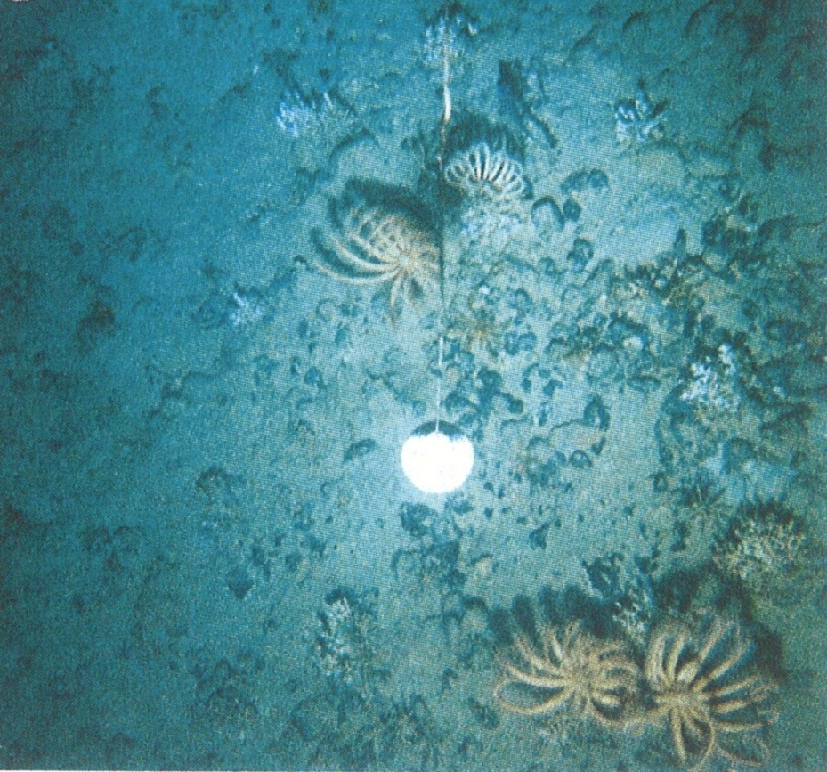

Figure 6: Massive sulphide deposit and black smoker chimney on the Kermadec
Ridge. Source: NIWA, 2012
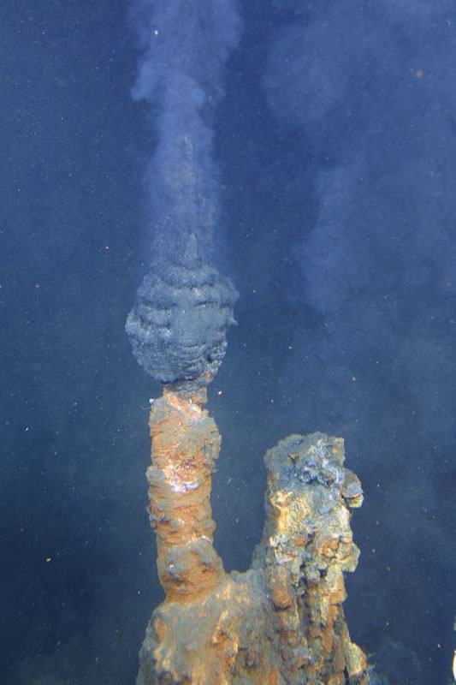
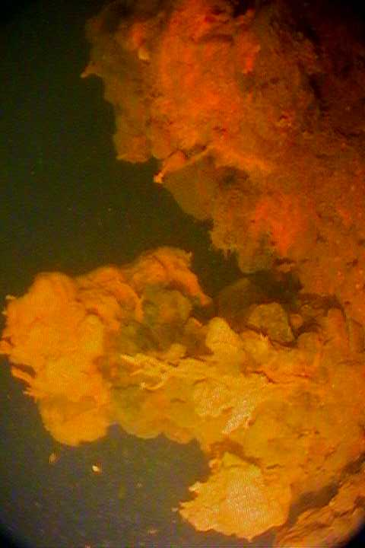

How is the seabed mining industry currently managed in the EEZ?
Operators are required to apply to New Zealand Petroleum and Minerals for a licence under the Continental Shelf Act 1964 (CSA) before commencing any prospecting, exploration or production activity. These licences set out the environmental conditions for the activities, along with a range of other conditions and commitments. The Ministry of Economic Development has proposed changes to the CSA to ensure it uses the environmental provisions of the Crown Minerals Act 1991, which are more comprehensive.

The environmental effects from seabed mining that relate to using a vessel, releasing any discharges into the water or dumping anything into the sea are currently regulated through the Maritime Transport Act. On 3 October 2011, Cabinet approved policy proposals to transfer the regulation of discharges from offshore installations and dumping in the EEZ and continental shelf from Maritime New Zealand (under the Maritime Transport Act 1994) to the EPA (under the EEZ Bill). This is not currently reflected in the Bill and will require changes to the Bill through the Parliamentary process.

What seabed mining activities will be covered by the EEZ regulations?
Regulations are proposed for the following activities, because they are restricted activities in clause 15 of the Bill due to their potential environmental effects and the fact they are not regulated by other legislation. The primary effects from these activities relate to the destruction, damage or disturbance of the seafloor and removal of material from the seafloor.

Prospecting
This includes:
- use of high-resolution acoustic sources for seismic surveying (eg, boomer, chirp)
- core sampling at low concentrations
- the use of ROVs or submersibles that have an impact on the seafloor or its communities
- spot sampling
- rock dredges
- bulk sampling (other than discharges to the water).

Exploration
This includes:
- core sampling at high concentrations
- test pit excavation using a variety of methods
- test drilling
- any smothering of the seabed from a sediment plume

Production

This includes:
- seafloor suction
- seafloor slurry pipes
- mooring blocks or anchors
- seafloor cutting/fragmentation
- the creation of an extraction and deposition plume that affects the seabed
- deposition of tailings in stock piles or pits.

What seabed mining activities are outside the scope of the EEZ regulations?
Regulations are not proposed for the following activities, because they are not restricted activities in clause 15 of the Bill as they are unlikely to have adverse effects or are currently regulated by other legislation.

Prospecting

This includes:
- multi-beam echo sounders (eg, swath mapping)
- use of camera systems
- surface lights and noise (regulated by the Maritime Transport Act)
- aerial or towed magnetometer surveys (regulated by the Maritime Transport Act)
- the use of a vessel for carrying out a surveying operation, including using surface lights (regulated for navigation purposes by the Maritime Transport Act)
- discharges to the water from bulk sampling.

Exploration
This includes:
- the creation of a sediment plume in the water column.

Production
This includes:
- toxic chemical release (regulated by the Maritime Transport Act)
- wash water return
- the creation of a sediment plume in the water column.

Question
- Do you consider the activities listed in the seabed mining section cover current and potential seabed mining activities in New Zealand? If not, what isn’t included in this list?

Proposed permitted activities for the seabed mining industry
It is proposed that the following activities be permitted:
- seismic surveying involving high-resolution electronic sources (ie, boomer, chirp)
- core sampling at low concentrations
- use of ROVs or submersibles
- spot sampling
- rock dredges
- bulk sampling (other than discharges to the water).
All the above activities are conducted in the prospecting phase of seabed mining.

Proposed conditions for the seabed mining industry
It is proposed that the above activities be permitted subject to the following conditions.
- Seismic surveying involving high-resolution electronic sources – this must comply with DOC’s Code of Conduct (see Appendix 5 for a summary). Refer to section 8.2 for details on monitoring.
- Collection of core samples – core samples must not exceed:
- a core depth of 10 m
- a core diameter of 15 cm
- one core per 10,000 m² over the prospecting area.
- Collection of small surface samples – there must be not more than 10 kg per 10,000 m².
- Bulk sampling: bulk sampling must not exceed:
- 100 m³ over the prospecting area
- one bulk sample of 1 m³ per 10,000 m²
and the sample is not permitted to be taken from massive sulphide deposits.
- Rock dredges – collecting samples using a rock dredge must not exceed:
- a dredge width of 2 m
- a total sample of 100 m³ over the prospecting area
- one dredge sample of a maximum of 1 m³ per hectare
and the sample is not permitted to be taken from massive sulphide deposits.
- Use of ROVs or submersibles – this is not permitted on massive sulphide deposits if the vehicle travels along the seafloor.
- Prior to commencing the activity, the operator must provide information to the EPA and relevant iwi on:
- the nature of the activities (including location); an option is that consent must also be sought from relevant iwi if the activity is likely to affect a known wāhi tapu area (see section 7.3)
- a high-level assessment of the baseline environment
- how the activities will be conducted within the conditions specified above
- regular assessments of how the baseline environment is being affected by the activity
- evidence that DOC is satisfied that the Code of Conduct will be complied with.
- Operators must provide the EPA and iwi with a monitoring management plan for how they intend to monitor compliance with the conditions, and a reporting schedule that sets out how often they will report compliance to the conditions. Monitoring data will be provided to the EPA and iwi as set out in this plan.

Rationale for proposed permitted classification

(1) Does New Zealand have binding international obligations to permit the activity?
No.

New Zealand does not have any binding international obligations to permit any seabed mining activities at any stage in the process.

(2) Are the environmental effects of the activity minor, or can they be controlled so they are minor?
Yes.

The effects of activities associated with prospecting for seabed minerals are either minor, or they can be avoided, remedied or mitigated to the point they are minor by applying standard conditions. The thresholds that have been set for the activities are to ensure the scale of activities is such that the effects will be minor.

Habitats relating to massive sulphide deposits have been identified as being particularly sensitive. For this reason, it is proposed the activities of rock dredging, bulk sampling and use of ROVs that travel along the seafloor be classed as permitted in all areas except for on massive sulphide deposits. This means the activities will be discretionary if they are to be conducted on massive sulphide deposits. These deposits are located around hydrothermal vents in the Kermadec Arc. The location of these vents is known and mapped.

The organisms living around active hydrothermal vents are different to those living around dormant or inactive vents. The organisms living around active vents are unique, in that they depend on the chemicals from the vents as their basic source of energy (as opposed to the sun for the majority of life; NIWA, 2012). The environment around active vents is also dynamic and subject to disruption as vent chimneys form and collapse. However, there is still only sparse information about how human-based activities might affect this ecosystem. Therefore, while the effects from the use of bulk sampling, dredging and ROVs might be confidently considered to be minor in the majority of situations, the same cannot be said for massive sulphide deposits around active vents. It is therefore more appropriate these activities are not permitted in this situation.

The organisms living on massive sulphide deposits surrounding dormant or inactive vents (eg, deep sea corals and other filter feeders) are less numerous but still highly vulnerable to disturbance, as they could take years or even decades to recover (NIWA, 2012). For this reason, the proposal not to permit bulk sampling, dredging and some ROV activity applies to massive sulphide deposits around both active and inactive vent systems.

(3)(a) Are there any other matters, including the effects on existing interests, that would make it more appropriate to consider the activity as part of a marine consent?
No.

Existing interests are unlikely to be noticeably affected by seabed prospecting because the activity is only on a very small scale. The possible effects from seismic surveying are covered in chapter 8.

There could be some public and iwi interest in knowing that the activity is occurring. This could be acknowledged by requiring notification to iwi and the EPA about the activity.

Questions
- Do you agree that activities related to seabed prospecting should be permitted? If not, how else would you classify the activities and why?
- Do you agree with the potential conditions for seabed prospecting activities? If not, what changes would you propose? What evidence supports these changes to the conditions?

Specific costs associated with the conditions on this proposal
There are opportunity costs related to the fact that some seabed prospecting activities are not permitted on massive sulphide deposits and therefore need to go through a discretionary process.

The impacts associated with notification and monitoring condition options for permitted activities are discussed in chapter 7.

Question
- What do you consider are the impacts of some seabed mining activities not being permitted on massive sulphide deposits? What would you estimate the scale of these impacts to be?

Proposed discretionary activities for the seabed mining industry
The following activities are proposed to remain as discretionary. They all fall within the exploration and production phases of seabed mining. If any other activities are not identified below or in the proposed permitted activities, they are also proposed to remain as discretionary.

Exploration
This includes:
- core sampling at concentrations higher than allowed for a permitted activity
- test mining techniques, including the use of test pits
- test drilling.

Production
This includes:
- seafloor suction
- seafloor slurry pipes
- mooring blocks or anchors
- seafloor cutting/fragmentation
- the creation of an extraction and deposition plume that affects the seabed
- deposition of tailings in stock piles or pits.

Any decommissioning of mooring blocks, anchors or any other structures on the seafloor will be regulated by the EPA through conditions on a marine consent. This will ensure any effects from decommissioning will be avoided, remedied or mitigated.

Potential conditions and monitoring
Conditions to mitigate, remedy or avoid potential environmental effects will be developed by the EPA on a case-by-case basis as part of the marine consent process. This could include specific conditions for monitoring and compliance.

Question
- Do you agree that the activities associated with exploration and production for seabed mining should be discretionary? If not, how else would you classify the activities and why?

Rationale for proposed discretionary classification

(1) Does New Zealand have binding international obligations to permit the activity?
No.

New Zealand does not have any binding international obligations to permit any seabed mining activities at any stage in the process.

(2) Are the environmental effects of the activity minor, or can they be avoided, remedied, or mitigated so they are minor?
No.

The potential environmental effects to the seafloor from the listed activities are likely to be more than minor. Measures to avoid, remedy or mitigate the effects will need to be developed on a case-by-case basis by the EPA through an application for a marine consent.

(3)(b) Will the environmental effect of an activity be unacceptable in every case, bearing in mind the potential for an adaptive management approach?
No.

For some marine environments, the effects of full-scale seabed mining could be very great. However, none of the seabed-mining industries covered in this discussion document (ironsands, rock phosphate, seafloor massive sulphides) have fully developed the technology and techniques required for full-scale mining. This means there is time to develop techniques that minimise effects and promote the likelihood of recovery of seafloor habitats. This can be done through a process of adaptive management (one of the tools available to the EPA through the EEZ Bill; see chapter 4 for an explanation). It would be pre-emptive to prohibit any of these activities before the methods to carry them out have been fully developed, tested and monitored through an adaptive management programme.

Consideration of potential environmental effects during decommissioning
Clause 40 of the EEZ Bill sets out the requirements for an impact assessment. Specifically, an impact assessment must identify the actual and potential effects of the activity on the environment and existing interests (40[1][c]), including how it is proposed that impacts will be avoided, remedied or mitigated. ‘Effect’ is defined in the Bill as including both future and cumulative effects (6[1]).

On this basis, an impact assessment required in the production phase must include the assessment of effects associated with decommissioning the production facilities and any effects associated with marine mammal interactions with the production facilities. The impact assessment for production will indicate the proposed method for decommissioning the facilities (ie, abandonment or removal) and how it is proposed the impacts will be avoided, remedied or mitigated. If the production facilities are to be decommissioned via abandonment, these activities will be regulated under the Maritime Transport Act until these functions are transferred to the EPA (for more information on the transfer of functions see section 1.3).

Iwi leaders have requested the environmental impacts of decommissioning be presented in a decommissioning plan that is considered alongside an impact assessment. The requirement of a decommissioning plan would be set out as a standard condition ([29(3)]). A decommissioning plan would describe the actions that operators would undertake to decommission the production facilities, the likely impacts, and the proposed measures to avoid, remedy or mitigate these impacts.

Therefore there are two proposals for how the environmental effects of decommissioning should be considered during the marine consent for oil and gas production:
- environmental impacts of decommissioning are considered as part of the impact assessment (clause 40[1] of the Bill)
- environmental impacts of decommissioning are considered in both a decommissioning plan and the impact assessment.

Question
- Of the two proposals for operators to consider the environmental impacts of decommissioning at the production phase, what would be your preferred way for operators to provide this information?

Summary of proposed permitted and discretionary activities
Table 4: Summary of proposed permitted and discretionary activities
Permitted | Discretionary
Seismic surveying
- Use of air guns  - High-resolution electronic source seismic surveys (ie, chirp and boomer) | - Seismic surveying activities that exceed specified conditions.
Submarine cabling
- Use of air guns  - High-resolution electronic source seismic surveys (ie, chirp and boomer)  - Collection of small surface samples  - Cable lowering and raising  - Cable trenching and installation  - Cable maintenance (effects related to lowering and raising) | - Cabling activities that exceed specified conditions.
Marine scientific research
- Use of high-resolution electronic acoustic sources (ie, chirp, boomer) and air guns  - Conductivity, temperature and depth (CTD) data collection methods  - Use of moored arrays or buoys  - Research dredging  - Seabed and subsoil sampling (sleds, box cores, multi-cores, piston cores or directed sampling from ROVs or submersibles(except for on massive sulphide deposits where the vehicle travels along the seafloor))  - Research drilling  - Installations of structures on the seabed | - Use of seafloor explosives  - Other research activities that exceed conditions (ie, larger-scale sampling of the seabed and larger-scale disturbance)
Oil and gas
- Use of high-resolution acoustic sources for seismic surveying (eg, boomer, chirp)  - Use of air guns for seismic surveying  - Shallow core sampling at low concentrations (this does not include collection of biological samples which is regulated under the Fisheries Act 1996)  - Collection of small surface samples  - Use of ROVs or submersibles that have an impact on the seafloor or its communities (except for on massive sulphide deposits where the vehicle travels along the seafloor)  - Maintenance of structure | - Well-drilling activities (exploration/appraisal and production/development) with the purpose of discovering, evaluating and producing oil and gas  - Construction of platform structure, including anchors and moorings  - Underwater pipeline laying, trenching, inspection and maintenance  - Well capping (decommissioning)  - Removal of all equipment, plant and machinery (decommissioning)
Seabed mining
- Seismic surveying involving high-resolution electronic sources (eg, boomer, chirp)  - Core sampling at low concentrations (this does not include collection of biological samples which is regulated under the Fisheries Act 1996)  - Use of ROVs or submersibles (except for on massive sulphide deposits where the vehicle travels along the seafloor)  - Spot sampling  - Rock dredges  - Bulk sampling (other than discharges to the water) | - Core sampling at concentrations higher than allowed for a permitted activity  - Test mining techniques, including the use of test pits  - Test drilling  - Seafloor suction  - Seafloor slurry pipes  - Mooring blocks or anchors  - Seafloor cutting/fragmentation  - Any smothering of the seabed from a sediment plume  - The creation of an extraction and deposition plume that affects the seabed  - Deposition of tailings in stock piles or pits

Cost recovery

Purpose
The purpose of this part is to seek feedback on the framework by means of which the EPA’s costs for functions associated with the EEZ Bill will be funded. The framework set out below covers all the statutory functions set out in the EEZ Bill, including both permitted and any future discretionary activities.

Background
When agreeing on the policy that underpins the EEZ Bill, Cabinet agreed the legislation would provide the power for the EPA to recover costs. The framework within which this recovery will occur (ie, the way the EPA will charge), along with the specific charges, will be set out in regulations made under the Bill.

When considering cost recovery it is worth keeping in mind three overarching matters.
- It is expected the EPA will operate within an uncertain financial environment, characterised by a low volume of high-value activities which exhibit a low degree of uniformity.
- The EPA may revisit the charging framework in the future when it has had the opportunity to gather information and learn from the assessment of applications and monitoring of permitted activities.
- The EPA should recover the direct and indirect costs of performing functions and providing services.

How will the EPA’s functions/services be funded?
The EPA has two funding avenues available to it. The first is the ability provided in the Bill for it to recover costs directly from those to whom it provides services. The second is through funding from the Crown. The criterion for how a function should be funded is whether the benefit from the provision of the service is derived by:
- the public, in which case it should be funded by the Crown from general taxation
- private individual(s), in which case costs should be recovered directly from the individual(s)
- a combination of both, in which case costs should be shared between the Crown and the individual(s).
This is consistent with the Treasury’s Guidelines for Setting Charges in the Public Sector.

Who benefits from these functions/ services?
Functions/ services | Benefit accrues to? | Should costs be recovered? | Rationale
Pre-application assistance | Private | Yes | The EPA will provide assistance to an application prior to the formal lodgement of an application. This is likely to result in a smoother post-lodgement assessment and decision-making process for the applicant.
Processing and deciding applications | Private | Yes | The outcome of a decision-making process could result in a financial benefit for an applicant. The EPA’s role in processing would not occur if the application was not made.
Processing notifications and confirmation of permitted activities | Private | Yes | Confirmation of permitted activity status would result in a financial benefit to an operator, as a marine consent would not be required.
Monitoring of marine consents | Mixed | Yes | The public will benefit from the assurance that activities are being monitored to ensure compliance with conditions on marine consents.  Those undertaking the activity should benefit from the public assurance that is derived from independent monitoring, through reduced public concern about activities.
Enforcement of conditions on marine consents | Public | No (although could be recovered if costs are awarded through the courts) | The public will benefit from the assurance that conditions on marine consents will be enforced.
Appeals | Mixed | No (will be recovered if costs are awarded through the courts) | It is uncertain where the benefit of an appeal lies until the decision has been made.
Monitoring of permitted activities under regulations | Mixed | Yes | The public will benefit from the assurance that activities are being monitored to ensure compliance with regulations.  Those undertaking the activity should benefit from the public assurance that is derived from independent monitoring, through reduced public concern about activities.
Additional monitoring (eg, for cumulative effects | Public | No | The public will benefit from the assurance that cumulative effects from activities are being monitored to ensure environmental integrity.
Reporting | Public | No | There is little, if any, discernible value to marine consent holders associated with reporting.
Information awareness | Public | No | There is little, if any, discernible value to marine consent holders associated with information awareness.

Question
- For each of the EPA’s following functions do you consider the benefit to be public, private or mixed?
- Pre-application assistance
- Processing and deciding applications
- Processing notifications of permitted activities
- Monitoring of marine consents
- Enforcement of conditions on marine consents
- Appeals
- Monitoring of permitted activities under regulations
- Other monitoring (eg, cumulative effects)
- Reporting
- Information awareness.

What are the methods available for recovering costs and how should they be applied?
For those functions that will have their costs recovered, the EEZ Bill provides a range of methods. The EEZ Bill also prescribes principles that should be kept in mind when selecting the appropriate method(s).

Cost recovery methods
These include:
- fixed charges
- charges based on a scale or formula, or at a rate determined on an hourly or other unit basis
- charges for actual and reasonable costs spent in or associated with the performance of a function or service
- estimated charges, or charges based on estimated costs, paid before the performance of the function or service, followed by reconciliation and an appropriate further payment or refund after performance of the function or service
- refundable or non-refundable deposits paid before performance of the function or service.

Principles guiding decisions relating to which method to use
The Bill requires the Minister to have regard to the following principles when determining the most appropriate methods of cost recovery (clauses 134(3)a to d):

- equity – funding should generally, and to the extent practicable, be recovered from the person(s) who benefits from the performance of the function and/or from the person(s) whose actions or inaction gives rise to the exercise of a function
- efficiency – costs should generally be allocated and recovered in order to ensure maximum benefits are delivered at minimum cost
- justification – costs should be collected only to meet the actual and reasonable costs (including indirect costs) of the performance of the relevant functions or service
- transparency – costs should be identified and allocated as closely as practicable for the recovery period in which the function or service is performed.
The cost recovery methods have been assessed against the above principles and the following framework is proposed as it best meets these principles. The framework below proposes that for the functions of pre-application, and processing notifications and confirmation of permitted activities, the preferred cost recovery method is a prescribed hourly rate plus actual and reasonable costs. This recognises that the time taken to carry out these functions may vary. Consistent with the principles above, an hourly rate is therefore more transparent and equitable than fixed charges or use of a scale/formula.
For processing and deciding applications, the preferred approach is a refundable deposit to be spent by the EPA, based on prescribed hourly rates and actual and reasonable costs. A refundable deposit is proposed here as processing and deciding applications is likely to be the most time-consuming function to be fully cost recovered by the EPA. In carrying out this work, the EPA will incur up-front costs. The deposit is intended to offset these costs.

What is the preferred framework within which the EPA will set charges?
Functions/services
Pre-application | Prescribed hourly rates plus actual and reasonable costs, invoiced on a monthly basis, to be paid by the 21st day following the date of issue.
Processing and deciding applications | Initially, a refundable deposit based on a percentage of the total estimated cost of the application process. Then monthly invoices for costs will be provided from the EPA to the applicant until the phase is complete.  The refundable deposit provided by operators will be spent by the EPA based on prescribed hourly rates and actual and reasonable costs.
Processing notifications and confirmation of permitted activities | Prescribed hourly rates and actual and reasonable costs, invoiced on a monthly basis, to be paid by the 21st day following the date of issue.
Monitoring of conditions on marine consents | Some of the EPA’s costs will be funded by the Crown and some will be funded by the marine consent holder.  Charges will be based on prescribed hourly rates and actual and reasonable costs. Half of the monthly amount will be invoiced to the applicant on a monthly basis, to be paid by the 21st day following the date of issue.
Enforcement of conditions on marine consents | This cost will be funded by the Crown.  The Crown may seek to recover costs through the courts.
Appeals | The EPA’s costs will be funded by the Crown.  If an appeal is unsuccessful, the Crown will seek costs.
Monitoring of permitted activities as required by regulations | Some of the EPA’s costs will be funded by the Crown and some by the person doing the activity.  If based on fixed charges, these would be payable when the operator notifies the activity. Where more extensive monitoring is required, prescribed hourly rates and actual and reasonable costs will be invoiced to the operator.
Other monitoring (eg, for cumulative effects) | This cost will be funded by the Crown.
Reporting | This cost will be funded by the Crown.
Information awareness | This cost will be funded by the Crown.

Question
- For each of the functions or services of the EPA listed in section 14.4, which cost recovery method do you consider to be the most equitable, efficient, transparent and justifiable?
- Do you agree with the proposed methods for cost recovery? What methods would you use?

Implementation

How will activities be monitored and enforced?
The Bill establishes the EPA as the authority responsible for implementing, monitoring and enforcing the regulations. This is a new function for the EPA, so the policies and processes that underpin what this will look like are currently being developed and will be in place when the Bill comes into force. The remote nature of the EEZ and continental shelf creates challenges for monitoring compliance.

For permitted activities, monitoring must be set out in regulation. This document seeks feedback on a range of monitoring options, including notification, self-reporting, third party audit and certificates of compliance.

For discretionary activities, the EPA can set monitoring requirements through conditions of the marine consent; for example, it may:
- require the consent holder to self-monitor and report on the exercise of the marine consent and the effects of the activity it authorises
- appoint an observer to monitor the activity authorised by the consent and its effects on the environment
- make records related to the activity authorised by the consent available for audit.

More direct monitoring action can be carried out by enforcement officers appointed and warranted by the EPA. The EPA may appoint its own employees or other persons with the appropriate experience, technical competence and qualifications, such as officers from Maritime New Zealand or the New Zealand Defence Force.

Enforcement officers have powers of entry and inspection for the purpose of monitoring compliance with the Bill, regulations, marine consents or enforcement orders.

How will compliance with conditions be enforced?
The EPA or an enforcement officer may apply to the Environment Court or an Environment Court Judge for an enforcement order. An enforcement order may require a person to do something or stop doing something to ensure compliance with the Bill or to avoid, remedy or mitigate any actual or likely effects that result from a breach of the Bill. In urgent situations, an interim enforcement order may also be made by an Environment Court Judge or District Court Judge.

It is an offence under the Bill to breach an enforcement order or to do any restricted act (from clause 15) unless it is permitted by regulations or a marine consent. The maximum penalty for a breach of clause 15 or an enforcement order is $300,000 for a natural person and $600,000 for any other person. Continuing offences attract an additional maximum penalty of $10,000 per day or part of a day. These penalties are aligned with those under the Resource Management Act.

Less serious offences under the Bill attract a maximum penalty of $10,000 and $1000 per day, and offences of obstruction or breach of a summons or order to give evidence are punishable by a maximum fine of $1500.

In addition to a monetary penalty, the court may make an enforcement order or an order requiring the EPA to review the relevant consent. Such an order may result in the amendment or revocation of a marine consent.

How will regulations and marine consents be reviewed?
The Ministry for the Environment, in partnership with the EPA, will review the need to amend regulations as new activities arise or new information becomes available. For example, where information becomes available that identifies sensitive areas, regulations could be developed to protect those areas.

The EPA may review the duration or conditions of a marine consent at any time specified for that purpose in the consent or to deal with any adverse effects on the environment, or existing interests that arise that were not anticipated when the consent was granted. A review may also occur where the application contained inaccuracies that materially influenced the decision made on the application, or if information becomes available to the EPA that was not available to the EPA when the consent was granted.

Review of a marine consent can be used with an adaptive management approach. Adaptive management means the EPA may allow an activity to commence under rigorous monitoring conditions. The effects of the activity can then be assessed over time and a decision made as to whether the activity should be discontinued on the basis of the observed effects.

Information about the nature of activities and the impacts on the environment can be gathered through conditions on permitted activities and conditions on marine consents. This information can be used to assess the potential for cumulative effects. These effects can be addressed through reviews and changes to regulations.

Iwi leaders have proposed that the regulations require the EPA to report at least every two years to the Government on potential cumulative impacts, recommending any necessary changes to regulations to deal with this issue if the evidence shows cumulative impacts occurring.

However, this proposal should not be addressed in the regulations. Regulations set out conditions on activities that may be carried out under the Bill. The regulations cannot prescribe obligations for the EPA or the Minister. Monitoring and reporting requirements are addressed under the Bill in clauses 21 and 25. The EPA does have a general obligation to monitor compliance with the Bill, keep records and make available information relevant to its performance of its functions. It will be the role of the Ministry for the Environment, in consultation with the EPA, to review the operation of the Bill and the regulation as the need arises.

Are there any transitional provisions?
A number of voluntary mechanisms are in place to manage the environmental effects of petroleum exploration before the Bill comes into force. To manage the environmental effects, the Government has asked industry to prepare impact assessments and provide them to the EPA for review. The voluntary regime has been agreed with industry.

When the legislation comes into force:
- operators of permitted activities will be required to comply with the regulations applying to the activity
- operators of discretionary activities (that are lawfully established) may continue for six months; if the operator intends to continue the activity beyond six months, they must apply for consent through the standard process within the six months, and may continue until the application is decided
- operators of prohibited activities may continue for a time prescribed in the regulations
- the existing petroleum platforms in the EEZ will be exempt from the requirements of the legislation; this exemption does not apply if the platforms are to be removed – removal would be a new activity that could affect the seafloor and would therefore be captured under the EEZ Bill.
- the three existing prospecting licenses for minerals granted under the Continental Shelf Act will also be exempt from the requirements of the legislation.

Part Three: Making a submission

Contents – Part Three
16 Making a submission 85
16.1 Next steps 85
17 Consultation questions 86
References 91
Appendices 92
Appendix 1: Objectives and considerations for the development of regulations 92
Appendix 2: How will the marine consent process work? 93
Appendix 3: Clause 15 of the EEZ Bill 94
Appendix 4: Diplomatic consent for foreign vessels undertaking marine research in New Zealand’s jurisdictions 95
Appendix 5: Guidelines for Minimising Acoustic Disturbance to Marine Mammals from Seismic Surveying Operations (2006) 96
Appendix 6: Comparison of EEZ regulations with international regimes 98

Making a submission
Anyone can make a submission on the matters discussed in this document. Your submission may address any aspect of the discussion, but we would appreciate you paying particular attention to the questions posed throughout the discussion document.

Please include the following information with your submission:
1. your name, email address, phone number and postal address (where applicable)
2. the title of the discussion document you are making the submission about
3. your submission, with reasons for your views
4. any further information you wish the Minister for the Environment to consider.

You must send your submission to the Ministry for the Environment either by:

- completing the online feedback form at www.mfe.govt.nz/issues/oceans/eez-regulations-consultation
- emailing it to EEZregulations@mfe.govt.nz, or
- posting it to:
Submission on proposed EEZ regulations policy proposals
Ministry for the Environment
PO Box 10362
Wellington 6143.

Submissions must be received no later than 5pm on Wednesday 20 June 2012.

Note that your submission is public information and will be subject to release under the Official Information Act 1982. All submissions will be made publicly available through the Ministry’s website. All submissions will inform and help shape the final policy proposals.

Next steps
Once all submissions have been received they will be analysed by officials at the Ministry for the Environment. The result of the analysis of submissions will be submitted to Cabinet along with policy proposals for the regulations.

If Cabinet approves, these policy proposals will be drafted into regulations by the Parliamentary Counsel Office. Once regulations have been drafted the Minister may consider releasing an exposure draft of the regulations for comment.

Final regulations will be signed by the Governor General and published in the New Zealand Gazette. Regulations in the Gazette come into force 28 days after they have been published.

Consultation questions

Assessment criteria
- Do you agree with the proposed assessment criteria and the way that they have been arranged? If not, please explain alternative assessment criteria and arrangements/ weightings, and how these might perform against the stated objectives.
- Do you agree that international obligations should be considered first, environmental effects second, and other matters third? If not, why? How else would you order or weight the criteria?

Criterion 1: Does New Zealand have binding international obligations to permit the activity?
- Do you agree with the proposed criterion for considering international obligations and how it is arranged within the assessment criteria? What other criterion would you use to meet the objectives?
- Do you agree with the impacts of this criterion? How would you describe the impacts? How would you assess the impacts of an alternative criterion?

Criterion 2: Are the environmental effects of the activity minor, or can they be avoided, remedied, or mitigated so they are minor?
- Do you agree with the proposed environmental threshold for a permitted activity being minor environmental effect (after the consideration of conditions to avoid remedy or mitigate)? How would you assess the impacts of this proposal?
- Is there a different threshold you consider would better manage the environmental effects of a permitted activity and result in classifications proportionate to the level of environmental effect?
- Do you agree with the impacts of this criterion? How would you describe the impacts? How would you assess the impacts of alternative thresholds?

Criterion 3(a) Are there any other matters, including the effects on existing interests, that would make it more appropriate to consider the activity as part of a marine consent?
- Do you agree with how non-environmental impacts are considered in the assessment criteria?
- Do you agree with the potential impacts of this criterion? How would you describe the impacts? How would you assess the impacts of an alternative criterion?

Criterion 3(b) Will the environmental effect of an activity be unacceptable in every case, bearing in mind the potential for an adaptive management approach?
- Do you agree with the proposed environmental threshold for a prohibited activity being unacceptable environmental effect? How would you assess the impacts of this proposal?
- Is there a different threshold you consider would be more appropriate for prohibited activities?
- Do you agree with the impacts of this criterion? How would you describe the impacts? How would you assess the impacts of alternative thresholds?

Net impacts of proposals

Costs and benefits of different classifications
- Do you agree with the assessment of costs and benefits of different classifications? What evidence do you have to support an alternative assessment?
- What costs and benefits are you aware of that have not been included? How should these be assessed?

Net impact of proposed assessment criteria
- What do you consider to be the net impacts of the proposed classifications criteria? How should we value those impacts? What evidence do you have to support this assessment?

Potential volume of activities
- What do you consider to be the potential volume of activities in the EEZ? What evidence do you have to support this assessment?

Detailed costs and benefits of the proposed permitted classifications
- Do you agree with the assessment of costs and benefits of the proposed permitted classifications? What evidence do you have to support an alternative assessment?
- Are you aware of any costs and benefits that have not been included? How should these be assessed?

Detailed costs and benefits of the proposed discretionary classifications
- Do you agree with the assessment of costs and benefits of the proposed discretionary classifications? What evidence do you have to support an alternative assessment?
- Are you aware of costs and benefits that have not been included? How should these be assessed?

Grouping of activities for assessment
Criteria
- Do you agree with the proposed criteria for how the activities should be grouped for assessment? If not, what other criteria would you suggest?

Options for grouping activities
- Do you agree with the options for how activities will be grouped for assessment? Are there any other options that should be considered?

Assessment of options
- Do you agree with the assessment of the options for grouping activities? How would you assess these options differently?

Preferred option and impacts
- Do you agree with the preferred option for grouping activities? What alternative option would you prefer?
- What do you consider are the net impacts of the proposed grouping? What are the net impacts of an alternative grouping option?

Industries proposed to be classified
- Do you know of any other activities that should be covered under the scope of this discussion document (ie, that are currently occurring in the EEZ or are likely to be operative over the next five years and are not covered by other legislation)?

How conditions for permitted activities are considered

How conditions for permitted activities are considered in this section
- Do you agree with the objectives for setting conditions on permitted activities? What objectives would you set?

Monitoring of activities by the EPA
- What information do you consider is important for the EPA to collect?
- How should this information be collected?
- Have all feasible monitoring options been identified? What other options should be considered?
- What are the potential impacts of these options? How should we value these impacts?

Involvement of relevant iwi
- Which of the two proposals for operators to engage with iwi/Māori for permitted activities do you prefer, ie, formally notify iwi, or formally notify iwi and receive consent from iwi about known wāhi tapu? What other options should be considered?
- Of the two proposals to seek information on wāhi tapu, what would be your preferred approach? What other options should be considered?
- What are the potential impacts of these options? How should we value these impacts?

Notification of local authorities
- Do you agree that regional councils and unitary authorities should be notified where the effects of a permitted activity might cross the boundary with the territorial sea?
- What are the potential impacts of this option?

Seismic surveying
- Do you consider the activities listed for seismic surveying cover the current seismic surveying activities in New Zealand? If not, what isn’t included in this list?
- Do you agree that seismic surveying should be a permitted activity? If not, how else would you classify the activity and why?
- Do you agree with the potential conditions for seismic surveying? If not, what changes would you propose? What evidence supports changes to the conditions?
- Do you agree with the estimated costs to comply with the DOC Code of Conduct? What would you estimate the costs to be? How would you value the benefits?

Submarine cabling
- Do you consider the activities listed in submarine cabling cover current cabling activities in New Zealand? If not, what isn’t included in this list?
- Do you agree that the above submarine cabling activities should be permitted? If not, how else would you classify the activities and why?
- Do you agree with the potential conditions for the above submarine cabling activities? If not, what changes would you propose? What evidence supports these changes to the conditions?
- What impacts do you consider result from obtaining written consent for submarine cabling from existing permit/licence holders?

Marine scientific research
- Do you consider the activities listed in marine scientific research cover current marine research activities in New Zealand? If not, what isn’t included in this list (the question relates to both lists of in-scope and out-of-scope activities)?
- Do you agree that the above marine scientific research activities should be permitted? If not, how else would you classify the activities and why?
- Do you agree with the proposed conditions for the above marine scientific research activities? If not, what changes would you propose? What evidence supports these changes to the conditions?
- What do you consider are the impacts of some marine scientific research activities not being permitted on massive sulphide deposits? What would you estimate the scale of these impacts to be?
- Do you agree that the use of seafloor explosives should be a discretionary activity? If not, how else would you classify the activity and why?

Oil and gas
- Do you consider the activities listed in the oil and gas section cover current oil and gas activities in New Zealand? If not, what isn’t included in this list?
- Do you agree that oil and gas exploration (surveying the seabed for deposits) should be a permitted activity? If not, how else would you classify the activity and why?
- Are you aware of any specific costs that might relate to the conditions for oil and gas activities?
- How do you consider that operators should provide information on the environmental impacts of decommissioning during the production phase?
- Do you agree that exploration/appraisal, development well drilling/production and decommissioning should be discretionary activities? If not, how else would you classify the activities and why?

Seabed mining
- Do you consider the activities listed in the seabed mining section cover current and potential seabed mining activities in New Zealand? If not, what isn’t included in this list?
- Do you agree that activities related to seabed prospecting should be permitted? If not, how else would you classify the activities and why?
- Do you agree with the potential conditions for seabed prospecting activities? If not, what changes would you propose? What evidence supports these changes to the conditions?
- What do you consider are the impacts of some seabed mining activities not being permitted on massive sulphide deposits? What would you estimate the scale of these impacts to be?
- Do you agree that the activities associated with exploration and production for seabed mining should be discretionary? If not, how else would you classify the activities and why?
- Of the two proposals for operators to consider the environmental impacts of decommissioning at the production phase, what would be your preferred way for operators to provide this information?

Cost recovery
- For each of the EPA’s following functions do you consider the benefit to be public, private or mixed?
- Pre-application assistance
- Processing and deciding applications
- Processing notifications of permitted activities
- Monitoring of marine consents
- Enforcement of conditions on marine consents
- Appeals
- Monitoring of permitted activities under regulations
- Other monitoring (eg, cumulative effects)
- Reporting
- Information awareness

- For each of the functions or services of the EPA listed in section 14.4, which cost recovery method do you consider to be the most equitable, efficient, transparent and justifiable?
- Do you agree with the proposed methods for cost recovery? What methods would you use?

References
de Ronde CEJ, Baker ET, Massoth GJ, Lupton JE, Wright IC, Sparks RJ, Bannister SC, Reyners ME, Walker SL, Greene RR, Ishibashi J, Faure K, Resing JA, Lebon GT. 2007. Submarine hydrothermal activity along the mid-Kermadec Arc, New Zealand: Large-scale effects on venting. Geochemistry, Geophysics, Geosystems 8: Q07007.

Department of Conservation. 2006. Guidelines for Minimising Acoustic Disturbance to Marine Mammals from Seismic Survey Operations. Wellington: Marine Conservation Unit. Retrieved from www.doc.govt.nz/publications/conservation/native-animals/marine-mammals/minimising-acoustic-disturbance-to-marine-mammals-from-seismic-surveys/

Ministry for the Environment. 2007. Environment New Zealand 2007.Wellington, New Zealand. Retrieved from http://www.mfe.govt.nz/publications/ser/enz07-dec07/index.html

Ministry for the Environment. 2010. Fishing Activity: Seabed Trawling: Environmental Snapshot March 2010. Retrieved from www.mfe.govt.nz/environmental-reporting/report-cards/seabed-trawling/2010/seabed-trawling.pdf

Ministry for the Environment. 2011. Regulatory Impact Statement: Exclusive Economic Zone and Continental Shelf (Environmental Effects) Bill. Wellington: Ministry for the Environment.

Ministry of Economic Development. 2010. New Zealand Petroleum Basins. Wellington. New Zealand.

Ministry of Transport. 2012. Sea. Retrieved from www.transport.govt.nz/ourwork/sea/ (February 2012).

NIWA (National Institute of Water and Atmospheric Research). 2012. Expert Assessment of Activities in the New Zealand Exclusive Economic Zone and Continental Shelf. Prepared for the Ministry for the Environment by the National Institute of Water and Atmospheric Research. Wellington: Ministry for the Environment.

Quality Planning. nd. Assessing the application and the assessment of environmental effects. Guidance on Consents Process: The Consent Processing Resource. Retrieved from www.qp.org.nz/consents/index.php

Telegeography. Submarine Cable Map. Retrieved from http://www.submarinecablemap.com/ (February 2012).

Appendices

Appendix 1: Objectives and considerations for the development of regulations
Achieve a balance between protection of the environment and economic development in relation to activities in the EEZ and continental shelf (clause 10) by requiring decision-makers to:
Take into account (clauses 10(a) and 12)  - The adverse effects on the environment of all activities undertaken in an area of the exclusive economic zone or the continental shelf, including the effects of activities not regulated under this Act  - The economic well-being of New Zealand  - The efficient use and development of natural resources  - The effects of activities on existing interests  - The effects on human health that may arise from adverse effects on the environment  - The nature and effect of other marine management regimes  - The protection of the biological diversity and integrity of marine species, ecosystems, and processes  - The protection of rare and vulnerable ecosystems and the habitats of threatened species | Take a cautious approach in decision-making if information available is uncertain or inadequate (clause 10(1)(b)) | (clause 13)  (1)(a) Make full use of information and other resources available to it and of its powers to obtain information and expert advice and commission research  (b) Base decisions on the best available information  (c) Take into account any uncertainty or inadequacy in the information available  (2) If in relation to the making of a decision under this Act that affects the environment, the information is uncertain or inadequate, the person must favour caution and environmental protection  (3) If favouring caution and environmental protection means that an activity is likely to be a prohibited activity or a marine consent is likely to be refused, the person must first consider whether taking an adaptive management approach would allow the activity to be undertaken | Recognise the Crown’s responsibility to take appropriate account of the Treaty of Waitangi (clause 14)
 | Act consistently with New Zealand’s international obligations under the United Nations Convention on the Law of the Sea (clause 11)
To the extent relevant in the circumstances, have regard to (Clause 33(3))
- comments on the proposed subject matter of the regulations from the public, iwi authorities and persons whose existing interests are likely to be affected
- the adverse effects on the environment or existing interests of activities
- the cumulative adverse effects on the environment of all activities undertaken in an area of the exclusive economic zone or the continental shelf, including the effects of activities not regulated under this Act
- best practice in relation to an industry or activity
- any other relevant matter.

Yes
No
No
Yes
Classify as a
permitted activity
with appropriate terms and conditions
Leave as a
discretionary activity
Classify as a
prohibited activity
To recognise the Crown’s responsibility to take appropriate account of the Treaty of Waitangi (clause 14)
To require the adverse effects of activities on the environment to be avoided remedied and mitigated (clause 10(c))

Appendix 2: How will the marine consent process work?
Marine consents are required before any activity classified as discretionary can proceed. A marine consent application must include an impact assessment which details the proposed activity, its anticipated effects on the environment and existing interests, and proposed measures to avoid, remedy and mitigate, among other matters. The EPA must give public notification of an application and serve a copy of the notice on affected parties, among others. Anyone may make a submission on an application for a marine consent and the EPA must conduct a hearing if the applicant or a submitter requests one.

The EPA will decide applications for marine consents and will be fully independent in relation to these decisions. In deciding an application for a marine consent, the EPA must consider the matters in subpart 2 of Part 1 of the EEZ Bill, including the:
- purpose of the EEZ Bill
- international obligations
- adverse effects on the environment
- economic well-being of New Zealand
- efficient use and development of natural resources
- effects of activities on existing interests
- effects on human health
- nature and effect of other marine management regimes
- protection of the biological diversity and integrity of marine species, ecosystems and processes
- protection of rare and valuable ecosystems and the habitats of threatened species.

The EPA must also have regard to submissions, evidence, advice, reports and information it has received in relation to the application and best practice in relation to the industry or activity involved.

The EPA must not consider trade competition or the effects of trade competition, the effects on climate change of discharging greenhouse gases into the air, or any effects on an existing interest if the person whose interest it is has given written approval to the activity. The effects on climate change of discharging greenhouse gases into the air must not be considered as the Emissions Trading Scheme is in place to regulate greenhouse gases at point of discharge. The focus of the Bill is on activities and their effect on the seabed and water column, not the end use of any resources produced.

After considering all the required matters, an application for a marine consent may be granted or refused. The EPA may grant a marine consent subject to whatever conditions it deems appropriate to deal with the adverse effects of the activity. All decisions will be in writing and publically notified.

The EPA is the final decision-maker on marine consent applications and appeals to the High Court are allowed on points of law only.

Appendix 3: Clause 15 of the EEZ Bill

Restrictions on activities in exclusive economic zone and on continental shelf
(1) No person may undertake an activity described in subsection (2) in the exclusive economic zone or on the continental shelf unless the activity is a permitted activity or authorised by a marine consent.
(2) The activities are—
(a) the construction, placement, alteration, extension, removal, or demolition of a structure on or under the seabed; or
(b) the construction, placement, alteration, extension, or removal of a submarine pipeline on or under the seabed; or
(c) the placement, alteration, or removal of a submarine cable on or from the seabed; or
(d) the removal of non-living natural material from the seabed or subsoil; or
(e) the disturbance of the seabed or subsoil in a manner that is likely to have an adverse effect on the seabed or subsoil; or
(f) the deposit of any thing or organism in, on, or under the seabed; or
(g) the destruction, damage, or disturbance of the seabed or subsoil in a manner that is likely to have an adverse effect on marine life or its habitat.
(3) No person may undertake an activity described in subsection (4) in the waters of the exclusive economic zone unless the activity is a permitted activity or authorised by a marine consent.
(4) The activities referred to in subsection (3) are—
(a) the construction, mooring or anchoring long-term, placement, alteration, extension, removal, or demolition of a structure or part of a structure; or
(b) the causing of vibrations in a manner that is likely to have an adverse effect on marine life; or
(c) the causing of an explosion.
(5) Despite subsection (2)(e) and (g), this section does not apply to lawful fishing for wild fish under the Fisheries Act 1996.
(6) Despite subsection (2)(f), this section does not affect the following activities regulated or prohibited by the Maritime Transport Act 1994:
(a) the dumping or storing of radioactive waste or other radioactive matter; or
(b) the storing of toxic or hazardous waste; or
(c) the dumping of waste or other matter.
(7) This section is subject to sections 16 to 18.

Appendix 4: Diplomatic consent for foreign vessels undertaking marine research in New Zealand’s jurisdictions
Foreign marine scientific research would be a permitted activity if the researcher received diplomatic consent from the Ministry of Foreign Affairs and Trade through the consent process stated below.

Procedure for requesting/granting diplomatic consent
Foreign states must apply at least six months in advance for diplomatic consent to undertake marine scientific research in New Zealand’s EEZ/ECS.

A full description of the research project must be provided to coastal state (UNCLOS article 248):
- nature/objectives of the project
- methods/means to be used (including the type of vessel and scientific equipment)
- geographical areas where the marine scientific research will occur
- dates of arrival and departure
- name of the sponsoring institution, etc
- the extent to which it is considered the coastal state should be able to participate or be represented in the project.

In normal circumstances marine scientific research applications will not be delayed or denied unreasonably. (Normal circumstances include when you do not have diplomatic relations with the country applying – article 246.)

Specific grounds for withholding diplomatic consent include (article 246[5]) when the marine scientific research project:
- has direct significance for exploration/exploitation
- involves drilling, explosive or harmful substances
- involves artificial islands, installations and structures
- contains inaccurate information or the applicant has outstanding obligations to the coastal state in relation to earlier marine scientific research projects.

Duties of the applicant
The applicant must ensure the coastal state can (if it wishes) participate or be represented in the marine scientific research project. During this participation, New Zealand scientists cannot charge for their time nor can the applicant expect a contribution towards the project.

The applicant must also provide New Zealand, at its request, the reports/data/samples resulting from the research (article 249).

Appendix 5: Guidelines for Minimising Acoustic Disturbance to Marine Mammals from Seismic Surveying Operations (2006)

and

A summary of the 2012 Draft Code of Conduct for Minimising Disturbance to Marine Mammals from Seismic Surveying Operations

2006 Guidelines
http://www.doc.govt.nz/upload/documents/conservation/native-animals/marine-mammals/marine-mammal-acoustic-disturbance-code.pdf

Summary of the Code of Conduct for Minimising Disturbance to Marine Mammals from Seismic Survey Operations(2012)



The Guidelines for Minimising Acoustic Disturbance to Marine Mammals from Seismic Survey Operations were originally established by the Department of Conservation in 2006 in conjunction with the Petroleum Exploration and Production Association of New Zealand (PEPANZ).

Since 2010 the Department has been working with stakeholders to review the guidelines and has developed the Code of Conduct for Minimising Disturbance to Marine Mammals from Seismic Survey Operations (the Code), in addition to a revised Reference Document that provides context and assists with interpretation. There is broad agreement across the stakeholder group for the direction taken, and the Code has been endorsed as industry best practise in New Zealand by PEPANZ.

The primary objectives of the Code are to:
- minimise disturbance to marine mammals from seismic survey activities;
- minimise noise in the marine environment arising from seismic survey activities;
- contribute to the body of scientific knowledge on the physical and behavioural impacts of seismic surveys on marine mammals through improved, standardised observation and reporting;
- provide for the conduct of seismic surveys in New Zealand continental waters in an environmentally responsible and sustainable manner; and,
- build effective working relationships between government, industry and research stakeholders.

The Code has a three-year duration, at which point there will be a performance review prior to the development of mandatory regulations.

A number of significant changes have been implemented, most notably:
- Recognition of three levels of surveys depending on scale and potential effects, determined based on the operational capacity of the acoustic source array
- Specific mitigation measures for Level 1 & 2 surveys (Level 3 being exempt due to negligible potential impacts)
- Increased focus on notifications of surveys to provide for pre-survey planning discussions with departmental officials
- Requirements for Marine Mammal Impact Assessments (MMIA) to be submitted to the Director-General
- Sound transmission loss modelling required as part of the MMIA for operations in Areas of Ecological Importance or Marine Mammal Sanctuaries, with scope for additional mitigation measures as advised by the Director-General
- Requirement for 2 qualified & independent Marine Mammal Observers (MMO), and 2 qualified & independent Passive Acoustic Monitoring (PAM) operators, on all Level 1 surveys
- Requirement for 2 qualified MMO on all Level 2 surveys
- Requirements for pre-start observations and soft starts
- Requirements for operating in poor sighting conditions or at night, or in new areas within the survey
- Provisions for marine mammal observations at all times while the acoustic source is in operation
- Limitation of observer effort to 12 hours in any 24 hour period
- Development of observer training, performance and reporting standards
- Specification of a range of shut-down zones according to marine mammal sensitivity
- Comprehensive reporting requirements
- Prohibition on the use of explosives as acoustic sources

In addition, the department is involved in ongoing work to review data management processes (by streamlining databases, verifying data and incorporating spatial planning tools). This will result in the development of web-based GIS tools to provide greater resolution in identifying Areas of Ecological Importance and seasonal sensitivities for planning purposes.

There is also a strong focus on industry responsibility for co-ordination of research opportunities during the three year duration in order to address specific areas of scientific uncertainty about effects on New Zealand species and habitats, ahead of any regulations that may be developed.

Appendix 6: Comparison of EEZ regulations with international regimes
Internationally, there is no single standard model for the regulation of environmental effects in the EEZ and continental shelf. This section compares the United Kingdom, Canada and Australia, where each regime has been enacted for a specific purpose in a unique context. The comparison helps to identify best practice from regimes as opposed to making direct overall comparisons. The classifications that are proposed in this document are in line with the level of risk management and regulatory controls implemented by other nations.

The key similarities between the New Zealand regime and international examples are:
- the use of different thresholds or standards for different activities depending on the nature of the effects
- a rigorous process for obtaining permission to carry out an activity
- rules or conditions under which permission may be granted
- the requirement for an impact assessment
- a public process.

International frameworks differ in the types of permit and permission requirements. For example, in Canada, the onus is on the applicant to develop a management regime according to regulation and compliance measures. This contrasts to the United Kingdom under the Marine and Coastal Access Act 2009, which grants permission in an effects-based approach.

Another key difference is in the permission process. Each jurisdiction’s approach to petroleum regulations differs according to its specific needs. Thus, where the United Kingdom takes a case-by-case approach, Canada has established prescriptive and performance-based regulations, and Australia uses performance-based regulations.

A comparison of three jurisdictions is given in table 5 below.

Table 5: A comparison of international environmental marine management regimes
Jurisdiction | Legislation | Sector | Type of permit or consent process | Conditions
United Kingdom | Marine and Coastal Access Act 2009 (MCAA) section 2 | All activities in the marine environment except oil, gas and mining | Marine licence required if activity involves:  - depositing substances on the seabed or in the sea  - scuttling a vessel or floating container  - construction on the sea or seabed  - dredging  - depositing explosive substances  - incinerating substances, or loading a vessel with substance for incineration | Conditions are determined by the licensing authority, the Marine Management Organisation (MCAA 2009 Part 4), and may relate to:  - activities to be carried out  - precautions around consequences of activities  - information required for authority  - and so on
United Kingdom | Petroleum Act 1998 | Oil, gas and mining | Permit required | Conditions are issued case by case as Secretary of State thinks fit
Canada | Various regulatory regimes | Most offshore industries | Authorisation required  Authorisation given when regulation and compliance measures are met  Each industry has a detailed set of regulations | Mainly prescriptive regulation based on industry and phase of activity
Canada | Canada Oil and Gas Drilling and Production Regulations 2009 (Pacific and Arctic Regions);  Drilling and Production Regulations (Eastern Maritime regions) | Oil and gas | Authorisation required, for which the applicant develops a management regime according to policies, safety goals, hazard evaluation and risk mitigation, and environmental protection | Prescriptive and performance-based regulation
Australia | Environmental Protection and Biodiversity Conservation Act 1999 (EPBC Act) | Overarching framework | Approval required, which may involve protection, repair or mitigation of damage, as well as establishing management and monitoring framework | Effects-based framework, specific to activity
Australia | Petroleum (Submerged Lands) Act 1967, EPBC Act, Seas and Submerged Lands Act 1973 | Petroleum | Approval required:  - for activities that may affect matters of national environmental significance  - for activities that affect cetaceans  - for activities within a Commonwealth marine reserve | Performance-based regulations  Actions must be consistent with principles of ecologically sustainable development  Incident reporting required

Although the regulatory approaches differ between the United Kingdom, Canada and Australia, there are similarities in approach to managing environmental risk. Each regime has identified key risk areas and potential risk management measures, depending on best practice for addressing risk. The proposed classifications in the New Zealand EEZ are comparable with the regulatory controls of these regimes, in as much as activities are based on assessment of environmental effects and the possibilities for avoiding, remedying or mitigating effects.

The New Zealand regulations regime is best served by a classification scheme that manages adverse effects on the environment and on existing interests while providing greater certainty to all parties. The proposed classification scheme fills a gap in the offshore management regime in a cost-effective manner, and is consistent with the approach taken to risk management and permissions as international best practice.

See Ministry for the Environment, 2010, for the current level of seabed trawling in New Zealand’s EEZ. Ministry for the Environment. 2010. Fishing Activity: Seabed Trawling: Environmental Snapshot March 2010.
Sea freight accounts for 99.5 per cent of our exports and 99.4 per cent of our imports. Ministry of Transport. 2012. Sea.
See New Zealand Petroleum and Minerals http://www.nzpam.govt.nz/cm
New Zealand has three international submarine cables. Refer to http://www.submarinecablemap.com/
If option 2 were the preferred option, it would not apply to foreign companies undertaking submarine cabling on our continental shelf, outside the territorial sea. This is because New Zealand does not have jurisdiction under international law to require a foreign cable company to obtain consent from iwi before laying a cable on our continental shelf, nor does it have the right, if consent were withheld by iwi, to stop the foreign company from laying the cable.
http://www.doc.govt.nz/publications/conservation/native-animals/marine-mammals/minimising-acoustic-disturbance-to-marine-mammals-from-seismic-surveys/
It is proposed that the Code of Conduct be incorporated into the EEZ regulations by reference. The final version of the Code of Conduct will be drafted in such a way that it carries the stringency of regulations.
‘Cable’ includes a line within the meaning of section 5 of the Telecommunications Act 2001.
It is proposed the Code of Conduct be incorporated into the EEZ Regulations by reference. The final version of the Code of Conduct will be drafted in such a way that ensures it carries the stringency of regulations.
Written approval is not required from fisheries quota holders, as written approval is only sought where the cable laying could interfere with the exploration and exploitation of natural resources on the continental shelf.
The EPA could decide if withholding written approval is unreasonable if there is a disagreement.
Operators could seek information about known wāhi tapu from iwi through the formal notification process. Alternatively, the EPA could hold a list of known wāhi tapu supplied by iwi. See chapter 4 for more information.
Typically, an individual exclusion zone is so small that it does not completely obscure any one fishing ground.
It is proposed that the Code of Conduct be incorporated into the EEZ regulations by reference. The final version of the Code of Conduct will be drafted in such a way that it carries the stringency of regulations.
Massive sulphide deposits are located around hydrothermal vent systems in the Kermadec Arc. The location of these deposits will be set out in final regulations.
Collection of biological samples is outside the scope, as this is currently regulated under the Fisheries Act 1996.
Foreign marine scientific research is defined as research undertaken by vessels that are not New Zealand vessels as defined in the Ship Registrations Act 1992.
Article 249 of UNCLOS sets out the standard conditions for all foreign marine scientific research. In addition, Article 246(5) provides four standard grounds on which a coastal state can withhold its consent for foreign marine scientific research: has direct significance for exploration/exploitation; involves drilling, explosives or harmful substances; involves artificial islands, installations and structures; or contains inaccurate information, or the applicant has outstanding obligations to a coastal state in relation to earlier marine scientific research projects.
Article 246(1) UNCLOS.
The EPA will be a key authority in this consultation process.
It is proposed that the Code of Conduct be incorporated into the EEZ regulations by reference. The final version of the Code of Conduct will be drafted in such a way that it carries the stringency of regulations.
Collection of biological samples is outside the scope as this is currently regulated under the Fisheries Act 1996.
Massive sulphide deposits are located around hydrothermal vent systems in the Kermadec Arc. The location of these deposits will be set out in final regulations.
Collection of biological samples is outside the scope as this is currently regulated under the Fisheries Act 1996.
It is proposed that the Code of Conduct be incorporated into the EEZ regulations by reference. The final version of the Code of Conduct will be drafted in such a way that it carries the stringency of regulations.
Massive sulphide deposits are located around hydrothermal vent systems in the Kermadec Arc. The location of these deposits will be set out in final regulations.
Where mixed benefits are identified, further work will be required to identify the share of costs to be met by the parties. This may vary depending on the function or activity concerned.

