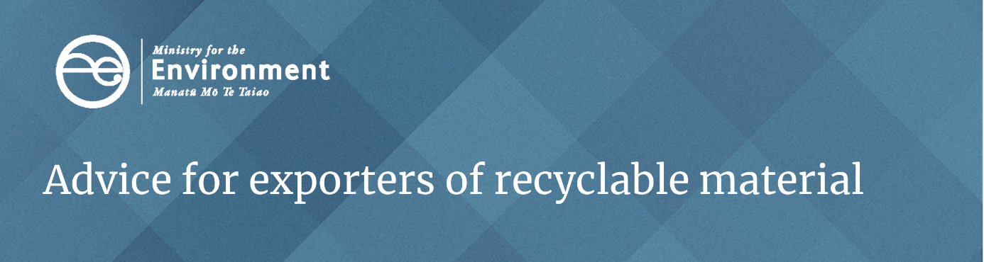
If you are an exporter of recyclable material or waste, it is important that you comply with the legal requirements of the country to which you are exporting.
Failure to comply could harm your company’s reputation, result in the material being rejected and returned to New Zealand at your expense, and affect your future ability to trade.
Importing requirements may change as the international market for waste and recyclable material changes. Several countries are beginning to restrict or ban imports, for example China, Malaysia and Indonesia. Some countries may also require a permit or registration before material can be shipped. The onus is on you to be aware of these changes and to comply with both New Zealand law and the laws of the importing country.

Exporting to Malaysia
For exports to Malaysia, you should check whether the importer has the correct permits or permissions from the Malaysian Government. You can contact the Malaysian Government directly to determine if the importer has the correct permissions:
JABATAN PENGURUSAN SISA PEPEJAL NEGARA
Kementerian Perumahan dan Kerajaan Tempatan
Aras 23, 24 dan 34 No. 51, Persiaran Perdana, Presint 4
Pusat Pentadbiran Kerajaan Persekutuan
62100 Putrajaya MALAYSIA
Phone: 03-8000 8000
Fax: 03-8891 3190
Email: webmaster@jpspn.kpkt.gov.my

Exporting to Indonesia
For exports to Indonesia, you must register with the Indonesian Embassy in Wellington in advance of any exports of material. The Embassy outlines the registration process and the documents you must provide on their website: see Procedure for authentication NZ exporter of non-hazardous and non-toxic waste.
Documents required by the Indonesian Government include:
- an authenticated New Zealand Certificate of Incorporation
- a recent New Zealand company profile
- a notarised letter of statement (a template is available on the website)
- a completed application form (a template is available on the website)
- a copy of the applicant’s passport or identification of the authorised person.
For more information and inquiries, email the Indonesian Embassy:
Email: ekonomi.wellington@kemlu.go.id

Exporting hazardous waste
For information on exports or imports of hazardous waste covered by the Basel Convention visit the Environmental Protection Authority’s website.

Find out more
For additional information on exports of recyclable material please contact – info@mfe.govt.nz.

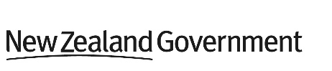
Published in December 2020 by the Ministry for the Environment Publication number: INFO 995

