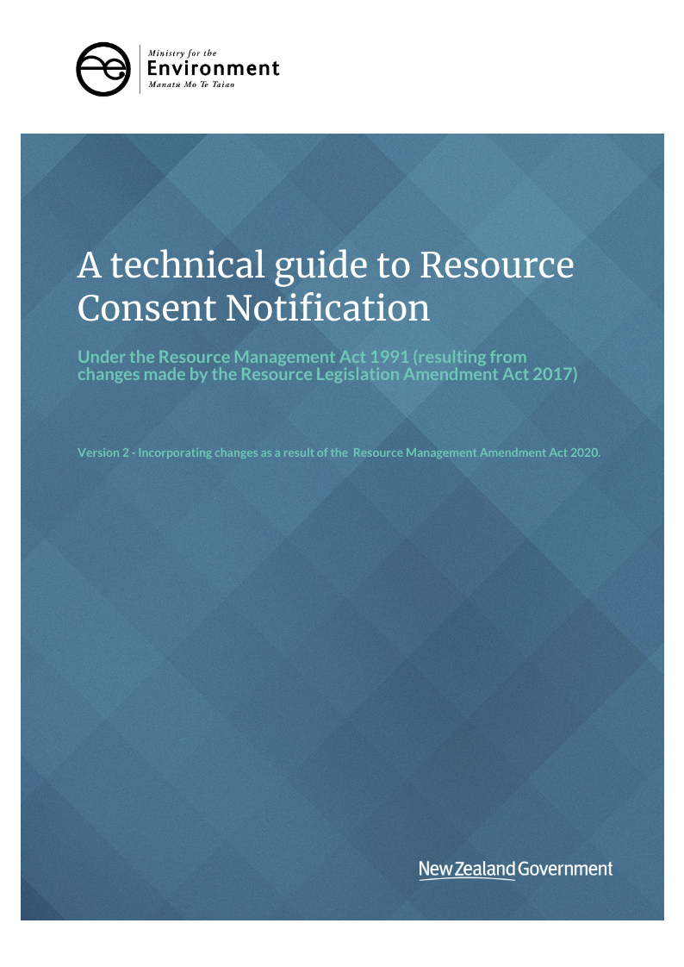AA technical guide to   
Resource Consent Notification

**Disclaimer**

The information in this publication is, according to the Ministry for the Environment’s best efforts, accurate at the time of publication and the Ministry makes every reasonable effort to keep it current and accurate. However, users of the publication are advised that:

* the information provided does not alter the laws of New Zealand and other official guidelines and requirements
* users should take specific advice from qualified professional people before undertaking any action as a result of information obtained in this publication
* the Ministry for the Environment does not accept any responsibility or liability whatsoever whether in contract, tort, equity or otherwise for any action taken as a result of reading, reliance placed on the Ministry for the Environment because of having read any part, or all, of the information in this publication or for any error, or inadequacy, deficiency, flaw in or omission from the information provided in this publication
* all references to websites, organisations or people not within the Ministry for the Environment are provided for conveniences only and should not be taken as endorsement of those websites or information contained in those websites nor of organisations or people referred to.

**Acknowledgements**

The Ministry for the Environment would like to thank the local authorities who provided feedback on this guidance in its draft form.

This document may be cited as: Ministry for the Environment. 2020*. A Technical Guide to Resource Consent Notification (version 2)*. Wellington: Ministry for the Environment.

Original version published in September 2017

Version 2 published in September 2020 by the   
Ministry for the Environment   
Manatū Mō Te Taiao

PO Box 10362, Wellington 6143, New Zealand

ISBN: 978-1-99-003333-9 (online)

Publication number: ME 1546

© Crown copyright New Zealand 2020

This document is available on the Ministry for the Environment website: [www.mfe.govt.nz](http://www.mfe.govt.nz).



# Contents

Introduction 4

Purpose of this guide 4

Background to the 2017 RMA amendments 4

Related changes made by the RMAA2020 5

When the provisions take effect 5

Scope of notification changes 6

‘Fast track’ resource consents 6

New notification decision process (s95A and 95B) 6

Notification decisions for ‘bundled’ consent applications 7

Notification due to special circumstances (s95A(9) and s95B(10)) 8

Requirements in relation to public notices (s2AB) 10

Requirements for the electronic service of documents (s352) 11

Limited scope for appeals (s120) 11

Flowcharts – new step-by-step notification decision process 13

Stage 1 of notification decision process – should the application be publicly notified? 15

Step 1 – Mandatory public notification 15

Step 2 – Public notification precluded in certain circumstances 16

Step 3 – Public notification required in certain circumstances 19

Step 4 – Public notification in special circumstances 20

Stage 2 of notification decision process – should the application be limited notified? 21

Step 1 – Certain affected groups and affected persons must be notified 21

Step 2 – Limited notification precluded in certain circumstances 22

Step 3 – Certain other affected persons must be notified 23

Step 4 – Further notification in special circumstances 24

Appendix A: Template for short summary of public notice 26

# Introduction

## Purpose of this guide

The purpose of this guide is to help consent authorities understand and implement the changes made to the notification provisions of the Resource Management Act 1991 (RMA) introduced by the Resource Legislation Amendment Act 2017 (RLAA17) which came into effect on 18 October 2017. The Resource Management Amendment Act 2020 (RMAA2020) introduced further changes to the notification provisions which came into effect on 30 September 2020. This guide has been updated to incorporate changes introduced by RMAA 2020.

This guide provides practical assistance to consent authorities and covers:

* why and what changes have been made to the RMA
* what these changes mean for consent authorities in the day-to-day processing of resource consent applications.

The guide has been written for a local authority audience. Local authorities are welcome to share this guide with the public, or to use information in the guide to develop their own customer information.

Please note this guide has no legal status and is not a legal interpretation of the RMA, RLAA17 or RMAA2020.

## Background to the 2017 RMA amendments

Prior to the 2017 amendments to the RMA, unless a rule in a plan or National Environmental Standard (NES) specified the notification pathway for an activity, the consent authority would use the “effects tests” (laid out in section 95D and section 95E of the RMA) to determine whether to give public or limited notification of a resource consent (or process it on a non‑notified basis).

Although several plans have non-notification clauses in them, there is considerable variability in the number and type of activities to which these rules apply. Most consent applications have still been subject to a comprehensive effects-based assessment by the consent authority before determining the notification outcome — even for proposals where there is a high level of certainty about how localised or widespread adverse environmental effects will be. For applicants, this has meant there has been a reasonably high level of uncertainty about whether their application is going to be notified or not.

In 2017 the RMA was been amended to:

* replace the previous public and limited notification assessment processes for resource consent applications with a new explicit step-by-step process
* remove the general discretion for councils to publicly notify resource consent applications
* introduce new preclusions on public and limited notification
* introduce a 10-working-day timeframe for councils to make notification decisions on fast‑track applications
* provide a coordinated notification process for some joint Reserves Act and RMA resource consent processes
* provide a new regulation making power, allowing central government to specify that certain activities must not be publicly notified, must not be limited notified, or to limit who may be considered an affected person
* replace the ‘discretion’ to notify, with a ‘requirement’ to notify, if special circumstances exist
* extend the consideration of special circumstances for notification decisions to both publicly and limited notification.

In addition, the RLAA17 has introduced the following changes also relating to the notification decision:

* full public notices to be published on a freely accessible internet site (instead of a newspaper) with a short summary of the online notice published in at least one local newspaper
* limit the scope of appeals to the Environment Court on decisions on resource consents
* new Part 6AA and Part 8 provisions for the notification of additional matters for Nationally Significant Proposals and notices of requirement for designations and heritage orders to maintain the pre-RLAA17 approach to notification for these processes.

## Related changes made by the RMAA2020

The following changes made through RMAA2020 result in update to the information above:

* public notification and appeal preclusions for resource consents for subdivision and residential activities are removed
* the restriction on submitters to only appeal matters that were raised in their original submission is removed
* the regulation making power that enable preclusion of notification for particular activities is removed
* the regulation making power that prescribe activities as fast track is removed.

## When the provisions take effect

The consenting provisions of the RLAA17 took effect on 18 October 2017.

The amendments relating to notification provisions from RMAA2020 came into effect on 30 September 2020. These changes do not have retrospective effect. This means applications lodged:

* before 30 September 2020 are subject to the un-amended provisions of the RMA,
* on or after 30 September 2020 are subject to the amended requirements of the RMA, as covered in this guide.

Any applications for a change or cancellation of a consent condition (s127 application) lodged on or after 30 September 2020 (for a resource consent granted prior to this date) are subject to the new notification provisions covered in this guide.

# Scope of notification changes

## ‘Fast track’ resource consents

The RLAA17 amended the RMA to introduce a new fast track process for particular types of resource consent applications (s87AAC). These applications must be processed within 10 (instead of the standard 20) working days. They are applications that are district land use activities with a controlled activity status, where the applicant has supplied an electronic address for service.

Applicants can opt out of the process if they wish (at the time of lodging the application).

Section 95 has been amended to introduce a 10-working day timeframe for consent authorities to make their notification decision on fast track consents.

A fast track consent ceases to be continued as a fast track application if the consent authority determines either:

* the application needs to be *publicly notified*:
* under s95C (public notification after request for further information), or
* if special circumstances exist (s95A(9)), or
* the application needs to be *limited notified*:
* because there are certain affected groups/persons who must be notified (s95B(2)–(4)) or if special circumstances exist in relation to the application (s95B(10)), or
* a *hearing is required* (for a non-notified consent).

The application then continues to be processed via the standard resource consent process (depending on the notification path it follows). The relevant timeframes that apply, and the date of lodgement of the original (fast track) consent remains the same.

Section 37 (waivers and extension of time limits) has not changed. Consent authorities can still apply this section to extend the timeframes outlined in the RMA, where criteria in section 37A are met.

## New notification decision process (s95A and 95B)

The new notification decision process retains the current two stage process. Public notification is addressed first and limited notification is being then addressed if public notification is not required. The process is however fundamentally different — the consent authority must move through a sequential mandatory step-by-step process to make its notification decision.

Sections 95A and 95B have been replaced with this step-by-step process, outlined in the flowcharts in this technical guidance — and in detail in the following chapters.

The notification process changes do not change the consent authority’s powers to:

* defer processing an application under s91, if the authority determines additional consents are needed, or
* request further information (under s92) if necessary to support their notification determination.

## Notification decisions for ‘bundled’ consent applications

It is common practice for an application to be prepared based on a proposed development, which often involves many activities requiring resource consent. However, an applicant may apply for consents for a proposal in separate applications.

In circumstances where there are multiple applications relating to the same proposal, the council has two interrelated decisions to make before making a notification decision:

* Firstly, the council must determine whether all necessary consents have been lodged. In some situations, a council may determine not to proceed with their notification decision until other related applications (that will help with a better understanding of the proposal as a whole) are made (s91). This may include consent applications that need to be processed by other consent authorities (in such cases, these applications may be processed as a joint application).
* Secondly, the consent authority must decide whether to treat those applications separately or as one overall activity (a ‘bundle’). If the decision is made that separate applications should be bundled, they are assessed together as a whole, and the overall activity status of the ‘bundle’ is generally that of the most restrictive rule applying to the proposal.

This decision has implications for the way in which the preclusions on, and requirements for, notification apply under the new step-by-step notification process. This is explained in more detail later in this guidance, but in brief:

### Preclusions to notification for bundled consents

* All activities in a ‘bundle’ of applications must fall within the scope of a given preclusion in a plan or national environment standard, for the preclusion on notification to apply (s95A(5)(a), s95B(6)(a)).
* All activities within a ‘bundle’ of applications must include only activities listed in s95A(5)(b)(i) for the preclusions on public notification to apply, and must include only controlled district land use activities (s95B(6)(b)) for the preclusions on limited notification to apply.
* ‘Boundary Activities’[1] (which are precluded from public notification by virtue of their definition in s87AAB) cannot form part of a ‘bundle’.

### Requirements for notification for bundled consents

Only one activity within a bundle of applications needs to fall within the scope of a mandatory notification requirement outlined in a plan or national environment standard for the whole of the bundle to require public notification (s95A(8)(a)).

## Notification due to special circumstances (s95A(9) and s95B(10))

The concept of ‘special circumstances’ in the context of public notification is not new. The presumption for notifying based on special circumstances has however changed. If the consent authority determines special circumstances exist, it MUST publicly notify the application (ie, it will no longer be discretionary).

The determination of special circumstances in relation to limited notification is new. If the consent authority determines special circumstances exist in the application that warrants the limited notification of the application to persons that have either:

* been precluded from being served notice (due preclusions listed in s95B(6)), or
* are not eligible persons (in the case of boundary activities or prescribed activities) (under s95B(7))

then the consent authority must serve notice on those persons (ie, process the application on a limited notified basis).

### What are ‘special circumstances’?

Current case law has defined ‘special circumstances’ (in the context of decisions on public notification of resource consent applications) as those “outside the common run of things which is exceptional, abnormal or unusual, but they may be less than extraordinary or unique”.[2]

Although the purpose is slightly different, this definition can also be applied to the treatment of special circumstances for limited notification, in that a special circumstance would be one which makes limited notification desirable, despite provisions excluding consideration being given to whether particular persons are ‘affected’.

The following case law outlines certain cases where the courts have considered special circumstances in relation to the public notification of resource consent applications. The case law summaries are not an exhaustive list of cases that relate to special circumstances and should be read in conjunction with the cases themselves for full context. These cases may simply be a helpful starting point for consent authorities in determining whether special circumstances exist for the limited notification of resource consent applications.

Table 1: ‘Special circumstances’ case law summary

| Case name & citation | Notes |
| --- | --- |
| *Murray v Whakatane DC*  [(1997) NZRMA 433 (HC)] | This case concerned an application for subdivision to complete a residential development. The plaintiffs (occupiers of land near the proposed subdivision) challenged the Whakatane District Council’s decision not to publicly notify the applications. The Court found the Council was wrong in deciding not to notify the applications, as there was likely to be high public interest in development of the site, given previous development proposals had been the subject of wide public opposition, and several parties (including the Department of Conservation) had indicated they wished to submit on the applications. The Court rejected the Council’s view that the proposed subdivision conformed with the Transitional District Plan and so alleviated any public interest concerns, as the Court observed the Transitional District Plan in itself was contentious. |
| *Urban Auckland v Auckland Council* [(2015) NZHC 1382, (2015) NZRMA 235] | This case concerned a resource consent to extend a wharf in Waitemata Harbour, obtained by Ports of Auckland Limited on a non-notified basis. The plaintiffs challenged the Council’s decision not to notify the application based on special circumstances. The Court concluded special circumstances existed in this case, because of high level of public interest in the proposal, significant plans for future development of the site, and the applicant was a Council-owned entity. |
| *Housiaux v Kāpiti Coast District Council* [HC Wellington  CIV- 2003-485-2678 19 March 2004] | This case concerned a resource consent for the construction of a heavy vehicle access onto a farm, which was granted on a non-notified basis. The plaintiff, who owned the neighbouring property, challenged the Council’s decision not to notify the application, on the basis there were special circumstances, namely she and another party had written to the Council requesting to be consulted about the application. The Court held that concern on the part of neighbouring residents did not amount to special circumstances. According to the Court, if that was the case, “every application would have to be advertised where there was any concern expressed by people claiming to be affected”.  The plaintiff also challenged the Council decision on the basis the application was a precursor to a possible future subdivision on the neighbour’s property, which constituted a “special circumstance triggering notification”. The Court held the possibility of future subdivision applications was outside the scope of the application and therefore could not constitute a special circumstance. |
| *Creswick Valley Residents Association Inc, v Wellington City Council*  [HC Wellington CIV-2011-485-2438] | The plaintiffs, neighbouring residents of a property, challenged the Council’s decision to grant an earthworks consent for the property on a non-notified basis. The plaintiffs argued the Council’s actions, in previously advising the plaintiffs they would be given the opportunity to comment before any significant change to the site occurred, amounted to special circumstances. The Court accepted the plaintiffs had an arguable case and granted them an interim injunction, preventing the developer from commencing earthworks on the site, pending a full hearing. However, at the hearing, the Court decided it unnecessary to decide the special circumstance issue, as the Court had already ruled the Council’s decision invalid for another reason. |
| *Fullers Group Ltd v Auckland Regional Council* [(1999) NZRMA 439 (CA)] | The plaintiff challenged the Council’s decision not to notify an application for a coastal permit for a floating pontoon in Waitemata Harbour to load and unload boat passengers. The plaintiff, an adjacent ferry operator, argued the proposed pontoon would create safety issues for the plaintiff, but the Council found no evidence of any safety risks. The Court concluded it is unlikely any special circumstances could be found in the absence of such evidence. |

## Requirements in relation to public notices (s2AB)

Once the decision is made to publicly notify an application under s95A, the consent authority must give public notice of the application.

Previously when giving public notice, the consent authority was required to publish a notice in a newspaper circulating in the entire area likely to be affected by the proposal, with the option to publish the notice on the internet as well.

RLAA17 has introduced a new section 2AB, requiring:

* public notices be published (along with all relevant information) on a freely accessible internet site, instead of a newspaper
* a short summary of the online notice be published in at least one newspaper circulated in the whole area affected by the topic of the notice, along with a web address directing readers to the full notice
* the notice and short summary be worded in a clear and concise way.

### Public notices

The public notice should include enough information about the application and the location to enable any person to decide whether or not to view the complete application for the purpose of making a submission. Notices must still comply with any relevant form in the Resource Management (Forms, Fees and Procedure) Regulations 2003.

There is no minimum length of time public notices must remain on a website. A general guideline is notices should be available online for at least the entire period the notice is relevant to the public (for example, the submission period it relates to). Some councils may choose to store public notices online after this period, for reference purposes.

The requirement for decision-makers to serve public notices to particular people has not changed (ie, they must be served on every person prescribed in Regulation 10 of the Resource Management (Forms, Fees and Procedure) Regulations 2003.

### Short summaries

Short summaries for public notices should cover the following information:

* the name of the relevant consent authority
* the name of the applicant
* a clear and concise description of the proposal
* a clear and concise description of the location
* the closing date of submissions (if applicable)
* web link to the full public notice (Note tinyurl.com is a useful tool to make web links more concise in length).

Appendix C provides a template of a short summary.

### Site Notices

Regulation 10A of the Resource Management (Forms, Fees and Procedure) Regulations 2003 has been amended so the consent authority only needs to affix the short summary of the public notice (instead of the full public notice as previously), and details of the internet page where they can find the full public notice to the site (note: this remains a discretionary option).

## Requirements for the electronic service of documents (s352)

RLAA17 amends section 352 of the RMA to make electronic delivery the default method of service for RMA processes. If a person provides an electronic address, for the matter to which the document relates, and does not request another method of service listed in section 352(1)(b), documents under the RMA must be served using the electronic address provided (unless a court directs otherwise).

People are not required to provide an electronic address as their address for service, however, this is encouraged (it is faster and less expensive than non-electronic methods).

* When a council notifies an application, and serves notice on affected persons (and groups), if those persons have provided an electronic address for service (for this purpose), the consent authority must serve notice to them via this electronic address for service.
* When a submission is received on a notified resource consent application, any further documents sent to the submitter (such as notification of the hearing, copy of the decision etc,) should be sent to their electronic address for service, if they have provided one for this purpose.

## Limited scope for appeals (s120)

Under section 120 of the RMA, an applicant/consent holder, or any person who made a submission on the application (or review of consent conditions) can appeal to the Environment Court against the whole or any part of a decision of a consent authority for a resource consent. The scope of this right to appeal is limited by section 120(1A) — which states if the resource was for a *boundary activity* (as defined in s87AAB) then the decision cannot be appealed (unless the proposal was a non-complying activity).

Preclusions on appeals for subdivision consents and residential activities were also introduced by RLAA17, but subsequently repealed by RMAA2020.

If multiple resource consents for the same proposal are considered together in a ‘bundle’, and one or more of those resource consents can be appealed, the entire ‘bundle’ of consents can be appealed together.

In addition, s120 has been amended so a submitter can only appeal to the Environment Court if their submission, or the part to which the appeal relates, has not been struck out under (new) section 41D of the RMA.

People can still challenge decisions to the High Court through judicial review regarding errors of process.

Applicants can also lodge an objection to the consent authority under s357A about the decision on a notified resource consent, if either no submissions were received, or all submissions were withdrawn. In such cases, the applicant may request their objection is heard by a hearing commissioner. If they make that request, the consent authority must arrange for the objection to be heard and decided, by one or more Commissioners who are not members of the consent authority. The appeal rights subsequent to a decision on an objection have been retained. However for boundary activities, where appeals are excluded under s120A, there is no right of appeal on the decision on an objection.

Any advice by a consent authority to applicants or submitters must be consistent with the new changes to appeal rights.

For example, a note on a resource consent for a boundary activity, should specify whether the applicant has appeal rights*.* The consent note might say “There are no rights of appeal to the Environment Court in relation to this decision”.

# Flowcharts – new step-by-step notification decision process

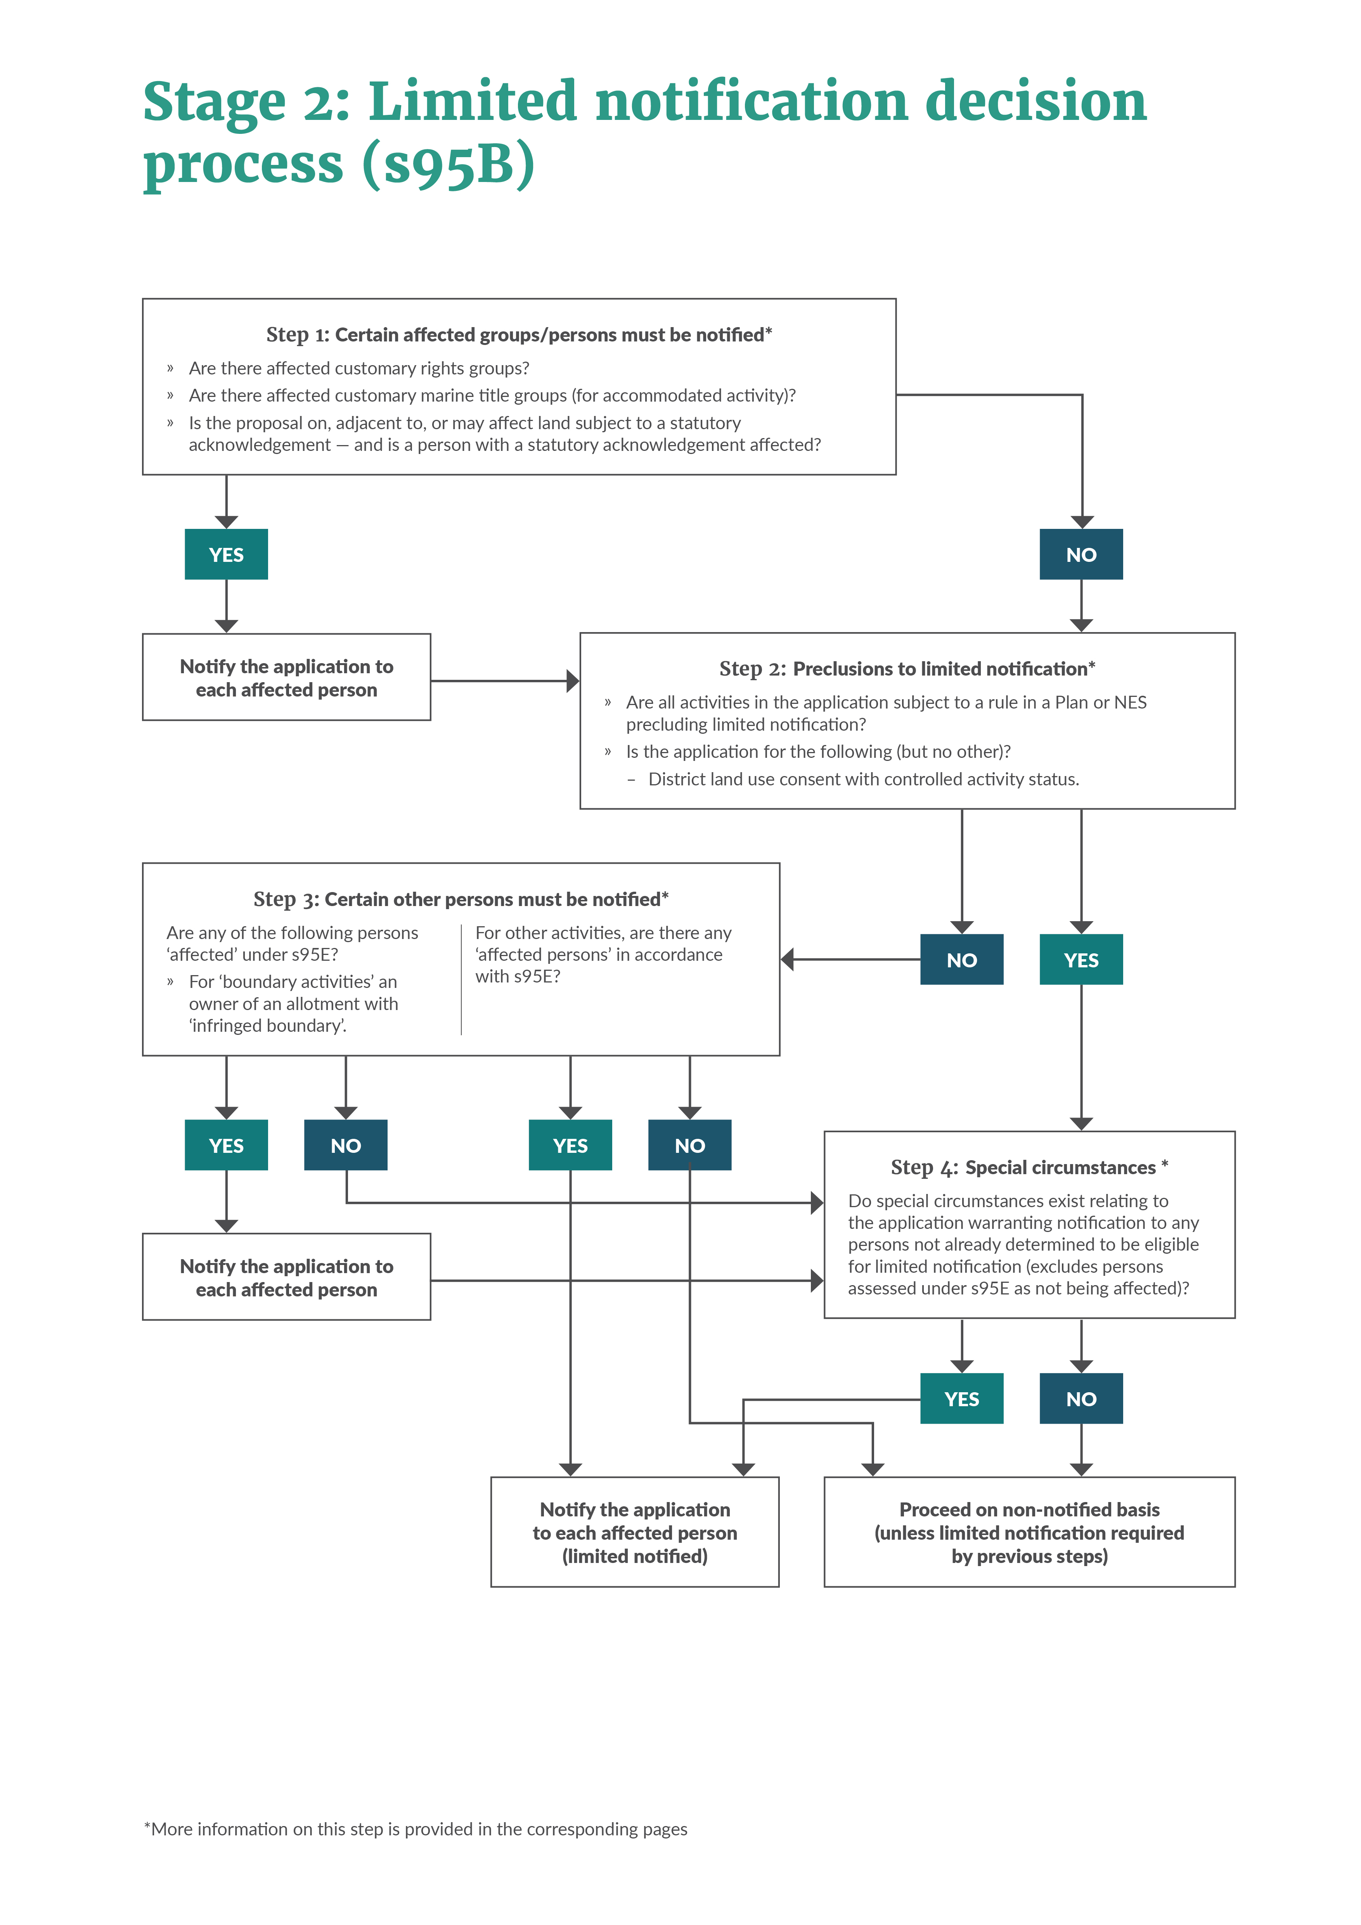

# Stage 1 of notification decision process – should the application be publicly notified?

## Step 1 – Mandatory public notification

If the application meets any of these three criteria, the application must be publicly notified:

### Criteria (a): The applicant has requested public notification (s95A(3)(a))

This provision is unchanged by the amendments.

|  |  |
| --- | --- |
| Has the applicant requested public notification? | |
| Yes | Publicly notify application.  No further notification assessment necessary. |
| No | Continue through step 1. |

### Criteria (b): Public notification is required under s95C (s95A(3)(b))

This provision is unchanged by the amendments. An application must be publicly notified if either:

* the consent authority makes a request for further information under s92(1) of the RMA before making a notification decision and the applicant refuses to provide the information, or does not provide it before the deadline
* the consent authority notifies the applicant they will be commissioning a report under s92(2) of the RMA before making a notification decision, and the applicant refuses to agree to the commissioning, or does not respond before the deadline.

|  |  |
| --- | --- |
| Is public notification required under s95C? | |
| Yes | Publicly notify application.  No further notification assessment necessary. |
| No | Continue through step 1. |

### Criteria (c): The application is made jointly with an application to exchange recreation reserve land under section 15AA of the Reserves Act 1977 (s95A(3)(c))

This is a new provision, as a consequence of the integrated process for Reserves Act and Resource Management Act permissions for exchange of Recreation Reserve land for other land to be held for the same purpose.

If the Recreation Reserve is administered by the council, an application can be made jointly under s88A of the RMA and s15AA(4) of the Reserves Act. If a joint application has been made, the application must be publicly notified.

The flowchart on the Ministry’s website ([Joint reserve exchange – RMA process initiation](http://www.mfe.govt.nz/publications/rma/joint-reserve-exchange-rma-process-initiation-flowchart) [flowchart](http://www.mfe.govt.nz/publications/rma/joint-reserve-exchange-rma-process-initiation-flowchart)) will help to determine whether a joint process can be applied to a reserve exchange request with a resource consent application:

|  |  |
| --- | --- |
| Has the application been made jointly with an application to exchange recreation reserve land? | |
| Yes | Publicly notify application.  No further notification assessment necessary |
| No | Move to step 2 |

|  |
| --- |
| JOINT EXCHANGE OF RESERVE LAND EXAMPLE |
| The ABC Council administers a specific recreation reserve. DEF Limited has a housing development adjacent to this reserve and proposed to Council they extend the development into a small part of the reserve. They propose to exchange an equivalent area from their site, also adjacent to the reserve. The Council has determined this matter can be addressed by a consent application, not a plan change. The joint Reserves Act/resource consent application must be publicly notified. |

## Step 2 – Public notification precluded in certain circumstances

For any applications not required to be publicly notified under step 1, public notification is precluded (ie, not allowed) in certain situations, unless special circumstances apply (see step 4).

Note: This step does not involve any consideration of the proposal’s environmental effects (which happens at step 3, if the application makes it that far). This is quite a significant shift from the previous notification assessment process.

The criteria outlining which circumstances preclude public notification are:

### Criteria (a): All activities in the application are subject to one or more rules or national environmental standards that preclude public notification (s95A(5)(a))

Local authorities can include rules in their plans which state certain types of resource consent applications shall not be publicly notified. Similarly, a NES can include provisions specifying particular activities be precluded from being publicly notified. Such preclusions will typically be either for a certain class of activity or particular types of activities.

If the application involves numerous activities requiring consent, or a bundle of applications are being processed together as a ‘bundle’, then public notification of the application as a whole is only precluded under this criterion if each of those activities is precluded public notification by a rule in a plan or a NES.

If public notification is precluded under this criterion, step 3 doesn’t apply and instead the consent authority must determine whether there are special circumstances that warrant the public notification of the application (step 4).

|  |  |
| --- | --- |
| Are all activities in the application precluded from public notification by a rule in a plan or a NES? | |
| Yes | Move to step 4 (special circumstances). |
| No | Continue through step 2. |

### Criteria (b): The application is for one (or more) of the following types of activities:

#### A controlled activity (s95A(5)(b)(i))

This is a new provision. It does not however represent a major departure from current practice, as very few controlled activities were previously publicly notified. In many cases, councils will already have a rule in their plan precluding notification for controlled activities (refer criteria (a) above). The preclusion of controlled activities under s95A(5)(b) will therefore pick up any controlled activities without rules precluding notification in a plan or by a NES.

The main purpose of this provision is to provide certainty for applicants. If an application is for a controlled activity (but no other activity other than those listed below relating to boundary activities), then it cannot be publicly notified, unless special circumstances exist. This provision applies to both district and regional resource consents.

|  |  |
| --- | --- |
| Is the application as a whole for a controlled activity? | |
| Yes | Move to step 4 (special circumstances). |
| No | Continue through step 2. |

|  |
| --- |
| CONTROLLED ACTIVITY EXAMPLE |
| In the district plan for ABC Council, erecting a wind powered turbine is identified as a controlled activity in the residential C zone (subject to standards). Ms Smith has applied to the Council for consent for a turbine in this zone, which meets the relevant standards. No other aspects of the proposal require consent. Unless the council determines special circumstances exist, it may not publicly notify the consent. |

#### Boundary activities (s 95A(5)(b)(iii))

This is a new provision, and a departure from current practice. This criterion applies to district plans only. A boundary activity is defined in new s87AAB as:

(1) An activity is a **boundary activity** if—

(a) the activity requires a resource consent because of the application of 1 or more boundary rules, but no other district rules, to the activity; and

(b) no affected infringed boundary is a public boundary

2) In this section,—

**boundary rule** means a district rule, or part of a district rule, to the extent that it relates to—

(a) the distance between a structure and 1 or more boundaries of an allotment; or

(b) the dimensions of a structure in relation to its distance from 1 or more boundaries of an allotment

**infringed boundary**, in relation to a boundary activity,—

(a) means a boundary to which an infringed boundary rule applies;

(b) if there is an infringement to a boundary rule when measured from the corner point of an allotment (regardless of where the infringement is to be measured from under the district plan), means every allotment boundary that intersects with the point of that corner;

(c) if there is an infringement to a boundary rule that relates to a boundary that forms part of a private way, means the allotment boundary that is on the opposite side of the private way (regardless of where the infringement is to be measured from under the district plan).

**Public boundary** means a boundary between an allotment and any road, river, lake, coast, esplanade reserve, esplanade strip, other reserve, or land owned by the local authority or by the Crown.

If an application is for a boundary activity (and has not been identified as being eligible as a ‘deemed permitted boundary activity’ through the process defined in s87BA) then it may not be publicly notified (unless special circumstances apply).

Refer to the [technical guidance on Deemed Permitted Activities](http://www.mfe.govt.nz/publications/rma/technical-guide-deemed-permitted-activities) for further information about boundary rule infringement exemptions.

A ‘boundary activity’ with a controlled activity status is precluded from public notification under the controlled activity preclusion above (s95A(5)(b)(i)).

|  |  |
| --- | --- |
| Is the activity a boundary activity (any activity status)? | |
| Yes | Move to step 4 (special circumstances). |
| No | Continue through step 2. |

|  |
| --- |
| BOUNDARY ACTIVITY EXAMPLE A |
| Ms Smith applies to ABC District Council for resource consent, because her proposed house extensions come within 1 metre of the boundary and the setback rule in her zone is 1.5 metres. No other rule infringements occur. The infringed boundary is with a privately-owned property. She has not been able to get written approval from her neighbour. The Council determines the consent application is for a restricted discretionary activity. This is an application for a boundary activity and may not be publicly notified, unless special circumstances apply. The application may however require limited notification under s95B. |

|  |
| --- |
| BOUNDARY ACTIVITY EXAMPLE B |
| DEF Limited applies to ABC District Council for an extension to its factory which infringes a boundary rule. The infringed boundary is with a privately-owned property. No other rule infringements occur. The Council determines the consent application is for a non-complying activity. This is an application for a boundary activity and may not be publicly notified (however may still be limited notified under s95B). |

## Step 3 – Public notification required in certain circumstances

For any applications not precluded from public notification under step 2, public notification may then be required if it meets either of the following criteria:

### Criteria (a): A rule or national environmental standard requires public notification (s95A(8)(a))

This provision is equivalent to an existing provision (previously within s95A(2)(c)). The new step-by-step process, however, has changed the priority of the criterion. Previously, an activity where a rule or NES provision required public notification would prevail over any other considerations. The RLAA17 amendments mean if the activity meets the preclusions outlined in step 2 above, then these prevail over the requirements of a rule or provision requiring public notification. Such a rule or provision may, however, contribute to a consideration regarding special circumstances. If the application is being processed as a ‘bundled consent’ (see page 7 for further guidance), and any of the activities within that application are subject to a rule or NES requiring public notification, the application as a whole must be publicly notified.

|  |  |
| --- | --- |
| Is any activity in the application subject to a rule or NES requiring public notification? | |
| Yes | **Publicly notify**application.  No further notification assessment required. |
| No | Continue through step 3. |

### Criteria (b): Adverse effects on the environment that are more than minor (s95A(8)(b))

This is an existing provision (previous section 95A(2)(a)), however, the new step-by-step process has changed the primacy that this section has. Previously, only a rule or NES provision precluding public notification would have priority over this provision. Now the determination of whether the adverse environmental effects are more than minor for the purpose of notification need only be undertaken if all of the above criteria in steps 1 (mandatory public notification), 2 (preclusions to public notification) and 3 (a rule in a plan requires public notification) do not apply.

Despite the change in the priority, the practice of applying the adverse effects test to applications remains largely unchanged (s95D).

|  |  |
| --- | --- |
| Does the activity have, or likely to have, adverse effects on the environment that are more than minor in accordance with s95D? | |
| Yes | **Publicly notify** application. |
| No | Move to step 4 (special circumstances). |

|  |
| --- |
| ADVERSE EFFECTS MORE THAN MINOR EXAMPLE |
| ABC Limited has applied to GHI Regional Council for a discharge permit for smoke from its incinerators. The Council has determined the proposal is a restricted discretionary activity. Odour from the smoke will be evident over a wide area on occasions. The Council has determined the effects of the odour are more than minor. The application must be publicly notified. |

## Step 4 – Public notification in special circumstances

If the application has not been publicly notified because of any of the previous steps, then the consent authority must consider whether special circumstances exist that warrant the public notification of the application. See page 8 of this document for guidance on what might constitute special circumstances.

This is a new provision, similar to the existing provision. The main change is the action that the consent authority took on finding special circumstances existed was discretionary prior to RLAA17. The new provisions define that if the consent authority determines that special circumstances do exist, then they *must* publicly notify the application.

|  |  |
| --- | --- |
| Do special circumstances exist that warrant the public notification of the application? | |
| Yes | **Publicly notify** application. |
| No | Determine whether limited notification is required under s95B. |

# Stage 2 of notification decision process – should the application be limited notified?

If public notification is not required under s95A, the consent authority must assess if limited notification is required under s95B as follows:

## Step 1 – Certain affected groups and affected persons must be notified

The following criteria have been worded slightly differently from the current legislation, with the same effect.

### (a): There are affected protected customary rights groups (s95B(2)(a))

This provision is a rewording of the current provision, but has the same effect (previous section 95B(1)). If an application is for an activity within a *protected customary rights area*, the consent authority must decide, with reference to s95F, whether a *protected customary rights group* is affected.

The terms **protected customary rights group**, **protected customary rights order** and **protected customary rights area**are defined in [section 9(1)](http://www.legislation.govt.nz/act/public/1991/0069/latest/link.aspx?id=DLM3213146&amp;DLM3213146) of the Marine and Coastal Area (Takutai Moana) Act 2011.

|  |  |
| --- | --- |
| Are there any affected protected customary rights groups? | |
| Yes | Protected Customary Right Group served notice. Continue through step 1. |
| No | Continue through step 1. |

### (b): There are affected customary marine title groups (in an application for a resource consent for an accommodated activity) (s95B(2)(b))

This provision is a rewording of the current provision, but has the same effect (previous section 95B(1) and 95B(4)).

When a consent authority is considering an application for an *accommodated activity*, within a *customary marine title area* (both defined in the Marine and Coastal Area (Takutai Moana) Act 2011), they must decide if the customary marine title group is affected (with reference to s95G).

If the council determines there is an affected customary marine title group (for a resource consent for an accommodated activity) the application must proceed on a limited notified basis, and the customary marine title group(s) must be served notice.

|  |  |
| --- | --- |
| For applications for an accommodated activity, is there an affected Customary Marine Title Group? | |
| Yes | Customary Marine Title Group served notice. Continue through step 1. |
| No | Continue through step 1. |

### (c): Statutory acknowledgements (s95B(3))

If the proposed activity is on or adjacent to, or may affect, land the subject of a statutory acknowledgement made in accordance with an act specified in Schedule 11 of the RMA; and the consent authority determines the person to whom the statutory acknowledgement is made is affected under s95E, then, unless that person has provided written approval, the application must proceed on a limited notified basis, and the affected person(s) must be served notice.

Schedule 11 of the RMA includes Settlement Acts which include statutory acknowledgments.

|  |  |
| --- | --- |
| Is the proposal on or adjacent to, or may affect, land the subject of a statutory acknowledgement, and is the person to who the statutory acknowledgement is made considered affected? | |
| Yes | Affected person(s) notified. Go to step 2. |
| No | Move to step 2. |

## Step 2 – Limited notification precluded in certain circumstances

Under this step, the consent authority must determine whether limited notification is precluded for the application (ie, not required). The criteria where this is the case are:

### (a): The application is for a resource consent for one or more activities, and each activity is subject to a rule or national environmental standard that precludes limited notification (s95B(6)(a))

The wording of this provision is similar to the current provision. If a plan or NES includes a rule waiving or precluding limited notification of all activities forming part of the application, then step 3 does not apply and instead the consent authority needs to consider if there are special circumstances existing that may warrant the limited notification of the application to any persons to whom limited notification is precluded (refer to step 4 below).

If the application is being processed as a ‘bundled consent’ (see page 7 for further guidance), then limited notification of the application as a whole is only precluded under this criterion if each of those activities is precluded from limited notification by a rule in a plan or a NES.

|  |  |
| --- | --- |
| Are all the activities in the application subject to one or more rules or NES precluding limited notification? | |
| Yes | Go to step 4 (special circumstances). |
| No | Continue through step 2. |

### (b): The application is for the following, but no other activities (s95B(6)(b)):

#### A controlled activity, requiring consent under a district plan (other than a subdivision)

This is a new provision, significantly reducing the number of applications requiring a limited notification decision. If an application is for a district land use consent with a controlled activity status, the application cannot be limited notified. The special circumstances test in step 4 however applies.

This preclusion does not apply to controlled activity subdivision consents or any resource consents processed by a regional council.

|  |  |
| --- | --- |
| Is the application for a district land use controlled activity? | |
| Yes | Go to step 4 (special circumstances). |
| No | Continue through step 2. |

## Step 3 – Certain other affected persons must be notified

If the activity is not precluded from limited notification under step 2 above, then subject to the eligibility clauses mentioned below for boundary activities and activities prescribed by regulations, a person is an affected person if the consent authority decides the activity’s adverse effects on the person are minor or more than minor (but not less than minor) (s95E).

### For ‘boundary activities’ (s95B(7))

If the proposed activity is a ‘boundary activity’, the only persons eligible to be considered as an affected person(s) is an owner (not an occupier) of an allotment with an ‘infringed boundary’. For more information on boundary activities, see pages 17 and 18.

If an application is for a boundary activity and has not been identified as being eligible as a ‘deemed permitted boundary activity’ through the process defined in s87BA, the consent authority must decide if the owner (not the occupiers) with the ‘infringed boundary’ is an affected person using the criteria in s95E. No other person(s) can be considered as an affected person with respect to a ‘boundary activity’.

This is a new provision, significantly changing the notification decision for many district land use consents.

If the owners with an allotment with an ‘infringed boundary’ are determined to be affected persons, they must be served notice. If they are not considered to be affected (in accordance with an assessment under s95E), consideration needs to be given as to whether there are special circumstances that exist that may warrant to limited notification of the application to any other persons (ie, persons who are not owners with an allotment with an infringed boundary). Refer to step 4 below.

|  |  |
| --- | --- |
| If the activity is a boundary activity, is the owner of an allotment with an infringed boundary ‘affected’ under s95E? | |
| Yes | Notify the application to each affected person and proceed to step 4 (special circumstances). |
| No | Proceed to step 4 (special circumstances). |

### For any other activities (s95B(8))

If the activity is not a ‘boundary activity’, the consent authority must determine if any persons affected by the proposal in accordance with s95E, and serve notice on those persons who are determined to be affected.

Apart from the significant changes to the limited notification criteria above, the wording of s95E remains similar. As previously, a person is not considered to be affected if they have given written approval for the proposal.

|  |  |
| --- | --- |
| For any other activity, are there any affected persons under s95E? | |
| Yes | Notify the application to each affected person and proceed on a limited notified basis. |
| No | Application can proceed on a **non-notified** basis. |

## Step 4 – Further notification in special circumstances

This is a new provision in the Act.

Section 95B(10) states the consent authority should “Determine whether special circumstances exist in relation to the application that warrant notification of the application to any other persons not already determined to be eligible for limited notification under this section (excluding persons assessed under s95E as not being affected persons)…”.

Refer to page 8 of this guidance for further discussion and existing case law regarding ‘special circumstances’ (in the context of public notification). The policy intent associated with the new test for special circumstances in the context of limited notification is that such circumstances are those that are “exceptional, abnormal or unusual but may be less than extraordinary or unique”.[3]

If the consenting authority determines special circumstances reside in the application, and any persons (or groups) who have not otherwise been notified because limited notification is precluded, those persons (or groups) must be notified of the application. If not, the application can proceed on a non-notified basis.

### If a proposed activity is precluded from limited notification under step 2

If the proposed activity is precluded from limited notification under step 2 above (ie, a rule in a plan or NES precludes limited notification, or the proposal is a district land use controlled activity), before proceeding on a non-notified basis, the consent authority needs to consider if any special circumstances warrant the notification of the application to any persons precluded from limited notification under step 2:

#### Where a rule in a plan or NES precludes limited notification (precluded under s95B(6)(a)):

The consent authority needs to determine if there are any special circumstances to the proposal that do not seem to fit with what the plan or NES anticipated, and subsequently if there are any persons that should be notified of the proposal due to these circumstances. If so, the consent authority must process the application on a limited notified basis, and notify those persons of the application.

#### Where the proposal is a district land use controlled activity (precluded under s95B(6)(b)):

Taking into consideration the consent authority must grant the application in accordance with s104A, and a controlled activity is one which (in general) is considered to be an anticipated activity in the district plan, the consent authority needs to determine if there are any special circumstances in the application which do not seem to fit within what the district plan anticipated, and subsequently if there are any persons that should be notified of the proposal due to these circumstances. If so, the consent authority must notify those persons of the application, and process the application on a limited notified basis.

### If certain persons are not considered eligible to be considered as affected under step 3

In the case of a ‘boundary activity’, even if the owner of an allotment with an’ infringed boundary’ has been deemed by the consent authority to not be an affected person (in accordance with s95E), the consent authority assess if there are special circumstances (exceptional, abnormal or unusual reasons) warranting the notification of the application to a person (other than the owner of an allotment with an infringed boundary). This is not intended to be an assessment as to whether those other persons are considered affected in accordance with s95E.

|  |  |
| --- | --- |
| Do special circumstances exist warranting notification to any other persons not already determined to be eligible for limited notification? | |
| Yes | Notify the application to each of these person(s) and proceed on a **limited notified** basis. |
| No | Application can proceed on a **non-notified** basis. |

| SPECIAL CIRCUMSTANCES EXAMPLE |
| --- |
| A developer applies for resource consent to develop a block of land into a complex to accommodate 60 new apartments. The proposed apartment complex is a residential activity with a restricted discretionary activity status, and the site is zoned residential. The council determines public notification is precluded, and no special circumstances exist warranting the public notification of the application. The project complies with all the bulk and location requirements of the district plan, and discretion is restricted to design, site access traffic and parking. The district plan precludes limited notification of this type of activity. |
| Directly across the road from the site is an industrial facility classed as a ‘major hazard facility’ under the Health and Safety at Work (Major Hazard Facilities) Regulations 2016. Due to the potential reverse sensitivity impact on the facility’s operation, and the increased risk resulting from a much higher number of people living in close proximity to the major hazard facility, the council has concluded this constitutes special circumstances. In response, the council decides to notify the owner of the industrial facility and also WorkSafe New Zealand (in its role in regulating major hazard facilities) under s95B(10)(a). |

# Appendix A: Template for short summary of public notice

**Publicly Notified Resource Consent Application: {Address/Location}**

**[Name of applicant]** has applied to **[name of consent authority]** for a resource consent to **[brief description of the proposal]** at **[brief description of the proposal’s location]**. Submissions close on **[date]**.

To view the full public notice, visit **[web link]**.

1. Defined in s87AAB
2. *Far North DC v Te Runanga-iwi o Ngati Kahu* [2013] NZCA 221 at [36].
3. *Far North DC v Te Runanga-iwi o Ngati Kahu* [2013] NZCA 221 at [36].