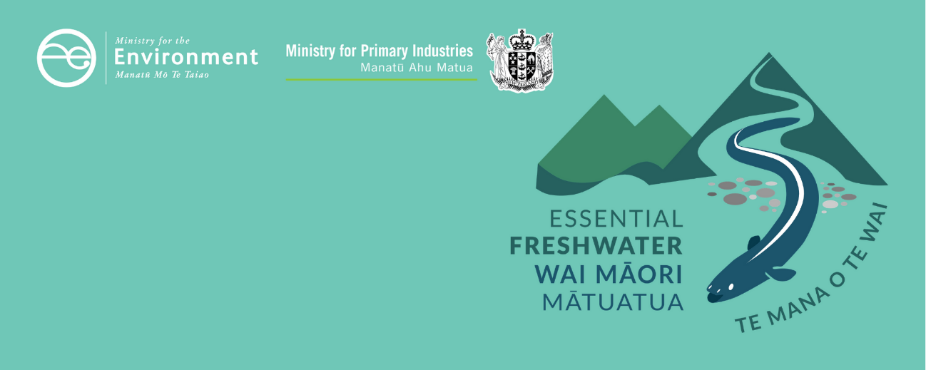

Values and attributes factsheet
Essential Freshwater is part of a new national direction to protect and improve our rivers, streams, lakes and wetlands. The Essential Freshwater package aims to:
- stop further degradation of our freshwater
- start making immediate improvements so water quality improves within five years
- reverse past damage to bring our waterways and ecosystems to a healthy state within a generation.
Te Mana o te Wai is fundamental to all freshwater management
Te Mana o te Wai recognises the vital importance of water. It expresses the special connection that New Zealanders have with freshwater. By protecting the health of freshwater we protect the health and well-being of people and our ecosystems.
When managing freshwater, Te Mana o te Wai ensures the health and well-being of the water is protected before providing for human needs, or enabling other uses of water. Through discussions with regional councils, tangata whenua and communities will have a say on how Te Mana o te Wai is applied in freshwater management locally. More information can be found in the Te Mana o te Wai factsheet.

Who should read this factsheet
This factsheet is part of a series and provides a high-level overview of values and attributes in the National Policy Statement for Freshwater Management 2020 (NPS-FM 2020). It is primarily intended for council staff, but may also be of interest to land users, iwi, the wider agricultural industry, farm advisors and consultants, and anyone else with an interest in freshwater policy.

What are the policies?
The NPS-FM 2020 requires every regional council, in consultation with its community, to develop a plan for maintaining or improving the state of freshwater in the region. There are a number of compulsory values and attributes (measures of the state of a river or lake) that must be met, and communities can identify other relevant values and attributes (or alternate criteria). This is especially relevant for mahinga kai and threatened species which don’t have compulsory attributes. Communities can also choose to go above and beyond the bottom lines.

Key concepts for these provisions

Compulsory values
There are four compulsory values in the NPS-FM 2020:
- ecosystem health
- human contact
- threatened species
- mahinga kai.
The NPS-FM 2020 requires regional councils to identify the values that are associated with the water bodies in their regions. For most values, regional councils will need to establish one or more attributes, and decide long-term goals (called target attribute states). Note that councils may need to develop additional attributes, particularly as mahinga kai and threatened species do not have pre-defined compulsory attributes.

Attributes
An attribute is something we can measure and monitor that tells us about the state of a river or lake.
There are 22 compulsory attributes in the NPS-FM 2020, many of which have a minimum standard, or national bottom line – these contribute to understanding how freshwater provides for ecosystem health and human contact.
The council and community must set target attribute states at or above the bottom line and plan what actions they will take to meet these targets. They are required to improve or at the very least maintain the current state of waterways. Regions can choose to add additional attributes, or higher targets.
More information about attributes can be found in the Attributes information sheet.

Action plans and limits
The regional council must then work out what needs to be managed to achieve the target attribute states (for example, contaminants, habitat or land use).
Attributes requiring limits
For attributes that require limits on resource use, councils need to set limits and develop rules about resource use to achieve the objectives they have set. An example of a limit setting attribute is total nitrogen found in lakes. A limit on resource use might include restricting the amount of nitrogen that is discharged into the lake from its catchment.
Attributes requiring action plans
Other attributes do not require limits on resource use but require councils to develop action plans. An example would be the macroinvertebrate attributes. It is less straightforward to improve macroinvertebrates using limits on resource use, and other actions such as restoration may be required.
Councils must also monitor and report on the extent to which the target attribute states are being achieved.
Note that there are other actions that may be required to achieve ecosystem health. For example, there is no attribute relating to the volume of water flowing through a waterway, but managing flows will contribute to the improvement of other attributes, such as macroinvertebrates, periphyton, and dissolved oxygen.
Table 1: Overview of the freshwater planning system
Values  Councils and communities identify the values they want to provide for in their catchments. | The NPS-FM 2020 defines four compulsory values that need to be provided for everywhere:  - ecosystem health  - human health for recreation  - threatened species  - mahinga kai  Councils and communities can identify other values unique to local circumstances, including optional values in the NPS.
Desired environmental outcomes  Councils and communities set out what they want to achieve in terms of the values they have identified. | The NPS-FM 2020 requires councils and communities to be explicit about what they want to achieve in terms of the values they identify, so that it can inform where they set target attribute states, and what flow regimes and take limits are needed (flows do not have attributes, and are managed in a slightly different way).
Attributes  Councils and communities identify how they will measure whether they are providing those values. | The NPS-FM 2020 defines 22 attributes that measure how well ecosystem health and human health for recreation are being provided.  Most (but not all) have a minimum acceptable states (“national bottom lines”).  Councils and communities also identify their own attributes to provide for values.
Target attribute states  Set desired outcomes for these attributes. | Target attribute states have to be set at or above national bottom lines, and at or above the current state.  Councils and communities can choose to improve freshwater further.
Limits and/or action plans  Work towards desired outcomes. | Limits and action plans achieve the target attributes by:  - limiting resource use (eg discharges)  - setting out other actions to improve freshwater.

When do the policies apply?
Councils need to follow these processes and notify plans that give effect to these provisions by 31 December 2024, with final decisions made and plan operational no more than two years after notification (or three years if they are granted an extension).

More about the Essential Freshwater package
The package includes a number of new national rules and regulations including:
- new National Environmental Standards for Freshwater
- new stock exclusion regulations under section 360 of the RMA
- amendments to the Resource Management (Measurement and Reporting of Water Takes) Regulations 2010
- the National Policy Statement for Freshwater Management 2020 which replaces the NPS-FM 2017
- amendments to the RMA to provide for a faster freshwater planning process
- amendments to the RMA to enable mandatory and enforceable freshwater farm plans, and the creation of regulations for reporting nitrogen fertiliser sales.
Factsheets in this series
The full set of Essential Freshwater factsheets is available on our website.
Find out more and give us feedback
Contact us by emailing freshwater@mfe.govt.nz, or visit the Essential Freshwater page on our website.

Disclaimer
The information in this publication is, according to the Ministry for the Environment’s best efforts, accurate at the time of publication. The information provided does not alter the laws of New Zealand and other official guidelines or requirements. Users should take specific advice from qualified professional people before undertaking any action as a result of information obtained from this publication.
The Ministry for the Environment does not accept any responsibility or liability whether in contract, tort, equity or otherwise for any action taken as a result of reading, or reliance placed on the Ministry for the Environment because of having read any part, or all, of the information in this publication or for any error, or inadequacy, deficiency, flaw in or omission from the information provided in this publication.

Published in October 2020 by the
Ministry for the Environment with input from the Ministry for Primary Industries
Publication number: INFO 992
