

Intensification
This is part of a series of seven fact sheets that give an overview of the National Policy Statement on Urban Development (NPS-UD). This fact sheet provides information on objective 3, policies 3, 4 and 5 and subpart 6 of Part 3.
These provisions come into force on commencement of the NPS-UD.

Purpose
The NPS-UD intensification provisions seek to enable intensification through council plans in appropriate locations, such as:
- places in or close to urban centres where people can access many jobs, services and amenities
- places that are well-served by public transport
- other areas with high demand for housing and business space.
Greater intensification would mean urban areas have increased land-use flexibility and more competitive land markets – for both existing urban areas and greenfield developments. The intensification policies will help to decouple land prices from housing costs by removing barriers to high-density developments and enabling more housing in areas where people want to live (places that tend to have the highest land values). This will mean more people can readily access housing in the places they want to live, and our communities will have more affordable housing and better access to jobs, amenities and services.
Rigid controls in locations subject to the intensification provisions increase the price of housing everywhere, and reduce the supply of higher density development. This is a particular issue in places close to urban centres where people can access many jobs, services, and amenities – and in areas where they can easily access these places by walking, cycling, or using public transport.
Enabling intensification in areas with many employment opportunities, services and amenities will make it easier for people to live within walking and cycling distances of these destinations. Similarly, intensification in areas well-serviced by public transport will increase the number of people using these services, therefore enabling these services to be improved. This positive relationship between intensification and active and public transport helps create well-functioning urban environments.

What has changed from the National Policy Statement on Urban Development Capacity?
The intensification policies are new to the NPS-UD.

Requirements
To enable intensification in urban areas, many local authorities will be required to implement new policies under the NPS-UD and make changes to their planning documents. The intensification policies include both prescriptive and descriptive components, which will be subject to local decision-making. The requirements and timeframes for tier 1, 2 and 3 local authorities are different, and summarised in table 1.
Table 1: Implementation timeframes and requirements for tier 1, 2, and 3 local authorities
 | Tier 1 | Tier 2 | Tier 3
Implementation timeframes | Plans must give effect to the intensification policies as soon as practicable and not later than two years after the NPS-UD commencement date. |  | Plans must give effect to the intensification policies as soon as practicable.
Implementation requirements | Provide for and enable the benefits of urban intensification through regional policy statements and district plans (eg, insert objective(s) to ensure they support intensification).
Implementation requirements | City centre zone – enable building heights and density to realise as much development capacity as possible. | Enable building heights and density commensurate to the level of accessibility and relative demand. | Enable building heights and density commensurate to the level of accessibility and relative demand.
Implementation requirements | Metropolitan centre zone – enable building heights of at least 6 storeys.
Implementation requirements | Walkable catchments – enable building heights of 6 storeys within walkable catchments of rapid transit stops, city centre zones and metropolitan centre zones.
Implementation requirements | All other locations – enable building heights and density commensurate to the level of accessibility and relative demand.

Things to be aware of
Tier 1 local authorities will have to undertake detailed analysis and policy development to effectively implement these requirements. As well as understanding demand for higher densities in parts of their urban areas, local authorities will also need to:
- determine how to measure accessibility and determine walkability
- determine what heights and densities are appropriate for locations based on both demand and overall accessibility
- realise intensification while achieving well-functioning urban environments.
For tier 1 local authorities, maximum capacity must be enabled in city centre zones. They must also enable development of at least six storeys in metropolitan centre zones and within walkable distances of rapid transit stops, and the edge of city centre and metropolitan zones. In these locations, six storeys is not a target, but is a minimum for what must be enabled in plans. If assessments show that both demand and access are high in these areas, councils should enable heights and densities that reflect this.
Tier 1 local authorities will also need to link height/density limits with accessibility, by allowing for greater density in areas where people can easily access many jobs, services and amenities. Zoning for higher densities is expected in areas that have strong demand for housing and have high accessibility. Areas with the highest accessibility tend to be places where people can easily reach jobs and amenities by walking, cycling, or using public transport.
Where high levels of intensification may not be appropriate, all tier 1 local authorities will also need to understand how to accommodate intensification or greater density in areas where qualifying matters apply (Policy 4, and clauses 3.32 and 3.33 of Part 3), noting that a:
- qualifying matter does not mean that intensification is not enabled, but rather intensification is enabled to the maximum degree possible, whilst protecting and providing other qualifying matters (inclusive of section 6 matters in the Resource Management Act 1991)
- high evidential standard at a site-specific level is required to apply a qualifying matter – a blanket overlay without this detailed analysis is not appropriate.
Once the components of the intensification assessment have been determined, including demand, accessibility, and qualifying matters, they can be combined to determine the areas that are most appropriate for intensification, and to what level, as shown in figure 1.
Figure 1: Matters to consider when determining heights and densities, and resulting example of suitable densities
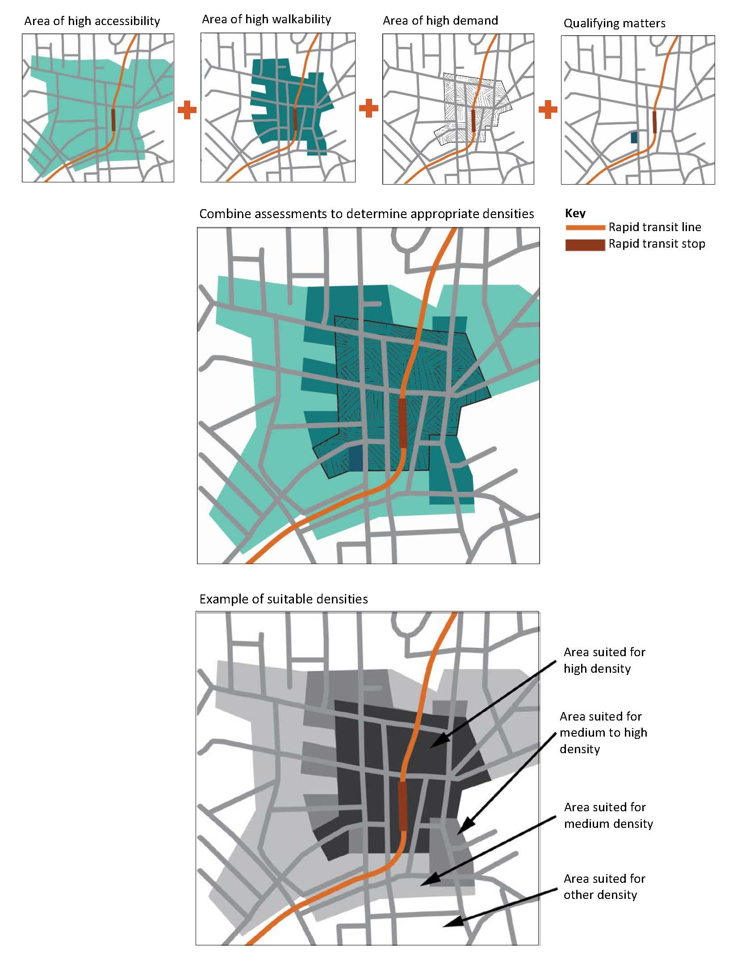

Development outcomes for zones should be consistent with intensification policies
As well as giving effect to the intensification requirements, territorial authorities will also need to ensure that development outcomes described for zones in their district plans are consistent with the intensification policies (subpart 7 of Part 3 – Monitoring Development Outcomes). Monitoring the consistency of the development outcomes with the intensification outcomes is required to ensure district plan provisions, specifically rule frameworks, do not unnecessarily undermine development outcomes. Further guidance on assessing development outcomes for zones is being developed and will be made available on the Ministry for the Environment’s website.

Outcomes
Outcomes we expect to see through the implementation of the intensification policies include:
- well-functioning urban environments (as defined in Policy 1)
- enough housing that lets people live affordably while being close to the places they most need and want to access – eg, places for work, education, healthcare, and recreation
- housing in locations where people can easily access other urban areas with high concentrations of jobs or services, particularly by way of public transit
- enabling plan frameworks to support development in areas where demand and accessibility is high.

Additional support
Further intensification guidance (including practical examples) will be provided on understanding and determining walkability, accessibility, appropriate heights and densities and how to implement and apply the qualifying matters. This guidance will be made available on the Ministry for the Environment’s website.

Fact sheets in this series
This is one of a series of seven fact sheets providing an overview of the National Policy Statement on Urban Development.
The full set of fact sheets is available on our website: www.mfe.govt.nz/about-national-policy-statement-urban-development.
Find out more
Contact the Ministry for the Environment by emailing npsurbandevelopment@mfe.govt.nz, or visit: www.mfe.govt.nz/contact.

Disclaimer
The information in this publication is, according to the Ministry for the Environment’s best efforts, accurate at the time of publication. The information provided does not alter the laws of New Zealand and other official guidelines or requirements. Users should take specific advice from qualified professional people before undertaking any action as a result of information obtained from this publication.
The Ministry for the Environment does not accept any responsibility or liability whether in contract, tort, equity or otherwise for any action taken as a result of reading, or reliance placed on the Ministry for the Environment because of having read any part, or all, of the information in this publication or for any error, or inadequacy, deficiency, flaw in or omission from the information provided in this publication.
Published in July 2020 by the
Ministry for the Environment
Publication number: INFO 956




