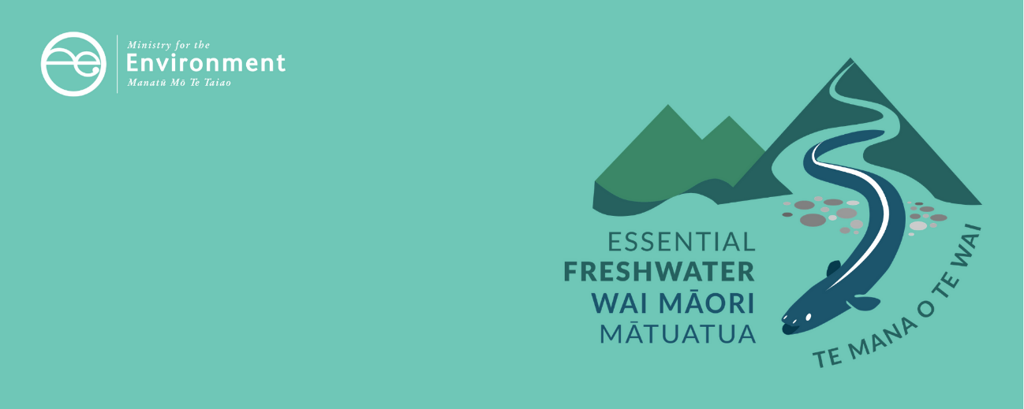

# District plans and territorial authorities factsheet

Essential Freshwater is part of a new national direction to protect and improve our rivers, streams, lakes and wetlands. The Essential Freshwater package aims to:

* stop further degradation of our freshwater
* start making immediate improvements so water quality improves within five years
* reverse past damage to bring our waterways and ecosystems to a healthy state within a generation.

**Te Mana o te Wai is fundamental to all freshwater management**

Te Mana o te Wai recognises the vital importance of water. It expresses the special connection that New Zealanders have with freshwater. By protecting the health of freshwater we protect the health and well-being of people and our ecosystems.

When managing freshwater, Te Mana o te Wai ensures the health and well-being of the water is protected before providing for human needs, or enabling other uses of water. Through discussions with regional councils, tangata whenua and communities will have a say on how Te Mana o te Wai is applied in freshwater management locally. More information can be found in the [**Te Mana o te Wai factsheet**](https://www.mfe.govt.nz/publications/fresh-water/essential-freshwater-te-mana-o-te-wai-factsheet).

## Who should read this factsheet

This factsheet is part of a [series](https://www.mfe.govt.nz/fresh-water/freshwater-guidance/factsheets-policies-and-regulations-essential-freshwater) and provides information on the new policies for district plans and the role of territorial authorities in the [National Policy Statement for Freshwater Management 2020](https://www.mfe.govt.nz/publications/fresh-water/national-policy-statement-freshwater-management-2020) (NPS-FM 2020). It is primarily intended for council staff, but may also be of interest to land users, iwi, the wider agricultural industry, farm advisors and consultants, and anyone else with an interest in freshwater policy.

## What are the policies?

Regional councils, unitary authorities, and territorial authorities (city and district councils) have overlapping roles in supporting integrated management of land and water. Territorial authorities are uniquely placed and have an important role to play in the integrated management of the effects of land use and urban development on freshwater, particularly in urban areas.

The policies in the NPS-FM 2020 provide greater clarity for the role of territorial authorities in managing the impacts of urban development on fresh water, while providing flexibility for territorial authorities to determine the objectives, policies and methods that would best apply in their district.

### Integrated management

Te Mana o te Wai requires all local authorities (regional councils, unitary authorities and territorial authorities) to adopt an integrated approach to the management of water and land, following the concept of [ki uta ki tai](https://www.mfe.govt.nz/publications/fresh-water/fresh-water-report-2017-introductionto-our-fresh-water/ki-uta-ki-tai-%E2%80%93), meaning from the mountains to sea. Ki uta ki tai is the recognition and management of the interconnectedness of the whole environment, from the mountains and lakes, down the rivers to hāpua (lagoons), wahapū (estuaries) and to the sea. All local authorities must:

* recognise the interactions between freshwater, land, water bodies, ecosystems, and sensitive receiving environments
* manage freshwater, and land use and development, in catchments in an integrated and sustainable way to avoid, remedy, or mitigate adverse effects, including cumulative effects on the health and wellbeing of water bodies, freshwater ecosystems and receiving environments
* encourage the co-ordination and sequencing of regional or urban growth.

In order to give effect to the NPS-FM 2020, local authorities that share jurisdiction over a catchment must co-operate in the integrated management of the effects of land use and development on fresh water.

### District plans

Territorial authorities must include objectives, policies, and methods in their district plans to promote positive effects, and avoid, remedy, or mitigate adverse effects (including cumulative effects), of urban development on the health and well-being of water bodies, freshwater ecosystems, and receiving environments.

The NPS-FM 2020 does not provide specific directions about what approaches territorial authorities should use to manage the effects of land use and development on freshwater in district plans. The approach provides flexibility for territorial authorities to determine the objectives, policies, and methods that would best apply in their district.

## When do the policies apply?

Territorial authorities are required to update their district plans to accommodate the integrated management provisions as soon as reasonably practicable, using the process in Schedule 1 of the RMA. Changes to district plans must be publicly notified.

## Why these policies?

The NPS-FM 2017 included policies that required regional councils to manage freshwater and the development and use of land in an integrated way to avoid, remedy or mitigate adverse effects, including cumulative effects on freshwater. However, the NPS-FM 2017 gave no explicit direction on the role of territorial authorities in supporting integrated catchment management.

This ambiguity contributed to a lack of integration between the functions of regional councils and territorial authorities with some territorial authorities viewing their role in freshwater management as limited to complying with water and discharge permits issued to them by regional councils. This left regional councils with the bulk of responsibility to plan for, and manage effects of land use and development on freshwater.

## More about the Essential Freshwater package

An overview of the Essential Freshwater package, including when different aspects commence or must be implemented, can be found in this [summary and milestones](https://www.mfe.govt.nz/publications/fresh-water/essential-freshwater-milestones-what-happens-when).

The package includes a number of new national rules and regulations including:

* new [National Environmental Standards for Freshwater](http://www.legislation.govt.nz/regulation/public/2020/0174/latest/LMS364099.html)
* new [stock exclusion regulations](http://www.legislation.govt.nz/regulation/public/2020/0175/latest/LMS379869.html) under section 360 of the RMA
* amendments to the [Resource Management (Measurement and Reporting of Water Takes) Regulations 2010](http://www.legislation.govt.nz/regulation/public/2020/0176/latest/LMS351161.html)
* the [National Policy Statement for Freshwater Management](https://www.mfe.govt.nz/publications/fresh-water/national-policy-statement-freshwater-management-2020) 2020 which replaces the NPS‑FM 2017
* [amendments to the RMA](https://www.mfe.govt.nz/rma/improving-our-resource-management-system) to provide for a faster freshwater planning process
* [amendments to the RMA](https://www.mfe.govt.nz/fresh-water/freshwater-acts-and-regulations/regulations-freshwater-farm-plans-and-reporting-of-sales) to enable mandatory and enforceable freshwater farm plans, and the creation of regulations for reporting nitrogen fertiliser sales.

Fact sheets in this series

The full set of Essential Freshwater factsheets is available on our website.

Find out more and give us feedback

Contact us by emailing [freshwater@mfe.govt.nz](mailto:freshwater@mfe.govt.nz), or visit [the Essential Freshwater page](https://www.mfe.govt.nz/fresh-water/freshwater-guidance/factsheets-policies-and-regulations-essential-freshwater) on our website.

### Disclaimer

The information in this publication is, according to the Ministry for the Environment’s best efforts, accurate at the time of publication. The information provided does not alter the laws of New Zealand and other official guidelines or requirements. Users should take specific advice from qualified professional people before undertaking any action as a result of information obtained from this publication.

The Ministry for the Environment does not accept any responsibility or liability whether in contract, tort, equity or otherwise for any action taken as a result of reading, or reliance placed on the Ministry for the Environment because of having read any part, or all, of the information in this publication or for any error, or inadequacy, deficiency, flaw in or omission from the information provided in this publication.

Published in October 2020 by the  
Ministry for the Environment   
Publication number: INFO 993

