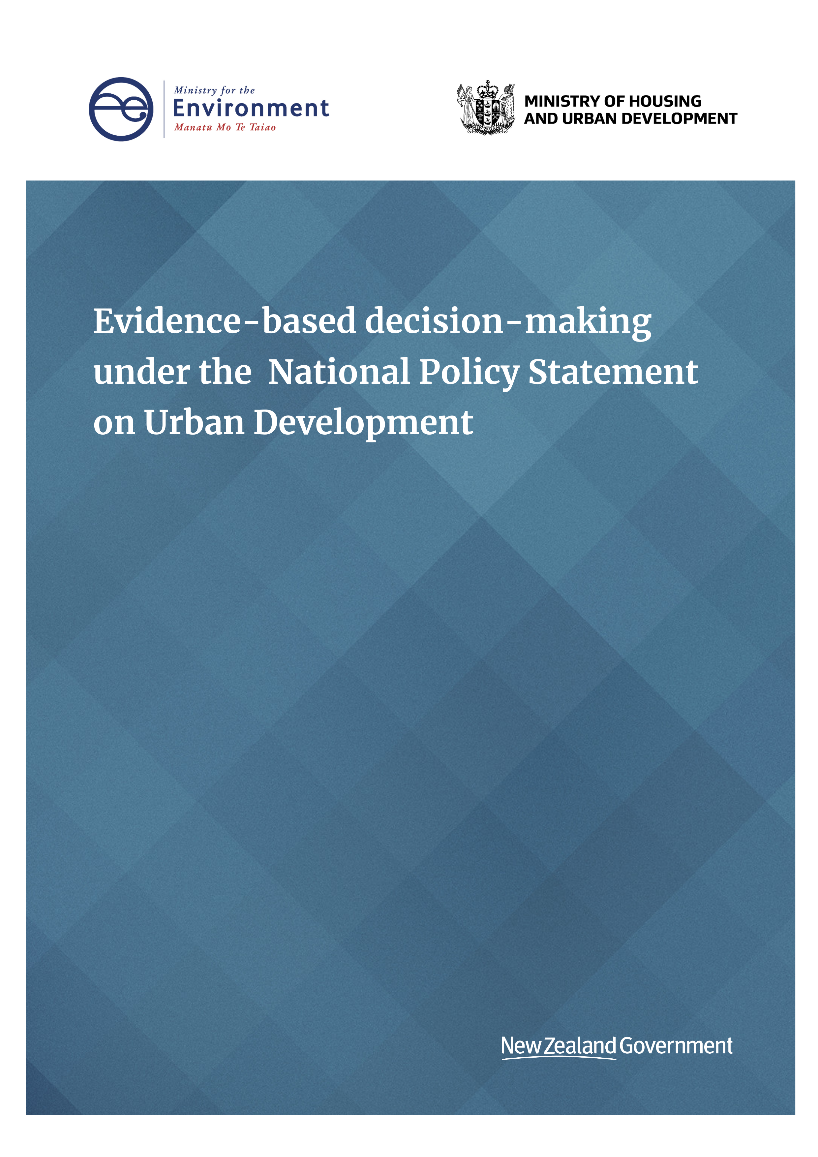
Disclaimer
The information in this publication is, according to the Ministry for the Environment’s best efforts, accurate at the time of publication. The information provided does not alter the laws of New Zealand and/or other official guidelines or requirements. Users should take specific advice from qualified professional people before undertaking any action as a result of information obtained from this publication.
The Ministry for the Environment does not accept any responsibility or liability whether in contract, tort, equity or otherwise for any action taken as a result of reading, or reliance placed on the Ministry for the Environment because of having read any part, or all, of the information in this publication or for any error, or inadequacy, deficiency, flaw in or omission from the information provided in this publication.
This document may be cited as: Ministry for the Environment. 2020. Evidence-based decision-making under the National Policy Statement on Urban Development. Wellington: Ministry for the Environment.

Published in December 2020 by the
Ministry for the Environment
Manatū Mō Te Taiao
PO Box 10362, Wellington 6143, New Zealand
ISBN: 978-1-99-003340-7
Publication number: ME 1550
© Crown copyright New Zealand 2020
This document is available on the Ministry for the Environment website: www.mfe.govt.nz.



Contents
1 Introduction 4
1.1 Purpose 4
1.2 Scope 5
1.3 Relevant objectives and policies 5
2 Monitoring and publishing requirements (clause 3.9) 6
2.1 Publishing methods 6
2.2 Choosing indicators (clause 3.9(1)) 7
2.3 Tier 1 monitoring development outcomes requirement (clause 3.9(2)) 7
3 Requirements for all local authorities (clause 3.10(1)) 9
4 Further guidance on using evidence and analysis (clause 3.11) 10
4.1 Using HBAs as evidence for well-functioning urban environments (clause 3.11(b)(i)) 10
4.2 Evidence for meeting at least sufficient development capacity (clause 3.11(b)(ii)) 11
4.3 Including evidence in section 32 reports (clause 3.11(2)) 11

Table
Table 1: New or updated requirements under the NPS-UD 4

Introduction

Purpose
This guidance has been developed to help local authorities understand and interpret the provisions for evidence-based decision-making in subpart 3 of the National Policy Statement on Urban Development (NPS-UD). This document should be read with the guidance produced for evidence and monitoring under the previous National Policy Statement on Urban Development Capacity 2016 (NPS-UDC), as the focus of this document is on new or amended requirements not contained in the NPS-UDC. This document contains further explanations and examples of good practice to assist local authorities in implementing subpart 3.
Additional support is available when implementing evidence-based decision-making, including:
- a fact sheet containing information evidence-based decision-making policies,
- updated guidance for Housing and Business Development Capacity Assessments (HBAs) under the NPS-UD, which will be published at the same time as this document, and
- an interactive online dashboard of housing market data and indicators.

1.1.1 Key changes from the NPS-UDC
The new or amended requirements for the NPS-UD, and the reasons for change, are shown in Table 1. These changes will produce a more robust and frequently updated evidence base to inform “planning decisions by any local authority that affect an urban environment.” (NPS-UD Part 1: Preliminary provisions 1.3(1)(b)).
Table 1: New or updated requirements under the NPS-UD
NPS-UD clause | Description of requirement | Reason for change
3.9(1) | The indicators to be monitored are less prescriptive. | Local authorities now have more options for monitoring indicators based on data availability and area-specific needs.
3.9(1) | Tier 3 local authorities are required to undertake monitoring. | Tier 3 urban character environments can also benefit from the insights the monitoring requirements provide.
3.9(1) & 3.9(3) | More information provided to detail the requirements for quarterly monitoring and annual publishing. | Reporting will be useful for keeping the authority up to date, while keeping stakeholders and the wider public aware of changes to import trends.
3.9(1) | All local authorities must monitor the proportion of development capacity that has been realised in previously urbanised and undeveloped areas. | To help forecast the development capacity that will be realised.
3.9(2) | Tier 1 local authorities must monitor the proportion of development capacity realised in certain zones within tier 1 urban environments. | To check the effectiveness of development capacity policies, and prompt further investigation if development aims are not being met.
3.10(1) | Requirements to assess demand and development capacity extended to tier 3 local authorities. | To promote evidence-based decision-making, sufficient development capacity, and well-functioning urban environments in all urban environments.
3.11 | When making or changing plans, evidence from monitoring and HBAs must be used to analyse the impacts on urban development. | This is to directly integrate the evidence base into plans and plan changes.

Scope
This guidance covers:
- the overarching objectives and policies informing evidence-based decision-making in the NPS-UD
- the key changes from the NPS-UDC to the NPS-UD
- further details on subpart 3 policies 3.9 to 3.11.

Relevant objectives and policies
Every tier 1, 2, and 3 local authority is required to use evidence-based decision-making for urban environments in their region or district, as outlined by subpart 3. This includes what must be monitored, the frequency of monitoring and publishing of monitoring results, and how evidence is used for plans and decision-making.
The purpose of the evidence-based decision-making is to ensure planning decisions are informed by robust and frequently updated information on urban environments. The most relevant parts of the objectives and policies from the NPS-UD are below.
Objective 7: Local authorities have robust and frequently updated information about their urban environments and use it to inform planning decisions.

Policy 1: Planning decisions contribute to well-functioning urban environments.
Policy 2: Tier 1, 2, and 3 local authorities, at all times, provide at least sufficient development capacity to meet expected demand for housing and for business land over the short term, medium term, and long term.
Policy 6: When making planning decisions that affect urban environments, decision-makers have particular regard to the following matters:
(d) any relevant contribution that will be made to meeting the requirements of this National Policy Statement to provide or realise development capacity

Monitoring and publishing requirements (clause 3.9)
This section covers the requirement to undertake quarterly monitoring and annual publication of monitoring results. This ensures that local authorities track key indicators outside of the production of Housing and Business Development Capacity Assessments (HBAs) and Future Development Strategies (FDSs), to serve as a source of evidence to continually inform local authorities’ planning and decision-making. The monitoring requirement clause of the National Policy Statement on Urban Development (NPS-UD) is shown below.
The aspects of the urban environment that must be monitored are provided in clauses
3.9(1–2). The purpose is to track the key indicators and provide comment and some analysis on what they indicate about housing demand, development trends, and land markets.
3.9 Monitoring requirements
(1) Every tier 1, 2, and 3 local authority must monitor, quarterly, the following in relation to each urban environment in their region or district:
(a) the demand for dwellings
(b) the supply of dwellings
(c) prices of, and rents for, dwellings
(d) housing affordability
(e) the proportion of housing development capacity that has been realised:
(i) in previously urbanised areas (such a through infill housing or redevelopment); and
(ii) in previously undeveloped (ie, greenfield) areas
(f) available data on business land
(2) In relation to tier 1 urban environments, tier 1 local authorities must monitor the proportion of development capacity that has been realised in each zone identified in clause 3.37(1) (ie, each zone with development outcomes that are monitored).
(3) Every tier 1, 2, and 3 local authority must publish the results of its monitoring at least annually.
(4) The monitoring required by this clause must relate to the relevant urban environments, but may apply more widely (such as, for example, where the relevant data is available only on a region or district-wide basis).
(5) If more than one tier 1 or tier 2 local authority has jurisdiction over a tier 1 or tier 2 urban environment, those local authorities are jointly responsible for doing the monitoring required by this subpart.

Publishing methods
The publishing methods used to meet the annual requirement will vary between local authorities. Methods could range from writing a report that is presented and published in one of the local authority’s meeting agendas, to hosting a monitoring page on the local authority’s website. It is best to use a method that is effective for sharing information with the wider community and can be updated frequently.

2.1.2 Monitoring timing and publication
Local authorities may choose an annual reporting schedule that works best for their planning purposes (eg, reporting at the end of financial or calendar years). There is no hard start date or deadline stated in the NPS-UD, but the first annual report is anticipated within the first year of the NPS-UD coming into effect.

Choosing indicators (clause 3.9(1))
Clause 3.9(1) outlines the aspects of urban environments that must be monitored. Although local authorities have flexibility in determining the indicators being monitored, they must ensure that all aspects of clause 3.9(1)(a–f) are being monitored quarterly and published annually. Local authorities should consider using indicators that are relevant to the assessments and methodologies used for their HBA, and consider the type, quality, and frequency of data that will be available for monitoring.
Clause 3.9(4) also recognises that granular data may not always be available, so allows local authorities to track indicators at a higher level than the urban area may cover (eg, district- or region-wide). Best practice will be to use the most granular data available that is representative of the urban area.

2.2.1 Existing guidance on indicators
The NPS-UDC evidence and monitoring guide is helpful for identifying and interpreting monitoring indicators. Part 5 of the NPS-UDC guide provides information on monitoring market indicators and part 6 provides guidance on using price efficiency indicators.

Tier 1 monitoring development outcomes requirement (clause 3.9(2))
According to clause 3.9(2), tier 1 local authorities must monitor the proportion of realised development capacity in each of the identified zones. The zones that must be monitored (or their nearest equivalent in district plans) from clause 3.37(1) are:
3.37(1) … zones:
(a) city centre zones
(b) metropolitan zones
(c) town centre zones
(d) mixed-use zones
(e) high-density residential zones
(f) medium-density residential zones
(g) general residential zones
Tier 1 local authorities should consider clause 3.9(2) when developing a methodology for their HBAs and determine how components of the methodologies can be used for monitoring. This is particularly the case when making links between clause 3.26(1), which requires assessing what is feasible and reasonably expected to be realised, and the clause 3.37 requirement to monitor whether development is being realised for the different zones.
The methodologies developed should also support a better understanding of the typology of development delivered. For example, if an area is zoned for a density with building heights of six storeys or more, these aspects should be captured and monitored.

2.3.1 Options for monitoring realised development capacity by zone
Tier 1 local authorities have discretion over how they monitor realised development capacity. Methods could include using building consent and data sources on land use, such as ratings data or CorLogic, to monitor the trends for different planning zones. For example, building consent data could be used to assess the number of new builds in a district plan zone, identify how much development capacity has been realised, and create insights into the size and form of capacity realisation. This could be coupled with information on rated land use, to understand if properties are being used for the same purpose as they are zoned. Additional insights could be gathered by consulting with the development sector and local experts, such as those identified for clause 3.21 of the HBA, to understand why capacity is or is not being realised, or why land use may or may not be matching the intended zoning.

Requirements for all local authorities (clause 3.10(1))
Most of the reporting requirements from the National Policy Statement on Urban Development (NPS-UD) are focused on tier 1 and 2 local authorities; however, clause 3.10(1) applies to all urban environments in New Zealand (see clause 1.3(1)(b)). Clause 3.10(1) requires that:
3.10(1) Every local authority must assess the demand for housing and for business land in urban environments, and the development capacity that is sufficient (as described in clauses 3.2 and 3.3) to meet that demand in its region or district in the short, medium, and long term.
Tier 1 and 2 local authorities satisfy this requirement by completing the Housing and Business Assessments (HBAs). Tier 3 local authorities have scope to determine the most appropriate methods for meeting this requirement.
Generally, all tier 3 local authorities are encouraged to adopt the monitoring, assessment, and reporting frameworks for creating an HBA, though it is not necessary to produce the HBA document itself. Any tier 3 local authority that does produce and submit an HBA will be part of the assessment and feedback process, provided the timings in clause 4.1 are met.
Tier 3 local authorities that do not create an HBA are encouraged to use the HBA guidance to assess the demand and supply for housing and business land, and ensure sufficient capacity is available.

Further guidance on using evidence and analysis (clause 3.11)
The main requirement of clause 3.11 is that local authorities use evidence to assess the effects of planning on their urban environments. The new requirement in the National Policy Statement on Urban Development (NPS-UD) is that authorities must use Housing and Business Development Capacity Assessment (HBA) and monitoring evidence to inform their planning decisions, and include the matters identified by the assessments in relevant evaluation reports and further evaluation reports prepared under section 32 and 32AA of the Resource Management Act 1991 (RMA). Clause 3.11 states:
3.11 Using evidence and analysis
(1) When making plans, or when changing plans in ways that affect the development of urban environments, local authorities must:
(a) clearly identify the resource management issues being managed; and
(b) use evidence, particularly any relevant HBAs, about land and development markets, and the results of the monitoring required by this National Policy Statement, to assess the impact of different regulatory and non-regulatory options for urban development and their contribution to:
(i) achieving well-functioning urban environments; and
(ii) meeting the requirements to provide at least sufficient development capacity.
(2) Local authorities must include the matters referred to in subclause (1)(a) and (b) in relevant evaluation reports and further evaluation reports prepared under sections 32 and 32AA of the Act.
More about the evidence that HBAs must produce is available through the existing NPS-UDC guidance and in the updated HBA guidance for the NPS-UD published alongside this document. An overview of how the HBA requirements relate to the requirements of clause 3.11 is provided below.

Using HBAs as evidence for well-functioning urban environments (clause 3.11(b)(i))
While other evidence sources should be used, clause 3.11(b) requires local authorities to use the HBAs and monitoring publications as part of the evidence to “assess the impact of different regulatory and non-regulatory options for urban development”. When using the evidence base provided by HBAs and monitoring requirements, local authorities are required to consider how this supports planning decisions that contribute to a ‘well-functioning urban environment’ sought by Policy 1. The guidance for how the HBA evidence aligns with Policy 1 is supplied in the HBA guidance under the NPS-UD.

Evidence for meeting at least sufficient development capacity (clause 3.11(b)(ii))
HBAs are required to show that sufficient capacity for housing is provided (in accordance with clause 3.27), to satisfy clause 3.2:
3.2 Sufficient development capacity for housing
(1) Every tier 1, 2, and 3 local authority must provide at least sufficient development capacity in its region or district to meet expected demand for housing:
(a) in existing and new urban areas; and
(b) for both standalone dwellings and attached dwellings; and
(c) in the short, medium, and long term.
(2) In order to be sufficient to meet expected demand for housing, the development capacity must be:
(a) plan-enabled (see clause 3.4(1)); and
(b) infrastructure-ready (see clause 3.4(3)); and
(c) feasible and reasonably expected to be realised (see clause 3.26); and
(d) for tier 1 and 2 local authorities only, meet the expected demand plus the appropriate competitiveness margin (see clause 3.22).
These provisions provide an evidence base to inform planning decisions, as required by clause 3.11.
Only tier 1 local authorities are required to continually monitor capacity that has been realised by zones (see clause 3.9(2)), but all local authorities (tier 1, 2 and 3) must link monitoring indicators to sufficient development capacity. This may require identifying key indicators used for HBA modelling and assessments and incorporating them into the monitoring regime for clause 3.9(1). For instance, if property sales and dwelling consent data were used to model sufficiency of housing capacity, the local authority should monitor these for relevant changes. Changes in excess of what was expected from the modelling may indicate a material change in the capacity required. Observations about the changes and their impact on capacity could be included in the annual publication of monitoring results for clause 3.9(3).

Including evidence in section 32 reports (clause 3.11(2))
As the HBA process is intended to inform RMA planning documents, clause 3.11(2) requires that matters in clause 3.11(1)(a) and (b) be included in “relevant evaluation reports and further evaluation reports prepared under section 32 and 32AA of the Act”. It is expected that the scope and detail of any HBA evidence used corresponds to the scale and significance of the effects from plans or plan changes. More guidance for section 32, 32AA, and evaluation reports is available from the Ministry for the Environment’s website (guide to section 32).

