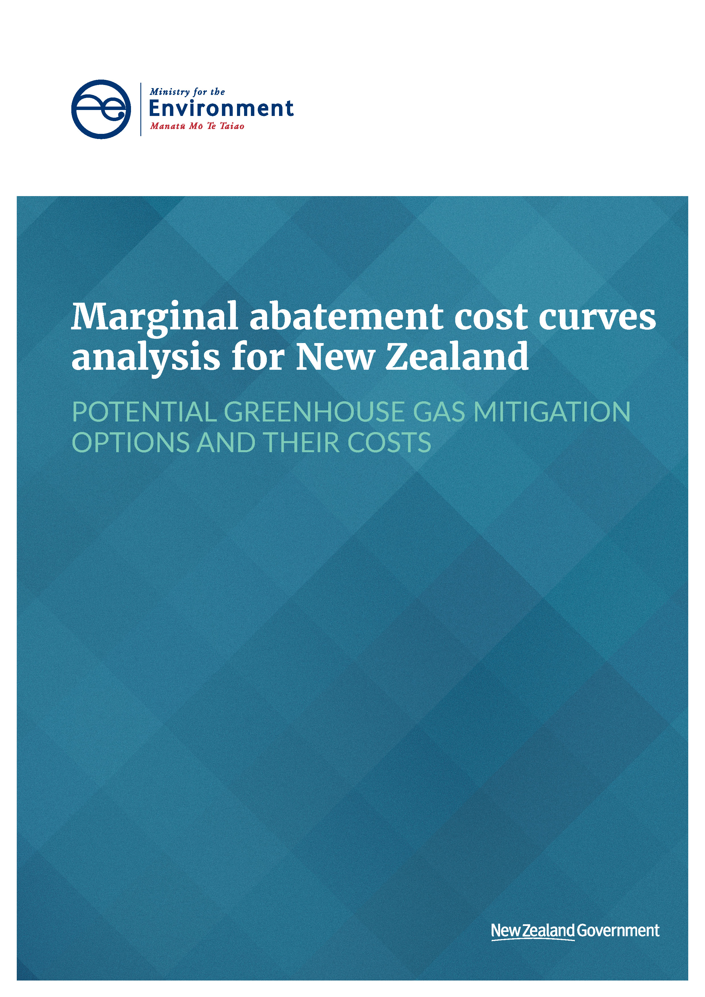

This document may be cited as: Ministry for the Environment. 2020. Marginal abatement cost curves analysis for New Zealand: Potential greenhouse gas mitigation options and their costs. Wellington: Ministry for the Environment.

Published in January 2020 by the
Ministry for the Environment
Manatū Mō Te Taiao
PO Box 10362, Wellington 6143, New Zealand
ISBN: 978-1-98-857971-9
Publication number: ME 1486
© Crown copyright New Zealand 2020
This document is available on the Ministry for the Environment website: www.mfe.govt.nz.


Contents
1 Introduction 7
1.1 Important things to understand about the work 7
1.2 A general health warning 8
2 Economy-wide overview 9
2.1 Non-land (ie, Energy, IPPU and Waste) sectors 9
2.2 Land sector (Agriculture and LULUCF (forestry)) 10
2.3 All sectors combined 10
3 Land sector (agriculture and forestry) 13
3.1 Options investigated 13
3.2 Methodology for estimating the MACCs 14
3.3 Provisional results and discussion 16
3.4 Issues and caveats 23
4 Industry 25
4.1 Options investigated 26
4.2 Methodology for estimating MACCs 29
4.3 Provisional results and discussion 31
4.4 Discussion on the importance of biomass across the economy 38
5 Transport 40
5.1 Options investigated 40
5.2 Methodology for estimating the MACCs 41
5.3 Provisional results and discussion 47
5.4 Issues and caveats 49
6 Electricity generation 50
6.1 Options investigated 50
6.2 Methodology for estimating the MACCs 50
6.3 Provisional results and discussion 52
7 Space and water heating 54
7.1 Options investigated 54
7.2 Methodology for estimating the MACCs 54
7.3 Provisional results and discussion 58
7.4 Issues and caveats 63
8 Waste 64
8.1 Options investigated 65
8.2 Results 66
8.3 Discussion 67
Appendix A: Road transport methodology and assumptions 69
Appendix B: Heavy transport modelling methodology and assumptions 79
References 91
Annex 1: Technical note on marginal abatement cost analysis 93

Tables
Table 1: Agriculture and forestry commodity price assumptions 20
Table 2: Estimated number of plants by industry sector/process (Atkins, 2019) 26
Table 3: Abatement options included for industry 27
Table 4: Summary of all waste abatement measures 66

Figures
Figure 1: Stylised example of a MACC 7
Figure 2: Breakdown of New Zealand's greenhouse gas emissions in 2017 9
Figure 3: Summary MACC for energy and industry sectors in 2030 11
Figure 4: Summary MACC for the land sector (agriculture and forestry) in 2030 11
Figure 5: Summary MACC for all sectors in 2030 12
Figure 6: MACC for on-farm abatement options in 2030, package A 16
Figure 7: MACC for on-farm abatement options in 2030, package B 17
Figure 8: How emissions costs affect profitability for sheep and beef and dairy farming vs forestry 18
Figure 9: Marginal abatement costs for land-use change from farming to forestry 19
Figure 10: Areas of farm land assumed available for planting 21
Figure 11: Area of farm land economic to convert to forest as a function of marginal abatement cost 21
Figure 12: Land sector MACC including land-use change options in 2030 22
Figure 13: Breakdown of 2017 emissions from top emitting industry sectors 25
Figure 14: Demand and supply side abatement measures for industry 26
Figure 15: Dairy processing MACC in 2030 32
Figure 16: Dairy processing MACC in 2030 with fuel switching to electricity instead of biomass 33
Figure 17: Meat processing MACC in 2030 33
Figure 18: Combined food processing and other boiler plant MACC in 2030 34
Figure 19: Wood processing MACC in 2030 35
Figure 20: Methanol and urea MACC in 2020 36
Figure 21: Petroleum refining MACC in 2030 36
Figure 22: Steel and aluminium MACC in 2030 37
Figure 23: Cement MACC in 2030 38
Figure 24: Potential demand for biomass for industrial process heat and biofuels for hard-to-electrify transport, compared with current potential supply from forestry residues 39
Figure 25: Potential land area for additional biomass to meet demand for industrial process heat and transport biofuels 39
Figure 26: Breakdown of 2016 transport-related emissions 40
Figure 27: Abatement cost of different low-carbon fuels for marine vessels for different re-fuelling patterns 44
Figure 28: Abatement cost of different low-carbon fuels for aircraft for different re-fuelling patterns 45
Figure 29: Abatement cost of different low-carbon fuels for rail for different re-fuelling patterns 46
Figure 30: Transport MACC for 2020 – public benefit basis 47
Figure 31: Transport MACC for 2030 – public benefit basis 47
Figure 32: Single year MACC for transport in 2030 – public benefit basis 48
Figure 33: McKinsey projection of timing of cost-parity of EVs with ICEs, based on total cost of ownership 49
Figure 34: Electricity generation MAC 52
Figure 35: First-order estimates of emissions intensity of different electricity demand profiles for different renewable futures 56
Figure 36: Lifetime cost of useful heat for different heater options in different consumer situations 60
Figure 37: MAC for residential and commercial space and water heating 62
Figure 38: Profile of emissions by source from 1990–2017 64
Figure 39: MACC for waste emissions minimisation 67
Figure 40: Mean daily distance travelled by vehicles in New Zealand (km) 70
Figure 41: Central petrol and diesel price projections ($/l) – excluding petrol excise duty, carbon, and GST 73
Figure 42: Assumed economic cost of electricity ($/kWh delivered) 74
Figure 43: Typical heavy freight total cost of ownership breakdown (diesel vehicle) 77
Figure 44: Variation in battery cost with battery re-charging frequency ($ per delivered kWh) 80
Figure 45: Variation in delivered electricity costs (including battery costs) with battery re-charging regimes 81
Figure 46: Break-even carbon prices for drop-in diesel to be cost-effective to displace fossil diesel for land transport 86
Figure 47: Break-even carbon prices for drop-in diesel to be cost-effective to displace fossil diesel for land transport – assuming a shorter capital recovery period for a biorefinery 87
Figure 48: Conceptual illustration of a MACC 94
Figure 49: Three measures of abatement potential 97
Figure 50: Uptake of measures over time in a MAC analysis 98
Figure 51: Illustration of abatement occurring in the baseline 99

Introduction
The Ministry for the Environment, with the help of Concept Consulting, has undertaken work to develop a marginal abatement cost curves (MACCs) analysis for New Zealand. This report describes our progress and stage 1 results.
A marginal abatement cost curve is a graph that visualises the abatement potential of greenhouse gas mitigation measures, and the relative costs associated with each of these measures. Figure 1 provides a simplified, hypothetical example of a MACC.
Figure 1: Stylised example of a MACC
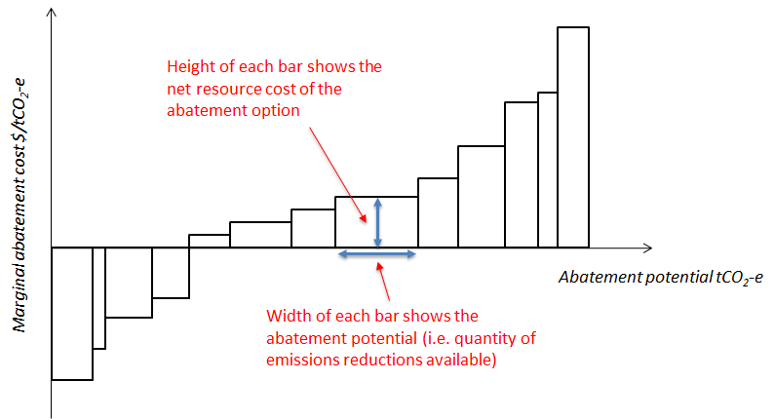
MACCs are a core part of the evidence base to inform cost-effective transition pathways to a low-emissions economy. They help us to compare cost-effectiveness of abatement options in a consistent way and to quantify potential abatement available across sectors and the economy as a whole. While MACCs have limitations and should not be seen as a ‘one stop shop’ for developing a climate change mitigation strategy, they are a critical part of the toolkit. The findings of the MACC analysis will help government agencies in focusing where future policy efforts to reduce emissions could be driven.
Many countries, states and businesses have used MACCs in developing climate mitigation strategies and plans. In the UK, MACCs have been integral to the work of the Committee on Climate Change and the UK Government in developing and responding to emissions budgets. Most recently, the Irish Government’s Climate Action Plan 2019 was underpinned by MACC analysis (Department of Communications 2019).

Important things to understand about the work
We shared a technical note with other agencies in late 2018. This introduced key concepts of MACC analysis and laid out our proposed approach on a number of design and methodology matters. This note is included in Annex 1 for reference and technical background.

Four key points to highlight are:
- Costs are analysed from a national economic perspective, ie, they inform on the costs and benefits to New Zealand of an abatement option being implemented. In many cases these will differ to the costs and benefits faced from a private consumer perspective, for reasons such as misaligned price signals. In some cases, we have also looked at a private perspective to inform on the potential extent of misalignment. Note we also use a discount rate of 6% across our analysis.
- The abatement potential shown is the technical potential. This assumes there are no non-cost barriers to implementation, such as infrastructure constraints, supply constraints, and behavioural barriers. It also does not take into account the time required to implement policies and build scale. The realisable potential is therefore likely to be smaller, particularly in the near-term. It is intended that future work will be undertaken to assess realisable potential.
- The analysis does not predict the market response to an emissions price. The estimated marginal abatement cost should therefore not be conflated with the required emissions price in the New Zealand Emissions Trading Scheme (NZ ETS).
- Our analysis identifies several options with negative abatement costs – a common finding in this type of work. This means these options are found to have net economic benefits over their lifetime, even with no cost to carbon. This indicates that cost is not likely to be the barrier to these options being adopted.

A general health warning
This is early stage analysis being shared for critique and feedback. We consider that the analysis provides a reasonable first-order assessment of abatement costs. However, all results should be treated with caution.
Caveats and issues specific to sectors or abatement options are discussed throughout this report. Two cross-cutting matters to highlight are:
- All estimates of abatement costs and potential are subject to uncertainty which is difficult to illustrate in a MACC. This uncertainty increases as we look further out in time. Often there is considerable cost variation within one ‘block’ on the MACC, which represents an average cost. It is therefore very important to recognise that there is an uncertainty range around all the numbers and not to ascribe precision to the results.
- The current analysis is not fully aligned with official baseline emissions projections across all sectors. Care is therefore required in using the MACCs to estimate future levels of emissions. Subsequent work will be undertaken to improve alignment.

Economy-wide overview
New Zealand’s gross greenhouse gas emissions in 2017 were estimated at 80.9 million tonnes of carbon dioxide equivalent (Mt CO₂-e). Figure 2 shows that New Zealand’s emissions are concentrated in a few key sectors or activities.
Figure 2: Breakdown of New Zealand's greenhouse gas emissions in 2017
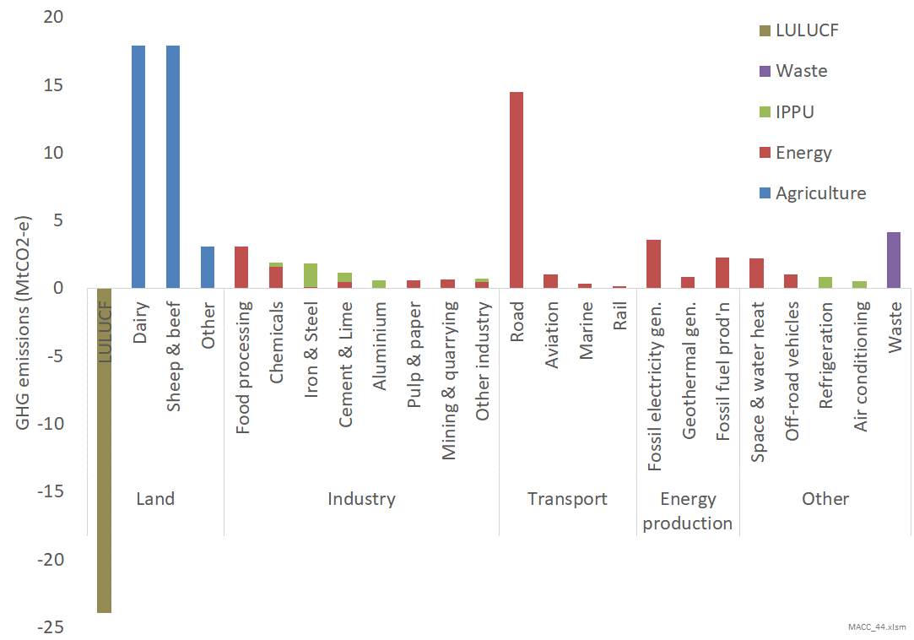
Our analysis covers all sectors of emissions (energy, industrial processes, agriculture, space and water heating and waste), and most (but not all) sources of emissions within these. Greatest effort has been placed on those sectors responsible for the greatest quantity of emissions.

Non-land (ie, Energy, IPPU and Waste) sectors
Figure 3 shows a provisional MACC for the non-land sectors in 2030, based on our central assumptions. Note the health warnings in the previous section and that this represents technical potential and a national economic perspective on costs.
The analysis indicates significant negative cost abatement potential (the area below the horizontal axis) by 2030. This is primarily in transport from electrifying the vehicle fleet, and efficiency opportunities in process heat. The total negative cost potential is estimated at around 10 Mt CO₂-e. For comparison, total emissions from these sectors is currently around 36 Mt CO₂-e.
A further ~16 Mt CO₂-e is estimated to be technically available at abatement costs of up to $150 per tonne of CO₂-e. This is mostly from replacing fossil electricity generation with renewables, and fuel switching in process heat. Note that this is relative to a baseline with high continued fossil fuel use for electricity generation, so may overstate the abatement relative to a more likely business-as-usual scenario.
Finally, a further ~5 Mt CO₂-e of abatement is estimated to be available from relatively high cost options such as carbon capture and storage. Note that the vertical axis in Figure 2 has been cut off at $500 per tonne of CO₂-e, but there are options at abatement costs higher than this.

Land sector (Agriculture and LULUCF (forestry))
Figure 4 shows a provisional MACC for the land sector in 2030, based on our central assumptions. A very important caveat to note is that this assumes no constraint on the rate of land-use change, so it is clearly unrealistic for 2030 but gives a useful sense of scale for long-term change.
The analysis, drawing on modelling by the Biological Emissions Reference Group (BERG), indicates there is moderate potential of up to around 2.5 Mt CO₂-e for on-farm reductions that could improve profitability, and hence be negative cost. However, the main finding is that land-use change to forestry has a relatively low abatement cost across most of the sheep and beef sector and even some of the dairy sector. Note that the abatement potential shown in figure 4 is for net emissions and most of this is CO₂ removals from forestry sequestration.
It also is based on a continuation of current commodity prices for meat, dairy, and harvested wood. Major international carbon-policy related changes in these commodity prices could significantly alter these results.

All sectors combined
Figure 5 shows the resulting MACC combining all of the above sectors. The abatement potential shown is net emissions including forestry sequestration, and comes to more than double New Zealand’s current gross emissions. Note again the caveat that this assumes no constraint on the rate of land-use change.
The major observation from figure 5 is that – negative abatement cost options aside – land-use change from sheep and beef farming to forestry produces a very large block of abatement potential between $0 and around $50 per tonne that pushes gross emissions reduction options such as process heat fuel switching far along to the right of the curve. Noting again the caveat that these MACC curves do not predict market behaviour in response to the emissions price through the NZ ETS, this raises questions around potential consequences of New Zealand’s current climate policy.
Figure 3: Summary MACC for energy and industry sectors in 2030
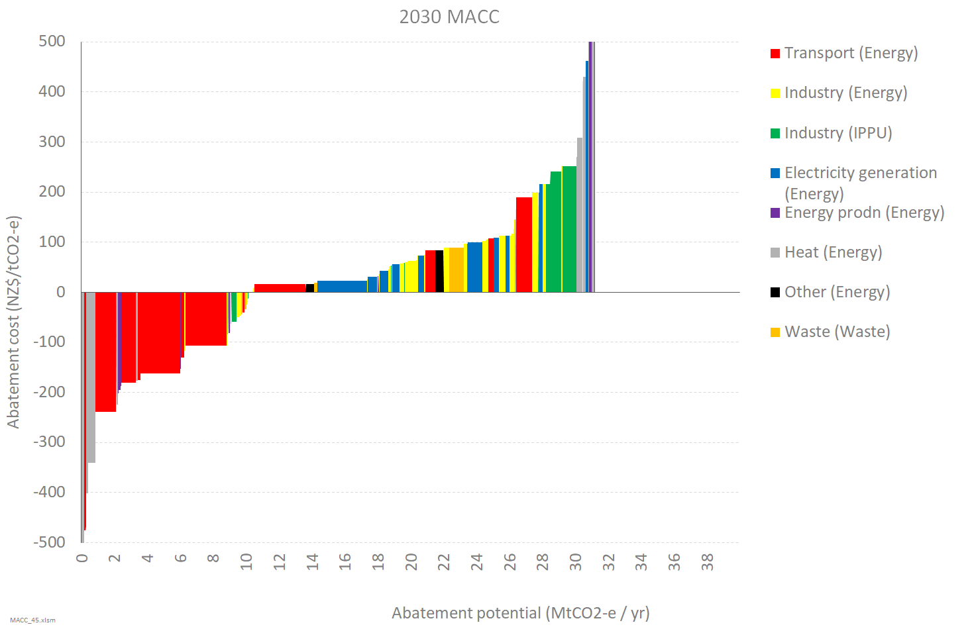

Figure 4: Summary MACC for the land sector (agriculture and forestry) in 2030
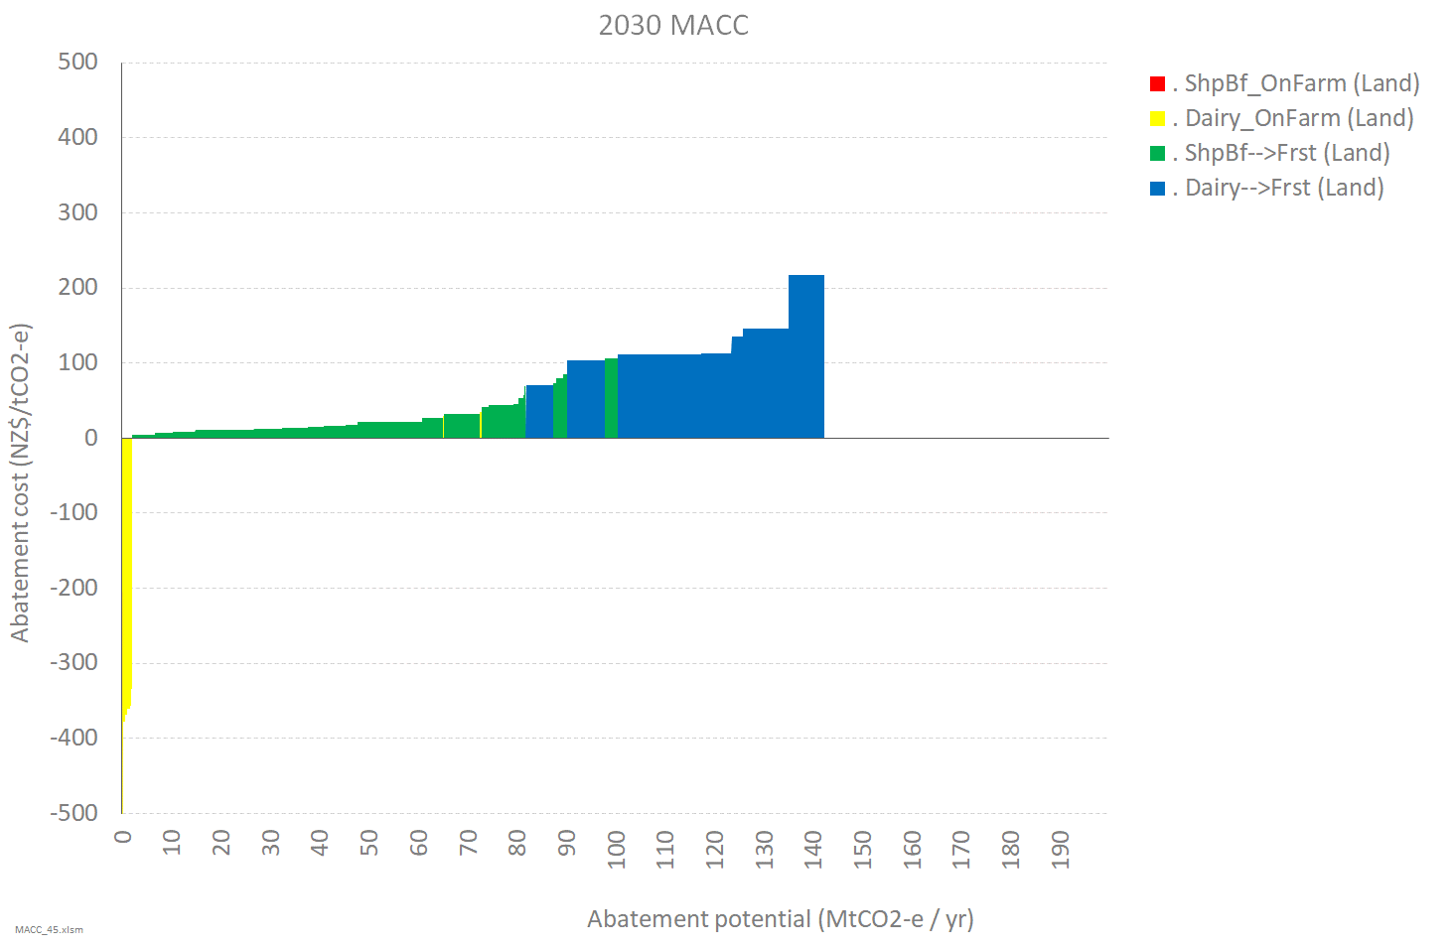

Figure 5: Summary MACC for all sectors in 2030
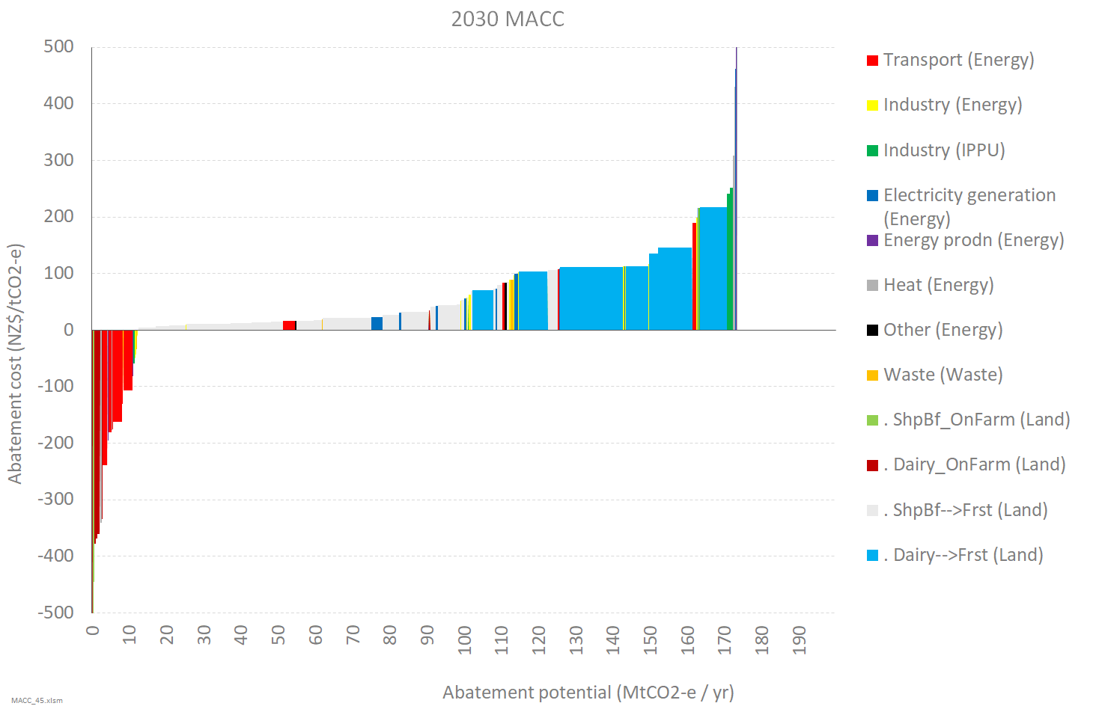
The following sections cover methodology and more in-depth analysis for each sector.

Land sector (agriculture and forestry)

Options investigated
The MACC analysis for the land sector has focused on:
- reducing on-farm emissions through currently available technologies and changes in practice
- reducing emissions and increasing carbon sequestration through land-use change.

On-farm abatement options
For on-farm abatement options we have relied primarily on the work of the Biological Emissions Reference Group (BERG). Options currently included are:
- Improving animal performance while reducing stocking rates (dairy, sheep and beef)
- Increased use of low-nitrogen supplementary feeds (dairy only)
- Removing nitrogen fertiliser and reducing production (dairy only).
We have assumed that for dairy, options 1 and 2 are complementary and can be implemented together, while option 3 is an alternative approach to be implemented in isolation.
Other options the BERG investigated (such as once-a-day milking, removing breeding beef cows, breeding low-emissions animals, and methane inhibitors or vaccines) are not included due to insufficient information on costs and/or abatement potential at the national scale.

Land-use change options
Land-use change options currently included are:
- Production forestry (Pinus radiata unpruned regime)
- Regenerating native forest.
For simplicity, the analysis focuses on full land-use change (eg, conversion of farm land into a commercial forestry operation) rather than integration of forestry in a continued farm operation.

Gaps and potential areas for future work
Gaps and potential areas for future work include:
- horticulture
- carbon farming (ie, permanent exotic)
- biomass plantations
- extended rotations
- carbon stock enhancement of existing forest land ie, planting forest into ‘scrub’ land.

Methodology for estimating the MACCs
The marginal abatement cost (MAC) of an option in the land sector is calculated by dividing the change in profit per hectare by the change in emissions per hectare.
For on-farm options, the steps taken to estimate this are:
- Estimate the livestock and production quantities for the baseline farm
- Estimate the baseline farm’s revenue and expenses to calculate profit per hectare
- Estimate the baseline farm’s emissions per hectare
- Estimate the measure’s per hectare impact on stocking rate, production, revenue, expenses and emissions
- Calculate the MAC by dividing the change in profit by the change in emissions.
For land-use change to forestry, the per hectare profit (excluding carbon revenue) and carbon sequestration of forestry on the land are estimated and the MAC is calculated as per the final step above.
Farm profits are estimated using a simple structural cost model calibrated to real-world data from Beef + Lamb New Zealand and DairyNZ. Calculations for sheep and beef farms are made for the average farm across five regions and eight farm classes (eg, East North Island Hill Country), with the ability to also look by performance quintile. Calculations for dairy farms are made for the average farm across eight different regions (eg,. Taranaki). Due to data limitations it was not possible to analyse dairy across other parameters such as farm systems.
Forestry profits are estimated using a discounted cashflow analysis and converted into an annuity to compare with farm profit. The calculations assume different yield curves by region and harvesting costs varying by land terrain. Carbon sequestration from production forestry is modelled using averaging, with assumptions intended to align with New Zealand’s Nationally Determined Contribution target accounting rules. The abatement cost calculation uses discounted carbon sequestration rates which account for the sequestration ceasing after the long-term average carbon stock is reached.
Assumptions for on-farm abatement options are all derived from modelling undertaken for the BERG (Reisinger et al., 2017). Each option is quantified by its impact on stocking rates, production, expenses, and on-farm methane and nitrous oxide emissions.
All greenhouse gases have been treated as carbon dioxide-equivalent using the conventional GWP100 metric. Different accounting approaches could be an area for future work.

Interactions between options
In the MACCs analysis, on-farm abatement options are assumed to be implemented unless their abatement cost exceeds the abatement cost for land-use change alone. The abatement cost for land-use change is then recalculated to account for the implemented measures’ impacts on emissions and profit. Similarly, where multiple on-farm options are implemented, their abatement cost and potential are calculated in succession rather than simply treated as additive.

Costs included in the analysis
Costs and benefits included | Costs and benefits excluded
Farm earnings and operating costs  Impact of abatement options on farm production and operating costs  Forestry earnings and operating costs (establishment, thinning, road construction, harvesting, transport) | Training or other transition costs associated with on-farm abatement options  Land costs  Co-benefits (eg, water quality, ecosystem services)  Wider economic costs and benefits (eg, changes to the rural economy)  Government grants and other incentives

Main sources of data and information
Category | Sources
Farm characteristics and economic data | Beef + Lamb New Zealand benchmarking data 2016/17; DairyNZ Economic Survey 2016/17; New Zealand Dairy Statistics 2016/17
Livestock emissions factors | Ministry for Primary Industries (MPI)
On-farm abatement options | BERG reports Reisinger et al. (2017) and Reisinger et al. (2018), and modelling spreadsheet provided by Andy Reisinger
Forestry yield and sequestration | MPI yield tables and ETS default carbon stock look-up tables, with scale factor of 130% applied to bring into rough alignment with Land-use and Carbon Analysis System (LUCAS) national average carbon stock values
Forestry expenses and revenue | Manley (2019), Impacts of carbon prices on forest management (paper prepared for MPI)
Area of farm land suitable for planting in production or permanent forest | Mapping analysis by Te Uru Rākau, via Manley (2018)
Future projections | MPI emissions projections and activity data; MPI Situation and Outlook for Primary Industries commodity price forecasts (to 2023).

Provisional results and discussion
All MACC graphs presented in this section show the variation for each abatement option by region, and also by farm class for sheep and beef.

On-farm abatement options
Package A: Improving animal performance while reducing stocking rates (dairy and sheep and beef) and increased use of low-nitrogen supplementary feeds (dairy only)
Figure 6 shows the 2030 MACC for a package including only the first two abatement options listed above (improving animal performance while reducing stocking rates and use of low-nitrogen feeds), which we have called Package A. The total abatement potential is estimated at 2.5 Mt CO₂-e/yr, approximately 6.5% of the total projected emissions from agriculture in 2030.
Figure 6: MACC for on-farm abatement options in 2030, package A
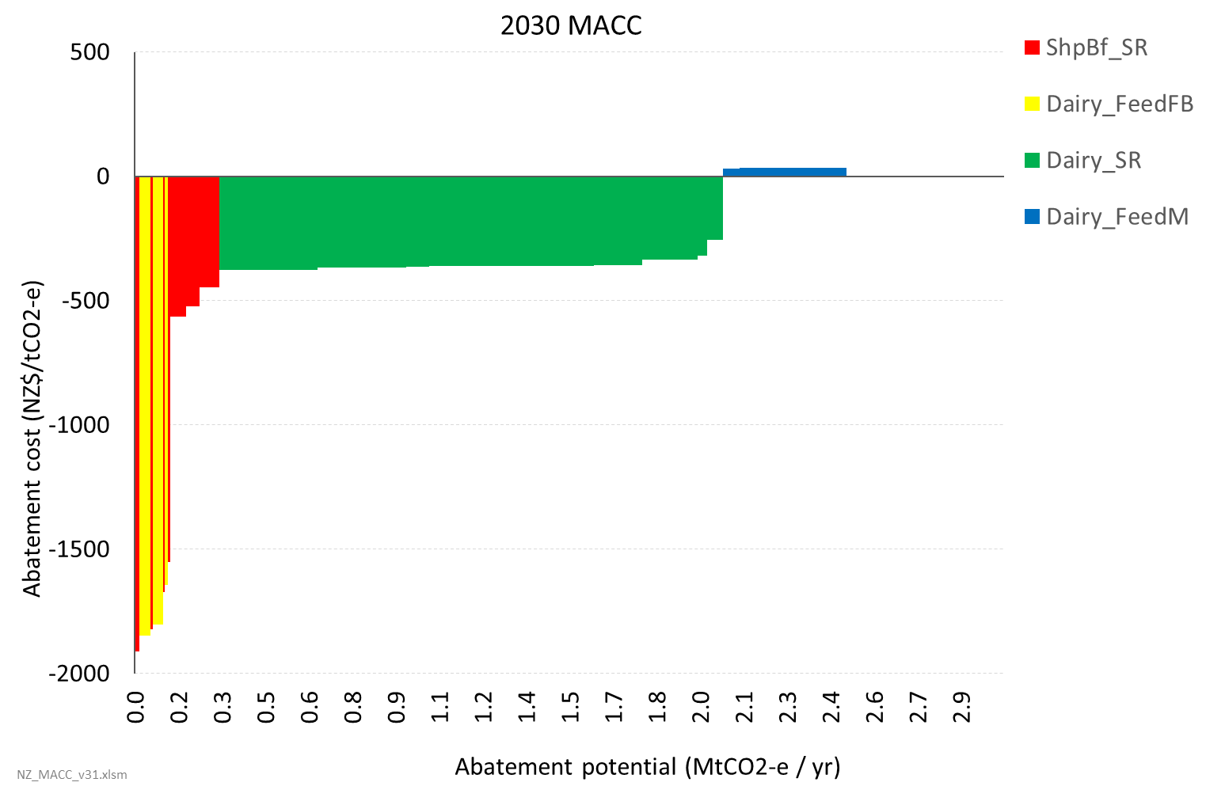
- Most of the potential abatement comes from dairy (2.3 Mt CO₂-e/yr or ~11% of projected dairy emissions) with a much smaller contribution from sheep and beef (0.2 Mt CO₂-e/yr or 1.5% of projected sheep and beef emissions).
- Analysis indicates most of this abatement potential could be achieved at negative abatement cost, ie, it is cost-effective even at a zero emissions price. This is because implementing the practice changes can improve farm profitability. However, this is subject to important caveats listed below.
- Increased use of on-farm fodder beet to replace pasture silage and bought-in barley grain (Dairy_FeedFB, assumed only applicable for South Island farms) is found to have a highly negative abatement cost, here exceeding -$1,500 per tonne CO₂-e.
- Improving performance and reducing stocking rates on dairy farms (Dairy_SR) and intensive sheep and beef farms (ShpBf_SR) accounts for most of the abatement potential, with abatement costs mostly in the range of -$300 to -$600 per tonne. For South Island sheep and beef farms the abatement cost of this option is below (ie, more negative than) -$1500 per tonne.
- Replacing all palm kernel expeller (PKE) and bought-in maize silage with on-farm maize silage (Dairy_FeedM, assumed only applicable for North Island farms) is found to have an abatement cost of around $30 per tonne.
- An alternative feed option for South Island dairy farms (not shown) is to replace bought-in pasture silage with bought-in barley grain. This has a higher abatement potential than switching to on-farm fodder beet (an extra ~0.3 Mt CO₂-e/yr), but at much higher abatement cost (~$100–150 per tonne).
Caveats: Applicability of the on-farm abatement options to individual farms will vary, and achieving the modelled results relies on farmer skill. In particular, if animal performance is not increased to the same extent as in the model then reducing stocking rates could have a less positive, or even negative, impact on profitability. Some options may also face technical challenges and costs that are not captured (eg, training costs, risks of crop failure). For detailed discussion of each abatement option see Reisinger et al. (2017).
Package B: Improving animal performance while reducing stocking rates (sheep and beef only) and removing nitrogen fertiliser and reducing production (dairy only)
Figure 7 shows the 2030 MACC for an alternative package, Package B, which looks at the removal of nitrogen fertiliser from dairy farms (Dairy_NoFert). Overall abatement potential is lower than Package A at around 2.0 Mt CO₂-e/yr.
Figure 7: MACC for on-farm abatement options in 2030, package B
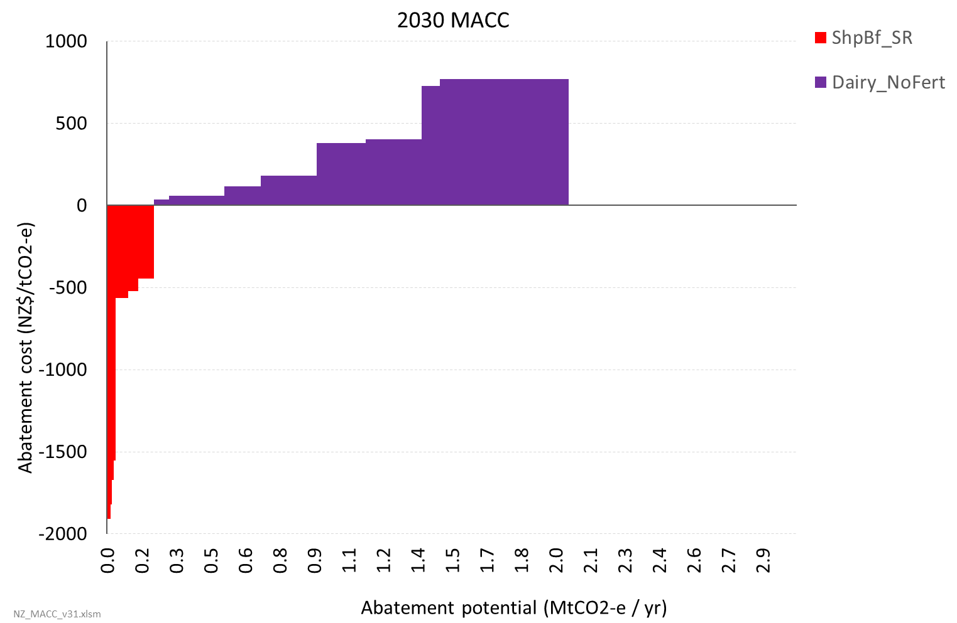
- The abatement cost of removing nitrogen fertiliser shows huge variation across regions, from ~$30 in Canterbury to ~$400 in Taranaki to ~$800 in Waikato.
- Note that this analysis excludes any valuation of co-benefits. Removing nitrogen fertiliser could have particularly strong co-benefits for water quality in some catchments, so valuing these may significantly affect the results for this option (ie,. lower abatement costs).

Land-use change options
Due to the special characteristics of land use change, these results are presented differently to results for other sectors. This section looks first at the estimated abatement costs across different farm categories, then at the area of land available within these categories, and finally at a provisional MACC.

Abatement costs
The abatement cost for land-use change can be thought of as the breakeven emissions cost to make another activity more profitable (or valuable) than the existing activity. Figure 8 illustrates this for two example farms converting to production forestry (note this uses the central commodity price assumptions shown in table 1 below). For the sheep and beef example, the difference in profitability is relatively small without an emissions cost, so the breakeven emissions cost to make forestry the more profitable activity is low. The change is almost entirely due to the added value of the forestry carbon sequestration, rather than the added expense of the sheep and beef emissions. For the dairy example, the much higher difference in starting profitability means a higher breakeven emissions cost, and the higher emissions intensity means the added emissions expenses are a more material factor.
Figure 8: How emissions costs affect profitability for sheep and beef and dairy farming vs forestry
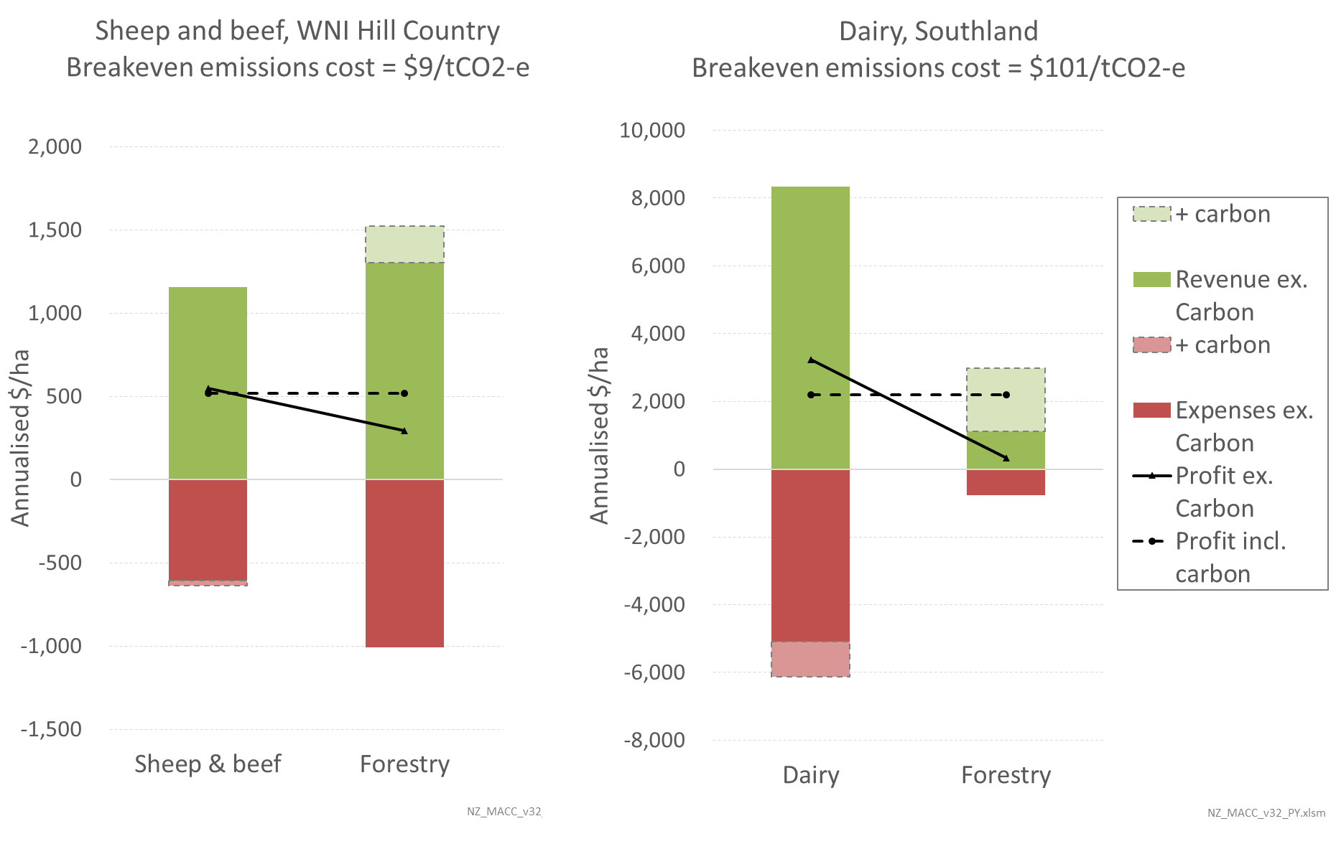
Figure 9 shows estimated abatement costs for land-use change to forestry across the different farm types and regions, based on current commodity prices for dairy, meat, and harvested wood. The central estimates for conversion to production forestry (solid brown line) range between $0–70 per tonne for sheep and beef farms and $50–150 per tonne for dairy farms. The central estimates for conversion to native forest (solid green line) range between $20–130 per tonne for sheep and beef farms and $130–200 for dairy farms.
Figure 9: Marginal abatement costs for land-use change from farming to forestry
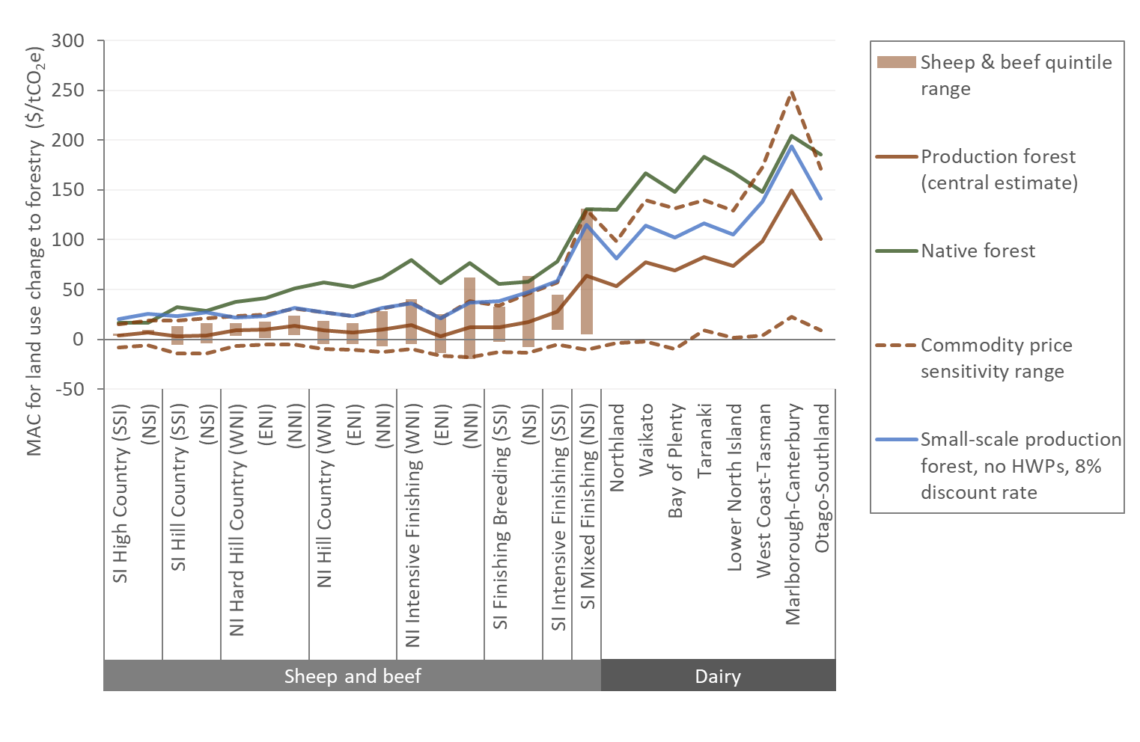
Regional variations in abatement cost reflect two factors:
- Differences in forest productivity. This is generally higher in the North Island, and particularly low in Canterbury/West Coast.
- Differences in farm profit per hectare, which correlates quite strongly with stocking rate. For dairy, profit per hectare tends to be higher in the South Island, particularly Canterbury. For sheep and beef, North Island hill country farms tend to have higher profit per hectare than South Island ones, while the reverse is true for intensive farms.
Variations by sheep and beef farm class reflect differences in profit per hectare as well as higher assumed harvesting costs on steeper, more difficult terrain.

Figure 9 also shows how the estimated abatement costs for conversion to production forestry vary under different considerations and input assumptions:
- The light brown bars show the range due to variation in profit per hectare for sheep and beef farms within each category (lowest to highest quintile).
- The dotted brown lines show the range due to changes in assumed commodity prices. Results for dairy are found to be more sensitive to changes in commodity prices than sheep and beef. The price assumptions are presented below in table 1.
- The solid blue line shows how the central estimates change under more conservative forestry assumptions and a higher discount rate. This series uses the default ETS carbon look-up tables and excludes harvested wood products from the long-term average carbon stock, assumed to be reached at age 17 rather than 21 (Manley, 2018). This case might reflect the perspective of a private ETS participant engaging in small-scale planting of less than 100 hectares.
Table 1: Agriculture and forestry commodity price assumptions
 | 2017 | Low | Central | High
Dairy | Milk payout  ~$5.80 per kgMS | -20%  ($4.60 per kgMS) | +14%  ($6.60 per kgMS) | +40%  ($8.10 per kgMS)
Sheep and beef | n/a | -20% | +12% | +40%
Forestry (weighted log price) | ~$115 per m³ | $95 per m³ | $110 per m³ | $130 per m³

Areas of land available
Figure 10 shows the total effective hectares of farmland within each category and how much is assumed available for planting. These assumptions are based on mapping analysis by Te Uru Rākau reported in Manley (2018). The total area of land assumed available for planting is around 7 million hectares, which is made up of 3.3 million hectares of hill country sheep and beef land, 1.9 million hectares of intensive sheep and beef land, and 1.9 million hectares of dairy land. Around 1.8 million hectares of hill country sheep and beef land cannot be planted in any type of forest.
Figure 10: Areas of farm land assumed available for planting
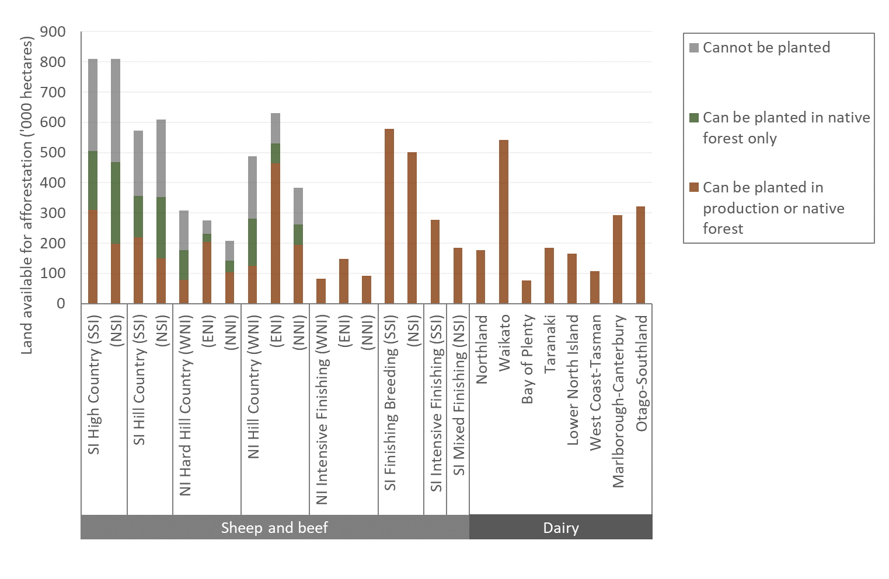
Figure 11 combines the above data to show the cumulative area that is economic to convert to forest as a function of the marginal abatement cost (using the central estimates). The analysis indicates around 3.9 million hectares is economic to convert at marginal abatement costs of up to $20 per tonne, rising to 4.7 million hectares at $50 per tonne (dashed yellow line). If conversions were restricted to native forest, around 2.1 million hectares would be economic to convert at marginal abatement costs of up to $50 per tonne (solid green line).
Figure 11: Area of farm land economic to convert to forest as a function of marginal abatement cost
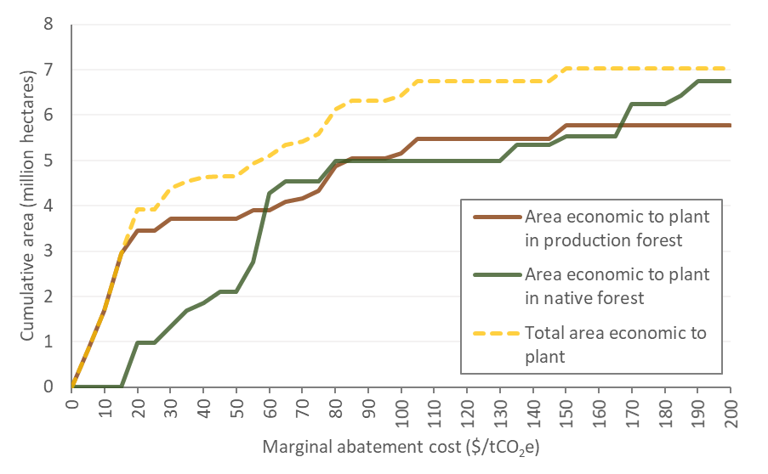

Land sector MACC
Before presenting a full land sector MACC it is important to highlight a major caveat: the current analysis does not have any constraints on the rate of land-use change. The MACC therefore shows the abatement potential (including sequestration) if all available land were converted to forest. While this is clearly unrealistic, it is useful to give a sense of the scale of abatement technically available over time at different levels of cost. Analysis on the constraints on the rate of conversions and other barriers to land-use change will be an important area for future work.
Figure 12 shows a MACC combining on-farm abatement options and land-use change options in 2030. The on-farm abatement options presented (Package A) are grouped together and can be seen at the far left of the graph. Note that the cost axis has been constrained for viewing reasons.
Figure 12: Land sector MACC including land-use change options in 2030
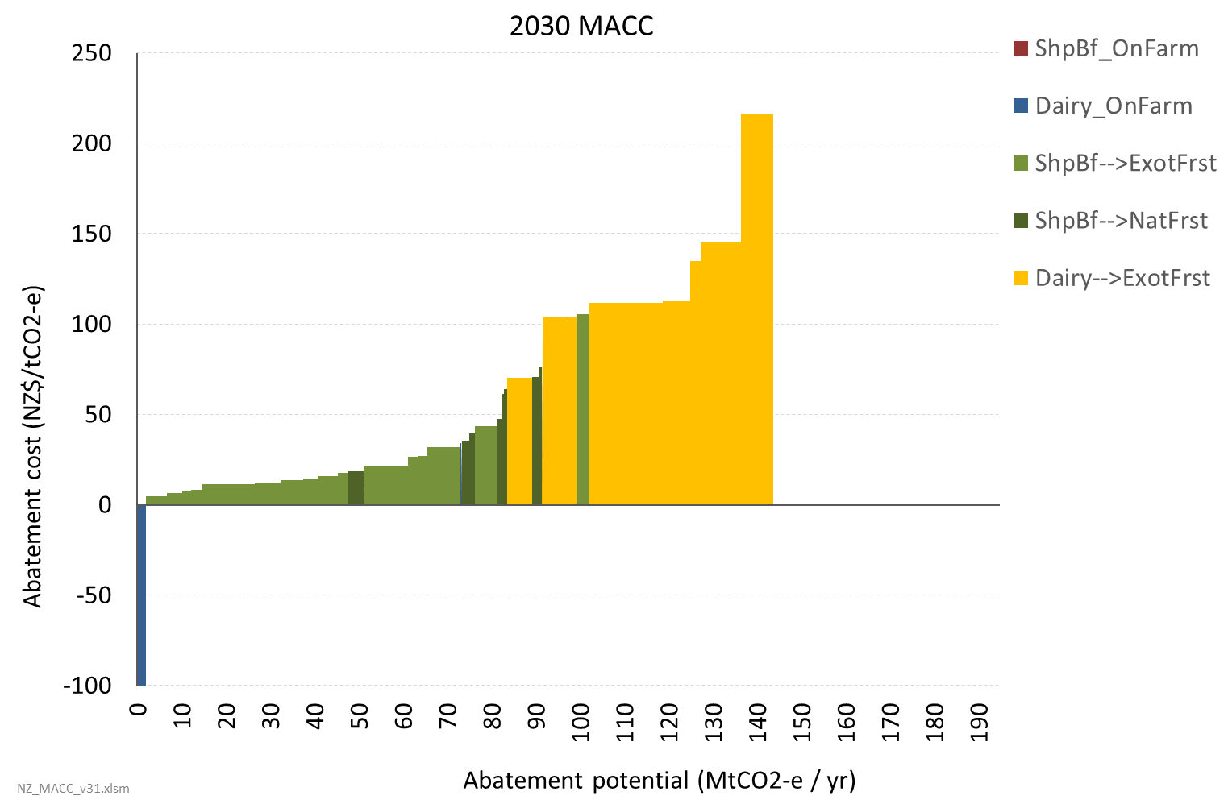
Figure 12 shows a total abatement potential of over 140 Mt CO₂-e/yr, close to double New Zealand’s current annual gross emissions. This includes both the reduction in agricultural emissions (totalling about 31 Mt CO₂-e/yr) and the forestry sequestration resulting from the land-use change.
Care is required when comparing sequestration to gross emissions reductions as production forestry in particular only provides a temporary sequestration benefit. This is difficult to illustrate on a MACC. The sequestration values used in figure 12 calculated by discounting the annual sequestration time series to give an effective sustained sequestration rate.
Note that the abatement costs for land use change shown in figure 12 are higher than seen in figure 9. This is for two reasons:
- Projected farm productivity gains under business-as-usual are assumed to occur without any increase in expenditure, thereby increasing profitability. This may be a strong assumption.
- In the MACCs analysis, on-farm abatement options are assumed to be implemented unless their abatement cost exceeds the abatement cost for land-use change on its own. As the on-farm measures mostly improve profitability while reducing emissions, implementing these raises the subsequent abatement cost for land-use change.

Issues and caveats
Several caveats have already been noted above:
- Applicability of the on-farm abatement options to individual farms will vary, and achieving the modelled results relies on farmer skill. See page 16 for more detail.
- The analysis currently excludes any valuation of co-benefits, such as improved water quality and biodiversity. Valuing these would have potentially large impacts on the abatement cost for some options, particularly reducing nitrogen fertiliser use (discussed on page 17) and land-use change. The report Analysis of drivers and barriers to land use change prepared for MPI estimates that the ecosystem service value of forestry could be around seven times the direct economic value (Journeaux et al., 2017, p. 36). Co-benefits will also be important for the relative value of native forest vs production forest.
- The analysis currently has no constraints on the rate of land-use change (discussed on page 21).
Further issues and caveats include:
- The analysis of land-use change options assumes full conversion to forest. Abatement costs and potential will differ for integration of forestry in a continued farm operation. On the one hand, tree planting on ‘marginal’ land could come at lower (or negative) cost compared with the above results if it has little impact on farm production. On the other hand, abatement costs could be higher if:
- planting some productive land reduces the profitability of the farm operation as fixed costs are spread over a smaller farmed area
- farm foresters are unable to attain the same sequestration and wood yield as a specialist forestry operation.
- Commodity prices are a key uncertainty and could be subject to dynamics that are not captured in the (static) MACC analysis.
- Prices for agricultural and forestry products will be shaped by global supply and demand and potential climate policies for these sectors across the rest of the world. It is unknown to what extent New Zealand’s actions alone might influence these. However, if similar land-use changes were to occur in other countries there will be dynamic feedbacks – for example, if many countries were to move from livestock farming toward forestry this would be expected to raise meat prices and reduce wood prices. Conversely, if the cost of ‘functionally-equivalent’ plant-based synthetic meat and milk proteins were to fall below the cost of animal-derived proteins, there could be a significant fall in meat and dairy prices. Likewise, a major global shift towards (low-carbon) timber-based construction materials away from (high-carbon) cement and steel would be expected to put upwards pressure on timber prices.
- Decisions around land use will be shaped by expectations of future commodity prices and emissions prices, not just current prices. This is especially the case for forestry given the long-term nature of the investment.
- As shown in figure 9, abatement costs for land-use change from sheep and beef to forestry are much less sensitive to commodity price changes than is the case for dairy.
- Static analysis is likely appropriate for moderate amounts of land-use change but not for the large-scale change this analysis indicates is possible.
- In addition to the potential commodity price dynamics mentioned above, there could be network effects that affect costs. For example, concentration of forestry in a region could reduce costs of harvesting and transporting logs.
- Interactions across the economy with competing uses for biomass is another key area for further analysis.

Industry
In New Zealand’s Greenhouse Gas Inventory, emissions from industry are divided into two categories:
- Energy-related emissions from combustion of fuels (mainly for process heat)
- Other process-related emissions, accounted for in the Industrial Processes and Product Use (IPPU) category.
We have considered the two categories together, to take into account that several industrial sectors are responsible for both energy and IPPU emissions (figure 13), and that some options to reduce energy emissions will also reduce IPPU emissions. The MACC analysis has the split of results by emissions category, sector and gas.
Figure 13: Breakdown of 2017 emissions from top emitting industry sectors
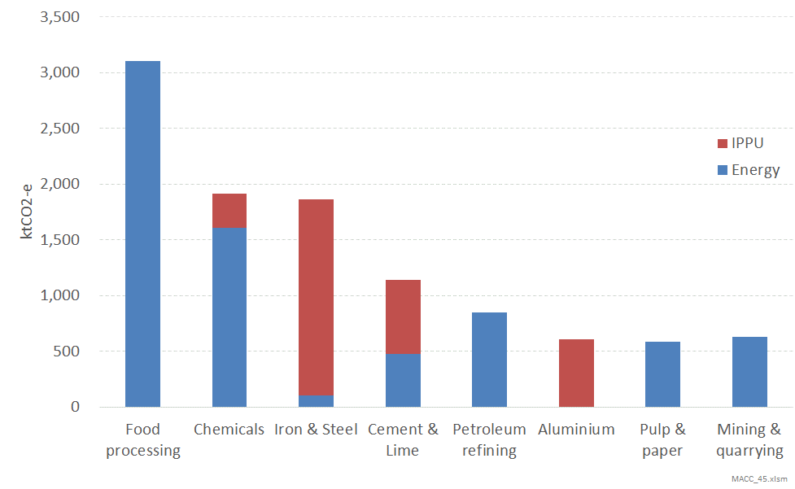
Industry emissions are dominated by the eight sectors shown in figure 13. Some sectors can be further disaggregated as follows:
- food processing into dairy, meat and other food processing
- chemicals into methanol, urea and hydrogen production.
It is helpful to distinguish the industry sectors with a large number of plants and more generic boiler requirements from those with a small number of plants and a ‘tightly integrated’ process, as shown in table 2.
Table 2: Estimated number of plants by industry sector/process (Atkins, 2019)
 | Sector/process | Number of plants in New Zealand
Boiler plant | Dairy processing  milk powder / other | ≈80  ≈50/30
Boiler plant | Meat processing | 86
Boiler plant | Other food | 44
Boiler plant | Wood processing | 75
Tightly integrated | Methanol | 2
Tightly integrated | Urea | 1
Tightly integrated | Refining | 1
Tightly integrated | Steel | 1
Tightly integrated | Aluminium | 1
Tightly integrated | Cement | 1
Tightly integrated | Kraft pulp | 2

Options investigated
The MACC analysis currently covers all industry sectors listed in table 2. The analysis has primarily drawn on the detailed assessment undertaken by Dr Martin Atkins (University of Waikato) for the Ministry of Business Innovation and Employment and the Energy Efficiency and Conservation Authority’s Process Heat in New Zealand programme. The analysis includes a wide range of abatement options investigated by Dr Atkins. These can be broadly grouped into demand side and supply side measures as illustrated in figure 14.
Figure 14: Demand and supply side abatement measures for industry
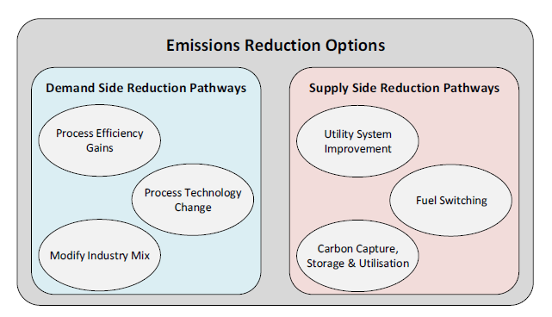
Source: Atkins, 2019
Options for the dairy, meat, other food and wood processing sectors include:
- demand-side measures (eg, heat recovery, process electrification)
- fuel switching to either biomass or an electrode boiler.
Options for the other ‘tightly integrated’ sectors (of which there are only 1-2 plants in New Zealand in each sector) are more diverse and case-specific. Fuel switching is less viable for these sectors due to high temperature requirements in these sectors and carbon capture is the main supply-side option investigated.
Table 3 gives a full list of abatement options included for each industry sector. More information on these can be found in Dr Atkins’ report. Note that Dr Atkins further divides dairy and meat processing by process. Dairy is divided into milk powder production (estimated to account for ~75% of total dairy processing emissions) and other processes (which includes eg, butter, cheese, UHT milk). Dr Atkins has also modelled two different types of milk powder plant, called Mechanical Vapour Recompression (MVR – more common) and Thermal Vapour Recompression (TVR – less common). Meat processing is also divided into rendering and slaughtering.
Table 3: Abatement options included for industry
Sector | Abatement option
Dairy processing – Milk powder, MVR and TVR type plants | Mechanical Vapour Recompression (MVR) replacement
Dairy processing – Milk powder, MVR and TVR type plants | Cow water preheat of milk (reduced TVR) [TVR plants only]
Dairy processing – Milk powder, MVR and TVR type plants | Cow water preheat of milk (main dryer inlet air)† [TVR plants only]
Dairy processing – Milk powder, MVR and TVR type plants | Dryer exhaust heat recovery
Dairy processing – Milk powder, MVR and TVR type plants | Heat pumps (low temp)†
Dairy processing – Milk powder, MVR and TVR type plants | Heat pump (main dryer air)†
Dairy processing – Milk powder, MVR and TVR type plants | Condensing economiser on existing boiler‡
Dairy processing – Milk powder, MVR and TVR type plants | Boiler fuel switch (coal/gas to biomass or electricity)‡
Dairy processing – other | Energy management/house-keeping
Dairy processing – other | Heat recovery
Dairy processing – other | Heat pump for hot water†
Dairy processing – other | Heat pump (air source)†
Dairy processing – other | Electrotechnologies†
Dairy processing – other | Boiler fuel switch
Meat processing – Rendering and Slaughtering | Efficiency – meet benchmark specific energy consumption (SEC)
Meat processing – Rendering and Slaughtering | Electrification of meal drying [Rendering only]
Meat processing – Rendering and Slaughtering | Heat pump for hot water†
Meat processing – Rendering and Slaughtering | Heat pump (air source)†
Meat processing – Rendering and Slaughtering | Boiler fuel switch†
Food processing – Other | Energy management/house-keeping
Food processing – Other | Heat recovery
Food processing – Other | Heat pump for hot water†
Food processing – Other | Heat pump (air source)†
Food processing – Other | MVR integration
Food processing – Other | Process design
Food processing – Other | Electrotechnologies†
Food processing – Other | Boiler fuel switch
Wood processing | Continuous drying kilns
Wood processing | Boiler fuel switch
Kraft pulp | Efficiency improvements
Kraft pulp | High efficiency recovery boiler
Methanol | CO₂ capture and recycle, with increased production
Methanol | CO₂ capture with Steam Methane Reformer
Urea | Efficiency improvement
Urea | Carbon capture and storage (CCS)
Refining | Heat integration and waste heat recovery
Refining | Fouling mitigation
Refining | Advanced process control
Refining | Motors, pumps, compressors and fans optimisation
Refining | Utility system optimisation
Refining | Process design (BAT)
Refining | Distillation column substitution
Refining | Renewable hydrogen production
Steel | Heat integration, waste heat recovery
Steel | Utility (including power) optimisation
Steel | Blast furnace optimisation
Steel | Improved automation and process control
Steel | Carbon capture and storage
Aluminium | New zero-carbon anode technology
Cement | Use of tyre-derived fuel
Cement | Heat recovery
Cement | Kiln chemistry optimisation
Cement | Carbon capture and storage
Note: † and ‡ denote options that are assumed mutually exclusive within a sector
The following options investigated by Dr Atkins are not currently active options in the MACC analysis:
- Dairy processing:
- co-firing with biomass for dairy processing – excluded as full fuel switching delivers significantly more abatement at slightly higher abatement cost
- boiler conversion – excluded for simplicity as results are similar to boiler replacement.
- Aluminium: CCS – excluded on the basis that it is less effective and assumed less viable than the zero-carbon anode technology option.
- Cement:
- maximum biomass fuel mix – excluded on the basis that the tyre-derived fuel option is understood to be proceeding and is estimated to have lower abatement cost
- electrical plasma arc kiln – excluded for simplicity as assumed to be mutually exclusive with other options (aside from kiln chemistry optimisation). This should be further investigated.
- Methanol: New plant – excluded on the assumption this is unlikely under gas supply outlook (based on Gas supply and demand scenarios by Concept Consulting). (Co 2019)
- Urea:
- renewable hydrogen – excluded on assumption that this is mutually exclusive with CCS and significantly higher cost
- new plant – excluded as per methanol. However, both this and the renewable hydrogen option are worth re-examining in light of recent developments such as the 8 Rivers project in Taranaki.
- Renewable hydrogen – this was not included as other analysis (ConceptConsultingGroup 2019) indicates it is likely to be higher cost than other options.

Methodology for estimating MACCs
The marginal abatement cost of an option is calculated based on the lifetime cost of providing useful heat, taking into account:
- capital costs, with such costs spread over the lifetime kWh of heat provided
- operating costs (particularly fuel costs)
- efficiency of converting delivered energy (ie, energy content of the fuel) into useful heat.
This is equivalent to calculating costs on an annualised basis.

Food and wood processing sectors
For demand-side options, the steps taken to estimate the MAC are:
- Estimate the annual reduction in demand for useful heat and increase in electricity demand
- Estimate the cost of implementing the measure per kWh of useful heat saved
- Subtract the variable costs ($ per useful kWh) of the original fuel to estimate the net cost
- Divide the net cost by the CO2 emissions savings to estimate the MAC.
Information on the abatement options’ costs and effectiveness was extracted from Dr Atkins’ spreadsheet models.
For fuel-switching options, the steps taken are to:
- Estimate the lifetime cost per useful kWh for the existing boiler, including future capital costs for replacement
- Estimate the lifetime cost per useful kWh for the fuel switching option
- Divide the net cost difference by the CO2 emissions savings to estimate the MAC.
The model calculates the MAC for fuel switching to a biomass or electrode boiler and selects the option with the lowest abatement cost.
The food and wood processing sectors are made up of a large number of plants, across which the abatement cost of an option may vary significantly due to different boiler sizes and load factors. To capture this variation, calculations are made at plant-level for coal and lignite plants using a regional data set from a GNS/Scion report (Alcaraz and Hall, 2018). Similar data were not available for gas plants, so these are currently calculated at the national sector level.
Some important assumptions made in the current analysis are:
- Fixed, uniform prices for coal and biomass ($7/GJ and $10/GJ respectively). There is some uncertainty around coal and biomass prices in different parts of the country, with biomass availability in different regions particularly being an issue. The model is designed to allow for regional fuel price projections but developing such projections for coal and biomass would be a stage 2 piece of work. Further, for biomass, there could be merit in exploring a regional cost-supply curve approach to biomass resource availability, which also considers the potential demand for biomass for transport biofuels.
- Default assumption for remaining boiler life (15 years). This is used to calculate the future capital costs for boiler replacement: the MAC for fuel switching a relatively new boiler will be higher than for one due to be replaced or refurbished soon. The model is designed to allow specific assumptions for each plant, but we do not currently have data on the age of the boiler fleet.
- Capital costs for all options are assumed to scale linearly with capacity, ie, per kW of useful heat saved/produced.
The results should be seen as first-order estimates, with some material margin of error either side – particularly for individual sites which may have site-specific factors which either increase or decrease the MAC.

Other sectors
For the other ‘tightly integrated’ sectors (eg, steel), we have simply extracted the estimated abatement cost and percentage reduction in emissions directly from Dr Atkins’ spreadsheets. In other words the options for these sectors are currently ‘hardcoded’ in the analysis and not linked up to variable assumptions such as fuel costs and discount rate. Properly integrating these is an area for future work.

Interactions between options
Demand-side options can all be done independently of fuel switching. However, some are mutually exclusive from each other (as shown in table 3). Others are assumed to be additive; this may not be appropriate in some cases and further examination is warranted.
In the model, if the abatement cost of a demand-side option when measured against the current fuel is higher than the abatement cost of fuel switching the boiler, it is not implemented. This is because it would be more cost-effective to switch the boiler and not do the demand-side measure. The abatement potential for fuel switching is calculated to take account of all implemented demand-side measures to avoid double-counting emissions reductions.
For the tightly integrated sectors we have similarly tried to avoid double-counting by scaling the abatement potential for supply-side measures (such as carbon capture and storage) to account for implementation of demand-side measures.

Activity projections
In the absence of sufficiently robust and detailed sectoral activity and energy demand projections, the current analysis mostly assumes constant activity in all sectors. This means the only factors changing over time in the model are fuel prices. Methanol and urea are the only exception to this, with scenario assumptions for when existing plants could close. This is informed by analysis by Concept Consulting for its Gas supply and demand scenarios report, which finds it is likely that New Zealand will not have sufficient gas to support petrochemical production at current levels much beyond 2030, with a progressive decline over the subsequent 10-15 years.

Costs included in the analysis
Costs and benefits included | Costs and benefits excluded
Capital costs  Fuel costs (including transmission component of electricity)  Maintenance costs | Air pollution  Potential production losses due to installation downtime (assumed avoidable)

Main sources of data and information
Category | Sources
Abatement options – costs and effectiveness | Atkins, M. Options to Reduce New Zealand’s Process Heat Emissions, March 2019
Boiler costs and efficiencies | Atkins, 2019
Coal boiler plant fleet information | Alcaraz, S. and Hall, P. 2018. Mapping of primary industrial processing heat demand and forestry resources to allow identification of Wood Energy Industrial Symbiosis opportunities at a regional level. (GNS/Scion report)
Wholesale energy prices (coal, gas, electricity and biomass) | Concept Consulting analysis (for electricity and gas)  Covec for coal  Martin Atkins (for biomass)
Electricity transmission charges | Based on observed values from Transpower info disclosure for the pulp and paper direct connects.  Assumes that some transmission costs are effectively fixed based on peak demand of the plant, therefore low load factor plant will have a higher electricity cost per unit.
Electricity emissions factors | Concept Consulting analysis

Provisional results and discussion
There is a lot of information contained in the industry MACCs due to the diverse nature of industrial energy use and emissions and the large number of abatement options investigated. The overall results are presented here at a relatively high level for ease of understanding.

Food processing
Figure 15 shows a MACC for dairy processing. The demand-side measures (listed in table 3 above) have been grouped into two broad categories of heat recovery (which includes ‘Cow water preheat of milk’) and process electrification (which includes all heat pump and MVR options). Different colours are used for the different current boiler fuel source (coal, lignite or gas), with shading used to distinguish the abatement option category.
Figure 15: Dairy processing MACC in 2030
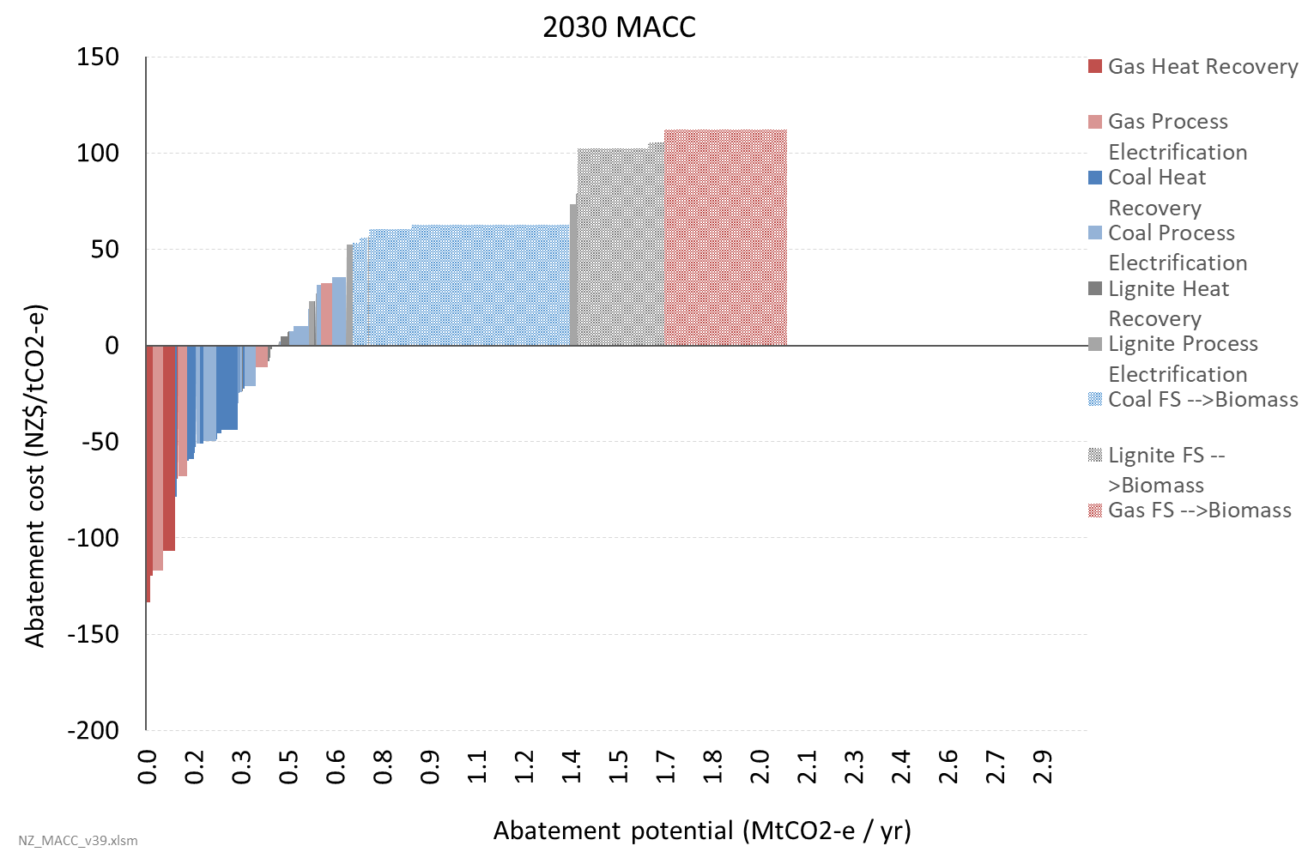
- The total abatement potential is slightly over 2.0 Mt CO₂-e/yr, representing essentially full decarbonisation of the sector within the model.
- The analysis finds that demand-side options could contribute up to around one-third of this abatement, largely at negative cost. The heat recovery options are found to generally have negative abatement costs, while for process electrification options the costs range from negative to around $70 per tonne.
- Biomass is found to have lower abatement costs for fuel switching than electricity. These are estimated to average around $60 for coal and $110 for lignite and gas; in reality there will be a wider range around this.
Figure 16 shows how the dairy processing MACC changes if the model is forced to choose an electrode boiler over biomass. The estimated abatement costs for fuel switching to electricity are significantly higher – more than doubling for coal and gas plants. This highlights the importance of biomass availability to achieve abatement at least cost. This scenario sees greater adoption of process electrification options that are not cost-effective to implement if biomass is an option.
Figure 16: Dairy processing MACC in 2030 with fuel switching to electricity instead of biomass
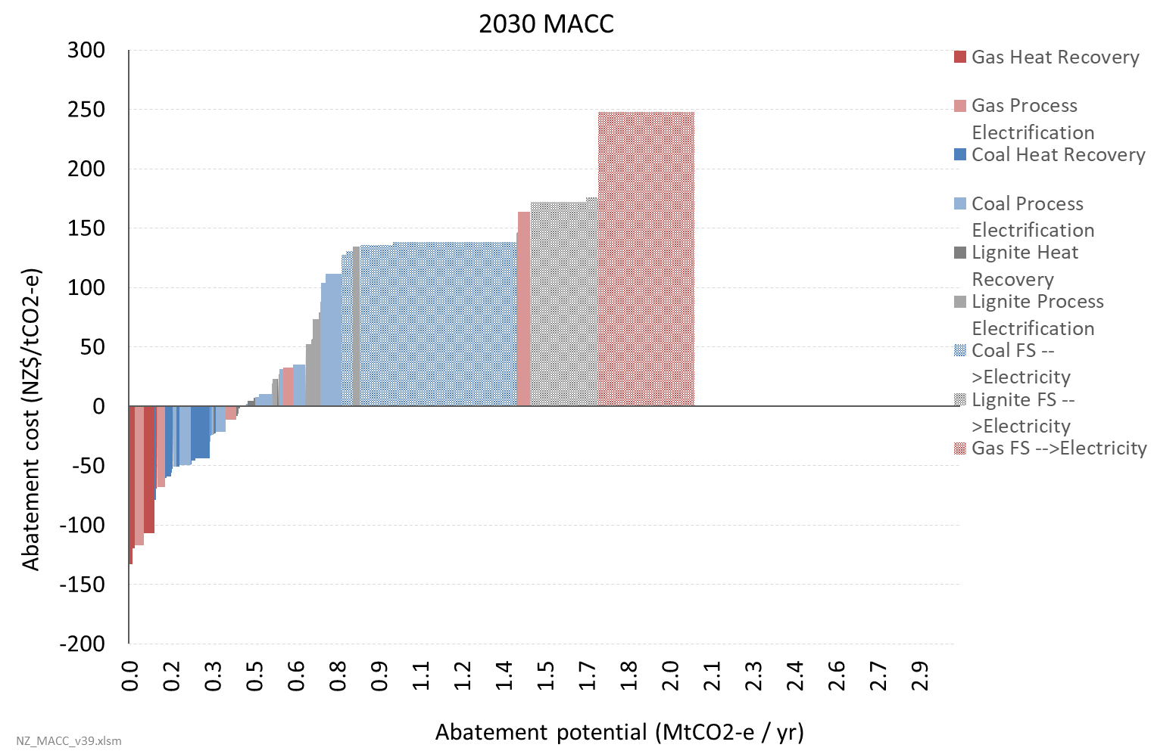
Figure 17 shows a similarly designed MACC for meat processing. The results are broadly similar to dairy processing, but with fewer abatement options. There is also greater variation in the estimated fuel switching costs for coal compared to dairy processing due to a larger number of plants with more variation in load factors. Similar variation could be expected for gas-fuelled plants if these were also modelled at plant level.
Figure 17: Meat processing MACC in 2030
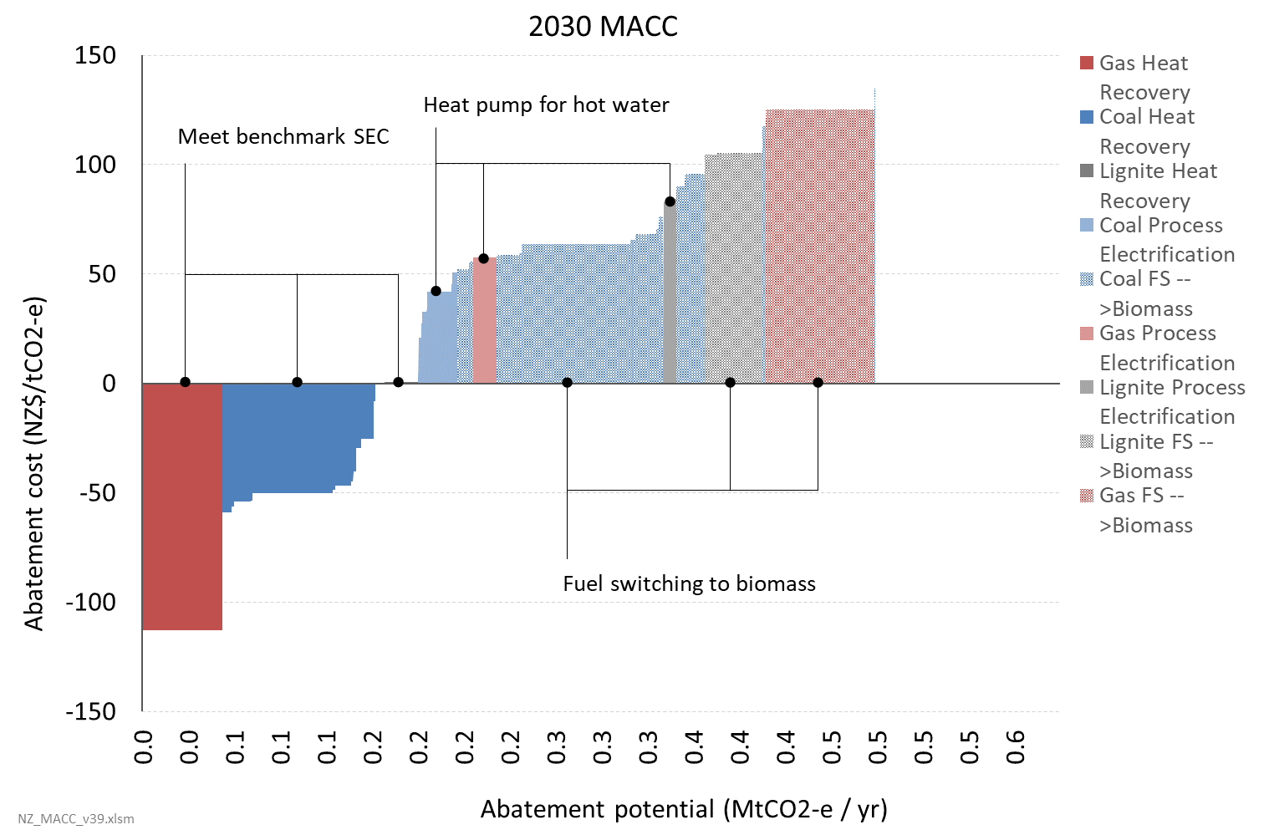
Figure 17 shows a MACC combining the food processing sectors, along with horticulture (indoor cropping) and some other miscellaneous boiler plants. In this graph all demand-side options have been grouped into a single category (‘Efficiency’) and different colours are used for different sectors.
Figure 18: Combined food processing and other boiler plant MACC in 2030
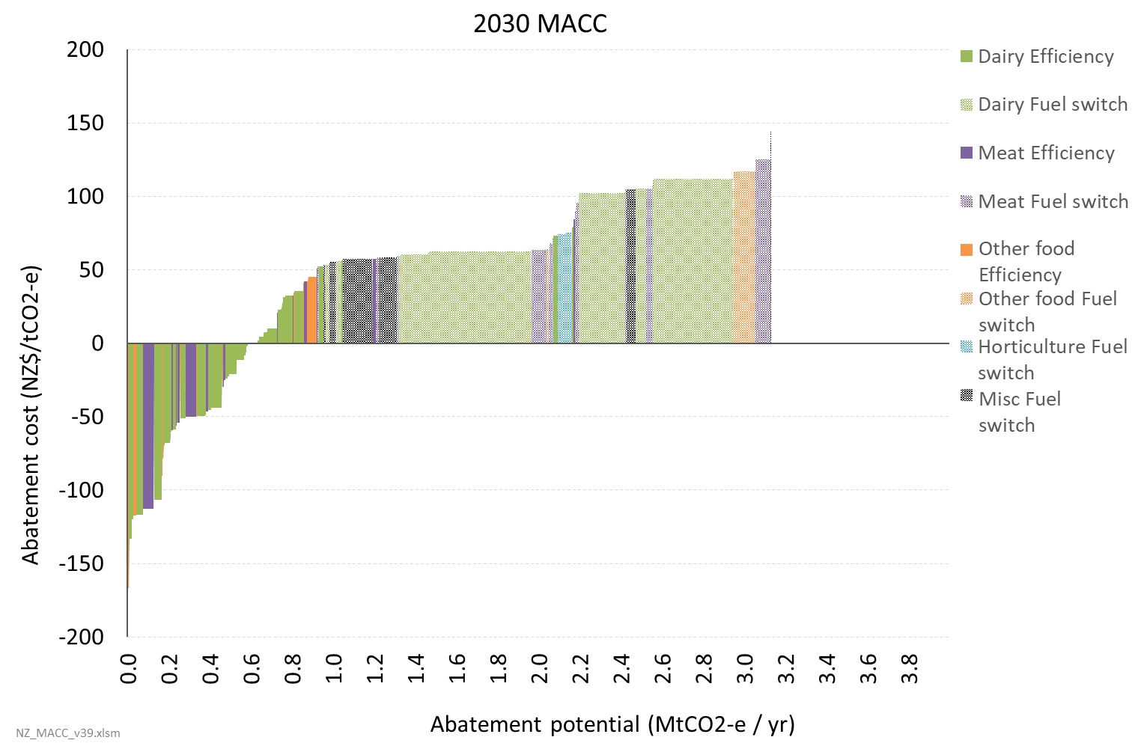
- The total abatement potential is around 3.1 Mt CO₂-e/yr, again representing essentially full decarbonisation of these sectors within the model.
- Note that LPG and diesel plants are not yet included in the model, so actual abatement potential in food processing may be slightly larger. Fuel switching may be a negative cost option for these plants.
- There may also be other issues with the size of some sectors being under-counted or over-counted.
- The analysis indicates fuel switching will tend to be more expensive in horticulture, mainly due to differences in load factors.

Wood processing
Figure 19 shows a MACC for the wood processing sector. Total abatement potential is estimated at around 0.5 Mt CO₂-e/yr, which would represent full decarbonisation.
Figure 19: Wood processing MACC in 2030
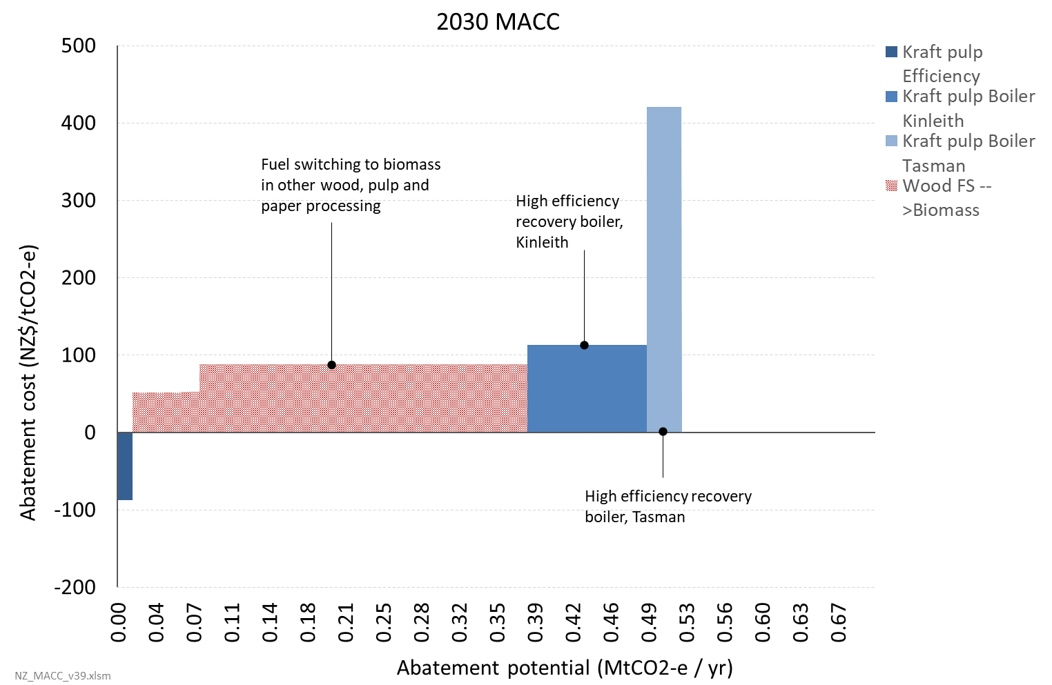
- Note that there are discrepancies between different sources on total wood processing emissions so there may be problems with these numbers.

Chemicals (methanol and urea)
Figure 20 shows a MACC for the methanol and urea sectors. We present this for 2020 due to the uncertainty over future production. As mentioned, analysis by Concept Consulting indicates we will likely see a decline in methanol production, especially over the coming decades, due to insufficient future gas supply. This means a substantial portion of these emissions may disappear under business-as-usual.
The flipside is that this poses a challenge for the economics of abatement options as the companies would require a very short payback to make the investment worthwhile. This analysis has assumed much shorter capital recovery periods than Dr Atkins initial assumption of 25 years: 5–10 years for methanol options and 15 years for urea. This increases the costs significantly. However, CO₂ capture and recycling is still found to be a negative cost option in the short-term with an estimated abatement potential of 0.2 Mt CO₂-e/yr.
Figure 20: Methanol and urea MACC in 2020
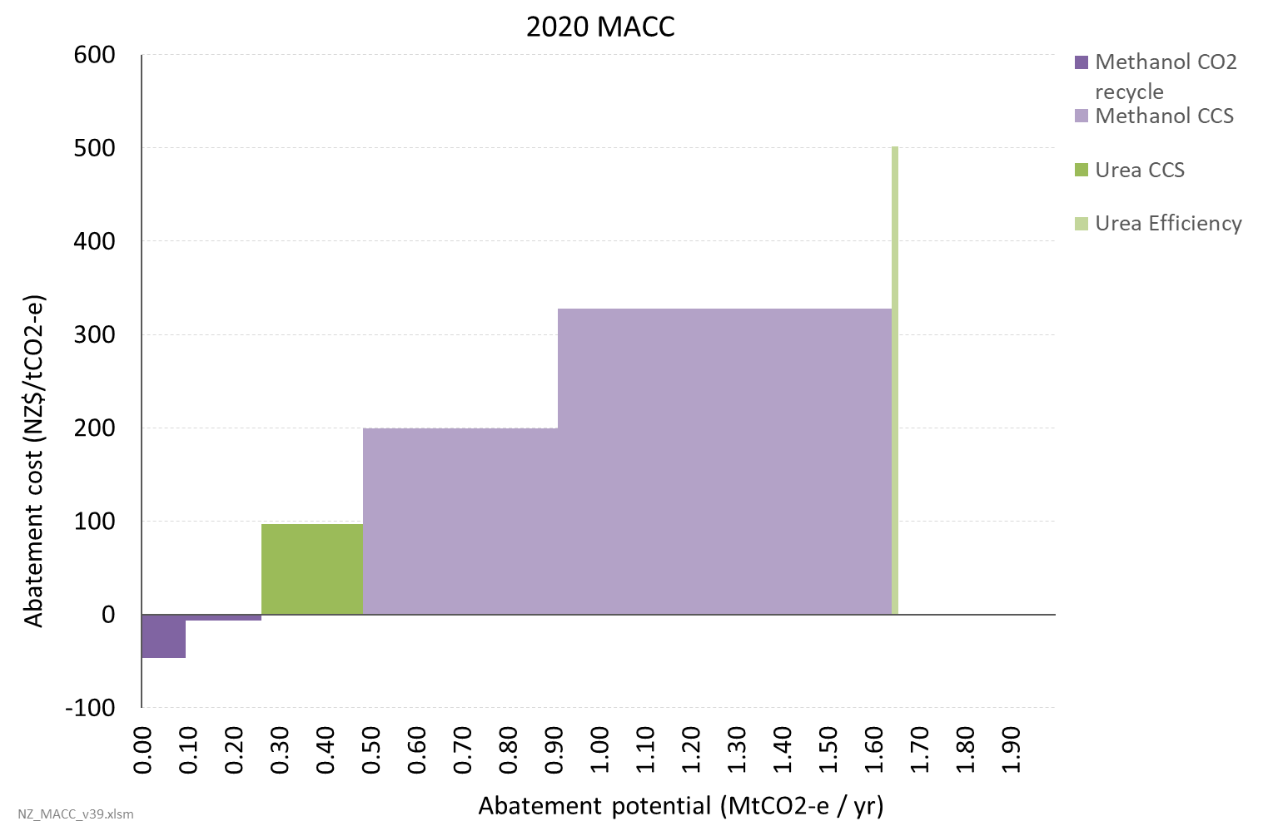

Petroleum refining
Figure 21 shows a MACC for the petroleum refining sector. Dr Atkins has identified multiple options his analysis indicates are negative cost – for a detailed description of these options see his report. (Atkins 2019)The total abatement potential identified for these negative and low cost options is around 0.4 Mt CO₂-e/yr, or around half of the refinery’s emissions excluding hydrogen production.
The abatement cost for changing to renewable hydrogen production is found to be very high at close to $1000 per tonne.
Figure 21: Petroleum refining MACC in 2030
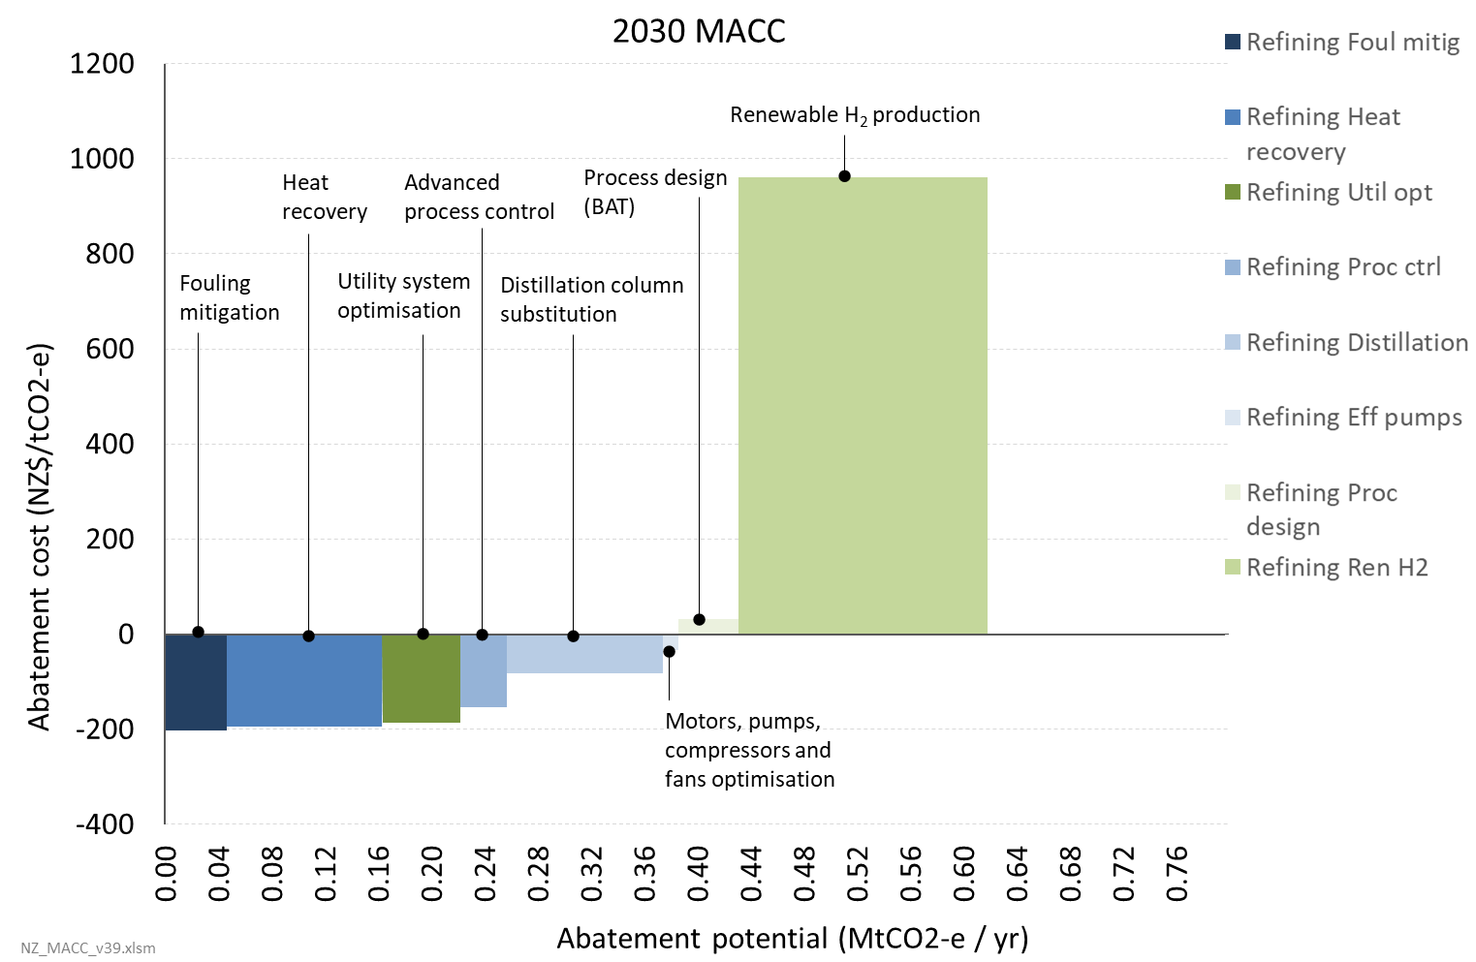

Metals (steel and aluminium)
Figure 22 shows a MACC for the steel and aluminium sectors. Total abatement potential is estimated at around 2.0 Mt CO₂-e/yr, though most of this is at abatement costs indicatively exceeding $200 per tonne.
Figure 22: Steel and aluminium MACC in 2030
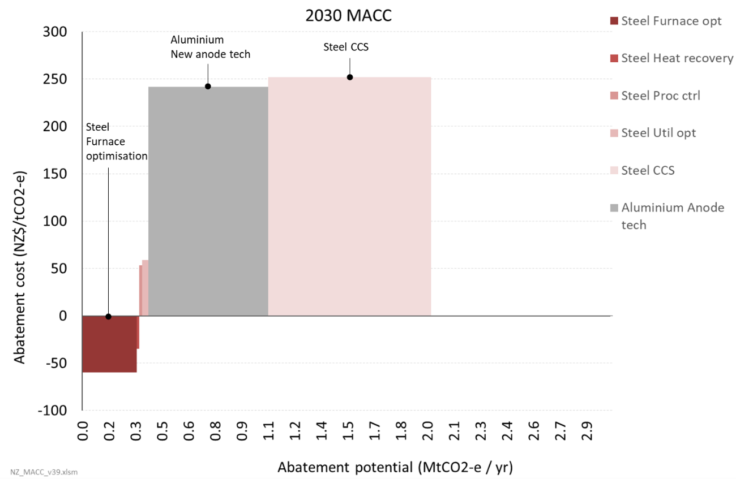
- Dr Atkins suggests that abatement of up to 0.3 Mt CO₂-e/yr could be achieved through blast furnace optimisation. This option is not detailed in his report.
- The abatement cost for the new zero-emissions aluminium anode technology is highly uncertain and the figure here is only indicative. Dr Atkins gave four cost scenarios with abatement costs ranging from ~$84–400 per tonne; we have simply used the average. However, the description in the report suggests the low end cost scenario may be more likely.
- It is not clear that the carbon capture and storage option for Steel is practicable as there are no underground formations nearby (such as a depleted oil and gas reservoir) where the CO₂ could be stored, and developing infrastructure to transport the CO₂ to the Taranaki region would materially increase the cost of this option above that shown in the graph.

Cement
Figure 23: Cement MACC in 2030
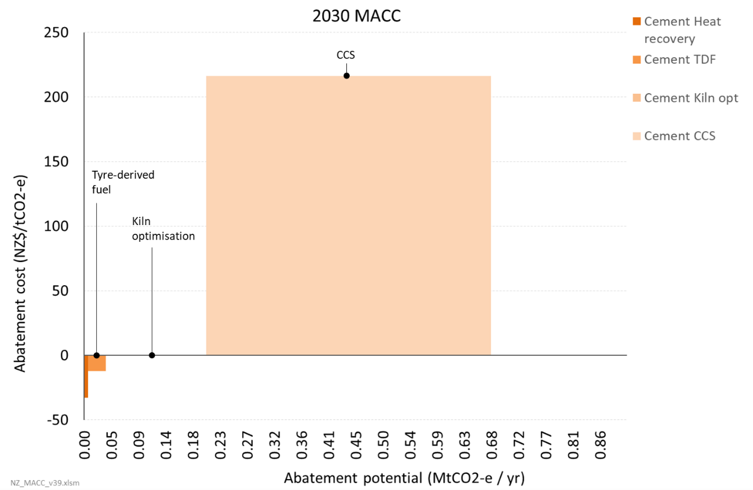
- As with Steel, it is not clear that the carbon capture and storage option is practicable as there are no underground formations nearby (such as a depleted oil and gas reservoir) where the CO₂ could be stored, and developing infrastructure to transport the CO₂ to the Taranaki region would materially increase the cost of this option above that shown in the graph.

Discussion on the importance of biomass across the economy
Biomass looks to be a relatively low-cost option for fuel-switching away from coal or gas. However, there is a finite supply of existing wood residues, with some regions having insufficient current biomass to support the level of fuel-switching required. That said, implementing efficiency measures for boiler plant will substantially reduce the amount of primary fuel required by approximately one-third.
The only two realistic fuel options are biomass hog or electricity. The breakeven distance for pellets to be cheaper than biomass hog adds such a large cost that electricity almost automatically becomes cheaper. Even if transport was not a factor, the cost of pellets is greater than the cost of electricity.
Electricity is more expensive than biomass because of the relatively high $/GJ cost of the input fuel. Further, site-specific issues can materially increase the network aspect of costs
– eg, where significant upgrades to connection capacity are required.
Because of this, and because there is insufficient biomass, complete least-cost decarbonisation of process heat will require planting of forests for energy. However, there is an inherent delay of approximately 20 years before these will start to produce biomass energy. Further, as indicated in figure 24 biomass for industrial process heat may need to compete with biomass for the production of ‘drop-in’ biofuels for the hard-to-electrify aviation and international marine transport sectors.
That said, figure 25 indicates that land-area does not appear to be a limiting factor for this in terms of conversion from sheep and beef farming.
Figure 24: Potential demand for biomass for industrial process heat and biofuels for hard-to-electrify transport, compared with current potential supply from forestry residues
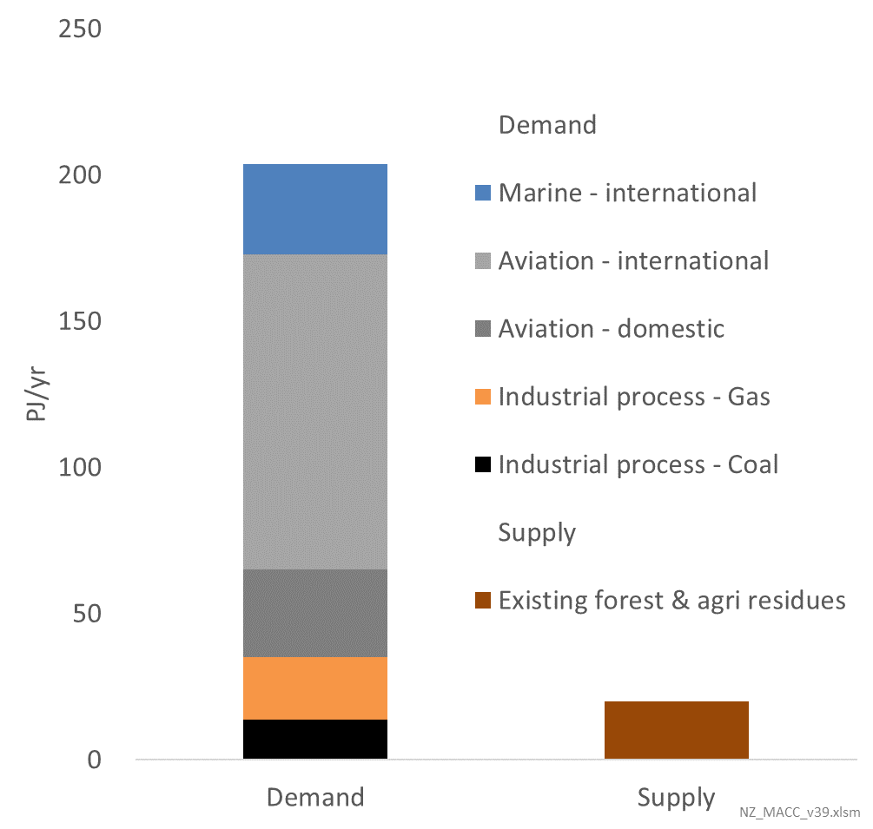
Figure 25: Potential land area for additional biomass to meet demand for industrial process heat and transport biofuels
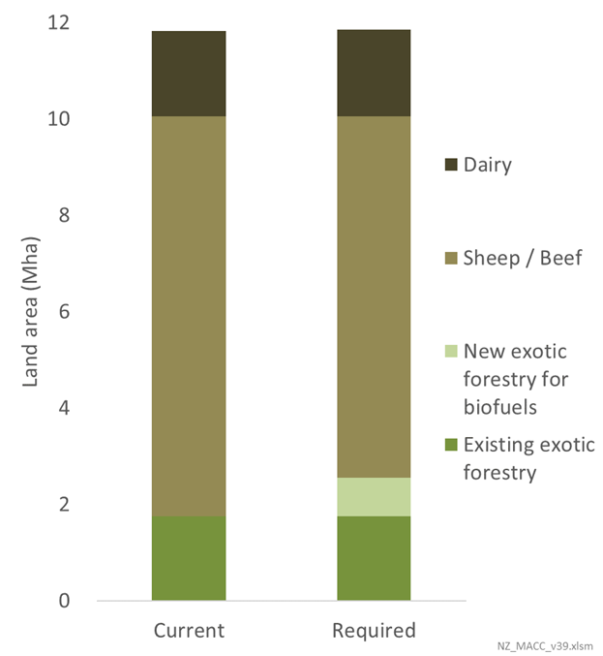

Transport
In 2016, transport emissions accounted for approximately 19% of New Zealand’s gross emissions. By far, the biggest proportion of these emissions were from road transportation, accounting for 66% of transport emissions.
Figure 26: Breakdown of 2016 transport-related emissions
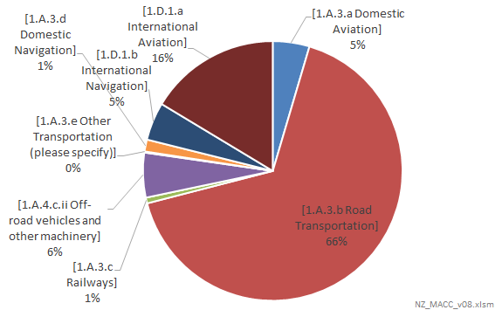

Options investigated
MACC analysis in this sector has focused on fuel switching options for light and heavy road vehicles (by vehicle class), rail, marine and aviation.
For light road vehicles, analysis of fuel switching options was confined to battery electric. For heavy road transport, rail, marine (domestic and international) and aviation (domestic and international), fuel switching options considered include:
- electricity (battery)
- hydrogen
- biofuels.

Gaps and potential areas for further work
The focus has been on fuel-switching within a mode of transport (eg, switching from diesel to electric trucks, or from jet fuel to biofuels for aviation). This is common in other MACC assessments.
For road transport the current analysis only considers switching vehicles that are entering the fleet. It does not consider the potential for replacing existing vehicles in the fleet, ie, accelerated scrappage. This area could be worth further investigation, especially as a longer-term option.
The following options are not included:
- Mode-shifting. The economics of this are very situation specific given the geographic disposition of origin and destination for freight journeys and existing transport infrastructure. This makes it hard to generalise. Other difficulties include where to draw the boundary on cost considerations, and accounting for interactions with technology change. However this warrants further exploration.
- Efficiency improvements to internal combustion engine vehicles (ICEs). These have not been considered as a measure in their own right, but projected ICE efficiency improvements are accounted for in business-as-usual projections of relative vehicle efficiencies.
- Travel demand reduction. Similar issues apply to mode-shifting.

Methodology for estimating the MACCs
The methodology used to estimate the MAC for transport is to estimate the lifetime cost of the fuel switching technology, relative to the counterfactual (eg, an ICE) and to divide by the estimated lifetime emissions.
Different models were developed for:
- Road transport
- Marine, Aviation, and Rail.

Modelling of road transport
For road transport, we have only considered the potential for switching vehicles that are entering the New Zealand fleet. The MAC is calculated by determining the expected lifetime cost of electric vehicles (EVs) and ICEs entering New Zealand, and solving for the carbon cost required for EVs to have lower lifetime costs than ICEs.

Costs included in the analysis
Costs and benefits included | Costs and benefits excluded
Battery cost (for EVs)  Other vehicle cost  Petrol/diesel costs  Electricity cost  Charger cost (for EVs)  Maintenance costs  EV ‘productivity penalties’  Respiratory health cost of ICE tailpipe emissions (optional) | End of life battery / storage  Other motor vehicle externalities

Main sources of data and information
Category | Sources
Non-battery vehicle cost | Various, including published NZ prices and international prices.
Fuel efficiency | Ministry of Transport
Cost of battery | Various, including Bloomberg New Energy Finance
Electricity supply cost (including transmission cost) | Various, but particularly Concept Consulting
Fuel costs | Based on oil price scenarios, coupled with additional costs from a pump-price ‘decomposition’ published by the AA
Battery cost | Depends on how often the battery is cycled (ie, filled and emptied)
The model also assesses the likely change in some of these costs over time. In particular, the likely significant reduction in EV capital costs as battery costs fall and EV production starts to achieve scale economies.
The model considered five main categories of vehicle that are sufficiently distinct in characteristics to warrant separate analyses:
- light passenger vehicles (‘LPVs’ ie, cars)
- light commercial vehicles (‘LCV’s ie,. vans and utes)
- ‘medium’ trucks (‘Truck_M’)
- ‘heavy’ trucks (‘Truck_H’)
- buses.
Further, within these categories the model distinguishes between new and used vehicles entering New Zealand (with used vehicles predominantly being second-hand imports from Japan).
For each of the above vehicle situations, for each year in the future, the model calculates the carbon cost required for EVs to have lower lifetime costs than ICEs.
Appendix B sets out the assumptions and modelling methodology in more detail.
The magnitude and cost of emissions savings is based against projected business-as-usual levels of EV uptake by the Ministry of Transport. For any given future year costs and benefits of electrification are assessed on the basis that all vehicles coming into the country between 2019 and that year are electric.
This means that for that year the magnitude of emissions savings is calculated as the avoided annual emissions in the future year if all vehicles entering the country from 2019 the year in question that were projected to be ICE were instead switched to be EVs. (Note that the start year assumption can be varied.)
For the given year, the cost of the emissions savings is calculated as the cumulative extra costs incurred from choosing EVs instead of ICEs for all vehicles entering the country from 2019 to the year in question that were projected to be ICEs on the BAU basis.
This means the MAC assessed in, say, 2030 is the weighted average MAC for replacing all incoming ICE vehicles with EVs from 2019 up to 2030. However, the model is also set up to allow us to look at the MAC just for vehicles entering the fleet in a given year.

Modelling of marine, aviation, and rail
This section examines the economics of fuel switching for aviation, marine, and rail from fossil fuels to three different technology options:
- battery electric
- biofuels
- hydrogen.
The framework used to evaluate the economics of fuel-switching from fossil to low-emissions fuels is a total cost of ownership (TCO) evaluation for delivering a freight service. This is measured in dollars per tonne-kilometre (t.km) (ie, the average cost for transporting one tonne of freight one km – noting that for aviation, it is effectively one tonne of passengers and associated luggage).
The building-blocks for such an analysis requires consideration of:
- the fuel cost of each option. This comprises:
- the cost of producing the fuel, and distributing it to the point where it can re-fuel the vehicle. That is, this gives the $/GJ ‘delivered’ cost of the fuel
- this delivered cost is then factored by the fuel efficiency of the vehicle to give a $/t.km fuel cost
- the emissions intensity of the delivered fuel, factored by the fuel efficiency, allows consideration of the emissions component of this fuel cost
- the capital cost of the vehicles – noting that battery electric and hydrogen vehicles cost more than fossil-fuelled vehicles
- non-fuel operating costs of vehicles (eg, maintenance)
- productivity penalties. This last factor applies to consideration of electric vehicles, where increased vehicle weight and longer refuelling times may require a greater number of vehicles to perform the same transport service.
The economics of the different options were evaluated for different patterns of travel – principally how frequently the vehicle is refuelled, ranging from once every few weeks (eg,. for trans-oceanic marine vessels) through to several times a day (to explore the economics of this option for battery-fuelled vehicles).
The fuel and capital cost assumptions were based on the same assumptions as for other sectors (eg, international oil costs, wholesale and network costs of electricity, and battery costs) including for such costs altering over time – for example, reductions in the cost of batteries.
Appendix B sets out the full detail of these assumptions and the methodology used for calculating the total cost of ownership of the different vehicle fuel options.
For each option the abatement cost was calculated as being the carbon price at which it would be cost effective to choose the low-carbon option, rather than the fossil-fuelled option. This is assuming that a new vehicle is required to be purchased. The model has also been configured to evaluate the extra costs associated with replacing an existing fossil vehicle which still has ‘x’ years of economic life left.

Key insights from analysis
Figure 27 shows the results of the analysis for marine vessels in terms of the carbon price required for choosing a low-carbon fuel option rather than fossil-fuelled.
Figure 27: Abatement cost of different low-carbon fuels for marine vessels for different re-fuelling patterns
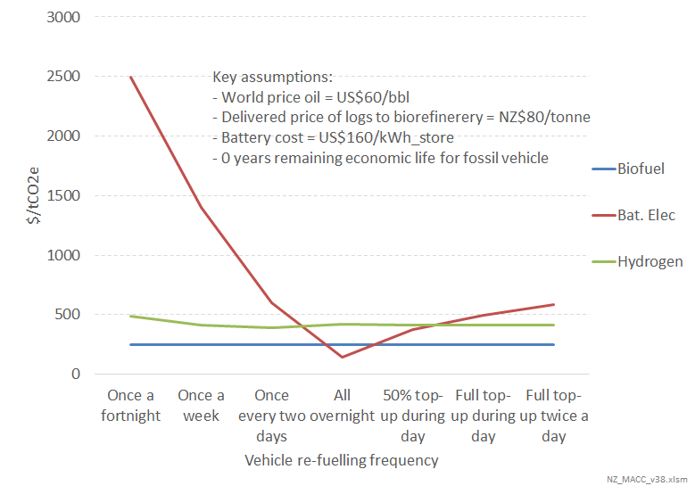
This analysis reveals that for vessels that can be re-fuelled regularly overnight (eg, ferries and other coastal shipping) battery electric is likely to be the cheapest option, with an abatement cost of just over NZ$100/tCO₂. As battery costs fall, this abatement cost will also fall.
However, for vessels which undertake multi-day journeys, the cost of battery electric vessels starts to become prohibitive. In these situations, drop-in marine biofuel appears to be the most cost-effective with an abatement cost of approximate $240/tCO₂. If either the world price of oil were to be higher, or if the price of logs to the refinery were lower, the abatement cost would likewise fall.
Figure 28 shows the results of the analysis for aircraft.
Figure 28: Abatement cost of different low-carbon fuels for aircraft for different re-fuelling patterns
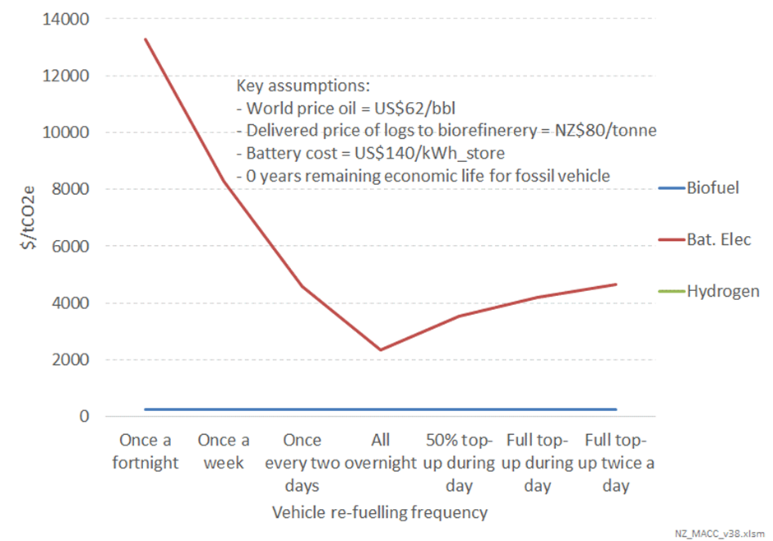
For the reasons set out in Appendix B, hydrogen is not considered to be a feasible option as an aviation fuel.
Battery electric aircraft are also considered to suffer significant productivity penalties due to the large weight of the aircraft – particularly for aircraft travelling more than a couple of hours.
However, drop-in aviation biofuels look to be prospective, with an abatement cost provisionally estimated to be NZ$240/tCO₂. This would go down if the price of oil were higher, or the price of logs were lower.
As set out in Appendix B, hybrid electric/fossil aircraft weren’t considered in this analysis. It is possible they might be an option for short-haul flights of an hour or two.
Figure 29 sets out the results for rail.
Figure 29: Abatement cost of different low-carbon fuels for rail for different re-fuelling patterns
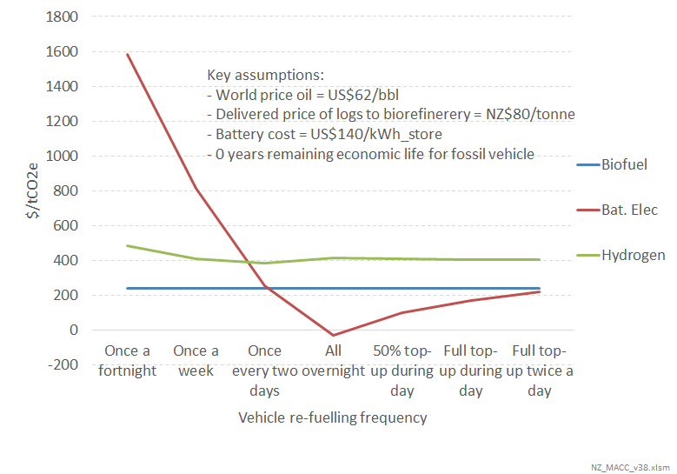
This indicates that battery electric locomotives, with batteries sized to enable recharging overnight, are likely to be the lowest cost option. Indeed, the analysis is indicating a negative carbon cost for this option. However, this assumes that the world’s manufacturers of locomotives are producing such vehicles at scale.
This is not yet happening. However, these results indicate this is likely to be a question of when, not if, this starts to happen.

Provisional results and discussion
Figure 30 and figure 31 show the results of the transport MACC analysis for 2020 and 2030, respectively.
Figure 30: Transport MACC for 2020 – public benefit basis
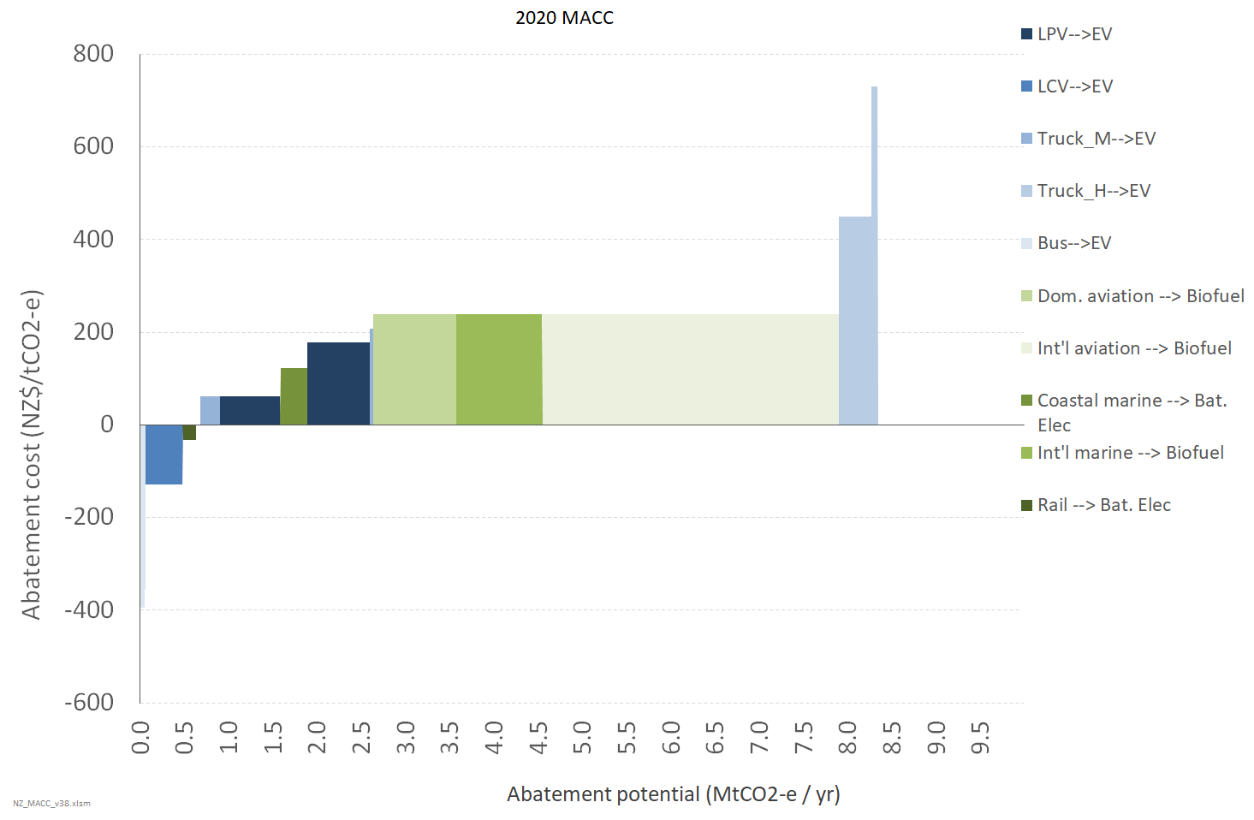
Figure 31: Transport MACC for 2030 – public benefit basis
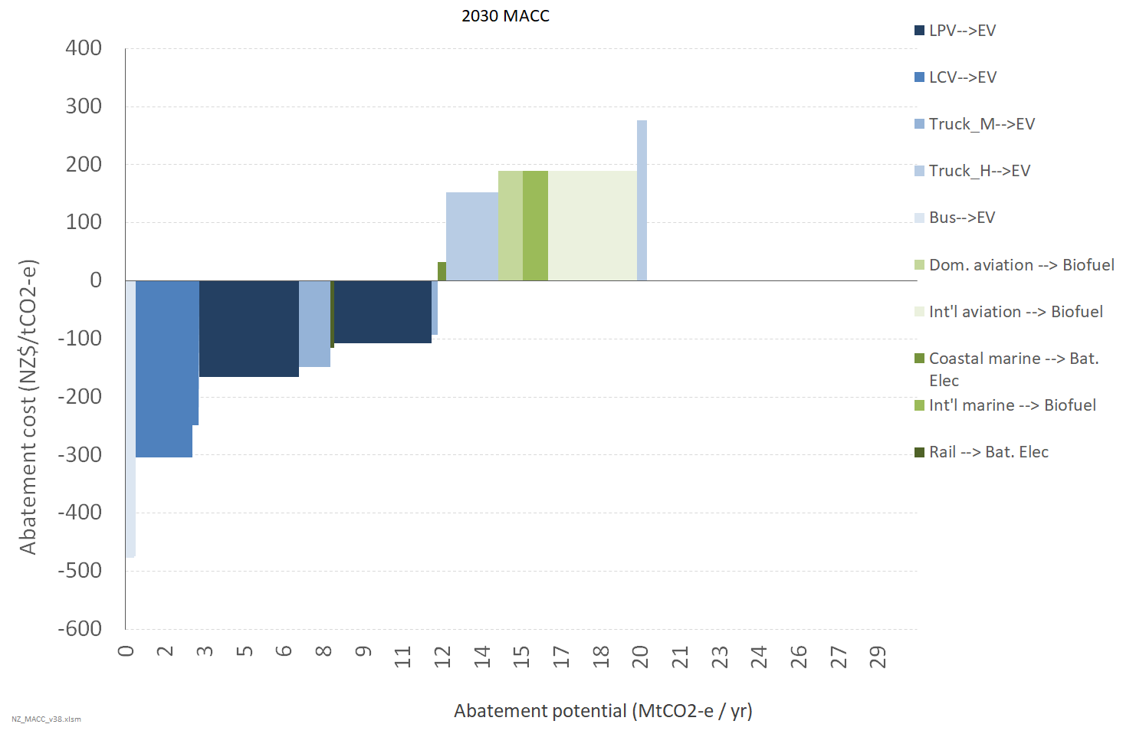
The analysis is indicating that switching to EVs for light and medium road vehicles will deliver net public savings, but that heavy transport (road, marine, and aviation) will still result in material costs.
That said, the above evaluation for road is the cumulative cost for the years 2020 to 2030 of switching all vehicles that are projected to be entering the fleet as ICEs to instead be EVs. For the early years of this period in particular, this is likely to be very high cost.
The model has also been configured to look at the lifetime cost and emissions of all vehicles entering the fleet in a given year. (ie, not looking at the cumulative cost up to the year in question).
This evaluation for 2030 is shown in figure 32.
Figure 32: Single year MACC for transport in 2030 – public benefit basis
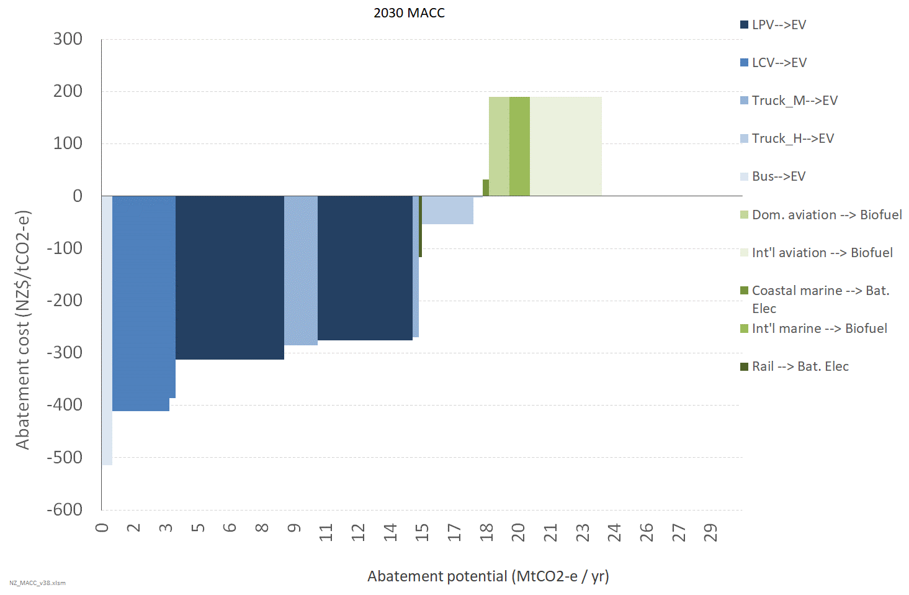
As can be seen, this is indicating that by 2030, even heavy trucks will be cost-effective to be battery electric.
This analysis is consistent with recent international studies. For example, the following analysis from McKinsey shown in figure 33 below is indicating that total cost of ownership (TCO) cost parity for heavy trucks will be achieved by 2028 – and that it has already been achieved for city buses.
Figure 33: McKinsey projection of timing of cost-parity of EVs with ICEs, based on total cost of ownership
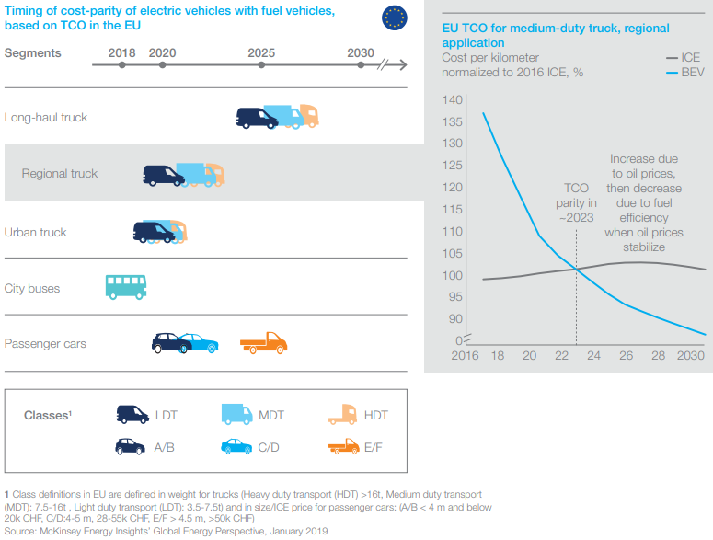
Source: “Global Energy Perspective 2019: Reference Case”, McKinsey, January 2019

Issues and caveats
This analysis is provisional, based on first-order estimates of costs.
Further, in many cases it has been necessary to make assumptions about vehicle and other costs in the absence of hard data.
As such there is some degree of uncertainty.
However, it is considered to be a reasonable basis for evaluating the relative costs of the different abatement options, and the likely first-order estimates of the scale and cost of such options.

Electricity generation

Options investigated
Two main types of options are considered for the electricity MACC analysis:
- Renewables replacing fossil generation, both baseload and peaking (higher merit order)
- Geothermal Carbon Capture and Storage (indicative).

Gaps and potential areas for further work
Gaps and potential areas for further work include:
- energy efficiency options
- possible dry year solutions.

Methodology for estimating the MACCs
The MACC model attempts to capture the key dynamics driving outcomes for these baseload and peaking generation requirements in a relatively simple spreadsheet model:
- baseload fossil generation that operates 24/7 (currently only met by the remaining two Combined Cycle Gas Turbine)
- peaking generation to meet seasonal and dry/wet year variations in demand and supply. This is currently met by a combination of gas-fired Open Cycle Gas Turbine, coal-fired Huntly Rankine units, and currently also by one of the two remaining Combined Cycle Gas Turbine (CCGT).
The intent is to achieve internally consistent first-order estimates of outcomes, without having to resort to the significant overhead of running complex hydro-thermal optimisation models.
The marginal abatement cost of an option is calculated by:
- Estimating the abatement cost for displacing fossil generation from baseload roles:
- establish quantity of baseload generation to be displaced
- estimate cost of running baseload gas-fired generation (excl. cost of CO₂)
- estimate cost of building renewables to displace baseload generation
- calculate the abatement cost for displacing baseload CCGT with new renewables.
- Considering the abatement costs for displacing fossil generation from peaking roles:
- estimate the cost of building renewables to operate at progressively lower capacity factors to progressively displace fossil from peaking roles
- estimate the cost of meeting peaking generation requirements from gas-fired peakers
- calculate the MAC based on the relative cost of renewables and gas-fired plant for different peaking duties.

Modelling electricity generation
The analysis estimates the relative cost of continuing to operate the existing CCGT to provide baseload power, versus building the cheapest new form of baseload renewable generation (wind, geothermal, or utility solar). In other words, it compares the short-run marginal cost (SRMC) of the CCGT to the long-run marginal cost (LRMC) of the renewable options.
For CCGTs, the cost is a function of the wholesale gas price ($/GJ), heat rate (GJ/MWh), annual fixed operation and maintenance costs ($/kW/yr), and variable operation and maintenance costs ($/MWh).
For renewables, the cost is a function of capital cost (in terms of $/kW/yr annual capital recovery), annual fixed operation and maintenance costs ($/kW/yr), variable operation and maintenance costs ($/MWh), and annual capacity factor. The cost of renewables is projected to fall in the future due to technology improvements, with utility solar projected to fall in cost the fastest, followed by wind.
For the intermittent renewables (wind and solar), this cost is also factored by the so-called ‘peaking factor’. As the proportion of an intermittent renewable grows on the system, the ratio between the generation-weighted average price (GWAP) it receives compared to the market time-weighted average (TWAP) price will fall. This is because the market will tend to be in relative surplus at times when the intermittent renewable is generating at high levels (ie,. when the wind is blowing, or the sun shining), and relative scarcity at times when it is generating at low levels (ie, when the wind is calm, or it is dark / cloudy). The extent of system surplus / scarcity will grow (as will the associated extremes of system price) as the proportion of the intermittent renewable on the system grows.
The model simulates this peaking factor by a simple linear relationship which says that the GWAP/TWAP will fall by X% for each 10% increase in the proportion of the variable renewable on the system. The peaking factor increase is greater for solar than for wind, because solar has a much lower capacity factor (it comes in relatively short, concentrated lumps) than wind.
It then calculates the extent to which wind and solar would increase as a proportion of generation if it were to be built to displace the CCGT from baseload mode. In this, the extent of baseload CCGT generation is projected to grow to meet increasing demand – absent any new renewables being built – up to the point where the two remaining CCGT are operating at full capacity. It assumes that it is not cost effective to build brand new CCGT.
The model then calculates the threshold carbon price where it would be cost-effective to build the cheapest new renewable to displace the existing CCGT from baseload duties. This calculation can be done for any future year, and takes into account the peaking factor for intermittent renewable generation, the change in the cost of building renewables, scenario-based changes in the cost of gas, assumed increases in the operation and maintenance cost of the CCGT as they get progressively older, and the emissions associated with geothermal generation.

Costs included in the analysis
Costs and benefits included
Gas price
Baseload capital and non-fuel opex cost
Fixed operating and maintenance costs
Variable operating and maintenance

Main sources of data and information
Category | Sources
Generation by type | 2018 figures
Demand growth | 2%
Gas price

Provisional results and discussion
Figure 34 shows the provisional MAC for electricity generation. It indicates that building renewables to displace the remaining gas-fired baseload CCGT is likely to be relatively low cost, but that displacing fossil electricity generation from progressively lower capacity factor ‘peaking’ roles gets progressively more and more expensive.
Figure 34: Electricity generation MAC
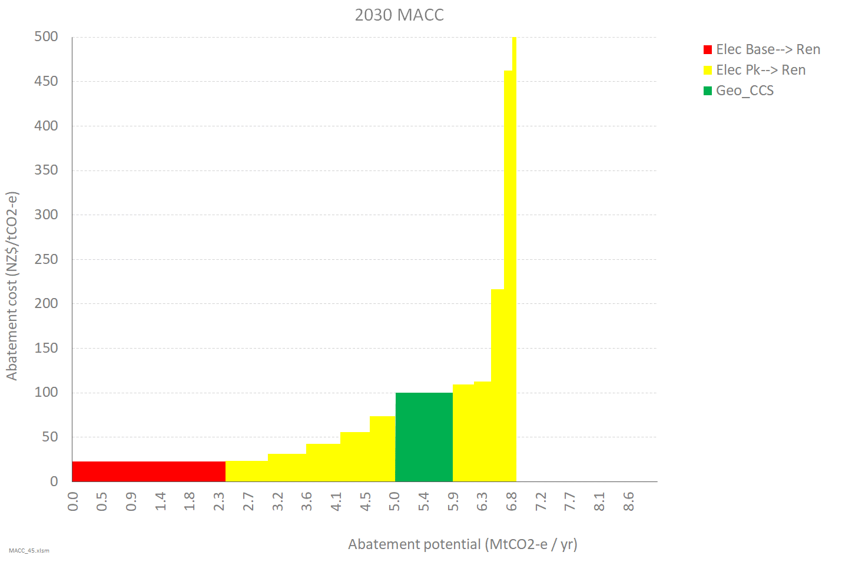
The above chart indicates that the displacement of the existing baseload CCGT is likely to be a relatively low-cost option. However, there are some material caveats to this conclusion:
- It is possible that the price of gas which the upstream gas producers are willing to sell to the remaining baseload CCGT could be lower than the ‘normal’ market price. This reflects the fact that this gas demand would disappear, and the gas producers would lose the margin on gas sales – or have it postponed 10-15 years to future gas sales to petrochemical production. A $1/GJ discount in gas price, would increase the MAC by $19/tCO₂.
- There is considerable uncertainty as to the ‘peaking factor’ that would apply to wind, particularly the extent to which this factor will increase with increasing amounts of wind.
It should also be noted that the geothermal CCS MAC is subject to significant uncertainty, and is based on a very high-level assessment of various international reports – with different reports having values considerably higher and lower than the value shown here.
Lastly, energy efficiency to reduce the demand for peaking generation has not been considered. It is likely that this will have a significant negative MAC. This is an area for future analysis in any ‘Stage 2’ work.

Space and water heating

Options investigated
The MACC analysis for space and water heating focuses on technological options associated with switching away from direct use of fossil fuels (principally natural gas and LPG) to electric heating.
Two different types of electricity heating appliance are considered for space and water heating:
- heat pump heaters
- simple resistance heaters.
These have different efficiencies (with heat pumps being much more efficient) and different capital costs (with heat pumps costing a lot more).
The analysis is principally from a national economic/public perspective (see section 1.1). However, it has also been done from a private perspective using current, non-cost-reflective electricity and gas tariffs.

Gaps and potential areas for further work
Gaps and potential areas for further work include:
- other heating appliance options, eg, log or pellet burners
- efficiency improvements to existing heating appliances.

Methodology for estimating the MACCs
The MACC analysis estimates the lifetime cost of providing useful heat. This includes taking into account:
- appliance capital costs, with such costs spread over the lifetime kWh of heat provided
- the efficiency of the appliance in converting electricity or gas delivered to the premises, and converting it into useful heat.
The steps taken to estimate the MACC are to:
- estimate the emissions intensity of electricity generation to meet a demand profile
- estimate the efficiency of the heating appliance
- estimate the $/kWh wholesale energy component of heating costs
- estimate the $/kWh network component of heating costs
- estimate the capital recovery costs
- estimate the $/kWh retail component of heating costs
- calculate the MAC for switching from a fossil fuel appliance to an electric appliance by dividing the difference in total cost by the difference in emissions (both expressed per kWh of heat).

Emissions intensity
The electricity system is dynamic, with changes in demand and supply interacting over various timescales. Currently, over short timeframes (1-2 years), a marginal increase in electricity demand is likely to be met by increased utilisation of existing fossil generation plant. Over longer timeframes, generation assets will be built and decommissioned in response to changes in demand. This MACC analysis seeks to estimate the marginal change in generation over the medium term (ie, a timeframe in which new generation can be built) resulting from the specific appliance change in isolation. This is then used to estimate an associated marginal emissions intensity.
The type of generation that is most economic to meet a type of appliance demand (eg, space heating, water heating) varies significantly with the profile (or pattern) of that demand. In short, demand that occurs only in winter evenings will almost entirely be met by fossil generation, whereas constant demand (a.k.a. ‘baseload’) will be met by renewable generation – with differing associated emission intensities. However, as New Zealand moves to a higher proportion of renewables, the emissions intensity of electricity demand profiles will tend to fall.
Simplified modelling has been done (see figure 35) to provide first-order estimates of the emissions intensity of different electricity profiles (space heating, water heating, cooking, lighting, refrigeration), and how these will change for three different levels of renewable electricity uptake:
- Low penetration. New Zealand still has baseload fossil stations in operation. Approx.
80-85% renewables.
- Medium penetration. No baseload fossil, and some ‘over-build’ of renewables resulting in some systematic ‘spill’ of surplus renewables at some times. Approx. 90-93% renewables.
- High penetration. Substantial over-build of renewables, with significant systematic spill of surplus renewable generation at times. Approx. 98% renewables.
Medium penetration has been used as a central scenario.
Figure 25: First-order estimates of emissions intensity of different electricity demand profiles for different renewable futures
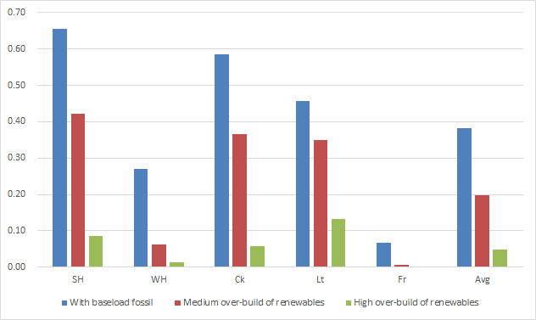
Note: SH = Space heating, WH = Water heating, Ck = Cooking, Lt = Lighting, Fr = Refrigeration.

Efficiency of the heating appliance
The efficiency of the heating appliance is expressed as ‘coefficient of performance’ (COP). The COP factors in the energy consumption per useful kWh of heat from the different appliances. The COP captures both the fact that heat pumps can have an apparent ‘efficiency’ of greater than 100%; and water cylinders have standing losses which reduce the apparent efficiency of these types of heating.
Average COPs are used for space and water heating heat pumps (3.5 and 1.6 respectively), even though actual COPs will vary by location (they will be higher in warmer parts of the country). Similarly, average COPs have been used for heat pump and resistance water cylinders, even though the effective COPs will vary according to the extent of insulation on the cylinder and the utilisation factor of the cylinder.

Wholesale energy
For both electricity and gas, the cost of baseload wholesale energy (eg, $75/MWh for electricity, or $6.50/GJ for gas) is factored by a shape factor to convert this time-weighted cost into a demand-weighted average. This captures that the cost of wholesale energy in winter is higher than in summer and higher in morning and evening peaks than overnight. This is especially true for electricity.
As well as estimating this cost from a public perspective (which effectively assumes time-of-use tariffs), the current private cost associated with non-cost-reflective tariffs is included. This is based on estimates of the wholesale cost recovery component of current tariffs.
Both the public and private costs are factored by the appliance COP to give a cost per kWh of useful heat.

Network costs component – electricity appliances
For electricity appliances the calculation:
- assumes an average level of operation (as a percentage of installed capacity) the appliances will be operating at during periods of peak network demand
- multiplies this number by the average $/kW/yr cost of providing peak network services
– ie, the long-run marginal cost of network expansion to meet peak demand
- divides this number by the estimated hours per year the average appliance is in operation.
This is consistent with the approach used in estimating other marginal impacts on the electricity system. However, note that in reality, investments in network expansion will be ‘lumpy’. In some cases the need for network expansion may be imminent while in other cases there may be significant surplus capacity. Further, there will be variation between different appliances as to the proportion of consumption at times of system peak.
Other, non-peak-driven costs of providing network services are considered unavoidable, and thus not economic costs that should be considered for the purposes of evaluating the public cost of electricity heating appliances.

Network cost component – gas appliances
Because gas networks have large amounts of surplus capacity, it is not considered that using gas appliances will give rise to a need for increased investment in the gas network. In the context of decarbonising New Zealand, the gas system itself could be considered avoidable – at least over a multi-decade timeframe. For the public cost calculation, the average $/kWh cost of providing gas network services is factored by the fraction of such costs which are considered not to be sunk and thus avoidable over this long term.
As well as estimating this cost from a public perspective (which effectively assumes time-of-use tariffs), the current private cost associated with non-cost-reflective tariffs is included which is based on estimates of the network cost recovery component of current tariffs. For electricity, this excludes fixed charges, but fixed charges are included (as a fully variablised $/kWh equivalent) for gas. This is because gas is considered to be a discretionary fuel for consumers.
Both the public and private costs are factored by the appliance COP to give a cost per kWh of useful heat.

Retail cost component
From a public perspective, increased electricity demand will not increase the retail component of electricity supply costs (ie, the costs associated with metering, billing, and customer services). Therefore, the retail component of such costs are set to zero.
The same could be considered to be true for gas appliances, except that, in the context of decarbonising New Zealand, the gas system itself could be considered avoidable – at least over a multi-decade timeframe. Therefore, for the public cost calculation, the average $/kWh cost of providing gas retail services is factored by the fraction of such costs which are considered avoidable over this long-term.
The private cost for both electricity and gas is based on current tariffs.
Both the public and private costs are factored by the appliance COP to give a cost per kWh of useful heat.

Costs included in the analysis
Costs and benefits included | Costs and benefits excluded
Wholesale energy price (electricity and gas)  Capital recovery costs  Average $/kW/yr cost of providing peak network services (for electricity)  Average $/kWh cost of providing gas network services (for gas), considering long-term ‘avoidable costs’  Average $/kWh cost of providing gas retail services, considering long-term ‘avoidable costs’  Network cost recovery component of current tariffs (for gas)  Capital recovery costs | Non-peak-driven costs of providing network services  Retail component of electricity supply costs (ie, the costs associated with metering, billing, and customer services)

Main sources of data and information
Category | Sources
Emissions intensity of delivered fuel – electricity | Concept Consulting analysis: varies according to demand profile, with scenarios of increasing levels of renewable generation in electricity mix.
Appliance efficiency | Concept Consulting analysis; assumptions provided by EECA
Wholesale energy costs | Concept Consulting analysis
Network costs | Concept Consulting analysis
Retail costs | Concept Consulting analysis

Provisional results and discussion
Figure 36 shows the breakdown of the lifetime cost of useful heat for different heater options (gas, LPG, heat-pump, or electric resistance) in different situations:
- an existing gas or LPG appliance (where there is no capital cost) or a new appliance
- residential or commercial – with commercial being assumed to have higher load factors. It may also have a consumption profile which is proportionately not as correlated with system demand peak as for residential. However, in the absence of data, this feature is not yet reflected in the model results. To the extent commercial demand is proportionately not as correlated with system peak demand, it will lower the MAC for commercial space heating.
The four different graphs represent:
- space heating (top row) and water heating
- public cost-benefit (left column) based on underlying resource cost implications for New Zealand or private cost-benefit (right column) based on the price signals faced by consumers under current electricity and gas tariff pricing structures.
Figure 37 later shows the MAC for the different heater situations, but all from a public perspective.

Figure 36: Lifetime cost of useful heat for different heater options in different consumer situations
 | Public cost-benefit | Private cost-benefit
Space heating | 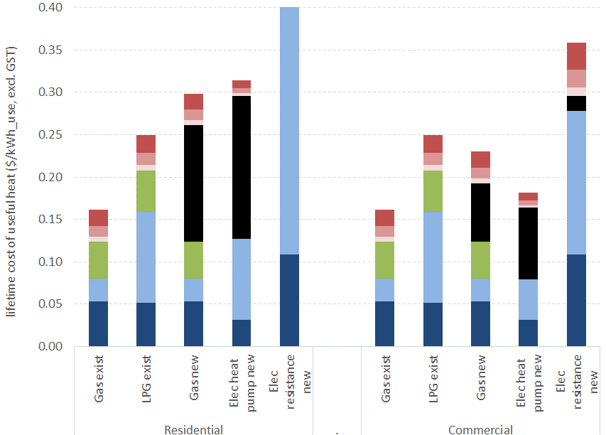 | 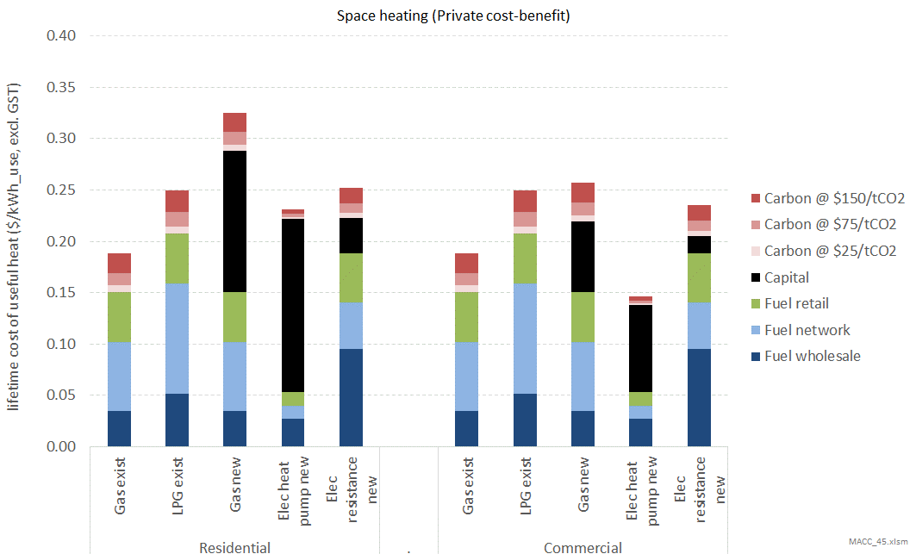
Water heating | 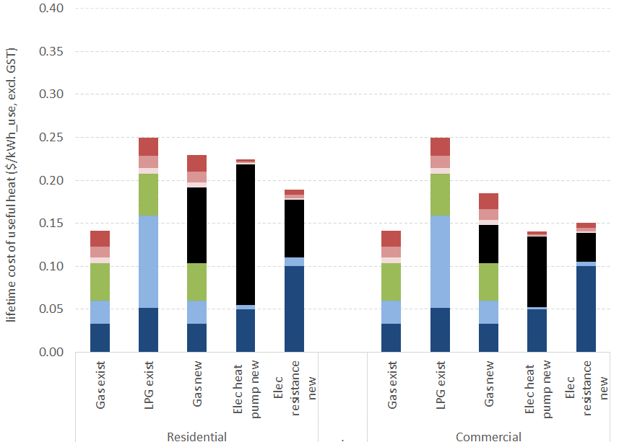 | 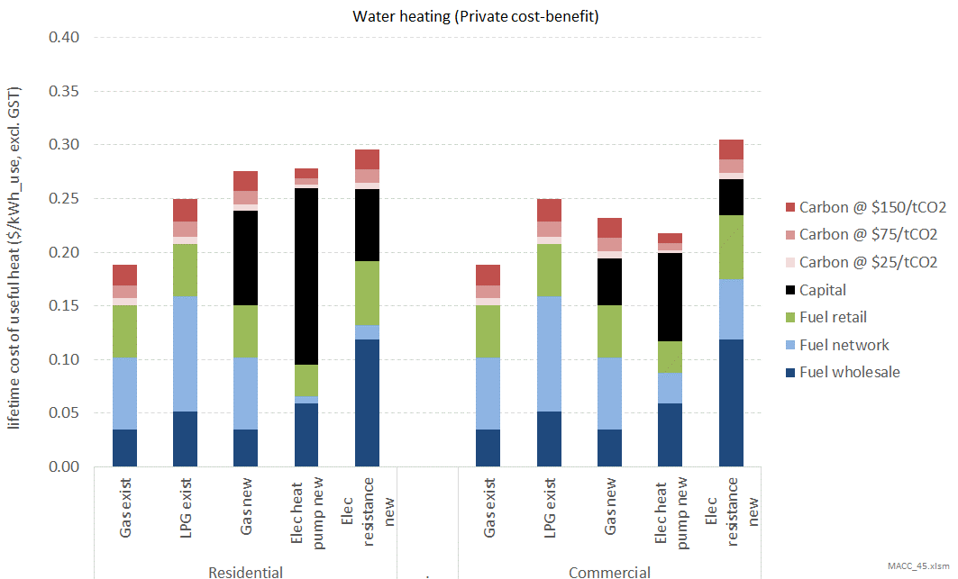

Figure 37: MAC for residential and commercial space and water heating
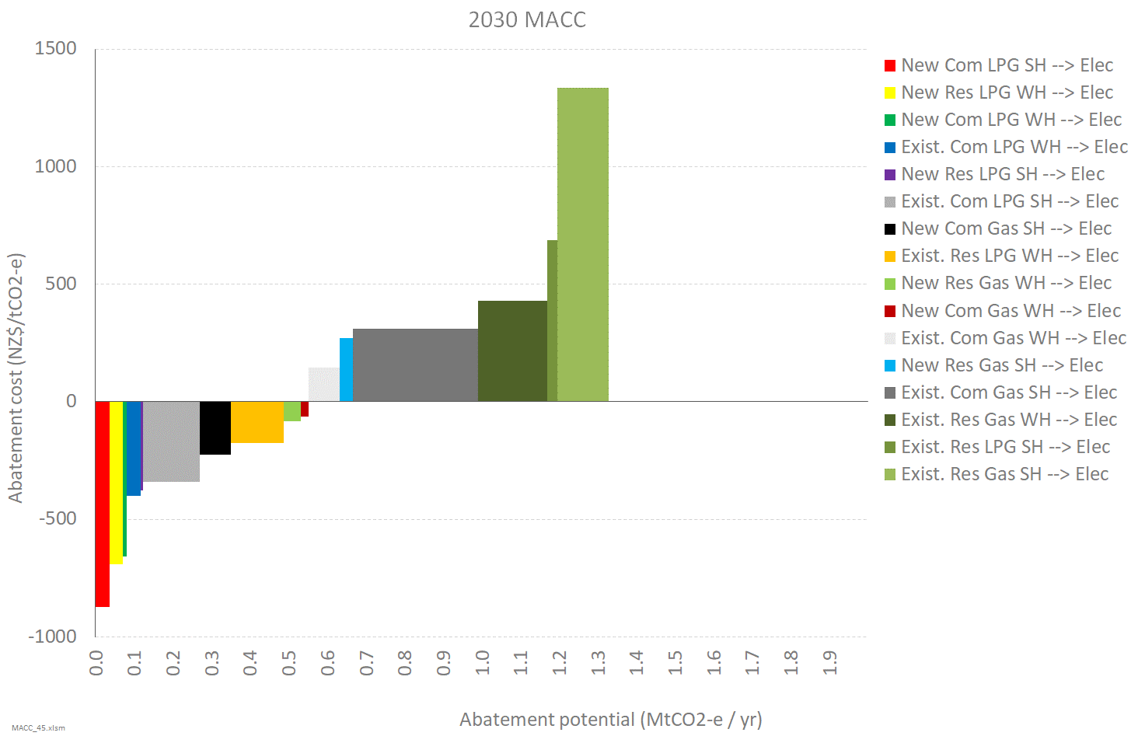
Note that in figure 37:
- the abatement potential shown is the direct reduction in emissions from gas or LPG use and does not account for increases in electricity emissions (though this is estimated in calculating the abatement cost)
- the proportion of new appliances (ie, those that would need to be replaced within the timeframe considered) is set by assumption at 20% and should be taken as illustrative only. More work is needed to determine the rate of replacement in the different appliance categories.
The key takeaways from the above analysis are:
- The relatively high price of LPG makes it more cost-effective for fuel-switching to electricity.
- It is much more expensive to switch away from an existing gas or LPG appliances with significant remaining economic life (where the capital costs of the are sunk) to an electric heating option (where the capital costs are not sunk). However, if a new gas or LPG appliance is required (in new-build situations, or where the existing appliance has reached the end of its life), it is considerably more cost-effective to switch to an electric option.
- The higher load-factors makes it more cost-effective for commercial consumers to switch to electric options than residential consumers. If there was also lower coincidence of commercial demand with system peak, this would make it even more relatively cost-effective to switch to electric heating.
- The high coincidence of space heating demand with system demand (and associated high electricity network costs), coupled with the relatively high electricity emissions factor for meeting a space heating demand, means the MAC for switching to electricity for space heating is higher than switching to electricity for water heating.
- The current non-cost-reflective structures of electricity and gas tariffs is distorting consumer decisions – favouring gas water heating, and working against gas space heating. On balance, current non-cost-reflective price structures are probably favouring gas heating.

Issues and caveats
The MAC calculation in this sector is highly sensitive to several input assumptions for which robust evidence is lacking. In particular:
- average load factors, particularly for commercial heating
- average demand at peak electricity times.
For example, changing the assumed load factor for commercial space heating from 10% to 20% changes the estimated MAC for switching an existing gas appliance to heat pump from +$335 per tonne to -$179 per tonne (with all other factors held constant). This reflects that the results are highly uncertain, and that abatement costs will vary significantly by specific circumstances.
The high uncertainty and variation in consumer circumstances means we cannot currently pinpoint likely MAC values with any precision, and the results above should be treated with caution. Further work is needed to gather better data and evidence around input assumptions. However, we are confident in the qualitative findings listed above and the relative positioning of the different blocks in the MACC. The finding that switching household gas heating to electricity has a relatively high MAC is also consistent with analysis by the UK Climate Change Committee.
A wider challenge for this analysis is how to deal with system-level dynamics in a marginal framework, particularly in determining the emissions factors and network costs. The analysis seeks to determine the marginal impact of an isolated change, but in reality this will be occurring alongside other changes. For example, switching from gas space heating to heat pump will add to peak electricity demand, but this effect could be offset through other changes such as switching to LED lighting. Work could be undertaken to test the results of this analysis using an electricity system model.
In this context, there is no analysis of the potential effect of future low-cost batteries (particularly those within EVs with vehicle-to-grid capabilities) on the peak network cost component for electricity. This will tend to make fuel-switching to electricity cheaper – particularly for space heating.
Likewise, there is no analysis of the potential for declining gas volumes progressively resulting in higher required gas network prices for the remaining gas consumers. This will tend to make fuel-switching to electricity progressively cheaper over time.

Waste
Emissions from the waste sector account for around 5% of New Zealand’s total greenhouse gas (GHG) emissions (around 4,124 kilotonnes of CO₂ equivalent (ktCO₂e) of 80,853 ktCO₂e in 2017).
The majority of the emissions from the waste sector are methane (CH₄) at 96.9%, with nitrous oxide (N₂O) at 3.0% and carbon dioxide (CO₂) at 0.1%. The largest single source of these emissions is solid waste disposal. Figure 38 shows a profile of emissions by source from 1990 to 2017.
The primary disposal method for household and commercial waste in New Zealand is to land. Many of these disposal facilities are those described as ‘managed fills’ in the Ministry for the Environment’s GHG inventory and ‘Class 1’ landfills under the industry’s Technical Guidelines for Disposal to Land – a key criteria being that they accept municipal waste, and therefore are subject to payment of the landfill levy.
Large quantities of industrial processing waste and cleanfill (inert) wastes are disposed of to unmanaged fills, or Class 2-5 landfills, around the country. In addition, waste is disposed of in numerous small sites on private properties in rural areas, known as ‘farm fills’. These are usually not legal disposal facilities.
Only a very small quantity of waste is incinerated in New Zealand, and the waste materials are primarily hazardous, clinical, and wood wastes. This practice produces a small quantity of GHG emissions.
Emissions from waste also arise in the management of waste water; primarily from the on-site management of domestic waste water using anaerobic septic tanks. Most centralised waste water treatment in New Zealand is aerobic.
There are a very small proportion of emissions from waste managed through aerobic composting and open burning.
Figure 38: Profile of emissions by source from 1990–2017
Source: Figure 7.1.1, New Zealand Greenhouse Gas Inventory for 2017, Ministry for the Environment

Options investigated
The MACC analysis was based on a study commissioned by the Ministry from UK consultants eunomia, (MACC 2019)and focuses on a number of different abatement options. These options, and the [waste category] they apply to are:
- Prevention – Food Waste [Class 1 fills]. Reduce the amount of food waste generated by households by targeting them with a communications campaign.
- Vermicomposting - Food Waste [Class 1 fills]. Divert food waste from landfills to vermicomposting facilities, a process of accelerated composting involving the use of worms.
- Vermicomposting – Timber Processing Waste [Class 2-5 fills]. Divert timber waste from landfills to vermicomposting facilities.
- Anaerobic Digestion (Standard) - Food Waste [Class 1 fills]. Divert food waste from landfills to standard anaerobic digestion (AD) facilities.
- Anaerobic Digestion (Flexible) - Food Waste [Class 1 fills]. Divert food waste from landfills to flexible AD facilities.
- Open Air Windrow Composting - Food Waste [Class 1 fills]. Divert food waste from landfills to open air windrow (OAW) composting facilities.
- Open Air Windrow Composting - Garden Waste [Class 1 fills]. Divert garden waste from landfills to open air windrow composting facilities.
- Burning in Industrial Boilers - Timber Waste [Class 1 & 2-5 fills]. Divert timber and wood waste for use as a fuel in industrial process heat boilers.
- Landfill with Biostabilisation – All Waste [Class 1 fills]. Introduce a biostabilisation phase for all waste prior to disposal in a landfill.

Results
Table 4 below shows the summary results from the eunomia report. It shows the abatement potential and cost for each intervention, as well as showing the current ‘Baseline’ process used for the waste (either going to Class 1 or Class 2-5 landfills).
Table 4: Summary of all waste abatement measures
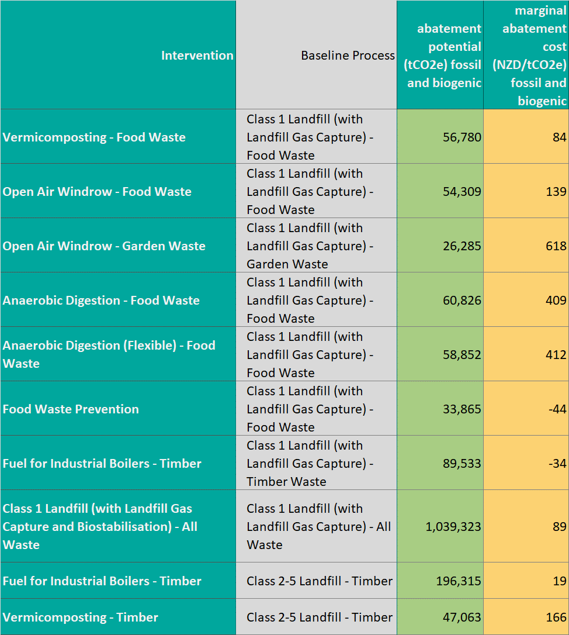
There is some overlap between many of the measures. For example, if the full 34 ktCO₂e potential for food waste prevention is achieved, it will reduce by 34 ktCO₂e the potential which could be achieved by biostabilisation.
For the purposes of the MACC analysis, it is assumed that only the most cost-effective measures are pursued, and that these will affect the scale of potential for other, more expensive measures. In many cases it means that a more expensive measure will not be pursued as the abatement quantity from cheaper measures is greater than the abatement quantity from the more expensive measure.
The consequent MACC is shown in figure 39.
Figure 39: MACC for waste emissions minimisation
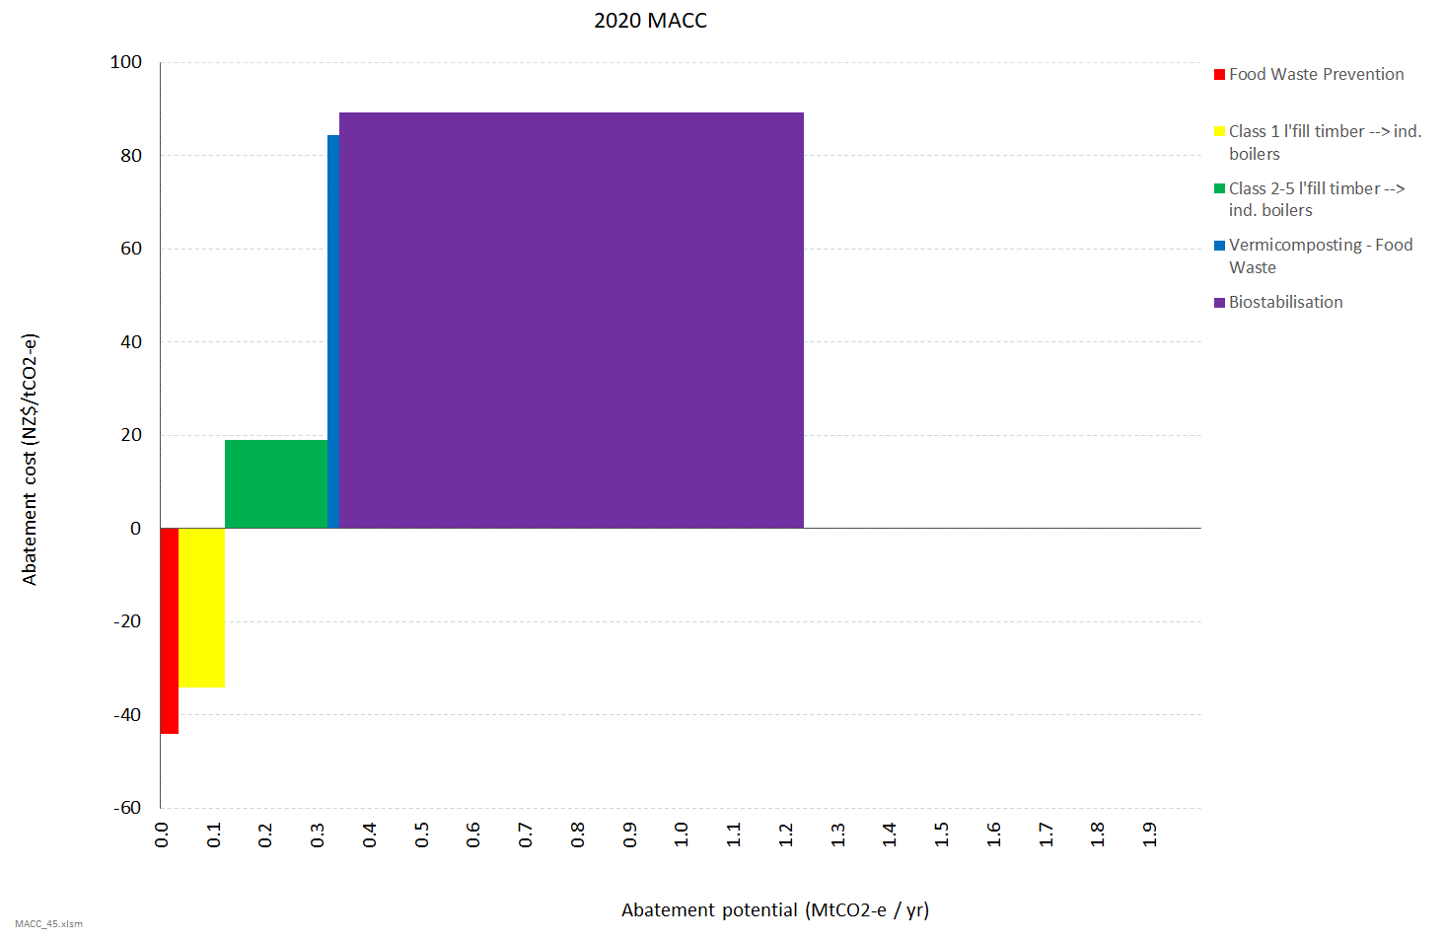
This represents approximately a 30% reduction in waste emissions.

Discussion
Eunomia highlight that there is a general issue with good quality data on which to base this analysis. As such, there is likely to be a reasonable margin of error.
With regards to the options for diverting timber to burn in industrial process heat boilers, this implicitly assumes that
a) there is sufficient heat demand from industrial boilers which are capable of burning such diverted timber
b) these boilers are located sufficiently close by to the source of the timber waste – noting that transport costs can make this option very expensive if the timber needs to be transported hundreds of kilometres.
Currently there are relatively few industrial boilers capable of burning such waste. This may increase significantly in the future if there is a significant uptake of biomass boilers for industrial process heat. However, it is not known whether these boilers will be located close to the source of the waste timber.
With regards to the biostabilisation option, while it is a new technology for New Zealand, eunomia indicate it is “commonplace in some European countries, including Germany, Austria, and the Netherlands.” While it therefore appears to be very technically feasible, eunomia raise some potential policy implications:
“It is also worth noting the risk of stranded assets that may come with widespread adoption of biostabilisation. Countries which commonly use biostabilisation before disposal to landfill typically do not have landfill gas capture systems as the landfills produce much less landfill gas. Therefore, it may be that existing landfill gas capture systems in New Zealand would no longer be of use.
This has implications for landfill business models which currently rely on energy exports and for existing GHG capture targets applied to managed landfill sites. However, such GHG targets may be driving perverse outcomes anyway (eg, landfill operators lobbying against separate food waste collections). So, it may be that widespread policy reform –including exploration of alternative landfill business models – would need to be considered alongside adoption of this measure to ensure a just transition.”

Appendix A: Road transport methodology and assumptions

Modelling approach
The model evaluates the lifetime cost of electric vehicles (EVs) and internal combustion engines vehicles (ICEs) at the time when they enter New Zealand. This includes consideration of:
- initial capital cost
- fuel costs (petrol/diesel in the case of ICEs, electricity in the case of EVs)
- maintenance costs
- emissions costs:
- global warming associated with CO₂ emissions
- human health costs associated with other tailpipe emissions (particularly particulates, and NO_{x}).
The model solves to determine the carbon price at which it would be more cost-effective for a vehicle entering New Zealand in a given year to be an EV rather than an ICE.
Five main categories of vehicle have been considered for this evaluation:
- light private vehicles (‘LPVs’ ie,. cars)
- light commercial vehicles (‘LCV’s ie,. vans)
- ‘medium’ trucks (‘Truck_M’)
- ‘heavy’ trucks (‘Truck_H’)
- buses.
These categories are sufficiently distinct in characteristics to warrant separate analyses.
Further, within these categories we distinguish between:
- new and used vehicles entering New Zealand (with used vehicles predominantly being second-hand imports from Japan)
- vehicles which are likely to be driven a lot over their lifetime, versus those driven relatively less often.
Lastly, the evaluation takes account of the likely change in some of these costs over time. In particular, the likely significant reduction in EV capital costs as battery costs fall and EV production starts to achieve scale economies.

Capital costs
Currently, EVs cost more to purchase than ICEs.
This is principally due to the high cost of the battery. However, it is also due to EVs not yet achieving the full economies associated with designing and manufacturing EV-only vehicle models at scale, rather than producing an EV-version and an ICE-version of a given vehicle (eg, a VW Golf).
Although EVs currently cost more to purchase, battery prices are projected to continue to decline at the high rates of reduction seen over the past couple of decades as EV uptake (and associated battery production) rapidly accelerates around the world. For example, a recent Bloomberg New Energy Finance report (Quong 2019) projected that EV battery costs would decline at almost 8% per year between 2018 and 2030. This may be conservative as it compares to an annualised rate of cost reduction between 2010 and 2018 of 21% per year. (Quong 2019)
Likewise, as EV-only models start to achieve manufacturing scale, further reductions in production cost are likely to be achieved.
The result of this is that EV cars are likely to achieve up-front capital cost purchase price parity within the next decade. For example, the Bloomberg report predicted that capital cost purchase price parity for medium-sized cars in the USA would be achieved by 2024.
The EV / ICE cost differential for medium and heavy trucks is currently significantly greater, due to:
- the production of EV trucks being even more limited to date than EV light vehicles, so less manufacturing scale efficiencies having yet been achieved
- such vehicles being driven much more than private cars, as illustrated by figure 40, and thus requiring relatively larger batteries.
Figure 40: Mean daily distance travelled by vehicles in New Zealand (km)
Cars | Vans | Medium trucks | Heavy trucks
31 | 39 | 67 | 199
However, the relative battery cost differential between trucks and cars is nowhere near that implied by figure 40. This is because, the ‘range anxiety’ for vehicle purchases is heavily driven by expectations of peak driving distances rather than average driving distances.
In this respect, the ratio between peak and average distance for a typical family car is significantly greater than for a typical truck:
- Family cars generally do <30km daily trips around their locale, with a handful of longer-distance journeys (eg, going on holiday).
- Trucks are working vehicles whose daily operating patterns are more consistent, with the peak daily distance being closer to their average daily distance than for light private vehicles.
Thus, while EV cars are projected to only require batteries capable of delivering 300 to 500 km range to overcome ‘range anxiety’, it may only be just over this amount for heavy trucks.
Further, it appears that EV manufacturers are starting to produce vehicles with a range of battery size options. For example, the Nissan Leaf comes with a choice of four battery sizes, and Tesla’s announced heavy truck will come with a standard and a long-range option.
This intuitively makes sense given the high cost of the battery, and the fact that many vehicle owners would be happy to not pay for a battery that gives them extra range they don’t need.
For our analysis we have built a model which considers the relative cost of the vehicles taking account of the key component differences. For example, an EV requires a battery and electric motor, but doesn’t require a combustion engine. This generic component model is capable of sizing to different vehicle sizes (ie, cars, vans, trucks) and (in the case of batteries) different range requirements.
It also allows for the relative cost of components to change over time. In particular:
- it assumes that battery costs will decline at approximately 7.5% p.a. (being the rate projected by Bloomberg)
- it assumes that non-battery costs of EVs will decline at a rate of 0.5% p.a. relative to ICEs
– reflecting the achievement of scale economies
- it applies a factor to account for the early stages of EV development for some vehicle types (eg, heavy trucks), with an additional overlay to account for an NZ premium (relative to US prices) for such EV vehicles in the early stages of development.
We have also applied a factor to account for what we term the EV ‘productivity penalty’ associated with some vehicle types. As set out later in this section, this accounts for the fact that the heavier vehicle weight and longer away-from-base re-fuelling times for some vehicle types mean that a greater number of EVs will be needed to perform the same transport service as an ICE vehicle.
Using this model and assumptions, it is estimated that:
- the average current capital cost differential in New Zealand (excluding GST) between new EVs and ICEs is $16k for cars, $20k for vans, $135k for medium trucks, and $475k for heavy trucks (noting that EV heavy trucks and (to a lesser extent) medium trucks have yet to start to be produced in scale by vehicle manufacturers)
- capital cost parity in New Zealand is estimated to be achieved by 2029 for light private vehicles, 2030 for vans, 2033 for medium trucks, and 2050 for heavy trucks. For heavy trucks, the proportionately larger battery requirement (due to travelling longer distances) and weight-driven productivity penalty, are the key factors driving the much longer time it is projected before they reach purchase cost parity with ICE heavy trucks.
These are considered to be relatively conservative assumptions given that, for example, Bloomberg NEF is projecting capital cost parity for cars to be achieved by 2024.
Although there is currently limited choice for EVs – particularly for heavy trucks – global vehicle manufacturers are starting to significantly scale up production at all levels, with many starting to make commitments such as not producing any ICE-only models from a certain date. Volume production has started to take off for cars, with the Bloomberg report indicating this would also be achieved for vans within 1-3 years, medium trucks within 3-5 years, and heavy trucks from beyond 5 years.

Fuel costs
For fuel costs, we have considered the economic costs of producing and delivering fuel to power an ICE or EV over its expected lifetime in New Zealand.

The key components to this analysis are:
- estimating delivered fuel prices for petrol / diesel and electricity
- ICE and EV vehicle efficiencies
- vehicle lifetime distances travelled.

Delivered fuel prices

Petrol and diesel costs
We estimate the pump price of petrol and diesel through a simple model with the following components:
- world oil price in US dollar per barrel (US$/bbl)
- refining cost (US$/bbl)
- shipping costs to New Zealand (comprised of a fixed component and an oil-price-driven component) (US$/bbl and in US dollar per gigajoule(GJ)
- NZ$ / US$ exchange rate
- within-NZ fuel distribution and service station costs – sometimes referred to as ‘importers margin’ – (NZ$/GJ)
- petrol and diesel energy densities in megajoules per litre (MJ/l).
The parameters for some of these elements (refining cost, shipping costs, and within-NZ fuel distribution costs) have been derived from various stand-alone analyses based on several observed data points (eg, analysis published by the AA, analysis of Z Energy accounts)
This ‘building-block’ approach allows for examination of the sensitivities of petrol and diesel prices to key parameters including:
- world oil price
- potential future increases in fuel distribution and service station costs as the fixed costs of such services are recovered over declining fuel sales (due to fuel switching to EVs). For this analysis we have conservatively set this parameter to zero, although it has the potential to materially add to petrol and diesel prices if the proportion of ICE vehicles on New Zealand’s roads decline significantly.
We have ignored the petrol excise duty currently included within the pump price of petrol as this is used to fund roading costs. Given that an EV will give rise to the same roading cost as an ICE, it would be inappropriate to penalise or advance ICEs for this differential. In this respect, although EVs are exempt from paying petrol excise duty or road user charges, it is expected they will need to start to contribute towards roading costs as the proportion of EVs on the roads rises.
Our projected costs are exclusive of GST. (As is the case for all costs calculated in this exercise.)

Figure 41 shows the resultant petrol and diesel prices for two scenarios, both taken from the International Energy Agency’s (IEA’s) World Energy Outlook projections:
- the IEA’s ‘Current Policies’ world oil price scenario
- the IEA’s ‘New Policies’ world oil price scenario.
Figure 41: Central petrol and diesel price projections ($/l) – excluding petrol excise duty, carbon, and GST
IEA ‘Current policies’ scenario | IEA ‘New Policies’ scenario
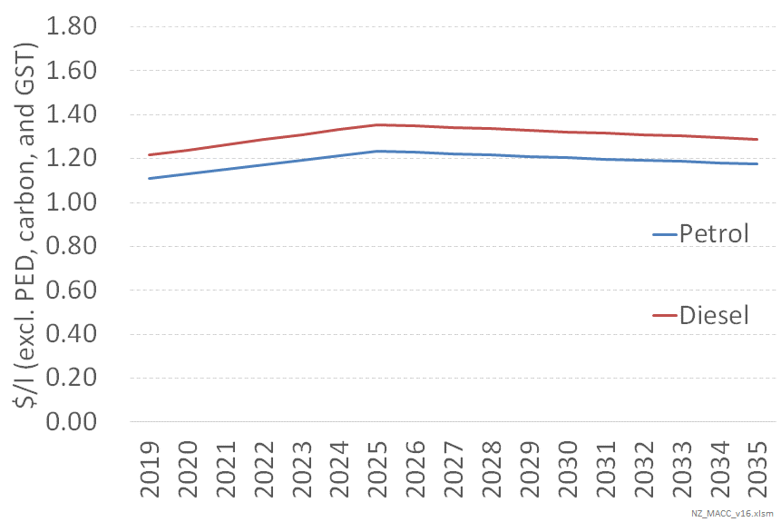 | 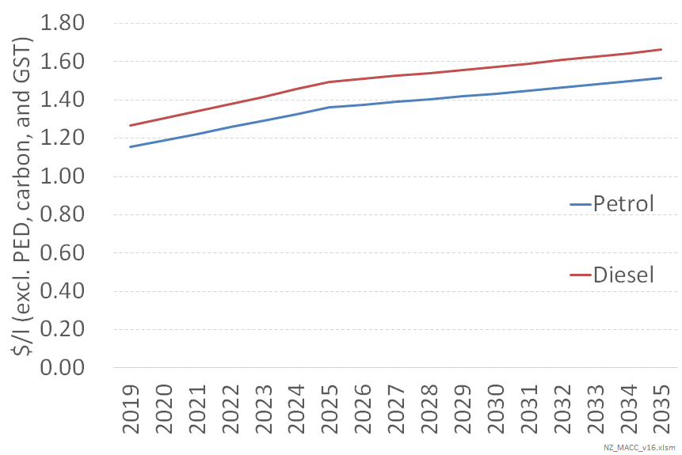
We have chosen these as we understand that the Ministry of Business, Innovation and Employment uses these projections for its own evaluations of potential future oil prices.

Electricity costs
The main components of costs for delivering electricity to fuel electric vehicles are:
- generation costs
- network costs
- charging infrastructure.
For the generation and network cost components, the cost varies according to when a vehicle is being charged. In simple terms, consuming electricity at times of low system demand (eg,. overnight) results in low generation costs and very low network costs, whereas consuming electricity at times of peak system demand (eg,. a cold winter’s evening) results in high generation costs and very high network costs.
Thus, the pattern of vehicle charging is a crucial consideration: vehicles charged during night-time periods will impose electricity system costs many times less than vehicles which are always charged in the early evenings.
For this analysis, we have assumed that the majority of charging undertaken at a vehicle’s ‘base’ is undertaken during night-time periods. However, we assume some proportion of charging occurs during early evening peak periods – times of greatest electricity cost. This proportion is greatest for light vehicles due to the assumption that optimising fuel cost is a greater consideration for larger commercial vehicles. It also assumes that, as technology improves and makes it easier, over time EVs will increasingly be charged at their base in a ‘smart’ fashion – predominantly overnight, and completely avoiding system peak demand period.
We have also assumed that most light vehicles (cars and vans) don’t require specific chargers, given that a standard domestic socket will be sufficient to recharge such vehicles overnight for the majority of journey distances. However, we assume some proportion of vehicle owners do purchase such chargers. All trucks and buses are assumed to require specific charging infrastructure. The capital cost of infrastructure has been based on estimates provided by the electricity network company, Orion.
The cost of away-from-base charging is assumed to be significantly greater as:
- it will be predominantly during day-time periods, with higher consequent wholesale energy and network costs
- charger capacities will need to be materially greater to re-charge the vehicle quicker (as opposed to base charging spread over night-time hours).
On a $/kWh delivered basis, all vehicle types are assumed to face the same cost for away-from-base charging.
Figure 42 shows the combined effect of these assumptions around wholesale energy, network, and charging infrastructure, to give a total $/kWh delivered cost. Note: these are economic costs to New Zealand, and do not necessarily represent current electricity tariffs.
Figure 42: Assumed economic cost of electricity ($/kWh delivered)
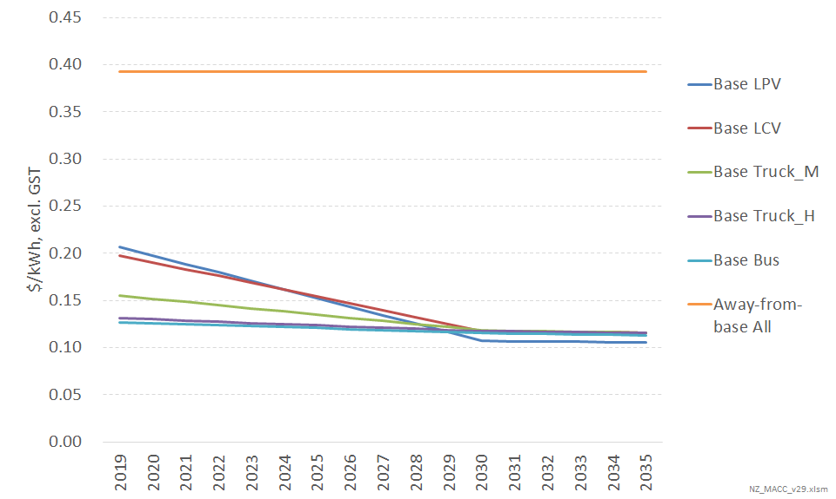
Light vehicles initially have a higher base cost than heavy vehicles because of the assumption that a greater proportion of such vehicles are not charged in a ‘smart’ fashion in the early years. However, as the proportion of light vehicles charged in a smart fashion increases to similar levels as for heavy vehicles by 2030, light vehicles achieve lower overall costs per kWh due to not requiring additional charging infrastructure.
Away-from-base charging is considerably more expensive than base charging. It is therefore important to consider the proportion of charging that is required away from a vehicle’s base, in order that the overall cost of electricity to refuel an EV can be estimated.
We have assumed that, on average for vehicles purchased in 2019, approximately 15% of annual kWh will be from away-from-base charging. This proportion is assumed to fall to 6.5% for vehicles purchased in 2035 due to the related assumption that average battery sizes will continue to increase as battery costs fall.

Vehicle fuel efficiencies
ICE and EV vehicle fuel efficiencies were based on data supplied by the Ministry of Transport. These indicate that on a GJ/km basis, EV LPVs are 3.65 times more energy efficient than their ICE counterparts. This rises to 3.9 times more energy efficient for trucks.
Part of this is due to the significant inherent differences in conversion efficiencies between a combustion engine (approximately 30% efficient) and an electric motor (90% efficient, but affected by losses associated with battery charging/discharging to give an overall efficiency of approximately 75 to 80%).
However, EVs can also ‘harvest’ a significant amount of additional energy from regenerative braking (between 15 to 25% depending on the nature of the driving and vehicle – it tends to be greater for heavier vehicles). In addition, EVs enjoy a significant advantage through consuming far less power when the vehicle is moving slowly or stationery due to traffic – a material issue for urban driving.
Combined with the fuel price assumptions set out above, the fuel efficiency assumption result in EVs having fuel costs which are approximately half that of ICEs per km travelled – excluding any costs associated with emissions.

Vehicle lifetime distances travelled
MoT data was used to estimate the distance a vehicle would travel over its lifetime after entering New Zealand. A central estimate of 215,000 km was used for a new light private vehicle entering New Zealand, rising to 520,000 km for a new heavy truck entering New Zealand. Used vehicles entering New Zealand were assumed to travel less over their lifetime on New Zealand roads, reflecting their older age and the km of ‘useful travel’ already incurred overseas prior to entering New Zealand.
MoT data was also used to project the extent to which the annual distance travelled by a vehicle varies over its life. Thus, the distance travelled in the first year of a light private vehicle’s life was assumed to be just over twice as much as in the 15th year of its life, with the pattern of this change following a ‘reversed-S-curve’ type profile. Capturing this pattern of travel over a vehicle’s life is considered important as the costs and benefits of EVs reflect higher initial capital costs offset by lower operating costs.

Maintenance costs
EVs have many fewer moving parts than ICEs, plus their operating environment is more benign compared to the heat and pressure associated with a combustion engine. This results in materially less wear and tear on an EV compared to an ICE, and thus lower maintenance costs.
Maintenance costs are assumed to increase proportionally to distance travelled, and vary between cars and trucks – with trucks having a higher maintenance cost per km travelled.
The maintenance costs for EVs and ICEs for cars and vans have been based on the values produced by EECA’s vehicle total cost of ownership tool and the AA’s information on vehicle ownership costs. The relativities from this tool were cross-checked with relativities from a study examining similar things in Canada. (Logtenberg 2018)
The values for ICE trucks have been derived from an Australian website (freightmetrics.com.au) with proportional relativities between EVs and ICEs assumed to be the same as projected for vans by EECA.
The resulting $/km maintenance costs for ICEs | EVs are as follows:
- cars 0.028 | 0.016
- vans 0.034 | 0.023
- medium trucks 0.063 | 0.042
- heavy trucks 0.092 | 0.062.
These maintenance costs exclude tyres as these will be the same between EVs and ICEs. Instead tyres are included within the category of ‘other’ costs which also include insurance, registration, and warrants.
Even though these other costs are notionally the same between EVs and ICEs, we consider them because for heavy trucks the productivity penalty (set out below) will cause the effective cost of these other costs to be greater for EVs than ICEs.

Productivity penalties
Some EVs are considered to suffer a productivity penalty arising from being heavier in weight (due to the weight of the battery), and due to longer away-from-base re-fuelling times.
For some vehicle situations, the fact that the battery makes the vehicle heavier makes no difference to the vehicle economics. The principal example of this is light road vehicles (ie, cars and vans), in that owners of such vehicles incur no penalty due to the vehicle weighing more than its petrol/diesel counterpart.
However, the heaviest category of trucks do incur a penalty due to there being an upper weight limit of 44 tonnes for any vehicle. With this weight limit, 1 tonne extra of battery means that 1 tonne less freight can be carried – meaning that a greater number of EV trucks are required to perform the same freight transport service as ICE trucks. This weight penalty only applies to the heaviest category of truck which only account for approximately 30% of fuel consumed by vehicles classed as ‘heavy’ in MoT statistics.
The other productivity penalty factor is due to the significantly longer time it takes to re-charge an EV vehicle than it does to re-fuel an ICE vehicle. This is clearly not an issue for overnight charging of EVs, but could be material for away-from-base recharging of EVs. Having an EV truck sitting unproductively stationary while it is being recharged will tend to increase the effective number of EV trucks required to perform the same freight service as ICE trucks.
The assumptions we have used to reflect this productivity penalty are the same as used for Concept Consulting’s hydrogen study. (ConceptConsultingGroup 2019) These assume that a productivity penalty will only really apply to the heaviest class of trucks, with a 9% weight penalty and 9% re-charge time penalty for vehicles purchased in 2019. The re-charge time penalty is considered to be conservative, and is assumed to decline to be close to zero for vehicles purchased in 2040 as improvements in battery technology and cost (and associated increase in range) will likely result in a significant reduction in the amount of away-from-base recharging required for heavy trucks.
This combined 18% productivity penalty for EV heavy trucks purchased in 2019 increases the fuel, capital and maintenance costs of EV heavy trucks by this amount. Further, it also increases the other operating costs of operating a heavy truck (employing drivers, paying road user charges, insurance, tyres) by the same amount. As shown in figure 43, these are significant – over twice the fuel component of the lifetime costs of an ICE heavy truck.
Figure 43: Typical heavy freight total cost of ownership breakdown (diesel vehicle)
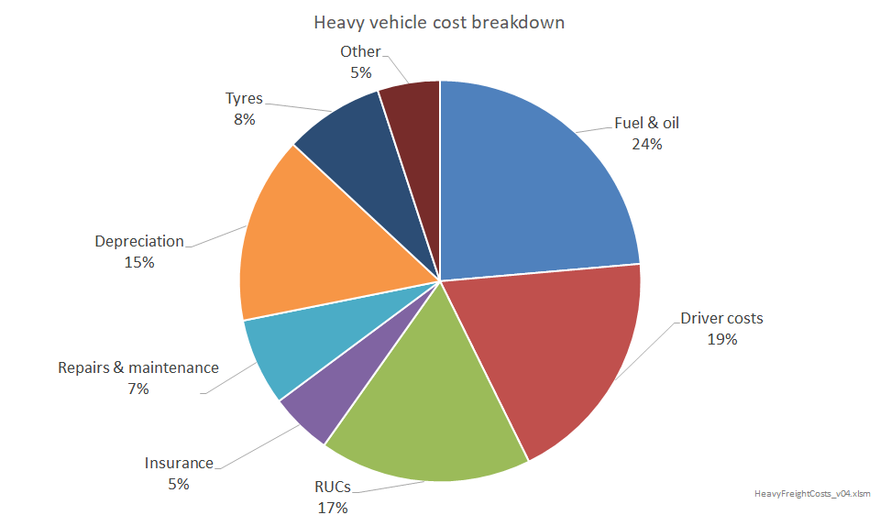
Note: Breakdown provided by one of New Zealand’s largest freight operators. ‘RUCs’ are road user charges.

Emissions costs
EVs are assumed to be completely zero emission vehicles in New Zealand, in that the increase in demand to meet their uptake will predominantly be met by developing renewable power stations such as wind.
In contrast, internal combustion engine vehicles are New Zealand’s largest energy-related source of greenhouse gas emissions.
Tailpipe emissions from ICEs also give rise to human health costs. A 2012 study funded by the Ministry of Transport and Ministry of Health (Kuschel n.d.) estimated that such costs are responsible for $1bn/year in adverse human health costs. This is principally due to the tiny particulates emitted, with diesel vehicles emitting significantly more particulates than petrol vehicles.
We have apportioned this $1bn cost among diesel and petrol volumes consumed in NZ, weighted by the proportion of PM₁₀ particulates from these vehicles. This results in the $/litre health cost of burning diesel to be 6.6 times that of burning petrol. We have further weighted this cost between cars, vans, trucks and buses according to a simple estimate of the proportion of travel undertaken by such vehicles in urban areas – noting that tailpipe emissions in rural areas have relatively little effect on human respiratory health.
This results in ICE buses facing proportionately 10 times greater human respiratory health costs per litre of fuel consumed than ICE heavy trucks, with ICE vans facing proportionately 5.1 times greater costs than ICE heavy trucks. This is due to heavy trucks spending a far greater proportion of their time (compared to buses and vans) on highways and rural roads than on urban roads.

Appendix B: Heavy transport modelling methodology and assumptions
This appendix examines the economics of fuel switching for aviation, marine, and heavy road freight from fossil fuels to three different technology options:
- battery electric
- biofuels
- hydrogen.
The framework we have used to evaluate the economics of fuel switching from fossil to low-emissions fuels is a total cost of ownership (TCO) evaluation for delivering a freight service. This is measured in dollars per tonne-kilometre ($/t.km) (ie, the average cost for transporting 1 tonne of freight 1 km – noting that for aviation, it is effectively 1 tonne of passengers and associated luggage).
The building blocks for such an analysis requires consideration of:
- the fuel cost of each option. This comprises:
- the cost of producing the fuel, and distributing it to the point where it can re-fuel the vehicle. This gives the $/GJ ‘delivered’ cost of the fuel
- this delivered cost is then factored by the fuel efficiency of the vehicle to give a $/t.km fuel cost
- the emissions intensity of the delivered fuel, factored by the fuel efficiency, allows consideration of the emissions component of this fuel cost
- the capital cost of the vehicles
- non-fuel operating costs of vehicles (eg, maintenance)
- productivity penalties. This last factor applies to consideration of electric vehicles, where increased vehicle weight and longer refuelling times may require a greater number of vehicles to perform the same transport service.

Battery electric

Battery costs
The battery component of the $/t.km cost of providing transport services will depend on how often the battery is cycled (ie, filled and emptied). For example, take a hypothetical battery whose cost per kWh of storage capacity is US$200/kWh_{_store}. Converting to NZ$, and assuming this up-front capital will be recovered over 15 years at a 6% discount rate, this approximately equates to a NZ$30/kWh_{_store}/yr capital recovery cost.
If this battery is filled and emptied every day of the year (ie, it is cycled 365 times a year), the cost per kWh of energy delivered = 30 ÷ 365 = NZ$0.082/kWh. If it is filled and emptied twice a day this cost will halve, whereas if it were filled and emptied once every two days this cost will double. This variation in the battery component of costs with the duty which the battery is required to perform (ie, how frequently it will be filled and emptied each year) is illustrated in figure 44 which uses the hypothetical US$200/kWh_{_store} battery example above.
Figure 44: Variation in battery cost with battery re-charging frequency ($ per delivered kWh)
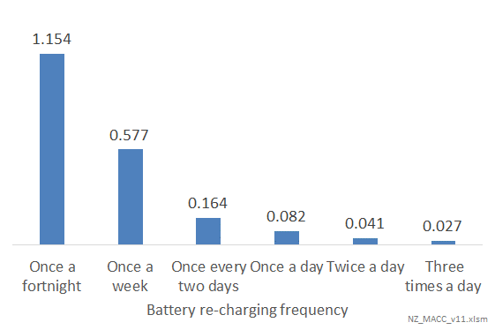

Electricity supply costs
While the above battery-cycling dynamic might point to having vehicles with smaller batteries that are regularly refilled during a day, there is a countervailing dynamic: namely, that re-filling batteries during the daytime will cost significantly more in terms of $/kWh electricity supplied. There are three drivers for this:
- the wholesale energy price of electricity is higher during the day than night
- re-charging during daytime periods will also tend to increase peak system demand, with consequent increases in electricity network costs
- re-charging during the day will require fast charging to prevent the vehicle needing to be stationary for long periods of time when it would otherwise be productively travelling. Fast-charging during the day has additional costs compared to slow-charging overnight including:
- the kW capacity of the charger needs to be several times greater
- the charger will need to be a DC charger, rather than an AC charger. These are more expensive per kW of capacity.
Figure 45 shows the results of how the overall cost per kWh of energy delivered to the vehicle varies with different charging regimes.
Figure 45: Variation in delivered electricity costs (including battery costs) with battery re-charging regimes
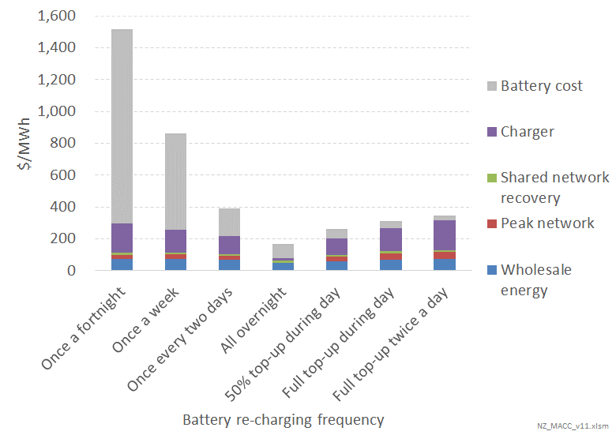
Figure 45 highlights that the overall least-cost battery size would be one which was large enough to allow a full day’s travel from a re-fill overnight: The advantages of being able to re-fill from cheap overnight electricity outweigh the costs of having a larger battery than one which would need to be topped up during the day.
This suggests that vehicles will be developed with batteries large enough to allow such a pattern of charging, except for vehicles which undertake multi-day journeys with no opportunity for re-charging during the journey. This only applies to international shipping.
The higher electricity supply costs for charging less frequently than once-a-night (ie, for international shipping) is due to the assumption that re-charging will occur in the turn-around period in port, and that this turn-around will be relatively rapid compared to the time sent travelling. This rapid turn-around will require fast charging, with much of it occurring during day-time periods.
It should be appreciated that figure 45 is a simplification. In particular, it assumes that vehicles will follow a totally consistent pattern of travel throughout the year. The reality is that many vehicles will travel different length distances at different times during the year. Some of this may be a regular variation (eg,. not travelling on weekends), whereas other variation may be due to vehicles travelling to different destinations at different times (eg, a truck travelling to different locations on different days.
It is therefore likely that trucks will have batteries sized to meet the majority of their journeys, and allow for some away-from-base charging during the day for the minority of very long journeys.

Vehicle efficiencies
The above analysis has been focussed on the cost of providing delivered energy to the vehicle. As noted in footnote 27, this delivered energy is factored by the efficiency of the engine to deliver motive power. This is important to account for the fact that fossil-fuelled engines have different fuel efficiencies to electric motors.
For electric motors versus internal combustion engines, the inherent difference in energy conversion efficiencies is such that combustion engines consume approximately 2.5 times as much energy to produce useful motive power. For trucks, this difference between electric and fossil is even greater due to the ability of trucks to use regenerative braking to ‘harvest’ the kinetic energy associated with braking, plus the fact that electric vehicles are more efficient at low speeds (or when stationary in traffic) than internal combustion engine vehicles.
These additional relative efficiency benefits accruing to electric vehicles for land transport don’t accrue for ships and planes, but do accrue for railway locomotives.
Aircraft jet engines are relatively more efficient than internal combustion engines, meaning that jet engines consume approximately 2.1 times as much energy as their electric-engine counterparts to deliver an equivalent amount of forward propulsion.

Productivity penalties
While the superior energy conversion efficiencies of electric motors are a huge factor in favour of electric vehicles, for some vehicle types this is significantly counter-balanced due to what we term ‘productivity penalties’ associated with using an electric vehicle.
The principal productivity penalty is because electric vehicles weigh more than their fossil-fuelled counterparts due to the weight of the battery.
For some vehicle situations, the fact that the battery makes the vehicle heavier makes no difference to the vehicle economics. The principal example of this is light road vehicles (ie, cars and vans), in that owners of such vehicles incur no penalty due to the vehicle weighing more than its petrol/diesel counterpart.
However, the heaviest category of trucks do incur a penalty due to there being an upper weight limit of 44 tonnes for any vehicle. With this weight limit, 1 tonne extra of battery means that 1 tonne less freight can be carried. This weight penalty only applies to the heaviest category of truck which account for approximately 30% of fuel consumed by vehicles classed as ‘heavy’ in MoT statistics. Given this weight penalty, we estimate that approximately 9% more electric heavy trucks are required to deliver the same freight transport service as diesel heavy trucks. We do not assume that such a weight penalty applies to battery electric trains.
Electric ships can also incur a weight penalty in that they have maximum allowable laden weights. Beyond this weight they will be too low in the water to be safe in heavy seas. With this weight limit, an extra tonne of battery will reduce the amount of cargo that can be carried by one tonne. As with trucks, this limit only applies to ships which regularly operate to these maximum limits, whereas passenger ferries may not have such limitations. We have estimated that electric ships have a 45% weight-related productivity penalty relative to ships powered by combustion engines. As with heavy trucks, this productivity penalty doesn’t just apply to the fuel and battery costs of electric ships, but also the non-fuel costs of operating a ship.
The vehicle mode for which this EV weight penalty is most acute is aviation. For planes, aircraft weight is a critical constraining factor on operation. Our initial calculations indicate that the extra weight of the batteries is a huge penalty on electric aircraft. Further, it will likely require aircraft to be re-designed (and strengthened) to accommodate the significant extra weight of the batteries in the wings.
For long-distance aviation travel, it appears that battery electric aircraft are simply not feasible using existing aircraft design: the extra weight of the batteries required to take a Boeing 747 from London to New York significantly exceeds the weight limit of the plane – even without carrying any passengers or freight.
Similar aircraft re-design issues are likely even for short-haul flights (eg, Wellington to Auckland), but even here, battery weight is estimated to deliver a productivity penalty that is likely to be the order of 500% (ie, five times more electric aircraft are likely to be required to transport a given amount of passengers or freight). However, this calculation is subject to a significant amount of uncertainty due to lack of data on electric commercial aircraft, and the fact that this issue has not been studied in detail for this analysis.
It is possible that ‘hybrid’ jet + electric aircraft may be cost-effective above certain carbon prices for short-haul aircraft. However, this option has not yet been studied.

Capital cost
Currently electric vehicles cost considerably more than fossil-fuelled vehicles.
The most significant factor in this is the cost of the battery, noting that (other than for aircraft) the non-battery capital cost of electric road vehicles and ships should be cheaper than the capital cost of their fossil-fuelled equivalents. Over time, as battery costs continue to improve, this capital cost penalty is likely to reduce to the point that electric vehicles should cost less than their fossil equivalents. Further, as vehicle manufacturers start to produce electric-only vehicle models, the production of electric vehicles should achieve the economies of scale and specialisation currently enjoyed by their fossil counterparts, thereby delivering additional cost savings.
Thus, many organisations are projecting that light private vehicles will achieve purchase price parity with petrol vehicles by the mid-20’s, with heavy trucks achieving parity anytime up to a decade later. (Noting that the longer driving distances for heavy trucks, and hence bigger battery requirements, gives electric heavy trucks a greater relative penalty to ICE heavy trucks than EV versus ICE for light private vehicles).
This requirement for bigger batteries for heavy trucks also applies to long-distance shipping
– indeed significantly more so. Figure 44 highlights how the battery cost rises massively for ships that require sufficient battery fuel for journeys of two weeks or more. As such, it is hard to see that battery electric ocean-going ships (as opposed to coastal ships) will achieve purchase price parity any time over the next few decades. However, for coastal shipping such as ferries, which can recharge every night, capital cost parity could be achieved at roughly the same time as it is achieved for heavy trucks – assuming that both have similar journey time requirements of approximately 12 hours travel a day.
The above analysis applies to the cost of purchasing a new vehicle. It will cost more to switch away from an existing fossil vehicle which has several years of life left in it. In such cases the cost comparison is between the upfront cost of the electric vehicle, versus the cost of purchasing a new fossil vehicle in ‘x’ years’ time discounted back to today’s money – where ‘x’ represents the number of years life left in the fossil vehicle. This sunk cost advantage for existing vehicles means it can be significantly more costly to replace a fossil-fuelled vehicle that has many more year’s economic life left in it.

Non-fuel operating costs
Electric vehicles have significantly fewer moving parts than their fossil-fuelled counterparts. Plus, electric motors are subject to far less extreme temperatures and pressures than their fossil-fuelled counterparts. This translates into reduced maintenance costs for electric vehicles.
Although not transformative in itself, this maintenance cost saving provides additional benefit for EVs relative to fossil vehicles, and brings forward the time when EVs are lower cost than fossil vehicles on a total cost of ownership basis. However, due to lack of data, no estimate has been made of this benefit for consideration of marine and aviation options.

Biofuels
This option considers ‘drop-in’ biofuels produced from forestry.
Drop-in biofuels are functionally identical to their fossil counterparts, and thus can be used in existing vehicles without requiring any modification. This is a crucial advantage as non-drop-in fuels:
- incur vehicle capital costs to be used – in some cases requiring a whole new vehicle, and in other cases requiring engine modifications (which, although lower cost, will often invalidate manufacturers’ warranties)
- require new fuel distribution infrastructure to be developed to varying degrees (noting that some of the existing service station network infrastructure can be used but new aspects will be required)
- alternatively, non-drop-in fuels can be used without incurring additional costs or requiring new infrastructure, but only when blended with a large proportion of fossil fuel (eg, Z Energy’s Bio-D, which is 95% fossil diesel)
- often require the energy crop feedstock to be grown on arable land. This is very high value land given the returns that can be achieved from growing other crops (eg, pipfruit), increasing the cost of such options. In contrast, forestry is suitable for low-value land that is not appropriate for arable crops.
Thus, while producing non-drop-in fuels can sometimes be cheaper than drop-in fuels, these advantages tend to be outweighed by these other costs. Further, the technology-taker nature of New Zealand’s transport sector requires the rest of the world to be heading down this path and developing vehicles and technology which can be adopted in New Zealand. However, while some countries developed non-drop-in fuel markets a couple of decades ago, international focus and investment has now heavily shifted towards alternative low-emissions fuels (particularly electric vehicles).
Drop-in biofuels therefore appear most prospective, with a huge potential market to displace fossil from existing vehicles – either as a transition fuel until vehicles are replaced by electric alternatives, or potentially as a permanent solution in some sectors for which electric or hydrogen vehicles are unlikely to be cost effective.
We have evaluated the break-even carbon price at which producing drop-in diesel will be cheaper than fossil diesel.
The components of this cost are:
- Raw feedstock cost delivered to the refinery.
- For fossil diesel this is comprised of the world oil price factored by the NZ$/US$ exchange rate, plus the cost of international shipping.
- For drop-in diesel this is the delivered cost of green biomass feedstock to a bio-refinery.
- For both options, sensitivities are undertaken as to the impact of different world oil prices or differences in the cost of logs – noting that both factors are subject to some uncertainty and inherent variation. For example, Scion identify that some biomass residues are available at relatively low cost (eg, $40-50/tonne), whereas if wood would need to be grown as an energy forest to provide feedstock, prices of $80-100/tonne may be more realistic (Hall 2017).
- The cost of refining the feedstock.
- For fossil diesel this is a constant US$/bbl adder based on observations of historical differentials between crude oil and refined diesel prices.
- For drop-in diesel this is based on the: (Scion 2018)
- energy-content of the wood factored by the energy efficiency of the refining process
- capital recovery and non-fuel operating costs of the biorefinery.
- The cost of delivering the refined fuel to service stations.
- This is based on analysis of AA reporting of such costs, (AA 2020)and Z Energy annual accounts. This latter analysis is to enable estimation of the extent to which drop-in diesel may enjoy some advantage relative to fossil diesel given that drop-in diesel will be produced regionally, whereas fossil diesel is produced at a single location and thus incur relatively greater distribution costs.
- Based on the emissions factor for each fuel (set out below), this reduced fuel distribution cost advantage is estimated to reduce the marginal abatement cost for switching from fossil to drop-in fuel by approximately NZ$50/tCO₂e.
- The emissions factor of each fuel.
- The emissions for fossil diesel are based on published data
- The emissions factor for drop-in diesel (noting that production of drop-in diesel releases CO₂) is derived from Scion data. (Scion 2018) It is possible that net emissions could be reduced if the char by-product of drop-in diesel production was used to displace coal burn in industrial process heat. However, this has not been considered for this analysis since coal displacement is likely to happen anyway through use of improved efficiency and fuel-switching to biomass and electrification.
The results of this analysis are shown in figure 46 below.
Figure 46: Break-even carbon prices for drop-in diesel to be cost-effective to displace fossil diesel for land transport
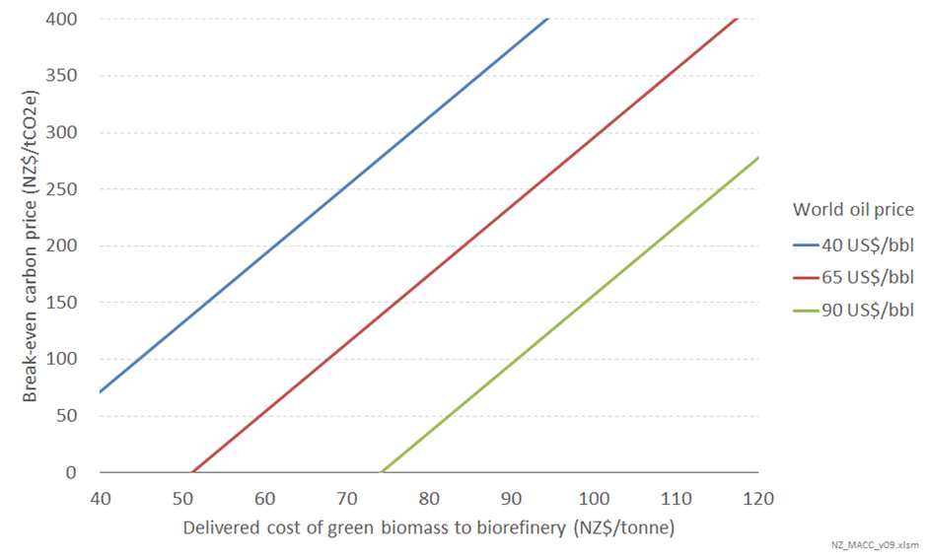
This analysis shows that the break-even carbon price is highly sensitive to world oil prices and the delivered cost of green biomass to a biorefinery.
However, using a central estimate of the delivered cost of logs from dedicated energy forests of NZ$80/tonne, and using the IEA’s ‘New Policies’ estimate of 2030 world oil prices of US$96/bbl, it appears that drop-in diesel is a very prospective option for decarbonising New Zealand’s heavy land transport sector.
However, there are some factors which could alter this including:
- potential declining demand for diesel
- biomass resource availability
- specific issues for biofuels for marine and aviation.
Each of these is addressed below.

Potential declining demand for diesel
The analysis set out elsewhere in this report reveals that electrification of heavy road transport is likely to achieve negative carbon cost in the next couple of decades. This is due to battery cost reductions resulting in electric trucks being genuinely cheaper options for delivering freight transport than diesel trucks. As this displacement of fossil fuel vehicles by electric gathers pace, there could be an additional positive feedback loop accelerating this process as the fixed costs of fossil fuel distribution to service stations need to be recovered off a declining volume of sales – causing the price of fossil diesel to increase further and thus increasing the rate of fuel switching further.
The implications of this are that there could be a declining market for drop-in diesel over the next couple of decades – being the residual fleet of diesel trucks that remain until they are completely displaced by new electric trucks.
This is likely to take several decades at least before for such a transition is complete. However, this does mean that a biorefinery developed in 2035, say, may require a much shorter capital recovery period than that assumed by Scion for its estimate of the costs of biofuels. Figure 47 illustrates that this does have some impact (by comparing the break-even carbon price for this scenario compared to that in figure 46), but does not necessarily mean it is a show stopper. However, this limited period for a market for drop-in diesel could also have implications for the development of specific ‘energy forests’ to provide feedstock for biorefineries. This issue is explored further below.
Figure 47: Break-even carbon prices for drop-in diesel to be cost-effective to displace fossil diesel for land transport – assuming a shorter capital recovery period for a biorefinery
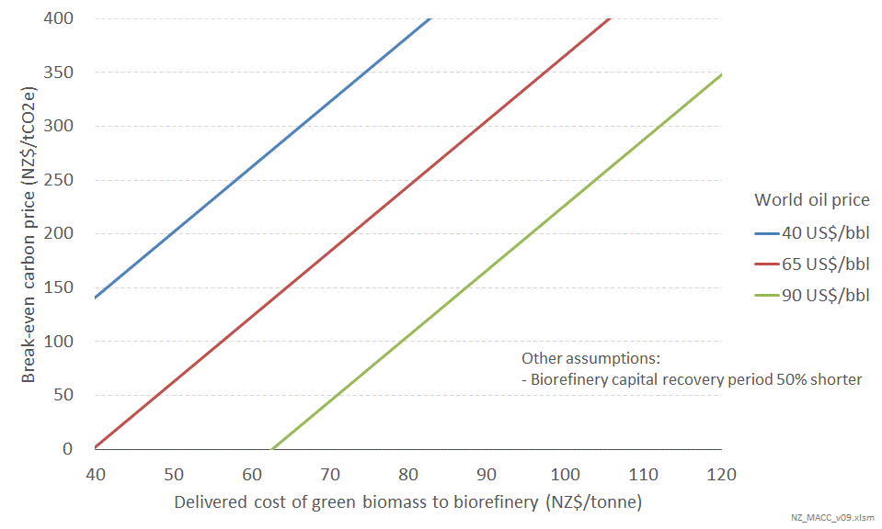
That said, this declining market for diesel for land transport may not be an issue if there is still a market for drop-in biofuels for marine and aviation – as could be likely based on the analysis below.

Biomass resource availability
The main initial source of feedstock for biorefineries would be residues from forestry and agricultural processes. Scion identifies that there is a significant quantity of such residues (Hall 2017). However, it also identifies that switching from coal or gas for industrial process heat could be a key competing use for such residues.
To the extent that it is more cost-effective to use biomass for process heat rather than creating drop-in diesel, then Scion’s analysis identifies that in many parts of New Zealand there will be no residual residues available for producing drop-in diesel.
Consideration of which option (decarbonising process heat versus producing drop-in diesel) is likely to be least cost requires additional analysis which has yet to be undertaken. That said, provisional high-level evaluations suggest that biomass for process heat may be more cost-effective than biomass for creating drop-in fuels.
However, this conclusion is sensitive to assumptions around future coal, gas and oil prices, and requires consideration of the extent to which there are other alternatives for decarbonising process heat versus transport. For both options, electrification is an alternative, although (as set out further below) electrification does not appear to be a practicable option for international marine and for aviation.
Further, to the extent that the scale of biomass residues are insufficient to meet the demand for process heat and creating drop-in fuels, there will be a need to grow specific ‘energy forests’. Evaluation of this will also require consideration of the economics of land-use change from dairy or sheep/beef to forestry. This evaluation is not trivial as it will be heavily driven by the extent to which world commodity prices for animal proteins and harvested wood products change in response to a carbon price progressively being applied to the international land sector. In addition, material regional variations in production of woody biomass and animal proteins per hectare due to climatic variations will further complicate this analysis.
In summary, biomass looks to be highly prospective as a fuel for creating drop-in diesel. However, quantifying the scale and cost of this potential requires consideration of multiple different competing uses for land and the biomass that could be used for energy purposes.
Undertaking this analysis is outside the scope of this current engagement, but it is recommended that such analysis be pursued given the major potential that biomass appears to have for decarbonising New Zealand’s economy.

Specific issues for biofuels for marine and aviation
The analysis illustrated in figure 46 above is equally applicable for consideration of producing drop-in marine and drop-in aviation fuels.
One potential difference is that the assumed advantage for drop-in diesel for land transport relating to fuel distribution costs will not hold (or at least not to the same extent) for marine and aviation fuels. This is because of the discrete point-source nature of demand for such fuels rather than the ubiquitous cross-country demand for land diesel. However, there may still be some advantage (or even the same advantage) given that biorefineries can be located around the country whereas there is only one fossil refinery in New Zealand.
The second difference is that the modelled drop-in fuel production process is assumed to use the cheapest possible pathways to turn biomass into fuels. The output of these processes are not specific, usable fuels but a mixture of different fuel fractions analogous to crude oil and with similar properties; this mixture is sometimes called ‘bio-crude’. Just like crude oil the bio-crude must be refined to separate the various biofuel fractions before they can be used.
The assumed lowest-cost pathways produce fuels in their ‘natural fractions’ – ie, the proportions of different fuel types produced are not modified by upgrading, cracking or other processes. This gives rise to a biorefinery producing a ‘natural’ mix of different types of drop-in fuel: petrol, diesel, marine bunker fuel, and aviation fuel.
It is possible to alter the proportions of finished fuels, eg, reducing the amount of petrol and increasing the proportion of jet fuel. This would require either a more targeted production pathway, specifically targeting, for example, jet fuel; or extra steps as part of the refining process such as upgrading or cracking. Either of these options would increase the cost of the finished fuels relative to the assumed minimum-cost scenario. The Scion Biofuels roadmap technical report illustrated this by showing that the cost of only producing drop-in jet fuel was substantially higher than the cost of producing such fuel in its natural proportion.
To the extent that land transport is decarbonised through electrification, say, but aviation decarbonisation is most cost-effectively achieved through drop-in jet fuel, this may give rise to a need for biorefineries to produce drop-in fuels in proportions which are very different to their natural fractions. This could substantially increase the cost.
However, a similar dynamic also applies to fossil fuels: a barrel of crude oil yields roughly fixed amounts of a given type of fuel (although this does vary between different oil fields). Each barrel ‘contains’ approximately, for example, 76 L of petrol and 15 L of jet fuel (as well as various other products). Through chemical processes petrol can be turned into jet fuel and vice versa (or diesel into petrol, etc.), to more closely match demand. As with biofuels, these extra steps increase the time and energy spent per litre of finished fuel, thus increasing the cost. The processes of upgrading, cracking, etc., are not significantly different for fossil or drop-in biofuels and therefore the increases in costs could be similar. However, consideration of the extent to which this conclusion is valid would need to be checked with a chemical engineer.

Hydrogen
We have developed a framework which calculates the cost of hydrogen on a lifetime
$/GJ use basis, ie, factoring for capital costs and vehicle efficiencies.
It assumes that bulk hydrogen can be produced for $7.5/kg. This is based on analysis undertaken for the Hydrogen in New Zealand study (ConceptConsultingGroup 2019), and assumes material improvements in the cost of producing two hydrogen atoms from the current situation. It assumes:
- a fuel cell and electric motor is 55% efficient
- the capital cost of a fuel cell and electric motor is twice that of a diesel engine (on a per kW of power output basis)
- the capital cost recovery factor for the hydrogen fuel tank in the vehicle is $0.5 per kg of fuel delivered for a fuel tank that is filled and emptied once a day.
These basic building blocks were then used to assess the cost of hydrogen transport for different patterns of travel as previously set out in figure 44 for electric vehicles. This is necessary because the cost of the hydrogen storage tank and the capital recovery for the engine will vary with different patterns of travel.
There are also some potential specific issues with hydrogen for marine and aviation set out below.

Hydrogen for marine
Liquid hydrogen has an energy density approximately one quarter that of bunker fuel, ie, a hydrogen-powered ship would require fuel tanks over three times larger than a conventional ship (assuming that a fuel-cell driven motor is 20% more efficient than a conventional ship engine). Given the enormous size of a container ship this is a relatively small productivity penalty.
There are additional factors which may alter the cost of hydrogen production from that which we have considered in our analysis:
- Recharging a ship like an electric car may create difficulties for electricity generation and transmission systems, using renewable hydrogen would compound some of these issues. A previous Concept report found a renewable hydrogen-powered vehicle ultimately consumes three times as much electricity as a battery-powered equivalent. (ConceptConsultingGroup 2019, Vol.2) A busy port would require a constant supply of hydrogen fuel, effectively adding a load to the electricity network three times greater than having a high-powered ship charger.
However, it could be possible for hydrogen production to be distributed across the country’s network, as opposed to the high point load of an electric charger, and transported to the port. This would incur additional transport costs.
- Hydrogen could also be produced from natural gas, eliminating the need for additional renewable electricity. To achieve significant decarbonisation this process would need to be paired with carbon capture and storage technology, at additional cost.
Unlike drop-in biofuels, which are compatible with existing ships and refuelling infrastructure, hydrogen powered shipping requires new ships and new infrastructure at every port on a given route. This gives rise to a ‘chicken-and-egg’ dilemma, where ship owners won’t commission a hydrogen ship until there is infrastructure in place to refuel it and ports won’t build hydrogen infrastructure unless there are ships to use it.

Hydrogen for aviation
As well as facing the same issues as hydrogen powered marine transport (chicken-and-egg, high electricity requirements, expensive fuel), hydrogen-powered aviation is not practical for aircraft as we know them today.
Gaseous hydrogen would have to be compressed to approximately 3000 bar to achieve the same energy density (MJ/m³) as kerosene. Although this in itself is not impossible, the fuel tanks in a Toyota Mirai hydrogen car store hydrogen at 700 bar, and weigh over 80 kg (17 kg of fuel tank for each 1 kg of hydrogen stored). (Toyota n.d.) If this ratio holds for aircraft fuel tanks, a (relatively more efficient) fuel-cell powered plane flying from London to New York would require fuel tanks weighing in excess of 200 tonnes – too heavy for today’s commercial aircraft.
The alternative, liquid hydrogen, would require aircraft with fuel storage 3.5 times larger than the volume of today’s fuel tanks. Liquid hydrogen has the additional challenge (and associated costs) of maintaining a cryogenic temperature to stop the fuel boiling – not insignificant on an aircraft, where vibration from the engines and turbulence in the air will be constantly agitating the fuel, leading to heat build-up through friction. The additional insulation and refrigeration equipment on each fuel tank would also consume space on board. A plane burning hydrogen in a jet turbine would require even more fuel tanks due to the somewhat lower efficiency of a combustion engine.
For these reasons, we do not believe hydrogen is a feasible aircraft fuel.

References
AA. 2020. fuel-prices-and-types/how-petrol-prices-are-calculated. Accessed January 29, 2020. https://www.aa.co.nz/cars/owning-a-car/fuel-prices-and-types/how-petrol-prices-are-calculated/.
Alcaraz S, Hall P. Wood Energy Industrial Symbiosis. 2018. Scion and GNS Science. Unpublished presentation.
Atkins M. 2019. Options to Reduce New Zealand’s Process Heat Emissions. Energy Efficiency and Conservation Authority. Retrieved from https://www.eeca.govt.nz/assets/Resources-EECA/research-publications-resources/Options-to-Reduce-New-Zealands-Process-Heat-Emissions.pdf
Concept Consulting. Long term gas supply and demand scenarios – 2019 update. 2019. Retrieved from https://www.gasindustry.co.nz/work-programmes/gas-supply-and-demand/long-term-gas-supply-and-demand-scenarios-2019-update/printable
Concept Consulting. 2019. Hydrogen in New Zealand. Accessed January 29, 2020. http://www.concept.co.nz/publications.html
Department of Communications, Climate Action and Environment. 2019. Department of Communications,Climate Action and Environment. Accessed January 29, 2020. https://www.dccae.gov.ie/documents/Climate%20Action%20Plan%202019.pdf
Gas Industry. 2019. gasindustry.co.nz. Accessed January 29, 2020. https://gasindustry.co.nz/work-programmes/gas-supply-and-demand/long-term-gas-supply-and-demand-scenarios-2019-update/
Hall, Peter. 2017. Residual biomass fuel projections for New Zeland. Rotorua: Scion.
Journeaux P, Van Reenen E, Manjala T, Pike S, Hanmore I, Millar S. 2017. Analysis of drivers and barriers to land use change. Ministry for Primary Industries. Retrieved from https://www.mpi.govt.nz/dmsdocument/23056/direct.
Logtenberg, Ryan. 2018. “reports.” 2degreeinstitute.org. September. Accessed January 29, 2020. https://www.2degreesinstitute.org/reports/comparing_fuel_and_maintenance_costs_of_electric_and_gas_powered_vehicles_in_canada.pdf
MACC, Waste. 2019. An analysis of greenhouse gas abatement options for New Zealand's waste sector. Analysis, Eunomia Consulting
Manley B. 2019. Impacts of carbon prices on forest management. Ministry for Primary Industries. Retrieved from https://www.teururakau.govt.nz/dmsdocument/37113/direct.
Quong, Leonard. 2019. “consumers driving a global transition.” NZ Downstream. Bloomberg NEF
Reisinger A, Clark H, Journeaux P, Clark D, Lambert G. 2017. On-farm options to reduce agricultural GHG emissions in New Zealand: Report to the Biological Emissions Reference Group. Retrieved from https://ourlandandwater.nz/wp-content/uploads/2019/03/BERG-Current-mitigaiton-potential-FINAL.pdf.
Reisinger A, Clark H , Abercrombie R , Aspin M , Ettema P , Harris M , Hoggard A , Newman M, Sneath G. 2018. Future options to reduce biological GHG emissions on-farm: critical assumptions and national-scale impact: Report to the Biological Emissions Reference Group. New Zealand Agricultural Greenhouse Gas Research Centre. Retrieved from https://www.mpi.govt.nz/dmsdocument/32128/send.
Scion. 2018. nz biofuels roadmap. February. Accessed January 29, 2020. https://www.scionresearch.com/science/bioenergy/nz-biofuels-roadmap
Toyota. n.d. “mirai specs.” toyota.com. Accessed January 29, 2020. https://www.toyota.com/mirai/assets/core/Docs/Mirai%20Specs.pdf
Residual biomass fuel projections for New Zealand, Scion, Aug 2017; and Analysis of large-scale bioenergy from forestry, Scion, April 2009
Watt M, Kimberley M, Dash J, Harrison D, Monge J, Dowling L. (2017). The economic impact of optimising final stand density for structural saw log production on the value of the New Zealand plantation estate. Forest Ecology and Management, 406, 361–369. Retrieved from https://doi.org/10.1016/j.foreco.2017.07.044.

Annex 1: Technical note on marginal abatement cost analysis

Summary
Marginal abatement cost (MAC) curve analysis is a common way of assessing the potential emissions reductions and cost-effectiveness of abatement measures across sectors. MAC curves are subject to limitations and should be just one tool in a broader set of decision-making aids used in climate policy-making. In the UK, MAC curves have been a key part of the evidence base developed under the UK Climate Change Act framework.
The Ministry has proposed the following approach for developing an initial set of MAC:
- NZ Inc. viewpoint rather than a private/consumer viewpoint
- focus on technical/economic potential, also gathering analysis on realisable potential where possible
- work with existing emissions projections as a baseline, to be updated when new projections are available
- quantify and communicate uncertainty in assumptions and projections to our best ability
- analyse measures independently but consider interactions when constructing MAC curves so these avoid double-counting
- conduct analysis on cost variations within abatement measures where possible, focusing on larger abatement opportunities
- collect quantitative information on potential co-benefits associated with abatement measures where available.

Introduction
The economic impacts of reducing emissions is a key question for policy makers in New Zealand as they consider the transition to a low-emissions economy. Considering how the economy can transition at least cost is important to minimise the impact on New Zealand’s households and industries. Looking at the cost-effectiveness of individual abatement measures across the economy using a consistent framework for analysis is important to understand which measures could be explored (and in what order) to achieve a transition at the lowest cost.
For any abatement measure (or package of measures) we are generally interested in answering two foundational questions:
- How much could this reduce emissions?
- What are the associated costs (and benefits)?
MAC analysis and the production of MAC curves is a common approach to addressing these questions and communicating the results.

What is the marginal abatement cost?
In environmental economics, the marginal abatement cost is the cost associated with eliminating a unit of pollution. In the climate change context, the MAC is the net cost per unit of greenhouse gas (GHG) emissions abated. This is typically expressed in dollars per tonne of CO₂-equivalent ($/tCO₂e).
The MAC can be calculated for a specific abatement measure (eg, switching a coal boiler to biomass) provided there is sufficient information about its costs and impact on emissions. In some cases, a measure’s MAC can be negative, indicating net cost savings are available even without valuing the emissions reductions.

What is a MAC curve?
Marginal abatement cost curves (MAC curves or MACCs) are a common tool for visualising the potential emissions reductions and cost-effectiveness of multiple abatement measures. MAC curves can be produced at different levels, including economy-wide, by sector (eg, transport, agriculture) and by emissions source (eg, light vehicles, milk drying plants).
Figure 48 is a conceptual example of a MAC curve. Each block in the graph represents a specific abatement measure. The height of the block (ie, position on the vertical axis) shows the measure’s MAC. The width of the block shows the measure’s potential abatement volume (expressed here as a reduction in emissions per year). The blocks are stacked in order from lowest to highest cost. This allows the reader to, for example, see the total volume of abatement that is available up to a given cost threshold. As discussed further below, much care is required in how MAC curves are produced and used in formulating a long-term mitigation strategy.
Figure 48: Conceptual illustration of a MACC
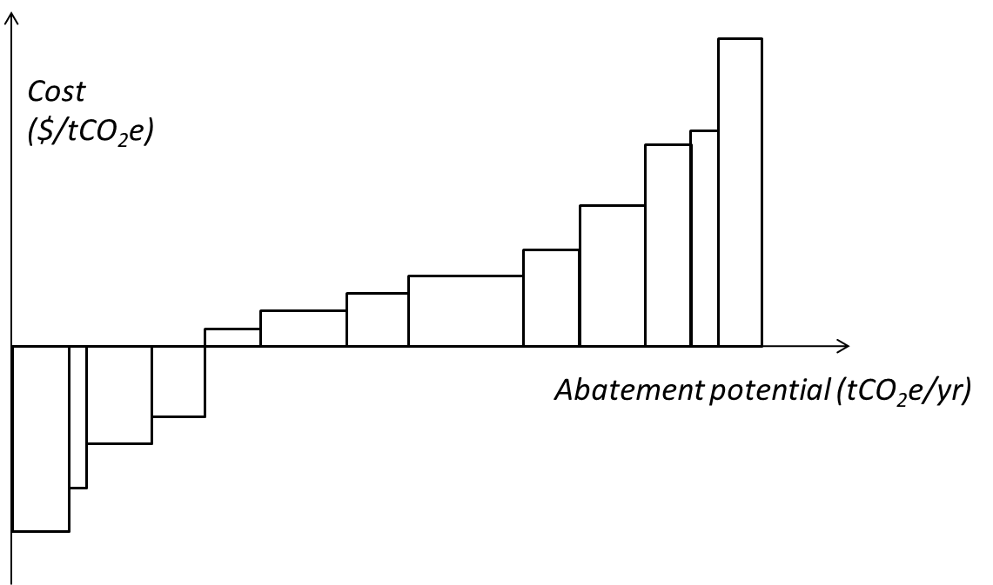
A different type of MAC curve can also be produced as an output from modelling exercises
– for example by running the model at different carbon prices and calculating the overall abatement. This approach, which we refer to as a ‘top-down MAC curve’, will typically not show the contributions of specific abatement measures, but can offer different strengths, such as incorporating interactions between measures and across sectors. The focus of this project is on producing ‘bottom-up’ MAC estimates and MAC curves as illustrated above.

Limitations of MAC curve analysis
MAC curve analysis is subject to limitations and is not sufficient on its own to determine an ‘optimal’ mitigation pathway or strategy. MAC curves should be just one tool in a broader set of decision-making aids used in climate policy-making (Kesicki and Ekins, 2012).
MAC curves provide a simplified, static snapshot of abatement potentials and average costs at a particular time. They are not designed to illustrate important dynamic aspects of the transition. In particular:
- A static cost assessment cannot reflect how the cost of different technologies is likely to evolve with different levels of deployment over time. For example, cost reductions can occur from learning effects, network effects and economies of scale (as has been observed in many cases such as solar and wind power, EVs and energy efficiency).
- MAC curves are limited in reflecting interdependencies across measures, both within and across different sectors (discussed further below).
- MAC curves fail to account for the lead-in time necessary to implement various technologies or measures and so are limited in informing decisions on the optimal timing of different abatement options.
The way information is presented in a MAC curve naturally suggests a merit order, in which the abatement options should be implemented in order of increasing cost until the required level of abatement volume is met. However, for the above reasons and more, “misinterpreting MAC curves as abatement supply curves can lead to suboptimal strategies” (Vogt-Schilb et al., 2015). In particular, focusing entirely on the ‘“ow-hanging fruit’ today can lock in options that are insufficient to meet long-term emissions goals, and therefore cause higher costs in the long run. Combining MAC curve analysis with a long-term outlook is critical to determining cost-effective transition pathways.
The limitations of MAC curves are critical for decision-makers to understand, and we will be careful to communicate these in all materials we produce. We will look to develop NZ-specific examples to clearly illustrate the issues discussed above. We discuss further issues and our proposed approach to dealing with these below.

How MAC curves are used in the UK
MAC curves are a key part of the evidence base for the UK Government and the UK Committee on Climate Change (UK CCC) under the UK Climate Change Act framework.
The UK CCC has developed detailed MAC curves for all relevant sectors. They have used these to ascertain the feasibility of meeting emissions budgets, identify the emissions reductions each sector may contribute, and consider the role of international units (Fankhauser et al., 2009). The UK CCC uses the MAC curves alongside other evidence and expert judgement. For example, they have used a central ‘cut-off’ carbon price in assessing the overall cost-effective abatement potential, but included several more expensive measures based on their ‘dynamic efficiency’ (ie, long-term potential for deep emissions cuts and cost reductions over time).
The UK’s former Department of Energy and Climate Change (DECC – now BEIS) also developed its own MAC ‘database’ for use in Government analysis and decision-making. This database was used in the impact assessments of the fourth and fifth carbon budget decisions to estimate overall costs of meeting proposed budgets (DECC, 2011; DECC, 2016). It was also used in developing the UK Government’s plans to meet the carbon budgets – the 2011 Carbon Plan and 2017 Clean Growth Strategy.

Design and methodology issues
The project requires several decisions on design options and methodology. Here we discuss issues and proposed approaches to dealing with these.

Viewpoint (NZ Inc. or consumer)
Costs can be analysed from a ‘NZ Inc.’ viewpoint (ie, social cost), or a consumer viewpoint (ie, private cost). Key factors that can differ based on viewpoint are:
- whether to use the resource cost or the retail price of an input; for example, a NZ Inc. viewpoint would use the cost of supplying fuel or electricity, while a consumer viewpoint would use the retail price (including all taxes and wealth transfers)
- what discount rate is appropriate to use.
Taking a NZ Inc. viewpoint informs on the overall cost or benefit to the New Zealand economy of an abatement measure. This is also likely to be more stable over time, as consumer prices are subject to potential policy change (eg, fuel taxes, responses to the electricity pricing review). However, analysis from the consumer viewpoint is important for understanding the likely market response to an emissions price or other policies. Comparing cost assessments from the different viewpoints can reveal market failures and other non-price barriers which may warrant policy intervention.

Proposed approach
We plan to focus on a NZ Inc. viewpoint initially, as our first task is to improve understanding of the national economic costs and benefits of measures to reduce emissions. At a later stage we will likely want to also consider the consumer viewpoint. To enable this, we will design our spreadsheets or other calculation tools such that input parameters (eg, discount rate) are easily varied.

Scope of abatement potential (economic or realisable)
When assessing the potential abatement volume, we can consider technical potential, economic potential, and realisable potential. Figure 49 provides definitions of these and illustrates the relationships between them.
Figure 49: Three measures of abatement potential
By definition, MAC analysis illustrates cost and therefore goes beyond just assessing technical potential. MAC curves can be produced to show either economic potential or realisable potential.
Generally speaking, realisable potential will be smaller than economic potential as not all theoretically cost-effective potential will be achieved. The time dimension is key here: realisable potential will tend to lag economic potential due to realistic timeframes for implementation (considering for example, technology diffusion, construction timeframes). In some cases economic potential may never be fully realised due to other non-financial factors in decision-making.
As an example, it may be technically feasible to replace most of the light vehicle fleet with EVs in 2020. The economic potential will be considerably smaller (particularly if sunk costs of current vehicles are considered). The realisable potential may be smaller still for reasons such as consumer decision-making methods, real or perceived barriers like ‘range anxiety’, and limited EV model choice.
Ultimately, realisable potential of abatement measures must be estimated to develop plausible pathways to meet emissions targets and budgets. Economic potential serves as an analytical starting point, and is important to understand in its own right. Realisable potential will require more work to estimate, introduces further uncertainty and subjectivity, and may differ depending on the policy options considered. In figure 50 we see an uptake of measures over time in a MAC analysis.
Figure 50: Uptake of measures over time in a MAC analysis
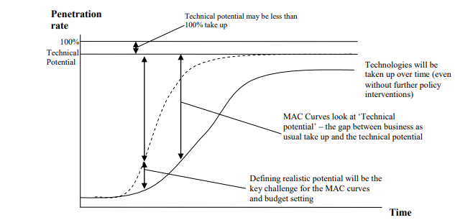
Source: Pye at al. (2008), Figure 2.1

Proposed approach
We plan to focus initially on the economic potential of abatement measures, but also want to capture relevant information on realisable potential where available. If time and information allows, we will look to illustrate this through scenarios.
This work will provide a starting point for identifying cost-effective abatement pathways. We intend that future stages of work will build on this by considering specific transition policy levers, which will further assess realisable potential. Other analysis and modelling could also be undertaken to explore issues such as implementation speed (as suggested by Vogt-Schilb and Hallegatte (2014)).

Developing a baseline
We are not only interested in the abatement available today, but out as far as 2050. Abatement costs and potential volumes can be calculated for the present or at a specified point in the future. Both costs and volumes will change over time, due to factors including:
- technology development
- changes in fuel and commodity prices
- changes in population and economic activity
- business-as-usual technology uptake
- cycles of capital replacement.
Constructing future MAC curves requires a baseline emissions projection, with detailed information on the above factors. The abatement potential we wish to calculate is the additional emissions reductions achievable below the baseline. Ideally, emissions projections will reflect existing policies and use harmonised input assumptions across sectors (eg, common sources of assumptions for GDP growth, oil prices).
Official projections exist and were extended to 2050 recently to inform modelling of 2050 target options. However, we understand there may be challenges with using these existing emissions projections as some aspects may be out of date (eg, technology price assumptions), and some sectors may lack sufficient detail (eg,energy projections may be done at an aggregated level and not explicitly separate activity and technology changes). This creates a particular risk of double-counting (or under-counting) potential abatement if we do not understand the level of uptake of given measures in the baseline (see figure 51).
Figure 51: Illustration of abatement occurring in the baseline
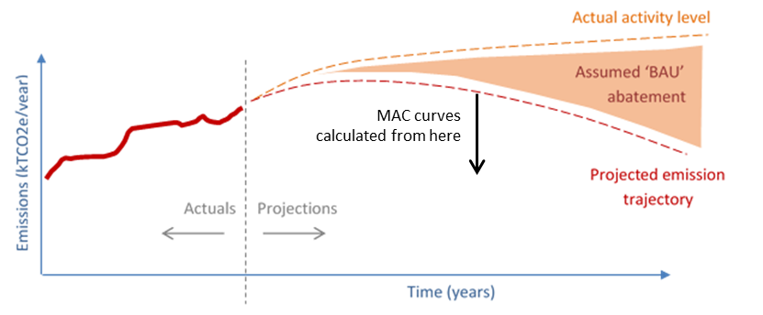

Proposed approach
We intend to produce MAC curves at five- or ten-year intervals looking out as far as 2050, so we will require a baseline projection covering this time period.
Due to the project’s time constraints, we plan to use existing emissions projections (ie, the most recent updates) for the first stage, and then update our analysis when new projections are available. We wish to work with agencies to access the deepest level of detail available for the emissions and activity data, and/or to find an appropriate method to disaggregate the projections to appropriate granularity.

Treatment of uncertainty
Estimating abatement costs and potentials requires assumptions that become more uncertain the further out we look (eg, 2050 vs. 2020). There are multiple sources of uncertainty including:
- changes in technology, fuel and commodity prices
- projected activity levels in the baseline (eg, population, travel demand, stock numbers)
- projected uptake of abatement measures in the baseline (eg, EV uptake under current policies).
Presenting a single MAC curve – which is common – does not illustrate uncertainties in the analysis. It is important to understand the scale of uncertainty (on costs and abatement volumes) and to identify assumptions to which the results are particularly sensitive.

Proposed approach
We plan to consider the uncertainty around assumptions and projections, and aim to quantify and communicate this to our best ability. This may involve creating multiple scenarios with varying assumptions for key drivers, and producing several MAC curves accordingly. When collecting data on assumptions and projections from other agencies, we will seek information on uncertainty ranges as well as central estimates.

Interactions and interdependencies
As mentioned earlier, MAC curves struggle to capture interactions and interdependencies between measures. Looking at light vehicle emissions, for example, abatement options includes:
- reducing vehicle use through demand management and mode shift
- improving the efficiency of internal combustion engine vehicles entering the fleet
- increasing the uptake of EVs.
All three measures are targeting the same underlying emissions source, and therefore the (independently assessed) abatement potentials cannot simply be added together – this would lead to double counting. In some cases, two measures are mutually exclusive (eg, choosing between a more efficient ICE vehicle or EV). Finally, uptake of one measure may also affect the costs of others (eg, vehicle use affects the economics of vehicle choice).
Electricity is subject to particularly complex interactions which a static MAC analysis cannot capture. Changes in the electricity generation mix (and associated cost) will both be driven by and drive changes in demand, such as electrification of process heat. Determining an appropriate electricity emissions factor (and how this will change over time) is one key challenge.

Proposed approach
We plan to start out with analysis of measures on an independent basis, before developing scenarios for constructing MAC curves so that these avoid double-counting. We anticipate this will require some systems thinking and an intervention logic, which we will discuss with relevant agencies.
Simplifying assumptions will be needed in some areas, such as the electricity emissions factor. Again, we will discuss and agree an approach with relevant agencies.
Ultimately, exploring the effects of interactions requires use of a dynamic modelling framework. This will be considered at a later point.

Cost variation within abatement measures
MAC curves usually indicate that there is a single abatement cost value for a given measure. In reality, there can be significant variation of abatement costs within a technology segment due to specifics of different end-use situations. Examples include:
- variation in usage (eg, annual distance travelled by vehicles)
- whether choosing a low-emission option would require replacing existing (sunk) capital associated with continuing with the high-emission option (eg, early boiler retirement)
- variation in fuel costs by location (eg, biomass).
Understanding the range of abatement costs within a segment, and the drivers behind such a range, is important to inform decision-making.

Proposed approach
We aim to collect information and conduct analysis on this where possible – particularly for the larger abatement opportunities. In the tools and outputs we develop, we will explore how we can present multiple levels of detail. For example, we could represent EV switching as a single block in a transport sector MAC curve using an average price, but also produce a separate MAC curve showing the variation within this. This could involve separating the vehicle fleet into tranches by annual distance travelled.

Co-benefits
Most MAC curves only show the direct financial costs and benefits associated with an abatement measure. Yet some measures may have significant co-benefits associated with them, such as reductions in local pollution. This may be an important consideration for policy-makers in developing a strategy or designing policy. However, co-benefits may be difficult to incorporate into MAC analysis unless they can be reliably quantified and expressed in monetary terms.

Proposed approach
We aim to collect quantitative information on potential co-benefits associated with abatement measures where available. Depending on what we find, we could explore producing MAC curves which illustrate potential co-benefits.

Annex references
DECC. 2011. Impact Assessment of Fourth Carbon Budget Level. Retrieved from https://www.gov.uk/government/uploads/system/uploads/attachment_data/file/48080/1685-ia-fourth-carbon-budget-level.pdf.
DECC. 2016. Impact Assessment for the level of the fifth carbon budget. Retrieved from https://www.legislation.gov.uk/ukia/2016/152/pdfs/ukia_20160152_en.pdf
Fankhauser S, Kennedy D, and Skea,J. 2009. The UK’s carbon targets for 2020 and the role of the Committee on Climate Change. In Building a low-carbon future: The politics of climate change (pp. 99–110). London: Policy Network. Retrieved from http://www.policy-network.net/publications_detail.aspx?ID=3136.
Kesicki F, and Ekins P. 2012. Marginal Abatement Cost Curves: A Call for Caution. Climate Policy 12(2):219–236. Related report retrieved from https://www.researchgate.net/publication/233042964_Marginal_Abatement_Cost_Curves_A_Call_for_Caution.
Pye S, Fletcher K, Gardiner A, Angelini T, Greenleaf J, Wiley T, and Haydock H. 2008. Review and update of UK abatement costs curves for the industrial, domestic and non-domestic sectors. Didcot, Oxford: AEA Energy and Environment. Retrieved from https://www.theccc.org.uk/wp-content/uploads/2008/12/MACC-Energy-End-Use-Final-Report-v3.2.pdf.
UK Government. 2011. The Carbon Plan: Delivering our low carbon future. Retrieved from https://www.gov.uk/government/publications/the-carbon-plan-reducing-greenhouse-gas-emissions--2.
UK Government. 2017. The Clean Growth Strategy: Leading the way to a low carbon future. Retrieved from https://www.gov.uk/government/publications/clean-growth-strategy.
Vogt-Schilb A, and Hallegatte S. 2014. Marginal abatement cost curves and the optimal timing of mitigation measures. Energy Policy 66, 645–653. Retrieved from https://openknowledge.worldbank.org/bitstream/handle/10986/16379/ENPOL-S030142151301152X.pdf?sequence=1&isAllowed=y.
Vogt-Schilb A, Hallegatte S, and de Gouvello C. 2015. Marginal abatement cost curves and the quality of emission reductions: a case study on Brazil. Climate Policy, 15:6, 703–723. Retrieved from https://www.researchgate.net/publication/277976875_Marginal_Abatement_Cost_Curves_and_Quality_of_Emission_Reductions_A_Case_Study_on_Brazil.

Measured as Earnings Before Interest and Taxes (EBIT) or operating profit, which we assume are the same.
The forestry annuity is the equivalent annual profit one would receive from a mixed age stand with equal areas being harvested each year.
Under averaging, sequestration is counted up until the long-term average carbon stock is reached, assuming the land will be continually harvested and replanted. At a national accounting level the long-term average carbon stock (including harvested wood products) is expected to be reached at age 21 for a 28-year rotation.
Not including land costs is because the analysis is undertaken from a public benefit perspective. Further changes in the underlying value of using land for different purposes will be reflected in land prices, and incorporating such land prices in the analysis could result in double counting.
Note that the estimated abatement excludes embedded emissions in imported feed.
Note that this will likely differ from the ETS unit price required to make the change economic to a private actor for a number of reasons, including forestry accounting rules and partial surrender obligations.
This demonstrates that the extent to which agricultural emissions face a price will have a significant impact on the breakeven emissions cost for dairy conversion to forestry, but little impact for sheep and beef. The same will apply to the impact of technologies that reduce agricultural emissions, such as a methane vaccine.
The native forest assumptions exclude any potential earnings from products such as mānuka honey.
There is some disagreement on this; and there is considerable variation in site productivity across Canterbury/Westland. Watt et al. (2017) modelled pinus radiata planting on current farm land and found higher average wood and carbon yield in Canterbury than Otago. Feedback from the Ministry for Primary Industries is that productivity in the foothills is much higher than the productivity on the Canterbury plain, while some parts of Otago are low productivity for forests. It all depends on the site and its characteristics.
Based on Beef + Lamb New Zealand 2016/17 benchmarking data. SI High Country and SI Hill Country farms were ranked by profit per stock unit rather than per hectare.
Kilogram of milk solids
The 2017 value is for an unpruned regime harvested at age 28, sourced from Manley (2018).
Available areas of hill country sheep and beef farms are based on the reported estimates for low-producing grassland. In the absence of information on high-producing grassland, all land currently in intensive sheep and beef or dairy farming is assumed to be available for planting in production forest.
This sequestration value is used in the abatement cost calculation and means that the carbon ‘revenue’ is being treated as an annuity, consistent with how log revenue is treated. Actual sequestration rates will average around 60% higher than shown in figure 12 over the first 21 years following planting, and then will be zero thereafter. For native forest, the sequestration continues for longer and the discounted and actual rates are more similar.
‘Functionally equivalent’ is a broad term which can apply to both the nutritional values of the synthetic proteins and the qualitative attributes such as taste and texture.
Note that petroleum refining is included in the fossil fuel production category in figure 2.
The load factor (or utilisation factor) is the ratio of the plant’s energy use over a year to its use if running at full capacity for the entire year.
Associated with the heavier weight of batteries and longer re-charging times.
This McKinsey analysis is based on the consumer perspective as indicated by its accompanying comment: “The timing of TCO parity in the US and China is comparable to Europe, with China slightly earlier and the US slightly later, reflecting differences in fuel taxation and subsidies for electric vehicles.”
The tCO₂/MWh emissions from geothermal generation is approximately 1/3 of the emissions from a baseload CCGT.
Note: ‘Spill’ could occur through wind turbines being turned off, rather than water in a hydro scheme being spilt over the top of the reservoir.
This average is an after-diversity number – ie, across all appliances in the fleet. Space heating is assumed to have a relatively high level of average output at such times (60%), whereas water heating has a much lower value – in large part due to the operation of hot water control during such times.
In some cases, if the waste disposed of to a farm fill is inert waste and in small volumes, these may actually qualify as a permitted cleanfill under the applicable regional plan. However, as no consent is required, regional councils are generally unaware of these facilities and hold no information on the types or quantities of waste disposed.
This biostabilisation phase is a period of accelerated aerobic degradation in a controlled environment which reduces the volume and biological activity of waste ultimately requiring disposal in landfill. Because the biostabilised waste disposed to landfill has already passed its most active phase, it emits landfill gas at a slow rate. The slow rate means that capture is uneconomical. Instead, an active lay of (for example) soil is applied which enables around 90% of landfill gas to be oxidised to CO₂ before entering the atmosphere.
The pump price of diesel does not include an excise tax to cover roading costs. Instead, diesel vehicles need to purchase road user charges to cover roading costs.
‘Base’ is at home for light private vehicles, and business premises for commercial vehicles).
Delivered energy to the vehicle will subsequently be factored by the vehicle efficiency in terms of converting the delivered energy into motive power.
On the other hand, uptake could exceed what is economic in some instances due to misaligned price signals or other perceived benefits (eg, solar PV and hot water in NZ).

