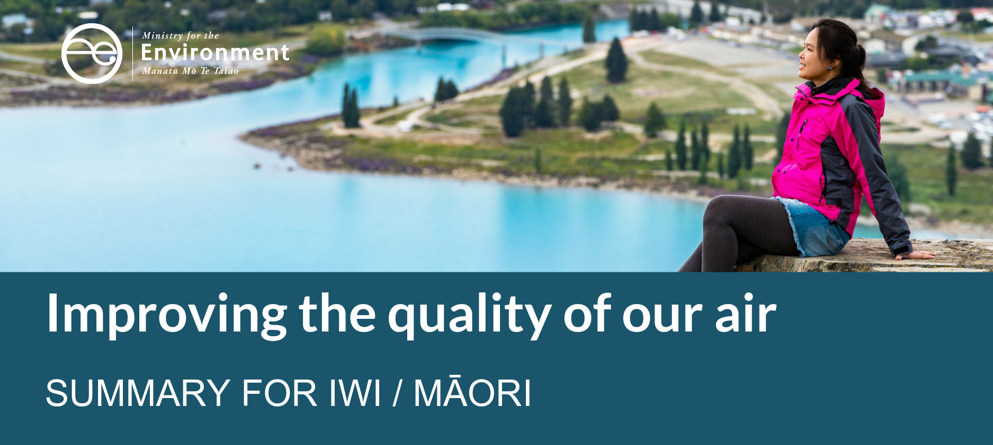

Proposed amendments to the National Environmental Standards for Air Quality: particulate matter and mercury emissions

Enhancing the mauri of our air in Aotearoa
Good air quality is critical to sustain all life on Earth. It is important to ensure the mauri and hau of our air is protected and enhanced through the exercise of kaitaikitanga. The mauri of our air can be compromised in many ways, such as through air contaminants and noise pollution. Diminished mauri upsets the balance within a system and affects the relationship between people and the environment, and the ultimate health of all living things.
Air quality is good in most places in Aotearoa and at most times of the year. We often take the air we breathe for granted. However, in some areas, poor air quality is a serious public health issue, with great social cost. Emissions from the way we heat our homes, how we get to work, and how and where we produce and process our everyday goods, can have direct, localised effects on the quality of our air.
In Aotearoa, air quality is managed through a range of regulatory tools. The main tool to enhance the mauri of our air is the National Environmental Standards for Air Quality (the Air Quality Standards). The Air Quality Standards were introduced in 2004 and amended in 2011. Advice and guidance from iwi strongly influenced the 2011 amendments. The Government is currently working on amendments to the Air Quality Standards.

What is being proposed?
The Government proposes to amend the Air Quality Standards in order to:
- take into account improved scientific understanding and evidence about the health impacts of particulate matter (fine airborne particles, small enough to be inhaled) in our air
- better target controllable sources of air pollution, for example wood and coal burners for home heating
- help Aotearoa to meet its obligations under the Minamata Convention on Mercury.

Account for health impacts associated with particulate matter
Exposure to air that is contaminated with particulate matter can have immediate effects on human health, such as itchy eyes and skin, shortness of breath, coughing or chest pain. Other health effects and diseases from exposure can take much longer to show, such as heart attack and stroke, and premature death from cardiovascular and respiratory causes. Exposure to particulate matter can also cause lung cancer and exacerbate asthma and emphysema.
The Air Quality Standards currently include regulations to limit particulate matter contaminants in our air. The standards are focused on PM₁₀, which includes the finer PM_{2.5} particles, as well as other coarser material. Some of these coarser particles come from natural sources, such as sea salt and volcanic eruptions, over which we have no control. Finer particles, which are more likely from human-made sources, have greater impacts on human health. We propose to:
- introduce PM_{2.5} as the primary regulatory tool to manage ambient (outdoor) particulate matter, and set these PM_{2.5} standards at levels recommended by the World Health Organization:
  - daily average standard of 25 µg/m³
  - annual average standard of 10 µg/m³
- retain the PM₁₀ standard for monitoring and managing coarse particles.
Regional councils (including unitary authorities) would be required to monitor and manage PM_{2.5} in their regions and notify the public if the standards have been exceeded. Councils are currently required to notify exceedances of the existing PM₁₀ standard on their websites and notices in local newspapers.
If an area has ongoing exceedances of the PM_{2.5} standards, regional councils would be restricted in their ability to issue resource consents for air discharges from new industrial activities that would increase PM_{2.5} concentrations in these polluted areas.
What is particulate matter?
Particulate matter is a collective term for particles suspended in the air that are small enough to be inhaled. Particulate matter can be solid or liquid. It varies greatly in structure and chemical composition, depending on where it comes from. It also varies in the harm it can cause.
Particular matter comes from human activities and natural sources. It is often classified according to its size because size determines how it interacts with the environment and the human body.
- PM₁₀ has a diameter of 10 micrometres (µm) or less.
- PM_{2.5} has a diameter of less than 2.5µm and is a subset of the PM₁₀ range.
- Ultrafine particles are even smaller (less than 0.1µm or 25 times smaller than PM_{2.5}).
You can view information about PM₁₀ levels in your region on the Land, Air, Water Aotearoa website: https://www.lawa.org.nz/explore-data/air-quality/.

Control emissions from burning wood and coal for home heating
Across the country, burning wood and coal is a common way to keep our homes warm and dry in winter. However, smoke from wood burners, coal burners, pellet burners, multi-fuel burners, cookers and water boilers (domestic solid-fuel burners) is one of our main sources of PM_{2.5}. Other sources include vehicle exhausts and industrial emissions. The Government proposes to:
- reduce the emission standard for new solid-fuel burners to no more than 1.0g/kg (down from 1.5g/kg in the current Air Quality Standard)
- include all types of new, domestic solid-fuel burners under the existing wood-burner regulations for emissions limits and thermal efficiency. Buildings on properties larger than two hectares in size would be able to use any type of solid-fuel burner (regardless of whether they meet the 1.0g/kg emissions standard).

Regulate mercury emissions from industrial processes
In 2013, Aotearoa signed the Minamata Convention on Mercury (the Convention), an international treaty to address the health impacts of mercury. One of main steps we need to take to ratify the Convention is to set controls on mercury emissions to air.
This requires amendments to the NESAQ that will:
- prohibit the use of mercury in industrial processes, including processes to produce certain chemicals (including chlor-alkali, acetaldehyde, sodium, potassium and others) and plastics (such as polyurethane)
- incorporate international best practice guidance that decision-makers must consider for sources of mercury emissions listed in the Convention, including coal-fired power plants and industrial boilers, metal smelting and roasting processes, waste incineration and cement clinker production.

The proposed amendments would not affect councils’ ability to develop and implement rules that are more stringent than the NESAQ. This ensures councils’ retain the flexibility to manage air quality issues in a way that meets the needs of their communities.

What would the proposed amendments mean for Māori?

Reduced exposure to fine particulate matter
Airborne particulate matter, especially PM_{2.5}, can diminish the mauri of our air and affect the health of our whānau, hapū and iwi. Tamariki and kaumātua are particularly susceptible to health impacts associated with exposure to PM_{2.5}. The proposed changes would have a direct impact on improving people’s health and wellbeing by enhancing the mauri of the air we breathe.
The proposed amendments would direct regional councils and unitary authorities to focus on regulating emissions of PM_{2.5}, rather than PM₁₀, when exercising their responsibilities under the NESAQ to manage air quality within their regions. This would affect how councils make planning and consenting decisions.

Stricter standards for newly-installed domestic solid fuel burners
For the homeowner, the proposed amendments would require all newly-installed domestic solid-fuel burners to meet a stricter standard for particulate matter emissions. The proposal would however, allow you to continue using your existing domestic solid-fuel burners. As older burners are replaced with newer, cleaner burners (or other heating appliances such as heat pumps), the air in neighbourhoods that currently experience smoke and smog in winter will become cleaner over time. Buildings on properties larger than two hectares would remain excluded from the burner regulations.
See the Ministry’s website for a list of solid-fuel burners that have been assessed under the NESAQ: https://www.mfe.govt.nz/woodburners.

Ongoing protection from exposure to mercury emissions
Mercury emissions do not currently present significant air quality issues in Aotearoa, as all of our industrial sources of mercury are already following best practice. The amendments will help to ensure that mercury emissions to air do not become a concern in the future.

What happens next?
The consultation on the proposed amendments to the National Environmental Standards for Air Quality opened on 26 February 2020 and will run until 24 April 2020. Staff from the Ministry will meet with iwi and hapū in areas with known air quality issues in March and April to seek advice and guidance on the proposals.
After the consultation period closes, staff from the Ministry will summarise and analyse the submissions, then refine and progress the policy proposals before providing advice to the Minister to amend the Air Quality Standards. Final policy decisions will be made by the Government.
To support implementation of the amendments, the Ministry will update its user guidance for the Air Quality Standards.

A few questions you might like to think about
- Does your whānau, hapū or iwi use a solid fuel burner for heating your kainga, wharenui or other buildings, for example, at the marae? What impact do you think the proposed amendments may have? How else do you think the proposed amendments to the NESAQ will impact your whānau, hapū and iwi?
- As the Government, we need to meet our treaty obligations. Regional councils will need to consider how they partner with iwi to implement the proposed amendments. Do the proposed amendments provide for this?
- The proposals will gradually reduce PM_{2.5} emissions from domestic solid-fuel burners by requiring newly-installed burners to meet stricter standards. Do you think this is the best approach?
- What else do you think the Government should consider in this process of amending the Air Quality Standards to increase the mauri of the air we breathe and decrease health effects associated with poor air quality?

Find out more
The Government seeks your advice and feedback on the proposed amendments to the National Environmental Standards for Air Quality.
- Formal consultation runs from 26 February to 24 April 2020
- Download the consultation document Proposed amendments to the National Environmental Standards for Air Quality: particulate matter and mercury emissions, available at www.mfe.govt.nz/consultations/improving-our-air
- Contact us:
Email: AirQualityNESsubmissions@mfe.govt.nz
Postal: Ministry for the Environment, PO Box 10362, Wellington 6143

Published in February 2020 by the
Ministry for the Environment
Publication number: INFO 929
