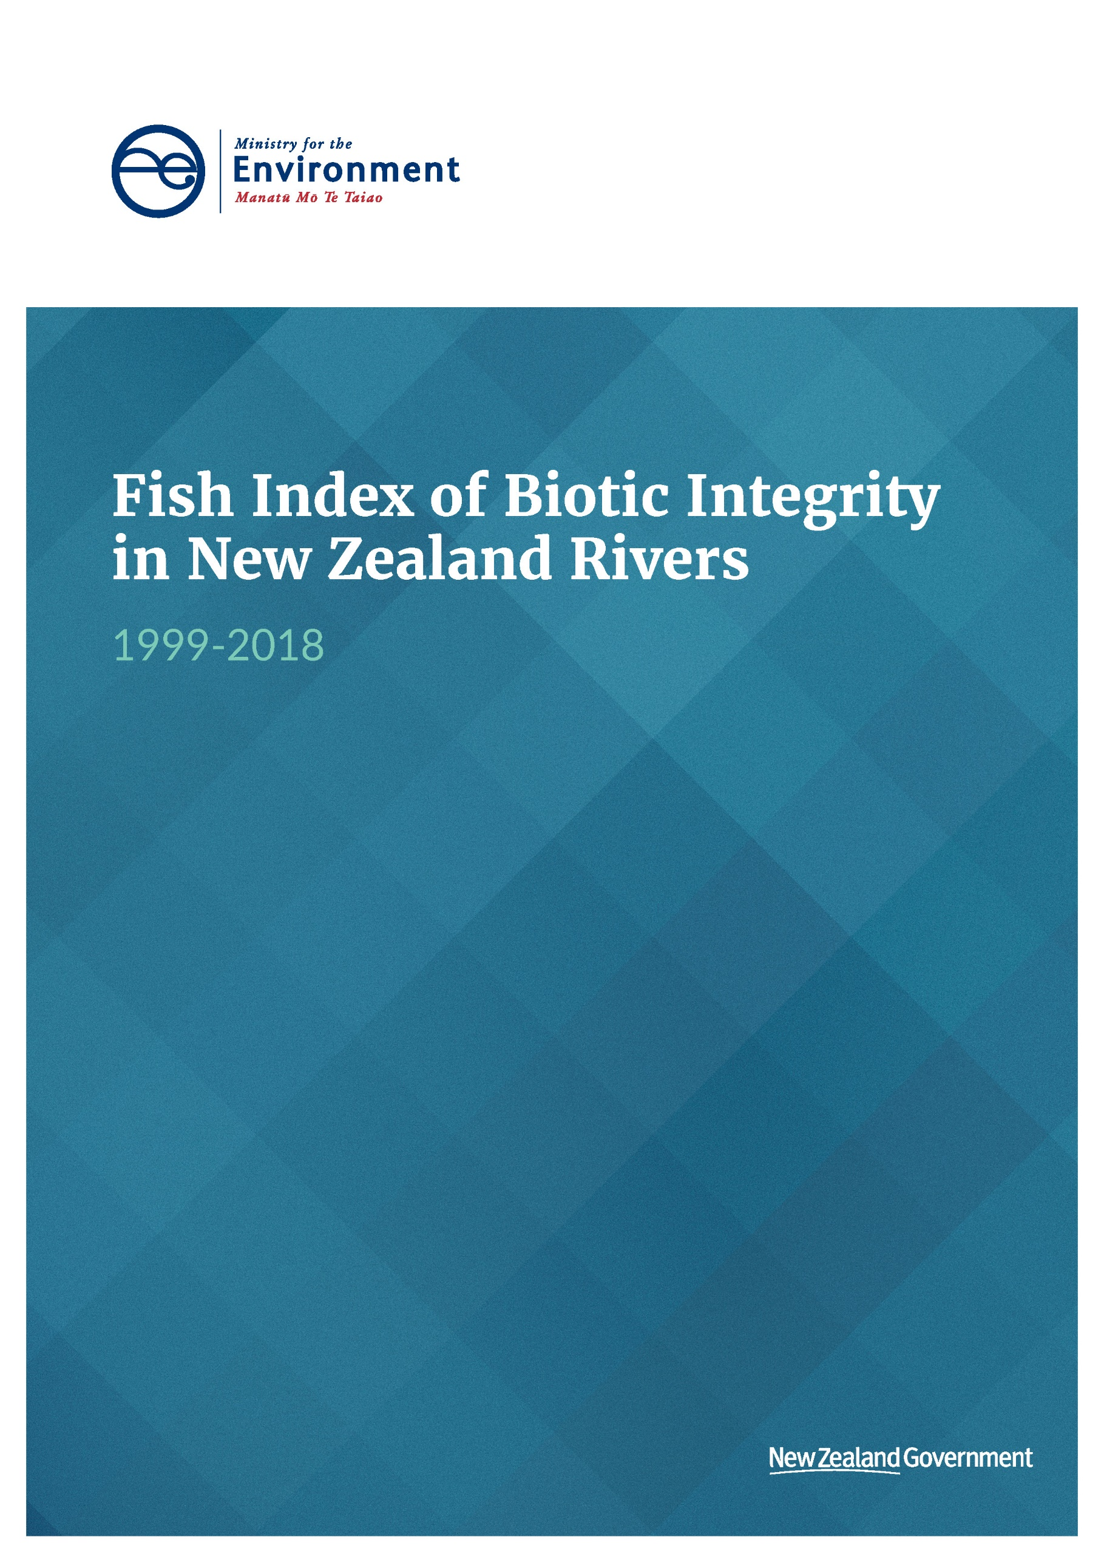

Acknowledgements
This report was prepared by Akika Takada, Isaac Bain, Dani Metin, Beckie Calder-Flynn and Chris Daughney from the Ministry for the Environment. The authors would like to acknowledge Mike Joy (Victoria University of Wellington) and Rick Stoffels (NIWA) for helpful discussions.

This document may be cited as: Ministry for the Environment. 2019. Fish Index of Biotic Integrity in New Zealand Rivers 1999–2018. Wellington: Ministry for the Environment.

Published in February 2020 by the
Ministry for the Environment
Manatū Mō Te Taiao
PO Box 10362, Wellington 6143, New Zealand
ISBN: 978-1-98-857972-6
Publication number: ME 1487
© Crown copyright New Zealand 2020
This document is available on the Ministry for the Environment website: www.mfe.govt.nz.


Contents
Introduction 5
Methods 7
Data sources 7
Representation of fish occurrence 8
Statistical and spatial analysis 9
Results and discussion 11
Spatial variation of Fish Index of Biotic Integrity (IBI) scores 11
Association of Fish IBI scores with land cover 19
Conclusion 20
Summary of findings 20
Limitations and recommendations for future work 20
References 22

Tables
Table 1: Concordance between the four land cover categories used in this study, and the 33 land cover classes in LCDB4 8

Figures
Figure 1: Fish IBI score at the monitoring site scale 12
Figure 2: Mean fish IBI score within regions 13
Figure 3: Distribution of IBI score within regions 14
Figure 4: Regional variations in the means of the six individual metrics used to calculate
fish IBI 15
Figure 5: Proportion of native species (metric 6) for individual NZFFD records 16
Figure 6: Mean fish IBI score within sea-draining catchments 17
Figure 7: Mean fish IBI score within third-order catchments 18
Figure 8: Mean fish IBI scores according to percentage of upstream pastoral, urban, exotic forest and native land cover 19

Introduction
New Zealand’s freshwater environments support more than 50 known native fish species (Dunn et al, 2018). There is a high degree of endemism, with 92 per cent of New Zealand’s named native fish species found nowhere else in the world (Joy and Death, 2013). New Zealand’s native freshwater fish species have several unusual characteristics: most are small, benthic, largely nocturnal, and more than half are diadromous, moving between the sea and freshwater habitats during their lifecycle (Joy and Death, 2013).
The objective of this study is to update previous analyses of New Zealand’s freshwater fish communities with the most recent observational data, in order to create a national Fish IBI dataset. The study will also investigate options for including this data as an Environmental Reporting Indicator. Categorisation of upstream land cover is also explored as a potential explanatory variable and stressor on fish community composition.
The investigation will improve insights into fish occurrence for the Environmental Reporting programme operated jointly by Ministry for the Environment and Statistics New Zealand, and ultimately inform effective management of freshwater ecosystems.
Background
New Zealand’s endemic freshwater fish species have declined over time (Joy et al, 2018, in line with freshwater biodiversity trends observed globally (Dudgeon et al, 2006). In 2017, 76 per cent of New Zealand’s native freshwater fish species were threatened with, or at risk of, extinction (Dunn et al, 2018; Ministry for the Environment and Stats NZ, 2019).
A number of interacting and cumulative stressors have contributed to the decline of New Zealand’s native freshwater fish:
- non-native fish can affect native fish species through predation and competition for food (Joy and Death, 2013)
- excess sediment can damage fish gills and settle to the bottom of rivers and lakes, filling the spaces between rocks and boulders, and degrading the habitats that fish rely on (Joy, 2014b; Lowe et al, 2015)
- elevated concentrations of nutrients such as nitrogen and phosphorus can promote algal blooms, which in turn can decrease dissolved oxygen concentrations and cause stress for fish species (Goodman, 2018)
- structures in waterways (for example, weirs, dams and culverts) and changes to river flows can disrupt or block migration, and are a significant and ongoing threat to our native fish (Ministry for the Environment and Stats NZ, 2017; Franklin et al, 2018; Goodman, 2018).
Decline of freshwater fish communities has potentially wide-ranging consequences. Fish play critical roles in nutrient cycles, transporting nutrients across habitat boundaries and transforming nutrients from one form (for example, particles) to another (for example, dissolved), which in turn affects how the freshwater food web functions (Townsend, 1996; Jeppesen et al, 2010). Degraded fish communities also adversely impact cultural health and mana of a waterway; Māori depend on taonga species like tuna and inanga for mahinga kai, and these species feature in traditional songs and stories, as well as acting as cultural health indicators for water bodies. Losing the ability to collect mahinga kai can jeopardise the mana of an iwi in relation to providing food for guests (Collier et al, 2017). A healthy freshwater environment can also support recreational and sport fishing (Ministry for the Environment and Stats NZ, 2017).
New Zealand does not currently operate a national monitoring programme to assess the health of its freshwater fish communities (or any trends in health indicators), despite the current at-risk status of these communities, the multiple stressors affecting them, and the potential ecological, social and cultural consequences of further decline. Some government departments, non-government organisations (NGOs) and regional councils operate monitoring programmes (David et al, 2016; Mitchell and Heath, 2019), but differences in methodologies used complicate comparisons at a national level.
In the absence of coordinated monitoring, national-scale assessments of freshwater fish communities have been based on analysis of records from the New Zealand Freshwater Fish Database (NZFFD) maintained by NIWA. The NZFFD contains over 140,000 records, created by a wide range of individuals and organisations, and dating back to 1901. The records in the NZFFD are based on many different fishing methods, and covariates include location, elevation, distance from coast, and so on. (Joy et al, 2018). Patchy information is available for abundance and size. Recent development of a national sampling protocol (Joy et al, 2013) is likely to improve the consistency and amount of fish monitoring data available in the future. Protocols for monitoring fish communities of lakes, wetlands, and larger rivers have yet to be developed or applied widely.
Some previous national-level assessment of records from the NZFFD have sought mainly to understand temporal trends in fish occurrence. For example, Crow et al (2016) used models to assess trends in the national-scale probability of capture of 11 species. This study showed that four native species (longfin eel, kōaro, Canterbury galaxias, and common bully) and two exotic species (rainbow trout and brown trout) had declined in abundance over the 39 years from 1977 to 2015, while upland bully and shortfin eel had increased in abundance over the same period. Another study by Joy et al (2018) assessed national-scale trends in fish occurrence and the Index of Biotic Integrity (IBI) across different land cover categories. This study showed that the average IBI declined over time in areas of pasture-dominated land, and that 75 per cent of the 20 assessed fish species had declining abundance over time. These studies provided important information about temporal trends in fish abundance, but did not incorporate a detailed assessment of their spatial variation.
Other previous national-scale assessments of records from the NZFFD have primarily sought to understand spatial variations in fish occurrence. For example, Crow et al (2014) and Canning (2018) developed spatial models to predict fish presence, based on a suite of variables related to environmental conditions, hydrological variation and other predictors. These two studies used different modelling approaches and different sets of predictor variables but produced similar conclusions about the spatial distribution of specific species. Canning (2018) also assessed the observed versus expected (O/E) distributions of fish species, and concluded that reduced fish abundance in many river reaches, particularly in lowland rivers and parts of the central North Island, was primarily due to nutrient enrichment, barriers to fish passage, and loss of riparian vegetation. These studies provided important information about spatial variations in the occurrence of particular fish species, but did not assess temporal trends.

Methods

Data sources

Fish occurrence data
Recorded observations of fish occurrence were extracted from the New Zealand Freshwater Fish Database (NZFFD) on 19 August 2018. Only the NZFFD records based on backpack electrofishing were retained, following the approach taken in recent studies. This approach was taken to avoid potential biases from differences in sampling methods (Canning, 2018; Joy et al, 2018). This means that the dataset used in this study is biased towards wadeable sections of rivers, as opposed to larger non-wadeable sections where the backpack electrofishing method cannot be applied. There were 51,726 backpack electrofishing records in the NZFFD, covering 1964 to 2019.
Following the method used by Joy et al (2018), all records were converted into occurrence data (presence versus absence), because information on fish abundance is not available for all records in the NZFFD.

Regional and catchment boundaries
The geographic boundaries of New Zealand’s 16 regional authorities were obtained from Stats NZ.
The boundaries of 10,131 catchments that drain to the sea (sea-draining catchments) were obtained from version 1.0 of the Freshwater Environments of New Zealand (FENZ) database (Leathwick et al, 2010).
The spatial boundaries of 14,098 third-order planning units were obtained from the Department of Conservation (West et al, 2018). The sub-catchments used as planning units in this analysis were based on the third‐order sub-catchment layer contained in FENZ. Sub-catchment data were edited extensively to ensure that all sub-catchment linkages were correctly specified, and that sub-catchment polygons around larger lakes were correctly defined.

Land cover data
Land cover data were obtained from the New Zealand Land Cover Database (LCDB) version 4.1 (Stats NZ 2018). LCDB 4.1 provides a national classification of land cover, mapped using satellite imagery, with four survey periods: summer 1996/97, summer 2001/02, summer 2008/09, and summer 2012/13.
The 33 land cover categories from LCDB 4.1 were mapped to four land cover categories for this study (table 1). These four categories have been used to evaluate the influence of land cover on water quality (for example, Ministry for the Environment and Stats NZ, 2019). The Intensive Agriculture class is a combination of three LCDB land cover classes, which are proposed to better reflect agricultural pressure on water quality than using the single High Producing Grassland class alone (McDowell et al, 2012; Larned et al, 2016).
Table 1: Concordance between the four land cover categories used in this study, and the 33 land cover classes in LCDB4
Landcover categories used in this study | LCDB4 Class Number | LCDB4 Class Name
Native Forest | 69 | Indigenous Forest
Exotic Forest | 71 | Exotic Forest
Urban | 1 | Built-up Area (Settlement)
Urban | 2 | Urban Parkland/Open Space
Intensive Agriculture | 40 | High Producing Grassland
Intensive Agriculture | 30 | Short-rotation Cropland
Intensive Agriculture | 33 | Orchard Vineyard & Other Perennial Crops

Representation of fish occurrence
Previous national-scale studies based on the NZFFD have used various methods to quantify fish community composition. One approach is to calculate the probability of capture for individual species, for example on a scale from 0 to 1, which can then visualised spatially (Crow et al, 2014) or as changes through time (Crow et al, 2016). This approach has the advantage of providing detailed spatial and temporal information about the occurrence of a particular species, but requires comparison of several different maps for individual species to gain perspective on fish community composition or richness. A second approach is to calculate metrics that compare species present with those expected to be present under reference conditions (observed/expected or O/E) (Canning, 2018). A challenge for application of this method in New Zealand is that there are at present few sites (or NZFFD records) that represent reference conditions; that is, meeting a specified level of naturalness due to no or limited human influence. This limitation can be addressed by modelling the observed fish distribution based on a number of anthropogenic stressors, then predicting the expected fish distribution under reference conditions when those stressors are reduced (Canning, 2018).
We selected the Fish Index of Biotic Integrity (IBI) as the preferred method for quantifying species’ richness in this study, because it has the advantage of synthesising data about several individual species into an overall score, and does not require complex modelling of reference conditions. The Fish IBI was adapted to New Zealand by Joy and Death (2004) to account for the unique attributes of New Zealand freshwater fish, such as low species diversity and a high proportion of migratory species. The main assumption is that the expected species richness is constant for any given distance inland and elevation, and assumes no influence of climate, river geomorphology, and so on.
Fish IBI is a composite index composed of six metrics of fish community composition:
- total number of native species
- number of native riffle-dwelling species
- number of native benthic pool-dwelling species
- number of native pelagic species
- number of intolerant or sensitive native species
- proportion of non-native species.
Each metric was scored as described below, then the metric scores were summed to determine the value of Fish IBI, ranging from 0 (no fish) to 60 (maximum score possible) at each site.
Each of the first five metrics were scored using two sub-metrics representing potential species richness, relative to a) elevation and b) distance from the sea. Unlike the previous scoring method (Joy and Death, 2004), we applied quantile regression to ensure consistency and increase the repeatability of the scoring approach for each sub-metric. Assuming that sites were equally distributed across all levels of environmental quality, two Species Richness Lines (SRLs) (based on the 33 and 67 per cent quantiles) were calculated for each sub-metric.
- The maximum sub-metric score of 5 was assigned to sites where the observed species richness was above the 67 per cent quantile SRL.
- A score of 3 was assigned to sites with species richness between the 33 and 67 per cent quantile SRLs.
- The minimum score of 1 was assigned for sites with species richness less than the 33 per cent quantile SRL.
- The scores for the two sub-metrics were summed, resulting in a range of scores from 2 to 10 for each of the first five metrics.
All 64 species observed using backpack electrofishing records in the NZFFD were used to define these SRLs.
Metric 6 was scored based on the proportion of native species.
- The maximum score of 5 was given to sites at which native species accounted for 67 per cent of all species observed.
- A score of 3 was assigned to sites at which native species accounted for between 33 and 67 per cent of all species observed.
- The minimum score of 1 was assigned to sites at which native species accounted for less than 33 per cent of the total number of observed species.
- The score from metric 6 was doubled to provide a score of between 2 to 10 for each site (as this metric was assumed to not be associated to elevation or distance to sea).
NZFFD records were included for all seasons. This maximises the amount of data available, but means that effects of seasonal fish migrations are not accounted for (Canning, 2018).

Statistical and spatial analysis
Statistical and spatial analyses were performed in R version 3.6.1 to assess spatial variations in fish IBI. Summary statistics were calculated using the Tidyverse family of packages. Scoring was performed using custom wrapper functions for quantile regression from the quantreg package. Spatial intersection used the sf package.
The first step in the analysis was to generate maps of site-specific IBI scores, to explore the spatial distribution of the NZFFD records. This step was primarily to determine the degree to which the NZFFD records were (or were not) spatially or temporally uniform, and to identify any potential biases that could be introduced by aggregating site-specific IBI scores into spatial units (for example, catchments) or time periods (for example, a 5- or 10-year time window).
The second step in the analysis was to investigate the appropriateness of spatial scales for aggregation of the results. NZFFD records were divided into spatial units based on:
- regional council boundaries
- sea-draining catchments
- third-order catchments.
The spatial units were chosen because they cover a range of sizes, management boundaries and, in the case of the latter two, are hydrologically based.
The third step in the analysis was to calculate and compare descriptive statistics such as median, mean, minimum and maximum site IBI for each combination of spatial unit.
Finally, the NZFFD records within different spatial units were compared according to the percentage of each land cover category upstream, using the four categories:
- native forest
- exotic forest
- intensive agriculture
- urban.
We divided sites into three categories based on the percentage of each of the four land cover categories; less than 33 per cent, 33 to 66 per cent, and greater than 66 per cent.

Results and discussion

Spatial variation of Fish Index of Biotic Integrity (IBI) scores

Variation in Fish IBI score at the monitoring site scale
Figure 1 shows the sites coloured by their calculated Index of Biotic Integrity (IBI) scores. There are distinct areas of relatively low IBI scores in the Southland, Otago, and central North Island region. These spatial patterns, discussed in more detail below, are broadly similar to results from previous studies (for example, Canning, 2018).
The 20-year period between 1999 and 2018 was selected to align with other Environmental Reporting indicators, and provide a reasonable trade-off between having recent data, and having enough data. It was uncommon for sites to be sampled more than once during this period (fewer than 100 sites met this criteria), and very uncommon for sites to be sampled more than three times (fewer than five sites). This meant that assessing trends in IBI score across multiple years for the same site was not possible, so aggregation of multiple sites to a nearby spatial unit was investigated.
Figure 1: Fish IBI score at the monitoring site scale
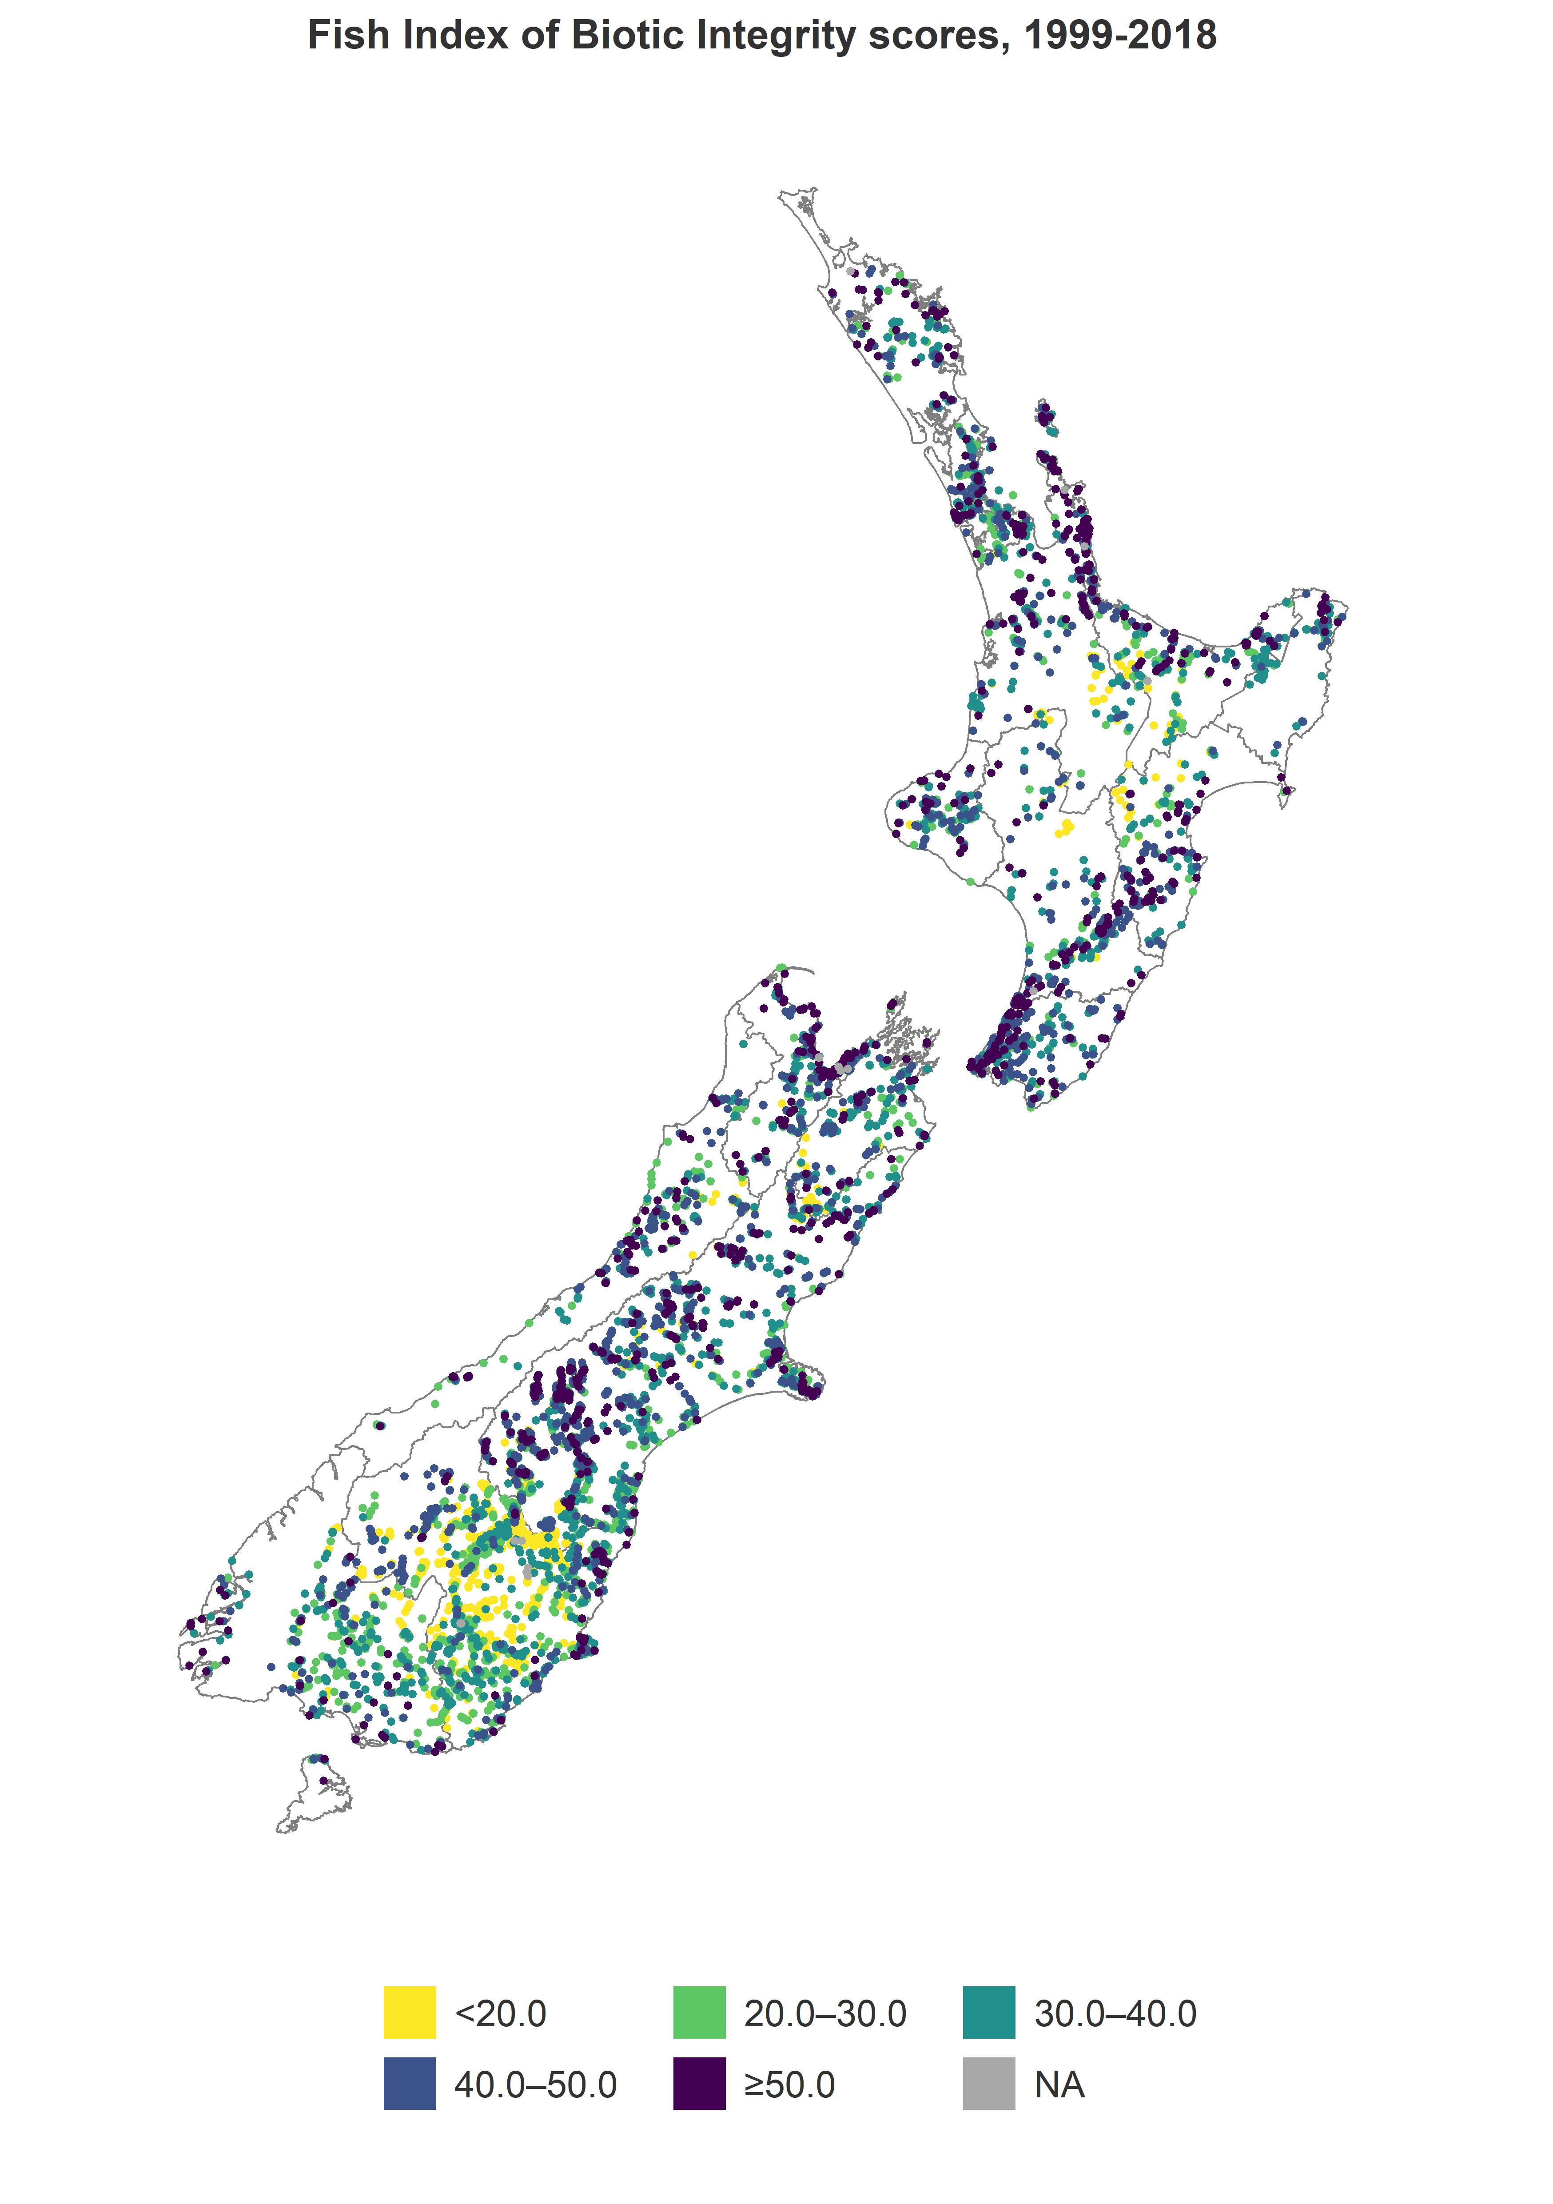

Variations in Fish IBI between regions
Mean and median Fish IBI scores ranged between 30 and 50 for most regions, except for Otago, which had scores lower than 30 for both statistics. There was variation within regions (figure 3), with most regions achieving both the theoretical maximum and minimum IBI score in at least one location. This is to be expected, given the full gradient of ecosystem health pressures in every region.
Figure 2: Mean fish IBI score within regions
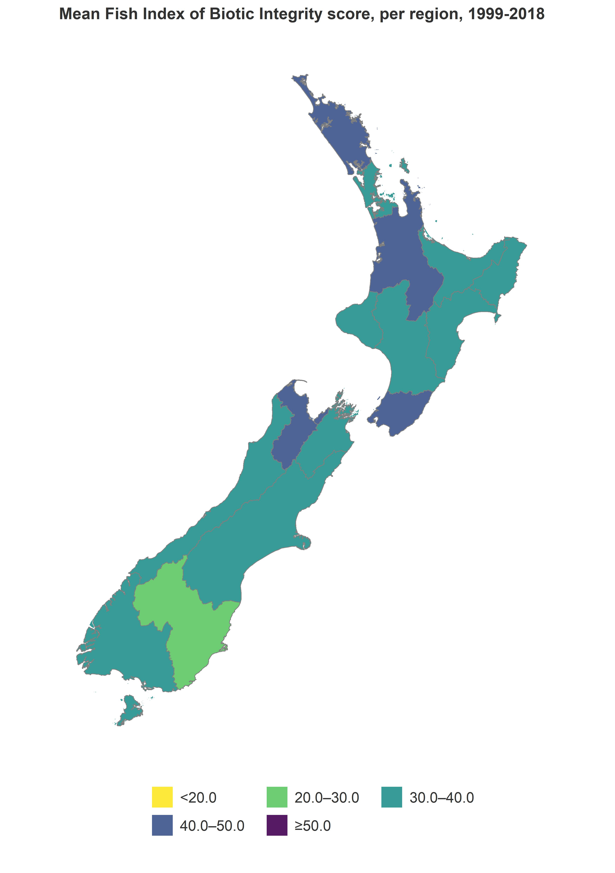
Figure 3: Distribution of IBI score within regions
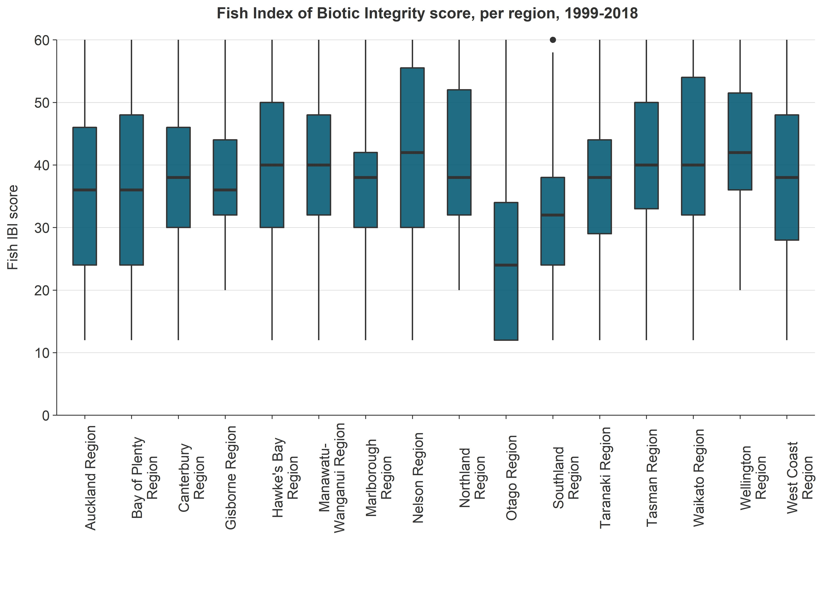
We investigated the six individual metrics that are used to calculate Fish IBI (figure 3). Metrics 4 and 5 tend to have relatively low scores for most regions. This may suggest that an absence of sensitive and/or pelagic species are among the most common drivers of low Fish IBI scores. On the other hand, metrics 1, 2 and 6 tend to have relatively high scores for most. This may suggest that a decline in the absolute number of native species, or the ratio of native to non-native species, are not the main drivers of low Fish IBI scores.
The previous discussion showed that the Otago region has low Fish IBI scores compared to most other regions. Figure 4 shows that the Otago region has low scores for all of the individual metrics; in other words, there is no single metric that is especially low and acting to drag the overall Fish IBI score down for the Otago region. The Auckland region has the lowest scores for metric 2. It is not clear which specific stressors may be affecting individual metrics in these regions.
Figure 4: Regional variations in the means of the six individual metrics used to calculate fish IBI
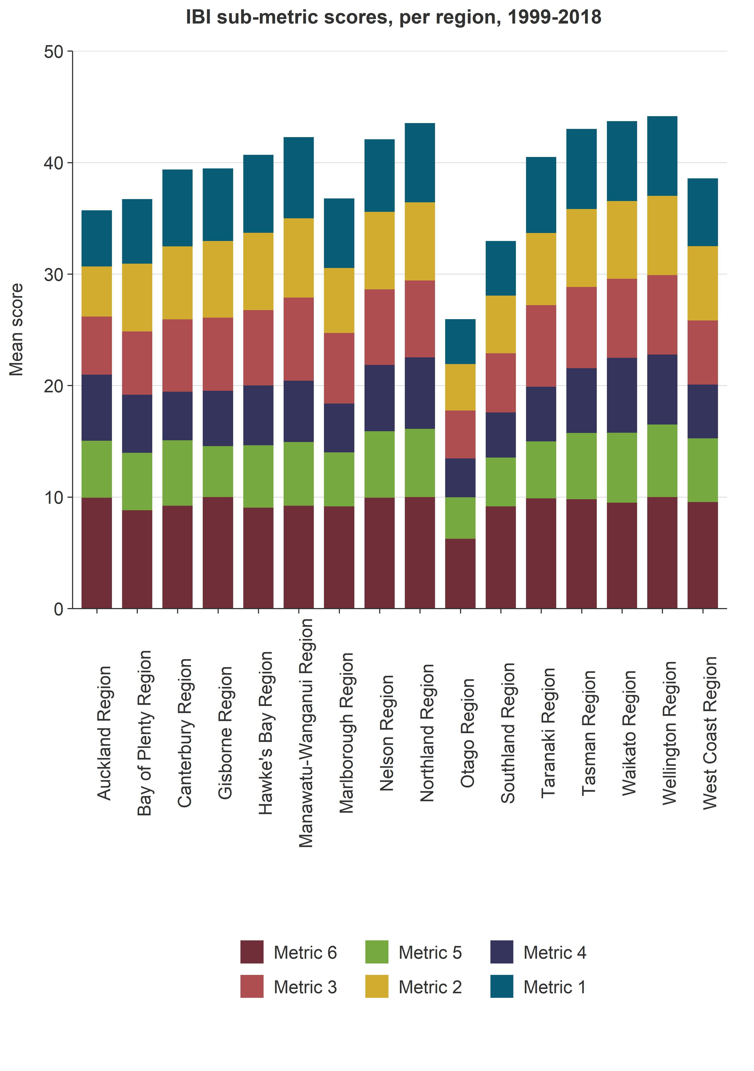
Plotting the individual metrics spatially offers insight into the specific contributors to the overall fish IBI scores. For example, figure 5 shows the proportion of native species (metric 6) for individual NZFFD records across the four time-periods used in this study. There are parts of the country in which native species dominate the fish assemblages for the majority of NZFFD records, but there are several areas, such as parts of Otago and in the central North Island, where fewer than 20 per cent of observed species were native.

Figure 5: Proportion of native species (metric 6) for individual NZFFD records
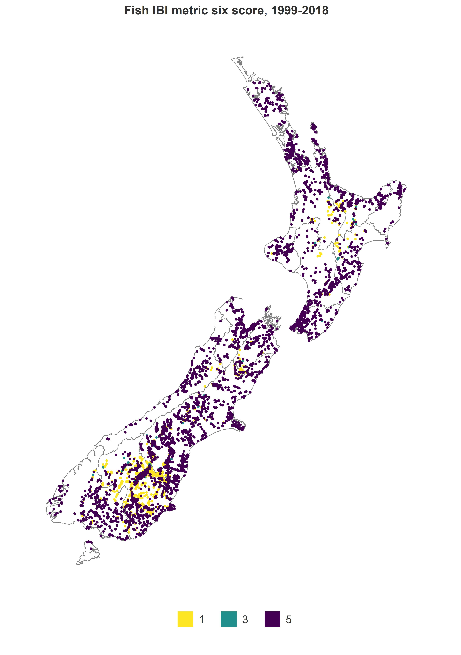
Note: Scores correspond to native species as a percentage of all species observed: a score of 1 indicates less than 20 per cent; 2 indicates 20–40 per cent, 3 indicates 40–60 per cent, 4 indicates 60–80 per cent, and 5 indicates over 80 per cent.

Variations in Fish IBI between sea-draining catchments and over time
The regional comparison in the last section is limited in that regional council boundaries encompass many catchments, and are not always strictly hydrologically based, so do not provide insight into the status of fish communities within individual catchments or waterways.
We therefore assessed the temporal variation of Fish IBI across the seven-year time periods within each sea-draining catchment (figure 6). Only those sea-draining catchments that had at least five NZFFD records within the given time period were retained for this analysis. In general these were the largest of the sea-draining catchments.
We conclude that this manner of displaying the Fish IBI is limited when compared to displaying the IBI score for each site (as in figure 1). This is because of the relatively low number of NZFFD records in some catchments, leading to biases and difficulty in interpreting the resulting mean or median values.
Figure 6: Mean fish IBI score within sea-draining catchments
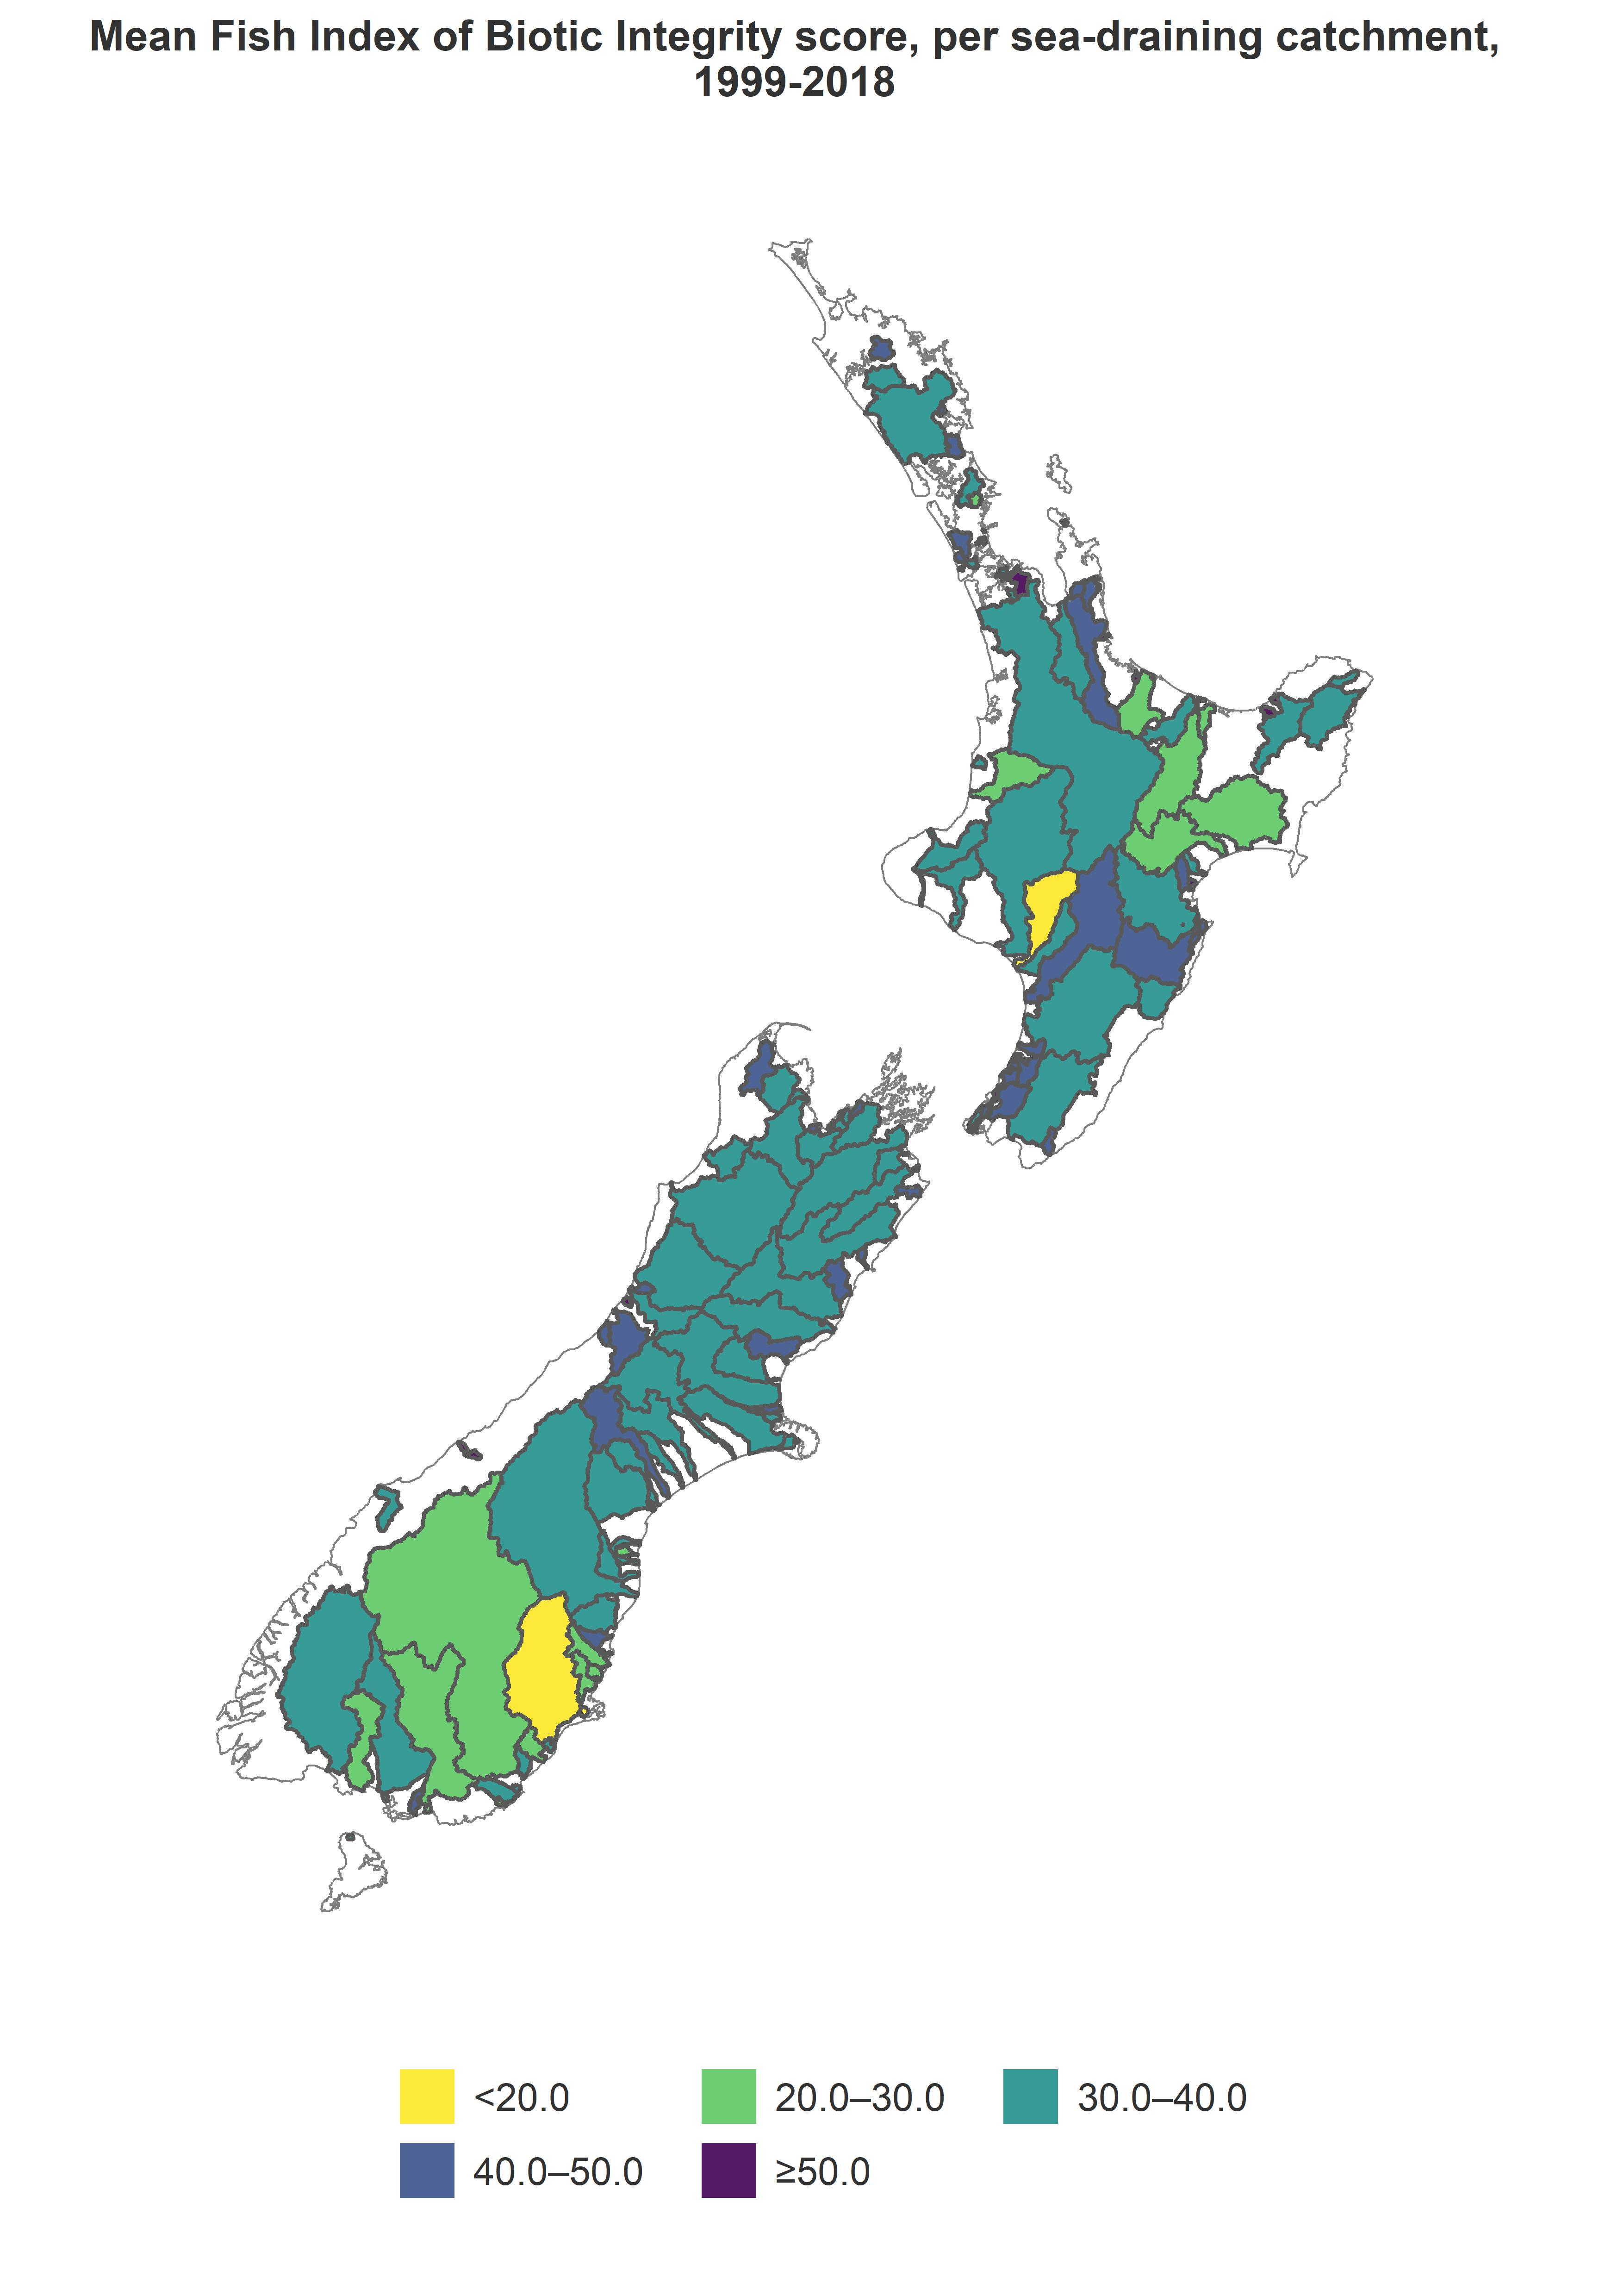
Note: Plots only show sea-draining catchments that have at least five NZFFD records within the given time period.

Variations in Fish IBI between third-order catchments and over time
The large majority of third-order catchments have too few NZFFD records to assess the temporal changes in Fish IBI (figure 7). National-level conclusions therefore cannot be drawn when NZFFD records are aggregated by third-order catchments, making this type of map unsuitable for Environmental Reporting.
Figure 7: Mean fish IBI score within third-order catchments

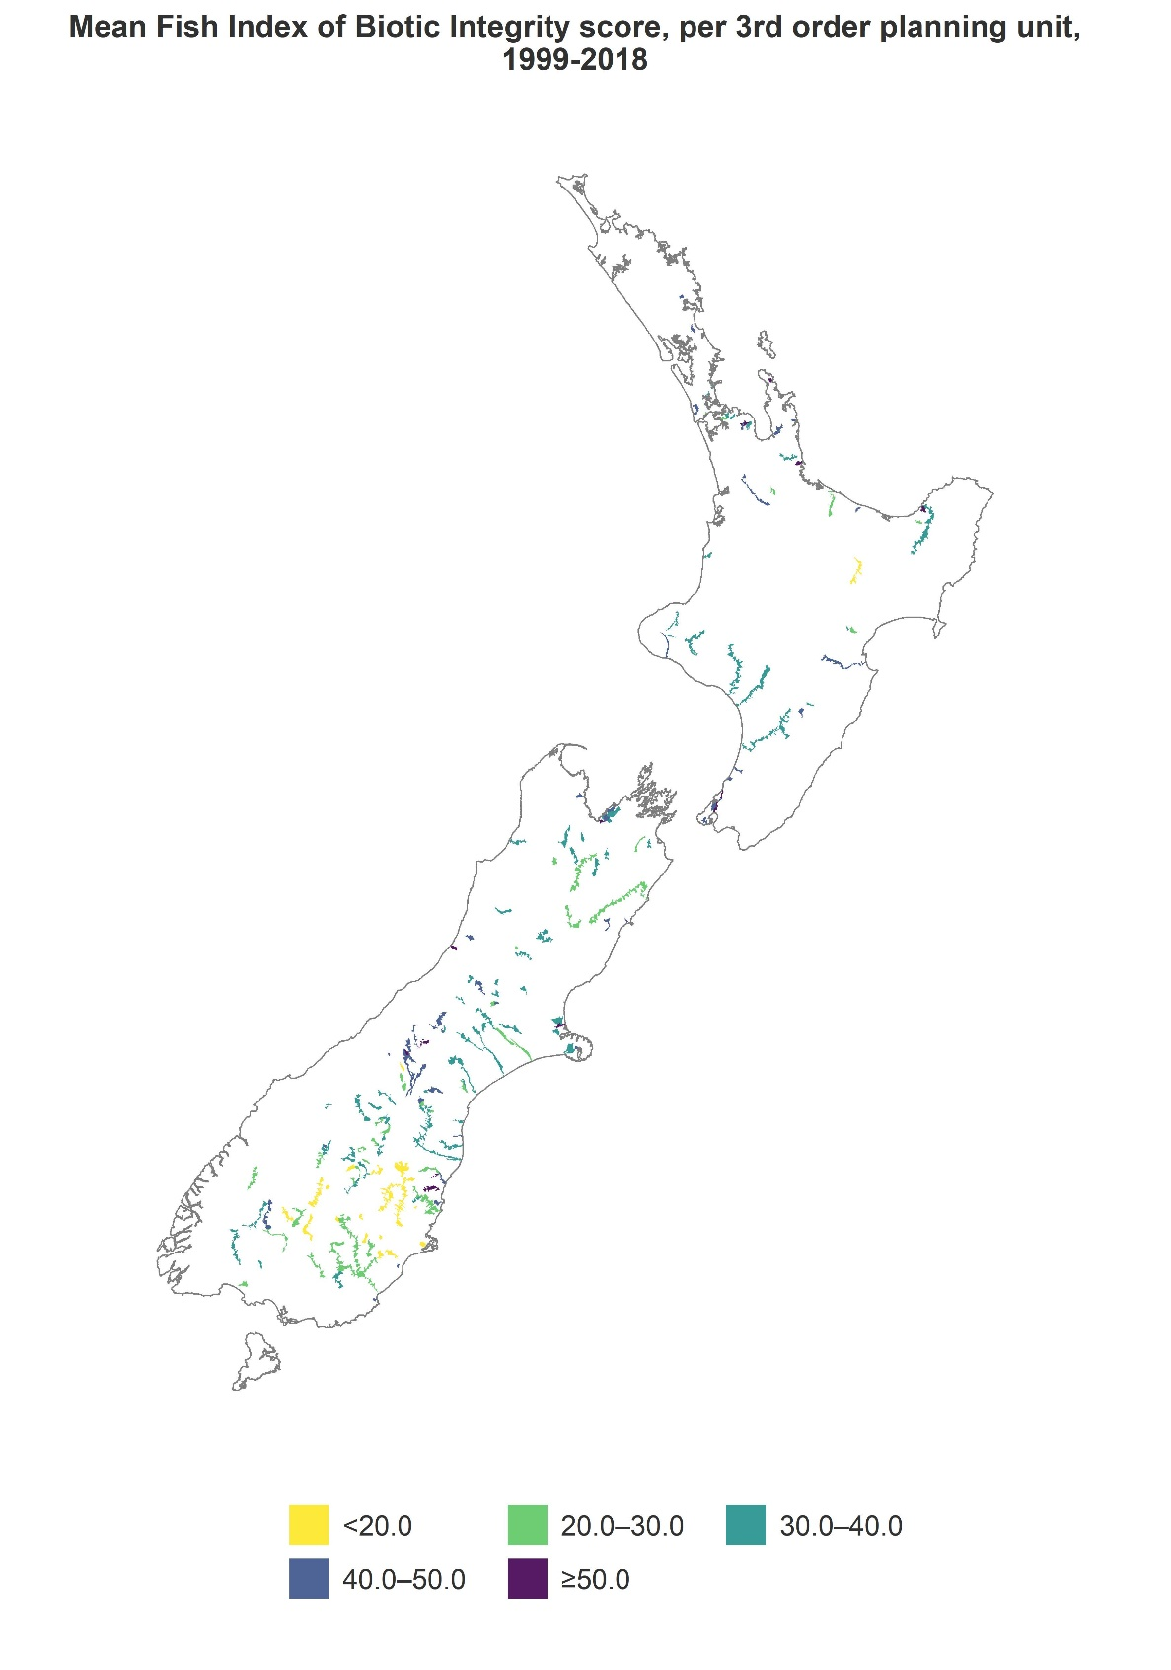
Note: Plots only show third-order catchments that have at least five NZFFD records within the given time window.

Association of Fish IBI scores with land cover
Mean Fish IBI scores increased with the percentage of native land cover upstream, and generally decreased with the percentage of upstream pastoral or exotic forest land cover (figure 8). The impact of upstream urban land cover was less clear, potentially because of the small number of NZFFD records available for predominantly urban catchments. The cyclical nature of exotic forest harvest may also confuse these results, as ecosystem health pressures can be extreme during harvest but relatively low the rest of the time.
Figure 8: Mean fish IBI scores according to percentage of upstream pastoral, urban, exotic forest and native land cover
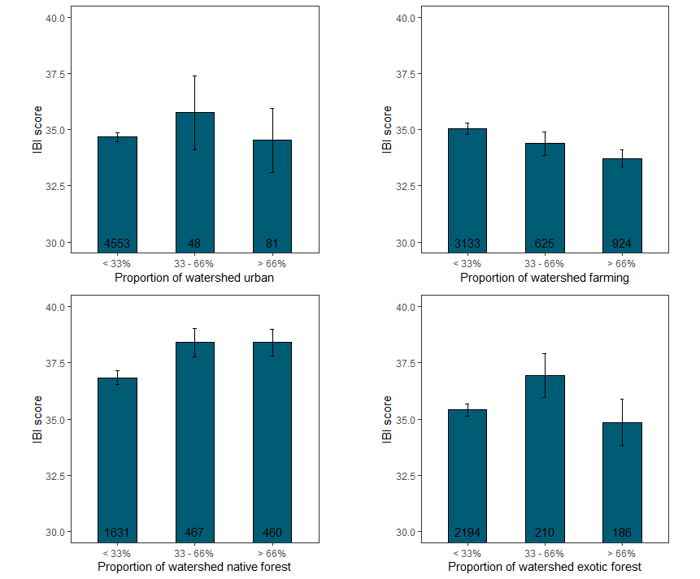
Note: Standard errors are shown by the error bars. Numbers at the base of each bar indicate the number of NZFFD records used to calculate the mean Fish IBI score.
The results of this comparison of Fish IBI scores to upstream land cover are generally similar to previous studies. Joy (2009), Canning (2018) and Joy et al. (2018) concluded that Fish IBI scores were generally highest at sites dominated by upstream native land cover, and significantly lower at sites dominated by upstream pasture, urban or exotic forest land cover.

Conclusion

Summary of findings
The objective of this study was to provide an update in our understanding of spatial patterns in fish occurrence, taking into account more recent observational data than previous studies. A second aim of this study was to select spatial aggregation of New Zealand Freshwater Fish Database (NZFFD) results that will allow enough samples from each group to calculate robust descriptive statistics (for example, median, mean), while also allowing significant differences between categories to be detected.
Some spatial factors in fish occurrence and community composition were identified, as shown by calculation of site-specific, regional and catchment Fish Index of Biotic Integrity (IBI) scores for selected time windows over the period 1999–2018. For example, mean and median Fish IBI scores are typically in the range of 30 to 50 for most parts of New Zealand, although lower scores were observed for parts of Southland, Otago and the central North Island. (These areas have a high proportion of non-migratory native fish species, which could result in IBI scores being low but not necessarily indicative of poor fish communities. Further methodological improvements related to reference condition are needed to fully resolve this.)
Upstream land cover was found to have an association with Fish IBI scores. Scores increased with the percentage of native land cover upstream, and generally decreased with the percentage of upstream pastoral or exotic forest land cover. The impact of upstream urban land cover was less clear.

Limitations and recommendations for future work
New Zealand does not have a coherent national-scale programme to monitor fish occurrence. Without this direction, the number of NZFFD records, the detail they contain, and the sampling methods used vary from place to place and through time. This complicates any national-scale interpretation of Fish IBI, due to the year-to-year and catchment-to-catchment differences in the number and distribution of sampled sites. Many studies (including ours) restrict sampling to electric fishing only, but this is known to be a poor method for sampling certain species, such as mudfish. Establishing a nationally consistent fish-monitoring programme would help address the limitations in the existing datasets.
Until such a national monitoring programme is established, grouping the NZFFD observations into spatial, temporal and/or land cover units is an approach that can be used to overcome the uneven distribution of sampling sites (Joy et al, 2018). This study has concluded that regional or sea-draining catchments are the most practical spatial units for aggregation of NZFFD records at this time. However, it must be noted that statistically detectable changes in the Fish IBI score for a particular spatial unit or temporal period might not indicate real shifts in fish occurrence or community composition, but arise because different sites were sampled.
Assessing the impacts of land cover on Fish IBI scores is complicated by the relatively infrequent updates of the national land cover database. How land is used and managed may be important drivers for Fish IBI, but national land-use intensity data are not presently available (Larned et al, 2018). Barriers to fish passage also influence observed fish abundance, but data on the locations and characteristics of such barriers is not yet available nationally (see the Fish Passage Assessment Tool). Understanding of the spatial and temporal patterns in Fish IBI would be greatly assisted by having nationally consistent, up-to-date information on land cover, land use, land management and locations and types of barriers to fish passage.
Fish IBI as a national metric may be limited because of the generally low species richness and high proportion of diadromous fishes (McDowall and Taylor, 2000). A future study could repeat the analyses presented in this investigation, but based on alternative metrics for fish community composition. Using quantitative measures of fish abundance, rather than just species presence or absence, may offer important additional insight into the health of freshwater ecosystems (Joy, 2013). Additionally, using an index that incorporates a size-class metric could improve understanding of the structure of fish populations.

References
Canning AD. 2018. Predicting New Zealand riverine fish reference assemblages. PeerJ, 6, p.e4890.
Collier KJ, Clearwater SJ, Harmsworth G, Taura Y, Reihana K. 2017. Physical and chemical attributes affecting survival and collection of freshwater mahinga kai species. Environmental Research Institute report no. 106. Hamilton: The University of Waikato. Retrieved from https://www.waikato.ac.nz/__data/assets/pdf_file/0007/391615/ERI_Report_106.pdf.
Crow S, Booker D, Sykes J, Unwin M, Shankar U. 2014. Predicting distributions of New Zealand freshwater fishes. Client Report CHC2014-145. Christchurch: NIWA.
Crow S, Snelder T, Jellyman P, Greenwood M, Booker D, Dunn A. 2016. Temporal Trends in the Relative Abundance of New Zealand Freshwater Fishes: Analysis of New Zealand Freshwater Fish Database Records. Client Report CHC2016-049. Prepared for the Ministry for the Environment by the National Institute of Water and Atmospheric Research (NIWA). Christchurch: NIWA. Retrieved from www.mfe.govt.nz/sites/default/files/media/Fresh%20water/temporal-trends-report.pdf.
David B, Bourke C, Hamer M, Scothern S, Pingram M, Lake M. 2016. Incorporating fish monitoring into the Waikato Regional Councils’ Regional Ecological Monitoring of Streams (REMS) – preliminary results for wadeable streams 2009–2015. Hamilton: Waikato Regional Council. Retrieved from www.waikatoregion.govt.nz/services/publications/tr201629/.
Dudgeon D, Arthington AH, Gessner MO, Kawabata Z-I, Knowler DJ, Lévêque C, Naiman RJ, Prieur-Richard A-H, Soto D, Stiassny MLJ, Sullivan CA. 2006. Freshwater biodiversity: importance, threats, status and conservation challenges. Biological Reviews 81(2) 163–182.
Dunn NR, Allibone RM, Closs GP, Crow SK, David BO, Goodman JM, … Rolfe JR. 2018. Conservation status of New Zealand freshwater fishes, 2017. New Zealand Threat Classification Series 24. Wellington: Department of Conservation. Retrieved from www.doc.govt.nz/Documents/science-and-technical/nztcs24entire.pdf.
Franklin P, Gee E, Baker C, Bowie S. 2018. New Zealand Fish Passage Guidelines. Hamilton: NIWA. Retrieved from https://niwa.co.nz/static/web/freshwater-and-estuaries/NZ-FishPassageGuidelines-upto4m-NIWA-DOC-NZFPAG.pdf.
Goodman J. 2018. Conservation, ecology and management of migratory galaxiids and the whitebait fishery. A summary of current knowledge and information gaps. Nelson: Department of Conservation. Retrieved from www.doc.govt.nz/globalassets/documents/conservation/land-and-freshwater/freshwater/conservation-ecology-and-management-of-migratory-galaxiids.pdf.
Jeppesen E, Meerhoff M, Holmgren K, González-Bergonzoni I, Teixeira-de Mello F, Declerck SAJ, … Lazzaro X. 2010. Impacts of climate warming on lake fish community structure and potential effects on ecosystem function. Hydrobiologia 646, 73–90.
Joy MK. 2009. Temporal and land-cover trends in freshwater fish communities in New Zealand’s rivers: An analysis of data from the New Zealand Freshwater Fish Database, 1970–2007. Prepared for the Ministry for the Environment by Massey University. Palmerston North: Massey University. Retrieved from www.mfe.govt.nz/sites/default/files/media/Environmental%20reporting/Temporal%20and%20land-cover%20trends%20in%20freshwater%20fish%20communities%20in%20New%20Zealand%27s%20rivers%20an%20analysis%20of%20data%20from%20the%20New%20Zealand%20Freshwater%20Database%20-%201970%20-%202007.pdf.
Joy M. 2013. Freshwater fish predictive modelling for bioassessment; A scoping study into fish bioassessment models as national indicators in New Zealand. Palmerston North: Wairesearch. Retrieved from www.mfe.govt.nz/sites/default/files/freshwater-fish-predictive-modelling-bioassessment-scoping-study.pdf.
Joy MK. 2014b. Diel habitat use of two sympatric galaxiid fishes (Galaxis brevipinnis and G-postvectis) at two spatial scales in a small upland stream in Manawatu, New Zealand. Environmental Biology of Fishes 97(8): 897–907.
Joy M, Bruno D, Lake M. 2013. New Zealand freshwater fish sampling protocols. Part 1: Wadeable rivers & streams. Palmerston North: Massey University. Retrieved from https://niwa.co.nz/static/web/New_Zealand_Freshwater_Fish_Sampling_Protocols.pdf.
Joy MK, Death RG. 2004. Application of the index of biotic integrity methodology to New Zealand freshwater fish communities. Environmental Management 34(3), 415–428.
Joy MK, Death RG. 2013. Freshwater biodiversity. In: Dymond JR (ed) Ecosystem services in New Zealand – conditions and trends. Lincoln: Manaaki Whenua Press. pp 448–459.
Joy MK, Foote KJ, McNie P, Piria M. 2018. Decline in New Zealand’s freshwater fish fauna: effect of land use. Marine and Freshwater Research 70(1): 114–124.
Larned ST, Snelder T, Unwin M, McBride GB. 2016. Water quality in New Zealand rivers: current state and trends. New Zealand Journal of Marine and Freshwater Research. DOI: 10.1080/00288330.2016.1150309
Larned S, Booker D, Dudley B, Moores J, Monaghan R, Baillie B, … Short K. 2018. Land-use impacts on freshwater and marine environments in New Zealand. Prepared for the Ministry for the Environment by the National Institute of Water and Atmospheric Research (NIWA). Christchurch: NIWA. Retrieved from www.mfe.govt.nz/publications/fresh-water/land-use-impacts-freshwater-and-marine-environments-new-zealand.
Leathwick JR, West D, Gerbeaux P, Kelly D, Robertson H, Brown D, Chadderton WL, Ausseil A-G. 2010. Freshwater Ecosystems of New Zealand (FENZ) Geodatabase. Wellington: Department of Conservation.
Lowe M, Taylor R, Morrison M. 2015. Harmful effects of sediment-induced turbidity on juvenile fish in estuaries. Marine Ecology Progress Series. 539: 241–254.
McDowall RM, Taylor MJ. 2000. Environmental indicators of habitat quality in a migratory freshwater fish fauna. Environmental Management 25(4), 357–374.
McDowell R, Snelder T, Booker D, Cox N, Wilcock R. 2012. Establishment of reference or baseline conditions of chemical indicators in New Zealand streams and rivers relative to present conditions. Marine and Freshwater Research 64: 387–400.
Ministry for the Environment & Stats NZ. 2017. New Zealand’s Environmental Reporting Series: Our fresh water 2017. Wellington: Ministry for the Environment. Retrieved from www.mfe.govt.nz/sites/default/files/media/Environmental%20reporting/our-fresh-water-2017_1.pdf.
Ministry for the Environment & Stats NZ. 2019. New Zealand’s Environmental Reporting Series: Environment Aotearoa 2019. Retrieved from www.mfe.govt.nz/sites/default/files/media/Environmental%20reporting/environment-aotearoa-2019.pdf.
Mitchell A, Heath M. 2019. Rivers Water Quality and Ecology monitoring programme: Annual data report, 2017/18. Report GW/ESCI-T-18/142. Wellington: Greater Wellington Regional Council. Retrieved from www.gw.govt.nz/assets/council-publications/Rivers-Water-Quality-and-Ecology-monitoring-programme-Annual-Data-Report-2017-18.pdf.
Snelder T, Biggs B, Weatherhead M. 2004, updated 2010. New Zealand River Environment Classification User Guide. Publication ME 1026. Wellington: Ministry for the Environment. Available from www.mfe.govt.nz
Stats NZ. 2018. Land cover. Retrieved from http://archive.stats.govt.nz/browse_for_stats/environment/environmental-reporting-series/environmental-indicators/Home/Land/land-cover.aspx.
Townsend CR. 1996. Invasion biology and ecological impacts of brown trout Salmo trutta in New Zealand. Biological Conservation 78, 13–22.
West DW, Leathwick JR, Dean-Speirs TL. 2018. Approaches to the selection of a network of freshwater ecosystems within New Zealand for conservation. Aquatic Conservation 2019; 1–13.

https://niwa.co.nz/information-services/nz-freshwater-fish-database.
https://fishpassage.niwa.co.nz/.

