Reporting Environmental Impacts on Te Ao Māori:

A Strategic Scoping Document

Reporting Environmental Impacts on Te Ao Māori:

A Strategic Scoping Document

Sue Scheele, Fiona Carswell, Garth Harmsworth, Phil Lyver, Shaun Awatere, Mahuru Robb, Yvonne Taura
Landcare Research

Steven Wilson
Maximize Consultancy Limited

Prepared for:

Ministry for the Environment

Ministry for the Environment

Manatū Mō Te Taiao

PO Box 10362, Wellington 6143

New Zealand

June 2016
Landcare Research, Gerald Street, PO Box 69040, Lincoln 7640, New Zealand Ph +64 3 321 9999, Fax +64 3 321 9998, www.landcareresearch.co.nz
Maximize Consultancy Limited, PO Box 9496, Hamilton 3240, New Zealand

Reviewed by: | Approved for release by:
Peter Bellingham  Senior Researcher  Landcare Research | Fiona Carswell  Portfolio Leader – Enhancing Biodiversity  Landcare Research
Landcare Research Contract Report: | LC2600
Disclaimer
This report has been prepared by Landcare Research for Ministry for the Environment. If used by other parties, no warranty or representation is given as to its accuracy and no liability is accepted for loss or damage arising directly or indirectly from reliance on the information in it.
© Crown copyright New Zealand 2016

Contents
Glossary v
Summary ix
1 Introduction 1

1.1 Te Ao Māori 1

1.2 Our approach 2
2 Objectives 2
3 Methodology 3

3.1 Hui 1, Wellington 3

3.2 Hui 2, Rotorua 4

3.3 Te Ao Māori framework 4

3.4 Post-hui prioritisation of measures and inventory of data 7
4 Results 7

4.1 Characterisation of measures 7

4.2 Prioritised measures 8

4.3 Inventory of data availability and relationship to impact topics 16
5 Conclusions 24
6 Recommendations 24
7 Acknowledgements 25
8 References 25

Appendix 1 – Hui Attendees 28
Appendix 2 – Themes from hui one grouped according to Lyver et al. (2016) categories 31
Appendix 3 – Measures from tables during hui 2 36
Appendix 4 – Consolidated themes and measures from both hui aligned to mana motuhake principles. 50
Appendix 5 – Characteristics of effective measures as supplied by hui participants 55

Glossary
Hapū Sub-tribe, pregnant
Harakeke New Zealand flax, Phormium tenax
Hui Meeting, conference, gathering
īnanga/īnaka Whitebait species, juvenile forms of native fish, five separate galaxiid species
Kahawai Arripis trutta
Kai moana Seafood
Kai awa, Kai roto Freshwater species used for food
Kaitiaki Agent or guardian carrying out the act of tiaki, of benefit to the resource or taonga, can be a human, animal, or spiritual being, e.g. taniwha
Kaitiakitanga Stewardship, guardianship
Kākahi Freshwater mussel, Echyridella menziesi
Kanakana, Piharau Lamprey, Geotria australis
Kaupapa Māori Māori focused, Māori framework or philosophy
Kawakawa Piper excelsum subsp. excelsum
Kāwanatanga Governorship, government, rule, authority
Kererū New Zealand pigeon, Hemiphaga novaeseelandiae
Kiekie Freycinetia banksii
Ki uta ki tai Mountains to the sea
Kina Evechinus chloroticus
Kōaro A species of whitebait, Galaxias brevipinnis
Kōrero Language, stories
Koromiko, Kokomuka Veronica (Hebe) spp., especially V. stricta and V. salicifolia
Kōura Freshwater and salt-water species of crayfish, Paranephrops spp.
Kuku Common mussel, Perna canaliculus
Kupu Word
Kuta, Paopao Eleocharis sphacelata
Mahi Actions, work
Mahinga kai Food gathering area
Mana motuhake Separate identity, self-government, mana through self-determination and control over one’s own destiny
Mana whakahaere Decision-making authority
Mana whenua People with tribal authority over a defined area of land, indigenous rights, status
Manaakitanga Principle of reciprocity, respect, act of hosting, looking after
Manu Bird
Mānuka Leptospermum scoparium
Marae Traditional gathering area, area for formal discourse at front of meeting house
Maramataka Māori calendar – a planting and fishing monthly almanac
Matariki Pleiades, The Seven Sisters - an open cluster of many stars in the constellation Taurus
Mātauranga Māori Māori knowledge, Māori philosophy
Mauri The essential essence of all being, the life force which is in everything
Ngahere Bush, forest
Oranga Well-being
Pīngao Ficinia spiralis
Pipi A type of shellfish, Paphies australis
Pou herenga Māori values and principles
Rangatiratanga Principle of authority
Ranginui Sky-father
Raranga Weaving
Raupō Bulrush, Typha orientalis
Rohe Boundary, territory, geographic location, typically of iwi/hapū
Rongoā Remedy, medicine, treatment
Takiwā Place, area, tribal area
Tamure Snapper, Chrysophrys auratus
Tangata whenua Local people, people born of the whenua, people who have authority in a particular place
Tangihanga Funeral, rites for the dead
Taniwha Mythical or spiritual creature or kaitiaki, can take many forms, e.g. large tuna
Taonga All things prized or treasured, tangible and intangible, treasured resource, possession or cultural item, including te reo, culturally significant species, etc.
Taonga tuku iho Those treasures that have been passed down, cultural property, heritage
Te hauora o te taiao Ecosystem health
Te Ao Māori The Māori world, Māori world view
Te Ao Tūroa The natural world
Tiaki Care for, look after, guard, sustain
Tī kōuka Cabbage tree, Cordyline australis
Tikanga Custom, protocols, ethics
Tipua Metaphysical/supernatural phenomena
Tītī Muttonbird, sooty shearwater, Puffinus griseus
Tohu Indicators, features or marks
Tohunga Skilled person, chosen expert, priest, healer
Tuangi, Tuaki Cockle, Protothaca crassicosta
Tuna Eel of various species, Anguilla spp.
Tūpuna Ancestors, grandparents
Tūrangawaewae Place of being, origin, homeland
Urupā Burial sites
Wāhi Place or location, site
Wāhi tapu Sacred sites, sites of restricted access, off-limits
Wāhi taonga Sites of significance, treasured sites
Wāhi tūpuna Historical sites, ancestral sites, heritage sites
Wai General term for water
Waiata Song
Waimate Water that has lost its mauri or life force, dead water
Waiora Health, well-being
Waipuna Water from a spring
Wairua Signifies spirit, or something having a spiritual component
Wairuatanga Act of spirituality, principle of spirituality
Wānanga Seminar, conference, Māori tertiary institute
Whakapapa Genealogy, ancestry, interconnectedness
Whānau Family, extended family, connection
Whānaungatanga Action of sharing experiences, connectedness
Whenua Land, homeland, placenta

Summary

Project and Client
Under the Environmental Reporting Act 2015 (the Act), the Ministry for the Environment (MfE) and Statistics New Zealand have an obligation to regularly report on the state of and pressures on New Zealand’s environment through synthesis and domain reports. Environmental impacts that have particular significance for Māori are reported under the impact category of Te Ao Māori. These reports must be informed by a holistic Māori perspective and capture information that contributes to Māori decision-making and well-being. The Ministry for the Environment contracted Landcare Research to provide a strategic direction for environmental reporting on Te Ao Māori in order to support the planning of future work to satisfy the Te Ao Māori requirement in the Act.

Objectives
The primary deliverable of the project is a report identifying the measures that will allow a comprehensive picture of the impacts on and state of the environment from a Te Ao Māori perspective.
Our objectives were:
to engage a community of Māori active in environmental research/monitoring to identify measures embedded within a Te Ao Māori worldview across three prioritised domains (land, freshwater, marine)
to use project team knowledge to prioritise the measures
to identify ways of measuring and data sources/streams.

Methods
We used a mixed methodological approach comprising literature review and hui to inform and develop a relevant Te Ao Māori framework and to ‘ground truth’ the types of measures that should be prioritised. Engagement with iwi, hapū and experts in mātauranga Maori is acknowledged in the scope as critical to inform the work.
Two hui were organised using the networks of both MfE and the project team. Kaumātua, iwi environmental practitioners and resource users, and Māori and Pākehā representatives from central and local government agencies and academia were invited. Most participants were specifically chosen for their familiarity and experience with environmental indicators, or their resource use expertise.
A framework promoting the Treaty of Waitangi principle of partnership was presented at the second hui and acknowledged by participants as fit for purpose in describing Te Ao Māori measures.
The project team took themes and measures developed at hui 1 and 2 and aligned them with the five principles of mana motuhake associated with the framework. Measures were then prioritised according to six criteria. From here, an inventory was undertaken of existing data versus data which would need to be commissioned. At the end of this process further prioritisation gave a starting set of measures for which rapid progress could occur.

Results
The hui participants (hui 2) came up with characteristics of appropriate measures and selected priority measures for the topics they worked on. The project team considered hui participants’ characteristics and those of the Ministry to settle on the following criteria for prioritising the measures: meaningful to Māori, national (where possible), realistically measurable, repeatable, data already exist (where possible), concern the environment directly. The project team settled on a group of measures that reflect each of the biophysical domains with some cross-domain measures relating to governance (although not all can be reported on under the Act). The measures were chosen to reflect the core values of rangatiratanga and kaitiakitanga, and seek to enhance whanaungatanga with taonga in the natural environment.

Conclusions
The primary deliverable in this project was to identify a set of prioritised measures across the biophysical domains (freshwater, land, and marine). Through extensive consultation, literature review and two national hui, we have organised provisional measures according to the Te Ao Māori framework given in the Results section. This provides an environmental reporting template for Te Ao Māori across five main principles:
Mana whakahaere (Leadership, Decision-making);
Tūrangawaewae (Place to stand, Sense of place);
Whanaungatanga (Relationships, Interconnectedness);
Taonga tuku iho (Intergenerational transfer of knowledge and practice);
Te Ao Tūroa (Interaction with the natural world).
Using this framework a set of measures has been developed and prioritised. Māori-related impact topics can be reported on through these prioritised measures, both quantitatively (e.g. metrics, statistics) or qualitatively (e.g. case studies, narratives, commentaries).
Components of measures for which there are likely to be sufficient data available for immediate to near-term reporting are:
Wetland extent
Abundance of a) shellfish and in-shore fish species (e.g. pāua, kina)
b) tuna, whitebait and other freshwater species
Water drinkability and swimmability
Health of aquifers and number of freshwater springs
Abundance of taonga manu using DOC Tier 1 data where possible (kererū, kiwi)
Wild food availability assessed by abundance of exotic animal and plant species (DOC Tier 1 data).

Recommendations
A number of recommendations are given:
- A cross-domain (cross-provider) technical advisory group should be established by MfE to further refine and order the priority measures for their successful interpretation. The TAG should include members able to advise on availability and suitability of data to meet SoE reporting requirements as well as ensuring measures and indicators are meaningful to Māori.
Further scoping of the suitability of existing data (such as inshore fish records) should be done before reporting on the specific species listed here.
Iwi/hapū have a keen and enduring interest in assessing the mauri of their natural environment. Future environmental monitoring and reporting needs to be embedded into regional SoE monitoring programmes with the active participation of local iwi/hapū.
To be consistent with best practice, the project team suggests that the strategic direction proposed in this report should be endorsed (or modified) via a) sharing the final report and b) holding a third hui where hui participants can engage with MfE and Statistics NZ to discuss findings and determine next steps.

Introduction
Under the Environmental Reporting Act 2015 (the Act) , the Ministry for the Environment (MfE) and Statistics New Zealand have an obligation for regular reporting on the state of New Zealand’s environment through synthesis and domain reports. The synthesis reports are on a three-year cycle, with a domain report on each of the five domains (air, atmosphere and climate, freshwater, land and marine) produced every six months.
The reports present the human and natural pressures that cause changes to the state of these domains, and the impacts that the state of the environment and changes to the state of the environment may be having on ecological integrity, public health, the economy, culture and recreation, and Te Ao Māori (the impacts) (Environmental Reporting Act 2015).
Environmental impacts that have particular significance for Māori are covered under Te Ao Māori. Reports must be informed by a holistic Māori perspective and capture information that contributes to Māori decision-making and well-being (Environment Aotearoa 2015, p. 18).
The Ministry for the Environment contracted Landcare Research in March 2016 to provide a strategic direction for reporting on Te Ao Māori. The primary deliverable is a set of prioritised measures across the biophysical domains (freshwater, land and marine) on the Māori-related impact topics identified by MfE and shortly to be gazetted as part of the regulatory framework. These topics are mātauranga Māori, tikanga practice and kaitiakitanga; customary use and mahinga kai; sites of significance, including wāhi taonga and wāhi tapu.

Te Ao Māori
The challenge for MfE and Statistics NZ is in giving full voice to the Māori world view, Te Ao Māori. The perspectives and approaches are quite different to ‘Te Ao Pākehā’. While most of the data contained in the environmental reporting series are as relevant to Māori as to other New Zealanders, there is a lack of information that has been collected using a framework embedded in a Māori worldview. That world view and experience is missing.
Māori knowledge, mātauranga, encompasses not only what is known, but how it is known – the way of perceiving and understanding the world, and the values and systems of thought that underpin those perceptions. Mātauranga embraces all that is distinctive about Māori culture and identity (Waitangi Tribunal 2011).
The defining principle is whānaungatanga, kinship, where all the elements of creation within the living and spiritual realms are interrelated. All animate and inanimate elements are infused with mauri (spirit or living essence) and related through whakapapa. Recent settlements between iwi and the Crown are increasingly reflective of this relationship. For example, the 2014 settlement between Whanganui iwi and the Crown upheld the mana of the Whanganui River, Te Awa Tupua, and recognised the intrinsic ties that bind Te Awa Tupua and its people to each other. Hence, in the Deed of Settlement, Te Awa Tupua is formally recognised as a legal entity, with its own rights and distinct relationship to the local iwi (Ruruku Whakatupua 2014).
The hierarchies of whakapapa and whanaungatanga bring both rights and obligations, encompassed in another core value, kaitiakitanga. Of all the values, this is most often evoked in policies relating to the natural environment. The notion of kaitiakitanga is frequently used in a one-dimensional sense of ‘caring for’ or stewardship. It is more profound than that. Everything of importance in Te Ao Māori has a kaitiaki, a spiritual guardian. The crucial concept of kinship embedded within kaitiakitanga explains why iwi and hapū have a duty of care encompassing not only concern for physical wellbeing, but also for mauri (Waitangi Tribunal 2011).
Kaitiaki obligations exist in relation to taonga, treasured things. In the environment, these are readily understood as significant sites, on both land and water, and valued flora and fauna species. However, kaitiaki responsibilities also extend to immaterial values, such as mātauranga and te reo. The use of Māori language in relation to environmental concepts, features and species is thus a key component of Te Ao Māori and affects how the environment is perceived and acknowledged.
Our task is how to reflect and respect all these components of the Māori way of knowing in measures and indicators used for environmental reporting. The selection of a suitable framework to manage both Te Ao Māori perspectives and suitable measures is fundamental to this work.

Our approach
This work draws upon the considerable expertise of the project team and their networks. In particular, we have been informed by Harmsworth and Awatere (2012), Awatere and Harmsworth (2014), Robb et al. (2015a,b) and Lyver et al. (2016). These works consider that reporting of environmental impacts on Te Ao Māori must reflect the underpinning values of Te Ao Māori but that a given framework may differ according to iwi/hapū needs or the questions that the monitoring is attempting to address.
Given that the reach of Environment Aotearoa is national, the project team has attempted to build a degree of national agreement with the direction and priorities for reporting Te Ao Māori. Therefore, although this report builds in existing knowledge of measures, it has also engaged a wider community through hui on the key things that needed to be measured to reflect Te Ao Māori, their relative importance and approaches to measurement.

Objectives
In order to provide MfE with strategic direction for Environmental Reporting of Te Ao Māori, our objectives were:
to engage a community of Māori active in environmental research/monitoring to identify measures embedded within a Te Ao Māori worldview across three prioritised domains (land, freshwater, marine)
to use project team knowledge to prioritise the measures
to identify ways of measuring and data sources/streams.

Methodology
We used a mixed methodological approach comprising literature review and hui to inform and develop a relevant Te Ao Māori framework and to ‘ground truth’ the types of measures that should be prioritised. Engagement with iwi, hapū and experts in mātauranga Maori is acknowledged in the scope as critical to inform the work (Mead 2003, Pipi et al 2004).
Two hui were organised using the networks of both MfE and the project team. Kaumātua, iwi environmental practitioners and resource users, and Māori and Pākehā representatives from central and local government agencies and academia were invited. Most participants were specifically chosen for their familiarity and experience with environmental indicators, or their resource use expertise. Participants are listed in Appendix 1. Whilst the two hui built upon each other, measures have been drawn from both as not all participants were common to both hui.

Hui 1, Wellington
The aim for the first hui was to develop a shared understanding among participants of the overall context for the work and the terms used, and to come to an agreed framework on how we could best measure impacts on the state of Te Ao Māori.
Catherine Knight, from MfE, presented the legislative framework, to ensure the group understood the constraints as well as the opportunities presented by the Act. A lively discussion ensued, with participants seeking to clarify how topics were selected, the parameters of data collection and use, and benefits that would emerge for Māori through engagement in national environmental reporting.
Garth Harmsworth and Shaun Awatere (Landcare Research) presented overviews of kaupapa Māori frameworks they have used in environmental monitoring and reporting, to show participants ways in which this might be managed.
In the afternoon, participants divided into small groups to deliberate the question:
‘What measures would you use to describe your world?’
Single statements of ‘measures’ were written on notes and put up on the wall, which were grouped by the facilitator Steven Wilson into broadly aligned categories. Towards the end of the day, participants allocated red dots, numbered 1 (lowest) to 5 (highest), to those statements and categories they deemed of highest value or priority.
Subsequent to the hui, responses were further categorised under various Te Ao Māori values and principles drawing on Lyver et al. (2016). It must be noted that few of the responses are ‘measures’ as defined in the scope. Hence, we categorised them as ‘themes’ for further analysis and breakdown into measures at hui 2. See Appendix 2 for a list of all themes from hui 1.

Hui 2, Rotorua
At this hui, we aimed for a stronger focus on defining measures. Mereana Wilson and Fiona Hodge, MfE, gave another quick overview of the scope, with attention paid to the benefits for Māori of State of Environment reporting.
Steven led a whiteboard exercise on ‘What are the characteristics of effective measures?’ This drew out comments on qualitative vs quantitative information, and the importance of mātauranga and ‘lived experience’ sitting behind the measures.
Most of the session following this exercise was devoted to group work. Each of five tables had a group of Te Ao Māori themes from hui 1 (those in Appendix 2) to work through to meaningful measures. The challenge was to use the criteria of effective measures developed that morning to move themes towards measures (see Appendix 3 for each table’s measures).
During this session a consensus emerged amongst the tables that a modified version of an Auckland Council (Treaty-based) framework could be appropriate for organising the measures of Te Ao Māori. This framework is shown in Figure 1.

Te Ao Māori framework
The framework promotes the Treaty of Waitangi principle of partnership, built on the explicit Treaty premise of Māori and Crown as formal equals, as the overarching framework and mechanism by which State of Environment reporting can ensure proper inclusion of Māori values (Scheele 2015).
Given its kāwanatanga responsibilities, the Crown has the right to govern and enact laws such as the Environmental Reporting Act 2015. However, that right is qualified by the guarantee of full authority for iwi and hapū over their mātauranga and treasured things. Thus, the measures which contribute to upholding Te Ao Māori must originate on this ‘right-hand-side’ (mana motuhake) of the framework. Iwi and hapū may not have the capacity to supply the data and indicators which support the measures but the priority measures reflect the values of rangatiratanga, kaitiakitanga, and manaakitanga.
We chose the phrase ‘mana motuhake’ rather than ‘tino rangatiratanga’ advisedly since it was used in the original framework and in discussion at the hui. Both are clearly related, and refer to self-determination, sovereignty, independence and control over one’s own destiny. According to Hawksley and Howson 2011, mana motuhake implies a stronger connection with land and political autonomy than tino rangatiratanga, (and is sometimes synonymous with Tūhoe aspirations for separate sovereignty). A recurring theme amongst participants was having control and the ability to make their own management decisions over natural resources.

Whakapapa (ancestral lineage, genealogical connections, relationships, and links to the natural environment) is an important construct for helping to define priorities for reporting based on a Māori environmental ideology. Whakapapa is more than just ancestral lineage between humans. Whakapapa binds iwi/hapū to the natural environment, ancestral homelands, the wider community, mokopuna or future generations, and empowers mana whenua to carry out their duties as tangata kaitiaki (human guardians) that strengthen those bonds. Implementation of the kaitiakitanga responsibility derived from whakapapa ensures that natural resources are managed in a sustainable manner to guarantee their availability for future generations (Harmsworth and Awatere 2013).
For the purposes of environmental reporting, the whakapapa ideology described above is represented by the five following principles (adapted according to Awatere and Harmsworth 2014)
Mana whakahaere (decision-making authority) is concerned with the effective participation of iwi/ hapū in natural resource management and monitoring. This decision-making right is derived from whakapapa or ancestral connections to an area or natural resource.
Tūrangawaewae (ancestral homelands) refers to the effectiveness of whānau, hapū and iwi identity to be reflected in the natural and built landscape. This connection to an ancestral homeland is based on ancestral lineage and occupation by iwi/hapū/whānau to an area or site.
Whanaungatanga (community connectivity) refers to how well whānau, hapū and iwi well-being and social prosperity is improved through their connection to, and interactions with, the natural environment.
Taonga tuku iho (intergenerational resources) is concerned with how effective whānau, hapū and iwi are in actively utilising kaitiakitanga to manage natural resources and whether these practices are being transferred between generations. To actively implement kaitiakitanga for the sustainable management of ngā taonga tuku iho requires the recognition of whakapapa to an area or natural resource.
Te ao tūroa (the natural environment) is concerned with how well whānau, hapū and iwi are sustainably harvesting ngā taonga tuku iho for physical and spiritual sustenance. Sustainably harvesting ngā taonga tuku iho requires access and use rights derived in part from whakapapa.

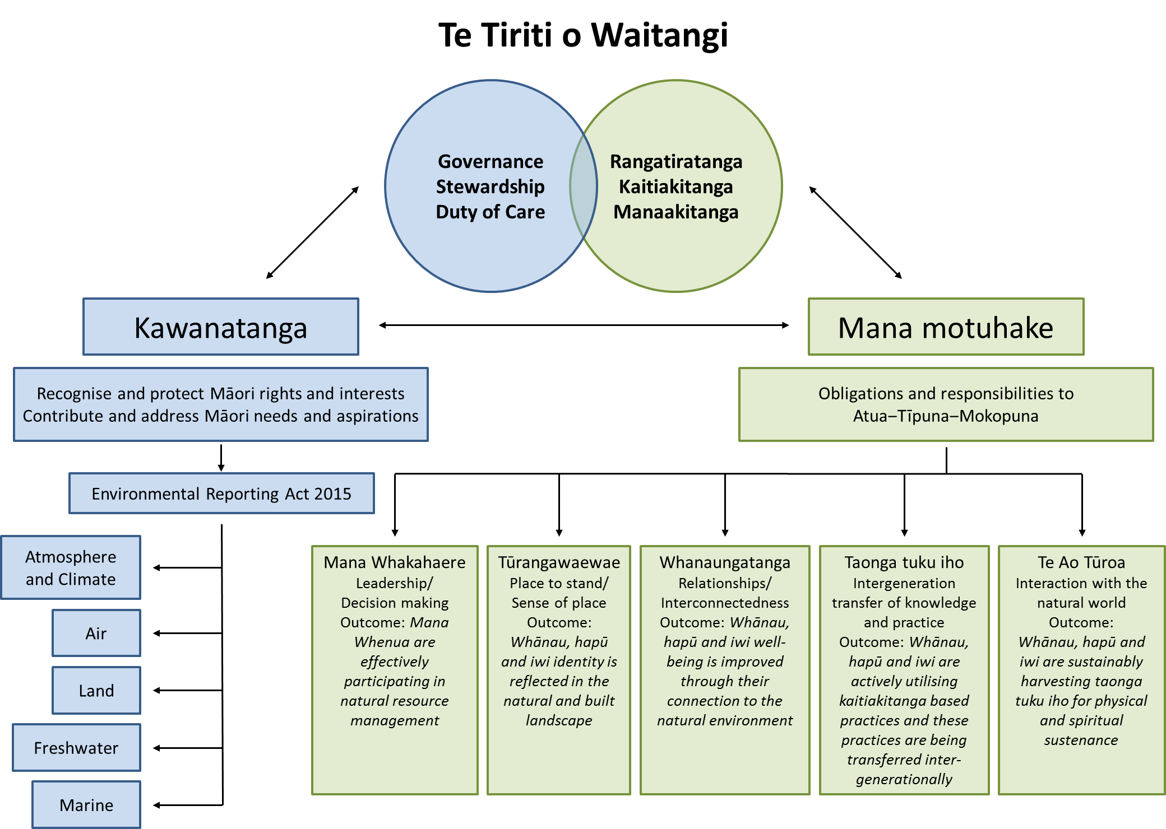

Figure 1 Framework proposed by Johnnie Freeland (Auckland Council) and adapted according to Awatere and Harmsworth 2014

Post-hui prioritisation of measures and inventory of data
The project team took themes and measures from both hui 1 and 2 and aligned them with the five principles of mana motuhake associated with the framework (Appendix 4). Measures were then prioritised according to the criteria given in the Results section below. From here, an inventory was undertaken of whether data are pre-existing and compiled, pre-existing but requiring recompilation or similar, and data that would need to be commissioned. This process resulted in further prioritisation according to ‘data readiness’ and enabled us to suggest a starting set of measures for which rapid progress could occur.

Results

Characterisation of measures
The hui participants (hui 2) came up with the following characteristics of appropriate measures:
Spatially defined
Repeatable
Aggregated across rohe (not unanimous)
Meaningful and relevant to the decision-maker
Defined parameters (could be layered into priorities).
It was agreed that both quantitative and qualitative measures of Te Ao Māori were possible. Some participants thought that the same person needed to take the measurement and perform the analysis; others felt that only tangata whenua were capable of making the measurements and needed sufficient resourcing to do so. Many participants felt that measures needed to be visually represented and others said that measures needed to relate to kawa (how things are done), and be able to reflect changes in tikanga, and ongoing aspirations, trends and authenticity in the Māori world. See Appendix 5 for an ‘as drawn’ list of the hui characteristics of measures.
The Ministry for the Environment has stressed that measures need to be ‘realistically measurable’ and ‘relate directly to the environment’. Statistics New Zealand has clear criteria for rating the quality of available data for reporting, and determining whether it can be used as a national indicator, a case study, or supporting information; relevance and accuracy are key (Statistics NZ 2007). Therefore, assignment of measures as suitable for national indicator, case study or supporting information falls outside the scope of the current study.
The project team considered hui participants’ characteristics and those of the Ministry to settle on the following criteria for prioritising the measures:
- Meaningful to Māori
- National (where possible)
- Realistically measurable
- Repeatable
- Data already exist (where possible)
- Concern the environment directly.

Prioritised measures
The project team settled on a group of measures that reflect each of the domains with some cross-domain measures relating to governance (Table 1). The measures were chosen to reflect the core values of rangatiratanga and kaitiakitanga, and seek to enhance whanaungatanga with taonga in the natural world. We are aware that not all suggested measures can be reported under the Environmental Reporting Act 2015 as they do not measure the environment directly. Nonetheless, given their centrality to Te Ao Māori, they are reported here as essential components of this worldview. We have indicated those measures as not able to be reported under the Act. They are still relevant to other areas of Ministry policy work.

Measures reflecting mana whakahaere
None of these measures can be reported under the Act but the principle is critical to Te Ao Māori. For example, a cornerstone of mana whakahaere is the active participation of Māori in resource management decision-making. This relates to the inseparability of the people from the land/water/stars via whakapapa. Hui participants strongly endorsed the sentiment from one table, ‘Mana whenua = mana motuhake = kaitiakitanga’, summed up by the facilitator as, ‘If we’re good, the environment is good’. We note that the Local Government Act (2002, Part 6, 81) requires councils to establish and maintain processes to provide opportunities for Māori to contribute to the decision-making processes of the local authority and to foster the development of Māori capacity to do so. Some councils have been especially proactive. Auckland Council works closely with the Independent Māori Statutory Board who produced ‘The Māori Plan for Tāmaki Makaurau’. This plan has a specific goal of Māori being ‘actively involved in decision-making and management of natural resources’ within the environmental area of ‘rangatiratanga’ (an underpinning value of the Plan). Further, they list indicative indicators of ‘kaitiakitanga’ as including ‘number of iwi management plans in Tamaki Makaurau’ and ‘number of full time equivalents employed by iwi/hapū in resource management’.
Given the desire for hui participants to see action for the environment (currently sits outside the Environmental Reporting Act 2015), other Ministry policy work should consider maintenance, degradation or enhancement of specific iwi/hapū values and measures and progress towards (or away from) iwi/hapū aspirations (outcomes).

Table 1 Prioritised measures organised by mana motuhake principles with data that could be used to measure Te Ao Māori and whether this exists already
Principles | Domain | Measure and method | Data owners / providers | Does data exist? | Willingness to share  (Definitely, Highly likely, Likely, Unlikely) | Ability to report on under the Environmental Reporting Act 2015
Mana whakahaere | Cross-domain | Active participation of Māori in resource management decision making, indicated by:  - number of Māori city/district/regional council members | Territorial Authorities  Ministry of Justice | Yes – via Department of Internal Affairs and Local Government New Zealand. | Definitely | No; but can be considered under other Ministry policy streams.
Mana whakahaere | Cross-domain | Active participation of Māori in resource management decision making, indicated by:  - number of iwi environmental management plans | Iwi authorities | Yes – Nationally commissioned survey required. | Highly likely | No; but can be considered under other Ministry policy streams.
Tūrangawaewae | Land | Changes of Māori land use, indicated by:  - temporal land-use maps showing Māori freehold land contrasted with other tenures | Landcare Research Land Cover Database (LCDB)  Ministry of Justice Māori Land online  Ministry for the Environment Land Use Map (LUM)  Landcare Research Whenua Viz | Yes – LCDB data openly available 1996, 2001/02, 2008, 2013/14  https://lris.scinfo.org.nz  http://www.maorilandonline.govt.nz/gis/home.htm  https://data.mfe.govt.nz/layer/2375-lucas-nz-land-use-map-1990-2008-2012-v016/  http://whenuaviz.landcareresearch.co.nz/  Note WhenuaViz has not been updated since 2011. | Definitely | Yes
Tūrangawaewae | Land  Freshwater | Natural habitat fragmentation, indicated by:  - wetland extent | - Wetland delineation tool and Freshwater Ecosystems of New Zealand database (FENZ)  - Landcare Research Land Cover Database (LCDB) | - Yes FENZ plus: http://www.landcareresearch.co.nz/science/plants-animals-fungi/ecosystems/wetland-ecosystems  - Yes – LCDB could be used to characterise contiguity  LCDB data openly available 1996, 2001/02, 2008, 2013/14  https://lris.scinfo.org.nz | - FENZ and wetland delineation tool – Highly likely  - LCDB – Definitely | Yes
Tūrangawaewae | Land | Mauri of wāhi taonga, affected by impact of visitors, indicated by:  - number of visitors | - DOC  - Territorial Authorities  - Heritage New Zealand | - Yes – Nationally commissioned survey required,  - Yes – Nationally commissioned survey required  3) Yes – http://www.heritage.org.nz/the-list | - Highly likely  - Highly likely  - Highly likely | Yes
Tūrangawaewae | Land | Mana whenua indicated by:  - bilingual signage and interpretation at conservation reserves | - DOC  - Territorial Authorities | - Yes – Nationally commissioned survey required  - Yes – Nationally commissioned survey required | - Highly likely  - Highly likely | No; but can be considered under other Ministry policy streams.
Whanaungatanga | Marine  Freshwater | Ability to access mahinga kai indicated by:  - abundance of shellfish and inshore fish species (e.g. pāua, kina)  - abundance of tuna, whitebait and other freshwater species  - abundance of tītī (harvest) | - NZ Fisheries Assessment Reports, MPI, Dept of Marine Science – Otago Uni, NIWA  - NIWA New Zealand Freshwater Fish Database  - Rakiura whānau via Tītī Island Administering Body, Rakiura Tītī Islands Committee | - Yes – Openly available  - Yes – Openly available but specific analyses may need to be commissioned.  - Yes – Data confidential | - Definitely  - Definitely  - Unlikely | Yes
Whanaungatanga | Land  Freshwater  Marine | Ability to provide traditional food for hui, wānanga, and tangihanga, indicated by:  - proportion of food items that are traditional mahinga kai or kai moana species | Rūnanga and marae | Yes – Nationally commissioned survey with rūnanga or marae required | Likely | Yes
Whanaungatanga | Marine  (applies to other domains also but Method of Measure not given here) | Ability to provide traditional food for hui, wānanga, and tangihanga, indicated by:  - number of customary fishing permits authorised by rūnanga | - Ministry for Primary Industries  - Rūnanga – Customary fisheries officers | - Yes – Data request to MPI required  - Yes – Nationally commissioned survey with rūnanga required | - Highly likely  - Likely | No; but can be considered under other Ministry policy streams.
Whanaungatanga | Land | Ability to gather and use rongoā plants, indicated by:  - distribution, abundance of selected plant species such as koromiko, kōkōmuka, kawakawa, mānuka and harakeke | - Landcare Research National Vegetation Survey (NVS) databank  - DOC Tier-1 vegetation data  - NZ Plant Conservation Network (NZPCN) | - Yes – Request for data required but specific analyses would need to be commissioned:  https://nvs.landcareresearch.co.nz  - DOC Tier-1 database. Specific analyses would need to be commissioned.  - Yes – Openly available | - Highly likely  - Highly likely  - Definitely | Yes
Taonga tuku iho | Land | Ability to find sufficient quantities of useable leaves, indicated by:  - distribution and abundance of pīngao, kuta and kiekie | - Landcare Research NVS databank  - Dune Restoration Trust | - Yes – Request for data required but specific analyses would need to be commissioned:  https://nvs.landcareresearch.co.nz/  - Yes – Coastal Reference Database http://www.dunestrust.org.nz/ | - Highly likely  - Definitely | Yes
Taonga tuku iho | Land | Ability to find sufficient quantities of useable leaves, indicated by:  - number of permits issued for customary harvest in reserves | - DOC  - Territorial Authorities | - Yes – Nationally commissioned survey required  - Yes – Nationally commissioned survey required | - Highly likely  - Highly likely | Yes
Taonga tuku iho | Freshwater | Quality of rivers, streams, and lakes indicated by:  - drinkability and swimmability | - Ministry for the Environment  - Parliamentary Commissioner for the Environment | - Yes – Request for data required via the National Objectives Framework  - Yes – Request for data required | - Definitely  - Definitely | Yes
Taonga tuku iho | Freshwater | Quality of rivers, streams, and lakes indicated by:  - health of aquifer and number of freshwater springs | - Land, Air, Water Aotearoa  - FENZ | - Yes – Request for data required via www.lawa.org.nz/  or National Objectives Framework under NPS-Freshwater Management (MfE)  - Yes – Request for data required via Geodatabase | - Highly likely  - Highly likely | Yes
Taonga tuku iho | Cross-domain | Number of native speakers of te reo, indicated by:  - recorded fluency of speakers | Statistics NZ | Yes – Openly available from census data | Definitely | No; but can be considered under other Ministry policy streams.
Taonga tuku iho | Cross-domain  Land (rongoā) | Census of practitioners and tohunga for selected expertise indicated by:  - number of people skilled in use of maramataka  - number of active practitioners of rongoā | - Iwi/hāpu/ whānau  - Ministry of Health (for funded rongoā clinics) | - No – Nationally commissioned survey required  - Yes – Request for data required; indicative only as clinics represent only a small proportion of total rongoā practitioners | - Likely  - Highly likely | No; but can be considered under other Ministry policy streams.
Taonga tuku iho | Land | Census of weavers and carvers, indicated by:  - number of wānanga relating to carving and weaving | - NZQA statistics  - Te Puia  - Iwi authorities | - Yes – Request for data required  - Yes – Request for data required  - No – Nationally commissioned survey required | - Highly likely  - Likely  - Likely | No; but can be considered under other Ministry policy streams.
Te Ao Tūroa | Land | Can environment support healthy populations of valued bird species abundance of taonga manu species, indicated by census of:  - kererū, kiwi (others will be of regional significance) | - Garden Bird Survey (Landcare Research)  - DOC  - Ornithological society citizen science database | - Yes – but not nationally representative. Strong bias to urban centres.  - Yes – DOC Tier 1 database (nationally representative).  - Yes – Data request required (not nationally representative):  http://osnz.org.nz/ebird-1 | - Definitely  - Highly likely  - Definitely | Yes
Te Ao Tūroa | Land  Marine  Freshwater | Effect of pests and diseases on taonga species, indicated by:  - reporting spread, occurrence of phytoplasma (yellow-leaf) diseases on taonga plant species such as harakeke, cabbage trees and other native plants  - reporting spread of kauri dieback  - reporting spread of selected exotic species which threaten native species and waterways such as carp, Asian paddle crab and myrtle rust (when it arrives) on mānuka, pōhutukawa, rātā  - reporting (positive) impact of new control measures (Vespex) on German and common wasps | - Ministry for Primary Industries  - Territorial Authorities | - Yes – Data request required  - Yes – Data request required | - Highly likely  - Highly likely | Yes
Te Ao Tūroa | Land | Availability of wild food, indicated by:  - wild food availability assessed by abundance of exotic animal species (e.g. feral pigs, deer)  - wild food availability assessed by abundance of exotic plant species (e.g. wātakirihi (watercress) or pūhā (sow thistle)) | DOC | 1) DOC Tier 1 vertebrate data for deer (not reported for pigs thus far but report could be commissioned).  2) DOC Tier 1 vegetation data – includes all land covers so will pick up wetland/seep occurrences | Definitely | Yes
Te Ao Tūroa | Atmosphere and climate  Land  Freshwater | Impacts of climate change, indicated by:  - frequency and intensity of storm events  - effect of coastal erosion and sea-level rise on significant cultural sites  - timing of īnanga (īnaka) spawning  - timing and frequency of flowering | - NIWA  - NIWA  - NIWA  - Some data with NZPCN, NatureWatch, DOC, cabbage tree records at LR | - Yes – data available but specific analyses may need to be commissioned if outside Ministry for the Environment/Royal Society NZ reports:  http://www.royalsociety.org.nz/media/2016/05/Climate-change-implications-for-NZ-2016-report-web.pdf  - NIWA – to be commissioned  - To be commissioned  - To be commissioned | - Definitely  - Definitely  - Likely  - Likely | Yes
Te Ao Tūroa | Atmosphere and climate  Air | Human activities affecting darkness indicated by:  - darkness – ability to observe stars and tikanga relating to maramataka and Matariki | Territorial Authorities  www.lightpollutionmap.info/ | Yes – Data request required | Highly likely | Yes

Measures reflecting Tūrangawaewae
Land in New Zealand has gone through transformative change since humans arrived 800 years ago, particularly since European settlement in the 19th century. Only one-third of forest remains, mainly in upland and mountainous areas, and once vast wetlands have been reduced to 10 per cent of their original extent. Agriculture (increasingly intensive) and horticulture occupy about 42 per cent of the land and plantation forestry a further 7.5 percent (MfE 2015). Land confiscation, changes in use and management, reduced and degraded habitats for native species, and limited access to customary resources have had, and continue to have, a profound effect on Te Ao Māori and the reflection of whānau, hapū and iwi identity in the natural and built landscape.
With an increased number of Treaty settlements, including return of lands to Māori ownership along with financial compensation, the timing is good to include a reporting measure on changes of Māori land use. Land is integral to Māori well-being and critical to Māori economic development. Currently over 70 per cent of Māori land is classified as erodible hill country while less than 30 per cent is suitable for intensive agriculture, cropping and horticulture (Harmsworth et al. 2010). Land use mapping will show changing patterns of tenure and utilisation over time, with potential improvements in land use reflecting settlement outcomes. We note that lands in tenures other than “Māori freehold land” impact on Māori freehold land and are also of wider interest with respect to achieving Māori land use aspirations.
The ecological and cultural health of wetlands is vital to Māori identity and well-being. Wetlands improve water quality, provide a breeding ground and habitat for eel, fish and birds, and are an essential source of mahinga kai, including weaving plants. Thus, monitoring trends in wetland loss or stabilisation is of interest and value to Māori.
Records of both wāhi tapu and wāhi taonga exist in national heritage registers (http://www.heritage.org.nz/the-list) or in district and regional plans to help improve the protection and management of cultural sites. Information on wāhi tapu, however, is mostly highly confidential and not suitable to use as a reporting measure. However, some wāhi taonga, such as battlegrounds of the Land Wars or the better-known springs and hot pools, are sites of ‘cultural tourism’. With tourism numbers burgeoning, we consider ‘number of visitors’ a useful measure to help identify where increased crowds may be affecting the mauri of special areas. Examples where visitor numbers are recorded are Waikoropupū Springs (DOC) and Waihou (Blue) Springs (South Waikato District Council).
We acknowledge hui participants’ concern at the impoverishment of te reo Māori and the drastic loss of kupu to describe the environment, including flora, fauna and natural features. A measure requested during the hui to show mana whenua and the importance of te reo in interpreting the local environment was to record bilingual signage and interpretation at conservation reserves. We include this in the table of measures to help inform policy, but it is out of scope under the Environmental Reporting Act 2015.

Measures reflecting Whanaungatanga
The principle of whanaungatanga emphasises how the well-being and prosperity of whānau, hapū and iwi are improved through their connection to and interactions with the natural environment. In our hui discussions, the themes and measures most to the fore related to abundance and access to mahinga kai, both marine and freshwater, rongoā plants and the ability to fulfil one’s obligations as a host.
We sought ways to measure the ability to provide traditional food for events such as hui and tangihanga. Some marae keep records of gifted food so it could be possible to commission a survey on this at, for example, ten-twenty marae throughout New Zealand for the type and abundance of traditional food items provided. Although records should also be available for another proposed measure – number of customary fishing permits issued (anecdotal evidence suggests there are fewer now than previously because of declining fish stocks) – this is out of scope under the Act.
With the majority of iwi and hapū having access to the sea, the ability to provide kai moana for the table is a fundamental part of Māori cultural identity and practice. Yet statistics on abundance of marine fish and shellfish are problematic. Dr Chris Hepburn, a marine biologist (University of Otago) and a hui participant, advised that the New Zealand Fisheries Assessment reports are not a good data source to report on the status of fisheries important for Māori communities and customary harvest. It is a question of scale. Catch data from commercial fishers are not necessarily applicable to local, inshore fisheries. Catch data on species of interest, such as pāua, kina, pipi and inshore fin fish, are poorly known. For instance, University of Otago data show sustained decline of a key local pāua fishery yet this is not born out in broader statistics for the region.
McCarthy et al. (2014) assessed the relative significance of important seafood species among different stakeholder groups. The common view among the 100 study participants was that access to important inshore seafood species had become more difficult during the course of their lifetime, with marked declines occurring from the 1970s onwards. Even where food species are present, they are typically harder to obtain, take longer to harvest and/or require expensive gear. Quantitative analysis revealed that pāua, tuna (eel) and tītī were of particular significance to Māori stakeholders. Furthermore, Māori associated the depletion of pāua with a loss of cultural identity, hospitality, tradition, practices, emotional and spiritual connection to their environment. This study’s assessment of key marine species was echoed by hui participants.
Kaitiaki lament the loss of fisheries and tikanga. Currently, the fisheries management system is not structured to protect fisheries at a scale relevant to kaitiaki. There is an opportunity here for reporting indicators to provide that information and tell the story of what is happening. Otago University, for instance, has 10 years of metrics on key species – pāua, kina, tuaki (cockles), tua tua, blue cod, flounder and tuna – and their habitat, particularly reef and seaweed. We suggest that pāua and kina could be advanced first as species of national importance and that further refinement of other species, especially the inshore fish species is required – priorities will vary by rohe.
Freshwater species are similarly treasured. Tuna (eels), īnanga (whitebait), freshwater kōura (crayfish), kanakana (lampreys) and kākahi (freshwater mussels) featured in hui discussions. Whilst tuna and īnanga/īnaka are of national significance, the relative importance of other species will vary by rohe. The Waikato River Independent Scoping Study (NIWA 2010) highlights taonga species and gives metrics on their abundance, distribution and condition. While each river iwi throughout New Zealand has its own special relationship and association with particular species, there are many species in common that could form part of a national survey.
The ability to gather rongoā plants is equally essential to the health and well-being of whānau, hapū and iwi. Different environmental conditions from north to south obviously determine the availability and abundance of particular species and there are very many plants that could be surveyed. We chose species highly regarded for rongoā, (see, for instance, Riley 1984 and Ko Aotearoa Tenei 2011), and that are widespread in New Zealand. Note that mānuka as a species is highly variable (genetically and phenotypically) throughout New Zealand – only non-cultivar forms will be of interest.

Measures reflecting Taonga Tuku Iho
A major concern of Māori, reflected in hui discussions, is reduced ability to actively carry out their role as kaitiaki of natural resources. As one participant said ‘whenua is our identity’. Arguably the greatest concern (as for many New Zealanders) is the diminished water quality of rivers, streams and lakes. For Māori, there is deepened resonance with cultural health and identity so dependent on using waterways for mahinga kai. There are a lot of data already available on the state of and pressures on freshwater. Hui participants sought data and analysis specifically on drinkability and swimmability, the overall health of the aquifer and number of freshwater springs.
Mahinga kai includes weaving resources. The last two decades have seen a revitalisation of both traditional weaving and the use of natural materials in contemporary art. However, while harakeke is often cultivated it is not always easy for weavers to access suitable supplies (quantity and quality) of other prized resources such as pīngao (Ficinia spiralis), kiekie (Freycinetia banksii) and kuta (Elaeocharis sphacelata). Our suggested measures relate to distribution, abundance and access to plants in reserves.
Taonga tuku iho also concerns the ongoing transmission of tikanga and knowledge through the generations. Hence, hui participants sought a census of experts in weaving and carving, in the use of maramataka (the Māori calendar), and the number of active and skilled practitioners of rongoā. These measures are out of scope under the Environmental Reporting Act but should be noted to inform future policy.
Every working group at the hui talked about the vital importance of te reo Māori. Participants were very clear that the lack of fluent speakers and loss of local dialects and a narrowing of environmental kupu (words) have real impact on how the environment is perceived and acknowledged. For example, the nature of karanga, which often took inspiration from the environment, is changing. If you can’t speak of it, you can’t really know it. One person suggested that improving knowledge about the environmental domains would improve te reo in expressing the domains, which in turn would improve the state of te reo Māori. Currently, metrics such as a census of native speakers of te reo (those who would have the words to express features and concepts of the natural world) are out of scope, but should be noted as a consideration for future policy.

Measures reflecting Te Ao Tūroa
Measures under Te Ao Tūroa concern the health of natural resources and their sustainable harvest. Hui participants were concerned for the state of the ngahere and the ability of the environment to support healthy populations of birds. The measure prioritised was the abundance and distribution of the nationally distributed bird species – kererū/kūkupa (Hemiphaga spp.) and kiwi (Apteryx spp.). Other species should be considered further even if not taonga species for all iwi, such as kākā (Nestor meridionalis meridionalis), tītī (Puffinus griseus) and weka (Gallirallus australis). The focus should be species which are valued for feathers or food (including gift exchange outside a rohe, common with tītī) and where appropriate data sources exist.
Not all valued resources are native species. The availability of wild food is important to whānau and hapū, and a suggested indicator is the abundance of deer and feral pigs. Data exist for both deer and pig abundance on public conservation land, although the latter has not yet been reported on. Two long-established, exotic vegetables are also widely used and have become part of Māori cultural identity – pūhā (Sonchus spp.) and watercress (Nasturtium officinale). Safe sources of watercress, in particular, are harder to find in the wild, because of reduced wetlands, fewer clean waterways (ditches), pollution such as weed sprays used on farms, and issues over access onto private land. The ability to gather food from the wild is hugely cherished as part of Te Ao Māori and provides a useful measure of environmental impact.
Pests and diseases impact on the health of taonga species. Although a native species, the disease caused by ‘Candidatus Phytoplasma australiense’ seriously affects harakeke, tī kōuka, and increasingly other native plants, and data on distribution and spread over time and space may provide knowledge on how to manage the worst effects. Many exotic pests pose a substantial risk to native flora and fauna, on land (insect pests and rusts on plants), in freshwater (e.g. carp), and in the sea (e.g. the aggressive Asian paddle crab, Charybdis japonica). The latter is present in some Northland estuaries, competes for food and space with native crabs, eats shellfish and is a threat to marine farming. Many freshwater invasive algae such as didymo (Didymosphenia geminata) and lake snot (Cyclotella spp.) are already being monitored and recorded as a general nuisance in waterways. One serious threat with particular relevance to Māori taonga species is myrtle rust, which will affect mānuka (Leptospermum scoparium), rātā and pōhutukawa (Metrosideros spp.). Although this rust has not yet arrived in New Zealand, it is expected to, and we suggest that as soon as it does, data relating to its distribution and spread should become part of environmental reporting.
There is an excellent opportunity now to record data on the impact of the newly introduced poison Vespex on wasp populations. German and common wasps spoil people’s enjoyment of the outdoors and impact on beekeeping, horticulture, forestry and tourism – all activities that contribute to Māori economic success. Crucially, wasps upset the ecological balance of native ecosystems and affect the food sources of native birds, particularly tūī, bellbirds and kākā.
Vespex is a significant advance in wasp control and we suggest that the effects could be monitored and form part of national environment reporting. Doing so in the realm of Te Ao Māori arguably brings a deeper resonance to the information.
The impacts of climate change affect all New Zealanders, but there are ways in which the frequency and intensity of storm events, coastal erosion and sea-level rise have particular impact on Te Ao Māori. One suggested measure/indicator is the effect on early settlement sites on the coast, which are a fundamental part of Māori (and New Zealand) cultural heritage. Sea temperature rise, ocean acidification and the effects of sediment loading from the land on marine fisheries and habitats are already reported on, but their particular impact on Māori communities and taonga species (pāua, kina, pipi, tuaki) could be highlighted in the marine domain report.
We also suggest commissioning work to record trends and changes in the timing of īnanga spawning and timing and frequency of flowering of selected species. Some data will exist. For instance, Landcare Research has kept flowering records from cabbage tree experimental sites in Auckland, Lincoln and Mosgiel since 1994.
Also related to the air domain, is to record the effect of human activities, especially lighting, on the night sky – darkness and the ability to observe stars and tikanga relating to maramataka and Mātariki (Abbari 2013). This measure would require further scoping.

Inventory of data availability and relationship to impact topics
We have identified that many data already exist that can indicate environmental impact on Te Ao Māori (Table 1). However, many of the datasets would need to be reanalysed in a form that is fit-for-purpose to directly reflect Te Ao Māori. Although the entire suite of prioritised measures given in Table 1 is required to adequately capture change across the five principles of Te Ao Māori, more rapid progress can be made with some measures than others. Therefore, we provide the measures below, ordered by domain and prioritised according to data existence and likely speed of progress (Table 2).
Further, we show potential alignment to the Māori-related impact topics identified by MfE for national environmental reporting. These topics are:
- mātauranga Māori; tikanga practice and kaitiakitanga
- customary use and mahinga kai
- sites of significance, including wāhi taonga and wāhi tapu.
Mātauranga Māori is a term that describes the body of knowledge originating from Māori ancestors (tūpuna) including the Māori world view and perspectives (Te Ao Māori), Māori creativity and cultural practices (Coffin 2015). It embraces individual, local, and collective knowledge, Māori values, cultural expressions, perspectives, observations, being traditional, historical and contemporary (Harmsworth et al. 2002; NIWA 2010; Awatere & Harmsworth 2014; Coffin 2015). Although mātauranga Māori informs everything as a body of knowledge for perspectives, values, practices, and taonga across domains, some priority measures can be primarily aligned alongside the other impact topics as well.

Table 2 Measures arranged by domain, with impact topic and state of data for use in environmental reporting. Note that data availability could be used to prioritise the measures with data ranked a) indicating current availability and needing no or only minor recompilation; b) indicating data exists but further synthesis is required; c) indicating analysis would need to be commissioned but some or all of the data is thought to be currently available; d) indicating further refinement to scope and exact data to be collected is required before using in environmental reports.
Domain | Principles | Impact topic/s | Measure and method | Data availability
Cross-domain | Mana Whakahaere | Mātauranga Māori, tikanga practice and kaitiakitanga | Active participation of Māori in resource management decision-making.  Can’t be used under Environmental Reporting Act 2015 but can be enacted in other areas of MfE policy
Cross-domain | Taonga Tuku Iho | Mātauranga Māori, tikanga practice and kaitiakitanga | Number of native speakers of te reo, indicated by:  census data on number of speakers  Can’t be used under Environmental Reporting Act 2015 but can be enacted in other areas of MfE policy
Atmosphere and climate  Air | Te Ao Tūroa | Mātauranga Māori, tikanga practice and kaitiakitanga | Human activities affecting darkness indicated by:  darkness – ability to observe stars and tikanga relating to maramataka and Matariki | d) Further refinement of scope required prior to commission
Atmosphere and climate  Land  Freshwater | Te Ao Tūroa | Mātauranga Māori, tikanga practice and kaitiakitanga  Sites of significance including wāhi taonga and wāhi tapu  Customary use and mahinga kai | Impacts of climate change, indicated by:  - frequency and intensity of storm events  - effect of coastal erosion and sea-level rise on significant cultural sites  - timing of īnanga (īnaka) spawning  - timing and frequency of flowering/fruiting | d) Further refinement of scope required prior to commission  d) Further refinement of scope required prior to commission  c) Clear scope so could be commissioned directly  c) Clear scope so could be commissioned directly
Land  Freshwater  Marine | Te Ao Tūroa | Customary use and mahinga kai | Effect of pests and diseases on taonga species, indicated by:  - reporting spread, occurrence of phytoplasma (yellow-leaf) diseases on taonga plant species such as harakeke, cabbage trees and other native plants  - reporting spread of kauri dieback  - reporting spread of selected exotic species which threaten native species and waterways such as carp, Asian paddle crab  - reporting before and after impacts of new control measures (e.g. Vespex) on German and common wasps | c) Clear scope so could be commissioned directly
Land  Freshwater  Marine | Whanaungatanga | Customary use and mahinga kai | Ability to provide traditional food for hui, wānanga, and tangihanga, indicated by:  - proportion of food items that are traditional mahinga kai or kai moana species | c) Clear scope so could be commissioned directly
Land | Tūrangawaewae | Mātauranga Māori, tikanga practice and kaitiakitanga | Changes of Māori land use, indicated by:  - land-use maps through time | b) Data exist but need to be recompiled
Land | Tūrangawaewae | Sites of significance including wāhi taonga and wāhi tapu | Mauri of wāhi taonga, affected by impact of visitors, indicated by:  - number of visitors | c) Clear scope so could be commissioned directly
Land | Tūrangawaewae | Mātauranga Māori, tikanga practice and kaitiakitanga | Mana whenua indicated by:  - bilingual signage and interpretation at conservation reserves  Can’t be used under Environmental Reporting Act 2015 but can be enacted in other areas of MfE policy
Land | Whanaungatanga | Customary use and mahinga kai | Ability to gather and use rongoā plants, indicated by:  - distribution, abundance of selected plant species such as koromiko, kokomuka, kawakawa, mānuka and harakeke | c) Clear scope so could be commissioned directly
Land | Taonga Tuku Iho | Customary use and mahinga kai | Ability to find sufficient quantities of useable leaves, indicated by:  - distribution and abundance of pīngao, kuta and kiekie | c) Clear scope so could be commissioned directly
Land | Taonga Tuku Iho | Customary use and mahinga kai | Ability to find sufficient quantities of useable leaves, indicated by:  - number of permits issued for customary harvest in reserves | b) Data exist but need to be recompiled
Land (rongoā) | Taonga Tuku Iho | Customary use and mahinga kai | Census of practitioners for selected expertise indicated by:  - number of people skilled in use of maramataka  - number of active practitioners of rongoā  Can’t be used under Environmental Reporting Act 2015 but can be enacted in other areas of MfE policy
Land | Taonga Tuku Iho | Mātauranga Māori, tikanga practice and kaitiakitanga | Census of weavers and carvers, indicated by:  - No. of wānanga relating to carving and weaving  Can’t be used under Environmental Reporting Act 2015 but can be enacted in other areas of MfE policy
Land | Te Ao Tūroa | Mātauranga Māori, tikanga practice and kaitiakitanga | Can environment support healthy populations of valued bird species? Abundance of taonga manu species, indicated by census of:  - kererū, kiwi | a) Could be reported with very little re-analysis using DOC Tier 1 data where available
Land | Te Ao Tūroa | Customary use and mahinga kai | Availability of wild food, indicated by:  - wild food availability assessed by abundance of exotic animal species (e.g. feral pigs, deer)  - wild food availability assessed by abundance of watercress and pūhā | - Could be reported with very little re-analysis for deer (pigs not yet analysed)  - Data exist but need to be recompiled
Freshwater | Tūrangawaewae | Customary use and mahinga kai | Natural habitat fragmentation, indicated by:  - wetland extent | a) Could be reported with very little re-analysis
Freshwater | Taonga Tuku Iho | Sites of significance including wāhi taonga and wāhi tapu  Customary use and mahinga kai | Quality of rivers, streams, and lakes indicated by:  - drinkability and swimmability | a) Could be reported with very little re-analysis
Freshwater | Taonga Tuku Iho | Sites of significance including wāhi taonga and wāhi tapu  Customary use and mahinga kai | Quality of rivers, streams, and lakes indicated by:  - health of aquifer and number of freshwater springs | a) Could be reported with very little re-analysis
Freshwater  Marine | Whanaungatanga | Customary use and mahinga kai | Ability to access kai moana indicated by:  - abundance of shellfish and inshore fish species (e.g. pāua, kina)  - abundance of tuna, whitebait and other freshwater species  - abundance of tītī (harvest) | a) Could be reported with very little re-analysis  a) Could be reported with very little re-analysis  d) Further refinement of scope required prior to commission
Marine | Whanaungatanga | Customary use and mahinga kai | Ability to provide traditional food for hui, wānanga, and tangihanga, indicated by:  - number of customary fishing permits authorised by rūnanga  Can’t be used under Environmental Reporting Act 2015 but can be enacted in other areas of MfE policy

Conclusions
The primary deliverable in this project was to identify a set of prioritised measures across the biophysical domains (freshwater, land and marine). Through extensive consultation, literature review and two national hui, we have organised provisional measures according to the Te Ao Māori framework given in the Results section. This provides an environmental reporting template for Te Ao Māori across five main principles:
Mana whakahaere (Leadership, Decision-making);
Tūrangawaewae (Place to stand, Sense of place);
Whanaungatanga (Relationships, Interconnectedness);
Taonga tuku iho (Intergenerational transfer of knowledge and practice);
Te Ao Tūroa (Interaction with the natural world).
Using this framework a set of measures has been developed and prioritised. Māori-related impact topics can be reported on through these prioritised measures, both quantitatively (e.g. metrics, statistics) or qualitatively (e.g. case studies, narratives, commentaries).
Components of measures for which there are likely to be sufficient data available for immediate to near-term reporting are:
Wetland extent
Abundance of a) shellfish and in-shore fish species (e.g. pāua, kina)
b) tuna, whitebait (and other freshwater species)
Water drinkability and swimmability
Health of aquifers and number of freshwater springs
Abundance of taonga manu using DOC Tier 1 data where possible (kererū, kiwi)
Wild food availability assessed by abundance of exotic animal and plant species (DOC Tier 1 data).

Recommendations
A number of recommendations are given:
- A cross-domain (cross-provider) technical advisory group should be established by MfE to further refine and order the priority measures for their successful interpretation. The TAG should include members able to advise on availability and suitability of data to meet SoE reporting requirements as well as ensuring measures and indicators are meaningful to Māori.
- Further scoping of the suitability of existing data (such as inshore fish records) should be done before reporting on the specific species listed here.
- Iwi/hapū have a keen and enduring interest in assessing the mauri of their natural environment. Future environmental monitoring and reporting needs to be embedded into regional SoE monitoring programmes with the active participation of local iwi/hapū.
- To be consistent with best practice, the project team suggests that the strategic direction proposed in this report should be endorsed (or modified) via a) sharing the final report and b) holding a third hui where hui participants can engage with MfE and Statistics NZ to discuss findings and determine next steps.

Acknowledgements
First and foremost, we acknowledge the generous donation of time and insight from all hui participants who travelled from all over the country and brought their considerable depth of experience to the kaupapa. Second, we acknowledge the assistance given by Auckland Council that has resulted from its own planning processes. We particularly acknowledge the framework presented to the hui by Johnnie Freeland and accepted by hui participants as a good basis for establishing the relationship between Crown reporting on the Environment and Te Ao Māori. Further, we acknowledge Dr Chris Hepburn (University of Otago), and Nigel Scott (Te Rūnanga o Ngāi Tahu) for input on marine priorities.
We thank Landcare Research staff who supported this project or the delivery of the report, especially Keith Ikin (kaihautū), Leah Kearns (editor) and Peter Bellingham (reviewer). Special mention must be given to Ngaire Raikabula who managed all the logistics and assisted hui participants with their travel arrangements.
We thank Ministry for the Environment and Statistics New Zealand staff for their support at hui and availability for continuous scope refinement. We are especially grateful for Manu Graham’s commitment to the second hui.
Finally, we acknowledge the great number of authors and experts not directly referenced in this report but whose study of, and connection to, Te Ao Māori has shaped the way in which the authors of this current report have approached the subject.

References
Abbari JA 2013. Defending Starlight as a Cultural Resource: the Use of Environmental Legislation in Aotearoa/New Zealand. MSc. Thesis, University of Canterbury.
Awatere S, Harmsworth G 2014. Ngā Aroturukitanga tika mō ngā Kaitiaki: summary review of mātauranga Māori frameworks, approaches, and culturally appropriate monitoring tools for management of mahinga kai. Landcare Research Contract Report LC1774. Environmental Reporting Act 2015 No 87. 45p.
Coffin A 2015. Mātauranga Māori networks. Onewa Consultants. 63p.
Coffin A, van Eyndhoven E 2009. Native Flora Impact Assessment. Biosecurity New Zealand Technical Paper no 2009/32. Prepared for Ministry of Agriculture and Forestry.
Harmsworth GR, Insley C, Tahi M 2010. Climate change business opportunities for Māori land and Māori organisations. Prepared for MAF Wellington, under the Sustainable Land Management Mitigation and Adaptation to Climate Change (SLMACC). Landcare Research report LC0910/157.
Harmsworth G, Awatere S 2012. Māori values – iwi/hapū perspectives of freshwater management in the Auckland region. Landcare Research Contract Report LC939 for the Auckland Council (Unitary Plan Team). 31 p.
Harmsworth G, Awatere S, Procter J 2014. Meeting water quality and quantity standards to sustain cultural values. 21st Century Watershed Technology Conference and Workshop, Improving Water Quality and the Environment, University of Waikato, New Zealand, 3–7 November 2014.
Harmsworth G, Awatere S 2013. Indigenous Māori knowledge and perspectives of ecosystems. Pp. 274–286. In: Dymond J ed. Ecosystem services in New Zealand: conditions and trends. Manaaki Whenua Press, Landcare Research, Palmerston North, NZ.
Hawksley C, Howson R 2011. Tino rangatiratanga and mana motuhake: Nation, state and self-determination in Aotearoa New Zealand. AlterNative: An International Journal of Indigenous Peoples 7(3): 246–257
Independent Māori Statutory Board 2012. The Māori Plan for Tāmaki Makaurau.
Lyver PO, Timoti P, Jones CJ, Richardson SJ, Tahi BL, Greenhalgh S 2016. An indigenous community-based monitoring system for assessing forest health in New Zealand. Biodiversity and Conservation. http://link.springer.com/article/10.1007/s10531-016-1142-6 (accessed 28 June 2016)
McCarthy A, Hepburn C, Scott N, Schweikert K, Turner R, Moller H 2014. Local people see and care most? Severe depletion of inshore fisheries and its consequences for Māori communities in New Zealand. Aquatic Conservation Marine and Freshwater Ecosystems 24(3): 369–390. doi: 10.1002/aqc.2378
Mead, HM. 2003 Tīkanga Māori: Living by Māori Values. Huia Publishers, Wellington.
Ministry for the Environment (MfE) 2005. Wai Ora: report of the sustainable water programme of action consultation hui. Wellington: Ministry for the Environment. http://www.mfe.govt.nz/publications/water/wpoa-hui-report-jul05/html/index.html (accessed 28 June 2016)
Ministry for the Environment and Statistics New Zealand 2015. New Zealand’s Environmental Reporting Series: Environment Aotearoa 2015. Available from www.mfe.govt.nz and www.stats.govt.nz (accessed 28 June 2016)
NIWA 2010. Waikato River independent scoping study (WRISS). National Institute of Water and Atmospheric Research Ltd. NIWA Client Report HAM2010-032. 265 p.
Pipi K, Cram F, Hawke R, Hawke S, Huriwai Te M, Mataki T, Milne M, Morgan K, Tuhaka H, Tuuta C 2004. A research ethic for studying Māori and iwi provider success. Social Policy Journal of New Zealand 23: 141–153
Riley M 1984. Māori healing and herbal. New Zealand ethnobotanical sourcebook. Paraparaumu, Viking Sevenseas.
Robb M, Harmsworth G, Awatere S 2015a. Māori values and perspectives to inform collaborative processes and planning for freshwater management. Landcare Research Contract Report LC2119. 66 p.
Robb M, Awatere S, Harmsworth G, Mackey L 2015b. Bicultural methods for biodiversity measurement and monitoring: Te Uri o Hau framework and model for achieving biodiversity outcomes in the Kaipara. Landcare Research contract Report LC2337. 58 p.
Ruruku Whakatupua. Whanganui River Deed of Settlement. 2014
Scheele S 2015. Safeguarding indigenous knowledge and access to plant resources through partnership; a New Zealand perspective. International Journal of Rural Law and Policy (IJRLP) 2: 4628. https://epress.lib.uts.edu.au/journals/index.php/ijrlp/article/view/4628/5424
Statistics New Zealand. Principles and protocols for producers of Tier 1 Statistics. 2007 www.statisphere.govt.nz
Tamaki Regional Mana Whenua Forum 2007. Te Kōhao o te Ngira: mana whenua response to the draft long-term sustainability framework for the Auckland region. Auckland, Auckland Regional Council (ARC).
Te Wai Māori 2008. Discussion on freshwater: A Wai Māori perspective. May 2008. Te Wai Māori Trust. Wellington, NZ. 14. http://waiMāori .Māori .nz/documents/publications/Discussion%20on%20Freshwater%20-%20A%20Wai%20Māori %20Perspective.pdf (accessed 28 June 2016)
Waikato River Authority 2011. Te ture whaimana o te awa o Waikato – vision and strategy for the Waikato River. 12 p.
Waitangi Tribunal 2011. Ko Aotearoa tēnei: a report into claims concerning New Zealand law and policy affecting Māori culture and identity. Te taumata tuarua (Waitangi Tribunal Report).

Appendix 1 – Hui Attendees
Wellington 15 April 2016
 | Name | Affiliation
1 | Amanda Black | Lincoln University
3 | Catherine Knight | Ministry for the Environment
4 | Cathy Schuster | Weaver
5 | Che Wilson | Ministry for the Environment
6 | Chris Hepburn | University of Otago
7 | Clive Stone | Ngāti Wai
9 | Edna Pahewa | Te Puia
10 | Fiona Hodge | Ministry for the Environment
11 | Garth Harmsworth | Landcare Research
12 | Guy Penny | Ngāti Kahungunu
14 | James Hudson | IMSB
15 | Jim Doherty | Tūhoe Tuawhenua Trust
16 | Jim Schuster | Heritage NZ
17 | Joe Harawira | Department of Conservation
18 | John Forne | Statistics New Zealand
19 | John Procter | Massey University
20 | John Turi | Weaver
23 | Mahuru Robb | Landcare Research
24 | Manu Graham | Ministry for the Environment
25 | Melanie Mark-Shadbolt | Lincoln University
26 | Mereana Wilson | Ministry for the Environment
27 | Morry Black | Ngāti Kahungunu
28 | Naomi Simmonds | University of Waikato
29 | Ngaire Raikabula | Landcare Research
30 | Phil Lyver | Landcare Research
31 | Puke Timoti | Tūhoe Tuawhenua Trust
33 | Shaun Awatere | Landcare Research
34 | Sue Scheele | Landcare Research
36 | Tina Wirihana | Te Roopu Raranga Whatu
37 | Tipene (Steven) Wilson | Consultant
38 | Tui Shortland | Consultant
39 | Waitangi Wood | Tau Iho I Te Po Trust
40 | Yvonne Taura | Landcare Research
42 | Cheri van Schravendijk-Goodman | Consultant
43 | Johnnie Freeland | Auckland Council
44 | Dianne Brown | Te Ohu Kaimoana
45 | Rereata Makiha | Auckland Council
46 | David Harris | Statistics New Zealand

Rotorua 13 May 2016

 | Name | Affiliation
1 | Amanda Black | Lincoln University
2 | Anthony Cole | Bay of Plenty Regional Council
3 | Caine Taiapa | Bay of Plenty Regional Council
4 | Cathy Schuster | Weaver
5 | Fiona Hodge | Ministry for the Environment
6 | Garth Harmsworth | Landcare Research
7 | Jim Doherty | Tūhoe Tuawhenua Trust
8 | Jim Schuster | Heritage NZ
9 | John Forne | Statistics New Zealand
10 | Kelly Palmer | Ministry for the Environment
11 | Kelly Ratana | NIWA
12 | Lisa Te Heuheu | Ngāti Hine
13 | Mahuru Robb | Landcare Research
14 | Manu Graham | Ministry for the Environment
15 | Matemoana McDonald | Bay of Plenty Regional Council
16 | Melanie Mark-Shadbolt | Lincoln University
17 | Mereana Wilson | Ministry for the Environment
18 | Morry Black | Ngāti Kahungunu
19 | Phil Lyver | Landcare Research
20 | Puke Timoti | Tūhoe Tuawhenua Trust
21 | Roku Mihinui | Te Arawa
22 | Shaun Awatere | Landcare Research
23 | Sue Scheele | Landcare Research
24 | Tina Wirihana | Te Roopu Raranga Whatu
25 | Tipene (Steven) Wilson | Consultant
26 | Waitangi Wood | Tau Iho I Te Po Trust
27 | Yvonne Taura | Landcare Research
28 | Cheri van Schravendijk-Goodman | Consultant
29 | Johnnie Freeland | Auckland Council
30 | Rereata Makiha | Auckland Council
31 | Fiona Carswell | Landcare Research

Appendix 2 – Themes from hui one grouped according to Lyver et al. (2016) categories
No. | Te Ao Māori concept | Te Reo Pākehā Definition | Theme (‘Red dot’ priorities)
1 | Hua o te whenua / wai/ moana | Natural productivity of the land / freshwater / ocean | Skinny Tūhoe coming out of the bush  Ecosystem and impacts  Abundance and quality  Timing  Fruiting and flowering out of season (1)  Forest looking like a bride (2)  Abundance of taonga species (manu, ika, rongoā, kai moana) (50)  Composition of environmental resources  Availability and accessibility of resource  Physical well-being of resource  Loss of biodiversity to sustain kai and shelter
2 | Mātauranga / Māramatanga | Knowledge / Wisdom | Mastery of practice  Number of wānanga institutions  Research and documentation  Rejuvenation of lost knowledge  Access to Crown/LGA/CRI information and databases  Kōrero tuku iho  Tūpuna knowledge  Tohunga – number, related hui, outcomes  Access to mātauranga  Retention of cultural knowledge (52)
3 | Tino rangatiratanga / Mana motuhake | Absolute governance / political agency | Taonga held overseas  Mana to decide and self-authorise (authority) (14)  Working with government departments  Co-governance (RMA S.33) and joint management agreement  Aggressive land management by Pākehā (who don’t consult with Māori)  Te Tiriti of Waitangi settlements  Sovereignty – positioning (land not ceded)  Policy engagement – full and effective participation  Land tenure (DOC, councils)  Impact on ture – law/lore  Inequitable resourcing  Under resourcing – over-expectation (20)
4 | Maramataka | Māori lunar calendar or annual timetable | Maramataka  Activities as measured by the maramataka  Māra kai – whānau, marae, hapori  Ngā whetū mārama  Wai – whetū
5 | Mana whenua | Mana over the landscape / People of the land) | Loss of sites and resource (22)  Access to cultural resources (6)  Mauri, mana, wairua, tapu, manaaki
6 | Āhua o te ngahere | Nature of character of the forest | Te tai ata te tai pō (Is the dawn chorus present?) (14)  No bird song in bush  Kanikani o te ngahere (natural rhythms of the forest)  Night sounds have changed – possums (paihamu) / frogs (poraka) (3)  Change in karanga – mooing Waikato  Sound of the ngahere (7)  Te reo o te ngahere  Te reo o te taiao
7 | Whānaungatanga | Collective responsibility / Inter-relationships | Whiria – weave together  Whānaungatanga – relationships (23)  Iwi relationships  Connectedness  Working too much for aroha (need balance)
8 | Te whakaora reo | The living state of the Māori language | Kapa haka – number of groups, quality measured, contribution to wider whānau/hapori, Māori outcomes  Ngā korero, ngā reo (13)  Reo – kitea, rongohuia, ākona, kōrerohia (2)  Reo pertaining to toi raranga  Linguistic diversity  Use of local names – protection of those names (4)
9 | Mahinga kai | Food procurement | Plentiful abundance for harvest (harvest of kererū, flock size of kererū) (17)  Composition of kai kete  Access to mahinga kai  Cultural harvest
10 | Ahi kā roa | Connection to land and place | Tūrangawaewae: whānau – tūpuna – mokopuna – whenua  Māori architecture in city scapes (12)  Urban design (3)
11 | Whakapapa | Genealogy | Cultural diversity  Connection to atua – Tāwhirimātea, Tangaroa, Tāne  Atua – whakapapa continuity. Tipua–Kaihaki; Tūpuna–Tāngata (9)
12 | Oranga | Personal well-being | Hauora / rongoā identity  Relationships between people and environment (Hauora) (7)
13 | Rauemi Māori | Natural resources that becomes a product (raranga, rongoā, whakairo, tāmoko) | Rongoā plants (7)  Quality and quantity of resources  Resources suitable for purpose  Range of resource materials
14 | Mauri taiao | Life essence of the environment | Conservation status  Mauri – resilience and adaptation (5)  Biodiversity – relative to the whenua and people  Species capability  Contaminants with respect to mauri, wairua and mana  Endangered species, ecosystems and knowledge  Ecosystem function
15 | Taha wairua | Spiritual dimension | Spiritual/wairua connections  Karakia – lack of karakia used in today’s traditional and contemporary practice (3) Impact loss of sustainability of the mauri. Not just science
16 | Kaitiakitanga | Guardianship, stewardship and co-management | Conservation and preservation practice  Te Roopū Raranga Whatu o Aotearoa members  Acknowledgement of Kāhui Whiri Toi  Traditional practices  Traditional occupations  Traditional practices  Kai harvesting sites  Harvesting techniques  Practices surrounding harvest – impacts on practice and knowledge  Water security – puna, karakia, whakapapa practices  Kaitiakitanga – ability to practice true kaitiakitanga (2)
17 | Taha kikokiko | Physical health | Hākinakina – whānau level, hapū level, marae/hapū level, rohe level
18 | Taha whānau | Social wellbeing | Whānau – tautiko  Community interactions
19 | Āhua o te whenua | Nature or character of the land | Ngā momo tai (Ki Uta Ki Tai) – land and whenua interface  Effects on ecosystems, tides, temperature (melt), erosion, & nutrient loading  Weed or feed  Te reo o te whenua  Ngā mea katoa – impacts from degradation of ecosystems  Abundance of species (pests vs native)
20 | Te ōhanga whai rawa | Economic development | Te Ao Ōhanga – economic return or gain
21 | Tikanga | Customs and protocols | Taonga tuku iho – mōteatea, waiata, whakapapa  Ceremonies
22 | Āhua o te wai | Nature of water | Te reo o te wai
23 | Āhua o te taiao | Nature of the environment | Impact of climate  Distribution (spatial and temporally)  Local risk to species  Ngā momo tohu
24 | Whāngai mokopuna | Guidance by elders. The practice of an elder nurturing or instructing a child or youth. | Tamariki engaged in the environment  Rangatahi – rangatahi groups – number of groups, activities/priorities, nature of connections  Local interactions with whenua and wai  Disconnect – how to reconnect minds and hearts  Succession planning (passing knowledge on)  Inter-generational knowledge – showing and telling  Story telling

Appendix 3 – Measures from tables during hui 2
Table 1: From themes to measures
Te Ao Māori concept | Te Reo Pākehā Definition | - Theme
Mātauranga / Māramatanga | Knowledge / Wisdom | - Mastery of practice  - Number of wānanga institutions  - Research and documentation  - Rejuvenation of lost knowledge  - Access to Crown/LGA/CRI information and databases  - Kōrero tuku iho  - Tūpuna knowledge  - Tohunga – number, related hui, outcomes  - Access to mātauranga  - Retention of cultural knowledge
Mahinga kai | Food procurement | - Plentiful abundance for harvest (harvest of kererū, flock size of kererū)  - Composition of kai kete  - Access to mahinga kai  - Cultural harvest
Oranga | Personal well-being | - Oranga  - Hauora / rongoā identity  - Relationships between people and environment (Hauora)
Āhua o te whenua | Nature or character of the land | - Ngā momo tai (Ki Uta Ki Tai) – land and whenua interface  - Effects on ecosystems, tides, temperature (melt), erosion, & nutrient loading  - Weed or feed  - Te reo o te whenua  - Ngā mea katoa – impacts from degradation of ecosystems  - Abundance of species (pests vs native)
Āhua o te wai | Nature of water | - Te reo o te wai
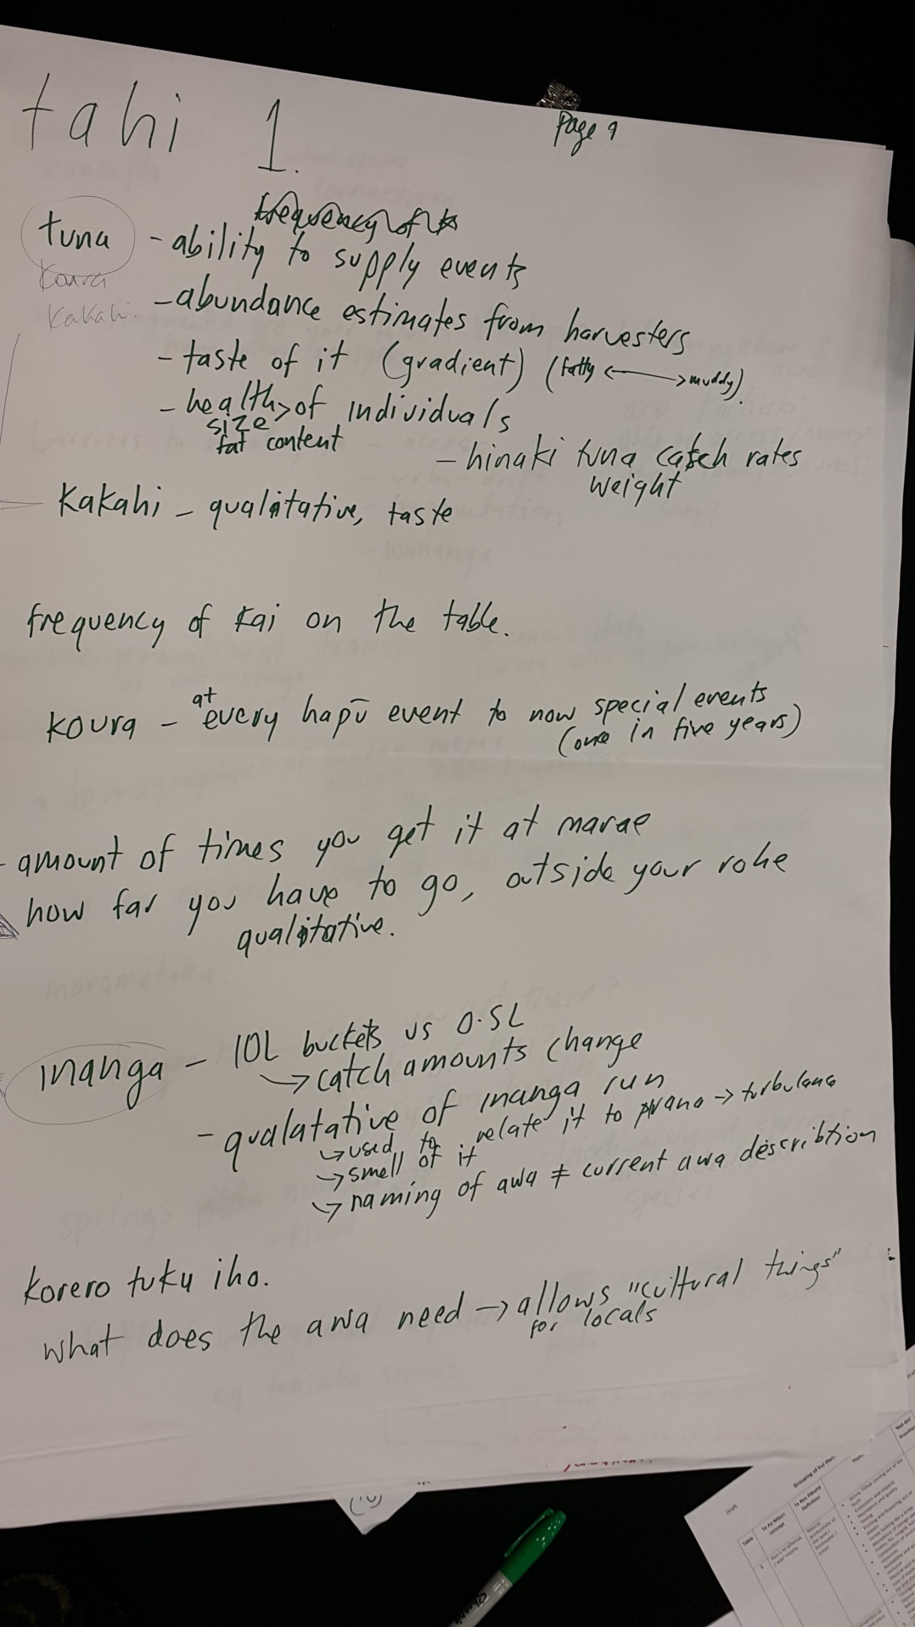
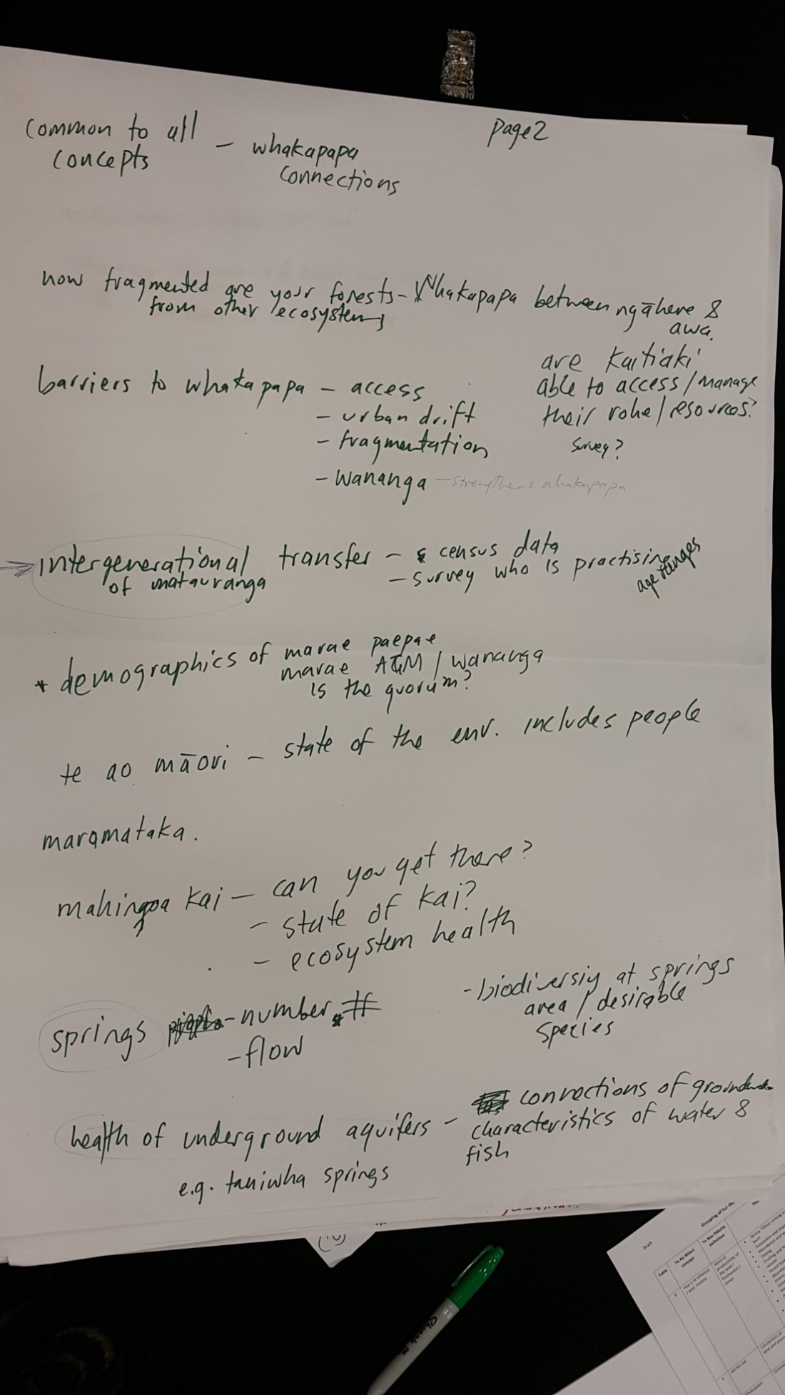
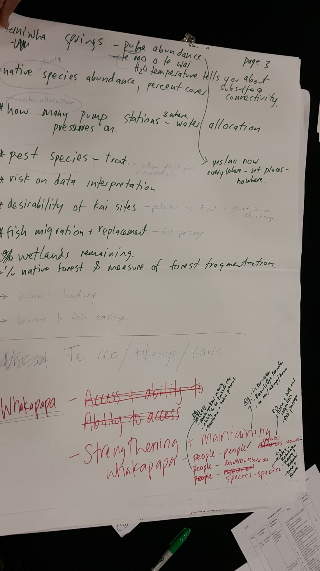
Figure 1: Photographic record of measures from Table 1
Table 2: From themes to measures
Te Ao Māori concept | Te Reo Pākehā definition | Theme
Hua o te whenua / wai/ moana | Natural productivity of the land / freshwater / ocean | - Skinny Tūhoe coming out of the bush  - Ecosystem and impacts  - Abundance and quality  - Timing  - Fruiting and flowering out of season  - Forest looking like a bride  - Abundance of taonga species (manu, ika, rongoā, kai moana)  - Composition of environmental resources  - Availability and accessibility of resource  - Physical well-being of resource  - Loss of biodiversity to sustain kai and shelter
Ahi kā roa | Connection to land and place | - Tūrangawaewae: whānau – tūpuna – mokopuna – whenua  - Māori architecture in cityscapes Urban design
Whakapapa | Genealogy | - Cultural diversity  - Connection to atua – Tāwhirimātea, Tangaroa, Tāne  - Atua – whakapapa continuity. Tipua– Kaihaki; Tūpuna-Tāngata
Te ōhanga whai rawa | Economic development | - Te Ao Ōhanga – economic return or gain
Tikanga | Customs and protocols | - Taonga tuku iho – mōteatea, waiata, whakapapa  - Ceremonies

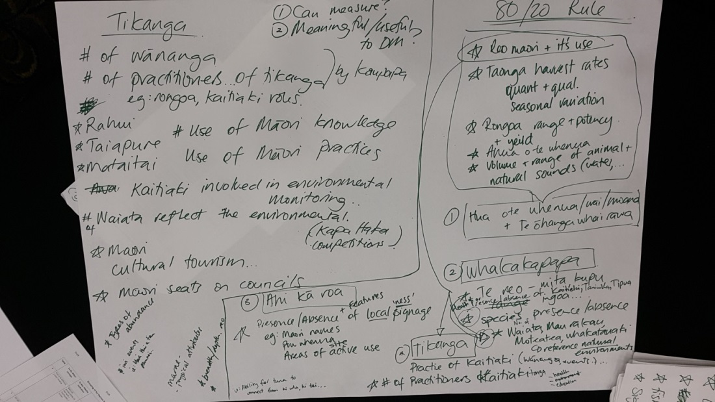
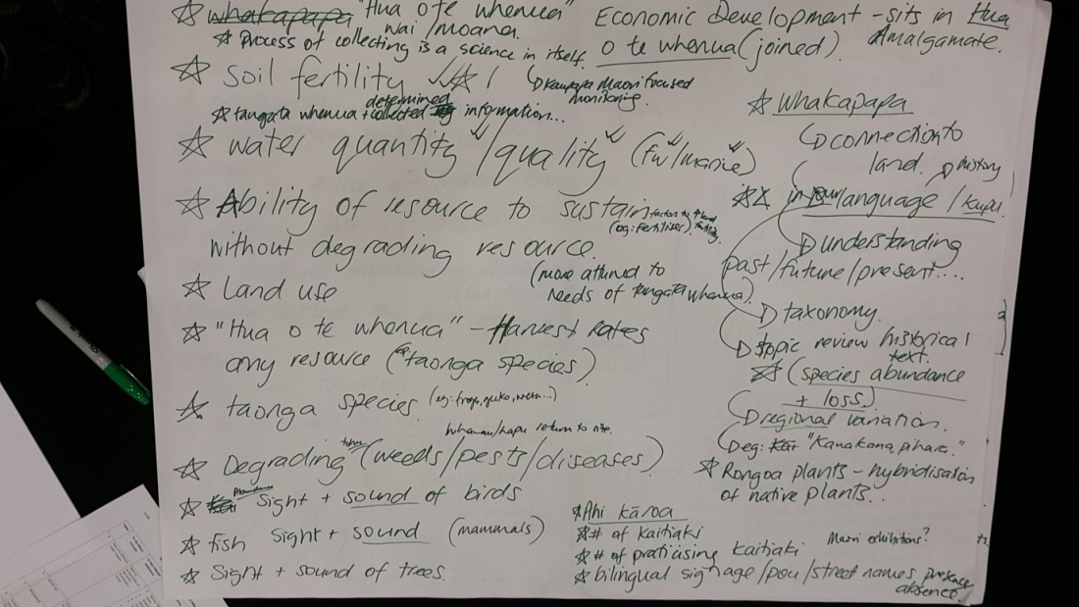
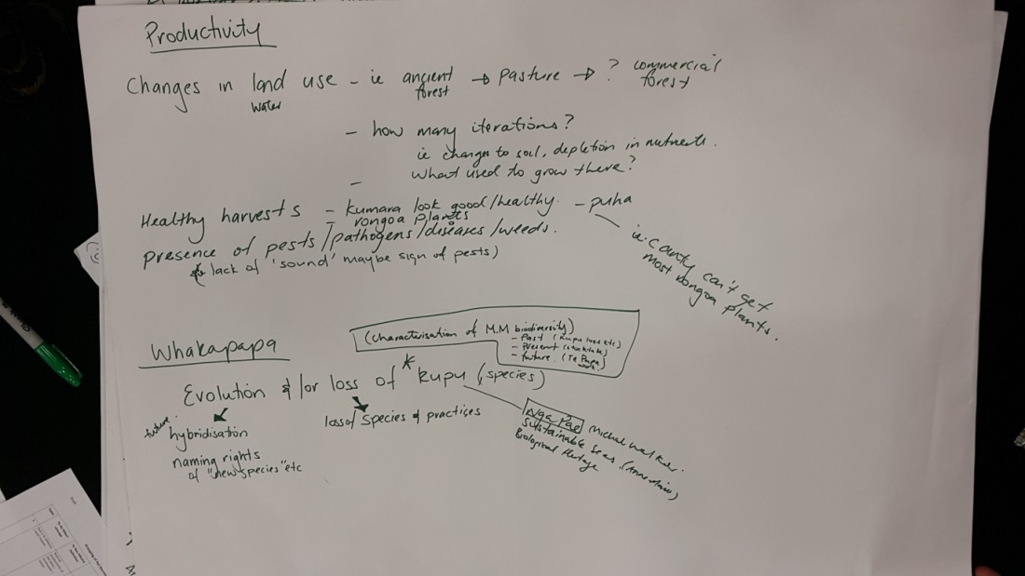
Figure 2: Photographic record of measures from Table 2

Table 3: From themes to measures
Te Ao Māori concept | Te Reo Pākehā Definition | - Theme
Tino rangatiratanga / Mana motuhake | Absolute governance / political agency | - Taonga held overseas  - Te Ture – Whaimana o te awa o Waikato (Vision and Strategy)  - Mana to decide and self-authorise (authority)  - Working with government departments  - Co-governance (RMA S.33) and joint management agreement  - Aggressive land management by Pākehā (who don’t consult with Māori)  - Te Tiriti of Waitangi settlements  - Sovereignty – positioning (land not ceded)  - Policy engagement – full and effective participation  - Land tenure (DOC, councils)  - Impact on ture – law/lore  - Inequitable resourcing  - Under resourcing – over-expectation
Te whakaora reo | The living state of the Māori language | - Kapa haka – number of groups, quality measured, contribution to wider whānau/hapori, Māori outcomes  - Ngā korero, ngā reo  - Reo – kitea, rongohuia, ākona, kōrerohia  - Reo pertaining to toi raranga  - Linguistic diversity  - Use of local names – protection of those names
Rauemi Māori | Natural resources that becomes a product (raranga, rongoā, whakairo, tāmoko) | - Rongoā plants  - Quality and quantity of resources  - Resources suitable for purpose  - Range of resource materials
Taha whānau | Social wellbeing | - Whānau – tautiko  - Community interactions
Āhua o te taiao | Nature of the environment | - Impact of climate  - Distribution (spatial and temporally)  - Local risk to species  - Ngā momo tohu

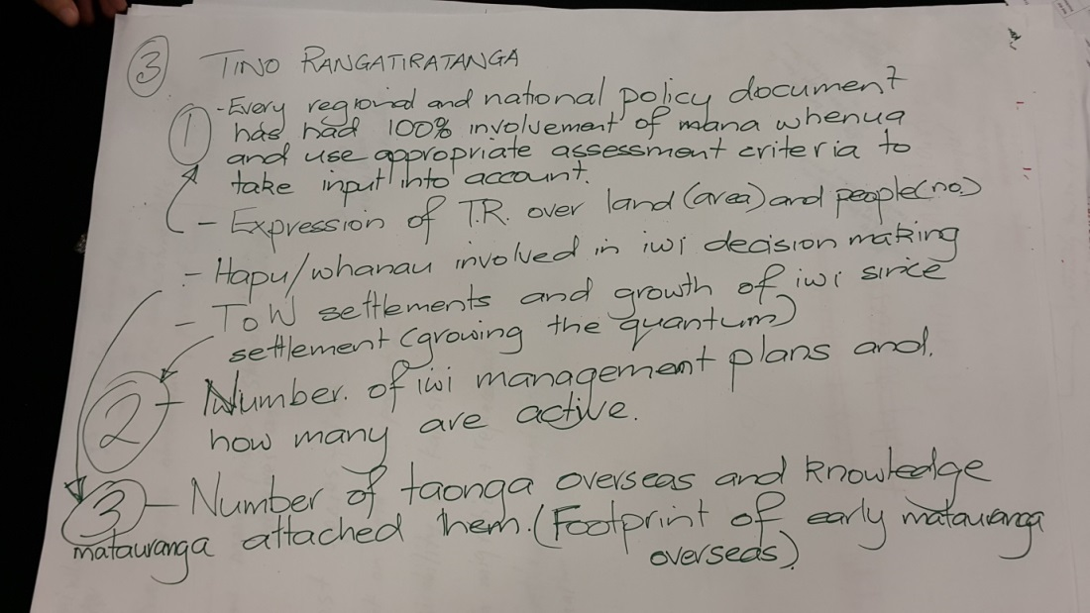

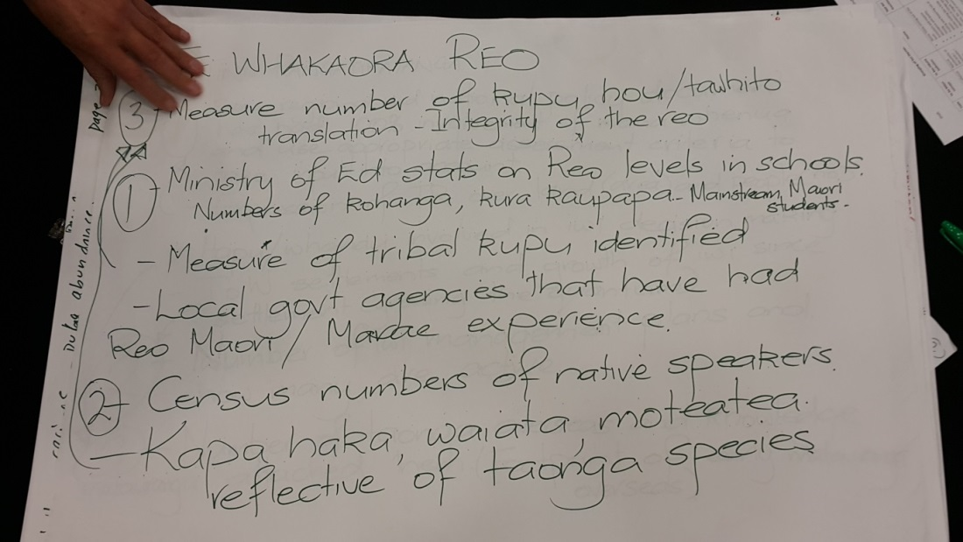
Figure 3: Photographic record of measures from Table 3

Table 4. From themes to measures
Te Ao Māori concept | Te Reo Pākehā Definition | - Theme
Mana whenua | Mana over the landscape / People of the land) | - Loss of sites and resource  - Access to cultural resources  - Mauri, mana, wairua, tapu, manaaki
Āhua o te ngahere | Nature of character of the forest | - Te tai ata te tai pō (Is the dawn chorus present?)  - No bird song in bush  - Kanikani o te ngahere (natural rhythms of the forest)  - Night sounds have changed – possums (paihamu) / frogs (poraka)  - Change in karanga - mooing Waikato  - Sound of the ngahere  - Te reo o te ngahere  - Te reo o te taiao
Taha wairua | Spiritual dimension | - Spiritual/wairua connections  - Karakia – lack of karakia used in today’s traditional and contemporary practice  Impact loss of sustainability of the mauri. Not just science
Kaitiakitanga | Guardianship, stewardship and co-management | - Conservation and preservation practice  - Te Roopū Raranga Whatu o Aotearoa members  - Acknowledgement of Kāhui Whiri Toi  - Traditional practices  - Traditional occupations  - Traditional practices  - Kai harvesting sites  - Harvesting techniques  - Practices surrounding harvest – impacts on practice and knowledge  - Water security – puna, karakia, whakapapa practices  - Kaitiakitanga – ability to practice true kaitiakitanga

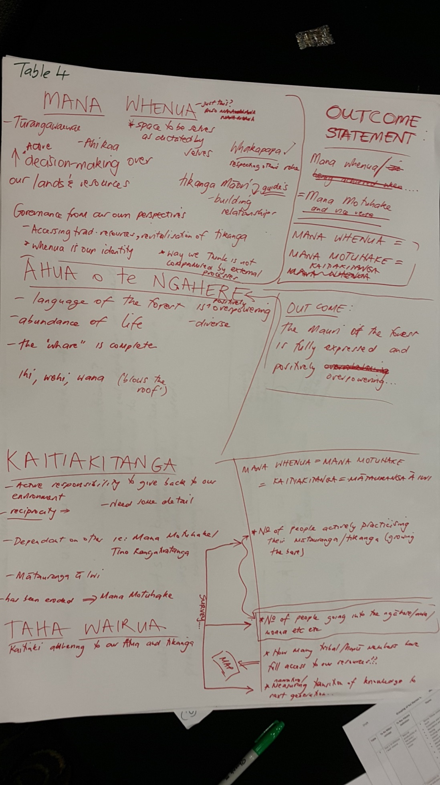
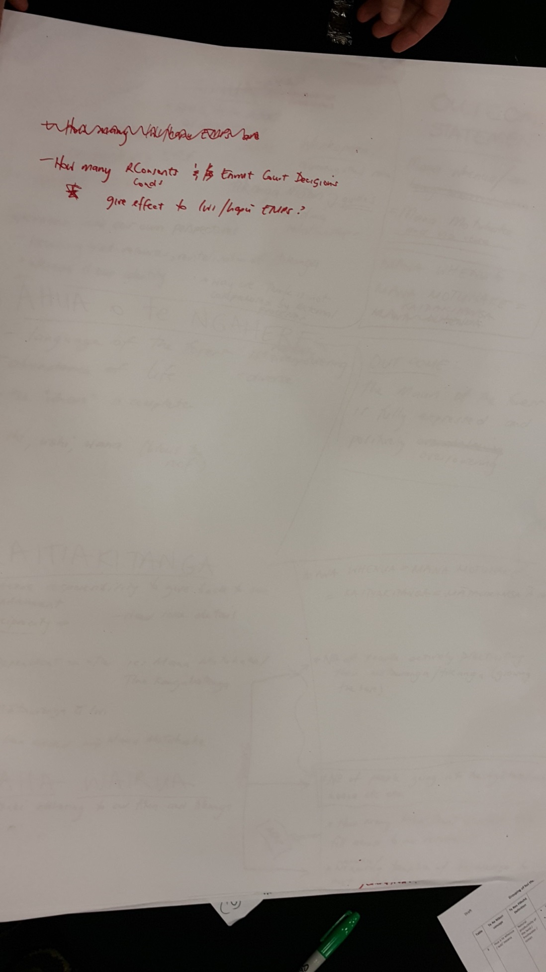
Figure 4. Photographic record of measures from Table 4
Table 5: From themes to measures
Te Ao Māori concept | Te Reo Pākehā Definition | - Theme
Maramataka | Māori lunar calendar or annual timetable | - Maramataka  - Activities as measured by the maramataka  - Māra kai – whānau, marae, hapori  - Ngā whetū mārama  - Wai – whetū
Whānaungatanga | Collective responsibility / Inter-relationships | - Whiria – weave together  - Whānaungatanga – relationships  - Iwi relationships  - Connectedness  - Working too much for aroha (need balance)
Mauri taiao | Life essence of the environment | - Conservation status  - Mauri – resilience and adaptation  - Biodiversity – relative to the whenua and people  - Species capability  - Contaminants with respect to mauri, wairua and mana  - Endangered species, ecosystems and knowledge  - Ecosystem function
Taha kikokiko | Physical health | - Hākinakina – whānau level, hapū level, marae/hapū level, rohe level
Whāngai mokopuna | Guidance by elders. The practice of an elder nurturing or instructing a child or youth | - Tamariki engaged in the environment  - Rangatahi – rangatahi groups – number of groups, activities/priorities, nature of connections  - Local interactions with whenua and wai  - Disconnect – how to reconnect minds and hearts  - Succession planning (passing knowledge on)  - Inter-generational knowledge – showing and telling  - Story telling

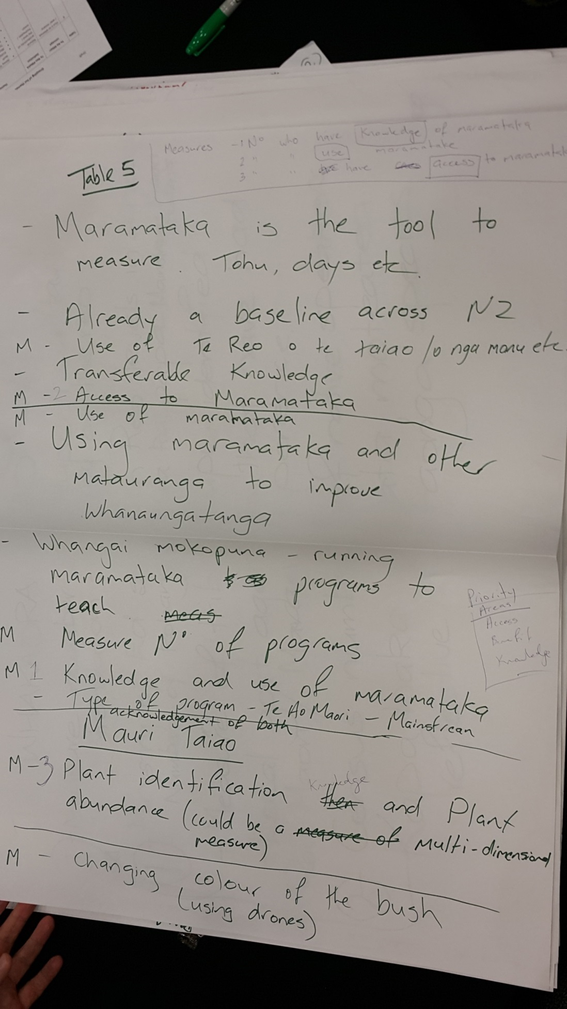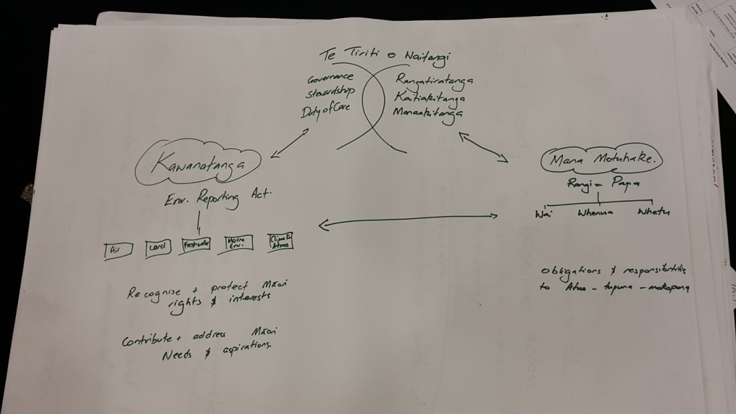
Figure 5. Photographic record of measures from Table 5

Appendix 4 – Consolidated themes and measures from both hui aligned to mana motuhake principles.
Mana Whakahaere | Tūrangawaewae | Whānaungatanga | Taonga Tuku Iho | Te Ao Tūroa
Outcome: Mana Whenua are effectively participating in natural resource management | Outcome: Whānau, hapū and iwi identity is reflected in the natural and built landscape | Outcome: Whānau, hapū and iwi well-being is improved through their connection to the natural environment | Outcome: Whānau, hapū and iwi are actively utilising kaitiakitanga based practices and these practices are being transferred inter-generationally | Outcome: Whānau, hapū and iwi are sustainably harvesting taonga tuku iho for physical and spiritual sustenance
Mana Whenua = Mana Motuhake and vice versa  Co-governance agreement  Effectiveness of co-management agreement  Customary reserve formally recognised  Access through private property  Access through DOC/council reserves  Policy engagement – full and effective participation of tāngata whenua  Number of iwi environmental management plans  How many active  Number of taonga repatriated  Adequate resourcing of mana whenua  Sites are identified by iwi/hapū  Formal recognition and protection of sites – Wāhi Tapu, Wāhi taonga, Mahinga kai sites, taiapure, mātaitai  Kaitiaki involved in environmental monitoring  Local government agencies have reo Māori/marae experience | Māori identity is recognised in urban design and infrastructure  Māori identity is recognised in conservation reserves  Number of information bulletins with mana whenua presence  Adequate and accurate pou whenua are present  Bilingual signage at conservation reserves  How fragmented are the forests? Whakapapa between ngahere and awa  Local place-names in te reo  Changes in land use over time – forest to pasture  Cultural tourism – impact on environment  The mauri of the forest is fully experienced and positively overwhelming | Oranga  Rongoā plants are readily accessible  Number of Māori attendees at planting or restoration activities  Number of Māori accessing walking tracks  Number of whānau, hapū and iwi based wānanga  Number of collaborative community initiatives involving whānau, hapū and iwi  Number of hākinakina (sports) events involving whānau, hapū and iwi  Barriers to whakapapa- access, urban drift  Is connectedness between people and people, people and environment, being maintained  Are soil fertility, water quality (freshwater, marine) being maintained.  Make whenua more fertile  Au Pūtea  Sustainable harvest/use  Local employment opportunities  No of Full Time Equivalents  Local training opportunities  No of Full Time Equivalents  Local investment  Whāngai Mokopuna  Number of tamariki engaged in the environment  Number of rangatahi groups  Number of wānanga with rangatahi  Inter-generational knowledge is transferred | Kaitiaki present for each marae  No. of Kaitiaki per marae  Kaitiaki are effective  Number of hui/ wānanga  Tikanga practised and maintained  Tribal knowledge databases  Ceremonies and rituals are performed  Number of tohunga  Rahui are formally recognised  Number of Rahui formally notified  Maramataka are utilised by Tangata Kaitiaki  Number of hui/wānanga  Number of people who have knowledge  Number of people who are users  Access to Crown/LGA/CRI information and databases  Sustainable harvesting techniques are utilised  Te Whakaora Reo  Number of waiata and mōteatea with taiao kaupapa  Reo pertaining to toi raranga maintained  Reo pertaining to toi mahinga kai maintained  Hapū and iwi reo diversity enhanced and maintained  Census of native speakers  Min. Educ. statistics on te reo levels in schools | Hua o te wai  Abundance of taonga species present (manu, ika, rongoā, kai moana)  Ngā Ika  Kaeo  Inanga  Kōura  Tuna  Ngā Manu  Spawning  Inanga spawning at right time  Tuna puhi at the right time  Kai are safe to eat/harvest  Pollution in water  E.coli  Pollution in kai  Heavy metal  Toxins  Kai tastes good  Catch per unit effort  How many inanga to fill bucket 10 l vs 0.5 l  Health of species- fat content, disease, worms in flesh  Distance to collect food  Sound of wai  Hua o te whenua  Taonga species present  Ngā Manu  Harvest of taonga species  Flock size  Quality of taonga species  Rongoā – potency and yield  Composition of kai kete  Productivity of māra kai  Māra kai produce utilised for hui  How often traditional kai on table  Sight and sound of birds, mammals, trees  Āhua o te wai  Te Reo o te wai  Water appearance  Clear after rain  Is it swimmable?  Is it potable?  Habitat  Slow current  Good vegetation cover along the bank  Shape of stream includes pools and runs  Water moves  Tī kouka used for ariari board to see īnanga  Flow  Enough for tuna heke  Enough for inanga spawning  Enough for kauanga kai activities  Health of aquifer  No and area of springs, flow, connection of freshwater bodies  How many pump stations, where?  Āhua o te Ngāhere  Te reo o te Ngāhere  Te tai ata te tai pō (Is the dawn chorus present?)  Bird song is present  Kanikani o te ngahere (natural rhythms of the forest)  Show changing colour of bush, using drones  Ability to identify plants  Āhua o te Whenua  Effects on ecosystems, tides, temperature (melt), erosion, & nutrient loading  Weed or feed  Pest species – (trout?)/pathogens/ diseases/weeds  Ngā mea katoa – impacts from degradation of ecosystems  Impact of climate  Skinny Tūhoe coming out of the bush  Ecosystem and impacts  Abundance and quality  Fruiting and flowering out of season  Forest looking like a bride  Taha Wairua  Mauri Taiao– resilience and adaptation  Cultural Health Index  Mauri Assessment  Whakapapa - connectivity  Presence of Tipua\Taniwha  Presence of Kaitiaki  Other Tohu

Appendix 5 – Characteristics of effective measures as supplied by hui participants

