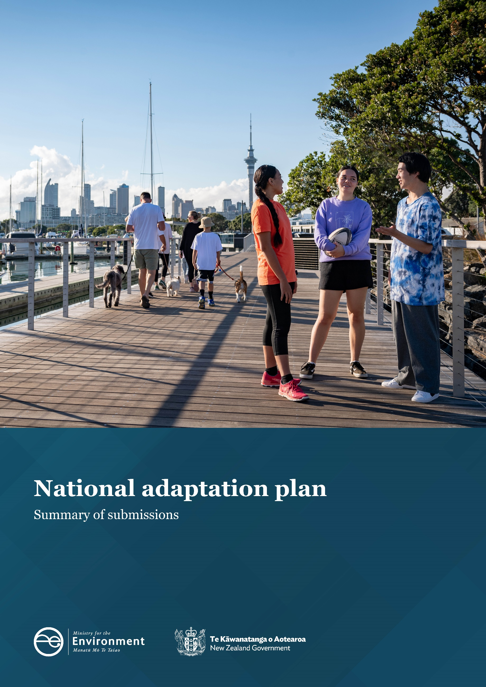

Disclaimer
The information in this publication is, according to the Ministry for the Environment’s best efforts, accurate at the time of publication. The Ministry will make every reasonable effort to keep it current and accurate. However, users of this publication are advised that:
- The information does not alter the laws of New Zealand, other official guidelines, or requirements.
- It does not constitute legal advice, and users should take specific advice from qualified professionals before taking any action based on information in this publication.
- The Ministry does not accept any responsibility or liability whatsoever whether in contract, tort, equity, or otherwise for any action taken as a result of reading, or reliance placed on this publication because of having read any part, or all, of the information in this publication or for any error, or inadequacy, deficiency, flaw in, or omission from the information in this publication.
- All references to websites, organisations or people not within the Ministry are for convenience only and should not be taken as endorsement of those websites or information contained in those websites nor of organisations or people referred to.

This document may be cited as: Ministry for the Environment. 2022. National adaptation plan: Summary of submissions. Wellington: Ministry for the Environment.

Published in August 2022 by the
Ministry for the Environment
Manatū Mō Te Taiao
PO Box 10362, Wellington 6143, New Zealand
ISBN: 978-1-99-102562-3
Publication number: ME 1671
© Crown copyright New Zealand 2022
This document is available on the Ministry for the Environment website: www.mfe.govt.nz

Contents
Executive summary 5
Part 1: Overview 9
Introduction 9
Public consultation 9
Methodology 11
Overview of submissions 11
Key priorities for submitters 16
Part 2: National adaptation plan 20
Major themes 20
The impact of climate change 21
Focus areas 22
Engagement 22
Implementing the national adaptation plan 22
Data, information and guidance 23
Key, urgent, existing inequalities actions and action gaps 24
Risks and costs of adaptation 26
Economic opportunities in adapting to climate change 31
System-wide actions 33
Major themes 33
The natural environment 43
Major themes 43
Homes, buildings and places 49
Major themes 49
Infrastructure 56
Major themes 56
Communities 63
The economy and financial system 70
Flood insurance 75
Major themes 83
Appendix 1: Support for actions and objectives 100
Appendix 2: Consultation questions for the draft national adaptation plan and managed retreat 106
Appendix 3: Glossary 119

Tables
Table 1: Themes from the general public webinars and workshops with local government, iwi/Māori, Pacific communities, and businesses on the draft national adaptation plan 10
Table 2: Quantification of submitters 12

Figures
Figure 1: Number of submitters in each region of Aotearoa New Zealand 13
Figure 2: Number of submissions made by iwi, hapū and Māori on the draft national adaptation plan, across regions of Aotearoa New Zealand 14
Figure 3: Number of submitters identifying with disproportionately impacted groups 15
Figure 4: Number of submissions on behalf of organisations 15
Figure 5: Number of submitters working in each sector 16
Figure 6: Support for system-wide objectives by submitter type 34
Figure 7: Support for homes, buildings and place objectives by submitter type 50
Figure 8: Support for the infrastructure objectives by submitter type 57
Figure 9: Support for communities objectives by submitter type 64
Figure 10: Support for the economy and financial system objectives by submitter type 71
Figure 11: Level of support for objectives by Māori communities 102
Figure 12: Level of support for objectives by Pacific communities 102
Figure 13: Level of support for objectives by ethnic communities 103
Figure 14: Level of support for objectives by disabled people 103
Figure 15: Level of support for objectives by low-income communities 103
Figure 16: Level of support for objectives by older and retired people 104
Figure 17: Level of support for objectives by rural communities 104
Figure 18: Level of support for objectives by LGBTQIA+ communities 105
Figure 19: Level of support for objectives by women 105
Figure 20: Level of support for objectives by children and young people 105

Executive summary
Between 27 April and 3 June 2022, the Ministry for the Environment (the Ministry) consulted on government proposals to address the risks Aotearoa New Zealand faces from climate change. This included:
- the draft national adaptation plan
- information on the early development of a managed retreat system for Aotearoa New Zealand and emerging issues relating to residential home insurance for flood risk.
The purpose of the consultation was to seek public input on these proposals to inform the finalisation of the national adaptation plan, which will be published in August 2022, and to inform initial stages of policy development for the Climate Adaptation Act.
This report summarises the views submitted on the draft national adaptation plan during the consultation. This includes key themes raised during engagement and a summary of the submissions received.
A summary of views submitted on the early development of a managed retreat system is also included in this document. Drawing from the input received through consultation, policy proposals for the Climate Adaptation Act will be progressed through 2022 and early 2023 with the aim of introducing the legislation in 2023.
Allen + Clarke were engaged to analyse submissions received on the draft national adaptation plan.

This report
This report summarises the submissions related to the draft plan in two parts.

Part 1: Overview
This introduces the national adaptation plan and submissions received. It includes information on the public consultation, the methodology for submissions analysis, an overview of submissions, and key priorities of submitters.

Part 2: National adaptation plan
This discusses the views on each component of the draft national adaptation plan:
- system-wide actions
- the natural environment
- homes, buildings and places
- infrastructure
- communities
- the economy and financial system.

Part 3: Managed retreat
Part 3 summarises views related to managed retreat and flood insurance. The specific issues in relation to managed retreat and flood insurance and the key policy issues in this area were outlined in the consultation document, which sat alongside the national adaptation plan.

Submissions received
The Ministry for the Environment received 294 unique submissions on the draft plan and consultation document. Submissions were coded against a framework based on the consultation questions. Most submissions were made on behalf of organisations (202, 69 per cent), including 54 (18 per cent) submitted by local government, 16 (5 per cent) submitted by iwi/hapū, and 34 (18 per cent) submitted by businesses or industry bodies.

Key messages
A number of key messages were repeated by submitters throughout their responses. Submitters often provided a similar answer to multiple questions. Where relevant, this repetition has been retained in the body of this report. Headline and key messages are also outlined below.

Urgency and ambition of the plan
Submitters frequently expressed concern about the timing and ambition of the draft plan. They spoke about the significant and increasingly urgent climate risks facing Aotearoa New Zealand, which require a much bolder set of actions than prescribed in the draft plan. Submitters considered the actions in the draft to be too high level and not tangible enough to appropriately advance adaptation actions and encourage transformational change.
Submitters were unclear about the reason the draft plan accounted for only 10 of the 43 risks identified in the National Climate Change Risk Assessment (NCCRA). They also questioned the reasoning behind splitting the risks evenly across domains instead of following the urgency and significance prioritisation outlined in the NCCRA. Submitters recommended greater focus on the ways the urgent risks would be addressed, and that the Ministry share its thinking around the correlation between risks and resulting actions.
Submitters also wanted to see actions being implemented sooner than outlined in the draft plan, including bringing forward the implementation of the Climate Adaptation Act and the managed retreat framework (ie, before 2025).

Roles and responsibilities for local government
Submitters repeatedly mentioned the need for the final plan to clarify the roles and responsibilities of all parties involved. The roles and responsibilities of local government were of particular importance to submitters, including appropriate funding and resourcing for these entities and their constituents to ensure the plan’s actions were successfully implemented. Clarity on how the costs of adaptation would be met was also widely sought. Submitters expected significantly more central government investment than what was signalled in the draft plan.
Submitters emphasised that many local authorities were already engaging with their communities regarding regional and local climate risks assessments and adaptation planning. Because of this ongoing work, central government was urged to work with local authorities to help design and implement actions appropriately.

Te Tiriti, mātauranga Māori, and Māori climate resilience
Submitters raised concerns about what they described as the noticeable absence of any meaningful references to Te Tiriti within the draft plan, maintaining that it needed to be embedded as an outcome area in its own right. Including Te Tiriti throughout the final plan would allow for greater leverage to be given to the Rauora framework and for a te ao Māori lens to be applied to adaptation planning. Te Tiriti was emphasised as the best vessel to bring about transformational change, and to require all parties involved to make the bold and challenging decisions needed to plan for adaptation.
Submitters reiterated the need to better integrate mātauranga Māori and te ao Māori principles throughout the final plan. From across groups and sectors, submitters wanted to see better consultation with Māori, and advocated for proper funding and resources to empower iwi and Māori communities to make decisions and implement the plan’s actions.

Legislative reforms
Aligning the final plan with scheduled reforms was also deemed very important by submitters to provide certainty for future decision-making. Examples of important reforms included the resource management reform, Three Waters, Building Act reform, and a possible overhaul of the emergency management system. Submitters wanted to see a Te Tiriti-based approach applied across all resource management systems, starting with the current reforms.
The role of the final plan against the backdrop of these reforms was widely discussed. Submitters noted the time it would take for reforms to come into play, arguing there was a risk that the final plan would not support conversations that needed to take place to address the needs of at-risk communities. Submitters also noted that the reforms would be instrumental to support adaptation actions, and how these reforms would function alongside the final plan required more thought.

Communities and education
Submitters were vocal throughout all sections about the importance of involving communities in their own adaptation planning, to identify risks and design their responses to climate impacts, to prioritise, and implement adaptation actions. Submitters noted the importance of providing communities with data, information and education to enable them to make their own decisions regarding local adaptation.

Equity and wellbeing
The importance of equity and wellbeing were key themes throughout the consultation. Submitters noted the importance of ensuring that any adaptation be undertaken equitably, with those who have the most resources or have contributed the most to climate change, being made to pay. Smaller local councils were concerned that they did not have the same resources and capabilities of other regions, with many constituents unlikely to be able to afford the rate increases to pay for adaptation suggested in the draft plan. Submitters also wanted to see wellbeing woven into the final plan, including the mental health impacts resulting from adaptation actions.

Access to climate risk planning tools and data
Access to reliable, up-to-date, localised climate-hazard data and risk-assessment guidance for all of Aotearoa New Zealand was considered by submitters to be essential for adapting to climate change. Individuals, communities and non-expert groups would depend on this data being accessible (both available and understandable) to make their own decisions about adaptation and plan for any changes to come. Bringing the adaptation information portal online as soon as possible was emphasised as a crucial enabler to support adaptation planning for communities.

Unlocking climate change investment
Partnership and collaboration between all parties, as well as certainty across the institutions involved in climate adaptation, were considered essential by submitters across all groups to unlock climate change investment. Emphasis was given to ensuring sufficient funding and resourcing for local authorities towards effective and timely delivery of regional actions for the most affected communities. Industry and sector submitters raised the importance of central government co-investment to rapidly respond to climate impacts and avoid exacerbating climate risks to vulnerable groups.

Developments in risky areas
Submitters were concerned about housing and other infrastructure being developed in areas already deemed at risk of climate impacts. Submitters emphasised that developers were able to make a profit without consequences. This left the buyer, who may not be aware of any issues, to deal with the consequences. Mitigating this risk by including consequences for developers in the Climate Change Adaptation Act, or within other current reforms, was widely discussed by submitters.

Part 1: Overview

Introduction
The Government is required by the Climate Change Response Act 2002 (CCRA) to publish a national adaptation plan within two years of the latest National Climate Change Risk Assessment. From 27 April to 3 June 2022, the Ministry for the Environment consulted on a draft version of the national adaptation plan and sought feedback on initial policy thinking around managed retreat.
This summary of submissions document covers the scope of engagement during public consultation and submissions on the draft national adaptation plan. We also received many submissions during consultation on the early development of a managed retreat system for Aotearoa New Zealand and emerging issues relating to residential home insurance for flood risk. These submissions have not been summarised within this document. We will be drawing from the input received through consultation to develop a managed retreat system for Aotearoa New Zealand. Policy proposals for the Climate Adaptation Act will be progressed through 2022 and early 2023 with the aim of introducing the legislation in 2023.
This will be the first national adaptation plan. It will be a plan for all New Zealanders and require action across all areas of society. The national adaptation plan will outline how Aotearoa New Zealand will adapt to the unavoidable impacts of climate change and address key climate risks up to 2028.
The input received during public consultation was used to finalise the national adaptation plan, which will be published in August 2022.

Public consultation
The Ministry released the draft national adaptation plan for public consultation on 27 April 2022. Members of the public were invited to submit views on the draft national adaptation plan by email or through the public consultation website, Citizen Space. This consultation included 51 questions covering the system-wide actions and outcome areas of the draft national adaptation plan. These questions covered the types of impacts that are being felt across Aotearoa New Zealand, the national adaptation plan’s key focus areas and actions, the roles and responsibilities for addressing climate impacts and economic opportunities brought by climate change. The full list of questions is attached as appendix 2.
Webinars and workshops took place during public consultation, including:
- two webinars with the public
- two local government workshops
- five workshops with iwi/Māori facilitated by Ihirangi
- four workshops with Pasifika, facilitated by the Pacific Advisory Group
- one business community workshop, facilitated by the Sustainable Business Council
- one workshop on flood insurance with ICNZ flood working group
- two workshops on managed retreat facilitated by Jonathon Boston.
The table below summarises the key themes that emerged from the webinars and workshops.
Table 1: Themes from the general public webinars and workshops with local government, iwi/Māori, Pacific communities, and businesses on the draft national adaptation plan
Group | Key themes
General public webinars | - Central and local government financial contributions to the costs of adaptation and managed retreat  - How iwi and Māori will be supported and included within implementation of adaptation measures  - Resilience of Aotearoa New Zealand’s food and freshwater systems
Local government | - Central government funding for local government adaptation action  - Strong support for central government-led tools and guidance  - Uncertainty about how the multitude of system reforms would be implemented and integrate or align with the actions  - The need for consistent public messaging from central and local government on adaptation  - Managed retreat proposals
Iwi/Māori | - Strong interest in involvement in policy on managed retreat regarding costs, equity and processes  - The language used within the national adaptation plan needs to better reflect te ao Māori  - The need for stronger partnership with Māori on the development and decision-making processes of climate actions specific for iwi, hapū, and Māori  - The need for greater clarification on how funding will be equitable
Pacific communities | - Greater alignment with the Ministry for Pacific Peoples to assist with the delivery of key messages to Pacific communities. This will help to make language used in the national adaptation plan more accessible to the communities  - Recognition of indigenous Pasifika voices and solutions as many have been living with climate change for years and have learnt to adapt and build resilience  - The national adaptation plan should not be ‘fixed’ but be flexible to reflect current adaptative measures  - Support for Pasifika households and communities to adapt
Businesses | - Support for a partnership approach between businesses and government  - Further clarity needed on roles and responsibilities for businesses and who will pay for costs of implementation  - The need for a long-term framework (30–100 years) on climate action to support business planning. More data is needed to support this  - Interaction between the national adaptation plan and other areas of work
Workshops on managed retreat | - The need to stop development in risky places and to provide adequate housing for those people forced to relocate as part of managed retreats  - The need to develop guidance for stakeholders on implementing managed retreat and provide clarity on areas such as risk thresholds  - The importance of effective community engagement and support for delivering equitable managed retreats, and clarification of the roles and responsibilities for local government is needed to support this  - Policy objectives and principles of the legislation need to be clearly distinguished and provide policy direction across different areas
The Ministry for the Environment ran a digital campaign to drive awareness and support engagement for the draft national adaptation plan consultation. The social media campaign generated 315 thousand impressions across 59 organic (non-paid) social media posts and 16 paid advertisement variations on Facebook and Instagram. There were more than 20 thousand video views across two hero videos and their three respective cutdowns. We also sent approximately 3.3 thousand emails to stakeholders promoting the public consultation. The Ministry’s website devoted four pages to the consultation, which directed traffic through to Citizen Space. In total these pages had 7.9 thousand views and 8.1 thousand publication downloads. The Citizen Space consultation page attracted more than 12.6 thousand visits with 216 completed submissions.

Methodology
The Ministry received submissions through Citizen Space and email, and analysed submissions using two types of tagging software. Selected submissions from Citizen Space were uploaded to NVivo 12 qualitative analysis software and tagged against a thematic framework. All submissions received by email and a selection of those received through Citizen Space were tagged and analysed using the Ministry’s Croissant software.

Limitations
This report has integrated responses from submissions received from Citizen Space and email, where possible. Analysis of submissions was undertaken in two software platforms. Questions at the start of the document typically had much higher rates of submitter participation than questions towards the end of the document. This may have led to participation bias, where submitters on questions with fewer responses were less representative of the total submissions. Given that the questions on flood insurance and managed retreat were located towards the end of the document, there were considerably fewer responses to these questions.
While submissions on Citizen Space included information on regions and organisation type, this data was not collected for some other submissions (ie, when submissions were provided to the Ministry via email). No specific data was collected on age or gender. Submitters were, however, asked if they identified with disproportionately impacted groups (ie, rangatahi, older/retired people, and women).

Overview of submissions
The Ministry received 294 unique submissions on the draft plan and consultation document. These submissions included individuals, community groups, iwi, companies and sector organisations, local government and non-governmental organisations.

Quantifying submitters
When referring to submitters, the report quantifies support for positions based on the classifications in table 2. These classifications relate to the number of responses received and are used relative to the proportion of responses to that question. An indication of the numbers of responses for each section is provided in section 3, ‘Summary of submissions’, and at the beginning of each section in parts 2 and 3.
Table 2: Quantification of submitters
Classification | Definition
Few | Fewer than 5% of submitters on this topic
Some | 5 to 25% of submitters on this topic
Many | 26 to 50% of submitters on this topic
Most | More than 50% of submitters on this topic
All | 100% of submitters on this topic

Demographics
Of the total number of submissions classified into submitter type:
- 202 were from organisations (69 per cent)
- 92 were from individuals (31 per cent).
Of those submitters who specified which region they were in, most were from Wellington, Auckland, Canterbury, Waikato, Otago and the Bay of Plenty (60 per cent in total). Twenty-one percent of submitters were national organisations. Four submitters indicated that they were from outside Aotearoa New Zealand. The region of submitters is depicted in figure 1.
Figure 1: Number of submitters in each region of Aotearoa New Zealand
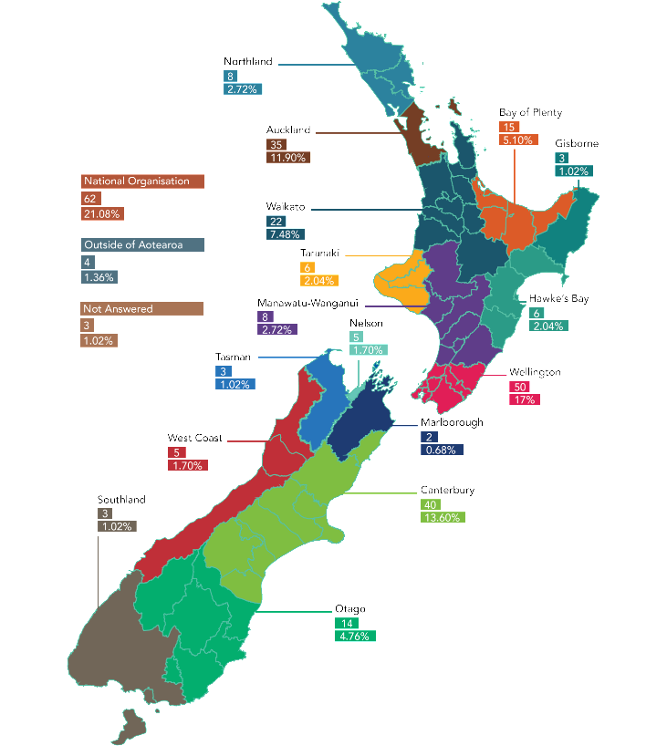

Figure 2: Number of submissions made by iwi, hapū and Māori on the draft national adaptation plan, across regions of Aotearoa New Zealand
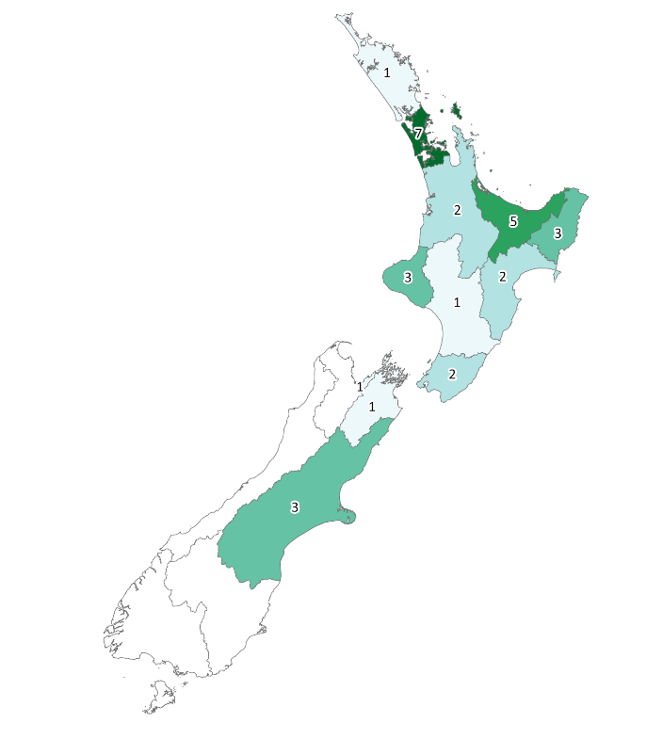

Submitters were given the option to specify one or more groups that they identified with or represented. These groups are depicted in figure 3.
Figure 3: Number of submitters identifying with disproportionately impacted groups
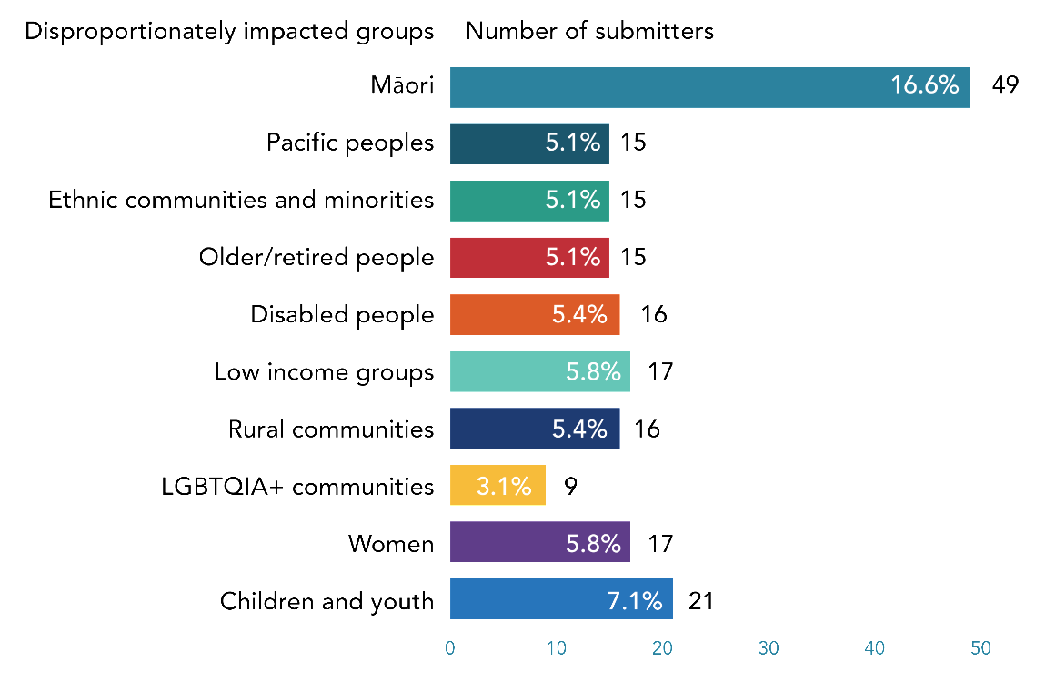
Submitters responding on behalf of an organisation were given the option to specify what kind of organisation they were submitting for. These organisations are depicted in figure 4.
Figure 4: Number of submissions on behalf of organisations
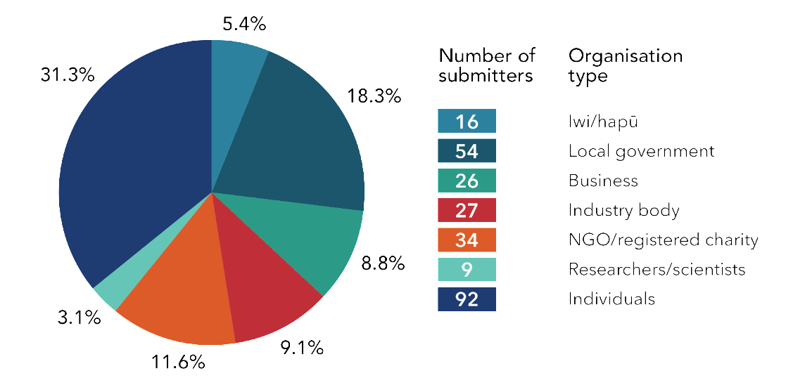
Individuals and organisation representatives were given the opportunity to specify which sector they worked in. Submitters by sector are depicted in figure 5.
Figure 5: Number of submitters working in each sector
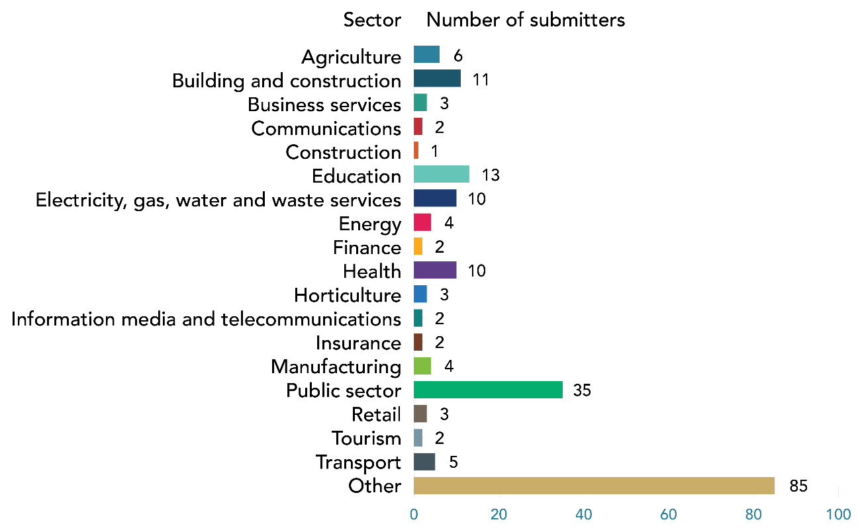

Key priorities for submitters
This section sets out the key priorities for the main submitter types. Key priorities were repeated by submitters across different questions in the consultation document and sections of the draft plan. A number of the priorities below are also included above in section 4 and will be reflected within specific questions in Part 2.

Māori and iwi/hapū
- Māori submitters highlighted the importance of kaitiakitanga, and the increased vulnerability of Māori communities to the impacts of climate change.
- Submitters who identified as Māori, or iwi/hapū submitters, highlighted the significant, varied challenges faced by Māori communities undertaking and activating climate change adaptation. These submitters described how challenges impeded their ability to actively engage with multiple and complex engagement processes, which could cause fatigue.
- Māori submitters wanted future development of national adaptation plans to be equitably resourced and provide for genuine Māori engagement.
- Submitters were particularly concerned about the lack of meaningful references to Te Tiriti throughout the draft plan. They maintained that Te Tiriti needed to be embedded as an outcome area in its own right throughout the plan.
- Submitters were supportive of the Rauora framework being included in the draft plan and wanted to see it woven throughout.
- Submitters wanted to see targeted engagement and communication with Māori communities on managed retreat that would impact them, to avoid exacerbating existing inequities. Submitters also emphasised the importance of being involved in decision-making about managed retreat for their own land.
- Submitters also noted that the principles and objectives of managed retreat should better reflect the injustices perpetuated against tangata whenua including dispossession of lands and territories and intergenerational impacts of colonisation.

Local government
- Local government submitters mostly agreed with the objectives for all chapters but sought more detail about who would lead actions and called for increased clarity about the roles and responsibilities of local government versus central government.
- Submitters wanted more clarity about how actions would be funded, and the mechanisms for providing funding to local government. Local government submitters emphasised throughout their submissions that they would require additional funding for adaptation and would not just be able to raise rates.
- In relation to funding, local governments also emphasised equity considerations. Submitters noted that smaller, less well-resourced local councils with small ratepaying bases would require additional central government support for adaptation planning and implementation. Submitters were also concerned that as the impacts of climate change increased, there was a risk that existing vulnerabilities would deepen.
- Local government emphasised that they were best placed to serve their own communities. Local government knew their communities well and could communicate and consult with them in the most effective way. These submitters highlighted that to serve their own communities, they would require data, tools, information and funding.
- Local government wanted to see greater detail and clarity of their role in managed retreat and noted the importance of this given local government’s role in service provision.
- Local government noted the importance of considering the most vulnerable in managed retreat planning and implementation. Local government also wanted to see special consideration of cultural and heritage sites such as urupā.

Businesses and industry bodies
- Business and industry body submitters repeatedly noted the importance of infrastructure and business in adapting to climate change and wanted to see industry’s role more clearly acknowledged in the plan.
- The availability of data was a big focus for industry. Submitters noted that the plan should facilitate better and more urgent access to climate data. Access to data and information was essential for people and businesses to make informed decisions about adaptation.
- Industry wanted to see the plan outline strategies within the Government’s control to create more favourable settings for industry to lead the mahi.
- Industry was mostly comfortable sharing the costs of adaptation with local and central government. Submitters in this group argued that costs and funding should be considered on a case-by-case basis.

NGOs and charities
- Many submitters commenting on behalf of NGOs and charities noted the importance of the role of tangata whenua as kaitiaki and wanted to see the plan and managed retreat better support this mahi.
- NGO and charity submitters wanted to see the establishment of co-governance models for key institutions to protect the natural environment, including the Department of Conservation, the Ministry for the Environment and the Ministry for Primary Industries.
- These submitters highlighted the importance of ensuring that investors were informed about natural-hazard information and risks associated with property development, to limit central government liability.
- Submitters also wanted to see more of an emphasis on equity throughout the plan. For example, regarding the issue of loss of homes or property, submitters wanted to see a distinction between impacts that resulted in a loss of privilege and impacts that resulted in further vulnerabilities.

Other disproportionately impacted groups
- There was considerable overlap between submitters who identified as Māori and submitters who identified as Pacific peoples, and therefore many of the key priorities were similar. Submitters who identified as Pacific peoples focused on ensuring a holistic approach to identifying and avoiding unintended negative consequences resulting from adaptation, particularly for vulnerable communities likely to be disproportionately impacted by change.
- Submitters, who identified as children/rangatahi, wanted to see better engagement from central government with communities. Rangatahi also wanted to be given opportunities and support to be involved in education, planning, and implementation of adaptation. Rangatahi wanted central government to engage with, listen to, and take young people seriously. Rangatahi also focused on intergenerational education on climate change and its impacts, which they saw as a key action.
- Submitters, who identified as disabled people, wanted to see more evidence on the intersectionality of disabled people and climate change. However, these submitters emphasised that action would need to take place before this data was available. Disabled people noted the importance of accessibility to safe homes and electric vehicles. Implementation of the plan would have a huge impact for disabled people, and this needed to be fully considered. These submitters also noted that the draft plan itself was not accessible. They stated that it was not sufficient for documents to be in Microsoft Word, and that all images must be described. Government documents should be accessible, and processes needed to cater to different levels of accessibility.
- Submitters, who identified as ethnic communities and minorities, mostly commented on the submission process, stating that they were frustrated with the form and process of the consultation. They noted the length of the document, its complexity, and the high number of questions.
- There was a high number of submissions from people who were older or retired. Older/retired submitters held a wide range of views, including wanting to see more innovation and creativity in solutions, and a greater sense of urgency for action on climate change.
- Submitters, who identified as women, focused on the natural environment, including increasing the resilience of land, and protecting, enhancing and restoring carbon sinks, such as indigenous forest.
- Submitters from rural communities were focused on ensuring that the tools, guidance and methodologies created were inclusive and accessible. Rural communities wanted to be provided with the right tools and information to adapt. In addition, rural communities saw that they would require strong central government funding and leadership to ensure equity with other areas.
- Submitters, who identified as LGBTQIA+, wanted to see central government encouraging a strong economy. In addition, these submitters focused on the global scale of climate change and the need for Aotearoa New Zealand to work with and learn from other countries to ensure the strongest response to adaptation.

Part 2: National adaptation plan

Major themes
Almost all submitters noted that climate change was already impacting their lives in some way. Impacts were wide-ranging and affected every aspect of life, including access to essential services, interference with transport networks, affecting livelihoods, and food and water security, and causing considerable stress and worry about the future.
The draft national adaptation plan focused on three key areas.
- Focus area one: reform institutions to be fit for a changing climate. This means updating the legislative settings so that those who are responsible for preparing for and reducing exposure to changing climate risk will be better equipped.
- Focus area two: provide data, information and guidance to enable everyone to assess and reduce their own climate risks. This means that all New Zealanders will have access to information about the climate risks relevant to them.
- Focus area three: embed climate resilience across government strategies and policies. This means that government agencies will be considering climate risks in their strategies and proposals.
Most submitters supported the three focus areas, and some stated that all three areas were equally important. Across the focus areas, submitters commented on the importance of community engagement, Māori involvement, support for local government and integrating and aligning the national adaptation plan with other plans and legislation.
A system-wide approach to implement the actions in the plan was of utmost importance to submitters, with a focus on strengthening government partnerships across the country, clearly communicating roles and responsibilities, and ensuring resources were supplied to co-design holistic frameworks alongside Māori.
Across all actions, submitters recommended that appropriate levels of funding and resources be supplied to all parties involved to ensure the proposed programmes were successfully implemented.
Most submitters commented on the roles of central and local government in bearing the risks and costs of adaptation, with some submitters discussing the roles of banks and insurers, asset owners and the private sector. Some submitters sought improved alignment and working relationships between insurers and local and central government to effectively deliver on mitigation and adaptation. Submitters also wanted to see government working closely with mana whenua.
Submitters considered that adaptation offered economic opportunities to communities and regions as well as businesses and sectors. Many of these opportunities supported a move to more self-sufficient communities. To maximise these economic opportunities, submitters commented that central government should harness them through a mixture of funding initiatives as well as changes to regulations, legislation and sustainable procurement.

The impact of climate change
Question 1: Climate change is already impacting New Zealanders. Some examples include extreme weather events such as storms, heatwaves and heavy rainfall, which affects lives, livelihoods, health and wellbeing, ecosystems and species, economic, social and cultural assets, services (including ecosystem services) and infrastructure. How is climate change impacting you? This could be within your community and/or hapū and iwi, and/or your business/organisation, and/or your region.
Most submitters who responded to this question had been impacted by climate change in some way. Very few noted no impact at all. An increase in extreme weather patterns was mentioned by most submitters. This varied from severe storms to extended drought, creating an increase in flooding, erosion, wildfires and sea-level rise. Some submitters noted the adverse impact climate change was having on biodiversity and Aotearoa New Zealand’s unique ecosystem.
Submitters noted that this had flow-on negative impacts on almost all areas of their lives, such as making it harder to access key services, interfering with key transport routes, affecting livelihoods, food and water security, and causing considerable stress and worry about the future.
Climate change is impacting mental health, particularly of our young communities, but many people of different generations cannot understand why more action is not being taken, and why government legislation continues to allow building over quality farmland and wilderness. We do not understand why this is not being treated with the focus and urgency that the Covid response did when the existential threat here is higher. – Local government
Many submitters also noted the negative impact climate was having on key industries, including agriculture, the electricity sector, first responders, tourism and horticulture. A few businesses noted the proactive steps they were taking to prepare for the effects of climate change, including long-term planning to try to mitigate risks.
It was clear through the range of submissions that climate change is and will continue to affect different regions, demographics, and communities in diverse ways. Some submitters noted that there would be disproportionate impacts on those in coastal areas, low socio-economic groups, Pasifika communities and Māori.
We have a disproportionally high percentage of low-income ratepayers who will struggle to adapt to climate change impacts, both physically and financially. As the costs of living, heating, and cooling increase due to extreme weather, our low-decile population will be hit hardest. As we are a landlocked district, the Ruapehu District may benefit from people moving to the district, looking to move away from coastal impacts. However, this potential population influx needs to be managed carefully to ensure that our residents who already live here are not negatively impacted by rising property values and supply shortages. – Local government

Focus areas
Question 2: The national adaptation plan focuses on three key areas. Please indicate which area is most important for you.
Focus area one: reform institutions to be fit for a changing climate. This means updating the legislative settings so that those who are responsible for preparing for and reducing exposure to changing climate risk will be better equipped.
Focus area two: provide data, information and guidance to enable everyone to assess and reduce their own climate risks. This means that all New Zealanders will have access to information about the climate risks that are relevant to them
Focus area three: embed climate resilience across government strategies and policies. This means that government agencies will be considering climate risks in their strategies and proposals.
Other? Please explain.
Those who responded to this question commented on a wide range of issues across all three of the focus areas. Most submissions supported the focus areas, with some submissions stating that all three areas were important.
Appropriate levels of funding, timelines for implementation, the need for system-level change, clarity about roles and responsibilities at national and regional levels, the need for certainty and consistency, and the equitable distribution of impacts were also discussed by some submitters across all three focus areas.

Engagement
Some submitters commented on the need for community, iwi, local government, and business engagement, highlighting opportunities to share knowledge and ensure actions were appropriate for the local context. It was also noted by a few submitters that reaching consensus could be challenging, and support would be welcome to engage effectively in contentious areas.
Some submitters noted the importance of iwi and Māori engagement and involvement and ensuring that Te Tiriti obligations were integral to the final plan. A few submitters expanded on this idea by suggesting more comprehensive integration of the Rauora framework, engagement with iwi and Māori being elevated to a critical action and ensuring adequate funding and resourcing for this engagement.
Many submitters said a system-wide transformation was required and that this was not only the responsibility of individuals. These submitters commented that some individuals would not have the resources to adapt, and consideration should be given to how to transition equitably.

Implementing the national adaptation plan
Some submitters noted the need to integrate, align or coordinate the final plan with other regulations and legislation to create a holistic, long-term approach. A few highlighted tensions between the requirements of various regulations and legislation, and it should be made clear how these tensions would be reconciled.
Given the scale of reform and change Aotearoa New Zealand is embarking on, we must ensure all of the proposed plans operate together to avoid the risk of one plan having an inconsequential [sic] impact on another. – Organisation
Some submitters also suggested that greater certainty was required to support consistent decision-making and planning. These submitters noted that greater clarity was required on roles and responsibilities to avoid inconsistency or overlap. Those from local government highlighted the need for clarity for their role, and support, tools and guidance on how to implement the reforms under way. A few noted the need for adequate time and resources to implement the significant changes in the reforms.
A few submitters raised concerns about funding models, liability and compensation, and subsidies. The concerns covered cost allocations, adaptation financing and building capacity and capability. Other submitters were also concerned about the timelines for the final plan and requested greater clarity. They noted the need for faster implementation of the final plan as a whole and the need to expedite professional training, so organisations had the required skills. This would ensure a transition phase with appropriate guidance and prevent delays in the interim.

Data, information and guidance
Most of the submitters who responded to focus area two supported a national data resource but noted that it needed to be usable by everyone, freely available and available in different formats.
In relation to data, some submitters noted that there were datasets already available, which should be reviewed and collated, and a few local government submitters were willing to share their data. The need for high quality and standardised data was noted by a few submitters and submitters also commented that data collection was only the start. Equitable use would mean the data was available in different forms for different audiences and accompanied by tailored messaging. A few submitters suggested education and made comparisons to the public campaigns around COVID-19.
A significant aspect to consider is the storytelling behind climate change. Storytelling gives Pacific peoples the ability to communicate information, stories, narratives and solutions in authentic and relevant ways. It plays a critical role in the way climate change is understood and responded to. – Advocacy group
A few submitters were concerned about whether there were sufficient resources to maintain a national data resource and a big enough skilled workforce to support organisations, particularly local government. They also noted the need for user involvement in the design of any platform.
Submitters also noted the important role of data and resources in holding institutions to account and tracking progress of the plan.

Key, urgent, existing inequalities actions and action gaps
Question 3: We all have a role to play in building resilience to climate change, but some New Zealanders may be more affected and less able to respond. There is a risk that climate change could exacerbate existing inequities for different groups in society.
a) What are the key actions that are essential to help you adapt? Please list them.
b) Which actions do you consider to be most urgent? Please list them.
c) Are there any actions that would help ensure that existing inequities are not exacerbated? Please list them.
d) Are there any actions not included in this draft national adaptation plan that would enable you to assess your risk and help you adapt?
Most submitters who responded to this question saw a comprehensive systems approach to adaptation as the most pressing and important action in the draft plan to enable Aotearoa New Zealand to adapt to the effects of climate change.
We support system-wide pathways to position future research, science and innovation on climate change and exploring how research can best honour Te Tiriti obligations and promote mātauranga Māori. – Local government

Key actions
Submitters identified a wide range of key actions specific or relevant to their industry or area of expertise. The most common key actions across all submitter types included:
- evaluation and monitoring to build accountability into Aotearoa New Zealand’s climate change response
- creating adaptation guidance across the system, including education programmes and accessible data and tools
- honouring Te Tiriti to ensure tino rangatiratanga in adaptation
- reforming the resource management system to enable largescale, visionary work to take place
- developing the adaptation information portal
- nature-based solutions, including a focus on green urban spaces and implementing Te Mana o te Taiao – Aotearoa New Zealand Biodiversity Strategy 2020.
Many submitters also recommended appropriate focus on developing a co-designed adaptation framework alongside Māori, including establishing roles and cost-sharing responsibilities; holistic integration of wider reforms and Emission Reduction Plan activities; and setting national direction on natural hazard risk management and climate adaptation through the National Planning Framework.

Urgent actions
Submitters discussed a wide range of actions that were most urgent depending on their specific geographical location, industry or sector, priorities and interests. The availability of climate-impact modelling and projections for communities depending on their identified needs was commonly discussed as the most pressing action. This was to ensure clear understanding of local risks and timelines, including access to the most up-to-date and accurate information. Bringing forward the timelines for current reforms was also considered a priority, including accelerating the timeframe for the Local Government Review Panel recommendations (2023 was considered too late).
Some submitters spoke about the importance of developing more resilient homes and buildings and working to improve health and disparities, including through the development of the Health National Adaptation Plan. Other submitters also strongly recommended implementing a comprehensive ban on new infrastructure in high climate change risk zones.

Existing inequities actions
Most submitters were highly supportive of what has been put forward in the draft plan and agreed that the ‘Communities’ chapter actions were a good start to ensuring existing inequalities were not exacerbated. Submitters were particularly concerned with education and awareness of climate-related hazards, and how to build community resilience. They discussed fostering social cohesion and working towards a common goal as the most important action. Some submitters sought a Māori climate authority or forum to engage iwi and Māori communities and include them in governing and implementing programmes.
Establishing a Māori climate authority also provides an opportunity [to] exemplify Te Tiriti, Matike Mai Aotearoa and human rights. – Independent Crown entity
Prioritising a just transition by focusing on populations and landscapes projected to be the worst affected by climate change was also commonly discussed, as well as providing the worst affected groups (rural communities, people with disabilities, people experiencing mental illness, youth and low-income families) with immediate and additional support to implement the proposed actions.

Action gaps
While most submitters recognised that the actions in the draft plan were comprehensive, many highlighted areas that required an increased focus. This included reforming the food system through a food security strategy or policy based on local production to ensure communities had access to sufficient, safe and nutritious food when the effects of climate change were felt.
Recognising that those most disproportionately affected by climate change would be those who had contributed to it the least, some submitters discussed the importance of ensuring the biggest climate polluters paid their share for adaptation policies, potentially through a carbon tax. Some submitters saw a need for tools or frameworks to strengthen central and local government partnerships, engagement with industries, and improved avenues to consult and involve mana whenua to implement all actions.

Risks and costs of adaptation
Question 4: Central government cannot bear all the risks and costs of adaptation. What role do you think asset owners, banks and insurers, the private sector, local government and central government should play in:
- improving resilience to the future impacts of climate change?
- sharing the costs of adaptation?

Roles in improving resilience

Shared roles
Most submitters commented on the roles of local and central government, with some submitters commenting on the roles of banks and insurers, asset owners and the private sector. A few submitters made comments about the shared roles of different actors to improve resilience.
Some submitters commented that the roles of all parties were not clearly defined in the draft plan, particularly that of local government. These submitters said that the burden of risk should be distributed across all parties and written into legislation by central government.
In addition, some submitters called for improved alignment and working relationships between insurers, local government and central government to deliver effectively on mitigation and adaptation. In addition, some submitters noted that central and local government would need to work closely with mana whenua, particularly when it came to initiatives such as managed retreat.

Asset owners
Some submitters considered that asset owners should be precautionary in their decisions based on climate change and consider climate change risks as part of the design and development of new infrastructure design. Some submitters urged that asset owners should not expect to be bailed out by the Government, particularly if they had bought in hazardous areas. Some submitters noted that asset owners should consider climate change risks as part of the design and development of new infrastructure.
In addition, some submitters noted the importance of education for asset owners to ensure they better understood the implications and made decisions about where to build and buy assets according to their own risk appetite.
A few submitters noted the vulnerability of Māori communities. These Māori communities were just realising the benefit of land returned through Te Tiriti processes and submitters noted the vulnerability of Māori land near the sea and rivers.

Banks and insurers
Most submitters noted that banks and insurers played a role in reducing risk, for example, by assessing risks before lending money or approving insurance.
Some submitters considered that banks should support individuals and businesses to invest their money wisely and provide investment advice. Submitters noted that it was in the banks’ best interests to help owners improve their property to protect it from risks, as they then reduced their own risks of having unpaid mortgages. In addition, some submitters noted that insurers were key players in adaptation, by refusing to insure properties built or bought in high-risk areas.
Some submitters discussed the need for banks and insurers to change policies to reflect changes in risk. This included restricting lending to support risk reduction and making mortgage applicants responsible for mitigating their own risks.
On the other hand, a few submitters noted that banks and insurers could play a more positive role in improving resilience by providing insurance rebates for resilient homes (eg, removable, flood-resistant, warm).

Private sector
Some submitters expressed strong views that the private sector would not take responsibility for climate action until expressly required to by legislation or policy change, emphasising that central government would need to encourage longer term thinking. A few submitters went further and did not want private sector (including banks and insurance) involved at all, as their sole motivation was seen as being ‘profit maximisation’.
Some submitters wanted industry to publicly disclose risks to create visibility of the true risks and costs of climate change adaptation. Submitters noted that adaptation required ongoing commitment from all sectors.
Ongoing commitment from all sectors is required to address these concerns. Good will and social responsibility require the current business models (profit driven) will need to be adjusted to accommodate this new reality. – NGO
Some submitters recommended that the final plan include an express and ongoing role for businesses and other stakeholders in developing and implementing Aotearoa New Zealand’s adaptation response. Submitters wanted to see industry’s role acknowledged more clearly in the final plan and outlined in government strategies.

Local government
Most submitters did not consider the roles and responsibilities of local government to be articulated clearly enough in the draft plan, including the strategic signals and which parts local authorities should prioritise. In addition, some submitters noted the current wide-ranging pressures on local government, such as the reform across resource management, Three Waters services, emergency management and the future of local government. These submitters noted the increased importance of specifying the roles and responsibilities of local government in this context.
Some submitters commented that local government held local knowledge and relationships with communities and was best placed to lead engagement and respond to national level guidance. These submitters pointed out that central government would need to provide clear regulatory powers and national level guidance.
Local government has a clear role in engaging with the community and leading climate adaptation strategy and decision-making. To do so, councils need to know how and by whom climate change adaptation will be funded. Given the pace and scale of the challenge of climate adaptation … as well as the community interest/pressure to undertake climate adaptation planning urgently, we are requesting that work on funding mechanisms/options is prioritised in the next 2 years. – Local government
Some submitters noted that while local government was identified as a priority actor in adaptation planning, it has not been given the sufficient range of funding, or the policy levers required to deliver on its expanding responsibilities. In addition, some submitters said that the final plan needed to recognise the different sizes and resource levels of local authorities. These submitters also suggested that the final plan have a particular focus on local authorities that do not have large and well-resourced climate change mitigation and adaptation teams.
There needs to be an acknowledgement that local authorities around the country are very diverse in size and resources, and while some have large, well-equipped teams working on climate change mitigation and adaptation, other smaller Councils often face similarly complex issues but have fewer resources to dedicate to this extremely important work. – Local government
Some submitters noted that there had not been close engagement with local councils about the potential roles and responsibilities of local government in the draft plan, and that local government would therefore not be able to clearly communicate necessary measures to communities about climate change adaptation.
Other roles for local government specified by submitters included:
- providing zoning for appropriate areas for managed retreat and new developments
- annotating Land Information Memorandum (LIM) reports regarding vulnerabilities
- in-depth knowledge of local hazards and risks
- improving resilience of transport, critical services and utilities
- driving local action
- conducting regional/local climate change risk assessments for identification of region-specific risks and priorities
- incorporating climate resilience (and broadly climate change considerations) in all local decision-making
- identifying site/region-specific resilience building needs
- planning and implementing local level resilience-building projects
- promoting local awareness on climate change adaptation (and mitigation)
- preventing further development in areas with increasing hazard risk due to climate change
- improving community resilience, particularly across vulnerable communities
- supporting community organisations, through the provision of public education and local planning processes
- continuing to ensure that communities have potable water.

Central government
Most submitters considered that central government should lead by example and clearly define the roles and responsibilities of other groups, particularly local government. Most submitters considered that central government had an important part to play in climate resilience, including setting legislation, regulation, policies, direction and guidance for local government. Some submitters also noted that central government had a role in providing centralised, standard guidance, information and data, and in clarifying the interplay of financial and legislative frameworks to enable private sector decision-making.
In addition, some submitters stated that central government must ensure that investment was equitable and targeted at priority groups, for example, in communities where high poverty, exposure to climate risk and vulnerability overlap. This included ensuring that areas with small local councils with less funding were well-resourced without just needing to increase rates. In addition, some submitters noted that central government would need to take a holistic approach to the climate response, considering other government priorities, such as emissions reduction planning, Three Waters, and resource management reform.

Sharing the costs of adaptation

Sharing costs
Some submitters recognised that there would need to be collective responsibility and accepted that responsibility for costs and risks of climate change adaptation would need to be shared between asset or property owners, insurance providers, banks, local and central government. A few submitters approved of the key role played by local government, being at the front line of climate change adaptation. Some submitters considered the costs should be split across sectors and distributed based on the size and risk associated with the sector.

Asset owners
Some submitters considered that asset owners should be expected to improve and rewild areas they have contributed to damaging and should be responsible for their own assets. This included educating themselves on risks and taking steps to minimise their exposure. Some submitters noted that central government should assist and compensate some asset owners who needed to adapt.
Some submitters agreed that property owners would need to take on some of the costs associated with adaptation and agreed that intervention should target communities facing hardship.
Working out the share of costs and liabilities that property owners should be responsible for will be a challenging task, particularly given the emotional attachment that individuals have to their homes and our societal and cultural preferences for living in high-risk areas such as on the coast and by rivers. Property owners are also going to be reluctant to move from high-risk areas unless they retain some or all of the value in their asset/s. – Local government
Some submitters also discussed the role of developers and noted that those who develop in at-risk areas take profit, with the risk transferred to the buyer. These submitters noted that central government should legislate to avoid development in at-risk areas, to avoid increasing collective exposure to risk.

Banks and insurers
Some submitters commented on the role of banks and insurers in contributing to the costs of adaptation. Submitters noted that the finance, banking and insurance sectors would need to work with central government to find ways to incentivise people to adapt or retreat. This could include mechanisms such as property transfer programmes, incentivising resilience improvements and developing alternative sites.
Some submitters noted that banks and insurers should be working together, for example, by not providing mortgages for properties that cannot be insured. Some submitters also commented on the role for insurers in responding to extreme weather events.

Private sector
Some submitters approved of the focus on “empowering entities to assess and manage their own climate risks” (Organisation). Private sector submitters agreed that climate risks to private entities should not be borne by the Government.
A few non-private sector submitters agreed, noting that the costs of adaptation should fall on greenhouse gas emitters on a “polluter pays basis”. – NGO

Local government
Submitters agreed that local government would require more support and funding for critical adaptation actions, and that local government and communities would not be able to bear the costs and risks of adaptation on their own. The funding mechanisms available to local government were seen to be insufficient to meet the challenges of climate change.
Some submitters noted that the final plan should be more explicit about how proposed functions were to be funded. A few submitters noted that the draft plan was silent on how local government was expected to fund actions that it was responsible for. These submitters considered that the only mechanism available to local government was to raise rates, which was not palatable to communities and would be subject to public consultation processes.
It is critical that the roles and responsibilities for local government are clarified, and that local government are engaged in discussion on roles and responsibilities, so that we can proactively plan and respond to future regional and local issues. – Local government

Central government
Submitters were divided on which costs of adaptation should fall to central government. While some submitters considered that the Government should not compensate asset owners, others said that the costs of mitigation and adaptation should be shared by central and local government. Submitters agreed that more information and clarity was required from central government about what the key actions were, and who would be funding them. In addition, submitters said that equity considerations should underpin any cost-sharing formula developed by the Government.
While Te Rūnanga acknowledges that central government cannot bear all costs of climate adaptation, it is well placed to bear a substantial proportion of these costs due to its ability to access funding from general taxation and other mechanisms. Central government is also well placed to ensure the equitable distribution of climate change funding to those who need it the most. – Iwi/hapū
Some submitters noted that it would be appropriate for central government to provide significant support, for example, by providing wastewater and stormwater infrastructure funding. Local government submitters reiterated that central government must ensure that people living in areas with small or under-resourced councils were not disadvantaged. Submitters also noted that central government would need to develop the framework for either assessing what the costs of climate change adaptation would be, or how costs would be shared.

Additional comments
A few submitters commented on the housing crisis and noted the importance of ensuring that any changes due to climate change did not make it harder for disadvantaged groups to access housing. A few others did not agree that anyone should share the costs of adaptation, as they considered that climate change was not a real issue.

Economic opportunities in adapting to climate change
Question 5: The National Climate Change Risk Assessment recognised that there may be economic opportunities in adapting to a changing climate.
- What opportunities do you think could exist for your community or sector?
- What role could central government play in harnessing those opportunities?
Many submitters identified economic opportunities for communities or regions. These largely centred around a move to self-sufficiency, including local food production and local initiatives for renewable energy, such as solar power. Submitters considered the strengthening of local economies as a key opportunity. One local government submitter noted that the centralisation of climate change risk through the plan could free up time and resource for local communities to focus and plan for their own adaptation efforts.
A few submitters noted opportunities for improved social welfare and considered that an integrated approach to planning adaptation between key agencies and communities could lead to greater wellbeing outcomes, which in turn would support the resilience of health in communities and regions.
Many submitters also identified opportunities for businesses and sectors. Submitters saw economic opportunities for businesses in promoting and transitioning to sustainable methods of energy production or use, transport, planning and production. These submitters discussed how such opportunities would create long-term, sustainable gains and reduce exposure to climate risk, while appealing to consumer attitudes in a more climate-focused market.
There are certainly economic opportunities for builders who specialise in or are interested in climate resilience construction, and we predict these opportunities will continue for the foreseeable future. – Industry body
However, a few submitters were concerned about the costs of programmes like transitioning to lower carbon operating models for small and medium businesses. Others were concerned about the potential for an increase in bureaucracy and associated impacts on businesses.
Some submitters identified funding initiatives for central government to harness opportunities. Many of these initiatives focused on subsidised training and apprenticeships or funding in areas like sustainable technology, green businesses, kaupapa Māori organisations, and local community projects. Submitters wanted funding support for small or local enterprises, businesses and entrepreneurs to be prioritised over bigger corporations and private enterprises, as well as funding for improved research and development at a local level.
Many submitters also discussed possible non-funding-related initiatives that central government could support. Many of these related to legislation and regulations. Submitters considered that the best way central government could harness opportunities would be through initiatives such as to revise the Building Code, mandate green spaces, support spatial planning, and procure climate active businesses and services.
Some submitters did not think economic opportunities should be the driving force of adaptation and said that they were secondary to personal wellbeing and the security of local communities. A few submitters did not consider there to be any opportunities associated with adaptation.

System-wide actions

Major themes
Most submitters supported the system-wide action objectives, with most considering the first objective the most important to secure Aotearoa New Zealand’s climate response well into the future. Unlocking central government funding was considered essential for the implementation and success of system-wide actions.
Some submitters were concerned that the objectives were not ambitious enough to support transformative system-wide change. Submitters also considered that information on roles and responsibilities (particularly for cost-sharing) was still forthcoming, but necessary to make appropriate conclusions regarding the objectives.
Education and training for the public and specific sectors was seen by most submitters as essential for guiding a whole-of-government, whole-of-country approach to adaptation and building climate resilience. Submitters also considered funding and resources from central government to be vital.
Some submitters stated that engagement and investment in NGOs/community/non-profit organisations would be one of the best ways to ensure that a whole-of-government approach is informed by and conscious of regional and community needs.
Some submitters saw tools, methodologies and guidance as key enablers to helping the country understand, plan for and respond to climate-related risks. Submitters were particularly supportive of making mapping systems, datasets and other tools and information as accessible as possible for a wide range of audiences.
Submitters also endorsed mātauranga Māori, te ao Māori, and Te Tiriti o Waitangi principles being included in the design and implementation of tools and guidance. Establishing a foundation to support Māori climate action was seen as an appropriate vehicle to ensure mana whenua involvement.
Submitters noted the need for free, accessible and good quality data to enable people to engage with all aspects of the plan, but particularly to support local government and community initiatives, public education and for vulnerable populations. Many submitters looked to central government to provide tools, guidance and methodologies to assist in adaptation, as well as support to remove barriers to investment.
Submitters noted that a variety of complex reforms were under way in conjunction with the development of the national adaptation plan. Support from central government was seen as important for local government to deal with reforms, as well as ensuring all reforms were consistent and resulted in the best outcomes for central and local government to work in partnership. Many submitters spoke about the need to align the different reforms to inform better decision-making, along with more climate-related information for infrastructure, and ensuring affected communities (particularly Māori) were involved in the design and implementation of system-wide actions.
System-wide actions that were most supported by submitters included provision of tools and resources, accessible and easy-to-understand information, and greater public awareness of climate risks.
Submitters wanted to see infrastructure actions to strengthen climate resilience, more regulation, an overarching research strategy, strengthened values of equity and wellbeing, and actions to improve the natural environment.
Submitters also noted that the plan should include more guidance across the system-wide actions from central government and greater cross-government coordination and accountability. Submitters wanted to see central government provide greater support for local government to identify and manage transitional risks and governance risks, including support with transitioning to zero carbon ways of working and potential future costs for emissions. Submitters also argued that there should have been engagement with communities on the major objectives of resource management reform before a completed draft was released for consultation.
Submitters sought central government funding support for environmental projects. Submitters also considered the Government could unlock greater investment in resilience by establishing schemes to promote ongoing risk assessment and adaptation measures.
Many submitters agreed that a taxonomy of ‘green activities’ would be helpful if done correctly. Some submitters agreed in principle and provided ways to improve the proposal to ensure it was done correctly.

Agreement with system-wide objectives
Question 6: Do you agree with the objectives in this chapter?
- Legislation and institutional arrangements are fit for purpose and provide clear roles and responsibilities.
- Robust information about climate risks and adaptation solutions is accessible to all.
- Tools, guidance and methodologies enhance our ability to adapt.
- Unlocking investment in climate resilience.
Figure 6: Support for system-wide objectives by submitter type
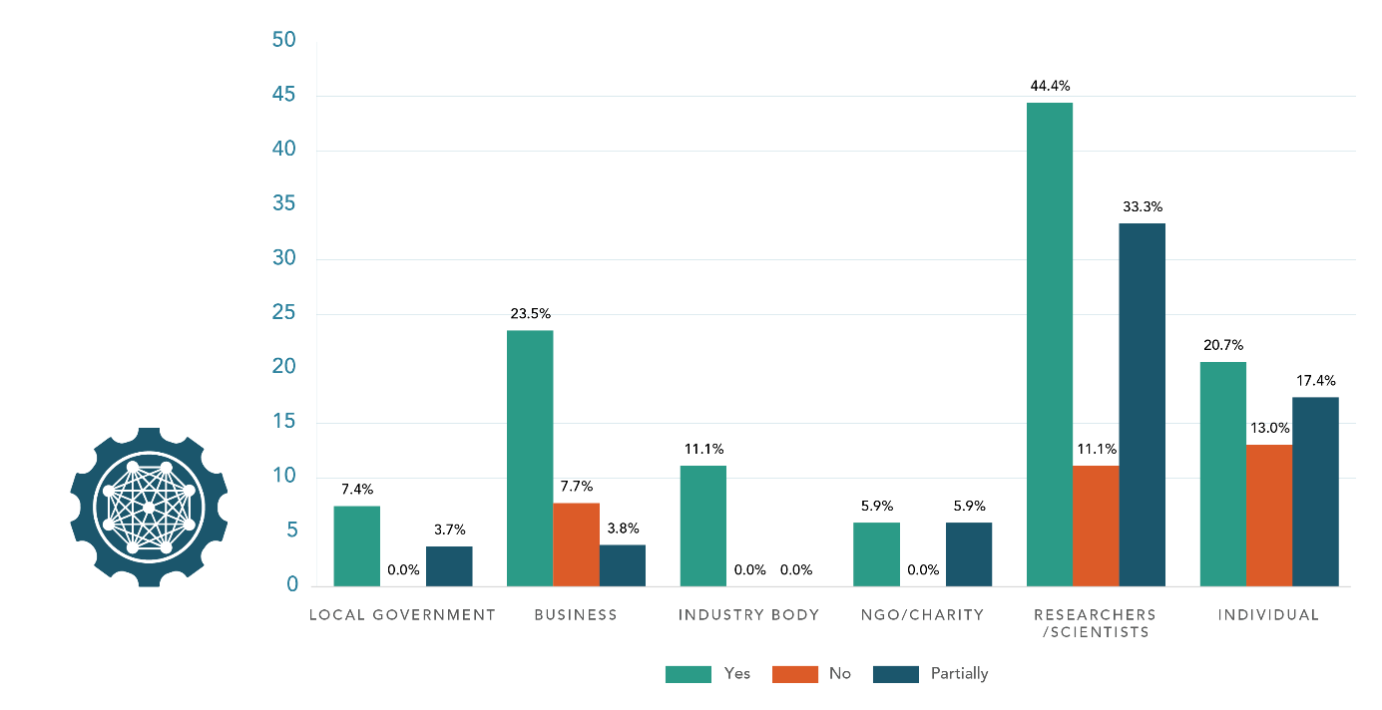
Overall, many submitters who responded to this question supported the ‘System-wide’ chapter objectives and noted that the terminology used for each one allowed for sufficient flexibility to ensure continued relevance in a changing climate. Some submitters were not fully convinced by the ambition of the objectives and were concerned about the lack of guidance regarding roles and responsibilities.
However, the Council questions whether the actions will lead to sufficient transformative system change outcomes noting that there are a range of coordinating/ sequencing risks for local governments, and no real answers to who will pay for adaptation. – Local government
There was widespread support for the first objective, with many submitters discussing a lack of coordination across all levels of government and sectors in accounting for changing risks. Some submitters commented on the need for bipartisan governance structures and arrangements that were not impacted by the current three-year political cycle. Submitters explained that these structures could therefore withstand changing agendas and secure Aotearoa New Zealand’s climate response, ensuring continued certainty, sustainability, information-sharing, and awareness of climate risks. These submitters said that such structures should be coupled with self-determination actions for communities to adapt according to their own needs.
Aligning the final plan and other climate and environmental legislation, especially the resource management reforms, was discussed by submitters as imperative to ensure consistency and to support changes brought on by climate impacts. Some submitters requested more information about the legislative framework for adaptation and proposed changes to better understand implications for their sectors, such as the necessary resources required to comply with reforms.
Appropriate resourcing to plan for adaptation was also seen to be essential by some submitters. Access to robust information about climate risks and adaptation solutions was considered particularly important. This included creating information with simple and concise language that could be easily understood by a wide range of audiences. These submitters said that providing information and tools, guidance and methodologies would enable effective risk assessment and adaptation planning across the whole country.
Risk information should not only be on climatic trends, but also on a variety of impacts (the “so what?”). Educational tools to improve community risk literacy would be helpful so that all members of the community can identify, understand and assess their risks and take appropriate action. – Individual
Submitters also supported the system-wide objective to invest in climate resilience, however, some noted that what was meant by ‘government support’ needed to be clarified. Across submitter types, unlocking central government funding to enable all parties involved to provide solutions that were financially viable for their respective communities was strongly supported.

Guiding the whole-of-government approach to adaptation
Question 7: What else should guide the whole-of-government approach to help New Zealand adapt and build resilience to a changing climate?
Most submitters noted that education and training were an essential consideration of guiding the whole-of-government approach. These submitters wanted public, apolitical education campaigns for people of all ages, and highlighted the need to communicate the importance of adaptation to the average person. Some submitters raised the need for education to be developed collaboratively with stakeholders such as local government, iwi and hapū, and local communities. Some submitters emphasised that any approach should be in bipartisan agreement to avoid the politicisation of climate change.
We have seen through the community and business education and behaviour change programmes that our members deliver, that there is a huge gap in understanding in terms of the causes and impacts of climate change and how we can mitigate those impacts and adapt. – Registered charity
Some submitters specified that funding and resources from central government would be essential to adapting and building resilience. Submitters wanted central government to empower iwi, communities and local government with funding and tools to enable them to plan and respond to climate change themselves. Some submitters emphasised that engaging with and investing in third sector/community/non-profit organisations would be essential in ensuring connections with communities and guidance from a grass-roots level.
Some submitters commented generally on the need for good quality data and considered that centralised, accessible, up-to-date and well-managed data would be essential for a whole-of-government approach.
Some submitters emphasised the importance of a whole-of-government approach guided by ensuring equitable outcomes for all communities in New Zealand. These submitters noted that this would not be a one-size-fits-all approach, as the impacts of climate change were not distributed equally across communities, some of which were already vulnerable.

Usefulness of tools, guidance and methodologies
Question 8: Do you agree that the new tools, guidance and methodologies set out in this chapter will be useful for you, your community and/or iwi and hapū, business or organisation to assess climate risks and plan for adaptation?
Many submitters recognised the important role that tools, guidance and methodologies would have to help establish a comprehensive approach to addressing climate change across Aotearoa New Zealand. Many submitters noted that there were significant gaps in the climate-risk data and the guidance available at the local level, making it challenging for regions, sectors, and communities to assess and respond to risk.
There was a sense of urgency for some submitters who said that too many people still did not understand what climate adaptation was and how it would affect them. Submitters maintained that the Government should ensure that people were resourced and encouraged to understand that change was coming and what it might look like in their part of the country. These submitters said that it would be essential to bring all communities along and to do this, Government must first explain what was happening in a more accessible manner.
Publishing documents, policies, and plans does not have a meaningful impact on the general population. Central and local government need to ensure we bring our communities along with us and explain the story better. – Local government
A nationwide mapping system of climate risk, 3D coastal mapping, and datasets, such as the NZ SeaRise: Te Tai Pari O Aotearoa Programme, were specific tools and methodologies referenced by submitters as being beneficial information for climate-resilience planning. Submitters also suggested that guidance would need to be developed so that communities, industries and sectors could make use of these along with industries and sectors.
There was support for establishing a foundation to work with Māori on climate actions to enable an equitable transition and provide a platform for mana whenua to be a part of the implementation of actions. Some submitters noted that the Crown needed to recognise and address its role as a Te Tiriti partner by enabling active Māori participation in planning and policy design, in order to balance its obligations to the principles of kāwanatanga and rangatiratanga.
If these tools, guidance and methodologies are by Māori for Māori, based on mātauranga Māori, mātauranga-a-hapū, mātauranga-a-iwi, which prioritise the outcomes that whānau, hapū, iwi want then yes. However, the tools, guidance and methodologies are only useful if they are well resourced in their implementation. – Individual
Some submitters strongly supported the creation of the adaptation information portal but sought a much faster and staged delivery and integration with regional initiatives. Submitters maintained this information tool could help to initiate the conversation about climate impacts and taking actions, but it needed to be made available sooner than what was proposed.
A few other submitters supported actions to make information as accessible as possible for communities to make informed decisions and plan for adaptation in a timely manner – beyond lengthy and complex scientific documents. It was suggested that these tools should be co-created alongside end-users to ensure relevancy and effectiveness of use.

Additional actions for central government consideration
Question 9: Are there other actions central government should consider to:
- enable you to access and understand the information you need to adapt to climate change?
- provide further tools, guidance and methodologies to assist you to adapt to climate change?
- remove barriers to greater investment in climate resilience?
- support local planning and risk-reduction measures while the resource management and emergency management system reforms progress?
Many submitters discussed the need to share knowledge across communities. These submitters considered that communities knew the needs of their region best, and care should be taken to ensure central government allowed room for locals to manage their own affairs.
Some submitters commented on the need for faster movement and better planning. These submitters wanted to expedite adaptation planning, citing that the risks and threats of climate change required not only commitment, but rapid action.
Across all four sub questions, a small number of submitters disagreed with the central government position on climate change, stating that the risks and threats of climate change had been overestimated or were made up. These submitters generally called for different data and research to be used, or for central government to abandon any adaptation plan and policies.

Enabling access and understanding information
Most submitters noted the importance of free, accessible and good quality data. Submitters considered that better data supported better outcomes, and so central government must ensure nationally owned and freely run data and insight platforms were available across sectors.
It is important that any data and/or information is distributed across a variety of platforms and displayed in a variety of ways, targeting a range of literacy levels to ensure vulnerable populations are included in decisions about their future. – Local government
Some local government submitters stated that local government needed support and funding to collect data on local and regional climate risks and hazards, and for GIS mapping.
Many submitters emphasised the importance of education and information to enable people to successfully adapt to climate change. These submitters wanted clear, succinct and accessible information from a variety of sources to keep them informed about adaptation. Some submitters highlighted the importance of third sector groups/NGOs as trusted sources to distribute information to communities, commenting that ‘top-down’ management of information from central government would likely not be as effective. A few submitters wanted information and resources to be developed in ways that were culturally responsive to targeted groups.

Provision of tools, guidance, and methodologies
Submitters identified a number of tools and methodologies that would assist in adaptation. Most submitters generally wanted guidance, direction and funding from central government.
To response [sic] effectively, we need central government support and direction. We need central government to provide regulatory clarity that defines local government’s role though local government’s voice needs to be heard developing that direction. Tools (including regulation) to be deployed by local government need to be developed with local government so that local knowledge and practicalities are considered. – Local government
A few submitters wanted examples of positive adaptation initiatives. However, some submitters considered that new tools were not needed, and time and resource should instead be used to work with what already exists.

Removing barriers for greater investment
Many submitters considered changes to regulation as important for removing barriers to investment, as often regulation and/or legislation were out-of-date or had not been designed with climate resilience in mind. Some submitters specified changes to the Resource Management Act (RMA), the New Zealand Coastal Policy Statement, the National and Built Environments Act, or the Building Code.
Some submitters considered it important to focus on New Zealand-based resources and investments, while other submitters suggested looking overseas to learn about what was working. Other submitters considered alternative energy and managing housing risks as key areas where barriers to investment should be removed. Some submitters were unsure what barriers the draft plan was referring to and wanted further clarification.

Supporting local planning and risks reduction measures during reforms
Many submitters discussed interim support needed from central government. Most of these submitters spoke from a local or regional perspective and wanted support for local government and communities in planning, risk management, waste reduction and climate services that were currently limited by the supplier market (eg, climate-risk assessments).
Some submitters noted that there were complex interactions between RMA, Three Waters, the future of local government and emergency management reforms, and that local government required support and clarification on the roles and responsibilities of local and central government in these areas. Some of these submitters were concerned that the sheer scope of these reforms did not allow for coherent and consistent activity across government.
The draft plan relies significantly on the broad schedule of reforms, work programmes and initiatives that are already in progress and being managed across ministerial portfolios … While an all-of-Government response to climate adaptation is critical, and an adaptation lens needs to be applied to all government work programmes, it is difficult to understand how the draft plan will provide a coherent management, reporting and governance framework across this wide range of government activity. – NGO

Actions that will have the most widespread and long-term impacts
Question 10: What actions do you think will have the most widespread and long-term benefit for New Zealand?
Many submitters commented that practical risk-assessment tools and support for adaptation planning, and political consensus and support for adaptation policies, would ensure certainty that climate change concerns would be addressed in a timely manner and have the most widespread impact. Submitters said that embedding cross-sector, whole-of-government approaches (including information and consistent use of language) would be essential to encourage public understanding and support for changes related to adaptation.
Many submitters made comments about the importance of climate-risk education, noting that ensuring appropriate public awareness about adaptation needed to be an absolute priority for the Government. Media was referenced by some as a useful tool to educate people on the cost of inaction, the urgent need to plan for climate change effects, and for regular communication and information on climate issues, programmes and other adaptation activities.
Some submitters spoke about the importance of ensuring that new infrastructure took climate risks into account. This included better urban design that incorporated plenty of green spaces and nature-based solutions, sustainable buildings and mandating low-carbon building materials, and insurance and finance options that encouraged change towards more resilient towns and cities.
Some submitters recommended further engagement and consultation with affected communities to identify the most important actions, along with the need for a strong foundation for working with Māori on climate actions and policy design. A few submitters wanted to see the final plan better incorporate and use the Rauora framework to commit to true Te Tiriti partnership and ensure an equitable transition.
Recognise tino rangatiratanga and mana whenua role as partners in adaptation planning and local solutions. Work with iwi and hapū to embed culturally appropriate safeguards in adaptation planning and action process to ensure that colonisation is not perpetuated. – Local government

Additional actions to strengthen climate resilience
Question 11: Are there additional actions that would strengthen climate resilience?

Action and guidance from central government
Many submitters noted that the coordinating role for climate action must sit with central government. These submitters considered that the draft plan currently lacked a lead agency with clearly defined responsibilities. Some submitters supported greater cross-government collaboration in the draft plan but wanted to see more information about how this would be achieved.

Investing in infrastructure
Some submitters sought more investment in infrastructure actions to strengthen climate resilience such as:
- higher standards of passive homes
- more hydro dams
- more solar panels on public buildings
- no new critical infrastructure below 80 metres
- green infrastructure investment to strengthen climate resilience
- all new coastal developments requiring insurance cover for the next 50 years
- flood protection
- potable water availability and quality protection.

Research and education
Some submitters wanted to see an overarching research strategy to guide research priorities and provide national coordination, to reduce knowledge gaps and duplication. In general, submitters wanted to see greater detail in the research strategy, and a coordinated approach to data-gathering and information-sharing at a local and regional level. In addition, a few submitters wanted to see teaching and learning related to climate change listed as a supporting action, with awareness of adaptation included in the entire education curriculum.
Some submitters recommended a more coordinated approach to data-gathering and information-sharing at a community, local and national level to enable this expertise in national projects.

Engaging community and partnering with iwi/Māori
Some submitters maintained that the effectiveness of central government agencies in serving the needs of regional and local communities, marae, iwi and hapū should be reviewed. In addition, a few submitters considered that hapū should be resourced to make their own decisions in managing their wāhi tapu. Submitters considered that Māori landowners should be directly involved in planning for climate-resilience actions.
Actions to promote indigenous knowledge in the preservation of ecosystems and the natural environment. – NGO
Some submitters considered it important for the Government to partner with iwi to assess how well climate-related hazards were being considered in iwi management plans. Submitters also emphasised improving the resilience of Māori-owned land and cultural sites.

Focusing on the primary sector
Some submitters noted that a system-wide food security plan and policy was needed, which could include improving food security by promoting and funding families to grow their own fruit and vegetables. A few submitters considered that further investigation into ways to manage the dual risk of flooding and drought was needed.

Addressing barriers before resource management system reforms
Question 12: There are several government reform programmes under way that can address some barriers to adaptation, including the resource management (RM) reform. Are there any additional actions that we could include in the national adaptation plan that would help to address barriers in the short term before we transition to a new resource management system?
Some submitters considered government could provide additional support for councils to identify and manage transitional and governance risks, including support for the transition to zero carbon ways of working and potential future costs of emissions.
In addition, a few submitters wanted clarity on funding mechanisms to support climate adaptation in the resource management reform legislation. This would help councils undertake climate adaptation planning. Others considered that capacity should be built within local government and communities to provide climate leadership, and the ability to implement changes.
A few submitters considered it essential to engage with communities on the major objectives of proposed resource management reform before completed drafts were released.
Early, direct and meaningful consultation with Māori landowners is critical to avoid exacerbating existing barriers in new and reformed policy. – Iwi/hapū

Greater investment in resilience
Question 13: In addition to clarifying roles and providing data, information, tools and guidance, how can central government unlock greater investment in resilience?
- Would a taxonomy of ‘green activities’ for New Zealand help to unlock investment for climate resilience?
Many submitters focused on mobilising and incentivising private sector finances and involving the community. Some submitters wanted to see the Government investing in adaptation, and prioritising co-investment in nature-based solutions. In addition, a few submitters acknowledged the importance of a mechanism that enabled green enhancements across private and public land. Other submitters considered that central government should provide incentives for green projects and development.
Some submitters noted that resilience required a culture change through educating, encouraging and enabling communities to take responsibility for their own resilience. It was suggested that central and local government could provide funding to encourage resilience initiatives for individuals and community-led adaptation projects. A few submitters also wanted to see the community and local government included when clarifying roles and providing data, information, tools and guidance.
[…] recommends that central government identifies adequate resourcing systems for mana whenua to develop their own solutions on how mātauranga Māori will inform whānau, hapū, and iwi responses to climate change. This would enable working with iwi/Māori to ensure that mātauranga Māori can inform modelling and quantitative assessments, with Māori determining and having ownership of appropriate use of the knowledge. A programme of research led by Māori to address adaptation areas of interest to Māori is needed to inform and upskill central and local government policy and practice. – Local government
Many submitters agreed that a taxonomy of ‘green activities’ would be helpful if done correctly, as it would:
- help people make informed choices
- provide initial ideas as to what ‘green activities’ could be
- prompt innovative thinking and entrepreneurship
- help business to understand what needed to be done and invest in appropriate actions
- clarify what constituted a ‘green activity’ and provide assurance that investment was going towards climate change
- empower local action.

Taxonomy of ‘green activities’
Some submitters supported the taxonomy in principle, but noted that:
- it should be a community-facing taxonomy rather than a government or council-facing framework
- the common language of green terms should be clarified to enable better communication
- the taxonomy must align with international best practice
- more detail was needed on what and how investments would support adaptation planning
- guidance was needed on integrating matāuranga Māori into adaptive planning and working with mana whenua
- the community and local and central government would need to be added when clarifying roles and providing data, information, tools and guidance
- communities should be resourced to allow mana whenua to develop their own solutions.

The natural environment

Major themes
Most submitters agreed with the actions proposed in the ‘Natural environment’ chapter. Many who only partially agreed suggested that some of the areas discussed needed a higher prioritisation or more urgency. Submitters wanted to see a wide range of additional actions that addressed risks to the natural environment from climate change, including actions related to land use, water use, research and education.
Submitters identified a range of opportunities to enhance the natural environment’s climate resilience, including specific adaptation policies for biodiversity and ecosystem conservation across Aotearoa New Zealand. Submitters commented that there needed to be an increased focus on pest eradication and the risks to indigenous ecosystems and species from the enhanced spread, survival and establishment of invasive species. Submitters also wanted to see Aotearoa New Zealand’s most vulnerable ecosystems and species prioritised.
Submitters sought greater collaboration between local government, iwi and community groups to increase the environment’s resilience to impacts of climate change. Submitters also discussed the importance of recognising the resilience provided by different natural environments, linking climate change and resilience outcomes with biodiversity outcomes and actions, and considering approaches to adaptation that involved nature-based solutions.
Most submitters commented that greater autonomy would advance the role of Māori as kaitiaki. A greater overall integration of matāuranga Māori was also important for many submitters.

Agreement with natural environment actions
Question 14: Do you agree with the actions set out in this chapter?
- Implement the Department of Conservation (DOC) Climate Change Adaptation Action Plan.
- Implement the proposed National Policy Statement on Indigenous Biodiversity.
- Implement the Water Availability and Security programme.
- Deliver a collection of actions run by Biosecurity New Zealand.
Most submitters agreed with the actions set out in the ‘Natural environment’ chapter. Many agreed partially with these actions, and very few disagreed altogether.
We agree that all aspects of life in New Zealand rely on a thriving natural environment, and that it is essential for our physical and mental health, food and water security, culture, and economy. We support the actions outlined in the draft NAP to preserve and secure our natural environment for generations to come. – Local government [Upper Hut City Council]
Many of the submitters who only partially agreed with the proposed actions did so because they thought more urgency was needed, or more specific actions needed to be focused on and addressed. For example, some submitters commented that the following should be emphasised more: freshwater security, soil health and ecological corridors.
The planned reforms to water management and the National Policy Statement on Freshwater Management go some way to addressing the quality of freshwater in New Zealand. However, there are well documented impacts on freshwater quality due to the intensification of animal agriculture, in particular dairy farming, that are not directly addressed. A key piece of action is to meaningfully include agriculture in the emissions trading scheme. This would have multiple benefits for freshwater quality by driving down nitrogen fertilizer use, encouraging the adoption of regenerative farming practices and a shift from animal agriculture to horticulture. – Local government

Guiding government actions to address risks
Question 15: What else should guide central government’s actions to address risks to the natural environment from a changing climate?
Submitters provided a wide range of suggestions about what else could guide government action to address risks to the natural environment from climate change. Most comments related to land use, water use, the need for research and education, regulatory changes and the reforms that are under way.
Although most submissions were unique, those submissions that were supported by a number of submitters suggested the following:
- review the contribution of agriculture and intensive farming to climate change
- protect indigenous biodiversity
- greater transparency when developing mātauranga Māori environmental indicators
- develop a baseline, monitor and report on progress, and provide economic assessments, for example, cost effectiveness and cost/benefits analysis
- show leadership, for example, ensure products are environmentally friendly and ensure appropriate engagement, including iwi, rural communities, local government and vulnerable communities.
Knowledge gaps exist in key areas – there is also a lack of understanding of the baseline and a lack of monitoring to understand the impacts of climate change and the effectiveness of adaptation. Without these, it will be difficult to assess whether adaptation is effective. The lack of clarity regarding accountability and reporting requirements as a risk that could undermine the progress of reliant or interconnected actions. – Research organisation

Additional actions for central government consideration
Question 16: Are there other actions central government should consider to:
- support you, your community, iwi and hapū, business and/or organisation to build the natural environment’s climate resilience?
- strengthen biosecurity in the face of climate change?
- identify and support New Zealand’s most vulnerable ecosystems and species in a changing climate?

Building the natural environment’s climate resilience
Many submitters noted several opportunities to enhance the natural environment’s climate resilience, including specific adaptation policies for biodiversity and ecosystem conservation across New Zealand. Some submitters commented that there was an opportunity to leverage indigenous biodiversity as a key tool for responding to climate change. Submitters suggested actions including providing funding and financing tools to incentivise landowners to adapt to climate risk, encouraging local biodiversity forums and other working groups that supported landowners in identifying, avoiding or mitigating problem species as they arose, and providing better tools and expertise to local government and facilitating more sustainable compliance monitoring solutions for the high country. A few submitters suggested that there was also a need to allocate funding with a pro-equity lens to reduce the impacts of climate change on various communities.
Mental health was also raised in connection to the Natural Environment, in that Pacific peoples felt acutely when nature was negatively impacted. It was raised that Pacific peoples felt a synergy between nature and indigenous knowledge systems, and that both contributed to their resilience. Participants recommended the inclusion of indigenous knowledge systems and their connection to the Natural Environment within the NAP. – Advocacy group

Strengthening biosecurity
Many submitters noted that there should be an increased focus on the impact of pest animals in weakening the resilience of ecosystems to climate-induced pressure. Some identified the risks to indigenous ecosystems and species from the enhanced spread, survival and establishment of invasive species due to climate change. Since this is one of the most significant risks to the natural environment, submitters noted the significant role councils have in biosecurity management.
[…] actions in response to the potential impacts of pest and disease incursion on tree species and other vegetation used for soil conservation and riparian protection could have greater acknowledgement and attention in the draft NAP. – Local government
A few primary sector submitters were concerned that the draft plan did not recognise the importance of farms and other exotic ecosystems. As a remedy, these submitters suggested that the draft plan acknowledge the risks to farms and other exotic ecosystems from the enhanced spread, survival and establishment of invasive species due to climate change. A few submitters stated that tourism would continue to be a potentially significant pathway for biosecurity risk and suggested that border control should be enhanced. This was reinforced by the viewpoint that biosecurity needed to be redefined and reinvested in or reinvented.

Vulnerable ecosystems
Some submitters suggested the need for a dedicated research programme targeted at understanding the threats to vulnerable species and ecosystems and planning for their protection now, rather than when they started to retreat in response to the changing climate. A few submitters suggested that pest eradication of introduced species must continue. These submitters commented that allowing and enabling recreational hunting could assist, but more drastic elimination policies would be needed.
A few submitters suggested that further work needed to be done to ensure the right conditions existed for native species to adapt, including significant natural areas and green corridors. Actions to create native habitat would have a positive impact on the ability of the system to offset carbon emissions.
Government should identify and support New Zealand’s most vulnerable ecosystems and species. Just as geospatial mapping is done to identify climate risk zones for prioritising areas suitable for climate response measures, we should identify the country’s most vulnerable ecosystems and species for prioritising climate action for our ecosystems. – Local government

Non-central government action for natural environment resilience
Question 17: What do you identify as the most important actions that will come from outside of central government (eg, local government, the private sector or other asset owners, iwi, hapū and/or other Māori groupings such as: business, forestry, fisheries, tourism, urban Māori, the private sector) to build the natural environment’s resilience to the impacts of climate change?

Most important actions outside of central government
Most submitters commented that iwi and local communities should be empowered to plan, fund and implement local initiatives that support local biodiversity strategies and benefit their constituents. A few submitters highlighted the importance of local government, iwi and community groups having an integrated and supported role in increasing the natural environment’s resilience to impacts of climate change.
In addition, some submitters suggested that developing mātauranga Māori indicators of climate impacts on the natural environment would enable iwi and local communities to identify local strategies to improve environmental outcomes at a local level. A few submitters stated that local government’s role was to enact legislation through planning, monitoring and enforcing compliance. These submitters also acknowledged that the private sector should play a supportive investment role and could start undertaking biodiversity disclosures.
LGLNZ has been calling for greater support for councils from the Government to undertake climate change adaptation planning and action including consistent national direction, a national managed retreat framework, support for having hard conversations about adaption [sic] with communities and clarity about how the costs of adaption [sic] will be met. – Local government
Some submitters suggested that businesses would need to adapt and change when required. These submitters noted that the Government should reconsider how to revive and increase tourism and support small businesses without adding to the burden on the natural environment. The contrary view shared by a few submitters was that no climate action was needed, and resources should instead be allocated to economic stimulus-based activity.
Mainstream business is still behind the curve and I think many companies in the Climate Leaders Coalition haven’t done much to imbed climate risk practices, not to mention done anything to start adapting. – Individual

Most important actions involving sectors
Most submitters mentioned local government’s important regulatory role in maintaining environmental quality. Most submitters acknowledged that all sectors and participants must accept that adaptation was necessary and needed to be aware of and understand the solutions available. A few submitters recommended that all industries should undertake modelling to understand how climate change impacts may affect the natural systems they interact with, for example, aquaculture and sea temperature, or land development and changes to rainfall intensities. These submitters suggested that industries should plan to ensure their actions supported environmental resilience for the future, and that future business models were based on likely climate impacts.
A few submitters mentioned the role of tangata whenua in protecting the environment for future generations despite a lack of land, support and resourcing. Submitters noted that this should be acknowledged, and greater funding provided to tangata whenua. This required strong relationships that allowed for collaborative regional efforts to occur with mana whenua as decision-makers.

Most important actions involving conservation efforts
Many submitters recommended that the final plan include approaches to adaptation that involve nature-based solutions and natural infrastructure, with their co-benefits for biodiversity, carbon sequestration and opportunities for kaupapa Māori adaptation. This would include restoring areas and, crucially, preventing development that was damaging to nature-based solutions from occurring. A few submitters said that the groups with the most impact would be Māori, forestry and the agriculture sector, as their actions included preserving natural spaces and ensuring that land remained productive and cared for. Therefore, it was suggested that agriculture must have support and accountability to maintain regenerative and sustainable farming methods.
Some submitters supported the aim of the proposed forestry planning advisory service to provide data-informed advice and planning tools. These submitters acknowledged that broadly adopting regenerative practices in the food and fibre industries would support ecological resilience by integrating and protecting biodiversity and ensuring an abundance of native species and natural habitats. A few submitters stated that Aotearoa New Zealand must invest in developing Māori-led solutions, including support for monitoring programmes.
Addressing climate change hazards demands a step-change in approach. Councils, who continually bear the brunt of the impacts of climate change know fundamentally what is needed is to move beyond business as usual: comprehensive planning, hard conversations with communities, and significant investment to mitigate and adapt to the risk climate change poses to their communities. – Local government

Additional actions to support Māori as kaitiaki
Question 18: Are there additional actions that would advance the role of Māori as kaitiaki in a changing climate?
Most submitters agreed that there were additional actions that could be considered to advance the role of Māori as kaitiaki of the natural environment.
Of these submitters, most supported actions to provide Māori with greater autonomy and decision-making power, and the implementation of a co-governance model. Suggestions included supporting the presence of matāuranga Māori within the school curriculum to enable Māori students to see pathways to support such kaitiaki roles. A few submitters noted this could extend to providing policy and planning scholarship programmes for tertiary and/or wānanga study.
Many noted that building a framework to support iwi/hapū in building climate resilience would be key to advancing the role of Māori as kaitiaki.
Resource hapū and iwi to make their own decisions regarding the management of their whenua, including in self-identifying the most appropriate sites for potential relocation of marae, papakāinga, urupā as well as current wāhi tapu. – Organisation
Suggestions included access to consistent open-source data, education, dedicated funding sources and support from central and local government. In addition, submitters noted that further embedding the principles of kaitiakitanga and matāuranga Māori throughout the final plan would advance this role.
A few submitters disagreed or were unsure about additional actions. They expressed concern that if implemented, funding would require monitoring and that the co-governance model could lose focus on the immediate need to get people working together.

Homes, buildings and places

Major themes
Most submitters supported the outcomes of the ‘Homes, buildings and places’ chapter. Submitters considered that prompt action was necessary, and the actions in this chapter should not be delayed. Financial support for resilient homes and buildings, and Māori cultural assets were seen as priorities.
Submitters emphasised the need to consider the conflict between the goals of climate resilience and affordability, especially the impact on existing social inequities. Submitters also said that achieving the Government’s goals involved working with and adequately resourcing a range of stakeholders, including homeowners, renters, people on low incomes, Māori and local authorities.
In terms of actions central government should consider, submitters focused on the importance of equipping a range of stakeholders with the right knowledge and funding to implement climate-resilient policies. Submitters also highlighted the need to protect both Māori and non-Māori cultural heritage.
Submitters emphasised that there was no need to ‘reinvent the wheel’ when integrating mātauranga Māori and Māori urban design principles when existing principles and networks were available. Submitters also noted that national guidance should create consistency without inhibiting flexibility at the local level and called for guidance on how to protect cultural heritage.
Submitters emphasised the role of central government to provide information and funding to enable climate resilience, in particular working through the medium of local government.
Low-income communities were identified by many submitters as being susceptible and likely the most impacted by the actions in the ‘Homes, buildings and places’ chapter, along with renters, coastal communities, Māori communities, and building and asset owners. A theme across all identified groups was the need to provide sufficient investment to support the application and ongoing success of these actions, with equitable allocation of resources as one of the top priorities for submitters.
Submitters identified a range of barriers to increasing the resilience of buildings to climate change impacts, including:
- regulation and compliance
- the cost of creating climate-resilient buildings
- a lack of targeted funding for Māori land
- a lack of appropriate information and education
- a lack of innovation and creativity.

Agreement with homes, buildings and places outcomes
Question 19: Do you agree with the outcome and objectives in this chapter?
- HBP1 – Homes and buildings are climate resilient and meet social and cultural needs.
- HBP2 – New and existing places are planned and managed to minimise risks to communities from climate change.
- HBP3 – Māori connections to whenua and places of cultural value are strengthened through partnerships.
- HBP4 – Threats to cultural heritage from climate change are understood and impacts minimised.
Figure 7: Support for homes, buildings and place objectives by submitter type
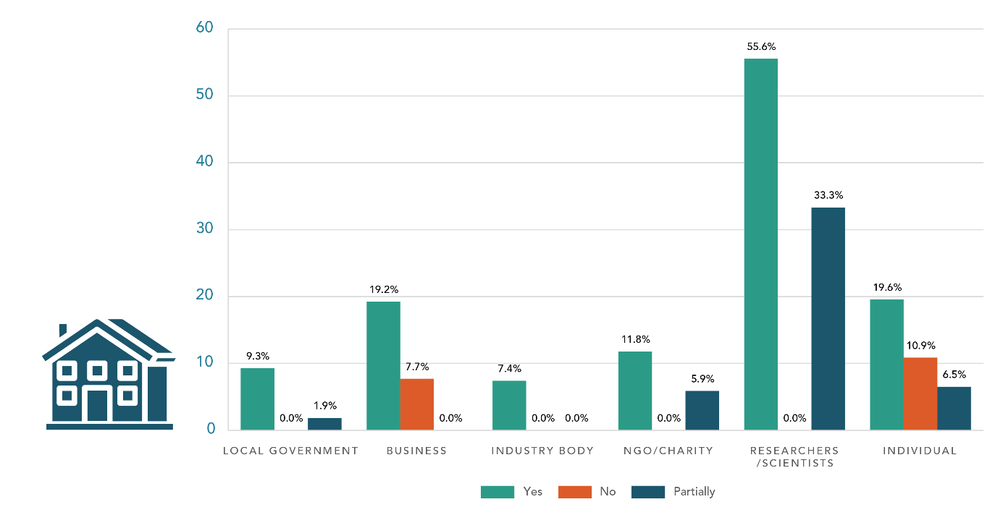
Most submitters supported the outcomes in this chapter. Many noted the importance of these outcomes to community health and wellbeing. A few submitters commented that the outcomes and objectives would play a key role in determining our health, wellbeing and overall quality of life.
Many submitters partially supported the outcomes and recommended greater linkages to other parts of the draft plan (such as infrastructure), clear prioritisation between objectives and better guidance/rules relating to risks of building in certain areas subject to climate impacts. Some submitters noted the need to maintain affordability while adapting to climate resilient housing and buildings.
Some submitters thought the outcomes did not go far enough and recommended a complete model shift. Funding and guidance would be needed to support this shift. A few submitters thought the outcomes relied too much on the status quo and lacked innovation.
Many submitters particularly welcomed the focus on iwi and Māori in this chapter and considered these aspects of the plan a priority. Many submitters noted the importance of partnership and funding for Māori communities to adapt and conserve taonga/cultural assets including urupā. Some submitters recognised the importance of cultural infrastructure and recommended including this concept in the objectives. Some submitters recommended the addition of an objective emphasising the empowerment of iwi/Māori in managing their cultural assets and taonga.
Other proposed amendments:
- Objective HBP2 – this should be amended to include the word ‘avoid’ – that is, ‘minimise or avoid risks to communities from climate change’.
- Include connectivity to places.
- Split HBP1 into two objectives: 1) Homes and buildings are climate resilient 2) Homes and buildings meet social and cultural needs.

Guiding central government actions to increase resilience
Question 20: What else should guide central government’s actions to increase the resilience of our homes, buildings and places?
Some submitters discussed the need for actions to be informed by the existing issues and challenges in the housing market (including affordability and poor housing), which were likely to be exacerbated by climate change. These submitters referred to the need to improve the quality of new and existing builds, and to incorporate passive cooling techniques, solar technology, and water-saving or reuse technology. Submitters mentioned the conflict between climate resilience and affordability. Submitters noted that changes proposed in the draft plan alongside other recent or planned regulatory changes could detrimentally impact construction costs as well as housing and building supply and affordability.
Some submitters noted a need to provide adequate housing for people forced to relocate as part of managed retreats (eg, after flooding). Some submitters sought a focus on equity and affordability of social housing for low-income earners, financial incentives for climate-resilient building solutions, guidance for local authorities and property owners, solutions for renters and opportunities to develop housing for Māori.
Making homes, buildings, and places resilient to the changing climate will result in added cost to home and building owners and to the communities that habitat [sic] places. Affordability must be addressed for those most impacted and vulnerable. – Local government
Some submitters discussed the need for the Government to work closely with Māori, local authorities and the private sector. Some submitters noted the key role of local authorities in implementing central government mitigation and adaptation policy. These submitters sought greater guidance at a national level and resourcing for local authorities, and updates to the Building Act and the Building Code to facilitate improvements to create climate-resilient buildings and information for homeowners and renters on how to increase the resilience of their homes.

Agreement with homes, buildings and places actions
Question 21: Do you agree with the actions set out in this chapter?
- Build property resilience.
- Establish an initiative for resilient public housing.
- Embed adaptation in funding models for housing and urban development, and Māori housing.
- Support kaitiaki communities to adapt and conserve taonga/cultural assets.
Some submitters expressed support for a range of building types being included. Submitters generally endorsed equipping people with knowledge, for example, through advice and guidance on the resilience of homes, buildings and places. This could include the development of a robust climate-hazard assessment framework for new builds and guidance on managing existing buildings.
Submitters called for funding and programme support, particularly for local government to ensure policies were effectively implemented, while criticising a lack of adequate funding for infrastructure providers. Submitters also emphasised the need for clear responsibilities among key stakeholders.
A significant barrier to increasing resilience is that the building code adopts a minimum compliance approach which does not enable Council to impose higher standards. Changes to the Building Code need to either provide greater flexibility or significantly improve standards to meet climate change outcomes. – Local government
Many submitters supported achieving change through standards, regulations, legislation and guidance to shape the industry and support climate resilience, in particular through updating the Building Code. Submitters explained that this would provide clarity for the industry, which could help to reduce costs (which was a concern of submitters due to the cost of making housing more resilient). Submitters referred to the use of incentives, for example, by local authorities, to supplement education and planning provisions, working with the insurance and banking sectors.
Central Government needs to prioritise support to assist local authorities to identify and plan for destinations where those that will be affected by managed retreat can be relocated to, as part of district planning. – Local government
Some submitters called for more detailed advice on how to conserve taonga, while others called for more information to help Māori to plan and adapt, taking a broader lens than just conserving taonga (eg, funding, mental health support and economic opportunities). Some submitters highlighted the distinction between protecting cultural heritage and protecting Māori cultural heritage, and the importance of protecting both.
Some submitters referred to the need to prioritise communities now and take a more holistic approach to land, flood plan and water management. This would include considering how homes, buildings and places were embedded within the wider infrastructure network through nature-based solutions.

Other actions for government consideration
Question 22: Are there other actions central government should consider to:
- better promote the use of mātauranga Māori and Māori urban design principles to support adaptation of homes, buildings and places?
- ensure these actions support adaptation measures targeted to different places and respond to local social, cultural, economic and environmental characteristics?
- understand and minimise the impacts to cultural heritage arising from climate change?
- Do you see any further opportunities to ensure that groups who may be disproportionally impacted by climate change, or who are less able to adapt (such as those on low incomes, beneficiaries, disabled people, women, older people, youth, migrant communities) have continued and improved access to infrastructure services as we adapt?
Submitters called for a range of actions to promote the use of mātauranga Māori and Māori urban design principles, including supporting the development of Māori housing, including mātauranga Māori in training and apprenticeships, and recognising existing Māori frameworks and groups, for example, Ngā Aho (a network of Māori and indigenous design professionals) and the Te Aranga Māori Design Principles.
Government should support Māori-led adaptation solutions but be cautious against having two different risk profiles that do not communicate to each other. – Local government
The current structure of central and local government institutions does not often provide for or serve Māori values. A genuine commitment from local and central government to learn and understand what they are trying to promote is therefore imperative. It will also assist in enhancing and strengthening the partnership aspect of objective HBP3. – Iwi/hapū
Some emphasised the need to defer to mana whenua when seeking to incorporate mātauranga Māori and Māori urban design principles to support adaptation. A few submitters disagreed with the recognition of mātauranga Māori at all.
Some submitters noted the importance of a local approach being integrated into the final plan to avoid a one-size-fits-all approach, which could be implemented by working with local government. Submitters explained that national guidance should provide consistency. Alongside this, there should be flexibility in responses to account for local needs.
While some issues are nationally applicable, other [sic] are location-specific and need to respond to local circumstances, where local government and local communities are the experts. – Local government
Some submitters commented on the need for improved guidance for applying cultural heritage values, for example, in prioritising resourcing due to the number of places at risk of climate hazards.
Some submitters referred to the importance of recognising the link that heritage can have to other disciplines, for example, to nature-based solutions. A few other submitters argued that cultural heritage should not be considered a priority in the context of the climate crisis.

Government role for supporting actions
Question 23: Do you think that there is a role for government in supporting actions to make existing homes and/or buildings more resilient to future climate hazards? If yes, what type of support would be effective?
Submitters noted that many people could not afford the costs of improving resilience and emphasised the need for government schemes to provide funding, particularly for high-deprivation households and building owners (eg, loans). Such schemes could be directed through local authorities.
Submitters suggested that central government provide people with information, tools and incentives to make their properties more resilient. Many submitters called for guidance, in particular for retrofitting, as part of the Government’s role in educating the public. This could include sections tailored for different types of homes, such as older, rural or coastal homes.
Council believes that there is a role for Government in supporting actions to make existing homes and/or buildings more resilient to future climate hazards. Some examples include:
a) Providing a national guide for retrofitting different times of builds.
b) Providing ongoing technical support to homeowners and offering a call-in service for answering questions on an ongoing basis
c) Rolling out a robust awareness programme so that everyone knows about the retrofitting kaupapa. – Local government
Some submitters stated that local councils should give targeted incentives to respond to local needs. Some submitters suggested amending the Building Code to incentivise resilience improvements and encourage building in appropriate locations only.
Submitters gave examples of a range of other measures for retrofitting existing stock, or to incentivise retrofitting. This included green roofs, solar panels and water-efficiency measures, such as water tanks, and mandatory climate-risk statements on LIMs.
A few submitters discussed the need for the Government to work with insurers and the Earthquake Commission to ensure that changes to insurance because of climate change were not detrimental to disadvantaged groups.

Groups most likely to be impacted
Question 24: From the proposed actions for buildings, what groups are likely to be most impacted and what actions or policies could help reduce these impacts?
Submitters provided different views on the groups most likely to be impacted by the ‘Homes, buildings and places’ chapter actions. Overall, however, submitters saw the need for appropriate levels of funding and investment for the actions to be successful. Submitters explained that chapter actions would need new targeted funding programmes to ensure everyone had an equitable chance to become climate resilient. Submitters strongly recommended developing a framework for these funding programmes to ensure resources were allocated equitably
Many submitters mentioned low-income communities and those in public and social housing as likely being most affected by the chapter actions. They noted that vulnerable communities would be disproportionately affected by climate change impacts and they should, therefore, be the primary focus of adaptation interventions.
In answer to this question, we would like to make a distinction between impacts that result in a loss of privilege and impacts that result in further oppression of already marginalised people [...] Those who have less of an economic safety net might be less impacted in absolute terms, but because they are already in a vulnerable position, the relative impact of a smaller loss can be enormous. – NGO
The financial implications of actions to improve climate resilience in buildings and housing were discussed by some submitters, who were concerned about the impact proposed requirements and upgrades would have on affordability – most likely disproportionately affecting renters.
Some submitters were concerned about the impacts of the actions in this chapter on coastal and low-lying communities who were not well resourced to make necessary improvements. Submitters argued that the majority of those most affected lived in areas where risks posed by storms, flooding and slips were prevalent – these events were going to have the most significant impacts on homes and buildings across the country.
A few submitters highlighted that Māori communities, especially those living on papakāinga where land is collectively owned, or in rural areas, already struggle to access mainstream funding and navigate regulations that do not embrace the concepts of te ao Māori. Submitters considered capacity and capability building and financial resourcing to enable climate resilience as crucial for supporting Māori communities.
For these communities, their valued urupa [sic] are threatened by erosion. The proposed policies relating to embedding adaptation in funding models for housing and supporting kaitiaki communities to adapt and conserve taonga are supported and would help to reduce impacts on communities. – Local government
Building and asset owners were also mentioned by a few submitters as being impacted. Others impacted included owner-occupiers who had unknowingly purchased property in areas recently identified as vulnerable to natural hazards, or areas that would become increasingly vulnerable. These submitters said that climate-related information in LIM reports could reassure people they were making the right purchasing decisions and safeguard their future investments.

Current barriers to increasing buildings’ resilience to climate impacts
Question 25: What are some of the current barriers you have observed or experienced to increasing buildings’ resilience to climate change impacts?
Most submitters noted that Resource Management Act and Building Act reforms were required to embed climate-resilient building in Aotearoa New Zealand. Many submitters noted that the Building Code was not fit-for-purpose and was currently set as a minimum standard. Some submitters noted that existing buildings had limited resilience and had a major footprint and impact on climate change. These submitters said the current consenting framework was a significant barrier. It was costly and time consuming. Some submitters referred to district plan rules and suggested that these should be more stringent.
Most submitters said the cost of creating climate-resilient homes was a significant barrier. Many noted the significant infrastructure costs and the lack of funding for upgrades. A few submitters noted specific barriers related to Māori land. These submitters said that the lack of targeted funding and difficulties with lending, development and governance of Māori land prevented Māori landowners from increasing the climate resilience of their whenua and assets. To address this issue, the submitters recommended targeted funding for Māori land.
Many submitters said that there was a lack of information and education about building and designing climate-resilient buildings. Some submitters also raised concern about the lack of information on climate risk to property. These submitters said that it was essential to identify risks to enable societies to make the right decisions.
Some submitters noted that there was no incentive to build more resilient homes, so builders build to the minimum standards as cheaply as possible to make the most profit. These submitters recommended legislative amendments and incentives to encourage more resilient building.

Infrastructure

Major themes
Most submitters agreed with the outcomes and objectives proposed in the ‘Infrastructure’ chapter. Many who only partially agreed suggested additional areas to consider or thought that more detail was needed.
Submitters considered that long-term focus for infrastructure development, renewal or replacement was needed to future-proof essential services and community resilience. Submitters also wanted to see incentives to promote actions at the individual/community level (eg, making solar power generation more affordable), and greater opportunity for Māori and communities to be engaged beyond the advisory level.
Submitters wanted to see infrastructure actions integrated with local government planning and standards, and actions developed in consultation with industry and local government.
Submitters considered alignment across local government, central government and private sector organisations to be important. It was suggested that Māori and community input into decision-making regarding infrastructure was required to ensure appropriate solutions were created for local contexts. Submitters noted that disproportionately impacted communities must be supported to take action and be involved in decisions that would likely affect them more than other communities. Submitters welcomed tools and guidance, and training in how to use them.
Submitters noted that consultation with Māori was essential – not just to identify problems and risks but also to ensure Māori had a ‘seat at the table’ to design infrastructure actions and monitor and respond to risks.
Submitters identified a number of important actions to strengthen Māori climate resilience including:
- individual asset resilience assessments for Māori communities
- using reforms to embed mātauranga Māori and focus on environment restoration
- ensuring appropriate proportions of funding (including for rural communities).
Submitters suggested a wide range of tools that asset owners could use to make decisions regarding infrastructure. These included adjusting existing government tools, using the geographic information system to provide nationwide risk mapping, and investment in tools for assessing existing and future impacts on infrastructure.
Ensuring tools and data were nationally consistent, accessible to all, and relevant to local needs was also discussed by submitters. The availability of good quality data for hazard modelling and climate scenarios was considered crucial for better decision-making.

Agreement with infrastructure outcome and objectives
Question 26: Do you agree with the outcome and objectives in this chapter?
- I1 – Reduce the vulnerability of assets exposed to climate change.
- I2 – Ensure all new infrastructure is fit for a changing climate.
- I3 – Use renewal programmes to improve adaptive capacity.
Figure 8: Support for the infrastructure objectives by submitter type
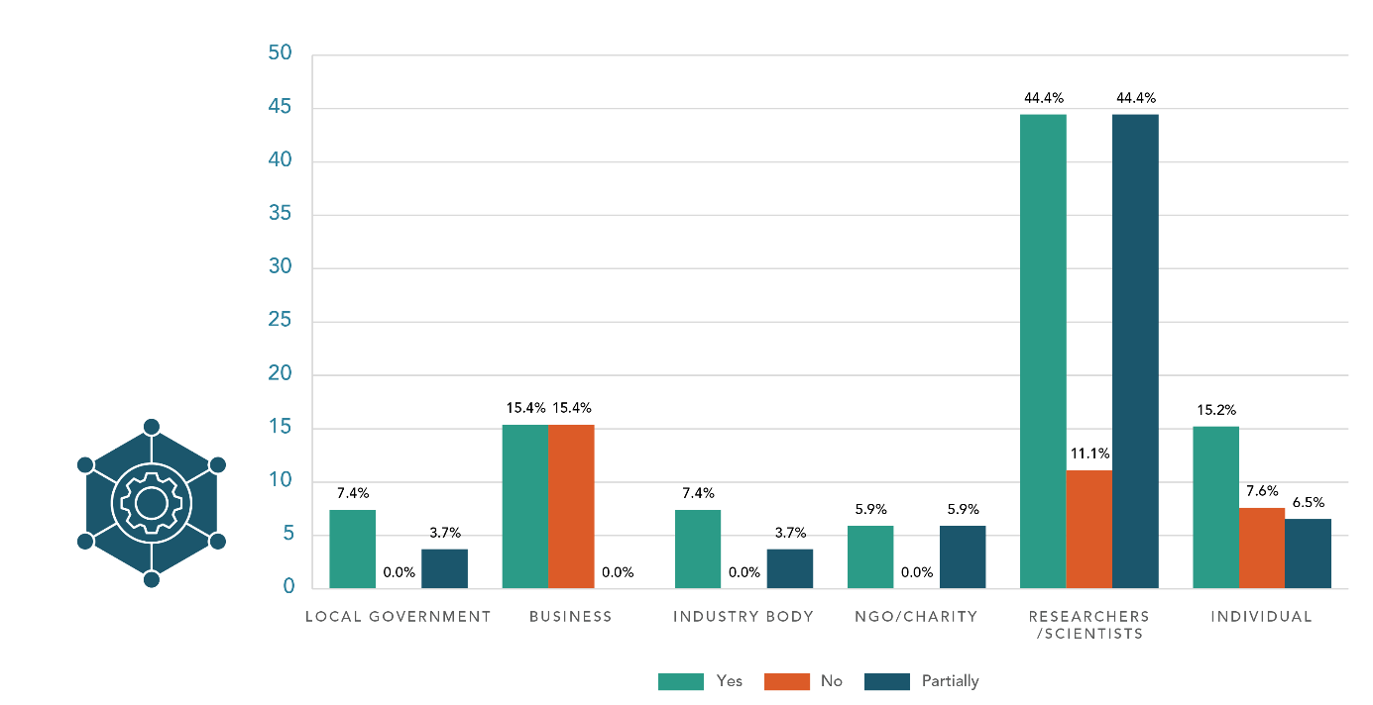
Most submitters agreed with the outcomes and objectives set out in this chapter. Many agreed partially and very few disagreed.
The CDHB agrees with the outcome and objectives of this chapter, which endeavour to create infrastructure which is resilient to a changing climate. Infrastructure is a key mechanism which protects and enhances the health and wellbeing of individuals and communities. – District health board
Some submitters were broadly supportive of the outcomes and objectives in the chapter but had reservations or comments. Others agreed with the objectives but noted that increasing the resilience of new and current assets would be expensive and commented that increased funding should be addressed.
The Draft Adaptation Plan does not provide enough detail on how Councils are to fund these additional costs. Regions such as Te Tai Tokerau have a significant coastline, as well as being exposed to a range of climate change impacts from drought, storms and fluvial flooding. To enable equitable access to adaptation actions, additional support and funding will be required. – Local government
A few submitters also wanted more clarity and detail, and more consideration to be given to creating intergenerational objectivity within the plan’s decision-making framework. Others also commented on the difference between urban and rural infrastructure, and across different regions, which must be considered to ensure equity.

Guidance for preparing infrastructure for climate change
Question 27: What else should guide central government’s actions to prepare infrastructure for a changing climate?
Some submitters noted that additional data, tools and decision-making frameworks could be provided to infrastructure owners to allow them to understand usage of and risks to infrastructure and consider appropriate action for renewing or replacing assets. Some submitters noted that developing a resilience standard or code for infrastructure would help to guide local government and asset owners’ long-term investment in infrastructure. These submitters noted that many adaptive actions would require emission-intensive activities to occur. Emissions costing, accounting or other measurement tools were suggested to support decision-making and evaluation of infrastructure provision over time.
A few submitters noted that essential infrastructure should be assessed to ensure hospital infrastructure, freight and other essential services could continue to operate. Other submitters noted the continued operation of key infrastructure such as bridges, roads, telecommunications, freight and other infrastructure as especially critical for rural communities who were geographically isolated.
Some submitters noted that individual and community resilience could be promoted through initiatives that enabled individual resource and energy production (such as solar power generation and rainwater collection). However, a few submitters noted that affordability was a constraint for individuals, businesses and local government.
Some submitters noted that local context should be considered when assessing infrastructure and making decisions. This involved engaging with communities to understand their infrastructure needs. Further, a few submitters explained that the draft plan provided limited scope for Māori to directly participate in infrastructure planning.
This chapter makes reference to cultural infrastructure and the need for physical and spiritual structures such as marae and urupā to be resilient to climate change. This is a limited scope and excludes opportunities for Māori to directly participate in infrastructure planning beyond an advisory or cultural lens approach. As can be seen around the motu, co design/partnership with regard to infrastructure (wastewater treatment or expressway design, for example), can provide solutions that centre climate change resilience in a wider prerogative of taiao management. – Research organisation
Additionally, many submitters noted that coordination between infrastructure developers, planners and various levels of government was essential, especially as significant reform occurs, namely the Three Waters reform.

Agreement with infrastructure actions
Question 28: Do you agree with the actions set out in this chapter?
- Develop a methodology for assessing impacts on physical assets and the services they provide.
- Scope a resilience standard or code for infrastructure.
- Integrate adaptation into Treasury decisions on infrastructure.
- Develop and implement the Waka Kotahi Climate Change Adaptation Action Plan.
Most submitters agreed with the actions set out in the ‘Infrastructure’ chapter. Local government submitters wanted actions to be integrated within long-term plans to inform decisions on how local government invests in and manages assets. Of the critical actions, all were supported, with most support given to a methodology for assessing impacts on physical assets and the services they provide and scoping a resilience standard or code for infrastructure. Comments on the methodology included that it should: have a whole-of-life approach, consider infrastructure such as roads, airports and ports, be strengthened to ensure (not explore) an equitable approach to iwi/Māori interests and be developed with key stakeholders.
In the action summary the [submitter] recommends adjusting wording to represent direct plans to partner with Iwi to protect these interests, rather than exploring or considering them. This demonstrates a greater commitment to active protection and partnership, as per Te Tiriti. – District health board
[…] any guidance needs to be developed in consultation with key infrastructure providers to ensure that it is workable, and appropriately recognises the nature of different infrastructure assets and the services they provide. – Business
Discussing the resilience standard or code, a few submitters wanted greater urgency with incentives for voluntary standards now (such as lower insurance premiums where risk is reduced), followed by a mandatory standard. A few others commented that minimising whole-of-life carbon should be integrated into Treasury decisions on infrastructure. A few other submitters mentioned concerns such as affordability, time-intensive reporting, and the need to avoid upgrades of infrastructure that may not have a long life in areas exposed to climate risk. In discussing the action to develop and implement the Waka Kotahi Climate Change Adaptation Action Plan, a few submitters said the initial focus should be on areas of higher socio-economic deprivation, for example, rural areas dependent on state highways for mobility.
Yes, we agree with the four critical actions particularly the action to develop and implement the Waka Kotahi Climate Change Adaptation Action Plan. The West Coast will benefit from this action as much of our state highway network is vulnerable to climate events. – Local government
Of the supporting actions and future proposals, submitters gave the most support to progressing the rail network investment programme, developing the National Energy Strategy, and investing in public transport and active transport. Regarding the rail network, comments included that the programme should go further to extend and update the network, and that this action should be part of an integrated transport plan. Submitters commenting on the National Energy Strategy said that work should start immediately, and energy should be a system-wide action. In discussing public and active transport, a few submitters noted that adaptation needed to be considered when developing walking and cycling networks, for example, constructing river stopbanks.
Some submitters endorsed the other supporting actions, including more explicit actions on landfills and contaminated sites. A few submitters discussed tools to invest in infrastructure in urban areas. These submitters suggested first identifying barriers to the uptake of tools and expediting this action to help local authorities respond to infrastructure deficit issues.
A few submitters sought other actions, including on national freight and supply, water, stormwater and flood management, irrigation, social, telecommunications and cultural infrastructure.
It is all well and good having separate plans for different aspects of the system, but we need holistic, integrated, transformational change of the whole system. – Individual

Further opportunities for infrastructure adaptation
Question 29: The national adaptation plan has identified several actions to support adaptation in all infrastructure types and all regions of Aotearoa New Zealand.
- Do you see potential for further aligning actions across local government, central government and private sector asset owners?
- Do you see any further opportunities to include local mana whenua perspectives and mātauranga Māori in infrastructure adaptation decision-making?
- Do you see any further opportunities to include local community perspectives in infrastructure adaptation decision-making?
- Do you see any further opportunities to ensure that groups who may be disproportionally impacted by climate change, or who are less able to adapt (such as those on low incomes, beneficiaries, disabled people, women, older people, youth, migrant communities) have continued and improved access to infrastructure services as we adapt?
- Do you think we have prioritised the right tools and guidance to help infrastructure asset owners understand and manage climate risk?
Most submitters supported further alignment of actions across local government, central government and private sector organisations. A few submitters noted the potential for efficiencies if asset owners worked together, that there was not a single approach for all infrastructure and that transport was an important area to further align.
Regarding opportunities to include perspectives of mana whenua and mātauranga Māori in infrastructure decision-making, most submitters supported further engagement and involvement with mana whenua A few submitters noted that mana whenua were connected to their communities, and it was important to include their voices as they were likely to be disproportionately impacted. They also outlined the need for funding and support to ensure this was done well.
Most submitters supported including local community perspectives. They noted that local knowledge was important, and that broad inclusion led to better solutions that were appropriate for the local context. Some submitters elaborated that local communities needed access to quality data and information to support good decision-making. A few submitters also highlighted that the local community would be the end users and would shoulder the costs. They noted that there was no specific requirement for this in the draft plan currently.
On prioritising the right tools and guidance to help infrastructure owners understand and manage climate risk, submitters provided a range of suggestions for priority action. Some noted the need for tools, specifically requesting detailed tools, open-source data sets, modelling tools and training to use the tools. A few submitters noted the focus on concrete infrastructure and the lack of guidance for other kinds of infrastructure. A few others highlighted the need for timely action and that the development of tools should be expedited.
The investment in adaptation is massive. The more parties that are involved the more efficiencies can be identified and better outcomes delivered for NZ. – Industry body
Evidence suggests that centralised infrastructure decision making may not produce the best outcome for all communities. Our research engagement with mana whenua has placed emphasis on sustainable, distributed infrastructure solutions. Especially for isolated communities or new papakainga [sic] development. There is a clear need to do more. – Crown research institute

Additional actions to strengthen Māori climate resilience
Question 30: Are there additional infrastructure actions that would help to strengthen Māori climate resilience?
Many submitters considered consultation with Māori to identify climate risks and infrastructure pressure points as most important in promoting climate resilience for their communities. Working with Māori beyond problem definition to develop and co-design appropriate responses to their self-identified needs was also widely supported. These submitters discussed additional actions that could cement direct mana whenua involvement in the governance of infrastructure systems, enabling Māori to proactively monitor and respond to their needs. This included ensuring rangatahi had access to infrastructure systems.
Some submitters supported Government working with Māori communities, iwi, and hapū to assess asset resilience and promote infrastructure equity across the country. It was suggested that this would help all parties build a comprehensive understanding of climate risks, including access to essential services, schools and hospitals, and sites of cultural significance. These submitters highlighted that assessing resilience of assets could also help to transition communities away from potentially vulnerable areas.
A few submitters referred to current reforms, such as the resource management reforms, as potential mechanisms to ensure holistic, te ao Māori perspectives and mātauranga Māori were appropriately included in infrastructure design and planning systems and processes. Other submitters discussed the opportunity for Māori adaptation actions to focus on removing harmful infrastructure that had previously negatively impacted the environment.
Climate change is a risk but also an opportunity for restoration. – Iwi/hapū
Ensuring appropriate funding mechanisms and investment to promote Māori climate resilience was discussed by a few submitters as crucial to ensure the success of the proposed actions.
As many Māori communities were based in places that were remote and/or more vulnerable to the impacts of climate change, some submitters commented that actions to support rural Māori communities would need to be prioritised. Submitters said that these communities were particularly reliant on infrastructure services funded by local and national investments (such as water services, access to energy and transport networks). Therefore, prioritising actions to invest in regional infrastructure would help strengthen these communities’ resilience.
Central provision of resources will almost certainly be needed to ensure regional equity and as part of honouring Te Tiriti o Waitangi. – NGO

Tools and data to help infrastructure asset owners
Question 31: Are there any other tools or data that would help infrastructure asset owners make better decisions?
Some submitters highlighted the need for nationally consistent tools and data to help integrate adaptation and resilience-building into infrastructure investment decisions. It was noted this was important given the large number of datasets proposed in the draft plan, and for developing local government long-term plans.
A few submitters suggested revisiting existing adaptation tools developed by various government agencies in the past. They recommended refining and adjusting these tools using the latest Intergovernmental Panel on Climate Change reports and the Ministry’s climate change advisory guidance information, rather than creating completely new tools and guidance.
A few submitters suggested using WEL Network’s geographic information system (GIS) to provide nationwide mapping and analysis of climate risk. Benefits of the GIS discussed by submitters included improved communication and efficiency, as well as better climate-related management and decision-making.
A few submitters sought tools to assess existing and future impacts on physical assets and the essential services they provide. These submitters emphasised the need for appropriate investment in platforms, software and dashboards to make more informed and faster decisions. A suggestion was put forward by one submitter:
[MERIT] is a tool created in partnership between GNS Science and Market Economics Research that could be routinely applied to test adaptation approaches. MERIT includes a suite of Integrated Spatial Decision Support Systems that estimate the economic consequences associated with disruption events. – Crown research institute
Other submitters mentioned the need to invest in tools such as flow and smart meters and various instruments for water management; urban planning guidance and design tools to densify urban centres; investment and availability of building maintenance and management systems; and a tool for measuring and reducing emissions from infrastructure while achieving resilience, such as the Moata Carbon Portal.
When discussing data needs, some submitters maintained that the most important action would be to make sure data was accessible, allowing communities to work together simultaneously on infrastructure improvements. These submitters highlighted that access to good quality data on the impacts of climate change (hazard modelling) and national guidance on climate change assumptions (climate scenarios) were essential to assist better infrastructure decision-making.
A few local government submitters spoke about the importance of access to better local data, which they considered crucial for regional decision-making.
Detailed, localized data will enable UHCC to make better informed decisions regarding asset lifespan, capacity, and materiality. – Local government

Communities

Major themes
Submitters agreed that a long-term intergenerational approach was needed to ensure the resilience of communities. Engagement at the local level was seen as essential to ensuring actions were tailored to the diverse needs of each community (ie, a different approach was needed for rural versus urban communities).
Most submitters agreed with or at least partially agreed with the actions in the ‘Communities’ chapter. It was noted that a bottom-up approach would ensure fit-for-purpose responses at the local level. Providing bespoke education and information was seen as important to ensure various communities were engaged.
Submitters considered that roles and funding at the local level needed to be better defined. It was noted that communities wanted to understand their risk profile and have barriers removed so they could act on this knowledge in a timely manner.
Submitters noted that the plan required a more holistic approach to health and defining of vulnerability, and an elevated focus on mental health. Submitters also wanted to see more tailored approaches for different people and groups to ensure they understood risks and could better engage in decision-making.
Submitters wanted to see local communities empowered through ground-up initiatives such as online seminars and nature-based solutions, building community resilience through proactive engagement. Submitters also noted that education played a key role in building community resilience through filling knowledge gaps.
Submitters repeated the importance of integrating mātauranga Māori and te ao Māori principles into the ’Communities’ chapter to ensure an equitable and inclusive response. It was noted, however, that in future Te Tiriti principles would be fundamental; more proactively incorporating te ao Māori and mātauranga Māori knowledge would lead to effective practical climate action. Submitters noted that leading with a mātauranga Māori approach would promote awareness of the environmental, cultural and socio-economic impacts of climate change on vulnerable communities.
Increasing the volume and level of Māori engagement on climate change related decision-making was seen as critical. Submitters highlighted that consultation between iwi and Government on climate policy should be reciprocal and meaningful. Submitters sought more clarity on how policies would impact Māori.

Agreement with community outcome and objectives
Question 32: Do you agree with the outcome and objectives in this chapter?
- C1 – Enable communities to adapt.
- C2 – Support vulnerable people and communities.
- C3 – Support communities when they are disrupted or displaced.
- C4 – The health sector is prepared and can support vulnerable communities affected by climate change.
Figure 9: Support for communities objectives by submitter type
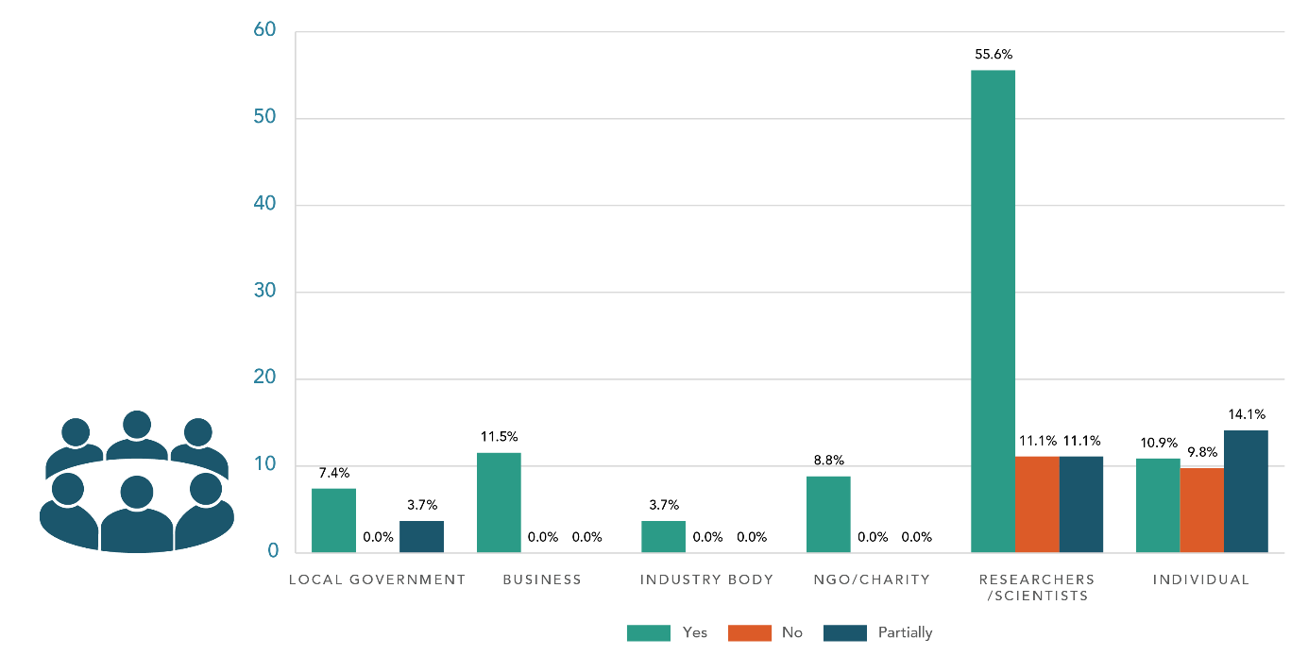
Most submitters agreed or partially agreed with the outcome and objectives of this section. Many submitters noted that an intergenerational, equity-focused approach was key to ensuring long-term resilience of communities. Some submitters also noted that this approach should align with a Te Tiriti-led system to ensure Māori were decision-makers on matters that impacted Māori. A few submitters noted that there should not be any preference given to particularly vulnerable communities, however, some submitters noted that Māori, Pacific, rural, youth and low-income and other vulnerable communities should be prioritised.
[…] some people are disproportionately affected for example, through poverty and insecure housing or health conditions. Intergenerational equity, as well as cultural and socio-economic equity, is critical to a fair transition. As a society, we are only as safe as our most vulnerable. Our priority action areas include resilience of our people and places, engagement, and supporting community initiatives. – Local government
Some submitters noted that this chapter outlined key responsibilities for local government. A few submitters explained that although community engagement with local government would be essential to achieve the objectives, local government would require greater resourcing and capability to support communities in decision-making and implementing initiatives. The importance of education at the local level was emphasised by a few submitters. Additionally, submitters sought engagement between communities and local government to ensure the initiatives were fit-for-purpose and tailored to the specific needs of each community before being implemented.
Some submitters noted that rural communities were susceptible to the impacts of climate change due to their geographic isolation and sensitive infrastructure. They expressed the view that a greater focus on supporting rural communities should be added to the final plan, especially as these communities were often central to national resilience through their role in food production.
A few submitters noted the importance of supporting those who were displaced, migrate, or might be disconnected from their communities to ensure they had sufficient support networks to adapt or react to disasters.

Agreement with community actions
Question 33: Do you agree with the actions set out in this chapter?
- Raise awareness of climate-related hazards and how to prepare.
- Develop Health National Adaptation Plan (HNAP).
Overall, most submitters agreed with the critical actions set out in the ‘Communities’ chapter. Submitters noted that developing a Health National Adaptation Plan was a key action that recognised the impacts of climate change beyond the physical environment. Submitters commented that it was important to identify communities vulnerable to climate change and that this should help to inform other actions. Further, some submitters agreed that improving natural-hazard information on LIMs was a key supporting action.
Many submitters noted that the actions had a top-down focus. These submitters commented that the roles of central government agencies were identified in the actions, however the role of communities and other key stakeholders were not. Submitters emphasised that for behaviour change to occur at a local level, communities needed to be engaged in the decision-making process to ensure tailored and fit-for-purpose actions were implemented.
Some submitters questioned whether central government was best placed to deliver these actions, while a few others expressed the view that the scope of the issues required central government to take a leadership role. In contrast, a few submitters said community-based actions would be best suited to achieve the objectives, however, the actions did not recognise the potential for transformative change that existed within the community sector, local government, or with others who may be better suited to determine communities’ needs.
Local government are engaged with communities, both rural and urban, and are well positioned to help communities adapt in ways that central government agencies may not be. To maximise their impact, actions such as building community resilience through social cohesion need to work with local government. – Local government
Many submitters supported the action relating to building community resilience, however, a number of these submitters suggested elevating this action by adding it to the list of critical actions and progressing it into the current work programme. Further, some submitters suggested a more holistic approach be taken when providing support to communities. Submitters agreed that there should be targeted support for Māori and Pacific communities, however, a broader scope should be considered when defining vulnerable communities to ensure an inclusive response.
Submitters largely supported actions relating to education and raising awareness of climate-related hazards. Some submitters noted that information should be tailored to ensure it was accessible to different groups of people. A few submitters noted that providing information and resources may not lead to changes in behaviour or support people to take action. Therefore, information should be provided alongside other forms of engagement such as learning within a structured teaching environment.
We support the investment for public education campaign and resources indicated in action one Raise awareness of climate-related hazards and how to prepare. However there needs to also be recognition that tailored information to those facing additional challenges will not necessarily lead to behaviour change and support them to take action. This could include for example, tailored information for Māori, Pacific, refugees, old people who are not digitally savvy, poverty groups that have limited access to the internet etc. Engagement initiatives with these communities, need to be considered and implemented, alongside information and resources. – Local government
A few submitters suggested that engaging organisations outside of government would support this action and others being implemented effectively.

Opportunities for communities to build resilience
Question 34: What actions will provide the greatest opportunities for you and your community to build climate resilience?
Many submitters agreed that there was a need to extend funding to the local level to ensure communities could effectively respond to build climate resilience. Some submitters explained that a collaborative and coordinated approach was needed between local government, central government, iwi and community members and groups. Submitters commented that it was essential to tap into the unique expertise of community groups, not-for-profits and iwi embedded within local communities. This required clearer definition of roles and funding arrangements to ensure responses were not fragmented and that organisations and partners were sufficiently resourced.
Enabling tino rangatiratanga and community empowerment will require a much stronger focus on devolving decision making power and resources to the local scale. For communities to have a high level of adaptive capacity and be resilient to change resources need to be devolved along with responsibility. The actions need to be focused on enabling and coordinating real action and responses that are community led and relevant to the local situation. This has to go way beyond awareness raising and top-down public education campaigns. Community cohesion is built through doing real stuff together at the local scale. – Registered charity
Further, a few submitters noted the importance of learning from and partnering with tangata whenua to ensure principles of te ao Māori were embedded in community responses to build resilience and ensure tangata whenua had agency over the decisions made.
Many submitters noted that building greater awareness of risks would enable their community to build resilience. Many submitters explained that access to clear, evidence-based information would support them to understand the risks they faced. Submitters said they would benefit from understanding the risk profile for their specific community as well as from information on potential actions to help prioritise actions at a community level. A few submitters also noted that improved information via the LIM report would help individuals to understand their risk profile.

Further actions for central government consideration
Question 35: Are there additional actions central government should consider to:
- support your health and wellbeing in the face of climate change?
- promote an inclusive response to climate change?
- target support to the most vulnerable and those disproportionately impacted?

Focusing on health and wellbeing
Many submitters commented that the final plan should have a greater focus on the mental health impacts of climate change. Some submitters suggested a holistic approach to developing supporting frameworks and material to ensure a broader wellbeing focus was taken and bespoke measures to support different groups of people were used. To support this, some submitters said that tools and resources should be provided to healthcare professionals, communities, teachers, youth and others to ensure they were sufficiently supported in understanding the impacts of climate change and could effectively support others.
There is inadequate focus on the mental health impacts of climate change including climate anxiety and depression. A programme of work should look to assess this problem and develop tools and resources for health care professionals and the community. – NGO
Further, many submitters agreed that the Health National Adaptation Plan would be an important tool to improve social determinants of health and guide decision-making. Some submitters noted that a resilient health sector was required to ensure continued high-quality healthcare. Submitters also explained that health practitioners required continued professional development opportunities, especially relating to the health impacts of climate change. A few submitters noted that physical infrastructure, such as hospitals, must be designed to withstand potential changes in weather patterns.

Enabling an inclusive response
Some submitters noted that support for communities was needed to ensure they were informed about the risks of climate change on their health and could make informed decisions. However, a few submitters noted that to ensure a diverse range of people were informed, greater understanding of the barriers to engaging was needed. A few others noted that national engagement and communications campaigns would help to coordinate responses. However, some submitters advised that communications should be led from the local level to ensure messages were culturally appropriate, motivational and meaningful.
A few submitters mentioned the need for greater involvement of disabled people in the final plan and related actions. Suggested actions included establishing a disability and climate reference group and providing tailored funding to enable the disability community to be meaningfully included and engaged in developing climate policy.
If we don’t involve disabled people in this way and have this kind of outreach to them, things will get forgotten about, missed and overlooked. When you ask people to engage with the Climate Adaptation Plan, you’re asking them to unpick their lives and think about what it will mean for how they live their lives. As disabled people, we don’t often unpick that, as a lot of people don’t. And yet, if this plan is to really be effective that’s what’s got to happen [...] Without a mechanism like a reference group, climate change adaptation for disabled people cannot be done effectively. – Advocacy group
A few submitters noted that integrating mātauranga Māori and te ao Māori principles into the final plan was key to ensuring an equitable and inclusive response; this includes acknowledging the impacts of climate change on all dimensions of Māori wellbeing. Further, a few others noted the importance of the Rauora framework in advancing intergenerational equity of Māori.
The Rauora Framework encourages the Government to be bold in addressing the pressures of climate change while prioritising the health and wellbeing of our whakapapa. It sets out how to empower and walk alongside our people, learn from us, and grow with us together as a nation. – NGO

Supporting vulnerable and disproportionately impacted communities
Some submitters explained that established structures within communities should be supported as they had existing connections and in-depth expertise about the community within which they were situated.
Some submitters commented that everyone would be affected by climate change and so all groups should receive support rather than targeting specific groupings. In contrast, a few submitters agreed that those listed as vulnerable required targeted support, however, a more holistic approach should be taken when identifying vulnerable groups to ensure people were not overlooked and approaches were coordinated across regions.
A few submitters mentioned that people who lived in isolated or rural areas may be more vulnerable and require additional funding and support to enable behaviour change to occur.
Most submitters supported local/central government engaging further with disproportionally affected communities. Some submitters noted that these communities would need targeted resources so they could understand their options, as some would need to adapt earlier, and may not be able to adapt as quickly. Social housing and transport were highlighted by a few submitters as areas where input was particularly needed as they were likely to be used more by disproportionally affected communities.

Non-government actions to build community resilience
Question 36: What do you think are the most important actions that will come from outside of central government (eg, local government, the private sector or other asset owners, iwi, hapū, non-government organisations, community groups) to strengthen community resilience in the face of climate change?
Most submitters who responded to this question discussed a need for central government to support local organisations to engage with the community. Submitters provided a range of views on the form this support could take, including non-involvement of central government.
Many submitters saw providing increased funding to community organisations (not local government) as the most effective way to deliver the initiatives necessary to build community resilience. These submitters acknowledged the role these organisations already played and sought to increase their capability through funding given the size of the challenge ahead and scope of adaptation outlined in the draft plan. This was based on various organisations’ purpose to provide practical actions to reduce emissions and to respond to climate change impacts.
The most important actions to strengthen community resilience in the face of climate change happen at the grassroots level. – Registered charity
Some submitters discussed a need for increased education about the local impacts of climate change as the most effective way to motivate community-led action. A few submitters cited the COVID vaccine roll-out as an example of education motivating effective community engagement, which in turn protected vulnerable communities.
Regarding specific types of education, mātauranga Māori was cited in a few submissions as a way to fill knowledge gaps, as long as it was made a priority in climate adaptation research. This was based on the ability for mātauranga Māori to facilitate the sharing of knowledge.
We support strengthening teaching and learning related to climate change but recommend that this is widen [sic] beyond the identified target audience of children and young people to include resistant populations which are likely to include older adults. – District health board

Additional actions to ensure Māori climate resilience
Question 37: Are there additional actions that could be included in the national adaptation plan to help strengthen climate resilience for iwi, hapū and whānau?
Most submitters discussed the need for Te Tiriti principles to frame policy thinking, and central and local government actions in the climate change space. The Crown’s responsibility to actively protect Māori and Māori interests was mentioned by multiple submitters as most applicable to the impacts of climate change. This was specifically the case for vulnerable Māori communities living in coastal areas.
Consultation was discussed by many submitters as an example of upholding Te Tiriti principles. Some iwi submitters called for more direct central and local government engagement, criticising procedural ‘tick-box’ consultation. Some submitters said that engaging in this sense required corresponding resourcing, including more funding and a wider kōrero on climate issues. Submitters saw this as necessary to match the urgency of action required for climate matters, especially for more vulnerable communities. Submitters stated that so far climate discourse with Māori had failed to reflect the scope of the problem and submitters hoped the final plan would be a step in the right direction.
Māori climate resilience is strengthened by recognising Te Tiriti, investing in Māori infrastructure demands faced by iwi / Māori, and valuing mātauranga. – Crown research institute [GNS Science]
Some submitters criticised the framework of the draft plan from an ideological standpoint. They said that the solutions offered within the RMA and existing insurance schemes still isolated Māori, particularly as these schemes had been in place as climate change impacts had worsened.
Economic incentives for Māori businesses were also highlighted by some submitters as a way to strengthen social cohesion. These would have the effect of empowering Māori business owners to prepare for climate change themselves.
As above, iwi, hapū and whanau need to be provided with the right tools (eg, guidance that is tailored to Māori and incorporates te ao Māori) and supported by resourcing. – Local government

The economy and financial system

Major themes
Submitters wanted to see a balance between the provision of immediate economic measures and striving to reimagine an economy that was more equitable and ambitious in its aims. Submitters focused on economic support to help people adapt to climate change impacts, and incentivising businesses to invest in resilience measures.
Submitters sought more clarity on how high-wage, low-emissions economies were defined. Most submitters largely agreed with the concept but highlighted that this could be achieved in a number of different ways, for example, sector-specific economic measures.
Submitters commented that central government should play a more active role in creating a circular economy. It was noted that the Government should be more ambitious, both in goal/target-setting and actions.
Some submitters sought degrowth and decreasing consumption, while others discussed planetary boundaries or material inputs. Submitters explained that the Government was not seen to be addressing the real problems, identified as excessive consumption and exploiting the environment for profit.
Most submitters supported some or all of the economic and financial actions presented. They emphasised the importance of financial institutions appropriately weighing the risks of climate change on the economy and to businesses. Some noted that while the draft plan discussed climate risks within sectors, it did not sufficiently address risks to the economy as a whole.
Many submitters expressed support for further research, investments in science, and monitoring programmes. Some discussed the need for insurance monitoring to cover a wide range of actions and associated risks, including access to insurance and affordability as well as trends in excesses and premiums.
Submitters considered that the plan would need a greater long-term focus on planning and investment in key sectors. Submitters also sought actions that considered the key role of tangata whenua and alignment with the wellbeing economy.
Submitters commented on the importance of Māori business development for the economy and stated that further emphasis on actions associated with Māori business was needed. To do this, engagement with Māori was seen as critical, as well as funding for Māori communities to develop and implement their own climate action programmes.

Agreement with economy and financial system outcomes and objectives
Question 38: Do you agree with the outcome and objectives in this chapter?
- F1 – Sectors, businesses and regional economies can adapt. Participants can identify risks and take action.
- F2 – A resilient financial system underpins economic stability and growth. Participants can identify, disclose and manage climate risks.
Figure 10: Support for the economy and financial system objectives by submitter type
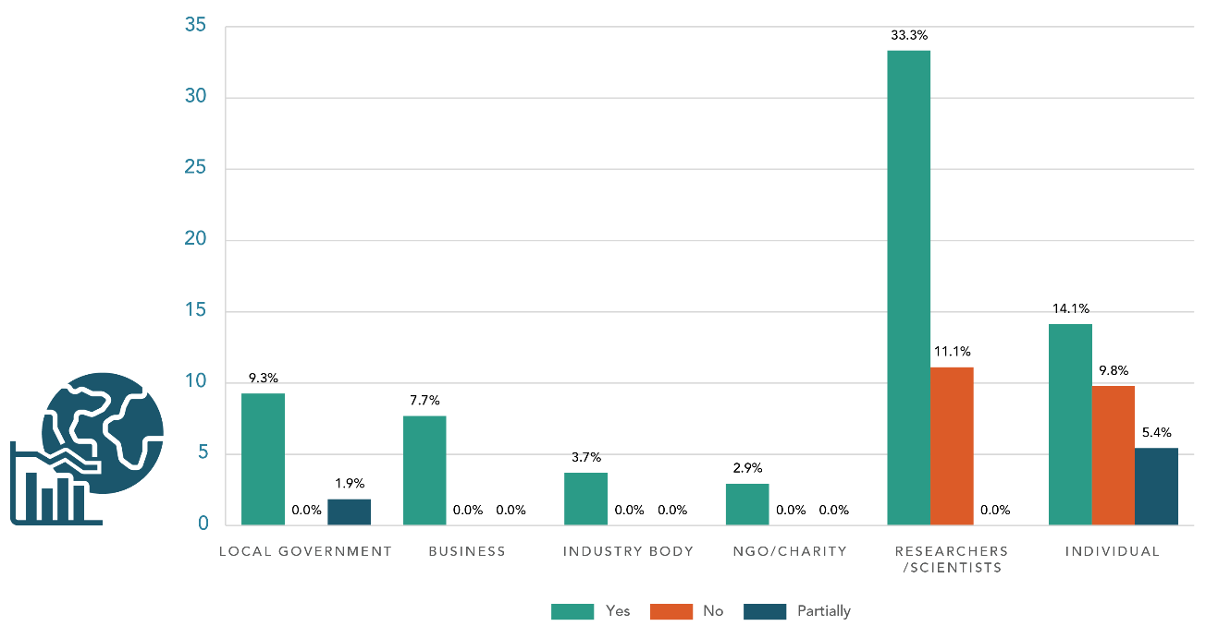
Most submitters supported the low-emissions, high wage economy as a largely beneficial description in looking towards Aotearoa New Zealand’s economic future.
The ambition of the draft plan’s economic vision was criticised by many submitters. Specifically, many mentioned the social changes brought on by the pandemic, demonstrating the need for new thinking about traditional forms of economic measures. It was suggested that incremental changes and business-as-usual measures would not result in the transformational changes to the economy and financial system needed to address worsening social issues such as housing unaffordability and cost-of-living issues.
Some submitters said that traditional economic concepts of growth and resource allocation needed to be rethought in a low-emissions economy.
Disruptions from climate change and pandemics have demonstrated the need for a more resilient economy that is regenerative, distributive, local, and enables Aucklanders to thrive. – Local government
Some submitters viewed top-down economic measures as largely inefficient for identifying large sector-specific environmental issues that required different economic approaches. Tourism was commonly raised by submitters as an example of an industry that disproportionately benefited from environmentally damaging practices. Applying a general economic measure to cover one industry was seen by many submitters as ineffective climate policy.
The regional economies of rural towns that rely on environmentally harmful but economically fundamental industries, such as mining on the West Coast, agriculture (which is rural by nature) and tourism, were also raised as needing the plan’s special consideration when it came to future environmental policy.
In addition to those listed in the chapter, we would like a further objective: Ensure high-value and economically significant sectors have the support required to continue to provide stability for the New Zealand economy, and to enable the required investment for climate change adaptation – Industry body

Things for central government to do to realise a productive, sustainable and inclusive economy
Question 39: What else should central government do to realise a productive, sustainable and inclusive economy that adapts and builds resilience to a changing climate?
Most submitters urged the Government to be more ambitious and take immediate action to create a more resilient economy and mitigate climate change. Submitters largely did not differentiate between adaptation and mitigation. Many submitters argued that central government should play a more active role in creating a circular economy.
Support development of more circular and local economies at both national and local levels to increase New Zealand’s economic and financial resilience. This would also work to address potential future supply chain issues such as those we are currently experiencing due to the impacts of Covid-19. – Local government
Some submitters discussed planetary boundaries and degrowth and/or decoupling emissions from gross domestic product. These submitters argued that the draft plan, and central government, did not accurately address the drivers of climate change or the actions necessary to adapt to a changing climate.
There must be express consideration of planetary boundaries in a credible adaptation plan, and regular monitoring and reporting on the status of planetary boundaries. – Individual
Some submitters said the Government should focus more on fostering innovation and technical solutions. They commented that this would also support the transition to a low-emissions economy.
Some submitters supported the action for government to provide tools and information to communities and businesses. A few submitters added that insurance or government support could then be dependent on businesses efforts to adapt or reduce emissions. Similarly, a few others argued risk management approaches must be implemented alongside nature-based solutions.
Conversely, some submitters considered central government should be less involved, and commented that any adaptation should not impose unfairly on businesses.

Agreement with economy and financial system actions
Question 40: Do you agree with the actions set out in this chapter?
- Deliver the national freight and supply chain strategy.
- Deliver the fisheries system reform.
- Deliver the aquaculture strategy.
- Support high-quality implementation of climate-related disclosures and explore expansion.
- Reserve Bank of New Zealand (RBNZ) supports the stability of the financial system.
- Develop options for home flood insurance issues.
Most submitters supported some or all of the actions presented. They stressed the importance of financial institutions appropriately weighing the risks of climate change on the economy and to businesses. Some said that while the draft plan discussed climate risks within sectors it did not sufficiently address risks to the economy as a whole. Some submitters criticised the draft plan for failing to sufficiently address the agricultural sector. A few advocated for a more comprehensive approach to addressing economic risks to Aotearoa New Zealand from the primary sector.
The NAP should take a more comprehensive, cross-sector approach, with targeted actions for a broader range of primary sector businesses… some primary sector actions are very specific (eg, farm plans), yet there is no mention of the financial risk that the dairy sector as a whole carries for Aotearoa. – NGO
Many submitters expressed support for further research, investments in science, and monitoring programmes. Some advocated for creating a central research platform (or similar) to ensure local and sector-specific information was shared between agencies and others responsible for adaptation actions.
[…] we have identified a significant data gap on the socio-economic impacts of the identified risks. We therefore urge government to address this data gap and include this aspect in its final Plan. – Local government
Similarly, some submitters discussed the need for insurance monitoring to cover a wide range of actions and associated risks. This included access to and affordability of insurance as well as trends in excesses and premiums.
Some submitters were encouraged by the future work programme proposals targeting Māori businesses and landowners. They expressed specific support for a tikanga-based support programme, and a te ao Māori approach to adaptation for Māori entities and organisations.

Other actions for central government consideration
Question 41: Are there other actions central government should consider to:
- support sectors, businesses and regional economies to identify climate risks and adapt?
- promote a resilient financial system in the face of climate change?
Many submitters considered that the final plan should have a greater focus on long-term planning and investment in key sectors. A few submitters noted the lack of measures for agriculture and clear strategies for aquaculture, fisheries and tourism industries. To support the actions in the plan many submitters recommended clear processes to fully involve industry and suggested that tailored sectoral plans were required. Many submitters thought the most vulnerable businesses and sectors should be identified and provided with targeted support.
A few submitters noted the role that Māori play in land-based primary industries, tourism and fisheries. They recommended the final plan include more actions that take account of the unique role of tangata whenua. They also considered that resourcing was required to consider the socio-cultural impacts of the plan on Māori communities.

Supporting actors to identify climate risks
Some submitters explained that there needed to be stronger actions for farming, agriculture and fisheries sectors. They said that fisheries and farms must be made sustainable as quickly as possible. Incentivising regenerative farm practices while discouraging non-sustainable practices would support this transition. A few submitters emphasised the importance of informing sectors about the benefits provided by natural ecosystems to inform better decision-making on nature-based solutions that lower climate risk.
Most submitters highlighted the importance of investing to enable sectors to adapt. Many recommended that a financial adaptation plan be developed that set out actions to reduce economic vulnerability across sectors.
Almost all submitters from local and regional councils noted the importance of working collaboratively to develop the resilience of regional economies. They highlighted several existing frameworks and initiatives that central government could further support and incentivise. It was noted by some submitters that despite the important role played by councils in regional economic development, there were no critical actions to support local government to build the resilience of local and regional economies. Climate impacts would vary across regions and most submitters considered funding and support should be tailored to regional circumstances.

Enabling a resilient financial system
Many submitters noted the importance of a resilient financial system. Some submitters said the current economic model was not resilient to market changes so would not be resilient to climate change. Some suggested that central government should identify opportunities to incentivise investment in green, resilient technologies and encourage lenders to do the same. Some submitters considered the draft plan to be too broad. They recommended greater detail on the role of finance, including to:
- encourage the Government and the Reserve Bank to consider how they could actively support strategic climate investment, particularly through reduced capital requirements and different risk weights to make such investments more attractive
- support nature-based adaptation solutions through public-private partnerships.
Some submitters noted the impact of climate change on the wellbeing economy and recommended that the final plan link to the wellbeing standards.

Most important non-central government actions
Question 42: What do you think are the most important actions that will come from outside of central government (eg, local government, the private sector or other asset owners, iwi, hapū and/or other Māori groupings such as: business, forestry, fisheries, tourism, urban Māori, the private sector) to reduce the economic and financial risk they face from climate change?
Many submitters noted the importance of consistent and clear public communication from the Government. They also emphasised the importance of collaboration between central government, local government, business and communities, and the need for responsibilities to be clearly established. Most submitters identified the need for training, education, research and innovation. They also noted the need for improved information on expected impacts on primary industry, tourism and Māori businesses.
Submitters identified a range of other specific actions including:
- early investment in adaptation
- extending the Māori agribusiness initiative
- contestable funding
- a review of corporate responsibility to ascertain what models could be applied to ensure corporations had a strong role to protect and regenerate ecosystems
- clear climate change legislative obligations being established for business
- investing in diversifying economies and food systems
- comprehensive plans for each sector.

Additional actions to strengthen Māori climate resilience
Question 43: Are there additional actions within the financial system that would help strengthen Māori climate resilience?
Most submitters emphasised the importance of Māori business to the economy and noted that there were some actions in the draft plan that touched on this sector. However, many submitters considered more actions needed to be developed specifically targeted to Māori. These submitters said that actions should be developed by Māori, for Māori. Many submitters noted the importance of funding, resources and training specifically targeted to Māori communities.
The development of the Māori Climate Platform and Māori Climate Strategy must be realised in a way that actively creates a structure that is of Māori, by Māori, for Māori. – Organisation
Many submitters noted the draft plan’s insurance framework did not extend to marae. Considering the role of marae in the community, including in times of natural disaster, submitters said that the insurance framework should be extended to cover marae, and other Māori institutions impacted by climate change.
Many … marae settlements are in low-lying, coastal areas and are at risk of coastal erosion and in some cases, of being totally consumed by rising sea levels in the coming years. They are at the heart of our communities, and we need to support our hapū face [sic] these challenges head on. – Iwi/hapū

Flood insurance

Role of insurance when responding to flood risk
Question 44: In the context of other risk-management options (eg, flood barriers, retreat from high-risk areas), what role should insurance have as a response to flood risk? Please explain your answer.
Many submitters noted that insurance did not inherently reduce exposure to risk; however, it did support recovery after shocks. These submitters noted that proactive adaptation needed to be incentivised to ensure property owners took steps to reduce their risk and exposure, and to reduce continued rebuilding of infrastructure and property in at-risk areas.
The issue with insurance is that it can only be used after damage has been incurred and only to reinstate the property to the condition prior to the event. Inherently it does not reduce the exposure or provide for implementation of adaptation principles. Differential premiums can help support adaptation principles as they are a clear signal that change is required. The differential premiums can be applied based upon the risk not the eventuality of the hazard. – Local government
Some industry bodies and insurance providers noted that the availability and affordability of insurance would unlikely be a major barrier in the near future; however, proactive measures needed to be taken by property owners to ensure continued access to insurance. Some submitters suggested that targeted price points or premiums be used to incentivise adaptation and retreat in the short term to keep pricing sustainable in the future. A few others noted that insurers could expand insurance cover to allow for retreat when a property became uninsurable. In addition, in was noted that property should not just be rebuilt but made more resilient when impacted by flooding.
Many submitters noted that insurance was just one tool that could be used to support communities respond to risk. Some submitters noted the importance of providing information alongside insurance to ensure people could effectively understand their risk exposure and the options available to them.
Insurance (financial risk transfer) should only ever be one component of a balanced approach to managing natural hazard risk. Careful attention also needs to be paid to the other choices across avoidance (land use planning) and control (engineering solutions), and acceptance (post-event response). Insurance can play a useful part in enabling faster recovery in the case of rare, high consequence events with community-wide impacts and losses. – National research organisation

Role of Government in supporting flood insurance
Question 45: Should the Government have a role in supporting flood insurance as climate change risks cause private insurance retreat?
- Does your answer to the above question depend on the circumstances? (For example, who the owner is (eg, low income), the nature and characteristics of the asset (eg, residential or commercial property, contents and vehicles), what other risk management options are available and their cost/benefit, and where the asset is located?) Please explain your answer.
Many submitted that current private insurance schemes were adequate. Most submitters agreed that central government should have a very limited role in supporting flood insurance or saw that the Government’s role should be a short-term measure. Further, some submitters noted that provision of insurance should be timebound. These submitters said that it should only be offered to those who purchased property before a scheme was implemented or offered to people while adaptation plans were being developed.
Most submitters explained that providing insurance incentivises inaction. Many felt that subsidies or support for retreat and other related actions would be a better use of funding as this would reduce continued investment in temporary fixes. Some submitters noted that avoiding moral hazard should be a key consideration when deciding who to provide insurance to and how.
[…] when private insurance becomes unavailable, it does not make sense for the Government to step in to become an insurer of an uninsurable risk. Therefore, Auckland Council recommends support is offered through risk reduction and managed retreat. A compensation scheme is needed for property owners who were unaware of the risk to their homes at time of purchase. – Local government
Some submitters noted that low-income families and communities would require additional support to ensure they could adapt to increasing levels of risk while considering long-term retreat measures. Additionally, a few submitters noted that places of significance for iwi and hapū were often at risk and were becoming increasingly unaffordable to protect and manage due to increases in insurance pricing.
These submitters suggested providing additional support for such places, including insurance. Some submitters explained that the Government and insurers should work together to ensure equitable outcomes for those who faced risk at no fault of their own (ie, who have owned the land for a long time).
Some submitters noted that it would be important that government insurance schemes did not mask risk by insuring developments and property that the private market saw as uninsurable.
By pricing risks, insurance also gives households, businesses and governments an incentive to reduce these risks. However, government intervention in insurance markets may mean that insurance premiums do not appropriately reflect the underlying level of risk. – Industry body

Direct or indirect government support
Question 46: If you think the Government should have a role in supporting flood insurance as climate change risks cause private insurance retreat, how do you envision the Government’s role, and how is this best achieved (eg, direct support and/or indirect support such as reducing underlying flood risk)?
Many submitters strongly opposed government support for flood insurance. Rather than short-term insurance measures, submitters said the Government should focus on long-term actions that would support communities, including creation of individual adaptation plans.
Ultimately, indirect support to implement measures that seek to reduce the underlying flood risk will only provide finite protection. Therefore, government support needs to be directed towards the implementation of adaptation plans, which will include transitional measures to mitigate intolerable risks, as well as longer term responses that are more sustainable. – Local government
Some submitters reflected on the American Flood Protection Scheme; explaining that the scheme incentivised rebuilding over retreat, in turn multiplying the costs related to flood recovery. These submitters noted that the New Zealand Government should learn from this and ensure short-term recovery was not prioritised over long-term resilience.
Some submitters noted that cost-benefit analyses focused on the long term would be important when assessing how communities planned and retreated in the future. A few submitters noted the importance of the Government’s role in urban planning, especially in limiting developments within at-risk areas. A few submitters also suggested that the Government could help to incentivise developers, bankers and insurance providers to reduce risk and take action before disaster occurs.

Government support for flood insurance
Question 47: If the Government were to directly support flood insurance:
- What is the best way to provide this direct support?
- Should the Government’s focus be to support availability or affordability of insurance, or both?
- How should the costs of that support be funded, and by whom?
- What are the benefits and downsides of this approach?
- Should this support be temporary or permanent?
- If temporary, what additional measures, if any, do you think would be needed to eventually withdraw this support (eg, undertaking wider flood-protection work)?
- What would the risks or benefits be of also including non-residential property, such as commercial property?
- What design features or complementary policies are needed so any flood insurance intervention retains incentives for sound flood-risk management (eg, discouraging development in high-risk locations)?

Direct support
Most submitters emphasised the importance of any government support being equitable. For example, ensuring that household incomes be factored in, and offering greater support to low-income earners and households. A few submitters considered that government support should be means tested and targeted to those who could not afford insurance in specific areas of concern.
We absolutely need an in-depth process, with adequate timing, where tangata whenua are asked how direct support could work for Māori. – Local government

Support for availability or affordability
Most submitters considered that the Government’s focus should be to support both the affordability and availability of insurance. These submitters said that the availability and affordability of insurance was complex and linked, and that considering both together was essential to modify behaviours and investment.
The government focus should be on accelerating the planning and implementation of adaptation plans. If interventions are timely and effective then the need for government insurance is avoided. However, if government insurance assistance is required it should be focused on both the availability and affordability of insurance as they are interlinked. – Local government
Many submitters commented that the Government should focus on affordability of insurance. These submitters considered that the most affected areas tended to be low-income, and that central government should indicate how support would be provided in these areas.
Many submitters considered that insurance availability was the most important and said that good decisions would lead to greater affordability.

How insurance support should be funded
Submitters held a range of views on how insurance should be funded and did not agree on a method.
Most submitters considered that insurance should be funded out of existing taxes, rather than a targeted levy on property owners, or some other kind of government support.
Other suggestions included:
- using the Emissions Trading Scheme to fund insurance
- using a means-tested sliding scale
- council restrictions on new developments
- central government collaborating with insurers to underwrite flood insurance
- central government, council, and insurer support for the cost of funding insurance in high-risk areas.

Who should fund insurance support
Submitters held a range of views on who should fund insurance. Many submitters considered that asset owners should be responsible for funding their own insurance.
Asset owners need to take some responsibility, however low socio-economic groups are more likely to be represented and will need assistance. – Local government
Many submitters also noted that central government played a role in ensuring there was safe social housing being built in appropriate places, which was funded by taxpayers. A few submitters noted that the Government should support owners who have held property in unsafe places for a long time, as it would be unfair to allow an insurance retreat in these circumstances.
Some submitters considered that the individuals and industries that have benefited most from high-emissions activities should have a role to play in insurance.

Benefits and downsides of direct support
Most submitters commented on the benefits of direct support to communities in low socio-economic areas and communities in areas prone to flooding. Submitters considered that direct support would ensure the wealth gap did not increase.
The main downside of direct support noted by submitters was ‘freeloading’ or gaming the system. Many submitters noted the importance of ensuring that people were not incentivised to build, develop or buy in high-risk areas.

Temporary or permanent support
Most submitters wanted government support to be temporary. In addition, many submitters wanted to see support coupled with nature-based solutions to reduce flood risk (making room for rivers and restoring wetlands) and incentivising adaptation and resilience. Some submitters considered that support should be linked to managed retreat.
Some submitters wanted support to be permanent, but only for vulnerable or lower income areas that did not have the means to assist themselves. A few submitters considered that a different approach should be taken for existing buildings and new builds in risk areas.

Measures to withdraw support
Most submitters agreed that support should eventually be withdrawn. Submitters considered that this should occur on a case-by-case basis, alongside managed retreat where insurance was no longer viable.
Other suggestions from a few submitters for withdrawing support included:
- education and/or measures put in place to inform the public
- clear planning rules that reduced or removed the opportunity to build in flood-prone areas
- clear managed retreat decisions.

Risks or benefits of including commercial property
Most submitters outlined risks of including non-residential property. The main risk cited by submitters was the cost. Submitters considered that businesses should make informed, risk-based decisions. Many submitters noted that the cost of this support would be high, and that government interventions should be prioritised towards protecting lives and homes.
A few submitters considered that there could be some benefits to including non-residential property in government support. These included certainty for the property market, and potential economic value in terms of jobs and taxes for the wider community.
The benefits would include local economy resilience if affordability and vulnerability from a socio-economic perspective are the main points of consideration. It would need to be supported with underlying risk management and long-term adaptation actions. – Local government

Design features or complementary policies
Most submitters wanted to see clear, consistent and enforced regulations on where building and development could take place to ensure that risk was reduced. Some submitters also wanted to see mechanisms to discourage investment in high-risk areas.
Some submitters considered that important complementary policies would be resource management reform and legislation covering managed retreat. A few submitters also noted the importance of aligning the Natural Hazards Insurance Bill with other legislation or policy responses to flood hazard insurance.

Effectiveness of insurance ‘price signal’ to provide incentives to reduce flood risk
Question 48: How effective do you think the insurance ‘price signal’ (eg, higher premiums or loss of insurance) is for providing incentives to reduce flood risk?
Many submitters considered that insurance price signals would be effective as incentives to reduce flood risk, with a few of these submitters stating that those who could afford to, would stay, and those who could not would be incentivised to move elsewhere. Other submitters emphasised that change happened when financial impact was felt, and that insurance price signals would encourage better outcomes. A few submitters acknowledged that increasing insurance premiums would be an effective way to signal a transition and give property owners time to respond.
Many submitters were also concerned about the inequalities that might arise for low-income communities. These submitters stated that flood insurance may be unaffordable to some people and, therefore, they may stay in high-risk places without any insurance. A few submitters provided potential solutions for the Government to consider.
For this reason, the government should focus its funds and efforts on proactively ensuring that economically vulnerable people have a positive alternative to this alarming picture: supported, managed retreat. – NGO
Some submitters commented that insurance price signals alone would not be effective enough to reduce flood risk. These submitters suggested that other support measures or tools need to be available alongside insurance price signals. A few submitters mentioned other ways to signal flood risk, for example, through including additional information in LIMs.

Using a scheme such as Flood Re in Aotearoa New Zealand
Question 49: In your view, should a scheme similar to Flood Re be used in New Zealand to address current and future access and affordability issues for flood insurance? Why or why not?
Many submitters supported a scheme similar to Flood Re, with some submitters saying that it would provide certainty to the property market and incentivise action in flood-prone areas. However, some submitters called for specific considerations for vulnerability and socio-economic situations. A few submitters suggested that support to address affordability should be targeted towards low-income households.
Some submitters suggested that any scheme like Flood Re should be accompanied by adaptation initiatives and flood-protection measures, and the Government had a role to invest in infrastructure to support this.
Yes, it would address insurability but as discussed above, this presents a moral hazard. The better outcome is timely development and implementation of adaptation plans to address the risk. – Local government
Some submitters suggested that more research was needed to understand how such an approach could be adapted to the New Zealand context. These submitters also emphasised that start and end dates for access to the scheme needed to be made clear.
Some submitters did not support the idea of a scheme similar to Flood Re in New Zealand. A few of these submitters were concerned that such a scheme would slow down adaptation measures.

Could a scheme similar to Flood Re support or hinder climate change initiatives
Question 50: How do you think a scheme similar to Flood Re in New Zealand could support or hinder climate change adaptation initiatives in New Zealand?
Most submitters noted that a scheme such as Flood Re would hinder adaptation for Aotearoa New Zealand. Many submitters noted that if such a scheme were to be implemented, it would have to be time bound and paired with clear communication to ensure people did not think it was an alternative to adaptation – rather a stop-gap tool to ensure people were not disproportionately penalised in the short-term for living in at-risk areas.
There is a very real risk that such a scheme will hinder climate change adaptation if people are supported and encouraged to remain in increasingly risky areas. A significant moral hazard will be created. – Industry body
The transition between subsidised insurance and managed retreat needs to be explicit from the outset. The government needs to be bold in this regard. – Local government
Some submitters noted that a scheme would offer opportunities for advanced monitoring and reporting. Submitters who saw benefit in such a scheme explained that it would encourage people to reduce flood risk in the short-term, however most emphasised that it would only be a temporary measure while people prepared to retreat.
Part 3: Managed retreat

Major themes
About half of submitters agreed with the principles and objectives for managed retreat. Submitters who agreed and disagreed with the principles and objectives wanted to see a clearer definition of ‘intolerable risk’.
A number of additional principles and objectives were suggested by submitters. Submitters wanted to see greater recognition of Te Tiriti and te ao Māori principles to inform managed retreat decision-making. In addition, submitters wanted the principles and objectives to acknowledge protection and restoration of the natural environment.
Submitters stressed the need for national level guidance, which could also be tailored at the local level, while highlighting the legal risks and negative perception for local authorities of managed retreat. The need for managed retreat proposals to align with broader legislative reforms was emphasised by many submitters.
Submitters urged the Government to develop greater guidance for stakeholders for implementing managed retreat, emphasising the need to retain flexibility to cater for local needs. Accurate and locally relevant data to inform decision-making by a range of stakeholders was considered key to successfully managed retreat processes, and the importance of prioritising research to obtain such data was discussed by submitters. The absence of information and analysis regarding the impacts of managed retreat on certain stakeholders and industry was also discussed, including for insurers, tourism and supply chains.
Submitters maintained that central government needed to provide oversight and empower local government to carry out managed retreat. These submitters emphasised that a balance needed to be struck between local flexibility, engagement with communities, autonomy, and national direction, alongside clear and consistent messaging.
Submitters noted that long-term, intergenerational impacts of managed retreat for mana whenua and iwi, through loss of land, needed to be better understood by central and local government. A range of targeted funding, engagement with communities, and initiatives specific to Māori were some of the key actions that submitters suggested could help Māori communities through this process.
Many submitters identified large carbon polluters as those who should bear the greatest responsibility for the costs of managed retreat. Submitters also recognised that, ultimately, all areas of society had a role to play in sharing these costs.
Nationally consistent managed retreat legislation that outlined clear frameworks was the key mechanism for central government to consider in its criteria. Some submitters criticised the assumption that central government would lead the development of these criteria, citing local authority expertise and knowledge of communities. Submitters noted that if communities had to be relocated, the whole community should be considered, including facilities (eg, schools, churches, marae) and the businesses needed for that community to thrive.
Submitters noted that businesses may have greater options and resources for relocation than homes or community buildings, and submitters stated that this should be taken into consideration when designing managed retreat processes.
Above all, submitters wanted to see a good balance of risk and costs – they noted that retreat could be required but only if there was an intolerable risk or significant costs to councils if people were to remain. Submitters noted that people should be allowed to stay but it had to be an informed decision, and that these people should bear the costs associated with remaining in high-risk areas and be able to provide their own services. In these cases, submitters urged the Government to consider the local context and work with communities.
Most submitters agreed that if the risk was clear at the time of purchase, the buyer of the property should be responsible for accepting that risk and face higher liability for the cost of adaptation or managed retreat, if required. However, many submitters acknowledged the difficulty in determining a threshold for risk. Some submitters emphasised the importance of improved risk identification and urged the Government to release clear and consistent hazard information and guidance to support buyer decision-making.
Submitters supported and called for wide consultation but offered diverging views on the groups that would be the most impacted or vulnerable and, therefore, should be most involved in the process. Many submitters stated that a greater degree of intervention or support should be provided where there were lower socio-economic communities at most immediate and highest risk. A few submitters stated that when there were options and means available to communities, intervention or support could begin to be rolled back.
Most submitters stated that land with historical, cultural, social or religious significance should be assessed and considered on a case-by-case basis. These submitters emphasised the importance of iwi, hapū and landowner views in local decision-making, explaining that all those affected should have the chance to be actively involved.
Most submitters considered that managed retreat would greatly affect Māori due to their connection to land and places. These submitters raised potential challenges for Māori associated with managed retreat, such as immovable taonga and wāhi tapu. Submitters said that more engagement with Māori was needed to appreciate their perspectives, co-develop Māori-led approaches and understand the cultural significance of places.
Submitters commented that the most important consideration for developing a managed retreat system for Māori was that it was Māori-led, and te ao Māori was fundamental to design this system. Some submitters highlighted that the whakapapa of Māori, which is linked to place and space, must be an essential consideration for any managed retreat system for Māori.
Many submitters mentioned the importance of maintaining Te Tiriti settlement processes, and that managed retreat should not interfere with this ongoing work. Submitters raised the historic treatment of Māori whenua and emphasised that caution must be taken to ensure further dispossession did not occur. Some submitters also suggested that any decisions relating to managed retreat of Māori land should be made in partnership to ensure Te Tiriti o Waitangi obligations were upheld.
A few submitters commented on the role of central government, noting the benefits and disadvantages of types of involvement. Insurance payments and how they should be dispersed and used was discussed by some submitters. Most agreed that insurability should be a key consideration to any managed retreat process, noting that insurability played an important role in the financial wellbeing of individuals and communities.

Agreement with ‘Managed retreat’ chapter principles and objectives
Question 52: Do you agree with the proposed principles and objectives for managed retreat? Please explain why or why not.
Objectives:
- To set clear roles, responsibilities and processes for managed retreat from areas of intolerable risk.
- To provide stronger tools for councils to modify or extinguish existing uses of land.
- To provide clarity on tools and processes for acquiring land and related compensation.
- To clarify local government liability for decision-making on managed retreat, and the role of the courts.
- To provide clear criteria for when central government will intervene (or not) in a managed retreat process.
Principles:
- Managed retreat processes are efficient, fair, open and transparent.
- Communities are actively engaged in conversations about risk and in determining and implementing options for risk management.
- Social and cultural connections to community and place are maintained as much as possible.
- There is flexibility as to how managed retreat processes play out in different contexts.
- Iwi/Māori are represented in governance and management and have direct input and influence in managed retreat processes, and outcomes for iwi/Māori are supported.
- Protection of the natural environment and the use of nature-based solutions are prioritised.
Overall, most submitters agreed with the proposed principles and objectives for managed retreat. In addition, most submitters said they understood and agreed with the need for managed retreat in general.
We support the principle to have iwi/Māori representation in governance and management and have influence in managed retreat processes. However, we stress that this principle must be tied to provision of funding to ensure that iwi Māori have sufficient capacity to effectively participate in all stages of the managed retreat process. This should include planning and preparation, investment, land transfers, the actual retreat process and clean up and repurposing where appropriate. – Local government
Many submitters made additional comments while agreeing in principle with the principles and objectives, including highlighting the importance of:
- clear legal frameworks, guidance and decision-making criteria
- flexibility for different community needs and risk types
- further clarifying what ‘intolerable risk’ was, and how it would be decided
- ensuring that Māori land was not unfairly impacted
- support for fairness and equity across communities and future generations
- support for an integrated approach to legislation and policy reform
- urgency in educating communities about how climate change would impact them personally, and what managed retreat would look like
- stronger wording for some of the principles
- support for maintaining cultural and social connections where possible
- clear direction for local government.
… the following whakataukā [sic] should be included to guide the principles and objectives of managed retreat: Ka mate kāinga tahi, ka ora kāinga rua. When the first home dies, a second home comes to life – Iwi/hapū
Many submitters disagreed with the proposed principles and objectives for managed retreat.
Only one of these specifically refers to iwi Māori. The principles and objectives do not acknowledge the weight and consequences of injustices perpetrated against tangata whenua including the dispossession of 95% of their lands and territories and the intergenerational impacts of colonisation, racism and poverty which are being exacerbated by climate change. – Iwi/hapū
Some submitters considered that the nature and scale of ‘intolerable risk’ were not defined clearly. Submitters noted that ‘intolerable risk’ should be defined to assist the identification of where and when retreat may be required.
Some submitters said that the proposed principles and objectives did not put enough emphasis on the inequitable impacts of climate change on vulnerable communities requiring managed retreat, particularly Māori. These submitters wanted to see a specific commitment in the principles and objectives to an equity focus during the managed retreat process.
Some submitters wanted to see central government taking more responsibility and leadership, and suggested that managed retreat follow a national framework, applied consistently across Aotearoa New Zealand.
Some submitters wanted to see confirmation that the Government would not compensate private property owners for expected climate risks.

Additional principles and objectives for managed retreat
Question 53: Are there other principles and objectives you think would be useful? Please explain why.
Many submitters suggested additional principles and objectives for managed retreat, including the following:
- te ao Māori principles and Māori decision-making to ensure that Māori voices had substantive input into decisions involving managed retreat
- protecting and restoring the natural environment
- emitter pays
- individual property rights not overriding public health and safety
- including river margins and flood plains in order to protect productive fertile soils
- the four wellbeings involved: social, economic, environmental and cultural
- multi-hazard, multi-risk prioritisation of mitigation
- partnerships first between local government, tangata whenua and central government
- putting communities at the heart of decision-making on managed retreat before it directly impacts them
- national collective responsibility.
Additional objectives suggested by submitters included objectives to:
- ensure that Māori needs and interests were central to managed retreat legislation and policy
- ensure that private property owners (and their banks and insurers) bear private property-related costs
- include an indigenous Pasifika and Māori approach to managed retreat to allow in-depth understanding of communal dimensions
- incentivise investment in innovative solutions for managed retreat
- consider the community’s role and provide guidance so that it could contribute to the process
- reduce risk from natural hazards
- clarify when local authorities or service providers may cease to provide services to properties subject to intolerable risk
- incentivise land valuation that accurately reflects its natural hazard risk without expectation of Crown or local authority compensation
- build resilience and reduce risk to people and places
- incorporate or align with existing adaptation plans and coastal strategies
- support coordination and alignment across regional governance, stakeholders and organisations with a role and responsibility in managed retreat
- understand the relative long-term costs and benefits of various climate adaptation response options
- prohibit further development in a managed retreat area.

Agreement with managed retreat process
Question 54: Do you agree with the process outlined and what would be required to make it most effective?
Some submitters emphasised the need to provide data and information to a range of stakeholders to enable them to assess their own risks. A few submitters sought further detail on the proposed managed retreat legislation, calling for clearer adaptation options and pathways, including thresholds and trigger points for activating adaptation actions. Some submitters emphasised that retreat processes were not linear, and that Step C, for example, should also be implemented now.
MDC requests that Central Government take a leadership role in relation to managed retreat and to create clear policies and thresholds for local government to implement through plans and policies at the Regional and local level. – Local government
Some submitters sought a national approach with defined roles and responsibilities. These submitters were uncertain about who was leading the process and stressed that the final plan should address this. Some submitters emphasised that leaving managed retreat solely at the local level could result in inconsistent approaches (land relocation, acquisition, clean-up, and planning and preparing for managed retreat generally). They queried who should be able to initiate managed retreat processes and stressed that managed retreat plans and actions should not need to wait for new legislation. Many submitters highlighted the importance of ensuring alignment and a coordinated approach with other changes, including the resource management reforms, water reforms, the dynamic adaptive pathways planning framework, the Zero Carbon Act, and the need to reduce carbon emissions.
Some submitters emphasised the importance of flexibility for the implementation of national guidance on risk thresholds locally and raising awareness for owner occupiers. These submitters supported provision of central government funding, particularly in terms of resourcing for local authorities to be able to progress managed retreat.
Some submitters stated that the managed retreat legislation should particularly define the role of banking and insurance in facilitating risk management. A few submitters expressed concern about local authorities’ legal liability with respect to managed retreat and encouraged central government to support councils by enabling risk-based decision-making while minimising the risk of legal challenges. Some submitters considered the future of existing use rights, as landowners needed to retreat, such as converting title to leasehold and reduced service for those who remained in at-risk areas.
Retreating from hazard prone areas is only one way of managing the risks of climate change and natural hazards. The discussion document jumps straight to retreat, without considering the other pou [sic] of adaptation - protect and accommodate. – Local government

Process triggers and required data and information
Question 55: What do you think could trigger the process? What data and information would be needed?
Some submitters emphasised the need for central government to provide guidance, particularly on the threshold of intolerable risk. In setting this threshold, a few submitters suggested imposing a moratorium for development in high-risk areas. Others highlighted the potential of using regional spatial strategies to identify areas of higher risk for development. However, a few submitters were concerned that there may be no clear single point of ‘initiation’ of a managed retreat process.
We consider that the Draft Plan could identify the development of a ‘toolkit’ for decision making as a critical action. This toolkit can be further developed in the CAA but should provide interim guidance for local authorities, particularly in relation to holding discussions with communities on long term planning. The toolkit should identify funding mechanism such as an EQC-like levy, acknowledging that there will need to be a central funding source available to achieve managed retreat on the ground. – Industry body
Some submitters emphasised the need to invest in stakeholders’ capacity and capability to implement managed retreat, as it was still foreign to Aotearoa New Zealand. Suggestions included well-developed community engagement processes and plans.
Some submitters wanted tools for local government and communities to deal with the effects of change, such as a toolkit or ‘build back better’ framework for managing change after events, or an assessment framework for building owners, developers and new-home builders to identify relevant adaptation requirements. A few submitters raised the clean-up and repurposing of, for example, abandoned structures that people could not afford to deal with. A few submitters requested different legal categories of land be considered, such as Māori land, and the status of land that has been retreated from.
In terms of triggering actions to address climate change it seems very optimistic to imagine communities and individuals will be simply convinced by good information, if only because of the huge investment New Zealanders make in property. – Organisation

Additional processes and circumstances
Question 56: What other processes do you think might be needed, and in what circumstances?
Many submitters were concerned about the high-level nature of the processes outlined in the draft plan. These submitters noted the need to better integrate actions strategically and to coordinate various reforms and managed retreat processes. Some submitters criticised perceived gaps in the draft plan, calling for more emphasis on nature-based solutions; marine, biodiversity and other environmental goals; emissions reduction; and agriculture and forestry.
Many submitters emphasised the need to recognise and outline the roles of non-central government stakeholders and partners, including communities, farmers, local authorities and Māori. These submitters wanted stakeholders to be engaged in a variety of ways and funding to be provided. Some submitters called for more emphasis and information on the impact of managed retreat on the financial system and the tourism sector and highlighted the importance of the freight and supply chain strategy. Some submitters supported requiring climate-related disclosure regimes for businesses, and a few also wanted them mandated for councils with appropriate support for implementation.
Resilience cannot just be legislated by government. It needs a culture change of educating, encouraging and enabling everyone to take responsibility for their own resilience. We need the nation to grow up. – NGO
Many submitters criticised what they considered to be limited tools and guidance outlined in the draft plan. These submitters highlighted perceived data gaps on the socio-economic impacts of risks, on soil and water quality, financial and insurance implications, sea-level data, and maps and models.
Climate change will also present possible economic, social, and environmental opportunities in several sectors. Both the ‘Economy and Financial System’ and the ‘Research strategy’ outcome areas in the draft NAP have not mentioned any intent by Government to investigate these opportunities across some economic growth and wellbeing sectors in New Zealand eg, Agriculture and Tourism. – Local government
Many submitters emphasised the need for funding for a variety of purposes, including to empower local communities and other stakeholders to determine their own adaptation responses, for example, through funding resilience and adaptation initiatives (particularly for under-funded localities), and to provide or collect data. Some submitters supported funding for climate-related research and a research strategy or platform, so that local data and mātauranga Māori could inform decisions and fill knowledge gaps.

Roles and responsibilities for government in the managed retreat process
Question 57: What roles and responsibilities do you think central government, local government, iwi/Māori, affected communities, individuals, businesses and the wider public should have in:
- A managed retreat process?
- Sharing the costs of managed retreat?
Most submitters emphasised the need for central and local government to collaborate in facilitating managed retreat. Many submitters recommended central government take a funding and oversight role and local government a community engagement function.
Central government needs to take a leadership role in any managed retreat process. Legislation will need to be clear around local government liability, decision-making and thresholds for managed retreat and provide clear tools for land acquisition and compensation. – Local government
Some submitters specified that central government should identify intolerable risk and leave local authorities to help homeowners, iwi and hapū, and businesses to manage this risk.
Central government sets out the guidance, thresholds, responsibilities etc and creates the legal framework to enable and ensure that local councils make managed retreat decisions. – Local government
Some submitters commented that most local authorities had climate change strategies in place, and therefore central government was best confined to a resourcing role.
Central government will need to provide legislative support and contribute to the costs of land acquisition and post-retreat rehabilitation. The capacity of regional government in managing such land needs to be considered realistically. Key criteria for central government involvement in managed retreat … will include the financial capability of the local authority to undertake the process. – Local government

Support for communities in the managed retreat process
Question 58: What support may be needed to help iwi/Māori, affected communities, individuals, businesses and the wider public participate in a managed retreat process?
Many submitters emphasised that support for Māori was necessary to enable a successful managed retreat process. Some submitters were concerned about the disparate nature of the effects of climate change and noted that support needed to be multifaceted. Funding for preventative costs, in combination with engaging with local authorities to advise on mātauranga Māori approaches to managed retreat, were also identified as key aspects of effective support for communities.
As tangata whenua hold a special relationship with the land, managed retreat has the potential to affect Māori communities in a much deeper way as the impacts could cascade from a discussion about individual property rights and values to concerns about the well-beings (cultural, social, economic, and environmental) of a wider group. – Local government

Cost-sharing responsibilities for managed retreat
Question 59: A typical managed retreat will have many costs, including those arising from preparation (including gathering data and information), the need to participate in the process, relocating costs and the costs of looking after the land post-retreat. In light of your feedback on roles and responsibilities (Q7), who do you think should be responsible for or contribute to these costs?
Many submitters said big carbon polluters should bear the greatest responsibility for the costs of managed retreat. The term ‘polluters’ was used widely, with some submitters identifying large corporate enterprises and other submitters identifying industries that have direct negative environmental impacts. From a data collection standpoint, some submitters said that the organisations that carried out these tasks should be responsible for the costs (eg, local government).
Some local government submitters, particularly smaller ones, noted that they were not in a position to finance costs, and would require central government funding. A few local government submitters considered that central and local government should share the costs, with individual homeowners also contributing. A few other submitters considered that the costs should be shared between central government and local governments, and that relocating costs could have a sliding scale for landowners depending on when the land was purchased.

Key criteria for government involvement in managed retreat
Question 60: What do you consider the key criteria for central government involvement in managed retreat?
Most submitters acknowledged that central government would need to take a wide-ranging role in managed retreat and provide enabling legislation and consistent advice for local governments. Some submitters, including local government submitters, criticised the assumptions the question made about central government involvement in managed retreat criteria-setting and were concerned that local authorities would be marginalised.
Taking the responsibility for leading the direction, including establishment of funding mechanisms, and/or dispersing functions equitably through local government. This will be through a legislative programme that binds all parties including banks and insurance companies. Central government should mandate accountabilities and audit agencies, including local government, for fulfilment of obligations. – Local government
Some submitters commented that clear statutory frameworks were integral to any type of central government-led managed retreat criteria setting. This was due to the cross-sector impact of managed retreat, and the ambition of change that these submitters envisioned for the scale of the entire process.

Commercial and residential properties in the managed retreat process
Question 61: There may be fewer options for homes and community buildings (eg, schools, churches, community halls) to move than businesses (eg, retail and office buildings, factories, utilities) for financial, social, emotional and cultural reasons. That may suggest a different process for retreat, and different roles and responsibilities for these actors. Should commercial properties/areas and residential properties/areas be treated differently in the managed retreat process? Please explain why.
A few submitters noted the need for the process to be the same for homes, community buildings and businesses. These submitters stated that some businesses deliver services that are required in their communities, and therefore the whole community should be considered. However, most submitters stated that homes and community buildings should be treated differently to other types of properties and businesses.
New Zealand has many small, family owned and run from home businesses so it may be difficult to separate residential and commercial. – Business
Many noted that businesses have more financial options and greater ability to relocate. Some submitters noted that relocation may be difficult for some businesses due to assets or infrastructure that was difficult or prohibitive to relocate. Other submitters noted the need to give a voice to the community and prioritise community facilities in a relocation.
If the trigger for initiating a managed retreat process is reached then all properties and areas should be treated equally regardless of the use of that property. – Local government

Circumstances for withdrawing community services
Question 62: Even in areas where communities are safe, local services and infrastructure, such as roads, power lines and pipes may become damaged more frequently and be more expensive to maintain because of erosion or increases in storms and rainfall, for example. Local councils may decide to stop maintaining these services. Are there circumstances in which people shouldn’t be able to stay in an area after community services are withdrawn?
Most responses from submitters supported requiring people to move once services were withdrawn, however, many submitters still supported people being able to stay.
There are circumstances where managed retreat will be required: when the risks from natural hazards are severe, the consequences from repeated natural hazard events are intolerable, the costs of remaining outweigh the benefits, and the impact of mitigation works on the natural environment cause irreparable long-term harm to Te Mana o te Wai or Te Mana o te Taiao. – Local government
Of those who supported requiring people to move once services had been withdrawn, many noted that people should only be required to move if there was intolerable risk to those remaining. Some submitters noted that local councils should be able to choose to withdraw services, and that there should be sufficient notice of the need for managed retreat. A few submitters noted that lessons could be learned from the red zoning in Christchurch after the 2011 earthquake.
Some submitters who supported people being able to stay noted that this was contingent on it being voluntary, that they understood the risks and covered the costs of providing their own services.
If a person makes an informed decision and voluntarily relinquishes any expectation of delivery of such services, then they have the right to do so. – NGO

Situations requiring people to move
Question 63: In what situations do you think it would be fair for you to be required to move from where you live?
Most submitters noted it would be fair to require someone to move from where they lived but only when there was significant risk. Many submitters stipulated that ‘significant risk’ should mean imminent risks to those who lived there or to those providing services to the area. Some of these submitters also noted that costs or repeated incidents of damage should also be reasons to require people to move away from where they lived.
Of those who thought that it would never be appropriate to require people to move, some noted the difficulty of physically removing people who did not want to be moved, and that all solutions should be appropriate for the local context.
Every property situation is different and property owners differ, so each requires an individual assessment with the property owner. – Business

Reasons for groups to have different levels of involvement in managed retreat process
Question 64: Many residential communities are made up of a combination of renters, owner/ occupiers and people who own a property and use it as a second/holiday house. Do you think there are reasons for these groups to have different levels of involvement in a managed retreat process?
Most submitters supported different levels of involvement for different groups in a managed retreat process. However, many other submitters supported the same level of involvement.
All should be involved but I think that there are different consequences for these groups. – Individual submitter
Submitters who supported different levels of involvement provided different reasons for their response. Some noted that renters and owner occupiers should have greater involvement, due to their connection to the community. Others stated that owner occupiers and people who own property and use it as a second/holiday house should have greater involvement due to their financial investments. Some submitters commented that renters were in a more vulnerable position and would have less access to financial support, so would need to be involved the most.
Of submitters who supported the same level of involvement, most noted that everyone in the community should be involved.
Different groups should not be discriminated against, as managed retreat processes require a whole of community response. – Local government

Different approaches based on risk knowledge
Question 65: It is not always obvious that an area is at high risk from natural hazards or the impacts of climate change. However, council risk assessments and increased data and information should make these risks clearer. Do you think different approaches should be taken for those who purchased properties before a risk was identified (or the extent or severity of the risk was known) and those who bought after the risk became clear?
Most submitters agreed there should be different approaches for those who purchased property before and after a risk was identified. They stated that if the risk was clear, the buyer of property should be responsible for accepting that risk and face higher liability for the cost of adaptation or managed retreat, if required. A few of these submitters stated that different approaches could promote good investment decisions.
Many submitters, while supporting different approaches, stated that it would be difficult to determine the risk and threshold at any given point in time. These submitters emphasised that the risks were constantly evolving and that a threshold would be difficult to implement in practice.
Some submitters discussed the importance of improved risk identification, and clear and consistent hazard information to support buyer decision-making. These submitters suggested that LIMs should be used to better communicate the risks when buying a property.
Potential solutions to this could include, for example, the LIM reports being provided with the property advert for all prospective buyers/renters to view. Risks that are expected to pass certain thresholds could also warn of these risks in the main text of the advert, not just the LIM report. – Local government
Some submitters emphasised that there was a very real risk that those with low incomes or from vulnerable communities may purchase or rent properties in areas identified as high risk due to affordability. These submitters emphasised that any approach should not exacerbate vulnerability.
A few submitters supported the same approach for everyone, with some reasoning that it would be too difficult to decide when a threshold of risk would be met. A few submitters suggested that purchasing property in areas at high risk should be prevented entirely and referenced the role of councils in supporting this through consent processes.

Lesser or greater degree of government intervention or support
Question 66: Under what circumstances do you think it would be fair or necessary for government to take different approaches with a greater or lesser degree of intervention or support?
Many submitters stated that the Government should provide a greater degree of intervention or support where there were lower socio-economic communities with the most immediate and highest level of risk. These submitters suggested that intervention and support should ensure that marginalised groups of society were not unfairly affected.
An equity approach is needed. Lower socio-economic communities at most immediate and highest risk would need the most support. This should aim to achieve a managed retreat that maintains social cohesion while improving housing quality and amenities. – NGO
Some submitters noted that areas of broad public interest, areas with high levels of infrastructure, or areas with an immediate timeframe for retreat should receive a greater degree of intervention or support.
A few submitters stated that where there were different options and means available to communities needing to adapt, a lesser degree of intervention or support was needed. A few submitters also stated that central government should not intervene at all. These submitters commented that Government should retain its role in solely providing timely information, data and guidance.

Treatment of land with historical, cultural, social or religious significance
Question 67: How do you think land with historical, cultural, social or religious significance (eg, cemeteries or churches) should be treated?
Most submitters stated that land with historical, cultural, social, or religious significance should be assessed and considered on a case-by-case basis, in a sensitive and respectful manner. These submitters emphasised that each circumstance would be different and should be treated at a local level, with communities and kaitiaki as the main decision-makers on how to design and implement any relocation activities. Some of these submitters highlighted the importance of iwi, hapū, and landowners in local decision-making, explaining that those affected should have the chance to be actively involved.
Some submitters said that the extent of significance and the costs of adaptation should be considered when deciding how to treat land with historical, cultural, social or religious significance. Some submitters compared the significance of land with the significance of buildings.
I think that land with special significance should be assessed and considered on a case-by-case basis. While it may be possible for buildings on these sites to be relocated, for many sites the significance is not tied to the building but the relationship to the land. – Individual submitter
Some submitters suggested that central government funding should be used for relocating buildings of significance. A few others stated that the risk to people’s lives, health and wellbeing should come before historical, cultural, social or religious aspects.

Effects of managed retreat on Māori
Question 68: Some Māori communities, both inland and coastal, have needed to relocate as a result of events (including natural disasters) that have impacted their marae and wāhi tapu. These examples show that Māori communities are aware of the ways that climate change is affecting their marae, papa kāinga and wāhi tapu, and how relocation can be approached as a community, with engagement from iwi, hapū, and whānau. The examples also demonstrate that climate change is impacting coastal communities as well as inland communities located closer to rivers and lakes. How do you think managed retreat would affect Māori?
Most submitters outlined the unique and diverse impacts that managed retreat would have on Māori and the potential challenges that may arise throughout the process. These submitters detailed the important connections that mana whenua have with places and land, much of which is situated on low-lying and flood-prone areas. Some of these submitters expressed concern about how Māori could maintain a connection to their whenua if relocated. Some submitters highlighted that some taonga could be relocated; however, taonga such as rivers or lagoons could not be moved, and the significance of sites was not necessarily replicable. These submitters acknowledged that planning for the protection of unmovable taonga would be challenging.
An example of an intangible immovable taonga is Wainono Lagoon and the Waihao River themselves. Wainono and the Waihao River have been central to the cultural expression of Waihao as a rūnanga, and central to the mahika kai activities of Waihao whānau for generations. In the future, with sea level rise and inundation these places will cease to be mahinga kai sites for whānau. We understand that sea level rise will transform Wainono from a freshwater coastal lagoon into a saltwater estuary, and in the process, the ecosystems and species that it supports will change markedly. We understand this change is ultimately inevitable, and so managed retreat to other inland sites of mahika kai importance is critical. However, the memory remains of Wainono, the Waihao River, and the Hao tuna that inhabits that river and gives our rūnanga its name. – Iwi/ hapū
A few submitters mentioned that multiple land ownership, customary for Māori communities, would also make the process of relocating difficult.
Most submitters urged the Government to seek Māori perspectives to better understand how managed retreat could affect their communities, and co-develop tailored, Māori-led processes. Some submitters emphasised the importance of extensive engagement with Māori to understand the cultural significance of places and sites.
Some submitters emphasised the responsibility of the Crown to ensure a partnership approach under Te Tiriti. A few of these submitters stated that as part of the Crown’s responsibility, adequate resourcing needed to be ensured for mana whenua to co-govern.
Some submitters raised concerns relating to legislative powers for managed retreat and emphasised that care must be taken to avoid exacerbating current power imbalances and difficulties.
Forcing displacement presents many complexities relating to the notion of rangatiraranga, ownership, value and connection to land, community, and culture. Legislated managed retreats may result in the forced displacement and dispossession of significant whenua for Māori, including possible loss of marae, whānau land, and urupā. – Industry body
A few submitters said that Māori would be affected by managed retreat in a similar way to others in Aotearoa New Zealand.

Most important considerations for developing a managed retreat system for Māori
Question 69: Managed retreat has rarely occurred in Aotearoa, especially within Māori communities. However, there are examples of Māori proactively working to protect their marae, papa kāinga and wāhi tapu by either relocating or protecting and developing their current sites. In these instances, the focus was on protecting and preserving their taonga for future generations. What do you see as being most important in developing a managed retreat system for iwi/hapū/Māori?
Most submitters commented that the most important consideration for developing a managed retreat system for Māori was that it was Māori-led. Many submitters emphasised the need to establish a system that worked for Māori, with te ao Māori fundamental to its design and development.
Some submitters stated that Māori must be engaged at a local level and discussions must be specific to the people and whenua involved. Some of these submitters emphasised the need for early engagement, and clear and accessible information to enable decision-making. The importance of ensuring tino rangatiratanga was also raised by a few submitters.
Māori have direct input into managed retreat policy and process and what happens to their land and infrastructure where managed retreat may be necessary. Further, it means Māori being involved in the design and development of the legislation and policy as well as having power to influence decision-making and have a critical role in responding to managed retreat. Decisions must be made by Māori and not for them for those decisions to be appropriate and meet the needs of Māori. – Iwi/ hapū
Some submitters suggested that funding from the Crown was needed so that iwi could be resourced accordingly to be able to make their own decisions.
Some submitters highlighted the importance of Māori whakapapa to a whole place and space. These submitters stated that this should warrant special consideration in any managed retreat legislation and highlighted the challenges of relocating away from immovable taonga.
The culture, identity and tikanga of Ngāi Tahu is inextricably linked to whenua, rivers and coasts. This makes retreating from or replacing this land or other features very difficult. – Iwi/hapū
A few submitters outlined that an important consideration should be the historic treatment of Māori land. These submitters recommended that any further land transfer or management that occurs under a managed retreat process should not resemble any historic confiscation of Māori land. These submitters also highlighted the limitations of retreat to land that is culturally appropriate.
The need to identify and provide access to land that is culturally appropriate to retreat to will need to be a major focus in any managed retreat discussion. In some cases, historical land alienation may leave few obvious alternatives. – Local government
A few submitters highlighted the complexities associated with multiple ownership structures of Māori land. They suggested that this was an important consideration for both retreat and relocation as part of a managed retreat system for Māori.
Recognise that whenua Māori has existing limitations on the ability of the owners to access finance to build, often due to the land being in multiple ownership. – Local government

Treatment of Māori land
Question 70: Māori land and Treaty settlement land have unique legislative arrangements. Restrictions and protections are placed on Māori land to meet a clear set of principles and objectives that recognise the cultural connection Māori have with the land and a specific focus on land retention and utilisation. Treaty settlement land that has been acquired through Treaty settlement processes is most likely to have cultural significance to a particular iwi or hapū and used to support the aspirations of their people. How do you think Māori land (including Treaty settlement land) should be treated?
Many submitters raised the historic treatment of Māori landowners and emphasised that caution must be taken to ensure further dispossession of land did not occur. These submitters emphasised that any managed retreat process must avoid repeating historic land purchases. To support this, many submitters suggested that managed retreat legislation must be developed alongside Māori to enable Māori to make their own decisions for the managed retreat of their land.
The Māori Trustee therefore advocates for a collaborative approach that allows for the health of the whenua to be put first because as the following whakataukī acknowledges Ka ora te whenua, ka ora te tangata, when the whenua is healthy so are the people. – Iwi/hapū
Many submitters mentioned the importance of maintaining Te Tiriti settlement processes, and that managed retreat should not interfere with this ongoing work. Some of these submitters acknowledged that some Māori land received through settlement processes may now be under threat. A few of these submitters suggested that central government provide support and assistance to Māori to manage any climate change risk which may result in iwi being unable to fully utilise this land.
Te Rūnanga is also concerned to ensure that managed retreat processes and mechanisms do not impact Ngāi Tahu property rights or rights to undertake traditional cultural practices eg, mahinga kai and nohoanga. This is particularly so for land obtained through the Deed of Settlement and purchased for the ongoing economic and social development of Ngāi Tahu Whānui. – Iwi/hapū
Some submitters suggested that any decisions relating to managed retreat of Māori land should be made in partnership to ensure Te Tiriti obligations are upheld. Some submitters also identified the need for specific equity considerations in the managed retreat of Māori land, with a few acknowledging that Māori have not always recovered from the socio-economic impacts of land confiscation.
Some submitters noted that the cultural significance of Māori land should be integral to a managed retreat regime. These submitters acknowledged the special connection iwi and hapū have with their land.
Council’s position is that risks to Māori land must be carefully managed with regards to cultural needs. If managed retreat must occur, Council believes that there must be processes, allowances and provisions for Māori land (including Treaty settlement land) that is co-designed with mana whenua to uphold Te Tiriti o Waitangi obligations. – Local government

Post-event insurance payments to support managed retreat
Question 71: How do you think post-event insurance payments could help support managed retreat?
Some submitters said that central government needed to include a flood reinsurance scheme with payment only available after managed retreat. Conversely, others noted that individuals would disengage if there was to be more control from central government. These submitters explained that individuals should have the right to decide to use payments to build in a different location to where the retreat was based.
Regarding insurance payments, some submitters suggested withholding a component of the funds to be paid out at stage C (enabling investment) of the managed retreat process. Further, they proposed a higher payment for buying elsewhere, specifically in a prescribed new development area.
The Māori Trustee considers that post-event insurance payments will need to have flexibility to support managed retreat. This can be achieved through allowing post-event insurance payments to go towards the relocation of buildings or similar. – Iwi/hapū
A few stated that insurance may not be sufficient, and instead people would need to educate themselves on the risks, cost, options and limitations, including new thinking and approaches.

Insurability as a factor for managed retreat
Question 72: Should insurability be a factor in considering whether the Government should initiate managed retreat from an area?
Most submitters agreed that insurability should be a factor in initiating managed retreat processes. They said that the insurance industry could play an important role in encouraging resilience and adaptation. Some submitters considered the detrimental cost and financial wellbeing of communities in case of a disaster. Others considered that risk would increase for the landowner and local government if most dwellings in a community became uninsurable.
Some submitters agreed with the question only if cultural considerations were in place. This included places that were uninsurable, as well as marae, noting annual insurance payments were often out of reach for facilities operated by volunteers and funded by grants and donations. They emphasised the need to take into consideration the needs of whānau, hapū, and Māori land trusts.
The Māori Trustee considers that post-event insurance payments will need to have flexibility to support managed retreat. This can be achieved through allowing post-event insurance payments to go towards the relocation of buildings or similar. – Iwi/hapū
A few disagreed with the question, considering the cost too great not just for people and communities, but for all living creatures.

Appendix 1: Support for actions and objectives
This appendix provides the level of support for the actions and objectives in each chapter of the draft plan, drawn from submissions to the Citizen Space platform. These figures do not include indications of support made via email. Email submissions, including levels of support are, however, reflected in the analysis in the body of the report.
The overall level of support for each section is provided in a table, followed by figures representing a breakdown of support levels by submitter type.
SYSTEM-WIDE OBJECTIVES
Question 6: Do you agree with the objectives in this chapter?
Yes | 38 | 49%
No | 15 | 19%
Partially | 24 | 31%
Total answered | 77
Question 8: Do you agree that the new tools, guidance and methodologies set out in this chapter will be useful for you, your community and/or iwi and hapū, business or organisation to assess climate risks and plan for adaptation?
Yes | 24 | 33%
No | 16 | 22%
Partially | 32 | 44%
Total answered | 72

THE NATURAL ENVIRONMENT
Question 14: Do you agree with the actions set out in this chapter?
Yes | 37 | 62%
No | 14 | 23%
Unsure | 9 | 15%
Total answered | 60

HOMES, BUILDINGS AND PLACES
Question 19: Do you agree with the outcome and objectives in this chapter?
Yes | 39 | 62%
No | 12 | 19%
Partially | 12 | 19%
Total answered | 63
Question 21: Do you agree with the actions set out in this chapter?
Yes | 26 | 46%
No | 12 | 21%
Partially | 18 | 32%
Total answered | 56

INFRASTRUCTURE
Question 26: Do you agree with the outcome and objectives in this chapter?
Yes | 30 | 53%
No | 12 | 21%
Partially | 15 | 26%
Total answered | 57
Question 28: Do you agree with the actions set out in this chapter?
Yes | 22 | 40%
No | 11 | 20%
Partially | 22 | 40%
Total answered | 55

COMMUNITIES
Question 32: Do you agree with the outcome and objectives in this chapter?
Yes | 26 | 47%
No | 10 | 18%
Partially | 19 | 35%
Total answered | 55
Question 33: Do you agree with the actions set out in this chapter?
Yes | 23 | 47%
No | 11 | 22%
Partially | 15 | 31%
Total answered | 49

THE ECONOMY AND FINANCIAL SYSTEM
Question 38: Do you agree with the outcome and objectives in this chapter?
Yes | 25 | 61%
No | 10 | 24%
Partially | 6 | 15%
Total answered | 41
Question 40: Do you agree with the actions set out in this chapter?
Yes | 20 | 51%
No | 11 | 28%
Partially | 8 | 21%
Total answered | 39
The following figures show the level of support for each of the objectives from disproportionately impacted groups.
Figure 11: Level of support for objectives by Māori communities
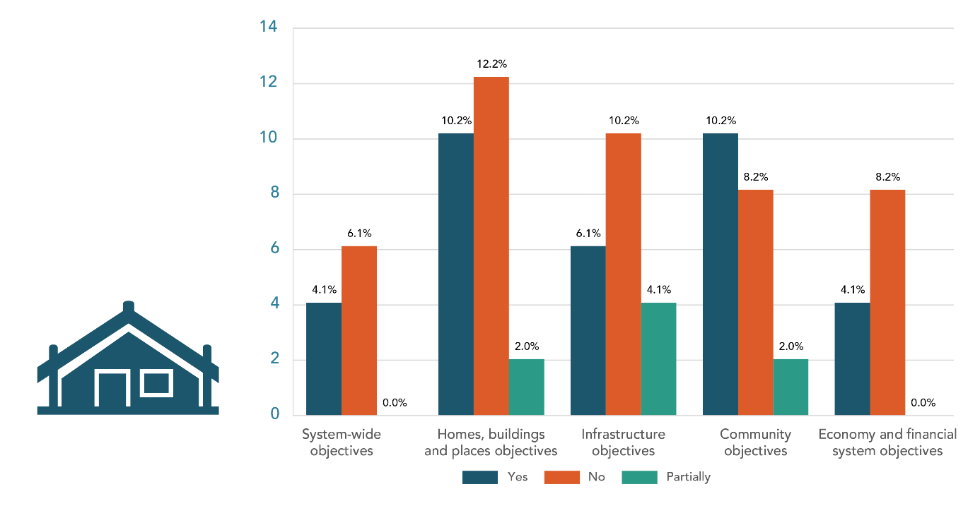
Figure 12: Level of support for objectives by Pacific communities
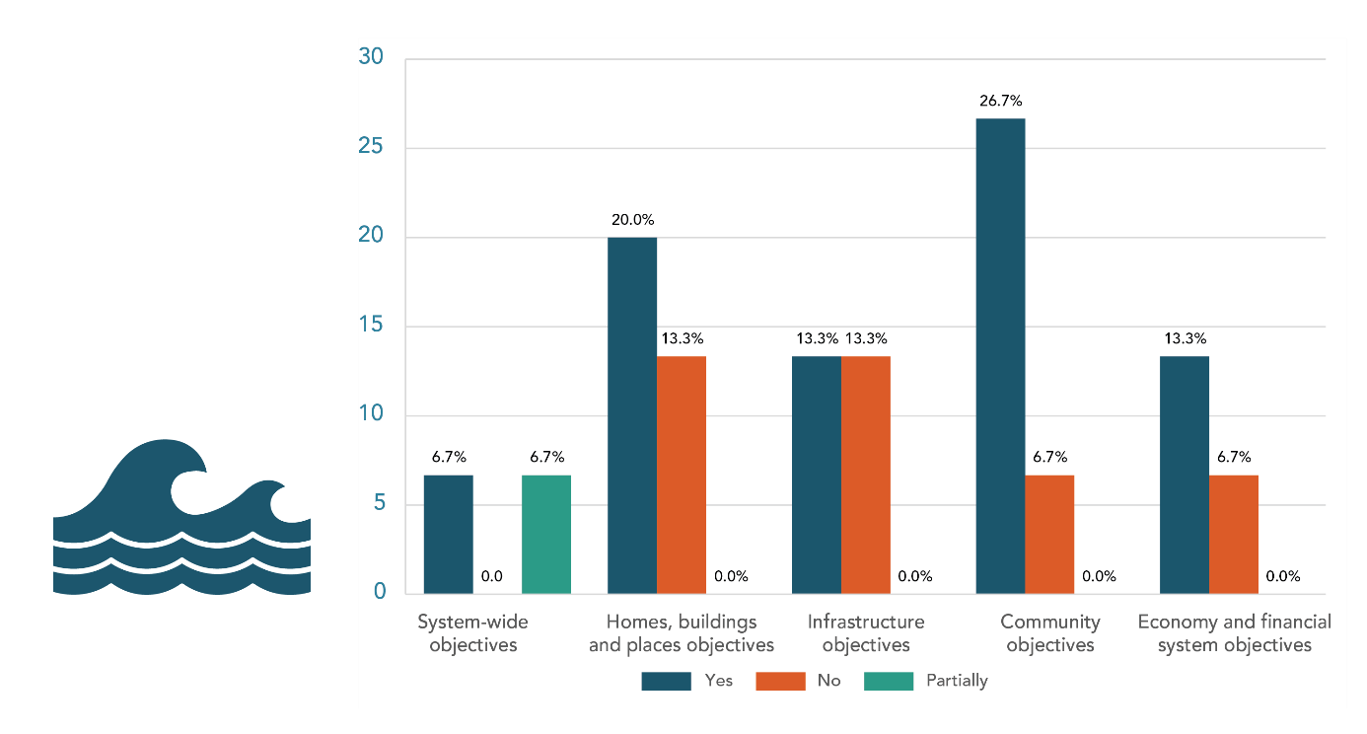
Figure 13: Level of support for objectives by ethnic communities
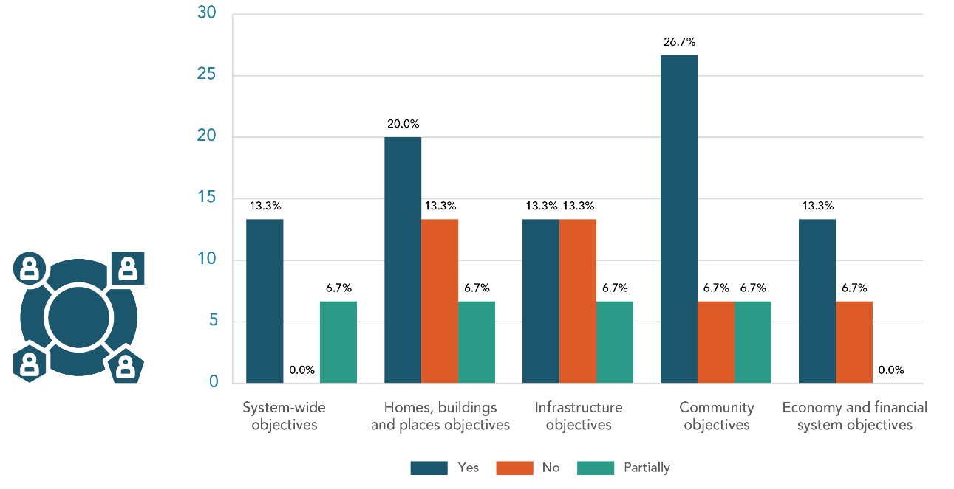
Figure 14: Level of support for objectives by disabled people
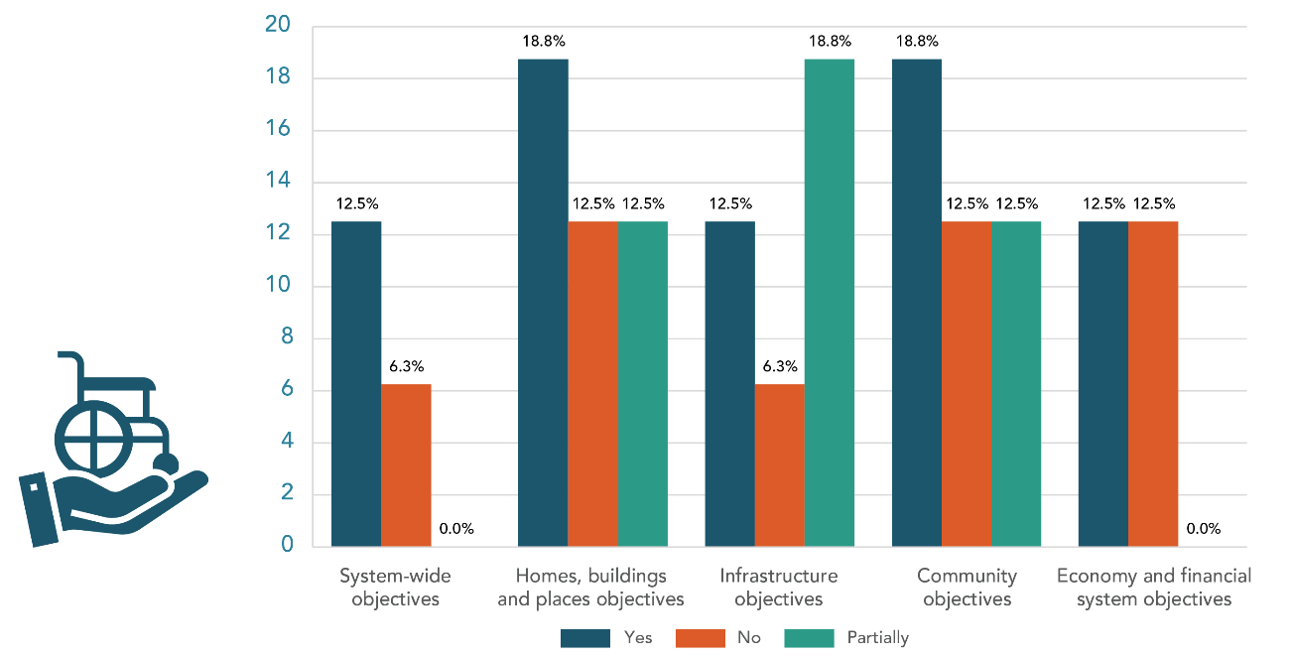
Figure 15: Level of support for objectives by low-income communities
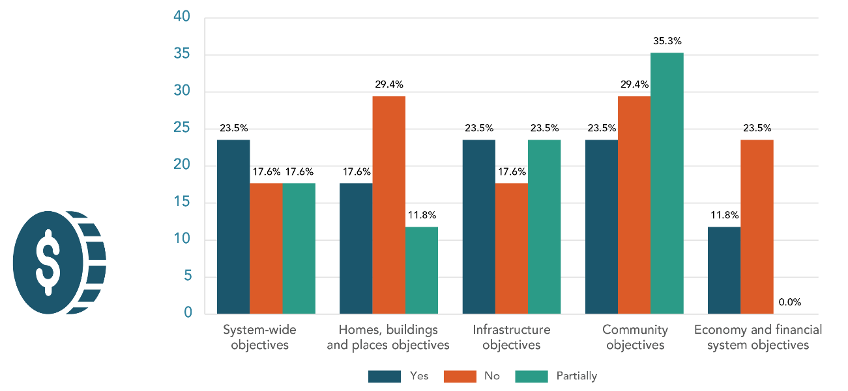
Figure 16: Level of support for objectives by older and retired people
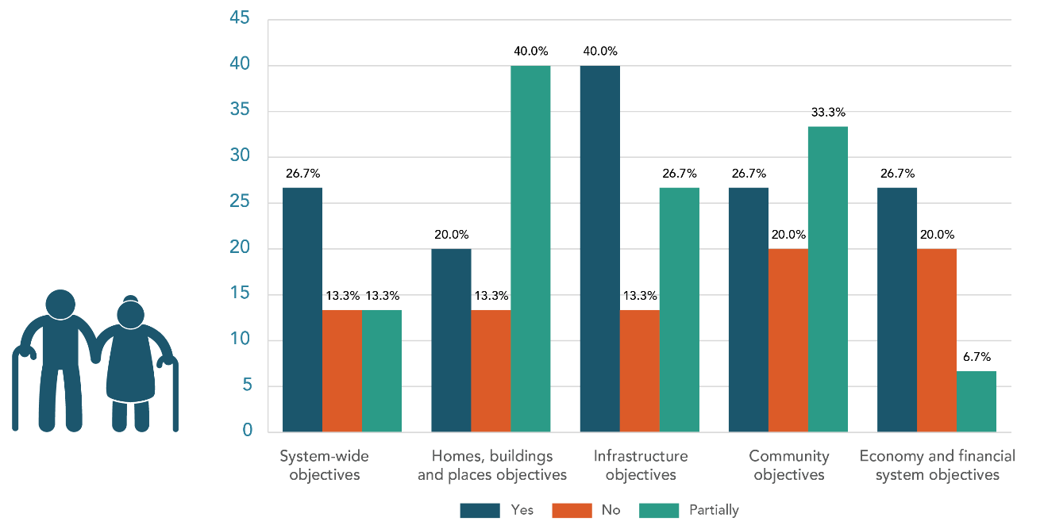
Figure 17: Level of support for objectives by rural communities
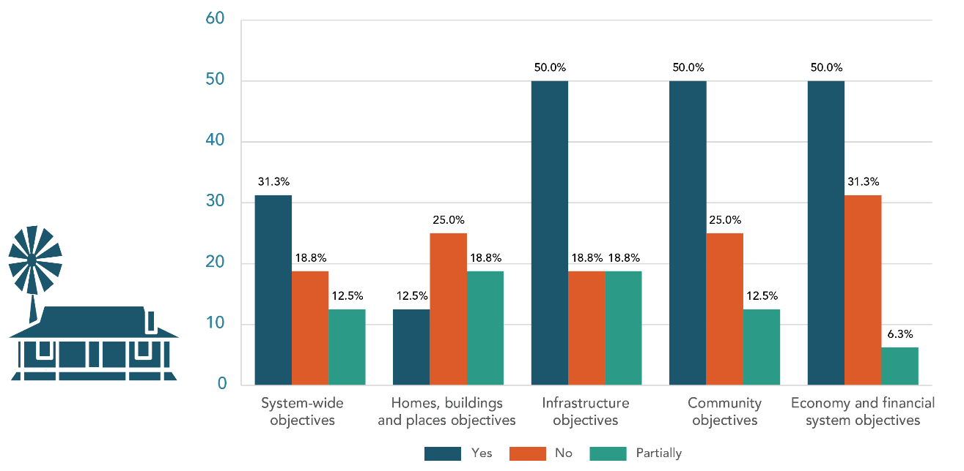
Figure 18: Level of support for objectives by LGBTQIA+ communities
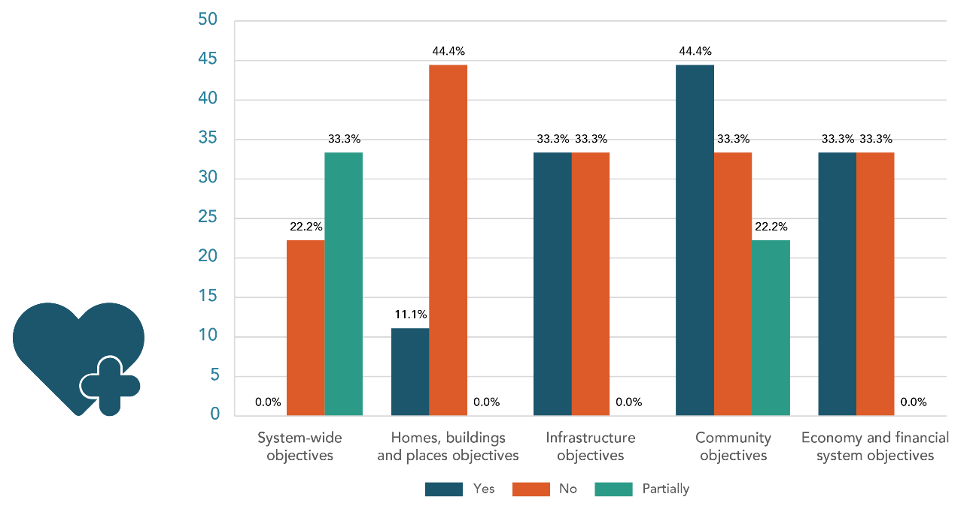
Figure 19: Level of support for objectives by women
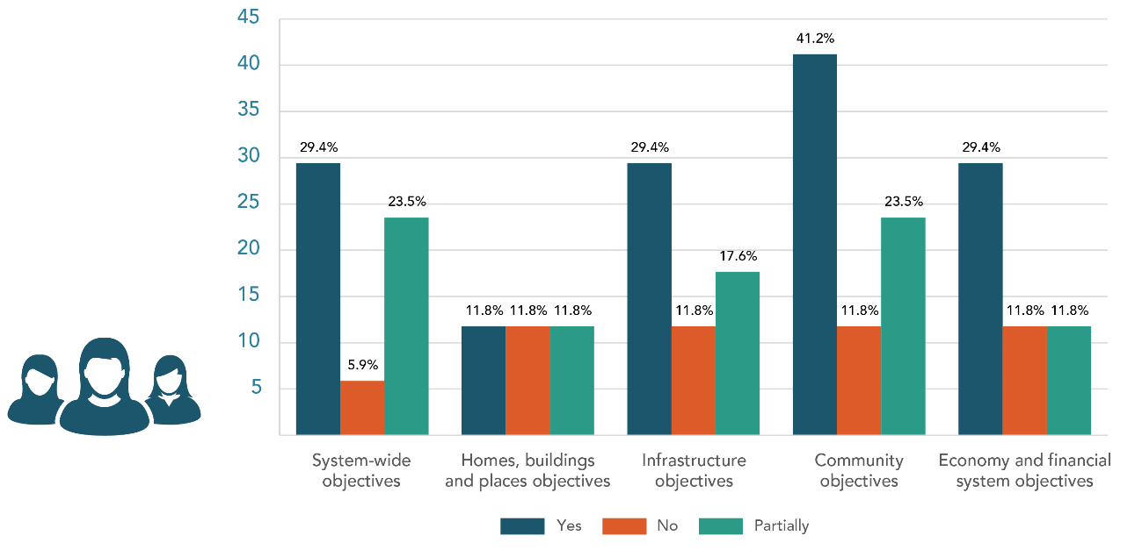
Figure 20: Level of support for objectives by children and young people
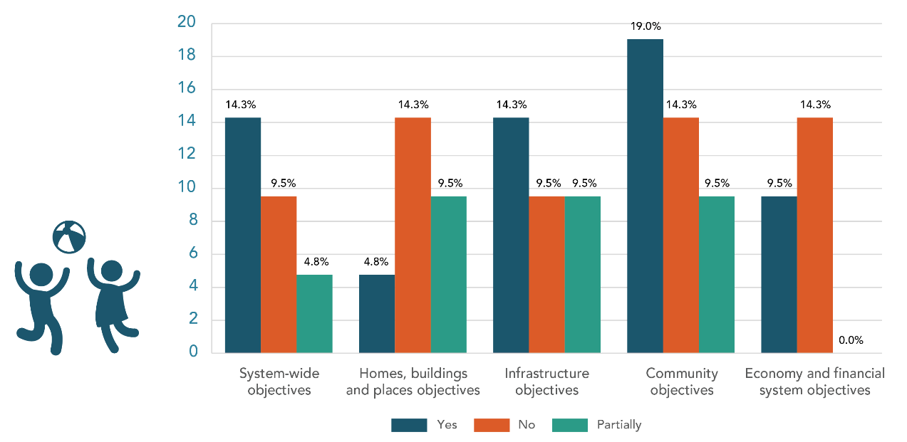

Appendix 2: Consultation questions for the draft national adaptation plan and managed retreat

General questions
- Climate change is already impacting New Zealanders. Some examples include extreme weather events such as storms, heatwaves and heavy rainfall which affects lives, livelihoods, health and wellbeing, ecosystems and species, economic, social and cultural assets, services (including ecosystem services) and infrastructure. How is climate change impacting you? This could be within your community and/or hapū and iwi, and/or your business/organisation, and/or your region.
- The national adaptation plan focuses on three key areas. Please indicate which area is most important for you (tick box).
focus area one: reform institutions to be fit for a changing climate. This means updating the legislative settings so that those who are responsible for preparing for and reducing exposure to changing climate risk will be better equipped.
focus area two: provide data, information and guidance to enable everyone to assess and reduce their own climate risks. This means that all New Zealanders will have access to information about the climate risks that are relevant to them
focus area three: embed climate resilience across government strategies and policies. This means that Government agencies will be considering climate risks in their strategies and proposals.
other? Please explain.
- We all have a role to play in building resilience to climate change, but some New Zealanders may be more affected and less able to respond. There is a risk that climate change could exacerbate existing inequities for different groups in society. Appendix 3 sets out the full list of actions in this national adaptation plan.
a) What are the key actions that are essential to help you adapt? Please list them.
b) Which actions do you consider to be most urgent? Please list them.
c) Are there any actions that would help ensure that existing inequities are not exacerbated? Please list them.
d) Are there any actions not included in this draft national adaptation plan that would enable you to assess your risk and help you adapt?
- Central government cannot bear all the risks and costs of adaptation. What role do you think asset owners, banks and insurers, the private sector, local government and central government should play in:
- improving resilience to the future impacts of climate change?
- sharing the costs of adaptation?
- The National Climate Change Risk Assessment recognised that there may be economic opportunities in adapting to a changing climate.
- What opportunities do you think could exist for your community or sector?
- What role could central government play in harnessing those opportunities?

System-wide actions
- Do you agree with the objectives in this chapter?
Yes
No
Partially
Please explain your answer.

- What else should guide the whole-of-government approach to help New Zealand adapt and build resilience to a changing climate?

- Do you agree that the new tools, guidance and methodologies set out in this chapter will be useful for you, your community and/or iwi and hapū, business or organisation to assess climate risks and plan for adaptation?
Yes
No
Partially
Please explain your answer.

- Are there other actions central government should consider to:
- enable you to access and understand the information you need to adapt to climate change?
Yes
No
Unsure
Please explain your answer.

- provide further tools, guidance and methodologies to assist you to adapt to climate change?
Yes
No
Unsure
Please explain your answer.

- remove barriers to greater investment in climate resilience?
Yes
No
Unsure
Please explain your answer.

- support local planning and risk reduction measures while the resource management and emergency management system reforms progress?
Yes
No
Unsure
Please explain your answer.

- What actions do you think will have the most widespread and long-term benefit for New Zealand?

- Are there additional actions that would strengthen climate resilience?
Yes
No
Unsure
Please explain your answer.

- There are several Government reform programmes underway that can address some barriers to adaptation, including the Resource Management (RM) reform. Are there any additional actions that we could include in the national adaptation plan that would help to address barriers in the short-term before we transition to a new resource management system?

- In addition to clarifying roles and providing data, information, tools and guidance, how can central government unlock greater investment in resilience?
a) Would a taxonomy of ‘green activities’ for New Zealand help to unlock investment for climate resilience?
Yes
No
Unsure
Please explain your answer.

The natural environment
- Do you agree with the actions set out in this chapter?
Yes
No
Unsure
Please explain your answer.

- What else should guide central government’s actions to address risks to the natural environment from a changing climate?

- Are there other actions central government should consider to:
- support you, your community, iwi and hapū, business and/or organisation to build the natural environment’s climate resilience?
Yes
No
Unsure
Please explain your answer.

- strengthen biosecurity in the face of climate change?
Yes
No
Unsure
Please explain your answer.

- identify and support New Zealand’s most vulnerable ecosystems and species in a changing climate?
Yes
No
Unsure
Please explain your answer.

- What do you identify as the most important actions that will come from outside of central government (eg, local government, the private sector or other asset owners, iwi, hapū and/or other Māori groupings such as: business, forestry, fisheries, tourism, urban Māori, the private sector) to build the natural environment’s resilience to the impacts of climate change?

- Are there additional actions that would advance the role of Māori as kaitiaki in a changing climate?
Yes
No
Unsure
Please explain your answer.

Homes, buildings and places
- Do you agree with the outcome and objectives in this chapter?
Yes
No
Partially
Please explain your answer.

- What else should guide central government’s actions to increase the resilience of our homes, buildings and places?

- Do you agree with the actions set out in this chapter?
Yes
No
Partially
Please explain your answer.

- Are there other actions central government should consider to:
- better promote the use of mātauranga Māori and Māori urban design principles to support adaptation of homes, buildings and places?
Yes
No
Unsure
Please explain your answer.

- ensure these actions support adaptation measures targeted to different places and respond to local social, cultural, economic and environmental characteristics?
Yes
No
Unsure
Please explain your answer.

- understand and minimise the impacts to cultural heritage arising from climate change?
Yes
No
Unsure
Please explain your answer.

The following questions are about existing buildings. These can include housing, communal residential (hotels, retirement village), communal non-residential (church, public swimming pools), commercial (library, offices, restaurant), industrial (factory, warehouse).
- Do you think that there is a role for government in supporting actions to make existing homes and/or buildings more resilient to future climate hazards?
Yes
No
Unsure
If yes, what type of support would be effective?

- From the proposed actions for buildings, what groups are likely to be most impacted and what actions or policies could help reduce these impacts?

- What are some of the current barriers you have observed or experienced to increasing buildings’ resilience to climate change impacts?

Infrastructure
- Do you agree with the outcome and objectives in this chapter?
Yes
No
Partially
Please explain your answer.

- What else should guide central government’s actions to prepare infrastructure for a changing climate?

- Do you agree with the actions set out in this chapter?
Yes
No
Partially
Please explain your answer.

- The national adaptation plan has identified several actions to support adaptation in all infrastructure types and all regions of Aotearoa.
- Do you see potential for further aligning actions across local government, central government and private sector asset owners?
Yes
No
Unsure
Please explain your answer.

- Do you see any further opportunities to include local mana whenua perspectives and mātauranga Māori in infrastructure adaptation decision-making?
Yes
No
Unsure
Please explain your answer.

- Do you see any further opportunities to include local community perspectives in infrastructure adaptation decision-making?
Yes
No
Unsure
Please explain your answer.

- Do you see any further opportunities to ensure that groups who may be disproportionally impacted by climate change, or who are less able to adapt (such as those on low incomes, beneficiaries, disabled people, women, older people, youth, migrant communities) have continued and improved access to infrastructure services as we adapt?
Yes
No
Unsure
Please explain your answer.

- Do you think we have prioritized the right tools and guidance to help infrastructure asset owners understand and manage climate risk?
Yes
No
Unsure
Please explain your answer.

- Are there additional infrastructure actions that would help to strengthen Māori climate resilience?
Yes
No
Unsure
Please explain your answer.

- Are there any other tools or data that would help infrastructure asset owners make better decisions?

Communities
- Do you agree with the outcome and objectives in this chapter?
Yes
No
Partially
Please explain your answer.

- Do you agree with the actions set out in this chapter?
Yes
No
Partially
Please explain your answer.

- What actions will provide the greatest opportunities for you and your community to build climate resilience?

- Are there additional actions central government should consider to:
- support your health and wellbeing in the face of climate change?
Yes
No
Unsure
Please explain your answer.

- promote an inclusive response to climate change?
Yes
No
Unsure
Please explain your answer.

- target support to the most vulnerable and those disproportionately impacted?
Yes
No
Partially
Please explain your answer.

- What do you think are the most important actions that will come from outside of central government (eg, local government, the private sector or other asset owners, iwi, hapū, non-government organisations, community groups) to strengthen community resilience in the face of climate change?

- Are there additional actions could be included in the national adaptation plan to help strengthen climate resilience for iwi, hapū and whānau?
Yes
No
Partially
Please explain your answer.

The economy and financial system
- Do you agree with the outcome and objectives in this chapter?
Yes
No
Partially
Please explain your answer.

- What else should central government do to realise a productive, sustainable and inclusive economy that adapts and builds resilience to a changing climate?

- Do you agree with the actions set out in this chapter?
Yes
No
Partially
Please explain your answer.

- Are there other actions central government should consider to:
- support sectors, businesses and regional economies to identify climate risks and adapt?
Yes
No
Unsure
Please explain your answer.

- promote a resilient financial system in the face of climate change?
Yes
No
Unsure
Please explain your answer.

- What do you think are the most important actions that will come from outside of central government (eg, local government, the private sector or other asset owners, iwi, hapū and/or other Māori groupings such as: business, forestry, fisheries, tourism, urban Māori, the private sector) to reduce the economic and financial risk they face from climate change?

- Are there additional actions within the financial system that would help strengthen Māori climate resilience?
Yes
No
Unsure
Please explain your answer.

- In the context of other risk management options (eg, flood barriers, retreat from high-risk areas), what role should insurance have as a response to flood risk? Please explain your answer.

- Should the Government have a role in supporting flood insurance as climate change risks cause private insurance retreat?
Yes
No
Unsure
Please explain your answer.

- Does your answer to the above question depend on the circumstances? (For example, who the owner is (eg, low income), the nature and characteristics of the asset (eg, residential or commercial property, contents and vehicles), what other risk management options are available and their cost/benefit, and where the asset is located?) Please explain your answer.

- If you think the Government should have a role in supporting flood insurance as climate change risks cause private insurance retreat, how do you envision the Government’s role, and how is this best achieved (eg, direct support and/or indirect support such as reducing underlying flood risk)?

- If the Government were to directly support flood insurance:
- what is the best way to provide this direct support?
- should the Government’s focus be to support availability or affordability of insurance, or both?
- how should the costs of that support be funded, and by whom?
- what are the benefits and downsides of this approach?
- should this support be temporary or permanent?
- if temporary, what additional measures, if any, do you think would be needed to eventually withdraw this support (eg, undertaking wider flood protection work)?
- what would the risks or benefits be of also including non-residential property, such as commercial property?
- what design features or complementary policies are needed so any flood insurance intervention retains incentives for sound flood-risk management (eg, discouraging development in high-risk locations)?

- How effective do you think the insurance “price signal” (eg, higher premiums or loss of insurance) is for providing incentives to reduce flood risk?

- In your view, should a scheme similar to Flood Re in New Zealand be used to address current and future access and affordability issues for flood insurance? Why or why not?

- How do you think a scheme similar to Flood Re in New Zealand could support or hinder climate change adaptation initiatives in New Zealand?

Closing general question
- Do you have any other thoughts about the draft national adaptation plan that you would like to share?

Managed retreat
52. Do you agree with the proposed principles and objectives for managed retreat? Please explain why or why not.
53. Are there other principles and objectives you think would be useful? Please explain why.
54. Do you agree with the process outlined and what would be required to make it most effective?
55. What do you think could trigger the process? What data and information would be needed?
56. What other processes do you think might be needed, and in what circumstances?
57. What roles and responsibilities do you think central government, local government, iwi/Māori, affected communities, individuals, businesses, and the wider public should have in
a) a managed retreat process?
b) sharing the costs of managed retreat?
58. What support may be needed to help iwi/Māori, affected communities, individuals, businesses and the wider public participate in a managed retreat process?
59. A typical managed retreat will have many costs, including those arising from preparation (including gathering data and information), the need to participate in the process, relocating costs and the costs of looking after the land post-retreat. In light of your feedback on roles and responsibilities (Q57), who do you think should be responsible for or contribute to these costs?
60. What do you consider the key criteria for central government involvement in managed retreat?
61. There may be fewer options for homes and community buildings (eg, schools, churches, community halls) to move than businesses (eg, retail and office buildings, factories, utilities) for financial, social, emotional and cultural reasons. That may suggest a different process for retreat, and different roles and responsibilities for these actors. Should commercial properties/areas and residential properties/areas be treated differently in the managed retreat process? Please explain why.
62. Even in areas where communities are safe, local services and infrastructure, such as roads, power lines and pipes may become damaged more frequently and be more expensive to maintain because of erosion or increases in storms and rainfall, for example. Local councils may decide to stop maintaining these services. Are there circumstances in which people shouldn’t be able to stay in an area after community services are withdrawn?
63. In what situations do you think it would be fair for you to be required to move from where you live?
64. Many residential communities are made up of a combination of renters, owner/occupiers and people who own a property and use it as a second/holiday house. Do you think there are reasons for these groups to have different levels of involvement in a managed retreat process?
65. It is not always obvious that an area is at high risk from natural hazards or the impacts of climate change. However, council risk assessments and increased data and information should make these risks clearer. Do you think that different approaches should be taken for those who purchased properties before a risk was identified (or the extent or severity of the risk was known) and those who bought after the risk became clear?
66. Under what circumstances do you think it would be fair or necessary for government to take different approaches with a greater or lesser degree of intervention or support?
67. How do you think land with historical, cultural, social or religious significance (eg, cemeteries or churches) should be treated?
68. Some Māori communities, both inland and coastal, have needed to relocate as a result of events (including natural disasters) that have impacted their marae and wāhi tapu. These examples show that Māori communities are aware of the ways that climate change is affecting their marae, papa kāinga and wāhi tapu, and how relocation can be approached as a community, with engagement from iwi, hapū, and whānau. The examples also demonstrate that climate change is impacting coastal communities as well as inland communities located closer to rivers and lakes. How do you think managed retreat would affect Māori?
69. Managed retreat has rarely occurred in Aotearoa, especially within Māori communities. However, there are examples of Māori proactively working to protect their marae, papa kāinga and wāhi tapu by either relocating or protecting and developing their current sites. In these instances, the focus was on protecting and preserving their taonga for future generations. What do you see as being most important in developing a managed retreat system for iwi/hapū/Māori?
70. Māori land and Treaty settlement land have unique legislative arrangements. Restrictions and protections are placed on Māori land to meet a clear set of principles and objectives that recognise the cultural connection Māori have with the land and a specific focus on land retention and utilisation. Treaty settlement land that has been acquired through Treaty settlement processes is most likely to have cultural significance to a particular iwi or hapū and used to support the aspirations of their people. How do you think Māori land (including Treaty settlement land) should be treated?
71. How do you think post event insurance payments could help support managed retreat?
72. Should insurability be a factor in considering whether the Government should initiate managed retreat from an area

Appendix 3: Glossary
This glossary of terms is drawn from the draft national adaptation plan.
Key term | Definition
Adaptation | In human systems, the process of adjusting to actual or expected climate and its effects, in order to moderate harm or take advantage of beneficial opportunities. In natural systems, the process of adjusting to actual climate and its effects. Human intervention may help these systems to adjust to expected climate and its effects.
Adaptation options | The wide range of strategies and measures that are available and appropriate for addressing adaptation. They can take the form of structural, institutional, ecological or behavioural actions.
Adaptive capacity | The ability of systems, institutions, humans and other organisms to adjust to potential damage, to take advantage of opportunities or to respond to consequences.
Asset | Something of value, which may be exposed or vulnerable to a hazard or risk. It may be something physical, environmental, cultural or financial/economic, and its value may be tangible, intrinsic or spiritual (see Taonga).
Baseline | An initial set of critical observations or data used for comparison or a control.
Biodiversity | The variability among all living organisms on Earth. It includes diversity within species, diversity between species and diversity of an ecosystem. The living organisms may be from any sources, such as terrestrial, marine and other aquatic ecosystems and the ecological complexes they belong to.
Capacity building | The practice of supporting an individual, community, society or organisation to respond to change by enhancing their strengths and attributes and improving the resources available to them.
Cascading impacts | A series of events where an initial impact produces further impacts that are significantly larger than the first one. In relation to extreme weather events, an extreme hazard causes a sequence of secondary events in natural and human systems that result in major physical, natural, social and/or economic disruption. Cascading impacts are complex and multidimensional and are associated more with the extent to which the natural and human systems are vulnerable than with the size of the original hazard.
Climate | Informally, the average weather over a period ranging from months to thousands or millions of years. In more formal terms, a statistical description of the mean and variability of quantities, usually of surface variables such as temperature, precipitation and wind, averaged over a period (typically 30 years, as defined by the World Meteorological Organization).  More broadly, climate is the state, including a statistical description, of the climate system.
Climate change | A change in the state of the climate that can be identified (eg, by using statistical tests) by changes or trends in the mean and/or the variability of its properties, and that persists for an extended period, typically decades to centuries. Includes natural internal climate processes and external climate forcings such as variations in solar cycles, volcanic eruptions and persistent anthropogenic changes in the composition of the atmosphere or in land use (IPCC, 2014a). The United Nations Framework Convention on Climate Change (UNFCCC) definition of climate change specifically links it to direct or indirect human causes, as: ‘a change of climate which is attributed directly or indirectly to human activity that alters the composition of the global atmosphere and which is in addition to natural climate variability observed over comparable time periods’. The UNFCCC thus makes a distinction between climate change attributable to human activities altering the atmospheric composition and climate variability attributable to natural causes.
Climate resilience | The ability to anticipate, prepare for and respond to the impacts of a changing climate, including the impacts that we can anticipate and the impacts of extreme events. It involves planning now for sea-level rise and more frequent flooding. It is also about being ready to respond to extreme events like forest fires or extreme floods, and to trends in precipitation and temperature that emerge over time like droughts.
Co-benefit | A positive effect that a policy or measure aimed at one objective has on another objective, thereby increasing the total benefit to society or the environment.
Coastal | Describes either the land near to the sea (eg, ‘coastal communities’) or the part of the marine environment that is strongly influenced by land-based processes (eg, ‘coastal seas’, meaning the part of the sea that is generally shallow and near-shore). The landward and seaward limits of the coastal zone are not consistently defined, neither scientifically nor legally. Thus, coastal waters can either be considered as equivalent to territorial waters (extending 12 nautical miles/22.2 km from mean low water), or to the full Exclusive Economic Zone, or to shelf seas, with less than 200 m water depth.
Coastal erosion | Coastal erosion, sometimes referred to as shoreline retreat, occurs when a net loss of sediment or bedrock from the shoreline results in landward movement of the high-tide mark. The process when the high-tide mark moves closer towards the land due to a net loss of sediment or bedrock from the shoreline. Also known as shoreline retreat.
Consequence | The outcome of an event that may result from a hazard. It can be expressed quantitatively (eg, units of damage or loss, disruption period, monetary value of impacts or environmental effect), by category (eg, high, medium, low level of impact) or qualitatively (a description of the impacts).  Alternatively, the outcome of an event that affects objectives.
(the) Crown | Generally, executive government conducted by Ministers and their departments. The Crown does not normally include organisations with their own corporate identities, such as state-owned enterprises.
Cultural asset | Material artefacts, non-material items and natural places that have cultural value.
Cultural heritage | Cultural heritage means those aspects of the environment that contribute to an understanding and appreciation of New Zealand’s history and cultures. It includes historic sites, structures, places, and areas, archaeological sites, sites of significance to Māori, including wāhi tapu, and cultural landscapes.
Disaster | A serious disruption of the functioning of a community or a society at any scale that occurs because hazardous events interact with conditions of exposure, vulnerability and capacity, leading to human, material, economic and/or environmental losses and impacts.
Disaster risk management | Processes for designing, implementing and evaluating strategies, policies and measures to improve understanding of current and future disaster risk, foster disaster risk reduction and transfer, and promote continuous improvement in disaster preparedness, prevention and protection, response and recovery practices. The aim is to increase human security, wellbeing, quality of life, and sustainable development.
Displacement | The involuntary movement, individually or collectively, of people from their country or community, notably for reasons of armed conflict, civil unrest, or natural or man-made disasters. In the context of this plan, displacement primarily refers to the involuntary movement of individuals or communities in response to climate change impacts.
Distributional impact | The effects of environmental policies (eg, higher transport or energy costs) across households, iwi/Māori, businesses, communities and regions. Some groups may pay more, or receive fewer benefits from the policies.
Drought | An exceptionally long period of water shortage for existing ecosystems and the human population (due to low rainfall, high temperature and/or wind).
Dry year | An extended period when the energy supply in Aotearoa New Zealand relies more on natural gas and coal because hydro-electric generation is reduced. This occurs because hydro lakes only hold enough water for a few weeks of winter energy demand if inflows (rain and snow melt) are very low.
Dynamic adaptive pathways planning | A framework that supports climate adaptation decision-making by developing a series of actions over time (pathways). It is based on the idea of making decisions as conditions change, before severe damage occurs, and as existing policies and decisions prove no longer fit for purpose.
Ecosystem | A functional unit consisting of living organisms, their non-living environment and the interactions within and between them. The purpose of the ecosystem defines what components belong to it and where its spatial boundaries lie. Ecosystem boundaries can change over time. Ecosystems are nested within other ecosystems and their scale can range from very small to the entire biosphere. In the current era, most ecosystems either contain people as key organisms or are influenced by the effects of human activities in their environment.
Ecosystem health | A metaphor that describes the condition of an ecosystem, by analogy with human health. The health status of an ecosystem is based not on a standard measurement but on a judgment of its resilience to change, which varies depending on which measures are used and which social aspirations are behind the assessment.
Ecological corridor | An area of habitat connecting wildlife populations that have been separated by human activities or structures.
Ecological integrity | The ability of an ecological system to support and maintain a community of organisms where the composition, diversity and functional organisation of its species is comparable to those of natural habitats within a region.
Emergency management | The process of applying knowledge, measures and practices that are necessary or desirable for the safety of the public or property, and are designed to guard against, prevent, reduce, recover from or overcome any hazard, harm or loss associated with any emergency. Activities include planning, organising, coordinating and implementing those measures, knowledge and practices.
Emissions | In the context of climate change, emissions of greenhouse gases, precursors of greenhouse gases and aerosols caused by human activities. These activities include the burning of fossil fuels, deforestation, land use and land-use changes, livestock production, fertilisation, waste management and industrial processes.
Erosion | The process in which actions of water, wind or ice wear away land.
Equity | The principle of being fair and impartial, often also aligned with ideas of equality and justice. It provides a basis for understanding how the impacts of and responses to climate change, including costs and benefits, are distributed in and by society in more or less equal ways. The principle can be applied in understanding who is responsible for climate impacts and policies, how those impacts and policies are distributed across society, generations and gender, and who participates and controls the processes of decision-making.
Exposure | Being present in a place or setting that could be adversely affected. Those that could be harmed in that environment include people; livelihoods; species or ecosystems; environmental functions, services and resources; infrastructure; or economic, social or cultural assets.
Extreme weather event | An event that is rare at a particular place and time of year. What is ‘extreme weather’ may vary from place to place in an absolute sense. The measure of what is ‘rare’ may also vary but it involves the occurrence of a value of a weather or climate variable above (or below) a threshold value near the upper (or lower) ends of the range of observed values of the variable. In general, an extreme weather event would be as rare as or rarer than the 10th or 90th percentile of a probability density function estimated from observations.  When a pattern of extreme weather persists for some time, such as a season, it may be classified as an extreme climate event, especially if it yields an average or total that is itself extreme (eg, high temperature, drought or heavy rainfall over a season).
Flood | An event where the normal boundaries of a stream or other water body overflow, or water builds up over areas that are not normally underwater. Floods can be caused by unusually heavy rain, for example during storms and cyclones. Floods include river (fluvial) floods, flash floods, urban floods, rain (pluvial) floods, sewer floods, coastal floods and glacial lake outburst floods.
Fiscal impacts | The fiscal impact of a policy or event refers to the implications it has for government expenditure or revenue.
Food security | A situation where all people, at all times, have physical, social and economic access to sufficient, safe and nutritious food that meets their dietary needs and food preferences for an active and healthy life. The four pillars of food security are availability, access, utilisation and stability. The nutritional dimension is integral to the concept of food security.
Frequency (of a hazard) | The number or rate of occurrences of hazards, usually over a particular period.
Governance | The governing architecture and processes of interaction and decision-making that exist in and between governments, economic and social institutions.  Governance permeates all aspects of New Zealand, from Te Tiriti partnership between Māori and the Crown to the relationship between local government and communities, and from the economy to the built environment to natural ecosystems.
Greenhouse gas (GHG) | Gas in the atmosphere, which may have natural or human causes, that absorbs and emits radiation at specific wavelengths within the spectrum of radiation emitted by the Earth’s ocean and land surface, by the atmosphere itself and by clouds. This property causes the greenhouse effect.  The main greenhouse gases in Earth’s atmosphere are water vapour, carbon dioxide, nitrous oxide, methane and ozone. Human-made GHGs include sulphur hexafluoride, hydrofluorocarbons, chlorofluorocarbons and perfluorocarbons.
Gross domestic product (GDP) | The sum of the gross value that all resident and non-resident producers in the economy added, at purchasers’ prices, to a country or region plus any taxes and minus any subsidies not included in the value of the products in a country or a geographic region for a given period, normally one year. GDP is calculated without deducting for depreciation of fabricated assets or depletion and degradation of natural resources.
Hazard | The potential occurrence of a natural or human-induced physical event or trend that may cause loss of life, injury or other health impacts, as well as damage and loss to property, infrastructure, livelihoods, service provision, ecosystems and environmental resources.
Heatwave | A period of abnormally hot weather often defined with reference to a relative temperature threshold, lasting from two days to months.
Intergovernmental Panel on Climate Change (IPCC) | The United Nations body for assessing the science related to climate change. The IPCC is organised into three working groups and a task force:  Working Group I (WGI) – physical science basis  Working Group II (WGII) – impacts, adaptation and vulnerability  Working Group III (WGIII) – mitigation  Task Force on national greenhouse gas inventories.
Impacts | The consequences of realised risks on natural and human systems, where risks result from the interactions of climate-related hazards (including extreme weather events), exposure and vulnerability. They are generally effects on human lives, livelihoods, health and wellbeing; ecosystems and species; economic, social and cultural assets; services (including ecosystem services); and infrastructure. They can be harmful or beneficial. Also known as consequences or outcomes.
Indigenous knowledge | The understandings, skills and philosophies developed by societies with long histories of interaction with their natural surroundings. For many indigenous peoples, indigenous knowledge informs decision-making about fundamental aspects of life, from day-to-day activities to longer-term actions. This knowledge is integral to cultural complexes, which also include language, systems of classification, resource use practices, social interactions, values, ritual and spirituality. These distinctive ways of knowing are important facets of the world’s cultural diversity.
Infrastructure | The designed and built set of physical systems, along with their institutional arrangements, that interact with the broader environment to provide services to people and communities to support economic growth, health, quality of life and safety.
Insurance/ reinsurance | A group of financial instruments for sharing and transferring risk among a pool of at-risk households, businesses and/or governments.
Land use | All of the arrangements, activities and inputs (a set of human actions) that people undertake in a certain type of land cover (eg, forest land, cropland, grassland, wetland or settlements).  Alternatively, the social and economic purposes for which land is managed (eg, grazing, timber extraction, conservation and city dwelling).
Maladaptation | Actions that may lead to increased risk of adverse climate-related outcomes, including increased greenhouse gas emissions, increased vulnerability to climate change or reduced welfare, now or in the future. Maladaptation is usually an unintended consequence.
Managed retreat | The purposeful, coordinated movement of people and assets (eg, buildings, infrastructure…) away from risks. This may involve the movement of a person, infrastructure (eg, building or road), or community. It can occur in response to a variety of hazards such as flood, wildfire or drought.
Māori values and principles | Values and principles that come from Māori views of the world and that Māori use to make sense of, experience and interpret the world. They form the basis for Māori ethics and principles.
Mitigation | In the context of climate change, a human intervention to reduce the sources or enhance the sinks of greenhouse gases.
Nature-based solutions | Solutions that are inspired and supported by nature and are cost-effective, and at the same time provide environmental, social and economic benefits and help build resilience. Such solutions bring more, and more diverse, nature and natural features (ie, vegetation and water features) and processes into cities, landscapes and seascapes, through locally adapted, resource-efficient and systemic interventions. For example, using vegetation (eg, street trees or green roofs) or water elements (eg, rivers or water treatment facilities) can help reduce heat in urban areas or support stormwater and flood management.
Pathway | The evolution of natural and/or human systems over time towards a future state. Pathway concepts range from sets of quantitative and qualitative scenarios or narratives of potential futures to solution-oriented decision-making processes to achieve desirable social goals. Pathway approaches typically focus on biophysical, techno-economic and/or socio-behavioural changes and involve various dynamics, goals and actors across different scales.
Place/places | Urban or rural areas, ranging from neighbourhoods to towns and regions. Adaptation must address both the physical elements of a place (eg, homes, buildings, infrastructure and spaces around them) and the social elements (eg, the identity of people and communities, cultural value).
Resilience/resilient | The capacity of interconnected social, economic and ecological systems to cope with a hazardous event, trend or disturbance, by responding or reorganising in ways that maintain their essential function, identity and structure. Resilience is a positive attribute when it allows systems to maintain their capacity to adapt, learn and/or transform.
Retrofitting | The process of adding new technology or features to older systems, especially industrial installations or buildings.
Risk | The potential for adverse consequences for human or ecological systems, recognising the diversity of values and objectives associated with such systems. In the context of climate change, risks can arise from potential impacts of climate change as well as human responses to climate change. Adverse consequences may affect human lives, livelihoods, health and wellbeing; economic, social and cultural assets and investments; infrastructure; services (including ecosystem services); and ecosystems and species.
Risk assessment | The scientific estimation of risks, which may be either quantitative or qualitative.
Risk management | The process of making plans, actions, strategies or policies to reduce the likelihood and/or scale of potential adverse consequences, based on assessed or perceived risks.
Sea-level rise | Change to the height of sea level over time, which may occur globally or locally. Causes may be:  - a change in ocean volume as a result of a change in the mass of water in the ocean (eg, due to melt of glaciers and ice sheets)  - changes in ocean volume as a result of changes in ocean water density (eg, expansion under warmer conditions)  - changes in the shape of the ocean basins and changes in Earth’s gravitational and rotational fields  - local subsidence or uplift of the land.
Storm surge | The temporary increase, at a particular location, in the height of the sea due to extreme meteorological conditions (low atmospheric pressure and/or strong winds). It is the excess in height above the level expected from the tidal variation alone at that time and place.
Sustainable/ sustainability | Describes conditions where natural and human systems can persist. Ecosystems continuously function, biodiversity is high, natural resources are recycled and, in the human sector, people successfully apply justice and equity.
Three waters | Drinking water, wastewater and stormwater.
Uncertainty | A state of incomplete knowledge that can result from a lack of information or from disagreement about what is known or even knowable. It may occur for many reasons. For example, the data may be imprecise, definitions of concepts or terminology may be ambiguous, understanding of critical processes may be incomplete or projections of human behaviour are in doubt.
Vulnerability/ vulnerable | Being predisposed or more likely to be adversely affected. Elements that contribute to this concept include sensitivity or susceptibility to harm and lack of capacity to cope and adapt.
Wellbeing | The health, happiness and prosperity of an individual or group. It can cover material wellbeing (eg, income and wealth, jobs and earnings, and housing), health (eg, health status and work/life balance), security (eg, personal security and environmental quality), social relations (eg, social connection, subjective wellbeing, cultural identity and education) and freedom of choice and action (eg, civic engagement and governance).

Ministry for the Environment. 2022. Exploring an indigenous worldview framework for the national climate change adaptation plan. Developed for the Ministry for the Environment by Ihirangi, the operational arm of Te Pou Take Āhuarangi (Climate Lead) for the National Iwi Chairs Forum. https://environment.govt.nz/publications/exploring-an-indigenous-worldview-framework-for-the-national-climate-change-adaptation-plan/.
Climate Change Response (Zero Carbon) Amendment Act 2019, 5ZT (1).
Legislation and institutional arrangements are fit for purpose and provide clear roles and responsibilities.
Ministry for the Environment. 2022. Adapt and thrive: Building a climate-resilient New Zealand. Wellington: Ministry for the Environment.

