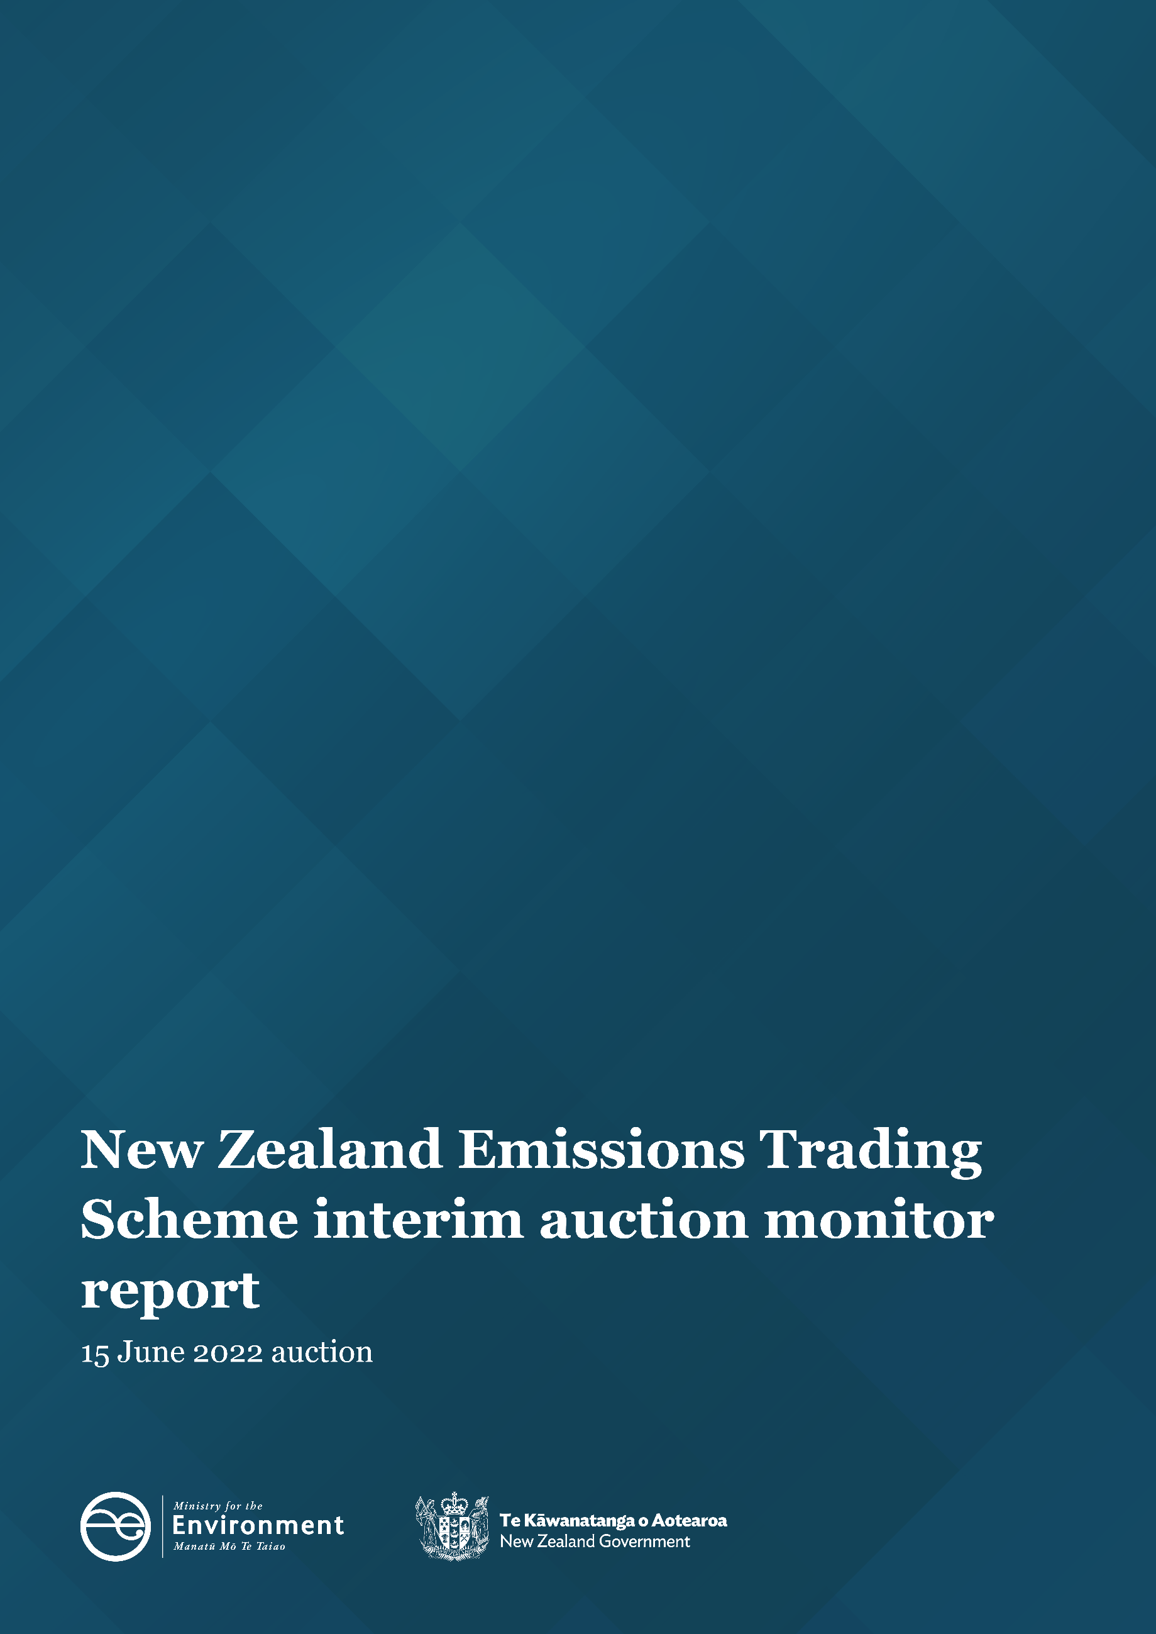
Disclaimer
The information in this publication is, according to the Ministry for the Environment’s best efforts, accurate at the time of publication. The Ministry will make every reasonable effort to keep it current and accurate. However, users of this publication are advised that:
- The information does not alter the laws of New Zealand, other official guidelines, or requirements.
- It does not constitute legal advice, and users should take specific advice from qualified professionals before taking any action based on information in this publication.
- The Ministry does not accept any responsibility or liability whatsoever whether in contract, tort, equity, or otherwise for any action taken as a result of reading, or reliance placed on this publication because of having read any part, or all, of the information in this publication or for any error, or inadequacy, deficiency, flaw in, or omission from the information in this publication.
- All references to websites, organisations or people not within the Ministry are for convenience only and should not be taken as endorsement of those websites or information contained in those websites nor of organisations or people referred to.

This document may be cited as: Ministry for the Environment. 2022. New Zealand Emissions Trading Scheme interim auction monitor report: 15 June 2022 auction. Wellington: Ministry for the Environment.

Published in July 2022 by the
Ministry for the Environment
Manatū Mō Te Taiao
PO Box 10362, Wellington 6143, New Zealand
ISBN: 978-1-99-102555-5
Publication number: ME 1665
© Crown copyright New Zealand 2022
This document is available on the Ministry for the Environment website: environment.govt.nz.

Contents
Introduction and purpose of this report 5
Background 6
Auction monitor to provide information on auctions 6
(Interim) auction monitor’s functions 6
Auction information: 15 June 2022 7
Auction metrics 7
Commentary on the results of the auction 7
The auction clearing price 8
The confidential reserve price 8
Resolved tied bids 8
Cost Containment Reserve (CCR) 9
Commentary on the auction operation 10
General 10
Collateral and settlement 10
Feedback on the auction monitoring report 10
Appendix 11
Graphical presentation of historical auction metrics 11
References 15

Tables
Table 1: Metrics for NZ ETS auction held on 15 June 2022 7

Figures
Figure A.1: Volume of NZUs bid for and Cover Ratio in each auction 11
Figure A.2: Total number of bids in each auction 12
Figure A.3: Participant numbers in each auction 12
Figure A.4: Bid volume (of thousands of NZUs) per participant and ‘win’ ratio 13
Figure A.5: Breakdown of successful bids by participant, March 2022 13
Figure A.6: Breakdown of successful bids aggregated by participants 14
Figure A.7: Proportion of Participants with mandatory compliance obligations under the NZ ETS 14

Introduction and purpose of this report
This report is produced by the Ministry for the Environment (MfE) acting in the role of the interim auction monitor for the sixth scheduled New Zealand Emissions Trading Scheme (NZ ETS) auction, the second of 2022, held on 15 June.
Auctioning of New Zealand Units (NZUs or ‘units’) is currently scheduled at quarterly intervals throughout the year as prescribed by the Climate Change Response (Emissions Trading Reform) Amendment Act 2020 and the Climate Change (Auctions, Limits, and Price Controls for Units) Regulations 2020.
The purpose of this report is to record and provide details on the results of the auction, to present a comparison with previous auctions, and to provide an assurance that the auction was conducted properly and in accordance with the applicable rules and laws.
The remaining auction dates for 2022 are 7 September and 7 December.

Background
Following the 2015/16 review of the NZ ETS, the Government agreed to introduce auctioning of NZUs to align the supply of units in the scheme with New Zealand’s climate change targets. Further public consultation on auctioning regulations took place between November and December 2019.
Following extensive regulatory and legislative development and an open market procurement process, an auction operator was appointed to run regular scheduled auctions through the NZX Managed Auction Service.
The first auction occurred on 17 March 2021.
This report concerns the sixth scheduled auction which occurred on 15 June 2022.

Auction monitor to provide information on auctions
The appointment of an auction monitor requires regulations to be made prescribing the appointment process and the functions of the auction monitor.
Until the required consultations and regulation development have been concluded to appoint an auction monitor, the Minister of Climate Change has agreed that the Ministry for the Environment will perform the function of the auction monitor, referred to in this document as interim auction monitor (IAM).
The IAM function is performed independently of the auction operator and of the Ministry for the Environment policy team responsible for developing the regulations for the auction monitor and auctioning.

(Interim) auction monitor’s functions
Based on feedback from the 2019 consultation, the Government agreed that the auction monitor should:
- publish certain information about each auction as soon as is practical following the auction
- publish a report on the outcome of each auction before the next auction occurs
- review the auctioning system after the first year and every subsequent two years.
Cabinet has agreed that the auction monitor must publish a report containing prescribed information from each auction and on the outcome of each auction prior to the subsequent auction occurring [DEV-20-MIN-0047].
The auction operator publishes information about NZ ETS auctions, which can be read in conjunction with this report.

Auction information: 15 June 2022

Auction metrics
Table 1 provides relevant metrics of the auction. Further details are presented graphically in the appendix.
Table 1: Metrics for NZ ETS auction held on 15 June 2022
Number of participants | 26
Number of successful participants | 17
Volume available at auction (including the CCR of 1,306,700 NZU) | 6,131,700
Volume of NZU sold | 6,131,700
Volume of NZU Bid for | 10,050,900
Average Bid Size | 31,807
Average volume bid per participant | 386,573
Average volume won per successful participant | 360,688
Average number of bids per participant | 12
Total number of bids submitted (not including withdrawn bids) | 316
Number of bids withdrawn | 30
Number of successful bids | 226
Aggregated Top Five participants volume (aggregated successful bids) as a percentage of total units sold | 96
Herfindahl–Hirschman Index (measure of market concentration by volume purchased ‘Top 10’) | 0.24
Percentage of bidders with mandatory compliance obligations | 46

Commentary on the results of the auction
The sixth NZ Emissions Trading Scheme auction and the second of 2022 was successfully conducted on 15 June 2022. The preceding (March) auction resulted in the sale of approximately 80 per cent of the full cost containment reserve volume for 2022 (7 million NZU). The remaining CCR volume (1.31 million NZU) was available for sale. All 4,825,000 units scheduled for sale and the remaining CCR volume were sold in the June auction.
Participation in the June auction was generally consistent with the previous instances. The auction metrics are very similar to those of the December 2021 auction.
Of the 26 entities who participated in the June 2022 auction, 17 were successful in their bids. This relatively low (65 per cent) success rate is perhaps surprising given that there was only one new participant in the June auction. The range of bids (by dollar value) continues to narrow, perhaps indicating an increasing level of participant/bidder experience.
The market concentration index is consistent with the average measurement across previous auctions (March 2022 being a relatively low outlier). The ‘usual players’ continue to dominate auction volume – the ‘top five’ participants purchased over 96 per cent (‘top 10’, 98 per cent) of the sold volume. However, the number and volume bid for by participants registered as having ETS surrender obligations failing to secure any units is very low.
As usual, it is very likely that several of the larger players represent a number of third-party bidders.
Despite the ongoing global political and economic influences, secondary market carbon prices and the auction clearing price remain relatively stable.

The auction clearing price
The auction operator is required to publish the clearing price following the auction.
The IAM notes that the CCR tigger volume price ($70) was breached and that the remaining annual allocation of CCR volume was exhausted in this auction. The auction clearing price was correctly interpreted as $76.00 per NZU (the CCR trigger price).
The interim auction clearing price (the theoretical clearing price in the absence of any CCR volume) was $78.00, down from the March 2022 interim clearing price of $86.00.
The auction clearing price was consistent with the secondary market closing pricing preceding the auction.

The confidential reserve price
The Climate Change Response Act enables the Minister of Climate Change to set a methodology for calculating a confidential reserve price for NZ ETS auctions. The confidential reserve price has the purpose of preventing NZUs from being sold at auction at a price significantly below the secondary market price. If the auction clearing price is less than the confidential reserve price, the auction will not sell any NZUs. Unsold NZUs will be rolled forward to be sold at the next auction in the same calendar year.
The legislation requires that the confidential reserve price cannot exceed the trigger price(s) for the cost containment reserve.
The auction operator has robust procedures and checks in place to ensure that the confidential reserve price is correct. The IAM is satisfied that these checks are sufficient and that the clearing price was above or equal to the confidential reserve price.
The IAM independently confirms that the calculated confidential reserve price did not have an impact on this auction.

Resolved tied bids
If more than one bid sets the clearing price, those bids are referred to as tied bids. If all tied bids together bid for more units than are left, each tied bid is allocated a proportional share of the remaining units, subject to rounding rules. Bids are only accepted in multiples of 100 units from 500 units (the lot size and minimum bid respectively). Units are allocated to bids in multiples of lot size. Therefore, when tied bids occur and the operator calculates proportional shares, they apply the following rounding rules:
- the number of units allocated to a tied bid, if not a multiple of the lot size, is rounded down to the nearest 100 units (this may include being rounded down to zero)
- if unallocated units remain after tied bids are awarded their proportional share (rounded to the nearest 100 units), any remaining lots are randomly allocated to the tied bids, but only up to their original bid amount.
The IAM has examined how units have been allocated among bids and confirms that the auction operator has correctly applied the allocation and rounding rules.
There were seven tied bids requiring consideration in the June 2022 auction.

Cost Containment Reserve (CCR)
The cost containment reserve (CCR) mechanism provides for an additional volume of NZUs to be added to the auction volume if the auction clearing price is equal to or exceeds the CCR trigger price. Currently, there is only one trigger price level in an ETS auction. The cost containment reserve trigger price for the June 2022 Auction was set at $70 per NZU, as previously published.
The available CCR volume to be shared across all four auctions in 2022 is 7.0 million NZUs.
Both the CCR trigger price and available volumes are set by regulation, though both may be reviewed and are subject to change. The available annual auction volumes and auction dates are published in October of the preceding year by the Ministry for the Environment.
The CCR trigger price was breached in the June 2022 auction and the full remaining CCR reserve volume (1,306,700 NZUs) was sold.

Commentary on the auction operation

General
The auction operator has confirmed that the auction ran smoothly with no outages or delays.
The IAM has no reason to believe that the auction rules were not followed.

Collateral and settlement
There were no significant issues noted with the receipt of collateral or the timely payment of invoices for settlement. The auction operator continues to remind prospective participants of the requirement to ensure payment within the prescribed schedule; particularly the need for offshore participants to allow additional time for banking processes. On occasion, prospective participants who had lodged collateral have been alerted that an auction was underway.
All invoices for successful participants were settled within the four working days of the auction requirement.
Uncommitted collateral was returned to participants promptly, though the transfer to one internationally based participant required additional time.
Standby Letters of Credit (SBLC) were the preferred instrument for lodging non-cash collateral for five of the participants, though continuing the trend, most buyers deposited cash as collateral. The amount of collateral deposited as cash was significantly reduced from the March auction.
All NZUs were transferred to successful bidders’ NZ ETS Registry accounts on the same day as the invoice settlement date.
The IAM notes that all participants lodged collateral within the prescribed timeframes, and all successful participants received their allocated units within the prescribed timeframe.

Feedback on the auction monitoring report
Please send any information about the ETS auctions to the interim auction monitor at etsconsultation@mfe.govt.nz for consideration in future reports.

Appendix

Graphical presentation of historical auction metrics
Legend for graphs in this report
June Auction 2, held on 23 June 2021
Sept. Auction 3, held on 1 September 2021
Dec. Auction 4, held on 1 December 2021
Mar. 22 Auction 5, held on 16 March 2022
June 22 Auction 6, held on 15 June 2022
The most recent auction and four trailing auctions will be presented in this appendix.
Figure A.1: Volume of NZUs bid for and Cover Ratio in each auction
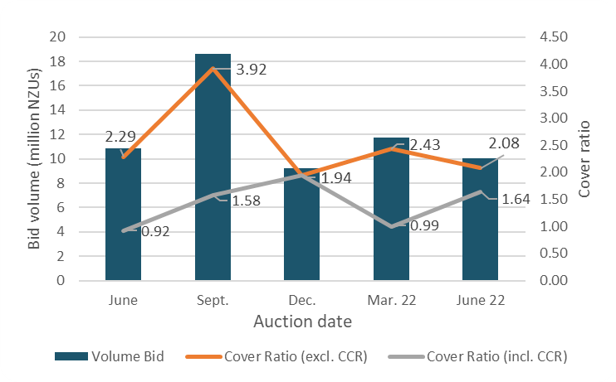

Figure A.2: Total number of bids in each auction
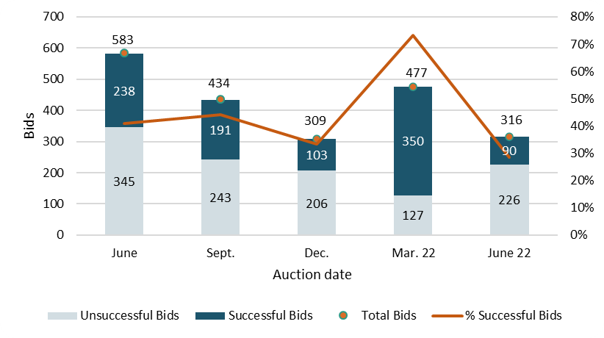

Figure A.3: Participant numbers in each auction
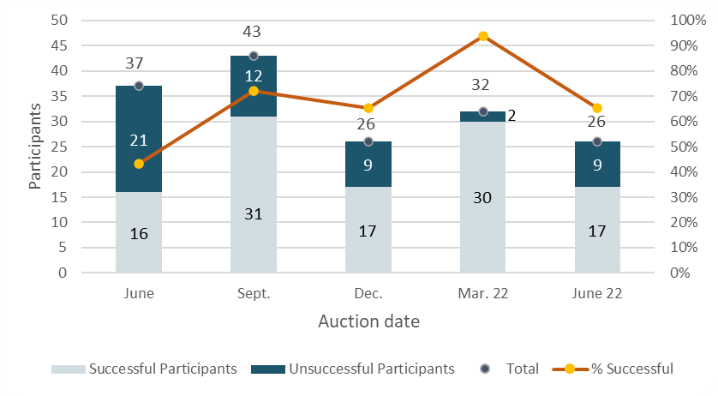

Figure A.4: Bid volume (of thousands of NZUs) per participant and ‘win’ ratio
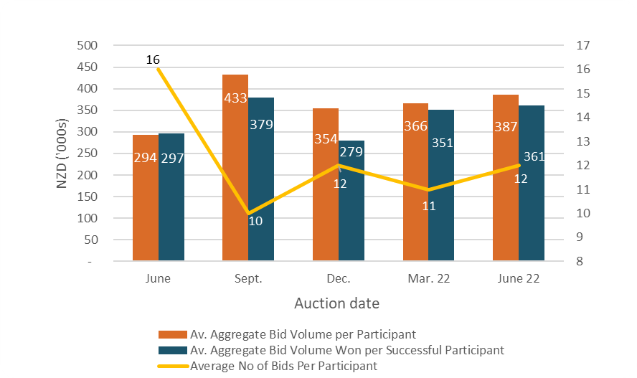

Note that many participants submitted multiple bids and there may be multiple bidders representing a single participant.

Figure A.5: Breakdown of successful bids by participant, March 2022
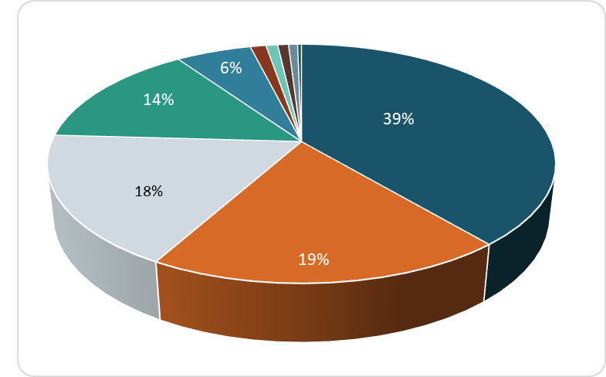

Figure A.6: Breakdown of successful bids aggregated by participants
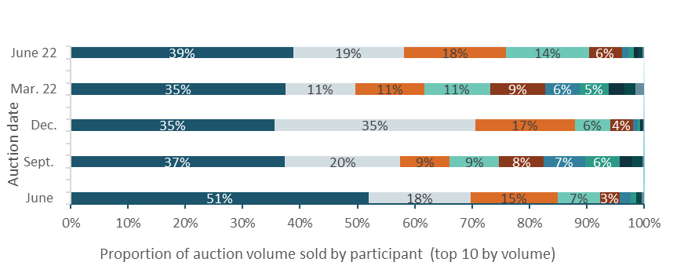

Figure A.7: Proportion of Participants with mandatory compliance obligations under the NZ ETS
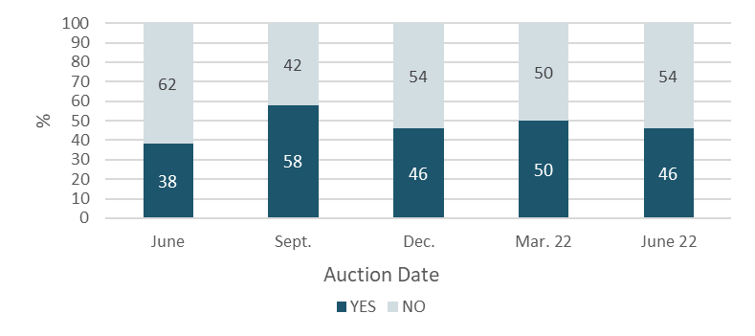
Figure A.7 represents the number of participants that are registered as having mandatory compliance obligations on the ETS Register. Larger volume participants, not necessarily registered as having compliance obligations, may be purchasing NZUs on behalf of smaller third parties that do have compliance obligations.

References
New Zealand Cabinet. 2018. Amendments to the Climate Change Response Act 2002: Tranche One. Cabinet Committee Minute of Decision CAB-18-MIN-0606.01. Wellington: Cabinet Office, Department of the Prime Minister and Cabinet.
Ministry for the Environment. 2019. Reforming the New Zealand Emissions Trading Scheme: Rules for auctioning: Technical consultation document. Wellington: Ministry for the Environment.
New Zealand Cabinet. 2020. New Zealand Emissions Trading Scheme: Regulatory Decisions on the Rules for Auctioning. Cabinet Economic Development Committee Minute of Decision DEV-20-MIN-0047. Wellington: Cabinet Office, Department of the Prime Minister and Cabinet.

https://environment.govt.nz/assets/Publications/amendments-to-ccra-tranche-1-cab-18-min-0606.01.pdf
https://environment.govt.nz/publications/reforming-the-new-zealand-emissions-trading-scheme-rules-for-auctioning-summary-of-submissions/
https://environment.govt.nz/assets/Publications/DEV-20-MIN-0047-Minute.pdf

