Understanding the Resource Management (Enabling Housing Supply and Other Matters) Amendment Act 2021
Medium Density Residential Standards
A guide for territorial authorities
This is one of a series of fact sheets on the Resource Management (Enabling Housing Supply and Other Matters) Amendment Act 2021 (RMA-EHS).
This fact sheet is an overview of the Medium Density Residential Standards (MDRS). The standards will need to be incorporated into all tier 1 (and specified tier 2) territorial authorities’ district plans. Tier 1 territorial authorities will need to notify plan changes by 20 August 2022.

Purpose
The MDRS enables housing choice across Aotearoa New Zealand’s main urban areas. These standards support the development of three homes up to three storeys on each site, without the need for resource consent.

Requirements
The RMA-EHS requires tier 1 territorial authorities in greater Auckland, Hamilton, Tauranga, Wellington and Christchurch to incorporate the MDRS into every relevant residential zone in their district plan. This includes areas that are being rezoned as residential. Plan changes will need to be made through an intensification planning instrument (IPI) and the intensification streamlined planning process (ISPP) and notified by August 2022.
Tier 2 territorial authorities with acute housing needs may also be required to implement the MDRS through an IPI if directed by the Minister for the Environment. Since enactment, Rotorua has been included among the tier 1 territorial authorities after a request from Rotorua Lakes Council and its partners based on acute housing need.
Tier 3 territorial authorities may request that the MDRS requirements apply to them. Different notification dates may apply to tier 2 and 3 territorial authorities.

Relevant residential zones
A relevant residential zone includes the following zones listed in standard 8 (zone framework standard) of the National Planning Standards or an equivalent zone:
- Low density residential zone
- general residential zone
- medium density residential zone
- high density residential zone.
A relevant residential zone does not include:
- zones that are not residential zones listed in standard 8 (zone framework standard) of the National Planning Standards or an equivalent zone
- large lot residential zones or an equivalent zone
- settlement zones or an equivalent zone
- a mainly urban area that the 2018 census recorded as having a resident population of less than 5,000 (unless a local authority intends it to become part of an urban environment)
- an offshore island.

Rules

Land use
The construction and use of a building, if it complies with the density standards (see table 1 below), is a permitted activity. This includes three residential units up to three storeys, and any other building on the site. A certificate of compliance may be applied for to give an applicant certainty.
The construction and use of four or more residential units, or residential units that do not comply with the density standards, requires consent as a restricted discretionary activity. This requirement applies only to residential units and does not extend to any other building on the site. There is no limit on the use of matters of discretion, but these should not be so wide as to make the restriction meaningless.

Notification
- Public and limited notification is precluded for the construction and use of four or more residential units that comply with the density standards.
- Public notification is precluded for the construction and use of one to three residential units that do not comply with the density standards.

Subdivision
Subdivision requires consent as a controlled activity for the purposes of the construction and use of residential units in accordance with the above land use rules. This applies regardless of whether or not a vacant lot is created, and is subject to section 106.

Notification
- Public and limited notification is precluded for subdivision in accordance with the above land use rules.
Any subdivision provisions must be consistent with the level of development permitted under the land use rules above. Territorial authorities may determine size-related requirements for vacant lot subdivision that are suitable to their area. However, there must be no minimum lot size, shape size or other size-related subdivision requirements for the following scenarios:
- any allotment with an existing residential unit if:
- the subdivision does not increase the degree of any non-compliance with the density standards (or land use consent has been granted) and no vacant allotments are created
- any allotment with no existing residential unit (where a subdivision application is accompanied by a land use application that will be determined concurrently) if the applicant can demonstrate that:
- it is practicable to construct (on every new allotment being proposed) a residential unit that meets the density standards and is a permitted activity, and no vacant allotments are created.

Density standards
District plans must include the density standards in table 1 (or standards that enable greater development).
Table 1: Density standards
Density standard
Number of residential units per site | Maximum | 3
Building height | Maximum | 11 m + 1 m for pitched roof
Height in relation to boundary | Maximum | 4 m + 60° recession plane
Setbacks | Minimum | Front yard: 1.5 m  Side yard: 1 m  Rear yard: 1 m (excluded on corner sites)
Building coverage | Maximum | 50% of the net site area
Outdoor living space (one per unit) | Minimum | Ground floor: 20 m², 3 m dimension  Above ground floor: 8 m², 1.8 m dimension
Outlook space (per unit) | Minimum | Principal living room: 4 m depth, 4 m width  All other habitable rooms: 1 m depth, 1 m width
Windows to street | Minimum | 20% glazing of the street-facing facade
Landscaped area | Minimum | 20% of the developed site with grass or plants
There must be no additional density standards for a permitted activity (except where qualifying matters have been identified, see below). Standards may be omitted or made more lenient than in the RMA-EHS to enable a greater level of development. Additional “restricted discretionary” density standards may be included for development that requires consent as a restricted discretionary activity. This allows for a more nuanced assessment of development that exceeds the density standards for a permitted activity.

Objectives and policies
District plans must include the objectives and policies provided in Schedule 3A of the RMA-EHS. This supports the MDRS rules and helps ensure more consistent territorial authority decisions on resource consent applications for development that exceeds the MDRS.
Additional objectives and policies may be included to allow for matters of discretion, or to link any density standards that are modified to enable a greater level of development than the MDRS.

Immediate legal effect
The RMA-EHS provides under section 86BA that immediate legal effect (ILE) applies to some permitted activity rules from the notification date of the IPI. This applies if the rule authorises the construction and use of a residential unit in a relevant residential zone in accordance with the density standards (in Part 2 of Schedule 3A).
This does not apply to:
- a density standard that is proposed to be more enabling
- omitted density standards
- an additional requirement, condition or permission regulating an effect other than those set out in Part 2 of Schedule 3A
- restricted discretionary activities
- areas where a qualifying matter has been identified (either carried over from an operative plan, or a proposed new qualifying matter)
- areas that were not previously residential zones (eg, greenfield development)
- subdivision rules and standards
- financial contribution rules.
If ILE does not apply (see bullet points above), the operative plan rules and associated matters of discretion continue to have legal effect until decisions on the IPI are notified.
Note that some rules may still have ILE under section 86B, for example, if the rule protects historic heritage.
If a territorial authority is required to decide on a resource consent application for an MDRS activity in a relevant residential zone after the IPI is notified but before it becomes operative, section 77M means the territorial authority must give full weight to the MDRS objectives and policies as part of the section 104 assessment. Any objectives and policies in the operative plan that are not inconsistent with the MDRS objectives and policies continue to have effect. This does not apply to sites to which qualifying matters are proposed to apply, or new residential zoned sites (eg, greenfield development).
Section 77M identifies any provisions (objectives and policies, but excluding rules) that are inconsistent with the MDRS objectives and policies cease to apply to the section 104 consideration of an application for resource consent. It is not the intent of section 77M to relate to rules. The legal effect of rules is controlled by section 86BA as described above.
A flowchart on ILE is provided in appendix A.

Things to be aware of

General
District plans must include the permitted activity rule, restricted discretionary rule, subdivision rule, objectives and policies, and density standards as required under Schedule 3A and the provisions of the RMA-EHS. Even if this means they will result in provisions in the district plan which are inconsistent with any objectives and policies in the relevant regional policy statement.
Existing provisions in a district plan that allow the same or a greater level of development than the MDRS do not need to be amended or removed from the district plan.
The notification requirements do not override the general notification provisions in the Resource Management Act 1991.

District-wide matters
Compliance with the MDRS does not exempt the general requirement to comply with all other district plan provisions.

Qualifying matters
A territorial authority may make the MDRS (and the relevant building height or density requirements under policy 3 of the National Policy Statement on Urban Development (NPS-UD)) less enabling of development in a relevant residential zone only to the extent necessary to accommodate one or more of the qualifying matters listed under section 77I of the Act. Further information on qualifying matters is in the intensification streamlined planning process guide.

Design guides
See the non-statutory national medium density design guide which encourages high-quality and well-functioning design for residential developments that are permitted under the MDRS. This is for voluntary use alongside any design guidance territorial authorities use to assess development that requires resource consent.

MDRS applies to future residential rezoning
Future plan changes that are not made through the IPI will also need to incorporate the MDRS. This includes private plan change requests. The standard plan change process applies as the IPI can only be used once.

Interaction between the MDRS and NPS-UD intensification requirements
There is overlap in relevant residential zones between the geographical application of the MDRS and NPS-UD intensification requirements, within walkable catchments of existing and planned rapid transit stops, the edge of city centre zones and the edge of metropolitan centre zones.
In these areas of overlap, the MDRS will apply. This means that three residential units up to three storeys are a permitted activity. However, this does not negate the direction of the NPS-UD, particularly policies 3 and 4. Territorial authorities are still required to enable buildings of at least six storeys in these areas, and buildings that comply with the MDRS. Territorial authorities may need to take a nuanced approach to encourage development exceeding the permitted height of three storeys.
Overlap also exists in relevant residential zone areas adjacent to neighbourhood centre zones, local centre zones, and town centre zones (or equivalent) as required by updated policy 3(d) of the NPS-UD. In these areas, building heights and density of urban form must be enabled commensurate with the level of commercial activities and community services. Any level of development greater than what is permitted in the MDRS will be at territorial authorities’ discretion, commensurate with their own criteria.

How MDRS applies to schools
The MDRS applies to schools with education designations (under district plans) that are in a relevant residential zone or adjoin a relevant residential zone. Works carried out under a designation of this kind can rely on the density standards, if the standards are more lenient than conditions in the designation.

Territorial authorities
Table 2: Tier 1 territorial authorities
Tier 1 urban environment | Tier 1 local authorities
Auckland | Auckland Council
Hamilton | Hamilton City Council, Waikato District Council, Waipā District Council
Tauranga | Tauranga City Council, Western Bay of Plenty District Council
Wellington | Wellington City Council, Porirua City Council, Hutt City Council, Upper Hutt City Council, Kāpiti Coast District Council
Christchurch | Christchurch City Council, Selwyn District Council, Waimakariri District Council

Table 3: Tier 2 territorial authorities
Tier 2 urban environment | Tier 2 local authorities
Whangārei | Whangārei District Council
Rotorua | Rotorua District Council
New Plymouth | New Plymouth District Council
Napier Hastings | Napier City Council, Hastings District Council
Palmerston North | Palmerston North City Council
Nelson Tasman | Nelson City Council, Tasman District Council
Queenstown | Queenstown Lakes District Council
Dunedin | Dunedin City Council

Table 4: Tier 3 territorial authorities
Tier 3 urban environment
Tier 3 | All other territorial authorities with jurisdiction over an “urban environment”. An “urban environment” is defined in the NPS-UD as “any area of land (regardless of size, and irrespective of local authority or statistical boundaries) that: (a) is, or is intended to be, predominantly urban in character; and (b) is, or is intended to be, part of a housing and labour market of at least 10,000 people”.

Appendix A: Flowchart on ILE and the MDRS under the RMA
A step-by-step process to determine the application of immediate legal effect on proposals under the Medium Density Residential Standards
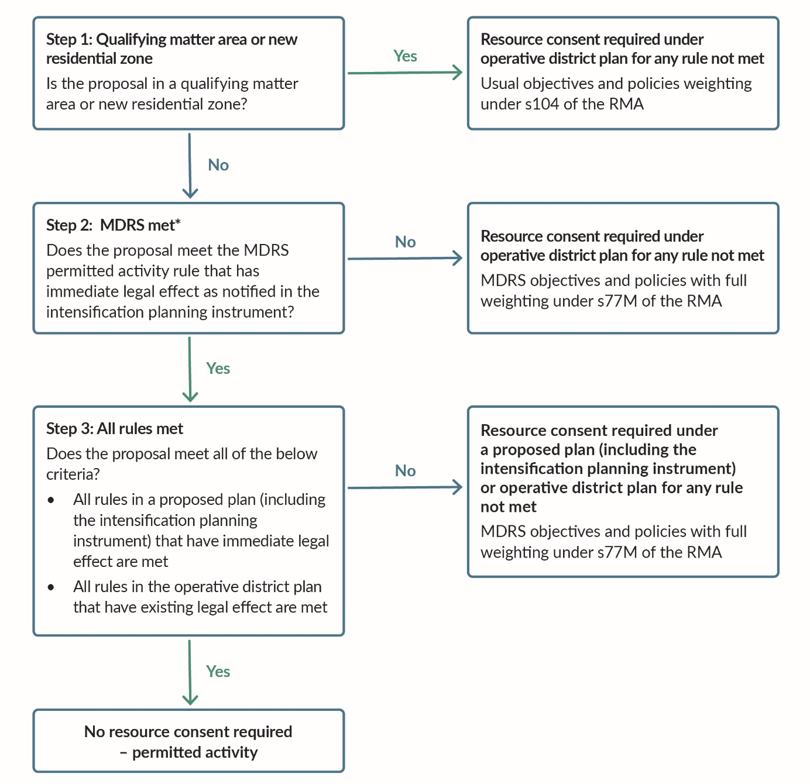
Notes
*If the MDRS as notified in the intensification planning instrument:
- includes any more lenient density standards, immediate legal effect does not apply to the more lenient density standards. However, all other density standards not made more lenient have immediate legal effect.
- omits a density standard or includes additional requirements, conditions or permissions relating to an effect other than one of the density standards, any relevant operative rule (or requirement, condition, or permission) which regulates the same effect continues to have legal effect until the Intensification Planning Instrument becomes operative.

Disclaimer
The information in this publication is, according to the Ministry for the Environment’s best efforts, accurate at the time of publication. The information provided does not alter the laws of New Zealand and other official guidelines or requirements. Users should take specific advice from qualified professional people before undertaking any action as a result of information obtained from this publication. The Ministry for the Environment does not accept any responsibility or liability whether in contract, tort, equity or otherwise for any action taken as a result of reading, or reliance placed on the Ministry for the Environment because of having read any part, or all, of the information in this publication or for any error, or inadequacy, deficiency, flaw in or omission from the information provided in this publication.

Published in July 2022 by the
Ministry for the Environment – Manatū Mō Te Taiao
Publication number: INFO 1042

Relevant information to determine whether a tier 2 territorial authority has an acute housing need includes the median multiple and any other information indicating that there is an acute housing need.
Areas used predominantly for residential activities and buildings, such as detached houses, on lots larger than those of the low density residential and general residential zones, and where there are particular landscape characteristics, physical limitations or other constraints on more intensive development.
Areas used predominantly for a cluster of residential, commercial, light industrial and/or community activities that are located in rural areas or coastal environments.
NPS-UD Policy 3(d): within and adjacent to neighbourhood centre zones, local centre zones, and town centre zones (or equivalent), building heights and density of urban form commensurate with the level of commercial activity and community services.

