Disclaimer
The information in this publication is, according to the Ministry for the Environment’s best efforts, accurate at the time of publication. The Ministry will make every reasonable effort to keep it current and accurate. However, users of this publication are advised that:
- The information does not alter the laws of New Zealand, other official guidelines, or requirements.
- It does not constitute legal advice, and users should take specific advice from qualified professionals before taking any action based on information in this publication.
- The Ministry does not accept any responsibility or liability whatsoever whether in contract, tort, equity, or otherwise for any action taken as a result of reading, or reliance placed on this publication because of having read any part, or all, of the information in this publication or for any error, or inadequacy, deficiency, flaw in, or omission from the information in this publication.
- All references to websites, organisations or people not within the Ministry are for convenience only and should not be taken as endorsement of those websites or information contained in those websites nor of organisations or people referred to.

This document may be cited as: Ministry for the Environment. 2022. Long-term Insights Briefing consultation phase I: Summary of submissions. Wellington: Ministry for the Environment.

Published in August 2022 by the
Ministry for the Environment
Manatū Mō Te Taiao
PO Box 10362, Wellington 6143, New Zealand
ISBN: 978-1-99-102556-2
Publication number: ME 1668
© Crown copyright New Zealand 2022
This document is available on the Ministry for the Environment website: www.environment.govt.nz.

Contents
Executive summary 4
Summary of submissions 4
Background 5
Our approach 5
What we heard from people 6
How we used the feedback 7
Appendix A: Summary analysis of LTIB public consultation from Kantar 8
Methodology 8
Summary 8
Connections to place 9
The places we use and value 13
Your role 14
Demographics 19

Executive summary
As part of a Long-term Insights Briefing (LTIB), the Public Service Act 2020 (Schedule 6, clauses 8 and 9) requires a chief executive of a government department to consult with the public on a proposed subject matter topic.
In May 2022, the Ministry for the Environment (the Ministry) carried out public consultation on the proposed topic for its 2022 LTIB and commissioned Kantar to analyse the submissions it received.
This document summarises the responses to the public consultation. Thank you to everyone who provided the Ministry with feedback. Your input will help to strengthen this and future briefings.

Summary of submissions
The first phase of public consultation of the Ministry’s LTIB ran from 5 to 20 May 2022. The proposed topic was ‘He tāngata, he wāhi – Kia ora ai ngā reanga katoa. People and place – Ensuring the wellbeing of every generation’. The consultation asked the public which focus area was of most interest to them when considering the people and place of Aotearoa New Zealand. The aim of the consultation was for respondents to share their aspirations for the future of the land (30 years and beyond) and offer ideas for how to get there.
The Ministry received 49 submissions during the public consultation period. The submissions showed an interest in the proposed topic and included useful suggestions. The key themes of submissions were as follows.
- Respondents feel that the land supports our wellbeing in a myriad of ways, in particular, physical and mental wellbeing.
- When thinking about our land in the future, respondents want to expand our natural environment, condense our urban environment, and reduce pollution. Respondents want the legacy of our generation to be an improved natural environment, to embrace the view that we are kaitiaki (guardians) of our environment, and to be more in tune with nature.
- Respondents consider that conservation and spaces for recreation are the most important land uses and activities for the wellbeing of future generations.
- Respondents are very interested in case studies about native forest and bush and sustainable urban development.
- Respondents think technology and infrastructure related to the environment could be improved, and that cost is the biggest barrier to sustainable choices.
Since the respondents are self-selected, the data may be affected by intrinsic bias and the respondents are not necessarily representative of New Zealand in terms of their demographics. Results should be viewed in this context and cannot be extrapolated to the wider population. We can still draw from the survey responses; we just need to be mindful of this limitation.
After analysis of the consultation responses, the Ministry has confirmed the proposed topic of the LTIB and will proceed to the next phase.
As well as the public consultation, the Ministry carried out workshops with targeted youth groups to better understand their aspirations for the future of land. The material generated from these workshops will be incorporated into our draft LTIB, which will be consulted on in the second round of public consultation.

Background
The Public Service Act 2020 introduced a new requirement for departmental chief executives to publish an LTIB at least every three years. The purpose of the LTIB is to reveal medium- and long-term trends, risks and opportunities that may affect New Zealand’s land and people.
The LTIB is not government policy and the requirement to publish it is a statutory duty of departmental chief executives, independent of ministers. LTIBs differ from the advice that the public service provides ministers, or the accountability and planning documents prepared for Parliament. For more information, see the Department of Prime Minister and Cabinet.

Our approach
The Ministry’s public consultation sought feedback on a proposed topic for its LTIB: ’He tāngata, he wāhi – Kia ora ai ngā reanga katoa. People and place – Ensuring the wellbeing of every generation.’
The consultation invited people to share what aspects of people and place are of most interest to them. The consultation questions focused the respondents’ attention on their aspirations for the future of the land (30 years and beyond) and to what New Zealanders need to do to get there.
Questions were divided into three sections.
- Connections to place
  - Importance of land in people’s everyday life today
  - Importance of land for the wellbeing of tomorrow’s generations
- The places you use and value
  - Understanding place through case studies
- Your role
  - What is holding people back?
  - What could make a difference?
We received feedback from 43 individuals and six organisations. Read the consultation document.

What we heard from people

Connections to place

Importance of land in people’s everyday life today
Respondents rated mental wellbeing as the aspect of their life most supported by the land, followed closely by physical wellbeing. Social and spiritual wellbeing were also highly rated and fewer respondents feel the land supports their cultural or material wellbeing.

Importance of land for the wellbeing of tomorrow’s generations
When asked about how today’s generations should care for the land, many respondents mentioned land restoration. This includes returning land back to its natural state and saving room for green spaces. Other major themes included mitigating urban sprawl, reducing pollution and changing agricultural practices.
Improving the natural environment is seen by respondents as the key legacy we should bestow on future generations. Two other key themes are kaitiakitanga and the unity of people and nature. Respondents listed conservation and spaces for recreation as the most important land uses and activities for the wellbeing of future generations.

The places you use and value

Understanding place through case studies
The Ministry plans to include case studies in its LTIB. These will reveal the opportunities and challenges communities experience that guide how they relate to and care for the land.
Respondents are most interested in case studies on the role of forest and bush to support native plant and bird species. Some respondents are also interested in green spaces, household waste, and sustainable urban development.

Your role

What is holding people back?
Respondents identify inadequate technology and infrastructure as the key barrier holding people back from making environmentally sustainable choices. Additionally, over three quarters of respondents believe that the costs for sustainable products are too high. Availability of sustainable products is also an issue for over half of respondents.

What could make a difference?
Respondents most frequently identify cost as the biggest barrier to the uptake of environmentally sustainable choices. Technology and infrastructure were also frequent responses, alongside education, information, and economic incentives.

How we used the feedback
The feedback received supported the proposed topic and provided the Ministry with useful suggestions about possible threads to address within both this and future LTIBs. After analysis and discussion of the responses, the Ministry decided to confirm the proposed topic for its LTIB without changes.

Appendix A: Summary analysis of LTIB public consultation from Kantar

Methodology

Fieldwork
The consultation was live on Citizen Space and the Ministry for the Environment website from the 5th to the 20th of May 2022.

Sample source
The consultation was advertised on social media and through a newsletter. This means that the sample is self-selecting so participants are likely to be highly engaged with the subject matter. In addition, the respondents are not representative of New Zealand in terms of their demographics. The results need to be viewed in this context and so cannot be extrapolated to the wider population.

Sample size
49 respondents in total responded to the consultation. See Demographics section below for more details. Although the consultation received a good turnout in responses, the sample size is relatively small. For some questions, responses are fewer than 30, so results should be taken with caution.

Summary

Connection to place
Respondents feel the land supports their wellbeing in a myriad of ways but most importantly their physical and mental wellbeing.
When it comes to how we think about our land in the future, respondents indicate that they want to expand our natural environment, condense our urban environment and reduce our pollution in general. Respondents want the legacy of our generation to be an improved natural environment and that includes embracing the view we are guardians of our environment (kaitiakitanga) and being more in tune with nature.
Finally, respondents believe the most important land use the Briefing should explore is conservation, followed by spaces for recreation.

The places we use and value
Respondents recommend the Ministry investigate case studies about native forest and bush to support plants and bird species. Conversely, respondents are less interested in hearing from the Ministry about housing developments and subdivisions. However, when asked to propose other case studies they may be interested in, respondents most commonly mentioned green urban design. This indicates respondents are potentially interested in housing development as long as it has a focus around sustainably.
Respondents also suggest the Ministry investigate coastal lands and the ocean as other potential case studies.

Your role
Respondents identify technology and infrastructure as a key barrier that prevents them from making sustainable choices. They also prioritise reducing the cost of making sustainable choices and increasing the availability of environmentally friendly products. Notably, respondents do not think the quality of the goods, nor time, are significant barriers to them making sustainable choices.
The focus is somewhat different when respondents were asked which barriers they would prioritise for action. In response to this question, cost takes out the top spot (not technology and infrastructure). This could reflect a difference in respondents' views on what is the key barrier for them personally (infrastructure) vs. what needs to be done to support society more widely (costs).

Connections to place
Mental wellbeing is rated as the most important aspect that the land supports, followed closely by physical wellbeing. Fewer respondents feel the land is important in supporting their cultural or material wellbeing.
Q. How important, or not, is the land in supporting the following aspects of your wellbeing?
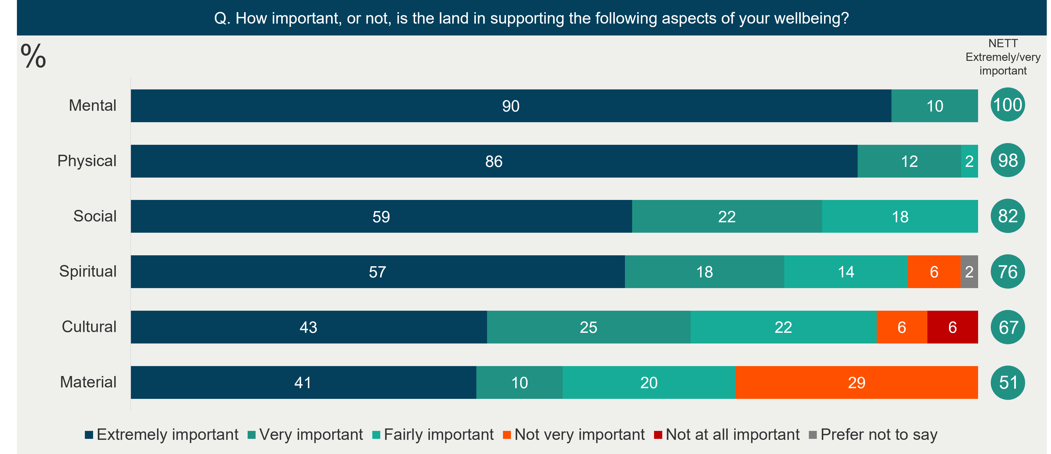
When it comes to changes in how we care for the land, a major theme mentioned by respondents is ‘Land restoration’. This encapsulates returning land back to its natural state and saving room for green spaces (see quotes below). Other major themes include: urban sprawl mitigation, reducing pollution and changes to agricultural practices.
Q. What do you think is the most important change that today’s generations of New Zealanders should make in how we care for the land?
“Reduce intensive farming to recover waterway health, reduce erosion and emissions. Intensify urban cities to prevent urban sprawl.”
“As a society, we need to develop - and sustain - a conservationist attitude towards development (rural, urban, industrial).This includes changes to farming practices, city design, encouraging particular types of investment, pricing in externalities such as damage to oxygen, food and water systems, educating in schools and in businesses.”
“Make sure we keep the land as unpolluted as possible, and always have space for nature and interactions with nature.”
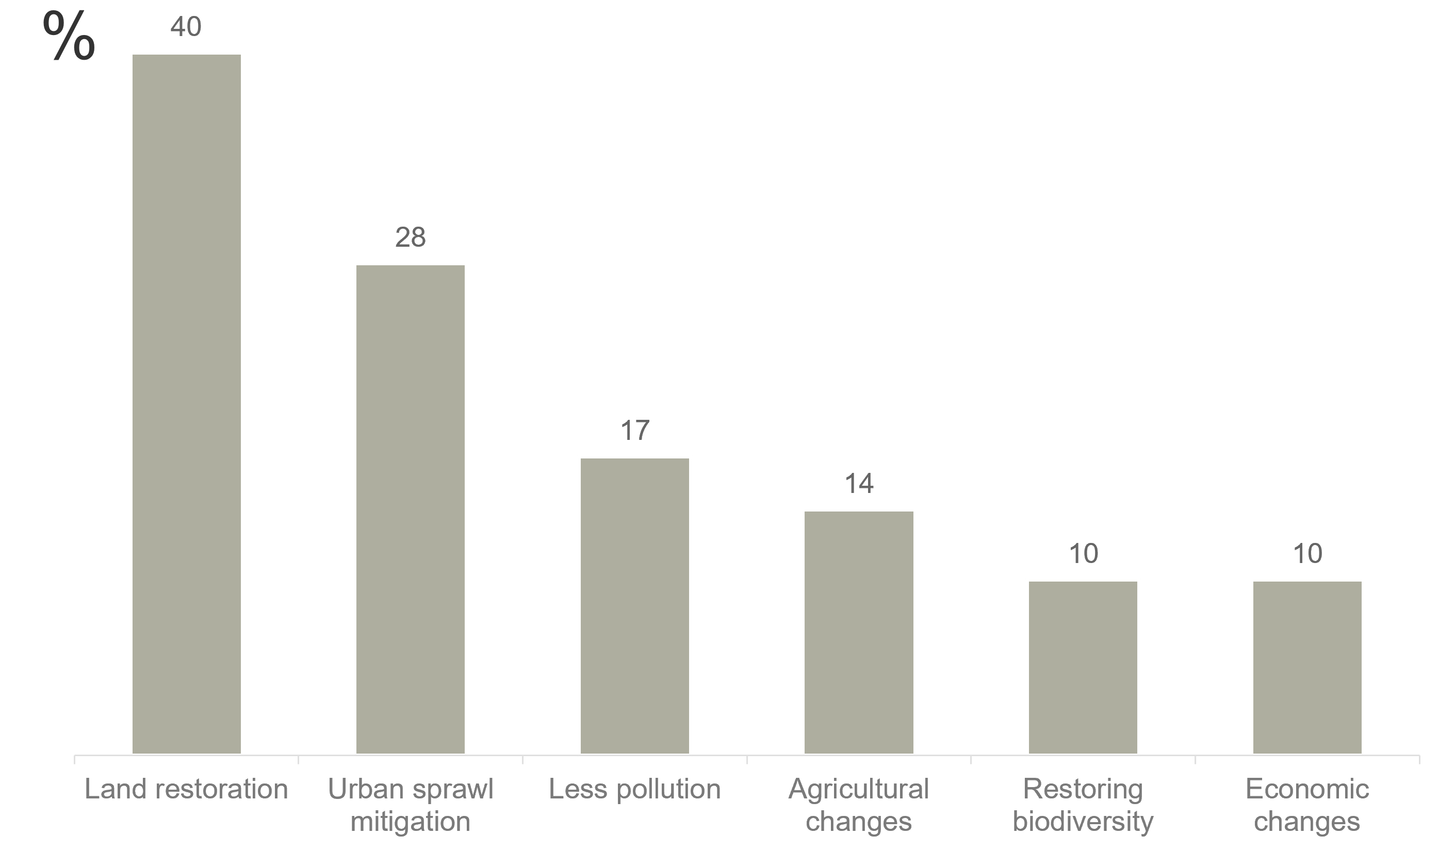
This section provides some illustrative comments around specific key changes respondents would like to see on land restoration, preventing urban sprawl and farming deintensification.
Q. What do you think is the most important change that today’s generations of New Zealanders should make in how we care for the land?
Land restoration
“Setting aside much more land for environmental restoration, climate change mitigation & adaptation. Reducing the use of intensive agriculture/silviculture on land.”
“Proactively setting aside green space at regular intervals across urban areas, increases in native planting over grassed areas.”
“Restore the land to pre-colonial state as much as possible, both in vegetation/trees and wildlife.”
Urban sprawl mitigation
“Ensure that cities are given the infrastructure required to be both dense and good to live in, minimizing sprawl due to living.”
“Banning sprawl and instead intensifying on the land we have already changed, and restoring the rest to its more natural and sustainable state.”
“Stop all sprawling greenfield developments influencing negatively on beautiful natural areas including natural parks, rivers and places of recreation close to cities. Keep our natural valleys green and free from development as is feared is about to happen in the amazing Maitai Valley, Nelson.”
Agricultural changes
“Halve the herd of livestock. […] Switch from industrialized animal agriculture to being world leaders in alternative protein production and technology. Sustainable horticulture and growing of plants, legumes and crops. Regenerative farming practices only.[…]”
“Commit to bolder climate action including limiting size and location of dairy cattle herds. Intensive dairying and irrigation are both damaging the land and fresh water sources as well as polluting the air with greenhouse gas emissions. […]”
“A more plant-based diet, to reduce our demand for dairy & meat agriculture.”
Improvements to the natural environment are seen as the key legacy that we should be bestowing on future generations, when it comes to caring for the land. Two other key themes are people and nature unity and kaitiakitanga.
Q. What should be the legacy of today’s generations?
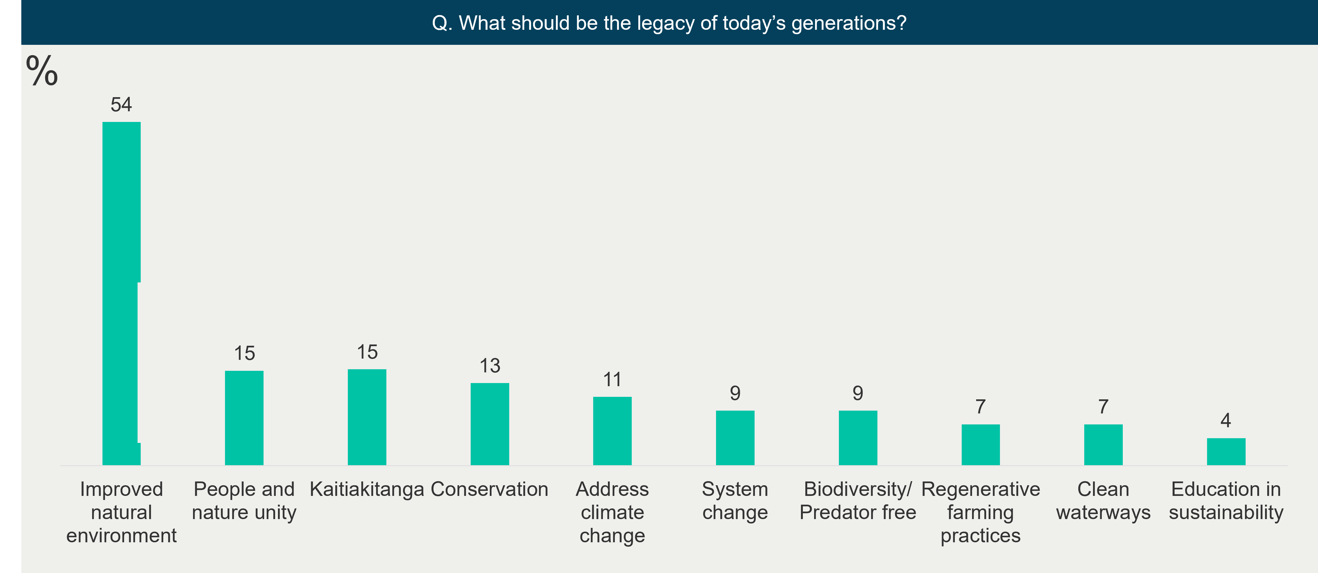
This section provides some illustrative comments around what respondents believe should be the legacy of today’s generation. Key themes include improved natural environment, people and nature unity and kaitiakitanga.
Q. What should be the legacy of today’s generations?
Improved natural environment
“Implement policies that address Climate Change urgently, so the legacy is a carbon-zero society. We should also ensure that future generations have access to rural environments, clean rivers & lakes to swim in, beaches that aren't crammed with housing, quiet rural areas to enjoy.”
“Our legacy should be establishing a thriving ecology with humans living in harmony with nature. Native flora and fauna will be protected in perpetuity, with vast tracts and smaller connected tracts of predator-free forest and other natural habitats covering the land. Endangered species will be making a conspicuous comeback.”
People and nature unity
“A space that is better than today’s space, cleaner, resilient, supportive both to the land itself and to people.”
“Our legacy should be a transformed relationship with our natural world; a move from exploitative and extractive to collaborative and caring.”
“We need to preserve what we have - our Great Walks, parks and reserves, golf courses. And we need to create communal food gardens everywhere, so that they're not just for the most needy, but for everyone to learn to care and share again.”
Kaitiakitanga
“Forging a combined approach both iwi and non iwi to taking care of the land and providing a space for it despite the pressures our country face.”
“Stewardship - protecting and not degrading land, and doing our bit to actually enhance the land for future generations”
“Abandon ‘land as a resource to be exploited for profit’ attitude, replace with ‘this is a critical life-support system’.”
“That we properly practiced kaitiakitanga and actively prioritised the conservation and protection of nature, allowing it and all life to flourish.”
All respondents thought it at least very important that the Briefing explores conservation and nine in ten believe it is important the Briefing explores how land is used for play and relaxation.

Q. How important, or not, is it to you that the Briefing explores the following land uses and activities when considering the wellbeing of future generations?
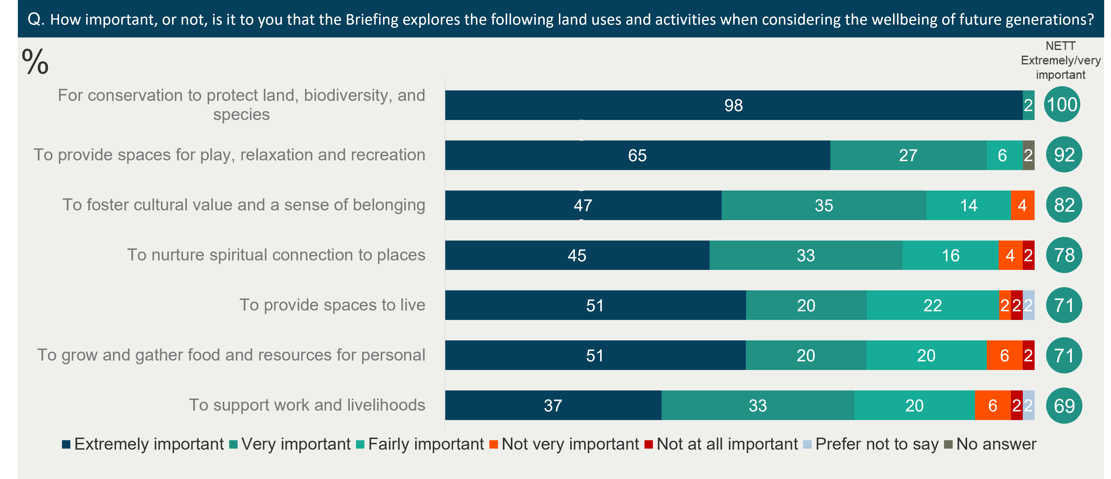

The places we use and value
The most interesting case study for respondents is forest and bush to support native plant and bird species. A minority of respondents are interested in housing developments and subdivisions.
Q. How interested, or not would you be in knowing more about the following types of case studies?
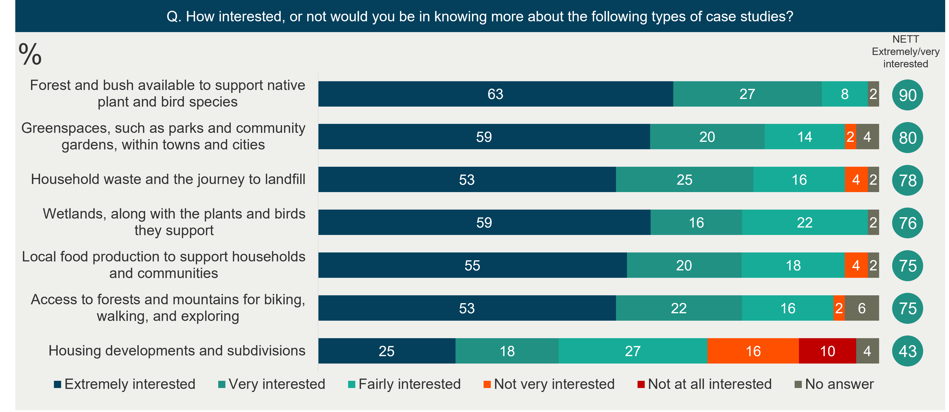
Respondents recommend the Ministry investigate green urban design which is similar in scope to the least favoured case study on housing development suggesting the focus of this case study could be adjusted. Other case studies mentioned include coastal areas, agriculture, the ocean and kaitiakitanga.

Q. Are there any other case studies, not listed in the previous question, that you would find it valuable for the Ministry to look at?
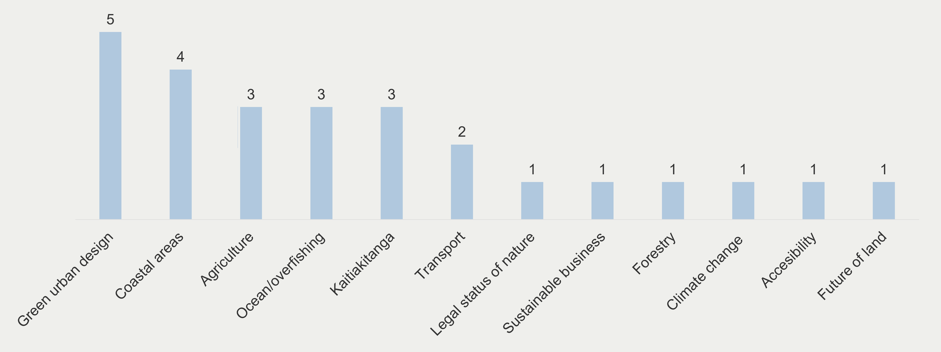

Your role
Respondents identify inadequate technology and infrastructure as the key barrier that holds people back from making environmentally sustainable choices. 86% agree this is a barrier. Sentiment is particularly strong with two in three strongly agreeing. Additionally, over three quarters of respondents agree that the costs for sustainable products are too high. Availability of sustainable products is also an issue for over half of the respondents.
Q. How much do you agree or disagree with the following statements?
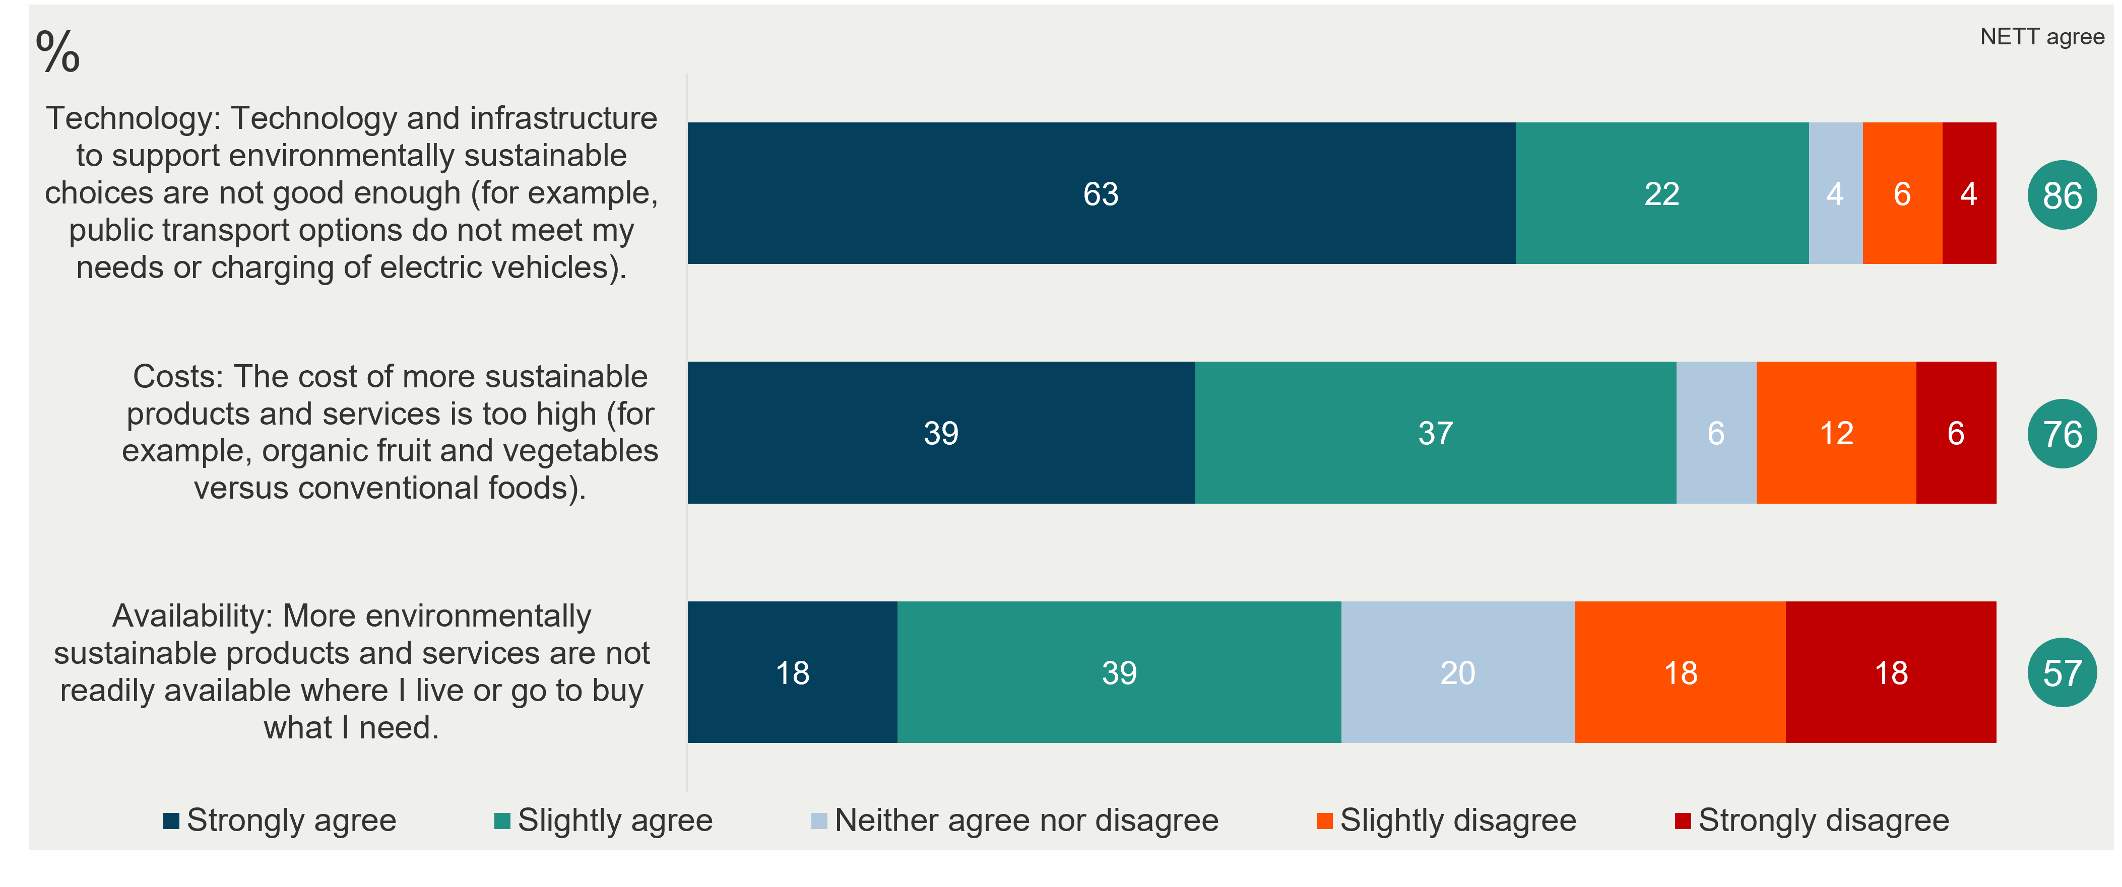
Only a minority of respondents feel that information, time and quality are key barriers to making environmentally sustainable choices. This is not to say there is not an opportunity to reduce friction for some with respect to these issues and making sustainable choices.

Q. How much do you agree or disagree with the following statements?
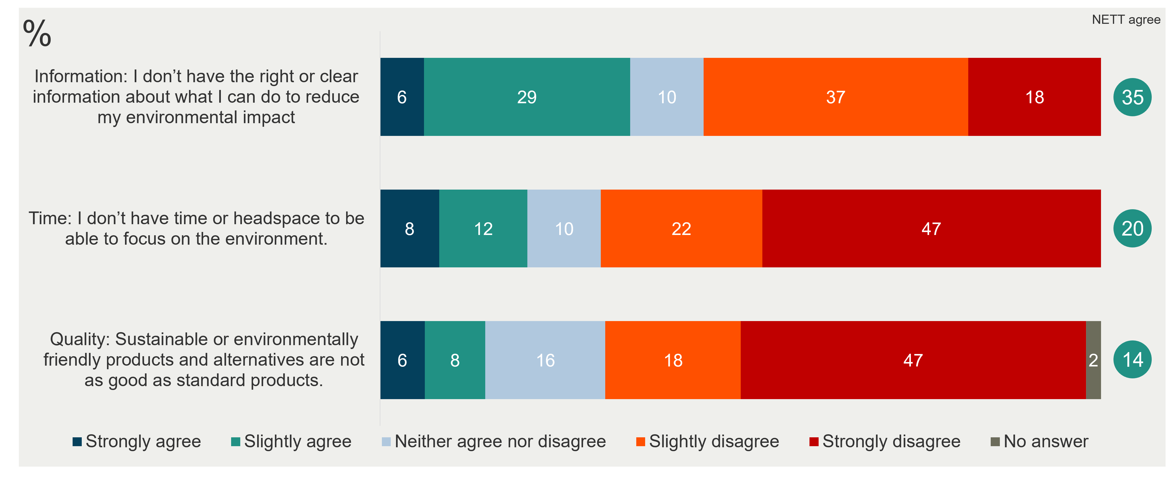
Respondents most frequently identify cost as the most important barrier to address for the uptake of environmentally sustainable choices. This is somewhat at odds with the graph below where technology and infrastructure was the key issue. This could reflect a difference in respondents' views on what they feel is the key barrier to them (infrastructure) and what needs to be done to support society more widely (costs). That said technology / infrastructure is a key response alongside education information and economic incentives.
Q. Which barrier or set of barriers do you think it is most important to address to encourage uptake of environmentally sustainable choices?
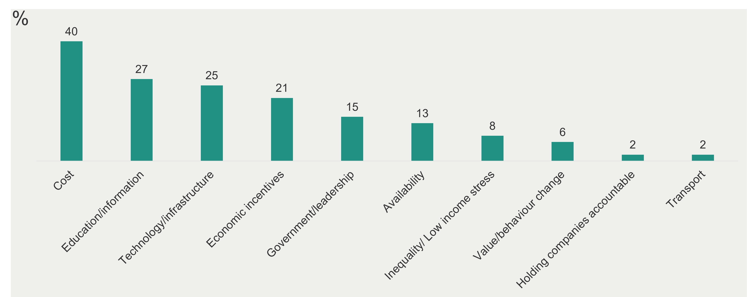
The following quotes are illustrative of what respondents think are the most important barriers to address to encourage uptake of environmentally sustainable choices.

Q. Which barrier or set of barriers do you think it is most important to address to encourage uptake of environmentally sustainable choices?
Cost
“Cost. Circular economy is the only way forward. If a product is damaging to the environment, it should be significantly more expensive than a product that isn't. Plant based diet should be cheap for example. Meat and dairy should incur the cost to the planet and become expensive. […]”
“Affordable and convenient options as well as subsidies to make the changes.”
“It still too easy not to change to enviro friendly. True cost of not being enviro friendly is not being counted.”
Education/Information
“More education on composting and growing your own food utilising Farmers Markets.”
“People seem unable to understand the 'big picture', how different aspects of ecology relate to and affect each other. I feel that people don't connect what they do with the impacts it has on the environment. And it's disturbing to read illogical comments on social media about biodiversity[…]”
“Levels of time, education and budget are probably the biggest impediments to behavioural change”
Technology/Infrastructure
“Infrastructure and technology. Large scale problems need to be solved on an industrial scale, using technology. Individual actions without technological availability or scales of industries lessening costs are unlikely to work.”
“Infrastructure and systems that support environmental sustainability. I am willing to make a lot of choices for the environment, but in many cases the choices are not available to me (e.g. public transport, bike infrastructure).”
There are a number of key themes that respondents mention would inspire and enable them to reach their aspirations for how the land is cared for. Leading responses include nature reserves, government action, changes to the system and infrastructure.

Q. What is likely to inspire and enable you to reach your aspirations for how the land is cared for?
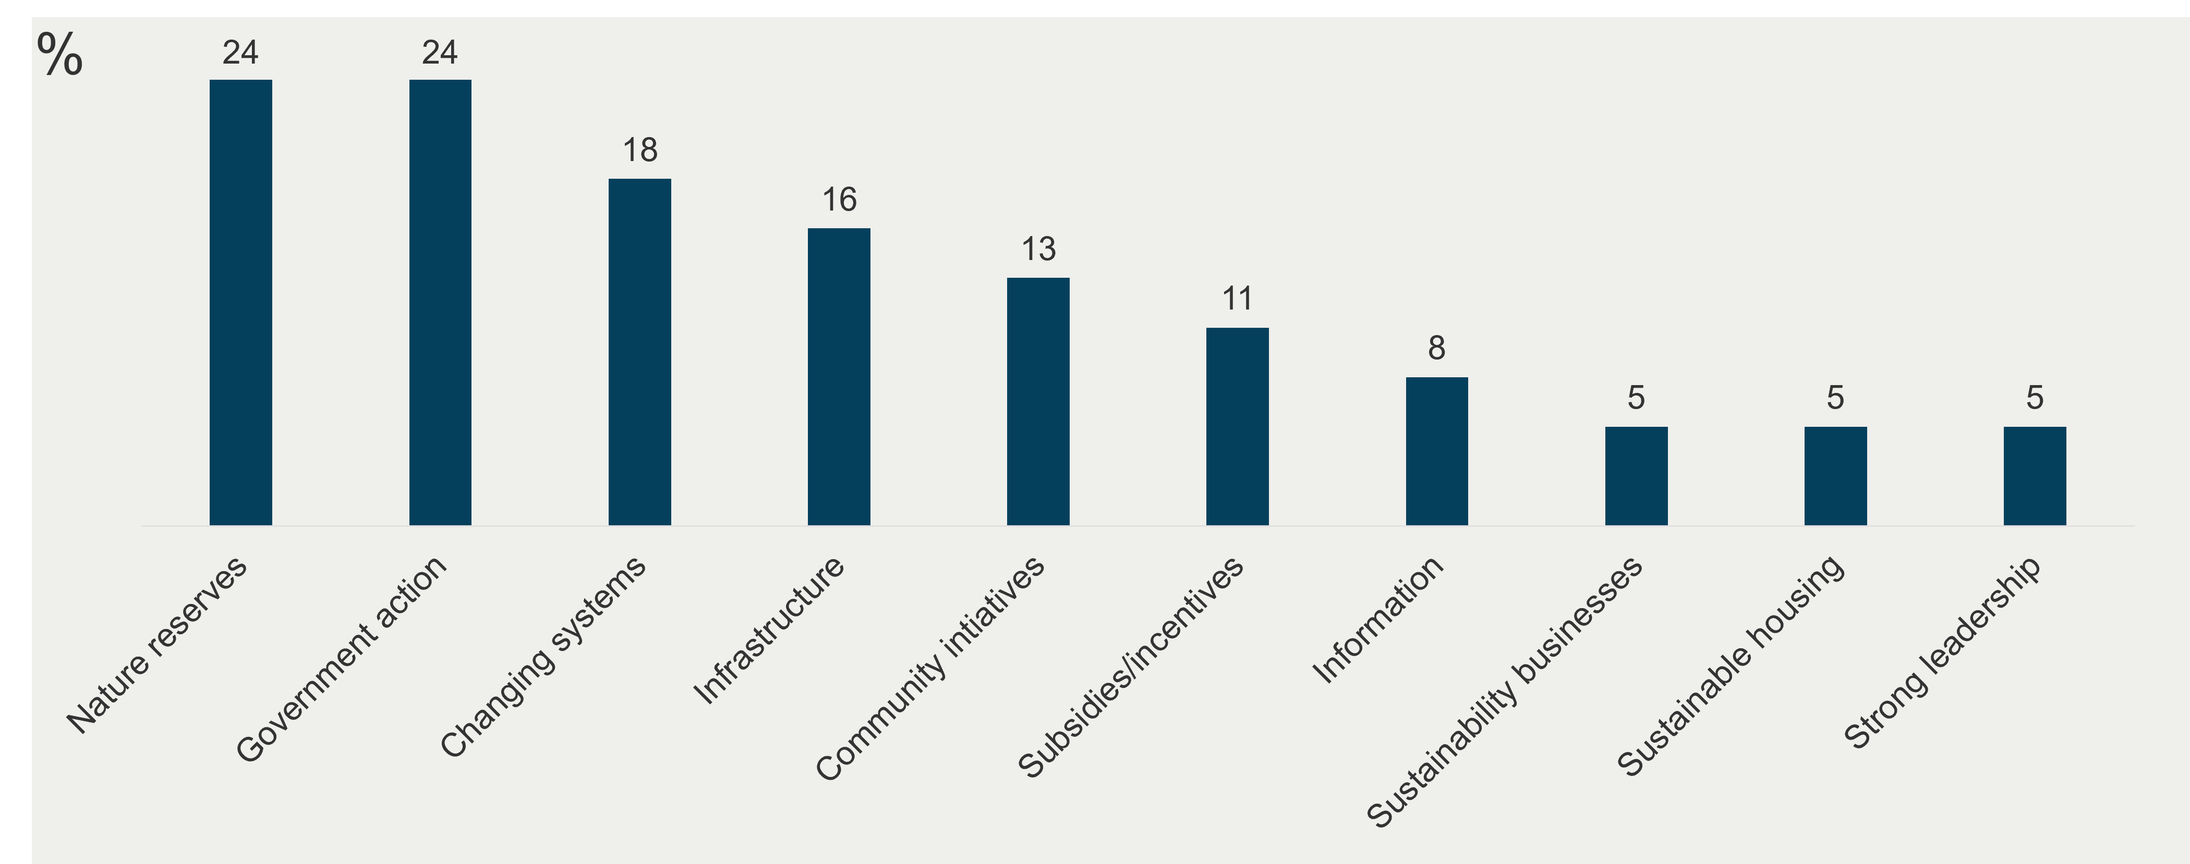
The following quotes are illustrative of what respondents say would enable them to reach their aspirations for how the land is cared for.
Q. What is likely to inspire and enable you to reach your aspirations for how the land is cared for?
Nature Reserves
“Real initiatives like jobs for nature, that show values in action. More native forests and fewer bare hillsides or seas of tile roofs.”
“Increased opportunity of engagement with local councils to help enhance local public greenspaces - e.g. Invitations to help shape and enhance local parks, freedom to develop berms in positive ways. Greater value placed on environmental protections and seeing the land and regeneration of it as an investment rather than cost”
“Spending time in nature to connect, having more time to engage in care for the land.”
Government Action
Governments taking bold steps to address the elephant in the room - dairy and livestock intensive farming, public transport, addressing overfishing. The most harmful activities are overlooked. Ban Palm Kernal extract. Ban synthetic nitrate fertilisers. Make the polluters pay. We need to see action from governments. We need to see native planting on mass scale. We need to restore our wetlands.”
“Seeing communities thriving and supporting each other - bring back communities. We need to go back to basics, get rid of plastic, we need a circular economy, everyone needs to live in a warm dry home where they have a backyard or access to wide open spaces very close by. Government needs to support the people that need it the most, the divide between the rich and the poor has gone too far and we are seeing the results of this every day.”

Changes to the system
“Knowing that it is being supported by institutional change and changing our financial system - don't leave it up to the committed individuals, work vertically across society.”
“Make the law more user friendly. E.g. Resource management is skewed toward development and professional input. Resources need to come before money!”
“To stop the corporate model that Māori land trusts aspire to and to let whanau take responsibility for managing parts for their whanau sustenance. Especially in Maketu where I live. Re-evaluate what constitutes well-being and encourage a model of well-being for Māori land trusts to follow, instead of the present corporate model of "making dollars" the only measure of well-being from the land.”
Respondents had the opportunity to share any final comments with the Ministry about the LTIB or beyond. Only one respondent commented on the scope of the LTIB. Other respondents raised a range of different issues, albeit two more common themes included concern about the housing development at Maitai valley in Nelson, as well as calls for bolder climate action.
Q. Are there any final comments you would like to share before completing your submission?
Maitai Valley
“Our current planning tools and policies are not providing the protection needed for areas highly valued for their natural and amenity values. The Maitai Valley in Nelson in an example of this. For more than 100 years, the local community have fought to retain the natural values of this area. A Private Plan Change process is currently underway that will see the natural and amenity values lost to future generations, lost forever.”
“I am strongly opposed to the current proposed development of Kaka Valley in the Maitai Valley in Nelson, and I am concerned that in the eyes of the local council this is a pre-done deal. Future generations deserve better, and at what cost to our local mental health service when this important recreational area is gone? It’s a prime example of the Govt proclaiming a desire at a national level and then local bureaucrats selling out at the local level.”
Scope of LTIB
“The Institute acknowledges that a lot of land-related policies and instruments already exist, and question whether a LTIB (in this form) is most effective. As mentioned above, expanding the scope of this topic to cover the sectors, industries and economic factors that have the worst impact on land, would deliver a more useful strategic observation and position on the future of land.”
“We need that spatial plan act. And we need harsh changes to the wildlife act so that things of the land can be protected. Currently for example, there are no controls in place in the building act or resource consenting that makes putting a net on your building to deter / kill birds something you can't do. Even if you built your building on the birds nesting site of generations. Tell me you don't care about the land without telling me you don't care about the land.”

Climate action
“Climate change mitigation & adaptation should be the #1 priority for anything to do with land.”
“We need to 100% prioritize climate action and biodiversity crisis. Not just climate resilience, climate action. We need to walk the talk and restore a clean, Green NZ. Currently we are not doing this job well at all.”
“Connection to land is important when thinking about climate change adaptation. There are many people with close links and cultural connection to the whenua. If Aotearoa is going to be more exposed to extreme events, global shocks etc we need to become more resilient to those impacts. Shifting people uphill or inland is not going to be a solution, especially not for mana whenua - it will put pressure on unused land and biodiversity, instead we should be looking for future ways of living in future environments.”

Demographics
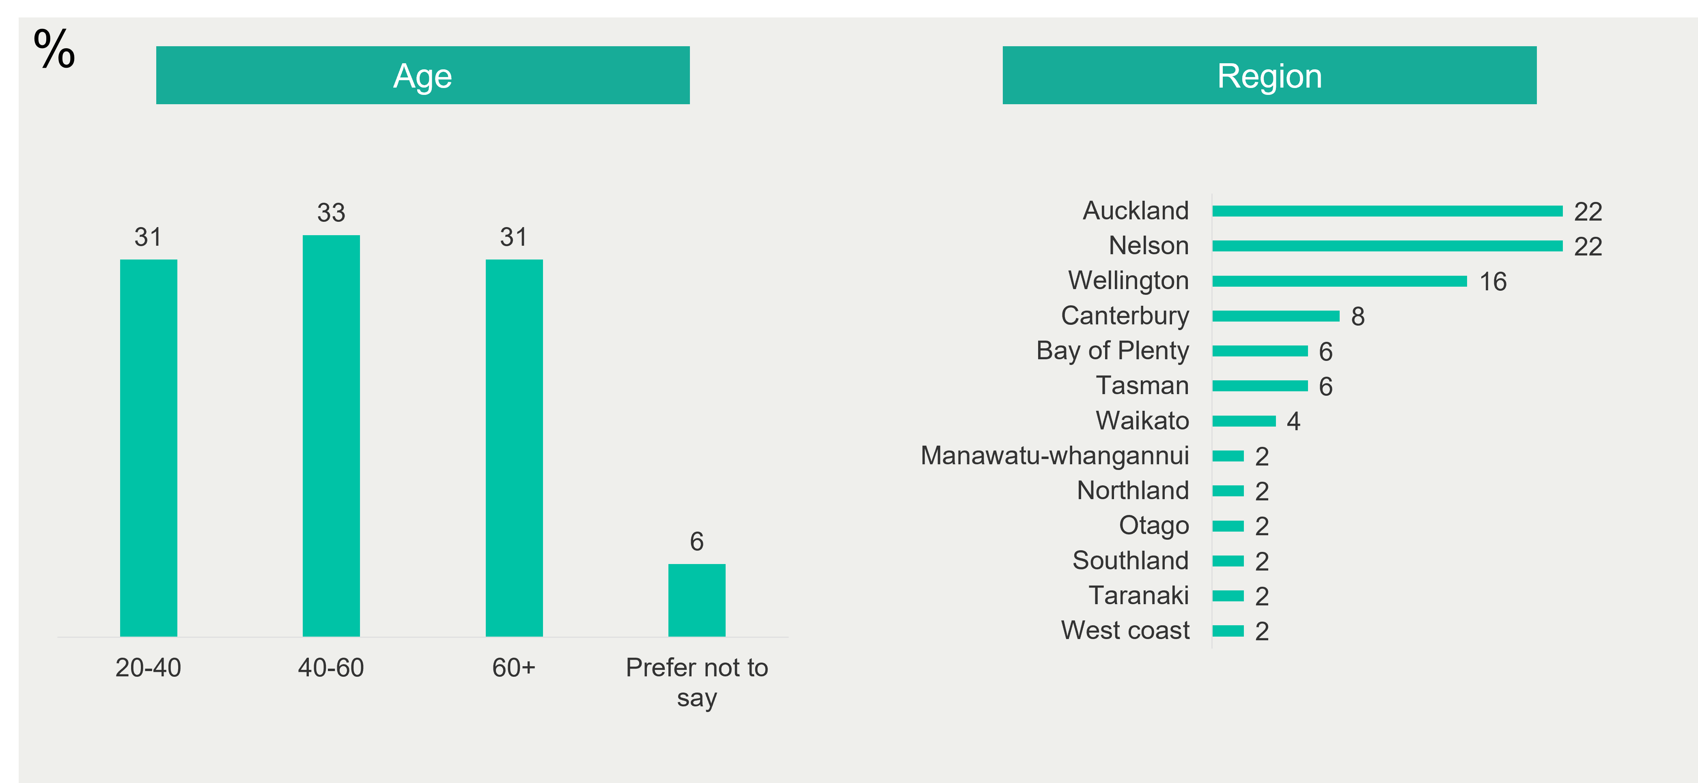
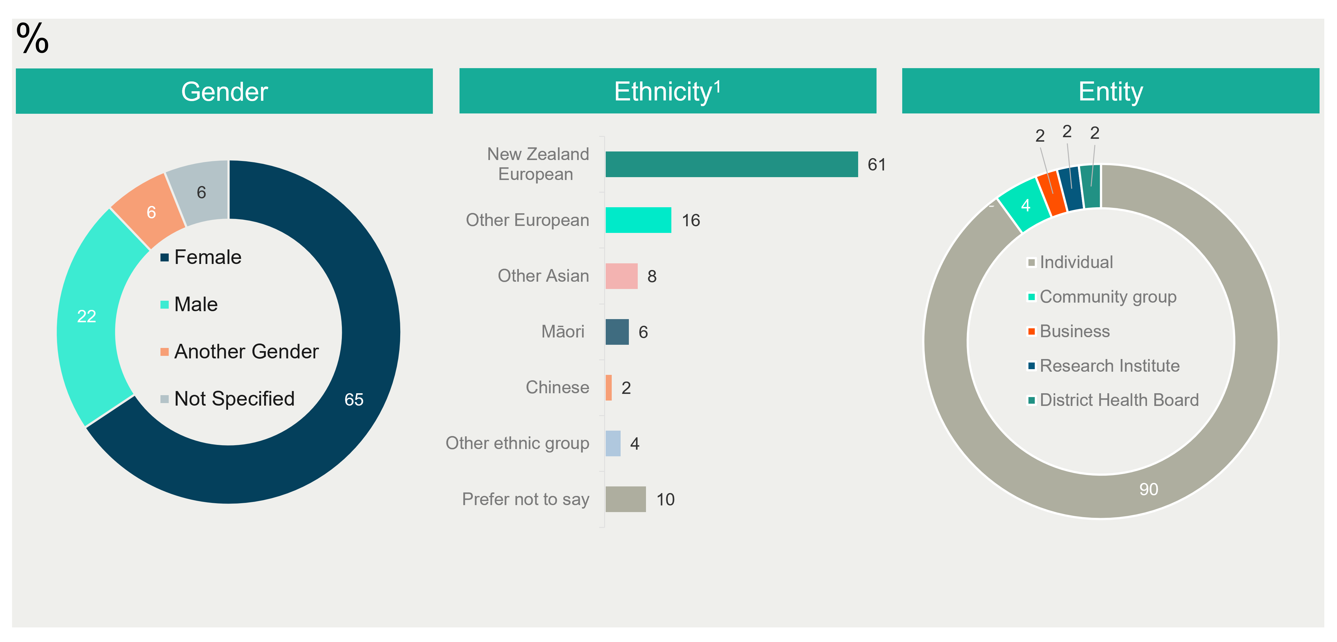

The Ministry received 49 responses to this question.
The Ministry received 47 responses to this question; percentages add up to over 100 as some responses are coded into more than one category; this was asked as an open-ended question.
The Ministry received 47 responses to this question; this was asked as an open-ended question.
The Ministry received 46 responses to this question; percentages add up to over 100 as some responses are coded into more than one category; this was asked as an open-ended question.
The Ministry received 46 responses to this question; this was asked as an open-ended question.
The Ministry received 49 responses to this question.
The Ministry received 49 responses to this question.
The Ministry received 27 responses to this question; this was asked as an open-ended question.
The Ministry received 49 responses to this question.
The Ministry received 49 responses to this question.
The Ministry received 48 responses to this question; percentages add up to over 100 as some responses are coded into more than one category; this was asked as an open-ended question.
The Ministry received 48 responses to this question; this was asked as an open-ended question.
The Ministry received 39 responses to this question; percentages add up to over 100 as some responses are coded into more than one category; this was asked as an open-ended question.
The Ministry received 39 responses to this question; this was asked as an open-ended question.
The Ministry received 25 responses to this question; this was asked as an open-ended question.

