Updated Coastal hazards and climate change guidance was published in early 2024 and is available on the Ministry’s website.

Disclaimer
The information in this publication is, according to the Ministry for the Environment’s best efforts, accurate at the time of publication. The Ministry will make every reasonable effort to keep it current and accurate. However, users of this publication are advised that:
The information does not alter the laws of New Zealand, other official guidelines, or requirements.
It does not constitute legal advice, and users should take specific advice from qualified professionals before taking any action based on information in this publication.
The Ministry does not accept any responsibility or liability whatsoever whether in contract, tort, equity, or otherwise for any action taken as a result of reading, or reliance placed on this publication because of having read any part, or all, of the information in this publication or for any error, or inadequacy, deficiency, flaw in, or omission from the information in this publication.
All references to websites, organisations or people not within the Ministry are for convenience only and should not be taken as endorsement of those websites or information contained in those websites nor of organisations or people referred to.

This guidance supersedes relevant parts of the 2017 Ministry for the Environment’s Coastal hazards and climate change: Guidance for local government.

Compiled by R.G. Bell with input and reviews by J. Lawrence, T. Naish, R. Levy and, S. Allan and reviewed by the Ministry for the Environment and a few local government practitioners. Funding was derived from the NZSeaRise programme, sponsored by the Ministry of Business, Innovation and Employment Endeavour Fund.
This document may be cited as: Ministry for the Environment. 2022. Interim guidance on the use of new sea-level rise projections. Wellington: Ministry for the Environment.

Published in August 2022 by the
Ministry for the Environment
Manatū Mō Te Taiao
PO Box 10362, Wellington 6143, New Zealand
ISBN: 978-1-99-102558-5
Publication number: ME 1667
© Crown copyright New Zealand 2022
This document is available on the Ministry for the Environment website: environment.govt.nz.

Contents
Summary 5
Why this revision? 7
Sea-level rise projections (national to regional scale) from IPCC AR6 7
Vertical land movement (VLM) 9
Change in type of scenarios used in IPCC AR6 and RSLR projections for New Zealand 10
Revised recommendations on using sea-level rise projections for land-use planning 12
Sea-level rise projections 13
Recommended use of SSP scenarios 13
Recommended use of the new sea-level rise projections 16
Revision of the minimum transitional guidance until DAPP strategies are in place 17
Reasons for changes to the minimum transitional guidance 19
The implications of VLM locally on RSLR projections 20
Accessing RSLR projections in Takiwā 23
Glossary 25
Appendix A 26
Appendix B 28
Appendix C 30
References 33

Tables
Table 1: Decadal increments for averaged “medium confidence” projections of SLR applied nationally 15
Table 2: Approximate years when various national sea-level rise increments could be reached 15
Table 3: Recommended updates to the minimum transitional procedures or RSLR allowances 18
Table 4: Average occurrences of coastal flooding events for the four main coastal centres 22
Table A-1: Comparison of the change in national average sea-level rise projections for 2120 from the 2017 coastal hazards guidance scenarios compared with the latest NZSeaRise projections 26

Figures
Figure 1: Comparison of new NZSeaRise projections with 2017 coastal hazards guidance projections from 2000 to 2150 7
Figure 1A: Comparison of new NZSeaRise projections with 2017 coastal hazards guidance projections from 1995 to 2020 8
Figure 2: Difference in mean sea level (MSL) shoreline between absolute and local (relative) sea-level rise where land subsidence occurs 10
Figure 3: Global mean temperature in a suite of five Shared Socio-economic Pathway (SSP) narratives that incorporate Representative Concentration Pathways (RCPs) 11
Figure 4: National distribution of VLM rates in Aotearoa New Zealand 21
Figure 5: Comparing RSLR scenario SSP2-4.5 with VLM (solid line) and without VLM (dashed line) at Petone, Lower Hutt (top) and New Brighton, Christchurch (bottom) 22
Figure 6: Comparing RSLR scenario SSP2-4.5 at Awatoto, with VLM (solid line) and without VLM (dashed line) 24
Figure A-1: Comparison of the new NZSeaRise projections (excluding VLM) for SSP2-4.5 M and SSP5-8.5 M for six locations with the equivalent global average GMSL from IPCC AR6 27
Figure B-1: Schematic of RSLR for a subsiding coastal area 29
Figure C-1: Mean vertical movement (mm/yr) of the land surface around the coastline of Aotearoa New Zealand 32

Summary
The recently updated future projections from the Intergovernmental Panel on Climate Change (IPCC) in 2021–22 confirm that sea-level rise is accelerating. The updated projections show an increase in projected sea-level rise compared with the earlier projections in the 2017 Ministry for the Environment (the Ministry) Coastal hazards and climate change guidance. New localised projections are also now available, which for the first time explicitly include the effect of local upward or downward movement of land locally on sea-level rise.
These new projections will affect present workflows for practitioners, so this interim guidance is for use until the Ministry is able to complete a refresh of the 2017 coastal hazards guidance.
The NZSeaRise research programme released updated Aotearoa New Zealand sea-level rise projections on 2 May 2022. These new projections combine the 2021 IPCC Sixth Assessment Report (AR6) sea-level data (downscaled to New Zealand), with localised rates of vertical land movement (VLM) around the coast. The result is estimates of relative sea-level rise (RSLR), or sea-level rise relative to the local landmass, which is critical as we plan and implement adaptation approaches locally in our coastal environments. The new sea-level rise projections (with and without VLM) are available from NZSeaRise through the Takiwā data analytics platform.
This interim guidance provides users of the 2017 coastal hazards guidance (and accompanying Summary: Preparing for coastal change, MfE, 2017a) with updated information directly associated with the new sea-level projections. It also outlines how the updated projections supersede relevant sections of chapter 5 (sections 5.3 to 5.7) in the 2017 coastal hazards guidance.
Key updates include:
- sea-level rise projections for Aotearoa New Zealand at a local scale, arising from:
- new global mean sea-level projections published by the IPCC, which have been downscaled to the regional level through the NZSeaRise programme
- new, consistently derived VLM rates at the local scale (2 km spacing) from analysis of satellite data (in Takiwā, hover on relevant location circle to obtain the VLM rate)
- RSLR projections that for the first time combine both the regional mean sea-level (MSL) projections and local VLM rates, which are available at points spaced approximately every 2 km around our coastline. Importantly, projections are also available as regional sea-level rise estimates without VLM.
- a new suite of scenarios for projections in IPCC AR6 (updating parts of section 5.4 of the 2017 coastal hazards guidance)
- recommended use of these latest RSLR projections from NZSeaRise in land-use planning practice (sections 5.6.3, 5.7.1–5.7.2 of the 2017 coastal hazards guidance)
- revised minimum transitional guidance (section 5.7.3 of the 2017 coastal hazards guidance and table 2 in the accompanying summary), which provides a guide on minimum sea-level rise allowances or steps for making planning decisions in transitional situations where the dynamic adaptive pathways planning (DAPP) approach has not been completed
- the effect of VLM, particularly for subsiding coasts, on changing planning timeframes for a specific sea-level rise threshold, which may accelerate and influence the design of an adaptation plan.
These new localised projections, which for the first time explicitly include VLM and provide RSLR, provide a step change from the generic New Zealand-wide projections in the 2017 coastal hazards guidance. They provide additional information and better support for decision-making at regional and local scales. However, the VLM rates used for the local projections have caveats, as they are derived and extrapolated from a relatively short period (2003–11) of satellite-based measurements and global navigation satellite system (GNSS) / global positioning system (GPS) data. This interim guidance provides new information and clarification regarding the use and application of these new RSLR projections. While these new projections introduce additional uncertainty due to the inclusion of VLM estimates, they are still preferable to ignoring VLM, which may cause unanticipated surprises in the future.
Continued adoption of dynamic adaptive pathways planning (DAPP) allows planners and communities to address the uncertainty of future VLM, in addition to uncertainty associated with sea-level rise processes, and our future carbon emissions pathway. New data and information (including revised VLM estimates) will continue to be collected and fed into an iterative, ten-step decision cycle. This process may bring forward planning triggers, maintain established triggers, or delay implementation if sea-level rise eases. If a substantial seismic event (eg, earthquake) occurs over the 100-year planning timeframe, then VLM rates and DAPP strategies for the areas affected will need to be reset.

Why this revision?
New information is now available on both updated sea-level rise projections and VLM at local scales for New Zealand. These changes are relevant to decision-making, so the interim revisions to the Ministry’s 2017 Coastal hazards and climate change: Guidance for local government are being made now. This only affects material in the 2017 coastal hazards guidance that was tied to specific sea-level rise scenarios or allowances in land-use planning decisions.
As each new IPCC assessment is undertaken, global and regional sea-level rise projections will continue to change as climate-ocean and ice sheet models and ongoing satellite monitoring improve and will depend on how global greenhouse gas emissions and associated mitigation programmes progress.

Sea-level rise projections (national to regional scale) from IPCC AR6
The new sea-level rise projections at the national and regional level have been downscaled from global projections produced for the 2021 IPCC AR6 Working Group I report (Fox-Kemper et al, 2021), using the same simulation process as AR6 (Naish et al, submitted). The updated sea-level rise projections for Aotearoa, averaged nationally (and excluding VLM), remain close to the national scenarios in the 2017 coastal hazards guidance until around 2070. By the end of the century, they show an increase of 3 to 14 cm (figure 1). Scenario labels on the graph are explained in the next section.
Figure 1: Comparison of new NZSeaRise projections with 2017 coastal hazards guidance projections from 2000 to 2150
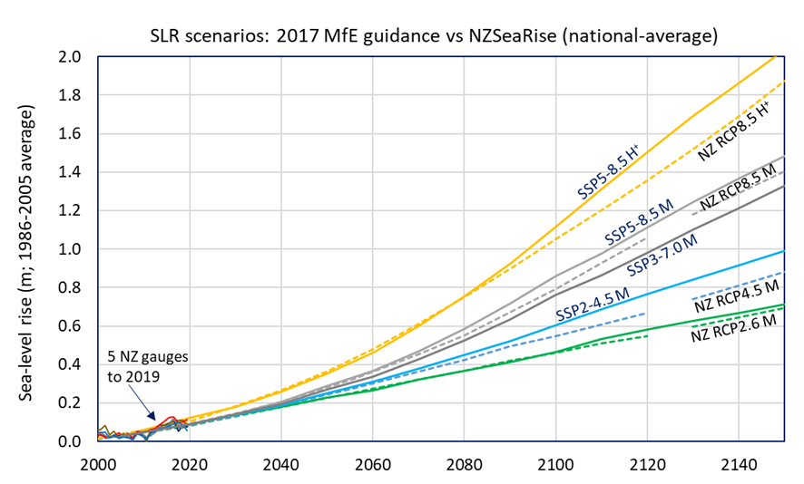
Note for figure 1: Comparison of the new nationally averaged NZSeaRise projections (excluding VLM) (solid lines) with the matching equivalent suite of four sea-level rise (SLR) projections in the 2017 coastal hazards guidance (dashed lines), all to a common zero baseline period used previously (1986–2005). Source: Ministry for the Environment, 2017; NZSeaRise/Takiwā platform (averaging six locations north to south) and tide-gauge data from the Ministry for the Environment and StatsNZ (https://www.stats.govt.nz/indicators/coastal-sea-level-rise).
Figure 1A: Comparison of new NZSeaRise projections with 2017 coastal hazards guidance projections from 1995 to 2020
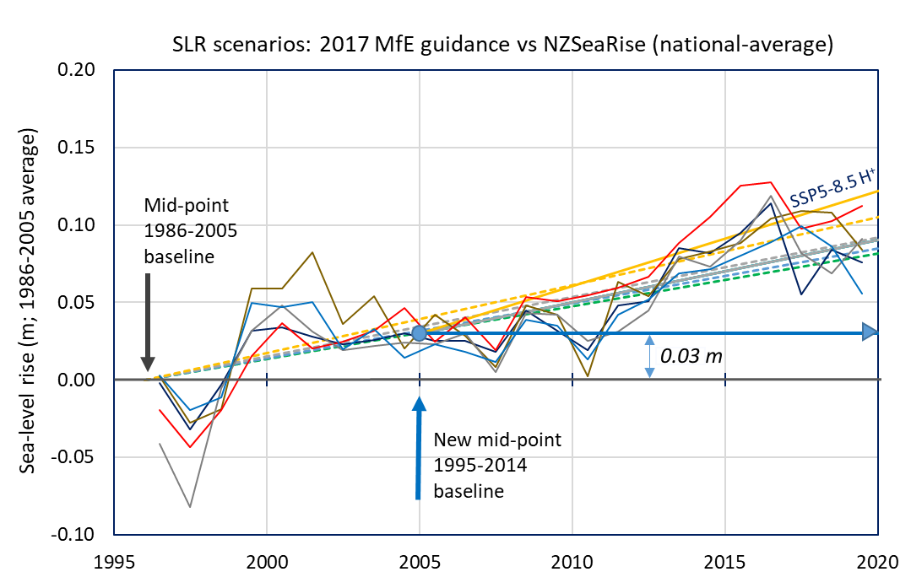
Note for figure 1A: Same comparison as figure 1, zooming in on 1995–2020 and showing how the new baseline period (mid-point 2005) and the associated average offset relates to the previous projections in the 2017 coastal hazards guidance (dashed lines).
The national-scale projections in the 2017 coastal hazards guidance were derived from the previous 2013 IPCC AR5 Working Group I assessment (Church et al, 2013), by downscaling global average projections that were relevant to the sea-level response of the Southwest Pacific. The latest NZSeaRise projections automatically include Southwest Pacific and regional sea-level responses, which are generally somewhat higher than the global average sea-level rise for each climate scenario within the simulation. Further comparisons between the new and previous sea-level rise projections, and differences from global average sea-level rise projections, are described in appendix A.
Another change is the new NZSeaRise (and IPCC AR6) sea-level rise projections are referenced against a new zero baseline that is shifted forward by a decade. The projections in the 2017 coastal hazards guidance were set to a zero baseline for the period 1986–2005, with a mid-point at 1996 (same timeframe as plotted in figure 1). The new projections are zeroed to the average MSL over the 1995–2014 period (mid-point 2005) to be consistent with IPCC AR6 projections. The change in baseline is shown in figure 1A, which zooms in on the period 19952020 in figure 1. Across Aotearoa New Zealand, there is on average a 3 cm offset between the two different baselines. Appendix B contains guidance on converting between baselines and adding on recent MSL to convert RSLR into elevations above a survey datum.
The variation in the differences between projections derived from the IPCC AR5 and AR6 in each scenario (figure 1) comes from improved climate-ocean-ice models, their sensitivity to warming, differences in modelled response of the ocean around New Zealand, and nuances in the new scenario suite used for IPCC AR6 projections.

Vertical land movement (VLM)
Through the recent analysis of satellite radar and GNSS/GPS data (Hambling et al, 2022), high-spatial resolution estimates of VLM rates (in mm/yr) for 2003–11 are now available via NZSeaRise on the Takiwā platform at 2-km spacings along the entire coast of Aotearoa New Zealand. These averaged local VLM rates, extrapolated into the future, have been assimilated into a second set of RSLR projections that include the effect of landmass uplift or subsidence (or neutral if no significant VLM).
Appendix B describes how the VLM rates were derived, quality scored and incorporated in RSLR projections, along with assumptions and caveats regarding the future VLM rates. VLM rates in the future will be subject to change and will be updated by ongoing analysis of InSAR and GNSS station trends.
If coastal land in areas of Aotearoa New Zealand continues to subside, this will exacerbate the height of sea-level rise relative to the sinking land, even if the rise in ocean elevation is unchanged (figure 2). The converse occurs with land that is uplifting locally or regionally, which will cause a slower rise in the height of sea-level relative to the rising land.
Given the limited information on coastal VLM rates in chapter 5 of the 2017 coastal hazards guidance, some additional context is provided in box 1.
Box 1: Context for VLM rates used in RSLR projections
On timescales longer than the seismic cycle (>100 years), most of Aotearoa New Zealand's coastline is either stable or experiencing uplift. This is due to the aggregate effect of vertical motion during earthquakes, although some areas have experienced slow long-term subsidence.
However, on planning and decision-making timeframes (generally 100 years), 40 per cent of New Zealand's coastline, especially around the lower North Island and upper South Island, is subsiding (based on recent satellite-based measurements).
This subsidence, which can vary over time, is occurring between earthquakes. Subsidence can also occur as sediments in low-lying areas (basins) compact (eg, lower Hauraki Plains). This inter-seismic and/or sedimentary basin VLM trend, measured from satellite radar and GNSS, is incorporated in the new NZSeaRise projections. Users of these projections should also consider their local seismic hazard risk and any known localised subsidence hotspots (eg, historic reclamations) when considering coastal adaptation measures.
There are uncertainties in the VLM rates currently used in the RSLR projections, arising from both the quality of the VLM data (Appendix C) and the uncertainty of how VLM trends will track in the future. While it is assumed that extrapolation of the inter-seismic VLM rate is valid, in lieu of an earthquake, the uncertainty of that rate is incorporated and propagated as part of the combined uncertainty range (shaded zone in Takiwā graphs) for each RSLR projection (outlined in Appendix C). The uncertainty in VLM rates this century is another reason to adopt an adaptive planning approach such as DAPP, where changes in VLM rates are monitored over time, along with other changes in risk, and responded to, if VLM continues to be a significant contributor to future RSLR.
This new ability to identify the variability that can occur in rates of VLM, and hence RSLR projections, over short stretches of Aotearoa New Zealand’s coastline is relevant to decision-making and can help prioritise local adaptation approaches (eg, Policy 27, NZ Coastal Policy Statement, 2010; Levy et al, 2020; Naish et al, submitted).
Figure 2: Difference in mean sea level (MSL) shoreline between absolute and local (relative) sea-level rise where land subsidence occurs
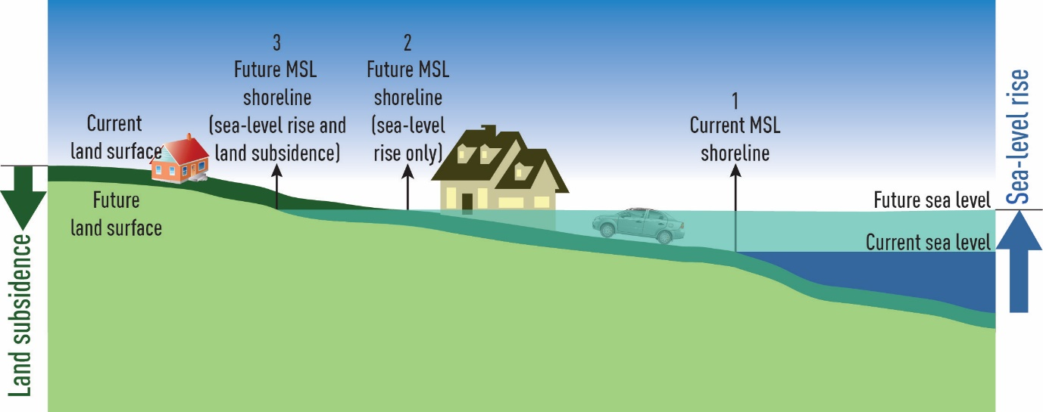
Note for figure 2: The landward shift in the mean sea level (MSL) shoreline (2à3) as the land mass continues to subside, even though the rising ocean level is largely unaffected by the local subsidence. Source: A Wadhwa, NIWA and figure 16, Ministry for the Environment, 2017.

Change in type of scenarios used in IPCC AR6 and RSLR projections for New Zealand
Scenario-based climate projections (including sea-level rise) for the IPCC AR5 assessment (2013) were based on four representative climate futures, known as representative concentration pathways (RCPs). These futures were represented by a radiative forcing of warming that could be reached in 2100, ranging from 2.6, 4.5, 6.0 to 8.5 Watts/m² of additional climate forcing since the pre-industrial era.
IPCC’s AR6 shifted to a new integrated set of future representative scenarios, based on shared socio-economic pathways (SSPs), comprising socio-economic assumptions and changes that influence future emissions trajectories. These scenarios, which complement the RCPs, span a wide range of plausible societal and climatic futures from a 1.5°C best-estimate warming to over 4°C warming by 2100 (Chen et al, 2021, section 1.6).
The new SSPs offer five different narratives describing what the world could become, represented by the titles shown in figure 3. Compared to previous scenarios, these offer a broader view than the “business as usual” socio-economic settings. The SSPs also show that it would be easier to both mitigate and adapt to climate change in some socio-economic futures (eg, SSP1 or SSP2) than in others. In contrast, in a SSP5 future, it would be harder to both achieve mitigation and implement effective adaptation.
Figure 3: Global mean temperature in a suite of five Shared Socio-economic Pathway (SSP) narratives that incorporate Representative Concentration Pathways (RCPs)
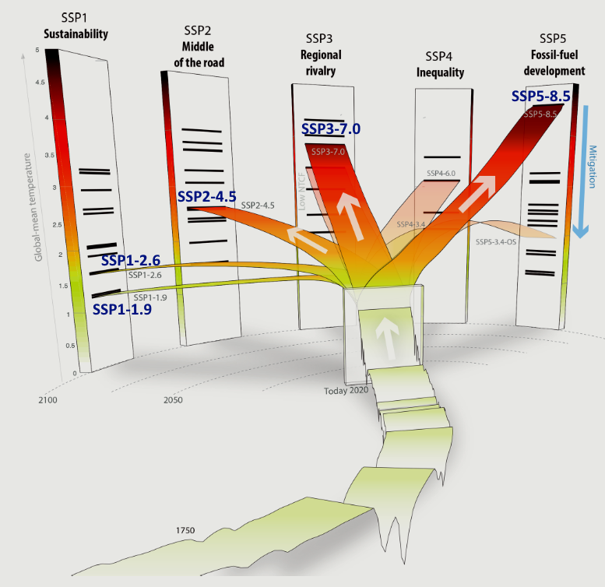
Notes for figure 3: These were used by IPCC AR6 to generate climate projections and the NZSeaRise projections for Aotearoa New Zealand. The vertical axis is global mean temperature. Source: Meinshausen et al, 2020. CC Attribution 4.0 License.
The change to SSP scenarios recognises that varying pathways could be used to reach global radiative forcing levels (as defined by the RCPs), such as different trajectories of CO₂ and non-CO₂ greenhouse-gas emissions, aerosols, population trends, income inequality, energy use and land use from different socio-economic stances and responses (Lee et al, 2021). A core suite of five combinations of SSPs and RCPs were adopted by IPCC for AR6 and climate researchers (figure 3), to develop global sea-level rise projections (Fox-Kemper et al, 2021). These five SSPs are named: SSP1-1.9, SSP1-2.6, SSP2-4.5, SSP3-7.0 and SSP5-8.5, with the latter numbers relating to the RCPs.
A further change from the IPCC AR5 SLR projections is that AR6 includes two sets of projections labelled “medium confidence” (out to 2150) and “low confidence” (out to 2300; Fox-Kemper et al, 2021). For the bulk of AR6’s SLR projections, only processes in which there is at least “medium confidence” (with some processes at “high confidence”) are incorporated (including polar ice sheet responses), with projections only extended to 2150 (previously 2100). A further, more limited set of “low confidence” projections out to 2300 uses a probabilistic ensemble based on a single Antarctic ice-sheet model. This model incorporates an additional process known with “low confidence” (ie, marine ice cliff instability; DeConto et al, 2021) and the results of a structured expert judgement (Bamber et al, 2019), instead of a model ensemble (Seroussi et al, 2020).
Three “low confidence” projections represent the upper range of plausibility, but "cannot be ruled out", according to IPCC AR6 Summary for Policy Makers (IPCC, 2021). These “low confidence” projections can be used to further stress-test new, long-lived development along the coast (eg, long-term infrastructure, proposed coastal subdivisions, and the land moved to in managed-retreat processes). These “low confidence” projections also convey that sea-level rise will be ongoing for centuries (not just to 2150) – exceeding 1 m by 2200 for the low-emissions scenario SSP1-2.6 (akin to the Paris Agreement to keep global temperature below 2°C).
NZSeaRise has uploaded the relevant New Zealand sea-level rise projections for the five SSPs for “medium confidence” projections and three SSPs for “low confidence” projections to the Takiwā platform (both with and without local VLM). These projections were derived using the same simulation process undertaken for IPCC AR6 (Naish et al, submitted).
We recommend using the new “medium confidence” SSPs out to 2150, rather than the RCP narratives, excluding the lowest, very aspirational SSP1-1.9. NZSeaRise projections in Takiwā also show “likely ranges” of uncertainty about the median or p50 (50th percentile, represented by the heavy coloured line), spanning the 17th and 83rd percentiles (labelled p17 and p83 in Takiwā).
Likely ranges arise from multiple simulations and different models of combinations (ensembles) of components and processes that could contribute to sea-level rise for a particular SSP narrative. It is worth noting that 33 per cent of possibilities for a particular SSP fall outside its likely range.
The recommended SSP scenarios to use for planning (see next section) use median (p50) projections, apart from the highest projection, which like the H⁺ scenario in the 2017 coastal hazards guidance, uses the 83rd percentile (p83) of SSP5-8.5.

Revised recommendations on using sea-level rise projections for land-use planning
IPCC Working Group II (AR6) found global mean sea-level rise is likely to continue accelerating, even under the lower SSP1-2.6 scenario and the more strongly forced scenarios (Cooley et al, 2022). Consequently, they determine with high confidence that coastal risks will increase by at least 10-fold over this century due to already committed sea-level rise. For New Zealand, nuisance and extreme coastal flooding have increased since 2000 because of a higher MSL. Ongoing sea-level rise will cause more frequent flooding before mid-century, with very high confidence (Lawrence et al, 2022). As sea level continues to rise, so does the scale and the frequency of adaptation interventions needed in coastal areas.
Planning for a possible range of sea-level rise today allows for precautionary planning and builds longer-term resilience for our coastal developments and natural environments. By 2100, we can expect sea level to rise between 0.4 and 1.1 m, depending on global carbon emissions and polar ice-sheet instabilities. By 2150, this range is 0.7–2.0 m. Therefore, it is important to consider short- to medium-term impacts on existing coastal developments and environmental systems, as well as the long-term risk for new long-lived developments and assets that will last beyond 100 years.
The 2017 coastal hazards guidance embeds a dynamic adaptive pathways planning (DAPP) approach to address and adaptively treat the ongoing increase in coastal risks, driven primarily by sea-level rise. DAPP enables adaptation/risk thresholds to be anticipated, determined, and planned for. It develops options and pathways to implement adaptation interventions over the coming decades, given the often-long lead-times and the varying lifetimes of options, irrespective of the widening uncertainty about sea-level rise beyond 2050 (Cooley et al, 2022).
By considering both short and long-term adaptation needs, including beyond 2100, coastal communities can address the shrinking portfolio of options for some types of adaptation, such as accommodate and protect (Cooley et al, 2022; Haasnoot et al, 2021). Therefore, in developing alternative pathways for adaptation options and actions, it is essential to stress-test them. Lead-times and a realistic lifetime for the various options should be considered against a range of possible coastal futures, using the new RSLR projections (with and without VLM) provided by NZSeaRise on the Takiwā platform.

Sea-level rise projections
We recommend that in planning for sea-level rise in coastal areas, the new SSP scenarios (excluding SSP1-1.9) should be used in place of the previous RCP scenarios used in the 2017 coastal hazards guidance. The SSP scenarios also introduce a new SSP3-7.0, which lies in the considerable gap between the previous RCP4.5 and RCP8.5.
Should SSP5-8.5 scenario still be used in coastal planning?
The upper-range scenario SSP5-8.5 (and its upper likely range of 8.5 H+) should continue to be used, given we are currently on a similar emissions trajectory, combined with the prospect of runaway polar-ice sheet instabilities and very long response time-lags (multi-decadal to centuries) in sea-level rise. This means impacts from sea-level rise will be distinctly different compared with other climate impacts that are more directly tied to global heating and therefore SSP scenarios (eg, heatwaves, precipitation, wind, etc.). These latter effects are also more responsive to cuts in global emissions and involve relatively short response times (decades), unlike sea-level rise.

Recommended use of SSP scenarios
We recommend using five updated “medium confidence” scenarios for sea-level rise projections out to 2150, instead of the four used in the 2017 coastal hazards guidance. The previous scenarios in the 2017 coastal hazards guidance align with the new SSPs as follows:
- SSP1-2.6 M ⇔ NZ RCP2.6 M
- SSP2-4.5 M ⇔ NZ RCP4.5 M
- SSP3-7.0 M ⇔ n/a (fills the sizeable gap between SSP2-4.5 and SSP5-8.5)
- SSP5-8.5 M ⇔ NZ RCP8.5 M
- SSP5-8.5 H⁺ [83rd percentile (p83); top of shaded “likely range”] ⇔ NZ RCP8.5 H⁺
The last scenario is essentially the same as the previous H⁺ scenario in the 2017 coastal hazards guidance, with higher values from the IPCC update. It should be used to stress-test plans, policies and adaptation options, as previously recommended in the 2017 coastal hazards guidance, and for risk screening to determine coastal areas “potentially affected” [Policy 24, NZCPS].
We also recommend at the local scale using RSLR scenarios that include the local VLM rate. Select the nearest node on Takiwā (see figure 4) but check the quality flag and averaging distance for VLM rates by downloading a .csv attribute file for the relevant site. Negative VLM rates indicate land subsidence, while positive values show uplift. Given the spatial averaging of satellite VLM estimates (Appendix C), localised subsidence may be present, while the wider average VLM rate could indicate uplift (eg, Moanataiari and the reclaimed strip along the Thames foreshore, compared with the main landward part of Thames). In areas where the local subsidence is more accurately known or is being monitored, then use the SSP scenarios in Takiwā without VLM, then add on the additional contribution from the estimated VLM rate (negative value), as follows:
–1.0 × VLM rate[mm/yr] × (Future Year – 2005)/1000 [m] [1]
Across some regions, districts, or cities, VLM can vary markedly, depending on the location and geology, so care is needed when averaging RSLR projections across a region for resource-management plans or council building/engineering standards. Where the VLM rates are broadly similar, RSLR projections could be averaged across a region.
Some “low confidence” SSP scenarios (SSP1-2.6, SSP2-4.5 and SSP5-8.5) out to 2300 (available from the Takiwā platform), cover the upper range of plausible sea-level rise by incorporating an additional ice-sheet instability process. These scenarios, using only the median (heavy line) out to 2150 and beyond, could also be used to stress-test new coastal developments, including long-lived infrastructure, in case the upper-range polar ice-sheet instabilities are triggered (see guidelines below).
Tables 1 and 2 list the projected sea-level rise for the five “medium confidence” SSP scenarios, averaged at the national scale across six sites from north to south.
Table 1: Decadal increments for averaged “medium confidence” projections of SLR applied nationally
Year | SSP1–2.6 M (median)  [m] | SSP2–4.5 M (median)  [m] | SSP3–7.0 M (median)  [m] | SSP5–8.5 M (median)  [m] | SSP5–8.5 H⁺ (83rd percentile)  [m]
2005 | 0 | 0 | 0 | 0 | 0
2020 | 0.06 | 0.06 | 0.06 | 0.06 | 0.09
2030 | 0.11 | 0.11 | 0.11 | 0.11 | 0.15
2040 | 0.15 | 0.16 | 0.16 | 0.18 | 0.23
2050 | 0.20 | 0.22 | 0.24 | 0.26 | 0.32
2060 | 0.24 | 0.28 | 0.31 | 0.34 | 0.43
2070 | 0.29 | 0.35 | 0.40 | 0.44 | 0.57
2080 | 0.34 | 0.42 | 0.50 | 0.56 | 0.72
2090 | 0.38 | 0.49 | 0.61 | 0.69 | 0.90
2100 | 0.44 | 0.57 | 0.73 | 0.83 | 1.09
2110 | 0.50 | 0.66 | 0.83 | 0.95 | 1.28
2120 | 0.55 | 0.74 | 0.95 | 1.08 | 1.47
2130 | 0.60 | 0.81 | 1.07 | 1.21 | 1.66
2140 | 0.64 | 0.89 | 1.19 | 1.34 | 1.84
2150 | 0.68 | 0.96 | 1.30 | 1.46 | 2.01
Notes for table 1: Decadal increments for average “medium confidence” projections of sea-level rise (metres above 1995–2014 baseline) applied nationally and excluding any regional and local factors including VLM. For local or regional scale sea-level rise projections, use the NZSeaRise maps in Takiwā and downloaded datasets to create a similar table.
Table 2: Approximate years when various national sea-level rise increments could be reached
SLR (m) | Year achieved for SSP5-8.5 H⁺ (83rd percentile) | Year achieved for SSP5-8.5 (median) | Year achieved for SSP3-7.0 (median) | Year achieved for SSP2-4.5 (median) | Year achieved for SSP1-2.6 (median)
0.3 | 2050 | 2055 | 2060 | 2060 | 2070
0.4 | 2060 | 2065 | 2070 | 2080 | 2090
0.5 | 2065 | 2075 | 2080 | 2090 | 2110
0.6 | 2070 | 2080 | 2090 | 2100 | 2130
0.7 | 2080 | 2090 | 2100 | 2115 | 2150
0.8 | 2085 | 2100 | 2110 | 2130 | 2180
0.9 | 2090 | 2105 | 2115 | 2140 | 2200
1.0 | 2095 | 2115 | 2125 | 2155 | >2200
1.2 | 2105 | 2130 | 2140 | 2185 | >2200
1.4 | 2115 | 2145 | 2160 | >2200 | >2200
1.6 | 2130 | 2160 | 2175 | >2200 | >2200
1.8 | 2140 | 2180 | 2200 | >2200 | >2200
2.0 | 2150 | 2195 | >2200 | >2200 | >2200
Notes for Table 2: Approximate year (to the nearest five-year value) when each national sea-level rise increment could be reached, under the “medium confidence” sea-level rise projections, with increments relative to a 1995–2014 baseline (midpoint 2005). Excludes any regional and local factors including VLM and the “low confidence” projections. Where VLM is significant, use the Takiwā maps and downloaded datasets to create a similar table.

Recommended use of the new sea-level rise projections
Recommendations for use of the updated RSLR projections are tailored, depending on how close the project or resource-management plan is towards completion or becoming operative.

For new or early stages of a project or plan (including plan reviews and changes):
- use the updated suite of five “medium confidence” RSLR scenarios (including VLM) to 2150 from the Takiwā platform for your area or region. These five scenarios (or a subset to cover the range) should be used to undertake risk/vulnerability assessments (chapter 8 in Ministry for the Environment, 2017) and to stress-test proposals, strategies, project designs, policies, rules, statutory coastal hazard overlays and emerging spatial plans.
This stress-testing and evaluation, especially considering the range of lowest to highest scenarios, will indicate how sensitive project proposals or DAPP pathways are across their design life or their degree of permanence (eg, subdivisions), to local adaptation thresholds. This enables the adjustment or adaptation of any proposal in the future, without locking in the asset or people. For example, it may ensure areas earmarked for intensification under the National Policy Statement on Urban Development (NPS-UD) are not potentially affected by any scenario over the lifetime of the development.
For other risk-sensitive projects (such as new subdivisions, long-lived infrastructure like a new or major upgrade of an airport or port, or moving a vulnerable cultural site like an urupā), we recommend using additional “low confidence” median scenarios beyond 2150 as a check, in conjunction with the main assessment using the “medium confidence” suite. This will enable evaluation of the proposal or option under a range of possible coastal futures and evaluate the sensitivity and robustness across their lifetimes or presumed permanence (Policy 24(g) in the New Zealand Coastal Policy Statement (NZCPS)).

For the later stages of a project approval or resource-management plan development:
- we recommend focusing on stress-testing the elements related to RSLR that arise from the new VLM information in the Takiwā platform (figure 4). This may indicate subsidence, potentially leading to an adaptation threshold that is a decade or more earlier (figure 5). This could require an adjustment of plan objectives, policies and rules, or render a specific project proposal uneconomic.
Besides VLM considerations, a quick check should also be made using the new “medium confidence” scenarios (without VLM), or using tables 1 and 2 above, to check that the plans, policies or designs are flexible enough to handle the slightly higher SSP sea-level rise projections arising from the IPCC AR6.

Ongoing development of DAPP strategies to adapt existing development:
- should now use this interim guidance to determine which projections to apply. Also, the adaptive pathways that emerge from these processes should use the range of future RSLR “medium confidence” projections provided in the Takiwā platform, to cross-check the realistic lifetime of adaptation options that make up DAPP pathways.

Where the localised subsidence rate is known:
- and differs from the wider averaged VLM rate available in Takiwā, then use the SSP scenarios in Takiwā without VLM for that area, then add on the additional contribution from the estimated VLM rate (see equation 1 above).

Revision of the minimum transitional guidance until DAPP strategies are in place
Guidance on using minimum transitional allowances for sea-level rise in land-use planning, until a DAPP strategy is in place, was presented in the 2017 coastal hazards guidance in section 5.7.3 (and in table 2, p. 21 of the Summary of the guidance; Ministry for the Environment, 2017a). These allowances were national averages and excluded local VLM. They form an initial planning/design response in the wider context of developing dynamic adaptive plans for communities and infrastructure along the coast.
The purpose of the transitional provisions was to cover the period until a DAPP strategy had been developed with communities, iwi/hapū and other stakeholders, given that decisions, policies and plan revisions needed to proceed in the interim. It was not intended that these sea-level rise allowances become de-facto recommendations instead of developing a DAPP strategy and processes. DAPP processes are closely aligned with Policy 27 (1)(e) of the 2010 NZCPS, which should be followed in coastal areas:
[27] (1) In areas of significant existing development likely to be affected by coastal hazards, the range of options for reducing coastal hazard risk that should be assessed includes:
….
(e) identifying and planning for transition mechanisms and timeframes for moving to more sustainable options.
The summary of the present transitional allowances in the 2017 coastal hazards guidance is replicated in table 3, along with recommended changes arising from the new RSLR projections (including VLM) from the NZSeaRise programme that are now available on the Takiwā platform.
For Category A, a more specific planning timeframe of 2130 has been applied, rather than the recommendation of “… over more than 100 years” given in the 2017 coastal hazards guidance.
With Category A activities (table 3), avoid long-term risks for new developments along the coast, on cliffs and in coastal lowlands and the lower reaches of rivers. These activities should now use the “medium confidence” RSLR projection for SSP5-8.5 H+ (ie, top of the shaded range, or the 83rd percentile or p83 for SSP5-8.5, which includes local or regional VLM). In addition, a recommendation for stress-testing the lifetime and utility of new developments (such as subdivisions and long-lived coastal infrastructure) and where to move to in managed-retreat processes, should also check the alternative “low confidence” scenarios in the Takiwā platform, using the median curves (heavy lines) out to 2150 and beyond.
For activities in Category B, more specific guidance is provided for where there has been insufficient time in most cases to develop a DAPP strategy, as recommended in the 2017 coastal hazards guidance. In the interim, this minimum transitional guidance for Category B has been revised to also include an alternative quantitative recommendation that mirrors Category A activities. This recommendation uses the highest H⁺ “medium confidence” RSLR projection for SSP5-8.5 83rd percentile or p83 (which includes VLM).
For categories C and D, the timeframes of 2130 and 2090 were derived for a SSP5-8.5 M scenario by raising the sea-level rise allowance somewhat from those values set in the 2017 minimum transitional guidance. This recognises the increases from the IPCC AR6 assessment.
Table 3: Recommended updates to the minimum transitional procedures or RSLR allowances
Category | Description | Transitional allowances in the 2017 coastal hazards guidance (s. 5.7.3) or table 2 of the Summary (Ministry for the Environment, 2017a) | Transitional allowances to use now, until the refresh of the coastal guidance
A | Coastal subdivision, greenfield developments, and major new infrastructure | Avoid hazard risk by using sea-level rise over more than 100 years and the H+ scenario | Avoid new hazard risk by using “medium confidence” sea-level rise out to 2130 for the SSP5-8.5 H+ (83rd percentile SSP5-8.5 or p83) scenario that includes the relevant VLM for the local/regional area (from table 1; typically 1.7 m rise in regional MSL before including VLM). Also, check the lifetime and utility of new developments using the median RSLR projections for the “low confidence” SSP scenarios out to 2150 and beyond.
B | Changes in land use and redevelopment (intensification) | Adapt to hazards by conducting a risk assessment using the range of scenarios and the pathways approach | Adapt to hazards by conducting a risk assessment using the range of updated “medium confidence” RSLR scenarios (including VLM) out to 2130 with the dynamic adaptive pathways planning approach; or if a more immediate decision is needed:  - avoid new and increased hazard risk by using “medium confidence” sea-level rise out to 2130 and the SSP5-8.5 H+ (83rd percentile SSP5-8.5 or p83) scenario that includes the relevant VLM for the local/regional area (from table 1; typically 1.7 m rise in regional MSL before including VLM).
C | Land-use planning controls for existing coastal development and assets planning. Use of single values at local/district scale transitional until dynamic adaptive pathways planning is undertaken | 1.0 m sea-level rise | Use the SSP5-8.5 M scenario out to 2130, which includes the relevant VLM for the local/regional area (from table 1; typically 1.2 m rise in regional MSL before including VLM).
D | Non-habitable, short-lived assets with a functional need to be at the coast, and either low-consequences or readily adaptable (including services) | 0.65 m sea-level rise | Use the SSP5-8.5 M scenario out to 2090 that includes the relevant VLM for the local/regional area (from table 1; typically 0.7 m rise in regional MSL before including VLM).
Notes for table 3: Recommended updates (last column) to the minimum transitional procedures or RSLR allowances, are for use in planning instruments while in transition towards a DAPP strategy. VLM = vertical land movement; p83= 83rd percentile (top of shaded likely range).

Reasons for changes to the minimum transitional guidance
- Five years have passed since the 2017 coastal hazards guidance was written. The requirement for a planning horizon of “… at least 100 years” (NZCPS), the ongoing nature of sea-level rise, and the availability of reliable projections to 2150 from IPCC and NZSeaRise means we have set the planning timeframe to 2130 for categories A and B. In the 2017 coastal hazards guidance, the timeframe was set at “… over more than 100 years”, which was often interpreted as 2120. Making the planning horizon longer in the transitional guidance also acknowledges that resource management plans, in conjunction with DAPP strategies, may take some years to become operative, as will the new resource management reforms.
- The updated sea-level rise projections nationally for Aotearoa New Zealand (excluding VLM) are higher than the equivalent 2017 coastal hazards guidance national scenarios (figure 1). As a result, we recommend somewhat higher sea-level rise allowances and associated planning horizons for categories C and D.
- Since the minimum transitional guidance was developed (first three columns of table 3 in Ministry for the Environment 2017), the NPS-UD became operative in 2020. Tier 1 and 2 councils are now under tight time and land availability pressures to set aside areas for intensification. They also have few constraining qualifying matters, with an unspecific requirement that well-functioning urban areas are resilient to the likely current and future effects of climate change. This has resulted in the alternative recommendation for Category B.

The implications of VLM locally on RSLR projections
The influence of VLM on RSLR, combined with AR6 “medium confidence” projections, gives us new knowledge about the New Zealand coast (box 2).
Box 2: Examples of VLM rates in regions around Aotearoa New Zealand (figure 4)
Negative VLM rates apply to land subsidence (blue colours in Takiwā and figure 4).
- Nationally, VLM rates vary in a wide range from -8 mm/yr (southern Wairarapa) to +5 mm/yr (near Pikowai, central Bay of Plenty), with most locations having less extreme rates.
- Some regions exhibit significant subsidence:
- Wairarapa coastline (subsiding at rates of between 2–8 mm/yr (figure 2) due to tectonic subsidence associated with subduction)
- Hawke’s Bay from Clive to Wairoa
- Wellington and Lower Hutt
- Northern South Island (eastern Tasman Bay, Collingwood, Kaikōura Peninsula and eastern Marlborough).
- Some regions exhibit significant uplift:
- Central Bay of Plenty
- Bluff, Fiordland, South Westland, East Cape, parts of the Coromandel Peninsula including parts of Thames and excluding the reclaimed coastal margin.
- Despite these generalisations, there can be significant spatial variability in rates in any region or even locally.
Note: VLM rates were averaged over the period 2003–11 to exclude any co-seismic and post-seismic effects from the Canterbury and North Canterbury-Kaikōura earthquakes (Hamling et al, 2022).

Figure 4: National distribution of VLM rates in Aotearoa New Zealand
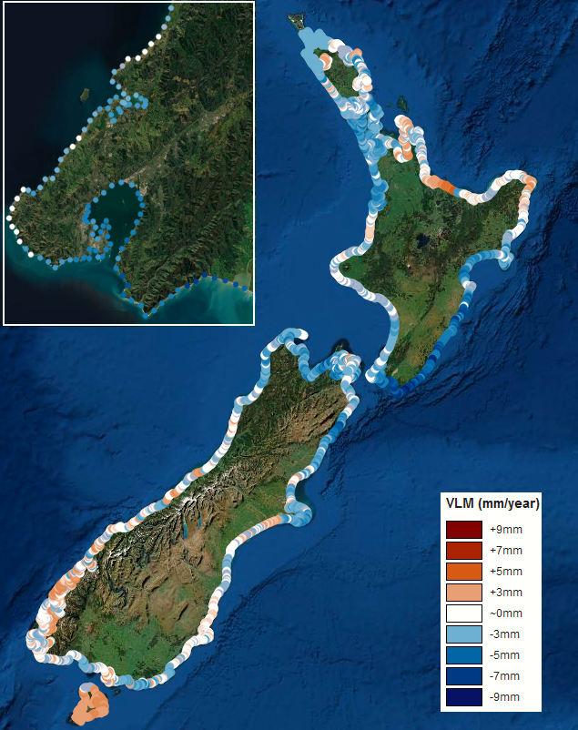
Notes for figure 4: National distribution of VLM rates (mm/yr) every 2 km, based on Hamling et al (2022). Blue indicates subsidence and white areas are neutral. The inset shows the spacing and spatial variability for the greater Wellington region. Source: Takiwā platform.
Where subsidence rates reach -8 mm/yr (figure 4), VLM can effectively double the rate and magnitude of RSLR experienced on subsiding land, compared with the rise in regional MSL of the ocean. For example, in southern Wairarapa, RSLR for the SSP2-4.5 scenario would reach a height of 1.35 m relative to the landmass by 2100, compared with only a 0.57 m rise if the land is stable.
In contrast, along the central Bay of Plenty coast near Pikowai, the rate of land uplift, if maintained, completely offsets the rate and magnitude of the rise in MSL of the adjacent ocean over the next 50 years. It halves RSLR over the next 100 years, compared with a stable landmass.
For RSLR projections in the main urban centres along the New Zealand coastline, only Auckland, Napier, Whanganui, Wellington, Picton and Nelson are affected significantly by VLM rates. In all these cases, this can include some sites where subsidence is -2 mm/yr or more, which increases the rate and magnitude of RSLR in the future.
As an example, if subsidence of -2 mm/yr is sustained (eg, in parts of the Wellington region), then by around 2060–70, triggers (decision points) in a DAPP strategy would be brought forward by about 25 years for the lower SSP1-2.6 scenario and about 10 years for the higher SSP5-8.5 H⁺ scenario, compared with the projections without VLM.
Figure 5 shows another example of two urban sites where subsidence leads to the earlier emergence of thresholds of RSLR. A 1 per cent annual exceedance probability (AEP) or 100-year coastal flood event is exceeded more frequently on an annual and a monthly basis (table 4).
Figure 5: Comparing RSLR scenario SSP2-4.5 with VLM (solid line) and without VLM (dashed line) at Petone, Lower Hutt (top) and New Brighton, Christchurch (bottom)
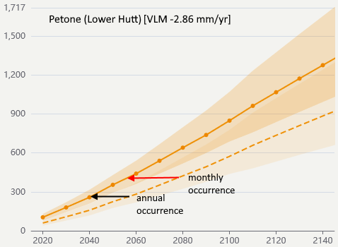
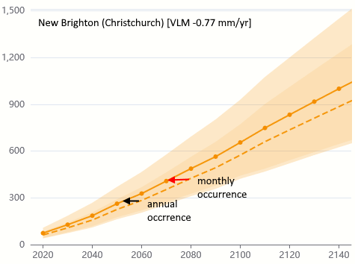
Notes for figure 5: Thresholds of RSLR for an equivalent historic 1 per cent AEP coastal flood that starts to occur annually and then monthly (table 4), are brought forward in time (arrows) due to subsidence. Graphs sourced from the Takiwā platform. New Brighton VLM rates may have changed following the two major South Island earthquake sequences in 2011 and 2016.
Table 4: Average occurrences of coastal flooding events for the four main coastal centres
RSLR (m) | Auckland | RSLR (m) | Wellington | RSLR (m) | Christchurch | RSLR (m) | Dunedin
-0.04 | 100-year | -0.03 | 100-year | -0.03 | 100-year | -0.03 | 100-year
0.36 | 2-year | 0.17 | 4-year | 0.17 | 5-year | 0.17 | 9-year
0.46 | 6-month | 0.27 | 1-year | 0.27 | 1-year | 0.27 | 2-year
0.66 | 1-month | 0.42 | 1-month | 0.43 | 1-month | 0.57 | 1-month
Notes for table 4: Occurrences (on average) of coastal flooding events for the four main coastal centres will increase from what used to be rare 100-year (centennial) events to occur more often with ongoing RSLR (relative to the new baseline 1995–2014 period). Source: adapted from table 3.2, PCE (2015) by subtracting an offset (2nd row) to adjust for the change in RSLR over the decade since the previous 1986–2005 baseline.
VLM proportionately makes a greater contribution to the highly mitigated low-emissions scenarios. Therefore, it could lead to a false sense of security if future global emissions reductions appear to be effective, and/or significant subsidence locally is not factored into planning and design.
Towards the end of this century and beyond, the influence of VLM gradually reduces relative to the accelerating rise in MSL of the ocean (unless VLM rates increase in the future). This declining influence will be more evident if the higher sea-level rise scenarios eventuate, and if non-linear processes that have “low confidence” but high impact are triggered. Such processes could include the accelerated loss of ice-sheet mass in the Antarctic, leading to dramatic increases in global sea-level rise (DeConto et al, 2021; Fox-Kemper et al, 2021).
The incorporation of VLM rates highlights the need to use RSLR projections (eg, figure 6) to inform guidance for decision-makers on local adaptation that recognises spatial VLM variability. These RSLR projections have implications for the timing of coastal hazard impacts at a finer local scale, if there is significant land subsidence (figure 2) or uplift. This has consequences for adaptive pathways planning and present and future land-use planning.

Accessing RSLR projections in Takiwā
RSLR and regional sea-level rise projections from NZSeaRise on the Takiwā platform, for the first time, explicitly include projected VLM rates every 2 km around the coast (figure 4). VLM rates, averaged over the period 2003–11, were determined from satellite (European Space Agency’s Envisat) interferometric synthetic aperture radar (InSAR) observations and weighted towards any continuous GNSS/GPS station records in the area. VLM rates have been extrapolated at the same rate into the future, with a statistical measure of the uncertainty in the estimate (Levy et al, 2020; Naish et al, submitted; Hamling et al, 2022). Appendix B describes how the VLM rates are derived along with the assumptions and caveats on future VLM rates.
These new higher resolution VLM rates every 2 km (figure 4) replace the previous sparse regional VLM information in section 5.3 of the 2017 coastal hazards guidance, where any estimate of VLM had to be added manually.
NZSeaRise projections with and without VLM can be viewed simultaneously on the Takiwā platform, to compare the relative influence of VLM locally. For example, figure 6 compares sea-level rise scenario SSP2-4.5 with and without VLM at Awatoto (south of Napier), where the averaged local VLM rate is -2.9 mm/yr (subsidence).
Figure 6: Comparing RSLR scenario SSP2-4.5 at Awatoto, with VLM (solid line) and without VLM (dashed line)
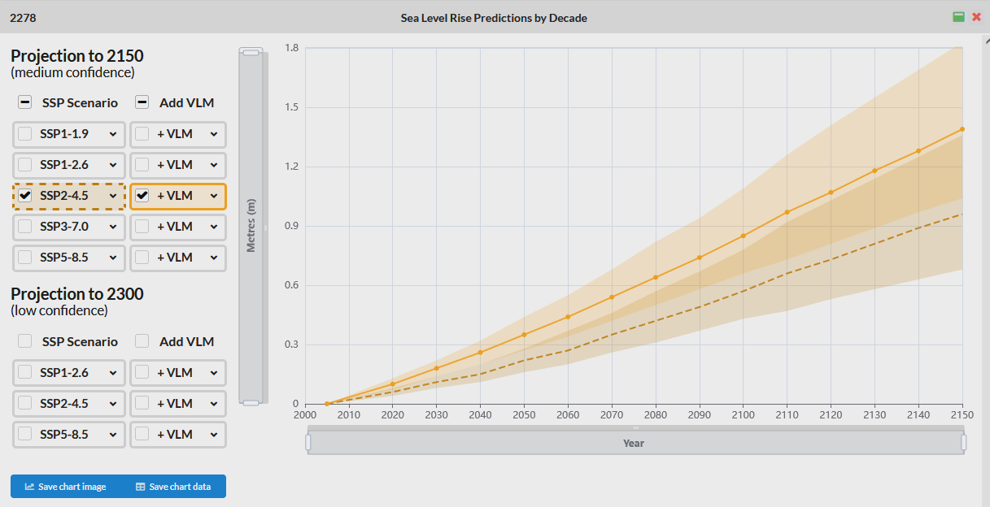
On the Takiwā platform on the NZSeaRise portal, if the entry gate “For Planners” is selected, the projections and site VLM analysis attributes are available for download. A polygon can be used to corral sites required for download. Selecting “Export to CSV” will enable a download of site attributes and VLM analysis and quality flags. Alternatively, selecting ‘Export to geodata” will generate a download request via email for all “medium confidence” and “low confidence” projections for the selected locations. Bulk downloads are also available by region. Individual site projections can be downloaded from a tab below any graph.

Glossary
Acronym | Description
AR5 | Fifth Assessment Report by IPCC on climate change (published 2013–14).
AR6 | Sixth Assessment Report by IPCC on climate change (published 2021–22).
DAPP | Dynamic adaptive pathways planning, which anticipates pathways of adaptation options or actions, working with the widening uncertainties in sea-level rise projections and being responsive (dynamic) to the ensuing changes. DAPP is the planning process embedded in the 2017 coastal hazards guidance.
GNSS | Global navigation satellite system. A general term describing any satellite system (eg, GPS, Galileo) that provides positioning, navigation and timing services on a global or regional basis.
GPS | Global positioning system.
IPCC | Intergovernmental Panel on Climate Change is the United Nations body for assessing the science related to climate change.
M | Median (50th percentile) RSLR projections for a particular SSP-RCP scenario (shown by heavy line for p50 in graphs on the Takiwā platform).
The Ministry | The Ministry for the Environment.
NPS-UD | National Policy Statement on Urban Development, issued in 2020.
MSL | Mean sea level of the ocean, averaged over a period of years.
NZCPS | New Zealand Coastal Policy Statement (2010 is the operative version).
RCP | Representative concentration pathways, comprising radiative forcing scenarios for deriving climate-related projections in AR5 and combined with SSPs in AR6.
RSLR | Relative sea-level rise is the net height of sea level experienced at a specific coastal location relative to the landmass, combining changes in MSL of the adjacent ocean and VLM. RSLR needs to be considered when planning local adaptation.
SLR | Sea-level rise.
SSP | Shared socio-economic pathways, comprising socio-economic assumptions driving emissions, used in AR6 to complement RCPs, to produce climate-related projections.
VLM | Vertical land movement (motion), which is the rate in mm/yr of the local land mass. It is influenced by tectonics, sediment-basin compaction, localised subsidence of historic reclamations or groundwater pumping, and glacial isostatic adjustment (the ongoing crustal adjustment to the past ice-sheet advance and retreat).
WGI | Working Group I of the IPCC, which assesses the physical science of climate change.
WGII | Working Group II of the IPCC, which assesses the impacts, adaptation and vulnerabilities related to climate change.

Appendix A
National comparison of the 2017 coastal hazards guidance projections (four scenarios) with the latest NZSeaRise projections (excluding VLM)
The new national average projections for Aotearoa New Zealand remain close to the national-scale scenarios in the 2017 coastal hazards guidance until around 2070 (see figure 1, which is set to a common baseline period of 1986–2005). Thereafter, the new projections diverge to higher sea levels (a few to several cm) for all four scenarios used in the 2017 coastal hazards guidance. There is a greater increase by 2120 for the previous RCP4.5 and RCP8.5 H⁺ scenarios (table A-1).
Table A-1 compares the new and 2017 coastal hazards guidance projections of sea-level rise nationally for 2120, leaving aside regional oceanographic and local VLM processes. The new projections have been adjusted to the previous baseline period used in the 2017 coastal hazards guidance to enable a direct comparison.
Table A-1: Comparison of the change in national average sea-level rise projections for 2120 from the 2017 coastal hazards guidance scenarios compared with the latest NZSeaRise projections
Scenario (MfE, 2017) | Sea-level rise from table 10 (MfE, 2017) (m) | Latest national average sea-level rise by NZSeaRise (table 1) (m) | Difference (m)
NZ RCP2.6 M | 0.55 | 0.58 | 0.03 ↑
NZ RCP4.5 M | 0.67 | 0.77 | 0.10 ↑
NZ RCP8.5 M | 1.06 | 1.11 | 0.05 ↑
NZ RCP8.5 H⁺ | 1.36 | 1.50 | 0.14 ↑
Note for table A-1: The new projections are zeroed to the previous time base (1986–2005) used in the 2017 coastal hazards guidance, so an offset of 0.03 m has been added to the latest projections for 2120 from table 1.
The national projections in the 2017 coastal hazards guidance were derived from the previous 2013 IPCC AR5 assessment, with an additional offset to account for the slightly higher sea-level rise projected for the SW Pacific Ocean, compared to the global MSL (GMSL) that IPCC reports on. Regional offsets from the global mean are now automatically accounted for in the simulations used for the NZSeaRise projections (Naish et al, submitted).
Figure A-1 shows two of the latest sets of NZSeaRise projections (excluding VLM) from six locations around Aotearoa New Zealand, and also compared to the AR6 GMSL projections from Fox-Kemper et al (2021). This additional offset of Aotearoa’s sea-level rise from the global average projections remains, more so for the higher-emissions scenarios. The new NZSeaRise projections also show a small variation in regional projections, with slightly lower sea-level rise in the south. This pattern is mainly the result of the gravitational fingerprint effect (Naish et al, submitted).
Figure A-1: Comparison of the new NZSeaRise projections (excluding VLM) for SSP2-4.5 M and SSP5-8.5 M for six locations with the equivalent global average GMSL from IPCC AR6
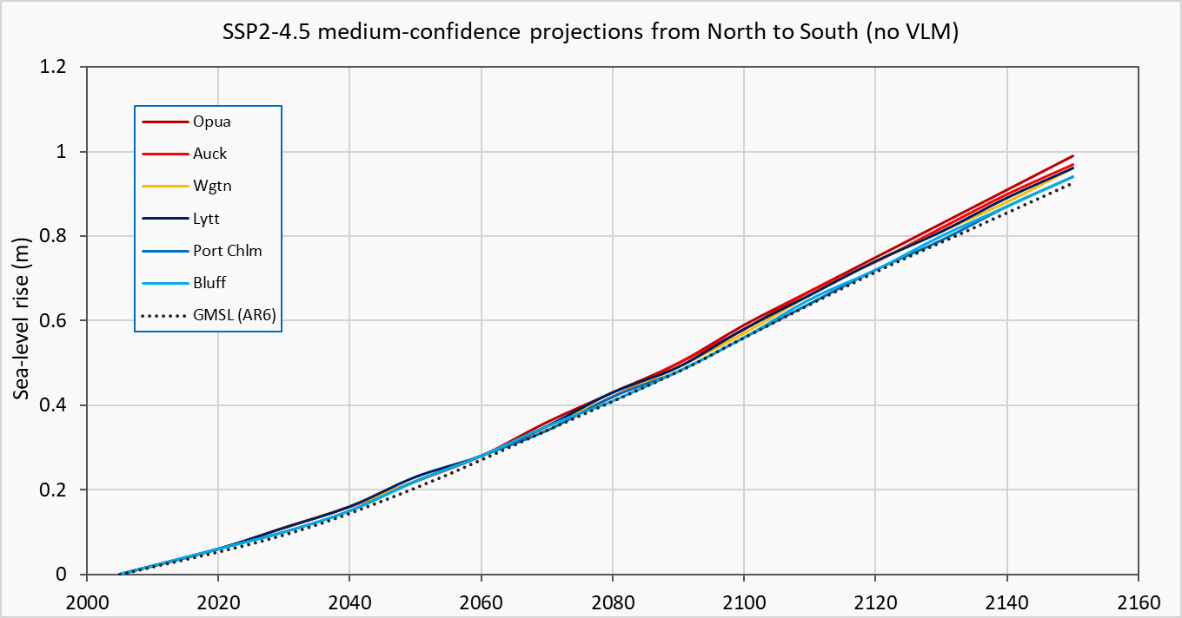
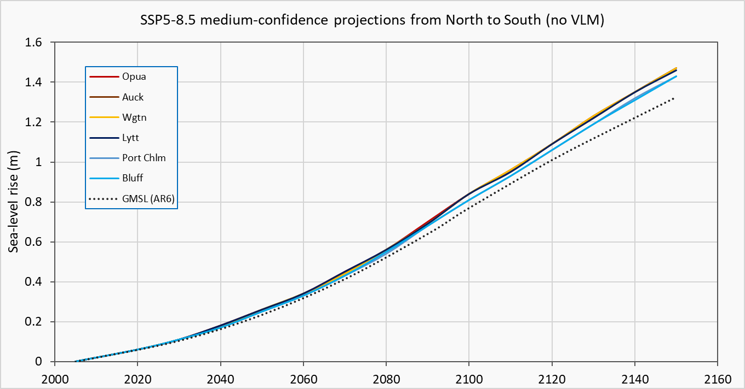
Notes for Figure A-1: Comparison of the new NZSeaRise projections (excluding VLM) for SSP2-4.5 M (top panel) and SSP5-8.5 M (bottom panel) for six New Zealand locations (north to south) with the matching equivalent global average GMSL from IPCC AR6 (dotted line) for a common zero baseline period (1995–2014). Source: Takiwā platform and GMSL from Fox-Kemper et al (2021).

Appendix B
Converting sea-level rise projections between IPCC AR5 and AR6 zero baselines
Projections of sea-level rise from the previous IPCC AR5 WGI Report (Church et al, 2013) and the 2017 coastal hazards coastal guidance projections used a zero baseline of MSL averaged over the 20-year period of 1986–2005.
The updated IPCC AR6 Working Group I and the NZSeaRise projections on Takiwā use a more recent 20-year baseline of 1995–2014, which shifts the mid-point forward by a decade to 2005. This is the zero point in the projection graphs in Takiwā.
The increase in average MSL over the decade between the two baseline periods is 0.03 m globally (Fox-Kemper et al, 2021), which is the same as the national average for MSL differences between these two baselines at our major tide-gauge records in New Zealand.
Appendix E of the 2017 coastal hazards guidance listed MSL values for coastal ports around New Zealand relative to the older 1986–2005 baseline. To combine these previous MSL elevations with the new projections to generate future MSL relative to a local or national vertical datum, add 0.03 m plus the additional VLM offset (rate in ±mm/yr × 10 years) to the relevant MSL listed in Appendix E of the 2017 coastal hazards guidance. This will re-align the baseline MSL elevation with the projections from Takiwā for the later 1995–2014 baseline. Alternatively, new MSL elevations could be calculated for tide-gauge locations, averaging annual MSL values over the period 1995–2014.
Examples (using Queens Wharf tide gauge in Wellington)
- From table E-1 (Appendix E in Ministry for the Environment, 2017), the MSL over the baseline period 1986–2005 for Wellington is -0.224 m relative to NZ Vertical Datum (NZVD) 2016. To convert the MSL to the new baseline (1995–2014 with mid-point 2005), add the NZ average 0.03 m offset for the intervening period. Therefore, the updated MSL is -0.194 m, which can then be added to the new RSLR projections in Takiwā for the Wellington Harbour area to generate future MSL scenarios relative to the survey datum (NZVD-2016). See figure B-1 as a schematic.
- Recalculate the new average MSL from annual MSL values for the Wellington tide gauge covering the new baseline (1995–2014), then add the new RSLR projections. For Wellington, the difference in MSL between baselines (a decade apart) is 0.027 m. For the five longest tide-gauge records, the highest offset is in Auckland (0.035 m) and the lowest at Moturiki–Mt Maunganui (0.026 m). Also see table 4.

Figure B-1: Schematic of RSLR for a subsiding coastal area
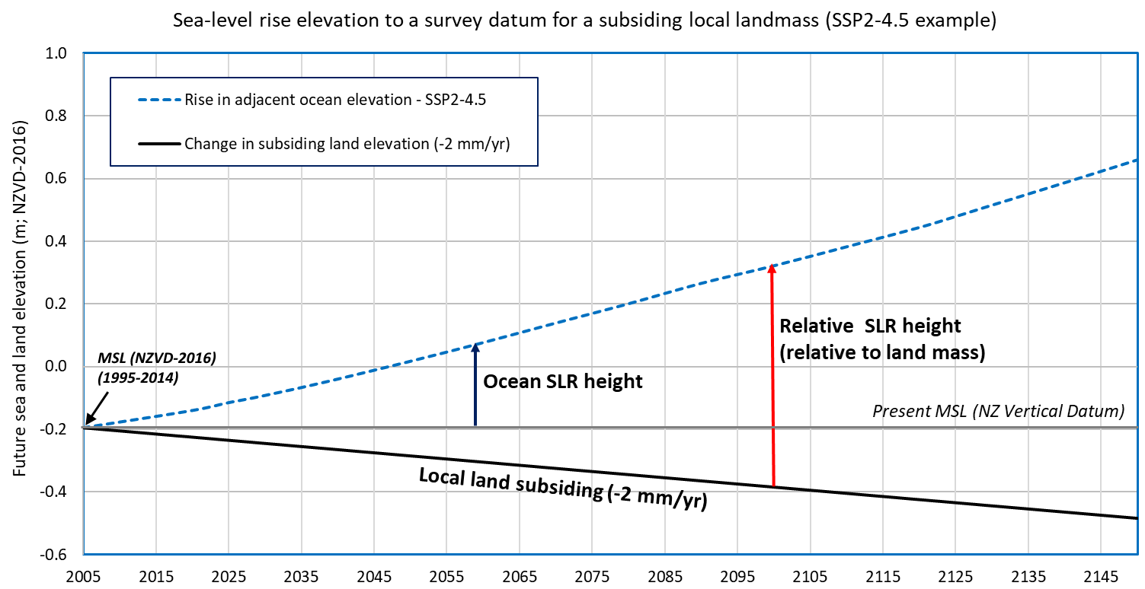
Note for Figure B-1: Schematic of RSLR for a subsiding coastal area, which is a height relative to the subsiding landmass, by adding the recent-past MSL (1995–2014; mid-point 2005) to convert RSLR into future elevations to a survey datum (NZ Vertical Datum 2016 in this example). The rise in the adjacent ocean level (dashed line) is unaffected by the gradual land subsidence locally.

Appendix C
How VLMs are derived and incorporated in RSLR projections: Assumptions and caveats
The VLM estimates for Aotearoa New Zealand are based on the analysis of historical interferometric synthetic aperture radar (InSAR) observations collected by the European Space Agency’s Envisat satellite between 2003 and 2011 (Hamling et al, 2022). Prior to computing the coastal VLM, about 2,700 individual interferograms were used to estimate the best-fitting annual land movement for each of the satellite tracks covering the New Zealand landmass. To aid in the removal of noise in the data and tie the InSAR into a consistent reference frame (International Terrestrial Reference Frame 14; Altamimi et al, 2016), vertical landmass velocities from the national GNSS network, spanning the same period, were used (figure C-1).
VLM estimates for each 2-km grid around the New Zealand coast were produced using a spatial search for all GNSS and InSAR points located nearby. Because of a lack of coverage in some areas, there were not always sufficient data points located close to the coast to provide a robust estimate. To overcome this problem, a search for observation points progressively expanded within circles of 1, 2.5, 5, 10, 20 and 40 km radii. To find the optimal search radius, a quality factor was derived, which considers the number of observations available for each coastal location, the radial distance used to bin the observations and the distance to the nearest GNSS station. After selecting the optimal search radius, a distance-weighted mean was calculated for all points, with additional weight given to any available GNSS observations. More information on the quality factor and range of VLM variability for each site is available in Naish et al (submitted) and on the Takiwā platform via NZSeaRise website.
To reduce the potential temporal influences of local earthquakes on long-term rates, we selected the period 2003–11, as it preceded many of the Mw >6 earthquakes that struck New Zealand since late 2009 and is, therefore, representative of the VLM rates between the seismic events. The inter-seismic rate is considered appropriate for the extrapolation of VLM used in the RSLR projections, because over the next 100 years, the probability of a high-magnitude earthquake at any location with large local vertical land displacement is low due to the historic length of the earthquake cycle (Beavan and Litchfield, 2012).
Still, seismic hazard risk (Stirling et al, 2012) and the potential for rapid subsidence and/or uplift, while difficult to predict, should always be considered. For example, a major event on the ~600-km Alpine Fault has a 75 per cent probability of occurring in the next 50 years (Howarth et al, 2021), but historical fault rupture data suggest little VLM change will occur in the South Island. The majority of the southern east coast margin of the North Island is currently experiencing subsidence, largely due to coupling along the plate interface. Model simulations of a rupture of the entire Hikurangi margin shows the inter-seismically coupled zone beneath Wellington would experience up to 2 m of subsidence, while the southern Wairarapa coast would experience uplift (Wallace et al, 2014).
The spatial distribution of co-seismic uplift and subsidence is highly variable and dependent on which fault or faults rupture. While parts of the margin may get a reprieve from the accumulated inter-seismic subsidence, other areas may have to contend with additional supporting subsidence as a result of any earthquake. In addition, large post-seismic transient deformation may follow a major event, temporarily amplifying the local VLM before returning to inter-seismic rates in as little as 10 years (Hamling et al, 2017; Hussain et al, 2018).
For 50 per cent of New Zealand’s coastline, clockwise from Christchurch to Hokitika and then from Whanganui to Tauranga, the region is relatively stable and rates of VLM are less than 2 mm/yr (figure C-1). These regions are also stable on geological timescales (over the last 125,000 years) and long-term VLM estimates are within the uncertainty bands of the GNSS rates (Beaven and Litchfield, 2012; Hamling et al, 2022; Naish et al, submitted). In these locations, VLM rates have less influence on RSLR projections.
In contrast, the coastline of the lower North Island and upper South Island has subsided over the last century, whereas on geological timescales there has been net upward land movement due to episodic plate tectonic processes and the long-term aggregate effect of large earthquakes. Figure C-1 shows that the greater Auckland region, Hawke’s Bay, Wairarapa, Wellington, Nelson, Marlborough, and the coast north of Kaikōura are all experiencing subsidence at rates greater than 2 mm/yr. In these locations, VLMs make a significant contribution to RSLR projections, and planning and decision-making timeframes.
When using the RSLR projections, note that VLMs in some locations can be highly variable within a 2 km radius. If there is local subsidence due to compaction of reclaimed land, or groundwater has been removed or the region sits across a tectonic boundary, 2 km RSLR projections will provide an average rate and sign of the VLM. However, it may not be accurate for very localised areas.
The coastal margin of the Thames township is an example, where the spatially heterogenous pattern of VLM is not fully represented by the 2 km-spaced RSLR projections, because of the following factors:
- it sits astride the eastern margin of the Hauraki Rift Basin
- it is affected by drainage of the Hauraki Plains
- parts of the town built along a narrow coastal margin are on subsiding reclaimed land.
Still, by sampling the VLM on a 2-km grid, spatial variability is captured within the uncertainties of each of the VLM estimates in RSLR projections. If a specific VLM rate is determined from local monitoring and is different than the averaged VLM from NZSeaRise on the Takiwā platform, then that estimated VLM rate can be added to SSP projections without VLM (see equation 1).
Figure C-1: Mean vertical movement (mm/yr) of the land surface around the coastline of Aotearoa New Zealand
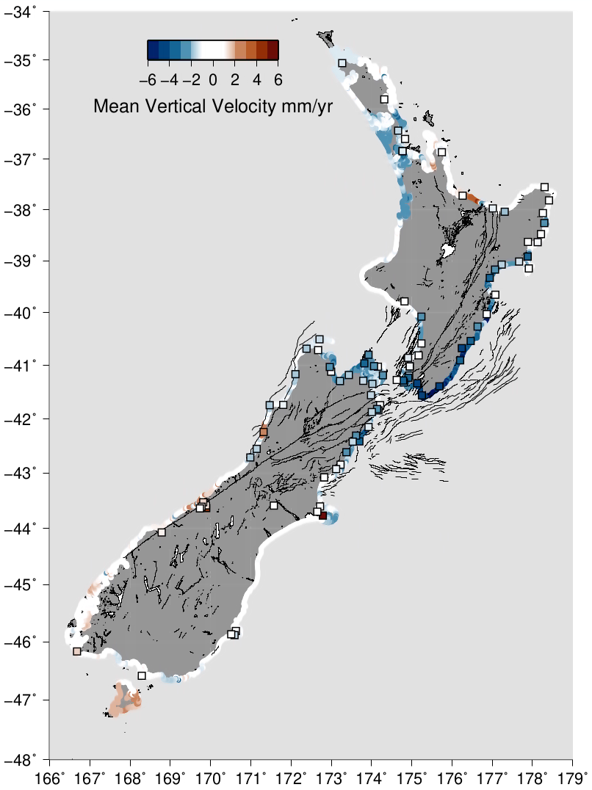
Notes for figure C-1. Mean vertical movement (mm/yr) of the land surface derived from InSAR data averaged for sites every 2 km around the coastline of Aotearoa New Zealand. Boxes show the location of GNSS sites used to calibrate InSAR data. The parts of the coastline coloured white are relatively stable, and RSLR projections for these areas are less influenced by VLM.

References
Altamimi Z, et al. 2016. ITRF2014: A new release of the International Terrestrial Reference Frame modeling nonlinear station motions. Journal of Geophysical Research: Solid Earth 121(8): 6109-6131.
Bamber JL, Oppenheimer M, Kopp RE, Aspinall WP, Cooke RM. 2019. Ice sheet contributions to future sea-level rise from structured expert judgment. PNAS 116 (23): 11195-11200. https://doi.org/10.1073/pnas.1817205116
Beavan RJ, Litchfield NJ. 2012. Vertical land movement around the New Zealand coastline: implications for sea-level rise. Lower Hutt: GNS Science. www.gns.cri.nz/static/pubs/2012/SR%202012-029.pdf
Chen D, Rojas M, Samset BH, Cobb K, Diongue Niang A, Edwards P, Emori S, Faria SH, Hawkins E, Hope P, Huybrechts P, Meinshausen M, Mustafa SK, Plattner GK, Tréguier AM. 2021. Framing, Context, and Methods. In: Masson-Delmotte V, Zhai P, Pirani A, Connors SL, Péan C, Berger S, Caud N, Chen Y, Goldfarb L, Gomis MI, Huang M, Leitzell K, Lonnoy E, Matthews JBR, Maycock TK, Waterfield T, Yelekçi O, Yu R, Zhou B (eds). Climate Change 2021: The Physical Science Basis. Contribution of Working Group I to the Sixth Assessment Report of the Intergovernmental Panel on Climate Change. IPCC AR6, WGI, Chapter 1. Cambridge University Press. https://www.ipcc.ch/report/ar6/wg1/downloads/report/IPCC_AR6_WGI_Chapter_01.pdf
Church JA, Clark PU, Cazenave A, Gregory JM, Jevrejeva S, Levermann A, Merrifield MA, Milne GA, Nerem RS, Nunn PD, Payne AJ, Pfeffer WT, Stammer D, Unnikrishnan AS. 2013. Sea level change. In: Stocker TF, Qin D, Plattner GK et al (eds) Climate Change 2013: The physical science basis. Cambridge: Cambridge University Press.
Cooley, S, Schoeman D, Bopp L, Boyd P, Donner S, Ghebrehiwet DY, Ito SI, Kiessling W, Martinetto P, Ojea E, Racault MF, Rost B, Skern-Mauritzen M. 2022. Ocean and Coastal Ecosystems and their Services. In: Pörtner HO, Roberts DC, Tignor M, Poloczanska ES, Mintenbeck K, Alegría A, Craig M, Langsdorf S, Löschke S, Möller V, Okem A, Rama B (eds). Climate Change 2022: Impacts, Adaptation, and Vulnerability. Contribution of Working Group II to the Sixth Assessment Report of the Intergovernmental Panel on Climate Change. IPCC AR6, WGII, Chapter 3. Cambridge University Press. https://www.ipcc.ch/report/ar6/wg2/downloads/report/IPCC_AR6_WGII_FinalDraft_Chapter03.pdf
DeConto RM, Pollard D, Alley RB, Velicogna I, Gasson E, Gomez N, et al. 2021. The Paris Climate Agreement and future sea-level rise from Antarctica. Nature 593: 83–89. https://doi.org/10.1038/s41586-021-03427-0
Fox-Kemper B, Hewitt HT, Xiao C, Aðalgeirsdóttir G, Drijfhout SS, Edwards TL, Golledge NR, Hemer M, Kopp RE, Krinner G, Mix A, Notz D, Nowicki S, Nurhati IS, Ruiz L, Sallée J-B, Slangen ABA, Yu Y. 2021. Ocean, Cryosphere and Sea Level Change. In: Masson-Delmotte V, Zhai P, Pirani A, Connors SL, Péan C, Berger S, Caud N, Chen Y, Goldfarb L, Gomis MI, Huang M, Leitzell K, Lonnoy E, Matthews JBR, Maycock TK, Waterfield T, Yelekçi O, Yu R, Zhou B (eds). Climate Change 2021: The Physical Science Basis. Contribution of Working Group I to the Sixth Assessment Report of the Intergovernmental Panel on Climate Change. IPCC AR6, WGI, Chapter 9. Cambridge University Press. https://www.ipcc.ch/report/ar6/wg1/downloads/report/IPCC_AR6_WGI_Chapter_09.pdf
Haasnoot M, Lawrence J, Magnan AK. 2021. Pathways to coastal retreat. Science 372 (6548): 1287–1290.
Hamling IJ, Hreinsdóttir S, Clark K, Elliott J, Liang C, Fielding E, Litchfield N, Villamor P, Wallace L, Wright TJ, et al. 2017. Complex multi-fault rupture during the 2016 Mw 7.8 Kaikōura earthquake, New Zealand.
Hamling IJ, Wright TJ, Hreinsdottir S, Wallace LM. 2022. A snapshot of New Zealand’s dynamic deformation field from Envisat InSAR and GNSS observations between 2003 and 2011. Geophysical Research Letters 49, e2021GL096465. https://doi.org/10.1029/2021GL096465.
Howarth JD, Barth NC, Fitzsimons SJ, Richards-Dinger K, Clark KJ, Biasi GP, et al. 2021. Spatiotemporal clustering of great earthquakes on a transform fault controlled by geometry. Nature Geoscience 14(5): 314-320.
Hussain E, Wright TJ, Walters RJ, Bekaert DP, Lloyd R, Hooper A. 2018. Constant strain accumulation rate between major earthquakes on the North Anatolian Fault. Nature Communications 9(1): 1–9.
IPCC. 2021. Summary for Policymakers. In: Masson-Delmotte V, Zhai P, Pirani A, Connors SL, Péan C, Berger S, Caud N, Chen Y, Goldfarb L, Gomis MI, Huang M, Leitzell K, Lonnoy E, Matthews JBR, Maycock TK, Waterfield T, Yelekçi O, Yu R, Zhou B (eds). Climate Change 2021: The Physical Science Basis. Contribution of Working Group I to the Sixth Assessment Report of the Intergovernmental Panel on Climate Change. Cambridge University Press. https://www.ipcc.ch/report/ar6/wg1/downloads/report/IPCC_AR6_WGI_SPM_final.pdf
Lawrence J, Mackey B, Chiew F, Costello MJ, Hall N, Hennessy K, Nidumolu UB, Pecl G, Rickards L, Tapper N, Woodward A, Wreford A. 2022. Australasia. In: Pörtner HO, Roberts DC, Tignor M, Poloczanska ES, Mintenbeck K, Alegría A, Craig M, Langsdorf S, Löschke S, Möller V, Okem A, Rama B (eds). Climate Change 2022: Impacts, Adaptation, and Vulnerability. Contribution of Working Group II to the Sixth Assessment Report of the Intergovernmental Panel on Climate Change. IPCC AR6, WGII, Chapter 11. Cambridge University Press. https://www.ipcc.ch/report/ar6/wg2/downloads/report/IPCC_AR6_WGII_FinalDraft_Chapter11.pdf
Lee, JY, Marotzke J, Bala G, Cao L, Corti S, Dunne JP, Engelbrecht F, Fischer E, Fyfe JC, Jones C, Maycock A, Mutemi J, Ndiaye O, Panickal S, Zhou T. 2021. Future Global Climate: Scenario-Based Projections and Near-Term Information. In: : Masson-Delmotte V, Zhai P, Pirani A, Connors SL, Péan C, Berger S, Caud N, Chen Y, Goldfarb L, Gomis MI, Huang M, Leitzell K, Lonnoy E, Matthews JBR, Maycock TK, Waterfield T, Yelekçi O, Yu R, Zhou B (eds). Climate Change 2021: The Physical Science Basis. Contribution of Working Group I to the Sixth Assessment Report of the Intergovernmental Panel on Climate Change. IPCC AR6, WGI, Chapter 4. Cambridge University Press. https://www.ipcc.ch/report/ar6/wg1/downloads/report/IPCC_AR6_WGI_Chapter_04.pdf
Levy R, Naish T, Bell R, Golledge N, Clarke L, Garner G, Hamling I, Heine Z, Hreinsdottir S, Lawrence J, Lowry D, Priestley R, Vargo L. 2020. Te tai pari o Aotearoa – Future sea level rise around New Zealand’s dynamic coastline. In: Hendtlass C, Morgan S, Neale D. (eds). Coastal systems and sea level rise: What to look for in future. Special Publication 4, NZ Coastal Society. pp 11–20. https://www.coastalsociety.org.nz/media/view/publications/sea-level-rise/
Meinshausen M, Nicholls ZRJ, Lewis J, Gidden MJ, Vogel E, Freund M, Beyerle U, Gessner C, Nauels A, Bauer N, Canadell JG, Daniel JS, John A, Krummel PB, Luderer G, Meinshausen N, Montzka SA, Rayner PJ, Reimann S, Smith SJ, van den Berg M, Velders GJM, Vollmer MK, Wang RHJ. 2020. The shared socio-economic pathway (SSP) greenhouse gas concentrations and their extensions to 2500. Geoscientific Model Development 13: 3571–3605. https ://doi.org/10.5194/gmd-13-3571-2020
Ministry for the Environment. 2017. Coastal Hazards and Climate Change: Guidance for Local Government. Bell RG, Lawrence J, Allan S, Blackett P, Stephens SA (eds). Wellington: Ministry for the Environment. https ://environment.govt.nz/publications/coastal-hazards-and-climate-change-guidance-for-local-government/
Ministry for the Environment. 2017a. Preparing for coastal change: A summary of coastal hazards and climate change guidance for local government. Wellington: Ministry for the Environment. https ://environment.govt.nz/publications/preparing-for-coastal-change-a-summary-of-coastal-hazards-and-climate-change-guidance-for-local-government/
Naish T, et al. Submitted. The significance of vertical land movements at a convergent plate boundary for probabilistic sea-level projections for AR6 scenarios: The New Zealand case. Submitted to Earth’s Future. Working paper available at https://www.searise.nz/publications and https://www.essoar.org/doi/abs/10.1002/essoar.10511878.1
Parliamentary Commissioner for the Environment. 2015. Preparing New Zealand for rising seas: Certainty and uncertainty. Wellington: Parliamentary Commissioner for the Environment. https://www.pce.parliament.nz/publications/preparing-new-zealand-for-rising-seas-certainty-and-uncertainty
Seroussi H, Nowicki S, Payne AJ, Goelzer H, Lipscomb WH, et al. 2020. ISMIP6 Antarctica: a multi-model ensemble of the Antarctic ice sheet evolution over the 21st century. The Cryosphere 14: 3033–3070. https://doi.org/10.5194/tc-14-3033-2020
Stirling MW, McVerry G, Gerstenberger M, Litchfield N, Van Dissen R, Berryman K, Barnes P, Wallace L, Bradley B, Villamor P, et al. 2012. National seismic hazard model for New Zealand: 2010 update. Bulletin of the Seismological Society of America 102 (4): 1514–1542. https://doi.org/10.1785/0120110170
Wallace LM, Cochran UA, Power WL, Clark KJ. 2014. Earthquake and tsunami potential of the Hikurangi subduction thrust, New Zealand: Insights from paleoseismology, GPS, and tsunami modeling. Oceanography 27(2): 104–117.

https://www.searise.nz/maps-2
Note: In comparison, the 2017 coastal hazards guidance only provided national-scale sea-level rise projections (figure 27 and tables 10–11) from the previous IPCC assessment (2013). It contained limited information on regional VLM rates (section 5.3) based on short continuous GPS records available at the time (and often not at the coast).
https://www.searise.nz/maps-2
Radiative or climate forcing is the increase in the difference between incoming (downward) and outgoing (upward) energy (in Watts per square metre) for the Earth’s atmosphere, due to a change in an external driver of climate change, such as a change in the concentration of carbon dioxide, volcanic aerosols or albedo (land surface reflectance).
More details on SSPs can be viewed in the SENSES Toolkit hosted by Potsdam Institute for Climate Impact Research: https://climatescenarios.org/primer/socioeconomic-development/.
This lowest scenario pathway relies on keeping global temperature increases below 1.5°C by the end of this century. It is largely aspirational for global greenhouse gas mitigation, rather than realistic for planning adaptation in coastal areas. SSP1-1.9 also has far fewer simulations available. While this low-emissions scenario would result in considerably slower rise in sea level this century, the long lag in sea-level response to current emissions means that some form of adaptation will still need to be considered, even if temperatures are successfully stabilised later this century.
The last number of the SSP relates to the RCP. M = median, represented by the bold coloured lines/markers on the graphs produced in Takiwā, also labelled p50 in the data cursor and datasets.
Advice from the modellers who derived IPCC AR6 projections is to only use the “low confidence” SSP2-4.5 scenario out to 2150 as it wasn’t tested as thoroughly out to 2300 (R. Kopp, pers comm)
https://www.searise.nz/maps
These replace tables 10 and 11 in the 2017 coastal hazards guidance as they incorporate the latest NZSeaRise projections based on IPCC AR6, but without VLM. They also use a baseline that is a decade later, centred on 2005. Figure 1A shows how sea-level rise at 5 tide-gauge sites tracked over that decade between the old and new time bases.
Averaged over six sites: Opua, Auckland, Wellington, Lyttelton, Port Chalmers and Bluff. Regional north to south differences from the national average (excluding VLM) range ±0.04 m for the lowest SSP1-2.6, only ±0.02 m for the middle scenarios, and ±0.03–0.05 m for the upper H⁺ scenario.
https://www.searise.nz/maps-2
Listed in tables 1–2, Appendix, NPS-UD.
https://www.searise.nz/maps
The mean sea level decreases more in the southern latitudes, because of a decreasing tidal attraction on the ocean nearer Antarctica, as substantial mass is lost from the Antarctic ice sheet.
https://www.stats.govt.nz/indicators/coastal-sea-level-rise
https://www.geonet.org.nz/data/gnss/map
https://www.searise.nz/maps-2

