Disclaimer
The information in this publication is, according to the Ministry for the Environment’s best efforts, accurate at the time of publication. The Ministry will make every reasonable effort to keep it current and accurate. However, users of this publication are advised that:
- The information does not alter the laws of New Zealand, other official guidelines, or requirements.
- It does not constitute legal advice, and users should take specific advice from qualified professionals before taking any action based on information in this publication.
- The Ministry does not accept any responsibility or liability whatsoever whether in contract, tort, equity, or otherwise for any action taken as a result of reading, or reliance placed on this publication because of having read any part, or all, of the information in this publication or for any error, or inadequacy, deficiency, flaw in, or omission from the information in this publication.
- All references to websites, organisations or people not within the Ministry are for convenience only and should not be taken as endorsement of those websites or information contained in those websites nor of organisations or people referred to.

This document may be cited as: Ministry for the Environment. 2022. Intensification streamlined planning process: A guide for territorial authorities. Wellington: Ministry for the Environment.

Published in July 2022 by the
Ministry for the Environment
Manatū Mō Te Taiao
PO Box 10362, Wellington 6143, New Zealand
ISBN: 978-1-99-102530-2
Publication number: ME 1643
© Crown copyright New Zealand 2022
This document is available on the Ministry for the Environment website: environment.govt.nz.

Contents
Intensification Streamlined Planning Process (ISPP) 6
Purpose of the ISPP 6
Key changes introduced by the RMA-EHS 6
ISPP steps 6
Intensification planning instruments (IPIs) 8
Qualifying matters 10
Immediate legal effect 12
Transitional arrangements 13
Tier 2 and tier 3 territorial authorities: regulations 13
Appendix 1: NPS-UD intensification policies 15

Tables
Table 1: Comparison of the ISPP and SPP 9
Table 2: Category of qualifying matter 12

Figures
Figure 1: Steps in the ISPP 7

Abbreviations
IHP Independent hearings panel
ILE Immediate legal effect
IPI Intensification Planning Instrument
ISPP Intensification Streamlined Planning Process
MDRS Medium density residential standards
NPS-UD National Policy Statement on Urban Development 2020
RMA Resource Management Act 1991
RMA-EHS Resource Management (Enabling Housing Supply and Other Matters) Amendment Act 2021
SPP Streamlined Planning Process (under the RMA)
TA Territorial authority

Intensification Streamlined Planning Process (ISPP)
This guide is part of a series giving an overview of the Resource Management (Enabling Housing Supply and Other Matters) Amendment Act 2021 (RMA-EHS). The RMA-EHS seeks to enable a wider variety of housing across Aotearoa New Zealand’s main urban areas through the Medium Density Residential Standards (MDRS) and the National Policy Statement on Urban Development (NPS-UD) intensification policies.
The RMA-EHS introduces the Intensification Streamlined Planning Process (ISPP) which enables intensification outcomes under the NPS-UD to be achieved earlier than using the Schedule 1 process. This guide aims to help local authorities understand the process.

Purpose of the ISPP
Specified territorial authorities (TAs) will use the ISPP to incorporate the MDRS and NPS-UD intensification policies in their district plans. TAs may use the ISPP to amend or include provisions relating to financial contributions, papakāinga and related provisions that support or are consequential on the MDRS or NPS-UD intensification policies. Compared to the standard Resource Management Act 1991 (RMA) processes, the ISPP enables faster intensification across Aotearoa New Zealand’s main urban areas.

Key changes introduced by the RMA-EHS
The RMA-EHS introduces a new planning process to support councils to implement the intensification policies in the NPS-UD and include the MDRS into their district plans.
The ISPP is based on the existing streamlined planning process (SPP) under the RMA, with some key factors involved in the ISPP and SPP.
- It enables TAs in Auckland, Waikato, Tauranga, Wellington and Christchurch to complete a plan change for the NPS-UD from August 2023, up to a year early.
- Councils are required to use an Intensification Planning Instrument (IPI) and the ISPP to incorporate the MDRS and Policy 3 or Policy 5 into their plans. For more guidance on the MDRS, see Medium Density Residential Standards: A guide for territorial authorities.
- The MDRS allows for building up to three homes of up to three storeys on sites in relevant residential zones without the need for resource consent.

ISPP steps
Figure 1 below shows the Intensification Streamlined Planning Process.
The ISPP sets out a timely pathway for plan changes to implement the MDRS, the NPS-UD’s intensification policies and other changes. Some steps require public participation, including the ability to make submissions and speak to submissions at a hearing convened by an Independent Hearings Panel (IHP).
- The RMA-EHS enables the Minister to issue a direction to support the ISPP. This may include timeframes, IHP membership and expertise and reporting requirements.
- The relevant IHP makes recommendations to each council, which then decides if it agrees.
- If the council does not agree, the Minister for the Environment (the Minister) becomes the decision-maker on those matters.
Figure 1: Steps in the ISPP
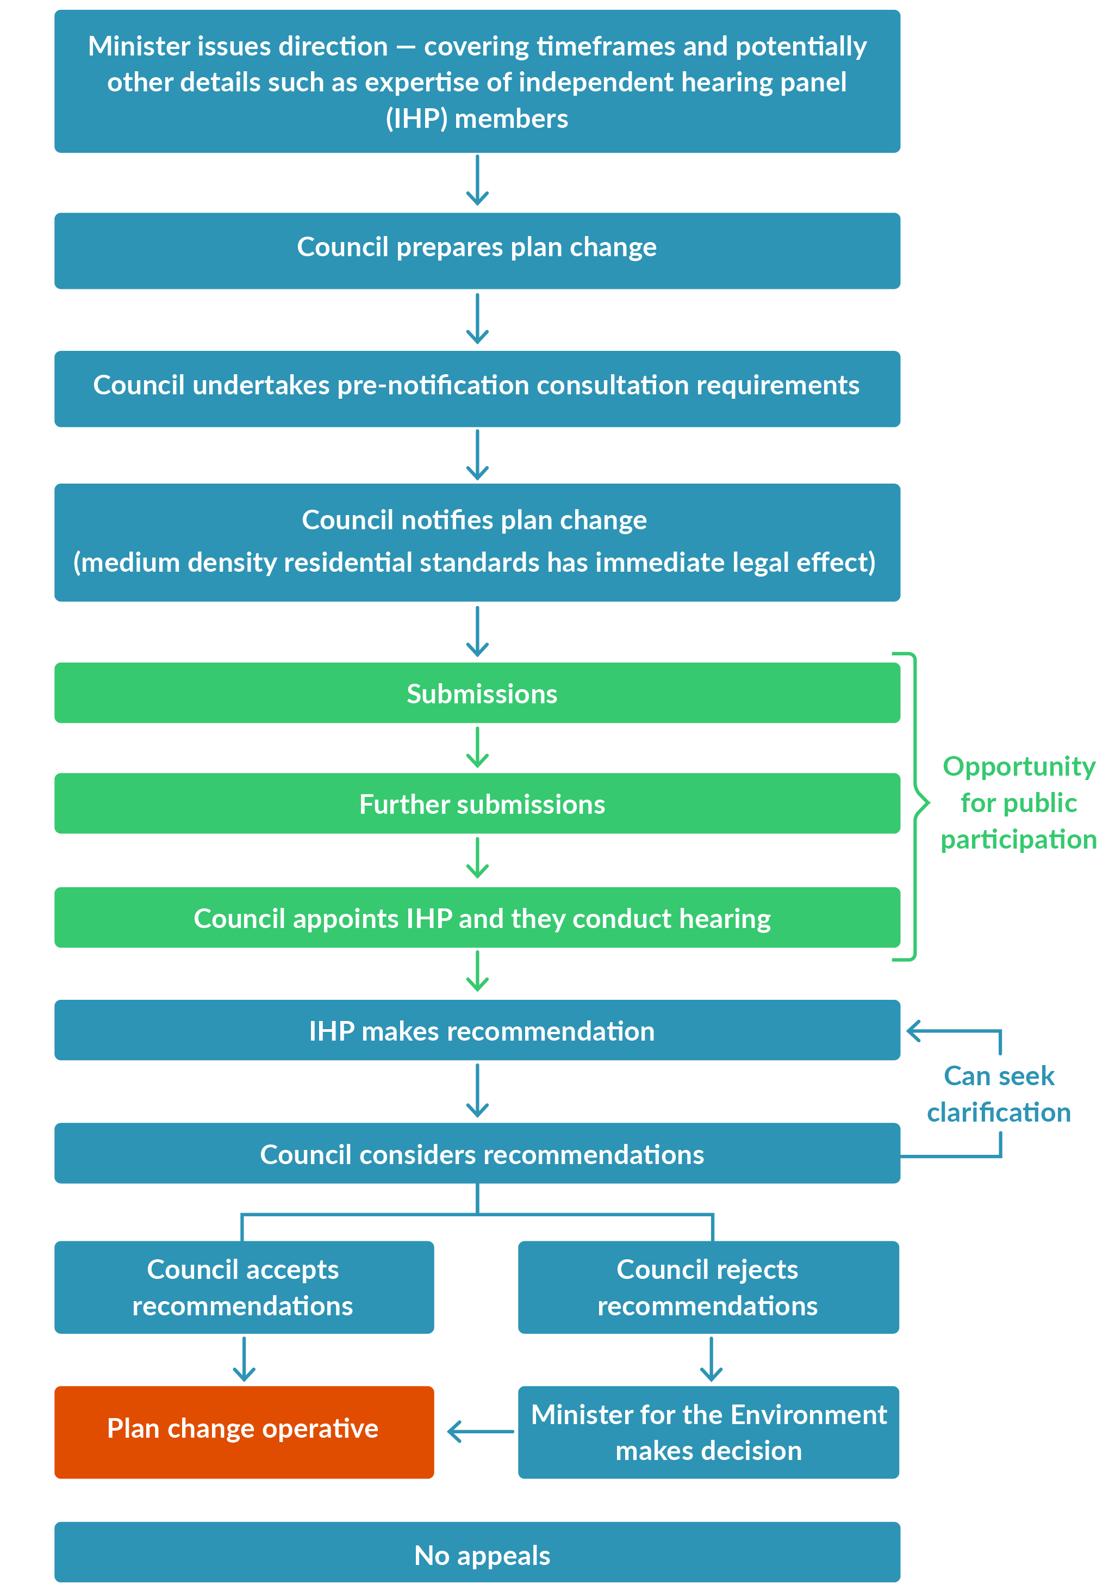

Intensification planning instruments (IPIs)
Plan changes notified under the ISPP are referred to as Intensification Planning Instruments (IPIs).

Scope
An IPI is defined in section 80E of the RMA-EHS as a change to a district plan or a variation to a proposed plan that must incorporate the MDRS and give effect to the NPS-UD intensification policies 3, 4 or 5 (as relevant to a specified territorial authority). These NPS-UD policies are listed in full in Appendix 1. The IPI may also include provisions relating to:
- financial contributions
- papakāinga housing
- related provisions (including objectives, policies, rules, standards and zones) that support or are consequential on the MDRS or the NPS-UD intensification policies.
A TA must only notify one IPI, when the MDRS is first incorporated into the relevant district plan. The IPI is processed through the ISPP.
The policy intent of section 80E is that the IPI provides for a comprehensive change to the relevant district plan. This plan change should sufficiently provide for the implementation of the MDRS and policies 3, 4 or 5 of the NPS-UD, without requiring additional supporting plan changes.
- An IPI could include provisions for district-wide matters, earthworks, fencing, infrastructure, stormwater management (including permeability and hydraulic neutrality), subdivision, and new and existing qualifying matters as they relate to urban areas (section 80E(2), RMA-EHS).
- Greenfield development can be incorporated in an IPI (see sections 77G(4) and 80E(b)(iii) of the RMA-EHS). The RMA-EHS enables an IPI to include new residential zones that implement the MDRS and related provisions (including non-residential zoning) which supports, or are consequential on, the MDRS (such as commercial, industrial or open space zoning).
- An IPI could also rezone land from an existing residential zone (where the MDRS would have to be incorporated under the RMA-EHS), to large lot residential zone or settlement zone (which are exempt from the MDRS) (see sections 77G(4) and 80E(b)(iii) and supported by policy 5 of the NPS-UD where applicable). This could occur when, as a consequence of giving effect to the MDRS or the intensification provisions of the NPS-UD, an existing residential zone may not be appropriate for greater residential intensification and is better described as large lot residential zone or settlement zone as set out in Table 13, Standard 8 (Zone Framework Standard) of the National Planning Standards.
The TAs will need to undertake an evaluation of the IPI under section 32 of the RMA, as amended by section 77J of the RMA-EHS.

Key factors involved in the ISPP and SPP
Table 1 highlights the key factors involved in the ISPP and the SPP and lists the standard Part 1 Schedule 1 processes.
Table 1: Comparison of the ISPP and SPP
Features | ISPP  (Subpart 5A – IPIs and ISPP) | SPP  (Part 5 Schedule 1 Process) | Standard Schedule 1 Process (Part 1 Schedule 1)
Eligibility | Specified territorial authority (TA) must notify IPI (s80F). | Set entry criteria (s80C(2)). Must be appropriate in circumstances. | No set criteria. A council can develop a plan or plan change at any time, to assist in carrying out its functions.
Initiation | The Minister sets direction on limited matters (s80L). | Local authorities must make a request to the relevant Ministers for a direction to use the SPP. | Initiated by local authority.
Process | Most Schedule 1 processes still apply – procedural steps are set by new Part 6 of Schedule 1.  The Minister’s direction may set timeframes. | Can be tailored in proportion to the planning issues.  Some Schedule 1 processes remain – procedural steps in Part 5 of Schedule 1 apply. Allows for further procedural steps and timeframes. | Procedural steps and timeframes set by Part 1 of Schedule 1.
Timeframe | Timeframes for notification of IPI set in RMA-EHS (s80F) or in regulations (s80I or 80K). Minister’s direction may set additional timeframes. | Minister’s direction sets timeframes. | Two years from notification to decision (s10(4)(a)).
Final decision | If the specified TA accepts all the IHP recommendations, the IPI becomes operative on notification of the TA’s decisions (clause 103 of Schedule 1).  If the specified TA rejects some or all of the IHP recommendations, the Minister becomes the final decision-maker on those recommendations and the remaining part of the IPI becomes operative on notification of the Minister’s decision (clauses 104 and 105 of Schedule 1). | Relevant Ministers. | Local authority is the decision-maker (except for a regional coastal plan, or where a requiring authority makes decisions on notices of requirement, designations or heritage orders).
Appeal rights | No right of appeal (s107). | Limited – only decisions of requiring authorities or heritage protection authorities (related to notices of requirement, designations or heritage orders). | Available to any person who has made a submission or further submission.  Merit appeals to the Environment Court.  Further appeals to higher courts on points of law.

Schedule 1 processes that apply
The following steps of Part 1 Schedule 1 apply to an ISPP.
A specified territorial authority:
- must prepare the IPI in accordance with any applicable Mana Whakahono a Rohe and iwi participation legislation (Clause 1A and B)
- must prepare an IPI (clause 2(1))
- must undertake consultation requirements during the preparation of the IPI (clause 3(1), (2), and (4)), consult with iwi authorities (clause 3B) and note previous consultation under other enactments (clause 3C)
- must provide a copy of the draft plan change to any iwi authorities consulted (clause 4A) before notifying the IPI
- must prepare an evaluation report for the IPI in accordance with section 32 and publicly notify the IPI (clause 5)
- must enable the public to submit on the IPI (clause 6)
- must give public notice of certain matters relating to submissions, including a summary of submissions report (clauses 7(1) and (2))
- must enable certain persons to make further submissions (clauses 8(1) and (2)) and allow for service of further submissions (clause 8A)
- must allow for resolution of disputes (clause 8AA)
- must hold a hearing into submissions on the IPI (clause 8B)
- can correct minor errors in the IPI (clause 16(2))
- can initiate variations to the IPI (clause 16A)
- shall approve the IPI (clause 17).

Qualifying matters
Specified TAs may modify, but only to the extent necessary, the intensification requirements of policy 3 or the MDRS if a qualifying matter applies. A qualifying matter makes higher density inappropriate in an area. The qualifying matters are listed in section 77I(a-i) and 77O(a-i). They include RMA section 6 matters of national importance. Any other matter may also be made a qualifying matter as per sections 77I(j) and 77O(j), but additional evidence must be provided to justify why it makes higher density (as required by policy 3 or the NPS-UD) inappropriate.
Intensification should not necessarily be excluded from an area where a qualifying matter applies. Instead, the level of intensification should be modified only to the extent necessary to accommodate the qualifying matter. Accommodating a qualifying matter may mean:
- reduced building heights
- lower densities
- no intensification (although this is expected to be an exception).

Additional information for section 32 evaluation report
If a specified TA is proposing to accommodate a qualifying matter in its IPI it needs to include additional information in the accompanying section 32 evaluation report. The information that needs to be included differs depending on the category of the qualifying matter. There are three different categories:
- existing qualifying matters – listed in 77I(a-i) and 77O(a-i) and included in an operative district plan
- new qualifying matters – listed in 77I(a-i) and 77O(a-i) but not included in an operative district plan
- other qualifying matters – provided for by 77I(j) and 77O(j), not listed in 77I(a-i) and 77O(a-i) and may or may not be included in the operative district plan.

Existing qualifying matters
An existing qualifying matter is a qualifying matter listed in section 77I(a) to (i) that is included in the relevant operative district plan when the IPI is notified.
Accommodating an existing qualifying matter requires a lesser assessment compared to that required to accommodate a new or other qualifying matter.
To accommodate an existing qualifying matter the specified TA must include in its section 32 evaluation report the information set out in section 77K (residential zones) or 77Q (non-residential zones). This includes:
- the location where the qualifying matter applies
- why one or more qualifying matters applies to that location
- alternative height and density standards for that area
- a general assessment based on a typical site of the level of development prevented by accommodating the existing qualifying matter (as compared to the level of development enabled by policy 3 or the MDRS).

New qualifying matters
A new qualifying matter is one that is listed in sections 77I(a-i) and 77O(a-i) but not included in the relevant operative district plan when the IPI is notified.
To accommodate a new qualifying matter the specified TA must include in its section 32 evaluation report the information set out in section 77J (residential zones) or 77P (non-residential zones). This includes:
- why the area is subject to a qualifying matter
- why the level of development permitted by the MDRS or policy 3 is incompatible with that area
- an assessment of the impact that the qualifying matter will have on the provision of development capacity
- an assessment of the costs and broader impacts of imposing those limits.

Other qualifying matters
To accommodate any other matter as provided for by section 77I(j) or 77O(j) the specified TA must include in its section 32 evaluation report the information set out in section 77J (residential zones) or 77P (non-residential zones) and the information set out in 77L (residential zones) and 77R (non-residential zones). This includes:
- identifying the specific characteristics that make the level of development provided by the MDRS or policy 3 inappropriate in the area
- justifying why the level of development is inappropriate in light of the national significance of urban development and the objectives of the NPS-UD
- providing a site-specific analysis that includes:
- identifying the site
- evaluating the specific characteristic on a site-specific basis
- evaluating an appropriate range of options to achieve the greatest heights and densities permitted by the MDRS or provided for by policy 3 while managing the specific characteristics.
Table 2 outlines the categories of qualifying matter and the section of the RMA-EHS that details the information required for the section 32 evaluation report.
Table 2: Category of qualifying matter
Category of qualifying matter | Section for evaluation report
Residential
Proposed new qualifying matter | 77J
Proposed new other qualifying matter | 77J and 77L
Existing qualifying matter | 77K
Existing other matter | 77J and 77L
Non-residential
Proposed new qualifying matter | 77P
Proposed new other qualifying matter | 77P and 77R
Existing qualifying matter | 77Q
Existing other qualifying matter | 77P and 77R

Including an appropriate level of detail in the section 32
The RMA-EHS allows the section 32 evaluation report to describe modifications to the requirements of section 32 necessary to achieve the development objectives of the MDRS.
Ministry for the Environment guidance on section 32 evaluation reports also states that the requirement in section 32 is to identify all options, but not necessarily to assess all these options in detail. An example of where scaling the section 32 evaluation report would be appropriate is in relation to 77O(f). This section allows a specified TA to modify policy 3 to be less enabling of development in areas dedicated to open space for public use. The information included in the section 32 report to support this being a qualifying matter should reflect that these areas are part of a well-functioning urban environment.
For further guidance, see A guide to section 32 of the Resource Management Act | Ministry for the Environment.

Immediate legal effect
The RMA-EHS provides that immediate legal effect applies to some permitted activity rules from the notification date of the IPI. This applies if the rule authorises the construction and use of a residential unit in a relevant residential zone in accordance with the density standards (in Part 2 of Schedule 3A).
There are some exceptions to immediate legal effect, including if a density standard that is proposed to be more enabling and in areas where a qualifying matter has been identified. More details are provided in the Medium Density Residential Standards: A guide for territorial authorities.

Transitional arrangements
Some specified TAs may be currently preparing plan changes or variations. The following guidance covers a variety of scenarios.
Councils that had already notified a proposed district plan when they became a specified TA are not required to modify their operative plans. They can instead use the ISPP to vary their proposed district plans to incorporate the MDRS and give effect to the NPS-UD intensification policies.
Councils that notified plan changes when they became a specified TA (this includes private plan changes they have adopted or accepted) must notify a variation to the plan change, to ensure that it incorporates the MDRS. They must notify the variation alongside their IPI, and the plan change will be able to continue.

Private plan change requests
Through the RMA-EHS, councils have the discretion to reject a private plan change request that does not incorporate the MDRS, or they can work with the requestor under the RMA Schedule 1 process to incorporate the MDRS.
In some circumstances, before IPI notification, councils can choose to accept or adopt a private plan change request that proposes to adopt all the zone provisions of a relevant residential zone without amendment. In this case, the IPI will incorporate the MDRS into relevant residential zones within the scope of the private plan change.

Tier 2 and tier 3 territorial authorities: regulations

Tier 2
Through an Order in Council recommended by the Minister, the Governor-General may make regulations requiring a tier 2 TA to prepare and notify an IPI.
Before recommending this, the Minister must consult the Minister of Housing and the Minister for Māori Crown Relations – Te Arawhiti. The Minister must also be satisfied that there is an acute housing need in the TA district.
If regulations are made, the TA will become a specified TA, and will need to prepare an IPI. This must incorporate the MDRS and give effect to NPS-UD policy 5. Through their IPI the TA can also change their financial contributions policies and make any consequential and complementary changes to their plan.
If regulations are made by 21 March 2022, the TA must prepare and notify an IPI by August 2022. If they are made after 21 March 2022, the TA must notify an IPI on or before the date set in the regulation.

Tier 3
Any tier 3 council can ask the Minister for the Environment to recommend regulations requiring it to prepare and notify an IPI. The Minister, before approving or declining the request, should determine whether the council is facing acute housing need, and consult the Minister for Māori Crown Relations – Te Arawhiti, and the Minister of Housing. Through an Order in Council recommended by the Minister, the Governor-General may make regulations requiring the TA to prepare and notify an IPI.
If regulations are made, the TA must notify an IPI on or before the date set in the regulation.

Appendix 1: NPS-UD intensification policies
Policy 3: In relation to tier 1 urban environments, regional policy statements and district plans enable:
(a) In city centre zones, building heights and density of urban form to realise as much development capacity as possible, to maximise benefits of intensification; and
(b) In metropolitan centre zones, building heights and density of urban form to reflect demand for housing and business use in those locations, and in all cases building heights of at least 6 storeys; and
(c) Building heights of at least 6 storeys within at least a walkable catchment of the following:
(i) existing and planned rapid transit stops
(ii) the edge of city centre zones
(iii) the edge of metropolitan centre zones
(d) Within and adjacent to neighbourhood centre zones, local centre zones and town centre zones (or equivalent), building heights and density of urban form commensurate with the level of commercial activity and community services.
Policy 4: Regional policy statements and district plans applying to tier 1 urban environments modify the relevant building height or density requirements under Policy 3 only to the extent necessary (as specified in subpart 6) to accommodate a qualifying matter in that area.
Policy 5: Regional policy statements and district plans applying to tier 2 and 3 urban environments enable heights and density of urban form commensurate with the greater of:
(a) The level of accessibility by existing or planned active or public transport to a range of commercial activities and community services; or
(b) relative demand for housing and business use in that location.

