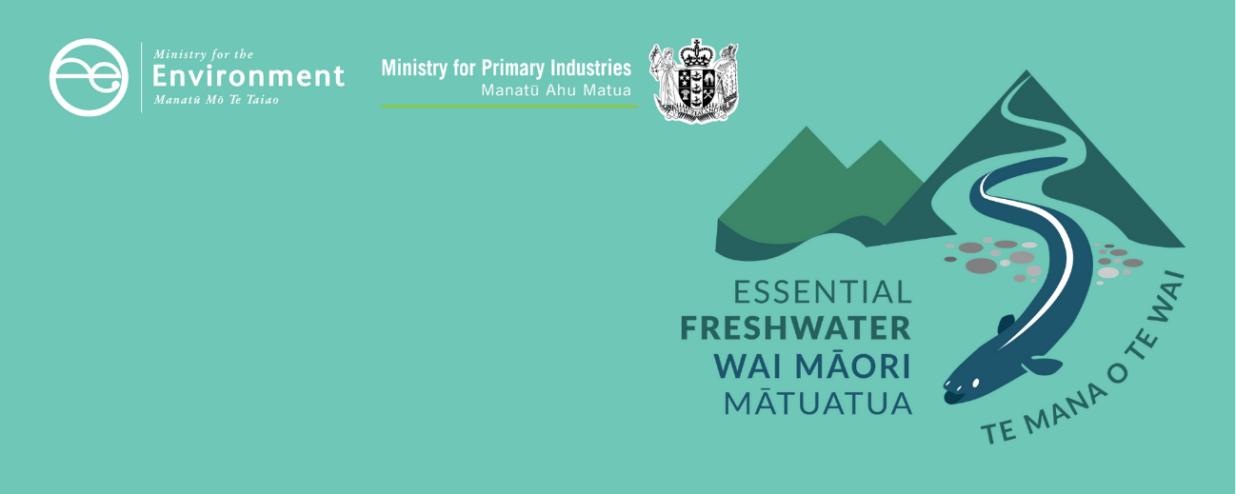

# Environmental flows and levels factsheet

Essential Freshwater is part of a new national direction to protect and improve our rivers, streams, lakes and wetlands. The Essential Freshwater package aims to:

* stop further degradation of our freshwater
* start making immediate improvements so water quality improves within five years
* reverse past damage to bring our waterways and ecosystems to a healthy state within a generation.

Te Mana o te Wai is fundamental to all freshwater management

Te Mana o te Wai recognises the vital importance of water. It expresses the special connection that New Zealanders have with freshwater. By protecting the health of freshwater, we protect the health and well-being of people and our ecosystems. When managing freshwater, Te Mana o te Wai ensures the health and well-being of the water is protected before providing for human needs or enabling other uses of water. Through discussions with regional councils, tangata whenua and communities will have a say on how Te Mana o te Wai is applied in freshwater management locally. More information can be found in the [**Te Mana o te Wai factsheet**](http://www.mfe.govt.nz/publications/fresh-water/essential-freshwater-te-mana-o-te-wai-factsheet).

## Who should read this factsheet

This factsheet is part of a [series](https://www.mfe.govt.nz/fresh-water/freshwater-guidance/factsheets-policies-and-regulations-essential-freshwater) and provides information on the new policies for setting environmental flows and levels, and requirements to set take limits, in the National Policy Statement for Freshwater Management 2020 (NPS-FM 2020). It is intended for council staff, land users, iwi, the wider agricultural industry, farm advisors and consultants, and anyone else with an interest in freshwater policy.

## What are the policies?

### **Setting environmental flows and levels**

Every regional council must include rules in its regional plan(s) that set environmental flows and levels for each freshwater management unit (FMU).

Flows and levels must:

* achieve the environmental outcomes for the values and the long-term vision that apply to the FMU
* be expressed in terms of the water level, flow rate and variability of flow that meets the environmental outcomes for that water body and any connected waterbodies.

When setting flows and levels, regional councils must have regard to the foreseeable impacts of climate change. Councils must also use the best information available and take into account results or information from freshwater accounting systems.

### Identifying take limits

To meet environmental flows and levels, regional councils must identify take limits for each FMU and these must be included as rules in their regional plans.

Where a regional plan or permit allows the taking, damming, diversion or discharge of water, it must identify the flows and levels at which these activities will be restricted, no longer allowed or, in the case of discharges, required. Councils must also state whether (and if so, which) existing water permits will be reviewed to comply with new rules.

Because take limits must achieve the environmental flows and levels for an FMU, take limits should not allow the taking or diversion of water when water is below a minimum flow and level.

Take limits must also:

* be expressed as a total volume, a total rate, or both, at which water may be taken or diverted from an FMU, or dammed within an FMU or part of an FMU
* provide for flow or level variability that meets the needs of the water body from which the water is taken or diverted, and the needs of connected waterbodies and their associated ecosystems (eg, a groundwater take limit would not cause a permanent lowering of the groundwater levels or reduce connected river flows below their environmental flow)
* safeguard ecosystem health from effects on the frequency and duration of lowered flows and levels (eg, a river system may have two or more take limits so restrictions can be applied in stages according to the environmental flows and levels)
* provide for the lifecycle needs of aquatic life (eg, a river system may have multiple take limits and apply restrictions to each limit according to seasons or flows or both)
* take into account environmental outcomes applying to the relevant and connected waterbodies (eg, a groundwater take limit may be set so water levels in a connected wetland maintain the hydrological conditions necessary for the wetland flora or fauna).

## When do the policies apply?

Councils must notify their plans by 31 December 2024, with final decisions made and plans operational no more than two years later (or three years if they are granted an extension).

## **Why these policies?**

**Water quantity** is one of the five components of ecosystem health and relates to the extent and variability in the level or flow of water in water bodies. Increasing demands on water resources and the frequency and length of droughts are adversely affecting ecosystem health because sustained low flows, lack of flow variability and long-term reductions in groundwater volumes and levels put stress on aquatic life. To mitigate these effects, it is important regional councils establish robust flow regimes for rivers, and water-level regimes for groundwater and lakes, that protect ecosystem health and allow environmental outcomes to be met.

## More about the Essential Freshwater package

An overview of the Essential Freshwater package, including when different aspects commence or must be implemented, can be found in this [summary and milestones](https://www.mfe.govt.nz/publications/fresh-water/essential-freshwater-milestones-what-happens-when).

The package includes several new national rules and regulations including:

* new [National Environmental Standards for Freshwater](http://www.legislation.govt.nz/regulation/public/2020/0174/latest/LMS364099.html)
* new [stock exclusion regulations](http://www.legislation.govt.nz/regulation/public/2020/0175/latest/LMS379869.html) under section 360 of the Resource Management Act 1991 (RMA)
* amendments to the [Resource Management (Measurement and Reporting of Water Takes) Regulations 2010](http://www.legislation.govt.nz/regulation/public/2020/0176/latest/LMS351161.html)
* the [National Policy Statement for Freshwater Management](https://www.mfe.govt.nz/publications/fresh-water/national-policy-statement-freshwater-management-2020) 2020, which replaces the NPS‑FM 2017
* [amendments to the RMA](https://www.mfe.govt.nz/rma/improving-our-resource-management-system), to provide for a faster freshwater planning process
* [amendments to the RMA](https://www.mfe.govt.nz/fresh-water/freshwater-acts-and-regulations/regulations-freshwater-farm-plans-and-reporting-of-sales), to enable mandatory and enforceable freshwater farm plans and the creation of regulations for reporting nitrogen fertiliser sales.

Factsheets in this series

The full set of Essential Freshwater factsheets is available [on our **website**](https://www.mfe.govt.nz/fresh-water/freshwater-guidance/factsheets-policies-and-regulations-essential-freshwater).

Find out more and give us feedback

Contact us by emailing [**freshwater@mfe.govt.nz**](mailto:freshwater@mfe.govt.nz), or visit [the **Essential Freshwater page**](https://www.mfe.govt.nz/fresh-water/freshwater-guidance/factsheets-policies-and-regulations-essential-freshwater) on our website.

### Disclaimer

The information in this publication is, according to the Ministry for the Environment’s best efforts, accurate at the time of publication. The information provided does not alter the laws of New Zealand and other official guidelines or requirements. Users should take specific advice from qualified professional people before undertaking any action as a result of information obtained from this publication.

The Ministry for the Environment does not accept any responsibility or liability whether in contract, tort, equity or otherwise for any action taken as a result of reading, or reliance placed on the Ministry for the Environment because of having read any part, or all, of the information in this publication or for any error, or inadequacy, deficiency, flaw in or omission from the information provided in this publication.

Published in December 2020 by the  
Ministry for the Environment with input from the Ministry of Primary Industries  
Publication number: INFO 1001

